CHAPTER 1
INTRODUCTION
The capability of buried pipes to resist forces associated with lateral soil movements is critical for design and risk evaluation in a variety of adverse environments, such as slope movement, urban excavations, and tunneling. Unexpected ground movement can cause significant strains in pipeline and influence pipeline performance and integrity.
Apart from above, pipe–soil interaction forces are influenced by many factors, such as the properties of soil and pipe, pipe orientation with respect to soil movement, the rate of soil movement, and boundary conditions too. The main factors are being listed bellow;
- Soil properties: soil type, friction angle, dilatancy and strain-hardening.
- Pipe properties: type of pipe (rigid or flexible) and diameter.
- Model properties: height of fill, H/D ratio, pipe-orientation with respect to soil movement, the rate of soil movement and boundary conditions.
Efforts have been made to study the influence of some of the above factors in pipe-soil interaction forces induced by lateral ground movements in sandy soils. This study concludes that the effects of pipe-size and burial-depth must be taken into account to properly estimate the maximum pipe–soil interaction forces which induces by lateral ground movement. The details of these in addition to the design requirement of UG piping have been presented in next chapters.
To avoid confusion, in this presentation, the effect of pipe diameter is called the size effect, the effect of model scale is called the model effect, and their combination is called as the scale-effect. The influence of burial depth ‘H’ has been referred to burial depth effect.
1.1 Organization of the Thesis
Chapter 1 lists the parameters that influence the pipe-soil interaction forces.
Chapter 2 detailed the literature review about soil & pipe mechanics and the importance of their relationships. It organized to explain soil-mechanics related to vertical soil pressure, pipe-soil interaction and abrupt ground ruptures, pipe-mechanics related to longitudinal analysis, ring analysis, ring stresses, ring strain, ring deformation, ring stability and plastic performance limit. It explains minimum soil cover requirement to overcome effects of dead loads, live loads including construction loads. It also covered the design requirements of pipe ring to resist the internal pressure, transportation / installation loads. It explains design requirements to strength of the pipe, ring stiffness and stability too.
Chapter 3 presents the principles of the finite element analysis, scope of the finite element analysis, finite element method setup and numerical analysis and how the detailed analysis carried through numerical finite element method using the software ANSYS 9.0. This chapter also explains the variation of observed $N_{h}$ through D-, H- and H/D series of tests.
Chapter 4 deals with the results & discussions of scale-effect in pipe-soil interaction. It explains in detail the variation of$N_{h}$with H/D, effect of burial depth ratio, model effect, dimensionless force-displacement curves, the influence of burial depth, effect of soil-properties related to soil-dilatancy, dilation-angle, $N_{h}$ -H/D relation, effect of dilatation angle at different burial depths, effect of dilatation-angle on force-displacement curves, effect of strain-hardening on pipe responses at H/D = 2.85. It also covers explaining the combined effects, and comparison of the results with published experimental studies.
Chapter 5 presents the conclusions of the presented work and scope for future study. It explains the significance to respect the current pipeline design guidelines which were developed after due consideration of the scale-effects in pipe-soil interaction.

CHAPTER 2
LITERATURE REVIEW
Various modeling efforts have led to a wide range for maximum predicted soil forces associated with relative pipe–soil movement. Studies examined that analytical models based on the work done by Hansen and Ovesen predict maximum lateral soil forces differ considerably (more than 200%) for a pipe buried three to four diameters below the ground surface in medium or dense sand.
Numerical studies related to pipe-soil interactions using finite element methods have been studied by number of Engineers and scientist. Katona (1978), Duncan and Jevapalan (1982) studied the interaction of culvert structures with surrounding soils; Rowe and Davis (1982) investigated the behavior of anchor plates buried in cohesive and cohesionless soils; Numerical modeling of pipe-soil interactions under various conditions can be found in Ng (1994), Zhou and Harvey (1996), Yang and Poorooshasb (1997), Guo and Popescu (2002) and Popescu et al (2002).
A comparison of model predictions with measured data and data collected from different publications, experimental studies done by various scientists and engineers has been performed and found lot of variability in terms of its accuracy.
Continuum finite element analysis through software ANSYS 9.0 has been performed for simulating pipe-soil interaction problems.
The difficulties in characterizing the real soil-properties have contributed to large variation in predicted soil-forces and pipe-responses. It leads to a lack of confidence and limited implementation of numerical modeling in practice.
The work performed by above mentioned scientists and engineers on pipe–soil interaction with lateral ground movements mainly focuses for predicting the maximum horizontal soil-forces and force-displacement relations. These are usually expressed in terms of the dimensionless force $N=\frac{P}{γ\text{HD}}$and the normalized pipe-displacement y/D, where P is the force on a unit length of pipe, H is the burial depth corresponding to the distance between ground surface and pipe center, D is the diameter of the pipe, and y is the lateral relative movement between pipe and surrounding soil mass.
Table 1 Data collected from lateral loading tests in sand (P.J. Guo et al-2005)
Test  Model | Dimension of specimen  (mm) | Measured Friction Angle $φ(^{ο})$ | Density of soil  (kN/m³) | Remarks
Plate | 900 | 32 | 14.4
Anchor | 15-150 | 32 | 15.2
 | 15-150 | 36 | 16.7
 | 15-150 | 38 | 16.7
 | 15-150 | 43 | 16.7
 | 50.8 | 43.6 | 16.5
Pipe | 25, 60, 114 | 33 | 15.7
 | 25, 60, 114 | 40 | 17.3
 | 229 | 35 | 16.8
 | 102, 324 | 31 | 14.8
 | 229 | 36 | 16.4
 | 229 | 44 | 17.7
Design requirement and structural mechanics associated for pipe soil interaction attempted by R. K. Watkins et al has been implied in this work. He explained the detail mechanism of soil and pipe in pipe-soil interactions as detailed bellow.
2.1 Soil Mechanics
An elementary knowledge of basic principles of soil-stresses is essential to understand the structural performance of buried pipes. A few are reviewed in the following paragraphs.
2.1.1 Vertical soil pressure, P
Vertical soil pressure at the top of pipe is caused by:
- Dead load $P_{d}$the weight of soil at the top of the pipe; and
- Live load $P_{l}$ the effect of surface live loads at the top of the pipe.
Figure 2.1 shows the vertical soil pressures at the top of the pipe as function of height of soil cover H. If the embedment on a buried pipe is densely compacted, soil pressure at the top of the pipe is reduced by arch action, like a masonry arch, it helps to support the load.
If the soil embedment is loose, soil pressure at the top of the pipe is increased by pressure concentrations. Pressure concentrations due to loose embedment cannot be ignored. For design, either a pressure concentration factor is needed, or minimum soil density should be specified. Over a long period of time, these pressure concentrations shall be reduced by creep in the pipe wall (plastic pipes), earth vibrations, freeze-thaw cycles, wet-dry cycles, etc.
Total vertical soil pressure at the top of the pipe is (see Figure 2.2).
$P=P_{d}+P_{l}$ ….(2.1)
Height | Pl | Pd | Pl+Pd
- | 2,050.00 | - | 2,050.00
2.50 | 1,250.00 | 250.00 | 1,500.00
5.00 | 500.00 | 500.00 | 1,000.00
7.50 | 250.00 | 750.00 | 1,000.00
10.00 | 150.00 | 1,000.00 | 1,150.00
12.50 | 100.00 | 1,250.00 | 1,350.00
15.00 | 60.00 | 1,500.00 | 1,560.00
17.50 | 55.00 | 1,750.00 | 1,805.00
20.00 | 50.00 | 2,000.00 | 2,050.00
A graph has been plotted as follows for the above assumed data for Equation 2.1 given by R. K. Watkins et al in order to understand the combined effect of dead and live loads.
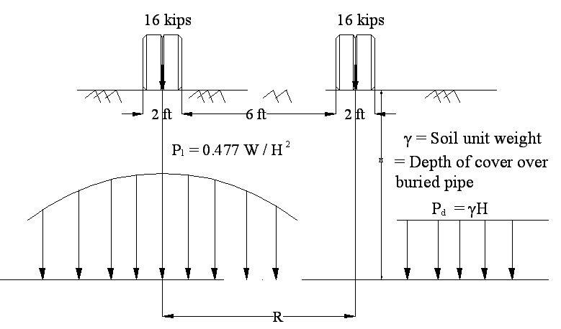
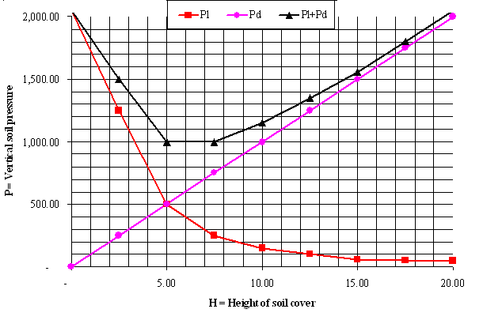
Figure 2.1 Vertical soil-pressure under one pair of dual wheel

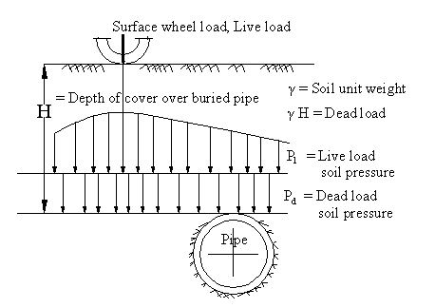 | $$P=P_{d}+P_{l}$$  $$=γH+N\frac{W}{H^{2}}$$  Where,  $N=\frac{3}{2π}{\left(\frac{H}{R}\right)}^{5}$and  $$\frac{3}{2π}=0\text{.}\text{477}$$
Figure 2.2 Vertical soil-pressures at the level of top of buried pipe
2.1.2 Dead load vertical soil pressure$P_{d}$
Dead load is the vertical pressure due to the weight of the soil at a given depth H. Total pressure$P_{d}$is the weight of soil, including its water content per unit area (Figure 2.3). Inter-granular (or effective) pressure$P_{d}$is the pressure felt by the soil skeleton when immersed in water. The total and inter-granular vertical stresses at the bottom of a submerged stratum can be related by the following stress equation:
$σ=σ_{v}−u$ ... (2.2)
For more than one stratum of soil as shown in Figure 2.4, the total vertical dead load soil pressure$P_{d}$at the bottom of the strata is the sum of the loads imposed by all of the strata; i.e.,
$P_{d}=\sum{γ_{t}H}$ ... (2.3)
$γ_{t}=\frac{(G+\text{Se})γ_{w}}{(1+e)}$ ... (2.4)
Table 2 gives the summary of dead load soil stresses from which dead load pressure$P_{d}$can be found and combined with the live load pressure$P_{l}$.
Inter granular vertical soil pressure P, at the bottom of multiple soil strata is:
$P=P_{t}−u=\text{Pt}−γ_{w}h$ … (2.5)
As the soil is compressed, pipe is also compressed in direct ratio. But soil compression depends only on inter granular stresses.
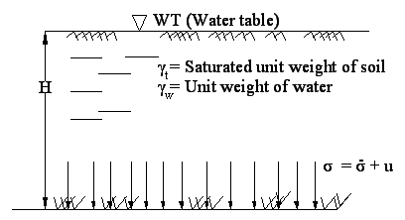  Figure 2.3 Vertical soil-pressure in buoyant case of single strata | 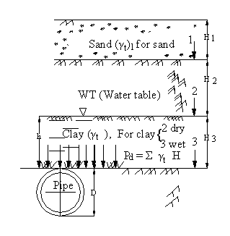  Figure 2.4 Vertical soil-pressure in buoyant case of multiple strata

Table 2 Summary of dead load pressure $P_{d}$
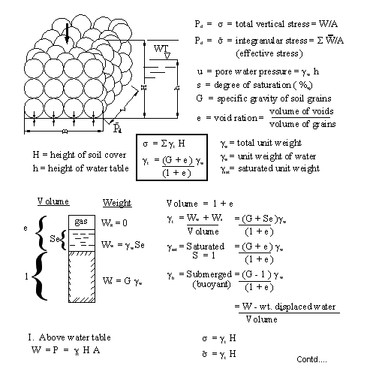
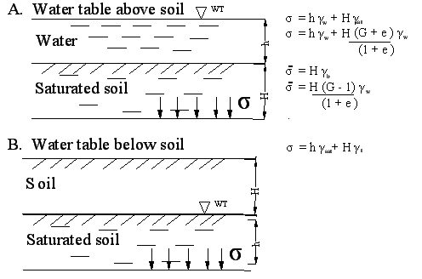
2.1.3 Live load vertical soil pressure$P_{l}$
Live load soil pressure$P_{l}$is the vertical soil pressure at the top of the buried pipe due to surface loads as shown in Figure 2.5. For a single concentrated load W on the surface, vertical soil pressure at point A top of the pipe is
$σ=\frac{\text{NW}}{H^{2}}$ ….(2.6)
where N = Boussinesq coefficient $=\frac{3}{2π}{\left(\frac{H}{R}\right)}^{5}$
For a single wheel (or dual wheel) load, the maximum stress$σ_{\text{max}}$at A occurs when the wheel is directly over the pipe; i.e. R = 0, for which
$σ_{\text{max}}=0\text{.}\text{477}\frac{W}{H^{2}}$ …. (2.7)
Load W can be assumed to be concentrated if the depth H is greater than three times the maximum diameter or length of the surface load area. The effect of a uniformly distributed surface load can be found by dividing the loaded surface area into infinitesimal areas and integrating to find the sum of their effects at some point at depth H (Figure 2.6). Newmark performed such integration and found the vertical stress σ at a depth H below corner A of a rectangular area length L and breadth B, and loaded with uniform pressure q
$σ=\text{Mq}$ …(2.8)
where M is the coefficient. It can be read from the chart shown in Figure 2.6 by entering the arguments L/B and B/H. If the stress due to pressure of an area is desired at some point other than a corner, the rectangular area can be subdivided such that the point A is common corner of number of areas. The maximum stress under a rectangular area occurs below the center as shown in Figure 2.7. The rectangle is subdivided into four identical rectangles of length L and breadth B. The stress at point A is 4Mq, where M is found from the Newmark chart as shown in Figure 2.6.

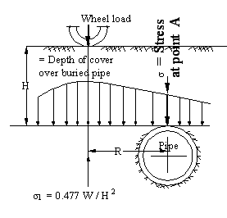
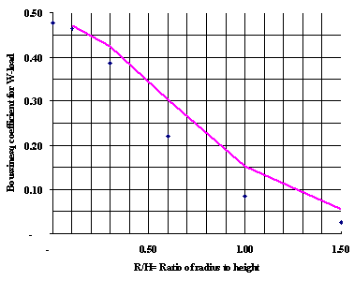
Figure 2.5 Vertical soil-pressures at depth, H for point loads (Bousinesq)

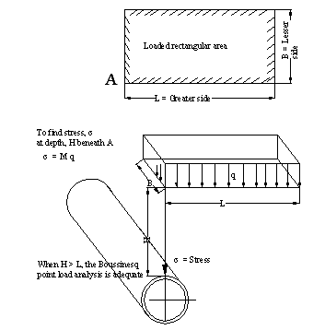
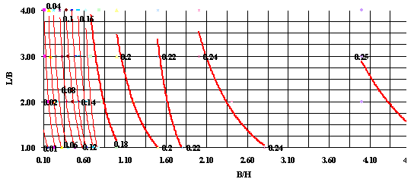
Figure 2.6 Vertical soil-pressures at depth, H for UDL (Newmark)

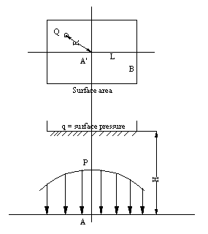
Figure 2.7 Vertical soil-pressure for eccentricity load (Newmark)
2.1.4 Pipe-soil interaction
An example of pipe-soil interaction curve with an unloading and reloading cycle is illustrated in Figures 2.9 and 2.10. These cycles are explained in publication of Offshore Technology Conference (OTC 16628). The right hand column of Figure 2.9 shows the relationship of the backbone curve (the maximum soil resistance force to pipe penetration) at a given depth, as well as the pipe-soil interaction curve (the force-displacement relationship) of a pipe moving through the soil. The left hand column shows the vertical motion of the pipe associated with the pipe-soil interaction curve. The details of the Figure 2.9 have been described below:
- The pipe is suspended above a virgin soil.
- The pipe penetrates into the soil, plastically deforming it. The pipe-soil interaction curve follows the backbone curve.
- The pipe moves upwards and the soil responds elastically. The pipe-soil interaction curve breaks away from the backbone curve, the force reduces over a small displacement.
- The pipe again penetrates in to the soil, deforming it elastically. The pipe-soil interaction curve follows an elastic loading curve similar to the previous elastic unloading curve of step 3.
- The pipe again penetrates into the soil, plastically deforming it. The pipe-soil interaction curve rejoins and follows the backbone curve.
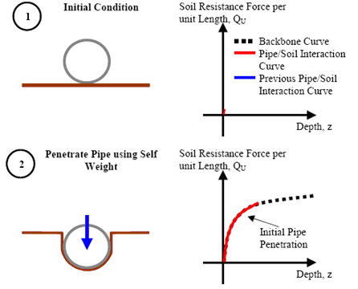
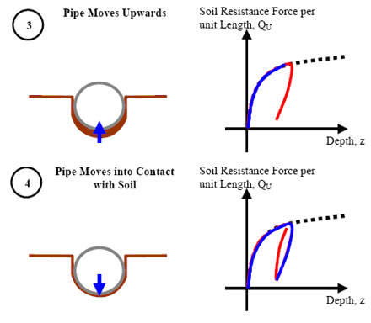
Figure contd…
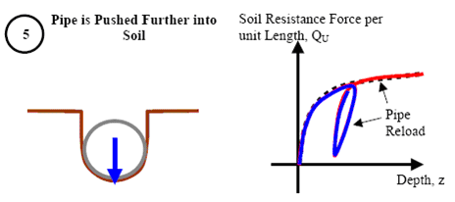
Figure 2.8 Illustration of pipe-soil interaction (OTC 16628, May-05)
Figure 2.9A Re-penetration pipe-soil interaction curves (OTC 16628, May-05)
2.1.5 Abrupt ground rupture patterns UG pipe line
Pipe also should be designed to resist the following generic types of ground rupture patterns (as shown in Figure 2.10). These affect buried lifelines seriously.
Figure 2.9B Pipe line subjected to abrupt ground rupture (Research publication on effect of ground ruptures by Cornel University Aug-05)
2.2 Pipe Mechanics
In case of buried pipes, forces are statically indeterminate because the soil is not uniform. Internal pressures also shall be indeterminable. Unknown soil loads are mitigated by the ability of soil due to its arch action over the pipe, and it relieves the pipe from some load. Failure is by buckling, collapsing, cracking and tearing, as well as excessive deformation of the pipe. It is evaluated from following procedures.
2.2.1 Longitudinal analysis
The two basic longitudinal analyses are axial and flexural. Axial analysis considers the longitudinal effects of temperature changes, catenary tension, thrust at valves and elbows, and poison effect of radial pressure. Flexural analysis considers the longitudinal effect of beam bending.
Longitudinal (beam) analysis of buried pipe follows classical procedures. Depending on the loads (weight of the pipe and its contents plus soil loads) and the reactions (high points or hard spots in bedding), bending moment diagrams can be drawn, and deformations, strains, and stresses can be evaluated.
2.2.2 Ring analysis
Ring analysis considers stress, strain, deformation, and stability of the cross section (ring).
2.2.3 Ring stresses
Stress theory is preferable for rigid rings, where as deformation and strain theories are for flexible rings. Circumferential stresses comprise: (1) hoop or ring compression stress, and (2) moment stress or its equivalent ring deformation stress. Circumferential stress analysis is similar to the stress analysis of eccentrically-loaded short column, see Figure 2.10. Within the elastic limit,
From beam$σ=\frac{F}{A}+\frac{\text{Mc}}{I}$, for a pipe ring similar to this, by theory of elasticity,
$σ=\frac{\text{Pr}}{A}+\frac{\text{Mc}}{I}$ …(2.8)
Putting, $m=\frac{r}{t}$ = ring flexibility into Equation 2.8,
$$σ=\text{Pm}\left(1+\frac{3}{2}m)\right)$$
For flexible rings, Equation 2.8 is more useful if flexural stress $\frac{\text{Mc}}{I}$is written in terms of change in radius of the ring. From theory of elasticity,$\frac{M}{\text{EI}}=dθ=\frac{1}{r}−\frac{1}{r'}$, (see Figure 2.10) and solving for M, Equation 2.8 becomes,
$σ=\frac{\text{Pr}}{A}+\text{Ecd}θ$ ….(2.9)
For rigid rings, Equation 2.9 applies. Thrust T =Pr and moment$M=\frac{{\text{Pr}}^{2}}{4}$are the functions of the soil loading.
For a plain pipe, Equation 2.9 becomes,
$σ=\text{Pm}+\left(\frac{E}{m}\right)\left(r'−r\right)2r$ ...(2.10)

Figure 2.10 Comparison of stress distribution of short-column and pipe-ring
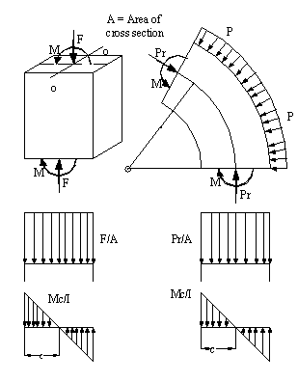
a) Short column showing stress distribution | b) Pipe ring showing stress distribution
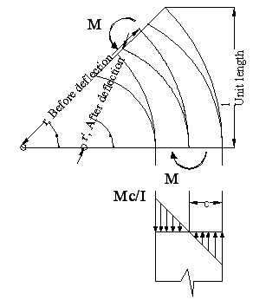
Figure 2.11 Free body diagram of section of ring showing deformation mechanism
2.2.4 Ring strain
Within the elastic limit, strain ε = σ/E. Putting this in Equation 2.9,
$ε=\frac{\text{Pr}}{\text{AE}}+\text{cd}θ$ ….(2.11)
For a plain pipe with wall thickness t,

$ε=\frac{\text{Pm}}{E}+\left(\frac{r'−r)}{2\text{mr}'}\right)$ …. (2.12)
2.2.5 Ring deformation
For a flexible ring, controlling of ring deformation is usually a better option than controlling of soil pressure. The best controlling is specifying the maximum allowable ring deformation. The basic ring deformation of a buried circular pipe is from circle to ellipse (see Figure 2.12). Ring deflection from circle to ellipse decreases radius of curvature at B by,
$dθ=\frac{1}{r_{x}}−\frac{1}{r}$, but from ellipse equation, $r_{x}=r\frac{(1−d)^{2}}{(1−d)}$ and for small ring deflections–say less than 10%, neglecting higher orders of d, for ellipse, by elastic analysis at spring lines;
$σ=\frac{\text{Pr}}{A}+\left(\frac{\text{Ec}}{r}\right)\left(\frac{3d}{1−2d}\right)$ . .. (2.13)
$\begin{aligned}\left(\text{comp} | \right) \\ \end{aligned}$, where d = ∆/D = ring deflection = $\frac{Δ_{y}}{D}=\frac{Δ_{x}}{D}$

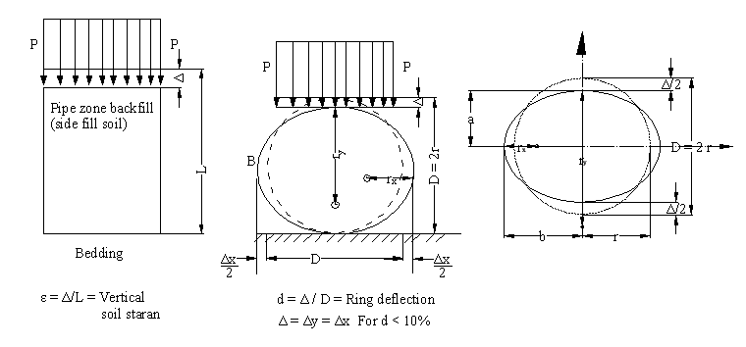
Figure 2.12 Ring deflections from a circle to ellipse
2.2.6 Ring stability
Ring stability is the resistance to progressive deformation due to persistent loads, internal pressure, beam loading, or external pressure. Persistent loads include constant or intermittent internal pressure or vacuum, and gravity loads that are not received by soil arching. Failure is usually sudden and catastrophic. Failure due to internal pressure is rupture because the diameter of the ring increases and wall thickness decreases at yield stress. Failure due to beam loading is fracture or buckling of the pipe wherever the bending moment is excessive. Failure due to external pressure is collapse. The loading for progressive deformation must be persistent; i.e., the load must bear against the pipe even as the pipe deforms away from the load. Instability most often implies collapse due to external pressure P (see Figure 2.13).

$\frac{F}{Δ}=\text{53}\text{.}\text{77}\left(\frac{\text{EI}}{D^{3}}\right)=6\text{.}\text{72}\frac{\text{EI}}{r^{3}}$ …. (2.14)
where F/∆ is called pipe stiffness and $\frac{\text{EI}}{r^{3}}$ is the ring stiffness. These are the properties of a circular ring which resists collapse caused by external pressure. Ring stiffness can either be calculated or measured from a parallel plate test or three edge bearing test (TEB).
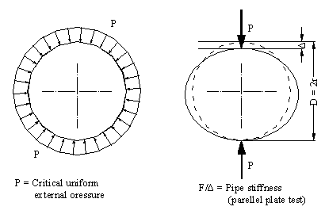
Figure 2.13 Notation used in deriving the equation for evaluating external pressure P by Plate load or TEB test.
2.2.7 Plastic performance limit
Ring stiffness $\frac{\text{EI}}{r^{3}}$ is derived from the theory of elasticity. It is conservative. When mitigation or failure analysis is needed, plastic theory may be more appropriate. Plastic theory can be related to elastic theory by moment resistance. See Figure 2.14. At the center located at the top of the pipe, point A (as cross-hatched) of an element of pipe wall of thickness, $t$of unit length along the pipe. Left one is elastic stress distribution due to ring deflection and right one is plastic stress distribution. The plastic resisting moment, $M_{p}=\frac{3}{2}\frac{\text{SI}}{c}$, and elastic resisting moment, $M_{e}=\frac{\text{SI}}{c}$. Elastic moment at surface yield stress is not collapse. Once the surface starts to yield, stresses within the wall thickness increase to the yield strength as shown at the right side Figure 2.14.
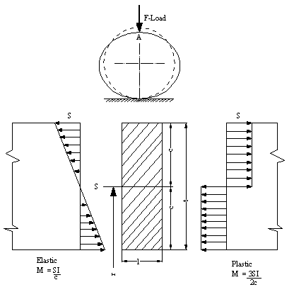

Figure 2.14 Flexural stresses on longitudinal section (cross-hatched) of pipe wall at $A$showing maximum elastic and plastic stress distributions.
2.3 Minimum Soil-Cover
As the soil cover H decreases, the live load effect on the buried pipe increases. The minimum height of soil cover is the height H less than from which the surface live load damages the pipe. Vehicles are generally unable to maneuver on poor soil such as wet cohesive soil and get stuck in the mud.
In many of the analyses, the effect of the surface live load on the pipe is based on the pyramid/cone model. The Boussinesq and Newmark have formulated procedures for calculating live load pressure on the pipe. These are based on the assumption that the soil is elastic. This assumption is not adequate for failures of buried pipes. Failure of pipes is due to surface loads on less than minimum soil cover, it is called punch through. The pipe is not subjected to failure load until the soil cover fails in shear due to punch through of the wheels through soil, and then fracture or distort the buried pipe. Based on such a model, the soil stress on a buried pipe is referred as the pyramid/cone soil stress.
A surface live load can damage the buried pipe only after it punches through the soil cover. If the loaded surface area is circular, a truncated cone of soil is punched out. If the loaded surface area is a rectangle, a truncated pyramid of soil is punched out.
For a surfaced highway, the height of soil cover remains constant during passes of live loads. But during construction, due to a heavy load crossing buried pipe faces ruts. In fact successive passes of the load may increase the depth of ruts. The depth of rut approach a limit as the number of passes increases. But if the depth of the ruts continue to increase with each pass of the surface load, the pipe feels increasingly adverse loads and may be in the process of inversion by ratcheting; i.e., an additional increment of ring deformation with each pass of the load. Whatever the ultimate damage may be, a performance limit shall be reached. So minimum height of soil cover is defined as that soil cover H less than which the pipe-soil system becomes unstable upon multiple passes of surface load W.
2.3.1 Dead load
Minimum cover of cohesionless soil over a buried pipe is required if the pipe is unable to support the variation in soil pressures around its perimeter. If the pipe is unable to support the difference in pressures due to ruts, the wedges will slide against the pipe, deforming the ring; it in turn lifts the top wedges. Collapse of the pipe is catastrophic if the pipe is rigid (brittle), collapse is fragmentation if the pipe is flexible. A suggested allowable value $D/6$of minimum cover allows for a margin for a perfectly flexible ring. In fact, pipes have ring stiffness and so provide resistance to dead load collapse.
2.3.2 Live load
The minimum cover of cohesionless soil required over a buried pipe is not based on the location of live load directly over the crown of the pipe, but based on the leading edge of the base area of the truncated pyramid at crown. Tests to failure of long span corrugated steel arches prove that the static surface loads symmetrically located over the crown can be many times greater than the load on one side. Static load failure is soil punch-through and ring collapse.
2.4 Design of the Pipe-Ring
Ring design is the design of the ring such that it can support the three most basic loads called 1) Internal Pressure (see Figure 2.15), 2) Transportation / Installation (see Figure 2.16) and 3) Eternal Pressure (Pressure that exists always from the beginning without an end).
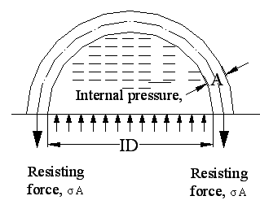
Figure 2.15 Free body diagram of semi-ring subjected to internal pressure$P_{1}$.
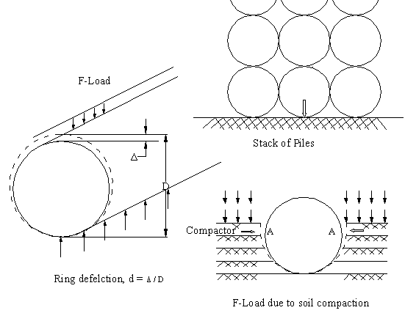
Figure 2.16 Transportation and installation loads on pipes (F-loads).
2.4.1 Internal pressure (minimum wall area)
The maximum rupturing force, F = P₁ (ID)
The resisting force by tension, T = σ (2 A)
Equating rupturing force to the resisting force,
$$σ=\frac{P_{1}(\text{ID})}{2A}$$
Performance limit is reached when stress, σ, equals yield strength, S. For design, the yield strength of the pipe wall is reduced by a safety factor,
$σ=\frac{P1(\text{ID})}{2A}=\frac{S}{\text{sf}}$ …..(2.15)
There fore, Minimum wall area, $A=\frac{P_{1}(\text{ID})\text{sf}}{2S}$
2.4.2 Transportation / Installation (maximum line load on pipe)
The most common load is diametral F-load (see Figure 2.17). This load occurs when pipes are stacked or when soil is compacted on the sides or on top of the pipe as shown. If yield strength of the pipe material is exceeded due to F-load, either the pipe wall will crack or the cross section of the pipe will permanently deform. Either of these deformations (a crack is a deformation) may be unacceptable. Two analyses are required for transportation and installation, (1) yield strength, and (2) ring deflection. In general, yield strength applies to rigid pipes such as concrete pipes (see Figure 2.16), and ring deflection applies to flexible pipes.
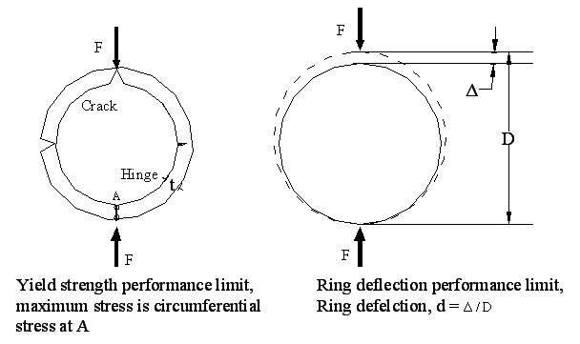
Figure 2.17 Ring subjected to F-loads showing pertinent variables, yield strength and ring deflection.

2.4.3 Yield strength (rigid pipes)
Circumferential stress, $σ=\frac{\text{MC}}{I}$, where $M=\frac{\text{FD}}{2π}$ and $F=\frac{2π\text{SI}}{\text{cD}}$
For plain pipes, $I=\frac{t^{3}}{\text{12}}$ and $c=\frac{t}{2}$
Rearranging terms, $F=\frac{π{\text{St}}^{2}}{3D}$ …(2.16)
where F is the load at yield strength S for plain pipes (smooth-cylindrical surfaces).
2.4.4 Ring strength
$\frac{F}{\text{SD}}=2\frac{D}{c}\frac{I}{D^{3}}$ ….(2.17)
Resolving for plain pipes $F=\frac{π\text{SD}}{3}{\left(\frac{t}{D}\right)}^{2}$
    - Ring deflection (flexible pipes)
Modulus of elasticity E is pertinent. Yield strength is not pertinent.
Ring deflection d due to F – load,
$$d={\text{Fr}}^{2}\left(\frac{π}{8}−\frac{1}{π}\right)\text{EI}$$
$d=0\text{.}\text{0186}x\frac{{\text{FD}}^{2}}{\text{EI}}$ ..(2.18)
where, $I=\frac{t^{3}}{\text{12}}$ and $c=\frac{t}{2}$
The relationship between circumferential stress and ring deflection is found by putting
$F=\frac{2π\text{SI}}{\text{cD}}$ in equation (2.18)
$d=0\text{.}\text{117}\frac{σ}{E}\frac{D}{c}$ ..(2.19)
For plain, pipes put c = t/2 in equation (2.19)
$$d=0\text{.}\text{234}\frac{σ}{E}\frac{D}{t}$$
    - External pressure
Consider a free body diagram of the half pipe with external pressure on it (see Figure 2.18).
The vertical rupturing force = P (OD)
The resisting force = 2σA, compression in the pipe wall.
Equating resisting force to rupturing force, ring compressive stress, $σ=\frac{P(\text{OD})}{2A}$ …(2.20)
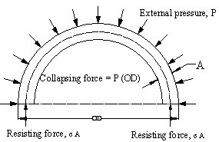
Figure 2.18 Semi ring subjected eternal radial pressure P.
2.5 Ring-Stiffness & Stability
2.5.1 Ring stiffness
Stiffness is defined as the resistance to deflection and it is the property of material. Figure 2.20 shows a typical stress-strain diagram. The abscissa is strain, deflection per unit length. The ordinate is stress, load per unit area and is the resistance of the material to strain. Stiffness of the material is the slope E of the stress-strain diagram at any particular point or at any particular stress. Stress strain diagrams can be provided for shearing stress-strain as well as normal stress-strain. The initial linear portion of the diagram is the elastic zone within which stress causes no permanent deformation. The material rebounds elastically. The slope is constant and is called the modulus of elasticity.
The concept of stiffness has been extended to a spring (see Figure 2.21). The leaf spring on the left is deflected to a vertical distance $Δ$due to load F. The spring stiffness is the slope of the$F/Δ$diagram and is equal to$F/Δ=\text{48}{\text{EI}}/{L^{3}}$. An interesting comparison has been drawn between the leaf spring and a circular spring, or ring on the right. The leaf spring is analogous to the circular spring, it has a spring stiffness of$F/Δ=\text{53}\text{.}\text{77}{\text{EI}}/{L^{3}}$. (Sp)ring stiffness is similar in form to the leaf spring stiffness. It contains the term${\text{EI}}/{L^{3}}$ and shows up in every analysis of ring deformation as well as deflection. ${\text{EI}}/{D^{3}}$is an important form of ring stiffness. For a pipe with a rectangular wall cross section,$I={t^{3}}/{\text{12}}$, the ring stiffness becomes$F/Δ=4\text{.}\text{48}(D/t)^{3}$. D/t is another form of ring stiffness.
Beyond the zone of elasticity, stiffness E is still the slope of the F/∆ diagram. However, it is no longer a constant. From the stress strain diagram of Figure 2.20, if the material is stressed to its ultimate where the slope is zero, it loses all stiffness and simply flows. For pipes, stiffness F/∆ often extends beyond the zone of elasticity. This is true particularly plastic pipes, and including metals which acts as plastics after reaching yield stress. For some materials, F/∆ is affected by temperature and/or time. Pipe stiffness F/∆ is preferred by plastic pipe industries because it can be measured by a parallel plate test.
To perform parallel plate test, a length of pipe usually longer than one diameter on a flat surface is F-loaded as shown in Figure 2.22. As load F is applied in increments, corresponding deflections ∆ are measured. The plot of F vs ∆ provides F/∆ values (pipe stiffness) within any load limits based on temperature and time (rate of loading) of the test. A similar test is the three-edge-bearing (TEB) test. See Figure 2.22. Double supports on the bottom position of the pipe. For the purpose of analysis, the TEB test is equivalent to a parallel plate test.

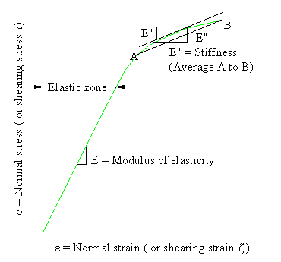
Figure 2.20 Stress-strain diagram.

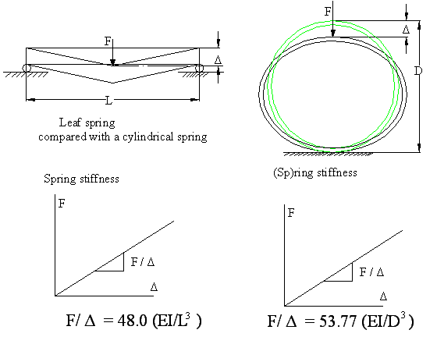
Figure 2.21 Stiffness of leaf and cylindrical spring.
Based on values of F/∆, plastic pipe industries evaluate the DR-term, the stiffness ratio$\text{Rs}$etc. For example, if E must be modified to serve in a different temperature than the parallel plate test, an adjusted value can be incorporated for stiffness ratio$\text{Rs}=E^{1}{D^{3}}/{\text{EI}}$to predict ring deflection.
Pipe industries have their reason for using F/∆. In riveted pipes or lock seams, spiral pipes allow enough slippage to affect${\text{EI}}/{D^{3}}$. The stiffness of mortar lined and /or coated pipe is affected by hairline cracking of the mortar. Reinforced concrete pipes defy analysis of$\text{Rs}$etc. Plastic pipe industries favor the use of dimension ratio DR, it is defined as the ratio of average outside diameter to minimum wall thickness. The outside diameter is held constant in the extrusion machine. Wall thickness is varied for the class of pipe (wall strength) to be produced. Steel pipe industries favor the use of the m-term, it is defined as the ratio of wall thickness to the mean diameter. Steel pipe industries often use the inverse D/t-term. D/t is called ring flexibility.
Ring stiffness $({\text{EI}}/{D^{3}})$is preferred by the steel industries. E is a constant. Values for I can be calculated. Because D and t describe pipes$D/t$finds its way into much ring deflection analysis.
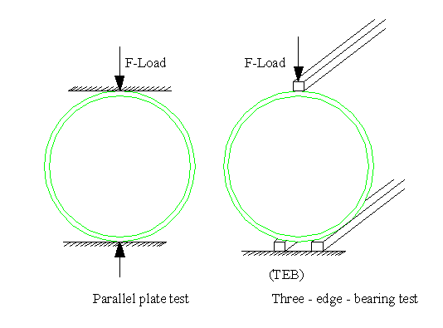
Figure 2.22 Methods of testing for pipe stiffness
    - Ring stability
The performance limit of ring stability is the instability. Ring instability is a spontaneous deformation that progresses towards inversion (reversal of curvature). At worst, instability is the collapse. Buried pipes can invert only if the ring deflects and the soil slips at the same time. Instability of buried pipes shall be analyzed as a soil-structure interaction. The stiffness of the ring resists inversion. Soil supports the ring by holding it in a stable (near circular) shape. Soil resists inversion of the ring. Two basic modes of ring instability are:
- Ring compression i.e., wall crushing or buckling at yield stress; and
- Ring deformation.
Each is analyzed separately. Instabilities of buried and unburied rings are analyzed separately.
i) Unburied ring collapse
External pressure at collapse of an unburied thin-walled, circular, elastic ring is found from equations:
$\frac{P_{r}}{A}=σ_{f}$ Ring compression collapse
$\frac{{\text{Pr}}^{3}}{\text{EI}}=3$ Ring deformation collapse
The ring compression collapse equation is a function of ring flexibility and yield strength. Performance limit is a wall crushing.
The ring deformation collapse equation is a function of ring stiffness, EI/r³. Performance limit is inversion. Ring stiffness is related to pipe stiffness; i.e., F/∆ = 53.77EI/D3. Pipe stiffness can be measured by a parallel plate test or three edge bearing test. The ring deformation collapse equation is based on assumptions that the ring is elastic, and that the pipe is restrained longitudinally. Longitudinal restraint results in a plane stress analysis. The poison ratio is not included.
In a plane strain analysis, longitudinal stress is zero, the poison ratio is included, and the pressure at collapse is,
$P_{\text{cr}}=\frac{3\text{EI}}{r^{3}}\left(1−υ\right)$,
The difference in fluid pressure in between top and bottom is usually ignored, but may be significant. For plane stress analysis of a critical pressure at collapse of circular, unburied pipes,
$P_{\text{cr}}=\frac{3\text{EI}}{r^{3}}$ ...(2.21)
For plain pipes (not coated, lined, rib stiffened or corrugated), critical pressure at collapse is,
$P_{\text{cr}}=\frac{E}{4m^{3}}$ . ..(2.22)
ii) Ring deformation collapse of buried pipes
For this analysis vacuum is negative pressure p inside the pipe plus positive external hydrostatic pressure u. Both affect ring collapse.
a) Rigid pipes
Because ring deflection of rigid pipes is negligible, rigid pipes are analyzed by ring compression except that vertical pressure on the pipe is $P+p$
For ring compression test,
$σ=\left(P+p\right)\left(\frac{\text{OD}}{2A}\right)$ ..(2.23)
Area A is transformed section if the wall is composite such as concrete reinforced with steel bars. To design the ring compression stress$σ$, Equation 2.23 shall be equated to the strength of the pipe wall $σ_{f}$ reduced by a safety factor.
In case of very large diameter pipe, it is necessary to consider the change in pressure of liquids (both inside and outside) through out the depth of the pipe. For example, if the pipe is empty but the water table is above the top of the pipe, it may be prudent to apply Equation 2.23 to the bottom of the pipe where total pressure P acts up on the bottom is greater than prismatic soil pressure on top by the increase in hydrostatic pressure between the top and bottom. Of course, water inside the pipe will negate any increase in external hydrostatic pressure. It is not worthy that internal vacuum and external hydrostatic pressures have a little effect on opening of cracks in rigid pipes.
b) Flexible pipes
Collapse of flexible pipes is either:
- Wall crushing (ring compression) or
- Inversion (ring deformation).
Bending deforms the pipe cross section into an ellipse with the short diameter as plane of the bend. Flexible ring analysis anticipates ring deflection$dθ$before vacuum applied. Ring deflection depends upon ring stiffness and stiffness of embedment soil.
Performance limit is the collapse, it occurs if the ring either crushes due to ring compression or inverts due to side fill soil slip.
$σ_{f}=\left(P+p\right)\left(1+d\right)\frac{\text{OD}}{2A}$ . ..(2.24)
Area A is used for transformed composite, ribbed and corrugated sections. At ring deformation collapse, the soil must slip in order for the ring to deflect. For flexible ring, shearing stresses between pipe and soil are negligible.

CHAPTER 3
DETAILED ANALYSIS
3.1 Introduction
As discussed in previous literature the capability of buried pipes to resist forces due to lateral soil movements is critical in design of the UG piping. Risk evaluation due to different kinds of adverse environments such as slope movement, urban excavations, explosives and tunneling is critical. These unexpected ground movements shall cause significant strains in pipelines and influence the performance and its integrity. Apart from these, soil interaction forces have been influenced by many factors such as the properties of soil and pipe, pipe orientation with respect to soil movement, the rate of soil movement and boundary conditions too.
In this presentation, a comparison of above difficulties has been evaluated and analyzed for different kinds of collected data. It displays a lot of variation in accuracy. The difficulties in characterizing real soil-properties have contributed a large variation in predicting soil-forces and pipe-responses. These results are expressed in terms of the dimensionless force parameter $N=\frac{P}{γ\text{HD}}$ and the pipe deformation$Δ$, where P is the force on a unit length of pipe, H is the burial depth between surface of the ground and pipe center, D is the diameter of the pipe, and $Δ$ or y is the lateral relative movement between the pipe and surrounding soil mass.
For pipes in sand, the ultimate lateral soil load$P_{\text{ult}}$,
$P_{\text{ult}}=N_{h}γ\text{HD}$ ….(3.1)
where,$N_{h}$ is the maximum dimensionless force parameter or horizontal bearing capacity factor. It is expressed as a function of burial depth ratio$H/D$and soil properties. Further, it has been observed that laterally loaded pipe behaves variety under essentially plane-strain conditions, since the length-to-width ratio of the pipe is very large. Figure 3.1 illustrates the variation of$N_{h}$ for the data listed in Table 1 (Chapter 1) in terms of soil-friction angle and $H/D$ratio. A wide variation has been found in results due to variations in experimental conditions and procedure (loading rate, measurements etc.), and due to the changes of pipe dimensions etc. The data listed in Table 1 has been found sensitive to pipe-diameter ‘D’ and burial depth ratio’$H/D$’. An overview of the results:
- Measured maximum dimensionless force$N_{h}$increases with burial depth ratio H/D for both dense and loose sands (see Figure 3.1A and Figure 3.1B). However, this change is rapid for shallow depths than deep burial depths.
- For dense sand, the maximum dimensionless force$N_{h}$ decreases with the increase of pipe diameter (see Figure 3.1C).
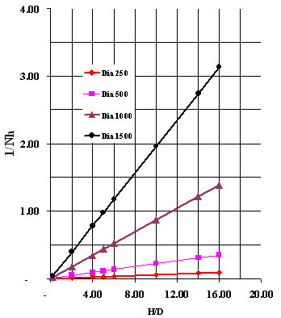
Figure 3.1A Maximum dimensionless forces$N_{h}$ under lateral loading for dense sands ($φ$= 40°)
Table used for Fig 3.1A
 | H/D | 1/Nh | H/D | 1/Nh | H/D | 1/Nh | H/D | 1/Nh
Dia (m) | 0.25 |  | 0.50 |  | 1.00 |  | 1.50
 | 0.20 | 0.00 | 0.20 | 0.00 | 0.20 | 0.02 | 0.20 | 0.04
 | 2.00 | 0.01 | 2.00 | 0.04 | 2.00 | 0.17 | 2.00 | 0.39
 | 4.00 | 0.02 | 4.00 | 0.09 | 4.00 | 0.35 | 4.00 | 0.78
 | 5.00 | 0.03 | 5.00 | 0.11 | 5.00 | 0.44 | 5.00 | 0.98
 | 6.00 | 0.03 | 6.00 | 0.13 | 6.00 | 0.52 | 6.00 | 1.17
 | 10.00 | 0.05 | 10.00 | 0.22 | 10.00 | 0.87 | 10.00 | 1.96
 | 14.00 | 0.08 | 14.00 | 0.30 | 14.00 | 1.22 | 14.00 | 2.74
 | 16.00 | 0.09 | 16.00 | 0.35 | 16.00 | 1.39 | 16.00 | 3.13

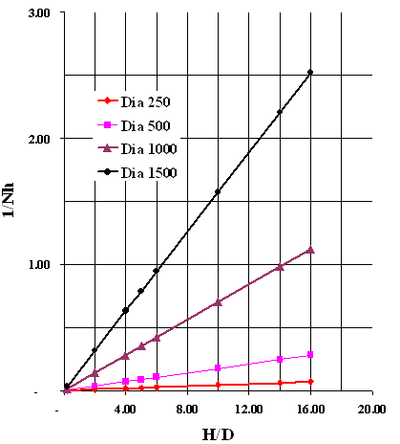
Figure 3.1B Maximum dimensionless forces$N_{h}$ under lateral loading for loose sands ($φ$ = 30°)
Table used for Fig 3.1B
 | H/D | 1/Nh | H/D | 1/Nh | H/D | 1/Nh | H/D | 1/Nh
Dia (m) | 0.25 |  | 0.50 |  | 1.00 |  | 1.50
 | 0.20 | 0.00 | 0.20 | 0.00 | 0.20 | 0.01 | 0.20 | 0.03
 | 2.00 | 0.01 | 2.00 | 0.04 | 2.00 | 0.14 | 2.00 | 0.32
 | 4.00 | 0.02 | 4.00 | 0.07 | 4.00 | 0.28 | 4.00 | 0.63
 | 5.00 | 0.02 | 5.00 | 0.09 | 5.00 | 0.35 | 5.00 | 0.79
 | 6.00 | 0.03 | 6.00 | 0.11 | 6.00 | 0.42 | 6.00 | 0.95
 | 10.00 | 0.04 | 10.00 | 0.18 | 10.00 | 0.70 | 10.00 | 1.58
 | 14.00 | 0.06 | 14.00 | 0.25 | 14.00 | 0.98 | 14.00 | 2.21
 | 16.00 | 0.07 | 16.00 | 0.28 | 16.00 | 1.12 | 16.00 | 2.52

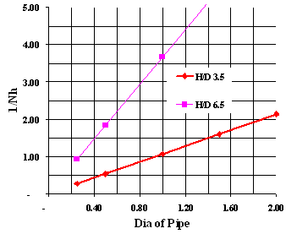
Figure 3.1C: Effect of pipe diameter on maximum dimensionless forces$N_{h}$ under lateral loading
Table used for Fig 3.1C
 | Dia (m) | 1/Nh | Dia | 1/Nh
H/D | 3.50 |  | 6.50
 | 0.25 | 0.27 | 0.25 | 0.92
 | 0.50 | 0.53 | 0.50 | 1.84
 | 1.00 | 1.07 | 1.00 | 3.68
 | 1.50 | 1.60 | 1.50 | 5.51
 | 2.00 | 2.13 | 2.00 | 7.35

In order to o make the consistency in evaluation of$N_{h}$, for different kinds of soils, boundary conditions of soil, and dimensions of pipe (it is termed as scale-effect) in pipe-soil interaction, design guide lines have been incorporated formulae. The accuracy of these incorporations have been studied through finite element analysis which has been explained in this presentation.
  - Setup of Finite Element Method and Numerical Analysis
3.2.1 Introduction
The finite element method was introduced as a tool for engineering applications by Turner et al. (1956). Since that time this method has become a useful and accepted tool in many areas of civil engineering. Applications in geotechnical engineering include static and dynamic stress analysis of various soil and soil-structure systems. Stress analysis applications in geotechnical engineering for static and dynamic loading was introduced in the late 1960s and early 1970s [Kulhawy, et al. (1969); Duncan (1972); Kulhawy and Duncan (1972)]; earthquake stress analysis of embankments [Clough and Chopra, (1966)]; earthquake response analysis [Idriss, et al (1974)], and soil-structure interaction [Clough, (1972)].
The basic idea behind the finite element method for stress analysis is that a continuum is represented by a number of elements connected only at the element nodal points (joints) in terms of mesh. It is similar to the structural analysis of a building. The process involves solving for the nodal displacements and then, based on the nodal displacements, the stresses and strains within each element of the assemblage can be determined. The major difference between the analysis of a continuum and a framed structure is that even though the finite element representation of a continuum is only connected to adjacent elements at its nodal points, it is necessary to maintain displacement compatibility between adjacent elements. Special shape functions are used to relate displacements along the element boundaries to the nodal displacements and to specify the displacement compatibility between adjacent elements. The boundary conditions along the line of symmetry must be properly established to model the full system behavior.
The finite element method is a powerful tool for stress analysis of complex systems. It has been particularly useful in geotechnical engineering for the solution of a wide variety of problems including soil-structure interaction problems such as the analysis of buried structures. Its application in solving soil-structure interaction problems requires an understanding of basic engineering mechanics and an understanding of soil behavior. Judgment is required in conducting and reviewing the results of finite element analysis of geotechnical problems. Comparing the results of a finite element analysis solution with measurements made on a physical system is important whenever possible. The power of the method lies in the ability to solve complex systems and in being able to look at many different loading conditions and system configurations. However, never accept the results at face value without a thorough critical review.
3.2.2 Basic principles of the finite element analysis
Equation 3.2 represents the equilibrium equations in a matrix form for each node of a finite element assemblage mesh. After applying boundary conditions (identifying nodes with fixed or restricted movement) the system of equations given by Equation 3.2 can be solved for the unknown nodal displacements represented by the vector$\left\{d\right\}$. These displacements can in turn be used to evaluate element stresses and strains.
$\left[K\right]\left\{d\right\}=\left\{f\right\}$ . ....(3.2)
where
$\left[K\right]$ = the global stiffness matrix
$\left\{d\right\}$ = the nodal displacement vector and
$\left\{f\right\}$ = the nodal load vector.
A finite element analysis of a soil-structure interaction system, such as a buried pipe is different from a finite element analysis of a simple linearly elastic continuum in several ways.
1. The soil has a nonlinear stress-strain relationship,
2. Different element types must be used to represent the pipe and the soil,
3. It may be necessary to allow movement between the soil and the walls of the pipe, requiring the use of an interface element,
4. Very flexible pipes may involve large displacements for which the solution may be geometrically nonlinear.
3.2.3 Required input
Execution of a finite element program requires the user to prepare data that includes the mesh geometry, material properties and loading conditions. Some programs (ANSYS 9.0) have an automatic mesh generation option that significantly reduces the effort required to input the data. The data that are required include nodal coordinates, element data, material properties, interface properties, nodal link properties, in formation on construction sequence, preexisting element stresses, strains and displacements, and external loading information, and boundary conditions. The boundary conditions indicate whether a node is free to displace in the x or y direction or in rotation. External loads are generally input as either concentrated loads or uniform loads. Each loading sequence must have the number of concentrated loads and number of uniform loads that are to be used. Concentrated loads are specified by denoting the node number which will receive the load, and the x and y components of the point load. Uniform loads are specified for each element that will receive the uniform load.
    - Output
Typical output from a finite element analysis includes a summary of the input data and the results of the analysis in terms of stresses, strains, and displacements. The input summary includes element and node information, material properties, construction and load sequencing, preexisting element information, and initial stresses used for estimating the initial elastic parameters. Nodal displacements include the total displacements for the x, y and rotation components, and the incremental displacements and rotations for each particular loading increment.
3.2.5 The scope of the finite element analysis:
- investigate the influence of geometrical factors (including burial depth and burial depth ratio) on the maximum lateral movement induced by soil forces transferred to pipes;
- identify the scale effect on pipe–soil interaction;
- characterize the sensitivity of soil properties related to maximum soil resistances; and
- compare the results of numerical modeling;
Present study is mainly focused on influence of scale-effect in pipe-soil interaction between “rigid” pipes with surrounding soil. The ratio of the pipe diameter ‘D’ to the pipe wall thickness ‘t’ has been chosen as $D/t=\text{20}$. The pipe material is considered as elastic with elastic modulus E = 207$\text{GPa}$and Poisson’s ratio$η$ = 0.3. In order to investigate the scale-effect, the influence of the burial depth H and the burial depth ratio H/D have been considered as independent variables. The pipe diameter varies in a wide range from 33mm to 3.30m for H/D ranges from 1.03 to 10. Figure 3.2 illustrates a standard FEM (Finite Element Mesh) used in this analysis.
This analysis have been performed to study the dependency of pipe-soil interaction on soil-properties which include stress dilatancy, mobilization of soil friction angle with plastic strain and the influence of stress level on elastic modulus, and friction-angle of sand. The following models have been used in the numerical modeling:
- a classical elasto-perfectly plasticity model with constant dilation angle ψ; and
- an elasto-plastic hardening model: The mobilization of friction angle shall be considered as a function of plastic shear-strain and stress level. The dilatancy of sand is described by a constant dilation angle ψ or by Rowe’s stress dilatancy equation in the form of equation 3.3 shown below.

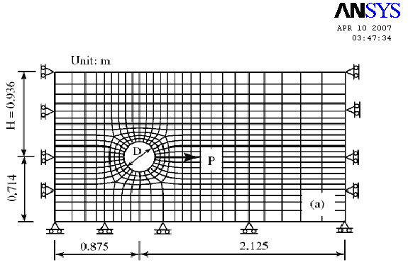
Figure 3.2 Finite element mesh at D = 0.33m used for numerical modeling
$\text{sin}ψ=\frac{\text{sin}φ_{m}−\text{sin}φ_{cυ}}{1−\text{sin}φ_{m}\text{sin}φ_{cυ}}$ …..(3.3)
where, $φ_{m}$= the mobilized friction angle; and
$φ_{cυ}$= friction angle at critical state.
Figure 3.3A drawn and gives the mobilization of soil friction angle with the plastic strain. The dependency of peak friction angle on stress level and density, as shown in Figure 3.3B is (Bolton’s empirical relation)
$φ=φ_{cυ}+3D_{r}\left(\text{10}−\text{ln}p\right)$ ….(3.4)
where, $D_{r}$= the relative density; and
p = mean effective stress.
For bulk density γ = 17.4 ${\text{kN}}/{m^{3}}$and Relative density $D_{r}$= 82%,
The peak friction angle was found vary in the range of 41 to 45° for the stress level of p = 50-200 $\text{kPa}$.
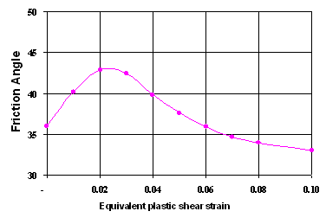 | $εP$$φ$
  0.00 | 36.00
  0.01 | 40.20
  0.02 | 42.80
  0.03 | 42.40
  0.04 | 39.80
  0.05 | 37.60
  0.06 | 35.90
  0.07 | 34.70
  0.08 | 34.00
  0.10 | 33.00
Fig. 3.3A Soil properties used in numerical modeling, mobilization of friction at p = 400 $\text{kPa}$

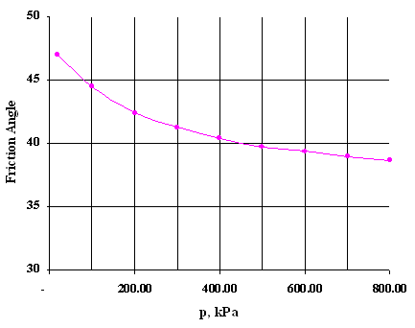
  p, kPa | Fr, Ang
  20.00 | 47.00
  100.00 | 44.48
  200.00 | 42.38
  300.00 | 41.24
  400.00 | 40.38
  500.00 | 39.71
  600.00 | 39.33
  700.00 | 38.95
  800.00 | 38.67
Fig. 3.3B Soil properties used in numerical modeling, dependency of peak friction-angle on pressure level
The elastic deformation of soil is calculated using elasticity with the elastic shear- modulus G, it is assumed to be either constant or stress level dependent; i.e.,
$G=G_{0}{\left(\frac{p}{p_{a}}\right)}^{n}$ ....(3.5)
where, the power exponent ‘n’ is an experimental parameter, $G_{0}$ represents the shear modulus at a reference mean effective stress$P_{a}$. $P_{a}$ has been chosen as the atmospheric pressure. For γ =17.4${\text{kN}}/{m^{3}}$, the representative values are $G_{0}$=16${\text{MP}}_{a}$and n=0.5. A value of G=9.5${\text{MP}}_{a}$ has been used in the elastoperfectly plasticity model. It is considered as the average of elastic shear modulus when p<150$\text{kPa}$. In all simulations, the Poisson’s ratio ‘n’ is assumed to be 0.3.
The friction angle on the pipe-soil interface generally varies in the range of (0.5–1.0)$φ$ with $φ$ being the peak friction angle of soil, depending on the pipe coating material and compaction of soil. All numerical simulations in this study assume a representative interface friction coefficient of 0.55, which corresponds to an interface friction angle of 28.80.
The software ANSYS 9.0 has been used for the Finite Element Analysis. The soil and pipe are simplified as a two dimensional plane strain system, in which the soil around the pipe is discretized using eight node biquadrate continuum elements with reduced integration, while the pipe is modeled using three node quadratic beam elements. The pipe–soil interface, assumed to be frictional, it is represented by the contact surface approach.
Table 3 Soil parameters used in analysis (Figure 3.3)
Model parameter | Dense sand
Shear modulus G, (${\text{MP}}_{a}$) | 9.5
Poison’s ratio $υ$ | 0.30
Bulk density$γ$ (${\text{kN}}/{m^{3}}$) | 17.5
Friction angle at critical state $φ_{cυ}$(°) | 33.0
Dilation angle $ψ$ (°) | 10
Friction hardening | Yes (Fig.3.3A)
Cohesion c (${\text{KP}}_{a}$) | 2.0
Pipe-soil friction coefficient | 0.55
Specific gravity of the sand is $G_{s}$ | 2.69
Maximum void ratios are $e_{\text{max}}$ | 0.76
Minimum void ratios are $e_{\text{min}}$ | 0.47
No restriction is applied on the vertical movement of the pipe. Owing to the stiffness of the pipe, limited pipe deformation occurs. In other words, the whole pipe moves through soil almost like a rigid body. The total interaction forces have been calculated by considering the equilibrium condition of the pipe under internal nodal forces and external interaction forces at the pipe–soil interface. At the end of each loading step, according to the nodal forces at each node on the pipe, we have evaluated the total nodal forces; these are equivalent to the pipe–soil interaction forces.
To avoid confusion, the effect of pipe diameter is called the size effect, the effect of model scale is called the model effect, and their combination is called as the scale-effect. The influence of burial depth ‘H’ has been referred to burial depth effect.

CHAPTER 4
RESULTS & DISCUSSIONS
4.1 Introduction
This section addresses the scale-effect and the influence of burial depth corresponding to three series as illustrated in Figure 4.1A. In HD-series, every linear dimension of a model is scaled proportionally and the model scale is defined as $S_{m}=D/{D_{0}}$ with D and$D_{0}$being the pipe diameters of the model and the prototype respectively. The soil is assumed to be an elastoplastic frictional material and the mobilization of the friction angle is described by an isotropic function of equivalent plastic strain as shown in Figure 3.3A. Shear induces volume change (i.e., dilatancy) and is characterized by a constant dilation angle. The influence of soil properties including dilatancy, strain hardening and pressure dependency have been studied by changing the parameters used in the soil model.
Mesh sensitivity of numerical modeling results was analyzed using the mesh shown in Figure 3.2. The force-displacement curves obtained using coarse and fine meshes were found to be almost identical. Since the ultimate soil resistance is of the interest, it is assumed that the effect of the mesh size could be ignored.
Fig. 4.1A Variation of$N_{h}$ with H/D, three series of numerical simulation (Pipe diameter D and burial depth H)

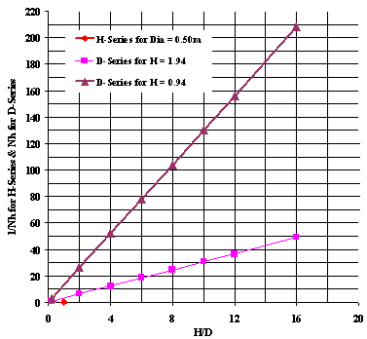
Fig. 4.1B Variation of$N_{h}$ with H/D, $N_{h}$ obtained from D- and H - series modeling
(Pipe diameter D and burial depth H)
Table for Fig 4.1B, H-Series Test for D = 0.50m
H | Dia | H/D | 1/Nh
0.10 | 0.50 | 0.20 | 0.00
1.00 | 0.50 | 2.00 | 0.04
2.00 | 0.50 | 4.00 | 0.09
3.00 | 0.50 | 6.00 | 0.13
4.00 | 0.50 | 8.00 | 0.17
5.00 | 0.50 | 10.00 | 0.22
6.00 | 0.50 | 12.00 | 0.26
8.00 | 0.50 | 16.00 | 0.35

Table for Fig 4.1B, D-Series for H = 1.94m
H | Dia | H/D | Nh
1.94 | 9.70 | 0.20 | 0.61
1.94 | 0.97 | 2.00 | 6.11
1.94 | 0.49 | 4.00 | 12.22
1.94 | 0.32 | 6.00 | 18.32
1.94 | 0.24 | 8.00 | 24.43
1.94 | 0.19 | 10.00 | 30.54
1.94 | 0.16 | 12.00 | 36.65
1.94 | 0.12 | 16.00 | 48.86

Table for Fig 4.1B, D-Series for H= 0.94m
H | Dia | H/D | Nh
0.94 | 4.70 | 0.20 | 2.60
0.94 | 0.47 | 2.00 | 26.02
0.94 | 0.24 | 4.00 | 52.03
0.94 | 0.16 | 6.00 | 78.05
0.94 | 0.12 | 8.00 | 104.07
0.94 | 0.09 | 10.00 | 130.08
0.94 | 0.08 | 12.00 | 156.10
0.94 | 0.06 | 16.00 | 208.13

In the following sections, pipe-soil interactions have been presented when soil properties are assumed to be pressure independent, and also discussed some special features of pipe-soil interaction when the pressure dependency of soil properties is taken into account.
4.2 Effect of Burial Depth Ratio
The effect of burial depth ratio H/D on$N_{h}$has been studied through simulations of both D- and H-series modeling (Figure 4.1A). Figure 4.1B represents the variation of $N_{h}$with respect to burial depth ratio H/D in the analysis (referring to Table 2 for model parameters).
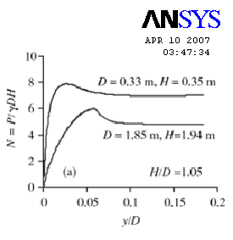  Fig. 4.2A Calculated dimensionless force-displacement curves (H/D = 1.05) | 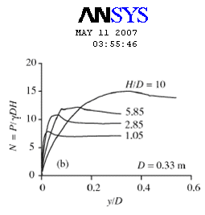  Fig. 4.2B Calculated dimensionless force-displacement curves (D = 0.33)

Unit of length: m; Plastic strain: %
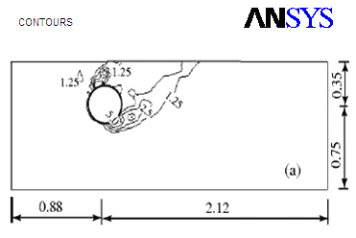
Fig. 4.3A Plastic deformation zone in soil around the pipe at H/D = 1.05 for D = 0.33 m (P.J. Guo et al)

Unit of length: m; Plastic strain: %
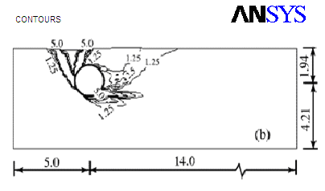
Fig. 4.3B Plastic deformation zone in soil around the pipe at H/D = 1.05 for D = 1.85 m (P.J. Guo et al)

Figures 4.2 and 4.3 further compare the dimensionless force-displacement curves and the distribution of plastic-strain in soil around the pipe when the maximum soil resistance is mobilized for H/D = 1.05, H = 1.94 m, and D = 0.35 m. By a close examination of Figures 4.1 to 4.3, we observe the following:
- Although$N_{h}$increases with H/D, the relation is not unique (see Figure 4.1B);
- For a given burial depth ratio H/D, a pipe with smaller diameter at shallower burial depth has a larger ultimate dimensionless force at smaller relative pipe displacement, and hence, it is with a stiffer response (Figure 4.2A);
- For a given pipe diameter D, with the increase of H/D ratio, a larger pipe-displacement has been observed to mobilize the maximum soil resistance (Figure 4.2B).
- At the instant when the maximum soil-resistance is mobilized, for a given burial depth ratio H/D, an active plastic deformation zone fully develops in soil behind the pipe of large diameter. However, the active state might not fully develop in soil behind a pipe of small diameter, as shown in Figure 4.3.
Based on the above observations, we conclude that the non-uniqueness of the$N_{h}$vs. H/D relation is induced by a combination of the effect of pipe size, model scale and burial depth H, or more generally, stress level.
4.3 Model Effect
Model effects have been observed from P. J. Guo et al. He has studied by proportionally changing the linear dimension of the physical model without changing soil-properties. Herein, the model scale, $S_{m}=D/{D_{0}}$is defined in terms of a reference pipe diameter of $D_{0}$ = 0.33m. The scale-effects have been investigated by changing H and D proportionally at H/D = 2.85. Figure 4.4A presents the simulated dimensionless force–displacement curves, in which the model scale changes two magnitudes, corresponding with the variation of pipe diameter in the range of 3.30cm to 3.30m. Given the same soil-properties, which are assumed to be pressure independent, a large maximum dimensionless force$N_{h}$is obtained at very small relative pipe-displacement for a small-scale model. More specifically$N_{h}$decreases from 21.2 to 8.7 when$S_{m}=D/{D_{0}}$increases from 1/10 to 10. The variation of ${N_{h}}/{N_{\text{ho}}}$with $S_{m}$ can be expressed as
$\frac{N_{h}}{N_{\text{ho}}}=0\text{.}\text{91}\left(1+\frac{1}{\text{10}S_{m}}\right)$, $S_{m}=\frac{D}{D_{o}}=\frac{H}{H_{o}}$ …….(4.1)
with $N_{\text{ho}}$ being the ultimate dimensionless force of the pipe with diameter $D_{0}$ = 0.33m. The results indicate that care must be taken when extrapolating the results of laboratory small-scale model tests to full-scale in situ structures since a small-scale physical model has a high dimensionless force. The difference in$N_{h}$ may be attributed to the effect of stress level associated with model scale. The distribution of plastic strain in the soil shown in Figure 4.3 also shows the effect of model scale. We observe that for given the burial depth ratio, the pipe with a larger diameter tends to penetrate more into the soil. This is because an increase of the model dimension causes geostatic stresses to increase by the same scale, resulting in different failure mechanisms under 1g conditions.
Fig. 4.4A Scale-effect at H/D = 2.85, dimensionless force-displacement curves | Fig. 4.4B Scale-effect at H/D = 2.85, variation of maximum dimensionless forces

4.4 Scale-Effects and Influence of Burial Depth
The results presented in Figures 4.2 and 4.4 show that the maximum dimensionless force$N_{h}$at a given burial depth ratio H/D varies with burial depth H (or pipe diameter D). A series of finite element simulations have been performed in order to understand the dependency of$N_{h}$on$γH$under the following conditions:
- changing the burial depth at a given burial depth ratio H/D,
- changing the pipe diameter for a given burial depth H; and
- varying the unit weight of soil while both H and D remain unchanged.
Figure 4.5 summarizes the variation of$N_{h}$as a function of H/D and $γH$ obtained from a number of cases, including the results presented in Figure 4.1. For a given burial depth ratio H/D, we found a unique relation between$N_{h}$ and $γH$(as per design guide lines, P.J. Guo et al):
$N_{h}=k_{1}\frac{p_{\text{ref}}}{γH}+k_{2}$ with $k_{1,2}=$k (H/D, soil properties) …(4.2)
where, $p_{\text{ref}}$ = reference pressure of $p_{\text{ref}}$ = 1${\text{kP}}_{a}$,
$k_{1}$and$k_{2}$are dimensionless parameters, these are functions of soil properties and burial depth ratio H/D.

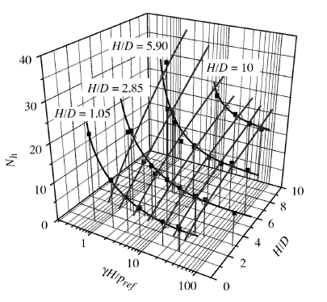
Figure 4.5 Dependency of $N_{h}$ on H/D and $γH$(P.J. Guo et al)

Figure 4.6 Dependency of $k_{1}$and$k_{2}$on burial depth ratio H/D

Figure 4.7 Scale-effects and the influence of burial depth (P.J. Guo et al)

Figure 4.6 presents the variation of $k_{1}$and$k_{2}$with H/D for the properties given in Table 2. It should be noted that Equation 4.2 implies that a unique relation between$N_{h}$and burial depth ratio H/D exists for a given γH.
As shown in Figure 4.7, the data from numerical modeling reveals that the scale-effect depends on burial depth ratio H/D according to the relation
$\frac{N_{h}}{N_{\text{ho}}}=f\left(\frac{D}{D_{o}}\right){\left[\frac{HD}{{\left(HD\right)}_{o}}\right]}^{m}$ ......(4.3)
with
$f\left(\frac{D}{D_{o}}\right)=0\text{.}\text{91}\left(1+\frac{1}{\text{10}DD_{o}}\right)$ or $f\left(\frac{D}{D_{o}}\right)={\left(\frac{D}{D_{o}}\right)}^{−n}$ .....(4.4)
By introducing a reference pipe diameter $D_{\text{ref}}$ = 1 m, Equation 4.3 shall be rewritten as
$N_{h}=k{\left(\frac{H}{D}\right)}^{m}{\left(\frac{D_{\text{ref}}}{D}\right)}^{n}$ …...(4.5)
with k, m, and n depending only on soil properties. For the present study, the representative values of these parameters are k = 6, m = 0.35, and n = 0.20 to 0.25. It should be noted that Equations 4.3 and 4.5 are consistent with Equation 4.2, which describes the effect of burial depth and burial depth ratio.
4.5 Effect of Soil Properties
It is known that shear-induced volume change, or dilatancy, strain hardening and stress level play important roles in the strength and deformation behavior of granular soils. Thus, we expect that these soil-properties affect the pipe–soil interaction induced by lateral soil movement.
4.5.1 Effect of soil dilatancy
The effect of soil dilatancy on pipe–soil interaction has been outlined bellow based on information collected from P.J. Guo et al publications.

Figure 4.8 Effect of dilation-angle on $N_{h}$ -H/D relation (P.J. Guo et al)

Figure 4.9 Dependency of $N_{h}$on γH and the angle of dilation φ (P.J. Guo et al)

Figure 4.10 Effect of dilation angle at different burial depths (P.J. Guo et al)

Figure 4.11 Effect of dilation-angle on force-displacement curves (P.J. Guo et al)

The influence of dilatancy on $N_{h}$ has been described by a dilation factor defined as R_{ψ};
$R_{ψ}=\frac{N_{h}}{N_{h,ψ=o}}$ .....(4.6)
in which $N_{h,ψ=0}$ = maximum dimensionless force corresponding to a dilation angle ψ =0. As shown in Figure 4.10, $R_{ψ}$varies over a wide range, depending on the pipe diameter and burial depth ratio. Based on an examination of Figures 4.8 to 4.10, the following relations have been observed:
- Given burial depth ratio H/D, there exists a unique relation among$N_{h}$, ψ, and γH;
- Given burial depth ratio H/D and dilation angle ψ, $N_{h}$ increases with γH and tends to approach a constant when γH is large enough;
- Given H/D and γH, $N_{h}$increases linearly with dilation angle ψ. However, the rate of increase of $N_{h}$is a function of H/D and γH; and
- For soils with small dilation angle, the variation of $R_{ψ}$with dilation angle ψ depends mainly on H/D.
From the above observations, we conclude that for physical model tests with a given burial depth ratio H/D, a model of reduced scale is affected more by the dilatancy properties of soil than the prototype. In all cases, the effect of dilatancy tends to decrease at deep burial depths due to increased confinement.
4.5.2 Effect of strain-hardening properties
From Figure 4.12, we observe that the pipe responses are not very sensitive to the hardening characteristics of the soil up to the peak loading.
Figure 4.12 Effect of strain-hardening on pipe responses, H/D = 2.85 (P.J. Guo et al)

4.6 Combined Effects
Figure 4.13 shows the combined effect of dilatancy, strain hardening and the pressure dependency of soil-friction angle on the dilation factor $R_{ψ}$ as defined in Equation 4.6. Given H/D = 2.85 and D = 0.33m, if the soil is elastoperfectly plastic, the value of$N_{h}$increases by approximately 12% when the dilation angle ψ increases from 0° to 20°. Similar results are obtained if we consider the strain hardening but ignore the pressure-dependency of soil-friction-angles. However, when both strain-hardening and pressure-dependency of soil-friction-angle are taken into account, a 22% increase of$N_{h}$is obtained. Therefore, we can argue that the effect of dilatancy on $N_{h}$should be related to both the dilation-angle and the pressure dependency of soil-friction-angle.
The modeling results also show that the introduction of a pressure dependent elastic modulus affects pipe–soil interaction characteristics. Figure 4.13 presents the force-displacement responses for H/D = 2.85 and D = 0.33m for both constant and pressure dependent cases. A limited influence has been observed for$N_{h}$.
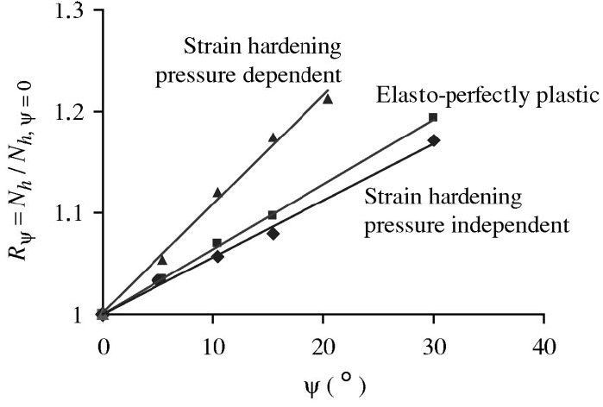
Figure 4.13 Combined-effects of dilatancy, pressure-dependency and strain-hardening on maximum dimensionless forces, H/D = 2.85, D = 0.33 m (P.J. Guo et al)

  - Comparison of Results with Published Experimental Studies
Dickin and Leung (1983) conducted a series of centrifuge tests at accelerations of 40g and less, as well as conventional small-scale model tests to investigate the behavior of vertical anchor plates in dense sand under horizontal pullout forces. As shown in Figure 4.14, the proposed relation Equation 4.1 is satisfactory for the burial depth ratio in the range of 0.5 to 3.5.
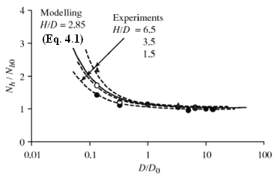
Figure 4.14 Scale effect, the comparison of numerical modeling and experimental results
Equation 4.2, which describes the variation of $N_{h}$with γH, is calibrated with experimental data shown in Figure 3.1A for burial depth ratios of approximately H/D = 3.5 and 5.9. The results presented in Figure 4.15 shows that Equation 4.2 matches the experimental data reasonably. Both Equation 4.2 and test data reveal that, given the burial depth ratio H/D, the values of$N_{h}$may vary in a wide range for shallow buried pipes with $\frac{γH}{P_{\text{ref}}}$is less than 20 (i.e., γH < 20${\text{kP}}_{a}$).
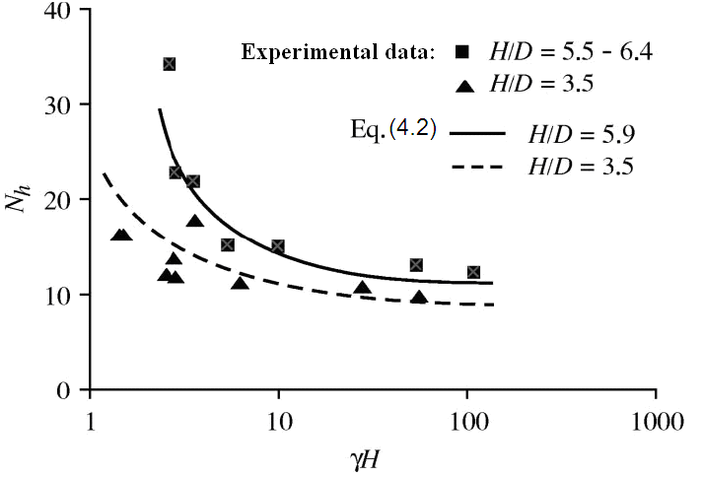
Figure 4.15 Effect of γH at given burial depth ratios, the comparison of numerical modeling and experimental results

CHAPTER 5
CONCLUSIONS
5.1 Conclusion of Results
The pipe-soil interactions associated with relative pipe movements in the lateral direction have been studied giving due consideration to scale effect (the effects of burial depth, burial depth ratio, and soil properties, including strain hardening and dilatancy). Main observations that have been found are listed bellow;
- $N_{h}$the dimensionless force parameter decreases with increase of H/D, the relation is not unique;
- For a given burial depth ratio H/D, a pipe with smaller diameter at shallower burial depth has a larger ultimate dimensionless force at smaller relative pipe displacement, and hence, it is with a stiffer response;
- For a given pipe diameter D, with the increase of H/D ratio, a larger pipe-displacement has been observed to mobilize the maximum soil resistance;
- At the instant when the maximum soil-resistance is mobilized, for a given burial depth ratio H/D, an active plastic deformation zone fully develops in soil behind the pipe of large diameter. However, the active state might not fully develop in soil behind a pipe of small diameter;
- Soil-dilatation and strain-hardening properties have significantly effect the absolute forces induced in pipe-soil interactions.
From the observations found and explained above, care must be taken when evaluating stresses and deformations in pipe-soil interactions using theoretical formulas, and during application of the results of laboratory small-scale model tests to full-scale in situ structures. This is due to structures of different sizes placed in initially identical soil masses fail with different failure mechanisms of non uniform stresses and strains.
Based on a parametric study using finite element method, a unique relation of the maximum dimensionless force$N_{h}$, pipe diameter D, and burial depth ratio H/D, which has been established in ASCE guide lines must be followed rather than implementing direct theoretical values without corrections due to the scale-effects. On the other hand scale-effects in pipe-soil interactions must be respected in design of the pipe lines since it runs through non-similar stretches in km.
Further, it has been observed through studies of P. J. Guo et al that soil dilatancy, which was found to have a significant effect on pipe response, may appreciably increase the ultimate soil force, particularly for deep-buried pipes in dense sand with pressure dependent properties. Furthermore, pipe–soil interactions are very sensitive to the pressure-dependent characteristics of the soil. The maximum dimensionless force transferred to a shallow–buried pipe is much greater when the pressure dependency of soil friction angle is considered.
5.2 Scope for Future Study
This presented work in this thesis is limited to pipe–soil interaction for rigid buried pipes in cohesion-less soils (sands). Induced forces have been measured to find the due affect of scale-effects.
Further, studies can be extended for rigid pipes in cohesive-soils, and flexible pipes running through both cohesive and cohesion-less soils. Also, scale-effect due to soil-properties have been not went thoroughly, same can be extended to all the combinations of pipe-soil interactions of rigid and flexible pipes, cohesive and cohesion-less soils. A lot of modeling can be done for scale-effects in pipe-soil interaction such as centrifugal model tests to make more nearer prototypes.
Most of the results have been produced from the results of finite element analysis using the software ANSYS 9.0, these results shall be cross checked with analytical methods which shall be taken as further study.
Design guidelines issued by ASCE in evaluation of $N_{h}$ have been considered the due of the scale-effect. Present work can be cross checked with these ASCE design guide lines.
REFERENCES
- Akinmusuru, J. O. (1978). “Horizontally loaded vertical plate anchors in sand.” J. Geotech. Eng. Div., Am. Soc. Civ. Eng., 104(2), 283–286.
- American Lifelines Alliance (ALA).(2001). “Guidelines for the design of buried steel pipe.” (www.americanlifelinesalliance.org)
- ANSYS 9.0 Manual (www.ansys.com)
- ASCE. Am. Soc. Civ. Eng., (1984). “Guidelines for the seismic design of oil and gas pipeline systems. Committee on Gas and Liquid Fuel Lifelines.” Technical Council on Lifeline Earthquake Engineering, ASCE, New York.
- Audibert, J. M. E., and Nyman, K. J. (1977). “Soil restraint against horizontal motion of pipes.” J. Geotech. Eng. Div., Am. Soc. Civ. Eng., 103(10), 1119–1142.
- Bolton, M. D. (1986). “The strength and dilatancy of sands.” Geotechnique, 36(1), 65–78.
- Bowles, J. E. (1997). Foundation Analysis & Design, Mc. Graw-Hill International edition, New York.
- C. S. Desai and J. F. Abel (2005). Introduction to the finite element method and numerical method for engineering analysis, CBS Publishers & Distributors, New Delhi.
- Das, B. M., and Seeley, G. R. (1975). “Load-displacement relationship for vertical anchor plates.” J. Geotech. Eng. Div., Am. Soc. Civ. Eng., 101(7), 711–715.
- Dickin, E. A., and Leung, C. F. (1983). “Centrifugal model tests on vertical anchor plates.” J. Geotech. Eng., 109 (12), 1503–1525.
- H.–Y. Fang. Foundation Engineering Hand Book, 2nd Edition, CBS Publishers, New Delhi.
- Hsu, T.-W., Chen, Y.-J., and Wu, C.-Y. (2001). “Soil friction restraint of oblique pipelines in loose sand.” J. Transp. Eng., 127(1), 82–87.
- Murray, E. J., and Geddes, J. D. (1989). “Resistance of passive inclined anchors in cohesionless medium.” Geotechnique, 39 (3), 417–431.
- Neely, W. J., Stuart, J. G., and Graham, J. (1973). “Failure loads of vertical anchor plates in sand.” J. Soil Mech. Found. Div., 99(9), 669–685.
- P. J. Guo et al (2005). Lateral Pipe-Soil Interaction in Sand with Reference to Scale Effect.
- R. K. Watkins and L. R. Anderson (2000). Structural Mechanics of Buried Pipes, CRC Press, Boca Raton.
- Rowe, R. K., and Davis, E. H. (1982). “The behaviour of anchor plates in sand.” Geotechnique, 32(1), 25–41.
- Taylor, R. N. (1995). Geotechnical Centrifuge Technology, Blackie Academic and Professional, Chapman and Hall, London.
- Trautmann, C. H., and O’Rourke, T. D. (1985). “Lateral force displacement response of buried pipe.” J. Geotech. Eng., 111(9), 1077–1092.
- Zienkiewicz, O. C., Humpheson, C., and Lewis, R. W. (1975). “Associated and nonassociated viscoplasticity and plasticity in soil mechanics.” Geotechnique, 25(4), 671–689.

