ROBUST IMAGE SEGMENTATION USING
ACTIVE CONTOUR MODEL
A
Dissertation thesis
submitted in partial fulfillment of the requirement for the Award of the degree of

Master of Engineering
in
Computer Technology & Applications

submitted by

Ms. Deepti Yadav
Roll No: 24/CTA/04

Under the expert guidance of

Dr.ASOK DE
Professor, Computer Engineering Dept.


DEPARTMENT OF COMPUTER ENGINEERING

DELHI COLLEGE OF ENGINEERING

UNIVERSITY OF DELHI

(June - 2007)

CERTIFICATE

This is to certify that the work that is being presented in this thesis report entitled “Robust Image Segmentation Using Active Contour Model”, in partial fulfillment of the requirement for the award of the degree of Master of Engineering in Computer Technology and Application submitted by Ms. Deepti Yadav to the Computer Engineering Department, Delhi College of Engineering, is carried out under the supervision and guidance of the undersigned.

( Dr.Asok De )
Professor,
Department of Computer Engineering,
Delhi College of Engineering
New-Delhi.

ACKNOWLEDGEMENT

I am in dearth of words in expressing my deep sense of gratitude & reverence, towards Dr. Asok De, Director, Ambedkar Institute of Technology, Delhi, for his sincere guidance, keen interest, continuous encouragement and valuable suggestions and support during the course of my thesis work. Whether it was review of relevant literature or clearing my doubts , he helped me in solving all the problems with comfortable ease . His observations and suggestions helped me in my critical times and led to the successful completion of my thesis work.

I am also thankful to all faculty members of Computer Engineering Dept., DCE for their valuable help and continuous encouragement throughout my work.

Lastly, I feel indebted to all the friends and classmates for their unconditional support and motivation during this entire thesis work.

Ms. Deepti Yadav Date:
Roll No. 24/CTA/04
M.E. Final year student,
Computer Engineering Dept.
Delhi College of Engineering.
TABLE OF CONTENTS

PAGE NO.

CERTIFICATE ……...………………………………………………… ii

ACKNOWLEDGEMENT …………………………………………… iii
- LIST OF FIGURES AND TABLES …………………………………… vii
- ABSTRACT …………………………………………………………… ix

CHAPTER 1: INTRODUCTION 1
1.1 Introduction . . . . . . . . . . . . . . . . . . . . . . . . . . . . . . . . . .1
1.2 Digitalizing an image . . . . . . . . . . . . . . . . . . . . . . . . . . . . . . 1
1.3 Image Segmentation . . . . . . . . . . . . . . . . . . . . . . . . . . . . . . 2
1.4 Need for Segmentation . . . . . . . . . . . . . . . . . . . . . . . . . . . 3
1.5 Active Contours . . . . . . . . . . . . . . . . . . . . . . . . . . . . . . . .4
1.6 Summary . . . . . . . . . . . . . . . . . . . . . . . . . . . . . . . . . . . . .5

CHAPTER 2: IMAGE SEGMENTATION : BACKGROUND 6
2.1 Introduction . . . . . . . . . . . . . . . . . . . . . . . . . . . . . . . . . . . 6
2.2 Edge-based Segmentation . . . . . . . . . . . . . . . . . . . . . . . . 6
2.3 Region-based Segmentation . . . . . . . . . . . . . . . . . . . . . . . . . 9
2.4 Other Segmentation Methods . . . . . . . . . . . . . . . . . . . . . . 12
2.5 Summary . . . . . . . . . . . . . . . . . . . . . . . . . . . . . . . . . . . . . . 14

CHAPTER 3: ACTIVE CONTOURS 15
3.1 Introduction . . . . . . . . . . . . . . . . . . . . . . . . . . . . . . . . . . . 15
3.2 Snakes . . . . . . . . . . . . . . . . . . . . . . . . . . . . . . . . . . . . . . 16
3.3 Level Set Methods . . . . . . . . . . . . . . . . . . . . . . . . . . . . . . . 18
3.4 Edge-based Active Contours . . . . . . . . . . . . . . . . . . . . . . . 22
3.5 Region-based Active Contours . . . . . . . . . . . . . . . . . . . 25
3.6 Active Contours Integrating Edge-and Region-based Segmentation . . . . . . . . . . . . . . . . . . . . . . . . . . . . . . . 30
3.7 Summary . . . . . . . . . . . . . . . . . . . . . . . . . . . . . . . . . . . . 31

CHAPTER 4: REGION-BASED SEGMENTATION USING ACTIVE CONTOURS 32
4.1 Introduction . . . . . . . . . . . . . . . . . . . . . . . . . . . . . . . . . . 32
4.2 Image, Subset, and Sub-region . . . . . . . . . . . . . . . . . . . . . . 32
4.3 The Base Segmentation Model . . . . . . . . . . . . . . . . . . . . . 35
4.4 Traditional Level Sets Methods . . . . . . . . . . . . . . . . . . . . . 37
4.5 Drawbacks with re-initialization . . . . . . . . . . . . . . . . . . . . . 38
4.6 Summary . . . . . . . . . . . . . . . . . . . . . . . . . . . . . . . . . . . . . 38

CHAPTER 5: ACTIVE CONTOUR IMPLEMENTATION USING LEVEL SET 40
5.1 Introduction . . . . . . . . . . . . . . . . . . . . . . . . . . . . . . . . . . 40
5.2 The Base Active Contour Model . . . . . . . . . . . . . . . . . . 40
5.3 Presented Active Contour Model . . . . . . . . . . . . . . . . . . 42
5.3.1 Advantages of presented model . . . . . . . . . . . . . . 43
5.3.2 Contour Evolution . . . . . . . . . . . . . . . . . . . . . . . . 43
5.4 Summary . . . . . . . . . . . . . . . . . . . . . . . . . . . . . . . . . . . . . 44

CHAPTER 6: IMPLEMENTATION ASPECTS 45

6.1 Introduction . . . . . . . . . . . . . . . . . . . . . . . . . . . . . . . . . . . 45

6.2 Edge Based – Segmentation Methods . . . . . . . . . . . . . . . 45

6.2.1 Edge detection operator . . . . . . . . . . . . . . . . . . . 46
6.2.2 Thresholding algorithm . . . . . . . . . . . . . . . . . . . . . . 46
6.2.3 Drawbacks of Edge based methods . . . . . . . . . . . .47
6.3 Active Contour by General Variational Level Set Formulation with Penalizing Energy . . . . . . . . . . . . . . . . . . . . . . . . . . 48
6.3.1 Variational Level Set Formulation of Active Contours without Re-initialization . . . . . . . . . . . . . . . . 49
6.3.2 Numerical Scheme . . . . . . . . . . . . . . . . . . . 50
6.3.3 Selection of Time Step . . . . . . . . . . . . . . . . . . 51
6.3.4 Flexible Initialization of Level Set Function . . . 51

6.4 Algorithm . . . . . . . . . . . . . . . . . . . . . . . . . . . . 52

CHAPTER 7: RESULTS AND THEIR DISCUSSIONS 54

7.1 Introduction . . . . . . . . . . . . . . . . . . . . . . . . . . . . . . . . 54
7.2 Segmentation results – active contour level set method . . . 54
7.3 Segmentation results - traditional methods . . . . . . . . . . . . . 57
7.4 Illustration of various aspects of segmentation results . . . . 64

- CONCLUSION AND SCOPE OF FURTHER WORK . . . . . . . . . . . 70
- REFERENCES . . . . . . . . . . . . . . . . . . . . . . . . . . . . . . . . . . . . . . . . . . 71

LIST OF FIGURES AND TABLES

FIGURES

Figure 1.1: Digitization of a continuous image . . . . . . . . . . . . . . . . . . . . . . . . 2
Figure 2.1: Examples of gradient kernels along: (a) vertical direction,
(b) horizontal direction . . . . . . . . . . . . . . . . . . . . . . . . . . . . . . . . . . . . 7
Figure2.2: Sobel operators along: (a) vertical direction, (b) horizontal direction ... 8
Figure2.3: Pixel aggregation: (a)original image with seeds underlined, (b) segmentation result. . . . . . . . . . . . . . . . . . . . . . . . . . . . . . . . . . . . . . 10
Figure 3.1: An example of classic snakes . . . . . . . . . . . . . . . . . . . . . . . . . . . . . .17
Figure 3.2: Level set evolution and the corresponding contour propagation . . . . . 18
Figure 3.3: Initial contours and corresponding signed distance . . . . . . . . . . . . . . 19
Figure 3.4: The change of topology observed in the evolution of level set function
and the propagation of corresponding contours . . . . . . . . . . . . . . . 22
Figure 4.1: Subsets {Ω_{0,} Ω₁} and sub-regions {ψ_{0,} ψ_{1,} ψ₂} . . . . . . . . . . . . . . . . . 34
Figure 5.1: Subsets and contours defined by two level set functions, {φ_{1,} φ₂} . . . . 41
Figure 7.1: Original Image (X-Ray image) . . . . . . . . . . . . . . . . . . . . . . . . . . . . 54
Figure7.2: Image With Contour Separating Constituent Parts From Noisy
Background . . . . . . . . . . . . . . . . . . . . . . . . . . . . . . . . . . . . . . . . . . . .55
Figure 7.3: An image with cancerous spot, on the right side of the chest which needs
to be detected by segmentation process. . . . . . . . . . . . . . . . . . . . . . . 56
Figure 7.4: Image with contour highlighting cancerous spot as desired . . . . . . . . 57
Figure 7.5 (a): After applying Sobel filter to detect edges at +45 degree . . . . . . . . 58
Figure 7.5 (b): Robert filter for edge detection . . . . . . . . . . . . . . . . . . . . . . . . . 59
Figure 7.6 : Iterative method for thresholding with t= 0.5280 . . . . . . . . . . . . 60
Figure 7.7 : Otsu’s method for global thresholding with threshold computed as
0.06784 . . . . . . . . . . . . . . . . . . . . . . . . . . . . . . . . . . . . . . . . . . . . . 61
Figure 7.8: Local thresholding method with threshold value 0.0784 . . . . . . . . . . 62
Figure 7.9: Superimposed watershed and original image . . . . . . . . . . . . . . . . . 62
Figure 7.10 : Applying hough transform to original image . . . . . . . . . . . . . . . . . 63

Figure 7.11 : Original image of gear . . . . . . . . . . . . . . . . . . . . . . . . . . . . . . . . . 64
Figure 7.12: Applying Laplacian of Gaussian (LoG) filter . . . . . . . . . . . . . . . . 65
Figure 7.13 : Applying active contour on original image . . . . . . . . . . . . . . . . . . 65
Figure 7.14: Image of parrot with contour at different stages of evolution (a) The
initial contour (b) after 300 iterations (c ) after 450 iterations (d) after
500 iterations . . . . . . . . . . . . . . . . . . . . . . . . . . . . . . . . . . . . . . . 66
Figure 7.15 (a): Original Image (having many constituent objects) . . . . . . . . . . . 67
Figure 7.15 (b): Applied active contour to select ROI . . . . . . . . . . . . . . . . . . . . 67
Figure 7.16: Image obtained using parameters ν = 1.5 and λ = 5 . . . . . . . . . . . 68
Figure 7.17 Segmentation result (a): using λ = 10 (b) using λ = 0.01 . . . . . . . . . 68
Figure 7.18 Segmentation results (a): using ν = 0.05, λ=5
(b) using ν = 9.5 and λ = 5 . . . . . . . . . . . . . . . . . . . . . . . . . . . . . . . . . 69

TABLES

Table 2.1: Path searching in Canny edge detector . . . . . . . . . . . . . . . . . . . . . . . . 9
Table 4.1: The criterion of general image segmentation . . . . . . . . . . . . . . . . . . . 33
Table 4.2: The criterion of region- based image segmentation . . . . . . . . . . . . . . . . 34

ABSTRACT

Image segmentation is a fundamental task in image analysis responsible for partitioning an image into multiple sub-regions based on a desired feature. Active contours have been widely used as attractive image segmentation methods because they always produce sub-regions with continuous boundaries, while the kernel-based edge detection methods, e.g. Sobel edge detectors, often produce discontinuous boundaries.

This work present a variational formulation for geometric active contours that forces the level set function to be close to a signed distance function, and therefore
completely eliminates the need of the costly re-initialization procedure. This variational formulation consists of an internal energy term that penalizes the deviation of the level set function from a signed distance function, and an external energy term that drives the motion of the zero level set toward the desired image features, such as object boundaries. The resulting evolution of the level set function is the gradient flow that minimizes the overall energy functional. The given variational level set formulation has three main advantages over the traditional level set formulations. First, a significantly larger time step can be used for numerically solving the evolution partial differential equation, and therefore speeds up the curve evolution. Second, the level set function can be initialized with general functions that are more efficient to construct and easier to use in practice than the widely used signed distance function. Third, the level set evolution in our formulation can be easily implemented by simple finite difference scheme and is computationally more efficient.

In this work, presented algorithm of active contour via level set methods is implemented and also many other available segmentation methods like Hough Transform, Watershed transform, Edge Detect filters are implemented with promising results. Comparative study is done by applying each method on wide variety of images characterized by low contrast, sharp or noisy images.

Chapter 1

INTRODUCTION

1.1 INTRODUCTION

Vision is the most advanced sense among the five senses of human beings, and plays the most important role in human perception. Although the sensitivity of human vision is limited within the visible band, imaging machines can operate on the images generated by sources that human vision cannot associate with. Thus, machine vision encompasses a wide and varied field of applications, even in areas where human vision cannot function, e.g. infrared (IR), ultraviolet (UV), X-ray, magnetic resonance imaging (MRI), ultrasound.

Although there is no clear distinction among image processing, image analysis, and computer vision, usually they are considered as hierarchies in the processing continuum. The low-level processing, which involves primitive operations such as noise filtering, contrast enhancement, and image sharpening, is considered as image processing. Here, both its inputs and outputs are images. The mid-level processing, which involves segmentation and pattern classification, is considered as image analysis or image understanding [1]. Its input generally are images, but its outputs are attributes extracted from those images, e.g. edges, contours, and the identity of individual objects, called class. The high-level processing, which involves ‘making sense’ of an ensemble of recognized objects and performing the cognitive functions at the far end of the processing continuum, is considered as computer vision [1]. Various technologies used in the image analysis, and presented novel segmentation methods are discussed elaborately in the subsequent chapters.

1.2 DIGITIZING AN IMAGE
A digital image a [m , n] described in a 2D discrete space is derived from an analog image a (x , y) in a 2D continuous space through a sampling process that is frequently referred to as digitization. The effect of digitization is shown in the figure below.
The 2D continuous image a (x , y) is divided into N rows and M columns. The intersection of a row and a column is termed a pixel. The value assigned to the integer coordinates [m , n] with {m=0,1,2,...,M-1} and {n=0,1,2,...,N-1} is a[m , n]. In most cases a (x , y) -- which might be considered to be the physical signal that impinges on the face of a 2D sensor--is actually a function of many variables including depth (z), color (), and time (t).
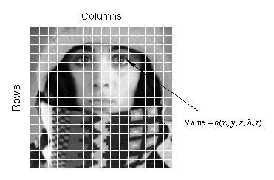
Figure 1.1 : Digitization of a continuous image.
The image shown in Figure above has been divided into N = 16 rows and M = 16 columns. The value assigned to every pixel is the average brightness in the pixel rounded to the nearest integer value. The process of representing the amplitude of the 2D signal at a given coordinate as an integer value with L different gray levels is usually referred to as amplitude quantization or simply quantization.

1.3 IMAGE SEGMENTATION

In most image analysis operations, pattern classifiers require individual objects to be separated from the image, so the description of those objects can be transformed into a suitable form for computer processing. Image segmentation is a fundamental task, responsible for the separating operation. The function of segmentation is to partition an image into its constituent and disjoint sub-regions, which are uniform according to their properties, e.g. intensity, color, and texture within a sub-region, though there are some segmentation algorithms relying on both discontinuity and uniformity.

The distinction between image segmentation and pattern classification is often not clear. The function of segmentation is to partition an image into multiple sub-regions, while the function of pattern classification is to identify the partitioned sub-regions. Thus, segmentation and pattern classification usually function as separate and sequential processes.

However, they might function as an integrated process depending on the image analysis problem and the performance of the segmentation method. In either way, segmentation critically affects the results of pattern classification, and often determines the eventual success or failure of the image analysis.

The level to which segmentation is carried depends on the problem being solved. That is, segmentation should stop when the region of interest (ROI) in the application have been isolated. Due to this property of problem dependence, autonomous segmentation is one of the most difficult tasks in image analysis. Noise and mixed pixels caused by the poor resolution of sensor images make the segmentation problem even more difficult. More segmentation related details are explained in Chapter 2.

1.4 NEED FOR SEGMENTATION

One of the most fundamental issues in the fields of image processing and computer vision is image segmentation. It is the basis of higher level applications such as in medical imaging. Its objective is to determine a partition of an image into a finite number of semantically important regions. Since segmentation is an important task in image analysis, it is involved in most image analysis applications, particularly those related to pattern classification, e.g. medical imaging, remote sensing, security surveillance, military target detection. Also scope of segmentation includes automatic detection of man-made objects such as buildings or roads from digital aerial images is useful for scene understanding, image retrieval, surveillance and updating of geographic information system databases etc. It is a scientifically challenging task, since the images of natural scenes contain large amount of clutter. Much research has been devoted to the detection and recognition of man-made objects in aerial images until now.

1.5 ACTIVE CONTOURS

In this section, a novel segmentation methods using a variational framework, called active contours is explored. Active contours are connectivity-preserving relaxation [2] methods, applicable to the Image segmentation problems. Active contours have been used for image segmentation and boundary tracking since the first introduction of snakes by Kass et al. [3]. The basic idea is to start with initial boundary shapes represented in a form of closed curves, i.e. contours, and iteratively modify them by applying shrink/expansion operations according to the constraints of the image. Those shrink/expansion operations, called contour evolution, are performed by the minimization of an energy function like traditional region-based segmentation methods or by the simulation of a geometric partial differential equation (PDE) [4].

NEED OF CONTOUR

An advantage of active contours as image segmentation methods is that they partition an image into sub-regions with continuous boundaries, while the edge detectors based on threshold or local filtering, e.g. Canny [5] or Sobel operator, often result in discontinuous boundaries. The use of level set theory has provided more flexibility and convenience in the implementation of active contours. Depending on the implementation scheme, active contours can use various properties used for other segmentation methods such as edges, statistics, and texture. The presented active contour models use the statistical information of image intensity within a sub-region. The active contours are selected as segmentation method in this work and are explained in detail in Chapter 3.

1.6 SUMMARY

The function of segmentation is to partition an image into its constituent and disjoint sub-regions, which are uniform according to their properties, e.g. intensity, color, and texture. The function of segmentation is to partition an image into its constituent and disjoint sub-regions, which are uniform according to their properties, e.g. intensity, color, and texture. Active contours have been widely used as attractive image segmentation methods because they always produce sub-regions with continuous boundaries. In Chapter 2, all available approaches for segmentation are discussed namely edge based and region based. Further in Chapter 3, background of technique considered in this work i.e active contour technique is discussed. In Chapter 4, general model of Region-based Segmentation using Active Contours is mentioned. In Chapter 5, implementation of active contour using level set function and the presented model is discussed. In Chapter 6, implementation aspects of the presented method are described. In Chapter 7, output results are shown and discussed.

--------------------------------------------------------------------

Chapter 2

IMAGE SEGMENTATION: BACKGROUND

  - INTRODUCTION

This chapter is dedicated on the various aspects of image segmentation. Image segmentation is one of the most important steps in the image analyses. Its main aim is to divide an image to some parts, which correlate strongly by objects of reality. Image segmentation is a difficult task mainly because of a big variability of object shapes, as well as different image quality. Images are often interfered by signals and artifacts which rose of during sampling, what may cause big problems at using of common techniques of segmentation.

Conceptually, there are two main approaches in image segmentation:

1) EDGE – Based Methods.
2) REGION – Based Methods.

Edge-based segmentation partitions an image based on discontinuities among sub-regions, while region-based segmentation does the same function based on the uniformity of a desired property within a sub-region. In this chapter, we briefly discuss existing image segmentation technologies as background.

2.2 EDGE – BASED SEGMENTATION

Edge-based segmentation looks for discontinuities in the intensity of an image. It is more likely edge detection or boundary detection rather than the literal meaning of image segmentation, introduced in section 1.3. An edge can be defined as the boundary between two regions with relatively distinct properties. The assumption of edge-based segmentation is that every sub-region in an image is sufficiently uniform so that the transition between two sub-regions can be determined on the basis of discontinuities alone. When this assumption is not valid, region-based segmentation, discussed in the next section, usually provides more reasonable segmentation results.

Basically, the idea underlying most edge-detection techniques is the computation of a local derivative operator. The gradient vector of an image I(x, y), given by

is obtained by the partial derivatives ∂I/∂x and ∂I/∂y at every pixel location. The local derivative operation can be done by convolving an image with kernels shown in figure 2.1.
Figure 2.1: Examples of gradient kernels along: (a) vertical direction, (b) horizontal direction

The magnitude of the first derivative

determines the presence of edges in an image.
The Laplacian of an image function I(x, y) is the sum of the second-order derivatives, defined as

The general use of the Laplacian is in finding the location of edges using its zero-crossings [12]. A critical disadvantage of the gradient operation is that the derivative enhances noise.

As a second-order derivative, the Laplacian is even more sensitive to noise. An alternative is convolving an image with the Laplacian of a Gaussian (LoG) function [13], given by

where a two-dimensional Gaussian function with the standard deviation σ is defined as

The LoG function produces smooth edges as the Gaussian filtering provides smoothing effect [14].

Sobel operation is performed by convolving an image with kernels shown in figure 2.2. Sobel operators have the advantage of providing both a derivative and a smoothing effect [12, 15]. The smoothing effect is a particularly attractive feature of the Sobel operators compared to the gradient kernels shown in figure 2.2 because the derivative enhances noise.

Figure 2.2: Sobel operators along: (a) vertical direction, (b) horizontal direction
Canny edge detector [16, 5] is based on the extrema of the first derivative of the Gaussian operator applied to an image. The operator first smoothes the image to eliminate noise, and then finds high gradient regions. After non-maximum suppression, the edges are finally determined by two thresholds, i.e. τmin and τmax as shown in table 2.1.

Table 2.1: Path searching in Canny edge detector

Canny edge detector is known as an optimal edge detector because it satisfies the criteria of low error rate, good localization of edge points, and a single response to a single edge pixel [17].

Edge detection by gradient operations generally work well only in the images with sharp intensity transitions and relatively low noise. Due to its sensitivity to noise, some smoothing operation is generally required as preprocessing, and the smoothing effect consequently blurs the edge information. However, the computational cost is relatively lower than other segmentation methods because the computation can be done by a local filtering operation, i.e. convolution of an image with a kernel. Edge-based active contour models, discussed in section 3.3, use the magnitude of gradient |∇I| to determine the position of edges.

2.3 REGION-BASED SEGMENTATION

Region-based segmentation looks for uniformity within a sub-region, based on a desired property, e.g. intensity, color, and texture. Clustering techniques encountered in pattern classification literature have similar objectives and can be applied for image segmentation [18].

Region growing [19] is a technique that merges pixels or small sub-regions into a larger subregion. The simplest implementation of this approach is pixel aggregation [12], which starts with a set of seed points and grows regions from these seeds by appending neighboring pixels if they satisfy the given criteria. Figure 2.3 shows a simple example of pixel aggregation.

Figure 2.3: Pixel aggregation: (a) original image with seeds underlined;
(b) segmentation result with τ =4

Segmentation starts with two initial seeds, and then the regions grow if they satisfy a criterion such as

|I(x, y) - I(seed)| < τ. (2.6)

Despite the simple nature of the algorithm, there are fundamental problems in region growing: the selection of initial seeds and suitable properties to grow the regions. Selecting initial seeds can be often based on the nature of applications or images. For example, the ROI is generally brighter than the background in IR images. In this case, choosing bright pixels as initial seeds would be a proper choice. Additional criteria that utilize properties to grow the regions lead region growing into more sophisticated methods, e.g. region competition. Region competition [20, 21] merges adjacent sub-regions under criteria involving the uniformity of regions or sharpness of boundaries. Strong criteria tend to produce over-segmented results, while weak criteria tend to produce poor segmentation results by over-merging the sub-regions with blurry boundaries. An alternative of region growing is split-and-merge [22], which partitions an image initially into a set of arbitrary, disjointed sub-regions, and then merge and/or split the sub-regions in an attempt to satisfy the segmentation criteria.

Another common approach in region-based segmentation is characterizing statistical uniformity of sub-regions using parametric models, so called statistical estimation. With this approach, two sub-regions are considered to be uniform, and consequently merged, if they can be represented by a single instance of the model, i.e. if they have common parameter values within a threshold. In practice, the parameters of a sub-region cannot be observed directly but can only be inferred from the observed data and the knowledge of the imaging process. In statistical approaches, this inference is often made using Bayes’s rule [23] and the conditional PDF p ( I(x, y) | θm ), which presents the conditional probability that certain data I(x, y) (or statistics derived from the data) will be observed, given that sub-region m has the parameter values of
θm. In typical statistical region merging algorithms [24], stochastic estimates in the parameter space are obtained for different sub-regions, and merging decisions are based on the similarity of these parameters.

A limitation of most estimation-based segmentation methods is that they do not explicitly represent the uncertainty in the estimated parameter values and, therefore, are prone to error when parameter estimates are poor. A Bayesian probability of homogeneity directly exploits all of the information contained in the statistical image models, instead of estimating parameter values [25]. The probability of homogeneity is based on the ability to formulate a prior probability density on the parameter space, and measures homogeneity by taking the expectation of the data likelihood over a posterior parameter space.

Image segmentation is often approached by edge-preserving smoothing operations as well as the partitioning operation. Edge-preserving smoothing techniques can be classified roughly two approaches [26]: Markov random field (MRF) including energy-based methods [27, 28] and diffusion-based methods [29, 30]. Both approaches show similar restoration characteristics because the diffusion-based methods can be viewed as an energy-based method that uses only the prior energy term at a given temperature [31]. Snyder et al. [32, 33, 34] proposed an edge-preserving smoothing method for image segmentation based on the technology called mean field annealing (MFA) [31, 35, 36, 37, 38, 39], and the same segmentation method was extended to vector-valued images by Han et al. [26, 40]. MFA is an energy-based method for finding the minimum of complex functions which typically have many minima [41]. For the image segmentation problem, a proper energy function is defined intending to keep the edges and to smooth the rest of areas in the image. The segmentation is performed by minimizing the energy function using MFA. MFA approximates a stochastic algorithm called simulated annealing (SA) [42], which has shown to converge to the global minimum, even for non-convex problems [43]. Hiriyannaiah et al. [44] derived MFA using the analogy
to physics for the restoration of piecewise-constant images, and Bilbro et al. [43] did the same job applying the MFA to the images with varying gray values.

Region-based approaches are generally less sensitive to noise, and usually produce more reasonable segmentation results as they rely on global properties rather than local properties, but their implementation complexity and computational cost can be often quite large. Statistical segmentation methods, both estimation-based and Bayesian-based, have been extended to many active contour models including the presented models. Those active contour models based on statistical segmentation will be discussed in section 3.4.

2.4 OTHER SEGMENTATION METHODS

The watershed algorithm [47, 48] is a morphology-based segmentation method [49, 50, 51]. It is based on the assumption that any gray-tone image can be considered as a topographic surface [52]. If we flood this surface from its minima preventing the merge of the waters coming from different sources, the surface is eventually separated as two different sets: the catchment basins and the watershed lines. If we apply this transformation to the magnitude of image gradient |∇I|, the catchment basins correspond to the uniform sub-regions in the image and the watershed lines correspond to the edges. The flooding operation is simulated using morphological distance operators [53, 54, 55].

Fusions of different principles have produced good results. There have been a few approaches to integrate region-and edge-based segmentation [56, 57], and also an approach to integrate region-and morphology-based segmentation called watersnakes [58].

Texture is another feature that we can use to determine the segmentation criteria. Images can be considered as either a collection of pixels in the spatial domain or the sum of sinusoids of infinite extent in the spatial-frequency domain. Gabor observed that the spatial representation and the spatial-frequency representation are just opposite extremes of a continuum of possible joint space/spatial-frequency representations [59]. In a joint space/spatial - frequency representations for images, frequency is considered as a local phenomenon that can vary with position throughout the image. The human visual system is performing a form of local spatial-frequency analysis on the retinal image, and the analysis is done by a bank of bandpass filters [60].

The same approach can be used to partition textured images in image analysis. Perceptually significant texture differences presumably correspond to differences in the local spatial-frequency content using the space/spatial-frequency paradigm. Texture segmentation is done by two steps: decomposing an image into a joint space/spatial-frequency representation with a bank of bandpass filters and using this information to locate the regions of similar local spatial-frequency content. The response of the filter bank generates a kind of multispectral images, where each band represents the response of the textured image at a particular spatial-frequency
bandwidth. The multi-channel filtering has been implemented by the convolution of the image with a stack of two-dimensional Gabor filters [61, 62, 63, 64, 65] or wavelets [66, 67].

2.5 SUMMARY
Edge detection is complicated with false edges created by image noise. Edge detection by gradient operations generally works well only in the images with sharp intensity transitions and relatively low noise. Another attempt was to use a Laplacian edge detector, but it picked up so much noise that it was nearly impossible to determine any regions. Also, the Laplacian filter did give thin edges. Threshold algorithms are simple and give very good results but deciding the threshold values is not easy.
Region-based approaches are generally less sensitive to noise, and usually produce more reasonable segmentation results as they rely on global properties rather than local properties, but their implementation complexity and computational cost can be often quite large.

An advantage of region based active contours as image segmentation methods is that they partition an image into sub-regions with continuous boundaries, while the edge detectors based on threshold or local filtering, e.g. Canny or Sobel operator, often result in discontinuous boundaries.

------------------------------------------------------------------------------

Chapter 3

ACTIVE CONTOURS: BACKGROUND

3.1 INTRODUCTION

The technique of active contours has become quite popular for a variety of applications, particularly image segmentation and motion tracking, during the last decade. This methodology is based upon the utilization of deformable contours which conform to various object shapes and motions. This chapter provides a theoretical background of active contours and an overview of existing active contour methods.

There are two main approaches in active contours based on the mathematic implementation: snakes and level sets. Snakes explicitly move predefined snake points based on an energy minimization scheme, while level set approaches move contours implicitly as a particular level of a function. More details about these two approaches will be discussed respectively in section 3.1 and 3.2. As image segmentation methods, there are two kinds of active contour models according to the force evolving the contours: edge-and region-based. Edge-based active contours use
an edge detector, usually based on the image gradient, to find the boundaries of sub-regions and to attract the contours to the detected boundaries. Edge-based approaches are closely related to the edge-based segmentation discussed in section 2.1. Region-based active contours use the statistical information of image intensity within each subset instead of searching geometrical boundaries. Region-based approaches are also closely related to the region-based segmentation discussed in section 2.2. More details of these two active contour models are respectively discussed in section 3.3 and section 3.4.

  - SNAKES

The first model of active contour was proposed by Kass et al. [3] and named snakes due to the appearance of contour evolution. Let us define a contour parameterized by arc lengths as
where L denotes the length of the contour C, and O denotes the entire domain of an image I(x, y). The corresponding expression in a discrete domain approximates the continuous expression as
where L = NΔs. An energy function E(C) can be defined on the contour such as
E(C)= E_{int} + E_{ext} , (3.3)
where E_{int} and E_{ext} respectively denote the internal energy and external energy functions.

The internal energy function determines the regularity, i.e. smooth shape, of the contour. A common choice for the internal energy is a quadratic functional given by
Here α controls the tension of the contour, and β controls the rigidity of the contour. The external energy term determines the criteria of contour evolution depending on the image I(x, y). It can be defined as
Where E _{img} (x, y) denotes a scalar function defined on the image plane, so the local minimum of E _{img} attracts the snakes to edges.
A common example of the edge attraction function is a function of image gradient, given by
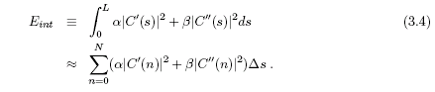

Where G_{σ} denotes a Gaussian smoothing filter with the standard deviation σ and λ is a suitably chosen constant. Solving the problem of snakes is to find the contour C that minimizes the total energy term E with the given set of weights
α, β, and λ . In numerical experiments, a set of snake points residing on the image plane are defined in the initial stage, and then the next position of those snake points are determined by the local minimum E. The connected form of those snake points is considered as the contour. Figure 3.1 shows an example of classic snakes [69]. There are about 70 snakes points in the image, and the snake points form a contour

Figure 3.1: An example of classic snakes

around the moth. The snakes points are initially placed at further distance from the boundary of the object, i.e. the moth. Then, each point moves towards the optimum coordinates, where the energy function converges to the minimum. The snakes points eventually stop on the boundary of the object.
The classic snakes provide an accurate location of the edges only if the initial contour is given sufficiently near the edges because they make use of only the local information along the contour. Estimating a proper position of initial contours without prior knowledge is a difficult problem. Also, classic snakes cannot detect more than one boundary simultaneously because the snakes maintain the same topology during the evolution stage. That is, snakes cannot split to multiple boundaries or merge from multiple initial contours. Level set theory [4] has given a
solution for this problem.

3.3 LEVEL SET METHODS

Level set theory, a formulation to implement active contours, was proposed by Osher and Sethian [4]. They represented a contour implicitly via a two-dimensional Lipschitz-continuous function φ (x, y) : Ω→ℜ defined on the image plane. The function φ (x, y) is called level set function, and a particular level, usually the zero level, of φ (x, y) is defined as the contour, such as
where Ω denotes the entire image plane.
Figure 3.2(a) shows the evolution of level set function φ (x, y), and figure 3.2(b) shows the propagation of the corresponding contours C.
Figure 3.2: Level set evolution and the corresponding contour propagation:
(a) topological view of level set φ (x, y) evolution, (b) the changes on the zero level set C : φ (x, y)=0
As the level set function φ (x, y) increases from its initial stage, the corresponding set of contours C, i.e. the red contour, propagates toward outside. With this definition, the evolution of the contour is equivalent to the evolution of the level set function, i.e. ∂C/∂t = ∂φ (x, y)/ ∂t.

The advantage of using the zero level is that a contour can be defined as the border between a positive area and a negative area, so the contours can be identified by just checking the sign of φ (x, y). The initial level set function φ₀(x, y): Ω→ℜ may be given by the signed distance from the initial contour such as,
φ₀ (x, y) = {φ (x, y) : t = 0} ∀ (x,y) ∈Ω
= ±D((x, y), N_{x,y}(C₀)) (3.8)
where ±D(a, b) denotes a signed distance between a and b, and N_{x,y} (C₀) denotes the nearest neighbor pixel on initial contours C₀ ≡ C(t = 0) from (x, y). Figure 3.3(a) shows an example of initial contours C₀, and figure 3.3(b) shows the initial level set function φ₀ (x, y) as the signed distance computed from the initial contour C₀.
φ₀ (x, y) increases, i.e. become brighter, as a pixel (x, y) is located further inwards

Figure 3.3: Initial contours and corresponding signed distance: (a) the initial contour C₀, (b) the initial level set function φ₀ (x, y) determined by the signed distance ±D((x, y), N_{x,y} (C₀)) ;from the initial contours C₀,while φ₀ (x, y) decreases, i.e. become darker, as the pixel is located further outwards from the initial contours. The initial level set function is zero at the initial contour points given by, φ₀ (x, y) = 0, ∀ (x, y) ∈ C₀.

The deformation of the contour is generally represented in a numerical form as a PDE. A formulation of contour evolution using the magnitude of the gradient of φ₀ (x, y) was initially proposed by Osher and Sethian [71, 72, 4], given by

where ν denotes a constant speed term to push or pull the contour, K(.): Ω→ℜ denotes the mean curvature of the level set function φ(x, y) given by

where φ_{x} and φ_{xx} denote the first-and second-order partial derivatives of φ(x, y) respect to x, and φ_{y} and φ_{yy} denote the same respect to y. The role of the curvature term is to control the regularity of the contours as the internal energy term E_{int} does in the classic snakes model, and ε controls the balance between the regularity and robustness of the contour evolution.

Another form of contour evolution was proposed by Chan and Vese [10, 73]. The length of the contour |C| can be approximated by a function of φ (x, y) [74, 75], such as

where H_{ε} (·) denotes the regularized form of the unit step function H(·):Ω→ℜ given by

and δ_{ε}(·) denotes the derivative of H_{ε} (·). Since the unit step function produces either 0 or 1 depending on the sign of the input, the derivative of the unit step function produces nonzero only where φ (x, y) = 0, i.e. on the contour C. Consequently, the integration shown in equation 3.11 is equivalent to the length of contours on the image plane. The associated Euler-Lagrange equation [76] obtained by minimizing L_{ε} (·) with respect to φ and parameterizing the descent directions by an artificial time t is given by

The contour evolution motivated by the equation above can be interpreted as the motion by mean curvature minimizing the length of the contour. Therefore, equation 3.9 is considered as the motion motivated by PDE, while equation 3.13 is considered as the motion motivated by energy minimization.

An outstanding characteristic of level set methods is that contours can split or merge as the topology of the level set function changes. Therefore, level set methods can detect more than one boundary simultaneously, and multiple initial contours can be placed. Figure 3.4(a) shows an example of the topological changes on a level set function, while figure 3.4(b) shows how the initially separated contours merge as the topology of level set function varies.

This flexibility and convenience provide a means for an autonomous segmentation by using a predefined set of initial contours.

Figure 3.4: The change of topology observed in the evolution of level set function and the propagation of corresponding contours: (a) the topological view of level set φ (x, y) evolution, (b) the changes on the zero level set C : φ (x, y)=0

The computational cost of level set methods is high because the computation should be done on the same dimension as the image plane. Thus, the convergence speed is relatively slower than other segmentation methods, particularly local filtering based methods. The high computational cost can be compensated by using multiple initial contours. The use of multiple initial contours increases the convergence speed by cooperating with neighbor contours quickly. Level set methods with faster convergence, called fast marching methods [77], have been studied intensively for the last decade. Because of these attractive properties, this work implements the active contour model using the level set method.

3.4 EDGE-BASED ACTIVE CONTOURS

Edge-based active contours are closely related to the edge-based segmentation. Most edge-based active contour models consist of two parts: the regularity part, which determines the shape of contours, and the edge detection part, which attracts the contour towards the edges.

Geometric active contour model was proposed by Caselles et al. [81] adding an additional term, called stopping function, to the speed function shown in equation 3.9. It was the first level set implemented active contour model for the image segmentation problem. Malladi et al. [82, 78] proposed a similar model given by

Where g(·): Ω→ℜ denotes the stopping function, i.e. a positive and decreasing function of the image gradient. A simple example of the stopping function is given by
Where n is given as 1 in [81] and 2 in [82]. Note that |∇I(x, y)| can be interchangeably used with E_{img} shown in equation 3.6. The contours move in the normal direction with a speed of g(I(x, y))( K ( φ (x, y)) + ν), and therefore stops on the edges, where g(·) vanishes. The curvature term K (·) maintains the regularity of the contours, while the constant term ν accelerates and keeps the contour evolution by minimizing the enclosed area [83].

Geodesic active contour model was proposed by Caselles et al. [84, 85] after the geometric active contour model. Kichenassamy et al. [86] and Yezzi et al. [87] also proposed a similar active contour model.

Based on the principle of the classic dynamic systems, solving the active contour problem is equivalent to finding a path of minimal distance, called geodesic curve [88] given by

Where N denotes the inward unit normal given by
From the relation between a contour and a level set function and the level set formulation of the steepest descent method, solving this geodesic problem is equivalent to searching for the steady state of the level set evolution equation [84, 89] given by

Where ν is an additional speed term to accelerate the evolution. The equivalence between classic snakes and geodesic active contours has been also shown by other authors [90, 91, 92, 93] in slightly different views.
We can notice that the geodesic active contour model shown in equation 3.18 is identical to the geometric active contour model shown in equation 3.14 except for the advection term ∇g(I(x, y)) ·∇φ (x, y). Geodesic active contours have been the most popular methods among the edge-based active contour models, and their applications have been extended to multispectral images by Sapiro.

Color snakes is the geodesic active contour model particularly for multispectral images proposed by Sapiro [88, 94, 95, 89]. In order to detect the edges in multispectral images, a special gradient function based on Riemannian geometry, called color gradient function, is used instead of the traditional image gradient function. A simple example of the color gradient function is given by

where λ ₊ and λ_respectively present the maximal and the minimal rate of changes on the multispectral image I(x, y). λ ₊ and λ_are the eigenvalues of the metric tensor [96] given by
where I_{b} denotes the b-th band of the multispectral image I(x, y). In the case of scalar images, i.e. gray images, λ ₊ = |∇I|² and λ _= 0, so the stopping function shown in equation 3.19 become identical to equation 3.15. Sapiro also introduced color self-snakes [88, 97, 95, 89], which diffuse the image in the same way that we evolve the level set function. This is an edge-preserving smoothing method like MFA or image diffusion using active contours.

Due to the structure of the speed functions and the stopping functions in equation 3.9
and equation 3.18, edge-based active contour models have a few disadvantages compared to the region-based active contour models, discussed in the next section. Because of the constant term ν , edge-based active contour models evolve the contour towards only one direction, either inside or outside. Therefore, an initial contour should be placed completely inside or outside of ROI, and some level of a prior knowledge is still required. Also, edge-based active contours inherit some disadvantages of the edge-based segmentation methods due to the similar technique used. Since both edge-based segmentation and edge-based active contours rely on the image gradient operation, edge-based active contours may skip the blurry boundaries, and they are sensitive to local minima or noise as edge-based segmentation does. Gradient vector flow fast geodesic active contours [98, 99] proposed by Paragios replaced the edge detection (boundary attraction) term with gradient vector field [100, 101, 102, 103, 104], that refers to a spatial diffusion of the boundary information and guides the propagation to the object boundaries from both sides, to give more freedom from the restriction of initial contour position.

3.5 Region-based Active Contours

Most region-based active contour models consist of two parts: the regularity part, which determines the smooth shape of contours, and the energy minimization part, which searches for uniformity of a desired feature within a subset. A nice characteristic of region-based active contours is that the initial contours can be located anywhere in the image as region-based segmentation relies on the global energy minimization rather than local energy minimization. Therefore, less prior knowledge is required than edge-based active contours.

Piecewise-constant active contour model was proposed by Chan and Vese [10, 73] using the Mumford-Shah segmentation model [107, 108]. Piecewise-constant active contour model moves deformable contours minimizing an energy function instead of searching edges. A constant approximates the statistical information of image intensity within a subset, and a set of constants, i.e. a piecewise-constant, approximate the statistics of image intensity along the entire domain of an image. The energy function measures the difference between the piecewise-constant and the actual image intensity at every image pixel. The level set evolution equation is given by

where µ₀ and µ₁ respectively denote the mean of the image intensity within the two subsets, i.e. the outside and inside of contours. The final partitioned image can be represented as a set of piecewise-constants, where each subset is represented as a constant.

This method has shown the fastest convergence speed among region-based active contours due to the simple representation. Lee et al. [109] showed an improvement to the piecewise-constant active contour model on illuminated images by proposing an alternative energy function.

Piecewise-smooth active contour model, an extension of piecewise-constant model using a set of smoothed partial images, was also proposed by Chan and Vese [110, 111, 112, 113, 114]. The same segmentation principles used for piecewise-constant model partitions an image, but smoothed partial images instead of constants represent each subset.

The level set evolution equation is given by

where µ₀(x, y) and µ₁(x, y) respectively denote the smoothed images within the outside and inside of contours. The segmentation result of piecewise-smooth active contours is similar to the segmentation by color self-snakes because of the similar approach.

Although traditional region-based active contours partition an image into multiple subregions, those multiple regions belong to only two subsets: either the inside or the outside of contours. Chan and Vese proposed multi-phase active contour model [110, 76, 115, 116, 117], which increases the number of subsets that active contours can find simultaneously.
Multiple active contours evolve independently based on the piecewise-constant model shown in equation 3.21 or the piecewise-smooth model shown in equation 3.22, and multiple subsets are defined by a group of disjoint combination of the level set functions. For example, N level set functions define maximum 2N subsets of the entire region. An example of subsets defined by 4-phase active contours is

where {Ω_{0,} Ω_{1,} Ω_{2,} Ω₄ } denote the four subsets defined by two level set functions {φ_{1,} φ₂}, i.e. two active contours.

The level set evolution equation for this case is given by

where H_{n} ≡ H_{ε} (φ_{n} (x, y)) and {μ_{0,} μ_{1,} μ_{2,} μ₃} denote the mean of image intensity within the corresponding subsets {Ω_{0,} Ω_{1,} Ω_{2,} Ω₄ } Rousson and Deriche [118, 11, 119] and Yezzi et al. [120, 121] proposed a similar multi-phase active contour model for segmentation problems, and Samson et al. [122, 123, 124] also proposed a multi-phase active contour model for pattern classification problems. Multi-phase active contours provide a means to integrate segmentation and pattern classification tasks. m-phase active contours partition the image into multiple sub-regions (.>>m), and they simultaneously identify those regions into m-subsets, i.e. classes. Depending whether training samples are provided or not, supervised or unsupervised segmentation can actually perform supervised or unsupervised pattern classification. This provides a way to the autonomous pattern classification technology reducing the number of procedures and processing time.

The same segmentation principle can be extended to multispectral images by taking the mean of energy functions measured at each band [6, 125]. The level set evolution equation of 2-phase active contour model is given by

where μ_{i} =[μ_{i1,} μ_{i2,}..., μ_{ib},..., μ_{iB}]^{T} denotes the mean vector of the vector valued image intensity I(x, y) within the corresponding subset Ω.
Rousson and Deriche proposed a variational formulation obtained from a Bayesian segmentation model [118, 11, 119]. While the piecewise-constant active contour model uses a group of constants to represent subsets, this method implicitly uses a conditional PDF of a given value I(x, y) with respect to the hypothesis, i.e. a unimodal (multivariate) Gaussian distribution, given by

where μ_{i} and ∑_{i} are the parameters of a (multivariate) Gaussian distribution. Taking the negative log form of the PDF as an energy function, the level set evolution equation minimizing the energy function is given by

where the objective functions ei are given by

The extension of this method for multispectral images is trivial as the energy function is based on the multivariate PDF. A unique feature of this method is that multivariate PDF consider each band of multispectral images as independent dimension of an image intensity space. Multivariate PDF does not make big improvement in this active contour model, but it does make a significant improvement in the active contour models using a mixture density function.

Due to the global energy minimization, region-based active contours generally do not have any restriction on the placement of initial contours. That is, region-based active contour can detect interior boundaries regardless of the position of initial contours. The use of pre-defined initial contours provides a method of autonomous segmentation. Also, they are less sensitive to local minima or noise than edge-based active contours. However, due to the assumption of uniform image intensity, most methods are applicable only to images where each subset is representable by a simple expression, e.g. single Gaussian distribution or a constant. If a subset, i.e. class, consists of multiple distinctive sub-classes, these methods would produce over-segmented or under-segmented results. We propose novel region-based active contour models which produce improved results using multivariate mixture density functions.

3.6 ACTIVE CONTOURS INTEGRATING EDGE-AND REGION-BASED SEGMENTATION

In order to improve the segmentation performance, the integration of edge-and region-based information sources using active contours has been proposed by a few authors. Geodesic active region is a supervised active contour model, proposed by Paragios [126, 127, 128], integrating edge-and region-based segmentation module in an energy function. A statistical analysis based on the Minimum Description Length (MDL) criterion and the Maximum Likelihood (ML) principle for the observed density function, i.e. an image histogram, indicates the number of sub-regions and the statistical PDF within those sub-regions using a mixture of Gaussian elements. Regional probability is estimated from the statistical PDF based on prior knowledge, i.e. training samples. Then, the boundary information is determined by a probabilistic edge detector, estimated from the regional probabilities of neighborhood [129, 130]. For example, an image pixel is more likely an edge pixel if the neighborhood pixels, located on the opposite sides, have high regional probabilities for a different class. The level set evolution equation is given by

where I_{b}(x, y) denotes b-th band of a multispectral image I(x, y), and p_{i}(I_{b}(x, y)) denotes the regional probability presenting a probability that a pixel I_{b} (x, y) belongs to sub-region i,e p_{e}(x, y) denotes the probabilistic edge detector presenting a probability that a boundary pixel is located at (x, y), and g(p_{e} ) denotes a positive and decreasing function of the probability. The regional probability is computed from each band and accumulated. A detail to determine both probabilities,

p_{i}(I_{b} (x, y)) and p_{e} (x, y), is explained in [130]. The geodesic active region model is later applied to a medical imaging problem [131, 132] with a gradient vector flow-based boundary component. The approach was based on a coupled propagation of two active contours, and integrates visual information with anatomical constraints.

Jehan-Besson et al. also proposed an active contour model [133, 134] minimizing an energy criterion involving both region and boundary functionals. These functionals are derived through a shape derivative approach instead of classical calculus of variation. They focus on statistical property, i.e. the PDF of the color histogram of a sub-region. Active contours are propagated minimizing the distance between two histograms for matching or tracking purposes.

3.7 SUMMARY

The two main approaches in active contours based on the mathematic implementation: snakes and level sets were discussed. Snakes explicitly move predefined snake points based on an energy minimization scheme, while level set approaches move contours implicitly as a particular level of a function. Both edge and region based segmentation can be applied using either method. Estimating a proper position of initial contours without prior knowledge is a difficult problem. Also, snakes cannot split to multiple boundaries or merge from multiple initial contours. Level set theory has given a solution for this problem. Due to the global energy minimization, region-based active contours generally do not have any restriction on the placement of initial contours. Region-based active contour can detect interior boundaries regardless of the position of initial contours. The use of pre-defined initial contours provides a method of autonomous segmentation. Also, they are less sensitive to local minima or noise than edge-based active contours. These are further discussed subjectively in next chapter.

-------------------------------------------------------------------

Chapter 4

REGION-BASED SEGMENTATION USING
ACTIVE CONTOURS

4.1 INTRODUCTION

Region-based segmentation looks for uniformity within a sub-region based on a desired feature, e.g. intensity, color, and texture. Region-based active contour models have shown attractive characteristics, such as the unrestricted position of initial contours, the automatic detection of interior boundaries, and reasonable segmentation due to global energy minimization though the segmentation results are still case dependent. Region-based active contours evolve deformable shapes based on two forces: energy minimization based on the statistical properties, which pursues the uniformity within each subset, and curvature motion motivated by level set function, which keeps the regularity of active contours. In this chapter, the terminology used in the image segmentation problem is redefined [discussed in section 4.2]. Then, the base segmentation model, proposed by Mumford-Shah, of the active contour model is discussed in section 4.3. Finally, traditional level set methods and their corresponding drawback are encompassed in subsequent sections.

4.2 IMAGE, SUBSET, AND SUB-REGION

As introduced in chapter 1, an image I(x, y) is the native input data of the image analysis, given as a form of a function defined on a two-dimensional spatial domain. We define a multispectral image as a general form of images and a scalar image as a particular case of multispectral images.
A multispectral image I(x, y) can be defined as a set of vectors given by

I(x, y) = [I₁(x, y), I₂(x, y),..., I_{b}(x, y),..., I_{B}(x, y)]^{T} : Ω→ℜ ^{B} , (4.1)

where I_{b} (x, y) denotes a scalar image measured at band b. Let the vector-valued image intensity of I(x, y) be a multi-dimensional random variable I ∈ ℜ ^{B} where B denotes the dimension of I and is equivalent to the number of optical bands measured.
Let ψ represent the entire region of an image I(x, y). Image segmentation is a task to partition the entire region ψ into n sub-regions, {ψ₁, ψ₂, ..., ψ_{i},...,ψ_{n}}, with the criteria shown in table 4.1. C _{i} denotes the boundary wrapping sub-region ψ_{i}. The first and second conditions indicate the property of boundaries wrapping sub-regions {ψ_{i}}. As each sub-region has a boundary, the boundaries of two neighbours
sub-regions are overlapped. C denotes the entire set of boundaries. The third condition indicates that the segmentation must be complete, that is, every image pixel should be an element of a sub-region ψ_{i} or boundaries C. The fourth condition requires that all image pixels in a sub-region must be connected in a predefined sense; that is, they should be located at the inside of a boundary. The fifth condition indicates that the sub-regions must be disjoint with each other, so an image pixel should be an element of only one sub-region. Here, we can notice the difference between the image segmentation problem and the pattern classification problem. A data sample can be a member of multiple classes in pattern classification, but an image pixel should be a member of only one sub-region in image segmentation.

Table 4.1 lists the criteria of general image segmentation, and we here introduce slightly different criteria for region-based segmentation. Let a set Ω, instead of a region ψ, represent the entire domain of an image I(x, y). The region-based image segmentation is a task to partition the entire set Ω of an image into m subsets, {Ω_{1,} Ω_{2,…..} ,Ω_{i,…….,} Ω_{m} } with the criteria shown in table 4.2. The only difference between a subset Ω_{i} and a sub-region ψ_{j} is that a subset Ω_{i} does not necessarily form a

spatial unit ,that is, Ω_{i} may contain multiple sub-regions ψ_{j} residing in different spatial locations on the entire set Ω of an image. Following expression shows the relation between n subsets and m sub-regions:
where i =1, 2,...,m and j =1, 2,...,n. (Ω = ψ ) denotes the entire set of an image as the largest possible spatial unit, while (x, y) denotes an image pixel as the smallest possible spatial unit. Figure 4.1 shows an example that sub-regions and subsets are not identical. The entire set of the image (Ω = ψ) consists of two subsets {Ω_{0,} Ω₁} and three sub-regions {ψ_{0,} ψ_{1,} ψ₂}.A subset Ω₁ exists at two different spatial locations, where each of them is independently marked as ψ₁ and ψ_{2.}
Therefore, two main approaches of segmentation, i.e. edge-and region-based, can be reintroduced such that edge-based segmentation partitions an image I(x, y) into multiple sub-regions ψ_{j} searching for discontinuities among sub-regions, while region-based segmentation partitions an image I(x, y) into multiple subsets Ω_{i} searching for uniformity within a subset Ω _{i}

4.3 THE BASE SEGMENTATION MODEL

Mumford and Shah [107, 108] posed the image segmentation problem as a variational problem to find an optimal piecewise-smooth approximation f(x, y) of the given scalar image I(x, y) and a set of boundaries C, such that the approximation f(x, y) varies smoothly within the connected components of the subsets excluding the boundaries, i.e. Ω\C. They proposed to solve the variational segmentation problem by minimizing the following global energy function [76]

with respect to two terms, the approximation f of the given image and the variational boundaries C. The global energy function E^{MS} consists of three parts. The minimization of the first part approximates the image I(x, y) with an alternative expression f(x, y) by minimizing the squared difference between the two expressions |I(x, y) - f(x, y)|² . The second part piece wisely smoothes f(x, y) by minimizing |∇f(x, y)|² on Ω\C. C has the role of approximating the edges of I(x, y). The third part smoothes C by minimizing the length |C|. The existence and regularity of the solution of the problem above is proven in [138, 107].
The global piecewise approximation f(x, y) can be represented as a sum of sub-approximations given by
where f _{i} approximates the given multispectral image I(x, y) within Ω_{i}, and χ_{i} (x, y):

Ω→{0, 1} is determined by the spatial domain of Ω_{i} such as
Note that f_{i} is not necessarily an image function but any expression that represents the feature, used as the region-based segmentation criteria, of the image within Ω_{i} .
The global energy function E^{MS} (f, C) given in equation 4.3 can be simplified and generalized by ignoring the smoothing term and defining independent objective functions for each subset, such that
where the variational contour C determines the domain of variational subsets Ω_{i}. The objective function e(x, y| f_{i}): Ω→ℜ determines the condition of region-based segmentation within each Ω_{i}, e.g. the uniformity of image intensity I, and how well the approximation f_{i} represents the given image. Better f_{i} results in lower e for each Ω_{i}, consequently lower E. The minimum of E is achieved by two sequential minimization procedures. First, the minimization of E with respect to each of f_{i} , while C is fixed, finds the best representations of each i of the given image I(x, y) minimizing the objective function e(x, y| f_{i}). Then, the minimization of E with respect to C, while { f_{i} } are fixed, smoothes the variational boundaries C minimizing |C|.

Combination of these two minimizations leads to the region-based active contour evolution, which moves a set of contours C satisfying the segmentation constraints on the given image.

Depending on the objective function e(x, y| f_{i}) and representation f_{i} , various active contour models can be achieved from the global energy function shown in equation 4.6.
The energy function of piecewise-constant active contour model [6] can be transformed to equation 4.6 with an objective function where f_{i} is given as a vector µ_{i} = [µ₁ ,..., µ_{b},...,µ_{B} ]^{T} ∈ℜ ^{B}. The optimal f_{i} minimizing E is the mean vector of I(x, y) within Ω_{i}. The energy function of [11] also can be transformed to the same form with an objective function
where f_{i} is given as a set of parameters, i.e. the mean vector µ_{i} and covariance matrix ∑_{i} of a multivariate Gaussian PDF. The optimal f_{i} minimizing E is the mean vector µ and covariance matrix ∑ of I(x, y) within Ω_{i}

4.4 TRADITIONAL LEVEL SETS METHODS

In level set formulation of moving fronts (or active contours), the fronts, denoted by C, are represented by the zero level set C(t)= {(x, y) |φ(t, x, y)=0}of a level set function φ(t, x, y). The evolution equation of the level set function f can be written in the following general form:
(4.9)
which is called level set equation [11]. The function F is called the speed function. For image segmentation, the function F depends on the image data and the level set function f. In traditional level set methods [5–7, 17], the level set function φ can develop shocks, very sharp and/or flat shape during the evolution, which makes further computation highly inaccurate. To avoid these problems, a common numerical scheme is to initialize the function φ as a signed distance function before the evolution, and then “reshape” (or “re-initialize”) the function φ to be a signed distance function periodically during the evolution. Indeed, the re-initialization process is crucial and cannot be avoided in using traditional level set methods [4–7].

4.5 DRAWBACKS ASSOCIATED WITH RE-INITIALIZATION

Re-initialization has been extensively used as a numerical remedy in traditional level set methods [5–7]. The standard re-initialization method is to solve the following re-initialization equation
(4.10)
where φ₀ is the function to be re-initialized, and sign(φ) is the sign function. There has been copious literature on re-initialization methods [15, 16], and most of them are the variants of the above PDE-based method. Unfortunately, if φ₀ is not smooth or φ₀ is much steeper on one side of the interface than the other, the zero level set of the resulting function φ can be moved incorrectly from that of the original function [4, 15, 17]. Moreover, when the level set function is far away from a signed distance function, these methods may not be able to re-initialize the level set function to a signed distance function. In practice, the evolving level set function can deviate greatly from its value as signed distance in a small number of iteration steps, especially when the time step is not chosen small enough.

So far, re-initialization has been extensively used as a numerical remedy for maintaining stable curve evolution and ensuring desirable results. From the practical viewpoints, the re-initialization process can be quite complicated, expensive, and have subtle side effects. Moreover, most of the level set methods are fraught with their own problems, such as when and how to re-initialize the level set function.

4.7 SUMMARY

Region-based active contour models have shown attractive characteristics, such as the unrestricted position of initial contours, the automatic detection of interior boundaries, and reasonable segmentation due to global energy minimization though the segmentation results are still case dependent. In traditional level set methods, the level set function φ can develop shocks, very sharp and/or flat shape during the evolution, which makes further computation highly inaccurate. The re-initialization process is crucial and cannot be avoided and is also expensive. The solution to this problem is discussed in next chapter as presented model which is implemented in this work.

--------------------------------------------------------------------------

Chapter 5

ACTIVE CONTOUR IMPLEMENTATION USING LEVEL SET METHOD

5.1 INTRODUCTION

The presented segmentation methods are implemented in a form of active contours.
It is proposed to use the region-based active contour model using level set theory. The level set implementation of the presented active contour model is based on the multi-phase active contour model proposed by Chan and Vese [110, 76, 115]. In this chapter, the level set implementation of the presented active contour models is discussed.

5.2 THE BASE ACTIVE CONTOUR MODEL

Multi-phase active contours can partition an image into more than two subsets simultaneously. Let us redefine the entire domain Ω of an image I(x, y) as a disjoint set of subsets, such that
where the interior regions include the contour pixels C ∈ Ω_{in} identified by a set of binary identity functions
comsposed of a group of regularized unit step functions H_{j} : Ω→{0,1}
The identity functions {χ_{i}(x, y): Ω→{0, 1}} for the case of 2 subsets and 4 subsets are respectively defined as

J level set functions {φ₁,..., φ_{j},..., φ_{J}} can compose up to 2 ^{j} subsets {Ω_{1,…,}Ω_{i,….,} Ω₂ ^{j} }
in this way. An example of subsets, defined by multi-phase level set functions, is shown in figure 5.1 where {Ω_{1,}Ω_{2,}Ω_{3,}Ω₄ }denote the four subsets defined by two level set functions {φ₁, φ₂}.
Figure 5.1: Subsets and contours defined by two level set functions, {φ_{1,} φ₂}

Using the identity functions {χ_{i}(x, y)}, the integration over each subset Ω_{i} in the global energy function E shown in equation 4.11 and 4.14 can be transformed to the integration over the entire image plane Ω, such as
which makes the computation much easier.

Also, the length of contours |C _{j}| is equivalent to the integration of |∇H _{j} |
over Ω,such that
where C_{j} denotes a set of active contours formed by the corresponding level set function φ_{j} (x, y) as C _{j} ≡φ_{j} {(x, y): -j(x, y)=0}. The global energy function of the multi-phase active contour model and the associated Euler-Lagrange equation obtained by minimizing the energy function E with respect to Φ = {φ₁,..., φ_{j},..., φ_{J} }, which are introduced in [76, 115], can be generalized with an arbitrary form of objective functions e_{i} (x, y), such as

Where δ_{j} = δ_{ε} (φ_{j} (x, y)) denotes the first derivatives of H_{j} with respect to φ_{j}, and
κ _{j} ≡ κ (φ_{j} (x, y)) denotes the mean curvature of φ_{j} (x, y).

5.3 PRESENTED ACTIVE CONTOUR MODEL (REGION-BASED SEGMENTATION)

In this work a new variational formulation that forces the level set function to be close to a signed distance function, and therefore completely eliminates the need of the costly re-initialization procedure. The variational energy functional consists of an internal energy term and an external energy term, respectively. The internal energy term penalizes the deviation of the level set function from a signed distance function, whereas the external energy term drives the motion of the zero level set to the desired image features such as object boundaries. The resulting evolution of the level set function is the gradient flow that minimizes the overall energy functional. Due to the internal energy, the level set function is naturally and automatically kept as an approximate signed distance function during the evolution. Therefore, the re-initialization procedure is completely eliminated.

5.3.1 ADVANTAGES OF PRESENTED MODEL

The presented algorithm has three main advantages over the traditional level set formulations.
- A significantly larger time step can be used for numerically solving the evolution PDE, and therefore speeds up the curve evolution.
- The level set function could be initialized as functions that are computationally more efficient to generate than the signed distance function.
- The presented level set evolution can be implemented using simple finite difference scheme, instead of complex upwind scheme as in traditional level set formulations.
The presented algorithm has been applied to both simulated and real images with promising results. In particular it appears to perform robustly in the presence of weak boundaries.

5.3.2 CONTOUR EVOLUTION

Unlike signed distance functions, which are computed from a contour, the initial level set functions are computed from an arbitrary region Ω₀ in the image domain Ω. Such region-based initialization of level set function is not only computationally efficient, but also allows for flexible applications in some situations. For example, if the regions of interest can be roughly and automatically obtained in some way, such as thresholding, then these can be used to roughly obtained regions as the region Ω₀ to construct the initial level set function φ₀. Then, the initial level set function will evolve stably according to the evolution equation, with its zero level curve converged to the exact boundary of the region of interest.

5.4 SUMMARY

A variational formulation that forces the level set function to be close to a signed distance function, and therefore completely eliminates the need of the costly re-initialization procedure is discussed in this chapter. Its advantages over other available methods were mentioned. Possible ways to initialize the contour and contour initialization basics were mentioned. In next chapter implementation aspects of this method is discussed with all relevant mathematical expressions.

---------------------------------------------------------------------
Chapter 6

IMPLEMENTATION ASPECT

6.1 INTRODUCTION

This work implements segmentation methodologies like EDGE BASED, ACTIVE CONTOUR. The implementation aspects of each of the method are explained in sub sections of this chapter.

6.2 EDGE BASED – SEGMENTATION METHODS
This particular method of image segmentation, focus is on the idea that edges define boundaries and that regions are contained within these edges. There are various ways to detect edges. The algorithm used in this program goes as follows:
Image Segmentation Outline
- Edge Detection: use gradient (sobel row-edge detector and & prewitt column- edge detector) or Laplacian of Gaussian edge detector on the image.
- Adaptive thresholding: find threshold for gray level edge values that allows between 20% & 35% of the values in an image to be kept as `edge', and set those values to `1' and all others to `0'.
- Hough transform: Hough transform was developed to detect a specific shape. Not like other edge detecting algorithms, it looks for already chosen or designed shape in an image.
The first step to segmenting images into regions is to determine where the edges are. This work implements several different edge-detection filters including true sobel, true prewitt, Laplacian of Gaussian. This 3x3 did in fact seem to work better on any input image with sharp edges.
The result of the edge detection scheme left us with a grayscale image that had bright intensities for strong edges, lower intensities for weaker edges, and black for wares with no edges.

6.2.1 EDGE DETECTION OPERATORS
1st order: Roberts Cross, Prewitt, Sobel, Canny
2nd Order: Marr-Hildreth, zero-crossings of the second-order derivative in the gradient direction.
Example:
- Sobel operators along: (a) vertical direction, (b) horizontal direction

- The Laplacian of a Gaussian (LoG) function, given by

Currently, the Canny operator (or variations of this operator) is most commonly used edge detection method. A large number of edge detection operators have been published but so far none has shown significant advantages over the Canny-type operators in general situations. In his original work, Canny studied the problem of designing an optimal pre-smoothing filter for edge detection, and then showed that this filter could be well approximated by a first-order Gaussian derivative kernel. Canny also introduced the notion of non-maximum suppression, which means that edges are defined as points where the gradient magnitude assumes a maximum in the gradient direction.

6.2.2 THRESHOLDING ALGORITHM

Another way of segmentation is to determine from the grayscale image which of the `edge' points were in fact edges. The most straight-forward method of determining which points to keep is a simple thresholding method. Points with intensities above the threshold are kept as edges and the rest are thrown out.
Search all the pixels f (i, j) of the image f. An image element g (i, j) of the segmented image is an object pixel if f (i, j) >= T, and is a background pixel otherwise.
Problem: Single global threshold is successful only under very unusual circumstances gray level variations are likely - due to non-uniform lighting, non-uniform input device parameters or a number of other factors.
A) Variable thresholding (also adaptive thresholding), in which the threshold value varies over the image as a function of local image characteristics, can produce the solution in these cases.
  - Image f is divided into subimages f_{c}
  - A threshold is determined independently in each subimage
  - If a threshold cannot be determined in some subimage, it can be interpolated from thresholds determined in neighboring subimages.
  - Each subimage is then processed with respect to its local threshold.

B) Otsu's method or Otsu's algorithm or Ad-hoc algorithm is used in computer vision and image processing to perform thresholding. It designed to separate foreground from background.
If each pixel p of an image has been assigned an 'interest' (or number of occurrences) score, f(p) then Otsu creates a histogram of f over the image; and selects a threshold to maximize the between-class variance. The method is non-iterative and relies on the assumption that all image pixels belong to one of two classes, background or foreground (i.e. object(s)).

6.2.3 HOUGH TRANSFORM ALGORITHM IMPLEMENTATION
It uses an array called accumulator to detect the existence of a line y = mx + b. The dimension of the accumulator is equal to the number of unknown parameters of Hough transform problem. For example, the Hough linear transform problem has two unknown parameters: m and b. The two dimension of the accumulator array would correspond to quantized values for m and b. For each pixel and its neighborhood, Hough transform algorithm determines if there is enough evidence of an edge at that pixel. If so, it will calculate the parameters of that line, and then look for the accumulator's bin that the parameters fall into, and increase the value of that bin. By finding the bins with the highest value, the most likely lines can be extracted, and their (approximate) geometric definitions read off. The simplest way of finding these peaks is by applying some form of threshold, but different techniques may yield better results in different circumstances - determining which lines are found as well as how many. Since the lines returned do not contain any length information, it is often next necessary to find which parts of the image match up with which lines.For each data point, a number of lines are plotted going through it, all at different angles. These are shown here as solid lines. For each solid line a line is plotted which is perpendicular to it and which intersects the origin. These are shown as dashed lines. The length and angle of each dashed line is measured. In the diagram above, the results are shown in tables. This is repeated for each data point. A graph of length against angle, known as a Hough space graph, is then created. The point where the lines intersect gives a distance and angle. This distance and angle indicate the line which bisects the points being tested. In the graph shown the lines intersect at the purple point; this corresponds to the solid purple line in the diagrams above, which bisects the three points.The point where the lines intersect gives a distance and angle. This distance and angle indicate the line which bisects the points being tested. In the graph shown the lines intersect at the purple point; this corresponds to the solid purple line in the diagrams above, which bisects the three points.

6.2.4 DRAWBACKS OF EDGE BASED METHODS
Edge detection is complicated with false edges created by image noise. The number of false edges can be lowered by using image noise reduction techniques before detecting edges. Also thresholding algorithms are simple and give very good results but deciding the threshold values is not easy.
Hough transform has difficulty of defining the specific shape equation in mathematic expression. As the searching shape is more complicated, it is more difficult to find the shape because the equation of that shape will have more parameters. That means it requires more complicated calculation. Hough transform requires long processing time. All tested segmentation algorithms have a common disadvantage to noise.

6.3 ACTIVE CONTOUR BY GENERAL VARIATIONAL LEVEL SET FORMULATION WITH PENALIZING ENERGY

In case of segmentation via active contour, it is crucial to keep the evolving level set function as an approximate signed distance function during the evolution, especially in a neighborhood around the zero level set. It is well known that a signed distance function must satisfy a desirable property of |∇φ|=1. Conversely, any function f satisfying |∇φ|=1 is the signed distance function plus a constant [19]. Considering the following integral

as a metric to characterize how close a function φ is to a signed distance function in Ω ⊂ ℜ². This metric will play a key role in presented variational level set formulation.

With the above defined functional P (φ), presenting the following variational formulation

E(φ)=µP(φ)+ ε_{m}(φ) (4)

Where µ> 0is a parameter controlling the effect of penalizing the deviation of f from a signed distance function, and ε_{m} (φ) is a certain energy that would drive the motion of the zero level curve of φ.

Gradient flow minimizes the functional ε. For a particular functional ε(φ) defined explicitly in terms of φ, the Gateaux derivative can be computed and expressed in terms of the function φ and its derivatives .

The focus will be on applying the variational formulation in (4) to active contours for image segmentation so that the zero level curves of φ can evolve to the desired features in the image. For this purpose, the energy ε_{m} will be defined as a functional that depends on image data, and therefore named as the external energy. Accordingly, the energy P (φ) is called the internal energy of the function φ, since it is a function of φ only.

During the evolution of φ according to the gradient flow that minimizes the functional (4), the zero level curve will be moved by the external energy ε_{m}. Meanwhile, due to the penalizing effect of the internal energy, the evolving function φ will be automatically maintained as an approximate signed distance function during the evolution according to the evolution. Therefore the re-initialization procedure is completely eliminated in the presented formulation.

6.3.1 VARIATIONAL LEVEL SET FORMULATION OF ACTIVE CONTOURS WITHOUT RE-INITIALIZATION:

To achieve this goal, explicitly defining an external energy that can move the zero level curve toward the object boundaries. Let I be an image, and g be the edge indicator function defined by
Where G_{σ} is the Gaussian kernel with standard deviation σ. Now an external energy for a function f(x, y) as below
Where λ> 0and ν are constants, and the terms L_{g} (φ) and A_{g} (φ) are defined by
respectively, where δ is the univariate Dirac function, and H is the Heaviside function.
Now, total energy functional

The external energy ε drives the zero level set toward the object boundaries, while the internal energy µP (φ) penalizes the deviation of φ from a signed distance function during its evolution. Coefficient ν of Ag can be positive or negative, depending on the relative position of the initial contour to the object of interest. For example, if the initial contours are placed outside the object, the coefficient . in the weighted area term should take positive value, so that the contours can shrink faster. If the initial contours are placed inside the object, the coefficient . should take negative value to speed up the expansion of the contours.

6.3.2 NUMERICAL SCHEME

In practice, the Dirac function δ(x) is slightly smoothed as the following function
δ_{e} (x) defined by:
The regularized Dirac δ_{e} (x) with e = 1.5, will be used for all the experiments in this work, as it gives satisfactory results.

6.3.3 SELECTION OF TIME STEP

In implementing the presented algorithm, the time step t can be chosen significantly larger than the time step used in the traditional level set methods. From the experiments, it is found that the time step t and the coefficient µ must satisfy τµ < 1/4 in order to maintain stable level set evolution. Using larger time step can speed up the evolution, but may cause error in the boundary location if the time step is chosen too large. There is a tradeoff between choosing larger time step and accuracy in boundary location. Usually, this work have used t = 10.0 for the most images.

6.3.4 FLEXIBLE INITIALIZATION OF LEVEL SET FUNCTION

Taking the following functions as the initial function φ. Let Ω₀ be a subset in the image domain Ω, and δΩ ₀ be all the points on the boundaries of Ω₀, which can be efficiently identified by some simple morphological operations. Then, the initial function φ₀ is defined as

where ρ > 0 is a constant. It is suggested to choose ρ larger than 2ε, where ε is the width in the definition of the regularized Dirac function δ_{ε} .
Unlike signed distance functions, which are computed from a contour, the presented initial level set functions are computed from an arbitrary region Ω ₀ in the image domain Ω. Such region-based initialization of level set function is not only computationally efficient, but also allows for flexible applications in some situations.

6.4 ALGORITHM

STEP 1 : Input an image.
STEP 2 : Filter an image by performing its convolution with Gaussian filter so as to smoothen it.
STEP 3 : Compute gradient of an image with respect to x and y in order to retrieve respective coefficient.
STEP 4 : Compute edge indicator function which uses gradient kernel with standard deviation, taken here as constant 1.5
STEP 5 : Choose the way to specify ROI statically or dynamically:
(i) Statically initialize the Level set function which defines initial contour as signed distance function assigned 0 at boundaries of level set function, positive outside (4) and negative value (-4) inside the contour.
(ii) Dynamically allow user to specify ROI (region of interest) by simple mouse clicks and initialize contour with that region as reference.
STEP 6 : Values of the constants for external and internal energy terms which has been experimentally determined is assigned to variables.
STEP 7 : Contour is now evolved to enclose the objects present in an image, this involves shrinking and expansion of contour based on energy terms.
STEP 8 : As, external energy depends on length and area of curve. So length is computed using λ, dirac computation of previous contour and convolution of gradient of previous contour and edge indicator function.
STEP 9 : Find internal energy which depends on μ and discrete laplacian of previous contour.
STEP 10: Contour will evolve till it enclose constituent objects of image separating them from background. Thus, steps 7-9 are repeated for fixed number of iterations decided by trial & error method (app. 300 iterations works well for ,most of images)
STEP 11: Original image (to be segmented) and position of initial contour on that image is obtained.
STEP 12: Further, subsequent evolution of contour with respect to objects in an image is displayed and hence final segmented image is shown as output of the process.

Chapter 7

RESULTS AND DISCUSSIONS

7.1 INTRODUCTION

The traditional segmentation methods and active contour variational level set method has been applied to a variety of real and synthetic images in different modalities. All the experimental results are shown and discussed in this chapter.

7.2 SEGMENTATION RESULTS – ACTIVE CONTOUR LEVEL SET METHOD

X-ray image shown below has been taken into account as a sample image for illustration of various aspects of segmentation methods via edge based traditional methods and active contour level set methods. X-ray or Ultrasound images are notorious for the speckle noise and low signal-to-noise ratio,
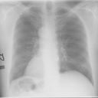
Figure 7.1: Original Image (X-Ray image)
and therefore are very difficult to apply traditional methods to extract the object boundaries. As we can see, some parts of the boundaries of the rib cage are quite blurry. Using this image the following output demonstrates the robustness of active contour method in the presence of weak object boundaries. The initial rectangular contour line successfully evolved to the rib cage boundaries, and their shapes are recovered very well. This result demonstrates desirable performance of active contour method in extracting weak object boundaries, which is usually very difficult for the traditional level set methods to detect as shown later in this chapter.

On applying active contour algorithm to the input image, following output was observed which partitions original image into two of its constituent parts (lungs in this sample), as shown below:
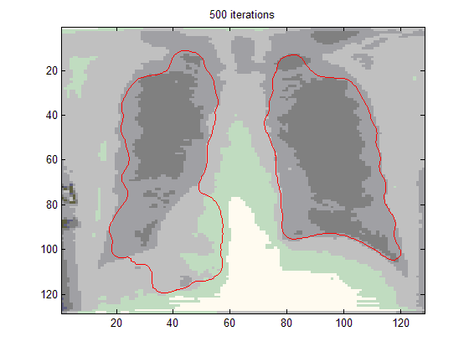
Figure 7.2: Image With Contour Separating Constituent Parts From Noisy Background
For the image in figure 7.2, the parameters used were λ =5.0, µ =0.04, ν =3.0, and time step t =5.0, which is significantly larger than the time step used for traditional level set methods. The curve evolution takes 500 iterations.

The practical implementation of the segmentation aspect has been explained elaborately using this medical image (Fig. 7.3). Here in this sample image a spot located on the right side of the chest has been considered as a cancerous clot. Thereafter the requirement is to locate this spot. Considering an image (Fig.7.3) with cancerous spot, which needs to be detected by any segmentation process. The clot was successfully extracted by the presented method despite the presence of strong noise as shown in Fig. 7.4

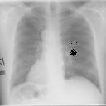

Figure 7.3: An image with cancerous spot, on the right side of the chest which needs to be detected by segmentation process.
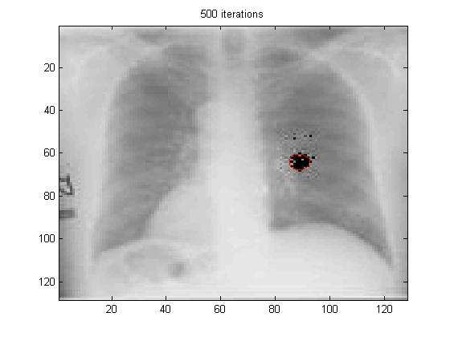
Figure 7.4: Image with contour highlighting cancerous spot as desired

Thus for the process of localization an active contour level set methodology has been implemented in MATLAB so as to highlight the cancerous spot automatically taking into consideration noise effects which is usually present in real time images.

7.3 SEGMENTATION RESULTS - TRADITIONAL METHODS

In this work traditional segmentation methods like thresholding i.e. global threshold, Otsu’s thresholding method, and sobel, prewitt or robert’s filtering, hough transform and watershed transforms have been implemented on the same image so as to differentiate between all techniques on the basis of quality of segmentation. The result of each of these methods and their corresponding observation has been discussed as shown below.

FOR SOBEL EDGE FILTER: Figure 7.5(a) below shows result of applying Sobel edge detector filter to detect edges in +45 degree direction. Sobel filter have also been applied to detect edges in horizontal, vertical and -45 degree direction. The work presented gives the user flexibility to either determine threshold automatically or allows user to provide threshold value dynamically. But as it can be easily observed from figure 7.5 (a), here result is not quite as explanatory as those with active contour and fails to detect cancerous spot.
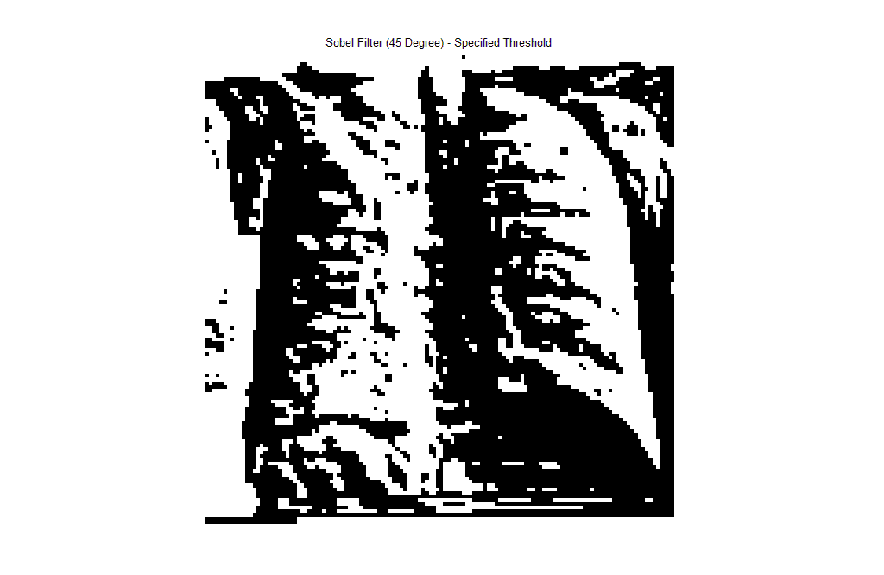

Figure 7.5 : (a) After applying Sobel filter to detect edges at +45 degree

ROBERT FILTER: When edge based Robert filter was applied to original image the results found were even more deteriorated than that of sobel filter. Therefore no meaningful edge, no region can be inferred from the output. Hence Robert operator is not suitable for sample image taken. Output displaying effect of Robert filter on sample image is shown below in figure 7.5 (b):

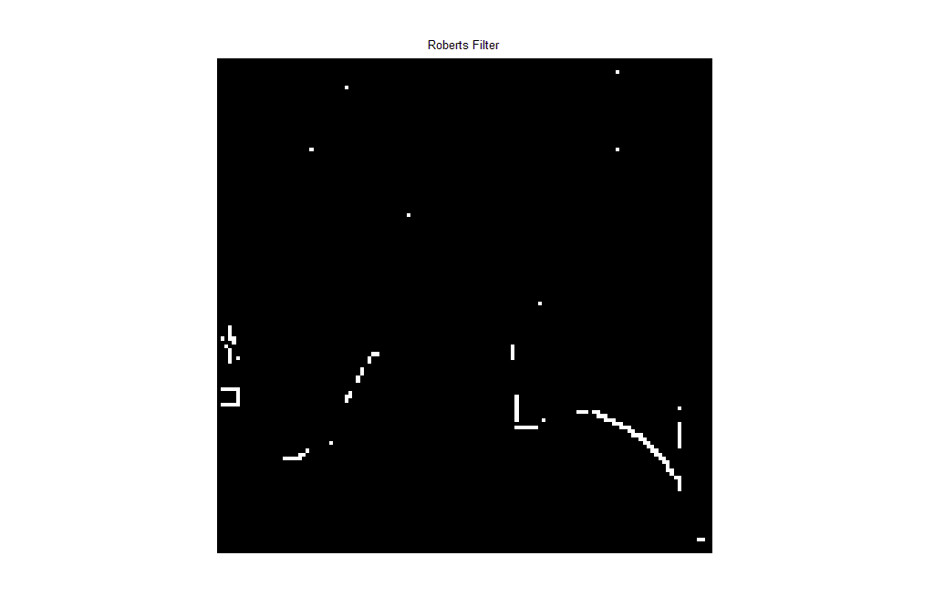
Figure 7.5(b): Robert filter for edge detection

Thresholding is another approach to perform segmentation of an image. Generally thresholding is used to reduce effect of noise. It is very difficult to decide a proper threshold value. In this work various thresholding methods were implemented including local and global methods namely Otsu’s method, iterative method.
Due to the various types of images that might need to be segmented, it is determined that this threshold value needed to be adaptive in some way. Very noisy images were coming up with too many edge points that were false, while very smooth or sparse images might no have enough edge points to create the enclosed areas necessary to grow regions. Thus, iteratively adjusting the threshold up or down accordingly until the number of edge pixels in the edge-detected image fit into this range. This worked well for most images, again leaving trouble for particularly sparse images like the sample image under consideration. Later in this chapter results are shown to display suitability of these thresholding methods on some example images. The algorithm is totally adaptive and can be applied to variety of input images and the results varied as per image content. Result of applying iterative thresholding method on sample X-ray image is shown below (figure 7.6), as it can be seen spot can not be distinguished in output. Threshold was iteratively computed as 0.5280

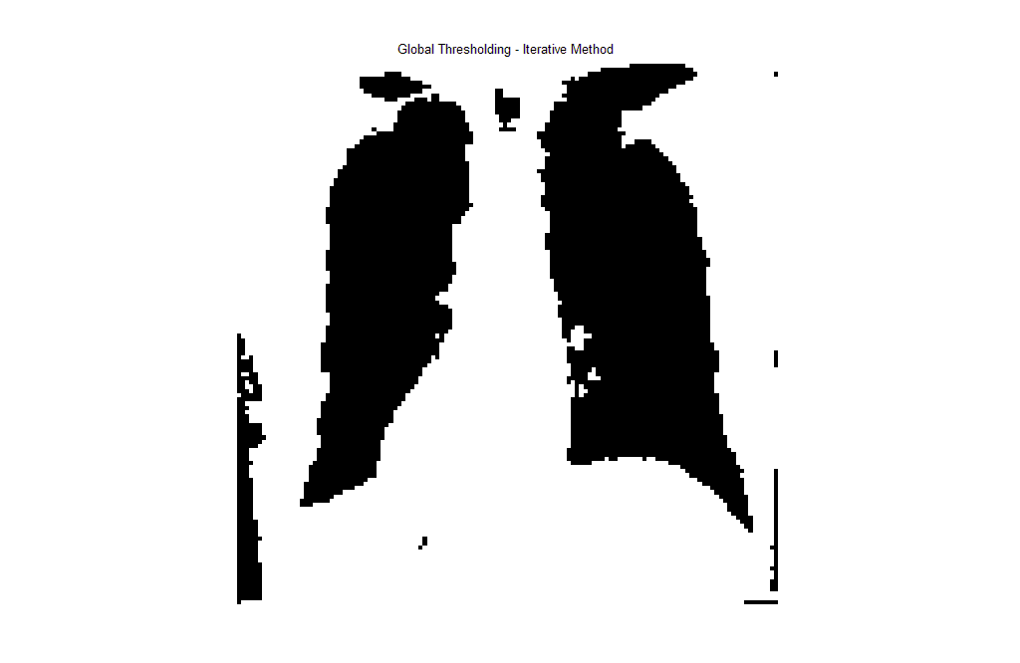
Figure 7.6 : Iterative method for thresholding with t= 0.5280

Result of applying Otsu’s global thresholding to sample is shown below (figure 7.7), this result is obtained with threshold value was automatically computed to 0.6784 by Otsu’s method, which chooses the threshold to minimize the intra class variance of the thresholded black and white pixels.

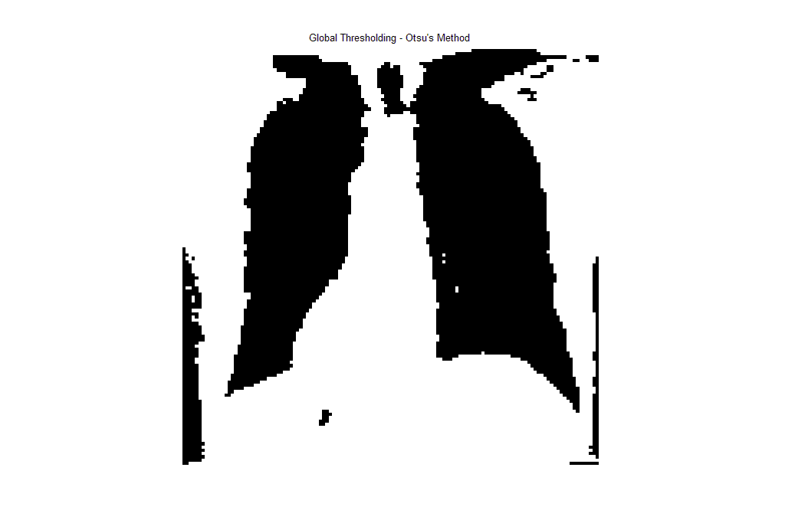

Figure 7.7 : Otsu’s method for global thresholding with
threshold computed as 0.06784

Output obtained by applying local thresholding method is shown in figure 7.8, here value of threshold being computed was 0.0784. in which top hat filtering is applied on input image top hat filtering can be used to correct uneven illumination when thebackground is dark. The result of local thresholding was almost a black image for this sample, as shown below. Hence this segmentation method is not suitable for this kind of images.
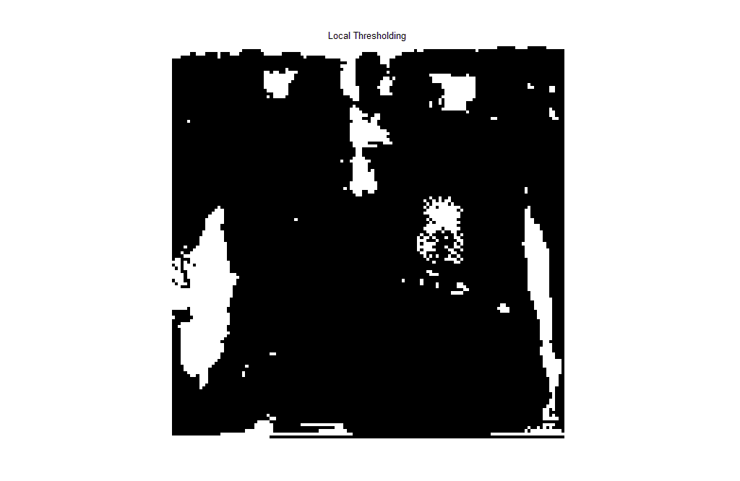
Figure 7.8: Local thresholding method with threshold value 0.0784

WATERSHED TRANSFORM : On applying watershed transform to sample image following is the result obtained (shown in figure7.9), this also is not highlighting the cancerous spot. Hence not suitable for such requirement.

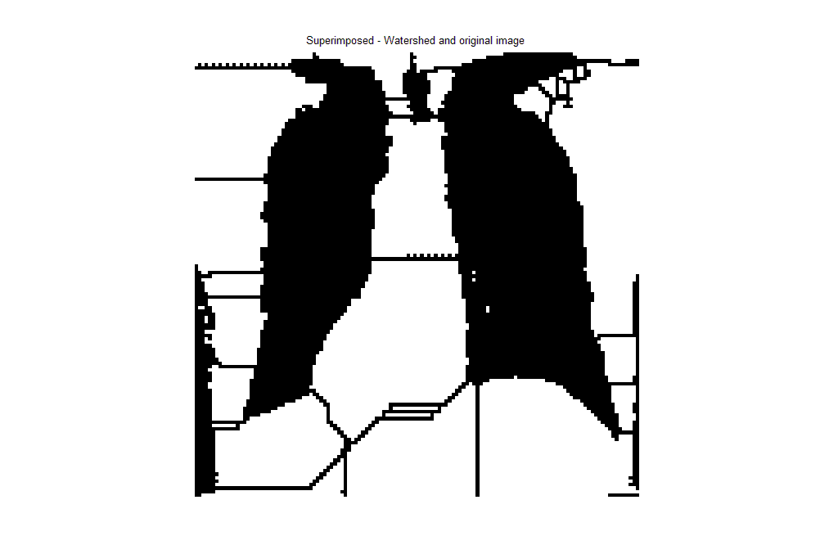
Figure 7.9: superimposed watershed and original image
The HOUGH TRANSFORM is a feature extraction technique used in digital image processing. The classical transform identifies lines in the image, but it has been extended to identifying positions of arbitrary shapes. Hough transform also has noise problem but it is less affected by random noise than other algorithms because it looks for a specific shape. It is very vulnerable to complicated and noisy image. Hough transform is a time-cost algorithm.

Hough transform was developed to detect a specific shape. Not like other edge detecting algorithms, it looks for already chosen or designed shape in an image. Therefore, its advantage is it can specify a desired useful shape. But it has difficulty of defining the specific shape equation in mathematic expression. As the searching shape is more complicated, it is more difficult to find the shape because the equation of that shape will have more parameters. Implementing this technique on sample image shows the following output in figure 7.10, it is observed fails to highlight spot.
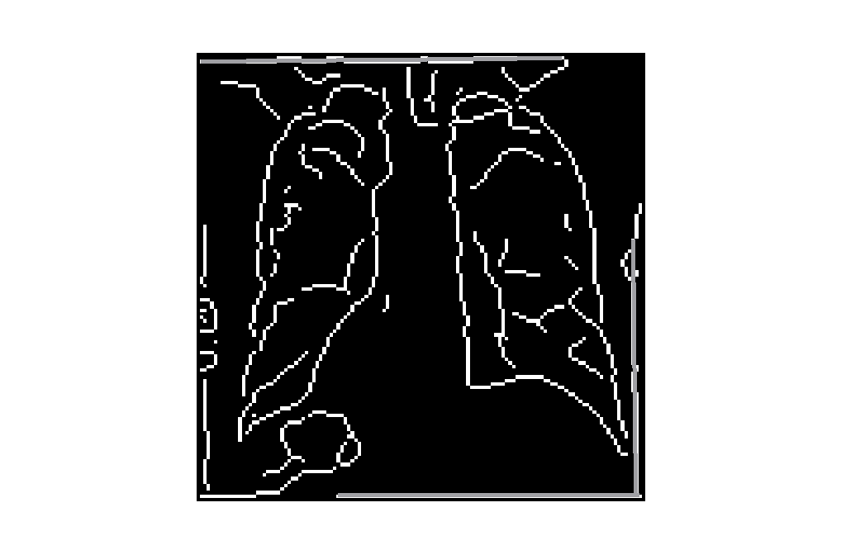
Figure 7.10 : Applying hough transform to original image

In nut-shell, all tested segmentation algorithms (Sobel, Prewit, Robert, Log, and Canny filter) have a common disadvantage to noise. Noise effect weakens almost in all algorithms. This means that preprocessing to remove or reduce noise effect must be required. Depending on image characteristics, some images give acceptable results with traditional methods which are relatively simple, in such cases there is trade off between time taken and output quality.

7.4 ILLUSTRATION OF VARIOUS ASPECTS OF SEGMENTATION RESULTS

As discussed in the previous section a trade off is required between the meaningful image output segmentation, quality of image, complexity of algorithm and processing time. For example , say image of an gear in which edges are sharply defined as shown in figure 7.11.


Figure 7.11 : Original image of gear

- After applying Laplacian of Gaussian the output obtained is shown below. As it can be seen from figure 7.12, that gears are detected successfully. This is due to well defined shape of gears, no blurriness and lack of noise in image, but the edges produced are very thin, (which is not of concern in this work but if tried filling the enclosed regions, many of the regions may end up bleeding together.)Result of applying LoG to original gears image is in figure 7.12 below :
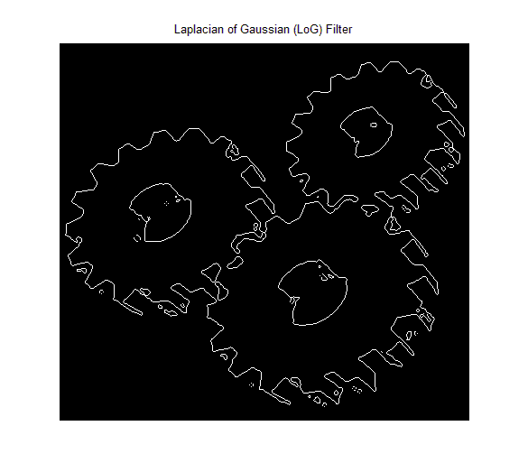
Figure 7.12: Applying Laplacian of Gaussian (LoG) filter

When same gear image was subjected to active contour level set method, a very fine contour spanning all teeth of gears was formed as shown in figure 7.13
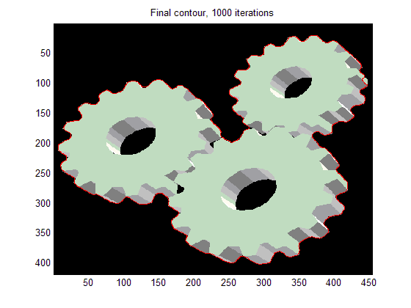
Figure 7.13 : applying active contour on original image
- Now, the following resulting figure 7.14 shows successive steps of implemented active contour model. It displays initial contour and also how contour evolves, its relative shape at 300 iterations ,450 iterations and finally it merges to boundary of constituent object in an image after 500 iterations.

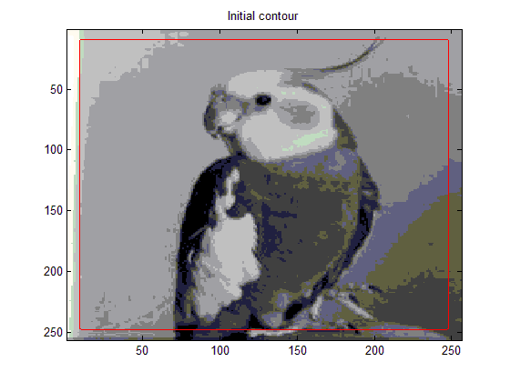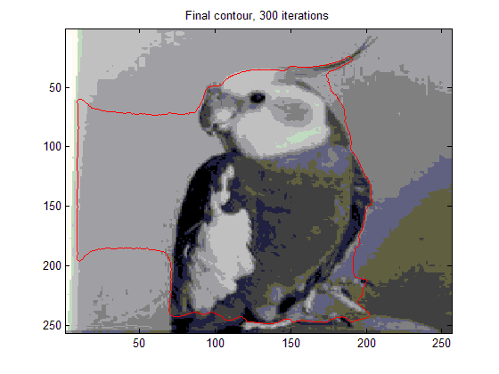

Figure7.14: image of parrot with contour at different stages of evolution
(a) The initial contour (b) after 300 iterations

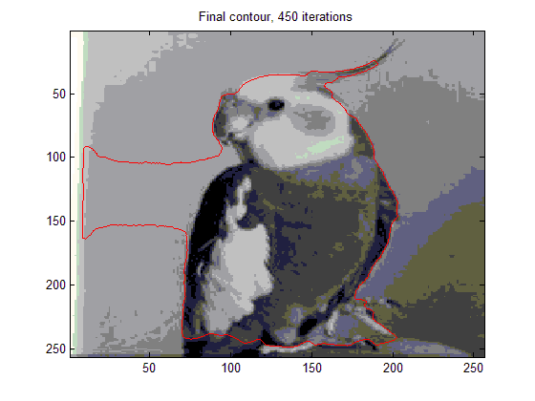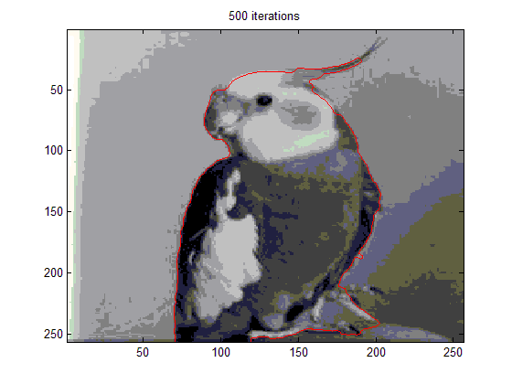
(c ) after 450 iterations (d) after 500 iterations

For this image, we used the parameters λ =5.0, µ =0.04, ν =3.0, and time step t =5.0, which is significantly larger than the time step used for traditional level set methods. The curve evolution takes 500 iterations.

- Consider another experimental result in which an image constituting many objects (as the one in figure 7.15(a) is subjected to active contour model. This result shows that the region of interest can also be selectively highlighted using this work. As shown in figure 7.15 (b) below one object of interest specified by user dynamically is identified and highlighted by contour.

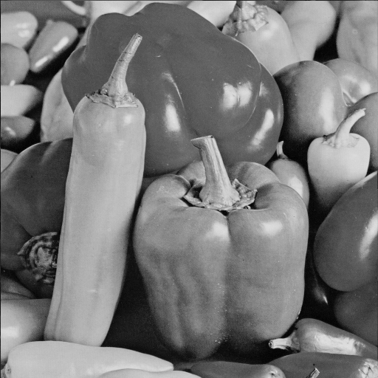

Figure 7.15 (a): Original Image (having many constituent objects)
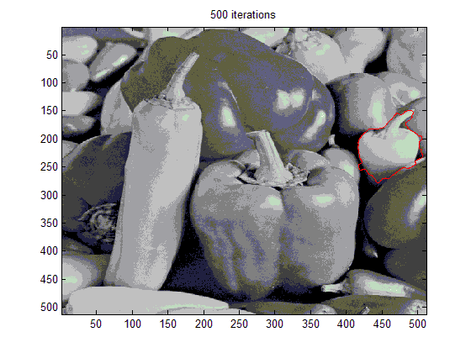
Figure 7.15 (b): Applied active contour to select ROI
- Effect of active contour model parameters has impact on the way contour evolves and also the final contour shape. Hence it decides how well output image will be segmented, as shown below in figure 7.16 is segmentation of acceptable quality
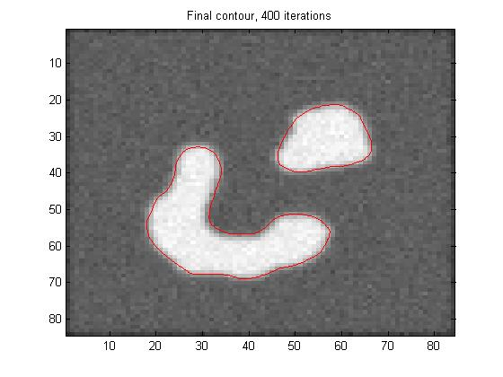
Figure 7.16: Image obtained using parameters ν = 1.5 and λ = 5
Next is result obtained by increasing and decreasing value of λ while keeping ν= 1.5 are shown in figure 7.17 (a&b).
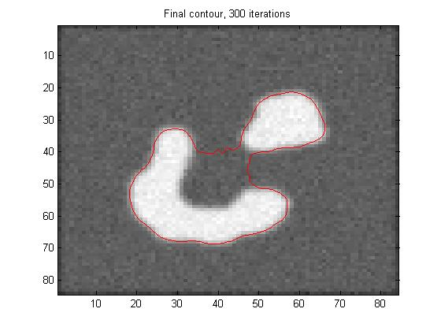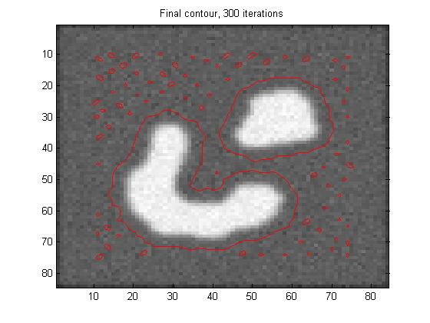
Figure 7.17 segmentation result (a): using λ = 10 (b) using λ = 0.01
It can be observed as value of lambda is increased it results under segmentation and it is decreased it results in over segmentation. Experimentally it was deduced that segmentation is of acceptable quality at λ = 5.

Now results obtained by varying ν to a lower and higher value with respect to 1.5 and keeping λ=5 are shown in figure 7.18 (a & b)

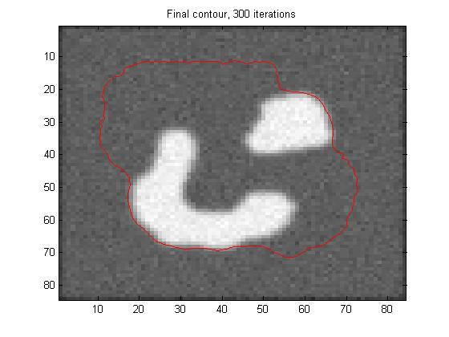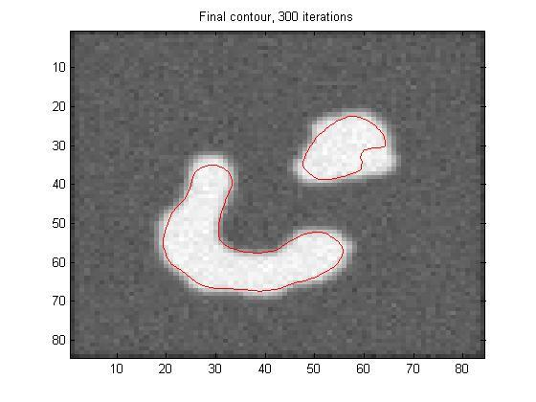
Figure 7.18 segmentation results (a ): using ν = 0.05, λ=5(b) using ν = 9.5 and λ = 5
It was observed that one should choose smaller value of ν if there are weak object boundaries in image for example ν = 1.5 is chosen, as shown in figure 7.16, for distinguishing two constituent object with blur boundaries. It may be increased to 3 if input image have more sharp boundaries in order to fasten contour evolution. ν can be positive or negative, depending on the relative position of the initial contour to the object of interest. λ and ν may also be varied simultaneously to observe variations in the output with respect to quality of segmentation.
------------------------------------------------------------------------------------------------

CONCLUSION & SCOPE OF FURTHER WORK

CONCLUSION

In this work, a variational level set formulation that completely eliminates the need of the re-initialization is implemented. The presented level set method can be easily implemented by using simple finite difference scheme and is computationally more efficient than the traditional level set methods. In this method, significantly larger time step can be used to speed up the curve evolution, while maintaining stable evolution of the level set function. Moreover, the level set function is no longer required to be initialized as a signed distance function. A region-based initialization of level set function is implemented, which is not only computationally more efficient than computing signed distance function, but also allows for more flexible applications. Also edge based traditional methods are also implemented. The performance of the presented algorithm using synthetic and real images is demonstrated, and in particular its robustness to the presence of weak boundaries and strong noise and in comparison with other edge based methods.

SCOPE OF FURTHER WORK

The mid-level processing, which involves segmentation, is considered as image analysis or image understanding, which is accomplished in this work. This work may be extended to perform high-level processing, which involves ‘making sense’ of an ensemble of recognized objects and performing the cognitive functions at the far end of the processing continuum, is considered as computer vision. Such as, consider a database consisting of number of images meant for human face recognition. The aim is to first highlight the face of the person that we are trying to match from a crowded image and then extract features of that region that enables us to match it with images stored in database hence confirming the identity of person. In this problem, interesting feature would be that, irrespective of angle at which image is captured matching with static image in database is to be performed. Hence captured image is to be preprocessed in specific manner to enhance matching. An example of this application can be to identify terrorist in crowded image taken by CCTV cameras installed at public places.
References
[1] R. Gonzales and R. Woods, Digital Image Processing. Prentice Hall, 2nd ed.,
2001.
[2] T. Fukuda, Y. Morimoto, S. Morishita, and T. Tokuyama, “Theory of
communication,” ACM Transactions on Database Systems, vol. 26, no. 2, pp. 179–213, 2001.
[3] M. Kass, A. Witkin, and D. Terzopoulos, “Snakes, active contour model,”
International Journal of Computer Vision, pp. 321–331, 1988.
[4] S. Osher and J. Sethian, “Fronts propagating with curvature dependent speed:
Algorithms based on hamilton-jacobi formulations,” Journal of Computationl Physics, pp. 12–49, 1988.
[5] J. Canny, “A computational approach to edge detection,” IEEE Transactions on
Pattern Analysis and Machine Intelligence, no. 8, p. 769, 1986.
[6] T. Chan, B. Sandberg, and L. Vese, “Active contours without edges for vector-
valued images,” Journal of Visual Communication and Image Representation, pp. 130–141, 2000.
[7] G. Sapiro and D. L. Ringach, “Anisotropic diffusion of multivalued images with
applications to color filtering,” IEEE Transactions on Image Processing, vol. 5, pp. 1582–1586, 1996.
[8] M. Dallwitz, “Introduction to computer images.” http://biodiversity.uno.edu/
delta/www/images.htm, April 1998.
[9] “Wikipedia, the free encyclopedia.” http://www.wikipedia.org, 2004.
[10] T. Chan and L. Vese, “Active contours without edges,” IEEE Transactions on
Image Processing, no. 2, pp. 266–277, 2001.
[11] M. Rousson and R. Deriche, “A variational framework for active and adaptive
segmentation of vector valued images,” in Proc. of IEEE Workshop on Motion and Video Computing, 2003.
[12] R. Gonzales and R. Woods, Digital Image Processing. Addison-Wesley
Publishing, 1st ed., 1993.
[13] B. Fisher, S. Perkins, A. Walker, and E. Wolfart, “Hypermedia image
processing reference: Digital filters.http://www.cee.hw.ac.uk/filtops.html,1994.

REFERENCES

[14] D. Marr and E. Hildreth, “Theory of edge detection,” in Proc. of Roy. Soc.,
(London), pp. 187–217, 1980.
[15] B. Green, “Edge detection tutorial.” ttp://www.pages.drexel.edu/weg22/edge.
html, 2002.
[16] E. Trucco and A. Verri, Introductory Techniques for 3-D Computer Vision.
Prentice Hall, 1998.
[17] B. Green, “Canny edge detection tutorial.” http://www.pages.drexel.edu”, 2002.
[18] A. Jain, Fundamentals of Digital Image Processing. Prentice Hall Information
and System Sciences Series, Prentice Hall, 1989.
[19] C. Brice and C. Fennema, Computer Method in Image Analysis, ch. Scene
Analysis using Regions. Los Angeles: IEEE Computer Society, 1977.
[20] S. Zhu and A. Yuille, “Region competition: Unifying snakes, region growing,
and bayes/MDL for multiband image segmentation,” IEEE Transactions on Pattern Analysis and Machine Intelligence, no. 9, pp. 884–200, 1996.
[21] S. Zhu and A. Yuille, “Region competition and its analysis: a unified theory for
image segmentation,” Tech. Rep. 7, Robotics Lab, Havard University, 1995.
[22] K. Fu, R. Gonzales, and C. Lee, Robotics: Control, Sensing, Vision, and
Inteligence. New York: McGraw-Hill, 1987.
[23] W. Snyder and H. Qi, Machine Vision. Cambridge University Press, 2004.
[24] J. Silverman and D. Cooper, “Bayesian clustering for unsupervised estimation
of surface and texture models,” IEEE Transactions on Pattern Analysis and Machine Intelligence, vol. 57, pp. 373–387, May 1993.
[25] M. LaValle and S. Hutchinson, “A bayesian segmentation methodology for
parametric image models,” IEEE Transactions on Pattern Analysis and Machine Intelligence, vol. 17, pp. 211–217, February 1995.
[26] Y. Han, W. Snyder, and G. Bilbro, “Discontinuity-preserving vector smoothing
of multivariate mr images using vector mean field annealing,” Journal of Mathematical Imaging and Vision, vol. 9, no. 3, pp. 199–212, 1998.

REFERENCES

[27] G. Bilbro and W. Snyder, “Range image restoration using mean field
annealing,” in Advances in Neural Information Processing Systems, vol. 2, pp.
594–601, 1989.
[28] D. Geman and S. Geman, “Stochastic relaxation, gibbs distributions and
bayesian restoration of images,” IEEE Transactions on Pattern Analysis and Machine Intelligence, vol. 6, pp. 721–741, November 1984.
[29] P. Perona and J. Malik, “Scale-space and edge detection using anisotropic
diffusion,” IEEE Transactions on Pattern Analysis and Machine Intelligence, vol. 12, no. 7, 1990.
[30] G. Gerig, O. Kubler, R. Kikinis, and F. Jolesz, “Nonlinear anisotropic filtering
of mri data,” IEEE Transactions on Medical Imaging, vol. 11, pp. 221–232, June 1992.
[31] W. Snyder, Y. Han, G. Bilbro, R. Whitaker, and S. Pizer, “Image relaxation:
Restoration and feature extraction,” IEEE Transactions on Pattern Analysis and Machine Intelligence, vol. 17, pp. 620–624, June 1995.
[32] W. Snyder, A. Logenthiran, P. Santago, K. Link, G. Bilbro, , and S. Rajala,
“Segmentation of magnetic resonance images using mean field annealing,” Image and Vision Computing, vol. 10, pp. 362–368, July 1992.
[33] W. Snyder, Y. Han, G. Bilbro, R. Whitakar, and S. Pizer, “Unified theory of
edge-preserving smoothing,” in Proc. of International Conference on Artificial Neural Networks, (U.K.), September 1992.
[34] M. Symonds, W. Snyder, and P. Santago, “Segmentation of phase-coded mr
images using the mean field annealing,” in Proc. of Symposium for Computer Assisted Radiology, (Baltimore), pp. 398–404, 1992.
[35] I. Abdelqader, S. Rajala, W. Snyder, and G. Bilbro, “Energy minimization
approach to motion estimation using mean field annealing,” Signal Processing, vol. 28, pp. 291–309, September 1992.

REFERENCES

[36] G. Bilbro, W. Snyder, S. Garnier, and G. Gault, “Mean field annealing, a
fromalism for constructing gnc-like algorithms,” IEEE Transactions on Neural Networks, vol. 3, pp. 131–138, January 1992.
[37] G. Bilbro, W. Snyder, and R. Mann, “Mean field approximation minimizes
relative entropy,” Journal of the Optical Society of America (A), vol. 8,
February 1991.
[38] J. Zerubia and R. Chellappa, “Mean field approximation using compound
gauss-malkov random field for edge detection and image restoration,” in Proc. of IEEE International Conference on Acoustics, Speech, and Signal Processing, pp. 2193–2196, 1990.
[39] G. Bilbro, R. Mann, T. Miller, W. Snyder, D. Vout, and M. White,
“Optimization by mean field annealing,” in Advances in Neural Information Processing Systems (Touretzky, ed.), vol. 1, pp. 91–98, 1988.
[40] Y. Han and W. Snyder, “Adaptive edge-preserving smoothing via adaptive
mean field annealing,” in Proc. of SPIE International Symposium on Optical Applied Science and Engineering, vol. 1766, 1992.
[41] G. Bilbro and W. Snyder, “Optimization of functions with many minima,”
IEEE Transactions on System, Man, and Cybernetics, vol. 21, pp. 840–849, July 1991.
[42] S. Kirkpatrick, C. Gelatt, and M. Vecchi, “Optimization by simulated
annealing,” Science, vol. 220, pp. 671–680, May 1983.
[43] G. Bilbro and W. Snyder, “Mean field annealing, an application to image noise
removal,” Journal of Neural Network Computing, Fall 1990.
[44] Hiriyannaiah, G. Bilbro, and W. Snyder, “Restoration of locally homogeneous
images using mean field annealing,” Journal of the Optical Society of America (A), vol. 6, pp. 1901– 1912, December 1989.
[45] A. Chakraborty, S. Lawrence, and J. Duncan, “Deformable boundary finding
influenced by region homogeneity,” in Proc. of IEEE Conference on Computer Vision and Pattern Recognition, pp. 624–627, 1994.

REFERENCES

[46] A. Chakraborty, S. Lawrence, and J. Duncan, “an integrated approach to
boundary finding in medical images,” in Proc. of IEEE Workshop on Biomedical Image Analysis, pp. 13– 22, 1994.
[47] J. Roerdink and A. Meijster, “The watershed transform: Definitions, algorithms,
and parallel strategies,” Fundamenta Informaticae, vol. 41, pp. 187–228, 2000.
[48] S. Beucher and C. Lantuejoul, “Use of watershed in contour detection,” in Proc.
of International Workshop in Image Processing, Real-time Edge and Motion Detection/Estimation, (Rennes, France), September 1979.
[49] G. Ederra, “Mathematical morphology techniques applied to anti-personnel
mine detection,” 1999, Dept. of Electronics and Information Processing, Vrije Universiteit Brussel, Belgium, 1999.
[50] S. Beucher, “The watershed transformation applied to image segmentation,” in
Proc. of Conference on Signal and Image Processing in Microscopy and Microanalysis, (Cambridge, UK), pp. 299–314, September 1991.
[51] F. Meyer and S. Beucher, “Morphology segmentation,” Journal of Visual
Communication and Image Representation, vol. 1, no. 1, pp. 21–46, 1990.
[52] S. Beucher, “The watershed transformation.” http://cmm.ensmp.fr/beucher/wtshed.
[53] H. Heijimans, Morphological Image Operators. Boston: Academic Press, 1994.
[54] J. Rivest, P. Soille, and S. Beucher, “Morphological gradients,” Journal of
Electronic Imaging, vol. 2, December 1993.
[55] E. Dougherty, Mathematical Morphology in Image Processing. Optical
engineering, New York: Marcel Dekker, 1993.
[56] J. Haddon and J. Boyce, “Image segmentation by unifying region and boundary
information,” IEEE Transactions on Pattern Analysis and Machine Intelligence, vol. 12, no. 10, pp. 929–948, 1990.
[57] T. Pavlidis and Y. Liow, “Integrating region growing and edge detection,”
IEEE Transactions on Pattern Analysis and Machine Intelligence, vol. 12, no. 3, pp. 225–233, 1990.

REFERENCES

[58] H. Nguyen, M. Worring, and R. Boomgaard, “Watersnakes: Energy-driven
watershed segmentation,” IEEE Transactions on Pattern Analysis and Machine Intelligence, vol. 25, pp. 330–342, March 2003.
[59] D. Gabor, “Theory of communication,” Journal of IEE, vol. 93, pp. 429–457,
1946.
[60] F. Campbell and J. Robson, “Application of fourier analysis to the visibility of
gratings,” Journal of Physiology, pp. 551–566, 1968.
[61] T. Weldon and W. Higgins, “Designing multiple gabor filters for multitexture
image segmentation,” SPIE Optical Engineering, vol. 38, pp. 1478–1489, September 1999.
[62] D. Dunn, W. Higgins, and J. Wakeley, “Texture segmentation using 2-d gabor
elementary functions,” IEEE Transactions on Pattern Analysis and Machine
Intelligence, vol. 16, pp. 130–149, February 1994.
[63] A. Jain and F. Farrokhnia, “Unsupervised texture segmentation using gabor
filters,” Pattern Recognition, vol. 23, pp. 1167–1186, 1991.
[64] A. Jain and F. Farrokhnia, “Unsupervised texture segmentation using gabor
filters,” in Proc. of IEEE International Conference on Systems, Man, and Cybernetics, 1990.
[65] K. Hammouda and E. Jernigan, “Texture segmentation using gabor filters,”
tech. rep., University of Waterloo.
[66] M. Unser, “Texture classification and segmentation using wavelet frames,”
IEEE Transactions on Image Processing, vol. 4, pp. 1549–1560, 1995.
[67] S. Mallat, “Multiresolution approximations and wavelet orthonormal bases of
L2(R),” Transactions of the American Mathematical Society, vol. 315, pp. 69–87, 1989.
[68] J. Aujol, G. Aubert, and L. Blanc-Feraud, “Supervised classification for
textured images,” Tech. Rep. 4640, INRIA, 2002.
[69] D. Young, “Active contour models (snakes).”
http://www.cogs.susx.ac.uk/users/davidy/teachvision/vision7.html,March 1995.

REFERENCES

[70] N. Ray, S. Acton, T. Altes, E. de Lange, and J. Brookeman, “Merging parametric active contours within homogeneous image regions for MRI-based lung segmentation,” IEEE Transactions on Medical Imaging, no. 2, pp. 189–199, 2003.
[71] J. Sethian, “Tracking interfaces with level sets,” American Scientist, vol. 85, no. 3, 1997.
[72] J. Sethian, Level Set Methods. Cambridge Monographs on Applied and Computational Mathematics, Cambridge University Press, 1st ed., 1996.
[73] T. Chan and L. Vese, “Active contours without edges,” Tech. Rep. 9853, Computational Applied Math Group, UCLA, 1998.
[74] L. Evans and R. Gariepy, Measure Theory and Fine Properties of Functions. Boca Raton, Florida: CRC Press, 1992.
[75] H. Zhao, T. Chan, B. Merriman, and S. Osher, “A variational level set approach to multiphase motion,” Journal of Computational Physics, vol. 127, pp. 179–195, 1996.
[76] L. Vese and T. Chan, “A multiphase level set framework for image segmentation using the mumford and shah model,” International Journal of Computer Vision, no. 3, pp. 271–293, 2002.
[77] J. Sethian, Level Set Methods and Fast Marching Methods. Cambridge Monographs on Applied and Computational Mathematics, Cambridge University Press, 2nd ed., 1999.
[78] R. Malladi and J. Sethian, “Image processing via level set curvature flow,” in Proc. of National Academy of Science, pp. 7046–7050, 1995.
[79] S. Osher and R. Fedkiw, Level set methods and dynamic implicit surfaces, vol. 153 of Applied mathematical sciences. New York: Springer, 2003.
[80] S. Osher and R. Fedkiw, “Level set methods: an overview and some recent results,” Journal of Computationl Physics, no. 2, pp. 463–527, 2001.
[81] V. Caselles, F. Catte, T. Coll, and F. Dibos, “A geometric model for active contours,” Numerische Mathematik, p. 19, 1993.

REFERRENCES

[82] R. Malladi, J. Sethian, and C. Vemuri, “Shape modeling with front propagation: a level set approach,” IEEE Transactions on Pattern Analysis and Machine Intelligence, no. 2, pp. 158–175, 1995.
[83] F. Cohen and D. Cooper, “Maximum likelihood unsupervised textured image segmentation,” Computer Vision, Graphics, and Image Process, vol. 54, pp. 239–251, May 1992.
[84] V. Caselles, R. Kimmel, and G. Sapiro, “Geodesic active contours,” International Journal of Computer Vision, no. 1, pp. 61–79, 1997.
[85] V. Caselles, R. Kimmel, and G. Sapiro, “Geodesic active contours,” in Proc. of IEEE International Conference on Computer Vision, p. 694, 1995.
[86] S. Kichenassamy, A. Kumar, P. Olver, A. Tannenbaum, and A. Yezzi, “Gradient flows and geometric active contour models,” in Proc. of IEEE International Conference on Computer Vision, pp. 810–815, 1995.
[87] A. Yezzi, S. Kichenassamy, and A. Kumar, “A geometric snake model for segmentation of medical imagery,” IEEE Transactions on Medical Imaging, no. 2, pp. 199–209, 1997.
[88] G. Sapiro, “Color snakes,” Computer Vision and Image Understanding, no. 2, pp. 247– 253, 1997.
[89] G. Sapiro, “Color snakes,” Tech. Rep. 113, Hewlett-Packard Labs, 1995.
[90] G. Aubert and L. Blanc-Feraud, “Some remarks on the equivalence between 2d and 3d classical snakes and geodesic active contours,” International Journal of Computer Vision, no. 1, pp. 19–28, 1999.
[91] Proceedings of the 2005 IEEE Computer Society Conference on Computer Vision and Pattern Recognition (CVPR’05) 1063-6919/05 $20.00 © 2005 IEEE
[92] V. Caselles, F. Catte, T. Coll, and F. Dibos, “A geometric model for active contours in image processing”, Numer. Math., vol. 66, pp. 1-31, 1993.
[93] V. Caselles, R. Kimmel, and G. Sapiro, “Geodesic active contours”, Int’l J. Comp. Vis., vol. 22, pp. 61-79, 1997. [94] R. Malladi, J. A. Sethian, and B. C. Vemuri, “Shape modeling with front propagation: a level set approach”, IEEE Trans. Patt. Anal. Mach. Intell., vol. 17, pp. 158-175, 1995.

