Reduction in Production Time of Main Wiring Harness for Two Wheelers

A Dissertation submitted in partial fulfillment
Of the award of Degree of

Master of Engineering

in

Production Engineering

Submitted by
Alka Sharma
University Roll No. 10251

Under the Supervision of
Dr. (Mrs.) REETA WATTAL

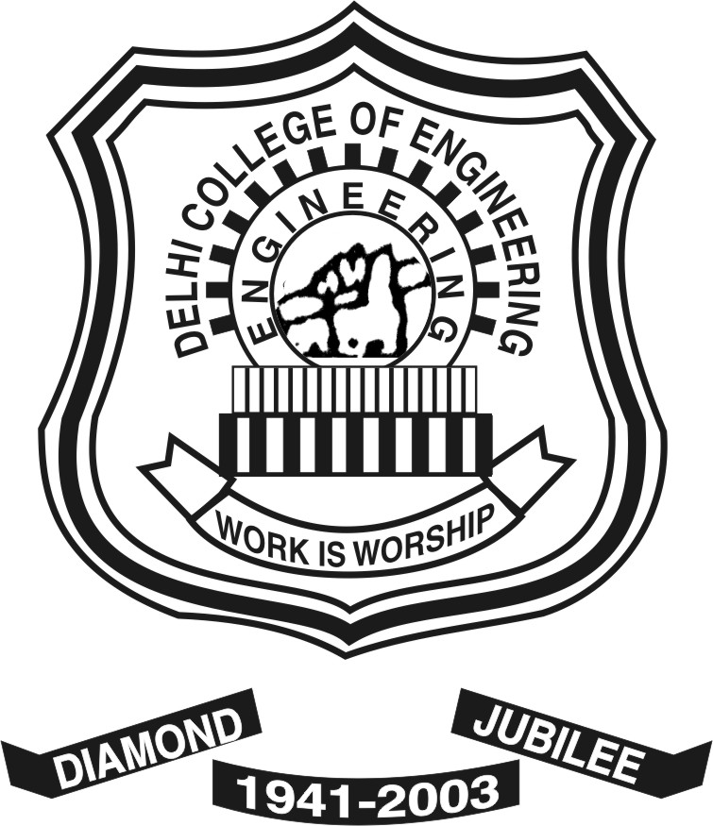

Department of Mechanical Engineering
Delhi College of Engineering, Delhi
June'2008

