Chapter 1
Introduction
1.1 Introduction:
The globalization of Indian economy is creating both opportunities and challenges for innovative enterprises, forcing them to make radical improvements, not only to compete and prosper, but also to survive. In present industrial scenario more and more firms are targeting higher level of globalization and thus cutthroat competition emerging as the single most challenge to be met by the firms and hence by the strategies adopted by the firms for it.
There are organizations, which face competition quite successfully. They are able to maintain their market leadership and market share. In spite of increasing competition, these organizations maintain consistency in results. On the other hand, there are examples of failures of companies, which were market leaders at some point of time. So the question arises, what is the reason that some companies are successful in the market and they maintain this? Why some companies fail, in spite of good products? To be very particular, why hero Honda is so successful? Is it only the product, which makes the difference or there are other factors also? Maruti has maintained its leadership. It adopted itself quite successfully for the changing conditions by implementing strategies to face competition. It becomes very important to manage the activities precisely, improve continuously, and then to compete vigorously.
Now a day, customer is the king and those who do not understand the languages of the market or those who do not adopt strategies to meet challenges are prone to failures.
Though there can be numerous causes for failure, but one of the most important reasons seems to be lack of an appropriate and dynamic continuous improvement. Strategies could have been formulated to meet the situation. Lack of proper and timely improvement in the processes and their control with respect to dynamic external environment of the firm might be an important cause of failure of any firm. There are thousands of variables affecting the activities of a company and thus to ensure achievement of the goals, proper evaluation of various activities, their control and continuous improvement; a proper and dynamic process improvement is a necessity for a company, which should be specifically designed for it.
A good manager keeps track of the continually improving product and the processes. His/her staffs carrying responsibility for certain activities within the system need continuous improvement to see how well they are performing their task. This also holds the employees actually executing the various process steps. So continuous improvement is important for everyone inside an organization.
In fact, improvement should be a proactive task of management, not simply a reaction to problems and competitive treats. Organization should also consider improving employee morale, satisfaction, and cooperation; improving managerial practices; improving processes; improving the design of the products with features that better meet customers’ needs, and which achieve higher performance, higher reliability, and other market driven dimensions of quality; and improving the efficiency of manufacturing systems by reducing worker idle time, and unnecessary motions, and by eliminating unnecessary inventory, unnecessary transportation and material handling, and scrap and rework.
The concept of continuous improvement was conceived and developed in the United States, yet it is often cited as the most important difference between Japanese and Western management.
The high competitiveness of modern industry leads companies to a continuous refinement of their manufacturing processes. Time and motion studies and continuous quality improvement programs are very useful tools in the improvement of any manufacturing systems.
In the present day world economy, where the whole world is now considered as a global village, all organizations operating at global level are prone to failure due to varying market pressure of different types and different levels and at different places. They need to work strategically, and working towards continuous improving the system, manufacturing processes to meet the ever increasing competition as well as changing business environment in every part of the world.

  - Importance of Continuous Improvement:
Continuous Improvement is used to denote the process of focused and systematic incremental changes that are aimed at small step improvements, and to a large extent rely on employee participation.
Continuous improvement in a management context means a never-ending effort to expose and eliminate root causes of problems. Usually, it involves many incremental or small-step improvements rather than one overwhelming innovation.
From a Japanese perspective continuous improvement is the basis for their business culture. Continuous improvement is a philosophy, permeating the Japanese culture, which seeks to improve all factors related to the transformation process (converting inputs into outputs) on an ongoing basis. It involves everyone, management and labor, in finding and eliminating waste in machinery, labor, materials and production methods.
Bond (1999) discusses a very important issue i.e. the role of performance measurement in continuous improvement. He suggests that approaches like Japanese-style Kaizan continuous improvement. JIT and radical reengineering etc. have their own characteristics which should be taken into account when determining performances metrics and designing approaches to process monitoring and control.
Performance measurement is a management tool that helps to measure the performance and provides a feedback to the organization on its activities. It’s an important part of the feedback approach system.
The most recognizable characteristic of world-class manufacturers is their ability to adapt quickly to changing customer and market requirement and to get their new products designed, produced and delivered to the customers better and faster than their competitors. The current challenge for all manufacturers is to regain and maintain a competitive advantage. To meet the challenges, various philosophies and approaches for managing manufacturing and technology are required. The philosophy focuses first and foremost on continual improvement to achieve world class manufacturing status.
  - Motivation for this Research:
In recent years all the companies have experienced the need for retaining the customer base in dynamically changing markets by offering better performance than their competitors. As the companies graduate from the supplier driven market to the consumer driven markets, we need to optimize the processes rather than best practices status.
The purpose of this research is to explore the various aspects of continuous improvement that are useful to understand and design continuous improvement for an organization. To review the work done in this field by researchers around the world and then to study the situation in India by doing a case study of a big Auto ancillary. The study has been done at Napino Auto & Electronics Ltd., manufacturer of main wire harnesses for two wheelers.
  - 1.4 Aims and Objectives of the present research:
Following are the objectives of this study:
- To study the existing Production line, raw material distribution of the organization.
- Identifying the problems existing with the current system.
- Implementation of ABC analysis
- Implementation of pareto analysis.
- Establishing the problem (data collection)
- Implementation of fish bone diagram, why-why analysis, finding the root cause
- Developing solutions, implementation,
- Achievement after improvement
  - Organization of the Report:
The thesis is organized into seven chapters. A brief outline of the chapters is given as under:
Chapter 1:
Chapter 1 deals with the Introduction, historical, importance of Continuous Improvement, motivation of the research. The research problem, aims and objectives are spelt out. It also describes the organization of the Thesis.
Chapter 2:
Chapter 2 gives a critical review of the literature on Continuous Improvement, Performance Measurement in CI and influencing factors. Literature review is carried out to identify research efforts and directions related to the focal area of this thesis. The chapter briefly describes the key conclusions of research papers of various authors with topic related to this project.
Chapter 3:
Chapter 3 deals with the present production system of an automobile company with an overview to the product and the company profile.
Chapter 4:
Chapter 4 analyzes the existing system and deals with the investigation of the problem. This chapter suggests the solution. Different tools are used for the solution of the problem.
Chapter 5:
Chapter 5 deals with the improvements. This chapter summarizes production improvement, cost saving, increase in capacity.
Chapter 6:
Chapter 6 deals with the continuous improvement, concept of world-class manufacturing, various tools and techniques.

Chapter 7:
Chapter 7 summarizes the conclusions, contribution of present research and future scope of work. One of the major conclusion of this complete study was that Continuous improvement provides ample scope for cost reduction and increase productivity can ensure a improve production system.
1.6 Concluding Remarks:
In this chapter the concept of continuous improvement is spelt out. Aims and objectives of the present research are defined. Organization of the report structure is also given for quick reference.

Chapter 2
Literature Review
2.1 Introduction:
Improve production system is a function of Continuous improvement. Continuous improvement is quality term originated from Japan in 1950s and became popular worldwide. The terms came from Gemba Kaizen in Japanese meaning “continuous improvement and perfection”.
Masaaki Imai raised kaizen theory in 1986, defined as “continuous improvement and perfection in different area and departments of company”.
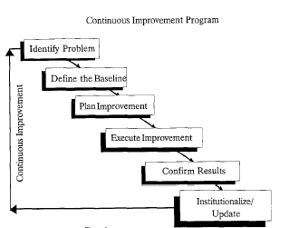
Fig 2.1 Continuous Improvement Program
Kaoru Ishikawa stated “unless one can obtain facts and accurate data about the work place, there can be no control or improvement.” The process of continuous improvement is a route necessary to achieve and maintain competitive positions in any type of manufacturing environment - mass, lean, or agile manufacturing.
Continuous improvement is constantly is constantly adapting by getting and using information, and by evaluating changes to make sure they are effective, Teaneck, NJ [2001].
“Continuous improvement is the only way to stay competitive” says Alan Keffler.
2.2 Performance Measurement in Continuous Improvement:
According to Neely et al’ (1996) performance measurement is the process of quantifying effectiveness and efficiency of actions. The purpose of performance measurement is to monitor and improve the performance of these actions on a continuous basis. In other words, performance measurement is a continuous improvement tool. Continuous improvement to the investors is to improve financial results, to the senior management it is to improve the business results, to the middle management it is to improve the processes, and to the operational staff it is to improve the activities and functions in which they are involved. In order to achieve all of these objectives (and hence achieve continuous improvement), the performance measurement system should assist in:
- Identifying key areas that need improvement
- Diagnosing and analyzing the reasons behind the low performance
- Planning and implementing changes necessary to improve performance in quantifiable or measurable way
- Monitoring the results to find whether they achieved the expected results
- Developing a closed loop control system to promote continuous improvement
Deming proposed that business processes should be analyzed and measured to identify the sources of variations that cause processes to deviate from customer requirements. Deming also recommended that the closed-loop control system should be used by managers to continuously monitor the performance of processes (business and manufacturing) to identify and change the parts of the process that
need improvements.
The Deming cycle is based on the premise that improvement comes from the application of knowledge. This knowledge may knowledge be of engineering, management, or how a process operates that can make a job easier, more accurate, faster, less costly, safer, or better meets customer needs. Through a process of learning, knowledge is developed.
Deming’s PDCA cycle for continuous improvement is illustrated together with its performance measurement implications:

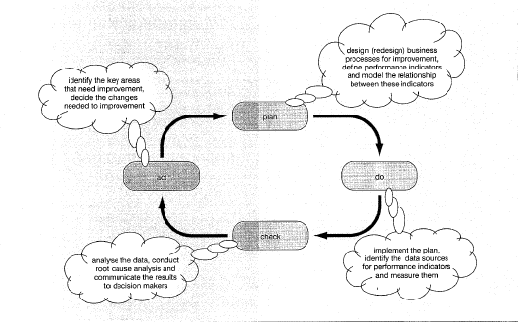

Fig. 2.2 Deming’s Cycle with Performance measurement
One of the key activities that make a significant impact on continuous improvement is defining the performance indicators and modeling their relationship. There are two key indicators that are used for improving the order fulfillment process. They are ‘on-time in-full’ (OTIF) and ‘process cost’. The problem with these indicators is that they are lagging indicators, i.e. by the time these indicators show poor performance, the situation is out of control.
2.3 Influencing factors of Production System:
Continuous improvement (CI) is an important means of establishing competitive advantages. Therefore, it is necessary that companies choose CI measures according to their competitive strategy.
Irani and Sharp suggest, based on a survey in a small scale manufacturer, that CI concept should be engrained as a belief into the employee’s heart. The deal situation of CI strategy is its integration with the corporate culture.
Under the influence of the external environment factors, such as
- product price,
- product functionality,
- conformance quality,
- delivery reliability,
- delivery speed,
- product design,
- product customization,
- product range etc.
The internal motive factors i.e.
- customer demands
- increase production volume
- increase productivity
- improve quality conformance
- reduce lead times
- improve delivery reliability
- Increase employee skills and competencies
- Management oriented
- Decrease absence etc.
Internal motive factors are sensitive to the popularization of CI activities in companies and show significant changing tendency.
Under the influence of the external environment factors, the motive factors have varying degrees of influence on CI activities, which are process factors, quality factors, cost, customer satisfaction and productivity as listed above. Among these factors quality, cost, customer and productivity can be regarded as items directly related to improve activities i.e. direct motives. Process and organizational factors are indirect motives of improvement activities, whose aim is to guarantee efficient execution of the direct improvement motives. The indirect motives of improvement activities are much more sensitive to the popularization of CI activities than direct motives. While executing CI activities, companies should pay more attention to the change of the external environment. This will facilitates the company to achieve better results in the CI activities. Improve production system will facilitate the company to achieve good results.
2.4 Monitoring and Managing:
To facilitate better production system following indicators need to be deployed right down to operational teams who use them to monitor, control and improve daily activities. These indicators should be:
- Simple to understand and use
- Relevant
- Visual
- Accurate and reliable
The distinction between improvement indicators and control indicators is that an improvement indicator is one that needs to be measured for an improvement. A control indicator is one that does not require improvement but has to be monitored in order to ensure that the process does not go out of control. Improvability is related to optimality.
To drive a good production system, the operational team should move with the right set of leading and lagging indicators to monitor performance of their activities and focus their improvement effort.
According to Herrera (1991), management commitment, partnership development, communications, and empowerment, training and recognition of the operators are all important aspects of continuous improvement program.
2.5 Continuous Improvement Tools:

According to Yasuhiro (1998) Continuous improvement is a management philosophy based on employees’ suggestions. To standardize a method is to choose out of the many methods the best one, and use it. Standardization means nothing unless it means standardizing upward. Today’s standardization, instead of being a barricade against improvement, is the necessary foundation on which tomorrow’s improvement will be based
. Creating a usable and meaningful standard is the key to the success of any enterprise. It is not the solution but is the target on which change can be focused. Using this standard, businesses usually use two different kinds of improvements: those that suppose a revolution in the way of working and those that suppose smaller benefits with less investment that are also very important.
In production systems, evolutionary as well as revolutionary change is supported through product and process innovations. The evolution consists of continuous improvements being made in both the product and the process. These revolutions are carried out by the use of methodologies such as process reengineering and a major product redesign.
2.5.1 Improvement philosophies and Methodologies:
In order to improve (quality, cost, and time) production activities, it is necessary to know the source of a factory’s problem(s). However, in order to find the factory’s problem, it is important to define and understand the source and core of the problem.
Any deviation from the standard value of a variable (quality and production rate) presents a problem. There are three main factors that production managers fear most: (1) poor quality, (2) an increase in production cost, and (3) an increase in lead time. These three factors are signs of poor production management. Production improvements should be based on improvements to processes and operations. Two of the best known improvement approaches have been discussed here: just-in-time methodologies (also known as lean manufacturing), discussed in next chapters and the 20 keys to workplace improvement developed by Kobayashi.
2.5.1.1Seven types of wastes:
Hiroyuki Hirano (1990) defined waste as “everything that is not absolutely essential.” This definition supposes that few operations are safe from elimination, and this is essentially what has happened. He also defined work as “any task that adds value to the product.”
Shigeo Shingo identified seven main wastes common to factories:
- Overproduction - Producing unnecessary products when they are not needed and in a greater quantities than required.
- Inventory – Material stored as raw material, work-in-process, and final products
- Transportation – Material handling between internal sections.
- Defects – Irregular products that interface with productivity, stopping the flow of high-quality products.
- Processes – Tasks accepted as necessary.
- Operations – Not all operations add value to the product.
- Inactivities –Machine with idle time or operators with idle time.
Of all these types of waste, inventory waste is considered to have the greatest impact. Inventory is a sign of an ill factory because it hides the problems instead of resolving them.
2.6 Lean Manufacturing:
Basically, lean manufacturing is the systematic elimination of waste. As the name implies, lean is focused on cutting “fat” from production activities. A definition that describes lean manufacturing is waste-free production.
Lean manufacturing is a management philosophy focusing on reduction of the seven wastes
- Over-production
- Waiting time
- Transportation
- Processing
- Inventory
- Motion
- Scrap in manufactured products or any type of business.
By eliminating waste (muda), quality is improved, production time is reduced and cost is reduced. Lean "tools" include constant process analysis (kaizen), "pull" production (by means of kanban) and mistake-proofing (poka-yoke). Lean, as a management philosophy, is also very focused on creating a better workplace through the Toyota principle of "respect for humanity."
Key lean manufacturing principles include:
- Pull processing: products are pulled from the consumer end, not pushed from the production end
- Perfect first-time quality - quest for zero defects, revealing & solving problems at the source
- Waste minimization – eliminating all activities that do not add value & safety nets, maximize use of scarce resources (capital, people and land)
- Continuous improvement – reducing costs, improving quality, increasing productivity and information sharing.

- Flexibility – producing different mixes or greater diversity of products quickly, without sacrificing efficiency at lower volumes of production
- Flexible, team-based work organisation with multi-skilled workforce
2.7 Conclusion:
The literature on Continuous Improvement has been discussed in this chapter-performance measurement, influencing factors of production system, various CI tools, wastes and various philosophies and methodologies.

Chapter 3
CONTINUOUS IMPROVEMENT
3.1 INTRODUCTIon
Manufacturing companies are under increasingly diverse and mounting pressures due to more sophisticated markets, changing customer choice and global competition. The market for products is becoming increasingly international. In this international marketplace, companies find themselves having to adopt international standards.
Community groups and environmentalists are bringing increased pressure to bear on manufacturers to improve the reliability and safety of their products and manufacturing processes. In such a competitive scenario companies have to search for new processes, new materials, new vendors, new shop floor design, and new channels to deliver their products and services at competitive price.
Indian companies have quite often followed an opportunistic approach to growth as opposed to a capability driven approach, and paid very little strategic attention to their shop floors in the last few decades (P. Chandra and T. Sastry , Competitiveness of Indian manufacturing. Vikalpa 3 (1998), pp. 25–36.Chandra and Sastry, 1998).
Manufacturing in India is at a critical juncture. The Indian perspective on manufacturing is characterized as a support activity for marketing and finance and invited little top management attention. Most of firms are still very far from world class practices. Meanwhile international competitors are continuously working on
improving manufacturing, bringing in new products and making manufacturing more proactive and responsive (P. Chandra and T. Sastry , Competitiveness of Indian manufacturing. Vikalpa 3 (1998), pp. 25–36.Chandra and Sastry, 1998).
3.2 World Class Manufacturing Concept:
Manufacturing firms achieves world- class status when it has successfully developed manufacturing to support the entire company in gaining a competitive advantage over its competitors in such areas as cost, quality, delivery, flexibility and innovation.
World class manufacturing operations as being externally supportive, those competitors. They seek to outperform their global competitors in targeted areas; they are not content simply to copy their competition. They dislike being dependent on outside organization for expertise; they want to develop their own work force, equipment and systems but they also respect the capabilities of others. Therefore, they continually scrutinize the outside world, particularly their top competitors, to ensure that they are aware of the newest ideas and approaches.
Consequent with the economic liberation envisaged through globalization of industrial collaborations, organizations, especially in developing countries are at present in the midst of revolutionary transformation: that of competition shifting from the ‘industrial age’ to an ‘information age’.
The emergence of the information era coupled with rapid changes in industrial technology have made the business practices, marketing strategies, customer orientation of companies in developing countries like India obsolete. So
merely deployment of new technologies will not suffice. Furthermore, availability of cheap labor may not be advantageous for ensuring global competitiveness.(Saxena & Sahay 1999)
Organizations are present in the midst of a revolutionary transformation: that of competition shifting from the industrial age. During the industrial age, companies succeeded by how well they could capture the benefits from economies of scale and scope. Technology was important, but ultimately success accrued to companies that could embedded the new technology into physical assets that offered efficient mass production of standard products.
The emergency of the information era, which started in the last decades of the twentieth century, made obsolete many of the fundamental assumptions of industrial age competition. Consequently, companies could no longer gain sustainable competitive advantage by merely deploying new technology into physical assets rapidly.
Intangible assets enable an organization to develop customer relationships and loyalty, introduce innovation products and services, produce customized highly-quality products and services at low-cost and with short lead times, mobilize employee skills and motivation for continuous process improvements and deploy information technology effectively.
The current challenge for all manufacturers is to regain and maintain a competitive advantage. To meet the challenges, various philosophies and approaches for managing manufacturing and technology are required. The philosophy focuses first and foremost on continual improvement to achieve world class manufacturing status.
Slow productivity growth, lost market share, and growing trade deficits indicate clearly that the manufacturing firm is losing its ability to compete. The causes most often cited include high labor costs, outdated factories and equipment and inflexible unions, as well as favorable government policies and incentives among the governments of chief competitors.
The manufacturing firm achieves world class status when it has successfully developed manufacturing capabilities to support the entire company in gaining a sustained competitive advantage over its competitors in such areas as cost, quality, delivery, flexibility and innovation.
World-class manufacturers regard their manufacturing operations as being externally supportive, that is playing a key role in helping the entire company to achieve an edge over its competitors. They seek to outperform their global competitors in targeted areas; they are not content simply to copy their competition. They dislike being dependent on outside organizations for expertise; they want to develop their own work force, equipment and systems, but they also respect the capabilities of others.
Therefore, they continually scrutinize the outside world, particularly their top competitors, to ensure that they are aware of the newest ideas and approaches.
3.3 Strategies of World-Class Manufacturer:
“The essence of strategy is choosing to perform activities differently than rivals do”
(-Porter 1996)
Manufacturing Strategies has been defined as “the effective use of manufacturing strengths as a competitive weapon for the achievement of business and corporate goals.”
(-Mills,Platts,Gregory 1996)
Competitive strategy is about being different. It means deliberately choosing a different set of activities to deliver a unique mix of values. (Porter, 1996). The essence of strategy is in the activities-choosing to perform activities differently or to perform different activities than rivals.
In 1969 Skinner believed it impossible for manufacturing to make wide range of high quality and low cost products quickly. World class strategies require chucking the (trade-off) notion. The right strategy has no optimum, only continual improvement in all things.
According to Hayes and Wheelwright manufacturing strategy should:
- Support the firm’s competitive success factors
- Be consistent with business and other functional strategies
- Show internal consistency between manufacturing decision areas
Most manufacturing companies are now experiencing rapid and continuous change in their business environment, which can be identified in terms of product change and/or in terms of process change (Luftman, 1996). Product change characterizes the demands for new goods or new services.
Companies change their products because of competitor moves shifting customer preferences, or the entry to new geographical or national markets whereas Process change concerns reformation of procedures and technologies of product development and services.
The manufacturing strategies are described below:
3.3.1. Mass Customization:
Organizations in a number of industries are facing customers making increasingly unique and unpredictable product demands. However, the basic processes that these companies are instituting to meet these demands soon evolve into identifiable patterns enabling the companies to build stable but flexible platforms of process capabilities. Such companies therefore need to be organized and managed for mass customization (Pine, 1993).
The major distinguish characteristic of the mass customization strategy is the capacity to produce product variety rapidly and inexpensively. This requires a
set of modular process capabilities with the linkage system that allows them to be brought together instantly for any particular customer order.
The presence of third party between manufacturing and the customer enables standard products to be altered to the needs of the customer. The customer must interact with the third party, to convey their needs and ensure the required solution is achieved.
Alternatively, manufacturers can design products that are self-customizing, enabling the customer to change the product at any time to suit their own preferences. Other manufacturers are simply pushing variety into the market in the expectation that customer will find what they want. This strategy relies on a strong understanding of the needs of the market, and a close coupling of these needs to the manufacturing system, that must be able to quickly respond to fluctuating demands.
3.3.2 Innovation Strategy:
The focus of innovation strategy is to frequently create small volumes of new products, while constantly innovating the process required to develop and produce them. The organizations are often separate research and development (R&D) units within mass production organizations. These organizations are inherently designed for change since product specifications and work processes are unpredictable and constantly shifting. To compete under innovation conditions,

organizations decentralize decision-making, broadly define jobs, develop few rules or procedures, and subjectively evaluate performance.
Developing a set of successful and profitable products and processes are key to the success of technology-based enterprises. Effective product and process development depends on the integration of a variety of specialized capabilities, strong functional groups with interdisciplinary teams and multiple progressive pressures (Nellore & Balachandra, 2001).
New product development (NPD) is an important and complex business process. It involves cross-function integration, a complicated interdisciplinary activity that requires many knowledge inputs to generate a robust product solution in a time-competitive environment.
Compared with other forms of cross-functional integration, research and development (R&D) integration of knowledge from past projects contributes most to variations in the length of the product development cycle (Sherman, Souder, & Jenssen, 2000).
3.3.3 Mass Production Strategy:
Throughout the twentieth century, most large organizations have competed under the conditions of relatively stable and predictable product specifications and demand. This permits them to standardize products, centralize decision-making, routinise work and reward, develop and enforce standard rules, and procedures,
and allocate work to dedicated, specialized jobs- i.e. to mass produce goods or services.
The focus of these firms is on efficiency through stability and control, always basing their strategy on economies of scale and low costs, and striving for the largest size and lowest cost structure in the industry. The organizational structure of such firms is often large, hierarchical, bureaucratic, and vertically integrated.
Their competitive advantage and profitability are based on reduction of unit costs, and therefore change in either process or product is anathema to the mass production strategy. Consequently, the design for stability requires limiting both product variety as well as process innovation.
3.3.4 Continuous Improvement:
In some industries, such as automobiles and machine tools, the nature of product demand is still relatively mature, stable, large, and homogeneous. But the competition in these industries is based on dynamic process terms i.e. the organizations are competing by achieving constant improvement in process quality, speed and cost.
The focus of the organizations in these industries is on customer satisfaction through process improvement. As opposed to mass production firms, they are very customer-or market-focused, striving to better satisfies the market as a whole through continuous process improvement.
These organizations manage rapid innovation and use of new process capabilities and therefore require systems and structures that facilitate long-term organizational learning about product but simultaneously achieving radical changes in the processes.
To make process innovation efficient, these organizations employ cross-functional teams that collaborate to improve processes or plan for product enhancement. The members of these teams then turn to their function-specific work and execute the rules they just developed, accomplishing a sort of micro-transformation. In this sense the teams of continuous improvement firms need to be as process-innovative as ‘invention’ organizations, and as process-efficient as ‘mass production’ firms.
Organization should also consider improving employee morale, satisfaction, and cooperation; improving managerial practices; improving the design of products with features that better meet customer needs, and which achieve higher performance, higher reliability, and other market driven dimensions of quality; and improving the efficiency of manufacturing systems by reducing worker idle time, and unnecessary motions, and by eliminating unnecessary inventory, unnecessary transportation and material handling, and scrap and rework. (R. Anthony Inman)
To encourage the kaizen attitude, organizations require a major change in corporate culture; one that admits problems encourages a collaborative attitude to

solving these problems, delegates’ responsibility and promotes continuous training in skills and development attitudes.
The driving force behind kaizen is dissatisfaction with the status quo, no matter how good the firm is perceived to be. Standing still will allow the competition to overtake and pass any complacent firm. The founder of Honda has been quoted as saying, "In a race competing for a split second, one time length on the finish line will decide whether you are a winner or a loser. If you understand that, you cannot disregard even the smallest improvement."
Continuous improvement involves making incremental changes that may not be highly visible in the short term; they can lead to significant contributions in the long term. Organizational performance can improve from knowledge gained through experience. Lessons learned from mistakes mean those mistakes are less likely to be repeated, while successes encourage workers to try the same thing again or continue to try new things. (R. Anthony Inman)
Continuous improvement is a philosophy, permeating the Japanese culture, which seeks to improve all factors related to the transformation process (converting inputs into outputs) on an ongoing basis. It involves everyone, management and labor, in finding and eliminating waste in machinery, labor, materials and production methods.

The Japanese word for continuous improvement, kaizen, is often used interchangeably with the term continuous improvement. From the Japanese character kai, meaning change, and the character zen, meaning good, taken literally, it means improvement.
The first and foremost concern of the kaizen philosophy is the quality of the people. If the quality of the people is improved, then the quality of products will follow. By instilling kaizen into people and training them in basic quality improvement tools, workers can build this philosophy into their work and continually seek improvement in their jobs. This process oriented a[approach to improvement encourages constant communication among workers and managers.
While the learning process occurs throughout the system it is particularly important for accomplishing the long-term improvement associated with continuous improvement. In order for production system to be successful, the organization must learn from past experience and translate this learning into improved performance.
Part of the learning process is trying new approaches, exploring new methods and testing new ideas for improving the various processes. So experimentation can be an important part of this organizational learning.
The achievement of continuous improvement requires a long-term view and the support of top management. But it is also important that all levels of

management actively support and become involved in the process. Proper support structures of training, management, resource allocation, measurement, and reward and incentive systems must be in place for successful adoption. This includes a willingness to provide financial support and to recognize achievements. It is desirable to formulate goals with the workers' help, publicize the goals, and document the accomplishments. These goals give the workers something tangible to strive for, with the recognition helping to maintain worker interest and morale.
Kaizen also requires that all employees in the organization be involved in the process. Every employee must be motivated to accept kaizen as a means by which the firm can achieve a competitive advantage in the marketplace. All involved must push continuously at the margins of their expertise, trying to be better than before in every area. Japanese companies have been very successful with the use of teams composed of workers and managers. (Evnans & Lindsay)
Three things are required for a successful Kaizen program: operating practices, total involvement, and training. (Robinson, 1991)
First, operating practices expose new improvement opportunities. Practices such as just-in-time reveal waste and inefficiency as well as poor quality. Second, in kaizen, every employee strives for improvement. Top management, for example, views improvement as an inherent component of corporate strategy and provides support to improvement activities by allocating resources effectively. They also

build system, procedures, and reward structures that are conducive to improvement.
Middle management can implement top management’s improvement goals by establishing, upgrading, and maintaining operating standards that reflect those goals: by improving cooperation between departments; and by making employees conscious of their problem solving skills through training. Supervisors can direct more of their attention to improvement rather than “supervision,” which, in turn, facilitates communication and offers better guidance to workers.
Finally, workers can engage in improvement through suggestion systems and small group activities, self development programs that teach practical problem solving techniques, and enhanced job performance skills. (Robinson, 1991)
These teams routinely work together on problem solving. Moreover, the workers are encouraged to report problems and potential problems to the teams; their input is as important as that of management. In order to establish a problem-solving orientation, workers should receive extensive training in statistical process control, quality improvement, and problem solving.
Problem solving is the driving force behind improved production system. Actually, it can be said to become a way of life or a culture that must be assimilated into the thinking of management and workers alike. Workers are trained to spot problems that interrupt, or have the potential to interrupt, the

smooth flow of work through the system. When such problems do occur, it is important to resolve them quickly. Also, workers are trained to seek improvements in the areas of inventory reduction, set-up time and cost reduction, increasing output rate, and generally decreasing waste and inefficiency.
Through kaizen or continuous improvement, firms are able to produce better products and services at lower prices, thus providing greater customer satisfaction. In the long term, the final product will be more reliable, of better quality, more advanced, cheaper and more attractive to customers.
One important program related to this is Work Simplification, was developed by Allan Mogensen. Mogensen believed that workers know their jobs better than anyone else. Therefore if they are trained in the simple steps necessary to analyze and challenge the work they are doing, then they are more likely to be able to make improvements.
In work simplification programs, workers receive training in the use of basic analytic techniques such as methods analysis, flowcharting, and diagramming to analyze work procedures for improvement.
Deming Cycle plays an important role in process improvement. This ‘wheel’ invented in the USA and rediscovered in the European countries by looking at the Japanese ‘miracle’ rolls upwards to ever-improving performance.

Successively four points of action are executed, once an activity is found unsatisfactory (Fortuin, 1988):
1. Make plans to improve a given activity (plan).
2. Carry out these plans, for instance by means of projects (Do).
3. Look at results; compare the actual results with the desires performance (Check).
4. Consolidate the measures that proved successful (Act).
Or simply, the plan stage consists of studying the current situation, gathering data, and planning for improvement. Its activities include defining the process, its inputs, outputs, customers, and suppliers, understanding customer expectations; identifying problems; testing theories of causes; and developing solutions.
In the do stage, the plan is implemented on a trial basis.
The study stage determines whether the trial plan is working correctly and if any further problems or opportunities are found. Often, a proposed solution must be modified or scrapped. New solutions are proposed and evaluated by returning to the do stage.

In last stage, act, the final plan is implemented and the improvements become standardized and practiced continuously. This process then leads back to the plan stage for further diagnosis and improvement.
As fig. shows, the cycle is never ending; that is, it is focused on continuous improvement.

Plan Do

Check Study
Fig.3.1 Deming Cycle

For continuous improvement various techniques are used which are:
- JIT (Just in Time)
- TQM (Total Quality Management)

3.4 Just-in-Time:
(JIT) is the Japanese approach to material management and control. JIT is more than a new method of material management; it represents a philosophy whose objective is to eliminate all sources of waste, including un-necessary inventory and scrap in production.
The process is driven by a series of signals, or Kanban that tell production processes to make the next part. Kanban are usually simple visual signals, such as the presence or absence of a part on a shelf. When implemented correctly, JIT can lead to dramatic improvements in a manufacturing organization's return on investment, quality, and efficiency. New stock is ordered when stock reaches the re-order level. This saves warehouse space and costs.
Richard J. Schonberger describes JIT as a “quality and scrap control tool, as a stream lined plant configuration that raises process yield, as a production line balancing approach, and as an employee involvement and motivational mechanism.”
The basic philosophy is to maintain inventories as close to zero as possible by producing only enough units to keep the next work station in a production process in operation.

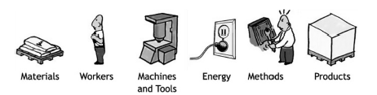
Fig.3.2 Resources that must be managed effectively
JIT cannot function properly if production has a high rate of defective items. Implementation of JIT requires painstakingly careful attention to quality both in purchasing and in production. Since lot sizes are small, no safety stock is available to back up nonconforming items, and any quality problem disrupts the flow of materials through the plant.
A related term is Kaizen which is an approach to productivity improvement literally meaning "continuous improvement" of process.
In the Kaizen philosophy, improvement in all ares of business such as cost, meeting delevery schedules, employee safety and skill development, supplier realtions, new product development, or productivity, all enhances the quality of the firm. Thus, any activity directed towards improvement falls under the kaizen umbrella.
As most companies use an inventory system best suited for their company, the Just-In-Time Inventory System (JIT) can have many benefits resulting from it. The main benefits of JIT are listed below:

1. Employees who possess multi-skills are utilized more efficiently. Having employees trained to work on different parts of the inventory cycle system will allow companies to use workers in situations where they are needed when there is a shortage of workers and a high demand for a particular product.
2. Better consistency of scheduling and consistency of employee work hours. If there is no demand for a product at the time, workers don’t have to be working. This can save the company money by not having to pay workers for a job not completed or could have them focus on other jobs around the warehouse that would not necessarily be done on a normal day.
3. Supplies continue around the clock keeping workers productive and businesses focused on turnover. Having management focused on meeting deadlines will make employees work hard to meet the company goals to see benefits in terms of job satisfaction, promotion or even higher pay.
3.5 Total Quality Management (TQM):
Total Quality Management is an approach to the art of management that originated in Japanese industry in the 1950's and has become steadily more popular in the West since the early 1980's.
Total Quality is a description of the culture, attitude and organization of a company that aims to provide, and continue to provide, its customers with products and services that satisfy their needs. The culture requires quality in all aspects of the company's operations, with things being done right first time, and defects and waste eradicated from operations.
TQM is a philosophy or approach to management that is grounded on three core principles:
- A focus on customer
- Participation and team work
- Continuous Improvement
3.5.1 Customer Focus:
The modern definition of quality centers on meeting or exceeding customer expectations. Thus the customer is the principal judge of quality. Perception of value and satisfaction are influenced by many factors throughout the customer’s overall purchase, ownership and service experience. Companies must focus on all product and service attributes that contribute to perceived values to the customer and lead to customer satisfaction.
All strategic decisions a company concerned with quality makes are “customer-driven.” In other words, the company shows constant sensitivity to emerging customer and market requirements; it also measures the factors that drive customer satisfaction.

A company close to its customer knows what the customer wants, how the customer uses its products, and anticipates the needs that the customer may not even be able to express.
Customer focus extends beyond the consumer and internal relationships, however. A world-class company, by definition, is an exemplary corporate citizen.
3.5.2 Participation and Team Work:
In any organization, the person who best understands his or her job and how to improve both the product and the process is the one performing it.
Good intentions alone are not enough to encourage employee involvement. Management’s task includes formulating the systems and procedures and then putting them in place to ensure that participation becomes a mart of the culture.
Another important element of total quality management is teamwork, which focuses attention on customer-supplier relationships and encourages the involvement of the total workforce in attacking systemic problems, particularly those that cross functional boundaries.
Some important type of teams are quality circles, self managed teams, and cross function team. Traditionally, organizations were integrated vertically by linking all the levels of management in a hierarchical fashion. TQM requires horizontal coordination between organizational units. Poor quality often results from breakdowns in responsibility that occurs when an organization focuses solely on vertical structures, and fails to recognize the horizontal interactions. Vertical structures lead to internal competition rather than promoting the good of the whole organization. A process focus on the other hand, which concentrates on creating outputs from inputs, provides better insights into how the organization actually operates.
Quality network is a customer satisfaction model that encourages teamwork and cooperation. Partnerships are an additional way of promoting teamwork. Partnerships between a company and organized labor and between customers and suppliers are common among companies practicing TQM.
3.5.3 Improvement in Production System:
Continuous improvement is an integral part of the management of all systems and process. Management plays a facilitating role in TQM. Achieving the highest levels of quality requires a well-defined and well-executed approach to continuous improvement. The process of continuous improvement requires systematic planning, execution, and evaluation.
Improvement is a critical aspect of all operations and of all work unit activities of a company. Improvements may take any one of several forms:
- Enhancing value to the customer through new and improved products and services,
- Reducing errors, defects and wastes
- Improving productivity and effectiveness in the use of all resources
- Improving responsiveness and cycle time performances.
The need to improve products and services to gain market advantage, reduce errors and defects, and improve productivity are basic business objectives. More businesses compete on services, success in competitive markets demands ever-shorter product and service introduction cycles and more rapid response to customers.
These aspects result when work processes meet both quality and response goals. Accordingly, response time improvement should be a major focus within all quality improvement processes of work units.
Major improvements in response time are requiring significant simplification of work processes. Response time improvements often drive simultaneous improvements in quality and productivity.
TQM requires a new set of skills and learning, including interpersonal awareness and competence, teambuilding, encouraging openness and trust, listening, giving and getting feedback, group participation, problem solving, clarifying goals, resolving conflicts, delegating and coaching, empowerment, and continuous improvement as a way of life.

Customer Requirements
Customer Satisfaction
Measurement and Feedback
People
Team work/Continuous Improvement
Material

Equipment

Methods & Systems

Environment

Fig.3.3 Quality Network Process Model
Companies adopt TQM to react to competitive threats to take advantage of perceived opportunities. Successful adoption of TQM requires a readiness for change, sound practices and implementation strategies, and effective organization. Changing the corporate culture is necessary if TQM is to take root in an organization. Change is easier when management has a clear vision, a focus on customers and continuous improvement, strong measurement, cross-functional orientation, and high employee morale.
Key strategies for successfully implementing TQM include a focus on quality through planning, commitment and involvement of top management, integration of customer satisfaction across functions, and employee participation and training.
3.6 Problem Solving Tools and Techniques:
3.6.1 Problem Solving cycle
Systematically solving problems encompasses phased and cyclic process consisting of nine steps (as shown in fig.). The first two steps in the problem solving cycle relate to problem solving.
Pose the problem
Specify the problem
Make an inventory of possible causes
Test Possible causes
Determine the correct cause
Generate solutions for the problem
Determine which solution eliminates the cause
Plan Do

Act Check
Implement the solution
Verify if the problem has disappeared
Fig.3.4 Problem Solving Cycle
First of all, it is necessary to appoint an improvement team, and to define the problem as a team. A precise definition of the problem is essential to find the exact cause for which an effective solution can be generated. For a clear problem description, the team needs to know which problems should be solved, where the problems occur, and which aspect plays a role here.
It should try to get as much information as possible about the problem, and consult several information sources regarding the subject such as customer survey results, customer complaints, data regarding process performance, and discussions with internal customers.
Then it should analyze all the information gathered, define the problem areas and the problem as concretely as possible, and formulate the desired objectives. These should be discussed with the problem owner so that one has accurate problem description. In this instance, it is advisable to use techniques such as ABC analysis, pareto analysis, fishbone diagram, and the why-why analysis. All these techniques will be discussed in the next section.
An inaccurately formulated definition of a problem may lead to ineffective solutions. An accurate problem definition, however identifies problem characteristics, determines its consequences, focuses on the difference between the current situation and the desirable situation consists of a global measurement of the problem (how frequently it occurs, how many such problems there are, when it happens, etc) For an accurate definition of a problem, it is also important to know how the process is presently being executed. Therefore, it is necessary to map the process in flow charts, where by all stages from input to output are illustrated.
After defining the problem, it is important to make an inventory of its possible causes, test them, and determine the correct cause. This process involves charting the many possible causes of the problem and selecting the most logical root cause. It is important to ensure that there is a systematic gathering of data at all key points in the process. Then, the most logical causes should be selected for further analyses. This involves the gathering and analyses of data through illustrative techniques such as the fish bone diagram, graphs, pareto analysis and histograms to spot ongoing trends.
Generating solutions for the problem, determining which solution eliminates the cause, and the implementing the solution are the text steps in the problem solving cycle. The team should then brainstorm, using the data from the previous steps, and generate an extensive list if possible solutions. It should then evaluate these solutions and choose the one with the highest chances of success or one which is most suited the problem. It is important to carefully plan the proposed solution, consider the consequences, and then implement the solution. For this it is imperative to communicate with all stakeholders about the proposed solution, clarify all plans, design procedures, identify potential barriers for implementation, consider all the necessary resources (material, equipment, facilities, people), and identify training requirements.
Verifying if the problem has disappeared is the final step in the problem solving cycle. Measurements are done to see whether the implemented solution has completely solved the problem or whether the problem has only been reduced or partially solved. An assessment is also made to determine whether the requirements of the customers are still not being met.
In case, the requirements of the customers are still not being met, it is possible that the solution was incorrect, the problem was incorrectly defined and/or the wrong cause was treated. Several techniques and methods can be used to measure the effectiveness of the implemented solution. The process should be standardized when the solution has solved or reduced the problem.
This encompasses the unambiguous establishment or documentation of process executions in standard procedures, and ensuring that all concerned employees in the organization understand these and use them consistently. This standardization would not only help incorporate the new process into the daily routine but also prevent the organization from returning to old habits.
3.6.2 Tools and Techniques:
In order to execute the problem solving process successfully, it is necessary to apply certain improvement tools and techniques. A large number of appropriate tools and techniques are available for this purpose. The important tools which are used, described here:
- ABC analysis
- Fishbone diagram (cause and effect diagram)
- Pareto analysis
- Why-why diagram

These tools and techniques are essential for the unambiguous establishment of quality improvements. They are described according in the following parts.
3.6.2.1 ABC Analysis
ABC analysis is used for selection of problems. First a number of problems are collected, then they are categorized and these categories are:
- Category A - Minimum involvement of other departments in solving problems
- Category B – Involvement of other department is a necessity
- Category C – Management sanction and support may be needed in implementing solutions.
Total numbers of problems are 53, and then they are categorized under three categories as explained above. 8 problems fall under category A. 41 problems fall, under category B. 4 problems fall, under category C.
Next is selection of main problem on the basis of rating. Rating is done on the basis of severity. Severity is based on the criticality of the problem. Rating is done to select the problem.
3.6.2.2 Fishbone Diagram:
A fishbone diagram, or cause and effect diagram (also called Ishikawa diagram) is graphic representation of the relationship between a given effect and its potential causes (Ishikawa, 1985). The potential causes are divided into categories and sub-categories, so that the display resembles the skeleton of a fish.
Following are the steps for drafting a fishbone diagram:
- Define the effect clearly and concisely. Place a short description of this in a box and a long line to the left from this box.
- Determine the most important categories of cause during brainstorming sessions. The possible categories of causes are:
  - Equipments
  - Working methods
  - Environment
  - Organization
  - Materials – raw materials, semi manufactured articles, energy, data and information
  - People- knowledge, skills, attitude, style and behavior
  - Means, facilities
  - Management-knowledge, skills, attitude, style behavior
  - Information
  - Measurements
- Place these categories with some distance between them along the main line.
- Draw skew lines from these categories to the main line.
- During brainstorming, look for a couple (if possible causes and place these on the diagram by the corresponding category; doing this for the subsequent levels also, results in branching. A good rule of thumb is to repeat the question “why” five times.
- Judge and analyze the possible causes.
- Select a small number (3-5) of highest level causes that are likely to have the greatest influence on the effect.
- Look for possible solutions to these causes.
- Introduce the changes.
3.6.2.3 Pareto Diagram
A pareto diagram is graphical tool used to gain insight into the most important causes of a problem. It is a bar chart in which the data are arranged in descending order of their importance; the diagram displays the relative contribution of each item to the total effect in decreasing order.
On the basis of this, the most important problems can be realized with the least effort. The diagram is based on the pareto principle, which states that just a few of the defects account for most of the effects. This patter is called the 80 20 rule and is applicable to all sorts of situation, thus, it is likely that only 20% of your equipment problems account for 80% at the downtime. The issue is here that of many problems, only a limited number have to be considered and should be solved immediately.
The steps for drafting a Pareto diagram
- Formulate the problem.
- Select the time period during which an inventory of its causes should be made.
- Design a check sheet for registering the gathered data.
- Make an inventory of the causes. Count the number of times each cause occurs and write it down on the check sheet.
- Calculate the total.
- Rank the causes in decreasing order. If necessary, the category “others” can be used.
- Draw a bar chart with two vertical axes. Along the left vertical axis, mark the measured values or each cause starting from tern till the number of causes. The right vertical axis should have the same height and should go from 0 to 100 percent. This axis displays the cumulative percentage. List of different kinds of causes along the horizontal axis, from left to right in decreasing order of frequency or costs.
- Draw a bar above each item whose height represents the number for that cause.
- Construct the cumulative frequency line. First draw the cumulative bears by adding the number of each cause from left to right. Then draw a cumulative curved line from zero till the 100% level on the right vertical axis, by connecting the top right hand corner of the bars with each other.
- Draw a horizontal line from 80% (on the right vertical axis) to file left till the point of intersection with the cumulative line, and then draw a vertical line from this intersection downwards till the horizontal axis. Left from this intersection point, 20% of the causes are located (the most essential bottlenecks) causing 80% of the damages. These are the causes which require immediate attention.
3.6.2.4 Why-Why Diagram:
The Why-Why diagram is a variation of the fishbone diagram. This technique helps to get a specification of a problem’s cause, by asking the question “Why?” three to five times. For example if someone suggests that the product is poor, the question “Why?” is immediately raised. If the person gives an answer, the question “Why?” is raised again, etc.
The Why-Why diagram is used to systematically expose a problem’s root cause
Product sales Disappointing
Poor Product
Badly Promoted
Ineffective Distribution System
Too Expensive
Poor Design
Poor Packaging
Poor Quality
Poor Image
Low Awareness
Inadequate Market Reach
Unproductive Process
Wrong Channels
Poor Physical Distribution
High Cost Raw Material
Badly Trained labour
Competitors with better Experience Curve
Fig.3.5 Why-Why Diagram

3.7 Concluding Remarks:
This chapter summarizes various tools and techniques-like fishbone diagram, why-why analysis, pareto analysis used in this case study.

Chapter 4
Company Profile &
Present SYSTEM
4.1 Company Profile:
Napino Auto & Electronics Ltd leading manufacturer of capacitor discharge ignition, main wire harnesses, small wire harnesses. The company offers product range of digital and analog capacitor discharge ignition. It is an ISO/TS 16949 certified company. Company has turn over 2392 million (in rupees) for April 2007 to March 2008. It has two units: Manesar and Gurgaon. Company has major clients like Hero Honda, Yamaha Motors India (pvt.) Ltd, Honda Motorcycles & Scooters India (pvt.) Ltd. And Suzuki motorcycle India (pvt.) ltd.
Napino Auto & Electronics Ltd is a focused and dynamic company committed to achieving enhanced value for its customers in the field of auto electrical and electronic components. Since its inspection, the company has endeavored to deliver products with utmost dedication. Despite the multifold increase in production, the meticulous work and planning behind each piece produced at Napino has continued as a legacy. Determination to achieve perfection through continuous improvement of processes and desire to exceed customer expectation is a way of life at Napino.
Appreciating the continually evolving needs of the automotive industry, the company has constantly developed new products for its customers, keeping pace with the leading technology available worldwide. Moving into the future, napino aims to reach out to customers across the globe and through diligent efforts increase the value being offered to them.
Napino is joint venture Company with Shindengen Electric Manufacturing Company of Japan, who are world leaders in the field of Power and Auto Electronic Products.
The company is in an advanced stage of implementation of its new manufacturing unit at Haridwar. This facility is being set up to cater to the requirements of company’s main customer Hero Honda Motors Ltd. Who are also setting up a new plant at Haridwar.

Fig: 4.1 Customer wise sales for the year 2006-07

Vision
To be recognized across the globe as a leading manufacturer and supplier of High Quality Auto Electrical and Electronic Components.
Mission
Our mission is to continuously strengthen and upgrade our manufacturing processes, quality systems and people competencies to achieve our mission.
4.1.1 Objectives at NAEL
- Increase the sale of MWH
- Strengthening of financial structure.
4.1.2 Driving Force at NAEL
In a business, where ideas, process and technology are changing faster then one can create them, in company’s words “we need to constantly reinvent ourselves both as a company and as individual”
4.1.3 Quality Management al NAEL
At NAEL, proper recognition is given to the importance of continuous quality improvement to get a sustained business advantage. Total quality management is a major thrust area for company. The commitment to total quality is shared by the entire company. Various laboratories for testing of materials, semi finished and finished products. Kaizans, total preventive maintenance (TPM) are the management philosophies that are being practiced for quality production.
4.1.4 Operations at NAEL
The company is manufacturing main wire harnesses for all models of Hero Honda in their two plants at Manesar and Udyog Vihar. Manufcaturing operations have been divided with respect to different models while R & D, marketing, finance and HRD have been centralized at Manesar. Udyog Vihar plant is old as compared to the Manesar plant and is manufacturing Capacitor discharge ignition also. Manesar plant is a modern plant in all respects.
    - R & D at NAEL
- Product development as per customer’s specification
- Multi source approval of components
- New technology absorption
- Continuous improvement in design /quality for making the cost of the product competitive
Challenge of the competition – Constantly upgrading the 4 Ms, i.e. man, materials, machines and method, is a challenge to our R & D team. Even, they also facilitate in developing better products for customers. The team strives to ensure that Napino offering meets every challenge in the market place.
NAEL manufacture MWH for all models of Hero Honda.
  - Main Wiring Harness:

Fig.4.2 Main Wiring harness
Main wiring harness is a collection of wires consists of couplers, terminals, fuse case, cover connectors, and sleeves. It makes all electrical connections from front light to rear light. MWH connects all electrical components of the bike either directly or through sub-harnesses.

4.3 Operations:
The typical process for production of Main Wire Harness is shown in Figure
Fig.4.3 Present Main Wiring harness production System
Stores
Kit issuance & Receiving
Kit verification
Changeover according to plan (Fixtures, assly table)
Stage wise raw material storage
Sub assembly of raw material
Wire kit receipt from WIP & preparation
Production Start
First material comes from stores. Raw material is stored in stores, so the issuance and receiving of the material kit is done. After that kit verification is done to make sure that kit which is provided is useful or not. Kit verification is done to correlate with production plan.
A kit consists of material which is used in a MWH. A MWH is consists of around 40 to 50 components. These components are like different types of couplers, different types of terminals, wires, sleeves, taping, sealing etc.
After the verification of the kit, changeover is done according to the plan. Changeover of the boards over which a MWH is produced. This board consists of circuits and various connectors over which wires are placed. On a conveyor line every person finishes his job and passes the board to next worker. Conveyor line is automated line.
After the change over raw material is stored stage wise. Wire harness is completed in different stages, so the raw material is stored according to the stages.
Next stage is sub assembly of raw material. Like transparent heat sealing is done over the terminal so this sub assembly is done prior to production.
Next stage is receiving of the wire kit from the work in process. Works in process, wires are cut in different lengths, processed like eyelet terminals are mounted at the end of the wire. A terminal mounter which is manually operated, various terminals are mounted at the end of the wire.
After these stages, production starts. And a complete main wire harness is produced.
4.4 Present Production System
Napino Auto & Electronics Ltd is a vendor of Hero Honda Motors Ltd. (HHML). They manufacture Main Wire Harness for HHML. In the existing system a main wire harness takes 32 minutes (average time period) to produce. Two conveyor lines are observed and each conveyor line consists of three models. Different stages take the time as follows:

Wire Assembly 18 min.
Coupler Assembly 5 min.
Taping 5 min.
Electrical testing 1.5 min.
Cover Connector insertion 1 min.
Final inspection 1.5 min.

So average time taken for first piece is 32 min.
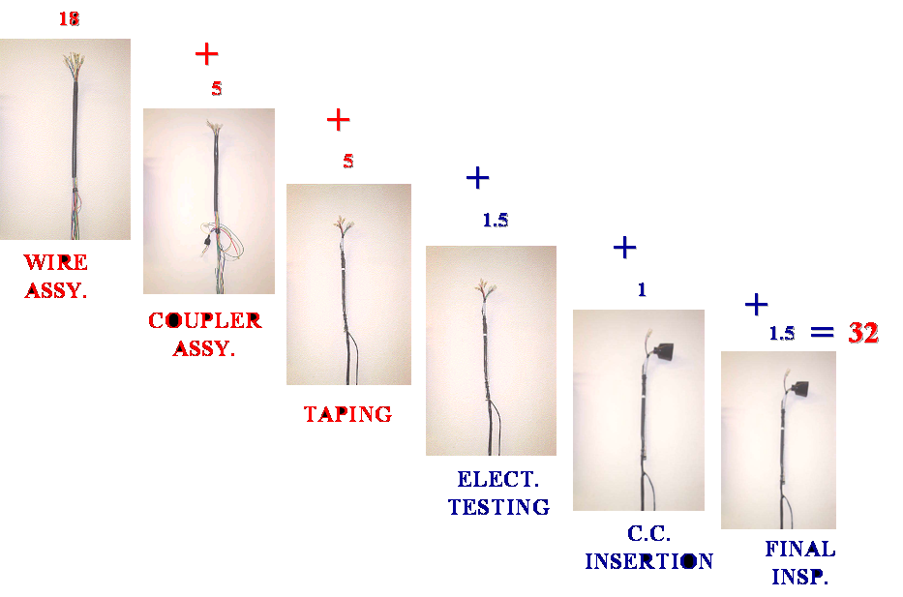
Fig.4.4 First piece production time
4.4.1 Wire Assembly- First wire kit is received from WIP and then all wires are arranged on the stand according to the process sequence. After that rubber band which is used to bind all wires in a bunch, is to be cut. Then job card is collected. Last stage of wire assembly is to arrange the raw material i.e. black sleeves. This process takes 18 minutes.
    - Coupler Assembly- Every model use different types of couplers, terminals, sleeves etc. So every time change over is required whether it is for coupler or electrical testing.
First change over of the coupler table is done according to the production plan and then arrangement of the raw material is done at the table. This raw material consists different couplers, sleeves etc. After this all wires are arranged over which couplers will be mounted. Again arrangement of raw material is done over coupler table. Now the total time is 23 minutes till this stage.

4.4.3 Taping- First change over of taping fixture is done then stage wise raw material and sleeves distribution and storage takes place. Distribution of protector cord, sub assembly of wires, sub assembly of fuse case & lamp is done. After that stage wise material distribution and tape distribution is done. At this stage total time is 28 minutes.

4.4.4 Electrical Testing- This process consists first removal of connectors of the previous fixture (previous model), changeover of the fixture then connection are made according to the new fixture. Now machine is set up by the master sample. Once the value of the master sample is set then all the samples are tested with reference to that value. Now the time is 29.5 minutes.

4.4.5 Cover Connector Insertion- At this stage material is taken from stores i.e. material handling, after that material distribution and storage is done. This process takes 1 minute so total time is 30.5 minutes.

4.4.6 Final Inspection- This stage is visual inspection of a complete wiring harness. To check that extra fuse lamp is present in fuse case or not.
This stage takes 1.5 minutes so total time is 32 minutes at final inspection.
  - Problem Finding:
1 | Excess line set up time at the start of the shift | 28 | Adhesive variation in tape
2 | Improper storage system on shop floor | 29 | Joints in tape
3 | Improper storage of master sample | 30 | Improper winding of adhesive tape
4 | Coupler interchange at coupler assembly stage | 31 | Soft core of tape
5 | Time loss in manual marking at coupler assembly stage | 32 | Improper shearing of tape
6 | Terminal damage at taping stage | 33 | Time loss in opening of tape
7 | Improper issuing system of processed wires | 34 | Improper locking in band harness
8 | Improper handling of raw materials | 35 | Without cutting protector cord
9 | Time loss in high change over of terminal/wire roll | 36 | Wire interchange at coupler assembly stage
10 | Joints in terminal roll | 37 | Terminal damage at wire assembly stage
11 | No. of joints in terminal roll not defined | 38 | Excess tool set up time at coupler insertion fixture
12 | Mixing of processed wires | 39 | Excess tool set up time in continuity testing stage
13 | Improper identification of job card | 40 | Testing pins wear out
14 | Improper storage of processed wires | 41 | Terminal damaged at coupler insertion stage
15 | Improper fitment of fuse case | 42 | Excess changeover time of taping fixture
16 | Leg height variation in terminals | 43 | Roller bearing of conveyor broken
17 | Terminal damage from vendor end | 44 | Improper height of hangers
18 | Sheet thickness variation in terminal | 45 | Improper identification of wire spool at AWP
19 | Improper knurling in terminals | 46 | Improper record storage of used job cards.
20 | Improper plated terminals | 47 | Improper storage of raw-material at coupler insertion stage
21 | Improper fitment gap in terminals | 48 | Improper storage of fixtures
22 | Pitch variation in terminal chain | 49 | Improper display of work instruction at shop floor
23 | Short moulding in couplers | 50 | Improper identification system of sleeves
24 | Lock missing in coupler | 51 | Terminal back out
25 | Improper lock height in coupler | 52 | Excess machine set-up time of continuity tester
26 | Flashes in couplers | 53 | Conveyor hanger broken
27 | Lock broken in 2P male coupler

Table 4.1 Problem Finding

This table consists of 53 problems; all problems are collected after observing store, WIP, and shop floor. These problems are divided into three categories:
Category A – 1 to 8
Category B – 9 to 49
Category C – 50 to 53

  - Selection of Problem
4.6.1 ABC Analysis

A | B | C | Total
8 | 41 | 4 | 53

Table 4.2 ABC Analysis
- ‘A’ CATEGORY - Minimum involvement of other departments in
solving problems.
- ‘B’ CATEGORY - Involvement of other departments is a necessity
- ‘C’ CATEGORY - Management sanction & support may be needed
in implementing solutions
4.6.2 Selection of Problem
To select the problem rating is done and category A problem is rated.
Severity is based on the criticality of the problem. So problem no. 3 i.e. “excess line set up time at the start of the shift” has maximum severity.
S. No. | Problem | Severity
1 | Improper storage on shop floor | 5
2 | Time loss in manual marking at coupler assembly stage | 6
3 | Excess line set up time at the start of the shift | 8
4 | Terminal damage at taping stage | 7
5 | Coupler interchange at coupler assembly stage | 6
6 | Improper issuing system of processed wires | 7
7 | Improper handling of raw material | 5
8 | Improper storage of master sample | 4

Table 4.3 Rating of problem on basis of severity
The problem with the present production system is the time period to produce a piece of main wire harness, which is 32 minutes. The aim is to reduce the line set up time. This time period is due to improper material handling. All raw material distribution is done at the production line which consumes a lot of time and a piece is produced after thirty two minutes.

4.7 Concluding Remarks:
In this chapter the company profile is explained in details. The present production system of main wiring harness is studied, with a view to identify the problems.
Chapter 5
INVESTIGATION AND SOLUTION
5.1 INVESTIGATION OF THE PROBLEM

The main objective of this case study is to reduce the set up time of production line. Here investigation of the problem means how line set up time can be reduced and what are the factors which are responsible for this. In this case various problem solving and investigation techniques are applicable. But the most suitable techniques are applied here. These are:
- Fish bone diagram
- Why-Why Diagram
Initial investigations have done by fish bone diagram as shown in the coming pages. Initial investigations have provided important possible causes of failures. Each of the possible causes and their effects has further analyzed to get highly effective cause of failure.
This highly effective cause of failure is further investigated by using the problem solving tool “Why-Why diagram”
After investigating Fish bone diagram it is found that problem was due to four factors- man, machine material and method. After that why-why analysis is performed to find the root cause.
Excess Time Taken To Produce First Piece
Operator Unaware About Running Plan
Man
Fig.5.1 (a) Cause & Effect Diagram for man
Excess Time Taken To Produce First Piece

Machine
Fig.5.1 (b) Cause & Effect Diagram for Machine

Excess Time Taken To Produce First Piece

Material
Fig.5.1(c) cause & Effect diagram for material

Excess Time Taken To Produce First Piece

Method
Fig.5.1 (d) Cause & Effect Diagram for method
Next stage is to analyze why-why diagram to find out the root cause of each problem. In why-why analysis various reasons are given to each problem. After analyzing the root causes, solutions of the problem can be find out. A table is shown below for why-why diagram:

Why-Why diagram for root cause:

PROBLEM | WHY 1 | WHY 2 | WHY 3 | WHY 4
Excess Time Taken For Stage Wise Distribution Of Raw Material & Processing Wires. | Large Quantity Of Material Issued In One Bin | Stage-Wise Kit Not Being Issued | Material Handling System Not Good | Resources Not Available (Partitioned Bins & Trolleys)
Operator Not Coming At Work Station On Time | Bus Coming Late | Traffic Jams & Too Many Stoppages | Route Not Ok & Fluctuation In Stoppage Timings | No Specified Bus Stoppage Timing
Operator Not Coming At Work Station On Time | Excess Changing Time Taken By Operator | Operator Not Awarded About Coming On Line In Time | No Specific Instructions To Operators | No Fixed Duration Specified
Time Loss In Sub Assembly Of W/Prf Wires | Sub Assembly Process Included With Taping Stage | No Separate Subassembly. Stage | Process Reviewed As Per Old Running Models
Time Loss In Assembly Of Fuse Case & Fuse Lamp | Extra Time Taken In Opening The Fuse Case & Fitment Of Fuse Lamp | Folded Fused Case Issued | Process Set As Per Old Models | Issue Not Discussed With Vendor

Table 5.1 Why-Why Analysis

Next stage is data Analysis. This analysis gives the idea of failures in percentage. The causes are observed 15 times and numbers of failures are noted every time. Finally numbers of failures are calculated in percentage.

S.No. | CAUSE | OBSERVATION | NO. OF FAILURES
S.No. | CAUSE | OBSERVATION | Nos. | in %
1 | Operators Not Coming To Work Station In Time | 15 Times Checked The Timings | 2 | 5.55
2 | Operators Unaware About Running Production Plan/ Shift Wise Production Plan Not Displayed | 15 Times Observed | 1 | 2.77
3 | Excess Time Taken For Stage-Wise Distribution Of Raw Material & Processing Wires/Material Handling. | 15 Times Checked The Distribution Time | 15 | 41.66
4 | Excess Time Taken For Sub Assembly Of:  a) Fuse Case & Fuse  Lamp  b) Assembly Of Water Proof  Wires | 15 Times Observed | 12 | 33.33
5 | Mixing Of Raw Material At Fuse Case Assembly Stage (Taping) | 15 Times Observed | 6 | 16.66

Table 5.2 Data Analysis

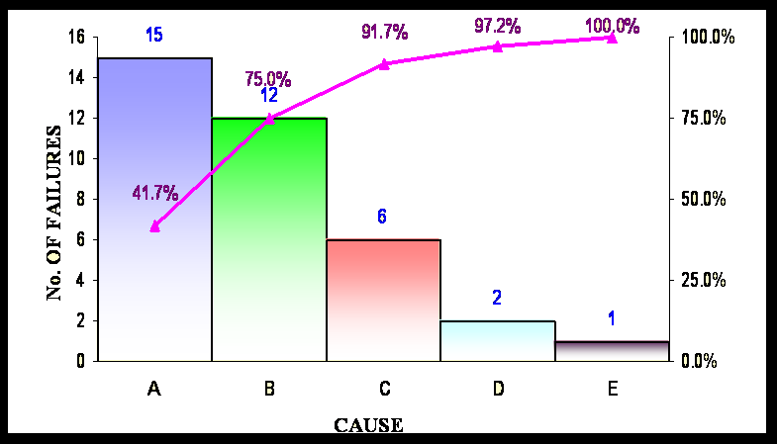

Fig. 5.2 Pareto Diagram
Causes:
A – Excess time taken for stage wise distribution of raw material & processing wires/material handling.
B- Excess time taken for sub assembly of
(a) Fuse case & Fuse lamp
(b) Assembly of water proof wires
C- Mixing of raw material at fuse case assembly stage (taping)
D – Operators not coming to work station on time
E – Operators unaware about running plan/shift wise production plan not displayed
5.2 SOLUTIONS MADE
After investigation various solutions are made:
- Problem – Excess time taken for stage wise distribution of raw material and processing wires.
Reason (i) – Kits were not issued stage wise, they issued randomly.
Action – Provision of new designed trolleys and bins (for proper identification of stage wise raw material)
Reason (ii) – Stage wise distribution of raw material is not maintained.
Action –Distribute the material in advance to each stage and provide awareness to the operator.
Reason (iii) – Processed wires are not received in advance.
Action –Provide the processed wires 30 minutes before at assembly stage.
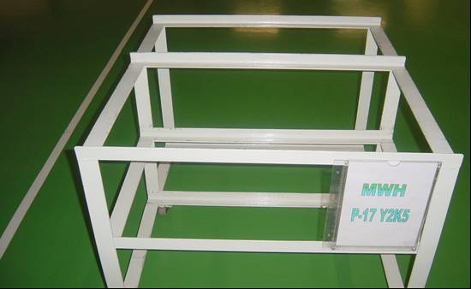
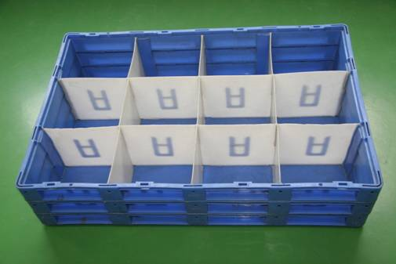
New Designed Trolleys New Designed Bins
Fig.5.3 New Designed trolleys & Bins
2. Problem- Excess time taken for sub-assembly of
(i) Fuse case and Fuse lamp
(ii) Assembly of water proof wires
Reason – (i) Sub assembly process is combined with taping process
(ii) Extra time taken in opening of folded fuse case
Action – (i) To separate the sub assembly process from taping process i.e. both processes are done separately
(ii) Suppliers are asked to supply the unfolded fuse case i. e. in opening condition
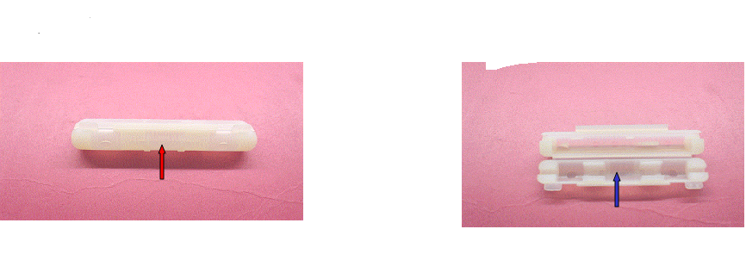
Before Improvement After Improvement
Fig.5.4 Fuse case before & after improvement

3. Problem –Mixing of raw material at fuse case assembly stage
Reason – Improper storage of material
Action – (i) Provide proper storage of raw material in bins with partitions.
(ii) Provide new aprons with three pockets so that operators can keep more raw material.
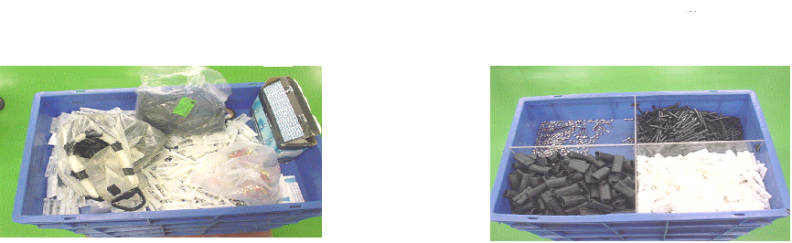
Before Improvement After Improvement
Fig.5.5 Mixing Of raw material
4. Problem – Operators are not coming to work station on time
Reason – (i) Bus late
(ii) Excess time taken to change the shoes and uniform
Action – (i) Problem discussed with P&A department to reschedule bus arrival time
(ii) Proper instructions are given to the operator
5. Problem – Operators are unaware about running production plan and shift wise production plan is not displayed at the shop floor.
Reason – Plan is not displayed properly
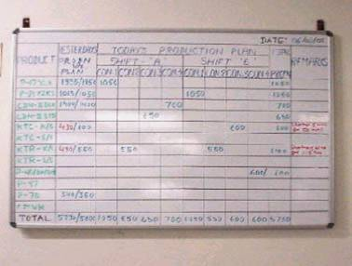
Action – provide the display board on the shop floor
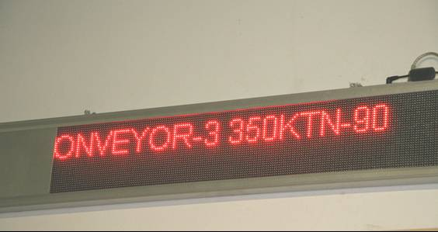
Existing Display Board New Display Board
Fig.5.6 Display Board before & after improvement

6. Material Handling –Before improvement al bins were placed over each other. It takes time to find out the required material for particular plan.
After improvement proper bins were made. Each rack was marked the model name and that rack contains the raw material for that model only.
Before Improvement After Improvement
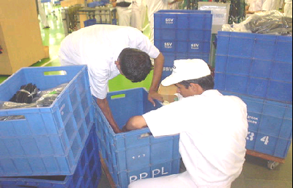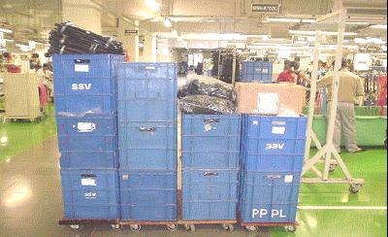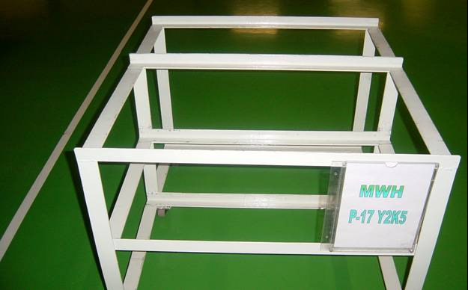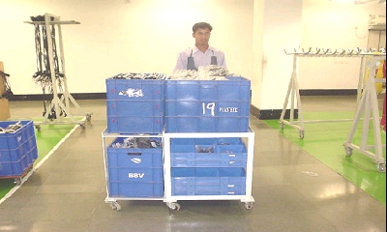
Fig.5.7 Material Handling

7. Raw Material Storage –
Before Improvement After Improvement
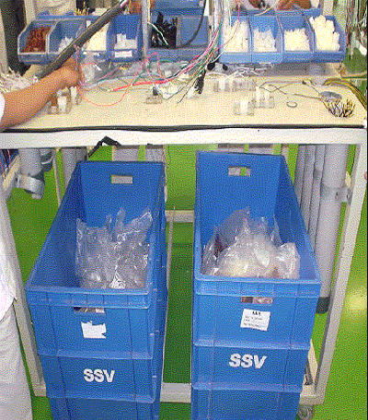
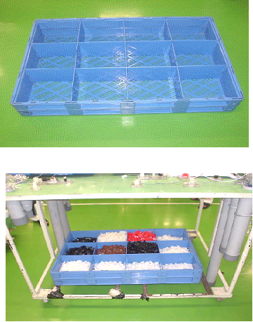
Fig.5.8 Raw material storage
Before improvement separate bins were not provided. Now separate bins are provided. Couplers, terminals are segregated in different bins.

8. COUPLER ASSEMBLY FIXTURES:
Before Improvement After Improvement

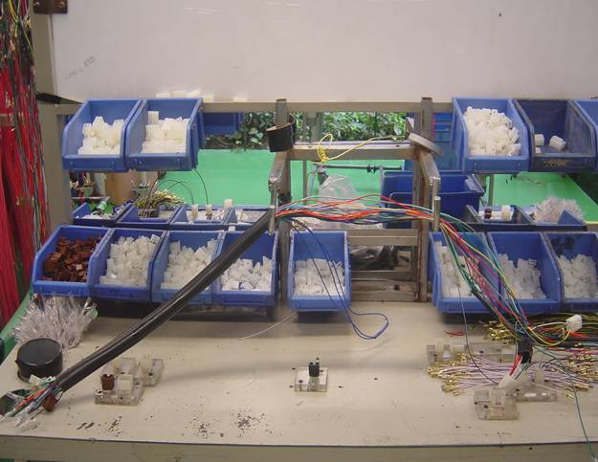
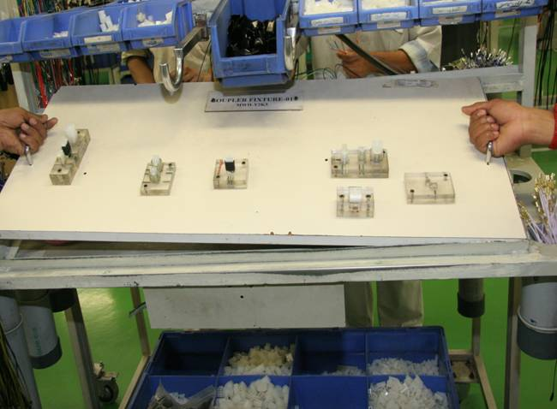
Fig.5.9 Coupler assembly fixture

Before improvement fixed fixtures were used for coupler assembly. Every time whole system is changed for coupler assembly-as the model changed complete system needs to be changed.
After improvement replaceable fixtures are used. Different fixtures are made. When model is changed, only the fixture is changed.
After improvement it has been found that total time which is 32 minutes to produce first piece, is reduced to 14 minutes after implementation of all the solutions which are discussed above.

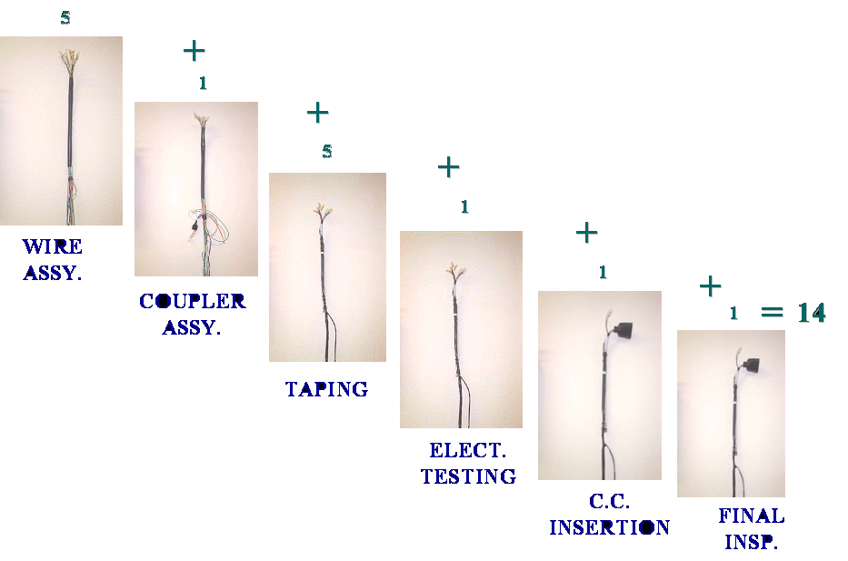
Fig.5.10 proposed production system

5.3 Concluding Remarks:
In this chapter investigation and solution of the problem is discussed. Cause and effect diagram, why-why diagram, pareto analysis is discussed to find the problem. To find the solution various reasons are given for each problem, and different improvements are made.

Chapter 6
IMPROVEMENT MADE
6.1 IMPROVEMENT IN MATERIAL MOVEMENT
After implementation of all the solutions, sequence of material movement is changed. The typical process after improvement for production of Main Wire Harness is shown in fig.
Stores
Kit Issuance & Receiving
Kit Verification
Wire Kit Receipt from WIP & Preparation
Stage Wise Raw Material Storage
Sub Assembly of Raw Material
Fig.6.1 Production System after improvement

6.2 IMPROVEMENT IN PRODUCTION PER SHIFT
Existing Production/Shift | Cycle Time/ Piece | First Piece Production Time |  | Total Time Saved | Production Increased/ Shift | Tentative Target/ Shift
Existing Production/Shift | Cycle Time/ Piece | Before | After | Total Time Saved | Production Increased/ Shift | Tentative Target/ Shift
1050 | 24 seconds | 32  minutes | 14 minutes | 18 minutes | 50 PCS | 1100

Table 6.1 Improvement in production per shift
6.3 BENEFITS:
6.3.1 REDUCTION IN MANPOWER COST / PIECE
Before Improvement:
Manpower required = 37/shift
Cost/pc = (37 * 130 = Rs. 4810 for 1050 pcs.)
= Rs. 4.58 /Piece
After Improvement:
Manpower required = 37/shift
Cost/pc = (37 * 130 = Rs. 4810 for 1100 pcs.) = Rs.4.37/Piece
6.3.2 COST SAVING:
Saving in manpower cost= (1100*2*30 – 1050*2*30) *4.58 = Rs. 13740 /Month
Total cost save= 13740 * 12 = Rs. 1, 64,880 / YEAR
6.3.3 PRODUCTIVITY IMPROVEMENT:
Before Improvement 37 Manpower required
= (1050 / 37 *8 for 1050 pcs.) i.e. 3.55 Piece/Opr./Hour After Improvement 37 Manpower required / shift
= (1100 / 37 *8 for 1100 pcs.) i.e. 3.71 Piece/Opr./Hour
6.3.4 INCREASING IN UTILIZATION HRS:
Before Improvement
= Total Time - Line Setup Time – Tea Time – Lunch Time
= 8.5 H - 32 M - 20 M - 30 M
= 7 Hrs 8 Minutes
After Improvement
= Total Time - Line Setup Time – Tea Time – Lunch Time
= 8.5 H - 14 M - 20 M - 30 M
= 7 Hrs 26 Minutes
6.3.5 CAPACITY INCREASED
100 PCS / DAY & 2600 PCS / MONTH
6.3.6 AESTHETICS
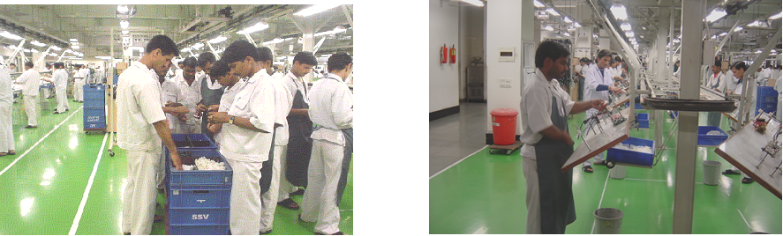
Before Improvement After Improvement
Fig.6.2 Aesthetics

6.4 Calculation For All Conveyor Lines:
Conveyor No. | Model | Prod/Shift | Cycle Time/Piece | Line Set Up Time |  | Total Time Save | Prod. Increased/Shift | Tent. Targ./Shift
 |  |  |  | Before | After | Total Time Save | Prod. Increased/Shift | Tent. Targ./Shift
01 | MWH 1 & MWH 2 | 1050 | 24 Second | 32 Minutes | 14 Minutes | 18 Minutes | 45 PCS | 1100
02 | MWH 3 | 600 | 42 Second | 32 Minutes | 14 Minutes | 18 Minutes | 25 PCS | 625
03 | MWH 4 | 550 | 46.1 Second | 32 Minutes | 14 Minutes | 18 Minutes | 25 PCS | 575
04 | MWH 5 & MWH 6 | 700 | 36 Second | 32 Minutes | 14 Minutes | 18 Minutes | 30 PCS | 730
Total |  | 2900 |  | 32 Minutes | 14 Minutes | 18 Minutes | 111 PCS | 3030

Table 6.2 Tabular Record for all conveyor lines
6.4.1 COST SAVING:
Saving in manpower Cost
Avg. prod. /shift before improvement =2900/4=725
Avg. prod. /shift after improvement = 3030/4=757.5
Saving in manpower Cost = (758*4*2*30 – 725*4*2*30) *6.57
= Rs. 52,034 /MONTH
Total costs save : 52,034 * 12 = Rs. 6, 24,408 / YEAR
6.4.2 INCREASE IN CAPACITY
260 pcs./day &7800 pcs./month
Before improvement After improvement
725 / Conveyor 758 / Conveyor
5800 / Day 6060 / Day
1, 74,000 / Month 1, 81,800 / Month
6.4.3 PRODUCTIVITY IMPROVEMENT:
Before Improvement average 36 Manpower required / shift
= (725 / 36 *8 for 725 pcs.) i.e. 2.51 Piece/Opr./Hour After Improvement 36 Manpower required / shift
= (758 / 36 *8 for 758 pcs.) i.e. 2.63 Piece/Opr./Hour
6.5 Concluding Remarks:
This chapter summarizes improvements like reduction in man power cost, cost saving, productivity improvement, overtime reduction, capacity increased.

SUMMARY: BENEFITS

- Time Saved - 18 Minutes per conveyor line
- Reduction in manpower cost - Rs.0.29 per piece
- Cost save - Rs. 6,24,408 per year
- Productivity improvement - 0.12 Piece per operator per hour
- Over time reduction - Save 500 hrs. per month
used in segregation of raw material
6. Capacity Increased - 7,800 pcs. per month
7. Reduction in Wastage & Mix Up Of raw material.
8. Improve the aesthetics.

Chapter 7
Summary and Conclusions
7.1 Introduction:
This chapter presents summary of the work done, contribution and limitations of the present work. The areas, which require further in depth study, are also outlined.
7.2 Summary of the work done:
The objective of this study is to study the entire production system for a real life case of Napino Auto & Electronics Limited, which is engaged in manufacturing of main wiring harnesses for two wheelers. After making a system wide study of the company, various problem areas were identified. This included:
- Excess line set up time at the start of the shift
- Improper handling of raw material
- Improper storage system on shop floor
Each of the above areas is very important in cost reduction and to improve effectiveness throughout the organizational production system.
- Identified a real life Company, Napino Auto & Electronics Limited where manufacturing is a vital issue.
- Accordingly a literature review was carried out and relevant Issues were identified.
- Production system analysis is carried out.
- The existing set up is studied, and a new set up is proposed.

7.3 Major Contribution of the Present Work:
The major contribution of this research is summarized below:
- A selective review of literature related to continuous improvement based on focus area and methodology employed.
- Improvement in the production time is considered as one of the most critical factor challenging the management in this competitive environment.
7.4 Limitations of the Study:
Some limitations observed while carrying out this research are listed below:
- This study is carried out only for main wire harness.
- Since the production of MWH is very competitive there are technical limitations to the access to the data provided by the organization. Some of the key data were not made available during the study.

7.5 Recommendations for Further Study:
Further research may be carried out to study the terminal problem; coupler problem; shop floor problem and operations aspects of the organization.
In this study, solution of the production system’s related problems is proposed. In this research, the various aspects are studied through continuous improvement tools. Solution of the wires, water proof couplers could be added in this study.
7.6 Learning Points:
- Exposure to production process problem.
- Exposure to corporate work culture by frequent visits to the company.
- Developments of skill, to assimilate their problems according to that develop the models to suit the problems.
7.7 Concluding Remarks:
This chapter synthesized the research work carried out and discussed in previous chapters. Major contributions of the study and the scope for further study are also identified. It is expected that this modest attempt for continuous improvement will help the organization in its efforts to be competitive in this globalize economy.

REFERENCES
- Ahire, S. L., Drefus, P. (2000), “The impact of design management and process management on quality: an empirical investigation,” Journal of Operations Management.
- Au, G., Choi K. (1999), “Facilitating implementation of total Quality Management Through information technology,” Information and Management.
- Abdolshah M., Jahan A. (2006), “How to use continuous improvement tools in different life periods of organization,” IEEE, International Conference on Management of Innovation and Technology, pp. 772-777.
- Azadeh A., Ghaderi f. S., Miran Y. P., Suzuki K., (2007), “An integrated Framework for Continuous Assessment and Improvement of manufacturing Systems, ” Applied Mathematics and Computation, Vol. 186, Issue 2, pp. 1216-1233.
- Alford D., Sackett P., and Nelder G., “mass Customization-An Automotive Perspective,” retrived on 7th June 2007.
- Alonso. Ramon, L. and Fraiser, C. W. (1991), “JIT Hits Home: A Case Study”, Sloan Management Review, Vol. 32, No.4, pp.59-67, June.
- An introductory tutorial about the continuous improvement process and total quality management from practitioner’s perspective. http://www.optants .com/tutor/ciptqm.htm.
- Bititici, U., Nudurupati, S., (2002), “Driving Continuous Improvement”, IEEE.
- Bond, T. C. (1999), “The role of performance measurement in continuous improvement” International Journal of Operation and Production Management, Vol. 19 No. 12, pp.1318-34.
- Bessant J. (2000), “Developing and sustaining employee involvement in Continuous Improvement,” IEE, Savoy Place, pp. 1-18.
- Bititci U. S., Turner T., Begemann C. (2000), “Dynamics of Performance Measurement Systems”, International Journal of Operations Management, Vol. 20 No. 6, pp. 692-704.
- B. Arne and A. Leo (1994), “A Systematic method for renewal of Production Technology,” Sessions on Optimization of manufacturing Systems, CIRP, pp. 409-412.
- Barbara, B., Roger, G. and Sadao, S. (1997), “The Impact of Just-in-Time Manufacturing and its Infrastructure on Manufacturing Performance” Management Science, Vol. 43, No.9, pp. 1246-1257, September.
- Choi, T. Y. Eboch, K. (1998), “The TQM paradox: relations among TQM practices, plant performance and customer satisfaction,” Journal of Operation Management.
- Chan F. T. S., Lau H. C. W., Chan H. K., and Kong S. (2005), “Implementation of total productive maintenance: a case study”, International Journal of Production Economics, Vol. 95, Issue 1, pp. 71-94, January.
- Cua, K. O., Mckone, K. E., Schroeder, R. G. (2001), “Relationships between implementation of TQM, JIT and TPM and Manufacturing Performance,” Journal of Operation Management.
- Dean M. Schroeder and A. G. Robinson, (1991) “America’s Most Successful Export to Japan: Continuous Improvement programs,” Sloan Management Review 32, No. 2 (spring), pp. 67-81.
- Deming W., Edwards (1981), “Improvement of quality and productivity through action by management,” National Productivity Review, 1, pp 12-22.
- Dangayach G. S., Deshmukh S. G. (2003), “Evidence of Manufacturing Strategies in Indian Industry: A Survey,” International Journal of production Economics, Vol. 83, Issue 3, pp. 279-298.
- Evanas J. R. and Lindsay W. M., “The Management and Control of Quality”.
- Edosomwan, J. A. “Productivity and quality improvement,” IFS Publication.
- Fortuin, L. (1988), “Performance Indicator-why, where and how?” European Journal of Operation research, Vol. 34, pp. 1-19.
- Fry, T. D. (1995), “Japanese manufacturing performance criteria:” International Journal of production Research, Vol. 33 No. 4. pp. 933-54.
- Fullerton R. R., Mcwatters C. S., (2001), “The production performance benefits from JIT implementation”, Journal of Operation Management, Vol. 19, Issue 1, pp. 81-96, January.
- Flynn, B. B., Schroeder, R. G., Sakakibara, S. (1995), “The impact of quality management practices on performance and competitive advantage”, Decision Sciences, September/October.
- Gertsen F. (2001), “How continuous improvement evolves as companies gain experience,” International Journal of Quality Management-Vol. 22, No. 4, pp-303-326.
- Gieskes, J. f. B., Boer, H. and Baudet, c. M. (1999), “CI and performance: a CUTE approach”, International Journal of Operation and Production management, Vol. 19, No. 11, pp. 1120-37
- Groover M. P. (2001), “Automation Production Systems and Computer Integrated Manufacturing,” Pearson Education.
- Gitlow , H., S. Gitlow, A. Oppenheim (1989), “Tools and Methods for the improvement of Quality”, Homewood.
- Gallagher M., Austin S., (1997), “Continuous Improvement Casebook,” Kogan Page, London.
- Golhar, D. Y., Stamm, C. L. and banerjee, S. (1993), “Just-in-time purchasing: an empirical investigation”, Production & Control, Vol. 4 No. 4, pp. 392-398.
- Green, F. B. (1991), “performance measures and JIT”, Management Accounting, February, pp. 50-3.
- Hiroyuki H. (1990), “JIT Implementation Manual,” Productivity Press, Portland, Vol. 1 and 2.
- Herrera R., Miller A., (1991), “Gaining competitive advantage through continuous improvement programs,” IEEE/Seminar Int’l Semiconductor Manufacturing Science Symposium, pp -69-74.
- Hung H. F., Kao H. P. and Chu Y. Y., “An empirical study on knowledge integration technology innovation and experimental practice,” Retrieved on 7th June 2007.
- Harrison A., (1998), “Manufacturing Strategy and the concept of World-Class Manufacturing,” International Journal of Operation Management, Vol. 18 No. 4, pp. 397-408.
- Higginson, J. K. and Bookbinder, T. H., (1990), “Implication of just-in-Time production on rail fright system”, Transportation Journal, Vol. 29, pp. 29-35.
- Hayek, F. A, “The use of Knowledge in Society”, American Economic Review, Vol. 35, No.4, 2005, pp. 519-530.
- Hasan, M., Kerr, R. M. (2003), “The relationship between total quality practices and organizational performance in service organizations”, The TQM Magazine.
- http://www.continuousimprovement.com (web reference)
- Jon D. and M. Semyon M. (1994). “System-theoretic properties process of continuous improvement in production system,” Proceedings of the America Control Conference, Vol. 3, pp. 3323-2237.
- Jacobs D., Meerkov S. M., (1993), “On the process of continuous improvement in production systems: fundamental properties and guidelines”, Control Group report no. CGR-93-10, Michigan.
- Keffler A. (2005). “Raising the Standards,” IEEE Engineering Management, Vol. 15, pp. 34-37, Oct-Nov.
- Kumar B., (2001), Industrial Engg., Khanna Publishers.
- Kaplan R. S., Norton D. P. (1992), “The Balanced Scored Card-Measures That Drive Performance”, Harvard Business Review, January-February Issue.
- Kaoru Ishikawa, “What is Total Control?” The Japanese way, Prentice Hall.
- Karmarkar U. (1989), “Getting Control of just-in-Time”, Harvard Business Review, September-October Isuue.
- Kuznetsova, E. S., (2004), “Continuous Improvement process as a way to increase effectiveness”, IEEE, Vol. 3, pp. 244-246
- Kirton, M. J., (1989), “Styles of creativity and problem solving”, Routledge, New York.
- Luftman (1996), “Competing in the information Age: Strategic Alignment in Practice,” Oxford University Press.
- Lynch, R. L. and Cross, K. F. (1991), Measure up! Yardstick for continuous improvement, Basil Blackwell, Cambridge, MA.
- Mason, R. O. (1979), “A general system theory of productivity”, International Journal of General System, Vol. 5, pp. 17-30.
- Mills J. Platts K., Gregory M. (1996), “A Framework for the Design of Manufacturing Strategy Process,” International Journal of Operation Management, Vol. 15, No. 4, pp. 17-49.
- Masaaki Imai, kaizen random house Business Division, 1986.
- Mara E. O. C., Hyland P., Sloan T. (1999), “Knowledge Transfer in New Product Development,” IEEE, Vol. 1, pp. 165.
- Matias J. C. H.,Vizan A., Perez-Garcia J., Rios J. (2008), “An Integrated Modeling Framework to Support Manufacturing System Diagnosis for Continuous Improvement,” Robotics and Computer Integrated Manufacturing, Vol. 24, Issue 2, pp. 187-199.
- M. A. Azadeh, (2000), “Creating High Reliable Manufacturing Systems: An Integrated Approach,” International Journal of Reliability Quality and Safety Engineering.
- M. A. Cusumano, (1994), The Limits of Lean, “Sloan Management Review”, 354 pp. 27-32.
- M. Terziovski, (2002), “Achieving Performance Excellence through Integrated Strategy of radical Innovation and Continuous Improvement,” Measuring Business Excellence.
- Mills J. Platts K., Gregory M., (1996), “A Framework for the Design of Manufacturing strategy Process ”, International Journal of Production management, Vol. 15, No. 4, pp. 17-49.
- Monden Y. (1994), “Toyota production system: an integrated approach to Just-in-Time”, Chapman and hall, UK.
- Neely A., Mills J., Gregory M., Richard H., Platts K. and Bourne M., (1996), “Getting the measure of your business,” University of Cambridge, Manufacturing Engineering Group, Mill Lane, Cambridge.
- Neely, A., Mills J., Gregory M and Platts K. (1995), “Performance measurement system design-a literature review and research agenda,” International Journal of Operation Management, Vol. 15, No. 4, pp. 80-116.
- Neely, A., Mills, j., Platts, K., Gregory, M. J. and Richards, A. H. (1994), “Realizing strategy through measurement”, International Journal of Operation Management, Vol. 14 No. 3, pp. 140-52.
- Nellore R. and R. Balachandra, (2001), “Factors influencing success in integrated product development (IPD) projects,” IEEE Transactions on Engineering Management 48, pp. 164-174.
- Nancy Blodgett. What is continuous improvement? http://www.dbianc.com.
- Novich, N. (1990), “Distribution Strategy - Are you Thinking Small Enough?” Sloan Management Review, Vol. 32, No.1, pp. 71- 76, September.
- Neely A., Adams C. (2001), “The Performance Prism Perspective”, Journal of Cost Management, January/February
- Porter M. E. (1996), “What is Strategy?” Harvard Business Review November-December.
- P. Chandra and T. Sastry (1998), “Competitiveness of Indian manufacturing,” Vikalpa 233, pp. 25-36.
- Power D., Terziovski M., (2007), “Quality Audit role and skills: Perception of non-financial auditors and their clients”, Journal of Operation Management, Vol. 25, issue 1, pp. 126-147.
- Powell, T. C. (1995), “TQM as competitive advantage: a review and empirical study’, Strategic Management Journal.
- Prajogo, D. I. Sohal, A.S. (2001), “TQM and innovation: a literature review and research framework”, Technovation.
- Robinson A. (1991), ed., “Continuous improvement in operations,” Cambridge, MA: Productivity Press.
- S. Shingo (1998), “Non Stock Production: The Shingo system for continuous Improvement,” Productivity Press, Cambridge.
- Saxena K. B. C. and Sahay B. S. (1999), “World-Class Manufacturing & Global Competitiveness,” Productivity, Vol. 40, No. 1, April-June.
- Skinner, W., “The Focused factory”, Harvard Business Review, May-June 1994.
- Sherman et. al. and Jenssen S. A. (2000), “Differential effects of the primary forms of cross functional integration on product development cycle time,” Journal of Product Innovation Management, Vol. 17, pp. 257-267.
- Skinner, W. (1986)., “The Productivity Paradox”, Harvard Business Review, pp. 55-9, July-August.
- Sweeney, M. T. and Szwejczewski, M. (1996), “Manufacturing strategy and performance”, International Journal of Operation and production Management, Vol. 16, No. 5, pp. 25-40.
- Tenner A. R., Detro I. J., (1992), “Total Quality management: Three steps to Continuous Improvement,” Reading MA: Addison-Wesley.
- Upton, D (1998), “Just In Time and Performance Measurement Systems”, International Journal of Operations and Production Management, Vol. 18, No. 11, pp. 1101-10.
- Ubgoro, I. O., Obeng, K. (2000), “Top management leadership, employee empowerment, job satisfaction and customer satisfaction in TQM organizations: an empirical study”, Journal of Quality Management.
- Vrat P. (1993), “Implementation of JIT in Indian Environment: Delphi Study”, Productivity, Vol. 34.
- William A. Levinson (1997), “SPC Essentials and productivity improvement”, Harris Corporation.
- White, G. P. (1996), “A Survey Taxonomy of strategy related performance measure for manufacturing”, Production and Inventory Management Journal, Third Quarter, pp. 5-11.
- Weir J. Y., (1997), “Continuous Improvement Through team Work”, IEE, U. K.
- Yanjiang C., Dan W., Lang X. (2006), “Influencing factors of continuous improvements and tendency of change,” IEEE International Conference on Management of Innovation and Technology, Vol. 1, pp. 181-185, June.
- Yasin, M., Yavas, U. (1999), “Enhancing customer orientation of the service delivery systems: an integrative framework”, Managing Service Quality.
- Zenger, D., Dewhurst, P.(1998), “Assessment of tooling costs”, Department of Industrial and Manufacturing engineering, University of Rohde Island.

