Chapter - 4

SIMULATION EXAMPLES

4.1 INTRODUCTION
In the previous Chapter, two algorithms have been suggested based upon the concept of eigen spectrum analysis for deriving the reduced order models of high order linear time-invariant dynamic systems. The algorithms presented were described only for the systems having real poles. In this Chapter, a wide variety of numerical/simulation examples are chosen from the literature to demonstrate the algorithms suggested in the previous Chapter.

4.2 Illustrative examples for algorithm no. 1
Four numerical/simulation examples are chosen from the literature for the comparison of the LOS with the original HOS. The proposed algorithm is described in detail for one example while only the results of the other three examples are given.
An error index ISE [79] known as integral square error in between the transient parts of original and reduced order systems is calculated to measure the goodness/quality of the LOS (i.e. the smaller the ISE, the closer is to ), which is given by :
ISE = (4.1)
where, and are the unit step responses of original and reduced order systems, respectively.
Also, the impulse response energy (IRE) [24, 75] is calculated for original and various reduced order models, which is given by :
IRE = (4.2)
where, is the impulse response of the system.

Example 1. Consider a 10th order system previously investigated by Edgar [16] and Mukherjee [48]. The poles of the system are all real and the system is without any numerator dynamics having very high gain.
The HOS transfer function is given as :
(4.3)
where, λ₁ = 2.04, λ₂ = 18.3, λ₃ = 50.13, λ₄ = 95.15, λ₅ = 148.85, λ₆ = 205.16,
λ₇ = 257.21, λ₈ = 298.03, λ₉ = 320.97, λ₁₀ = 404.16.
The above system is having IRE of 0.9032. If a 2nd order model is to be synthesized using the algorithm no. 1, then steps to be followed are as under :
Step-1: Fixing of ESZ of HOS :
Since all poles are real, it will be a line joining the nearest and farthest poles.
Step-2: Quantification of pole centroid and stiffness of HOS :
Step-3: Determination of eigen spectral points of LOS :
Equation (3.10) can be formed as under :
(4.4)
where, the values of , Q, p' and N are to be put as 5.0475 x 10⁻³, 0, 2, 360, respectively.
Solution of the (4.4) gives the location of the farthest pole and M, where M = (Farthest pole − Nearest pole)/( p' – 1) and since p' = 2; Reλ'_{p'} = 358.19202; M=356.38404 ESPs of LOS are its two poles as λ'₁ = 1.8079742 and λ'₂ = 358.19202.
Therefore, .
Step-4: Following (3.12), we have :
Therefore, finally is given as :
(4.5)
with an ISE and IRE of 1.5 x 10⁻³, 2.1867, respectively. The unit step responses of original and reduced order models are shown in Fig. 4.1.

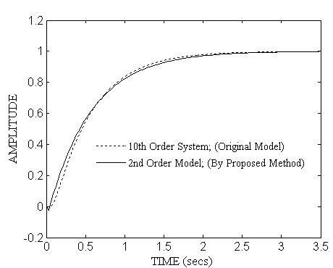

Fig. 4.1 Step responses of and for example 1.

Example 2. Consider a 4th order system investigated by Moore [47] :
(4.6)
with an IRE of 2.736 x 10⁻⁴. If a 2nd order model is required, then by following the steps, as described in Section 3.3 ,we will get the as :
(4.7)
with an ISE and IRE of 1.561 x 10⁻⁶, 3.122x10⁻⁴, respectively. The unit step responses of original and reduced order models are shown in Fig. 4.2.

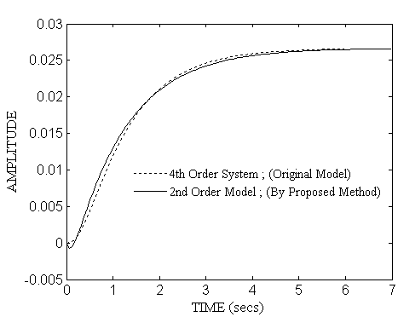
Fig. 4.2 Step responses of and for example 2.

Example 3. This example is chosen to compare the proposed algorithm [29] with some well-known existing methods of order reduction. Consider a 4th order system taken from Mittal et al. [45] and Mukherjee & Mishra [49] :
(4.8)
with an IRE of 4.66251 x 10⁻¹. If a 2nd order model is required, then by following the steps, as described in Section 3.3 ,we will get the as :
(4.9)
with an ISE and IRE of 2.64337x10⁻⁴, 4.61297x10⁻¹, respectively. The unit step and frequency responses of original and reduced order models are shown in Fig. 4.3 (a)-(b) and a comparison of the proposed algorithm with some well-known existing order reduction techniques for a 2nd order reduced model is given in Table 4.1. Further, a qualitative comparison in terms of transient response parameters [53] for original and various reduced order models is also shown as given in Table 4.2.

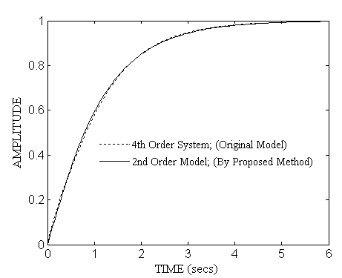
(a)

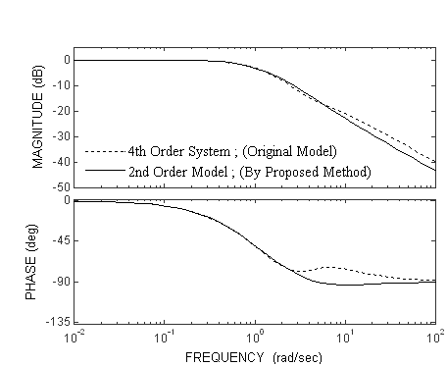
(b)
Fig. 4.3 (a) Step responses (b) Frequency responses of and
for example 3.

Table 4.1 Comparison of reduced order models obtained through proposed and other methods for example 3
Method of order reduction | Reduced models; | ISE | IRE
Proposed algorithm [29] |  | 2.64337 x 10⁻⁴ | 4.61297 x 10⁻¹
Chen et al. [12] |  | 2.6655 x 10⁻³ | 4.24378 x 10⁻¹
Chidambara [13] |  | 220.2379 x 10⁻³ | 3.07899
Davison [15] |  | 220.2379 x 10⁻³ | 3.07899
Gutman et. al [23] |  | 4.5593 x 10⁻² | 7.54249 x 10⁻¹
Hutton and Friedland [24] |  | 3.58814 x 10⁻⁴ | 4.51312 x 10⁻¹
Krishnamurthy and Seshadri [34] |  | 9.5891 x 10⁻³ | 4.69766 x 10⁻¹
Lucas [39] |  | 3.2865 x 10⁻⁴ | 4.71699 x 10⁻¹
Mittal et al. [45] |  | 2.3785 x 10⁻⁴ | 4.61187 x 10⁻¹
Moore [47] |  | 1.56955 x10⁻⁴ | 4.62532 x 10⁻¹
Mukherjee and Mishra [49] |  | 2.37856 x 10⁻⁴ | 4.61248 x 10⁻¹
Pal [54] |  | 1.1688 x 10⁻² | 3.97301 x 10⁻¹
Prasad and Pal [68] |  | 1.53427 | 6.14777 x 10⁻²
Shamash [74] |  | 3.3086 x 10⁻⁴ | 4.71828 x 10⁻¹

Table 4.2 Qualitative comparison in terms of transient response parameters for

example 3
System | Method of order reduction | Rise Time  t_{r} (secs) | Peak Overshoot  M_{p} | Settling Time  t_{s} (secs)
Original 4th Order [45, 49] | ……………….. | 2.26 | 0 % | 3.93
2nd Order | Proposed algorithm [29] | 2.26 | 0 % | 4.02
" " | Chidambara [13] | 1.7 | -200 % | 3.26
" " | Davison [15] | 1.7 | -200 % | 3.26
" " | Gutman et al.[23] | 1.54 | 0 % | 2.73
" " | Krishnamurthy and Seshadri [34] | 1.93 | 3.59 % | 5.59
" " | Pal [54] | 2.20 | 2.69 % | 5.57
" " | Prasad and Pal [68] | 15.4 | 0 % | 27.4

It can be seen in Tables 4.1 and 4.2 that the proposed algorithm is comparable in quality with the other existing techniques. Further, the step and frequency responses of original and various reduced order models are comparable as shown in Fig. 4.1-4.3(a) and Fig. 4.3(b), respectively.

Example 4. This example is chosen to illustrate the extension of the proposed algorithm for the order reduction of linear multivariable systems.
Consider a 6th order two-input two-output system [4, 66] described by the transfer function matrix :
(4.10)
=
where, the common denominator is given by :
=
and
The proposed algorithm [29] is successively applied to each element of the transfer function matrix of the above multivariable system and the reduced order models of the LOS () are obtained. The general form of the reduced second order model is taken as :
(4.11)
where, .
and , ,
, .
The step responses of original and reduced order models are compared in Fig. 4.4(a)-(d).

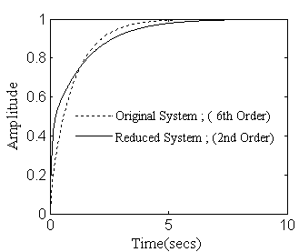

- u₁ = 1, u₂ = 0

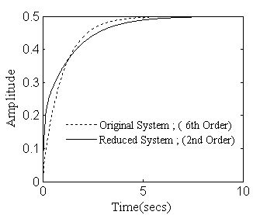

(c) u₁ = 1, u₂ = 0
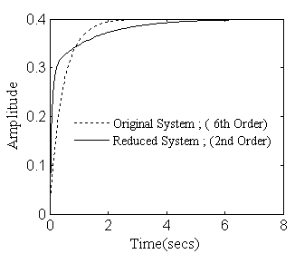

(b) u₁ = 0, u₂ = 1

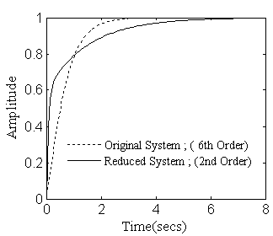

(d) u₁ = 0, u₂ = 1

Fig. 4.4 Comparison of step responses for example 4.

4.3 Illustrative examples for algorithm no. 2
Four numerical examples are chosen from the literature for the comparison of the LOS with the original HOS. The results using various reduction methods are given in tabular forms.
An error index ISE [79] known as integral square error in between the transient parts of original and reduced order systems is calculated for unit step input to measure the goodness of the LOS, which is given by (4.1).
Also, the IRE [24, 75] is calculated and compared in the tabular form for original and various reduced order models, which is given by (4.2).

Example 5. Consider the same 10th order system [16, 48, and 82] taken earlier in example 1 and given by (4.3). The system is having IRE of 0.9032. If a 2nd order model is to be synthesized using the proposed algorithm, steps to be followed are as under :
Step-1: The denominator of the can be obtained in a similar way as in example 1. Therefore, the denominator polynomial is given by :
.
Step-2: By using Cauer second form [8], as described earlier in Section 3.4, we have :
Therefore, finally is given as :
; Poles are at.
with an ISE and IRE of 1.5 x 10⁻³, 2.1868, respectively.
The unit step responses of original and reduced order models are shown in Fig. 4.5, and a comparison of the proposed method with some other existing methods for this example is given in Table 4.3.

Table 4.3 Comparison of the methods for example 5
Method of order reduction | Reduced models; | IRE
Proposed algorithm |  | 2.1868
Edgar [16] |  | 0.9347
Mukherjee [48] |  | 12.3484
Therapos and Diamessis [82] |  | 1.0568

It can be seen in Table 4.3 that, the IRE value is very high for Mukherjee’s method [48], which is not desirable. On the other hand, the values of IRE are comparable for the proposed and the other order reduction techniques [16, 82], which are also close to the IRE value of the original 10th order system, which is 0.9032.
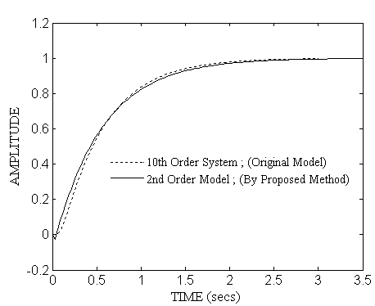

Fig. 4.5 Step responses of and for example 5.

Example 6. Consider the same 4th order system [47, 56] taken earlier in example 2 and given by (4.6). The system is having IRE of 2.736 x 10⁻⁴. If a 2nd order model is required, then by following the steps, as described in Section 3.4, we will get the as :
; Poles are at.
with an ISE and IRE of 1.5618 x 10⁻⁶, 3.122 x 10⁻⁴, respectively.
The unit step responses of original and reduced order models are shown in Fig. 4.6 and a comparison of the proposed method with some other existing methods for this example is given in Table 4.4.
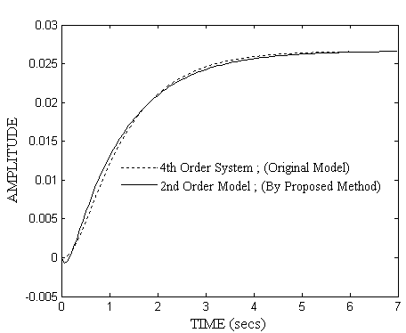
Fig. 4.6 Step responses of and for example 6.

Table 4.4 Comparison of the methods for example 6
Method of order reduction | Reduced models; | IRE
Proposed algorithm |  | 3.122 x 10⁻⁴
Moore [47] |  | 2.686 x 10⁻⁴
Mukherjee [48] |  | 3.865 x 10⁻⁴
Pal [56] |  | 2.711 x 10⁻⁴

It can be seen in Table 4.4 that, the values of IRE are comparable for the proposed and the other order reduction techniques [47, 48, and 56] and these values are also close to the IRE value of the original 4th order system, which is 2.736 x 10⁻⁴.

Example 7. Example 4. Consider a 8th order system investigated by Shamash [74] :
(4.12)
where,
The above system is having IRE of 24.2469. By using the proposed algorithm, the following reduced 2nd order approximant is obtained :
; Poles are at.
with an ISE and IRE of 4.8090 x 10⁻², 37.6894, respectively.
The unit step responses of original and reduced order models are shown in Fig. 4.7 and a comparison of the proposed method with some other existing methods for this example is given in Table 4.5. Further, a qualitative comparison of the original and reduced order models in terms of transient response parameters [53] is also shown as given in Table 4.6.

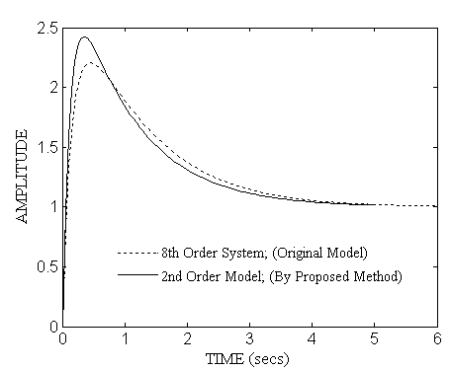

Fig. 4.7 Step responses of and for example 7.

Table 4.5. Comparison of the methods for example 7
Method of order reduction | Reduced models; | ISE | IRE
Proposed algorithm |  | 4.8090 x 10⁻² | 37.6894
Chen et al. [12] |  | 7.2101 | 2.6192
Gutman et al. [23] |  | 1.3760 | 4.3426
Hutton and Friedland [24] |  | 1.9170 | 1.9868
Krishnamurthy and Seshadri [34] |  | 1.6532 | 2.8871
Lucas [39] |  | 27.92 x 10⁻² | 8.9823
Mittal et al. [45] |  | 2.689 x 10⁻¹ | 9.7906
Mukherjee and Mishra [49] |  | 2.689 x 10⁻¹ | 9.7893
Mukherjee et al. [52] |  | 5.6897 x 10⁻² | 18.1060
Pal [54] |  | 1.6509 | 2.7581
Prasad and Pal [68] |  | 1.4584 | 34.1223
Shamash [74] |  | 27.92 x 10⁻² | 8.9823

Table 4.6 Qualitative comparison in terms of transient response parameters for

example 7
System | Rise Time  t_{r} (secs) | Peak Overshoot  M_{p} | Settling Time  t_{s} (secs)
8th Order | 0.0572 | 120 % | 4.82
2nd Order | 0.0409 | 142 % | 4.39

It can be seen in Table 4.5 that, the proposed algorithm gives low value of the ISE in comparison to the other existing methods. Also, the value of IRE for the proposed algorithm is close to that of original 8th order system, which is . Further, the transient response parameters for the original and reduced order models are also comparable as shown in Table 4.6.

Example 8. This example is chosen to illustrate the extension of the proposed algorithm for the order reduction of linear multivariable systems.
Consider the same 6th order two-input two-output system [4, 66] taken earlier in example 4 and given by (4.10). The proposed algorithm is successively applied to each element of the transfer function matrix of the above multivariable system and the reduced order models of the LOS () are obtained. The general form of the reduced second order model is given by (4.11),
where, .
and , ,
, .

An error index ISE known as integral square error in between the transient parts of original and reduced order models is calculated and given in Table 4.7 for each element of the transfer function matrix, which is given by :
ISE = (4.13)
where, and are the unit step responses of original and reduced order models, respectively.
The unit step responses of original and reduced order models are compared in Fig. 4.8 (a)-(d).

Table 4.7 ISE for reduced order models for example 8
ISE
2.27 x 10⁻²
6.9 x 10⁻³
6.2 x 10⁻³
6.83 x 10⁻²

- u₁ = 1, u₂ = 0

(c) u₁ = 1, u₂ = 0

(b) u₁ = 0, u₂ = 1

(d) u₁ = 0, u₂ = 1

Fig. 4.8 Comparison of step responses for example 8.

4.4 CONCLUSIONS
In this Chapter, several simulation/numerical examples have been given to demonstrate the algorithms suggested in the previous Chapter. The concept of eigen spectrum analysis has been used for deriving the reduced order models of high order linear time-invariant dynamic systems. The proposed algorithms have been described for the systems having real poles only. The matching of the unit step responses is quite good but, in some cases the reduced order systems develop tendency to become non-minimum phase. Though not investigated mathematically, the reason seems to be forced equalisation of the system stiffness. The algorithms are simple, rugged and take little computational time. These algorithms have also been extended for the order reduction of linear multivariable systems, which is a direct application of the SISO algorithm on the elements of the transfer function matrix of MIMO system. These algorithms have been implemented in Matlab 7.0.1 on a Pentium-IV processor. The proposed algorithms guarantee the stability of the reduced model if the original high order system is stable and are comparable in quality with some well-known existing methods of order reduction, as shown in the illustrative examples. To be more precise, the salient features of the proposed algorithms can be summarized as follows :
- The algorithms are computationally very attractive since only linear algebraic equations are required to be solved to arrive at reduced order models.
- The stability and the steady state values of the original systems are preserved. Therefore, the proposed algorithms overcome the stability problem associated with the continued fraction expansion (CFE) based methods [12, 55, and 68], in which some stability preserving methods have been used to preserve the stability of the original HOS in association with the CFE [8, 9, 77, and 78] methods.
- The algorithms can be easily applied to the systems where there are no dominant poles or where the dominant poles are difficult to identify (e.g. a system with poles at , ). Therefore, the algorithms circumvent the difficulties associated with some other existing methods [39, 45, 49, and 74]. Further, no error minimization technique [45, 49, and 52] is required in the proposed algorithms in order to match the step responses of original and reduced order systems.
- The values of the ISE and IRE are compared for the proposed and some well-known existing order reduction techniques as shown in the illustrative examples, from which it is clear that the proposed algorithms are comparable in quality with the other existing techniques. Also, the values of IRE for the proposed algorithms are close to that of original high order systems as shown in the examples.

