Chapter 1

Introduction and Problem Definition

1.1 Sensor Networks
Recent advances in micro-electro-mechanical systems (MEMS) technology, wireless communications, digital electronics and computer technology have enabled the development of small, low-power, multifunctional sensor nodes that can now be manufactured cost-effectively in large quantity [1, 2, 3, 4]. Sensor nodes are capable of sensing many types of information from the environment, including temperature; light; humidity; radiation; the presence or nature of biological organisms; geological features; seismic vibrations; specific types of computer data; and more. Very small in size, these nodes have embedded processing ability and can have multiple on-board sensors operating in the acoustic, seismic, infrared (IR) and magnetic modes, as well as imagers and micro radars. Also onboard are storage, wireless links to neighbouring nodes, and location and position knowledge through the global positioning system (GPS) or local positioning algorithms [7]. The sensor nodes are therefore capable of gathering, processing, storing and communicating information to other nodes and to the outside world. A wireless

Figure 1.1: The Components of a Sensor Node [8]

sensor network is composed of a large number of such sensor nodes, deployed densely either inside a phenomenon or very close to it. It represents a significant improvement over the traditional sensors. Compared to the use of a few expensive (but highly accurate) sensors, the strategy of deploying a large number of inexpensive sensors has significant advantages, at smaller or comparable total system cost: much higher spatial resolution; higher robustness against failures through distributed operation; uniform coverage; small obtrusiveness; ease of deployment; reduced energy consumption; and, consequently, increased system lifetime [6]. The position of sensor nodes need not be engineered or predetermined. This allows random deployment in inaccessible terrains or disaster relief operations. These could involve: in the air, under water, on bodies, in vehicles, and inside buildings. On the other hand, this also means that sensor network protocols and algorithms must possess self-organizing capabilities. Self-organization means that the system can achieve the necessary organizational structures without requiring human intervention, i.e., the sensor network should be able to carry out functional operations through cooperation among individual nodes rather than set up and operated by human operators. Another unique feature of sensor networks is the cooperative effort of sensor nodes in gathering the data. Sensor nodes are fitted with an onboard processor. They are usually battery based, with limited energy resources and capabilities; and it is difficult or unpractical to recharge each node. Instead of sending the raw data to the nodes responsible for the fusion, they use their processing abilities to locally carry out simple computations and transmit only the required and partially processed data [4]. When a sensor node is fixed/attached to a mobile platform, it acts as a mobile sensor node or a sensor robot. The terms ’sensor node’ and ’sensor robot’ are used interchangeably in this thesis, since in this work we are dealing with mobile sensor nodes.

Features
To summarize, some of the basic features of sensor networks are:
• Self-organizing capabilities
• Short-range broadcast communication and multihop routing
• Dense deployment and cooperative effort of sensor nodes
• Frequently changing topology due to fading and node failures
• Limitations in energy, transmit power, memory, and computing power
These characteristics [6], particularly the last three, make sensor networks different from other wireless ad hoc or mesh networks.

1.2 Applications

Below we list some of the common applications of Sensor Networks
- Monitoring environmental phenomena such as seismic data, temperature distribution by spreading the sensor nodes over a target region.
- Battle field surveillance using mobile and static sensors.
- Distributed tracking of target objects such as an enemy aircraft.
- Habitat monitoring of animals.
- Body sensor networks for monitoring the health of an individual.
- Traffic control.
- Industrial Sensing.

Figure 1.2: Sensor network used in military application [6]
A set of sensor nodes (black circles) are selected to work as data aggregators; through them data are sent to the external base station. If an Internet connection is available, a quality copy of the readings can be sent through the Internet to the central command. Source: [6]

The opportunities for wireless sensor networks are ubiquitous. However, a number of formidable challenges must be solved before these exciting applications may become reality.

1.2.1 Challenges
In order to understand the challenges involved, it is necessary to examine a list of metrics that determine the performance of a sensor network [6]:

Performance Metrics
- Energy efficiency/system lifetime: The sensors are battery operated, rendering energy a very scarce resource that must be wisely managed in order to extend the lifetime of the network.
- Accuracy: Obtaining accurate information is the primary objective; accuracy can be improved through joint detection and estimation. Rate distortion theory is a possible tool to assess accuracy.
- Fault tolerance: Robustness to sensor and link failures must be achieved through redundancy and collaborative processing and communication.
- Transport capacity/throughput: Because most sensor data must be delivered to a single base station or fusion center, a critical area in the sensor network exists (please refer section 2.2, figure 2.10), whose sensor nodes must relay the data generated by virtually all nodes in the network. Thus, the traffic load at those critical nodes is heavy, even when the average traffic rate is low. Apparently, this area has a paramount influence on system lifetime, packet end-to-end delay, and scalability. Because of the interdependence of energy consumption, delay, and throughput, all these issues and metrics are tightly coupled. Thus, the design of a WSN necessarily consists of the resolution of numerous trade-offs, which also reflects in the network protocol stack, in which a cross-layer approach is needed instead of the traditional layer-by-layer protocol design.
- Latency: Many sensor applications require delay-guaranteed service. Protocols must ensure that sensed data will be delivered to the user within a certain delay. Prominent examples in this class of networks are certainly the sensor-actuator networks. Of course, there are also many applications which are delay tolerant.
- Scalability: Because a sensor network may contain thousands of nodes, scalability is a critical factor that guarantees that the network performance does not significantly degrade as the network size (or node density) increases.
- Thus, the design of a WSN necessarily consists of the resolution of numerous trade-offs.
- Some of the key challenges involved in design of a wireless sensor network are as follows:

Limited energy resources
As with any embedded system, sensor nodes also face the challenge of reducing energy consumption, as much as possible, to maximize its operational lifetime [1]. A traditional hand held, consumer electronic class, embedded system has the provision of recharging whenever its batteries drain out, but this luxury is not available to a sensor node. This is due to the fact that most of the time a sensor node will be deployed in a remote area where a battery change is either impossible or costs more than the node itself. Consider changing the battery of a node buoyed up in the middle of pacific ocean? Another factor that highlights the importance of judicious use of energy resources is the fact that battery technology itself hasn’t advanced as much as the computers in the last few decades. Technologies such as Energy Scavenging, that generate power from environment on the fly, are still not adapted commercially. Under these conditions it is imperative that software written for sensor networks should be energy aware.

Design of Energy efficient protocols
Protocols designed for sensor networks should be energy efficient. Some of the common techniques used for this are [6]:
- Clustering: It is an efficient way to save energy for static sensor networks (i.e. in which nodes are fixed). First, data compression in the form of distributed source coding is applied within a cluster to reduce the number of packets to be transmitted. Second, the data-centric property makes an identity (e.g., an address) for a sensor node obsolete. In fact, the user is often interested in phenomena occurring in a specified area [15], rather than in an individual sensor node. Third, randomized rotation of cluster heads helps ensure a balanced energy consumption [10].
- Use of broadcast trees: This takes advantage of the broadcast property of omni-directional antennas. The disadvantage is that the high computational complexity may offset the achievable benefit.
- Sleep modes: The exploitation of sleep modes is imperative to prevent sensor nodes from wasting energy in receiving packets unintended for them.

Limited computational resources
MEMS have made it possible to bring the size of sensors and actuators down to the millimeter scale. Similarly, advances in VLSI technology have made button sized computers a reality. Such devices, however, are designed with low cost in mind and as a result the computational resources, such as CPU speed and memory are limited. For example, the MICA2 Motes [1] comes with a 8 MHz CPU and 4K of SRAM. The amount of computational resources on a node determines the amount of computation that can be performed in a given unit of time. This clearly influences the design of algorithms and data structures that run on these nodes. This calls for collaborative data processing among neighboring nodes, putting pressure on the communications channel, which also is at premium. Thus, any software designed for a sensor node should maintain a neat balance between the amount of local and distributed processing, taking into amount the task deadlines

Autonomous Operation
Deploying a sensor network in isolated environments requires that the network be capable of self-configuring itself as its goals change, nodes add or drop, or radio bandwidth changes. Self-configuration is not only necessary, but rather implicitly tied with the very definition of sensor networks [1]. This also involves nodes allocating the tasks among themselves and subsequently relaying the results to a base station. Any query generated at a base station, automatically routes to a region of interest, even as nodes or links fail. More capable networks have the capability to self heal, i.e. healthy nodes take up the position / alloted tasks of the nodes that fail.

Modelling
The bases for analysis and simulation studies of sensor networks are accurate and tractable models. Comprehensive network models should include accurate modelling of sensor nodes, the number of nodes and their relative distribution; their degree and type of mobility; the characteristics of the wireless link and internode communication; the volume of traffic injected by the sources; and detailed energy consumption models. This issue is further elaborated in coming chapters.

Routing
In ad hoc networks, routing protocols are expected to implement three main functions: determining and detecting network topology changes (e.g., breakdown of nodes and link failures); maintaining network connectivity ; and calculating and finding proper routes. In sensor networks, up-to-date, less effort has been given to routing protocols, even though it is clear that ad hoc routing protocols (DSDV, TORA, DSR, and AODV) are not suited well for sensor networks since the main type of traffic in WSNs is many to one because all nodes typically report to a single base station or fusion center. Nonetheless, some merits of these protocols relate to the features of sensor networks, like multihop communication and QoS routing. Routing may be associated with data compression to enhance the scalability of the network.

Other issues
- Distributed signal processing: Most tasks require the combined effort of multiple network nodes, which requires protocols that provide coordination, efficient local exchange of information, and, possibly, hierarchical operation.
- Synchronization and localization: The notion of time is critical. Coordinated sensing and actuating in the physical world require a sense of global time that must be paired with relative or absolute knowledge of nodes locations.
- Wireless reprogramming: A deployed WSN may need to be reprogrammed or updated. So far, no networking protocols are available to carry out such a task reliably in a multihop network.
Some of the other prominent challenges which are not covered here because of lack of space are:
- Channel Access and Scheduling
- Capacity/Throughput
- Connectivity
- Quality of Services (QoS)
- Security
- Hardware implementation

1.3 Self-Organization in Sensor Networks
Self-organization means that the system can achieve the necessary organizational structures without requiring external intervention. In case of sensor networks this becomes applicable in multiple ways. Sensor networks are self sustaining systems of nodes that co-ordinate amongst themselves autonomously but, their development is hindered by the constraints of the devices used. Firstly, sensor nodes are (usually) battery based, and it is difficult or unpractical to recharge each node. This also makes energy efficient communication essential. Nodes can die and are also prone to failure. This implies frequent topology change even in case of a static (i.e. nodes are fixed) network. Nodes also have limited computing power, preventing sophisticated network protocols from being run, and limited bandwidth which constraints the amount of communication.
Under these (and similar other) constraints, sensor networks face a host of tasks in providing an end to end application [1]. These include:
- Dynamic networking: As discussed before, the nodes are randomly deployed densely and rapidly in inaccessible terrains, for example in their thousands from an aircraft. As a result, they need to set up a network dynamically, in an ad-hoc manner, that would be flexible enough to respond to frequent topological changes. These changes are the result of potential sensor failures, node mobility or additions that should prompt the network to re-organize itself, to deal with the respective loss or gain of a system resource.
- Self-calibration: The nodes need to calibrate themselves automatically and adapt to the changes in their environment independently. Manual operation of the network could be made difficult by the weather or location, so unattended independent operation is imperative. The devices need to divide among themselves, the task of monitoring, while adapting to the resources at their disposal.
- Peer to peer communication: The nodes need to be able to talk among themselves, to develop a multi-dimensional view of the sensing environment. A centralized approach would not provide the vast scalability expected from a sensor network, thus distributed and localized algorithm are needed, where information is passed between sensors in the same vicinity. The data can then be compressed and aggregated to give an accurate global representation.
- Mobility: Since sensor nodes have limited sensing range, they need to be located at the regions where spatial activity is of particular interest in order to optimally fulfill their purpose. Such mobility or self-organization is dependent on local information, set of rules, inter-node communication, and coordination among nodes to achieve the overall system goals. To summarize, implementing sensor networks involves methods that allow the nodes to cooperatively make decisions based on their local environment, their own individual state and predefined rules, and their mutual communication that would result in the global purpose of the network being fulfilled. Thus self-organization among sensor nodes can be listed into a set of features [1].
- The system is composed of units that individually respond to local information, based on predefined rules.
- These units collaborate and communicate to divide the task among themselves.
- The system, as a whole, achieves the goals more efficiently.

1.4 Role of queries in Sensor Networks
In query based sensor networks, the sensors report their results in response to an explicit request from the user. Users input the queries at the sink that describes the data they wish to collect. In a home network, user may send a query for eg. “Whether the gas tank should be refilled or the lights are ‘on’”. Based on the query for a particular detail, data can be collected from the corresponding subset of nodes in the complete network. The flow of data packets from the sensors to sink can be classified as broadcast, unicast or multicast based on the queries. The types of queries can be categorized as follows based on the applications:
- Continuous queries, which result in extended data flows (e.g. “Report the measured temperature for the next 7 days with a frequency of 1 measurement per hour”) versus Oneshot queries, which have a simple response (e.g. “Is the current temperature higher than 70 degrees?”)
- Aggregate queries, which require the aggregation of information from several sources (e.g. “Report the calculated average temperature of all nodes in region X”) versus Non-aggregate Queries which can be responded to by a single node (e.g. “What is the temperature measured by node x?”)
- Complex queries, which consist of several nested or batched sub-queries (e.g. “What are the values of the following variables: X, Y, Z?”) versus Simple queries, which have no sub-queries (e.g. “What is the value of the variable X?”)
- Queries for unique data, in which the response is given for a already defined query . Queries for replicated data, in which the response to a given query can be provided by many nodes (e.g. “Is there at least one target in the area?”). When the sink disseminates a query into the network, a routing tree is formed as nodes forward the query to other nodes in the network. All child nodes hearing the query, process it and forward it to their children and so on until the entire network or subnet has heard the query. Nodes acquire readings from sensors corresponding to the attributes referenced in the query. Each node has a connection to the root that is few hops long and forwards the query results up this path. Since the nodes are battery operated, energy conserving protocols should be used for data collection. In our work, we propose a novel schedule that provides minimum end-to-end latency for query based sensor networks with maximum energy savings. Our sleep schedule dynamically activates the radios’ of the nodes along the query path. This kind of temporal activation of the intermediate nodes in advance by predicting the packet arrival time, helps us to achieve low latency.
In our work, we have proposed the protocol for answering unique kind of queries.

1.5 Query Processing
Researchers have noted the benefits of a query processor-like interface to sensor networks [10,11, 12, 13]. Sensor Networks are essentially data-centric networks. Unlike in standard communication networks, we are interested in monitoring some phenomena or events of interest, and not just send data from one node to another. In other words, we as end users, are interested not in data from a specific node, but data based on certain attributes. Some instances of such attribute-based queries are: ” Please tell me the temperature of region A”, or ”Please tell the locations where temperature is higher than 70F”. Query processing in mobile self-organizing sensor networks is illustrated by a sample scenario:
Consider a region of space under monitoring. Sensor nodes have been randomly deployed in the region. We are interested in monitoring a spatio-temporal phenomena in the region. For e.g.: in case of seismic or fire monitoring, this could be temperature. The nodes are left unattended in this inaccessible region with their batteries charged up (initially). The nodes are equipped with sensors to collect data for temperature, humidity, pressure, noise level etc. They are also programmed with necessary protocols (as presented in this work) for mobility, self-organization based on the queries and data aggregation (please refer section 1. for a discussion of this term). They are now required to operate autonomously, self-organizing themselves and aggregate data in such a way so as to answer the queries launched at control center/base station. The weather/seismic staff (as end user) may simply be interested in knowing: “the average temperature of region X today” or “the location where temperature exceeds 50 degree celsius”. The network will process such queries and act accordingly. As data is being gathered, stored and aggregated in-network, regular reports/information could be sent to the control room (or weather staff) automatically. The data is suitably interpreted to satisfy the end user (e.g.: weather staff). Alarm notifications in emergency situations, such as a fire breaking out, can be sent without delay, thus increasing the chance of reducing damages.
From a data processing side such scenarios require efficient data management and query processing techniques which support queries of various types e.g. point, range, aggregate based queries [10]. Typical queries in such scenario may look like:
- SELECT temperature FROM temperature-sensors WHERE region-id = 92 (point query). Our work satisfies such kind of queries.
- SELECT region-id FROM complex readings WHERE temperature is 60 and pressure IN (80,90) (range query)
- SELECT COUNT (*), AVG (temperature) FROM complex-readings WHERE region-id = 56 (aggregate query) Also our work satisfies such kind of queries.

1.6 Self-Organization based on queries [1]
Research is being directed towards combining robotics with sensor networks for applications such as target tracking or surveillance [14]. Mobile nodes can be brought together or spread away to increase the fidelity or area of coverage, respectively, making the sensor network truly dynamic. By moving the nodes from regions with low or no activity, to that with high activity, one can utilize a node’s resources to the fullest. This also means that fewer nodes are needed to achieve the same effect as with a static network. As was discussed in section 1.2, self-organization in case of sensor networks takes on multiple meanings. The focus of this present work is mobility based self-organization of nodes based on queries. Depending on such queries as discussed in last section, the nodes need to appropriately arrange themselves in such a way that they can answer the query. We note that resources (like energy) are limited, nodes have limited sensing range and are not spread all over the space as to adequately sample every possible whole region, so ’appropriate nodes’ need to reach the appropriate places so as to adequately sample that region. Once the nodes do reach the place, the issue of data aggregation comes in which is discussed in the next section.

1.7 Data Aggregation problems in sensor networks
Data gathering is defined as the systematic collection of sensed data from multiple sensors to be eventually transmitted to the base station for processing. To understand and appreciate the issue of ’data aggregation’ in sensor networks, it would be helpful to look at following features of a sensor network [1]:
- Spatial correlation. Sensor nodes are generally deployed to monitor a phenomenon. Adequate coverage of the region of concern requires spatially dense deployment. Since region activity/phenomenon is not likely to change very drastically within a short range, spatially proximal sensor observations are highly correlated, the degree of correlation increasing with decreasing inter-node separation. In other words, multiple sensors record information about a single event in the sensor field.
- Temporal correlation. The sensor nodes may be required to periodically perform observation of the phenomenon and transmit the sensed event features. The nature of the energy-radiating physical phenomenon constitutes the temporal correlation between each consecutive observation of a sensor node. The degree of correlation between consecutive sensor measurements may vary according to the temporal variation characteristics of the phenomenon.
- Energy constraints. Since sensor nodes are energy constrained, it is inefficient for nodes to transmit ’all’ the data they sense ’directly’ to the base station. As mentioned above, data is highly redundant. Moreover, bandwidth and radio frequencies are finite resources. The energy cost for communications is also generally much larger than the computational cost. Hence in many applications, we need methods to combine the highly redundant data, into high quality information, at the sensors or intermediate nodes, which can reduce the number of packets transmitted to the base station resulting in conservation of energy and bandwidth. This can be accomplished by data aggregation.
- The term ’data aggregation’ is used to denote the process of data gathering with aggregation. It is defined as the process of aggregating the data from multiple sensors to eliminate redundant transmission and provide fused information to the base station [15]. Data aggregation usually involves the fusion of data from multiple sensors at intermediate nodes and transmission of the aggregated data to the base station (sink). Data aggregation attempts to collect the most critical data from the sensors and make it available to the sink in an energy efficient manner (The term ’sink’ is generally used to represent the base station). The frequency of data reporting and the number of sensors which report data will usually depend on the specific application. Data accuracy, latency and network lifetime are some of the important performance measures of data aggregation algorithms.
- Though routing is a part of data aggregation, the term data aggregation in sensor networks differs significantly from ’routing’ used for traditional/adhoc networks [6]: Because of spatial and temporal redundancy, in-network aggregation of data is needed to yield energy-efficient data delivery.
- Due to their data-centric nature (fig. 1.5), data are requested based on certain attributes, rather than from a specific node.
- Sensor nodes can be self-organizing, so network organization and configuration should be performed automatically.
- Numbers of nodes deployed are in hundreds or thousands, so nodes need not have a unique ID because of the overhead of ID maintenance. In datacentric WSNs, the data can be more important than knowing which nodes sent the data (fig. 1.5).
- Attribute-based addressing is used. For example, if the query is [temperature > 60F], then sensor nodes that sense temperature > 60F only need to respond and report their readings.
- Position awareness of sensor nodes is important for data collection. At present, it is not feasible to use global positioning system (GPS) hardware for this purpose. Other techniques like triangulation [3] are being used.

Figure 1.3: Address-centric v/s Data Centric Routing [6]

In case of mobile sensor networks, the problem of data aggregation is further aggravated due to the dynamic nature of network. Routing messages from or to moving nodes is more challenging since route stability becomes an important issue, in addition to energy, bandwidth etc. In case of static nodes, routes can be much more easily formed and maintained even in case of faults etc. But in a dynamic network, this becomes very difficult. Also, if the sensed phenomenon is itself dynamic (e.g.: target detection, tracking applications etc.) this becomes further difficult.

1.8 Scope and Objective of Project
Having understood the concepts of data aggregation, self-organization and role of queries in sensor networks, it is now possible to clearly define the problem. As is evident from the discussion above, it is desirable to have a system of sensor nodes i.e. a wireless sensor network, which operates unattended in inaccessible terrains, so as to monitor that terrain or a related phenomenon without human intervention, but still supplies all the necessary information about that phenomenon to the end user sitting in the comforts of his home/office. It is desirable to develop protocols that enable such a system of sensor nodes to communicate, cooperate and self-organize themselves to collectively achieve the desired task – satisfying user defined spatio-temporal queries. The inherent limitations of sensor nodes like energy, put several challenges to achieve the same. Several peculiarities of such a problem like spatio-temporal correlation, motivate to develop appropriate protocols for data aggregation. The current work is an effort in this direction. Broadly, the Objectives of the project were as follows:

- To develop a detailed protocol for query-based, autonomous self-organization among sensor nodes.
- To simulate and validate this protocol.

1.9 Chapter Layout
The present chapter has clearly discussed the problem in detail and provides the motivation behind the present work. Chapter 2 discusses the state of art. Both these chapters are based on extensive literature review that was primarily carried out in Part 1. In chapter 3, a detailed model for query-based self-organization of sensor nodes is outlined. Chapter 4 discusses the protocol developed for data aggregation and interpretation. Finally, chapter 5 concludes the report with contributions, a summary study and future directions.

Chapter 2

State of Art
The current chapter discusses the state of art with respect to the problem addressed in this work. The discussion is divided under the categories of static (fixed) nodes and mobile nodes (i.e. capable of mobility).

2.1 Static nodes
Most of the work done in sensor network community has addressed the case of static nodes, i.e. a sensor network in which the nodes are fixed. Protocols have been developed for data aggregation in such a static network. Issue of self-organization is also addressed but which is considerably different from the mobility based self-organization looked at in this work.

Data aggregation[1]
The sensor nodes and the sink, both, in this framework are fixed (the word ’sink’ is used interchangeably with ’base station’ in literature). Most of the initial work in this domain focussed merely on the problem of gathering data. The approaches discussed here are based on the network architecture. These can be classified as schemes for
- Flat-networks
- Hierarchical networks
- Location-based or query based, depending on the network structure.

Figure 2.1: Sensor Network Architectures [6]

Flat networks
In flat networks, each sensor node plays the same role and is equipped with approximately the same battery power. In such networks, data aggregation is accomplished by data centric routing [16, 8] where the sink usually transmits a query message to the sensors, e.g., via flooding [16, 8] and sensors, which have data matching the query, send response messages back to the sink. The choice of a particular communication protocol depends on the specific application at hand. Push and pull based diffusion schemes have been described. (fig 2.2) In push based schemes, the sources are active participants and initiate the diffusion while the sinks respond to the sources. The source nodes flood the data to network/ sinks whenever they have an event of interest. In pull based schemes, sink nodes send interest messages that propagate through the network establishing gradients. The sources transmit data through the reverse route, after removing redundant data by aggregation at intermediate nodes. Simple aggregates like duplicate suppression are used.

Figure 2.2: An example of interest diffusion in sensor network [6]

Hierarchical networks
A flat network can result in excessive communication and computation burden at the sink node resulting in a faster depletion of its battery power. The death of the sink node breaks down the functionality of the network. Hence, in view of scalability and energy efficiency, several hierarchical data aggregation approaches have been proposed. Hierarchical data aggregation involves data fusion at special nodes, which reduces the number of messages transmitted to the sink. This improves the energy efficiency of the network. Approaches adopted include cluster based, chain based, tree based and grid based protocols [15]. In cluster based schemes, sensors can transmit data to a local aggregator or cluster head which aggregates data from all the sensors in its cluster and
transmits the concise digest to the sink. (Fig 2.3 illustrates this: the arrows indicate wireless communication links.) This results in significant energy savings for the energy constrained sensors. The cluster heads can communicate with the sink directly via long range transmissions or multi-hopping through other cluster heads. For example, in one of popular protocol LEACH (Low Energy Adaptive Clustering Hierarchy) [7], a designated node (cluster head) in each cluster transmits the fused data from several sensors in its cluster to the sink. This reduces the amount of information that is transmitted to the sink. The data fusion is performed periodically at the cluster heads. The protocol is suited for applications which involve constant monitoring and periodic data reporting. The two main phases involved in LEACH are: setup phase and steady state phase. The setup phase involves the organization of the network into clusters and the selection of cluster heads. The steady state phase involves data aggregation at the cluster heads and data transmission to the sink. A predetermined fraction of nodes, f, elect themselves as the cluster head during the set up phase. All elected cluster heads broadcast a message to all the other sensors in the network informing that they are the new cluster heads. All non cluster head nodes which receive this advertisement decide as to which cluster they belong to based on the signal strength of the message received. Randomization is employed to rotate cluster heads.
Unlike LEACH, in another cluster based protocol HEED (Hybrid Energy Efficient Distributed Clustering Approach) [15], multiple power levels are available at sensor nodes, and cluster head selection is based on a combination of node residual energy of each node and a secondary parameter which depends on the node proximity to its neighbors or node degree. Another cluster based scheme CLUDDA (clustered diffusion with dynamic data aggregation)[16] performs data aggregation by including query definitions within interest messages. The interest messages of a new query initiated by the sink contains the query and also a detailed definition of the query. The query definition describes the operations that need to be performed on the data components in order to generate a proper response.
This format of the interest message has some interesting features such as interest transformation and dynamic aggregation. Interest transformation utilizes existing knowledge of queries in order to reduce the overhead in processing. The protocol combines directed diffusion with clustering during the initial phase of interest or query propagation.

Figure 2.3: Cluster based sensor network [15]

The clustering approach ensures that only cluster heads and gateway nodes which perform inter cluster communication are involved in the transmission of interest messages. This technique conserves energy since the regular nodes remain silent unless they are capable of servicing a request. The aggregation points are dynamic. The data aggregation task is not assigned to any specific group of nodes in the network. The nodes performing data aggregation change as the locations of source nodes change. Any cluster head or gateway node which has the knowledge of query definition can perform data aggregation. An interesting feature of CLUDDA is that a query cache is maintained at the cluster heads and gateway nodes. The query cache lists the different data components that were aggregated to obtain the final data. It also contains the addresses of neighboring nodes from which the data messages originated. These addressees can be used to propagate interest messages directly to specific nodes instead of broadcasting.
However, the memory requirements for this technique are yet to be investigated, and the technique also needs to be implemented and compared with other existing approaches.
In cluster-based sensor networks, sensors transmit data to the cluster head where data aggregation is performed. However, if the cluster head is far away from the sensors, they might expend excessive energy in communication. The key idea behind chain based data aggregation [16] is that each sensor transmits only to its closest neighbor (refer fig 2.4: the ovals indicate sensors and the arrows indicate the direction of data transmission.) For example, in one of the chain based algorithms, nodes are organized into a linear chain for data aggregation. The farthest node from the sink initiates chain formation and at each step, the closest neighbor of a node is selected as its successor in the chain. In each data gathering round, a node receives data from one of its neighbors, fuses the data with its own and transmits the fused data to its other neighbor along the chain. Eventually the leader node which is similar to cluster head transmits the aggregated data to the sink. The effectiveness of chain based data aggregation protocols depends largely on the construction of an energy efficient chain. A multiple chain scheme has also been proposed which divides the whole network into four regions centered at the node that is closest to the center of the sensing region. In a tree based network [15], sensor nodes are organized into a tree where data aggregation is performed at intermediate nodes along the tree and a concise representation of the data is transmitted to the root node. In fig 2.5, the arrows indicate the routing path and f (., .) is the data aggregation function. Tree based data aggregation is suitable for applications which involve in-network data aggregation. In grid-based data aggregation [1], a set of sensors is assigned as data aggregators in fixed regions of the sensor network.

Figure 2.4: Chain based organization in a sensor network [15]

Figure 2.5: Tree based routing protocol in a sensor network [15]

The sensors in a particular grid transmit the data directly to the data aggregator of that grid. Hence, the sensors within a grid do not communicate with each other. In-network aggregation is similar to grid based data aggregation with two major differences viz.
- Each sensor within a grid communicates with its neighboring sensors.
- Any sensor node within a grid can assume the role of a data aggregator.
Grid-based scheme is illustrated in Figure 2.6. The numbers indicate the signal strengths detected by the sensors. The arrows indicate the exchange of signal strengths between neighboring nodes.

Figure 2.6: An in-network data aggregation scheme. [15]

Query-based aggregation
Query based protocols discuss approaches based on disseminating the query through the static network, establishing gradients, and returning the data through the reverse route [8]. Query architectures involving such aggregation are proposed in [12, 11]. These cater to only static sensor networks. The current protocols do not discuss the case of query answering and data aggregation in framework of mobile nodes.

2.2 Self-Organization and Query-Processing
As discussed in section 1.2, for static nodes, self-organization considered is related to:
- Network maintenance: The static nodes need to maintain a network dynamically, flexible enough to respond to frequent topological changes due to
- Potential node failures or additions that prompt the network to re-organize itself, to deal with the respective loss or gain of a system resource.
- Self-calibration: The devices need to divide among themselves, the task of monitoring, while adapting to the changing resources at their disposal.
- Peer to peer communication: The nodes need to be able to talk among themselves, to develop a multi-dimensional view of the sensing environment. A centralized approach would not provide the vast scalability expected from a sensor network, thus distributed and localized algorithms are needed, where information is passed between sensors in the same vicinity. The data can then be compressed and aggregated to give an accurate global representation.

Query-Processing
Query-processing schemes for static sensor networks are proposed in literature like data-centric storage (fig 2.7), comb-needle (fig 2.8) and tree-based (fig 2.9). (In fig 2.7 and 2.8, N is the number of nodes in the regular grid structure shown). In some of these for example, the BS node sends a query, which is then forwarded by each node receiving the query. During this, each node tries to respond to the query partially by using its pre-cached information and then forward it to another sensor node. If the pre-cached information is not up-to-date, the nodes gather information from their neighbors within a look-ahead of d hops. Once the query is being resolved completely, it is sent back through either the reverse or shortest-path to the BS. Architectures for query processing in fixed (static) sensor networks have been proposed like TinyDB, Cougar etc [11,12, 13]. Some of these view the network as a huge distributed database system.

Figure 2.7: Data Centric Storage (DCS) [1]

Figure 2.8: Comb Needle (CN) [1]

All the above mechanisms are for static nodes. They do not address the problem of data aggregation in a framework where sensor nodes are mobile. Next, some of the work done in case of mobile nodes is looked at as well.

Figure 2.9: Tree-based routing [17]

2.3 Mobile Nodes

Data aggregation
Though research in data aggregation has been mostly confined to static nodes, recent work has looked at the possibility of using a mobile element to collect and carry data mechanically from a sensor network [18, 9]. The motivations for this follows.
Motivation for use of mobile element data collector a major performance bottleneck in sensor networks is energy since it is impractical to replace the batteries in embedded sensor nodes post-deployment. A significant portion of the energy expenditure is attributed to communicating the sensor readings, in raw or processed form, from the sensors to a central user location (the gateway). Usually, these readings are relayed to a base station using ad hoc multihop routes in the sensor network. A problem with this approach, however, is that the nodes close to the sensor network gateways used for data collection, have to relay data for a large part of the network and thus deplete their batteries very quickly [6, 9], leading to a nonuniform depletion of energy in the network. (please see figure 2.10, the gray-shaded area indicates the critical area whose nodes must relay all the packets). Even with compression and in-network processing to reduce the amount of communicated data, all the processed data must still traverse these nodes to reach the gateway. Once the nodes with connectivity with the base station exhaust their energy, the network is disconnected and, hence, considered dead for all practical purposes.

Figure 2.10: Sensor network with base station (or fusion center). [6]

Use of mobility
An alternative for data transfer that does not involve relaying it over multiple hops is to use mobility. A mobile node moving through the network deployment region can collect data from the static sensor nodes over a single hop radio link as and when the mobile node is within radio range of the static nodes [2]. This naturally avoids multi hop relaying and reduces the energy overhead at nodes near the base station, enabling the network to last longer. This may increase the latency of data transfer, but is acceptable in several delay-tolerant applications [18,19, 9], such as in environmental studies [2], [3], [4]. The field experts in these studies, such as biologists and ecologists, are interested in studying the behavior of the environment and do not need to take any real-time action. As a result, it is not an issue if data does not reach them as soon as it is generated. In other scenarios, certain event information or processed data may be transmitted over multi hop wireless routes to achieve low delay for immediate actions, but the bulk raw data could be collected by the mobile node for detailed analysis with a much longer delay. Another advantage of using a mobile element is that it can handle sparse or disconnected networks [10]. An alternative method to maintain connectivity in sparse networks is to increase the communication range such that network is connected. But, since the radio energy grows super-linearly (typically with an exponent between 2 and 4) with the transmission range while the energy used by a mobile increases only linearly with distance moved (at a given speed) [10], using a mobile node is again advantageous. Also, increasing transmit power alone cannot always increase the range sufficiently in cluttered environments with multipath and fading concerns. In fact, the mobile node can be used for enabling other network functionality not feasible with static nodes alone, such as energy replenishment, coverage repair, and localization [10].

The issue of mobility however has been largely confined to sink mobility only and not much work has been done to address the issue of data aggregation in an all mobile nodes framework.

All mobile nodes
Data aggregation in a network of all mobile nodes has been covered in a very limited way. For example, a framework has been discussed with heterogeneous nodes, where sensors probe and router nodes which are stationary, forward the data [8]. The architecture is based on a virtual grid structure which consists of many fixed router nodes. Sensing node should be able to reach the router otherwise connectivity would break. It also requires addressing of each sensor node. Also a hierarchical architecture where groups of nodes are formed and merged when needed is proposed. It also incurs costs for maintaining routing tables and keeping a balanced routing hierarchy. Another issue is related to the formation of hierarchy. It could happen that there are many cuts in the network, and hence the probability of applying reorganization phase increases, which is expensive. Another data gathering protocol has been proposed by [23] based on the LEACH protocol [16], which considers node mobility while forming clusters for data gathering.

Motion coordination algorithms
Motion coordination algorithms are recently being discussed [14], for robotic sensor networks. The problem of deploying a group of agents to form an arbitrary pattern using distributed decision-making and limited communication is in general an open problem. [14] Loosely speaking, by a motion coordination problem we mean a task where the network objective can be captured by the final spatial configuration of its agents and/or of their velocity vectors. Research is being directed to address key problems including flocking [24](fig 2.14), foraging, rendezvous, pursuit, coverage, cooperative search, and formation control. Research is however in its incipient stages. In another work [25], bio-inspired control method called the Digital Hormone Model is used to control the tasking and executing of robot swarms based on local communication, signal propagation, and stochastic reactions. These types of works come conceptually closest to the current work, as they seek to cater to networks where nodes are capable of mobility. Our work is basically modified work [1].The work done in [1] assumes the target as a signal field also corresponding to that the nodes are moving, but where to mention the query is not defined . Also the no. of nodes, we want to deploy is not user defined, which we have incorporated in our work. Also the current work addresses a totally novel problem of achieving query-based autonomous self organization of mobile robotic sensor nodes. Protocols are developed for autonomous inter-node communication and collective navigation of sensor nodes according to the given query.

2.4 Limitations of existing work
Most of the work in data aggregation is done for static nodes, as discussed above. The work done in case of mobile nodes is also confined primarily to use of a mobile sink, which moves around in a random, predictable or controlled manner to collect data. Also protocol for, where to give the query is not defined.

Figure 2.11: Flocking [7]

No work is found related to data aggregation in a dynamic network of all mobile nodes, as is addressed in the current work. Self-organization in case of static nodes as addressed in literature, is quite different from the framework addressed in this work. For mobile nodes, the work done is quiet limited. Motion coordination schemes are being developed for example for area-coverage based, visibility based and source detection based problems. Query architectures are also limited to static sensor networks.

2.5 Novelty of current work
The current work looks at a novel problem of query-based self-organization of sensor nodes. This sort of framework is not addressed elsewhere in literature, at least to our best knowledge. The goal is to develop and validate through simulations, algorithms for autonomous query-based self organization among sensor nodes to achieve a particular task. By autonomous it is meant that the nodes organize themselves and achieve the task on their own without any external support. Also looked at is the problem of data aggregation and interpretation in such a scenario. Two types of generic queries addressed in the present work are: static target monitoring, and mobile target tracking.

Chapter 3
Protocol for Query-based Self-Organization

In this chapter, the detailed protocol developed for query-based self-organization among sensor nodes is outlined. Some of the simulation results of the protocol are presented along with to illustrate the algorithms and their working. For the sake of completeness of this chapter, and for the convenience of the reader, the scenario is presented again here briefly though it was discussed already in section 1. We are given a region of space and a phenomenon to be monitored in it which is both spatially and temporally varying. Sensor nodes are randomly deployed in this region. The end user is interested in answer to various queries, and region based tasks. These tasks/queries could be for e.g.: to know about activity in a certain region, to track a moving object, recognizing and classifying an object through a multi-robot camera sensor network etc. For the purpose of such tasks, nodes/sensor robots need to autonomously self-organize themselves, based on inter-node communication and cooperation, to adequately answer the user query. Since resources are limited, nodes must intelligently allocate themselves to such queries and self-organize correspondingly. This chapter (or the protocol presented in this chapter) ends at the stage when sensor nodes have adequately self-organized themselves according to user query. Protocol for further functionality of the nodes (i.e. data aggregation) to achieve the end task will be presented in coming chapter.

Several challenges are involved in achieving such a task:
- How do the nodes know the task to be done?
- How do nodes decide which nodes should work on which query? What is the optimum number of sensor robots required for the query?
- How do nodes communicate, to collectively achieve the task?
- How do nodes cooperate? What strategies they use? How do they act intelligently?
- How to transgress the limitations of limited sensing and communication range of nodes, still to be able to self-organize and achieve the task?
- How to make the sensor robots intelligently navigate to the region?
- How to make them avoid collisions as they navigate?
- Where and when to stop this node navigation for a given task?

These and some other questions will be answered as we move through the protocol presented here.

3.1 Basics
Some basic understandings, assumptions, modeling:
- Sensor nodes are all homogeneous, that is they have similar modalities/ capacities. This forms one of the unique features of the work, as nodes are redundant, and it is ultimately the group objective to be met that matters. This is unlike other works in literature [7, 8], which require multiple tier or heterogeneous nodes to achieve the task, and hence are not so ’flexible’.
- Sensor nodes are randomly deployed in a region. The region considered is assumed to be a 2-dimensional space. Regular grids (square, triangle, hexagon) and uniformly random distributions are widely used analytically tractable models [6]. In the framework of this problem/simulation, the region is logically considered to be divided into squares. The grid used in this work and for the corresponding simulation results presented, is a 50*50 one. i.e. 2500 square tessellations. The sensor robots are also modeled as essentially 2-d circular objects. Each sensor robot/sensor node can occupy one square region at a time.
- Sensor nodes have a definite communication range, sensing range, finite number of states, limited battery power, storage power. The communication messages passed by nodes are valid/detectable only within their communication range. Since all nodes are homogeneous this also in effect means that nodes can listen to messages originating only from within their communication range.
- Nodes are assumed to be mounted on mobile platforms, hence fully capable of mobility. Mobility however is assumed to be limited to fixed speed. This is modeled as one finite step per unit time.
- It is assumed that sensor robots (sensor nodes) know their current location always. This is possible through techniques like triangulation and other localization techniques, even when more sophisticated techniques like GPS (Global Positioning System) may not be possible because of high density, high system cost etc (fig 3.1). In context of simulation experiments, the region is considered to be logically square-tessellated, discretely in finite units, in x and y directions. By saying that nodes know their positions, therefore it is meant that nodes know the x and y coordinates of their square positions.

Figure 3.1: Localization System [1]

2 types of queries are looked at in current work:
  - Region-based queries: These pertain or ask the nodes to relocate to a particular sub-region, and give information about that sub-region. An example of region-based point query is: ’Please tell me the average temperature of region X today’. Put more formally this is: _ SELECT AVG (temperature) FROM complex-readings WHERE region-id = 92 (point query)[11].
  - Mobile target based queries: These ask sensor nodes to track a moving target in the region. However, the protocol is readily adaptable/scalable to cover other queries like area coverage based queries etc.
  - It is also assumed in this implementation that, based on the query-type, base station knows the requirement of task allocation, i.e. the number of robots required to achieve the task, and this is passed on at the beginning of the simulation. The purport will become more clear in section 3.6. However, the task of actually allocating/positioning, pattern formation with that many nodes - these tasks are to be achieved autonomously by the sensor robots.

The current work assumes no node failures in simulations. However this is irrelevant as by the nature of the protocol, no node is indispensable and the group always collectively works to achieve the query objective. These were some of the basic understandings, assumptions etc. related to the modeling. With these, we can now go on to discussing the protocol in detail.

3.1.1 Handling queries
In literature various querying techniques are used for static nodes (please refer section 2.1). In our work we look at the phase of self-organization given a certain region-based query, or target tracking based query in the network. In our work, we give the sensor nodes, their task (query to be addressed) . For purpose of simulations, the region-based queries are implemented by a ’target signal source’ in the region, and similarly the mobile target is modeled by a mobile target signal source. The signal source continuously generates signals into its surrounding space and creates a field to attract nearby robots. In reality, target signal field can be created in some of these postulated ways:

- Some situations may be inherently similar to the simulation framework implemented here. For example, consider sensor robots equipped with acoustic sensors attempting to detect and track a sound-source (or similarly, antennas detecting RF signals, or chemical sensors localizing a pollutant source). For a variety of criteria, when the source (static or mobile) emits a known signal, robots in the sensing range will be activated.
- Other way is dependent on use of localization algorithm like GPS etc. If the location of target can be centrally broadcasted to the sensor nodes, which already know their location, than they can use the algorithm presented here, to implement the autonomous self-organization protocol to achieve query task. In other words, the nodes centrally come to know whenever there is a new query, the location of the query, and then based on their proximity and other resources (these will become more clear as we go along in the thesis), they can implement the protocol.
- Even if exact location information may not be possible to pass on, if the sensor nodes know the correspondence relationship of various grid locations and their logical ids, and their own location, and the base station has a similar record; then when the id of the target location is broadcasted, nodes can still know the target location and take appropriate actions.
- These are only some of the possible ways, there can be other ways. The point is that the idea of modeling the target as a ’target signal source’ is not an invalid one, and it captures the practical purview of real situation in this simulation scenario.

3.2 Node states and transitions
The nodes have 4 states:
- LISTEN In the Listen state a node turns-off its sensors and just listens to neighbours for possible messages.
- PROBE In the Probe state the node takes samples of environmental data through its sensors and conditionally transmits messages.
- MOVE The Move state captures the mobility of nodes combined with the necessary intelligence embedded within (including collision avoidance) for locomotion of the node from an initial co-ordinate to a final one.
- AGGREGATE The Aggregate state captures the aggregation phase of the nodes where they aggregate locally and transmit messages for spatial aggregation.Inter-state node transitions, Nodes are all initially in Listen state. All the nodes listen to possible message packets. Based on their current states and message information, nodes decide to change their states if required.

- A node in listen state can go to move state and aggregate phase.
- A node in probe state can go to listen state and aggregate state.
- A node in move state can go to probe state and aggregate state.
- A node in aggregate state can go to listen state and probe state.

3.3 Inter-node Communication Model
What is the basis of self-organization? It is the cooperation, and hence communication that nodes have among themselves. In this section the inter-node communication model/protocol is presented. The same model is used for query addressing. In our work , also at base station we use the same protocol and model, but with just a single difference. The difference is that , in case of base station node, the target information is passed by the user , while for the nodes in the field , they get the target information either if they sense some interesting event or by target information broadcasted by the base node. It helps us in modeling the real world communication, and also achieving the self-organization. Communication Message the crux of communication among nodes is the message packet (fig 3.2).

Figure 3.2: Communication Packet

The self information models the information of node passing the message packet. ’id refers to the node id. Position variables x and y are the position coordinates in the square-tessellated space. Direction variable ’dir’ models current node direction of movement. ’Flag’ variable captures other useful information for self-organization. The Relay ’sub-packet’ captures the relay (target information). The motivation and purpose behind including this is discussed in section 3.4. Some of the information contained in the packet, like ’epoch’ and ’dir’ field of self information, and ’id’ field of relay -information, are not used in the current work, but are preserved for any further extension of the work.

Message transmission and retrieval
A node transmits a message packet under two conditions: A node in probe state can send message if it finds event interesting (i.e. activity above a threshold, or suited to the query). A node in move state also transmits message packet to facilitate node navigation (section 3.4) for self-organization. A node listens to and receives possible communication message packets in two states: Listen and Move. The first provision is for the node to start moving in case of any ’interesting’ event/signal, while the other is to facilitate adaptive motion direction calculation (this is discussed in section 3.4).

Modelling fading, path-loss effects
Wireless fading, path-loss effects are inherent of wireless communication. To explain simply, their effect is to kill message information. More the distance of message transmission, more these effects, i.e. the message will degrade more. A widely accepted model for path loss is an attenuation proportional to da, where d is the distance between two nodes and a is the so-called path loss exponent [7]. This path loss model, together with the fact that packets are successfully transmitted if the signal-to-noise-and-interference ratio (SNIR) is bigger than some threshold, results in a deterministic model often used for analysis of multi-hop packet networks [7]. Thus, the radius for a successful transmission has a deterministic value, irrespective of the condition of the wireless channel. If only interference within a certain distance of the receiver are considered, this physical model turns into a disk model [6]. The stochastic nature of the fading channel and thus the fact that the SNIR is a random variable are mostly neglected. In the present work and simulations the disc radius is modelled by the variable called communication range. In other words, every sensor message packet lasts a fixed communication range (in space). The packet information will thus be fully reconstructed within this communication range, whereas its information (at least for our purpose) will become useless beyond this distance. It must be noted here that this model is a simplistic assumption for purpose of this work, and does not necessarily capture the wireless channel properties.

3.4 Node navigation Model
The Node navigation algorithms form the central basis/foundation for this self-organization protocol. This has several aspects which are discussed in the following.

State transition: Listen to Move
Based on the messages a node in Listen state receives at a particular time unit, if the event is ’interesting’ (i.e. suits the group/query objective), the node toggles its state - from Listen to Move. Again note that messages transmitted by sensor nodes are modelled to last only within their communication range, and only if the receiving node falls within the communication range of sending node will it be able to receive the message.

Motion vector calculation for single message
Before we go on, it is to be noted again that in the current mode and protocol, the magnitude of motion vector (speed) of sensor nodes is always assumed to be constant. (Given the primitive development in case of sensor networks hardware, real motes, this seems to be a fairly good assumption.) The model of course gives the latitude to extend it to changing speed case also. The calculation of motion vector is based on the present position of node, and message source information contained in the packet itself. In simple terms, if we know that source location is xk, yk and node position is xi, yi, then a simple displacement vector calculation can be done. This will give the motion direction. This is illustrated by figure 3.3.

Mobility model used
Unlike some works in literature like [22, 11], the mobility model of mobile nodes here is not random-walk model. This is because the scenario considered here is based on specific region-based, or tracking-based queries, which therefore have particular target regions/locations of interest (stationary or mobile) to address.

Figure 3.3: Relative orientation of target

These thus induce the requirement of goal-directed motion on the sensor robots rather than a random walk model as considered in above works. The above works considered collection of data through mobile sinks and hence accomodated the random-walk model, which is not applicable here. The random-walk model can though be used for different example queries like: coverage-based queries, queries which are dependent on area coverage of the mobile nodes. For example: ’Please tell me all locations in the region where temperature is above 60 degree celsius’. These queries are not considered in present work.

Cascaded movement
Consider the simulation snapshots in figures 3.4 and 3.5, showing situation without collective-node-navigation model: The 2nd node does not move because it is beyond the communication range of the source node. The protocol for cascaded movement works to remove this problem. How is cascaded movement achieved? The node which initially starts moving to the target, also transmits/retransmits a communication packet in all directions. This enables even nodes outside the range of source to receive such a packet and follow the moving node. This effectively becomes the basis of collective movement. Figures 3.6 and 3.7 illustrate the concept.

Figure 3.4: Node 0 is within the field of the source, but the Node 1 is not.

Figure 3.5: Node 0 is thus attracted to the source, but the Node 1 is not.

Figure 3.6: Node 1 is within communication range of Node 0. Node 0 can further
send a packet to Node 1

Relay
The nodes receiving message from moving nodes, calculate their motion vector accordingly and move toward the mobile node. But this doesn’t necessarily achieve the desired effect of ’directed locomotion’ toward the target i.e. collective movement toward the region related to the query. This is because as the nodes follow another mobile node, two things may happen. Either the mobile node may move out of the communication range of the following node - which thus gets stuck up somewhere in the region instead of going all the way to the target location. Also, since both mobile nodes periodically emit signals of their own, they may become attracted to each other instead of following the target, which is actually observed in simulation studies (Figures 3.8 and 3.9).

Figure 3.7: Node 0 enables cascaded movement of Node 1, which is thus also
attracted to the target.
This motivated to introduce the concept of relay information. As is already discussed in section 3.3, the communication packet contains this relay information. There are two possible envisioned implementations of this relay concept, which depends on the actual (real-life) situation:
• The mobile node(s) which initially start moving to the target, actually relays (retransmits) the target source/information also, instead of just sending information about its own location. This depends on whether the node(s) knows about the target information (location etc.). (Otherwise some other mechanism like using direction information etc. will have to be used). The effect is that the node receiving the packet, instead of just following the mobile node, knows about the target location and hence can move towards the target directly.
• The other possibility is the following: The node(s) which initially start moving to the target (because of effect of target source signal field), only relaytheir own location information. This way they need not know the target location. But any further node that starts moving, not just relays its location information but also relays the information of these ’beginning/leader’ nodes. Since the leader nodes (which initially start moving) are/were within the sensing range of the target, what is required is just to bring other nodes also within this sensing range. Thereon, the effect of target field carries the node movement further. This collective movement thus occurs in a cascaded manner. As connectivity is dynamically increased like this, more and more nodes cascadedly proceed towards the target. Figures 3.8 and 3.9 illustrate the effect of communication without relay. Figure 3.10 show what happens when relay information is incorporated. The nodes actually achieve the goal-oriented cascaded motion.

Figure 3.8: Navigation without relay information. Watch what happens in next
figure.

Figure 3.9: Nodes 1 and 2 are attracted to each other rather than towards the
goal.

Figure 3.10: Relay information achieves the goal-directed cascaded motion.

Adaptive motion vector calculation
A sensor node that receives message packets at a given time unit, stores all the ’interesting’ message packets in the buffer. If the node is in Move state, it decides its motion vector at any time based on the following Gradient Move rule.

Gradient Move Rule
The Gradient move rule facilitates motion vector calculation for a node. A node accumulates all the ’interesting’ message packets it receives for the duration T in its buffer. T=T_{listen} if there is state transition from Listen to Move state, otherwise T=1 epoch (time unit) For each message, it calculates gradient g_{k} , Where,
g_{k} = (r_{k}(t_{x}))/d_{i,k} (1)
Where:
r_{k}(t_{x}) = Sensor reading corresponding to the message transmitted/relayed by the k_{th} node.
d_{i,k} = distance between this i_{th} node and the source location based transmitted/relayed message packet.
Based on the g_{k} , g_{k} ^{max} is determined, and a motion vector L is calculated which has the direction corresponding to the node with maximum gradient g_{k} ^{max} .
Why is the above mechanism called ’adaptive’? This is because, in order to steer to the correct/desired location, the mechanism of motion direction calculationneeds to be adaptive. Figure 3.11 illustrates this point. Figures 3.12 and3.13 give snapshots of real simulation experiments showing how adaptive motion vector calculation takes place and helps.

Figure 3.11: Navigation to the target

Figure 3.12: Adaptive Motion Vector Calculation.

Node 0 calculates motion vector adaptively based on target. Since the rule is implemented at each epoch (time unit) by the node, the mechanism inherently facilitates achieving the above objective.

Figure 3.13: Node 1 also follows, calculating motion vector adaptively.

Timestamp
Timestamp is a concept introduced to tackle an interesting situation that was found out based on simulation experiments. Since the network contains a lot of message packets being transmitted and relayed all the time, a lot of these become redundant after some time, as network topology changes due to node movements. A sensor node receives multiple packets at a time/time-interval, and some of these packet information may already have become redundant due to this topology change. But unless the node has mechanism to determine it, it may wrongly take decision about its next course of action based on such false/redundant information. To tackle this problem, the concept of timestamp was introduced. Each packet generated in the network is supposed to have a finite utility life-time. The life-time elapsed of a packet is calculated by the current time information and the birth-time information contained in the message packet itself. Otherwise it could also be calculated by a packet counter. Thus this mechanism helps eliminate redundant node movements.
Thus in this and the previous section, we have discussed in detail about the algorithms/concepts developed for node navigation and inter node communication model. The next section discusses about algorithm developed for avoiding collisions.

3.5 Collision Avoidance
This section discusses the strategies developed in this work for collision avoidance, as the nodes move in the region. Collision avoidance is a concomitant issue of any multi-robot motion planning algorithm. Multi-robot motion planning algorithms are traditionally classified as centralized or decentralized [27]. In a centralized approach a single processor computes the plans for all the robots and the robots are controlled from a unified command. In the decentralized approach each robot computes its own plan and coordination between robots occur when conflicts are detected through exchange or broadcast of their plans. In case of centralized approach that computes all possible conflicts over entire trajectories, the number of collision checks to be performed and the planning time tends to increase exponentially as the number of robots in the system increases. Also the requirement that all the world knowledge be localized at a single place often turns out to be not practical. Also complete recalculation of paths is required even if one of the robots plans is altered or environment changes. However centralized approaches can guarantee completeness and optimality of the method.
Decentralized approaches on the other hand are less computationally intensive as the computational burden is distributed across the agents and in principle the computational complexity of the system can be made independent of the number of agents in it. It is more tolerant to changes in the environment or alterations in objectives of the agents. However they are intrinsically incapable of satisfying optimality and completeness criterion. The current work has features of the decentralized approach. In this problem scenario sensor-robots are autonomous. They need to autonomously act in such a way as to avoid any possible future collision. A robot’s awareness of other robots in this framework, is limited to the knowledge of robots within its communication range (field of vision), through the communication packets it receives. This information can be utilized to devise appropriate schemes for local action to avoid collisions. Two algorithms have been developed in this work. Simulation results for Algorithm 1 are presented.

Problem formulation and premises
Some premises for the problem, as inherent of the problem framework, are mentioned/ repeated here for completeness:
• Each sensor-robot Ri moves in a square-tesselated, uniform, 2-dimensional, logical grid in space.
• Each sensor-robot Ri can move just one step of fixed size at a time, in any of the 8 possible directions (please see figure 3.3), at a particular timeiteration. Briefly these are in x, y and diagonal directions.
• The sensor-robot has access to its position coordinates on a 2-d space through a localization system (triangulation, GPS etc.)
• The sensor-robot has access to its current velocity (motion direction). The speed of a sensor robot is assumed constant.
• The sensor-robot receives communication packets from other robots within its communication range. It can thus see other such robots within its field of vision. This communication field of vision is assumed to be circular in dimension. A sensor robot thus knows about only those sensor robots within its communication field of vision, through the packets it receives from them.
• Each communication packet has information of position coordinates of the other sensor-robot.
• The sensor-robot is capable of transmitting its own communication message packet containing its position coordinates.

Collision avoidance strategy: Basics
• Let us consider a worst case scenario of 2 sensor robots on their way to ahead-on collision (fig 3.14). Let the sensor robots have following motion parameters:
v: Speed of robot.
T: Epoch length after which the collision avoidance algorithm is implemented and the motion direction recomputed.
C_{R}: Communication radius of the sensor node/robot.
v, T and C_{R} are assumed same for both the robots.

Figure 3.14: Effect of communication range on collision avoidance strategy formulation

In fig 3.14, robot R2 is just outside the communication range C_{R} of robot R₁ when it employs collision avoidance algorithm. Sensor node R₁ therefore does not find R₂, and hence is not able to take any appropriate action. The next time collision avoidance algorithm is implemented is after epoch length T. The distance it moves in this time would therefore be vT. Therefore for robot R₁ to avoid possible collision before it can take appropriate action is:
vT CR
This is the case when robot R₂ is assumed stationary. If in worst case robot R2 is also assumed to move with velocity v towards R1, then the condition for collision avoidance becomes:
2vT CR
These are the collision avoidance conditions taking into account the effect of finite wireless communication range of the robots. In the simulation studies of this work, since sensor robots are assumed to move only one step size at a time, v = 1 and also T = 1 since the robots employ collision avoidance algorithm at every epoch. The communication range chosen therefore should always be 2.
• Consider the sensor robot at a particular position in the 2-d, logically square-tessellated space. Since sensor-robots move just one fixed-size step at a time in any direction, a collision can occur in next epoch (time unit) only if there is another sensor-robot within a logical grid of 5*5 centered around this robot. This is illustrated through figures 3.15 and 3.16.

Figure 3.15: Illustrating how collision cannot occur if a node lies outside the 5*5
grid centered around this sensor node.

Figure 3.16: No collision in this worst case. Nodes can move only one step at a
time.
If there is a node within the 5*5 local grid, then the algorithm for collision avoidance should be such that, the sensor-robot should be able to autonomously take an appropriate action in next step, so as to avoid a collision. This should be true for all the sensor robots.
• Possible actions for a sensor-robot as a result of collision avoidance algorithm implementation are:
– STOP
– CONTINUE: in same motion direction
– CHANGE: toggle motion direction, and move in that direction.
Actions can also be defined as:
– STOP
– SELECT direction, AND MOVE one step in that direction.
Further, as a result of such local actions on part of (all) the sensor-robots involved in the possible collision, a ’collective’ motion avoidance should occur.
Algorithm 1 - Repulsion-fields
This continues from the basic discussion.
(Repulsion-field Collision Avoidance)
- A sensor node Ri accumulates all the message packets it receives from the neighbouring nodes. Then, the node calculates distance di,k, for each of the packet received. Where, d_{i,k} = Distance between the robot R_{i}, and the robot R_{k} which sends the packet.
- Then R_{i} selects the robots which lie within the 5*5 grid centered around itself. Let these be denoted by Rj (j= 1, 2...p) where p is the total number of neighbours within the 5*5 grid.
- For all robots R_{j} (j=1,2...p), the robot R_{i} calculates repulsion force vector Fj,i. Where,
- Fj,i = Force exerted by Rj on R_{i} (j=1,2...p) Repulsive force between two objects A and B, is characterized by the following 2 characteristics:
• The force vector on A is opposite in direction to the vector r a,b from A to B.
• The magnitude of force is inversely proportional to the square of magnitude of ra,b.
In this algorithm, the square criteria is ignored, and the magnitude of force Fj,I on robot Ri in the above formulation, just has an inverse relationship with the magnitude of vector ri,j .
4. Vectors Fj,i are summed for all j=1 to p. And the resultant force Fi gives the direction of the displacement vector Di for robot Ri. This can also be looked at in other way: the displacement Dj,i on Ri due to Rj is summed for all j=1,2...p. And the resultant displacement on Ri is Di. As the implementation is done on a 2-d square-tesselated discrete grid space, with each node occupying a particular grid square, the above algorithm developed is practically implemented in the following fashion. Figure 3.17 shows all possible distinct positions of a neighbour around the central sensor robot Ri and Figure 3.18 gives the corresponding displacement locations as a result of force acting on Ri from (only that) neighbouring position.

Figure 3.17: Possible neighbour positions around a central sensor node

Figure 3.18: Displacement locations corresponding to force from particular neighbour.
Since, the sensor robots can actually move only one step at a time in the protocol, the above scheme reduces to that shown in figures 3.19. 5. Each sensor robot involved in a collision, implements the same algorithm autonomously, to achieve collision avoidance in next step. The analytical proof of the above algorithm is not done/presented in the current work due to time- constraints, and is left to future work. However, the simulation results confirm the validity of the above algorithm, as no collisions are observed in the simulated self-organization protocol. Figures 3.20-22 give snapshots of simulation showing collision avoidance among 3 nodes when the protocol is implemented

Figure 3.19: Neighbour positions and corresponding displacement locations due
to finite step size constraint

Figure 3.20: Initial positions of 3 nodes/robots
There is another wonderful implication of using/implementing the above collision algorithm. It helps in ’Pattern formation’. This will become more clear in section 3.6.

Figure 3.21: About to collide

Figure 3.22: Collision avoidance mechanism executed by nodes autonomously find New locations

Algorithm 2- Human-walk inspired model
The inspiration for this algorithm comes from the way human intelligence can/would avoid collisions with other humans while moving. The goal is only to extract ideas from way human intelligence can/would work in such a situation of collision avoidance; other features of the problem like mobility pattern, group objective etc. may be different. Consider a group of humans Hj (j=1,2...N) who are walking in a room in different direction. Let us consider how a person Hi avoids possible collision with others.
Assumptions/constraints on human walk model:
• It is assumed that the humans are walking in the same grid like model as in case of our sensor robots (discussed earlier in this chapter).
• A human takes uniform steps of one unit at a time, in one of the 8 different directions (figure 3.1).
• A human has a fixed size of ’field of vision’. The field of vision of a human is assumed to be circular, whose radius is greater than the radius of the circumcircle of a 5*5 grid centered around him.
• A human can thus can see others approaching him who are only within this field of vision. He also knows the exact location and thus distance from himself, of those in his field of vision. He also knows the direction of motion of others in his field of vision.
• A human thus has complete information of location, distance and motion direction of all other humans in the 5*5 grid centered around him. This follows from above two assumptions.
• A human knows that collision can occur only if someone enters a 5*5 grid centered around him. (same logic as presented in beginning of section 3.5)
• A human assumes a ’constant velocity profile’ for its approaching neighbours.
• A human can either STOP, or CONTINUE in same direction, or CHANGE his direction of motion and move in that, after taking decision. These are equivalent to the following assumptions/constraints in the sensor robot scenario:
• A sensor robot is assumed to move in a grid like model discussed earlier in this chapter.
• A sensor robot moves uniform steps at a time, in one of the 8 different directions.
• A sensor robot has a finite ’field of vision’, the communication range. The communication range is assumed to be circular, whose radius is greater than the radius of the circumcircle of a 5*5 grid centered around him.
• A sensor robot can thus ’see’ other robots approaching it which are within its field of vision. It also knows the exact location and thus distance from itself, of robots within its field of vision. It also knows their direction of motion.
• A sensor robot thus has complete information of location, distance and motion direction of all other sensor robots in the 5*5 grid centered around it. This follows from above two assumptions.
• A sensor robot also knows that collision can occur only if another robot enters a 5*5 grid centered around him.
• A sensor robot also assumes a ’constant velocity profile’ for its approaching neighbours.
• A sensor robot can also either STOP, or CONTINUE in same direction, or CHANGE his direction of motion and move in that, after taking decision.

How do they avoid collision?

Approach of a human in such scenario
• Human Hi is alerted when any human Hk (k = 1,2...p) enters the 5*5 grid centered around him. ’p’ is the maximum number of humans that finally enter the 5*5 grid around Hi. Please note here again that from above assumptions, the ’field of vision’ of a human is assumed to be greater than
the circumcircle of the 5*5 square grid.
• Human Hi knows its next location, pi.
• For all H_{k} (k = 1,2...p), human Hi calculates their next positions p_{k}, assuming a constant velocity profile.
• Hi then takes decision based on the following rules:
– Rule 1: if pi = pk for any k, it STOPS.
– Rule 2: if pi is not equal to any pk for all k=1,2..p., then Hi CONTINUEs.
• Since in case of possible collision, rule 1 is implemented by all the humans involved in the collision, they all ’stop’. In the next iteration, one of them selected randomly, moves, then other and so on, till deadlock is resolved.

Human-inspired model for sensor robot collision avoidance
• Sensor robot Ri is alerted when any other sensor robot Rk (k = 1,2...p) enters the 5*5 grid centered around it. ’p’ is the maximum number of sensor robots that finally enter the 5*5 grid around Ri. It is to be carefully noted here that, as mentioned in assumptions, the communication range of a sensor robot is assumed to be greater than the radius of the circumcircle of the 5*5 grid.
• Robot Ri knows its next location, pi.
• For all Rk (k = 1,2...p), sensor robot Ri calculates their next positions pk, assuming a constant velocity profile.
• Ri then takes decision based on the following rules:
– Rule 1: if pi = pk for any k, it STOPS.
– Rule 2: if pi is not equal to any pk for all k=1,2..p., then Ri CONTINUEs.
• Since in case of possible collision, rule 1 is implemented by all the robots involved in the collision, they all stop. In the next iteration, one of them selected randomly, moves, then other and so on, till deadlock is resolved. The algorithm is distributed in that each robot computes its own plan and the computations for optimal collision free motion in the form of the modified velocity profile is done on each robot. At individual level one of the robots involved in a forthcoming collision modifies its velocity. The cooperative level is characterized by the fact that all the robots involved in the collision modify their velocities in a synchronized fashion. This algorithm though presented, is not implemented in final simulations due to some implementation errors, and is left to future work/extension.

3.6 Pattern Formation and Robot Allocation
This section discusses strategy for optimum robot allocation for a given query, and formation of robot pattern for next stage of data aggregation.

Robot allocation
Robot allocation for a static target is decided (at present, centrally) based on the type of query, based on the following formula.
N = gint(((A_{ROI}) (k)) A_{SR} ) (3.2)
where:
A_{ROI} = Area of query region of interest.
A_{SR} = Area under sensing range of 1 sensor robot.
k = A constant
gint(.) = Greatest Integer Function
Based on the value N for a given task, the sensor robots autonomously stop the navigation (and prepare for aggregation) when N number of robots enter the query region of interest. This is achieved using the ’flag’ counter in the communication packet (refer section 3. )

Pattern formation
Though the robot allocation strategy gives required number of robots for a query, but these robots need to be so arrange/organized in the region of interest so as to sample phenomenon adequately for subsequent data aggregation and interpretation stage. In the current work, the strategy developed for this is simplistic. It involves 2 aspects:
• Since area of a circle with radius R is proportional to R², so number of robots that need to be deployed at a distance R from center of region of interest/target is also implemented to vary as R^{m} where 1 < m < 2. This is again achieved autonomously by the sensor robots through the ’flag’ counter in the communication packet (figure 3.2).
• There is a second type of pattern formation mechanism. Besides the number of nodes, nodes also need to arrange themselves in a symmetrical (in general case) pattern in the target region. This is where collision avoidance algorithm, developed in section 3.5 plays an additional role. As the nodes navigate into the desired region, deadlocks may result due to dense deployment and with a simple collision avoidance algorithm (like just ’stopping’in case of a prospective collision) nodes may not arrange in a desired manner. But the collision avoidance algorithm, because of its repulsion field concept helps in actually helping the nodes to change trajectories and locate into empty locations. This is observed in simulation experiments. The strategies developed and implemented for robot allocation and pattern formation provide ample scope for improvement/modification in future extension of the work. Some of these are discussed in section 5.3 related to future work.

3.7 Self-Organization for Mobile targets
The self-organization scheme for mobile targets (for applications like target tracking etc.) differs in some aspects from the protocol for static targets as outlined in this chapter, since it depends also on data aggregation and interpretation. This is therefore discussed in Chapter 4 (section 4.2).

Chapter 4
Data Aggregation and Interpretation Protocol

Chapter 1 gives a detailed description and motivation for ’data aggregation’ in context of sensor networks. Still, for the sake of completeness of this chapter, a very brief discussion of the motivation follows:

Data aggregation is the process of combining the highly redundant data, into high quality information, at the sensors or intermediate nodes, which can reduce the number of packets transmitted to the base station resulting in conservation of energy and bandwidth. The motivation for this are the following unique characteristics of a sensor network application:

- Spatial correlation. Sensor nodes are generally deployed to monitor a phenomenon, and adequate coverage of the region of concern requires spatially dense deployment. As region activity/phenomenon is not likely to change very drastically within a short range, spatially proximal sensor observations are highly correlated, the degree of correlation increasing with decreasing inter-node separation. In other words, multiple sensors record information about a single event in the sensor field.
- Temporal correlation. The sensor nodes may be required to periodically perform observation of the phenomenon and transmit the sensed event features. The nature of the energy-radiating physical phenomenon constitutes the temporal correlation between each consecutive observation of a sensor node. The degree of correlation between consecutive sensor measurements may vary according to the temporal variation characteristics of the phenomenon.
- Energy constraints. Since sensor nodes are energy constrained, it is inefficient for nodes to transmit ’all’ the data they sense ’directly’ to the base station. As mentioned above, data is highly redundant. Moreover, bandwidth and radio frequencies are finite resources. The energy cost for communications is also generally much larger than the computational cost. In this chapter, the protocol developed and implemented (simulated) for data aggregation and interpretation is presented. The discussion is divided into the distinct cases of static targets and mobile target.

4.1 Static Targets

4.1.1 Use of Aggregates
Aggregate functions are commonly used in large-scale distributed applications to reduce/represent redundant data into application specific critical data. The aggregates used in present implementation are: MAX, MIN, COUNT, and AVERAGE.
- MAX = Maximum of a set of readings.
- MIN = Minimum of a set of readings.
- COUNT = A count variable. (e.g. number of times sensor reading is above or below a particular value)
- AVERAGE = Average of a set of readings.
Any number of more aggregates can be included, based on the application.
4.1.2 Aggregation algorithm
Briefly described, the algorithm is as follows:
- Begin of a new aggregation phase.
- Local (temporal) aggregation by sensor nodes.
- Spatial aggregation by cluster head.
- Sending the aggregate to gateway.

Local Aggregation
All the sensor nodes of a given aggregation team begin the aggregation phase simultaneously. Each sensor node samples for a time duration Tagg called the aggregation round. As it samples, or after the aggregation round, it aggregates the local data using the aggregate functions discussed above. At the end of aggregation round, it calculates a summary of local data for the aggregation round. This summary is represented using an aggregation packet. Figure 4.1 shows the aggregation packet.

Figure 4.1: Aggregation Packet

Aggregation model chosen
The section on ’aggregate functions’ above talks about the types of aggregates used. In the present work, the model for this aggregation is chosen as follows: the node stores the data for the aggregation round. For ’average’ aggregate, simple averaging is used; for max’ aggregate, maximum of the set of readings is chosen and similarly for the ’min’ aggregate; for the ’count’ aggregate the number of times the readings are above a predefined value (based on query) is calculated. This aggregation model is a simplistic one, for purpose of implementing the data aggregation protocol. Further refinements are possible like adaptive aggregation where only ’interesting’ samples are taken, and/or only differences of samples are stored, and so on. Also other aggregates can be use, or same aggregates used in a different way. This whole issue is a separate topic in itself and not addressed in further detail here. Cluster Head Election after sensor nodes have finished the aggregation round, and calculated the correspondent summary in form of a aggregation packet, this packet is transmitted by all the nodes to the cluster head. In the present work, the central node (node at the center of target region) is chosen as the cluster head. But this may not be optimum in a general implementation. Better cluster head election schemes may be employed. Some of these ideas are already presented in section 2.1.

Figure 4.2: Multi-Sensor Detection and Central Fusion

A simplistic model is: since different sensor nodes are left with different amount of battery at any given time, cluster head election depends on two factors:
- Nearness to center, and
- Remaining Battery.
The first factor is useful since a node nearer to the center is most likely to be within communication range of all other nodes of the team. The second factor is useful to preserve energy. These factors can be used to develop a more generic and optimum cluster head election algorithm.

Spatial Aggregation
Once the cluster head gets aggregate packets from all the nodes, it forms a table, and finds a spatial summary of the aggregation round. Two types of summaries are possible:
- Simply calculate a similar aggregate message as in fig. 4.1 for whole region.
- Calculate an aggregate message which depicts within region variation by also including position information. The choice of type of spatial aggregation depends on application.

Mobile agent Aggregate Transportation to Gateway
Finally the system is interested in getting the aggregated data at the gateway. This is achieved as follows: the cluster head then transmits the spatial aggregate to a node on the periphery (selected based on proximity to gateway). This node then carries the aggregate to the gateway, delivers it there and returns back. Meanwhile, next aggregation phase of the robot team begins.

4.2 Mobile Targets
This section discusses Data aggregation and interpretation protocol for mobile tagets. It simultaneously also discusses the self-organization among nodes for mobile targets (for applications like target tracking) which is boosted by simultaneous data aggregation and interpretation. The global behavior of a robotic sensor network deployed for target tracking can be seen as the sum of the local actions taken by its members. Each robot in the network can sense its immediate environment, process the information gathered and move according to it, and communicate with its neighbors. The integrated capabilities together determine the behavior of each agent, which in turn impacts the overall collective response. The scenario considered is where sensor network deployed is required to track mobile targets. For illustration, consider the case of an acoustic sensor network i.e. sensor robots equipped with acoustic sensors, to detect a sound-source (or similarly, antennas detecting RF signals, or chemical sensors localizing a pollutant source). Sensor nodes/robots are randomly scattered in the region. Each sensor robot has a sensing range SR. As a mobile target enters the region, and moves along its trajectory, nodes within the range of the target sense it and move towards the target. As the target moves, it can move out of node’s range, in any case other sensor nodes along (near) the trajectory do the same thing. But since nodes are not all over the region, the system may not be able to efficiently track the target unless a mechanism for tracking based self-organization is there. A self-organization algorithm is therefore required to maximize detection likelihood. The key idea is to design policies that move the network nodes in such a way as to maximize the information that the nodes will gather about the target. Though the self-organization scheme developed for static targets can be equally applied in case of mobile targets (as validated by simulation experiments), but a more improved algorithm is discussed here which caters to the ’mobile’ nature of the target. The scheme aims at implementing in-network data aggregation and interpretation by the sensor nodes to predict the target’s trajectory, and hence improve the detection likelihood of the mobile target’s trajectory, thus gathering even more information about the target.

Algorithm
Layer 1: Layer 1 of the algorithm is similar as detailed in the case of static targets. Nodes which first capture the target, follow it using the adaptive node navigation model discussed in section 3.4. As they move they can broadcast packets to other nodes, which results in other nodes using that information to move towards the target. Following in a cascaded fashion.
Layer 2: The sensor nodes which are currently tracking the target, do not just send their (or target’s) location information, but aggregate the data about target’s position, interpret it to predict the trajectory of the target, and then broadcast the prediction information (along with other information) to other nodes. This is likely to result in future nodes moving directly to the apprehended locations before hand, thus increasing tracking performance.Figures 4.4-6 show snapshots of mobile target tracking based self-organization among the sensor nodes, using the same algorithm as for static targets (Ch.3)

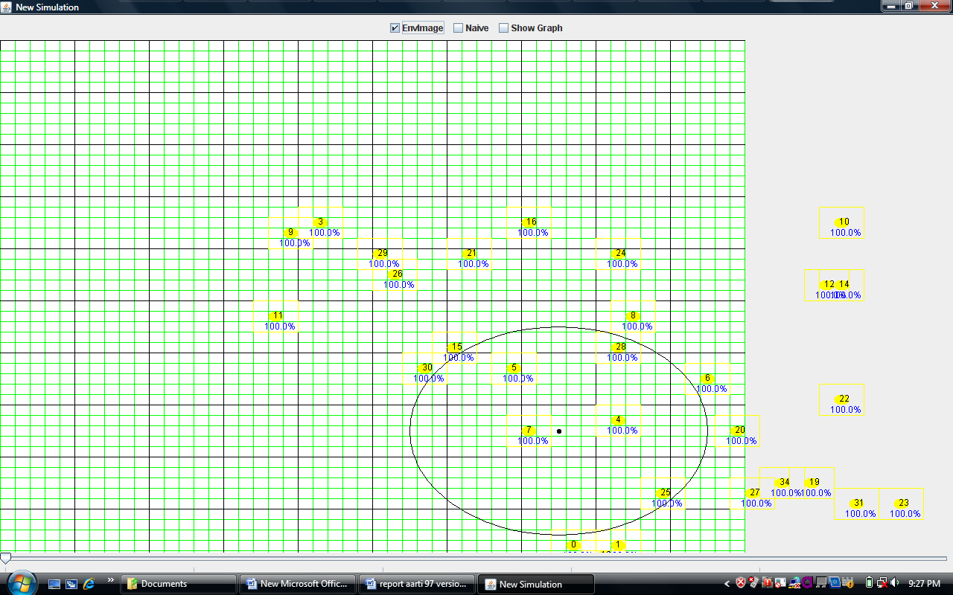
Figure 4.3: A target about to enter the sensor field.
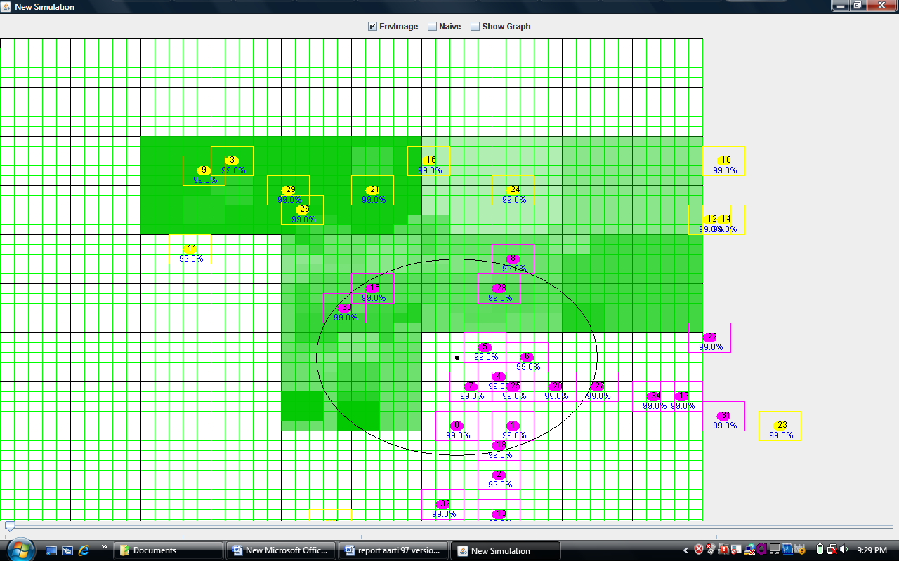
Figure 4.4: Nodes near the target sense it and approach it.
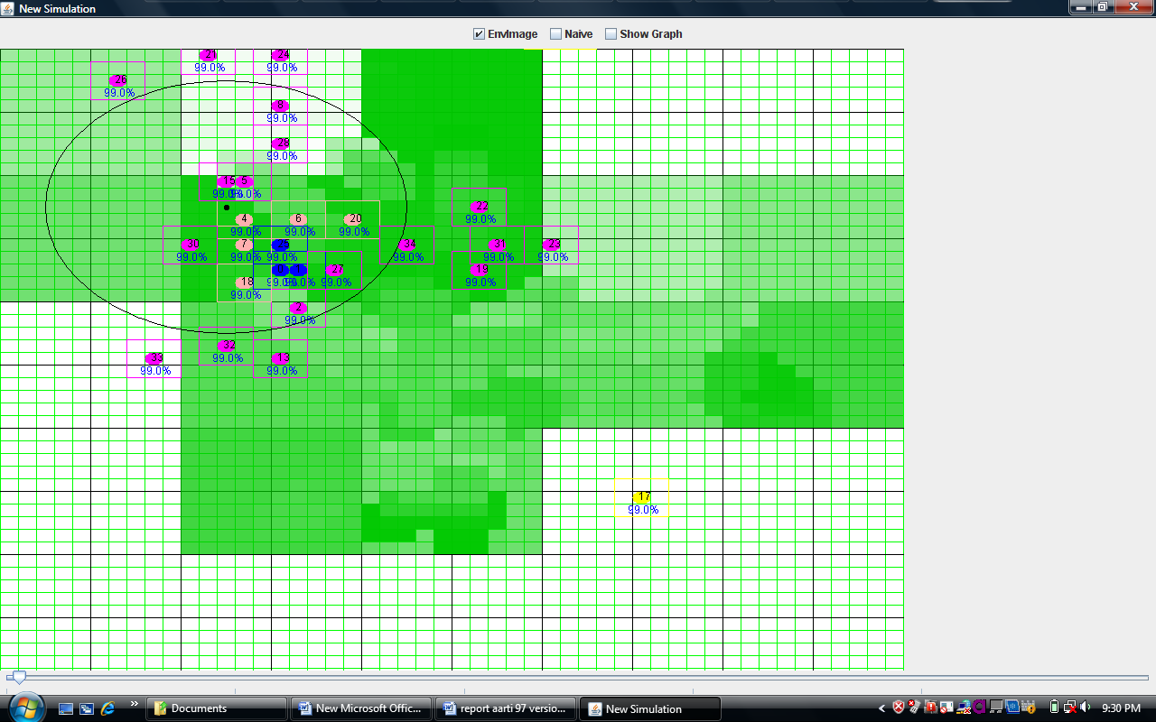

Figure 4.5: Self-Organization of sensor nodes along the target trajectory

Chapter 5

Implementation
To verify the feasibility of model presented in Chapters 3 and 4, detailed simulations were performed. The simulator used is based on work carried out in [8]. The simulator was appropriately modified to model and simulate the current work. This chapter looks at some key implementation (simulation) aspects/issues.

5.1 Challenges, Solutions and Limitations
The basis for simulation studies are accurate and tractable models. Comprehensive sensor network models should include: the nature of logical grid structure (tesselation), type of spatio-temporal artificial data generated, the number of nodes and their relative distributions, their features like states, capacities and type of mobility, the characteristics of the wireless link, and energy consumption models [7]. Some of the other modelling issues are already covered briefly in section 3.1. The following add up and expand to that discussion.

Grid structure used
The region considered is assumed to be a 2-dimensional space. Regular grids (square, triangle, hexagon) and uniformly random distributions are widely used analytically tractable models [6]. In the framework of this problem/simulation, the region is logically considered to be divided into squares. The grid used in this work and for the corresponding simulation results presented, is a 50*50 one. i.e 2500 square tesselations. The sensor robots are also modelled as essentially 2-d circular objects. Each sensor robot/sensor node can occupy one square region at a time, which gives a (theoretically) maximum capacity of 2500 nodes.

Artificial Spatio-temporal data
The type of artificial spatio-temporal data used form a key component of simulation studies of this problem. The data used for this purpose is randomly generated, avoiding discontinuities, by taking a small local variation variable (15/255) and larger global variation variable (230/255). The temporal variation is modelled by using a change probability variable (0.01-0.05) in conjunction with the local variation variable.

Node characteristics.
Node characteristics are already discussed in sections 3.1 and 3.2, and are therefore not discussed here.

Wireless Link
An attenuation proportional to da, where d is the distance between two nodes and a is the so-called path loss exponent, is widely accepted as a model for path loss [7]. a ranges from 2 to 4 or even 5, depending on the channel characteristics (environment, antenna position, frequency). This path loss model, together with the fact that packets are successfully transmitted if the signal-to-noise-andinterference ratio (SNIR) is bigger than some threshold, results in a deterministic model often used for analysis of multihop packet networks. Thus, the radius for a successful transmission has a deterministic value, irrespective of the condition of the wireless channel. If only interferers within a certain distance of the receiver are considered, this physical model turns into a disk model. The stochastic nature of the fading channel and thus the fact that the SNIR is a random variable are mostly neglected. In the present work and simulations the disc radius is modeled by the variable called communication range. Some of the results presented show comparisons with respect to change in the communication range.
Limitations: This modelling has certain limitations. This all-or-nothing model leads to the assumption that a transmission over a multihop path fails completely or is fully successful, ignoring the fact that end-to-end packet loss probabilities increase with the number of hops [7]. Researchers have suggested a more accurate rayleigh fading model which they say is not only more accurate than the disk model, but also has the additional advantage of permitting separation of noise effects and interference effects due to the exponential distribution of the received power [7].

Energy consumption
The energy consumption by a node is modelled according to the 7 different generic operations of a node: transmission, reception, listening, probing, aggregating, moving and toggling (between one state and another). They are supposed to model the following tasks:
• Acquisition (probing and aggregation): sensing, processing, and storing (as needed)
• Transmission: Transmission costs should include packetization, encoding, framing, and maybe queuing; supply for the baseband and RF circuitry (The nonlinearity of the power amplifier must be taken into account because the power consumption is most likely not proportional to the transmit power)
• Reception: Reception costs should include cost for detection, filtering, decoding, error detection, Low-noise amplifier, downconverter oscillator; and reception even if a node is not the intended receiver
• Listening: Similar to reception except that the signal processing chain will stop at the detection.
• Moving: Cost for locomotion; includes reception, transmission and probingcosts.
• Handling: Power supply to toggle between various states Reception and transmission comprise all the processing required for physical communication and networking.
Limitations: The costs assigned in simulations for above, are based on a rough estimate and not based on any in-depth study. This also forms part of further work (section 7.3) to model real situation more accurately in the simulationmodel.

5.2 Simulation Framework
The simulation is done on Java platform. Some of the features are:

Object-oriented programming
To model and simulate this highly complex problem, object-oriented programming is an useful tool. Since nodes are homogenous in characteristics/model, yet maintain their own individuality (states, positions, actions etc.), OOP provides an appropriate framework for modelling nodes through just one class, by using its various instances. Similarly, other aspects of the scenario like communication messages, aggregation messages, simulation panel, all have fixed characteristics/ model yet several instances of them may be required to be modelled by the simulation at a given time.

Simulator GUI
The simulator also has a GUI, for best simulation studies. As simulator is a discreet time simulator, the entire simulation period is divided into a number of epochs, where each epoch is a time unit. Simulation panel (gui) can show node position and states at any epoch. Simulation studies can be done by changing a variety of paramters such as number of nodes, their initial position, signal, sensing and communication range, costs of various states etc. Figure 5.1 shows a snapshot of the simulation panel.

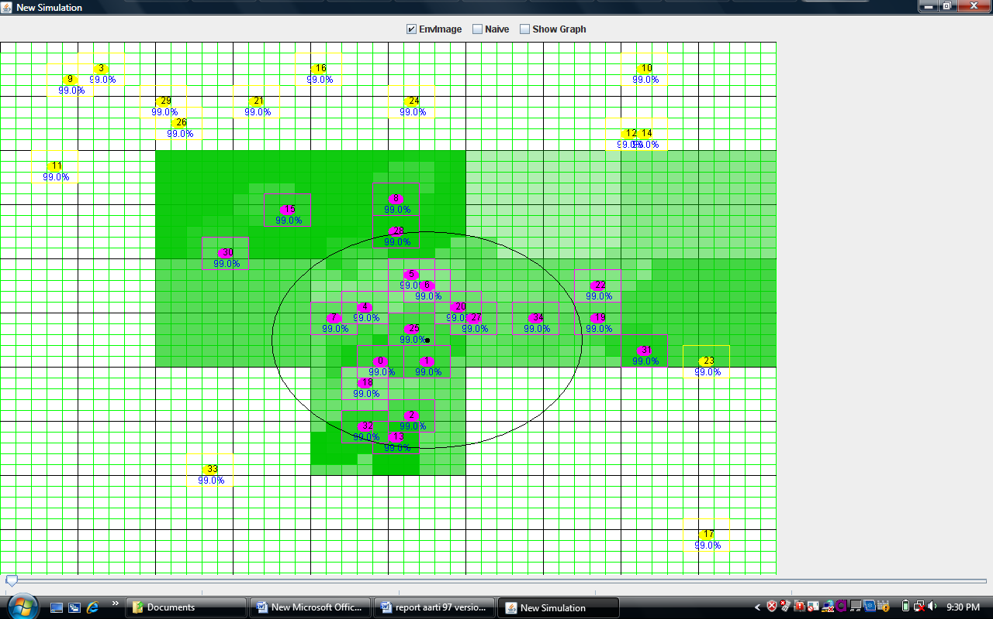

Figure 5.1: Simulator

Chapter 6

Results and Discussion
This section presents some further results of simulation studies, besides those already presented in Chapters 3 and 4, with discussion.

6.1 Query-based Self Organization
The framework developed in this work can be used to study various characteristics. 6.1.1 Network Response: Robot Allocation Depending on a particular user query, a fixed/approximate number of sensor robots may be required to achieve the task. The capability of the network to supply these many nodes/robots depends (among others) on the following prime factors:
• The Communication range of the nodes.
• Node density.
For example, as node density increases at a given communication range of sensor nodes, it is expected that the network will be able to supply more number of nodes. Similarly, if node density is fixed, than it is expected that with an increase in communication range network will be able to do this task.

The simulation experiment presented here, sought to investigate this very issue. It also involved considerable motivation to determine these relations, for use in practical purposes.

Simulation experiment:
Node density was kept fixed, and communication range, CR was varied from: 8,9,10,11,12,13. (For e.g.: a value of CR = 8 means an area of pi _ 102 = 314 approximate square units. The total area is 50*50 = 2500 square units.)
For each set of parameter values a number of iterations of the simulation experiment were performed (10 iterations for each data point shown in figure 6.1, as also in figure 6.2). For each experiment iteration, the maximum number of robots supplied by the network for the task was noted, and average value was calculated at the end of the iterations. This gave: Average value of Maximum number of robots supplied by the network at a given node density, with a given communication range.
The experiment was repeated for different communication ranges. Then number of nodes (in the same size region of 50*50) was varied from 15, 20,25,30,35. These corresponded to percentage node densities of 5.4, 7.2, 9, 10.8 and 12.6 respectively.
Node density is defined as:
N_{D} = (N S_{R}) /A_{R} (6.1)
where:
N_{D} = Node density. N= Number of nodes in the region. S_{R} = Sensing Range
of a node. A_{R} = Area of the region.
For each set (of node density), the experiment was repeated again. Figure 6.1 shows the relation between Task allocation requirement fulfillment, and the communication range, at different node densities (number of nodes), based on these simulation experiments. Interpreting the graph in figure 6.1 is easy:

Figure 6.1: Task Allocation fulfillment at different tradeoffs of Communication range and Node density.

For example if Number of robots required to be allocated for a given task is 15, we can calculate the required parameter value given other fixed value. If (say) communication range of nodes is fixed at 10 (i.e 314 square units area communication range), and if we know that our queries will generally require about 15 nodes, then we can calculate the node density required to be 7.2 percent, based on above protocol. Also, we can calculate the tradeoff values of CR and ND that meet the same task requirement. For example, for same number of node requirement (15), the following sets will work: Communication range = 12, 11, and 9; while node density of 5.4, 7.2 and 9.8 respectively. Since different parametric settings would have different costs etc., these can form basis for optimal choice of deployment parameters.

Network connectivity
Since nodes are considered to be uniformly spread out in the network, if we calculate the percentage of nodes that are allocated at a particular set of parametric values, it gives us an indication of the dynamic connectivity of the network, based on this protocol.
Percentage of Nodes allocated = (Nodes allocated (average))/ Total number of nodes (6.2)
Taken to be a direct indication of the connectivity of the network, due to the random initialization of nodes over the region, it is thus plotted with respect to communication range and node densities (Figures 6.2 and 6.3). The above graph (figure 6.2) gives a very good understanding of how node density and communication range effects network connectivity. For example, if we want 90 percent connectivity in the network, we can have the following tradeoffs
based on graph (table 6.1):

Figure 6.2: Variation of Network response or Percentage Connectivity, with respect
to Node density and Communication range.

Node Density | Communication Range
5.4 | 13
7.2 | 13
9 | 12
10.8 | 11
12.6 | 10
Table 6.1: Node density and Communication range tradeoffs to achieve same performance (network connectivity)

It should be understood here, that these results are based on simulation experiments with limited iterations and not perfect modelling of real nodes, conditions etc. The results presented here give an indication and understanding of the likely trade-off, and are in no means accuracte for practical purposes.

6.2 Delay Variation
There is another aspect of network response that gives us an indication of the way network behaves to serve particular queries at given/different communication ranges and node densities. Suppose the task requirement for a query is fixed (say 12), then depending on these 2 parameters (node density and communication range), the relative time delay in which network serves the request will vary. This is therefore an important parameter to study. The term ’relative’ delay is used because time as it is cannot be exactly modelled given the imperfect nature of simulation framework with respect to modelling the real life situation. But a relative estimate of delay can still be had.In the simulation experiment performed, it was required to allocate K (K =12) number of sensor robots for a given query-task. Experiments were performed in a similar way as discussed in section 6.1 (with same number of iterations for each data point), except that this time task allocation was fixed, and the delay it took for network to settle down into a team formation for aggregation, and (just) begin aggregation was recorded. Average delay was calculated over all iterations. Figure 6.3 shows this variation. The graph above (figure 6.3) is self-explanatory.

Figure 6.3: Relative delay for Aggregation to begin, as a function of Communication
range, and number of nodes.
For example if it is known that the applications we are interested are delayinsensitive, and the relative delay tolerated is not more than 25 time units, then one would never settle for communication range less than 13 and would prefer high node densities. The above discussion affirms inverse relationship between Node density and Communication range to achieve a given network performance.

6.2.1 Effect of Node Navigation model
As discussed in Chapters 3 and 4, the node navigation and inter-node communication models of the protocol enable network to achieve task of moving the desired number of nodes to the region under concern. A simulation experiment was performed, for both static an mobile targets, to calculate the difference in robot allocation/task fulfillment with and without the node navigation model. 20 iterations were performed for each case and output was averaged. The output for static targets was: task fulfillment in terms of number of robots allocated, when the query requirement was 12. For mobile targets, output was: the number of sensor nodes that are able to detect and track the target as it moved along in the sensor field. Figure 6.4 shows the results.
Figure 6.4: Effect of Node Navigation model in fulfilling task requirement for query

6.3 Data Aggregation: Static Targets
Figure 6.5 and 6.6 show snapshots of how nodes start from a random location to self-organize into a formation for beginning aggregation.
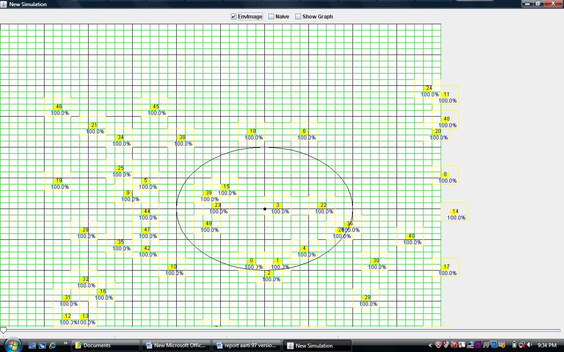

Figure 6.5: Nodes begin from random locations
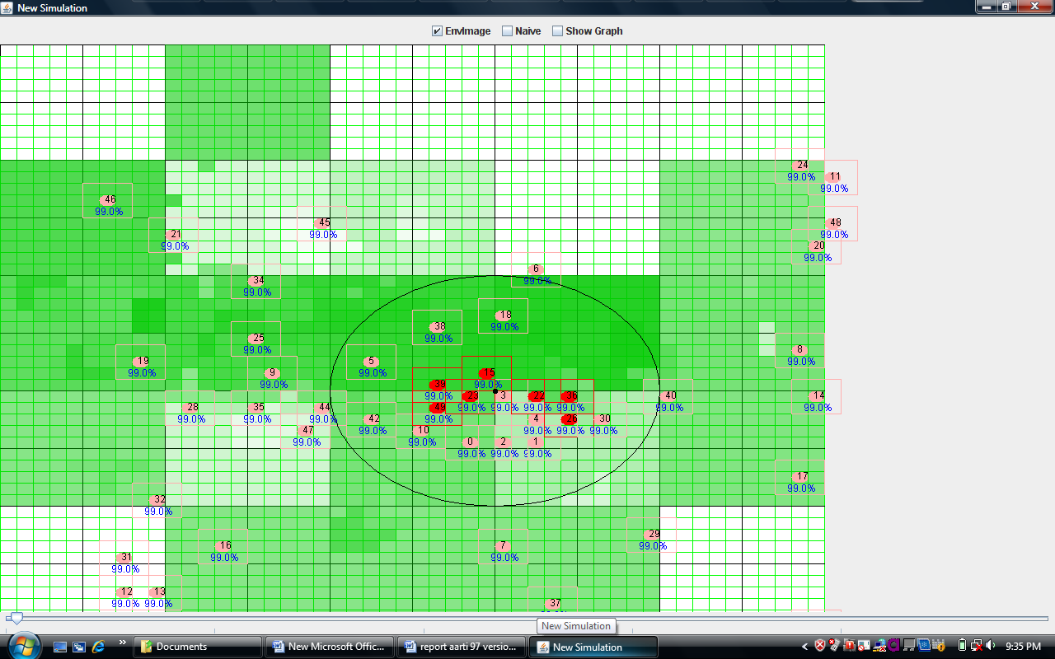

Figure 6.6: Self-organize into a formation for static target query

Local aggregation
Figures 6.7 and 6.8 show a (different) formation for aggregation and corresponding local aggregates
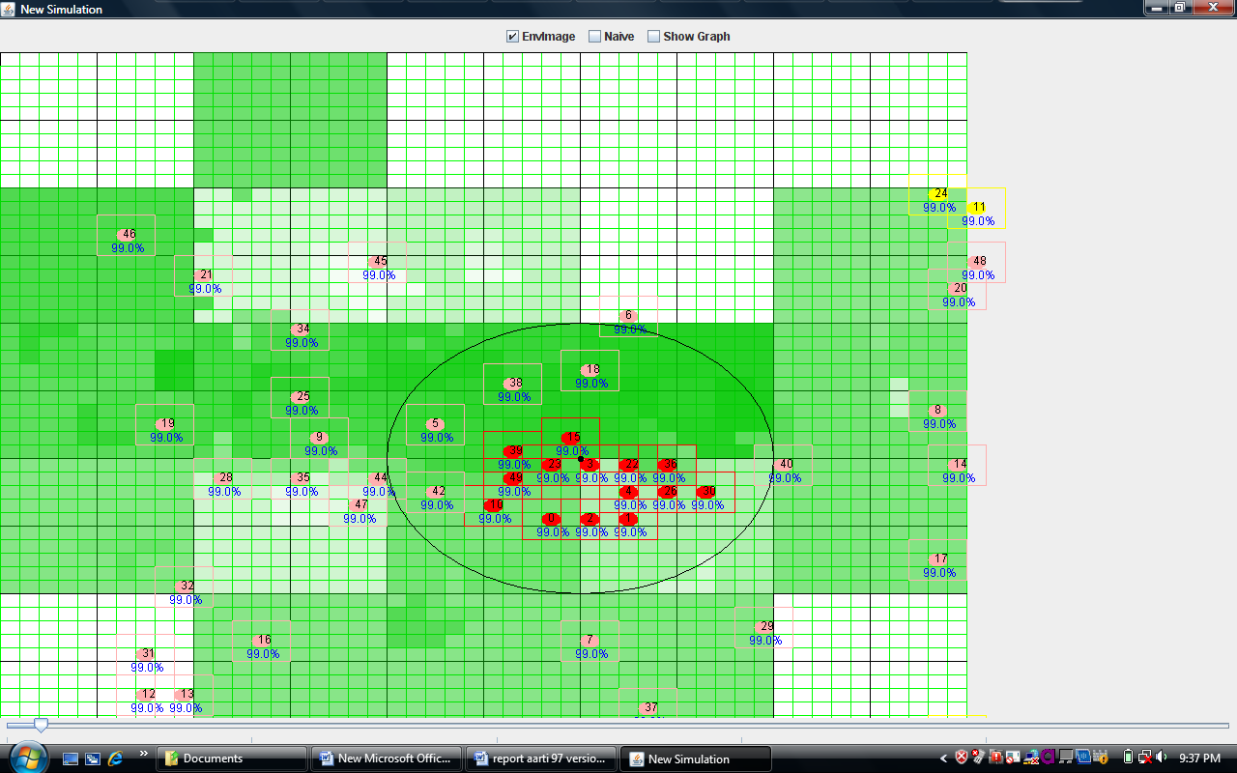

Figure 6.7: Snapshot showing aggregation

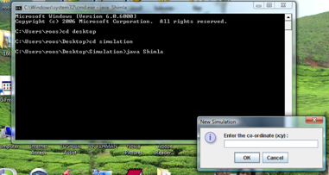
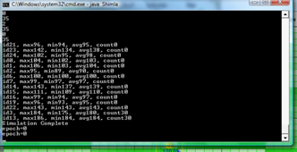

Figure 6.8: Snapshot of corresponding Local aggregates calculated and generated
by the nodes

6.4 Data Aggregation and Interpretation: Mobile Targets
From the simulation studies, it is seen that node navigation model does not boost task allocation fulfillment in case of mobile targets, as much as in static targets. This is because: in mobile scenario, target is itself moving, therefore in one sense increasing its influence/connectivity over the network, resulting in more number of sensor nodes automatically approaching it even without node navigation. This however, is a relative discussion. The real task is to improve tracking of such mobile targets. This is achieved not just by node navigation, but by an innovative technique of simultaneous trajectory prediction and selforganization achieved autonomously by the network (fig 6.10)

Figure 6.9: Prediction based Self-organization for mobile targets

Though the scheme looks good, there are no strong simulation results to support it at present. This is because, even though a simple kinematics based prediction scheme is implemented, the prediction mechanism is practically (in coding) not working accurately due to some inter-node communication problems. No more results are provided as yet therefore for the scheme.

Chapter 7

Summery and Conclusions

7.1 Summary
The present work looks at and addresses a novel problem in sensor networks. The report begins with a study of sensor networks, its applications and various challenges. It also defines the problem clearly by understanding the terms ’spatiotemporal sampling’, ’self-organization’, ’data aggregation’ and ’queries’ in context of sensor networks. The problem definition is thus clearly stated.

A detailed study of existing work related to the problem is presented, based on literature survey. Based on this literature survey, the novelty of the work is clearly understood: most of the existing work in data aggregation addresses the case of static (fixed) nodes, and very limited work is done in case of mobile nodes. This also does not addresses the problem in case of a dynamic network of all mobile nodes. Also, self-organization is looked at in a very limited way, and no such work related to a dynamic mobility based self-organization of sensor nodes, based on user queries is found. The current work looks at this novel problem to develop protocols for the same, followed by protocol for data aggregation and interpretation.

Based on ideas from literature and own innovative ideas, a protocol for query based self-organization is outlined, which has various features like the inter-node communication model, node navigation model, collision avoidance, and robot task allocation and pattern formation. A protocol for aggregation of data for such static targets is then outlined. Self-organization protocol for such mobile targets then uses not just the layer 1 (static target case) of the protocol but additional feedback information from simultaneous data aggregation and interpretation, to improve the accuracy. The whole work involves algorithm development and software simulations, with a GUI on a java platform. The work thus validates the possibility of using these algorithms/protocol to a real sensor network of mobile sensor robots to address user queries by autonomous self-organization and in-network data aggregation.

7.2 Limitations and Future Work
As the work has addressed various issues of the problem, there are limitations to the work which give further scope for improvement. This section outlines the scope of such future work:
The present work and work presented in [8] can be combined to achieve:
- Extension of the model to coverage based queries, like ”Tell me the all the locations in region where temperature is above 50 degree Celsius”
- Energy optimizations in protocol: Energy is an essential commodity in sensor networks. There is scope for energy optimizations at various levels in the current framework. This involves first of all looking at the relative expenditure of energy by the various mechanisms of the model and determine areas of energy savings. Some of the possible areas are:
- Nodes may not need to communicate every time for node navigation, and this possibility can be looked at.
- Gradient move rule may not be needed to be implemented at every epoch by the nodes.
- Energy optimizations of in various other aspects related to sensor processing like collision avoidance algorithms, task allocation and pattern formation.

Improvements in data aggregation protocol for static targets:
- Cluster head election protocol: The cluster head election used in this work is simple. More sophisticated algorithm as discussed in [17] may be used for a more evolved version of the model, and for addressing more complex queries.
- Taking aggregated data to gateway for the case of mobile targets, is not addressed in this work and provides scope for future work.
- Local data aggregation done by sensor nodes can be made more energy efficient, by using compression techniques etc.
- Data aggregation presented here may not be useful for coverage based queries, and there is scope of possible work there.

There are various limitations in modeling. These have scope for improvement. Some of these are:
- Modeling of costs of various node functions like reception, transmission, probing etc. In the current work, these are not based on in-depth investigation, but based on a rough estimate.
- Considering other grid models like hexagonal tessellation.
- Wireless link: if more accurate wireless link model is desired.
- Development of a complete reconstruction model.
- Complete simulation of Algorithm for collision avoidance, and comparison of Collision Avoidance strategies developed with existing work collision avoidance for multi-robot path planning.
- The issue of task allocation and pattern formation is addressed at a basic level for the purpose of this work. More complex and suitable strategies/ mechanisms may be required to be developed for other applications/in future work.
For example:
There is another kind of robot allocation involved. This involves the choice of robot whether it should go for a particular query. This can be based on two factors:
- Battery: the battery power available with the robot for a particular task
- Proximity: to query-region. For this purpose the gradient move rule can be easily modified/ used for proximity based allocation.
- Simulating flocking: Researchers are trying to use/model ’flocking’ phenomenon seen in birds, swarms etc. for various applications. The mechanisms of the protocol can be improved/reshaped to simulate ’flocking’ in its exact form for appropriate query-based applications. The inter-node communication and node navigation model can thus be suitably modified if required for above purposes.
- Implementation Of course, the whole model can be suitably implemented on real motes (hardware) in stages. The future scope presented here does not limit the contribution of the present work, as the problem in itself is very complex and involves work at multiple levels/platforms.

Bibliography
- Aashish Gupta, query based self organization, data aggregation and interpretation in a sensor network, MTech Thesis, 2006. IIT Delhi.
- John Heidemann , Ramesh Govindan. Embedded Sensor Networks , Technical report ISI-TR-2004-594,USC. November , 2004.
- D. Culler, D. Estrin and M. B. Srivastava. Introduction: Overview of Sensor Networks , IEEE Computer August 2004.
- Bharathidasan, V.A.S. Ponduru. Sensor Networks: an Overview URL: http://wwwcsif.cs.ucdavis.edu/ ponduru/
- I. Akyildiz, W. Su, Y. Sankarasubramaniam, E. Cayirci. A survey on sensor networks , IEEE Commun. Mag. 40 (8) (2002) 102–114.
- Chee-Yee Chong, Srikanta P. Kumar. Sensor Networks: Evolution, Opportunities, and Challenges, Proceedings of the IEEE, Vol. 91, No. 8, August 2003.
- Shubham Mankhand. Self organizing Sensor Networks., MTech Thesis ,2006. IIT Delhi.
- Mohammad Ilyas, Imad Mahgoub. Handbook of Sensor Networks: Compact Wireless and Wired Sensing Systems
- J. N. Al-Karaki and A. E. Kamal. Routing techniques in wireless sensor networks: a survey, In IEEE Wireless Communications, Volume 11, No. 6, pp. 6-28, 2004.
- Bhaskar Krishnamachari, Deborah Estrin, and Stephen Wicker. Modeling Data-Centric Routing in Wireless Sensor Networks , In IEEE INFOCOM 2002.
- A.A.Somasundara, A.Kansal, D.Jea, D.Estrin, M.B. Srivastava. Controllably Mobile Infrastructure for Low Energy Embedded Networks IEEE transactions on mobile computing, vol.5, no.8, August 2006.
- A.Ouksel, L.Xiao and M.Hauswirth. Dynamically Self-Organizing Sensors as Virtual In-Network Aggregators and Query Processors in Mobile Ad- Hoc Sensor Databases , 2007 IEEE 23rd International Conference on Data Engineering (ICDE 2007), April 16-20, 2007 Istanbul, Turkey
- J.Gehrke and S. Madden. Query processing in sensor networks , IEEE Pervasive Computing 3, 1 (Jan. 2004), 46–55.
- Y. Yao and J. Gehrke. Query Processing for Sensor Networks , First Biennial Conference on Innovative Data Systems Research (CIDR’03), January 2003.
- S. Madden, R. Szewczyk, M. J. Franklin, D. Culler. Supporting Aggregate Queries Over Ad-Hoc Wireless Sensor Networks , In Proceedings of the IEEE Workshop on Mobile Computing Systems and Applications, 2002, pp. 49–58.
- A. Ganguli, S. Susca, S. Martnez, F. Bullo, J. Corts. On collective motion in sensor networks: sample problems and distributed algorithms , In Proceedings of the 44th IEEE Int. Conf. Decision and Control, Seville, Spain, 2005, pp. 4239-4244.
- R. Rajagopalan, P.K. Varshney.Data Aggregation Techniques in Sensor Networks: A survey , IEEE Communications Surveys and Tutorials, vol. 8, no. 4, 4th Quarter 2006.
- B. Krishnamachari, D. Estrin, and S. Wicker. The impact of data aggregation in wireless sensor networks , IEEE International Workshop on Distributed Event-Based Systems (DEBS), pages 575–578, July 2002.
- K.Vaidyanathan, S.Sur, S.Narravula, P.Sinha. Data Aggregation Techniques in Sensor Networks , Technical Report, OSU-CISRC-11/04-TR60, Ohio State University, 2004.
- Shyam Kapadia and Bhaskar Krishnamachari. Comparative Analysis of Push-Pull Query Strategies for Wireless Sensor Networks , International Conference on Distributed Computing in Sensor Systems (DCOSS), June 2006.
- Sam Madden. Querying Sensor Networks. URL: db.lcs.mit.edu/madden/html/jobtalk3.ppt
- R.C.Shah, S.Roy, S.Jain, and W.Brunette. Data MULEs: Modeling a Three-Tier Architecture for Sparse Sensor Networks , Proceedings of the IEEE Workshop on Sensor Network Protocols and Applications (SNPA), 2003.
- C. Mascolo and M. Musolesi. SCAR: Contextaware Adaptive Routing in Delay Tolerant Mobile Sensor Networks , In Proceedings of the Delay Tolerant Networks Symposium, ACM International Wireless Communications and Mobile Computing Conference (IWCMC) 2006, ACM Press, July 2006.
- Chuan-Ming Liu and Chuan-Hsiu Lee. Power efficient Communication Protocols for Data Gathering on Mobile Sensor Networks , In Proceedings of the 60th Vehicular Technology Conference (VTC 2004 Fall), Los Angeles CA , pp. 4635-4639.
- R.Olfati-Saber. Flocking for Multi-Agent Dynamic Systems: Algorithms and Theory IEEE Transactions on Automatic Control, Vol.51, No.3,March 2006.
- Wei-Men Shen, Peter Will and Aram Galstyan Hormone Inspired Self- Organization and Distributed Control of Robotic Swarms, Autonomous Robots 17, pp 93-105, Kluwer Academic Publishers, 2004.
- K. Madhava Krishnam, Henry Hexmoor. Reactive Collision Avoidance of Multiple Moving Agents by Cooperation and Conflict Propagation, Proceedings of the 2004 IEEE International Conference on Robotics and Automation, April 26-May 1, 2004, Hilton New Orleans Riverside, New Orleans, LA, USA.
- Bisnet (Biologically Inspired Sensor Networks) Project University of Massachusetts, Boston. URL: http://dssg.cs.umb.edu/projects/bisnet.html
- Prof. Krishnamachari’s WSN Research Group’s Bibliography/Links. URL: http://ceng.usc.edu/ anrg/SensorNetBib.html

