PREPARATION AND CHARACTERIZATION OF GUAR GUM BASED FILM

A MAJOR PROJECT REPORT SUBMITTED
TOWARD THE PARTIAL FULFILLMENT OF THE REQUIREMENT FOR
THE AWARD OF THE DEGREE OF

Master of Engineering
In
Polymer Technology
2007-2009
By

GOVIND GOPAL KUSHAWAHA
Roll No-12353
Under the Supervision of
Prof. A.P.Gupta
Deptt. Of Applied Chemistry and Polymer Technology.
Delhi College of Engineering.
Delhi-110042

Department of Applied Chemistry and Polymer Technology,
Delhi College of Engineering
University of Delhi
Delhi-110007, INDIA
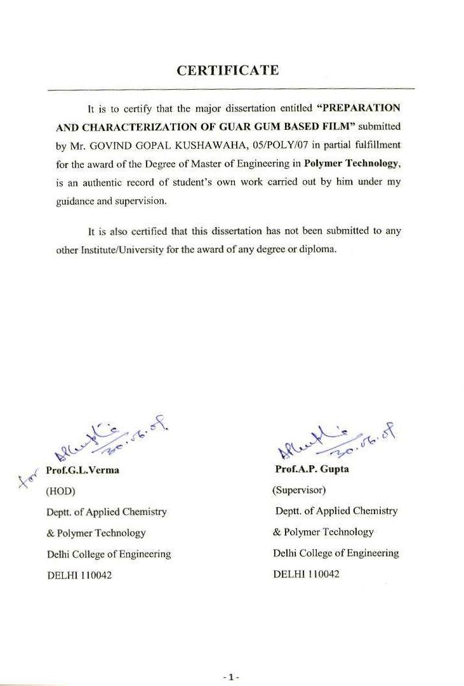
ACKNOWLEDGEMENT

It gives me immense pleasure to acknowledge my indebtedness and great sense of gratitude to Prof. A.P.Gupta, Applied Chemistry and Polymer Technology Department, Delhi College of Engineering, Delhi for his able guidance, sympathetic and encouraging attitude throughout the project work. In spite of his busy schedule, he could find time to provide me precious guidance.
I also like to thank Mr. Gopal Arora, PhD scholar for his time and help rendered to me in the entire related problem before and during the project period for such a long apart. My sincere thanks are also to my fellow friends Mr. Bharat Kumar, Mr. D.R.Poonia, Mr. Mohd. Faizy Khan, Mr. Pravat Behera, Mr. Vijay and colleagues who were always there to lend a helping hand in the hour of need.
Last but not the least I would like to convey my heartiest and warmth gratitude to all the laboratory staff for giving me valuable suggestions, support and inspirations during the project.

Govind Gopal Kushawaha
05/poly/07
Master of Engineering
(Polymer Technology)

CONTENTS

S.No. | Contents | Page No.
- | Acknowledgements | 2
- | List of Figures | 7-8
- | Abstract | 9
CHAPTER 1. | INTRODUCTION | 10-14
1.1 | AIM AND SPECIFIC OBJECTIVE | 14
CHAPTER 2. | LITERATURE REVIEW | 15-37
2.1 | Introduction……………………………………… | 16
2.2 | Guar gum………………………………………... | 18
2.2.1 | Production……………………………………….. | 19
2.2.2 | Properties………………………………………… | 19
2.2.2.1 | Solubility and Viscosity…………………………… | 19
2.2.2.2 | Thickening…………………………………………. | 20
2.2.2.3 | Ice crystal growth…………………………………. | 20
2.2.3 | Grading……………………………………………… | 20
2.2.4 | Industrial application……………………………… | 20
2.2.5 | Food application…………………………………….. | 21
2.2.6 | Nutritional and medicinal effect…………………… | 22
2.3 | Polyvinyl alcohol………………………………... | 23
2.3.1 | Properties………………………………………... | 24
2.3.2 | Uses……………………………………………… | 24
2.3.2.1 | Fishing …………………………………………... | 25
2.3.3 | Production………..……………………………… | 25
2.3.4 | Preparation………………………………………. | 26
2.4 | Citric acid………………………………………... | 26
2.4.1 | Properties………………………………………... | 27
2.4.2 | Measurement…………………………………. | 27
2.4.3 | History…………………………………………… | 28
2.4.4 | Production (Citric acid monohydrate)… | 28
2.4.5 | Uses | 29
2.4.5.1 | Food additive | 29
2.4.5.2 | Water softening | 29
2.4.5.3 | Others | 30
2.4.6 | Safety | 31
2.5 | Borax | 32
2.5.1 | Uses | 32
2.5.1.1 | Buffer | 32
2.5.1.2 | Co-complexing | 33
2.5.1.3 | Flux | 33
2.5.1.4 | Small-scale mining | 33
2.5.1.5 | Putty | 33
2.5.1.6 | Food additive | 34
2.5.1.7 | Other uses | 34
2.5.2 | Natural sourses | 35
2.5.3 | Toxicity | 35
2.5.4 | Chemistry | 36
CHAPTER 3. | MATERIAL AND METHOD | 38-46
3.1 | Technical detail of raw material | 39
3.2 | Miscellaneous chemicals | 40
3.3 | Preparation of GG solution | 40
3.4 | Preparation of PVA solution | 40
3.5 | Preparation of film | 40
3.5.1 | GG film preparation | 40
3.5.2 | GG,PVA blend film preparation | 41
3.5.3 | Preparation GG,PVA blend film with CA | 41
3.5.4 | Preparation GG,PVA blend film with CA and borax | 41
3.6 | Characterization of blend film | 43
3.6.1 | Spectroscopic analysis | 43
3.6.2 | Infrared (IR) spectroscopy | 44
3.6.3 | Universal testing machine(UTM) | 45
CHAPTER 4. | RESULTS AND DISCUSSIONS | 47-56
4.1 | FTIR-ATR and UTM analysis of GG+PVA(6:4) film | 48
4.2 | Polymer blend compatibility | 51
4.3 | FTIR-ATR and UTM analysis of blend film with different composition of CA | 52
4.4 | FTIR-ATR and UTM analysis of blend film with CA (20%) and borax | 54
CHAPTER 5. | CONCLUSIONS AND FUTURE SCOPE OF WORK | 57-58
CHAPTER 6. | REFERENCES | 59-61

LIST OF FIGURES

Sl. No. | Title | PageNo.
Figure 1. | Polymerization of vinyl acetate………………………. | 13
Figure 2. | The chemical structure of guar gum………………….. | 18
Figure 3. | Chemical structure of Poly (vinyl alcohol)…………… | 23
Figure 4 | Chemical structure of citric acid……………………… | 26
Figure 5 | Nicolet 380 FTIR (Fourier Transform Infrared Spectrometer) | 44
Figure 6. | Instron 3369 UTM (Universal Testing Machine) | 45
Figure 7. | FTIR-ATR spectra of pure guar gum…………………. | 48
Figure 8. | FTIR-ATR spectra poly (vinyl alcohol)……………… | 49
Figure 9. | FTIR-ATR spectra of GG+PVA (6:4) blend…………. | 49
Figure 10. | Tensile strength curve of GG, PVA and GG+PVA…… | 50
Figure 11. | Effect of the composition of heterogeneous binary blends on their physical properties. | 51
Figure 12. | FTIR-ATR spectrum of blend films with different composition of citric acid. | 52
Figure 13. | Tensile strength curve of blend films with different composition of citric acid. | 53
Figure 14. | Tensile strain curve of blend films with different composition of citric acid. | 53
Figure 15. | FTIR-ATR spectra of blend film with citric acid (20%) and 0.5% of borax. | 54
Figure 16. | FTIR-ATR spectra of blend film with citric acid (20%) and 2.5% of borax. | 54
Figure 17. | Tensile strength curve blend films with citric acid and different composition of borax. | 55
Figure 18. | Tensile strain curve of blend films with citric acid and different composition of borax. | 56

Abstract
A series of blends films of guar gum an edible carbohydrate polymer and poly (vinyl alcohol) with various functional aids are prepared by usual solution casting method and find the composition having better interaction. In this study the mechanical property of guar gum film are improved by using the biodegradable polymer such as poly (vinyl alcohol) and cross-linking agent borax. To improve % elongation citric acid was added.
The film was characterized with the help of FTIR-ATR (Nicolet 380) and universal testing machine (Instron 3369). The FTIR results showed that no esterification took place between citric acid and guar gum during processing at 50⁰C, so that the citric acid acted as a plasticizer, the tensile strength of the film get decreases as we increase the concentration of citric acid from (10% to 50% wt. bases of polymer) and elongation at break of films get increases, in our study of the effect of borax on GG-PVA blends with citric acid plasticizer and various borax combination we get the tensile strength increases while elongation break get decrease, it shows that borax will act as a good cross linking agent.

CHAPTER-1

INTRODUCTION

Long life and attractive properties have made plastics a material of choice for many applications. Because of tremendous growth in applications, Plastics are one of the fastest growing segments of the waste stream. This is because the vast majority of plastic products are made from petroleum-based synthetic polymers that do not degrade in a land fill site or in a composite-like environment. Especially, polyolefins such as polyethylene (PE) and polypropylene (PP) are very resistant to hydrolysis and are totally non-biodegradable. As a consequence, the disposal of these products poses a serious environmental threat. An environmentally conscious alternative is to design and synthesize polymers that are biodegradable. Biodegradable plastics provide opportunities for reducing municipal solid waste through biological recycling to the ecosystem and can replace the conventional non-biodegradable synthetic plastic products. In addition, it is desirable that these biodegradable polymers come primarily from agriculture or other renewable resources for a sustainable environment.
Guar gum (GG) is an edible carbohydrate polymer ^{[1]} which is useful as a thickening agent for water and as a reagent for absorption and hydrogen bonding with mineral and cellulosic surfaces. GG is a galactomannan. It consists of a straight chain of mannose units joined by β⎯D (1→4) linkages having α⎯D galactopyranose units attached to this linear chain by (1→6) linkages. The molecular weight of GG is about 220,000 ^{[2]}. GG is being used in explosives, foods, cosmetics and pharmaceuticals, and in mining, paper and textile industries, mostly as a water binder.
Guar gum is produced from guar seeds. Guar seed is dicotyledonous, having a diameter of approximately 8 mm. It consists of 14-17% hull, 43-47% germ and 35-42% endosperm. Pure guar gum is extracted from endosperm which is separated from the hull and embryo by taking advantage of the difference in hardness of the various seed components. Powdered endosperm is usually sold as guar gum.
Guar gum is a cold water soluble polymer. In its powdered commercial form, the rate of thickening and the final viscosity reflect the process history of product. Guar gum is one of the most highly efficient water thickening agents. Very low concentration of guar gum when dissolve in water forms viscous solutions.
Although the viscosity of aqueous solution of guar gum is advantageous, it is difficult to control its quick biodegradation. Polysaccharides like guar gum are very susceptible to biodegradation. ^{[3-5]}
PVA is the largest synthetic water-soluble crystalline polymer produced in the world. The prominent properties of PVA may include its biodegradability ^{[6]} in the environment. It has often been used in blending with other polymeric material for improved mechanical and expanding properties, biodegradability, and biocompatibility ^{[7-9]}. The generally accepted biodegradation mechanism occurs via a two-step reaction by oxidation of hydroxyl group followed by hydrolysis. It was concluded that the initial biodegradation step involves the enzymatic oxidation of secondary alcohol group in PVA to ketone groups, and hydrolysis of the ketone groups results in cleavage. The biodegradation of PVA is influenced by the stereo-chemical configuration of the hydroxyl groups of PVA. The isotactic material of PVA preferentially degraded.^{[10-11]} PVA has been studied extensively because of its good biodegradability and mechanical properties. These properties have made PVA as attractive material for disposable and biodegradable plastic substitutes.
Poly (vinyl alcohol) (PVA) is manufactured by alcoholysis/ hydrolysis of poly (vinyl acetate), which is, in turn, produced by free-radical polymerization of vinyl acetate monomer (Fig.1)
Polymerization of vinyl acetate monomer can be effected by bulk, solution, or emulsion techniques. The poly (vinyl acetate) formed is then dissolved in solvent (e.g., CH3OH) and alcoholized/hydrolyzed with acidic or basic catalysts. Vinyl acetate can also be polymerized in a controlled fashion via RAFT/MADIX. PVA is insoluble in CH3OH and precipitates. It is isolated by filtration, washing, and drying.

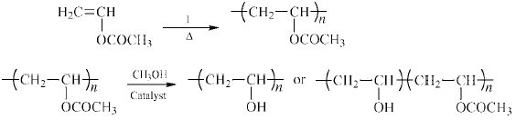
Figure1:Polymerization of vinyl acetate.

Properties of PVA depend on the degree of alcoholysis/hydrolysis and polymer viscosity/molecular weight. Bulk/film properties (e.g., tensile strength, tear resistance, elongation, and flexibility) of PVA increase with increasing extent of alcoholysis/hydrolysis and with increasing viscosity/molecular weight. The tensile strength is exceptional compared with other water-soluble polymers. Water solubility/sensitivity is at a maximum at 88% alcoholysis/hydrolysis. Beyond that level, polymer–polymer interactions via intramolecular H-bonding become so extreme that solvation of the polymer becomes difficult.
Other noteworthy properties of PVA are its film-forming ability, its barrier, adhesive, and emulsifier properties, and its grease, oil, and solvent resistance. PVA films and coatings do not require a curing cycle because tough films can be formed by evaporation. PVA film also has remarkable gas impermeability, forming barriers to oxygen, nitrogen, carbon dioxide, hydrogen, helium, and hydrogen sulfide. However, PVA does exhibit permeability to ammonia and water vapor. Its adhesive binding strength is attributable, in part, to its film-forming ability and its high strength. PVA has surface activity as an o/w emulsifier and/or protective colloid. Oil and solvent resistance increases with extent of hydrolysis.
Poly (vinyl alcohol) is used alone or combined with extenders, pigments, etc, in the preparation of high wet-strength adhesives for paper. It is an excellent binder for textiles and sizing agent for paper and can be used to emulsify a wide range of materials including vegetable oils, mineral oils, solvents, plastics, waxes, and resins. Its emulsifying, binding, film-forming, and thickening behaviors are useful in cosmetic formulation. PVA films can also be used for making oxygen tents.
Citric acid (CA) was used as additive at this work appears in a natural way in foods like citrus fruits and pineapples where it is the main organic acid. CA is utilized as multi-functional food additive in the processes of producing different foods because it presents antibacterial and acidulant effect, reinforces the antioxidant action of other substances, and improves the flavour of juices, soft drinks, and syrups.
1.1 Aim and specific objective
The major aim of this project is to prepare a polymeric film which is made up of fully biodegradable an inexpensive, easily available and water-soluble natural resin,
Material for this we have taken guar gum an edible carbohydrate polymer and poly (vinyl alcohol) in 60:40 ratios to prepare a polymeric blend and added citric acid plasticizer to improve flexibility of the film along with the cross linking agent borax to improve the mechanical strength of the film.

CHAPTER-2

LITERATURE REVIEW

2.1 INTRODUCTION
Plastic made from petroleum have been in widespread use throughout the world. With plastic having an increase number of applications, disposal of waste become a serious problem. Therefore, the development of novel plastics that could be degraded by microorganism in soil and sea water has recently been emphasized. Biodegradable plastics that can be easily degraded in the natural environment are arousing public interest. Generally, biodegradable polymers from renewable resources can be classified into three groups ^{[12]} (1) natural polymers, such as guar gum ^{[3-5]}, starch ^{[13-15]}, and cellulose ^{[16]}; (2) biodegradable synthetic polymers, such as PVA^{[17-19]}, and polylactic acid(PLA)^{[20]}; (3) polymer from microbial fermentation, such polyhydroxybutyrate(PHB) ^{[21]}.
Guar gum is a natural polysaccharide which is capable of forming film by using the solution casting technique. In the case of guar gum the solvent used is most commonly water. Guar gum is known to give brittle film with extremely poor flexibility.
The molecular structure of the guar gum has found to be unaffected and no oxidation of the guar gum by the application of free radical or microwave radiation. These observations are confirmed via FTIR analysis of the depolymerized guar gum. The thermal degradation studies does not show any defragmentation or depolymerization. ^{[22]}
The blends of hydroxypropyl guar gum and chitosan were studied by solvent casting technique using water as solvent to prepare the blend. The physical, thermal and mechanical properties of the blend were studied by using a variety of testing method like X-ray diffractometry, scanning electron microscopy. The thermal stability of the blend was seen to improve as compared to the individual components. The clarity of the films was also increased in the films which lead to an increase in the respective properties. ^{[23]}
Biodegradable film based on guar gum and carboxymethyl cellulose was investigated for their use as ibuprofen releasing matrices. Differential scanning calorimetry and viscosity measurements are used to study the miscibility and interaction of the guar gum. Cationic guar gum and sodium carboxymethyl cellulose blends. The investigation revealed the presence of ionic forces and hydrogen bonding between the two polymers. It was observed that the blends degraded faster than the individual components, this was attributed to the interaction between the polymer as evaluating the performance the blends as carrier and a release matrix for ibuprofen. It was observed that the pH blend, blend composition and ibuprofen concentration played a major role in the release kinetics. The conclusion drawn from the study was that these blends showed promises as controlled release matrices for ibuprofen. ^{[24]}
Films based on cross-linked carboxymethyl guar gum and water borne polyurethane resin was evaluated for various physical, mechanical, thermal properties and its morphology. The films were prepared by using solution casting method by varying the weight fraction of the two components. The effect of carboxymethyl guar gum on blend miscibility morphology and physical properties were evaluated by FTIR, scanning electron microscopy, density measurements, DSC, DMTA. The carboxymethyl guar gum was cross-linked with use of calcium chloride. The tensile strength of the cross-linked film and other mechanical properties were seen to be better than that of uncross-linked guar gum film.^{[25]}

2.2.1 GUAR GUM ^{[26]}
Guar gum, also called guaran, is a natural accumulated hydrocolloid stored in the endosperm of the seeds of the guar plant. From the chemical point of view, guar is a gallactomannan with a characteristically configured macromolecular structure. The macromolecular structure of guar lies between a spherocolloid (like amylopectin) and a linear hydrocolloid (like cellulose). The backbone of the carbohydrate is made of a chain of (1 to <4) glycosidic linked mannose units, on which every second unit is branched with a (1 to <6) linked gallactose. The chemical structure is shown in Figure 2. Like most polysaccharides, guar has two or three free hydroxyl groups on the mannose unit of the main chain or the gallactose side chains. These are available for bonding and can be utilized in bonding with the numerous hydroxyl groups.

Figure 2: Chemical structure of guar gum.

2.2.2 Production
Guar gum is extracted from the guar bean, where it acts as a food and water store. The guar bean is principally grown in India and Pakistan, with smaller crops grown in the U.S., Australia, China, and Africa. The drought-resistant guar bean can be eaten as a green bean, fed to cattle, or used in green manure.

2.2.3 Properties

2.2.3.1 Solubility and viscosity
Guar gum is more soluble than locust bean gum and is a better emulsifier as it has more galactose branch points. Unlike locust bean gum, it is not self-gelling. However, either borax or calcium can cross-link guar gum, causing it to gel. In water it is nonionic and hydrocolloidal. It is not affected by ionic strength or pH, but will degrade at pH extremes at temperature (e.g. pH 3 at 50°C). It remains stable in solution over pH range 5-7. Strong acids cause hydrolysis and loss of viscosity, and alkalies in strong concentration also tend to reduce viscosity. It is insoluble in most hydrocarbon solvents.
Guar gum shows high low-shear viscosity but is strongly shear-thinning. It is very thixotropic above concentration 1%, but below 0.3% the thixotropy is slight. It has much greater low-shear viscosity than that of locust bean gum, and also generally greater than thxanthan gum. Guar gum and micellar casein mixtures can be slightly thixotropic if a biphase system fo at of other hydrocolloids. Guar gum shows viscosity synergy with rms.

2.2.3.2 (B) Thickening
Guar gum is economical because it has almost 8 times the water-thickening potency of cornstarch - only a very small quantity is needed for producing sufficient viscosity. Thus it can be used in various multi-phase formulations: as an emulsifier because it helps to prevent oil droplets from coalescing, and/or as a stabilizer because it helps to prevent solid particles from settling.

2.2.3.3 Ice-crystal growth
Guar gum retards ice crystal growth non-specifically by slowing mass transfer across the solid/liquid interface. It shows good stability during freeze-thaw cycles.
2.2.4 Grading
Manufacturers define different grades and qualities of guar gum by the particle size, the viscosity that is generated with a given concentration, and the rate at which that viscosity develops. Coarse-mesh guar gums will typically — but not always — develop viscosity more slowly. They may achieve a reasonably high viscosity, but will take longer to achieve. On the other hand, they will disperse better than fine-mesh, all conditions being equal. A finer mesh, like a 200 mesh, requires more effort to dissolve.
2.2.5 Industrial applications
- Textile industry – sizing, finishing and printing
- Paper industry – improved sheet formation, folding and denser surface for printing
- Explosives industry – as waterproofing agent mixed with ammonium nitrate, nitroglycerin etc.
- Pharmaceutical industry – as binder or as disintegrator in tablets
- Cosmetics and toiletries industries – thickener in toothpastes, conditioner in shampoos (usually in a chemically modified version)
- Oil and gas drilling, hydraulic fracturing
- Mining
- Hydro seeding – formation of seed bearing "guar tack"

2.2.6 Food applications
The largest market for guar gum is in the food industry. In the U.S., differing percentages are set for its allowable concentration in various food applications. In Europe, guar gum has EU food additive code E412.
Applications include:
- Baked goods - increases dough yield, gives greater resiliency, and improves texture and shelf life; in pastry fillings, it prevents "weeping" (syneresis) of the water in the filling, keeping the pastry crust crisp.
- Dairy - thickens milk, yogurt, kefir, and liquid cheese products; helps maintain homogeneity and texture of ice creams and sherbets
- Meat - functions as lubricant and binder.
- Dressing and sauces - improves the stability and appearance of salad dressings, barbecue sauces, relishes, ketchups and others
- Misc. - Dry soups, sweet desserts, canned fish in sauce, frozen food items and animal feed.

2.2.7 Nutritional and medicinal effects
Guar gum is a water-soluble fiber that acts as a bulk forming laxative, and as such, it is claimed to be effective in promoting regular bowel movements and relieve constipation and chronic related functional bowel ailments such as diverticulosis, Crohn's disease, colitis and irritable bowel syndrome, among others. The increased mass in the intestines stimulates the movement of waste and toxins from the system, which is particularly helpful for good colon health, because it speeds the removal of waste and bacteria from the bowel and colon. In addition, because it is soluble, it is also able to absorb toxic substances (bacteria) that cause infective diarrhea.
Several studies have found significant decreases in human serum cholesterol levels following guar gum ingestion. These decreases are thought to be a function of its high soluble fiber content.
Guar gum has been considered of interest with regards to both weight loss and diabetic diets. It is a thermogenic substance. Moreover, its low digestibility lends its use in recipes as a filler, which can help to provide satiety, or slow the digestion of a meal, thus lowering the glycemic index of that meal. In the late 1980s, guar gum was used and heavily promoted in several weight loss products. The U.S. Food and Drug Administration eventually recalled these due to reports of esophageal blockage from insufficient fluid intake, after one brand alone caused at least 10 users to be hospitalized and a death. For this reason, guar gum is no longer approved for use in over-the-counter weight loss aids in the United States. Moreover, a meta-analysis that combined the results of 11 randomized controlled trials found that guar gum supplements were not effective in reducing body weight.
Two Japanese studies using rats showed that guar gum supports increased absorption of calcium occurring in the colon instead of in the small intestine. This means that lesser amounts of calcium may be consumed in order to obtain its recommended minimum daily intake (RDI). This has obvious implications for reduced calorie diets, since calcium rich dairy products tend to be high in calories.
However, guar gum is also capable of reducing the absorbability of dietary minerals (other than calcium), when foods and/or nutritional supplements containing them are consumed concomitantly with it. However, this is less of a concern with guar gum than with various non-soluble dietary fibers.
Some studies have found guar gum to improve dietary glucose tolerance. Research has revealed that the water soluble fiber in it may help people with diabetes by slowing the absorption of sugars by the small intestine. Although the rate of absorption is reduced the amount of sugar absorbed is the same overall. This helps diabetic patients by lowering the amount of insulin needed to keep the blood glucose at a normal level.
It also functions as an adjuvant for diabetic drugs that are sometimes employed for the treatment of noninsulin dependent diabetes. The effect is to help lower blood glucose levels. Thus, diabetic patients who are taking drugs should consult their doctors before supplementing with guar gum.
2.3 Poly (vinyl alcohol) [PVA] ^{[27]}

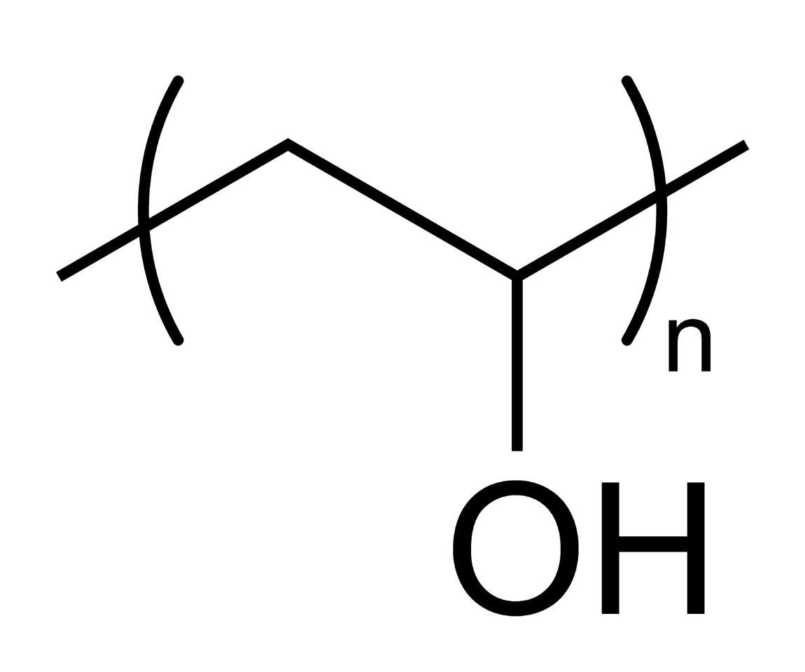
Figure 3: Chemical structure of Poly (vinyl alcohol)

2.3.1 Properties
Polyvinyl alcohol has excellent film forming, emulsifying, and adhesive properties. It is also resistant to oil, grease and solvent. It is odorless and nontoxic. It has high tensile strength and flexibility, as well as high oxygen and aroma barrier properties. However these properties are dependent on humidity, in other words, with higher humidity more water is absorbed. The water, which acts as a plasticizer, will then reduce its tensile strength, but increase its elongation and tear strength. PVA is fully degradable and is a quick dissolver. PVA has a melting point of 230°C and 180–190°C for the fully hydrolyzed and partially hydrolyzed grades. It decomposes rapidly above 200°C as it can undergo pyrolysis at high temperatures.
PVA is an atactic material but exhibits crystallinity as the hydroxyl groups are small enough to fit into the lattice without disrupting it.
2.3.2 Uses
Preparation of polyvinyl butyral is the largest use for polyvinyl alcohol in the U.S. and Western Europe. Its use as a polymerization aid is the largest market in China. In Japan the major use is vinylon fiber production.
Some other uses of polyvinyl alcohol include:
- Adhesive and thickener material in latex paints, paper coatings, release liner, hairsprays, shampoos and glues.
- Textile sizing agent.
- Carbon dioxide barrier in polyethylene terephthalate (PET) bottles.
- Carotid phantoms for use as synthetic vessels in doppler flow testing.
- Movie practical effect and children's play putty or slime when combined with borax.
- Feminine hygiene and adult incontinence products as a biodegradable plastic backing sheet.
- As a mold release because materials such as epoxy do not stick to it.
- As a water-soluble film useful for packaging.
- As fiber reinforcement in concrete.
- As a surfactant for the formation of polymer encapsulated nanobeads.
- Used with polyvinyl acetate to make Elmer's glue.
- Used in eye drops and hard contact lens solution as a lubricant.
- Used in protective chemical-resistant gloves.
- Used as a fixative for specimen collection, especially stool samples.
- When doped with iodine, PVA can be used to polarize light.
- As an embolization agent in medical procedures.

2.3.2.1 Fishing
PVA is widely used in freshwater sport fishing. Small bags made from PVA are filled with dry- or oil-based bait and attached to the hook, or the baited hook is placed inside the bag and cast into the water. When the bag lands on the lake or river bottom it breaks down, leaving the hook bait surrounded by ground bait, pellets etc. This method helps attract fish to the hook bait.
Anglers also use string made of PVA for the purpose of making temporary attachments. For example, holding a length of line in a coil, that might otherwise tangle while the cast is made.

2.3.3 Production
Consumption of polyvinyl alcohol was over one million metric tons in 2006.Larger producers include Kuraray (Japan and Europe) and Celanese (USA) but mainland China has installed a number of very large production facilities in the past decade and currently accounts for 45% of world capacity.

2.3.4 Preparation
Unlike most vinyl polymers, PVA is not prepared by polymerization of the corresponding monomer. The monomer, vinyl alcohol, almost exclusively exists as the tautomeric form, acetaldehyde. PVA instead is prepared by partial or complete hydrolysis of polyvinyl acetate to remove acetate groups.

2.4 Citric acid (C₆H₈O₇) ^{[28]}
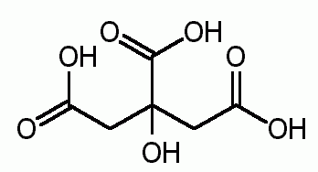
Figure4: Chemical structure of citric acid

Citric acid is a weak organic acid, and it is a natural preservative and is also used to add an acidic, or sour, taste to foods and soft drinks. In biochemistry, it is important as an intermediate in the citric acid cycle and therefore occurs in the metabolism of virtually all living things. It can also be used as an environmentally benign cleaning agent and acts as an antioxidant and a lubricant.
Citric acid exists in greater than trace amounts in a variety of fruits and vegetables, most notably citrus fruits. Lemons and limes have particularly high concentrations of the acid; it can constitute as much as 8% of the dry weight of these fruits (1.44 and 1.38 grams per ounce of the juices, respectively). The concentrations of citric acid in citrus fruits range from 0.005 mol/L for oranges and grape fruits to 0.030 mol/L in lemons and limes. These values vary depending on the circumstances in which the fruit was grown.
2.4.1 Properties
Citric acid crystal under polarized light, enlarged 200x
At room temperature, citric acid is a white crystalline powder. It can exist either in an anhydrous (water-free) form or as a monohydrate. The anhydrous form crystallizes from hot water, whereas the monohydrate forms when citric acid is crystallized from cold water. The monohydrate can be converted to the anhydrous form by heating above 78 °C. Citric acid also dissolves in absolute (anhydrous) ethanol (76 parts of citric acid per 100 parts of ethanol) at 15 degrees Celsius.
In chemical structure, citric acid shares the properties of other carboxylic acids. When heated above 175°C, it decomposes through the loss of carbon dioxide and water. Citric acid leaves a white crystalline precipitate.

2.4.2 Measurement
Citric acid has been used as an additive to soft drinks, beer, and seltzer, and occurs naturally in many juices. This causes a problem in measurement because the standard measuring technique for sugar is refractive index. The refractive index of sugar and citric acid is almost identical. For soft drinks and orange juice the best measure of sweetness is the sugar/acid ratio. Recently, the use of infrared sensors has allowed measurement of both Brix (sugar content) and acidity by detecting sugars and citric acid through their characteristic molecular vibrations; this gives an accurate assessment of a drink's sweetness.

2.4.3 History
Lemons, oranges, and other citrus fruits contain high concentrations of citric acid
The discovery of citric acid has been credited to the 8th century Iranian alchemist Jabir Ibn Hayyan (Geber). Medieval scholars in Europe were aware of the acidic nature of lemon and lime juices; such knowledge is recorded in the 13th century encyclopedia Speculum Majus (The Great Mirror), compiled by Vincent of Beauvais.Citric acid was first isolated in 1784 by the Swedish chemist Carl Wilhelm Scheele, who crystallized it from lemon juice. Industrial-scale citric acid production began in 1890 based on the Italian citrus fruit industry.
In 1893, C. Wehmer discovered that Penicillium mold could produce citric acid from sugar. However, microbial production of citric acid did not become industrially important until World War I disrupted Italian citrus exports. In 1917, the American food chemist James Currie discovered that certain strains of the mold Aspergillus niger could be efficient citric acid producers, and Pfizer began industrial-level production using this technique two years later, followed by Citrique Belge in 1929.

2.4.4 Production
Citric acid monohydrate
In this production technique, which is still the major industrial route to citric acid used today, cultures of Aspergillus niger are fed on a sucrose or glucose-containing medium to produce citric acid. The source of sugar is corn steep liquor, molasses, hydrolyzed corn starch or other inexpensive sugary solutions. After the mould is filtered out of the resulting solution, citric acid is isolated by precipitating it with lime (calcium hydroxide) to yield calcium citrate salt, from which citric acid is regenerated by treatment with sulphuric acid.

2.4.5 Uses
In 2007 world wide annual production stands at approximately 1,700,000 MT. More than 50% of this volume is being produced in China. More than 50% is being used as acidulent in beverages and some 20% in other food applications. 20% is being used for detergent applications and 10% for other non-food related applications like cosmetics, pharma and in the chemical industry.

2.4.5.1 Food additive
As a food additive, citric acid is used as a flavoring and preservative in food and beverages, especially soft drinks. It is denoted by E number E330. Citrate salts of various metals are used to deliver those minerals in a biologically available form in many dietary supplements. The buffering properties of citrates are used to control pH in household cleaners and pharmaceuticals. In the United States the purity requirements for citric acid as a food additive are defined by the Food Chemical Codex (FCC), which is published by the United States Pharmacopoeia (USP).

2.4.5.2 Water softening
Citric acid's ability to chelate metals makes it useful in soaps and laundry detergents. By chelating the metals in hard water, it lets these cleaners produce foam and work better without need for water softening. In a similar manner, citric acid is used to regenerate the ion exchange materials used in water softeners by stripping off the accumulated metal ions as citrate complexes.The saturation point for citric acid and water is 59%.

2.4.5.3 Others
Citric acid is used in biotechnology and the pharmaceutical industry to passivate high-purity process piping (in lieu of using nitric acid). Nitric acid is considered hazardous to dispose once used for this purpose, while citric acid is not.
Citric acid is the active ingredient in some bathroom and kitchen cleaning solutions. A solution with a 6% concentration of citric acid will remove hard water stains from glass without scrubbing. In industry it is used to dissolve rust from steel.
Citric acid is commonly used as a buffer to increase the solubility of brown heroin. Single-use citric acid sachets have been used as an inducement to get heroin users to exchange their dirty needles for clean needles in an attempt to decrease the spread of AIDS and hepatitis. Other acidifiers used for brown heroin are ascorbic acid, acetic acid, and lactic acid; in their absence, a drug user will often substitute lemon juice or vinegar.
Citric acid is one of the chemicals required for the synthesis of HMTD, a highly heat-, friction-, and shock-sensitive explosive similar to acetone peroxide. For this reason, purchases of large quantities of citric acid may rouse suspicion of potential terrorist activity.
Citric acid can be added to ice cream to keep fat globules separate, and can be added to recipes in place of fresh lemon juice as well. Citric acid is used along with sodium bicarbonate in a wide range of effervescent formulae, both for ingestion (e.g., powders and tablets) and for personal care (e.g., bath salts, bath bombs, and cleaning of grease).
Citric acid is commonly employed in wine production as a substitute or improver where fruits containing little or no natural acidity are used. It is mostly used for inexpensive wines due to its low cost of production.
Citric acid can be used in shampoo to wash out wax and coloring from the hair. It is notably used in the product "Sun-in" for bleaching, but is generally not recommended due to the amount of damage it causes.
Citric acid is also used as a stop bath in photography. The developer is normally alkaline, so a mild acid will neutralize it, increasing the effectiveness of the stop bath when compared to plain water.
Citric acid is used as one of the active ingredients in the production of anti-viral tissues.
Citric acid may be used as the main ripening agent in the first steps of making mozzarella cheese.
Citric acid was the first successful eluant used for total ion-exchange separation of the lanthanides, during the Manhattan Project in the 1940s. In the 1950s, it was replaced by the far more efficient EDTA.
Citric acid is used as a good alternative to nitric acid in the process of stainless steel passivation (i.e. "Citrisurf")
Citric acid can be used as a delay to prompt natural cement. It can delay the very rapid setting time substantially.

2.4.6 Safety

Contact with dry citric acid or with concentrated solutions can result in skin and eye irritation, so protective clothing should be worn when handling these materials.
Excessive consumption is capable of eroding the tooth enamel.
Contact to the eyes can cause a burning sensation, and may cause blindness with prolonged exposure in extremely high concentrations (as anything with low enough pH will).
Sometimes a high concentration of citric acid can damage hair and bleach it.
2.5 Borax (Na₂B₄O₇·10H₂O or Na₂ [B₄O₅(OH)₄]·8H₂O) ^{[29]}
Borax, also known as sodium borate, sodium tetraborate, or disodium tetraborate, is an important boron compound, a mineral, and a salt of boric acid. It is usually a white powder consisting of soft colorless crystals that dissolve easily in water.
Borax has a wide variety of uses. It is a component of many detergents, cosmetics, and enamel glazes. It is also used to make buffer solutions in biochemistry, as a fire retardant, as an anti-fungal compound for fiberglass, as an insecticide, as a flux in metallurgy, and as a precursor for other boron compounds.
The term borax is used for a number of closely related minerals or chemical compounds that differ in their crystal water content, but usually refers to the decahydrate. Commercially sold borax is usually partially dehydrated.
The word borax is from Persian and originates in the Middle-Persian būrak.

2.5.1 Uses

2.5.1.1 Buffer
Sodium borate is used in biochemical and chemical laboratories to make buffers, e.g. for gel electrophoresis of DNA, such as TBE or the newer SB buffer or BBS (borate buffered saline) in coating procedures. Borate buffers (usually at pH 8) are also used as preferential equilibration solution in DMP-based crosslinking reactions.

2.5.1.2 Co-complexing
Borax as a source of borate has been used to take advantage of the co-complexing ability of borate with other agents in water to complex various substances. Borate and a suitable polymer bed are used to chromatograph non-glycosylated hemoglobin differentially from glycosylated hemoglobin (chiefly HbA1c), which is an indicator of long term hyperglycemia in diabetes mellitus. Borate and a proprietary synthetic amino acid, Deselex (from Henkel) have been used to complex water "hardness" cations to make a non-precipitating water "softener". Borate alone does not have a high affinity for "hardness" cations, although it has been used for that purpose.

2.5.1.3 Flux
A mixture of borax and ammonium chloride is used as a flux when welding iron and steel. It lowers the melting point of the unwanted iron oxide (scale), allowing it to run off. Borax is also used mixed with water as a flux when soldering jewelry metals such as gold or silver. It allows the molten solder to flow evenly over the joint in question. Borax is also a good flux for 'pre-tinning' tungsten with zinc - making the tungsten soft-solderable.

2.5.1.4 Small-scale mining
Borax is replacing mercury as the preferred method for extracting gold in small-scale mining facilities. The method is called the borax method and was first discovered in Sweden and used in the Philippines.

2.5.1.5 Putty
When a borax-water solution is mixed with PVA glue (wood glue), a rubbery precipitate is formed which is the result of cross-linking in the polymer.

2.5.1.6 Food additive
Borax, given the E number E285, is used as a food additive in some countries but is banned in the United States. In consequence certain foods, such as caviar, produced for sale in the U.S. contain higher levels of salt to assist preservation. In China it was found to have been added to hand-pulled noodles (lamian). In Indonesia it is a common, but forbidden, additive to such foods as noodles, meatballs and steamed rice. The country's Directorate of Consumer Protection warns of the risk of liver cancer with high consumption over a period of 5–10 years.

2.5.1.7 Other uses
- Component of detergents.
- Ingredient in enamel glazes.
- Component of glass, pottery, and ceramics.
- Fire retardant.
- Anti-fungal compound for fibreglass and cellulose insulation.
- Insecticide to kill ants, cockroaches and fleas.
- Precursor for sodium perborate monohydrate that is used in detergents, as well as for boric acid and other borates.
- Tackifier ingredient in casein, starch and dextrin based adhesives.
- Precursor for Boric acid, a tackifier ingredient in polyvinyl acetate, polyvinyl alcohol based adhesives.
- Treatment for thrush in horses' hooves.
- Used to make indelible ink for dip pens by dissolving shellac into heated borax
- Curing agent for snake skins.
- Swimming pool buffering agent to control the pH.
- Neutron absorber, used in nuclear reactors and spent fuel pools to control reactivity and to shut down a nuclear chain reaction.
- In agriculture it can be used to correct boron deficient soils; however, it is required in small amounts. Excess can cause injury to plants.
- To clean the brain cavity of a skull for mounting.
- To colour fires a green tint.
- Borax can be used as an additive in ceramic slips and glazes to improve fit on wet, green ware, and bisque.
- Borax was traditionally used to coat dry-cured meats such as hams to protect them from becoming fly-blown during further storage.

2.5.2 Natural sources
Borax "cottonball"
Borax occurs naturally in evaporite deposits produced by the repeated evaporation of seasonal lakes. The most commercially important deposits are found in Turkey and Boron, California and other locations in the Southwestern United States, the Atacama desert in Chile, and in Tibet and Romania. Borax can also be produced synthetically from other boron compounds.

2.5.3 Toxicity
Borax, sodium tetraborate decahydrate, is not acutely toxic. It’s LD₅₀ (median lethal dose) score is tested at 2.66 g/kg in rats. This does not mean that it is safe, merely that a significant dose of the chemical is needed to cause severe symptoms or death. The median lethal dose for humans tends to differ for a given compound from that of rats. Simple exposure can cause respiratory and skin irritation. Ingestion may cause gastrointestinal distress including nausea, persistent vomiting, abdominal pain, and diarrhea. Effects on the vascular system and brain include headaches and lethargy, but are less frequent. "In severe poisonings, a beefy red skin rash affecting palms, soles, buttocks and scrotum has been described. With severe poisoning, erythematous and exfoliative rash, unconsciousness, respiratory depression, and renal failure."
A reassessment of boric acid/borax by the United States Environmental Protection Agency Office of Pesticide Programs found potential developmental toxicity (especially effects on the testes). Boric acid solutions used as an eye wash or on abraded skin are known to be especially toxic to infants, especially after repeated use because of its slow elimination rate.

2.5.4 Chemistry
The term borax is often used for a number of closely related minerals or chemical compounds that differ in their crystal water content:
- Anhydrous borax (Na₂B₄O₇)
- Borax pentahydrate (Na₂B₄O₇·5H₂O)
- Borax decahydrate (Na₂B₄O₇·10H₂O)
Borax is generally described as Na₂B₄O₇·10H₂O. However, it is better formulated as Na₂[B₄O₅(OH)₄]·8H₂O, since borax contains the [B₄O₅(OH)₄]²⁻ ion. In this structure, there are two four-coordinate boron atoms (two BO₄ tetrahedra) and two three-coordinate boron atoms (two BO₃ triangles).
Borax is also easily converted to boric acid and other borates, which have many applications. If left exposed to dry air, it slowly loses its water of hydration and becomes the white and chalky mineral tincalconite (Na₂B₄O₇·5H₂O).
When borax is added to a flame, it produces a yellow green color. This property has been tried in amateur fireworks, but borax in this use is not popular because its waters of hydration inhibit combustion of compositions and make it an inferior source of the boron which is responsible for most of the green color, and which is overwhelmed by the yellow contributed to the flame by sodium.
However, commercially available borax can be mixed with flammables such as methanol to give the characteristic green flame of boron when ignited, which then slowly gives way to the characteristic yellow-orange flame of the sodium.

CHAPTER-3

MATERIAL AND METHOD

3.1 Technical Details of Raw Material
The following raw materials were used for the modification of guar gum as well as the analysis and testing of the products and composites. The chemicals used were analyzed for their physical properties to check their purity before use..
- GUAR GUM
  - Mesh size 200 Mesh
  - Viscosity of 1% solution at 30⁰C 5000 cP was
  - Supplied by Dabur India Limited.
Poly (vinyl alcohol) (-CH₂CHOH-) _{n}
  - Weight average molecular weight approx 1, 25,000.
  - A white powder/flakes,
  - Soluble in water,
  - Viscosity of 4% aqueous solution at 20⁰C 35-50cP
  - Ash max 0.75% was
  - Supplied by Central Drug House (P) LTD. Post Box No.7138, New Delhi-110002.
Citric acid (anhydrous) (C₆H₈O₇)
  - Molecular weight 192.13
  - Max assay 99.0%,
  - Max limit of impurities
  - Sulphate (SO₄) 0.03%,
  - Iron 0.005%,
  - Heavy metals 0.001%, was
  - Supplied by THOMAS BAKER (Chemicals) Ltd. 4/86, Bharat Mahal-400002 and
Di-sodium tetraborate (Borax) Na₂B₄O₇.10H₂O
  - Molecular weight 381.38,
  - Minimum assay (acidimetric 98.0%),
  - Max limit of impurities
  - Chloride (Cl⁻) 0.02%,
  - Sulphate (SO₄⁻⁻ ) 0.05%, was
  - Supplied by Galaxo Laboratory (INDIA) Ltd, Bombay – 400025
3.2 Miscellaneous Chemicals
Solvents such as acetone, ethanols were obtained from M/s.S.D.Fine Chemicals were of laboratory grade. They were distilled and fraction collected between ±1ºC of their respective boiling points. Deionised water was used for all Chemicals.
3.3 Preparation of Guar Gum solution
Guar-gum solution was prepared by adding the dry guar-gum powder slowly into the hot deionised water at 80⁰C with constant stirring to avoid lump formation. The solution with concentration of 0.6 g of guar gum was prepared in 200 ml beaker.
3.4 Preparation of PVA solution
Poly (vinyl alcohol) solution was prepared by adding pva granules slowly in the deionised water with constant stirring.
3.5 Preparation of films
3.5.1 GG film preparation
Guar gum film was prepared simply by dissolving the GG in deionised water with the help of magnetic stirrer. When homogenous slurry formed the polymeric material simply poured on the Teflon mold and evaporating the water at 50⁰C in an air circulating oven.

3.5.2 GG, PVA blend film preparation
Solution blends were prepared using the required volumes of 1% GG, and PVA solutions. These blends were mixed thoroughly at 2000rpm to result in a uniform homogeneous solution. The films were prepared by casting 100 ml of a 1% solution (w/w) onto a Teflon mold and evaporating the water at 50⁰C in an air circulating oven.
3.5.3 Preparation of GG-PVA blend film with Citric acid
Films were prepared by casting method, first the solution was prepared by dissolving the PVA–GG in water and the mixture was blended for 4hr with a magnetic stirrer at 1000 rpm at room temperature to form a homogenous solution. CA solution was added into the mixture and rotating the solution with a magnetic stirrer for 10 min 1000 rpm at 50⁰C. The prepared solution was poured into the Teflon Mold. Water was evaporated from the mold in a ventilated air oven at 50⁰C. The dried films were sealed in polyethylene bags and store at 50 % RH for one week prior to perform the test.
3.5.4 Preparation of GG-PVA blend film with Citric acid and borax
A similar method to that used for the preparation of the above blend films was used for the preparation of films containing GG, PVA, CA and borax. A solution of the salts was prepared such that it had a concentration of 0.001gm / ml. Various aliquots of this solution was then added to prepared blend solutions making the requisite amount of borax in the blend.

Table-1 Composition of Guar gum/PVA Blends Films

S.N | Samples | GG in gram | PVA in gram | CA(wt% of polymer) | Bx (wt% of polymer)
1. | X | 1.00 | 0.00 | 0.00 | 0.00
2. | Y | 0.00 | 1.00 | 0.00 | 0.00
3. | A | 0.60 | 0.40 | 10% | 0.00
4. | B | 0.60 | 0.40 | 20% | 0.00
5. | C | 0.60 | 0.40 | 30% | 0.00
6. | D | 0.60 | 0.40 | 40% | 0.00
7. | E | 0.60 | 0.40 | 50% | 0.00
8. | K | 0.60 | 0.40 | 20% | 0.50%
9. | L | 0.60 | 0.40 | 20% | 1.00%
10. | M | 0.60 | 0.40 | 20% | 1.50%
11. | N | 0.60 | 0.40 | 20% | 2.50%
  - GG=Guar gum
  - PVA=Poly (vinyl alcohol)
  - CA=Citric acid
  - Bx=Borax

3.6 CHARACTERIZATION OF BLEND FILMS
Measurement
Infrared spectrum of pure and blend films were measured with a Nicolet 380 FTIR (USA). The tensile strength and breaking elongation of the film are measured on an Instron Tensile Tester Instron 3369 with tensile rate of 12.5mm/min at the gauge length of 125.0mm and width of the film was 10mm according to ASTM D882. The temperature and relative humidity were 50⁰C and 50.
3.6.1 Spectroscopic analysis
Miscibility
With FTIR spectra, if two polymers are compatible, there should be considerable difference between the IR spectra of the blend and the co-addition of the spectra of two components. The difference would be derived from chemical interaction, resulting in band shifts intensity changes and broadening.Figure;7-9 shows the Fourier Transform Spectra of the film in the wavelength range of 4000-400 cm⁻¹ with pure and 6:4 ratio of composition of GG and PVA. For the pure GG the strong absorption band occurred at 3356cm⁻¹ was concerned with the stretching frequency of the O-H group. The band around 2962cm⁻¹ and 1148 cm⁻¹were assigned to C-O stretching and C-H stretching respectively.
It can be seen that the broad absorption band in PVA at 3422 cm-1 was a result of the stretching frequency of O-H of vinyl alcohol.

3.6.2 Infrared (IR) Spectroscopy ^{[30]}
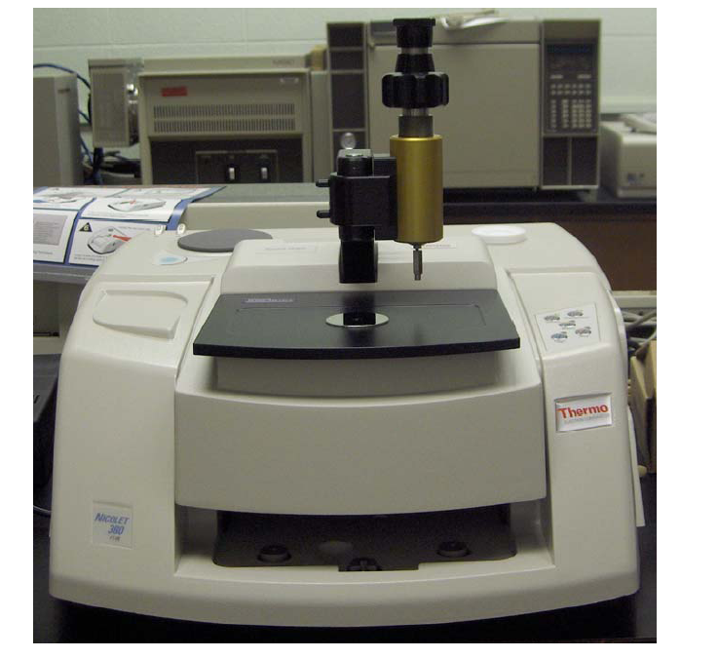
Figure5: Nicolet 380 FT-IR (Fourier Transform Infrared Spectrometer)
Background Information
Infrared (IR) spectroscopy looks at the vibrational motion of bonds in molecules. By identifying the types of bonds present in a certain compound, one is able to gain insight into that compound’s structure. There are certain characteristics of bonds that are dependent upon the compound’s complete structure, namely the wavelength and amount of energy absorbed. What the infrared spectrometer does is give us an understanding of the structure and bonding present in a molecule by looking at the vibrational motions of which it undergoes. It is through these means that a compound is able to be identified since every compound has a unique spectrum (Silberberg 343). It should be noted, however, that infrared spectroscopy will only work for compounds that have a dipole moment (Skoog 382).
The peaks on the IR spectrum correspond to the energies absorbed by the various functional groups. By noting the functional groups in a molecule, interpretation of an IR spectrum can indicate the identity of a molecule by the presence or absence of such peaks. The fingerprint region (1400 – 990 cm-1) can also help identify a compound since this region consists of peaks that are attributed to the molecule as whole and not just specific functional groups (Zubrick 271). It is also possible, through analyzing and comparing IR spectra, to observe changes in a compound by looking for shifts in band frequency or the appearance of new features in the spectra (Mitra 38-39).
3.6.3 Mechanical Properties
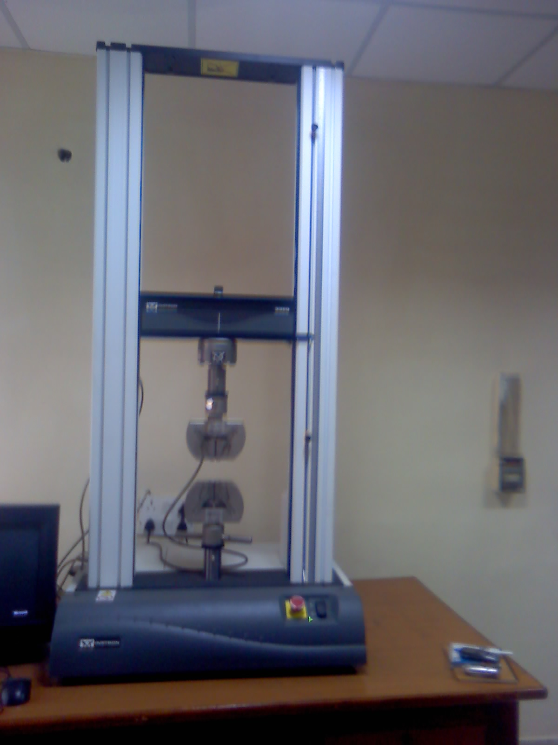
Figure6: UNIVERSAL TESTING MACHINE (UTM)
Universal Testing Machine (UTM) otherwise known as a materials testing machine/ test frame is used to test the tensile and compressive properties of materials. The Universal Testing machine is named so because it can perform all the tests like compression, bending ,tension etc to examine the material in all mechanical properties Such machines generally have two columns but single column types are also available. Load cells and extensometers measure the key parameters of force and deformation as the sample is tested. These machines are widely used and would be found in any materials testing laboratory.
A typical testing system consists of a materials testing machine/test frame, control and analysis software, and critically, the test fixtures, accessories, parts and devices used to hold and support the test specimen.
A tension test is a destructive test in the sense that the specimen is finally broken or fractured into two pieces. To perform the tensile test, the universal testing machine should be capable of applying that load which is required to break or fracture the material. The test piece or specimen of the material is generally a straight piece, uniform in the cross-section over the test length and often with enlarged ends which can be held in the machine holders. However, the machine can hold the specimen without enlarged ends also. Two fine marks are often made near the end of uniform test section of the specimen and the distance between these points is termed "gauge length". The gauge length is that length which is under study or observation when the experiment on the specimen is performed. The gauge length of a specimen bears a constant standardized ratio to the cross-sectional dimension for certain reasons. The specimen is placed in the machine between the holders and any measuring device to record the change in length is fitted on to the specimen between the gauge points. If such a device, generally extensometer, is not fitted, the machine itself can record the displacement between its cross heads on which the specimen is held. Once the machine is started it begins to apply a slowly increasing load on specimen. At preset interval, the reading of the load and elongation of specimen are recorded.

CHAPTER-4

RESULTS AND DISCUSSION

4.1 FTIR-ATR and UTM analysis of GG+PVA (6:4) blend film
The FTIR-ATR spectrum of the pure guar gum film shows absorption band at around 3280.76cm⁻¹ for the O—H stretching vibrations and another band at 2940.52 cm⁻¹ assigned as C—H stretching vibration band, for the in-plane bending of O—H group at around 1423.55 cm⁻¹, strong band at 1249.98cm⁻¹ C—O stretching vibration of alcoholic group present in guar gum. ^{[31]}
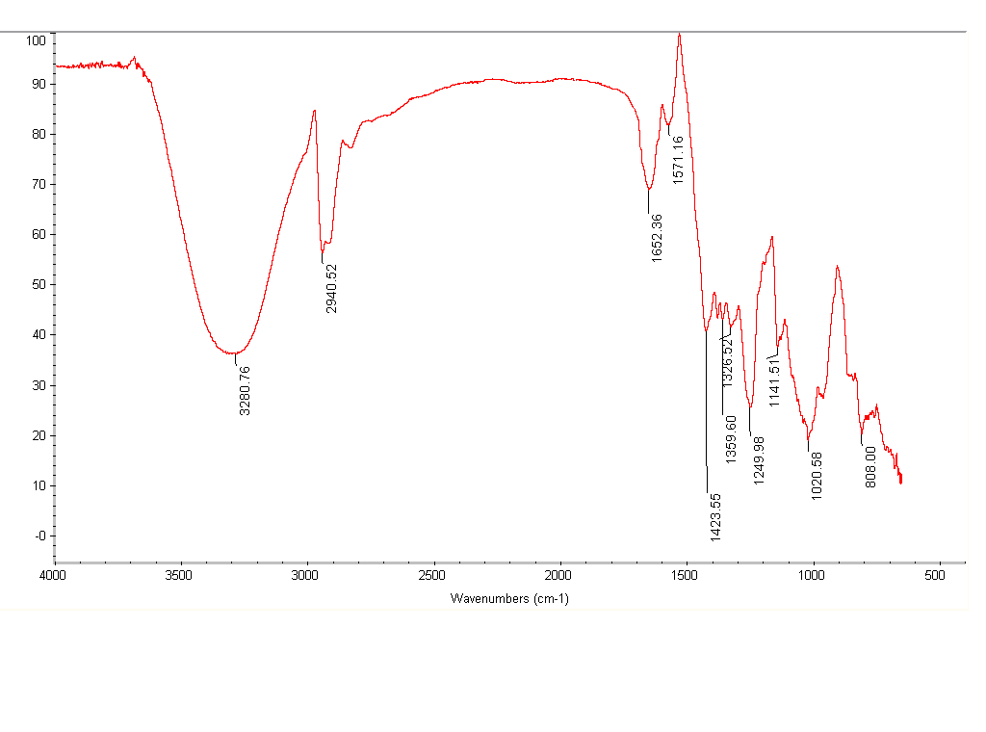 Figure7: FTIR-ATR spectrum of GG film.
For PVA, a broad band at 3400-3100 cm⁻¹due to O—H stretching vibration and another band at 2943.35 cm⁻¹ assigned as C—H stretching vibration for the O—H group in-plane bending, at around 1423.57 cm⁻¹ and 1096 cm⁻¹for the C—O group were observed.^{[32]} The absorption peaks of 947.67 cm⁻¹ represent C—C stretching.
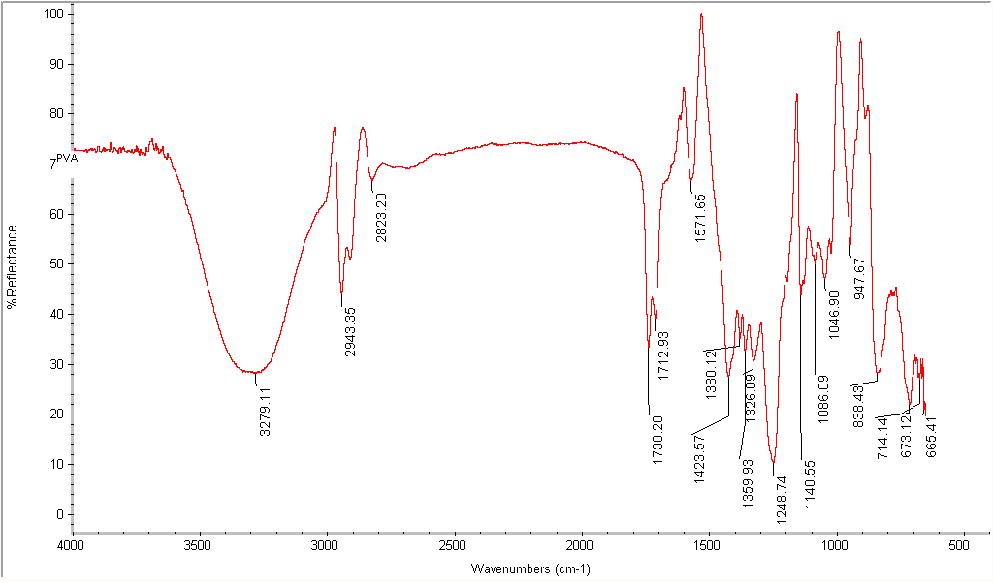
Figure 8: FTIR-ATR spectrum of PVA film.
The 1200-1100 cm⁻¹ region contains a number of modes, which have been shown to be sensitive to the degree of crystallinity in PVA. The peak at 1140.55 cm⁻¹ is crystallinity-dependent. ^{[33]}
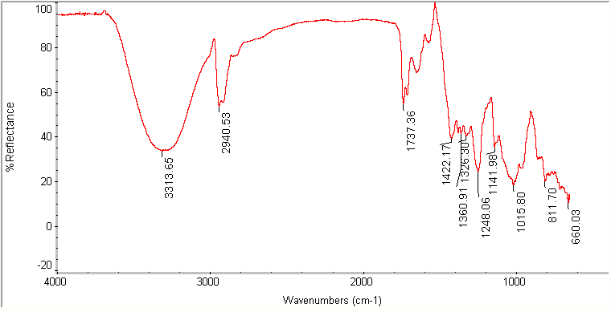
Figure 9: FTIR-ATR spectrum of GG+PVA (6:4) blend film.
The FTIR-ATR spectra shows major differences when GG, PVA blend prepared were the crystallinity peak of PVA weakened and the band of GG at 1020.58cm⁻¹ and band at1046.90 cm⁻¹ of PVA shifted toward lower wavenumber value in blend. This shift appears as a result of the formation of intermolecular hydrogen bonds by the OH of PVA, OH of GG.This will indicate the compatibility of GG and PVA blend.
Figure 10: Tensile strength curve of GG, PVA and GG+PVA blend films.

4.2 Polymer Blends Compatibility
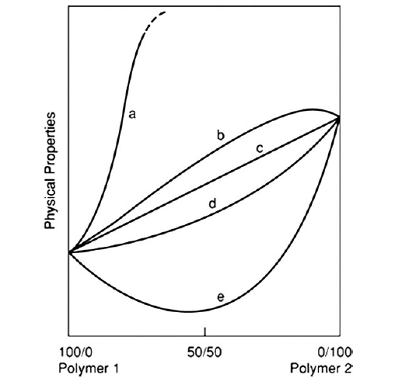
Figure11: Effect of the composition of heterogeneous binary blends on their physical properties (schematically). (a) Fracture resistance, toughness and impact resistance of commercial rubber-toughened polymers; (b) modulus and tensile (yield) strength of blends consisting of partially miscible polymers; (c) density (straight line corresponds to the rule of mixtures); (d) modulus, compliance, tensile yield strength, stress at break, permeability to gases, thermal conductivity of compatible blends with good interfacial adhesion; (e) tensile yield strength and stress at break of blends with poor interfacial adhesion; fracture and/or impact resistance of nontoughened blends.^{[34]}
4.3 FTIR-ATR and UTM analysis of blend films with different composition of citric acid.
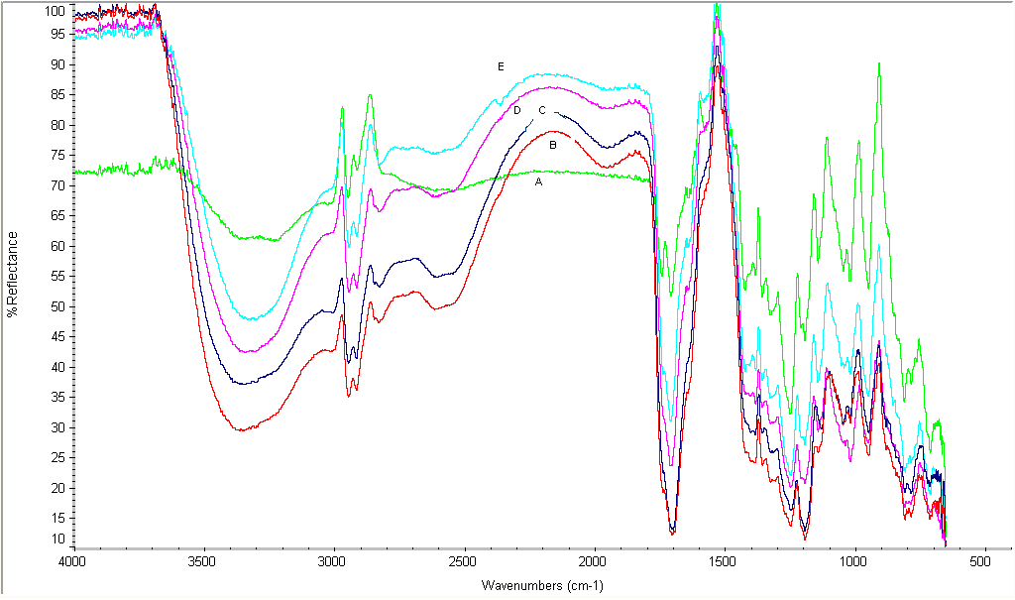
Figure 12: FTIR-ATR spectra of blend films with different composition of citric acid.
  - A= GG: PVA (6:4): CA 10 %( wt% of polymer).
  - B= GG: PVA (6:4): CA 20 %( wt% of polymer).
  - C= GG: PVA (6:4): CA 30 %( wt% of polymer).
  - D= GG: PVA (6:4): CA 40 %( wt% of polymer).
  - E= GG: PVA (6:4): CA 50 %( wt% of polymer).
The FTIR spectrum of blend film with different composition of citric acid clearly indicate that along with the increase of the concentration of citric acid the O—H peak shifted toward higher wavenumber (CA 10% 3231.85cm⁻¹ to 3366.59cm⁻¹ of CA 50%) this confirm the inter molecular H-bonding (absorption shifted toward higher wave number on dilution) and the peak of carbonyl group strong with great intensity area.
Figure13: Tensile strength curve of blend films with different composition of citric acid.
Figure 14: Tensile strain curve of blend films with different composition of citric acid.
4.4 FTIR-ATR and UTM analysis of blend film with citric acid (20%) and 0.5% of borax
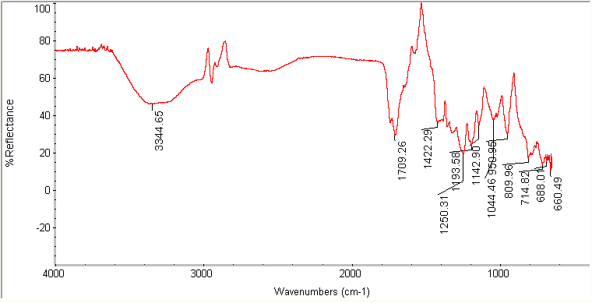
Figure15: FTIR-ATR spectrum of blend film with citric acid (20%) and 0.5% of borax.
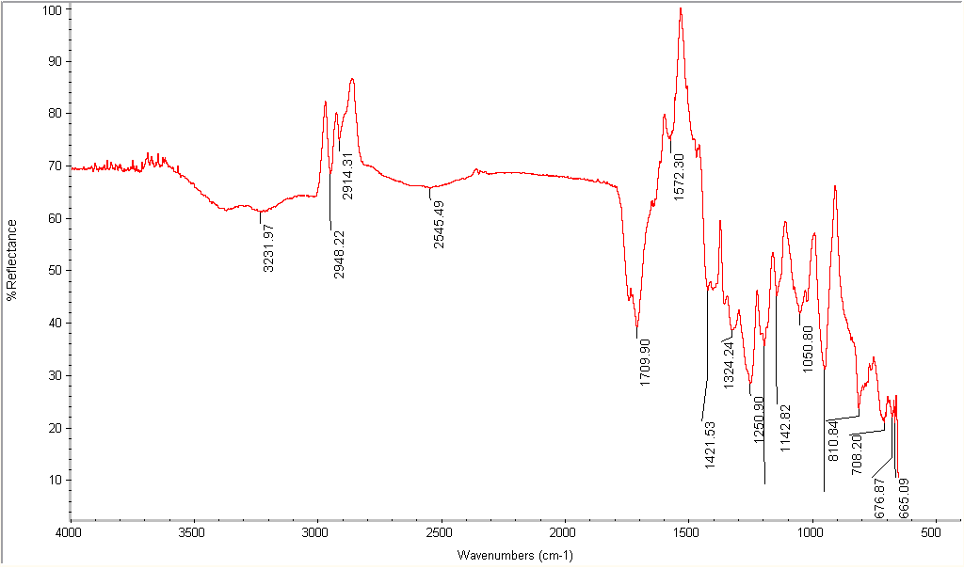
Figure16: FTIR-ATR spectrum of blend film with citric acid (20%) and 2.5% of borax.
The FTIR spectra of blend fllm with CA and borax shows that the peak at 3100-3350 cm⁻¹ of absorption bands weakened and the crystallinity-dependent 1147 cm⁻¹ peak of PVA weakened, and absorption peak of PVA at 838.43 cm⁻¹ shifted. The weakness and shift of the characteristic absorption bands may result from the interaction of different -OH groups in the GG and PVA molecular chains. So it may be deduced from these results that the GG was linked with PVA by chemical binding introduced by borax. This kind of linkage has great effect on the improvement of compatibility.

Figure 17, Tensile strength curve blend films with citric acid and different composition of borax.
Figure 18: Tensile strain curve of blend films with citric acid and different composition of borax.
The above tensile strength and tensile strain curve shows that the tensile strength and tensile strain at maximum load depend on the CA and borax concentration. The tensile strength increases with increasing borax content achieved a maximum value of 29.71MPa at 2.5% borax. Tensile strength without borax was gradually decreases when CA content increases but on increasing the CA % elongation increases 6 to 35 %. It can be concluded that the blend of GG with PVA considerably enhance the mechanical properties.
Enhancement of tensile strength and elongation at breaking point may have resulted from intermolecular hydrogen bonding between GG, PVA and CA and cross-linking agent borax.

CHAPTER-5

CONCLUSIONS AND FUTURE SCOPE OF WORK

The FTIR-ATR and UTM data analysis shows that PVA was compatible with the guar gum. The addition of the citric acid to the blend increases the percent elongation and decreases the tensile strength of the blend film. While the addition of the borax to the guar gum, PVA, blend having citric acid plasticizer continuously increase in the tensile strength along with the decrease in percentage elongation of the blend film. This revealed that the cross-linking agent and the plasticizers always have the contrary effects.
The polymeric film was manufactured by using hundred percent biodegradable ingredients so it can be frequently used useful as a temporary protective coating for metals, plastics, and ceramics. The coating reduces damage from mechanical or chemical agents during manufacturing, transport, and storage. The protective film can be removed by peeling or washing with water.

CHAPTER-6

REFERENCES

1. Whistler, R. L. The Encyclopedia of Polymer Science and Technology John Wiley & Sons: New York, NY, 1969; Vol.11, p 416.
2. Bajpai, U. D. N., Jain, A. & Rai, S., J. Appl. Polym. Sci., 39 (1990) 2187.
3.Kenis,P. R.;Hoyt, J. W. Friction Reduction by Algal and Bacterial Polymers Naval Undersea Research and Development Center, San Diego, USA Report No. NUC TP 1971, 204.
4. Desmukh, S. R.; Chaturvedi, P. N.; Singh, R. P. J. Appl. Polym. Sci. 1985, 30, 4013.
5. Desmukh, S. R.; Singh, R. P. J. Appl. Polym. Sci. 1987, 33, 1963
6. Mayer,J.M.;Kaplan, D.L. Trends polym Sci 1994, 2, 227.
7. Chandy, T.; Sharma, C.P.J Appl Polym Sci 1992, 44 (12), 2145-2156.
8. Um, I. C.;Park, Y.H. Korean JSericultural Sci 1998, 40, 169.
9. Kim, D. H.; Na. S K.; Park, J. S.; Yooon, K. J.; Ihm, D. W. Eur Polym J 2002, 38, 1199.
10. Matsumura, S.; Tanaka, T. J Environ Polym Degrad 1994, 2, 89.
11. Fukae, R.; Fujii, T.; Taheo, M.; Yamamoto, T.; Sato, T.; Maeda, Y.; Sangen, O.Polym J1994, 26, 1381.
12. L. Yu, S. Petinakis. Dean, A. Bilik, D. Wu, Macromoi. Symp. 2007, 249-250, 535.
13.R. F. T. Stepto, Macromol. Symp. 2003, 201, 203.
14. S. K. Rath, R. P. Singh, J. Appl. Polym. Sci. 1998, 70, 1795.
15. J. Lorcks, Polym. Degrad. Stab. 1998, 59, 107.
16. J. Simon, H. P. Muller, R. Koch, V. Muller, Polym. Degrad. Stab. 1998. 59. 107.
17.S. Mishra, R. Bajpai, R. Katare, A. K. Bajpai, J. Appl. Polym. Sci. 2006, 100, 2402.
18. E. Chiellini, A. Corti, R. Solaro, Polym. Degrad. Stab. 1999, 64, 305.
19. D. Preechawong, M. Peesan, R. Rujiravanit, P. Supaphol. Macromol. Symp. 2004, 216, 217.
20. R. L. Shogren, W. M. Doane, D. Garlotta, J. W. Lawton, J. L. Willett, Polym. Degrad. Stab. 2003. 79, 405.
21. L. H. Innocential-Mei, J. R. Bartoli, R. C. Baltier, Macromol. Symp. 2003, 197, 77.
22. T. T. Reddy, S. Tammishetti, Polym. Degrad. Stability. 86, 455, 2004.
23. C. Xiao, T. Zhang, L. Zhang, JAPS, 90(7), 1991, 2003.
24. J. Z. Yi, L. M. Zhang, JAPS, 1033, 3553, 2006.
25. Y. Hang, H. Yi, C. Xiao, Carbohydrate Polymer, 66 (4), 500, 2006.
26. "http://en.wikipedia.org/wiki/Guar_gum"
27. "http://en.wikipedia.org/wiki/Polyvinyl_alcohol"
28. “http://en.wikipedia.org/wiki/Citric_acid”
29. “http://en.wikipedia.org/wiki/Borax”
30. “http://www.ucmo.edu/Documents/cas/chem/nicolet_380_ftir_07_06.pdf”
31. R. M. Silverstein, F. X. Webster, Spectrometric Identification of Organic Compounds, John Wiley & Sons, Inc. (Pg. 79- 93)
32. Denice S. Vicentini , Arthur Smania Jr. , Mauro C.M. Laranjeira, Materials Science and Engineering C, (Article in Press)
33. R. Jayasekara, I. Harding and I. Bowater, Preparation, surface modification and characterization of solution cast starch PVA blended films, Polym. Testing, 23 (2004) 17_27.
34. Whistler, R. L. The Encyclopedia of Polymer Science and Technology John Wiley & Sons: New York, NY, 1969; Vol.9, p 30.

