Chapter 1
Photonic Crystals: Molding the flow of light
1.1 Introduction
For the past fifty years, semiconductor physics has played a vital role in almost every aspect of modern technology. The ability to engineer the electrical properties of the semiconductor materials has allowed scientists and engineers to tailor the conducting properties of certain materials and have initiated the transistor revolution in electronics. New research suggests that we can tailor the properties of light and a similar revolution in the field of optics is being experienced. The key in achieving this goal lies in the use of a new class of materials called photonic crystals. The underlying concept behind these materials stems from the pioneering work of Yablonovitch and John in 1987, who independently studied spontaneous emission control and localization of light in novel periodic materials [1, 2]. The basic idea consists in designing materials that can affect the properties of photons in much the same way that ordinary semiconductor crystals affect the properties of electrons. This is achieved by constructing a crystal consisting of a periodic array of macroscopic uniform dielectric “atoms” popularly known as Photonic Crystals (PhCs) or Photonic Band Gap (PBG) structures.
  - Classification of Photonic Crystals
In essence photonic crystals are materials in which the refractive index is periodically modulated on a length scale comparable to the wavelength of light, which affects the dispersion relations and spatial distribution of light traveling through the photonic crystal. They can be mainly classified into three categories , that is, one dimensional (1D) PhCs, two dimensional (2D) PhCs and three dimensional (3D) PhCs according to the dimensionality of the stack as shown in figure 1.1.
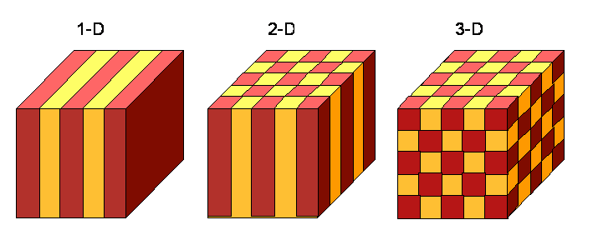
Figure 1.1 Model of 1D, 2D and 3D photonic crystals

The simplest PhC is a dielectric stack or a Bragg reflector in which the periodicity in one dimension is obtained. In such a periodic structure the shape of the dispersion relation deviates from that of the constituent materials and appears as a set of allowed and forbidden frequency intervals. The appearance of such forbidden intervals or gaps is a consequence of Bragg diffraction by the planes forming the crystal, and their spectral position and width are determined both by the period and the refractive indices of the constituent materials. Such structures with periodicity in one dimension have been known and exploited for decades, where as, their two dimensional and three dimensional counter parts in which the periodicity in two and three dimensions is obtained respectively, have been explored since the publication of the original ideas of Yablonovitch and John in 1987 [3-22].
In the PhCs or photonic band gap (PBG) structures, the allowed and forbidden frequency intervals are expected along each of the periodic directions. In general, the forbidden intervals may not necessarily span the same spectral region for different directions, and one then talks of the pseudo photonic band gaps. But under certain conditions such as the dielectric contrast of the constituent materials, the symmetry of the lattice, its topology and the filling fraction of the constituent materials one can reach a situation where the gaps for different directions within the crystal share a common frequency range. Such spectral range is known as a complete photonic band gap (CPBG), a frequency interval for which no light can propagate within the crystal regardless of its direction [23-28].
Although 3D PhCs would have been the preferred choice, since they can control the light propagation in all three directions and are ideally lossless, they are difficult to integrate with optoelectronic devices. The technology developed so far for the fabrication of 3D photonic crystals often only allows the fabrication of homogeneous PhC blocks without any functional elements such as mirrors, waveguides or resonators. A more suitable approach would then be to use 2D PhCs, even though they are more difficult to fabricate than 1D PhCs, they nevertheless remain of moderate complexity and also because of their comparative ease of fabrication and integration with planar integrated circuits.
The research work reported in this thesis focuses on the photonic band gap engineering, complete photonic band gap engineering and then the design and modeling of various devices in 2D photonic crystals.
  - Characteristics of Photonic Crystals
Photonic Crystals as the name suggests arise from the cooperation of periodic scatterers and hence are called “crystals” because of their periodicity and “photonic” because they act on light. The optical properties of these crystals are directly related to the dispersion relations or the photonic band diagrams. In order to obtain the dispersion relations of photonic crystals and their analogy with semiconductor crystals a number of concepts such as that of Brillouin zone, reciprocal lattice, etc, have been borrowed from the field of solid state physics, because of the aforementioned similarity of the photons in a periodic refractive index to that of electrons in a periodic potential [29-31].
In a semiconductor crystal, electron localization is described using a Schrödinger equation; where as in photonic crystals, photon localization can be described by the master equation.
The starting point for determining the photonic band structure of a photonic crystal is Maxwell’s equations which, in the absence of charges, may be expressed as

(1.1)
and the two constitutive equations
(1.2)

The standard notations for the electric field, the magnetic field, the electric displacement , the magnetic induction , the magnetic permeability , the dielectric constant of free space and the relative dielectric constant have been used in the equations.
Combining equations (1.1) with equations (1.2), following wave equations are obtained
1
(1.3)
These are the master equations for the photons in the periodic refractive index which are analogous to the Schrödinger equation for the electrons in the periodic potential. Any of these master equations can be used to obtain the dispersion relations or the photonic band diagrams for the photonic crystals for which various numerical techniques have been developed.
Although the existence of photonic band gaps is one of the most fascinating features of the photonic crystals, there are other interesting features associated with the photonic crystals.
Other interesting property of these crystals is that the density of states can be manipulated i.e. it can be reduced as well as enhanced by appropriately tailoring the photonic crystal structure. Thus the strength of the optical field can be enhanced and this property of local field enhancement in the case of nonlinear photonic crystals can be utilized to enhance the nonlinear optical effects that are strongly dependent on the local field [32-34].
The photonic band diagrams or the dispersion relations not only provide the information on the existence of forbidden intervals, they also allow one to study the light wave propagation through them which is studied in terms of equifrequency (or dispersion) surfaces (EFS). An EFS is just the collection of all allowed wave vectors for a certain frequency. In terms of light wave propagation, photonic crystals exhibit the interesting feature of anomalous dispersion. The group velocity is strongly modified in a photonic crystal because of the presence of a highly anisotropic and complicated band structure. The group velocity can vary widely from zero in the band gap region to values significantly lower than the vacuum speed of light, being in general dependent both on the frequency of light in relation to the band gap and on the direction of propagation [35,36].
Another important feature is the group velocity dispersion defined as$β_{2}=∂^{2}k∂ω^{2}$, which is given by the curvature of the band structure. In the electronic band structure the curvature $∂^{2}E∂k^{2}$ relates to the effective mass of the electron, whereas $β_{2}$ is inversely proportional to the effective mass of photon. An anomalous dispersion can be encountered near the band gap, where the effective photon mass is negative below the gap and positive above the gap. Inside the stop gap, group velocity dispersion shows rapid decrease to zero.
Also the anomalous refraction effects are observed which refer to the deviations from the predictions of Snell’s law that describes the light refraction in conventional materials. Because of the anomalous dispersion and anomalous refraction many new phenomena such as superprism phenomenon, self collimation phenomenon as well as the negative refraction have been predicted and verified [37-39].
  - Spatial Defects in the PBG Materials
Once such a medium which is impervious to light is obtained, photons can be manipulated in many interesting ways by creating defects in the otherwise perfect photonic crystal, which can be done by breaking the periodicity of 1D, 2D or 3D PhC. Defects can lead to the localized photonic states in the band gap, whose shapes and properties would be dictated by the nature of the defect. A defect in a photonic crystal could in principle be designed to be of any size, shape or form and could be chosen to have any of wide variety of dielectric constants. Thus the defect states in the gap could be tuned to any frequency and spatial extent as per the designer’s perspective. In addition to tuning the frequency, one also has control over the symmetry of the localized photonic state [40-49].
The defects typically fall into two classes: point defects, which create resonant cavities and line defects which create waveguides. In both the cases the key point is that the defect can support modes that lie inside the band gap of the crystal.
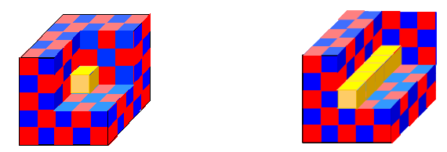
Figure 1.2 Representation of point defect and line defect in photonic crystal structures

A point defect is simply a defect of finite extent in all directions, which thus supports a resonant cavity mode, or modes, with a discrete sequence of frequencies. A line defect conversely is a defect that extends periodically with infinite extent in one axial direction (usually the symmetry direction of the crystal) and with finite extent in lateral directions forms a waveguide.
In contrast to the line defects employed for 2D PhC waveguides in planar applications, Photonic Crystal Fiber (PCF) can also be made by creating defects in 2D PhC. The core in a photonic crystal fiber may in fact be considered a point defect in an ideal 2D photonic crystal. And both the point defect and the line defect in 2D photonic crystal extend infinitely in the invariant direction to form photonic crystal fiber. Light with a non zero out of plane wave vector component, which falls within the 2D photonic band gap of the photonic crystal, may therefore be trapped in the plane of periodicity and guided along the point defect in the direction perpendicular to the periodic plane. The out of plane wave vector component, hence is identical to the propagation constant of the fiber. In this case the fiber is truly operating by PBG effect and it is shown that the light can be guided through a medium of lower index than that of cladding having higher refractive index which are popularly known as PBG fibers. The PCFs may, however also trap light at a spatial defect in a more conventional manner namely if the spatial defect has higher refractive index than the effective index of the surrounding photonic crystal structure. In this case the PCF operates by simple index guidance [50-52].
All of these capabilities provide a new dimension in the ability to mold or control the properties of light which is guided because of the index guided effect or the photonic band gap effect. In this sense defects are good things in photonic crystals and therein lies the exciting potential of photonic crystals which provide the ability to mold the flow of light. These defects throw open the possibility of the design of various ultra compact optical devices and low loss photonic crystal fibers leading to another revolution in the field of optical communication.
1.5 Theoretical Modeling of Photonic Crystals
The modeling of photonic crystals and the proposed photonic crystal devices is challenging, not only because of the strong scattering environment which is the consequence of the geometry and scale of the structure, but also because of the high contrast optical materials that are used. Over the years, a range of computational methods for photonic band structure computation and light wave propagation in photonic crystals both analytical as well as numerical have evolved including the Plane Wave Expansion Methods, Finite Difference Time Domain methods, Transfer Matrix methods, layer Korringa Kohn Rostocker methods, Wannier function methods and Finite Element methods. The methods fall in two broad categories: the frequency domain methods and the time domain methods [53].
1. Frequency domain techniques, namely Plane Wave Expansion (PWE) method, Scattering Matrix Method, Korringa Kohn Rostoker (KKR) method are the methods where the photon eigen value equation is solved to obtain the allowed photon states and their energies. The advantage provided by these methods is that they directly provide the band structure.
Crucial to the study of photonic crystal devices is the capacity to compute band diagram of the underlying lattice and the dispersion diagrams for defect states. Plane Wave Expansion method remains the reference method for the calculation of band gaps in photonic crystals which is based on the Fourier Expansion of the electromagnetic field and the dielectric function. In fact two different methods exist, depending on whether the electric field or the magnetic field is actually considered; these are referred to as E and H method respectively, which have been discussed in detail in appendix A [54,55].
Since plane wave methods utilize the periodicity of the photonic crystals for the expansion of the electromagnetic fields and the refractive index distributions, they are not directly suited for simulating spatial defects. However, the plane wave methods may still be applied, if the smallest region describing the structure is enlarged to include the defect and several periods of the photonic crystal that surround it. In this way, an artificial super periodicity is introduced, where the defect is also repeated periodically. To accurately determine the properties of the defect region, the size of the super cell must be large enough to ensure that neighboring defects are uncoupled.
Another method to analyze the photonic crystals is the scattering matrix method. In this method the source wave and the scattering objects are initially defined. The electromagnetic field of light at an arbitrary position is subsequently calculated from the summation of two waves: the wave arriving directly from the source position and the wave that is scattered by an object. Every scattered wave is represented in terms of Fourier – Bessel series and the simple summation of these scattered waves gives the total scattered wave. The amplitude of each degree of cylindrical function is represented by the scattering matrix. The source position, the scattering matrix, and the scattered wave are related to each other in simultaneous equations, which can be solved to obtain electromagnetic field distributions at arbitrary positions [56,57].
Another method referred to as Korringa Kohn Rostocker (KKR) method, relies on the use of scattering matrix of the elementary cell, while the Green function of the periodic structure is developed on the basis of spherical harmonics in three dimensional case [58].
2. Time domain techniques calculate the temporal evolution of the input electromagnetic field propagating through the crystal. Then, the band structure is calculated by the Fourier transform of the time independent field to the frequency domain. A widely used method is the finite difference time domain (FDTD) method [59-63].
The FDTD method calculates time evolution of the electromagnetic waves by direct discretization of Maxwell’s equations. In this method, the differentials in Maxwell’s equations are replaced by finite differences to connect the electromagnetic fields in one time interval to the ones in the next interval.
However, recently finite element method has also been explored for the analysis of photonic crystals both in time domain as well as frequency domain [64, 65].
One of the important properties of photonic bands is the scaling law which is the direct consequence of the fact that the Maxwell’s Equations in general are scale independent, which means that one can solve the equations once and then apply the same results to problems at all length scales and frequencies. Because of this scale invariance, it is convenient to use dimensionless units for the distance and time. Hence, the natural length scale ‘a’ in the system (usually the periodicity or lattice constant) is picked up and all distances are expressed as a multiple of ‘a’ and all angular frequencies ‘$ω$’ as a multiple of ‘$2{πc}/a$’.
PWE method and FDTD method that have been employed for band structure calculations and for modeling of photonic crystals in this thesis have been discussed in detail in Appendix A and B respectively.
1.6 Fabrication techniques
PhCs mimic the role of the atomic structure of a semiconductor in manipulating electrons, in this case for light. Hence called the semiconductors of light, these crystals are generally not found in nature and have to be designed and fabricated. A wide variety of methods have been developed for the fabrication of photonic crystals each carrying its own advantages and disadvantages [66].
The first fabrication methods developed to fabricate photonic crystals were the lithographic methods which use well-developed techniques in microelectronics [67, 68]. The two most common lithographic techniques which are used are two photon lithography and e beam lithography. Two photon lithography technique utilizes the fact that certain materials, such as polymers, are sensitive enough for two photon excitation to trigger chemical or physical changes in the material structure, with nano scale resolution in three dimensions [69].
In E beam lithography, the sample is covered with an electron sensitive material called resist which undergoes a substantial change in its chemical or physical properties, when it is exposed to an electron beam [70]. These methods are rather versatile in terms of the fabricated structure and allow for the introduction of the designed defects, required for various applications. Their main drawbacks are the expensive technology and large time scales involved in the fabrication process.

Figure 1.3 3D photonic crystals fabricated by: (a) lithography, (b) self assembly & further
processing to obtain an inverse opal, (c) holographic lithography and (d) direct
laser writing. Images have been taken from references 68, 76, 71 and 78.

Holographic Lithography has recently been introduced and has become a promising technique [71, 72]. This technique utilizes the interference between two or more coherent light waves to produce a periodic intensity pattern, to produce a periodic photo produced photonic structure in a photo resist. The initial laser beam is split into several beams and allowed to overlap in the resin at angles predetermined by the desired periodicity.
Another most popular approach to fabricate 3D photonic crystals is that of self assembly. This method is based on the natural tendency of the mono disperse colloidal particles to self assemble into ordered arrays commonly termed as artificial opals, after their similarity with precious gems. A number of techniques are available for colloidal assembly fabrication. A widely used technique for creating colloidal crystals is gravity sedimentation in which the particles suspended in a solution settle to the bottom of the container as the solvent evaporates, but it is a slow process and takes as long as four weeks to form good crystals [73-75].
Another self assembly technique is the Cell method in which an aqueous dispersion of spherical particles is injected into the cell formed by two glass substrates and a frame of photo resist, placed on the surface of the bottom substrate. One side of the frame has channels that can retain the particles, while allowing the solvent to flow through. The particles settle down in the cell to form an ordered structure [76].
Initial samples grown by sedimentation have a number of drawbacks concerning the difficulty to control sample thickness and the fact that they were not easy to manipulate [71, 73], the vertical deposition method, another self assembly technique has been developed which provides better results and produces a very long range order. Another variation of vertical deposition is the convective self assembly method.
Auto cloning technique, another fabrication technique, rests on balance between three processes occurring simultaneously: the sputtering deposition of dielectric layers, their physical etching by ions accelerated perpendicularly to the surface and the redeposition of neutral particles torn from the deposited layer by accelerated ions. The subtle balance achieved between these three processes results in the repetition of the topology of a pre structured growth substrate from one deposited layer to the other [77].
A number of alternative methods have been developed for the fabrication of 3D photonic crystals in the optical regime, but have not become as popular as the ones above. This has been due to the difficulties of the process, the impossibility of yielding good quality samples or just due to the recent development of the technique. Among these one can mention techniques based on direct laser writing [78], focused ion beam milling [79] and nanorobotic manipulation [80].
1.7 Outline of the thesis
As a first step towards the analysis of the photonic crystals, the photonic band gap calculations and their analysis using plane wave expansion (PWE) method have been presented, which is followed by the band gap engineering and further the devices in 2D PhCs. Various numerical methods have been used to obtain and analyze photonic band gap diagrams. In the thesis two methods namely PWE Method and the FDTD method have been used. Mathematical details of both the methods have been discussed in Appendix A and B of the thesis.
Chapter 2 of the thesis begins with obtaining the photonic band diagrams for the various PBG structures using the PWE method which forms the first and foremost step towards the analysis of the photonic crystals. The chapter further deals with the PBG engineering as well as the complete photonic band gap (CPBG) engineering by introduction of asymmetry in the PBG structures. It has been observed that the both the pseudo as well as complete photonic band gaps vary by varying the shape as well as the orientation of the constituent dielectric rods/air holes in air/dielectric respectively.
After the detailed analysis of the photonic band gaps in 2D PhCs, defects are introduced in otherwise perfect photonic crystal such that the light is localized or guided in these structures. As discussed earlier by creating a linear defect in the PhC structure, PhC waveguide can be formed, which forms the building block of various devices. There are two ways in which the light can be guided in the PhC structure, one because of the index guided effect and other because of the photonic band gap effect.
Chapter 3 deals with the design of PhC optical waveguides created by the making line defects in otherwise perfect photonic crystal. The material used here is silica in which air holes are arranged periodically. Light is guided in the photonic crystal waveguides because of the index guided effect. And by placing the two parallel PhC waveguides close to each other, photonic crystal directional coupler has been designed. The coupling characteristics of PhC coupler have been studied for both the polarizations over the entire operational range. It has been observed that the coupling length of the directional coupler lies in the micrometer range. Further the effect of barrier width on coupling characteristics has also been investigated in the proposed PhC directional coupler.
In Chapter 4, PBG waveguides have been created by creating linear defects in the PBG structure in which the light is guided because of the photonic band gap effect. These PBG waveguides have been used to design photonic band gap waveguide coupler. Since the photonic crystal structure considered possesses pseudo band gap, the coupler is operational for only one polarization. Coupling characteristics of the PBG coupler have been studied and the coupling lengths have been obtained in the micrometer range leading to the design of ultra compact PBG waveguide directional coupler. The designed PBG coupler has further been used for the design of ultra compact PBG multiplexer - demultiplexer (mux-demux) modeled using the FDTD method.
Chapter 5 of the thesis uses the concept of complete band gap engineering discussed in chapter 2 to design complete photonic band gap based devices namely polarization splitters. Two designs of PBG polarization splitters have been presented utilizing the PhC structures exhibiting the complete photonic band gap effect. These polarization splitters exhibit different coupling lengths for TE and TM polarizations leading to the splitting of the two polarizations. The efficiency of the polarization splitters have been measured in terms of extinction ratio and insertion loss. The PBG polarization splitters offer large bandwidths and have been designed to operate around 1550 nm wavelength.
Chapter 6 of the thesis focuses on the engineering of defects in PBG structure. The design of photonic band gap polarizers in both the topologies of the photonic crystal using the concepts of complete photonic band gap effect and the polarization sensitivity of the photonic band gaps along with defect band engineering has been presented. Two designs of PBG polarizers have been proposed in different topologies of photonic crystals. The polarizer action has been modeled using the FDTD method and the performances of the PBG polarizers have been measured in terms of degree of polarization, transmittance and band width.
The research work reported in this thesis has been summarized in chapter 7. The chapter concludes the thesis and also presents the future scope of work. In brief, the research work is focused on photonic band gap engineering, complete photonic band gap engineering and defect band gap engineering in various 2D photonic crystal structures. Further, the light guidance via two possible mechanisms in photonic crystal structures has been explored to design various photonic crystal devices. PhC directional coupler based on the index guided effect as well as the PBG waveguide coupler operating via photonic band gap effect has been designed. Further the devices based on the complete photonic band gap have been designed namely the designs of ultra compact optical polarization splitters have been proposed, modeled and characterized. Finally the concept of complete photonic band gap along with the defect engineering has been clubbed to give the design of PBG polarizers.
The work can further be extended by designing PhC tunable couplers and switches by using non linear photonic crystals. The concepts of defect engineering can be put to design other passive and active optical devices which could be helpful in the design of all integrated photonic circuits.
Chapter 2
Photonic Band Gap Engineering in 2D Photonic Crystals
2.1 Introduction
In the recent past, PhCs have attracted much attention from both fundamental and practical viewpoints, due to their unique optical properties and their potential application in optical devices. These crystals consist of a periodic dielectric structure, with lattice spacing comparable to the wavelength of light. The periodic dielectric structure affects the dispersion relations and spatial distribution of light traveling through the photonic crystal. There exist many analogies between photonic crystals and the more familiar electronic crystals. In both cases, the reciprocal lattice can be described by Brillouin zones that reflect the symmetry of the real space crystal. For large enough dielectric contrast, there exist wavelength regions where no solutions of Maxwell’s equations in the periodic structure exist, creating photonic band gaps. The existence of photonic band gap gives rise to a number of interesting and useful properties including the localization of light at defects and surfaces and the inhibition of radiation.
The photonic band gaps in photonic crystals depend upon the arrangement of constituent air holes/dielectric rods, fill factor and dielectric contrast of the two media used. In the past, a lot of work has been reported on the design of 2D photonic crystals and their possible applications in design of photonic band gap based optical devices. In these studies, 2D photonic crystals that have been considered consist of arrays of circular holes/dielectric rods in dielectric/air in various lattice arrangements (for eg. square, triangular, etc.). And it has been shown that with the adequate dielectric contrast between the host material and the constituent object material, lattice type, and filling factor (percentage space occupied by the constituent objects), the
position and size of photonic band gaps (PBGs) in a PhC can be engineered to meet the requirements of the specific applications [3-23]. However, in the recent past some studies on the photonic crystals consisting of elliptical air holes/dielectric columns have been done where the variation of complete photonic band gap with varying roundedness in a photonic crystal consisting of air holes in a dielectric in a triangular lattice has been studied. Another study projects the method of obtaining complete photonic band gap with elliptical air holes in a dielectric medium in a rectangular lattice. However, most of the studies on the existence of complete photonic band gap have been done on the 2D photonic crystals composed of air holes in dielectric media [24-29]. Since, the photonic band gaps in 2D photonic crystals are polarization dependent and this property of photonic crystal can be used to design and develop polarization sensitive devices which have been discussed in the forth coming chapters. Therefore, to take the maximal advantage of the ability of photonic crystals to control electromagnetic radiation, analysis of photonic band gaps in photonic crystals is a must.
There are two basic topologies for 2D PhCs: high index rods surrounded by low index material and low index holes embedded in high index medium. Generally, the 2D PhCs consist of columns (holes or rods) of circular shape as shown in figure 2.1(a) and 2.1(b) respectively.
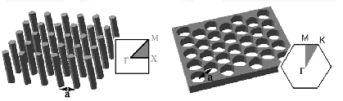
Figure 2.1(a) Periodic arrangement of dielectric rods in air
Figure 2.1(b) Periodic arrangement of air holes in dielectric slab

In this chapter, the variation of photonic band gap sizes because of the ellipticity of the constituent air holes (low index material) or dielectric rods (high index medium) in the PhC in section 2.2 has been studied. Further in section 2.3, the possibility and variation of complete photonic band gaps in PhCs has been explored. It has been observed that any kind of asymmetry introduced by making the rods elliptical or rectangular and further their orientation angle produces a variation in photonic band gaps as well as complete photonic band gaps.
2.2 Photonic Band Gap Engineering
Photonic Band Gap engineering as the name suggests deals with tailoring of the photonic band gaps in the PBG structures by varying the various possible design parameters which could be helpful for specific applications. In this section, variation in photonic band gaps by altering the radii of the constituent air holes/dielectric rods has been analyzed.
2.2.1 Design parameters of the PhCs
To investigate the variation of photonic band gap size with varying ellipticity, the following two structures have been considered:
- PhC composed of square lattice of elliptical air holes in silicon (Si) (n = 3.42) shown in figure 2.2 (a).
- PhC composed of square lattice of elliptical Si rods in air shown in figure 2.2 (b).
Figure 2.2 (c) depicts the model of the PhC consisting of square lattice of air holes in Si and figure 2.2 (d) depicts the model of the PhC consisting of square lattice of elliptical Si rods in air. Figure 2.2(e) shows the Brillouin zone for the two structures used.

Figure 2.2 (a) Figure 2.2 (b)

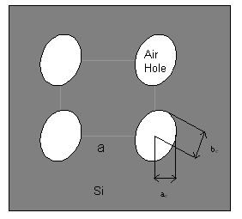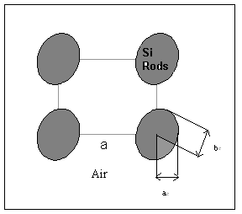

Figure 2.2(c) Figure 2.2 (d)

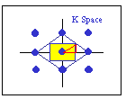
Figure 2.2 (e)

Figure 2.2(a) Schematic view of the PhC composed of a square lattice of elliptical air holes in Si

Figure 2.2(b) Schematic view of the PhC composed of square lattice of elliptical Si rods in air
Figure 2.2(c) Model of the PhC composed of square lattice of elliptical air holes in Si
Figure 2.2(d) Model of the PhC composed of square lattice of elliptical Si rods in air

Figure 2.2(e) Brillouin zone of the square lattice of air holes/Si rods in Si/air

2.2.2 Numerical Analysis and Results
First the investigation of photonic band gaps of the considered photonic band gap structures composed of circular air holes /dielectric rods have been calculated using the plane wave expansion (PWE) method (as discussed in the appendix A). Then the variation of photonic band gap in case of elliptical holes/dielectric rods in dielectric/air respectively has been studied under the following headings
- Keeping the fill factor constant (a_{e}b_{e} = constant)
- Keeping the major axis b_{e} constant (ellipticity is induced by decreasing the minor axis)
- Changing the orientation angle of the constituent air holes/dielectric rods
For propagation of radiation in the plane of periodicity in 2D PhCs, the two possible polarizations decouple, leading to the two scalar problems, referred to as the transverse electric (TE) and transverse magnetic (TM) polarizations respectively.
2.2.2.1 PhC composed of square lattice of air holes in Si
First, the investigation has been done for the PhC structure composed of square lattice of air holes in Si along the above mentioned lines. As a first step, the photonic band diagram has been obtained for the PhC structure composed of square lattice of circular air holes in Si. The variation in the photonic band gap size by changing the radius of the circular air holes in the PhC structure has been plotted in figure 2.3. Then the asymmetry in the structure has been introduced by making the holes elliptical and the photonic band diagrams have been obtained. In figure 2.3, the variation of TE1-2 photonic band gap size (size of the photonic band gap between first and second bands) with the normalized air hole radii (r/a), which is the fictive radius of a circle having the same area as the ellipse considered, for three different ellipticities (e = a_{e}/b_{e}) of the constituent air holes namely e = 1, e = 0.95 and e = 0.9 keeping the fill factor constant has been shown. ‘a_{e}’ and ‘b_{e}’ denote the minor and major axis of the air holes respectively. For this structure the photonic band gap for TE polarization has been studied, as the photonic band gap does not exist for TM polarization.
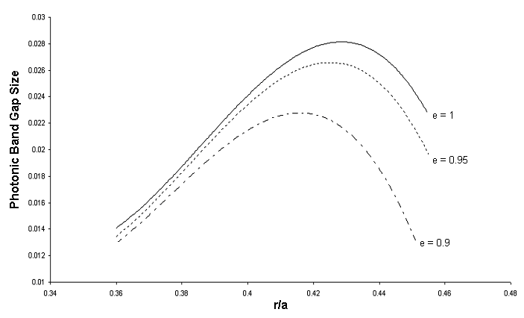
Figure 2.3. Variation of TE 1-2 PBG size for PhC structure consisting of square lattice of
elliptical air holes in Si with normalized air hole radius ‘ r/a’ keeping fill factor
constant

From figure 2.3, it is evident that the TE1-2 photonic band gap size first increases with the increase in normalized air hole radius ‘r/a’ and then starts decreasing after a particular value for all the three cases. However, for a fixed value of ‘r/a’, the TE1-2 photonic band gap size decreases with the decreasing ellipticity. Figure 2.4 shows the variation of photonic band gap observed in the three cases (i) e = 1, (ii) e = 0.95 and (iii) e = 0.9 for normalized fictive radius of air holes r = 0.43a in Si. From the band diagrams shown in figure 2.4, it is evident that the photonic band gap size decreases with decreasing ellipticity of constituent air holes.

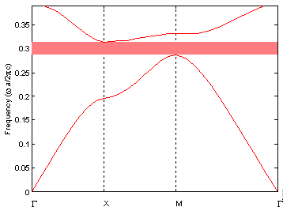
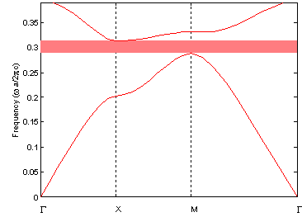
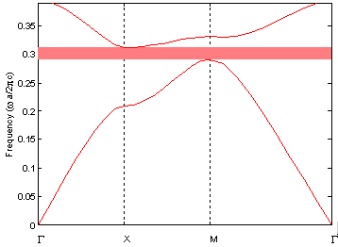

e = 1 e = 0.95 e = 0.9
Figure 2.4 TE 1-2 PBG variation in PhC structure composed of elliptical air holes having
‘r/a’ = 0.43 in Si for e = 1, 0.95 and 0.9

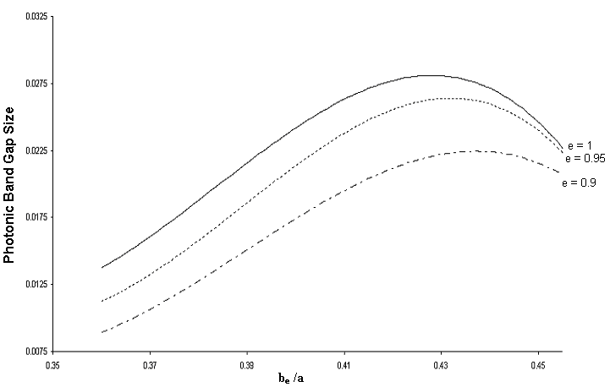
Figure 2.5 Variation of TE1-2 PBG size for a PhC crystal consisting of square lattice of
elliptical air holes in Si with normalized major axis ‘b_{e}/a’ keeping b_{e} constant.

Figure 2.5 shows the variation of TE1-2 photonic band gap size with the normalized major axis ‘b_{e}/a’ for three different values of ellipticities i.e. e = 1, e = 0.95 and e = 0.9, where major axis is kept constant and the ellipticity is induced by changing the minor axis. As decreasing the minor radius induces the ellipticity, this results in the decrease of the fill factor. Hence the graph shows the effect of both the ellipticity of air holes as well as the fill factor on the width of photonic band gaps. The photonic band gap size first increases with the increase in fill factor, becomes maximum for a particular ‘b_{e}/a’ value and then starts decreasing for all the three cases.
Further, asymmetry has been introduced by changing the orientation of the constituent elliptical air holes for one particular value of ‘r/a’ and the change in photonic band gap width has been investigated. Figure 2.6 shows the normalized PBG size variation due to change in the orientation angle for ‘r = 0.43a’ keeping fill factor constant for three cases (i) e = 1 (ii) e = 0.95 and (iii) e = 0.9.
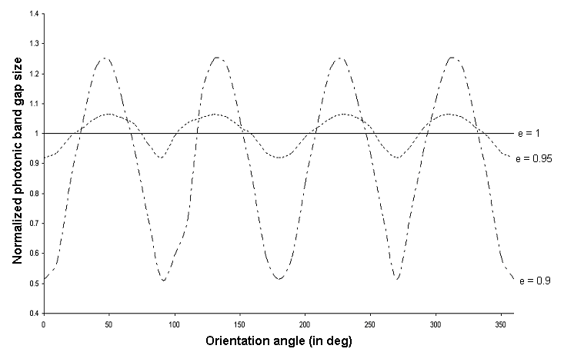

Figure 2.6 Variation of TE1-2 PBG size with the orientation angle of the constituent air
holes of the PhC composed of square lattice of air holes in Si for ‘r/a’ = 0.43

Figure 2.6 shows that the TE 1-2 photonic band gaps exhibit an oscillatory behavior in terms of gap sizes with the variation in the orientation angle of the constituent air holes for e = 0.95 and e = 0.9. The TE band gaps show 90⁰ oscillations. However, the variation becomes more pronounced with decreasing ellipticity (more elliptical air holes).
2.2.2.2 PhC structure composed of square lattice of Si rods in air
Similar analysis has been done for the second structure i.e. the PhC structure composed of Si rods in air as shown in figure 2.2 (b) , using the PWE method.
Figure 2.7 shows the variation of the TM1-2 photonic band gap size with normalized fictive radius ‘r/a’ of the constituent Si rods for three different values of ellipticities with constant fill factor. In this case only TM1-2 photonic band gap has been studied, as TE1-2 gap does not exist.
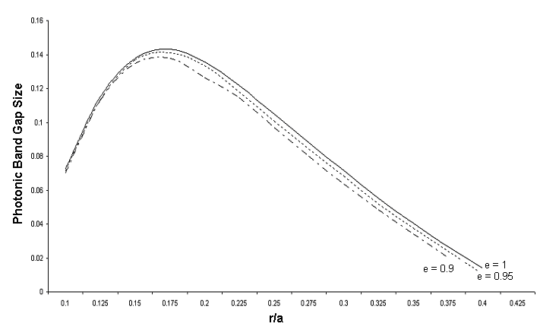
Figure 2.7 Variation of TM1-2 PBG size for a PhC crystal structure composed of square
lattice of elliptical Si rods in air with normalized rod radius ‘r/a’ keeping fill
factor constant

Figure 2.8 shows the variation of PBG size with the normalized major axis ‘b_{e}/a’ for three different values of ellipticities i.e. e = 1, e = 0.95 and e = 0.9, where major axis is kept constant and the ellipticity is induced by changing the minor axis. The graphs shown in figure 2.7 and figure 2.8 exhibit that the photonic band gap size for the TM mode first increases with increasing ‘r/a’, becomes maximum and then decreases for all the three cases.
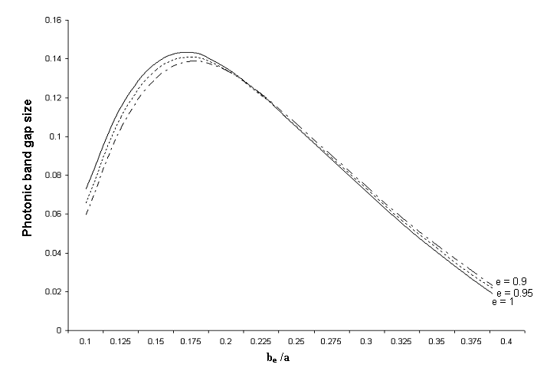Figure 2.8 Variation of TM1-2 PBG size for a PhC structure composed of square lattice of
elliptical Si rods in air with normalized major axis ‘b_{e}/a’ keeping b_{e} constant.
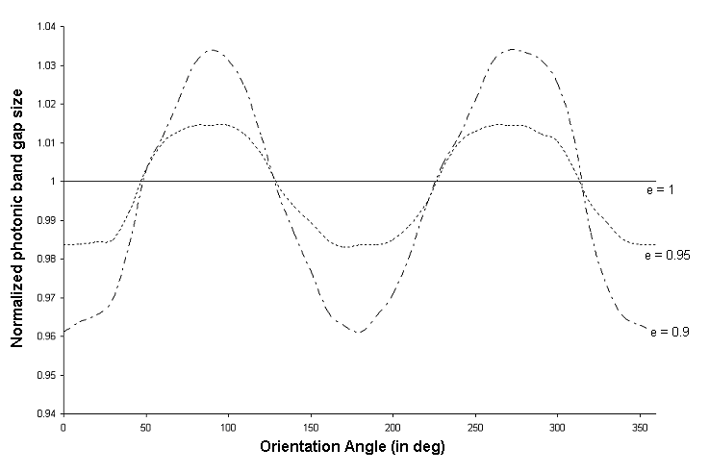
Figure 2.9 Variation of TM1-2 photonic band gap size with the orientation angle of the
constituent Si rods of the PhC composed of square lattice of Si rods in air for
r/a = 0.25.
Figure 2.9 shows the variation in photonic band gap size due to change in the orientation angle for normalized rod radius r/a= 0.25 for e =1, e = 0.95 and e = 0.9. As evident from figure 2.9, the TM1-2 photonic band gap size shows an oscillatory behaviour for e = 0.95 and e = 0.9 with a period of 180⁰.
2.2.3 Discussion
The variation in photonic band gap sizes shown in figure 2.5 and figure 2.8 for the two structures is the combined effect of ellipticity and changing fill factor. Whereas, the variation of PBG sizes in figure 2.3 and figure 2.7 show the effect of ellipticity, as the fill factor is kept constant. The variation in photonic band gap sizes due to the orientation angle for the two structures, show an oscillatory behavior of band gap sizes in the two structures as shown in figure 2.6 and figure 2.9. It has been observed that the PBG size for TE polarization in PhC composed of square lattice of air holes in Si and photonic band gap size for TM polarization in the PhC consisting of Si rods in air show oscillatory behaviors with the change in the orientation angle. It has been observed from figure 2.6 that TE 1-2 photonic band gap size shows 90⁰ oscillations with the change in orientation angle of constituent elliptical air holes in dielectric whereas TM1-2 photonic band gap size show an oscillation of 180⁰ with the change in the orientation angle of the constituent elliptical dielectric rods in air, which can be explained by the symmetry considerations.
2.3 Complete Photonic Band Gap Engineering
As an empirical rule of thumb, transverse magnetic (TM) band gaps are favored in a lattice of isolated high dielectric regions and transverse electric (TE) band gaps are favored in a connected lattice, also shown in section 2.2. Thus to obtain a complete photonic band gap (CPBG) isolated spots as well as connected regions of dielectric material are required and such a requirement can be fulfilled by photonic crystal structure composed of honeycomb lattice of dielectric rods in air. CPBG indicates the region where PBG for both TE and TM polarization exist and overlap. The variation of CPBG size with the change in shape and orientation of constituent dielectric rods with a view to estimate the size of the complete photonic band gap for given designs of 2D photonic crystals, which can prove helpful in the design of various photonic devices operational in the range of complete photonic band gap, has been studied. Very recently, a large number of photonic devices like couplers, switches and polarization splitters have been reported involving polarization dependent photonic band gap materials, in which knowledge of engineering photonic band gaps is essential.
2.3.1 Design Parameters
To analyze the variation of complete photonic band gap size in 2D PhCs, the following two structures of PhCs have been considered:
1. PhC structure composed of elliptical GaAs rods (n = 3.376) in air in honeycomb
lattice as shown in figure 2.10(a).
2. PhC structure composed of rectangular GaAs rods (n = 3.376) in air in honeycomb
lattice as shown in figure 2.10(b).
Figure 2.10 (c) shows the Brilllouin zone for the two structures used to study the variation of complete photonic band gap size. Figure 2.10 (d) depicts the model of the PhC consisting of elliptical rods in air in honeycomb lattices where ‘a’ is the lattice constant, ‘a_{e}’and ‘b_{e}’are the minor and major radii of the constituent elliptical rods respectively. Figure 2.10(e) shows the model of the PhC consisting of rectangular rods in air in honeycomb lattice where ‘a’ is the lattice constant, ‘l_{x}’and ‘l_{y}’ are the sides of the constituent rectangular rods such that l_{x} ≤ l_{y} respectively.

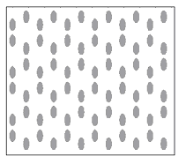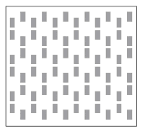
Figure 2.10 (a) Figure 2.10(b)

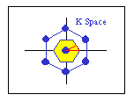
Figure 2.10(c)

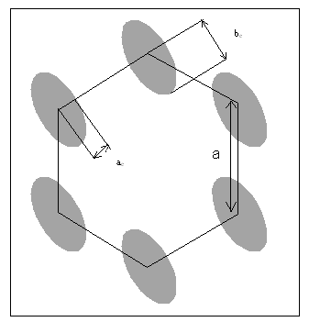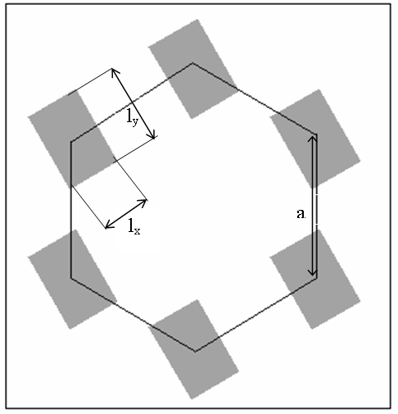

Figure 2.10(d) Figure 2.10(e)

Figure 2.10 (a) Schematic view of PhC structure composed of honeycomb lattice of elliptical
GaAs rods in air
Figure 2.10 (b) Schematic view of PhC structure composed of honeycomb lattice of rectangular
GaAs rods in air
Figure 2.10(c) Brillouin zone of the honeycomb lattice of elliptical/rectangular rods in air
Figure 2.10(d) Model of PhC structure composed of elliptical GaAs rods in air in honeycomb
lattice
Figure 2.10(e) Model of PhC structure composed of rectangular GaAs rods in air in honeycomb lattice
2.3.2 Numerical Analysis
The variation of photonic band gaps in case of elliptical rods/rectangular rods has been studied using the PWE method under the following headings
1. Keeping fill factor constant [πab = l_{x}l_{y} = constant]
2. Changing the orientation angle of the constituent dielectric rods.
2.3.2.1 PhC composed of honeycomb lattice of elliptical dielectric
rods in air

Photonic band diagrams for the two polarizations have been obtained for PhC composed of circular GaAs rods in air in honeycomb lattice and are shown in figure 2.11(a) and 2.11(b). As evident from the band diagrams the complete photonic band gap in the two structures results from the overlap of TE5-6 photonic band gap (i.e. the gap between the fifth and sixth photonic bands for TE mode) and TM7-8 photonic band gap (i.e. the gap between the seventh and eighth photonic bands for TM mode). Further ellipticity is introduced by changing the circular rods to elliptical rods and the change in the complete photonic band gap has been observed.
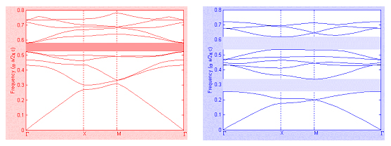
Figure 2.11(a) Figure 2.11 (b)
Figure 2.11(a) Band diagram for the 2D PhC composed of circular dielectric rods in
honeycomb lattice with ‘r/a’= 0.24 in air for TE polarization
Figure 2.11(b) Band diagram for the 2D PhC composed of circular dielectric rods in
honeycomb lattice with ‘r/a’ = 0.24 in air for TM polarization

Figure 2.12 shows the variation of complete photonic band gap size with the normalized rod radius ‘r/a’ for four different ellipticities namely e = a_{e}/b_{e} = 1, 0.9, 0.8 and 0.7 keeping fill factor constant. Here, the CPBG size is defined as the direct difference between the maximum and minimum values of the CPBG limit.
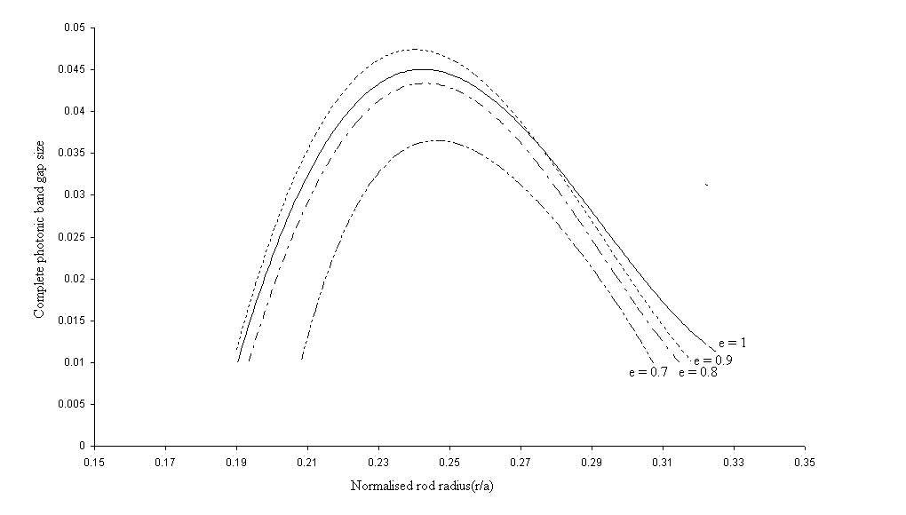Figure 2.12 Variation of CPBG size with normalized rod radius ‘r/a’ for a PhC composed of
honeycomb lattice of elliptical GaAs rods in air for e = 1, 0.9, 0.8 &0.7 keeping
fill factor constant

Figure 2.13 shows the variation of the normalized CPBG size for ‘r/a’ = 0.24, where the maximum CPBG is obtained for e = 1, with the change in the orientation angle of the constituent elliptical rods for all the four cases i.e. e =1, 0.9., 0.8 and 0.7.
2.3.2.2 PhC structure composed of honeycomb lattice of rectangular
GaAs rods in air

Similar analysis for the PhC structure composed of honeycomb lattice of rectangular GaAs rods in air has been done. Figure 2.14 shows the CPBG size variation with the normalized rod length ‘l/a’ for four different aspect ratios ‘e = l_{x}/l_{y}’ namely e = 1, 0.9, 0.8 and 0.7.
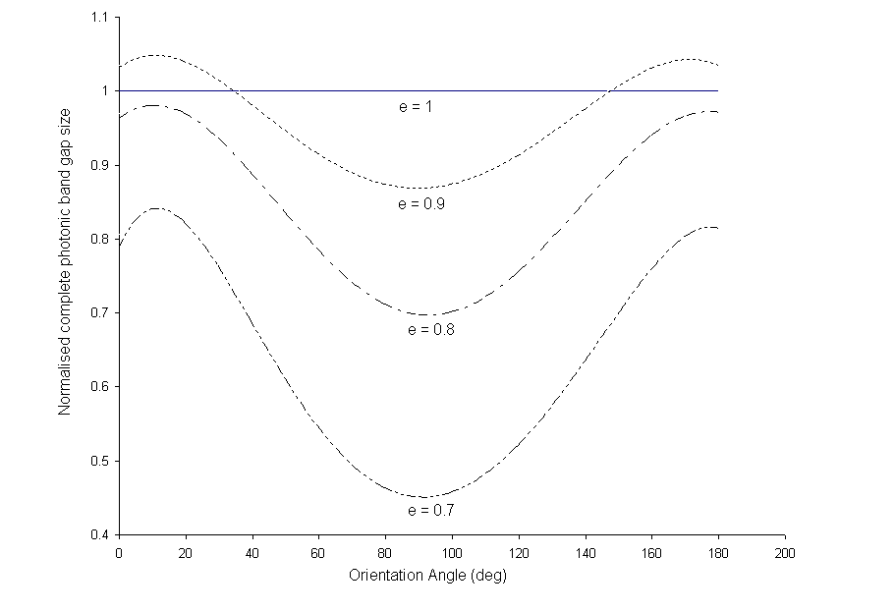
Figure 2.13 Variation of CPBG size with the orientation angle of constituent elliptical GaAs
rods with ‘r/a’ = 0.24 in air in honeycomb lattice for e = 1, 0.9, 0.8 & 0.7

Figure 2.15 shows the variation of the normalized complete band gap size for ‘l/2a’ = 0.21 with the change in the orientation angle of the constituent rectangular rods for all the four cases i.e. e =1, 0.9., 0.8 and 0.7.
Figures 2.12 and 2.14 indicate that the CPBG size first increases with the increase in fill factor and then starts decreasing with the increase in fill factor. The graphs indicate that the slight introduction of asymmetry increases the size of complete photonic band gap. But as the constituent rods become more elliptical or rectangular in the respective cases, the size of the CPBG is reduced as compared to the case of PhC composed of circular or square dielectric rods. Figures 2.13 and 2.15 show the variation of the complete photonic band gap size with the change in the orientation angles and it has been observed that after 180⁰ rotation the structure provides the same complete photonic band gap as we started with. This can be explained on the basis of symmetry considerations.

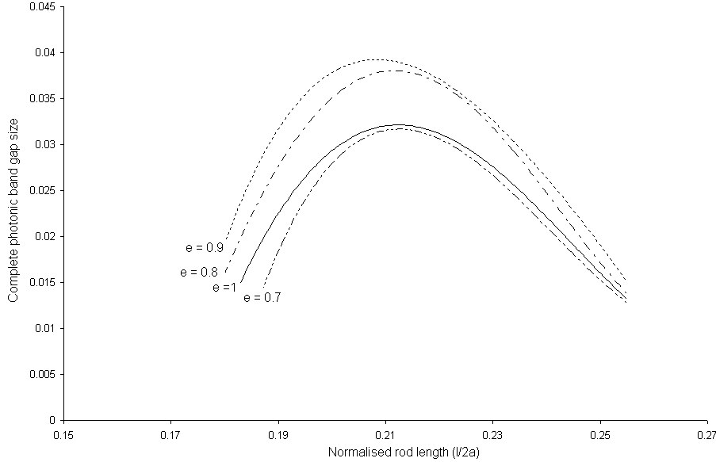
Figure 2.14 Variation of CPBG size with normalized rod length ‘l/2a’ for a PhC composed
of honeycomb lattice of rectangular GaAs rods in air for e = 1, 0.9, 0.8 &0.7
keeping fill factor constant

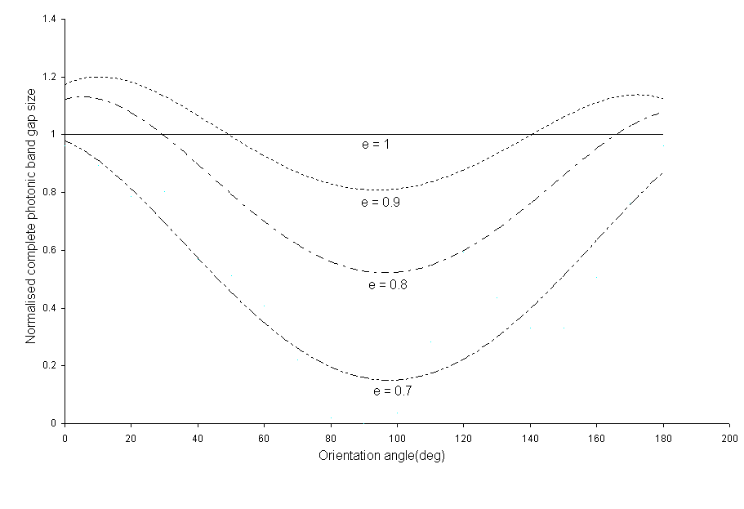
Figure 2.15 Variation of CPBG size with the orientation angle of constituent rectangular
GaAs rods with ‘l/2a’ = 0.21 in air in honeycomb lattice for e = 1, 0.9, 0.8 &0.7

2.4 Conclusion

The variation in the photonic band gap as well as the complete photonic band gap in square and honeycomb lattices respectively in the PhC structures has been analyzed using the numerical approach based on the PWE method. It has been observed that both the photonic band gaps as well as the complete photonic band gaps show a variation with the introduction of asymmetry. The graphs exhibit that the slight introduction of asymmetry increases the size of the photonic band gap as well as complete photonic band gap in the respective cases. But as the rods are made more elliptical or rectangular, the size of the PBG as well as CPBG decreases as compared to the case of circular or square rods. Further the asymmetry has been introduced by changing the orientation of the constituent rods because of which the variation in PBG and CPBG has been observed.
For investigating the variation of photonic band gaps Si and GaAs have been chosen. Both Si and GaAs are popularly used materials for the fabrication of devices. Moreover the materials provide adequate refractive index contrast, which is also one of the requirements for obtaining large enough photonic band gaps. The analysis can be extended to other materials.
The analysis can prove useful in the design of various photonic band gap and complete photonic band gap based devices respectively, where it will be important to find or engineer structures with correct band structure characteristics and hence in the design of compact all integrated photonic circuits which have been discussed in the subsequent chapters.
Chapter 3
Photonic Crystal Waveguides and Devices: An index guided effect
3.1 Introduction
A new class of materials called photonic crystals affects photon’s properties in much the same way that a semiconductor affects an electron’s properties. The ability to mold and guide light leads to novel and interesting applications. A very important class of applications of PhCs in optical communication is PhC optical waveguides, obtained by introducing linear defects in a PhC structure, which forms the basic building block of various devices.
By creating defects in the otherwise perfect PhC, the light can be localized, guided in the photonic crystals. Creation of linear defects in the PhC structure, PhC waveguides can be obtained. Light guidance in these waveguides can take place via two mechanisms i.e. the index guidance and the photonic band gap guidance. In this chapter, the light guidance in PhC waveguides via index guided effect has been considered that has further been used to design PhC directional coupler. Basically, index guidance is the tendency of the light to stay in the stronger dielectric compared to the weaker dielectrics.
When two waveguides are brought sufficiently close to each other so that their modal fields overlap, power can be transferred periodically between the two waveguides; such a structure is known as a directional coupler. Directional Couplers have many interesting applications in power splitting, wavelength multiplexing/demultiplexing, polarization splitting, and so forth [81-89]. Based on the above two concepts , the design of PhC directional couplers using the dielectric core waveguides designed by embedding air holes in the dielectric medium has been presented in section 3.2. The dielectric material used to design the PhC directional coupler is silica, which is one of the popular materials used in designing passive optical devices for photonic integrated circuits [5, 90]. Further, their numerical analysis using the FDTD method has been presented in section 3.3. It has been shown that the proposed directional couplers are functional for both the polarizations and the comparative numerical analysis of the coupling characteristics of the proposed directional couplers has been done. Numerical investigation reveals that the coupling length decreases with the increase in wavelength similar to that is observed in conventional couplers. But the dimensions of the PhC directional coupler lies in the micrometer range as compared to the conventional couplers whose dimensions lie in the millimeter range, which could be helpful in miniaturization of the optical circuits. Further the dependence of the coupling length on the barrier width has been presented.
3.2 Design of PhC directional coupler
The main component required to design a PhC directional coupler is a straight 2D PhC waveguide. A PhC waveguide can be formed by creating a linear defect in a PhC structure formed either by air holes embedded in a high refractive index material, or by high refractive index dielectric pillars embedded in air. The PhC waveguides used to design directional couplers have been made by removing one row of air holes from a square lattice of air holes of radius ‘r = 0.45a’ in silica (SiO₂) where ‘a’ is the lattice constant with dielectric constant ‘ε = 2.1’. Thus PhC waveguides can be thought of as a channel waveguides surrounded by photonic crystal clad where the core has a higher dielectric constant than the cladding which allows the wave guidance due to index guided effect.
Two parallel PhC waveguides are placed in close proximity of each other so that under suitable conditions the power can be transferred from one waveguide to another leading to the design of a PhC directional coupler. These two PhC waveguides are separated by row/rows of air holes whose radius is r_{d} ≤ r (r_{d} is the radius of the air holes in the barrier layer) nominated as Type 1 and Type 2 PhC directional coupler. Figure 3.1 (a) and 3.1(b) show the schematic view of the proposed Type 1 and Type 2 PhC directional coupler structures in which the two PhC waveguides are separated by one row and two rows of air holes respectively.
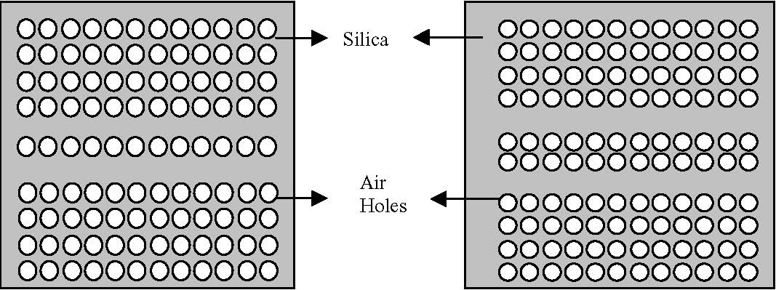
Figure 3.1 (a) Figure 3.1 (b)
Figure 3.1(a) Schematic view of the proposed Type 1 PhC directional coupler where two
waveguides are separated by one row of air holes
Figure 3.1(b) Schematic view of the proposed Type 2 PhC directional coupler where two
waveguides are separated by two rows of air holes

3.3 Numerical Analysis and Results

The numerical modeling of the proposed PhC directional couplers has been done using the FDTD method. The coupling characteristics i.e. the coupling length, coupling coefficient , etc of the PhC directional couplers have been analyzed for both the polarizations over the entire operational range which is necessary for the use of PhC directional couplers in various devices.
Figure 3.2 shows the variation of normalized coupling coefficient ‘κa’, calculated using the FDTD method as a function of the normalized frequency ‘a/λ’ for different values of normalized defect radius ‘r_{d}/a’ for TE mode for the proposed Type 1 as well as Type 2 PhC directional couplers, shown in figure 3.1(a) and 3.1(b) respectively.
Figure 3.3 shows the variation of normalized coupling coefficient ‘κa’ as a function of the normalized frequency for different values of normalized defect radius ‘r_{d}/a’ for TM mode for the proposed Type 1 as well as Type 2 PhC directional couplers.
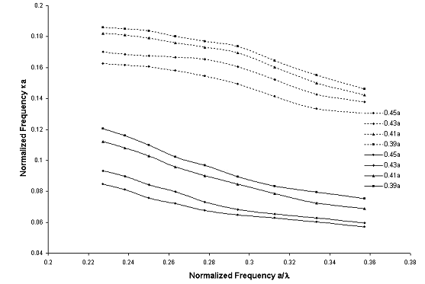

Figure 3.2 Normalized coupling coefficient ‘κa’ vs normalized frequency ‘a/λ’ for different
‘r_{d}/a’ values for TE Mode for the proposed Type 1 and Type 2 PhC directional couplers

The graphs shown in figure 3.2 and 3.3 indicate that the Type1 and Type 2 PhC directional couplers are functional for TE mode in the normalized frequency range 0.2273 ≤ a/λ ≤ 0.3571 and for the TM mode in the range 0.2778 ≤ a/λ ≤ 0.3571 calculated using the FDTD method. The graphs also show that as ‘r_{d}’ decreases i.e. as the barrier between the two waveguides decreases for each type, the coupling coefficient increases for the same frequency range i.e. 0.2273 ≤ a/λ ≤ 0.3571 for TE mode and 0.2778 ≤ a/λ ≤ 0.3571 for TM mode. However, the coupling coefficient is lower for both cases in the Type 2 directional coupler as compared to the Type 1 directional coupler, as the barrier in the Type 2 directional coupler is nearly double to that in the Type 1 directional coupler.
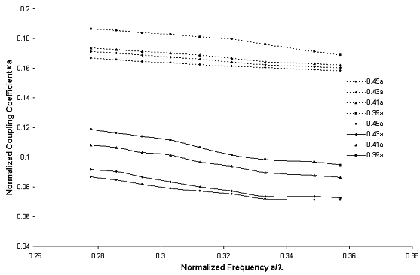
Figure 3.3 Normalized Coupling Coefficient κa vs normalized frequency a/λ for different
r_{d} /a values for TM Mode for the proposed Type 1 and Type 2 PhC directional
couplers

A snapshot of simulated power coupling in the designed directional coupler (as an example) has been shown in figure 3.4. Further, the coupling length at various wavelengths over the entire operational range has been calculated for both the polarizations. Coupling length ‘Lc’ is defined as the length after which the input light after moving to the second waveguide couples back to the original waveguide. The variation of normalized coupling length ‘Lc/a’ as a function of normalized defect radius ‘r_{d}/a’ for different ‘a/λ’ (normalized frequency) for both Type 1 and Type 2 proposed PhC directional couplers for TE as well as TM mode has been studied.

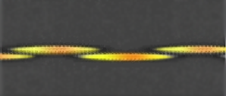
Figure 3.4 Snapshot of simulated power coupling in the PhC directional coupler

Figure 3.5(a) and 3.5(b) show the variation of normalized coupling length ‘Lc/a’ as a function of normalized defect radius ‘r_{d}/a’ for different ‘a/λ’ for TE mode for the proposed Type 1 and Type 2 PhC directional couplers respectively.
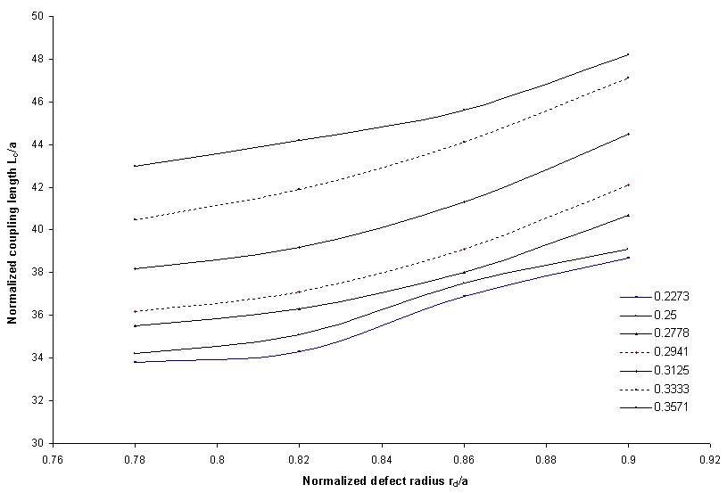
Figure 3.5(a) Normalized coupling length ‘Lc/a, vs. normalized defect radius ‘r_{d}/a’ for
different normalized frequencies ‘a/λ’ in Type 1 PhC directional coupler
for TE mode

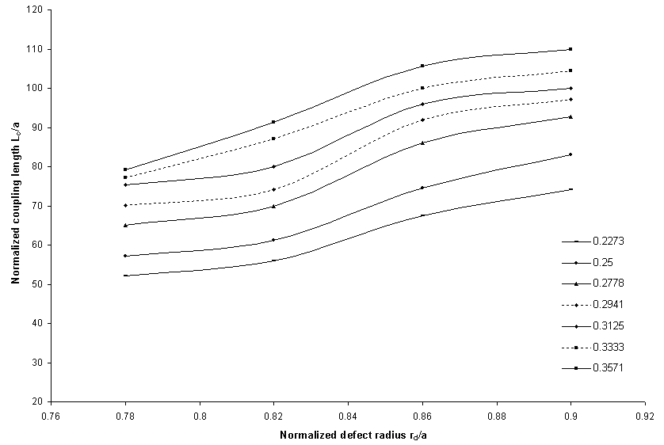

Figure 3.5(b) Normalized coupling length ‘Lc/a’ vs. normalized defect radius ‘r_{d}/a’ for
different normalized frequencies a/λ in Type 2 PhC directional coupler
for TE mode

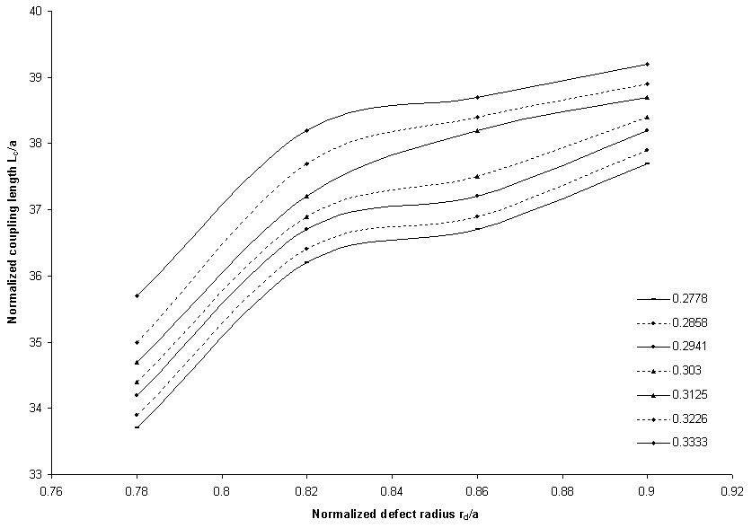

Figure 3.6(a) Normalized coupling length ‘Lc/a’ vs. normalized defect radius ‘r_{d}/a’ for
different normalized frequencies ‘a/λ’ in Type 1 PhC directional coupler
for TM mode

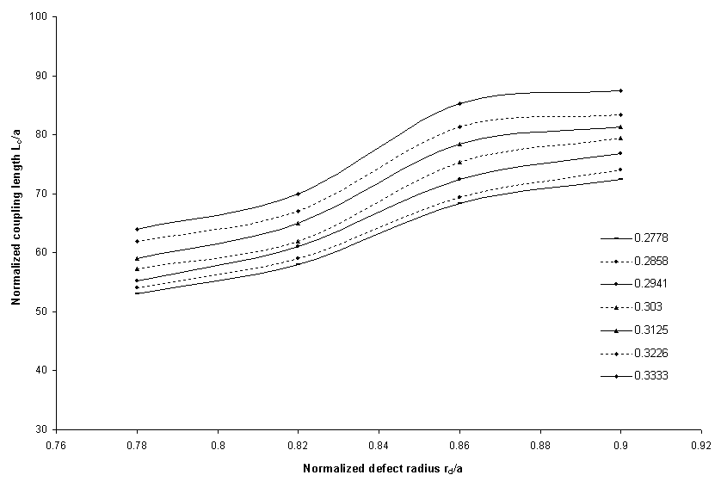

Figure 3.6(b) Normalized coupling length ‘Lc/a’ vs. normalized defect radius ‘r_{d}/a’ for
different normalized frequencies ‘a/λ’ in Type 2 PhC directional coupler
for TM mode
The graphs shown in figure 3.6 (a) and 3.6(b) exhibit the variation of normalized coupling length ‘Lc/a’ as a function of normalized defect radius ‘r_{d}/a’ for different values of normalized frequency ‘a/λ’ for TM mode in the proposed Type 1 and Type 2 PhC directional couplers.
3.4 Conclusion
The design of PhC directional coupler has been proposed and its numerical analysis and modeling using the FDTD method has been presented. Numerical investigations indicate that as normalized frequency ‘a/λ’ decreases, the coupling length ‘Lc/a’ curves shift towards the lower values for both TE as well as TM modes in Type 1 and Type 2 directional couplers respectively. It is observed that the coupling length decreases for the same range of ‘r_{d}/a’ values with decrease in ‘a/λ’ i.e. coupling length decreases with increase in wavelength for both TE and TM modes. This is explained by the fact that as the wavelength is increased, the evanescent tail of the wave increases and it becomes easier for the wave to cross the barrier leading to stronger coupling and hence smaller coupling length. The coupling lengths in PhC directional couplers lie in the micrometer range, which thereby, reduces the coupling length as compared to the conventional directional couplers, which falls in the millimeter range. Thus, the use of PhC directional couplers can help in making compact integrated optical devices.
Chapter 4
Photonic Band Gap Waveguides and Devices
4.1 Introduction
Photonic Crystals or Photonic Band Gap Structures, that are micro structured materials in which dielectric constant is periodically varied on length scale in one, two or three directions with periodicity, comparable to the wavelength of light, selectively transmit or reflect light at various wavelengths. One of the characteristics of the PhC structures is that there exists a range of wavelengths where a photonic crystal exhibits strong reflection called a photonic band gap.
Photonic band gap materials are usually viewed as an optical analog of semiconductors that modify the properties of light similarly to a microscopic atomic lattice that creates a band gap for electrons in semiconductors. In the chapter 2, the detailed analysis of how the photonic band gaps can be engineered has been done. Thereby, providing a stimulating framework to manipulate light on micrometer scale, required for the development of devices now envisaged for use in all optical networks. PhCs enable band gap engineering in photonics by which the optical properties of solids can be controlled. Light can be guided in PBG structures by creating defects. Creating a linear defect in a photonic crystal can make a photonic crystal waveguide that allows directed light transmission for the frequencies inside the photonic band gap. PBG waveguides, which form the basic building block of all PBG devices, have been a subject of interest because of their potential ability for tightly controlling the propagation of light, thereby providing the ability to design various PBG based devices [91-100]. In chapter 3, the light guidance in PhC structures based on the index guided effect has been considered and a design of PhC directional coupler based on it has been proposed.
In this chapter, the co directional coupling between two closely placed PBG waveguides has been studied using the FDTD method, where the light guidance takes place because of the PBG effect. In section 4.2, the design parameters of the PBG couplers have been discussed. It has been shown that by changing the lattice arrangement in the PBG structure, one can alter the operational range of PBG waveguide coupler. Thus by altering the structural parameters as well as lattice arrangement, it is possible to design and develop ultra short optical devices in the same material system for desired wavelength windows. In section 4.3, the spectral responses of PBG couplers with different lattice arrangements have been investigated using the FDTD method and it has been shown that the coupling length of the PBG waveguide couplers falls in the micrometer regime, which is helpful in realizing compact optical devices. Finally in section 4.4, it has been shown that significantly shorter optical multiplexers demultiplexers can be designed using the PBG waveguide couplers.
4.2 Design Parameters of PBG waveguide couplers

To design the PBG waveguide couplers two types of PBG structures have been used. The photonic band gap structure 1 i.e. PBG1 is a square lattice of dielectric rods in air of radius ‘r = 0.18a’, where ‘a’ is the lattice constant. The dielectric material has a dielectric constant of 10.5 (i.e. refractive index n = 3.24, similar to the effective index in an InP/InGaAsP heterostructure system). The photonic band gap structure 2 i.e. PBG2 is a triangular lattice of dielectric rods having ‘ε = 10.5’ of radius ‘r = 0.18a’ in air.
Both PBG1 and PBG2 yield photonic band gaps for the TE polarization, but no gap for TM polarization. Thus only the TE polarization has been considered. PBG1 exhibits a band gap for TE polarization ranging from 0.324186 to 0.430233 in the normalized frequency units ‘a/λ’, λ being the wavelength in vacuum. The PBG2 exhibits a band gap for TE mode ranging from 0.329767 to 0.480465 in the normalized frequency units.
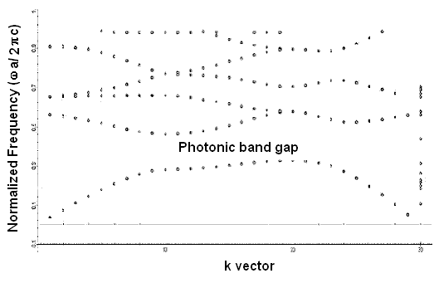
Figure 4.1 Band diagram for PBG1 structure with square lattice arrangement of dielectric
rods (ε =10.5) in air
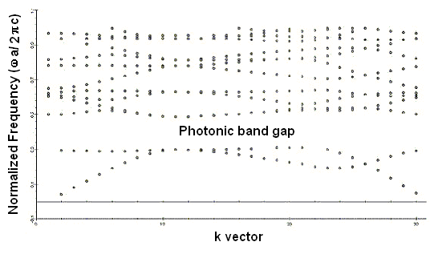
Figure 4.2 Band Diagram for PBG2 structure with triangular lattice arrangement of dielectric rods (ε=10.5) in air
Figure 4.1 and figure 4.2 show the band diagrams for PBG1 and PBG2 structures respectively, obtained using the FDTD method. The light in the PBG1 and PBG2 structures can be guided by creating line defects leading to the design of PBG waveguides that can guide the light if the frequency lies in the photonic band gap region.
The PBG waveguide couplers consist of two parallel waveguides placed in close proximity of each other so that under suitable conditions the power can be transferred from one waveguide to another. The two waveguides used to design PBG waveguide couplers are symmetric and are separated by a row of dielectric rods air whose radius is r_{d} ≤ r, where ‘r_{d}’ is the radius of the dielectric rods in the barrier layer and ‘r’ is the radius of the dielectric rods in the PBG structure.
Figure 4.3(a) depicts the schematic view of the proposed Type 1 PBG waveguide coupler made by using two PBG1 waveguides described above. Figure 4.3(b) depicts the schematic view of the proposed Type 2 waveguide coupler consisting of two PBG2 waveguides separated by one row of dielectric rods.
Dielectric rods

Figure 4.3 (a) Figure 4.3(b)

Figure 4.3 (a) Schematic view of the proposed Type 1 PBG waveguide coupler made from two
PBG1 waveguides
Figure 4.3 (b) Schematic view of the proposed Type 2 PBG waveguide coupler made from two
PBG2 waveguides

4.3 Coupling Characteristics

The FDTD calculations have been done to investigate the coupling parameters of the proposed PBG waveguide couplers. The proposed PBG waveguide couplers have been studied for TE polarization, as for the TM polarization no band gap is observed for the constituent waveguides. The coupling length at various wavelengths for PBG waveguide couplers for TE polarization has been calculated and the variation of the coupling length against the optical frequency has been studied which is necessary for the use of PBG waveguide couplers in various devices.
The coupling length L is given by
$L=\frac{π}{β_{e}−β_{o}}$ (4.1)
where β_{e} is the propagation constant of even mode
β_{o} is the propagation constant of odd mode
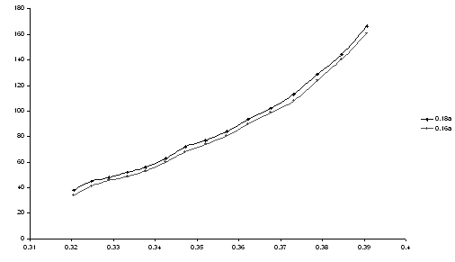
Normalized Coupling Length (L/a)
Normalized Frequency (a/λ)
Normalized Frequency (a/λ)
Figure 4.4 Normalized Coupling Length ‘L/a’ as a function of normalized frequency a/λ for
different ‘r_{d}/a’ values for TE Mode for the proposed Type 1 PBG waveguide coupler

Normalized Coupling Length (L/a)
Normalized Frequency (a/λ)

Figure 4.5 Normalized Coupling Length ‘L/a’ as a function of normalized frequency ‘a/λ’
for different ‘r_{d}/a’ values for TE Mode for the proposed Type 2 PBG waveguide coupler

The graphs shown in figure 4.4 and figure 4.5 show the variation of normalized coupling length ‘L/a’, obtained using the FDTD method, as a function of the normalized frequency (a/λ) for two different values of normalized defect radius ‘r_{d} /a’ for TE polarization for the proposed Type 1 and Type 2 PBG waveguide couplers respectively.
4.4 Design of PBG Waveguide Mux-Demux
Keeping in view the variation of coupling length shown by the PBG waveguide couplers with wavelength, the PBG waveguide coupler can separate two wavelengths ‘λ₁’and ‘λ₂’ if it is in bar coupled state for one wavelength and cross coupled state for the other wavelength, i.e. after traversing the same distance in the PBG coupler one wavelength ‘λ₁’ comes back to the original waveguide in which the light was launched (bar coupled state) and the other wavelength ‘λ₂’ is in the adjacent waveguide (cross coupled state) leading to the design of PBG Mux-Demux. The following snapshots shown in figure 4.6(a) and 4.6(b) exhibit bar coupled state for ‘λ₁’ = 1260 nm and cross coupled state for ‘λ₂’ = 1300 nm for the Type 2 PBG waveguide coupler which can be used as ultra-short optical mux-demux as the device length lies in the micrometer range.
Thus, from the above analysis and snapshots, it follows that the coupling length ‘L_{λ1} ’ at the wavelength ‘λ₁’ and the coupling length ‘L_{λ2}’ at wavelength ‘λ₂’ should satisfy the following relation to be used for the design of PBG mux-demux

L_{λ1} : L_{λ2} = even : odd
Or (4.2)
L_{λ1} : L_{λ2} = odd : even
Hence, the use of PBG waveguide couplers can help in developing micro scale optical integrated circuits.
4.5 Conclusion
The graphs shown in figure 4.4 and 4.5 exhibit that Type1 PBG waveguide coupler is functional for TE mode in the range 0.324186 ≤ a/λ ≤ 0.430233 and the Type 2 PBG waveguide coupler is functional for TE mode in the range 0.329767 ≤ a/λ ≤ 0.480465. This is a direct consequence of the photonic band gap difference shown by the two PBG structures shown in figure 4.2 and 4.3. It is evident from the graphs that as ‘r_{d}’ (radius of the defect rods) decreases i.e. as the barrier between the two waveguides decreases for each type, the coupling length decreases for the same

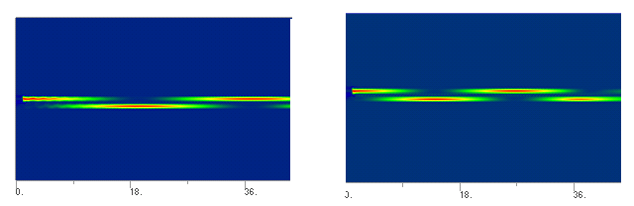 Figure 4.6(a) Figure 4.6 (b)
Figure 4.6(a) Snapshot of the bar coupled state in the Type 2 PBG waveguide coupler for
λ = 1260 nm
Figure 4.6(b) Snapshot of the cross coupled state in the Type 2 PBG waveguide coupler for
λ = 1300 nm

frequency range i.e. 0.324186 ≤ a/λ ≤ 0.430233 for Type1 PBG waveguide coupler and 0.329767 ≤ a/λ ≤ 0.480465 for Type2 PBG waveguide coupler for TE polarization. Thus, by changing the lattice arrangement, the operational frequency range of PBG waveguide couplers can be altered in a given material system. Further, the graphs show that as ‘a/λ’ decreases, the normalized coupling length ‘L/a’ decreases. The coupling length decreases with increase in wavelength. This is explained by the fact that as the wavelength is increased, the evanescent tail of the wave increases and it becomes easier for the wave to cross the barrier leading to stronger coupling and hence smaller coupling length.
Moreover, the PBG waveguide couplers can prove helpful in making compact devices as their coupling lengths have been shown to lie in the micrometer range, which in case of conventional couplers lies in the millimeter range. Further, the design of ultra-short photonic mux-demux desired for DWDM communication systems has been presented.
Chapter 5

Polarization Splitters based on Complete Photonic Band Gap

5.1 Introduction
Photonic Crystals are periodic arrangement of two or more materials of different refractive index with the periodicity of the order of wavelength that alter the flow of light in ways not possible with traditional optical components. Because of periodicity, PhCs exhibit photonic band gaps in which electromagnetic fields cannot propagate in given directions, if the geometrical parameters and dielectric contrast of the photonic lattices are appropriately chosen.
As discussed in chapter 2, in general, in 2D PhC/PBG structures, the dispersion relations for orthogonal polarizations are significantly different. And in most cases photonic band gaps are exhibited either for TE or TM polarization or if the structure exhibits the photonic band gap for both the polarizations, they differ in width and spectral position. Hence, the photonic band gaps for the two polarizations do not overlap for the same frequency region in most of the structures. Only certain select structures exhibit complete photonic band gap i.e. a frequency region where the photonic band gaps for both the polarizations (i.e. TE and TM modes) exist and overlap. Here, a PBG structure with honeycomb lattice that exhibits a complete photonic band gap, as discussed in chapter 2 has been selected for the design of polarization splitters.
A PBG waveguide can be created by introduction of linear defect in the structure. A PBG coupler can be created by setting two parallel 2D PhC waveguides in close proximity of each other, which has been discussed in chapter 4. The PBG based couplers offer the route to design ultra compact photonic integrated circuits. In this chapter the polarization dependent property of propagation of light in PBG structures has been exploited to design polarization mode splitter.
Polarization mode splitters are essential components in integrated photonics and have many applications in coherent optical communication systems and fiber optic sensors [101-109]. Various polarization splitters using the polarization dependence of the photonic band gaps have been reported in the recent past, however they are based on the reflection and transmission characteristics of PhC. More recently polarization splitters based on grating couplers, dual core and three core photonic crystal fibers have also been reported. Also, a planar PhC mode splitter based on the different equifrequency dispersive surfaces for the two orthogonal polarizations has been investigated [110-116].
In this chapter, two novel designs of PBG polarization splitters using two PhC structures exhibiting complete photonic band gap have been proposed, which are as follows:
- Type 1 PBG polarization splitter
To design Type 1 PBG polarization splitter, PhC structure composed of
circular Si rods in air in honeycomb lattice has been considered as discussed
in section 5.2.
- Type 2 PBG polarization splitter
To design Type 2 PBG polarization splitter, PhC structure composed of
rectangular Si rods in air in honeycomb lattice has been considered as
discussed in section 5.3.
Their coupling and polarization splitting characteristics around λ = 1.55μm have numerically been investigated using the FDTD method. It has been exhibited that the coupling lengths for the TE and TM modes in the complete photonic band gap region are quite different and hence the two polarizations can be separated at the coupling lengths. Further the extinction ratio, coupling efficiency, insertion loss and operational bandwidth of both types of polarization splitters have been calculated. The device dimension of the designed polarization splitters have been observed to lie in the micrometer range which can help in the miniaturization of all optical integrated circuits.
5.2 Type 1 PBG polarization splitter
To design a Type 1 PBG polarization splitter a PBG structure composed of circular Si rods (n = 3.42) in air in honeycomb lattice has been considered.
5.2.1 Design Parameters
As discussed in the earlier chapter that a PhC structure with honeycomb lattice arrangement and adequate dielectric contrast exhibits a complete photonic band gap as the requirements for the band gaps to appear for both TE and TM polarizations are satisfied by this kind of lattice arrangement. First, the variation of complete photonic band gap size with the variation in the radii of dielectric rods using the PWE method has been studied. Figure 5.1 shows the variation of CPBG size with the normalized rod radii of the constituent Si rods. As shown in the graph in figure 5.1, the structure exhibits a maximum CPBG size at ‘r/a = 0.24’ where ‘r’ is the radius of dielectric rods and ‘a’ is the lattice constant. So, to design the directional coupler, a PBG structure composed of Si rods with ‘r/a = 0.24’ in air in honeycomb lattice with lattice constant a = 0.86μm has been considered.

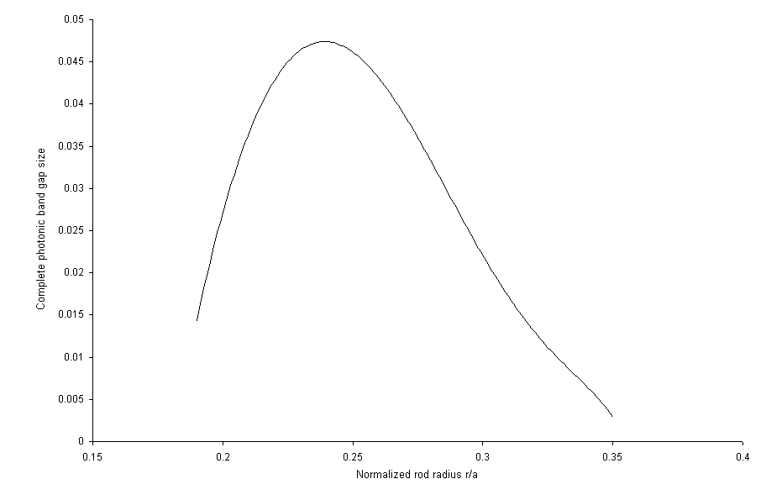
Figure 5.1 Variation of complete photonic band gap size vs. normalized rod radii
‘r/a’ of the constituent Si rods in air in honeycomb lattice

This structure exhibits a CPBG for the normalized frequency range 0.53197 ≤ a/λ ≤ 0.57936 calculated using the PWE method as shown in the band diagrams for TM and TE polarizations in figure 5.2 (a) and 5.2(b) respectively.

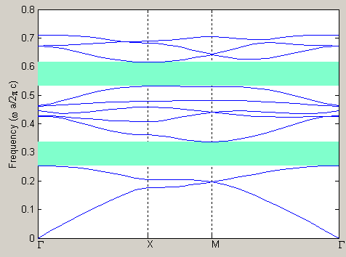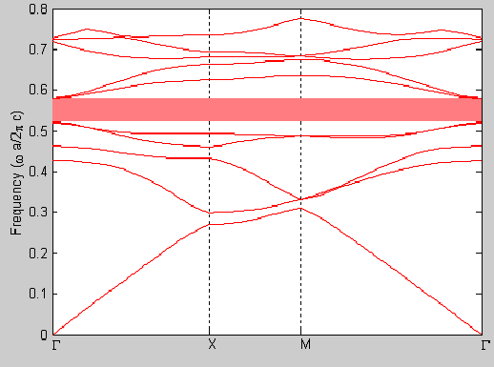
TM mode TE mode
Figure 5.2 Band diagrams for the PBG structure composed Si rods with r/a = 0.24
in air in honeycomb lattice

The PBG waveguide coupler has been designed by removing two parallel rows of rods that act as PBG waveguides separated by two rows of dielectric rods as depicted in the schematic diagram in figure 5.3.
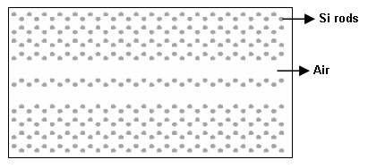
Figure 5.3 Schematic diagram of the proposed Type 1 PBG directional coupler

5.2.2 Polarization Splitting Characteristics
The modeling of the PBG polarization splitter has been done using the FDTD method and the polarization splitting characteristics in terms of bandwidth, extinction ratio, insertion loss and coupling efficiency have been investigated. Since the PBG structure used exhibits a CPBG, light of both TE as well as TM polarization can be guided in the proposed structure in the complete photonic band gap region.
5.2.2.1 Band width
Bandwidth is defined as the difference of the maximum and minimum operational wavelengths of the CPBG polarization mode splitter. As shown in figure 5.2, this PhC structure exhibits a complete photonic band gap which extends from λ = 1.49 μm to λ = 1.61 μm, where λ is the wavelength in free space, providing a large bandwidth of 120 nm. But the operational bandwidth extends from λ = 1.51 μm to λ = 1.6 μm providing an operational bandwidth of 90nm, as the losses are more near the band edges. Hence the results have been presented from λ = 1.51 μm to λ = 1.6 μm
5.2.2.2 Coupling length
Coupling length is defined as the length after which light couples from one waveguide (input waveguide) to another waveguide. Designing a polarization selective coupler, in which one polarization can couple between the two channels, while another one cannot, can make a polarization splitter. Theoretically, the splitter length can be taken equal to the coupling length of the polarization state coupled. Figure 5.4 shows the calculated coupling lengths for both polarizations over the entire operational range. From the graph it is evident that the coupling length, the length at which the light of a specific polarization couples from one waveguide to another, for TE polarization is smaller than that for the TM polarization.
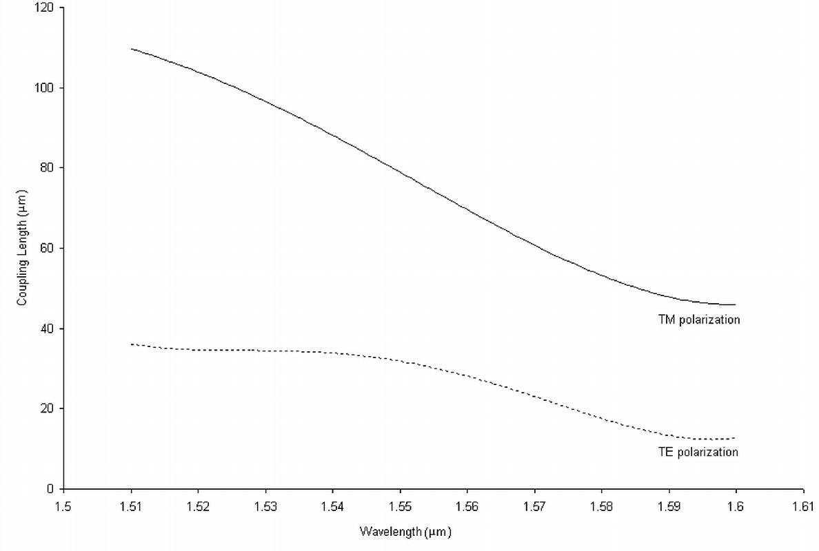 Figure 5.4 Variation of coupling length with wavelength for TE and TM polarizations

Figures 5.5(a) and (b) show the snapshots of the coupling phenomena for TE and TM polarizations for the wavelength ‘λ = 1.55 μm’ which exhibit a considerable difference in the coupling lengths of the two polarization states.

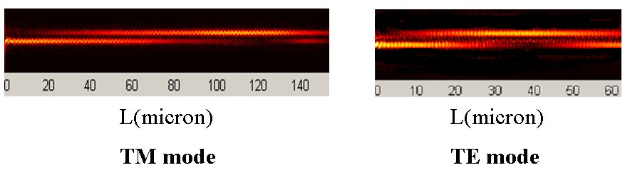
Figure 5.5 (a) Snapshot of the coupling phenomena in the proposed PBG polarization splitter
for TM mode at λ = 1.55 μm
Figure 5.5 (b) Snapshot of the coupling phenomena in the proposed PBG polarization splitter
for TE mode at λ = 1.55 μm
Thus, the figures 5.4, 5.5(a) and 5.5(b) indicate that the light of the TE polarization couples faster as compared to that of TM polarization. Hence, this phenomenon can be used to design PBG polarization splitter and the coupling length for TE polarization can be taken as the length of the polarization splitter. Specifically, the proposed polarization splitter can split the two polarizations at the propagation distance of 32 μm for λ = 1.55 μm, which is the coupling length for TE mode at λ = 1.55 μm calculated using the FDTD method.
5.2.3 Extinction ratios and insertion loss
Further, the spectral response of the extinction ratios, ERA and ERB at propagation distance of 32 μm, where the separation of the two polarization states is achieved for λ = 1.55 μm, has been obtained and is shown in figure 5.6.

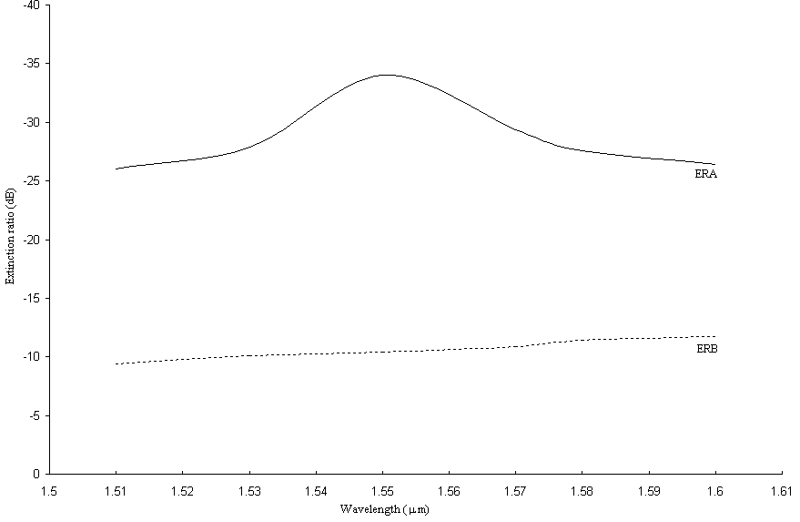
Figure 5.6 Spectral response of the extinction ratios at device length of 32 μm

The extinction ratios ERA and ERB are defined as
$\text{ERA}=\text{10}{\text{log}}_{\text{10}}\frac{\text{fractional output power of TE polarization in waveguide A}}{\text{fractional output power of TM polarization in waveguide A}}$ (5.1)
and
$\text{ERB}=\text{10}{\text{log}}_{\text{10}}\frac{\text{fractional output power of TM}\text{ polarization in waveguide B}}{\text{fractional output power of TE polarization in waveguide B}}$ (5.2)

The FDTD simulations indicate that the extinction ratios ERA = -34dB and ERB = -11dB at λ = 1.55 μm can be obtained in the proposed splitter.
The insertion loss, which is defined as -10 times the logarithm of the ratio of the output power coupled in the second waveguide and the input power in the first waveguide, has been found to be ~1dB for the proposed PBG polarization splitter over the entire operational range.
  - Type 2 PBG polarization splitter
On the similar lines another design of type 2 PBG polarization mode splitter has been proposed, which makes use of the PBG structure composed of square Si rods in honeycomb lattice.
5.3.1 Design Parameters
Similar analysis has been done and first the variation of CPBG size in terms of gap mid gap ratio with the variation in the length of the constituent square dielectric rods has been studied using the PWE method as shown in figure 5.7.
Since the structure exhibits a maximum CPBG size at normalized rod length ‘l/a = 0.42’, hence a PhC structure composed of square Si rods of length ‘l = 0.3612μm’ with lattice constant ‘a = 0.86μm’ in air in honeycomb lattice has been considered. The band diagrams for the considered PhC structure are shown in the figure 5.8(a) and figure 5.8(b) for TE and TM polarizations respectively, which exhibit a complete photonic band gap for the normalized frequency range 0.53908 ≤ a/λ ≤ 0.5745. As discussed in the previous section a PBG coupler can be created. Figure 5.9 shows the schematic diagram of the proposed type 2 PBG polarization splitter.
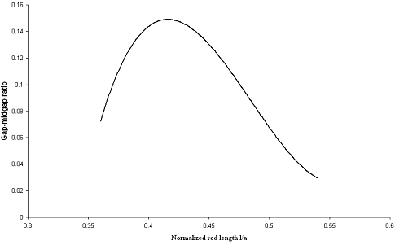
Figure 5.7 Gap-midgap ratio with normalized rod length ‘l/a’ of the constituent square Si
rods in air in honeycomb lattice.
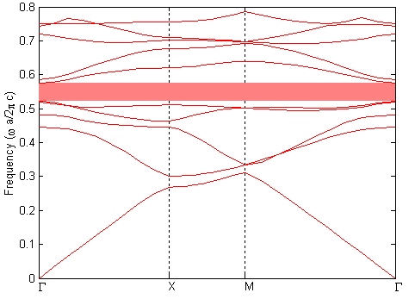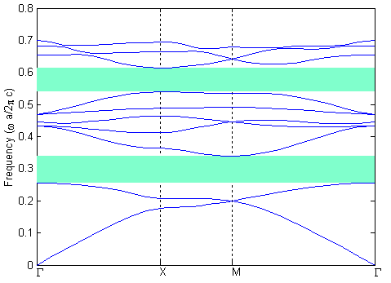
Figure 5.8(a) Figure 5.8(b)
Figure 5.8 (a) Band Diagram for the PBG structure composed of Si rods with l/a = 0.42 in air
in honeycomb lattice for TE mode
Figure 5.8(b) Band Diagram for the PBG structure composed of Si rods with l/a = 0.42 in air
in honeycomb lattice for TM mode

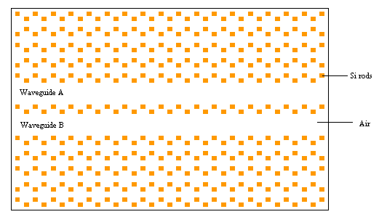
Figure 5.9 Schematic diagram of the proposed Type 2 CPBG polarization mode splitter

5.3.2 Polarization splitting characteristics
On the similar lines the Type 2 CPBG polarization mode splitter has been modeled using the FDTD method
    - Bandwidth
The proposed CPBG polarization mode splitter is operational and hence guides the light of both TE and TM polarization in the wavelength range 1.51 μm ≤ λ ≤ 1.59μm providing a large operational bandwidth of 80nm.
5.3.2.2 Coupling length
As discussed in the previous section, a polarization selective coupler can be designed if the coupling lengths of the two polarizations in a directional coupler are different and the splitter length is equal to the coupling length of the polarization state that has a smaller coupling length. The graphs in figure 5.10(a) and (b) show the wavelength dependence of the coupling lengths for TE and TM polarizations respectively in the entire operational range. From the graphs it is evident that the coupling length for TE polarization is much smaller as compared to that for the TM polarization, light of the TE polarization couples faster compared to that of TM polarization.
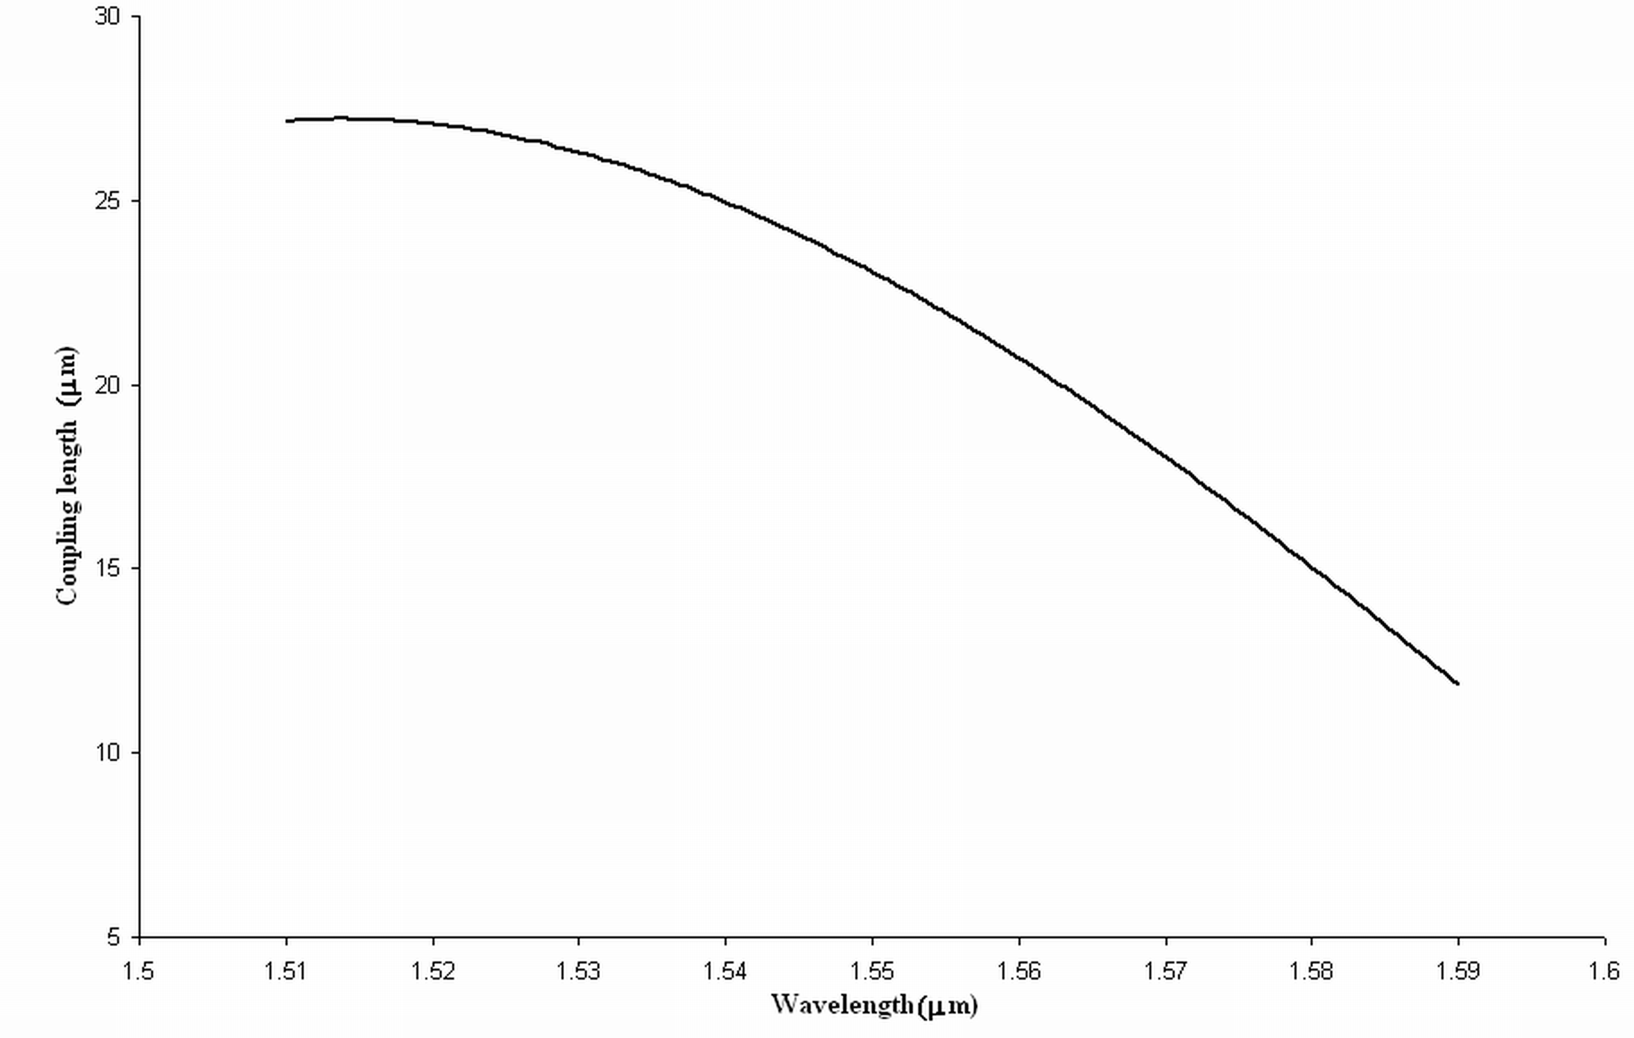
Figure 5.10 (a) Variation of coupling length with wavelength for TE polarization

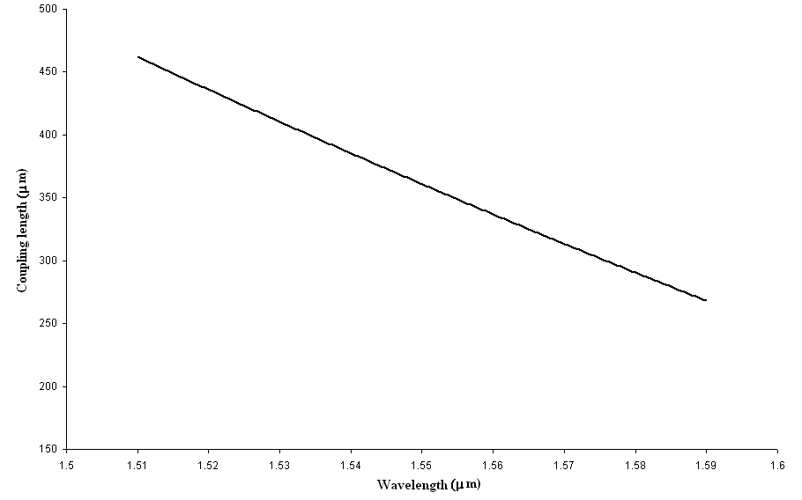
Figure 5.10 (b) Variation of coupling length with wavelength for TM polarization

Therefore, this phenomenon can be used to design CPBG polarization mode splitter and the coupling length for TE polarization can be taken as the length of the polarization splitter. Thus the dimension of this polarization splitter can be calculated for a given structure at a particular operating wavelength. As an example, for λ=1.55μm the separation of the two polarizations is achieved at 24μm, which is the coupling length for TE polarization at λ=1.55μm. Thus the device dimension of the polarization splitter lies in the micrometer range.
5.3.2.3 Extinction Ratio and Insertion loss
Further, the extinction ratios ERA and ERB have been calculated at the coupling length of TE polarization for each wavelength in the entire operational range and are shown in figure 5.11.

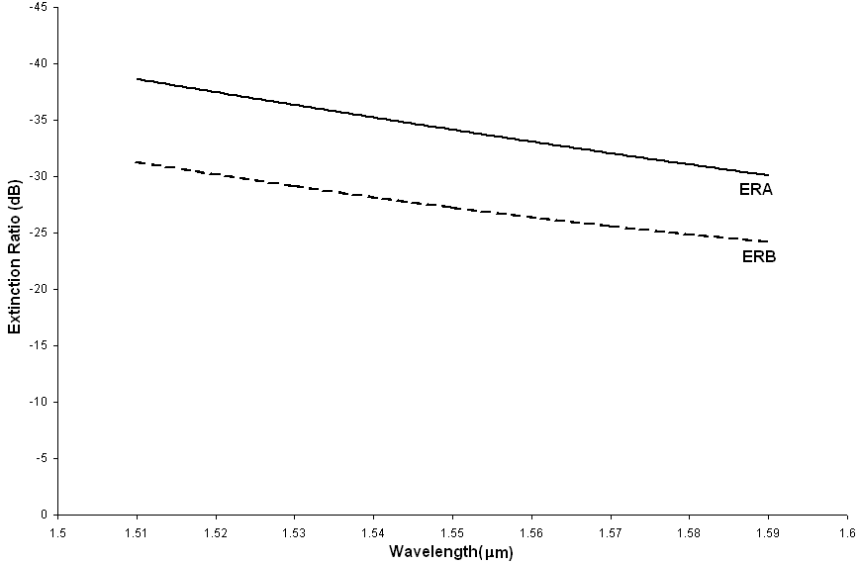
Figure 5.11 Variation of extinction ratio with wavelength in the two waveguides A and B at
the coupling length of TE polarization

The graph shows that the extinction ratios better than -24dB can be obtained and the extinction ratio decreases for the higher wavelengths. This is in accordance with the fact the difference in the coupling lengths of the two polarizations decreases for the higher wavelengths. Greater the difference in the coupling lengths of the two polarizations better is the extinction ratio and this enhances the polarization splitting efficiency of the CPBG polarization mode splitter.
Further, the spectral response of the insertion loss for TE mode at the respective coupling lengths has been calculated using the FDTD method and is shown in figure 5.12.

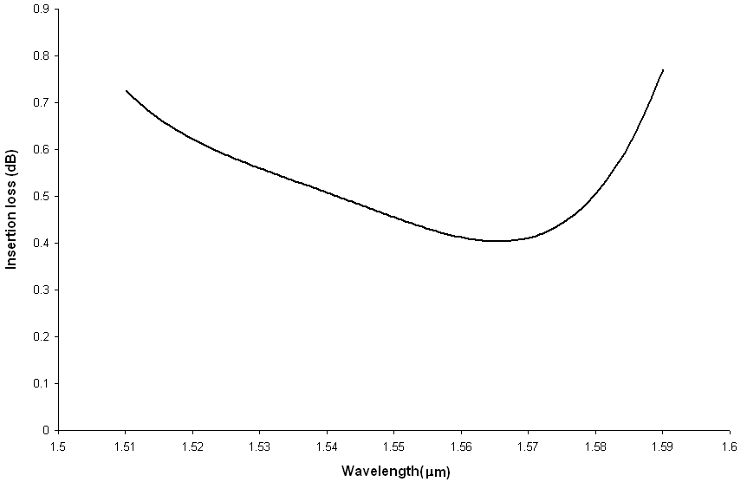
Figure 5.12 Spectral response of the insertion loss for TE mode at respective coupling
lengths

From the graph it is observed that the insertion loss is high near the band edges. In the wavelength region from 1.53μm to 1.57μm the insertion loss is less than 0.56 dB but at the edges it becomes more than 0.7dB.

5.3.2.4 Coupling Efficiency
The spectral response of the coupling efficiency for TE mode at the respective coupling lengths has been calculated using the FDTD method where coupling efficiency is defined as

(5.3)

Figure 5.13 shows the spectral response of the coupling efficiency for TE mode at respective coupling lengths, which shows that the coupling efficiency is low near the band edges and high in the middle of the band gap region

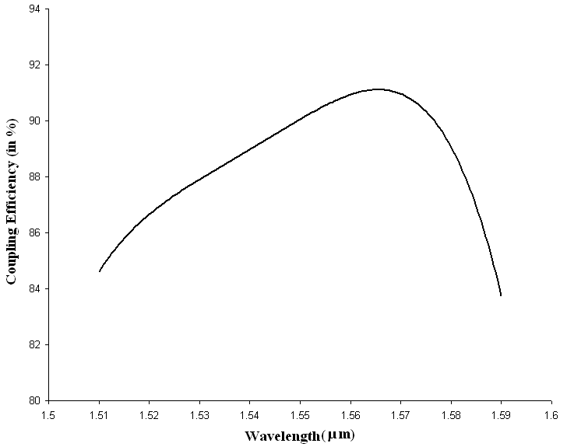

Figure 5.13 Spectral response of the coupling efficiency for TE mode at respective coupling

lengths

5.4 Conclusion
In this chapter, two novel designs of polarization mode splitters based on the complete photonic band gap involving coupled PhC waveguides have been presented. The coupling and polarization splitting characteristics of polarization mode splitters namely bandwidth, coupling length, extinction ratio, insertion loss, etc have been studied using the FDTD method. It has been shown that the device length can be reduced to a few microns leading to the design of ultra compact all optical integrated circuits. Moreover large operational bandwidths can be obtained in the photonic crystal polarization splitters.
Further, the efficiency of the CPBG polarization mode splitter can be improved by making changes in the coupling layer separating the two waveguides such that the difference in the coupling lengths of the two polarizations increases. The coupling length can be further reduced by making changes in the intermediate coupling layer i.e. by reducing the thickness or by changing the dimension of the dielectric rods of the coupling layer. Thus, the design parameters of the CPBG splitter can be tailored to make the CPBG polarization mode splitter in the required wavelength range, which can prove helpful in the design and development of ultra compact all optical integrated circuits.
Moreover, if the light of TE and TM polarizations is separately launched in the two waveguides, the light of TE polarization couples in the second waveguide where the light of TM polarization is propagating, the two polarizations completely merge at the coupling length of TE polarization. Thus, the proposed structures can also be used as polarization combiners.
Chapter 6
Defect Engineering in Photonic Crystals: Design of PBG polarizers
6.1 Introduction
Photonic Crystals represent a novel class of optical materials which elevate the principle of controlling the flow of light to a new level of sophistication. A large variety of promising applications of photonic crystals depend on many adjustable parameters. A spatially periodic modulation of the dielectric constant alone may lead to the existence of photonic stop band. As discussed in chapter 1, effects like micro resonator properties and associated localization of light are single defect states within the band gap. A dislocation line, a line of defects or a periodic array of defects can give rise to wave guiding phenomena in photonic crystals. The array of defects can correspond to an impurity band within the band gap. Making use of these properties of light localization, one can control the optical properties of light as per the requirement of the specific application. Thus the incorporation of artificial defects in periodic structures for localizing, wave guiding and filtering is the current engineering target to realize PBG based devices.
In this chapter, the applications of the PhC structures possessing complete photonic band gap as discussed in Chapter 5 and the variation induced by the introduction of defects have been explored. Defects influence the photonic band structure of the PhC and can result in the flow or confinement of light along particular pathways in the crystal and this property of the PBG structures has been exploited to design PBG polarizers.
In this chapter the possibility of designing PBG polarizers in both topologies i.e. the PhC composed of dielectric rods embedded in air in honeycomb lattice and PhC composed of air holes in the dielectric in triangular lattice have been investigated. Polarizer is one of the basic elements in optics, which selectively transmits one state of polarization and blocks the other state of polarization, by using the properties of absorption, reflection and refraction [117-122, 123-125]. Defects have been created in the otherwise perfect photonic crystals to first create an input waveguide to guide the light in the crystal and then defects are created such that they selectively allow one state of polarization to pass through whereas the other state of polarization is blocked, which is followed by another defect waveguide to trap the light of the selected polarization leading to the design of PBG polarizer.
Two different designs of PBG polarizers have been proposed
(i) Type 1 PBG polarizer
To design Type 1 PBG polarizer, PhC structure composed of Si rods in air in
honeycomb lattice has been considered as discussed in section 6.2.
(ii) Type 2 PBG Polarizer
To design Type 2 PBG polarizer, PhC structure composed of air holes in Si rods in triangular lattice has been considered and has been discussed in section 6.3.
The photonic band gap computations for the proposed PBG polarizers have been carried out using the PWE method and the light wave propagation in the proposed PBG polarizer has been modeled using the FDTD method. Thus, the designed polarizers have been characterized in terms of degrees of polarization, transmittance and the band width.
6.2 Type 1 PBG Polarizer
First the pillar type topology in honeycomb lattice in photonic crystal structure has been explored for the design of PBG polarizer.

6.2.1 Design Parameters for the Type 1 PBG polarizer
A PBG structure composed of honeycomb lattice of Si rods in air with lattice constant a = 0.885μm has been considered. First the gap map for the considered structure has been obtained using the PWE method as shown in figure 6.1. A graphic representation of the relationship between gap frequencies and the filling ratio is known as gap map.
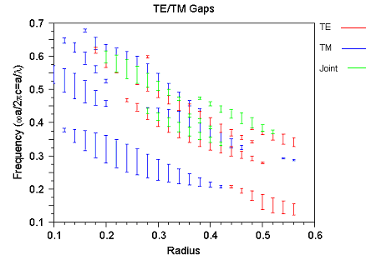
Figure 6.1 Gap map for the PBG structure composed of Si rods in air in honeycomb lattice

A PBG structure composed of honeycomb lattice of Si rods in air with normalized rod radius ‘r/a = 0.24’ has been selected to have a maximum range of complete photonic band gap as evident from the gap map. The PBG structure exhibits CPBG for normalized frequency range 0.53711 ≤ a/λ ≤ 0.58793 as evident from the gap map shown in figure 6.1.
A photonic crystal waveguide can be formed by either introducing a defect layer in a photonic crystal or by bounding a dielectric space by a photonic crystal. The guided modes are strongly confined because any electromagnetic energy cannot escape through the surrounding medium because of the photonic band gap effect.
First an input waveguide has been created by removing two rows of dielectric rods in the PBG structure. Since the considered PBG structure possesses the CPBG, light of both TE and TM polarization in the wavelength range 1.51 μm ≤ λ ≤ 1.65 μm can be guided in this structure.
Further, to design a PBG polarizer a PhC heterostructure is designed in such a way that the light of one polarization is blocked while the light of another polarization is allowed to pass, so that at the output end light of one polarization is obtained. So after the input waveguide, modifications are made in the PBG structure such that it exhibits a band gap for either of the two polarizations.
To, obtain such a structure a linear defect waveguide in the photonic crystal structure after the input waveguide by changing the radius of the Si rods in the two rows has been created, which is followed by an output waveguide formed by removing two rows of the Si rods. Figure 6.2 shows the schematic diagram of the type 1 PBG polarizer.

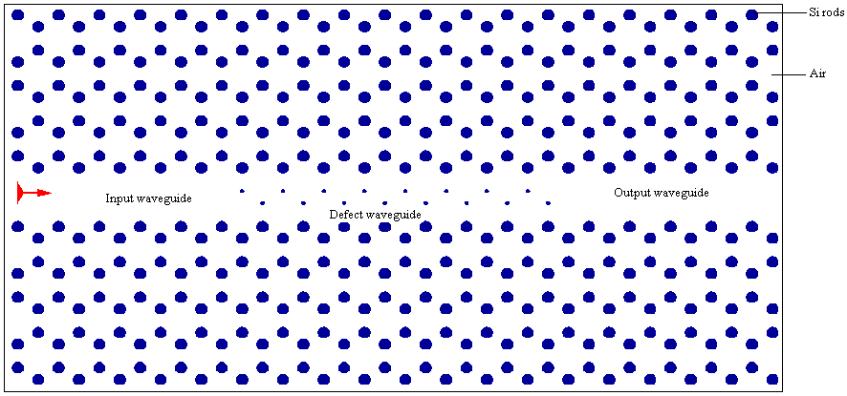
Figure 6.2 Schematic view of the type 1 PBG polarizer

To find the parameters of the defect waveguide, the variation of photonic band gaps by changing the radius of defect rods in the linear defect waveguide using the PWE method have been investigated . The range of the photonic band gaps for the TE and TM polarizations by changing the radius of the defect rods has been shown in table 6.1.
To design a polarizer at λ =1.55 μm, radius of the defect rods in the linear defect waveguide has been chosen to be 0.08a. This defect waveguide supports only TE modes but exhibits a PBG for TM mode as evident from table 6.1.

Radius of Si rods in the defect waveguide | Photonic band gap range for TM polarization | Photonic band gap range for TE polarization
0.08a | 0.54967 ≤ a/λ ≤ 0.55829  0.56006≤ a/λ ≤ 0.57243
0.10a | 0.54422 ≤ a/λ ≤ 0.5542  0.55476 ≤ a/λ ≤0.57092 | 0.57101 ≤ a/λ ≤ 0.5542
0.12a | 0.54209 ≤ a/λ ≤ 0.55157  0.55238 ≤ a/λ ≤ 0.56914 | 0.56919 ≤ a/λ ≤ 0.58238
0.14a | 0.54074 ≤ a/λ ≤ 0.54962  0.55069 ≤ a/λ ≤ 0.56731 | 0.56723 ≤ a/λ ≤ 0.57824
0.16a | 0.53893 ≤ a/λ ≤ 0.54684  0.54785 ≤ a/λ ≤ 0.56151
0.18a | 0.55658 ≤ a/λ ≤ 0.56482
0.20a | 0.54352 ≤ a/λ ≤ 0.5519 | 0.56472 ≤ a/λ ≤ 0.57933
0.22a | 0.55597 ≤ a/λ ≤ 0.56092 | 0.5649≤ a/λ ≤ 0.56686
0.26a | 0.54065 ≤ a/λ ≤ 0.5472  0.55604 ≤ a/λ ≤ 0.58878  0.5889 ≤ a/λ ≤ 0.5942 | 0.55604 ≤ a/λ ≤ 0.58878
0.28a | 0.53703 ≤ a/λ ≤ 0.54523  0.55274 ≤ a/λ ≤ 0.58389 | 0.55274 ≤ a/λ ≤ 0.57606
0.30a | 0.535 ≤ a/λ ≤ 0.54117  0.54999≤ a/λ ≤ 0.56447 | 0.52651 ≤ a/λ ≤ 0.53445
0.32a | 0.5673 ≤ a/λ ≤ 0.57441 | 0.59161 ≤ a/λ ≤ 0.59899

Table 6.1 Range of photonic band gaps for TM and TE polarizations with varying defect
radii calculated using PWE method

Thus if at the input end light of both TE and TM polarization is launched in the input waveguide then at output end light of TE polarization is obtained as TE modes are allowed to propagate in the defect waveguide whereas TM modes are not allowed and hence are reflected back as shown in figure 6.3(a) and figure 6.3(b).
6.2.2 Characterization
The performance of a polarizer is conventionally characterized by the degree of polarization and transmittance. The degree of polarization ‘P’ which is defined as
(6.1)
where () is the intensity of the outgoing TE(TM) component which is found to be one as the light of TM polarization is completely blocked because of the photonic band gap effect.
And, the transmittance ‘T’ of a polarizer is defined as the ratio of the intensity of the light of TE mode in the output waveguide to the intensity of the light in the input waveguide.
(6.2)
where in and out stand for the incident and outgoing waves, respectively. For type 1 PBG polarizer transmittance ‘T’ is found to be 0.74.
Similarly, PBG polarizer can be designed at different wavelengths by changing the radius of the rods in the defect waveguide which induces the PBG for the either polarization as calculated in table 6.1.

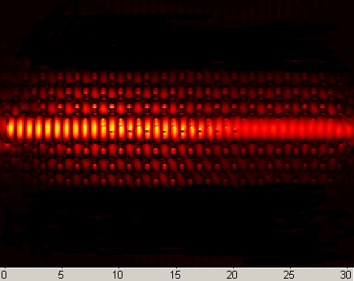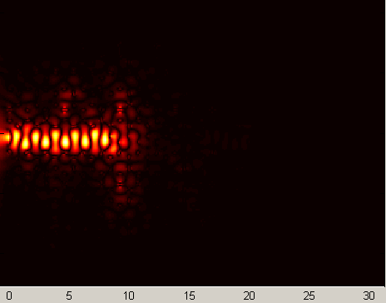
μm μm
TE mode TM mode
Figure 6.3 (a) Figure 6.3(b)
Figure 6.3 (a) Snapshot of the Type1 PBG polarizer for TE mode at 1.55 μm
Figure 6.3(b) Snapshot of the Type1 PBG polarizer for TM mode at 1.55 μm
6.3 Type 2 PBG Polarizer
To design Type 2 PBG polarizer, the PBG structure composed of air holes in Si in a triangular lattice has been explored.
6.3.1 Design Parameters for the Type 2 PBG Polarizer
To obtain the design parameters for the Type 2 PBG polarizer, first the gap map for the structure is obtained as shown in figure 6.4. After analyzing the gap map for the PBG structure composed of triangular lattice of air holes in Si, lattice constant ‘a = 0.79 μm’ with normalized air hole radius ‘r/a = 0.48’ has been chosen to have a maximum range of complete photonic band gap. The PBG structure exhibits a complete photonic band gap for normalized frequency range 0.45244 ≤ a/λ ≤ 0.53077 as evident from the gap map shown in figure 6.4.
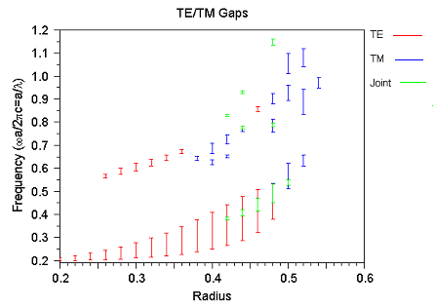

Figure 6.4 Gap map for the PBG structure composed of air holes in Si in triangular lattice

Based on similar lines as for type 1 PBG polarizer, a polarizer is deigned by first creating an input waveguide by removing one row of air holes followed by a linear defect waveguide in which the radius of the air holes is modified and finally an output waveguide by removing one row of air holes, schematic diagram of which has been shown in figure 6.5.

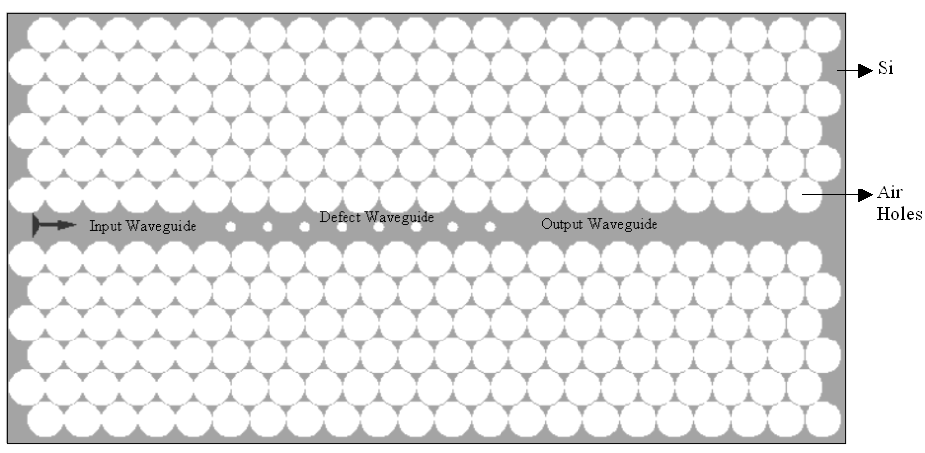
Figure 6.5 Schematic view of the type 2 PBG polarizer
Since the considered PBG structure possesses the CPBG, light of both TE and TM polarization in the wavelength range 1.41 μm ≤ λ ≤ 1.67 μm can be guided in the input waveguide.
Similarly , to find the parameters of the defect waveguide, the variation of photonic band gaps by changing the radius of the air holes in the linear defect waveguide has been investigated , details of which have been given in table 6.2 . In the present case, radius of the air holes in the linear defect waveguide has been chosen to be 0.12a to design the PBG polarizer, which introduces a PBG for TM mode in the range 0.49273 ≤ a/λ ≤ 0.528 as evident from table 6.2.
The dispersion relations for the defect waveguide for TE and TM polarizations are shown in the figures 6.6 (a) and 6.6 (b) respectively. The dispersion diagrams indicate that a photonic band gap is introduced for TM polarization in the range 0.49273 ≤ a/λ ≤ 0.528, however no such photonic band gap is observed for TE polarization. From the dispersion relations it has been made evident that the guided mode exists for this structure in the region where the PBG has been observed for TM polarization. Hence, if at the input end light of both TE and TM polarization is launched in the input waveguide then light of TE polarization should be guided in the defect waveguide.
Radius of the air holes in the defect waveguide | Photonic band gap range for TM polarization | Photonic band gap range for TE polarization
0.06a | 0.48891≤ a/λ ≤ 0.5116 | 0.49394≤ a/λ ≤ 0.50178
0.08a | 0.49015≤ a/λ ≤0.516 | 0.49459≤ a/λ ≤ 0.50213
0.10a | 0.4915≤ a/λ ≤0.52165 | 0.49581≤ a/λ ≤ 0.50287
0.12a | 0.49273≤ a/λ ≤ 0.52
0.14a | 0.49462≤ a/λ ≤ 0.52839
0.16a | 0.49721≤ a/λ ≤ 0.52899
0.18a | 0.50036≤ a/λ ≤ 0.52986
0.2a | 0.50424≤ a/λ ≤ 0.53082
0.22a | 0.51006≤ a/λ ≤ 0.53242
0.24a | 0.51658≤ a/λ ≤ 0.53479
0.26a | 0.45606≤ a/λ ≤ 0.46457  0.50041≤ a/λ ≤ 0.50647  0.52438≤ a/λ ≤ 0.53772
0.28a | 0.43221≤ a/λ ≤ 0.43845  0.46344≤ a/λ ≤ 0.47429  0.50581≤ a/λ ≤ 0.51656 | 0.42925≤ a/λ ≤ 0.45522
0.30a | 0.43704≤ a/λ ≤ 0.44447  0.46765≤ a/λ ≤ 0.48696  0.51402≤ a/λ ≤ 0.52927 | 0.44000≤ a/λ ≤ 0.47151  0.52428≤ a/λ ≤ 0.53642
0.32a | 0.44338≤ a/λ ≤ 0.4511  0.47097≤ a/λ ≤ 0.50108  0.5227≤ a/λ ≤ 0.54139 | 0.45265≤ a/λ ≤ 0.48943  0.51375≤ a/λ ≤ 0.52302
0.34a | 0.45115≤ a/λ ≤ 0.45919  0.47491≤ a/λ ≤ 0.51548  0.52884≤ a/λ ≤ 0.54654 | 0.46796≤ a/λ ≤ 0.50524  0.52743≤ a/λ ≤ 0.5387
0.36a | 0.46274≤ a/λ ≤ 0.46937  0.48011≤ a/λ ≤ 0.53019 | 0.49864≤ a/λ ≤ 0.5215
0.38a | 0.43585≤ a/λ ≤ 0.45199  0.48808≤ a/λ ≤ 0.53366 | 0.34944≤ a/λ ≤ 0.45579
0.40a | 0.43275≤ a/λ ≤ 0.43955  0.45804≤ a/λ ≤ 0.47183  0.50051≤ a/λ ≤ 0.53572 | 0.35152≤ a/λ ≤ 0.48474
0.42a | 0.43417≤ a/λ ≤ 0.4581  0.4844≤ a/λ ≤ 0.4964  0.5185≤ a/λ ≤ 0.53808 | 0.35446≤ a/λ ≤ 0.50958
0.44a | 0.43609≤ a/λ ≤ 0.48189  0.51725≤ a/λ ≤ 0.52743 | 0.35805≤ a/λ ≤ 0.51787
0.46a | 0.44035≤ a/λ ≤ 0.51095 | 0.36412≤ a/λ ≤ 0.52407

Table 6.2 Range of photonic band gaps for TM and TE polarizations with varying radii of
the air holes in the defect waveguide as calculated using PWE method
whereas the light of TM polarization should be blocked because of the photonic band gap.
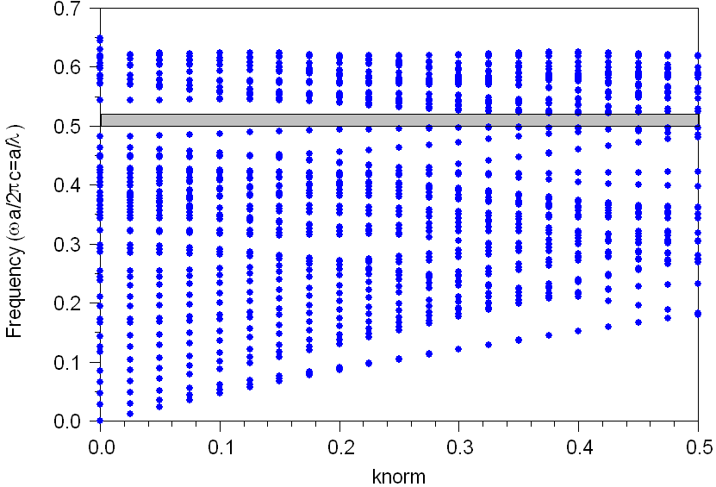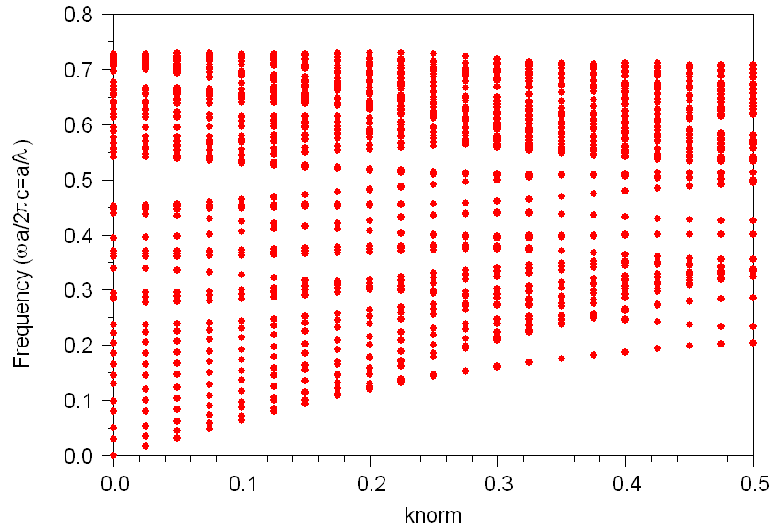
Figure 6.6 (a) Dispersion diagram for the defect waveguide for TM polarization
Figure 6.6 (b) Dispersion diagram for the defect waveguide for TE polarization

The FDTD method has been used to simulate light propagation in the proposed PBG polarizer. The simulation results have been shown in figure 6.7(a) and (b) for λ = 1.55µm for TM and TE polarization respectively.
The simulations exhibit, if at the input end light of both TE and TM polarization of the allowed operational range is launched in the input waveguide then at output end, light of only TE polarization is obtained as expected from the dispersion relations.
6.3.2 Characterization
The proposed Type 2 polarizer is operational in the range 0.49273 ≤ a/λ ≤ 0.528 providing a large bandwidth of 90 nm, where bandwidth is defined as the difference of the maximum and minimum operational wavelengths.
The degree of polarization ‘P’ is obtained to be one and the transmittance for TE mode is obtained as 0.5 for the entire operational range for the designed PBG polarizer.

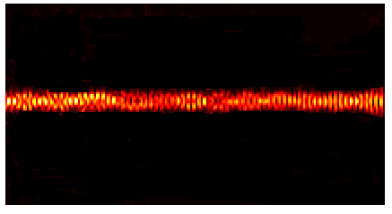
TM mode TE mode
Figure 6.7 (a) Figure 6.7 (b)
Figure 6.7(a) Snapshots of the type 2 PBG polarizer for TM mode at 1.55 μm
Figure 6.7(b) Snapshots of the type 2 PBG polarizer for TE mode at 1.55 μm
Further, the parameters of the defect waveguide can be altered to change the operational range as well as the type of polarization required at the output end as per the data given in table 6.2. Moreover the PBG polarizers designed are of a few microns thus leading to the design of ultra compact polarizers.
6.4 Conclusion
The designs of ultra compact PBG polarizers by utilizing the photonic band gaps exhibited by PhC structures have been modeled using the FDTD and the PWE method. These polarizers are fundamentally different from conventional ones as here the one state of polarization is blocked because of the photonic band gap effect. It has been shown that the PBG polarizers can be designed in both the topologies if the band gap requirements are satisfied; however both have their own advantages and disadvantages.
PBG polarizer designed in the PhC composed of Si rods in air in honeycomb lattice has the transmittance equal to 0.74 with degree of polarization as one but the operational range is very narrow and hence becomes highly wavelength specific. However the PBG polarizer designed in the PhC composed of air holes in Si in triangular lattice is characterized by the transmittance of 0.5 and degree of polarization as one with a large band width of 90nm. It has been shown that the dimensions of the PBG polarizer lie in the micrometer range, which renders it to be used as a micro polarizer in micro optics.
Further, by tailoring the radius of the defect rods/air holes in PhC heterostructure, PBG polarizer can be designed for the desired wavelength range depending upon the defect bands.
Chapter 7

Summary and Future Scope

In this chapter, a recapitulation of the main results obtained has been presented, conclusions have been drawn and a perspective of the open problems and further work has been sketched.
The thesis emphasis on the modeling and numerical analysis of 2D photonic crystals and the functionalities they offer.
In chapter 1, the concept of photonic crystals or photonic band gap structures has been introduced and some of the salient features and unique characteristics exhibited by these structures have been discussed. Finally, chapter 1 provides a brief overview of the thesis.
As a first step towards the theoretical analysis of photonic crystals Chapter 2 explores the existence of photonic band gaps pseudo as well as complete in various photonic crystal structures. The chapter further systematically analyzes the effect on the photonic band gaps because of the introduction of asymmetry in photonic crystal structure in terms of shape and orientation of the dielectric rods or air holes as per the respective structures using the plane wave expansion method.
Light can be guided and localized in photonic crystal structures by the introduction of defects. Light is guided in these defects via two mechanisms namely the index guided effect and the photonic band gap effect. Chapter 3 discusses the light guidance in photonic crystal waveguide, which is formed by creation of linear defects in otherwise perfect photonic crystals, because of the index guided effect. The design of PhC coupler has been proposed using the designed photonic crystal waveguides and their coupling characteristics have been investigated.
In chapter 4, the design of PBG coupler has been proposed in which the light is guided in the coupler because of the photonic band gap effect. The coupling characteristics of the proposed coupler have been obtained. Further the design of PBG mux-demux has been proposed and numerically modeled using the FDTD method. It has been shown that the dimensions of photonic crystal coupler lies in the micrometer range leading to the design of ultra compact all integrated optical circuits. The tunable photonic crystal couplers can also be designed using the non linear photonic crystals. Further photonic crystal couplers can also be used to design photonic crystal switches by the application of electric and magnetic field.
Chapter 5 focuses on the devices based on the complete photonic band gap exhibited by certain select PhC structures. The concept of complete photonic band gap in 2D photonic crystals has been utilized to propose the designs of polarization splitters in two different photonic crystal structures. Coupling and polarization splitting characteristics namely band width, extinction ratio, insertion loss, etc. have been obtained. These ultra compact polarization splitters can find application in optical integrated circuits. Further tailoring of design parameters can be done to utilize the polarization splitter to design ultra compact wavelength cum polarization filter desired for DWDM communication systems.
Chapter 6 focuses on the versatility provided by the PBG structures because of the introduction of defects in the PBG structures. The concept of defect engineering has been introduced and utilized to design photonic crystal polarizer. The idea of introduction of defect modes by the creation of defects in the photonic crystal structures has been used to design polarization sensitive devices. Also, the designed polarizers have been characterized using the FDTD method. Further designs can be explored to design polarizer using the idea of photonic band gaps.
Various other devices can be designed using the ideas of photonic as well as complete photonic band gap engineering and the light guidance in the PBG structures through various defects because of the index guided effect or due to the photonic band gap effect along with the possibility of defect bands in photonic crystals. Thus the photonic crystals open new arenas to manipulate the flow of light and hence custom engineer the various parameters leading the design of ultra compact optical components required in the all integrated optical circuits.

Appendix A
Computational Methods-Plane Wave Expansion Method
Since photonic crystals are generally complex, high index contrast, two and three dimensional vectorial systems, numerical computations are a crucial part of most theoretical analyses. As already discussed in chapter 1 that various computational methods have been devised to study photonic crystal structures and light propagation in these structures. Plane wave expansion method and finite difference time domain method, which have been extensively employed to carry out the research work reported in this thesis, have been discussed in Appendix A & B respectively.

A.1 Plane Wave Expansion (PWE) method
Plane Wave Expansion (PWE) method is a numerical method based on the fourier expansion of the electromagnetic field and the dielectric function.
A.1.1 Maxwell’s equations

In the most general form Maxwell’s equations can be written in MKS units as follows:

(A.1)

(A.2)

(A.3)

(A.4)

where E and H are electric and magnetic fields, D is electric displacement and B is magnetic induction.
The magnetic permeability of the photonic crystal is assumed to be equal to that in free space, µ₀
(A.5)

As for the dielectric constant, it is assumed to be real, isotropic, and perfectly periodic with respect to the spatial coordinate and does not depend on the frequency. The dielectric constant of free space is denoted by and the relative dielectric constant of the photonic crystal by. The electric displacement is thus given by
(A.6)

The periodicity of implies

(A.7)

where {a_{i}} are the elementary lattice vectors of the photonic crystal. Because of this spatial periodicity, can be expanded in a Fourier series. For this, the elementary reciprocal lattice vectors {b_{i}; i= 1, 2, 3} and the reciprocal lattice vectors {G} are introduced
(A.8)

(A.9)

where {l_{i}} are arbitrary integers and is kronecker’s delta. can be expressed as
(A.10)

Since the dielectric function is assumed to be real, .Substituting (A.5) and (A.6) in (A.1) to (A.4), following equations are obtained:

(A.11)

(A.12)

(A.13)

(A.14)
Eliminating or in (A.13) and (A.14), the following wave equations are obtained
(A.15)
(A.16) where c stands for light velocity in free space
(A.17)
The solutions of (A.15) and (A.16) can be seeked of the form
(A.18)
(A.19)
where is the eigen angular frequency, and and are the eigen functions of the wave equations. These eigen functions should thus satisfy the next eigen value equations.
(A.20)
(A.21)
where two differential operators and are defined by the first equality in each of the above equations.
Because ‘’ is a periodic function of the spatial coordinate , Bloch’s theorem can be applied to (A.20) and (A.21) as in the case of the electronic wave equation in ordinary crystals with a periodic potential due to the regular array of atoms. and are thus characterized by a wave vector k in the first Brillouin zone and a band index n and can be expressed as
(A.22)
(A.23)
where and are periodic vectorial functions that satisfy the following relations
(A.24)
(A.25)
for i=1, 2, 3.

Because of the spatial periodicity of these functions, they can be expanded in Fourier series like in (A.10). This Fourier expansion leads to the following form of the eigenfunctions.
(A.26)
(A.27)

The expansion coefficients in reciprocal lattice space, i.e., and are denoted by the same symbols as the original ones in real space. Substituting (A.10), (A.26) and (A.27) into (A.20) and (A.21), following eigen value equations for the expansion coefficients {} and {} are obtained:
(A.28)
(A.29)

where denotes the eigen-angular frequency of and. By solving one of these two sets of equations numerically, the dispersion relation of the eigen modes or the photonic band structure can be obtained.
For two-dimensional crystals, the eigen value equations are much simplified if the k vector is parallel to the 2D plane. In the 2D crystal, the dielectric structure is uniform in the z direction. The electromagnetic waves travel in the x-y plane and are also uniform in the z direction. Hence,, , andare independent of the z coordinate in (A.13) and (A.14). In this case, these vectorial equations are decoupled to two independent sets of equations. In a two dimensional case, the fields can be decoupled into two transversely polarized modes, namely E polarization (and) and the H polarization (and).
Appendix B

Computational Methods-Finite Difference Time Domain Method
The finite difference time domain (FDTD) method is very often used approach to solve Maxwell’s equations [59]. It has been used to solve a wide variety of problems related to electromagnetic waves, such as wave propagation, scattering, electronic circuits, antenna analysis. In the present section, some details about FDTD and how it can be used to study photonic crystals or photonic band gap structures has been discussed.
B.1 Three dimensional FDTD time stepping formulas
For a linear isotropic material in a source free region , the time dependent Maxwell’s curl equations can be written in the following form,
(B.1)
(B.2)
where and are the position dependent permittivity, permeability and conductivity of the material, respectively.
Maxwell’s equations can be discretized in space and time by a so called Yee cell technique on a discrete three dimensional mesh. Figure B.1 depicts the unit Yee cell (not to be confused with the photonic crystal unit cell)
of the three – dimensional mesh in a Cartesian xyz coordinate system,
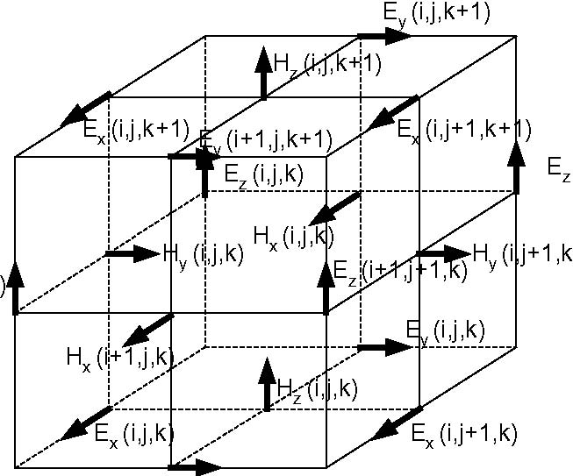

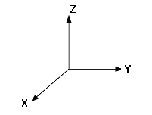

E_{y} (i+1,j,k)

Figure B.1 A unit Yee cell of the three-dimensional FDTD mesh

(B.3)

(B.4)

(B.5)
(B.6)

(B.7)
where the superscript n indicates the discrete time step, the subscripts i, j and k indicate the position of a grid point in the x, y and z directions, respectively. is the time increment, and and are the space increments between two neighboring grid points along the x, y and z directions, respectively.

(B.8)

One can easily see that for a fixed total number of time steps the computational time is proportional to the number of discrimination points in the computation domain, i.e., the FDTD algorithm is of order N.
B.2 Compact FDTD time –stepping formulas
For a system which is homogeneous along the direction, (e.g. the direction of photonic crystal fibers), one can introduce the propagation constant along the z- direction (propagation direction). Thus, each field component has the form, where denotes any field component. In Maxwell’s equations, therefore, the z derivatives can be replaced by, to reduce them to a two-dimensional space. Figure B.2 gives the unit Yee cell of the two dimensional mesh over the cross-section of the system. For example, the discrete form of the x component of becomes,
(B.9)

The rest of the equations for other field components can be obtained in similar manner.

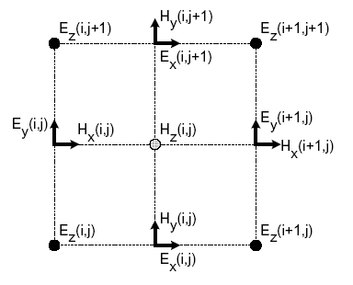
Figure B.2 The unit Yee cell of the two dimensional hybrid mesh

The above equation introduces complex number into the computation. It does not change the complexity of computations when calculating the off plane band structures for two dimensional photonic crystals, since the boundary conditions are the complex Bloch theory. However, when computing guided modes in photonic crystal fibers, one wishes to refer only to real number. One way to eliminate the complex number is to assume that and have a component, and, and have a component , where is the phase factor. Then, equation (B.9) becomes,

(B.10)

Only real variables remain. The other field components are given by the following equations,
(B.11)
(B.12)
(B.13)

(B.14)

(B.15)

B.3 Two-dimensional FDTD time stepping formulas
In a two dimensional case, the fields can be decoupled into two transversely polarized modes, namely E polarization (and) and the H polarization (and). The FDTD time-stepping formulas can easily be obtained by simply letting in the equations (B.10-B.15) for the Cartesian coordinate system.
For triangular lattice photonic crystals or honeycomb lattice photonic crystals, it is difficult to discretize the unit cell (not the Yee cell) using the orthogonal Cartesian coordinate. Therefore, it is convenient to use a non orthogonal FDTD method to study such systems. Define a non orthogonal coordinate () in accordance with the skew lattice of the photonic crystal (with an angle between the axis and the axis) [60].

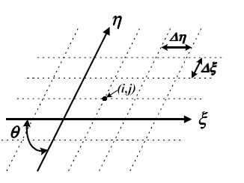
Figure B.3 A non orthogonal two dimensional mesh for a skew lattice. The axes
are labeled by and, and the angle between them is

The entire plane with a mesh of uniform cells formed by lines of constant and is discretized, and a two dimensional non orthogonal mesh as shown in figure B.3 is obtained. Thus, the following FDTD time stepping formulas for the E polarization case are obtained,

(B.16)

(B.17)

(B.18)

The following FDTD time stepping formulas for the H polarization case can also be obtained

(B.19)

(B.20)
(B.21)

B.4 Numerical Stability
The choice of the time step is not arbitrary. The FDTD time-stepping formulas require that has a specific bound relative to the space increments and. This bound is necessary to avoid numerical stability, an undesirable possibility with explicit differential equation solvers that can cause the computed results to spuriously increase without limit as time marching continues [61].
The three dimensional FDTD time – stepping formulas are stable numerically if the following condition is satisfied,
(B. 22)
where c is the speed of the light. For compact FDTD time- stepping formulas, the stability condition becomes
(B.23)
For two-dimensional FDTD time stepping formulas, the stability conditions for orthogonal case is
(B.24)
and for non orthogonal case [62]
(B.25)

B.5 Boundary conditions
Special consideration should be given to the boundary of finite computational domain, where the fields are updated using special boundary conditions since information outside the computational domain is not available.
When calculating band structures of photonic crystals, one naturally chooses a unit cell of lattice as the finite computation domain, and uses the periodic boundary condition which satisfies the Bloch theory. Therefore, we have the following simple boundary conditions for updating the fields,

(B.26)
(B.27)
where L is the lattice vector.
When calculating defect modes (or guided modes in photonic crystal fibers), one can also use the perfectly matched layer (PML) method [63] for the boundary treatment. In the PML method, the electric or magnetic field components are split into two sub components (e.g., ) with the possibility of assigning losses to the individual split field components. The net effect of this is to create an absorbing medium (which is nonphysical) adjacent to the outer FDTD mesh boundary such that the interface between the PML and the FDTD mesh is reflection less for all frequencies, polarizations, and angles of incidence. The FDTD technique can be applied directly for the numerical implementation of the fields inside the PML without any special treatment. One may use a combination of the periodic boundary condition and the PML when calculating the guided modes or surface modes in photonic crystals.
B.6 Total /Reflected field formulation and initial field distributions
The FDTD numerical scheme yields the solution of an initial value problem. At the first time step of the simulation, all the fields are set to zero. The algorithm needs the initial field excitation that will be propagated through the computational domain. The computational domain is separated into two sub-regions: total field region and the reflected field region as shown in figure B.4. The plane separating these regions is called the incident field.
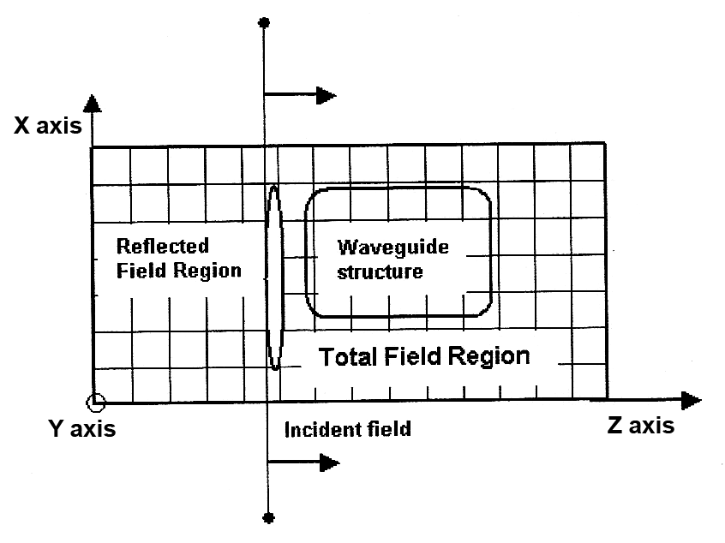
Figure B.4 Total/Reflected field formulation
In the total field region, the structures of interest are designed. The interaction between the incident field and the designed structure takes place in this region. Thus the total field region contains information for both the incident and scattered (reflected) waves. In the reflected field region the geometry is uniform and the propagating waves are presented by the fields reflected from the total field region. There are no objects in this region and the signal is not reflected back to the total field region.
B.7 Transformation to the frequency domain/Output data
With the FDTD method, all the fields are obtained in the time domain. However, the dispersion relation (the band structures, guided modes, etc) of a photonic crystal is a relation between the frequency and the wave vector. Therefore, a Fourier transform is required,
(B.28)
where one of the field components and the results are obtained in frequency domain.

References

- E. Yablonovitch, “Inhibited spontaneous emission in solid state physics and electronics,” Physical Review Letters., 58, 2059-2062, 1987
- S. John, “Strong localization of photons in certain disordered dielectric superlattices,” Physical Review Letters, 58, 2486-2489, 1987
- J.B. Pendry and A. Mackinnon, “Calculation of Photon Dispersion Relations”, Physical review Letters, 69, 2772-2774, 1992
- D. Cassagne, C. Jouanin and Bertho, “ Hexagonal photonic band gap structures”, Physical Review B, 53, 7134-7141, 1995
- A.Reynolds, F. Lopez-Tejeira, D. Cassagne, F.J.Gracia-Vidal, C. Jounanin and J. Sanchez Dehesa, “Spectral Properties of opal-based photonic crystals having a SiO2 matrix”, Physical Review B, 60, 422-426, 1999
- “Special Issue on Development and applications of materials exhibiting photonic band gap”,
J. of Opt. Soc. Am. B, 10, 208-408, 1993
- Zhi - Yuan Li, Jian Wang and Ben Yuan Gu, “Creation of partial band gaps in anisotropic
photonic band gap structures”, Physical Review B, 58, 3721-3729, 1998
- R. Wang R and X. H. Wang, “ Effects of shapes and orientations of scatterers and lattice symmetries on photonic band gap in two dimensional photonic crystals”, Journal of Applied Physics, 90, 4307, 2001
- K.M. Ho , C.T. Chan and C.M. Soukoulis, “Existence of photonic band gap in periodic dielectric structures ”, Physical Review letters, 3152-3155, 1990
- P.R. Villeneuve and M. Piche, “Photonic Band Gaps in two dimensional square and hexagonal lattices”, Physical Review B, 46, 4973 – 4975, 1992
- P.R. Villeneuve and M. Piche, “Photonic Band Gaps in Two dimensional square and circular rods”, Physical Review B, 46, 4969 – 4972, 1992
- “Special issue on Photonic Band Structures”, J. Modern Optics, 41, 171-404, 1994
- R.D. Meade, A.M. Rappe, K.D. Brommer , J.D. Joannopoulous and O.L. Alerhand, “ Accurate theoretical analysis of photonic band gap materials”, Physical Review B, 48, 8434-8437, 1993
- W.M. Robertson and G. Arjavalingam, “Measurement of Photonic Band Structure in a two Dimensional Periodic Dielectric Array”, Physical Review Letters, 68, 2023-2026, 1992
- K.Sakoda, “Transmittance and Bragg reflectivity of two dimensional photonic lattices”, Physical review B, 52, 8992-9002, 1995
- J. D. Joannopolous, R. D. Mead and J. N. Winn, “Photonic Crystals: Molding the flow of light”, Princeton University Press, 1995.
- “Special issue on photonic bandgaps”, J. Optics A: Pure & Applied Optics, 3, S103-S207, 2001
- K.Sakoda, “Optical transmittance of a two dimensional triangular photonic lattice”, Physical Review B, Rapid Communications , 51, 4672—4675, 1995
- Richard De La Rue and Chris Smith, “On the threshold of success”, Nature, 408, 653-656, 2000
- Peide Han, Bingshe Xu , Jian Liang , Xuguang Liu and Huiqiang Bao, “Band gaps of two dimensional photonic crystal structure using fullerene films”, Physica E ,29-34, 2004
- V.Agarwal and J.A. del Rio, “Tailoring the photonic band gap of a porous silicon dielectric mirror”, Applied Physics Letters, 82, 1512-1514, 2003
- H.B. Lin, R.J. Tonucci and A.J. Campillo, “Observation of two dimensional photonic band behaviour in the visible”, Applied Physics Letters, 68, 2927-2929, 1996
- R.D. Meade , A. Rappe , Btomer and J.D. Joannopoulous, “ Nature of photonic band gap : Some insights from a field analysis”, Journal of Optical Society of America B, 10, 328-332, 1993
- R. Hillerbrand, W Hergert and W Harms, “Photonic band structure of 2D non circular air lattices in Si”, Material Science in Semiconductor Processing, 3, 493 -497, 2000
- R. Hillebrand and W. Hergret, “Band Gap studies of triangular 2D photonic crystals with varying pore roundness”, Solid State Communications, 115, 227-232 , 2000
- Zhi - Yuan Li, Jian Wang and Ben Yuan Gu, “Large absolute band gap in 2D anisotropic photonic crystals”, Physical Review A, 58, 2574-2577, 1998
- Min Qiu, “Band Gap effects in asymmetric photonic crystal slabs”, Physical Review B, 66, 033103-1 -033103-4, 2002
- Ruey- Lin Chern , Chien – Chung Chang, Chien C. Chang and Robert R. Hwang, “Two classes of photonic crystals with simultaneous band gaps”, Japanese Journal of Applied Physics, 43, 3484-3490, 2004
- Min Qiu and Sailing He, “Large complete band gap in two dimensional photonic crystals with elliptic air holes”. Physical Review B, 60, 10610 -10612,1999
- C. Kittel, “Introduction to Solid State Physics”, John Wiley and Sons, New York, 2003
- N.W. Ashcroft and N.D. Mermim, “Solid State Physics”, Saunders College Publishing, Philadelphia ,1976
- A. Yariv and P. Yeh, “Optical waves in crystals”, Wiley & Sons, USA ,1984
- R.E. Slusher and B.J. Eggleton , “Nonlinear photonic crystals”, Springer Verlag, Berlin 2003
- “Special issues on nonlinear optics of photonic crystals”, J. Optical Society of America B, 19, 2046-2296, 2002
- K.W.K. Shung and Y.C. Tsai, “Surface Effects and Band Measurements in Photonic Crystals” Physical Review B , 48, 11265-11269 , 1993
- Paras N. Prasad, “ Nanophotonics”, Wiley – Interscience, 2004
- A. Imhof ,W.L. Vos, R. Sprik and A. Lagendijk, “Large dispersive effects near the band edges of Photonic Crystals” , Physical Review Letters, 83, 2942-2945, 1999
- M. Notomi, M. “Theory of light propagation in strongly modulated photonic crystals: Refraction like behavior in the vicinity of the photonic band gap”, Physical Review B, 62, 10696-10705, 2000
- H. Kosaka et al. , “Superprism phenomena in photonic crystals”, Physical Review B, 58, 10096-10099, 1998
- “Special issue on modeling of photonic crystals”, Optical & Quantum Electronics, 5, 417-521, 2002
- “Feature section on photonic crystal structure and application”, J. of Quantum Electronics, 38, 724-942, 2002
- J.M. Lourtioz, H.Bensity, V.Berger, J.-M. Gerard, Dd. Maystre and A. Tchnelnokov, “Photonic Crystals :Towards Nanoscale Photonic Devices”, Springer, 2005
- “Special Issue on Photonic Crystals”, J. of Lightwave Technology, 17, 1931-2207, 1999
- H. Benisty , C.Weisbuch, D. Labilloy , M.Rattier, C.J.M. Smith , T.F.Krauss, Richard M. De la Rue, R. Houdre, U.Oesterle, C. Jouanin and D. Cassagne, “Optical and confinement properties of two dimensional photonic crystals” , Journal of lightwave technology, 17, 2063-2077, 1999
- M.K. Chin, “Polarization dependence in waveguide coupled micro resonators”, Optics Express, 11, 1724-1730, 2003
- E.Ozbay, M. Bayindir,I. Bulu and. E.Cubukcu, “Investigation of localized coupled cavity modes in two dimensional photonic band gap structures”, Journal of Quantum Electronics, 38, 937-843, 2002
- A.Adibi, Y.Xu, R.K.Lee and A.Yariv, “Slab Modes in photonic crystal optical waveguides”, J. of lightwave technology, 18, 1554-1564, 2000
- A.Adibi, R.K.Lee, Y.Xu, A. Yariv and A. Scherer, “Design of photonic crystal optical waveguides with single mode propagation in the photonic band gap”, Electronics Letters, 36, 1376 – 1377, 2000
- A.Mekis, J.Chen, I.Kurland, P.Villeneuve, J.Joannopolous, “High transmission through sharp bends in photonic crystal waveguides”, Physical Review Letters, 77, 3783-3790, 1996
- Bjarklev, J. Broeng and A. S. Bjarklev, “Photonic Crystal Fibers”, Kluwer Academic Publishers, 2003
- R.K.Sinha and S.K.Varshney, “Dispersion properties of photonic crystal fibers”, Microwave and Optical Technology Letters, 37, 129-132, 2003, Available online: http://www3.interscience.wiley.com
- S.K.Varshney, M.P.Singh and R.K.Sinha, “Propagation characteristics of photonic crystal fibers”, J. of Optical Communications, 24, 2003, Available: http://www.joc-online.de/online 46
- Matthew N.O. Sadiku, “Numerical techniques in Electromagnetics”, CRC, 2001
- Steven G. Johnson and J.D.Joannopoulous, “Block iterative frequency domain methods for Maxwell’s equations in plane wave basis”, Optics Express, 8, 173-190, 2001
- Steven G. Johnson and J.D.Joannopoulous, “Photonic Crystals- The Road from theory to practice”, Springer, 2002
- X. Wang, X.G. Zhang, Q. Yu and B. N. Harman, “Multiple scattering Theory for Electromagnetic Waves”, Physical Review B , 47, 4161-4167,1993
- Arthur R. Mc Gurn, “ Green’s function theory for row and periodic defect arrays in photonic band structures”, Physical Review A, 53, 7059-7064, 1996
- A. Modinos, N.Stefanou amd V. Yannopapas, “Applications of the layer KKR method to photonic crystals”, Optics Express, 8, 197-202, 2000
- Allen Taflove, “Advances in computational electrodynamics- The finite Difference time domain method”, Artech House, 1998
- Min Qiu and Sailing He, “ A non orthogonal finite difference time domain method for computing the band structure of a two dimensional photonic crystal with dielectric and metallic inclusions”, Journal of Applied Physics, 87, 8268 -8275 , 2000
- A.C. Cangellaris, “Numerical stability and numerical dispersion of a compact 2D FDTD method used for the dispersion analysis of waveguides”, Microwave Guided Wave Letter, 3, 3-5, 1993
- S.L.Ray, “Numerical Dispersion and stability characteristics of time domain methods on non orthogonal meshes”, Transactions on Antennas and Propagation , 41, 233-255, 1993
- J.R. Berenger, “A perfectly matched layer for the adsorption of electromagnetic waves”, Journal of computational physics, 114, 185-200, 1994
- Aubourg and P. Guillon, “A mixed finite element formulation for microwave device problems - Applications to MIS structure”, J. Electromagnetic Waves , 5, 371- 375,1991
- Brechet F. J. Marcou, D. Pagnoux and P. Roy, “Complete analysis of the characteristics of propagation into photonic crystal fibers by finite element method”, Optical Fiber Technology, 6, 181-191, 2000
- K. Busch, S. Lolkes, R.H. Weherspohn and H. Foll , “Photonic Crystals : Advances in Design ,fabrication and characterization”, Wiley- VCH, 2004
- S.Y. Lin et al. “A three-dimensional photonic crystal operating at infrared wavelengths” Nature , 394, 251-253, 1998
- S. Noda, K. Tomoda, N. Yamamoto and A. Chutinan, “Full three-dimensional photonic bandgap crystals at near-infrared wavelengths” Science, 289, 604-606 , 2000
- B.H. Cunpston, S. P. Ananthavel, S. Barlow, D.L. Dyer, J.E. Erhlich, L.L. Erskine, A.A. Heikal, S.M. Kuebler, I.-Y.S. Lee, D. McCord-Maughon, J.Qin, H. Rockel, M. Rumi, X.-L. Wu, S.R. Marder and J.W. Perry, “Two photon polymerization initiators for three dimensional optical data storage and microfabrication”, Nature , 398, 51-54, 1999
- G. Subramania and S.Y. Lin, “Fabrication of three dimensional photonic crystal with alignment based on electron beam lithography”, Applied Physics Letters, 85 ,5037-5039, 2004
- M. Campbell et al., “Fabrication of photonic crystals for the visible spectrum by holographic lithography” Nature , 404, 53-56 , 2000
- V. Berger, O. Gauthier- Lafaye and E. Costard, “Photonic band gaps and holography”, J. of Applied Physics, 82, 60-64, 1997
- J.B. Jones, E.R. Segnit and J.V. Sanders, “Structure of Opal”, Nature , 204, 990-991, 1964
- S. H. Park and Y. Xia, “Self assembly of mesoscale particles over large areas and its application in fabricating tunable optical filters”, Langmuir, 15, 266-273, 1999
- B. Gates, D. Qin and Y. Xia, “Assembly of Nanoparticles into opaline structures over large areas”, Advanced Material, 11, 466-469, 1999
- Y.A. Vlasov, X.Z. Bo, J.C. Sturm and D.J. Norris, “On-chip natural assembly of silicon photonic bandgap crystals”, Nature , 414, 289-293 , 2001
- M. Kawakami, “ Photonic crystals for the visible range fabricated by auto cloning technique and their applications”, Optical and Quantum Electronics, 34, 63-70, 2002
- M. Deubel et al. “Direct laser writing of three-dimensional photonic-crystal templates for telecommunication.” Nature Materials, 3, 444-447 , 2004
- A. Chelnokov et al., “Near-infrared Yablonovite-like photonic crystals by focused-ion beam etching of macroporous silicon”, Applied Physics Letters, 77, 2943-2945 , 2000
- 27 F. Garcia-Santamaria, F., “Nanorobotic manipulation of microspheres for on-chip diamond architectures”, Advanced Materials,14, 1144-1147 , 2002
- D. Marcuse, “Theory of Dielectric Optical waveguides”, Academic Press, 1991
- K.Okamoto, “Fundamentals of Optical Waveguides”, Academic Press, 2000
- A.W.Snyder and J.D.Love, “Optical Waveguide Theory”, Chapman and Hall, 1983
- J. Salzwan and G, Lenz, “ The Bragg reflection waveguide directional coupler”, Photonics Technology Letters, 1, 319-322, 1989
- H. C. Cheng and R.V. Ramaswamy, “Determination of the coupling length in directional couplers from spectral response” Photonics Technology Letters, 2, 823-826, 1990
- Andrew M. Sarangan and Wei-Ping Huang, “A coupled mode theory for electron wave directional couplers”, J. of Quantum Electronics, 30, 2803-2810, 1994
- Harald Herrmann, Ulrich Rust, and Klaus Schafer, “ Tapered acoustical directional couplers for integrated acousto-optical mode converters with weighted coupling”, J. of Lightwave Technology, 13, 364-374, 1995
- Cheng P. Wen, “Coplanar-waveguide directional couplers”, Transactions on microwave theory and techniques, 18, 318-322, 1970
- Dong I.Kim and Yoshiyuki, “ Broad-Band Design of Improved Hybrid-Ring 3-dB Directional Couplers”, Transactions on microwave theory and techniques, 30, 2040-2046, 1982
- M.Le Vassor, D’ Yerville, D.Cassagne and C.Jounanin, “Photonic band gap microcavities in nitrides”, Physica Status Soidil (a), 183, 17-22, 2001
- M.Bayindir, C. Kural and E. Ozbay, “Coupled optical microcavities in one dimensional photonic band gap structures”, Journal of Optics: Pure and Applied Optics, 3, 184-189, 2001
- M.Shirane, A. Gomyo.K.Miura,H. Yamada and S. Kawakami, “Optical directional couplers based on autocloned photonic crystals”, Electronics Letters, 39, 53-54, 2003
- K. Sakoda, “Optical properties of photonic crystals”, Springer, 2000
- M. Koshiba, “Wavelength division multiplexing and demultiplexing with photonic crystal waveguide couplers”, J. of Lightwave Technology , 19,1970, 2001
- A. Martinez, F.Cuesta and J.Marti , “Ultra short 2D photonic crystal directional couplers”, Photonics Technology Letters,15, 694, 2003
- C.C. Chen, C.Y. Chen, W.K. Wang, F.H. Huang, C. K. Lin, W.Y. Chiu and Y.J. Chan, “Photonic crystal directional couplers formed by InAlGaAs nano rods”, Optics Express, 13, 38-43, 2005
- A. Sharkawy, S. Shi and D.W. Prather, “Electro-optical switching using coupled photonic crystal waveguides”, Optics Express, 10, 1048-1059, 2002, Available: http://www.opticsexpress.org
- Raffaella Costa, Andrea Melloni and Mario Martinelli, “Band pass resonant filters in photonic
crystal waveguides”, Photonics Technology Letters, 15, 401-403, 2003
- F. Cuesta-Soto, A. Martinez, J. Garcia, F. Ramos, P. Sanchis, J. Blasco, and J.Marti, “All-optical switching structure based on photonic crystal directional coupler”, Optics Express, 12, 161-167, 2004
- M. Bayindir and E. Ozbay, “Band dropping via coupled photonic crystal waveguides”, Optics Express, 10, 1279-1284, 2002
- A. R. Vellekoop and M. K. Smit , “ Low loss planar optical polarisation splitter with small dimensions”, Electronics Letters, 25, 946-947, 1989
- R. Hereth and G. Schiffner, “ Broad-band optical directional couplers and polarization splitters”, J. of Lightwave Technology, 7, 925-930, 1989
- P. Albretch , M. Hamacher, H. Heidrich, D. Hoffmann, H. P. Nolting and C. M. Weinert, “ TE/TM Mode Splitters on InGaAsP/InP”, Photonics Technology Letters, 2, 114-115,1990
- H. Yanagawa, H. Mak, Y. Kamata, and K. Ueki, “ High Extinction Guided-Wave Optical Polarization Splitter”, Photonics Technology Letters, 3, 17-18, 1991
- C. Duchet and N. Flaaronning, “ New TE/TM polarisation splitter made in Ti: LiNbO using X-cut and Z-axis propagation”, Electronics Letters , 26, 995-996, 1990
- U. Trutschel, F. Ouellette, V. Delisle, , M. A. Duguay , G. Fogarty, and F. Lederer, “Antiresonant on polarization splitter based reflecting optical waveguides”, J. of Lightwave Technology, 13, 239-244, 1995
- J. J. G. M. van der Tol, J. W. Pedersen, , E. G. Metaal, J. J.-W. van Gaalen, Y. S. Oei, and F. H. Groen, “A short polarization splitter without metal overlays on InGaAsP–InP”, Photonics Technology Letters, 9, 209-211, 1997
- Dirk Taillaert,, Harold Chong, Peter I. Borel, Lars H. Frandsen, Richard M. De La Rue and Roel Baets, “A compact two-dimensional grating couple used as a polarization splitter”, Photonics Technology Letters , 15, 1249-1251, 2003
- Sean M. Garner, Vadim Chuyanov, Sang-Shin Lee, Antao Chen, William H. Steier, and Larry R. Dalton, “Vertically integrated waveguide polarization splitters using polymers”, Photonics Technology Letters, 11, 842-844,1999
- K. Saitoh, Y. Sato and M. Koshiba, “ Polarization splitter in three core photonic crystal fibers”, Optics Express, 12, 3940-3946, 2004
- L. Zhang and C. Yang, “Novel polarization splitter based on the photonic crystal fiber with nonidentical dual cores”, Photonics Technology Letters, 16, 1670-1672, 2004
- L. Zhang and C.Yang, “Polarization dependent coupling in twin core photonic crystal fibers”, J.of Lightwave Technology, 22, 1367-1373,2004
- K.C. Lin, W.C. Chuang and W.Y.Lee, “Proposal and Analysis of an ultra short directional coupler polarization splitter with an NLC coupling layer”, J. of Lightwave Technology, 14, 2547-2553, 1999
- Y. Ohtera, T. Sato, T. Kawashima, T. Tamamura and S. Kawakami, “Photonic crystal polarization splitters”, Electronics Letters, 35, 1271-1272, 1999
- L.Wu, M. Mazilu, J.-F. Gallet , T.F. Krauss, A. Jugessur and R.M.De La Rue, “Planar photonic crystal polarization splitter”, Optics Letters, 29, 1620-1621, 2004
- S.Kim, Gregory P. Nordin, Jingbo Kai and Jianhua Jiang, “Ultra compact high-efficiency polarizing beam splitter with a hybrid photonic crystal and conventional waveguide structure”, Electronics Letters, 28, 2384-2386, 2003
- Yu Tong And Wu Yizun, “Theoretical study of metal-clad optical waveguide polarizer, Journal of Quantum Electronics, 25, 1209-1213,1989
- K. Thyagarajan, Supriya Diggavi Seshadri and A. K. Ghatak, “Waveguide polarizer based on resonant tunneling”, Journal of Lightwave Technology, 9, 315-317, 1991
- Min-Cheol Oh, Myung-Hyun Lee and Hyung-Jong Lee, “ TE-pass and TM-pass waveguide polarisers with buried birefringent polymer” , Electronics Letters, 35 ,471-472, 1999
- T. Nakano, K. Baba and M. Miyagi, “Coupler - type waveguide polariser using metal island films: its mechanism and design” , Electronics Letters , 29 , 536-538, 1993
- Toshihito Hosaka, Katsunari Okamoto and Juichi Noda, “Single-Mode Fiber-Type Polarizer, Journal of Quantum Electronics, 18, 1569-1573,1982
- Luca Pierantoni, Alessandro Massaro, and Tullio Rozzi, “Accurate modeling of TE/TM propagation and losses of integrated optical polarizer” Transactions On Microwave Theory and Techniques, 53, 1856-1862, 2005
- M. Kamp, T. Happ, S. Mahnkopf, G. Duan, S. Anand and A. Forhel, “Semiconductor photonic crystals for optoelectronics”, Physica E, 21 ,802-808, 2004
- V. Rinnerbauer, J.Schermer and K. Hingerl, “Polarization splitting based on planar photonic crystals”, Proceedings of ECOC 2004 We2.1.3
- E.A. Camargo, Harold M. H. Chong and Richard M. De La Rue, “ Four port coupled channel-guide device based on 2D photonic crystal structure”, Photonics and Nanostructures – Fundamentals and Applications, 2, 227-213, 2004

