EXERGY ANALYSIS OF COMBINED CYCLE POWER PLANT

Praveen Kumar
ROLL NO – 12303



DEPARTMENT OF MECHANICAL ENGINEERING
DELHI COLLEGE OF ENGINEERING, DELHI-110042

UNIVERSITY OF DELHI

July 2009
EXERGY ANALYSIS OF COMBINED CYCLE POWER PLANT

A Major Project Report Submitted in Partial Fulfillment

For the Requirement of the Degree of

Masters of Engineering

In

Mechanical Engineering (Thermal)

By
Praveen Kumar
ROLL NO – 12303

Under the guidance of
Prof. SAMSHER

DEPARTMENT OF MECHANICAL ENGINEERING
DELHI COLLEGE OF ENGINEERING, DELHI-110042

UNIVERSITY OF DELHI

July 2009

Declaration by the Candidate
Date: ___________

I hereby declare that the work presented in this dissertation entitled “EXERGY ANALYSIS OF COMBINED CYCLE POWER PLANT” has been carried out by me under the guidance of Dr. Samsher, Professor, Department of Mechanical Engineering, Delhi College of Engineering, Delhi and hereby submitted for the partial fulfillment for the award of degree of Master of Engineering in Mechanical Engineering (THERMAL) at Delhi College of Engineering (Delhi University), Delhi.
I further undertake that the work embodied in this major project has not been submitted for the award of any other degree elsewhere.

CERTIFICATE

It is to certify that the above statement made by the candidate is true to the best of my knowledge and belief.

Dated :------------------------ Dr. SAMSHER
Professor Mechanical Engineering Department
Delhi College of Engineering, Delhi-42

Acknowledgement

I would like to acknowledge those people and institute who have given me the knowledge and light of guidance which has helped me to wade through the darkness. Here, I express my heartily and sincere gratitude and indebtedness to Dr. SAMSHER, Professor in Mechanical Engineering Department, Delhi College of Engineering, Delhi for his valuable guidance and wholehearted cooperation. He has a special place in my heart for many reasons but to be limited, he is the one who inspires me to move ahead in life with persistence and endurance.
My heartily thanks to all of my Professors for their expertise and all rounded personality they have imparted to me.
My special thanks go to my parents who have given me the strength, love and care to carry out this course successfully.

PRAVEEN KUMAR

ABSTRACT
Combined cycle power plants (CCPPs) have an important role in power generation as we are presently facing shortage of power both during peak and off peak hours. To improve the performance of the plant, first it is necessary to find out the equipment/locations where the losses are more and the same can be rectified by more attention to those equipments. Seven cases of different configuration have been considered to study the change in exergy destruction with modification in cycle using computer program made in engineering equation solver (version 7.929).

In the first configuration only compressor, combustor and gas turbine have been taken. One regenerative heat exchanger is added in 2nd configuration followed by addition of intercooler in 3rd case and one re-heater in 4th case. Keeping 4th case as base, WHRB, steam turbine and condenser is added in the 5th case followed by an addition of one regenerative feed heater in 6th case and two regenerative feed heaters in 7th case. The exhaust gas exergy destruction and exergy destruction for each component for all seven cases have been evaluated. The effects of overall pressure ratio, turbine inlet temperature, ambient relative humidity, stack temperature and pressure loss in the components on the combined cycle parameters have also been investigated. Thermodynamics analysis indicates that exergy destruction in various components of the combined cycle is significantly affected by overall pressure ratio, turbine inlet temperature and pressure loss in air filter and less affected by the ambient relative humidity. It is also indicated that the maximum exergy is destroyed in the combustion chmber, which represents over 60% of the total exergy destruction in the overall system. The first-law efficiency and second-law efficiency of the cycle significantly vary with the change in the overall pressure ratio and turbine inlet temperature, but the change in relative humidity shows small variations in these parameters. Exergy destruction in all components of gas turbine for case 5, case 6 and case 7 are individually same. Results clearly show that as complicacy of the plant increases, we move to the reversible process.

Keywords: firs-law, second-law, exergy destruction, gas turbine cycle, steam turbine cycle, combined cycle power plant, Waste heat recovery boiler
LIST OF CONTENTS
Declaration of Candidate  Certificate  Acknowledgement  Abstract  List of Contents  List of figures  List of tables  Nomenclature | I  I  II  III  IV  IX  XIV  XVI

Chapter 1 |  |  | INTRODUCTION | 1
 | 1.1 |  | Energy Scenario of India | 1
 | 1.2 |  | Critical Coal Stock | 1
 | 1.3 |  | Motivation | 2
 | 1.4 |  | Problem Statement | 2
Chapter 2 |  |  | LITERATURE REVIEW ( BASIC CONCEPTS) | 3
 | 2.1 |  | Power Plant | 3
 |  | 2.1.1 | Gas Turbine Power Plant | 4
 |  | 2.1.2 | Brayton Cycle | 6
 |  | 2.1.3 | Steam Turbine Power Plant | 9
 |  | 2.1.4 | Rankine Cycle | 10
 |  | 2.1.5 | Combined Cycle Power Plant | 11
 | 2.2 |  | First Law of Thermodynamics | 12
 | 2.3 |  | Exergy | 13
 | 2.4 |  | Reversible Work And Irreversibility | 14
 | 2.5 |  | Second-Law Efficiency | 16
 | 2.6 |  | Exergy Change of A System | 19
 | 2.7 |  | Exergy Destruction | 22
Chapter 3 |  |  | LITERATURE REVIEW (RECENT WORK) | 24
 | 3.1 |  | Conclusion of Literature Review | 33
Chapter 4 |  |  | MODELLING OF SELECTED CONFIGURATIONS | 34
 | 4.1 |  | System Description | 34
 | 4.2 |  | Mathematical Model | 38
 | 4.3 |  | Performance Parameters | 44
 | 4.4 |  | Computer programming / Coding | 45
 | 4.5 |  | Assumptions | 45
Chapter 5 |  |  | RESULTS AND DISCUSSION | 47
 | 5.1 |  | Validation of computer code | 47
 | 5.2 |  | Effect of variation of pressure ratio on first-law efficiency and second-law efficiency for case 7 | 51
 | 5.3 |  | Effect of variation of turbine inlet temperature on first-law efficiency and second-law efficiency for case 7 | 53
 | 5.4 |  | Effect of variation of ambient relative humidity on first-law efficiency and second-law efficiency for case 7 | 54
 | 5.5 |  | Effect of variation of pressure ratio on exergy destruction in combustion Chamber | 55
 | 5.6 |  | Effect of variation of pressure ratio on exergy destruction in regenerative heat exchanger | 57
 | 5.7 |  | Effect of variation of pressure ratio on exergy destruction in compressor | 59
 | 5.8 |  | Effect of variation of pressure ratio on exergy destruction in intercooler | 60
 | 5.9 |  | Effect of variation of pressure ratio on exergy destruction in turbine | 61
 | 5.10 |  | Effect of variation of pressure ratio on exergy destruction in reheater | 63
 | 5.11 |  | Effect of variation of pressure ratio on exergy destruction in air filter | 64
 | 5.12 |  | Effect of variation of pressure ratio on exergy destruction in WHRB | 66
 | 5.13 |  | Effect of variation of pressure ratio on exergy destruction in steam turbine | 67
 | 5.14 |  | Effect of variation of pressure ratio on exergy destruction in condenser | 69
 | 5.15 |  | Effect of variation of pressure ratio on exergy destruction in feed water heater | 70
 | 5.16 |  | Effect of variation of pressure ratio on exergy destruction in pump | 72
 | 5.17 |  | Effect of variation of pressure ratio on exergy destruction in exhaust gas | 73
 | 5.18 |  | Effect of variation of pressure ratio on first-law efficiency and second-law efficiency for case 1 and case 7 | 75
 | 5.19 |  | Effect of variation of turbine inlet temperature on exergy destruction in combustion chamber | 75
 | 5.20 |  | Effect of variation of turbine inlet temperature on exergy destruction in regenerative heat exchanger | 76
 | 5.21 |  | Effect of variation of turbine inlet temperature on exergy destruction in compressor | 77
 | 5.22 |  | Effect of variation of turbine inlet temperature on exergy destruction in intercooler | 78
 | 5.23 |  | Effect of variation of turbine inlet temperature on exergy destruction in turbine | 79
 | 5.24 |  | Effect of variation of turbine inlet temperature on exergy destruction in reheater | 80
 | 5.25 |  | Effect of variation of turbine inlet temperature on exergy destruction in air filter | 81
 | 5.26 |  | Effect of variation of turbine inlet temperature on exergy destruction in WHRB | 82
 | 5.27 |  | Effect of variation of turbine inlet temperature on exergy destruction in steam turbine | 83
 | 5.28 |  | Effect of variation of turbine inlet temperature on exergy destruction in condenser | 84
 | 5.29 |  | Effect of variation of turbine inlet temperature on exergy destruction in feed water heater | 85
 | 5.30 |  | Effect of variation of turbine inlet temperature on exergy destruction in pump | 86
 | 5.31 |  | Effect of variation of turbine inlet temperature on exergy destruction in exhaust gas | 87
 | 5.32 |  | Effect of variation of turbine inlet temperature on first-law efficiency and second-law efficiency for case 1 and case 7 | 88
 | 5.33 |  | Effect of variation of stack temperature on mass flow rate of steam and net work of steam turbine | 89
 | 5.34 |  | Effect of variation of stack temperature on exergy destruction in exhaust gas, WHRB and steam turbine | 90
 | 5.35 |  | Effect of variation of stack temperature on first-law efficiency and second-law efficiency | 91
 | 5.36 |  | Effect of variation of ambient relative humidity on exergy destruction in different components of the cycle | 91
 | 5.37 |  | Effect of variation of pressure loss in air filter on exergy destruction in different components of the cycle | 92
 | 5.38 |  | Effect of variation of pressure loss in heat exchanger air side and gas side on exergy destruction in different components of the cycle | 92
 | 5.39 |  | Effect of variation of pressure loss in combustion chamber on exergy destruction in different components of the cycle | 92
 | 5.40 |  | Effect of variation of pressure loss in reheater on exergy destruction in different components of the cycle | 93
 | 5.41 |  | Effect of variation of pressure loss in WHRB on exergy destruction in different components of the cycle | 93
Chapter 6 |  |  | CONCLUSION | 98
Chapter 7 |  |  | RECOMMENDATIONS OF FUTURE WORK | 101
 |  |  | REFERENCES | 102
 |  |  | Appendix (Program Coding) | 105

LIST OF FIGURES
Figure 2.1 Simple open cycle gas turbine 7
Figure 2.2 A simple steam plant representing Rankine cycle 9
Figure 2.3 Rankine cycle on p-v, T-s and h-s coordinates 10
Figure 2.4 Combined cycle operation with Brayton and Rankine cycle 11
Figure 2.5 As a closed system expands, some work needs to be done to push the atmospheric air out of the way 15
Figure 2.6 Difference between reversible work and actual work 16
Figure 2.7 Two heat engine having same thermal efficiency but different maximum efficiency 17
Figure 2.8 Second law efficiency is a measure of performance of device relative to its performance under reversible conditions 17
Figure 2.9 Reversible works done by an open system while exchanging heat only with the surroundings 20
Figure 4.1 Schematic diagram of combined cycle power plant with two feed water heaters (Case 7) 35
Figure 4.2 Schematic diagram of simple gas turbine cycle 35
Figure 4.3 Schematic diagram of gas turbine cycle with regenerator 36
Figure 4.4 Schematic diagram of gas turbine cycle with regenerator and intercooler 36
Figure 4.5 Schematic diagram of gas turbine cycle with regenerator, intercooler and reheater 37
Figure 4.6 Schematic diagram of combined cycle power plant 37
Figure 4.7 Schematic diagram of combined cycle power plant with one feed water heater 38
Figure 5.1 Effect of variation of pressure ratio on Air rate 50
Figure 5.2 Effect of variation of pressure ratio on specific fuel consumption 50
Figure 5.3 Effect of variation of pressure ratio on work ratio 51
Figure 5.4 Effect of variation of pressure ratio at various TIT on first-law efficiency 52
Figure 5.5 Effect of variation of pressure ratio at various TIT on second-law efficiency 52
Figure 5.6 Effect of variation of pressure ratio on first-law efficiency and second-law efficiency 53
Figure 5.7 Effect of variation of turbine inlet temperature on first-law efficiency and second-law efficiency 54
Figure 5.8 Effect of variation of ambient relative humidity on first-law efficiency and second-law efficiency 55
Figure 5.9 Effect of variation of pressure ratio on exergy destruction in combustion chamber 56
Figure 5.10 Exergy destruction in combustion chamber at TIT = 1400 K, =14 and = 60% 57
Figure 5.11 Effect of variation of pressure ratio on exergy destruction in regenerative heat exchanger 58
Figure 5.12 Exergy destruction in regenerative heat exchanger at TIT = 1400 K, =14 and = 60% 58
Figure 5.13 Effect of variation of pressure ratio on exergy destruction in compressor 59
Figure 5.14 Exergy destruction in compressor at TIT = 1400 K, =14 and = 60% 60
Figure 5.15 Effect of variation of pressure ratio on exergy destruction in intercooler 61
Figure 5.16 Exergy destruction in intercooler at TIT = 1400 K, =14 and = 60% 61
Figure 5.17 Effect of variation of pressure ratio on exergy destruction in turbine 62
Figure 5.18 Exergy destruction in turbine at TIT = 1400 K, =14 and = 60% 63
Figure 5.19 Effect of variation of pressure ratio on exergy destruction in reheater 64
Figure 5.20 Exergy destruction in reheater at TIT = 1400 K, =14 and = 60% 64
Figure 5.21 Effect of variation of pressure ratio on exergy destruction in air filter 65
Figure 5.22 Exergy destruction in air filter at TIT = 1400 K, =14 and = 60% 65
Figure 5.23 Effect of variation of pressure ratio on exergy destruction in WHRB 66
Figure 5.24 Exergy destruction in WHRB at TIT = 1400 K, =14 and = 60% 67
Figure 5.25 Effect of variation of pressure ratio on exergy destruction in steam turbine 68
Figure 5.26 Exergy destruction in steam turbine at TIT = 1400 K, =14 and = 60% 68
Figure 5.27 Effect of variation of pressure ratio on exergy destruction in condenser 69
Figure 5.28 Exergy destruction in condenser at TIT = 1400 K, =14 and = 60% 70
Figure 5.29 Effect of variation of pressure ratio on exergy destruction in feed water heater 71
Figure 5.30 Exergy destruction in feed water heater at TIT = 1400 K, =14 and = 60% 71
Figure 5.31 Effect of variation of pressure ratio on exergy destruction in pump 73
Figure 5.32 Exergy destruction in pump at TIT = 1400 K, =14 and = 60% 73
Figure 5.33 Effect of variation of pressure ratio on exergy destruction in exhaust gas 74
Figure 5.34 Exergy destruction in exhaust gas at TIT = 1400 K, =14 and = 60% 74
Figure 5.35 Effect of variation of pressure ratio on first-law efficiency and second-law efficiency for case 1 and case 7 75
Figure 5.36 Effect of variation of turbine inlet temperature on exergy destruction in combustion chamber 76
Figure 5.37 Effect of variation of turbine inlet temperature on exergy destruction in regenerative heat exchanger 76
Figure 5.38 Effect of variation of turbine inlet temperature on exergy destruction in compressor 77
Figure 5.39 Effect of variation of turbine inlet temperature on exergy destruction in intercooler 78
Figure 5.40 Effect of variation of turbine inlet temperature on exergy destruction in turbine 79
Figure 5.41 Effect of variation of turbine inlet temperature on exergy destruction in reheater 80
Figure 5.42 Effect of variation of turbine inlet temperature on exergy destruction in air filter 81
Figure 5.43 Effect of variation of turbine inlet temperature on exergy destruction in WHRB 82
Figure 5.44 Effect of variation of turbine inlet temperature on exergy destruction in steam turbine 83
Figure 5.45 Effect of variation of turbine inlet temperature on exergy destruction in condenser 84
Figure 5.46 Effect of variation of turbine inlet temperature on exergy destruction in feed water heater 85
Figure 5.47 Effect of variation of turbine inlet temperature on exergy destruction in pump 86
Figure 5.48 Effect of variation of turbine inlet temperature on exergy destruction in exhaust gas 87
Figure 5.49 Effect of variation of turbine inlet temperature on first-law efficiency and second-law efficiency for case 1 and case 7 88
Figure 5.50 Effect of variation of stack temperature on mass flow rate of steam and net work of steam turbine 89
Figure 5.51 Effect of variation of stack temperature on exergy destruction in exhaust gas, WHRB and steam turbine 90
Figure 5.52 Effect of variation of stack temperature on first-law efficiency and second-law efficiency 92

LIST OF TABLES
Table 1 Effect of variation of pressure ratio on exergy destruction in different components of the cycle for TIT = 1600 K, = 60%, = 1 bar, = 298 K [11] 48
Table 2 Effect of variation of turbine inlet temperature on exergy destruction in different components of the cycle for = 36, = 60%, = 1 bar, = 298 K [11] 48
Table 3 Effect of variation of ambient relative humidity on exergy destruction in different components of the cycle for TIT = 1600 K, = 60%, = 1 bar, = 298 K [11] 48
Table 4 Effect of variation of pressure ratio on exergy destruction in different components of the cycle for TIT = 1600 K, = 60%, = 1 bar, = 298 K 49
Table 5 Effect of variation of turbine inlet temperature on exergy destruction in different components of the cycle for = 36, = 60%, = 1 bar, = 298 K 49
Table 6 Effect of variation of ambient relative humidity on exergy destruction in different components of the cycle for TIT = 1600 K, = 60%, = 1 bar, = 298 K 49
Table 7 Effect of variation of ambient relative humidity on exergy destruction in different components of the cycle for TIT = 1400 K and =14 94
Table 8 Effect of variation of pressure loss in air filter on exergy destruction in different components of the cycle for TIT = 1400 K and =14 94
Table 9 Effect of variation of pressure loss in heat exchanger air side on exergy destruction in different components of the cycle for TIT = 1400 K and =14 95
Table 10 Effect of variation of pressure loss in heat exchanger gas side on exergy destruction in different components of the cycle for TIT = 1400 K and =14
95
Table 11 Effect of variation of pressure loss combustion chamber on exergy destruction in different components of the cycle for TIT = 1400 K and =14 96
Table 12 Effect of variation of pressure loss combustion chamber on exergy destruction in different components of the cycle for TIT = 1400 K and =14 96
Table 13 Effect of variation of pressure loss in WHRB on exergy destruction in different components of the cycle for TIT = 1400 K and =14 97

Nomenclature
Exergy rate (kJ/s)
= heat supplied by fuel (kJ/kg)
= heat of reaction of fuel (kJ/kg of fuel)
PL=pressure loss
R = gas constant (kJ/kg K)
T = absolute temperature (K)
W = work (kJ/s)
= specific heat at constant pressure (kJ/kg K)
= specific heat at constant volume (kJ/kg K)
e = specific exergy (kJ/kg)
= Gibbs function of fuel (kJ/kg)
h = specific enthalpy (kJ/kg)
= mass flow rate (kg/s)
p = pressure (bar)
= expansion ratio
= pressure ratio
s = entropy (kJ/kg K)
t = temperature (°C)
= specific volume (/kg)
Greek Symbols
ω= humidity ratio (kg of water vapour per kg of dry air)
φ= relative humidity (%)
ε= effectiveness (%)
η= efficiency (%)
γ= specific heat ratio
Subscripts
AC=air cooler
AF=air filter
AH1=air humidifier 1
AH2=air humidifier 2
C=compressor
GT=gas turbine
CC=combustion chamber
D= destruction
HE= regenerative heat exchanger
HPC= high-pressure compressor
HPT= high-pressure turbine
I= intercooler
LPC= low-pressure compressor
p= product
PT= power turbine
WHRB=waste heat recovery boiler
ST=steam turbine
COND=condenser
FWH1=feed water heater 1
FWH2=feed water heater 2
REH= reheater
HEAS=heat exchanger air side
HEGS=heat exchanger gas side
P=pump
Q= heat
R= reactant
W= work
a= ambient air
av= average
f= fuel
g= gas
gen= generator
i= inlet
l= liquid
o= outlet
sat= saturated
v= water vapor
w= water
s=steam
cw=cooling water
1,2,3,…,25= state points in the cycle
Chapter 1
INTRODUCTION

  - Energy Scenario of India
India is a rapidly developing economy, with a need for dependable and reliable supply of electricity and to be a power sufficient country is one of its prime concerns. The present installed capacity of electricity in India is 132,110.21 MW which gives the per capita consumption of power in 2005-06 as calculated by the Central Electricity Authority about 631 KWH. While the per capita consumption of power in developed countries like U.S. is 13,338 KWH. The National Electricity Policy envisages that the per capita availability of electricity will be increased to over 1000 units by 2012. So large number of new power projects are currently in progress.
Thermal power plants account for 64.7% of the installed capacity. Because of this higher efficiency gas turbine and combined cycle power plants are becoming more and more attractive with regard to reduced fuel consumption and less emissions.
1.2 Critical Coal Stock
As many as 56 thermal power stations in the country were left with a critical coal stock of less than seven days at the end of October 2008. High generation, inadequate linkages and most importantly insufficient coal supply were the major reasons behind the critical stock of coal at these power stations. The Lehra Mohabbat and Paricha power stations in the northern region received coal amounting to only 52 percent and 64 percent of their linkages respectively. The Anpara, Obra and Singrauli STPS in the same region suffered due to poor linkages. In the Western region, Korba East and Dahanu stations received coal supply of only 77 percent of their linkages, the Chandrapur and Khaperkheda II stations had insufficient linkage. The Ennore, North Chennai and Mettur power stations in south received coal supply of 64 percent, 66 percent and 75 percent of their linkages, respectively. Kothagudem station suffered due to high generation and inadequate linkage. Coal supply to the Kahalgaon and Farakka stations in the eastern region received only 69 percent and 62 percent of their linkage respectively in the month. Ib Valley, Talcher TPS, Tenughat and Budge Budge plants suffered due to insufficient linkages. Durgapur Valley Corporation (DVC) received only 41 percent of the linkage due to insufficient supply.

  - Motivation
India has been spending a great amount of money to import the fuels, which could be used the in the development and growth of our country. In order to reduce the shortage of power efforts are required to improve the performance of existing plants. The project work on this thesis is an attempt to utilizing the wastage of exhaust to reduce the consumption of fuels and determination of the source of losses.

1.4 Problem Statement
The present work is concentrated on determination of the exergy destruction of each component of the combined cycle power plant, and comparison of exergy destruction in exhaust gas and each component of the plant with seven different configurations varying overall pressure ratio, turbine inlet temperature, ambient relative humidity and pressure loss in components.
Case 1: Simple gas turbine
Case 2: Gas turbine + regenerator
Case 3: Gas turbine + regenerator + intercooler
Case 4: Gas turbine + regenerator + intercooler + reheater
Case 5: Gas turbine + regenerator + intercooler + reheater + steam turbine
Case 6: Gas turbine + regenerator + intercooler + reheater + steam turbine + 1 feed heater
Case 7: Gas turbine + regenerator + intercooler + reheater + steam turbine + 2 feed heater

The project report contains total 6 chapters. Literature review of the basic concepts and recent work has been presented in chapters 2 and 3 respectively. Chapter 4 covers the thermodynamic analysis of all the configurations considered for the study. Results and discussions have been presented in chapter 5 followed by conclusions in chapter 6. Scope for future work, list of references and EES programme coding have been given at the last.
Chapter 2
LITERATURE REVIEW (BASIC CONCEPTS)

2.1 Power Plant
A power plant is an assembly of systems or subsystems to generate electricity, i.e., power with economy and requirements. While the stress is on energy efficient system regards conventional power systems viz., to increase the system conversion efficiency the supreme goal is to develop, design, and manufacturer the non-conventional power generating systems in coming decades preferably after 2050 AD which are conducive to society as well as having feasible energy conversion efficiency and non-friendly to pollution, keeping in view the pollution act. The subject as a whole can be also stated as modern power plants for power viz electricity generation in 21st century. The word modern means pertaining to time.
The main equipment for the generation of electric power is generator. When coupling it to a prime mover runs the generator, the electricity is generated. The type of prime move determines the type of power plants. The major types of power plant are:
1. Steam power plant
2. Diesel power plant
3. Gas turbine power plant
4. Nuclear power plant
5. Hydro electric power plant
The Steam Power Plant, Diesel Power Plant, Gas Turbine Power Plant and Nuclear Power Plants are called THERMAL POWER PLANT, because these convert heat into electric energy.
2.1.1 Gas turbine Power Plant
Gas turbines are described thermodynamically by the Brayton cycle, in which air is compressed isentropically, combustion occurs at constant pressure, and expansion over the turbine occurs isentropically back to the starting pressure.
In practice, friction, and turbulence cause:
- Non-isentropic compression: for a given overall pressure ratio, the compressor delivery temperature is higher than ideal.
- Non-isentropic expansion: although the turbine temperature drop necessary to drive the compressor is unaffected, the associated pressure ratio is greater, which decreases the expansion available to provide useful work.
- Pressure losses in the air intake, combustor and exhaust: reduces the expansion available to provide useful work.
The gas turbine obtains its power by utilizing the energy of burnt gases and air, which is at high temperature and pressure by expanding through the several ring of fixed and moving blades. It thus resembles a steam turbine. To get a high pressure (of the order of 4 to 10 bar) of working fluid, which is essential for expansion a compressor, is required.
The quantity of the working fluid and speed required are more, so, generally, a centrifugal or an axial compressor is employed. The turbine drives the compressor and so it is coupled to the turbine shaft. If after compression the working fluid were to be expanded in a turbine, then assuming that there were no losses in either component the power developed by the turbine would be just equal to that absorbed by the compressor and the work done would be zero. But increasing the volume of the working fluid at constant pressure, or alternatively increasing the pressure at constant volume can increase the power developed by the turbine. Adding heat so that the temperature of the working fluid is increased after the compression may do either of these. To get a higher temperature of the working fluid a combustion chamber is required where combustion of air and fuel takes place giving temperature rise to the working fluid.
Thus, a simple gas turbine cycle consists of
(1) A compressor,
(2) A combustion chamber and
(3) A turbine.
Since the compressor is coupled with the turbine shaft, it absorbs some of the power produced by the turbine and hence lowers the efficiency. The network is therefore the difference between the turbine work and work required by the compressor to drive it.
Gas turbines have been constructed to work on the following: oil, natural gas, coal gas, producer gas, blast furnace and pulverized coal.
The gas turbine power plants which are used in electric power industry are classified into two groups as per the cycle of operation.
(a) Open cycle gas turbine.
(b) Closed cycle gas turbine.
As with all cyclic heat engines, higher combustion temperature means greater efficiency. The limiting factor is the ability of the steel, nickel, ceramic, or other materials that make up the engine to withstand heat and pressure. Considerable engineering goes into keeping the turbine parts cool. Most turbines also try to recover exhaust heat, which otherwise is wasted energy. Recuperators are heat exchangers that pass exhaust heat to the compressed air, prior to combustion. Combined cycle designs pass waste heat to steam turbine systems and combined heat and power (co-generation) uses waste heat for hot water production.
Mechanically, gas turbines can be considerably less complex than internal combustion engines. Simple turbines might have one moving part: the shaft/ compressor/ turbine/ alternative-rotor assembly not counting the fuel system.
More sophisticated turbines (such as those found in modern jet engines) may have multiple shafts (spools), hundreds of turbine blades, movable stator blades, and a vast system of complex piping, combustors and heat exchangers.
As a general rule, the smaller the engine the higher the rotation rate of the shaft(s) needs to be to maintain top speed. Turbine blade top speed determines the maximum pressure that can be gained. This produces the maximum power possible independent of the size of the engine. Jet engines operate around 10,000 rpm and micro turbines around 100,000 rpm.
2.1.2 Brayton cycle
Fresh air at ambient conditions is drawn into the compressor, where its temperature and pressure are raised. The high-pressure air proceeds into the combustion chamber, where the fuel is burned at constant pressure. The resulting high-temperature gases then enter the turbine, where they expand to the atmospheric pressure while producing power. The exhaust gases leaving the turbine are thrown out (not recirculated), causing the cycle to be classified as an open cycle.
The open gas-turbine cycle described above can be modeled as a closed cycle by utilizing the air-standard assumptions. Here the compression and expansion processes remain the same, but the combustion process is replaced by a constant-pressure heat-addition process from an external source, and the exhaust process is replaced by a constant-pressure heat-rejection process to the ambient air. The ideal cycle that the working fluid undergoes in this closed loop is the Brayton cycle, which is made up of four internally reversible processes:
Isentropic compression (in a compressor)
Constant-pressure heat addition
Isentropic expansion (in a turbine)
Constant-pressure heat rejection
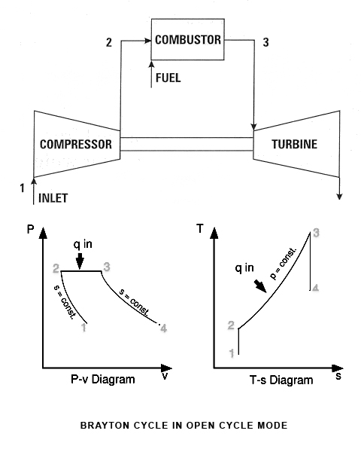
Figure 2.1 Simple open cycle gas turbine
Notice that all four processes of the Brayton cycle are executed in steady-flow devices; thus they should be analyzed as steady-flow processes. When the changes in kinetic and potential energies are neglected the energy balance for a steady-flow process can be expressed on a unit mass basis under the cold-air-standard assumptions, the thermal efficiency of an ideal Brayton cycle depends on the pressure ratio of the gas turbine and the specific heat ratio of the working fluid. The thermal efficiency increases with both of these parameters, which is also the case for actual gas turbines. The highest temperature in the cycle occurs at the end of the combustion process and it is limited by the maximum temperature that the turbine blades can withstand. This also limits the pressure ratios that can be used in the cycle. For a fixed turbine inlet temperature the net work output per cycle increases with the pressure ratio, reaches a maximum, and then starts to decrease. Therefore there should be a compromise between the pressure ratio (thus the thermal efficiency) and the net work output. With less work output per cycle a larger mass flow rate (thus a larger system) is needed to maintain the same power output, which may not be economical. In most common designs, the pressure ratio of gas turbines ranges from about 11 to 16.
The air in gas turbines performs two important functions: It supplies the necessary oxidant for the combustion of the fuel, and it serves as a coolant to keep the temperature of various components within safe limits. The second function is accomplished by drawing in more air than is needed for the complete combustion of the fuel. In gas turbines, an air fuel mass ratio of 50 or above is not uncommon. Therefore, in a cycle analysis, treating the combustion gases as air does not cause any appreciable error. Also, the mass flow rate through the turbine is greater than that through the compressor, the difference being equal to the mass flow rate of the fuel. Thus, assuming a constant mass flow rate throughout the cycle yields conservative results for open-loop gas-turbine engines.
The two major application areas of gas-turbine engines are aircraft propulsion and electric power generation. When it is used for aircraft propulsion the gas turbine produces just enough power to drive the compressor and a small generator to power the auxiliary equipment. The high-velocity exhaust gases are responsible for producing the necessary thrust to propel the aircraft. Gas turbines are also used as stationary power plants to generate electricity as stand-alone units or in conjunction with steam power plants on the high-temperature side. In these plants, the exhaust gases of the gas turbine serve as the heat source for the steam. The gas-turbine cycle can also be executed as a closed cycle for use in nuclear power plants. This time the working fluid is not limited to air, and a gas with more desirable characteristics (such as helium) can be used.

2.1.3 Steam Turbine Power Plant
Power plants are set ups that convert the energy stored in the fuel into electricity. The fuel is required to produce temperatures required for conversion of water (the working fluid) into steam. This steam transfers its work potential to turbine coupled to the shaft and to the generator. The bled steam is further transformed to liquid water after passing through condenser and the cycle repeats over and over again. The cycle can be considered as the heat engine cycle in which a certain amount of heat is transferred from furnace to the water in the boiler which then works on the turbine rotor to produce certain work, then the steam rejects certain amount of heat to the sink and finally work is done on the system to pump the water back to the boiler.
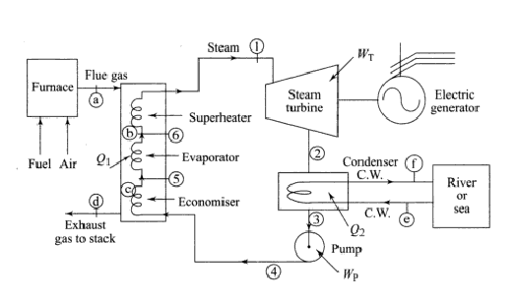
Figure 2.2 A simple steam plant representing Rankine cycle [21]
For the sake of analyzing the power plant, each process in vapour power cycle is assumed to be a hypothetical or ideal process which represents the basic intended operation. The irreversibility or the deviations which will be encountered in the practical application will be taken care off by considering an appropriate factor of efficiency. This gives rise to an ideal cycle, called a RANKINE CYCLE. Accordingly, heat is added at constant pressure reversibly; work done by the system is reversible adiabatic expansion; heat is rejected at reversible constant pressure in the condenser and the liquid is compressed adiabatically and reversibly ending it at the initial pressure. Within the furnace, the heat transfer to water takes place in three different regimes. Water is first heated sensibly in the economiser in the liquid phase at a certain pressure followed with the absorption of latent heat of vaporization owing to phase change in the evaporator. Finally the saturated vapours are further heated at constant pressure in the super heater.
2.1.4 Rankine Cycle
The water is sensibly heated from state 4s to 5 in the economizer. At the state 5 water becomes saturated liquid.
At the same pressure saturated liquid converts into the saturated vapour from state 5 to 6 by absorbing the latent heat of the vaporization. The saturated vapour at state 6 is further heated at constant pressure in the super heater to state 1in the vapour or gaseous state.
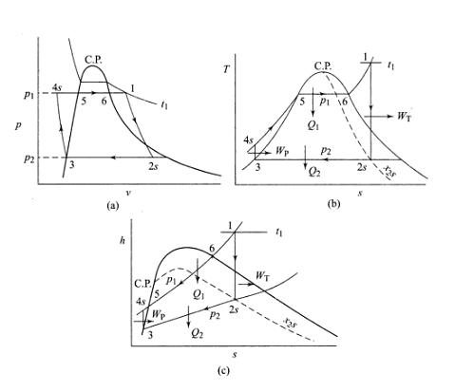
Figure 2.3 Rankine cycle on p-v, T-s and h-s coordinates [21]

2.1.5 Combined cycle power plants
On account of the ever-increasing demand of electric power, several new technologies have been developed during the last two decades. The thrust is mainly in the direction of increasing the efficiency of generation and the capacity of individual units and the entire power plants. New possibilities have been examined for large base load power plants, and more suitable and reliable peak load plants.
In some countries gas turbine power plants are preferred on account of the abundantly available fuel oil and natural gas. Recently large combined cycle power plants have also become popular.

Figure 2.4 Combined cycle operation with Brayton and Rankine cycle
The gas turbine power plant has been a late comer in the field of electric power generation. Its main disadvantages are lower thermal efficiency and capacity compared to the ‘main player’ in this field namely the hydro and steam turbine power plants. Attempts to improve the efficiency and output power of the gas turbine power plants by employing regeneration, intercooling and reheating result in significant pressure losses on account of longer gas flow passages; this also increase the capital and maintenance costs.
It has been found that a considerable amount of heat energy goes as a waste with the exhaust of the gas turbine. This energy must be utilized. The complete use of the energy available to a system is called the total energy approach. The objective of this approach is to use all of the heat energy in a power system at the different temperature levels at which it becomes available to produce work, or steam, or the heating of air or water, thereby rejecting a minimum of energy waste. The best approach is the use of combined cycles.
There may be various combinations of the combined cycles depending upon the place or country requirements. Even nuclear power plant may be used in the combined cycles.
Combined cycle power plant is a combination of an open cycle gas turbine and steam turbine. The exhaust of gas turbine which has high oxygen content is used as the inlet gas to the steam generator where the combustion of additional fuel takes place. This combination allows nearer equality between the power outputs of the two units than is obtained with the simple recuperative heat exchanger. For a given total power output the energy input is reduced (i.e., saving in fuel) and the installed cost of gas turbine per unit of power output is about one-fourth of that of steam turbine. In other words, the combination cycles exhibit higher efficiency. The greater disadvantages include the complexity of the plant, different fuel requirements and possible loss of flexibility and reliability. The most recent technology in the field of co-generation developed in USA utilizes the gaseous fuel in the combustion chambers produced by the gasification of low quality of coal. The system is efficient and the cost of power production per kW is less.
2.2 First Law of Thermodynamics
Based on experimental observations, the first law of thermodynamics states that energy can be neither created nor destroyed during a process; it can only change forms. Therefore, every bit of energy should be accounted for during a process.
Consider a system undergoing a series of adiabatic processes from a specified state 1 to another specified state 2. Being adiabatic, these processes obviously cannot involve any heat transfer, but they may involve several kinds of work interactions. Careful measurements during these experiments indicate the following: For all adiabatic processes between two specified states of a closed system, the net work done is the same regardless of the nature of the closed system and the details of the process. Considering that there are an infinite number of ways to perform work interactions under adiabatic conditions, this statement appears to be very powerful, with
a potential for far-reaching implications. This statement, which is largely based on the experiments of Joule in the first half of the nineteenth century, cannot be drawn from any other known physical principle and is recognized as a fundamental principle. This principle is called the first law of thermodynamics or just the first law. A major consequence of the first law is the existence and the definition of the property total energy E. Considering that the net work is the same for all adiabatic processes of a closed system between two specified states, the value of the net work must depend on the end states of the system only, and thus it must correspond to a change in a property of the system. This property is the total energy. Note that the first law makes no reference to the value of the total energy of a closed system at a state. It simply states that the change in the total energy during an adiabatic process must be equal to the net work done. Therefore, any convenient arbitrary value can be assigned to total energy at a specified state to serve as a reference point.
2.3 Exergy
The energy content of the universe is constant, just as its mass content is. Yet at times of crisis we are bombarded with speeches and articles on how to “conserve” energy. As engineers, we know that energy is already conserved. What is not conserved is exergy, which is the useful work potential of the energy. Once the exergy is wasted, it can never be recovered. When we use energy (to heat our homes for example), we are not destroying any energy; we are merely converting it to a less useful form, a form of less exergy.
The useful work potential of a system at the specified state is called exergy. Exergy is a property and is associated with the state of the system and the environment. A system that is in equilibrium with its surroundings has zero exergy and is said to be at the dead state. The exergy of heat supplied by thermal energy reservoirs is equivalent to the work output of a Carnot heat engine operating between the reservoir and the environment.
Reversible work Wrev is defined as the maximum amount of useful work that can be produced (or the minimum work that needs to be supplied) as a system undergoes a process between the specified initial and final states. This is the useful work output (or input) obtained when the process between the initial and final states is executed in a totally reversible manner. The difference between the reversible work Wrev and the useful work Wu is due to the irreversibilities present during the process and is called the irreversibility I. It is equivalent to the exergy destroyed. For a totally reversible process, the useful and reversible work terms are identical and thus exergy destruction is zero. Exergy destroyed represents the lost work potential and is also called the wasted work or lost work. The second-law efficiency is a measure of the performance of a device relative to the performance under reversible conditions for the same end states. Exergy can be transferred by heat, work, and mass flow. The exergy of an isolated system during a process always decreases or, in the limiting case of a reversible process, remains constant. This is known as the decrease of exergy principle.
2.4 Reversible work and irreversibility
The evaluation of exergy alone is not sufficient for studying engineering devices operating between two fixed states. This is because when evaluating exergy, the final state is always assumed to be the dead state (state at which the system is in thermodynamic equilibrium with the environment it is in), which is hardly ever the case for actual engineering systems.
We know that maximum amount of work that can be produced between two specified states is the reversible work. This reversible work is obtained when the process undergoes work in a totally reversible manner.
Irreversibilities are actually the losses which the energy encounters as the process progresses. It can be considered as the exergy destroyed or the reduction in work potential. Irreversibility is a positive quantity for all actual (irreversible) processes since W_{rev} ≥W_{u} for work- producing devices and W_{rev} ≤W_{u} for work-consuming devices. The smaller the irreversibility associated with a process, the greater the work that is produced (or the smaller the work that is consumed). The performance of a system can be substantially improved by minimizing the irreversibility associated with it.
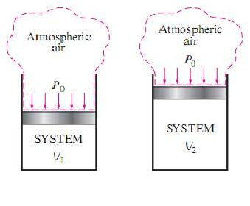

Figure 2.5 As a closed system expands, some work needs to be done to push the atmospheric air out of the way [22]
The concept will be clarified further with the help of an example [22]. When a gas in a piston–cylinder device expands from volume V₁ to V₂, part of the work done by the gas is used to push the atmospheric air at pressure P₀ out of the way of the piston. This work, which cannot be recovered and utilized for any useful purpose (irreversible work), is equal to the atmospheric pressure P₀ times the volume change of the system,
W_{surr} = P₀ (V₂-V₁)
The difference between the actual work W and the surroundings work Wsurr is called the useful work W_{u}.
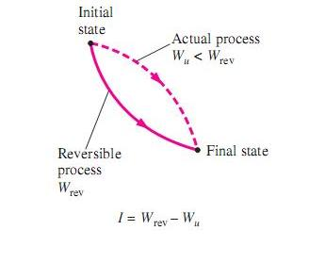
W_{u}=W-W_{surr}

Figure2.6 Difference between reversible work and actual work [22]
2.5 Second law efficiency
Second law efficiency may be termed as maximum thermal efficiency or maximum first law efficiency. To have a thorough idea what we are exactly dealing with, we will consider an [22]. Consider two heat engines both have a thermal efficiency of 30%. Engine A and B are accepting heat from 600K and 1000K respectively. Both of them reject the heat to a sink at 300K.
At first glance, both engines seem to convert to work the same fraction of heat that they receive; thus they are performing equally well. When we take a second look at these engines in light of the second law of thermodynamics, however, we see a totally different picture. These engines, at best, can perform as reversible engines, in which case their efficiencies would be

η_{rev,A} = ( 1 – T_{L}/ T_{H})_{A} = 1- (300/600) = 50%
η_{rev,B} = ( 1 – T_{L}/T_{H})_{B} = 1 – (300/1000) = 70%

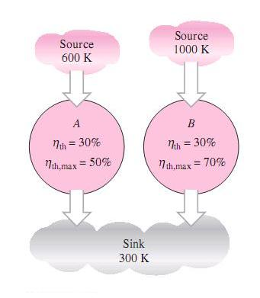

Figure 2.7 Two heat engine having same thermal efficiency but different maximum efficiency
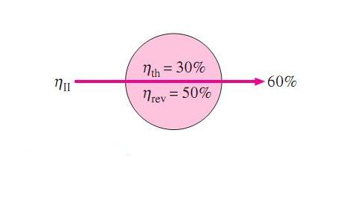
Now it is becoming apparent that engine B has a greater work potential available to it (70 percent of the heat supplied as compared to 50 percent for engine A), and thus should do a lot better than engine A. Therefore, we can say that engine B is performing poorly relative to engine.

Figure 2.8 Second law efficiency is a measure of performance of device relative to its performance under reversible conditions [22]

Even though both have the same thermal efficiency. It is obvious from this example that the first-law efficiency alone is not a realistic measure of performance of engineering devices. To overcome this deficiency, we define a second-law efficiency η_{II} as the ratio of the actual thermal efficiency to the maximum possible (reversible) thermal efficiency under the same conditions:
η_{II} = (η_{th} / η_{th,rev} )
Based on this definition, the second law efficiencies of the heat engines discussed above are:
η_{II,A} = (0.3 / 0.5) = 0.6 and η_{II,B} = (0.3/0.7) = 0.43
That is, engine A is converting 60 percent of the available work potential to useful work. This ratio is only 43 percent for engine B. Now, in order to give the expression a mathematical form, we need to define it first in the most general form. The second-law efficiency is intended to serve as a measure of approximation to reversible operation. Keeping this in mind, we define the second-law efficiency of a system during a process as:
η_{II} = ( Exergy recovered / Exergy supplied )
One must bear in mind that the exergy can be supplied or recovered at various amounts in various forms such as heat, work, kinetic energy, potential energy, internal energy, and enthalpy. Sometimes there are differing (though valid) opinions on what constitutes supplied exergy, and this causes differing definitions for second-law efficiency. At all times, however, the exergy recovered and the exergy destroyed (the irreversibility) must add up to the exergy supplied. For instance, in a heat engine, the exergy supplied is the decrease in the exergy of the heat transferred to the engine, which is the difference between the exergy of the heat supplied and the exergy of the heat rejected. (The exergy of the heat rejected at the temperature of the surroundings is zero.) The net work output is the recovered exergy.
Similarly in other devices like refrigerator or heat pump, the exergy supplied is the work input since the work supplied to a cyclic device is entirely available. The recovered exergy is the exergy of the heat transferred to the high-temperature medium (which is
the reversible work) for a heat pump, and the exergy of the heat transferred from the low-temperature medium for a refrigerator.
But for a heat exchanger with two unmixed fluid streams, normally the exergy supplied is the decrease in the exergy of the higher-temperature fluid stream, and the exergy recovered is the increase in the exergy of the lower- temperature fluid stream.
2.6 Exergy change of a system
From above discussions it’s clear that unlike energy, the value of exergy depends on the state of the environment as well as the state of the system. Therefore, exergy is a combination property. The exergy of a system that is in equilibrium with its environment i.e. dead state is zero. Depending upon the surrounding conditions, we have broadly classified exergy change in two categories i.e. flow exergy and non-flow exergy.
2.6.1 Exergy change of an open system exchanging heat only with the surroundings: Flow exergy
Let us consider an open system exchanging energy only with the surroundings at constant temperature T₀ and at constant pressure p₀ as illustrated in figure 7[1]. A mass dm₁ enters the system at state 1, a mass dm₂ leaves the system at state 2, an amount of heat Q is absorbed by the system, an amount of work W is delivered by the system, and the energy of the system (control volume) changes by an amount d(E)_{σ}. Applying the first law, we have

W = dE_{σ} = 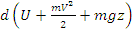
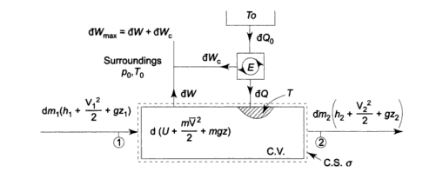
Figure 2.9 Reversible work done by an open system while exchanging heat only with the surroundings [22]
For the maximum work, the process must be entirely reversible. There is a temperature difference between the control volume and the surroundings. To make the heat transfer process reversible, let us assume a reversible heat engine E operating between the two. Again, the temperature of the fluid in the control volume may be different at different points. It is assumed that heat transfer occurs at points of the control surface σ where the temperature is T. Thus in an infinitesimal reversible process an amount of heat Q0 is absorbed by the engine E from the surroundings at temperature T0, an amount of heat Q is rejected by the engine reversibly to the system where the temperature is T, and an amount of work Wc is done by the engine. For a reversible engine,
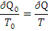
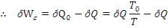

Now since the process is reversible, the entropy change of the system will be equal to the net entropy transfer, and S_{gen} = 0. Therefore,
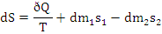
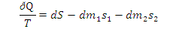
Now, the maximum work is equal to the sum of the system work dW and the work W_{c} of the reversible engine E,
W_{max} =W_{rev}= W + W_{c}

Substituting value for W,
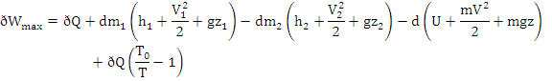
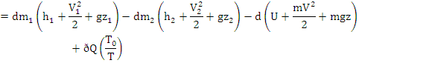
On substituting the value of,
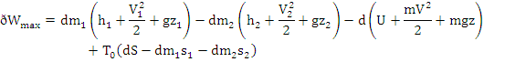
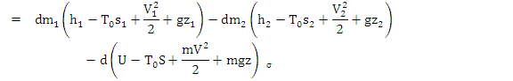
The above equation is the general expression for the maximum work of an open system which exchanges heat only with surroundings at T₀, p_{0.}
2.6.2 Exergy of a steady flow stream: Steady Flow exergy

For steady flow process
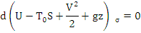
The above equation reduces to:
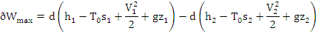
For total mass flow,
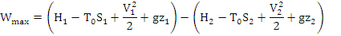
Where ψ is called the availability function of a steady flow process
If K.E. and P.E. changes are neglected, the above equations become:
2.7 Exergy destruction
Irreversibilities such as friction, mixing, chemical reactions, heat transfer through a finite temperature difference, unrestrained expansion, nonquasiequilibrium compression or expansion always generate entropy, and entropy always destroys exergy. The exergy destroyed is proportional to the entropy generated and is expressed as

X_{destroyed} = T_{o} S_{gen}

This equation is applicable to any kind of system undergoing any kind of process since any system and its surroundings can be enclosed by a sufficiently large arbitrary boundary across which there is no heat, work, and mass transfer, and thus any system and its surroundings constitute an isolated system. No actual process is truly reversible, and thus some exergy is destroyed during a process. The more irreversible a process is, the larger the exergy destruction during that process. No exergy is destroyed during a reversible process.

Chapter 3
LITERATURE REVIEW: Recent work

Combined cycle power plant is an extensive area of research, in which several researchers have already made their valuable contribution and several others are indulging themselves in this direction. Literature survey of recent work related to exergy destruction in thermal power pant is presented in this chapter.
Habib et al. (1995) have studied the optimization of reheat pressures in thermal power plants. They presented a procedure for optimization of the first and second reheat pressures in thermal power plants. The analysis is based on the first-law efficiency and exergy-balance equations. For analysis, they had divided the plant into two main units (the steam generator and the turbine cycle). The results of this study indicate that a range of first and second reheat pressures satisfy different constraints. Improvements in the plant second-law efficiency with increased reheat pressure are due to improvements in the turbine-cycle unit. They had also observed that exergy destruction in the steam generator, which accounts for more than half of the exergy destruction in the power plant, is not significantly affected by reheat pressures. [1]

Radcenco et al. (1998) have studied thermodynamic optimization of a gas turbine power plant with pressure drop irreversibilities. In this paper they showed that the thermodynamic performance of a gas turbine power plant can be optimized by adjusting the flow rate and the distribution of pressure losses along the flow path. Specifically, they observed that the power output has a maximum with respect to the fuel flow rate or any of the pressure drops. The maximized power output has additional maxima with respect to the overall pressure ratio and overall temperature ratio. They observed that when the optimization is performed subject to a fixed fuel flow rate, and the power plant size is constrained, the power output and efficiency can be maximized again by properly allocating the fixed total flow area among the compressor inlet and the turbine outlet. [2]

Bassily (2001) has studied the effects of evaporative inlet and aftercooling on the recuperated gas turbine cycle. The researcher had observed that inlet air cooling and cooling of the compressor discharge using water injection boost both efficiency and power of gas turbine cycles. In this paper four different layouts of the recuperated gas turbine cycle are presented. Those layouts include the effect of evaporative inlet and aftercooling (evaporative cooling of the compressor discharge). A parametric study of the effect of turbine inlet temperature (TIT), ambient temperature, and relative humidity on the performance all four layouts is investigated. The results of the study showed that as TIT increase the optimum pressure ratio increases by 0.45 per 100 K for the regular recuperated cycle and by 1.4 per 100 K for the recuperated cycle with evaporative aftercooling. The cycle with evaporative aftercooling have distinctive pattern of performance curves and higher values of optimum pressure ratios. The result also showed that evaporative cooling of the inlet air could boost the efficiency by up to about 110% and cycle efficiency by up to 16%. [3]

Franco and Casarosa (2002) have studied on some perspectives for increasing the efficiency of combined cycle power plants. The paper proposes an analysis of some possibilities to increase the combined cycle plant efficiency to values higher than the 60% without resorting to a new gas turbine technology. This study reveals that the optimization of heat recovery steam generator (HRSG) with the use of parallel sections and of limit subcritical conditions (up to 220 bar) is the key elements to obtain this result. They found that HRSG optimization is sufficient to obtain combined cycle plant efficiencies of the order of 60% while, joining HRSG optimization with the use of gas turbine reheat (postcombustion) and gas to gas recuperation can lead the efficiency of the whole plant to the limit value of 65%. Results of this study are proposed with reference to a turbine inlet temperature of 1500 K, corresponding to those of usual commercial D-F series gas turbine. [4]

Dincer (2002) has studied the role of exergy in energy policy making. This paper deals with the utilization of exergy as an efficient tool for energy policy making applications since exergy is a measure of quantity and quality of the exergy sources unlike energy which is only about the quantity. In addition, energy and exergy concepts are evaluated for various actual process, and the role of exergy is discussed for energy and environment policymaking activities from several key perspectives, e.g., quality, energy conservation environment, economy, and sustainable developments. The results of this study exhibit that the potential usefulness exergy in addressing and solving environment problems as well as attaining sustainable development is crucial. The researcher has concluded some crucial remarks on exergy from this study as:
1. It is an effective method using the conservation of mass and conservation of energy principles together with the second law of thermodynamics for the design and analysis of energy systems.
2. It is a suitable technique for furthering the of more efficient energy-resource use and hence energy conservation.
3. It is an efficient technique revealing whether or not and by how much it is possible to design more efficient energy systems by reducing the inefficiencies in existing systems.
4. It is an essential indicator to distinguish the quality between energy resources.
5. It is recognized as a new measure of environmental degradation and hence one of the potential techniques to minimize the eliminate the environmental impact. [5]

Leo et al. (2003) has studied gas turbine turbocharged by a steam turbine: a gas turbine solution increasing combined power plant efficiency and power. In this paper a new design of a combined-cycle gas turbine power plant (CCGT) with sequential combustion that increases efficiency and power output in relation to conventional CCGT plants is studied. This innovative proposal consists fundamentally in using all the power of the steam turbine to turbocharge the gas turbine. A computer program has been developed in this study to carry out calculations and to evaluate performance over a wide range of operating conditions. The obtained results are compared with those of combined cycles where the gas turbines are not turbocharged and the gas and the steam turbines have independent power exits; the advantages of the new design are stated. [6]

Bassily (2004) has studied the Performance improvements of the intercooled reheat recuperated gas-turbine cycle using absorption inlet-cooling and evaporative after-cooling. An absorption inlet cooling system is introduced to the intercooled reheat recuperated gas-turbine cycle (I cycle). The exhaust gas of the cycle is used to run the system, which cools the inlet air to the low pressure compressor and high-pressure compressor using two stages of cooling in the intercooler. In this paper five different layouts of the I cycle are presented. Those layouts include the effects of absorption inlet cooling, evaporative inlet cooling, evaporative aftercooling, and absorption inlet cooling with evaporative aftercooling. A parametric study of the effect of pressure ratio, ambient temperature, ambient relative-humidity, turbine’s inlet-temperature (TIT), and the effectiveness of the recuperated heat-exchanger () on the performance of all cycles is carried out. The results of this study indicate that using two stages of cooling in the intercooler could boost the gain in efficiency, because of applying evaporative inlet cooling, by up to 1.55%. Applying absorption inlet-cooling could increase the efficiency of the I cycle by up to 6.6% compared with 3.9% for applying evaporative inlet cooling. Applying absorption inlet-cooling with evaporative aftercooling could increase the optimum efficiency of the I cycle by 3.5% and its maximum power by more than 50%. Increasing TIT increases the capacity of the recuperated heat exchanger and absorption cooling system and raises the gain in efficiency because of increasing () has also observed. [7]

Khaliq and Kaushik (2004) have studied Second-law based thermodynamic analysis of Brayton/Rankine combined power cycle with reheat. The aim of the present paper is to use the second-law approach for the thermodynamic analysis of the reheat combined Brayton/Rankine power cycle. Expressions involving the variables for specific power-output, thermal efficiency, exergy destruction in components of the combined cycle, second-law efficiency of each process of the gas-turbine cycle, and second law efficiency of the steam power cycle have been derived. The standard approximation for air with constant properties is used for simplicity. In this paper the effects of pressure ratio, cycle temperature ratio, number of reheats and cycle pressure-drop on the combined cycle performance parameters have been investigated. The results of this study showed that the exergy destruction in the combustion chamber represents over 50% of the total exergy destruction in the overall cycle. The combined cycle efficiency and its power output were maximized at an intermediate pressure-ratio, and increased sharply up to two reheat-stages and more slowly thereafter. [8]

Ertesvag et al. (2005) have shown the exergy analysis of a gas-turbine combined-cycle power plant with precombustion CO₂ capture. A concept for natural-gas (NG) fired power plants with CO₂ capture was investigated using exergy analysis. NG was reformed in an auto-thermal reformer (ATR), and the CO₂ was separated before the hydrogen-rich fuel was used in a conventional combined-cycle (CC) process. The main purpose of the study was to investigate the integration of the reforming process and the combined cycle. A corresponding conventional CC power plant with no CO₂ capture was simulated for comparison. A base case with CO₂ capture was specified with turbine-inlet temperature (TIT) of 1250 and an air-compressor outlet pressure of 15.6 bar. In this case, the net electric-power production was 48.9% of the lower heating value (LHV) of the NG or 46.9% of its chemical exergy. The captured and compressed CO₂ (200 bar) represented 3.1% of the NG chemical exergy, while the NG, due to its pressure (50 bar), had a physical exergy equal to 1.0% of its chemical exergy. This research explores the effects of the changed NG composition and environmental temperature. [9]

Sengupta et al. (2007) have studied the exergy analysis of a coal-based 210 MW thermal power plant. In the present work, exergy analysis of a coal-based thermal power plant is done using the design data from a 210 MW thermal power plant under operation in India. The entire plant cycle is split up into three zones for the analysis: (1) only the turbo-generator with its inlets and outlets, (2) turbo-generator, condenser, feed pumps and the regenerative heaters, (3) the entire cycle with boiler, turbo-generator, condenser, feed pumps, regenerative heaters and the plant auxiliaries. It helps to find out the contributions of different parts of the plant towards exergy destruction. The exergy efficiency is calculated using the operating data from the plant at different conditions, viz. at different loads, different condenser pressures, with and without regenerative heaters and with different settings of the turbine governing. The load variation is studied with the data at 100, 75, 60 and 40% of full load. Effects of two different condenser pressures, i.e. 76 and 89 mmHg (abs.), are studied. Effect of regeneration on exergy efficiency is studied by successively removing the high pressure regenerative heaters out of operation. The turbine governing system has been kept at constant pressure and sliding pressure modes to study their effects. They have observed that the major source of irreversibility in the power cycle is the boiler, which contributes to exergy destruction of the order of 60%. Part load operation increases the irreversibilities in the cycle and the effect is more pronounced with the reduction of the load. Increase in the condenser back pressure decreases the exergy efficiency. Successive withdrawal of the high pressure heaters show a gradual increment in the exergy efficiency for the control volume excluding the boiler, while a decrease in exergy efficiency when the whole plant including the boiler is considered. Keeping the main steam pressure before the turbine control valves in sliding mode improves the exergy efficiencies in case of part load operation. [10]

Khaliq and Choudhary (2007) have studied the combined first and second-law analysis of gas turbine cogeneration system with inlet air cooling and evaporative aftercooling of the compressor discharge. They performed Computational analysis to investigate the effects of the overall pressure ratio, turbine inlet temperature, and ambient relative humidity on the exergy destruction in each component, first-law efficiency, power-to-heat ratio, and second-law efficiency of the cycle. They found that the thermodynamic analysis indicates that exergy destruction in various components of the cogeneration cycle is significantly affected by overall pressure ratio and turbine inlet temperature, and not at all affected by the ambient relative humidity. It also indicates that the maximum exergy is destroyed during the combustion process, which represents over 60% of the total exergy destruction in the overall system. Results clearly show that performance evaluation based on first-law analysis alone is not adequate, and hence, more meaningful evaluation must include second-law analysis. [11]

Sanjay et al. (2007) have performed research work on energy and exergy analysis of steam cooled reheat gas steam combined cycle. This research paper deals with parametric energy and exergy analysis of reheat gas–steam combined cycle using closed-loop-steam-cooling. They have compared the blade cooling techniques and found that closed-loop-steam-cooling to be superior to air-film cooling. The reheat gas–steam combined cycle plant with closed-loop-steam-cooling exhibits enhanced thermal efficiency (around 62%) and plant specific work as compared to basic steam–gas combined cycle with air-film cooling as well as closed-loop-steam cooling. Further, with closed-loop-steam-cooling, the plant efficiency, reaches an optimum value in higher range of compressor pressure ratio as compared to that in film air cooling. They have also concluded that
1. Reheat pressure is an important design parameter and its optimum value gives maximum plant efficiency.
2. Air-film-cooling offers more exergy loss in compressor as compared to closed-loop-steam cooling while gas turbine exergy loss is less in air-film-cooling. Higher value of exergy in gas turbine is exhibited for closed-loop-steam cooling, while higher value of steam turbine exergy is that for air-film-cooling. Lower values of exergy losses are observed in compressor, gas turbine, heat-recovery-steam-generator, stack, steam turbine, condenser boiler-feed-pump and deaerator for closed-loop-steam cooling.
3. The summation of all exergy losses of all components are found to be lesser in closed-loop steam cooling than in air-film-cooling. [12]

Butcher and Reddy (2007) have studied Second law analysis of a waste heat recovery based power generation system. In this paper the performance of a waste heat recovery power generation system based on second law analysis is investigated for various operating conditions. The temperature profiles across the heat recovery steam generator (HRSG), network output, second law efficiency and entropy generation number are simulated for various operating conditions. The variation in specific heat with exhaust gas composition and temperature are accounted in the analysis and results. The effect of pinch point on the performance of HRSG and on entropy generation rate and second law efficiency are also investigated. The researchers found that the second law efficiency of the HRSG and power generation system decreases with increasing pinch point. The first and second law efficiency of the power generation system varies with exhaust gas composition and with oxygen content in the gas. The results contribute further information on the role of gas composition, specific heat and pinch point influence on the performance of a waste heat recovery based power generation system based on first and second law of thermodynamics. [13]

Ameri et al. (2008) have studied the exergy analysis of a 420MW combined cycle power plant. Their objective is to evaluate irreversibility of each part of Neka CCPP using the exergy analysis. The results show that the combustion chamber, gas turbine, duct burner and heat recovery steam generator (HRSG) are the main sources of irreversibility representing more than 83% of the overall exergy losses. The results show that the greatest exergy loss in the gas turbine occurs in the combustion chamber due to its high irreversibility. As the second major exergy loss is in HRSG, the optimization of HRSG has an important role in reducing the exergy loss of total combined cycle. In this case, LP-SH has the worst heat transfer process. The first law efficiency and the exergy efficiency of CCPP are calculated. Thermal and exergy efficiencies of Neka CCPP are 47 and 45.5% without duct burner, respectively. The results show that if the duct burner is added to HRSG, these efficiencies are reduced to 46 and 44%. Nevertheless, the results show that the CCPP output power increases by 7.38% when the duct burner is used. [14]

Som and Datta (2008) have shown the thermodynamic irreversibilities and exergy balance in combustion processes. The present paper makes a comprehensive review pertaining to fundamental studies on thermodynamic irreversibility and exergy analysis in the processes of combustion of gaseous, liquid and solid fuels. The need for such investigations in the context of combustion processes in practice is first stressed upon and then the various approaches of exergy analysis and the results arrived at by different research workers in the field have been discussed. It has been recognized that, in almost all situations, the major source of irreversibilities is the internal thermal energy exchange associated with high temperature gradients caused by heat release in combustion reactions. They observed that the primary way of keeping the exergy destruction in a combustion process within a reasonable limit is to reduce the irreversibility in heat conduction through proper control of physical processes and chemical reactions resulting in a high value of flame temperature but lower values of temperature gradients within the system. The optimum operating condition in this context can be determined from the parametric studies on combustion irreversibilities with operating parameters in different types of flames. [15]
Borelli and Junior (2008) have studied the exergy-based method for analyzing the composition of the electricity cost generated in gas-fired combined cycle plants. They proposed a method to analyze the composition of the cost of electricity is based on the energy conversion processes and the destruction of the exergy through the several thermodynamic processes that comprise a combined cycle power plant. This method uses thermoeconomics to evaluate and allocate the cost of exergy throughout the processes, considering costs related to inputs and investment in equipment. Although the concept may be applied to any combined cycle or cogeneration plant, this work develops only the mathematical modeling for three pressure heat recovery steam generator (HRSG) configurations and total condensation of the produced steam. It is possible to study any n×1 plant configuration (n sets of gas turbine and HRSGs associated to one steam turbine generator and condenser) with the developed model, assuming that every train operates identically and in steady state. The variations and adaptations include, for instance, use of reheat, supplementary firing and partial load operation. It is also possible to undertake sensitivity analysis on geometrical equipment parameters. [16]

Aljundi (2009) has studied energy and exergy analysis of a steam power plant in Jordan. In this study, the energy and exergy analysis of Al-Hussein power plant in Jordan is presented. The primary objectives of this paper are to analyze the system components separately and to identify and quantify the sites having largest energy and exergy losses. In addition, the effect of varying the reference environment state on this analysis will also be presented. The performance of the plant was estimated by a component-wise modeling and a detailed break-up of energy and exergy losses for the considered plant has been presented. The researcher has observed that the energy losses mainly occurred in the condenser where 134 MW is lost to the environment while only 13 MW was lost from the boiler system. The percentage ratio of the exergy destruction to the total exergy destruction was found to be maximum in the boiler system (77%) followed by the turbine (13%), and then the forced draft fan condenser (9%). In addition, the calculated thermal efficiency based on the lower heating value of fuel was 26% while the exergy efficiency of the power cycle was 25%. For a moderate change in the reference environment state temperature, no drastic change was noticed in the performance of major components and the main conclusion remained the same; the boiler is the major source of irreversibilities in the power plant. Chemical reaction is the most significant source of exergy destruction in a boiler system which can be reduced by preheating the combustion air and reducing the air-fuel ratio. [17]

3.1 Conclusion of Literature review
During study the research papers mentioned in the literature review, it has been observed that a limited amount of work is available on exergy analysis of combined cycle power plant. There is a need to carry out the exergy analysis of combined cycle plants with different configurations and how the irreversibilities associated in the plan can be reduced by modifying the cycle. The efforts have been made through this work to find out exergy destruction of each component of the plant with respect to change in variation of turbine inlet temperature, overall pressure ratio, ambient relative humidity and other input variables.

Chapter 4
MODELLING OF SELECTED CONFIGURATIONS

4.1 System Description
Figure 4.1 shows the schematic diagram of a combined cycle power plant with two feed water heaters, air filter and inlet air cooling. Ambient air enters the air filter to protect the compressor blades and other components of the plant from the dust particle. After pressure drop at constant pressure in air filter air reached at state 2. Ambient air is cooled and humidified in the air humidifier (AH1) before it counter pass the inlet air to lower-pressure compressor (LPC) in the air cooler (AC), cooling the inlet air. Air at 3 is cooled to a temperature that is close to the wet bulb temperature at 2. Compressed air from the lower-pressure compressor at 4 is cooled to 5 in an indirect intercooler using ambient humidifier air that is humidified in the air humidifier (AH2) and has a lower than ambient temperature. This air enters the high-pressure compressor (HPC) and is compressed from state 5 to state 6. The outlet air of HPC at 6 enters the regenerative heat exchanger (HE), where it exchanges heat with power turbine (PT) exhaust at 11, gets heated at 7 and supplied to the combustion chamber (CC) (where fuel is burned), producing hot gases at 8. The hot gas is then expanded to 9 in the high pressure turbine (HPT) to a lower pressure and temperature before it is recombusted in the reheater (REH), after which the reheat gas expands, through a power turbine to drive a load. Part of the heat of hot exhaust gas is used in the HE, and part of this heat is utilized in the waste heat recovery boiler (WHRB) to generate steam. The steam which produced in WHRB from liquid feed by pump (P3) by exchanging heat enters steam turbine (ST) at 13; expand till condenser pressure at state 16 to drive a load. In the condenser steam turbine exhaust condensed to saturated state 17 and feed by the pump (P1) in the feed water heater (FWH2) at state 18 for direct mixing with steam which bled from the steam turbine at 15 to FWH2. Saturated liquid which is at state 19 pumped by P2 to feed water heater (FWH1) at state 20 for direct mixing with steam which bled from steam turbine at state 14 to FWH1. Saturated liquid at state 21 feed by pump (P3) to WHRB at state 22 to produced heat.

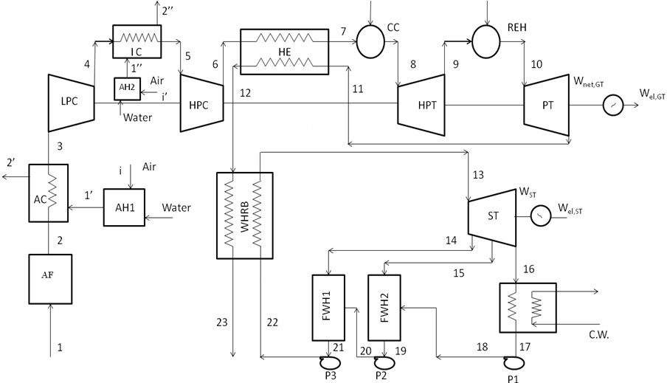

Figure 4.1 Schematic diagram of the combined cycle power plant with two feed water heaters (CASE 7)

For performing the comparative study, the configurations of other six cases are as follows:
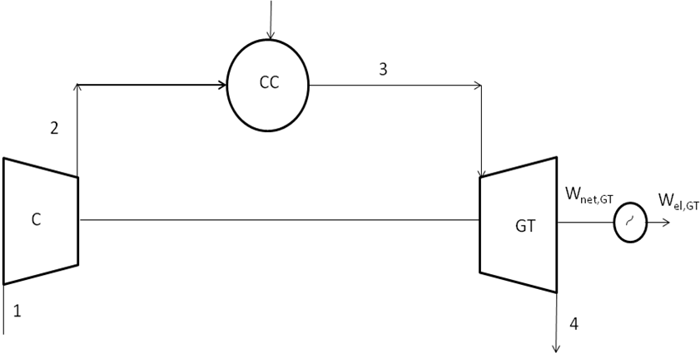
Figure 4.2 Schematic diagram of the simple gas turbine cycle (CASE 1)

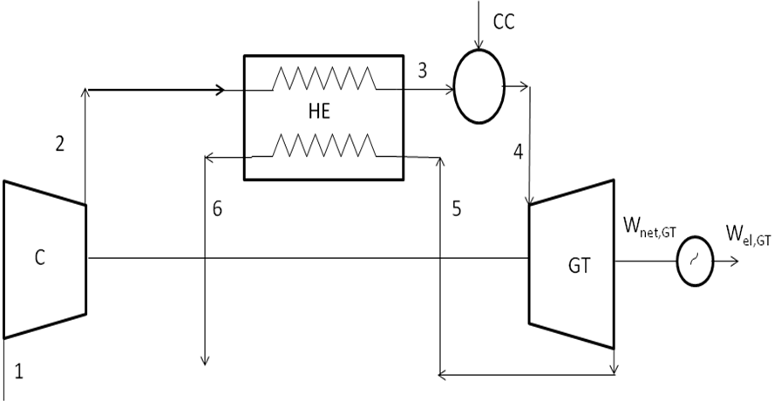
Figure 4.3 Schematic diagram of the gas turbine cycle with regenerator (CASE 2)

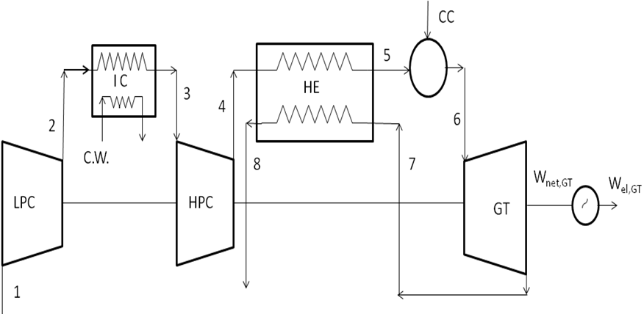
Figure 4.4 Schematic diagram of the gas turbine cycle with regenerator and intercooler (CASE 3)

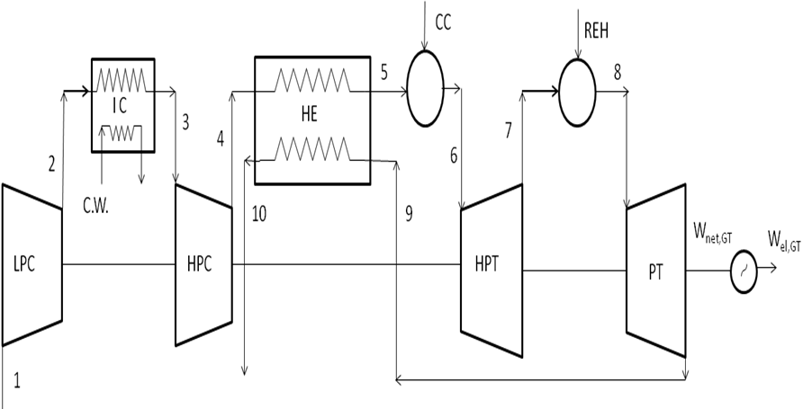

Figure 4.5 Schematic diagram of the gas turbine cycle with regenerator, intercooler and reheater (CASE 4)

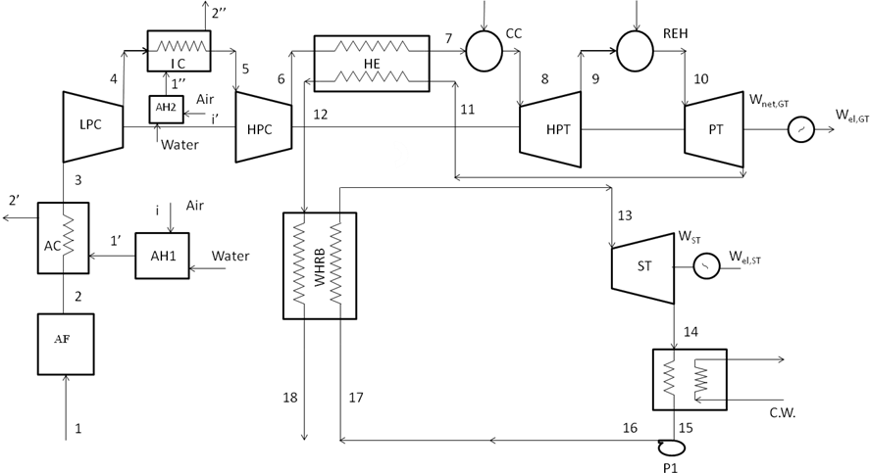
Figure 4.6 Schematic diagram of the combined cycle power plant (CASE 5)

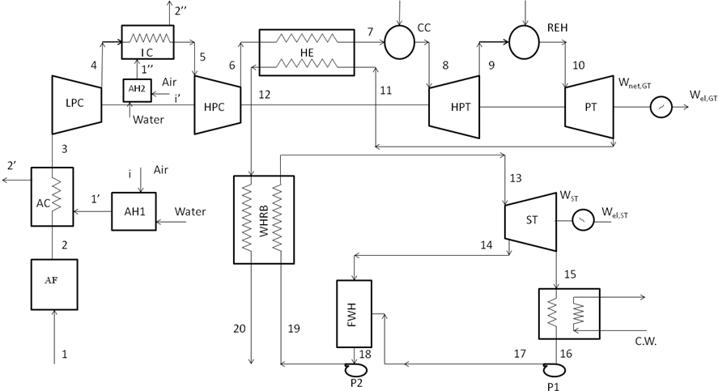
Figure 4.7 Schematic diagram of the combined cycle power plant with one feed water heater (CASE 6)
4.2 Mathematical Model
Energy technologies are normally examined using energy analysis. A better understanding is attained when a more complete thermodynamic view is taken, which uses the second law of thermodynamics in conjunction with energy analysis, via the exergy method [18]. An exergy analysis is the combination of the first and second laws of thermodynamics, in which the efficiencies of processes and devices are evaluated and the locations and cause/ sources of major inefficiencies are identified. If the system operates in a steady-state, steady flow condition and all the nonreacting gases are arbitrarily assigned as zero thermomechanical enthalpy, entropy, and exergy at the condition of ambient pressure and temperature regardless of their chemical composition, then the entropy of mixing different gaseous components can be neglected, and the general exergy-balance equation is given by [19].

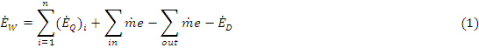

For single stream flow,

(2)

where

(3)
and
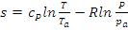 (4)

4.2.1 Air Filter
The exergy balance for the air filter gives exergy destruction

= () (5)

4.2.2 Air Humidifier
Applying the mass balance equation yields

(6)

Temperature and humidity ratio at the exit of a air humidifier can be calculated by energy balance given as

(7)

The enthalpy h is calculated by

(8)

The exergy balance for air humidifier gives exergy destruction

(9)

4.2.3 Air Compressors
For a given compressor isentropic efficiency and pressure ratio, other state variables for the incoming and outgoing streams can be calculated. The energy balance yields the compressor work , and the exergy balance for the compressor gives the exergy destruction

(10)

(11)

The temperature at the compressor outlet can be calculated from the following equation
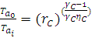 (12)

4.2.4 Gas Turbines
For the expansion ratio, temperature at the exit of the turbine isentropic process can be calculated by
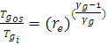 (13)
The actual temperature at the exit of the turbine can be calculated by

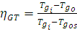 (14)

The energy balance yields the turbine work and the exergy balance for the turbine gives the exergy destruction as

=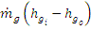 (15)

(16)

4.2.5 Heat Exchanger
Temperature of air (Ta_{o}) at the exit of a heat exchanger can be calculated by

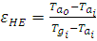 (17)

Assume that the air- and gas-side pressure drop, both are 2%, so that
(18)
(19)
Applying the energy balance equation on the heat exchanger yields
( (20)
The exergy balance of the heat exchanger yields exergy destruction
(21)
4.2.6 Combustor
Mass of fuel supplied can be calculated by energy balance
) (22)
The exergy balance of the combustion chamber yields exergy destruction.
] (23)
Where A=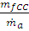
(24)
(25)
where is the entropy change during the combustion process and is given as
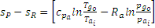 (26)

4.2.7 Waste Heat Recovery Boiler
Mass of steam can be calculated by the energy balance equation as
( (27)
Exergy destroyed in WHRB can be calculated by
(28)

4.2.8 Steam Turbine
The actual enthalpy at the exit of the steam turbine can be calculated by
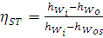 (29)
The energy balance yields the turbine work and the exergy balance for the turbine gives the
exergy destruction as

= (30)
(31)

4.2.9 Feed Water Heaters
The energy balance yields the supplied mass of steam and respectively in the feed water heater 1 and feed water heater 2, and the exergy balance for the feed water heaters gives the exergy destruction and

+ () = (32)

+ () (33)

+ ()= (34)

+ () (35)

4.2.10 Condenser
The energy balance yields the mass of cooling water , and the exergy balance for the condenser gives the exergy destruction

()= (36)

() () +() (37)

4.2.11 Pumps
The actual enthalpy at the exit of the pump can be calculated by
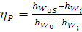 (38)

The energy balance yields the pump work and the exergy balance for the pump gives the exergy destruction as

(39)

(40)

4.3 Performance Parameter
The relevant parameters required for the combined first- and second-law analysis of combined cycle power plant may be considered as follows.
4.3.1 First-Law Efficiency
The ratio of all the useful energy extracted from the system (electricity) to the energy of fuel input is known as the first-law efficiency. By definition,
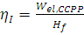 (41)
where is the electrical power output and is given by
= (42)
(43)
(44)
(45)
(46)

4.3.2 Second-Law Efficiency
Since exergy is more valuable than energy according to the second law of thermodynamics. It is useful to consider both output and input in terms of exergy [20]. The amount of exergy supplied in the product to the amount of exergy associated with the fuel is a more accurate measure of the thermodynamic performance of a system which is defined as
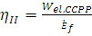 (47)
Where
(48)

4.5 Computer programming / Coding
The program coding for present study has been written in Engineering equation Solver ver. 7.929. The detailed coding is enclosed as Appendix.

4.5 Assumptions
The assumptions which take to solve this problem listed below.
- Pressure losses in air filter at new state filter media (new cartridge) based on 100% air flow is 3.5 mbar and the filter cartridges withstand a pressure drop (before they collapse) of air intake system is 250 mbar
- The relative humidity at air humidifiers outlet is 100%.
- The pressure drop for air in the air humidifier is negligible.
- The pressure drop for air in the air intercooler is 1%.
- The pressure drop for air in the air cooler (AC) is 1%.
- The pressure drop for air in the regenerative heat exchanger (HE) is 2%.
- The pressure drop for gas in the regenerative heat exchanger (HE) is 2%.
- The pressure drop in the combustion chamber and reheater is 4%.
- The pressure drop in the waste heat recovery boiler is 4%.
- The effectiveness for the air cooler (AC) is 85%.
- The effectiveness of the air intercooler is 90%.
- The effectiveness of the regenerative heat exchanger is 55%.
- The compressor isentropic efficiency is 87%.
- The gas turbine isentropic efficiency is 89%.
- Efficiency of the combustion chamber and reheater () is 95%.
- Generator efficiency () is 97%.
- The gas turbine capacity is 30 MW.
- The steam pressure at the steam turbine inlet is 25 bar.
- The steam temperature at the steam turbine inlet is 294
- Turbine exhaust pressure is 0.09 bar.
- Temperature rise of cooling water in condenser is 10.98
- Cooling water inlet temperature in condenser is 25
- Cooling water outlet temperature from condenser is 36
- The stack temperature is 140.
- The pump isentropic efficiency is 0.85%.
- The turbine isentropic efficiency is 0.85%.
- The fuel is methane gas, which has a lower heating value of 42,000 kJ/kg.
- Th
The ambient pressure and temperature are, respectively, 1 bar and 298
Chapter 5
RESULTS AND DISCUSSION

In this chapter the results and discussion have been presented. Before carrying out the study about the present work, the program code has been validated by comparing the results of present code with the published literature. Results and discussion on effect of variation of pressure ratio, turbine inlet temperature, ambient relative humidity on first-law efficiency and second-law efficiency have been presented next. After this the effect of variation of pressure ratio, turbine inlet temperature on exergy destruction in each component and in exhaust gas for all the seven configurations has been discussed followed by discussion on effect of variation of stack temperature on mass flow rate of steam, net work of steam turbine, exergy destruction in exhaust gas, WHRB and steam turbine, first-law efficiency and second-law efficiency. The effect of variation of ambient relative humidity, pressure loss in air filter, heat exchanger air side and gas side, combustion chamber, re-heater and WHRB on exergy destruction of each component for case 7 have been discussed at the end.
5.1 Validation of computer code
Initially the study was carried out for the configuration considered by Khaliq and Choudhary [11]. The computer program on engineering equation solver (EES) was made and tested for variation of pressure ratio, turbine inlet temperature separately on the exergy degradation in each component. The results obtained unit part code have been compared with the results of Khaliq and Choudhary [11] and it has been found that results are matching very closely. Tables 1, 2 and 3 contain results of Khaliq and Choudhary [11] and Table 4, 5 and 6 are results find out by EES in the present study.

Table 1 Effect of variation of pressure ratio on exergy destruction in different components of the cycle for TIT = 1600 K, = 60%, = 1 bar, = 298 K [11]
 | (kJ/kg da) | (kJ/kg da) | (kJ/kg da) | (kJ/kg da) | (kJ/kg da) | (kJ/kg da) | (kJ/kg da) | (kJ/kg da) | (kJ/kg da)
12 | 12.82 | 5.24 | 10.7 | 66.08 | 164.06 | 22.74 | 118.44 | 21.94 | 10.01
20 | 14.5 | 7.22 | 12.26 | 56.07 | 192.96 | 26.85 | 149.21 | 25.99 | 12.94
28 | 13.7 | 8.83 | 13.14 | 49.61 | 209.98 | 30.62 | 168.99 | 29.73 | 14.04
36 | 15.3 | 9.95 | 13.82 | 43.34 | 224.45 | 33.43 | 183.7 | 32.58 | 16.27
44 | 15.8 | 11.00 | 14.41 | 38.9 | 239.1 | 35.85 | 193.8 | 35.08 | 21.25
52 | 16.4 | 11.83 | 14.82 | 34.2 | 247.23 | 41.1 | 200.8 | 36.95 | 20.26

Table 2 Effect of variation of turbine inlet temperature on exergy destruction in different components of the cycle for = 36, = 60%, = 1 bar, = 298 K [11]
TIT  (K) | (kJ/kg da) | (kJ/kg da) | (kJ/kg da) | (kJ/kg da) | (kJ/kg da) | (kJ/kg da) | (kJ/kg da) | (kJ/kg da) | (kJ/kg da)
1300 | 15.3 | 9.95 | 13.82 | 29.17 | 205.7 | 33.45 | 173.3 | 32.69 | 6.09
1400 | 15.3 | 9.95 | 13.82 | 34.46 | 215.5 | 33.55 | 176.74 | 32.7 | 9.37
1500 | 15.3 | 9.95 | 13.82 | 39.88 | 220.03 | 33.47 | 180.2 | 32.63 | 12.74
1600 | 15.3 | 9.95 | 13.82 | 45.34 | 224.45 | 33.43 | 183.7 | 32.58 | 16.27
1700 | 15.3 | 9.95 | 13.82 | 50.83 | 234.00 | 33.43 | 187.4 | 32.6 | 19.9
1800 | 15.3 | 9.95 | 13.82 | 56.3 | 238.4 | 33.46 | 188.0 | 32.4 | 23.6
1900 | 15.3 | 9.95 | 13.82 | 61.83 | 242.6 | 33.26 | 189.14 | 32.4 | 27.4

Table 3 Effect of variation of ambient relative humidity on exergy destruction in different components of the cycle for TIT = 1600 K, = 60%, = 1 bar, = 298 K [11]
(%) | (kJ/kg da) | (kJ/kg da) | (kJ/kg da) | (kJ/kg da) | (kJ/kg da) | (kJ/kg da) | (kJ/kg da) | (kJ/kg da) | (kJ/kg da)
0.2 | 14.8 | 8.79 | 13.3 | 47.47 | 219.5 | 33.21 | 177.99 | 32.35 | 12.35
0.4 | 15.1 | 9.96 | 13.55 | 45.52 | 224.5 | 33.34 | 178.3 | 32.51 | 15.15
0.6 | 15.3 | 9.95 | 13.82 | 45.34 | 224.5 | 33.43 | 183.7 | 32.58 | 16.27
0.8 | 12.43 | 9.9 | 14.14 | 45.43 | 229.4 | 33.57 | 184.1 | 32.81 | 17.05

Table 4 Effect of variation of pressure ratio on exergy destruction in different components of the cycle for TIT = 1600 K, = 60%, = 1 bar, = 298 K
 | (kJ/kg da) | (kJ/kg da) | (kJ/kg da) | (kJ/kg da) | (kJ/kg da) | (kJ/kg da) | (kJ/kg da) | (kJ/kg da) | (kJ/kg da)
12 | 13.43 | 5.57 | 11.01 | 63.14 | 182.3 | 21.81 | 129.8 | 23.21 | 9.95
20 | 14.89 | 7.64 | 13.13 | 60.07 | 204.2 | 27.69 | 161.4 | 27.32 | 13.61
28 | 14.73 | 9.47 | 14.27 | 51.53 | 218 | 29.83 | 184.9 | 32.51 | 15.32
36 | 15.69 | 10.83 | 14.93 | 41.27 | 228 | 35.17 | 198.7 | 32.58 | 17.48
44 | 15.97 | 11.79 | 15.21 | 36.76 | 235.7 | 36.15 | 209.5 | 34.67 | 22.18
52 | 17.82 | 12.63 | 15.72 | 35.21 | 242.1 | 43.32 | 218.5 | 40.17 | 22.17

Table 5 Effect of variation of turbine inlet temperature on exergy destruction in different components of the cycle for = 36, = 60%, = 1 bar, = 298 K
TIT  (K) | (kJ/kg da) | (kJ/kg da) | (kJ/kg da) | (kJ/kg da) | (kJ/kg da) | (kJ/kg da) | (kJ/kg da) | (kJ/kg da) | (kJ/kg da)
1300 | 16.1 | 10.73 | 14.93 | 26.41 | 208 | 35.32 | 189.2 | 29.86 | 6.13
1400 | 16.1 | 10.73 | 14.93 | 37.23 | 215.3 | 35.67 | 192.6 | 29.91 | 10.18
1500 | 16.1 | 10.73 | 14.93 | 39.71 | 221.9 | 35.42 | 195.7 | 31.83 | 13.12
1600 | 16.1 | 10.73 | 14.93 | 43.62 | 228 | 35.33 | 198.7 | 31.94 | 15.67
1700 | 16.1 | 10.73 | 14.93 | 53.74 | 233.7 | 35.36 | 201.5 | 33.41 | 20.96
1800 | 16.1 | 10.73 | 14.93 | 59.13 | 239.1 | 35.72 | 204.3 | 34.24 | 25.27
1900 | 16.1 | 10.73 | 14.93 | 64.65 | 244.3 | 35.83 | 207.2 | 31.78 | 29.96

Table 6 Effect of variation of ambient relative humidity on exergy destruction in different components of the cycle for TIT = 1600 K, = 60%, = 1 bar, = 298 K
(%) | (kJ/kg da) | (kJ/kg da) | (kJ/kg da) | (kJ/kg da) | (kJ/kg da) | (kJ/kg da) | (kJ/kg da) | (kJ/kg da) | (kJ/kg da)
0.2 | 15.83 | 9.13 | 14.2 | 49.82 | 228.9 | 35.23 | 198.7 | 33.62 | 11.76
0.4 | 16.2 | 10.79 | 14.67 | 48.36 | 228.4 | 36.16 | 198.9 | 33.67 | 13.84
0.6 | 16.8 | 8.97 | 14.93 | 47.12 | 228 | 36.41 | 199.7 | 34.73 | 14.68
0.8 | 11.75 | 10.23 | 15.42 | 46.03 | 227.6 | 36.63 | 201.5 | 35.85 | 18.33

Figure 5.1, 5.2, 5.3 represents the effect of variation of pressure ratio on air rate, variation of pressure ratio on specific fuel consumption and variation of pressure ratio on work ratio, respectively. These results follow the similar trend as presented by Yadav [23].
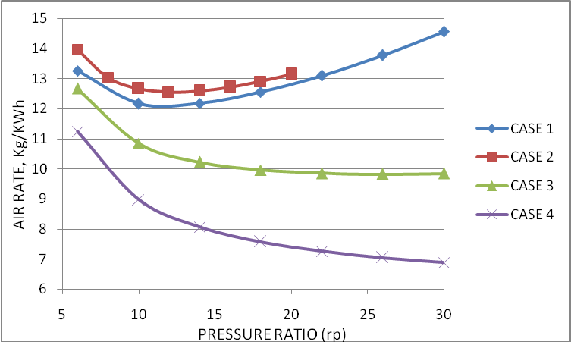
Figure 5.1 Effect of variation of pressure ratio on Air rate

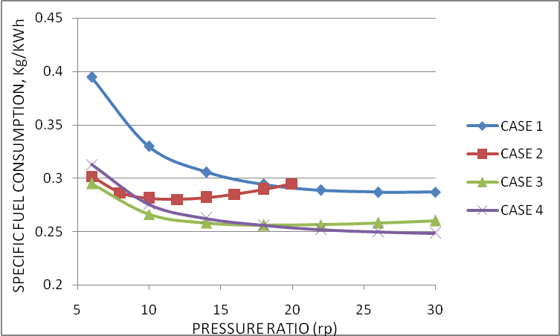
Figure 5.2 Effect of variation of pressure ratio on specific fuel consumption
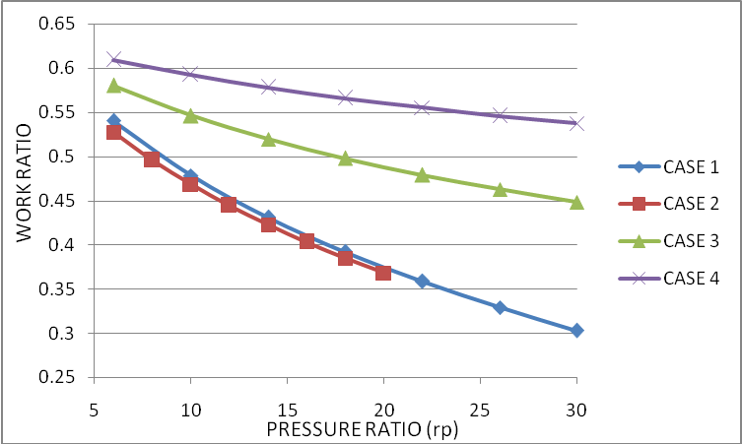
Figure 5.3 Effect of variation of pressure ratio on work ratio

5.2 Effect of pressure ratio on first and second -law efficiency for case 7
Figure 5.4 shows the variation of first-law efficiency of combined cycle power plant (CCPP) for case 7 with a change in compressor pressure ratio for different values of turbine inlet (TIT) and constant ambient relative humidity = 60%. As the pressure ratio increase the compressor work increases, raising the temperature at the compressor outlet. Increase the pressure ratio also increases the turbine work. As the pressure ratio increases, the air temperature at the inlet of the combustion chamber decreases due to the decrease in temperature of turbine exhaust entering to the regenerative heat exchanger. The ratio of net work output of the CCPP to the heat added represent the first-law efficiency of the cycle increase to its maximum value at optimum for at particular TIT. Further increase in reduces the first-law efficiency because, at much higher pressure ratio, the heat added to the cycle increases. Figure 5.5 shows the variation of second-law efficiency of CCPP for case 7 with a change in compressor pressure ratio () for values of TIT and = 60%, which is a more accurate measure of thermodynamic performance. Since the quality of fuel (i.e., exergy associated with the heat addition) is more than the heating value or energy of fuel because the exergy of fuel would increase while bringing it from the ambient pressure to combustion pressure at ambient temperature. Hence, exergy associated with the heat addition will be equal to exergy associated with the heating value of fuel plus exergy increase, i.e. mechanical exergy due to increase of pressure of fuel from the ambient to combustion state. Therefore second-law efficiency of cycle is slightly lower than the first-law efficiency as shown in figure 5.6.
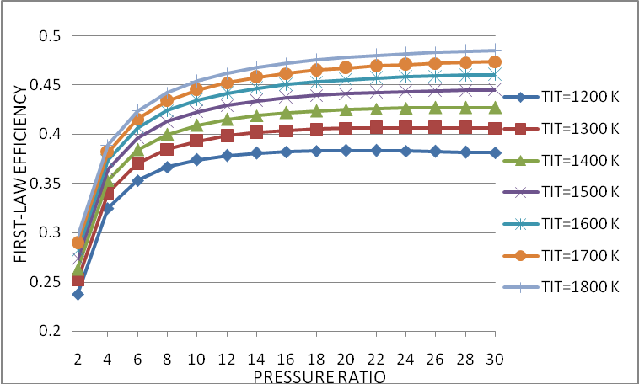
Figure 5.4 Effect of variation of pressure ratio at various TIT on first-law efficiency
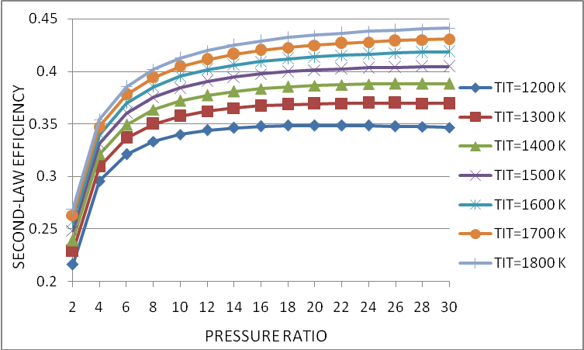
Figure 5.5 Effect of variation of pressure ratio at various TIT on second-law efficiency
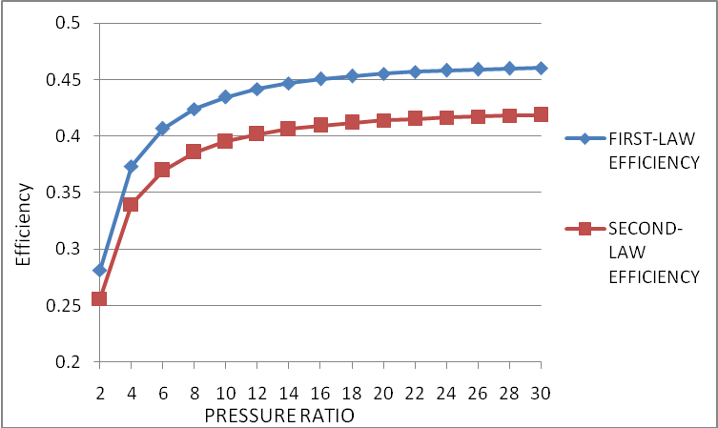
Figure 5.6 Effect of variation of pressure ratio on first-law efficiency and second-law efficiency at TIT 1600 K

5.3 Effect of variation of turbine inlet temperature on first-law efficiency and second-law efficiency for case 7
Figure 5.7 shows the variation of the first-law efficiency and second-law efficiency for the case 7 with the change in turbine inlet temperature for =14 and = 60%. For a given pressure ratio and ambient relative humidity, the first-law and second-law efficiencies increases with the higher TIT significantly. This is because at higher TIT the temperature of turbine exhaust entering to regenerative heat exchanger increases. The heat transfer for the hot gas to the compressed air in the heat exchanger increases, so the temperature of air inlet to the combustion chamber would increase, which in turn would increase the mean temperature of heat addition in the cycle. Therefore cycle efficiency increase with an increase in TIT.
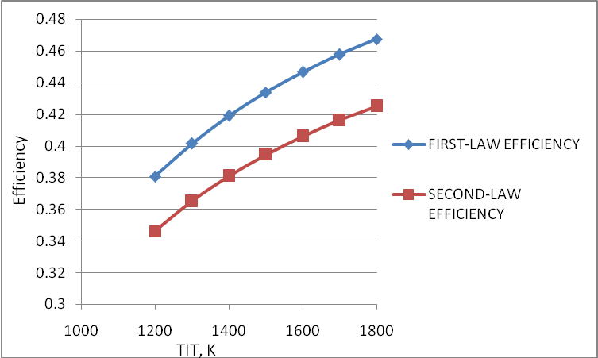
Figure 5.7 Effect of variation of turbine inlet temperature on first-law efficiency and second-law efficiency

5.4 Effect of variation of ambient relative humidity on first-law efficiency and second-law efficiency for case 7
Figure 5.8 shows the variation of the first-law efficiency and second-law efficiency with the change in ambient relative humidity for TIT = 1400 K and =14. The increase in ambient relative humidity results in increasing the compressor inlet air temperature, which increases the mean temperature of heat addition slightly but increases the mass of fuel significantly, which results in a large amount of heat addition to the cycle. Therefore, the first-law and second-law efficiency of the cycle decreases with the increase in relative humidity.
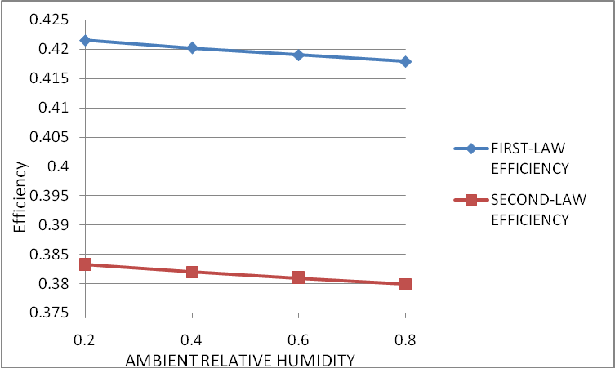
Figure 5.8 Effect of variation of ambient relative humidity on first-law efficiency and second-law efficiency
5.5 Effect of variation of pressure ratio on exergy destruction in combustion Chamber
Figure 5.9 shows the variation of the exergy destruction in the combustion chamber for the all cases with respect to the change in pressure ratio for fixed values of TIT = 1400 K and = 60%. It is found from the analysis exergy destruction in the combustion process dominates. It represents over 60% of the total exergy destruction in the overall system. As the pressure ratio increases the exergy destruction in the combustion chamber decreases significantly except case 2 and case 3. This is because the increase in pressure ratio implies lower difference of exergy between the combustion products and compressed air but its difference with exergy carried by fuel drops. Also as pressure ratio increases the exergy loss in combustion or reaction decreases due to the decrease in mass of fuel. As pressure ratio increases the mass flow rate of air also decreases and from equation (23) it is also justifies that the exergy destruction in the combustion chamber decreases as pressure ratio increases.
For the case 2, the compressor pressure ratio has been taking from 6 to 20, because at pressure ratio above 20, the function of regenerator fails due to the temperature of air at compressor outlet became greater than the turbine exhaust temperature. For the case 2 and case 3, as pressure ratio increases, the air rate decreases to a minimum value first and after that it again increases [23]. As we know that the air rate is proportional to the mass flow rate of air. The mass of fuel in the combustion chamber also follow the same trend of decrease and then increase as mass flow rate of air, so the exergy destruction in the combustion chamber decreases to a minimum value first and after that it again increases. Figure 5.10 shows the variation of exergy destruction in the combustion chamber for all cases for fixed values of TIT = 1400 K, =14 and = 60%. From the figure it is clear that as the complicacy of the plant increases, the exergy destruction in the combustion chamber decreases, it means we are moving to the reversible process. For the case 5, case 6 and case 7, the exergy destruction in the combustion chamber are same, because on adding the any component on the steam turbine part, the exergy destruction in the combustion chamber not affected. The exergy destruction in the combustion chamber for case 5, case 6, and case 7 is greater than the case 4 due to pressure loss in the air filter, waste heat recovery boiler (WHRB) and functioning of other components.
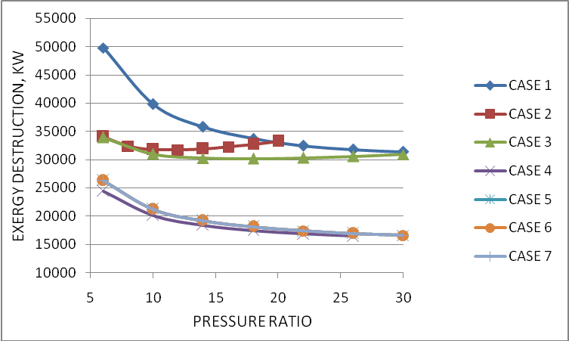
Figure 5.9 Effect of variation of pressure ratio on exergy destruction in combustion chamber
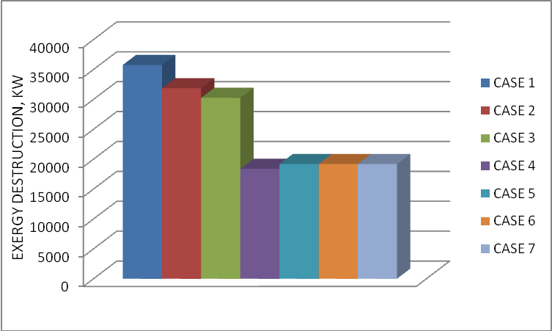
Figure 5.10 Exergy destruction in combustion chamber at TIT = 1400 K, =14 and = 60%
5.6 Effect of variation of pressure ratio on exergy destruction in regenerative heat exchanger
Figure 5.11 shows the variation of the exergy destruction in the regenerative heat exchanger for case 2 to case 7 with respect to the change in pressure ratio for fixed values of TIT = 1400 K and = 60%. The exergy destruction in the regenerative heat exchanger decreases as the pressure ratio increases. This is because the higher pressure ratio results in the lower power turbine exit temperature. Figure 5.12 shows the variation of exergy destruction in the regenerative heat exchanger for case 2 to case 7 for fixed values of TIT = 1400 K, =14 and = 60%. This figure shows that the exergy destruction in the heat exchanger for the case 4 is greater than that of case 3. This is because at same pressure ratio and TIT, the power turbine exhaust temperature for case 4 is greater than the turbine exhaust temperature for case 3. For the case 5, case 6 and case 7, the exergy destruction in the heat exchanger are same, because on adding the any component on the steam turbine part, the exergy destruction in the heat exchanger not affected. The exergy destruction in the heat exchanger for case 5, case 6, and case 7 is greater than the case 4 due to pressure loss in the air filter, waste heat recovery boiler (WHRB) and functioning of other components.
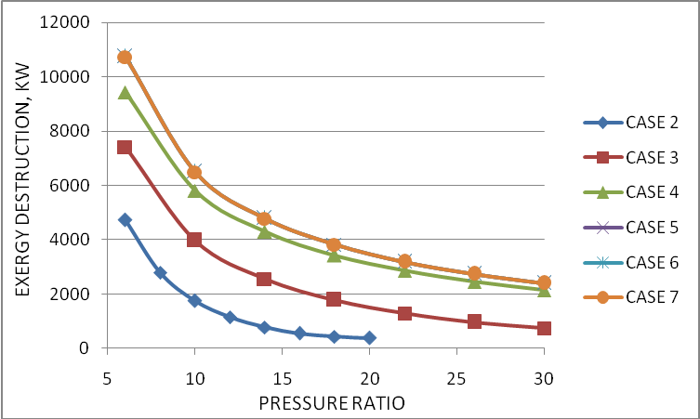
Figure 5.11 Effect of variation of pressure ratio on exergy destruction in regenerative heat exchanger
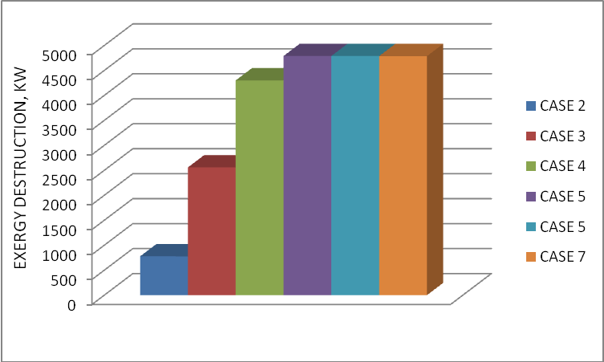
Figure 5.12 Exergy destruction in regenerative heat exchanger at TIT = 1400 K, =14 and = 60%

5.7 Effect of variation of pressure ratio on exergy destruction in compressor
Figure 5.13 shows the variation of the exergy destruction in the compressor for the all cases with respect to the change in pressure ratio for fixed values of TIT = 1400 K and = 60%. As pressure ratio increases, work of compressor increases, so the exergy destruction in compressor increases for case 1 to case 3. The air rate for case 2 is greater than the air rate for case 1 [23], so the exergy destruction in the compressor for the case 2 is greater than the case 1. Figure 5.14 shows the variation of the exergy destruction in the compressor for the all cases for fixed values of TIT = 1400 K, =14 and = 60%. This figure shows that the exergy destruction in the high pressure compressor (HPC) is greater than lower pressure compressor (LPC) for case 3 to case 7, because the HPC consumes more work than the LPC. The exergy destruction in the HPC for the case 5, case 6, and case 7 and exergy destruction in LPC for the same cases are same, because on adding any component in steam turbine part, the exergy destruction in the both compressors are not affected. The exergy destruction in LPC and HPC for case 5, case 6 and case 7 is greater than that of case 4, due to the effect of pressure loss in the air filter, WHRB and function of other components. As complicacy of the plant increases we are moving to the reversible process as shown in the figure 5.14.
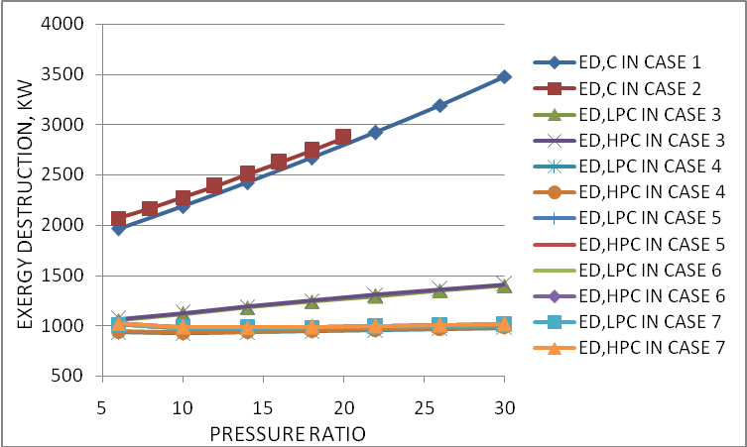
Figure 5.13 Effect of variation of pressure ratio on exergy destruction in compressor
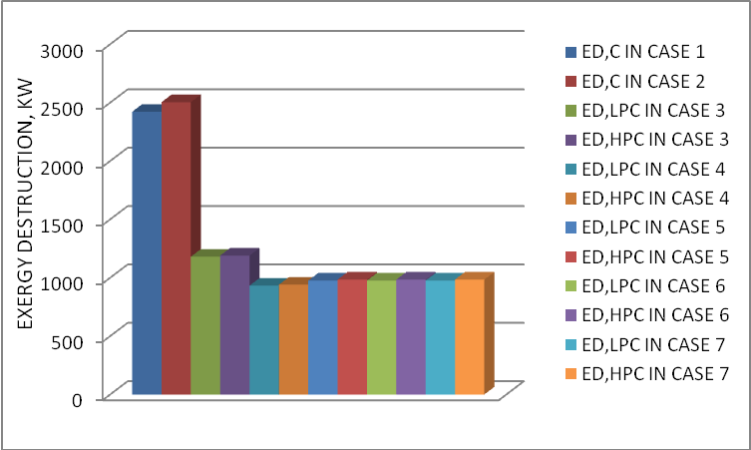
Figure 5.14 Exergy destruction in compressor at TIT = 1400 K, =14 and = 60%

5.8 Effect of variation of pressure ratio on exergy destruction in intercooler
Figure 5.15 shows the variation of the exergy destruction in the intercooler for case 3 to case 7 with respect to the change in pressure ratio for fixed values of TIT = 1400 K and = 60%. As pressure ratio increases exergy destruction in the intercooler increases due to the temperature of air at the inlet of intercooler increases. Figure 5.16 shows the variation of exergy destruction in the intercooler for case 3 to case 7 for fixed values of TIT = 1400 K, =14 and = 60%. This figure shows that the exergy destruction in intercooler for case 4 is less than that of case 3 due to the mass flow rate of air for case 4 is less than that of case 3. Exergy destruction in intercooler for case 5, case 6 and case 7 are same and greater than that of case 4 due to the pressure loss in the air filter, WHRB and function of other components.
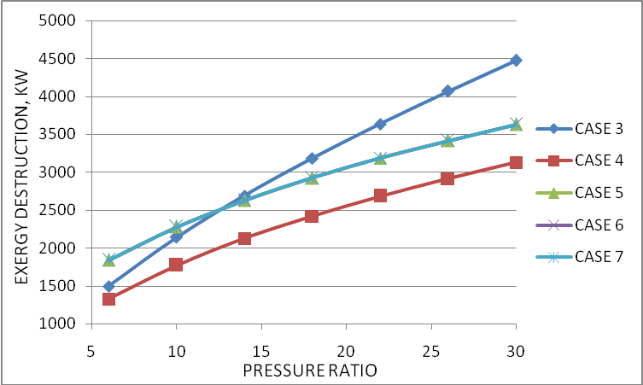
Figure 5.15 Effect of variation of pressure ratio on exergy destruction in intercooler
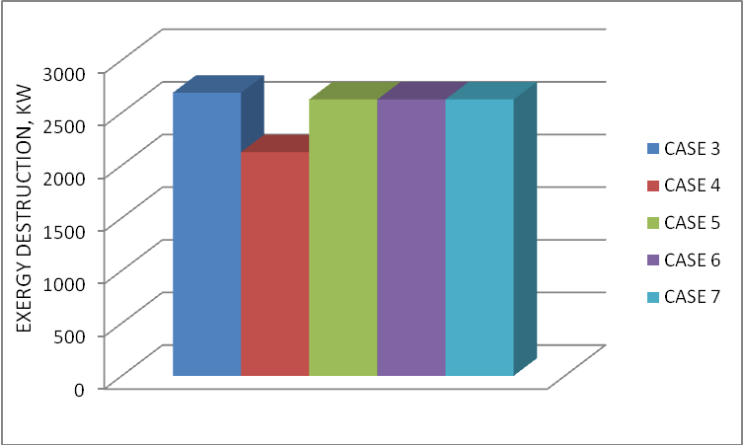
Figure 5.16 Exergy destruction in intercooler at TIT = 1400 K, =14 and = 60%

5.9 Effect of variation of pressure ratio on exergy destruction in turbine
Figure 5.17 shows the variation of the exergy destruction in the turbine for the all cases with respect to the change in pressure ratio for fixed values of TIT = 1400 K and = 60%. As pressure ratio increases, the exergy destruction in the turbine for all cases increases, because the entropy at turbine inlet decreases. Figure 5.18 shows the variation of exergy destruction in the turbine for all cases for fixed values of TIT = 1400 K, =14 and = 60%. This figure shows that exergy destruction in high pressure turbine (HPT) is slightly more than that of power turbine (PT) for case 3 to case 7, because the difference of entropy at the outlet and inlet in the HPT is slightly more than that of power turbine. The exergy destruction in the turbine in case 2 is more than that of case 1due to the air rate for case 2 is more than that of case 1. The exergy destruction in HPT and PT for case 5, case 6 and case 7 is slightly more than that of case 4 due to the pressure drop in air filter, WHRB and function of other components.
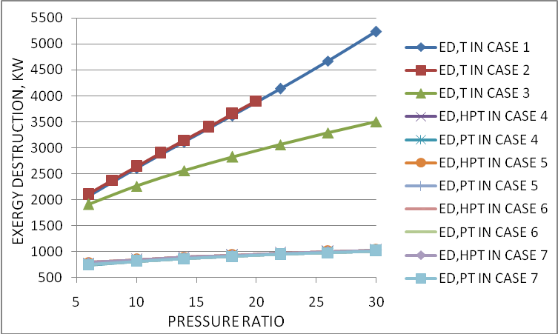
Figure 5.17 Effect of variation of pressure ratio on exergy destruction in turbine
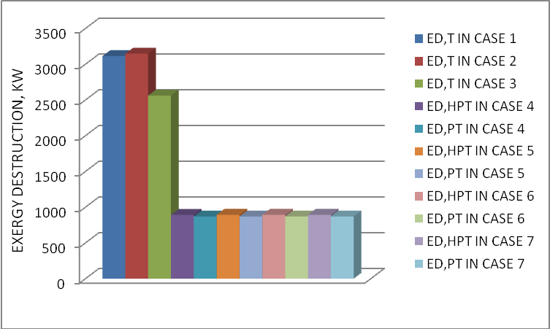
Figure 5.18 Exergy destruction in turbine at TIT = 1400 K, =14 and = 60%

5.10 Effect of variation of pressure ratio on exergy destruction in reheater
Figure 5.19 shows the variation of the exergy destruction in the reheater for case 4 to case 7 with respect to the change in pressure ratio for fixed values of TIT = 1400 K and = 60%. It is found the analysis after the combustion chamber the reheater has maximum exergy destruction in the plant. As pressure ratio increases, the mass of fuel in the reheater increases to compensate the reduction in energy due to decrease in the Tav. Due to decrease in the Tav and increase in the mass of fuel in the reheater and ratio A, the exergy destruction in the reheater increases. Figure 5.20 shows the variation of exergy destruction in the reheater for case 4 to case 7 for fixed values of TIT = 1400 K, =14 and = 60%. From this figure it is clear that the exergy destruction in the reheater for the case 5, case 6 and case 7 are same and is greater than that of 4 due to the pressure loss in air filter, WHRB and function of other components.
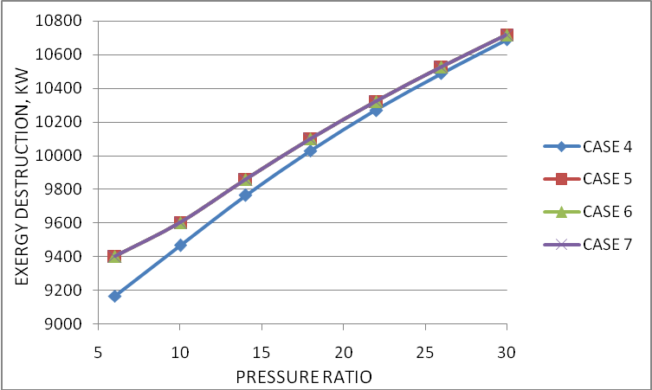
Figure 5.19 Effect of variation of pressure ratio on exergy destruction in reheater
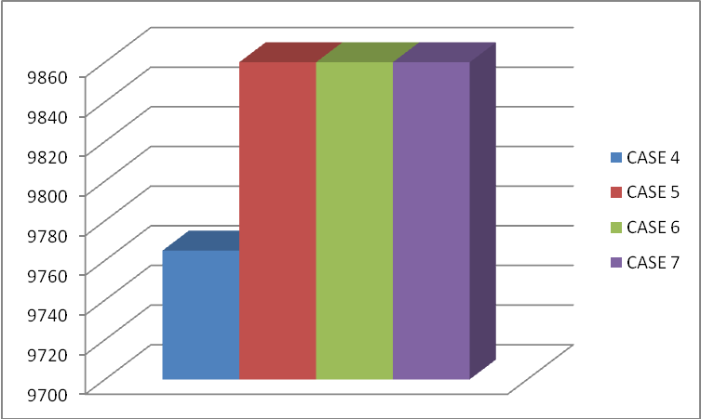
Figure 5.20 Exergy destruction in reheater at TIT = 1400 K, =14 and = 60%

5.11 Effect of variation of pressure ratio on exergy destruction in air filter
Figure 5.21 shows the variation of the exergy destruction in the air filter for case 5 to case 7 with respect to the change in pressure ratio for fixed values of TIT = 1400 K and = 60%. As pressure ratio increases mass flow rate of air decreases, so the exergy destruction in the air filter decreases. Figure 5.22 shows the variation of exergy destruction in the air filter for case 5 to case 7 for fixed values of TIT = 1400 K, =14 and = 60%. This figure shows that the exergy destruction in the air filter for case 5, case 6 and case 7 are same.
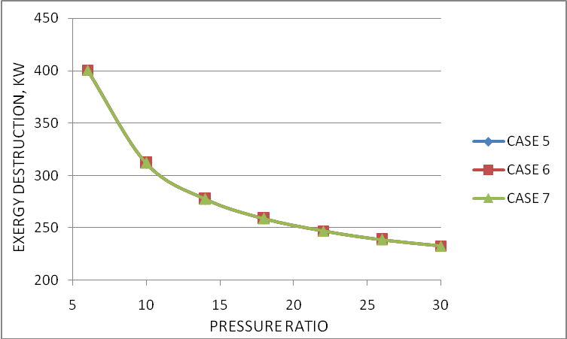
Figure 5.21 Effect of variation of pressure ratio on exergy destruction in air filter
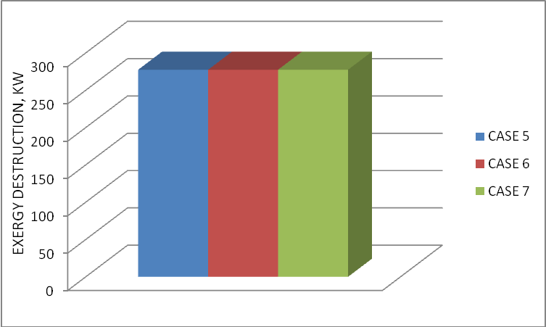
Figure 5.22 Exergy destruction in air filter at TIT = 1400 K, =14 and = 60%
5.12 Effect of variation of pressure ratio on exergy destruction in WHRB
Figure 5.23 shows the variation of the exergy destruction in the WHRB for case 5 to case 7 with respect to the change in pressure ratio for fixed values of TIT = 1400 K and = 60%. As pressure ratio increases the power turbine exhaust temperature decreases, so the exergy destruction in WHRB decreases. Figure 5.24 shows the variation of exergy destruction in the WHRB for case 5 to case 7 for fixed values of TIT = 1400 K, =14 and = 60%. This figure shows that on moving from case 5 to case 7 the exergy destruction in WHRB decreases. This is because the mass, temperature and exergy of water inlet to WHRB decreases.
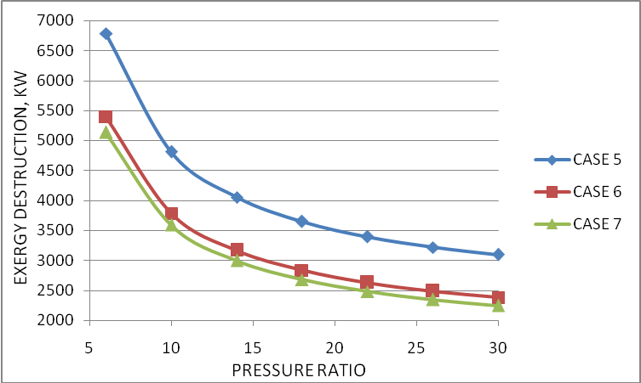
Figure 5.23 Effect of variation of pressure ratio on exergy destruction in WHRB
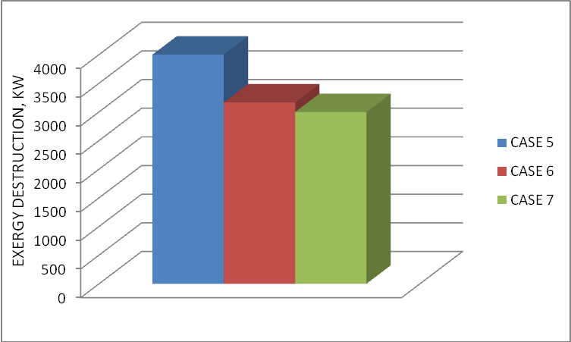
Figure 5.24 Exergy destruction in WHRB at TIT = 1400 K, =14 and = 60%

5.13 Effect of variation of pressure ratio on exergy destruction in steam turbine
Figure 5.25 shows the variation of the exergy destruction in the steam turbine for case 5 to case 7 with respect to the change in pressure ratio for fixed values of TIT = 1400 K and = 60%. As pressure ratio increases the mass the mass of steam produced and work of steam turbine decreases, so the exergy destruction in the steam turbine decreases. Figure 5.26 shows the variation of exergy destruction in the steam turbine for case 5 to case 7 for fixed values of TIT = 1400 K, =14 and = 60%. This figure shows that on moving from case 5 to case 7, the exergy destruction in the steam turbine increases. This is because the mass of steam and work of steam turbine increases.
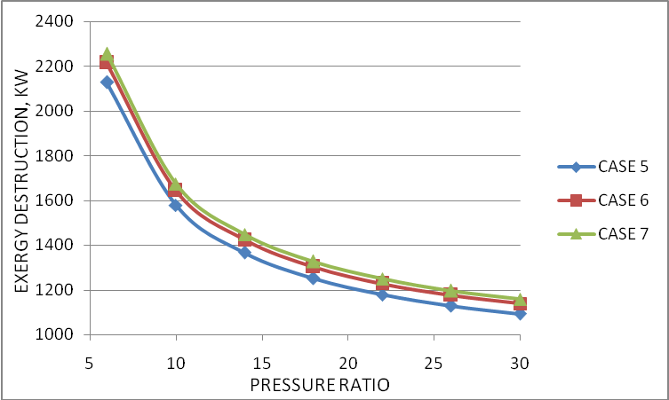
Figure 5.25 Effect of variation of pressure ratio on exergy destruction in steam turbine
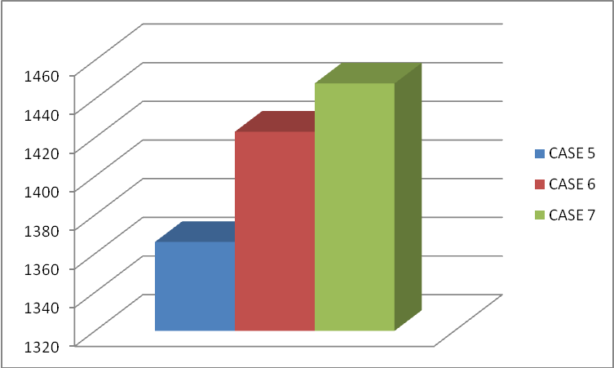
Figure 5.26 Exergy destruction in steam turbine at TIT = 1400 K, =14 and = 60%

5.14 Effect of variation of pressure ratio on exergy destruction in condenser
Figure 5.27 shows the variation of the exergy destruction in the condenser for case 5 to case 7 with respect to the change in pressure ratio for fixed values of TIT = 1400 K and = 60%. As pressure ratio increases the exergy destruction in the condenser decreases because mass of steam inlet to condenser and mass of cooling water decreases. Figure 5.28 shows the variation of exergy destruction in the condenser for case 5 to case 7 for fixed values of TIT = 1400 K, =14 and = 60%. This figure shows that on moving from case 5 to case 7 the exergy destruction in condenser decreases due to the same reason as in figure 5.27.
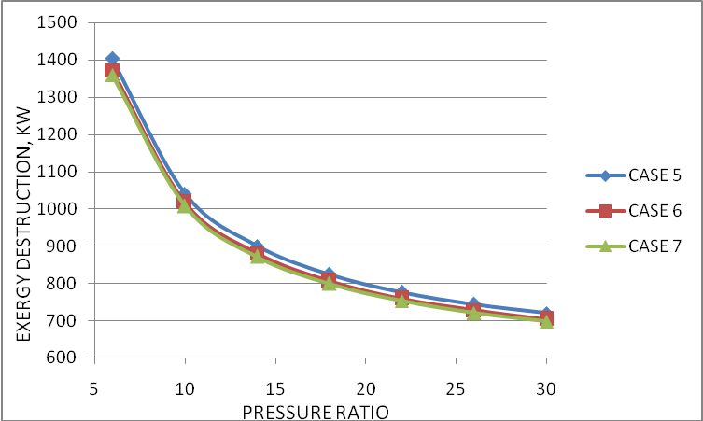
Figure 5.27 Effect of variation of pressure ratio on exergy destruction in condenser
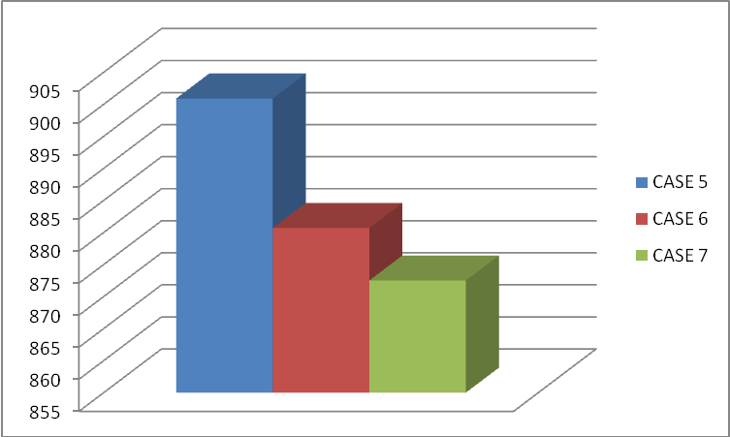
Figure 5.28 Exergy destruction in condenser at TIT = 1400 K, =14 and = 60%

5.15 Effect of variation of pressure ratio on exergy destruction in feed water heater
Figure 5.29 shows the variation of the exergy destruction in the feed water heater for case 6 to case 7 with respect to the change in pressure ratio for fixed values of TIT = 1400 K and = 60%. As pressure ratio increases the exergy destruction in the feed water heater decreases due to the amount of mass of steam entering and leaving the feed water heater. Figure 5.30 shows the variation of exergy destruction in the feed water heater for case 5 to case 7 for fixed values of TIT = 1400 K, =14 and = 60%. This figure shows that the summation of exergy destruction of both feed water heaters in case 7 is less than the exergy destruction in feed water heater for case 6.
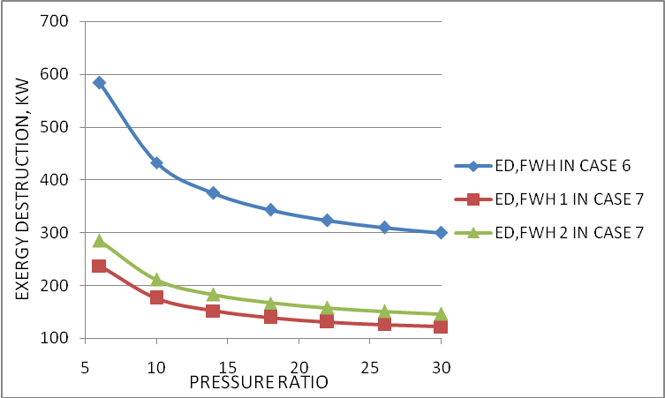
Figure 5.29 Effect of variation of pressure ratio on exergy destruction in feed water heater
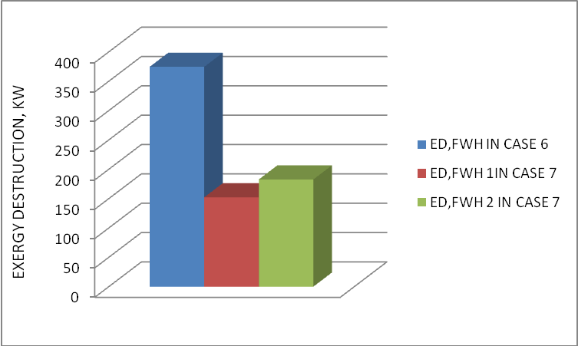
Figure 5.30 Exergy destruction in feed water heater at TIT = 1400 K, =14 and = 60%.

5.16 Effect of variation of pressure ratio on exergy destruction in pump
Figure 5.31 shows the variation of the exergy destruction in the pump for case 5 to case 7 with respect to the change in pressure ratio for fixed values of TIT = 1400 K and = 60%. As pressure ratio increases the exergy destruction in the pump decreases due to the mass of steam entering to the pump decreases. Figure 5.32 shows the variation of exergy destruction in the pump for case 5 to case 7 for fixed values of TIT = 1400 K, =14 and = 60%. This figure shows that the summation of exergy destruction in pumps in case 6 and case 7 is less than the exergy destruction in pump for case 6.
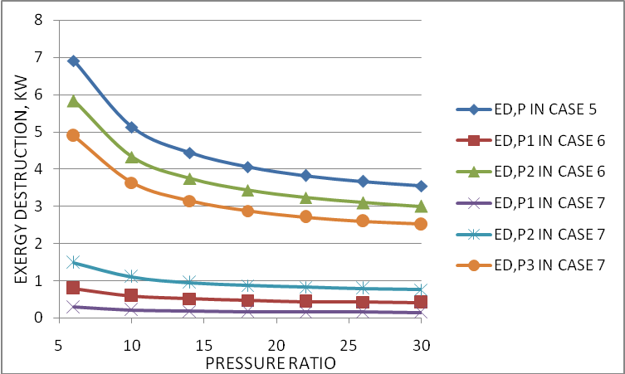
Figure 5.31 Effect of variation of pressure ratio on exergy destruction in pump
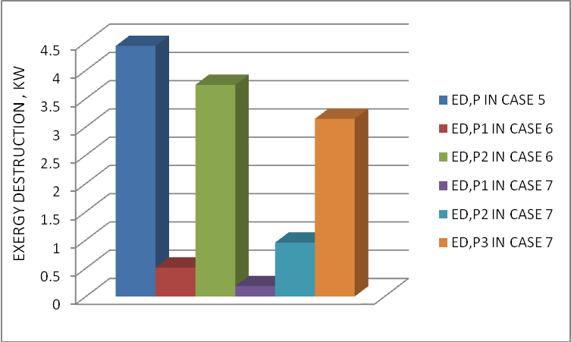
Figure 5.32 Exergy destruction in pump at TIT = 1400 K, =14 and = 60%

5.17 Effect of variation of pressure ratio on exergy destruction in exhaust gas
Figure 5.33 shows the variation of the exergy destruction in the exhaust gas for the all cases with respect to the change in pressure ratio for fixed values of TIT = 1400 K and = 60%. As pressure ratio increases the turbine exhaust temperature decreases, so the exergy destruction in exhaust gas decreases for case 1 to case 4. Exergy destruction in exhaust gas decreases for case 5 to case 7, due to mass flow rate of gas decreases as pressure ratio increases. Figure 5.34 shows the variation of exergy destruction in the exhaust gas for all cases for fixed values of TIT = 1400 K, =14 and = 60%. The exergy destruction in exhaust gas for case 2 greater than that of case 1, due to mass flow rate of gas for case 2 is more than case 1. The exergy destruction in exhaust gas for case 3 is less than that of case 1 and case 2, due to the mass flow rate of gas is less than that of case 1 and case 2. The exergy destruction in exhaust gas for case 4 is greater than case 3 due to the power turbine exhaust temperature for case 4 is greater than turbine exhaust temperature for case 3. The exergy destruction in exhaust gas for case 5, case 6 and case 7 is same. From this figure it is clear that as complicacy of the plant increases, we are moving to the reversible process.

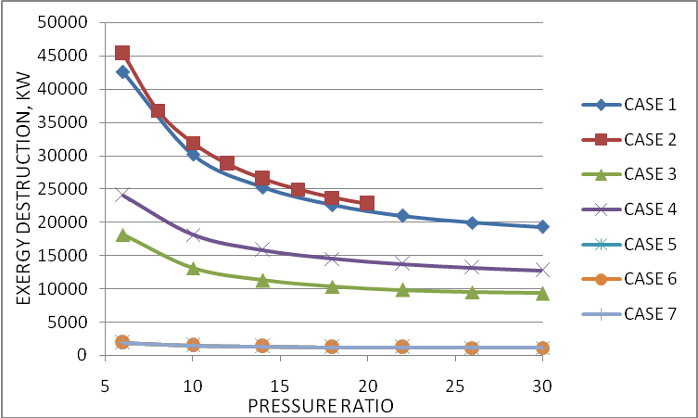
Figure 5.33 Effect of variation of pressure ratio on exergy destruction in exhaust gas
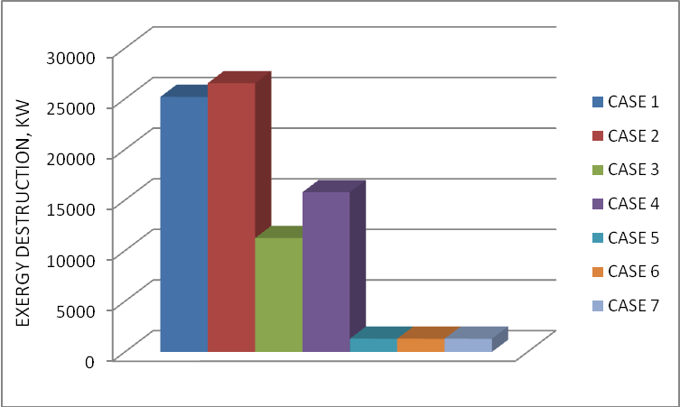
Figure 5.34 Exergy destruction in exhaust gas at TIT = 1400 K, =14 and = 60%

5.18 Effect of variation of pressure ratio on first-law efficiency and second-law efficiency for case 1 and case 7
Figure 5.35 shows the variation of first-law efficiency and second-law efficiency with respect to the change in pressure ratio for fixed values of TIT = 1400 K and = 60% for case 1 and case 7. It is clear from the figure as complicacy of the plant increases the efficiency increases.
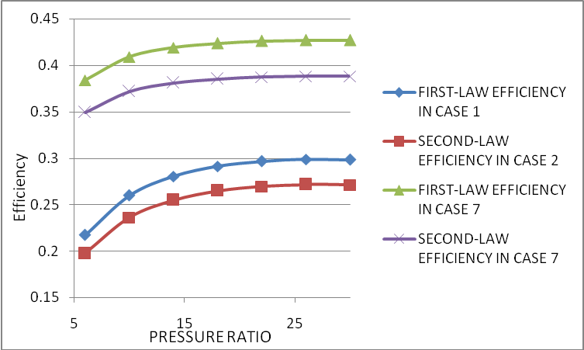
Figure 5.35 Effect of variation of pressure ratio on first-law efficiency and second-law efficiency for case 1 and case 7

5.19 Effect of variation of turbine inlet temperature on exergy destruction in combustion chamber
Figure 5.36 shows the variation of the exergy destruction in the combustion chamber for the all cases with respect to the change in turbine inlet temperature for fixed values of =14 and = 60%. As TIT increases the Tav in equation (25) increases and mass flow rate of air and mass of fuel in combustion chamber decreases, so the exergy destruction in combustion chamber decreases.
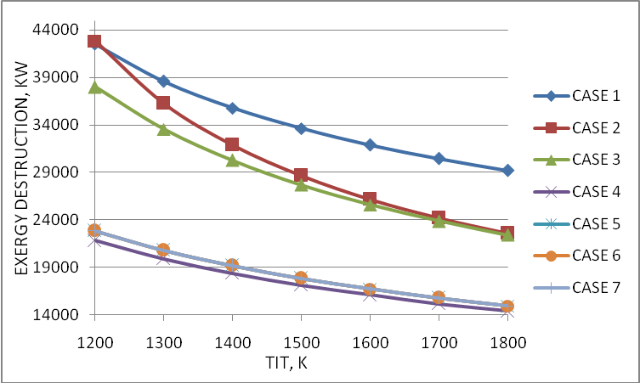
Figure 5.36 Effect of variation of turbine inlet temperature on exergy destruction in combustion chamber
5.20 Effect of variation of turbine inlet temperature on exergy destruction in regenerative heat exchanger
Figure 5.37 shows the variation of the exergy destruction in the regenerative heat exchanger for case 2 to case 7 with respect to the change in turbine inlet temperature for fixed values of =14 and = 60%. Exergy destruction in regenerative heat exchanger increases as TIT increases. This is because the higher TIT results in higher power turbine exit temperature.
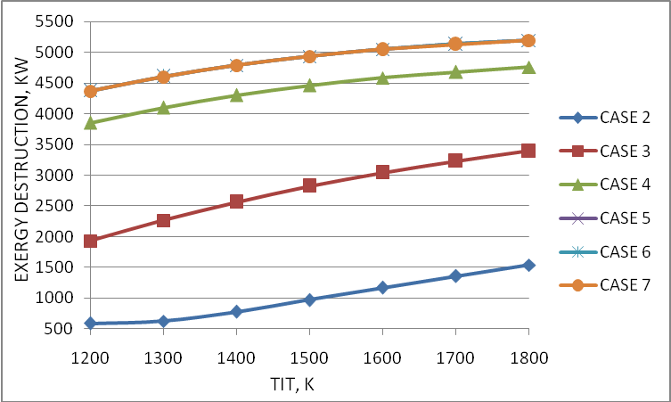
Figure 5.37 Effect of variation of turbine inlet temperature on exergy destruction in regenerative heat exchanger
5.21 Effect of variation of turbine inlet temperature on exergy destruction in compressor
Figure 5.38 shows the variation of the exergy destruction in the compressor for all cases with respect to the change in turbine inlet temperature for fixed values of =14 and = 60%. As TIT increases the exergy destruction in compressor for all cases decreases. This is because the mass flow rate of air and compressor work decreases.

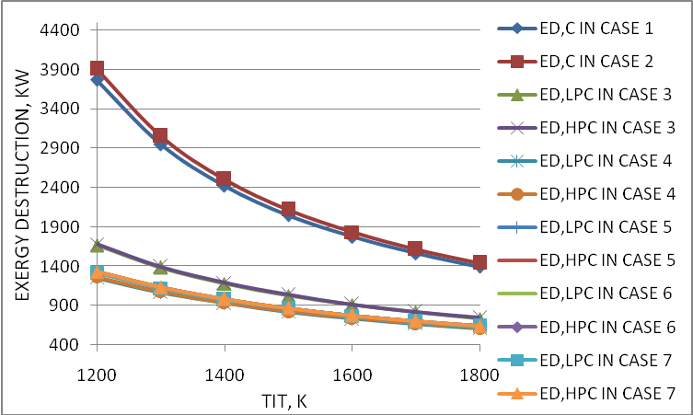
Figure 5.38 Effect of variation of turbine inlet temperature on exergy destruction in compressor

5.22 Effect of variation of turbine inlet temperature on exergy destruction in intercooler
Figure 5.39 shows the variation of the exergy destruction in the intercooler for case 3 to case 7 with respect to the change in turbine inlet temperature for fixed values of =14 and = 60%. As TIT increases exergy destruction in intercooler decreases, due to the mass flow rate of air decreases.
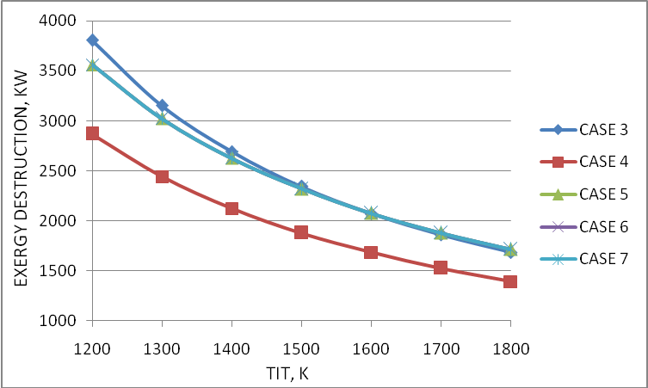
Figure 5.39 Effect of variation of turbine inlet temperature on exergy destruction in intercooler

5.23 Effect of variation of turbine inlet temperature on exergy destruction in turbine
Figure 5.40 shows the variation of the exergy destruction in the turbine for all cases with respect to the change in turbine inlet temperature for fixed values of =14 and = 60%. As TIT increases mass flow rate of gas in the turbine decreases, so exergy destruction in turbine decreases.
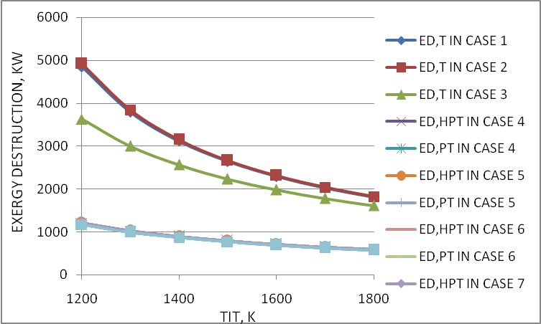
Figure 5.40 Effect of variation of turbine inlet temperature on exergy destruction in turbine

5.24 Effect of variation of turbine inlet temperature on exergy destruction in reheater
Figure 5.41 shows the variation of the exergy destruction in the reheater for case 4 to case 7 with respect to the change in turbine inlet temperature for fixed values of =14 and = 60%. As TIT increases high pressure turbine exhaust temperature increases, so the temperature at reheater inlet and Tav in equation (25) increase. As TIT increases mass of fuel in the reheater decreases. Due to the increase in Tav and decrease in mass of fuel in the reheater, exergy destruction in the reheater decreases.
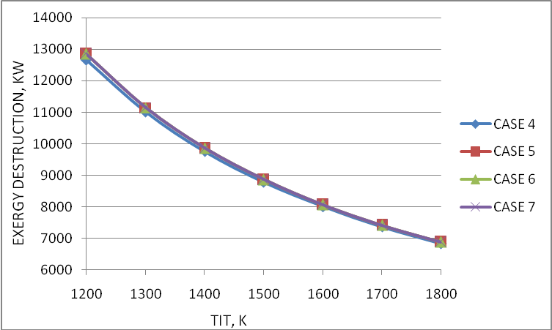
Figure 5.41 Effect of variation of turbine inlet temperature on exergy destruction in reheater

5.25 Effect of variation of turbine inlet temperature on exergy destruction in air filter
Figure 5.42 shows the variation of the exergy destruction in the air filter for case 5 to case 7 with respect to the change in turbine inlet temperature for fixed values of =14 and = 60%. As TIT increases mass flow rate of air decreases so the exergy destruction in the air filter decreases.
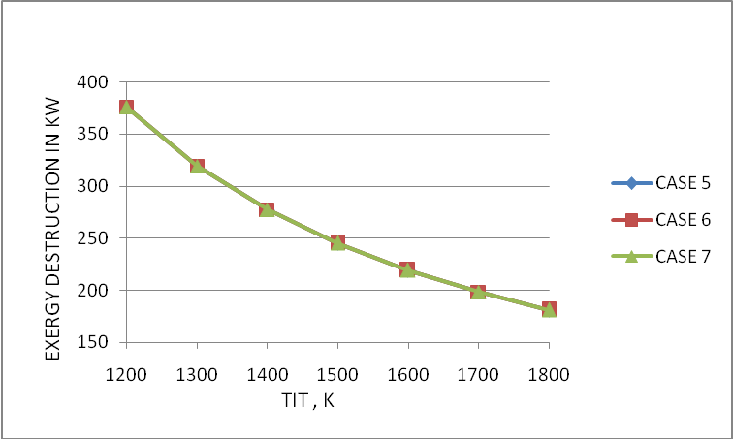
Figure 5.42 Effect of variation of turbine inlet temperature on exergy destruction in air filter

5.26 Effect of variation of turbine inlet temperature on exergy destruction in WHRB
Figure 5.43 shows the variation of the exergy destruction in the WHRB for case 5 to case 7 with respect to the change in turbine inlet temperature for fixed values of =14 and = 60%. As TIT increases power turbine exhaust temperature increases, so the exergy destruction in WHRB increases.
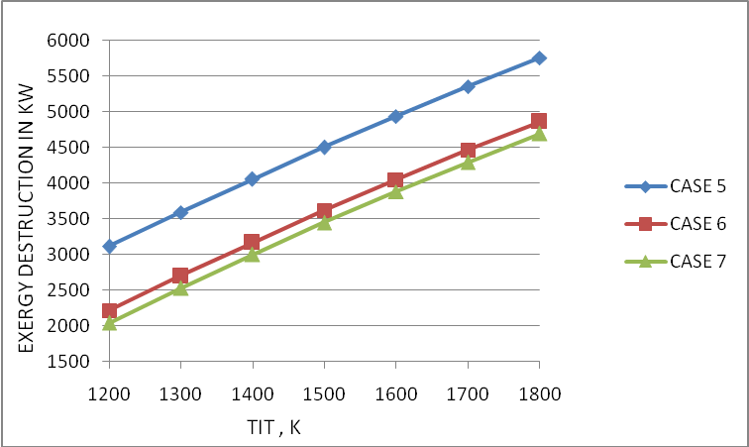
Figure 5.43 Effect of variation of turbine inlet temperature on exergy destruction in WHRB

5.27 Effect of variation of turbine inlet temperature on exergy destruction in steam turbine
Figure 5.44 shows the variation of the exergy destruction in the steam turbine for case 5 to case 7 with respect to the change in turbine inlet temperature for fixed values of =14 and = 60%. As TIT increases the mass of steam produced decreases till TIT = 1500 K and after this TIT increases. So the exergy destruction in steam turbine first decreases till TIT = 1500 K and after this TIT, exergy destruction in steam turbine increases.
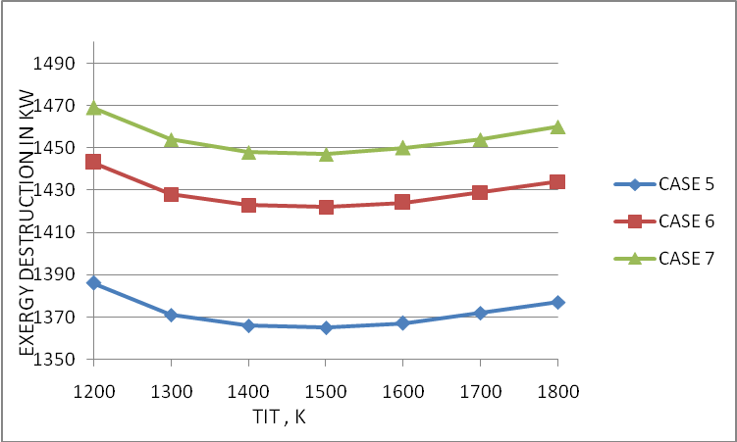
Figure 5.44 Effect of variation of turbine inlet temperature on exergy destruction in steam turbine

5.28 Effect of variation of turbine inlet temperature on exergy destruction in condenser
Figure 5.45 shows the variation of the exergy destruction in the condenser for case 5 to case 7 with respect to the change in turbine inlet temperature for fixed values of =14 and = 60%. As TIT increases, exergy destruction in condenser increases after a decrease due to the mass flow rate of steam produced.
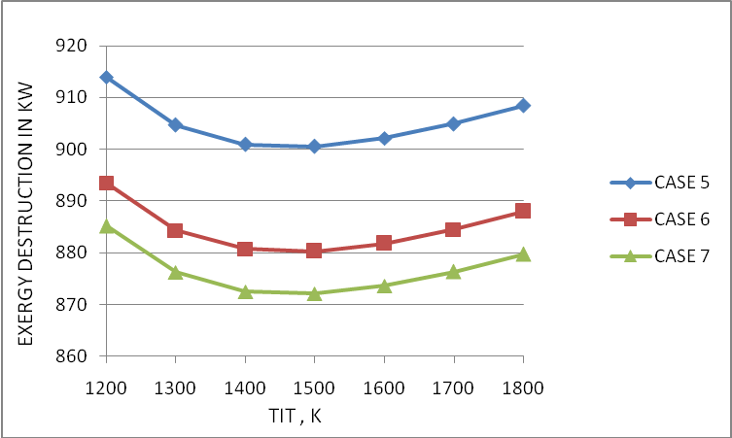
Figure 5.45 Effect of variation of turbine inlet temperature on exergy destruction in condenser

5.29 Effect of variation of turbine inlet temperature on exergy destruction in feed water heater
Figure 5.46 shows the variation of the exergy destruction in the feed water heater for case 6 and case 7 with respect to the change in turbine inlet temperature for fixed values of =14 and = 60%. As TIT increases, exergy destruction in the feed water heater increases after a decrease due to the mass flow rate of steam produced.

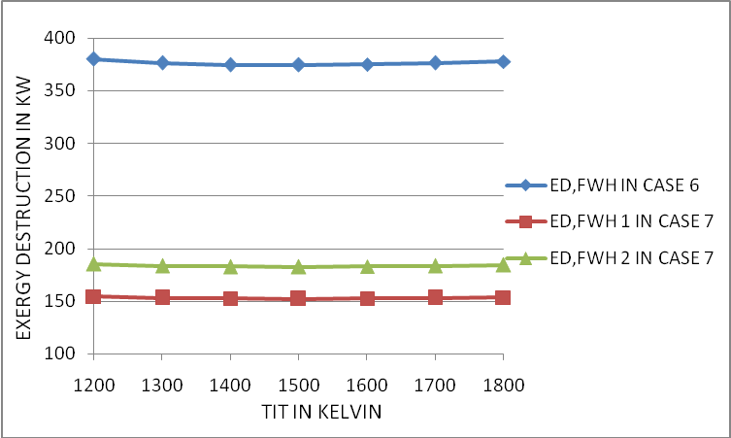
Figure 5.46 Effect of variation of turbine inlet temperature on exergy destruction in feed water heater

5.30 Effect of variation of turbine inlet temperature on exergy destruction in pump
Figure 5.47 shows the variation of the exergy destruction in the pump for case 5 to case 7 with respect to the change in turbine inlet temperature for fixed values of =14 and = 60%. As TIT increases, exergy destruction in the pump increases after a decrease due to the mass flow rate of steam produced.

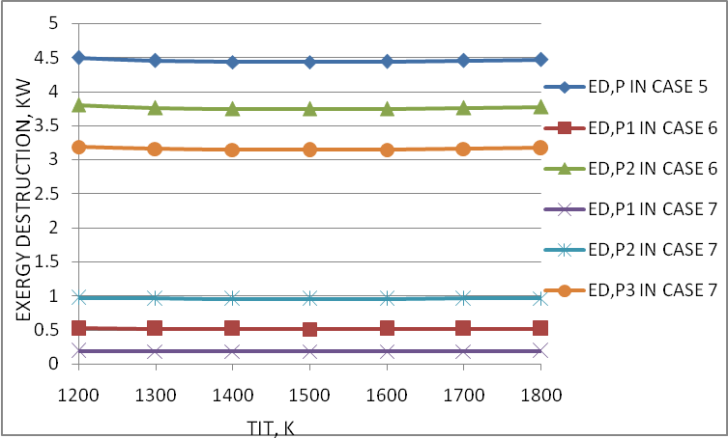
Figure 5.47 Effect of variation of turbine inlet temperature on exergy destruction in pump

5.31 Effect of variation of turbine inlet temperature on exergy destruction in exhaust gas
Figure 5.48 shows the variation of the exergy destruction in the exhaust gas for all cases with respect to the change in turbine inlet temperature for fixed values of =14 and = 60%. As TIT increases the turbine exhaust temperature increases for case 1 to case 4, so exergy destruction in exhaust increases for case 1 to case 4. Exergy destruction in exhaust gas decreases for case 5 to case 7, due to mass flow rate of gas decreases as TIT increases.

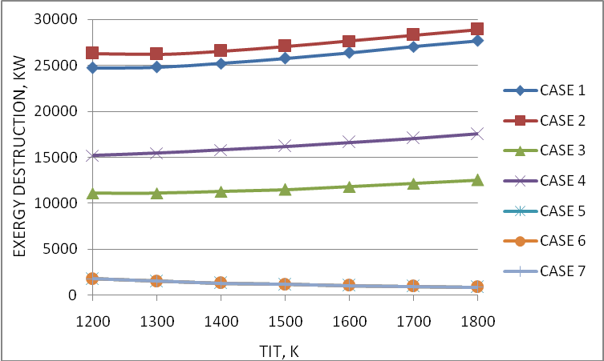
Figure 5.48 Effect of variation of turbine inlet temperature on exergy destruction in exhaust gas

5.32 Effect of variation of turbine inlet temperature on first-law efficiency and second-law efficiency for case 1 and case 7
Figure 5.49 shows the variation of first-law efficiency and second-law efficiency with respect to the change in turbine inlet temperature for fixed values of =14 and = 60% for case 1 and case 7. It is clear from the figure as complicacy of the plant increases the efficiency increases. It is clear from the figure as complicacy of the plant increases the efficiency increases.
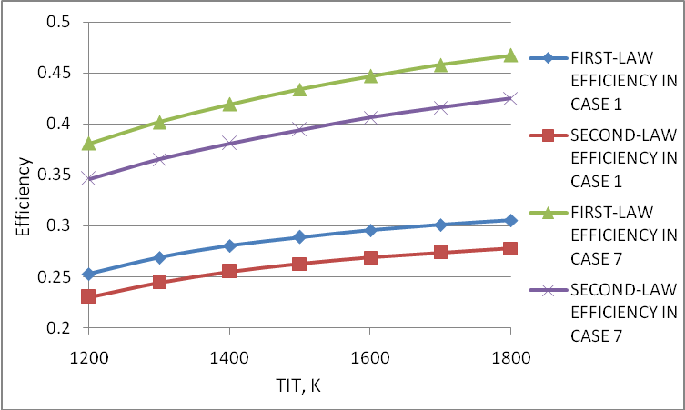
Figure 5.49 Effect of variation of turbine inlet temperature on first-law efficiency and second-law efficiency for case 1 and case 7

5.33 Effect of variation of stack temperature on mass flow rate of steam and net work of steam turbine
Figure 5.50 shows the variation of mass flow rate of steam and net work of steam turbine with respect to change in stack temperature for fixed values of TIT = 1600 K, =14 and = 60% for case 7. As stack temperature increases, mass flow rate of steam and net work of steam turbine decreases.

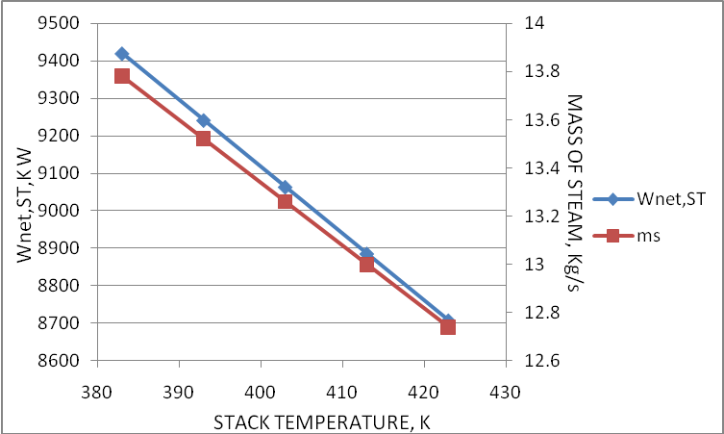
Figure 5.50 Effect of variation of stack temperature on mass flow rate of steam and net work of steam turbine

5.34 Effect of variation of stack temperature on exergy destruction in exhaust gas, WHRB and steam turbine
Figure 5.51 shows the variation of the exergy destruction in the exhaust gas, WHRB and steam turbine with respect to the change in stack temperature for fixed values of TIT = 1600 K, =14 and = 60% for case 7. As stack temperature increases, exergy destruction in steam turbine and exhaust gas increases but exergy destruction in steam turbine decreases due to mass flow rate of steam and work of steam turbine decreases.

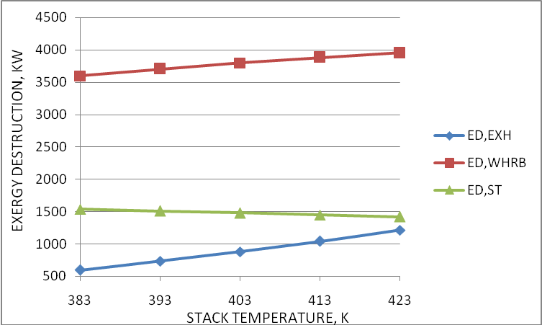
Figure 5.51 Effect of variation of stack temperature on exergy destruction in exhaust gas, WHRB and steam turbine

5.35 Effect of variation of stack temperature on first-law efficiency and second-law efficiency
Figure 5.52 shows the variation of first-law efficiency and second-law efficiency with respect to the change in stack temperature for fixed values of TIT = 1600 K, =14 and = 60% for case 7. As stack temperature increases, first-law efficiency and second-law efficiency decreases due to decrease in net work of steam turbine.
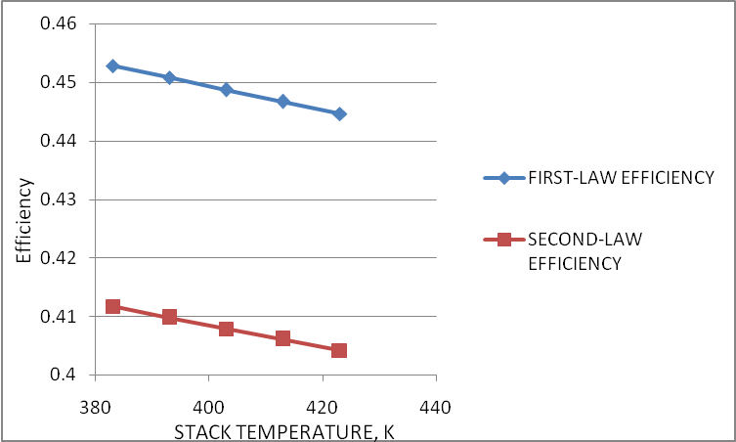
Figure 5.52 Effect of variation of stack temperature on first-law efficiency and second-law efficiency

5.36 Effect of variation of ambient relative humidity on exergy destruction in different components of the cycle
Table 7 shows the variation of the magnitude of exergy destruction in components of the plant with the change in ambient relative humidity for TIT = 1400 K and =14 for case 7. It has been observed that the exergy destruction in all components of the plant have no any major effect with the change in ambient relative humidity.

5.37 Effect of variation of pressure loss in air filter on exergy destruction in different components of the cycle
Table 8 shows variation of the magnitude of exergy destruction in components of the plant with the change in pressure loss in air filter for TIT = 1400 K, =14 and = 60% for case 7. It is shown that the exergy destruction in air filter increases significantly and the exergy destruction in the remaining components of the plant also increases as pressure loss in air filter increases. It should be always remember that the pressure loss in air filter should be lowest possible.

5.38 Effect of variation of pressure loss in heat exchanger air side and gas side on exergy destruction in different components of the cycle
Table 9 and Table 10 shows the variation of the magnitude of exergy destruction in components of the plant with the change in pressure loss in heat exchanger air side and gas side respectively for TIT = 1400 K, =14 and = 60% for case 7. It is clear from the table that the exergy destruction in heat exchanger increases significantly and in remaining components has no any major effect with the increase in the pressure loss in the heat exchanger air side and gas side.

5.39 Effect of variation of pressure loss in combustion chamber on exergy destruction in different components of the cycle
Table 11 shows the variation of the magnitude of exergy destruction in components of the plant with the change in pressure loss in combustion chamber for TIT = 1400 K, =14 and = 60% for case 7. It has been seen that the exergy destruction in combustion chamber increases significantly but exergy destruction in remaining components have no any major effect with the change in pressure loss in combustion chamber.

5.40 Effect of variation of pressure loss in reheater on exergy destruction in different components of the cycle
Table 12 shows the variation of the magnitude of exergy destruction in components of the plant with the change in pressure loss in reheater for TIT = 1400 K, =14 and = 60% for case 7. It is observed that the exergy destruction in reheater increases significantly but exergy destruction in remaining components have no any major effect with the change in pressure loss in reheater.

5.41 Effect of variation of pressure loss in WHRB on exergy destruction in different components of the cycle
Table 13 shows the variation of the magnitude of exergy destruction in components of the plant with the change in pressure loss in WHRB for TIT = 1400 K, =14 and = 60% for case 7. It is observed that the exergy destruction in WHRB increases significantly but exergy destruction in remaining components have no any major effect with the change in pressure loss in WHRB.

Chapter 6
CONCLUSION

Exergy destruction in each component of combined cycle power plant with seven different configuration have been studied. It has been observed that the exergy destruction in each component is significantly affected by overall pressure ratio and turbine inlet temperature and comparatively less affected by ambient relative humidity. The maximum exergy is destroyed in the combustion chamber, which represents more than 60% of the total exergy destruction in the overall system for all the configurations.. The next largest exergy destruction occurs in regenerator, WHRB, turbine and compressor. The minimum exergy destruction occurs in the pumps in overall system. The first-law efficiency and second-law efficiency of the cycle are significantly influenced by the overall pressure ratio and TIT and small variations are observed in these parameters with the change in ambient relative humidity and stack temperature. Important conclusions are further summarized below:
- The exergy destruction in combustion chamber decreases significantly for all cases except case 2 and case 3 as pressure ratio increases. The exergy destruction in combustion chamber for case 2 and case 3 increases after a decrease. On moving from case 1 to case 7 exergy destruction in combustion chamber decreases.

- The exergy destruction in regenerative heat exchanger decreases significantly as pressure ratio increases. On moving from case 2 to case 7 exergy destruction in heat exchanger also increases.

- The exergy destruction in re-heater increases significantly as pressure ratio increases and exergy destruction in turbine also increases for all cases as pressure ratio increases.

- The exergy destruction in compressor increases with pressure ratio for all case 1 to case 3 and for case 4 to case 7 the exergy destruction in compressor initially decreases and after a decrease it again increase.

- The exergy destruction in air filter, WHRB, steam turbine, condenser, feed water heater, pump and exhaust gas decreases as pressure ratio increases. On moving from case 5 to case 7 the exergy destruction in WHRB and condenser decreases but exergy destruction in steam turbine increases.

- The exergy destruction in combustion chamber and re-heater decreases but in heat exchanger increases significantly as TIT increases. On moving from case 1 to case 7 exergy destruction in combustion chamber decreases. On moving from case 4 to case 7 exergy destruction in re-heater slightly increases but on moving from case 2 to case 7 the exergy destruction in heat exchanger increases significantly.

- The exergy destruction in compressor and turbine decreases as TIT increases. On moving from case 1 to case 7 exergy destruction in compressor and turbine decreases. The exergy destruction in air filter decreases as TIT as increases.

- Exergy destruction in WHRB increases significantly as TIT increases. On moving from case 5 to case 7 the exergy destruction in WHRB decreases.

- The exergy destruction in steam turbine, condenser, feed water heaters and pump decreases till TIT = 1500 K and after TIT = 1500 K it increases. On moving from case 5 to case 7 exergy destruction in steam turbine increases and in condenser decreases.
- The exergy destruction in exhaust gas increases significantly for case 1 to case 4 and for case 5 to case 7 decreases as TIT increases.

- On moving from case 5 to case 7 the exergy destruction in all components of gas turbine individually same. Exergy destruction in exhaust gas for case 5, case 6 and case 7 is also same and minimum in comparison to case 1 to case 4.

- As stack temperature increases, exergy destruction in WHRB and exhaust gas increases but exergy destruction in steam turbine slightly decreases.

- The exergy destruction in all components of the plant increases with the increase in pressure loss in air filter.

- On increasing the pressure loss in heat exchanger air side, heat exchanger gas side, combustion chamber re-heater and WHRB, the exergy destruction in all components of the plant have no any major effect except respective components.
Chapter 7
SCOPE FOR FUTURE WORK

- The vapor absorption refrigeration system (VARS) has only one major input energy source i.e. generator, which takes energy in the form of heat and other one energy input source is pump, which takes negligible energy with respect to generator. The exhaust gas from the WHRB has sufficient heat to run the VARS, by which we can use the refrigeration for any type of cooling purpose. The exergy analysis of gas turbine with VARS, MHD and other cogeneration and combined cycle plants.
- Study on effect of compressor inlet air cooling using refrigeration effect of the VARS including use in the intercoolers can also be carried.
REFERENCES
[1] | Habib M. A., Said S. A. M., and Al-Zaharna I., 1995, “Optimization of Reheat Pressures In Thermal Power Plants,” Energy, 20, No. (6), pp. 555-565.
[2] | Radcenco V., Vargas J. V. C., and Bejan A., 1998, “Thermodynamic Optimization of A Gas Turbine Power Plant With Pressure Drop Irreversibilities”, ASME Journal of Energy Resources, 120, pp. 233-240.
[3] | Bassily A. M., 2001, “Effects of Evaporative Inlet and Aftercooling on The Recuperated Gas Turbine Cycle,” Applied Thermal Engineering, 21, pp. 1875-1890.
[4] | Franco A., and Casarosa C., 2002, “On Some Perspectives for Increasing The Efficiency of Combined Cycle Power Plants,” Applied Thermal Engineering, 22, pp. 1501-1518.
[5] | Dincer I., 2002, “The Role of Exergy In Energy Policy Making,” Energy Policy, 30, pp.137- 149.
[6] | Leo T. J., Grande I.P., and Notario P. P., 2003, “Gas Turbine Turbocharged by a Steam Turbine: A Gas Turbine Solution Increasing Combined Power Plant Efficiency and Power,” Applied Thermal Engineering, 23, pp. 1913-1929.
[7] | Bassily A.M., 2004, “Performance Improvements of the Intercooled Reheat Recuperated Gas-Turbine Cycle Using Absorption Inlet-Cooling and Evaporative After-Cooling,” Applied Energy, 77, pp. 249-272.
[8] | Khaliq A., and Kaushik S.C., 2004, Second-Law Based Thermodynamic Analysis of Brayton/Rankine Combined Power Cycle with Reheat, Applied Energy, 78, PP. 179-197.
[9] | Ertesvag IS., Kvamsdal H. M., and Bolland O., 2005, “Exergy Analysis of A Gas-Turbine Combined-Cycle Power Plant with Precombustion CO₂ Capture,” Energy, 30, pp. 5-39.
[10] | Sengupta S., Datta A., and Duttagupta S., 2007, “Exergy Analysis of a Coal-Based 210 MW Thermal Power Plant,” International Journal of Energy Research, 31, pp. 14-28.
[11] | Khaliq A., and Choudhary K., 2007, “Combined First and Second-Law Analysis of Gas Turbine Cogeneration System with Inlet Air Cooling and Evaporative Aftercooling of the Compressor Discharge,” ASME Journal of Engineering for Gas Turbine and Power, 129, pp. 1004-1011.
[12] | Sanjay Y., Singh O., and Prasad B.N., 2007, “Energy and Exergy Analysis of Steam Cooled Reheat Gas Steam Combined Cycle,” Applied Thermal Engineering, 27, pp. 2779-2790.
[13] | Butcher C.J., and Reddy B.V., 2007, “Second Law Analysis of a Waste Heat Recovery Based Power Generation System,” International Journal of Heat and Mass Transfer, 50, PP. 2355-2363.
[14] | Ameri M., Ahmadi P., and Khanmohammadi S., 2008, “Exergy Analysis of a 420 MW Combined Cycle Power Plant,” International Journal of Energy Research, 32, pp. 175-183.
[15] | Som S.K., and Datta A., 2008, “Thermodynamic Irreversibilities and Exergy Balance in Combustion Processes,” Progress in Energy and Combustion Sciences, 34, pp. 351-376.
[16] | Borelli S. J. S., and Junior S. D. O., 2008, “Exergy-Based Method for Analyzing the Composition of the Electricity Cost Generated in Gas-Fired Combined Cycle Plants,” Energy, 33, pp. 153-162.
[17] | Aljundi I. H., 2009, “Energy and Exergy Analysis of a Steam Power Plant in Jordan,” Applied Thermal Engineering, 29, pp. 324-328.
[18] | Rosen, M. A., 1999, “Second Law Analysis: Approach and Implications,” Int. J. Energy Res., 23, No. (5), pp. 415–429.
[19] | Moran, M. J., and Sciubba, E., 1994, “Exergy Analysis: Principles and Practice,” ASME J. Eng. Gas Turbines Power, 116, pp. 285–290.
[20] | Bejan, A., 2002, “Fundamentals of Exergy Analysis, Entropy Generation Minimization, and the Generation of Flow Architecture,” Int. J. Energy Res., 26, pp. 545–565.
[21] | Nag P. K., 2004, “Power Plant Engineering” Tata McGraw-Hill Publication company Limited, New Delhi, Second Edition
[22] | Cengel Y. A. and Boles M. A., 2008 “Thermodynamics an Engineering Approach,” Tata McGraw-Hill Publication company Limited, New Delhi, Sixth Edition.
[23] | Yadav R., 2006 “Steam and Gas Turbines and Power Plant Engineering,” Central Publishing House, Allahabad, 7th Revised Edition (SI Units), pp. 728-732.
[24] | Technical Diary, National Thermal Power Corporation, 817 MW Dadri Combined Cycle Power Plant

{PROGRAM CODING FOR CASE 7}

{GAS TURBINE INPUT PARAMETRES}
P0=1 {ATMOSPHERIC PRESSURE}
T0=298 {ATMOSPHERIC TEMPERATURE}
s0=Entropy(Air,T=T0,P=P0) {ENTROPY AT ATMOSPHERIC CONDITION}
PLaf=0.045 {PRESSURE LOSS IN AIR FILTER}
PLac1=1 {PRESSURE LOSS IN AIR COOLER 1}
PLic=1 {PRESSURE LOSS IN INTERCOOLER}
PLheas=2 {PRESSURE LOSS IN HEAT EXCHANGER AIR SIDE}
PLhegs=2 {PRESSURE LOSS IN HEAT EXCHANGER GAS SIDE}
PLcc=4 {PRESSURE LOSS IN COMBUSTION CHAMBER}
PLreh=4 {PRESSURE LOSS IN REHEATER}
PLhrsg=4 {PRESSURE LOSS IN HRSG}
r_p=30 {TOTAL PRESSURE RATIO}
TIT=1400 {TURBINE NLET TEMPERATURE}
W_net=30000 {NET WORK DEVELOPED BY GAS TURBINE}
T25=140+273 {TEMPERATURE OF GAS AT HRSG OUTLET OR
STACK TEMPERATURE}
T13=Tsat24+70 {TEMPERATURE AT STEAM TURBINE INLET}
P23=P25 {PRESSURE IN WHRB}
P16=0.09 {CONDENSOR PRESSURE}
P1=P0 {PRESSURE AT AIR FILTER INLET}
T1=T0 {TEMPERATURE AT AIR FILTER INLET}
P2=P1-PLaf {PRESSURE AT AIR FILTER OUTLET}
T2=T1 {TEMPERATURE AT AIR FILTER OUTLET}
P3=(1-0.01*PLac1)*P2 {PRESSURE AT COMPRESSOR INLET}
rh0=0.6 {RELATIVE HUMIDITY AT ATMOSPHERIC
CONDITION}

wi=HumRat(AirH2O,T=T0,r=rh0,P=P0) {SPECIFIC HUMIDITY AT ATMOSPHERIC CONDITION}
T1`=WetBulb(AirH2O,T=T0,w=wi,P=P0){WET BULB TEMPERATURE AT ATMOSPHERIC
CONDITION}
T3=T1` {TEMPERATURE AT COMPRESSOR INLET}
T8=T10 {T8: COMBUSTION CHAMBER INLET TEMPERATURE}
T10=TIT {T10: REHEATER INLET TEMPERATURE}
(P6/P3)=r_p {P6: HPC OUTLET PRESSURE}
P4=(P6*P3)^(1/2) {P4: LPC OUTLETPRESSURE}
P5=(1-0.01*PLic)*P4 {HPC INLET OR IC OUTLET PRESSURE}
P7=(1-0.01*PLheas)*P6 {PRESSURE AT HEAT EXCHANGER AIR SIDE OUTLET OR CC INLET}
P11=(1+0.01*PLhegs)*P12 {POWER TURBINE OUTLET PRESSURE}
P8=(1-0.01*PLcc)*P7 {PRESSURE AT CC OUTLET OR HPT INLET}
CV=42000 {CALORIFIC VALUE OF FUEL}
nc=0.87 {LPC & HPC ISENTROPIC EFFICIENCY}
nt=0.89 {HPT & PT ISENTROPIC EFFICIENCY}
Eic=0.9 {EFFECTIVENESS OF INTERCOOLER}
ncc=0.95 {COMBUSTION CHAMBER EFFICIENCY}
nreh=0.95 {REHEATER EFFICIENCY}
Ehe=0.55 {EFFECTIVENESS OF HEAT EXCHANGER}
ngen=0.97 {GENERATOR EFFICIENCY}
Eac=0.85 {EFFECTIVENESS OF AIRCOOLER }
{STEAM TURBINE INPUT PARAMETERS}
P25=1.1 {WHRB OUTLET PRESSURE}
P12=(1+0.01*PLhrsg)*P25 {PRESSURE AT HRSG INLET OF GAS}
Tsat24=Tsat23 {SATURATION TEMPERATURE IN THE BOILER T23, T24}
Tsat23=T_sat(Water,P=P23) {HRSG SATURATION TEMPERATURE}
T23=Tsat23
P13=P22
P22=P23
P24=P23
P16=P17
Tcw_in= T0 {COOLING WATER INLET TEMPERATURE}
Tcw_out= T0+11 {COOLING WATER OUTLET TEMPERATURE}
nst=0.85 {STEAM TURBINE EFFICIENCY}
np=0.85 {PUMP EFFICIENCY}
Tsat17=T_sat(Water,P=P17) {CONDENSOR SATURATION TEMPERATURE}
T17=Tsat17
n=2 {NUMBER OF FWH}
{LPC}
s3=Entropy(Air,T=T3,P=P3)
s4=s3
T4=Temperature(Air,P=P4,s=s4)
nc=(T4-T3)/(T4`-T3)
{INTERCOOLER}
T1``=T1`
Eic=(T4`-T5)/(T4`-T1``)
{HPC}
s5=Entropy(Air,T=T5,P=P5)
s6=s5
T6=Temperature(Air,P=P6,s=s6)
nc=(T6-T5)/(T6`-T5)
{HPTOUTLET PRESSURE P9}
P9=(P8*P11)^(1/2)
{POWER TUIRBINE}
P10=(1-0.01*PLreh)*P9
s10=Entropy(Air,P=P10,T=T10)
s11=s10
T11=Temperature(Air,P=P11,s=s11)
nt=(T10-T11`)/(T10-T11)
{RHE}
Ehe=(T7-T6`)/(T11`-T6`)
{COMBUSTION CHAMBER}
cpa7=Cp(Air,T=T7)
cpg8=Cp(Air,T=T8)
M1*CV*ncc=((1+M1)*cpg8*T8)-(cpa7*T7)
M1=(mfcc/ma) {FUEL AIR RATIO IN COMBUSTION CHAMBER}
mg8=ma*(1+M1) {mg8=(mfcc+ma)}
{HIGH PRESSURE TURBINE OUTLET TEMPERATURE}
s8=Entropy(Air,P=P8,T=T8)
s9=s8
T9=Temperature(Air,P=P9,s=s9)
nt=(T8-T9`)/(T8-T9)
{REHEATER}
cpg9`=Cp(Air,T=T9`)
cpg10=Cp(Air,T=T10)
M2*CV*ncc=((1+M1+M2)*cpg10*T10)-((1+M1)*cpg9`*T9`)
M2=(mfreh/mg8) {FUEL AIR RATIO IN REHEATER}
mg10=ma*(1+M1+M2) {mg10=(mg8+mfreh)}
M=M1+M2 {TOTAL FUEL AIR RATIO}
mf_total=mfcc+mfreh {TOTAL MASS OF FUEL}
{CALCULATION OF ma}
W_net=((ma*(1+M1)*((cpg8+cpg9`)/2)*(T8-T9`))+(ma*(1+M1+M2)*((cpg10+cpg11`)/2)*(T10-T11`)))-((ma*((cpa3+cpa4`)/2)*(T4`-T3))+(ma*((cpa5+cpa6`)/2)*(T6`-T5)))
{COMPRESSOR WORK}
cpa3=Cp(Air,T=T3)
cpa4`=Cp(Air,T=T4`)
W_LPC=ma*((cpa3+cpa4`)/2)*(T4`-T3)
cpa5=Cp(Air,T=T5)
cpa6`=Cp(Air,T=T6`)
W_HPC=ma*((cpa5+cpa6`)/2)*(T6`-T5)
W_c=W_LPC+W_HPC
{TURBINE WORK}
W_HPT=ma*(1+M1)*((cpg8+cpg9`)/2)*(T8-T9`)
cpg11`=Cp(Air,T=T11`)
W_PT=ma*(1+M1+M2)*((cpg10+cpg11`)/2)*(T10-T11`)
W_el=W_net*ngen
W_t=W_HPT+W_PT
{HEAT SUPPLIED}
Hs=mfcc*CV*ncc+mfreh*CV*nreh
{FIRST LAW EFFICIENCY}
eta_I_gt=W_el/Hs
{EXERGY DESTRUCTION}

{AIR FILTER}
s2=Entropy(Air,P=P2,T=T2)
s1=s0
ED_AF=T0*ma*(s2-s1)
{AIR COOLER}
T2`=T1`+5
cpa2=Cp(Air,T=T2)
ma*cpa2*(T2-T3)=ma_out_AH1*cpah1`*(T2`-T1`)
s2`=Entropy(AirH2O,T=T2`,w=w1`,P=P0)
ED_AC1=T0*((ma*(s3-s2))+(ma_out_AH1*(s2`-s1`)))
{AIR HUMIDIFIER1}
wb1`=T1`
cpah1`=Cp(AirH2O,T=T1`,B=wb1`,P=P0)
rh1`=1
w1`=HumRat(AirH2O,T=T0,r=rh1`,P=P0)
si=Entropy(AirH2O,T=T0,w=wi,P=P0)
sw=Entropy(Water,T=T0,P=P0)
s1`=Entropy(AirH2O,T=T1`,w=w1`,P=P0)
ma_out_AH1=ma_dry_AH1*(1+w1`)
ma_in_AH1=ma_dry_AH1*(1+wi)
mw_in_AH1=ma_out_AH1-ma_in_AH1
si`=si
ED_AH1=T0*((ma_out_AH1*s1`)-(ma_in_AH1*si`)-(mw_in_AH1*sw))
{LPC}
s4`=Entropy(Air,P=P4,T=T4`)
ED_LPC=ma*T0*(s4`-s3)
{HPC}
s6`=Entropy(Air,P=P6,T=T6`)
ED_HPC=ma*T0*(s6`-s5)
{INTERCOOLER}
w1``=w1`
s2``=Entropy(AirH2O,T=T2``,w=w1``,P=P0)
T2``=T1``+5
w2``=w1`
cpah2``=Cp(AirH2O,T=T2``,w=w2``,P=P0 )
cpah1``=cpah1`
ma*((cpa4`+cpa5)/2)*(T4`-T5)=ma_out_AH2*((cpah1``+cpah2``)/2)*(T2``-T1``)
s1``=s1`
ED_IC=T0*(ma*(s5-s4`)+(ma_out_AH2*(s2``-s1``)))
{AIR HUMIDIFIER 2}
ma_out_AH2=ma_dry_AH2*(1+w1``)
wi`=wi
ma_in_AH2=ma_dry_AH2*(1+wi`)
mw_in_AH2=ma_out_AH2-ma_in_AH2
ED_AH2=T0*((ma_out_AH2*s1``)-(ma_in_AH2*si`)-(mw_in_AH2*sw))
{RHE}
s7=Entropy(Air,P=P7,T=T7)
s11`=Entropy(Air,T=T11`,P=P11)
ma*(1+M1+M2)*cpg11`*(T11`-T12)=ma*cpa6`*(T7-T6`)
s12=Entropy(Air,P=P12,T=T12)
ED_HE=T0*(ma*(s7-s6`)+(ma*(1+M1+M2)*(s12-s11`)))
{COMBUSTION CHAMBER}
FAI=1.045
ef_cc=mfcc*CV*FAI
eD_recn_cc=mfcc*CV*(FAI-1)
cvg8=Cv(Air,T=T8)
cva7=Cv(Air,T=T7)
Rg8=cpg8-cvg8
Ra7=cpa7-cva7
EDcc=T0*((ma*(1+M1)*((cpg8*ln(T8/T0))-(Rg8*ln(P8/P0))))-(ma*((cpa7*ln(T7/T0))-(Ra7*ln(P7/P0)))))+eD_recn_cc
{REHEATER}
ef_reh=mfreh*CV*FAI
eD_recn_reh=mfreh*CV*(FAI-1)
s9`=Entropy(Air,T=T9`,P=P9)
cvg10=Cv(Air,T=T10)
cvg9`=Cv(Air,T=T9`)
Rg10=cpg10-cvg10
Rg9`=cpg9`-cvg9`
EDreh=T0*((ma*(1+M1+M2)*((cpg10*ln(T10/T0))-(Rg10*ln(P10/P0))))-(ma*(1+M1)*((cpg9`*ln(T9`/T0))-(Rg9`*ln(P9/P0)))))+eD_recn_reh
{HIGH PRESSURE TURBINE}
ED_HPT=ma*(1+M1)*T0*(s9`-s8)
{POWER TURBINE}
ED_PT=ma*(1+M1+M2)*T0*(s11`-s10)
{SECOND LAW EFFICIENCY
ef=(ef_CC+ef_reh)
eta_II_gt=W_el/ef
{AIR RATE}
AR=(3600*ma)/W_net
{SPECIFIC POWER}
SP=(1/AR)
{WORK RATIO}
WR=W_net/W_t
{SPECIFIC FUEL CONSUMPTION}
sfc=(3600*(mfcc+mfreh))/W_net

{STEAM TURBINE}

{POSITION FOR SECOND FWH}
deltaT_fwh=(Tsat23-Tsat17)/(n+1)
Tsat21=Tsat23-deltaT_fwh {SECOND FWH SATURATION TEMPERATURE}
T21=Tsat21
h13=Enthalpy(Water,T=T13,P=P13){ENTHALPY AT STEAM TURBINE INLET }
Psat21=P_sat(Water,T=T21) {SECOND FWH SATURATION PRESSURE}
P21=Psat21
P20=P14
P20=P21
{POSITION FOR FIRST FWH}
Tsat19=Tsat21-deltaT_fwh {FIRST FWH SATURATION TEMPERATURE}
T19=Tsat19
Psat19=P_sat(Water,T=T19) {FIRST FWH SATURATION PRESSURE}
P19=Psat19
P18=P15
P15=P19
{ENTHALPY OF FW AT HRSG INLET}
x0=0
h23=Enthalpy(Water,P=P23,x=x0)
s21=Entropy(Water,P=P21,x=x0)
s22=s21
h21=Enthalpy(Water,P=P21,x=x0)
h22=Enthalpy(Water,P=P22,s=s22)
np=(h22-h21)/(h22`-h21)
{ENTHALPY OF FW AT FIRST FWH INLET}
s19=Entropy(Water,P=P19,x=x0)
s20=s19
h19=Enthalpy(Water,P=P19,x=x0)
h20=Enthalpy(Water,P=P20,s=s20)
np=(h20-h19)/(h20`-h19)
{ENTHALPY OF FW AT SECOND FWH INLET}
s17=Entropy(Water,P=P17,x=x0)
s18=s17
h17=Enthalpy(Water,P=P17,x=x0)
h18=Enthalpy(Water,P=P18,s=s18)
np=(h18-h17)/(h18`-h17)
{MASS FLOW RATE OF STEAM CALCULATION}
cpg12=Cp(Air,T=T12)
cpg25=Cp(Air,T=T25)
ma*(1+M1+M2)*((cpg12+cpg25)/2)*(T12-T25)=ms*(h13-h22`)
{MASS BALANCE FOR FWH TO DETERMINE ms1}
X1=1
hf14=h21
hg14=Enthalpy(Water,P=P14,x=x1)
s13=Entropy(Water,P=P13,T=T13)
s14=s13
sf14=s21
sg14=Entropy(Water,P=P14,x=x1)
s14=sf14+(x14*(sg14-sf14))
h14=hf14+(x14*(hg14-hf14))
nst=(h13-h14`)/(h13-h14)
h14`=hf14+(x14`*(hg14-hf14))
ms1=ms*((h21-h20`)/(h14`-h20`))
{MASS BALANCE FOR FWH TO DETERMINE ms2}
hf15=h19
hg15=Enthalpy(Water,P=P15,x=x1)
s15=s13
sf15=s19
sg15=Entropy(Water,P=P15,x=x1)
s15=sf15+(x15*(sg15-sf15))
h15=hf15+(x15*(hg15-hf15))
nst=(h13-h15`)/(h13-h15)
h15`=hf15+(x15`*(hg15-hf15))
ms2=(ms-ms1)*((h19-h18`)/(h15`-h18`))
{CALCULATION OF h16` TO DETERMINE WORK OF ST}
s16=s13
sf16=s17
sg16=Entropy(Water,P=P16,x=x1)
s16=sf16+(x16*(sg16-sf16))
hg16=Enthalpy(Water,P=P16,x=x1)
hf16=h17
h16=hf16+(x16*(hg16-hf16))
nst=(h13-h16`)/(h13-h16)
h16`=hf16+(x16`*(hg16-hf16))
{STEAM TURBINE WORK}
W_st=(ms*(h13-h14`))+((ms-ms1)*(h14`-h15`))+((ms-ms1-ms2)*(h15`-h16`))
{PUMP 1 WORK}
W_p1=(ms-ms1-ms2)*(h18`-h17)
{PUMP 2 WORK }
W_p2=(ms-ms1)*(h20`-h19)
{PUMP 3 WORK }
W_p3=ms*(h22`-h21)
{NET STEAM TURBINE WORK }
W_net_st=W_st-(W_p1+W_p2+W_p3)
W_el_st=W_net_st*ngen
{FIRST LAW EFFIECIENCY OF STEAM TURBINE}
eta_I_st=W_el_st/(ms*(h13-h22`))
{FIRST LAW EFFIECIENCY OF CCPP}
W_ccpp=W_el+W_el_st
eta_I_ccpp=(W_el+W_el_st)/Hs
{SECOND LAW EFFIECIENCY OF CCPP}
eta_II_ccpp=(W_el+W_el_st)/ef
{COOLING WATER MASS FLOW RATE CALCULATION}
hcw_in=Enthalpy(Water,T=Tcw_in,P=P0)
hcw_out=Enthalpy(Water,T=Tcw_out,P=P0)
mcw_cond=((ms-ms1-ms2)*(h16`-h17))/(hcw_out-hcw_in)
{HEAT LOSS IN CONDENSOR}
Q_LOSS_cond=(ms-ms1-ms2)*(h16`-h17)
{EXERGY DESTRUCTION IN WHRB}
s22`=Entropy(Water,P=P22,h=h22`)
cvg25=Cv(Air,T=T25)
cvg12=Cv(Air,T=T12)
Rg_whrb=((cpg25+cpg12)/2)-((cvg25+cvg12)/2)
ED_whrb=T0*((ms*(s13-s22`))+(ma*(1+M1+M2)*((((cpg12+cpg25)/2)*ln(T25/T12))-(Rg_whrb*ln(P25/P12)))))
{EXERGY DESTRUCTION IN STEAM TURBINE}
s14`=Entropy(Water,P=P14,h=h14`)
s15`=Entropy(Water,P=P15,h=h15`)
s16`=Entropy(Water,P=P16,h=h16`)
ED_st=T0*((ms*(s14`-s13))+((ms-ms1)*(s15`-s14`))+((ms-ms1-ms2)*(s16`-s15`)))
{EXERGY DESTRUCTION IN CONDENSOR}
sf_cw_out=Entropy(Water,P=P0,T=Tcw_out)
sf_cw_in=Entropy(Water,P=P0,T=Tcw_in)
ED_cond=T0*(((ms-ms1-ms2)*(s17-s16`))+((mcw_cond)*(sf_cw_out-sf_cw_in)))
{EXERGY DESTRUCTION IN FWH 1}
s20`=Entropy(Water,P=P20,h=h20`)
ED_FWH_1=T0*((ms*s21)-((ms-ms1)*s20`)-(ms1*s14`))
{EXERGY DESTRUCTION IN FWH 2}
s18`=Entropy(Water,P=P18,h=h18`)
ED_FWH_2=T0*(((ms-ms1)*s19)-((ms-ms1-ms2)*s18`)-(ms2*s15`))
{EXERGY DESTRUCTION IN PUMP 1}
ED_p1=T0*(ms-ms1-ms2)*(s18`-s17)
{EXERGY DESTRUCTION IN PUMP 2}
ED_p2=T0*(ms-ms1)*(s20`-s19)
{EXERGY DESTRUCTION IN PUMP 3}
ED_p3=T0*ms*(s22`-s21)
{EXHAUST GAS EXERGY DESTRUCTION}
Texh=T25
ED_exh=ma*(1+M1+M2)*cpg25*((Texh-T0)-(T0*ln(Texh/T0)))

{PROGRAM CODING FOR CASE 6}

{GAS TURBINE INPUT PARAMETERS}
P0=1 {ATMOSPHERIC PRESSURE}
T0=298 {ATMOSPHERIC TEMPERATURE}
s0=Entropy(Air,T=T0,P=P0) {ENTROPY AT ATMOSPHERIC CONDITION}
PLaf=0.045 {PRESSURE LOSS IN AIR FILTER}
P1=P0 {PRESSURE AT AIR FILTER INLET}
T1=T0 {TEMPERATURE AT AIR FILTER INLET}
P2=P1-PLaf {PRESSURE AT AIR FILTER OUTLET}
T2=T1 {TEMPERATURE AT AIR FILTER OUTLET}
PLac1=1 {PRESSURE LOSS IN AIR COOLER 1}
P3=(1-0.01*PLac1)*P2 {PRESSURE AT COMPRESSOR INLET}
rh0=0.6 {RELATIVE HUMIDITY AT ATMOSPHERIC
CONDITION}
wi=HumRat(AirH2O,T=T0,r=rh0,P=P0) {SPECIFIC HUMIDITY AT ATMOSPHERIC CONDITION}
T1`=WetBulb(AirH2O,T=T0,w=wi,P=P0){WET BULB TEMPERATURE AT ATMOSPHERIC
CONDITION}
T3=T1` {TEMPERATURE AT COMPRESSOR INLET}
r_p=30 {TOTAL PRESSURE RATIO}
TIT=1400 {TURBINE NLET TEMPERATURE}
P22=1.1 {WHRB OUTLET PRESSURE}
T13=Tsat21+70 {TEMPERATURE AT STEAM TURBINE INLET}
P20=25 { PRESSURE IN HRSG}
T22=140+273 {TEMPERATURE OF GAS AT HRSG OUTLET OR
STACK TEMPERATURE}
T8=T10 {T8: COMBUSTION CHAMBER INLET TEMPERATURE}
T10=TIT {T10: REHEATER INLET TEMPERATURE}
(P6/P3)=r_p {P6: HPC OUTLET PRESSURE}
P4=(P6*P3)^(1/2) {P4: LPC OUTLETPRESSURE}
PLic=1 {PRESSURE LOSS IN INTERCOOLER}
P5=(1-0.01*PLic)*P4 {HPC INLET OR IC OUTLET PRESSURE}
PLheas=2 {PRESSURE LOSS IN HEAT EXCHANGER AIR SIDE}
P7=(1-0.01*PLheas)*P6 {PRESSURE AT HEAT EXCHANGER AIR SIDE
OUTLET OR CC INLET}
PLhegs=2 {PRESSURE LOSS IN HEAT EXCHANGER GAS SIDE}
P11=(1+0.01*PLhegs)*P12 POWER TURBINE OUTLET PRESSURE}
PLcc=4 {PRESSURE LOSS IN COMBUSTION CHAMBER}
P8=(1-0.01*PLcc)*P7 {PRESSURE AT CC OUTLET OR HPT INLET}
PLreh=4 {PRESSURE LOSS IN REHEATER}
CV=42000 {CALORIFIC VALUE OF FUEL}
nc=0.87 {LPC & HPC ISENTROPIC EFFICIENCY}
nt=0.89 {HPT & PT ISENTROPIC EFFICIENCY}
Eic=0.9 {EFFECTIVENESS OF INTERCOOLER}
ncc=0.95 {COMBUSTION CHAMBER EFFICIENCY}
nreh=0.95 {REHEATER EFFICIENCY}
Ehe=0.55 {EFFECTIVENESS OF HEAT EXCHANGER}
ngen=0.97 {GENERATOR EFFICIENCY}
W_net=30000 {NET WORK DEVELOPED BY GAS TURBINE}
Eac1=0.85 {EFFECTIVENESS OF AIRCOOLER 1}
{STEAM TURBINE INPUT PARAMETERS}
PLhrsg=4 {PRESSURE LOSS IN HRSG}
P12=(1+0.01*PLhrsg)*P22 {PRESSURE AT HRSG INLET OF GAS}
Tsat20=T_sat(Water,P=P20) {HRSG SATURATION TEMPERATURE}
Tsat21=Tsat20 {SATURATION TEMPERATURE IN THE BOILER T20,
T21}
P13=P19
P19=P20
P21=P20
P15=0.09 {CONDENSOR PRESSURE}
P16=P15
Tcw_in= T0 {COOLING WATER INLET TEMPERATURE}
Tcw_out= T0+11 {COOLING WATER OUTLET TEMPERATURE}
nst=0.85 {STEAM TURBINE EFFICIENCY}
np=0.85 {PUMP EFFICIENCY}
Tsat16=T_sat(Water,P=P16) {CONDENSOR SATURATION TEMPERATURE}
T20=Tsat20
T16=Tsat16
n=1
deltaT_fwh=(Tsat20-Tsat16)/(n+1) {POSITION FOR FWH}
Psat18=P_sat(Water,T=T18) {FWH SATURATION PRESSURE}
Tsat18=Tsat16+deltaT_fwh {FWH SATURATION TEMPERATURE}
T18=Tsat18
P18=Psat18
P17=P18
P17=P14
h13=Enthalpy(Water,T=T13,P=P13) {ENTHALPY AT STEAM TURBINE INLET }
x20=0
h20=Enthalpy(Water,P=P20,x=x20)
{LPC}
s3=Entropy(Air,T=T3,P=P3)
s4=s3
T4=Temperature(Air,P=P4,s=s4)
nc=(T4-T3)/(T4`-T3)
{Intercooler}
T1``=T1`
Eic=(T4`-T5)/(T4`-T1``)
{HPC}
s5=Entropy(Air,T=T5,P=P5)
s6=s5
T6=Temperature(Air,P=P6,s=s6)
nc=(T6-T5)/(T6`-T5)
{HPT outlet Pressure P9}
P9=(P8*P11)^(1/2)
{PT}
P10=(1-0.01*PLreh)*P9
s10=Entropy(Air,P=P10,T=T10)
s11=s10
T11=Temperature(Air,P=P11,s=s11)
nt=(T10-T11`)/(T10-T11)
{RHE}
Ehe=(T7-T6`)/(T11`-T6`)
{Combustion Chamber}
cpa7=Cp(Air,T=T7)
cpg8=Cp(Air,T=T8)
M1*CV*ncc=((1+M1)*cpg8*T8)-(cpa7*T7)
M1=(mfcc/ma) {FUEL AIR RATIO IN COMBUSTION CHAMBER}
mg8=(mfcc+ma)
{HPT}
s8=Entropy(Air,P=P8,T=T8)
s9=s8
T9=Temperature(Air,P=P9,s=s9)
nt=(T8-T9`)/(T8-T9)
{Reheater}
cpg9`=Cp(Air,T=T9`)
cpg10=Cp(Air,T=T10)
M2*CV*ncc=((1+M1+M2)*cpg10*T10)-((1+M1)*cpg9`*T9`)
M2=(mfreh/mg8) {FUEL AIR RATIO IN REHEATER}
mg10=(mg8+mfreh)
M=M1+M2 {TOTAL FUEL AIR RATIO}
{CALCULATION OF ma}
W_net=(((ma*(1+M1)*((cpg8+cpg9`)/2)*(T8-T9`))+(ma*(1+M1+M2)*((cpg10+cpg11`)/2)*(T10-T11`))))-((ma*((cpa3+cpa4`)/2)*(T4`-T3)+ma*((cpa5+cpa6`)/2)*(T6`-T5)))
{Compressor work }
cpa3=Cp(Air,T=T3)
cpa4`=Cp(Air,T=T4`)
W_LPC=ma*((cpa3+cpa4`)/2)*(T4`-T3)
cpa5=Cp(Air,T=T5)
cpa6`=Cp(Air,T=T6`)
W_HPC=ma*((cpa5+cpa6`)/2)*(T6`-T5)
W_c=W_LPC+W_HPC
{Turbine Work}
W_HPT=ma*(1+M1)*((cpg8+cpg9`)/2)*(T8-T9`)
cpg11`=Cp(Air,T=T11`)
W_PT=ma*(1+M1+M2)*((cpg10+cpg11`)/2)*(T10-T11`)
W_el=W_net*ngen
W_t=W_HPT+W_PT
{Heat supplied}
Hs=(mfcc*CV*ncc)+(mfreh*CV*nreh)
{First Law Efficiency}
eta_I_gt=W_el/Hs
{EXERGY DESTRUCTION}

{Air Filter}
s2=Entropy(Air,P=P2,T=T2)
s1=s0
eD_AF=T0*ma*(s2-s1)
{AC}
T2`=T1`+5
cpa2=Cp(Air,T=T2)
ma*cpa2*(T2-T3)=ma_out_AH1*cpah1`*(T2`-T1`)
s2`=Entropy(AirH2O,T=T2`,w=w1`,P=P0)
ED_AC1=T0*((ma*(s3-s2))+(ma_out_AH1*(s2`-s1`)))
{AH1}
wb1`=T1`
cpah1`=Cp(AirH2O,T=T1`,B=wb1`,P=P0)
rh1`=1
w1`=HumRat(AirH2O,T=T0,r=rh1`,P=P0)
si=Entropy(AirH2O,T=T0,w=wi,P=P0)
sw=Entropy(Water,T=T0,P=P0)
s1`=Entropy(AirH2O,T=T1`,w=w1`,P=P0)
ma_out_AH1=ma_dry_AH1*(1+w1`)
ma_in_AH1=ma_dry_AH1*(1+wi)
mw_in_AH1=ma_out_AH1-ma_in_AH1
si`=si
ED_AH1=T0*((ma_out_AH1*s1`)-(ma_in_AH1*si`)-(mw_in_AH1*sw))
{LPC}
s4`=Entropy(Air,P=P4,T=T4`)
ED_LPC=ma*T0*(s4`-s3)
{HPC}
s6`=Entropy(Air,P=P6,T=T6`)
ED_HPC=ma*T0*(s6`-s5)
{Intercooler}
s1``=s1`
cpah1``=cpah1`
w1``=w1`
s2``=Entropy(AirH2O,T=T2``,w=w1``,P=P0)
T2``=T1``+5
w2``=w1`
cpah2``=Cp(AirH2O,T=T2``,w=w2``,P=P0)
ma*((cpa4`+cpa5)/2)*(T4`-T5)=ma_out_AH2*((cpah1``+cpah2``)/2)*(T2``-T1``)
ED_IC=T0*((ma*(s5-s4`))+(ma_out_AH2*(s2``-s1``)))
{AIR HUMIDIFIER 2}
ma_out_AH2=ma_dry*(1+w1``)
wi`=wi
ma_in_AH2=ma_dry*(1+wi`)
mw_in_AH2=ma_out_AH2-ma_in_AH2
ED_AH2=T0*((ma_out_AH2*s1``)-(ma_in_AH2*si`)-(mw_in_AH2*sw))
{RHE}
s7=Entropy(Air,P=P7,T=T7)
s11`=Entropy(Air,T=T11`,P=P11)
mg10*cpg11`*(T11`-T12)=ma*cpa6`*(T7-T6`)
s12=Entropy(Air,P=P12,T=T12)
ED_HE=T0*((ma*(s7-s6`))+(ma*(1+M1+M2)*(s12-s11`)))
{Combustion Chamber}
FAI=1.045
ef_cc=mfcc*CV*FAI
eD_recn_cc=mfcc*CV*(FAI-1)
cvg8=Cv(Air,T=T8)
cva7=Cv(Air,T=T7)
Rg8=cpg8-cvg8
Ra7=cpa7-cva7
EDcc=T0*(((ma*(1+M1))*(((cpg8*ln(T8/T0))-(Rg8*ln(P8/P0)))))-(ma*((cpa7*ln(T7/T0))-(Ra7*ln(P7/P0)))))+eD_recn_cc
{Reheater}
ef_reh=mfreh*CV*FAI
eD_recn_reh=mfreh*CV*(FAI-1)
s9`=Entropy(Air,T=T9`,P=P9)
cvg10=Cv(Air,T=T10)
cvg9`=Cv(Air,T=T9`)
Rg10=cpg10-cvg10
Rg9`=cpg9`-cvg9`
EDreh=T0*((ma*(1+M1+M2))*(((cpg10*ln(T10/T0))-(Rg10*ln(P10/P0))))-((ma*(1+M1))*((cpg9`*ln(T9`/T0))-(Rg9`*ln(P9/P0)))))+eD_recn_reh
{HPT}
ED_HPT=ma*(1+M1)*T0*(s9`-s8)
{PT}
ED_PT=ma*(1+M1+M2)*T0*(s11`-s10)
{Second Law Efficiency}
ef=(ef_CC+ef_reh)
eta_II_gt=W_el/ef
{AIR RATE}
AR=(3600*ma)/W_net
{SPECIFIC POWER}
SP=(1/AR)
{WORK RATIO; should be high}
WR=W_net/W_t
{SPECIFIC FUEL CONSUMPTION}
sfc=(3600*(mfcc+mfreh))/W_net {unit in Kg/KWh}

{STEAM TURBINE}

{ENTHALPY OF FW AT WHRB INLET}
s19=s18
x18=0
s18=Entropy(Water,P=P18,x=x18)
h18=Enthalpy(Water,P=P18,x=x18)
h19=Enthalpy(Water,P=P19,s=s19)
np=(h19-h18)/(h19`-h18)
{TEMPERATURE OF GAS AT HRSG OUTLET OR STACK TEMPERATURE
h21=Enthalpy(Water,P=P21,x=x21)
{MASS FLOW RATE OF STEAM CALCULATION}
cpg12=Cp(Air,T=T12)
cpg22=Cp(Air,T=T22)
ma*(1+M1+M2)*((cpg12+cpg22)/2)*(T12-T22)=ms*(h13-h19`)
{MASS BALANCE FOR FWH TO DETERMINE ms1}
x16=0
h16=Enthalpy(Water,P=P16,x=x16)
s16=Entropy(Water,P=P16,x=x16)
s17=s16
h17=Enthalpy(Water,P=P17,s=s17)
np=(h17-h16)/(h17`-h16)
hf14=h18
xg14=1
hg14=Enthalpy(Water,P=P14,x=xg14)
s13=Entropy(Water,P=P13,T=T13)
s14=s13
sf14=s18
sg14=Entropy(Water,P=P14,x=xg14)
s14=sf14+(x14*(sg14-sf14))
h14=hf14+(x14*(hg14-hf14))
nst=(h13-h14`)/(h13-h14)
h14`=hf14+(x14`*(hg14-hf14))
ms1=ms*((h18-h17`)/(h14`-h17`))
{CALCULATION OF h15` TO DETERMINE WORK OF ST}
s15=s13
sf15=s16
xg15=1
sg15=Entropy(Water,P=P15,x=xg15)
s15=sf15+x15*(sg15-sf15)
hg15=Enthalpy(Water,P=P15,x=xg15)
hf15=h16
h15=hf15+x15*(hg15-hf15)
nst=(h13-h15`)/(h13-h15)
h15`=hf15+(x15`*(hg15-hf15))
{STEAM TURBINE WORK}
W_st=(ms*(h13-h14`))+((ms-ms1)*(h14`-h15`))
{PUMP 1 WORK}
W_p1=(ms-ms1)*(h17`-h16)
{PUMP 2 WORK }
W_p2=ms*(h19`-h18)
{NET STEAM TURBINE WORK }
W_net_st=W_st-(W_p1+W_p2)
W_el_st=W_net_st*ngen
{FIRST LAW EFFIECIENCY OF STEAM TURBINE}
eta_I_st=W_el_st/(ms*(h13-h19`))
{FIRST LAW EFFIECIENCY OF CCPP}
W_ccpp=W_el+W_el_st
eta_I_ccpp=(W_el+W_el_st)/Hs
{SECOND LAW EFFIECIENCY OF CCPP}
eta_II_ccpp=(W_el+W_el_st)/ef
{COOLING WATER MASS FLOW RATE CALCULATION}
hcw_in=Enthalpy(Water,T=Tcw_in,P=P0)
hcw_out=Enthalpy(Water,T=Tcw_out,P=P0)
mcw_cond=((ms-ms1)*(h15`-h16))/(hcw_out-hcw_in)
{HEAT LOSS IN CONDENSOR}
Q_LOSS_cond=(ms-ms1)*(h15`-h16)
{EXERGY DESTRUCTION IN WHRB}
s19`=Entropy(Water,P=P19,h=h19`)
cvg22=Cv(Air,T=T22)
cvg12=Cv(Air,T=T12)
Rg22.12=((cpg22+cpg12)/2)-((cvg22+cvg12)/2)
ED_whrb=T0*((ms*(s13-s19`))+(ma*(1+M1+M2)*((((cpg12+cpg22)/2)*ln(T22/T12))-(Rg22.12*ln(P22/P12)))))
{EXERGY DESTRUCTION IN STEAM TURBINE}
s14`=Entropy(Water,P=P14,h=h14`)
s15`=Entropy(Water,P=P15,h=h15`)
ED_st=T0*((ms*(s14`-s13))+((ms-ms1)*(s15`-s14`)))
{EXERGY DESTRUCTION IN CONDENSOR}
sf_cw_out=Entropy(Water,P=P0,T=Tcw_out)
sf_cw_in=Entropy(Water,P=P0,T=Tcw_in)
ED_cond=T0*(((ms-ms1)*(s16-s15`))+((mcw_cond)*(sf_cw_out-sf_cw_in)))
{EXERGY DESTRUCTION IN FWH}
s17`=Entropy(Water,P=P17,h=h17`)
ED_FWH=T0*((ms*s18)-((ms-ms1)*s17`)-(ms1*s14`))
{EXERGY DESTRUCTION IN PUMP 1}
ED_p1=T0*(ms-ms1)*(s17`-s16)
{EXERGY DESTRUCTION IN PUMP 2}
ED_p2=T0*ms*(s19`-s18)
{EXHAUST GAS EXERGY DESTRUCTION}
Texh=T22
ED_exh=ma*(1+M1+M2)*cpg22*((Texh-T0)-(T0*ln(Texh/T0)))

{PROGRAM CODING FOR CASE 5}

{GAS TURBINE INPUT PARAMETERS}
P0=1 {ATMOSPHERIC PRESSURE}
T0=298 {ATMOSPHERIC TEMPERATURE}
s0=Entropy(Air,T=T0,P=P0) {ENTROPY AT ATMOSPHERIC CONDITION}
PLaf=0.045 {PRESSURE LOSS IN AIR FILTER}
r_p=30 {TOTAL PRESSURE RATIO}
TIT=1400 {TURBINE NLET TEMPERATURE}
P19=1.1 {WHRB OUTLET PRESSURE}
T13=Tsat18+70 {TEMPERATURE AT STEAM TURBINE INLET}
P17=25 { PRESSURE IN WHRB}
T19=140+273 {TEMPERATURE OF GAS AT HRSG OUTLET OR STACK TEMPERATURE}
P1=P0 {PRESSURE AT AIR FILTER INLET}
T1=T0 {TEMPERATURE AT AIR FILTER INLET}
P2=P1-PLaf {PRESSURE AT AIR FILTER OUTLET}
T2=T1 {TEMPERATURE AT AIR FILTER OUTLET}
PLac=1 {PRESSURE LOSS IN AIR COOLER }
P3=(1-0.01*PLac1)*P2 {PRESSURE AT COMPRESSOR INLET}
rh0=0.6 {RELATIVE HUMIDITY AT ATMOSPHERIC
CONDITION}
wi=HumRat(AirH2O,T=T0,r=rh0,P=P0) {SPECIFIC HUMIDITY AT ATMOSPHERIC CONDITION}
T1`=WetBulb(AirH2O,T=T0,w=wi,P=P0) {WET BULB TEMPERATURE AT ATMOSPHERIC
CONDITION}
T3=T1` {TEMPERATURE AT COMPRESSOR INLET}
T8=T10 {T8: COMBUSTION CHAMBER INLET TEMPERATURE}
T10=TIT {T10: REHEATER INLET TEMPERATURE}
(P6/P3)=r_p {P6: HPC OUTLET PRESSURE}
P4=(P6*P3)^(1/2) {P4: LPC OUTLETPRESSURE}
PLic=1 {PRESSURE LOSS IN INTERCOOLER}
P5=(1-0.01*PLic)*P4 {HPC INLET OR IC OUTLET PRESSURE}
PLheas=2 {PRESSURE LOSS IN HEAT EXCHANGER AIR SIDE}
P7=(1-0.01*PLheas)*P6 {PRESSURE AT HEAT EXCHANGER AIR SIDE
OUTLET OR CC INLET}
PLhegs=2 {PRESSURE LOSS IN HEAT EXCHANGER GAS SIDE}
P11=(1+0.01*PLhegs)*P12 {POWER TURBINE OUTLET PRESSURE}
PLcc=4 {PRESSURE LOSS IN COMBUSTION CHAMBER}
P8=(1-0.01*PLcc)*P7 {PRESSURE AT CC OUTLET OR HPT INLET}
PLreh=4 {PRESSURE LOSS IN REHEATER}
CV=42000 {CALORIFIC VALUE OF FUEL}
nc=0.87 {LPC & HPC ISENTROPIC EFFICIENCY}
nt=0.89 {HPT & PT ISENTROPIC EFFICIENCY}
Eic=0.9 {EFFECTIVENESS OF INTERCOOLER}
ncc=0.95 {COMBUSTION CHAMBER EFFICIENCY}
nreh=0.95 {REHEATER EFFICIENCY}
Ehe=0.55 {EFFECTIVENESS OF HEAT EXCHANGER}
ngen=0.97 {GENERATOR EFFICIENCY}
W_net=30000 {NET WORK DEVELOPED BY GAS TURBINE}
Eac=0.85 {EFFECTIVENESS OF AIRCOOLER }
{STEAM TURBINE INPUT PARAMETERS}
PLhrsg=4 {PRESSURE LOSS IN HRSG}
P12=(1+0.01*PLhrsg)*P19 {PRESSURE AT HRSG INLET OF GAS}
Tsat18=Tsat17 {SATURATION TEMPERATURE IN THE BOILER T17, T18}
Tsat17=T_sat(Water,P=P17) {HRSG SATURATION TEMPERATURE}
T17=Tsat17
P13=P16
P16=P17
P18=P17
P14=0.09 {CONDENSOR PRESSURE}
P15=P14
Tcw_in= T0 {COOLING WATER INLET TEMPERATURE}
Tcw_out= T0+11 {COOLING WATER OUTLET TEMPERATURE}
nst=0.85 {STEAM TURBINE EFFICIENCY}
np=0.85 {PUMP EFFICIENCY}
Tsat15=T_sat(Water,P=P15) {CONDENSOR SATURATION TEMPERATURE}
T15=Tsat15
h13=Enthalpy(Water,T=T13,P=P13) {ENTHALPY AT STEAM TURBINE INLET }
x0=0
h17=Enthalpy(Water,P=P17,x=x0)
{LPC}
s3=Entropy(Air,T=T3,P=P3)
s4=s3
T4=Temperature(Air,P=P4,s=s4)
nc=(T4-T3)/(T4`-T3)
{Intercooler}
T1``=T1`
Eic=(T4`-T5)/(T4`-T1``)
{HPC}
s5=Entropy(Air,T=T5,P=P5)
s6=s5
T6=Temperature(Air,P=P6,s=s6)
nc=(T6-T5)/(T6`-T5)
{HPT outlet Pressure P9}
P9=(P8*P11)^(1/2)
{PT}
P10=(1-0.01*PLreh)*P9
s10=Entropy(Air,P=P10,T=T10)
s11=s10
T11=Temperature(Air,P=P11,s=s11)
nt=(T10-T11`)/(T10-T11)
{RHE}
Ehe=(T7-T6`)/(T11`-T6`)
{Combustion Chamber}
cpa7=Cp(Air,T=T7)
cpg8=Cp(Air,T=T8)
M1*CV*ncc=((1+M1)*cpg8*T8)-(cpa7*T7)
M1=(mfcc/ma) {FUEL AIR RATIO IN COMBUSTION CHAMBER}
mg8=(mfcc+ma)
{HPT}
s8=Entropy(Air,P=P8,T=T8)
s9=s8
T9=Temperature(Air,P=P9,s=s9)
nt=(T8-T9`)/(T8-T9)
{Reheater}
cpg9`=Cp(Air,T=T9`)
cpg10=Cp(Air,T=T10)
M2*CV*ncc=((1+M1+M2)*cpg10*T10)-((1+M1)*cpg9`*T9`)
M2=(mfreh/mg8) {FUEL AIR RATIO IN REHEATER}
mg10=(mg8+mfreh)
M=M1+M2 {TOTAL FUEL AIR RATIO}
{CALCULATION OF ma}
W_net=(ma*(1+M1)*((cpg8+cpg9`)/2)*(T8-T9`))+(ma*(1+M1+M2)*((cpg10+cpg11`)/2)*(T10-T11`))-((ma*((cpa3+cpa4`)/2)*(T4`-T3))+(ma*((cpa5+cpa6`)/2)*(T6`-T5)))
{Compressor work}
cpa3=Cp(Air,T=T3)
cpa4`=Cp(Air,T=T4`)
W_LPC=ma*((cpa3+cpa4`)/2)*(T4`-T3)
cpa5=Cp(Air,T=T5)
cpa6`=Cp(Air,T=T6`)
W_HPC=ma*((cpa5+cpa6`)/2)*(T6`-T5)
W_c=W_LPC+W_HPC
{Turbine Work}
W_HPT=ma*(1+M1)*((cpg8+cpg9`)/2)*(T8-T9`)
cpg11`=Cp(Air,T=T11`)
W_PT=ma*(1+M1+M2)*((cpg10+cpg11`)/2)*(T10-T11`)
W_el=W_net*ngen
W_t=W_HPT+W_PT
{Heat supplied}
Hs=mfcc*CV*ncc+mfreh*CV*nreh
{First Law Efficiency}
eta_I_gt=W_el/Hs
{EXERGY DESTRUCTION}

{Air Filter}
s2=Entropy(Air,P=P2,T=T2)
s1=s0
ED_AF=T0*ma*(s2-s1)
{AC1}
T2`=T1`+5
cpa2=Cp(Air,T=T2)
ma*cpa2*(T2-T3)=ma_out_AH1*cpah1`*(T2`-T1`)
s2`=Entropy(AirH2O,T=T2`,w=w1`,P=P0)
ED_AC1=T0*((ma*(s3-s2))+(ma_out_AH1*(s2`-s1`)))
{AH1}
wb1`=T1`
cpah1`=Cp(AirH2O,T=T1`,B=wb1`,P=P0)
rh1`=1
w1`=HumRat(AirH2O,T=T0,r=rh1`,P=P0)
si=Entropy(AirH2O,T=T0,w=wi,P=P0)
sw=Entropy(Water,T=T0,P=P0)
s1`=Entropy(AirH2O,T=T1`,w=w1`,P=P0)
si`=si
ma_out_AH1=ma_dry_AH1*(1+w1`)
ma_in_AH1=ma_dry_AH1*(1+wi)
mw_in_AH1=ma_out_AH1-ma_in_AH1
ED_AH1=T0*((ma_out_AH1*s1`)-(ma_in_AH1*si`)-(mw_in_AH1*sw))
{LPC}
s4`=Entropy(Air,P=P4,T=T4`)
ED_LPC=ma*T0*(s4`-s3)
{HPC}
s6`=Entropy(Air,P=P6,T=T6`)
ED_HPC=ma*T0*(s6`-s5)
{Intercooler}
s1``=s1`
s2``=Entropy(AirH2O,T=T2``,w=w1``,P=P0)
T2``=T1``+5
w2``=w1`
cpah2``=Cp(AirH2O,T=T2``,w=w2``,P=P0)
ma*((cpa4`+cpa5)/2)*(T4`-T5)=ma_out_AH2*((cpah1``+cpah2``)/2)*(T2``-T1``)
ED_IC=T0*(ma*(s5-s4`)+(ma_out_AH2*(s2``-s1``)))
{AH2}
cpah1``=cpah1`
w1``=w1`
ma_out_AH2=ma_dry*(1+w1``)
wi`=wi
ma_in_AH2=ma_dry*(1+wi`)
mw_in_AH2=ma_out_AH2-ma_in_AH2
ED_AH2=T0*((ma_out_AH2*s1``)-(ma_in_AH2*si`)-(mw_in_AH2*sw))
{RHE}
s7=Entropy(Air,P=P7,T=T7)
s11`=Entropy(Air,T=T11`,P=P11)
mg10*cpg11`*(T11`-T12)=ma*cpa6`*(T7-T6`)
s12=Entropy(Air,P=P12,T=T12)
ED_HE=T0*((ma*(s7-s6`))+(ma*(1+M1+M2)*(s12-s11`)))
{Combustion Chamber}
FAI=1.045
ef_cc=mfcc*CV*FAI
eD_recn_cc=mfcc*CV*(FAI-1)
cvg8=Cv(Air,T=T8)
cva7=Cv(Air,T=T7)
Rg8=cpg8-cvg8
Ra7=cpa7-cva7
EDcc=T0*((ma*(1+M1)*((cpg8*ln(T8/T0))-(Rg8*ln(P8/P0))))-(ma*((cpa7*ln(T7/T0))-(Ra7*ln(P7/P0)))))+eD_recn_cc
{Reheater}
ef_reh=mfreh*CV*FAI
eD_recn_reh=mfreh*CV*(FAI-1)
s9`=Entropy(Air,T=T9`,P=P9)
cvg10=Cv(Air,T=T10)
cvg9`=Cv(Air,T=T9`)
Rg10=cpg10-cvg10
Rg9`=cpg9`-cvg9`
EDreh=T0*((ma*(1+M1+M2)*((cpg10*ln(T10/T0))-(Rg10*ln(P10/P0))))-(ma*(1+M1)*((cpg9`*ln(T9`/T0))-(Rg9`*ln(P9/P0)))))+eD_recn_reh
{HPT}
ED_HPT=ma*(1+M1)*T0*(s9`-s8)
{PT}
ED_PT=ma*(1+M1+M2)*T0*(s11`-s10)
{Second Law Efficiency}
ef=(ef_CC+ef_reh)
eta_II_gt=W_el/ef
{AIR RATE; lower air rate smaller plant }
AR=(3600*ma)/W_net
{SPECIFIC POWER}
SP=(1/AR)
{WORK RATIO; should be high}
WR=W_net/W_t
{SPECIFIC FUEL CONSUMPTION}
sfc=(3600*(mfcc+mfreh))/W_net
{STEAM TURBINE }

{ENTHALPY OF FW AT HRSG INLET}
s16=s15
s15=Entropy(Water,P=P15,x=x0)
h15=Enthalpy(Water,P=P15,x=x0)
h16=Enthalpy(Water,P=P16,s=s16)
np=(h16-h15)/(h16`-h15)
{MASS FLOW RATE OF STEAM CALCULATION}
cpg12=Cp(Air,T=T12)
cpg19=Cp(Air,T=T19)
ma*(1+M1+M2)*((cpg12+cpg19)/2)*(T12-T19)=ms*(h13-h16`)
{CALCULATION OF h14` TO DETERMINE WORK OF ST}
s13=Entropy(Water,P=P13,T=T13)
s14=s13
sf14=s15
X1=1
sg14=Entropy(Water,P=P14,x=x1)
s14=sf14+x14*(sg14-sf14)
hg14=Enthalpy(Water,P=P14,x=x1)
hf14=h15
h14=hf14+(x14*(hg14-hf14))
nst=(h13-h14`)/(h13-h14)
h14`=hf14+(x14`*(hg14-hf14))
{STEAM TURBINE WORK}
W_st=ms*(h13-h14`)
{PUMP WORK}
W_p=ms*(h16`-h15)
{NET STEAM TURBINE WORK}
W_net_st=W_st-W_p
W_el_st=W_net_st*ngen
{FIRST LAW EFFIECIENCY OF STEAM TURBINE}
eta_I_st=W_el_st/(ms*(h13-h16`))
{FIRST LAW EFFIECIENCY OF CCPP}
W_ccpp=W_el+W_el_st
eta_I_ccpp=(W_el+W_el_st)/Hs
{SECOND LAW EFFIECIENCY OF CCPP}
eta_II_ccpp=(W_el+W_el_st)/ef
{COOLING WATER MASS FLOW RATE CALCULATION}
hcw_in=Enthalpy(Water,T=Tcw_in,P=P0)
hcw_out=Enthalpy(Water,T=Tcw_out,P=P0)
mcw_cond=(ms*(h14`-h15))/(hcw_out-hcw_in)
{HEAT LOSS IN CONDENSOR}
Q_LOSS_cond=ms*(h14`-h15)
{EXERGY DESTRUCTION IN WHRB}
s16`=Entropy(Water,P=P16,h=h16`)
cvg19=Cv(Air,T=T19)
cvg12=Cv(Air,T=T12)
Rg19.12=((cpg19+cpg12)/2)-((cvg19+cvg12)/2)
ED_whrb=T0*((ms*(s13-s16`))+(ma*(1+M1+M2)*((((cpg12+cpg19)/2)*ln(T19/T12))-(Rg19.12*ln(P19/P12)))))
{EXERGY DESTRUCTION IN STEAM TURBINE}
s14`=Entropy(Water,P=P14,h=h14`)
ED_st=T0*ms*(s14`-s13)
{EXERGY DESTRUCTION IN CONDENSOR}
sf_cw_out=Entropy(Water,P=P0,T=Tcw_out)
sf_cw_in=Entropy(Water,P=P0,T=Tcw_in)
eD_cond=T0*((ms*(s15-s14`))+((mcw_cond)*(sf_cw_out-sf_cw_in)))
{EXERGY DESTRUCTION IN PUMP }
ED_p=T0*ms*(s16`-s15)
{EXHAUST GAS EXERGY DESTRUCTION}
Texh=T19
ED_exh=ma*(1+M1+M2)*cpg19*((Texh-T0)-(T0*ln(Texh/T0)))

{PROGRAM CODING FOR CASE 4}

{INPUT PARAMETERS}

P0=1 {ATMOSPHERIC PRESSURE}
T0=298 {ATMOSPHERIC TEMPERATURE}
P1=P0 {PRESSURE AT COMPRESSOR INLET}
T1=T0 {TEMPERATURE AT COMPRESSOR INLET}
r_p=30 {TOTAL PRESSURE RATIO}
TIT=1400 {TURBINE NLET TEMPERATURE}
T6=T8 {T6: COMBUSTION CHAMBER INLET
TEMPERATURE}
T8=TIT {T8: REHEATER INLET TEMPERATURE}
(P4/P1)=r_p {P4: HPC OUTLET PRESSURE}
P2=(P4*P1)^(1/2) {P2: LPC OUTLETPRESSURE}
PLic=1 {PRESSURE LOSS IN INTERCOOLER}
P3=(1-0.01*PLic)*P2 {HPC INLET OR IC OUTLET PRESSURE}
PLheas=2 {PRESSURE LOSS IN HEAT EXCHANGER AIR SIDE}
P5=(1-0.01*PLheas)*P4 {PRESSURE AT HEAT EXCHANGER AIR SIDE
OUTLET OR CC INLET}
PLhegs=2 {PRESSURE LOSS IN HEAT EXCHANGER GAS SIDE}
P10=1.1 {PRESSURE AT EXHAUST}
P9=(1+0.01*PLhegs)*P10 {POWER TURBINE OUTLET PRESSURE}
PLcc=4 {PRESSURE LOSS IN COMBUSTION CHAMBER}
P6=(1-0.01*PLcc)*P5 {PRESSURE AT CC OUTLET OR HPT INLET}
PLreh=4 {PRESSURE LOSS IN REHEATER}
CV=42000 {CALORIFIC VALUE OF FUEL}
nc=0.87 {LPC & HPC ISENTROPIC EFFICIENCY}
nt=0.89 {HPT & PT ISENTROPIC EFFICIENCY}
Eic=0.90 {EFFECTIVENESS OF INTERCOOLER}
ncc=0.95 {COMBUSTION CHAMBER EFFICIENCY}
nreh=0.95 {REHEATER EFFICIENCY}
Ehe=0.55 {EFFECTIVENESS OF HEAT EXCHANGER}
ngen=0.97 {GENERATOR EFFICIENCY}
W_net=30000 {NET WORK DEVELOPED BY GAS TURBINE}

{LPC}
s0=Entropy(Air,P=P0,T=T0)
s1=s0
s2=s1
T2=Temperature(Air,P=P2,s=s2)
nc=(T2-T1)/(T2`-T1)
{INTERCOOLER}
Eic=(T2`-T3)/(T2`-T1)
{HPC}
s3=Entropy(Air,T=T3,P=P3)
s4=s3
T4=Temperature(Air,P=P4,s=s4)
nc=(T4-T3)/(T4`-T3)
{HPT outlet Pressure P7}
P7=(P6*P9)^(1/2)
{LPT}
P8=(1-0.01*PLreh)*P7
s8=Entropy(Air,P=P8,T=T8)
s9=s8
T9=Temperature(Air,P=P9,s=s9)
nt=(T8-T9`)/(T8-T9)
{RHE}
Ehe=(T5-T4`)/(T9`-T4`)
{COMBUSTION CHAMBER}
cpa5=Cp(Air,T=T5)
cpg6=Cp(Air,T=T6)
M1*CV*ncc=((1+M1)*cpg6*T6)-(cpa5*T5)
M1=(mfcc/ma) {FUEL AIR RATIO IN COMBUSTION CHAMBER}
mg6=(mfcc+ma)
{HPT}
s6=Entropy(Air,P=P6,T=T6)
s7=s6
T7=Temperature(Air,P=P7,s=s7)
nt=(T6-T7`)/(T6-T7)
{REHEATER}
cpg7`=Cp(Air,T=T7`)
cpg8=Cp(Air,T=T8)
M2*CV*ncc=((1+M1+M2)*cpg8*T8)-((1+M1)*cpg7`*T7`)
M2=(mfreh/mg6) {FUEL AIR RATIO IN REHEATER}
mg8=(mg6+mfreh)

M=M1+M2 {TOTAL FUEL AIR RATIO}
{CALCULATON OF ma }
W_net=((ma*(1+M1)*((cpg6+cpg7`)/2)*(T6-T7`))+(ma*(1+M1+M2)*((cpg8+cpg9`)/2)*(T8-T9`)))-((ma*((cpa1+cpa2`)/2)*(T2`-T1))₊₍ma*((cpa3+cpa4`)/2)*(T4`-T3)))

{COMPRESSOR WORK }
cpa1=Cp(Air,T=T1)
cpa2`=Cp(Air,T=T2`)
W_LPC=ma*(cpa1+cpa2`)/2*(T2`-T1)
cpa3=Cp(Air,T=T3)
cpa4`=Cp(Air,T=T4`)
W_HPC=ma*((cpa3+cpa4`)/2)*(T4`-T3)
W_c=W_LPC+W_HPC
{TURBINE WORK }
W_HPT=ma*(1+M1)*(cpg6+cpg7`)/2*(T6-T7`)
cpg9`=Cp(Air,T=T9`)
W_PT=ma*(1+M1+M2)*((cpg8+cpg9`)/2)*(T8-T9`)
W_t=W_HPT+W_PT
W_el=W_net*ngen
{HEAT SUPPLIED}
Hs=mfcc*CV*ncc+mfreh*CV*nreh
{FIRST-LAW EFFICIENCY}
eta_I=W_el/Hs
{EXERGY DESTRUCTION}

{LPC}
s2`=Entropy(Air,P=P2,T=T2`)
eD_LPC=ma*T0*(s2`-s1)
{HPC}
s4`=Entropy(Air,P=P4,T=T4`)
ED_HPC=ma*T0*(s4`-s3)
{INTERCOOLER}
Tb=Ta+5
Ta=T0
cpw_a=Cp(Water,T=Ta,P=P0)
ma*cpa2`*(T2`-T3)=mw_IC*cpw_a*(Tb-Ta)
sb=Entropy(Water,T=Tb,P=P0)
sa=Entropy(Water,T=Ta,P=P0)
ED_IC=(ma*T0*(s3-s2`))+(mw_IC*T0*(sb-sa))
{RHE}
s5=Entropy(Air,P=P5,T=T5)
s9`=Entropy(Air,T=T9`,P=P9)
mg8*cpg9`*(T9`-T10)=ma*cpa4`*(T5-T4`)
s10=Entropy(Air,P=P10,T=T10)
ED_HE=T0*((ma*(s5-s4`))+(mg8*(s10-s9`)))
{COMBUSTION CHAMBER}
FAI=1.045
ef_cc=mfcc*CV*FAI
eD_recn_cc=mfcc*CV*(FAI-1)
cvg6=Cv(Air,T=T6)
cva5=Cv(Air,T=T5)
Rg6=cpg6-cvg6
Ra5=cpa5-cva5
EDcc=T0*((ma*(1+M1)*((cpg6*ln(T6/T0))-(Rg6*ln(P6/P0))))-(ma*((cpa5*ln(T5/T0))-(Ra5*ln(P5/P0)))))+eD_recn_cc
{REHEATER}
ef_reh=mfreh*CV*FAI
eD_recn_reh=mfreh*CV*(FAI-1)
s7`=Entropy(Air,T=T7`,P=P7)
cvg8=Cv(Air,T=T8)
cvg7`=Cv(Air,T=T7`)
Rg8=cpg8-cvg8
Rg7`=cpg7`-cvg7`
EDreh=T0*((ma*(1+M1+M2)*((cpg8*ln(T8/T0))-(Rg8*ln(P8/P0))))-(ma*(1+M1)*((cpg7`*ln(T7`/T0))-(Rg7`*ln(P7/P0)))))+eD_recn_reh
{HPT}
ED_HPT=mg6*T0*(s7`-s6)
{PT}
ED_PT=mg8*T0*(s9`-s8)
{SECOND-LAW EFFICIENCY}
ef=(ef_CC+ef_reh)
eta_II=W_el/ef
{EXHAUST GAS EXERGY DESTRUCTION}
Texh=T10
cpg10=Cp(Air,T=T10)
ED_exh=ma*(1+M1+M2)*cpg10*((Texh-T0)-T0*ln(Texh/T0))
{AIR RATE }
AR=(3600*ma)/W_net
{SPECIFIC POWER}
SP=(1/AR)
{WORK RATIO}
WR=W_net/W_t
{SPECIFIC FUEL CONSUMPTION}
sfc=(3600*(mfcc+mfreh))/W_net

{PROGRAM CODIN FOR CASE 3}

{INPUT PARAMETERS}
P0=1 {ATMOSPHERIC PRESSURE}
T0=298 {ATMOSPHERIC TEMPERATURE}
P1=P0 {PRESSURE AT COMPRESSOR INLET}
T1=T0 {TEMPERATURE AT COMPRESSOR INLET}
r_p=30 {TOTAL PRESSURE RATIO}
TIT=1400 {TURBINE NLET TEMPERATURE}
T6=TIT {T6: COMBUSTION CHAMBER INLET
TEMPERATURE}
(P4/P1)=r_p {P4: HPC OUTLET PRESSURE}
P2=(P4*P1)^(1/2) {P2: LPC OUTLETPRESSURE}
PLic=1 {PRESSURE LOSS IN INTERCOOLER}
P3=(1-0.01*PLic)*P2 {HPC INLET OR IC OUTLET PRESSURE}
PLheas=2 {PRESSURE LOSS IN HEAT EXCHANGER AIR SIDE}
P5=(1-0.01*PLheas)*P4 {PRESSURE AT HEAT EXCHANGER AIR SIDE
OUTLET OR CC INLET}
PLhegs=2 {PRESSURE LOSS IN HEAT EXCHANGER GAS SIDE}
P8=1.1 {PRESSURE AT EXHAUST}
P7=(1+0.01*PLhegs)*P8 {POWER TURBINE OUTLET PRESSURE}
PLcc=4 {PRESSURE LOSS IN COMBUSTION CHAMBER}
P6=(1-0.01*PLcc)*P5 {PRESSURE AT CC OUTLET OR HPT INLET}
CV=42000 {CALORIFIC VALUE OF FUEL}
W_net=30000 {NET WORK DEVELOPED BY GAS TURBINE}
nc=0.87 {LPC & HPC ISENTROPIC EFFICIENCY}
nt=0.89 {TURBINE ISENTROPIC EFFICIENCY}
Eic=0.9 {EFFECTIVENESS OF INTERCOOLER}
ncc=0.95 {COMBUSTION CHAMBER EFFICIENCY}
Ehe=0.55 {EFFECTIVENESS OF HEAT EXCHANGER}
ngen=0.97 {GENERATOR EFFICIENCY}
{LPC}
s0=Entropy(Air,P=P0,T=T0)
s1=s0
s2=s1
T2=Temperature(Air,P=P2,s=s2)
nc=(T2-T1)/(T2`-T1)
{INTERCOOLER}
Eic=(T2`-T3)/(T2`-T1)
{HPC}
s3=Entropy(Air,T=T3,P=P3)
s4=s3
T4=Temperature(Air,P=P4,s=s4)
nc=(T4-T3)/(T4`-T3)
{RHE}
s6=Entropy(Air,P=P6,T=T6)
s7=s6
T7=Temperature(Air,P=P7,s=s7)
nt=(T6-T7`)/(T6-T7)
Ehe=(T5-T4`)/(T7`-T4`)
cpa5=Cp(Air,T=T5)
cpg6=Cp(Air,T=T6)
{COMBUSTION CHAMBER}
M*CV*ncc=((1+M)*cpg6*T6)-(cpa5*T5)
{CALULATION FOR ma}
W_net=(ma*(1+M)*((cpg6+cpg7`)/2)*(T6-T7`))-((ma*((cpa1+cpa2`)/2)*(T2`-T1))+(ma*((cpa3+cpa4`)/2)*(T4`-T3)))
M=(mfcc/ma)
mg=(mfcc+ma)
{COMPRESSOR WORK}
cpa1=Cp(Air,T=T1)
cpa2`=Cp(Air,T=T2`)
W_LPC=ma*((cpa1+cpa2`)/2)*(T2`-T1)
cpa3=Cp(Air,T=T3)
cpa4`=Cp(Air,T=T4`)
W_HPC=ma*((cpa3+cpa4`)/2)*(T4`-T3)
{TURBINE WORK }
cpg7`=Cp(Air,T=T7`)
W_t=ma*(1+M)*((cpg6+cpg7`)/2)*(T6-T7`)
Hs=mfcc*CV*ncc
W_el=W_net*ngen
{FIRST-LAW EFFICIENCY}
eta_I=W_el/Hs
{EXERGY DESTRUCTION}
{LPC}
s2`=Entropy(Air,P=P2,T=T2`)
eD_LPC=ma*T0*(s2`-s1)
{HPC}
s4`=Entropy(Air,P=P4,T=T4`)
ED_HPC=ma*T0*(s4`-s3)
{INTERCOOLER}
Tb=Ta+5
Ta=T0
cpw_a=Cp(Water,T=Ta,P=P0)
ma*cpa2`*(T2`-T3)=mw_IC*cpw_a*(Tb-Ta)
sb=Entropy(Water,T=Tb,P=P0)
sa=Entropy(Water,T=Ta,P=P0)
ED_IC=(ma*T0*(s3-s2`))+(mw_IC*T0*(sb-sa))
{RHE}
s5=Entropy(Air,P=P5,T=T5)
s7`=Entropy(Air,T=T7`,P=P7)
mg*cpg7`*(T7`-T8)=ma*cpa4`*(T5-T4`)
s8=Entropy(Air,P=P8,T=T8)
ED_HE=T0*((ma*(s5-s4`))+(mg*(s8-s7`)))
{COMBUSTION CHAMBER}
FAI=1.045
ef=mfcc*CV*FAI
ED_recn=mfcc*CV*(FAI-1)
cvg6=Cv(Air,T=T6)
cva5=Cv(Air,T=T5)
Rg6=cpg6-cvg6
Ra5=cpa5-cva5
EDcc=T0*((ma*(1+M)*((cpg6*ln(T6/T0))-(Rg6*ln(P6/P0))))-(ma*((cpa5*ln(T5/T0))-(Ra5*ln(P5/P0)))))+ED_recn
{TURBINE}
eD_T=mg*T0*(s7`-s6)
{SECOND-LAW EFFICIENCY}
eta_II=W_el/ef
{EXHAUST GAS EXERGY DESTRUCTION}
Texh=T8
cpg8=Cp(Air,T=T8)
ED_exh=ma*(1+M)*cpg8*((Texh-T0)-T0*ln(Texh/T0))
{AIR RATE }
AR=(3600*ma)/W_net
{SPECIFIC POWER}
SP=(1/AR)
{WORK RATIO; should be high}
WR=W_net/W_t
{SPECIFIC FUEL CONSUMPTION}
sfc=(3600*mfcc)/W_net

{PROGRAM CODING FOR CASE 2}

{INPUT PARAMETERS}
P0=1 { ATMOSPHERIC PRESURE IN BAR}
T0=298 {ATMOSPHERIC TEMPERATURE IN K}
P1=P0 {INLET PRESSURE TO COMPRESSOR}
T1=T0 {INLET TEMPERATURE TO COMPRESSOR IN K}
TIT=1400
T4=TIT
Pr=20 {COMPRESSOR PRESSURERATIO}
(P2/P1)=Pr
PLheas=2
P3=(1-0.01*PLheas)*P2
PLhegs=2
P6=1.1
P5=(1+0.01*PLhegs)*P6
PLcc=4
P4=(1-0.01*PLcc)*P3
CV=42000
Wnet=30000
nc=0.87
nt=0.89
ncc=0.95
Ehe=0.55
ngen=0.97
s0=Entropy(Air,T=T0,P=P0)
s1=s0
s2=s1
T2=Temperature(Air,P=P2,s=s2)
nc=(T2-T1)/(T2`-T1)
s4=Entropy(Air,T=T4,P=P4)
s5=s4
T5=Temperature(Air,P=P5,s=s5)
nt=(T4-T5`)/(T4-T5)
Ehe=(T3-T2`)/(T5`-T2`)
cpa3=Cp(Air,T=T3)
cpg4=Cp(Air,T=T4)
M*((CV*ncc)-(cpg4*T4))=((cpg4*T4)-(cpa3*T3))
M=(mfcc/ma)
mg=(mfcc+ma)
cpa1=Cp(Air,T=T1)
cpa2`=Cp(Air,T=T2`)
Wc=ma*(cpa1+cpa2`)/2*(T2`-T1)
cpg5`=Cp(Air,T=T5`)
Wnet=(ma*(1+M)*((cpg4+cpg5`)/2)*(T4-T5`))-(ma*((cpa1+cpa2`)/2)*(T2`-T1))
Wt=ma*(1+M)*((cpg4+cpg5`)/2)*(T4-T5`)
Hs=mfcc*CV*ncc
Wel=Wnet*ngen
nI=Wel/Hs
s2`=Entropy(Air,P=P2,T=T2`)
eD_C=ma*T0*(s2`-s1)
s3=Entropy(Air,P=P3,T=T3)
s5`=Entropy(Air,T=T5`,P=P5)
mg*cpg5`*(T5`-T6)=ma*cpa2`*(T3-T2`)
s6=Entropy(Air,P=P6,T=T6)
ED_HE=T0*((ma*(s3-s2`))+(mg*(s6-s5`)))
FAI=1.045
ef=mfcc*CV*FAI
ED_recn=mfcc*CV*(FAI-1)
scvg4=Cv(Air,T=T4)
cva3=Cv(Air,T=T3)
Rg4=cpg4-cvg4
Ra3=cpa3-cva3
EDcc1=T0*((ma*(1+M)*((cpg4*ln(T4/T0))-(Rg4*ln(P4/P0))))-(ma*((cpa3*ln(T3/T0))-(Ra3*ln(P3/P0)))))+eD_recn
ED_T=mg*T0*(s5`-s4)
nII=Wel/ef
{EXHAUST GAS EXERGY DESTRUCTION}
Texh=T5`
eD_exh=ma*(1+M)*cpg5`*((Texh-T0)-T0*ln(Texh/T0))
{AIR RATE}
AR=(3600*ma)/Wnet
{SPECIFIC POWER}
SP=(1/AR)
{WORK RATIO}
WR=Wnet/Wt
{SPECIFIC FUEL CONSUMPTION}
sfc=(3600*mfcc)/Wnet

{PROGRAM CODING FOR CASE 1}

{INPUT PARAMETRS}
P0=1 {ATM PRESURE IN BAR}
P1=P0 {INLET PRESSURE TO COMPRESSOR}
T0=298 {ATMOSPHERIC TEMPERATURE IN K}
T1=T0 {INLET TEMPERATURE TO COMPRESSOR IN K}
Pr=12 {COMPRESSOR PRESSURERATIO}
Wnet=30000
TIT=1400 {TURBINE INLET TEMPERATURE}
PLcc=4 {PRESSURE LOSS IN COMBUSTION CHAMBER }
P4=1.1 {EXIT PRESSURE FROM TURBINE}
nc=0.87 {COMPRESSOR ISENTROPIC EFFICIENCY}
ngt=0.89 {GAS TURBINE ISEN TROPIC EFFICIENCY}
ncc=0.95 {COMBUSTION CHAMBER EFFICIENCY}
ngen=0.95 {GENERATOR EFFICIENCY}
CV=42000 {CALORIFIC VALUE OF NATURAL GAS}
{ATMOSPHERIC CONDITION PARAMETRS}
s0=Entropy(Air,T=T0,P=P0)
{state 1}
cpa1=Cp(Air,T=T1)
cva1=Cv(Air,T=T1)
s1=Entropy(Air,T=T1,P=P1)
{state2}
(P2/P1)=Pr
s2=s1
T2=Temperature(Air,P=P2,s=s2)
nc=(T2-T1)/(T2`-T1)
h2`=Enthalpy(Air,T=T2`)
cpa2=SpecHeat(Air,T=T2`)
Wc=ma*((cpa1+cpa2)/2)*(T2`-T1)
{combustion chamber}
T3=TIT
P3=(1-0.01*PLcc)*P2
cpg3=SpecHeat(Air,T=T3)
M*((CV*ncc)-(cpg3*T3))=((cpg3*T3)-(cpa2*T2`))
M=mfcc/ma
mg=mfcc+ma
cvg3=Cv(Air,T=T3)
s3=Entropy(Air,T=T3,P=P3)
s4=s3
T4=Temperature(Air,P=P4,s=s4)
ngt=(T3-T4`)/(T3-T4)
cpg4`=SpecHeat(Air,T=T4`)
Wnet=(ma*(1+M)*((cpg4`+cpg3)/2)*(T3-T4`))-(ma*((cpa1+cpa2)/2)*(T2`-T1))
Wt=ma*(1+M)*((cpg4`+cpg3)/2)*(T3-T4`)
Wel=Wnet*ngen
Hs=mfcc*CV*ncc
h3=Enthalpy(Air,T=T3)
nI=Wel/Hs
{Exergy Calculation}
s2`=Entropy(Air,T=T2`,P=P2)
ED_C=ma*T0*(s2`-s1)
FAI=1.045
ef=mfcc*cv*FAI
ED_recn=mfcc*CV*(FAI-1)
Rg3=cpg3-cvg3
cva2=Cv(Air,T=T2`)
Ra2=cpa2-cva2
EDcc=T0*((ma*(1+M)*((cpg3*ln(T3/T0))-(Rg3*ln(P3/P0))))-(ma*((cpa2*ln(T2`/T0))-(Ra2*ln(P2/P0)))))+eD_recn
s4`=Entropy(Air,P=P4,T=T4`)
ED_T=ma*(1+M)*T0*(s4`-s3)
nII=Wel/ef
Texh=T4`
ED_exh=ma*(1+M)*cpg4`*((Texh-T0)-(T0*ln(Texh/T0)))
{AIR RATE}
AR=(3600*ma)/Wnet
{SPECIFIC POWER}
SP=(1/AR)
{WORK RATIO}
WR=Wnet/Wt
{SPECIFIC FUEL CONSUMPTION}
sfc=(3600*mfcc)/Wnet

