

***DELHI SCHOOL OF MANAGEMENT***

***DELHI TECHNOLOGICAL UNIVERSITY***

**MBA MAJOR PROJECT**

**“PERCEPTION OF PEOPLE TOWARDS MOBILE PAYMENT APPS”**

***SUBMITTED TO***

***Mr. Mohit Beniwal  
Assistant Professor***

***Delhi School of Management***

***SUBMITTED BY***

***Akash Bhati***

***2K19/DMBA/09***

**CERTIFICATE**

This is to certify that the work titled ‘*PERCEPTION OF PEOPLE TOWARDS MOBILE PAYMENT APPS*’ as part of the final year Major Research Project submitted by Akash Bhati in the 4th Semester of MBA, Delhi School of Management, Delhi Technological University during January-May 2020 is her original work and has not been submitted anywhere else for the award of any credits/ degree whatsoever. The project is submitted to Delhi School of Management, Delhi Technological University in partial fulfillment of the requirement for the award of the degree of Master of Business Administration.

_________________________ _________________________

**DECLARATION**

I hereby declare that the work titled ‘*PERCEPTION OF PEOPLE TOWARDS MOBILE PAYMENT APPS*’ as part of the final year Major Research Project submitted by me in the 4th Semester of MBA, Delhi School of Management, Delhi Technological University, during January-May 2020 under the guidance of Prof. is my original work and has not been submitted anywhere else. The report has been written by me in my own words and not copied from elsewhere. Anything that appears in this report which is not my original work has been duly and appropriately referred/ cited/ acknowledged.

**ACKNOWLEDGMENT**

It is a great pleasure for me to acknowledge the kind of help and guidance received during the research work. I would like to thank my faculty advisor ***Mr. Mohit Beniwal***, who helped me to take up the topic ‘*PERCEPTION OF PEOPLE TOWARDS MOBILE PAYMENT APPS*’ and guided me to complete this project properly. The project provided me with an excellent opportunity to explore the areas of Economics and Analytics. I am highly indebted to Delhi School of Management, Delhi Technological University for giving me an opportunity to work on this project. Lastly, I would like to express my gratitude to all the honorable faculty members for sharing their experience and expertise on this project. I have put all my efforts to ensure that the project is completed in the best possible manner and also ensured that the project is error-free.

**ABSTRACT**

Payment Apps or mobile wallet refers to the payment services operated under financial regulation and is performed using a mobile device. The concept of paying using cash, cheque, debit or credit card is off lately becoming outdated. The new payment mechanism which involves payment for a transaction using the mobile wallet or mobile money transfer is gaining momentum. The concept of mobile payment is gradually being accepted and adopted across the globe in different ways. The exclusive first patent defined as ‘Mobile Payment System’ was filed way back in the year 2000. A mobile payment app is an app that consists of your debit and credit card information which helps the users to pay for goods and services digitally or to transfer money to other users using their mobile devices.

**TABLE OF CONTENTS**

1. Certificate ……………………………………………………………………………........2
2. Declaration ……………………………………….……………………………………….3
3. Acknowledgement ………………………………...………………………………….......4
4. Abstract ……………………………………………..…………………………………….5
5. Table of Contents ………………………………………..………………………..............6
6. Introduction …………………………………………………………………….…………7
   1. Background ……………………………………………………………………….7
   2. Digital Payments…………………………………………………..…….………..9
      1. Banking cards…………………………………………………………….10
      2. USSD………………………………………………………………….…10
      3. Aadhaar Enabled Payment System (AEPS)……………………………...10
      4. UPI…………………………………………………………………….…11
      5. Mobile Wallets………………………………………………………...…12
      6. Bank pre-paid cards……………………………………………………...13
      7. Point of Sale (PoS)……………………………………………………….13
      8. Internet Banking………………………………………………………….13
      9. Mobile Banking………………………………………………………….14
      10. Bharat Interface for Money (BHIM) app……………………………...…14
   3. Benefits of Digital Payments…………………………………………………….16
7. Review of Literature ………………………...…………………………………….…….17
8. Statement of the Problem …………………………………………………………….…21
9. Methodology …………………………………………………………………………….22
10. Analysis ………………………………………………………………………………….23
11. Conclusion and Recommendations ……………………………………………………...42
12. Reference ………………………………………………………………………………..43
13. Appendix …………………………………………………………….. …………………44

**INTRODUCTION**

In year 2020 even there was a pandemic-driven lockdown, online transactions still managed to grow by 80% in India as compared to last year, which suggests a significant rise in adaptation of digital payments by customers/consumers and Companies/businesses alike especially from the smaller cities, a new report on Tuesday said that, The second tier and third tier cities were a major role player or driver for online transactions in the year and witnessed 92% growth.

The present scenario of the Indian economy is showing an increase in cashless transactions. Indian government is putting more efforts to change the face of the economy from cash to cashless transactions. Many awareness programs are conducted by government and other organizations to create the awareness on the cashless transactions. To increase the usage of this method of transactions various e- payment systems have been introduced to make necessary changes in the economic life of people. India economy is in phase of transforming the cash into cashless and it is considered as a milestone in the Indian economy. The growth of the E-payments mechanism is depended to be driven by various trends and this may show an impact on the industries accepts. Regulatory environment, next generation service providers and improvised consumer experience are the four drivers contributed to the growth of Indian online payment systems. The vision of Digital India program is to transform the country into a completely cashless society and knowledge economy. Faceless, Paperless, Cashless are few major changes in the concept of digitalization. Government of India has initiated various programs and came up with several discounts programs to get the implementation of digital transactions. It is on 15th Aug 2014 when the idea of transforming India to cashless has enlightened. It is on the same day when there was opening of the Jandhan accounts by Prime Minister of India so that poor and unbanked areas can get the facilities availed under the financial inclusion. After that 9th November, 2016 Prime Minister Mr. Narendra Modi implemented demonetization in India.

ACI Worldwide delivered another report that demonstrated more than 70.3 billion constant installments exchanges were prepared internationally in 2020, a flood of 41% contrasted with the earlier year. This comes as the Covid-19 pandemic drastically sped up patterns from money and checks towards more prominent dependence on continuous and computerized installments, as indicated by the report. For the examination, the organization broke down worldwide constant, account-to-account installment volumes and estimates across 48 worldwide business sectors. It projected a Compound Annual Growth Rate (CAGR) for ongoing installments of 23.6 percent from 2020 to 2025. As per the report, India held the best position with 25.5 billion constant installments exchanges, trailed by China with 15.7 bn exchanges.

In 2020, the exchange volume share in India remained at 15.6 percent and 22.9 percent for moment installments and other electronic installments individually, while paper-based installments had a significant portion of 61.4 percent. The report hypothesized that by 2024 the portion of ongoing installments volume in by and large electronic exchanges will surpass 50%. This will additionally contact 71.7 percent by 2025.

These payment methods are more convenient methods than compared to transactions which involve hard cash. It involves transparency, accountability, reduced transactions costs. As in the economy it is considered as main accept which includes these key points such as There is no additional cost in printing the cash for example in the demonetization phase RBI has spent 7900 crores (approx.) to print the cash. These cashless transactions save money as well as time whereas cash transactions leads to black money and fake currency.

**GLOBAL TREND**

The report noticed that versatile wallet selection rose to a memorable high of 46% in 2020, up from 40.6 percent in 2019 and 18.9 percent in 2018. Nations like Brazil, Mexico, and Malaysia where numerous individuals verifiably depended on cash are currently probably the quickest adopters of portable wallets. On a worldwide level, the complete number of continuous exchanges in 2020 was 70.3 billion, up 41 percent from 50.0 billion out of 2019.

**PAYMENT FRAUD**

All around the world, card-related extortion stays the most noteworthy as far as detailed episodes from buyers. Notwithstanding, misrepresentation episodes related with continuous installments were on the ascent from 2019 to 2020 as fraudsters will in general objective new channels.

Constant installments tricks that were on the ascent incorporate certainty stunts (12.5 percent ascending to 13.7 percent), Identity burglary (6% ascending to 11.6 percent) and advanced wallet account hacks (4.4 percent ascending to 6.2 percent).

**DIGITAL PAYMENT**

The Government of India has been taking a couple of measures to progress and support modernized portions in the country. As a segment of the 'Electronic India' campaign, the public power intends to make a 'painstakingly drew in' economy that is 'Unexceptional, Paperless, and Cashless'. There are various sorts and strategies for cutting edge portions. A part of these fuse the use of charge/Visas, web banking, adaptable wallets, automated portion applications, Unified Payments Interface (UPI) organization, Unstructured Supplementary Service Data (USSD), Bank pre-stacked cards, compact banking, etc

Automated portion procedures are much of the time easy to make, more invaluable and give customers the flexibility to make portions from wherever and at whatever point. These are a respectable choice as opposed to ordinary procedures for portion and speed en up trade cycles. Post demonetization, people progressively started tolerating progressed portions and shockingly humble sellers and retailers started enduring portions through the electronic mode.

**Computerized/Digital Payment?**

To say it in straightforward words, a computerized/digital payment/installment happens when products /administrations are bought using different electronic/digital mediums. There is no utilization/involvement of hard/paper money or checks in this kind of installment technique.

**Credit only Economy?**

In a credit only economy, all exchanges are done utilizing various kinds of installment techniques and this doesn't include the actual utilization of cash for the acquisition of different labor and products.

**Ten Digital Payment Methods available in India**

1. Banking cards
2. USSD
3. Aadhaar Enabled Payment System (AEPS)
4. UPI
5. Mobile Wallets
6. Bank pre-paid cards
7. Point of Sale (PoS)
8. Internet Banking
9. Mobile Banking
10. Bharat Interface for Money (BHIM) app
11. **Banking cards:**

Cards are among the most generally utilized installment strategies and accompany different highlights and advantages like security of installments, accommodation, and so on The primary benefit of charge/credit or prepaid financial cards is that they can be utilized to make different kinds of advanced installments. For instance, clients can store card data in computerized installment applications or portable wallets to make a credit only installment. The absolute most presumed and notable card installment frameworks are Visa, Rupay and MasterCard, among others. Banking cards can be utilized for online buys, in computerized installment applications, POS machines, online exchanges, and so forth

**How to get banking cards?**

* Apply with your separate bank and give Know Your Customer (KYC) subtleties.

* The card will get enacted inside a week and you will be distributed a 4-digit pin, which can be utilized for all exchanges.

1. **USSD:**

Another sort of computerized installment strategy, *99#, can be utilized to do versatile exchanges without downloading any application. These sorts of installments can likewise be made with no versatile information office. This office is supported by the USSD alongside the National Payments Corporation of India (NPCI). The fundamental point of this kind of computerized installment administration is to establish a climate of consideration among the underserved segments of society and incorporate them into standard banking. This help can be utilized to start reserve moves, get a gander at bank articulations and make balance inquiries. Another benefit of this sort of installment framework is that it is likewise accessible in Hindi.

**How to Use *99#?**

* + This help can be utilized by dialing *99#, after which the client can communicate with an intuitive voice menu through their portable screen. To utilize the assistance the versatile number of the client ought to be equivalent to the one connected to the ledger
  + The subsequent stage is to enlist for USSD, MMID (Mobile Number Identifier) and MPIN

1. **AEPS:**

Extended as Aadhaar Enabled Payment System, AEPS, can be utilized for all financial exchanges, for example, balance enquiry, cash withdrawal, cash store, installment exchanges, Aadhaar to Aadhaar reserve moves, and so forth All exchanges are helped out through a financial journalist dependent on Aadhaar check. There is no compelling reason to genuinely visit a branch, give charge or Mastercards, or even make a mark on an archive. This assistance must be benefited if your Aadhaar number is enlisted with the bank where you hold a record. This is another drive taken by the NPCI to advance computerized installments in the country.

**How to utilize AEPS?**

* It is easy to utilize AEPs, you should simply to give the exact Aadhaar number and the installment will be effectively made to the concerned dealer

1. **UPI:**

UPI is a kind of interoperable installment framework through which any client holding any ledger can send and get cash through a UPI-based application. The assistance permits a client to connect more than one financial balance on a UPI application on their cell phone to consistently start reserve moves and make gather demands on an every minute of every day premise and on each of the 365 days per year. The fundamental benefit of UPI is that it empowers clients to move cash without a ledger or IFSC code. All you need is a Virtual Payment Address (VPA). There are numerous UPI applications on the lookout and it is accessible on both Android and iOS stages. To utilize the help one ought to have a legitimate financial balance and an enlisted versatile number, which is connected to a similar ledger. There are no exchange charges for utilizing UPI. Through this, a client can send and get cash and make balance enquiries.

**FAQs of Digital Payment**

* 1. How are computerized installments better than cash?

**Ans:** Digital installments are a lot simpler and more secure than cash installments. They are significantly more helpful than cash installments too. Since they are computerized, you don't need to convey cash too.

* 1. What are the diverse security necessities of advanced installments?

**Ans:** The diverse security necessities of advanced installments are referenced beneath:

1. Confidentiality
2. Integrity
3. Authentication
4. Availability
5. Authorization
6. Non-renouncement
   1. **What are the destinations of advanced exchanges?**

Ans: The principle goals of computerized exchanges are to lessen the expenses and dangers of dealing with cash and to build the simplicity of managing exchanges.

* 1. **How do computerized installments work?**

Ans: Payments that are done over versatile channels and the web are computerized installments. Computerized installments can likewise be characterized as any installments that are done online through the web or versatile empowered administrations.

* 1. **How are advanced installments significant?**

Ans: Since advanced installments decrease the expenses of furnishing destitute individuals with monetary administrations, they have become a crucial apparatus in improving monetary incorporation. The accommodation and wellbeing of utilizing protection, installments, and reserve funds items likewise increment by utilizing computerized installments.

* + 1. Download the application on Android or iOS stage
    2. Register for the assistance by giving ledger subtleties
    3. Create a VPA, get a MPIN

1. **Mobile Wallets:**

A Mobile/versatile wallet is a kind of virtual wallet administration that can be utilized by downloading an application. The advanced or portable wallet stores ledger or charge/Visa data or financial balance data in an encoded arrangement to permit secure installments. One can likewise add cash to a portable wallet and utilize something similar to make installments and buy labor and products. This killed the need to utilize credit/charge cards or recollect the CVV or 4-digit pin. Numerous banks in the nation have dispatched e-wallet administrations and separated from banks, there are additionally numerous private players. A portion of the versatile wallet applications in the market are PhonePay, PayTm, MobiKwik, FreeCharge, and so forth The different administrations offered by versatile wallets incorporate sending and accepting cash, making installments to traders, online buys, and so forth Some portable wallets may charge a specific exchange expense for the administrations advertised.

* **How to use a mobile wallet?**

1. Download the intended app on your device
2. Register for the wallet/service by following instructions provided by the app service provider and providing all details correctly.
3. Add money to wallet or Load money.
4. **Bank pre-paid cards:**

A prepaid /pre-loaded card is a sort of installment instrument on to which you load cash to make buys. The sort of card may not be connected to the financial balance of the client. In any case, a charge card gave by the bank is connected with the ledger of the client.

* **How to Use a Prepaid Card?**

1. Apply for the card to the service provider with your details
2. Get the pin generated
3. Load/Add money from your bank account/debit card to Prepaid card
4. **PoS terminals:**

Traditionally, PoS terminals referred to those that were installed at all stores where purchases were made by customers using credit/debit cards. It is usually a hand held device that reads banking cards. However, with digitization the scope of PoS is expanding and this service is also available on mobile platforms and through internet browsers. There are different types of PoS terminals such as Physical PoS, Mobile PoS and Virtual PoS. Physical PoS terminals are the ones that are kept at shops and stores. On the other hand, mobile PoS terminals work through a tablet or smartphone. This is advantageous for small time business owners as they do not have to invest in expensive electronic registers. Virtual PoS systems use web-based applications to process payments.

1. **Internet Banking:**

Internet banking refers to the process of carrying out banking transactions online. These may include many services such as transferring funds, opening a new fixed or recurring deposit, closing an account, etc. Internet banking is also referred to as e-banking or virtual banking. Internet banking is usually used to make online fund transfers via NEFT, RTGS or IMPS. Banks offer customers all types of banking services through their website and a customer can log into his/her account by using a username and password. Unlike visiting a physical bank, there are to time restrictions for internet banking services and they can be availed at any time and on all 365 days in a year. There is a wide scope for internet banking services.

1. **Mobile Banking:**

Mobile banking is referred to the process of carrying out financial transactions/banking transactions through a smartphone. The scope of mobile banking is only expanding with the introduction of many mobile wallets, digital payment apps and other services like the UPI. Many banks have their own apps and customers can download the same to carry out banking transactions at the click of a button. Mobile banking is a wide term used for the extensive range or umbrella of services that can be availed under this.

1. **Bharat Interface for Money (BHIM) app:**

The BHIM app allows users to make payments using the UPI application. This also works in collaboration with UPI and transactions can be carried out using a VPA. One can link his/her bank account with the BHIM interface easily. It is also possible to link multiple bank accounts. The BHIM app can be used by anyone who has a mobile number, debit card and a valid bank account. Money can be sent to different bank accounts, virtual addresses or to an Aadhaar number. There are also many banks that have collaborated with the NPCI and BHIM to allow customers to use this interface.

* **How to Use BHIM App?**

1. To install Download the BHIM app from app store
2. Choose your favorite language
3. By providing mobile number linked to bank account you can register for the service
4. Add bank-related information that are asked by the service provider and follow the given instructions and set-up a UPI PIN

**BENEFITS OF DIGITAL PAYMENTS**

* Faster, less complex, more worthwhile: Perhaps, likely the best advantage of credit only installments is that it speeds up the portion communication and there is no convincing motivation to fill in broad information. There is no convincing motivation to stay in a line to pull out cash from an ATM or pass on cards in the wallet. Similarly, with the change to mechanized, banking organizations will be available to customers on an all day every day premise and on all through the hours of a year, including bank events. Various organizations like progressed wallets, UPI, etc, work on this reason.
* Economical and less trade cost: There are various installment applications and versatile wallets that don't charge any kind of organization cost or dealing with charge for the help gave. The UPI interface is one such model, where organizations can be utilized by the customer freed from cost. Diverse settlements ahead of time systems are reducing down expenses.
* Discounts, Waivers and cashbacks: There are various prizes and restricts offered to customers using settlement ahead of time applications and convenient wallets. There are charming cash back offers given by various progressed portion banks. This comes as help to customers and besides acts a persuasive factor to go credit in particular.
* Record of cash trades: One of various benefits of going modernized is that all trade records can be kept up. Customers can follow each and every trade that is made, paying little mind to how minimal the trade whole this.
* One stop answer for dealing with bills: Many progressed wallets and installment applications have become an accommodating stage for covering administration bills. Be it cell bills, web or utility charges, all such help bills can be paid through a lone application with no issue.
* Helps screen dull money/Black cash: Digital trades will help the public position screen things and it will help discard the course of dim money and phony notes as time goes on. Beside this, this may in like manner give a lift to the economy as the cost of stepping cash furthermore goes down.
* Digital installments are gradually acquiring fame in India and there are numerous applications that are being dispatched in this area. It has become an issue free and secure approach to make installments.

**REVIEW OF LITERATURE**

* + - 1. Bamasak (2011) inferred that there was a grater future for m-installment. An illicit utilization of cell phones and security of installments through cell phones were the significant issues in computerized installment framework.
      2. Liu, et al (2012) tracked down that advanced wallet installments gave extra accommodation to customers by giving adaptable installment alternatives and speeding up exchanges.
      3. Padashetty and Kishore (2013) uncovered that usability, expressiveness and trust affected appropriation of advanced installment through wallets and these additionally went about as inspirations to receive computerized installment.
      4. Roy and Sinha (2014) demonstrated that epayment frameworks had filled impressively in India and there was a more noteworthy extension for expanding use of advanced installments. They additionally found that ingenuity, motivating forces, accommodation and lawful arrangements were adding to improve the e-installment framework.
      5. Rouibah (2015) showed that helpless security, absence of trust, dread of disappointment, high charges and helpless commonality were the significant imperatives that influenced e-installments. Additionally, security highlights of web, banking offices, protection and nature of administrations were likewise influencing appropriation of e-installments.
      6. Rathore (2016) expressed that computerized installment utilizing wallet was profoundly advantageous for customers in buying items through online without actual developments across places.
      7. Singh (2017) presumed that there was critical distinction between instruction of purchasers and reception of computerized installment. The impression of customers for computerized installment had positive and huge impact on appropriation of advanced installment among purchasers.
      8. Dr. R. Gokilavani (2018) in his study revealed that half of customers have low perception towards online payment. The superiority, efficiency, safe and secured, convenient, cost and time savings, user friendly, easiness and protection of privacy of online payment have positive and effect on the rate of adoption of online payment of consumers.
      9. K. Suma Vally (2018) in her study revealed that the effect of online payments adoption and its impact on customers in the banking industry. The overall results imply importance of the policies adhering to the cashless payments. It also indicates the implementation of the technology of the online payments which improves the overall performance of the banking sector.
      10. V. Rengarajan & V. Vijayanand (2018) in their study revealed that the customers mostly prefer the private banks on the whole and these Private Banks play a healthy role in introducing the online payments compared to the public sector banks. For each and every variable the Private bank has a positive reply from the customer as compared to the public sector.
      11. ArpitaPandey (2018) in their study revealed that effect and significance of online payment in India. According to Government of India the online payment will increase the employment, reduces risk related to cash like corruption, robbery, and carrying of large volume of cash and makes all the transactions are done digitalized in which the transfer of money is done with security.
      12. Prof. Pushpa (2018) the author in their study revealed that introduction of online payment is a unique initiation and as an alternative for cash foe the customer. This cashless economy will help to fight against the black money, fake currency, reduces robbery related to hard cash etc., thus helps in country’s economic growth.
      13. DhaniShanker Chaubey (2017) in their study revealed that the online payment had given relief and force to learn digital transaction after demonetization. People adopted technology slowly, but don’t wanted to pay extra for digital transaction. However, people of India face money problems during demonetization they suffer with no cash.
      14. Mamta, Prof. Hariom Tyagi and Dr. Abhishek Shukla (2016). In this study the authors describe about the challenges and the issues in the payment systems and certain solutions regarding to the quality of e- payments systems. These systems mainly depend upon the security and privacy mainly which are looked up by the customers.
      15. Vidya Shree DV, Yamuna N. and Nitua Shree G (2015) in their study which is entitled as “A Study on new Dynamics in Online payment System – with special reference to Paytm and Pay U Money”. The authors mainly described about the effect of the online payments and the problems faced during the transactions. The study found that, people are more aware about the online payments through mobile applications and there is a wider increase in growth rate. The study also found that, Paytm is providing easy payment structures compared to Online payment system.

Advanced wallet portions convey extra solace to clients by offering versatile portion alternatives and accelerating exchanges. Shin and Ziderman attempted a thorough model of customer affirmation with respect to versatile portion. It used the united theory of affirmation and use of advancement (UTAUT) model with creates of wellbeing, trust, social effect, and self-reasonability. The model certified the customary occupation of development affirmation factors (i.e., saw to customers' aura), the results moreover showed that customers' attitudes and assumptions are affected by evident security and trust. In the comprehensive model, the coordinating effects of economics on the relations among the variables were found to be basic. Progressed wallets offer the clients the solace of portions without swiping their charge or Visas. Second Cash openness and renders steady flexibility is also an exceptional component of these electronic applications, for instance the harmony in your Paytm wallet can be conveniently moved to your record as and when you need. Following are some various advantages of making trades through e wallets:

**Saves time:** automated wallets hold the entirety in the electronic design to work with the portion collaboration where customers can make online portions without entering any card nuances.

**Comfort:** As cutting edge wallet takes after a solitary tick pay without filling experiences concerning card viz card number and passwords no matter what, It licenses customer to interface mechanized wallet to records and pay promptly so the clients face no issues to enter the nuances each time a trade happen.

**Security:** There is a respectable proportion of wellbeing when portions are made through e wallets since the wallet doesn't pass the portion card nuances to the site. These virtual wallets grant customers to bolt their wallet.

**Profitable and information set aside under one roof:** As cutting edge wallets helps with murdering need to pass on the real wallet they are significantly useful. In like manner a predominant organization is possible as there is synchronization of data from various stages like monetary equilibriums, credit and charge cards, flexible records and charging sections.

**Engaging Discount:** Cash back and restricts are being offered by an enormous bit of the players close by giving detached wallet balance top up known as 'Cash Pickup' organization. This assistance is being offered by Mobikwik that will work with cash to be directly added to MobiKwik wallet where clients of impressively more unobtrusive towns can be benefitted.

As per Ministry of Finance Report (December 2016) on Digital portion, financial thought is one of the central test defying India. 53% of India people moved toward formal financial organizations. In this particular circumstance, electronic portion can go about as gas pedal to money related thought. Extending openness of cell, availability of data network structure, rollout of 3G and 4G associations and gigantic seller eco system are the essential engaging impacts of electronic portion in India. It is moreover maintained by the arranged undertakings of industry, regulator and government. As per RBI's report 'Vision 2018' four pronged system focusing in on rule, generous structure, convincing managerial instrument and customer centricity has been embraced to push determination of cutting edge portion in India.

The degree of cash for trades has seen a speedy reduction in the past couple of years in India. In 2010, the degree of cash in all portions was 89% differentiated and 78% in 2015. This speedy decline is an outcome of an extended assignment of non-cash instruments, for instance, cards and mechanized portions like convenient wallets, electronic trades, etc Put away worth instruments like compact wallets (Paytm, Mobikwik, Citrus, etc) and paid early and blessing vouchers have made portions anyway web contraptions supportive and straightforward. India tends to one of the greatest market openings for cutting edge portions. With a general population of 1.25 billion, India addresses commonly 18% of the overall people. The two key drivers of electronic portions cells and web customers are as of now grounded in India. Until this point, India has about 1.0 billion phone endorsers and 300 million web customers, situating second on the two estimations around the world.

**STATEMENT OF THE PROBLEM**

Digital India program is an initiation of vision to change the phase of the country from cash to cash less society. Paperless and cashless transactions are the prime agenda of the program. To implement this government has come up various initiatives towards online payment system for their money transactions. Customers are important for any business especially for the banking industry they play a key major role and to what level they are aware about the uses and the implantation of the cashless transactions.

**OBJECTIVES OF THE STUDY**

* To study the various modes of digital /electronic payments,
* To find out the awareness and preferences of the users towards Mobile Payments apps in their daily life
* To analyze the consumer perception towards use Mobile Payments apps for shopping, bills payments money transfer etc.

**METHODOLOGY**

* The present study is descriptive in nature and it attempts to know the attitude, perception of the users with regard to the Mobile payment apps. The primary data collected through well-structured questionnaire through Google form using online source medium.
* The area of the study has been confined to only consumer available on various social media.
* Primary and secondary data has been collected.

**LIMITATIONS OF THE STUDY**

• The study has been limited to only consumers that were be covered only in

• Due to time constant the number of respondents was limited.

• The main source of data for the study was respondents from which the primary data were collected through questionnaire. Hence, the chances of biased information are arise.

**MAJOR PROJECT SURVEY ANALYSIS**

**Overview Of The Responses**

The number of responses received from the Google survey was about 86 in number. The Respondents who are using Online Payment Apps were 60 and the percentage of the Respondents who are using Online Payment Apps is about 69.8%

**Respondent’s profile**

1. **Age:** The below Pie Chart and Bar graph represents the percentage and numbers of respondents in a particular age group. There are 7% (6 in number) people who are below the age of 18, 31.4% (27 in number) people who are in between the age of 18 to 30, 25.6% (22 in number) people who are between the age of 31 to 40, 26.7% (23 in number) people who are between the age of 41 to 50, 9.3% (8 in number) people who are between the age of 51 to 60 and there was no one among the respondent who was above 60.

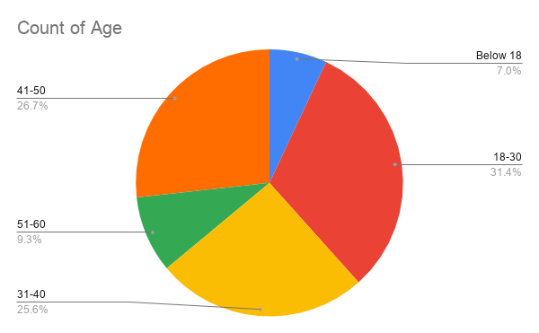

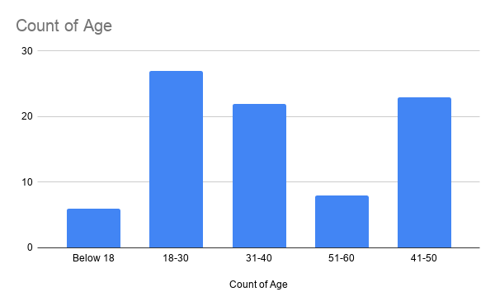

1. **Gender:** The below Pie Chart represents the percentage of respondents of a particular gender. There are 69.8% (60 in number) Male, 29.1% (25 in number) Female and 1.2 % (1 in number) from other gender.

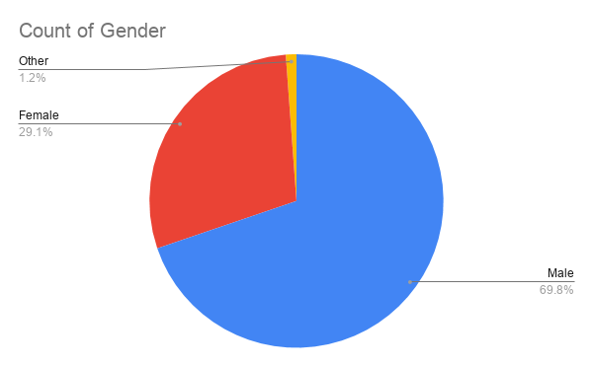

1. **Education:** The below Pie Chart and Bar graph represents the percentage and numbers of respondents in a particular Education level. There are 5.8% (5 in number) people who have studied up to Matriculation level, 8.1% (7 in numbers) people who have studied up to 10+2 level, 60.5% (52 in number) people who have studied up to Graduation level and 25.6% (22 in number) people who have studied up to Post-Graduation level.

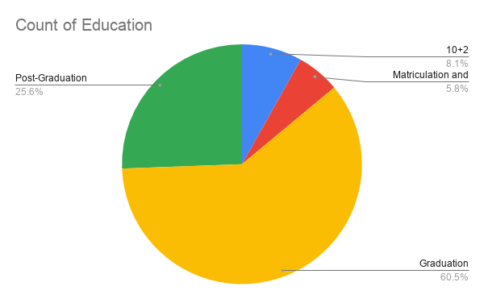

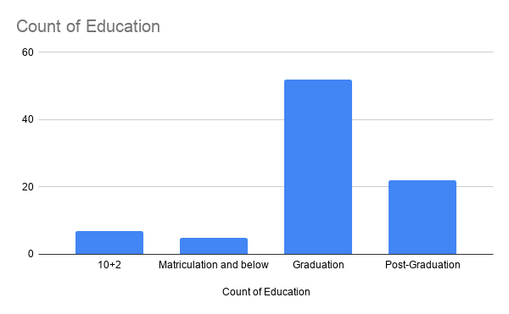

1. **Profession:** The below Pie Chart and Bar graph represents the percentage and numbers of respondents in a particular profession. There are 17.4% (15 in number) people who are still studding and are a student, 17.4% (15 in numbers) people who are working as a private sector employee,32.6% (28 in number) people who are working as a public sector employee, and 32.6% (28 in number) people who are not working under any public or private sector company but are self-employed.

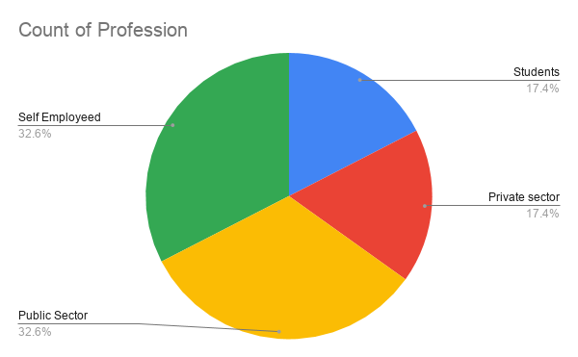

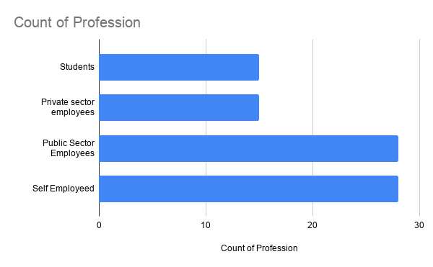

1. **Annual Income:** The below Pie Chart and Bar graph represents the percentage and numbers of respondents in a particular income group. There are 17.4% (15 in number) people who are not earning anything, 8.1% (7 in numbers) people who are earning up to 2.5 lakh yearly, 24.4% (21 in numbers) people who are earning between 2.5 lakh to 5 lakh yearly, 26.7% (23 in numbers) people who are earning between 5 lakh to 7.5 lakh yearly, 19.8% (17 in numbers) people who are earning between 7.5 lakh to 10 lakh yearly and 3.5% (3 in numbers) people who are earning above 10 lakh yearly

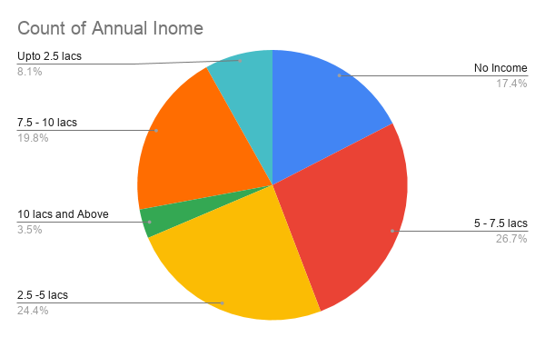

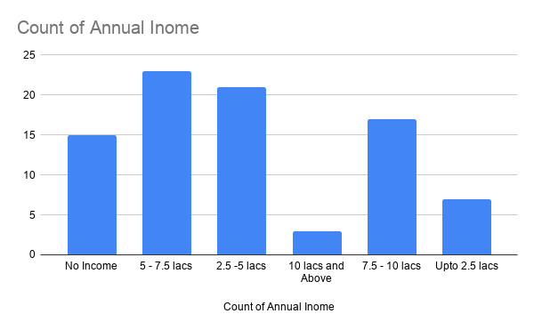

**DO YOU USE MOBILE PAYMENT APP?**

* 30.2% respondent said that they do not use any Mobile payment app and 69.8% respondent said that they are using Mobile payment app.

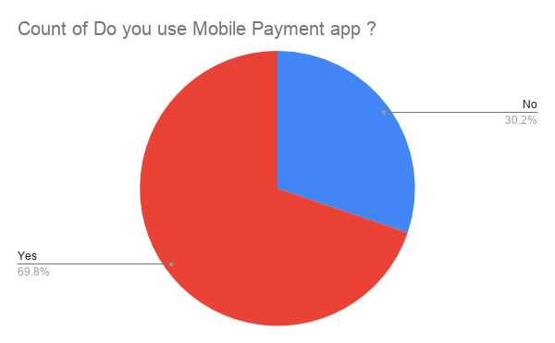

* On the basis of the response to the above question the form was divided into two different sections One was for who use Mobile payment apps and one who don’t use Mobile payment apps.

**RESPONSE TO DIFFERENT QUESTIONS WHO SAID ‘YES’**

* **WHICH OTHER PAYMENT METHODS DO YOU USE?**

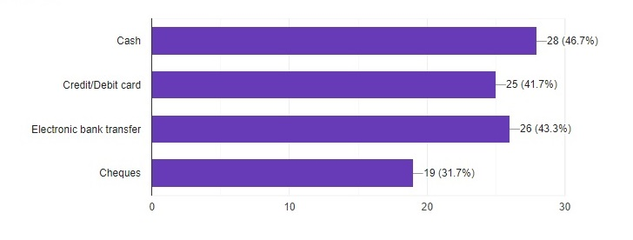

Except from online payment apps 46.7% respondents said that they use Cash as the payment method, 41.7 % said that they used Credit card as the payment method, 43.3 % said that they used Electric Bank Transfer as the payment method and 31.7 % said that they used Cheques as the payment method for different services

* **MOBILE WALLET/DIGITAL PAYMENT APPS USED ARE IMPORTANT FOR YOU?**

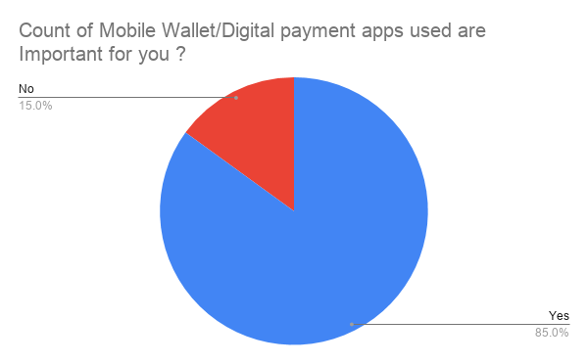

85% respondent said that Mobile payment Apps are Important for them and rest 15% said that it’s not important to them.

* **FREQUENCY OF USING DIGITAL PAYMENT TO MAKE ONLINE PAYMENT.**

The below Pie Chart and Bar graph represents the percentage and numbers of respondents which shows how frequently the respondent uses mobile payment apps. 31.7% respondent said that they are very frequently using the apps, 31.7% said that they are frequent in the use of the apps, 31.7% said that they are not so frequent in using the apps and 5% said that they are using it very less or not using it currently.

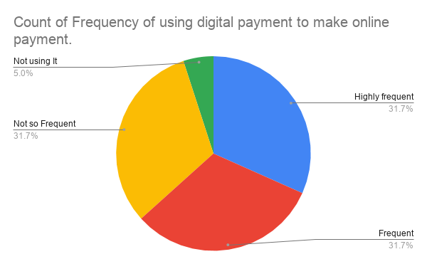

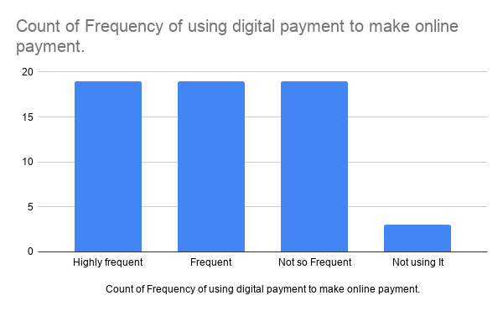

* **DO YOU PREFER MOBILE PAYMENT APP ABOVE OTHER PAYMENT MODES LIKE CASH, CARD ETC.?**

81.7% respondent said that they prefer Mobile payments app above other modes of payment.

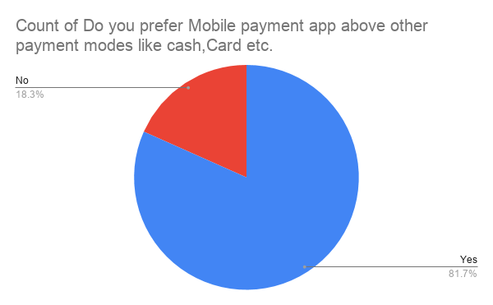

* **WHICH OF THE FOLLOWING MOBILE PAYMENT APP DO YOU USE?**

Most of the respondents i.e. 55% are using BHIM and Google Pay app, 45% are using Paytm, 31.7% are using Phone pay 21.7% are using Amazon pay 11.7% are using Bank provided apps and very less 8.3% are using PayPal.

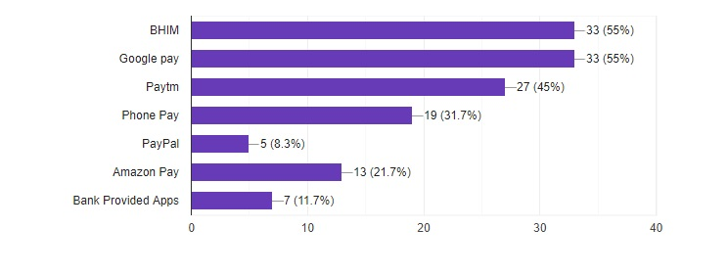

* **WHICH OF THE FOLLOWING MOBILE WALLET APP DO YOU PREFER THE MOST?**

The below Pie Chart and Bar graph represents the percentage and numbers of respondents respectively which shows which mobile payment app they prefer. 36.7% respondent said that they prefer BHIM app over other apps, 30% respondent said that they prefer Google pay over other apps, 16.7% respondent said that they prefer Paytm over other apps, 10% respondent said that they prefer Phone pay over other apps, 3.3 % respondent said that they prefer PayPal over other apps and 3.3 % respondent said that they prefer Amazon pay over other apps.

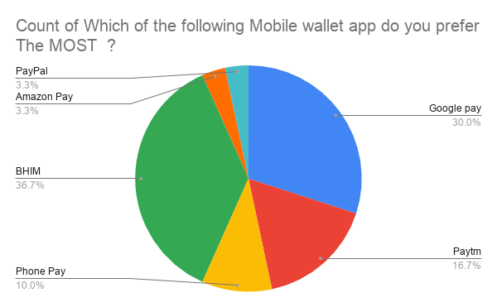

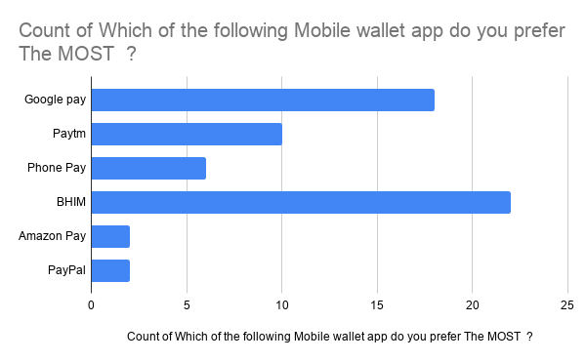

* **WHAT DO YOU LIKE THE MOST ABOUT THE MOBILE PAYMENT APP SELECTED ABOVE?**

43.3% of the respondent said that they prefer the app because of the user friendly interface, then the second reason why people like the app is because of the convenience of storing the card info and other details at one place and they can use it at one go and don’t have to enter the data again and again. Surprisingly respondents have given the least value to the security aspect of the preferred app.

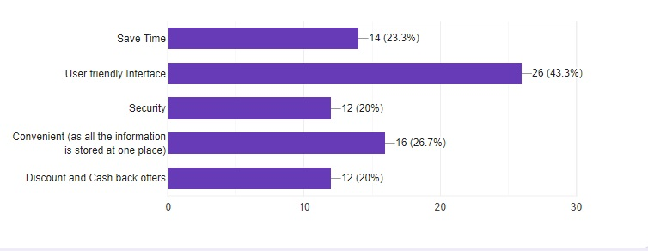

* **WHICH OF THE FOLLOWING THINGS DO YOU LIKE TO DO USING MOBILE WALLET APP?**

45% people like to do money transfer, then they use the app for Mobile recharge and Electricity/Gas bill. 8.3% use the app for credit card payment and 5% for flight and bus tickets booking.

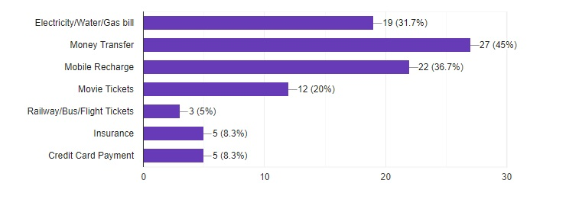

* **ACCEPTANCE OF WALLET/DIGITAL PAYMENT MODE WHILE SHOPPING IS _________ FOR YOU.**

The below pie chart and bar graph represents the percentage and numbers of respondents respectively which shows the importance of Mobile Payment mode while shopping. In which 41.7% respondent said that it is important or very important for them that the shopping of the product have a Mobile payment app option, 25% respondent said that it is moderately important for them, 13.3% respondent said that it is not so important or slightly important for them and 6.7% respondent said that it is not important for them to have a digital mobile app payment option while shopping.

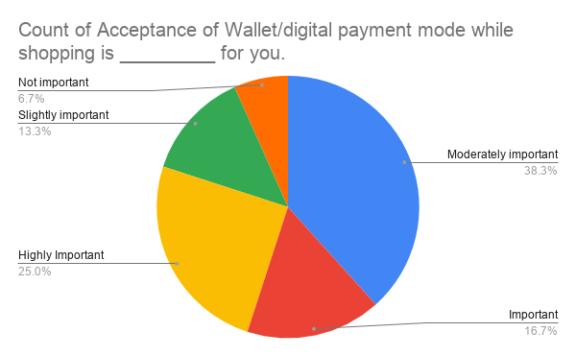

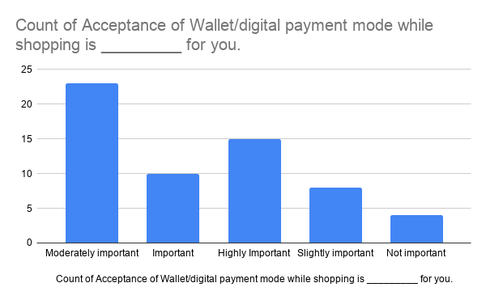

* **ACCEPTANCE OF MOBILE WALLETS ARE ABLE TO INCREASING SALE OF PRODUCT?**

The below pie chart and bar graph represents the percentage and numbers of respondents respectively which shows the acceptance of Mobile wallet increases the sales of product. In which 38.4% respondent said that they agree or strongly agree that the acceptance of Mobile wallet increases the sales of product. 35% said that they are moderate that it increases the sales of product and 26.7% said that they disagree or strongly disagree that the acceptance of Mobile wallet increases the sales of product.

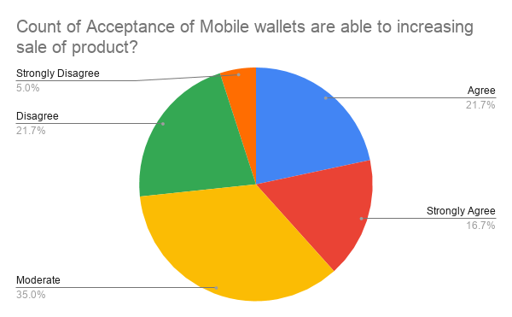

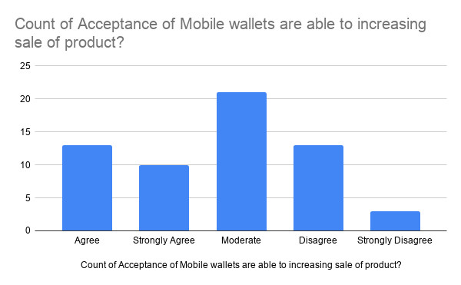

* **MOBILE WALLET HAS ENABLED ME TO MAKE A QUICK DECISION FOR BUYING PRODUCTS.**

The below pie chart and bar graph represents the percentage and numbers of respondents respectively which shows the acceptance of Mobile wallet has helped them to make a quick decision for buying some product. In which 45% respondent said that they agree or strongly agree that the acceptance of Mobile wallet has helped them to make a quick decision for buying some product. 28.3% said that they are moderate that it speedup the buying decision process and 26.7% said that they disagree or strongly disagree that the acceptance of Mobile wallet has helped them to make a quick decision for buying some product.

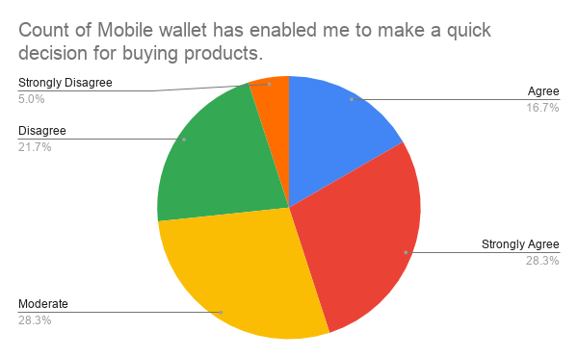

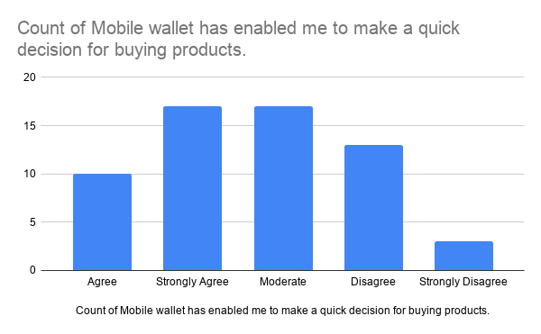

* **I BELIEVE MOBILE WALLETS ARE USEFUL IN BUYING PRODUCTS THAN THE TRADITIONAL METHODS.**

The below pie chart and bar graph represents the percentage and numbers of respondents respectively which shows the acceptance of Mobile wallet is more useful than Traditional methods for buying some product. In which 41.6% respondent said that they agree or strongly agree that the acceptance of Mobile wallet is more useful than Traditional methods for buying some product. 33.3% said that they are moderate towards both the methods and 25% said that they disagree or strongly disagree that the acceptance of Mobile wallet is not more useful than Traditional methods for buying some product.

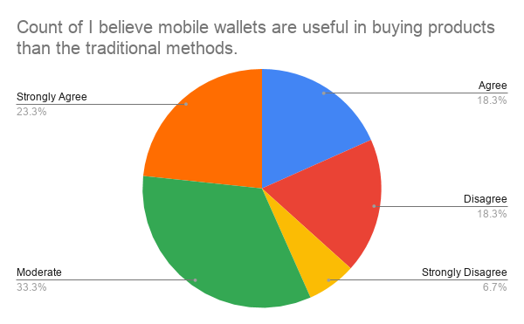

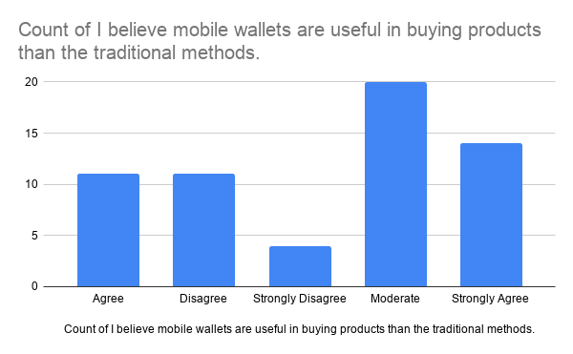

* **SERVICE CHARGE WHILE USING DIGITAL PAYMENT MODE IS _________ FOR YOU.**

The below pie chart and bar graph represents the percentage and numbers of respondents respectively which shows the importance of Service charge while using Mobile Payment mode. In which 50% respondent said that it is important or very important for them that the Mobile payment app don’t have any charge, 35.7% respondent said that it is moderately important for them, 10% respondent said that it is not so important or slightly important for them and 3.3% respondent said that it is not important for them if Mobile Payment mode have any service charges.

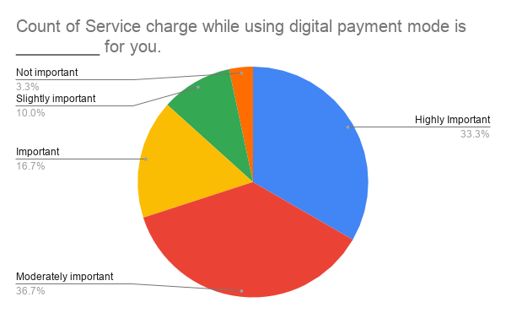

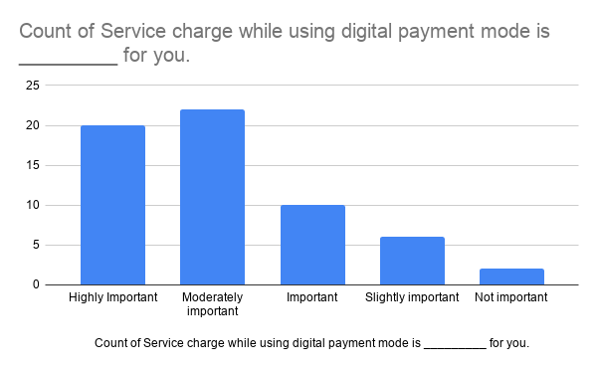

* **HAVING SECURED TRANSACTIONS IS ALWAYS A CONCERN FOR YOU?**

The below pie chart and bar graph represents the percentage and numbers of respondents respectively which shows the concern of respondents regarding a secured transaction. In which 83.3% respondent said that they are always concerned about the transaction while 5% said that they are concerned only if a huge amount is involved in the transaction and rest 11.7% said that they are not concerned at all.

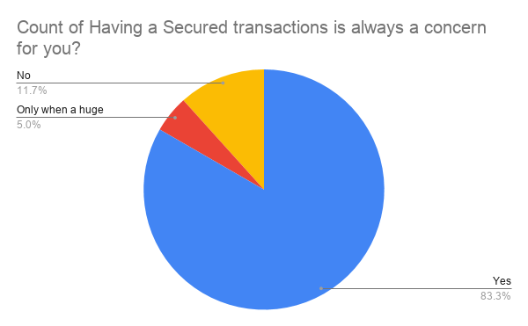

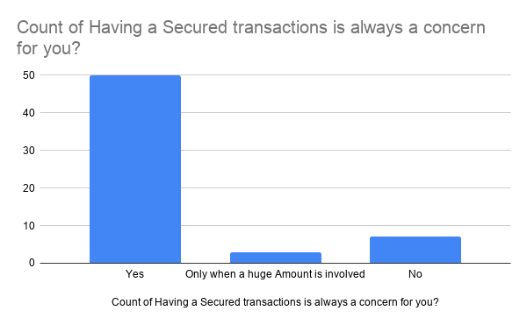

* **I TRUST THE SERVICE PROVIDERS OF MOBILE WALLET**

The below pie chart and bar graph represents the percentage and numbers of respondents respectively which shows that they trust the service provider for safe keeping of their data and a secured transaction. In which 41.6% respondent said that they agree or strongly agree that they trust the service provider for safe keeping of their data and a secured transaction. 30% said that they are moderate towards both the service provider and 26.7% said that they disagree or strongly disagree that they do not trust the service provider for safe keeping of their data and a secured transaction.

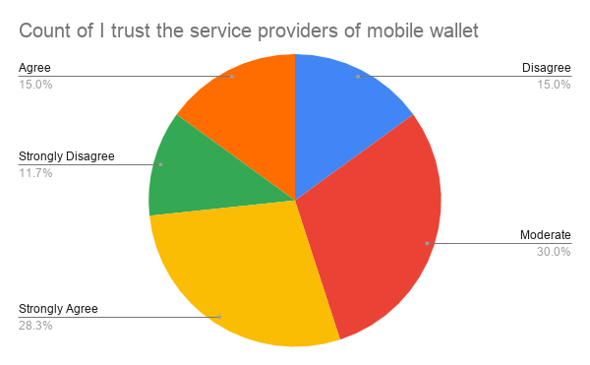

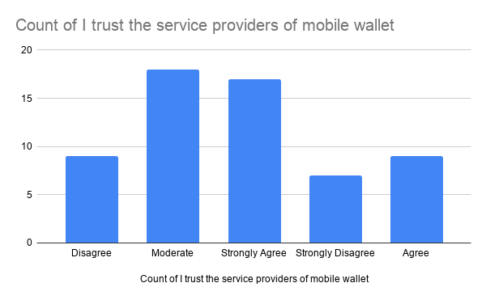

**RESPONSE TO DIFFERENT QUESTIONS WHO SAID ‘NO’**

* **WHICH OF THE FOLLOWING PAYMENT METHODS DO YOU USE?**

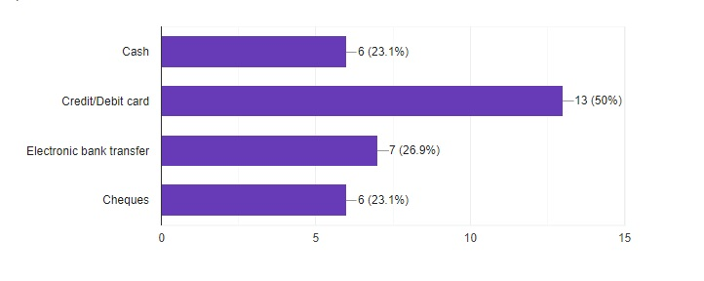

Except from online payment apps 23.1% respondents said that they use Cash as the payment method, 50 % said that they used Credit card as the payment method, 26.9 % said that they used Electric Bank Transfer as the payment method and 23.1 % said that they used Cheques as the payment method for different services

* **IF YOU HAVE NEVER USED MOBILE PAYMENT APP, WHAT ARE THE MAIN REASONS? (CHECK ALL THAT APPLY)**

The main reason why people don’t use Mobile payment apps is because of the technology is very new to them and they don’t understand how to use. Second reason is they don’t think it is valuable for them and they find it difficult to trust the service provider. Also 11.5% people said that their bank is not letting them use these types of apps.

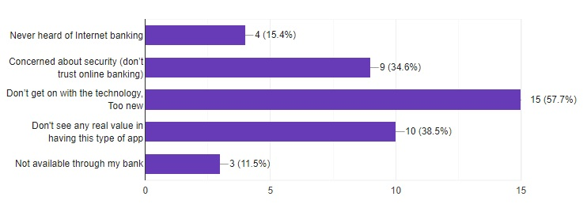

**CONCLUSION**

**Respondent profile:**

* Around 86 respondents have taken part in the survey in which 83.7% respondent belonged to the age group of 18-50.
* 70% respondents were male and 29% were female and 1% others.
* 86.1% respondents are Graduate or Post Graduate.
* 82.6% respondents were working in either private sector or public sector or were self-employed and 17.4% were students.
* 82.6% respondents were earning rest 17.4% have no income.

**Analysis:**

* 30.2% respondent said that they do not use any Mobile payment app and 69.8% respondent said that they are using Mobile payment app.
* Most used payment method after cash is Credit/Debit card.
* 85% feel that mobile wallets are important and 63.4% are using them frequently and 81% said that they prefer it over the other payment methods.
* BHIM, G-pay and Paytm are the most used and preferred app.
* The reason why they like these apps is because the user friendly interface and the convenience they provide.
* Payment apps are mostly used for money transfer, mobile recharge and bill payments like electricity, gas and water bills.
* 80% respondent find it important to have a digital payment option while shopping
* 73.4% respondent said that they believe that mobile wallet acceptance as payment for a product can increase sales
* 73.3% respondent believe that mobile wallet acceptance has enabled them to make a quick decision for buying products
* 74.9% respondent said that mobile wallets are more useful than traditional methods
* 88.3% people are always concerned about the security of a transaction that is taking place.
* 86.7% respondent is concerned about service charges that are implemented during any payment or transfer.
* Only 43.3% respondent said that they trust the service providers of the mobile payment app.
* The main reason why people don’t use Mobile payment apps is because of the technology is very new to them and they don’t understand how to use.
* Second reason is that they don’t think it is valuable for them and they find it difficult to trust the service provider.
* 11.5% people said that their bank is not letting them use these types of apps.

**REFRENCE**

* Bamasak, O., (2011), “Exploring Consumers Acceptance of Mobile Payments-An Empirical Study”, International Journal of Information Technology, Communications and Convergence, 1: pp.173-185
* Liu, S., Zhuo, Y., Soman, D., and Zhao, M., (2012), “The Consumer Implications of the Use of Electronic and Mobile Payment Systems”, Rotman School of Management, University of Toronto, Toronto.
* Padashetty, S., and Kishore, K.S., (2013), “An Empirical Study on Consumer Adoption of Mobile Payments in Bangalore City-A Case Study”, Researchers World 4: pp.83-84.
* Rathore, H.S., (2016), “Adoptionof Digital Wallet by Consumers. BVIMSR’s Journal of Management Research, 8:pp. 69-71. International Journal of Pure and Applied Mathematics Special Issue 2173
* Rouibah, K., (2015), “Digital Payment Systems Use and Satisfaction in an Arabic”, Issues in Information Systems, 16(2):pp. 149-160.
* Sanghita Roy, and Indrajit Sinha, (2014), “Determinants of Customers’ Acceptance of Electronic Payment System in Indian Banking Sector-A Study”, International Journal of Scientific & Engineering Research, 5(1):pp.177-187.
* Shamsher Singh, (2017), “Study of Consumer Perception of Digital Payment Mode” Journal of Internet Banking and Commerce, 22(3), pp.1-14.
* Sivasubramanian, J., Velavan, M., Arunkumar,S., Abirami,P., Therasa, C., and Abirami,G.,(2017), “Preference towards Digital Payment among Gen X-ERS, International Journal of Economic Research, 14(3):pp. 375-384.
* Subhash Bhagavan Kommina and 2 Jinil Persis Devarajan,” Social Media Data Driven Determination of
* Student Perceptions”, International Journal of Pure and Applied Mathematics ( IJPAM), Vol 117 ,No. 15,pp no. 227-239, 2017.
* Sumathy, M., and Vipin, K.P.,(2017), “Digital Payment Systems: Perception and Concerns among Urban Consumers”, International Journal of Applied Research, 3(6): pp.1118-1122.
* Irfan Ahmed Mohammed Saleem, Dr. S. Jaisankar **(**2018), A Study On Kaizen Based Soft-Computing In Electric Vehicle Manufacturing Processes, International Journal Of Innovations In ScientificAnd EngineeringResearch, 5(5),.
* DR.S.Manikandan*1 , J.Mary Jayakodi 2, An Emprical Study On Consumers Adoption Of Mobile Wallet With Special Reference To Chennai City, International Journal Of Research -Granthaalayah ,Vol.5 (Iss.5): May, 2017] ,DOI: https://doi.org/10.5281/zenodo.583902
* Shivangi Jaiswal1 ,Pankaj Joge (2018) “A Study on Consumers Acceptance of Mobile Wallet with Special Reference to Durg/Bhilai”. International Journal of Advanced in Management, Technology and Engineering Sciences, Volume 8, Issue III,

**APPENDIX**