Project Dissertation
On
“Total Quality Management in Human
Resource Management”

Submitted By :
Meghaa Gupta
2K13/MBA/40

Under the Guidance of :
Shikha N Khera
Assistant Professor, DSM, DTU


DELHI SCHOOL OF MANAGEMENT
Delhi Technological University
Bawana Road Delhi 110042

CERTIFICATE

This is to certify that the Project Report titled “Total Quality Management in Human Resource Management” is a bonafide work carried out by Ms. Meghaa Gupta of MBA 2013-2015 and submitted to Delhi School of Management, Delhi Technological University, Bawana Road, Delhi - 42 in fulfillment of the requirement for the award of the Degree of the Masters of Business Administration.

Signature of Guide Signature of Head(DSM)

Place:
Date:

DECLARATION

I, Meghaa Gupta, student of MBA 2013-2015 of Delhi School Of Management, Delhi Technological University, Bawana Road, Delhi-42 declare that the dissertation report on “Total Quality Management in Human Resource Management” submitted in fulfillment of Degree of Masters of Business Administration is an original work.
The information and data given in the report is authentic to the best of my knowledge and is not being submitted to any other university for award of any other Degree, diploma and Fellowship

Meghaa Gupta
Place:
Date:

ACKNOWLEDGEMENT

"Acknowledgement is an art, one can write glib stanzas without meaning a word, on the other hand one can make simple expression of gratitude".
On the very outset of this report, I would like to extend my sincere & heartfelt obligation towards all the personages who have helped me in this endeavour. Without their active guidance, help, cooperation & encouragement, I would not have made headway in the project.
I am extremely thankful and pay my gratitude to my mentor, Ms Shikha N Khera & Mr. Sahil Mallik for their genuine concern, guidance and valuable inputs during the course of this project.
I also express my sincere thanks to Prof. P.K.Suri, Head of Department and all the faculty members of Delhi School of Management, DTU Delhi.
I extend my gratitude to Delhi Technological University for giving me this opportunity.
An appreciative "Thank you" is accorded to all my colleagues for their positive support.
I also acknowledge with a deep sense of reverence, my gratitude towards my parents who have always supported me, in every possible way.

ABSTRACT

The key to improving and standardizing business processes in terms of reducing wastes in both efforts and material and thereby improving efficiencies is controlling and maintaining quality, as a repetitive and continuous process. This fact however is well known in the industry today. What is not known is the fact that the same principles Total Quality Management can be applied in the function of Human Resource Management to reduce wastages there as well.
With increasing globalization and industrialization, Human assets today have N number of opportunities in front of them. This has lead to improved instances of attrition as well as Job hoping. The Human Resource Executives, therefore, have to keep coming up with improvements in the processes that deal with these assets so as to keep them happy and satisfied. Applying TQM principles in HRM is gaining increased importance as a tool to do just the same.
This report covers :
  - Introduction to the Concept of TQHRM
  - Its presence in India
  - Its relevance to the country &
  - Perception of HR Managers towards it.

Chapter 1: INTRODUCTION

1.1 Introduction
This report is about all about the theory and practical scenario of TQM and its impact on HRM, i.e. the amalgamation of both. By having a through knowledge and understanding about these core areas we will be able to think in a new way in the future as HR professional.
Total quality human resources management (TQHRM) is “an approach to human resources management that involves many of the concepts of quality management.” The primary goal of TQHRM is employee empowerment. Several differences exist between the traditional human resources approach and TQHRM. Thomas Foster developed a table that was adapted from an article by Cardy and Dobbins
The TQHRM approach focuses on providing employee empowerment through alignment, authority, capability, and commitment. As Juran states:
“The full potential of employee empowerment is realized in the empowered organization, when employees: align their goals with appropriate higher organization purpose; have the authority and opportunity to maximize their contribution; are capable of taking appropriate action; are committed to the organization’s purpose; and have the means to achieve it.”
Companies are beginning to realize that employee involvement is critical to product and service quality, and thus essential to the total quality management strategy.

1.1.1 How to implement TQHRM
The primary goal of TQHRM is to provide an atmosphere that promotes employee empowerment. Empowerment requires the alignment, authority, capability, and commitment of employees. In order to achieve these goals, Juran has identified several steps that must be taken to achieve each goal.

Alignment
Alignment can be realized if employees:
• Know the needs of customers and stakeholders
• Know, concur in, and be prepared to contribute effort to organization strategies, goals, objectives, and plans

Authority
In order for employees to the have the authority and opportunity to contribute to the organization, the following steps are required:
• Individual authority, responsibility, and capability are consistent
• Barriers to successful exercise of authority have been removed
• The necessary tools and support are in place

Capability:
Employee capability can be developed through:
• Organizational training initiatives
• Educational development

Commitment:
An organization must earn the commitment of employees through:
• Reinforcement
• Recognition
• Rewards

1.1.2 Combination of HRM, TQM, Job Involvement and Organizational Commitment
- Job design
- Job analysis
- Selection and Recruitment
- Training & Development
- Employee empowerment & Recognition
- Teamwork and Leadership
- Employee participation

1.2 Objectives of the Study:
1. To briefly introduce the relationship between following concepts and HR functions in aligning with TQM.
2. To understand the managerial perception of TQHRM in the Industry.
3. To gauge their understanding about and attitude towards the concept.
4. To identify the various costs and resources required to implement TQHRM and their relative importance.

Chapter 2: LITERARURE REVIEW

2. LITERATURE REVIEW
Introduction to Total Quality Management
Everyone has experiences of poor quality when dealing with business organizations. These experiences might involve an airline that has lost a passenger’s luggage, a dry cleaner that has left clothes wrinkled or stained, poor course offerings and scheduling at your college, purchased product that is damaged or broken, or a pizza delivery service that is often late or delivers to you the wrong menu in wrong order.
The experience of poor quality is exacerbated when employees of the company either are not empowered to correct quality inadequacies or do not seem willing to do so. We have all encountered service employees who do not seem to care. The consequences of such an attitude are lost customers and opportunities for competitors.
Successful companies understand the powerful impact customer-defined quality can have on business. For this reason many competitive firms continually increase their quality standards.
For example, both the Ford Motor Company and the Honda Motor Company have recently announced that they are making customer satisfaction their number one priority. Ford is focusing on tightening already strict standards in their production process and implementing a quality program called Six-Sigma. Honda, on the other hand, is focused on improving customer-driven product design. Although both firms have been leaders in implementing high quality standards, they believe that customer satisfaction is still what matters most.
Total quality management (TQM) is an integrated organizational effort designed to improve quality at every level. TQM functions on the premise that the quality of products and processes is the responsibility of everyone who is involved with the creation or consumption of the products or services offered by an organization. In other words, TQM capitalizes on the involvement of management, workforce, suppliers, and even customers, in order to meet or exceed customer expectations
In strategic context, TQM is probably most accurately categorized as a tactic for carrying out strategies requiring high level of product or service quality. Essentially TQM pulls together a number of well-known management principles into a coherent and systematic framework. Through the systematic interaction of these principles, TQM has the potential to lead to increased quality.
TQM principles emphasize:
- Articulation of strategic vision
- Objective and accurate measurements
- Benchmarking
- Widespread employee empowerment and team building
- Striving for continuous improvement
- Emphasis on a systems view of quality that conceptualize quality-related activities as being highly interdependent
- Leadership committed to quality
- Great emphasis on customer satisfaction
2.2 Introduction to Human Resource Management
Same time this concept deal with Human Resource Management and management of processes, respectively. This addresses the issues of people and process. Human resource focus addresses issues of employee involvement. This entails continuous improvement programs, employee training, and functioning of teams. Employee involvement is considered a critical element of quality. Similarly, process management involves documentation of processes, use of tools for quality improvement such as statistical process control, and the degree of process integration within the organization. In the achievement of total quality in the organization the human resource dimension is very important (Deming, 1982, 1986). Continuous quality improvement depends upon the best use of the talents and abilities of a company's workforce. To achieve world class quality, it is imperative that a company empowers its workers. Companies must develop and realize the full potential of their workforce and maintain an environment conducive to full participation, personal and organizational growth
Flexibility is the key, especially in a business environment that is diverse and constantly changing, as most are today. In modeling these aspects of the TQM process, the HR department would need to identify human resource concerns of other departments and undertake to continually improve its performance, especially in any trouble areas that come to light.
David Bowen and Edward Lawler have described the relationship between TQM and Human Resource Management as follows:
‘The importance of the HR side of quality equation provides HR department with golden opportunity. Quality can be the “business issue” that truly brings senior managers and HR executives together to move from just HRM to strategic HRM. A major role in the quality improvement effort puts HR in a position to contribute directly and visibly to the bottom-line, to add value to the company’s products and services in the same way that other functions, such as sales, accounting, and production, add value.’
achieved through creating the appropriate human resource development through training, employee participation and involvement, building quality awareness among employees, and motivating employees. The main issues considered in human resource development are: human resource management, employee involvement, quality education and training, employee recognition and performance, and employee well-being and morale. The human resource development in an organization is an important contributor to proper and meaningful quality management since the quality philosophy and practice have to be part and parcel of the entire workforce and not the concern of only a few.

2.3 Combination of HRM & TQM
TQM programs hae the potential to increase the importance of the human resource management function. Human resource management plays a major role in providing more systematic training, facilitating changes that empower employees, instituting team-based reward systems, and communicating to workers their role in quality.
Before the human resource function can make full contribution to TQM efforts, high quality must be assured within the function itself. Benchmarking provides a useful means of both evaluating the quality of human resource programs, activities and impact as well as a means of identifying areas in which resource should be concentrated. The following quotations by David Ulrich, Wayne Brockbank, Arthur Yeung describes practice:
Benchmarking HR practices provides the means of focusing attention on highest value-added HR activities–those practices which are more likely to be practiced by successful companies. Rather than fall into the trap of trying to do everything well and please everyone with insufficient resources–which results in no one being satisfied–HR professionals could use benchmarking to focus limited resources on critical activities.
One of the important impacts of TQM, from strategic HRM perspective, is that it places great emphasis on training. TQM maintains that error and mistakes, which detract from the quality of companies’ products and services, are predictable result of untrained workers, and therefore training must be provided. Consistent with the emphasis on measurement, in some companies that use TQM, training is evaluated with the use of control groups and experimental designs.
In contrast to training, TQM is sharply at odds with conventional human resource practices in the area of performance evaluation. According to Deming, traditional performance evaluation systems are flawed because they are directed toward the individual instead of a team. Such systems are also focus on assigning blames for past mistakes instead of pointing out the direction for the future and may even detract from teamwork.
Despite these differences, most of the concpets of TQM are very much applicable in HRM and if used in a systemactic and well-planned manners can result in good product and service quality and organizational growth

HRM is the efficient and effective utilization of human resources to achieve goals of an organization. Human resource management is the distinctive approach to employment management which seeks to achieve competitive advantage through the strategic development of a highly committed and capable work force, using an integrated array of cultural, structural and personal techniques. So we can say HRM is the process of acquiring, developing, maintaining and keeping relationships of human beings of an organization to achieve its core purpose.
TQM is the way of managing for the future and is far wider in its application than just assuring product or service quality. It is a way of managing people and business processes to ensure complete customer satisfaction at every stage, internally and externally. TQM combined with effective leadership, results in an organization doing the right things right, first time. Therefore TQM is the art of managing the whole to achieve excellence.
Job involvement means the degree to which a person identifies with his or her job, actively participates in it and consider his or her performance important to self-worth. That means intensity of a person’s psychological identification with the job.
The success and the progress of an organization is heavily depends on the combination of HRM, TQM, organizational commitment and the job involvement. Attraction and retention of the best employees within the organization, increasing job satisfaction, getting higher level performance from the employees are the most important tasks in HRM. But to achieve all of these things and to reach to organizational goals an organization should have employees with organizational commitment and job involvement.
Organizational commitment means the extent to which an individual identifies with and is involved with his or her organization and/or is unwilling to leave it. There is a positive relationship between job satisfaction and job involvement. When job satisfaction is high due to pay people fairly, improve the quality of supervision, match people to jobs that fit their interests and decentralize organizational power job involvement is also high. When there is job dissatisfaction job involvement is also low. Job involvement starts with the quality of the HR practices. The organization develops the policies according to the HR practices.
If an organization experience HR practices with a high quality, TQM is there. But TQM is not HRM. In simply TQM is the art of managing the whole to achieve excellence. So when the HRM practices in its maximum level it is called TQM. Then the organizational commitment and job involvement of employees are also increase. According to this, TQM, HRM, Job involvement and organizational commitment have an inter dependence on each other while on the other hand conflict with each other.

2.4 TQM in the HR Functions:

2.4.1 Empowerment
The dictionary definition of empowerment is to invest people with authority
Empowerment should not be confused with delegation or job enrichment. Delegation refers to distributing and entrusting work to others. Employee empowerment requires that he individual is held responsible for accomplishing the whole task. The employee becomes process owner- thus the individual is not only responsible but also accountable. Employee empowerment requires that the individual is held responsible for accomplishing a whole task.
The link between HRM and TQM was identified as being in the area of development and empowerment of people and the shift from a control based style of management to an empowering management where attention is focused on coaching and leading.
It is generally accepted that a TQM environment fosters employee empowerment. According to the literature, TQM should promote empowerment of front-line employees, giving them more responsibility and information (Schuler and Harris, 1992), and so undermining middle managers‟ traditional role in implementing and monitoring the instructions of top management. TQM means taking on greater responsibility, often for the same pay (Snape et al., 1995). Thus, for quality initiatives to work, there must be sufficient participation (Ferna´ndez, 1996; Newall and Dale, 1991; Schuler and Jackson, 1987) and communication on the part of all employees in quality decisions, because they can improve the organizational processes (Mohanty and Sethi, 1996; Schonberger, 1994; Wilkinson et al., 1994). Organizational job descriptions should reflect these variables and be designed to promote quality. Moreover, jobs descriptions require a customer and innovation orientation and continual improvement (Blackburn and Rosen, 1993; Schonberger, 1994), allowing employee autonomy, responsibility and flexibility (Simmons et al., 1995; Snape et al., 1995). However, although job descriptions should be explicit and formal (Schuler and Jackson, 1987), because of the importance of documentation to the system (Ferna´ndez, 1996), TQM may require a move away from detailed, fixed job descriptions in order to foster flexibility and teamwork (Bowen and Lawler, 1992; Snape et al., 1995).

2.4.2 Job design and Job analysis
Job design is the personnel or engineering activity of specifying the contents of the job, the tools, and the techniques to be used, the surroundings of the work and the relationship of one to other jobs. In simply job design means creation of jobs which individuals in an organization have to perform. So job design can be prepared as the function of arranging tasks, duties and responsibilities in to an organizational unit of work for the purpose of accomplishing a certain objective.
Job analysis is a systematic approach to collect information about a job such as tasks, duties responsibilities and the skills required to perform those tasks. That means JA is a systematic investigation of jobs and jobholder characteristics in order to create a collection of information that can be used to perform various HRM activities and functions. For the success of all the other HRM functions job analysis is very important. So apply TQM for job design and job analysis is very important. If we use TQM for techniques of job design such as job enrichment, job enlargement etc and to the process of job analysis to produce job specification and job description we can gain so many benefits rather than a company who are not practicing TQM in job design and job analysis.
By using TQM in these 2 functions we can increase efficiency of employees, effectiveness of employees and productivity. And also it causes to minimize cost, increase health and safety of employees and finally to increase employee satisfaction and quality of work life. When job satisfaction is high it causes to have high job involvement and organizational commitment. On the other hand when TQM is not practicing in job design and job analysis it will cause to lower productivity, employee turnover. Absenteeism, complains, unionization and resignation.

2.4.3 Recruitment, Selection, Hiring and Induction
Recruitment means the process of finding and attracting suitably qualified people to apply for employment. Recruitment is the set of activities an enterprise uses to attract job candidates who have the abilities and attitudes needed to help the enterprise achieve objectives. Selection is the process of making the choice of the most appropriate person from the pool of applicants recruited to fill the relevant job vacancy. Hiring is the process of appointing the candidate selected to the post/job which is vacant. And also induction is the HRM function that systematically and formally introduces the new employees to the organization, the job, the work group to which the new comer will belong and the work environment where the new comer will work. Recruitment is one of the most important tasks that a company undertakes and can be costly and time consuming, involving advertising costs, interview expenses and staff time. Placing the right people in the right jobs reduces the staff turnover rate and the costs involved with constant recruitment. In order for you to get a head start and attract a right people in to your organization TQM solutions is very important. TQM has an effect on selection procedures, more sophisticated recruitment and selection techniques were being introduced, including psychometric and aptitude tests and assessment centers in an attempt to identify team workers appropriate to a quality culture.
As we are practicing TQM in HRM we always recruit the right people to the right position. Because of that everyone gets the right job as to their skills, interests and qualifications. So their job satisfaction is in a higher level. Assessment centers are tailored to provide a positive environment for participants and deliver robust for your organization that enables you to make fair judgments and decisions. Following the selection process TQM solutions will help you to develop induction and probationary period tools for the job holder. These development tools are designed to be used by organization to develop quality people, who will make a difference to the business, they measure and give manageable results on the individuals progress and identify further support and development opportunities. Organizations which are practicing TQM can be an employer of choice. That means one for who people wants to work. There is desire to join the organization and once they join they stay. So the best people are joining to our organization and the organization can select most suitable people among that. Job involvement and organizational commitment of those selected people are in a higher level because they can work in a pleasant working environment.
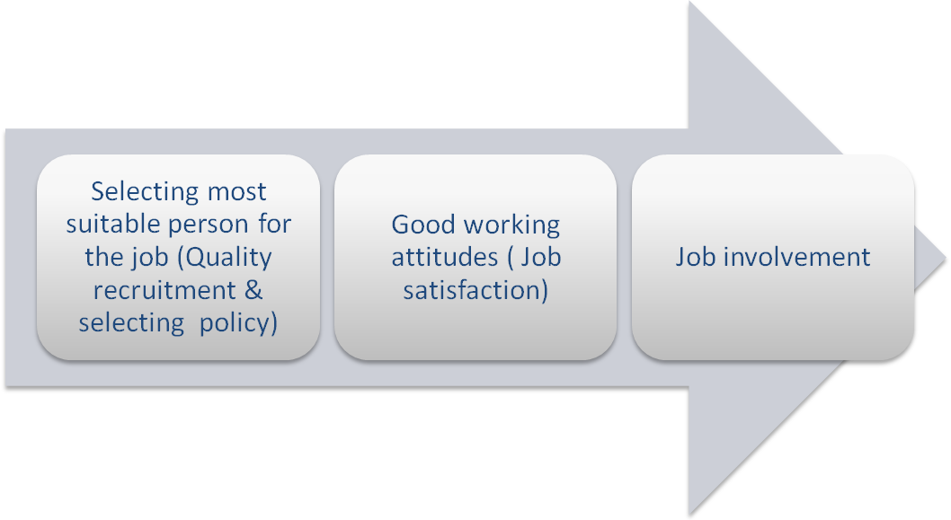

2.4.4 TQM & Training and Development
There should be an affective training and development procedure in an organization. If there is an effective training & development programme, the output of employees will be a quality one. First organizations are identifying the training needs of employees by performance appraisal. In HRM, we are doing individual training. Here we are doing individual training. Here we are choosing the most suitable ones for training. The training will be having for limit number of people in the organization. So others may de-motivate, because they are not having a chance to develop their skills.
Training will be developed the technical skills of low level of employees. Development procedure is helpful to develop the managers’ skills of executive level. But in TQM we mainly discuss about teamwork and the quality of everything that we are doing. Here we are focus on total quality not about individual training.
Ex: In garment industry, they are implementing training programmes for team. They are grouping people and developed. There they will be identify their task and learn to achieve the task. From that their job satisfaction also will be increased.
But the training programme must be a quality one. From that only we can gain the maximum benefit for the training cost. Organizations are spending lot of cost on training and development. So spending that much of cost, they are expecting a higher level of contribution of employees to achieving the organizational goals. Organizations are mostly expecting the job involvement and organizational commitment of employees after T & D programme.
In general, HRM is responsible for providing training and development. With their background, HR departments are well-positioned to take the leading role in providing such programs consistent with the TQM philosophy. HR managers have an important opportunity to communicate a history of their organization's TQM program and its champions. Equally important, HRM can tell stories of employees who are currently inspiring the TQM philosophy. As corporate historian, the HR department should be primarily responsible for relaying the TQM culture to members of the organization in employee orientation training.
Beyond communicating the TQM philosophy, the specific training and development needs for making TQM a practical reality must be assessed. Basically HR professionals must decide the following: What knowledge and skills must be taught? How? What performance (behaviors) will be recognized, and how will we reward them? HRM has faced these questions before and can best confront them in the TQM process. Training and development that does not fit within the realm of these questions will more than likely encounter heavy resistance. However, training and development does fall within the realm of these questions probably will be accepted more readily.


Basically, training has to be oriented to the process methodology (Schonberger, 1994). Employee training is fundamental for many TQM programs such as the adoption of new quality concepts, the set-up and practices of customer satisfaction systems, the use of statistical quality control, or the change of culture or quality control circle (Bowen and Lawler, 1992; Yang, 2006). Moreover, employees require three basic areas of training (Clinton et al., 1994): principles of TQM, the use of TQM tools and problem-solving techniques.
Basic Steps of Effective Training Plans
The first step in training process is to make everyone aware of what the training is all about. Thoughts suggestions should be gathered.
The second step is to get acceptance. The trainees must feel that training will be of value to them.
The third step is to adept to adapt the program. Is everyone ready to buy into it? Does everyone feel they are a part of what is going to take place?
The fourth step is to adept to what has been agreed upon. What changes must be made in behavior and attitudes.

2.4.5 TQM and Employee Empowerment
Employee empowerment is a term used to express the ways in which non-managerial staff can make autonomous decisions without consulting a boss/manager. These self-willed decisions can be small or large depending upon the degree of power with which the company wishes to invest employees. Employee empowerment can begin with training and converting a whole company to an empowerment model. Conversely it may merely mean giving employees the ability to make some decisions on their own.
There are employee empowerment workshops, books, magazines and articles. The thinking behind employee empowerment is that it gives power to the individual and therefore makes for happier employees.
Following diagram explains the three levels of Employee Empowerment:
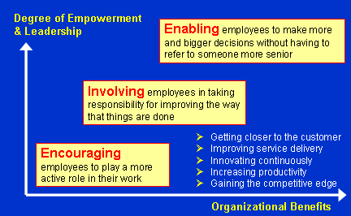
For employee empowerment to work successfully, the management team must be truly committed to allowing employees to make decisions. They may wish to define the scope of decisions made. Building decision-making teams is often one of the models used in employee empowerment, because it allows for managers and workers to contribute ideas toward directing the company.
Top management commitment and employees empowerment is one of the most important and vital principle in total quality management, because it is often assumes to have a strong relationship with customer satisfaction. In TQM implementation top management commitment in creating an organizational climate that empowers employees is very imperative. Thus, this can be achieved with top management commitment in training employees and giving employees opportunities to be responsible for the quality of their work.
Employee Empowerment in TQM brings about a flattened organizational chart where there is a shared responsibility between the managers and the employees.
Training also provides an opportunity to empower and motivate employees, reducing employee resistance and increases the chances of TQM success. Empowerment is a very important aspect and actually pays off because workers need to feel some sense of control over their work experience, and what motivates people is the feeling of having that fulfillment of needs (Kappelman and Prybutok, 1995).

2.4.6 TQM and Employee Recognition
Recognition is a key success factor even at higher levels of management.
Employee recognition is the timely, informal or formal acknowledgement of a person’s or team’s behavior, effort or business result that supports the organization’s goals and values, and which has clearly been beyond normal expectations.
To be really effective in a particular job, we need to understand the psychological scenario behind ‘praising’ others for their good work, to apply the principles of employee recognition. The cost of a recognition system is quite small and the benefits are large when implemented effectively.
Appreciation is a fundamental human need. Employees respond to appreciation expressed through recognition of their good work because it confirms their work is valued. When employees and their work are valued, their satisfaction and productivity rises, and they are motivated to maintain or improve their good work.
There are two aspects to employee recognition:
The first aspect is to actually see, identify or realize an opportunity to praise someone. If you are not in a receptive frame of mind you can easily pass over many such opportunities. This happens all too frequently.
The other aspect of employee recognition is, of course, the physical act of doing something to acknowledge and praise people for their good work.
Surveys conducted by Sirota Consulting have revealed that only 51% of workers were satisfied with the recognition they received after a job well done.1 This figure is as conclusive as you could get – it has been reached from interviewing 2.5 million employees in 237 private, public and not-for-profit organizations in 89 countries around the world in the ten years to 2003.

Benefits of Employee Empowerment
- Increased individual productivity – the act of recognizing desired behavior increases the repetition of the desired behavior, and therefore productivity.
- Greater employee satisfaction and enjoyment of work - more time spent focusing on the job and less time complaining.
- Direct performance feedback for individuals and teams is provided.
- Higher loyalty and satisfaction scores from customers.
- Teamwork between employees is enhanced.
- Retention of quality employees increases – lower employee turnover.
- Better safety records and fewer accidents on the job.
- Lower negative effects such as absenteeism and stress.

Costs of Employee Empowerment
- Time spent in designing and implementing the program.
- Time taken to give recognition.
- Dollar cost of the recognition items given
- Time and cost of teaching people how to give recognition.
- Costs of introducing a new process.
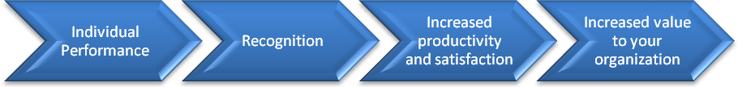

TQM can be used in Employee Recognition in several ways. A company can spontaneously praise people – this is highly effective. To many employees, receiving sincere thanks is more important than receiving something tangible. Employees enjoy recognition through personal, written, electronic and public praise from those they respect at work, given in a timely, specific and sincere way.
This day-to-day recognition is the most important type of recognition. Day-to-day recognition brings the benefit of immediate and powerful reinforcement of desired behavior and sets an example to other employees of desired behavior that aligns with organizational objectives. It gives individuals and teams at all levels the opportunity to recognize good work by other employees and teams, and it also gives the opportunity for them to be recognized on the spot for their own good work.

2.4.7 Team work
Team work is the process of working collaboratively with a group of people in order to achieve a common goal.
Teamwork is often a crucial part of a business, as it is often necessary or colleagues to work well together, trying their best in any circumstance. Teamwork means that people will try to cooperate, using their individual skills and providing constructive feedback, despite any personal conflict between individuals.
Since Team Work facilitates job satisfaction and job involvement and TQM encourage job satisfaction and job involvement the development of people and their involvement in improvement activities both individually and through teamwork is a key feature in a company’s approach to TQM.
A key aspect of this is making full use of the skills and knowledge of all employees to the benefit of the individuals and the organization and to create a group culture.The organizations with TQM practices, they are encouraging teamwork from their HR practices. HR manager’s role in teamwork is very important. HR role in teamwork is to encourage, support and help in solving their problems. HR managers work closely, friendly manner with team members.
Teams and team working is highly valued in today’s organizations. That will increase the productivity of the production as well as the job involvement of employees. An organization can gather following benefits from quality team working. These include:
- Continuous learning.
- Flexibility in working.
- Better employee attitudes.
- Co-ordination and supportiveness.
- Building good partnership between employees and managers.
- Create more commitment and involved employees within the organization.

The role of teams in Team working:
- Aid the commitment of people to the principles of TQM.
- Provide an additional means of communication
- Improve relationships
- Help to develop people and encourage leadership traits
- Build collective responsibility and develop a sense of ownership
- Aid personal development and build confidence.
- Develop problem-solving skills
- Facilitate awareness of quality improvement potential
- Help to facilitate a change in management style and culture
- Improve morale

2.4.8 Total Quality Management and Leadership
The definition of leadership is a process whereby an individual influences a group of individuals to achieve a common goal.
Characteristics of quality leaders:
- Give priority attention to customer
- Empower rather than control subordinates
- Emphasize improvement rather than maintenance
- Emphasize prevention
- Encourage collaboration rather than competition
- Train & coach rather than direct & supervise
- Learn from problems
TQM is a management approach of an organization centered on quality based on the participation of all of its members aiming at long term success through customer satisfaction and benefits to all members of the organization and to the society.
Having discussed what is meant by TQM, we can look in at the two aspects of the TQM namely Hard and Soft aspects.(Wilkinson,1998).The hard aspect reflecting the production orientation.
The soft side focuses on the management of human resources in the organization and lays particular emphasis on the need to change the culture. TQM thus emphasizes both production oriented and employee relations oriented elements.
TQM is a very people oriented technique and it indicates that the leadership, conducive work culture and positive attitudes of employees as the major factors that affect the excellence of TQM.
Some principles and practices of TQM may differ among firms and industries, but there is unanimous agreement as to the importance of leadership by top management in implementing TQM. Such leadership is a pre-requisite to all strategy and action plans .According to Juran (1989) it cannot be delegated. Those firms that have succeeded in making total quality work for them have been able to do so because of strong leadership (Juran, 1989) If moral integrity is fundamental to TQM, the TQM is the means by which it is expressed. Leadership is defined in the context of TQM as providing and driving the vision. (Mittal,1999,p:200)
Dimensions of TQM in Leadership
According to Schmidt and Finnigan (1992), there are twelve behaviors that successful quality leaders demonstrate. They were considered as the dimensions of the leadership behavior.These dimensions are,
D₁ - Giving priority attention to the needs of external and internal customers
D₂ - They empower rather than control
D₃ - They emphasize improvement rather than Maintenance
D₄ - They emphasize prevention rather than correction
D₅ - They encourage collaboration rather than Competition
D₆ - They train and coach, rather than direct and Supervise
D₇ - They learn from problems
D₈ - They continually try to improve communications
D₉ - They continually demonstrate their commitment to quality
D₁₁ - They establish organizational systems to support the quality effort.
D₁₂ - They encourage and recognize team effort.
According to the theory TQM success is measured in five main areas of effectiveness, efficiency, productivity, quality, and non-quality related measures such defects, error rates, cost of poor quality and deliveries not on time etc. (Oakland, 1995, Pp.173-187). TQM success is measured in terms of employee perception of the quality. Accordingly TQM success is the perception of a person to see in the production of the final product that, he should be educated in the process and should be participated with full authority and self-control with the intention of being innovative, so that the ultimate product or service to be free of errors in accordance with the current prevailing quality concepts. There are seven dimensions identified for the measurement of success of TQM. They are,
D₁ - Educative Process
D₂ - Participative structures (Quality Circles, Action Teams etc.)
D₃ - Greater autonomy and self control
D₄ - Decreasing trend of errors towards zero defects
D₅ - Adherence to quality concepts
D₆ - Creativeness or innovativeness
D₇ - Perception of customer satisfaction.

2.4.9 Employee participation
Employee participation is the process of empowering members of an organization to make decisions and to solve problems appropriately to their levels in the organization. Many organizations are attracting to various employee participation schemes such as quality circles, team working and total quality management as numerous commentators advocate their benefits. Although employee participation is not a new management concept, it has only recently seen a revival in popular support along with the concomitant rise in human resource management (HRM). Since HRM seeks to regard the employee as an asset that can be invested in through further training and development, it is argued that involving them in decision making can only enhance employee motivation, commitment and performance.
Moreover, if people at all levels of an organization manage their own work then they will find their jobs more rewarding. This can result in ‘higher quality products’ and reduced labor costs since fewer employees are required. Consequently with the prospect of productivity gains, in increasingly competitive international markets, many organizations are keen to adopt participative management schemes. Also, at the same time many courses on participative management appeared, providing low-cost, turnkey approaches for managers.
Most types of employee initiative, whether it is aimed at employee empowerment os employee problem solving are bound to fail if employers do not show commitment. .
people get the outcome of the things that they have curtained so that these employees can be satisfied that their suggestions have been implemented. This will be ornamental in positive attitudes and behaviors in place of work. They do their job more pleasantly. Because of that their job association will be increasing. And as a result of employee contribution employees have a chance to expand their skills and awareness.
As executive decisions become more multifaceted managers will be requisite to put together the knowledge of the authority in different purposeful and technical areas. Employees are people who know about the job best. Therefore participation of those employees enhances the worth of the decision.
thriving employee involvement schemes need to be entrenched in an organizations traditions and the process of change prevalent to company philosophy.
therefore if an organization is dedicated to employee participation then, a number of factors will need addressing for the proper implementation of employee participation systems:
- a willingness by management to concede some of their prerogatives;
- the necessity to train managers and supervisors in employee participation initiatives;
- to have a clear policy regarding the role and prerogatives of line managers in relation to senior management and the workforce under their supervision;
- the necessity to train workers in group working skills such as presentation, leadership, assertiveness, problem solving, etc.;
- the necessity of providing proper feedback mechanisms which clearly indicate the workforce is being listened to and not purely in a lip-service fashion;
- that action is being taken to implement group decisions – this reinforces the view amongst the workforce that their contributions are well received;
- that conflicting views have a place in developing initiatives.

2.4.10 Compensation System
The traditional compensation systems have been based on:
1. Pay for Performance
2. Pay for responsibility (as per the job description)
Each of these is based on individual performance, which creates a competitive atmosphere among employees. If compensation criteria are focused exclusively on individual performance, initiatives promoting teamwork will fail.
The TQM Philosophy emphasizes flexibility, lateral-communication, group effectiveness, and responsibility for an entire process that has the ultimate outcome of customer satisfaction.
A team based compensation approach is Gain Sharing or Performance Bonus to all employees. It is a system of management in which an organization seek higher levels of performance through involvement and participation of its people.
The approach is a team effort and reinforces TQM, partially because it contains common components, such as involvement and commitment

2.4.11 TQM & Appraisal:
Under TQM, the customer — internal or external — is regarded “supreme and it thus seems a logical step to include customer evaluation of managerial performance in their overall appraisal’ (Snape, Redman & Bamber, 1994). This is a prime area in which the gap between the broad organisational philosophy (eg “quality is king”) and managerial practices/systems (eg people are not appraised on the basis of quality) can be most easily observed. Any contradiction between policies and operational reality can easily lead to employee pessimism and frustration.

To summarize, TQM is defined as an integrated organizational effort designed to improve quality at every level. “TQM functions on the premise that the quality of products and processes is the responsibility of everyone who is involved with the creation or consumption of the products or services offered by an organization”.
Subsequently this concept deals with Human Resource Management and management of processes thus addressing the issues of both people and process. Human resource focus addresses issues of employee involvement. This involves continuum in order to meet or exceed customer expectations, improvement programs, employee training, and functioning of teams. Employee involvement is considered to be a critical element of quality. Similarly, process management involves documentation of processes, use of tools such as statistical process control for quality improvement, and the degree of process integration within the organization.
We can thus conclude that Total quality human resources management is “an approach to human Resources management that involves many of the concepts of quality management.” The primary goal is employee empowerment. Several differences exist between the traditional human resources approach and Total Quality Human Resource Management. Thomas Foster developed a table that lists the major differences between the two. The key points are listed:

2.5 HR versus TQHRM
HR Versus TQHRM
Traditional HRM TQHRM
Process Characteristics Unilateral role Consulting role
Centralization Decentralization
Pull Release
Administrative Developmental

Content Characteristics Nomothetic Pluralistic
Compartmentalized Holistic
Worker- oriented System –oriented
Performance measurers Satisfaction Measurers
Job- based Person -based

2.4.13 TQHRM in Action
Eastman Chemical Company is an outstanding example of TQHRM in action. It designed an “employee development system” for employee development and coaching to replace its traditional performance appraisal system. Table 2 shows the process.
Adding together with the employee development system, Eastman Chemical was successful in implementing “an empowered management system to aid in the successful management of employees in an empowered environment”. Eastman Chemical identified the specific changes that needed to be made to its traditional human resources management style in order to implement TQHRM. Upon identification, they set up guidelines and training programs to ensure that these changes were made.

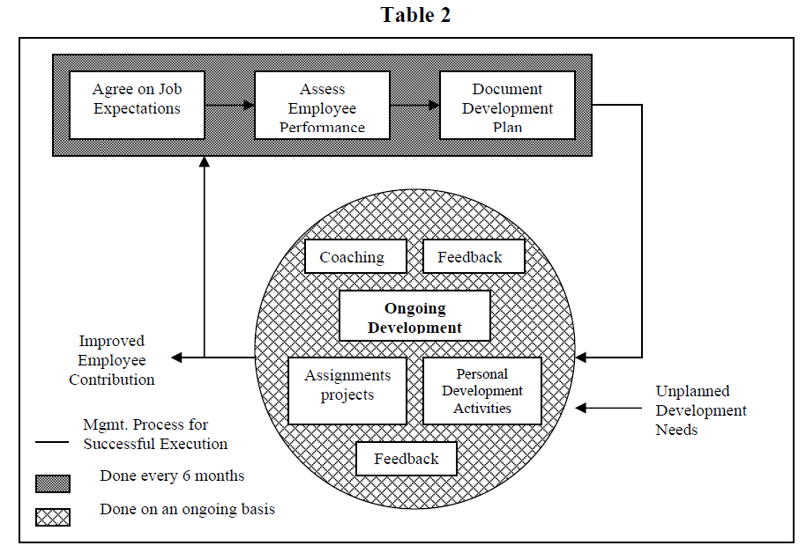

Chapter 3: METHODOLOGY

3.1 Data Collection

The data can be collected either by primary methods or secondary methods or both, and the data collected by these methods is called primary and secondary data respectively.
Primary data is the new data gathered to help solve the problem at hand. It is the fresh data which is collected from field with your own questionnaire.
While secondary data is the data that is collected from other sources. Such data is cheaper and more quickly obtainable than the primary data and also can come in handy when primary data cannot be collected at all.

Primary data:
The study contains fresh data which has been collected for the first time through a questionnaire.

RESPONDENTS PROFILE
Following is the profile of respondent’s that were approached for survey:
- The survey was sent to more than 200 consumers across different metro cities of India and around 60% responses were received.
- Their Profiles varies from students, working professionals, house wives.

Respondents were approached through, personal e-mail contacts, Linked in connections and facebook friends.

Secondary data:
To supplement the primary data, secondary data is required.
This was obtained from various websites, journals, magazines, articles and research papers.

3.2 Tools of Analysis

The data in the study was analysed primarily by depicting it, using various Pie Charts and Bar charts and basic Microsoft excel functionality. Email, and internet surveys were conducted which consisted mostly of closed ended questions. Analysis of the same was done to understand the perception and prevalence of the idea of TQHRM in the Industry with special emphasis on India .

Chapter 4: DATA ANALYSIS & RECOMMENDATION

4.1 Gender
The respondents to this study were :
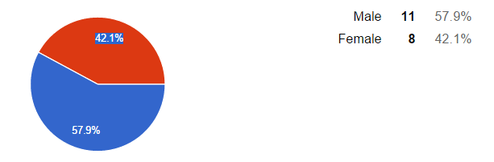

4.2 Age
The age group they represented were as:

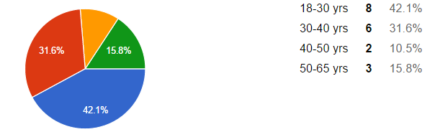

Fortunately, the respondents were a right mix of Genders as well as represented all age groups that were targeted.
This incident gave right range of opinions in context with the age groups and gender.

4.3 Work Experience

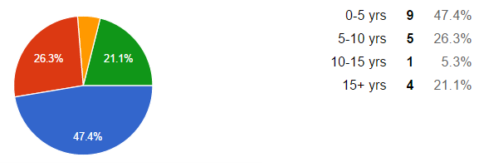
As can be seen from the data, major respondents to the study were from the slab of 0-5 years of work experience and fortunately, some were also veterans from the industry.
This gave the opinions of both the new entrants i.e. the new entrants as well as old players in the market.

4.4 Awareness about Total Quality Management

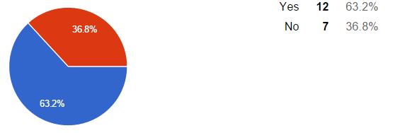

Surprisingly, only around 60% percent of total respondents were aware of the concept of Total Quality Management in general.

4.5 Satisfaction with HR Policies of the Organization
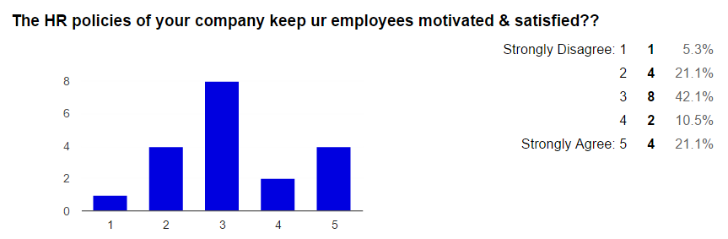
Around 40% of the respondents were neutral about their HR Policies and around 27% were dissatisfied with them. This segment could be the people who could accept a shift towards TQHRM with comparatively less resistance.
The remaining 31.6% were happy & satisfied with their HR Administration. Hence, they might not be very attracted to the concept.

4.6 Perception of TQM and HRM incorporation
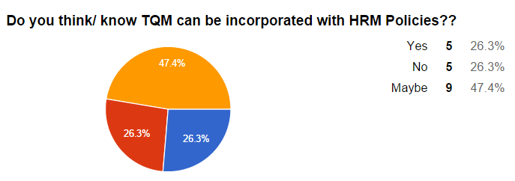
Surprisingly, people who believe & who do not believe this can happen were exactly the same. But around 50% of people are still indecisive.
This makes the total percentage of people who can be influenced for adopting the concept to about 75%.

4.7 Interest towards incorporating TQM with HRM as an Organization
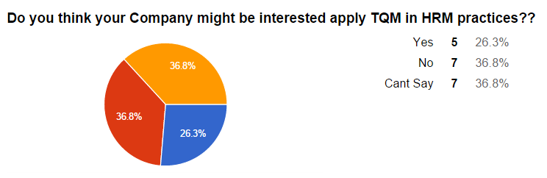
As per the respondents, only 26% were sure that their organization can incorporate the concept. Rest of them were either indecisive or sternly believed that they are not interested.

4.8 Perception about possible success of TQHRM in India
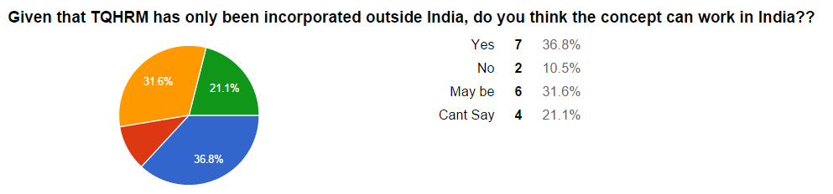
As is shown in the Pie Chart, around 37% people were positive about the acceptance of TQHRM in India while around 42% can still swing both ways. However, around 10% of people firmly believe that this concept wont work in the Indian scenario.

4.8 Need for shift towards TQHRM
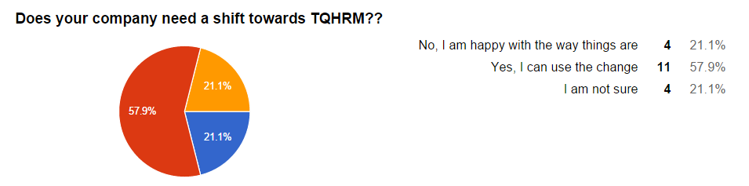
Around 60% of the respondents feel that their organization needs a shift from the current scenario towards TQHRM while 21% did not show much interest.

4.9 The HR fields that needed the shift.
Out of the people who were positive about the above, the following was their opinion on which field of HR needed the said shift.
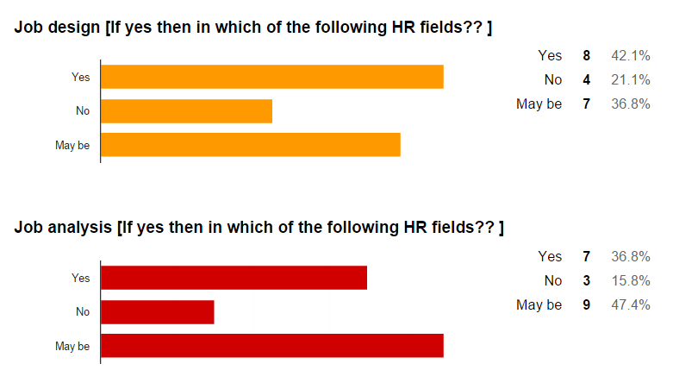

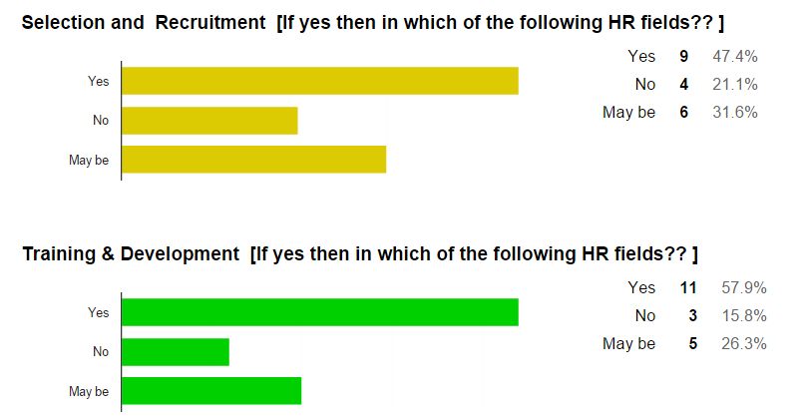

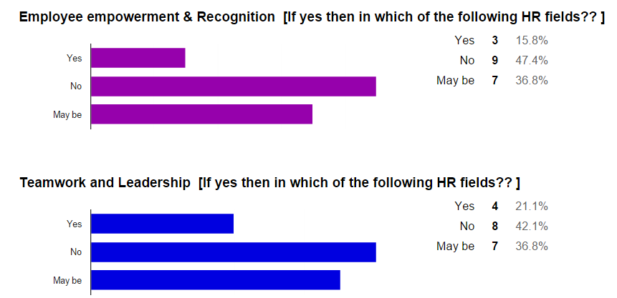

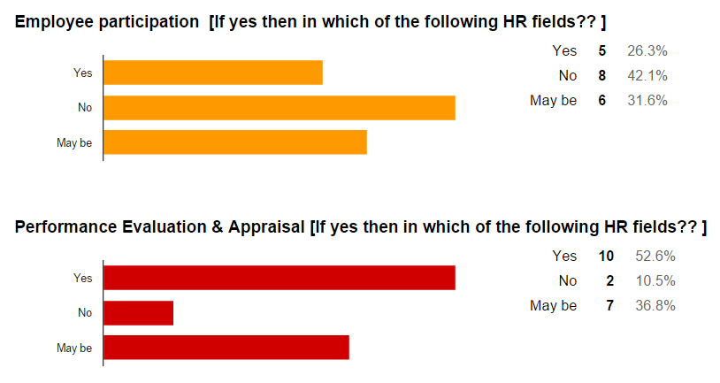

Studying all the responses from above representations, according to the respondents Training & Development and Performance Appraisal are the two fields that were the most popular as recipient of TQHRM policies.
Whereas, Employee Participation & Leadership can still survive without TQHRM.

4.10 The resources needed to incorporate TQHRM
The respondents were asked to select all the resources that, according to them, would be needed to incorporate TQHRM in their company policies, if they choose to do so.
The responses were as follows:
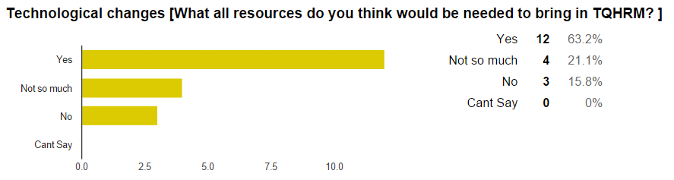
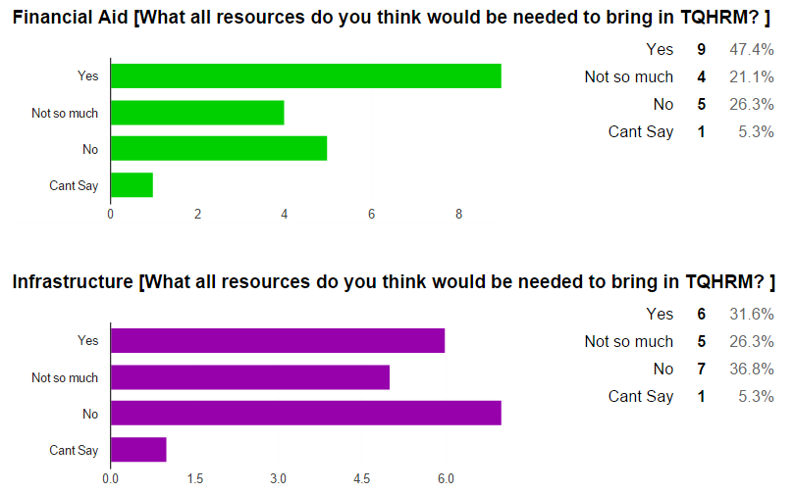

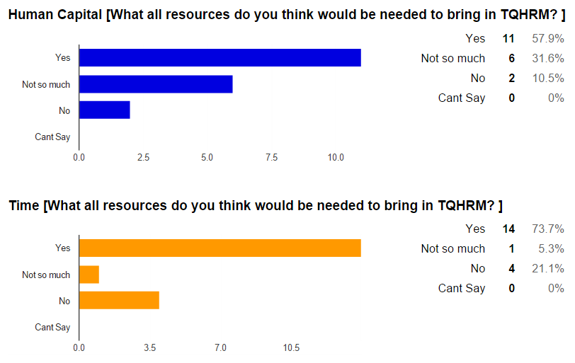

According o the responses obtained, Time was the most important resource that would have to be invested, closely followed by Technological Changes.
Any change in or expansion of Infrastructure however needs not to be focused upon too much, especially in the initial stages.

4.11 Preference of employees
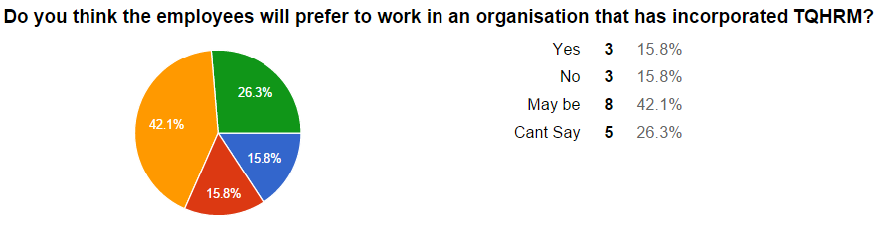
When asked if the employees of their current organization would like to work in a or shift into an organization that has TQHRM implemented in its policies, most of the respondent were indecisive with an inclination towards preference.

4.11 TQHRM as a motivation factor
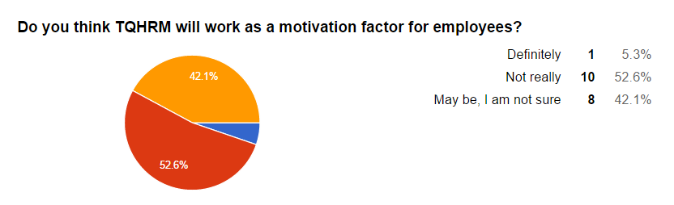
When asked if TQHRM can potentially work as a motivation factor for the employees, a majority of the respondents did not agree. The reason for the same may be unawareness about the concept or no practical examples to look up to yet.

4.12 TQHRM worth a trial
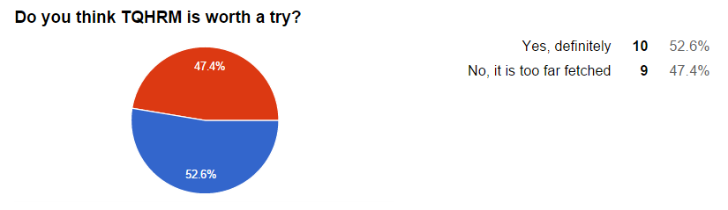
A majority of the respondents agreed that TQHRM is definitely worth one try atleast.

4.13 Understanding about TQHRM
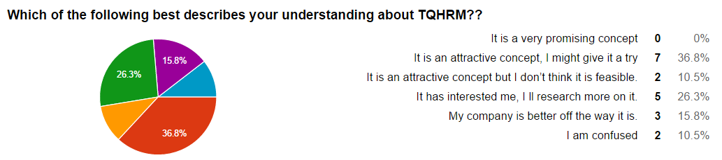

Most of the respondents thought of TQHRM as an attractive concept which also interested them and they would give it a try after some research.
Surprisingly, not even a single respondent thought that it is a promising concept. Infact, around 15% people thought that their company would be better off without it.

4.14 Requirement about change, in order of Importance
The respondents were asked to choose the requirements to bring in this change into the organization as well as manage it effectively. This was there response.
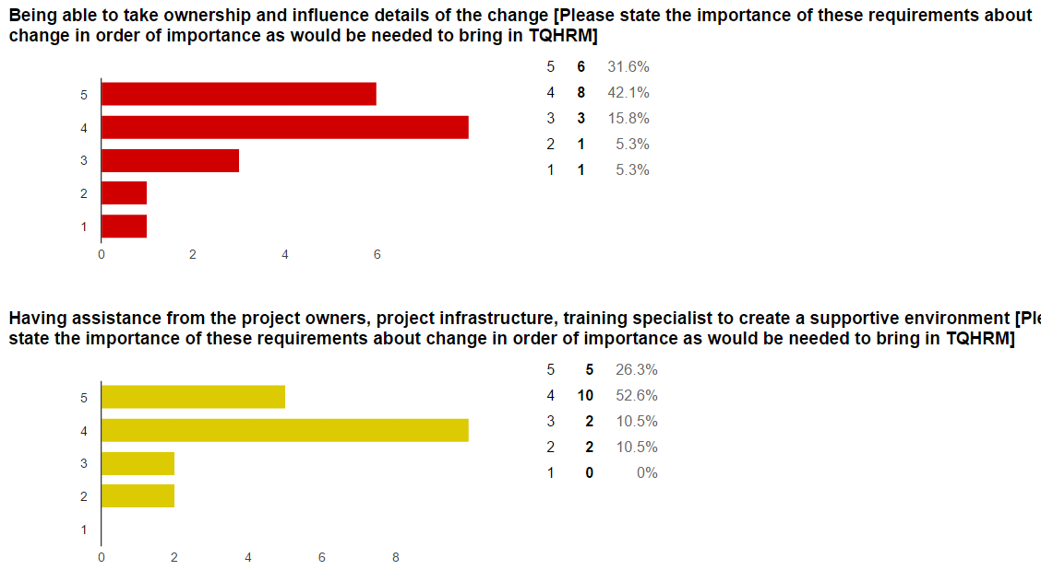

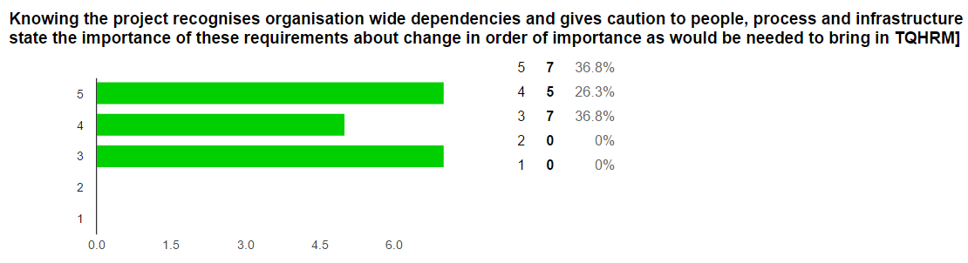

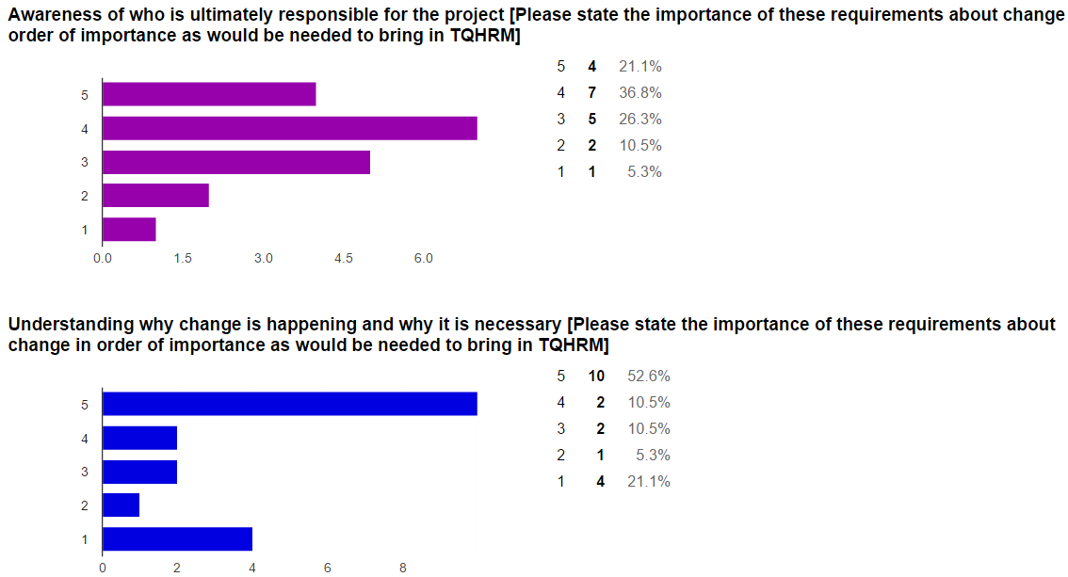

Analysing the above we realize that a change is best accepted when people know its importance and why is it happening (this was confirmed through secondary research as well). However, Awareness of who is ultimately responsible for the project, doesnt really matter that much.

4.15 Difficulties that could be faced while implementing TQHRM
Resistance from the management | 9 |  | 47.4%
Resistance & obstacles from the employees | 13 |  | 68.4%
Inability to understand the concept clearly | 10 |  | 52.6%
Preference to evaluate existing ideas instead of generating new ideas. | 8 |  | 42.1%
Unionisation | 10 |  | 52.6%
Training Requirements | 8 |  | 42.1%
Politics involved in coordinating different teams/departments in the organization. | 10 |  | 52.6%
Ingrained organizational cultures and norms |  | 8 |  | 42.1%
Existing organizational values that conflict with those implied by the need for organizational change. |  | 9 |  | 47.4%
Difficulty delegating tasks because everyone else is already overloaded with work. |  | 9 |  | 47.4%
Less support from above: management overwhelmed or unavailable |  | 12 |  | 63.2%

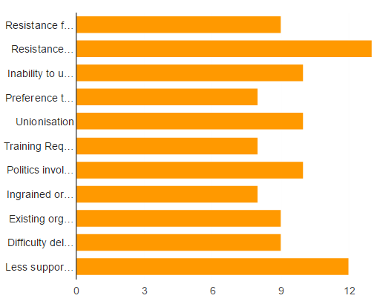
As per the responses recorded by the participants of this survey, major obstacles to the implementation of TQHRM are:
- Resistance & obstacles from the employees
- Less support from above: management overwhelmed or unavailable.
These need to be tackled carefully while implementing the change.
However, the areas that posed the least thread were:
- Ingrained organizational cultures and norms
- Training Requirements
- Preference to evaluate existing ideas instead of generating new ideas.
All three surprisingly tie-ing at the last spot with equal number of selections.

4.2 RECOMMENDATION
With the changing workplace & advancing opportunities everywhere, keeping top talent with you and attracting worthy candidates has become a task in itself. Human resources Department everywhere is devising new ways to make this happen. Every field of HRM is being looked upon and studied to fiind areas where opportunities can be identified to improvise & innovate to make the above happen.
This problem, however, has been intensified manyfolds due to intense & cut throat competition in the job market. To tackle this problem, minor tweaks in the system wont help. We have to incorporate something that cuts through & covers the entire value chain, just as the human resources of any organization does & Total Quality Human Resource Management is one such initiative.
Since TQHRM is a budding concept and hasn’t shown much results so far, organizations are apprehensive to adopt it. However, as has been seen from the study conducted the people are either inclined towards accepting & trying it or are indecisive. The percentage of people absolutely against the concept is very low.
TQHRM, by definition is a concept that aims at maintaining & controlling quality in HR activities of the organization. The scope of variability across the organization is thus reduced and every field of HR is empowered.
With active research in the field and a little less skepticism, this concept if applied & incorporated in the organizational processes is sure to bring in some positive results atleast in the initial stage. As time passes and improvements are brought about and shortcomings are reduced, this concept will definitely bring in results in line with what Total Quality Management has brought about in the manufacturing industry.

Chapter 5: BIBLIOGRAPHY

http://www.freepatentsonline.com/article/SAM-Advanced-Management-Journal/15703603.html
Authors:
Clinton, Roy J.
Williamson, Stan
Bethke, Art L.
(1.)Crosby, P. B. Quality is Free. New York: McGraw-Hill, 1979.
(2.)Deming, W. E. Out of the Crisis. Cambridge, MA: Center for Advanced Engineering Study, 1986.
(3.)Fairbairns, Jill. "Plugging the Gap in Training Needs Analysis." Personnel Management (February, 1991) p. 43--45.
(4.)Feigenbaum, A. V. Total Quality Control. 3rd ed. (New York: McGraw-Hill, 1983).
(5.)Giles, Eillen and Williams, Roger. "Can the Personnel Department Survive Quality Management?" Personnel Management (April, 1991) p. 28--33.
(6.)Greene, Robert J. "A '90s Model for Performance Management." HR Magazine (April, 1991) p. 62.
(7.)Jerris, Linda A. "Quality Shines in Small Details." Personnel Journal (January, 1990) pp. 26--30.
(8.)Juran, J. M. Juran's Quality Control Handbook, 4th ed. (New York: McGraw-Hill, 1988).
(9.)Klekamp, Robert C. "Commitment to Quality Is Not Enough." SAM Advanced Management Journal (Winter, 1989) p. 13--16, 36.
(10.)McCormack, Shaun. "TQM -- Getting It Right the First Time." Training and Development (June, 1992) p. 43--46.
(11.)Norman, Carol A. And Zawacki, Robert A. "Team Appraisals-Team Approach." Personnel Journal (September, 1991) p. 101--104.
(12.)Port, Otis; Carey, John; and Kelley, Kevin. "Quality--Small and Midsize Companies Seize the Challenge." Business Week (November 30, 1992) p. 66--72.
References
Crosby, P.B., (1979), Quality is Free, McGraw-Hill, New York.
Cruise O’Brien R. & Voss C., (1992), In Search of Quality. London Business School Working Paper.
Dale B.C. & Plunkett J.J., (1990), Managing Quality, Phillip Allan, Herts.
Dale B.C. & Cooper C.L., (1992), Total Quality Management and Human Resources: An Executive Guide, Basil Blackwell, Oxford.
Dale B.C. & PlunkettJ.J., (1994), Quality Costing (2nd edition), Chapman and Hall, London.
Deblieux M., (1991), Performance Reviews Support the Quest for Quality, HR Focus, November, pp. 3-4.
Deming, W.E., (1986), Out of the Crisis, MIT Centre for Advanced Engineering Study, Cambridge; Mass.
Feigenbaum, A.V., (1983), Total Quality Control (3rd edition), McGraw-Hill, New York.
Giles E. & Williams, R., (1991), Can the Personnel Department Survive Quality Management?, Personnel Management, April, pp. 28-33.
Hill S., (1991), Why Quality Circles Failed but Total Quality Might Succeed, British Journal of Industrial Relations, 29, 4, pp. 541-568.
Incomes Data Services Limited (1991) Bonus Schemes Study No 492 October.
Institute of Personnel Management, (1993), Quality, People Management Matters, IPM, London.
Ishikawa K., (1985), (translated by D.J. Lu) What is Total Quality Control? The Japanese Way, Prentice Hall, Englewood Cliff.
Juran J.M., (1965), Managerial Breakthrough, McGraw-Hill, New York.
Kearney, A.T., (1992), Total Quality — Time to Take Off the Rose-Tinted Spectacles, IFS Publications, London.
Legge, K., (1978), Power, Innovation and Problem Solving in Problem Management, McGraw-Hill, London.
Marchington M., Wilkinson A. & Dale B.C., (1993), Quality and the Human Resource Dimension: The case study report in Quality, People Management Matters, IPM, London.
Miller, C., (1992), TQM value criticised in New Report, American Marketing Association Journal, 9 November, p. 16.
Oakland J., (1989), Total Quality Management, Heinemann, London.
Plowman, B., (1990), Management Behaviour, The TQM Magazine, 2, 4, pp. 217-219.
Snape, E., Redman, T. & Bamber, C., (1994), Managing Managers, Basil Blackwell, Oxford.
Storey, J., (1992), Developments in the management of human resources, Basil Blackwell, Oxford.
The Economist Intelligence Unit, (1992), Making Quality Work, Lessons from Europe’s Leading Companies, London.
Wheatley, M., (1991), The Future of Middle Management, British Institute of Management, London.
Wilkinson A., (1992), The Other Side of Quality: Soft Issues and the Human Resource Dimension, Total Quality Management, 3, 3, pp. 323-329.
Wilkinson A., (1994), Managing Human Resources for Quality in B.C. Dale (Eds) Managing Quality (2nd Edition), Prentice Hall, Hemel Henipstead.
Wilkinson A., Allen P. & Snape F., (1991), TQM and the Management of Labour, Employee Relations, 13, 1, pp. 24-31.
Wilkinson, A. & Witcher, B., (1991), Fitness For Use? Barriers to Full TQM in the UK, Management Decision, 29, 8, pp. 46-51.
Wilkinson A., Marchington M., Ackers P. & Goodman J., (1992), Total Quality Management and Employee Involvement, Human Resource Management Journal, 2, 3, Summer, pp. 1-20.
Wilkinson, A., Redman, T. & Snape, F., (1993), Quality and The Manager, Institute of Management; London.

