**Term Major Project**

**“Part I: feasibilityof Telecom Service Providers under the threat of OTT players**

**Part II:Net Neutrality: Consumer Perception”**

**By-**

**Vaibhav Bhasin,**

**2K16/EMBA/534**

**Under Guidance of -**

**Dr. Rajesh Sharma,**

**Delhi School of Management (DTU)**

**Submitted in partial fulfilment of the requirement for award of**

**Master of Business Administration (Executive)**



**Delhi School of Management**

**Delhi Technological University**

**Bawana Road, Delhi-110042**

**Disclaimer**

The views expressed in this project are personal and not of the organization and this project is done as a detailed study under the course from strategy perspective only.

**Certificate**

This is to certify that the project entitled **"Part I: feasibility of Telecom Service Providers under the threat of OTT players & Part II: Net Neutrality: Consumer Perception”** has been successfully completed by Vaibhav Bhasin – 2K16/EMBA/534

This is further certified that this project work is a record of bona fide work done by him under my guidance. The matter embodied in this report has not been submitted for award of any degree.

Vaibhav Bhasin

2K16/EMBA/534

Dr. Rajesh Sharma

Delhi School of Management (DSM)

Delhi Technological University

***ACKNOWLEDGMENT***

The successful completion of post-graduation research project facilitates the beginning of a never-ending learning experience. The project “**Part I: feasibility of Telecom Service Providers under the threat of OTT players &Part II**:**Net Neutrality: Consumer Perception**” aims at bringing about a change in the current processes in the telecom industry to adapt with the latest developments.

I would like to take this opportunity to express my deep sense of gratitude and thankfulness to my academic mentor **Dr. Rajesh Sharma**.

**VIABILITY OF TELECOM SERVICE PROVIDERS UNDER THE THREAT OF OTT PLAYERS**

***Abstract***

*In today’s world where the IT and Telecom industries are merging to form the ICT industry, we see the advent of OTT (over-the-top) players much more than conventional Telecom Service Providers. OTT players are using the internet technology to provide functionalities similar to TSPs at much lesser prices. So, in this paper, I will first try to explain the basic definition and taxonomy of OTT players and then cover the business models for each type of taxonomy. This will help our readers understand how the business models of the new emerging OTT players are beginning to overlap with the existing TSP players.*

*Further, I would be comparing both the sides over the years so as to understand the viability of the TSPs in the near future. Whether they would be able to sustain themselves on the basis of increased data consumption or would they have to find new and innovative ways to survive in the industry? I will also look at some possible ways in which the TSPs can either optimize their ways of working or adapt to the changing environment by co-existing with the OTT players.*

***Literature Review***

The term Over-the-top has gained a lot of traction in literature over the last few years. The definition has been covered by not just scholars but also by official telecom organisations across the globe like OECD, BEREC and TRAI.

While, BEREC (2015) defines OTT as:

“OTT service as content, a service or an application that is provided to the end user over the open Internet. Including in the definition that what is provided can be either content, a service or an application, means that anything provided over the open Internet is an OTT service.”

Telecom Regulatory Authority of India (TRAI) (2015) identifies it as

“An OTT provider can be defined as a service provider offering Information Communication Technology (ICT) services, but neither operates as a network nor leases network capacity from a network operator. Instead, OTT providers rely on the global internet and access network speeds (ranging from 256 Kilobits for messaging to speeds in the range of Megabits (0.5 to 3) for video streaming) to reach the user, hence going “over-the-top” of a telecom service provider’s (TSP’s) network. Services provided under the OTT umbrella typically relate to media and communications and are, generally, free or lower in cost as compared to traditional methods of delivery.”

From the existing formal definitions, Quoc Lai Nguyen (July, 2016)[1] brought out the two common aspects in most definitions - the use of open Internet and the provision of service over that. Another noteworthy fact from these definitions is the ability of OTT services to provide these services or content at a much lower price as compared to the telcos.

Having covered the basic definition, let us move onto understanding the taxonomy of OTT in the existing literature. Taxonomy is important to understand as there are various kinds of OTT applications that are being driven on the internet. All provide different kinds of services - instant messaging ex. WhatsApp, video streaming ex. Netflix, calling services ex. Skype. Thus, it’s of utmost importance to understand how we can categorise the different OTT players to understand the basic business models and then compare with the business models of the TSPs.

OTT classification has been done in many ways by various scholars. It has been quite elaborately classified by Detcon Consulting (2014). They have divided the internet applications based on the usage as follows:

Figure 1: Classification of Internet Applications by Detcon Consulting

BEREC (2016), on the other hand has divided OTT into Communication and other services. Communication services are further divided into ECS and not ECS.



Figure 2: OTT Taxonomy as proposed by BEREC

While these classifications exist in literature, for the purpose of this paper i.efor comparison with the TSPs, I will follow a general and by far the most simplistic classification (Mahim Sagar & Alok Pandey 2017) of OTT players as follows[2]:

Figure 3: General Taxonomy of OTT services

This classification is paramount as we need to understand the overlap between the features of the OTT and TSP players. For this we need to study the business models of both. The business model concept has received considerable attention in the literature over the past few years. It is helpful in gaining a more comprehensive view of the nature and the

Nitty-gritties of a business (Al-Debei& Avison, 2010).

A business model has been defined as “the design of organizational structures to enact a commercial opportunity” (George & Bock, 2011, p. 99). So, primarily it describes how an organization delivers value to its customers. George & Bock have emphasized on the role of being able to identify an opportunity, idea generationfor that opportunity and its implementation. They have implied that business models fundamentally create value by utilizing the underlying opportunity. While this is the general concept, business models have been studied in much more detail. The creation of value has also been considered of prime importance. It takes the form of the value proposition which describes how the customers derive benefits from the products or services (Osterwalder et al., 2014). This component is widely considered as a key business model element (Afuah& Tucci, 2001; Chesbrough & Rosenbloom, 2002; Morris et al., 2005; Al‐Debei& Avison, 2010; Burkhart et al., 2011; Krumeich et al., 2012, among others).

Al‐Debei& Avison (2010) identify three additional elements of business models in the literature: value architecture (i.e. the configuration of assets, resources and core competencies), value network (i.e. the relationships to customers and other stakeholders such as partners and suppliers) and value finance (i.e. the financial set‐up in terms of costing, pricing and revenue structure). Covering all these elements, A. Osterwalder has created the business model canvas in his book (2010). In the book ‘Business Model Generation’[3], he has extensively covered 9 elements of a business model, namely – Customer Segments, Value Propositions, Channels, Customer Relationships, Revenue Streams, Key Resources, Key Activities, Key Partnerships and Cost Structure. Widely identified in literature today as follows:

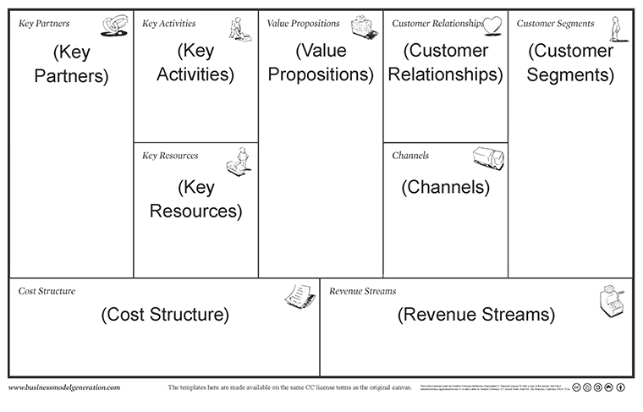

Figure 4: Business Model Canvas

A.Osterwalder(2010, pg. 63-125) has further used this canvas to explain the types of business models.

1. Unbundled – Three different types of businesses – Customer Relationship businesses, product innovation businesses & infrastructure businesses
2. Long Tail Model - Focus on a large number of products, each selling in low volumes
3. Multi-Sided Platforms – bringing two distinct types of customer groups on one platform. The platform becomes valuable to one set of customers only when the other group is also present. For example, eBay, It requires both sellers and buyers to be present on the platform for it to be successful
4. Free – When one Customer segment is able to derive continuous benefits free of cost, it may be compensated by another customer segment e.g. advertising in metros; Freemium – An extension of the Free business model, where the basic features are free and certain advanced ones would be paid e.g. Skype
5. Open Business Models – Firms creating their own business models to capture value in unique ways

Important to understand, Osterwalder in his book has explained the ‘unbundled’ business model for a telco as follows:

1. Equipment Manufacturers – Telcos like France Teelcom, Vodafoneoutsource the operation & maintenance (O&M) of their networks to equipment manufacturers such as Ericsson & Alcatel-Lucent.

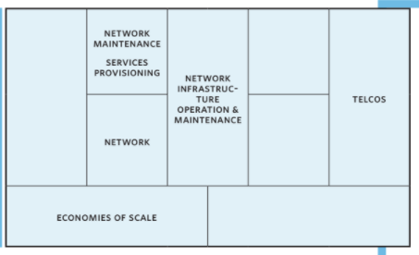

1. Unbundled Telco – sharpened focus on branding and customer relationships which actually form telco’s core business.

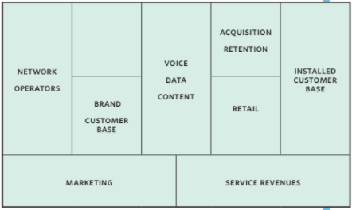

1. Content Providers – In the past, mostly telcos have turned to small creative firms to provide for product and service innovation on their networks.

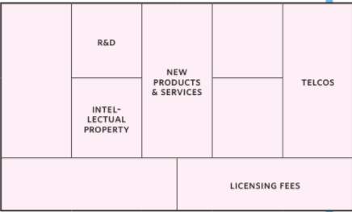

***Business Models***

The most generic classification of the OTT players on the basis of their business models is shown in the following figure.

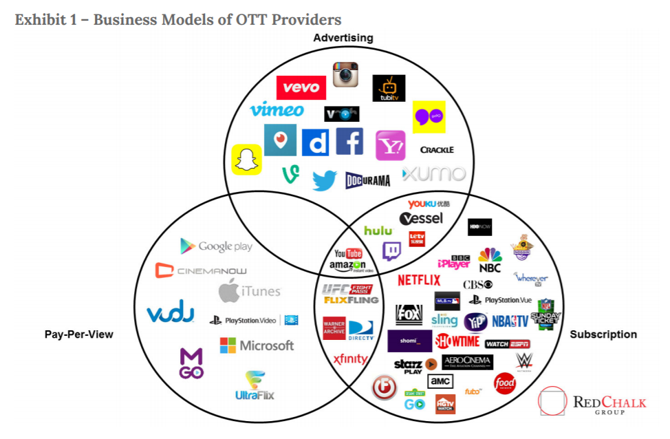

Figure 5: General Business Model Categorisation of OTT Players

As earlier established, communications OTT players include instant messaging and voice calling services over the internet. And since this type of OTT players are the major ones competing with the TSP players, in this paper, I will study the business models of a few players under of the communications OTT type – WeChat, WhatsApp and Line.

**WeChat[4]**

The instant messaging application gainingmaximum popularity in China is WeChat. The user base has drastically soared57 percent to reach 438 million in the second quarter of 2014, as compared to the same time last year. Globally, it is ranked the second most popular messaging app after WhatsAppwhich has 600 million active users. While it took WhatsApp four and a half years, it took WeChat only around 3 yearsto reach 400 million monthly users. Let us look at the business model of WeChat & why was it so successful.

***1.1General Business Model — Multisided***

WeChat provides diversified services and has both individual users as well as service providers on its platform. Thus, it has a multi-sided model serving different parties.

***1.2Business Model to Individual Users — Freemium***

Freemium is a mix of free and premium business models. Normally, it would imply free basic usage of the application/website, but charge for premium functions. A business model of online products is built on the basis of the habits of the customers. WeChat has therefore adopted the Freemium model. It is free for download and also some features like instant messaging service and moments are all free. Its revenue structure is mainly focused on the value-added services like games and virtual stickers.

* + 1. **Gaming**has been used by Tencent very strategically to increase both its user base as well as revenues as gaming is a major stickiness factor for the users. WeChat has also extended this outside of China with the help of the launch of a non-Chinese game called ‘Candy Crush Saga’ in partnership with King.   
         
       The success of WeChat games is closely connected to its social features. It attracts downloads of games by emphasizing that they are free. Once downloaded, they encourage users to share their scores among their WeChat friends and invite them to play and compete. Thus, due to the network effect, this helps them grow their user base. Also, to beat other players, one may need extra weapons or lives in the game which are paid value-added services. This is how Tencent makes revenue even from free games. In the second quarter of 2014, online games revenues increased to RMB11,081 million.
    2. **Virtual stickers** have been a popular feature especially in Asia. They have becomecrucial parts of casual chatting. On WeChat, there are more than hundreds of virtual stickers of popular anime and cartoons, and some are even from Disney and Pixar. Most of these stickers are free, but some of the popular ones like Hello Kitty or characters from Monsters University are paid, each costing HK$7 for a set of particular number of stickers.

***1.3Business Model to Business Partners — Online-to-Offline (O2O)***

Tencent also has extended e-commerce services - WeChat Payments, though only available in China. This service enables users to link their bank accounts with WeChat, making their mobile phone serve as a wallet. In stores, consumers just need to scan the item’s QR code while purchasing or click on the item if the brand has official account on the app, and then enter the password to complete the deal. With this, WeChat has connected the online & offline platforms for retailers.For consumers, it is convenient as they save time and get discounts on WeChat and this attracts more consumers onto their platform.This also proves beneficial for WeChat as it can collect various kinds of information from customers’ transactions likedemographics of customers, rates of products purchased, and feedback. So it doesn’t just earn the commissions but can also make use of this big database to give suggestions to consumers and business partners.

WeChat’s e-commerce partners are quite diverse including JD.com, McDonalds and Starbucks to name a few.In the second quarter of 2014,revenues from e-commerce transactions business were RMB1,324 million.

**Value Proposition:** Using WeChat users can communicate with friends and family members using chat and voice/video calling. Apart from these users also have social services such as booking a medical appointment or other recreational activities such as buying a movie ticket, paying at any store or population heat maps on concurrent sites in your city.

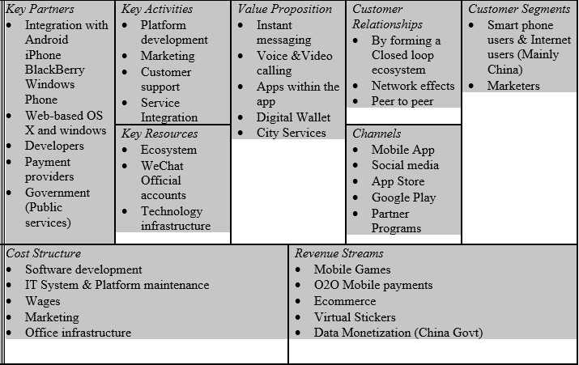

Figure 6: Business Model Canvas for WeChat

Some of WeChat’s success factors can be identified as:

1. Support and strongassistance from the parent firm Tencent which helps in promptly transferring users from QQ to WeChat. This also helps WeChat in capturing the Chinese market of IM much faster than other international competitors like WhatsApp and Line.

2. Freemium business model. Users are attracted to the free basic services and thus WeChat has been able to expand its user base in a short span of time. Monetization is easier with a large group of loyal users.

3. Multi-functioning application. It stands out from other similar IM apps by offering a diversified range of services. This not only helps in increasingthe stickiness i.e. retaining the existing users,but also means more opportunities to make money.

4. Free of promotions. WeChat being for close circles, individuals would not expect hard-offering promotions, but rather just user created substance. Users can just discover and followpublic accounts only when they know the name. Tencent doesn't give a rundown of pulic accounts for users and has likewise restricted the promotional messages conveyed by them.

5. Partnership with leading service providers – mutually beneficial. Besides, WeChat can gather advertising and demographic measurements for future improvement.

**WhatsApp**

Following is the detailed business model of WhatsApp[5],[6],[7].

**Customer Segment:** WhatsApp customer segment are friends, family staying distance apart who have smart phones with internet connection.

**Value Proposition:** Users can use it for instant messaging, voice & video calling. WhatsApp does not contain any Ads, Games or any kind of Gimmicks. It is a simple platform for communication that is compatible across the range of mobile phones.

**Key Activities:** WhatsApp had a super lean team focused on great app development and providing users a clean, flawless and lightning fast communication. They also focused on servers’ maintenance.

**Key Resources:** Core engineering team (of just 32 engineers), Users for emerging economies, Flawless IT infrastructure was some of WhatsApp key resources.

**Key partnerships:**WhatsApp had critical tie-ups partnerships with 50+ carriers around the world. App was coming preinstalled on many phones; also their partnership with Sequoia Capital was a big boost. These partnerships played a big role in WhatsApp's spread and sustainable growth.  
  
**Customer Relationship:**WhatsApp used social media to interact with users, honest blogposts, regular media appearance that came their way, and in app notifications. These were few methods used by WhatsApp to build relationship with users.   
  
**Revenue Streams:**Initially they had freemium model, where the first year of app usage was free and lateron had yearly $0.99 subscription fees for iOS users. For others (Android, Windows, etc.) they don't have any charges. After being acquired by Facebook the major revenue stream id monetizing users’ data as via app developers can easily find out peoples likesand dislikes etc.    
  
**Cost Structure:** They have a lean cost structure which includes employee wages, IT infrastructure maintenance.

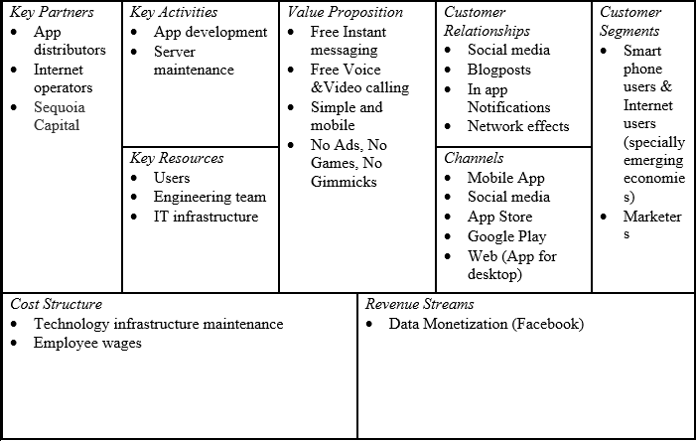

Figure 7: Business Model Canvas for WhatsApp

|  |  |  |  |  |  |
| --- | --- | --- | --- | --- | --- |
| *Key Partners*   * NTT DoCoMo * Content providers * Game contributors | *Key Activities*   * App development * IT maintenance * Customer support * Marketing | *Value Proposition*   * Free Instant messaging * Free Voice &Video calling * Play games with LINE friends * Taxi bookings * Digital wallet | | *Customer Relationships*   * LINE points * Online channels * Offline channels * Network effects | *Customer Segments*   * Smart phone users & Internet users * Businesses * Marketers & Advertisers |
| *Key Resources*   * Users * Programmers and designers * Sales and PR managers * LINE stickers & Game ecosystem | *Channels*   * LINE channel (App and web) * Line Theme Park * Media (news) * Blogs and social media |
| *Cost Structure*   * Software development * Technology infrastructure maintenance * World-wide team * Marketing | | | *Revenue Streams*   * Official accounts (company) * Mobile payments * Mobile Games * Promotional stickers * Merchandising & Advertising | | |

Figure 8: Business Model Canvas for Line App

As is evident from the comparison of the business models, the instant messaging and voice calling features of WhatsApp, WeChat and Line are in direct contradiction to the SMS and voice telephony of the TSPs like Airtel and Vodafone. Another noteworthy fact is that these two have predominantly been the most major sources of revenue for the TSPs over the years.

***Viability of TSPs as compared to OTT***

As discussed above, it is observed that some of the Key Activities of the OTT players directly interfere with the major activities of the TSPs.Thus this directly corresponds to arevenue loss for the TSPs due to the emergence of the OTT players.This revenue loss can be established through various data points from the global telecom industry:

1. Research and analytics firm, Ovum, had predicted that between 2012 and 2018, the telecommunications industry will lose $386 billion in total to OTT. [8]
2. *Messaging Revenue*

Informa’s[9] World Cellular Revenue Forecasts for 2018, as released in 2013, had estimated that the global annual SMS revenues will fall by US$ 23 billion - from US$120 billion in 2013 to US$96.7 billion by 2018. This is ascribed to the expanding adoption and utilization of OTT messaging apps.

1. *Voice Revenue*
   * 1. The effect of OTT VoIP (Voice over Internet Protocol) applications on customary voice income of the TSPs has been studied bySpirit DSP in a report called “The Future of Voice”. As indicated by this report, the overall worldwide telco voice incomes (including fixed subscriptions) will decreaseat a CAGR of 2.4%, reaching to $799.6 billion by 2020 from $970.4 billion in 2012. And not just voice revenues, the telecom industry worldwide may see a loss of revenues as a result of VoIP by 2020which could be roughly worth $479 billion – this accounts for 6.9% of the aggregate income from voice.[10]
     2. Another report “Consumer OTT VoIP Outlook: 2013 to 2018” by Ovum[11], showcases that the OTT VoIP market is growing at a rate of 20 percent. Its application’s utilization will reach 1.7 trillion minutes by 2018, which translates to a revenue loss of $63 billion in 2018. As reported by this study it is because of the rising demand of online messaging apps that by the year 2016 telecom operators will stand to lose revenue worth $54 billion in messaging services.
2. *Data Revenue[12]*

As far as data is concerned, the revenue is increasing for the telcos. According to the report “Cisco Visual Networking Index: MobileData and Internet Traffic, 2013–2018”, mobile data traffic is expected to increase at a CAGR of 61 per cent.By end of 2018,it is anticipated to rise from 1.5 Exabyte to 15.9 Exabyte per month. And with a CAGR of 70 per cent, the mobile video traffic is expected to increase from 633 Petabyte to 9103 Petabyte per month.

All these facts have well established the current reality of the ICT industry that while the SMS & voice telephony revenues are going down, the data revenues are increasing.

Overall the development of the global telco and OTT market has been depicted in the following figure:

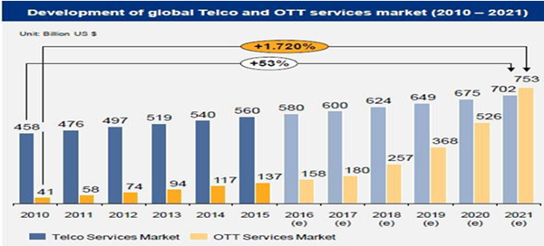

Figure 9: Development of global Telco & OTT services market (2010-2021)

Even in the Indian context, if we study the breakup of the revenue of a TSP as per TRAI data, a similar shift from SMS & telephony voice calls to data dependent calls and messaging can be established.



Figure 10: Breakdown of ARPU

In 2015-16, the voice revenues had accounted for two-thirds[13] or approximately 66 per cent of the total revenue. Within two years, it has declined to 26 per cent, a drop of 40 points.

But the real question remains whether the increase in the data revenues compensate for the revenue lost due to other sources. This lack of viability is also evident from the fact that the industry ARPU declined drastically from Rs.131 per month in September 2016 to Rs.79.39 per month in December 2017. This decrease clearly establishes that the increase in usage of data has not monetarily compensated for the loss due to voice calls. This is because the tariff for data is one of the lowest in India as compared to the rest of the world - $3.5 per 1 Giga byte of data while it is $10 in USA and $15 in China.

***What can TSPs do to remain viable?***

As we have established that TSPs cannot remain viable in the long run if things continue to operate in the same manner. The profits of TSPs will definitely be decreasing or remain stagnant while the profits of OTT players would be on a rise. This brings me to determining ways in which the TSPs can counter the OTTs.

There are two main suggestions for the TSPs to bring about in their business modelsto adjust with the changing environment:

1. Super-Slim Telcos
2. Seeking adjacent verticals
   1. financial services and e-commerce services - B2B being a major opportunity - providing intelligent networks, solutions in ICT, cloud services, analytics
   2. Content Partnerships& content generation

**Super-Slim Telcos**

To become a Super-Slim Telco, a TSP has to improve efficiency and make its ways of working more effective. This can be done bytransforming business models to optimize efficiency hinges,completely digitize their customer front ends, develop and deliver products that are completely software generated, and fully automate processes, such as billing and service coordination as well as increasing efficiency by using technologies like CBRS (Citizens Broadband Radio Service) and white spaces.The global TV white space spectrum market was valued at USD 1.2 Million in 2015 and is expected to reach USD 53.1 Million (approximately) by 2022, at a CAGR of 74.30% during the forecast period.

**Seeking Adjacent Verticals**

In this paper, our main focus would be on suggesting seeking new adjacent verticals for the TSPs. While Super-Slim Telco would also increase the viability of a telco, the real future lies in the merging of these two players – OTT & TSP. And not just these two, I see OTT players themselves moving into all sorts of varied fields like financial services. In this ever dynamic environment of the ICT industry, no one will be able to operate solely in one domain as most domains are merging to become one.

I will try and study these new business models that TSPs should seek to achieve through the help of two existing case studies. First I would study AT&T, amultinational Telecom giant, which has already started establishing itself in the adjacent verticals such as the TV and entertainment industry.

**AT&T**

The first example that I will explain is the international telecommunications firm – AT&T. It comprises of many subsidiary telecom providers and has a variety of businesses including the standard fixed and wireless telecom solutions and TV subscriptions.

I see a classic example of seeking adjacent verticals. Along with the standard telecom services,AT&T has already made sure of its presence inthe TV and cable industry.  It has also been in news recently for its attempt to buy the media titan – Time Warner. Time Warner includes major brands like HBO, CNN, Warner Bros and TNT. With this merger, AT&T will have a major stake in the content generation activity of the industry and will become a major giant in the TV and content domain as well. Content generation partnerships are being majorly looked upon by many of the existing TSPs around the world to counter attack the OTT players.

Let’s look at the business model of AT&T in detail.[14]

|  |  |  |  |  |  |
| --- | --- | --- | --- | --- | --- |
| *Key Partners*   * IT Solutions company – Merrill Hill Lynch * Mobile data service provider DatXoom * IT Infrastructure firm Alliant Technologies * Manufacturers of computing devices, storage devices, and network devices * Third Party Integration for security and automation solutions | *Key Activities*   * Mobile network * Wireless Broadband * Fixed-line telephone * Pay TV * Connectivity & Mobile Security services/ solutions to businesses | *Value Proposition*   * Reliable services * Packages at discounted rates * Extensive customer support network * Niche services for businesses’ security | | *Customer Relationships*   * Existing subscriptions – self-service on website * Businesses - sales representatives * Social Network Fb, Twitter * Help & support section & community forum | *Customer Segments*   * Mass market -Smart phone users & Internet users ; Households (TV & fixed-line) * Large Businesses |
| *Key Resources*   * Suppliers * Personnel * Technology infrastructure | *Channels*   * Stores & third party retailers * Online * Company website * MyAT&T App |
| *Cost Structure*   * Installation of in-home services & external networks * After sale support service * IT System & Platform maintenance * Retail Outlets fixed cost * Salaries & employee benefits * Marketing * Office infrastructure * Acquisitions | | | *Revenue Streams*   * Mobile, fixed-line & broadband subscriptions * Business Solutions * TV services & advertising solutions | | |

Figure 11: Business Model of AT&T

I see how AT&T has evolved its key activities. In 2014, AT&T had completed around 50 acquisitions aimed at improving the company’s wireless infrastructure. In January 2015, as part of an auction organized by the FCC,AT&T purchased 251 spectrum licenses[15].

Till 2015, AT&T earned the maximum share of its revenue from Business Solutions and thus I see that even while improving the core telecom infrastructure and performing so well, it still entered the TV and entertainment industry.In 2015, AT&T acquired DirecTV, with the assistance of which it provides satellite TVmemberships, .And now, it is attempting to also become a major giant in the content generation area through the acquisition of Time Warner.

The second example I will elaborate upon would be from the Indian context – Reliance Jio.

**Reliance Jio**

Jio is one TSP which has established itself not only for the network but also in many adjacent verticals primarily catered by OTTs like content generation for their own network. Let’s have a detailed look at their business model

|  |  |  |  |  |  |
| --- | --- | --- | --- | --- | --- |
| *Key Partners*   * British Telecom, Deutsche Telecom, Millicom, MTS, Orange, Rogers, TeliaSonera and Tim * Integration with Android   iPhone  BlackBerry  Windows Phone   * LYF smartphones * Phone Pe | *Key Activities*   * Jio Apps development * Marketing * Customer support * Customer Acquisition | *Value Proposition*   * Affordability * Quality – clearer voice calls * Free Voice calling and SMS * No Roaming * Plethora of Jio Apps (Jio Money, Music, TV, Cinema, chat, Magazine, Xpress News, Cloud etc.) | | *Customer Relationships*   * Introductory offers launched * Dedicated customer service support * Retailers network | *Customer Segments*   * Smart phone users & Internet users   (India) |
| *Key Resources*   * Fiber Optic Infrastructure (2,50,000 kilometres route of fibre optic cables) * Ecosystem (90,000 eco-friendly 4G towers) * Huge Capital | *Channels*   * Mobile App * Social media * Partner Programs * Company website * Customer centres |
| *Cost Structure*   * Technology Setup * IT System & Platform maintenance * Offers to gain new customers * Salaries & employee benefits * Marketing * Office infrastructure * Acquisitions | | | *Revenue Streams*   * Data Plans * LYF phones * Subscription for Jio prime * Ads on ‘My Jio’ App | | |

Figure 12: Business Model of Reliance Jio

Jio has a subscription based business model.

It offers free voice calling over VoLTE platform and free SMS, but has data limit on a per day basis.Jio basically charges for the data it provides to customer and therefore has come up with series of Jio Apps to make sure the customer consumes more and more data resulting in increase in its ARPU.

Jio has smartly moved from the traditional method of generating revenue from voice to generating revenue from data usage.

Jio has a well-established fibre optic network, which can support 5G, 6G technology and due to such a high speed data network, Jio provides seamless internet experience. In fact, Jio has been the first telco to launch an only-VoLTE(Voice over LTE) network in India. It utilizes the IMS technology – IP Multimedia Subsystem, which provides voice calls strictly over IP packet-switched network (as established by Jio using fibre optics). This technology abandons the changes of the 2G/3G network in favour of high-speed data resulting instronger connectivity and clearer voice calls.

Also the cost of adding a new customer to Jio network is negligible, which means more the number of customers more is the profits for Jio, which increases exponentially with the number of customers.

To make sure the Jio enables more data usage they have come up with lots of Apps eg:

Jio TV: In this a jio user can watch TV for free but would be consuming high level of data which is chargeable.

Jio Cinema, Jio Music: These entertainment apps provide seamless experience as they are supported by high speed optic fiber cable.

Jio Money: With this App Jio has tried to enter into payments app, which has a future of around $200 billion dollars as per the survey.

Jio also provides digital newspaper and Magazine to its users, thus making Jio a one stop solution for all kind of digital interaction and transaction

Jio basically wants to generate revenue (profits) by making customer opt for entertainment Apps which consumes more data.

***Conclusion***

As we have seen from the statistics that the firms with key activities revolving strictly around those of a TSPmay not remain viable for a very long time in the near future. Thus I have suggested ways in which they can cope up with the changing environment of the telecom industry and with the emergence of the OTT players. From the two cases of AT&T and Reliance Jio, it’s evident that even the TSPs have already started realising this viability issue and started entering into adjacent verticals. The rising success of Reliance Jio in the Indian context and AT&T in the global context showcases the possibility of the mergers of TSPs and OTTs and the possibility of TSPs entering into content generation to remain viable.

**NET NEUTRALITY: CONSUMER PERCEPTION**

**INTRODUCTION**

Internet is the primary requirement for any digital communication. There are various services provided on internet such as VOIP (Voice over IP), browsing, email, peer-to-peer services and various applications that run on top of the internet browser like delivery of audio, video and other media (For example: Netflix for Video, Skype etc).

Net neutrality does not distinguish between the bits and packets transferred over internet in terms of prices depending upon the identity and purpose which these bits and packets are going to serve. The data is transferred from the content providers to the end consumers via physical or virtual pipe of certain bandwidth. The content providers and the end consumers get access to this medium by internet service providers (ISP). Some of the examples of ISPs are Bharti Infotel, RailTel Network, Hathway Cable, AT&T, Verizon etc.

The ISP buys the network access to whole internet from internet backbone. The content moves from the content provider to the end consumer via internet backbone (Such as Bharti Airtel, Vodafone, and Reliance Jio) and ISPs. Since, the ISPs buy access to the whole internet from the internet backbone, it is not required to maintain any contractual relationships with other ISPs.

**KEYWORDS**

**Net neutrality, Consumer perception, India**

# **LITERATURE REVIEW**

There has been growing scholarly discussion in recent times about the issue of net neutrality (Brito &Ellig, 2007; Anderson, 2009; Chester, 2007; Newman, 2008; Shrimali, 2008). Scholars from a diverse range of backgrounds have addressed concerns surrounding net neutrality (the term was first coined by Tim Wu, 2009), offering perspectives from fields such as communication studies, legal studies, economics, technology, telecommunications law and policy, STS, and even cultural studies. A complex set of concerns and arguments have been raised about the history, politics, and country-specific policy implications of net neutrality concepts. In order to capture general trends in thinking about net neutrality, it is possible to identify a series of debates and contentions around which literature and public debate are focused.

Because of such varied approaches what one thought of a straightforward definition might be multifarious and often catered to serve varying interests. As evident, there are many approaches to understanding the concept of net neutrality. Stakeholders who are involved with net neutrality like telecom companies, consumers, media reform groups and businesses have different perspectives and different remedial measures. So, the way net neutrality is viewed from wider context determines how the issue is addressed. Opponents of net neutrality view regulation as hindrance to the innovation, antithetical to internet or a repetitive telecom policy. They believe that existing laws and policies should be able to cover potential problems on an individual basis (Globerman, 2008).

Technologically net neutrality can be understood as follows. Content data is stored on servers which are connected to local broadband data carriers (ISP - Internet Service Provider line or DSL - Digital Subscriber Line). ISPs are connected to each other through “Backbone Lines”. ISPs further transfer the data to the end users through the use of optical fibre, copper wire, satellite etc. The basic structure connecting the content providers to the end consumers is as follows:

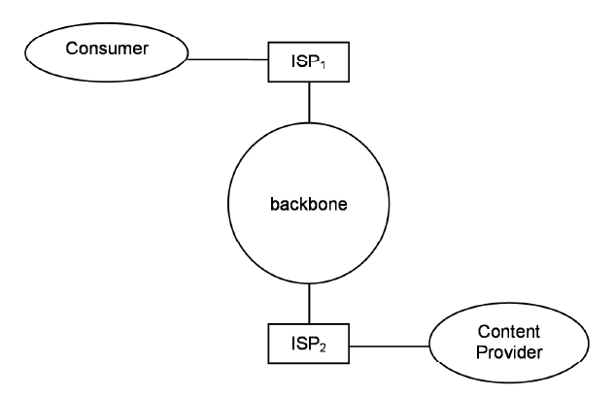

Figure 1: The basic structure of Internet. Adapted from "Network neutrality: A survey of the economic literature.” by Schuett, Florian Review of Network Economics 9.2 (2010): 1-13.

Data is transferred through TCP/IP (Transmission control protocol or Internet Protocol) which treats data packets in same way regardless of size, content or origin. Same standard protocols are used for VOIP services, peer to peer connection, video streaming, multiplayer gaming, email and Browsing. (Shane Greenstein, Christine Snively, 2016) This non-discriminatory approach is believed to be a central premise for the Internet by a few.

However, in actual practice, data packets are sometimes treated differently in order to avoid network congestion. Network providers defend such network management practices by the lack of available bandwidth. So, the debate exists whether in practice net neutrality even exists. (Internet Society, 2015)

In technical terms, the following practices question the concept of net neutrality: Blocking & filtering of certain content by ISPs, Fast lanes (giving preferential treatment to certain data), Throttling (reducing the data throughput of specific data streams delivered to the end user), Zero-rated services (delivering content to consumer at substantially lower cost or for free). (ISOC, 2015)

According to Tim Wu in his article Economic Theory of Two-Sided Market (Lee and Wu, 2009) **“**An ISP should treat all data from content provider in the same way a telecommunication company treats voice and cannot offer preferential deal to a new customer. Net neutrality also forbids data throttling of certain types of content over other.”

The two-sided market theory states that internet acts as an intermediary between the two sides i.e., the content providers and the users and exhibits price dynamics just like other two-sided markets. The setup of standard two-sided model was given by Armstrong (2006). The content providers pay the ISPs an access fee, to get access to the internet and usage fee-based on the bandwidth and time consumption. However, there are no extra charges paid by content providers on the basis of services they provide.

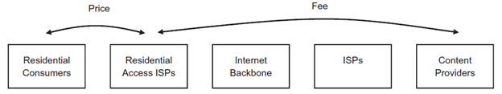

Figure 2: Adapted from “Network neutrality on the Internet: A two-sided market analysis” by Economide, N., Tag, J., 2012. Information Economics and Policy 24, 91-104.

Net neutrality means a zero-price rule to be followed in this two-sided market structure (Hemphill, 2008). This implies that no additional fee is to be charged from the content providers. Ed Whitacre, AT&T’s then CEO, was quoted in BusinessWeek referring to AT&T’s internet infrastructure: “Now what they would like to do is use my pipes free, but I ain’t going to let them do that because we have spent this capital and we have to have a return on it.” This statement contradicts the two-sided market structure where the content providers and the users pay a certain amount to their respective ISPs to access the internet. So, nobody is using internet for free.

Economic or market perspective is a way to characterize the debate which is quite popular in age of neoliberalism. Addressing the user of internet as consumers instead of citizens, scholars such as Hahn and Wallsten (2006) are concerned with net neutrality’s effects on the market, and believe in a so-called “hands-off” approach (the cornerstone of neoliberal regulation), or “deregulation” in the name of market mechanisms. Hahn and Wallsten argue that, “mandating net neutrality would be inconsistent with sound economic management of the Internet” (Hahn &Wallsten, 2006: 2). Similarly, Globerman (2008), Greenstein (2007), and Hass (2007), have looked at net neutrality as unfavourable to end users. Those who view debate with a market perspective believe that any sort of regulation even mandate of net neutrality will degrade the efficiency of the market. Quite the argument made by the telecom.

Net neutrality is a global concept. The debate around net neutrality had started in 2005 in USA when AT&T had come up with a suggestion of charging certain websites to prioritize traffic. This was the time when FCC (Federal Communications Commission) adopted four principles concerning net neutrality where customer is entitled to access content as per their choice, run apps of their choice, choice of device and benefit of competition between network and content provider. In 2010, FCC introduced Open Internet Order & in 2016 US court rejected the appeal filed by companies like AT&T and other telecommunication companies for the preferential data treatment and classification of Internet as information service instead of telecommunication service. (Shane Greenstein, Christine Snively, 2016)

Regulations in the other parts of the world are summarised in the following table (Marsden, 2010: 159-180, 2011)

|  |  |  |  |
| --- | --- | --- | --- |
| **Nation Net** | **Net neutrality policy** | **Regulatory basis** | **Major cases** |
| Brazil | Marco Civil 2014 | Drafting regulations 2015 | Zero rating 2015 |
| Chile | Law of 2010 | Regulations of 2011 | Zero rating of 2014/15 |
| Norway | Co-regulatory agreement 2009 | Co-regulation | Zero rating declaration by NKOM of 2014 |
| Netherlands | Law of 2012 | Regulations of 2013 | Zero rating 2015 |
| Slovenia | Law of 2012 | Regulations of 2013 | Zero rating 2015 |
| Canada | Hearing of 2010 | Telecom Act 1993 | Zero rating 2015 |
| United States | Open Internet Order 2015 | Title II, Telecoms Act 1996 | Zero rating 2015 |
| UK | Code of Practice 2011 | Self-regulatory | None to 2015 |

Table 1: Net neutrality policy, regulatory basis, and major cases

In Brazil, a legislation called “Internet Bill of Rights” was passed on 22 April 2014. The bill banned telecom companies to charge differently to users on based of content they use. It also recommended that ISP are not allowed to influence consumption pattern of data to users (Grassmuck, Ralf Volker , 2009).Chile was the first country to pass net neutrality legislation back in 2010. The legislation mandates no blocking and no content discrimination (Stover, Christine M, 2010).Canada’s net neutrality rules were established in 2011. ISPs are required to disclose their network management and traffic treatment policies to Canadian Radio-television and Telecommunications Commission (CRTC). Surprisingly, there are no penalties for ISPs that fail to abide by the rules (Krämer, Jan, Lukas Wiewiorra, and Christof Weinhardt , 2013).Europe’s approach to net neutrality has emphasized transparency and competition. Like the UK, many European households have a choice of using one from among three or more fixed-line broadband providers. In April 2014, the European Parliament voted to implement net neutrality rules that would prevent ISPs from charging data-intensive CPs such as Netflix for fast-lanes. Under the ruling, ISPs can only slow down Internet traffic to ease congestion, and cannot penalize specific services for heavy data use (Leal, Maria Cristina, 2014)

Another important aspect of net neutrality is what it means to the end-consumers as they are a major stakeholder in the network models. As studied by scholars like Christine Quail and Christine Larabie (2010), net neutrality as perceived by the consumers involves many different interpretations mainly because of the lack of knowledge of the concept of net neutrality as well as due to the different media discourses. Since the media plays an important role in the viewpoint formation of the public, the scholars have studied the impact of media discourses on the general public. Through focus groups as well as analysis of articles in the media, they have presented the lack of clarity in the minds of the consumers with respect to net neutrality and its utility. Customers are unaware of its actual implications. On the basis of focus group discussion conducted by Christine Quail and Christine Larabie (Focus Group, 2010, March 9), the consumers perceive Net neutrality as “too complex” and “abstract” (Christine Quail, 2010). Most of the participants didn’t know who will be affected by net neutrality and whether they themselves will be affected or not.

While many public interest advocates look at net neutrality as an issue of freedom of speech (Blevins & Barrow, 2009) and the democracy of Internet freedom, some look at Internet as a ‘public utility’ (Barratt & Shade, 2007). There are many views supporting zero-rating practices on the basis of human rights. But as Professor Arturo J. Carrillo (2016) explains, the context, country wide circumstances and the necessity also play a major role. For example, consumers in Zambia may perceive zero-rating platforms as a means of promoting connectivity as less than twenty percent of its population has access to internet. But what about countries like India with not such a low connectivity issue but still a great rural-urban digital divide.

Facebook had launched Free Basics campaign in 2014. By 2015, it was available in 36 different countries including Zambia, where it showed significant results in bringing an increasing number of people online. But it was banned in India in February 2016 based on the "Prohibition of Discriminatory Tariffs for Data Services Regulations, 2016" notification.

The tagline “If the sun is free...If the air is free...then why shouldn’t the internet be free?” was quoted in the advertisement by Reliance during Facebook’s Internet.org campaign in India in partnership with Reliance Mobile (The Guardian, May 12,2016).

**RESEARCH OBJECTIVE AND RATIONALE OF STUDY**

The literature review reveals the vast amount of information that’s available on Net Neutrality and its various aspects and definitions - technical, economic (relating to the business models), and concerning the consumers. As from the review, I realise that country-specific conditions play an important role in the consumers perceiving the net neutrality as legitimate or not. And even though there have been recent discussions around Facebook Free Basics and Internet.org, there is a lack of research on the consumer perception in the Indian context.

Given the research gap, I have defined the research objective for this paper as trying to study the Indian consumers and how much do they really understand the meaning of net neutrality and its effects. Given the long-lasting nature of this debate and the possibility of reintroducing this ‘through the backdoor’ (Parminder Jeet Singh, 2016), it’s of utmost importance to understand the awareness levels and the relevance of Net Neutrality in the lives of the consumers.

# **METHODOLOGY APPROACH**

I have focused on exploratory research trying to identify a research gap in the growing area of Net Neutrality. It has helped us to get a deep understanding from the technology, business and regulatory points of view. Further for the customer perspective, our approach will be inductive research. I will be focussing on what customers think about net neutrality.

I will collect data through interviews, following a stratified and convenience-based sampling method. For convenience purposes, I have chosen Ericsson India Campus and within the campus, I will be covering different strata of the population - Engineers, Specialists, ManagersASP/ARP resources & Directors. After analysis of the data, I will attempt to analyse the awareness level among the Indian consumer as well as try and determine if any factors appear in the discussions about how to create better awareness and which are the influencing factors.

# **DATA COLLECTION APPROACH**

I will make the use of primary data for the proposed research study. I will collect primary data through conducting surveys based on a semi-structured questionnaire (please see appendix) prepared to measure customer’s awareness about the concept of net neutrality. The data will help us to understand how general people (naïve customers) understand net neutrality and what their view about this topic is. Since the sample consists of Indian population, I have also related questions about the connection of net neutrality and a major event of net neutrality in India - Internet.org / Facebook Free Basics.

# **CONSUMER PERCEPTION OF NET NEUTRALITY: INTERVIEW STUDY**

The perspective of the consumers can be divided into three broad categories:

1. Unawareness about net neutrality
2. Digital Activism
3. Economic perspective

**UNAWARENESS**

* 43% of the people in India are not aware about net neutrality
* 52% of the population doesn’t have any opinion - whether they support or do not support net neutrality
* A big concern is that even if 56% people believe that they are aware about net neutrality, the coherence of the term may still be missing, due to which 21.7% of the people may be aware but still do not have any opinion in regard to net neutrality
* Another observation was the confusion in the minds of the consumers because of the term ‘free basics’ which made people believe internet will be free, unaware of the differential pricing concept.

*“Not well aware, if it is free is should be nice”*

* Even among the 56% people who are aware of net neutrality, there are only 38% who support it. 23% i.e. 3 among the 13 who are aware, do not support net neutrality. Among these 3 is a respondent who supported Free Basics as well and believes:

*“We are not the right people to judge the availability for those who don’t have internet*

*In end what is TRAI there for? It should be able to handle and regulate”*

But the point of observation is that when asked ‘what do you think net neutrality is?’, his response was:

*“Everybody should have same access not depending on the ability to pay”*

which is a very flawed and skewed definition of net neutrality.

* Around 35% of the population wasn’t even aware of the free basics campaign which shows a lack of awareness among the Indian population. Even though all the respondents are educated with a minimum qualification of a graduation degree, the awareness, not just about net neutrality, but also about internet.org is low.
* Only 56% were informed of the existence of a movement called internet.org or free basics in India. This accentuates the possibility of even lower awareness levels among the rural population of India
* Consumer perception can be formed even if the consumer is unaware. So even if we observe the people unaware about Free Basics and interpret their interviews we can decipher that 62% of them do not support it.

**DIGITAL ACTIVISM**

Research shows people who were not completely aware of what was the Free Basics Campaign launched by Facebook in India were also its supporters. This is termed as ‘Digital Activism’ in this research paper. Users of Facebook and other social media websites, may support things or raise opinions about matters of which they are not even fully aware and majorly this is due to the other users supporting a cause. So, the population which is digitally active these days, may end up being a victim of this.

* 8.6% of the population was a part of the digital activism. Their responses were as follows:

*“Initially did, saw the other perspective, limited to only reliance creating a cartel, Facebook viral campaign against Facebook”*

*“Yes, initially supported because Facebook kept prompting so many friends are supporting free basics. Regretted later because realised Facebook was trying to monopolise (read in news sites)”*

* Only 8 respondents out of 23 (34.7%), were aware of the fact that Free Basics was related to Net Neutrality

**ECONOMIC PERSPECTIVE**

People in India have an economic perspective to the concept of net neutrality. They want to get the worth of the money which they spend for buying data packs. Responses such as *“net should be neutral like landline”, “everybody should have same access irrespective of their ability to pay”, “certain websites will be free and will be included in the data packs offered by the operators”, “you don’t have to pay for the stuff which should be free”* signifies the economic perspective on net neutrality. Even though after analysing the data, 56% people are aware about net neutrality, they have a different perspective to it.

One of the responses was *“It is good if it is free”.*

When asked about the free data provided by Reliance Jio, people are using it because it is free. “*Customers are very happy with free data and have started using more applications and it has also increased awareness in digital India”.*

About the autoplay service initiated by Facebook, there was a mixed opinion. Those who are less active on Facebook are indifferent to it. However, people who consume mobile data via data packs don’t like the service as it consumes more data and also they want only those videos to play which they like. On the other hand, those who use Facebook through the Wi-Fi don’t dislike this service as they don’t have to pay for that.

Mukesh Ambani, was quoted in televised conference in Mumbai: *“*India has become no. 1 country in mobile data usage. Jio users consumed more than 100 crore GB of data per month on the Jio network and that’s more than 3.3 crore GB a day*”.*

**WHAT CAN BE DONE TO CREATE MORE AWARENESS?**

After collecting responses from the customers, the following things came forward that can be done to improve customer awareness.

* Broadcasting information on Radio in all languages can help people gain awareness as most people have access to radios while travelling. Language barriers should also be taken into account while broadcasting information.
* However, the homemakers have access to television at home. So, they prefer information to be broadcasted on television in advertisements and news.
* Another important point that I came across was ethicality in media. The media itself shouldn’t be biased. It should take a neutral stand without supporting any of the sides.
* People think that Facebook itself is not the correct medium to create awareness about free basics as it will portray a biased opinion. Rather, other alternatives such as videos and youth channels can be used to create more awareness among the youth. Similarly,Whatsapp messages can be used to create more awareness.
* Considering the rural people, it is important to teach people and create more awareness. Gram panchayats can be given this responsibility to make people aware by adopting various measures.

***References:***

1. Nguyen Q., (2016 July 22). A Literature Review of Over-The-Top Related Policy And Regulatory Issues. P2-8
2. Pandey A., Sagar M. Nisheeth D., (2017), Global Economic and Legal Perspective: Over The Top Services
3. Osterwalder A., Pigneur Y (2010), Business Model Generation, John Wiley & Sons Inc. Hoboken, New Jersey
4. Lianghao. (2017, April 16). Business Model of WeChat and Its Success Factors. Retrieved from https://medium.com/@lianghao.gao/business-model-of-wechat-and-its-success-factors-ce72d0f550fa
5. Čirjevskis, Andrejs. (2017). Acquisition based dynamic capabilities and reinvention of business models: Bridging two perspectives together. ENTREPRENEURSHIP AND SUSTAINABILITY ISSUES. 4. 516-525. 10.9770/jesi.2017.4.4(9)
6. Page V. (2018, April 3), How WhatsApp Makes Money, Retrieved from https://www.investopedia.com/articles/personal-finance/040915/how-whatsapp-makes-money.asp
7. Pahwa A. (2018, February 11). How does WhatsApp Make Money? WhatsApp’s Revenue Model, Retrieved from https://www.feedough.com/how-does-whatsapp-make-money/
8. Heinrich E. (2014, June 23). Telecom companies count $386 billion in lost revenue to Skype, WhatsApp, others, Retrieved from: http://fortune.com/2014/06/23/telecom-companies-count-386-billion-in-lost-revenue-to-skype-whatsapp-others/
9. Informa’s World Cellular Revenue Forecasts 2018 (2013) Retrieved from:https://informa.com/media/press-releases-news/latest-news/global-annual-sms-revenues-will-be-us23-billion-less-by-2018/
10. Spirit DSP(2012) The Future of Voice, Retrieved from: http://www.spiritdsp.com/industry-news/read-more-industry-news/article/ott-voip-to-cost-telcos-479b-to-2020/
11. Consumer OTT VoIP Outlook: 2013 to 2018 (2013) by Ovum. Retrieved from: http://fortune.com/2014/06/23/telecom-companies-count-386-billion-in-lost-revenue-toskype-whatsapp-others/
12. Cisco Visual Networking Index: Global Mobile Data Traffic Forecast Update, 2013-2018. Retrieved from: http://www.cisco.com/c/en/us/solutions/collateral/service-provider/

    visual-networking-index-vni/white_paper_c11-520862.pdf
13. Siva M. (2017, February 27), All you wanted to know about ARPU, Retrieved from: https://www.thehindubusinessline.com/opinion/columns/slate/all-you-wanted-to-know-about-arpu/article9562345.ece
14. Business Model of AT&T (2018) Retrieved from:https://www.cleverism.com/company/att/
15. Fernando J. (2016, October 16), A Closer Look at AT&T, Retrieved from: https://www.investopedia.com/articles/investing/101615/closer-look-att.asp