PARAMETRIC STUDY OF VAPOUR-COMPRESSION VAPOUR-ABSORPTION CASCADE REFRIGERATION SYSTEM

A Major Project Report Submitted towards the Partial Fulfillment of the requirements for the Award of the
DEGREE OF MASTER OF ENGINEERING
IN
THERMAL ENGINEERING
Submitted by

GIRISH KUMAR
ROLL NO. 13842

Under the guidance of
Dr. B. B. ARORA
Prof. R.S.MISHRA

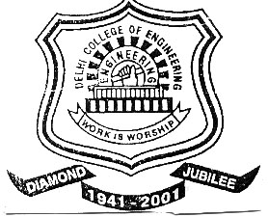

University of Delhi
Department of Mechanical Engineering
Delhi College of Engineering
Delhi -110042

