CHAPTER 1

INTRODUCTION AND OUTLINE

This chapter briefly introduces the research work proposed in the thesis. Section 1.1 gives an overview of the research undertaken. Section 1.2 sets out the research objectives. Section 1.3 illustrates the proposed framework and the main contributions arising from the work undertaken. Section 1.4 presents an outline of this thesis describing the organization of the remaining chapters. Finally, Section 1.5 gives the summary of the chapter.

  - Introduction
During the last decade, the World Wide Web has evolved into a large worldwide network as announced by many computer experts in the early 1990´s. One of the early attempts of formalizing the concept of evolution on the Web was done by Tim Berners-Lee in 1989, the father of World Wide Web. Many people agree on Web evolution, but few people have thoughtfully studied its principles, i.e. why and how the Web evolves. Web evolution is supposed to be a major branch of Web Science. The figure 1.1 shows the timeline depicting the Web evolution.
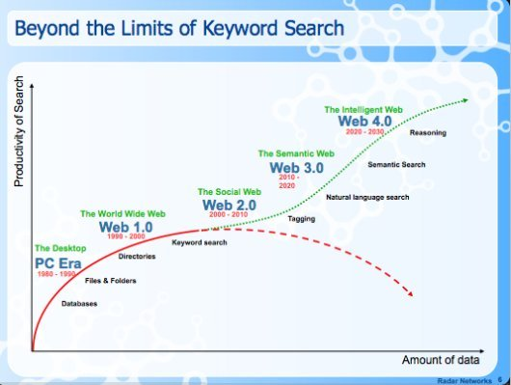
Figure 1.1: Timeline depicting the evolution of Web
The traditional World Wide Web [1], also known as Web 1.0 (1991-2003) is a heteronym that refers to the state of the World Wide Web, and any website design style used before the advent of the Web 2.0 phenomenon. Web 1.0 is Read-or-Write Web and refers to the original information-oriented web. Web 1.0 began with the release of the WWW to the public in 1993, and is the general term that has been created to describe the Web before the "bursting of the Dot-com bubble" in 2001. Since 2004, Web 2.0 [2] has been the term used to describe the current web design, business models and branding methods of sites on the World Wide Web. The term Web 2.0 is commonly associated with web applications that facilitate interactive information sharing, interoperability, user-centered design, and collaboration on the World Wide Web. It is a Read/Write Web. At Web 2.0, not only writers but also readers can both read and write to a same web space. Web 2.0 is basically a metaphor to describe how applications which are delivered over the web allow one to use it much like using a desktop. A Web 2.0 site gives its users the free choice to interact or collaborate with each other in a social media dialogue as creators of user-generated content in a virtual community, in contrast to websites where users are limited to the passive viewing of content that was created for them.

The third stage of web evolution is Web 3.0 [10]. It refers to the currently evolving version of the web. There are different conceptions of Web 3.0. Some see Web 3.0 as the semantic web (or the meaning of data), personalization (eg. iGoogle), or the intelligent web, where software agents will collate and integrate information to give "intelligent" responses to human operators. An ideal semantic web is a Read/Write/Request Web. We can summarize by saying that Web 1.0 connects real people to the World Wide Web and Web 2.0 connects real people who use the World Wide Web. The future semantic web, however, will connect virtual representatives of real people who use the World Wide Web.

With the rapid development and wide popularity of Internet and e-commerce, the emergence of Web 2.0 technology is growing day-by-day. Various services of Web 2.0 include social-networking sites, blogs, wikis, websites, podcasts, vodcasts, VoIP, RSS, folksonomies and various other web applications.
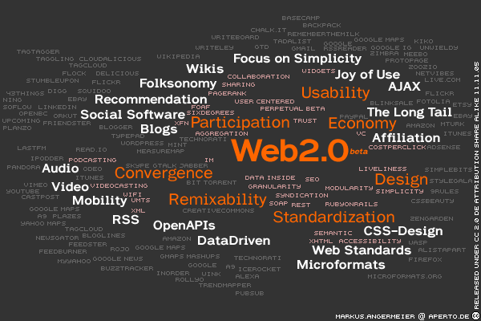
Figure 1.2: Web 2.0 Technologies

Now-a-days, the most critical aspect is to use these social networks in a certain collaborative context. This gives rise to the “virtual community system”, most commonly referred as “on-line communities”. Virtual community [19] means groups of people who are in contact because they share same kind of knowledge and interests, corresponding with each other using interconnected computers in a collaborative process. In other words, it refers to the aggregation of people who have got similar interests and who work together to achieve a common goal or objective (collaboration). It adopts the specifications of Web 2.0 and its basic features include sharing of knowledge, transmission of knowledge and co-operation among its participants. It leads to a better use of social networking tools like blogs, wikis etc. . There are a number of right tools which we can choose for the development of the virtual team. When choosing the tools for virtual collaboration, we start by identifying the tasks that the team will need to accomplish and only then we can choose the appropriate tool for each situation [22]. Various collaborative tools include collaborative software suites, information gathering tools, wikis, blogs, chats etc. Blogs [3] are like online journals where we can post updates - in the form of text, pictures, audio or video files. The image at left shows the title bar. Wikis [4] are collaboratively authored websites, where anyone with a password can make alterations to unlocked sections. The image at left shows a section of the homepage of this wiki as it would appear to a user with editing rights.
With the advent and proliferation of the Internet and e-commerce, the use of web has fueled up for everyday tasks, right from sending e-mails, reading news articles, searching for information, viewing real-time stock quotes, and performing Internet banking to shopping online. Consequently, users spend most of their time in navigating through a large volume of information sources before identifying the nuggets of information they seek. Furthermore, as the web is growing complex on a continuous basis, the information overload problems faced by the users are also increasing at a rapid pace. Increasingly, people are turning to recommender systems [26] to help them find the information that is most valuable to them as recommender systems help in addressing this information overload problem by retrieving the information desired by the user based on his/her similar users' tastes and preferences. Recommender systems support a broad range of applications, including recommending movies, books, relevant search results, and even pets. One of the most successful technologies in recommender systems research and practice is collaborative filtering. Collaborative filtering [27] (also known as social information filtering) is based on the basic principle of finding a subset of users who have similar tastes and preferences to that of the active user, and offering recommendations based on the subset of users. Commercial application of collaborative filtering technique includes “Customers who bought” (www.amazon.com). The most prominent problem existent in collaborative filtering is the First-Rater or the cold- start problem, which is based on the fact that collaborative filtering based systems require a large set of customer preferences for predicting the new preferences accurately. That is, for a reliable collaborative filtering based prediction system, we need to have a large set of customer ratings on a variety of items available on the database. As the system can predict accurately only after it has gathered a large set of opinions, customers will not be willing to express their detailed preferences in the initial stages (if it is not going to help them in any way, despite offering preference ratings).

Summing up, the operative challenges motivating researchers in Web 2.0 setting and recommendation system call for convergence between the two areas of active research. The motivation for the research presented in this thesis was instigated by the challenges related to the information overload problem being faced by the users in their day-to-day activities and the cold- start problem, the most prominent problem existent in collaborative filtering. It calls for proposing methods that allow users with similar interests and expertise to collaborate among themselves, and thereby carry out their collaborative work and resource sharing in an efficient manner. Because of this, it is of key interest to set up a collaborative interest group (virtual community) and then identify an expert from each group who will be the centre of the group, and finally providing relevant recommendation to the users in the form of positive, negative or neutral opinion based on the reviews of the expert in his respective blog. This would overcome the cold-start problem, and provide users with the suitable recommendation.

Most of the notations used and issues raised in this section are addressed in more detail in later chapters. The remainder of this chapter sets out the research objectives, describes the main contributions of the research work, and presents an outline of this thesis.

1.2 Research Objectives

Statement of Research Question
“Can virtual communities leverage recommendation by mining the interest between the community members?”

Building on the gaps that exist in the diversified web and in response to the identified need to better exploit the knowledge capital accumulated on the web which fosters the need of collaboration among people, this unifying research question can be broken down into the following four questions, each of which will be addressed by this research:

- How can virtual communities be built?

- How can interest be mined in virtual communities?

- How can expertise be accessed and used in virtual communities?

- Finally, how can recommendation be realized from the interest mined and expertise accessed from the virtual communities?

Consequently, the three main research objectives of the work undertaken are:
- Research Objective I – To construct a collaborative interest group known as the virtual community which will cluster researchers with similar interests in a same group and thereby facilitate collaborative work.

- Research Objective II – To access the expertise from the virtual community and realize the importance of finding the expertise.

- Research Objective III –To build a recommendation system which will provide recommendation to the users in the form of positive, negative or neutral opinion.

The research objectives realize a more efficient methodology to exploit the knowledge capital accumulated on the diversified web and fosters the need of collaboration among people with similar interests by constructing a virtual community or an interest group. It also addresses the user need of reducing information overload problem, a problem that is applicable to all internet users & frequently experienced at present when locating and exploring information online. This is accomplished with the help of the recommendation system so proposed. It promises vastly augmented opportunities for collaboration and resource sharing and at the same time addresses the information load problem. It is complemented by a framework that utilizes various approaches/techniques incorporating the tastes and preferences of the users with the help of interest similarity relations like interest vector and similarity score. It also includes various data mining and NLP techniques to provide suitable recommendation to the user.

  - Proposed Framework

We propose a COMREC system which defines and expounds the role of a “collaborative and recommendation web”, comprehended by incorporating shared interest for a virtual group (community) construction and then to characterize an Interest based Collaborative recommendation system based on this virtual collaborative group. The goal of the framework is to realize an entirely different approach to solve the problem of discovering people who have particular interests or expertise and then providing relevant recommendation to a particular user by retrieving the information as desired by him based on his similar user’s tastes and preferences. The idea is to provide the basis for carrying out cooperative work and thus, to promise vastly augmented opportunities for collaboration and resource sharing, that would ultimately solve the issues related to the information load problems faced by the users which is increasing at a rapid pace.

Consequently, we propose and investigate a novel recommender system based on the virtual collaborative group set up using an algorithmic framework. Under the proposed COMREC system, we provide the development of the Interest Mining Module and Recommendation Module. The Interest Mining module defines a constructing algorithm of Interest Group by uncovering shared interest relationships between people, based on their blog document entries and using interest similarity relations like Interest vector and Interest similarity score. The collaborative Interest group is constructed using the technique of K-means clustering algorithm which would let them arrange into groups effectively and thereby share the resources and carry out their cooperative work. Once the interest similarity group is constructed, then we identify an expert from each of the group so formed who provides recommendation to the user based on the input given by him on the user interface. The identified expert provides his recommendation based on our recommendation module so proposed.

This will help overcome the most prominent problem existent in collaborative filtering, the First-Rater or the cold- start problem, which is based on the fact that Collaborative filtering-based systems require a large set of customer preferences for predicting the new preferences accurately.
The Recommendation Module performs sentiment analysis of a particular document in question and then provides the relevant recommendation to a particular user in the form of positive, negative or a neutral opinion. This module performs this task with the help of Review Data Server which is responsible for collecting the review web pages from the expert’s blog and storing them in the review repository, thereafter Sentiment Mining Search Engine provides the actual recommendation by making use of data mining and NLP techniques and finally the User Interface presents the result to the user in the form of a positive, negative or a neutral opinion.

1.4 Organization of Thesis

This thesis is structured into 5 chapters followed by references and appendix.

Chapter 1 presents the research problem, research objectives, justifies the need for a Collaborative Recommendation system to foster the collaboration among the researchers with similar interests thereby reducing the information load problem, and outlines the main contributions arising from the work undertaken.

Chapter 2 provides the essential background and context for this thesis and provides a complete justification for the research work described in this thesis.

Chapter 3 provides the details of the methodology employed and outlines the Collaborative Recommendation system (COMREC System) that constitutes the proposed approach of the research.

Chapter 4 describes the experimental results obtained from a document illustration. It also presents the analysis to account for the tests performed.

Chapter 5 presents future research avenues and conclusions based on the contributions made by this thesis.

1.5 Chapter Summary

This chapter has laid the foundations for this thesis. It briefly introduced the research problem, research objectives and the proposed solution framework. A justification for the research problem is outlined, together with an explanation of the research methodology used. The next chapter examines the pertinent literature most relevant to this research.

