DISSERTATION
On
INTEREST MINING FOR RECOMMENDATION SYSTEM IN VIRTUAL COMMUNITIES
SUBMITTED IN PARTIAL FULFILMENT OF THE REQUIREMENTS
FOR THE AWARD OF DEGREE
Of
MASTERS OF TECHNOLOGY
(Software Engineering)
Delhi Technological University, Delhi

Submitted By:

ABHA JAIN
06/MT/SE/FT

Under the Guidance of:

Dr. AKSHI KUMAR
Assistant Professor

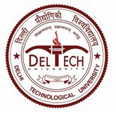

DEPARTMENT OF SOFTWARE ENGINEERING
DELHI TECHNOLOGICAL UNIVERSITY
2011

