Dissertation on

Design of
Current Comparators
and its Application as ADC

by :
Ranjana Sridhar
Roll No.: 11/VLSI/2k10
M.Tech (VLSI and Embedded System)

Dissertation Submitted in Partial Fulfillment
of the
Requirements for the Degree of

Master of Technology
in the

Dept.of Electronics and Communication Engg.
Delhi Technological Univ. (formerly DCE)

2010-2012
CERTIFICATE

This is certified that the dissertation entitled “Design of Current Comparators and its Application as ADC” is the work of Ms.Ranjana Sridhar (Roll No.: 11/VLSI/2k10), a student of M.Tech (VLSI Design and Embedded System) in Delhi Technological University (Formerly DCE). This work is completed under my direct supervision and guidance and forms a part of Master of Technology (Electronics and Communication) course and curriculum. She has completed her work with utmost sincerity and diligence.
The work embodied in this major project has not been submitted to any other Institute/University for the award of any other degree to the best of my knowledge.

Dr. Neeta Pandey Date:__________
(Project Guide)
Assistant Professor
Department of Electronics and Communication,
Delhi Technological University (formerly DCE),
Delhi.
ACKNOWLEDGEMENT

I am grateful to many people who supported and encouraged me during the work leading to this dissertation: guide, friends, and family.
First of all I would like to express my sincere gratitude to my guide, Asst.Prof.(Dr.)Neeta Pandey. She has been an excellent mentor and a constant source of knowledge, inspiration, and encouragement throughout my thesis/ M.Tech work.
I am extremely thankful to Prof. Asok Bhattacharya, former HOD of Electronics and Communication Deptt., Prof. Rajiv Kapoor, Head of Department, Electronics and Communication (ECE), Delhi Technological University, for their motivation and inspiration. I am also thankful to Mr.Rajendra Kumar, Mr. Baljeet, Mr.Pawan and all the non-teaching staff of ECE Department for providing unconditional access to resources.
I am grateful to my parents and sister and friends for their continuous support and encouragement during this work.

Ranjana Sridhar
M.Tech (VLSI Design and Embedded System)
Roll No.: 11/VLSI/2K10
Delhi Techological Univ., (formerly DCE)
Delhi-110042

Abstract

With the development of current-mode applications, the mixed-mode circuits are gaining in importance because of the necessity of optimizing the interface between the sub-blocks, which are working in different modes i.e current mode and voltage mode. This thesis presents the design of high speed, high resolution and wide input range current comparator that converts the current input data into equivalent binary voltage levels. New current comparator structures were proposed and analyzed and were compared to existing current comparator in terms of parameters like propagation delay, resolution, power dissipation etc.

Applications such as image sensory information processing, control and instrumentation rely on direct input current processing capability where current mode ADC has a natural advantage. A current mode flash analog to digital converter (ADC) with 4-bit resolution was implemented using proposed current comparator. All the proposed circuits are verified for the functionality using SPICE and 0.18μm TSMC CMOS technology parameters.

CONTENTS

Certificate  Acknowledgement  Abstract  Table of Contents  List of Figures  Introduction and Thesis Outline  1.1 Introduction  1.2 Research Goals  1.3 Thesis Organization  Current Mode Comparators  2.1 Introduction  2.2 Basic Concepts  2.3 Comparator Circuits  2.4 Proposed Comparators  2.4.1 Proposed Comparator I.  2.4.2 Proposed Comparator II  2.5 Simulation Results  2.5.1 Transient Analysis  Current Mirrors  3.1 Introduction  3.2 Current Mirror Circuits  3.2.1 Simple Current Mirror  3.2.2 Cascode Current Mirror  3.2.3 Regulated Cascode Current Mirror  3.3 Simulation results  3.3.1 DC Analysis  3.3.2 Transient Response  Encoder  4.1 Introduction  4.2 Encoder Circuit  4.3 Simulation Results  Digital to Analog Converter  5.1 Introduction  5.2 DAC Terminology and Basic Operation  5.3 Types of DAC  5.4 Performance Parameters  5.5 DAC Circuit  5.6 DAC Simulation Results  Analog to Digital Converter  6.1 Introduction  6.2 ADC Architectures  6.2.1 An Area-Speed Efficient Method for  Current Mode ADC  6.3 Parameters of ADC  6.4 Simulation Results  Conclusion  References | i  ii  iii  iv-v  vi-viii  1-4  1  2  3  5-25  5  5  8  15  17  18  20  20  26- 41  26  28  28  29  30  31  31  38  42-45  42  42  44  46-54  46  46  47  49  52  53  55-69  55  56  60  62  65  70  71
List of Figures

Fig. 2.1(a): Ideal current comparator operation –
Transfer characteristics
Fig. 2.1(b): Ideal current comparator operation –
Transient response
Fig. 2.2: Basic CMOS current mirror Comparator
Fig. 2.3: Basic CMOS High Speed CMOS current Comparator
Fig. 2.4 CMOS Current Comparator
Fig. 2.5: CMOS Current Comparator proposed by
Fig. 2.6: CMOS Current Comparator with Resistive Feedback
Fig. 2.7: A Robust High Speed and Low Power CMOS
Current Comparator
Fig. 2.8: Comparator proposed in [Banks]
Fig. 2.9: DCCII Active Block
Fig. 2.10: CMOS Current Comparator from [Ref DCC2]
Fig. 2.11: Current Differencing stage
Fig. 2.12: Proposed Current Comparator I- Gain and Output stage
Fig. 2.13: Proposed Current Comparator II- Gain and Output stage
Fig. 2.14 (a): Input-Output for Traff Comparator
Fig. 2.14 (b): Input-Output for Proposed Comparator I
Fig. 2.14 (c): Input-Output for Proposed Comparator II
Fig. 2.15 (a): Delay versus Current Difference
Fig. 2.15 (b): PDP versus Current Difference
Fig. 2.16 (a): Delay with respect to current difference and
power supply for proposed comparator I
Fig. 2.16 (b): Delay with respect to current difference and
power supply for proposed comparator II.
Fig. 3.1 : Block Diagram of Current Mirror
Fig. 3.2: Simple Current Mirror
Fig. 3.3: Cascode Current Mirror
Fig. 3.4: Regulated Cascode Current Mirror
Fig. 3.5 (a): Output Current versus Input Current for
Simple current mirror
Fig. 3.5 (b): Output Current versus Input Current for
Cascode current mirror
Fig. 3.5 (c): Output Current versus Input Current for
Regulated Cascode current mirror
Fig. 3.6 (a) : Output versus Input Current with variation in Vout for Simple current mirror.
Fig. 3.6 (b) : Output versus Input Current with variation in Vout
for Cascode current mirror.
Fig. 3.6 (c): Output versus Input Current with variation in Vout
for Regulated Cascode current mirror.
Fig. 3.7 (a): Output versus Input Current Pulse under
Transient Analysis for Simple current mirror.
Fig. 3.7 (b): Output versus Input Current under
Transient Analysis for Cascode Current Mirror.
Fig.3.7 (c): Output versus Input Current under
Transient Analysis for Regulated Cascode Current Mirror
Fig. 4.1: 2:1 Multiplexer based encoder
Fig. 4.2: Pass Transistor logic based 2:1 Multiplexer
Fig. 4.3: Transient analysis of the Encoder
Fig. 5.1: DAC Input-Output
Fig. 5.2: PWM DAC
Fig. 5.3: Current Steering DAC using
Binary weighted current sources
Fig. 5.4: Example of DNL
Fig. 5.5: Example of INL
Fig. 5.6: Illustration of Offset Error
Fig. 5.7: Illustration of Gain Error
Fig. 5.8: DAC circuit
Fig. 5.7: Transient Simulation result showing Iout for
different B1-B0 combinations
Fig. 6.1: Flash ADC architecture
Fig. 6.2 : Pipeline ADC architecture
Fig. 6.3 (a): Single Slope ADC
Fig. 6.3(b): Dual Slope ADC
Fig. 6.4: Successive Approximation ADC
Fig. 6.5(a): Oversampling ADC
Fig. 6.5(b): First Order Sigma Delta modulator
Fig. 6.6: Area Speed Efficient ADC [ref ASEADC]
Fig. 6.7 Example of DNL
Fig. 6.8 Example of INL
Fig. 6.9 Illustration of Offset Error
Fig. 6.10 Illustration of Gain Error
Fig. 6.11: Transient Analysis Result of the ADC
Fig. 6.12: ADC Transfer Characteristic
Fig. 6.13 (a): Differential Nonlinearity for the 4-bit ADC
Fig. 6.13 (b): Integral Nonlinearity for the 4-bit ADC

Chapter 1

Introduction and Thesis Outline

1.1 Introduction

Current mode circuits are gaining acceptance in variety of applications such as data acquisition and processing, testing, filter design and image sensory processing to name a few [1]. This is due to the many advantages offered by current mode circuits such as high speed, large bandwidth and ability to work under lower power supply voltage [2]. Another important consideration is that while voltage mode circuits require the use of complex techniques to lower power dissipation, current mode circuits can do the same in standard VLSI CMOS technology [2].
Comparators compare two input values and produce binary output decision level. They are important components of data converters, function generation and level shifting etc. The importance of comparators combined with the advantages of current mode circuits brings us to current comparators. The design of current comparators is a relatively new field which is a few decades old and the range of applications of current comparators is very wide. Keeping this in view, the design of current comparators was chosen as the topic of the thesis. Current comparators compare two input currents and give a corresponding binary output voltage and can be used wherever the sensors give an output current signal. There exist a wide range of current comparator applications such as image processing [3, 4, 5], VLSI IDDQ testing [6], implantable biomedical devices [7], sequence detection applications [8] etc. As an application of current comparator, Current mode flash Analog to Digital Converter(ADC) is chosen, as digital computing power has increased and widely available and the analog signal of interest has to be translated into a digital format. The flash current mode ADC was implemented and its characteristics were measured.

1.2 Research Goals

The focus of this thesis is the design and implementation of current comparators which have the characteristics of high speed, high resolution, low power dissipation and smaller transistor count. Additionally, a 2 stage area speed efficient current mode ADC is built with the proposed current comparator as the core component its characteristics are analyzed.
1) To study the current comparators which are already present in literature.
2) To compare them on the basis of properties like delay, power dissipation, power delay product, number of transistors etc.
3) Based on the study, to develop new current comparators which give better performance results and are more suitable to present applications.
4) To see the viability of the proposed current comparator, they were used as part of current mode ADC and the characteristics of the ADC were simulated.
5) As part of the development of flash ADC, other components such as current mirrors, encoders etc were also developed

1.3 Thesis Organization

The thesis is organized as follows:
Chapter 2 presents the background on current comparators and goes on to explain some of the existing current comparators present in literature. They are also simulated to get a qualitative idea of their performance. Then, the proposed current comparators are presented and their behavior is discussed. The proposed current comparators were simulated to get their performance parameters like delay, power dissipation power delay product etc. The simulation results show that the proposed comparators have acceptable performance. The usefulness of the proposed comparator is demonstrated through a flash ADC wherein the current mirror, encoder, digital to analog converter are integral components. The explanation of these components is given in subsequent chapters.
In Chapter 3, current mirrors are discussed. Current mirrors are common analog circuits which are a basic part of many applications like data converters, current adder/subtractor, biasing circuits etc. For conceptual purpose, the simple current mirror is explained and later the regulated cascode current mirror which is reported to have good current mirroring capabilities. The design of regulated cascode current mirror such that it mirrors current in the ranges required is presented. This is followed by simulation results where the results of DC and transient analysis are presented. The characteristics of the current mirror were calculated from the simulation results and were found to be satisfactory.
The design and implementation of an encoder is presented in Chapter 4. Firstly the requirement for encoders is explained and then the Boolean equation for the encoder to be designed is presented. The encoder is implemented and its transient analysis is performed to check the operation. This section is finished by presenting the simulation results of the encoder.
In Chapter 5, the concept of digital to analog converter (DAC) is presented as it is essential to implement a two step flash ADC. It converts the first stage digital outputs into equivalent analog signal which is processed by second stage. Then various types of DAC and performance parameters of DAC are discussed. The circuit design and description of DAC is then presented followed by the simulation results.
Chapter 6 is devoted to the study of analog to digital converters. Common analog to digital converter architectures are discussed followed by description of area speed efficient ADC architecture. The said ADC is then designed and implemented and simulations were carried out to measure its performance. The simulation results are then reported.
Chapter 7 presents the conclusions and summarizes the research work done in the thesis. Possible improvements to the design of current comparators are given along with a future vision for the work.

Chapter 2

Current Comparators

2.1 Introduction

Current comparators perform comparison between two input currents and give binary output voltage depending on which input current is greater. Generally, one of the two input currents is a constant, known as the reference current. Current comparators play an important role in current mode function generation, data converters etc. Apart from the advantages due to current mode operation such as higher bandwidth and ability to work under lower power supply, current comparators also lead to a reduction in the circuit area [2]. This is because many sensors output signal in the form of current [aps, CMOS etc] and a current comparator eliminates the need for current to voltage converter. Thus, because of its advantages the current comparator is a key element of analog and mixed signal processing. [1]

2.2 Basic Concepts

The current comparator accepts two input currents (I_{in1} and I_{in2}) and provides an output signal (voltage or current) which in binary form represents the case where I_{in1} > I_{in2} or vice versa. Here, the current comparator with output signal in the form of voltage is considered.

The functionality of the current comparator can be represented as:
v_{out} = 1, I_{in1}(t)> I_{in2}(t)
0, I_{in1}(t)< I_{in2}(t)

From the above representation it is seen that the comparator acts as a transimpedance structure [1]. Figure 2.l shows the ideal current comparator transfer characteristic and the transient response with single ended power supply.. Here, EOL and EOH denote the boundary values for the output logical states meaning that v₀ has two states. The x-axis, i, denotes the input current difference i.e I_{in1}-I_{in2}.
Figure 2.l (a) shows the ideal current comparator transfer characteristics for voltage codification. Figure 2.l (b) shows the ideal comparator transient response. These figures illustrate the ideal current comparator features: a) infinite transimpedance in the transition region; b) zero offset; and c) zero delay. In order to reduce the loading error due to the finite output resistance of the driving current source, the input voltage to the current comparator should be kept constant for the full range of the input current. In addition, all these characteristics ought to hold true for the smallest and the largest possible input current.

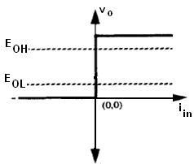
Fig. 2.1(a): Ideal current comparator operation - Transfer characteristics [1]
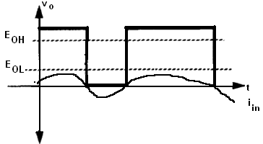
Fig. 2.1(b): Ideal current comparator operation - Transient response [1]

Practical circuit performance deviates from these ideal features and is characterized by a set of static and dynamic design parameters amongst which the most significant ones are:
- Offset (Ios) is defined as the input current required to annul the output voltage.
- Gain error (Δ) or static resolution - defined as the input current increase required to drive the output voltage from EOL to EOH. Any input larger than the static resolution is called an overdrive.
- Propagation delay (TD) - defined as the time required for the output to change between two logical states following an input edge between two overdrives of opposite polarities.

In this section, selected current comparator designs already present in the literature are reviewed in section 2.3. In succeeding section 2.4, the proposed comparator circuits I and II are presented and analyzed. Finally, in section 2.5, their simulated performances are presented.

2.3 Comparator Circuits

There are a number of ways to implement a current comparator. The first CMOS current comparator was proposed in [9]. It is based on current mirrors and can be improved using current mirrors with cascode structures.

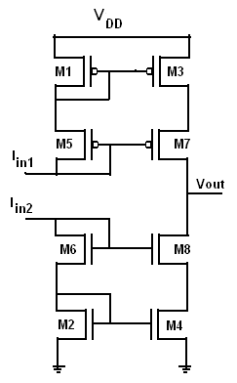
Fig. 2.2: Basic CMOS current mirror Comparator

Figure 2.2 shows the simple form of this current comparator. Transistors M2-M4-M6-M8 and M1-M3-M5- M7 form a simple current mirror pair using NMOS and PMOS respectively. The NMOS current mirror replicates the input current I_{in1} and PMOS current mirror replicates the reference current I_{in2}. The drains of M8 and M7 are connected to generate the comparator output Vout which depends on the current difference.
The circuit will provide a logical HIGH output voltage when I_{in1} is greater than I_{in2} and a logical LOW output voltage when I_{in1} is lesser than I_{in2}. To increase the amplitude of the output voltage, additional CMOS gain stages can be attached to the output to attain rail-to-rail voltage. Thus, the current mirror comparator uses high output resistance current mirrors connected as a class AB stage, to amplify small differences in input currents to large variations in output voltage. The drawback is that the frequency performance is reduced due to high output resistance and the capacitive load i.e. CMOS stages in which are added to achieve clocked rail-to-rail slewing and short transition times [10].
Building on the basic concept of current comparator given in Figure 2.2, several current comparators have been proposed [10-16], with improved frequency response and resolution. For the comparator proposed by Traff [10], shown in Figure 2.3, Idiff is the difference between the two input currents.

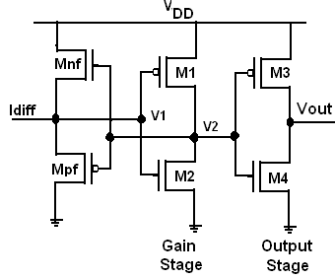

Fig. 2.3: .Basic CMOS High Speed CMOS current Comparator [10]

The input resistance of the new structure [10], shown in Figure 2.3, is approximately l/gm. The source follower input stage offers low resistance and the ability to apply feedback to the gates. Positive voltage feedback from a CMOS inverter is used to achieve sufficient gain for amplifying small voltage variations at the input stage node, which increases the gain and reduces the response time.
A CMOS inverter stage may be used to as the output stage to bring the output swing from ground to power supply voltage, as shown in Figure 2.3. The circuit works in the following manner: When Iin is positive, V1 is pulled high, and V2 will be low after V1 is amplified by the inverting amplifier (M1 and M2). Thus, Mpf is on and Mnf is off. Iin then passes through Mpf. When Iin is negative and V1 is pulled low as V2 goes high. Mnf is now on and Mpf is off. Iin will pass through Mnf. In either case, the input node of this current comparator has low impedance. As Iin changes sign, there will be a voltage range when V1 is neither high enough for Mnf to neither turn on nor low enough to turn Mpf on.
In such a case, Mnf and Mpf are both temporarily off and the input node has high impedance. This region of operation is known as the deadband and the width of the deadband is determined by the threshold voltages of Mnf and Mpf. A comparator should have low input impedance so that input current can be sensed and hence this high input impedance region should be removed.
The current comparator shown in Figure 2.4 has been proposed by [11] and uses a complicated biasing scheme to reduce the dead band.
The implementation of the biasing scheme requires large number of transistors for the four current sources. Additionally, as MB1 (NMOS) and MB2 (PMOS) in Figure 2.4 have their substrates tied to the sources (not to ground or V_{DD}), twin-tub CMOS technology will be required during manufacturing.
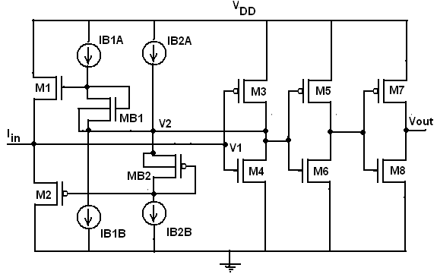
Fig. 2.4: CMOS Current Comparator [11]

The main difference between [10] and [12] is that, in [12], M4 and M5, operating in the diode configuration have been introduced, which prevent M1 and M2 from entering deep subthreshold state.
The current comparator proposed by [12] is shown in Fig 2.5. By properly dimensioning M4 and M5, M1 and M2 reach, at most, the limit of the off-state threshold (optimal operating condition). As a result, M3 and M4 promptly follow the variations in input current, thus reducing the total delay time of the comparator. This improvement in speed is achieved at the cost of reduction in the output voltage swing. This requires more output stages to ensure full rail to rail swing for the output signal. The delay time introduced by the additional inverters is negligible in all practical cases. The presence of such inverters obviously increases the power consumption, making it comparable with that of Tang's circuit.
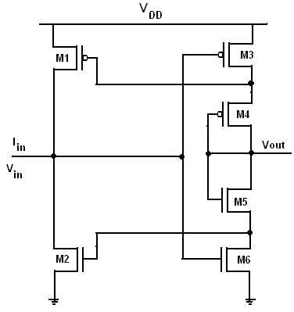
Fig. 2.5: CMOS Current Comparator proposed by [12]

Another approach to improving the performance of current comparator has been given by [13]. The corresponding current comparator is shown in Figure 2.6. It utilizes resistive feedback in order to reduce the input and the output impedances.

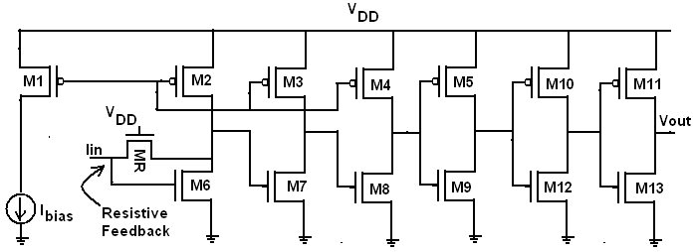

Fig. 2.6: CMOS Current Comparator with Resistive Feedback
Three inverting amplifiers are used to lower input impedance and a transistor MR to provide the resistive feedback. The circuit reports good response time, though the speed and resolution depend upon the value of the biasing current. Then, for high-resolution applications, a large biasing current is required and the power dissipation gets increased.
In the comparator shown in Figure 2.7, negative resistive feedback is used to reduce the voltage swing at node 1 and node 2 which speeds up the comparator operation.
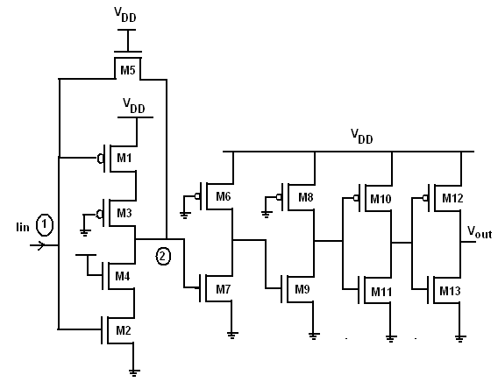
Fig. 2.7: A Robust High Speed and Low Power CMOS Current Comparator [14]

The transistor M5 working in linear region acts as the negative feedback resistor of the CMOS complementary amplifier (M1-M2). The small input and output resistances at node 1 and 2 reduce the corresponding voltage swings, which causes a reduction in the response time. To amplify the small voltage swing at node 2, two resistive-load amplifiers are used to provide additional gains. The last CMOS inverters can output a rail-to-rail compared result signal, while the introduced delay time is negligible in practice.
The principle difference between Traff [10] and the comparator given in [15] shown in Fig. 2.8, is that the new current comparator is optimized for low power consumption whilst maintaining high speed. In the Traff comparator, the feedback operation of the circuit causes the input node to vary between the threshold voltages of the PMOS and NMOS transistors N1 and P1 instead of changing from rail to rail. This leads to neither NMOS nor the PMOS being fully OFF during the operation, which in turn leads to quiescent non-zero DC power consumption. A direct path from V_{DD} to ground is prevented in this case as P2/N2 are controlled by voltage at node Vout, which ensures that only P2 or N2 are On at a time.

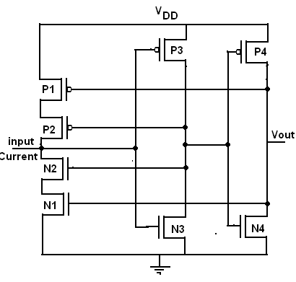
Fig. 2.8: Comparator proposed in [15]

2.4 Proposed Comparators

In this section two new CMOS current comparators are presented. The section starts with the description of Differential Current Conveyer - DCCII active block and its structure. Comparators can be developed at transistor level or by active blocks directly. The differential current conveyor structure given in [16] has been considered as our starting point.
Here, the DCCII configured as a current comparator is studied and the current differencing stage is selected for use in subsequent designs to generate the difference current. The structure of the differential current conveyor (DCCII) circuit is given in Figure 2.9.
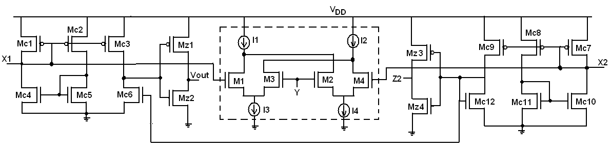
Fig. 2.9: DCCII Active Block [16]

As seen from Figure 2.9, some functionality is redundant for a current comparator, for example, the voltage transfer function from port X to port Y. The current comparator circuit given by Figure 2.10 is arrived at by removing these parts.
In this, X1 and X2 are input current terminals and the transistors Mc1-Mc12 generate the current difference. The current difference is available at the drain of Mc3-Mc6 and is converted into output voltage Vout by Mz1-Mz2.
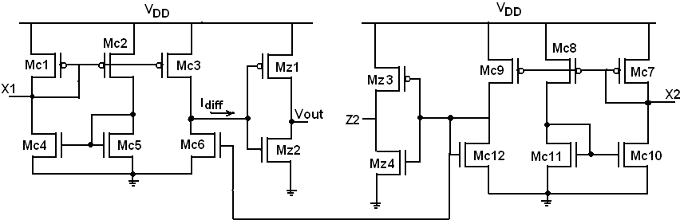
Fig. 2.10: CMOS Current Comparator from [16]

A current comparator should have low input impedance and low voltage swing at the input current difference node [1] to have high speed and high resolution. One method is to have negative feedback [14] and second method is to have non linear feedback [1] around the gain stage. In the following sections, the concept of negative feedback and nonlinear feedback is used in the design of two proposed comparators. Both the proposed comparators have different implementations in their gain and output stage but have the same current differencing stage, as in Fig. 2.11.
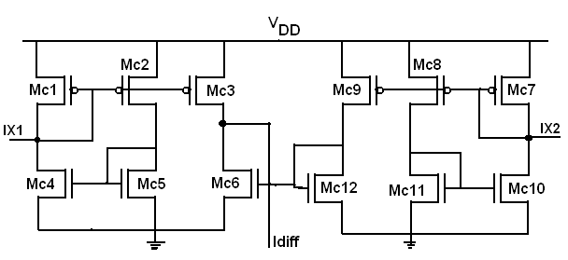
Fig. 2.11: Current Differencing stage [Ref DCC2]
Here, the current differencing stage, as in Figure 2.11, is taken from [16]. I_{X1}, input current at terminal X1 and I_{X2}, input current at terminal X2 are the two input currents and Idiff is the output difference current.

2.4.1 Proposed Comparator I
A current comparator consists of a current differencing stage, a gain stage and an output stage. The current differencing stage is as shown in Fig. 2.11.
The gain (Mr1-Mr4) and output stage (M1-M4) of the proposed current comparator is shown in Figure 2.12.
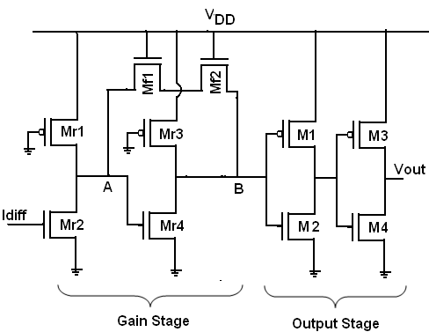
Fig. 2.12: Proposed Current Comparator I- Gain and Output stage

The gain stage consists of two cascaded resistive load amplifiers which amplify the output voltage of each stage so that the voltage swing is wide enough to switch CMOS inverters. The gain stage accepts Idiff as the input and produces corresponding voltage at node ‘B’. The output stage consists of two CMOS inverters to ensure full rail to rail swing.
As the voltage swing at each node in the gain stage increases, the time required for charging/ discharging of the node capacitances also increases. Thus, if voltage swing is reduced the time required for charging/ discharging of the node capacitances also decreases. To reduce the voltage swing at node ‘A’ and ‘B’, negative feedback in the form of resistive feedback (Mf1-Mf2) is used around nodes ‘A’ and ‘B’ which causes the impedance at node ‘A’ and node ‘B’ to reduce. This leads to overall reduction in comparators delay. The dimensions of Mf1-Mf2 were adjusted such that voltage swing at node ‘B’ is adequate for correct switching of the output stage. The operation of the current comparator, shown in Figure 2.12, is demonstrated through the results in the simulation section.

2.4.2 Proposed Comparator II
The circuit of the gain and output stage of the proposed comparator II is shown in Figure 2.13. The gain stage in the proposed comparator II consists of cascade of two resistive amplifiers (Mr1-Mr4) and the CMOS inverter (M1-M2) within the feedback loop with non linear feedback (Mpf-Mnf) around the gain stage. The output stage is a CMOS inverter (M3-M4) which ensures a full rail to rail swing.
The current difference stage in Fig 2.11 is used to generate the current difference (Idiff) which is fed to the gain stage at node ‘1’. The gain stage responds by giving appropriate output voltage at node ‘2’ which is further magnified by the output CMOS inverter stage (M3-M4).

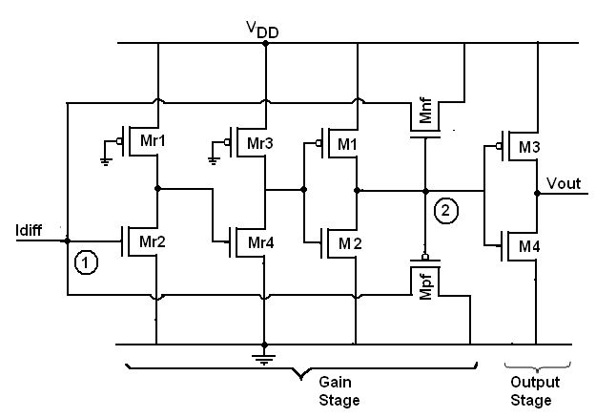

Fig. 2.13: Proposed Current Comparator II - Gain and Output stage

Depending on the voltages node ‘1’ and node ‘2’ either Mpf or Mnf is ON. If voltage at node ‘1’ is high (low), the corresponding voltage at node ‘2’ is low (high), due to the inverter like structure (Mr1-Mr4, M1-M2), which makes Mpf ON (Mnf ON). For the first case, Mpf conducts and pulls down node ‘1’. For the second case, Mnf conducts and pulls up node ‘1’. The net result of non linear feedback is that voltage swing at node ‘1’ reduces. This decreases the charging/ discharging time of the node ‘1’ parasitic capacitances and speeds up the comparator.
The dimensions of Mnf and Mpf were adjusted such that there is minimum voltage swing at node ‘1’ is and it doesn’t affect the operation of the comparator. The functionality of the proposed comparator II is verified through simulation and is shown in the following section on Simulation.

2.5 Simulation Results

In this section all the simulations presented were carried out in ORCAD PSPICE with circuit implemented using TSMC 0.18µm CMOS technology at power supply voltage of 1.8V. For proposed comparator I and II, as the current difference circuit is included, both I_{X1} and I_{X2} have to be set. For simulation purposes, I_{X2} has been set as the reference current (Iref) terminal and I_{X1} as the input current terminal. The Traff [10] comparator (Figure 2.3) was also simulated along with the current differencing stage used in proposed comparator I and II. To simulate the transient behavior of the comparators Iref is set at 1µA and Iin is varied from Iref ± 100nA to Iref ± 1µA.
In section 2.5.1, the result of transient analysis on Traff [10] for proposed comparators I and II are presented. In section 2.5.2, characteristics of the comparators like delay, power dissipation and the power delay product are plotted and compared. Lastly, the proposed comparators were simulated under lower power supply voltages to study their behavior.

2.5.1 Transient Analysis
The input and output for the comparators Traff [10], I and II are shown in Figure 2.14 (a), (b) and (c). The input-outputs are plotted for Iref at 1µA and Iin=Iref ± ∆I, where ∆I=500nA and the output is denoted by Vout.

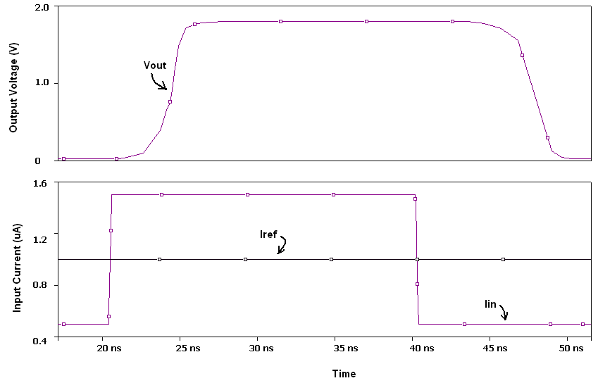
Fig. 2.14 (a) : Input-Output for Traff [10] Comparator

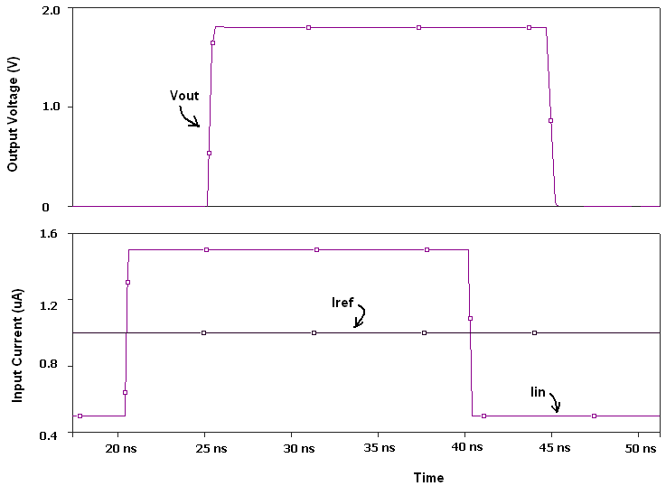
Fig. 2.14 (b): Input-Output for Proposed Comparator I
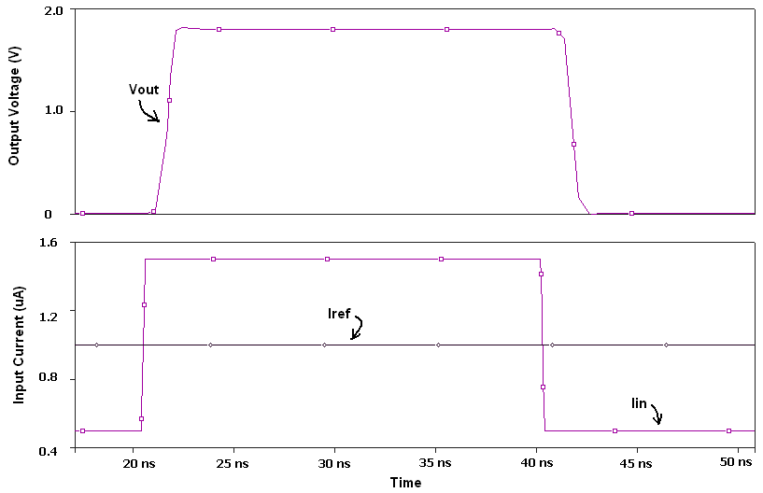
Fig. 2.14 (c): Input-Output for Proposed Comparator II

From Figure 2.14, it is seen that Traff comparator is the slowest while proposed comparator II is the fastest.

Transient analysis was carried out on Traff [10], proposed comparator I and II with Iref at 1µA and Iin=Iref ± ∆I, where ∆I=100nA to 1000nA. The delay was calculated for each Iin and is plotted in Figure 2.15 (a). From simulation results it was found that the resolution of the proposed comparator I is ±50nA, proposed comparator II is ±10nA while resolution of Traff [10] comparator is ±100nA.

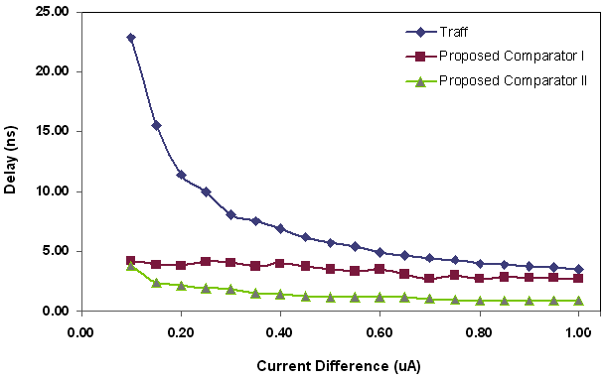

Fig. 2.15 (a) : Delay versus Current Difference

The total power dissipated by the circuit for each Iin was also noted from PSPICE output file. The power dissipation remains almost constant, @ ≈0.52mW for Traff [10] comparator, @≈0.45mW for proposed comparator I and @≈0.646mW for proposed comparator II. The corresponding PDP is plotted in Figure 2.15 (b).

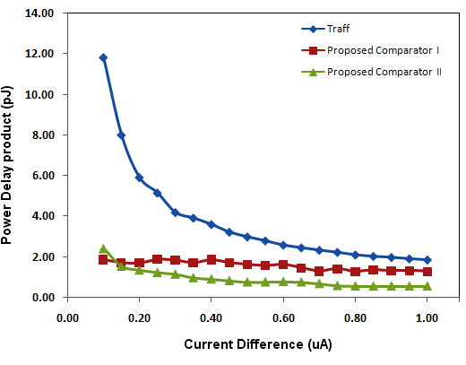
Fig. 2.15 (b) : PDP versus Current Difference

To study the delay under lower power supply voltages, the proposed comparators I and II were simulated under different supply voltages of 1,1.2V,1.4V,1.6V and 1.8V and input currents of Iin=Iref ± ∆I, where ∆I=100nA to 1000nA. The following Figures 2.16 (a) and (b) show the variation in delay as 3-D plot for proposed comparators I and II respectively.

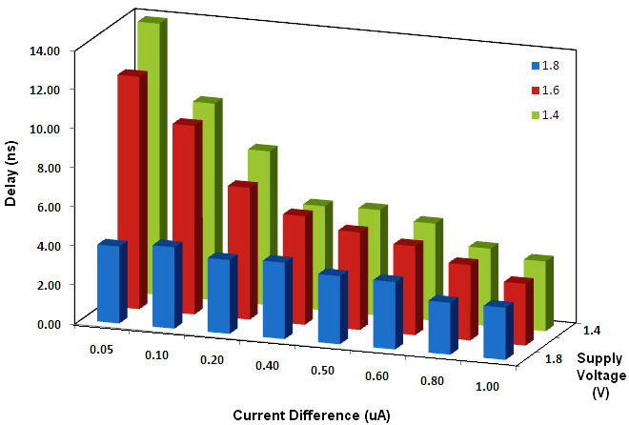
Fig. 2.16 (a) : Delay with respect to current difference and power supply for proposed comparator I
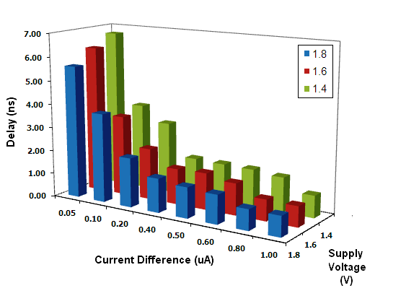
Fig. 2.16 (b) : Delay with respect to current difference and power supply for proposed comparator II.
Chapter 3

Current Mirrors

3.1 Introduction

In this chapter, current mirror circuits are discussed as they are an important part of Analog to Digital converters, which will be presented in Chapter6 as a design example.
Current mirrors are one of the basic building blocks of current mode circuits and their functionality is to copy the input current. The current mirror may also be defined as circuit that sources or sinks a constant current. Ideally, a current mirror is designed to give high output impedance and to mirror current accurately for widest possible range of output voltages. Current mirrors range from very simple two transistor circuit to complex structures [17] which offer better characteristics. Current mirrors have their uses mainly in biasing of the circuits, in amplifiers, comparators, regulated current sources etc.
The block diagram of a basic current mirror is shown in Fig. 3.1. Iin is the input current which is to be mirrored and Iout is the output current. The voltage Vout at the output node is a important parameter.
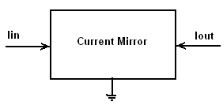
Fig. 3.1 : Block Diagram of Current Mirror

An ideal current mirror should have the following properties:
- Very high output resistance and low input resistance
- The range of output voltages at which it will work should be as large as possible.
Here, the section starts with a discussion of the simple current mirror and then move to cascode current mirror and then to the regulated drain current mirror in succeeding section 3.2. Each circuit is simulated and the results are presented and in the end, a comparison of their results is done in Section 3.3. Because of its better performance, regulated drain cascode current mirror is selected for use in the ADC.

3.2 Current Mirror Circuits

In this section, various current mirror circuits are discussed starting with the simple current mirror.

3.2.1 Simple Current Mirror

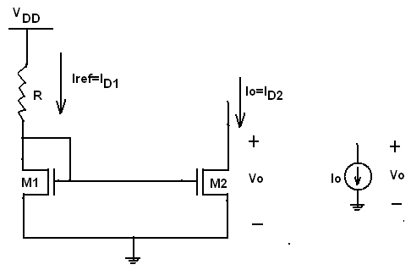

Fig. 3.2: Simple Current Mirror [18]

Figure 3.2 shows a simple current mirror. It consists of a MOS M1 which is diode connected thus ensuring that it is always in saturation. The gates of MOS M1-M2 are connected together to keep their gate potentials the same. As both the sources are grounded, V_{gs1}=V_{gs2} and (assuming that M1 and M2 have the same dimensions) Io= Iref (neglecting channel length modulation effect). In the above figure, the drain current of M1, ID1 is the reference current and the drain current of M2 is the mirrored current. The range of output voltages where the current source behaves as a current source is between V_{DSsat} and V_{DD}. For a simple current mirror, V_{DSsat}= V_{GS2}-V_{THN}.
The drawbacks of the simple current mirror are that:
- The output resistance = ro (in the kΩ)
- Because of channel length modulation effect, the current is not mirrored accurately.
To improve the current mirroring, the cascode current mirror is next studied.

3.2.2 Cascode Current Mirror

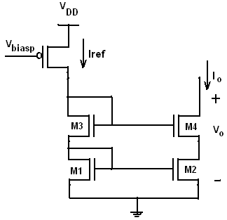
Fig. 3.3 : Cascode Current Mirror [18]
In the cascode current mirror shown in Figure 3.3, the output current Io is determined by the gate-source voltages of M1 and M2 while the sizes of M3-M4 only changes the drain voltage. To make current mirroring more ideal, the drain-source voltages of M1-M2 should be the more constant so that the output resistance of the current mirror increases. The same current mirroring operation as in simple current mirror exists here, while the output resistance increases to g_{m}r_{o}². The minimum voltage at the output required to maintain both M2 –M4 in saturation increases in this case to 2V_{DSsat+}V_{THN}.
3.2.3 Regulated Cascode Current Mirror

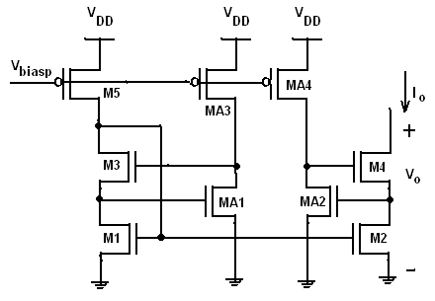

Fig. 3.4 : Regulated Cascode Current Mirror [20]
In Regulated Cascode Current Mirror, the main idea is that the drain potential of M2 should be maintained constant so that the drain current of M2 is fixed, which means that output resistance of the current mirror will be infinite. To implement this, feedback is incorporated in this circuit, consisting of MA1-MA2. As an example, let us take the case where drain potential of M2 decreases. Then, MA2 starts shutting off resulting in increase in gate voltage of M4, which pulls up the drain potential of M2. Thus, the drain potential of M2 is stabilized. MA1 is used so that the drain potentials of M1 and M2 are the same.
3.3 Simulation results

In this section all the simulations were carried out in ORCAD PSPICE with circuit implementation using TSMC 0.18µm CMOS technology. The current mirror circuits all have three output mirrors.

3.3.1 DC Analysis

In this sub section, the three current mirrors are subjected to DC analysis and the results are presented. In the simulations, the mirrored current (I_{out1}, I_{out2}, I_{out3}) and the input current (I_{in}) are plotted for the range of input current 0-5µA and the error between them is calculated. Secondly, the range of output voltages for which the current mirror behaves ideally is also shown through simulations.
Figure 3.5 shows the matching between the input (I_{in}) and the output current (I_{out1}, I_{out2}, I_{out3}) for the range 0-5µA for (a) Simple current mirror, (b) Cascode current mirror and (c) Regulated Cascode Current Mirror respectively. In Figure 3.6, the variation in the mirrored currents with respect to the variation in input current and the output voltage change is plotted for (a) Simple current mirror, (b) Cascode current mirror and (c) Regulated Cascode Current Mirror. This aids us in finding the V_{CM,min} at the output.
From Figures 3.5 (a), (b) and (c), the mismatch between the input current and the mirrored current is calculated. Using the expression
Percentage error = $\frac{I_{\text{in}}−I_{\text{out}}}{I_{\text{in}}}X\text{100}$ ;
The error was found to be between 23% and 33% for simple current mirror, between 0.1% and 0.3% for cascode current mirror, between 0.166% and 0.028% for regulated cascode current mirror.
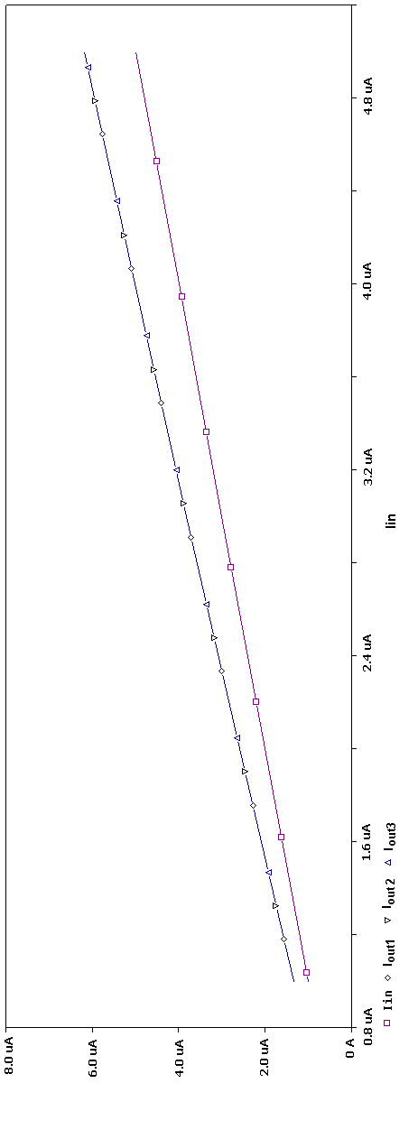

Fig. 3.5 (a) : Output Current versus Input Current for Simple current mirror
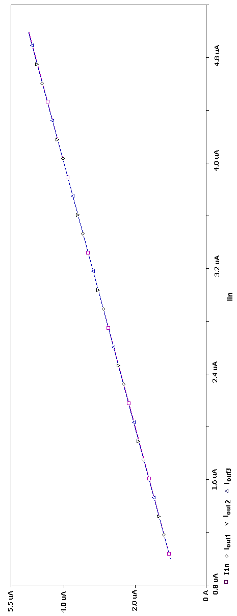

Fig. 3.5 (b) : Output Current versus Input Current for Cascode current mirror
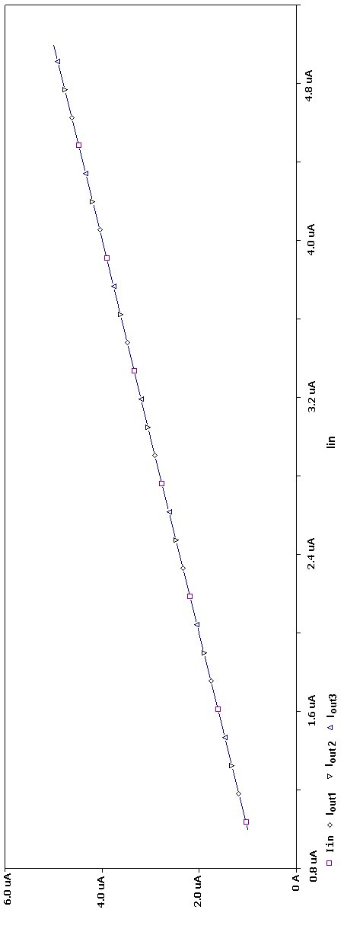

Fig. 3.5 (c) : Output Current versus Input Current for Regulated Cascode current mirror
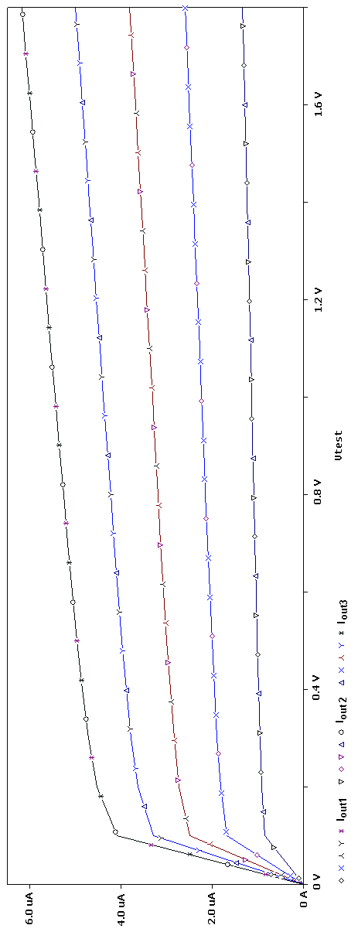

Fig. 3.6 (a) : Output versus Input Current with variation in Vout for Simple current mirror.
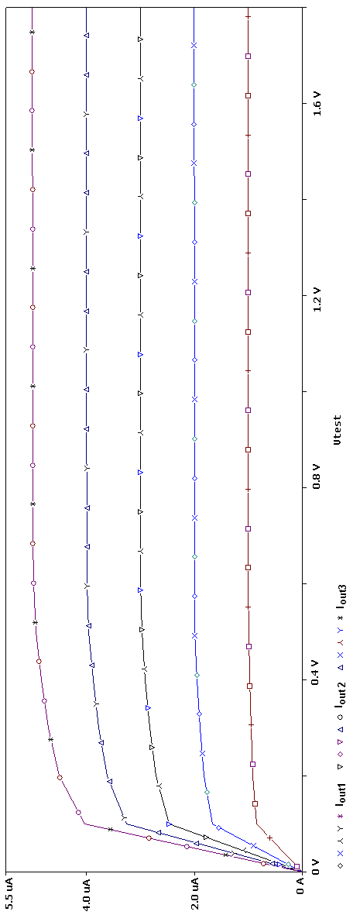

Fig. 3.6 (b) : Output versus Input Current with variation in Vout for Cascode current mirror.

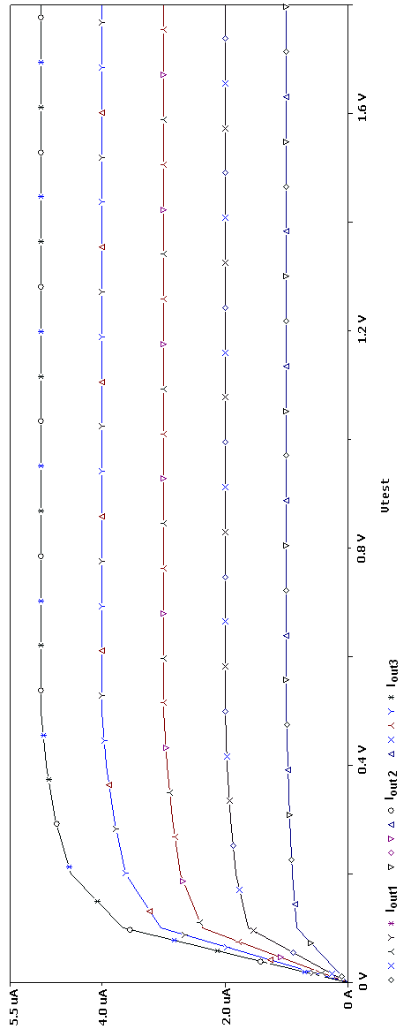

Fig. 3.6 (c): Output versus Input Current with variation in Vout for Regulated Cascode current mirror.
3.3.2 Transient Response
In this section, the response speed and the power dissipation of the current mirrors is calculated through transient analysis as in this case the parasitic capacitances and resistances in the circuit come into play. Here, an input current pulse was given to the three current mirrors and from the resulting output pulse the delay was measured. The current mirror is used for mirroring the input current in the ADC for the range 0-4µA. As the delay is the longest at lowest currents, to calculate the worst delay, an input current pulse of 1µA to 1.5µA was given, which is the lowest current in the input current range. The response time was calculated as the time delay between the moment when the input current begins to change and the moment when the corresponding output current reaches its steady value. The associated power dissipation was measured from ORCAD PSPICE output file. The result of the transient analysis is shown in Figure 3.7 (a), (b) and (c). The delays are listed in Table 3.1 and the corresponding power dissipation in Table 3.2. From Table 3.2, it is seen that the Power D(P_{DISS}) is highest for regulated cascode CM as it uses internal biasing currents but it has the highest accuracy among the other CMs discussed in the chapter.
Table 3.1 : Delay at 1µA

 | Simple Current Mirror | Cascode Current Mirror | Regulated Cascode Current Mirror
Delay (ns) | 7.8 | 8.5 | 17.5

Table 3.2 : Power Dissipation (P_{DISS}) at 1µA

 | Simple Current Mirror | Cascode Current Mirror | Regulated Cascode Current Mirror
PDISS (µW) | 9.04 | 7.22 | 14.4
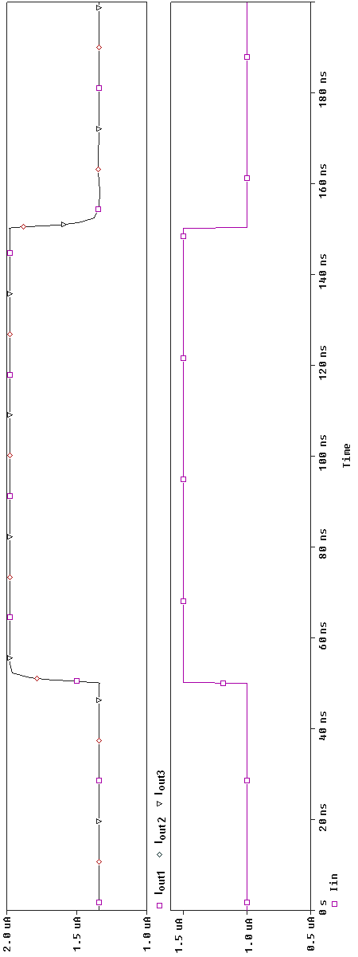

Fig. 3.7 (a): Output versus Input Current Pulse under Transient Analysis for Simple current mirror.
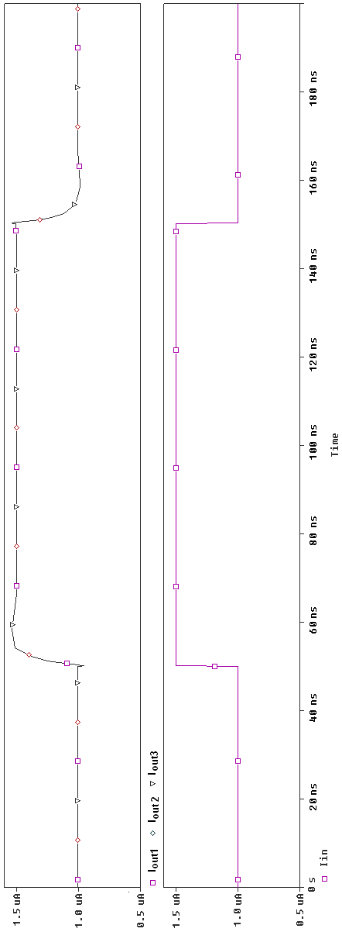

Fig. 3.7 (b) : Output versus Input Current under Transient Analysis for Cascode Current Mirror.
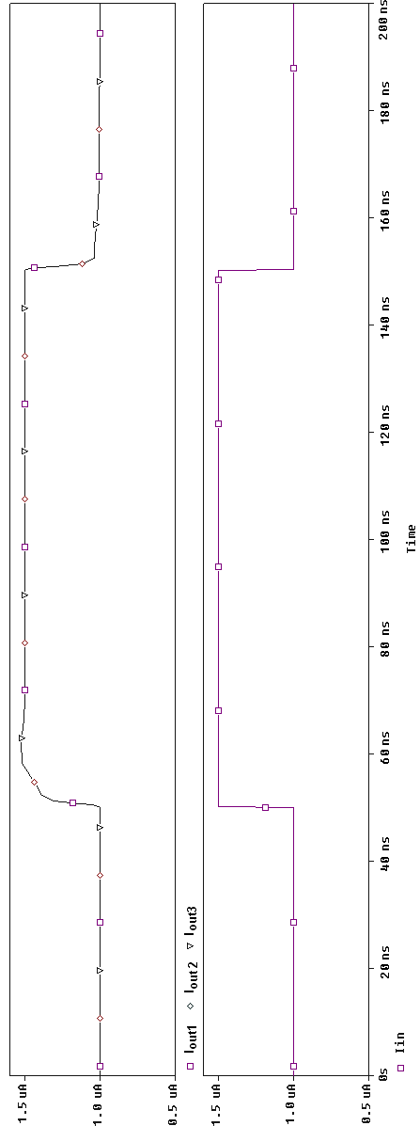
Fig.3.7 (c) : Output versus Input Current under Transient Analysis for Regulated Cascode Current Mirror.
Chapter 4

Encoder

4.1 Introduction

In this chapter, encoder circuits are discussed as they are a part of analog to digital converter, required for conversion of output from thermometer code to binary code. The encoder circuit is designed for 4bit ADC to produce a 2 2-bit binary output.
An encoder is a circuit that converts information from one format or code to another. This is done due to requirement of standardization, security, speed or compression. The encoder can be realized in various ways. Here, a multiplexer based realization for the circuit is selected, with two transistors multiplexer, because of its low power dissipation and high speed characteristic. [21]

4.2 Encoder Circuit

The encoder circuit here works as a code converter converting thermometer code to its binary equivalent. The encoder circuit accepts seven inputs (C1-C3) and it outputs the 2 bit binary code (O₁ - O₂). The structure of the encoder circuit is shown in Fig. 4.1. The truth table of the encoder is shown in Table 4.1, as given below.

Table 4.1 Encoder Truth table

Comparator Outputs |  |  | Encoder Outputs
C3 | C2 | C1 | B3,B1 | B2
0 | 0 | 0 | 0 | 0
0 | 0 | 1 | 0 | 1
0 | 1 | 1 | 1 | 0
1 | 1 | 1 | 1 | 1

The circuit is implemented using 2:1 multiplexer connected as a tree. Each level of the tree divides the input thermometer scale into two and calculates one of the bits of the binary output. The second highest bit is found in the same way, but only considering a part of the whole thermometer code i.e lower part if middle bit is zero and upper part if middle bit is one.

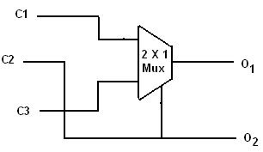

Fig. 4.1: 2:1 Multiplexer based encoder

The 2:1 Multiplexer shown in Figure 4.1 is implemented using pass transistor logic style and it requires two transistors per multiplexer. The internal structure of the 2:1 Mux is shown in Figure 4.2.

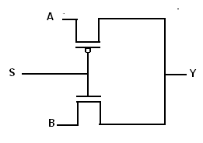
Fig. 4.2 : Pass Transistor logic based 2:1 Multiplexer

A multiplexer is a circuit that accepts multiple data inputs and transfers one of the inputs to the output depending on the value of the control inputs. In equation form it is represented as:
$$F=\overline{S}A+\text{SB}$$

In the above figure, ‘S’ is the control input, ‘A’ and ‘B’ are the data inputs and ‘Y’ is the output. For ‘S’ equal to 0, output Y= ‘A’ and for ‘S’ equal to 1 output Y= ‘B’.

4.3 Simulation Results

In this section, the result of the transient analysis of the encoder is presented. The encoder was implemented in TSMC 0.18µm CMOS technology in PSPICE. The input thermometer code was simulated by driving C1, C2 and C3 and the resulting binary code was observed at B0 (LSB) and B1 (MSB). The following figure, Fig. 4.3 represents the result of transient analysis.

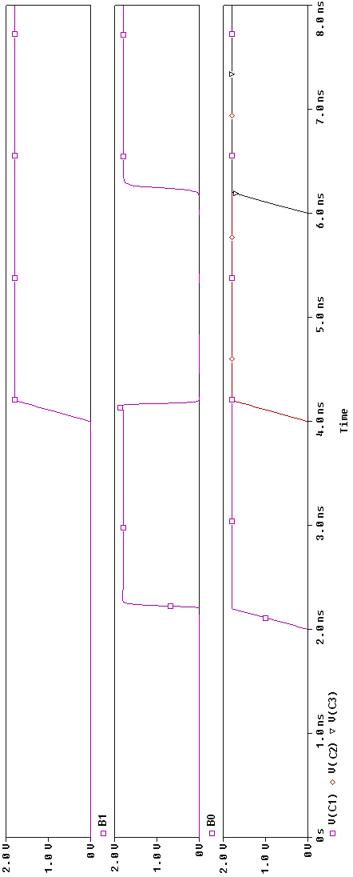

Fig. 4.3 : Transient analysis of the Encoder
Chapter 5

Digital to Analog Converter

5.1 Introduction

In this chapter a Digital to Analog converter (DAC) and its design is discussed, as it’s a part of the area speed efficient analog to digital converter [22] which is presented in Chapter 6. A DAC or D-to-A is a device that converts digital codes to an analog signal. There are many categories of DACs, for example sigma delta DAC, pulse width modulator DAC, interpolating and high speed DAC etc.
In Section 5.2, DAC Terminology and Basic Operation is introduced. In section 5.3, types of DAC are discussed, including the current steering DAC which will be used in the ADC. Section 5.4 is devoted to performance parameters of the DAC. Section 5.5 and 5.6 are devoted respectively to the DAC circuit and its operation and to simulation results.

  - DAC Terminology and Basic Operation

Fig. 5.1 shows the basic block diagram, functionality and common terminology used with time domain output. In the Figure, the 6-bit DAC accepts a digital input at time instants set by the sampling frequency, Fs. The DAC then generates an equivalent analog output voltage, which is held till the next sample. Thus, the output is the staircase approximation of the actual analog input.
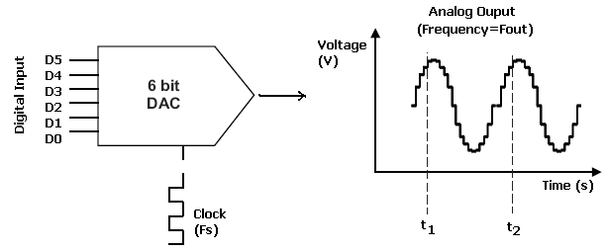
Fig. 5.1 : DAC Input-Output

5.3 Types of DAC

- PWM DAC: The generation of an analog voltage using a digital Pulse-Width-Modulated signal is known as a PWM DAC. PWM DACs are widely used in very low-cost applications, where accuracy is not a primary concern. For example in MCU applications, where PWM unit is already available and with the addition of few analog components, analog output voltage is generated which can used for actuating motors etc. Figure 5.2 shows a basic configuration of the PWM DAC. A PWM unit outputs the signal to an RC low pass-filter. The PWM pulse train’s digital value becomes an analog voltage, when it passes through the RC filter. At a given period of time, the analog output is proportional to the PWM pulse’s high durations.
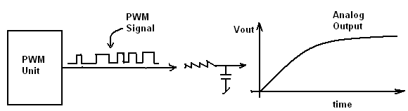
Fig. 5.2 : PWM DAC

- Sigma Delta DAC: The name Delta-Sigma comes directly from the presence of a Delta modulator and an integrator, as firstly introduced by Inose et al. in their patent application. That is, the name comes from integrating or "summing" differences, which are operations usually associated with Greek letters Sigma and Delta respectively. Both names Sigma-Delta and Delta-Sigma are frequently used. They use the Oversampling technique which allows for use of lower resolution DAC internally. Most high resolution DACs (greater than 16 bits) are of this type, due to its high linearity and low cost.
- Interpolating and High Speed DAC: Here, the basic concept is to provide a slower data rate to the DAC inputs and oversample the data inside the interpolating DAC. The advantage is that the low pass filter used, has to filter out the images, and doesn’t have strict requirements for a brick wall like response in this case. When compared to a standard DAC the trade-offs are increased cost, a slightly larger package footprint, and possibly a more complicated clock scheme.
- Current Steering: This type of DAC works with current signal directly [23]. The binary input signal controls whether the current i_{out} sources or not. The current i_{out} lies between the limits:
0 ≤ i_{out} ≤ (2^{N}-1).I, where I is the unit current source.
As compared to the (2^{N}-1) current sources required in the previous architecture, if current sources are binary weighted, then only N current sources are required. The current steering DAC with binary weighted current sources is shown in Fig. 5.3. Depending on the input binary word, the respective currents get added and are available as i_{out}.
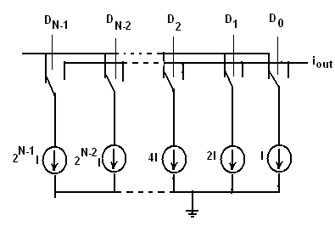
Fig. 5.3 : Current Steering DAC using Binary weighted current sources

5.4 Performance Parameters

The DAC is characterized in both time domain and frequency domain [23]. In frequency domain, the parameters are:
- SNR: Is the ratio of signal power to noise power at analog output. Higher the SNR the better is the performance f the DAC.
- SFDR: Is the ratio of the rms value of the signal to the rms value of the worst spurious signal regardless of where it falls within the frequency spectrum.
- SNDR: Is the ratio of signal power to (noise + distortion) power. This gives us an accurate idea of the functioning of the DAC at different frequencies. It is also used to calculate the effective number of bits (ENOB).
In time domain, the DAC is characterized by:
- Resolution: It is measured in number of bits. It is derived from given step size and the reference voltage.
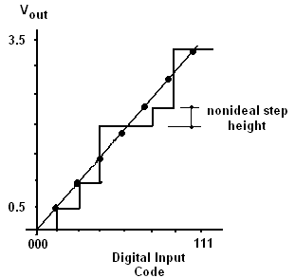
- DNL: Differential Non Linearity :
DNL _{n}= Actual height of the code transition for n^{th} step -Ideal step height
In the output of ideal DAC, the voltage output increments should be the same. Non ideality of DAC causes the analog increments to be different from the ideal values. The difference between them is called differential non linearity or DNL.
Fig. 5.4: Example of DNL
- INL: This parameter defines the linearity of the overall transfer curve. It is measured as the difference between output value for code n and the value of the reference line at that point. The reference line is the line drawn between the endpoints.
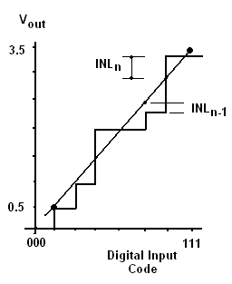
Fig. 5.5 : Example of INL

- Offset: It is defined as the shift in the DAC transfer curve.
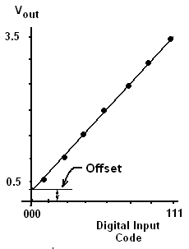
Fig. 5.6 : Illustration of Offset Error
- Gain Error: It is the difference between the slope of the line through the end points of the DAC transfer curve and the slope of the ideal line.

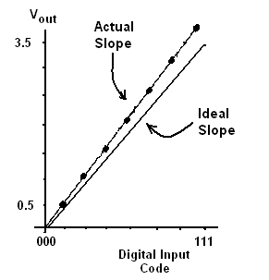
Fig. 5.7 : Illustration of Gain Error

- Latency: It is the total time elapsed between the change in input digital word and the appearance of the corresponding output value.
- Dynamic Range: Dynamic range is the ratio of the largest output signal to the smallest output signal. In dB, the dynamic range is defined as DR= 20log (2^{N}-1).

5.5 DAC Circuit

As area speed efficient current mode ADC [22] is to be implemented, a DAC circuit is required that can work directly with currents and so, Current Steering DAC architecture with binary weighted current sources has been selected. It converts into equivalent analog signal the output of the encoder which is used by the second stage of the ADC [22] to generate the lower bits. The DAC circuit used in present design is shown in the following Figure 5.8.

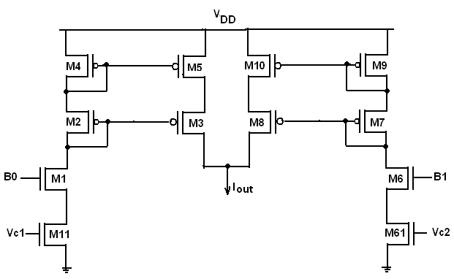
Fig. 5.8 : DAC circuit

In the above circuit, M2 - M5 and M7 - M10 act as a PMOS cascode current mirror. Their job is to mirror the current flowing through M1 - M11 (M6-M61) into the output node. The current outputs of M3 and M8 are summed at node Iout, which is the DAC output current.
In the DAC circuit, the dimensions of the MOS transistors were adjusted so that the required current level at the output was achieved with respect to the digital input combination. The following table, Table 5.1 shows the digital inputs and the corresponding output current levels.

Table 5.1 : Digital Inputs & Corresponding Output Currents

B1(V) | B0(V) | Output Current (µA)
0 | 0 | 0
0 | 1 | 1
1 | 0 | 2
1 | 1 | 3

5.6 DAC Simulation Results

The DAC circuit shown in Fig. 5.8 was implemented in TSMC 0.18um CMOS technology in Orcad PSPICE under power supply of 1.8V. To verify the correctness of the circuit, transient analysis was performed, where all the input voltage combinations were tried out and the corresponding output current of the DAC was recorded. The result of the transient analysis is shown in Figure 5.7. Here, B1 and B0 are the two output bits of the first stage encoder and Iout is the DAC output current.

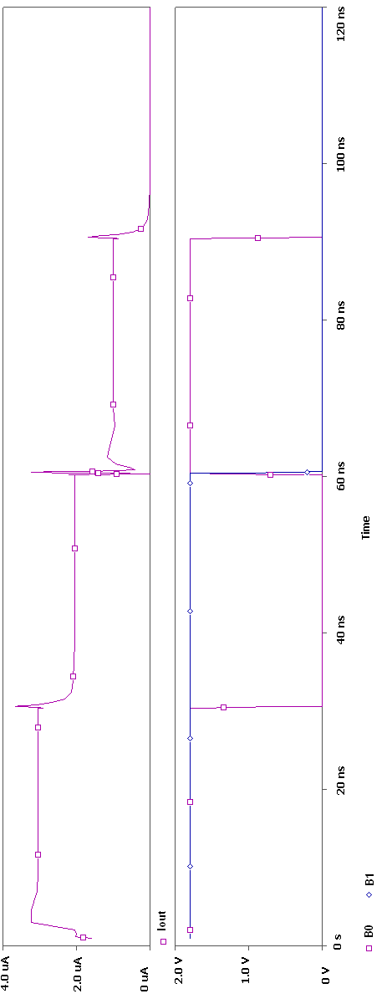

Figure 5.7 : Transient Simulation result showing Iout for different B1-B0 combinations
Chapter 6

Analog to Digital Converter

6.1 Introduction

In this chapter the design of current mode two step flash ADC which uses proposed current comparator II is presented. The ADC is designed to show the applicability of the proposed comparators in practical setting. An ADC is a circuit that accepts continuous, infinite valued signal as the input, samples and quantizes it to output a digital signal. The ADC is designed and the various static parameters like, INL/DNL, offset, gain error and dynamic characteristics like SNR, ENOB, SFDR in the frequency domain are calculated.
A current mode ADC has the following functional blocks:
- Current comparators
- Current mirrors
- DAC
- Encoder
The design and implementation of all the four components is presented in the previous chapters. In this chapter, they are integrated into single circuit and the properties of the ADC are calculated.
In section 6.2, different types of ADCs are discussed, their structure and the advantages, finishing with area speed efficient ADC. In section 6.3, a description of the parameters of the ADC is presented. Lastly, in Section 6.4, the simulation results are presented.

6.2 ADC Architectures

The majority of ADC fall into four major categories, namely-flash type, pipeline, successive approximation and oversampled ADCs [23]. Each type of ADC has particular characteristics which are discussed in brief as below [23].
- Flash ADC :
Flash or parallel converters have the highest speed of any type of ADC. They use one comparator per quantization level and the 2^{N} reference voltages is generated and fed to each comparator. The input signal is compared to the reference level and the output of each comparator is a binary 1 or 0.
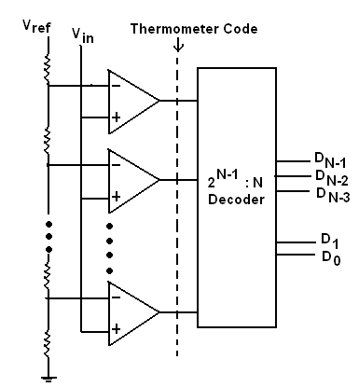

Fig. 6.1: Flash ADC architecture
The output of all the comparators together forms a thermometer code which is converted into binary code using a code converter circuit. The block diagram of a flash converter is shown in Figure 6.1. The main advantage of Flash ADC is that the conversion speed at which output is available is same as the clock speed. The disadvantage is that the number of comparators required for the simultaneous comparison is equal to 2 ^{N}-1, where N is the resolution of the ADC which leads to larger footprint of the device and higher power consumption.
The two step flash ADC is a variation of the flash ADC architecture which reduces the number of comparators required for a n-bit ADC from 2 ^{N}-1 to 2(2 ^{N/2}-1). In the first stage the input is sampled and the most significant bits (MSBs) are generated. This is called the coarse conversion process. The bits generated in the first stage are converted into equivalent analog voltage by the DAC and it is subtracted from the original input. The result of the subtraction is multiplied by 2^{N/2} and input into the second ADC. The second ADC performs the fine conversion process i.e generates the lower significant bits (LSBs).
- Pipeline ADC:
The pipeline ADC is a N stage converter, with one bit being converted per stage. The N-stages are connected in series and each stage consists of a 1-bit ADC (a comparator), a sample and hold, a summer and a gain stage with gain set to two. The architecture of a pipeline ADC is shown in Figure 6.2.
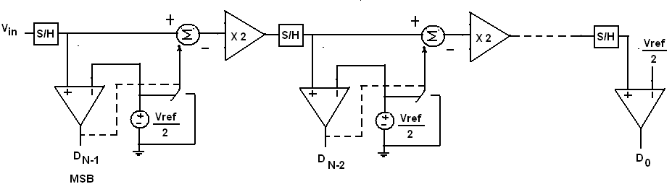
Fig. 6.2 : Pipeline ADC architecture
In each stage, the input signal is sampled and compared to Vref/2. If the comparator output equal to one, then Vref/2 is subtracted from the input and result is passed to the amplifier. If the comparator output is zero the input signal is passed as it is to the amplifier. The amplifier multiplies the difference by two and passes the result to sample and hold of the next stage. The pipelined converter has high throughput with a latency of N clock cycles.

- Integrating ADC: This type of ADC performs the conversion by integrating the input signal and correlating the integration time with a digital counter. These type of converters have high resolution but slow speed. They are of two types: Single slope and dual slope. Their architecture is shown in Figures 6.3 (a) and 6.3 (b).

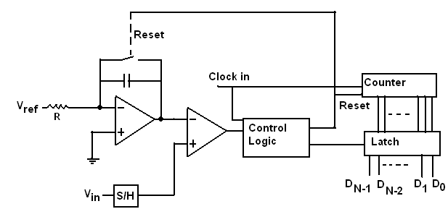
Fig. 6.3 (a) : Single Slope ADC

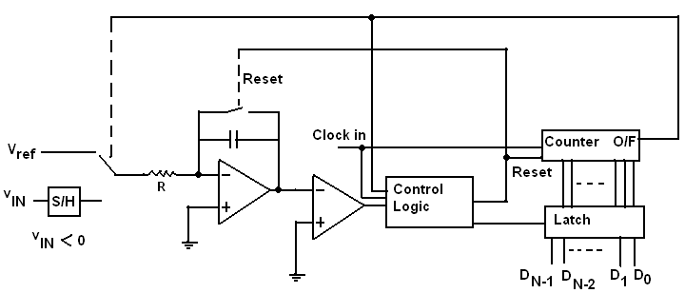
Fig. 6.3(b) : Dual Slope ADC

- Successive Approximation ADC: The block diagram of a successive approximation ADC is shown in Figure 6.4. SAR works by dividing the input range to half and finding if the input signal lies in the higher or the lower range and setting the MSB accordingly and this process is continued till all the bits are set. The comparator controls the direction of the binary search and the output of the SAR is the actual binary output. With each bit decided, the search space decreases by one-half until the correct answer is reached.
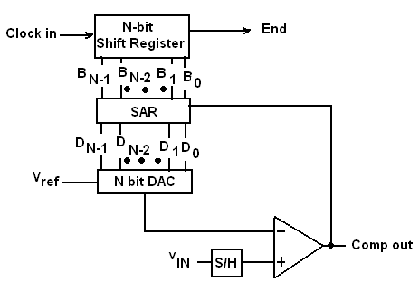
Fig. 6.4 : Successive Approximation ADC
- Oversampling ADC: It is shown in Figure 6.5(a). In this implementation, the input signal is sampled at a rate much greater than Nyquist sampling rate and hence aliasing is not a problem. The output of the ∑∆ or ∆∑ modulator is a pulse density modulated signal that represents the average of the input signal. The block diagram of a ∑∆ or ∆∑ modulator is shown in Figure 6.5 (b).

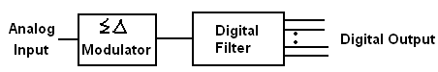
Fig. 6.5(a) : Oversampling ADC
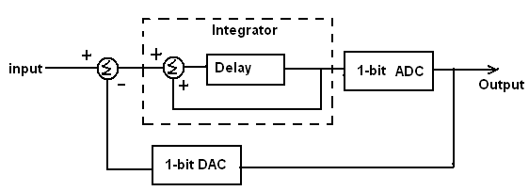
Fig. 6.5(b) : First Order Sigma Delta modulator

A area speed efficient method for current mode ADC [22] is based on two step flash ADC. This architecture for current mode which offers high speed and low component count and therefore, is selected for implementation.

    - An Area-Speed Efficient Method
for Current Mode ADC

In this section, a 4-bit current mode ADC based on the method described in [22] for converting analog information to digital in current mode is discussed. This ADC type is implemented in the thesis and simulated. The block diagram of 4-bit ADCM is shown in Figure 6.6. In the figure, I_{in} is the input current, I_{refi} are the input reference currents to the respective comparators, the DAC block generates the analog equivalent of the first stage digital outputs (B3 and B2), I_{consti} are the constant currents used to generate the reference currents for the second stage and B₃ B₂ B₀ B₁ are the four output bits. The encoder blocks (Encoder 1 and Encoder 2) shown in Figure 6.6 are used to convert thermometer code into binary form (B₃ B₂ B₀ B₁). Its circuit representation is shown in Chapter 4.
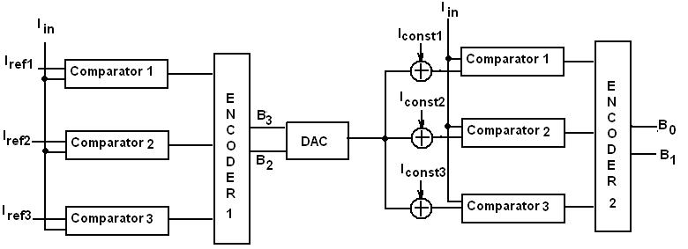
Fig. 6.6 : Area Speed Efficient ADC [22]
In this method, the analog to digital conversion takes place in a two stage process, with each stage having three comparators and generating two bits.
In the first stage the current comparators perform the coarse conversion with the reference current to each comparator shown in Table 6.1. The reference currents for the next stage are generated as sum of the output current of the first stage generated by the DAC and the constant currents set according to the rule in Table 6.1, second half. To generate the output current of the first stage a 2 bit DAC is used.

Table 6.1 Reference Currents for the First Stage
I_{ref1} | I_{ref2} | I_{ref3}
Step size* 2² | Step size* 2³ | Step size* (2²+2³)
I_{const1} | I_{const2} | I_{const3}
Step size* 2⁰ | Step size* 2¹ | Step size* (2⁰+2¹)

The step size is defined as Input range / 2^{N}, where N is the resolution.

  - Parameters of an ADC

The ADC is characterized in both time domain and frequency domain [23]. In frequency domain the parameters are:
- SNR: Is the ratio of signal power to noise power at analog output. Higher the SNR the better is the performance of the ADC.
- SFDR: Is the ratio of the rms value of the signal to the rms value of the worst spurious signal regardless of where it falls within the frequency spectrum.
- SNDR: Is the ratio of signal power to (noise + distortion) power. This gives us an accurate idea of the functioning of the ADC at different frequencies. It is also used to calculate the effective number of bits (ENOB).

In the time domain, the ADC is characterized by:
- Resolution: It is measured in number of bits. It is derived from given step size and the reference voltage.
- DNL: In the output of ideal ADC, the voltage intput increments should be the same. Non ideality of ADC causes the analog increments to be different from the ideal values. An example of DNL is shown in Fig. 6.7. The difference between them is called differential non linearity or DNL. It is given by:
DNL _{n}= Actual width of the code transition at n^{th} step-Ideal step width
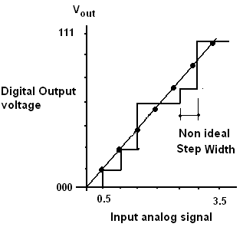
Fig. 6.7 Example of DNL

- INL: This parameter defines the linearity of the overall transfer curve. It is measured as the difference between output value for code n and the value of the reference line at that point. The reference line is the line drawn between the endpoints.
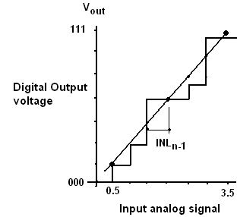
Fig. 6.8 Example of INL

- Offset: It is defined as the shift in the ADC transfer curve.
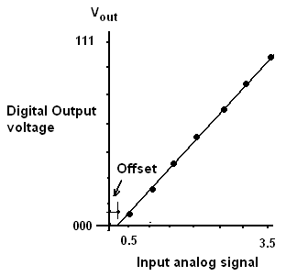
Figure 6.9 Illustration of Offset Error

- Gain Error: It is the difference between the slope of the line through the end points of the ADC transfer curve and the slope of the ideal line.
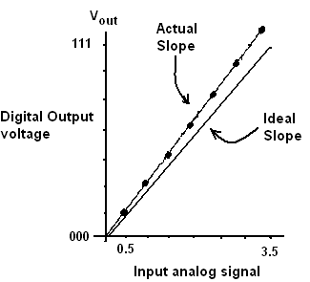
Figure 6.10 Illustration of Gain Error

- Latency: It is the total time elapsed between the change in input digital word and the appearance of the corresponding output value.
- Dynamic Range: Dynamic range is the ratio of the largest output signal over the smallest output signal. In dB, the dynamic range is defined as :
DR= 20log (2^{N}-1)

6.4 Simulation Results

The ADC circuit shown in Figure 6.6 was implemented in TSMC 0.18um CMOS technology in Orcad PSPICE under power supply of 1.8V. The 4-bit ADC was designed to function in the range of 0-4uA and thus had a step size of 0.25uA. According to Table 6.1, the reference currents I_{ref1}, I_{ref2} and I_{ref3} were set as 1µA, 2µA and 3µA respectively. The constant currents I_{const1}, I_{const2}, I_{const3} required in the second stage were respectively set to 0.25 µA, 0.5 µA and 0.75 µA.

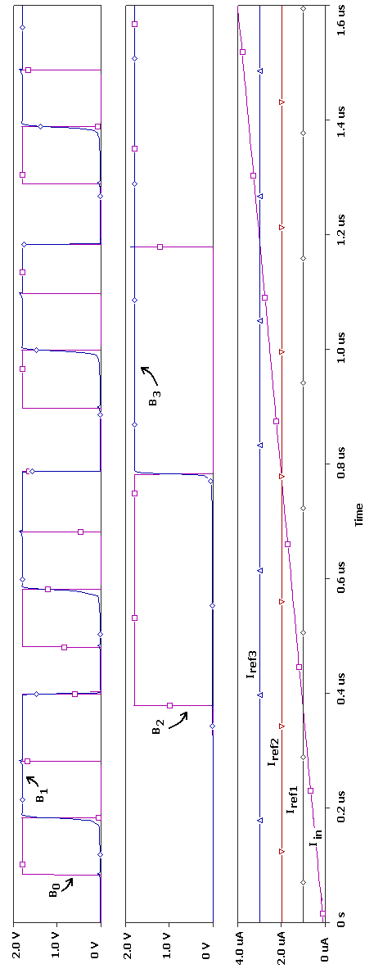
Fig. 6.11: Transient Analysis Result of the ADC
To verify the correctness of the circuit, transient analysis was performed, where all the input current values were tried out by applying an input ramp varying between 0-4µA and the corresponding 4-bit digital outputs were observed. The result of the transient analysis is shown in Figure 6.11.
From the simulation results, the actual code transition points were noted. These points were used to build the actual ADC transfer characteristic, shown in Figure 6.12.
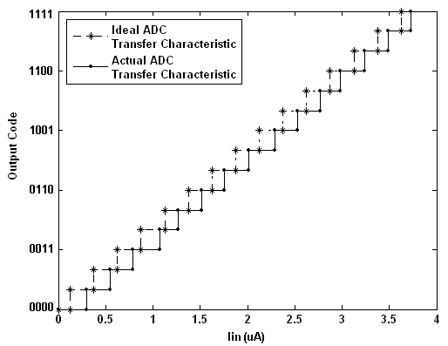
Fig. 6.12: ADC Transfer Characteristic
The offset, gain error and INL/DNL were calculated from ADC transfer characteristic using MATLAB. Using the definition of these characteristics, given in Section 6.3, the offset was found to be 0.18, gain error equal to 0.987, DNL as 0.208LSB and INL as 0.1389LSB. The DNL/INL are respectively shown in Figure 6.13 (a) and (b).

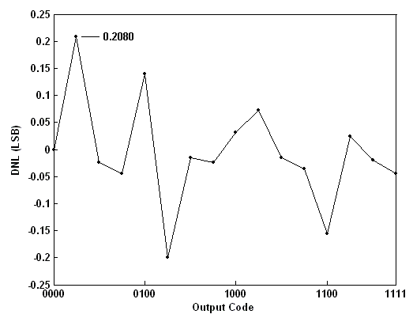
Fig. 6.13 (a): Differential Nonlinearity for the 4-bit ADC
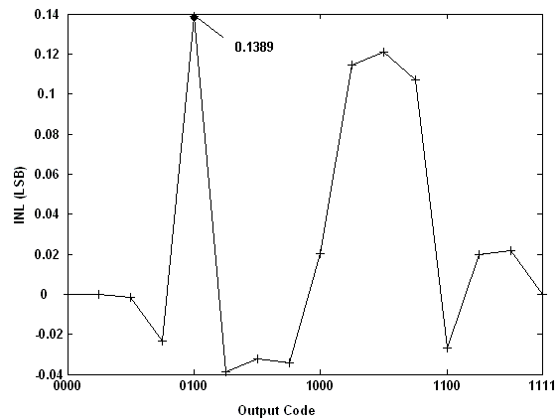
Fig. 6.13 (b): Integral Nonlinearity for the 4-bit ADC
Similarly, to characterize the ADC in the frequency domain, Fast Fourier transform was performed on the output of the ADC while sine input was applied.
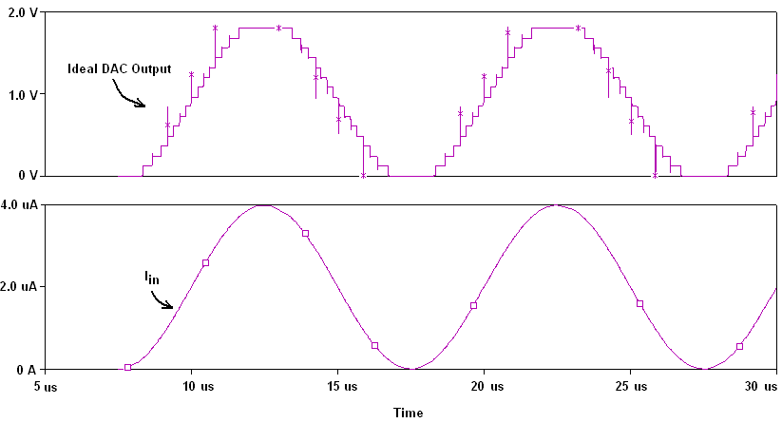
Fig. 6.14 : ADC Output for input sine wave @ 100kHz
For full scale sine input and a 4-bit ADC the Signal to Noise Ratio (SNR) was calculated as 21.126dB. For input sine frequency of 100kHz, the ENOB was calculated as 3.2bits and Spurious Free Dynamic Range (SFDR) as 15.43dB.
Chapter 7

Conclusion

In this thesis, two new current comparators are proposed. The first comparator used the concept of resistive feedback whereas the second is based on the concept of non linear feedback for an improvement in speed and resolution. The proposed current comparators were implemented in TSMC 0.18µm CMOS technology and simulated using PSPICE. The first proposed comparator has a resolution of ±50nA and a delay of 1.48ns at input difference current 1µA. The second proposed comparator has a resolution of ±10nA and a delay of 0.86ns at input difference current 1µA. Thus the second comparator performs better in terms of resolution and delay. As an application of the proposed comparator, a 4-bit area-speed efficient current mode ADC was designed for a input current range of 0-4µA. The components required for current mode ADC- current mirrors, 2 bit encoder and 2 bit DAC were all designed and simulated. The characteristics of the ADC are found to be: offset=0.18µA, gain error=0.987, DNL=0.208LSB, INL=0.1389LSB. In the frequency domain, for full scale sine wave input the characteristics were, SNR=21.13dB SFDR=15.43dB, ENOB= 3.2bits at input frequency of 100kHz.

The presented work may be extended to see the effect of different current differencing stages on comparator and ADC. Other ADCs such as pipelined ADC may also be designed.

References
- Rodriguez-Vasquez, R.Dominguez-Castro, F.Medeiro and M.Delgado-Restituto, “High Resolution CMOS Current Comparators: Design and Applications to Current-Mode Function Generation,” Analog Integrated Circuits and Signal Processing, Vol. 7, pp. 149-165 ,1995.
- C.Toumazou, F.J.Lidgey and D.G.Haigh,” Analogue IC Design: The Current-Mode Approach,” Peter Peregrinus Ltd, 1990.
- A.G. Andreou, et al., "Current-mode subthreshold MOS circuits for analog VLSI neural systems," IEEE Trans. on Neural Networks, Vol. 2, pp. 205-213, 1991.
- A.Rodriguez-Vazquez, Servando Espejo, Rafael Domhguez-Castro, Jose L. Huertas, and E. Shnchez-Sinencio, “Current-mode techniques for the implementation of continuous and discrete-time cellular neural networks,” IEEE Trans. Circuits and Systems, Vol. 28, pp. 132-146, 1993.
- S. Bibyk, and M.Ismail, "Neural network building blocks for analog MOS VLSI," in Analogue IC Design: The Current-Mode Approach (edited by C. Toumazou et al.), Peter Peregrinus, 1990.
- J. Rius, and J. Figueras, "Proportional BIC sensor for current testing," Journal of Electronic Testing, Vol. 3, pp. 387-396, 1992.
- M. Barú, O. de Oliveira, F. Silveira,”A 2V Rail-to-Rail Micropower CMOS Comparator”.
- 2.8V asynchronous high speed current comparator for sequence detection applications. IEEE, 1998.
- O.A.Freitas, and K.W.Current., “CMOS current comparator circuit,” Electron. Letters, Vol.19, pp. 695-697,1983.
- H. Traff, "Novel Approach to High Speed CMOS Current Comparators," Electronics Letters, Vol. 28, no. 3, pp. 310-312, 1992.
- A.T.K.Tang, C.Toumazou, ”High performance CMOS current comparator,” Electronics Letters, Vol.30, no.1, pp. 5-6, 1994.
- L. Ravezzi., D. Stoppa, G. F. Dalla Betta, “Simple high-speed CMOS current comparator,” Electronics Letters, vol.33, pp. 1829–1830, 1997.
- M. Min, W. Kim, “High performance CMOS current comparator using resistive feedback network,” Electronics Letters, Vol.34, no.22, pp. 2074-2076. 1998.
- L.Chen, B. Shi, C.Lu, “Circuit Design of a High Speed and Low Power CMOS Continuous-time Current Comparator,” Analog Integrated Circuits and Signal Processing, Vol. 28, pp. 293–297, 2001.
- D.Banks, C. Toumazou, ”Low-power high-speed current comparator design,” Electronics Letters, Vol. 44, no. 3, pp. 171–172, 2008.
- R.Chavoshiani, O.Hashempour,“Differential current conveyor based current comparator,” Int. J. Electron. Commun. (AEÜ), Vol. 65, pp. 949– 953, 2011.
- A.Zeki, H.Kuntman, "Accurate and high output impedance current mirror suitable for CMOS current output stages", Electron letters, Vol. 33, No.12, pp.1042-1043, 1997.
- AHolberg,”Analog Integrated circuit”,TMH,2000.
- A.Sackinger, W.Guggenbuhl, ”A High-Swing, High-Impedance MOS Cascode Circuit”, IEEE Journal of SoliD-State Circuits, vol. sc-25, no. 1, February 1990.
- G.L.Madhumati ,M.Madhavilatha,K.R.Rao,” Power and Delay Analysis of a 2-to-1 Multiplexer Implemented in Multiple Logic Styles for Multiplexer-Based Decoder in Flash ADC”, International Journal of Recent Trends in Engineering, Vol. 1, No. 4, May 2009.
- G.Khodabndehloo, M.Mirhassani and M.Ahmadi,”An Area-Speed Efficient Method for Current Mode Analog to Digital Converters”, IEEE,2009.
- R.J.Baker,”CMOS Circuit Design,Layout and Simulation”, IEEE Press Series on Microelectronics, Second Edition.

