CHAPTER 1
INTRODUCTION
In India, most of the small and medium enterprises are an unorganized sector because of investment, manpower, organizational sector, space, plant and machinery etc. are limited, whereas this sector fulfills the need of many large scale units by supplying low cost components as per their specifications and their requirements (within finished as well as semi-finished). In the era of globalization, more and more competition has to face by this sector.
At present, micro small and medium enterprises are facing difficulties because input cost (like raw material cost, electricity cost, fuel cost and transportation cost) has increased but final product price are not increasing accordingly. There is no space for rejection/reworking because it is a non value added activity of the company. No customer will pay cost for this. So customer wants defect free product with economical price.
1.1 DEFECT ANALYSIS
An item is considered to be defective if it fails to confirm the specifications in any of the characteristics [1]. Each characteristic that does not meet the specification is a defect. An item is defective if it contains at least one defect.
Defect analysis is the process of analyzing a defect to determine its root causes and it looks at:
- When a defect was created (“injected”)
- When a defect was found (“detection”)
- What caused a defect (type of defect, and/or orthogonal defect classification)
- How a defect was found (triggers)

1.1.1 Defect Analysis by SQC
The Statistical Quality Control (SQC) helps in findings problems, stating them in meaningful terms and solving them. The SQC provides a plan or roadmap that leads to a better competitive position. Attempts to improve individual performance are useless when the problem lies in the system itself. But use of statistical tools by all employees provides a common method of identifying the critical problems and managing their solutions by the facts. The seven most commonly used statistical tools for quality controls are:
- Cause and Effect Diagram
- Check Sheet
- Control Chart
- Histogram
- Pareto Chart
- Scatter Diagram
- Stratification
Cause and Effect Diagram
The Cause and Effect Diagram, graphically portrays the potential causes of an effect. The causes are grouped into categories. Common categories are manpower (personnel), materials, methods and machines. A problem can be due to a variety of reasons or causes. The solution to the problem becomes simpler and easier if only true causes for the problems can be identified. The diagram is also known as an Ishikawa diagram since Dr. Ishikawa devised its first use of the diagram. Another name for the diagram is a Fishbone diagram because of its appearance.
When to use a fishbone diagram
- When identifying possible causes for a problem.
- Especially when finding major solutions and figuring out what to do.

Fishbone diagram procedure
- Agreeing on a problem statement (effect). Writing it at the center right of the flipchart or whiteboard. Drawing a box around it and a horizontal arrow running to it.
- Brainstorming the major categories of causes of the problem. If this is difficult, use generic headings:
(a) Methods
(b) Machines (equipment)
(c) People (manpower)
(d) Materials
(e) Management
- Writing the categories of causes as branches from the main arrow.
- Brainstorming all the possible causes of the problem. Causes can be written in several places if they relate to several categories.
- Writing sub-causes branching of the causes. Generating deeper levels of causes. Layers of branches indicate causal relationships as shown in Figure 1.1.
- When the group runs out of ideas, focusing attention to places on the chart where ideas are few.
Check Sheet
A check sheet is a structured, prepared for collecting and analyzing data. This is a generic tool that can be adapted for a wide variety of purposes. It is also called defect concentration diagram.
When to use a check sheet
- When data can be observed and collected repeatedly by the same person or at the same location.
- When collecting data on the frequency or patterns of events, problems, defects, defect location, defect causes, etc.
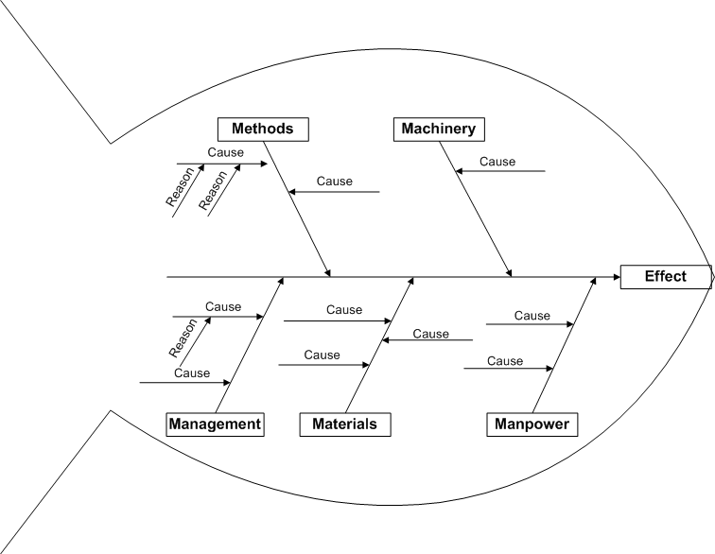
Figure 1.1: Cause and Effect Diagram
- When collecting data from a production process.
Check sheet procedure
- Deciding what event or problem will be observed. Developing operational definitions.
- Deciding when data will be collected and for how long.
- Designing the form. Setting it up so that data can be recorded simply by making check marks or Xs or similar symbols and so that data do not have to be recopied for analysis.
- Labeling all spaces on the form.
- Testing the check sheet for a short trial period to be sure it collects the appropriate data and is easy to use.
- Each time the targeted event or problem occurs, recording data on the check sheet.
Control Chart
The control chart is a graph used to study how a process changes over time. These are also called as statistical process control. Data are plotted in time order. A control chart always has a central line for the average, an upper line for the upper control limit and a lower line for the lower control limit. These lines are determined from historical data. By comparing current data to these lines, conclusions can be drawn about whether the process variation is consistent (in control) or is unpredictable (out of control, affected by special causes of variation).
Control charts for variable data are used in pairs. The top chart monitors the average, or the centering of the distribution of data from the process. The bottom chart monitors the range, or the width of the distribution. If data were shots in target practice, the average is where the shots are clustering, and the range is how tightly they are clustered. Control charts for attribute data are used singly.
When to use a control chart
- When controlling ongoing processes by finding and correcting problems as they occur.
- When predicting the expected range of outcomes from a process.
- When determining whether a process is stable (in statistical control).
- When analyzing patterns of process variation from special causes (non-routine events) or common causes (built into the process).
- When determining whether quality improvement project should aim to prevent specific problems or to make fundamental changes to the process.
Control chart basic procedure
- Choosing the appropriate control chart for data.
- Determining the appropriate time period for collecting and plotting data.
- Collecting data, constructing chart and analyzing the data.
- Looking for “out-of-control signals” on the control chart. When one is identified, marking it on the chart and investigating the cause. Documenting how it was investigated and corrected.
- Continuing to plot data as they are generated. As each new data point is plotted, checking for new out-of-control signals.
- When starting a new control chart, the process may be out of control. If so, the control limits calculated from the first 20 points are conditional limits. When at least 20 sequential points are there and when the process is operating in control, recalculating control limits.
Histogram
A frequency distribution shows how often each different value in a set of data occurs. A histogram is the most commonly used graph to show frequency distributions. It looks very much like a bar chart, but there are important differences between them.
When to use a histogram
- When the data are numerical.
- When need to see the shape of the data’s distribution, especially when determining whether the output of a process is distributed approximately normally.
- When analyzing whether a process can meet the customer’s requirements.
- When analyzing what the output from a supplier’s process looks like.
- When seeing whether a process change has occurred from one time period to another.
- When determining whether the outputs of two or more processes are different.
- When wish to communicate the distribution of data quickly and easily to others.

Histogram construction
- Collecting at least 50 consecutive data points from a process.
- Using the histogram worksheet to set up the histogram. It will help in determine the number of bars, the range of numbers that go into each bar and the labels for the bar edges.
- Drawing x-axes and y-axes on graph paper. Marking and labeling the y-axis for counting data values. Marking and labeling the x-axis with the L values from the worksheet. The spaces between these numbers will be the bars of the histogram.
- For each data point, marking off one count above the appropriate bar with an X or by shading that portion of the bar.
Pareto Chart
A Pareto chart is a bar graph. The lengths of the bars represent frequency or cost (time or money), and are arranged with longest bars on the left and the shortest to the right. In this way the chart visually depicts which situations are more significant.
When to use a Pareto chart
- When analyzing data about the frequency of problems or causes in a process.
- When there are many problems or causes and want to focus on the most significant.
- When analyzing broad causes by looking at their specific components.
- When communicating with others about collected data.
Pareto chart procedure
- Deciding what categories use to group items.
- Deciding what measurement is appropriate. Common measurements are frequency, quantity, cost and time.
- Deciding what period of time the Pareto chart will cover: One work cycle? One full day? A week?
- Collecting the data, recording the category each time (Or assemble data that already exist).
- Subtotaling the measurements for each category.
- Determining the appropriate scale for the measurements. The maximum value will be the largest subtotal from previous step.
- Constructing and labeling bars for each category. Placing the tallest at the far left, then the next tallest to its right and so on. If there are many categories with small measurements, they can be grouped as “other.”
These Steps are optional but are useful for analysis and communication.
- Calculating the percentage for each category.
- Calculating and drawing cumulative sums.
Scatter Diagram
The scatter diagram graphs pairs of numerical data, with one variable on each axis, to look for a relationship between them.
When to use scatter diagram
- When paired numerical data is there.
- When dependent variable may have multiple values for each value of independent variable.
- When trying to identify potential root causes of problems.
- After brainstorming causes and effects using a fishbone diagram, to determine objectively whether a particular cause and effect are related.
- When determining whether two effects that appears to be related both occur with the same cause.
- When testing for autocorrelation before constructing a control chart.
Scatter diagram procedure
- Determining the two items that will be comparing. One may be identified as the suspected cause and the other as the suspected effect.
- Identifying the measurements to be taken. Making the measurements as specific as possible in order to reduce variation and increasing the chance of a higher correlation.
- Making 50 to 100 pairs of measurements. When doing this, aiming to keep all other variables as steady as possible, as they could interfere with the final figures.
- Plotting the measured pairs on the Scatter Diagram. Designing the axes and scales on the diagram to give the maximum visual spread of points. This may involve using different scales and making the axes cross at non-zero values.
- If the correlation is high, a regression ('average') line may be drawn through the plotted points, to emphasizing the trend.
- If the correlation is reasonably linear, then a correlation coefficient may be calculated.
- Interpreting the diagram and acting accordingly. This may be to identifying improvements or to enabling estimation of future effect values.
Stratification
Stratification is a technique used in combination with other data analysis tools. When data from a variety of sources or categories have been lumped together, the meaning of the data can be impossible to see. This technique separates the data so that patterns can be seen.
When to use Stratification
- Before collecting data.
- When data come from several sources or conditions, such as shifts, days of the week, suppliers or population groups.
- When data analysis may require separating different sources or conditions.

Stratification procedure
- Before collecting data, considering which information about the sources of the data might have an effect on the results. Setting up the data collection so that information can be collected.
- When plotting or graphing the collected data on a scatter diagram, control chart, histogram or other analysis tool, using different marks or colors to distinguish data from various sources. Data that are distinguished in this way are said to be “stratified.”
1.1.2 Defect Analysis by FMEA
Failure Mode and Effect Analysis (FMEA) is a procedure in operations management for analysis of potential failure modes within a system by determination of the effect of failures on the system [2]. It is widely used in manufacturing industries in various phases of the product life cycle and also finds application in the service industry. Failure modes are any errors or defects in a process, design, or item, especially those that affect the customer, and can be potential or actual. Effect analysis refers to studying the consequences of those failures.
FMEA can provide an analytical approach, when dealing with potential failure modes and their associated causes. When considering possible failures in a design – like safety, cost, performance, quality and reliability – FMEA provides a lot of information about how to alter the development/manufacturing process, in order to avoid these failures. FMEA provides an easy tool to determine which risk has the greatest concern, and therefore an action is needed to prevent a problem before it arises. The development of these specifications will ensure the product will meet the defined requirements.
When to use FMEA
- At the beginning of a cycle (new product/process)
- Changes are made to the operating conditions
- Changes are made in the design
- New regulations are instituted
- Customer feedback indicates a problem
Uses of FMEA
- For developing the system requirements that minimize the likelihood of failures.
- For evaluating the requirements of the customer to ensure that those do not give rise to potential failures.
- For identifying the certain design characteristics that contribute to failures, and minimize or eliminate those effects.
- Tracking and managing potential risks in the design. This helps in avoiding the same failures in future projects.
- Ensuring that any failure that could occur will not injure the customer or seriously impact a system.
- For producing world class quality products.

Advantages
- Improve the quality, reliability and safety of a product/process.
- Improve company image and competitiveness.
- Increase user satisfaction.
- Reduce system development timing and cost.
- Collect information to reduce future failures, capture engineering knowledge.
- Reduce the potential for warranty concerns.
- Early identification and elimination of potential failure modes.
- Emphasis problem prevention.
- Minimize late changes and associated cost.
- Catalyst for teamwork and idea exchange between functions.
- Reduce the possibility of same kind of failure in future.

1.2 FIXTURES
A fixture is a device used for rapidly and accurately position (or “locate” as is the more commonly used term) the workpiece, and support and secure it adequately such that all parts that are produced using this fixture will be within the design specifications for that part [3]. This accuracy facilitates the interchangeability of parts that is prevalent in many modern manufacturing. There are many types of manufacturing operations such as various forms of heat treatment, welding, chemical treatments, and so on.
Fixtures are important in both traditional manufacturing and modern flexible manufacturing systems (FMS), which directly affect machining quality, productivity, and cost of products. The time spent on designing and fabricating fixtures significantly contributes to the production cycle in improving current products and developing new products. If a component is required in large quantities, then clearly a method which is suitable for producing one off (such as marking out, setting on machine, clamping to machine table etc.) would not be suitable for economic reasons. A faster and more profitable method requires some device on which the component can quickly be positioned in the correct relationship to the cutting tools a quickly clamped before machining takes place.
Fixtures were developed for job, batch and mass productions, which are widely used in manufacturing operations to locate and hold a part firmly in position so that the required manufacturing processes can be carried out according to design specifications. In machining processes, geometric accuracy of a manufactured part mainly depends on the relative position of workpiece to the machining tool. It is clear that primary requirements for a fixture are to locate and secure the workpiece in a given position and orientation on a worktable of the machine tool. In order to locate a workpiece, locators and supports are usually used in contact with the locating surfaces of the workpiece to restrict it to six degrees of freedom, including linear and rotational motions. To secure the workpiece on a fixture, clamps are often utilized to keep a stable location against the machining force.

1.2.1 Structure of a Fixture
Physically, a fixture is comprised of devices capable of supporting and clamping the workpiece. Typical fixture structure is shown in Figure 1.2.
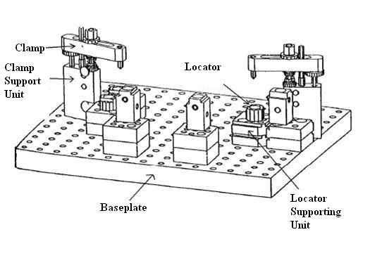
Figure 1.2: Typical Structure of a Fixture
In such fixtures the workpiece rests on locators that accurately locate the workpiece. Clamps are used to hold the workpiece against the locators during machining thus securing the workpiece’s location. The typical structure of a fixture consists of a base-plate, to which the clamping and locating units are attached. The locating units themselves consist of the locator supporting unit and the actual locator. The locator is the part of the locating unit that a clamp that contacts the workpiece. The clamping units consist of a clamp supporting unit and a clamp that actually contacts the workpiece and exerts a clamping force on it.
Although the primary function of a fixture is to accurately locate and secure a workpiece, there are many other criteria that it should attempt to satisfy, most often concerned with ergonomic factors. The fixture should:
- be simple and quick to operate (by facilitating easy loading and unloading of the workpiece from the fixture);
- be error-proof (prevent the workpiece from being loaded into the fixture incorrectly orientated);
- offer some means of preventing unnecessary chip accumulation during machining;
- provide extra support where necessary for unusually shaped or large workpieces;
Finally one of the most important aspects of a fixture is that it should not add unnecessarily to production costs, whether the cost is incurred as a result of fixture assembly time, expensive materials, fixture manufacture costs, and so on [4].
1.2.2 Basic Principles of Fixture Design
The basic principles of fixture design can be categorized under six broad headings [5]:
- Handling and fixing
- Location
- Clamping
- Clearance
- Stability and rigidity
- Ease of construction and design
Location
The main function of any fixture is to positively locate the workpiece. This basically means the workpiece is constrained in the desired position. Once the location method has been decided, the locations should be positioned so that they do not hold swarf, which can cause misalignment. In cases where the workpiece is a rough casting, locations should ideally be adjustable to allow for excess metal in casting. Equally important for use of the fixture is that all locations should be easily seen by the operator in his normal working position and the location is progressive, that is, the workpiece is located on one locator first and then the other in sequence.

Clamping
The main function of the clamping system is to hold the workpiece in the desired location against the forces endured during processing. These could be any one or all of the gravitational forces, centrifugal forces, inertial forces and cutting forces. Therefore the clamps must be positioned to provide the best resistance to these forces, particularly the cutting forces. However, care must also be taken to ensure that the clamping system does not distort or deform the workpiece. This is usually achieved by having the clamps placed above the locating points. Finally, if possible, clamping devices should be an integral part of the fixture body.
Clearance
As stated, when considering location, there may be variations in workpiece dimensions, particularly for rough castings. Therefore fixture should be designed with clearance for such variations. There should also be clearance for the operation to easily load and unload the workpiece. The build-up of swarf can not only cause misalignment but can also be dangerous. Therefore, clearance should be incorporated for swarf clearance. Finally, in some instances, clearance may be required for the formation of burrs during machining, especially for drill operations. Therefore burr grooves or clearance slots should be incorporated where a machining operation is likely to cause burring.
Stability and Rigidity
In terms of stability, it is important to provide form feed for the fixture so that uneven seating is visibly obvious. Equally important is that all forces acting on the fixture are within the area bounded by the seating points. All fixtures should be made as rigid as possible for the operation at hand. Inadequate construction will generally result in vibration and chatter. Finally, rigidity is as equally important for the loading and unloading of the workpiece. This is because many fixtures are damaged more during the load/unload cycle than during the actual machining operation.

Handling and Fixing
Although fixtures should be made as rigid as possible, it should also be as light as possible for ease of handling. If parts of fixtures have to be lifted, handles or hooks should be incorporated to facilitate this. From the safety perspective the presence of sharp corners and/or edges should be minimized. From the point of view of fixing the fixture to the machine table, adequate means of fixing should be provided. The most common method of fixing is the use of lugs with slots. The use of lugs instead of holes facilitates the fixing, positioning and removal of the fixture.
Ease of Design and Construction
In general, the design should be kept as simple as possible. This not only reduces the cost, but also improves reliability by avoiding breakdowns caused by overly complex designs.
The most common approach to the design of fixtures is to design around the workpiece. Thus, it is important to physically study the workpiece and keep one handy for reference. This is because a frequent error in this approach is designing a fixture that the workpiece can neither be loaded into nor removed from.
1.2.3 Principles of Locations
A workpiece in space and unconstrained can move in any direction in any one of the three planes X, Y and Z as shown in Figure 1.3. These can be defined as:
- Motion in both directions along the X axis;
- Motion in both directions along the Y axis;
- Motion in both directions along the Z axis;
- Rotation about the X axis in both directions (α_{x});
- Rotation about the Y axis in both directions (α_{y});
- Rotation about the Z axis in both directions (α_{z});
Figure 1.3: Six Degrees of Freedom
These are known as the six degrees of freedom, although sometimes referred to as the 12 degrees of freedom as motion can be in both directions in all instances i.e. positive/negative direction along the axes and in clockwise and anti-clockwise rotation. For any workpiece to be located, motion in all twelve directions must be constrained. The most commonly employed method of positive location is known as the 3-2-1 principle of location. This principle is based on the assumption that any workpiece can be constrained through the use of six locating pins in a manner which prevents motion in nine of the twelve directions. Workholder locations always start by restricting the first plane of reference with three pins as illustrated in Figure 1.4.
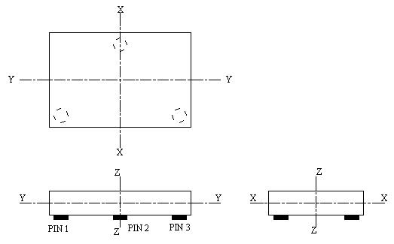
Figure 1.4: Workpiece Constrained by Three Pins
In practice, this is very often the largest plane on the workpiece. These pins are supporting the workpiece in a plane that is parallel to the X-Y plane. These pins will prevent rotation in both directions along the X and Y axes and down the Z axes, which means that five directions of motions are restricted. A second plane of reference is then assigned in which two further pins are located as shown in Figure 1.5. These prevent rotation in both directions along the Z axis and motion in one direction along the Y axis, which means that a further three directions of motion are now constrained.
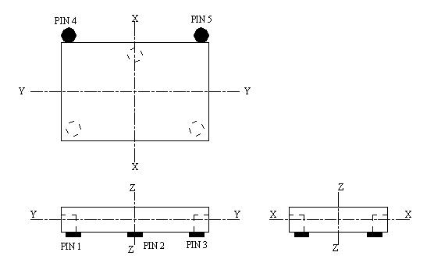
Figure 1.5: Workpiece Constrained by Five Pins
A third and final plane is then designated which is perpendicular to both previous planes and a single locating pin placed in it. This restricts motion in one direction along the X axis as shown in Figure 1.6. This leaves motion in only three directions unconstrained. Although additional pins could be used to fully restrict motion, this is unpractical as it would at worst prevent loading and unloading of the workpiece. Therefore, clamping system must be designed in such a way as to prevent motion in the remaining three directions, in addition to resist the forces experienced during the machining operation.
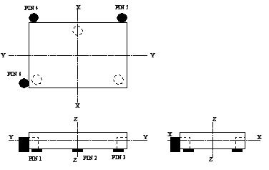
Figure 1.6: 3-2-1 Location Principle
1.2.4 Principles of Clamping
There are a number of points that must be considered when designing clamps for specific machining processes and operations. For example, milling operations tend to induce vibrations in the workpiece and employ large cutting forces.
Consideration must also be given to the workpiece geometry and surface finish specifications. The main consideration for shape and form is that contouring clamps may be required to give satisfactory holding. However, it may be that in some instances a component may have to be redesigned to facilitate clamping. The need for good surface finish may mean that the clamping device may need to be made from a material which does not mark the surface, for example, nylon, rubber, plastics, etc.
Types of Clamps
The following are the different types of clamps which are commonly used in fixtures:
- Strap clamp
- Screw clamp
- Swing clamp
- Hook clamp
- Toggle clamp
Clamping Through 3-Jaw Chuck
A self-centering chuck uses dogs (usually called jaws), interconnected via a scroll gear (scroll plate), to hold onto a tool or workpiece. Because they most often have three jaws, the term three-jaw chuck without other qualification is understood by machinists to mean a self-centering three-jaw chuck. The term universal chuck also refers to this type. These chucks are best suited to grip circular or hexagonal cross-sections when very fast, reasonably accurate centering is desired.
Figure 1.7 shows a three-jaw chuck and key with one jaw removed and inverted showing the teeth that engage in the scroll plate. The scroll plate is rotated within the chuck body by the key, the scroll engages the teeth on the underside of the jaws which moves the three jaws in unison, to tighten or release the workpiece. Three-jaw chucks can often be found on lathes and indexing heads.
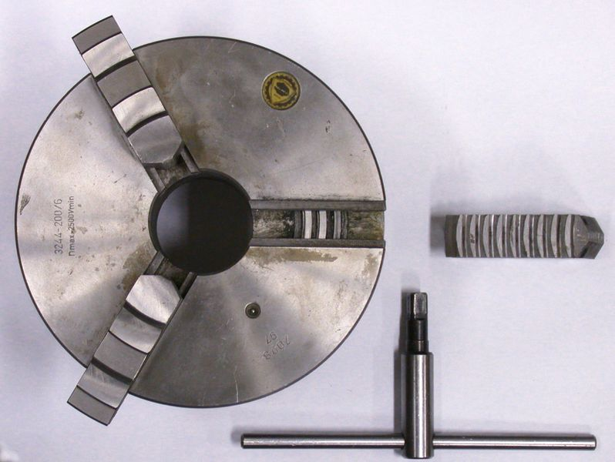
Figure 1.7: Three-Jaw Chuck
1.2.5 Advantages of Fixtures
The following are the advantages of employing fixtures in mass production work [6]:
- It eliminates the marking out, measuring and other setting methods before machining.
- It enables production of identical parts which are interchangeable. This facilitates the assembly operation.
- It increases the production capacity by enabling a number of workpieces to be machined in a single set up and in some cases a number of tools may be made to operate simultaneously. The handling time is also greatly reduced due to quick setting and locating of the work. The speed, feed and depth of cut for machining can be increased due to high clamping rigidity of fixturing system.
- It increases the machining accuracy.
- It reduces the operator’s labour and consequently fatigue as the handling operations are minimized and simplified.
- It enables semi-skilled operator to perform the operations as the setting operation of the tool and the work are mechanized. This saves labour costs.
- It reduces the expenditure on the quality control of the finished products.
- It reduces the overall cost of machining by fully or partly automatising the processes.
1.3 HEAT TREATMENT
Heat Treatment is the controlled heating and cooling of metals to alter their physical and mechanical properties without changing the product shape [7]. Heat treatment is sometimes done inadvertently due to manufacturing processes that either heat or cool the metal such as welding or forming.
Heat Treatment is often associated with increasing the strength of material, but it can also be used to alter certain manufacturability objectives such as improve machining, improve formability, restore ductility after a cold working operation. Thus it is a very enabling manufacturing process that can not only help other manufacturing process, but can also improve product performance by increasing strength or other desirable characteristics.
Steels are particularly suitable for heat treatment, since they respond well to heat treatment and the commercial use of steels exceeds that of any other material. Steels are heat treated for one of the following reasons:
- Softening
- Hardening
- Material modification
1.3.1 Introduction to Hardness
Hardness is a function of the Carbon content of the steel. Different changes in steel structure during hardening process. Hardening of steel requires a change in structure from the body-centered cubic structure found at room temperature to the face-centered cubic structure found in the Austenitic region. The steel is heated to Austenitic region. When suddenly quenched, the Martensite is formed. This is a very strong and brittle structure. When slowly quenched it would form Austenite and Pearlite which is a partly hard and partly soft structure. When the cooling rate is extremely slow then it would be mostly Pearlite which is extremely soft.
Hardenability, which is a measure of the depth of full hardness achieved, is related to the type and amount of alloying elements. Different alloys, which have the same amount of Carbon content, will achieve the same amount of maximum hardness; however, the depth of full hardness will vary with the different alloys. The reason to alloy steels is not to increase their strength, but increase their hardenability — the ease with which full hardness can be achieved throughout the material.
Usually when hot steel is quenched, most of the cooling happens at the surface, as does the hardening. This propagates into the depth of the material. Alloying helps in the hardening and by determining the right alloy one can achieve the desired properties for the particular application.
Such alloying also helps in reducing the need for a rapid quench cooling — thereby eliminates distortions and potential cracking. In addition, thick sections can be hardened fully.
1.4 COMPANY PROFILE
M/s Bubber Industries is a small scale-manufacturing unit, established in 1980. The total covered area is 20×50 m². Figure 1.8 shows the layout of the industry. The layout displays the major machines and sections of the industry. All the machines performing similar type of operation are grouped at one location i.e. the machines are arranged according to the nature or type of operation. In this figure 1.8,
‘L’ refers to lathe machine,
‘D’ refers to drill machine,
‘HTRM’ refers to hydraulic thread rolling machine and
‘SPM’ refers to special purpose machine.
The company is situated at Plot No.175, Industrial Area, Panchkula. It produces around 45 components for the original equipment manufacturers (OEM’s). The list of customers is shown in Table 1.1.
Table 1.1: List of Customers
Sr. No. | Name of the Company and Address | Products
 | M/s Mahindra & Mahindra ltd., Swraj Tractor Division, Plant –1, Mohali | Tractors
 | M/s Swaraj Engines Ltd., Mohali | Engines for Tractors
 | M/s Mahindra & Mahindra ltd., Swraj Tractor Division, Plant –2, Mohali | Harvester combines, fork lift
 | M/s Swaraj Mazda Ltd, Ropar | Light commercial vehicles
 | M/s Diesel loco modernization work, Patiala | Diesel Engine Locomotive

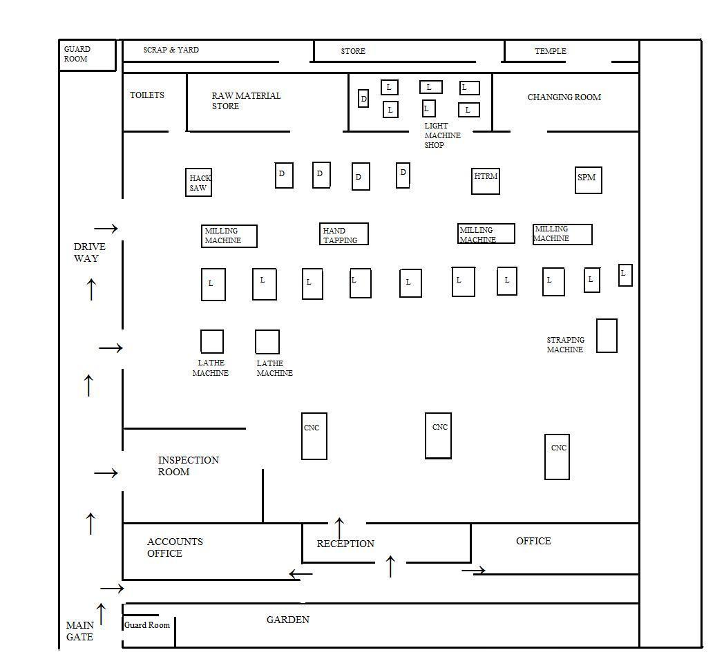

Figure 1.8: Layout of Industry

The company is manufacturing many components on regular and non regular basis. The customer gives monthly requirement for regular components whereas non regular components are manufactured as per customer’s demand. Regular components are tractor components, harvester combine parts, light commercial vehicle parts and tractor engine parts whereas non regular components are fork lift parts, light commercial vehicle parts and diesel engine locomotive parts. The list of regular components manufactured and their monthly requirement are given in Table 1.2.
Table 1.2: List of Regular Components Manufactured
TRACTOR COMPONENTS
SR. NO. | ITEM NAME | MONTHLY REQUIREMENT
1 | Thrust Pad | 4000
2 | Withdrawal Nut | 7000
3 | Spacer (4 types) | 15000
4 | Hollow bush | 4000
5 | Plug | 4000
6 | Dome nut | 4000
7 | Adjusting screw | 3000
HARVESTER COMBINE PARTS
1 | Cam shaft long | 300
2 | Shaft | 250
3 | Bush | 300
4 | Excel | 250
5 | Withdrawal nut | 500
6 | Key | 500
7 | Arm | 500
8 | Shaft GE | 200
9 | Shaft EE | 200
10 | Bolt | 500
LIGHT COMMERCIAL VEHICLE PARTS
1 | Lock nut (big) | 2500
2 | Nut steering knuckle | 2500
3 | Lock nut (small) | 500
4 | Lock nut differential | 3500
TRACTOR ENGINE PARTS
1 | Deflector | 4000
2 | Crank nut for crank pulley | 4000
3 | Special nut | 500
The turnover and profit of M/s Bubber Industries, Panchkula from 2006 to 2009 is as shown in Figure 1.9. The turnover of the company increased from Rs. 62 lacs to Rs. 1.18 crores whereas the profit increased from Rs. 2.45 lacs to Rs. 2.9 lacs in the last 3 years.
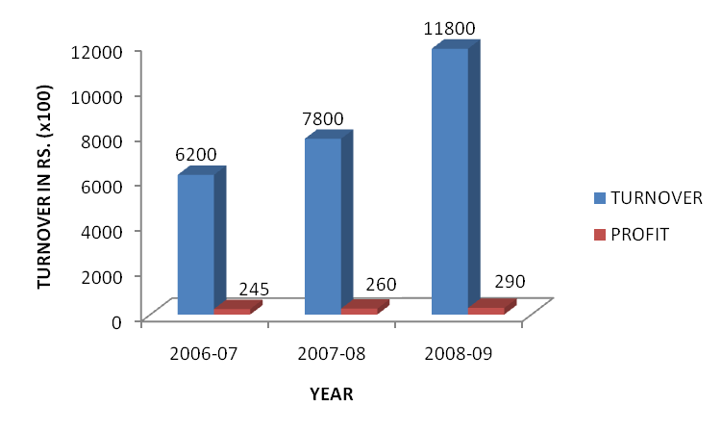

Figure 1.9: Company’s Turnover
Initially all the major production work of industry was carried out through conventional lathe machines and milling machines. In 2005, CNC machine was purchased with a view to increase the production capacity. At present, the company is having three CNC turning centre, hydraulic thread rolling, two drilling machine, milling machine, lathe machine and various other machines. The list of machinery/equipment installed by the company is shown in Table 1.3. Various other machinery/equipment installed is shown in Table 1.4.
Table 1.3: List of Machinery/Equipment

SR. NO. | DESCRIPTION | QUANTITY | SPECIFICATION
1 | CNC Turning Center, Jyoti Make, Fortius Model (2005) | 1 | Swing over Bed: 400 mm,  Max. Turning Length: 400 mm,  X axis Travel: 150 mm,  Z axis Travel: 400 mm.
2 | CNC Turning Center, Jyoti Make, Swifter Model (2007) | 1 | Swing over Bed: 400 mm,  Max. Turning Length: 400 mm,  X axis Travel: 150 mm,  Z axis Travel: 400 mm.
3 | CNC Turning Center, Jyoti Make, DX-100 Model (2009) | 1 | Swing over Bed: 250 mm,  Max. Turning Length: 100 mm,  X axis Travel: 150 mm,  Z axis Travel: 150 mm.
4 | Hydraulic Thread Rolling Machine | 1 | Max Nominal Diameter: 20mm,  Max. Pitch can be rolled: 2.5 mm.
5 | Drilling Machine  1” Cap | 2 | Drill Cap (Upto)1”
6 | Drilling Machine  1/2” Cap | 3 | Drill Cap (Upto)½”
7 | Strapping Machine | 1 | Strapping Speed: 1.5 Second/Strap,  Strap Width: 6 mm to 15 mm,  Strap Core Size: 200 mm.

Table 1.4: List of Other Machinery/Equipment

SR. NO. | DESCRIPTION | QUANTITY
1 | Milling Machine Horizontal (Big) | 1
2 | Milling Machine Horizontal (Medium) | 1
3 | Milling Machine Horizontal (Small) | 1
4 | Lathe Machine 6’ | 3
5 | Lathe Machine 5’ | 4
6 | Lathe Machine 3’ | 3
7 | Lathe Machine 2’ | 8
8 | Power Hacksaw | 2
9 | Hand Tapping Machine | 1
1.5 PROBLEM FORMULATION
M/s Bubber Industries is manufacturing many items like Chuck Nuts, Spacers, Plugs, Dome Nuts, Castle Nuts, Nut Steering Knuckles, and Nut Lock Bearing etc. The company has also established some vendors for the supply of semi finished components like rough-turning, facing, drilling etc. to minimize in-house production cost.
When the manufacturing operation of different components were studied, it was found that, in manufacturing of Nut Steering Knuckle, company was having average 15.18% defective pieces per month. The production cost of Nut Steering Knuckle is Rs. 34/- per piece. This has lead to an urgent critical study and analysis of the production process of Nut Steering Knuckle. Table 1.5 gives the month wise description of defective pieces of nut steering knuckle.
Table 1.5: Defective Components Month wise
Months  Number of components | Oct-08 | Nov-08 | Dec-08 | Jan-09 | Feb-09 | Mar-09
PRODUCTION | 3000 | 3000 | 3500 | 3000 | 2500 | 2500
DEFECTIVE COMPONENTS | 467 | 429 | 482 | 443 | 412 | 424

Problems faced- The major reasons for rejection of Nut Steering Knuckle were as follows:
- Thread Distortion: Thread found loose or tight when inspected with the help of standard thread plug gauge (M30 x 1.0- 6H). The loose threads are scraped and tight threads are kept for reworking which is a difficult work because of hardenability of the component. This reduces the life of the tap and thereby increases the manufacturing cost.
- Breakage of knuckle: Breakage takes place in some components due to thin section (at the slotting area) of the component.

***************

CHAPTER 2
LITERATURE SURVEY
2.1 CURRENT STATUS
Defect analysis is the prime objective of the quality control process before releasing the product. So it is important to detect the defects at early stages.
Fixturing is one of the important steps involved in process planning for machining that add to the lead time in the design to manufacture cycle.
Lot of research work has been done on defect analysis and fixture design. Thousands of technical papers have been published in relevant journals and magazines.
2.1.1 Defect Analysis
With growing demand for improved product quality and shorter time-to-market, there is need for analysis of defects at every stage. An overview of literature collected on defect analysis is given below:
C.R. Gagg [8] concluded that manufacturing necessitates the transformation of raw materials from their initial form into finished, functional products. This change was achieved by a variety of processes, each of which was designed to perform a specific function in the transformation process. Implicit within the design and operation of such processes was a required understanding of the properties of engineering materials and their specific response to such manufacturing methods. However, various defects can be ‘in-built’ during the transformation cycle, dependent on factors such as materials, part design, processing techniques and welding techniques. A review of the major routes in the production of engineered components was presented, highlighting the possibilities of introducing defects at each stage.
Pankaj Jalote et al. [9] described the when–who–how approach for analyzing defect data to gain a better understanding of the quality control process and identify improvement opportunities. At the component level, the analysis provided the capability to assess strength of dependency between components, and new ways to study correlation between early and late defects. They applied this approach for analyzing the defect data. The analysis showed up some clear areas of improvement, like internal teams effectiveness, defect detection capability of the process in early stages, and insufficient operational profile based testing. These observations led to simple yet effective suggestions for improving the quality control processes.
J. Zackrisson et al. [10] focused on the effectiveness of the on-line quality control in the low scale industries. The basis of the study was manufacturing process of trams. The result indicates that the quality control program demands a solid base to be effective from the beginning of its implementation. Empirical results show that during the off-line process the lead time in the production was reduced by 50% and the mean cycle time of the storage was decreased by 33%. Formally, quality tools were investigated as regards the scale of the industry.
Michael Yu Wang [11] presented an analysis describing the impact of localization source errors on the potential datum-related geometric errors of machined features. The analysis reveals the error sensitivity and error characteristics of critical points of multiple manufacturing features. It shows the importance to consider the overall error among the multiple critical points in fixture layout design. He also suggested an optimal approach to the locator configuration design for reducing geometric variations at the critical points of machined features. He investigated how geometric errors of machined feature surfaces (or manufacturing errors) are related to main sources of fixel errors. In a mathematic framework he presented, locator positional errors, locator surface geometric errors, and the workpiece datum geometric errors were shown to result in a localization error of the workpiece. The localization error in turn yields a relational form error in a machined feature. These relationships were characterized by the critical configuration matrix relating the critical variations to the fixel errors.

2.1.2 Fixture Design
Fixture design involves the identification of clamp, locator and support points and the selection of corresponding fixture elements for their respective functions. An overview of literature collected on fixture design is given below:
A. Y. C. Nee and A. Senthil Kumar [12] determined that automation of the fixture design process can be accomplished with the use of solid modeler, an object/ rule based expert system and a feature recognizer coupled with external analysis routines. Although the proposed framework was only capable of solving relative simple cases based on fixture elements, it has excellent application potential in flexible manufacturing system. The final output can be in the form of robotic assembly sequence or a series of “assembly slides” to be sent to the loading stations where the operator can manually build up the fixture based on pictorial instructions.
X Dong et al. [13] investigated the use of features in the domain of fixture design. They developed a method to describe a machined part, intermediate workpiece geometry and material properties, machined features and their intermediate states. The information represented about the intermediate workpiece and features enables a fixture design program to determine the surfaces available for locating and supporting and will facilitates the detection of interference between the workpiece, the cutting tool and the fixture. The representation of machining processes described the operation between intermediate workpiece states and provided the process information that allowed the generation of such information as cutting force directions. A sample part has been used to demonstrate the use of features in two fixture design tasks. It has been shown that feature information was very useful for the selection of locating elements and surfaces.
Hiroshi Sakural [14] developed an automatic setup planning and fixture design system. Algorithmic and heuristic methods were developed to synthesize and analyze setup plan and fixture configurations. Based on the study, the task of setup planning and fixture design was structured into a setup planning and fixture design plan. The plan was implemented as a system that automatically plans the setup sequence and design fixture configurations from the tolerance solid model of the finished component. He described the result of the study of the requirements, the setup planning and fixture design plan and the result of the implementation.
E.C. DeMeter [15] used total restraint analysis to evaluate the ability of a machining fixture to restrain workpiece motion. He explained how to apply restrain analysis to a fixture which relies on frictionless or frictional surface contact. Presented model of the wrench systems defined by frictionless and frictional planar, spherical and cylindrical contact as well as hard point contact. These models were applicable to the restrain analysis of other work holding devices such as gripper and assembly fixtures. In addition, they were the basis for other types of fixture analysis. He also presented a linear program which uses static equilibrium constraints to directly prove the existence of total restraint. Both the models and the linear program are applied to the analysis of the fixture.
Shyr-Long Jeng et al. [16] described the minimum clamping forces that keep the workpiece stable during the metal cutting process. However, previous search algorithms for the instant centre of motion either lack theoretical sufficiency or computational efficiency. They presented a new method derived from the correlation between cutting force and clamping moment. This method increases the search efficiency by proving inadequate search directions. In addition, examples are provided to illustrate minimum clamping force analysis under different fixturing conditions.
Ajay Joneja and Tien-Chien Chang [17] developed a system that attempted to perform setup planning, fixture planning, unit design and verification. Verification is limited to ensuring that stability of the workpiece is achieved. Fixture planning is performed by a planner that exhibits preferences for a particular solution strategy. The system inputs are the workpiece geometry and machining forces. Outputs are a setup plan, fixture plan and unit designs for the locating and clamping units and the base plate.
Y.F. Wang et al. [18] developed an intelligent fixturing system (IFS) for machining. They presented the concept, architecture, control scheme, models and methodologies for IFS. Using off-line simulations and on-line experimental verification, the performance of the proposed IFS is evaluated and verified. As adaptive clamping forces appropriate to the dynamic machining environment are employed, the IFS offer higher quality of machined parts and greater robustness to disturbance. This system is suitable for application in high-precision machining environment as well as flexible manufacturing system (FMS).
A. Senthil Kumar et al. [19] used a GA/neural network approach to conceptually design complete fixture units. The neural network was trained with a selection of previous design problems and their respective solutions. Basic information regarding a new fixturing design problem was supplied to the system and a population of possible solutions randomly generated. The neural network then evaluated these designs and guided the genetic algorithm until a satisfactory design solution was attained, at which point the GA process was terminated. The criteria for evaluating possible solutions were related to design considerations of cost, ease of fixture operation, and effect of the fixture on production rate. A very basic fixture plan outlining the type of surfaces used for location (but no locating coordinates) was required as an input to the system. The output was a conceptual design that lists the types of components that should be used (for example types of locators or clamps) in the fixture. No locating coordinates or data regarding the structural dimensions or physical form of the fixture units were provided.
S. Kashyap and W.R. DeVries [20] concerned with minimizing deformation of the workpiece due to machining loads about fixturing support positions, especially in thin castings. Finite element analysis was used in simulating the deformation of the workpiece at selected points. An optimization algorithm was developed to minimize deflections at these selected nodal points by considering the support and tool locations as design variables. The resulting support locations and tool point designs ensure part support, kinematics closure and minimal workpiece deflections during machining. The tool points were designed to withstand about 20% of the maximum machining load possible in the three coordinate directions. The examples demonstrated the robustness of the procedure by considering cases of simultaneous drilling and milling loads that would occur in a practical situation. In cases tested the optimization reduced the workpiece deflection by the order of 30% from the initial deflection.
Kulankara Krishnakumar and Shreyes N. Melkote [21] employed a GA approach to determine an optimal fixture plan layout: i.e. the optimal locating and clamping points such that deformation as a result of clamping and machining forces was minimized. This type of technique involved discretizing a workpiece into small elements, resulting in the creation of a series of nodes (contact points) across the surface of the workpiece. The design variables, clamp and locator locations, were coded in a binary string of integers. The GA then randomly generated a population of strings from this initial string, and for each initial string the deformation at each node was determined. They adopted a finite element approach to determine the displacements and assume frictionless boundary conditions. The GA selected the strings that resulted in the least workpiece deformation and alters them using the processes of reproduction, crossover, and mutation to create new strings that result in even lower deformations. Rule-based techniques were normally employed to control the functioning of the GA.
A. Senthil Kumar et al. [22] discussed a methodology to capture fixture design rules using the induction process. Two classification models had been generated from the fixture data using induction theory. The first model was helpful towards understanding the process of induction and served as a basis for a more in-depth and complex model. The second model verified the use of machine learning as a feasible tool for conceptual design of fixtures. It was envisaged that the developed system can further be expanded to select automatically suitable fixturing elements using the captured design knowledge to build a fixture. The use of genetic algorithms and fuzzy logic, coupled with machine learning, to improve the design strategy was being explored.
Utpal Roy and Jianmin Liao [23] reported the development of a computational methodology for quantitatively analyzing the workpiece’s stability in the automated fixture design (AFD) environment. In stability analysis, the virtual disturbance which was expressed as a wrench in the screw coordinates and had the same tendency as those fixturing and machining forces to destabilize the workpiece was adopted in the study, and the stability of the workpiece was characterized based on its capability to overcome the virtual disturbance. The stability characteristics for each fixturing configuration (i.e., positions for fixturing components of supporters, locators and clamps) itself were obtained from the stability analysis and used in the re-design process to determine the better design of fixturing configuration.
W. Hu and Y. Rong [24] evaluated an interference checking algorithm in fixture design for possible interference with the cutting tool. During operation, the system selected the appropriate simplified 2D contour model of each element and augments it with details of the element height. For example on a 3-axis machine, the cylinder can be projected on to the fixture baseplate and simplified to a circle with a certain height. The 2D contours of the fixture components were expanded by the radius of the circle and the cutter itself was reduced to a dot with height information. Both the fixture components and the cutter models were now 2D geometric elements with a height value. The interference checking algorithm then evaluated when the cutting tool was within the 2D contour of the fixture components and if so it then used the height information to determine if there was an overlap between the height of the tool and the fixture. If an overlap existed then a collision had occurred. Inputs to the system were the finished fixture plan, the unit design, the cutter toolpath, and the cutter dimensions. The output of the system was a list of any collisions that occur, details of the location of the interference, and the fixture components involved.
J. Cecil [25] performed work on how to dimension strap clamps. Scope is limited to obtaining satisfactory dimensions of the clamp itself and thus concludes any attempts to determine the dimensions of the clamping support unit. Cecil’s criterion is that the clamp dimensions be such that failure by stress fracture is not predicted. Inputs include the maximum force the clamp is subjected to during machining, the clamp material type and the ultimate tensile strength of that material. Outputs are the dimensions of strap clamp, but no dimensions of the clamping unit are provided.
Y. G. Liao and S. J. Hu [26] presented an integrated analysis model of the whole fixture–workpiece system. For the purpose of machined surface quality prediction, a methodology was developed to integrate a FEA model of the locator–workpiece with the experimental stiffness of the fixture base and machine table. In this integrated model, the clamping preloads, machining forces, locator–workpiece contact interaction, fixture compliances, machine table stiffness, and forced vibrations, were taken into account. Based on the material, structure, and fixturing scheme of a workpiece, the clamping preloads and machining forces have different influences on the machined surface error. For a more rigid workpiece, such as a cast iron part, the cutting forces have the greater (than clamping preloads) impact on the surface error. The dynamic stiffness of a fixture–workpiece system depends on the structure of the workpiece and its locating and clamping arrangements. Hence, each machining feature on the workpiece has a different response to forced vibration. This application example demonstrates that the developed methodology was capable of estimating the surface quality for a large complicated workpiece.
Z. M. Bi and W. J. Zhang [27] summarized the latest studies in the field of flexible fixture design and automation. First, a brief introduction was given on this research area. Secondly, taxonomy of flexible fixture design activities was presented. Thirdly, the flexibility strategies based on the existing flexible fixture systems were discussed. Fourthly, the contributions on design methodologies and verifications were examined. Fifthly, advances on computer-aided design and see-up systems were summarized. Finally, some prospective research trends were presented.
They separated fixture configuration design into three phases: description of design requirements, the fixture analysis, and fixture synthesis. Fixture analysis involves the relational models among design variables, kinematic and dynamic constrictions, and performance evaluation; while fixture synthesis involves finding an optimal solution for a given workpiece and its machining.
Bo Li and Shreyes N. Melkote [28] presented a fixture layout and clamping force optimal synthesis approach that accounts for workpiece dynamics during machining. They found that the optimization method was quite effective in optimizing the layouts and clamping forces for a general three-dimensional part. The maximum magnitude of the positional error vector during machining was reduced by as much as 58.7% using the optimization algorithm. The convergence properties of the iterative algorithm were also investigated. Different initial conditions, specifically, clamping force and fixture layout, were tested with this algorithm. The results suggest that the solution obtained from this algorithm is relatively insensitive to the initial conditions selected.
Somashekar R. Subrahmanyam [29] described attributes that are used to generate design feature information. This information was used as the driving factors for the generation of machining and fixturing features. Attribute driven rules were used eventually to find machining features. Fixturing features were generated by considering forces and moments involved in machining. He concentrated on heuristics-based methods for volume decomposition, feature evolution machining and recovery of machining.
Tugrul Ozel [30] investigated the influence of edge preparation in cubic boron nitrite cutting tools on process parameters and tool performance by utilizing practical finite element (FE) simulates and high speed orthogonal cutting tests. The predicted process parameters through FE simulations in high-speed orthogonal cutting were explained to help optimize tool life and surface finish in hard machining of AISI H-13 hot work tool steel. The result shows that a zone of workpiece material is formed under the chamfer acting as an effective rake angle during cutting.
Y. Kang et al. [31] presented the methodologies of fixture verification. Two models – geometric and kinematic – were established and applied in the following aspects of fixture design: geometry constraint analysis, tolerance analysis, stability analysis, and accessibility analysis. The geometric fixture model formulated the relationship between fixture displacements and workpiece displacement. Jacob matrix was utilized to represent this relationship. The kinematic fixture model formulated the relationship between workpiece displacement, fixture deformation, and external force (clamping and machining forces). Given clamping and machining forces, they were able to calculate the fixture deformation and workpiece displacement.
Tugrul Ozel et al. [32] studied effects of cutting edge geometry, workpiece hardness, feed rate and cutting speed on surface roughness and resultant forces in the finish hard turning of AISI H-13 steel. Cubic boron nitrite inserts with two distinct edge preparations and through-hardened AISI H-13 steel bars were used. Four factor (hardness, edge geometry, feed rate and cutting speed) - two level fractional experiments were conducted and statistical analysis of variance was performed. During hard turning experiments, three components of tool forces and roughness of the machined surface were measured. They showed the effects of workpiece hardness, cutting edge geometry, feed rate and cutting speed on surface roughness were statistically significant. The effects of two-factor interactions of the edge geometry and the workpiece hardness, the edge geometry and the feed rate, and the cutting speed and feed rate were also appeared to be important. Especially, small edge radius and lower workpiece surface hardness resulted in better surface roughness. Cutting edge geometry, workpiece hardness and cutting speed were found to be affecting force components. The lower workpiece surface hardness and small edge radius resulted in lower tangential and radial forces.
Guang-Feng Chen et al. [33] presented a development computer aided fixture design system which integrates variant and generative fixture design system. In variant system, a fixture case retrieval methods by hybrid using template retrieval and nearest neighbour algorithm was proposed and implemented. With the retrieval method, a similar fixture solution could be quickly and accurately found for a new fixture. Fixture case modification method was also provided; base on modification method, suitable modification could be made to generate a feasible fixture design case. A complete automation was achieved from the feature extraction to the selection of fixture elements. The system can automatically retrieve the fixture feature from CAD model. A novel automated locating design algorithm by hybrid using RBR and fuzzy evaluation method was proposed and implemented. Fixture points were selected by generating candidate points list and then optimally select based on selection criteria. Element selection automation was realized by RBR and db-search program. At last, a case was presented to illustrate the issues and to show the effectiveness of the presented system.

2.2 CONCLUDING REMARKS
From the present literature review, it can be concluded that objective of defect analysis is to identify process changes that will result in greatest improvements in quality and productivity. Various techniques and tools such as statistical quality control and failure mode effect analysis have been developed and implemented for the analysis of defects.
Fixture forms an important factor in traditional and modern manufacturing systems, since fixture design directly affects manufacturing quality and productivity. Traditionally, fixtures were designed by trial and error, which was expensive and time consuming. But now, research in flexible fixturing and Computer-Aided-Fixture-Design (CAFD) has significantly reduced manufacturing lead-time and cost.
Typically, fixture design involves the identification of clamp, locator and support points and the selection of corresponding fixture elements for their respective functions. Fixture design configuration can be separated into three phases:
- Description of design requirements
- Fixture analysis
- Fixture synthesis
Fixture analysis involves the relational models among design variables, kinematic and dynamic constrictions, and performance evaluation; while fixture synthesis involves finding an optimal solution for a given workpiece and its machining. The automation of fixture design activities in manufacturing is an important research area, which must be addressed to achieve the integration of design and manufacturing.

***************

CHAPTER 3
METHODOLOGY
This chapter discusses about the methodology adopted during the present work for defect analysis and development of fixture for slot milling.

The methodology adopted for present work was as follows:
- Studying the existing manufacturing process of Nut Steering Knuckle used in light commercial vehicle (Swaraj Mazda Small Truck) assembly in front wheel hub.
- Determination of Rejection rate of Nut Steering Knuckle
- Types of processes causing defects in the part:
- Thread milling
- Heat treatment
- Blackening
- Study of Existing fixture
- Cost of existing fixture
- Life of existing fixture
- Existing method of clamping
- Fixture Modification
3.1 EXISTING MANUFACTURING PROCESS
For manufacturing of nut steering knuckle, lot size of 1000 components was processed on conventional lathe machine, after that this lot was sent on special purpose machine for threading operation. The raw material of Nut Steering Knuckle is a plain carbon steel. The standard chemical composition (IS 5517-1978) required for nut steering knuckle and the observed chemical composition (Appendix-I) is given in table 3.1.

Table 3.1: Chemical Composition (in %) of Nut Steering Knuckle

Element→ | C | Mn | S | P | Si | Al
Standard (IS 5517-1978) | 0.4-0.5 | 0.6-0.9 | 0.03-0.05 | 0.03-0.05 | 0.1-0.3 | 0.01-0.03
Observed | 0.425 | 0.85 | 0.04 | 0.0395 | 0.2 | 0.021

The chemical compositions of different elements are well within the standard limits.
The raw material is in the shape of forged component as shown in Figure 3.1:

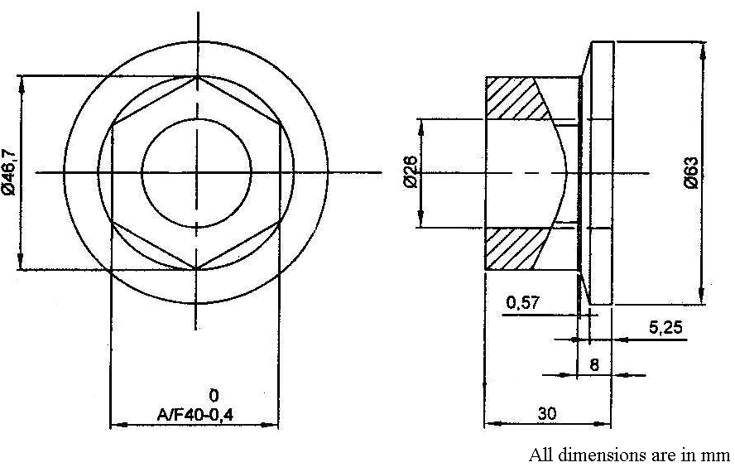
Figure 3.1: Forged Component of Nut Steering Knuckle
The present sequence of manufacturing process of Nut Steering Knuckle is given in Table 3.2.

Table 3.2: Existing Manufacturing Operation of Nut Steering Knuckle
OPERATION NO. | DESCRIPTION
- | Forging : (C-45) as per forging drawing
1 | Facing, OD-1
2 | Total length, Rough OD, Step diameter
3 | Boring, Grooving, Back Boring
4 | Threading
5 | Slotting
6 | Bore cut, OD cut
7 | Groove Deburring
8 | Tapping for Thread Cleaning
9 | Hardened to 28-32 HRC
10 | Blackening
11 | Inspection of Thread

Manufacturing process of Nut Steering Knuckle is explained as below:
- After receiving the forged component, the first operation was facing first side and the outer diameter on conventional lathe machine as per operation-1 and shown in Figure 3.2. This operation was performed by using brazed carbide tool (single point). Machining time for facing operation was calculated from machine center’s data-base. The total cycle time for an operation was the summation of the machining time of the operation and the clamping and unclamping time of one component. The clamping and unclamping time for this machine was seven to ten seconds. This variation of three seconds depends on the skill level and motivation level of the operator. The clamping and unclamping time was considered as 10 seconds (maximum value) for calculating total cycle time, so the analysis does not vary with the unskilled worker. The total cycle time for the completion of the facing is 120 second. Diameter and length was chucked until the required dimensions were not achieved.
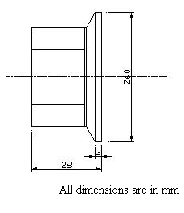
Figure 3.2: Facing
- The operation-2 was turning as shown in Figure 3.3. This process was also done on conventional lathe machine. This operation was performed by using brazed carbide tool (single point). Machining time for turning operation was 110 second and total cycle time for the completion of the turning operation is 120 second.
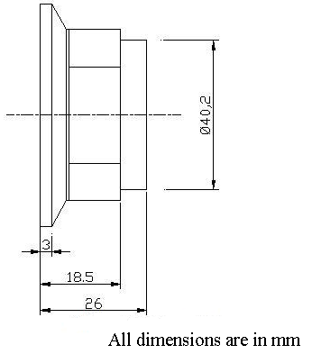
Figure 3.3: Turning
- The operation-3 (Figure 3.4) was carried out on conventional lathe machine which includes boring, grooving and back boring. These operations were performed by using brazed carbide tool (single point). For boring and grooving operation A-A section was clamped in 3-jaw chuck and after completion of these operations B-B section was clamped and then back boring operation was done. Machining time for boring operation was 40 second, for grooving 90 second and for back boring 110 second. So the total cycle time for the completion of boring and grooving was 140 second and for back boring 120 second.
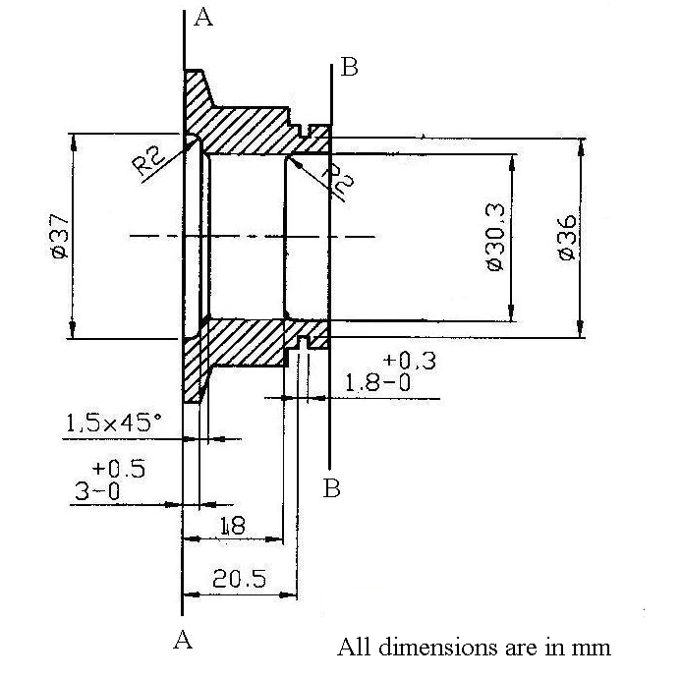
Figure 3.4: Boring, Grooving, Back boring

- The operation-4 (threading) was carried out on special purpose machine i.e. on thread milling as shown in Figure 3.5. This operation was performed by using multiple thread milling cutter. The material of multiple thread milling cutter was high speed steel. Machining time for threading operation was 150 second and total cycle time for the completion of the threading operation was 160 second.

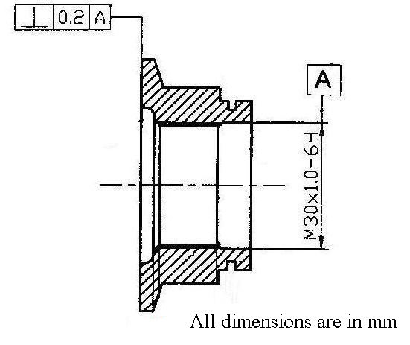
Figure 3.5: Threading
- The next process was slot milling operation which was carried out on conventional milling machine on indexing fixture as shown in Figure 3.6. The cutter used for the operation was convex radius slating cutter and material of the cutter was high speed steel. Machining time for slotting operation was 450 second and total cycle time for the completion of the slotting operation was 510 second.
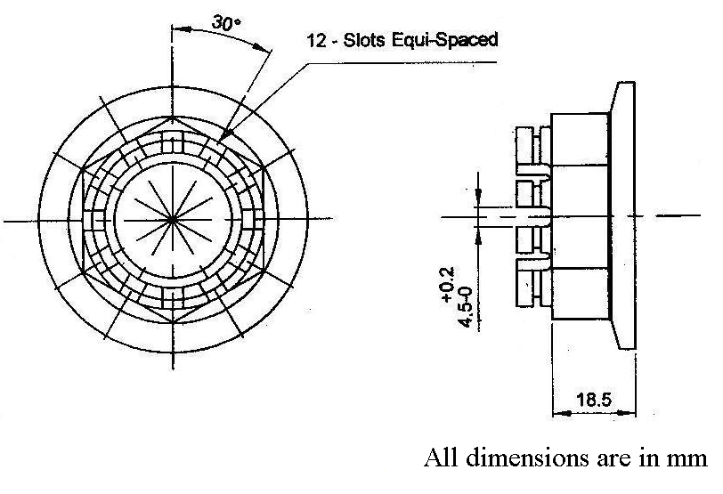
Figure 3.6: Slotting
- After slot milling operation, the component was sent for boring to remove the burrs of slotting operation as shown in Figure 3.7. Total time for removing the burrs for one component was 90 second.
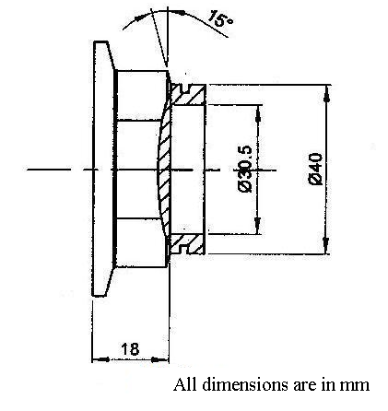
Figure 3.7: Boring
- After Deburring of the milling operation, the component was sent for heat treatment having a hardness of 28 to 32 HRC. As this is the outside process so it takes one or two days for hardening the components depending upon the furnace availability.
- Then it goes for blackening, for cleaning as well as surface plating. It is also outside process. It also takes one or two days for blackening the components.
- The next process was inspection in which each component was inspected for threads with the help of thread plug gauge and also visual inspection for the breakage of any knuckle. Total time for the completion of the inspection of one component was 120 second. Finished nut steering knuckle is shown in Figure 3.8 as below:
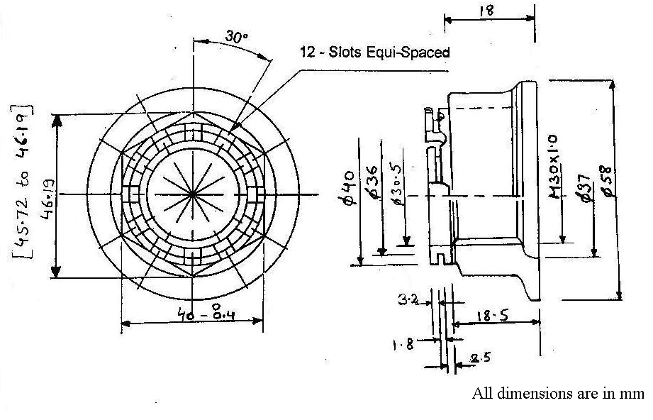
Figure 3.8: Finished Nut Steering Knuckle
3.2 DETERMINATION OF REJECTION RATE
At M/s. Bubber Industries, components are produced as per the customer requirements. The demand for nut steering knuckle component is fluctuating. For the defect analysis, component produced in six months (Oct-08 to Mar-09) were selected and the numbers of pieces which were reworked and rejected (scrap) were determined.
3.3 causes OF defects
During manufacturing process of nut steering knuckle, two defects occurred i.e. thread distortion and breakage of knuckle. These defects occurred during the following processes:
- Thread milling
- Heat treatment
- Blackening
- Existing fixture
Thread Milling Process
The company is manufacturing components having maximum threading operations (internal and external). Thread milling cutter which is used for the nut steering knuckle is shown in Figure 3.9.
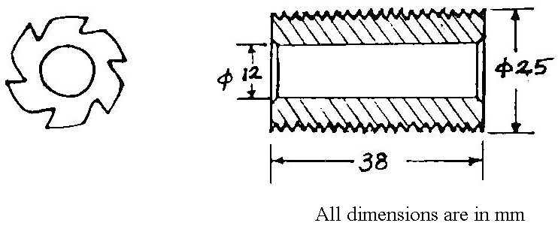
Figure 3.9: Thread Milling Cutter (Hole type)
The specifications of thread milling cutter is given in Table 3.3.
Table 3.3: Specifications of Thread Milling Cutter
Outside dia (mm) | Length (mm) | Bore (mm) | Pitch (mm)
25 | 38 | 12 | 1.5
25 | 38 | 12 | 1.0
25 | 38 | 12 | 2.0
Thread milling is a special purpose machining system which does only threading operation. Threading operation external as well as internal is done on this machine. It is one of the main methods for producing screw threads. In a number of cases thread milling is the most productive and economical method. It is high productive manufacturing method which completes the thread in one pass i.e. no. of depths is not required. The limitation of this process is that it cannot be done on hard surface. The following kinds of thread milling are widely used:
- Milling short-length threads with multiple-thread milling cutters;
- Milling short-length threads with hollow multiple-thread milling heads;
- Milling threads with single-thread (disk) milling cutters.
Thread milling with multiple-thread milling cutters
Multiple-thread milling cutters are mainly applied for producing short threads, 15 to 75mm long with a pitch of 3 to 6 mm. In this case the cutter should be 2-3 pitches longer than the thread being cut.
Long multiple-thread milling cutters are difficult to manufacture, since with a large number of turns, deformations of turns along pitch considerably increase when the cutters are hardened, which presents a problem in grinding the cutters.
The minimum diameter of external thread is limited by the rigidity of the workpieces and amounts to 10-15mm.
The minimum diameter of internal thread is limited by the rigidity and strength of the cutter and is taken to be 27-30mm for metric coarse-pitch threads and 18-22 mm for fine-pitch threads.
Milling an internal thread with a multiple-thread milling cutter is shown in Figure 3.10.
Thread milling is recommended when the lot size exceeds 20 units. This method is not advisable for smaller lots since the time spent for setting up the machine exceeds the time necessary for producing the parts.
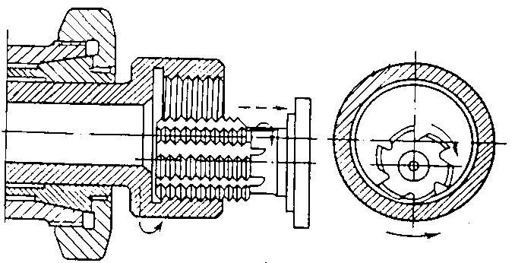
Figure 3.10: Multiple-Thread Milling Cutter
Rejection was mostly due to setting of the cutter on the machine. During machining operation, the cutting edge of the tool gradually wears out and at certain stage it stops cutting metal. After a certain degree of wear, tool has to be resharpened to make it cut again. Figure 3.11 shows the fresh cutter and Figure 3.12 shows resharpened cutter.
The inspection of internal thread was carried out after every 5th piece production. Thread plug gauge was used for internal thread checking. If thread plug gauge goes tight, it was assumed that the tool had worn and then resharpening was done by grinder. After resharpening again resetting was done and it has been found that on every setting 2-3 components gets rejected.
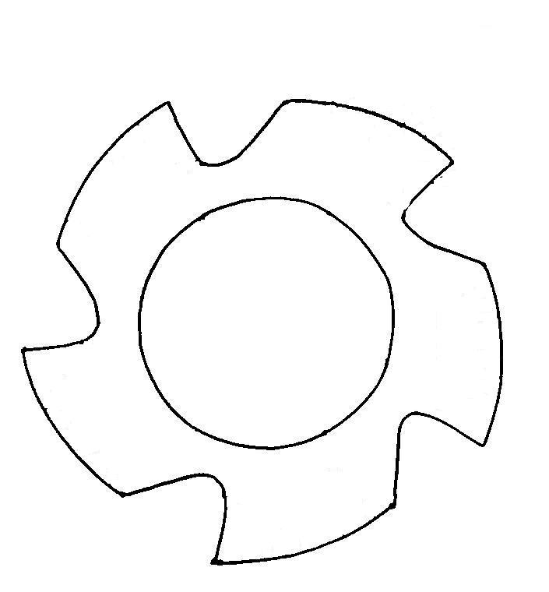
Figure 3.11: Fresh Cutter
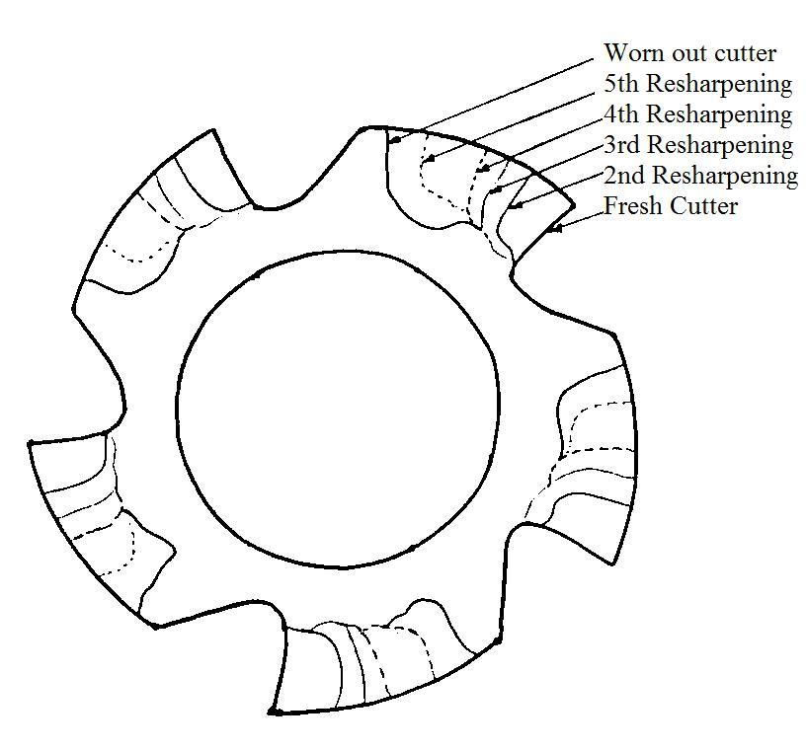
Figure 3.12: Resharpened Cutter
The following types of rejection were frequently encountered in thread milling: inaccurate dimensions of the pitch diameter, scored thread, crushed surface of the thread, shear of the thread turns, low class of the surface roughness, inaccurate pitch of the thread, incorrect thread form, etc.
The rejection occurred due to:
- Incorrect setting up of cutter on the machine,
- Incorrect cutting conditions such as depth of cut and feed rate,
- Incorrectly ground tool angles (geometrical parameters) such as rake angle, clearance angle and nose radius,
- Wear of cutting tool,
- Quality of coolant.

The main causes of rejection found were:
- Inaccurate dimensions of pitch diameter due to the variation in depth of thread milling cutter.
- Scored thread is produced when a dull cutting tool is used, or in the case of improper choice of cutting conditions and composition of coolant.
- Crushed surface of the thread is a result of vibration. In the thread milling, workpiece, cutting tool, machine, and fixtures were subjected to vibrations.
- Shear of turns occurs when the traverse of cutting tool does not agree with the pitch of thread and also when the sense of rotation of workpiece or tool was incorrect.
- Low class of surface roughness resulted from improperly ground tool, its heavy wear, incorrect conditions of machining and feeding the coolant, insufficient clamping rigidity of workpiece and tool, etc.
- Incorrect pitch of thread results from incorrect setting up of the machine or from errors in the pitch of thread milling cutter.
- Incorrect thread form was due to incorrect setting of the tool or its incorrect cutting edge.
- Non-uniform depth of thread along the turn occurred because of workpiece run out when it was improperly mounted.
The defect analysis was carried out using Cause and Effect Diagram (Fishbone Diagram). The fishbone diagram represents meaningful relationship between a defect and its causes. It also enables to identify, explore and graphically displays all the possible causes related to a problem. The fishbone diagram for the defects in thread milling process is shown in Figure 3.13. The fishbone diagram shows the major factors which affect the quality of the threading. The major factors depicted in the figure are operator, machine and method. For each factor the possible causes of defect as observed are shown. The main causes of the defects were incorrect setting up of machine tool, incorrect ground tool angles, wear of cutting tool and faulty machine tool. This leads to the defects in component.

Wear of cutting tool
Faulty Machine Tool
Defective
Component
Incorrect ground tool angles
Material
Man
Method
Machine
Incorrect setting up of the machine tool

Figure 3.13: Cause and Effect Diagram for Thread Milling Process
Heat Treatment Process
The complete process of hardening consists of first preheating the components to about 400⁰ C to 450⁰C in a preheating furnace, holding them at that temperature for 2 hours and then heating at a faster rate to 850⁰C in salt bath furnace (electrically heated). Salt used is barium chloride. Soaking time is 20 min.
Stepped Quenching
It is employed for producing martensite. After holding the component at the hardening temperature for the required period the components are quenched in salt bath, which was maintained at a temperature slightly above the temperature at which martensite formation starts (i.e. between 160⁰ C to 180⁰C). The component was soaked in the bath till its temperature comes down to bath temperature (i.e. for 20 min), but it was not allowed to be immersed for a longer period lest the austenite starts decomposing. Here, the salt used was mixture of nitrate and nitride. Its melting point was 140⁰ C. It was then removed from the bath and cooled in water. Here austenite was transformed into martensite. Fresh water washing was done for removal of salt from component threaded surface i.e. for the purpose of thread cleaning. Here the hardness of the component was 50-55HRC.
Tempering
Tempering after hardening was essential in order to do away with some extra brittleness. It also helps in removing the internal stresses set up during the hardening process. Tempering involves reheating to specified temperatures followed by cooling. This process enables the steel structure being finally transformed into sorbite, which results in the material attaining high ductility while retaining enough hardness. Plain carbon steel was reheated to a temperature range from 600⁰ C to 650⁰C for 1-1.5 hour. Hardness achieved through this is 30-32 HRC, which is company’s requirement.
Reasons for Rejection of Nut Steering Knuckle
- Thread distortion was observed in final product
- Opening of the component from wire bundle after hardening but before tempering leads to breakage of components
- High Hardening temperature
- No proper method for removing component from wire bundle after hardening i.e. in salt bath
- Less skilled operator
- Time error
Figure 3.14 shows the main causes and their effects in heat treatment process. The fishbone diagram shows the major factors which affect the quality of the threading and breakage of component. For each factor the possible causes of defect as observed are shown. The main causes of the defects were mishandling at heat treatment stage, removing component from wire bundle, high hardening temperature and faulty maintenance. This leads to breakage and thread distortion problem in component.

Removing component from wire bundle
Removing component from wire bundle

Defective
Component
Material
Man
Method
Machine
Time error at H&T stage

Mishandling at H&T stage

High hardening temp.
Faulty maintenance (leakage of pot)

Figure 3.14: Cause and Effect Diagram for Heat Treatment Process

Blackening Process
Then these components were sent for blackening process which is also carried out outside the industry at M/s K.K. Industries, Plot No. 435, Industrial Area, Chandigarh. The detail of the process is as under:
In this process, the component was cleaned in HCl by taking 10-12 components in a batch and then component undergoes for water washing. After that nut steering knuckle was dipped in chemical at temperature around 100⁰C-150⁰C. In this chemical auto blackening salt was used. (Name of the salt was not given due to company’s secret). But according to theory caustic soda and calmic sora was used. Then component was cleaned with mobile oil for rust prevention. Then it was sent to M/s. Bubber Industry, Panchkula.
Reasons for Rejection of Nut Steering Knuckle
Since heavy scaling was there, so it was necessary to dip the component for more time in acid to remove the scaling. Because the section of thread was very fine, the acid affected the thread.
3.4 STUDY OF EXISTING FIXTURE
The company was using indexing fixture. This fixture was very simple and any lay man can operate this fixture. Also the repair was very less. Only disadvantage of this fixture for nut steering knuckle was that the clamping of the component on this fixture was through threading i.e. threaded mandrel was used to hold the component and then slotting was done. It was a time consumable process as it took more time for loading and unloading through threading. Figure 3.15 shows assembly of indexing fixture with nut steering knuckle.
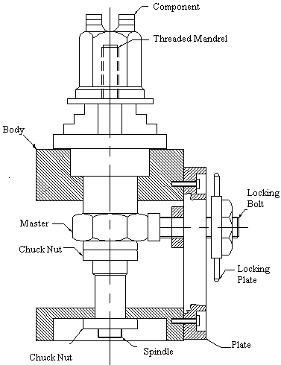

Figure 3.15: Existing Assembly of Indexing Fixture with Component
Different parts used in existing fixture, their material and bill of material are given in Table 3.4.
Table 3.4: Parts Used in Indexing Fixture with Component
Sr. No. | Nomenclature | Material | No.
1 | Body | C-20 | 1
2 | Spindle | C-55 | 1
3 | Chuck Nut | C-45 | 1
4 | Master | C-55 | 1
5 | Chuck Nut | C-45 | 2
6 | Plate | C-20 | 1
7 | Locking Bolt | C-55 | 1
8 | Locking Plate | C-55 | 1
9 | Threaded Mandrel | C-45 (Soft) | 1
10 | Component | C-45 (Forged) | 1
The detail of the various parts of existing fixture is as given:
(i) Body
This is the main part of indexing fixture. The material used in body is mild steel. It consists of base plate, side plates, and top plate. The weight of the body is 32.32 kg. All the plates are welded as per drawing shown in Figure 3.16. After welding body is stress relived in tempering furnace at temperature 500⁰C. The machining of body is carried out on centre lathe.
(ii) Spindle
The spindle as shown in Figure 3.17 is also important part in this fixture because all the accuracy depends upon this. The material of spindle is plain carbon steel (C-55) having 0.4% to 0.5% carbon. The machining of the spindle is carried out on centre lathe. After machining the spindle is hardened and tempered to achieve hardness of 35-40 HRC which gives strength and long life.
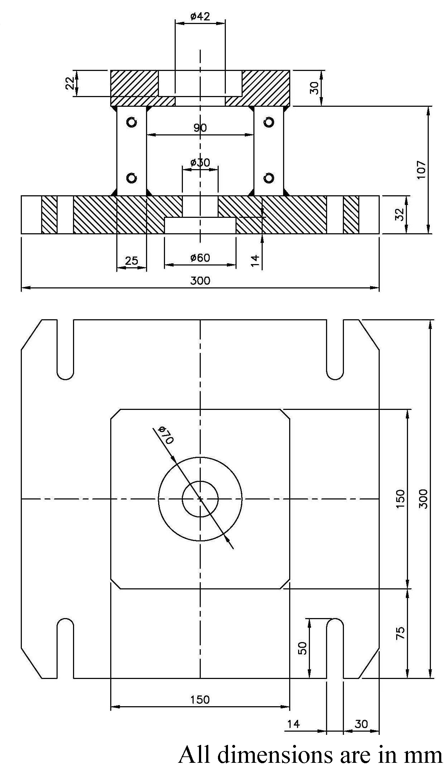
Figure 3.16: Body of Fixture
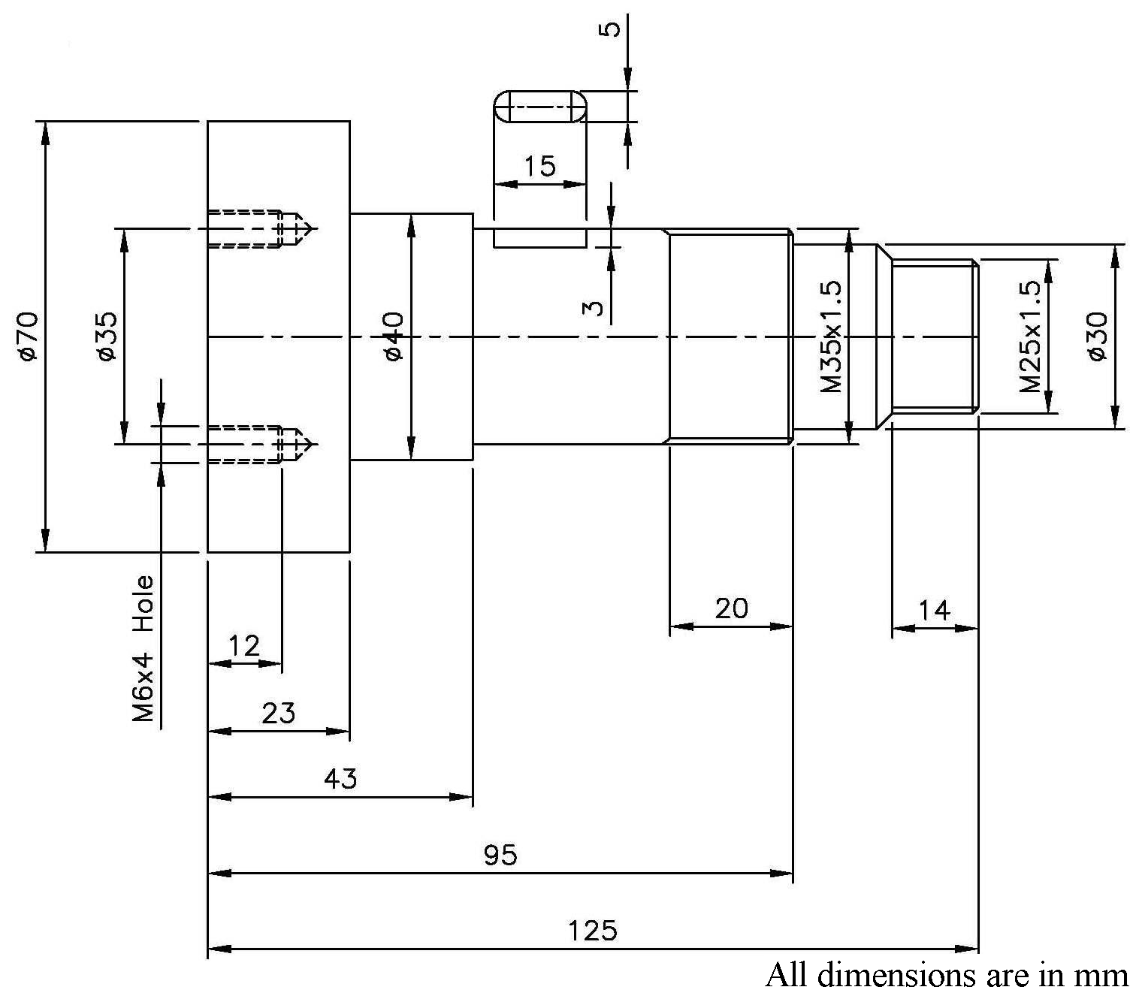
Figure 3.17: Spindle

(iii) Chuck Nut
Chuck Nut M35x1.5 as shown in Figure 3.18 is used in two numbers as a standard part because the company is manufacturing different types of chuck nuts in-house. It tights the master in the indexing fixture.
(iv) Master
The master (shown in Figure 3.19) is machined on a centre lathe. The material used for master is carbon steel (En-9) having carbon 0.4 to 0.5% and toughened to 25-30HRC for long life and strength.
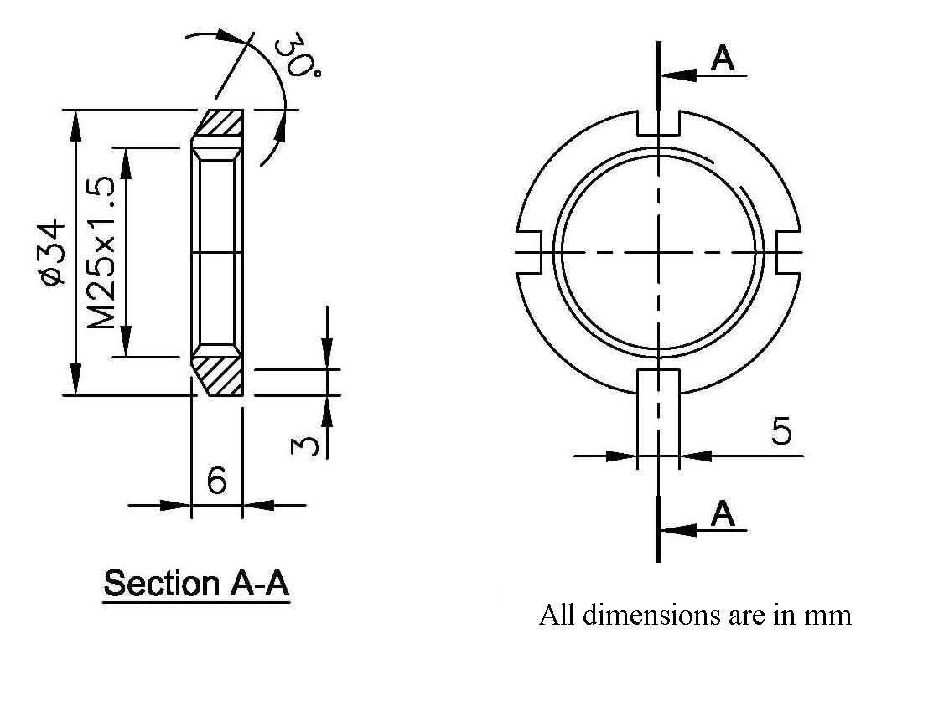
Figure 3.18: Chuck Nut
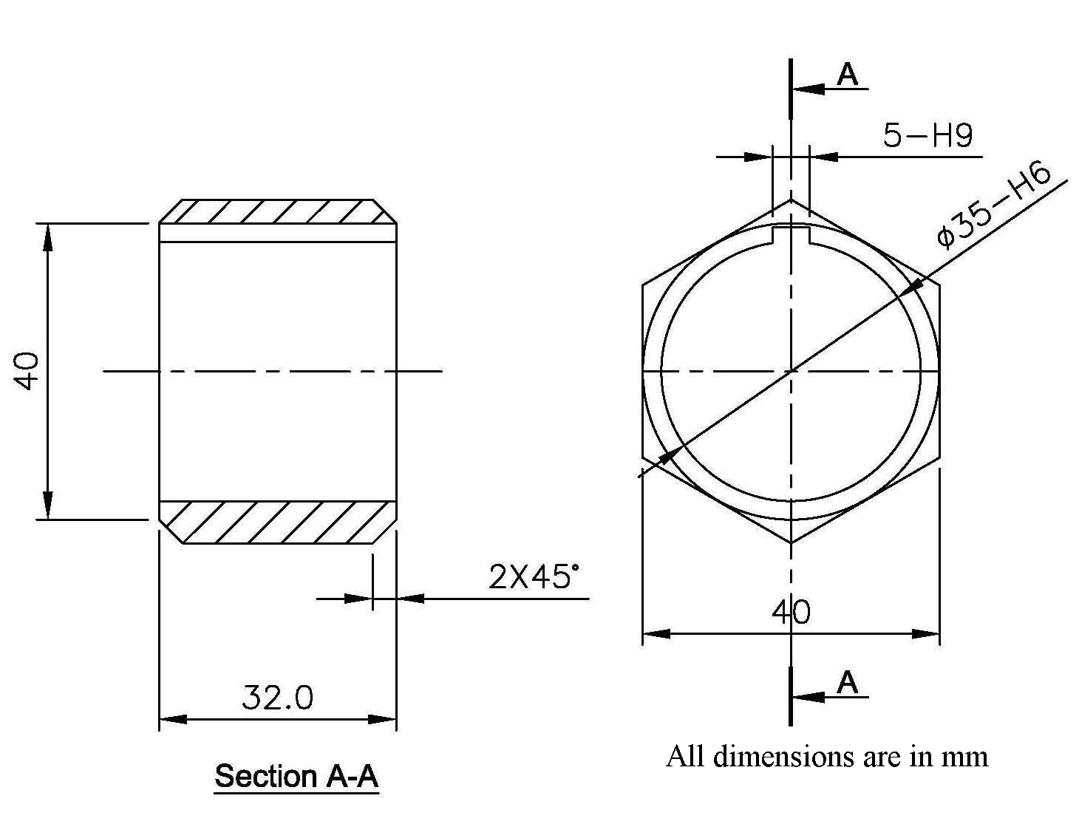
Figure 3.19: Master
(v) Chuck Nut
The chuck Nut M25x1.5 as shown in Figure 3.20 is used for tightening the spindle from bottom as specified in the assembly drawing. This is also a standard component manufactured by company in-house.
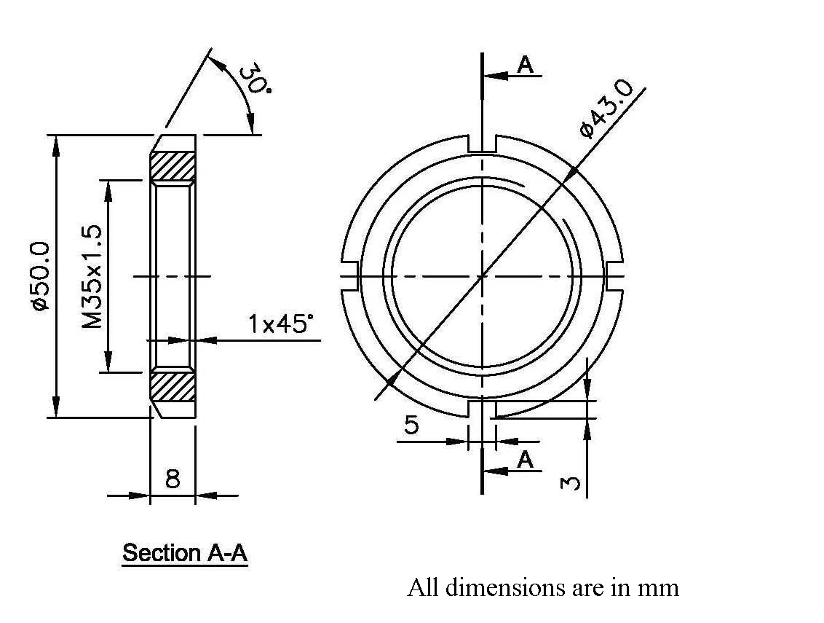
Figure 3.20: Chuck Nut
(vi) Plate
The plate as shown in Figure 3.21 is made from 140x140x15mm mild steel material. The machining on the plate is done on milling and drilling machine available in the company.

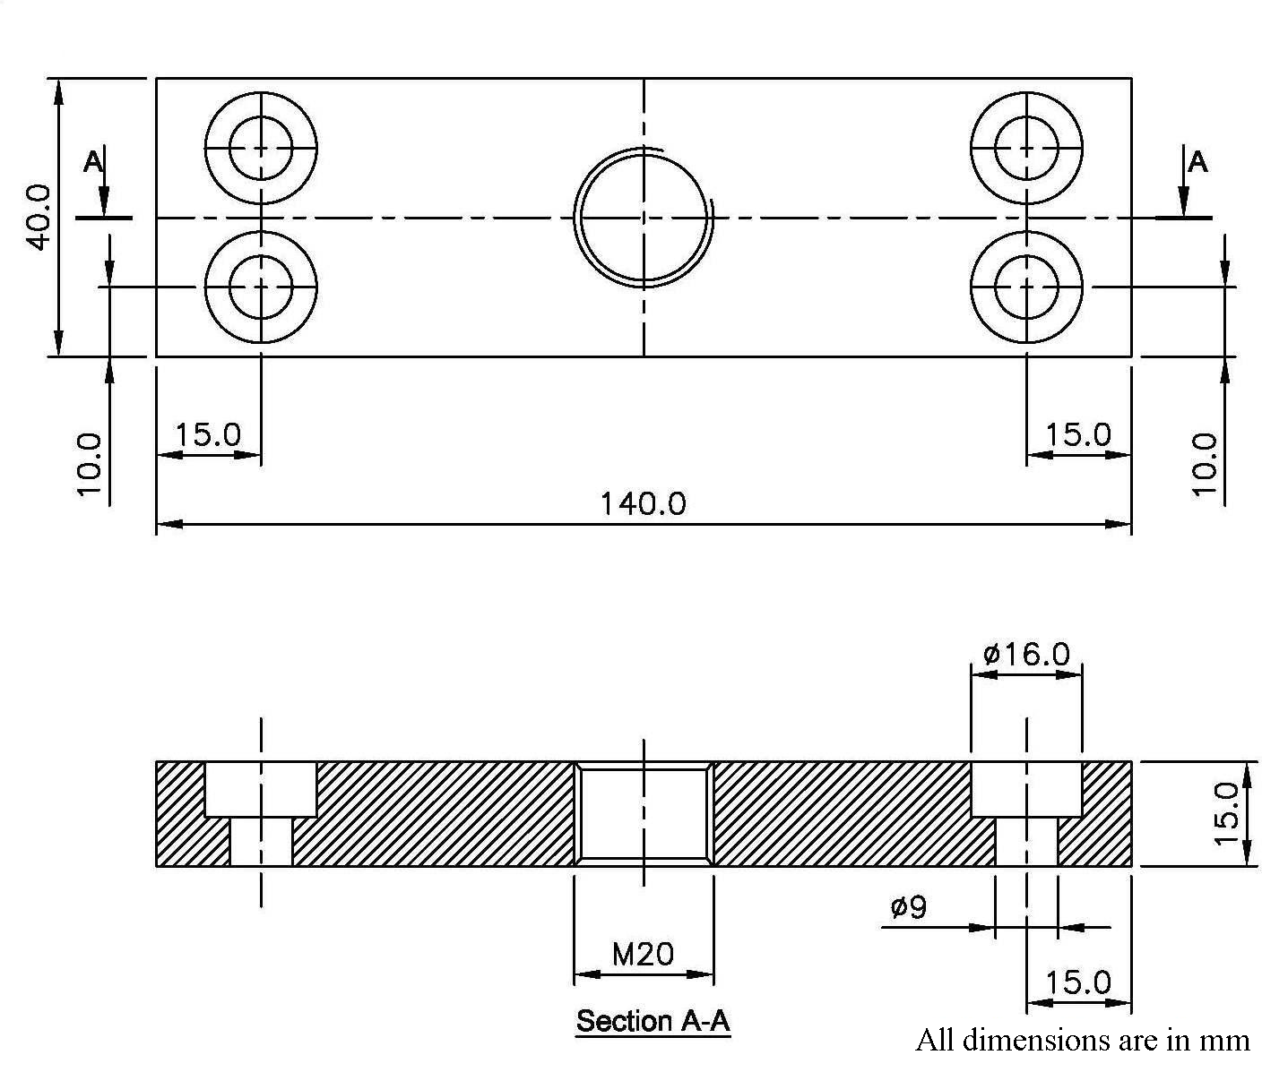
Figure 3.21: Plate
(vii) Locking Bolt
The purpose of bolt is to tight the master after indexing and positioning it properly. This is shown in Figure 3.22.
(viii) Locking Plate
The locking plate (Figure 3.23) is made out of carbon steel material having carbon 0.4 to 0.5% and toughened to 25-30HRC. The purpose of this plate is to lock and unlock the locking bolt. The machining is done on centre lathe as per specifications. Two pins of dia 10x30 mm are welded with the plate for rotation purpose.
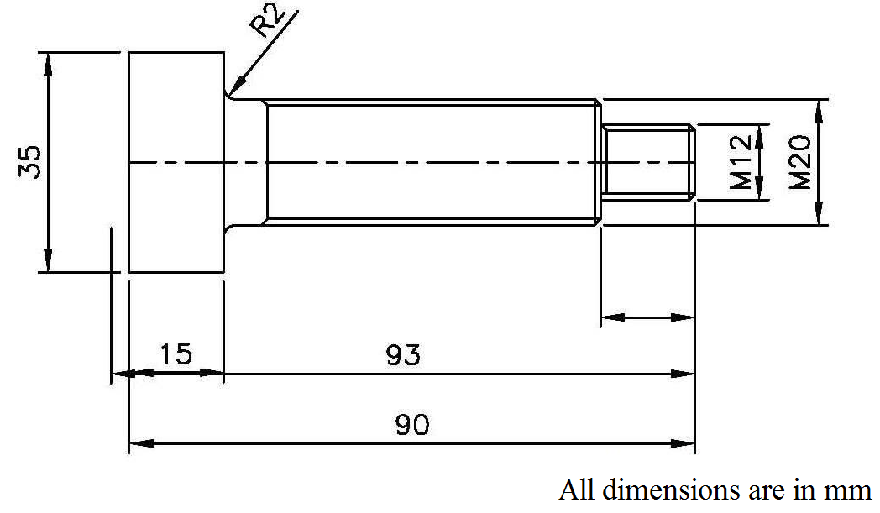
Figure 3.22: Locking Bolt
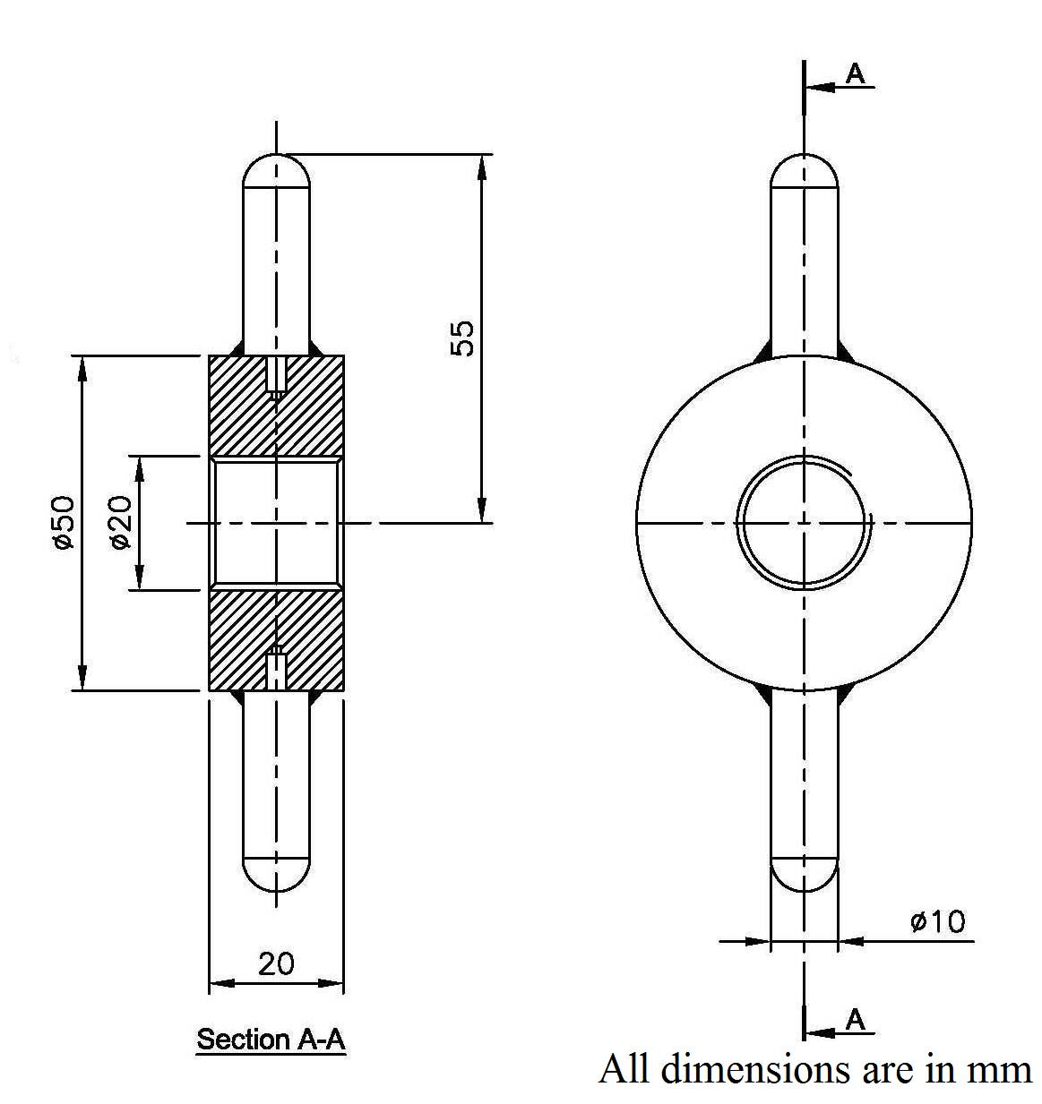
Figure 3.23: Locking Plate
3.4.1 Cost of Existing Fixture
Cost of existing fixture involves material cost of different parts, manufacturing cost of these parts and overheads. The fixture cost was estimated as discussed below:
(a) Material Cost
Different parts of the fixture, their weight and estimated cost are given in Table 3.5.
Table 3.5: Material Cost
Sr. No. | Nomenclature | Size (mm) | Weight (kg) | Rate (Rs) per kg | Cost (Rs)
1 | Body
1 | Base plate (Mild Steel) | 300x300x32 | 22.60
1 | Top plate (Mild Steel) | 150x150x30 | 5.30
1 | Side plate (Mild Steel) | 75x150x25 | 4.42
1 |  |  | 32.32 | 35 | 1132
2 | Spindle (C-55) | Dia 70x130 | 3.93 | 44 | 173
3 | Chuck Nut | In-house product | - | - | 24
4 | Master (En-9) | Hex 55x36 | 0.74 | 50 | 37
5 | Chuck Nut (2 No.) | In-house product | - | - | 48
6 | Plate (Mild Steel) | 140x40x15 | 0.66 | 35 | 23
7 | Locking Nut | In-house product | - | - | 30
8 | Locking Plate with 3 pins | Dia 50x20 | 0.4 | 50 | 20
Total cost |  |  |  |  | 1487

(b) Manufacturing Cost
Manufacturing cost involves welding, stress relieving, machining cost, heat treatment cost and assembling cost which comprises drilling and fitting costs. The manufacturing cost for producing different parts of fixture is given in Table 3.6.
Table 3.6: Manufacturing Cost
Sr. No. | Process | Cost (Rs)
1 | Welding (outside) | 200
2 | Stress relieving (wt. 32.30 kg) @ Rs. 10/- per kg | 323
3 | Machining cost (in house) 48 hrs @ Rs. 40/- per kg | 1920
4 | Heat treatment of the parts (outside) | 400
5 | Nuts and Bolts | 200
Total |  | 3043

(c) Overheads
This involves the cost of freight, electricity cost, labour welfare cost, cost of consumables (oil, water etc.), depreciation cost. These are calculated by taking 15% of material cost and manufacturing cost (Fixed by the management).
Overhead cost = 0.15 x (Material cost + Manufacturing cost)
= 0.15 x (1487+3043)
= 680 Rs.
Total Cost = Material cost + Manufacturing cost + Overheads
= 5210 Rs.
The specifications of existing fixture are as follows:
Overall height without chuck 138mm
Base area 300x300mm
Weight (approx.) 20 kg
Holding devices 3 jaw self centering Chuck
3.4.2 Life of Existing Fixture
In this fixture there is no part which moves at higher speed and the main important parts are hardened and tempered. All the parts are replaceable. They can be change according to the requirement. This fixture can be disassembled by the operator itself because it is a very simple assembly. The life of the fixture is 5 years approximately unless any major breakage or failure occurs.
3.4.3 Existing Method of Clamping
For holding the component on milling machine on simple indexing fixture, company was using threaded mandrel. It was taking time (non machining time) for clamping the component and by operator’s mistake the tendency of thread damage was high. This was because of misalignment of the component and the threaded mandrel which leads to thread distortion. Figure 3.24 shows threaded mandrel which is made from plain carbon steel i.e. C-45, having C- 0.50% to 0.60% & Mn- 0.60% to 0.90%. After clamping a total of 600 components, the mandrel was replaced by a new mandrel. The cost of threaded mandrel is Rs. 200.
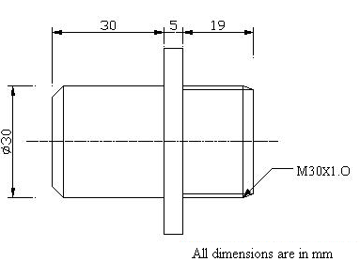
Figure 3.24: Threaded Mandrel
3.5 FIXTURE MODIFICATION
A careful study of cause and effect diagram reveals that the main cause of rejections was incorrect setting up of machine tool on special purpose machine and mishandling of component during heat treatment stage. If the threading and grooving is done after the heat treatment, then rejection can be eliminated or minimized, whereas threading can be done on CNC after heat treatment, because inserts are available for hard part machining up to 60HRC. But for this, slot milling operation must be completed before heat treatment. After discussion with the management, it was decided to revise the manufacturing process.
If threading operation is done after the heat treatment process then the clamping of the component should be changed from the previous clamping method where it was held through threaded mandrel as depicted in Figure 3.15. Hence a need of fixture modification is required in existing fixture.
***************

CHAPTER 4
RESULTS AND DISCUSSION
This chapter discusses about the results of defect analysis and the outcome of fixture modification for slot milling of nut steering knuckle.

4.1 ANALYSIS OF DEFECTS
Analysis of data is an important task. The production data was collected from Oct-08 to Mar-09 and analysis of defects was done for four processes as given below:
- Thread milling
- Heat treatment
- Blackening
- Existing fixture
Thread milling Process
In thread milling process, the rejection occurred due to:
- Incorrect setting up of cutter on the machine,
- Incorrect cutting conditions such as depth of cut and feed rate,
- Incorrectly ground tool angles (geometrical parameters) such as rake angle, clearance angle and nose radius,
- Wear of cutting tool and
- Quality of coolant.
Table 4.1 shows the month wise description of defective pieces of nut steering knuckle in thread milling process.

Table 4.1: Defective Components in Thread Milling Process
Months  Number of components | Oct-08 | Nov-08 | Dec-08 | Jan-09 | Feb-09 | Mar-09
PRODUCTION | 3000 | 3000 | 3500 | 3000 | 2500 | 2500
DEFECTIVE COMPONENTS | 40 | 48 | 46 | 40 | 35 | 29
% DEFECTIVE COMPONENTS | 1.33 | 1.6 | 1.31 | 1.33 | 1.4 | 1.16
AVERAGE % DEFECTIVE | 1.36%

The percentage of defective component ranges from 1.16% to 1.6%. The histogram for the above data is shown in Figure 4.1. In this figure, there is a decrease in defective components from November-08 to March-09 because of decrease in demand of the component.
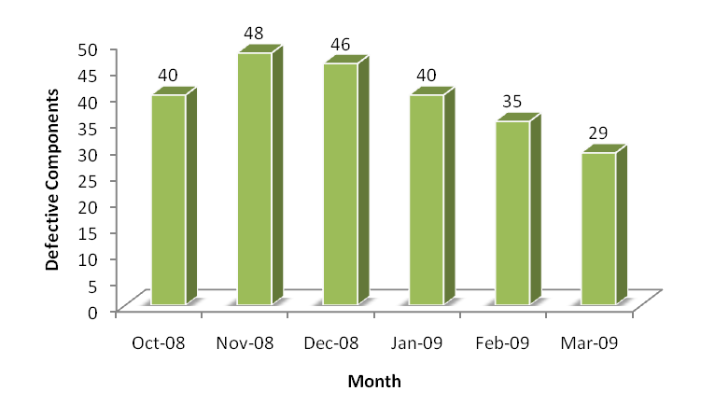
Figure 4.1: Defective Components in Thread Milling Process
Heat Treatment Process
After thread milling process, analysis of heat treatment process was done. In heat treatment, process the rejections were due to high hardening temperature, mishandling during opening of the component from wire bundle and also due to less skilled operator. Table 4.2 shows the month wise description of defective pieces of nut steering knuckle in heat treatment process.
Table 4.2: Defective Components in Heat Treatment Process
Months  Number of components | Oct-08 | Nov-08 | Dec-08 | Jan-09 | Feb-09 | Mar-09
PRODUCTION | 3000 | 3000 | 3500 | 3000 | 2500 | 2500
DEFECTIVE COMPONENTS | 308 | 312 | 330 | 311 | 280 | 288
% DEFECTIVE COMPONENTS | 10.26 | 10.4 | 9.42 | 10.37 | 11.2 | 11.52
AVERAGE % DEFECTIVE | 10.45%

The percentage of defective component ranges from 9.42% to 11.52% which is very high. The histogram for the above data is shown in Figure 4.2.
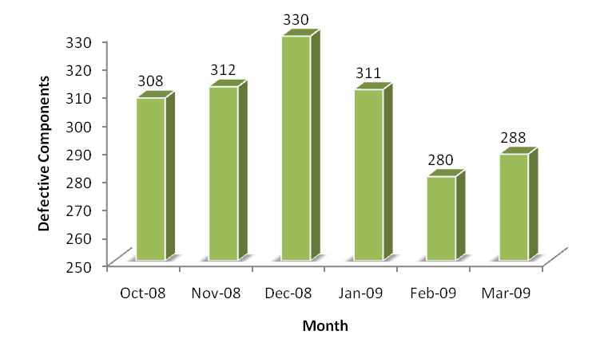
Figure 4.2: Defective Components in Heat Treatment Process
Blackening Process
In blackening process, the rejections were due to heavy scaling, so it was necessary to dip the component for more time in acid to remove the scaling. Because the section of thread was very fine, the acid affected the thread. Table 4.3 shows the month wise description of defective pieces of nut steering knuckle in blackening process.
Table 4.3: Defective Components in Blackening Process
Months  Number of components | Oct-08 | Nov-08 | Dec-08 | Jan-09 | Feb-09 | Mar-09
PRODUCTION | 3000 | 3000 | 3500 | 3000 | 2500 | 2500
DEFECTIVE COMPONENTS | 74 | 83 | 87 | 77 | 68 | 65
% DEFECTIVE COMPONENTS | 2.47 | 2.77 | 2.48 | 2.57 | 2.72 | 2.6
AVERAGE % DEFECTIVE | 2.59%

The percentage of defective component ranges from 2.47% to 2.77%. The histogram for the above data is shown in Figure 4.3.
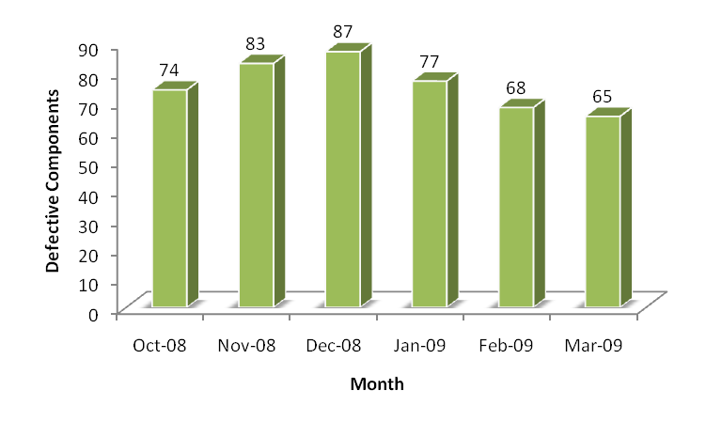
Figure 4.3: Defective Components in Blackening Process
Existing Fixture
For holding the component on milling machine, company was using threaded mandrel. It was taking more time for clamping the component and by operator’s mistake the tendency of thread damage was high. This was because of misalignment of the component and the threaded mandrel which leads to thread distortion. Table 4.4 shows the month wise description of defective pieces of nut steering knuckle using existing fixture.
Table 4.4: Defective Components Using Existing Fixture
Months  Number of components | Oct-08 | Nov-08 | Dec-08 | Jan-09 | Feb-09 | Mar-09
PRODUCTION | 3000 | 3000 | 3500 | 3000 | 2500 | 2500
DEFECTIVE COMPONENTS | 23 | 24 | 30 | 22 | 18 | 20
% DEFECTIVE COMPONENTS | 0.77 | 0.8 | 0.86 | 0.73 | 0.72 | 0.8
AVERAGE % DEFECTIVE | 0.78%

The percentage of defective component is less than 1%. The histogram for the above data is shown in Figure 4.4.
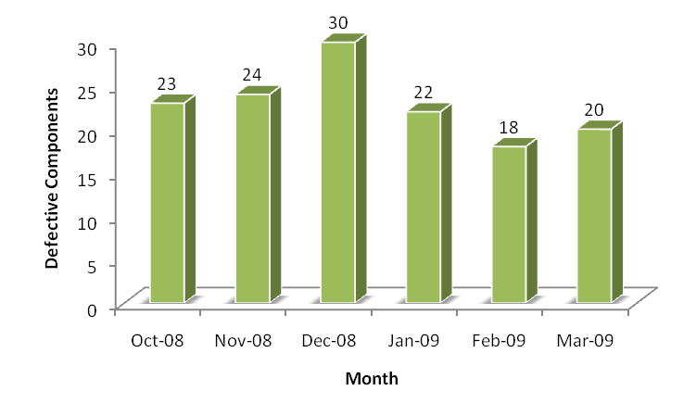
Figure 4.4: Defective Components Using Existing Fixture
Figure 4.5 shows the types of process which causes defects in nut steering knuckle with percentage. The defective components are in heat treatment, blackening process, thread milling process and also due to existing fixture clamping method. The figure shows that heat treatment process accounts for maximum (10.45%) defective components as compared to the other process/means.
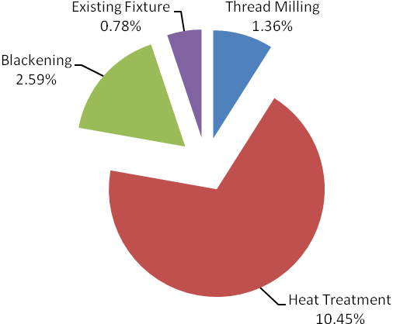
Figure 4.5: Causes of Defects
For the rectification of these problems, following suggestions were approved by the management of the company for implementation:
- Modification of Manufacturing Process
- Fixture Modification
4.2 MODIFIED MANUFATURING PROCESS
In the modified process, boring, back boring, threading and grooving is done after the heat treatment i.e. the component is sent for heat treatment without threading and grooving. Boring, back boring, threading and grooving operation is carried out on CNC turning centre.
Figure 4.6 shows the comparison between existing manufacturing process and the modified manufacturing process of nut steering knuckle. Figure 4.6(b) shows the operations which have been modified by dotted lines. The operations 7 and 8 have been proposed to be carried out on CNC machines. Moreover, the heat treatment process which was earlier performed after threading operation is now performed before boring and threading operation.
Operation No.9-Blackening
Operation No.10-Inspection and Packing
Dispatch
Operation No.8-Threading and Grooving
Forging (Outside)
Operation No.1-Facing, OD-I
Operation No.2-Turning

Operation No.3-Slotting

Operation No.6 –Acid Cleaning
Operation No.7- Boring, Back boring

Operation No.4- Deburring
Operation No.5-Heat Treatment
Forging (outside)

Operation No.1-Facing, OD-I

Operation No.2-Turning

Operation No.3-Boring, Grooving, Back boring

Operation No.4-Threading
Operation No.5-Slotting
Operation No.6-Bore cut, OD cut
Operation No.8-Tapping for thread cleaning
Operation No.9- Heat Treatment
Operation No.10- Blackening
Operation No.7-Deburring
Dispatch
Operation No.11- Inspection and packing
(a) Existing Process (b) Modified Process

Figure 4.6: Comparison of Manufacturing Processes
4.2.1 CNC Turning Centre
It is used to meet industries requirement of high productivity and flexibility at low cost. The precision spindle directly driven by AC Servo motor provides the machine sufficient power to remove large quantity of material. Linear motion guide ways ensure high work piece accuracy and stick-slip free motion. 8 station tool turrets with minimum cutting time ensure high productivity. AC Servo motors are directly coupled to the C3 class ball screws together with linear motion guide ways for all axes, provides rapid traverse of as fast as 20 m/min with optional traverse of 36 m/min extremely fast, accurate and reliable positioning of slides. Latest CNC control system of renowned brand ‘Siemens’ with user-friendly features makes the machine extremely competitive. Threading insert (shown in Figure 4.7) used is VARDEX 3IR 1.0 ISO VTX.
Figure 4.7: Internal Threading Insert
Cost of threading insert, tool life of one insert and rate of production/hour for the CNC turning centre is given in Table 4.5.
Table 4.5: Threading Insert
Cost of One Threading Insert | Rs. 650
Tool Life of One Edge | 200 Components
Total Tool Life of One Insert ( 3 edges) | 600 Components
Rate of Production/Hour | 50 Components

The tool life of the insert depends upon the hardness of the material. This insert was attached to the tool holder as shown in Figure 4.8 and then various operations were carried out on CNC turning centre.
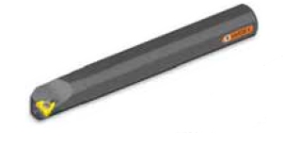
Figure 4.8: Internal Threading Tool Holder
After receiving the component from heat treatment, then acid cleaning was done. Different operations carried out on CNC turning centre are as follows:
- Boring
- Back Boring
- Grooving
- Threading
A CNC program was exclusively developed for these operations and is given in Appendix-II. Cycle time of each operation on CNC was again observed. New cycle time for different operations is given in Table 4.6.
Table 4.6: New Cycle Time
SR. NO. | Operation | Machining Time  (sec) | Total Cycle Time  [Machining time + Clamping/unclamping time]  (sec)
1 | Boring | 15 | 20
2 | Back boring | 25 | 30
3 | Grooving | 25 | 30
4 | Threading | 30 | 35

It is clear from Table 4.6 that new cycle time was very much less as compared to previous cycle time. Cycle time of boring operation on conventional lathe machine was 50 sec and on CNC machine this cycle time was reduced to 20 sec. This resulted in 60% reduction of machining time. For back boring, cycle time was 110 sec and on CNC machine total cycle time was 30 sec. Similarly, for grooving and threading, the cycle time was reduced to 30 sec and 35 sec respectively. The comparison of old cycle time and new cycle time is given in Table 4.7 and shown in Figure 4.9. The table shows that threading operation accounts for maximum (76.7%) reduction in machine time as compared to the other process/means.
Table 4.7: Comparison of Cycle Time
Operation | Old Cycle Time  (sec) | New Cycle Time  (sec) | Machine time reduction
Boring | 50 | 20 | 60%
Back boring | 120 | 30 | 75%
Grooving | 100 | 30 | 70%
Threading | 150 | 35 | 76.7%

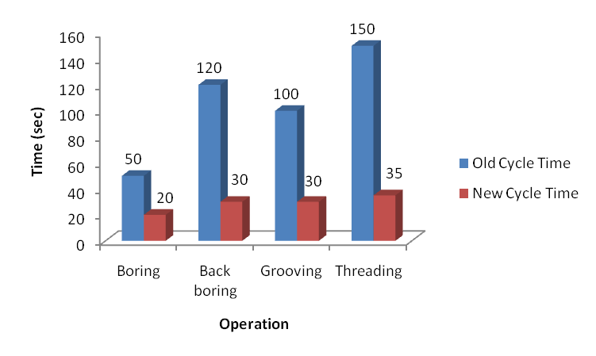
Figure 4.9: Comparison of Old and New Cycle Time
The above manufactured components were then subjected to inspection. It is an in-process inspection method in which every 10th component is inspected for dimensions checking like diameter, length and pitch of thread as shown in Figure 4.10. If dimensions are not according to the specifications then monitoring of tool wear is done. If tool is not within the specified limits then resetting of the tool is done on CNC machine and after resetting again machining operation is carried out.
After completion of machining operation on CNC turning centre, the component was sent for blackening process. After blackening process, components were packed and then dispatched.
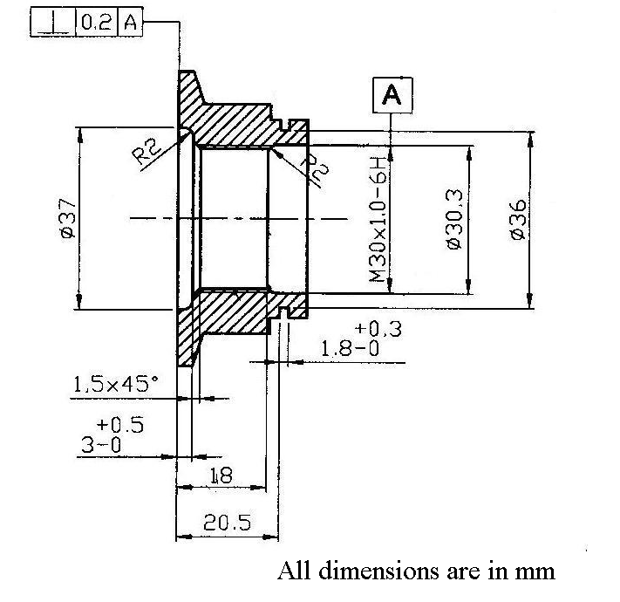
Figure 4.10: Nut Steering Knuckle after CNC Operation
Benefits of using CNC machine
Although it was costly to machine the component on CNC machine as the machine cost and tool cost was high, but the rejections on CNC machine was very less as compared to conventional machine, so it compensated for the cost and also productivity was very high. The following were the benefits of manufacturing nut steering knuckle on CNC machine:
- Reduction in labour as boring, back boring and grooving was done on conventional lathe machine and then threading was done on special purpose machine. So these operations were done by two workers but now boring, back boring, grooving and threading was done on CNC machine so only one worker was required to carry out these operations.
- Reduction in rejection/reworking of component.
- The vendor rating at the customer’s end was enhanced. Hence the confidence of the customer was also increased by way of meeting his requirement in time. There by the company was able to get more business.
- Increase in Productivity.
- Inspection cost was reduced.
4.3 MODIFIED FIXTURE
It was decided to perform threading operation after heat treatment to avoid the rejection of component. But if threading was done after the heat treatment then the clamping of the component should be changed from the previous clamping method where it was held through threaded mandrel. Hence for slot milling operation a need of fixture modification was required in existing fixture. For this the component was directly clamped through hard jaws without threaded mandrel.
4.3.1 Clamping through Hard Jaws
For clamping the component, three jaw self centering standard chuck as shown in Figure 4.11 was used to clamp the component without threaded mandrel.
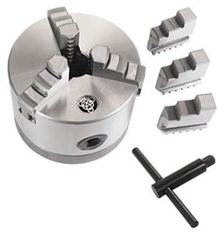

Figure 4.11: Three Jaw Self Centering Standard Chuck
When the component was fitted in the chuck and slotting operation was carried out, it was found that component comes out from the chuck. Again, the component was clamped with more force in the three jaw chuck but result remains same i.e. component comes out from the chuck.
Then analysis was carried out, from which following results were obtained:
- It was found that the gripping area of the jaws according to the component was not sufficient as shown in Figure 4.12 which resulted in slippage of the component when the milling cutter contacts the component. Insufficient contact area is indicated by coloured lines.
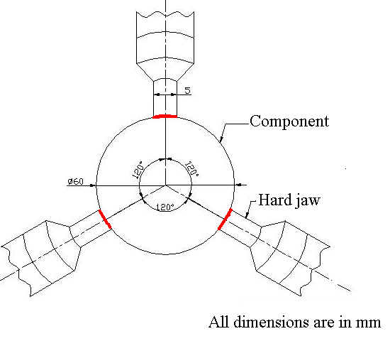
Figure 4.12: Clamping Through Hard Jaws
- Due to heavy clamping force applied on the component, the surface of the component was damaged.
- The unclamping of the component was due to higher cutting force of form cutter.

Hard jaws used were made from steel by case hardening which has carbon content from 0.15% to 0.25% and Mn 0.6% to 0.9%. These jaws can not be machined because of hardness of jaws. Hence this clamping system was not suitable for this operation.
4.3.2 Clamping through Soft Jaws
Standard hard jaws are used for many different size components, but these jaws can not be modified according to the shape and size of component. So it was decided that instead of hard jaws, soft jaws should be used. The material of these jaws is plain carbon steel in which carbon content is from 0.48% to 0.55% and Mn 0.6% to 0.9%. These jaws are available in rectangular shape. Since soft jaws can be shaped according to the requirement i.e. it can be machined to any specification, so in this case, jaws were modified as per the shape and size of the component as shown in Figure 4.13. The gripping area of the jaws was increased. Initially the gripping width for hard jaws was 5 mm per jaw whereas the modified gripping width of soft jaw was 20 mm per jaw. So when the slotting operation was carried out with the soft jaws, it was found that the component was able to bear the force of the milling cutter. Hence, slotting operation was done successfully.
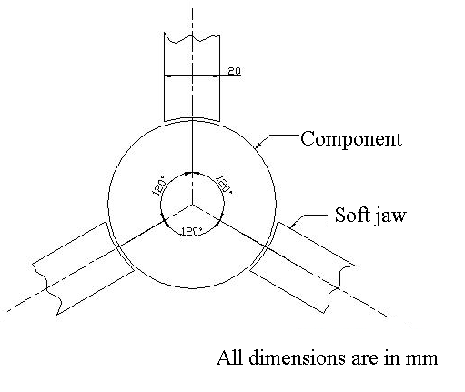
Figure 4.13: Clamping Through Soft Jaws
Figure 4.14 shows the comparison of existing and modified fixture. In the existing fixture, the component was clamped through threaded mandrel, whereas in modified fixture the component was directly clamped in soft jaws and Figure 4.15 shows the slotting operation by modified clamping method.
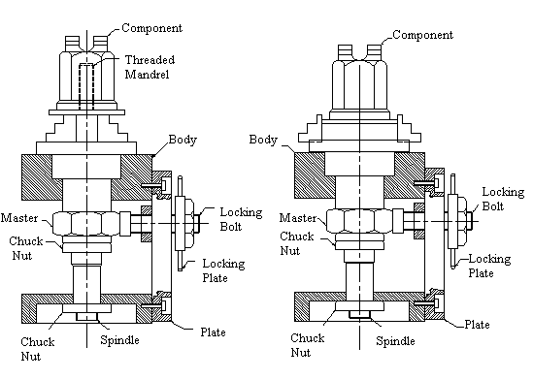
Figure 4.14: Comparison of Existing and Modified Fixture
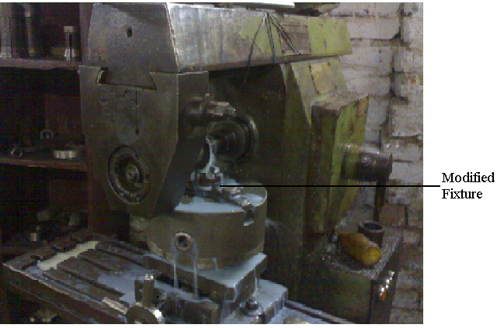
Figure 4.15: Slotting Operation
4.3.3 Cost Variation
Since in the modified process, the threaded mandrel was not used and the component was clamped directly in the chuck with the help of soft jaws.
4.4 PRODUCTION TRIAL
After taking corrective actions, each operation of manufacturing nut steering knuckle was again observed. The production and defective components of nut steering knuckle data as obtained from April-09 to September-09 is given in Table 4.8.
Table 4.8: Defective Components Using Modified Process
Months  Number of components | Apr-09 | May-09 | Jun-09 | July-09 | Aug-09 | Sep-09
PRODUCTION | 2500 | 2700 | 3000 | 2500 | 2500 | 2500
DEFECTIVE COMPONENTS | 24 | 26 | 34 | 27 | 22 | 25
% DEFECTIVE COMPONENTS | 0.96 | 0.96 | 1.13 | 1.08 | 0.88 | 1.00
AVERAGE % DEFECTIVE | 1.00%
It is clear from Table 4.8 that modification in manufacturing process and fixture resulted in decrease in defective components from 15.18% to 1.00%.
As threading operation was done on CNC machine, so special purpose machine was not used in modified process. Again in heat treatment, the main reason for rejection was thread distortion and breakage of knuckle. But now, threading and grooving was done after heat treatment, so no rejection was found in heat treatment process. Then threading operation was carried out on CNC machine after heat treatment. It was found that there were only 1% defective components in modified process. This rejection was due to the tool wear in CNC machine.
Table 4.9 shows the comparison of existing and modified process. It is clear from table 4.9 that when existing process was used, defective components varies from 13.77% to 16.96% and by using modified process; defective components variation reduced to 0.88% to 1.13%. This resulted in average 6.58% reduction of defective components.
Table 4.9: Reduction in Defective Components
Defective components (Existing process) | Defective components (Modified process) | Percentage reduction
Oct-15.57% | Apr-0.96% | 6.61%
Nov-14.30% | May-0.96% | 6.71%
Dec-13.77% | Jun-1.13% | 8.20%
Jan-14.76% | Jul-1.08% | 7.31%
Feb-16.48% | Aug-0.88% | 5.33%
Mar-16.96% | Sep-1.00% | 5.89%
Average-15.18% | Average-1.00% | 6.58%

***************

CHAPTER 5

CONCLUSIONS AND SCOPE FOR FUTURE WORK
Every work has some limitations and there is always some scope for further work. The conclusions of the work carried out are as follows:
5.1 CONCLUSIONS
- The defective components were found in heat treatment, blackening process, thread milling process and also due to existing fixture clamping method. The heat treatment process accounts for maximum (10.45%) defective components as compared to the other process/means.
  - For the rectification of these problems, following suggestions were approved by the management of the company for implementation:
- Modification of manufacturing process
- Fixture modification
  - In the modified process, boring, back boring, threading and grooving is done after the heat treatment i.e. the component is sent for heat treatment without threading and grooving. Boring, back boring, threading and grooving operation is carried out on CNC turning centre.
  - Cycle time of boring operation on conventional lathe machine was 50 sec and on CNC machine this cycle time was reduced to 20 sec. This resulted in 60% reduction of machining time. For back boring, cycle time was 110 sec and on CNC machine total cycle time was 30 sec. Similarly, for grooving and threading, the cycle time was reduced to 30 sec and 35 sec respectively.
- Reduction in labour by using modified process as boring, back boring and grooving was done on conventional lathe machine and then threading was done on special purpose machine. So these operations were done by two workers but now boring, back boring, grooving and threading was done on CNC machine so only one worker is required to carry out these operations.
  - The modified clamping method of the component for slot milling helps the company to perform the threading operation after heat treatment.
  - Modification in manufacturing process and fixture resulted in decrease in defective components from 15.18% to 1.00%.
  - LIMITATIONS OF PRESENT WORK
- Since the cutting parameters of the milling machine for slotting and cutting parameter for threading are not available with the company, so the exact force analysis of the fixture proposed cannot be carried out.
- The complete old record of the heat treatment process is not available. Since this process is done outside the company.
- The blackening process data is also not available since this process is also done outside the company and that company is not ready to disclose the salts used for blackening as well as method of process.
  - SCOPE FOR FUTURE WORK
Though a systematic analysis has been carried for detecting the defect in nut steering knuckle and determine there causes, ample scope is there for carrying out further research in the area.
- Further investigation of threading operation can be done on CNC turning centre by changing tool material, speed, feed etc.
- During the study, it was assumed that the forged component was free from any defects. A defect analysis of microstructure of component can be carried out.
- In present work, Ergonomics Study is not considered as a part of improvement. So it can be area of further work.

***************

REFERENCES
[1] | O. P. Khanna, “Statistical Quality Control”, Dhanpat Rai Publications, New Delhi, 1st Edition, 2001.
[2] | Kanishka Bedi, “Quality Management”, Oxford University Press, New Delhi, 1st Edition, 2006.
[3] | Cyril Donaldson, George H Lecain and V. C. Goold, “ Tool Deisgn”, Tata McGraw-Hill Publishing Company Limited, New Delhi, 36th Edition, 2006.
[4] | Peter Scallan, “Process Planning: The Design/Manufacture Interface”, Butterworth Heinemann Publication, London, 1st Edition, 2003.
[5] | P. H. Joshi, “Jigs and Fixtures”, Khanna Publishers, New Delhi, 2005.
[6] | P. C. Sharma, “A Text Book of Production Engineering”, S. Chand & Co., New Delhi, 1990.
[7] | B. S. Raghuwansi, “Workshop Technology (volume-1)”, Dhanpat Rai & Co.(P) Limited, Educational and Technical Publishers, New Delhi, 16th Edition, 2005.
[8] | C. R. Gagg, “Failure of Components and Products by Engineered-in Defects: Case Studies”, Journal of Engineering Failure Analysis, Vol. 12, 2005, pp. 1000-1026.
[9] | Pankaj Jalote , Rajesh Munshi, Todd Probsting, “The When-Who-How Analysis of Defects for Improving the Quality Control Process”, Journal of Systems and Software, Vol. 80, 2007, pp. 584-589.
[10] | J. Zackrisson, M. Franzen, M. Melbin, H. Shahnavaz, “Quality by a Step-By-Step Program in Low Scale Industries”, International Journal of Production Economics, Vol. 41, 1995, pp. 419-427.
[11] | Michael Yu Wang, “Tolerance Analysis for Fixture Layout Design”, International Journal of Assembly Automation, Vol. 22, 2002, pp. 153-162.
[12] | A. Y. C. Nee and A. Senthil Kumar, “A Framework for an Object/ Rule-Based Automated Fixture Design System”, Annals of CIRP, Vol. 40, No. 1, 1991, pp. 147-151.
[13] | X. Dong, W.R. DeVries and M. J. Wozny, “Feature-Based Reasoning in Fixture Design”, Annals of CIRP, Vol. 40, No. 1, 1991, pp. 111-114.
[14] | Hiroshi Sakural , “Automatic Setup Planning and Fixture Design for Machining” Journal of Manufacturing Systems, Vol. 11, No. 1, 1992, pp. 30-37.
[15] | E.C.DeMeter , “Restraint Analysis of Fixtures Which Rely on Surface Contact” Journal of Engineering for Industry, Vol. 116, 1994, pp. 207-215.
[16] | Shyr-Long Jeng, Long-Gwai Chen and Wei-Hua Chieng, “Analysis of Minimum Clamping Force”, International Journal of Machine Tools and Manufacture, Vol. 35, No. 9, 1995, pp. 1213-1224.
[17] | Ajay Joneja and Tien-Chien Chang, “Setup and Fixture Planning in Automated Process Planning Systems”, IIE Transactions, Vol. 31, 1998, pp. 653-665.
[18] | Y.F. Wang, Y.S. Wong, J.Y.H. Fuh, “Off-Line Modeling and Planning of Optimal Clamping Forces for an Intelligent Fixturing System”, International Journal of Machine Tools and Manufacture, Vol. 39, No. 2, 1999, pp. 253-271.
[19] | A. Senthil Kumar, V. Subramaniam and K. C. Seow, “Conceptual Design of Fixtures Using Genetic Algorithms”, International journal of Advanced Manufacturing Technology, Vol. 15, 1999, pp. 79-84.
[20] | S. Kasyap and W.R. DeVries, “Finite Element Analysis and Optimization in Fixture  Design”, Structural Optimization, Vol. 18, 1999, pp. 193-201.
[21] | Kulankara Krishnakumar and Shreyes N. Melkote., “Machining Fixture Layout Optimization Using the Genetic Algorithm”, International Journal of Machine Tools and Manufacture, Vol. 40, 2000, pp. 579- 598.
[22] | A. Senthil Kumar, V. Subramaniam and Tan Boon Teck, “Conceptual Design of Fixtures Using Machine Learning Techniques”, International journal of Advanced Manufacturing Technology, Vol. 16, 2000, pp. 176-181.
[23] | Utpal Roy and Jianmin Liao, “Fixturing Analysis for Stability Consideration in an Automated Fixture Design System”, Journal of Manufacturing Science and Engineering, Vol. 124, 2000, pp. 98-104.
[24] | W. Hu and Y. Rong “A Fast Interference Checking Algorithm for Automated Fixture Design Verification”, International Journal of Advanced Manufacturing Technology, Vol. 16, 2000, pp. 571-581.
[25] | J. Cecil, “A Clamping Design Approach for Automated Fixture Design” International Journal of Advanced Manufacturing Technology, Vol. 18, 2001, pp. 784-789.
[26] | Y. G. Liao and S. J. Hu, “An Integrated Model of a Fixture–Workpiece System for Surface Quality Prediction”, International Journal of Advanced Manufacturing Technology, Vol. 17, 2001, pp. 810-818.
[27] | Z.M. Bi and W.J. Zhang, “Flexible Fixture Design and Automation: Review, Issues and Future Direction”, International Journal of Production Research, Vol. 39(13), 2001, pp. 2867-2894.
[28] | Bo Li and Shreyes N. Melkote, “Optimal Fixture Design Accounting for the Effect of Workpiece Dynamics”, International Journal of Advanced Manufacturing Technology, Vol. 18, No. 10, 2001, pp. 701-707.
[29] | Somashekar R. Subrahmanyam, “Fixturing Features Selection in Feature-Based Systems”, International Journal of Computer in Industry, Vol. 48, 2002, pp. 99-108.
[30] | Tugrul ozel, “Modeling of Hard Part Machining: Effect of Insert Edge Preparation in CBN Cutting Tools” International Journal of Materials Processing Technology, Vol. 141, 2003, pp. 284-293.
[31] | Y. Kang, Y. Rong, J. Yang and W. Ma “Computer-Aided Fixture Design Verification”, International Journal of Advanced Manufacturing Technology, Vol. 21(10-11), 2003, pp. 827- 849.
[32] | Tugrul Ozel, Tsu-Kong Hsu and Erol Zeren, “Effects of Cutting Edge Geometry, Workpiece Hardness, Feed Rate and Cutting Speed on Surface Roughness and Forces in Finish Turning of Hardened AISI H13 Steel”, International Journal of Advanced Manufacturing Technology, Vol. 25, No. 3-4, 2005, pp. 262-269.
[33] | Guang-Feng Chen, Yi-Ze Sun and Wen-Jian Liu, “Study on Integrated Fixture Design System”, Proceedings of the Sixth International Conference on Machine Learning and Cybernetics, 19-22 August 2007, Hong Kong, pp. 2362-2367.

***************



CNC program for BORing, BACK BORING, GROOVING AND THREADING
n10 g0g90g71g95g64g40
n20 t05d01m16
n30 g96s165lims=2800m03
n40 g0x30.5z10m08
n50 z5
n60 g01z-8.7f0.1
n70 g1x29.15z-9
n80 g1z-27.5f0.22
n90 g0x27
n100 z5
n110 x200z115
n120 t07d01m16
n130 g96s160lims=2200m03
n140 g0x27z50
n150 z10m8
n160 z-25.5
n170 g1x36.7f0.12
n180 g0x28z-26.5
n190 z-24.5
n200 g1x35
n210 g0x28z-25.5
n220 z-21.52
n230 g1x29
n240 g1x32.0z=23.5
n250 g1x33
n260 g03x37z-25.5
n270 g1z-27
n280 g1x38.5
n290 x35.5z-24.8
n300 g0x28
n310 z15
n320 x200z100
n330 t08d01m16
n340 m03s1200
n350 g96s150lims=1500m03
n360 g0x100z50m08
n370 x50z-5.2m52
n380 x43
n390 g1x36.15f0.05
n400 x36.4f0.5
n410 x36.1f0.08
n420 g04f0.5
n430 g1x43f0.5
n440 g0x50
n450 g0x200z125
n460 m05
n470 t02d01m16
n480 g97s550m4
n490 g0x27z50
n500 g0x27z2m8
n510 cycle97 (1.000000, 0, -5.000000, -26.50000, 29.020, 29.00, 0.00000, 0.00000, 0.613, 0.000000, 30.00000, 0.00000, 8, 0, 4, 1)
n520 g0z5m5
n530 g0x200z100m09
n540 m53
n550 m30

