CHAPTER – III

MATHEMATICAL MODELING
3.1 VAPOUR COMPRESSION SYSTEM
A schematic vapour compression system is shown in Fig. 3.1. It consists of a compressor, a condenser, an expansion device for throttling and an evaporator. The compressor – delivery head, discharge line, condenser and liquid line form the high pressure side of the system. The compressor and matching condenser together are also available commercially as one unit called the condensing unit. The expansion line, evaporator, suction line and compressor – suction head form the low- pressure side of the system. It may be pointed out here that, in actual systems unlike in Fig. 3.1, the expansion device is located as close to the evaporator as possible in order to minimise the heat gain in the low temperature expansion line.
In plants with a large amount of refrigerant charge, a receiver is installed in the liquid line. Normally, a drier is also installed in the liquid the particularly in flurocarbon systems. The drier contains silica gel and absorbs traces of moisture present in the liquid refrigerant so that it does not enter the narrow cross- section of the expansion device causing moisture choking by freezing. The thermodynamic processes are as follows:
Process 1-2 Isentropic compression: S₂ = S₁. Q = 0
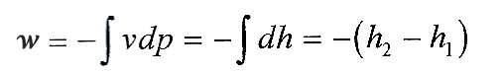
Work done,
(3.1)
Process 2-3 Desuperheating and condensation : p_{k} = Const.
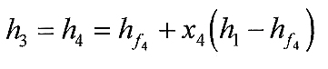
Heat rejected , q_{k} = h₂ – h₃ (3.2)
Process 3-4 Isenthalpic expansion :
(3.3)
Process 4-1 Evaporation : p_{o} = const.
Refrigerating effect, q_{o} = h₁-h₄ (3.4)
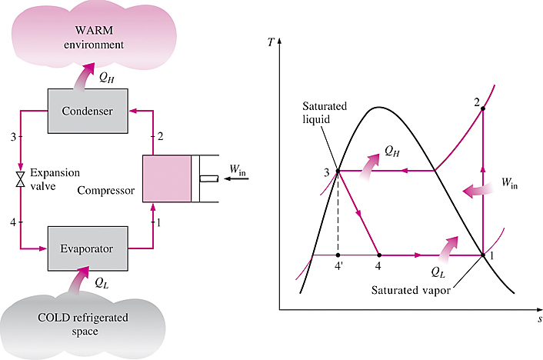
Fig:3.1 Vapor compression system
3.1.1 REPRESENTATION VAPOUR COMPRESSION CYCLE ON PRESSURE ENTHALPY DIAGRAM
Two of the processes are at constant pressure and one is at constant enthalpy. It is, therefore, found convenient to represent the vapour compression cycle on a pressure enthalpy (p-h) diagram as shown in Fig. 3.2. Therefore, even though the fourth process is an isentropic one, the p-h diagram is still found convenient as the work done is given by the increase in enthalpy.
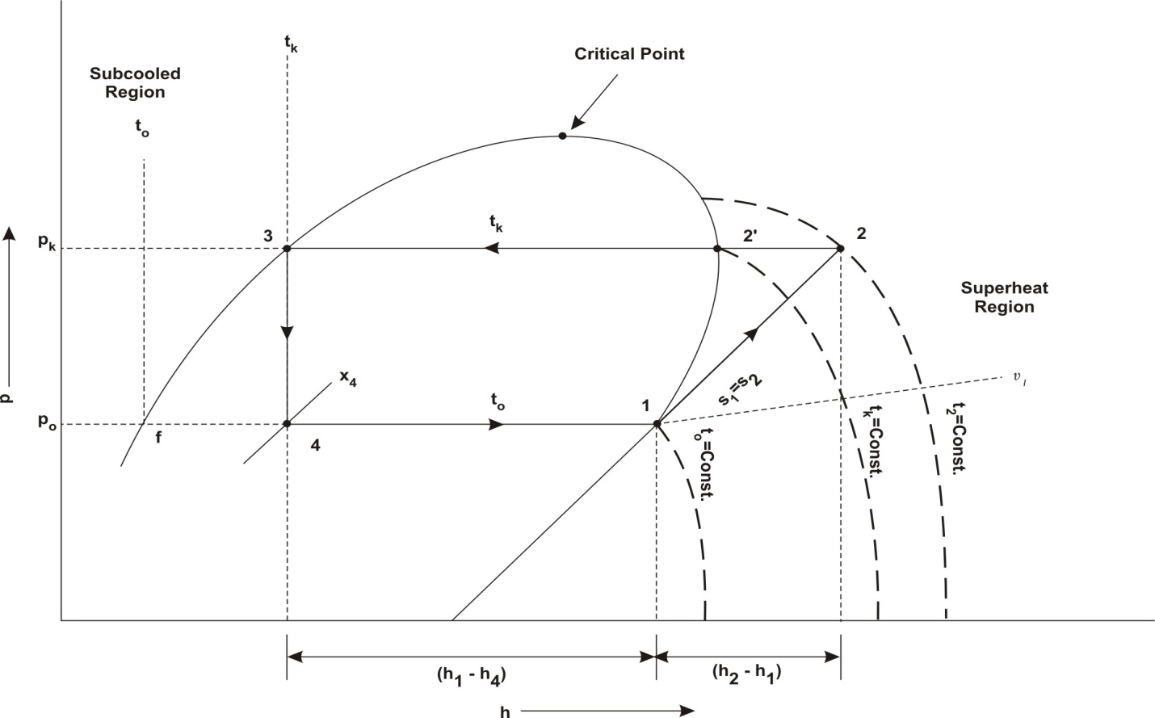
Fig. 3.2 Vapour Compression cycle on p-h diagram
The cycle described and shown in Figs. 3.2 a simple saturation cycle implying that both the states of liquid after condensation and vapour after evaporation, are saturated and lie on the saturated liquid and saturated vapour curves respectively. The condensation temperature t_{k} and evaporator temperature t_{o}, corresponding to the respective saturation pressures p_{k} and p_{o}, are also called saturated discharge temperature and saturated suction temperature respectively. However, the actual discharge temperature from the compressor is t₂.
Figure also shows constant temperature lines in the subcooled and superheat regions along with constant volume lines. It may be noted that constant temperature lines in the subcooled liquid and low pressure vapour regions are vertical as the enthalpy of the liquid and the ideal gas are functions of temperature only and do not depend on pressure.
Further calculations of the cycle can be done as follows :
Heat rejected q_{k} = q_{o} + w = h₂ – h₃
COP for cooling, (3.5)
COP for heating, (3.6)
Refrigerant circulation rate, m =
(3.7)
Specific volume of the vapour at suction = v₁
Theoretal piston displacement of the compressor or volume of the suction vapour,
V = mv₁ (3.8)
Actual piston displacement of the compressor,
where is the volumetric efficiency.
Power consumption, W = mw = m(h₂ – h₁) (3.9)
Heat rejected in the condenser, Q_{k} = mq_{k} = m(h₂ – h₃) (3.10)
Expressing the power consumption per ton of refrigeration as unit power consumption, denoted by W, we have for mass flow rate and power consumption per ton refrigeration,
(3.11)
It will be seen that
Similarly, the suction volume requirement per ton is
(3.12)
The isentropic discharge temperature t₂ may be found by the following three methods.
- Graphically from p-h diagram by drawing the isentropic from point 1 to p_{k} = constant line, or by iteration, finding t₂ corresponding to s₂ = s₁

- Using saturation properties and the specific heat of vapour
(3.13)
where
- Using superheat tables and interpolating for the degree of superheat (T₂ – T'₂) corresponding to the entropy difference (s₂ – s'₂) which is known.

3.2 ENERGY ANALYSIS OF VAPOR- COMPRESSION REFRIGERATION CYCLE
A vapor-compression refrigeration cycle consists of a number of flow processes as mentioned above and can be analyzed by applying steady state flow according to the first law of thermodynamics, as applied to each of the four components individually (Figure 3.2), since energy must be conserved by each component of the system is as follows (with the assumption that the changes in kinetic and potential energies are negligible)
For Compressor:
$${\overset{\text{.}}{E}}_{\text{in}}={\overset{\text{.}}{E}}_{\text{out}}$$
$$\overset{\text{.}}{m}h_{1}+\overset{\text{.}}{W}=\overset{\text{.}}{m}h_{2}$$
$\overset{\text{.}}{W}=\overset{\text{.}}{m}(h_{2}−h_{1})$ (3.14)
where $\overset{\text{.}}{m}$ is mass flow rate of refrigerant, kg/s; h is enthalpy, KJ/Kg; and $\overset{\text{.}}{W}$ is compressor power in put, kW.
For condenser :
$\overset{\text{.}}{m}h_{2}=\overset{\text{.}}{m}h_{3}+{\overset{\text{.}}{Q}}_{H}$
${\overset{\text{.}}{Q}}_{H}=\overset{\text{.}}{m}(h_{2}−h_{3})$ (3.15)
where ${\overset{\text{.}}{Q}}_{H}$ is the heat rejection from the condenser to the high- temperature environment.
For expansion valve:
$\overset{\text{.}}{m}h_{3}=\overset{\text{.}}{m}h_{4}$
h₃ = h₄ (3.16)
Figure 3.2 shows an ideal vapor- compression refrigeration system for analysis and its temperature- entropy diagram.
For evaporator
$\overset{\text{.}}{m}h_{4}+{\overset{\text{.}}{Q}}_{L}=\overset{\text{.}}{m}h_{1}$
${\overset{\text{.}}{Q}}_{L}=\overset{\text{.}}{m}(h_{1}−h_{4})$ (3.17)
where ${\overset{\text{.}}{Q}}_{L}$ is the heat taken from the low- temperature environment to the evaporator.
For the entire refrigeration system, the energy balance can be written as
$\overset{\text{.}}{W}+{\overset{\text{.}}{Q}}_{L}={\overset{\text{.}}{Q}}_{H}$ (3.18)
The coefficient of performance (COP) of the refrigeration system becomes
$\text{COP}=\frac{{\overset{\text{.}}{Q}}_{L}}{\overset{\text{.}}{W}}$ (3.19)
The isentropic efficiency of an adiabatic compressor is defined as
$η_{\text{Comp}}=\frac{{\overset{\text{.}}{W}}_{\text{isen}}}{\overset{\text{.}}{W}}=\frac{h_{2S}−h_{1}}{h_{2}−h_{1}}$ (3.20)
where h_{2S} is the enthalpy of the refrigerant at the turbine exit, if the compression process is isentropic (i.e., reversible and adiabatic).
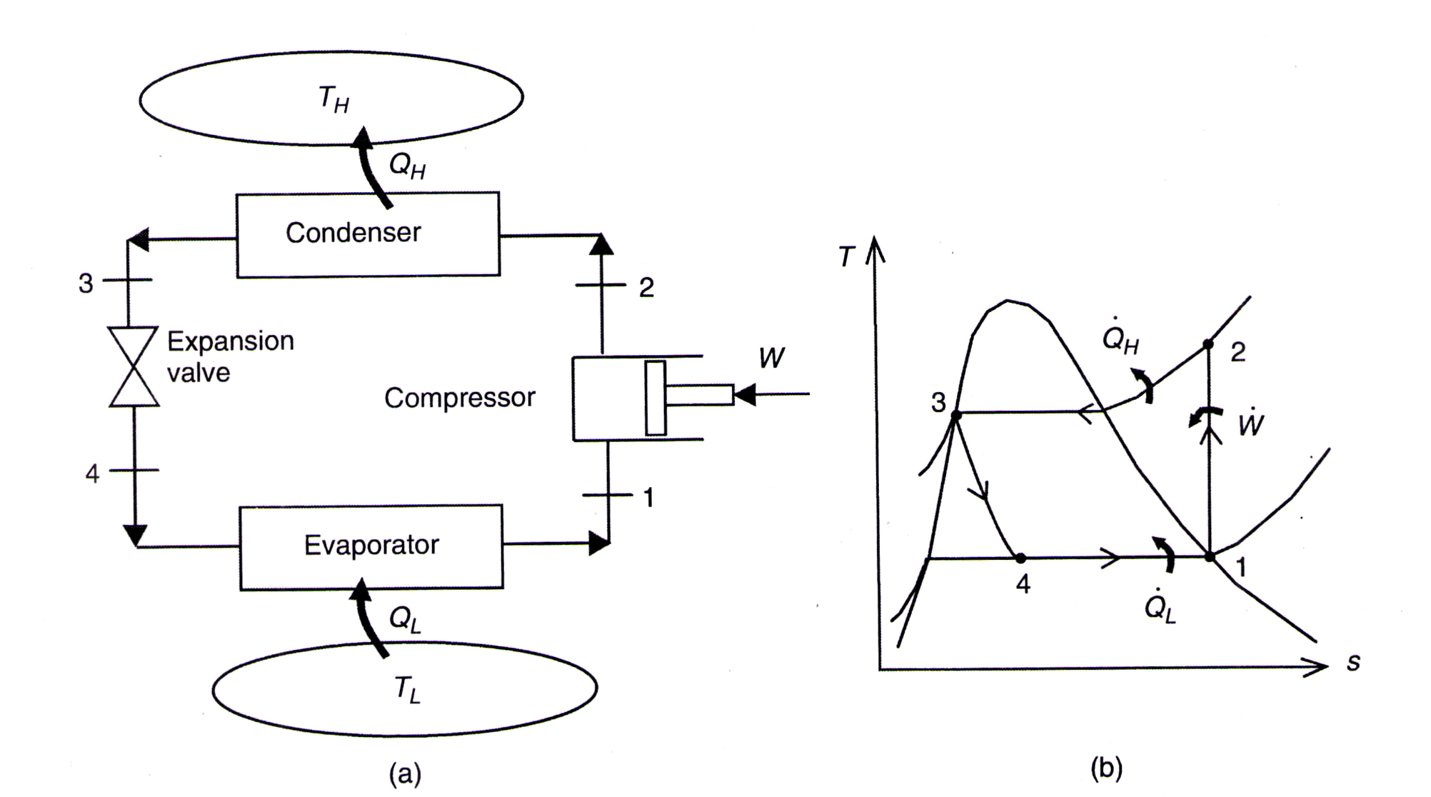
Fig. 3.2.1 : An ideal vapor compression refrigeration system for analysis and its temperature entropy diagram.
The temperature - entropy diagram of an ideal vapor- compression refrigeration cycle is given in Figure 3.2. In this cycle, the refrigerant enters the compressor as a saturated vapor. It is compressed isentropically in a compressor; it is cooled and condensed at constant pressure by rejecting heat to a high-temperature medium until it exists as a saturated vapor at the exit of the condenser. The refrigerant is expanded in an expansion valve, during which the enthalpy remains constant; it is evaporated in the evaporator at constant pressure by absorbing heat from the refrigerated space and it leaves the evaporator as a saturated vapor.
Note that in the energy analysis of this kind of vapor- compression system, it is required to obtain the enthalpy values. Three practical methods are available :
- using log P-h (pressure- enthalpy) diagrams, which provide the thermodynamic properties of the refrigerants,
- using the tabulated numerical values of the thermodynamic properties of the refrigerants, and
- using known values of the latent heats and specific heats of the refrigerants and making use of the fact that areas on the T-s diagrams represent heat quantities.

3.3 EXERGY ANALYSIS OF VAPOR- COMPRESSION REFRIGERATION CYCLE
Figure 3.2 is a schematic of a vapor-compression refrigeration cycle operating between a low temperature medium (T_{L}) and a high-temperature medium (T_{H}). The maximum COP of a refrigeration cycle operating between temperature limits of T_{L} and T_{H} based on the Carnot refrigeration cycle was given as
${\text{COP}}_{\text{Carnot}}=\frac{T_{L}}{T_{H}−T_{L}}=\frac{1}{{T_{H}}/{T_{L}}−1}$ (3.21)
Practical refrigeration systems are not as efficient as ideal models like the Carnot cycle, because of the lower COP due to irreversibilities in the system. As a result of Equation 3.21, a smaller temperature difference between the heat sink and the heat source (T_{H}- T_{L}) provides greater refrigeration system efficiency (i.e., COP). The Carnot cycle has certain limitations, because it represents the cycle of the maximum theoretical performance.
The aim in an exergy analysis is usually to determine the exergy destructions in each component of the system and to determine exergy efficiencies. The components with greater exergy destructions are also those with more potential for improvements. Exergy destruction in a component can be determined from an exergy balance on the component. It can also be determined by first calculating the entropy generation and using.
$\overset{\text{.}}{E}x_{\text{dest}}=T_{0}{\overset{\text{.}}{S}}_{\text{gen}}$ (3.22)
where T₀ is the dead- state temperature or environment temperature. In a refrigerator, T₀ is usually equal to the temperature of the high-temperature medium T_{H}. Exergy destructions and exergy efficiencies for major components of the cycle are as follows (state numbers refer to Figure 3.2) :

Compressor :
$\overset{\text{.}}{E}x_{\text{in}}−\overset{\text{.}}{E}x_{\text{out}}−\overset{\text{.}}{E}x_{\text{dest},1−2}=0$
$\overset{\text{.}}{E}x_{\text{dest},1−2}=\overset{\text{.}}{E}x_{\text{in}}−\overset{\text{.}}{E}x_{\text{out}}$ (3.23)
$\overset{\text{.}}{E}x_{\text{dest},1−2}=\overset{\text{.}}{W}+\overset{\text{.}}{E}x_{1}−\overset{\text{.}}{E}x_{2}$
$=\overset{\text{.}}{W}−Δ\overset{\text{.}}{E}x_{\text{12}}=\overset{\text{.}}{W}−\overset{\text{.}}{m}[h_{2}−h_{1}−T_{0}(s_{2}−s_{1})]=\overset{\text{.}}{W}−{\overset{\text{.}}{W}}_{\text{rev}}$
or $\overset{\text{.}}{E}x_{\text{deest},1−2}=T_{0}{\overset{\text{.}}{S}}_{\text{gen},1−2}=\overset{\text{.}}{m}T_{0}(s_{2}−s_{1})$ (3.24)
$η_{\text{ex},\text{Comp}}=\frac{{\overset{\text{.}}{W}}_{\text{rev}}}{\overset{\text{.}}{W}}=1−\frac{\overset{\text{.}}{E}x_{\text{dest},1−2}}{\overset{\text{.}}{W}}$ (3.25)
Condenser :
$\overset{\text{.}}{E}x_{\text{dest},2−3}=\overset{\text{.}}{E}x_{\text{in}}−\overset{\text{.}}{E}x_{\text{out}}$
$\overset{\text{.}}{E}x_{\text{dest},2−3}=(\overset{\text{.}}{E}x_{2}−\overset{\text{.}}{E}x_{3})−\overset{\text{.}}{E}x_{\overset{\text{.}}{Q}H}$ (3.26)
$=\overset{\text{.}}{m}[h_{2}−h_{3}−T_{0}(s_{2}−s_{3})]−{\overset{\text{.}}{Q}}_{H}\left(1−\frac{T_{0}}{T_{H}}\right)$
or $\overset{\text{.}}{E}x_{\text{dest},2−3}=T_{0}{\overset{\text{.}}{S}}_{\text{gen},2−3}=\overset{\text{.}}{m}T_{0}\left(s_{3}−s_{2}+\frac{q_{H}}{T_{H}}\right)$ (3.27)
$η_{\text{ex},\text{Cond}}=\frac{\overset{\text{.}}{E}x_{\overset{\text{.}\text{.}}{Q}H}}{\overset{\text{.}}{E}x_{2}−\overset{\text{.}}{E}x_{3}}=\frac{{\overset{\text{.}}{Q}}_{H}\left(1−\frac{T_{0}}{T_{H}}\right)}{\overset{\text{.}}{m}[h_{2}−h_{3}−T_{0}(s_{2}−s_{3})]}=1−\frac{\overset{\text{.}}{E}x_{\text{dest},2−3}}{\overset{\text{.}}{E}x_{2}−\overset{\text{.}}{E}x_{3}}$ (3.28)
Expansion valve : $\overset{\text{.}}{E}x_{\text{dest},3−4}=\overset{\text{.}}{E}x_{\text{in}}−\overset{\text{.}}{E}x_{\text{out}}$
$=\overset{\text{.}}{E}x_{\text{dest},3−4}=\overset{\text{.}}{E}x_{3}−\overset{\text{.}}{E}x_{4}=\overset{\text{.}}{m}[h_{3}−h_{4}−T_{0}(s_{3}−s_{4})]$ (3.29)
Or $\overset{\text{.}}{E}x_{\text{dest},3−4}=T_{0}{\overset{\text{.}}{S}}_{\text{gen},3−4}=\overset{\text{.}}{m}T_{0}(s_{4}−s_{3})]$ (3.30)
$η_{\text{ex},\text{ExpValve}}=1−\frac{\overset{\text{.}}{E}x_{\text{dest},3−4}}{\overset{\text{.}}{E}x_{3}−\overset{\text{.}}{E}x_{4}}=1−\frac{\overset{\text{.}}{E}x_{3}−\overset{\text{.}}{E}x_{4}}{\overset{\text{.}}{E}x_{3}−\overset{\text{.}}{E}x_{4}}$ (3.31)
Evaporator :
$\overset{\text{.}}{E}x_{\text{dest},4−1}=\overset{\text{.}}{E}x_{\text{in}}−\overset{\text{.}}{E}x_{\text{out}}$
$\overset{\text{.}}{E}x_{\text{dest},4−1}=\overset{\text{.}}{E}x_{\overset{\text{.}}{Q}L}+\overset{\text{.}}{E}x_{4}−\overset{\text{.}}{E}x_{1}$
$\overset{\text{.}}{E}x_{\text{dest},4−1}=(\overset{\text{.}}{E}x_{4}−\overset{\text{.}}{E}x_{1})−\overset{\text{.}}{E}x_{\overset{\text{.}}{Q}L}$ (3.32)
$=\overset{\text{.}}{m[h_{4}−h_{1}−T_{0}(s_{4}−s_{1})]−}\left[−{\overset{\text{.}}{Q}}_{L}\left(1−\frac{T_{0}}{T_{L}}\right)\right]$
$\overset{\text{.}}{E}x_{\text{dest},4−1}=T_{0}{\overset{\text{.}}{S}}_{\text{gen},4−1}=\overset{\text{.}}{m}T_{0}\left(s_{1}−s_{4}−\frac{q_{L}}{T_{L}}\right)$ (3.33)
$η_{\text{ex},\text{Evap}}=\frac{\overset{\text{.}}{E}x_{\overset{\text{.}\text{.}}{Q}L}}{\overset{\text{.}}{E}x_{1}−\overset{\text{.}}{E}x_{4}}=\frac{−{\overset{\text{.}}{Q}}_{L}\left(1−\frac{T_{0}}{T_{L}}\right)}{\overset{\text{.}}{m}[h_{1}−h_{4}−T_{0}(s_{1}−s_{4})]}=1−\frac{\overset{\text{.}}{E}x_{\text{dest},4−1}}{\overset{\text{.}}{E}x_{1}−\overset{\text{.}}{E}x_{4}}$ (3.34)
The total exergy destruction in the cycle can be determined by adding exergy destructions in each component :
$\overset{\text{.}}{E}x_{\text{dest},\text{total}}=\overset{\text{.}}{E}x_{\text{dest},1−2}+\overset{\text{.}}{E}x_{\text{dest},2−3}+\overset{\text{.}}{E}x_{\text{dest},3−4}+\overset{\text{.}}{E}x_{\text{dest},4−1}$ (3.35)
It can be shown that the total exergy destruction in the cycle can also be expressed as the difference between the exergy supplied (power input) and the exergy recovered (the exergy of the heat transferred from the low- temperature medium):
$\overset{\text{.}}{E}x_{\text{dest},\text{total}}=\overset{\text{.}}{W}−\overset{\text{.}}{E}x_{\overset{\text{.}}{Q}L}$ (3.36)
where the exergy of the heat transferred from the low temperature medium is given by
$=\overset{\text{.}}{\overset{\text{.}}{E}x\overset{\text{.}}{Q}L=}\overset{\text{.}}{Q}L\left(1−\frac{T_{0}}{T_{L}}\right)$ (3.37)
The minus sign in needed to make the result positive. Note that the exergy of the heat transferred from the low- temperature medium is in fact the minimum power input to accomplish the required refrigeration load $\overset{\text{.}}{\text{QL}}$ :
${\overset{\text{.}}{W}}_{\text{min}}=\overset{\text{.}}{E}x_{\overset{\text{.}}{Q}L}$ (3.38)
The second- law efficiency (or exergy efficiency) of the cycle is defined as
$η_{Π}=\frac{\overset{\text{.}}{E}x_{\overset{\text{.}\text{.}}{Q}L}}{\overset{\text{.}}{W}}=\frac{{\overset{\text{.}}{W}}_{\text{min}}}{\overset{\text{.}}{W}}=1−\frac{\overset{\text{.}}{E}x_{\text{dest},\text{total}}}{\overset{\text{.}}{W}}$ (3.39) Substituting $\overset{\text{.}}{W}=\frac{{\overset{\text{.}}{Q}}_{L}}{\text{COP}}$ and $\overset{\text{.}}{E}x_{\overset{\text{.}}{Q}L}={\overset{\text{.}}{Q}}_{L}\left(1−\frac{T_{0}}{T_{L}}\right)$ into the second- law efficiency relation
$η_{Π}=\frac{\overset{\text{.}}{E}x_{\overset{\text{.}\text{.}}{Q}L}}{\overset{\text{.}}{W}}=\frac{−{\overset{\text{.}}{Q}}_{L}\left(1−\frac{T_{0}}{T_{L}}\right)}{\frac{\overset{\text{.}}{\text{QL}}}{\text{COP}}}=−\overset{\text{.}}{\text{QL}}\left(1−\frac{T_{0}}{T_{L}}\right)\frac{\overset{\text{.}}{\text{COP}}}{\overset{\text{.}}{\text{QL}}}=\frac{\text{COP}}{\frac{T_{L}}{T_{H}−T_{L}}}=\frac{\text{COP}}{{\text{COP}}_{\text{Carnot}}}$ (3.40)
since T₀ = T_{H.} Thus, the second- law efficiency is also equal to the ratio of actual and maximum COPs for the cycle. This second-law efficiency definition accounts for irreversibilities within the refrigerator since heat transfers with the high - and low- temperature reservoirs are assumed to be reversible.
3.4 THREE STAGE CASCADE VAPOUR COMPRESSION REFRIGERATION SYSTEM
A schematic layout and T-S plot of three stage cascade system using three refrigerants as shown in Fig. 3.3 and 3.4 . The compressed refrigerant vapour from the lower stage is condensed in a heat exchanger, usually called cascade condenser or cascade heat exchanger, which is also the evaporator of the next higher stage refrigerant. The only useful refrigerating effect is produced in the evaporator of low temperature cascade system. The high temperature and low temperature cycle uses a refrigerant with high boiling temperature and low boiling temperature respectively. Medium temperature circuit refrigerant is having the boiling temperature in between of other two refrigerants.
The lubricant selected for the low side of the cascade must be compatible with the specific refrigerant employed and also suitable for the low temperatures expected in the evaporator. It is important that adequate coalescing oil separation (5 ppm) is provided to minimize oil carryover from the compressor to the evaporator.
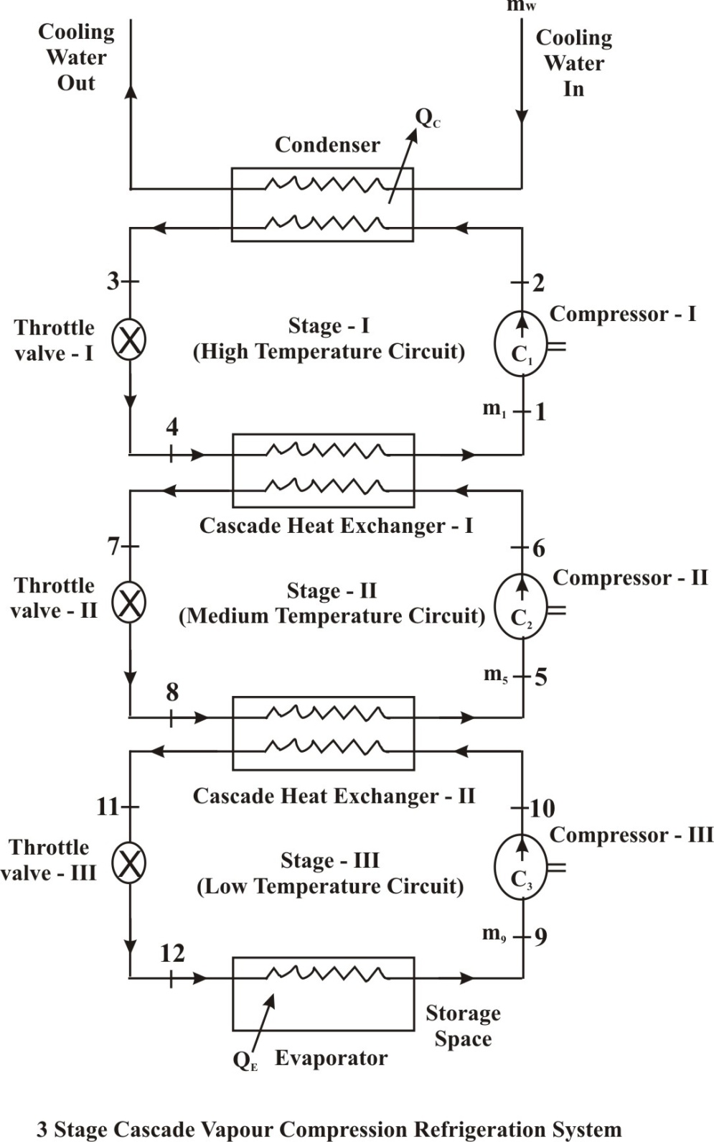

Fig 3.3 Systematic diagram of three stage vapour compression
Refrigeration system

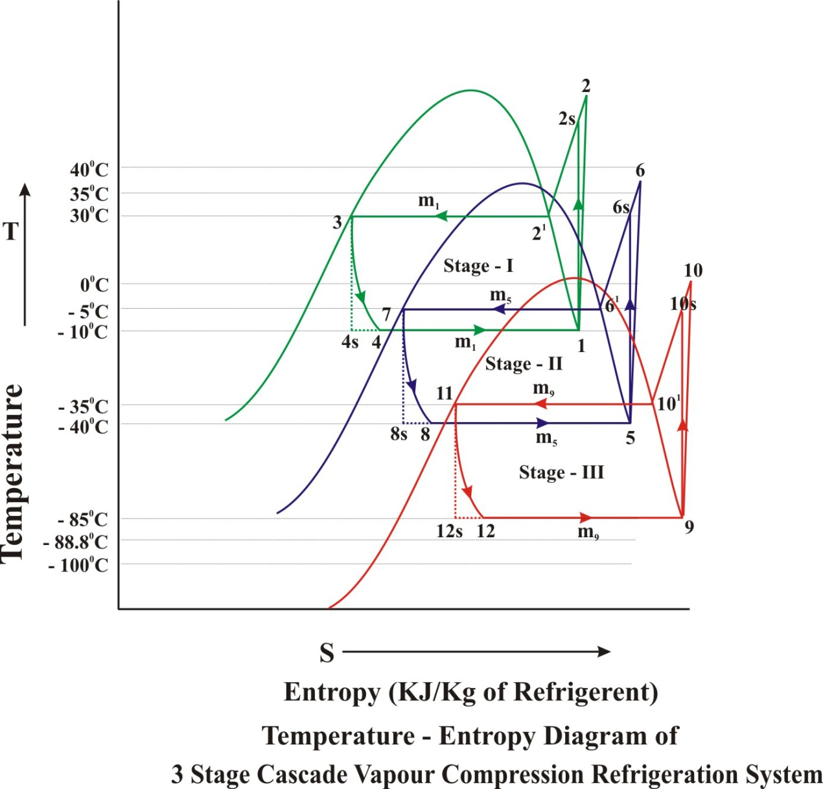

Fig 3.4 Systematic T-S diagram of three stage vapour compression
Refrigeration system

Details of Process occurring in this system are given below
Stage-I (High temperature circuit)
i) Process 1-2 and 1-2s – Actual and Isentropic compression process in compressor-I
ii) Process 2-3 – Isobaric heat rejection in condenser
iii) Process 3-4 & 3-4s – Actual and isentropic expansion in expansion value-I
iv) Process 4-1 & 4s-1 – Isobaric actual & isentropic heat addition in evaporator of stage-I or cascade heat exchanger-I
Stage-II(Medium Temperature Circuit)
i) Process 5-6 & 5-6s – Actual & Isentropic compression Process in compressor-II
ii) Process 6-7 – Isobaric heat rejection in condenser of medium temperature circuit i.e. cascade heat exchange-I
iii) Process 7-8 & 7-8s – Actual & isentropic expansion of refrigerant in expansion value -II
iv) Process 8-5 – Heat addition in evaporator of medium temperature circuit in cascade heat exchange-II
Stage-III (Low Temperature Circuit)
i) Process 9-10 & 9-10s – Actual & Isentropic compression in compressor-III
ii) Process 10-11 – Isobaric actual heat rejection in condenser of low temperature circuit in cascade heat exchange-II
iii) Process 11-12 &11-12s – Actual & Isentropic expansion of refrigerant in expansion value-III
iv) Process 12-9 &12_{s}-9 – Actual & Isentropic heat addition in evaporator of low temperature circuit
3.5 THERMODYNAMIC ANALYSIS OF A THREE STAGE CASCADE REFRIGERATION SYSTEM
The cycle is modeled modularly incorporating each individual process of the cycle. Steady flow energy equation and mass balance equation has been employed.
For simplify the calculation, the thermodynamic analysis of a three-stage cascade refrigeration system was conducted based on the following general assumptions.
1. Non-isentropic compression is expressed as a function of the pressure ratio. The combined motor and mechanical efficiency of each compressor is assumed to be 0.85 [3].
2. Negligible pressure and heat losses/gains in the pipe networks or system components.
3. Isenthalpic expansion across expansion valves.
4. Heat transfer process in heat exchanger is isobaric.
5. Heat transfer in cascade heat exchanger with the ambient is negligible.
6. Negligible changes in kinetic and potential energy.
7. The dead state conditions are 30ºC and 101.3 kPa.
8. Maximum difference between the refrigerated space temperature (TF) and the evaporating temperature (TE) is 5ºC.
9. System cooling capacity is 10 Ton of Refrigeration.
Based on the above assumptions, balance equations are applied to find the mass flow rate of each cycle, the work input to the compressor, the heat transfer rates of the condenser and the cascade-condenser, the entropy generation rate and the exergy destruction rate as follows:
Mass balance
$\sum_{\text{in}}{\overset{\text{.}}{m}} = \sum_{\text{out}}{\overset{\text{.}}{m}}$ (3.41)
Energy balance
$\overset{\text{.}}{Q}−\overset{\text{.}}{W}=\underset{\text{out}}{Σ}\overset{\text{.}}{m}\text{.}h\text{.}—\underset{\text{in}}{Σ}\overset{\text{.}}{m}\text{.}h$ (3.42)
Exergy balance
$\overset{\text{.}}{X_{\text{des}}=\underset{\text{out}}{Σ}}\left(1−\frac{T_{o}}{T_{j}}\right)\text{.}\overset{\text{.}}{Q}j−\overset{\text{.}}{W}+\underset{\text{in}}{Σ}\overset{}{m\text{.}Ψ−}\underset{\text{out}}{Σ}\overset{\text{.}}{m}\text{.}Ψ$ (3.43)
Specific equations for each system's components are summarized in table – 3.1
The cycle is modeled modularly incorporating each individual process of the cycle. Steady flow energy equation and mass balance equation has been employed. The following assumptions has been considered to simplify the calculation,
1. Heat transfer in cascade heat exchanger with the ambient is negligible.
2. The compressor process in the compressor is adiabatic and irreversible.
3. The expansion process is isenthalpic
4. Pressure drop in the connecting pipes and heat exchangers are negligible.
5. Heat transfer process in heat exchanger is isobaric.
Table – 3.1
Balance equations for each system components
Component | Mass | Energy | Exergy
High temperature Circuit
Compressor | m₁ = m₂ | $${\overset{\text{.}}{W}}_{H}=\frac{\overset{\text{.}}{m_{1}}\left(h_{2s}−h_{1}\right)}{h_{m,H}}$$ | $${\overset{\text{.}}{X}}_{\text{des}}={\overset{\text{.}}{W}}_{H}−{\overset{\text{.}}{m}}_{1}\left(Ψ_{2^{1}}−Ψ_{1}\right)$$
Condenser | $${\overset{\text{.}}{m}}_{3}={\overset{\text{.}}{m}}_{2}$$ | $${\overset{\text{.}}{Q}}_{e}={\overset{\text{.}}{m}}_{2}\left(h_{3}−h_{2}\right)$$ | $${\overset{\text{.}}{X}}_{\text{des}}={\overset{\text{.}}{m}}_{2}\left(Ψ_{2}−Ψ_{3}\right)$$
Expansion device | $${\overset{\text{.}}{m}}_{4}={\overset{\text{.}}{m}}_{3}$$ | h₃ = h₄ | $${\overset{\text{.}}{X}}_{\text{des}}={\overset{\text{.}}{m}}_{3}\left(Ψ_{3}−Ψ_{4}\right)$$
Cascade Heat exchange - I | $$\begin{aligned}{\overset{\text{.}}{m}}_{1}={\overset{\text{.}}{m}}_{4}, \\ {\overset{\text{.}}{m}}_{6}={\overset{\text{.}}{m}}_{7}\end{aligned}$$ | $${\overset{\text{.}}{Q}}_{\text{Cas}−I}={\overset{\text{.}}{m}}_{4}\left(h_{1}−h_{4}\right)={\overset{\text{.}}{m}}_{6}\left(h_{7}−h_{6}\right)$$ | $${\overset{\text{.}}{X}}_{\text{des}}={\overset{\text{.}}{m}}_{4}\left(Ψ_{4}−Ψ_{3}\right)$$  $$={\overset{\text{.}}{m}}_{6}\left(Ψ_{6}−Ψ_{7}\right)$$
Medium temperature Circuit
Compressor | $${\overset{\text{.}}{m}}_{5}={\overset{\text{.}}{m}}_{6}$$ | $${\overset{\text{.}}{W}}_{M}=\frac{{\overset{\text{.}}{m}}_{5}\left(h_{6S}−h_{5}\right)}{h_{m\text{.}M}}$$ | $${\overset{\text{.}}{X}}_{\text{des}}={\overset{\text{.}}{W}}_{m}−\left(Ψ_{6}−Ψ_{5}\right)$$
Expension device | $${\overset{\text{.}}{m}}_{7}={\overset{\text{.}}{m}}_{8}$$ | h₇ = h₈ | $${\overset{\text{.}}{X}}_{\text{des}}={\overset{\text{.}}{m}}_{8}\left(Ψ_{7}−Ψ_{8}\right)$$
Cascade Heat exchange - II | $$\begin{aligned}{\overset{\text{.}}{m}}_{5}={\overset{\text{.}}{m}}_{8}, \\ {\overset{\text{.}}{m}}_{\text{10}}={\overset{\text{.}}{m}}_{\text{11}}\end{aligned}$$ | $${\overset{\text{.}}{Q}}_{\text{Cas}\text{.}\text{II}}={\overset{\text{.}}{m}}_{5}\left(h_{5}−h_{8}\right)={\overset{\text{.}}{m}}_{\text{10}}\left(h_{\text{11}}−h_{\text{10}}\right)$$ | $${\overset{\text{.}}{X}}_{\text{des}}={\overset{\text{.}}{m}}_{5}\left(Ψ_{8}−Ψ_{5}\right)$$  $$={\overset{\text{.}}{m}}_{\text{10}}\left(Ψ_{\text{10}}−Ψ_{\text{11}}\right)$$
Low temperature Circuit
Compressor | $${\overset{\text{.}}{m}}_{9}={\overset{\text{.}}{m}}_{\text{10}}$$ | $${\overset{\text{.}}{W}}_{L}=\frac{{\overset{\text{.}}{m}}_{9}\left(h_{\text{10}s}−h_{9}\right)}{h_{m\text{.}L}}$$ | $${\overset{\text{.}}{X}}_{\text{des}}={\overset{\text{.}}{W}}_{L}−{\overset{\text{.}}{m}}_{9}\left(Ψ_{\text{10}}−Ψ_{9}\right)$$
Expension device | $${\overset{\text{.}}{m}}_{\text{11}}={\overset{\text{.}}{m}}_{\text{12}}$$ | h₁₁ = h₁₂ | $${\overset{\text{.}}{X}}_{\text{des}}={\overset{\text{.}}{m}}_{\text{11}}\left(Ψ_{\text{11}}−Ψ_{\text{12}}\right)$$
Evaporator | $${\overset{\text{.}}{m}}_{9}={\overset{\text{.}}{m}}_{\text{12}}$$ | $${\overset{\text{.}}{Q}}_{E}={\overset{\text{.}}{m}}_{9}\left(h_{9}−h_{\text{12}}\right)$$ | $${\overset{\text{.}}{X}}_{\text{des}}=\overset{\text{.}}{\left(1−\frac{T_{o}}{T_{E}}\right)}{\overset{\text{.}}{Q}}_{E}={\overset{\text{.}}{m}}_{9}\left(Ψ_{\text{12}}−Ψ_{9}\right)$$
The system's coefficient of performance (COP) has been calculated by the following equation $\text{COP}=\frac{\overset{\text{.}}{Q_{E}}}{{\overset{\text{.}}{W}}_{H}+{\overset{\text{.}}{W}}_{M}+{\overset{\text{.}}{W}}_{L}}$ (3.44)
The COP of the high temperature circuit has been calculated by the following equation
${\text{COP}}_{H}=\frac{\overset{\text{.}}{Q_{\text{Cas}−I}}}{{\overset{\text{.}}{W}}_{H}}$ (3.45)
for the medium temperature circuit
${\text{COP}}_{M}=\frac{\overset{\text{.}}{Q_{\text{Cas}−\text{II}}}}{{\overset{\text{.}}{W}}_{M}}$ (3.46)
for the low temperature circuit
${\text{COP}}_{L}=\frac{\overset{\text{.}}{Q_{E}}}{{\overset{\text{.}}{W}}_{L}}$ (3.47)
The second law efficiency of the whole system is the ratio of the actual COP to the ideal COP_{carnot}, which is
$h_{Π}=\frac{\text{COP}}{{\text{COP}}_{\text{carnot}}}$ (3.48)
Where ${\text{COP}}_{\text{Carnot}}=\frac{T_{E}}{T_{C}−T_{E}}$ (3.49)
Where T_{E} - evaporating temperature (⁰K), T_{C} = condenser Temperature (⁰K)
The rate of heat transfer in the cascade Heat exchange is determined by
For Cascade Heat Excharger - I
${\overset{\text{.}}{Q}}_{\text{Cas}−I}={\overset{\text{.}}{m}}_{4}(h_{1}−h_{4})={\overset{\text{.}}{m}}_{6}(h_{6}−h_{7})$
$={\overset{\text{.}}{m}}_{1}(h_{1}−h_{4})={\overset{\text{.}}{m}}_{5}(h_{6}−h_{7})$ (3.50)
For Cascade Heat Excharger - II ${\overset{\text{.}}{Q}}_{\text{Cas}−\text{II}}={\overset{\text{.}}{m}}_{5}(h_{5}−h_{8})={\overset{\text{.}}{m}}_{\text{10}}(h_{\text{10}}−h_{\text{11}})$
$={\overset{\text{.}}{m}}_{5}(h_{5}−h_{8})={\overset{\text{.}}{m}}_{9}(h_{\text{10}}−h_{\text{11}})$ (3.51)

The equations of the mathematical model reveal that both the system's COP & its energetic efficiency can be expressed as a function of seven design/operating parameters as shown in the equation.
$\text{COP},η_{Π}=f\left(T_{E},T_{C},T_{\text{Cas}−I},T_{\text{Cas}−\text{II}},\text{DT}\text{.}h_{s}\right)$ (3.52)
For calculating of the Thermodynamic properties of the refrigerant at a specific State point during the cycle, REFPROP-6 software has been used. For the shake of simplicity the equation of the State point is given in Table – 3.2.
Table- 3.2
Calculation of thermo dynamic state points of cascade systems using REFPROP- 6
Evaporator outlet | Compressor outlet | Condenser outlet | Expansion device outlet
High temperature Circuit
P₁ = f(T_{cas.E-I}, x =1) | P₂ = P₃ | P₃ = f(TC, X = 0) | P₄ = P₁
T₁ = T_{Cas.E-I} | T₂ = f (P₂, S₁) | T₃ = T_{C} | T₄ = T_{cas.E-I}
H₁ = f (T₁, P₁) | h_{2s} = f(P₂, S₁) | h₃ = f (T₃, P₃) | h₄ = h₃
S₁ = f(T₁, P₁) | $$h_{2}=\frac{\left(h_{2s}−h_{1}\right)}{h_{\text{isent}−I}}+h_{1}$$ | S₃ = f (T₃.P₃) | S₄ = f(P₁, h₄)
Medium Temperature Circuit
P₅ = f(T_{Cas.E-II}, X = 1) | P₆ = P₇ | P₇ = f (T_{case-II}, X = 0) | P₈ = P₅
T₅ = T_{Cas.E-II} | T₆ = f(P₆,S₅) | T₇ = T₁ - DT  = T_{Cas.C-I} | T₈ = T_{Cas.E-II}
h₅ = f (T₅, P₅) | h_{6s} = f(P₆, S₅) | h₇ = f(T₇, P₇) | h₈ = h₇
S₅ = f(T₅, P₅) | $$h_{6}=\frac{\left(h_{6s}−h_{5}\right)}{h_{\text{isent}−\text{II}}}+h_{5}$$ | S₇ = f(T₇, P₇) | S₈ = f(P₅, h₈)
Low temperature circuit
P₉ = f(TE, X = 1) | P₁₀ = P₁₁ | P₁₁ = f(T_{Cas.C-II},  X = 0) | P₁₂ = P₉
T₉ = TE | T₁₀ = f(T₁₀, S₉) | T₁₁ = T₅ - DT = T_{Cas.C-II}) | T₁₂ = T_{E}
h₉ = f(T₉, P₉) | h_{10s} = f(T₁₀, S₉) | h₁₀ = f (T₁₀, P₁₀) | h₁₂ = h₁₁
S₉ = f(T₁, P₁) | $$h_{\text{10}}=\frac{\left(h_{\text{10}s}−h_{9}\right)}{h_{\text{isent}−\text{III}}}+h_{9}$$ | S₁₀ = f(T₁₀, P₁₀) | S₁₂ = f(P₉, h₁₂)

The mass flow ratio can be derived from equations 9 & 10
$\frac{\overset{\text{.}}{m_{1}}}{\overset{\text{.}}{m_{5}}}=\left(\frac{\left(h_{6}−h_{7}\right)}{\left(h_{1}−h_{4}\right)}\right)$ (3.53)
$\frac{\overset{\text{.}}{m_{5}}}{\overset{\text{.}}{m_{9}}}=\left(\frac{\left(h_{\text{10}}−h_{\text{11}}\right)}{\left(h_{5}−h_{8}\right)}\right)$ (3.54)
The isentropic efficiency of each compressor is considered to be equal to the volumetric efficiency and it is estimated as given below.
Isothermal efficiency, $η_{T}=\frac{\text{Isothermal} \text{work}}{\text{Actual} \text{work}}$
Isentropic efficiency $η_{\text{isen}}=\frac{\text{Isentropic} \text{work}}{\text{Actual} \text{work}}$

So isentropic efficiency for compressor- I
$η_{\text{isen}}=\frac{h_{2s}−h_{1}}{h_{2}−h_{1}}$ [3.55(i)]
Similarly isentropic efficiency for compressor - II is given below
$η_{\text{isen}−\text{II}}=\frac{(h_{6s}−h_{5})}{(h_{6}−h_{5})}$ [3.55(ii)]
Similarly isentropic efficiency for compressor - III is given below
$η_{\text{isen}−\text{III}}=\frac{(h_{\text{10}s}−h_{9})}{(h_{\text{10}}−h_{9})}$ [3.55(iii)]
Volumetric efficiency of reciprocating compressor is find out by the equation given below
$η_{\text{Cv}}=1+C−C{\left(\frac{P_{2}}{P_{1}}\right)}^{1γ}$ (3.56)
Where C - Clearance factor = $\frac{V_{C}}{V_{P}}$
This factor is normally < 5%
or Isentropic efficiency of compressor can also be found out by equation
$η_{\text{cv}}=1−0\text{.}\text{04}\text{RC}$ (3.57)
Where RC - Compression ratio of compressor.
Taking 1 Tone of refrigeration = 3.5166 KJ/s = 211 KJ/Min
The mass flow rate of refrigerant
$\overset{\text{.}}{m}=\frac{\text{Cooling} \text{capacity} × 3\text{.}\text{5166}}{\text{Re}\text{frigeration} \text{effect} \text{per} \text{Kg} \text{of} \text{refrigerent}}$ (3.58)
Where Unit of mass flow rate is Kg/Sec
$\text{So} m_{3}=\frac{\text{10}\text{TR}×3\text{.}\text{5166}}{(h_{9}−h_{\text{12}})}$
OR $\frac{\text{10}\text{TR}×\text{211}}{\text{60}×(h_{9}−h_{\text{12}})}$ (3.59)
Assuming the volumetric efficiency of compressor 85%
So fo find out the Bore of cylinder(D) & stroke length (L) we use equation
$\frac{π}{4}D^{2} L N=\frac{m\text{.}ν}{η_{\text{Vol}}}$ (3.60)
where N is speed of compressor in Revolution per min.
$ν$ specific volume (m³/Kg) of refrigerant at the inlet of compressor.
Assuming L= 1.2 D
Taking ratio of Bore of cylinder & stroke length is 1.2.

