Exergy & Energy Analysis of Three Stage Cascade
Refrigeration System for Biomedical Application
using Natural Refrigerants

A Major Thesis Submitted in partial fulfillment of the
requirements for the award of the degree of

MASTER OF ENGINEERING
in
THERMAL ENGINEERING

By
RAHUL KUMAR
Roll no. 16/THR/08
(UNIVERSITY ROLL NO.14051)

Under the Guidance of
Prof.(Dr.) R.S. Mishra
Professor (Mechanical)

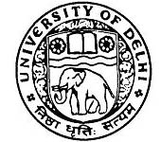

DEPARTMENT OF MECHANICAL ENGINEERING
DELHI COLLEGE OF ENGINEERING,
UNIVERSITY OF DELHI
Session 2008-11

