MAJOR PROJECT REPORT

“IDENTIFYING INHIBITORS OF PROTEASE OF CHIKUNGUNYA VIRUS”

SUBMITTED
IN PARTIAL FULFILLMENT FOR THE DEGREE OF

MASTER OF TECHNOLOGY
IN
BIOINFORMATICS



DEPARTMENT OF BIOTECHNOLOGY
DELHI TECHNOLOGICAL UNIVERSITY
(FORMERLY DELHI COLLEGE OF ENGINEERING)

By:
SONAM GABA
(16/BINF/2010)
BATCH: 2010-2012

Certificate

This is to certify that the project entitled –“IDENTIFYING INHIBITORS OF PROTEASE OF CHIKUNGUNYA VIRUS” has been carried out by Ms. Sonam Gaba at the Department of Biotechnology, Delhi Technological University, (formerly Delhi College of Engineering), Delhi in partial fulfillment for the degree of Master of Technology in Bioinformatics from Delhi Technological University, (formerly Delhi College of Engineering), Delhi.

Supervisor
Dr. Navneeta Bharadvaja Professor Sager Maji
Assistant Professor Head of the Department
Department of Biotechnology Department of Biotechnology
Delhi Technological University Delhi Technological University
ACKNOWLEGEMENT

I express my deep gratitude to DR. NAVNEETA BHARADVAJA ASSISTANT PROFESSOR, Department of Biotechnology, Delhi Technological University, who had confidence in me and helped me in realization of my aspiration to work.
I would like to thank my parents and my sister for supporting me and understanding me.

SONAM GABA
(16/BINF/2010)

DECLERATION

I hereby declare that the dissertation entitled “IDENTIFYING INHIBITORS OF PROTEASE OF CHIKUNGUNYA VIRUS” submitted for the partial fulfilment of the Master of Technology Degree in Bioinformatics is a record work done by me, during the period JANUARY 2012 TO JUNE 2012 and has not formed the basis for the award of any Degree or other similar titles under my University in India or Abroad.

SONAM GABA

TABLE OF CONTENTS

1 INTRODUCTION…………………………………………………………10-11

1.1 Chikungunya Virus

1.2 Viruses similar to Chikungunya

  - Non Structural Protease

2 OBJECTIVE……………………………………………………………….12

3 Literature Review…………………………………………………13-23

3.1 Alphavirus

3.2 Vectors

3.3 Genome

3.4 Distribution of the Disease

3.5 Cysteine Proteases

3.6 Inhibitors

3.7 Virtual Screening

3.8 Docking

4 Methodology…………………………………………………………………24-31

4.1 Downloading the target protein

4.2 Preparing the ligand

4.3 Virtual Screening

4.4 Refinement

4.4 Docking

5 RESULTS………………………………………………………………………32-50

5.1 CHEMBL results

5.2 ZINC results

5.3 DSX results

5.4 Structure of compounds

6 DISCUSSION………………………………………………………………….51-52

7 CONCLUSIONS AND FUTURE PERSPECTIVE…………………………53

8 REFERENCES…………………………………………………………………54-56

9 APPENDIX……………………………………………………………………..57

LIST OF FIGURES

Figure 1 Chikungunya Virus………………………………………………………14

Figure 2 Classification……………………………………………………………...14

Figure 3 Chikungunya Virus Genome Structure………………………………….16

Figure 4 Chikungunya Virus Replication Cycle…………………………………16

Figure 5 PDB structure of NSP2 Protaese……………………………………….18

Figure 6 Mechanism of Action of Cysteine Proteases…………………………..18

Figure 7 Interaction of Substrate with NSP2…………………………………….19

Figure 8 Norstatine molecule………………………………………………………25

Figure 9 Inhibitor…………………………………………………………………...25

Figure 10 4-[[(2S)-2-[[(2S)-2-[[(2R)-2-hydroxy-4-methyl pentanoyl]amino
propanoyl]amino]-4-methyl-pentanoyl]am………………………………44

Figure 11 N~2~-{[1-(2-cyclohexylethyl)-3-hydroxy-2-oxopiperidin-3-yl]methyl}-
cyclopropylglycinamide…………………………………………………45

Figure 12 4-acetyl-N-(1-carbamoyl-2-cyclohexyl-ethyl)-1-(2-methoxyacetyl)-
piperazine-2-carboxamide……………………………………………….45

Figure 13 (2R)-N,2-dicyclohexyl-2-[(2-hydroxyacetyl)-methyl-amino]acetamide...46
..
Figure 14 (2S)-N-butyl-2-[hexyl-(2-hydroxyacetyl)amino]heptanamide…………..46

Figure 15 2-[[2-(1-adamantyl)acetyl]amino]-N-(4-hydroxycyclohexyl)acetamide...47

Figure 16 (2R)-N,2-dicyclohexyl-2-[hexyl-(2-hydroxyacetyl)amino]acetamide…..47

Figure 17 (2S)-N-tert-butyl-2-[hexyl-(2-hydroxyacetyl)amino}
heptanamide………………………………………………………………48

Figure 18 (2S)-N-tert-butyl-2-cyclohexyl-2-[hexyl(hydroxyacetyl)amino]
acetamide……………………………………………………………… 48

Figure 19 1-({[1-(2-cyclohexylethyl)-3-hydroxy-2-oxopiperidin-3-yl
methyl}amino)cyclohexanecarboxamide……………………………… 49

Figure 20 (2R)-N-[(1S)-2-amino-1-(cyclohexylmethyl)-2-oxo-ethyl]-1-(2-
methoxyacetyl)piperazine-2-carboxamide………………………………49

Figure 21 (2R)-2-[(2-cyclohexylacetyl)amino]-N-[(2S)-2-cyclohexyl-2-hydroxy-
ethyl]propanamide………………………………………………………50

ABSTRACT

To date, no suitable vaccine or specific antiviral drug is available to treat Chikungunya viral (CHIKV) fever. Therefore, it is essential to identify drug candidates that could potentially impede CHIKV infection. Here I present the work to identify inhibitors of a nsp2 protease of chikungunya which helps in cleavage of polyproteins and thus in virulence of chikungunya. An inhibitor was made in computationally using the substrate of the enzyme. Using this inhibitor, virtual libraries namely ZINC database and CHEMBL were screened to identify molecules which can be the potent inhibitors of the enzyme. Then docking is done to calculate the binding energy of the target-inhibitor complex using DSX-ONLINE docking server. Twelve top compounds were found to have good docking scores. These could inhibit the virulence of this virus by blocking the enzyme.

1 INTRODUCTION

Chikungunya (in the Makonde language "that which bends up") virus (CHIKV) is an insect-borne virus, of the genus Alphavirus. There have been recent breakouts of CHIKV associated with severe illness. CHIKV infection causes an illness with symptoms similar to dengue fever, with an acute febrile phase of the illness lasting only two to five days, followed by a prolonged arthralgic disease that affects the joints of the extremities. The pain associated with CHIKV infection of the joints persists for weeks or months, or in some cases years.

In Kenya and the Comoros, the vector of the chikungunya virus was Aedes aegypti, the vector previously reported to be involved in transmission in Africa and Asia. In contrast, in Reunion and Mauritius A. albopictus, the Asian tigermosquito, was the primary vector.The devastating outbreak resulted from a human–mosquito–human cycle that, as in dengue, did not require an external nonhuman reservoir. A. albopictus is generally considered to have a lower vector capacity for arboviruses than A. aegypti. Specific mosquito populations, however may have a high vector capacity, as suggested by a massive outbreak of dengue that was propagated by A. albopictus in Reunion in 1977. It is also possible that the strain of chikungunya virus in the Indian Ocean became better adapted to the A. albopictus vector.

In Africa and Asia, two outbreaks of Chikungunya virus have occurred, with time intervals of 7–8 years to 20 years between consecutive epidemics . In recent years, emerging and re-emerging tropical infectious diseases have been shown to have high social and economic impacts. (Ng LFP et al, 2009)
.
There are no specific treatments for Chikungunya. A Phase II vaccine trial, sponsored by the US Government and published in the American Journal of Tropical Medicine and Hygiene in 2000, used a live, attenuated virus, developing viral resistance in 98% of those tested after 28 days and 85% still showed resistance after one year. ( Edelman R et al, 2000).

The most effective means of prevention are protection against contact with the disease-carrying mosquitoes and mosquito control.

1.1 CHIKUNGUNYA VIRUS

Chikungunya virus is a small (about 60–70 nm-diameter), spherical, enveloped, positive-strand RNA virus The virion consists of an envelope and a nucleocapsid. The chikungunya virus genome is 11,805 nucleotides long and encodes for two polyproteins – the non structural polyprotein consisting of four proteins (nsP1, nsP2, nsP3 and nsP4) and the structural polyprotein consisting of five proteins (Capsid, E3, E2, 6K and E1) The 5’ end of the RNA molecule is capped with a 7-methylguanosine while the 3’ end is poly-adenylated.

1.2 VIRUSES SIMILAR TO CHIKUNGUNYA VIRUS

O'nyong'nyong virus - This is an alphavirus which causes disease with symptoms very similar to Chikungunya virus. It is also transmitted by mosquito and the disease symptoms include arthritis, fever and rashes.
This virus is so far limited to african countries mainly Uganda. It is not known to be fatal.

Ross River virus - This is also an alphavirus which causes rashes and athritis. This virus epidemic is seen in Australia and some of the surrounding islands. This virus is also transmitted by mosquitoes.

1.3 NON STRUCTURAL PROTEASE
.
Among the virus-encoded enzymes, nsP2 constitutes an attractive target for the development of antiviral drugs. It is a multifunctional protein of approximately 90 kDa with a helicase motif in the N-terminal portion of the protein while the papain-like protease activity resides in the C-terminal portion. The nsP2 proteinase is an essential enzyme whose proteolytic activity is critical for virus replication. (Pastorino BA et al, 2008)

Three inhibitors were found in two different studies. Compound IDs of 27943 (IUPAC name not available) , 21362(2S,3R,5R,9R,10R,13R,14S,17S)-2,3,14-trihydroxy-10 dimethyl-17-[(3R)-2,3,6-trihydroxy-6-methylheptan-2-yl]-2,3,4,5,9,11, 12,15,16,17-decahydro-1H-cyclopenta[a]phenanthren-6-one and -butyl-9-[3,4-dipropoxy-5-(propoxymethyl)oxolan-2-yl] Pn-6-amine) could block the enzyme function. Both the studies are based on the homology model of the protein.

2 objectives

- To prepare the target protein that is non structural protease2 of chikungunya, whose PDB structure is available .

- To prepare the substrate based inhibitor of non structural protaese2 for virtual
screening.

- To virtually screen the databases namely ZINC and CHEMBL using the substrate based inhibitor as a query and taking similarity as 70 percent.

- To remove redundancy of the retrieved molecules and also removing those inhibitors which do not follow Lipinski rules.

- To dock the final inhibitors in the target protein and finding its docking score using DSX online server and to analyse the results.

3 LITERATURE REVIEW

The Chikungunya is caused by the chikungunya virus (CHIKV), an arthropod-borne virus (arbovirus). Chikungunya virus (CHIK) is a member of the Alphavirus genus of the family Togaviridae There are 29 different types of alphaviruses that cause diseases in humans and other mammals. These species of arboviruses have been classified into 7 antigenic complexes: Barmah Forest (BF), Eastern equine encephalitis (EEE), Middelburg (MID), Ndumu (NDU), Semliki Forest (SF), Venezuelan equine encephalitis (VEE), and Western equine encephalitis (WEE). (Porter®eld, 1980); ( Strauss & Strauss, 1994; Van Regenmortel)

3.1 ALPHAVIRUS

An alphavirus belongs to the group IV Togaviridae family of viruses, according to the system of classification based on viral genome composition introduced by David Baltimore in 1971. Alphaviruses, like all other group IV viruses have a positive sense single stranded RNA genome. Alphaviruses can be divided into New World and Old World viruses. These two groups have evolved distinct ways of interacting with their respective hosts and differ in for instance their pathogenicity, and tropism. Chikungunya virus is part of the Semliki Forest SF group of Old World Alphaviruses. Predominantly New World viruses are associated with encephalitis, whereas poly-arthritis and a rash is predominantly associated with Old World alphaviruses Although chikungunya virus is a member of the arthritogenic Alphaviruses there are also cases of meningoencephalitis and haemorrhagic disease. CHIK was first isolated from the serum of a febrilepatient during a dengue epidemic that occurred in the Newaladistrict, Tanzania, in 1953. (Ross, 1956)

3.2 VECTORS

Chikungunya is generally spread through bites from Aedes aegypti mosquitoes, but recent research by the Pasteur Institute in Paris has suggested that Chikungunya virus strains in the 2005-2006 Reunion Island outbreak incurred a mutation that facilitated transmission by Aedes albopictus (Tiger mosquito). [(Martin E (2007)]. Concurrent studies by arbovirologists at the University of Texas Medical Branch in Galveston, Texas, confirmed definitively that enhanced chikungunya virus infection of Aedes albopictus was caused by a point mutation in one of the viral envelope genes (E1). (Tsetsarkin KA et al 2007) .There was a replacement of alanine at position 226 with valine (E1-A226V). Within a year, the mutated virus was present in La Reunion Island, and Aedes albopictus apparently vectored the large epidemic infecting one third of the Island’s population. The E1-A226V mutation also enabled an increase in infectivity of Aedes albopictus when compared to its infectivity of Aedes aegypti. Aedes albopictus has become the new preferred and more lethal vector for chikungunya virus

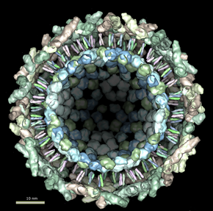

Figure 1 Chikungunya viruS

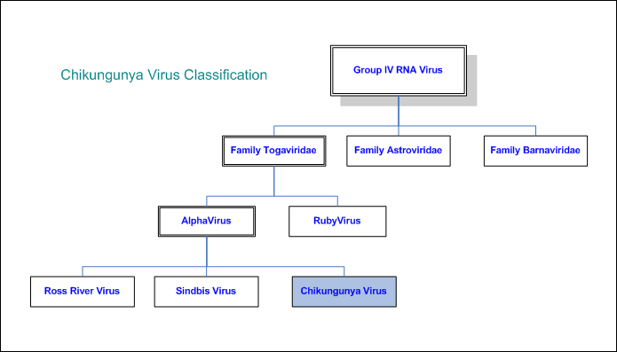

figure 2 classification

3.3 Genome

The nucleotide sequence of CHIK was determined bidirectionally from cDNA by directly sequencing RT-PCR products, according to the sequencing strategy summarized in The genomic RNA was 11805 nucleotides long, excluding the 5’cap nucleotide, an I-poly(A) site and the 3’poly(A) tract. The 5’ NTR was composed of 76 nucleotides, the 3’ NTR of 526 nucleotides and the junction region, which is also untranslated, of 68 nucleotides. The calculated base composition was as follows : 30% A, 25% C, 25% G and 20% T(U).

The non-structural proteins were contained in an open reading frame of 7425 nucleotides initiated by a start codon triplet (ATG) at position 77-79 and terminated at a stop codon triplet (TAG) at position 7499-7501. This open reading frame encoded a polyprotein of 2474 amino acids from which the individual non-structural proteins are formed by proteolytic cleavage. The subgenomic RNA (26S RNA) was 4327 nucleotide long excluding only the poly(A) tract at the 3’ end and startedat position 7498. The structural proteins were contained in an open reading frame of 3735 nucleotides initiated by a start codon at position 7567-7569 and terminated by a stop codon at position 11299-11301. This open reading frame encodes a polyprotein of 1244 amino acids from which the individual structural proteins are formed.(Afjal Hossain Khan et al 2002)

Chikungunya virus is a small (about 60–70 nm-diameter), spherical, enveloped, positive-strand RNA virus The virion consists of an envelope and nucleocapsid. The chikungunya virus genome is 11,805 nucleotides long and encodes for two polyproteins – the non structural polyprotein consisting of four proteins(nsP1,nsP2, nsP3 and nsP4) and the structural polyprotein consisting of five proteins (Capsid, E3, E2, 6K and E1) The 5’ end of the RNA molecule is capped with a 7-methylguanosine while the 3’ end is poly-adenylated. A subgenomic positive-strand RNA referred to as 26SRNA is transcribed from a negative-stranded RNA intermediate. This RNA serves as the mRNA for the synthesis of the viral structural proteins. Alphaviruses have conserved domains that play an important role in the regulation of viral RNA synthesis. These domains are found at the 5’ and 3’ ends as well as at the intergenic region. The E1 and E2 glycoproteins are expected to form heterodimers that associate as trimeric spikes on the viral surface covering the surface evenly. The envelope glycoproteins play a role in attachment to cells.

FIGURE 3 Chikungunya virus genome structure

Virions located on the surface of the cell membrane enter the host cells by fusion and endocytosis of the viral envelope. The uncoating of the virions occurs in the cytoplasm. The site of mRNA transcription is in the cell cytoplasm. Replication is not restricted to a particular tissue or organ of the host so the virus replication occurs in various organs. The insect host initiates the virus replication. The genome replication is done in the cytoplasm (see figure 4).

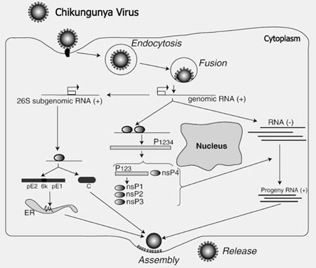
Figure 4 Chikungunya virus replication cycle. Devaux C. (2009)

3.4 DISTRIBUTION OF THE DISEASE

The epidemic started with outbreaks in Kenya in 2004 and the Comoros early in 2005. More recently, it jumped to India, where there have been an estimated 1.3 million cases to date. When all is said and done, the global toll of Chikungunya in 2006 could be close to 2 million, and the disease may well continue to spread in coming years. Introductions of non adaptive species of plants, invertebrates, and vertebrates are increasingly being recognized in countries with temperate climates.5 Among migrating invertebrate species mosquitoes that are capable of transmitting infectious diseases are of particular interest. The expansion of global air travel and seaborne trade removes geographic barriers to insect disease vectors, enabling the insects to move great distances in short periods. If they can adapt to the local environment, they establish themselves in new areas. It is thus that mosquitoes of the aedes (stegomyia) genus have gained an increasingly global distribution. In the past 50 years, the anthropophilic A. albopictus has spread to all continents and adapted to most climates. ( Parola P, et al, 2008)

3.5 CYSTEINE PROTEASES

NSP2 of chikungunya belongs to C9 pepetidases which are cysteine proteases. Chikungunya virus replication and propagation is dependent on the protease activity of the viral nsP2 protein, which cleaves the nsP1234 polyprotein replication complex into functional unit CHIKV replication causes general host shut-off. CHIKV replication is resistant to inhibition by interferon once RNA replication has been established and that CHIKV actively suppress the antiviral IFN response by preventing IFN-induced gene expression. (Mehdi Bouraï1 et al, 2012)

3.5.1 MECHANISM

The thiol group of the active site cysteine and the imidazole ring of histidine are believed to exist as thiolate/imidazolium ion pair. The thiolate anion is therefore highly nucleophilic and readily attacks the scissile amide bond. The tetrahedral intermediate produced is stabilized by the oxyanion hole. This intermediate collapses, via acid-assisted catalysis, to the thioester intermediate with release of the C-terminal substrate fragment. Water hydrolysis gives the regenerated active site and the N-terminal substrate fragment

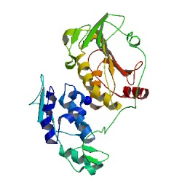

FIGURE 5 PDB STRUCTURE OF NSP2 PROTEASE (APPENDIX)

.

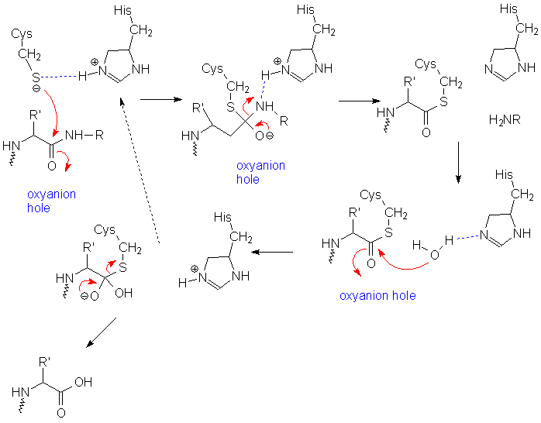

FIGURE 6 MECHANISM OF ACTION OF CYSTEINE PROTEASES

3.6 Inhibitors

Compound IDs of 27943 (IUPAC name not available) and 21362(2S,3R,5R,9R,10R,13R,14S,17S)-2,3,14-trihydroxy-10, 13-dimethyl-17-[(3R)-2,3,6-trihydroxy-6-methylheptan-2-yl]-2,3,4,5,9,1112,15,16,17-decahydro-1H-cyclopenta[a]phenanthren-6-one could inhibit the enzyme by blocking its active site. In their study they developed homology model of nsP2 protein based on the crystal structure of the nsP2 protein of Venezuelan equine encephalitis virus (VEEV). The protein modelled was optimized using molecular dynamics simulation; the junction peptides of a nonstructural protein complex were then docked in order to investigate the possible protein– protein interactions between nsP2 and the proteins cleaved by nsP2. Based on the results, they proposed the pharmacophore features that must be present in an inhibitor of nsP2 protease. The resulting pharmacophore model contained anaromatic ring, a hydrophobic and three hydrogen-bond donor sites. Using these pharmacophore features, they screened a large public library of compounds (Asinex, Maybridge, TOSLab, Binding Database) to find a potential ligand that could inhibit the nsP2 protein. (Singh KD, 2011). They also showed that Gly534-Ala535-Gly536-Ile537 forms six hydrogen bonds to the active site of the nsP2 protein . The Gly534 backbone nitrogen forms a trifurcated hydrogen bond with the oxygens of Ser1293, Glu1296 and Glu1157. However, in reality, the NH2 at the starting position can form only two interactions, as it is attached to the preceding residue and hence should be a backbone NH. Ala535 does not interact with the protein residues. The Gly536 backbone oxygen forms a hydrogen bond with the nitrogen of Gln1039. The Ile537 oxygen and nitrogen form hydrogen bonds with the oxygen and nitrogen of His1222 and Lys1239. So three hydrogen bond donars , two hydrogen bond acceptors and one hydrophobic group are required in the inhibitor for the interaction with the nsp2

FIGURE 7 INTERACTION OF THE SUBSTRATE WITH NSP2

In another study, N-butyl-9-[3,4-dipropoxy-5-(propoxymethyl)oxolan-2-yl]purin-6-amine) was found to have the most stable interaction with the nsP2 CHIKV Protease indicating that this could be a promising inhibitor for nsP2 Protease of CHIKV virus as the drug target (Limpon Bora, 2012)

3.6.1 IMPORTANT CONSIDERATIONS IN DESIGNING SUBSTRATE
BASED IHIBITORS

- reducing the size of the inhibitor

- introducing special functional groups so as to improve dissolution, cellular penetration, membrane permeability, and intestinal absorption

- replacing optimized natural amino acid residues with structurally similar non-natural amino acid residues, thereby reducing the peptidic nature of the inhibitor, so as to avoid premature digestion of the inhibitor by other proteases.

3.7 VIRTUAL SCREENING
Virtual screening (VS) is a computational technique used in drug discovery research. It involves the rapid in silico assessment of large libraries of chemical structures in order to identify those structures that most likely to bind to a drug target, typically a Protein receptor or enzyme

In order to efficiently process large virtual libraries, or libraries of virtually formatted synthetic compounds, computational methods are required to automatically evaluate databases, reduce their size, or prioritize compounds for biological evaluation. Computer programs designed for such purposes are subsumed as ‘‘virtual screening’’ (VS) or ‘‘in silico screening’’ tools and have become an integral part of pharmaceutical research. Virtual screening involves scanning databases of compounds to find molecules that may exhibit some bioactivity of interest, so as to prioritise a screening programme.

Wide range of methods available are Similarity searching, pharmacophore searching, substructural analysis, ligand docking and scoring.

3.7.1 LIGAND BASED VIRTUAL SCREENING

It utilizes information derived from available small molecules with known biological activity. Given a set of structurally diverse ligands that binds to a receptor, a model of the receptor can be built based on what binds to it. These are known as pharmacophore models. A candidate ligand can then be compared to the pharmacophore model to determine whether it is compatible with it and therefore likely to bind.

Another approach to ligand-based virtual screening is to use chemical similarity analysis methods to scan a database of molecules against one active ligand
structure.

3.7.2 STRUCTURE (TARGET) BASED VIRTUAl SCREENING

3D Structure of the target available and Structure-based virtual screening involves docking of candidate ligands into a protein target followed by applying a scoring function to estimate the likelihood that the ligand will bind to the protein with high affinity.
3.7.3 ZINC DATABASE
It is a free database of commercially-available compounds for virtual screening. ZINC contains over 21 million purchasable compounds in ready-to-dock, 3D formats. ZINC is provided by the Shoichet Laboratory in the Department of Pharmaceutical Chemistry at the University of California, San Francisco (UCSF). (Irwin et al, 2005)
3.7.4 CHEMBL
ChEMBL is a database of bioactive drug-like small molecules, it contains 2-D structures, calculated properties (e.g. logP, Molecular Weight, Lipinski Parameters, etc.) and abstracted bioactivities (e.g. binding constants, pharmacology and ADMET data. (Gaulton L et al, 2011)

3.7.5 LIPINSKI's RULES
Also called the "Rule of Five" – because the cutoffs for each of the four parameters are all close to 5 or a multiple of 5 – it evaluates the drug-likeness* of a determined compound. Although the rule does not predict whether the compound is pharmacologically active, it lies on molecular properties that ensure a biodisponibility for that particular compound.
The Lipinski's Rule of Five (1) states that an orally active drug should respect:
a. a molecular weight under 500 Daltons,
b a limited lipophilicity (expressed by Log P < 5,with P = [drug(org)/drug(aq)}
c. max 5 H-bond donors (expressed as the sum of OHs and NHs),
d. max 10 H-bond acceptors (expressed as the sum of Os and Ns

3.8 Docking
Docking refers to the ability to position a ligand in the active or a designated site of a protein and calculate specific binding affinities. It is the key to rational drug design: The results of docking can be used to find inhibitors for specific target proteins and thus to design new drugs. Two types of docking exists: rigid and flexible docking. Postdocking score is calculated which gives the binding affinity of the protein ligand complex.
Docking is frequently used to predict the binding orientation of small molecule drug candidates to their protein targets in order to in turn predict the affinity and activity of the small molecule. Hence docking plays an important role in the rational design of drugs. Given the biological and pharmaceutical significance of molecular docking, considerable efforts have been directed towards improving the methods used to predict docking
There are three general classes of scoring functions:
3.8.1 Force field
In this affinities are estimated by summing the strength of intermolecular van der Waals and electrostatic interactions between all atoms of the two molecules in the complex. The intramolecular energies (also referred to as strain energy) of the two binding partners are also frequently included. Finally since the binding normally takes place in the presence of water, the desolvation energies of the ligand and of the protein are sometimes taken into account using implicit solvation methods such as GBSA or PBSA.
3.8.2 Empirical –
It is based on counting the number of various types of interactions between the two binding partners. Counting may be based on the number of ligand and receptor atoms in contact with each other or by calculating the change in solvent accessible surface area (ΔSASA) in the complex compared to the uncomplexed ligand and protein. The coefficients of the scoring function are usually fit using multiple linear regression methods. These interactions terms of the function may include for example:
a. hydrophobic — hydrophobic contacts (favorable),
b hydrophobic — hydrophilic contacts (unfavorable),
c hydrophilic — hydrophilic contacts (no contribution to affinity except for \ for special cases) d number of hydrogen bonds (favorable electrostatic contribution to affinity
especially from the solvent)
e number of hydrogen bond "mismatches" or other types of electrostatic
repulsion (very unfavorable and rarely seen in stable complexes),
f number of rotatable bonds immobilized in complex formation (unfavorable
entropic contribution).
3.8.3 Knowledge-based
It is based on statistical observations of intermolecular close contacts in large 3D databases (such as the Cambridge Structural Database or Protein Data Bank) which are used to derive "potentials of mean force". This method is founded on the assumption that close intermolecular interactions between certain types of atoms or functional groups that occur more frequently than one would expect by a random distribution are likely to be energetically favorable and therefore contribute favorably to binding affinity [Muegge I (2006)]
3.8.4 DSX ONLINE SERVER DSX^{ONLINE}

It is a web-based user interface for the knowledge-based scoring functionDSX. DSXONLINE enables you to score (putative) protein-ligand complexes of your interest, to browse and download the scoring results, and to visualize the per-atom score contributions(Gohlke, H et al, 2000)

4 METHODOLOGY

4.1 DOWNLOADING THE TARGET PROTEIN

The Protein Data Bank (PDB) is a repository for the 3-D structural data of large biological molecules, such as proteins and nucleic acids. The data, typically obtained by X-ray crystallography or NMR spectroscopy and submitted by biologists and biochemists from around the world, are freely accessible on the Internet via the websites of its member organisations (PDBe, PDBj, and RCSB). The PDB is overseen by an organization called the Worldwide Protein Data Bank, wwPDB.

The PDB is a key resource in areas of structural biology, such as structural genomics. Most major scientific journals, and some funding agencies, such as the NIH (National Institute of Health) in the USA, now require scientists to submit their structure data to the PDB. If the contents of the PDB are thought of as primary data, then there are hundreds of derived (i.e., secondary) databases that categorize the data differently

A PDB file of non structural protein NSP2 was downloaded from protein data bank.(appendix)

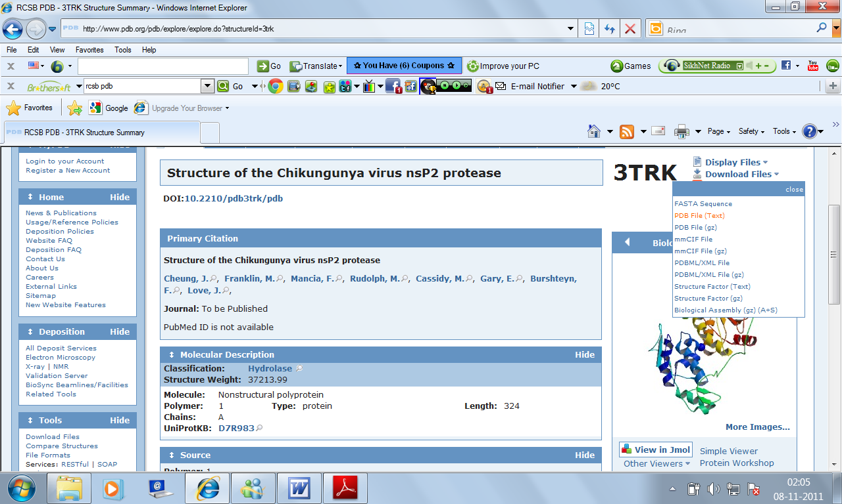

4.2 PREPARING THE LIGAND

An inhibitor was designed taking the substrate of the nsp2 protease. The very first position where the enzyme cuts the polyproteins is at pepetide bond between alanine (535) and guanine (536)

GLY-ALANINE-GLYCINE-ISOLEUCINE is the part of the substrate at which the protein cuts.

A hydroxymethyl isostere (norstatine ) is used in place of alanine so that bond between the alanine and glycine becomes uncleavable because of unnatural amino acid.

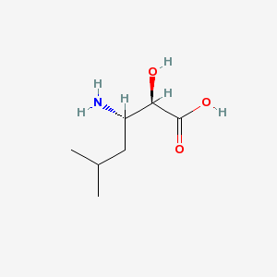

FIGURE 8 NORSTATINE MOLECULE

A tertiary butylamine was used in place of isoleucine which looks similar to isoleucine and has a protection of 3 methyl groups.

A large inhibitor cannot be used for the nsp2 protaese as cysteine proteases have a shallow pocket.

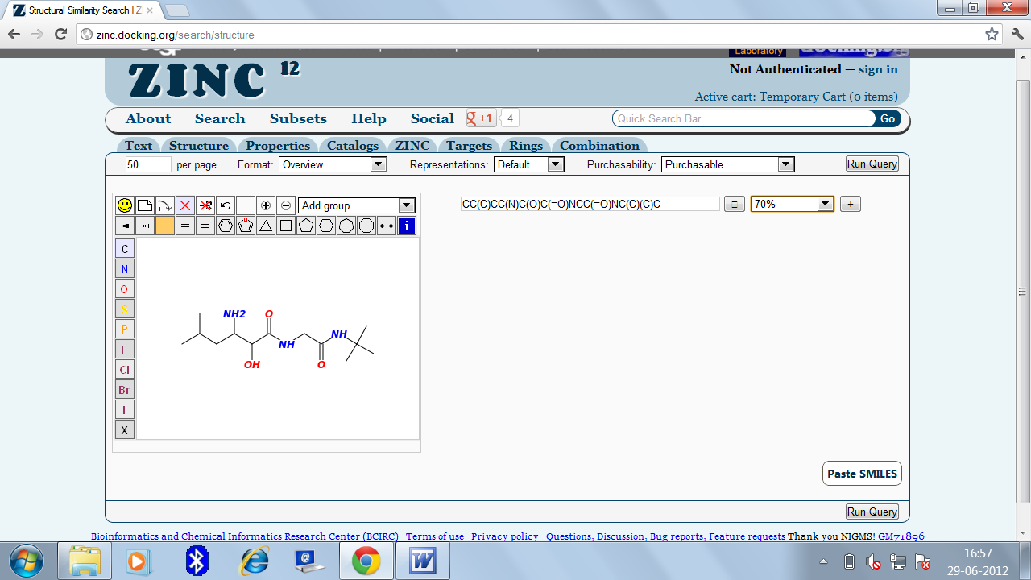
FIGURE 9 INHIBITOR

4.3 VIRTUAL SCREENING

4.3.1 CHEMBL DATABASE

ChEMBL version 2 (ChEMBL_02) was launched in January 2010, including 2.4 million bioassay measurements covering 622,824 compounds, including 24,000 natural products. This was obtained from curating over 34,000 publications across twelve medicinal chemistry journals. ChEMBL's coverage of available bioactivity data has grown to become "the most comprehensive ever seen in a public database." In October 2010 ChEMBL version 8 (ChEMBL_08) was launched, with over 2.97 million bioassay measurements covering 636,269 compounds.
ChEMBL_10 saw the addition of the PubChem confirmatory assays, in order to integrate data that is comparable to the type and class of data contained within ChEMBL.

CHEMBL compound database is screened by drawing the same molecule online and keeping the similarity of 70 percent (appendix)

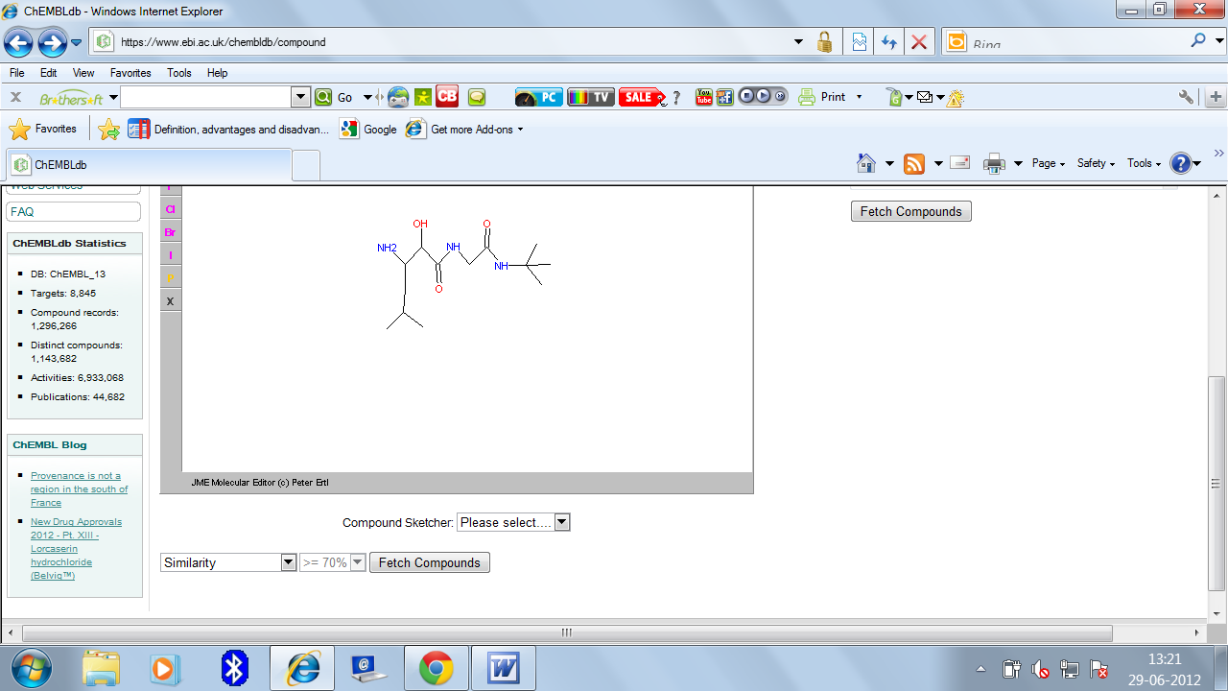

Mol files of all the resultant molecules were downloaded
Chembl does not provide the mol2 files , so the mol files of the compounds obtained are converted to mol2 files by online molecular format converter (appendix)

    - ZINC DATABASE

The ZINC database is a curated collection of commercially available chemical compounds prepared especially for virtual screening. ZINC is used by investigators (generally people with training as biologists or chemists) in pharmaceutical companies, biotech companies, and research universities.

ZINC is different from other chemical databases because it aims to represent the biologically relevant, three dimensional form of the molecule

ZINC was originally designed for target based virtual screening (docking), and this remains it s primar y focus. However, ZINC is also useful for many other things, including:
a finding a compound to purchase
b downloading a library in SMILES format for ligand based virtual screening
c find compounds by similarity to a starting compound
d find compound ANNOTATED for a particular target
e find compounds PREDICTED for a particular target

It focuses on biologically relevant compounds. To achieve this focus, ZINC filters out molecules widely considered unsuitable for docking, such as peroxides, big insoluble molecules, large peptides, and highly reactive reagents including many building blocks.

Again the same molecule was drawn online and 70 percent similarity is again taken to fetch the similar molecules (appendix)

Mol2 files of all the resultant molecules from zinc database were downloaded .

4.4 All the molecules obtained from the 2 databases were refined on basis of
Lipinski factors.

.
4.5 DOCKING

.
DSX consists of distance-dependent pair potentials, novel torsion angle potentials, and newly defined solvent accessible surface-dependent potentials. DSX pair potentials are based on the statistical formalism of DrugScore, extended by a much more specialized set of atom types. The original DrugScore-like reference state is rather unstable with respect to modifications in the used atom types. Therefore, an important method to overcome this problem and to allow for robust results when deriving pair potentials for arbitrary sets of atom types is presented.

DSX features superior performance with respect to docking- and ranking power and runtime requirements. Furthermore, the beneficial combination with torsion angle-dependent and desolvation-dependent potentials is demonstrated. DSX is robust, flexible, and capable of working together with special features of popular docking engines, e.g., flexible protein residues in AutoDock or GOLD

A DSX ONLINE server was used for docking. A pdb file of the protein which is 3TRK is uplaoded and mol2 file of the ligand is uploaded to get the docking score (appendix)

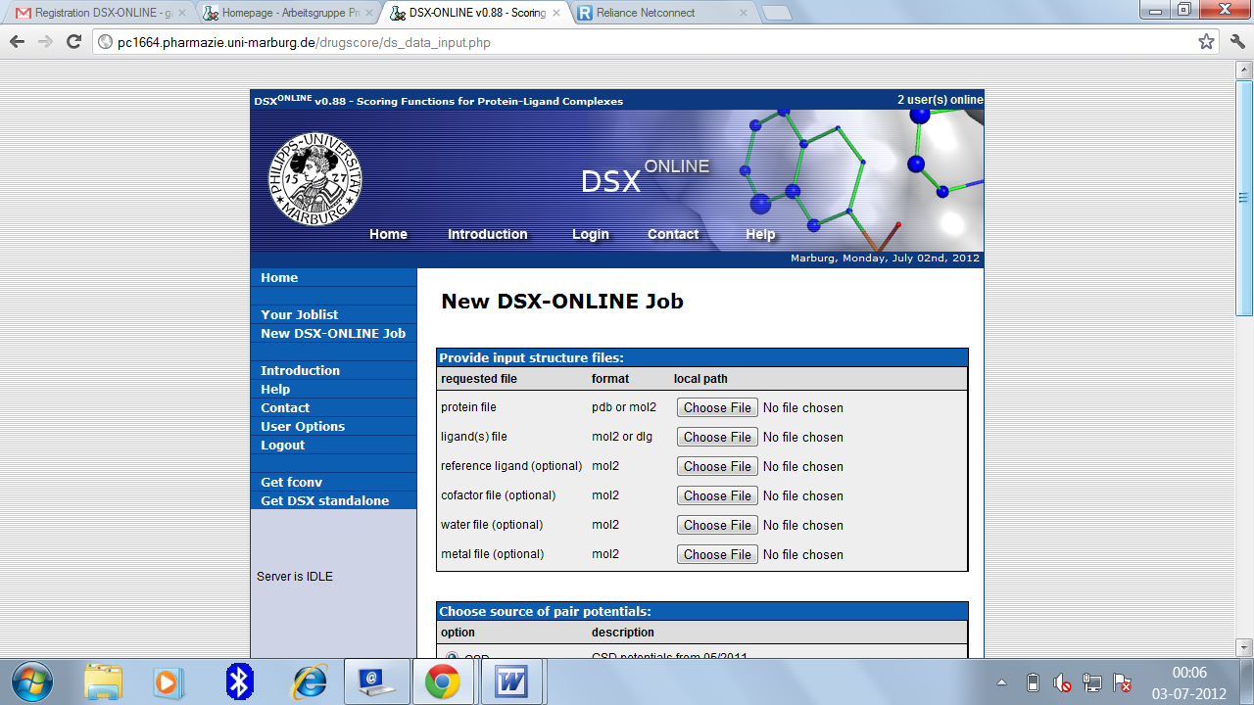

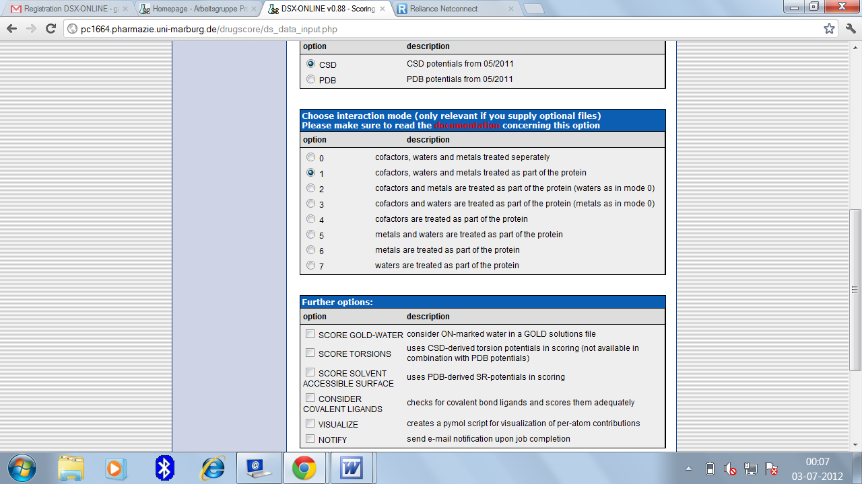

PARAMETERS

Pair potential type
CSD: chooses the pair potentials derived from small molecule crystal data as stored in the CSD.
PDB: chooses the pair potentials derived from protein-ligand complexes as stored in the PDB.
As protein ligand complex was not there, CSD option was switched on.
Interaction mode
This option is of no interest as long as you do not supply an additional file with cofactors, waters or metals.

Further options
SCORE GOLD-WATER: Switch this on if your docking solutions are from a GOLD run considering water molecules. GOLD stores the informations about used water molecules within the MOL2 file of the docking solutions. DrugScoreX will read this information and consider ON-marked water for scoring of the corresponding ligand.
SCORE TORSIONS: This option has only an effect if using CSD potentials. The torsion potentials are also statistical potentials derived from CSD structures. So this option was also switched on
SCORE SOLVENT ACCESSIBLE SURFACE: If switched on, solvent accessible surface ratio potentials are used as an additional term. So this option was switched on
CONSIDER COVALENT LIGANDS: If you have covalently bound ligands you have to switch on this option .this option was also switched on as covalently bound Na ligand is there in the protein
NOTIFY: If you check this option, you will be notified upon job completion.

- RESULTS

After drawing the inhibitor in the drawing area of the CHEMBL database, thirty five molecules appeared in the result which were 70 percent similar to the query inhibitor.

TABLE 5.1 CHEMBL RESULT red colour shows the characteristics not satisfying the Lipinski rules

S.NO | CHEMBL ID | MOL WT | LOGP | HBA | HBD
1 | 100395 | 343.5 | 1.7 | 4 | 3
2 | 1093156 | 457.6 | 1.41 | 8 | 3
3 | 1221950 | 315.4 | -1.85 | 5 | 4
4 | 1222158 | 245.3 | -3.63 | 5 | 4
5 | 1222167 | 232.2 | -0.33 | 5 | 3
6 | 1222169 | 232.2 | -0.33 | 5 | 3
7 | 1222257 | 315.4 | -1.85 | 5 | 4
8 | 135426 | 274.4 | -1.67 | 5 | 4
9 | 1364606 | 359.4 | 0.37 | 6 | 3
10 | 151538 | 456.6 | 1.77 | 6 | 3
11 | 152084 | 318.3 | -3.16 | 8 | 3
12 | 1520908 | 317.3 | -0.7 | 6 | 3
13 | 152125 | 274.3 | -2.94 | 6 | 3
14 | 152536 | 264.3 | -1.72 | 4 | 3
15 | 152556 | 260.3 | -3.23 | 6 | 3
16 | 155306 | 318.3 | 3.47 | 8 | 3
17 | 158187 | 288.3 | -2.05 | 6 | 3
18 | 167093 | 514.7 | 2.87 | 6 | 5
19 | 16890154 | 274.4 | -1.46 | 5 | 4
20 | 1689155 | 274.4 | -1.67 | 5 | 4
21 | 171038 | 290.3 | -3.56 | 7 | 3
22 | 171067 | 260.3 | -2.97 | 6 | 3
23 | 171209 | 288.3 | -1.93 | 6 | 3
24 | 1715355 | 303.4 | -0.27 | 6 | 4
25 | 173321 | 288.3 | -2.05 | 6 | 3
26 | 173371 | 264.3 | -1.72 | 4 | 3
27 | 273356 | 348.3 | -0.78 | 9 | 5
28 | 303948 | 450.5 | 3.2 | 7 | 3
29 | 347401 | 290.3 | -3.56 | 7 | 3
30 | 350892 | 274.3 | -2.85 | 6 | 3
31 | 594541 | 217.3 | -3.56 | 5 | 4
32 | 595874 | 217.3 | -3.56 | 5 | 4
33 | 595876 | 217.5 | -3.56 | 5 | 4
34 | 611358 | 217.3 | -3.56 | 5 | 4
35 | 81941 | 574.7 | 2.57 | 6 | 5

The same inhibitor was drawn in the drawing area of zinc database. The similarity percentage was again taken as 70 percent. Then three hundered ninety eight molecules appeared in the result.

TABLE 5.2 ZINC RESULT red colour shows characteristics not satisfying Lipinski rules

 | ZINC ID | MOL WT. | LOGP | HBA | HBD
1 | 55128367 | 256.37 | 0.59 | 5 | 5
2 | 55128369 | 256.37 | 0.59 | 5 | 5
3 | 55128371 | 256.37 | 0.59 | 5 | 5
4 | 55087464 | 242.343 | 0.35 | 5 | 5
5 | 55087463 | 242.343 | 0.35 | 5 | 5
6 | 55087460 | 242.343 | 0.35 | 5 | 5
7 | 55087458 | 242.343 | 0.35 | 5 | 5
8 | 55128373 | 256.37 | 0.59 | 5 | 5
9 | 55128382 | 256.37 | 0.59 | 5 | 5
10 | 55128385 | 256.37 | 0.59 | 5 | 5
11 | 55128386 | 256.37 | 0.59 | 5 | 5
12 | 55128380 | 256.37 | 0.59 | 5 | 5
13 | 49428138 | 270.373 | 1.73 | 5 | 2
14 | 49428140 | 270.373 | 1.73 | 5 | 2
15 | 36517949 | 398.632 | 5.80 | 5 | 2
16 | 36574892 | 356.551 | 4.23 | 5 | 2
17 | 36517947 | 398.632 | 5.80 | 5 | 2
18 | 36574893 | 356.551 | 4.23 | 5 | 2
19 | 71789699 | 473.547 | -2.99 | 12 | 7
20 | 71789698 | 473.547 | -2.99 | 12 | 7
21 | 71789697 | 473.547 | -2.99 | 12 | 7
22 | 71404893 | 473.547 | -2.99 | 12 | 7
23 | 3872463 | 473.547 | -2.99 | 12 | 7
24 | 3872462 | 473.547 | -2.99 | 12 | 7
25 | 71404892 | 473.547 | -2.99 | 12 | 7
26 | 36532684 | 473.547 | -2.99 | 12 | 7
27 | 3872461 | 473.547 | -2.99 | 12 | 7
28 | 36532596 | 473.547 | -2.99 | 12 | 7
29 | 36532596 | 473.547 | -2.99 | 12 | 7
30 | 16051674 | 473.547 | -2.99 | 12 | 7
31 | 3872464 | 473.547 | -2.99 | 12 | 7
32 | 71789700 | 473.547 | -2.99 | 12 | 7
33 | 55129701 | 256.37 | -0.46 | 5 | 4
34 | 55087728 | 242.343 | -0.70 | 5 | 4
35 | 55129698 | 256.37 | -0.46 | 5 | 4
36 | 55129699 | 256.37 | -0.46 | 5 | 4
37 | 55129696 | 256.37 | -0.46 | 5 | 4
38 | 55087730 | 242.343 | -0.70 | 5 | 4
39 | 55087733 | 242.343 | -0.70 | 5 | 4
40 | 55087732 | 242.343 | -0.70 | 5 | 4
41 | 40793057 | 270.373 | 1.69 | 5 | 2
42 | 40793056 | 270.373 | 1.69 | 5 | 2
43 | 55129158 | 256.37 | 0.12 | 5 | 5
44 | 55129160 | 256.37 | 0.12 | 5 | 5
45 | 55140565 | 242.343 | -0.26 | 5 | 5
46 | 55140564 | 242.343 | -0.26 | 5 | 5
47 | 55140562 | 242.343 | -0.26 | 5 | 5
48 | 55140560 | 242.343 | -0.26 | 5 | 5
49 | 55090455 | 228.316 | 0.50 | 5 | 5
50 | 55090454 | 228.316 | 0.50 | 5 | 5
51 | 55090452 | 228.316 | -0.50 | 5 | 5
52 | 55090450 | 228.316 | -0.50 | 5 | 5
53 | 55087623 | 242.343 | -0.12 | 5 | 5
54 | 55087625 | 242.343 | -0.12 | 5 | 5
55 | 55087627 | 242.343 | -0.12 | 5 | 5
56 | 55087628 | 242.343 | -0.12 | 5 | 5
57 | 55129155 | 256.37 | -0.12 | 5 | 5
58 | 55129155 | 256.37 | -0.12 | 5 | 5
59 | 55129174 | 256.37 | -0.46 | 5 | 4
60 | 55129710 | 256.37 | -0.46 | 5 | 4
61 | 55129714 | 256.37 | -0.46 | 5 | 4
62 | 55129717 | 256.37 | -0.46 | 5 | 4
63 | 49428142 | 256.346 | 1.35 | 5 | 2
64 | 49428144 | 256.346 | 1.35 | 5 | 2
65 | 42166523 | 270.397 | 1.64 | 5 | 3
66 | 42166524 | 270.397 | 1.64 | 5 | 3
67 | 42166525 | 270.397 | 1.64 | 5 | 3
68 | 55140581 | 242.343 | -0.26 | 5 | 5
69 | 55140579 | 242.343 | -0.26 | 5 | 5
70 | 55129170 | 256.37 | 0.12 | 5 | 5
71 | 55129168 | 256.37 | 0.12 | 5 | 5
72 | 36536505 | 328.497 | 3.36 | 5 | 2
73 | 36536506 | 328.497 | 3.36 | 5 | 2
74 | 55129171 | 256.37 | 0.12 | 5 | 5
75 | 55129173 | 256.37 | 0.12 | 5 | 5
76 | 55140575 | 242.343 | -0.26 | 5 | 5
77 | 55140577 | 242.343 | -0.26 | 5 | 5
78 | 42166522 | 270.397 | 1.64 | 5 | 3
79 | 49316659 | 256.346 | 1.22 | 5 | 2
80 | 49316660 | 256.346 | 1.22 | 5 | 2
81 | 31167600 | 400.496 | 0.40 | 9 | 4
82 | 31167607 | 400.496 | 0.40 | 9 | 4
83 | 35464597 | 400.496 | 0.40 | 9 | 4
84 | 35464600 | 400.496 | 0.40 | 9 | 4
85 | 20504963 | 354.451 | 0.06 | 8 | 4
86 | 42166347 | 256.37 | 1.83 | 5 | 4
87 | 42166346 | 256.37 | 1.83 | 5 | 4
88 | 42166349 | 256.37 | 1.83 | 5 | 4
89 | 42166348 | 256.37 | 1.83 | 5 | 4
90 | 37476468 | 230.332 | 0.86 | 5 | 5
91 | 37476469 | 230.332 | 0.86 | 5 | 5
92 | 37476467 | 230.332 | 0.86 | 5 | 5
93 | 37476466 | 230.332 | 0.86 | 5 | 5
94 | 36517869 | 398.632 | 5.48 | 5 | 2
95 | 36517868 | 398.632 | 5.48 | 5 | 2
96 | 71974194 | 187.263 | -0.56 | 4 | 5
97 | 71973278 | 187.263 | -0.56 | 4 | 5
98 | 71974196 | 187.263 | -0.56 | 4 | 5
99 | 71973277 | 187.263 | -0.56 | 4 | 5
100 | 36590707 | 370.578 | 4.54 | 5 | 2
101 | 36590708 | 370.578 | 4.54 | 5 | 2
102 | 44763570 | 242.343 | -0.72 | 5 | 4
103 | 37607675 | 244.359 | 0.67 | 5 | 4
104 | 37607676 | 244.359 | 0.67 | 5 | 4
105 | 37607677 | 244.359 | 0.67 | 5 | 4
106 | 37607678 | 244.359 | 0.67 | 5 | 4
107 | 42166062 | 242.343 | 1.88 | 5 | 4
108 | 42166063 | 242.343 | 1.88 | 5 | 4
109 | 44763569 | 242.343 | -0.72 | 5 | 4
110 | 69491909 | 338.492 | 3.24 | 5 | 3
111 | 69491905 | 338.492 | 3.24 | 5 | 3
112 | 69491903 | 338.492 | 3.24 | 5 | 3
113 | 69491907 | 338.492 | 3.24 | 5 | 3
114 | 55141843 | 270.397 | 0.62 | 5 | 5
115 | 55090881 | 256.37 | 0.38 | 5 | 5
116 | 55141840 | 270.397 | 0.62 | 5 | 5
117 | 55141842 | 270.397 | 0.62 | 5 | 5
118 | 55090888 | 256.37 | 0.38 | 5 | 5
119 | 55090887 | 256.37 | 0.38 | 5 | 5
120 | 55090883 | 256.37 | 0.38 | 5 | 5
121 | 55141844 | 270.397 | 0.62 | 5 | 5
122 | 49116889 | 242.319 | 0.85 | 5 | 2
123 | 49116892 | 242.319 | 0.85 | 5 | 2
124 | 52013352 | 243.371 | 1.48 | 4 | 4
125 | 52013350 | 243.371 | 1.48 | 4 | 4
126 | 52013348 | 243.371 | 1.48 | 4 | 4
127 | 52013346 | 243.371 | 1.48 | 4 | 4
128 | 55129728 | 270.397 | -0.44 | 5 | 4
129 | 55129726 | 270.397 | -0.44 | 5 | 4
130 | 61270019 | 258.386 | 2.15 | 5 | 4
131 | 61270020 | 258.386 | 2.15 | 5 | 4
132 | 61270021 | 258.386 | 2.15 | 5 | 4
133 | 61270022 | 258.386 | 2.15 | 5 | 4
134 | 37793156 | 285.364 | 0.77 | 6 | 1
135 | 37793155 | 285.364 | 0.77 | 6 | 1
136 | 67847726 | 368.542 | 2.46 | 6 | 4
137 | 67880748 | 354.515 | 1.95 | 6 | 4
138 | 67847725 | 368.542 | 2.46 | 6 | 4
139 | 67880746 | 354.515 | 1.95 | 6 | 4
140 | 52010729 | 241.355 | 1.09 | 4 | 4
141 | 36517698 | 380.573 | 4.77 | 5 | 2
142 | 36574651 | 338.492 | 3.20 | 5 | 2
143 | 36574652 | 368.562 | 4.07 | 5 | 2
144 | 36517699 | 410.643 | 5.64 | 5 | 2
145 | 36517700 | 410.643 | 5.64 | 5 | 2
146 | 36574653 | 410.643 | 5.64 | 5 | 2
147 | 36574654 | 312.454 | 2.73 | 5 | 2
148 | 36574655 | 312.454 | 2.73 | 5 | 2
149 | 36517701 | 354.535 | 4.30 | 5 | 2
150 | 36517702 | 354.535 | 4.30 | 5 | 2
151 | 36517936 | 342.524 | 4.21 | 5 | 2
152 | 36517937 | 342.524 | 4.21 | 5 | 2
153 | 36574887 | 300.443 | 2.64 | 5 | 2
154 | 36574886 | 300.443 | 2.64 | 5 | 2
155 | 52010723 | 241.355 | 1.09 | 4 | 4
156 | 36517693 | 354.535 | 4.05 | 5 | 2
157 | 36517694 | 354.535 | 4.05 | 5 | 2
158 | 36517697 | 354.535 | 4.05 | 5 | 2
159 | 36574650 | 338.492 | 3.20 | 5 | 2
160 | 52010726 | 354.535 | 4.05 | 5 | 2
161 | 36574647 | 338.492 | 3.20 | 5 | 2
162 | 52010719 | 354.535 | 4.05 | 5 | 2
163 | 36574646 | 338.492 | 3.20 | 5 | 2
164 | 55141853 | 270.397 | 0.62 | 5 | 5
165 | 36517871 | 342.524 | 4.14 | 5 | 2
166 | 36517870 | 342.524 | 4.14 | 5 | 2
167 | 36517863 | 342.524 | 3.89 | 5 | 2
168 | 36517862 | 342.524 | 3.89 | 5 | 2
169 | 55135290 | 270.397 | 0.83 | 5 | 4
170 | 55135288 | 270.397 | 0.83 | 5 | 4
171 | 55135286 | 270.397 | 0.83 | 5 | 4
172 | 55135284 | 270.397 | 0.83 | 5 | 4
173 | 58415029 | 336.476 | 2.12 | 5 | 3
174 | 55135005 | 284.424 | 1.21 | 5 | 4
175 | 55135003 | 284.424 | 1.21 | 5 | 4
176 | 55135001 | 284.424 | 1.21 | 5 | 4
177 | 55134999 | 284.424 | 1.21 | 5 | 4
178 | 58415034 | 336.476 | 2.12 | 5 | 3
179 | 55088906 | 270.397 | 0.97 | 5 | 4
180 | 4905374 | 322.449 | 2.30 | 5 | 3
181 | 4905371 | 322.449 | 2.30 | 5 | 3
182 | 55089000 | 256.37 | 0.59 | 5 | 4
183 | 55088998 | 256.37 | 0.59 | 5 | 4
184 | 55088995 | 256.37 | 0.59 | 5 | 4
185 | 55088992 | 256.37 | 0.59 | 5 | 4
186 | 55088914 | 270.397 | 0.97 | 5 | 4
187 | 55088911 | 270.397 | 0.97 | 5 | 4
188 | 55088908 | 270.397 | 0.97 | 5 | 4
189 | 55141858 | 270.397 | 0.62 | 5 | 5
190 | 55141856 | 270.397 | 0.62 | 5 | 5
191 | 55141854 | 270.397 | 0.62 | 5 | 5
192 | 44762892 | 282.452 | 1.53 | 4 | 3
193 | 67675356 | 352.499 | 1.64 | 6 | 4
194 | 67675357 | 270.397 | 0.62 | 5 | 5
195 | 36576964 | 370.578 | 4.85 | 5 | 1
196 | 36576965 | 270.397 | 0.62 | 5 | 5
197 | 71924060 | 269.409 | 0.76 | 4 | 2
198 | 71924061 | 269.409 | 0.76 | 4 | 2
199 | 49448136 | 228.292 | 0.27 | 5 | 2
200 | 49448138 | 228.292 | 0.27 | 5 | 2
201 | 49448140 | 228.292 | 0.27 | 5 | 2
202 | 49448142 | 228.292 | 0.27 | 5 | 2
203 | 36521106 | 412.659 | 6.42 | 5 | 1
204 | 36521105 | 412.659 | 6.42 | 5 | 1
205 | 61270247 | 272.413 | 1.95 | 5 | 3
206 | 52013498 | 257.398 | 1.98 | 4 | 4
207 | 52013496 | 257.398 | 1.98 | 4 | 4
208 | 61270248 | 272.413 | 1.95 | 5 | 3
209 | 44763576 | 270.397 | 0.29 | 5 | 4
210 | 61270246 | 272.413 | 1.95 | 5 | 3
211 | 61270245 | 272.413 | 1.95 | 5 | 3
212 | 52013492 | 257.398 | 1.98 | 4 | 4
213 | 44763575 | 270.397 | 0.29 | 5 | 4
214 | 44763572 | 270.397 | 0.29 | 5 | 4
215 | 44763571 | 270.397 | 0.29 | 5 | 4
216 | 52013495 | 257.398 | 1.98 | 4 | 4
217 | 70610511 | 230.332 | -0.78 | 5 | 5
218 | 70610512 | 230.332 | -0.78 | 5 | 5
219 | 70610513 | 230.332 | -0.78 | 5 | 5
220 | 70610514 | 230.332 | -0.78 | 5 | 5
221 | 37796613 | 271.337 | 0.96 | 6 | 2
222 | 37796612 | 271.337 | 0.96 | 6 | 2
223 | 9918480 | 322.449 | 2.29 | 5 | 3
224 | 55128396 | 270.397 | 0.60 | 5 | 5
225 | 67805134 | 380.553 | 2.73 | 6 | 5
226 | 67856683 | 340.491 | 2.92 | 4 | 3
227 | 67805133 | 380.553 | 2.73 | 6 | 5
228 | 55135020 | 284.424 | 1.21 | 5 | 4
229 | 55135304 | 270.397 | 0.83 | 5 | 4
230 | 55135299 | 270.397 | 0.83 | 5 | 4
231 | 55722323 | NF | NF | NF | NF
232 | 55135302 | 270.397 | 0.83 | 5 | 4
233 | 55135300 | 270.397 | 0.83 | 5 | 4
234 | 55135014 | 284.424 | 1.21 | 5 | 4
235 | 55135017 | 284.424 | 1.21 | 5 | 4
236 | 55135018 | 284.424 | 1.21 | 5 | 4
237 | 37008248 | 272.413 | 0.32 | 5 | 4
238 | 37008249 | 272.413 | 0.32 | 5 | 4
239 | 37008256 | 230.332 | -0.96 | 5 | 4
240 | 37008257 | 230.332 | -0.96 | 5 | 4
241 | 42166060 | 228.316 | 1.37 | 5 | 4
242 | 42166061 | 228.316 | 1.37 | 5 | 4
243 | 55086746 | 228.316 | 0.05 | 5 | 5
244 | 55086748 | 228.316 | 0.05 | 5 | 5
245 | 55086750 | 228.316 | 0.05 | 5 | 5
246 | 55086751 | 228.316 | 0.05 | 5 | 5
247 | 55087071 | 214.289 | -0.33 | 5 | 5
248 | 55087072 | 214.289 | -0.33 | 5 | 5
249 | 55087074 | 214.289 | -0.33 | 5 | 5
250 | 55087076 | 214.289 | -0.33 | 5 | 5
251 | 55125765 | 242.343 | 0.29 | 5 | 5
252 | 55125767 | 242.343 | 0.29 | 5 | 5
253 | 55125768 | 242.343 | 0.29 | 5 | 5
254 | 55125769 | 242.343 | 0.29 | 5 | 5
255 | 55126592 | 228.316 | -0.09 | 5 | 5
256 | 55126593 | 228.316 | -0.09 | 5 | 5
257 | 55126594 | 228.316 | -0.09 | 5 | 5
258 | 55126595 | 228.316 | -0.09 | 5 | 5
259 | 12315087 | 352.499 | 1.59 | 6 | 3
260 | 4277856 | 396.488 | 0.02 | 9 | 3
261 | 12315088 | 396.488 | 0.02 | 9 | 3
262 | 40779843 | 229.344 | 1.11 | 4 | 4
263 | 40778539 | 229.344 | 1.11 | 4 | 4
264 | 40778533 | 229.344 | 1.11 | 4 | 4
265 | 40778531 | 229.344 | 1.11 | 4 | 4
266 | 40779846 | 229.344 | 1.11 | 4 | 4
267 | 40779840 | 229.344 | 1.11 | 4 | 4
268 | 40779837 | 229.344 | 1.11 | 4 | 4
269 | 40779836 | 229.344 | 1.11 | 4 | 4
270 | 71381577 | 284.424 | 2.77 | 5 | 3
271 | 71381577 | 284.424 | 2.77 | 5 | 3
272 | 4689135 | 268.357 | 1.27 | 5 | 3
273 | 71381575 | 284.424 | 2.77 | 5 | 3
274 | 71381576 | 284.424 | 2.77 | 5 | 3
275 | 69493537 | 350.503 | 3.09 | 5 | 2
276 | 69493534 | 350.503 | 3.09 | 5 | 2
277 | 69493531 | 350.503 | 3.09 | 5 | 2
278 | 69493528 | 350.503 | 3.09 | 5 | 2
279 | 44763659 | 242.343 | -0.15 | 5 | 5
280 | 52013454 | 229.344 | 0.96 | 4 | 4
281 | 44763550 | 242.343 | -0.15 | 5 | 5
282 | 44763549 | 242.343 | -0.15 | 5 | 5
283 | 44762832 | 270.397 | 1.33 | 5 | 5
284 | 44762830 | 270.397 | 1.33 | 5 | 5
285 | 52013452 | 229.344 | 0.96 | 4 | 4
286 | 52013451 | 229.344 | 0.96 | 4 | 4
287 | 52013449 | 229.344 | 0.96 | 4 | 4
288 | 44763660 | 242.343 | -0.15 | 5 | 5
289 | 36536262 | 310.438 | 2.32 | 5 | 2
290 | 36536261 | 310.438 | 2.32 | 5 | 2
291 | 51996699 | 268.357 | 1.44 | 5 | 2
292 | 51996697 | 268.357 | 1.44 | 5 | 2
293 | 51996694 | 268.357 | 1.44 | 5 | 2
294 | 51996691 | 268.357 | 1.44 | 5 | 2
295 | 36536264 | 310.438 | 2.32 | 5 | 2
296 | 36536263 | 310.438 | 2.32 | 5 | 2
297 | 55126600 | 228.316 | -0.09 | 5 | 5
298 | 55126557 | 228.316 | -0.09 | 5 | 5
299 | 55126556 | 228.316 | -0.09 | 5 | 5
300 | 55126555 | 228.316 | -0.09 | 5 | 5
301 | 55126554 | 228.316 | -0.09 | 5 | 5
302 | 55125777 | 242.343 | 0.29 | 5 | 5
303 | 55125776 | 242.343 | 0.29 | 5 | 5
304 | 55125775 | 242.343 | 0.29 | 5 | 5
305 | 55125774 | 242.343 | 0.29 | 5 | 5
306 | 55087062 | 228.316 | -1.03 | 5 | 4
307 | 55087061 | 228.316 | -1.03 | 5 | 4
308 | 55087059 | 228.316 | -1.03 | 5 | 4
309 | 55087058 | 228.316 | -1.03 | 5 | 4
310 | 36517951 | 342.524 | 4.46 | 5 | 2
311 | 36517953 | 342.524 | 4.46 | 5 | 2
312 | 36574895 | 300.443 | 2.89 | 5 | 2
313 | 36574894 | 300.443 | 2.89 | 5 | 2
314 | 55126603 | 228.316 | -0.09 | 5 | 5
315 | 55126602 | 228.316 | -0.09 | 5 | 5
316 | 55126601 | 228.316 | -0.09 | 5 | 5
317 | 36574822 | 356.551 | 3.91 | 5 | 2
318 | 36574823 | 356.551 | 3.91 | 5 | 2
319 | 4260001 | 323.393 | -0.07 | 7 | 2
320 | 55129183 | 270.397 | 0.13 | 5 | 5
321 | 55140591 | 256.37 | -0.24 | 5 | 5
322 | 50943423 | 284.424 | 0.78 | 5 | 3
323 | 55129185 | 270.397 | 0.13 | 5 | 5
324 | 37000394 | 258.386 | 0.52 | 5 | 5
325 | 37000395 | 258.386 | 0.52 | 5 | 5
326 | 50943425 | 284.424 | 0.78 | 5 | 3
327 | 55140590 | 256.37 | -0.24 | 5 | 5
328 | 37000402 | 258.386 | 0.52 | 5 | 5
329 | 37000403 | 258.386 | 0.52 | 5 | 5
330 | 50942694 | 256.37 | -0.41 | 5 | 3
331 | 50942691 | 256.37 | -0.41 | 5 | 3
332 | 58110889 | 348.487 | 2.52 | 5 | 3
333 | 36538324 | 342.524 | 3.97 | 5 | 1
334 | 48072201 | 268.357 | 1.10 | 5 | 3
335 | 36538325 | 342.524 | 3.97 | 5 | 1
336 | 36536257 | 284.4 | 1.60 | 5 | 2
337 | 36536258 | 284.4 | 1.60 | 5 | 2
338 | 37633971 | 286.44 | 1.21 | 5 | 3
339 | 37633973 | 286.44 | 1.21 | 5 | 3
340 | 55129687 | 256.37 | -0.71 | 5 | 4
341 | 55089319 | 228.316 | -0.39 | 5 | 6
342 | 55089316 | 228.316 | -0.39 | 5 | 6
343 | 55089313 | 228.316 | -0.39 | 5 | 6
344 | 55128661 | 256.37 | 0.79 | 5 | 5
345 | 55128658 | 256.37 | 0.79 | 5 | 5
346 | 55128656 | 256.37 | 0.79 | 5 | 5
347 | 55087515 | 242.343 | 0.55 | 5 | 5
348 | 55087361 | 214.289 | -0.31 | 5 | 6
349 | 55087359 | 214.289 | -0.31 | 5 | 6
350 | 55087357 | 214.289 | -0.31 | 5 | 6
351 | 55087355 | 214.289 | -0.31 | 5 | 6
352 | 44762834 | 240.327 | 0.01 | 5 | 5
353 | 55127859 | 228.316 | -0.07 | 5 | 6
354 | 55127858 | 228.316 | -0.07 | 5 | 6
355 | 55127856 | 228.316 | -0.07 | 5 | 6
356 | 55127854 | 228.316 | -0.07 | 5 | 6
357 | 55147860 | 270.397 | -0.17 | 5 | 4
358 | 55147858 | 270.397 | -0.17 | 5 | 4
359 | 55147857 | 270.397 | -0.17 | 5 | 4
360 | 55147854 | 270.397 | -0.17 | 5 | 4
361 | 36536499 | 272.389 | 1.76 | 5 | 2
362 | 36536500 | 272.389 | 1.76 | 5 | 2
363 | 36780251 | 236.315 | 2.40 | 4 | 3
364 | 36780252 | 236.315 | 2.40 | 4 | 3
365 | 55136373 | 242.343 | -0.15 | 6 | 5
366 | 55136371 | 242.343 | -0.15 | 6 | 5
367 | 55136369 | 242.343 | -0.15 | 6 | 5
368 | 55136368 | 242.343 | -0.15 | 6 | 5
369 | 37008264 | 286.44 | 0.83 | 5 | 4
370 | 55089325 | 228.316 | -0.39 | 5 | 4
371 | 37008265 | 286.44 | 0.83 | 5 | 4
372 | 37618477 | 272.413 | 0.70 | 5 | 3
373 | 37618478 | 272.413 | 0.70 | 5 | 3
374 | 61290481 | 258.386 | 0.05 | 5 | 3
375 | 61290483 | 258.386 | 0.05 | 5 | 3
376 | 55129685 | 256.37 | -0.71 | 5 | 4
377 | 42570567 | 243.371 | 1.19 | 4 | 3
378 | 42570570 | 243.371 | 1.19 | 4 | 3
379 | 42570639 | 229.344 | 0.68 | 4 | 3
380 | 42570641 | 229.344 | 0.68 | 4 | 3
381 | 43600278 | 244.359 | 0.02 | 5 | 3
382 | 55087517 | 242.343 | 0.55 | 5 | 5
383 | 55087518 | 242.343 | 0.55 | 5 | 5
384 | 55087520 | 242.343 | 0.55 | 5 | 5
385 | 43600279 | 244.359 | 0.02 | 5 | 3
386 | 55128663 | 256.37 | 0.79 | 5 | 5
387 | 69493331 | 310.438 | 2.28 | 5 | 3
388 | 53106375 | 296.411 | 2.03 | 5 | 2
389 | 53106377 | 296.411 | 2.03 | 5 | 2
390 | 53106379 | 296.411 | 2.03 | 5 | 2
391 | 69493322 | 310.438 | 2.28 | 5 | 3
392 | 53106372 | 296.411 | 2.03 | 5 | 2
393 | 69493325 | 310.438 | 2.28 | 5 | 3
394 | 69493328 | 310.438 | 2.28 | 5 | 3
395 | 55126564 | 242.343 | -0.79 | 5 | 4
396 | 55126562 | 242.343 | -0.79 | 5 | 4
397 | 55126563 | 242.343 | -0.79 | 5 | 4
398 | 55126565 | 242.343 | -0.79 | 5 | 4

Out of 35 molecules of CHEMBL database, seven satisfied the Lipnksi rules and out of 398 molecules, one hundered thirty two molecules were uploaded for docking

TABL3 5.3 DOCKING RESULT green colour shows good docking energy

S.NO | CHEMBL ID | DRUGSCORE
1 | 100395 | -1
2 | 1093156 | -1
3 | 1222167 | -1
4 | 1222169 | -1
5 | 1364606 | -1
6 | 1520908 | -1
7 | 1715355 | -1
8 | 273356 | -1
9 | 303948 | - -1
SNO | ZINC | DRUGSCORE
1 | 55128367 | -6
2 | 55087464 | -6
3 | 49428138 | -5
4 | 36574892 | -8
5 | 55129701 | -5
6 | 55087728 | -6
7 | 40793057 | -9
8 | 55129158 | -5
9 | 55140565 | -4
10 | 55090455 | -5
11 | 55129714 | -7
12 | 49428142 | -5
13 | 42166523 | -5
14 | 36536505 | -4
15 | 49316659 | -5
16 | 31167600 | -11
17 | 20504963 | -13
18 | 42166347 | -5
19 | 37476468 | -5
20 | 71974194 | -7
21 | 36590707 | -5
22 | 42763570 | -6
23 | 37607675 | -5
24 | 42166062 | -3
25 | 44763659 | -6
26 | 69491909 | -13
27 | 55141843 | -5
28 | 55090881 | -6
29 | 49116889 | -6
30 | 52013352 | -5
31 | 55129728 | -5
32 | 61270019 | -5
33 | 37793156 | -4
34 | 67847726 | -9
35 | 67880748 | -10
36 | 52010729 | -8
37 | 36517698 | -12
38 | 36574651 | -9
39 | 36574652 | -4
40 | 36574654 | -8
41 | 36517707 | -10
42 | 36517936 | -12
43 | 36574887 | -7
44 | 52010723 | -8
45 | 36517693 | -9
46 | 36517697 | -12
47 | 36574650 | -9
48 | 36517871 | -10
49 | 55135290 | -5
50 | 36517863 | -9
51 | 58415029 | -7
52 | 55135005 | -8
53 | 55088906 | -8
54 | 4905374 | -10
55 | 55089000 | -5
56 | 44762892 | -8
57 | 67675356 | -11
58 | 36576964 | -9
59 | 71924060 | -5
60 | 48448136 | -4
61 | 61270247 | -6
62 | 52013498 | -5
63 | 44763576 | -4
64 | 70610511 | -5
65 | 37796613 | -4
66 | 9918480 | -6
67 | 55128396 | -9
68 | 67805134 | -12
69 | 63856683 | -9
70 | 55135020 | -9
71 | 55135304 | -5
72 | 55135014 | -7
73 | 37008248 | -7
74 | 37008256 | -4
75 | 42166060 | -4
76 | 55086746 | -6
77 | 55087071 | -6
78 | 55125765 | -6
79 | 55126592 | -6
80 | 12315087 | -10
81 | 4277856 | -11
82 | 40779843 | -9
83 | 40778539 | -7
84 | 71381577 | -10
85 | 4689135 | -7
86 | 69493537 | -10
87 | 52013454 | -6
88 | 49762832 | -5
89 | 36536262 | -11
90 | 51996699 | -7
91 | 55126600 | 14
92 | 55125777 | -5
93 | 55087062 | -5
94 | 36517951 | -11
95 | 36574895 | -9
96 | 36574822 | -5
97 | 4260001 | -9
98 | 55129183 | -4
99 | 55140591 | -6
100 | 50943423 | -8
101 | 37000394 | -8
102 | 50942694 | -6
103 | 58110889 | -11
104 | 36538324 | -7
105 | 48072201 | -7
106 | 36536257 | -5
107 | 37633971 | -4
108 | 55129687 | -4
109 | 55089319 | -4
110 | 55128661 | -5
111 | 55087515 | -6
112 | 55087361 | -3
113 | 44762834 | -7
114 | 55127859 | -3
115 | 55147860 | -7
116 | 36536499 | -6
117 | 36782051 | -7
118 | 55136373 | -3
119 | 37008264 | -7
120 | 55089325 | -5
121 | 37618477 | -5
122 | 61290481 | -4
123 | 55129685 | -4
124 | 42570567 | -3
125 | 42570639 | -4
126 | 43600278 | -4
127 | 55087517 | -5
128 | 55128663 | -5
129 | 53106375 | -7 -
130 | 69493322 | -9
131 | 55126564 | -6
132 | 44763659 | -6

Out of these, top twelve compounds structures were taken and their structures are shown below.

5.4 COMPOUNDS WITH DSX SCORE OF -11

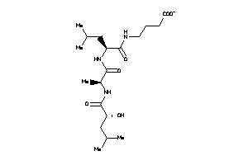

FIGURE 10 4-[[(2S)-2-[[(2S)-2-[[(2R)-2-hydroxy-4-methyl pentanoyl]amino]propanoyl]amino]-4-methyl-pentanoyl]am

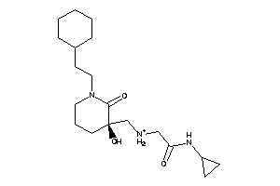

FIGURE 11 N~2~-{[1-(2-cyclohexylethyl)-3-hydroxy-2-oxopiperidin-3-yl]methyl}- cyclopropylglycinamide

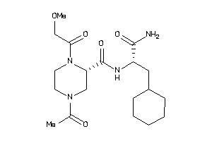

FIGURE 12 4-acetyl-N-(1-carbamoyl-2-cyclohexyl-ethyl)-1-(2-methoxyacetyl)-piperazine-2-carboxamide

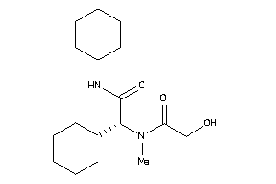

FIGURE 13 (2R)-N,2-dicyclohexyl-2-[(2-hydroxyacetyl)-methyl-amino]acetamide

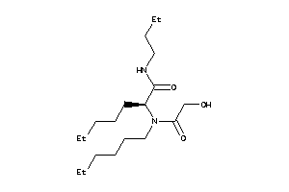

FIGURE 14 (2S)-N-butyl-2-[hexyl-(2-hydroxyacetyl)amino]heptanamide

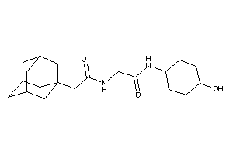
FIGURE 15 2-[[2-(1-adamantyl)acetyl]amino]-N-(4-hydroxycyclohexyl)acetamide

5.5 COMPOUNDS WITH DSX SCORE OF -12

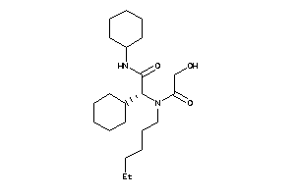

FIGURE 16 (2R)-N,2-dicyclohexyl-2-[hexyl-(2-hydroxyacetyl)amino]acetamide

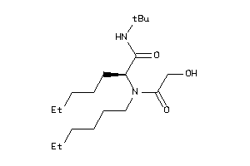

FIGURE 17 (2S)-N-tert-butyl-2-[hexyl-(2-hydroxyacetyl)amino]heptanamide

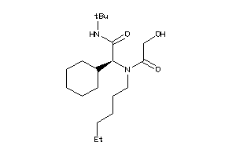

FIGURE 18 (2S)-N-tert-butyl-2-cyclohexyl-2-[hexyl-(hydroxyacetyl)amino]acetamide

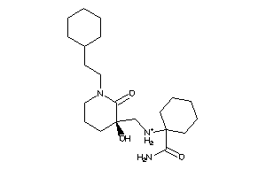

FIGURE 19 1-({[1-(2-cyclohexylethyl)-3-hydroxy-2-oxopiperidin-3-yl]methyl}amino)cyclohexanecarboxamide

5.6 COMPOUNDS DSX SCORE OF -13

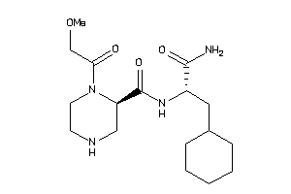

FIGURE 20 (2R)-N-[(1S)-2-amino-1-(cyclohexylmethyl)-2-oxo-ethyl]-1-(2-
methoxyacetyl)piperazine-2-carboxamide

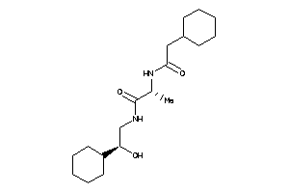

FIGURE 21 (2R)-2-[(2-cyclohexylacetyl)amino]-N-[(2S)-2-cyclohexyl-2-hydroxy-ethyl]propanamide

6 DISCUSSION

TABLE 4.1 shows the total of 35 molecules which were fetched from the CHEMBL database after drawing the query inhibitor keeping 70percent similarity. Out of this only 9 molecules satisfied Lipinski rules of five . the rest of the molecules’ characteristics which were out of the range of Lipnski rules were showed in red colour.

TABLE 4.2 shows 400 molecules which was a redundant set of molecules fetched from ZINC database after drawing the same query inhibitor keeping the similarity as 70 percent. After the removing the redundant molecules, a total of 139 molecules were found. Out of which 7 molecules did not satisfy the Lipinski rules of five. So total of 132 molecules of zinc database were uploaded for docking

TABLE 4.3 gives the docking result of total of 139 molecules (132 from ZINC database and 7 from CHEMBL database) . These chemical compounds with a certain pharmacological or biological activity has properties that would likely to make it an orally active drug in humans. The rule describes molecular properties that are important in the drug’s pharmacokinetics in the human body, including its ADME. However, the rule does not predict whether a compound is pharmacologically active or not.

Pharmacokinetics is currently deﬁned as the study of the time course of drug absorption, distribution, metabolism, and excretion. Pharmacodynamics refers to the relationship between drug concentration at the site of action and the resulting effect, including the time course and intensity of therapeutic and adverse effects. The effect of a drug present at the site of action is determined by that drug’s binding with a receptor. Receptors may be present on neurons in the central nervous system (i.e., opiate receptors) to depress pain sensation, on cardiac muscle to affect the intensity of contraction, or even within bacteria to disrupt maintenance of the bacterial cell wall. For most drugs, the concentration at the site of the receptor determines the intensity of a drug’s effect . However, other factors affect drug response as well. Density of receptors on the cell surface, the mechanism by which a signal is transmitted into the cell by second messengers (substances within the cell), or regulatory factors that control gene translation and protein production may inﬂuence drug effect. This multilevel regulation results in variation of sensitivity to drug effect from one individual to another and also determines enhancement of or tolerance to drug effects

Gly534-Ala535-Gly536-Ile537 forms six hydrogen bonds to the active site of the nsP2 protein . The Gly534 backbone nitrogen forms a trifurcated hydrogen bond with the oxygens of Ser1293, Glu1296 and Glu1157. However, in reality, the NH2 at the starting position can form only two interactions, as it is attached to the preceding residue and hence should be a backbone NH. Ala535 does not interact with the protein residues. The Gly536 backbone oxygen forms a hydrogen bond with the nitrogen of Gln1039. The Ile537 oxygen and nitrogen form hydrogen bonds with the oxygen and nitrogen of His1222 and Lys1239. So three hydrogen bond donars , two hydrogen bond acceptors and one hydrophobic group are required in the inhibitor for the interaction with the nsp2

There are six chemical compounds having DSX SCORE OF -11. Out of which three chemical compounds (figure 9, 10, 11) have a greater number of hydrogen bond acceptors than required. Other three chemical compounds (figure 12 , 13, 14) have low number of minimum hydrogen bond donors required for the interaction.

There are four chemical compounds having a score of -12. Three chemical compound out of these (figure 15, 16, 17) have low number of hydrogen bond donors than minimum required for the interaction. Figure 18 shows the compound of same DSX SCORE but this compound has approximately equal number of hydrogen bond acceptors and hydrogen bond donors required for good interaction.

Two best molecules having score of -13 also have approximately equal number of hydrogen bond donors and hydrogen bond acceptors that the original substrate has. These molecules could bind to the active site of the nsp2 protease and can inhibit it . Also these molecules can be used for taking fragments for building the inhibitors

7 CONCLUSION AND FUTURE PERSPECTIVES

Chikungunya virus replication and propagation depends on the nsP2 protein; so a chemical compound that inhibits this protein by targeting the key residues specified in the discussion will be potentially applicable therapeutically. Based on the DSX SCORE, twelve chemical compounds were found that may bind to the active site of the nsp2 protease of Chikungunya and can inhibit the protein

These chemical compounds can be synthesized and IC50 (inhibition constant) can be calculated using specific cell lines to analyse the effect of the drug. IC50 is the concentration of the drug at which fifty percent of the cells die.

These lead compounds could also serve as building blocks in the design of drug-like\ molecules for the treatment of Chikungunya viral fever specially the chemical compounds having the DSX SCORE of -11 and -12 can be used for designing the inhibitors for Chikungunya. These can also be analysed computationally by docking with other alphavirus proteins of other members other than Chikungunya as there is a high sequence similarity among alphavirus

8 REFRENCES

.

- Afjal Hossain Khan, Kouichi Morita, Maria del Carmen Parquet, Futoshi Hasebe, Edward G. M. Mathenge and Akira Igarashi. (2002) . Complete nucleotide sequence of chikungunya virus and evidence for an internal polyadenylation site. Journal of General Virology , 83, 3075–3084.

- Andres Merits, Lidia Vasiljeva, Tero Ahola,. Leevi Ka$a$ ria$inen and Petri Auvine. (2001). Proteolytic processing of Semliki Forest virus-specific non-structural polyproteins by nsP2 protease Journal of General Virology , 82, 765–773

- B. SIMIZU,t* K. YAMAMOTO, K. HASHIMOTO, AND T. OGATA (1984) Structural Proteins of Chikungunya Virus JOURNAL OF VIROLOGY, p. 254-258.

- Bradley S. Hollidge 1, 2, Susan R. Weiss 3 and Samantha S. Soldan. (2011). The Role of Interferon Antagonist, Non-Structural Proteins in the Pathogenesis and Emergence of Arboviruses Viruses , 3, 629-658.

- Centers for Disease Control and Prevention (CDC) (September 29, 2006). "Chikungunya fever diagnosed among international travelers—United States, 2005–2006".

- Devaux C. (2009). Chikungunya virus replication cycle. Virology, 25;393(2):183.

- Edelman R, Tacket CO, Wasserman SS, Bodison SA, Perry JG, Mangiafico JA. (June 2000). "Phase II safety and immunogenicity study of live chikungunya virus vaccine TSI-GSD-218". The American Journal of Tropical Medicine and Hygiene.

- Gaulton, L. Bellis, J. Chambers, M. Davies, A. Hersey, Y. Light, S. McGlinchey, R. Akhtar, F. Atkinson, A.P. Bento, B. Al-Lazikani, D. Michalovich, & J.P. (2011). Overington ChEMBL: A Large-scale Bioactivity Database For Chemical Biology And Drug Discovery' Nucleic Acids Research Database Issue

- Gohlke, H.; Hendlich, M.; Klebe, G. ( 2000). Knowledge-based scoring-function to predict protein-ligand interactions. J. Mol. Biol. , 295, 337-356.
- He´le`ne Malet, Bruno Coutard, Saïd Jamal, He´le`ne Dutartre,Nicolas Papageorgiou, Maarit Neuvonen, Tero Ahola, Naomi Forrester, Ernest A. Gould, Daniel Lafitte, Francois Ferron, Julien Lescar, Alexander E. Gorbalenya, Xavier de Lamballerie, and Bruno Canard. (2009). The Crystal Structures of Chikungunya and Venezuelan Equine Encephalitis Virus nsP3 Macro Domains Define Conserved Adenosine Binding Pocket JOURNAL OF VIROLOGY, p. 6534–6545.

- Irwin, Sterling, Mysinger, Bolstad and Coleman, Homology Modeling and Docking to Potential Novel Inhibitor for Chikungunya (37997) Protein nsP2 Protease. ( 2012). J. Chem. Inf. Model. DOI: 10.1021/ci3001277.

- Karpe YA, Aher PP, Lole KS. (2011). NTPase and 59-RNA Triphosphatase Activities of Chikungunya Virus nsP2 Protein. PLoS ONE 6(7): e22336. doi:10.1371.

- Kudukkil P Niyas, Rachy Abraham, Ramakrishnan Nair Unnikrishnan, Thomas Mathew, Sajith Nair, Anoop Manakkadan, Aneesh Issac1, Easwaran Sreekumar. (2010). Molecular characterization of Chikungunya virus isolates from clinical samples and adult Aedes albopictus mosquitoes emerged from larvae from Kerala, South India, Virology Journal , 7:189.

- Kui Zheng, Jiandong , Quanfu Zhang, Mifang Liang, Chuan Li, Miao Lin, Jicheng Huang, Hua Li, Dapeng Xiang, Ninlan Wang, Ye Hong, Li Huang, Xiaobo Li1, Deguan Pan, Wei Song, Jun Dai, Boxuan Guo, Dexin Li. (2010). Genetic analysis of chikungunya viruses imported to mainland China in 2008 Zheng et al. Virology Journal , 7:8.

- Limpon Bora*. (2012). Homology Modeling and Docking to Potential Novel Inhibitor for Chikungunya (37997) Protein nsP2 Protease , J Proteomics Bioinform,5:2.

- Mudur G. (2006). Failure to control mosquitoes has led to two fever epidemics in India. BMJ ;333:773.

- Mehdi Bouraï, Marianne Lucas-Hourani, Hans Henrik Gad Christian Drosten, Yves Jacob, Lionel Tafforeau, Patricia Cassonnet, Louis M. Jones, Delphine Judith Therese Couderc , Marc Lecuit Patrice André, Beate Mareike Kümmerer, Vincent Lotteau, Philippe Desprès, Frédéric Tangy, and Pierre-Olivier Vidalain (Jan 2012). Mapping of Chikungunya Virus Interactions with Host Proteins Identified nsP2 as a Higly Connected Viral Component. ,journal of virology
- Muegge I (2006). "PMF scoring revisited". J. Med. Chem. 49 (20): 5895–902. doi:10.1021/jm050038s.

- Ng LFP, Chow A, Sun YJ, Kwek DJC, Lim PL, Dimatatac F, Ng LC, Ooi EE, Choo KH, Her Z, Kourilsky P, Leo YS. (2009). IL-β, IL-6, and RANTES as biomarkers of Chikungunya severity. PLoS ONE 4:e4261

- Parola P, de Lamballerie X, Jourdan J, et al. (2006). Novel Chikungunya virus variant in travellers returning from Indian Ocean islands. Emerging Infectectious Diseases 2006;12:1493-9.

- Pastorino BA, Peyrefitte CN, Almeras L, Grandadam M, Rolland D, Tolou HJ, Bessaud M. (2008 feb). Expression and biochemical characterization of nsP2 cysteine protease of Chikungunya virus, Virus Research, 131(2):293-8.

- Singh KD, Kirubakaran P, Nagarajan S, Sakkiah S, Muthusamy K, Velmurgan D, Jeyakanthan. .(2011 Mar 29). Homology modeling, molecular dynamics, e-pharmacophore mapping and docking study of Chikungunya virus nsP2 protease. .J Mol Model 18:39–51.

- Schuffenecker I, Iteman I, Michault A, Murri S, Frangeul L, et al. (2006). Genome microevolution of chikungunya viruses causing the Indian Ocean outbreak. PLoS Med 3(7): e263. DOI: 10.1371/journal.

- Vikash K. Dubey, Monu Pande, Bishal Kumar Singh and Medicherla V. Jagannadham. (2007) . Papain-like proteases: Applications of their inhibitors African. Journal of Biotechnology Vol. 6 (9), pp. 1077-1086.

- V Ravi. (2006). Remergence of Chikungunya virus in india. Indian journal of medical virology 24(2): 83-4.

9 APPENDIX

S.NO | LIST OF URL | PAGE NUMBER
1. | https://www.ebi.ac.uk/chembldb/compound | 25
2. | http://zinc.docking.org/search/structure | 27
3. | http://www.webqc.org/molecularformatsconverter.php | 26
4. | http://www.rcsb.org/pdb/explore/explore.do?structureId=3trk | 23
5. | http://pc1664.pharmazie.uni-marburg.de/drugscore/ | 28

