EFFECT OF CASING ROTATION ON THE PERFORMANCE OF DIFFUSER
A major thesis submitted
In partial fulfilment for the requirements of the award of degree
Of
Master of Engineering
In
Thermal Engineering
Submitted by
ANIL KUMAR
ROLL NO. 8572
(Session 2009-11)
Under the Guidance of
Dr. B. B. ARORA

Department of Mechanical Engineering
Delhi College of Engineering
University of Delhi

Candidate’s Declaration
I hereby declare that the work which being present in the major thesis entitled “EFFECT OF CASING ROTATION ON THE PERFORMANCE OF THE DIFFUSER” in the partial fulfilment for the award of degree of MASTER Of ENGINEERING with specialization in “THERMAL ENGINEERING” submitted to Delhi College of Engineering, University of Delhi, is an authentic record of my own work carried out under the supervisions of Dr. B.B.ARORA, Department of Mechanical Engineering Delhi College of Engineering. I have not submitted the matter in this dissertation for the award of any other Degree or Diploma or any other purpose what so ever.

ANIL KUMAR
College Roll No. 02/THR/2009
University Roll No: 8572

Certificate
This is to certify that the above statement made by ANIL KUMAR is true to the best of my knowledge and belief.

Dr. B.B.ARORA
Department of Mechanical Engineering
Delhi College of Engineering, Delhi

Acknowledgement

It is a great pleasure to have the opportunity to extend my heartiest felt gratitude to everybody who helped me throughout the course of this dissertation.
It is distinct pleasure to express my deep sense of gratitude and indebtedness to my learned supervisor Dr. B.B.ARORA, Department of Mechanical Engineering, Delhi College of Engineering, for his invaluable guidance, encouragement and patient review. His continuous inspiration only has made me complete this dissertation.
I would also like to take this opportunity to present my sincere regards to my teachers for their kind support and encouragement.
I am thankful to my friends and classmates for their unconditional support and motivation for this dissertation.

ANIL KUMAR
College Roll No. 02/THR/2009
University Roll No: 8572

Abstract

A diffuser is a device for converting the kinetic energy of an incoming fluid into pressure efficiently. The task of a diffuser is to decelerate the flow and to regain total pressure. As the flow proceeds through the diffuser there is continuous retardation of the flow resulting in conversion of kinetic energy into pressure energy. Such a process is termed as diffusion. Diffuser forms an important part in flow machinery and structures.
The present study involves the CFD analysis of effect of casing rotation on annular diffuser performance using Fluent.. CFD analysis is conducted without swirl in an annular diffuser with the inlet velocity profile obtained experimentally. The variation in parameters i.e. Axial Velocity, Radial velocity, Swirl Velocity and Pressure Co-efficient, in the flow through annular diffuser studied along the various sections of the diffuser and also at various casing rotation speeds for a diffuser of constant length and Area Ratio. The velocity and pressure variations are calculated for different casing rotations. The various values of casing RPM studied are 200, 400, 600, 800, 1000, 1200, 1400, 1600, 1800, 2000, 2200, 2400, 2600, 2800, 3000 and 3200 rpm. In order to predict the performance characteristics of an annular diffuser, the Geometric parameters of annular diffuser are calculated for constant area ratio and length. The data is obtained with respect to a inlet velocity of 60 m/s. It is assumed that the flow is exhausted to atmosphere, so pressure at exit of diffuser is assumed to be atmospheric. The results are depicted in the form of variation of pressure coefficient along the diffuser length at different casing rotation. and velocity (axial velocity, radial velocity, swirl velocity) variation from hub to casing (along the diffuser height). These graphs are at no swirl condition and also variation of pressure coefficient with respect to casing rotation at no swirl condition. The pressure recovery coefficient at hub and casing side has been worked out.

CONTENTS

Candidate’s Declaration . i
Acknowledgement ii
Abstract iii
Contents iv
Lists of Figures vii
Nomenclature viii

1. INTRODUCTION 1-12
1.1 Axial Diffuser 2
1.2 Radial Diffuser 3
1.3 Curved Wall Diffuser 3
1.4 Annular Diffuser 3
1.5 Principle of Diffuser Design 4
1.6 Diffuser Performance Parameters 5
1.6.1 Geometric Parameter 5
1.6.2 Aerodynamic Blockage 6
1.6.3 Reynolds number 7
1.6.4 Inlet Mach number 7
1.6.5 Inlet Turbulence intensity 7
1.6.6 Effect of Compressibility 7
1.6.7 Effect of Compressibility on Wall Design 8
1.7 Design Performance Parameters 8
1.7.1 Static Pressure Recovery Coefficient 8
1.7.2 Diffuser Effectiveness 9
1.7.3 Total Pressure Loss Coefficient 9
1.7.4 Ideal Pressure Recovery 10

1.8 Swirling Flow 10
1.8.1 Physics of Swirling and Rotating Flows 10
1.8.2 Method of swirl generation 11
1.9 Motivation 11

2. LITERATURE REVIEW 13-22
2.1 Effect of Geometric Parameters 15
2.1.1 Passage Divergence and Length 16
2.1.2 Wall Contouring 17
2.2 Effects of Flow Parameters 17
2.2.1 Aerodynamic Blockage 17
2.2.2 Inlet Swirl 18
2.2.3 Inlet Turbulence 19
2.2.4 Mach number Influence 20
2.2.5 Reynolds Number Influence 21
2.2.6 Boundary Layer Parameter 21
2.2.7 Blowing and Injection 22

3. CFD ANALYSIS 23-30
3.1 Why Use CFD for analysis 23
3.2 Program Capabilities 24
3.3 Planning CFD Analysis 25
3.3.1 Definition of the Modeling Goals 25
3.3.2 Grid Generation and its Independence 25
3.3.3 Choice of the Computational Model 25
3.3.4 Choice of Physical Models 26
3.3.5 Determination of the Solution Procedure 26
3.4 Discretization of partial equations 26
3.5 Convergence Criteria 27
3.6 Simulation Procedure 27
3.7 FLUENT Applications 28

4. FLOW FIELD NUMERICAL MODELLING 31-41
4.1 Conservation principles 31
4.1.1 The Mass Conservation Equation 31
4.1.2 Momentum Conservation Equations 32
4.2 Turbulence Modelling 33
4.2.1 Choosing a Turbulence Model 33
4.2.2 FLUENT Turbulence models 34
4.3 The Standard, RNG, and Realizable k- ε Models 34
4.3.1 The Standard k-ε Model 35
4.3.2 Transport Equations for the Standard k-ε Model 35
4.3.3 Modeling the Turbulent Viscosity 36
4.3.4 The Model Constants 36
4.3.5 The RNG k-ε Model 36
4.3.6 Transport Equations for the RNG k-ε Model 37
4.3.7 The Realizable k-ε Model 38
4.3.8 Turbulence Modeling in Swirling Flows 38
4.3.9 Modeling Axisymmetric Flows with Swirl or Rotation 39
4.3.10 Modeling the Turbulent Viscosity 39
4.3.11 Model Constants 40
4.3.12 Turbulence Modeling in Swirling Flows 40
4.3.13 Modeling Axisymmetric Flows with Swirl or Rotation 41

5 RESULT AND DISCUSSION 42-45

6 RECOMMENDATIONS FOR FUTURE WORK 46

REFERENCES 47-50
FIGURES 51-84
APPENDIX 85
LIST OF FIGURES:

List Of graphs between pressure coefficient & position ( x-direction along the diffuser length) at different casing rotation for casing and hub

Fig 1 Swirl Angle =$0^{∘}$, 200 rpm 51
Fig 2 Swirl Angle =$0^{∘}$, 400 rpm 51
Fig 3 Swirl Angle =$0^{∘}$, 600 rpm 52
Fig 4 Swirl Angle =$0^{∘}$, 800 rpm 52
Fig 5 Swirl Angle =$0^{∘}$, 1000 rpm 53
Fig 6 Swirl Angle =$0^{∘}$, 1200 rpm 53
Fig 7 Swirl Angle =$0^{∘}$, 1400 rpm 54
Fig 8 Swirl Angle =$0^{∘}$, 1600 rpm 54
Fig 9 Swirl Angle =$0^{∘}$, 1800 rpm 55
Fig 10 Swirl Angle =$0^{∘}$, 2000 rpm 55
Fig 11 Swirl Angle =$0^{∘}$, 2200 rpm 56
Fig 12 Swirl Angle =$0^{∘}$, 2400 rpm 56
Fig 13 Swirl Angle =$0^{∘}$, 2600 rpm 57
Fig 14 Swirl Angle =$0^{∘}$, 2800 rpm 57
Fig 15 Swirl Angle =$0^{∘}$, 3000 rpm 58
Fig 16 Swirl Angle =$0^{∘}$, 3200 rpm 58

List Of Graphs Showing Variation of axial Velocity with position (y-direction Along the Diffuser Height)

Fig 17 Swirl Angle =$0^{∘}$, 200 rpm 59
Fig 18 Swirl Angle =$0^{∘}$, 400 rpm 59
Fig 19 Swirl Angle =$0^{∘}$, 600 rpm 60
Fig 20 Swirl Angle =$0^{∘}$, 800 rpm 60
Fig 21 Swirl Angle =$0^{∘}$, 1000 rpm 61
Fig 22 Swirl Angle =$0^{∘}$, 1200 rpm 61
Fig 23 Swirl Angle =$0^{∘}$, 1400 rpm 62
Fig 24 Swirl Angle =$0^{∘}$, 1600 rpm 62
Fig 25 Swirl Angle =$0^{∘}$, 1800 rpm 63
Fig 26 Swirl Angle =$0^{∘}$, 2000 rpm 63
Fig 27 Swirl Angle =$0^{∘}$, 2200 rpm 64
Fig 28 Swirl Angle =$0^{∘}$, 2400 rpm 64
Fig 29 Swirl Angle =$0^{∘}$, 2600 rpm 65
Fig 30 Swirl Angle =$0^{∘}$, 2800 rpm 65
Fig 31 Swirl Angle =$0^{∘}$, 3000 rpm 66
Fig 32 Swirl Angle =$0^{∘}$, 3200 rpm 66

List Of Graphs Showing Variation of radial Velocity with position (y-direction Along the Diffuser Height)

Fig 33 Swirl Angle =$0^{∘}$, 200 rpm 67
Fig 34 Swirl Angle =$0^{∘}$, 400 rpm 67
Fig 35 Swirl Angle =$0^{∘}$, 600 rpm 68
Fig 36 Swirl Angle =$0^{∘}$, 800 rpm 68
Fig 37 Swirl Angle =$0^{∘}$, 1000 rpm 69
Fig 38 Swirl Angle =$0^{∘}$, 1200 rpm 69
Fig 39 Swirl Angle =$0^{∘}$, 1400 rpm 70
Fig 40 Swirl Angle =$0^{∘}$, 1600 rpm 70
Fig 41 Swirl Angle =$0^{∘}$, 1800 rpm 71
Fig 42 Swirl Angle =$0^{∘}$, 2000 rpm 71
Fig 43 Swirl Angle =$0^{∘}$, 2200 rpm 72
Fig 44 Swirl Angle =$0^{∘}$, 2400 rpm 72
Fig 45 Swirl Angle =$0^{∘}$, 2600 rpm 73
Fig 46 Swirl Angle =$0^{∘}$, 2800 rpm 73
Fig 47 Swirl Angle =$0^{∘}$, 3000 rpm 74
Fig 48 Swirl Angle =$0^{∘}$, 3200 rpm 74

List Of Graphs Showing Variation of swirl Velocity with position (y-direction Along the Diffuser Height)

Fig 49 Swirl Angle =$0^{∘}$, 200 rpm 75
Fig 50 Swirl Angle =$0^{∘}$, 400 rpm 75
Fig 51 Swirl Angle =$0^{∘}$, 600 rpm 76
Fig 52 Swirl Angle =$0^{∘}$, 800 rpm 76
Fig 53 Swirl Angle =$0^{∘}$, 1000 rpm 77
Fig 54 Swirl Angle =$0^{∘}$, 1200 rpm 77
Fig 55 Swirl Angle =$0^{∘}$, 1400 rpm 78
Fig 56 Swirl Angle =$0^{∘}$, 1600 rpm 78
Fig 57 Swirl Angle =$0^{∘}$, 1800 rpm 79
Fig 58 Swirl Angle =$0^{∘}$, 2000 rpm 79
Fig 59 Swirl Angle =$0^{∘}$, 2200 rpm 80
Fig 60 Swirl Angle =$0^{∘}$, 2400 rpm 80
Fig 61 Swirl Angle =$0^{∘}$, 2600 rpm 81
Fig 62 Swirl Angle =$0^{∘}$, 2800 rpm 81
Fig 63 Swirl Angle =$0^{∘}$, 3000 rpm 82
Fig 64 Swirl Angle =$0^{∘}$, 3200 rpm 82

Combined Graphs of pressure coefficient (y-axis) Vs diffuser length (x-axis) For Hub

FIG.65: pressure coefficient (y-axis) Vs diffuser length (x-axis) For casing 83
FIG.66: pressure coefficient (y-axis) Vs diffuser length (x-axis) For Hub 83

Graphs of Pressure Coefficient (y-axis) Vs Casing Rotation (x-axis) For Casing & Hub

Fig.67: pressure coefficient (y-axis) Vs casing rotation (x-axis) For Casing 84
Fig.68: pressure coefficient (y-axis) Vs casing rotation (x-axis) For hub 84

NOMENCLATURE

A Area
AR Area ratio
AS Aspect Ratio
B Blockage factor
C Constants
C_{P} Pressure recovery co-efficient
C_{PI} Ideal pressure recovery co-efficient
D Diameter
G generation of turbulence kinetic energy
g acceleration due to gravity
K Total pressure loss co-efficient
k Turbulent kinetic energy
P Static pressure
P_{t} Total pressure
Q Volume flow rate
R Radius
Re Reynolds number
S Swirl Number of flow
S_{m} Mass added
U Velocity
w Swirl velocity
x,y,z Cartesian coordinate system
Y_{M} fluctuating dilatation in compressible turbulence.
Symbols
$\bar{\bar{τ}}$ Stress tensor
µ Laminar viscosity
µ_{t} Turbulent viscosity
2θ Equivalent cone angle
Γ Circulation
ε Turbulent kinetic energy dissipation rate
η Diffuser effectiveness
θ Wall angle
ν Kinematics viscosity
ξ Total pressure loss co-efficient
ρ Density
Σ Turbulent Prandtl no.

Subscript
B Blocked
ci casing inlet
co casing outlet
E Effiective
eq Equivalent flow
hi hub inlet
ho hub outlet
in inlet
m maximum
out outlet
r radial direction
t tangential direction
x longitudinal direction

INTRODUCTION CHAPTER 1

Diffusers are one of the standard challenges in fluid mechanics. A diffuser is a device which decelerates the flow & to regain total pressure or device which increases the pressure of a fluid at the expense of its kinetic energy. The task of a diffuser is to decelerate the flow and to regain total pressure. It is more difficult to arrange for an efficient deceleration of flow than it is to obtain an efficient acceleration. There is a natural tendency in a diffusing process for the flow to break away from the walls of the diverging passage, reverse its direction, and flow back in direction of the pressure gradient. If the divergence is too rapid, this may result in the formation of eddies with consequent transfer of some kinetic energy into internal energy and a reduction in useful pressure rise. A small angle of divergence, however, implies a long diffuser and a high value of skin friction loss. Usually, flow separation in a diffuser is sought to be avoided due to the invoked additional pressure loss. Other than in many strongly separated flows, such as the flow over a backward facing step, the point of flow separation, in diffuser, is not defined by the geometry but entirely by the pressure gradient. Hence, diffuser flows are very sensitive and are difficult to predict with numerical means. Diffusers have been studied extensively in the past, since this is a very common flow configuration. Apart from the characterization of diffusers, these flows are used to study fundamental physics of pressure-driven flow separations.
Diffusers are extensively used in centrifugal compressors, axial flow compressors, ram jets, combustion chambers, inlet portions of jet engines etc. The energy transfer in these turbo machineries involves the exchange of significant levels of kinetic energy in order to accomplish the intended purpose. As a consequence, very large levels of residual kinetic energy frequently accompany the work input and work extraction processes, sometime as much as 50% of the total energy transferred. A small change in pressure recovery can increases the efficiency significantly. Therefore diffusers are absolutely essential for good turbo machinery performance.
The flow in the diffuser is governed by the behavior of the boundary layers at the diffuser walls. The deceleration of the flow through the diffuser produces a pressure rise in the stream wise direction. The wall shear layers are therefore subjected to a positive or adverse pressure gradient. As is well known, adverse pressure gradients cause the boundary layer thicken and possibly separate from the diffuser walls, forming areas of back flow in diffusers. The net result of thickening of the wall boundary layers or the formation of region of back-flow is the blockage of the flow area which reduces the effective area available to the flow. Reduction the effective flow area in turn results in a reduced pressure rise through the diffuser. The interaction of wall shear layers and / or separated zone with the core flow in diffusers is very complicated; therefore diffuser design and performance estimation is largely based on experimental data and empiricism.

1.1 Axial Diffuser
In axial diffusers, fluid flows along the axis of diffusers and there is continuous retardation of the flow. Axial diffuser is divided in to the following categories-
- Conical diffuser
- Channel diffuser
- Annular diffuser
The basic geometric parameters for these types of diffusers are as follows:
For conical diffuser
Non dimensional length, L/W₁
Aspect ratio, AS = b/W₁
Area ratio, AR = A₂/A₁
For channel diffuser
Non dimensional length, L/D₁
Area ratio, AR = A₂/A₁
For annular diffuser
Non-dimensional length, L/∆r or L/h
Area ratio, AR = A₂/A₁
(For equiangular case)

1.2 Radial Diffuser
In radial diffusers fluid flows in radially outward direction in confined space between the two boundaries. Diffuser used in radial turbo machinery fall under this category. They may be vane less and vaned types. unlike the axial diffuser, this type of diffuser may convert kinetic energy into static pressure rise by one or two principles – an increases in flow passage area in order to bring about a reduction in the average velocity; – a change in the mean flow path radius to bring about a recovery in angular velocity according to the conservation of angular momentum.
1.3 Curved Wall Diffuser
In recent time most of the aircrafts use curved wall diffuser. In aircraft engines several modifications may introduce non-uniformities and higher level of turbulence in flow field entering the diffuser. In addition mechanical and structural requirement place limits on the length of the passage. Curved wall diffuser is useful in this case and compatible with down stream requirement of flow besides it, these diffuser are also of fundamental and practical interest for various other applications like gas turbine system.
Curved diffusers are broadly classified as –
- 90 or part turn diffuser or half diffuser.
- 180 or U- diffuser.
- S- Diffuser.
- Y-Diffuser.

1.4 ANNULAR DIFFUSER
For decades researchers have paid more attention to conical diffuser and channel diffuser than to annular diffusers. But, the annular diffusers have a very strong industrial significance and have received attention in recent years. These types of diffuser are very much used in aircraft applications. With the help of annular diffuser the maximum presser recovery is achieved within the shortest possible length. With annular diffuser, good performance is possible with large wall angles since an inner surface is present to guide the flow radially outward. The annular diffuser affords the possibility of introducing many different geometric combinations since there is now an inner surface that can be varied independently of the outer surface.
It is more difficult to define the essential geometric parameters for annular diffusers since the numbers of independent variables are large. The essential variables to define the geometry of annular diffuser are two wall angles, area ratio, non-dimensional length and inlet radius ratio. As the number of variables increases, geometry becomes more complex. By suitable combination of these variables we can find out number of geometry.
A survey of diffuser research has revealed that considerably more investigations have been carried out on two dimensional and conical diffusers. Much of the extent data covering annular diffusers was done in the experimental laboratory Stafford and James [1957]. Annular diffusers have a very strong industrial significance and have received attention in recent years. These types of diffuser are very much used in aircraft applications. With the help of annular diffuser the maximum presser recovery is achieved within the shortest possible length. With annular diffuser, good performance is possible with large wall angles since an inner surface is present to guide the flow radially outward. The annular diffuser affords the possibility of introducing many different geometric combinations since there is now an inner surface that can be varied independently of the outer surface. It is more difficult to define the essential geometric parameters for annular diffusers since the numbers of independent variables are large Goebel and Japikse [1981]. The essential variables to define the geometry of annular diffuser are two wall angles, area ratio, non-dimensional length and inlet radius ratio. As the number of variables increases, geometry becomes more complex. This has not been economically possible by experiments and hence led to the development of computational fluid dynamic methods to analyze the performance characteristics of annular diffuser Arora, Pathak and Singh [2005].
1.5 Principle for Diffuser Design
Since flow in diffusers are subjected to an adverse pressure gradient there is potential danger for flow separation to occur which leads to loss in performance and damage of downstream equipment. The aim of design is to keep the adverse pressure gradient as high as possible, but below a critical limit, by controlling the length versus area-ratio of the diffuser.
The design requirements for a good diffuser are as following-
- Convey the flow efficiently by transferring a portion of the kinetic energy into a static pressure rise.
- It must accept a variety of inlet conditions including extreme swirl, blockage and Mach number.
- Deliver the fluid with reasonable velocity and angle profiles without separated regions.
- Wall curvature must not have a deleterious effect upon passage performance.
- Pressure recovery achieved over a short axial length.
While obtaining the best possible design, some limitations are imposed on a diffuser.
- Limited length
- Specified area ratio
- Specified cross- sectional shape
- Maximum static pressure recovery
- Minimum stagnation pressure loss

1.6 Diffuser performance parameter
1.6.1 Geometric parameters
Any diffuser geometry with increasing area in the stream wise direction constitutes subsonic diffuser geometry. Therefore, the number of different diffusers geometries that can be conceived in infinite. However in practice adequate design data are available for limited numbers of geometries. These are:
- Rectangular cross section plan diffusers
- Conical diffuser
- Annular diffuser

These geometric parameters can be consolidated to few non dimensional parameters that are found to be important in terms of diffuser performance.
  - The first is area ratio (AR). The area ratio is measure of theoretical diffusion of pressure recovery expected.
  - The second important parameter is the dimensionless diffuser length is define as N/Wi or L/Wi for planar diffusers, and L/ (Rit-Rih), for annular diffusers.
  - The third geometric parameter commonly used in displaying diffuser performance is the wall divergence angle 2D for planar and conical diffusers.

Area ratio and non dimensional length tells the overall diffusion and pressure gradient respectively, which is the main factor in boundary layer development. Paterson Cockrell and Markland [1986] found that a variation in the AR from 2.5 to 8.0 has a small effect on the loss coefficients of the 2-D diffuser. Sharan[1972] reported that for a constant AR the performance of diffuser deteriorates with the increase in diffusion angle. Reneau et al [1967] concluded that for two dimensional straight diffusers the maximum pressure recovery at a constant area ratio occurs in the range of diffuser angle equal to 6-8deg.

1.6.2 Aerodynamic blockage
Thin inlet boundary layers tends to be beneficial to high diffuser recovery and those longer diffusers necessary to achieve high levels of recovery as the inlet boundary thickness increases as stated by Hoadley D,et.al, 1969.
The blockage is the fraction or percentage of the inlet passage area which is occluded the boundary layer displacement thickness on all walls. The displacement thickness is taken as equal on all surfaces and then the following relationships ensue:
B = 2*/h for annular diffusers where h is annular height at inlet
B = 2*/D₁ for conical diffusers with uniform inlet boundary layers
1.6.3 Reynolds number:
Viscosity is an important parameter in any fluid dynamic process and normally appears in the form of a Reynolds number. Diffusers are characterizes by Reynolds number based on an inlet hydraulic diameter. Shaalan, et al [1975] studies reported in this field suggest that the Reynolds number is a comparatively weak parameter as long as the flow is fully turbulent regime.

1.6.4 Inlet Mach number:
The Mach number at the inlet to the diffuser was thought to be important at values as low as approximately 0.7 and performance to fall off past this point. No significance on Mach number develops at throat for Mach numbers of less than 1.0 is studied by Thayer E B, [1971].
1.6.5 Inlet Turbulence intensity
The turbulence intensity is most frequently defined as an RMS value:
This equation defines the parameter most frequently used to specify the over all level of inlet turbulence intensity is given by Shaalan, et al [1975].

1.6.6 Effect of Compressibility:
With compressible flow both area, A, and density, p, increases with passage down the diffuser so that the reduction in velocity V, will be greater than in the case of incompressible flow where only the cross sectional area increases. It therefore follows that the pressure recovery coefficient should also be greater.
The rate of increase in value of Cp is not rapid until Mach number of 0.6 have been exceeded and than the effect is most pronounced when area ratios are low. These low area ratios correspond to the diffuser inlet vision and flow separation would therefore occur here as a result of predicted increasing adverse pressure gradient caused by the higher subsonic inlet mach number.

1.6.7 Effect of Compressibility on Wall Design:
The design of diffuser walls is achieved by using a step by step or “ marching” method where small element of diffuser are considered in sequence it was recommended the length of each element, s, should be on the order of to percent of the hydraulic diameter when assessed diffuser inlet

1.7 Design Performance Parameters
Performance parameters are very helpful in designing and predicting the performance of diffusers. These parameters reveal that diffuser geometry will give the desire output or not. The following parameters are important to find out diffuser performance.

1.7.1 Static Pressure Recovery Coefficient
The pressure recovery coefficient of a diffuser is most frequently defined as the static pressure rise through the diffuser divided by the inlet dynamic head
where subscripts 1 and 2 refers to diffuser inlet and outlet conditions respectively. V_{avi} represents the average velocity at the inlet. An ideal pressure recovery can be defined if the flow is assumed to be isentropic. Then, by employing the conservation of mass, this relation can be converted to an area ratio for incompressible flow

1.7.2 Diffuser Effectiveness
The diffuser effectiveness is simply the relation between the actual recovery and the ideal pressure recovery.
This is an excellent parameter for judging the probable level of performance when it is necessary to estimate the expected performance under unknown conditions, relative to available data.

1.7.3 Total Pressure Loss Coefficient
The total pressure loss coefficient reflects the efficiency of diffusion and drag of the system. The most common definition of loss coefficient is as the ratio of total pressure rise to the diffuser inlet dynamic head.
where p₀₂ is the total pressure in the core region at the exit, the over bar indicate the mass averaged quantity, and α₁ and α₂ are the kinetic energy parameters at the inlet and exit of the diffuser.

For the case where the velocity profile at the inlet of diffuser is flat with a thin wall boundary layer, α₁=1 However, due to the thickening of boundary layer through the diffuser, α₂ is generally greater than unity. Nonetheless, it is often assumed that kinetic energy coefficient is equal to unity, then

1.7.4 Ideal Pressure Recovery
Another parameter of interest is the ideal pressure recovery, C1, which is the pressure recovery coefficient assuming an inviscid flow through diffuser, which represent the maximum pressure recovery attainable by the given diffuser. When the definition of pressure recovery, the Bernoulli equation, and the conservation of mass and conservation of angular momentum principles are all employed, the following relationship is obtained for Cpi.

1.8 SWIRLING FLOWS

1.8.1 Physics of Swirling and Rotating Flows
In swirling flows, conservation of angular momentum (rw or r²Ω = constant) tends to create a free vortex flow, in which the circumferential velocity, w, increases sharply as the radius, r, decreases (with w finally decaying to zero near r = 0 as viscous forces begin to dominate). A tornado is one example of a free vortex. Figure depicts the radial distribution of w in a typical free vortex.
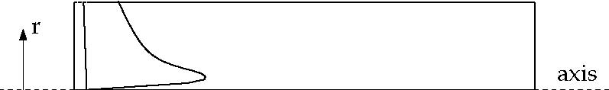
Typical Radial Distribution of w in a Free Vortex

It can be shown that for an ideal free vortex flow, the centrifugal forces created by the circumferential motion are in equilibrium with the radial pressure gradient:
As the distribution of angular momentum in a non-ideal vortex evolves, the form of this radial pressure gradient also changes, driving radial and axial flows in response to the highly non-uniform pressures that result. Thus, as you compute the distribution of swirl in your FLUENT model, you will also notice changes in the static pressure distribution and corresponding changes in the axial and radial flow velocities. It is this high degree of coupling between the swirl and the pressure fleld that makes the modeling of swirling flows complex.
In flows that are driven by wall rotation, the motion of the wall tends to impart a forced vortex motion to the fluid, wherein w/r or Ω is constant. An important characteristic of such flows is the tendency of fluid with high angular momentum (e.g., the flow near the wall) to be flung radially outward. This is often referred to as “radial pumping”, since the rotating wall is pumping the fluid radially outward.

1.8.2 Method of swirl generation
Methods of including rotation in a stream of fluid can be divided into three principle category:
- Tangential entry of the fluid stream, or a part of it, into the cylindrical duct.
- The use of guide vanes in axial tube flow.
- Rotation of mechanical devices which impart swirling motion to the fluid passing through them. This includes rotating vanes or grids and rotating tubes.

1.9 Motivations
The purpose of this study is to investigate the level of knowledge and in certain important areas the lack thereof, concerning the performance of annular diffusers. For decades investigators have conducted individual studies without a careful consideration of how all the studies may be interwoven. A pattern of consistent behavior among the database elements for annular diffusers is established in this investigation. However, it may be of even greater significance that the investigation reveals areas where critical design knowledge is missing. It will be observed that conducting individual investigations of annular diffuser performance has blinded most investigators from seeing the larger picture and the critical interactions between the different variables which have been discussed in the literature. This study begins by looking at historical data, then proceeds to investigate the parametric dependence, resulting in the development of a preliminary design set of equations and then finally by careful examination of further investigations which are needed before the annular diffuser design problem will be well understood.

LITERARTUER SURVEY Chapter 2
Diffusers are ducts that convert flow kinetic energy to pressure by decelerating the flow. Cockrell and Markland [1963], reported that a variation in the area ratio from 2.5 to 8.0 has a small effect on the loss coefficients of conical diffusers. The study carried out by Moller [1965], who designed an axial to radial band with the intention of eliminating diffusion in the inlet region; found that the peak pressure recovery for the entire band and radial diffuser sections was 0.88 and 0.82 for the low blockage and high blockage cases, respectively. Sovran and Klomp [1967] and Howard et al. [1967] produced the first widely used annular diffuser maps for channel diffusers. Sovran and Klomp conducted a large number of performance measurements which spanned a broad selection of geometric types of diffusers. The map is only a broad representation of the bulk of configurations tested in the vicinity of their best performance areas. The poorer diffusers are not well defined by the map. These maps also show optimal diffuser geometrics under different conditions and two optimum lines are established. The line of Cp* shows the best area ratio for a given length/passage height ratio, and the line of Cp** shows the best length/ passage height ratio for a given area ratio. The same results were found out by Howard et al [1967]. The important difference between this and the Sovran and Klomp [1967] map was that the latter was made for very low inlet aerodynamic blockage whereas the former study was carried out for fully developed inlet profiles, implying high aerodynamic blockage Along the line of peak recovery there is fairly good agreement between the two maps but in the region of heavy transitory stall the maps disagree substantially.
In this early work of Hoadley and Hughes [1969], an ideal pressure recovery contour is plotted parallel to the actual pressure recovery. This suggests that much of the effect of geometry and swirl can be taken care of in the ideal pressure recovery and that a sensible way of developing a correlation for static pressure recovery performance will be to use diffuser effectiveness which is $η=\frac{C_{p}}{C_{\text{pi}}}$ or in other words the ratio of the actual pressure recovery coefficient divided by the ideal pressure recovery coefficient. A variety of past experiences suggests that there is some development of progressive stalling occurring which will not be reflected in the ideal pressure recovery, but must be dealt with in the actual pressure recovery.
Takehira et al [1977] presented extensive data for a large set of both straight annular diffusers and curved wall diffusers, and determined that the use of strong curvature at the exit of diffuser was not debilitating but did produce a penalty compared to non-curved diffusers or diffusers with curvature at the inlet. Adkins et al [1983] tested an annular diffuser of constant outer radius and a conical canter body with cones of different angles. In general the pressure recovery increases with decreasing cone angle for various area ratios, but the 13.2° and sometimes the 45° cone angle produced lower pressure recoveries than an equivalent sudden expansion. This was attributed to a large and rapid separation at the base of the cone where the diffuser starts. Adding a radius to the base of the cone so that it smoothly blended into the upstream hub, was found to improve the performance. An extensive study of diffusers which, although annular, begin with a circular cross section was reported by Ishikawa and Nakamura [1989]. The author found that the performance of the diffuser differed significantly depending on whether it is parallel or diverging for L/r1 greater than about 2. When both types have the same non dimensional length and area ratio, the parallel diffuser has the higher Cp. The lines of optimum performance are also drawn. The line of Cp shows the best area ratio for a given non dimensional length, and the line of Cp shows the best non dimensional length for a given area ratio. In the case of the latter line, there is no difference between the parallel and diverging diffuser.
Yuki Miyazoe, Toshio Sawairi, Kazuyuki Ito, Yoshiaki Konishi, Takashi Yamane, Masahiro Nishida, Balazs Asztalos, Toru Masuzawa, Tomonori Tsukiya, Seiko Endo, and Yoshiyuki Taenaka$\left[\text{1999}\right]$. To study CFD analysis indicated that a change to a smaller radial gap greatly affected the shear stress in fluid. In the model with a small radial gap, relocation of the outlet diffuser position did not have a large effect on the haemolytic performance. St efano Ubertini, Umberto Desideri$\left[\text{2000}\right]$. As it is well-known, flow separation can only occur when pressure rises in the direction of the flow and, therefore, diffusers are prone to separation. Separation of the fluid causes pressure losses and sometimes flow reversals that can be destructive in its effect. Tom Bajcar, Brane Sirok, Ferdinand Trenc$\left[\text{2003}\right]$. The radial velocity distribution depends on the rotating frequency of the diffuser and on the axial inlet Reynolds number of the airflow. M.N. Noui-Mehidi, J. Wu, I.D. S utalo, C. rainger.$\left[\text{2004}\right]$.The space limitation in industrial plants often requires diffusers with a rapid transition and a short working length, but the wide angles cause flow separation just downstream of the inlet of the diffuser. To overcome this problem, many devices such as perforated plates, wire gauze screens and vortex generators mounted on diffuser walls have been installed within diffusers. Perforated plates and wire gauzes prevented the flow from separating, but introduced pressure drops and non-uniform flow distributions downstream of the diffuser. Tushar Goel, Daniel J. Dorney, Raphael T. Haftka, Wei Shyy$\left[\text{2007}\right]$. Optimization of the vane shape, in the absence of manufacturing and stress constraints, led to a nearly 8% reduction in the total pressure losses compared to the baseline design by reducing the base separation.

Ali Pinarbasi$\left[\text{2008}\right]$. To find vane less space ratio is very sensitive in the diffuser design as it is related with throat blockage. When the location of the vane leading edge is close to the impeller it is known that, there is increased noise level, increased vibration and high Mach numbers result at the vane leading edge. S. Ghosh, D. K. Pratihar, B. Maiti and P. K. Das$\left[\text{2009}\right]$. Flow decelerations is affected by varying the cross sectional area. A diffuser is generally used either to recover static pressure or to minimize total pressure loss in a pipe or in a duct. The CFD software has been combined in a monolithic platform for a fully automated operation using some special control commands. Based on the developed algorithm, an extensive exercise has been made to optimize the diffuser shape. Different methodologies have been adopted to create a large number of design options. However, in all the approaches, a better design has been obtained through a proper selection of the number of design variables.

2.1 Effect of Geometric Parameters
Stefano Ubertini, Umberto Desideri$\left[\text{2000}\right]$. In an annular diffuser, a number of different geometric variables can influence the variation of pressure recovery and inlet condition of flow. The basic equations of motion reveal the importance of both geometric and aerodynamic parameters on the ultimate performance of annular diffuser. The specification of a wide variety of geometric parameters is essential before the performance of diffuser is givenJapikse Dr. David [2003] gave the correlations for annular diffuser performance with geometry, swirl and blockage. Most design variables in the optimal design were at the boundary of the design space, further improvements in the performance of the diffuser might be obtained by refining the design space. To reduce the computational expense, we reduce the design space by utilizing the findings of the global sensitivity analysis.

Studied effect of geometry on the performance of annular diffuser. Arora B.B., Pathak B.D. [2005]. The turbulent structures in a gas turbine exhaust diffuser, the effect of the struts on the distortion of the flow, the evolution of the struts wakes, the interaction between the struts and the inlet guide vanes wakes in the separation process around the hub and the shell are all elements that not only reveal useful information on the nature of the flow field but are also particularly important in the validation and development of CFD codes. Tushar Goel, Daniel J. Dorney, Raphael T. Haftka, Wei Shyy$\left[\text{2007}\right]$. Analysed numerically the impact of conical diffuser geometry change on velocity distribution in its outlet cross-section.

2.1.1 Passage Divergence and Length
Area ratio and non-dimension length prescribes the overall diffusion and pressure-gradient respectively, which is the principle factor in boundary layer development. The study by Henry and Wood [1958] is useful to understand the subsonic annular diffuser. Two diffusers with area ratio 2.1 and divergence of 5° and 10° were tested at various Mach number. It found by this study that most of data clusters around a line of constant effectiveness. It is also observed that the inner wall is being starved of fluid. If a higher divergence had been used, then one might anticipate stall on the inner surface. An extensive study is carried out by Kmonicek and Hibs [1974] in which, the pressure loss coefficient is found out on the basis of the work of compression required to meet the static pressure rise, the results are very interesting but difficult to understand due to use of unconventional terminology.
Johnston [1959] and Johnston [1953] reported a study of four different annular diffusers. Three of the four agree tolerably well with the basics Sovran and Klomp [1967] map, one of them disagree substantially; the case a strong disagreement is probably in stall. Srinath [1968] studied four equiangular annular diffuser with 2θ = 7º, 10º, 15º and 20º respectively. Tests were reported with a variety of L/Δr values. The line of best pressure recovery shown as CP* by Sovran and Klomp [1967] was again confirmed, and Srinath’s map is quite similar to that of Howard et al. [1967]. Srinath [1968], also observed that the existence of a down stream pipe improved the pressure recovery of the diffuser itself. Tom Bajcar, Brane Sirok, Ferdinand Trenc$\left[\text{2003}\right]$. Large diffuser divergence angles (>12) cause separation of the boundary layer, which in turn deteriorates the diffuser efficiency. On the other hand, diffusers with small divergence angles have to be very long to provide enough pressure rise at considerably high friction losses. S. Ghosh, D. K. Pratihar, B. Maiti and P. K. Das(2009) tested an increase in length of the diffuser beyond a certain limit may give a marginal advantage in the reduction of form drag but increases skin friction.

2.1.2 Wall Contouring
Several annular diffuser studies have been published in which contoured walls were an essential part of the design problem. Thayer [1971], reported that curved wall diffusers had pressure recovery as high as 0.61 to 0.65 for an area ratio of 2.15. An extensive study by Stevens and Williams [1980], reported that for curved wall diffuser, good pressure recovery was found for a loss significantly below the level which would be expected from pressure recovery loss correlation , but pressure recovery values were lower then those which would be expected from the Sovran and Klomp [1967], map. Upon careful examination, it was determined that the boundary layers in this diffuser are different from those which would be expected in most diffuser studies. Takehira et al [1977], presented extensive data for a large set of both straight annular diffusers and curved wall diffusers, and determined that the use of strong curvature at the exit of diffuser was not debilitating but did produce a penalty compared to no curved diffusers or diffusers with curvature at the inlet. Adkins et al [1983], tested an annular diffuser of constant outer radius and a conical centre body with cones of different angles.
An additional study by Japikse [2000] shows that wall contouring is an important parameter regarding pressure recovery.
2.2 Effects of Flow Parameters
2.2.1 Aerodynamic Blockage
The aerodynamic blockage on annular diffusers is much less well understood than it is in channel and conical diffusers. Coladipietro et al [1974] reported that for short diffusers, the variation of pressure recovery with blockage was similar to the channel and conical diffusers; that is the pressure recovery decreased with increasing blockage. However, for the long diffusers, higher performance was observed at the higher blockage levels.
Stevens and Williams [1980] determined that pressure recovery initially decreases with increased blockage but then for very long inlet lengths where the flow is able to achieve a fully developed form, the pressure recovery again rises. From a careful study of these data it is evident that not only the inlet boundary layer displacement thickness but also other higher order effects such as turbulence intensity and boundary layer mixing phenomena can greatly alter the measured result. In another study by Geobel and Japikse [1981] found that the pressure recovery reduces as aerodynamic blockage increases. In concluding this section several notes can be made. First, the influence of inlet conditions on annular diffuser performance is more complicated than for channel and conical diffuser. In this case, both the hub and casing surfaces can develop boundary layers with significantly different histories. The two differing boundary layers will experience different growth processes as they pass through the diffuser. Furthermore, blockage on one wall has the effect of modifying the effective flow area and hence the core flow velocity, thereby influencing the growth of the boundary layer on the opposite wall. Hence complex interactions can develop within the diffuser.
2.2.2 Inlet Swirl
The method of swirl generation can itself influence the performance of an annular diffuser and, therefore, consideration must be given first to this question. Most investigators have chosen to generate swirled in a radial inflow plane in order to take advantage of the simple cascade design geometry. Others have preferred to use axial cascade which have the advantage that they more closely simulate specific turbo machinery flow condition and permit control of the spacing between the diffuser and the vanes in form that may be more typical of an actual turbo machine. On the other hand axial cascade invariably introduces tip and hub leakage since the cascades are of a variable geometry type, an effective sealing is impossible. In addition to inlet swirl, there may be changes in inlet turbulence intensity, velocity or total pressure gradients, vorticity or wake shading, and inlet aerodynamic blockage may change indirectly as a function of the swirl angle as it is varied. In order for firm conclusion to be drawn, the effect of swirl variation must be deciphered from the performance data.
Srinath [1968] considered an axial flow equiangular diffuser with swirl between 0° and 15°. Peak pressure recovery was found at approximately 10°and then decreased rapidly. Hoadley and Hughes [1969] tested an annular diffuser with a cylindrical inner body and reported that best recovery was achieved at approximately 10° of swirl. Divehi and Kartavenko [1975] also reported by the same type of study that the best performance can be achieved between the ranges of 10º to 20º of inlet swirl angle. A study is presented by Japikse and Pamprreen [1979] of an exhaust diffuser and hood found that substantial recovery has been achieved even up to swirl angle in excess of 40º. Steenbergen. W. J. Voskamp [1998] the rate of decay of swirl in turbulent pipe flow. He found that on increase of swirl number the rate of increase. Numerical Investigation of Swirling Flow in Annular Diffusers with a Rotating Hub Installed at the Exit of Hydraulic Machines is done by Kochevsky A.N. [2000]. Guo Bayou et, al [2001] done the CFD simulation of precession in sudden pipe expansion flows with low inlet swirl. It seems that higher swirl level require fine grid Numerical investigation of swirl flow on conical diffuser was done by the Walter Gyllenram et, al [2004]. Najafi A.F. [2005] have done. Numerical analysis of turbulent swirling decay pipe flow The flow characteristics through a rotating honeycomb and resulting downstream swirling decay flow through a fixed pipe have been investigated in this research. The modelling of the rotating honeycomb is observed to be of major importance for the prediction of the downstream flow. Several methods are used and tested. The flow field properties obtained by the honeycomb tubes which are the annular cylinders in our axi-symmetric computations have a considerable effect on the downstream flow. Ogor Buntiæ et al, [2006] give them An Adaptive Turbulence Model for Swirling Flow.
2.2.3 Inlet Turbulence
With long approach pipes diffuser performance rises as approach length increases. This was first noted in the Cockrell and Markland [1963] and attributed this to changes in turbulence which enhances mixing transverse to flow directions, thus reducing the distortions. Indeed, the core turbulence intensity of developing pipe flow rises significantly from La /D is equal to 20 to 45 and than remains nearly constant. Two studies have been published which considered variation in inlet turbulence intensity or structure for there impact on annular diffuser performance. The data of Coladieiepro et al [1974] have included both low and high inlet turbulence intensity levels, and this may be explanation for the unusual measurements observed at different blockage. The second study is the work of Williams and Stevens [1969] and Stevens and Fry [1973], which showed that substantial improvements in radial momentum transport were achieved by turbulence producing grids and wall spoilers. Additional results by Hestermann et al [1995] and Klein [1995] also show that increasing the level of turbulence to 6 – 8.5 % is beneficial in increasing the pressure recovery and, in one case of removing the separation of stalled diffuser. Ubertini and Desideri [2000] determined the flow development in terms of the mean and fluctuating components of the velocity and turbulence dissipating eddy length scales in annular exhaust diffuser. Leschziner M.A.[2004] had done modelling turbulent separated flow in the context of aerodynamic applications. The K-ε and other turbulent models are evaluated with respect to their applicability in swirling flows by Arora.B.B. et.al [2005]. In most of the past numerical simulations, swirling air is introduced around this, in most cases perpendicular to the axis. In this configuration, it is straightforward to specify the inlet velocity profiles Ogor Buntic et al, [2006] studied various Turbulence Model for Swirling Flow. Bajcar Tom et, al [2006] Heat transfer influenced by turbulent airflow inside an axially rotating diffuser. Tornblom Olle[2006] give an Experimental and computational studies of turbulent separating internal flows The experimental investigation of the mean flow and turbulence properties revealed a flow with several interesting characteristics: strong and suddenly imposed shearing, non-equilibrium turbulence, separation, reattachment and turbulence relaxation. The conclusion of above study is that the effect of increasing inlet turbulence intensity is to increase pressure recovery.
2.2.4 Mach number Influence
Most annular diffuser research has been carried out at low inlet mach numbers. However, several studies have shown measurement at different Mach number. The study by Thayer [1971], Wood and Henry [1958] and Japikse and Pampreen [1979] illustrate virtual independence of recovery with Mach number up to some critical level of approximately 0.80 to 1.1. The actual level depends on method of measurement and the type of inlet. Wood and Henry [1971] show that a shock structure must be presented before the performance begins to deteriorate, but the reference Mach number may have little to do with the actual shock location and shock structure. In most cases, the reduction of performance with Mach number is very slight but in a few cases there can be a degradation of five or ten point of performance recovery.

2.2.5 Reynolds Number Influence
Viscosity is an important parameter in any fluid dynamic process and normally appears in the form of a Reynolds number. Typically, diffusers are characterized by a Reynolds number based on an inlet hydraulic diameter. All studies reported that the Reynolds number is a comparatively weak parameter as long as the flow is in the fully turbulent regime. Crockrell and Markland [1963] state that a variation of the inlet Reynolds number has no significant effect on the diffuser performance if this variation is uncoupled from its effects on the inlet boundary layer parameters. For Reynolds number variation within the range of 2×10⁴–7×10⁵, they also pointed out that the diffuser performance would be practically independent of Reynolds number provided the inlet boundary parameters remain constant. Sharan [1972] reported that for thick boundary layers, there is no change in pressure recovery as the Reynolds number increases.

2.2.6 Boundary Layer Parameter
The flow in diffuser is governed by the behaviour of the boundary layers at the diffuser walls. The deceleration of the flow through the diffuser produces a pressure rise in the stream wise direction. The wall shear layers are therefore subjected to a positive or adverse pressure gradient. As is well known, an adverse pressure gradients cause the wall boundary layers to thicken and possibly separate from the diffuser walls, forming areas of backflow in the diffuser. The net result of thinking of the wall boundary layers or the formation of regions of backflow is the blockage of flow area which reduces the effective area available to the flow. Reduction in effective flow area in turn results in a reduced pressure rise through the diffuser.
The effect of suction consists in the removal of decelerated fluid particles from the boundary layer before they are given a chance to cause separation. Wilbur and Higginbotham [1957] investigated the suction phenomenon and found that a suction flow rate of 2.3% increased the static pressure rise by 25 – 60% and decreased the measured total pressure loss by 63%. In another study by Wilbur and Higginbotham [1955], it is shown that suction control is not efficient when applied in an extensive backflow region such as exists immediately downstream of an abruptly turned body. Experiments by Juhasz [1974], on short annular diffuser showed that the diffuser exit profiles could be shifted either towards the hub or towards the casing of annulus by bleeding off a small fraction of the flow through the inner and outer wall respectively. Boundary Layer Suction is also adopted by Ackert [1967], for both channel and conical diffuser with large divergence angle. Stefano Ubertini and Umberto Desideri (2000) show that a rapid growth of the boundary layer at the hub can be observed. Also separation from the hub, which occurs not far downstream the strut, can be mainly attributed to the interaction of the strut's with guide vanes wakes.

2.2.7 Blowing and Injection
Wilbur and Higginbotham [1955], found that at an injection rate of 3.4%, a 33% increases in the measured static pressure rise and a 50% decrease in the measured total pressure loss can be obtained. Juhasz [1974], have reported results of their investigations on the effect of injecting secondary fluid into wild angle conical diffusers through annular slot at inlet. Injection was found to result in considerable improvement in the uniformity of exit flow as well as in the magnitude of pressure recovery.

CFD ANALYSIS Chapter 3
Computational fluid dynamics (CFD) is a branch of fluid mechanics that uses numerical methods and algorithms to solve and analyze problems that involve fluid flows. Computers are used to perform the calculations required to simulate the interaction of liquids and gases with surfaces defined by boundary conditions. With high-speed supercomputers, better solutions can be achieved. Ongoing research, however, yields software that improves the accuracy and speed of complex simulation scenarios such as transonic or turbulent flows. Initial validation of such software is performed using a wind tunnel with the final validation coming in flight tests.
So Computational Fluid Dynamics (CFD) can be described as the use of computers to produce information about the ways in which fluids flow in given situations. CFD embraces a variety of technologies including mathematics, computer science, engineering and physics, and these disciplines have to be brought together to provide the means of modeling fluid flows. Such modeling is used in many fields of science and engineering but, if it is to be useful, the results that it yields must be a realistic simulation of a fluid in motion.

3.1 Why Use CFD for analysis:
- CFD can be used to:
  - Improve understanding of how fluid flows under various conditions.
  - Evaluate the flow or new technological performance.
  - Provide conceptual designs.
  - Identify potential operational problems.
  - Guide experiments.
- CFD is more cost-effective than physical testing
- CFD provides more complete information than testing
CFD does NOT make decisions for engineers, but does help them be more informed

FLUENT is a state-of-the-art CFD computer program for modeling fluid flow and heat transfer in complex geometries. FLUENT is a finite volume analysis program for solving fluid flow and conjugate heat transfer problems. The fluid flow problem is defined by the laws of conservation of mass, momentum, and energy. These laws are expressed in terms of partial differential equations which are discretized with a finite volume based technique.

Assumptions about the fluid and the analysis made are:
- There is only one phase.
- The user must determine:

  - If the problem is laminar (default) or turbulent
  - If the incompressible (default) or the compressible algorithm must be invoked

The governing equations solved by FLUENT are the Navier-Stokes equations combined with the continuity equation, the thermal transport equation, and constitutive property relationships.

Continuity Equation
Navier Stokes Equation

3.2 Program Capabilities
The FLUENT solver has the following modeling capabilities:
- 2D planar, 2D axisymmetric, 2D axisymmetric with swirl (rotationally symmetric), and 3D flows
- Quadrilateral, triangular, hexahedral (brick), tetrahedral, prism (wedge), pyramid, polyhedral, and mixed element meshes
- Steady-state or transient flows
- Incompressible or compressible flows, including all speed regimes (low subsonic, transonic, supersonic, and hypersonic flows)
- Inviscid, laminar, and turbulent flows
- Newtonian or non-Newtonian flows
- Heat transfer, including forced, natural, and mixed convection, conjugate (solid/fluid) heat transfer, and radiation
- Chemical species mixing and reaction, including homogeneous and heterogeneous combustion models and surface deposition/reaction models
- Free surface and multiphase models for gas-liquid, gas-solid, and liquid-solid flows
- Lagrangian trajectory calculation for dispersed phase (particles, droplets, bubbles), including coupling with continuous phase and spray modeling
- Cavitation model Phase change model for melting/solidification applications
- Porous media with non-isotropic permeability, inertial resistance, solid heat conduction, and porous-face pressure jump conditions
- Lumped parameter models for fans, pumps, radiators, and heat exchangers
- Acoustic models for predicting flow-induced noise
- Inertial (stationary) or non-inertial (rotating or accelerating) reference frames
- Multiple reference frame (MRF) and sliding mesh options for modeling multiple moving frames
- Mixing-plane model for modeling rotor-stator interactions, torque converters, and similar turbo-machinery applications with options for mass conservation and swirl conservation
- Volumetric sources of mass, momentum, heat, and chemical species
FLUENT is ideally suited for incompressible and compressible fluid-flow simulations in complex geometries.

3.3 Planning CFD Analysis
The following consideration should be taken while planning CFD analysis:

3.3.1 Definition of the Modeling Goals:
What specific results are required from the CFD model and how will they be used? What degree of accuracy is required from the model?
3.3.2 Grid Generation and its Independence:
What type of element will be used? What size of the mesh should be kept so as to optimize between accuracy and time and resources being consumed?
3.3.3 Choice of the Computational Model:
How will you isolate a piece of the complete physical system to be modeled? Where will the computational domain begin and end? What boundary conditions will be used at the boundaries of the model? Can the problem be modeled in two dimensions or is a three-dimensional model required? What type of grid topology is best suited for this problem?
3.3.4 Choice of Physical Models:
Is the flow inviscid, laminar, or turbulent? Is the flow unsteady or steady? Is heat transfer important? Will you treat the fluid as incompressible or compressible? Are there other physical models that should be applied?

3.3.5 Determination of the Solution Procedure:
Can the problem be solved simply, using the default solver formulation and solution parameters? Can convergence be accelerated with a more judicious solution procedure? Will the problem fit within the memory constraints of your computer, including the use of multigrain? How long will the problem take to converge on your computer?
Careful consideration of these issues before beginning CFD analysis will contribute significantly to the success of modeling effort.

3.4 Discretization of partial equations
The governing equations are converted into algebraic equations with the help of the finite volume technique that can be solved numerically. This control volume technique consists of integrating the governing equations about each control volume, yielding discrete equations that conserve each quantity on a control-volume basis.
Discretization of the governing equations can be illustrated most easily by considering the steady-state conservation equation for transport of a scalar quantity φ. This is demonstrated by the following equation written in integral form for an arbitrary control volume V as follows:
where
ρ = density
v = velocity vector A = surface area vector
Γ_{φ} = diffusion co-efficient for φ
_{φ} = gradient of φ
S_{φ} = source of φ per unit volume
Above equation is applied to each control volume, or cell, in the computational domain. Discretization of Equation on a given cell yields
Where
N_{faces} = number of faces enclosing cell
φf = value of φ convected through face f
ρ_{f} v_{f} A_{f} = mass flux through the face
A_{f} = area of face f,
(∇φ)_{n} = magnitude of ∇φ normal to face
V = cell volume

The equations take the same general form as the one given above and apply readily to multi-dimensional, unstructured meshes composed of arbitrary polyhedral, the discrete values of the scalar φ at the cell centers. However, face values φ_{f} is required for the convection terms in Equation and must be interpolated from the cell center values. This is accomplished using an upwind scheme.
Up winding means that the face value φf is derived from quantities in the cell upstream, or “upwind,” relative to the direction of the normal velocity v_{n}

3.5 Convergence Criteria
Finally, one needs to set the convergence criteria for a iterative method. Deciding when to stop the iterative process is very important, from both the efficiency and accuracy point of view. A numerical is said to be convergent if the solution of the discretized equations tend to exact the solution of the differential as the grid spacing tends to be zero. The convergence criterion of 10⁻⁴ for all variables is taken for all the iterations.

3.6 Simulation Procedure
(STEP 1) Modeling (In Gambit):
- Diffuser geometry is created
- Stabilizing length equal to D was attached at inlet.
- Boundary layer was attached to both the hub and casing wall with growth factor 1.1 and 10 rows.
- The model has been meshed with quadratic-mesh. Fine meshing with spacing 0.07 was done and mesh elements range from 12000 – 75000 elements.
- Boundary conditions taken were for velocity at inlet, pressure at outlet and wall type for both the hub and casing.
- Fluid was specified as air for the continuum type and the mesh was exported to Fluent for post processing.
(STEP 2) Post Processing (In Fluent):
- Grid was checked and scaled.
- 2DDP axisymmetric solver and segregated solution method was chosen.
- Air was chosen as the fluid for flow, and its properties were selected.
- K-ε RNG models is selected.
- At air inlet section, the inlet velocity of 60 m/s with no swirl was specified.
- Turbulence intensity of 3% based on inlet flow diameter was specified. At the exit section, the pressure was specified being equal to atmospheric pressure.
- Second order upwind scheme was selected to solve continuity and momentum equations.
- Convergence criteria of 10⁻⁴ were taken.
- Solution was initialized at inlet and made to iterate until it converges.
Once solution is converged, various data for pressure and velocity were obtained and graphs were plotted.
3.7 FLUENT Applications
FLUENT has been applied to a variety of applications from a wide range of industries.
- AUTOMOTIVE
  - Study of air flow over vehicles
  - Passenger compartment flow
  - Fluid flow, conjugate heat transfer analysis of engine exhaust manifolds and water jackets - Flow through radiator passages
  - Flow analysis through various valve configurations
  - Multi-Component fuel spray simulation
  - IC engine simulation
  - innovative intake port design
  - high-speed ground vehicle aerodynamics
- AEROSPACE
  - External flow over various wing configurations
  - Internal flow analyses of nozzles and ducts
  - Fluid flow, heat transfer analysis of aircraft passenger compartments
  - Compressible flow analysis with shock/boundary layer interaction
  - Thermal analyses
- ELECTRONICS
  - Electronic cooling in a computer terminal
  - Conjugate heat transfer analysis of IC package
  - Heat transfer analysis of electronic fin array
  - Heat transfer analysis of a simulated card cage
  - Disk flow
- POWER
  - Thermally stratified turbulent pipe flow
  - Pressurized thermal shock
  - Natural convection cooling
  - Fluid bed reactor analysis
  - Valve analysis
- HVAC
  - Flow inside buildings
  - Flow in ducts
  - Flow in pipes
  - Flow through coolant passages
  - Heat exchanger analysis
- TURBO MACHINERY
  - Torque converter flow analysis
  - Flow through vaned and vane-less diffusers
  - Labyrinth seal flow
  - Blade cooling analysis
  - Flow in pump, compressor, turbine, impeller passages
  - Pulse turbo-charging simulation

FLOW FIELD NUMERICAL MODELLING Chapter 4

The present study involves various models and basic laws of fluid mechanics to attain the results. FLUENT provides comprehensive modeling capabilities for a wide range of incompressible laminar and turbulent fluid problems. In FLUENT, a broad range of mathematical models for transport phenomena (like heat transfer swirl and chemical reactions) is combined with the ability to model complex geometries. The range of problems that can be addressed is very wide. The turbulence models provided have broad range of applicability without the need for fine tuning to a specific application.
FLUENT uses four equations to simulate a 2-D flow problem in addition to the turbulence modelling equations. These four equations are
- Conservation Principle
  - Momentum equation
  - Continuity equation
- Velocity Equations
  - X- velocity equation
  - Y- velocity equation

4.1 Conservation principles
Conservation laws can be derived considering a given quantity of matter or control mass and its extensive properties, such as mass, momentum and energy. This approach is used to study the dynamics of solid bodies. In fluid flows, however it is difficult to follow a parcel of matter. It is more convenient to deal with the flow within a certain spatial region we call a control volume, rather than a parcel of matter, which quickly passes through the region of interest. For all fluid flows the two extensive properties mass and momentum are solved. Flows involving heat and mass transfer or compressibility, an additional equation of energy conservation are solved. Additional flow transport equations are solved when the flow is turbulent.

4.1.1 The Mass Conservation Equation (Continuity Equation)
The equation for conservation of mass, or continuity equation, can be written as follows:
Equation is the general form of the mass conservation equation and is valid for incompressible as well as compressible flows. The source S_{m} is the mass added to the continuous phase from the dispersed second phase (e.g., due to vaporization of liquid droplets) and any user-defined sources.
For 2D ax symmetric geometries, the continuity equation is given by
Where x is the axial coordinate, r is the radial coordinate, v_{x} is the axial velocity, and v_{r} is the radial velocity.

4.1.2 Momentum Conservation Equations
Conservation of momentum in an inertial (non-accelerating) reference frame
where p is the static pressure, τ is the stress tensor (described below), and ρg and F are the gravitational body force and external body forces (e.g., that arise from interaction with the dispersed phase), respectively. F also contains other model-dependent source terms such as porous-media and user-defined sources.
The stress tensor τ is given by
$$\overline{\overline{τ}}=μ\left[\left(∇\vec{v}+∇\vec{v^{T}}\right)−\frac{2}{3}∇⋅\vec{v}I\right]$$
Where µ is the molecular viscosity, I is the unit tensor, and the second term on the right hand side is the effect of volume dilation.
For 2D axisymmetric geometries, the axial and radial momentum conservation equations are given by
and

Where $∇⋅\vec{v}=\frac{∂v_{x}}{∂x}+\frac{∂v_{r}}{∂r}+\frac{v_{z}}{r}$
$v_{z}$is the swirl velocity
The tangential momentum equation for 2D swirling flows may be written as

4.2 TURBULENCE MODELLING
Turbulent flows are characterized by fluctuating velocity fields. These fluctuations mix with transported quantities such as momentum, energy, and species concentration, and cause the transported quantities to fluctuate as well. Since these fluctuations can be of small scale and high frequency, they are too computationally expensive to simulate directly in practical engineering calculations. Instead, the instantaneous (exact) governing equations can be time-averaged, ensemble-averaged, or otherwise manipulated to remove the small scales, resulting in a modified set of equations that are computationally less expensive to solve. However, the modified equations contain additional unknown variables, and turbulence models are needed to determine these variables in terms of known quantities.

4.2.1 Choosing a Turbulence Model
It is an unfortunate fact that no single turbulence model is universally accepted as being superior for all classes of problems. The choice of turbulence model will depend on considerations such as the physics encompassed in the flow, the established practice for a specific class of problem, the level of accuracy required, the available computational resources, and the amount of time available for the simulation. To make the most appropriate choice of model for your application, one needs to understand the capabilities and limitations of the various options. The purpose of this section is to give an overview of issues related to the turbulence models provided in FLUENT. The computational effort and cost in terms of CPU time and memory of the individual models is discussed. While it is impossible to state categorically which model is best for a specific application, general guidelines are presented to help you choose the appropriate turbulence model for the flow you want to model.

4.2.2 FLUENT provides the following choices of turbulence models:
- Spalart-Allmaras model
- k- ε models
- Standard k- ε model
- Renormalization-group (RNG) k- ε model
- Realizable k- ε model
- k- ω models
- Standard k- ω model
- Shear-stress transport (SST) k- ω model
- Reynolds stress model (RSM)
- Large eddy simulation (LES) model

4.3 The Standard, RNG, and Realizable k- ε Models
All three models have similar forms, with transport equations for k and ε. The major differences in the models are as follows:
- the method of calculating turbulent viscosity
- the turbulent Prandtl numbers governing the turbulent diffusion of k and ε
- the generation and destruction terms in the ε equation
The transport equations, methods of calculating turbulent viscosity, and model constants are presented separately for each model.

4.3.1 The Standard k-ε Model
The simplest “complete models" of turbulence are two-equation models in which the solution of two separate transport equations allows the turbulent velocity and length scales to be independently determined. The standard k- ε model in FLUENT falls within this class of turbulence model and has become the workhorse of practical engineering flow calculations in the time since it was proposed by Launder and Spalding. Robustness, economy, and reasonable accuracy for a wide range of turbulent flows explain its popularity in industrial flow and heat transfer simulations. It is a semi-empirical model, and the derivation of the model equations relies on phenomenological considerations and empiricism.
The standard k- ε model is a semi-empirical model based on model transport equations for the turbulence kinetic energy (k) and its dissipation rate (ε). The model transport equation for k is derived from the exact equation, while the model transport equation for ε was obtained using physical reasoning and bears little resemblance to its mathematically exact counterpart.
For k- ε model, it was assumed that the flow is fully turbulent, and the effects of molecular viscosity are negligible, therefore valid only for fully turbulent flows.

4.3.2 Transport Equations for the Standard k-ε Model
The turbulence kinetic energy, k, and its rate of dissipation, ε, are obtained from the following transport equations:

and
In these equations, G_{k} represents the generation of turbulence kinetic energy due to the mean velocity gradients. G_{b} is the generation of turbulence kinetic energy due to buoyancy. Y_{M} represents the contribution of the fluctuating dilatation in compressible turbulence to the overall dissipation rate. C_{1ε}, C_{2ε}, and C_{3 ε} are constants. σ_{k} and σ_{ε} are the turbulent Prandtl numbers for k and ε , respectively.

4.3.3 Modeling the Turbulent Viscosity
The turbulent (or eddy) viscosity, µ_{t}, is computed by combining k and ε as follows:
where C_{µ} is a constant.

4.3.4 The Model Constants
C_{1ε}, C_{2ε}, C_{µ}, σ_{k}, and σ_{v} have the following default values:
C_{1ε} = 1.44, C_{2ε} = 1.92, C_{µ} = 0.09, σ_{k} = 1.0, σ_{ε} = 1.3
These default values have been determined from experiments with air and water for fundamental turbulent shear flows including homogeneous shear flows and decaying isotropic grid turbulence. They have been found to work fairly well for a wide range of wall-bounded and free shear flows.

4.3.5 The RNG k-ε Model
The RNG-based k-ε turbulence model is derived from the instantaneous Navier-Stokes equations, using a mathematical technique called “renormalization group” (RNG) methods. It is similar in form to the standard k-ε model, but includes the following refinements:
- The RNG model has an additional term in its ε equation that significantly improves the accuracy for rapidly strained flows.
- The effect of swirl on turbulence is included in the RNG model, enhancing accuracy for swirling flows.
- The RNG theory provides an analytical formula for turbulent Prandtl numbers, while the standard k-ε model uses user-specified, constant values.
- While the standard k-ε model is a high-Reynolds-number model, the RNG theory provides an analytically-derived differential formula for effective viscosity that accounts for low-Reynolds-number effects. Effective use of this feature does, however, depend on an appropriate treatment of the near-wall region.
These features make the RNG k-ε model more accurate and reliable for a wider class of flows than the standard k-ε model.
4.3.6 Transport Equations for the RNG k-ε Model
The RNG k- ε model has a similar form to the standard k-ε model:
and
In these equations, G_{k} represents the generation of turbulence kinetic energy due to the mean velocity gradients. G_{b} is the generation of turbulence kinetic energy due to buoyancy. Y_{M} represents the contribution of the fluctuating dilatation in compressible turbulence to the overall dissipation rate,. The quantities α_{k} and α_{ε} are the inverse effective Prandtl numbers for k and ε, respectively. S_{k} and S_{ε} are user-defined source terms.

4.3.7 Modeling the Effective Viscosity
The scale elimination procedure in RNG theory results in a differential equation for turbulent viscosity:
where
Equation is integrated to obtain an accurate description of how the effective turbulent transport varies with the effective Reynolds number (or eddy scale), allowing the model to better handle low-Reynolds-number and near-wall flows.
In the high-Reynolds-number limit, Equation gives
with C_{µ} =0.0845, derived using RNG theory. It is interesting to note that this value of Cµ is very close to the empirically-determined value of 0.09 used in the standard k- ε model.

4.3.8 The Realizable k-ε Model
The realizable k-ε model is a relatively recent development and differs from the standard k-ε model in two important ways:
- The realizable k-ε model contains a new formulation for the turbulent viscosity.
- A new transport equation for the dissipation rate, ε, has been derived from an exact equation for the transport of the mean-square vorticity fluctuation.
The term “realizable" means that the model satisfies certain mathematical constraints on the Reynolds stresses, consistent with the physics of turbulent flows. Neither the standard k-ε model nor the RNG k- ε model is realizable. An immediate benefit of the realizable k-ε model is that it more accurately predicts the spreading rate of both planar and round jets. It is also likely to provide superior performance for flows involving rotation, boundary layers under strong adverse pressure gradients, separation, and recirculation. Since the model is still relatively new, it is not clear in exactly which instances the realizable k-ε model consistently outperforms the RNG model. One limitation of the realizable k-ε model is that it produces non-physical turbulent viscosities in situations when the computational domain contains both rotating and stationary fluid zones (e.g., multiple reference frames, rotating sliding meshes). This is due to the fact that the realizable k- ε model includes the effects of mean rotation in the definition of the turbulent viscosity. This extra rotation effect has been tested on single rotating reference frame systems and showed superior behavior over the standard k-ε model.

4.3.9 Transport Equations for the Realizable k-ε Model
The modeled transport equations for k and ε in the realizable k-ε model are
and
where
4.3.10 Modeling the Turbulent Viscosity
As in other k-ε models, the eddy viscosity is computed from:
The difference between the realizable k-ε model and the standard and RNG k-ε models is that C_{µ} is no longer constant. It is computed from
Where

4.3.11 Model Constants
The model constants C₂, σ_{k}, and σ_{ε} have been established to ensure that the model performs well for certain canonical flows. The model constants are
C_{1ε} = 1:44; C2 = 1:9; σ_{k} = 1:0; σ_{ε} = 1:2

4.3.12 Turbulence Modeling in Swirling Flows

If you are modeling turbulent flow with a significant amount of swirl (e.g., cyclone flows, swirling jets), you should consider using one of FLUENT’s advanced turbulence models: the RNG k-ε model, realizable k- ε model, or Reynolds stress model. The appropriate choice depends on the strength of the swirl, which can be gauged by the swirl number. The swirl number is defined as the ratio of the axial flux of angular momentum to the axial flux of axial momentum:
where R is the hydraulic radius.
For swirling flows encountered in devices such as cyclone separators and swirl combustors, near-wall turbulence modeling is quite often a secondary issue at most. The fidelity of the predictions in these cases is mainly determined by the accuracy of the turbulence model in the core region. However, in cases where walls actively participate in the generation of swirl (i.e., where the secondary flows and vertical flows are generated by pressure gradients), non-equilibrium wall functions can often improve the predictions since they use a law of the wall for mean velocity sensitized to pressure gradients.

4.3.13 Modeling Axisymmetric Flows with Swirl or Rotation
A 2D axisymmetric problem that includes the prediction of the circumferential or swirl velocity can be solved. The assumption of axisymmetric implies that there are no circumferential gradients in the flow, but that there may be non-zero circumferential velocities

RESULTS AND DISCUSSION Chapter 5

In order to predict the performance characteristics of an annular diffuser, the Geometric parameters of annular diffuser are calculated for constant area ratio and length. The data is obtained with respect to a inlet velocity of 60 m/s. It is assumed that the flow is exhausted to atmosphere, so pressure at exit of diffuser is assumed to be atmospheric. All the performance parameters are carried out for the non swirl condition.
In this chapter, results of theoretical investigations are presented and discussed. As already outlined in chapter 4, the objective of the computational investigation was to obtain data on the flow and performance characteristics of annular diffuser. CFD analysis was conducted without swirl in an annular diffuser with the inlet velocity profile obtained experimentally. To carry out the investigations same CFD model was used which validated the experimental results .Finally the performance parameters of the diffusers have been plotted and discussed.
Effect on Pressure Co-efficient
To predict the effect of rotation of casing on the performance of diffuser, casing is rotated and hub made stationary. casing is rotated at 200rpm,400rpm,600rpm,800rpm,1000rpm,1200rpm,1400rpm,1600rpm,1600rpm,1800rpm, 2000rpm,2200rpm,2400rpm,2600rpm,2800rpm,3000rpm and 3200rpm and different graphs (fig.1-16) of pressure coefficient with respect to positions (x-direction along the diffuser length) are obtained from fluent. These figures show that Pressure coefficient increases along the diffuser length for both hub and casing. And at the end of the diffuser it becomes uniform for both casing and hub. In fig.1 casing rotation is 200rpm at no swirl condition and this fig shows pressure coefficient increases along the diffuser length for both hub and casing. It is clear from the fig that at the inlet of diffuser, pressure coefficient for hub is more than pressure coefficient for casing. Fig.2-16 show that as the rotation of casing increases, pressure coefficient decreases for both casing and hub. For the range of casing rotation from 200 rpm to 3200 rpm, combined graph of pressure coefficient with respect to diffuser length plotted and the figure 65,66 show the combined graph of pressure coefficient with respect to diffuser length for casing and hub respectively. we obtained the variation of pressure coefficient with respect to different casing rotation for casing (fig.67) and hub (fig.68) . It can be seen from graphs (fig 67, 68) that as we increase the RPM of the casing, the pressure recovery decreases.

Effect on Velocity
The axial, radial and swirl velocity at different positions along the diameter of diffuser (y direction) is shown by different figures (fig.17 -64). Fig 17-32 shows axial velocity variation with respect to positions at inlet (x=0), x0.1, x0.3, x0.5, x0.7, x0.9 and outlet(x1). Where x is the total diffuser length. As the flow proceeds from inlet to outlet, the maximum axial velocity position shifts away from the hub. In the early part of diffuser section, the velocity at a particular cross section is almost uniform but as flow proceeds, the boundary layers at casing wall grow in size, so at the exit cross section of the diffuser there is large change in velocity. At the mid of section, velocity is large than the velocity at end regions. It is the region where velocity is greater than the velocity applied at the inlet section. This increase in velocity is due to convergent effect at the inlet portion of the diffuser.
Fig 33-48 shows radial velocity variation with respect to positions at inlet (x=0), x0.1, x0.3, x0.5, x0.7, x0.9 and outlet(x1). Where x is the total diffuser length.. These graphs show that as we move from hub to casing, pressure coefficient increases and reaches to its maximum value and then decreases.
The swirl velocity at different positions for different rpm is shown by different figures (fig.49-64). At the centre part of diffuser, there is no swirl but on the casing side swirl velocity increases rapidly. There is no swirl on the hub side. Swirl velocity increases with the increase in the RPM.

The comparison between the values of pressure coefficient for the different values of the maximum value of pressure coefficient in the diffuser and value at the outlet obtained from the CFD analysis, and the reported value obtained at exit which shows negligible variation.
The following conclusions were drawn:
- Fig. 1-16 show the result generated by FLUENT. these figures shows the variation of pressure co-efficient at different positions for different casing rotation. pressure coefficient increases along the diffuser length and at the end of the diffuser it becomes uniform for both casing and hub.

- At the inlet of diffuser, pressure coefficient for hub is more than pressure coefficient for casing.

- Maximum pressure recovery is achieved in a short span of diffuser length with increasing RPM .

- Fig 17-64 shows the variation of axial velocity, radial velocity as well as swirl velocity at different positions (y direction) for different casing rotation .we move from hub to casing, axial velocity increases and reaches to its maximum value and then decreases. As the flow proceeds from inlet to outlet, the maximum axial velocity position shifts away from the hub.

- All maximum axial velocity position lies in the region between hub and centre point of hub and casing.

- At the centre part of diffuser, there is no swirl but on the casing side swirl velocity increases rapidly. There is no swirl on the hub side.
- From figures(49-64), it can be predicted that Swirl velocity increases with the increase in the RPM.

- It can be seen from fig 67,68 that as we increase the RPM of the casing , pressure recovery decreases.

RECOMMENDATIONS FOR FUTURE WORK Chapter6

- The present work was done for sub-sonic flow uncompressible flow only. The scope can be extended to compressible and sonic flows.

- Annular diffuser in considered in the present study. Future work can be done on conical, rectangular, radial type diffusers.

- The present analysis is done for a diverging type diffuser. As the geometry is an important parameter, which indicates the overall diffusion and hence varying the geometry type can extend further studies.

- The effect of hub-generated swirl can be considered for future study.

- The effect of Mach number can be studied.

- It can be studied at different values of Reynolds’s Number.

- It can be studied for different fluids or air ratio.

- It can be studied for different values of speed of rotation of the hub as well as the casing, in two different directions in the clockwise as well as anti clockwise direction.

- Modeling of the geometry can be modified by attaching a tailpipe at the exit to recover some of the excess kinetic energy of a non-uniform diffuser exit profile in to pressure energy.

- The analysis is basically performed with an advanced k-ε RNG model for swirling flows. Using higher order discretization schemes and better turbulence models can be used for better results in case of swirling flows.

REFRENCES
1. Ackert, J. 1967. “Aspect of Internal Flow. Fluid Mechanics of Internal Flow” Ed. Sovaran G., Elsvier Amsterdum, ppl.
2. Adkins R.C ,Jacobsen OH, Chevealier P, 1983, “A Premilary Study of Annular Diffuser With Constant Diameter Outer Wall” ASIVIE paper no. 83-GT-218
3. Adkins R.C., 1983. “A simple Method for Design Optimum Annular Diffusers” ASTVE Paper No. 83-GT-42.
4. Awai T., Nakagawa T., Sakai T., 1986. “Study of Axially Curved Mixed Flow Vane-less Diffuser”. Bull JSME 29, 1759-1764.
5. Arora, B.B., Pathak, B.D., 2005 “Flow characteristics of parallel hub diverging casing axial annular diffusers”. ISME publication pp 794-798.
6. Arora, B.B., 2007, “Aerodynamic Analysis of Diffuser”, PhD Thesis, 2007, DU, Delhi.
7. Ali Pinarbasi,2008,” Experimental hot-wire measurements in a centrifugal compressor with vaned diffuser,” Department of Mechanical Engineering, Engineering Faculty, Cumhuriyet University, 58140, Sivas, Turkey 10.
8. Cockrell, D.J., Markland, E., 1963. “A Review of Incompressible Diffuser Flow” Aircraft Engg. Volume 35, pp 286.
9. Coladipietro, R., Schneider, J.M., Sridhar, K.1974. “Effects of Inlet Flow Conditions on the Performance of Equiangular Annular Diffusers,” Trans. CSME 3 (2)
10. Dovzhik, S.A., Kartavenko, V.M., 1975. “Measurement of the Effect of Flow Swirl on the Efficiency of Annular Ducts and exhaust Nozzles of Axial Turbo-machines,” Fluid Mechanics/Soviet Research 4(4): 156-172.
11. Goebel J. H., Japikse D., 1981. “The Performance of an Annular Diffuser Subject to Various Inlet Blockage and Rotor Discharge Effects “. Consortium Final Report, Creare TN-325.
12. G. Einberg, K. Hagstrom, P. Mustakallio, H. Koskela, S. Holmberg,” CFD modelling of an industrial air diffuser—predicting velocity and temperature in the near zone,” Building and Environment 40 (2005) 601–615.
13. Howard J. H. G., Thornton, Trump A. B., Henseler H. J., 1967. “Performance and Flow Regime for Annular Diffusers “. ASME Paper No. 67-WA/FE-2 1.

14. Hoadley D., Hughes D .W, 1969. “Swirling Flow in an Annular Diffuser”. University of Cambridge, Department of Engineering, Report CUED/ATurbo/TR5.
15. Hoadley D., 1970. “Three Dimensional Turbulent Boundary Layers in an Annular Diffuser “. Ph.D. Thesis University of Cambridge.
16 Hesterman R., Kim S., Ban Khalid A., Witting S., 1995. “Flow Field and Performances Characteristics of Combustor Diffusers”. ASME Journal Engineering for Gas Turbine and Power 117, pp 686-694.
17. Ishkawa K,Nakamura I, 1989. “An Experimental Study on The Performance of Mixed Flow Type Conical Wall Annular Diffuser”, ASIVIE FED-69.
18. Johanston I.H., 1959. “Effect of Inlet Conditions on the Flow in Annular Diffusers.” National Gas Turbine Establishment Memo No. 167,Cp No.178
19. Johnston J. P., 1959. “Summary of Results of Test on Short Conical Diffuser with Flow Control Inserts”: as of June 1, 1959.Ingersoll —Rand TN No. 71.
20. Juhasz,A.J. 1974. “Performance Of An Asymmetric Annular Diffuser With Non Diverging Inner Wall Using Suction”, NASA TN -7575.
21. Japikse, D., and Pampreen, R., “Annular Diffuser Performance for an Automotive Gas Turbine,” ASIVIE Publication 78-GT-147. 1978.
22. Japikse, D., 1980. “The Influence of Inlet Turbulence on Diffuser Performance,” Concepts ETI, Inc., Design Data Sheet No. 1,
23. Japikse, D., 1986. “A New Diffuser Mapping Technique — Studies in Component Performance: Part 1,” ASIVIE Paper No. 84-GT-237, Amsterdam, June 1984; also, Journal of Fluids Engineering, Vol. 108, No. 2. pp. 148-156.
24. Japikse, D., 2000. “Performance of Annular Diffusers Subject to Inlet Flow Field Variations and Exit Distortion,” Presented at the ISROMAC conference in Honolulu, Hawaii, March 26-30.
25. Kamonicek V., Hibs M., 1974. “Results of Experimental and Theoretical Investigation of Annular Dffuiser.” CSIRO, Division of Mechanical Egg
26. Klein, A., 1995. “Characteristics of Combustor Diffusers.” Program Aerospace Science 31: 171-271
27. Moller E.S, 1965. “Radial Diffuser Using Incompressible Flow between Disks.” ASIVIE paper no. 65-FE-12.
28. Moller ES., 1965. “Radial Flow without Swirl between Parallel Disks Having both Supersonic and Subsonic Regions.” ASME Paper No. 65-FE-li.

29. Mahalakshmi N.V., Krithiga G., Sandhya S., Vikraman J., Ganesan V., 2007, “Experimental investigations of flow through conical diffusers with and without wake type velocity distortions at inlet” Experimental Thermal and Fluid Science (2007), doi: 10.1016/j.expthermflusci. 2007.
30. Shaalan, M.R.A., Shabaka, I.M.M., 1975. “An Experimental Investigation of the Swirling Flow Performance of an Annular Diffuser at Low Speed,” ASIVIE Paper No. 75-WA/FE-17.
31. Sharan V K, 1972.Diffuser Performance Co-Relations. JASI, Volume 24, pp 4l5.
32. Sovran, G., Klomp, E.D., 1967. “Experimentally Determined Optimum Geometries for Rectilinear Diffusers with Rectangular, Conical or Annular Cross- Section,” Fluid Dynamics of Internal Flow, Elsevier Publishing Company.
33. Srinath T, 1968, “An Investigation of the Effects of Swirl on The Flow Regimes and Performance of Annular Diffuser With Equal Inner and Outer Cone Angles. “ M.A. Science Thesis, University of Waterloo Canada
34. Stafford W. Wilbur, James T.H. 1957. “Investigation of Short Annular Diffuser Configuration Utilizing Suction as a Means of Boundary Layer Control”, NACA TN-3996
35. Stafford W.Willbur, James T.H. 1957. “Investigation of Short Annular Diffuser Configuration Utilizing Suction As A Means of Boundary Layer Control.” NACA TN-3996
36. Stafford, W. Wilbur, James T. Higginbotham, 1955. “Investigation of Two Short Annular Diffuser Configurations Utilizing Suction and Injection as Means of Boundary Layer Control”. NACA RI\4 L54K18.
37. Stevan S. J., Williams G.J., 1980. “The Influence of Inlet Conditions on The Performance of Annular Diffuser.” Trans. ASIVIE Journal Fluids Engg. 2002, 357-363.
38. Stevens S.J., Fry P., 1973. “Measurements of the Boundary Layer Growth in Annular Diffusers.” Journal Aircraft Feb., pp 73-89
39. Stevens S. J., Williams G. J., 1969. “Performance of Annular Diffusers” Gas Turbine Collaboration Committee Report No. 299.
40. Stevens S. J., Williams G. J., 1980. “The Influence of Inlet Conditions on the Performance of Annular Diffuser”. Trans. ASME Journal Fluids Egg. 102, 357-363.
41. S. Ghosh, D. K. Pratihar, B. Maiti and P. K. Das, 2009,"
42. Thayer E B, 1971 “Evaluation of Curved Wall Annular Diffuser” ASIVIE paper no .71 -WA/FE-3 5
43. Takehira, A., et al., 1977, “An Experimental Study of the Annular Diffusers in Axial- Flow Compressors and Turbines,” Japan Society of Mechanical Engineers, Paper No.39, 1977.

44. Tom Bajcar, Brane Sirok, Ferdinand Trenc, 2003,” Flow kinematics in a rotating axial diffuser,” Experimental Thermal and Fluid Science 769–780
45. Wood, C .C. Henary, JR., 1958. “Effects of Shock Boundary Layer Interaction on the Long and Short Subsonic Annular Diffuser”, NACA RIVI L58A3 1.

GRAPHS BETWEEN PRESSURE COEFFICIENT & POSITION (X-DIRECTION ALONG THE DIFFUSER LENGTH)) AT DIFFERENT CASING ROTATION FOR CASING AND HUB

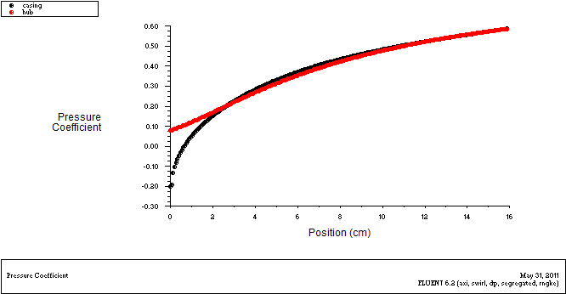
Fig.1. Swirl0,200rpm

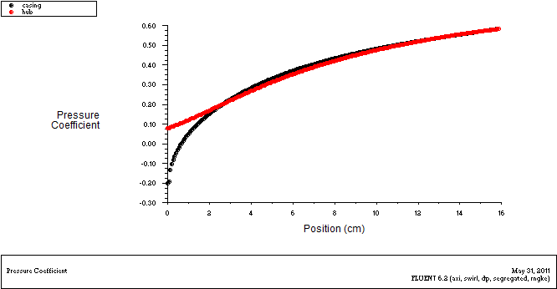
Fig.2. Swirl0,400rpm

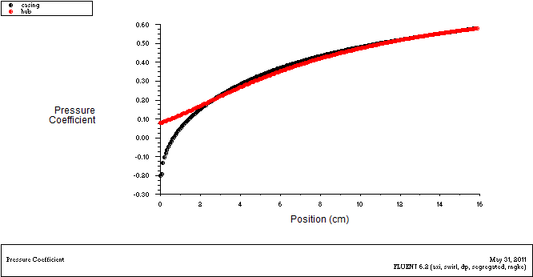
Fig.3. Swirl0,600rpm

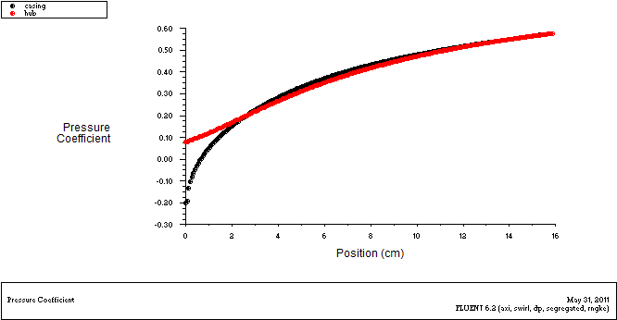
Fig.4. Swirl0,800rpm

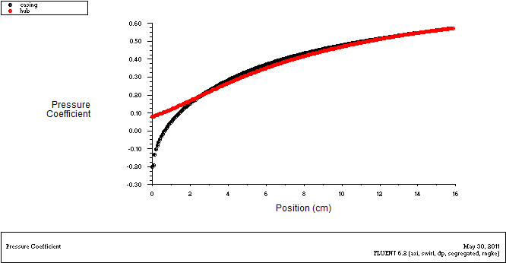
Fig.5. Swirl0,1000rpm

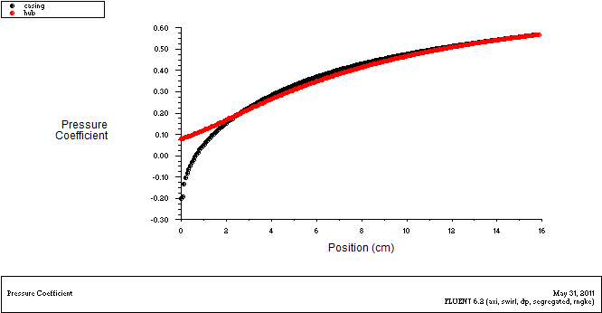
Fig.6. Swirl0,1200rpm

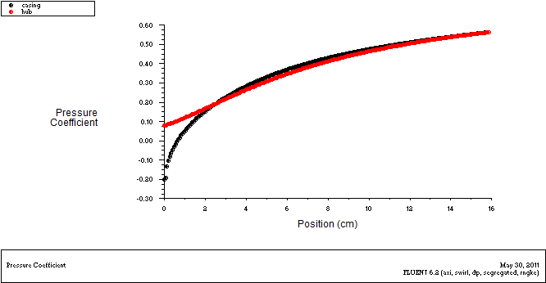
Fig.7. Swirl0,1400rpm

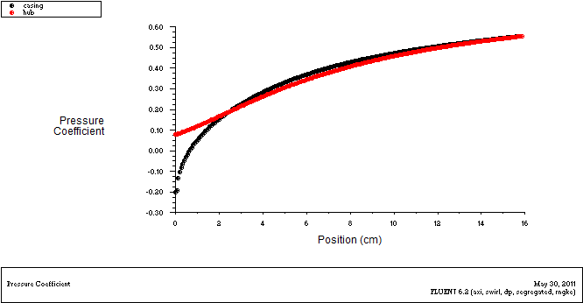
Fig.8. Swirl0,1600rpm

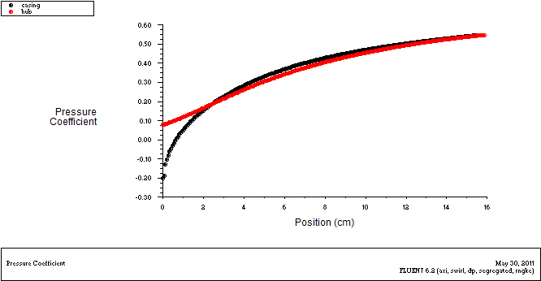
Fig.9. Swirl0,1800rpm

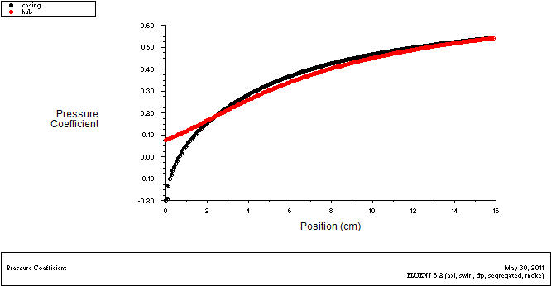
Fig.10. Swirl0,2000rpm

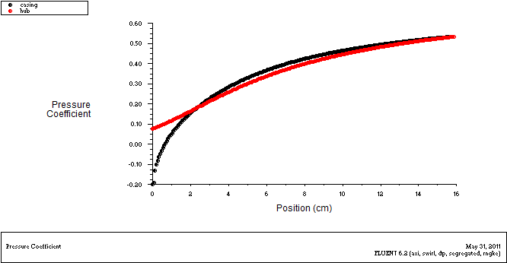
Fig.11. Swirl0,2200rpm

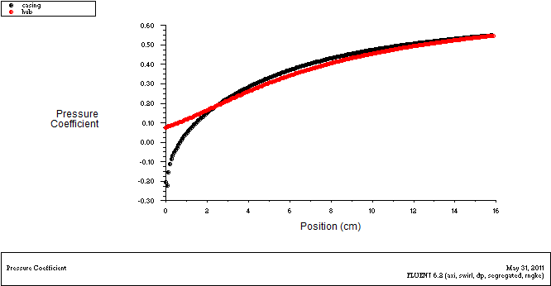
Fig.12. Swirl0,2400rpm

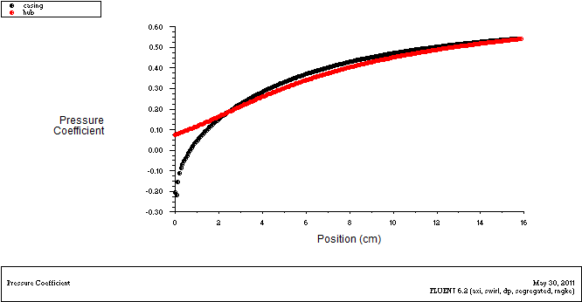
Fig.13. Swirl0,2600rpm

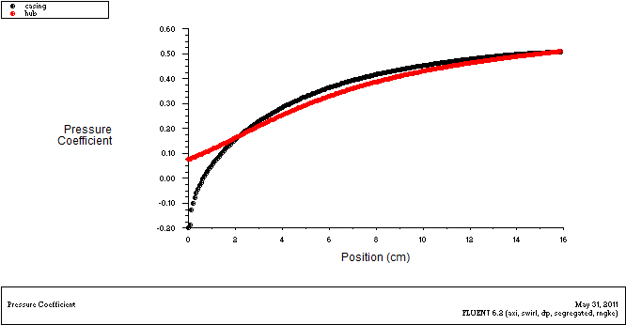
Fig.14. Swirl0,2800rpm

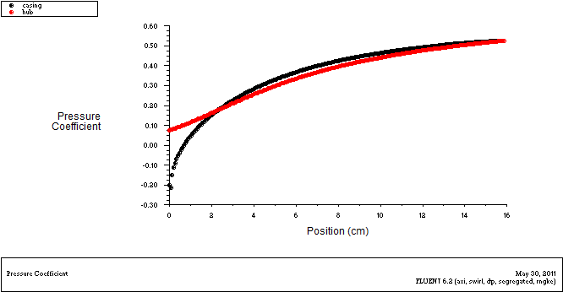
Fig.15. Swirl0,3000rpm

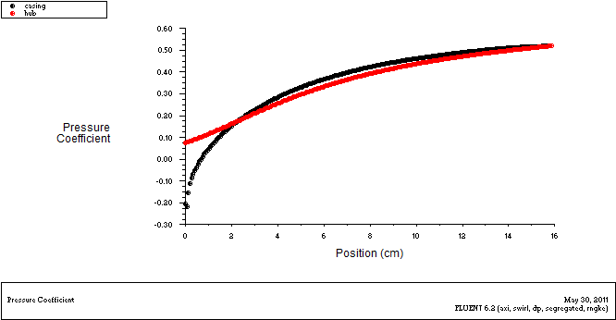
Fig.16. Swirl0,3200rpm
Graphs Showing Variation of Axial Velocity with position (y-direction Along the Diffuser Height)

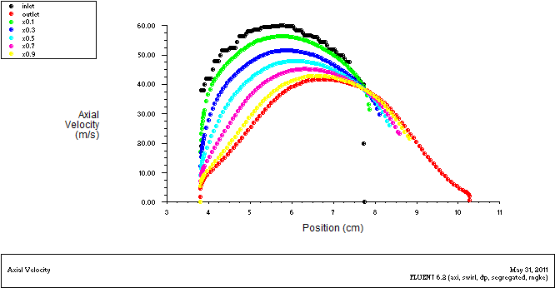
Fig.17. Swirl0,200rpm

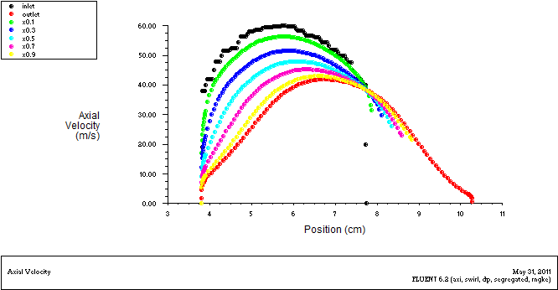
Fig.18. Swirl0,400rpm

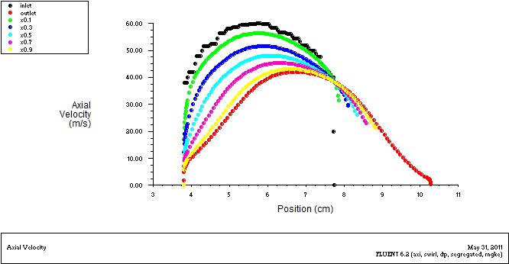
Fig.19. Swirl0,600rpm

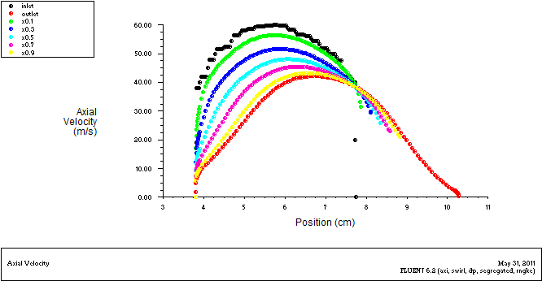
Fig.20. Swirl0,800rpm

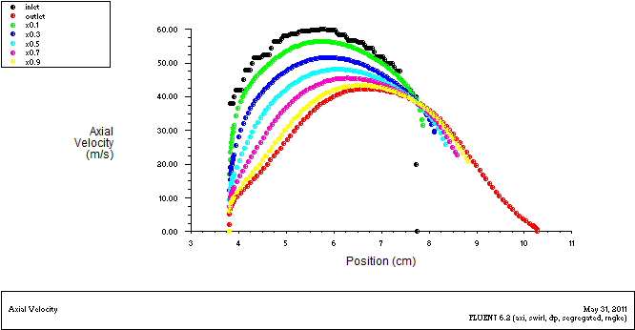
Fig.21. Swirl0,1000rpm

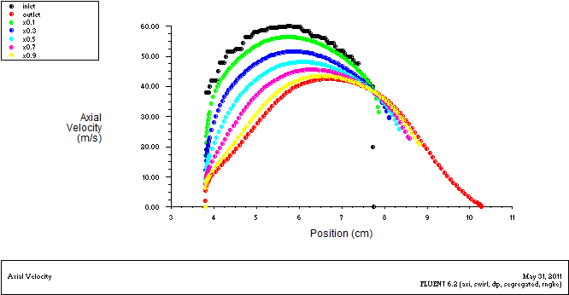
Fig.22. Swirl0,1200rpm

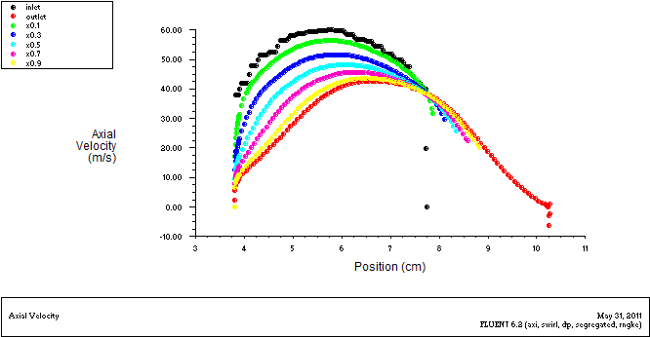
Fig.23. Swirl0,1400rpm

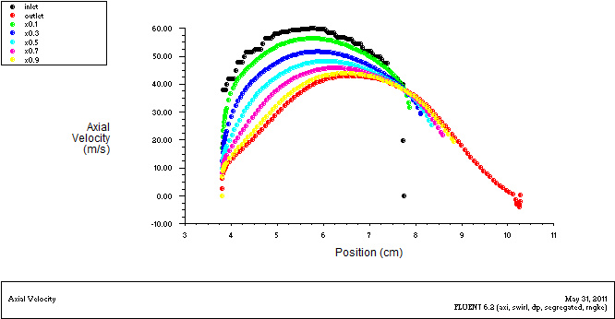
Fig.24. Swirl0,1600rpm

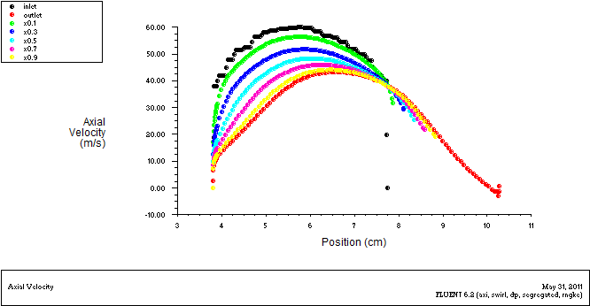
Fig.25. Swirl0,1800rpm

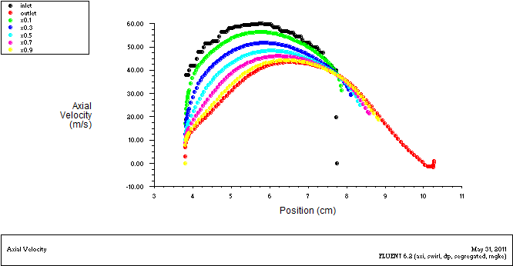
Fig.26. Swirl0,2000rpm

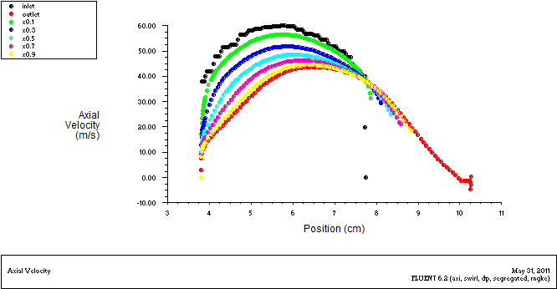
Fig.27. Swirl0,2200rpm

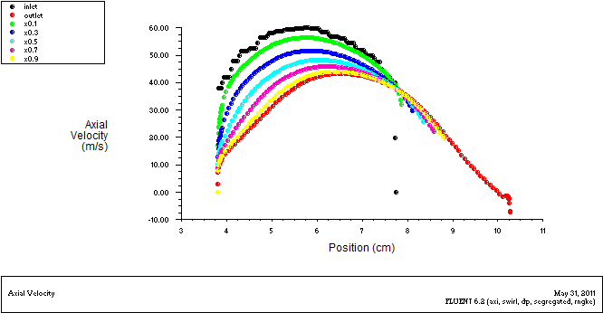
Fig.28. Swirl0,2400rpm

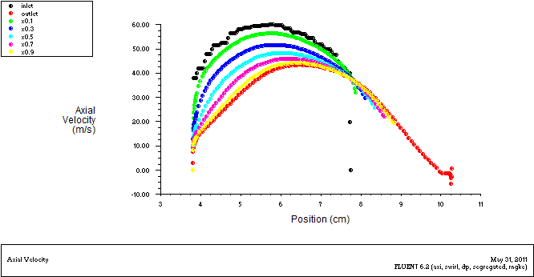
Fig.29. Swirl0,2600rpm

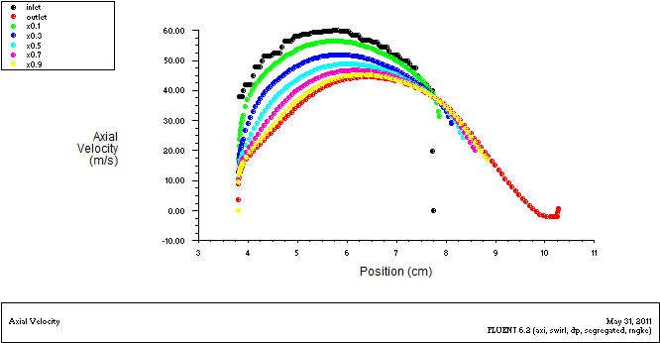
Fig.30. Swirl0,2800rpm

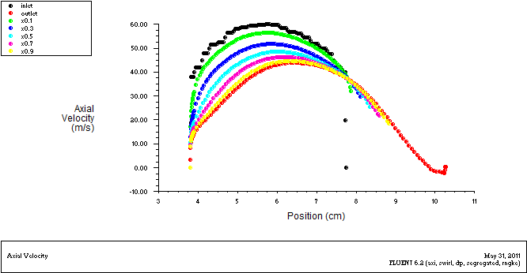
Fig.31. Swirl0,3000rpm

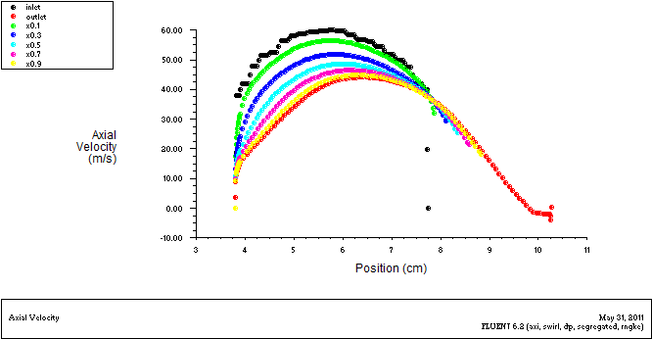
Fig.32. Swirl0,3200rpm
Graphs Showing Variation of Radial Velocity with position (y-direction Along the Diffuser Height)

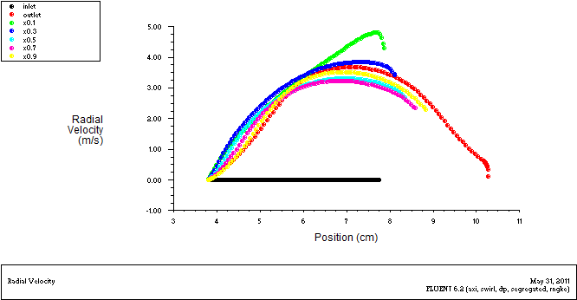
Fig.33. Swirl0,200rpm

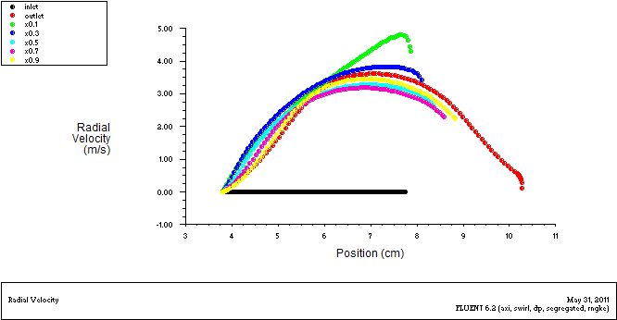
Fig.34. Swirl0,400rpm

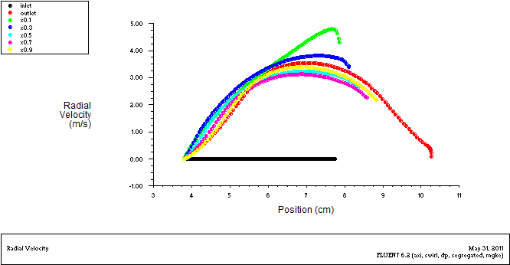
Fig.35. Swirl0,600rpm

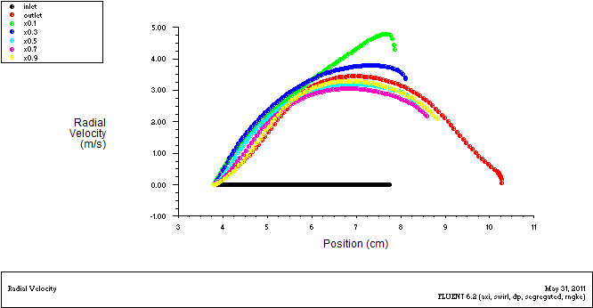
Fig.36. Swirl0,800rpm

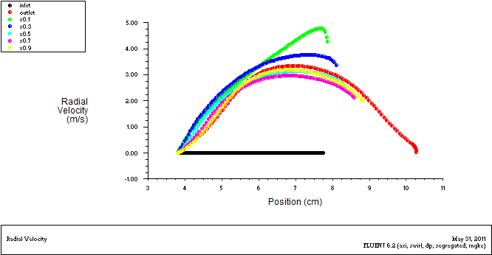
Fig.37. Swirl0,1000rpm

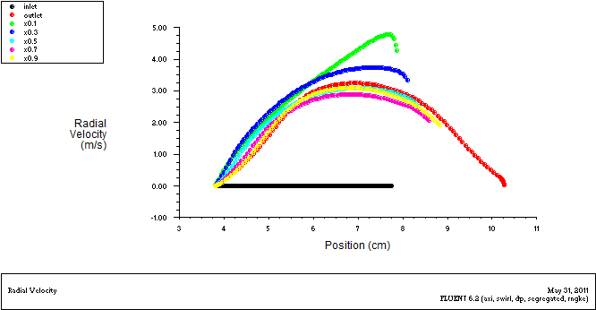
Fig.38. Swirl0,1200rpm

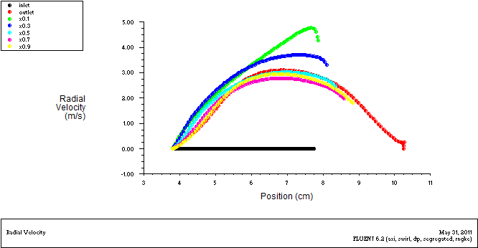
Fig.39. Swirl0,1400rpm

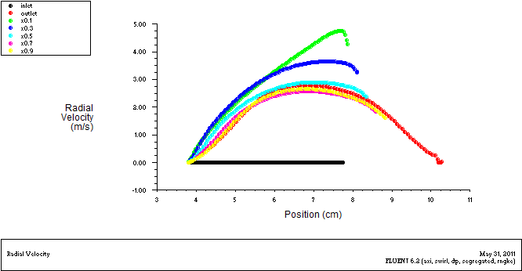
Fig.40. Swirl0,1600rpm

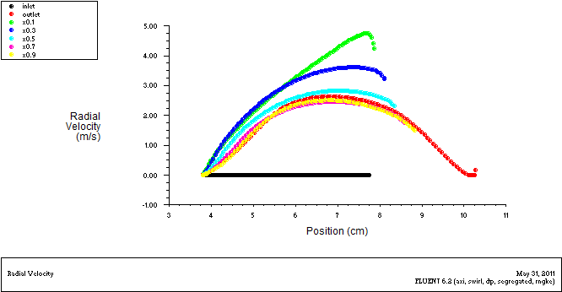
Fig.41. Swirl0,1800rpm

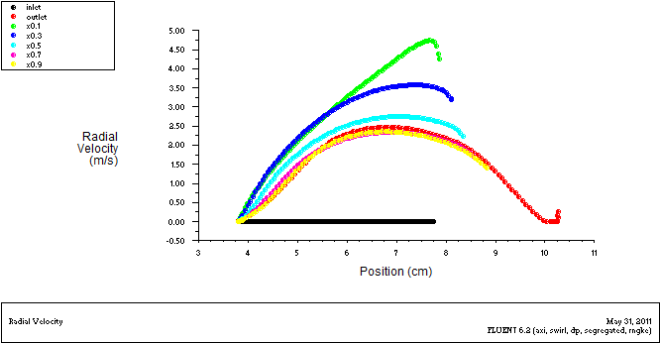
Fig.42. Swirl0,2000rpm

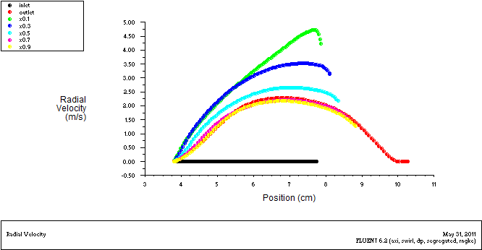
Fig.43. Swirl0,2200rpm

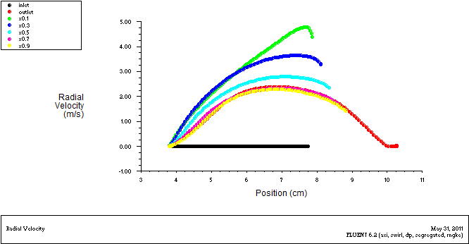
Fig.44. Swirl0,2400rpm

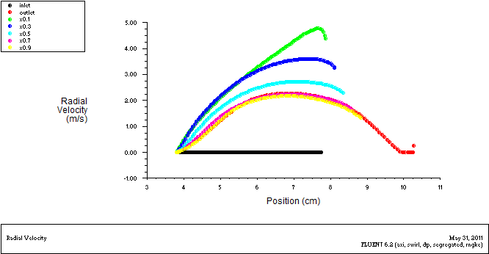
Fig.45. Swirl0,2600rpm

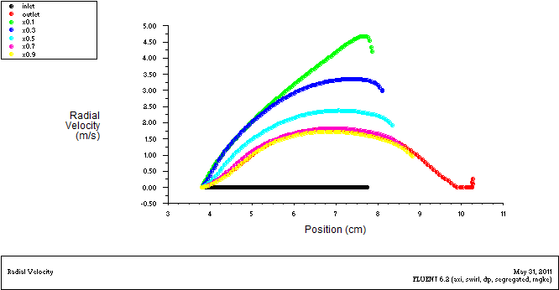
Fig.46. Swirl0,2800rpm

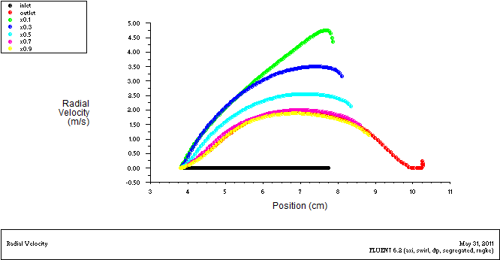
Fig.47. Swirl0,3000rpm

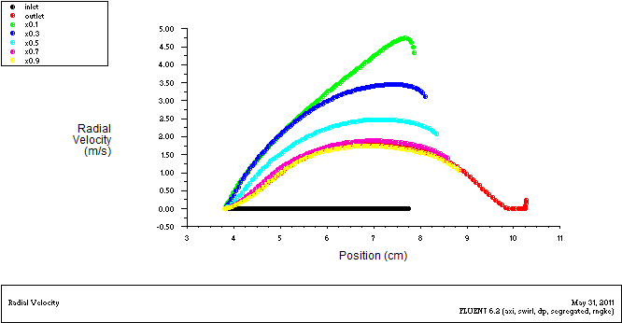
Fig.48. Swirl0,3200rpm

Graphs Showing Variation of Swirl Velocity Along the Diffuser

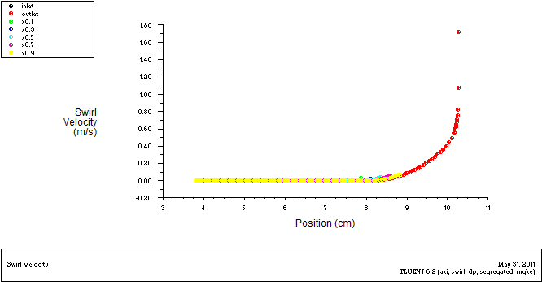
Fig.49. Swirl0,200rpm

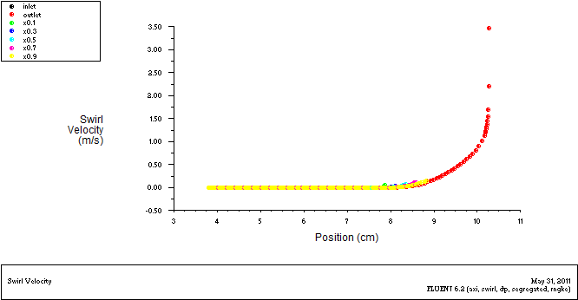
Fig.50. Swirl0,400rpm

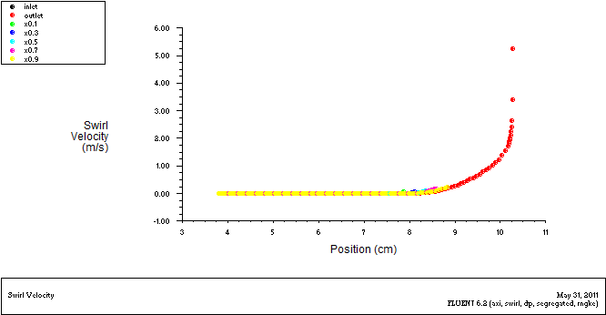
Fig.51. Swirl0,600rpm

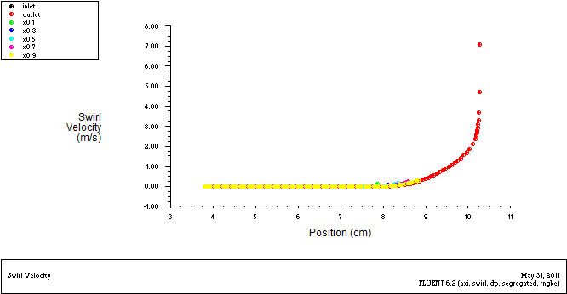
Fig.52. Swirl0,800rpm

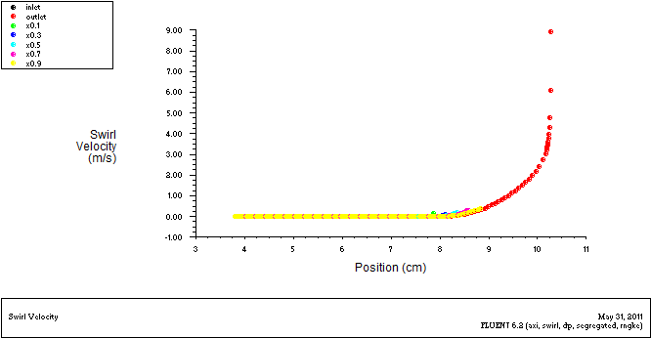
Fig.53. Swirl0,1000rpm

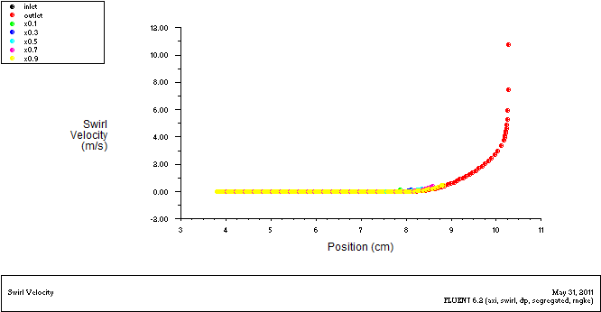
Fig.54. Swirl0,1200rpm

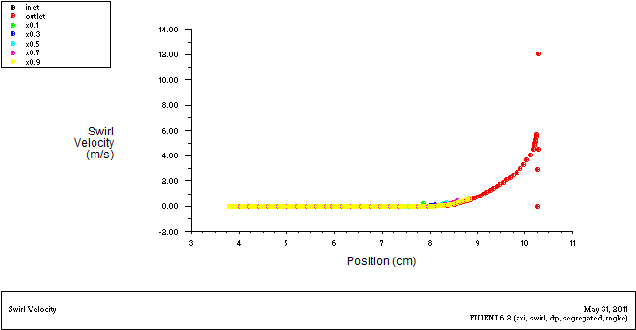
Fig.55. Swirl0,1400rpm

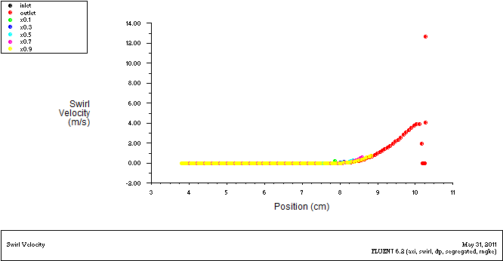
Fig.56. Swirl0,1600rpm

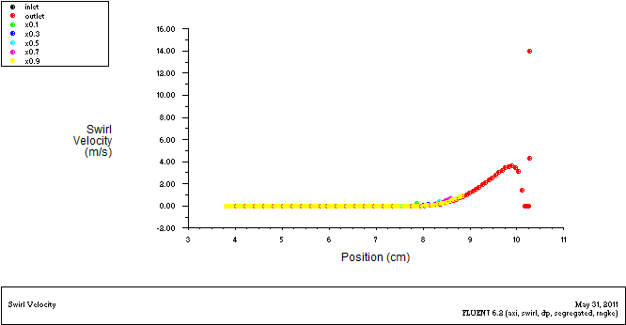
Fig.57. Swirl0,1800rpm

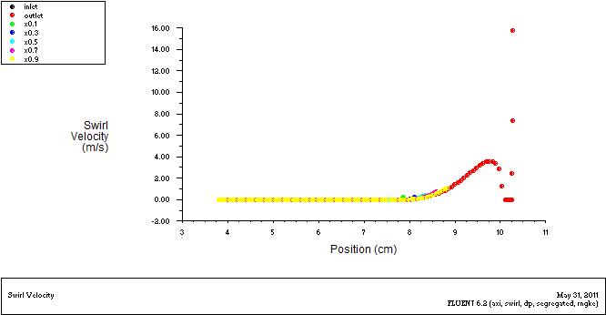
Fig.58. Swirl0,2000rpm

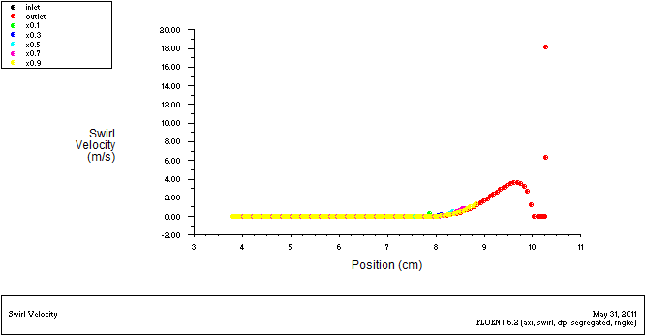
Fig.59. Swirl0,2200rpm

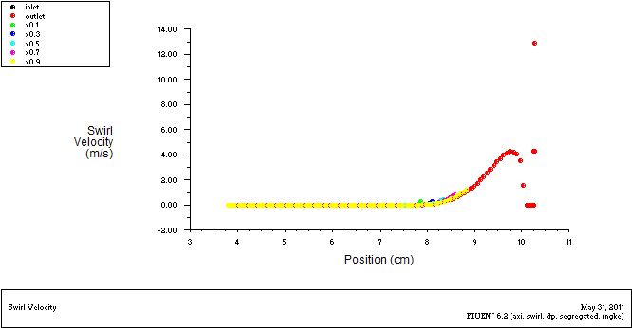
Fig.60. Swirl0,2400rpm

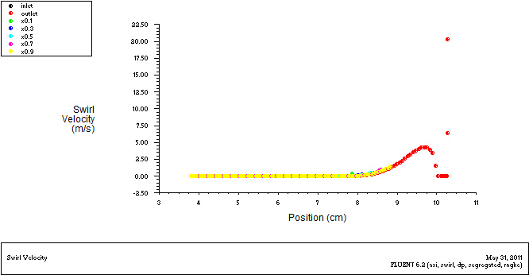
Fig.61. Swirl0,2600rpm

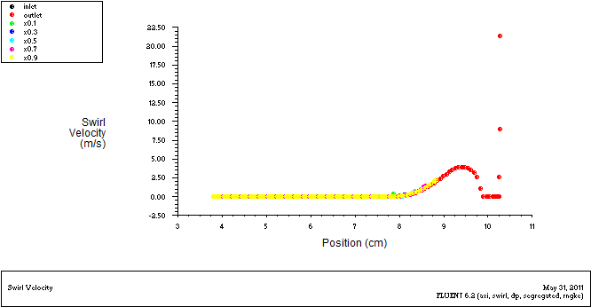
Fig.62. Swirl0,2800rpm
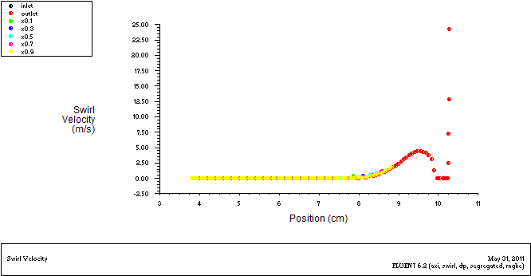
Fig.63. Swirl0,3000rpm

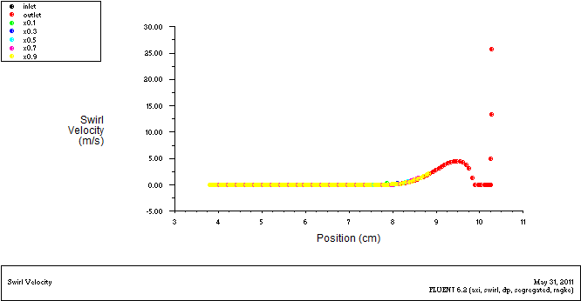
Fig.64. Swirl0,3200rpm

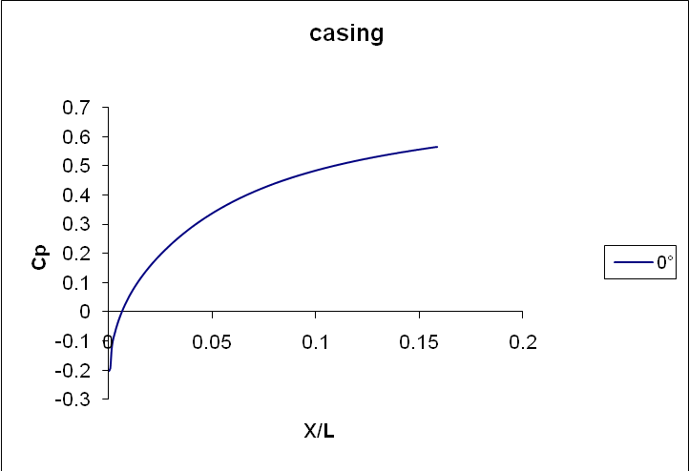

FIG.65: pressure coefficient (y-axis) Vs diffuser length (x-axis) For Casing

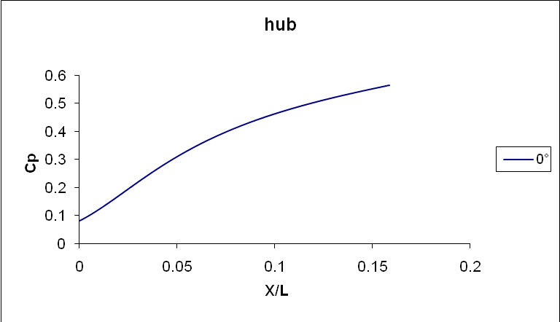

FIG.66: pressure coefficient (y-axis) Vs diffuser length (x-axis) For Hub
Graphs of Pressure Coefficient (y-axis) Vs Casing Rotation (x-axis) For Casing & Hub
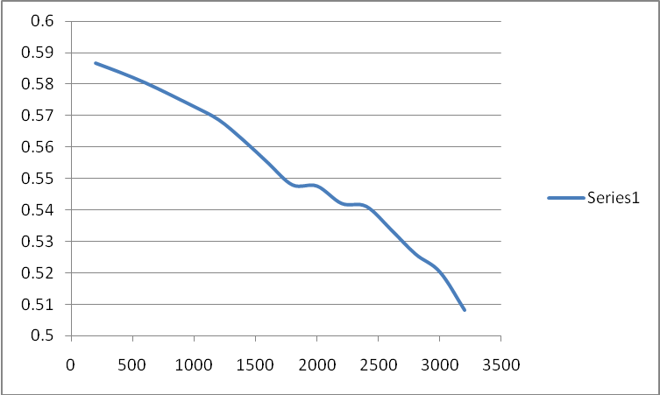

FIG.67: pressure coefficient (y-axis) Vs casing rotation (x-axis) For Casing

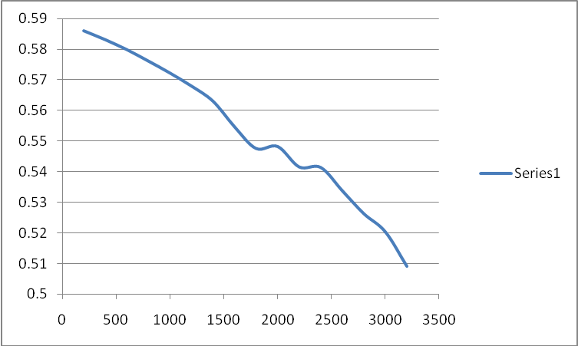
FIG.68: pressure coefficient (y-axis) Vs casing rotation (x-axis) For Hub
APPENDIX

Flow-Chart for CFD modelling and simulation
Geometry
Boundary Layer Meshing
Meshing

Stop
Selection of Solver and types of boundaries
Export Mesh and Case to solver (FLUENT)
Grid check, Smoothing and swapping
Boundary conditions
Model Selection
Initialization
Converge Criteria, Solution Controls
Iterations

Convergence
Post Processing

