PERFORMANCE AND EMISSIONS ANALYSIS OF CNG–DIESEL DUAL FUEL ON A VCR ENGINE

A Major Dissertation Submitted in partial fulfillment of the
requirements for the award of the degree of
Master of Engineering
In
Thermal Engineering

By
PANKAJ KUMAR
(University Roll No. 12300)

Under the Supervision of
Prof. Amit. Pal and Prof. Dr. S. Maji
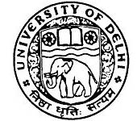

Department of Mechanical Engineering
Faculty of Technology, University of Delhi
Delhi-110007, INDIA

2009

