www.uplaindia.org: A tool for professional development

R.K.SHUKLA*

[Abstract: In the internet era, for an Association to be recognized and its services to be made available globally creation of a web-site is indispensable. The paper describes procedures with reference to designing, registering, uploading the UPLA web-site and its subsequent submission to search engines.]
1. INTRODUCTION:
Internet is bringing sweeping changes in most of our daily activities. It is offering access to news, banking services, business opportunities, mails, educational facilities and technology online at our desktops, laptops, and mobile phones. This has changed the overall ways and means, mode and methods of information dissemination. Here the only mantra is how fast the information can be sent to the end users. Like other fields, in the field of library and information science too it has made a great impact. It has changed the overall concept of libraries, role of librarians and has shown the library professionals how the information can be disseminated to their clientele at minimum cost, effort and time. With the fast growth and easy accessibility to internet, libraries either now or in the near future have to develop their own homepages to meet the wide information requirements of their clientele. Considering the huge costs involved in developing the necessary infrastructure such as owning and maintaining the webservers, high bandwidth internet connection, the required softwares, and the technical know-how many libraries, especially in developing countries like India, are finding it difficult to make a beginning in this direction.
2.NEED AND PURPOSE:
To have a close contact with members of UPLA it was thought to have a powerful tool and it was no other than the web-site of its own
3. PRE-REQUISITESFOR UPLA MEMBERS TO ACCESS SITE:
the members must have access to the following hardware and softwarefor taking the full benefits of the web-site:
* Librarian Delhi College of Enginnering & PRO UPLA
1. PC (Minimum 486/Pentium series)
2. Modem
3. Internet connection (Dialup/Leased line/VSAT)
4. Internet browser (Netscape/Internet Explorer)
6. Telephone connection
4. CREATION OF HOMEPAGE OF UPLA:
The creation of homepage/ website and its subsequent hosting involved certain major steps such as, signing with the web space provider, creating contents, uploading the site by using FTP (File Transfer Protocol) and so on. Each one of these has to be dealt carefully to make the website live and interesting.
5 WEBSPACE PROVIDERS:
A good number of service providers available on the Internet offer free web space for developing homepages. The amount of space provided by them varies from each other. Most of these services are ad based, i.e., these are sponsored and therefore will have sponsor's advertisement on the site. The advertisement may be a banner or a pop-up. It is needless to say that the service providers earn revenue from these advertisements. Therefore, while seeking free service it becomes mandatory to accept certain conditions posed by the service providers. Main consideration should be the speed, i.e., how fast the service provider's site gets loaded on to the browser and how fast will be the subsequent retrieval and accordingly it was thought to have a paid service provider.
On signing the agreement with the service provider, a user name and a password of one's choice was provided subject to availability. This user name later becomes the web address of a site on the internet. It is also known as
URL (Uniform/Universal Resource Locator).
The URL looks like:
http://www.uplaindia.org

6. CONTENTS FOR THE WEBSITE:
Before signing with the service provider, we have to create contents for UPLA web site. There are certain tools, like Microsoft front page, Dream Weaver and HTML that were used in creation of web site.
Initially we got puzzled to decide what to put on it so It was thought to better to do some homework before actually creating the contents. This was done by going through WebPages of other Associations, which are already available on the net. To start with, we have included the following information:
6.1. History:
The circumstances which led to the formation of UPLA and the details of its subsequent development is given under this link
6.2.Organisational Structure
The Constitution of the UPLA is available under this link, which may be referred for formation of new branches.
6.3. Membership
Membership form is available under this link
6.4. Executive: Central body executive with following details is available under this link
Sr. | Designation | Name | Address | Phone & E-mail

6.5. Publications
The list of publications of Central Body and branches are available with short details The full text of the latest issue of Lucknow Librarian is also available
6.6.Activities
The various activities including workshops seminars delegations etc are available under this link
6.7. Conferences
A list of conferences organized by central body and branches is available under this link
6.8. Current News
The link provides the current news related with the Central body branches and members
6.9.UPLA Courses
Details of courses run by various branches and details of principals are provided
6.10. Sponsor
This link is created to generate funds through various vendors ready to help the association
6.11. LIS Gate Way
The link provides links to various useful resources for librarians

UPLA HOME PAGE:
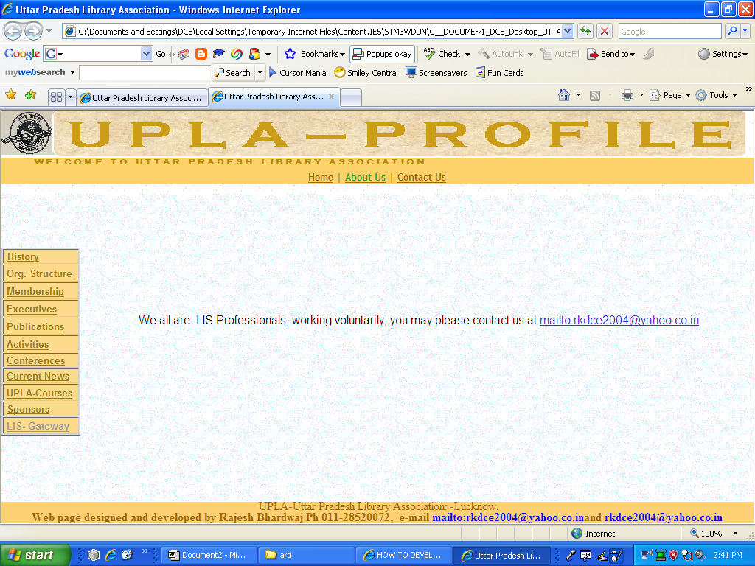

.

7. UPLOADING THE SITE:
After creating the pages, the contents and design was verified before finally putting these on the net. Loading the page(s) on the browser locally did this. It was necessary to check the results both on Netscape and Internet Explorer and on some other browser as pages might have looked differently on different browsers and even on different versions of the same browser.
After such verification, the contents were transferred to the service provider's web server. Transferring was done using FTP programme. FTP stands for 'File Transfer Protocol' and is the way of transferring files to and from computers on the internet. This program should be available at the workstation, i.e., the user's PC. An FTP client program sends a request to an FTP server asking for exchange of information and transfer files. The server in turn verifies whether the user is authorized to send or receive files and responds accordingly. There are many graphical FTP client software's available on the net. Popular among them is WS_FTP. It can be downloaded from www.download.com or www.ftppro.com. This is some time available on the CD's coming along with popular computer magazines PC-Quest or Chip. It is possible on some sites, to transfer files online from their webpage.
Transferring of pages by using FTP client varies from one network to another depending on the network structure and server set-up. One need not panic if it does not work. It is always a good idea to consult the system administrator to learn about how to use a FTP client. After successful transferring of files to the web server the site will be up with immediate effect. It can be checked by typing the URL address in the local browser window.

8. SUBMISSION OF SITE TO SEARCH ENGINES:
To make the site known to all, it was necessary to submit the site to search engines. This would increase the hits to the site. The submission could be done either automatically or manually. To get best results, it was done manually to each one of the search engines.
Using the services of following sites can do automatic submission:
http://uswebsites.com/submit
http://www.netcreations.com/postmaster
http://addme.com
Going to the respective sites of the search engines did manual submission individually. The search engines index sites under various categories such as education, business, sports etc. To submit a site one has to click on the option 'Submit your site or Add URL', which in turn asks for URL, category, description and keywords. The category e 'Education' and then ‘Libraries’ were selected and all these information typed manually. Some search engines do accept URL without asking for categories. Depending upon the keywords and description given, search engines themselves put the submitted site under the appropriate category. Important search engines available are
http://www.google.com
http://www.yahoo.com
http://www.altavista.com
http://www.lycos.com
http://www.infoseek.com
http://www.khoj.com
http://www.indianindex.com
http://www.hotbot.com
Each search engine has its own rules for accepting the sites for indexing.

