STUDIES ON CONDUCTING POLYANILINES
AND ITS COMPOSITES

A major project submitted for partial fulfillment of the requirements for the award of the degree of

MASTER OF ENGINEERING

IN

POLYMER TECHNOLOGY

By
BAL MUKUND MISHRA
Roll No. : 01/Poly/09

Under the supervision of

Dr. D. KUMAR



DEPARTMENT OF APPLIED CHEMISTRY AND POLYMER TECHNOLOGY,
DELHI COLLEGE OF ENGINEERING
UNIVERSITY OF DELHI
(2011)

Department of Applied Chemistry & Polymer Technology
Delhi College of Engineering
University of Delhi
Main Bawana Road, Delhi-110042

Certificate

This is to certify that the major project work that is being presented in this dissertation entitled “Studies on conducting polyanilines and its composites” has been carried out by Bal Mukund Mishra (Roll. No. 01/poly/09), a student of Delhi College of Engineering, University of Delhi. This work was completed and carried out under my supervision and forms a part of the Master of Engineering (Polymer Technology) course and curriculum. He has completed this work with utmost sincerity.

(Prof. G. L. Verma) (Dr. D. Kumar)
Head Associate professor,
Department of Applied Chemistry, Department of Applied Chemistry,
Delhi College of Engineering Delhi College of Engineering

Acknowledgements
I would like to express my humble gratitude for the contribution and support of various individuals for successful completion of this dissertation. I am grateful to my mentor and guide Dr. D. Kumar, Associate Professor, Department of Applied Chemistry & Polymer Technology, Delhi College of Engineering for providing me an opportunity to work under his able guidance.
I express my grateful thanks to Professor G.L.Verma, Head, Department of Applied Chemistry & Polymer Technology, Delhi College of Engineering and all the faculty members of the departments for their valuable suggestions and help.
I express my deep sense of gratitude to Mrs. Tarushee Ahuja, research scholar, Department of Applied Chemistry & Polymer Technology for her kind discussion and valuable comments. I am also thankful to Ms.Sudha, Ms.Reetu Prabhakar, Ms. Sarita S. Nair, research scholars Department of Applied Chemistry & Polymer Technology, Delhi College of Engineering for their support throughout the study.
I am grateful to Dr. Saurabh Mehta, Assistant Professor for his patience while carrying out FTIR of my samples. I am also thankful to MHRD, Government of India, for the financial support.

(Bal Mukund Mishra)
Roll No. 01/poly/09
M.E. (Polymer Technology)
Department of Applied Chemistry & Polymer Technology,
Delhi College of Engineering, University of Delhi, Delhi 110042
CONTENTS
CHAPTER I Introduction
1.1 The advent of conducting polymers 4
1.2 Types of conducting polymers 6
1.3 Preparation of conducting polymers 9
1.4 Polyaniline 12
1.5 Derivatives of polyaniline 12
1.6 Processing of polyaniline and its composites 13
1.7 Doping of conducting polymers 15
1.8 Types of doping 16
1.9 Charge transport in conducting polymers 18
1.10 Process of doping in polyaniline and its derivatives 20
1.11 Nanofibers of conducting polymers 21
1.12 Composite films of conducting polymers 24
1.13 Applications of conducting polymers 24
1.14 Objective of the current work 27

CHAPTER II Experimental work
2.1 Chemicals used 29
2.2 Chemical synthesis of polyaniline powder 29
2.3 Chemical synthesis of poly(o-toluidine) powder 30
2.4 Chemical synthesis of aniline-o-toludine copolymer 31
  - Preparation of conducting composite films 31
2.6 UV-Visible spectroscopy 33
2.7 Fourier transform infrared spectroscopy 34
2.8 Thermogravimetric analysis 36
2.9 Tensile test 38
2.10 X-ray diffraction pattern 41

CHAPTER III RESULTS AND DISCUSSION
3.1UV-Visible spectroscopy 46
3.2 FTIR Spectroscopy 48
3.3 Thermogravimetric analysis 52
3.4 Tensile test 55
3.5 X-ray diffraction pattern 58
CHAPTER IV CONCLUSION 63
References 65

Chapter I

Introduction

1.1 The advent of conducting polymers
Plastic has many attributes, including light weight, corrosion resistance and design flexibility. An unlimited number of shapes and sizes of parts can easily be created with thousands of different grades of polymer. The plastic materials also appeal to engineers because it allows them to create single-piece components that simplify assembly. Traditionally, one of the only drawbacks of plastic has been its lack of electrical conductivity. Nearly 45 years ago, organic polymers were hard to believe conducting and almost all of its studies, publications and uses were based on its insulating properties. But, now it is being started to change. Nanotechnology is enabling the engineers to create hybrid materials that can be processed with traditional production methods, such as injection molding and laser welding.
After the synthesis and developments of polyacetylene, a new field of conducting polymers has attracted the attention of many theoretical and experimental professionals working under various domains of science and technology through out the world. These new materials, also called synthetic metals, combine the electrical properties of metals with the advantages of polymers such as light weight, greater workability, resistance to corrosion and lower cost [1]. The major target of conductive polymer technology development has been to combine the electrical and optical properties of these new materials with the mechanical properties and processability of commodity bulk polymers. New products having properties difficult or impossible to achieve by existing materials like metals, ceramics etc, can now be produced by new conducting materials that offer significant application potential as substitute of these existing materials.
This has triggered a world wide research and publication activities regarding synthesis, developments and applications of various intrinsic conducting polymers. After the discovery of concept of doping led by Shirakawa et al, conductivity of polyacetylene was liable to be adjusted on the extent of doping. Further investigations showed that doping of this form of polyacetylene by halogens increases its conductivity a billion fold. Undoped, the polymer was silvery, insoluble and intractable, with conductivity similar to that of semiconductors. When it was weakly oxidized by compounds such as iodine it turned a golden color and its conductivity increased to about 10⁴ S/cm. Later in 1980's polyheterocycles were first developed. These polyheterocycles were found to be much more air stable than polyacetylene, although their conductivities were not so high, typically about 10³ S/cm. By adding various side groups to the polymer backbone, derivatives were prepared which were soluble in various solvents. Further it was reported that conductivity of conducting polymers is a function of temperature too.
The most important feature of conducting polymers to be considered is its stability. Conducting polymers are liable to two distinct type of instability extrinsic and intrinsic. Extrinsic stability is related to vulnerability to external environmental agent such as oxygen, water, peroxides. This is determined by the polymers susceptibility of charged sites to attack by nucleophiles, electrophiles and free radicals present in environment. If a conducting polymer is extrinsic unstable then it must be protected by a stable coating.
Intrinsic instability is thermodynamic in origin. It is likely to be cause by irreversible chemical reactions. Many conducting polymers, however, degrade over time even in dry, oxygen free environment [2]. A Logarithmic conductivity ladder of some of these polymers is shown below in fig. 1.1.

Figure 1.1 Conductivities of some metals and conducting polymers

1.2 Types of conducting polymers
During the development of conducting polymers, a variety of techniques were tried to introduce conductivity in plastics. The major aim of these works was to synthesize a material which exhibit electrical conductivity with all the advantages of polymers. On the basis of mechanism of conduction in polymeric materials, conducting polymers can be classified in following four categories.
1.2.1 Organometallic polymeric conductors
When organometallic groups are added to conventional polymers this type of conducting material is obtained. It is believed that the d-orbitals of metals overlap with the orbitals of organic structure and thereby increases the electron delocalization. There are some certain examples like metallopthalocyanines and their polymers in which d-orbitals may also bride adjacent layers in crystalline polymers to give conducting properties. These polymers have extensively conjugated structures. These bridge transition metal complexes form one of the stable systems exhibiting intrinsic electric conductivities, without external oxidizing doping. Another example of this type of material is polyferrocenylene.
1.2.2 Conducting polymer composites
When conducting particles are added with polymers in a specified ratio, it results conducting polymer composites. Various conducting particles use are carbon black, graphite, flakes, fibers, metal powders, CNTs, etc. When volume fraction of conducting fillers exceeds 25% then the composites turn non-insulating [3]. Electrical conductivity of the composite is of course decided by the volume fraction of the conducting fillers.
1.2.3 Polymeric charge transfer complexes
When acceptor like molecules are added to insulating polymers, it results polymeric charge transfer complexes, e.g. tetrathifulvalene (TTF) with bromine, chlorine, TCNQ etc is a good conductor. The reason for high conductivity in polymeric charge transfer complexes and radical ion salts are still not fully understood. It is believed that in polymeric materials, the donor-acceptor interaction promotes orbital overlap, which contributes to alter molecular arrangements and enhanced electronic delocalization.
1.2.4 Inherently conducting polymers
Those polymer material which possess their polymer chain having alternate single and double bonds are called conjugated polymers. Inherently conducting polymers as shown in fig. 1.2 are basically conjugated polymers which are either semiconductor or non insulator in oxidized or doped state. This electronic property of conjugated polymers is due to delocalization of electrons. In such polymers, conductivity arises due to a special type of metallic bonding in which valence electrons are completely delocalized and move almost freely through the crystal lattice. So it becomes necessary for polymer backbone to behave as an electrical conductor.

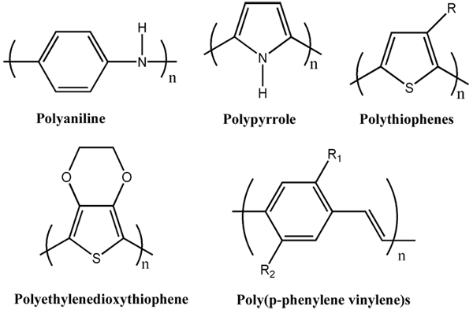
Figure 1.2 Some Conducting Polymers

For the process of delocalization of electrons, it is a necessary criterion that the molecular structure of the backbone should be planer. And hence it is required to be no torsion at the bonds, which would decrease the delocalization of electrons in the backbone and ultimately the conductivity is decreased. In case of hetero-atoms (e.g., S, N, etc.) present in the polymer backbone, the delocalization of electrons occurs through the interaction of π electrons with non-bonded electrons of hetero atom.
The chemical nature of the repeating units decides the electrical and optical properties of these kinds of materials. The conductivity of any material at bulk level is directly proportional to the drift mobility of the charge carriers and its density. Drift mobility is a reflection of ease of delocalization of charge carriers through the material and it is numerically equal to the ratio of drift velocity to the electric field applied. In order to improve the conductivity of the polymeric material, an increase in the carrier mobility and charge density is required.

1.3 Preparation of conducting polymers
Before the conducting polymers are characterized and made ready for its application, it is synthesized and then doped. For the preparation of some of conducting polymers such as polyaniline and its derivatives, the process of doping may be done during the process of synthesis itself. There are two most widely used methods of polymerization of conducting polymers.
1.3.1. Chemical method of polymerization
This is the most commonly used method of polymerization. In this process by the help of initiator, free radicals are generated and then the process of polymerization starts. The free radicals present in monomer starts the process of polymerization process and it propagates through free radical mechanism. The average chain length of the polymer so formed is dependent of the monomer to initiator ratio. Generally the average chain length of the polymer decreases with the increase in the concentration of initiator (oxidant).
There are four types of polymerization techniques, which come under chemical method of polymerization:
- Bulk polymerization
- solution polymerization
- suspension polymerization
- emulsion polymerization
1.3.2. Electrochemical method of polymerization
The electrochemical technique has received wider attention both because of the simplicity and the added advantage of obtaining a conductive polymer being simultaneously doped. Electrochemical polymerization is normally carried our in a single or dual-compartment cell by adopting a standard three-electrode configuration in a supporting electrolyte, both dissolved in a suitable solvent. Electrochemical polymerization can be carried out potentiometrically by using a suitable power supply. In fact, monomers exist in different chemical form at different electrical potentials. The electric potential at which a monomer or an oligomer chain exists into oxidized form is called anodic potential and the potential at which the same is in reduced form is called anodic potential. With the help of cyclic voltameter the potential (or sometimes current too) is swap between cathodic to anodic potential several times in cyclic manner. This causes nucleation of monomers on the acting cathode and thus polymeric film is deposited over it. Generally, potentiostatic conditions are recommended to obtain thin films, while galvanostatic conditions are recommended to obtain thick films. Many people though out the world, have synthesized ployanilne and its derivatives electrochemically and reported. There are some certain set of difficulties in case of electrochemical polymerization of poly (o-toluidine). It is supposed that poly (o-toluidine) can be synthesized by cyclic voltammetry in the potential range between -0.2 to 0.7 V. However, no polymer is deposited on the electrode surface in the above mentioned potential region during the first scan. The initiation of polymer nucleation and its skelton formation occurs above 0.9 V. The number of nuclei strongly depends upon the polarization condition. There is formation of degradation products during the film growth. It is recomended to reduce anodic potential from 0.7 V to 1.2 V for few scans in order to avoid the degradation products, which ultimately causes peeling off the film from electrode surface. Low concentration of protonic acid during electrochemical polymerization of o-toluidine causes oxidation/reduction of degradation products. The presence of degradation products (benzoquinone type compounds) have been confirmed by spectroscopic data as reported by Aleksandra Buzarovska et al [4-8]. Due to the degradation products the adherence to the electrodeposited film is poor and it peels off the electrode surface. So high concentration of protonic acid is recomended during electrochemical polymerization of o-toluidine.

1.4 Polyaniline
Although polyaniline was discovered over 150 years ago, only since the early 1980s it has captured the intense attention of the scientific community due to the rediscovery of its high electrical conductivity. Amongst the family of inherently conducting polymers, polyaniline is unique and the most important due to its ease of synthesis, environmental stability (both air and moisture stable), and simple acid/base doping/dedoping chemistry. It has a great variety of potential applications including anticorrosion coatings, batteries, sensors, separation membranes, and antistatic coatings. Although the synthetic methods to produce polyaniline are quite simple, its mechanism of polymerization and the exact nature of its oxidation chemistry are quite complex. Due to its interesting characteristic and applications, polyaniline has attracted the attention of many professionals and is one of the most studied conducting polymer for last 25 years. Polyaniline in its way to synthesize and/or doping can be designed to achieve the required conductivity for an assigned application. The conductivity of polyaniline can be as low as insulating glass and as high as the semiconductor silicon or germanium. It is very easy to fabricate and can be mixed with conventional polymers to give specific shapes.

1.5 Derivatives of polyaniline
In order to meet the need of industrial demand of new material of specific properties, derivatives of polyaniline were being studied. Many such derivatives of aniline have been polymerized successfully by both chemical and electrochemical methods [5,6]. Different kind of halogen derivatives of aniline have been polymerized and studied already. Polymers of derivatives of aniline having some other substituents like methoxy, ethoxy, hydroxyl, nitro, carboxy, cyclohexyl, ethyl and methyl are also known and well studied. Some studies on the copolymerization of substituted aniline with aniline have been also successfully done and their properties are known. Copolymers of different substituted aniline like o-toluidine and o-chloroaniline have been synthesized and already reported.
Some of these derivatives have better properties than polyaniline but due to introduction of a new bulky group in the vicinity of amino group of aniline their ease of polymerization as well as some properties like conductivity, processability and stability with air and moisture is adversely affected.
1.5.1. Poly (o-toluidine) or POT
Methyl derivatives of aniline are called toluidine. Its ortho, meta and para derivatives are easily available or can be synthesized by Electrophilic substitution reaction. Since polymerization takes place at the para position of aniline, poly(p-toludine) is not much explored and has very little interest among researchers. Due to bulky group on meta position the polymerization process is difficult in case of poly(m-toluidine), and very few work has been published about it. Whereas poly(o-toluidine) is a very stable polymer and its properties and uses has been extensively studied [5,6]. Due to its unique properties like corrosion resistance, good processability and ease of polymerization, it has attracted attention of people through out the world and has got many applications in the field of bio-sensors, corrosion resistance, antistatic applications, etc. [6,7]

1.6 Processing of polyaniline and its composites
Polyaniline based compositions can be processed using conventional techniques such as blow and injection moulding, extrusion, calendaring, film casting, and fibre spinning. These compositions withstand temperatures as high as 230-240°C for short periods of time (5-10 min) without significant change in electrical properties, and can be melt blended with many commodity polymers such as nylons, PVA, PE, PP etc. and fillers like carbon blacks, metal particles and flakes, carbon fibers, and others. They provide precisely controlled electrical conductivity over a wide range, improve phase compatibility and thus blendability with bulk polymers, provide easier means of processing and forming conductive products and provide low cost solutions for the production of transparent and colored thin films and coatings. Selected industrial solvents like formic acid, DMF, etc, can be used for solution processing for polyaniline composites. Polyaniline based materials are both solution and melt processible [8].

The Processing Techniques for the fabrication of polyaniline are given as below.

Melt Processing
• Injection moulding
• Extrusion
• Blow moulding
• Calandering
• Fibre spinning
• Compression moulding
• Extrusion coating

Solution Processing
• Coating - films
• Spraying
• Solution spinning - fibres
• Casting - films
• Spin coating -thin films
1.7 Doping of conducting polymers
Virgin conducting polymers (i.e, before doping) are called intrinsic conducting polymers. These intrinsic conducting polymers generally exhibit poor electrical conductivity, which comes either in insulator range or in semiconductors range. In order to enhance their conductivity remarkably up to metallic range, these polymers need to be treated with a suitable oxidizing or reducing agents. This process of treating intrinsic conducting polymers with oxidizing agents or reducing agents is referred as doping. The conductivity range of intrinsic conducting polymer is 10⁻⁹ to 10⁻⁵ S/cm, whereas doped or extrinsic conducting polymers have its conductivity range 1 to 10⁴ S/cm [9]. The doping process simply can be regarded as insertion or ejection of electrons. The controlled addition of known chemical species (dopants), usually small and none stoichiometric quantities results in dramatic changes in electronic, electrical, magnetic, optical, and structural properties of polymers. Doping of intrinsic conducting polymers involves random dispersion or aggregation of dopants in molar concentrations in the disordered structure of entangled chain and fibrils. The incorporation of dopant molecules in the quasi-one dimensional polymer chain leads to considerable disturbance in the chain order which caused re-organization of the polymer. Both the process of doping and undoping involving dopant counter ions which stabilizes the doped state, may be carried out chemically or electrochemically [2,10].
Doping of conducting polymers is different than doping of inorganic semiconductors. For example doping of silicon produces a donor energy level close to the conduction band or an acceptor level close to the valence band [11]. In other words, the band gap in inorganic semiconductors is decreased by generating either holes or valence electrons by the doping process. But in case of conducting polymers, doping leads to the formation of free spins due to conjugation defects like solitons, polarons and bipolarons in the polymer chain. Electron spin spectroscopy is an evidence of the free spins in doped conducting polymers. The concentration of free spins increases with the concentration of dopants initially but after a particular concentration it reaches a maximum value and does not change with concentration of dopant. So in such case, by controllably adjusting the doping level, conductivity anywhere between that of non-doped (insulating) to fully doped (conducting) level can be achieved easily.

1.8 Types of doping
Doping is a process to generate charge transfer agents in the polymer chain of an intrinsic conducting polymer. Sometimes this may be done by adding a suitable amount of known chemical species or even without it by exposure of radiation. On the basis of technique applied to the polymer chain to dope, we classify the doping process as following.
Redox doping
All conducting polymers and almost all of their derivatives undergo redox doping of either kind of n-type doping or p-type doping by chemical or electrochemical processes. During the doping process the number of electrons associated with the polymer backbone changes, p-type doping agents are oxidizing agents and they do partial oxidation of the п-backbone of an organic polymer. The main criterion of p- or n-type doping agents is its ability to oxidize or reduce the polymer without lowering its stability. In other words, the doping agents must not be capable of initiating side reactions that inhibits the polymers ability to conduct electricity. For example while doping with bromine (which is powerful oxidant) it adds across the double bond forming sp³ carbons. Typical oxidizing agents which are commonly used include iodine, arsenic pentachloride, FeCl_{3,} NOPF₆. When NOPF₆ is left for too long time it also gets chemically bonded with the conjugated carbon backbone [2].
On the other hand in case of intrinsic conducting polymer chains are partially reduced to generate conjugation defects. One example of n-type dopant is sodium naphthalate.
Photo-doping
It comes under “no dopant” doping process. When trans (CH)_{x} is exposed to suitable radiation of energy greater than band gap, the electrons are promoted across the gap and polymer undergoes photo-doping.
Charge injection doping
In this case, a metal and a conducting polymer is separated by thin layer of high dielectric strength insulator and the whole metal/insulator/semiconductor (MIS) configuration is applied an electric field. Application of an appropriate potential across the structure can give rise to a surface charge layer in the polymer. And the surface charge which causes conductivity in polymer is there without any associated dopant ions.
Non-redox doping
Irrespective of oxidative dopant, in polyaniline a widely used method of doping is acid doping (or proton doping). Acid doping differs redox doping since number of electrons associated with the polymer backbone does not change during doping process in case of acid doping. Once protonated the polymer chain is positively charged and has counter anions.
Types of doping agents
On the basis of their molecular structure doping agents can be classified as
- Neutral doping agents: I_{2,} Br₂, AsF₂, Na, K, H₂SO₄, FeCl₃, etc.
- Ionic doping agents: LiClO₄, FeClO₄, CF₃SO₃Na, etc
- Organic doping agents: CF₃COOH, p-CH₃C₆H₄SO₃H, etc.
- Polymeric doping agents: PVC, PPS.
Neutral doping agents once used in doping changes into negative or positive ions with or without chemical modifications during the process of doping. Whereas ionic dopants are either oxidized or reduced by electron transfer with the polymer chain and the counter ion remains with the polymer chain to make overall system neutral.

1.9 Charge transport in conducting polymers
Doping and transport process in a conducting polymer system have generated substantial interest among chemists and physicists. Chemists use their own terms free radicals, ions, conjugated system etc, while physicists use their own technical terms like solitons, polarons, bipolarons etc in order to explain it [3]. Since most of these conducting polymers are extrinsic conductors of electricity, it would be worth now to investigate their electronic strucures and conduction properties in the doped state. Only a few such investigations have so far been carried out because doped organic polymers are very complicated systems with properties sensitive to factors such as disorder, low dimensionality of electronic motion and strong electron phonone coupling. The doping procedure in these conducting polymers is basically a redox process accompanied by modification of their structural geometry. This local modification of the geometry affects the electronic structure by inducing localized electronic states in the band gap, corresponding to the formation of elementary excitations; such as charged solitons, polarons and bipolarons [11] as shown in figure 1.3.
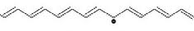
Fig 1.3 (a) Neutral soliton present in polyacetylene

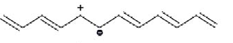
Fig 1.3 (b) Polaron in polyacetylene

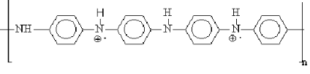
Fig 1.3 (c) Bipolaron in polyaniline
If we consider dopant as an acceptor, it produces a polaron (radical cation). This polaron is pinned to the ionisation site and does not contribute significantly to conductivity. As more dopant is added, the chain is ionised further and a higher concentration of polarons is formed. Also, the polarons can be further ioinized to produce bipolarons (dications). The polarons being more easily ionised than the polymer chains. As the polaron concentration increases, polarons interact to produce bipolarons, which are uncorrelated charged solitons in case of polyacetylene and correlated dications in poly(p-phenylene) or other cases. The bipolarons transport charge via interchain hopping and are responsible for the observed spinless conductivity. In cases where still higher doping levels can be achieved there would be little left of the electronic structure of the original polymer and geometrical defects would overlap spatially along the polymer chain, leading to the elimination of erergy gap between occupied and unoccupied states. Above description is applied to all the conducting polymer systems [3].

1.10 Process of doping in polyaniline and its derivatives
Polyaniline holds a special position amongst conducting polymers due to its ease of doping and adjustable conductivity. Its most highly conducting doped form can be reached by two completely different processes: acid doping and oxidative doping.
Protonic acid doping of emeraldine base units of polyaniline results in complete protonation of the imine nitrogen atoms to give the fully protonated emeraldine hydrochloride salt. With the extent of protonation the conductivity of polyaniline rises up to pH 1, after this lowering pH does not change its conductivity. Protonation increases the conductivity of polyaniline remarkably by 9 to 10 order in magnitude. Each state of polyaniline has different conductivity and processing ability. The emeraldine base is the most widely used form of polyaniline, due to its good processing ability with sufficient conductivity. It is evident that similar doped polymer can be obtained by chemical oxidation (p-doping) of leucoemeraldine base. On the basis of extent of doping, polyaniline and its derivatives have different oxidation states. The four oxidation states have been shown in the following figure 1.4.
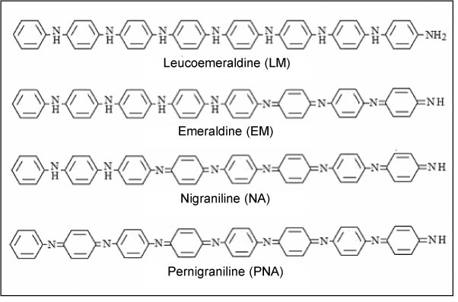
Fig. 1.4 Different oxidation states of polyaniline

This actually involves the oxidation of conjugated sigma- pie system rather than just the pie system of the polymer as is usually the case in p-type doping. Its reaction with a solution of chlorine in carbon tetrachloride proceeds to give emeraldine hydrochloride.

1.11 Nanofibers of conducting polymers
In recent years, there has been growing interest in research on conducting polymer nanostructures (i.e., nano-rods, -tubes, -wires, and -fibers) since they combine the advantages of organic conductors with low-dimensional systems and therefore create interesting physicochemical properties and potentially useful applications. Traditionally, an advantage of polymeric materials is that they can be synthesized and processed on a large scale at relatively low cost. And many of the applications (sensors, functional coatings, catalysts, etc.) of conducting polymers indeed need bulk quantity materials. Polyaniline is used as a model material to systematically investigate the syntheses, properties, and applications of nanofibers of conjugated polymers. It has been found that the nanofibers significantly improve the processibility of polyaniline and its performance in many conventional applications involving polymer interactions with its environment. This leads to much faster and more responsive chemical sensors, new inorganic/polyaniline nanocomposites, and ultra-fast nonvolatile memory devices.
Synthesis and formation mechanism of nanofibers
Conventional polyaniline synthesis is known to produce particulate products with irregular shapes. Therefore, many methods have been developed to make nanostructures of polyaniline. Some recent work indicates that uniform polyaniline nanofibers can be obtained without the need for any template simply by controlling the electrochemical polymerization kinetics. Basic morphological unit for chemically synthesized polyaniline also appears to be nanofibers with diameters of tens of nanometers by introducing “structural directing agents” during the chemical polymerizing reaction. Through careful electron microscopy observations, a small amount of nanofibers can be found among the irregularly shaped particulates in conventionally synthesized polyaniline [12,13]. This suggests the possibility of obtaining polyaniline nanofibers without any external structural directing agents. As reported by Haung et al, polyanlilne nanofibers are synthesized by interfacial polymerization in which the reaction is placed in a heterogeneous biphasic system, where the polymerization occurs primarily at the interface [13-16]. Since the as-made polyaniline product is synthesized in its hydrophilic emeraldine salt form, it diffuses away from the reactive interface into the water layer. This makes more reaction sites available at the interface and avoids further overgrowth. In this way, the nanofibers formed at the interface are collected in the water layer without severe secondary overgrowth. In this process [15], 3.2 mmol aniline is dissolved in 10 ml of xylene while ammonium persulphate (0.8 mmol) is dissolved in 10 ml of 1M hydrochloric acid solution. Both the solutions are kept at low temperature (~4 °C). The aniline solution was transferred to a 50 ml glass vial and then APS solution was carefully poured over to obtain an interface between the two layers. The polymerization reaction was allowed to proceed for 24 h at room temperature. Polyaniline obtained was filtered and washed several times with deionised Millipore water and ethanol, then dried at room temperature.
Enhanced processibility of nanofibers
The solution processibility and film-forming capability are of critical importance for the applications of a polymer. Polyaniline is insoluble in water, and it has been known to have poor water processibility, likely due to the irregularly shaped micron-sized morphology. However, polyaniline synthesized by either interfacial polymerization or rapidly mixed reactions exhibit excellent water dispersibility due to its uniform nanofibrillar morphology. For example, when purified by dialysis or centrifugation, polyaniline nanofibers readily disperse in water without any adduct. Casting such dispersion onto a substrate, a mat of a random nanofiber network is obtained. Most interestingly, when the pH value of the solution is around 2.6, the nanofibers can form a stable colloidal dispersion by themselves.

1.12 Composite films of conducting polymers
Composites are materials made by combining two or more than two distinct and identifiable components to give the combination those properties which can not be there in the original materials. In composites the dispersion phase is called matrix and the dispersed phase is called reinforcement. The role of matrix in the composites is to bind the fibers/ fillers together and hold them in an important stress direction to enhance mechanical strength. It also protects the reinforcing fillers from mechanical damage (like abrasion) and from environmental attacks. The most widely used matrices are metals, polymers, ceramics etc. and the reinforcements are fibers, fillers, whiskers, flakes, particulates etc.
Neat conducting polymers do not have mechanical strength, so utilizing them in neat form is an improbable task. When we use them as reinforcement in polymer matrix, they have suitable mechanical strength and can be utilized.

1.13 Applications of conducting polymers
Polyaniline based conductive polymers have got major use in packaging industry, electronics, construction, fenestration, mining and textile industries. They can be used neat, or as blends and compounds with commodity polymers. Several prototype objects and articles have been made of these compounds with polyethylene, polypropylene, polystyrene, soft PVC, and thermoplastic elastomers.
There are two main groups of applications for these polymers. The first group utilizes their conductivity as its main property. The second group utilizes this electroactivity. They are shown below
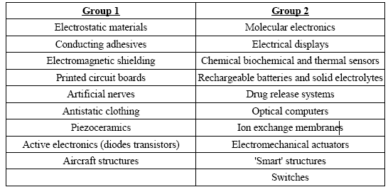
Table 1.1 Various applications of conducting polymers
The solution processing properties of polyaniline based conductive polymers make totally new product ideas possible. These include electroactive inks, paints, coatings, and adhesives, electrochromic “smart” windows, electrically conductive transparent films, and conductive high performance fibres. Solution processing can be carried out using the neat material or a blend.
Polyaniline based materials are used in packaging industry for making antistatic films. Injection moulded polyaniline based materials are directly utilized as a packaging material due to its antistatic property. Antistatic packaging of various components in an electronic system is also a significant area where polyaniline based materials are being used. In the field of electronics printed circuit boards are made of polyaniline based materials. Due to its conducting properties polyaniline based materials have got their use in textile industry for making condutive fabrics. The antistatic properties of polyaniline material makes it a widely useful material in construction for making antistatic floors and work surfaces, in mining for antistatic packaging and in automotive industry for antistatic charge dissipation. The electrochromic properties of polyaniline and its derivatives makes it useful in automotive and fenestration industry for making electrochromic ‘smart’ windows and electrochromic automobile rear vision system. Electrochromic or smart glasses are materials which have adjustable opacity on the application of voltage. So it becomes possible to increase or decrease the light in room coming from outside by just pressing a button. Electrochromic properties of poly(o-toluidine) has been established already [5]. Polyaniline and its derivatives are used in paint industry for making paint primers. In mining conductive pipes for explosive are made of polyaniline based materials.

Electrostatic Discharge (ESD) Protection Materials
One target application of these materials is the protection from ElectroStatic Discharge (ESD). ESD causes problems when handling sensitive electronic components, explosive chemicals or dry powders. The use of, e.g, antistatic materials in specific environments reduce ESD related problems, such as the amount of damaged valuable end products in an assembly line. The controllable conductivity in ESD protection materials is one of the basic benefits of conductive polymer technology.
Biosensors
Conducting polymers are used as a base material for manufacture of chemical, biochemical and thermal sensors. In medical field, various biosensors are made on polyaniline or polyaniline based materials as a matrix material due to its conducting nature. Biosensors are made by immobilizing enzymes on the conducting polymer matrix. The conducting polymer acts as an intermediate between the enzyme and the electronic transducer reflecting results. Biosensors are classified on the basis of their functions. For monitoring level of urea in blood, urea biosensor is utilized. Similarly uric acid biosensor, glucose biosensor, DNA biosensors have attracted the intension of many researchers [17-21].

1.14 Objective of current work
Conducting polymers, specially polyaniline and its derivatives are stable but they do not possess satisfactory mechanical strength. To improve the mechanical properties of conducting polymers, a new class of materials, i.e., composite materials have been developed. Composite films of polyanilines have been synthesized and used as reinforcement. Poly(o-toluidine) can also be utilized as a reinforcement material similar to polyaniline for making conducting composite materials. The objective of this work is to develop composite materials based on conducting polyanilines to have better mechanical properties.

CHAPTER II

Experimental work

2.1 Chemicals Used

The chemicals used in the present study along with their sources are given in Table 3.1. The chemicals were used as obtained for synthesis purpose except aniline and o-toluidine. Aniline and o-toluidine were distilled three times before synthesis to make them extra pure.

CHEMICALS | SOURCES
Aniline | CDH Chemical India
Ammonium persulphate | MERK India
Hydrochloric acid | CDH Chemical India
Xylene | MERK India
o-toluidine | CDH Chemical India
Nylon 6,6 granules | SRF Limited
Formic acid | Qualigens
De-ionized water | Lab

Table 2.1 Chemicals used along with their sources

2.2. Chemical synthesis of polyaniline powder
The most common synthesis of polyaniline involves single step oxidative polymerization, in which the polymerization and doping occurs concurrently, and may be accomplished either electrochemically or chemically. Electrochemical methods tend to have lower yields than chemical yields. Chemical polymerization of aniline was carried out using ammonium peroxodisulfate as an oxidizing agent. The temperature during the reaction was maintained low because the reaction is exothermic and also because at low temperature side reactions get depressed and hence the molecular weight of polyaniline can be increased [12].
A solution of aniline (0.2 M) in 2 M HCl was maintained at low temperature. To this solution 0.1 molar ammonium persulfate solution in dil.HC1 was added drop wise for about 40 min under vigorous stirring. It is very important to keep the monomer: oxidant ratio 1:1. After this the solution is stirred at low temperature for 3 h. The solution was left overnight at low temperature. Next morning a dark green precipitate that had formed was collected by filtration and then washed repeatedly with dil. HCl followed by distilled water. Polyaniline-hydrochloride thus obtained was converted into polyaniline-base by treatment of 10% NaOH. This powder was then dried below 60º C for about 6 h.
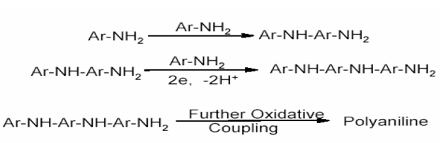

2.3 Chemical synthesis of poly(o-toluidine) powder
The monomer o-toluidine (10.716g) and 11.8 ml of conc. HCl were dissolved in sufficient water to make the solution 500 ml. By this way a 0.2 M solution of o-touidine in HCl was prepared. Then 500 ml of 0.2 molar ammonium persulphate was prepared and this solution was added in earlier solution drop wise in 40 min. In this way the monomer: oxidant ratio was taken 1:1. This solution was also stirred for 3 h and then it was left overnight to polymerize under low temperature. Next morning the solution was filtered and was with dilute HCl and distilled water respectively. Thus obtained powder was dried below 60ºC for about 6 h. In this way, the powder formed was doped simultaneously. In order to get processible emeraldine base form of poly(o-toluidine), it was undoped by dissolving it in 10% NaOH and stirring for 1 h.

2.4. Chemical synthesis of aniline-o-toluidine copolymer
In order to prepare copolymer of aniline and o-toluidine, the ratio of monomer: oxidant was
supposed to take 1:1. So an equimolar mixture of aniline and o-toluidine was taken, in which the total number of moles of monomers is same as the number of moles of ammonium peroxodisulphate to be added.
For this 2.679g of o-toluidine and 2.382 g of aniline were dissolved in 2 M HCl to make the whole solution 250 ml. Then 250 ml of 0.2 M ammonium peroxodisulphate was added drop wise with continuous stirring at low temperature within 40 min. After adding oxidant, the solution was stirred for 3 h at low temperature and then it is left overnight at low temperature. It was filtered and washed by dilute HCl followed by distilled water. Thus prepared copolymer powder is then undoped by dissolving it in 10% NaOH and stirring it for 1 h. Then this was filterd and washed by dilute NaOH and water respectively to make emeraldine base. Thus found powder was dried in oven below 60º C for about 6 h.

2.5 Preparation of conducting composite films
The conducting films of different conducting materials were prepared in different fractions. The matrix material taken for preparation of composites is Nylon 6,6 granules. The solution casting method was employed for preparation of composites as reported by M. Banimahad Keivani et. al [12]. The process of solution casting is one of the widely used process for composite film making due to its ease of preparation. In this process, the matrix material and the reinforcement both is dissolved in a common solvent and mixed homogeneously and then the solvent is dried off. Selection of solvent is of great importance in solution casting process. Due to solubility of polyaniline in some solvents, these polymers have attracted special attention towards solution casting process compared to other conducting polymers—such as polypyrrole, which is insoluble in any solvent and infusible [22]. N- methyl pyrrolidone (NMP) is the most famous solvent of polyaniline and its derivatives. However, we find that it is an expensive solvent and at the same time its boiling point is too high (bp = 202ºC) to be utilized in solution casting process. Due to above to factors the probability to implement NMP as a solvent at large scale preparation of conducting films of polyaniline and its derivatives is curtailed. One the other hand, we find formic acid as good alternative due to its lower cost and boiling point (bp-102ºC). It is reported that the films prepared by using NMP as a solvent has lower utility and less corrosion resistant as compared to formic acid.
1% solution of nylon 6,6 and 1% solution of poly(o-toluidine) was made separately using formic acid as solvent and then it was passed in four varying proportions in separate patri dishes. Four different proportion of conducting polymer to nylon ratios were taken 1:1, 1:2, 1:3 and 1:4. The same process was employed for polyaniline, copolymer and nanofibers of polyaniline and poly(o-toluidine) in separate patri dishes. The solvent was then dried off at 50-60ºC in oven using dring fans for 4 h. Afterward the free standing films were found, which were sticking to the patri dishes. These free standing films were taken out from patri dishes by the help of dilute HCl. The thickness of free standing films was found 30-40 micrometers. Four films of each material (polyanilines and its nanofibers, poly(o-toluidine) and its nanofibers and copolymer) were prepared in different composition. Hense, total 20 films of different composition of conducting materials and different thickness were casted.

2.6 UV-Visible spectroscopy
UV-Visible is an absorption spectroscopy in which light of wavelength range in ultraviolet and visible range is radiated on molecules having unsaturation or hetroatoms like O, N, S etc. The greater the number of molecules capable of absorbing light of a given wavelength the greater is the extent of light absorption. Furthermore, the more effectively a molecule absorbs light of a given wavelength, the greater the extent of light absorption.
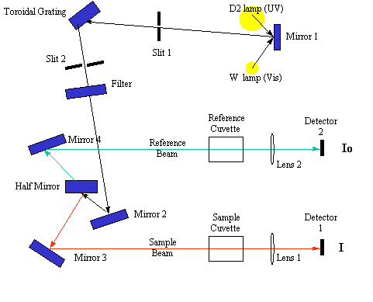
Figure 2.1 Schematic diagram of UV-Visible double beam spectrophotometer
From these guiding ideas, the following empirical expression has been formulated.
A = log(I/I₀) = εcl
Above expression is known as Beer-Lambert law. Where, A is absorbance, I is intensity of light leaving sample cell, I₀ is intensity of light incident upon sample cell, ε is molar extinction coefficient which depends upon the molecule only not on the solvent or set up and l is length of sample cell (cm).
A typical UV-Visible spectrophotometer as shown in figure 2.1 consists of a light source (tungsten lamp), a monochromator and a detector. The monochromator is a diffraction grating which spreads the beam of light into its component wavelengths. In a typical double beam spectrophotometer the light coming from light source is split into two beams the sample beam and the reference beam.
The reference beam passes through reference cell and the detected light is taken to be equal to the intensity of light entering the sample I₀. And the intensity of light coming through sample cell is taken I. The sample and reference cells are made of material that is transparent to the electromagnetic radiation being used in experiment.

2.9 Fourier Transform Infrared Spectroscopy
Fourier Transform Infrared (FTIR) spectroscopy is a technique used to determine qualitative and quantitative features of IR-active molecules in organic or inorganic solid, liquid or gas samples. It is a rapid and relatively inexpensive method for the analysis of solids that are crystalline, microcrystalline, amorphous, or films. Fourier Transform Infrared (FT-IR) spectrometry was developed in order to overcome the limitations encountered with dispersive instruments. The main difficulty was the slow scanning process. A method for measuring all of the infrared frequencies simultaneously, rather than individually, was needed. A solution was developed which employed a very simple optical device called an interferometer. The interferometer produces a unique type of signal which has all of the infrared frequencies “encoded” into it. The signal can be measured very quickly, usually on the order of one second or so. Thus, the time element per sample is reduced to a matter of a few seconds rather than several minutes. A simple diagram of FTIR spectrophotometer is given in figure 2.2.

Figure 2.2 A simple working diagram of FTIR instrument
The Sample Analysis Process
The normal instrumental process is as follows:
1. The Source: Infrared energy is emitted from a glowing black-body source. This beam passes through an aperture which controls the amount of energy presented to the sample (and, ultimately, to the detector).
2. The Interferometer: The beam enters the interferometer where the “spectral encoding” takes place. The resulting interferogram signal then exits the interferometer.
The design of optical pathway of FTIR produces a pattern called an interferrogram. The interferrogram is a complex signal, but its wave like pattern contains all the frequencies that make up the infrared spectrum. An interferrogram is essentially a plot of intensity versus time (a time-domain spectrum). However a chemist is more interested in a spectrum that is a plot of intensity versus frequency (a frequency-domain spectrum). A mathematical operation known as Fourier transform can separate the individual absorption frequencies from the interferrogram, producing a spectrum virtually identical to that obtained with a dispersive spectrometer [23]. In other words Fourier transform converts the interferrogram from the time domain plot into one spectral point on the more familiar form of frequency domain [24].

2.10. Thermogravimetric Analysis (TGA)
Thermogravimetric analysis (TGA) is a technique used to measure weight (mass) changes of a sample as a function of temperature (time) under controlled atmosphere. TGA measurements provide valuable information that can be used to select materials for certain end-use applications, predict product quality [25]. This technique is widely used for knowing the thermal and oxidative stability of material but with more sophisticated instruments following types of measurements can be performed [26]. A lay out of TGA instrument is given as below in figure 2.3.
- Compositional analysis of multi-component materials or blends
- Thermal stabilities
- Oxidative stabilities
- Estimation of product lifetime
- Decomposition kinetics
- Filler content of materials
- Effects of reactive atmospheres on materials
- Moisture and volatiles content
- Inorganic material content

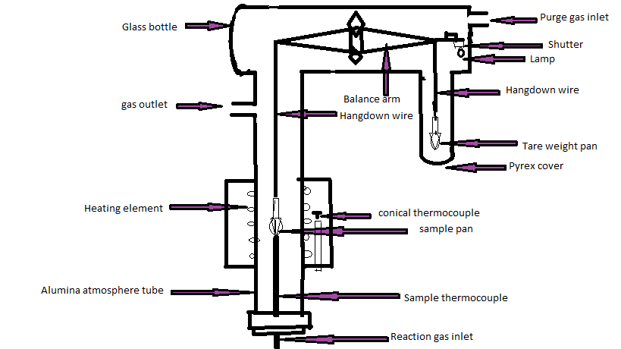
Figure 2.3 : A Layout of TGA instrument
The analyzer usually consists of a high-precision balance with a pan (generally platinum) loaded with the sample. The pan is placed in a small electrically heated oven with a thermocouple to accurately measure the temperature. The atmosphere of sample assembly may be purged with an inert gas to prevent oxidation or other undesired reactions. A computer is used to control the instrument. Analysis is carried out by raising the temperature gradually and plotting weight against temperature. The temperature in many testing methods routinely reaches 1000ºC or greater, but the oven is so greatly insulated that an operator would not be aware of any change in temperature even if standing directly in front of the device. After the data is obtained, curve smoothing and other operations may be done such as to find the exact points of inflection.
A method known as high-resolution TGA is often employed to obtain greater accuracy in areas where the derivative curve peaks. In this method, temperature increase slows as weight loss increases. This is done so that the exact temperature at which a peak occurs can be more accurately identified.
2.11. Tensile Test
Tensile test is a measurement of the ability of a material to withstand forces that tend to pull it apart and to determine to what extent the material stretches before breaking [27]. The various tensile properties measured by UTM (Fig. 2.4) are tensile strength, tensile modulus, elongation at yield point, elongation at break, toughness, etc. Tensile properties of a material play an important role for control and specification purposes in order to its identification and characterization. The speed of testing is the relative rate of motion of the grips during the test. Basically there are five different testing speeds specified by ASTM D 638 standard, among them 0.2 inch/min is the most frequently employed speed. The test specimen is positioned vertically in the grips of the testing machine. The grip are tightened evenly and firmly to prevent any slippage. The speed of testing is set at the proper rate and machine is started. As the specimen elongates the resistance of the specimen increases and is detected by load cell. This load value is recorded by the instrument. The elongation of the specimen is continued till a rupture in the specimen is observed.
Figure 2.4 A diagram of Universal Testing Machine (UTM)
Tensile properties can vary with specimen thickness, method of preparation, speed of testing, type of grips used, and manner of measuring extension. Tensile tests are performed for several reasons.
The results of tensile tests are used in selecting materials for engineering applications. Tensile properties frequently are included in material specifications to ensure quality. Tensile properties are measured during development of new materials and processes, so that different materials and processes can be compared [28,29]. Tensile properties are used to predict the behavior of a material under forms of loading other than uni-axial tension. The tensile force is recorded as a function of the increase in gage length. Engineering stress, or nominal stress, s, is defined as
s =F/A₀
where F is the tensile force and A₀ is the initial cross-sectional area of the gage section. strain, or nominal strain, E is defined as
E = dL/L₀
where L₀ is the initial length and dL is the change in length (L - L₀).
The tensile strength at yield point or ultimate tensile strength is measured by following formula. Tensile strength at break point is important parameters to be measured. It is interesting to know that the tensile strength at break point is lower than ultimate tensile strength.
Tensile strength at yield = maximum load/cross sectional area
Tensile strength at break = load recorded at break/cross sectional area
The strength of a material often is the primary concern. The strength of material is measured in terms of either the stress necessary to cause appreciable plastic deformation or the maximum stress that the material can withstand. Ultimate tensile strength is the maximum stress which the material can withstand [27].
Cross-sectional area of the test specimen is a very important parameter for determining tensile strength. Although the cross-sectional area of the specimen changes with the change in applied stress, but for our calculations we use the original cross-sectional area.
As tensile strength is a measure of stress at fracture, ductility is a measure of strain at fracture. More ductile material is more elastic and can withstand more strain before fracture. This property of material can be measured as a function of percentage elongation. Young’s modulus (or modulus of elasticity) of a material is the slope of stress versus strain curve before yield point. It is a characteristic property of material. The material having lower value of Young’s modulus reflects can have higher strain (more elongation) at lower stress as compared to a material having higher value of Young’s modulus. In fact Young’s modulus is an index of the stiffness of thin plastic sheets.
The tensile energy to break (TEB) is the total energy absorbed per unit volume of the specimen up to the point of rupture. Tensile energy to break is also referred as toughness. It is used to evaluate materials that are subjected to heavy abuse or that can stall web transport equipment in the event of a machine malfunction in end-use applications.

2.11 X-ray diffraction pattern
X-ray diffraction techniques give information about the structure of solids, that is, the arrangement of the atoms that compose the solid. Among various assessment methods the X-ray diffraction method is commonly used because it permits nondestructive structure analysis, although it is relatively low in sensitivity. The types of information this method can provide are:
(1) The kinds of materials that compose a solid (qualitative analysis).
(2) The quantities of materials that compose the solid (quantitative analysis).
(3) The quantities of materials that are crystallized (crystallinity).
(4) The amount of stress present in the solid (residual stress).
(5) The size of crystallites that compose the solid (crystallite size).
(6) Average orientation of crystallites that compose the solid (texture).
X-ray diffraction has been in use in two main areas, for the fingerprint characterization of crystalline materials and the determination of their structure. Each crystalline solid has its unique characteristic X-ray powder pattern which may be used as a "fingerprint" for its identification. We can determine the size and the shape of the unit cell for any compound most easily using the diffraction of X-rays.
X-ray powder Diffraction analysis is a powerful method by which X-rays of a known wavelength are passed through a sample to be identified in order to identify the crystal structure. The wave nature of the X-rays means that they are diffracted by the lattice of the crystal to give a unique pattern of peaks of 'reflections' at differing angles and of different intensity, just as light can be diffracted by a grating of suitably spaced lines. The diffracted beams from atoms in successive planes cancel unless they are in phase, and the condition for this is given by the Bragg relationship.
n λ = 2 d Sin θ
where, λ is the wavelength of the X-rays, d is the distance between different plane of atoms in the crystal lattice, and θ is the angle of diffraction.
The X-ray detector moves around the sample and measures the intensity of these peaks and the position of these peaks [diffraction angle 2θ ]. The highest peak is defined as the 100% peak and the intensity of all the other peaks are measured as a percentage of the 100% peak.
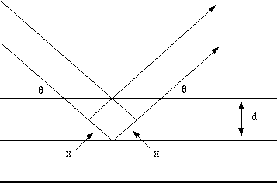
Figure 2.5. Reflection of X-rays from two planes of atoms
The X-ray diffraction experiment requires an X-ray source, the sample under investigation and a detector to pick up the diffracted X-rays. Schematic diagram of a powder X-ray diffractometer is given below in figure 2.6.
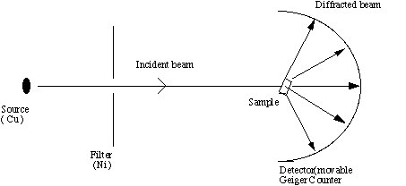 Figure 2.6 Schematic of an X-ray powder diffractometer
The X-ray radiation most commonly used is that emitted by copper, whose characteristic wavelength for the K radiation is =1.5418Å. When the incident beam strikes a powder sample, diffraction occurs in every possible orientation of 2θ. The diffracted beam may be detected by using a moveable detector such as a Geiger counter, which is connected to a chart recorder. In normal use, the counter is set to scan over a range of 2θ values at a constant angular velocity. Routinely, a 2θ range of 5 to 70 degrees is sufficient to cover the most useful part of the powder pattern. The scanning speed of the counter is usually 2θ of 2 degree min⁻¹ and therefore, about 30 min are needed to obtain a trace.

Chapter III

RESULTS AND
DISCUSSION

3.1 UV-Visible spectroscopy
UV-Visible spectra were taken by dissolving samples powder in formic acid using double beam UV-Visible spectrophotometer (Model UV-5704SS). Spectra for conducting polymers and Nylon 6,6 are given in Fig. 3.1.
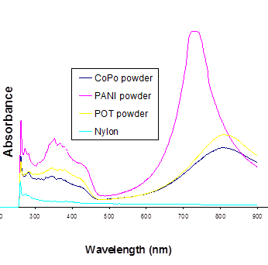
Figure 3.1 UV-Visible spectra of conducting polymers and Nylon 6,6

It is clearly seen from the spectra that polyanilines show two absorption peaks while there is no peak in case of nylon. We find absorption peaks from the spectra at 340 and 750 nm which suggest the formation of polyaniline. In general, there are two peaks in polyaniline due to п-п* and n-п*transitions. It is known that 100% leucoemeraldine base of polyaniline has only one absorption peak due to п-п* transition and has been verified by its absorption spectra [31]. The spectra of polyaniline (emeraldine base) present two absorption bands, i.e., 634 nm (1.96 eV) showing n-п* transition and another at 320 nm (3.75 eV) showing п-п* transition. It is evident that the band at 634 nm (due to n-п*) tends to disappear in the reduced state [32,33]. Different oxidized and reduced forms of polyaniline exhibit the difference in absorption intensity and a slight shift from their λ_{max} values.
In case of poly(o-toluidine), there are two peaks found in spectra similar to polyaniline. An absorption peak at 560 nm is an evidence of pernigraniline base and a broad peak near by 820 nm is an evidence of emeraldine salt [8]. In the present spectra, we find absence of 560 nm peak, which reflects the absence of pernigraniline base phase in the powder mixture. As we know that the pernigraniline base is a 100% oxidized phase of poly(o-toluidine), and it is electrically insulating. The presence of a broad peak nearby 820 nm reveals the formation of emeraldine salts, which is only electrically conducting form of poly(o-toluidine) [8,34]. We find a broad and intense peak nearby 820 nm and no peak near 560 nm. So, it is a sure evidence of formation of emeraldine salt form of poly(o-toluidine) and absence of insulating form (pernigraniline base) of poly(o-toluidine).
Similarly, the spectra of poly(aniline-co-o-toluidine) copolymer also show broad peaks near by 340 and 790 nm as seen in case of polyaniline and poly(o-toluidine). It is clear from the UV-Visible data that there are two absorption bands in all samples of polyanilines in the present work.
Figure 3.2 UV-Visible spectra of conducting polymer/nylon 6,6 composite films

In conducting composite films, it is expected to find both the characteristic peaks of matrix and the reinforcements, i.e., conducting polyanilines. Fig. 3.2 shows two characteristic peaks in all three samples with a shift in λ_{max}.

3.2 FTIR Spectroscopy
The IR spectra of samples were recorded using Fourier transform infrared spectrophotometer (Model Thermo Nicolet 380). FTIR studies on conducting polyaniline, poly(o-toluidine) and its copolymer were recorded by making pressed pellets of powdered samples in KBr, whereas the composite films were studied by putting these films directly in the sample assembly.
FTIR spectra give information about functional groups present in the material. The structure of emeraldine base (EB) form of polyaniline is given below:
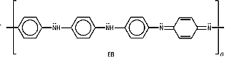
The important functional groups present in above structure are amine and imine. The characteristic absorption peaks for these functional groups are N-H stretching vibration, N-H in plane bending, aromatic C-H stretch, C=C ring stretching, and C-N stretching. In figure 3.3, a broad single peak near 3200-3600 cm⁻¹ is due to hydrogen bonded N-H stretch is common to all three spectra of polyaniline, poly(o-toluidine) and their copolymer. Hydrogen bonding lowers the stretching frequency of both groups involving in it remarkably, and also changes the shape and intensity of the absorption band [23]. A characteristic peak at 3345 cm⁻¹ is attributed due to the C=N stretching. A weak intense peak at 1576 cm⁻¹ is due to the presence of quinoid form in polyaniline and its derivatives. The characteristic peak for C-N bond stretching is found near 1160 cm⁻¹, this peak is present in all three spectra. A characteristic peak at 1497 cm⁻¹ is attributed due to the presence of benzenoid form in polyaniline and its derivatives. A characteristic peak at 2950 cm⁻¹ is present in the spectra due to the presence of methyl in case of poly(o-toluidine) and copolymer.

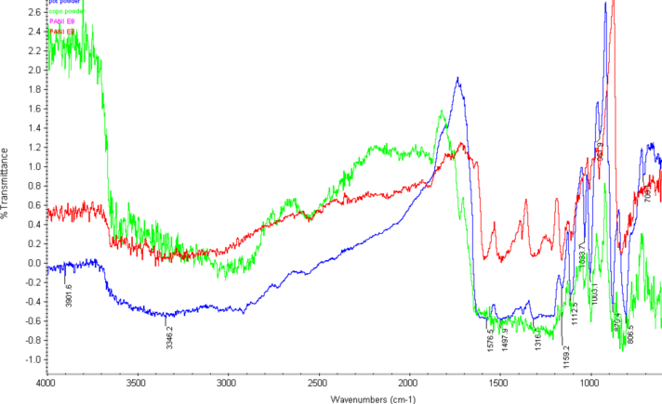
Figure 3.3 FTIR spectra of conducting polyaniline (red), poly(o-toluidine) (blue) and copolymer of aniline and o-toluidne (green)

The composite films are composed of nylon 6,6 and the conducting polymers. The structure of nylon 6,6 is given as below.
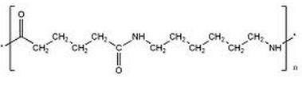
All three spectra have a common peak in region 3140-3320 cm⁻¹ due to the secondary amide group present in the composite materials. This peak appears broad due to the hydrogen bonding. Since the carbonyl peak due to amide linkage in nylon appears as a sharp peak at 1630-1680 cm⁻¹, so the presence of nylon is supported by all three spectra having a sharp peak at 1633 cm⁻¹ due to C=O stretching. Lower value of absorption frequency for C=O stretching in nylon based films is due to the formation of hydrogen bonding. In carbonyl group hydrogen bonding lengthens C=O bond and lowers the stretching force constant, resulting in the lowering of absorption frequency [23]. Apart from these peaks, spectra of composite films also contain a broad single peak near 3200-3600 cm⁻¹ due to hydrogen bonded N-H stretch present in all three spectra of polymers (with reduction in reflectance intensity in polyaniline and copolymer), which is characteristic of both nylon and polyaniline [24]. A weak intense peak at around 1536 cm⁻¹ is due to the plane bending of N-H bond present in polyaniline based composite samples. The characteristic peak for C-N bond stretching is found near 1261 cm⁻¹ in all three spectra. A weak peak present at 2924 cm⁻¹ in poly(o-toluidine) and poly(aniline-co-o-toluidine) based composite films is due to the methyl C-H stretching vibration.

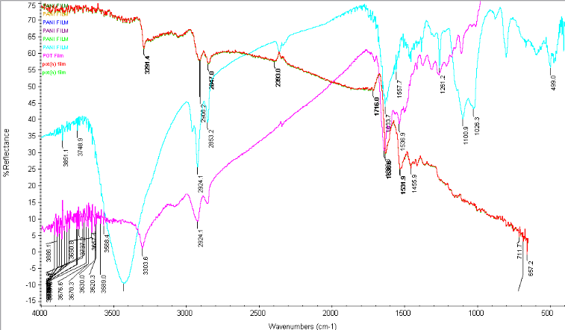

Figure 3.4 FTIR spectra of conducting composite films of polyaniline (red), POT (violet), copolymer (sky blue)

3.3 Thermogravimetric analysis
Polymers undergo heat treatment during its fabrication processes like extrusion, injection molding, etc. Due to heat they undergo degradation. So knowing their thermal stability is a prime factor before fabrication. At the same time there are several uses of polymer products where their thermal stability is an important factor. Thermogravimetric analysis was done in order to evaluate the thermal stability of the polymer and their composite films. For this purpose, thermogravimetric analyzer (Model Q50) from TA instruments was utilized at a heating rate 10⁰C/min under nitrogen atmosphere from room temperature to 650⁰C.
Figure 3.5 TGA thermograms of polyaniline (blue), poly(o-toluidine) (pink) and poly(aniline-co-o-toluidine)

Thermal stability of polymers depends upon the stability of C-C bond (in case of polyaniline C-N bond). Although, there is no much difference in the thermal stabilities of polyaniline and poly(o-toluidine) in both powder and composite film. This can be explained on the basis of the effect of substitution on bond dissociation enthalpy. It is evident that C-C bond dissociation enthalpy is found to be decreased with the substitution of methyl (or even phenyl) group(s). Polyethylene has better thermal stability than polypropylene due to one methyl group substitution. The thermal stability is further decreased with more substitution and polyisobutylene has even lower thermal stability than polypropylene. Lower thermal stability of POT may be due to the formation of more stable free radicals during thermal degradation.
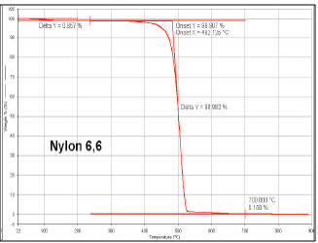

Figure 3.6 TGA plot of nylon 6,6

Figure 3.6 shows that Nylon 6,6 can withstand temperature as high as 400⁰C, without undergoing thermal degradation. The higher value of its thermal stability is due to its high molecular weight and stable C-C bond, C-N bond.

Figure 3.7 TGA Thermograms of composite films of polyaniline (blue), poly(o-toluidine) (pink) and their copolymer (yellow)

Generally, it is observed that the aromatic groups in a polymer backbone increase the thermal stability of the polymer [25]. For example, polycarbonates and poly(p-phenylene) have much higher thermal stability. Polyaniline and its derivatives too, have sufficiently higher thermal stability. It can be seen in figure 3.5, that polyaniline and its derivatives are almost equally thermally stable as nylon 6,6. The composite films based on polyaniline is found more stable than poly(o-toulidine) and copolymer. Moreover, the thermal stability trend of copolymer based composite is found very similar to the parent copolymer as seen from the TGA thermogram (Fig. 3.7).
3.4 Tensile test
Tensile test is a useful mechanical test for polymeric materials in order to understand their applications in terms of their mechanical stability and durability. These conducting composite films were tested using Universal Testing Machine (UTM) from Instron Co. For gripping of these 40 μm thin films, soft rubber pads were utilized. It was found that the tensile strength of poly(o-toluidine)/Nylon composite of same thickness and composition (1:3) has better tensile strength than polyaniline/nylon composite.
Table 3.1Mechanical properties of 1:3 polyaniline/nylon 6,6 composite films
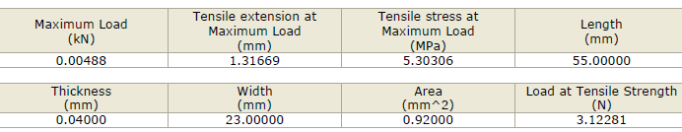

Ultimate tensile strength = maximum load/cross-sectional area
= 488/0.920 N/mm²
= 530 N/mm²
Percentage elongation = (Elongation/original length) x 100
= (1.31669/55.000) x 100
= 2.4 %

Table 3.2 Mechanical properties of 1:3 poly(o-toluidine)/Nylon 6,6 composite films
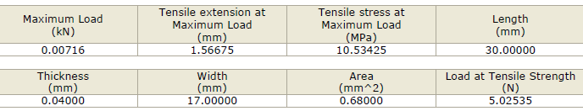

Ultimate Tensile strength = maximum load/cross-sectional area
= 716/0.680 N/mm²
= 1053 N/mm²
Percentage elongation = (Elongation/original length) x 100
= (1.56675/30.000) x 100
= 5.2 %
Table 3.3 Tensile properties of 1:3 aniline-o-toluidine copolymer/Nylon 6,6 composite films
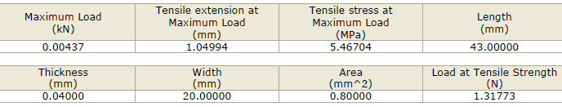
Ultimate tensile strength = maximum load/cross-sectional area
= 488/0.920 N/mm²
= 531 N/mm²
Percentage elongation = (Elongation/ original length) x 100
= (1.04994/43) x 100
= 2.44 %

The tensile strength of composite film containing poly(o-toluidine) as an additive, was found almost double than composite films containing additives like polyaniline or copolymer of aniline and o-toluidine. The thickness and composition of composite films were kept same in case of all composite films. High value of tensile strength in case of poly(o-toluidine) may be due to unidirectional grains being formed due to methyl group present in it. Due to the presence of methyl group, the polymer chain may have got less entangled and makes it one dimensional linear chain which increases tensile strength.
Table 3.4 Comparative study of tensile properties of composite films
 | Ultimate tensile strength (N/mm²) | Young’s modulus  ( in MPa ) | % elongation
Polyaniline composite film | 530 | 291.4 | 2.40%
Poly(o-toluidine)  composite film | 1053 | 249.4 | 5.19 %
Copolymer  composite film | 531 | 320.2 | 2.44 %

Ductility is a measure of strain at fracture, that is, a more ductile material can withstand large strain before failure. Percentage elongation is a measure of ductility of material. Incorporating poly(o-toluidine) in nylon the composite material is more ductile as compared to adding other conducting polymers, such as polyaniline or the copolymer of aniline and o-toluidine. Young’s modulus is the slope of stress versus strain curve in elastic region before yield point is reached. A material having lower value of Young’s modulus can have higher value of strain at the same value of stress than a material having high value of Young’s modulus.

3.5 X-Ray diffraction pattern
The X-ray diffraction spectra were recorded using a D-8 Advance X-ray diffractometer, BRUKER Co., Germany. The powder conducting polymers were crushed and placed on glass slide specimen holder and exposed to X-ray. In case of composite films, the polymeric films were pasted on the glass specimen holder using adhesive and the films were exposed to the X-ray. The rate of scan was kept 1⁰ per minute.
X-ray diffraction spectra of pure Nylon_{6,6} exhibit sharp diffraction peaks at 2θ= 19⁰, 24⁰, 13⁰. Althought the peaks are centered at 2θ = 19⁰. The XRD pattern of polyaniline/Nylon composite exhibits peaks both corresponding to Nylon and polyaniline.

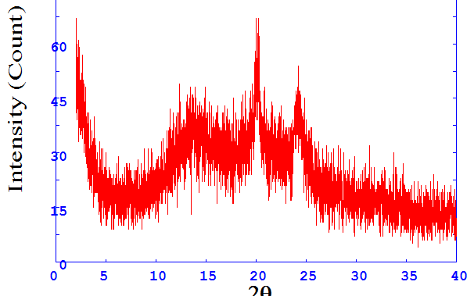

Figure 3.8 XRD pattern of nylon 6,6

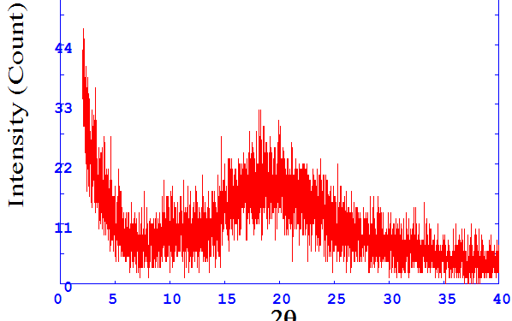
Figure 3.9 (a) XRD pattern of polyaniline powder

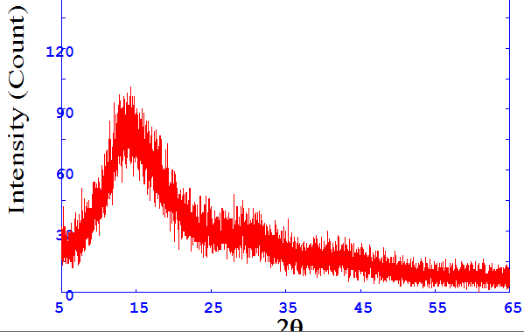

Figure 3.9(b) XRD pattern of poly(o-toluidine) powder

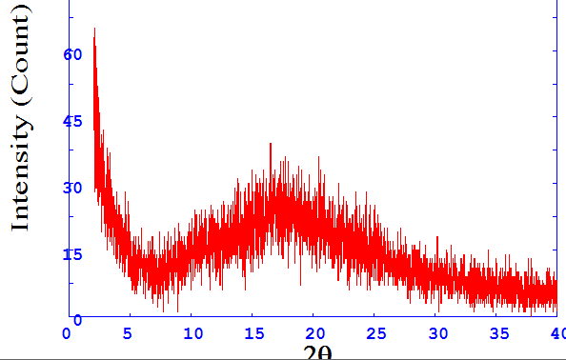

Figure 3.9 (c) XRD pattern of copolymer of aniline and o-toluidine

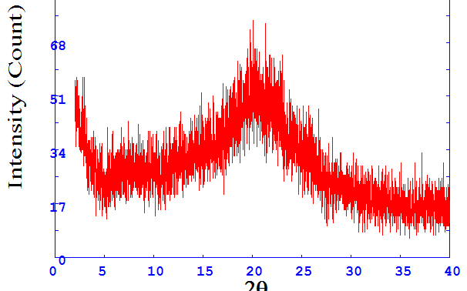
Figure 3.10 (a) XRD pattern of 1:3 polyaniline/Nylon composite film

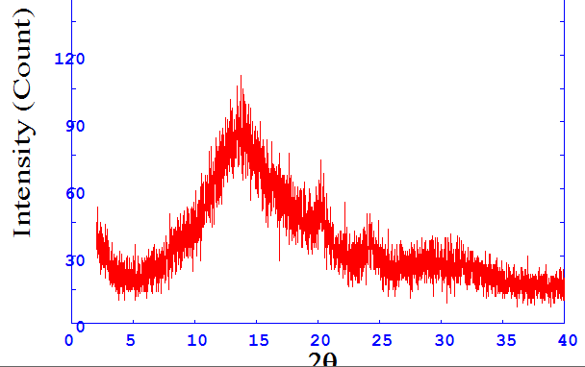

Figure 3.10 (b) XRD pattern of 1:3 poly(o-toluidine)/Nylon composite film

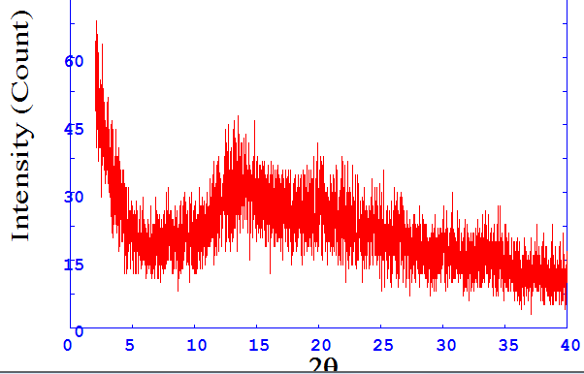

Figure 3.10 (c) XRD pattern of poly(aniline-o-toluidine)/nylon composite

CHAPTER IV

CONCLUSION

From the above observations following conclusions can be drawn:

- Polyaniline, poly(o-toluidine) and copolymer were synthesized by chemical polymerization.
- In-situ protonic acid doping was done in the course of polymerization itself and later emeraldine base of polymers were prepared by undoping them with NaOH solution.
- Conducting composite films of various composition (1:1, 1:2, 1:3, and 1:4) with [polyaniline, poly(o-toluidine), poly(aniline-co-o-toluidine) were prepared by taking nylon 6,6 as a matrix material by solution casting method.
- Equal volumes of solution were put in patri-dishes having equal area, and all films were allowed to dry for same period of time, so the thickness of prepared films were almost equal ranging between 35-40 μm.
- UV-Visible spectra establish the characteristic bands of polyaniline and its derivatives.
- FTIR spectra establish the presence of different functional groups in the samples.
- In order to measure the thermal stability of samples TGA thermograms provide valuable informations.
- Poly(o-toluidine)/Nylon composite film was found to have better mechanical stability in terms of tensile strength, ductility and elasticity as compared to polyaniline/nylon composite film.

References:

1. Siegmer Roth, Conducting polymers – physical concepts and practical applications, Indian Journal of Chemistry, 33(A), 453-460, 1994
2. Collin Pratt, Review on conducting polymers, 1-6, 22 Feb., 1996,
3. T. A. Skotheim, Handbook of conducting polymers, vol-2, page-855, publisher: Marcel Dekker, New York, 1985
4. Buzarovska A., Arsova I., Electrochemical synthesis of poly(2-methyl aniline) : Electrochemical and spectroscopic charecterisation.
5. Devendra Kumar, Poly(o-toluidine) polymer as electrochromic material, European Polymer Journal, 37, 1721-1725, 2001
6. Mustafa Ozden, Ergun Ekinci, Ersin Karagozler, Electrochemical preparation of poly(o-toluidine) film and its application as permselective membrane, Journal of applied polymer science, volume 71, 2141-2146, 1999
7. Ergun Ekinci, Preparation and sensor properties of poly(o-toluidine) film, Polymer Bulletin, 42, 693-699, 1999
8. Patil Dewyani., Patil P. P, Electrodeposition of poly(o-toluidine) on brass from aqueous salicylate solution and its corrosion protection performance, Journal of applied polymer science, 118, 2084-2091, 2010
9. http://en.wikipedia.org/wiki/Polyaniline
10. Sirakawa H., Louis E. J., MacDiarmid A.G., Scintific America, 60-65, 1988.
11. Bakhshi A. K., Electronic structure of conducting polymers. Indian Journal of Chemistry, 33 (A), 254-168, 1994
12. Banimahd M. Keivani, Zare K., Aghaie M., Aghai H., Monajjemi M., Synthesis of nano conducting polymer based polyaniline and its composite: Mechanical properties, conductivity and thermal studies, E-Journal of Chemistry 7(1), 105-110, 2010
13. Liu J., Lin Y. H., Liang L., Voigt J. A., Huber D. L., Tian Z. R., Coker E., Templateless assembly of molecularly aligned conductive polymer nanowires: A new approach for oriented nanostructures. Chemistry – A European Journal, 9, 605, 2003
14. Liang L., Liu J., Windisch C. F., Exarhos G. J., Lin Y. H., Direct assembly of large arrays of oriented conductin polymer nanowires. Angewandte Chemie International Edition, 41, 3665, 2002
15. Huang J. X., Kaner R. B., Nanofiber formation in the Chemical Polymerization of aniline: A mechanistic study. Angewandte Chemie International Edition, 43, 5817, 2004
16. Huang J. X., Kaner R. B., A general chemical route to polyaniline nanofibers, Journal of American Chemical Society. 126, 851, 2004
17. Tiwari A., Aryal S., Pilla Srikant, An amperometric urea biosensor based on covalently immobilized urease on an electrode made of hyprebranched polyster functionalized gold naoparticles, Talanta 78, 1401-1407, 2009
18. Mariana P. Massafera, Susana I. Cordoba, Urea amperometric biosensors based on a multifunctional bipolymeric layer: comparing enzyme immobilisation methods. Sensors and Actuators B: Chemical, 137, 476-482, 2009
19. Fatma Arslan, An amperometric biosensor for uric acid determination prepared from uricase immobilised in polyaniline-polypyrorole film, Sensors, 8, 5492-5500, 2008
20. Trivedi U. B., Lakshminarayana D., Kotahri I. L., Potentiometric biosensor for urea determination in milk. Sensors and Actuators: B 140, 260-266, 2009
21. Zhanga Y., Wena G., Zhoua Y., Shuanga S., Development and analytical application of an uric acid biosensor using an uricase- immobolised eggshell membrane, Biosensors and Bioelectronics, 22(8), 1791-797.
22. Ansari R., Amir H., Application of polyaniline/nylon composites coating for corrosion protection of steel, J. Coat. Technol. Res., 6(2) 221-227, 2009.
23. Donald L. P., Garry M. L., Spectroscopy, 2007 edition, Cenage Learning, 33-34, 63,
24. Silverstein R. M., Clayton G. Bassler, Spectrometric identification of organic compounds, 1991 edition, John Willey & Sons, Page-98.
25. Gowariker V. R., Vishwanathan N. V., Jayadev Sreedhar, Polymer Science, First edition, New Age International Publishers.
26. Sichana W. J., Marketing Manager, PerkinElmer instruments, Characterization of polymers using TGA,
27. Shah V., Handbook of plastic testing technology, second edition
28. Richard G., Quality test & inspection, Tensile Testing Basics Tips and Trends
29. http://www.asminternational.org/pdf/spotlights/5106_01.pdf
30. Serope Kalpakjian, Steven R. Schmid, Manufacturing process of engineering materials. Fourth addition, Pearson Education Publication.
31. Master J. G., Ginder J. M., MacDiarmid A. G., Epstein A. J., J. Chem. Phys. 96, 4768, 1992
32. Albuquerque J. E., Mattoso L. H. C., Faria R. M., Masters J.G., MacDiarmid A.G., A simple method to estimate the oxidation state of polyaniline. Synthetic Metals 113, 19-22, 2002
33. Reja M. N., Golbace M., Polyaniline/TiO₂ nano-composite, enzymatic synthesis and electrochemical properties. International journal of electrochemical science, 3, 1117-1126, 2008
34. Patil S. Ph.D. thesis, North Maharastra University, Jalgaon, India, 2000.

