A Secure Access Control Using Biometric System

A Dissertation Submitted in partial fulfillment of the requirement
For the Award of degree of
MASTER OF ENGINEERING
In
Computer Technology and Application
By
D.Santhadevi
(University Roll No.10071 )

Under the Guidance of
Dr. RAJNI JINDAL
(Associate Professor and Project Guide)
Delhi Technological University
(Formerly Delhi college of Engineering)


DEPARTMENT OF COMPUTER ENGINEERING
UNIVERSITY OF DELHI
JUN – 2011

CERTIFICATE

This is to certify that project entitled “A Secure Access Control Using Biometric System ” has been completed by D.Santhadevi , University Roll No. 10071 in the partial fulfillment of the requirement for the award of degree of Master in Engineering in Computer Technology & Application.
This work is carried out by her under my supervision and support. This is a beneficial work in the field of data base security and privacy protection.

( Dr. RAJNI JINDAL)
ASSOCIATE PROFESSOR & PROJECT GUIDE
(Dept. of Computer Engineering)
DELHI TECHNOLOGICAL UNIVERSITY
(Formerly Delhi College of Engineering)
BAWANA ROAD, DELHI - 110042

ACKNOWLEDGEMENT

It is distinct pleasure to express my deep sense of gratitude and indebtedness to my learned supervisor Dr. Rajni Jindal ( Associate Professor of Computer Engineering Dept, Delhi Technological University) for her invaluable guidance, encouragement and patient reviews. Her continuous inspiration only has made me complete this dissertation. All of them kept on boosting me time and again for putting an extra ounce of effort to realize this work.
I am also thankful to Dr. Daya Gupta, Head of the Department, Computer Engineering, Delhi Technological University, Delhi for the motivation and inspiration that triggered me for the thesis work.
I would also like to thank the staff members and my colleagues who were always there at the need of the hour and provided with all the help and facilities, which I required for the completion of my thesis work.
Finally I am also thankful to my classmates and my family members for their unconditional support and motivation during this work.

(D. Santhadevi)
Master in Engineering
(Computer Technology & Application)
Dept. of Computer Engineering
Delhi College of Engineering

BAWANA ROAD, DELHI - 110042

Abstract

The absence of secure database access in software development is one of the major issue in the society. Though there is increasing development in the database security systems, due to increasing number of specific attacker’s attacks the security system, it needs effective access control.
Biometric technologies such as fingerprint, face and iris recognition have seen an increasing interest throughout the past decades. Such interest has been intensified with various large-scale initiatives from governments that seek to incorporate biometric technologies for the purposes of identification and verification. Far from being purely adhoc technological implementations, biometric devices are now seen as being of strategic value and consequently of strategic importance. With the perception of better efficiency and effectiveness, governments are beginning to embrace biometric technologies. Industry is also geared up to sell the products, and all over the world businesses are looking to incorporate biometrics for many different uses ranging from access-control to e-commerce and entertainment.
Authentication and authorization as the part of the access control can ensure proper security in database systems. Biometric authentication provides a better way to control authenticated individual access.
So we propose a model frame work for an access control using two level authentication scheme combines biometric with password provide high security remote authentication. Proposed biometric access control system implemented by facial recognition using eigenface algorithm. It has two phase that are enrollment phase and identification phase.
Enrollment phase is the process of entering or registering their physiological information into biometric system. The biometric system used in this thesis is face recognition system, in which the user’s face is captured in camera and stored in the biometric database system derived.
Identification phase is the process which determines the acception or rejection of the identified input of the user during the validation attempt. After successful identification, authenticated user allowed to access the data in the database.
The proposed biometric system implemented using Eigenface with PCA algorithm.

Contents

CHAPTER 1 Introduction - Database Access Control................................................... 7
1.1 General Concepts................................................................................................................ 7
1.2 Computer Security.............................................................................................................. 8
1.2.1 Identification and Authentication............................................................................. 9
1.2.2 Authorization.......................................................................................................... 9
1.2.3 Accountability.......................................................................................................... 10
1.3 Access Control Models........................................................................................................ 11
1.3.1 Attribute Based Access Control................................................................................ 11
1.3.2 Discretionary Access Control................................................................................. 11
1.3.3 Mandatory Access Control....................................................................................... 12
1.3.4 Role Based Access control....................................................................................... 12
1.3.5 Biometric Access Control......................................................................................... 13
1.4 Components of Access Control............................................................................................ 14
1.5 Motivation.......................................................................................................................... 15
1.6 Proposed Systems............................................................................................................... 16
CHAPTER 2 Biometric Access Control
2.1 Introduction to Biometrics ...................................................................................................17
2.2 Characteristics of Biometric System......................................................................................18
2.2.1 Throughtput & Acceptability.....................................................................................20
2.2.2 Exclusivity, Reliability and Forgery.............................................................................21
2.2.3 Datastorage & Enrollment .......................................................................................21
2.2.4 Infringment.............................................................................................................22
2.3 Types of Biometric Access Control.......................................................................................22
2.3.1 physical Access Control...........................................................................................23
2.3.2 Logical Access Control.............................................................................................24
2.4 Biometric Identification Methods........................................................................................26
2.5 Anomalies in biometrics......................................................................................................27

CHAPTER 3 Biometric- Facial Recognition using EigenFace
3.1 Faction Recognition –History.........................................................................................................30
3.2 Face Recognition Approaches........................................................................................................33
3.2.1 PCA....................................................................................................................................34
3.2.2 LDA....................................................................................................................................34
3.2.3 BGM..................................................................................................................................35
3.3 Face Recognition Key Features......................................................................................................35
3.4 Eigenface Recognition Technique..................................................................................................36
3.4.1. Overview of the Algorithm...............................................................................................37

CHAPTER 4 Implementation of Eigenface using PCA
4.1 Eigenface Recognition Technique..................................................................................................39
4.2 Algorithm for finding Eigenfaces...................................................................................................41
4.2.1 Finding weights.................................................................................................................43
4.2.2 Recognition Task...............................................................................................................43
4.2.3 Distance Measures............................................................................................................44
4.2.4 Deciding Thershold..........................................................................................................45
4.3 Process of Eigenface algorithm......................................................................................................47
4.3.1 Recognition Procedure.....................................................................................................49
4.3.2 Pattern Recognition in High-dimensional spaces.............................................................50
4.3.3 Dimensionality Reduction.................................................................................................50
4.3.4 Information Loss...............................................................................................................51
4.4 Implementation of PCA..................................................................................................................52
4.4.1 Geometric Interpretation.................................................................................................53
4.4.2 Standardization.................................................................................................................54
4.5 problems........................................................................................................................................56

Conclusion..............................................................................................................57

References..............................................................................................................58
CHAPTER 1 Introduction to Database Access Control
  - General Concept
Fast growing, constantly changing world of Information Technology demands fast responding and reliable security devices. Every day our world converts more business data into an electronic format, and we are obligated to protect information from those lacking social life individuals, who cannot sleep well at night or from those unethical persons who just want to explore the possibilities.
Confidential data, the heart of any organization, is vulnerable to attacks, with attacks coming from both outside and inside of a company. Assuming that outside hackers are restricted by firewalls and encryptions, then we have to wary about the insiders or strangers who can get inside. Keeping data secure means that we need to make sure that any access to data is supervised.
One of the most important parts of any secure environment is the employees themselves. They represent the “Human firewall” inside the organization; they must be trained to behave securely and monitor the surroundings. The Information System Security Association (ISSA) designed a “human firewall” web site, built to educate people, to provide with the survey to evaluate their security level and in general to make individuals aware of possible threats. Dave Cullinane, ISSA president said: “We find that people are generally aware of the danger out there, but not aware of what they should do to keep their systems secure” (Kawamoto D., 2004).
Now that employees are aware of the dangers, alert to any suspicious activities, and outsiders are kept securely at a distance, does it mean the precious data is safe? Not really. Now we need to worry that only authorized people can access data and hope that they do not intend to cause any harm. We need to make sure access is easy but properly secured for physical access to a building to retrieve necessary information in the work place.

  - Computer Security
In computer security, access control includes authentication, authorization and audit. It also includes measures such as physical devices, including biometric scans and metal locks, hidden paths, digital signatures, encryption, social barriers, and monitoring by humans and automated systems.
In any access control model, the entities that can perform actions in the system are called subjects, and the entities representing resources to which access may need to be controlled are called objects . Subjects and objects should both be considered as software entities and as human users. Although some systems equate subjects with user IDs, so that all processes started by a user by default have the same authority, this level of control is not fine-grained enough to satisfy the Principle of least privilege, and arguably is responsible for the prevalence of malware in such systems.
Access control models used by current systems tend to fall into one of two classes: those based on capabilities and those based on access control lists (ACLs). In a capability-based model, holding an unforgettable reference or capability to an object provides access to the object; access is conveyed to another party by transmitting such a capability over a secure channel. In an ACL-based model, a subject's access to an object depends on whether its identity is on a list associated with the object; access is conveyed by editing the list. Different ACL systems have a variety of different conventions regarding who or what is responsible for editing the list and how it is edited.
Both capability-based and ACL-based models have mechanisms to allow access rights to be granted to all members of a group of subjects (often the group is itself modeled as a subject).
Access control systems provide the essential services of identification and authentication (I&A), authorization, and accountability where:
- identification and authentication determine who can log on to a system, and the association of users with the software subjects that they are able to control as a result of logging in;
- authorization determines what a subject can do;
- accountability identifies what a subject (or all subjects associated with a user) did.

1.2.1 Identification and authentication (I&A)
Identification and authentication (I&A) is the process of verifying that an identity is bound to the entity that makes an assertion or claim of identity. The I&A process assumes that there was an initial validation of the identity, commonly called identity proofing. Various methods of identity proofing are available ranging from in person validation using government issued identification to anonymous methods that allow the claimant to remain anonymous, but known to the system if they return. The method used for identity proofing and validation should provide an assurance level commensurate with the intended use of the identity within the system. Subsequently, the entity asserts an identity together with an authenticator as a means for validation. The only requirement for the identifier is that it must be unique within its security domain.
Authenticators are commonly based on at least one of the following four factors:
- Something you know, such as a password or a personal identification number (PIN). This assumes that only the owner of the account knows the password or PIN needed to access the account.
- Something you have, such as a smart card or security token. This assumes that only the owner of the account has the necessary smart card or token needed to unlock the account.
- Something you are, such as fingerprint, voice, retina, or iris characteristics.
- Where you are, for example inside or outside a company firewall, or proximity of login location to a personal GPS device.

1.2.2 Authorization
Authorization applies to subjects. Authorization determines what a subject can do on the system. Most modern operating systems define sets of permissions that are variations or extensions of three basic types of access:
- Read (R): The subject can
  - Read file contents
  - List directory contents
- Write (W): The subject can change the contents of a file or directory with the following tasks:
  - Add
  - Create
  - Delete
  - Rename
- Execute (X): If the file is a program, the subject can cause the program to be run.
These rights and permissions are implemented differently in systems based on discretionary access control (DAC) and mandatory access control (MAC).

1.2.3 Accountability
Accountability uses such system components as audit trails (records) and logs to associate a subject with its actions. The information recorded should be sufficient to map the subject to a controlling user. Audit trails and logs are important for
- Detecting security violations
- Re-creating security incidents
If no one is regularly reviewing your logs and they are not maintained in a secure and consistent manner, they may not be admissible as evidence.
Many systems can generate automated reports based on certain predefined criteria or thresholds, known as clipping levels. For example, a clipping level may be set to generate a report for the following:
- More than three failed logon attempts in a given period
- Any attempt to use a disabled user account
These reports help a system administrator or security administrator to more easily identify possible break-in attempts.

1.3 Access control models
Access control models are sometimes categorized as either discretionary or non-discretionary. The three most widely recognized models are Discretionary Access Control (DAC), Mandatory Access Control (MAC), and Role Based Access Control (RBAC). MAC and RBAC are both non-discretionary.

1.3.1 Attribute-based access control
In attribute-based access control (ABAC), access is granted not based on the rights of the subject associated with a user after authentication, but based on attributes of the user. The user has to prove so called claims about his attributes to the access control engine. An attribute-based access control policy specifies which claims need to be satisfied in order to grant access to an object. For instance the claim could be "older than 18" . Any user that can prove this claim is granted access. Users can be anonymous as authentication and identification are not strictly required. One does however require means for proving claims anonymously. This can for instance be achieved using anonymous credentials or XACML (extensible access control markup language).

1.3.2 Discretionary access control
Discretionary access control (DAC) is an access policy determined by the owner of an object. The owner decides who is allowed to access the object and what privileges they have.
Two important concepts in DAC are
- File and data ownership: Every object in the system has an owner. In most DAC systems, each object's initial owner is the subject that caused it to be created. The access policy for an object is determined by its owner.
- Access rights and permissions: These are the controls that an owner can assign to other subjects for specific resources.
Access controls may be discretionary in ACL-based or capability-based access control systems. (In capability-based systems, there is usually no explicit concept of 'owner', but the creator of an object has a similar degree of control over its access policy.)

1.3.3 Mandatory access control
Mandatory access control (MAC) is an access policy determined by the system, not the owner. MAC is used in multilevel systems that process highly sensitive data, such as classified government and military information. A multilevel system is a single computer system that handles multiple classification levels between subjects and objects.
- Sensitivity labels: In a MAC-based system, all subjects and objects must have labels assigned to them. A subject's sensitivity label specifies its level of trust. An object's sensitivity label specifies the level of trust required for access. In order to access a given object, the subject must have a sensitivity level equal to or higher than the requested object.
- Data import and export: Controlling the import of information from other systems and export to other systems (including printers) is a critical function of MAC-based systems, which must ensure that sensitivity labels are properly maintained and implemented so that sensitive information is appropriately protected at all times.
Two methods are commonly used for applying mandatory access control:
- Rule-based (or label-based) access control: This type of control further defines specific conditions for access to a requested object. All MAC-based systems implement a simple form of rule-based access control to determine whether access should be granted or denied by matching:
  - An object's sensitivity label
  - A subject's sensitivity label
- Lattice-based access control: These can be used for complex access control decisions involving multiple objects and/or subjects. A lattice model is a mathematical structure that defines greatest lower-bound and least upper-bound values for a pair of elements, such as a subject and an object.

1.3.4 Role-based access control
Role-based access control (RBAC) is an access policy determined by the system, not the owner. RBAC is used in commercial applications and also in military systems, where multi-level security requirements may also exist. RBAC differs from DAC in that DAC allows users to control access to their resources, while in RBAC, access is controlled at the system level, outside of the user's control. Although RBAC is non-discretionary, it can be distinguished from MAC primarily in the way permissions are handled. MAC controls read and write permissions based on a user's clearance level and additional labels. RBAC controls collections of permissions that may include complex operations such as an e-commerce transaction, or may be as simple as read or write. A role in RBAC can be viewed as a set of permissions.
Three primary rules are defined for RBAC:
- Role assignment: A subject can execute a transaction only if the subject has selected or been assigned a role.
- Role authorization: A subject's active role must be authorized for the subject. With rule 1 above, this rule ensures that users can take on only roles for which they are authorized.
- Transaction authorization: A subject can execute a transaction only if the transaction is authorized for the subject's active role. With rules 1 and 2, this rule ensures that users can execute only transactions for which they are authorized.
Additional constraints may be applied as well, and roles can be combined in a hierarchy where higher-level roles subsume permissions owned by sub-roles.
1.3.5 Biometric Access Control
When a credential is presented to a reader, the reader sends the credential’s information, usually a number, to a control panel, a highly reliable processor. The control panel compares the credential's number to an access control list, grants or denies the presented request, and sends a transaction log to a database. When access is denied based on the access control list, the door remains locked. If there is a match between the credential and the access control list, the control panel operates a relay that in turn unlocks the door. The control panel also ignores a door open signal to prevent an alarm. Often the reader provides feedback, such as a flashing red LED for an access denied and a flashing green LED for an access granted.
The above description illustrates a single factor transaction. Credentials can be passed around, thus subverting the access control list. For example, Alice has access rights to the server room but Bob does not. Alice either gives Bob her credential or Bob takes it; he now has access to the server room. To prevent this, two-factor authentication can be used. In a two factor transaction, the presented credential and a second factor are needed for access to be granted; another factor can be a PIN, a second credential, operator intervention, or a biometric input.

There are three types (factors) of authenticating information:
- something the user knows, e.g. a password, pass-pharse or PIN
- something the user has, such as smart card
- something the user is, such as fingerprint, verified by biometric measurement
Passwords are a common means of verifying a user's identity before access is given to information systems. In addition, a fourth factor of authentication is now recognized: someone you know, where another person who knows you can provide a human element of authentication in situations where systems have been set up to allow for such scenarios. For example, a user may have their password, but have forgotten their smart card. In such a scenario, if the user is known to designated cohorts, the cohorts may provide their smart card and password in combination with the extant factor of the user in question and thus provide two factors for the user with missing credential, and three factors overall to allow access.

Credential
A credential is a physical/tangible object, a piece of knowledge, or a facet of a person's physical being, that enables an individual access to a given physical facility or computer-based information system. Typically, credentials can be something you know (such as number or PIN), something you have (such as an access badge), something you are (such as a biometric feature) or some combination of these items. The typical credential is an access card, key fob, or other key. There are many card technologies including magnetic stripe, bar code, Wiegand, 125 kHz proximity, 26 bit card-swipe, contact smart cards, and contact less smart cards. Also available are key-fobs which are more compact than ID cards and attach to a key ring. Typical biometric technologies include fingerprint, facial recognition, iris recognition, retinal scan, voice, and hand geometry.
1.4 Components of Access Control
Proper identification, authentication, authorization, accountability are the important components of an access control, a process that relays on its components to enforce security. We start with identifying users, and then we verify the identity by authenticating them, making sure they are who they claim they are. If we are successful in these steps, authorization component checks what levels of information users are allowed to access, what tasks they can execute and then permits a connection to the system.
Another important role is played by the accountability part of an access control. It monitors and records all activities performed by an authenticated user so if necessary, a user can be hold accountable for the actions accomplished. The main underlying idea of an access control process is to protect the confidentiality, integrity and availability of data. It means that we want data to be protected from unauthorized viewing; we want data at any retrieving time to be in the same state as it is expected to be; we want data to be highly secure but easily available, finding a balance between security and accessibility.
We can be proactive in dealing with access control, making sure all financially possible precautions are done and therefore reducing a risk of a threat. Proactive control can be achieved through new employee’s background checking when hiring them, through continuously security awareness training of the personnel, through an implementation of a company’s policies. Separation of duties, split knowledge and data classification are also good ways of access control to make sure people are exposed only to the information they are authorized to. At the point of entry it is a good practice to have alarms for after-hours control, and ID badges, I card-key, tokens and biometrics devices to control record and monitor daily flow of employees. Passwords and now biometrics protect the actual access to data.
1.5 Motivation
Biometric authentication, the one relies on measurable physical characteristics that can be automatically checked, and is becoming more popular and demanded. Every individual is unique, while the overall human structure is the same; this approach puts biometrics in a great demand in the constantly updating field of security. Though the approach is still in its infancy, many people believe that biometrics will play a critical role in future computers, and especially in electronic commerce. It seems like every part of a human body was tested to determine if it is produce a unique pattern: face and ear shapes, voice and odor, retina and iris, fingerprints, DNA, gait and veins of a hand. Obviously for convenience reasons, only normally visible parts of a body were implemented; probably users wouldn’t want to take the shoes off to measure a toes pattern or the pressure applied while walking. May be someday we will be authenticating people by a heart beat , it all depends on the progress we are making in the field, the demand of different identifiers and hackers success in reproducing someone’s characteristics.
1.6 Proposed Systems
Our proposed biometric solution access control system is based on face recognition technology with password. It thus eliminates the usage of the primitive security methods of implying security guards or maintaining a heap of papers containing the access details. This electronic security system captures the facial details of the individual and saves the data electronically into the database of the computer. When the individual revisits the premise for the next time, the face recognition system again captures the facial details and performs a match with the already stored patterns. When it finds a match with the correct username and password gives the permission for access right. By this our access control system checks the access of the individuals to certain restricted areas or resources.

CHAPTER 2 Biometric Access Control
2.1 Biometrics -Introduction

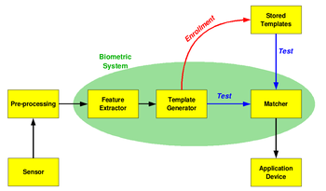
Figure 2.1 The basic block diagram of a biometric system[8]
The diagram on right shows a simple block diagram of a biometric system. The first block (sensor) is the interface between the real world and our system; it has to acquire all the necessary data. Most of the times it is an image acquisition system, but it can change according to the characteristics desired. The second block performs all the necessary pre-processing: it has to remove artifacts from the sensor, to enhance the input (e.g. removing background noise), to use some kind of normalisation, etc. In the third block features needed are extracted. This step is an important step as the correct features need to be extracted and the optimal way. A vector of numbers or an image with particular properties is used to create a template. A template is a synthesis of all the characteristics extracted from the source, in the optimal size to allow for adequate identifiability.
If enrollment is being performed the template is simply stored somewhere (on a card or within a database or both). If a matching phase is being performed, the obtained template is passed to a matcher that compares it with other existing templates, estimating the distance between them using any algorithm (e.g. Hamming distance). The matching programme will analyse the template with the input. This will then be output for any specified use or purpose.
As stated by Jain and Ross, “Biometrics refers to the automatic identification (or verification) of an individual (or a claimed identity) by using certain physiological or behavioral traits associated with the person” [2,3]. Biometrics utilizes different measures for determining who someone is rather than by means of determining who someone is by what they posses.
For example, biometric methods use fingerprints, voice, face, iris, retina, and other individual characteristics to identify a person. Imagine being able to enter one’s home by having a facial recognition scan instead of a key that could be lost or stolen or being able to start one’s car by having
the steering wheel perform a palm print recognition scan before allowing the vehicle to be started. Biometric systems involve two processes:
- The enrollment phase
- The identification phase

The enrollment phase is the process that a valid user has to perform in order for their physiological information to be entered into the biometric system. For example, if the biometric system is a voice recognition system, the user might have to speak into a microphone a pre-defined phrase ten different times. The identification phase is the process that entails determining whether to accept or reject the identification inputted by a user during a validation attempt. For example, when an individual attempts access to a controlled device or facility, the individual is required to submit their biometric information via some type of input device where the biometric system will compare the enrollment data to the scanned data and determine if the user is accepted or rejected [2]. Biometric authentication provides a means for excellent access control. However, there is a problem. Today, biometric systems are not completely flawless [2,3,5].
2.2 Characteristics of Biometric Systems
- FRR, FAR, and CER
Biometric systems must take into account various characteristics in which to improve. According to Richards, “the areas include accuracy, speed and throughput rate, acceptability to users, uniqueness of the biometric organ and action, resistance to counterfeiting, reliability, data storage requirements, enrollment time, intrusiveness of data collection, and subject and system contact requirements”[2,3,4]. These biometric systems are constantly tested and provide information regarding False Reject Rate (FRR), FalseAccept Rate (FAR), and Crossover Error Rate (CER) for accuracy measurements[3,4,5].
These accuracy measurements are used to determine if a particular biometric system would perform optimally in a given environment.
FRR, also known as Type I errors, measure in percentage values the amount of authorized and valid individuals that are rejected or unverified by the biometric authentication system[3,7]. This type of error might be acceptable by some and rejected by others. It depends on the type of business. For example, a business that is customer-oriented in selling certain products might not accept any amount of Type I errors. This would state that some of the business’s legitimate customers are not being allowed to purchase items. This in turn could cause irritability amongst customers, therefore producing negative
results for the company in the form of reduced sales. On the other hand, Type I errors might be perfectly acceptable to highly secure and classified areas in the government. Access to missile control systems would be considered highly classified, and if some authorized personnel are occasionally denied access to these systems, the government might conclude this to be acceptable as long as no unauthorized individuals are permitted entry[1]. This scenario gives rise to another important accuracy measurement known as FAR, also known as Type II errors.
This is also a measurement in percentage of the number of unauthentic individuals that are verified as being authentic and permitted access[3,4]. This percentage is highly examined by companies purchasing biometric systems. Depending on the nature of business, Type II errors might be acceptable to a certain threshold. A biometric system that provides access control through authentication to a company’s food court facility with a small percentage of Type II errors might be considered acceptable.
However, biometric access control to a missile silo could have no Type II errors. Fingerprint scanner FRR is around 0.2% with FAR around 0.2%, face recognition scanners have FRR around 10% and FAR around 1%, and voice recognition scanners have FRR around 10-20% and FAR around 2-5%3.
Finally, the CER is another accuracy measurement used to determine the effectiveness of a biometric authentication system. The CER is considered to be the most important quantity to be examined by biometric system consumers[4]. The reason for the significance of the CER is that the CER is a percentage measurement, where the FRR and FAR meet on a graph.

CER

FRR FAR

Figure 2.2 Rate Adjustments[1]
Examining the above Figure , as a biometric system is adjusted to provide a lower FRR, conversely, the FAR increases. Depending on the purchaser of a biometric authentication system, if the buyer desires a lower FRR, the system developer can adjust the system parameters within the biometric device to provide the results desired by means of more sensitive calculations or more data to be obtained by the intended users. The problem is lowering one of the percentages increases the other. For example, by lowering the FRR, this places the biometric system in a more lackadaisical state of verification so that less authentic individuals are rejected[1]. The flip side to this is that in this new state of recognition, the FAR increases, allowing more unauthentic individuals to be verified by the biometric system.
The CER, indicated in the above Figure , is the point where the FRR and FAR intersect. This intersection is denoted as a percentage. This percentage point demonstrates where this biometric system will perform at optimum in the field of use. This point is the equal error point of FRR and FAR; therefore, the lower percentage of CER will provide a more accurate biometric authentication device.
2.2.1 Throughput and Acceptability[1]
The objectives of biometric authentication systems are to provide reliable verification measures as indicated via the different rates discussed earlier and the ability to be non-obtrusive to the individual users. One characteristic in developing an acceptable biometric system is speed and throughput[4]. The biometric system must be able to quickly gather the biometric information from the user and process that information to provide or deny access. Slow authentication processing is a negative factor that affects the end users. Companies that employ biometric systems do not want their end users to have negative effects from authentication devices. Also, depending on the biometric access point, the system must be able to provide rapid authentication to allow for steady throughput. For example, an entry point into a major corporate facility needs to operate quickly due to the mass of individuals entering into the building. Having a slow authentication process places individuals at risk by having them wait in a possible unsecured area or allowing multiple people to pass through the entry point without being verified. According to Richards, generally accepted standards are five seconds from biometric input to system decision[4].
Acceptability is another factor that must be examined when researching biometric systems. Biometric systems collect data that is used for verification purposes. Care must be taken not to use that data for any other purpose. For example, users do not want biometric systems to be used in a way to collect personal health information. If a retina scanner is used for authentication, the retina scan information should not be used to determine if a particular individual might have a physical ailment.

2.2.2 Exclusivity, Forgery and Reliability[1]
Biometric systems must be designed to use physiological properties that are distinct. Using hair color as a biometric trait for authentication would be useless. Biometric systems are being developed to utilize qualities that are unique, such as face, fingerprints, iris, voice, and retina. According to Richards, the iris, retina,face and fingerprint provide the most unique physiological features for positive identification for biometric systems[4].
Forgery has quickly become the means for bypassing biometric authentication devices. Developers of biometrics must examine all possible scenarios for possible forgery attacks. Fingerprint scanners have a possible risk of someone obtaining a legitimate fingerprint of an authentic individual
and using the stolen fingerprint to gain access to a restricted system. The same applies to voice recognition[3], where an authentic person’s voice could be recorded and played back at a later time for an attacker to gain entry or access.
Finally, the reliability of the biometric system must be obtained. If the biometric system is unreliable, unauthorized access may be acquired or authorized access may be denied. The biometric system must operate in an environment where numerous access requests are submitted. A failure in reliability will have negative effects with legitimate users. Also, the biometric system should always sustain the same speed, accuracy and throughput, all of which translates to minimum downtime and maintenance windows.
2.2.3 Data Storage and Enrollment[1]:
Data storage must be taken into consideration when developing and implementing any biometric system that will store the biometrical information on a centralized server. The data storage requirements are composed of two factors:
- The physiological part being scanned, and
- The number of users.
The biometric data files typically range from 256 bytes to 1,000 bytes[4] in a unimodal biometric system. Later in this article, multimodal biometric systems are discussed, which causes an increase in the data storage size of biometric information. This information, combined with the number of users, can cause significant performance issues. The biometric system must first read the user’s biometric information from the scanning interface, then search the database for the user’s enrollment data, and finally compare the two to determine if access is permitted. These two factors definitely affect biometric system performance. Enrollment time is another issue of concern. Each user will be required to perform a series of tests in order for the biometric system to register the user into the database. These series of tests could include writing one’s signature five different times before being enrolled into a signature-based biometric system or saying a pre-defined phrase ten different times before being enrolled into a voice recognition system. This enrollment time needs to be considered before implementation.

2.2.4 Infringement[1]:
The last issue to be addressed in the development and implementation of biometric systems is intrusiveness. Some people have an issue with biometric
systems violating their personal space. For example, some people do not want to use biometric systems where they might be physically injured. Some people consider having to speak into a microphone at close proximity places them at risk[4]. Also, having to place one’s hand where many other unknown people have placed their hands can introduce other dangers. The issue of intrusiveness should be examined before implementing and developing a biometric system; however, in some situations
intrusiveness might have to be accepted.
For example, retina scanning is a highly effective means for authentication but can be viewed as intrusive because of the red light needed for the scanning retina[4], or having to use the headrest for correct scanning placement where numerous unknown individuals have placed their heads. Identity theft is also an issue. If a user’s physiological information is stolen, that information can be used in other areas[5]. Therefore, securing the physiological information is another important factor to consider in the development and use of biometric systems. Encrypting and securing access to the biometric database should be a top priority.

2.3 Types of Biometric Access Control
2.3.1 Physical Access Control Biometrics
It includes everything that requires identity authentication by scanning a person's unique physical characteristics. It is used where high security is a necessity due to its superiority compared with conventional access control methods. Hospitals, police, the military as well as the financial industry all use physical access biometrics for the purpose of greater security and efficiency.
The most common physical access control biometrics applications are in access control devices for doors and computers with highly confidential and important information or high level network access. They often use fingerprint recognition or biometric 2D barcode ID cards to authenticate the user's identity. Iris, face and vein recognition are also used in access control applications.

Physical access control biometric devices and software store digital information that has been gathered from scanning the user's physical characteristic. To access the information or area protected by a biometric device, the laser sensors must recognize the unique pattern of the user's physical characteristic and match it with its stored digital template. Biometric devices use an algorithm to match templates and authenticate the user's identity therefore false acceptance and rejection rates are remarkably low.
The most remarkable thing about physical access control as opposed to conventional security solutions is its ability to capture complex and detailed images of physical traits, encode this in files and compare sets of data within seconds. This advanced technology has become a serious option for the average homeowner and is essential in office buildings, hospitals and military bases. It requires advanced software and middleware to successfully maintain a biometric security network for physical access but the security provided is unmatched.
In south east Asia, especially Japan and South Korea, common applications include ATM access and other financial industry uses. Everything from accessing an ATM to withdraw money to the safes in bank vaults require biometric identity authentication to gain access.Physical access biometric applications are increasing and becoming more common in day to day life.
Biometric identity authentication provides much greater financial security and safety from identity thieves and hackers. Passwords and PIN numbers can be stolen or discovered and subsequently exploited by criminals over the internet as well as banking and commerce networks. Physical access control with biometrics effectively eliminates the risk that exists with online passwords and PIN numbers as physiological characteristics are nearly impossible to forge.
Secure networks reinforced by biometric physical access control reduce the risk of human error as well as the risk of data loss. Both businesses and government institutions can run more efficiently, safely, securely and profitably by securing their assets and valuable private information. Physical access biometric devices and software also provide the identity management infrastructure to maintain many identity authentication codes and integrate into the system new ones while discarding the templates for old ones and to differentiate a specific image from potentially millions of others.

Switching from conventional security measures to biometric physical access control eliminates the need for multiple passwords and different processes and integrates all access allowance into one touch of the finger, or scan of the eye, or swipe of a 2D barcode card. Therefore physical access biometric applications not only enhance security but also efficiency in the workplace.There are many biometric physical access security solutions for many different needs. Whatever the size of your security needs, there are many leading companies which have developed biometric solutions designed for many different levels of security needs, whether just one office computer or a large military bunker requiring biometric identity authentication for every door and every computer.

2.3.2 Logical Access Control
Logical access control refers to electronic access controls whose purpose is to limit access to data files and computer programs to individuals with the genuine authority to access such information. It is made possible by the use and application of OEM modules and algorithms for imaging authentication and differentiation. They produce very high accuracy rates due to highly sensitive stripe line sensors, optical and thermal sensors which recognize the similarity between existing templates and an authentic user's identity.
Militaries and governments use logical access biometrics to protect their large and powerful networks and systems which require very high levels of security. It is essential for the large networks of police forces and militaries where it is used not only to gain access but also in six main essential applications. Without logical access control security systems highly confidential information would be at risk of exposure.
There is a wide range of biometric security devices and software available for different levels of security needs. There are very large complex biometric systems for large networks that require absolute air tight security and there are less expensive systems for use in office buildings and smaller institutions.
Approximately 65% of logical access biometric scanners are for fingerprints. For an even higher security level, iris and vein recognition and employed for identity authentication.
Logical access control biometric systems distribute a user's unique information throughout all physical access points so that a registered user can be identified at any access point within the system. Microprocessors for logical access control devices usually contain multiple cores, complex algorithm processing and encryption engines this complex composition is essential to support sensor accuracy and reduce false acceptance and rejection.
Biometric technology can also be integrated with existing security systems by the use of 2D barcode on which biometric identities can be encoded and be compatible with conventional software and security systems. Logical access biometric security systems also make it possible to keep an air tight and complete record of all access attempts and transactions. It is beginning to replace conventional methods of network security such as PINs and passwords.
Logical access control is different from physical access control biometrics in the sense that it only refers to computer network and systems access control. A large sever room for instance, would have a physical access biometric security system for the doors and a logical access security system for the actual computers.
The logical access controls industry is expected to expand a great deal more than physical access technology due to the large and increasing need for high security in corporate networks and internet transactions. The market for logical access security systems includes anyone who feels the need for more security on the internet, especially in online purchases and banking transactions.
Biometric technology is compatible with existing networks and software by converting biometric templates from the physical characteristic scanned into binary code which can be recognized by conventional software. If a person's biometric data matches up with the verification template the result is transmitted and access is granted. Logical access control is essential in any network where the burden of password management is large and has resources with high security needs.
Logical access control systems are replacing conventional network security solutions by becoming more cost effective. Biometric equipment and software is becoming more affording and the process of integration into an existing network is now seamless. In recent years, hospitals, airports, police departments, telecommunications companies and businesses of all sizes have been integrating biometric technology into their networks. Not only is security greatly heightened, time is saved by eliminated tedious password management. It provides a return on investment by saving time and money and provides air tight security and preventing loss of assets and confidential information. It allows business to take place more efficiently and productively.

2.4 Biometric Identification Methods
- Face Recognition biometrics security - This is one of the most flexible methods as it can be done without the person being aware that they are being scanned. This system analyzes specific features that everyone’s face has like the distance between the eyes, width of the nose, position of cheekbones, jaw line and chin to only name a few.
- Fingerprint Identification - Your fingerprints remain the same throughout your life and no two fingerprints are alike. This may not work in industrial applications as this requires clean hands and some people may have injury to their prints that prevent proper identification.
- Hand Geometry biometrics security - This will work in harsh environments, does not require clean conditions and uses a small dataset. It is not considered as intrusive and is often used in industrial environments.
- Retina Scan - There is just no known way to replicate a retina and, as far as is known, the pattern of the blood vessels at the back of the eye is totally unique and never changes. The downside is that it takes about 15 seconds of careful concentration to do a good scan but this still remains a standard one in military and government installations.
- Iris Scan - This is also very difficult to duplicate and stays the same for your lifetime although it may be difficult for children or the infirm.
- Signature biometrics security - This type of security is easy to gather and is not physically intrusive.
- Voice Analysis - This method of security biometric can be accomplished without the person’s knowledge although it is easier to fake by using a tape recording but it cannot be done by trying to imitate another person’s voice.

2.5 Anomalies in Biometrics

One problem area in biometrics is concerned with fluctuations in the sensed data. For example, what happens to an iris scan when someone decides to wear contacts? This could possibly cause errors in an iris recognition scan. Another problem could be when someone has a cold and attempts to get authenticated via a voice recognition scan. Finally, sensors that are used to collect the information can malfunction due to excessive use. A fingerprint scanner could possibly become dirt-ridden, resulting in
false rejects to be generated[3].
Another problem area deals with the acquisition of the user data. When implementing a signature scanner, a user registers by signing their name on a sensing device. The sensing device then creates a digital template of the individual’s signature. Depending on the template creation process or how the
user signs their name the next time might produce a false reject. On some sensors, they register the intensity of a signature in different areas in order to generate the authentication template. The same user can sign again and produce different pressure intensity points, thus causing his identify not to be verified.
Finally, other areas include failure to enroll (FTE) rates[3]. This is explained by the failure of fingerprint sensors to scan individuals with subtle or no fingerprint ridges. The sensor would not be able to create a template based on the lack of information obtained by the user and would result in the individual not being enrolled into the system. Some biometric authentication systems are subject to spoof attacks. For example, fingerprints can be lifted from something the targeted user touches and can be used to gain access to a protected system. Recording a user’s voice for playback against voiceprint recognition scanners is another problem.
signature recognition systems are even more prone to spoof attacks because of the lack of difficulty to obtain someone’s signature. These problem areas are currently being addressed in various biometric verification systems.
As with any other technology, biometrics has its own advantages and disadvantages. The best reason why biometrics is getting more popular and widely implemented is a convenience of having authenticating mechanisms with a user. We can’t forget parts of our body at home, and we can’t lend it. We don’t need to memorize fingerprints and then change it every 3 months as with passwords. Biometrics can last virtually forever, until something is amputated or damaged.
On the opposite side, there is a factor of users accepting or not accepting a particular biometric technique. Some people are still hesitant to be authenticated using fingerprints, since it was associated for a long time with criminals and prisons. However, most people accept voice recognition. Retina and iris recognitions trouble some people due to the exposure to the light, which they consider to be harmful for the eyes. Good news is that improvements in eye recognition allow users to be scanned from up to 12 inches away from the camera.
Most biometric technologies are patented, which means it is very expensive to companies to license the use and implementation of any type of biometrics. Fortunately, some patents will expire within 3 years, allowing more businesses to implement biometrics at a lower cost, keeping a concern to get a profitable return on technical investment (Bowcott, 2004).
According to Networks and Telecommunications Research Group finding of July 2004, the cost of biometric authentication is still high. In addition to purchasing hardware and software, the integration into the current network needs to be considered. Simplistic networks work the best with biometrics devices, where most companies use more complicated network configuration. The research group presents an “all or nothing technology”, meaning that “…there is no point in having biometric authentication at every desktop on your network if someone using a laptop can remotely login in with no biometric authentication as this would completely undermine the system” (Networks and Telecommunications Research Group, 2004).
Companies agree that the most reliable biometrics are fingerprints and iris scans, but are also concern with the accuracy of devices. It is possible to fool some of them, known cases include recreating one’s hand prints out of gelatin or children’s modeling material.
Facial recognition can be difficult due to people preferences of facial hair, bloating of pregnant women or just long time travelers.
Voice recognition can suffer because of users’ sickness as a sore throat or lost of voice; and high quality recording would attempt to reproduce ones voice. Another big issue in biometric implementation is software support for the biometric hardware devices. This problem is rapidly disappearing though. A consortium known as the BioAPI group aims to develop a widely available and widely accepted API (Application Programming Interface) that will serve for various biometric technologies. This API is intended to be Operating system and Biometric Data independent. Already vendors are announcing products that are compliant to the BioAPI standards. Gateway is advertising laptops with a build-in biometrics.
Microsoft can’t stay away from such an important issue too; in the spring of 2000 Microsoft announced that upcoming versions of Windows would have biometrics technology integrated into them (Networks and Telecommunications Research Group, 2004).
Biometric development in India
India is undertaking an ambitious mega project (the Multipurpose National Identity Card) to provide a unique identification number to each of its 1.25 billion people. The Identification number will be stored in a central databases. consisting the biometric information of the individual. If implemented, this would be the biggest implementation of the Biometrics in the world. India's Home Minister, P Chidambaram, described the process as "the biggest exercise... since humankind came into existence". The government will then use the information to issue identity cards. Officials in India will spend one year classifying India's population according to demographics indicators. The physical count will begin on February 2011[8] .

Chapter 3 Face Recognition Access Control System

3.1 Introduction- Face Recognition History
A facial recognition is one that views an image or video of a person and compares it to one that is in the database. It does this by comparing structure, shape and proportions of the face; distance between the eyes, nose, mouth and jaw; upper outlines of the eye sockets; the sides of the mouth; location of the nose and eyes; and the area surrounding the check bones.
Upon enrollment in a facial recognition program, several pictures are taken of the subject at different angles and with different facial expressions. At time of verification and identification the subject stands in front of the camera for a few seconds, and then the image is compared to those that have been previously recorded.
To prevent a subject from using a picture or mask when being scanned in a facial recognition program, some security measures have been put into place. When the user is being scanned, they may be asked to blink, smile or nod their head. Another security feature would be the use of facial thermograph to record the heat in the face.
The main facial recognition methods are: feature analysis, neural network, eigenfaces, automatic face processing.
Some facial recognition software algorithms identify faces by extracting features from an image of a subject's face. Other algorithms normalize a gallery of face images and then compress the face data, only saving the data in the image that can be used for facial recognition. A probe image is then compared with the face data.
A fairly new method on the market is three-dimensional facial recognition. This method uses
3-D sensors to capture information about the shape of a face. This information is then used to identify distinctive features on the face, such as the contour of eye sockets, nose and chin. The advantages of 3-D facial recognition are that it is not affected by changes in lighting, and it can identify a face from a variety of angles, including profile view.
Another new technique in facial recognition uses the visual details of the skin, as captured in standard digital or scanned images. This technique is called skin texture analysis, turns the unique lines, patterns, and spots apparent in a person's skin into a mathematical space. Preliminary tests have shown that using skin texture analysis in facial recognition can increase performance in identification by 20 to 25 percent. The benefits of facial recognition are that it is not intrusive, can be done from a distance even without the user being aware they are being scanned. (i.e.: bank or government office) What sets apart facial recognition from other biometric techniques is that it can be used for surveillance purposes; as in searching for wanted criminals, suspected terrorists, and missing children. Facial recognition can be done from far away so with no contact with the subject so they are unaware they are being scanned.
Facial recognition is most beneficial to use for facial authentication than for identification purposes, as it is too easy for someone to alter their face, features with a disguise or mask, etc. Environment is also a consideration as well as subject motion and focus on the camera.
Humans often use faces to recognize individuals and advancements in computing capability over the past few decades now enable similar recognitions automatically. Early face recognition algorithms used simple geometric models, but the recognition process has now matured into a science of sophisticated mathematical representations and matching processes. Major advancements and initiatives in the past ten to fifteen years have propelled face recognition technology into the spotlight. Face recognition can be used for both verification and identification (open-set and closed-set).
Automated face recognition is a relatively new concept. Developed in the 1960s, the first semi-automated system for face recognition required the administrator to locate features (such as eyes, ears, nose, and mouth) on the photographs before it calculated distances and ratios to a common reference point, which were then compared to reference data. In the 1970s, Goldstein, Harmon, and Lesk used 21 specific subjective markers such as hair color and lip thickness to automate the recognition. The problem with both of these early solutions was that the measurements and locations were manually computed. In 1988, Kirby and Sirovich applied principle component analysis, a standard linear algebra technique, to the face recognition problem. This was considered somewhat of a milestone as it showed that less than one hundred values were required to accurately code a suitably aligned and normalized face image. In 1991, Turk and Pentland discovered that while using the eigenfaces techniques, the residual error could be used to detect faces in images – a discovery that enabled reliable real-time automated face recognition systems. Although the approach was somewhat constrained by environmental factors, it nonetheless created significant interest in furthering development of automated face recognition technologies. The technology first captured the public’s attention from the media reaction to a trial implementation at the January 2001 Super Bowl, which captured surveillance images and compared them to a database of digital mugshots. This demonstration initiated much-needed analysis on how to use the technology to support national needs while being Face Recognition considerate of the public’s social and privacy concerns. Today, face recognition technology is being used to combat passport fraud, support law enforcement, identify missing children, and minimize benefit/identity fraud.
The Face Recognition Problem

The basic pattern recognition problem can be described as follows:
A given a dataset that has elements belonging to certain classes, the class knowledge being available to us. Then given a new data element whose class is unknown, how would one be able to hypothesize which of the above classes the unknown data element belongs to? The problem of Face Recognition is easily encompassed by the pattern recognition problem. The Face Recognition problem would be to design a way wherein a machine can automatically identify a face as belonging to one of the individuals whose faces the machine has a sample of. Thus, it would be a question of identifying the “class”, which is the identity of the person, of the input element, which is the face. The dataset whose identity s known to the classifier is called the Training data : it is used to define the characteristics of different classes to the classifier. The dataset whose identity is to be hypothesized is called the Testing data.
Steps in Pattern Recognition [20],[21],[22]:
Pattern recognition usually consists of the following sequential steps:
preprocessing, feature extraction and classification.
Preprocessing
Preprocessing is done for one of two purposes: to (i) reduce noise and possible convolute effects of interfering system, or to (ii) transform the image into a different space where classification may prove easier by exploitation of certain features. Examples of such latter transformations are Fourier transforms etc.
In this Thesis, the preprocessing that has been done on the image is normalization – the mean of each image is subtracted from the image, and the resultant is divided by its variance. This is to ensure that all images are on an “equal platform”, so that no images dominate over the other in terms of energy, thus possibly causing misclassification.
Feature Extraction
Feature extraction, also called Dimensionality Reduction, is done for a two-fold purpose: it helps in reducing the dimension of the data to more tractable limits, and further, it is useful in capturing salient class-specific features of the data, and eliminate redundancy. Similarly, there may be explicit information in the image that could be used to describe the image. Removal of redundancy is also an important problem in image processing applications. In most cases of pattern recognition in images, the technique is just “raw” processing of the signal, without using any of the visual information in the signal (e.g., birthmark on face could be used for face recognition; this information is not explicitly provided to the classifier but instead, may be captured by the feature extractor). Thus, the entire image needs to be used to extract information. Consequently, the memory requirements shoot up, and it is important to reduce the dimensionality of the image. This will become clearer in the following sections.
Classification
Classification is performed by mathematically modeling the behavior of the feature vectors by appropriate descriptions using probability density functions (pdf.s), and then exploiting the statistical behavior of the feature vectors to define decision regions corresponding to different classes. Any new pattern would then be classified depending on which decision region it would be falling in. A variant of the probabilistic modeling is to simply assume that the statistical behavior would cause the data elements to fall in localized regions (without calculating them), and using the available training data to define such regions. It can prove to be a significantly easier problem to solve, because of its simplicity and geometric and analytical appeal. Further, modeling the pdfs can be a very difficult problem in the higher dimensions, and the fact that the heuristic techniques can give error rates not worse than twice the best possible, renders them more preferable than the mathematical techniques.
A pictorial description of the overall pattern recognition system is given below:
Preprocessing
Feature
Extraction
Classification

Noise Removal, PCA, ICA Bayesian classifiers,
Transformation Heuristic methods, minimax algorithm, nearest
Manual neighbor clustering, kmeans
feature extracton algorithm, gradient descent
techniques etc.
3.2 Face Recognition Approaches
There are two predominant approaches to the face recognition problem: geometric (feature based) and photometric (view based). As researcher interest in face recognition continued, many different algorithms were developed, three of which have been well studied in face recognition literature: Principal Components Analysis (PCA), Linear Discriminant Analysis (LDA), and Elastic Bunch Graph Matching (EBGM).
3.2.1 PCA: Principal Components Analysis (PCA)
PCA, commonly referred to as the use of eigenfaces, is the technique pioneered by Kirby and Sirivich in 1988. With PCA, the probe and gallery images must be the same size and must first be normalized to line up the eyes and mouth of the subjects within the images. The PCA approach is then used to reduce the dimension of the data by means of data compression basics[23 ] and reveals the most effective low dimensional structure of facial patterns. This reduction in dimensions removes information that is not useful[24] and precisely decomposes the face structure into orthogonal (uncorrelated) components known as eigenfaces. Each face image may be represented as a weighted sum (feature vector) of the eigenfaces, which are stored in a 1D array. A probe image is compared against a gallery image by measuring the distance between their respective feature vectors. The PCA approach typically requires the full frontal face to be presented each time; otherwise the image results in poor performance[24]. The primary advantage of this technique is that it can reduce the data needed to identify the individual to 1/1000th of the data presented.[25]

3.2.2 LDA: Linear Discriminant Analysis
LDA is a statistical approach for classifying samples of unknown classes based on training samples with known classes[24]. This technique aims to maximize between-class (i.e., across users) variance and minimize within-class (i.e., within user) variance. Where each image block is represented as a class, there are large variances between classes, but little variance within classes. When dealing with high dimensional face data, this technique faces the small sample size problem that arises where there are a small number of available training samples compared to the dimensionality of the sample space[26].
3.2.3 EBGM: Elastic Bunch Graph Matching
EBGM relies on the concept that real face images have many non-linear characteristics that are not addressed by the linear analysis methods discussed earlier, such as variations in illumination (outdoor lighting vs. indoor fluorescents), pose (standing straight vs. leaning over) and expression (smile vs. frown). A Gabor wavelet transform creates a dynamic link architecture that projects the face onto an elastic grid[24]. The Gabor jet is a node on the elastic grid, notated by circles on the image below, which describes the image behavior around a given pixel. It is the result of a convolution of the image with a Gabor filter, which is used to detect shapes and to extract features using image processing.[A convolution expresses the amount of overlap from functions, blending the functions together.] Recognition is based on the similarity of the Gabor filter response at each Gabor node[24]. This biologically-based method using Gabor filters is a process executed in the visual cortex of higher mammals. The difficulty with this method is the requirement of accurate landmark localization, which can sometimes be achieved by combining PCA and LDA methods[24].
3.3 Face Recognition– Key Features
- Convenient and secure method of controlling outdoor ,indoor,and system entry.
- Higher security than conventional systems.
- No keys and cards to carry.
- Arrival and departure record with face image.
- Real-time monitoring of system access.
- Intelligent access control by group and time schedule.
- Networked / Stand-alone operation modes.
- Integral Import/Export feature.
- It the simplest method for obtaining high security.
- It is more effective than the primitive methods.
- It is based on no human touch technology. Therefore it removes buddy punching method of security.
- It supports easy installation method.
- This biometric solution needs a very easy and simple maintenance.
- The involvement of the electronic storage facility enhances the system for storing large amount of data and also reduces the data loss
- comprising of all these features it achieves effectiveness at various premises in the field of security.
3.4 Eigenface Recognition Technique
The task of facial recogniton is discriminating input signals (image data) into several classes (persons). The input signals are highly noisy (e.g. the noise is caused by differing lighting conditions, pose etc.), yet the input images are not completely random and in spite of their differences there are patterns which occur in any input signal. Such patterns, which can be observed in all signals could be - in the domain of facial recognition - the presence of some objects (eyes, nose, mouth) in any face as well as relative distances between these objects. These characteristic features are called eigenfaces in the facial recognition domain or principal components generally. They can be extracted out of original image data by means of a mathematical tool called Principal Component Analysis (PCA).
By means of PCA one can transform each original image of the training set into a corresponding eigenface. An important feature of PCA is that one can reconstruct reconstruct any original image from the training set by combining the eigenfaces. Remember that eigenfaces are nothing less than characteristic features of the faces. Therefore one could say that the original face image can be reconstructed from eigenfaces if one adds up all the eigenfaces (features) in the right proportion. Each eigenface represents only certain features of the face, which may or may not be present in the original image. If the feature is present in the original image to a higher degree, the share of the corresponding eigenface in the ”sum” of the eigenfaces should be greater. If, contrary, the particular feature is not (or almost not) present in the original image, then the corresponding eigenface should contribute a smaller (or not at all) part to the sum of eigenfaces. So, in order to reconstruct the original image from the eigenfaces, one has to build a kind of weighted sum of all eigenfaces. That is, the reconstructed original image is equal to a sum of all eigenfaces, with each eigenface having a certain weight. This weight specifies, to what degree the specific feature (eigenface) is present in the original image.
If one uses all the eigenfaces extracted from original images, one can reconstruct the original images from the eigenfaces exactly. But one can also use only a part of the eigenfaces. Then the reconstructed image is an approximation of the original image. However, one can ensure that losses due to omitting some of the eigenfaces can be minimized. This happens by choosing only the most important features (eigenfaces). Omission of eigenfaces is necessary due to scarcity of computational resources.
How does this relate to facial recognition? that it is possible not only to extract the face from eigenfaces given a set of weights, but also to go the opposite way. This opposite way would be to extract the weights from eigenfaces and the face to be recognized. These weights tell nothing less, as the amount by which the face in question differs from ”typical” faces represented by the eigenfaces. Therefore, using this weights one can determine two important things:
- Determine, if the image in question is a face at all. In the case the weights of the image differ too much from the weights of face images (i.e. images, from which we know for sure that they are faces), the image probably is not a face.
- Similar faces (images) possess similar features (eigenfaces) to similar degrees (weights). If one extracts weights from all the images available, the images could be grouped to clusters. That is, all images having similar weights are likely to be similar faces.

3.4.1 Overview of the algorithm
Figure.3.1 Face images used as the training set

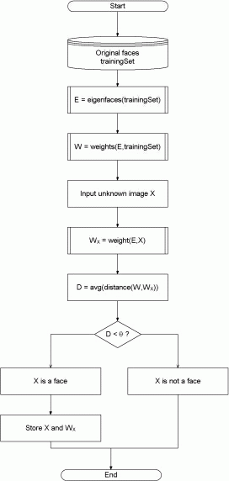
Figure3.2 : | High-level functioning principle of the eigenface-based facial recognition algorithm

The algorithm for the facial recognition using eigenfaces is basically described in the figure.3.2. First, the original images of the training set are transformed into a set of eigenfaces E(eg. figure.3.1). Afterwards, the weights are calculated for each image of the training set and stored in the set W .
Upon observing an unknown image X, the weights are calculated for that particular image and stored in the vector W_{X}. Afterwards, W_{X} is compared with the weights of images, of which one knows for certain that they are faces (the weights of the training set W ). One way to do it would be to regard each weight vector as a point in space and calculate an average distance D between the weight vectors from W_{X} and the weight vector of the unknown image W_{X}. If this average distance exceeds some threshold value , then the weight vector of the unknown image W_{X} lies too ”far apart” from the weights of the faces. In this case, the unknown X is considered to not a face. Otherwise (if X is actualy a face), its weight vector W_{X} is stored for later classification. The optimal threshold value has to be determined empirically.

Chapter 4 Implementation -Eigen Face Recognition Technique using PCA
4.1 EigenFace Recognition Technique
The aim of the eigenface is to represent a face as a linear combination of a set of basis images.
That is :
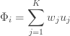
Where ф_{i} represents the i^{th} face with the mean subtracted from it, w_{j} represent weights and u_{j} the eigenvectors. This can be represented in a figure as:
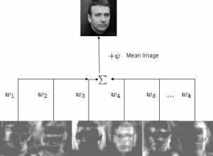
Figure 4.1 Eigenface representation[15]
In the above figure, a face that was in the training database was reconstructed by taking a weighted summation of all the basic faces and then adding to them the mean face. In the figure the ghost like basis images (also called as Eigenfaces) are not in order of their importance.
An Information Theory Approach:
First of all the idea of Eigenfaces considers face recognition as a 2-D recognition problem, this is based on the assumption that at the time of recognition, faces will be mostly upright and frontal. Because of this, detailed 3-D information about the face is not needed. This reduces complexity by a significant bit.
Before the method for face recognition using Eigenfaces was introduced, most of the face recognition literature dealt with local and intuitive features, such as distance between eyes, ears and similar other features. This wasn’t very effective. It uses an Information Theory appraoch wherein the most relevant face information is encoded in a group of faces that will best distinguish the faces. It transforms the face images in to a set of basis faces, which essentially are the principal components of the face images.
Principal Component Approach
The Principal Components basically seek directions in which it is more efficient to represent the data. This is particularly useful for reducing the computational effort. To understand this, suppose we get 60 such directions, out of these about 40 might be insignificant and only 20 might represent the variation in data significantly, so for calculations it would work quite well to only use the 20 and leave out the rest. This is illustrated by this figure:

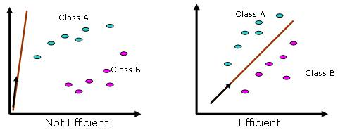
Figure4.2 Varation in the data direction[15]
Such an information theory approach will encode not only the local features but also the global features. Such features may or may not be intuitively understandable. When we find the principal components or the Eigenvectors of the image set, each Eigenvector has some contribution from each face used in the training set. So the Eigenvectors also have a face like appearance. These look ghost like and are ghost images or Eigenfaces. Every image in the training set can be represented as a weighted linear combination of these basis faces.
The number of Eigenfaces that we would obtain therefore would be equal to the number of images in the training set. Let us take this number to be M. some of these Eigenfaces are more important in encoding the variation in face images, thus we could also approximate faces using only the K most significant Eigenfaces.
Assumptions:
1. There are M images in the training set.
2. There are K most significant Eigenfaces using which we can satisfactorily approximate a face. Needless to say K < M.
3. All images are N X N matrices, which can be represented as N² x 1 dimensional vectors. The same logic would apply to images that are not of equal length and breadths. To take an example: An image of size 112 x 112 can be represented as a vector of dimension 12544 or simply as a point in a 12544 dimensional space.
4.2 Algorithm for Finding Eigenfaces:
1. Obtain M training images I₁ ,I_{2,.}...I_{m} , it is very important that the images are centered.
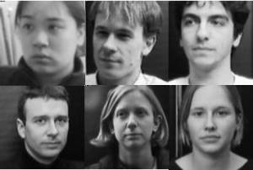
2. Represent each image I_{i} as a vector Γ_{i} as discussed above.

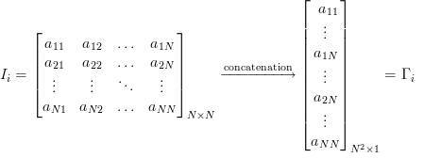
3. Find the average face vector ψ.
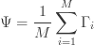
4. Subtract the mean face from each face vector Γ_{i} to get a set of vectors ф_{i}. The purpose of subtracting the mean image from each image vector is to be left with only the distinguishing features from each face and “removing” in a way information that is common.
ф_{i} = Γ_{i} - ψ
5. Find the Covariance matrix C:
C = AA^{T}, where A=[ ф_{1,} ф₂ ....ф_{m,}]
Note that the Covariance matrix has simply been made by putting one modified image vector obtained in one column each.
Also note that C is a N² X N² matrix and A is a N² X M matrix.
6. We now need to calculate the Eigenvectors u_{i} of C, However note that C is a N² X N² matrix and it would return N² Eigenvectors each being N² dimensional. For an image this number is HUGE. The computations required would easily make your system run out of memory. How do we get around this problem?
7.Instead of the Matrix A A^{T} consider the matrix A^{T}A. Remember A is a N² X M matrix, thus A^{T}A is a
M X M matrix. If we find the Eigenvectors of this matrix, it would return M Eigenvectors, each of Dimension M X 1, let’s call these Eigenvectors V_{i}
Now from some properties of matrices, it follows that: U_{i} = AV_{i} .We have found out V_{i} earlier. This implies that using V_{i} we can calculate the M largest Eigenvectors of A A^{T} . Remember that M<< N² as M is simply the number of training images.
8. Find the best M Eigenvectors of C = A A^{T} by using the relation discussed above. That is: U_{i} = AV_{i}.
Also keep in mind that || U_{i} ||=1.
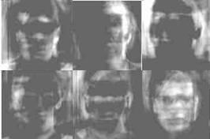
Figure [15] Eigenfaces for the training set chosen from the MIT-CBCL database, these are not in any order]
9. Select the best K Eigenvectors, the selection of these Eigenvectors is done heuristically.

4.2.1 Finding Weights:[11,15]
The Eigenvectors found at the end of the previous section,U_{i} when converted to a matrix in a process that is reverse to that in STEP 2, have a face like appearance. Since these are Eigenvectors and have a face like appearance, they are called Eigenfaces. Sometimes, they are also called as Ghost Images because of their wired appearance.
Now each face in the training set (minus the mean), ф_{i} can be represented as a linear combination of these Eigenvectors U _{i} :
m, where U_{j} ‘s are Eigenfaces.
These weights can be calculated as :
W_{j} = U_{j}^{T} ф_{i.}
Each normalized training image is represented in this basis as a vector.
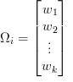where i = 1,2… M. This means we have to calculate such a vector corresponding to every image in the training set and store them as templates.
4.2.2 Recognition Task:
Now consider we have found out the Eigenfaces for the training images , their associated weights after selecting a set of most relevant Eigenfaces and have stored these vectors corresponding to each training image.
If an unknown probe face Γ is to be recognized then:
1. We normalize the incoming probe Γ as ф = Γ - ψ.
2. We then project this normalized probe onto the Eigenspace (the collection of Eigenvectors/faces) and find out the weights.
W_{j} = U_{j}^{T} ф_{i.}
3. The normalized probe ф can then simply be represented as:

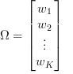
After the feature vector (weight vector) for the probe has been found out, we simply need to classify it. For the classification task we could simply use some distance measures . In case we use distance measures, classification is done as:
Find e_{r} = min |Ω - Ω_{i} |. This means we take the weight vector of the probe we have just found out and find its distance with the weight vectors associated with each of the training image.
And if e_{r} < Ѳ, where Ѳ is a threshold chosen heuristically, then we can say that the probe image is recognized as the image with which it gives the lowest score.
If however e_{r >} Ѳ then the probe does not belong to the database.
For distance measures the most commonly used measure is the Euclidean Distance.
4.2.3 Distance Measures:[11,15]
Euclidean Distance:
The Euclidean Distance Mahalanobis Distance are probably the most widely used distance metric. It is a special case of a general class of norms and is given as:
|x – y|= √|x_{i} –y_{i}|²
The Mahalanobis Distance:
The Mahalanobis Distance is a better distance measure when it comes to pattern recognition problems. It takes into account the covariance between the variables and hence removes the problems related to scale and correlation that are inherent with the Euclidean Distance. It is given as:
Where C is the covariance between the variables involved.

4.2.4 Deciding Threshold
Why is the threshold, Ѳ important?
Consider for simplicity we have ONLY 5 images in the training set. And a probe that is not in the training set comes up for the recognition task. The score for each of the 5 images will be found out with the incoming probe. And even if an image of the probe is not in the database, it will still say the probe is recognized as the training image with which its score is the lowest. Clearly this is an anomaly that we need to look at. It is for this purpose that we decide the threshold. The threshold Ѳ is decided heuristically.
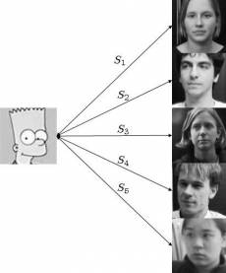
[15]Figure 4.3 finding thersold using training set.
Let’s say S4 is the lowest score out of all. But the probe image is clearly not beloning to the database. To choose the threshold we choose a large set of random images (both face and non-face), we then calculate the scores for images of people in the database and also for this random set and set the threshold Ѳ ,(which was mentioned in the “recognition” part above) accordingly.

More on the Face Space:
To conclude this post, here is a brief discussion on the face space.
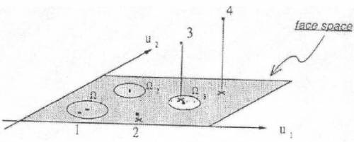
Figure4.3 [Image Source - [15]
Consider a simplified representation of the face space as shown in the figure above. The images of a face, and in particular the faces in the training set should lie near the face space. Which in general describes images that are face like.
The projection distance e_{r} should be under a threshold Ѳ as already seen. The images of known individual fall near some face class in the face space.
There are four possible combinations on where an input image can lie:
1. Near a face class and near the face space : This is the case when the probe is nothing but the facial image of a known individual (known = image of this person is already in the database).
2. Near face space but away from face class : This is the case when the probe image is of a person (i.e a facial image), but does not belong to anybody in the database i.e away from any face class.
3. Distant from face space and near face class : This happens when the probe image is not of a face however it still resembles a particular face class stored in the database.
4. Distant from both the face space and face class: When the probe is not a face image i.e is away from the face space and is nothing like any face class stored.
Out of the four, type 3 is responsible for most false positives. To avoid them, face detection is recommended to be a part of such a system.
4.3 Process of Eigenface Algorithm:[11,15]
The first step is to obtain a set S with M face images. Each image is transformed into a vector of size N and placed into the set.
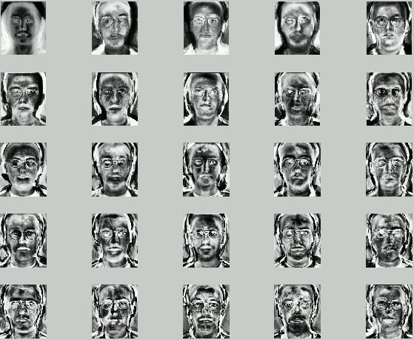
figure.4.4[11] These are the eigenfaces of our set of original images
- After we could obtained our set, we will obtain the mean image Ψ
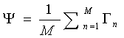

Example Image shown below.
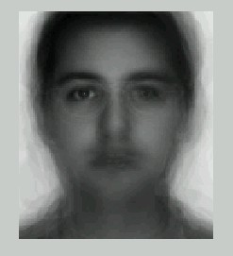
- Then we will find the difference Φ between the input image and the mean image
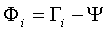
- Next we seek a set of M orthonormal vectors, u_{n}, which best describes the distribution of the data. The k^{th} vector, u_{k}, is chosen such that
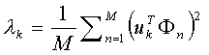
is a maximum, subject to
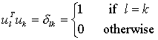
u_{k} and λ_{k} are the eigenvectors and eigenvalues of the covariance matrix C
- We obtain the covariance matrix C in the following manner
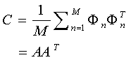
- A^{T}
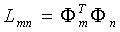
- Once we have found the eigenvectors, v_{l}, u_{l}
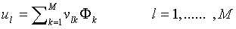
4.3.1 Recognition Procedure[11]
1. A new face is transformed into its eigenface components. First we compare our input image with our mean image and multiply their difference with each eigenvector of the L matrix. Each value would represent a weight and would be saved on a vector Ω.
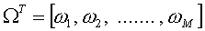
2. We now determine which face class provides the best description for the input image. This is done by minimizing the Euclidean distance
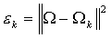
3. The input face is consider to belong to a class if ε_{k} is bellow an established threshold θ_{ε}. Then the face image is considered to be a known face. If the difference is above the given threshold, but bellow a second threshold, the image can be determined as a unknown face. If the input image is above these two thresholds, the image is determined NOT to be a face.
4. If the image is found to be an unknown face, you could decide whether or not you want to add the image to your training set for future recognitions. You would have to repeat steps 1 trough 7 to incorporate this new face image.
4.3.2 Pattern recognition in high-dimensional spaces[15]
- Problems arise when performing recognition in a high-dimensional space (curse of dimensionality).
- Significant improvements can be achieved by first mapping the data into a lower-dimensional sub-space.
- The goal of PCA is to reduce the dimensionality of the data while retaining as much as possible of the variation present in the original dataset.
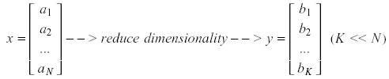
4.3.3 Dimensionality Reduction
PCA allows us to compute a linear transformation that maps data from a high dimensional space to a lower dimensional sub-space.
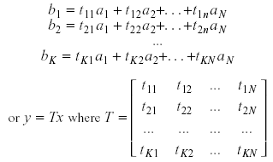
Higher-dimensional space representation
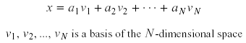

Lower-dimensional space representation
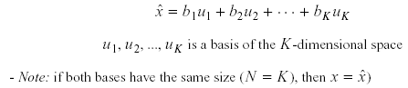
Example:
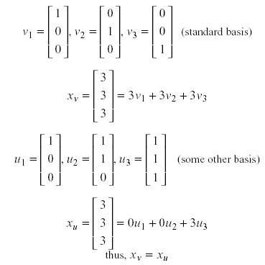
4.3.4 Information loss
- Dimensionality reduction implies information loss
- Want to preserve as much information as possible, that is
  - Minimize |x - x̂ | ( error)
- Best low dimentional space can be determined by the “best” Eigen vectors of the covariance matrix of x.
- The eigen vectors corresponding to the “largest” eigen values also called “principal Components” .

4.4 Implementation of PCA:[15,16,17]
Suppose x₁, x₂, ..., x_{M} are N x 1 vectors
M
Step 1: x = 1/M ∑ x_{i}
i = 1

Step 2: Subtract the mean:ф_{i} = x_{i} – x

Step 3: form the matrix A = [ ф_{1 ,}ф₂ ,.....ф_{m}] (N x M matrix), then

Compute the coverance C.

M
C =1/M ∑ ф_{n ,}ф_{n}^{T} = A A^{T}
n= 1

Step 4: Compute the eigenvalues of C: λ₁ > λ₂ >..... > λ_{n}

Step 5: Compute the Eigenvectors of C : U₁ ,U₂, ..........,U_{n}

Since C is Symmetric, U₁ ,U₂, ..........,U_{n} form a basis(ie., any combination of x or

(x – x)can be written as a linear combination of the eigenvectors).
N
(x – x) = b₁U₁+ b₂U₂+.............................b_{n}U _{n} = ∑ b _{i} U_{i}
i=1

Step 6: (Dimensionality reduction step) keep only the terms corresponding to the K largest eigenvalues
k
( x̂ - x ) =∑ b _{i} U_{i} k << N
i=1

the representation of ( x̂ - x ) into the basis of U₁ ,U₂, ..........,U_{k} is thus
b₁ b₂
...
b_{k}

4.4.1 Geometric interpretation[15,16]
- PCA projects the data along the directions where the data varies the most.
- These directions are determined by the eigenvectors of the covariance matrix corresponding to the largest eigenvalues.
- The magnitude of the eigenvalues corresponds to the variance of the data along the eigenvector directions.
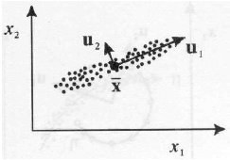
Figure. Choosing Principle components
To choose K, use the following criterion is used:
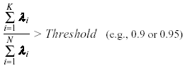
The error due to dimensionality reduction:
We saw above that an original vector x can be reconstructed using its principal components:
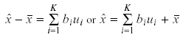
It can be shown that the low-dimensional basis based on principal components minimizes the reconstruction error:
It can be shown that the error is equal to:
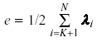
4.4.2 Standardization
    - The principal components are dependent on the units used to measure the original variables as well as on the range of values they assume.
    - We should always standardize the data prior to using PCA.
    - A common standardization method is to transform all the data to have zero mean and unit standard deviation:
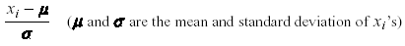
Computation of the eigenfaces[15,16,17,19]
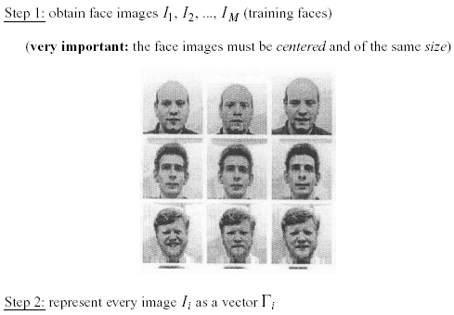
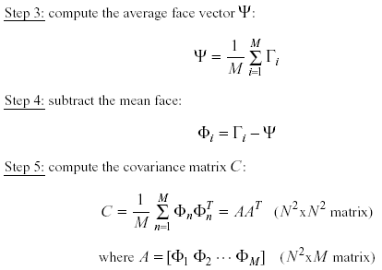
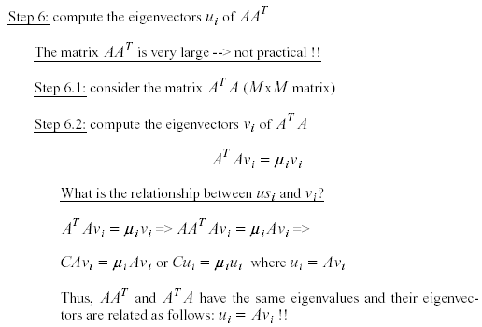

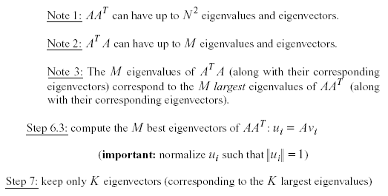

Representing faces onto this basis[17,18,19]
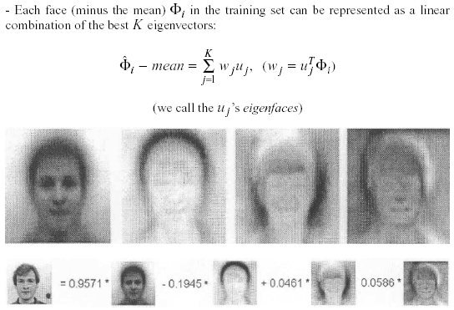
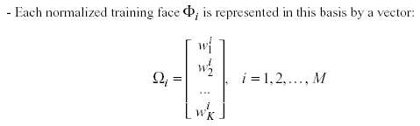
4.6 Problems
  - Background (de-emphasize the outside of the face – e.g., by multiplying the input image by a 2D Gaussian window centered on the face)
  - Lighting conditions (performance degrades with light changes)
  - Scale (performance decreases quickly with changes to head size)
  - multi-scale eigenspaces
  - scale input image to multiple sizes
  - Orientation (performance decreases but not as fast as with scale changes)
  - plane rotations can be handled
  - out-of-plane rotations are more difficult to handle
Conclusion
Authentication is a major component in the area of computer security. Without a method for identifying and authenticating users, security cannot be achieved. Access Control Systems and Methodology is a domain for information security professionals in which biometrics is a significant topic.
Authentication originated with the use of user IDs and passwords, and then because of their subjectivity to problems, knowledge and token-based solutions were developed to secure and better the process of authentication. Biometric authentication systems were developed to provide an even better way for authenticated individual access. Biometrics, along with knowledge and tokenbased authentication, provides an encompassing solution for access validation.
The process of biometric authentication involves an enrollment procedure that digitizes the individual’s biometric information for future verification. Still, a problem remains in that biometric authentication systems are not totally flawless. Therefore, developers are researching areas that could provide person-specific information without the compromise of the biometric information itself. Other researchers are starting to develop multimodal biometric systems that require different types of authentication within one authentication process.Indeed, many items must be examined before designing a biometric authentication system. For example, which biometric feature to use, how much storage will be needed based on this biometric feature, what false accept and false reject rates are realized, and more. Development and research into biometric authentication systems appear to be on the correct path for providing a secure and accurate solution for authentication without being extremely intrusive.
Facial recognition, when used in combination with another biometric method, can improve verification and identification results dramatically.

References
1. Robby S. Fussell” Authentication: The Development ofBiometric Access Control” the ISSA journal , july 2005.
2. Jain, A., Hong, L. and Pankanti, S. Biometric Identification Communications of the ACM, ACM Press
New York, 2000, 90-98.
- Jain, A.K. and Ross, A. Multibiometric Systems Communications of the ACM, ACM Press New York,
2004, 34-40.
4. Richards, D.R. Biometric Identification. in Krause, M. and Tipton, H.F. eds. Handbook of Information
Security Management, Auerbach, Boca Raton, 1999.
5. Fairhurst, M.C., Document Identity, Authentication and Ownership: The Future of Biometric verification in Seventh International Conference on Document Analysis and Recognition Volume II, (2003), IEEE.
6. Nataliya B. Sukhai, “Access Control & Biometrics”InfoSecCD Conference’04,Kennesaw, GA, USA
(2004).
7. http://openbin.sourceforge.net/resource/eigenfaces
8. http://wikipedia.org/biometric
9. Z. Bai, J. Demmel, J. Dongarra, A. Ruhe, and H. Vander Vorst, editors. “Templates for the Solution of Algebraic Eigenvalue Problems:” A Practical Guide. SIAM, Philadelphia, 2000.
10. James W. Demmel. Applied Numerical Linear Algebra. SIAM, Philadelphia, 1997.
11. http://www.pages.drexel.edu
12. M. Turk, A. Pentland, "Eigenfaces for Recognition", Journal of Cognitive Neuroscience, 3(1), pp. 71-86, 1991
13. D. Swets, J. Weng, "Using Discriminant Eigenfeatures for Image Retrieval", IEEE Transactions on Pattern Analysis and Machine Intelligence, 18(8), pp. 831-836, 1996.
14 Face Recognition Using Eigenfaces, Matthew A. Turk and Alex P. Pentland, MIT Vision and Modeling Lab, CVPR ’91.
15. Eigenfaces Versus Fischerfaces : Recognition using Class Specific Linear Projection, Belhumeur, Hespanha, Kreigman, PAMI ’97.
[16] J. Ruiz-del-Solar and P. Navarrete, “Eigenspacebased face recognition: a comparative study of different approaches”, IEEE Transactions on Systems, Man and Cybernetics, Part C, Vol. 35, Issue 3, Page(s):315 – 325, Aug. 2005.
[17] K.I. Chang, K.W. Bowyer and P.J. Flynn, “An evaluation of multimodal 2D+3D face biometrics”, IEEE Transactions on Pattern Analysis and Machine Intelligence, Vol. 27, Issue 4, pp.:619 – 624, April 2005.
[18] Y. Hu et al., “Automatic 3D reconstruction for face recognition”. Proceedings. Sixth IEEE International Conference on Automatic Face and Gesture Recognition, 2004.
[19] A.Pentland, B. Moghaddam, T. Starner, O. Oliyide, and M. Turk., “View-Based and Modular Eigenspaces for Face Recognition”, Technical Report 245, MIT Media Lab, 1993.
[20] Duda, R. and Hart, P. Pattern Classification and Scene Analysis. New York: Wiley, 1973.
[21] Fukunaga, K. 1989. Statistical Pattern Recognition, Academic Press, New York, NY.
[22] Belhumeur, P. N., Hespanha, J. P., AND Kreigman, D. J. 1997. Eigenfaces vs. Fisherfaces: Recognition using class specific linear projection. IEEE Trans. Patt. Anal. Mach. Intell. 19, 711–720.
[23] L.Sirovich and M.Kirby, “ A Low Dimentional Procedure for the characterzation of Human Faces”,J.Optical soc.Am. A,1987,vol.4,No.3,519-524.
[24] D.Bolme, R.Beveridge, M.Teixeria, and B.Draper, “The CSU Face Indentification Evaluation System: Its Purpose, Features and Structure”, international conference on vision system, Graz, Austria, April 1-3,2003.(Springer –Verlog) 304-311.
[25] ”Eigenface Recognition”
< http ://et.WCU.edu/aidc/Biowebpages/eigenfaces.htm>
[26] J.LU,K.N.Plataniotis and A . N.Venetsanopoulos,”Regularized Discriminant Analysis for the small sample size problem in Face Recognition”, Pattern Recognition Letters,December 2003 vol.24,Issue 16:3079-3087.

