Analog Filters Design using CDBA and CDTA

A dissertation Submitted in fulfillment of the requirement
for the award of Degree of

MASTER OF ENGINEERING
(Electronics & Communication Engineering)
Submitted By:
Gagandeep Kaur
College Roll No: 15/E&C/08
University Roll No: 10051

Under the Guidance of:
Mrs. Rajeshwari Pandey
Dept. of Electronics & Communication
Delhi College of Engineering, Delhi-42



DEPARTMENT OF ELECTRONICS & COMMUNICATION ENGINEERING
DELHI COLLEGE OF ENGINEERING
DELHI UNIVERSITY
Session: 2008-2011

DELHI COLLEGE OF ENGINEERING
DEPARTMENT OF ELECTRONICS & COMMUNICATION ENGINEERING

CERTIFICATE

This is to certify that the work contained in this dissertation entitled “Analog filters Design using CDBA and CDTA” submitted by Gagandeep Kaur, University Roll No: 10051 is the requirement for the fulfillment for the award of the degree of Master of Engineering in Electronics & Communication Engineering, Delhi College of Engineering is an account of her work carried out under my guidance and supervision. She has completed her work with utmost sincerity and diligence.
The work embodied in this project has not been submitted for the award of any other degree to the best of my knowledge

Mrs. Rajeshwari Pandey (Project Guide)
Assistant Professor
Dept. of Electronics and Communication Engineering
Delhi college of Engineering

ACKNOWLEDGEMENT

It is a great pleasure to have the opportunity to extend my heartiest felt gratitude to everybody who helped me throughout the course of this project.

It is distinct pleasure to express my deep sense of gratitude and indebtedness to my learned supervisor Mrs. Rajeshwari Pandey for her invaluable guidance, encouragement and patient reviews. I am very thankful to Prof. Rajiv Kapoor, H.O.D Electronics & Communication Department who allows me to do project under the Guidance of Mrs. Rajeshwari Pandey. With their continuous inspiration only, it becomes possible to complete this dissertation and both of them kept on boosting me with time, to put an extra ounce of effort to realize this work.

I would also like to take this opportunity to present my sincere regards to all the faculty members of the Department for their support and encouragement.

I am grateful to my husband and son for their moral support all the time; they have been always around to cheer me up, in the odd times of this work. I am also thankful to my classmates for their unconditional support and motivation during this work.

GAGANDEEP KAUR
M.E. (Electronics & Communication Engineering)
College Roll No. 15/E&C/08
University Roll No. 10051
Department of Electronics & Communication Engineering
Delhi College of Engineering, Delhi-42

ABSTRACT

During the last few decades, designers have used voltage mode techniques to solve several circuit design problems. A traditional operational amplifier has a bandwidth which is dependent on the closed - loop voltage gain. To overcome this problem, circuits operating in current mode are preferred. Current-mode circuits are useful for the low voltage operation In addition to the low voltage operation, popularity of current-mode circuits can be attributed to some other features such as larger dynamic range, low power consumption and higher speed.

The major goal of this work is to study, Current Differencing Buffered Amplifier (CDBA), a current mode building block and implement various signal processing and generation applications. A detailed description of CDBA including its nodal equations and different implementations has been presented in this thesis work. The Literature survey section consists of the already existing applications that have been developed using CDBA. Various existing circuits like analog filters and floating inductance etc. have been studied and implemented for verification of their results. The circuits are simulated with PSPICE. The simulation results verify that the circuit topologies using CDBAs for realizing signal generating circuits are simple, effective, flexible, versatile, and easily tunable.

In the final section a multimode Allpass filter is proposed that can operate in all modes viz transimpedance mode, transadmittance mode, voltage mode and current mode. For the above circuit, simulations have been done on PSPICE to verify their working.

Table of Contents

CERTIFICATE……………………………………………………………………………..2
ACKNOWLEDGEMENT………………………………………………………………....3
ABSTRACT…………………………………………………………………………….…..4
1. Introduction......................................................................................................................6
1.1 Current Differencing Buffered Amplifier.……………………………………………...6
1.2 Current Differencing Transconductance Amplifier……………………………………..7
2. Literature Survey.............................................................................................................9
2.1 CDBA Realization............................................................................................................9
2.2 CDBA Applications........................................................................................................11
2.2.1 Filters…………………………………………………………………………11
2.2.2 Oscillators…………………………………………………………………….12
2.2.3 Passive Component Realization………………………………………………13
3. Realization of CDBA…………….……………………………………………..............14
3.1 CDBA Terminal Characteristics…..................................................................................14
3.2 Low voltage Low power CMOS Current Differencing Buffered Amplifier……………15
3.3 Simulation Results for CMOS realization of CDBA......................................................20
3.4 CDBA Realization using AD844……………………………………………………….23
3.5 Simulation results of CDBA using CFA (AD844)……………………………………..24
4. Active Filter Realization Using CDBA…………………………………………………26
4.1 Realization of Current-mode second-order notch filter…………………………………26
4.2 Realization of First order allpass filter.............................................................................29
4.3 Realization of Voltage mode second order allpass/notch filter........................................31
4.4 Realization of current mode universal filter......................................................................35
4.5 Realization of voltage mode multi-input single-output Biquad…………………............39
4.5.1 Lowpass filter………………………………………………………………….42
4.5.2 Highpass filter…………………………………………………………………44
4.5.3 Bandpass filter…………………………………………………………………45
4.5.4 Bandstop filter…………………………………………………………………46
4.5.5 Allpass filter…………………………………………………………………...47
4.6 Realization of single input multi output Biquadratic filter………………………............48
4.6.1 Circuit Topology I ………………………………………………………….....48
4.6.2 Circuit Topology II………………………………………………………….....49
4.7 Realization of multimode multifunction filter…………………………………………....53
4.8 Realization of multi-mode multi-function (SISO) filter using single CDBA…………….57
4.8.1 Lowpass filter in voltage mode configuration………………………………….62
4.8.2 Highpass filter in voltage mode configuration………………………………….63
4.8.3 Bandpass filter in voltage mode configuration………………………………….64
5. Component realization using CDBA……………………………………………………..65
6. Proposed work……………………………………………………………………………..68
6.1 Realization of Second-Order Multi-Mode Allpass Filter Using a Single CDBA………..68
6.1.1 CM configuration……………………………………………………………….68
6.1.2 TIM configuration………………………………………………………………69
6.1.3 VM configuration……………………………………………………………….69
6.1.4 TAM configuration……………………………………………………………..70
6.2 Simulation results for proposed allpass filter…………………………………………….70
Conclusion and Future scope……………………….………………………………………73
Reference……………………………………………………………………………………..74

CHAPTER 1
INTRODUCTION

Analog vlsi can address almost all real world problems and finds exciting new information processing applications in variety of areas such as integrated sensors, image processing, speech recognition, hand writing recognition etc. All conventional analog circuits viz op amps, voltage to frequency converters , voltage comparators etc are voltage mode circuits (VMCs) , which suffer from low bandwidth arising due to stray and circuit capacitances and are not suitable in high frequency applications . The need for low-voltage low power circuits is immense in portable electronic equipments like laptop computers, pace makers, cell phones etc. VMCs [1] are rarely used in low-voltage circuits as the minimum bias voltages depend on the threshold voltages of the MOSFETs. However, in current mode circuits (CMCs) the current decide the circuit operation and enable the design of system that can operate over wide dynamic range. The low end of circuit operating range is limited by the leakage current and noise flow level while the high end is decided by degradation of the trance conductance per unit current available above the threshold voltage these circuits can give large bandwidth and are suitable for low voltage applications. Current feedback amplifiers (CFAs) operational floating conveyors (OFCs) current conveyors (CCs), Current differencing buffered amplifier (CDBA), current differencing transconductance amplifiers (CDTA) etc are popular CMC structures.

1.1 Current differencing buffered amplifier
Current differencing buffered amplifier (CDBA) [2] is a kind of extended current conveyor and composed of a unity gain current differential amplifier and a unity gain voltage buffer. CDBA is a multi terminal active component with two inputs and two outputs.

Fig 1.1 shows the symbol of CDBA, which has four terminals the current and voltage relation between these terminals are defined by,
- Vp = Vn = 0,
- Iz = Ip − In,
- Vw = Vz.
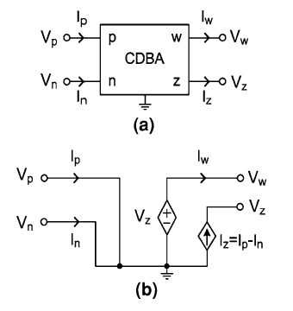
Fig 1.1 (a) Symbol of CDBA (b) equivalent circuit of CDBA

The input impedances of the terminals p and n are zero. The differential input current Ip – In is converted to the output voltage Vw through an impedance connected at the terminal z. the cdba is simplifying the implantation, free from parasitic capacitances and able to operate in the frequency range of more than hundreds of MHz (even GHz) and suitable for current mode operation while it also provides a voltage output.

1.2 Current Differencing Transconductance Amplifier
Current differencing transconductance amplifiers (CDTA) has a pair of low - impedance current inputs and p, n and an auxiliary terminal z, whose outgoing current is the difference of input currents [3]. Output terminal currents are in equal in magnitude but follow in opposite directions and the product of transconductance (gm) and the voltage at terminal z gives their magnitudes. The symbol of cdta is given in Fig 1.2 and the active element can be characterized with the following equations:-
- Vp = Vn = 0,
- Iz = Ip − In,
- Ix + = gm.Vz,
- Ix − = − gm.Vz
(b)
Fig 1.2 (a) Symbol of CDTA (b) equivalent circuit of CDTA

Where Vz = Iz.Zz and Zz is the external impedance connected to z terminal of the cdta, cdta can be thought as combination of a current differencing unit followed by a dual output operational transconductance amplifier , DO – OTA. The CDTA is free from parasitic input capacitances and it can operate in a wide frequency range due to its current-mode operation.

CHAPTER 2
Literature Survey

2.1 CDBA Realization
Current differencing buffered amplifiers (CDBA) are important building blocks of many analog signal processing applications. The realization of Current differencing buffered amplifier has attracted the attention of researcher in the area of analog signal processing since long. IC Op-Amps were the main building blocks for the realization of analog signal processing filters during the decades of seventies and eighties. The current feedback operational amplifier (CFOA) which is commercially available as AD844 was developed by analog devices as a high speed Op-Amp which did not suffer from slew rate limitations and gain bandwidth (GB) conflict for medium and low frequency applications. Though the CFOA was intended to be substitute for traditional VOA, it is actually a 4 terminal device whereas traditional VOA is a 3 terminal device. Acar and Ozoguz [2] proposed a multi terminal active component with two inputs and two outputs, namely Current differencing buffered amplifier. It is derived from current feedback operational amplifier (CFOA). It can operate in both current and voltage mode provides flexibility and enables a variety of circuit designs. These building blocks (CDBA) have been employed by many researchers to design analog signal processing circuits with different properties [4-10].

The Current conveyor (CCII) proposed by Smith and Sedra [11] has been used by many researchers to design different circuits with different properties. Tarim and Kuntman [12] proposed a high performance current differencing buffered amplifier by using two second generation current conveyors (CCII) and a voltage buffer. The CDBA offered contains only MOS transistors and is designed to be implemented in CMOS technology.

Sawangarom, Tangsrirat and Surakampontom [13] proposed the NPN based current differencing buffered amplifier. It was shown that the CDBA based on NPN transistor can operate with a minimum power supply of 2 volts. NPN based CDBA consist of two blocks, current differencing circuit and voltage follower. The current differencing circuit is obtained by using two unity gain current amplifier and the current mirror reflects the current to output port.
M. Steyaert, W. Dehaene, J. Craninckx, M.Walsh and P. Real [14] proposed that to realize the same transconductance with transistors of the same gate length, a PMOS gate length must be 3 times wider than a NMOS. This is because the junction capacitance per unit area is approximately 2 times larger for PMOS than for NMOS. In order to avoid the limitation of the high frequency operation effecting from PMOS transistors, the CDBA should be designed so that signals pass through only NMOS transistors. Therefore W.Tangsrirat, K. Klahan, K. Kaewdang and W. Surakampontorn [15] proposed a low voltage wide band NMOS based CDBA, which has a low resistance at both the current-input terminals (p, n) and at the output-voltage terminal (w). it was shown that the CDBA based on NMOS transistor was superior in terms of supply voltage and frequency range. It can operate at minimum supply voltage of ±1.25 volts. The realization of NMOS based CDBA was based on the modification of low impedance current conveyor (CCII+) to function as a current differencing circuit and a voltage buffer circuit.

The existing CDBAs do not use low-voltage power supplies and have quite high input terminal resistances, high power consumption, most of them suffer from limited output voltage swing. Therefore Cem Cakir, Shahram Minaei, and Oguzhan Cicekoglu [16] proposed a low voltage low power CDBA which overcome these drawbacks. Supply voltages of this circuit are chosen as ±0.75 V. The current subtractor circuit exploits the flipped voltage follower current sources (FVFCS). A FVFCS is characterized by very low supply requirements and low impedance at input terminals [17,18].

Cem CAKIR and Oguzhan CICEKOGLU [19] in 2008 proposed a low power high performance CDBA, a modification over [16]. This circuit can be operated with the power supplies down to ±0.75V and it also consumes less power than its counterparts. This circuit is based on the flipped voltage follower current sources (FVFCS) which give rise to very low input resistances at the input ports. Output stage of this CDBA offers low output impedance and a moderate output swing. This circuit is a class AB voltage buffer which is based on the differential FVF (DFVF) topology [20].

Cem Cakir, Shahram Minaei, and Oguzhan Cicekoglu [23] in 2009 proposed a low voltage low power CMOS CDBA. The circuit can operate with the minimum supply voltage of ±0.6 volts. Low voltage CDBA circuit, which is based on the use of current differencing circuit and voltage buffer. This circuit offers very low terminal resistance at n and p terminal and consumes much less power as compare to the other CDBA circuits available in literature.

2.2 CDBA Applications

2.2.1 Filters
Various filters have been designed by using CDBA. These filters can be classified into four categories: current mode, voltage mode, transimpedance mode and transadmittance mode [4].

Bilgin Metin, Oguzhan Cicekoglu and Kirat Pal proposed a voltage mode all pass filter [5] with a single CDBA which is suitable for high performance analog signal processing.

A voltage mode second order all pass/notch filter with single CDBA was proposed by Cem Cakir, Shahram Minaei, and Oguzhan Cicekoglu [23] which is suitable for low Q applications. Cem CAKIR and Oguzhan CICEKOGLU [19] also proposed current mode second order notch filter.

Sawangarom, Tangsrirat and Surakampontom [13] proposed the current mode universal filter constructed with two CDBAs and six passive elements. This circuit can simultaneously realized the three current transfer function that is low pass, bandpass and high pass functions without changing circuit configurations.

A voltage mode multi input single output type multifunction biquad [6] using single CDBA was proposed by A.U Keskin, using this byquad all five filter functions (i.e, low pass, high pass, bandpass, notch and allpass) can be realized without changing the circuit topology.

S. Pisitchalermpong, T. Pukkalanun, W. Tangsrirat and W. Surakampontom [7] proposed a voltage mode multiple output multi functional biquadratic filters which realizes low pass, high pass, bandpass, bandstop and allpass transfer functions at low resistance output which directly enables cascading to next stage.

Mehmet Sagbas and Muhammet Köksal [8] proposed a multimode multifunction filter. This filter is eligible to obtain all transfer function characteristics (transimpedance mode, transadmittance mode, voltage mode and current mode).

2.2.2 Oscillators
R. Nandi, P. Venkateswaran, Soumik Das and M. Kar [9] proposed CDBA-based realization of electronically tunable bandpass (BP) / lowpass (LP) filters and voltage controlled quadrature oscillator (VCQO). The circuit uses the CDBA building block along with a multiplier (ICL-8013) element inserted suitably in the circuit-loop.

A Sinusoidal Quadrature Oscillator with Current Controlled Amplitude was proposed by Danucha Prasertsom and Worapong Tangsrirat [10]. The proposed circuit consists of two CDBAs, three virtually grounded resistors, and two grounded capacitors. The oscillation condition (OC) and the oscillation frequency of the circuit are independently controlled by a single resistor, whereas the oscillation amplitude is electronically controlled by an external DC current.

A Multiphase Sinusoidal Oscillator Using Grounded Capacitors was proposed by Sumaytee Pisitchalermpong, Worapong Tangsrirat and Wanlop Surakampontom [22]. The proposed MSO circuit, which is composed of n cascaded CDBA-based lossy integrators and a CDBA-based inverter, can generate n sinusoidal output voltages with phase difference of 180°/n.

Ali Umit Keskin [23] proposed a design of minimum Component Oscillators (MCO) using Negative Impedance (NIC) approach based on CDBA. The NIC based oscillator synthesis procedure consists of two steps: a) A grounded NIC circuit of a given type of active element is found, b) a shunt branch to NIC is connected so that, any real terms are removed in complex plane and a symmetric pole pair is placed on the imaginary axis.

2.2.3 Passive Component Realization
Worapong Tangsrirat and Wanlop Surakampontorn [24] proposed an electronically tunable lossless floating inductance simulator. The floating inductance circuit uses only three proposed CC-CDBAs and a grounded capacitor. Its equivalent inductance can linearly be tuned by means of the external bias current of the CC-CDBA. Without the employment of any external passive resistors, the proposed inductance simulation circuit is particularly attractive for integrated circuit (IC) implementation

Ali Ümit Keskin and Erhan Hancioglu [25] introduce two different current differencing buffered amplifiers (CDBA)-based synthetic floating inductance circuits. Both configurations use a grounded capacitor. They are fully integrable and provide the advantages of electronic tuning.

CHAPTER 3
Realization of CDBA
Current-mode circuits are useful for the low voltage operation and therefore, they have been receiving a great deal of interest as an alternative to voltage-mode circuits especially for analog signal processing applications. In addition to the low voltage operation, popularity of current-mode circuits can be attributed to some other features such as larger dynamic range, low power consumption and higher speed.

The current differencing buffered amplifier can operate in both current-mode and voltage-mode, which provides flexibility. Moreover, it is free from many parasitic capacitances and appropriate for high frequency operation.

3.1 CDBA Terminal Characteristics
The block diagram and the equivalent circuit of the CDBA are shown in Fig 3.1 CDBA basically consists of two fundamental building blocks, which are namely current subtractor and voltage follower. The current and voltage characteristics of the CDBA can be described by the following equations;
where and are current gains, and is the voltage gain. They should be equal to unity in the ideal case.
In practice, they can be expressed as
With

ε_{p} and ε_{n} denote the current-tracking errors and ε_{v} denotes voltage-tracking error. It is clear that p and n are current-mode input terminals which have ideally zero impedance. The current of the terminal-z is equal to the difference of the input currents, I_{p} and I_{n}. Therefore, it is defined as the current output which has ideally infinite impedance. Moreover, the voltage of terminal-w follows that of terminal-z. Hence, terminal-w is the voltage output that should have zero impedance.

Fig 3.1 CDBA (a) Block diagram (b) Equivalent circuit

3.2 Low voltage Low power CMOS Current Differencing Buffered Amplifier.
Low voltage CDBA circuit [21] is based on the use of the current differencing circuit (M1–M8) and the voltage buffer (M9–M14). The circuit is supplied by the voltages of ±0.6 V. The performance of the CDBA is verified with PSPICE using 0.18 µm, level 7 parameters provided by TSMC.

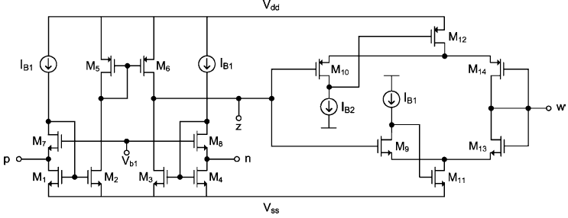

Fig 3.2 CMOS realization of CDBA

The aspect ratios of the transistors are reported in Table 3.1. The bias currents IB1 and IB2 are selected as 56 uA and 84 uA, respectively.

Transistor | W/L (um/um)
M1, M2, M3, M4 | 3.6/1.8
M5, M6 | 180/1.8
M7, M8 | 180/1.8
M9 | 45/0.36
M10 | 240/0.36
M11 | 72/0.36
M12 | 240/0.36
M13 | 72/0.36
M14 | 240/0.36

Table 3.1 Aspect Ratios of the transistors.

The current subtractor circuit is based on the flipped voltage follower current sources (FVFCS) which give rise to very low input resistances at the input terminals. The FVFCS is shown in Fig.3.3 given below

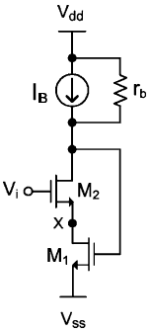

Fig 3.3 Flipped voltage follower current source (FVFCS)

The current subtractor circuit is illustrated in Fig 3.2 which consists of the transistors M1 to M8. Current of the terminal-z follows the difference of the currents of terminal-p and terminal-n. Hence, we name terminal-z as current output. The current of the terminal-z can be expressed as follows:

Assuming that each group of transistors, (M1–M4), (M5–M6) and (M7–M8) is matched and all transistors operate in the saturation region, the circuit operates as follows: The current source, I_{B1} forces equal currents of 56 uA in the transistors (M1–M4). Thus, the gate to source voltages of these transistors will be equal, which forces the voltages of the two input terminals to be zero. Since terminal-z is defined as the current output, it should ideally have infinite impedance. Following Figure 3.4 displays the DC current transfer characteristic of the CDBA [21]. It can easily be seen that this CDBA has a high linearity over the entire dynamic range (I_{B1} = 56 uA) and also has very low offset current on terminal-z, which is 0.05 uA.

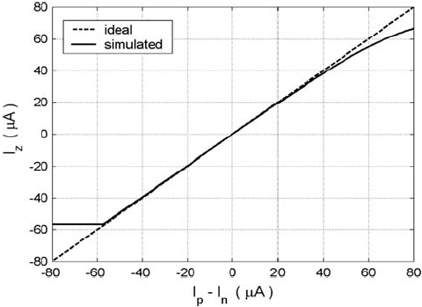

Fig 3.4 Current transfer characteristic

The output stage of the proposed CDBA is based on the differential flipped voltage follower (DFVF), which is shown in Fig 3.5. The impedance at node Y is very low and its voltage remains approximately constant for large currents through transistor M₃. If we consider quiescent conditions when V₁ = V₃, and assuming the same transistor sizes for M₁ and M₃, the condition is satisfied. A differential voltage V₁–V₃ generates current variations in M₃ that follow the MOS square law. Another important characteristic of the DFVF is that it can also be operated with very low supply voltage. The minimum supply voltage is found as

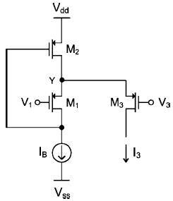

Fig 3.5 Differential flipped voltage follower

Figure 3.6 illustrates the AC transfer characteristics of the CDBA. The current and voltage transfer ratios, α_{p}, α_{n} and β_{v} are found to be 0.981, 0.981 and 0.978, respectively. It can be observed that the -3 dB frequencies of Iz/Ip, Iz/In and V_{w}/V_{z} are approximately equal to 25 MHz, 25 MHz and 474 MHz, resp. and Schematic simulation results are summarized in Table 3.2.

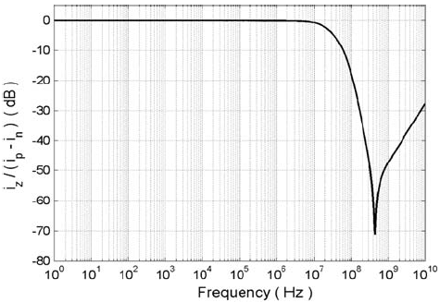
Fig 3.6 AC transfer characteristics of the CDBA-Frequency response of the current transfer ratio [21]
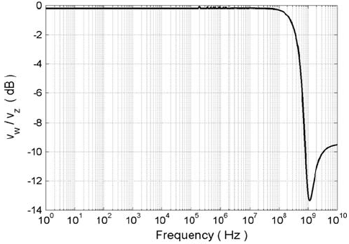

Fig 3.7 AC transfer characteristics of the CDBA-Freq. response of the voltage transfer ratio [21]

Parameter | Schematic
Supply voltage (V) | ±0.6
Bias voltage, V_{bl} (V) | 0.45
Power dissipation (uW) | 565.25
Current transfer ratio, α=I_{z}/(I_{p}-I_{n}) | 0.981
Current transfer BW (MHz) | 25
Voltage transfer ratio, β_{v}=V_{w}/V_{z} | 0.978
Voltage transfer BW (MHz) | 474
Terminal-p resistance (Ω) | 56.4
Terminal-n resistance (Ω) | 56.4
Terminal-z resistance (kΩ) | 157
Terminal-w resistance (Ω) | 270

Table 3.2 Performance of the CDBA.

3.3 Simulation Results for CMOS realization of CDBA.

Fig 3.8 PSPICE Schematic for low voltage low power CMOS based CDBA.

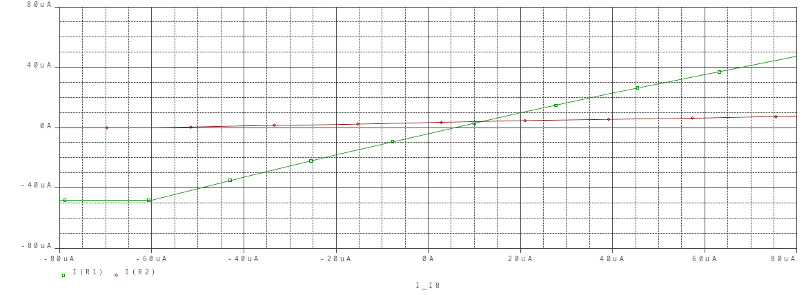
Fig 3.9 PSPICE Simulation for current transfer characteristics

Fig 3.10 PSPICE Simulation for AC transfer characteristics

Therefore, Fig 3.9 and Fig 3.10 shows that the simulation results are very close to the results obtained in [21]

3.4 CDBA Realization using AD844
Two CFOA blocks are used in this alternative realization of CDBA [2]. The p terminal of both the CFOA blocks has been grounded. I_{p} is fed to the n terminal of the first block whereas I_{n} is fed to the n and z terminal of the first block as well as the n terminal of the second block. In the first CFOA block, the current entering the p terminal (I_{p}) is the same current which is drawn at its z terminal. Thus the effective current reaching the p terminal of the second block is I_{n}-I_{p}. This current is also drawn at the z terminal of the second block which is equivalent to I_{p}-I_{n} flowing out of the z terminal. Hence, the current difference output is obtained at the z terminal of the second block. Since the voltage at z is replicated at terminal w, voltage buffer action is also realized.
CDBA realization using CFA (AD844) is shown in Fig 3.11

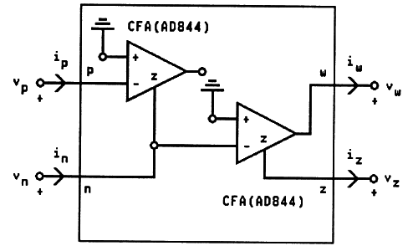
Fig 3.11 Implementation of CDBA using CFA (AD844)

3.5 Simulation results of CDBA using CFA (AD844)

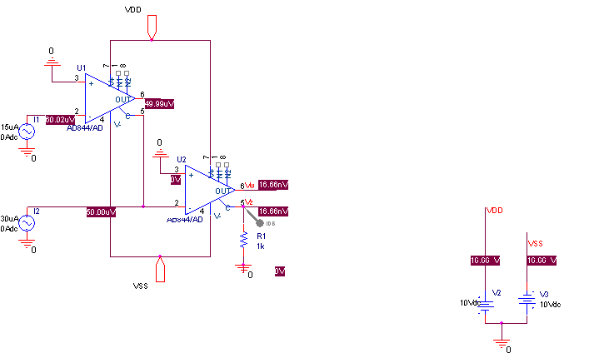
Fig 3.12 PSPICE Schematic for realization of CDBA using CFA.

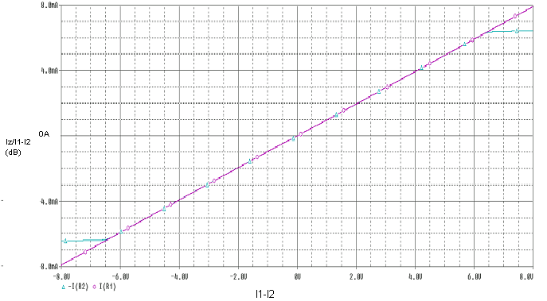
Fig 3.13 PSPICE Simulation for current transfer characteristics.

Frequency
1.0Hz
10Hz
100Hz
1.0KHz
10KHz
100KHz
1.0MHz
10MHz
100MHz
1.0GHz
10GHz
100GHz
20* LOG10(I(U2:C)/ I(I1)- I(I2))
-100
-80
Gain -60 (dB)
-40
-20
-0
Fig 3.14 PSPICE simulation for frequency response of the current transfer ratio.

Fig 3.15 PSPICE simulation for frequency response of the voltage transfer ratio.

Frequency
1.0Hz
10Hz
100Hz
1.0KHz
10KHz
100KHz
1.0MHz
10MHz
100MHz
1.0GHz
20*LOG10(V(U2:OUT) / V(U2:C))
-15
Vw/Vz (dB)
-10

-5
0
CHAPTER 4
Active Filter Realization Using CDBA

4.1 Realization of Current-mode second-order notch filter
Current-mode second-order notch filter is constructed with single CDBA [16] and four passive elements as shown in Fig 4.1

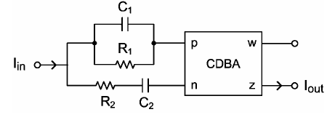
Fig 4.1 Current-mode second-order notch filter

The current transfer function of the circuit is given as follows:

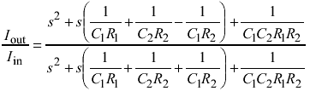

Therefore matching condition for the realization of the second-order notch filter will be C1R1+C2R2=C2R1. The natural frequency, ω_{Ο} and quality factor, Q for the filter can be expressed as;

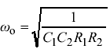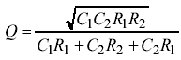

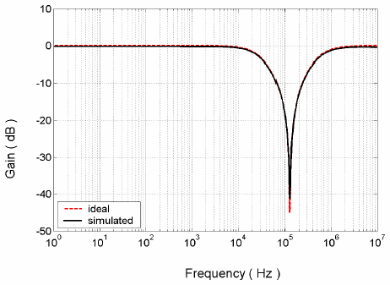
Fig 4.2 Gain response of the second-order notch filter

Fig 4.2 shows simulated gain and phase responses of the notch filter compared to the ideal case, external component values are chosen as R₁=50 kΩ , R₂=25 kΩ , C₁=25 pF and C₂=50 pF. the center frequency of the circuit is found as fc=127 kHz which is in close agreement with the theoretical one.

Fig 4.3 PSPICE Schematic for current mode second order notch filter.
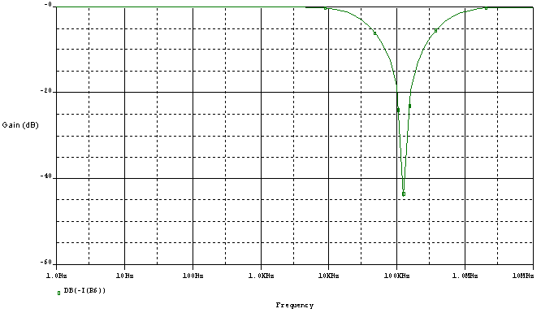
Fig 4.4 PSPICE simulation for Gain response of the second order Notch filter

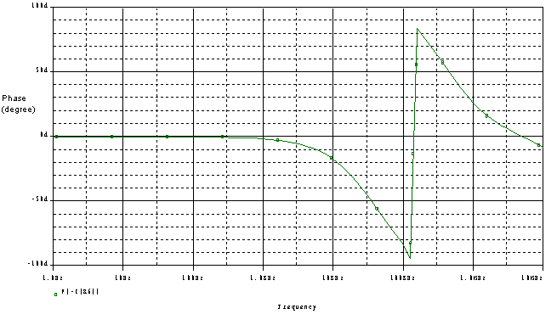
Fig 4.5 PSPICE simulation for Phase response of the second order Notch filter

4.2 Realization of First order allpass filter.
Allpass filters provide phase shifting while the amplitude of the signal remains constant over the frequency range. [12] They are used in many applications such as in the realization of oscillators and high-Q bandpass filters. First order allpass filter is realized with single CDBA and four passive components. The configuration of the allpass filter is given in Fig 4.6. The filter transfer function is given by the expression below:

In order to realize a first order allpass filter with a gain value of 1, above Eqn. requires the conditions R₁=2R₂ and R₃=4R₂ to be satisfied. Choosing the external component values as C=lnF, R₁=20k- , R₂=10k- , R₃ = 40k- yields a pole frequency of 15.9 kHz.

Fig 4.6 First order allpass filter configuration

Fig 4.7 the Gain and phase response of first order allpass filter

Fig 4.8 PSPICE circuit for first order allpass filter.

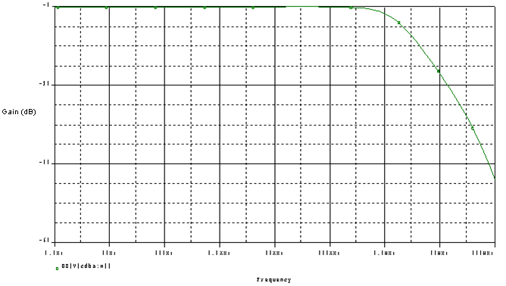
Fig 4.9 PSPICE simulation for Gain response of allpass filter.

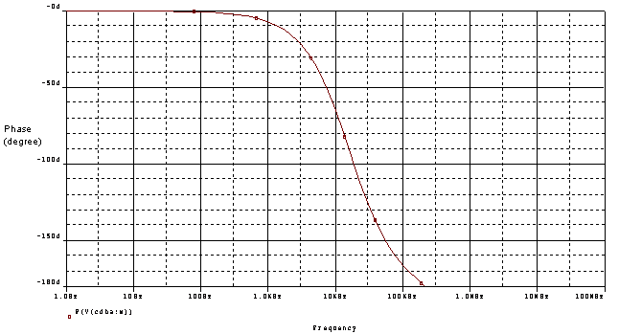
Fig 4.10 PSPICE simulation for Phase response of allpass filter

4.3 Realization of Voltage mode second order allpass/notch filter.
Allpass or notch responses depending on the matching condition of its passive elements is realized. This configuration contains only one active element (CDBA), [21] three resistors and two capacitors. the general voltage transfer function between Vo and Vi can be written as;

If

A second-order allpass filter is obtained;
The natural frequency, ωo and quality factor, Q for the filter can be expressed as;

Fig 4.11 voltage-mode second-order allpass/notch filter configuration

By taking the matching condition into consideration, external component values are chosen as R₁ = 2 kΩ, R₂ = 6 kΩ, R₃ = 6 kΩ, C₁ = 25 pF and C₂ = 25 pF. Then the center frequency of the circuit is measured as fc = 1.08 MHz, which is in close agreement with the theoretical one. If the matching condition, C₁R₁ = C₂R₂ in general Eq. a second-order notch filter is obtained;

If the component values are chosen as R₁ = 10 kΩ, R₂ = 10 kΩ, R₃ = 2 kΩ, C₁ = 20 pF and C₂ = 20 pF, then the center frequency of the circuit is found as fc = 1.8 MHz.

Fig 4.12 Gain response of second order allpass filter

Fig 4.13 Gain response of second order notch filter

Fig 4.14 PSPICE Schematic of Second order allpass/notch filter.

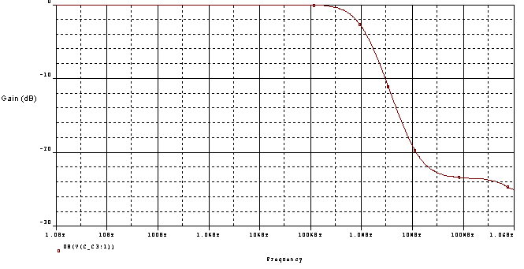
Fig 4.15 PSPICE simulation for the Gain response of allpass filter
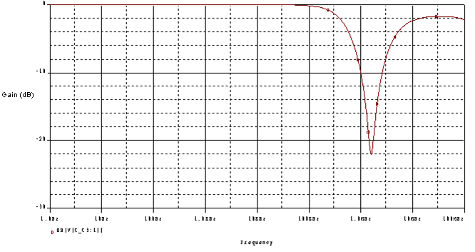
Fig 4.16 PSPICE simulation for the Gain response of notch filter

4.4 Realization of current mode universal filter.
The current-mode universal filter constructed with two CDBAs [13] and six passive elements is shown in Fig. 4.17.

Fig 4.17 Current-mode universal filters using CDBAs

Circuit analysis yields the following current transfer functions

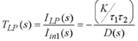
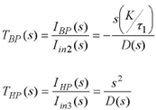

Where

the circuit can simultaneously realize the three current transfer functions, i.e., lowpass (LP),bandpass (BP) and highpass (HP)functions, without changing circuit configuration. From the above characteristic equations, the natural frequency (ω₀) and the quality factor (Q) of this filter are:

In order to verify high frequency performance of the filter, the simulation results for the LP, BP and HP filter characteristics when Ri (i = 1, 2, 3, 4) = 1 kΩ and C_{l} = C₂ = 0.1 nF are illustrated in Fig. 4.18. The filter is designed to realize the filter responses with a natural frequency of fo = 1.59 MHz at Q = 1.

Fig 4.18 Gain response for the LP, BP and HP filter

Fig 4.19 PSPICE Schematic for current mode universal filter

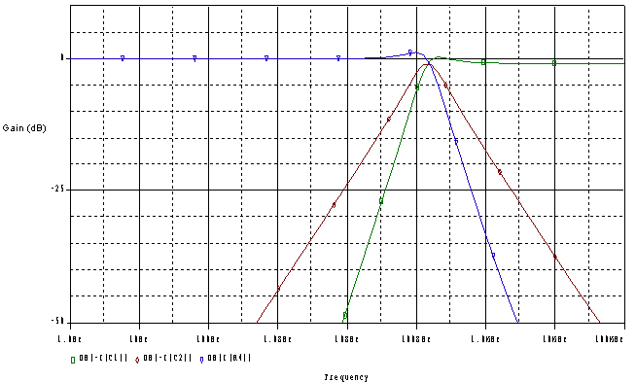
Fig 4.20 PSPICE simulation result for the LP, BP and HP responses of the filter

4.5 Realization of voltage mode multi-input single-output Biquad.
A voltage-mode, multi-input single-output (MISO) type multi-function biquad having the following features: [6]

(a) It uses only one current differencing buffered amplifier as the active element.

(b) Using this biquad, one may realize all five filter functions (i.e., lowpass, highpass, bandpass, notch and allpass) without changing the circuit topology.

(c) It can be directly cascaded without any need of impedance matching circuits.

(d) Its Q-factor can be independently adjusted if the natural frequency is fixed.

Let Ya be the admittance between a voltage source Vin and p terminal, Yb the admittance between Vin and n terminal, Yc the admittance between the z terminal and ground, and Yd admittance connecting p and w terminals of the CDBA. Voltage transfer function of this configuration can be described by the following relationship.

If Ya = Ra||Ca, Yc = Rc||Cc, Zb = (1/Yb) = Rb+(1/sCb), Zd = (1/Yd) = Rd+(1/sCd), and splitting Ya, Yb junction into three parts as shown in Fig. 4.21 and applying superposition of input voltages Vin, V1, V2 in the circuit yields the equation for the output voltage Vw (=Vo) as

Fig 4.21 Single CDBA-based voltage-mode Universal biquad

In this circuit, with the condition RbCb = RdCd (except APF), biquad voltage transfer functions (=Vo/Vin) realize.

1. LPF; if V1 = Vin, V2=0, Ra = Rb

2. HPF; if V2 = Vin, V1=0, Ca = Cb

3. BPF; if V1=V2=0,
4. BSF; if V1 = V2 = Vin, Ra = Rc = 2Rb, Cb = 2Cc = 2Ca

5. APF; if V1 = V2 = Vin, Ra = Rc = 4Rb, Cb = 2Cc = 4Ca

Note that, Ca is omitted (Ca=0) for the low pass configuration, Ra is omitted (Ra=∞) for the high pass filter realization. On the other hand, both Ra and Ca are omitted for the band pass configuration, while Rd is omitted for the all pass case. The natural angular frequency xo and the pole Q-factor of this filter are

Component values used in the experiments are the following:

(a) LPF (Butterworth); Ra = Rb = Rc = Rd=10 kΩ, Cb = Cd=70 nF, Cc=140 nF,

(b) HPF (Butterworth); Rb = Rd=14 kΩ, Rc=7 kΩ,Ca = Cb = Cc = Cd=100 nF,

(c) BPF(Butterworth); Rb = Rc=10 kΩ, Rd=20 kΩ, Cc = Cd=70 nF, Cb=140 nF,

(d) BSF (Butterworth symmetric notch); Ra = Rc =14 kΩ, Ca = Cc=70 nF, Rb=7 kΩ, Cb=140 nF, Rd=24 kΩ.

(e) APF; Ra = Rc=50 kΩ, Ca = Cc=20 nF, Rb= 12.5 kΩ, Cb=80 nF.

Fig 4.22 Gain response for the CDBA based universal biquad.

4.5.1 Lowpass filter

Fig 4.23 PSPICE Schematic for LP filter (multifunction biquad)
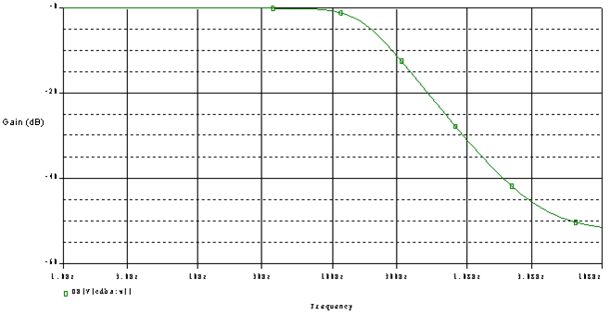
Fig 4.24 PSPICE simulation result for the Gain response of lowpass filter

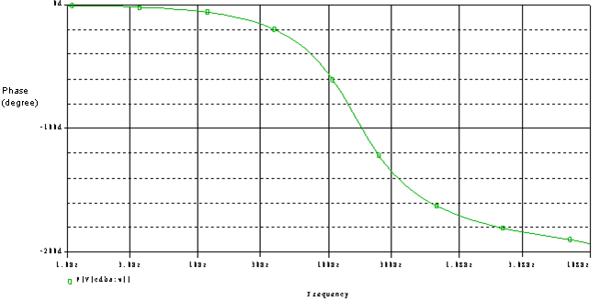
Fig 4.25 PSPICE simulation result for the Phase response of lowpass filter

4.5.2 Highpass filter

Fig 4.26 PSPICE Schematic for highpass filter.

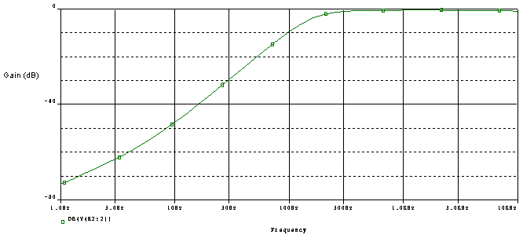
Fig 4.27 PSPICE simulation result for Highpass filter.
4.5.3 Bandpass filter

Fig 4.28 PSPICE Schematic for bandpass filter

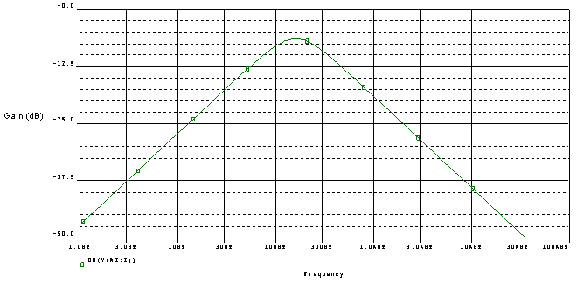
Fig 4.29 PSPICE simulation for Bandpass filter
4.5.4 Bandstop filter

Fig 4.30 PSPICE Schematic for BSF

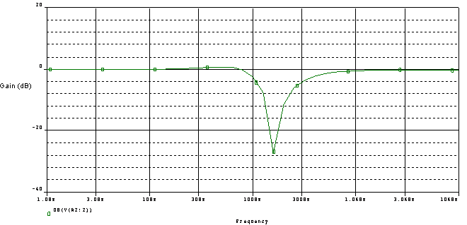
Fig 5.31 PSPICE simulation for BSF
4.5.5 Allpass filter

Fig 4.32 PSPICE Schematic for Allpass filter

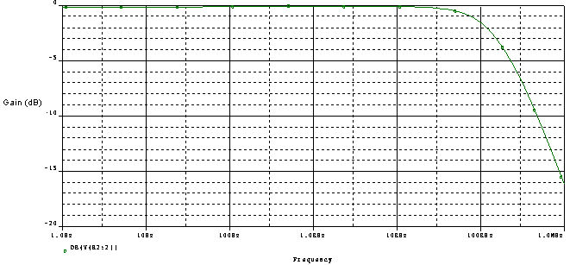

Fig 4.33 PSPICE simulation for allpass filter

4.6 Realization of single input multi output Biquadratic filter.
The circuit topologies are mainly composed of the CDBA-based cross-coupled feedback configuration and the voltage substractor. [7] By an appropriate choice of virtually grounded passive components, the configurations can simultaneously realize lowpass, highpass, bandpass, bandstop and allpass voltage transfer functions, all at low resistance outputs.

4.6.1 Circuit Topology I
The circuit topology I is shown in Fig.4.34, which consists of a cross-coupled feedback configuration (CDBA1 and CDBA2) and a voltage substractor (CDBA3). The voltage-mode LP, BP and AP transfer functions can be obtained at the Vol, Vo2 and Vo3 terminals respectively as:

Where

Fig 4.34 Circuit topology I
From equations of LP, BP and BS, ωo and Q-factor are given by

Fig 4.35 Gain response of LP, BP and BS filters (Circuit topology I)

4.6.2 Circuit Topology II
Consider the circuit topology II shown in Fig 4.36, where all resistors R from the circuit topology I are replaced by capacitors C and conversely. For this case, the circuit will include the HP, BP and AP voltage transfer functions at the nodes Vo4, Vo5 and Vo6 respectively as:

Fig 4.36 Circuit topology II

The parameters ω0 and Q for this type can be expressed by

Fig 4.37 Gain response of HP, BP and AP filters. (Circuit topology II)

Fig 4.38 PSPICE Schematic for LP, BP and BS filters (circuit topology I)

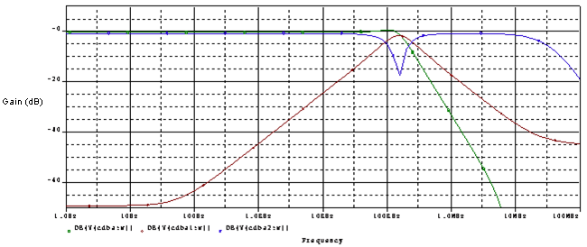
Fig 4.39 PSPICE simulation for LP, BP and BS filters (circuit topology I)
Fig 4.40 PSPICE Schematic for HP, BP and AP filters (Circuit topology II)

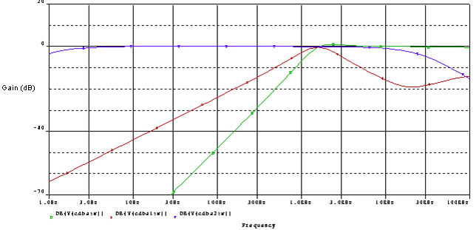
Fig 4.41 PSPICE simulation for HP, BP and AP filters (Circuit topology II)
4.7 Realization of multimode multifunction filter.
The filter has a single current input and three voltage outputs and operates in transimpedance-mode. [8] It can generate all biquadratic filter functions of low-pass, high-pass and band-pass, and also band-reject and all-pass filter responses by selecting different output signal combinations. This filter can be converted into voltage-mode by an additional input resistor. It can also be used in current mode at the output by using one extra load resistor at each output. With these additional resistors at the input and outputs the filter operates in transadmittance mode. The structure of the new filter contains two capacitors, three resistors and three CDBAs. This filter has second order structure and due to its zero-input voltage impedance property it is adaptable for all other modes. Further, it can be used to synthesize for all types of second order filter characteristics. In order to obtain TAM, VM and CM multifunction filter, we convert the input current source to a voltage source and/or the output voltage responses to current response. To convert output-voltage response to a current response, a load resistor is connected to the output stage of the active circuit as shown in Fig. 4.42a and 4.42b. Therefore,

To convert the input-current source to a voltage source, the current source is replaced by a voltage source and a serial resistor as shown in Fig. 4.42c and 4.42d assuming zero input voltage for the active device. Therefore, new input voltage of the active circuit according to input current becomes as follows
Fig 4.42 Circuit diagram of converting.
With the above mentioned source and/or response conversion the original transimpedance mode operation can be transformed the following modes:

(i) VM multifunction filters: obtained by converting input current source to voltage source using extra one serial resistor.

(ii) CM multifunction filter: obtained by converting output voltage responses to current responses using extra three load resistors.

(iii) TAM multifunction filter: obtained by converting both input current source to voltage source and output voltage responses to current responses using extra four resistors.

The multifunction filter is shown in Fig. 4.43. The transfer function of the circuit at different outputs can be found by using the terminal equations of CDBA

Filter simultaneously produces at different outputs LP, HP and BP responses, respectively. The undamped natural frequency and the quality factor of the filter are calculated from the denominator polynomial of the transfer functions as follows,

Fig 4.43 Circuit diagram of the multifunction filter

Table 4.1: Transfer mode (TM) and transfer function (TF) characteristics of the multi-mode multifunction filter

The denominator polynomial of the transfer function for the proposed filter becomes

Where, the subscripts of α and β refer to the number of each CDBA
Fig 4.44 PSPICE Schematic of the multifunction filter in TIM mode

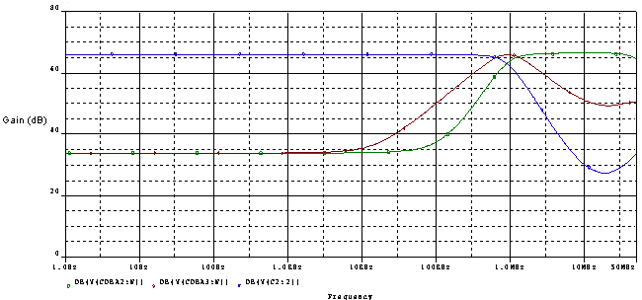
Fig 4.45 PSPICE Simulation of the multifunction filter (HP, BP and LP) in TIM mode
4.8 Realization of multi-mode multi-function (SISO) filter using single CDBA
This configuration uses a single current differencing buffered amplifier (CDBA) and, depending on topology, a total of four/five passive elements (two/three capacitors and two/three resistors). Current-mode (CM), voltagemode (VM), transimpedance-mode (TIM) and transadmittance mode (TAM) topologies are presented for realizing BP, LP and HP filter responses. [4] General multi-mode filter topology is given in Fig. 4.46 This topology uses a single CDBA and four or five passive elements (y1 can be skipped in some modes). Depending on the choices of passive elements, three filter transfer functions can be obtained in CM, VM, TIM, and TAM.

Fig 4.46 General filter topology

A. CM Configuration
This analysis requires a current source input and removal of admittance y1 in Fig.4.46. Current mode transfer function can be derived as,

LP, BP, and HP filter characteristics can be obtained by the choices of the admittances (components) shown in Table 4.2. Non-ideal ωo and Q are obtained for LP, BP, HP transfer functions, respectively, as

;

Table 4.2: CM Filters with appropriate admittances

B. VM Configuration
For a voltage input case, in which the admittance y1 is included in Fig. 4.46, the new general transfer function can be obtained as follows

LP, BP, and HP filters can be obtained by the choices of the components shown in Table 4.3. Non-ideal ωo and Q for LP, BP, HP transfer functions, respectively, are obtained as

TABLE 4.3: Design parameters used for VM Filters

TABLE 4.4 VM Filters with appropriate admittances

C. TIM Configuration
The derivation of TIM filter transfer function requires removal of admittance y1 in Fig. 4.46 TIM transfer function can be derived as follows

LP and BP filter characteristics can be obtained by the choices of the components shown in Table 4.5; note that HP filter cannot be achieved in this mode.

TABLE 4.5: TIM Filters with appropriate admittances

Non-ideal ωo and Q for LP and BP transfer functions are obtained, respectively, as

D. TAM Configuration
The derivation of TAM filter transfer function requires removal of admittance y1 in Fig. 4.46. TAM transfer function can be derived as follows

As in CM and VM configurations, three of the basic filter structures (LP, BP, and HP) can be realized by the choice of the component values shown in Table 4.6 Non-ideal ωo and Q for LP, BP, HP transfer functions are obtained, respectively, as

;

TABLE 4.6: TAM Filters with appropriate admittances

4.8.1 Lowpass filter in voltage mode configuration

Fig 4.47 PSPICE Schematic for LP filters in voltage mode (VM) configuration.

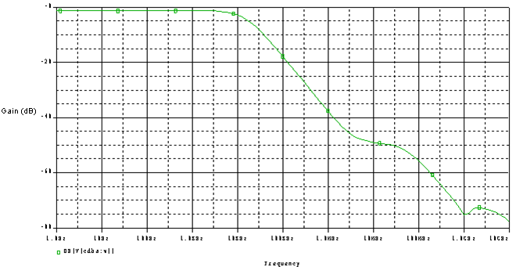
Fig 4.48 PSPICE simulation for LP filter in VM configuration
4.8.2 Highpass filter in voltage mode configuration

Fig 4.49 PSPICE circuit for HP filter in VM configuration

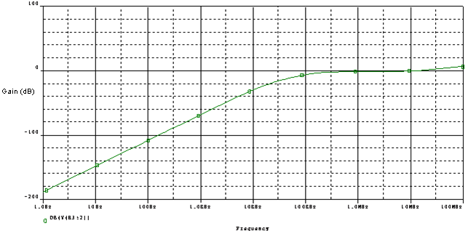

Fig 4.50 PSPICE simulation for HP filter in VM configuration
4.8.3 Bandpass filter in voltage mode configuration

Fig 4.51 PSPICE Schematic for BP filter in VM configuration

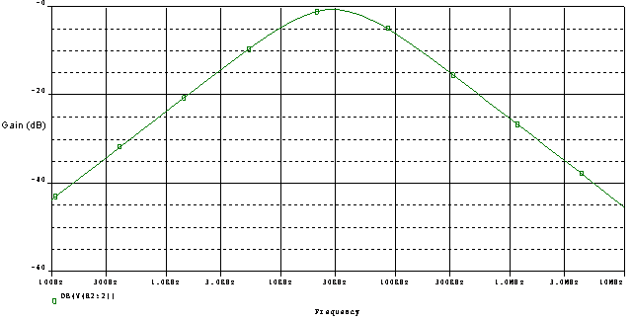
Fig 4.52 PSPICE simulation for BP filter in VM configuration
CHAPTER 5
Component realization using CDBA

In literature various components are realized using CDBA as the active element. In this chapter a synthetic floating inductance [24] circuit is studied and a filter is realized based on it. CDBA-based tunable FI configuration. Here, CDBA1 and CDBA2 along with MRC1 and MRC2 constitute a gyrator circuit [25]. Therefore, a floating inductor can be synthesized easily by cascading two identical gyrators and placing a grounded capacitor C at their connection terminal. This will yield a floating inductor whose inductance can be tuned electronically by adjusting the gate voltages of the respective MOSFETs in MRCs.

Fig 5.1 Tunable, floating inductor using four CDBAs

In the MOS resistive circuit (MRC) shown in Fig.5.2, both the even and odd nonlinearities are cancelled by subtraction of the drain-source currents of transistors operating in their triode region. Because the transistors have equal drain and source voltage.

Fig 5.2 MOSFET resistive circuit (MRC) nonlinearity cancellation
Fig 5.3 PSPICE Schematic for Tunable, floating inductor using four CDBAs

Fig 5.4 Series resonance circuit using CDBA-based floating inductance

Fig 5.5 PSPICE Schematic for series resonant circuit using CDBA based floating inductance

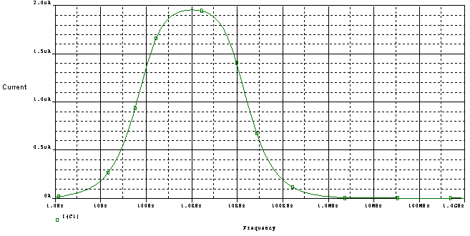
Fig 5.4 PSPICE simulation for the response of series resonance circuit
CHAPTER 6
Proposed work

6.1 Realization of Second-Order Multi-Mode Allpass Filter Using a Single CDBA
A new second order multi-mode allpass filter configuration is introduced. This configuration uses a single CDBA and depending on topology, a total of five/six passive elements. General multi-mode allpass filter topology is given in Fig 6.1. Depending on the choices of passive elements, transfer function of allpass filter can be obtained in current mode (CM), voltage mode (VM), transimpedance mode (TIM) and transadmittance mode (TAM).

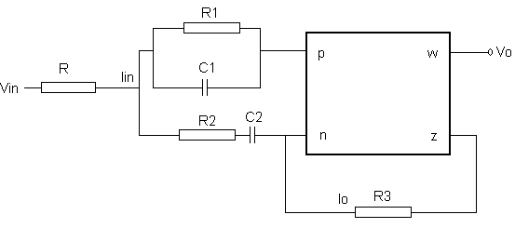
Fig 6.1 General Allpass filter topology

6.1.1 CM configuration
This analysis requires a current source input and removal of resistance R. the general transfer function can be given as

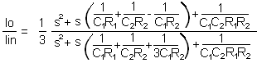

If

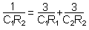
Then
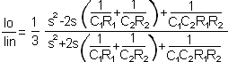

The natural frequency ω_{o} and quality factor Q for the filter can be expressed as

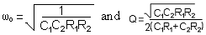

To verify the theoretical analysis, this filter is simulated by using PSPICE.

6.1.2 TIM configuration
The derivation of TIM filter transfer function requires removal of resistance R in Fig 6.1. the TIM transfer function can be derived as follows.

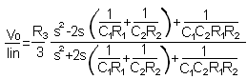

The natural frequency ω_{o} and quality factor Q for the filter can be expressed as

6.1.3 VM configuration.
This analysis requires a voltage source input and resistance R is included. the general transfer function can be obtained as

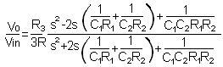

The natural frequency ω_{o} and quality factor Q for the filter will remain the same.
6.1.4 TAM configuration.
The derivation TAM filter transfer function requires a voltage source input and resistance R is included in Fig 6.1, the general transfer function can be derived as

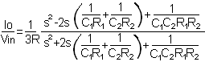

By taking the matching condition into consideration, external component values are chosen as
R₁=12kΩ, R₂=2kΩ, R₃=14kΩ, R=1kΩ, C₁=5pF and C₂=30pF. The simulated gain and phase responses of the second order allpass filter compared to the ideal case.

6.2 Simulation results for proposed allpass filter

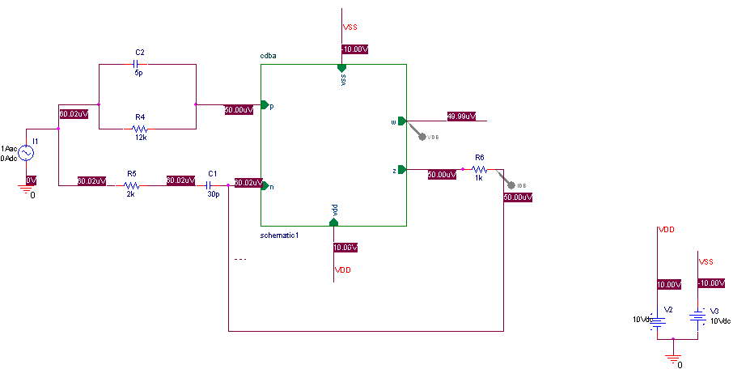

Fig 6.2 PSPICE Schematic for allpass filter in CM and TIM configuration.

Frequency
1.0Hz
10Hz
100Hz
1.0KHz
10KHz
100KHz
1.0MHz
DB(V(cdba:w))
DB(-I(R6))
-20
0
Gain 20 (dB)
40
60
Fig 6.3 PSPICE simulation for the frequency response of allpass filter in CM and TIM configuration.

Frequency
1.0Hz
10Hz
100Hz
1.0KHz
10KHz
100KHz
1.0MHz
10MHz
100MHz
P(-I(R6))
-400d
-300d
Phase (degree)

-200d
-100d
0d
Fig 6.4 PSPICE simulation for the Phase response for the allpass filter.
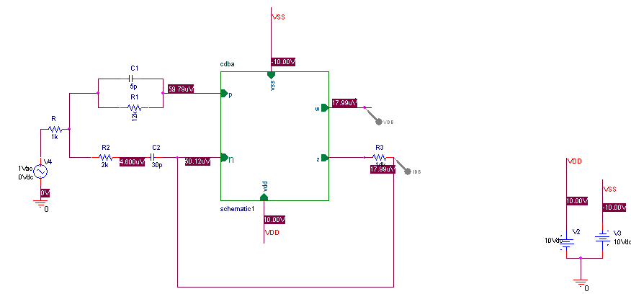

Fig 6.5 PSPICE Schematic for allpass filter in VM and TAM configuration.

Frequency
1.0Hz
10Hz
100Hz
1.0KHz
10KHz
100KHz
1.0MHz
DB(V(cdba:w))
DB(-I(R3))
-100
-80
Gain (dB)

-60
-40
-20
-0
Fig 6.6 PSPICE simulation for the allpass filter in VM and TAM configuration.

Conclusion and Future scope

In this thesis, a detailed study of the Current Difference Buffer Amplifier (CDBA) has been presented in which its realization has been done using CMOS as well as using CFOA (AD844). A survey of the existing literature on CDBA block and its applications has been done. Therein, simulations have been done for active filters using the CDBA block realized using AD844. This has been done to verify the behavior of circuits made using CDBA that are already existing.

The final part of the thesis presents the proposed circuits that have been made using the CDBA block. . These circuits include allpass filter in CM , VM ,TIM and TAM configuration. For each of the proposed circuit, a detailed analysis is formulated. Also, simulations have been done for all of the above circuits on PSPICE to show their response.

The primary advantages of implementing these circuits using CDBA are large dynamic range, higher slew rate, low power consumption, less complex circuitry and higher signal bandwidth. CDBA can operate in both voltage and current mode, provides flexibility and enables a variety of circuit design. Hence, CDBA is one of the modern current mode building blocks which has a lot of improved features and hence can be used to design various types of circuits.

In the field of signal generation applications using CDBA, there is a lot of scope for future work as there are many circuits which can be implemented using CDBA. These include variations of various sinusoidal oscillators, monostable multivibrators, astable multivibrators etc.

References

[1] Mohit Kumar, “Low-Voltage Current-Mode Analog Cells”, M.Tech. credit seminar report, Electronic Systems Group, EE Dept, IIT Bombay, submitted November 2002

[2] C. Acar and S. Ozoguz, “A new versatile building block: current differencing buffered amplifier suitable for analog signal processing filters”, Microelectronics Journal, 30, pp. 157-160, 1999.

[3] Fırat KACAR and Hulusi Hakan KUNTMAN, “A new, improved CMOS realization of CDTA and its filter applications” Turk J Elec Eng & Comp Sci, Vol.19, No.4, 2011

[4] M. Koksal, S.E. Oner and M. Sagbas, “A New Second-Order Multi-Mode Multi-Funtion Filter Using a Single CDBA” IEEE, pp. 699–702, 2009

[5] Bilgin Metin, Oguzhan Cicekoglu and Kirat Pal, “Voltage Mode All-pass Filter with a Single Current Differencing Buffered Amplifier” IEEE, pp. 734-737, 2008.

[6] A. U. Keskin, “Multi-function biquad using single CDBA” Electrical Engineering (2006) 88: pp. 353–356

[7] S. Pisitchalermpong, T. Pukkalanun, W. Tangsrirat and W. Surakampontom, “Current Differencing Buffered Amplifier Based Multiple-output Biquadratic Filters”, IEEE, 2005, pp. 521-524

[8] Mehmet Sagbas and Muhammet Köksal, “A New Multi-mode Multifunction Filter Using CDBA”, Department of Electronics Engineering, Fatih University, Turkey.

[9] R. Nandi, P. Venkateswaran, Soumik Das and M. Kar, “CDBA-based electronically tunable filters and sinusoid quadrature oscillator. Journal of Telecommunication”, 2010, 4(1): 35-41

[10] Danucha Prasertsom and Worapong Tangsrirat, “CDBA-based Sinusoidal Quadrature Oscillator with Current Controlled Amplitude”, IEEE, 2010, pp. 187-191.

[11] A. Sedra, and K.C. Smith, “A second generation current conveyor and its applications,” IEEE Trans. vol.17, pp. 132-134, 1970

[12] N. Tarim and H. Kuntman, “A high performance current differencing buffered amplifier”, Proc. of the 13th International Conference on Microelectronics, Rabat, Morocco, pp. 153–156, 2001.

[13] Visawa Sawangarom, Worapong Tangsrirat, Wanlop Surakampontorn,” NPN-based Current Differencing Buffered Amplifier and Its Application”, SICE-ICASE International Joint Conference 2006.

[14] M. Steyaert, W. Dehaene, J. Craninckx, M.Walsh and P. Real, “A CMOS rectifier-integrator for amplitude detection in hard disk servo loops”, IEEE J. Solid-state Circuits, vol.30, no.7, pp.743-751, 1995.

[15] W. Tangsrirat, K. Klahan, T. Dumawipata and W. Surakampontorn, “Low-voltage NMOS-based current differencing buffered amplifier and its application to current-mode ladder filter design”, International Journal of Electronics, Volume 93, Number 11, pp. 777-791(15), 2006.

[16] Cem Cakir, Shahram Minaei, and Oguzhan Cicekoglu, “Low-Voltage Low-Power and High-Swing Current Differencing Buffered Amplifier”, Circuits and Systems and TAISA Conference, 2009.

[17] R. G. Carvajal et al, “The flipped voltage follower: a useful cell for low-voltage low-power circuit design,” IEEE Transactions on Circuits and Systems I: Fundamental Theory and Applications, Regular Papers Vol. 52, Issue 7, 1276–1291, 2005

[18] A. J. L. Martin, J. R. Angulo, and R. Carjaval, “Low-voltage low-power wideband CMOS current conveyors based on the flipped voltage follower”, IEEE, pp. 801-804, 2003.

[19] Cakir, C., & Cicekoglu, O. (2008). Low-voltage high-performance CMOS current differencing buffered amplifier (CDBA). In Proceedings of the 4th IEEE conference on Ph.D. research in microelectronics and electronics (PRIME 2008) Istanbul, Turkey, pp. 37–40.

[20] R. G. Carvajal, A. Torralba, J. Ramírez-Angulo, J. Tombs and F. Muñoz, “Compact low-power high slew-rate CMOS buffer for large capacitive loads,” Electronics Letters, vol.38, no. 32, pp. 1348-1349, 2002.

[21] Cem Cakir, Shahram Minaei & Oguzhan Cicekoglu “Low voltage low power CMOS current differencing buffered amplifier” , Analog Integr Circ Sig Process (2010), springer

[22] Sumaytee Pisitchalermpong, Worapong Tangsrirat and Wanlop Surakampontom,”CDBA-based Multiphase Sinusoidal Oscillator Using Grounded Capacitors” SICE-ICASE International Joint Conference 2006, IEEE.

[23] Ali Umit Ke skin,” Design of Minimum Component Oscillators Using Negative Impedance Approach Based On Different Single Active Elements”, I EEE MELECON 2004

[24] Worapong Tangsrirat and Wanlop Surakampontorn,” Electronically Tunable Floating Inductance Simulation Based on Current-Controlled Current Differencing Buffered Amplifiers”, ThammasatI nt. J. Sc. Tech..V ol. 11.N o. 1. Januarv-March 2006.

[25] Ali Ümit Keskin and Erhan Hancioglu,” CDBA-Based Synthetic Floating Inductance Circuits with Electronic Tuning Properties”, ETRI Journal, Volume 27, Number 2, April 2005

