A
Dissertation
On

“Efficient Algorithm for Frequent Pattern Mining and its Application in Predicting Pattern in Web Usage Data”

Submitted in Partial fulfillment of the requirement
For the award of Degree of

MASTER OF ENGINEERING
Computer Technology and Application
Delhi University, Delhi

SUBMITTED BY

VIVEK GOEL
University Roll No: 8557

Under the Guidance of:
Dr. RAJNI JINDAL
Associate Professor
Delhi Technological University



DEPARTMENT OF COMPUTER ENGINEERING
DELHI COLLEGE OF ENGINEERING
DELHI UNIVERSITY
2009-2011

CERTIFICATE

This is to certify that the work contained in this dissertation entitled “Efficient Algorithm for Frequent Pattern Mining and its application in predicting pattern in Web Usage Data” submitted in the partial fulfillment, for the award for the degree of M.E in Computer Technology and Applications at DELHI COLLEGE OF ENGINEERING by VIVEK GOEL, Roll No. 18/CTA/09, University Roll No. 8557 is carried out by him under my supervision. This matter embodied in this project work has not been submitted earlier for the award of any degree or diploma in any university/institution to the best of our knowledge and belief.

(Dr. RAJNI JINDAL)
Project Guide
Associate Professor
Department of Computer Engineering
Delhi Technological University

ACKNOWLEDGEMENT

First of all, let me thank the almighty god and my parents who are the most graceful and merciful for their blessing that contributed to the successful completion of this project.
I feel privileged to offer sincere thanks and deep sense of gratitude to Dr. RAJNI JINDAL, project guide for expressing her confidence in me by letting me work on a project of this magnitude and using the latest technologies and providing their support, help & encouragement in implementing this project.
I would like to take this opportunity to express the profound sense of gratitude and respect to all those who helped us throughout the duration of this project. DELHI COLLEGE OF ENGINEERING, in particular has been the source of inspiration, I acknowledge the effort of those who have contributed significantly to this project.

VIVEK GOEL
(University Roll No.: 8557)

ABSTRACT
Frequent Pattern Mining, the task of finding sets of items that frequently occur together in a dataset, has been at the core of the field of data mining for the past many years. With the tremendous growth of data, users are expecting more relevant and sophisticated information which may be lying hidden in the data. Data mining is often described as a discipline to find hidden information in a database. It involves different techniques and algorithms to discover useful knowledge lying hidden in the data.
In this thesis, we propose an efficient algorithm for finding the frequent patterns which is the extension of IP tree algorithm. Also we prove its effectiveness over various previous algorithms like Aprioi, FPGrowth, CATS tree, Can tree. Apriori is the first popular algorithm for frequent patterns but it makes use of multiple database scan that make it inefficient for large database. To improve the drawback of Apriori algorithm, prefix-tree based algorithms have become popular. However most of the prefix tree based algorithms still suffer with either more execution time or take more memory. For e.g. FP Growth algorithm still requires two database scans and Can tree takes large memory.
Our proposed algorithm constructs a FP tree like compact tree structure only for the frequent items in the database with only one database scan. It firstly store transactions in a lexicographic order tree and then restructured the tree by sorting the frequent items in a frequency-descending order and prune the infrequent items from each path. We evaluate the performance of the algorithm using both synthetic and real datasets, and the results show that the proposed algorithm is much more time efficient and take less memory than the previous algorithms.

TABLE OF CONTENTS

Certificate 2
Acknowledgement 3
Abstract 4
List of Figures 7
List of Tables 8
1. Introduction 9
1.1 Motivation..................................................................................................... 10
1.2 Research Objective………………………………………………………..11
1.3 Related Work………………………………………………………………11
1.4 Scope of the Work ………………………………………………………..13
1.5 Organization of Thesis …………………………………………………..14
2. Literature Review 15
2.1 Data Mining Basic Concepts …………………………………………. . 15
2.1.1 What is Data Mining? .............................................................................15
2.1.2 Data Mining Background, Research and Evolution …….......................15
2.1.3 Introduction to Data Mining Techniques ……………………………....17
2.1.3.1 Clustering....................................................................................17
2.1.3.2 Classification…………………………………………………...18
2.1.3.3 Association …………………………………………………….18
2.1.3.4 Sequential Pattern ……………………………………………...19
2.2 Association Rule Mining………………………………………...19
2.2.1 Problem Definition…………………………… ………………………..19
2.2.2 Benefits and applications ………………………………………………20
2.3 Algorithms for finding the frequent patterns………………….....21
2.3.1 Apriori Algorithm……………………………………………………….21
2.3.2 FP Growth………………………………………………………………23
2.3.3 CATS Tree……………………………………………………………...24
2.3.4 Can Tree………………………………………………………………...27
2.3.5 IP Tree…………………………………………………………………..28
2.4 Summary…………………………………………………………31
3. Proposed Algorithm for Frequent Pattern Mining 32
3.1 Traditional Approach Weakness ………………………………..32
3.2 Proposed Algorithm……………………………………………...33
3.2.1 Tree Construction………………………………………………………33
3.2.1.1 Example………………………………………………………..34
3.2.1.2 Pseudo-code……………………………………………………38
3.2.2 Mining Frequent Patterns………………………………………………40
3.3 Comparison with other algorithms………………………………40
3.4 Summary…………………………………………………………41
4. Implementation & Experimental Results 42
4.1 Environmental Setup…………………………………………….42
4.2 Datasets…………………………………………………………..42
4.2.1 Real Datasets…………………………………………………………...42
4.2.2 Synthetic Datasets……………………………………………………...45
4.3 Analysis and Results……………………………………………...45
4.3.1 Memory Comparison…………………………………………………...46
4.3.2 Runtime Comparison…………………………………………………...48
4.4 Summary………………………………………………………....52
5. Conclusion & Future Scope 53
5.1 Conclusion……………………………………………………….53
5.2 Future Scope………………………………………………….....53
References 54
Appendix A Coding 58
Appendix B Screenshots 74
List of Figures

Figure 2.1: Construction of CATS tree 26
Figure 2.2: Construction of Can tree 27
Figure 2.3: Transformation of Lexicographic tree to IP- tree 31
Figure 3.1: Construction of initial tree (Lexicographic order tree) 35
Figure 3.2: Restructuring of lexicographic order tree 37
Figure 3.3 Proposed Tree 37
Figure 4.1 Details of Microsoft Web data 43
Figure 4.2 (a): Memory Comparison on Microsoft Web data 47
Figure 4.2(b): Memory Comparison on T10I4D100K 47
Figure 4.2(c): Memory Comparison on T40I1D100K 48
Figure 4.3 (a): Time Comparison on T40I1D100K 49
Figure 4.3 (b): Time Comparison on T1014D100K 50
Figure 4.3 (c): Time Comparison on Microsoft Web data 50
Figure 4.3 (d): Time Comparison on Microsoft Web data 51
Figure 4.3 (e): Time Comparison on BMS-WebView-1 51

List of Tables

Table 2.1: Sample database of 5 transactions 25
Table 3.1: Conversion of original sequence to lexicographical sequence of items 34
Table 3.2: Hash Table (frequent items with their support value) 36
Table 3.3 Conditional Pattern Base and Conditional FP-tree 40
Table 3.4: Proposed Algorithm vs. Earlier Algorithms 40
Table 4.1: Dataset Characteristics 45
Table 4.2 (a): Memory Comparison on Microsoft Web data 46
Table 4.2 (b): Memory Comparison on T10I4D100K 47
Table 4.2 (c): Memory Comparison on T4014D100K 48
Table 4.3 (a): Time Comparison on T40I1D100K 49
Table 4.3 (b): Time Comparison on T1014D100K 49
Table 4.3 (c): Time Comparison on Microsoft Web data 50
Table 4.3 (d): Time Comparison on BMS-WebView-1 50

Chapter 1: Introduction
The explosive growth of many business, government and scientific databases has explored a wide area for data analyst to interpret and digest this data. There is a need, therefore, once the data is there to find ways of extracting information out of them and patterns of users’ behavior must be found. The answer to this problem was the development of data mining techniques, which is the subject of our thesis. Recently, data mining attracted a lot of research attention.
Mining association rules, as one of the several data mining tasks, have a big share in the data mining research. This is attributed to its wide area of applications. Applications of association rule mining span a wide area of business from market basket analysis, to analysis of promotions and catalog design and form designing store layout to customer segmentation based on buying patterns [6].
The problem of discovering all association rules can be decomposed into two sub problems [6]:
- Find all sets of items (item sets) that have transaction support above the minimum support. These are the frequent itemsets. Other itemset called infrequent itemsets.
- Use the frequent itemsets to generate the desired rules.
There is a wide agreement among the literature that the first sub-problem is the most important of the two. This is because it is more time consuming due to the huge search space( the power set of the set of all items) and the rule generation phase can be done in main memory in a straightforward manner once the frequent itemsets are found [2]. That is the reason for the great attention researchers paid to this problem in the recent years.
In this thesis, we expand the horizon of frequent pattern mining by introducing an efficient algorithm for mining the frequent patterns. We analyze the performance of our algorithm on different real and synthetic data sets and proved that our algorithm is very much efficient than previous algorithms like Aprioi, FP Growth, CATS Tree, Can Tree, IP Tree [2,3,4,7,8,9].
  - Motivation
A host of technological advances have resulted in generating a huge amount of electronic data, and have enabled the data to be captured, processed, analyzed, and stored rather inexpensively. This capability has enabled industries and innovations that generate huge volumes of electronic data such as [5]
- Banking, insurance, financial transactions - electronic banking, ATMs, credit cards, stock market data
- Supermarket check-out scanner data, point-of-sale devices, barcode readers
- Healthcare - pharmaceutical records
- Communications - telephone-call detail records
- Location data - GPS, cell phones
- Internet and e-commerce - Web logs, click-streams
An important new trend in information technologies is to identify meaningful data collected in information systems. As this knowledge is captured, this can be key to gaining a competitive advantage over competitors in an industry that inspires us to explore the field of frequent pattern mining.
One of the biggest challenges that the analysts face today is to find the frequent patterns from continuously increasing data set efficiently. In the past few years many algorithms have been made and the motivation for our work comes from the study of these algorithms in data mining for finding the frequent patterns. Each of these algorithms has contributed to different enhancements in frequent pattern mining. So we have decided to do our thesis with the aim of giving a more efficient algorithm that not only is time efficient but also handle the ever growing database in an efficient manner.
1.2 Research Objective
This thesis reports on our approach to frequent pattern mining. With respect to this, it explores data mining techniques that could be applied to large data sets to discover users’ patterns and identify association among the frequent itemsets. The problem statement is: “To propose an efficient algorithm for finding the frequent patterns from a large incremental datasets and comparing its performance with earlier algorithms like FP Growth, CATS tree, Can tree, IP tree using various real and synthetic datasets”.
1.3 Related Work
Frequent pattern mining was first proposed by Agrawal et al. (1993) [6] for market basket analysis in the form of association rule mining. It analyses customer buying habits by finding associations between the different items that customers place in their “shopping baskets”. For instance, if customers are buying milk, how likely are they going to also buy cereal (and what kind of cereal) on the same trip to the supermarket? Such information can lead to increased sales by helping retailers do selective marketing and arrange their shelf space.
Agrawal and Srikant (1994) [2] observed an interesting downward closure property, called Apriori, among frequent k itemsets i.e. a k-itemset is frequent only if all of its sub-itemsets are frequent. The main problems of Apriori-like approaches are their multiple scans requirement of a database and huge amount of candidate pattern generation. To overcome this problem, Han et al. [3] proposed a frequent pattern tree and an FP-growth algorithm that can eliminate the requirement of candidate generation. FP tree is a highly compact tree that introduced a new wing of research in mining frequent patterns with prefix-tree structure. However, the two database scans requirement of FP-tree still limits its applicability when we do not have enough opportunity to scan the database more than once.
Cheung and Osmar(2003) [4] give the concept of CATS tree which is the extension of FP Growth Algorithm and is very much time efficient as it needs only one scan of database and also supports the incremental mature of database. In CATS tree items are arranged in descending order of local frequency in each path of the tree. The main drawback of CATS tree is that updating in database may cause many swapping or merging of tree nodes that make it very complex.
In [7], Leung et al. proposed CanTree that captures the contents of a transaction database with a single-pass and stores them in a prefix-tree with a canonical order of items. It follows FP-growth based divide-and-conquer approach to discover frequent patterns. The simple tree construction process of CanTree enables it to capture the database content easily. However, since it does not follow FP-tree like compactness and frequency-descending order of items during tree construction or afterward, the mining phase takes more amount of time than FP-tree approach does when the number of frequent patterns in a database is reasonably large.
In 2008 LEE et al. [8] present an extension to the CATS tree called CP-tree (compact pattern tree), that captures database information with one scan (insertion phase) and provides the same mining performance as the FP Growth method (restructuring phase). The CP-tree introduces the concept of dynamic tree restructuring to produce a highly compact frequency-descending tree structure at runtime. An efficient tree restructuring method, called the branch sorting method that restructures a prefix-tree branch-by-branch is also proposed.
In [9] Ming et al. propose an IP-tree in 2010. The transactions are firstly retrieved from the database in lexicographic order, and then stored in an IP-tree. During the second step, nodes are arranged in a frequency-descending order, and then each path of the tree is sorted according to the updated order. Only one scan is required while updating the database, for IP-tree retains all items in the database. The IP-tree can be maintained easily and it can avoid rescan in the case of the entire updated database or the reconstruction of a new tree for incremental updating.
1.4 Scope of the work
In this thesis, a new algorithm for frequent pattern mining is proposed. This algorithm gives better execution time as compare to many previous algorithms like Apriori, FP Growth, CATS tree, Can tree, IP tree. It also supports the incremental nature of database.
Our proposed algorithm constructs a FP-tree like compact tree structure only for the frequent items in a database with only one database scan. Using an FP-growth mining technique this tree mines the complete set of frequent patterns for the user-given support threshold. The key benefit of the proposed algorithm is that it requires at most one scan of the database to find the frequent patterns. Our experimental analysis using various real and synthetic data sets shows that our proposed algorithm is highly efficient in terms of execution time and memory than earlier algorithms.
1.5 Organization of the thesis
In this chapter, we have highlighted the problems faced by users in the frequent pattern mining and the evolution in data mining which serves as the motivation for the work reported in this thesis. Furthermore we have also outlined the specific objective of our research and related research work that has occurred in the past.
Chapter 2 provides an overview of related works in the field of data mining with brief explanations of data mining techniques. It also briefly introduces the association rule mining with its problem definition and benefits. Finally, we present studies that employ the algorithms to find the frequent itemsets which help to position our work in its context in the following chapters.
Chapter 3 introduces our approach to frequent itemsets mining and discusses some of the tasks carried out with respect to the objective outlined. It also includes the limitation of earlier approach towards frequent pattern mining. Finally we present the comparison of our proposed algorithm with the earlier algorithms.
Chapter 4 presents the performance study conducted on the proposed algorithm. Each conducted experiment is discussed and detailed comments on the results are given. Finally, Chapter 5 concludes the thesis and gives some suggestions for future work.

Chapter 2: Literature Review

2.1 Data Mining Basic Concepts
2.1.1 What is Data Mining?
Data Mining (DM), [10] can simply be explained as an automated process of discovering unanticipated knowledge from massive amount of data. Data Mining involves complex Data Structures, Algorithms, Statistics and Artificial Intelligence [10]. It also includes learning from previous knowledge and recognizing hidden data pattern and providing the realistic results along with rationalization. Knowledge Discovery in Database also known as KDD a synonym of Data Mining, which comprises of three stages [10]:
• The understanding of business and data.
• Performing the pre-processes tasks.
• Data Mining and Reporting
.2.1.2 Data Mining Background, Research and Evolution
In today’s world, the increasing processing power and sophisticated technologies has increased the business need, and now people expect more from systems [10]. These days, the computer systems are not only used for storing data but also for providing information and forecasting. Data Mining is part of a word, which has been recently introduced known as BI or Business Intelligence [10]. The need is to derive knowledge out of the abstract data. With recent technical advances in processing power, memory, interconnectivity data mining is seen as an increasingly important tool by modern business to transform abstract data into business intelligence form giving an additional advantage [10].
The rise of data mining originated from the emergence of data warehouse [11]. As early as 1990s, in “Building the Data Warehouse”, William H. Inmon--the U.S. information engineering [11] professional introduced the concept and implementation steps of data warehouse. The concept is that. Data Warehouse is a subject oriented, integrated, nonvolatile, and time variant collection of data, in support of management’s decision-making [11]. In his monograph, he divided the implementation steps into three major parts: data preprocessing, data mining and KDD.
After 20 years development, while confirming the accuracy of the definition, a number of applications have further confirmed the essence of “Building the Data Warehouse” Data processing is the core to establish data warehouse; Data mining is regarded as the important technology and method [11]; KDD is regarded as the important process and method of data warehouse and data mining is one important step of KDD. From the above, we can see that the major technology and core to establish a complete data warehouse is whether the data mining model system is in common use [11].
Data mining application are characterized by the ability to deal with the explosion of business data and accelerated market changes, these characteristics help providing powerful tools for decision makers, such tools can be used by business users (not only statisticians) for analyzing huge amount of data for patterns and trends [12]. Consequently, data mining has become a research area with increasing importance and it involved in determining useful patterns from collected data or determining a model that fits best on the collected data [12]. Different classification schemes can be used to categorize data mining methods and systems based on the kinds of databases to be studied, the kinds of knowledge to be discovered, and the kinds of techniques to be utilized [12].
Data mining techniques used in business-oriented applications are known as Business intelligence (BI) [12]. BI is a general term to mean all processes, techniques, and tools that gather and analyze data for the purpose of supporting enterprise users to make better decisions [12]. The difficulty of discovering and deploying new knowledge in the BI context is due to the lack of intelligent and complete data mining system [12]. The measure of any business intelligence solution is its ability to derive knowledge from data. The challenge is met with the ability to identify patterns, trends, rules, and relationships from volumes of information which is too large to be processed by human alone.
2.1.3 Data Mining Techniques
The most important data mining techniques are as follows:
2.1.3.1 Clustering
Clustering is a process of partitioning a set of data (or objects) in a set of meaningful sub-classes, called cluster. Cluster is a collection of data objects that are similar to one another and thus can be treated collectively as one group but as a collection, they are sufficiently different from other groups. Clustering is a unsupervised classification which means we do not know the class labels and may not know the number of classes. Clustering has wide applications in Pattern Recognition, Spatial Data Analysis, Image Processing, Market Research, Information Retrieval, Web Mining etc.
2.1.3.2 Classification
Classification is the task of mapping a data item into one of several predefined classes. In the Web domain, one is interested in developing a profile of users belonging to a particular class or category. This requires extraction and selection of features that best describe the properties of a given class or category. Classification can be done by using supervised inductive learning algorithms such as decision tree classifiers, naive Bayesian classifiers, k-nearest neighbor classifiers, Support Vector Machines etc. For example, classification on server logs may lead to the discovery of interesting rules such as: 30% of users who placed an online order in /Product/Music are in the 18-25 age groups and live on the West Coast.
2.1.3.3 Association Rule
Association rule discovery techniques are generally applied to databases of transactions where each transaction consists of a set of items. In such a framework the problem is to discover all associations and correlations among data items where the presence of one set of items in a transaction implies (with a certain degree of confidence) the presence of other items. One of the ways in which this goal may be realized is by understanding what products or services customers tend to be purchased at the same time, or later as follow-up purchases. As such, determining consumer purchasing behavioral trends is a very common application of data mining, and association and sequencing techniques can perform this kind of analysis. For example, using association rule discovery techniques we can find correlations such as the following:
- 40% of clients who accessed the Web page with URL /company/product1, also accessed /company/product2; or
- 30% of clients who accessed /company/special placed an online order in /company/product1.

2.1.3.4 Sequential Patterns
Sequential patterns are another form of a commonly used application in data mining. Sequential pattern mining functions are quite powerful and can be used to detect the set of customers associated with some frequent buying pattern. A sequential pattern function tries to detect frequently occurring patterns in the data. As an example, if customers increase their purchase of a particular product A by 20% and also increase their consumption of another product B by 25%, then product C is found to also increase by 10%. Whether product’s C increase in purchases was a direct result of the increase in sales of products A & B collectively is uncertain; what is certain is that this relationship holds and it is up to the data miner to examine this trend further by issuing further queries to determine whether or not a particular relationship is a casual one. In this manner, sequential patterns are used in detecting frequency of events occurring and their relationship to other events.
2.2 Association Rule Mining
2.2.1 Problem Definition
The problem of finding association rules can be stated as follows [13]: given a database of sales transactions, it is desirable to discover the important associations among items such that the presence of some items in a transaction will imply the presence of other items in the same transaction. An example of an association rule is: 30% of transactions that contain beer also contain diapers; 2% of all transactions contain both of these items. Here 30% is called the confidence of the rule, and 2% the support of the rule. The problem is to find all association rules that satisfy user-specified minimum support and minimum confidence constraints [14]. The problem of mining association rules was first introduced in [6] and the following formal definition was proposed in [2] to address the problem.
Let I = {i1, i2, …, im} be a set of items. Let D be a set of transactions, where each transaction T (a data case) is a set of items such that T ⊆ I. An association rule is an implication of the form, X → Y, where X ⊂ I, Y ⊂ I and X ∩ Y = Ø. The rule X → Y holds in the transaction set T with confidence c, if c% of transactions in T that support X also support Y. The rule has support s in T if s% of the transactions in T contains X ∪Y.
2.2.2 Benefits and applications
The most famous application of association rules is its use for market basket analysis [16]. Consider a supermarket where the database records items purchased by a customer at a single time as a transaction. The planning department may be interested in finding “associations” between sets of items with some minimum specified confidence. Such associations might be helpful in designing promotions and discounts or store layout.
However, association rules have many other fields in which it have been helpful. In [17], two successful examples for the application of association rules in the telecommunications and medical fields is reported. Association rule mining has been also used on other types of data sets. It has been used to mine web server log files to discover the patterns that access different resources consistently and occur together or the access of a particular place occurring at regular times. Other types of data include census data and text documents as in [18] for example. Other examples of applications of association rules include catalog design, customer segmentation based on buying patterns, fraudulent discovery and health insurance.
2.3 Algorithms for finding the frequent patterns
2.3.1 Apriori Algorithm [2]
The Apriori algorithm was appeared first in 1994[2] and remain the standard reference of all algorithms for finding association rules. It outperformed the previous algorithms by a great margin. The major difference in Apriori was the much less candidate set of itemsets it generates for testing in every database pass. Here comes the time saving. The algorithm benefited of the fact that for an itemset to be frequent, all its subsets must be frequent.
The algorithm starts by collecting all the frequent 1-itemsets in the first pass. It uses this set (called L₁ ) to generate the candidate sets to be frequent in the next pass (called C₂ ) by joining L₁ with itself. The trick here is that the algorithm eliminates from C₂ any set that has a subset not in L₁ , because it knows a-priori that it can’t be frequent, hence reducing its size dramatically. The algorithm proceeds in the same manner generating the candidates of size k from the large itemsets of size k-1, then reduces the candidate set by eliminating all those which have infrequent k-1 subsets, then counts occurrences of the remaining candidates in the next pass to find the frequent k itemsets. The algorithm terminates when there are no candidates to be counted in the next pass.
The key concepts in this algorithm are:
- Frequent Item sets: The sets of item which has minimum support (denoted by Li for ith Item set).
- Apriori Property: Any subset of frequent item set must be frequent.
- Join Operation: To find L_{k}, a set of candidate k-item sets is generated by joining L_{k-1} with itself.

Pseudo-code:
C_{K}: Candidate itemset of size k
L_{K}: frequent itemset of size k
L₁= {frequent items};
For (k=1; L_{k} != ∅; k++) do begin
C_{K+1}= candidates generated from L_{K};
for each transaction t in database do
Increment the count of all candidates in C_{K+1} that are contained in t
L_{K+1} = candidates in C_{K+1} with min support
End
return U_{k} L_{k}
Advantages of Apriori algorithm [15]:
- Uses large item set property.
- Easily parallelized
- Easy to implement
Limitations of Apriori algorithm [15]:
Apriori algorithm, in spite of being simple, has some limitation. They are:
- It is costly to handle a huge number of candidate sets.
- It is tedious to repeatedly scan the database and check a large set of candidates by pattern matching, which is especially true for mining long patterns.
In order to overcome the drawback inherited in Apriori, an efficient FP-tree based mining method, FP-growth, which contains two phases, where the first phase constructs an FP tree, and the second phase recursively Researches the FP tree and outputs all frequent patterns.
2.3.2 FP Growth [3]
This section will review the FP-growth algorithm [3]. An FP-tree is an extended prefix-tree structure for storing compressed and crucial information about frequent patterns, while the FP-growth algorithm uses the FP-tree structure to find the complete set of frequent patterns.
An FP-tree consists of one root labeled as “null”, a set of item prefix subtrees as the children of the root and a frequent-item header table. Each node in the prefix subtree consists of three fields: item-name, count and node-link. The count of a node records the number of transactions in the database that share the prefix represented by the node, and node-link links to the next node in the FP-tree carrying the same item-name. Each entry in the frequent-item header table consists of two fields: item-name and head of node-link, which points to the first node in the FP-tree carrying the item-name. Besides, the FP-tree assumes that the items are sorted in descending order of their support counts, and frequent items are the only things to be considered.
An FP-tree is constructed as follows. Scan the database once to find out all frequent 1-itemsets and their counts. All the frequent 1-itemsets, denoted as L1, are arranged in the descending order according to their counts. After that, create the root of an FP-tree and label it as “null”. Scan the database once again. The transactions in the database are inserted into the FP-tree one after another. Before a transaction is inserted, the items in that transaction are sorted according to the order of L1 and those infrequent items are discarded. On inserting a transaction, the FP-tree is traversed down the path specified by those sorted frequent items. Counter of each node in the path is increased by 1. If the path specified by those sorted frequent items is incomplete in the tree, then new branches and nodes are created for the remaining part of the transaction, and these new nodes’ node-link will be linked to the nodes with the same item-name via the node-link structure.
After we build the FP-tree, the FP-growth algorithm recursively builds “conditional pattern base” and “conditional FP-tree” for each frequent item from the FP-tree and then it uses them to generate all frequent itemsets.
2.3.3 CATS tree [4]
The CATS tree [4] contains all transactions of a database in a descending order of local frequency. Unlike the construction of FP-tree, new transactions are added at the root level. If the new transaction contains the same items that also appear in child nodes, the transaction is merged with the node with the highest frequency. The frequency of node is increased. The remainder of the transaction is added to the last merged node as a branch and the process is repeated recursively until all common items are found. If the frequency of a descendant node becomes larger than that of its ancestor, the child node has to swap in front of its previous ancestor to maintain the structural integrity of CATS tree. The construction processes is discussed in example described below:
Transaction | Original Items | Items in frequency descending order
1 | F, A , C , D , G , I , M , P | F , C , A , M , P , D , G , I
2 | A , B , C , F , L , M , O | F , C , A , B , L , M , O
3 | B , F , H , J , O | F , B , H , J , O
4 | B , C , K , S , P | C , B , P , K , S
5 | A , F , C , E , L , P , M , N | F , C , A , M , P , E , L , N
Table 2.1 Sample Database
Consider a table 2.1 that shows a sample database. The mining process is conducted as follows. The CATS tree is empty at first. Transaction 1 is added as shown in Fig. 2.1(a). Transaction 2 (A, B, C, F, L, M, O) is added, nodes F, A and C are extracted from transaction 2 and are merged with the existing tree. Node M appears in transaction 2 so that it is also merged. Transaction 2 cannot be merged directly at M for the parent node’s frequency must be greater than the sum of its children’s frequencies. So M is swapped in front of D as shown in Fig.2.1(b) and the remaining part is added to M. F in transaction 3 is merged and the remaining nodes are inserted as a new branch shown in Fig.1(c). For there is no common node within an existing tree, transaction 4 is added as a new branch to the root as shown in Fig. 2.1(d). Transaction 5 contains F, A, C and M, which can be merged into the tree. P is a common item and is swapped in front of D after being merged. The remainders are inserted as a new branch, as shown in Fig. 2.1(e).
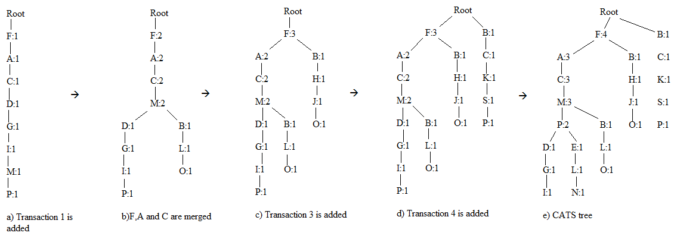
Figure 2.1 Construction of CATS tree

Given that the above tree construction step takes only a single data scan (i.e., constructing the tree without prior knowledge of data), Cheung et. al [4] admitted that their CATS tree is not guaranteed to have the maximal compression. Moreover, the tree compression is sensitive to (a) the ordering of transactions within the database and (b) the ordering of items within each transaction.
Problems/Weakness [7]
- Tree construction could be computationally expensive, because it searches for common items and tries to merge the new transaction (the entire one or a portion of it) into an existing tree path when each transaction is added. It checks existing tree paths one-by-one until a mergeable one is found. Since items are arranged according to their local frequency in the path in the CATS tree, an item may appear above another item on one branch, but below it on another branch. This makes such a search-and-merge costly.
- Extra cost is required for the swapping and/or merging of nodes.
- Since items are arranged in descending local frequency order in the CATS tree. So, during the mining process, the algorithm needs to traverse both upwards and downwards to include frequent items.
2.3.4 Can Tree
The CanTree[7] captures the contents of a transaction database with only one scan. The items are arranged according to some canonical order, which can be determined by the user prior to the mining process or at runtime during the mining process such as lexicographic order or fixed frequency-related order. The order will not be affected by the node frequency. It follows a divide and- conquer approach to mine frequent patterns, which is similar to FP-growth. The next example shows the construction of a CanTree.
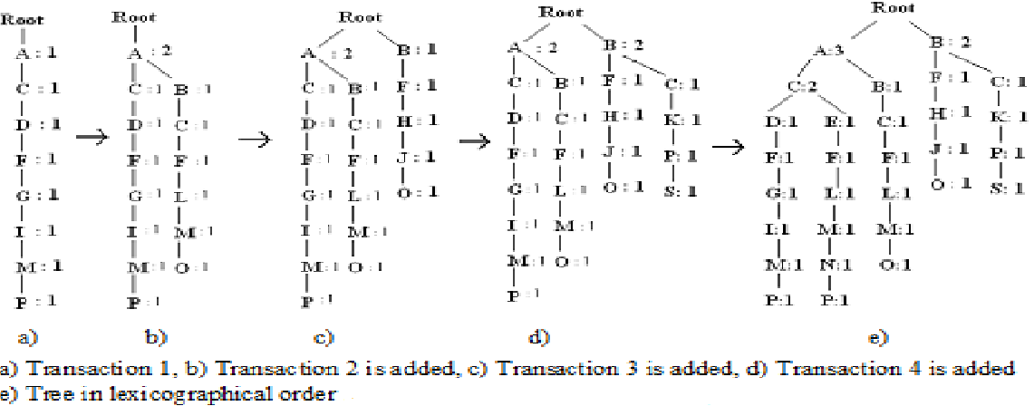
Figure 2.2 Construction of Can tree
Consider the same database as in Tab.2.1. The nodes are fixed in a pre-defined order such as lexicographic order. The transactions are sorted as t1= {A, C, D, F, G, I, M, P}, t2= {A, B, C, F, L, M, O}, t3= {B, F, H, J, O}, t4= {B, C, K, S, P}, t5= {A, C, E, F, L, M, N, P}. Each transaction is inserted into the tree and merged with the same nodes without swapping of tree nodes. The process is shown in Fig. 2.2
The CanTree is not so compacted as FP-tree and thus the mining phase takes more time than FP-tree approach if the number of frequent patterns is large. However, it offers single-pass solution, which maintains complete information suitable for incremental mining.
2.3.5 IP Tree [9]
After analyzing the above tree-based algorithm, we introduce IP-tree that contains all nodes appearing in the original database following a frequency-descending order. Like the tree structure mentioned in earlier algorithms, transactions are firstly inserted into IP-tree according to a lexicographic or alphabetic order. Meanwhile, the actual support of each item is recorded into F-list. After one scan of the database, we rearrange F-list in frequency descending order and restructure the tree nodes according to this newly ordered F-list through sorting each path. The IP-tree improves the possibility of prefix-sharing among all the patterns in database with one scan and thus enhances the compactness of the tree. Once IP-tree is built, we employ a divide-and-conquer approach to mine frequent patterns.
Algorithm [9]
Input: a transaction database
Output: an improved pattern tree
Step 1 Construct an IP-tree and obtain F-list
T ← Root
F ←Ø
For all transactions in the database, do the following. Sort each transaction in a lexicographic order. Let the sorted transactions be [p | P], where p is the first element and P is the remaining item. Then call Insert ([p/ P], T).
Insert ([p / P], T) is performed as follows.
For each child node N in T
If N.itemname=p.itemname
Then N.frequency++
If P!= Ø
Then Insert (P, N)
Create a new node N’
N’. itemname ← p.itemname
N’. frequency ←1
T.childList ← N’
If P is nonempty
Then Insert (P, N’)
Step 2 Restructure the initial tree
Sort F in frequency descending order as F-list
Set T’ ← Root
For each unprocessed path Pi in T
If Pi is a sorted path
Then Insert (Pi, T’)
Else Sort (Pi)
Terminate when all paths are processed and output IP tree
Sort (P)
{Set the support of all nodes in P as the node next to the last branching node.
Sort P in an array according to F-list as P’.
Call Insert (P’, T’)
Remove P from T}
Consider the same database as in Tab.2.1. Initialize T with a root and an empty F-list. During the first step, the tree is constructed following the lexicographic order by merging the same node. The result is shown in Fig. 2.3(a). In the second step, the F-list is sorted as { (F:4), (C:3), (A:3), (B:3), (M:3), (P:3), (L:2), (O:2), (D:1), (E:1), (G:1), (H:1), (I:1), (J:1), (K:1), (N:1), (S:1)}. The first path {(A: 3), (C: 2), (D: 1), (F: 1), (G: 1), (I: 1), (M: 1), (P: 1)}, which is an unsorted path according to the definition, will turn to Sort (P). The support of the path is set as node <D:1> and P sorted as P′ {(F:1), (C:1), (A:1), (M:1), (P:1),(D:1), (G:1), (I:1) }, after which Insert (P, T′) is called. The second path becomes {(A:2), (C:1), (E:1), (F:1), (L:1),(M:1), (N:1), (P:1) }. By the same process as the first path, the next four paths are processed in the same fashion and inserted to the new tree. When all paths are processed and inserted into the new tree, we can output IP-tree. The result is shown in Fig. 2.3(b). Based on the restructuring mechanism, each path in T is sorted according to F-list and put back to T′. So there is one path in T′ corresponding to one path in T, and vice versa. In other words, IP-tree contains the complete information of database. The tree structure also contains header table and itemname, count and nodelink for each node. There is no need to readjust the link pointers of items in the F-list.

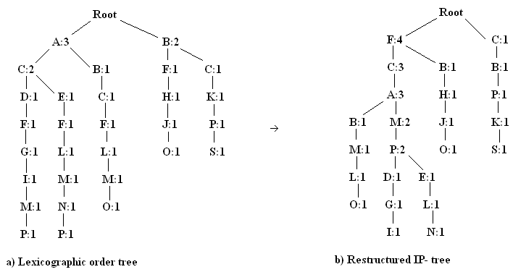
Figure 2.3 Transformation of Lexicographic tree to IP- tree

2.4 Summary

In this chapter, we have surveyed the broad area of Data Mining with a specific focus on Association rule mining. We have also introduced various techniques of data mining. The problem definition of Association Rule mining and its benefits and application are explored in detail. We have also surveyed many of the earlier algorithms for frequent pattern mining like Apriori, FP Growth, CATS, Can, IP trees etc. and also explain them in detail using pseudo-code and example. We found that all the earlier algorithms are either lack in memory or in execution time. So we have proposed a new efficient algorithm in the next chapter.

Chapter 3: Proposed Algorithm for Frequent Pattern Mining
The objective of this chapter is to introduce our approach to frequent pattern mining and to provide details of the work carried out in acquiring frequent patterns from the data sets. In particular, we will suggest our approach to give a time efficient algorithm for finding the frequent patterns from a large data set.
The chapter is organized as follows. Section 3.1 gives the detailed description of the proposed algorithm with. Section 3.2 provides the algorithm of the proposed algorithm. Section 3.3 provides the comparison of the proposed algorithm with the earlier algorithms. Finally section 3.4 summarizes the chapter.
3.1 Traditional Approach Weakness
To overcome the drawbacks of earlier algorithms, we need to improve the process of finding the frequent patterns that allow the analysts to make useful enhancements in corresponding field.
It was found that all earlier algorithms are either take multiple scan of the database or is not much time efficient in finding the frequent patterns.
This way we reach a point where many researchers are trying to give a more efficient algorithm for finding the frequent pattern. Cheung et al. gives CATS algorithm which is very much improved over FP Growth as it takes only a single scan but it needs many swapping that makes it too complex. Leung et al. provides the Can tree that has reduced the complexity of CATS algorithm but it too suffered with memory issues. Ming et al. has proposed a very good algorithm that is very much time efficient. Their proposed tree is the combination of CATS and Can tree and gives a highly compact tree that is very time efficient. But still there is a scope to improve the execution time of this algorithm as this algorithm does not include the pruning while constructing the tree.
Another factor is that many traditional approaches do not include the incremental and interactive nature of data set but as data is continuously increasing so it is important to make an algorithm that efficiently make frequent patterns from the incremental data set.
We propose a simple solution that time efficiently find all frequent patterns and also support the incremental and interactive nature of data sets
3.2 Proposed Algorithm
We have reviewed many algorithms like Apriori, FP Growth, Can tree, CATS tree, IP tree in previous chapter. In this section, a new tree structure is proposed for mining freque nt pattern. It is an extended version of the IP tree structure.
3.2.1 Tree Construction
The FP –growth technique which mines frequent pattern without candidate generation require two database scans to achieve highly compact frequency descending tree(FP- tree). Our proposed tree on the contrary build FP tree like frequency descending compact tree structure with only one database scan. At first transactions are inserted into tree according to some predefined item order (lexicographical item order) one by one. The frequent items of this initial tree are then inserted into hash list, H in frequency descending order. Finally tree is restructured by sorting the items in each path according to the Hash list and removes the items that are not frequent. By this way we get final frequency order tree in highly compact form.
In summary, tree construction mainly consists of two phases:
- Insertion Phase: Scan transactions and insert it into a tree in lexicographical item order. Finally Hash List, H is created that consists of all frequent items sorted in the frequency descending order.
- Restructuring Phase: Restructures the tree nodes on the basis of H-List and prune the infrequent nodes i.e. the item name that are not in the Hash list, H.
These two phases are executed in sequential order starting with the insertion phase by scanning and inserting the first part of DB, and finishing with the restructuring phase.
We use an example to illustrate the construction of proposed tree from the sample database shown in Table 3.1 that shows a sample database with corresponding transaction Ids.
Transaction | Original Items | Items in lexicographical order
1 | F, A , C , D , G , I , M , P | A , C , D , F , G , I , M , P
2 | A , B , C , F , L , M , O | A , B , C , F , L , M , O
3 | B , F , H , J , O | B , F , H , J , O
4 | B , C , K , S , P | B , C , K , P , S
5 | A , F , C , E , L , P , M , N | A , C , E , F , L , M , N , P
Table 3.1 Sample database

3.2.1.1 Example
Consider a sample database shown in table 3.1 and the user given support threshold equal to 3. According to algorithm the order of items in the tree is arranged in descending order according to minimum support of the items. The rightmost column of table 3.1 lists all items in each transaction follow the lexicographical order.

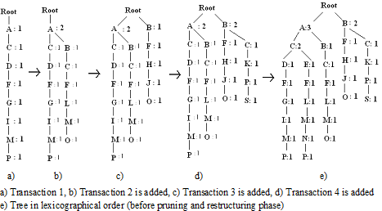
Figure 3.1 Construction of initial tree (Lexicographic order tree)
The construction of proposed tree starts with an insertion phase. We also assume that the tree construction begins by inserting the transactions in the predefined item order (e.g. lexicographical item order). Initially, the tree is empty which means it starts with a ‘null’ root node. Like an FP-tree, our proposed tree contains nodes representing an itemset and the total number of passes (i.e. support) of that itemset in the path from the root up to that node. The scan of the first transaction leads to the construction of first branch of the tree: ((A: 1), (C: 1), (D: 1), (F: 1), (G: 1), (I: 1), (M: 1), (P: 1)). Notice that all items in the transaction would be inserted into the tree according to the lexicographical order. The second transaction (A, B, C, F, L, M, O) share the same prefix ‘A’ with existing path. So the count of each shared prefix is increased by 1 and the remaining item list (B, C, F, L, M, and O) would be created as new node and one new node (B: 1) is linked as the child of (A:2) and (C: 1) is linked as the child of (B: 1) and so on. For the third transaction it does not share any node with earlier transactions. So it is directly connected to the root node of the tree. The remaining transactions in database can be done in the same way.
After scanning all the transactions, we will get the count of each item as (A:3, B:3, C:4, D:1, E:1, F:4, G:1, H:1, I:1, J:1, K:1, L:2, M:3, N:1, O:2, P:3, S:1) and the incompact tree is shown in fig. 3.1. According to definition we need to retain only that item whose support is greater than or equal to 3. So we remove the nodes with the item name (D, E, G, H, I, J, K, L, N, O, and S) and the remaining frequent item with their support value is shown in the hash table 3.2
Item Name | C | F | A | B | M | P
Frequency | 4 | 4 | 3 | 3 | 3 | 3
Table 3.2 Hash Table (frequent items with their support value)
Once we have initial lexicographic order tree we make a final more compact tree of frequent items only by applying the restructuring phase. In this phase each path of the tree is restructured by removing the infrequent items and sorted the remaining frequent items according to the items in Hash table and inserts this path into a new tree. Fig. 3.2 shows the step by step construction of the restructuring phase of the initial lexicographic order tree.
The first path P in the initial tree of fig. 3.1(e) ((A: 3), (C: 2), (D: 1), (F: 1), (G: 1), (I: 1), (M: 1), (P: 1)) has count value of 1 for the last node. So a new path P’ is created from P with count value set to 1 for all nodes. Now P’ contains three infrequent items D, G, I. Therefore these items are removed and the remaining path is sorted as C: 1, F: 1, A: 1, M: 1, P: 1 and this path is inserted into the new tree T’ as shown in fig 3.2(a). Similarly second path (A:2, C:1, E:1, F:1, L:1, M:1, N:1, P:1) contains three infrequent items E,L,N. Therefore these items are removed and the sorted path C:1, F:1, A:1, M:1, P:1 is inserted into the new tree(fig. 3.2 b).Similarly all other paths from the initial tree are inserted into the final tree(fig. 3.2c-3.2e) and fig 3.2e is the final proposed tree which is highly compact and consists of only frequent items which makes the mining of frequent patterns very fast.
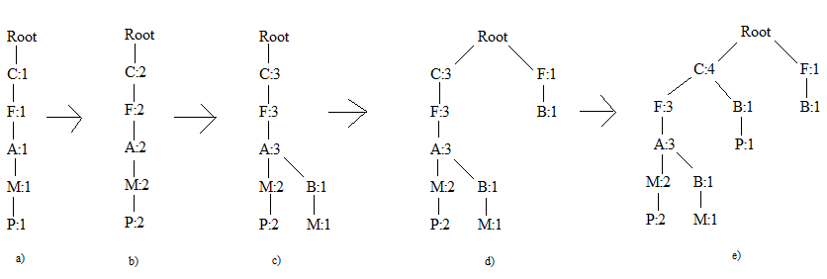
Figure 3.2: Restructuring of lexicographic order tree
To facilitate tree traversal, an item header table is built in which each item points to its occurrences in the tree via the node-link. Nodes with the same item-name are linked in sequence via such node-links. After all the transactions are scanned, the tree with the associated node-links is shown in Figure 3.3.
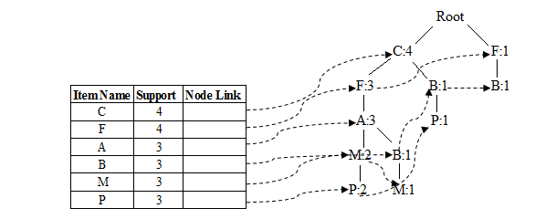
Figure 3.3 Proposed Tree
3.2.1.2 Algorithm
According to the definition we have the following tree construction algorithm:
Input: A Transaction database
Output: An Improved pattern tree
Step 1: Construct an initial tree and obtain hash List H
Set T ← Root
H ← Ø
ArrayList data [ itemname][frequency]
For each (Transaction [p | P] in database)
//p is the first item and P is the remaining item
Insert_Tree ([p | P], T);
Foreach ( Item I in [p | P] )
Insert_ArrayList (I,data);
For each (object obj in data.OrderByDescending(frequency) )
If ( obj.support >= minSupport)
Then H.Add(obj);
Step 2: Restructure the initial tree
Set T’ ← Root
For each unprocessed path P_{i} in T
For every item pi in P_{i}
If (! H.Contains(pi))
Pi.Remove (pi);
If P_{i} is a sorted path
Then Insert (P_{i ,} T’);
Else
Sort (Pi);
Terminate when all paths are processed and output final tree
Insert_Tree([p / P],T)
{
For each (child node N in T)
If ( N.itemName == p.itemName)
Then N.Frequency++;
If (P ≠ Ø)
Then Insert (P,N);
If (no child node in T matches the p.itemName)
Then Create a new node N’;
N’.itemname ← p.itemname;
N’.frequency ← 1;
T.childList ←N’;
If (P ≠ Ø)
Then Insert (P,N’);
}
Insert_ArrayList(I,data)
{
If (data.Contains(I))
Then data[I].frequency++;
Else
data.Insert(I);
data[I].frequency=1;
}
Sort (P)
{
Set the support of all nodes in P as corresponding to the last node in the path;
Sort P in an array according to H as P’;
Insert (P’,T’);
Reduce the support value of all the nodes in P from the support of last node in P;
}

3.2.2 Mining Frequent Patterns
The primary goal of constructing the tree is to obtain a significant improvement in mining performance based on its compact tree structure. Once the proposed tree is constructed, we can employ the FP-growth mining technique discussed in 2.4.2 applied on it to find the frequent patterns. Conditional Pattern Base and Conditional FP Tree for the proposed tree (shown in fig 3.3) are shown in the following table.
Item | Conditional Pattern Base | Conditional FP-tree
P | CFAM:2 , CB:1 | (C:3) | P
M | CFA:2, CFAB:1 | (C:3, F:3 , A:3 ) | M
B | CFA:1, C:1, F:1 | Empty
A | CF:3 | (C:3, F:3) |A
F | C:3 | (C:3) |F
C | Null | Empty
Table 3.3 Conditional Pattern Base and Conditional FP-tree
3.3 Comparison with other algorithms
Table 3.4 describe the comparison between the proposed algorithm, FP Tree, CATS tree, Can tree and IP tree. Also, earlier we have explained the drawbacks for Apriori algorithm also which clearly shows its differences with the proposed algorithm.
FP Tree | CATS Tree | Can Tree | IP Tree | Proposed Algorithm
Contains only frequent items. | Contains all items in every transaction | Contains all items in every transaction but in canonical order | Contains all items in every transaction | Initially contains all items in every transaction then after pruning contain only frequent items.
Two scan of database require to make FP tree | Only one scan on database is required to maintain the CATS tree | Only one scan on database is required to maintain the Can tree | Only one scan on database is required to maintain the IP tree | Only one scan on database is required to maintain the tree.
Items are arranged in descending order of frequency of database. | Items are arranged in descending order of local frequency in each path of CATS tree. | Items are arranged according to some canonical order | Items are first arranged in canonical order and then arranged in order of frequency of database. | Items are first arranged in canonical order and then only frequent items are arranged in order of frequency of database.
Update to database may cause splitting or merging of nodes | Update to database may require splitting or merging of nodes | Update to database does not lead to swapping of nodes | Update to database does not lead to swapping of nodes | Update to database does not lead to swapping of nodes
Execution time is least as it takes 2 database scans | Execution time is wasted in swapping or merging of nodes | Execution time may be large or small depend on the compactness of the tree | Execution time is better as it overcomes the drawback of CATS and Can tree. | Pruning of infrequent item makes its execution time fastest among all other algorithms.
Table 3.4: Proposed Algorithm vs Earlier Algorithms
3.4 Summary
In this chapter, we have identified the drawbacks in the existing methods used to solve the frequent pattern mining. With respect to this, we have introduced our approach to frequent pattern mining by proposing an efficient algorithm and explain it in detail with example and algorithm. We also described the advantage of our approach and finally chapter ends with the comparison of the proposed algorithm with the existing methods.
Chapter 4: Implementation and Experimental Results
4.1 Environmental Setup
We have used the following configuration while finding the experimental results
4.1.1 Hardware Configuration
Processor : Intel Core 2 Duo
Processor Speed : 2.20GHz
Main Storage : 4GB RAM
Hard Disk Capacity : 80GB
Monitor : Samsung 17”5’ Color
4.1.2 Software Configuration
Operating System : Windows 7
Front end : C#.Net
Back end : Datasets (explained in 4.2)
4.2 Datasets
In our proposed system, we had assumed four datasets ( 2 real and 2 synthetic) which are used to find the experimental results of the comparison of our proposed algorithm with the earlier algorithms. These four datasets are further elaborated as given below in the next section.
4.2.1 Real Datasets
We have used two set of real datasets namely Microsoft Web data [19] and BMS-Web View1 [20] to prove the efficiency of our proposed algorithm.

4.2.1.1 Microsoft Web data [19]
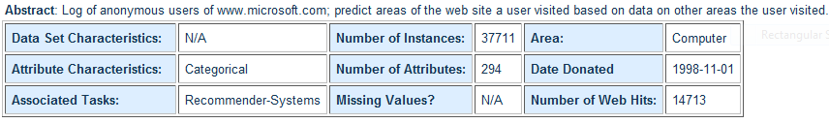
Figure 4.1 Details of Microsoft Web data
This data was created by sampling and processing the www.microsoft.com logs. The data records the use of www.microsoft.com by 38000 anonymous, randomly-selected users. For each user, the data lists all the areas of the web site (Vroots) that user visited in a one week timeframe.
Users are identified only by a sequential number, for example, User #14988, User #14989, etc. The file contains no personally identifiable information. The 294 Vroots are identified by their title (e.g. "NetShow for PowerPoint") and URL (e.g. "/stream"). The data comes from one week in February, 1998.
Dataset format:
The data is in an ASCII-based sparse-data format. Each line of the data file starts with a letter which tells the line's type. The three line types of interest are:
- Attribute lines: For example, ‘A,1277,1, "NetShow for PowerPoint","/stream"' where:
'A' marks this as an attribute line,
'1277' is the attribute ID number for an area of the website (called a Vroot),
'1' may be ignored,
‘NetShow for PowerPoint' is the title of the Vroot,
"/stream" is the URL relative to http://www.microsoft.com
- Case and Vote Lines: For each user, there is a case line followed by zero or more vote lines. For example:
C,"10164",10164
V,1123,1
V,1009,1
V,1052,1
Where:
'C' marks this as a case line,
'10164' is the case ID number of a user,
'V' marks the vote lines for this case,
'1123', 1009', 1052' are the attributes ID's of Vroots that a user visited.
'1' may be ignored.
4.2.1.2 BMS-WebView-1
The BMS-WebView-1 datasets contains several months’ worth of clickstream data from two e-commerce web sites [21]. Each transaction in this dataset is a web session consisting of all the product detail pages viewed in that session. That is, each product detail view is an item. The goal of dataset is to find associations between products viewed by visitors in a single visit to the web site. We are making the BMSWebView-1 dataset available to the research community. This dataset comes from a small dot-com company called Gazelle.com, a legwear and legcare retailer, which no longer exists; a portion of their data was used in the KDD-Cup 2000 competition [22]. The access information is available from the KDD-Cup 2000 home page at http://www.ecn.purdue.edu/KDDCUP.

4.2.2 Synthetic Datasets
We have also included two IBM-Artificial dataset [23], typically designated T10I4D100K, T40I1D100K which is often used in the association rule research community. This dataset was generated using a data generator obtained from IBM Almaden [24]. Table 4.1 gives the overview of all the real and synthetic data sets that we have used for experimental results.
Dataset | Type of Data | Transactions | Distinct Items
Microsoft Web Data | Real | 37711 | 294
BMS-Web-View 1 | Real | 59602 | 497
T10I4D100K | Synthetic | 100000 | 870
T40I1D100K | Synthetic | 100000 | 942

Table 4.1 Dataset Characteristics

4.3 Analysis and Results
In this section, we present the experimental analysis and results on the performance of our proposed tree algorithm. We compare the performance of our proposed tree with that of CanTree in terms of memory requirement and with Apriori, FP Growth, CATS, Can and IP tree in terms of time consumption. The runtime reported in different figures in this section are the average of multiple runs in each case.
The experiments are pursued on several synthetic datasets, developed at IBM Almaden Quest research group [24] and real datasets obtained from UCI Machine Learning Repository [23]. We obtain consistent results for all of the above datasets. We divide the experimental analysis in two parts: in the first part we examine the performance in memory requirement and in the next part we study the performance comparison in runtime.
4.3.1 Memory Comparison
We study the memory requirement of the proposed tree with the variation of support threshold on different datasets as described above. The results are presented in Fig. 4.2, which indicates the size of tree. The x-axes in the graphs in the figure report the change in support threshold in each case. It can be observed from the figures that, irrespective of dataset types and sizes, the lower the minimum support value, the higher the memory requirements. The reason is that, with lowering the minimum support value, more and more itemsets become frequent, and the tree size increases accordingly. However, for the graphs in Fig. 4.2 we can observe that proposed tree requires reasonably less amount of memory to store the tree structure in all datasets presented in the experiment than memory requirement in Can tree as in Can tree the items are stored in lexicographical order than frequency descending order.
Support (%) | Proposed Algorithm | Can Tree
12 | 2 | 3.66
10 | 2 | 3.66
8 | 7 | 46.13
6 | 10.23 | 50.34
4 | 29.1 | 89.57
Table 4.2 (a): Memory Comparison on Microsoft Web data
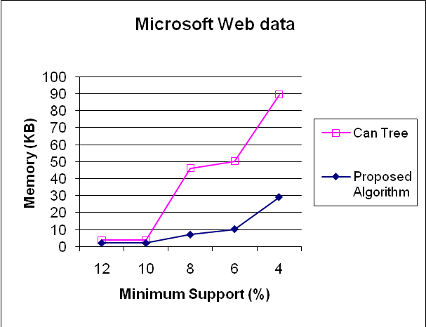
Figure 4.2 (a): Memory Comparison on Microsoft Web data

Support (%) | Can Tree | Proposed Algorithm
5 | 0.77 | 0.0044
4 | 1.49 | 0.096
3 | 2.86 | 0.75
2 | 5.42 | 3.5
1 | 8.93 | 7.86
Table 4.2 (b): Memory Comparison on T10I4D100K

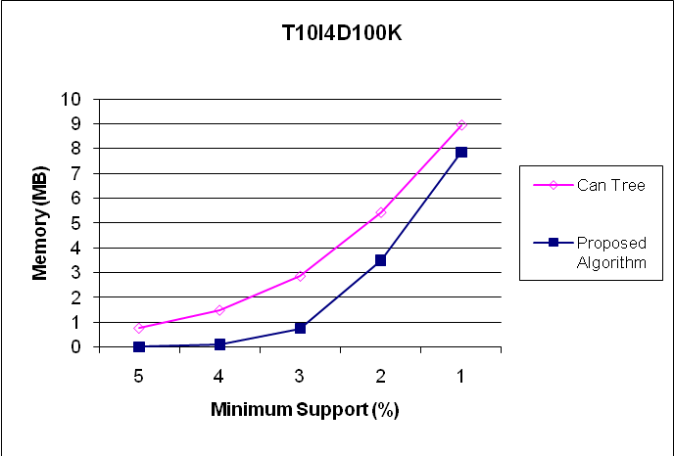
Figure 4.2(b): Memory Comparison on T10I4D100K

Support (%) | Proposed Algorithm | Can Tree
8 | 18.37 | 22.58
7 | 23.5 | 27.1
6 | 28.61 | 31.98
5 | 34.19 | 36.9
4 | 39.28 | 41.78
Table 4.2 (c): Memory Comparison on T4014D100K

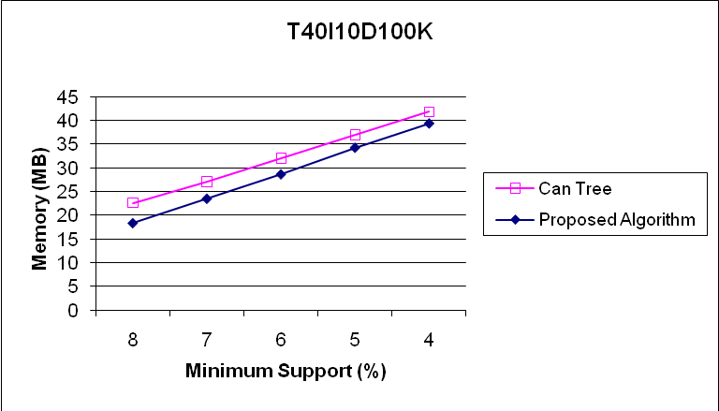
Figure 4.2(c): Memory Comparison on T40I1D100K

4.3.2 Runtime Comparison
In this section, we compare the runtime between proposed tree, IP tree and FP Growth. The results are illustrated in Fig. 4.3. The x-axis in each graph shows the change of support threshold value in decreasing order and y-axis indicates the overall runtime for each algorithms. The graphs in Fig. 4.3 demonstrate that the runtime of proposed tree is rather stable with respect to the change of support threshold, and it is much lower than that of all other algorithms in all datasets. The gain in our proposed algorithm is due to pruning of the infrequent items while constructing the tree. On the contrast, In IP tree no pruning takes place and in FP Growth there are two scans of database that makes them time inefficient.
Support (%) | Proposed Algorithm | IP tree | FP Growth
12 | 52.05 | 102.24 | 126.89
10 | 60.95 | 112.77 | 139.81
8 | 88.76 | 143.48 | 170
6 | 156.27 | 205.46 | 245
4 | 297.8 | 332.6 | 369.29
Table 4.3 (a): Time Comparison on T40I1D100K

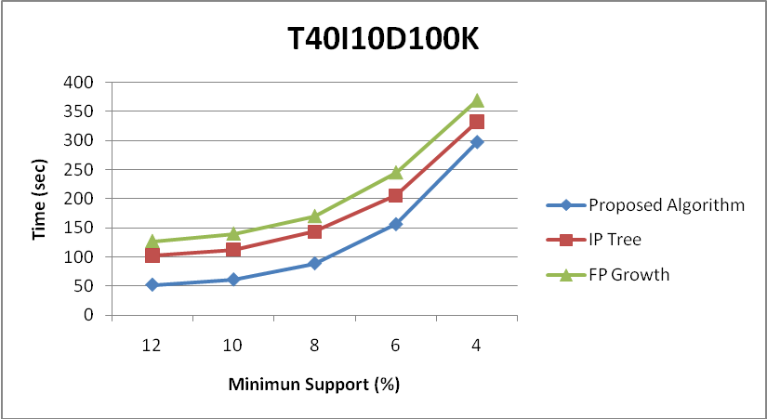
Figure 4.3 (a): Time Comparison on T40I1D100K

Support (%) | Proposed Algorithm | IP Tree | FP Growth
6 | 12.31 | 22.79 | 48.4
5 | 13 | 23 | 49.3
4 | 13.6 | 23.3 | 49.6
3 | 14.5 | 24.6 | 51.2
2 | 17.7 | 27.8 | 56.9

Table 4.3 (b): Time Comparison on T1014D100K

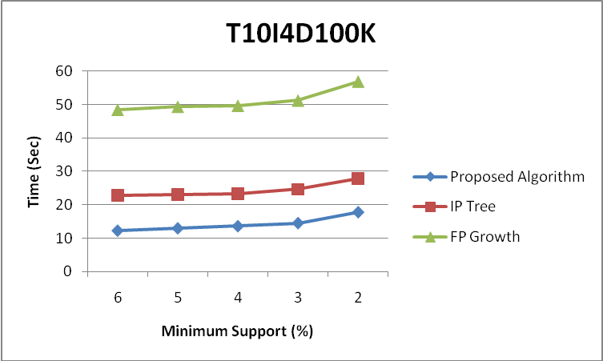
Figure 4.3 (b): Time Comparison on T1014D100K

Support (%) | Proposed Algorithm | IP Tree | FP Growth
6 | 0.407 | 0.529 | 3.76
5 | 0.437 | 0.55 | 3.804
4 | 0.46 | 0.567 | 3.856
3 | 0.482 | 0.576 | 3.918
2 | 0.509 | 0.614 | 4.008
Table 4.3 (c): Time Comparison on Microsoft Web data
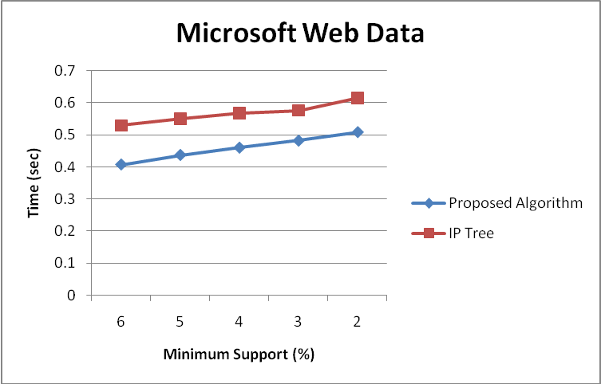
Figure 4.3 (c): Time Comparison on Microsoft Web data
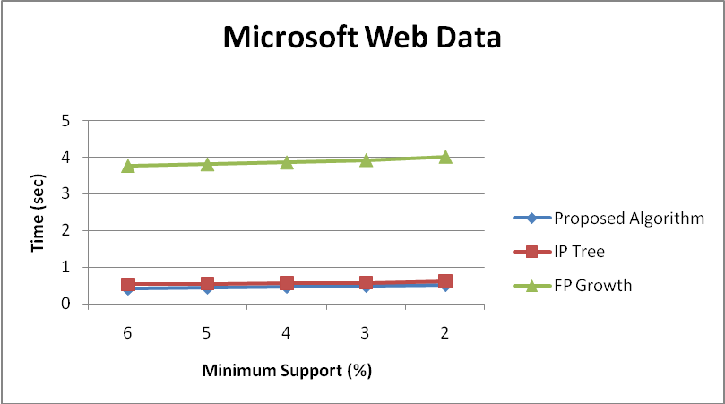
Figure 4.3 (d): Time Comparison on Microsoft Web data
Support (%) | Proposed Algorithm | IP Tree | FP Growth
5 | 2694 | 3679 | 17559
4 | 2725 | 3721 | 18028
3 | 2741 | 3750 | 18412
2 | 2820 | 3837 | 18714
1 | 3152 | 4198 | 22270
Table 4.3 (d): Time Comparison on BMS-WebView-1
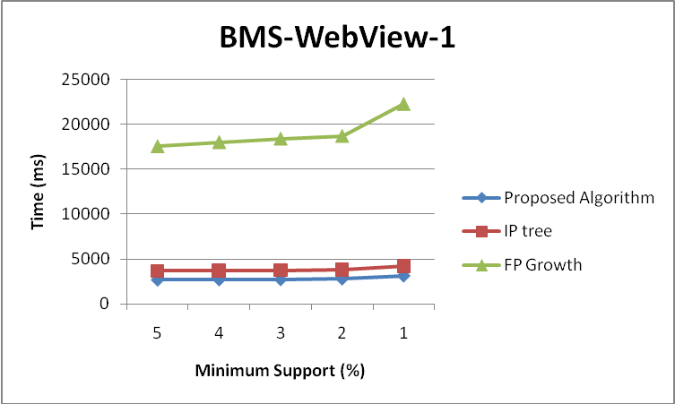
Figure 4.3 (e): Time Comparison on BMS-WebView-1
Above experimental analysis demonstrates that, mining frequent patterns with proposed tree is rather time and memory efficient compared to that with IP tree, Can tree, FP Growth algorithm etc.
4.4 Summary
In this chapter I have introduced the environmental setup which I have used while making the experimental results. In addition to this I have also explain the types of dataset which I have used and explain them in detail. Finally I have mentioned all the analysis and experimental results that we have got and found that our proposed algorithm is both time and memory efficient in comparison to earlier algorithms.

Chapter 5: Conclusion & Future Scope

5.1 Conclusion
In this thesis, a new algorithm for frequent pattern mining is proposed. We have analyzed many of the earlier algorithms like Apriori, FP Growth, CATS tree, Can tree, IP tree etc. and found that either they lack in execution time or they take large amount of memory. So we propose a new algorithm in which the transactions are firstly retrieved from the database in lexicographic order, and then stored in a tree. During the second step, pruning of infrequent nodes is performed and then the remaining frequent nodes are arranged in a frequency-descending order, and then each path of the tree is sorted according to the updated order. The best part of our proposed algorithm is that only one scan is required to construct the tree and also is very memory efficient. It can also support the incremental nature of the database. We have also introduced the comparison of the proposed algorithm from the earlier algorithms.
The performance of the proposed algorithm is compared with the earlier algorithms using various real and synthetic data sets. Experimental results clearly show that the proposed algorithm is highly efficient in terms of both memory and execution time.

5.2 Future Scope
- Using our proposed algorithm, a large number of association rules are generated depending on the confidence but it does not give any information about interesting rules. So our work can be extended to give better interesting rules.
- These days a lot more research is going on Web mining as there are large amount of data available in incremental web logs. So our algorithm can be extended to mine the patterns form the web usage data more efficiently.
- Our proposed algorithm can become more efficient for incremental data mining.
In general, we feel that as a young research field in data mining, frequent pattern mining has achieved tremendous progress and claimed a good set of applications. However, in-depth research is still needed on several critical issues so that the field may have its long lasting and deep impact in data mining applications.

REFERNCES

- M.Klemettinen, H.Mannila, P. Ronkainen, H.Toivinen, and A.I. Verkamo. “Finding interesting rules form large sets of discovered association rules”. In CIKM’94, pp.401-408.
- Agrawal, R. and Srikant, R. “Fast algorithms for mining association rules.” VLDB-94, 1994.
- J.Han, J.Pei, Y.Yin Mining frequent patterns without candidate generation, In: Proc. the 2000 ACM SIGMOD International Conference on Management of Data, pp. 1-12, (2000)
- Cheung W, Zaïane OR. Incremental mining of frequent patterns without candidate generation or support constraint[C]. In: Proc IDEAS 2003. Hongkong, China, 2003. 111-116.
- http://cis.poly.edu/~mleung/FRE7851/f07/introDataMining1.pdf
- Agrawal, R.; Imielinski, T.; and Swami, A. Mining Associations between Sets of Items in Massive Database. Proc. Of the ACM SIGMOD Int’l Conference on Management of Data, pp. 207-216, Washington D.C., May 1993.
- Leung,C.; Khan,I.; and Hoque,T., CanTree (2005). A Tree Structure for Efficient Incremental Mining of Frequent Patterns Proceedings of the Fifth IEEE International Conference on Data Mining
- Tanbeer,S.; Ahmed,F.; Jeong,S.;(2008). Efficient single-pass frequent pattern mining using a prefix-tree Department of Computer Engineering, Kyung Hee University, Information Sciences pp. 559–583
- Ming,Z.; Taiyong,W.;(2010) Improved Pattern Tree for Incremental Frequent-Pattern Mining Springer-Verlag Berlin Heidelberg. pp. 129-134
- “CAKE – Classifying, Associating & Knowledge Discovery An Approach for Distributed Data Mining (DDM) Using Parallel Data Mining Agents (PADMAs)”,Danish Khan, 2008 IEEE/WIC/ACM International Conference on Web Intelligence and Intelligent Agent Technology
- Yan Chen1, Ming Yang2, Lin Zhang3,” General Data Mining Model System Based on Sample Data Division”, 2009 Second International Symposium on Knowledge Acquisition and Modeling
- Mouhib Al-Noukari, Wael Al-Hussan, Using Data Mining Techniques for Predicting Future Car market Demand”,DCX Case Study
- Chen, M. S.; Han, J.; and Yu, P.S. Data Mining: An Overview from a Database Perspective. IEEE Transactions on knowledge and Data Engineering, 8(6): 866-883, 1996.
- Agrawal, R.; Arning, A.; Bollinger, T.; Mehta, M.; Shafer, J. and Srikant, R. The Quest Data Mining System. Proc. Of the 2nd Int’l Conference on Knowledge Discovery in Databases and Data Mining, Portland, Oregon, August 1996
- Kumar,Santosh,Rukmani,K.V.(2010). Implementation of Web Usage Mining Using APRIORI and FP Growth Algorithms. International Journal of Advanced Networking and Applications.1 (6). Pp. 400-404
- Agrawal, R.; Imielinski, T.; and Swami, A. Database Mining: A Performance Perspective. IEEE Transactions on Knowledge and Data Engineering, Special issue on Learning and Discovery in Knowledge and Data Engineering, Special issue on Learning and Discovery in Knowledge-Based Databases, 5(6): 914-925, December 1993.
- Ali, K.; Manganaris, S.; and Srikant, R. Partial Classification using Association Rules. In Proc. of the 3rd Int’l Conference on Knowledge Discovery in Databases and Data Mining August 1997.
- Brin, S.; Motwani, R.; and Silverstein, C. Beyond Market Baskets: Generalizing Association Rules to Correlations. In Proc. of the 1997 SIGMOD Conf. on the Management of Data, pp. 265-276.
- http://archive.ics.uci.edu/ml/datasets/Anonymous+Microsoft+Web+Data
- http://www.ecn.purdue.edu/KDDCUP/data/BMS-WebView-1.dat.gz
- "Real world performance of association rule algorithms" by Zheng, Kohavi and Mason. Available at http://robotics.stanford.edu/users/ronnyk/realWorldAssoc.pdf
- Kohavi, R., Brodley, C.E., Frasca, B., Mason, L., and Zheng, Z. KDD-Cup 2000 Organizers’ Report: Peeling the Onion, SIGKDD Exploration 2(2), 2000, 86-93.
- http://fimi.ua.ac.be/data/
- http://www.almaden.ibm.com/cs/quest//syndata.html#assocSynData

APPENDIX A: CODING

using System;
using System.Collections;
using System.Collections.Generic;
using System.IO;
using System.Linq;
using System.Text;
using System.Windows.Forms;

namespace Apriori
{
public partial class frmMain : Form
{
#region Global Variables
Dictionary<int, string> m_dicTransactions = new Dictionary<int, string>();
public static Dictionary<string, double> m_dicAllFrequentItems = new Dictionary<string, double>();
int m_nLastTransId = 1;
DateTime startTime;
DateTime stopTime;
string strFileName;
private void btn_Solve_Click(object sender, EventArgs e)
{
startTime = DateTime.Now;
Solve();
}
private void Solve()
{
m_dicAllFrequentItems = null;
m_dicAllFrequentItems = new Dictionary<string, double>();
double dMinSupport = double.Parse(txt_Support.Text) / 100;
double dMinConfidence = double.Parse(txt_Confidence.Text) / 100;
Dictionary<string, double> dic_FrequentItemsL1 = GetL1FrequentItems(dMinSupport);
Dictionary<string, double> dic_FrequentItems = Dic_FrequentItemsL1;
Dictionary<string, double> dic_Candidates = new Dictionary<string, double>();
do
{
dic_Candidates = GenerateCandidates(dic_FrequentItems);
dic_FrequentItems = GetFrequentItems(dic_Candidates, dMinSupport);
}
while (dic_Candidates.Count != 0);
stopTime = DateTime.Now;
TimeSpan duration = stopTime - startTime;
MessageBox.Show(duration.TotalMilliseconds.ToString());
Dictionary<string, Dictionary<string, double>> dicClosedItemSets = GetClosedItemSets();
List<string> lstMaximalItemSets = getMaximalItemSets(dicClosedItemSets);
List<clssRules> lstRules = GenerateRules();
List<clssRules> lstStrongRules = GetStrongRules(dMinConfidence, lstRules);
frmOutput objfrmOutput = new frmOutput(m_dicAllFrequentItems,
dicClosedItemSets,
lstMaximalItemSets,
lstStrongRules);
objfrmOutput.ShowDialog();
}

private Dictionary<string, Dictionary<string, double>> GetClosedItemSets()
{
Dictionary<string, Dictionary<string, double>> dicClosedItemSetsReturn = new Dictionary<string, Dictionary<string, double>>();
Dictionary<string, double> dicParents;
for (int i = 0; i < m_dicAllFrequentItems.Count; i++)
{
string strChild = m_dicAllFrequentItems.Keys.ElementAt(i);
dicParents = GetItemParents(strChild, i + 1);
if (IsClosed(strChild, dicParents))
dicClosedItemSetsReturn.Add(strChild, dicParents);
}
return dicClosedItemSetsReturn;
}

private List<string> GetMaximalItemSets(Dictionary<string, Dictionary<string, double>> dicClosedItemSets)
{
List<string> lstMaximalItemSetsReturn = new List<string>();
Dictionary<string, double> dicParents;
foreach (string strItem in dicClosedItemSets.Keys)
{
dicParents = dicClosedItemSets[strItem];
if (dicParents.Count == 0)
lstMaximalItemSetsReturn.Add(strItem);
}
return lstMaximalItemSetsReturn;
}

private bool IsClosed(string strChild, Dictionary<string, double> dicParents)
{
foreach (string strParent in dicParents.Keys)
{
if (m_dicAllFrequentItems[strChild] == m_dicAllFrequentItems[strParent])
{
return false;
}
}
return true;
}

private Dictionary<string, double> GetItemParents(string strChild, int nIndex)
{
Dictionary<string, double> dicParents = new Dictionary<string, double>();
for (int j = nIndex; j < m_dicAllFrequentItems.Count; j++)
{
string strParent = m_dicAllFrequentItems.Keys.ElementAt(j);
if (strParent.Length == strChild.Length + 1)
{
if (IsSubstring(strChild, strParent))
{
dicParents.Add(strParent, m_dicAllFrequentItems[strParent]);
}
}
}
return dicParents;
}

private List<clssRules> GetStrongRules(double dMinConfidence, List<clssRules> lstRules)
{
List<clssRules> lstStrongRulesReturn = new List<clssRules>();
foreach (clssRules Rule in lstRules)
{
string strXY = Alphabetize(Rule.X + ' ' + Rule.Y);
AddStrongRule(Rule, strXY, ref lstStrongRulesReturn, dMinConfidence);
}
lstStrongRulesReturn.Sort();
return lstStrongRulesReturn;
}

private void AddStrongRule(clssRules Rule, string strXY, ref List<clssRules> lstStrongRulesReturn, double dMinConfidence)
{
double dConfidence = GetConfidence(Rule.X, strXY);
clssRules NewRule;
if (dConfidence >= dMinConfidence)
{
NewRule = new clssRules(Rule.X, Rule.Y, dConfidence);
lstStrongRulesReturn.Add(NewRule);
}
dConfidence = GetConfidence(Rule.Y, strXY);
if (dConfidence >= dMinConfidence)
{
NewRule = new clssRules(Rule.Y, Rule.X, dConfidence);
lstStrongRulesReturn.Add(NewRule);
}
}

private double GetConfidence(string strX, string strXY)
{
double dSupport_X, dSupport_XY;
dSupport_X = m_dicAllFrequentItems[strX];
dSupport_XY = m_dicAllFrequentItems[strXY];

return dSupport_XY / dSupport_X;
}

private List<clssRules> GenerateRules()
{
List<clssRules> lstRulesReturn = new List<clssRules>();
foreach (string strItem in m_dicAllFrequentItems.Keys)
{
int CountItem = strItem.Split(' ').Length;
if (CountItem > 1)
{
int nMaxCombinationLength = CountItem / 2;
GenerateCombination(CountItem, strItem, nMaxCombinationLength, ref lstRulesReturn);
}
}
return lstRulesReturn;
}

private void GenerateCombination(int CountItem, string strItem, int nCombinationLength, ref List<clssRules> lstRulesReturn)
{
int nItemLength = CountItem;
if (nItemLength == 2)
{
AddItem(strItem.Substring(0, strItem.IndexOf(' ')), strItem, ref lstRulesReturn);
return;
}
else if (nItemLength == 3)
{
for (int i = 0; i < strItem.Length; i = i + 5)
{
AddItem(strItem.Substring(i, 4), strItem, ref lstRulesReturn);
}
return;
}
else
{
for (int i = 0; i < strItem.Length; i = i + 5)
{
GetCombinationRecursive(strItem.Substring(i, 4), strItem, nCombinationLength, ref lstRulesReturn);
}
}
}

private void AddItem(string strCombination, string strItem, ref List<clssRules> lstRulesReturn)
{
string strRemaining = GetRemaining(strCombination, strItem);
clssRules Rule = new clssRules(strCombination, strRemaining, 0);
lstRulesReturn.Add(Rule);
}

private string GetCombinationRecursive(string strCombination, string strItem, int nCombinationLength, ref List<clssRules> lstRulesReturn)
{
AddItem(strCombination, strItem, ref lstRulesReturn);
string[] combination = strCombination.Split(' ');
string cLastTokenCharacter = combination[combination.Length - 1]; int nLastTokenCharcaterIndex = combination.Length - 1;
string[] item = strItem.Split(' ');
int nLastTokenCharcaterIndexInParent = 0;
for (int i = 0; i < item.Length; i++)
{
if (item[i] == cLastTokenCharacter)
{
nLastTokenCharcaterIndexInParent = i; break;
}

}

string cNextCharacter;
string cLastItemCharacter = item[item.Length - 1];
if (combination.Length == nCombinationLength)
{

if (cLastTokenCharacter != cLastItemCharacter)
{
strCombination = strCombination.Replace(cLastTokenCharacter, "").Trim();
cNextCharacter = item[nLastTokenCharcaterIndexInParent + 1];
string strNewToken = strCombination + ' ' + cNextCharacter;
return (GetCombinationRecursive(strNewToken, strItem, nCombinationLength, ref lstRulesReturn));
}
else
{
return string.Empty;
}
}
else
{
if (strCombination != cLastItemCharacter)
{
cNextCharacter = item[nLastTokenCharcaterIndexInParent + 1];
string strNewToken = strCombination + ' ' + NextCharacter;
return (GetCombinationRecursive(strNewToken, strItem, nCombinationLength, ref lstRulesReturn));
}
else
{
return string.Empty;
}
}
}

private string GetRemaining(string strChild, string strParent)
{
string[] child = strChild.Split(' ');
foreach (string c in child)
{
strParent = strParent.Replace(c, "").Trim().Replace(" ", " ");
}
return strParent;
}

private Dictionary<string, double> GetFrequentItems(Dictionary<string, double> dic_Candidates, double dMinSupport)
{
Dictionary<string, double> dic_FrequentReturn = new Dictionary<string, double>();
for (int i = dic_Candidates.Count - 1; i >= 0; i--)
{
string strItem = dic_Candidates.Keys.ElementAt(i);
double dSupport = dic_Candidates[strItem];
if ((dSupport / (double)(m_nLastTransId - 1) >= dMinSupport))
{
dic_FrequentReturn.Add(strItem, dSupport);
m_dicAllFrequentItems.Add(strItem, dSupport);
}
}
return dic_FrequentReturn;
}

private Dictionary<string, double> GenerateCandidates(Dictionary<string, double> dic_FrequentItems)
{
Dictionary<string, double> dic_CandidatesReturn = new Dictionary<string, double>();
for (int i = 0; i < dic_FrequentItems.Count - 1; i++)
{
string strFirstItem = Alphabetize(dic_FrequentItems.Keys.ElementAt(i));
for (int j = i + 1; j < dic_FrequentItems.Count; j++)
{
string strSecondItem = Alphabetize(dic_FrequentItems.Keys.ElementAt(j));
string strGeneratedCandidate = GetCandidate(strFirstItem, strSecondItem);
if (strGeneratedCandidate != string.Empty)
{
strGeneratedCandidate = Alphabetize(strGeneratedCandidate);
double dSupport = GetSupport(strGeneratedCandidate);
dic_CandidatesReturn.Add(strGeneratedCandidate, dSupport);
}
}
}
return dic_CandidatesReturn;
}

private string Alphabetize(string strToken)
{
string[] arrToken = strToken.Split(' ');
Array.Sort(arrToken);
string final = "";
foreach (string arr in arrToken)
final = final + arr + " ";
final = final.Remove(final.Length - 1);

return final;
}

private string[] SplitByLength(string str, int maxLength)
{
string[] arr = new string[str.Length];
int arrCount = 0;
for (int index = 0; index < str.Length; index += maxLength)
{
arr[arrCount++] = str.Substring(index, Math.Min(maxLength, str.Length - index));
}
return arr;
}

private double GetSupport(string strGeneratedCandidate)
{
double dSupportReturn = 0;
foreach (string strTransaction in m_dicTransactions.Values)
{
if (IsSubstring(strGeneratedCandidate, strTransaction))
{
dSupportReturn++;
}
}
return dSupportReturn;
}

private bool IsSubstring(string strChild, string strParent)
{
string[] child = strChild.Split(' ');
foreach (string s in child)
{
if (!strParent.Contains(s))
{
return false;
}
}
return true;
}

private string GetCandidate(string strFirstItem, string strSecondItem)
{
int nLength = strFirstItem.Length;
if (strFirstItem.IndexOf(' ') == -1)
{
return strFirstItem + " " + strSecondItem;
}
else
{
string strFirstSubString = strFirstItem.Substring(0, strFirstItem.LastIndexOf(' '));
string strSecondSubString = strSecondItem.Substring(0, strSecondItem.LastIndexOf(' '));

if (strFirstSubString == strSecondSubString)
{
return strFirstItem + " " + strSecondItem.Substring(strSecondItem.LastIndexOf(' ') + 1);
}
else
return string.Empty;
}
}
private Dictionary<string, double> GetL1FrequentItemsFP(double dMinSupport)
{
Dictionary<string, double> dic_FrequentItemsReturn = new Dictionary<string, double>();
foreach (ListViewItem lviItem in lv_Items.Items)
{
double dSupport = GetSupport(lviItem.Text);
if ((dSupport / (double)(m_nLastTransId - 1) >= dMinSupport))
{
dic_FrequentItemsReturn.Add(lviItem.Text, dSupport);
}
}
return dic_FrequentItemsReturn;
}

private Dictionary<string, double> GetL1FrequentItems(double dMinSupport)
{
Dictionary<string, double> dic_FrequentItemsReturn = new Dictionary<string, double>();
foreach (ListViewItem lviItem in lv_Items.Items)
{
double dSupport = GetSupport(lviItem.Text);
if ((dSupport / (double)(m_nLastTransId - 1) >= dMinSupport))
{
dic_FrequentItemsReturn.Add(lviItem.Text, dSupport);
m_dicAllFrequentItems.Add(lviItem.Text, dSupport);
}
}
return dic_FrequentItemsReturn;
}

private bool ItemIsRemovable(string strItem, ref List<int> lst_Transactions)
{
string strTransaction;
bool bItemRemovable = true;
foreach (int nTransaction in m_dicTransactions.Keys)
{
strTransaction = m_dicTransactions[nTransaction];
if (strTransaction.Contains(strItem))
{
lst_Transactions.Add(nTransaction);
bItemRemovable = false;
}
}
return bItemRemovable;
}

// FP Growth

public void btnFpGrowth_Click(object sender, EventArgs e)
{
startTime = DateTime.Now;

FpGrowthSolve();
stopTime = DateTime.Now;
TimeSpan duration = stopTime - startTime;
MessageBox.Show(duration.TotalMilliseconds.ToString());
Dictionary<string, double> temp = new Dictionary<string, double>();
foreach (KeyValuePair<string, double> kvp in m_dicAllFrequentItems)
{
string[] freqPattern = kvp.Key.Split(' ');
Array.Sort(freqPattern);
string final = "";
foreach (string freq in freqPattern)
{
final=final+freq+' ';
}

final=final.Remove(final.Length-1);
temp.Add(final, kvp.Value);
}
m_dicAllFrequentItems = temp;

double dMinConfidence = double.Parse(txt_Confidence.Text) / 100;

List<clssRules> lstRules = GenerateRules();
List<clssRules> lstStrongRules = GetStrongRules(dMinConfidence, lstRules);
frmOutput objfrmOutput = new frmOutput(m_dicAllFrequentItems, lstStrongRules);
objfrmOutput.ShowDialog();
}

public void FpGrowthSolve()
{

TtreeNode rootNode = new TtreeNode();
List<headerTable> headList = new List<headerTable>();
double dMinSupport = double.Parse(txt_Support.Text) / 100;
double dMinConfidence = double.Parse(txt_Confidence.Text) / 100;
int suppCount = (int)(dMinSupport * (m_nLastTransId - 1));

Dictionary<string, double> dic_FrequentItemsL1 = GetL1FrequentItemsFP(dMinSupport);
foreach (var FreqItem in dic_FrequentItemsL1.OrderByDescending(key => key.Value))
{
headList.Add(new headerTable { item = FreqItem.Key, support = FreqItem.Value });
}
foreach (string strTransaction in m_dicTransactions.Values)
{
ArrayList data = new ArrayList();

for (int i = 0; i < headList.Count(); i++)
{

if (strTransaction.Contains(headList[i].item))

data.Add(headList[i].item);
}
addFPTree(rootNode, 0, data, headList);

}

m_dicAllFrequentItems = null;
m_dicAllFrequentItems = new Dictionary<string, double>();
startMining(headList, suppCount);

}

public static void addFPTree(TtreeNode root, int place, ArrayList itemset, List<headerTable> headList)
{
if (place < itemset.Count)
{
if (!addFPTree1(root, place, itemset, headList))
{
addFPTree2(root, place, itemset, headList);

}
}
}

public static void addFPTree2(TtreeNode root, int place, ArrayList itemset, List<headerTable> headList)
{
TtreeNode node = new TtreeNode(itemset[place].ToString(), root, 1);
root.child.Add(node);
addReferenceToHeaderTable(itemset[place], node, headList);
addRestOfitemSet(root.child[root.child.Count - 1], place + 1, itemset, headList);

}

private static void addRestOfitemSet(TtreeNode TtreeNode, int place, ArrayList itemset, List<headerTable> headList)
{
if (place < itemset.Count)
{
TtreeNode node = new TtreeNode(itemset[place].ToString(), TtreeNode, 1);
TtreeNode.child.Add(node);
addReferenceToHeaderTable(itemset[place], node, headList);
addRestOfitemSet(TtreeNode.child[TtreeNode.child.Count - 1], place + 1, itemset, headList);
}
}

private static void addReferenceToHeaderTable(object p, TtreeNode node, List<headerTable> headList)
{
foreach (headerTable h in headList)
{
if (h.item == p.ToString())
{
TtreeNode temp;
temp = h.nodeLink;
h.nodeLink = node;
node.Next = temp;
break;
}
}
}

public static bool addFPTree1(TtreeNode root, int place, ArrayList itemset, List<headerTable> headList)
{
if (root.child.Count != 0)
{
for (int index = 0; index < root.child.Count(); index++)
{
if (itemset[place].ToString() == root.child[index].Info)
{
root.child[index].support++;
addFPTree(root.child[index], place + 1, itemset, headList);

return (true);
}
}
}
return (false);
}

public void startMining(List<headerTable> tableRef, int suppCount)
{
for (int index = tableRef.Count() - 1; index >= 0; index--)
{
if (tableRef[index].nodeLink != null)
{
if (tableRef[index].support >= suppCount)
{
m_dicAllFrequentItems.Add(tableRef[index].item, tableRef[index].support);
freqPattern.Add(tableRef[index].item);
j++;

startMining1(tableRef[index].nodeLink, suppCount);
}
}
}

}

private static void startMining1(TtreeNode TtreeNode, int suppCount)
{
List<headerTable> headLocal = new List<headerTable>();
Dictionary<string, int> unique = new Dictionary<string, int>();
TtreeNode localRootNode = new TtreeNode();
while (TtreeNode != null)
{
int support = TtreeNode.support;
ArrayList itemset = new ArrayList();
TtreeNode parent = TtreeNode.ParentRef;
while (parent.Info != null)
{
itemset.Add(parent.Info);
parent = parent.ParentRef;
}
itemset.Reverse();

for (int i = 0; i < itemset.Count; i++)
{
if (!unique.ContainsKey(itemset[i].ToString()))
{
unique.Add(itemset[i].ToString(), 0);
headLocal.Add(new headerTable(itemset[i].ToString()));

}
}
addLocalFPTree(localRootNode, 0, itemset, headLocal, support);
TtreeNode = TtreeNode.Next;
}
foreach (headerTable table in headLocal)
{
table.support = genSupport(table.nodeLink);
}
int z = j;
for (int index = headLocal.Count() - 1; index >= 0; index--)
{
string pattern = headLocal[index].item + ' ' + freqPattern[z - 1];

if (headLocal[index].support >= suppCount)
{
m_dicAllFrequentItems.Add(pattern, headLocal[index].support);
freqPattern.Add(pattern);
j++;
startMining1(headLocal[index].nodeLink, suppCount);
}
}

}

private static void addLocalFPTree(TtreeNode root, int place, ArrayList itemset, List<headerTable> headLocal, int support)
{
if (place < itemset.Count)
{
if (!addLocalFPTree1(root, place, itemset, headLocal, support))
{
addLocalFPTree2(root, place, itemset, headLocal, support);

}
}

}

public static bool addLocalFPTree1(TtreeNode root, int place, ArrayList itemset, List<headerTable> headLocal, int support)
{
if (root.child.Count != 0)
{
for (int index = 0; index < root.child.Count(); index++)
{
if (itemset[place].ToString() == root.child[index].Info)
{
root.child[index].support += support;
addLocalFPTree(root.child[index], place + 1, itemset, headLocal, support);

return (true);
}
}
}
return (false);
}

public static void addLocalFPTree2(TtreeNode root, int place, ArrayList itemset, List<headerTable> headLocal, int support)
{
TtreeNode node = new TtreeNode(itemset[place].ToString(), root, 0);
node.support += support;
root.child.Add(node);
addReferenceToLocalHeaderTable(itemset[place], node, headLocal);
addRestOfLocalitemSet(root.child[root.child.Count - 1], place + 1, itemset, headLocal, support);

}

private static void addRestOfLocalitemSet(TtreeNode TtreeNode, int place, ArrayList itemset, List<headerTable> headList, int support)
{
if (place < itemset.Count)
{
TtreeNode node = new TtreeNode(itemset[place].ToString(), TtreeNode, 0);
node.support += support;
TtreeNode.child.Add(node);
addReferenceToLocalHeaderTable(itemset[place], node, headList);
addRestOfLocalitemSet(TtreeNode.child[TtreeNode.child.Count - 1], place + 1, itemset, headList, support);
}
}

private static void addReferenceToLocalHeaderTable(object p, TtreeNode node, List<headerTable> headList)
{
foreach (headerTable h in headList)
{
if (h.item == p.ToString())
{
TtreeNode temp;
temp = h.nodeLink;
h.nodeLink = node;
node.Next = temp;
break;
}
}
}

private static int genSupport(TtreeNode TtreeNodeLink)
{
int counter = 0;

while (TtreeNodeLink != null)
{
counter = counter + TtreeNodeLink.support;
TtreeNodeLink = TtreeNodeLink.Next;
}

return (counter);

}
}

public class TtreeNode
{
public TtreeNode()
{
}
public TtreeNode(string info, TtreeNode Parent, int supp)
{

this.Info = info;
this.ParentRef = Parent;
this.support = supp;
}
public string Info;

public int support = 0;

public TtreeNode ParentRef = null;

public TtreeNode Next = null;

public List<TtreeNode> child = new List<TtreeNode>();
}

public class headerTable
{
public string item;
public double support = 0;
public TtreeNode nodeLink = null;
public headerTable()
{
}
public headerTable(string info)
{
item = info;
}

}
}

APPENDIX B: SCREEN SHOTS

