LIST OF ABBREVIATIONS

KDD Knowledge Discovery from Data
DSS Decision Support System
KDDS Knowledge Discovery Decision Support System
TKMM Tired Knowledge Management Model
CRM Customer Relationship Management
KSQAO Karnataka State Quality Assessment Organization
DM Data Mining
CHAID Chi-Squared Automatic Interaction Detection
ANN Artificial Neural Network
C&R Tree/CRT Classification and Regression Trees
ID3 Iterative Dichotomise
AIEEE All India Engineering Entrance Examination
MS SQL Microsoft Structured query language
REM Remarks
LIST OF FIGURES

Figure Page No
Figure 1.1: A KDD System 5
Figure 2.1: Recommender System Architecture 8
Figure 2.2: Relation between Explicit and Tacit Knowledge 10
Figure 2.3: Topography of Tiered Knowledge Management Model (TKMM) for explicit knowledge 11
Figure 3.1: High Level Flow of Data Mining Activities 15
Figure 3.2: CRISP-DM [12] 16
Figure 3.3: Block diagram of “KDD based Technique” 17
Figure 3.4: D Tree 19
Figure 3.5: Neurons are organized into layers 21
Figure 4.1: Using C5.0/See5 Algorithm 29-30
(a) Stream Canvass with a ratio of Placement to family pressure
(b) Inputs without derived class
(c) Inputs with derived class with a condition that based on family pressure
Figure 4.2: Stream Canvass Using C&R Tree Algorithm 30
Figure 4.3: Stream Canvass Using ANN Algorithm 31
Figure 4.4: Distribution of BRANCH Attribute 33
Figure Page No
Figure 4.5: Data Audit view 34
Figure 4.6: Web graph of Branch vs. Family pressure 35
Figure 4.7: Distribution graph of Family pressure vs. Semester performance 36
Figure 4.8: Histogram of Semester performance 37
Figure 4.9: Distribution of Branch field from Derived class 38
Figure 4.10: Graph view of Table 4.2.4 38
Figure 4.11: Graph view of Table 4.2.5 39
Figure 4.12: Graph view of Table 4.2.6 40
Figure 4.13: Graph view of Table 4.2.7 41
Figure 4.14: Graph view of Table 4.2.8 42
Figure 4.15: Graph view of Table 4.2.9 45
Figure 4.16: (a) Login 47
(b) home page 47
Figure 4.17: Creation of Student DB 48
Figure 4.18: Placement Strategy 49
Figure 4.19: (a) Student Search 50
(b) Mining Branch 50

LIST OF TABLES

Table Page No
Table 4.2.1: List of Eligible candidates for Central Counselling 32
Table 4.2.2: List of Eligible candidates after merging student and discipline DB 33
Table 4.2.3: Partition of Data for Training and Testing 35
Table 4.2.4: Analysis of Algorithms using Training partition size 45 and Testing partition size 55 38
Table 4.2.5: Analysis of Algorithms using Training partition size 50 and Testing partition size 50 39
Table 4.2.6: Analysis of Algorithms using Training partition size 55 and Testing partition size 45 40
Table 4.2.7: Analysis of Algorithms using Training partition size 70 and Testing partition size 30 41
Table 4.2.8: Analysis of Algorithms using Training partition size 30 and Testing partition size 70 42
Table 4.2.9: Overall Analysis of Algorithms using different Training partition size and Testing partition size 43-44

CHAPTER-1
INTRODUCTION

1.1 Background
The primary objective of decision support systems is to analyze large pools of data. The knowledge discovery from data involves data preprocessing, data transformation, data mining techniques like classification & clustering etc, Pattern evaluation and knowledge presentation techniques [9].These techniques are used to discover the knowledge that can be applied to decision making, process control, information management. A KDD system is shown in figure 1.1.
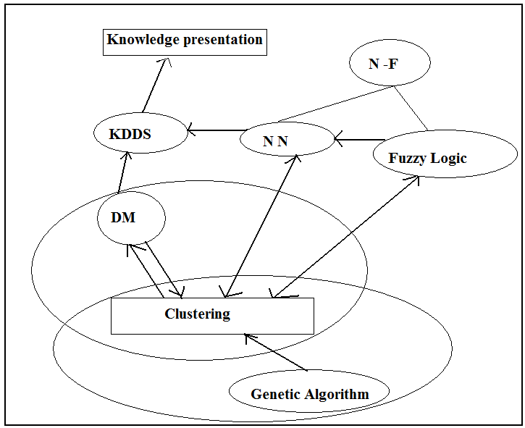
Figure 1.1: A KDD System [3]
In context of higher engineering education planning, a KDD system also enhance national capacities to manage, plan, monitor and improve the efficiency of the education system by promoting the culture and practices of data collection, processing, analysis and utilization of data in decision-making. The issues highlighted below are critical in the education system.
- Predicting Decision: To take the right decision from innumerable choices of engineering discipline/branches for seeking admission in Engineering Colleges/ Universities / Institutions.
- Resource utilization within an institute: To monitor the usage of resources like faculty and equipment in real time with in an institute will result in savings and proper planning.
- Resource sharing across institute: Examine the scope of sharing of resources across institutes.
- Identification of critical resources at each institute.
- Real time access to an integrated common database of faculty, courses provided and equipment available at each institute.
- Development of a database for various industries and the specialized areas in which technical manpower is required.

In view of the above points it becomes very important to study the delivery of education provided using Knowledge Discovery based Technique (as a part of KDDS) and to quantify the benefits of deploying such a system in terms of efficient and better education planning.

1.2 Problem Statement
The aim of this dissertation is to implement a Knowledge Discovery based Technique (as a part of KDDS) to predict a right decision in particular engineering discipline/branch for a particular student. The work emphasizes on building a Decision Tree and a Rule set using C5.0/See5, Classification and Regression Tree(C&R Tree) and Artificial Neural network (ANN) Algorithm in SPSS Clementine 11.1 Environment. Based on these algorithms, accuracy Rate for different partition sizes of the data is calculated and compared. Finally we have introduced a hybrid knowledge based decision technique in .NET platform to take a right decision of engineering discipline/branches.
1.3 Chapter Organization
In this chapter, an overview of the KDD in Higher Engineering Education Planning is given and also the statement of the problem is presented. The remainder of the work is organized as follows.
Chapter 2 represents the Literature review and focuses given on Higher Education Planning.
In Chapter 3, we have discussed about Knowledge Discovery Based Decision Support Systems.
In Chapter 4, KDD based techniques that we have implemented has been discussed in detail.
Conclusions and Future work are also included in this thesis.
In References Section, publication in conferences, journals and books are listed.
Finally, The Appendix A & B provides resultant Rule set &Decision Tree.

CHAPTER-2
LITERATURE REVIEW

2.1 Introduction
One of the major agenda in higher education planning is Quality in higher education. There are some quality characteristics and measures in higher educational systems that facilitate evaluating the quality of the system. In order to evaluate different aspects of the higher educational system, different quality models use different indicators. For example (as shown in figure 2.1), in systematic approach these indicators can be categorized into three groups: human resource as input, process the recommender system and finally output.
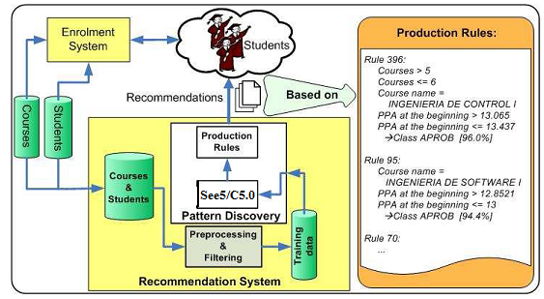
Figure 2.1: Recommender System Architecture [3]
Important process are educating methods, researching methods, teaching methods, studying opportunities, qualitative and quantitative educational improvements. The most important output indicators are alumni and graduates. Some of these measures and characteristics can be used in evaluating the implemented data mining system in a higher educational system. Nowadays, higher education encounters many challenges which prevent them to achieve their quality objectives. Some of these problems come from knowledge gap in higher educational processes. Knowledge gap is the lack of enough and deep knowledge at educational processes such as evaluation, planning, registration, counselling and marketing. Data mining technology can help bridging knowledge gap in higher educational systems. The hidden patterns that are discovered by data mining techniques from educational data can improve decision making processes in higher educational systems [1]
2.2 Knowledge Management Driving Data Mining
Several authors have written about the factors behind the drawn of data mining. For instance, Therling identified 3 reasons: the ease of data collection and storage, the computing power of modern processors, and the need for fast and real time data mining. Yet another one important reason absent from these is the growing interest in knowledge management. Knowledge , a focal point of ontology or epistemology , is the product of moving from data to information and finally to knowledge. The following model, Tired Knowledge Management Model (TKMM) developed by Jing Luan(2000)illustrates the dichotomous nature of modern knowledge management frame work for higher education research professionals.
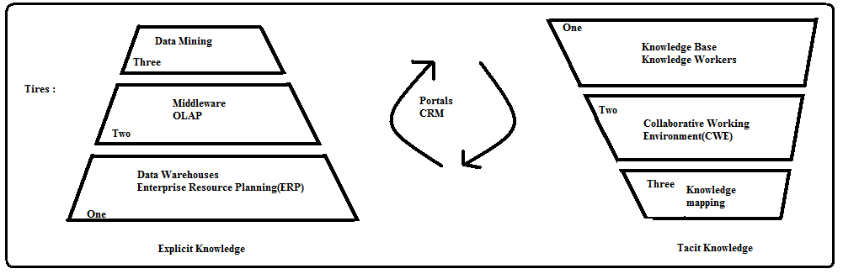
Figure 2.2: Relation between Explicit and Tacit Knowledge
The components of knowledge management are explicit (documented, measurable) and Tacit (subjective, qualitative). Documented, measurable explicit knowledge is most familiar and available to us, as it exists mostly in databases and other similar medium. While tacit knowledge, an entry of feelings, personalities and aptitudes is crucially important, but it is hard to quantify. Customer Relationship Management (CRM) and portals are the mechanisms that make both types of knowledge work together for a business purpose. All the three components in CRM, operational, analytical and collaborative, are key users of data mining.

On the Explicit side, data mining reflects the highest level of knowledge attainment that requires skills in data domain (Tier one), data querying and presentation (Tier two) and artificial intelligence/machine learning (Tier three). Data mining occupies the top tier and is dependent on the lower tires. The following chart is a topology of the Explicit Knowledge of Tiered Knowledge Management Model (TKMM) that illustrative in detail the relationships among three tires.
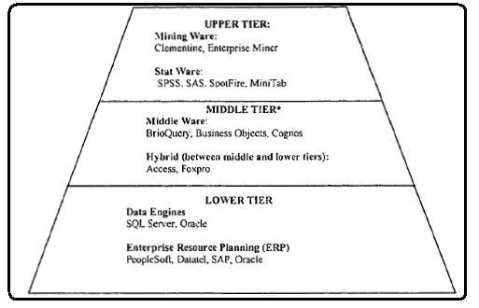
Figure 2.3: Topography of Tiered Knowledge Management Model (TKMM) for explicit knowledge [15].
2.3 Related Research Works
During the year 2000, innovation in educational system was commonly based on web based education [7] which is one kind of static process. One of the improvements of the dynamic and intelligent web based education system can be generated with the help of data mining or Knowledge Discovery in Data bases (KDD) system [10].

Knowledge extraction in education can be represent in formative education technique which can be used to continually improve the educational program [6].

Some recommender systems are also designed in higher education planning [3].

In recent researches [1][2], focus is on predicting the student behavior(dropout, transfer or persist) in higher educational planning by constructing the decision tree using J48 algorithm in WEKA environment.
The work by Mansmann, S.Scholl, M. H. (Dept. of Computer & Information Science, Konstanz University) presents a methodology for assessing educational capacity and planning its distribution and utilization, implemented as a decision support system allowing simulation and evaluation of various proposals and scenarios. The system integrates input data from relevant sources into an autonomous data warehouse. Graphical client front- end ensures adequate output presentation to the decision-makers by revealing significant details and dependencies in the data. Applying the system as an "on-the-fly" decision-support utility by the policy-makers leads to significant acceleration of planning procedures, deepens the insight into the data and the underlying methodology, and, consequently, provides for more efficient academic administration.
As per a news article, i-flex solutions has signed a Memorandum of Understanding (MoU) with the Government of Karnataka to build a Decision Support System (DSS), for the state's department of education. The DSS will help the department monitor the quality of elementary education in schools across the state.
The DSS is being developed by i-flex’s Center for Business Intelligence (CBI) in two phases. The first phase has just been completed and has helped the Karnataka State Quality Assessment Organization (KSQAO), a part of the Department of Education; analyze the quality of education of around 19 Lac children in 41,000 schools, in around 2100 clusters, in around 200 taluks in 32 districts of the State of Karnataka.
"i-flex will also work with the Policy Planning Unit and e-Governance unit of the Education Department, and provide Project Management Support to implement Information Analytics, Data Warehousing and Decision Support System.”
The DSS helps the Karnataka State Quality Assessment Organization (KSQAO).
- Identify the top performing Districts, Taluks, Clusters and Schools, as they
are classified for the purpose of assessment
- Share the information on the assessment with all stakeholders -- parents,
Teachers, communities and political representatives, to enable collective
- Efforts to work towards quality of education in the state.
- Identify student groups that need special focus.
- Refine the assessment process.
- Enable the Department to co-relate the performance at a level, to the kind of infrastructure, funding and logistics, and make the necessary adjustments.
- Perform adhoc analyses on the data -based decision making within the Government
- Provide an integrated Decision Support System that covers information in multiple transaction databases – School Assessment, Education Management Information System, etc.

CHAPTER-3
KNOWLEDGE DISCOVERY BASED DECISION SUPPORT SYSTEM (KDDS)

3.1 Overview of KDDS
There is no universally accepted definition of DSS. A DSS can help people to make right decisions. DSS can be represented as an interactive, flexible and adaptive Computer based Information System specially developed for supporting the solution of a particular problem for improved decision-making [15]. KDD is an automatic, exploratory analysis and modelling of large data repositories. KDD is the organized process of identifying valid, novel, useful and understandable patterns from large and complex data sets. Data Mining is the core of the KDD process, involving the inferring of algorithms that explore the data, develop the model and discover previously unknown patterns. The model is used for understanding phenomena from the data, analysis and prediction [16].

3.2 Data Mining in KDDS

Improvement of engineering education planning is possible by applying innovative ideas which leads to quality Engineering education. A KDDS may be built to will help the Stake holder of the education to take right decision for enrolment in appropriate engineering discipline, identify the right/proper courses, design better course curriculum, efficient utilization of resources and technology as per industry needs that leads towards knowledge driven society. Data Mining is a core process of KDDS. The figure 3.1 represents a high level flow of data Mining Activities.
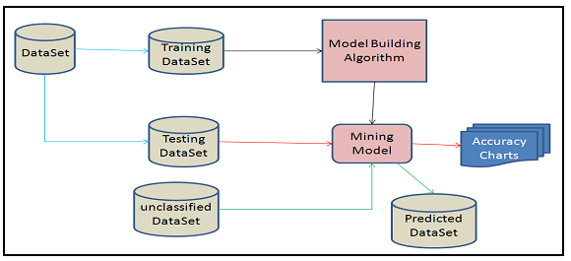
Figure 3.1: High Level Flow of Data Mining Activities [13]
Given a data set, the data mining process starts with elementary data analysis. It allows an analyst to understand the characteristics of the attributes of the data set (dependency, ranges, max, min, count, average, standard deviation, quartiles, outliers, etc.). The data set is then divided into a training data set and a testing and validation data set. The training data set is used to build the mining structure and associated mining models. If a model is valid and its accuracy is acceptable, it is then used for prediction .The data mining process is very elaborate. It requires extensive front-end processing and presentation of results. Using accuracy charts, the holdout set is used to test the accuracy and the efficiency of the mining models.

3.2.1 Data Mining Process Model

The data mining process model recommended for use with Clementine is the Cross-Industry Standard Process for Data Mining (CRISP-DM)[12].

Figure 3.2: CRISP-DM [12]

The general CRISP-DM process model includes six phases that address the main issues in data mining. The six phases include:
- Business understanding includes determining business objectives, assessing the situation, determining data mining goals, and producing a project plan.
- Data understanding addresses the need to understand what your data resources are and the characteristics of those resources. It includes collecting initial data, describing data, exploring data, and verifying data quality.
- Data preparation: Preparations include selecting, cleaning, constructing, integrating, and formatting of data.
- Modelling : This phase involves selecting modelling techniques, generating test designs, and building and assessing models.
- Evaluation: This phase include evaluating results, reviewing the data mining process, and determining the next steps.
- Deployment: This phase includes plan deployment, monitoring and maintenance, producing a final report, and reviewing the project.

3.2.2 KDD based Techniques
Knowledge discovery as a process is depicted in figure 3.3 and consists of an iterative sequence of the following steps.
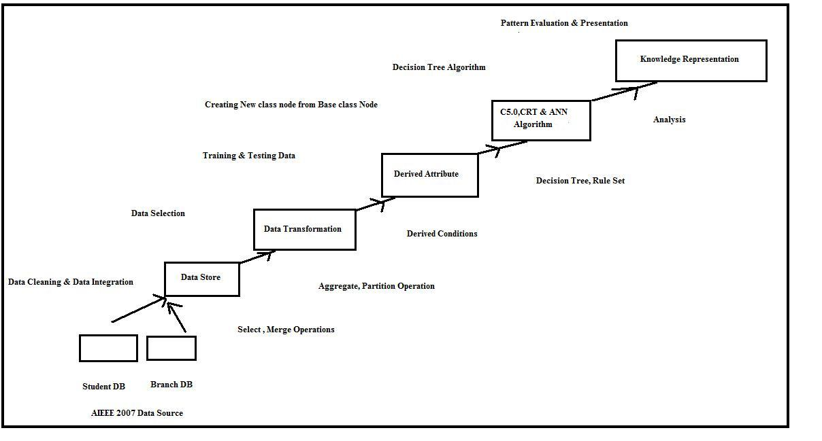
Figure 3.3: Block diagram of “KDD based Technique”

The steps are [9]:
- Data Cleaning : To remove noise and inconsistent data
- Data Integration: Where multiple data sources may be combined.
- Data Selection: Where data relevant to the analysis task are retrieved from the database
- Data Transformation: Where data are transformed or consolidated into forms appropriate for mining by performing summary or aggregation operations.
- Data Mining: An essential process where intelligent methods are applied in order to extract data patterns.
- Pattern Evaluation: To identify the truly interesting patterns representing knowledge based on some interestingness measures.
- Knowledge Presentation: Where visualization and knowledge representation techniques are used to present the mined knowledge to the user.

3.3 Classification and prediction
Data classification is a process of extracting important data classes or to predict future data trends. The classification systems predicts discrete , unordered labels known as categorical labels where as prediction models continuous valued function[9].

3.3.1 The Data Classification Process
The Data Classification Process is a two-step process: Learning Process ( Training Phase) and Classification Process( Testing Phase).

In first process, classification algorithm builds the classifier by analyzing a training set. The training set consisting of tuples and their associated class labels. Let a tuple T is represent by an n dimensional Attribute Vector, T=(t1,t2,-----tn),depicting n measurements made on the tuple from n Attributes(A1,A2------An). Each tuple, T, is assumed to belong to predefined class as determined by another database attribute called class label attribute. This learning method is known as supervised learning[9].

In second process test data set are analysed to estimate the accuracy of the classification rules.

3.3.2 The Classification Techniques
Many Classification and Prediction techniques developed in the field of machine learning, Patter Reorganization and Statistics. Some techniques are listed below.
- Decision tree
- Bayesian Classification
- Rule based Classification
- Classification by Back Propagation
- Lazy Learners
- Genetic Algorithm
- Fuzzy Set approach etc.
One of the most popular Classification Technique in DM is Decision Tree. A Decision Tree can represent as a labelled tree as shown in figure 3.4..
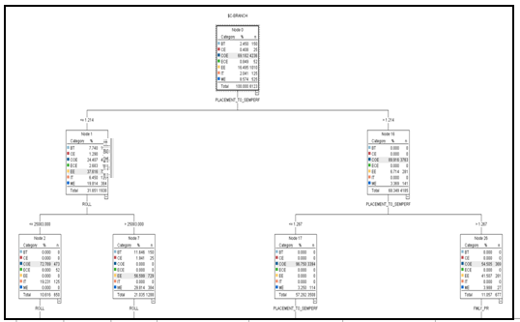
Figure 3.4: D Tree
The Top most node represents the root node. Non leaf nodes denote a test on an attribute. Leaf node is labelled with a class. Branch represents an outcome of the test.

Important parameters of DT induction are as follows.
- Attribute selection measure such as information gain, gain ratio and gini index.
- Tree pruning ( Pre & Post pruning) which address the problem of overfiting the data.
- Scalability approach that capable of handling training tuples.

The induction of DT can be done using DT algorithm described in section 3.4.

3.4 Data Mining and Decision Tree Algorithm

Data Mining is a process of extracting useful information from large databases.
According to the Gartner Inc “data mining is a process of discovering meaningful new correlations, patterns, and trends by sifting through large amounts of data stored in repositories, and by using pattern recognition technologies, as well as statistical and mathematical techniques [5]”. For this purpose, Decision tree or Rule based Algorithms can be applied so that the predicted decision can be viewed as a Tree or a set of Rules. Some commonly used and commercially popular algorithms are CHAID, ANN, C&R Tree, ID3, C4.5 (J4.8) and See5/ C5.0 [11].

3.4.1 CHAID
Chi-Squared Automatic Interaction Detection (CHAID) [19] uses multi way splits and pre pruning.

3.4.2 ANN

Artificial Neural Network (ANN) Algorithm represents each cluster by a neuron based on the neural structure of the brain [21]. The field of neural networks was originally kindled by psychologists and neurobiologists who sought to develop and test computational analogous of neurons [9].Each connection has a weight, which is learned adaptively during learning.
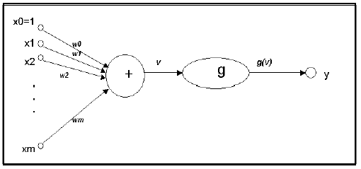
Figure 3.5: Neurons are organized into layers [21].
Neural Network learning is also known connectionist learning. Advantages of Neural Network include their high tolerance of noisy data as well as their ability to classify patterns on which they have not been trained. They can be used when a little knowledge of the relationships between attributes and classes.

Back propagation learns by iteratively processing a data set of training tuples, comparing the network’s for each tuple with the actual known target value .The Back propagation Algorithm is as follows [9]:

Input:
D: a Data set consisting of the training tuples and their associated target values
l: the learning rate
network, a multilayer feed-forward network.
Output:
A trained neural network.

Method:
Initialize all weights and biases in network
While terminating condition is not satisfied
{
for each training tuple X in D {
for each input layer unit j {
Oj=Ij ;
for each hidden or output layer unit j {
Ij=∑I w_{i}Oi + Ɵj ;
previous layer , i
Oj=1/(1+1/e _{j});
for each unit j in the output layer
Errj = Oj(1-Oj)(Tj-Oj);
for each unit j in the hidden layers , from the last to the first hidden layer
Err j= Oj(1-Oj)∑Errkw_{jk};
next higher layer, k
for each weight wij in network {
∆ w_{ij} =(l)ErrjOi;
w_{ij} = w_{ij} +∆w_{ij}; }
for each bias Ɵj in network
{
∆Ɵj=(l) Errj ;
Ɵj= Ɵj +∆ Ɵj;
}
}
}

3.4.3 C& R Tree [22]
Classification and Regression Trees (C&R Tree) approach is restricted to Binary splits and uses post-pruning. The use of trees in the statistical community dates back to AID (Automatic Interaction Detection) by Morgan & Son-quist (1963) The basic methodology of divide and conquer is also used in CART.

Splitting Criteria
CART uses the Gini diversity index (GDI) as a splitting criterion. Let RF(Cj; S) denote the relative frequency of cases in S that belong to class Cj . The GDI is defined as:
r
I_{gini}(S) = 1 -∑ RF(C_{j}, S)² ;
j=1

The mean squared error, or MSE, is defined as:
r
MSE = Ee [∑ (C_{j(e)-}, P_{j(e))})² ];
j=1

Where Pj(e) represents the probability assigned to class j. The important property of Gini diversity index is that it minimizes the re substitution estimate for the mean squared error.
Pruning
CART uses a pruning technique called minimal cost complexity pruning, which assumes that the bias in the re substitution error of a tree increases linearly with the number of leaf nodes. The cost assigned to a sub tree is the sum of two terms: the re substitution error and the number of leaves times a complexity parameter.

Missing Values
Unlike C4.5, CART does not penalize the splitting criterion during the tree construction if examples have unknown values for the attribute used in the split. Only the known value instances the criterion is used. CART uses surrogate splits, and it cannot be chosen based on the original splitting criterion because the sub tree at each node is constructed based on the original split. To maximize a measure of predictive association with the original split, the surrogate splits criteria are chosen and it works reasonably well if attributes are highly correlated with the chosen attribute.
Regression Trees
CART also supports building regression trees.The regression tree structure is similar to a classification tree, except that each leaf predicts a real number.
The re substitution estimate is the mean squared error:
R(S) = 1/n ∑ (Y_{j} - h (t_{j} ))²
i

Where Y_{j} is the real-valued label for example ti and h(ti) is the (real-valued) prediction. The splitting criteria is chosen to minimize the re substitution estimate.
3.4.4 ID3
Iterative Dichotomise (ID3) [5] is Inductive Logic Programming methods, developed by Quinlan, it is an Attribute based machine-learning algorithm that creates a decision tree on a training set of data and an entropy measure to build the leaves of the tree.

3.4.5 C4.5
Ross Quinlan has developed a statistical classifier algorithm i.e C4.5 algorithm [18] as an extension of Iterative Dichotomise (ID3) algorithm which is used to generate either a Decision Tree or a Rule set.

C4.5 algorithm differs in several respects from CART [9], such as:
- Tests in CART are always binary, but C4.5 allows two or more outcomes.
- CART uses the Gini diversity index to rank tests, whereas C4.5 uses information-based criteria.
- CART prunes trees using a cost-complexity model whose parameters are estimated by cross-validation; C4.5 uses a single-pass algorithm derived from binomial confidence limits.
- CART looks for surrogate tests that approximate the outcomes when the tested attribute has an unknown value, but C4.5 apportions the case probabilistically among the outcomes.
C4.5 made a number of improvements to ID3. Some of these are:
- Handling both continuous and discrete attributes - In order to handle continuous attributes, C4.5 creates a threshold and then splits the list into those whose attribute value is above the threshold and those that are less than or equal to it.
- Handling training data with missing attribute values - C4.5 allows attribute values to be marked as question mark for missing and these values are simply ignore in gain calculations.
- Handling attributes with differing costs.
- Tree Pruning - after creation of the tree C4.5 goes back through the tree once and attempts to remove branches that do not help by replacing them with leaf nodes.
C4.5 builds decision trees from a set of training data in the same way as ID3, using the concept of information entropy. The training data is a set S = s₁,s₂,... of already classified samples. Each sample s_{i} = x₁,x₂,... is a vector where x₁,x₂,... represent attributes or features of the sample. The training data is augmented with a vector C = c₁,c₂,... where c₁,c₂,... represent the class to which each sample belongs.
At each node of the tree, C4.5 chooses one attribute of the data that most effectively splits its set of samples into subsets enriched in one class or the other. Its criterion is the normalized information gain (difference in entropy) that results from choosing an attribute for splitting the data. The attribute with the highest normalized information gain is chosen to make the decision. The C4.5 algorithm then recurs on the smaller sub lists.
This algorithm has a few base cases[18].
- All the samples in the list belong to the same class. When this happens, it simply creates a leaf node for the decision tree saying to choose that class.
- None of the features provide any information gain. In this case, C4.5 creates a decision node higher up the tree using the expected value of the class.
- Instance of previously-unseen class encountered. Again, C4.5 creates a decision node higher up the tree using the expected value.
In pseudo code, the general algorithm for building decision trees is[18]:
- Check for base cases
- For each attribute a
  - Find the normalized information gain from splitting on a
- Let a_best be the attribute with the highest normalized information gain
- Create a decision node that splits on a_best
- Recur on the sublists obtained by splitting on a_best, and add those nodes as children of node
3.4.6 See5/C5.0
As an improved version of C4.5 algorithm, Ross Quinlan has developed See5/C5.0 algorithm [18][20] which is one of the commercially popular Decision making Algorithm.

The main improvements of C5.0 algorithm over above mentioned algorithms are faster, space efficient, smaller decision tree, more accuracy, weighting and automatic winnowing of databases.

CHAPTER-4
Proposed Technique in SPSS Clementine 11.1 Environment

4.1 Introduction
In this work, we analyzed the real data (65,534 records) of All India Engineering Entrance Examination (AIEEE) 2007.The database is divided in to two parts consisting of Students data base (attributes like AIEEE Roll_no, Applicn_no, CName, Sex, Caste, AI_Eng_rank, SC_Eng_rank, ST_Eng_rank, Rem1,Rem2 etc) and Discipline data base(attributes like AIEEE Roll_no, Famaly_psr, Sem_perf, Placement,Branch etc.).Training the dataset with C5.0/See5, C&R Tree and ANN Algorithm results a Decision Tree and a Rule Set. This Decision Tree and Rule set helps the students to predict their appropriate engineering discipline/branch. Based on these algorithms, the work is also compared to get suitable Accuracy Rate. Finally we have introduced a hybrid knowledge based decision technique in .NET platform to take a right decision of engineering discipline/branches.

4.2 KDD based Technique
As a first part of this technique the following streams were created in SPSS Clementine 11.1 Environment.

Using See5/ C5.0 Algorithm
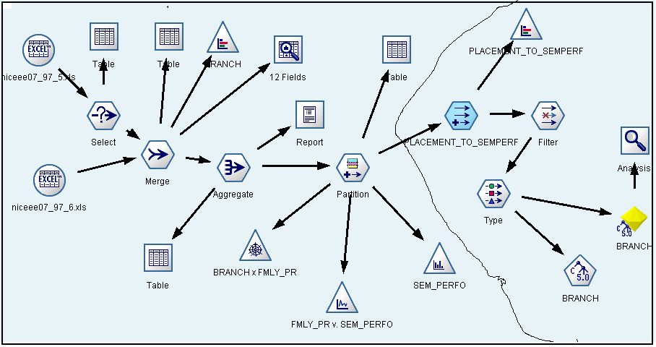
(a)
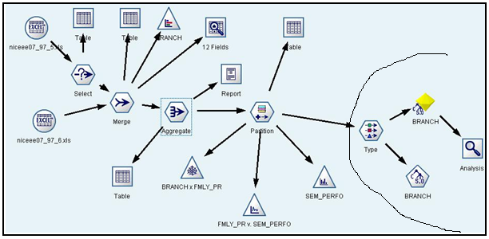
(b)
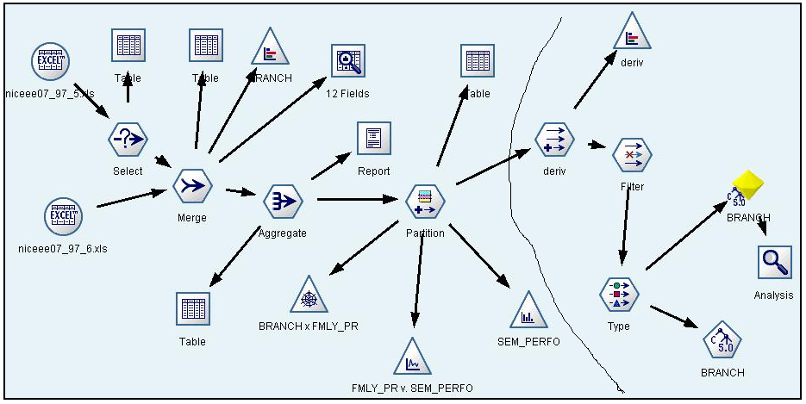
(c)
Figure 4.1: Using C5.0/See5 Algorithm (a) Stream Canvass with a ratio of Placement to family pressure (b) inputs without derived class (c) inputs with derived class with a condition that based on family pressure

Using C&R Tree Algorithm
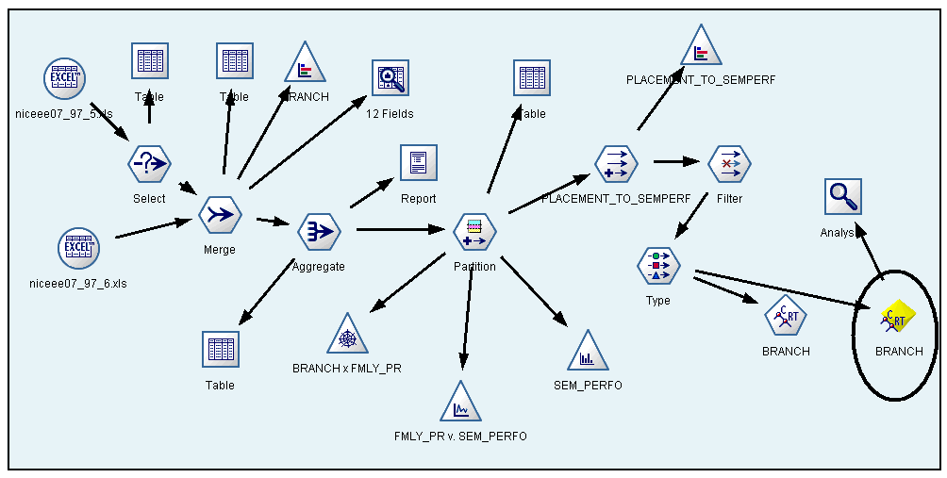
Figure 4.2: Stream Canvass Using C&R Tree Algorithm
Using ANN Algorithm
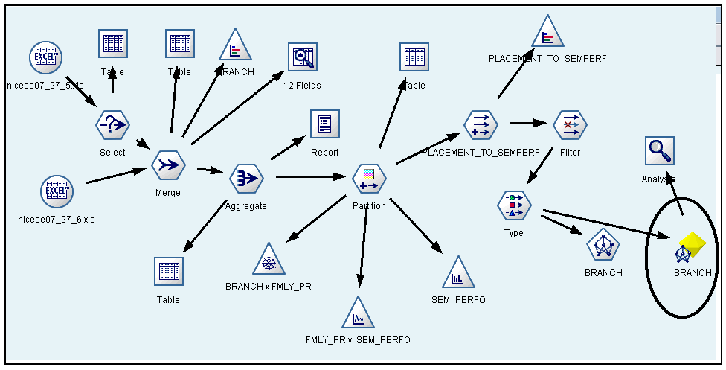
Figure 4.3: Stream Canvass Using ANN Algorithm
The above streams were created with the help of following techniques:
4.2.1 Data Cleaning: It is the first process of data preparation in Knowledge Discovery based Technique. As a first step of Data cleaning technique “Null rule” was applied in the given data base for finding the null conditions such as special characters, question marks, blanks or missing value. Similarly in the second step Select node with a condition “REM1 AND REM2 'Not Eligible for Central Counseling'” was applied to the 65,534 records of student database and finally gets a table of 13,800 records of Eligible candidates for Central Counseling shown in table 4.2.1.
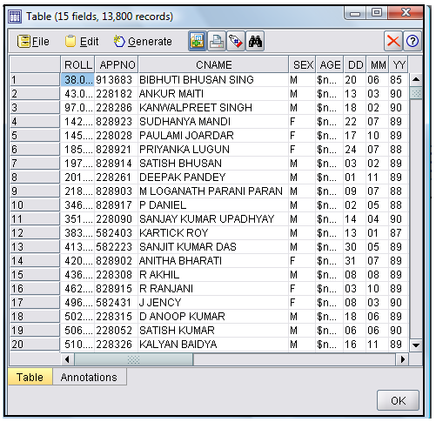
Table 4.2.1: List of Eligible candidates for Central Counseling
4.2.2 Data Integration: Data integration merges data from multiple sources into coherent data store [8]. We merged Student and Branch data base into a data store. The database can be viewed with the help of table. It is also important to visualize the proportion of the students responded to each Branch, hence we used a Distribution node.
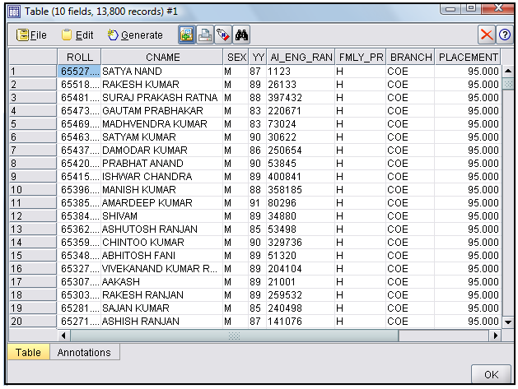
Table 4.2.2: List of Eligible candidates after merging student and discipline DB
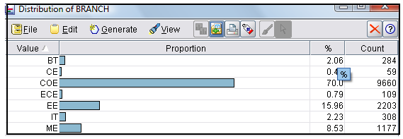
Figure 4.4: Distribution of BRANCH attribute
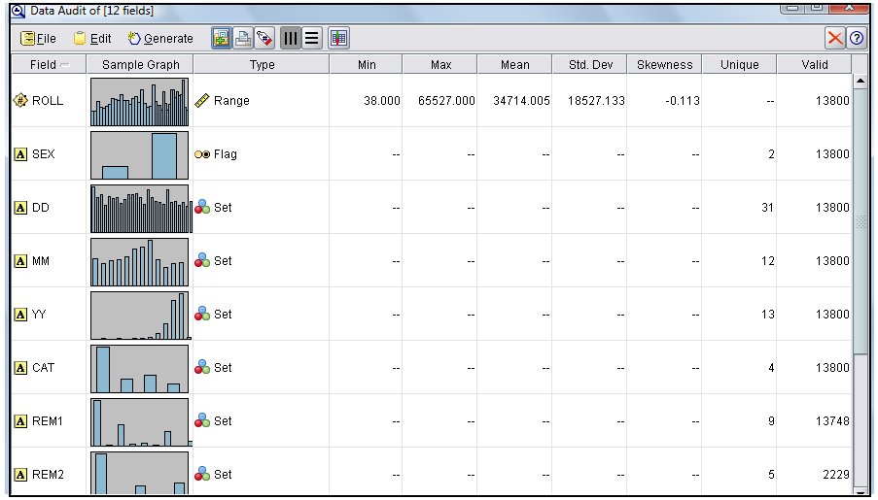
Figure 4.5: Data Audit view
4.2.3 Data Selection and Data Transformation : We have considered the Aggregation node to reduce the size of the dataset and hence the 09 key attributes were selected for further data operation. Similarly Partition node is used to split the dataset into two equal sets such as training and testing. We have drawn the Web graph which maps associations between different categories such as BRANCH and FMLY _PR and it shows that Branch COE is tightly associated with all the Levels of the Family pressure. Again we have tested our data with a derived class with different conditions to derive PLACEMENT _TO_SEMPER. We used Filter node to filter out the input fields that we have used already used. The Type node connected to the Filter node indicates the types of fields that we are using. It also indicates how they are used to predict the outcomes. In this work our main aim is to predict the right Decision/Branch so we are setting branch attribute as out field, indicating that Branch is the field we want to predict.
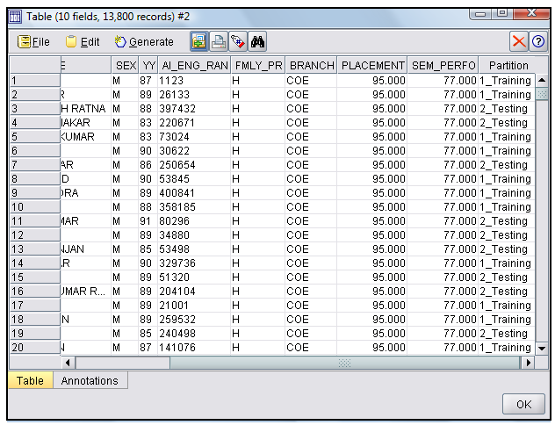
Table 4.2.3: Partition of Data for Training and Testing
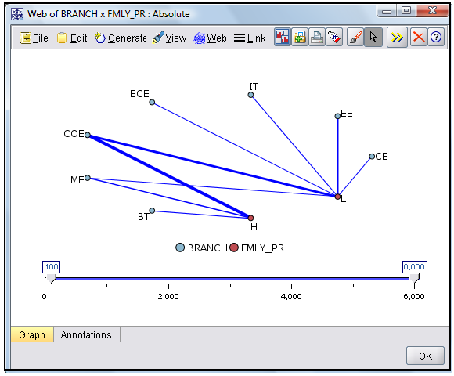
Figure 4.6: Web graph of Branch vs. Family pressure
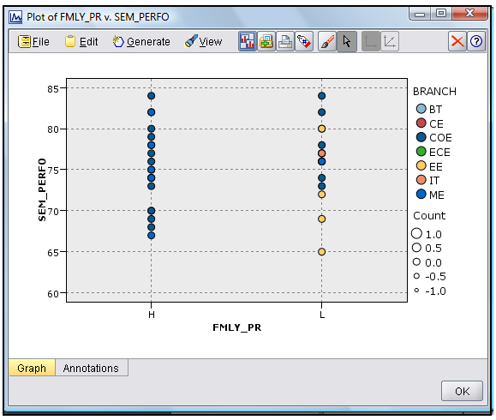
Figure 4.7: Distribution graph of Family pressure vs. Semester performance
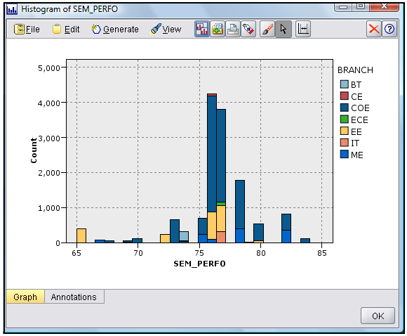
Figure 4.8: Histogram of Semester performance

4.2.4 Data Mining: After carrying out these steps we have been able to form some hypotheses as to which parameters were more effective to predict a particular Branch. But still it is not possible to fully explain all of the relationships among the given parameters. So, modeling is required and hence we used C5.0/See5, C&R Tree and ANN algorithm. After applying these algorithm to the trained data set, the set of Rules (shown in appendix A) as well as Decision Tree(shown in appendix B) are generated.
4.2.5 Pattern Evaluation: Here we utilized the Base class and derived class to predict the frequently used interesting parameters to represent the knowledge base.
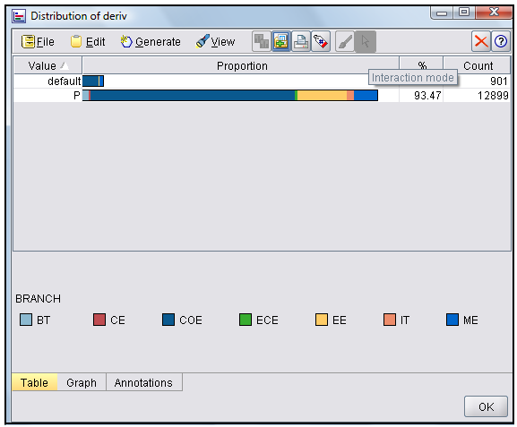
Figure 4.9: Distribution of Branch field from Derived class
4.2.6 Knowledge Presentation: It is the final step of KDD based Techniques where the mined knowledge is presented to the user. The accuracy obtained from analysis is as follows:

Accuracy:

Sl No | Algorithm | Partition size |  | Partition | 1_Training |  | 2_Testing
Sl No | Algorithm | Training | Testing | Partition
 | See5/C5.0 |  |  | Correct | 4,958 | 80.97% | 6,171 | 80.38%
 |  |  |  | wrong | 1,165 | 19.03% | 1,506 | 19.62%
1 | C&R Tree |  |  | Correct | 5,996 | 97.93% | 7,520 | 97.95%
 |  | 45 | 55 | wrong | 127 | 2.07% | 157 | 2.05%
 | ANN |  |  | Correct | 5,537 | 90.43% | 6,969 | 90.78%
 |  |  |  | wrong | 586 | 9.57% | 708 | 9.22%
 |  |  |  | Total | 6,123 |  | 7,677
Table 4.2.4: Analysis of Algorithms using Training partition size 45 and Testing partition size 55
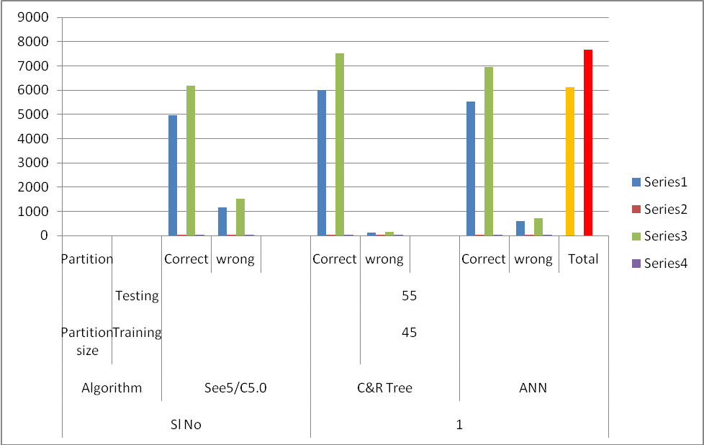

Figure 4.10: Graph view of Table 4.2.4

Sl No | Algorithm | Partition size |  | Partition | 1_Training |  | 2_Testing
Sl No | Algorithm | Training | Testing | Partition
 | See5/C5.0 |  |  | Correct | 5,525 | 80.89% | 5,604 | 80.40%
 |  |  |  | wrong | 1,305 | 19.11% | 1,366 | 19.60%
 | C&R Tree |  |  | Correct | 6,688 | 97.92% | 6,827 | 97.95%
2 |  | 50 | 50 | wrong | 142 | 2.08% | 143 | 2.05%
 | ANN |  |  | Correct | 5,914 | 86.59 | 6,074 | 87.14%
 |  |  |  | wrong | 916 | 13.14% | 896 | 12.86%
 |  |  |  | Total | 6,830 |  | 6,970
Table 4.2.5: Analysis of Algorithms using Training partition size 50 and Testing partition size 50

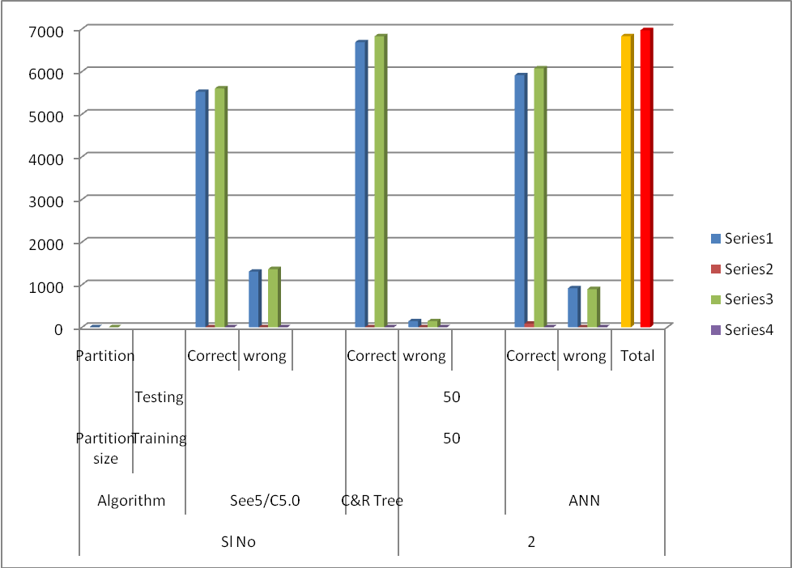
Figure 4.11: Graph view of Table 4.2.5
Sl No | Algorithm | Partition size |  | Partition | 1_Training |  | 2_Testing
Sl No | Algorithm | Training | Testing | Partition
 | See5/C5.0 |  |  | Correct | 7,406 | 98.60% | 6,185 | 98.35%
 |  |  |  | wrong | 105 | 1.04% | 104 | 1.65%
 | C&R Tree |  |  | Correct | 7,352 | 97.88% | 6,164 | 98.01%
3 |  | 55 | 45 | wrong | 159 | 2.12% | 125 | 1.99%
 | ANN |  |  | Correct | 6,692 | 89.10% | 5,656 | 89.93%
 |  |  |  | wrong | 819 | 10.90% | 633 | 10.07%
 |  |  |  | Total | 7,511 |  | 6,289
Table 4.2.6: Analysis of Algorithms using Training partition size 55 and Testing partition size 45
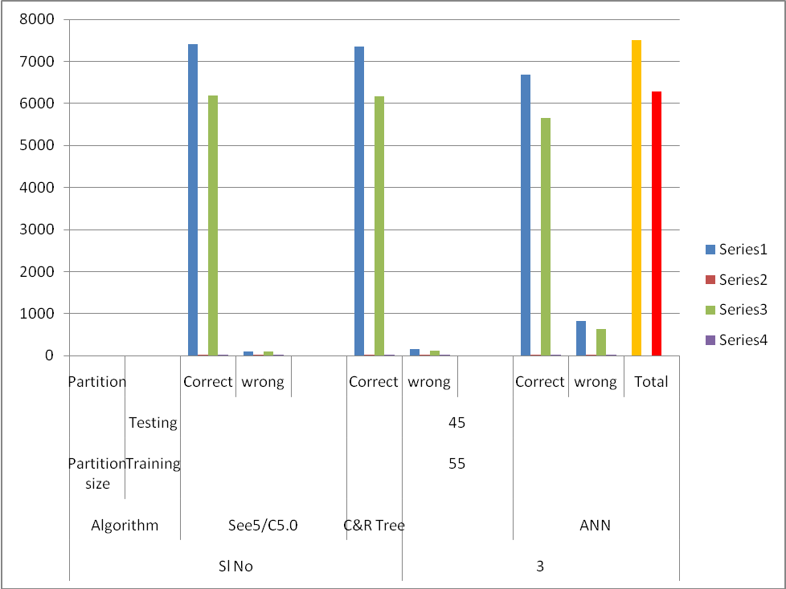

Figure 4.12: Graph view of Table 4.2.6
Sl No | Algorithm | Partition size |  | Partition | 1_Training |  | 2_Testing
Sl No | Algorithm | Training | Testing | Partition
 | See5/C5.0 |  |  | Correct | 9,468 | 98.57% | 4,126 | 98.36%
 |  |  |  | wrong | 137 | 1.43% | 69 | 1.64%
4 | C&R Tree | 70 | 30 | Correct | 9,413 | 98% | 4,103 | 97.81%
 |  |  |  | wrong | 192 | 2% | 92 | 2.19%
 | ANN |  |  | Correct | 8,689 | 90.46% | 3,789 | 90.32%
 |  |  |  | wrong | 916 | 9.54% | 406 | 9.68%
 |  |  |  | Total | 9,605 |  | 4,195
Table 4.2.7: Analysis of Algorithms using Training partition size 70 and Testing partition size 30

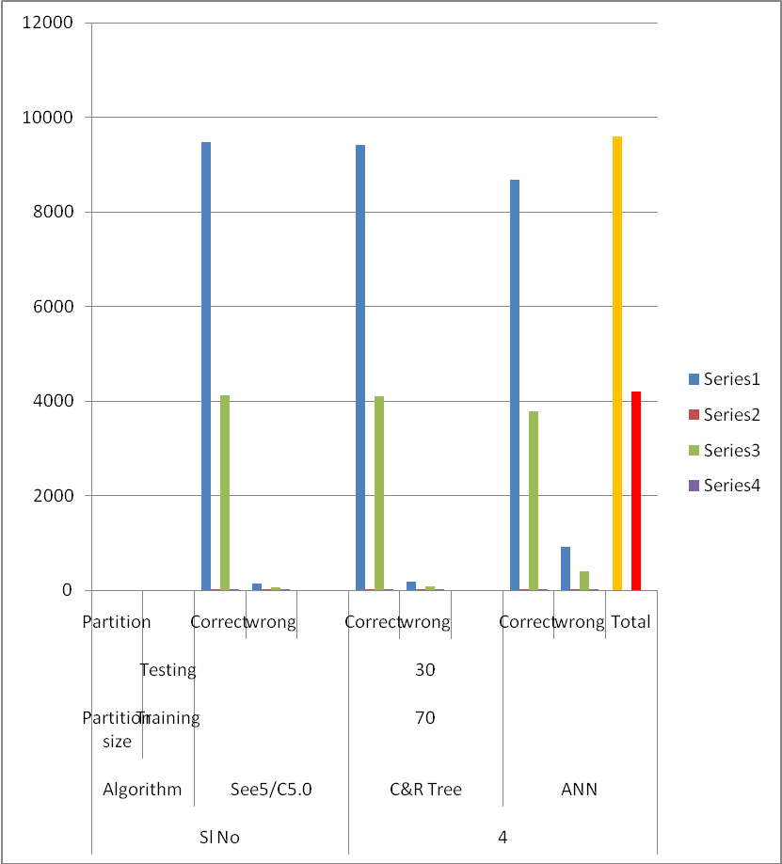

Figure 4.13: Graph view of Table 4.2.7

Sl No | Algorithm | Partition size |  | Partition | 1_Training |  | 2_Testing
Sl No | Algorithm | Training | Testing | Partition
 | See5/C5.0 |  |  | Correct | 3,992 | 98.49% | 9,598 | 98.47%
 |  |  |  | wrong | 61 | 1.51 | 149 | 1.53%
5 | C&R Tree | 30 | 70 | Correct | 3,971 | 97.98% | 9,544 | 97.92%
 |  |  |  | Wrong | 82 | 2.02% | 203 | 2.08%
 | ANN |  |  | Correct | 3,457 | 85.29% | 8,393 | 86.11%
 |  |  |  | Wrong | 596 | 14.71% | 1,354 | 13.89%
 |  |  |  | Total | 4,053 |  | 9,747
Table 4.2.8: Analysis of Algorithms using Training partition size 30 and Testing partition size 70

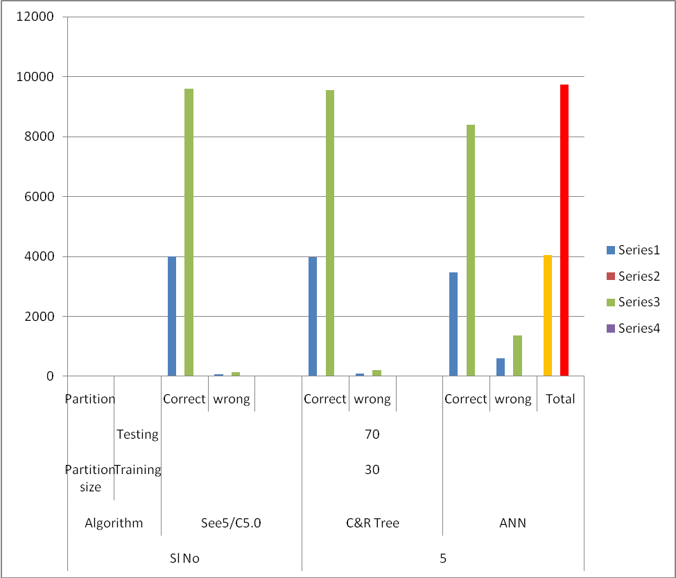
Figure 4.14: Graph view of Table 4.2.8

Sl No | Algorithm | Partition size |  | Partition | 1_Training |  | 2_Testing
Sl No | Algorithm | Training | Testing | Partition
 | See5/C5.0 |  |  | Correct | 4,958 | 80.97% | 6,171 | 80.38%
 |  |  |  | Wrong | 1,165 | 19.03% | 1,506 | 19.62%
1 | C&R Tree |  |  | Correct | 5,996 | 97.93% | 7,520 | 97.95%
 |  | 45 | 55 | Wrong | 127 | 2.07% | 157 | 2.05%
 | ANN |  |  | Correct | 5,537 | 90.43% | 6,969 | 90.78%
 |  |  |  | Wrong | 586 | 9.57% | 708 | 9.22%
 |  |  |  | Total | 6,123 |  | 7,677
 | See5/C5.0 |  |  | Correct | 5,525 | 80.89% | 5,604 | 80.40%
 |  |  |  | Wrong | 1,305 | 19.11% | 1,366 | 19.60%
 | C&R Tree |  |  | Correct | 3,992 | 98.49% | 9,598 | 98.47%
2 |  | 50 | 50 | Wrong | 61 | 1.51% | 149 | 1.53%
 | ANN |  |  | Correct | 5,914 | 86.59 | 6,074 | 87.14%
 |  |  |  | Wrong | 916 | 13.14% | 896 | 12.86%
 |  |  |  | Total | 6,830 |  | 6,970
 | See5/C5.0 |  |  | Correct | 7,406 | 98.60% | 6,185 | 98.35%
 |  |  |  | Wrong | 105 | 1.04% | 104 | 1.65%
 | C&R Tree |  |  | Correct | 7,352 | 97.88% | 6,164 | 98.01%
3 |  | 55 | 45 | Wrong | 159 | 2.12% | 125 | 1.99%
 | ANN |  |  | Correct | 6,692 | 89.10% | 5,656 | 89.93%
 |  |  |  | Wrong | 819 | 10.90% | 633 | 10.07%
 |  |  |  | Total | 7,511 |  | 6,289

Sl No | Algorithm | Partition size |  | Partition | 1_Training |  | 2_Testing
Sl No | Algorithm | Training | Testing | Partition
 | See5/C5.0 |  |  | Correct | 9,468 | 98.57% | 4,126 | 98.36%
 |  |  |  | Wrong | 137 | 1.43% | 69 | 1.64%
4 | C&R Tree | 70 | 30 | Correct | 9,413 | 98% | 4,103 | 97.81%
 |  |  |  | Wrong | 192 | 2% | 92 | 2.19%
 | ANN |  |  | Correct | 8,734 | 90.93% | 3,808 | 90.77%
 |  |  |  | Wrong | 871 | 9.07% | 387 | 9.23%
 |  |  |  | Total | 9,605 |  | 4,195
 | See5/C5.0 |  |  | Correct | 3,992 | 98.49% | 9,598 | 98.47%
 |  |  |  | Wrong | 61 | 1.51 | 149 | 1.53%
5 | C&R Tree | 30 | 70 | Correct | 3,971 | 97.98% | 9,544 | 97.92%
 |  |  |  | Wrong | 82 | 2.02% | 203 | 2.08%
 | ANN |  |  | Correct | 3,457 | 85.29% | 8,393 | 86.11%
 |  |  |  | Wrong | 596 | 14.71% | 1,354 | 13.89%
 |  |  |  | Total | 4,053 |  | 9,747

Table 4.2.9: Overall Analysis of Algorithms using different Training partition size and Testing partition size

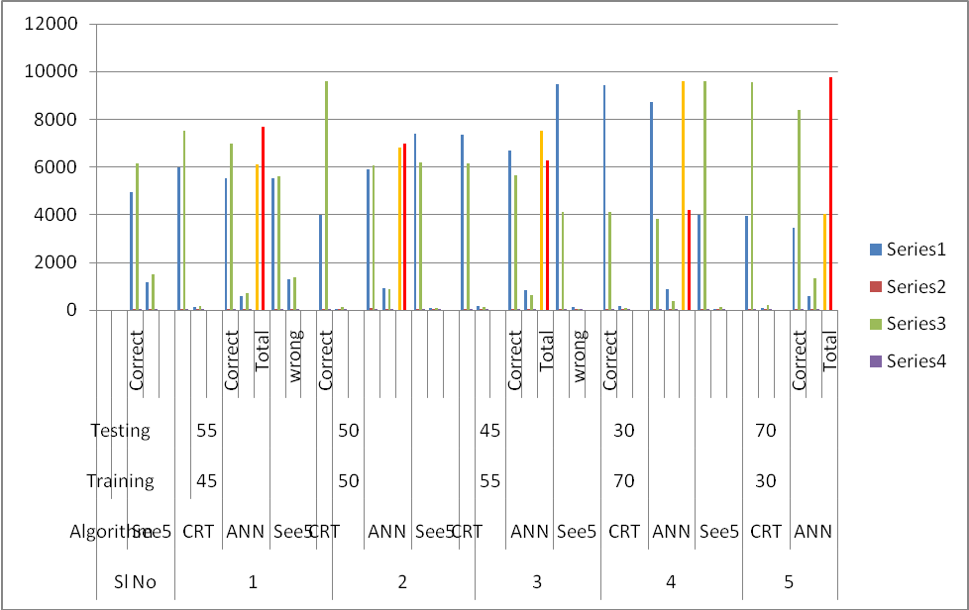

Figure 4.15: Graph view of Table 4.2.9
4.3 Analysis of the Graph

Case 1 and Case2:

We have found that CRT Algorithm works reasonably well with a percentage of 7 (approx.) in Training phase and a range of 10-17% during Testing phase.

Case 3, Case 4 and Case5:

In these cases See5/C5.0 algorithm places the highest accuracy rate in terms of correctly classified tuples for both Training & Testing phase.

So, See5/C5.0 has produced the best model for predicting right decision in enrolment process.

From the above tables and graphs, We found that the decision tree algorithm See5/ C5.0 works reasonably well.

4.4 An Approach for KD based Technique in .NET platform

After analyzing the partition data set with the help of different decision tree algorithm, we have introduced another technique for mining right decision in enrollment process.

In this technique we have used MS SQL Server 2005 at the backend and .NET platform at the front end. The work procedure is listed below.

4.4.1 Login Phase

This is the first phase of this approach. Here Administrator should login using valid user id and password to enter in to the home page shown in the figure 4.16 (a) & (b).

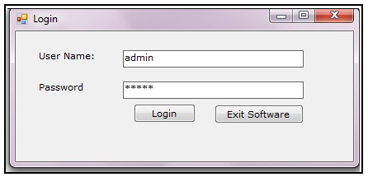
Figure 4.16: (a) Login
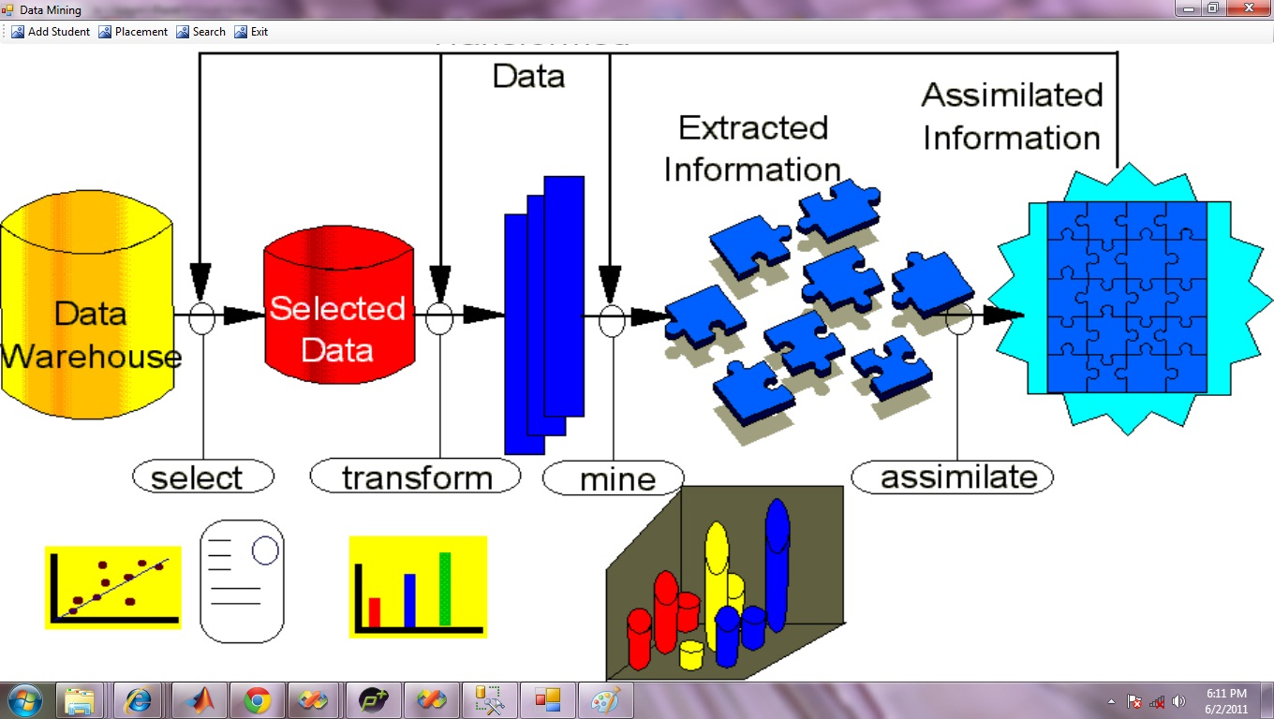
Figure 4.16: (b) Home page

4.4.2 Add Student

Using this option Student data base can be created (as shown in figure 4.17). Student details can be obtain using search option. The modification is permissible only for Administrator.

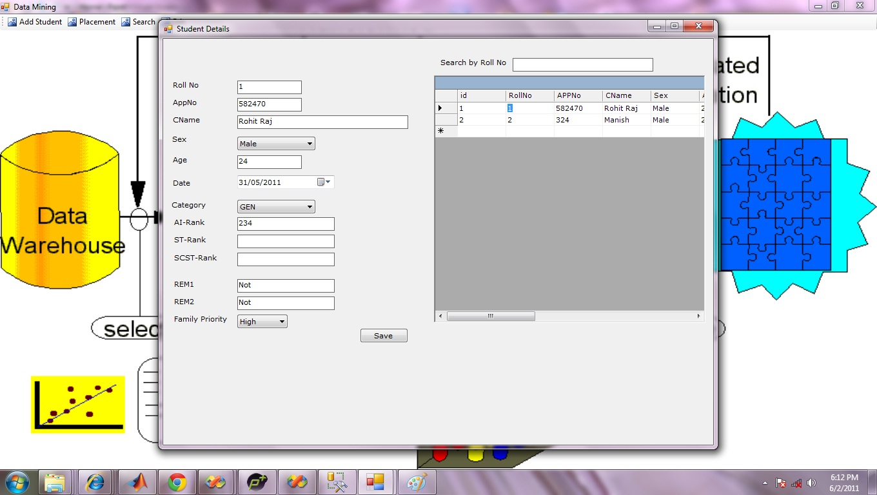

Figure 4.17: Creation of Student DB

4.4.3 Placement

Here previous year student’s (as per the data available) overall semester performance, placement strategy can be obtained.

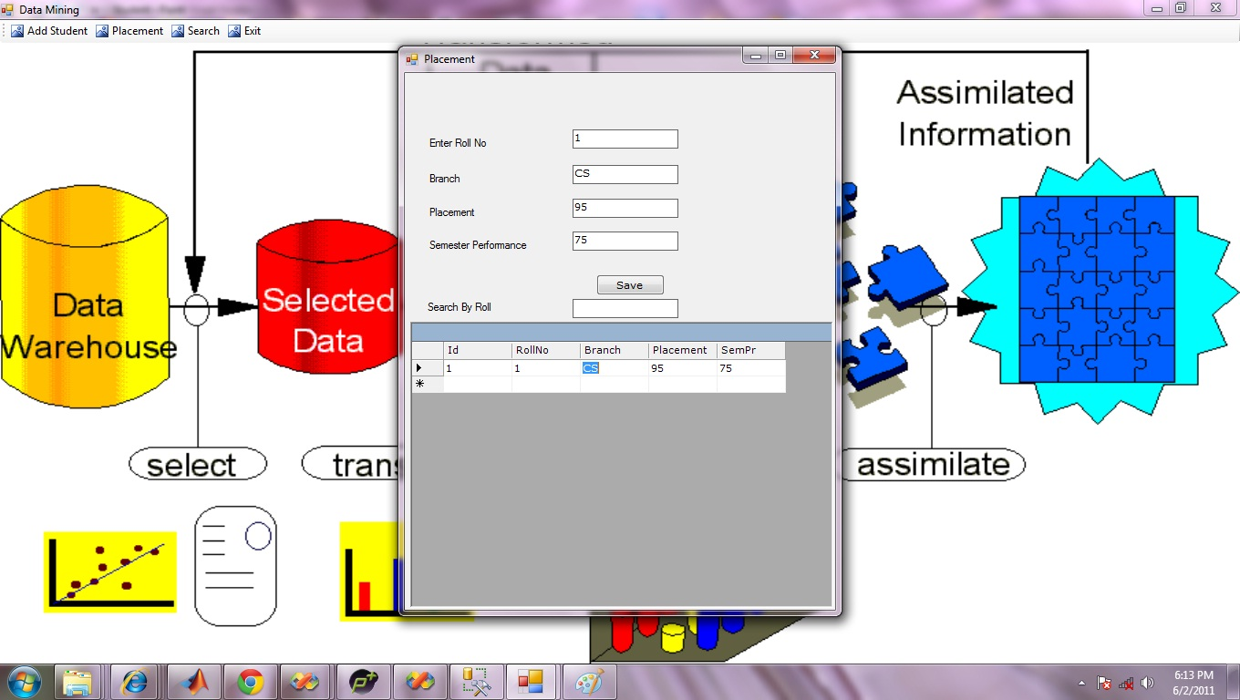

Figure 4.18: Placement Strategy

4.4.4 Search

This process divided in to two parts.
- Searching the student’s details that exists in the data base ( as shown in figure 4.19 (a))
- New Student Search. In this process a fresh candidate can place his AIEEE rank, Family pressure and Placement percentage, Semester performance from previous year students. Now our mining technique will predict the enrollment decision for selecting proper branch( as shown in figure 4.19(b))

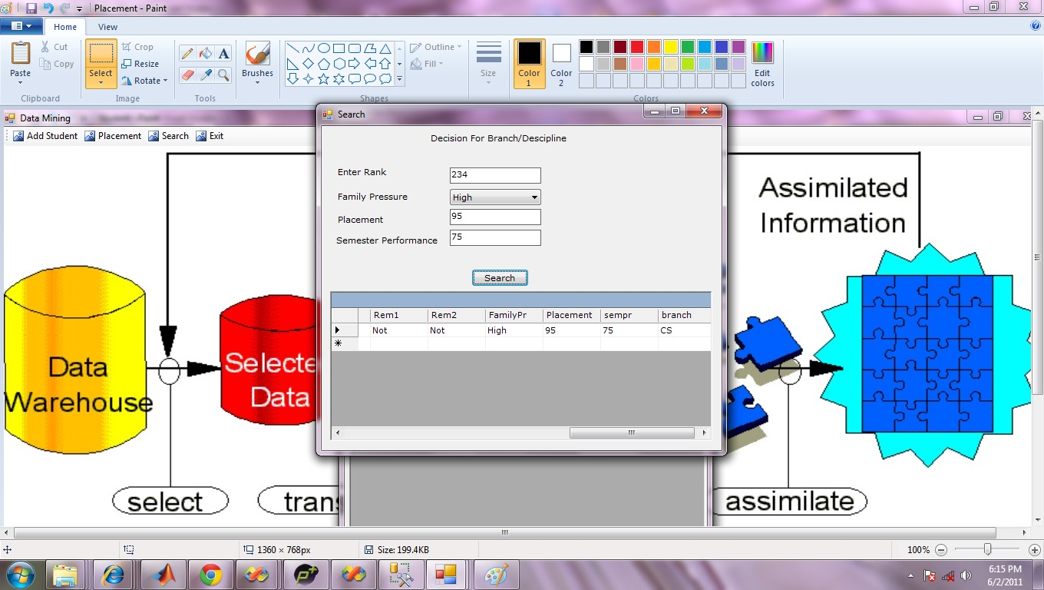
(a)

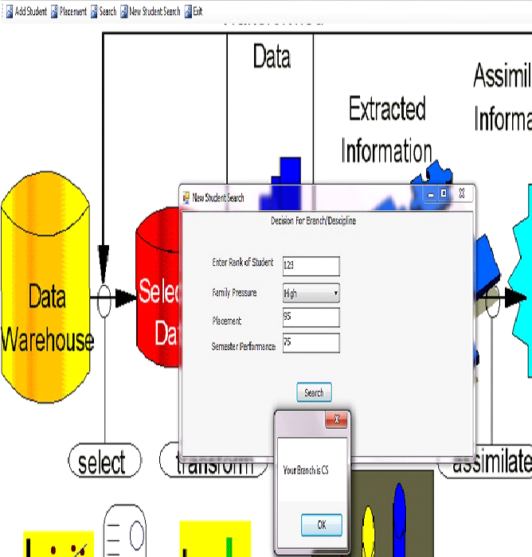.(b)
Figure 4.19: (a) Student Search, (b) Mining Branch

4.4.5 Lines of Codes

using System;
using System.Collections.Generic;
using System.ComponentModel;
using System.Data;
using System.Drawing;
using System.Text;
using System.Windows.Forms;

namespace DataMining
{
public partial class Form1 : Form
{
public Form1()
{
InitializeComponent();
}

private void button1_Click(object sender, EventArgs e)
{
if (textBox1.Text.Equals("admin") && textBox2.Text.Equals("admin"))
{
frmHome frm = new frmHome();
frm.Show();
this.Hide();
}
else
{
MessageBox.Show("Invalid User Id Password!");
textBox1.Focus();
return;
}

}
}
}

using System;
using System.Collections.Generic;
using System.ComponentModel;
using System.Data;
using System.Drawing;
using System.Text;
using System.Windows.Forms;

namespace DataMining
{
public partial class frmHome : Form
{
public frmHome()
{
InitializeComponent();
}

private void toolStripButton1_Click(object sender, EventArgs e)
{
frmAddStudent frm = new frmAddStudent();
frm.Show();
}

private void toolStripButton2_Click(object sender, EventArgs e)
{
Application.Exit();
}

private void toolStripButton3_Click(object sender, EventArgs e)
{
frmPlacement frm = new frmPlacement();
frm.Show();
}

private void toolStripButton4_Click(object sender, EventArgs e)
{
frmSearch frm = new frmSearch();
frm.Show();
}

private void toolStripButton5_Click(object sender, EventArgs e)
{
frmNewStudentSearch frm = new frmNewStudentSearch();
frm.Show();
}
}
}

using System;
using System.Collections.Generic;
using System.ComponentModel;
using System.Data;
using System.Drawing;
using System.Text;
using System.Windows.Forms;
using System.Data.SqlClient;
namespace DataMining
{
public partial class frmAddStudent : Form
{
public frmAddStudent()
{
InitializeComponent();
}

private void button1_Click(object sender, EventArgs e)
{
if (txtRoll.Text.Equals(""))
{
MessageBox.Show("Please Enter Valid Roll No");
return;
}
if (txtAIRank.Text.Equals(""))
{
MessageBox.Show("Please Enter Valid AI Rank");
return;
}
try
{
SqlConnection con = new SqlConnection(DB.getcon());
con.Open();
SqlCommand com = new SqlCommand();
com.Connection = con;
com.CommandText = "insert into Student(Rollno,AppNo,CName,Sex,Age,dt,Category,AiRank,StRank,SSTRank,Rem1,Rem2,Familypr) values('" +
txtRoll.Text + "','" +
txtAppNo.Text + "','" +
txtCName.Text + "','" +
cmbSex.Text + "'," +
txtAge.Text + ",'" +
txtDt.Value.ToString() + "','" +
cmbCat.Text + "','" +
txtAIRank.Text + "','" +
txtSStRank.Text + "','" +
txtSStRank.Text + "','" +
txtRem1.Text + "','" +
txtRem2.Text + "','" +
cmbFamilyPr.Text + "')";
com.ExecuteNonQuery();
con.Close();
MessageBox.Show("Save");
txtRem2.Text = "";
txtRem1.Text = "";
txtSStRank.Text = "";
txtAge.Text = "";
txtAIRank.Text = "";
txtAIRank.Text = "";
txtCName.Text = "";
txtRoll.Text = "";
txtAppNo.Text = "";
txtStRank.Text = "";
getlist();

}
catch (SqlException ex)
{
MessageBox.Show(ex.Message);

}

}

private void frmAddStudent_Load(object sender, EventArgs e)
{
getlist();
}
void getlist()
{
try
{
SqlConnection con = new SqlConnection(DB.getcon());
con.Open();
SqlDataAdapter da = new SqlDataAdapter("Select * from Student where Rollno like '"+txtSearch.Text+"%'", con);
DataSet ds = new DataSet();
da.Fill(ds, "Student");
DG.DataSource = ds.Tables[0];
con.Close();
}
catch (SqlException ex)
{
MessageBox.Show(ex.Message);

}
}

private void txtSearch_TextChanged(object sender, EventArgs e)
{
getlist();
}

private void DG_CurrentCellChanged(object sender, EventArgs e)
{
if (DG.CurrentRowIndex == -1)
return;
try
{
SqlConnection con = new SqlConnection(DB.getcon());
con.Open();
SqlCommand com = new SqlCommand("Select * from Student where id=" + DG[DG.CurrentCell.RowNumber, 0].ToString() + "", con);
SqlDataReader dr = com.ExecuteReader();
if (dr.Read())
{
txtAge.Text = dr["Age"].ToString();
txtAIRank.Text = dr["Airank"].ToString();
txtRem1.Text = dr["Rem1"].ToString();
txtRem2.Text = dr["Rem2"].ToString();
txtRoll.Text = dr["RollNo"].ToString();
txtCName.Text = dr["CName"].ToString();
txtDt.Text = dr["Dt"].ToString();
txtAppNo.Text = dr["AppNo"].ToString();
cmbCat.Text = dr["Category"].ToString();
cmbSex.Text = dr["Sex"].ToString();
cmbFamilyPr.Text = dr["FamilyPr"].ToString();

}
dr.Close();
con.Close();

}
catch (SqlException ex)
{
MessageBox.Show(ex.Message);

}
}
}
}
using System;
using System.Collections.Generic;
using System.ComponentModel;
using System.Data;
using System.Drawing;
using System.Text;
using System.Windows.Forms;
using System.Data.SqlClient;

namespace DataMining
{
public partial class frmPlacement : Form
{
public frmPlacement()
{
InitializeComponent();
}

private void frmPlacement_Load(object sender, EventArgs e)
{
try
{
SqlConnection con = new SqlConnection(DB.getcon());
con.Open();
SqlCommand com = new SqlCommand();
com.Connection = con;
SqlDataReader dr;
txtRollNo.AutoCompleteMode = AutoCompleteMode.Suggest;
txtRollNo.AutoCompleteSource = AutoCompleteSource.CustomSource;
com.CommandText = "select distinct RollNo from placement order by RollNo";
dr = com.ExecuteReader();
while (dr.Read())
{
txtRollNo.AutoCompleteCustomSource.Add(dr["RollNo"].ToString());
}
dr.Close();
con.Close();
getlist();
}
catch (SqlException ex)
{
MessageBox.Show(ex.Message);

}
}

private void button1_Click(object sender, EventArgs e)
{
try
{
SqlConnection con = new SqlConnection(DB.getcon());
con.Open();
SqlCommand com = new SqlCommand();
com.Connection = con;
SqlDataReader dr;
com.CommandText = "Select rollNo from Placement where RollNo='" + txtRollNo.Text + "'";
dr = com.ExecuteReader();
if (dr.Read())
{
MessageBox.Show("Already Exist!");
dr.Close();
return;
}
dr.Close();
com.CommandText = "insert into Placement(RollNo,Branch,Placement,SemPr) values('" + txtRollNo.Text + "','" +
txtBranch.Text + "'," +
txtPlacement.Text + "," +
txtSemPr.Text + ")";
com.ExecuteNonQuery();
con.Close();
MessageBox.Show("Save");
txtRollNo.Text = "";
txtBranch.Text = "";
txtPlacement.Text = "";
txtSemPr.Text = "";
getlist();

}
catch (SqlException ex)
{
MessageBox.Show(ex.Message);

}
}
void getlist()
{
try
{
SqlConnection con = new SqlConnection(DB.getcon());
con.Open();
SqlDataAdapter da = new SqlDataAdapter("select * from Placement where RollNo like'"+txtSearch.Text+"%'", con);
DataSet ds = new DataSet();
da.Fill(ds, "Placement");
dataGrid1.DataSource = ds.Tables[0];
con.Close();
}
catch (SqlException ex)
{
MessageBox.Show(ex.Message);

}
}

private void dataGrid1_CurrentCellChanged(object sender, EventArgs e)
{
try
{
SqlConnection con = new SqlConnection(DB.getcon());
con.Open();
SqlCommand com = new SqlCommand("select * from Placement where Id=" + dataGrid1[dataGrid1.CurrentCell.RowNumber, 0].ToString() + "", con);
SqlDataReader dr = com.ExecuteReader();
if (dr.Read())
{
txtBranch.Text = dr["Branch"].ToString();
txtPlacement.Text = dr["Placement"].ToString();
txtRollNo.Text = dr["RollNo"].ToString();
txtSemPr.Text = dr["SemPr"].ToString();
}
dr.Close();
con.Close();
}
catch (SqlException ex)
{
MessageBox.Show(ex.Message);

}
}

private void txtSearch_TextChanged(object sender, EventArgs e)
{
getlist();

}
}
}
using System;
using System.Collections.Generic;
using System.ComponentModel;
using System.Data;
using System.Drawing;
using System.Text;
using System.Windows.Forms;
using System.Data.SqlClient;

namespace DataMining
{
public partial class frmSearch : Form
{
public frmSearch()
{
InitializeComponent();
}

private void frmSearch_Load(object sender, EventArgs e)
{
try
{
SqlConnection con = new SqlConnection(DB.getcon());
con.Open();
SqlCommand com = new SqlCommand();
com.Connection = con;
SqlDataReader dr;
txtPlacement.AutoCompleteMode = AutoCompleteMode.Suggest;
txtPlacement.AutoCompleteSource = AutoCompleteSource.CustomSource;
com.CommandText = "select distinct Placement from Placement order by Placement";
dr = com.ExecuteReader();
while (dr.Read())
{
txtPlacement.AutoCompleteCustomSource.Add(dr["Placement"].ToString());
}
dr.Close();
txtSemester.AutoCompleteMode = AutoCompleteMode.Suggest;
txtSemester.AutoCompleteSource = AutoCompleteSource.CustomSource;

com.CommandText = "select distinct SemPr from Placement order by Sempr";
dr = com.ExecuteReader();
while (dr.Read())
{
txtSemester.AutoCompleteCustomSource.Add(dr["SemPr"].ToString());
}
dr.Close();
con.Close();
}
catch (SqlException ex)
{
MessageBox.Show(ex.Message);

}
}

private void button1_Click(object sender, EventArgs e)
{
try
{
SqlConnection con = new SqlConnection(DB.getcon());
con.Open();
SqlDataAdapter da = new SqlDataAdapter("select a.*,b.Placement,b.sempr,b.branch from Student a,Placement b where a.FamilyPr='" + txtFamilyPressure.Text + "' and a.AIRank='" + txtRank.Text + "' and SemPr=" + txtSemester.Text + " and b.Placement=" + txtPlacement.Text + " and a.RollNo=b.RollNo", con);
DataSet ds = new DataSet();
da.Fill(ds);
dataGrid1.DataSource = ds.Tables[0];
con.Close();
}
catch (SqlException ex)
{
MessageBox.Show(ex.Message);

}
}
}
}
using System;
using System.Collections.Generic;
using System.ComponentModel;
using System.Data;
using System.Drawing;
using System.Text;
using System.Windows.Forms;
using System.Data.SqlClient;

namespace DataMining
{
public partial class frmNewStudentSearch : Form
{

public frmNewStudentSearch()
{
InitializeComponent();
}

private void button1_Click(object sender, EventArgs e)
{
try
{
SqlConnection con = new SqlConnection(DB.getcon());
con.Open();
bool Found = false;
SqlCommand com=new SqlCommand("select a.*,b.Placement,b.sempr,b.branch from Student a,Placement b where a.FamilyPr='" + txtFamilyPressure.Text + "' and a.AIRank='" + txtRank.Text + "' and SemPr=" + txtSemester.Text + " or b.Placement=" + txtPlacement.Text + " and a.RollNo=b.RollNo",con);
SqlDataReader dr = com.ExecuteReader();

if (dr.Read())
{
string msg = dr["Branch"].ToString();
MessageBox.Show("Your Branch is " + msg);
Found = true;
}
dr.Close();
if (!Found)
{
MessageBox.Show("Not Match For as per Database");
return;
}
con.Close();

}
catch (SqlException ex)
{
MessageBox.Show(ex.Message);

}

}

private void frmNewStudentSearch_Load(object sender, EventArgs e)
{
try
{
SqlConnection con = new SqlConnection(DB.getcon());
con.Open();
SqlCommand com = new SqlCommand();
com.Connection = con;
SqlDataReader dr;
txtPlacement.AutoCompleteMode = AutoCompleteMode.Suggest;
txtPlacement.AutoCompleteSource = AutoCompleteSource.CustomSource;
com.CommandText = "select distinct Placement from Placement order by Placement";
dr = com.ExecuteReader();
while (dr.Read())
{
txtPlacement.AutoCompleteCustomSource.Add(dr["Placement"].ToString());
}
dr.Close();
txtSemester.AutoCompleteMode = AutoCompleteMode.Suggest;
txtSemester.AutoCompleteSource = AutoCompleteSource.CustomSource;

com.CommandText = "select distinct SemPr from Placement order by Sempr";
dr = com.ExecuteReader();
while (dr.Read())
{
txtSemester.AutoCompleteCustomSource.Add(dr["SemPr"].ToString());
}
dr.Close();
con.Close();
}
catch (SqlException ex)
{
MessageBox.Show(ex.Message);

}
}
}
}

CONCLUSION AND FUTURE WORK

Improvement of engineering education planning is possible by applying innovative ideas which leads to quality Engineering education. A KDDS may be built to will help the Stake holder of the education to take right decision for enrolment in appropriate engineering discipline, identify the right/proper courses, design better course curriculum, efficient utilization of resources and technology as per industry needs that leads towards knowledge driven society.
In this thesis, A KDD based Technique has been implemented to predict a right decision in particular engineering discipline/branch for a particular student. As a part of this technique, See5/C5.0, C&R Tree, ANN algorithms are used to make a Rule set as well as Decision tree. Based on these algorithms, Accuracy rate for different partition sizes of the data is calculated and compared. Finally we have introduced a hybrid knowledge based decision technique in .NET platform for the same purpose.
Apart from the task to take right decision for enrolment in appropriate engineering discipline, identify the courses, as a future work one approach is to develop a Recommender System which will help the Stake holder of the education to design better course curriculum, predicting alumni pledges, Student’s satisfaction rate etc.
Adding new large data base, the quality of the decision tree can be improved.
Further different engineering colleges/institutions affiliated to the same University should adopt a single model for academic planning to strengthen the existing resources.
Lastly this work can further be improved for designing KDD technique which will capable of giving right decision for research in Science & Technology based on the demand of the society.
REFFERENCES

[1] Asma A. Al-shargabi, Ali N. Nusari, “Discovering Vital Patterns From UST Students Data by Applying Data Mining Techniques”, IEEE, pp 547-551, 2010.

[2] Daya Gupta, Rajni Jindal, Vaibhav Verma, Dilpreet Singh Kohli, Shashi Kant Sharma, “Predicting student’s behaviour in education using J48 algorithm Analysis tools in WEKA environment”, BIDW, 2010.

[3] Cesar Vialardi, Javier Bravo, Leila Shafti, Alvaro Ortigosa, “Recommen dation in Higher Education Using Data Mining Techniques”, Educational Data Mining, pp 190-199, 2009.

[4] C. Romero, S. Ventura “Educational data mining: A survey from 1995 to 2005”, Expert Systems with Applications Elsevier Ltd, pp 135–146, 2006.

[5] Michael Wald, “Trends in Engin eering Education”, IEEE, pp 1-16, 2007.

[6] Arruabarrena, R.perrez, T.A, Lopez –euadvado, J,,& Vadillio , J.G.J, “On evaluating adaptive systems for education”,in Adaptive hypermedia, pp 363-367, 2002.
[7] Ha,S Bae,S & Park, S, “Web Mining for distance education” in IEEE international conference on management of innovation and technology ,pp 715-719, 2000.
[8] Srivastava, J.,Cooley, R., Deshpande, M., & Tan.P. “Web usage mining: Discovery and applications of usage patterns from web data”. SIGKDD Explorations, chapter 1.2, pp 12–23, 2000.

[9] Jiawei Han and Micheline Kamber, “Data Mining Concepts and Techniques, 2/e”,Morgan Kaufmann Publishers, An imprint of Elsevier,2010.

[10] Klosgen, W., & Zytkow, J. “Handbook of data mining and knowledge discovery” New York: Oxford University Press, 2002.

[11] SPSS Course Notes “Applying Data Mining Techniques Using Enterprise Miner™”, chapter 2.3, pp 2.43.

[12] Jing Luan, “Data Mining Applications in Higher Education”, SPSS Executive report.

[13] Musa J. Jafar, “A Tools-Based Approach to Teaching Data Mining Methods”,
Journal of Information Technology Education : Innovations in Practice, Vol 9, 2010.
[14]M. Dayne Aldridge and Larry Benefield, “A Planning model for ABET engineering criteria 2000”, Frontiers in Education Conference, IEEE, 1997.
[15] Luan, Jing, Willet, Terrence ,“Data mining and knowledge management: A System Analysis for establishing a Tiered Knowledge Management Model”, Descriptive reports ,2000.
[16] Oded Maimon ,Lior Rokach , “The Data Mining and Knowledge Discovery Handbook”, Springer publication,2005.
[17] Quinlan JR,“ Induction of decision trees : Machine Learning”, vol 1. Morgan Kaufmann. pp. 81-106, 1986.

[18] Quinlan JR, “C4.5: programs for Machine Learning”, Morgan Kaufmann, Los Altos, 1993.

[19] Kass G.V, “An exploratory technique for investing large quantities of categorical data”, Applied Statistics, pp. 119-127, 1980.

[20]Quinlan, J.R. ,C5.0 Online Tutorial, http://www.rulequest.com, 2003.

[21]. "http://en.wikipedia.org/wiki/Artificial_neural_network"

[22] Ron Kohavi, Ross Quinlan , “C 5.1.3 Decision Tree Discovery”, Updated October 10,1999.

Appendix A: Set of Rules

N.B: EE – Electrical Engg., COE – Computer Engg., ME-Mechanical Engg., BT-Bio Technology , CE-Civil Engg., ECE-Electronics & Comm. Engg., IT-Information Technology etc.

1. Analysis of Algorithms using Training partition size 45 and Testing partition size 55
a. See5/C5.0

PLACEMENT_TO_SEMPERF <= 1.214 [ Mode: EE ]
ROLL <= 25,083 [ Mode: COE ]
ROLL <= 22,147 [ Mode: COE ] => COE
ROLL > 22,147 [ Mode: IT ]
PLACEMENT_TO_SEMPERF <= 1.188 [ Mode: IT ] => IT
PLACEMENT_TO_SEMPERF > 1.188 [ Mode: ECE ] => ECE
ROLL > 25,083 [ Mode: EE ]
ROLL <= 35,325 [ Mode: EE ] => EE
ROLL > 35,325 [ Mode: ME ]
ROLL <= 50,984 [ Mode: BT ]
FMLY_PR = L [ Mode: ME ]
PLACEMENT_TO_SEMPERF <= 1.203 [ Mode: CE ] => CE
PLACEMENT_TO_SEMPERF > 1.203 [ Mode: ME ] => ME
FMLY_PR = H [ Mode: BT ] => BT
ROLL > 50,984 [ Mode: ME ] => ME
PLACEMENT_TO_SEMPERF > 1.214 [ Mode: COE ]
PLACEMENT_TO_SEMPERF <= 1.267 [ Mode: COE ]
PLACEMENT_TO_SEMPERF <= 1.227 [ Mode: COE ]
PLACEMENT_TO_SEMPERF <= 1.218 [ Mode: COE ] => COE
PLACEMENT_TO_SEMPERF > 1.218 [ Mode: ME ] => ME
PLACEMENT_TO_SEMPERF > 1.227 [ Mode: COE ]
PLACEMENT_TO_SEMPERF <= 1.243 [ Mode: COE ]
PLACEMENT_TO_SEMPERF <= 1.234 [ Mode: COE ] => COE
PLACEMENT_TO_SEMPERF > 1.234 [ Mode: ME ] => ME
PLACEMENT_TO_SEMPERF > 1.243 [ Mode: COE ] => COE
PLACEMENT_TO_SEMPERF > 1.267 [ Mode: COE ]
FMLY_PR = L [ Mode: EE ]
ROLL <= 14,860 [ Mode: COE ] => COE
ROLL > 14,860 [ Mode: EE ] => EE
FMLY_PR = H [ Mode: COE ]
ROLL <= 50,295 [ Mode: COE ] => COE
ROLL > 50,295 [ Mode: ME ] => ME

b. C & R Tree

PLACEMENT_TO_SEMPERF <= 1.216 [ Mode: EE ]
ROLL <= 22,153 [ Mode: COE ] => COE
ROLL > 22,153 [ Mode: EE ]
ROLL <= 35342.500 [ Mode: EE ]
ROLL <= 25103.500 [ Mode: IT ] => IT
ROLL > 25103.500 [ Mode: EE ] => EE
ROLL > 35342.500 [ Mode: ME ]
ROLL <= 50,986 [ Mode: BT ]
ROLL <= 42,879 [ Mode: ME ] => ME
ROLL > 42,879 [ Mode: BT ] => BT
ROLL > 50,986 [ Mode: ME ] => ME
PLACEMENT_TO_SEMPERF > 1.216 [ Mode: COE ]
PLACEMENT_TO_SEMPERF <= 1.406 [ Mode: COE ]
PLACEMENT_TO_SEMPERF <= 1.272 [ Mode: COE ]
PLACEMENT_TO_SEMPERF <= 1.230 [ Mode: COE ]
ROLL <= 51,102 [ Mode: COE ] => COE
ROLL > 51,102 [ Mode: ME ] => ME
PLACEMENT_TO_SEMPERF > 1.230 [ Mode: COE ] => COE
PLACEMENT_TO_SEMPERF > 1.272 [ Mode: COE ]
FMLY_PR in [ "H" ] [ Mode: COE ] => COE
FMLY_PR in [ "L" ] [ Mode: EE ] => EE
PLACEMENT_TO_SEMPERF > 1.406 [ Mode: EE ] => EE

c.ANN
Analysis
Estimated accuracy: 90.038
Input Layer: 17 neurons
Hidden Layer 1: 3 neurons
Output Layer: 7 neurons
Relative Importance of Inputs
ROLL 0.256391
FMLY_PR 0.144855
PLACEMENT_TO_SEMPERF 0.1361
YY 0.056364
SEX 0.00149255
ROLL 0.256391
FMLY_PR 0.144855
PLACEMENT_TO_SEMPERF 0.1361
YY 0.056364
SEX 0.00149255

Fields
Target
BRANCH
Inputs
FMLY_PR
PLACEMENT_TO_SEMPERF
ROLL
SEX
YY
Build Settings
Use partitioned data: true
Partition: Partition
Method: Quick
Stop on: Default
Set random seed: false
Prevent overtraining: true
Sample %: 50.0
Optimize: Memory
Training Summary
Algorithm: Neural net
Model type: Classification
Stream: C:\Users\MALAYA\Desktop\FinalYrproject\main_data\FINAL_STREAMS\final6_tr30_tes_70\ann_45_55.str
User: MALAYA
Date built: 5/20/11 4:02 PM
Application: Clementine 11.1
Elapsed time for model build: 0 hours, 0 mins, 15 secs

2. Analysis of Algorithms using Training partition size 70 and Testing partition size 30
a.See5/C5.O

PLACEMENT_TO_SEMPERF <= 1.214 [ Mode: EE ]
ROLL <= 25,083 [ Mode: COE ]
ROLL <= 22,147 [ Mode: COE ] => COE
ROLL > 22,147 [ Mode: IT ]
PLACEMENT_TO_SEMPERF <= 1.188 [ Mode: IT ] => IT
PLACEMENT_TO_SEMPERF > 1.188 [ Mode: ECE ] => ECE
ROLL > 25,083 [ Mode: EE ]
ROLL <= 35,335 [ Mode: EE ] => EE
ROLL > 35,335 [ Mode: ME ]
ROLL <= 50,984 [ Mode: BT ]
FMLY_PR = L [ Mode: ME ]
PLACEMENT_TO_SEMPERF <= 1.203 [ Mode: CE ] => CE
PLACEMENT_TO_SEMPERF > 1.203 [ Mode: ME ] => ME
FMLY_PR = H [ Mode: BT ] => BT
ROLL > 50,984 [ Mode: ME ] => ME
PLACEMENT_TO_SEMPERF > 1.214 [ Mode: COE ]
PLACEMENT_TO_SEMPERF <= 1.267 [ Mode: COE ]
PLACEMENT_TO_SEMPERF <= 1.227 [ Mode: COE ]
PLACEMENT_TO_SEMPERF <= 1.224 [ Mode: COE ] => COE
PLACEMENT_TO_SEMPERF > 1.224 [ Mode: ME ] => ME
PLACEMENT_TO_SEMPERF > 1.227 [ Mode: COE ]
PLACEMENT_TO_SEMPERF <= 1.243 [ Mode: COE ]
FMLY_PR = L [ Mode: COE ] => COE
FMLY_PR = H [ Mode: COE ]
PLACEMENT_TO_SEMPERF <= 1.234 [ Mode: COE ] => COE
PLACEMENT_TO_SEMPERF > 1.234 [ Mode: ME ] => ME
PLACEMENT_TO_SEMPERF > 1.243 [ Mode: COE ] => COE
PLACEMENT_TO_SEMPERF > 1.267 [ Mode: COE ]
FMLY_PR = L [ Mode: EE ]
ROLL <= 14,850 [ Mode: COE ] => COE
ROLL > 14,850 [ Mode: EE ] => EE
FMLY_PR = H [ Mode: COE ]
ROLL <= 50,297 [ Mode: COE ] => COE
ROLL > 50,297 [ Mode: ME ] => ME

b. C& R Tree

PLACEMENT_TO_SEMPERF <= 1.216 [ Mode: EE ]
ROLL <= 22,153 [ Mode: COE ] => COE
ROLL > 22,153 [ Mode: EE ]
ROLL <= 35347.500 [ Mode: EE ]
ROLL <= 25101.500 [ Mode: IT ] => IT
ROLL > 25101.500 [ Mode: EE ] => EE
ROLL > 35347.500 [ Mode: ME ]
ROLL <= 50,987 [ Mode: BT ]
ROLL <= 42,879 [ Mode: ME ] => ME
ROLL > 42,879 [ Mode: BT ] => BT
ROLL > 50,987 [ Mode: ME ] => ME
PLACEMENT_TO_SEMPERF > 1.216 [ Mode: COE ]
PLACEMENT_TO_SEMPERF <= 1.406 [ Mode: COE ]
PLACEMENT_TO_SEMPERF <= 1.272 [ Mode: COE ]
PLACEMENT_TO_SEMPERF <= 1.230 [ Mode: COE ]
ROLL <= 51,102 [ Mode: COE ] => COE
ROLL > 51,102 [ Mode: ME ] => ME
PLACEMENT_TO_SEMPERF > 1.230 [ Mode: COE ] => COE
PLACEMENT_TO_SEMPERF > 1.272 [ Mode: COE ]
FMLY_PR in [ "H" ] [ Mode: COE ] => COE
FMLY_PR in [ "L" ] [ Mode: EE ] => EE
PLACEMENT_TO_SEMPERF > 1.406 [ Mode: EE ] => EE

c. ANN

Analysis
Estimated accuracy: 87.467
Input Layer: 17 neurons
Hidden Layer 1: 3 neurons
Output Layer: 7 neurons
Relative Importance of Inputs
FMLY_PR 0.17264
ROLL 0.167494
PLACEMENT_TO_SEMPERF 0.13884
YY 0.0301475
SEX 0.00311649
FMLY_PR 0.17264
ROLL 0.167494
PLACEMENT_TO_SEMPERF 0.13884
YY 0.0301475
SEX 0.00311649

Fields
Target
BRANCH
Inputs
FMLY_PR
PLACEMENT_TO_SEMPERF
ROLL
SEX
YY
Build Settings
Use partitioned data: true
Partition: Partition
Method: Quick
Stop on: Default
Set random seed: false
Prevent overtraining: true
Sample %: 50.0
Optimize: Memory
Training Summary
Algorithm: Neural net
Model type: Classification
Stream: Stream2
User: MALAYA
Date built: 6/4/11 10:26 AM
Application: Clementine 11.1
Elapsed time for model build: 0 hours, 0 mins, 15 secs

Appendix B: Decision Tree

1. Analysis of Algorithms using Training partition size 45 and Testing partition size 55
a. See5/C5.0
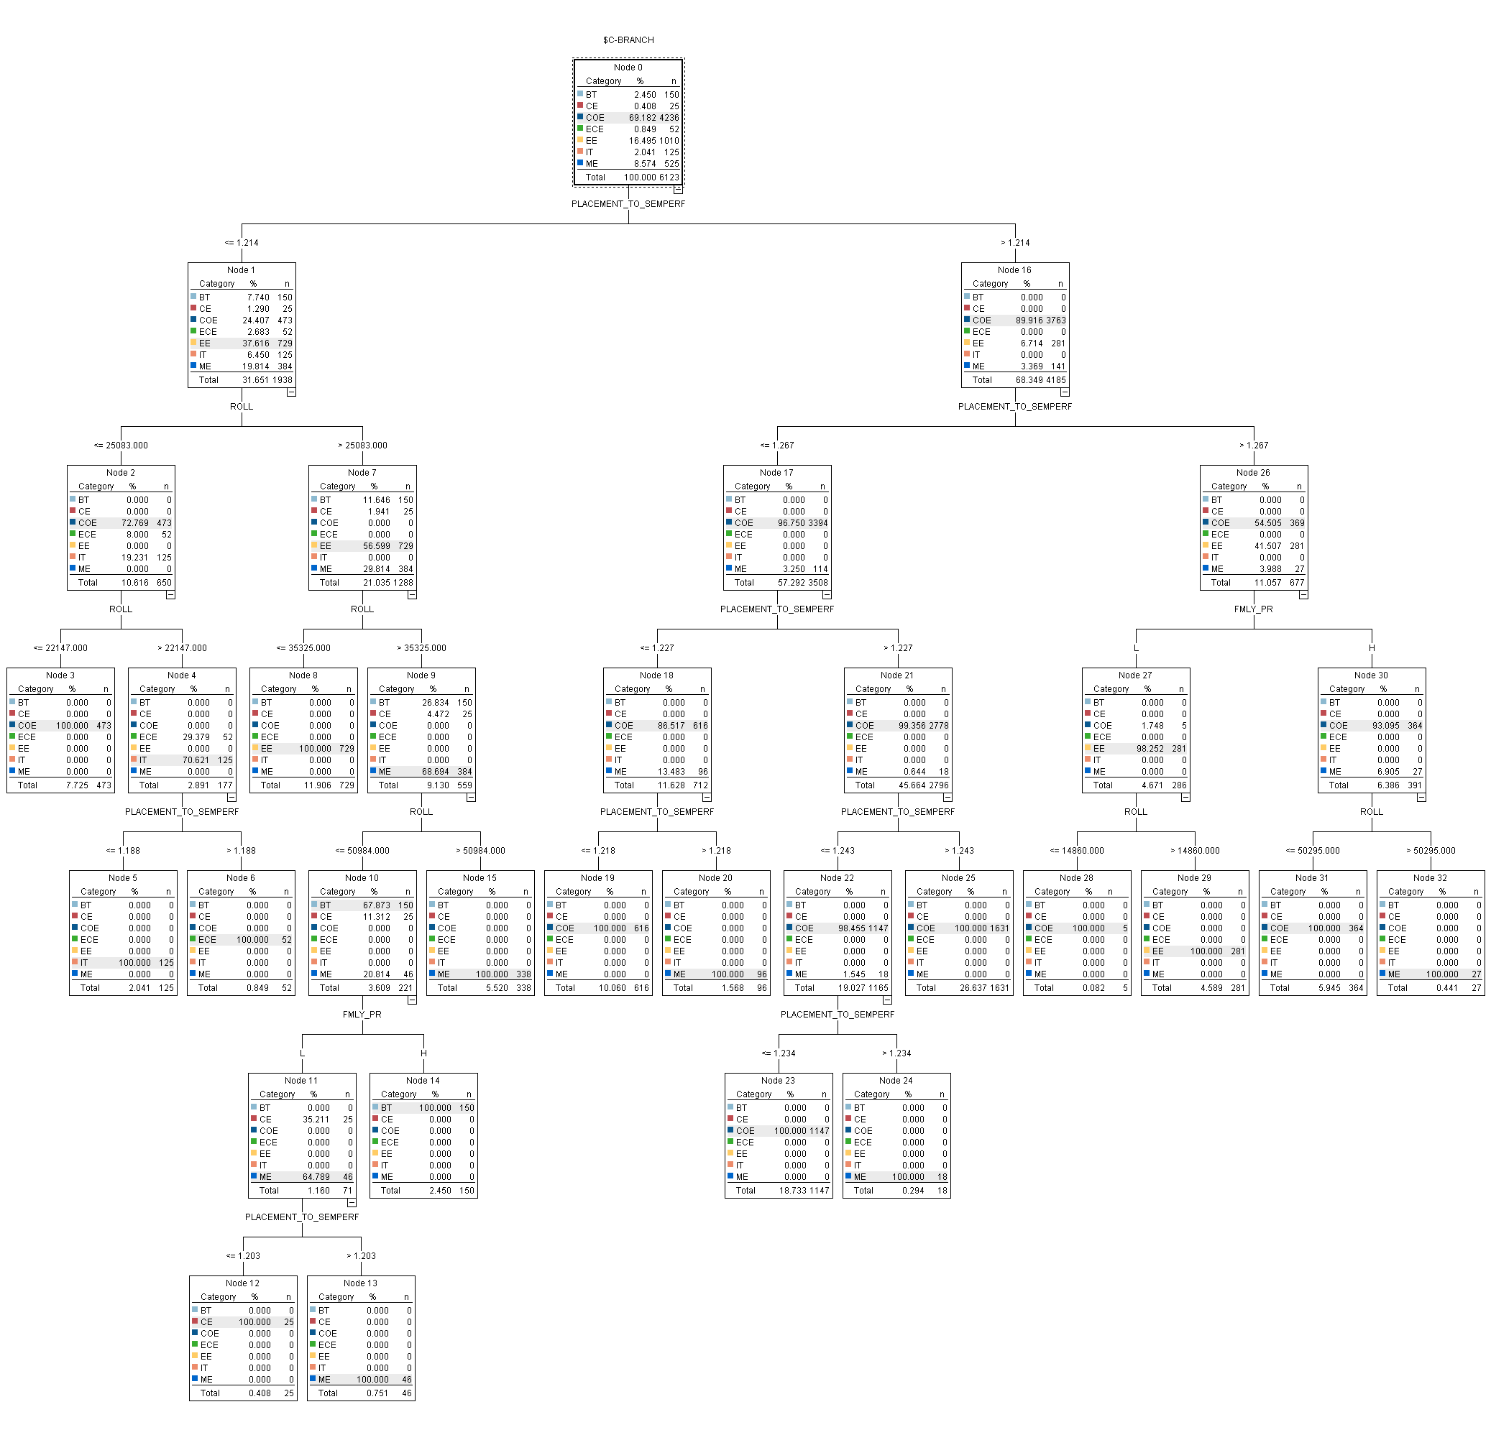

b. C & R Tree
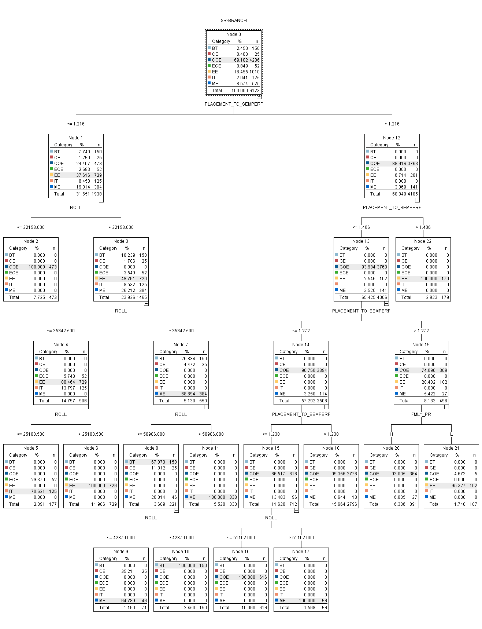
c.ANN
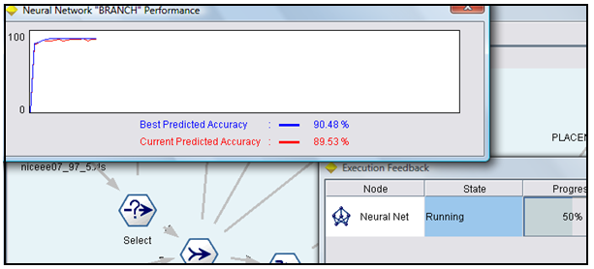

2.Analysis of Algorithms using Training partition size 70 and Testing partition size 30
a. See5/C5.
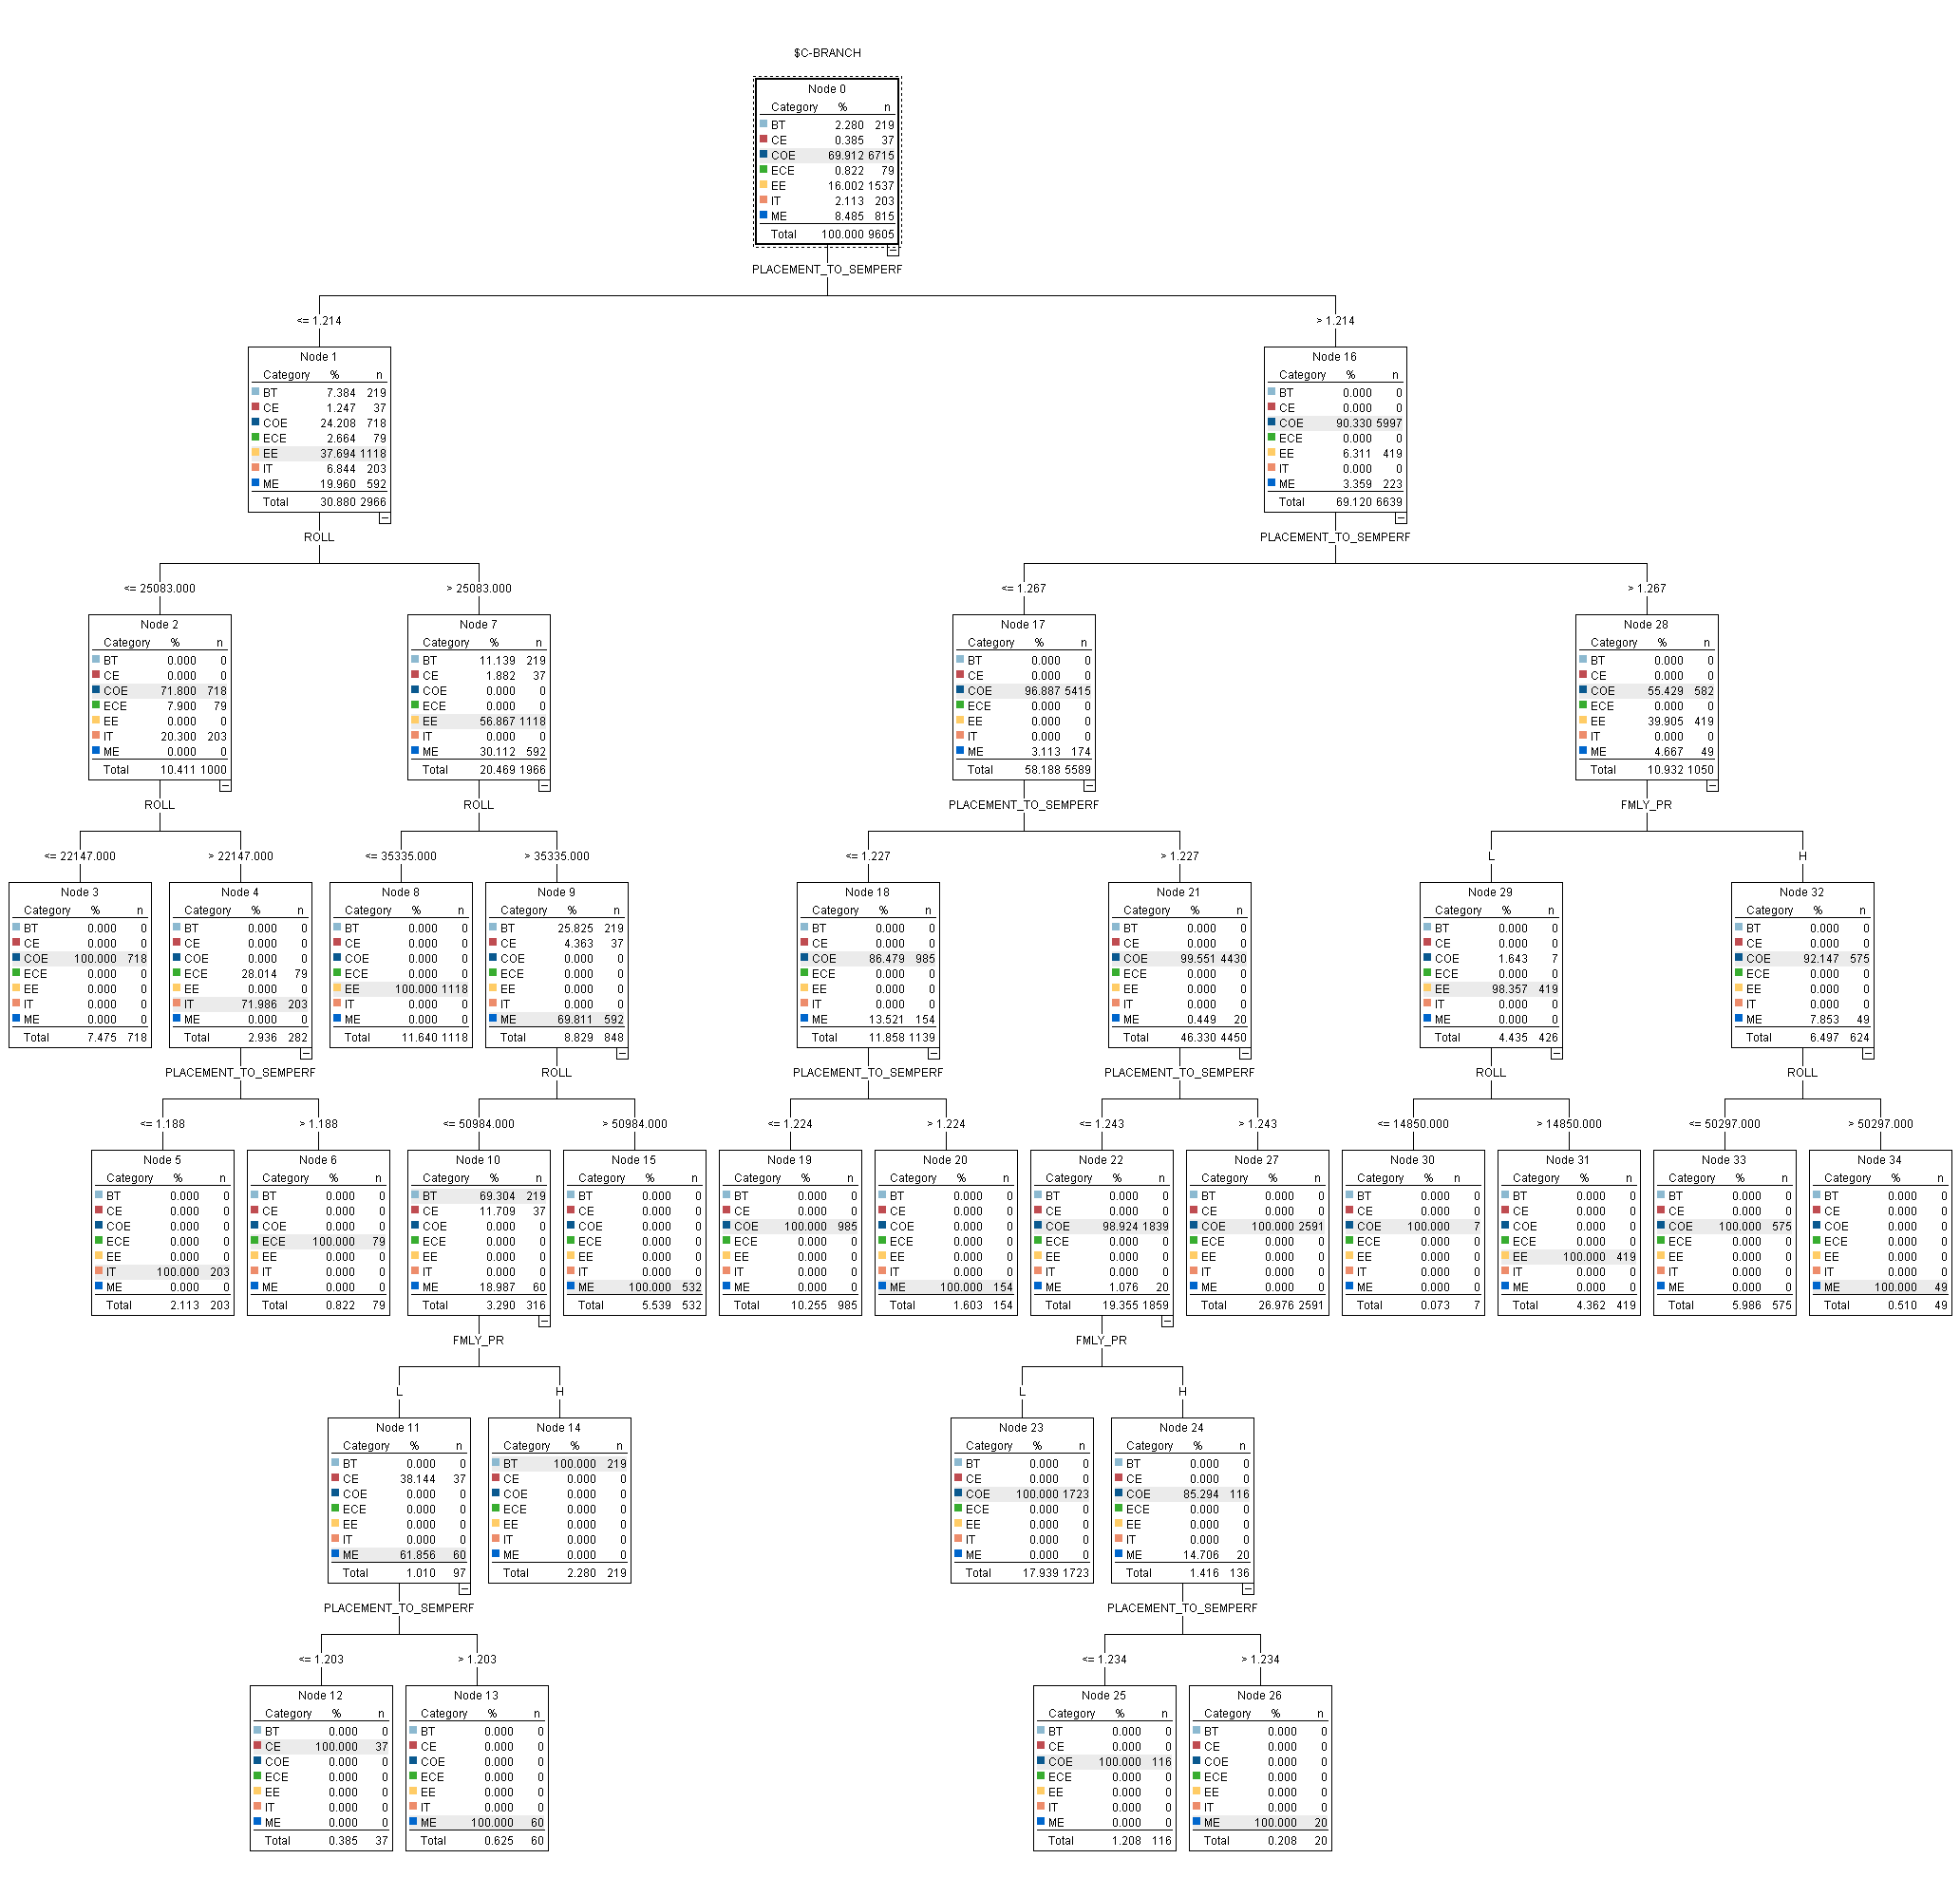

b. CRT
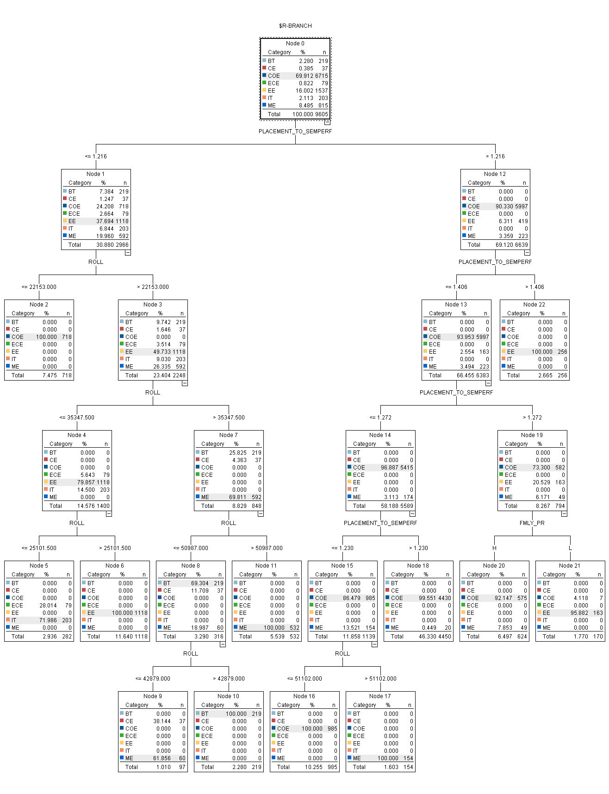

c. ANN
