A
Dissertation
On
IMPLEMENTATION OF REAL TIME OBJECT
DETECTION & TRACKING
Submitted in partial fulfillment of the requirement
for the award of the degree of
MASTER OF TECHNOLOGY
(VLSI Design & Embedded System)

Submitted By:
Prateek Kabra
College Roll No: 14/VLSI/09

Under the Supervision of:
Sh. Rajesh Rohilla
Associate Professor
Delhi Technological University

DEPARTMENT OF ELECTRONICS & COMMUNICATION ENGINEERING
DELHI TECHNOLOGICAL UNIVERSITY
2009-2011
A
Dissertation
On
IMPLEMENTATION OF REAL TIME OBJECT
DETECTION & TRACKING
Submitted in Partial fulfilment of the requirement
for the award of the degree of
MASTER OF TECHNOLOGY
(VLSI Design & Embedded System)

Submitted By:
Prateek Kabra
College Roll No: 14/VLSI/09

Under the Supervision and Guidance of:
Sh. Rajesh Rohilla
Associate Professor
Delhi Technological University

DEPARTMENT OF ELECTRONICS & COMMUNICATION ENGINEERING
DELHI TECHNOLOGICAL UNIVERSITY
2009-2011

CERTIFICATE

This is to certify that the work contained in this major project entitled “ Implementation of Real Time Object Detection and Tracking” submitted by Prateek Kabra (14/VLSI/09) of Delhi Technological University in partial fulfillment of the requirement for the degree of Master of Technology in VLSI Design and Embedded System is a bonafide work carried out under my guidance and supervision in the academic year 2009-11.

The work embodied in this dissertation has not been submitted for the award of any other degree to the best of my knowledge.

Mr. Rajesh Rohilla
Associate Professor
ECE Department
Delhi Technological University Delhi - 42

ACKNOWLEDGEMENTS

It is a great pleasure to have the opportunity to extend my heartiest gratitude to everybody who helped me throughout the course of this project.

First and foremost, I would like to thank my esteemed supervisor Mr. Rajesh Rohilla, Delhi Technological University for his support and encouragement for the past two years. I am greatly indebted to him for the many occasions in which he has gone out of his way to assist me in the timely completion of this dissertation. He has been an ongoing inspiration for me not only in terms of academic endeavor’s, but his charismatic personality has also made my studies a much more interesting and rewarding experience.

I would also like to take the opportunity to present my sincere regards to our H.O.D., Electronics & Communication Engineering Department, Prof. Rajiv Kapoor for his support and encouragement.

I owe the most to my family for their love and support, who has given me enormous support. Lastly I like to remember the mercy and blessings of Almighty, on whose desire I have come to this level of career in my life.

Prateek Kabra
M.Tech (VLSI Design & Embedded System)
College Roll No. 14/VLSI/09
Department of Electronics and Communication
Delhi Technological University, Delhi-110042

TABLE OF CONTENTS

PAGE NO.

LIST OF FIGURES I
ABSTRACT
1 INTRODUCTION
2 DISCRETE KALMAN FILTER
2.1 The Process to be Estimated
2.2 The Computational Origin of the Filter
2.3 The Probabilistic Origin of the Filter
2.4 The Discrete Kalman Filter Algorithm
3 SIMULINK MODELS FOR VIDEO PROCESSING
3.1 Introduction to Simulink
3.2 Basic Elements
3.2.1 Blocks
3.2.2 Lines
3.3 Design and Simulate Video and Image Processing Systems
3.4 Modelling and Simulating Video Imaging Systems
3.4.1 Multimedia I/O, Video Viewer, and Display Blocks
3.4.2 The Video and Image Processing Block Set Lets You
3.5 Delay
3.6 Sample Based Operation
3.7 Frame Based Operation
3.8 Data Type Conversion Block
3.10 Constant
3.11 Sample and Hold Block
4 OBJECT TRACKING USING KALMAN FILTER
4.1 Object Detection Using Histogram Matching Technique
4.2 Object Extraction
4.3 Tracking Algorithm
5 SIMULATION AND RESULT
5.1 Simulink Model for Object Tracking using Kalman Filter
5.1.1 Background Estimation Model
5.1.2 Object Detection Model
5.1.3 Object Tracking Model
a. Tracking Input from Library File
b. Tracking Input via Camera
5.2 Result
6 CONCLUSION AND FUTURE SCOPE
7 REFERENCES

LIST OF FIGURES

PAGE NO.
Figure 2.1: The ongoing Discrete Kalman Filter Cycle
Figure 2.2: A complete picture of the operation of the Kalman Filter
Figure 4.1: Connectivity of Pixels
Figure 5.1: Background Estimation using Sample and Hold Method
Figure 5.2: Object Detection Model using Histogram Matching
Figure 5.3: Simulink model for Object Tracking
Figure 5.4: Simulink model for Object Tracking using Camera
Figure 5.5(a) - 5.5(v): Images for Object Tracking
Figure 5.6(a) - 5.6(g): Images for Object Tracking with change in light intensity

ABSTRACT

In this project we present an approach to develop a real-time object tracking system using a static camera to grab the video frames and track an object. The work presents the concepts of histogram matching and absolute frame subtraction to implement a robust automated object tracking system. Once the object is detected it is tracked using discrete Kalman filter technique. The histogram matching algorithm helps to identify when the object enters the viewing range of the camera and the absolute frame subtraction gives better results even with low quality videos. Such a tracking system can be used in surveillance applications and proves to be cost effective. A simulink model is also developed for object tracking for real time video.

CHAPTER 1
INTRODUCTION

Video tracking is the process of locating a moving object (or several ones) in time using a camera. An algorithm analyses the video frames and outputs the location of moving targets within the video frame. The main difficulty in video tracking is to associate target locations in consecutive video frames, especially when the objects are moving fast relative to the frame rate. The role of the tracking algorithm is to analyze the video frames in order to estimate the motion parameters. These parameters characterize the location of the target.
The video surveillance systems have been the subject of intensive research due to their great importance for security reasons. Video Surveillance is described as the task of analyzing videos to detect certain unusual activities.
Classical image segmentation using graphical tools use either texture (color) information, e.g. Magic Wand, or edge (contrast) information, e.g. Intelligent Scissors which are normally user-interactive i.e. the operator or user creates a rectangle or marks certain part of the required object that is to be detected and tracked. The drawback of these techniques is that these are operator driven and is very slow. To overcome the above two problems background subtraction method (BSM) has been considered widely. It makes the processing fast as well as automated. Although this method is fast and is automated but it comes at the expense of addition of excessive noise due to either change in the position of objects in the reference frame, example movement of the leaves or change in position of dustbins or wall paintings etc. or sudden change in the luminosity of the light. The above problem is solved by applying a certain threshold which removes smaller particles of noise and certain morphological operations like erosion to reduce the non connected parts smaller in size. Even though the noise is removed we also lose on the essential information i.e. certain part of the object gets eroded while applying erosion. Thus we present our approach of absolute Histogram subtraction of consecutive frames to detect the object (if appeared) in the frames to avoid complete processing of each and every frame. If object appears, we use absolute image subtraction to extract the object followed by the Kalman tracking of the object.

In this project we developed object tracking for real time video which demonstrates the histogram matching and absolute frame subtraction. A simulink model is also developed for object tracking for real time video.

CHAPTER 2

DISCRETE KALMAN FILTER

Kalman filter is a recursive solution to the discrete-data linear filtering problem. The Kalman filter is essentially a set of mathematical equations that implement a predictor-corrector type estimator that is optimal in the sense that it minimizes the estimated error covariance—when some presumed conditions are met. The Kalman filter has been used extensively for tracking in interactive computer graphics.

2.1 The Process to be Estimated
The Kalman filter addresses the general problem of trying to estimate the state X Є R^{n} of a discrete-time controlled process that is governed by the linear stochastic difference equation
X_{k} = A X_{k-1} + B U_{k} + W_{k-1} (2.1)

with a measurement Z Є R^{m} that is

Z = H X_{k} + V_{k} (2.2)

The random variables W_{k} and V_{k} represent the process and measurement noise (respectively). They are assumed to be independent (of each other), white, and with normal probability distributions

p(w) ~ N(0, Q), (2.3)

p(v) ~ N(0, R). (2.4)

In practice, the process noise covariance Q and measurement noise covariance R matrices might change with each time step or measurement, however here we assume they are constant.
The n×n matrix in the difference equation equation (2.1) relates the state at the previous time step k-1 to the state at the current step k, in the absence of either a driving function or process noise. Note that in practice A might change with each time step, but here we assume it is constant. The n×l matrix B relates the optional control input u Є R^{l} to the state x. The m×n matrix H in the measurement equation (2.2) relates the state to the measurement z_{k}. In practice H might change with each time step or measurement, but here we assume it is constant.

2.2 The Computational Origins of the Filter

We define X^_{k}⁻Є R^{n} (note the “super minus”) to be our a priori state estimate at step k given knowledge of the process prior to step k, and X^_{k} Є R^{n} to be our a posteriori state estimate at step k given measurement z_{k} . We can then define a priori and a posteriori estimate errors as

e⁻_{k} ≡ X_{k} – X^_{k}⁻ , and

e_{k} ≡ X_{k} – X^_{k} .

The a priori estimate error covariance is then

P⁻_{k} = E[e⁻_{k} e⁻_{k}^{T}] , (2.5)

and the a posteriori estimate error covariance is

P⁻_{k} = E[e_{k} e_{k}^{T}] , (2.6)

In deriving the equations for the Kalman filter, we begin with the goal of finding an equation that computes an a posteriori state estimate X^_{k} as a linear combination of an a priori estimate X^_{k}⁻ and a weighted difference between an actual measurement z_{k} and a measurement prediction HX^_{k}⁻ as shown below in equation (2.7). Some justification for equation (2.7) is given in “The Probabilistic Origins of the Filter” found below.

X^_{k} = X^_{k}⁻ + K(z_{k} - H X^_{k}⁻) (2.7)

The difference (z_{k} - H X^_{k}⁻) in equation (2.7) is called the measurement innovation, or the residual. The residual reflects the discrepancy between the predicted measurement and the actual measurement. A residual of zero means that the two are in complete agreement. The matrix K in equation (2.7) is chosen to be the gain or blending factor that minimizes the a posteriori error covariance equation (2.6). This minimization can be accomplished by first substituting equation (2.7) into the above definition for, substituting that into equation (2.6), performing the indicated expectations, taking the derivative of the trace of the result with respect to K, setting that result equal to zero, and then solving for K.
K_{k} = P⁻_{k} H^{T} ( HP⁻_{k} H^{T} + R)⁻¹ (2.8)

Looking at equation (2.8) we see that as the measurement error covariance approaches zero, the gain K weights the residual more heavily. Specifically,

Lim K_{k} = H⁻¹
R_{k} -> 0

On the other hand, as the a priori estimate error covariance approaches zero, the gain K weights the residual less heavily. Specifically,

Lim K_{k} = 0
P_{k} -> 0

Another way of thinking about the weighting by K is that as the measurement error covariance R approaches zero, the actual measurement z_{k} is “trusted” more and more, while the predicted measurement H X^_{k}⁻ is trusted less and less. On the other hand, as the a priori estimate error covariance P⁻_{k} approaches zero the actual measurement z_{k} is trusted less and less, while the predicted measurement H X^_{k}⁻ is trusted more and more.

2.3 The Probabilistic Origins of the Filter

The justification for equation (2.7) is rooted in the probability of the a priori estimate x^_{k}⁻ conditioned on all prior measurements z_{k} (Bayes’ rule). For now let it suffice to point out that the Kalman filter maintains the first two moments of the state distribution,

E[x_{k}] = x^_{k}
E[(x_{k} - x^_{k})( x_{k} - x^_{k})^{T}] = P_{k}

The a posteriori state estimate equation (2.7) reflects the mean (the first moment) of the state distribution— it is normally distributed if the conditions of equation (2.3) and equation (2.4) are met. The a posteriori estimate error covariance equation (2.6) reflects the variance of the state distribution (the second non-central moment). In other words,

p(x_{k}| z_{k}) ~ N(E[x_{k}], E[(x_{k} - x^_{k})( x_{k} - x^_{k})^{T}])
= N(x^_{k}, P_{k})

2.4 The Discrete Kalman Filter Algorithm

The Kalman filter estimates a process by using a form of feedback control: the filter estimates the process state at some time and then obtains feedback in the form of (noisy) measurements. As such, the equations for the Kalman filter fall into two groups: time update equations and measurement update equations. The time update equations are responsible for projecting forward (in time) the current state and error covariance estimates to obtain the a priori estimates for the next time step. The measurement update equations are responsible for the feedback—i.e. for incorporating a new measurement into the a priori estimate to obtain an improved a posteriori estimate.

The time update equations can also be thought of as predictor equations, while the measurement update equations can be thought of as corrector equations. Indeed the final estimation algorithm resembles that of a predictor-corrector algorithm for solving numerical problems as shown below in Figure 2.1.

Figure 2.1: The ongoing discrete Kalman filter cycle.

The time update projects the current state estimate ahead in time. The measurement update adjusts the projected estimate by an actual measurement at that time.

The specific equations for the time and measurement updates are presented below

Table 2.1: Discrete Kalman filter time update equations.

X^{^-}_{k} = A X^_{k-1} + B U_{k} (2.9)

P⁻_{k} = AP_{k-1} A^{T} + Q (2.10)

Again notice how the time update equations in table 2.1 project the state and covariance estimates forward from time step k-1 to step k. A and B are from equation (2.1), while Q is from equation (2.3). Initial conditions for the filter are discussed in the earlier references.

Table 2.2: Discrete Kalman filter measurement update equations.
K_{k} = P⁻_{k} H^{T} ( HP⁻_{k} H^{T} + R)⁻¹ (2.11)
X^_{k} = X^_{k}⁻ + K(z_{k} - H X^_{k}⁻) (2.12)
P_{k} = (I – K_{k} H)P⁻_{k} (2.13)

The first task during the measurement update is to compute the Kalman gain, K_{k}. Notice that the equation given here as equation (2.11) is the same as equation (2.8). The next step is to actually measure the process to obtain z_{k}, and then to generate an a posteriori state estimate by incorporating the measurement as in equation (2.12). Again equation (2.12) is simply equation (2.7) repeated here for completeness. The final step is to obtain an a posteriori error covariance estimate via equation (2.13).

After each time and measurement update pair, the process is repeated with the previous a posteriori estimates used to project or predict the new a priori estimates. This recursive nature is one of the very appealing features of the Kalman filter—it makes practical implementations much more feasible than (for example) an implementation of a Wiener filter which is designed to operate on all of the data directly for each estimate. The Kalman filter instead recursively conditions the current estimate on all of the past measurements. Figure 2.2 below offers a complete picture of the operation of the filter, combining the high-level diagram of Figure 2.1 with the equations from table 2.1 and table 2.2.

Figure 2.2: A complete picture of the operation of the Kalman filter

CHAPTER 3
SIMULINK MODELS FOR VIDEO PROCESSING

3.1 Introduction To Simulink
Simulink is a graphical extension to MATLAB for modeling and simulation of systems. In Simulink, systems are drawn on screen as block diagrams. Many elements of block diagrams are available, such as transfer functions, summing junctions, etc., as well as virtual input and output devices such as function generators and oscilloscopes. Simulink is integrated with MATLAB and data can be easily transferred between the programs. Simulink is supported on UNIX, Macintosh, and Windows environments; and is included in the student version of MATLAB for personal computers.

Simulink is started from the MATLAB command prompt by entering the following command: Simulink

3.2 Basic Elements
There are two major classes of items in Simulink: blocks and lines. Blocks are used to generate, modify, combine, output, and display signals. Lines are used to transfer signals from one block to another.

3.2.1 Blocks

There are several general classes of blocks:
- Sources: Used to generate various signals
- Sinks: Used to output or display signals
- Discrete: Linear, discrete-time system elements (transfer functions, state-space models, etc.)
- Linear: Linear, continuous-time system elements and connections (summing junctions, gains, etc.)
- Nonlinear: Nonlinear operators (arbitrary functions, saturation, delay, etc.)
- Connections: Multiplex, Demultiplex, System Macros, etc.
Blocks have zero to several input terminals and zero to several output terminals. Unused input terminals are indicated by a small open triangle. Unused output terminals are indicated by a small triangular point. The block shown below has an unused input terminal on the left and an unused output terminal on the right.
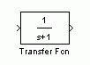

3.2.2 Lines
Lines transmit signals in the direction indicated by the arrow. Lines must always transmit signals from the output terminal of one block to the input terminal of another block. On exception to this is a line can tap off of another line, splitting the signal to each of two destination blocks. Lines can never inject a signal into another line; lines must be combined through the use of a block such as a summing junction.

A signal can be either a scalar signal or a vector signal. For Single-Input, Single-Output systems, scalar signals are generally used. For Multi-Input, Multi-Output systems, vector signals are often used, consisting of two or more scalar signals. The lines used to transmit scalar and vector signals are identical. The type of signal carried by a line is determined by the blocks on either end of the line.

3.3 Design and Simulate Video and Image Processing Systems
The Video and Image Processing Blockset extends Simulink® with a rich, customizable framework for the rapid design, simulation, implementation, and verification of video and image processing algorithms and systems. It includes basic primitives and advanced algorithms for designing embedded imaging systems in a wide range of applications in aerospace and defense, automotive, communications, consumer electronics, education, and medical electronics industries.

Built-in block libraries provide two-dimensional (2-D) filters, conversions, geometric transformations, morphological operations, 2-D transforms, motion estimation techniques, and input/output (I/O) capabilities. The blockset supports floating- and fixed-point data types for modeling, simulation, and C-code generation. It provides analysis and statistical functions to enable rapid optimization and debugging of your models. These functions include video displays, scopes, and other techniques for visualizing image and video data and validating simulation results.

3.4 Modeling and Simulating Video and Imaging Systems
The Video and Image Processing Blockset extends Simulink with a specialized library for designing the behavior of your imaging system. The Simulink environment provides tools for hierarchical modeling, data management, and subsystem customization that make it easy to create concise, accurate representations, regardless of your system’s complexity.

All blocks in the Video and Image Processing Blockset support double-precision and single-precision floating-point data types. Most also support integer and fixed-point data types.

Simulink and the Video and Image Processing Blockset enable you to run fast simulations for real-time embedded video, vision, and imaging systems. You can create executable specifications for communicating the system to downstream design teams and to provide a golden reference for verification throughout the design process.

3.4.1 Multimedia I/O, Video Viewer and Display Blocks
The Video and Image Processing Blockset can import multimedia files, such as AVI, MPEG, WMA, or any file type supported by Windows Media (Windows platform only). Video viewer and display blocks enable you to view the status of the video stream in real time throughout the model. You can start, stop, pause, and step through simulations one frame at a time. These time-saving features enable rapid design and debugging of your video and imaging system models.

3.4.2 The Video and Image Processing Block Set Lets You
- Send live video data to a video output device, monitor, or camera connected to the system
- View the video signal on your PC or workstation screen
- Write the input to an array in the MATLAB® workspace
- Display RGB or intensity video streams or images
- Write video frames to a multimedia file to analyze and share results

3.5 Delay
The Delay block delays a discrete-time input by the number of samples or frames specified in the Delay units and Delay parameters. The Delay value must be an integer value greater than or equal to zero. Also, when you enter a value of zero for the Delay parameter, any initial conditions you might have entered have no effect on the output.

The Delay block allows you to set the initial conditions of the signal that is being delayed. The initial conditions must be numeric. Select the Show additional parameters check box in order to specify the initial conditions.

3.6 Sample-Based Operation
When the input is a sample-based M-by-N matrix, where the block treats each of the M*N matrix elements as an independent channel. When the input is a sample-based scalar, the Delay parameter can be a scalar integer by which to equally delay all channels. When the input is a sample-based vector, the Delay parameter can be a scalar integer by which to equally delay all channels, or a vector whose length is equal to the number of channels. When the input is a sample-based M-by-N matrix, where M>1 and N>1, then the Delay parameter can be a scalar integer by which to equally delay all channels or an M-by-N matrix of nonnegative integers that specify the number of sample intervals to delay each channel of the input. There are four different choices for initial conditions. The initial conditions can be the same or different for each channel. They can also be the same or different along each channel.

3.7 Frame-Based Operation
When the input is a frame-based M-by-N matrix, the block treats each of the N columns as an independent channel, and delays each channel as specified by the Delay parameter.

When the input is frame based, the Delay parameter can be a scalar integer by which to equally delay all channels or a vector whose length is equal to the number of channels.

There are four different choices for initial conditions. The initial conditions can be the same or different for each channel. They can also be constant or varying along each channel.

3.8 Data Type Conversion Block
The Data Type Conversion block converts an input signal of any Simulink data type to the data type and scaling specified by the block's Output data type mode, Output data type, and/or Output scaling parameters. The input can be any real- or complex-valued signal. If the input is real, the output is real. If the input is complex, the output is complex.

This block requires that you specify the data type and/or scaling for the conversion. If you want to inherit this information from an input signal, you should use the Data Type Conversion Inherited block. The Abs block outputs the absolute value of the input.

For signed data types, the absolute value of the most negative value is problematic since it is not representable by the data type. In this case, the behaviour of the block is controlled by the Saturate on integer overflow check box. If checked, the absolute value of the data type saturates to the most positive representable value. If not checked, the absolute value of the most negative value represented by the data type has no effect.

3.9 Constant
The DSP Constant block generates a signal whose value remains constant throughout the simulation. The Constant value parameter specifies the constant to output, and can be any valid MATLAB expression that evaluates to a scalar, vector, or matrix.

When Sample mode is set to Continuous, the output is a continuous-time signal. When Sample mode is set to Discrete, the Sample time parameter is visible, and the signal has the discrete output period specified by the Sample time parameter.
You can set the output signal to Frame-based, Sample-based, or Sample-based (interpret vectors as 1-D) with the Output parameter.

3.10 Sample and Hold block
The Sample and Hold block acquires the input at the signal port whenever it receives a trigger event at the trigger port. The block then holds the output at the acquired input value until the next triggering event occurs. When the acquired input is frame based, the output is frame based; otherwise, the output is sample based.

The trigger input must be a sample-based scalar with sample rate equal to the input frame rate at the signal port. You specify the trigger event in the Trigger type pop-up menu. Rising edge triggers the block to acquire the signal input when the trigger input rises from a negative value or zero to a positive value.

Falling edge triggers the block to acquire the signal input when the trigger input falls from a positive value or zero to a negative value. Either edge triggers the block to acquire the signal input when the trigger input either rises from a negative value or zero to a positive value or falls from a positive value or zero to a negative value.

You specify the block's output prior to the first trigger event using the Initial condition parameter. When the acquired input is an M-by-N matrix, the Initial condition can be an M-by-N matrix, or a scalar to be repeated across all elements of the matrix. When the input is a length-M 1-D vector, the Initial condition can be a length-M row or column vector, or a scalar to be repeated across all elements of the vector.

If you select the Latch (buffer) input check box, the block outputs the value of the input from the previous time step until the next triggering event occurs.

CHAPTER 4
OBJECT TRACKING USING KALMAN FILTER

4.1 Object Detection Using Histogram Matching Technique

Histogram is the representation of the frequency of pixels lying in the range of certain color. Our Histogram function gives the frequency of the pixels within a range of 20. The above obtained histogram is used for the analysis of the appearance of the object by the absolute subtraction of the histograms of consecutive frames. Adding the absolute difference in the frequency of the pixels gives a value (Hist value) which, if is greater than certain threshold (obtained by testing) indicates that the object has appeared in the frame. This threshold helps us in overcoming the problem of change in light intensity and any small insignificant changes in the background. We used this technique to save time and memory by avoiding the excessive processing in those frames that restrain a significant object.

4.2 Object Extraction
If the object is detected, we go for further processing i.e. extraction followed by tracking. Thus for extraction we take the absolute difference (subtracting each element in array Y
from the corresponding element in array X and return the absolute difference in the corresponding element of the output array Z) of the current image from the ref. image. This gives a better output than background subtraction method. The resultant image is converted into a binary image using global image threshold by Otsu's method. Otsu’s method is used to compute a global threshold (level) that can be used to convert gray level image to a binary image. This level is a normalized intensity value that lies in the range [0, 1]. It chooses the threshold to minimize the intra class variance of the black and white pixels. We then perform smoothening to connect the small non connected parts. This effectively removes the small particles by connecting them into one and also helps in connecting the disconnected components of the object if any. The above process of smoothening helps in connectivity. The connectivity can be done in two ways a) 4-connectivity b) 8 connectivity as shown in Fig. 4.1

4-Connectivity 8-Connectivity
Figure: 4.1 Connectivity of Pixels

Thus after connectivity the pixels labeled 0 are the background. The pixels labeled 1 make up one component; the pixels labeled 2 make up a second component, and so on. The components with max label assigned have max area which corresponds to the object. This component having max area has some id or label assigned to it. Through that label we could extract the pixels of the object very easily and thus can calculate the centroid of the extracted object. Similarly, the system can be extended for extracting more than one object as the component with the next maximum area will represent our second object and so on. If two objects are very close to each other they are treated as one and tracked together. The centroid calculated is used in tracking to calculate the further states by using Discrete Kalman Filter.

4.3 Tracking Algorithm

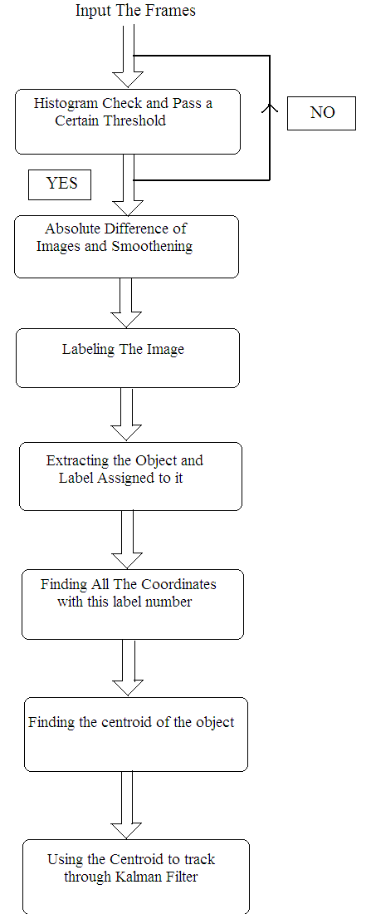

CHAPTER 5
SIMULATION AND RESULTS

5.1 Simulink Model for Object Tracking using Kalman Filter

5.1.1 Background Estimation Model

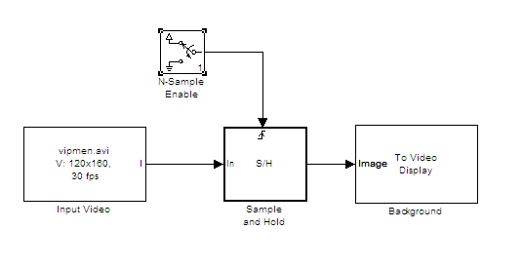
Figure: 5.1 Background Estimation using Sample and Hold Method

5.1.2 Object Detection Model

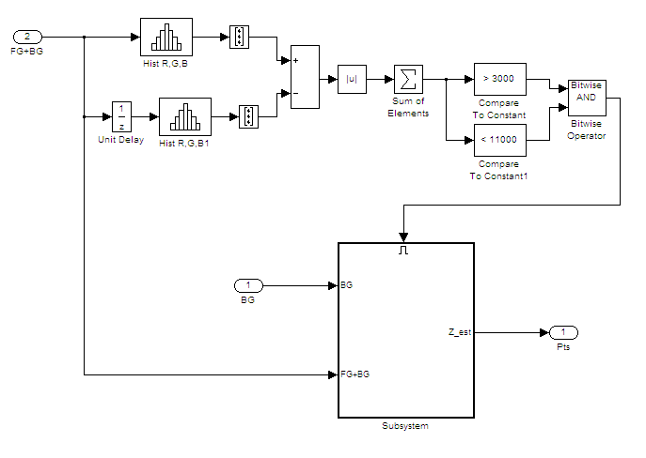
Figure: 5.2 Object Detection Model using Histogram matching

5.1.3 Object Tracking Model
a. Tracking Input from Library File
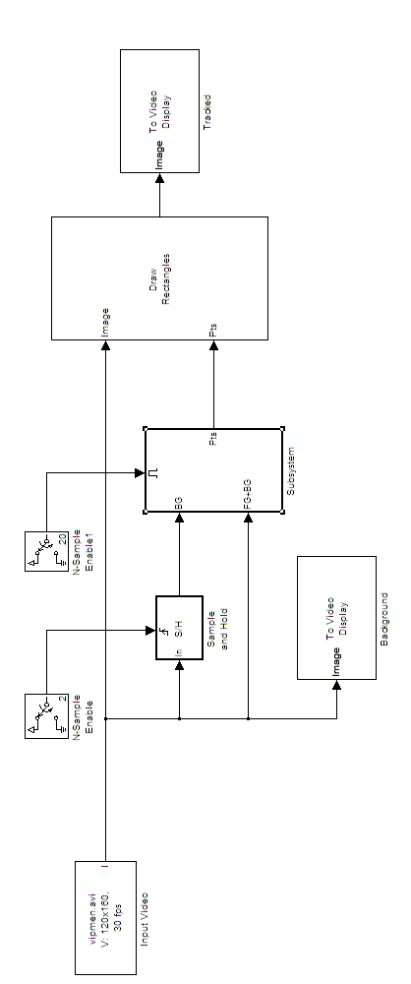
Figure:5.3 Simulink Model For Object Tracking
b. Tracking Input via Camera
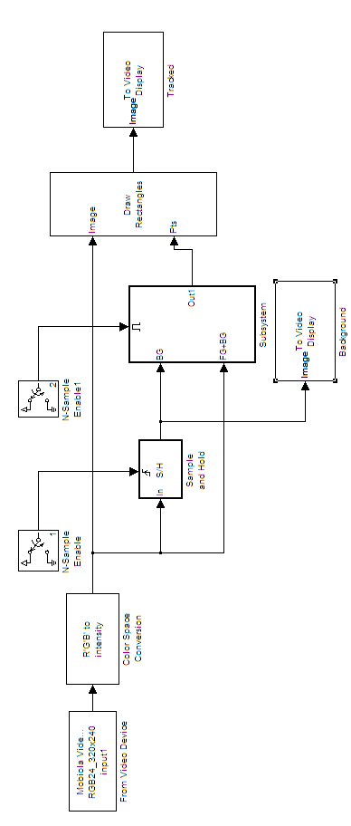
Figure:5.4 Simulink Model For Object Tracking using camera

5.2 Result

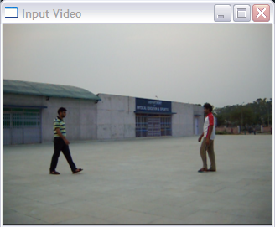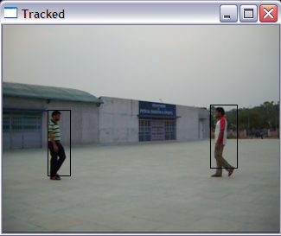
Figure 5.5 (a)

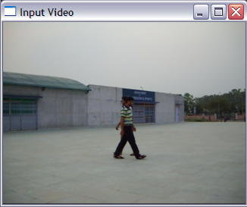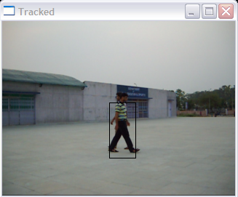
Figure 5.5 (b)

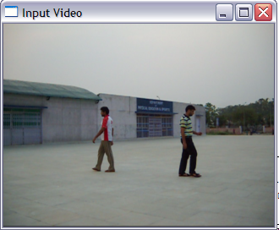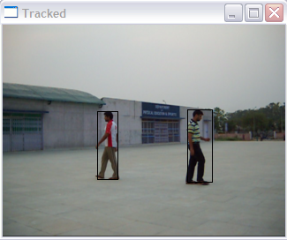
Figure 5.5 (c)
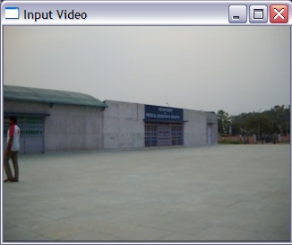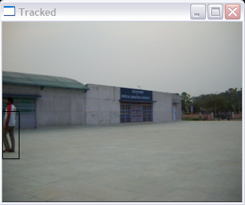
Figure 5.5 (d)

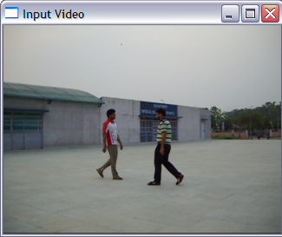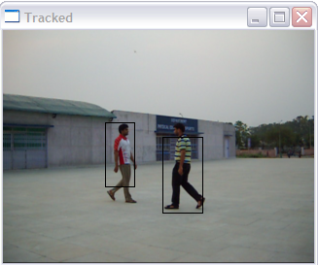
Figure 5.5 (e)

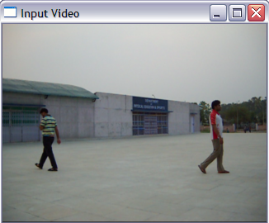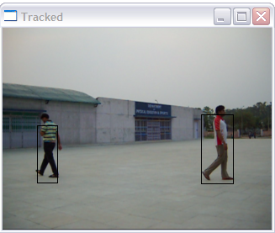
Figure 5.5 (f)

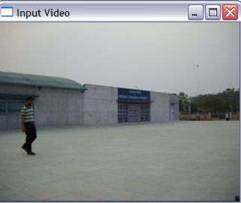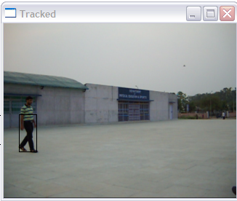
Figure 5.5 (g)

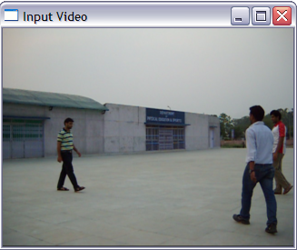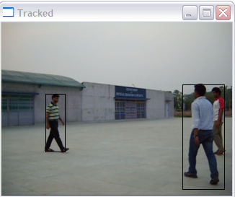
Figure 5.5 (h)

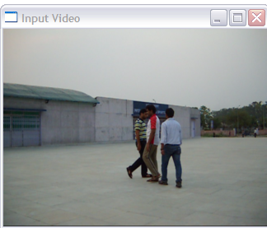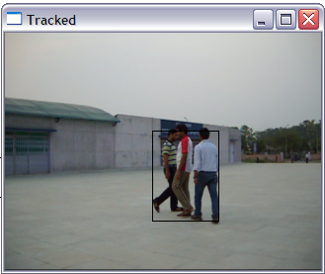
Figure 5.5 (i)

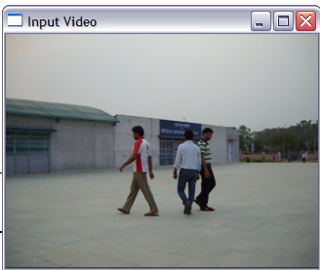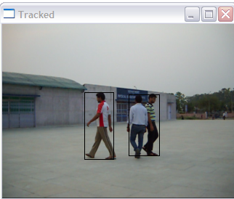
Figure 5.5 (j)

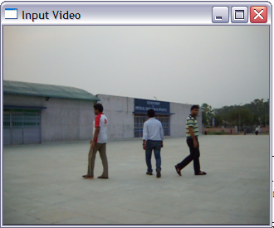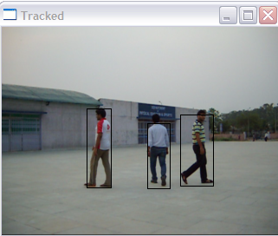
Figure 5.5 (k)

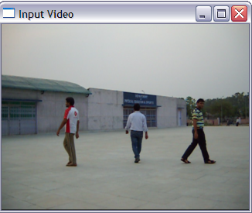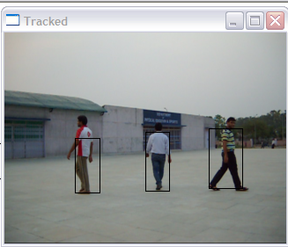
Figure 5.5 (l)

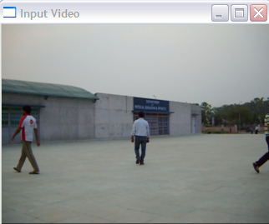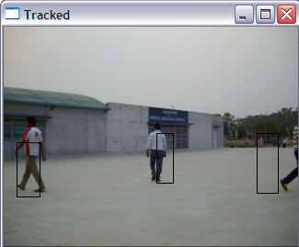
Figure 5.5 (m)

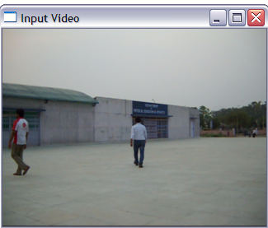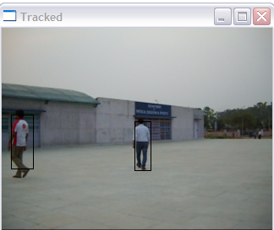
Figure 5.5 (n)

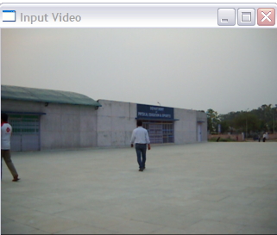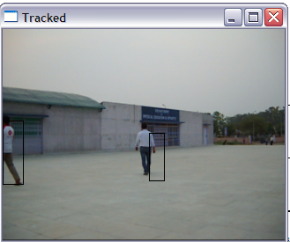
Figure 5.5 (o)

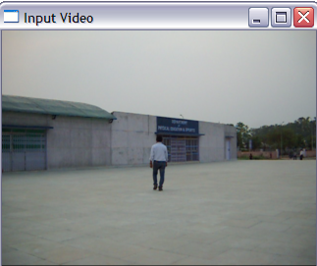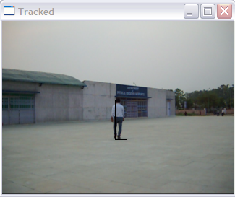
Figure 5.5 (p)

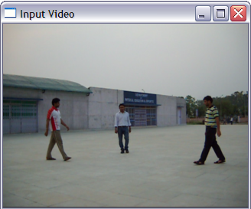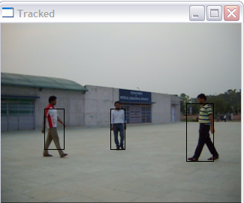
Figure 5.5 (q)

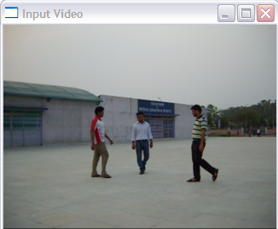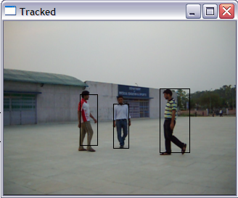
Figure 5.5 (r)

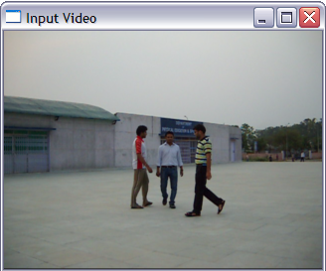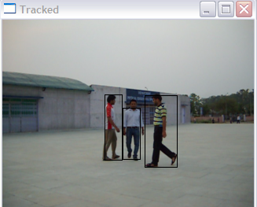
Figure 5.5 (s)

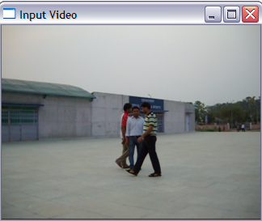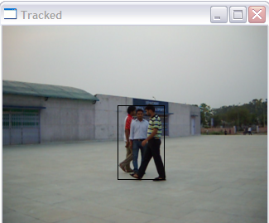
Figure 5.5 (t)

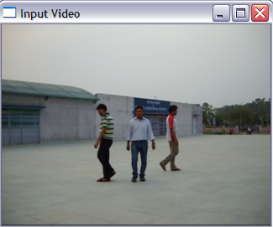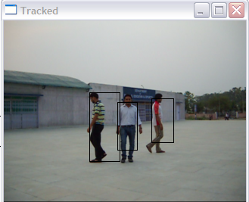
Figure 5.5 (u)

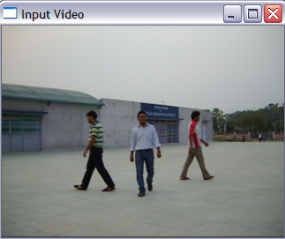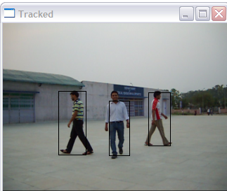
Figure 5.5 (v)

Figure 5.5(a)- 5.5(v) : Images for Object Tracking

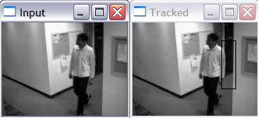
Figure 5.6 (a)

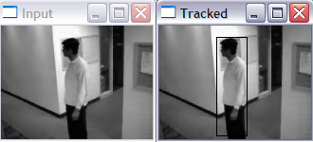
Figure 5.6 (b)

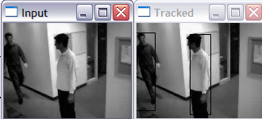
Figure 5.6 (c)

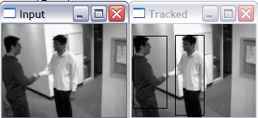
Figure 5.6 (d)

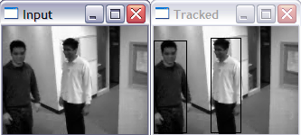
Figure 5.6 (e)

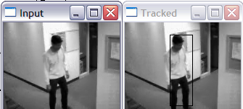
Figure 5.6 (f)

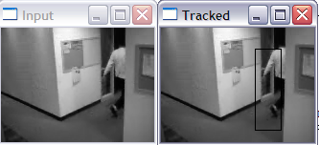
Figure 5.6 (g)

Figure 5.6(a)- 5.6(g) : Images for Object Tracking with change in light intensity

CHAPTER 6
CONCLUSION AND FUTURE SCOPE

To conclude, this dissertation gives us the detailed knowledge of key issues in the field of Object Tracking named “Implementation of Real time Object Detection and Tracking”. We introduced the theory and literature survey behind Object Tracking and discuss the basic concepts of object tracking, properties and performance of object tracking , in various fields of its applications i.e. image tracking by keeping camera constant or camera in motion and object constant or object in motion. We identified some factors which are not performing to its potential. These factors includes faster movements , single object among multiple object etc., and the noise effect and issues of implementing them is crucial for proper functionality. We have discussed and reserved some for our discussion for latter pursuits and we hope to carry that in our next work.

In this dissertation we focused our attention on the object tracking for real time video. We used Histogram Subtraction of conjugating frames and designed it for object tracking for real time video to detect the motion of object in different views. Our aim is to track the motion of an object and improve the performance of object tracking. Here after discussion and the result we got, we can conclude that the Histogram Subtraction technique is easier and can be implemented easily and economical compare to the standard algorithms which are used for object tracking.

To support my work, I have simulated the entire work on MATLAB 7.4. At this stage my work should be considered as a preliminary as it has plenty of scope for future investigation and analysis. Major work can be carry in the field of tracking.

CHAPTER 7
REFERENCES

- Web side : www.mathworks.com
- Madhur Mehta, Chandni Goyal, M.C. Srivastava, R.C. Jain, “Real Time Object Detection and Tracking: Histogram Matching and Kalman Filter Approach”, in Computer and Automation Engineering (ICCAE), 2010 The 2nd International Conference on Feb. 2010.
- A Monnet, A. Mittal, N. Paragios, and V. Ramesh, “Background modeling and subtraction of dynamic scenes”. In CVPR, 2003.
- Greg Welch and Gary Bishop, “An Introduction to the KalmanFilter” presented at ACM SIGGRAPH 2001.
- Otsu, N., "A Threshold Selection Method from Gray-Level Histograms," IEEE Transactions on Systems, Man, and Cybernetics, Vol. 9, No. 1, 1979, pp. 62-66.
- A. Elgammal, D. Harwood, and L. Davis. Non-parametric model for background subtraction. In ECCV, pages 751–757, 2000
- Carsten Rother, Vladimir Kolmogorov, Andrew Blake.“GrabCut” -Interactive Foreground Extraction using Iterated Graph Cuts, In proceedings SIGGRAPH 2004.
- Kar-Han Tan, Narendra Ahuja, “Selecting Objects With Freehand Sketches,” In Proceedings IEEE Computer Society Conference on Computer Vision and Pattern Recognition. 2001.

