CHAPTER # 1
INTRODUCTION OF
REVERSIBLE WATERMARKING.

[1.1] INTRODUCTION:
Along with the explosive growth of the Internet not only desirable new possibilities - like publicly available access to information databases around the world, distributed project work across different countries, or fast and reliable means of electronic communication - emerged, but the ease with which digital media can be duplicated and modified, or the fact that legislation is seemingly unable to cope with its rapid rate of change makes it also very attractive to people with dishonourable motives. With these drawbacks of the “digital age” in mind, creators of multimedia content may wish for a digital analogy to the watermarks that have been used in bookmaking since the 13th Century.
This need for methods and tools to protect ones intellectual property rights initiated the relatively new research field of “digital watermarks”. Someone familiar with encryption techniques might be tempted to ask why there is such an amount of interest in the research community to develop robust watermarking techniques, if numerous secure encryption algorithms are readily available because encryption alone often is insufficient to protect digital content, since unconsidered and erroneous usage by human operators often renders it useless.
Reversible Watermarking is one type of fragile watermarking. Fragile watermarking is a method where after authentication the watermark, the original image is fully recovery from the watermarked image. That is why it is highly used is sensible imagery application like military and medical.

[1.2] HISTORY OF WATERMARKING AND REVERSIBLE WATERMARKING:

Although the art of papermaking was invented in China over one thousand years earlier, paper watermarks did not appear until about 1282, in Italy [1]. The marks were made by adding thin wire patterns to the paper moulds. The paper would be slightly thinner where the wire was and hence more transparent. The meaning and purpose of the earliest watermarks are uncertain. They may have been used for practical functions such as identifying the moulds on which sheets of papers were made, or as trademarks to identify the papermaker. On the other hand, they may have represented mystical signs, or might simply have served as decoration. By the eighteenth century, watermarks on paper made in Europe and America had become more clearly utilitarian. They were used as trademarks, to record the date the paper was manufactured, and to indicate the sizes of original sheets. It was also about this time that watermarks began to be used as ant counterfeiting measures on money and other documents.
It is difficult to determine when digital watermarking was first discussed. In 1979, Szepanski described a machine-detectable pattern that could be placed on documents for anti-counterfeiting purposes. Nine years later, Holt described a method for embedding an identification code in an audio signal. However, it was Komatsu and Tominaga in 1988, which appear to have first used the term digital watermark. Still, it was probably not until the early 1990s that the term digital watermarking really came into vogue. About 1995, interest in digital watermarking began to mushroom.Figure1 is a histogram of the number of papers published on the topic. The first Information Hiding Workshop (IHW), which included digital watermarking as one of its primary topics, was held in 1996. The SPIE began devoting a conference specifically to Security and Watermarking of Multimedia Contents beginning in 1999.

Annual number of papers published on watermarking and stenography by IEEE

From the application point of review, most digital watermarking methods can be divided into two categories: robust watermarking and fragile watermarking. Robust watermarking is mainly aimed to copy right protection. Here “robust” means the embedded watermark should be very resistant to various signal processing operation. On the other hand, fragile watermarking is aimed at content authentication. A fragile watermark will be altered or destroyed when the digital content is modified. As a special subset of fragile watermarking, reversible watermarking has drawn lots of attention recently. Reversible watermarking has an additional advantage such that when watermarked content has been detected to be authentic, one can remove the watermark to retrieve the original, un watermarked contain. Such reversibility to get back unwatermarked content is highly desired in sensitive imagery, such as military data and medical data.
In reversible watermarking, the watermark is embedded in a reversible way so that one Can extract the hidden watermark and also restore the digital content to its original state. The first publication to investigate reversible watermarking was by Barton [34] in 1997.In his article, digital information is embedded within a digital stream for authentication. The embedded information can be extracted and used to verify the original digital data stream. Then Honsinger et al.[35] proposed a lossless data embedding technique that allows the recovery of the original image. The watermark is embedded using modulo arithmetic. Later on in Macq’s article[36], a modification to Honsinger’s algorithm is presented to achieve lossless watermarking. However, the embedded image with salt-and-pepper artifact appeared on both Honsinger and Macq’s techniques. In order to reduce the artifact, Vleeschouwer et al.[37] proposed a lossless watermarking algorithm by circular interpretation of bijective transforms. Besides, Fridrich et al.[38] developed a reversible data embedding algorithm based on compressing one of the least significant bit planes of the original image. They also described two extended reversible data embedded techniques for all image formats[39]. Although these techniques can reduce the salt-and-pepper artifact, the capacity of the algorithms is low. Celik et al. [40] introduced a high-capacity and low-distortion reversible watermarking algorithm in 2002. The pixels of the original image are quantized and the residues are compressed using a lossless image compression algorithm in order to create capacity for the payload data. Not long ago, Tian [41] used a difference expansion method to reversibly embed a payload into digital images.He explored the redundancy in digital images to achieve a high-capacity and low-distortion reversible watermarking. His method divides the image into pairs of pixels, and some difference values that are not expected to cause an overflow or underflow are selected for the difference expansion (DE).One watermark bit will be embedded into the difference of each selected pixel pairs. Finally, a location map of the selected expandable pixel pairs is losslessly compressed and included in the payload. In order to achieve a high capacity reversible data embedding method for digital images, a multiple-layer embedding is employed in Tian’s algorithm. In 2004, Alattar[42] proposed a generalized difference expansion method. This method hides several bits in the difference expansion of vectors of adjacent pixels. Besides, Voigt et al. [43] proposed a reversible watermarking scheme for 2D-vector data. Only a few reversible schemes are designed for vector maps until now.

[1.3] STEGANOGRAPHY:
Steganography is derived from the Greek for covered writing and essentially means “to hide in plain sight”. Steganography is the art and science of communicating in such a way that the presence of a message cannot be detected. Simple steganographic techniques have been in use for hundreds of years, but with the increasing use of files in an electronic format new techniques for information hiding have become possible.

[1.4] Digital Watermarking:

Digital watermarking is the process of embedding information into a digital signal. The signal may be audio, pictures or video, for example. If the signal is copied, then the information is also carried in the copy.
In visible watermarking, the information is visible in the picture or video. Typically, the information is text or a logo which identifies the owner of the media. When a television broadcaster adds its logo to the corner of transmitted video, this is also a visible watermark.
In invisible watermarking, information is added as digital data to audio, picture or video, but it cannot be perceived as such. An important application of invisible watermarking is to copyright protection systems, which are intended to prevent or deter unauthorized copying of digital media.

Unlike encryption, which is useful for transmission but does not provide a way to examine the original data in its protected form, the watermark remains in the content in its original form and does not prevent a user from listening to, viewing, examining, or manipulating the content. Also, unlike the idea of steganography, where the method of hiding the message may be secret and the message itself is secret, in watermarking, typically the watermark embedding process is known and the message (except for the use of a secret key) does not have to be secret. In steganography, usually the message itself is of value and must be protected through clever hiding techniques and the “vessel” for hiding the message is not of value. In watermarking, the effective coupling of message to the “vessel,” which is the digital content, is of value and the protection of the content is crucial. Watermarking is the direct embedding of additional information into the original content or host signal. Ideally, there should be no perceptible difference between the watermarked and original signal[2],[3] and the watermark should be difficult to remove or alter without damaging the host signal. In some instances, the amount of information that can be hidden and detected reliably is important. It is easy to see that the requirements of imperceptibility, robustness, and capacity conflict with each other. For instance, a straightforward way to provide an imperceptible watermark is to embed the watermark signal into the perceptually insignificant portion of the host data. However, this makes the watermark vulnerable to attack because it is fairly easy to remove or alter the watermark without affecting the host signal. To provide a robust watermark, a good strategy is to embed the watermark signal into the significant portion of the host signal. This portion of the host data is highly sensitive to alterations, however, and may produce very audible or visible distortions in the host data. Applications for digital watermarking include copyright protection, fingerprinting, authentication, copy control, tamper detection, and data hiding applications such as broadcast monitoring.
Transparent watermarking techniques can be fragile, robust, or semifragile. Fragile watermarks do not survive lossy transformations to the original host signal and their purpose is tamper detection of the original signal. There are many effective ways to insert a fragile watermark into digital while preserving the imperceptibility requirement. Placing the watermark information into the perceptually insignificant portions of the data guarantees imperceptibility and provides fragile marking capabilities

We define watermarking as the practice of imperceptibly altering a Work to embed a message about that Work.
We define steganography as the practice of undetectably altering a Work to embed a secret message. Block diagram of a watermarking system

[1.5] REVERSIBLE WATERMARKING:
The reversible watermarking is used to protection of the copyright by embedding the assigned watermark into the original image but also can recover the original image from the suspected image. The retrieved watermark can be used to determine the ownership by comparing the retrieved watermark with the assigned one. Similar to conventional watermarking schemes, reversible watermarking schemes have to be robust against the intentional or the unintentional attacks, and should be imperceptible to avoid the attraction of attacks and value lost. Therefore, the reversible watermarking also has to satisfy all requirements of the conventional watermarking such as robustness, imperceptibility, and readily embedding and retrieving. Except for these requirements, reversible watermarking has to grantify the following two additional requirements.

- Blind:

Some of the conventional watermarking schemes require the help of an original image to retrieve the embedded watermark. However, the reversible watermarking can recover the original image from the watermarked image directly. Therefore, the reversible watermarking is blind, which means the retrieval process does not need the original image.

- Higher Embedding Capacity:

The capable size of embedding information is defined as the embedding capacity. Due to the reversible watermarking schemes having to embed the recovery information and watermark information into the original image, the required embedding capacity of the reversible watermarking schemes is much more than the conventional watermarking schemes. The embedding capacity should not be extremely low to affect the accuracy of the retrieved watermark and the recovered image.

Comparison chart between watermarking and reversible watermarking.

[1.6] DISTORSIONS AND ATTACKS:
In practice, a watermarked object may be altered either on purpose or accidentally, so the watermarking system should still be able to detect and extract the watermark. Obviously, the distortions are limited to those that do not produce excessive degradations, since otherwise the transformed object would be unusable. These distortions also introduce a degradation on the performance of the system. For intentional attacks, the goal of the attacker is to maximize the reduction in these probabilities while minimizing the impact that his/her transformation produces on the object; this has to be done without knowing the value of the secret key used in the watermarking insertion process, which is where all the security of the algorithm lies. Next, we introduce some of the best known attacks. Some of them may be intentional or unintentional, depending on the application:
[1.6.1] Additive Noise:
This may stem in certain applications from the use of D/A and A/D converters or from transmission errors. However, an attacker may introduce perceptually shaped noise (thus, imperceptible) with the maximum unnoticeable power. This will typically force to increase the threshold at which the correlation detector works.
[1.6.2]Filtering:
Low-pass filtering, for instance, does not introduce considerable degradation in watermarked images or audio, but can dramatically affect the performance, since spread-spectrum-like watermarks have a non negligible high-frequency spectral contents.
[1.6.3]Cropping:
This is a very common attack since in many cases the attacker is interested in a small portion of the watermarked object, such as parts of a certain picture or frames of a video sequence. With this in mind, in order to survive, the watermark needs to be spread over the dimensions where this attack takes place.
[1.6.4]Compression:
This is generally an unintentional attack which appears very often in multimedia applications. Practically all the audio, video and images that are currently being distributed via Internet have been compressed. If the watermark is required to resist different levels of compression, it is usually advisable to perform the watermark insertion task in the same domain where the compression takes place. For instance, DCT domain image watermarking is more robust to JPEG compression than spatial-domain watermarking

[1.6.5] Rotation and Scaling:
This has been the true battle horse of digital watermarking, especially because of its success with still images. Correlation based detection and extraction fail when rotation or scaling are performed on the watermarked image because the embedded watermark and the locally generated version do not share the same spatial pattern anymore. Obviously, it would be possible to do exhaustive search on different rotation angles and scaling factors until a correlation peak is found, but this is prohibitively complex. Note that estimating the two parameters becomes simple when the original image is present, but we have argumented against this possibility in previous sections. In [5] the authors have shown that although the problem resembles synchronization for digital communications, the techniques applied there fail loudly. Some authors have recently proposed the use of rotation and scaling-invariant transforms (such as the Fourier-Mellin [6]) but this dramatically reduces the capacity for message hiding. In any case, publicly available programs like Strirmark break the uniform axes transformation by creating an imperceptible non-linear resampling of the image [4] that renders invariant transforms unusable. In audio watermarking it is also quite simple to perform a non-linear transformation of the time axis that considerably difficults watermark detection.
[1.6.6] Statistical Averaging:
An attacker may try to estimate the watermark and then ‘unwatermark’ the object by substracting the estimate. This is dangerous if the watermark does not depend substantially on the data. Note that with different watermarked objects it would be possible to improve the estimate by simple averaging. This is a good reason for using perceptual masks to create the watermark.

[1.6.7] Multiple Watermarking:
An attacker may watermark an already watermarked object and later make claims of ownership. The easiest solution is to timestamp the hidden information by a certification authority.
[1.6.8] Attacks at Other Levels:
There are a number of attacks that are directed to the way the watermark is manipulated. For instance, it is possible to circumvent copy control mechanisms discussed below by super scrambling data so that the watermark is lost or to deceive web crawlers searching for certain watermarks by creating a presentation layer that alters they way data are ordered. The latter is sometimes called ‘mosaic attack’ .
[1.7]APPLICATIONS OF REVERSIBLE WATERMARKING:
In this section we discuss some of the scenarios where reversible watermarking is being already used as well as other potential applications. The list given here is by no means complete and intends to give a perspective of the broad range of business possibilities that reversible watermarking opens.
As reversible watermarking is a sub set of digital watermarking, so the application of digital watermarking is also applicable in case of reversible watermarking. But it has an additional advantage such that when watermarked content has been detected to be authentication, one can remove the watermark to retrieve the original, unwatermarked content. That is why this technology is very much used in sensitive images.
[1.7.1] MILITARY DATA:
In case of defence, the data is communicated through various channels. This data is very much sensitive. That is why this technique is here. Another advantage is that the original image is fully recovered from watermarked image. This is very much necessary in this case because lots of information is stored in the original image.

[1.7.2] MEDICAL DATA:
As medical image is very much sensitive i.e. any slight changes in the image the meaning of image is totally changed, we used the reversible watermarking technique in this field. By using this technique we can also improve the quality of the image which is necessary in some cases.
As reversible watermarking is a sub set of digital watermarking, the application of watermarking is also applicable in case of reversible watermarking. So the common a application of reversible watermarking and digital watermarking is given below.

[1.7.3] Video Watermarking:
In this case, most considerations made in previous sections hold. However, now the temporal axis can be exploited to increase the redundancy of the watermark. As in the still images case, watermarks can be created either in the spatial or in the DCT domains. In the latter, the results can be directly extrapolated to MPEG-2 sequences, although different actions must be taken for I, P and B frames. Note that perhaps the set of attacks that can be performed intentionally is not smaller but definitely more expensive than for still images.
[1.7.4] Audio Watermarking:
Again, previous considerations are valid. In this case, time and frequency masking properties of the human ear are used to conceal the watermark and make it inaudible. The greatest difficulty lies in synchronizing the watermark and the watermarked audio file, but techniques that overcome this problem have been proposed.
[1.7.5] Hardware/Software Watermarking:
This is a good paradigm that allows us to understand how almost every kind of data can be copyright protected. If one is able to find two different ways of expressing the same information, then one bit of information can be concealed, something that can be easily generalized to any number of bits. This is why it is generally said that a perfect compression scheme does not leave room for watermarking. In the hardware context, Boolean equivalences can be exploited to yield instances that use different types of gates and that can be addressed by the hidden information bits. Software can be also protected not only by finding equivalences between instructions, variable names, or memory addresses, but also by altering the order of non-critical instructions. All this can be accomplished at compiler level.
[1.7.6] Text Watermarking:
This problem, which in fact was one of the first that was studied within the information hiding area can be solved at two levels. At the printout level, information can be encoded in the way the textlines or words are separated (this facilitates the survival of the watermark even to photocopying). At the semantic level (necessary when raw text files are provided), equivalences between words or expressions can be used, although special care has to be taken not to destruct the possible intention of the author.
[1.7.7] Executable Watermarks:
Once the hidden channel has been created it is possible to include even executable contents, provided that the corresponding applet is running on the end user side.
[1.7.8] Labelling:
The hidden message could also contain labels that allow for example to annotate images or audio. Of course, the annotation may also been included in a separate file, but with watermarking it results more difficult to destroy or loose this label, since it becomes closely tied to the object that annotates. This is especially useful in medical applications since it prevents dangerous errors.
[1.7.9] Fingerprinting:
This is similar to the previous application and allows acquisition devices(such as video cameras, audio recorders, etc) to insert information about the specific device (e.g., an ID number) and date of creation. This can also be done with conventional digital signature techniques but with watermarking it becomes considerably more difficult to excise or alter the signature. Some digital cameras already include this feature.
[1.7.10] Authentication:
This is a variant of the previous application, in an area where cryptographic techniques have already made their way. However, are two significant benefits that arise from using watermarking: first, as in the previous case, the signature becomes embedded in the message, second, it is possible to create ‘soft authentication’ algorithms that offer a multivalued ‘perceptual closeness’ measure that accounts for different unintentional transformations that the data may have suffered (an example is image compression with different levels), instead of the classical yes/no answer given by cryptography-based authentication. Unfortunately, the major drawback of watermarking-based authentication is the lack of public key algorithms that force either to put secret keys in risk or to resort to trusted parties.
[1.7.11]Copy and Playback Control:
The message carried by the watermark may also contain information regarding copy and display permissions. Then, a secure module can be added in copy or playback equipment to automatically extract this permission information and block further processing if required. In order to be effective, this protection approach requires agreements between content providers and consumer electronics manufacturers to introduce compliant watermark detectors in their video players and recorders. This approach is being taken in Digital Video Disc (DVD).
[1.7.12]Signalling:
The imperceptibility constraint is helpful when transmitting signalling information in the hidden channel. The advantage of using this channel is that no bandwidth increase is required. An interesting application in broadcasting consists in watermarking commercials with signalling information that permits an automatic counting device to assess the number of times that the commercial has been broadcast during a certain period. An alternative to this would require complex recognition software.

CHAPTER # 2
Reversible Image Watermarking:
Evolution

[2.1] REVERSIBLE IMAGE WATERMARKING:
Many techniques have been developed for the reversible watermarking of still image data. The technique is also divided according to which level the watermarked is embedded. For grey-level or color-image watermarking, watermark embedding techniques are designed to insert the watermark directly into the original image data, such as the luminance or color components or into some transformed version of the original data to take advantage of perceptual properties or robustness to particular signal manipulations. Requirements for image watermarking include imperceptibility, robustness to common signal processing operations, and capacity. Common signal processing operations which the watermark should survive include compression (such as JPEG), filtering, rescaling, cropping, A/D and D/A conversion, geometric distortions, and additive noise.
Capacity refers to the amount of information (or payload) that can be hidden in the host image and detected reliably under normal operating conditions. Many of the watermarking techniques are additive, where the watermark signal is added directly to the host signal or transformed host signal. The watermark may be scaled appropriately to minimize noticeable distortions to the host. Perceptual models may be used to determine and adapt the watermark scale factor appropriately to the host data. The watermark itself is a function of the watermark information, a secret or public key and perhaps the original host data. Some examples of watermark information includes a binary sequence representing a serial number or credit card number, a logo, a picture, or a signature.

[2.2]SPREAD SPECTRUM REVERSIBLE WATERMARKING:
Many of the current watermarking techniques insert one bit of information over many pixels or transform coefficients and use classical detection schemes to recover the watermark information. These types of watermarking techniques are usually referred to as spread-spectrum approaches, due to their similarity to spread-spectrum communication systems.
When used in digital image watermarking, this translates to inserting the watermarking bits at more than one location in the image . Thus, even if subsequent image operations may remove the watermark in some parts of the image, it is very likely that the embedded copyright is still detectable .Here is an overview:

[2.2.1] Watermark Embedding:
The first step is to assign –1 and +1 to the watermarking bits 0 and 1 respectively. The resulting bit stream is then arranged either in rows, columns or tiles across the whole image (Figure 1, “key2”: logical ‘0’: white areas, logical ‘1’: black areas; each tile corresponds to one bit in the watermark). To accomplish the band spread, “key2” is then multiplied by the output of a “pseudo-noise generator” like a “linear feedback shift register” (LFSR) or other random generators. Lastly, the values of the watermark are adjusted by multiplying them with a “rescaling factor” and added to the original image in a pixel wise manner. The “rescale factor” determines the strength with which the watermark is embedded (usually depending on the characteristics of different parts of the image, e.g. some parts of the image might allow for a rescale factor of 5 or more, while others suffer a visible degradation in image quality even if the rescale factor is reduced to 1)

[2.2.2] Watermark Detection:
The obvious problem in the watermark detection step is how to retrieve the embedded watermark from a (possibly) watermarked image. There are several approaches to this problem:
“private/non-blind watermarking”: The embedded watermark is recovered by subtracting the original image.
“semi-blind watermarking”: The detector requires access to the published/unmodified watermarked image.
·“public/blind watermarking”: The embedded watermark can be detected without the original image.
The described watermark is an example for a public/blind watermarking scheme, because the embedded copyright can be retrieved without the original image by taking advantage of the specifics of the algorithm described in 2.1.1. Since the watermark is added as a pseudo-noise sequence having a high spatial frequency, it can be recovered by applying a high-pass filter such as the following convolution mask:
high-pass filter≔ 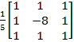
To calculate the filtered image, the convolution mask is shifted over the whole image. In each step the pixel below the “-8” is replaced by the inner product of the convolution mask and the underlying pixel values. The resulting image is then multiplied by password-dependent pseudo-noise sequence “key1” to get the “correlation image”. After summing the values of the correlation image for each copyright bit, the actual bit values (key2) are finally recovered using the following formula (see Figure 2):

Output Bit(corrSquare[i][j]) = 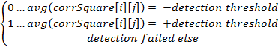

[2.3] SPATIAL DOMAIN REVERSIBLE WATERMARKING:
For still image watermarking, watermark embedding is applied directly to the pixel values in the spatial domain or to transform coefficients in a transform domain such as the discrete cosine transform (DCT) or discrete wavelet transform (DWT). Watermark detection usually consists of some preprocessing step (which may include removal of the original host signal if it is available for detection) followed by a correlation operator.
Spatial-domain watermarking techniques for image data include. Some of the earliest techniques [13], [18] embed m-sequences into the least significant bit (LSB) of the data to provide an effective transparent embedding technique. M-sequences are chosen due to their good correlation properties so that a correlation operation can be used for watermark detection. Furthermore, these techniques are computationally inexpensive to implement. Such a scheme was first proposed in [13] and extended to two dimensions. In [18] the authors reshape the m-sequence into two-dimensional watermark blocks which are added and detected on a block-by-block basis. The block-based method, referred to as variable-w two-dimensional watermark (VW2D) is shown to be robust to JPEG compression. This technique has also been shown to be an effective fragile watermarking scheme which can detect image alterations on a block basis. Other early work [19] suggests using check sums for LSB watermark embedding.
Several spatial-domain watermarking techniques for images are proposed in [15]. One technique consists of embedding a texture-based watermark into a portion of the image with similar texture. The idea here is that due to the similarity in texture, it will be difficult to perceive the watermark. The watermark is detected using a correlation detector. Another technique described as the patchwork method divides the image into two subsets A and B where the brightness of one subset is incremented by a small amount and the brightness of the other set is decremented by the same amount. The incremental brightness level is chosen so that the change in intensity remains imperceptible. The location of the subsets is secret and assuming certain properties for image data, the watermark is easily located by averaging the difference between the values in the two subsets. It is assumed that, on average, without the watermark, this value will go to zero for image data. In the example where the pixels in Set A are incremented by one and the pixels in set B are decremented by one, with N locations in the set, the expected value of the sum of differences between the sets is given by 2N. For non watermarked data, this value should go to zero. A variation of this approach is described in [17], where more information can be inserted in the host signal. Another spatial-domain technique is proposed in [20], where the blue component of an image in RGB format is watermarked to ensure robustness while remaining fairly insensitive to human visual system (HVS) factors.

[2.4] TRANSFORM DOMAIN REVERSIBLE WATERMARKING:
Transform domain watermarking is useful for taking advantage of perceptual criteria in the embedding process, for designing watermarking techniques which are robust to common compression techniques, and for direct watermark embedding of compressed bit streams. A common transform framework for images is the block-based DCT which is a fundamental building block of current image coding standards such as JPEG and video coding standards such as the MPEG video coders and the ITU H.26x family of codecs. One of the first block-based DCT watermarking technique is proposed in. The DCT is performed on 8×8 blocks of data, pseudorandom subsets of the blocks are chosen and a triplet of mid-range frequencies are slightly altered to encode a binary sequence. This is a reasonable heuristic watermarking approach since watermarks inserted in the high frequencies are vulnerable to attack whereas the low frequency components are perceptually significant and sensitive to alterations. One of the most influential watermarking works [10], [11] was first to describe how spread spectrum principles borrowed from communication theory can be used in the context of watermarking. The published results show that the technique is very effective both in terms of image quality and robustness to signal processing and attempts to remove the watermark. The technique is motivated by both perceptual transparency and watermark robustness. One of the significant contributions in this work is the realization that the watermark should be inserted in the perceptually significant portion of the image in order for it to be robust to attack. A DCT is performed on the whole image and the watermark is inserted in a predetermined range of low frequency components minus the DC component. The watermark consists of a sequence of real numbers generated from a Gaussian distribution which is added to the DCT-coefficients. The watermark signal is scaled according to the signal strength of the particular frequency component. This is a reasonable and simple way to introduce some type of perceptual weighting into the watermarking scheme. The watermark embedding algorithm could be described as
S =I (1+αW)
where I is the original host signal, S is the watermarked signal, and W is the watermark consisting of a random, Gaussian distributed sequence .α is a scaling factor which the authors suggest to set to 0.1 to provide a good trade off between imperceptibility and robustness. Referring to Fig. 1 for a block diagram of a general watermarking system, the secret key is used to generate the random sequence W in this case. Also note that this particular algorithm addresses the case of watermark detection where you would like to detect whether a particular watermark is or is not present in the host signal at the receiver.
The watermark detector for this scheme [10] is described by the similarity measure
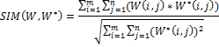

Where W$ is the extracted watermark from the received, possibly distorted signal Y.The authors show that the similarity measure is also normally distributed so that a high similarity value is extremely unlikely for W$ ≠W. Other post filtering operations could be performed to undo possible distortions, improve performance, and get a better similarity measure.

Encoder
Decoder

Brief diagram of reversible watermarking technique.
A variation on this idea is variable length DCT-based watermarking, where the DCT coefficients are sorted by magnitude and only the n largest coefficients are marked that correspond to a user specified percent of the total energy. This allows the user to trade off imperceptibility and robustness to attack. Other DCT-based watermarking schemes use more elaborate models of the human visual system to incorporate an image adaptive watermark of maximum strength subject to the imperceptibility criterion [12], [8], [9]. Two image-adaptive watermarking schemes are described in[8], which are based on a block-based DCT framework and wavelet framework. The perceptual models used here can be described in terms of three different properties of the human visual system that have been studied in the context of image coding: frequency sensitivity, luminance sensitivity, and contrast masking [21]. Frequency sensitivity describes the human eye’s sensitivity to sine wave gratings at various frequencies. This component only depends on the modulation transfer function (MTF) of the eye and is independent of the image data. Luminance sensitivity measures the effect of the detectability threshold of noise on a constant background. For the human visual system, this is a nonlinear function and depends on local image characteristics. Contrast masking refers to the detectability of one signal in the presence of another signal and the effect is strongest when both signals are of the same spatial frequency, orientation, and location. A combination of the three components results in just noticeable distortion (JND) thresholds for the entire image. These models were first developed to design more efficient image compression schemes than waveform techniques alone could provide. This model was derived for the baseline mode of JPEG and showed a significant improvement in compression performance when used to derive an image-adaptive quantization table [21]. A similar model was developed for wavelet-based compression using only frequency sensitivity to derive perceptual weights for each of the sub bands [22]. This model was used for a wavelet-based watermarking scheme [8]. Unlike compression, where the amount of perceptual information that can be incorporated into the encoder is limited to the amount of side information that is necessary to transmit this information to the decoder, all of the perceptual information can be utilized in a watermarking scheme. For instance, in JPEG, we are limited to one quantization matrix for the entire image which cannot take full advantage of local visual threshold characteristics. The image dependent masking thresholds are used to determine the location and maximum strength of the watermark signal that can be tolerated in every location of the host image under the constraint of imperceptibility at some specified viewing condition. Examples of the image- adaptive watermarks described in [8] are illustrated in the figure below.

Fig: First and third row display watermarked images and second, fourth row display corresponding image adaptive watermarks using perceptual models

We can see how the watermark structure is similar to the local image properties.

CHAPTER # 3
WAVELETS AND SECOND GENERATION WAVELET TRANSFORM

[3.1] INTRODUCTION:
Wavelets are mathematical functions that cut up data into different frequency components, and then study each component with a resolution matched to its scale. They have advantages over traditional Fourier methods in analyzing physical situations where the signal contains discontinuities and sharp spikes. Wavelets were developed independently in the fields of mathematics, quantum physics, electrical engineering, and seismic geology. Interchanges between these fields during the last ten years have led to many new wavelet applications such as image compression, turbulence, human vision, radar, and earthquake prediction. This paper introduces wavelets to the interested technical person outside of the digital signal processing field. I describe the history of wavelets beginning with Fourier, compare wavelet transforms with Fourier transforms, state properties and other special aspects of wavelets, and finish with some interesting applications such as image compression, musical tones, and de-noising noisy data.
[3.2] WAVELET DEFINATION:
A wavelet is a small wave which has its energy concentrated in time. It has oscillating wave like characteristic but also has the ability to allow simultaneous time and frequency analysis and it is a suitable tool for transient, non-stationary or time-varying phenomena.

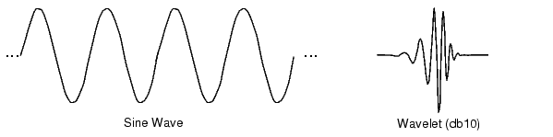 Fig 1

The difference between wave and wavelet is shown in the above fig. waves are smooth, predictable and everlasting, whereas wavelets are limited duration, irregular and may be asymmetric. Waves are used as deterministic basis functions in Fourier analysis for the expansion of functions (signals), which are time-invariant, or stationary. The important characteristic of wavelets is that they can serve as deterministic or non-deterministic basis for generation and analysis of the most natural signals to provide better time-frequency representation, which is not possible with waves using conventional Fourier analysis.

[3.3] WAVELET ANALYSIS:
The wavelet analysis procedure is to adopt a wavelet prototype function, called an ‘analyzing wavelet’ or ‘mother wavelet’ .Temporal analysis is performed with a contracted , high frequency version of the prototype wavelet , while frequency analysis is performed with a dilated, low frequency version of the same wavelet. Mathematical formulation of signal expansion using wavelets gives wavelet transform (WT) pair, which is an analogue to the Fourier transform (FT) pair. Discrete-time and discrete-parameter version of WT is termed as discrete wavelet transforms (DWT). DWT can be viewed in a similar framework of discrete Fourier transform (DFT). DWT can be viewed in a similar framework of discrete Fourier transform (DFT) with its efficient implementation through fast filter bank algorithms similar to fast Fourier transform algorithms.

[3.4] EVOLUTION OF WAVELET TRANSFORMS:
The need of simultaneous representation and localization of both time and frequency for non-stationary signals (e.g. music, speech, images) led toward the evolution of wavelet transform form the popular Fourier transform. Different ‘time-frequency representations’ (TFR) are very informative in understanding and modeling of wavelet transform.

[3.4.1] Fourier Transform
Fourier transform is used to find the frequency content of a signal. It allows going back and forwarding between the raw and processed (transformed) signals. However, only either of them is available at any given time. That is, no frequency information is available in the time-domain signal, and no time information is available in the Fourier transformed signal. Fourier transform of a time domain signal X(t) and inverse Fourier transform (IFT) of a frequency domain signal X(f) are given below.
1
2
Though FT has a great ability to capture signal’s frequency content as long as X(t) is composed of few stationary components (e.g. sine waves) .However , any abrupt change in time for non-stationary signal X(t) is spread out over the whole frequency axis in X(f). Hence the time-domain signal sampled with dirac-delta function is highly localized in time but spills over entire frequency band and vice versa. The limitation of FT is that it cannot offer both time and frequency localization of a signal at the same time. To overcome the limitations of the standard FT, Gabor introduced the initial concept of short time Fourier transform (STFT).

[3.4.2] Short Term Fourier Analysis:
This is the revised version of the Fourier transform. There is only a minor difference between short term Fourier analysis (STFT) and FT. In STFT, the signal is divided into small enough segments, where these segments (portions) of the signal can be assumed to be stationary. For this purpose, a window function “w” is chosen. The width of this window must be equal to the segment of the signal where its stationary is valid.
This window function is the first located to the very beginning of the signal. That is, the window function is located at t=0. Let’s suppose that the width of the windows is “T” s. At this time instant (t=0), the window function will overlap with the first T/2 seconds. The window functions and the signal are then multiplied. By doing this , only the first T/2 seconds of the signal is being chosen, with the appropriate weighting of the window (if the window is a rectangle, with amplitude “I” , then the product will be equal to the signal) Assuming the product just as another signal, FT is taken.
The result of this transformation is the FT of the first T/2 seconds of the signal. If this
Portion of the signal is stationary, as it is assumed, the obtained result will be as true frequency representation of the first T/2 seconds of the signal. The next step would be shifting this window (for some t1 seconds) to a new location, multiplying with the signal and taking the FT of the product. This procedure is followed until the end of the signal is reached by shifting the window with “t1” seconds intervals. The following definition of the STFT summarizes all the above explanations in one line:

In the above equation X(t) is the signal , w(t) is the window function, and * is the complex conjugate. As you can see from the equation, the STFT of the signal is nothing but the FT of the signal multiplied by a window function. Using STFT one cannot know the exact time-frequency representation of a signal, i.e., one cannot know what spectral components exist at what instances of times. What one can know are the time intervals in which certain band of frequencies exists, which is a resolution problem. This problem occurs because of width of window function used.
Narrow window ➔ good time resolution, poor frequency resolution
Wide window ➔ good frequency resolution, poor time resolution and violates the condition of stationary.
The selection of proper window is application dependent. Once a window has been chosen for STFT, the time-frequency resolution is fixed over the entire time-frequency plane because the same window is used at all frequencies. There is always a trade off between time resolution and frequency resolution in STFT.

[3.5] CONTINUOUS WAVELET TRANSFORM:
The continuous wavelet transform was developed as alternative approach to the short time Fourier transforms to overcome the resolution problem. The wavelet analysis is done in a similar way to the STFT analysis, in the sense that the signal is multiplied with a function (i.e. the wavelet) , similar to the window function in the STFT, and the transform is computed separately for different segments of the time-domain signal, however, there are two main differences between the STFT and the CWT.
- The Fourier transforms of the windowed signals are not taken, and therefore are not computed.
- The width of the window is changed as the transform is computed for every single spectral component, which is probably the most significant characteristic of the wavelet transform.
The wavelet transform (WT) in its continuous (CWT) form provides a flexible time-frequency window, which narrows when observing high frequency phenomena and widens when analyzing low frequency behavior. Thus time resolution becomes arbitrarily good at low frequencies. This kind of analysis is suitable for signals composed of high frequency components with short duration and low frequency components with long duration, which is often the case in practical situation.
The continuous wavelet transform is defined as follows
As seen in the above equation, the transformed signal is a function of two variables, and s, the translation and scale parameters, respectively. Ψ (t) is the transforming function, and it is called the mother wavelet.
The mother wavelet is a prototype for generating the other window functions. The term translation is related to the location of window, as the window is shifted through the signal. This term corresponds to the time information in transform. The scale parameter is defined as the inverse of frequency. High scales (low frequencies) correspond to global information of a signal (that usually spans the entire signal) whereas low scales (high frequencies) do not last for entire duration of signal but usually appear from time to time as short bursts and high scales (low frequencies) usually last for the entire duration of the signal.
The CWT is the correlation between a wavelet at different scales and the signal with the scale (or the frequency) being used as a measure of similarity. The continuous wavelet transform was computed by changing the scale of the analysis window, shifting the window in time, multiplying by the signal, and integrating over all times.

[3.6] DESCRETE WAVELET TRANSFORM:
The CWT has the drawbacks of redundancy and impracticability with digital computers. The discrete wavelet transform (DWT) provides sufficient information both for analysis and synthesis of the original signal, with a significant reduction in the computation time. The DWT is considerably easier to implement when compared to the CWT.
The DWT analyzes the signal at different frequency bands with different resolutions by decomposing the signal into a coarse approximation and detail information. DWT employs two sets of functions, called scaling functions and wavelet functions, which are associated with low pass and high pass filters, respectively. The original signal x[n] is first passed through a half-band high pass filter g[n] and a low pass filter h[n]. After the filtering, half of the samples can be eliminated according to the nyquist’s rule. The signal can therefore be sub sampled by 2, simply by discarding every other sample. This constitutes one level of decomposition and can mathematically be expressed as follows:

and are the outputs of the high pass and low pass filters, respectively after sub sampling by 2. This decomposition halves the time resolution since only half the number of samples now characterizes the entire signal. However, this operation doubles the frequency resolution, since the frequency band of the signal now spans only half the previous frequency band, effectively reducing the uncertainty in the frequency by half. The above procedure, which is also known as the sub-band coding can be repeated for further decomposition. At every level, the filtering and sub sampling will result in half the number of samples (and hence half the time resolution) and half the frequency band spanned (and hence half the frequency resolution). Hence the fig. illustrates this procedure, where x[n] is the original signal to be decomposed, and h[n] and g[n] are low pass and high pass filters, respectively. The bandwidth of the signal at every level is marked on the figure as “ f “.

The frequencies that are most prominent in the original signal will appear as high amplitudes in that region of the DWT signal that includes those particular frequencies. The frequency bands that are not very prominent in the original signal will have very low amplitudes , and that part of the DWT signal can be discarded without any major loss of information , allowing data reduction. The difference of this transform from the Fourier transform is that the time localization of these frequencies will not be lost.

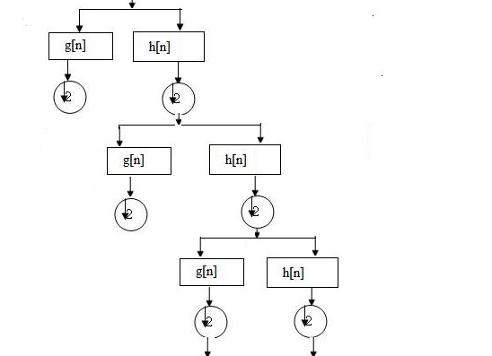
Fig 2
Four resulting sets of wavelet coefficients,, and are conventionally named according to the filtering types along rows and columns respectively (H: high pass filtering, L: for low pass filtering). These sets are also called wavelet sub bands (LL, LH, HL, and HH). The perfect reconstruction is also obtained by applying the
ID synthesis scheme on rows and columns successively.

It is worth pointing out that the order in which rows and columns are processed at the analysis and synthesis sides has no importance since the global transformation is linear.
An advantage of wavelet transform is that the windows vary. In order to isolate signal discontinuities, one would like to have some very short basis functions. At the same time, in order to obtain detailed frequency analysis, one would like to have some very long basis functions. A way to achieve this is to have short high-frequency basis functions and long low-frequency ones. This happy medium is exactly what you get with wavelet transforms. One thing to remember is that wavelet transforms do not have a single set of basis functions like the Fourier transform, which utilizes just the sine and cosine functions. Instead, wavelet transforms have an infinite set of possible basis functions. Thus wavelet analysis provides immediate access to information that can be obscured by other time-frequency methods such as Fourier analysis.

[3.7] COMPARATIVE VISUALIZATION:
A comprehensive visualization of various time-frequency representations, shown in figure, demonstrates the time-frequency resolution for a given signal in various transform domains with their corresponding basis functions.
Figure describes the time and frequency responses in different domains.
Here
x axis denotes -> time
y axis denotes -> frequency

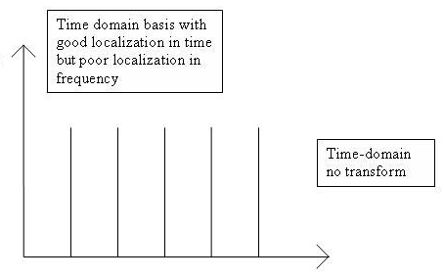

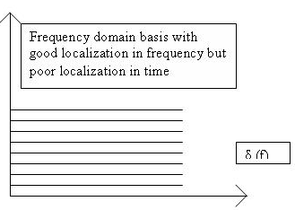
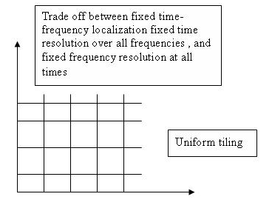
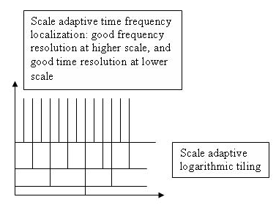

[3.8] WAVELET PROPERTIES:
The most important properties of wavelets are the admissibility and the regularity conditions and these are the properties which gave wavelets their name. It can be shown that square integrable functions satisfies the admissibility condition
˂ +
Can be used to first analyze and then reconstruct a signal without loss of information.
Stands for the Fourier transform of . The admissibility condition implies that the Fourier transform of vanishes at the zero frequency.
i.e.,
This means that wavelets must have a band-pass like spectrum. This is a very important observation, which we will use later on to build an efficient wavelet transform.
A zero at the zero frequency also means that the average value of the wavelet in the time domain must be zero.
And therefore it must be oscillatory. In other words must be a wave. As from the above knowledge the wavelet transform of one dimensional function is two dimensional; the wavelet transform of two-dimensional function is four-dimensional. The time-bandwidth product of the wavelet transform is the square of the input signal and for most practical applications this is not a desirable property. Therefore one imposes some additional conditions on the wavelet functions in order to make the wavelet transform decrease quickly with decreasing scale s. These are the regularity conditions and they state that the wavelet function should have some smoothness and concentration in both time and frequency domains.
If we expand the wavelet transform into the Taylor series at t=0 until order n (let τ=0 for simplicity) we get
Hence f^{(p)} stands for the p^{th} derivative of f and O(n+1) means the rest of the expansion. Now, if we define the moments of the wavelet by M_{p} ,
M_{p} =
Then we can get the finite development
From the admissibility condition we already have that the 0th moment M₀= 0 so that the first term in the right-hand side of above equation is zero. If we now manage to make the other moments up to M_{n} zero as well, then the wavelet transform coefficients will decay as fast as s^{n+2} for a smooth signal f(t). This is known in literature as the vanishing moments or approximation order. If a wavelet has N vanishing moments, then the approximation order of the wavelet transform is also N. The moments do not have to be exactly zero , a small value is often good enough. In fact experimental research suggests that the number of vanishing moments required depends heavily on the applications.
The admissibility condition gave us the wave, regularity and vanishing moments gave us the fast decay or the let, and put together they give us the wavelet.

[3.9] A BAND-PASS FILTER:
With the redundancy removed, we still have two hurdles to take before we have the wavelet transform in a practical form. We continue by trying to reduce the number of wavelets needed in the wavelet transform and save the problem of the difficult analytical solutions for the end.
Even with discrete wavelets we still needed an infinite number of scaling and translations to calculate the wavelet transform. The easiest way to tackle this problem is simply not to use an infinite number of discrete wavelets. Of course this poses the question of the quality of the transform. Is it possible to reduce the number of wavelets to analyze a signal and still have a useful result?

The translation of the wavelets is of course limited by the duration of the signal under investigation so that we have an upper boundary for the wavelets. This leaves us with the question of dilation how many scales do we need to analyze our signal?
How do we get the lower bond? it turns out that we can answer this question by looking at the wavelet transform in a different way.
The wavelet has a band-pass like spectrum. From Fourier theory we know that compression in time is equivalent to stretching the spectrum and shifting it upwards
This means that a time compression of the wavelet by a factor of 2 will stretch the frequency spectrum of the wavelet by a factor of 2 and also shift all frequency components up by a factor of 2. Using this insight we can cover the finite spectrum of our signal with the spectrum of dilated wavelets in the same way as that we covered our signal in the time domain with translated wavelets. To get a good coverage of the signal spectrum the stretched wavelet spectra should touch each other, as if they were standing hand in had. This can be arranged by correctly designing the wavelets.

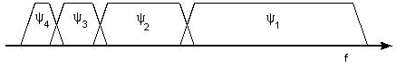
Fig 5.
If one wavelet can be seen as a band-pass filter, then a series of dilated wavelets can be seen as a band-pass filter bank. If we look at the ratio between the center frequency of a wavelet spectrum and the width of this spectrum we will see that it is the same for all wavelets. This ratio is normally referred to as the fidelity factor Q of a filter and in the case of wavelets one speaks therefore of a constant-Q filter bank.

A CONSTRAINT:
As a constraint we will now take a look at an important constraint on our signal, which has sneaked in during the last section the signal to analyze must have finite energy. When the signal has infinite energy it will be impossible to cover its frequency spectrum and its time duration with wavelets. Usually this constraint is formally stated as
And it is equivalent to stating that the L² norm of our signal f(t) should be finite. This is where Hilbert spaces come in so we end our constraint by stating that natural signals normally have finite energy.

[3.10] THE SCALING FUNCTION:
The question arises how to cover the spectrum all the way down to zero? Because every time we stretch the wavelet in time domain with a factor of 2, its bandwidth is halved. In other words, with every wavelet stretch we cover only half of the remaining spectrum, which means that we will need an infinite number of wavelets to get the job done.
The solution of this problem is simply not to try to cover the spectrum all the way down to zero with wavelet spectra, but to use a cork to plug the hole when it is small enough. This cork then is a low-pass spectrum and it belongs to the so-called scaling function. The scaling function was introduced by mallet. Because of the low-pass nature of he scaling function spectrum it is sometimes referred to as the averaging filter.

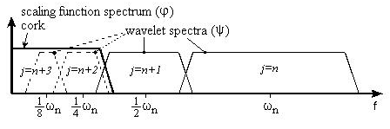
Fig 6
Figure shows scaling function of wavelet.
If we look at the scaling function as being just a signal with a low-pass spectrum, then we can decompose it in wavelet components and express it as
Since we selected the scaling function in such a way that its spectrum neatly fitted in the space left open by the wavelets, the expression uses an infinite number of wavelets up to certain scale j. This means that if we analyze a signal using the combination of scaling function and wavelets, the scaling function by itself takes care of the spectrum otherwise covered by all the wavelets up to scale j, while the rest is done by the wavelets. In this way we have limited the number of wavelets form an infinite number to a finite number.
By introducing the scaling function we have circumvented the problem of the infinite number of wavelets and set a lower bound for the wavelet. Of course when we use a scaling function instead of wavelets we lose information. That is to say, from a signal representation view we do not loose any information, since it will still be possible to reconstruct the original signal but from a wavelet-analysis point of view we discard possible valuable scale information. The width of the scaling function spectrum is therefore an important parameter in the wavelet transform design. The shorter its spectrum the more wavelet coefficients, we will have and more scale information. But , as on , in the discrete wavelet transform this problem is more or less automatically solved.
The low-pass spectrum of the scaling function allows us to state some sort of admissibility condition similar to
Which shows that the 0th moment of the scaling function can not vanish?
If one wavelet can be seen as a band-pass filter and scaling function is a low pass filter, then a series of dilated wavelets together with a scaling function can be seen as a filter bank.

[3.11] SUBBAND CODING:
If we regard the wavelet transform as a filter bank, and then we can consider wavelet transforming a signal as passing the signal through this filter bank. The outputs of the different filter stages are the wavelet-and scaling function transform coefficient. Analyzing a signal by passing it through a filter bank is not a new idea and has been around for many years under the name sub-band coding. It is used for instance in computer vision applications.
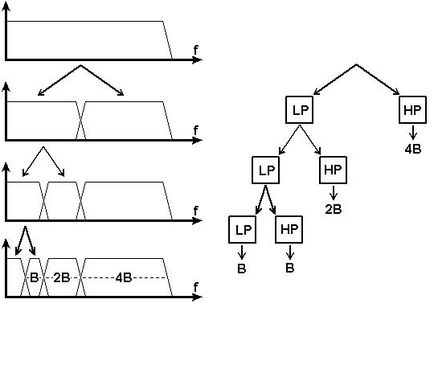
Fig 7.
The filter bank needed in sub band coding can be built in several ways. One way is to build many band-pass filters to split the spectrum into frequency bands. The advantages are that the width of every band can be chosen freely, in such a way that the spectrum of the signal to analyze is covered in the places where it might be interesting. The disadvantage is that we will have to design every filter separately and this can be a time consuming process. Another way is to split the signal spectrum in two parts a low-pass and a high-pass part. The high-pass part contains the smallest details we are interested in and we could stop here. We now have two bands. However the low-pass part still contains some details and therefore we can split it again. And again, until we are satisfied with the number of bands we have created. In this way we have created an iterated filter bank. Usually the number of bands is limited by for instance the amount of data or computation power available. The process of splitting the spectrum is graphically delayed in fig. The advantage of this scheme is that we have to design only two filters , the disadvantage is that the signal spectrum coverage is fixed.
Looking in above fig. we see that what we are left with after the repeated spectrum splitting is a series of band-pass bands with doubling bandwidth and one low-pass band. (Although in first split gave us a high-pass band and a low-pass band, in reality the high-pass band is a band-pass band due to te limited bandwidth of the signal.) .The same can be done in another way by feeding the signal into a bank of band-pass filters of which each filter has a bandwidth twice as wide as his left neighbor (the frequency axis runs to the right here) and a low-pass filter. This is same as applying a wavelet transform to the signal. The wavelet gives us the band-pass bands with doubling bandwidth and scaling function provides us with the low-pass band. So we can conclude that a wavelet transform is the same thing as a sub-band coding scheme using a constant-Q filter bank. This analysis is referred to as a multi-resolution analysis.

[3.12] ORTHOGONAL WAVELET:
An orthogonal wavelet is a Wavelet where the associated wavelet transform is orthogonal. That is the inverse wavelet transform is the ad joint of the wavelet transform. If this condition is weakened you may end up with bi-orthogonal wavelet.
The scaling function is a re-definable function. That is, it is a fractal functional equation, called refinement equation:
,
Where the sequence of real numbers is called scaling sequence or scaling mask. The wavelet proper is obtained by a similar linear combination,
Where the sequence of real numbers is called wavelet sequence or wavelet mask.
A necessary condition for the orthogonality of the wavelets is, that the scaling sequence is orthogonal to any shifts of it by an even number of coefficients:
In this case there is the same number M=N of coefficients in the scaling as in the wavelet sequence, the wavelet sequence can be determined asb_{n}=(-1)^{n}a_{N-1-n} . In some cases the opposite sign is chosen.

[3.13] BI-ORTHOGONAL WAVELET:
A bi-orthogonal wavelet is a wavelet where the associated wavelet transform is invertible but not necessarily orthogonal. Designing bi-orthogonal wavelets allows more degrees of freedoms than orthogonal wavelets. One additional degree of freedom is the possibility to construct symmetric wavelet functions.
In the bi-orthogonal case, there are two scaling functions, which may generate different multi-resolution analyses, and accordingly two different wavelet functions . So the numbers M,N of coefficients in the scaling sequences may differ. The scaling sequences must satisfy the following bi orthogonality condition
. Then the wavelet sequences can be determined as, , n=0,…,M-1 and ,n=0,…,N-1.

[3.14] GENERATING SCALING FUNCTIONS AND WAVELETS FROM FILTER COEFFICIENTS:
The following equation represents as
is the frequency response of H.
Rewriting this above equation as
Where we have set Φ(0)=1, we have the coefficients of the impulse response of a discrete-time filter h(n) satisfy the par unitary conditions. The sequence 2h(n) can serve as the set of coefficients for the dilation equation to generate a potential scaling function ϕ(t) for an orthonormal decomposition. If substitution of the frequency response H(ω) in the right-hand side of the equation leads to a function of Φ(ω), then its inverse Fourier transform is such a scaling function. There is a simple time-domain iteration method based on this result.
The steps of the algorithm are
- Set c(n)=2h(n).
- Let the initial scaling function be the haar scaling function
_{otherwise} ^{0≤t<1}
- At iteration n set
- Iterate until either divergence is established or the desired convergence is obtained. If there is convergence, the scaling function is given by
Transforming the iteration to the frequency domain, at the end of the first iteration,
Where denotes the Fourier transform of the scaling function at the n^{th} iteration. The function is the Fourier transform of the Haar scaling function.
Thus the scaling function become

[3.15] SECOND GENERATION WAVELET TRANSFORM:
We have gone in quite details of the root of all mathematical tools for analysing signals. Wavelets has been seen as a primary tool for decomposing signal getting signal’s time and frequency information at the same time .It started from Fourier transform where no such wavelet concept exist and the signal decomposition primarily depends upon sine and cosine terms . Then as a part of evolution originated Discrete Cosine Transform which was having only cosine terms in its decomposition. Then we saw in previous chapter that its the wavelet which greatly transformed the way with which signal decomposition has been seen in mathematical perspective. We came across Continuous Wavelet Transform and then Discrete Wavelet Transform which was quite more compatible and versatile while implementing in digital systems enhancing computational speed as well.
Now we are going to illustrate some another method of obtaining Discrete Wavelet Transform whose computational complexity is quite low as compared to FFTs and DFTs previously discussed and the speed is fast as well .This another method is known as Lifting Scheme which in comparison to convolution allows to get half the cost of computation for long FIR filters.
The concept of Lifting Scheme was popularised by Sweldens [23]. It has thrown new insight and ideas on wavelets and has served to enhance the power and versatility of wavelet transforms. Lifting provides an efficient way to implement the DWT and the computational efficiency of the lifting implementation can be up to 100% higher than the traditional direct convolution based implementation [24]. The lifting scheme has also provided an easy way to construct new types of wavelet transforms which can be nonlinear. The Integer Wavelet Transforms are one of them.

We call Integer Wavelet Transform as a second generation wavelet transforms because of its capability to maps integers to integers and perfect invertibility with finite precision arithmetic (i.e. reversible). A simple and effective way to construct IWT is to first factor the traditional DWT into lifting steps and then to apply a rounding operation at each step [25]. The IWT can thus be used for lossless compression but there are also advantages in using the IWT for lossy compression. The IWT can be used in a unified lossy and lossless codec. The IWT also have the potential for simpler implementation as many of the operands are integer. The rounding operation makes the IWT strictly a nonlinear transform and several studies have been made to study the effect of the nonlinearity .

[3.15.1]The Lifting Based Discrete Wavelet Transform:
The computation of the wavelet series requires significant computational time and resources. It is possible to reduce this by using a sub band coding algorithm which yields a faster wavelet transform. The wavelet transform of a signal using the CWT is obtained by changing the scale of the analysis window, shifting the window in time, multiplying the signal and integrating the result over all time. In case of the DWT, the wavelet transform is obtained by filtering the signal through a series of digital filters at different scales .The scaling operations is done by changing the resolution of the signal by sub sampling.
The DWT can be computed using either the convolution based or lifting based procedures. We already have known the convolution procedure so will concentrate upon the lifting method.

[3.15.2]Lifting Based:
The lifting scheme is a much more efficient method to calculate wavelet transforms than the classical convolution method. The original motivation for the development of the lifting technique was the implementation of second generation wavelets. Second generation unlike the first generation wavelets do not use the translation and dilation of the same wavelet prototype in different levels. The lifting scheme is a general scheme and is not limited to developing a filter structure for second generation wavelets. It can also be used to build a ladder type structure for first generation wavelet filters. Any classical wavelet filter bank can be decomposed into lifting steps through the use of Euclidean algorithm which will be shown later in this chapter.
There are two different ways to introduce the lifting scheme. One approach is to discuss how lifting affects the wavelet transform[5]. The other approach is to show how the lifting steps can be derived from the filter bank structures used for the DWT computation.
The lifting scheme consists of three stages: split, predict and update. Consider a one dimensional sequence or signal x[n] whose elements have some correlation between them. We can represent the signal compactly by exploiting the correlation structure present in it [23].
The first step in the lifting scheme is splitting the input signal into two subsets, the even sample set ( ) and the odd sampled set (). This splitting is called Lazy wavelet transform. Even though the splitting into subsets can be done in many ways, for the ease of reconstruction the Lazy wavelet transform is used.
Since we would like to get a more general representation of the original sequence x[n], the aim is to get a sparser approximation of one of the subsets. This is done by using the predict step where the linear combination of elements in one subsequence is used to predict the values of the other subsequence using the assumption that the two sub sequences produced in the splitting step are correlated. If the correlation present in the original data is high, the predicted values will be close to the actual values.
The predict step is shown in above equation where p[k] is the prediction coefficient. The linear combination of the even subsequence values is used to predict the old subsequence values. The detail variable {d1} records the difference between the actual value and the predicted value. If the original sequence is smooth the detail sequence will be sparse set. After the predict step the original sequence is represented in terms of even samples s0[n] and detail values d1[n]. The detail sequence can be considered to be equivalent to the sequence obtained after sub sampling the output from the high pass wavelet analysis filter
The predict step results in loss of some basic properties of the signal like the mean value which needs to be preserved. The update step lifts the even sequence values using the linear combination of predicted odd sequence values so that the basic properties of the original signal are preserved. The even sequence value s1 obtained as the result of equation above is equivalent to the sub sampled low pass version of the original sequence
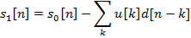
The DWT of a one dimensional signal using simple lifting scheme with pair of lifting sub steps will follow the steps summarized as below
1: Split Step: The input signal x[n] is split into odd and even sub sequences d[n] and s[n] respectively.
2: Predict Step: Predict Step: This step predict data in the subsequence d[n] using the sample in s[n] replaces the sample in d[n] using the prediction error.
3: Update step: This step updates the data in using the data in

[3.15.3]Filter Banks using Euclidean algorithm:
The previous section introduced the lifting scheme through the implementation of a second generation wavelet. We can use this powerful scheme to decompose every FIR wavelet or filter banks into lifting steps. The filter bank structure used in the DWT computation at each level can thus be replaced by this more efficient computational scheme to give a low resolution part and a high resolution part.
If we filter a signal x[n] using a FIR filter with impulse response h[n],the output of the filter is written as
If we down sample the output of the filter keeping only the even samples, we get
Similarly, down sampling the output of the filter keeping only the odd samples, we get
Thus we can write as

The filtering operation in the 1D-DWT decomposition shown by the figure is written as
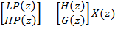

After down sampling the filter outputs and taking only the even samples, we get
In the matrix form it is written as
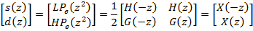

By first filtering and then sub sampling the outputs, we are throwing away half the computed values. Hence it would be more efficient if we subsample before we filter the signal. Then we will be calculating only the even parts of and
Thus we can write
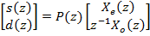
Where P(z) is the poly phase matrix
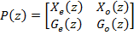

Daubechies and Swelden showed in the paper[24], that the poly-phase matrix can be factorized into a sequence of alternating upper and lower triangular 2 x 2 matrices and a diagonal normalization matrix. Thus every FIR wavelet filter can be obtained by starting with the Lazy transform followed by n lifting and dual lifting steps as shown in equation below. The number of lifting steps required depends on the length of the filter.
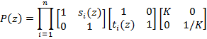
Where and are the Laurent polynomials and K is the normalization factor
From this the inverse wavelet transform can be written as
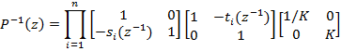

In order to compare the computational complexity of the lifting scheme with that of standard convolution scheme, we can compare the cost in terms of additions and multiplications required in each method . Consider a low pass filter h[n] of order 2N and a high pass filter g[n] of order 2M . The cost of standard convolution algorithm is 4(N+M)+2(2M additions + 2M + 2N additions +1 multiplications). Using the Euclidean algorithm, the cost of the lifting scheme including the normalizing step is 2(N+N+2). Thus the computational savings using lifting scheme is about one half that of the convolutional scheme for longer FIR filters[7].

[3.15.4]Reversible Integer Wavelet Transform:
The wavelet transform usually produces floating point coefficients even when applied to integer sequences. The original integer data can be reconstructed perfectly in theory by using these coefficients. However in practice, we usually use the fixed point format for data values as fixed point systems are easier to implement. The reduced precision arithmetic used in such systems can introduce round off errors in the computations. Hence in applications where we need lossless reconstruction, we need transforms which have the reversibility property when reduced precision is used.
We can build wavelet transforms that map integers to integers using the lifting structure. The reversibility property is obtained by rounding off the predict filter or update filter output before adding or subtracting in each lifting step. Hence the lifting step at level i decomposition become

These lifting steps are invertible and the inverse lifting steps can be obtained by reversing the operations and flipping the signs.
Even though the lifting step now results in an integer to integer transform, the normalization step using the scaling factor will reintroduce floating point coefficients. This issue can be avoided by using one of the two methods
- Omitting the scale factor K,and keeping in mind that the actual low pass value will be obtained by multiplying the low pass value obtained through lifting by the scale factor and the actual high pass value by dividing the high pass obtained via lifting with the scale factor. We can obtain coefficients through using only lifting steps by choosing a factorization method that makes K as close to 1 as possible.
- With three extra lifting steps that make the scale factor equal to 1. By choosing to factorize in this way, we gat integer to integer transforms through using lifting steps.

The block diagram shows the forward integer to integer transform. The inverse integer to integer transform is obtained by reversing the computations in the forward transform, using appropriate sign changes.

[3.15.5] Integer Wavelet Filter Examples:
The two filters which are supported by JPEG2000 are the (5,3) Integer filter and the Daubechies (9,7) filter. The table shows the coefficients of the bi-orthogonal linear phase (5,3) and (9,7) wavelet filters.
We will examine the integer to integer transform lifting steps for these two filters. Let the input signal be x[n], low pass signal s[n] and high pass signal d[n]. The lazy wavelet transform step is given by equations below
The poly-phase matrix for the bi-orthogonal (5,3) filter after normalizing the filter coefficients with 1/root2 is
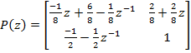
The lifting steps for the (5,3) filter given in the equation below are obtained after factorizing the poly-phase matrix.

The factorization which is symmetric with every quotient a multiple of (z+1) was chosen although many factorization exist for the poly-phase matrix for the (9,7) filter. The factorized poly-phase matrix is given by equation below.
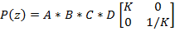
Where
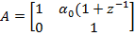
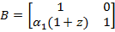
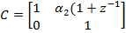
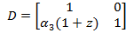
=1.586134, =.052980, =.882911 and = 0.443506. The normalization factor for the (9,7) filter, k = .812893. The lifting steps for the (9,7) bi-orthogonal filer are thus given by the following equations

The cost of computation using the convolution scheme for the (9,7) filter to get the low pass wavelet coefficients and the high pass wavelet coefficients is 30 (16 multiplications+14 additions). The cost using the lifting scheme is 14 (6 multiplications +8 additions).
Thus the computational cost in lifting is less than half that of the convolution scheme.

CHAPTER # 4
ADVANCES IN REVERSIBLE IMAGE WATERMARKING

[4.1]REVERSIBLE WATERMARKING THE IMAGES GOT NEW IDEAS:
Till now we have gone in good details of the techniques that could be used when it comes to reversible watermarking images. Though they had been traditional but they are still functional, not all but some of them are still intact when used to decompose the image in order to hide additional information. Reversible watermarking techniques have always been enhanced to lead better and better results. Researchers are trying each day to limit the trade off between imperceptibility and Robustness to its maximum by putting their hard work in innovating new techniques. Although not the whole algorithm changes but there has been seen advances in them which target some specific obstacles which are seen when results are simulated.
Some of the techniques are meant to resist distortion arising after watermarked images undergoes filtering attacks. Some are meant to acquire good robustness against RST (Rotation, Scaling and Translation) attacks and some techniques are dedicated to provide resistance against lossy compressions. The most important part while inventing any new technique is that one cannot compromise with other robustness parameters while strengthening the targeted areas of concern.
While improving in reversible watermark’s robustness we have to keep in mind the imperceptibility issue as well. So with time it’s not just DCT and DWT are taken use of, new transforms like Integer Wavelet Transform and SVD (Singular Value Decomposition) have come under play to integrate with advance techniques.

[4.2] SINGULAR VALUE DECOMPOSITION:
Here we are going to introduce another useful transform in the area of Reversible Watermarking, popularly known as SVD (Singular Value Decomposition). Work has already been done using this transform but I would like to present a briefing of this transform [26] before we move further.
The singular value decomposition (SVD) of a matrix with real or complex entries is one of the fundamental tools of numerical linear algebra. It has applications to regression analysis, data compression and numerical linear algebra among others. Because of its importance, there is a wealth of numerical tools available for computing the SVD. In this section we summarize the definitions and properties of the SVD that we shall need. A full development can be found in most linear algebra texts, for example Golub and Van Loan.[27]
Let A be an n × n matrix with real entries. Note that while we restrict our discussion to real-valued, square matrices, the SVD applies more generally to complex-valued rectangular matrices. The singular value decomposition of A is a representation
(1)
in which U and V are n * n orthogonal matrices, and S is a diagonal matrix with nonnegative entries. Recall that a matrix U is orthogonal if . Put another way, U is orthogonal if its columns are pair wise orthogonal unit vectors. As usual, denotes the transpose of the matrix U.
As a rule, it is the largest singular values that exert the most influence on the matrix A. In particular, when A contains the greyscale values for an image, perturbations of the smaller singular values and their corresponding singular vectors have no perceptible effect on the image. It is this mathematical principle that our embedding technique is designed to exploit.
The diagonal entries of S in equation (1) are of the form √λ, where λ is an eigen value of the symmetric matrix . The corresponding eigenvectors form the columns of U. The diagonal entries of S are called the singular values of A, while the columns of U and V are the left and right singular vectors. Note that the eigen values of are real and nonnegative. Consequently the singular values of A are also real and nonnegative.
The question of uniqueness in the decomposition (1) is of concern to us here. To that end we make the following definition.

[4.2.1]Definition:
1. A vector is lexicographically positive if its first nonzero component is positive.
2. A singular value decomposition A= is normal if the columns of U are lexicographically positive and the diagonal entries of S are in non-increasing order.
[4.2.2]Theorem: A matrix has unique normal singular value decomposition if its singular values are pair wise distinct and nonzero.
Proof. Since the singular values of A are pair wise distinct, the eigen values of the matrix B = AAT are pair wise distinct as well. B is a symmetric matrix; hence the spectral theorem asserts that B has a basis of eigenvectors. Combining these two facts, each eigen space of B is one-dimensional. Thus, if we require the eigenvectors to have unit length, there are exactly two choices for each eigenvector, u and -u, only one of which is lexicographically positive. Since the eigenvectors of B form the columns of U, we have only one choice for each column of U.
The requirement that the diagonal entries of S be decreasing imposes uniqueness on S and also on the order of the columns of U. Hence U is unique. Since the singular values are nonzero, S is invertible. Finally, we obtain V uniquely as .
In our applications, the matrix A will have integer entries in the rangeand dimension between 8 and 16. It seems quite difficult to determine the probability that such a matrix will fail to satisfy the hypothesis of Theorem, however our experience suggests that this probability is exceedingly small. Thus we will proceed under the assumption that all matrices have distinct, nonzero singular values and all singular value decompositions are normal. Of course in practice, this means our computations have to be sufficiently accurate that we can distinguish between distinct singular values.

[4.3]A REVERSIBLE WATERMARKING TECHNIQUE THAT UTILIZES SVD:
1. Compute the normal singular value decomposition, , of A.
2. Transform in to :
(a) Set certain components
(b) Choose remaining components to ensure that is still orthogonal.
3. Compute
4. Clip and round the entries in to integers in the range 0. . . 255. The resulting matrix, will be a block of the stego-image.
[4.3.1] Description Of The Algorithm:
We denote by .the payload that we wish to embed. Each payload bit is assumed to have a value in. (A conventional -bit b can be converted to a -bit using either of the transformations .The cover image is assumed to be a rectangular array of pixel locations with values in the range 0 . . . 255. All of our experiments were done with greyscale images; however, our approach could be applied to color images either by utilizing the intensity byte in HSI images, or possibly by embedding bits into each of the three color components of a cover image in RGB format.
The cover image is divided into a series of n × n blocks in some standard order. If the number of rows or columns in the cover image is not a multiple of n, extra rows and columns can be ignored. Several bits of payload will be embedded into each block.
Let A be a typical n × n block. Payload bits are embedded into A by a simple four-step process, given in Figure 2. Step 2 requires further explanation. Recall that the visual quality of A is primarily determined by its largest singular values and singular vectors. By assumption, those are the left-most values of S and the left-most columns of U and V. Part of our strategy is to leave those columns untouched in order to achieve imperceptibility in our method. The precise number of columns that we protect in this way is a parameter that can be adjusted. We discuss the tradeoffs in this parameter below. We denote by m the number of columns of U that will be left unchanged.
For simplicity in this discussion, let us take n = 8 and m = 2. In other words, we will be manipulating the right-most 6 columns of each 8x8 block. At the end of this section we shall give formulas for general values of n and m. With n = 8, m = 2, we can embed 15 bits in each block of the cover image.
A schematic illustration of the matrix U is given in Figure below. Note that it is divided into three regions. The shaded region consists of those entries that are to be left unchanged. This consists of the two columns we wish to protect as well as the first row. The first row is left unchanged because the definition of normal SVD requires the top row of U to be all nonnegative. The upper triangular region contains the entries that will hold the embedded bits. The bits are embedded according to the formula
.
In this equation, simply counts from 1 to 15. The effect of this transformation is that the triangular entries in differ only from the corresponding entries in U in their sign. The sign of the entry in is the embedded bit.

The Matrix U
We now use the remaining entries in the matrix (those in the lower trapezoid) to ensure that will be orthogonal. Let denote the ith column of the matrix . Orthogonality requires that . We proceed as follows. First choose and to satisfy the pair of equations
This amounts to solving a homogeneous 2x2 system of linear equations. Then choose to satisfy the system
Continue this process to determine the lower entries in . Note that determining each column requires solving a simple system of linear equations. (In fact, these equations could be solved once symbolically, and then the solution evaluated for each block of the image.) Finally, we finish the process by dividing each column of by its Euclidean norm. That is . The resulting matrix is orthogonal and its columns will be lexicographically positive.
Step 3 of the basic algorithm simply multiplies together the new matrix with the original matrices S and . This produces a matrix from which the payload can be reliably recovered. From Theorem, has a unique normal SVD. Thus can be computed from and the payload bits extracted from the triangular region in .
Unfortunately, the entries in are not generally integers in the range 0 . . . 255, so additional processing is necessary before can be used as a block of the stego-image. We have chosen the simplest processing scheme: each entry is rounded and clipped to the range 0. . . 255. That is, if an entry x satisfies 0 ≤ x ≤ 255, it is rounded to the nearest integer. If x < 0, then x is replaced by 0, and if x > 255, it is replaced by 255. This strategy does indeed result in a valid image and furthermore, the perturbation caused by the embedding process is imperceptible. However, we now a have a different problem: the extraction process gets many of the payload bits wrong. The signs of the entries in the singular vectors are not particularly robust to the process of rounding and clipping. It is this defect that the additional measures described in Section 5 are intended to remedy.
Figure below shows an example of the basic embedding technique. On the left is a 512 × 512 pixel cover image before embedding. On the right is the result of embedding 61,440 bits into the image. Any distortion caused by the embedding is completely invisible. 77% of the embedded bits were retrieved correctly.

[4.3.2]The Extraction Algorithm:
1. Compute the SVD:
2. Extract payload bits from the signs of the entries in the triangular portion of

[4.4]Matrix Norm:
Matrix norm has been an increasingly used tool found in new watermarking schemes. Mathematically [34]
The p-norm of a vector x
This is defined by any value of p > 1, but the most common values of p are 1, 2, and ∞. The default value is p = 2, which corresponds to Euclidean length

The p-norm of a matrix A

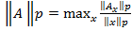
Again, the default value is p = 2.
The norm of a matrix is a scalar that gives some measure of the magnitude of the elements of the matrix.

F norm of a non negative matrix A is expressed as below
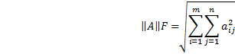

As it is known, matrix’s spectral norm is maximal singular value, F-norm is square sum of all singular values, and there is certain corresponding relationship between matrix norm and singular values.

[4.5]HYBRID REVERSIBLE WATERMARKING SCHEMES:
There has been times when any reversible watermarking scheme has a traditional algorithm like decomposing the image with a transform, then encrypting the watermark and then with their embedding algorithm, embed the information. Some schemes were found implementing variations in any available traditional algorithm to achieve robustness and imperceptibility criterion and this gave the idea of using hybrid schemes.

Hybrid reversible watermarking schemes can be described as the schemes which are aimed to minimize the trade off between imperceptibility and robustness of watermark by cleverly picking the appropriate transform from the wealth of transforms, previously illustrated ideas, some variations or innovative advancements in them and then finally mixing them in right way to have a good degree of compatibility. To finally have a scheme that has taken the best possible use of available innovations and is capable of showing desired robustness and imperceptibility parameters.

[4.6]An Example Is DCT-SVD Domain Reversible Watermarking:
The process of separating the image into bands using the DWT is well-defined. In two-dimensional DWT, each level of decomposition produces four bands of data denoted by LL, HL, LH, and HH. The LL sub-band can further be decomposed to obtain another level of decomposition. In two-dimensional DCT, we apply the transformation to the whole image but need to map the frequency coefficients from the lowest to the highest in a zig-zag order to 4 quadrants in order to apply SVD to each block. All the quadrants will have the same number of DCT coefficients. For example, if the cover image is 512x512, the number of DCT coefficients in each block will be 65,536. To differentiate these blocks from the DWT bands, we will label them B1, B2, B3, B4. This process is depicted in Fig shown below.

In pure DCT-based reversible watermarking, the DCT coefficients are modified to embed the watermark data. Because of the conflict between robustness and transparency, the modification is usually made in middle frequencies, avoiding the lowest and highest bands.
In SVD-based reversible watermarking, several approaches are possible. A common approach is to apply SVD to the whole cover image, and modify all the singular values to embed the watermark data. An important property of SVD-based watermarking is that the largest of the modified singular values change very little for most types of attacks.
We will combine DCT and SVD to develop a new hybrid non-blind image watermarking scheme [28] that is resistant to a variety of attacks. The proposed scheme is given by the following algorithm. Assume the size of visual watermark is nxn, and the size of the cover image is 2nx2n.

[4.6.1]Watermark Embedding:
1. Apply the DCT to the whole cover image A.
2. Using the zig-zag sequence, map the DCT coefficients into 4 quadrants: B1, B2, B3, and B4.
3. Apply SVD to each quadrant: , k = 1,2,3,4, where k denotes B1,B2,B3 and B4
4. Apply DCT to the whole visual watermark W.
5. Apply SVD to the DCT-transformed visual watermark W: .
6. Modify the singular values in each quadrant , k = 1,2,3,4, with the singular values of the
DCT-transformed visual watermark:
where are the
singular values of , and are the singular values of .
7. Obtain the 4 sets of modified DCT coefficients:
8. Map the modified DCT coefficients back to their original positions.
9. Apply the inverse DCT to produce the watermarked cover image

[4.6.2]Watermark Extraction:
1. Apply the DCT to the whole watermarked (and possibly attacked) cover image .
2. Using the zig-zag sequence, map the DCT coefficients into 4 quadrants: B1, B2, B3, and B4.
3. Apply SVD to each quadrant: where k denotes the attacked quadrants.
4. Extract the singular values from each quadrant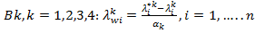
5. Construct the DCT coefficients of the four visual watermarks using the singular vectors:
6. Apply the inverse DCT to each set to construct the four visual watermarks

The DCT coefficients with the highest magnitudes are found in quadrant B1, and those with the lowest magnitudes are found in quadrant B4. Correspondingly, the singular values with the highest values are in quadrant B1, and the singular values with the lowest values are in quadrant B4.
The largest singular values in quadrants B2, B3, and B4 have the same order of magnitude. So, instead of assigning a different scaling factor for each quadrant, we used only two values: One value for B1, and a smaller value for the other three quadrants

[4.6.3]ADVANTAGE AS SEEN IN THE DESCRIBED HYBRID ALGORITHM:
A comparison of the hybrid DCT-SVD reversible watermarking scheme with a pure SVD based algorithm shows that the proposed scheme performs much better, providing more robustness and reliability
In most DCT-based reversible watermarking schemes, the lowest frequency coefficients are not modified as it is argued that watermark transparency would be lost. In the DCT-SVD based approach, we experienced no problem in modifying the coefficients in quadrant B1.
Watermarks inserted in the lowest frequencies (B1) are resistant to one group of attacks, and watermarks embedded in highest frequencies (B4) are resistant to another group of attacks. The only exception is the rotation attack for which the data embedded in middle frequencies survives better. With different angles, the results may be different. If the same watermark is embedded in 4 quadrants, it would be extremely difficult to remove or destroy the watermark from all frequencies.

So as we have seen the advantages that lead from implementing a hybrid reversible watermarking scheme, we can be pretty sure that thinking in right direction and mixing the available techniques with innovation can result in fairly appreciable and noticeable outcome.

CHAPTER # 5
THE PROPOSED TECHNIQUE

[5.1]BACKGROUND:

Reversible watermarking (data hiding) is the process of embedding data into a multimedia element such as an image, audio or video file. This embedded data can later be extracted from, or detected in, the multimedia for security purposes. A reversible watermarking algorithm consists of the watermark structure, an embedding algorithm, and an extraction, or detection, algorithm. Watermarks can be embedded in the pixel domain or a transform domain. In multimedia applications, embedded watermarks should be invisible, robust, and a high capacity. The approaches used in reversible watermarking still images include least-significant bit encoding, basic M-sequence, transform techniques, and image-adaptive techniques. In the classification of reversible watermarking schemes, an important criterion is the type of information needed by the detector:
• Non-blind schemes require both the original image and the secret key(s) for watermark embedding.
• Semi-blind schemes require the secret key(s) and the watermark bit sequence.
• Blind schemes require only the secret key(s).
The most important uses of reversible watermarks include copyright protection (identification of the origin of content, tracing illegally distributed copies) and disabling unauthorized access to content. The requirements for reversible watermarks in these scenarios are different, in general. Identification of the origin of content requires the embedding of a single watermark into the content at the source of distribution. To trace illegal copies, a unique watermark is needed based on the location or identity of the recipient in the multimedia network. In both of these applications, non-blind schemes are appropriate as watermark extraction or detection needs to take place in a special laboratory environment only when there is a dispute regarding the ownership of content. For access control, the watermark should be checked in every authorized consumer device, thus requiring semi-blind or blind schemes. Note that the cost of a watermarking system will depend on the intended use, and may vary considerably.
In all frequency domain watermarking schemes, there is a conflict between robustness and transparency. If the watermark is embedded in perceptually most significant components, the scheme would be robust to attacks but the watermark may be difficult to hide. On the other hand, if the watermark is embedded in perceptually insignificant components, it would be easier to hide the watermark but the scheme may be less resilient to attacks.
In image watermarking, two distinct approaches have been used to represent the watermark. In the first approach, the watermark is generally represented as a sequence of randomly generated real numbers having a normal distribution with zero mean and unity variance. This type of watermark allows the detector to statistically check the presence or absence of the embedded watermark. In the second approach, a picture representing a company logo or other copyright information is embedded in the cover image. The detector actually reconstructs the watermark, and computes its visual quality using an appropriate measure.

Not long ago, Tian [41] used a difference expansion method to reversibly embed a payload into digital images. He explored the redundancy in digital images to achieve a high-capacity and low-distortion reversible watermarking. His method divides the image into pairs of pixels, and some difference values that are not expected to cause an overflow or underflow are selected for the difference expansion (DE). One watermark bit will be embedded into the difference of each selected pixel pairs. Finally, a location map of the selected expandable pixel pairs is losslessly compressed and included in the payload. In order to achieve a high capacity reversible data embedding method for digital images, a multiple-layer embedding is employed in Tian’s algorithm. Here extend Tian’s algorithm to increase the hiding capacity of host image. The proposed algorithm enlarges the subset of the expandable pixel pairs by histogram shifting, but no extra storage space is needed.

[5.2]RELATED WORK:
Most reversible watermarking algorithms rely on some form of lossless compression to create space for embedding the payload. Tian used the redundancy in digital images to achieve very high embedding capacity, and keeps the distortion low. He employed the difference expansion (DE) technique to reversibly embed watermark into digital images. Let’s explain the DE with a simple example. Assume we have two neighboring pixels with values p1 = 106 and p2 = 104. Then the difference d and the average g can be computed as follows.
d = (p1-p2) =106-104=2.
g =└((P1+P2)/2) ┘=└((106+104)/2)┘=105.
Here, └ ┘ denotes the least nearest integer. To embed a watermark bit w = 1 into the pixel pair, the difference d is represented using the binary format, shift it left by one bit and append the watermark bit w into the vacant least significant bit (LSB). If l is the bit length of d (i.e.d = b(l-1)b(l-2) . . .b0), then the new difference value d0 can be obtained as
dˈ=b(l-1)b(l-2)………b0w = 2*d+ w=2*2+1=5.
Finally, the new pixel values of p01 and p02 are computed as follows.
pˈ1 = g +└((dˈ+1)/2┘=105+3 =108.
pˈ2 =g -└(dˈ/2)┘=105-2=103.
In the decoder, the watermark bit can be extracted from the LSB of the difference value, and the original difference value can be restored.
dˈ = pˈ1 - pˈ2 = 108-103=5.
w = LSB(dˈ) = LSB (101)=1.
d = └(dˈ/2)┘=2.
Then the original pixel values p1 and p2 can be restored completely.
P1 =└((pˈ1+ pˈ2)/2)┘+ └((d+1)/2┘= 105+1=106.
p2 =└((pˈ1 + pˈ2)/2┘- └(d/2)┘=105-1=104.
To prevent the overflow and underflow problems in a gray scale image, the new pixel values must satisfy
0 <= (g + └((dˈ+1)/2)┘) <= 255 and
0 <=( g - └(dˈ/2)) <= 255.
As the DE does not lead to overflow or underflow, the pixel pair is called expandable. From the above constraints, a generalized boundary condition is derived for the expandable pixel pairs.
|2 *( d) + w | <= min(2 * (255-g), 2* g + 1).
Besides, a pixel pair is called changeable if
|2 *└(d/2)┘+ w|<= min(2 * (255 –g),2*g +1).
It means that the new pixel values will not introduce an overflow or underflow after changing the LSB of the difference value. Obviously, it can be seen that an expandable pixel pair is also changeable. And the conditions on expandable and changeable are equivalent when d = 0 or -1.
Now, the embedding procedure can be stated as follows
1. The original image is partitioned into pixel pairs firstly.The pairing could be done horizontally or vertically.
2. Divide the set of pixel pairs into four subsets S1, S2, S3,and S4. The subset S1 contains all expandable pixel pairs with d = 0 and d = _1. The subset S2 contains all
expandable pixel pairs that are not in S1. The subset S3 contains all changeable pixel pairs that are not in S1 U S2. The subset S4 contains all non changeable pixel pairs. To control the distortion between the originalimage and the embedded image, a threshold T is set and the subset S2 is partitioned into S21 and S22. Here, S21 contains all pixel pairs with |d|<= T in S2 and S22 contains all pixel pairs with |d| > T in S2.
3. To identify the locations of the pixel pairs in S1, S21, S22,S3, and S4, a location map M is created. The symbol ‘‘1” in M indicates the locations of S1 or S21, and the symbol‘‘0” indicates the locations of S22, S3, or S4. Then the location map M will be losslessly compressed by a JBIG2 compression or run-length coding. The compressed
bitstream is denoted as B1. A unique identifier EOS is appended to B1 in the meantime.
4. Extract the LSBs of difference values in S22 and S3. Collect these bits into bitstream B2.
5. Assume the watermark (payload) to be embedded is B3.Concatenate B1, B2, B3 to form the bitstream B = B1 U B2 U B3 = b1b2 . . . bm, where m is the bit length of B.
Finally, the bitstream B is embedded in the host image.

To extract the watermark and restore the original image, the decoding procedure is summarized in the following steps:
1. Extract the LSBs of difference values of all changeable pixel pairs. Collect these bits into bit stream B.
2. Retrieve B1 from B and decompress it to restore the location map M.
3. Determine the expandable pixel pairs using M and restore the original pixel pairs.
4. Retrieve B2 from B and the other changeable pixel pairs can be restored.
5. Extract the embedded watermark from B.

[5.3]PROPOSED ALGORITHM:
The scheme for establishing the ownership of image is presented here. Standard digital signature algorithm is used to generate digital signature of image. Let S be the size of digital signature in bits. S can be taken as 256, 512, or 1024. One bit of signature (watermark) is inserted in every pair of image pixels. So minimum image size required here is 2*S, i.e. 512, 1024, or 2048 pixels. If Image size is large enough, multiple watermarks can be inserted in the image.
Image data is used to generate a hash value called message digest using standard hashing algorithm like MD5, SHA. This message digest is used to generate digital signature by encrypting hash value with owner’s private key. Size of digital signature generated depends upon parameters of digital signature algorithm. This digital signature is used as watermark, and embedded into the image using our reversible watermarking algorithm discussed in next section. If Image is large enough, multiple copies of watermark are embedded into the image. In the next page we give the block-diagram of our proposed algorithm.

Owner’s Private Key (K)

IMAGE

Hash Function
SHA/MD5

Digital Signature Generation

Reversible Watermarking Algorithm
Digital Signature of Image
(Watermark)

Watermarked Image

Figure 1: Embedding digital signature of Image as watermark.

Watermarked Image
Watermark extraction algorithm
Extracted
Watermark

Hash Function
Computed
Message Digest

Digital Signature Verification
Owner’s Public Key
(K)
Valid or Invalid

Original Image
Figure 2: Extraction of watermark and verification process.

To achieve good result, we must focus on the reversible technique. So here we used histogram shifting reversible watermarking algorithm for better result. In below we discussed the technique.
Consider the histogram of difference values in a digital image. The difference values will lie in the range [-255, 255] , where the notation [i, j) refers to a range of integers beginning with i and up to but not including j. A threshold T is used for distortion control. Based on Tian’s algorithm, the difference values (which will not lead to overflow or underflow) lie in the range [-T,T] are expandable. In our algorithm, the difference values (which will not lead to overflow or underflow)lie in the range [-2T,-T) U (T,2T) are defined as shiftable. The difference value will be shifted left by T for positive values and shifted right by T for negative values. It means
that a difference value d is shiftable if
-2T <= d < -T or T < d < 2T .
After shifting, the shifted difference value ds will lie in the range [-T,T).

ds =( d –T) if T < d < 2T
or
(d + T) if - 2T <= d < -T .
Then the shifted difference value ds can be expanded using DE. After expansion embedding, the new difference value will lie in the range [-2T,2T). This would result in a state of ambiguity between the expandable pixel pairs and the shiftable pixel pair. To enable the decoder to distinguish between the two different pixel pair, the symbol ‘‘1” in location map M is used to indicate the locations of expandable pixel pairs, and the symbol ‘‘0” is used to indicate the locations of shiftable pixel pairs. The shiftable pixel pairs can be identified by the location map and the difference range [-2T,2T).

Now the proposed embedding procedure can be described as follows.

1. The original image is partitioned into pixel pairs firstly.The pairing could be done horizontally or vertically.
2. Divide the pixel pairs into five sets S1, S2, S3, S4, and S5.The set S1 contains all expandable pixel pairs with d = 0 and d = -1. The set S2 contains all expandable pixel pairs that are not in S1 and |d| <= T. The set S3 contains all shiftable pixel pairs with -2T <= d <= -T and T < d < 2T. The set S4 contains all changeable pixel pairs that are not in S1 U S2 U S3. The set S5 contains all non changeable pixel pairs.
3. To identify the locations of the pixel pairs in S1, S2, S3,S4, and S5, a location map M is created. The symbol ‘‘1” in M indicates the locations of S1 or S2, and the symbol ‘‘0” indicates the locations of S3, S4, or S5. Then the location map M will be losslessly compressed by a JBIG2 compression or run-length coding. The compressed bitstream is denoted as B1. A unique identifier EOS is appended to B1 in the meantime. 4. Extract the LSBs of difference values in S4. Collect these bits into bitstream B2.
5. Assume the watermark (payload) to be embedded is B3. Concatenate B1, B2, and B3 to form the bitstream B = B1 U B2 U B3 = b1b2 . . .bm, where m is the bit length of B.
Finally, the data embedding algorithm can be described as follows.
i = 0.
For each pixel pair (p1,p2) {
d = p1 - p2:
g =└((p1 + p2)/2)┘.
If the pixel pair belongs to S1 U S2
dˈ = 2*d + b(i).
pˈ1 = g +└((dˈ+1)/2)┘.
pˈ2 =g -└(dˈ/2)┘.
i = i + 1.
Else if the pixel pair belongs to S3
If d > 0 then ds = d - T else ds = d + T.
dˈ = 2 * ds + b(i).
pˈ1= g + └((dˈ+1)/2)┘.
pˈ2 =g + └(dˈ/2)┘.
i = i + 1.
Else if the pixel pair belongs to S4
dˈ =2*└(d/2)┘ + b(i).
pˈ1= g + └((d’+1)/2)┘.
p’2 = g - └(d’/2)┘.
i = i + 1.
}
To extract the watermark and restore the original image,the decoding procedure is summarized in the following steps:
1. Extract the LSBs of difference values of all changeable pixel pairs. Collect these bits into bit stream B.
2. Identify the bit stream B1 and decompress it to restore the location map M. Then the decoding algorithm can be listed using the steps below.
i = s + 1. (s is the bit length of B1)
For each pixel pair (p’1,p’2) {
d’ =p’1-p’2.
g =└((p’1+p’2)/2)┘.
If the pixel pair is changeable
If its value in location map is 1
d = └(d’/2)┘.
Else
If (0 ≤ d’ ≤ 1)
d = 1.
Else if (-2 ≤ d’ ≤ -1)
d = -2.
Else if (1 < d’ < 2T)
d =└(d’/2)┘.
d = d + T.
Else if (-2T ≤ d’ < -2)
d = └(d’/2)┘.
d = d -T.
Else
d = 2*└(d’/2)┘+b(i).
i = i + 1.

p1 = g + └((d+1)/2)┘.
p2 = g - └(d/2)┘.
}
Please note that the size of the location map M of the proposed algorithm is the same as that of Tian’s algorithm.The proposed algorithm does not need any extra storage space to indicate the shiftable pixel pairs. The embedding capacity is increased as a result of the use of shift embedding.In general, higher hiding capacity will degrade more on the visual quality. However, the difference values have been shifted for expansion and low-distortion embedded image is introduced in the proposed algorithm. Assume a block of six pixels in an image is shown as Fig. The watermark bitstream is 01101101. . . and the threshold T is set to 3. The pairing is done horizontally.Thus, the first pair is grouped by (p1, p2) = (105, 103) and d = 2, g = 104. Since the difference value d 6 T, the pixel pair is expandable. The new difference value will be d’ = 2 * d + w = 2 * 2 + 0 = 4, and the new pixel values are computed as follows.
P’1 = g + └((d+1)/2)┘=104 +2 =106.

P’2 = g - └(d’/2)┘ = 104-2 =102.
The second pair is (p1, p2) = (104, 100) and d = 4,g = 102. This pair is shiftable because of T < d < 2T. Thus,the difference value will be shifted left by T, and the new difference value will be d’ = 2 *ds + w = 2 * (4 - 3) +1 = 3. The new pixel values can be obtained as follows.
Example of embedding.

p’1 = g + └((d’+1)/2)┘= 102 + 2 = 104.
p’2 = g - └(d’/2)┘=102-1=101.

The third pair is (p1, p2) = (102, 95) and g = 98. The difference value d is 7, which makes this pair belongs to set S4.Thus, the difference value d can only have its LSB modified and d’ = 2*└(d/2)┘+ w = 6+1=7. Then the new pixel values are computed as follows.

p’1 = g + └((d’+1)/2)┘=98+4=102.

P’2 = g - └(d’/2)┘= 98-3 = 95.

CHAPTER # 6
RESULTS AND DISCUSSION

Original image 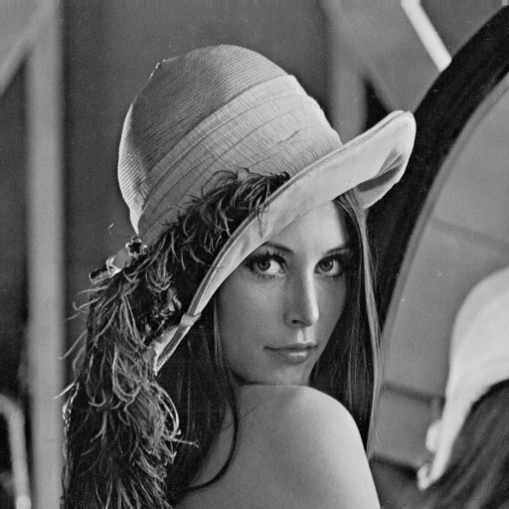
Fig6.1 Original image 256*256 gray scale image ‘Lena’

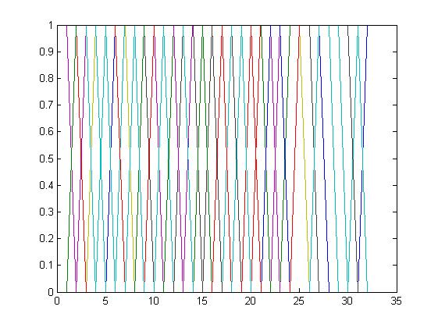 Fig 6.2(a) the above figure shows the original watermark which is embedded in the original image. This is a binary watermark of size 32x32.

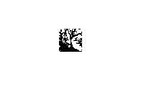
Fig 6.2(b) Above is the image view of the binary watermark used in the original image. Visually recognizable watermarks provide more effective means to perceptually judge the extraction effectively.

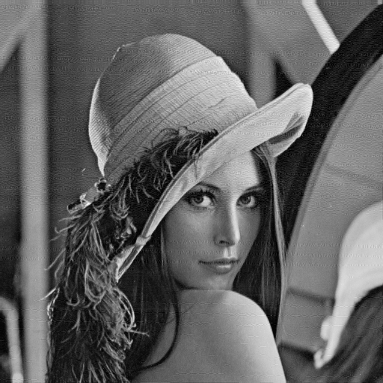
Fig 6.3: watermarked image.

Fig 6.4: Restored image from the watermarked image.

Fig 6.5: Restored watermarked from watermarked image

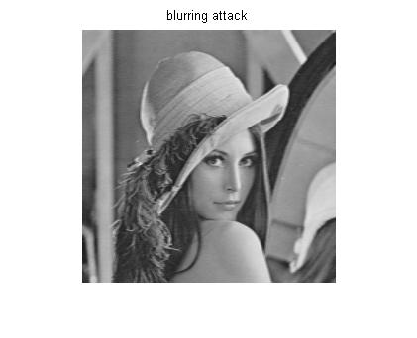
Fig 6.6: blurred watermarked image at step size=4

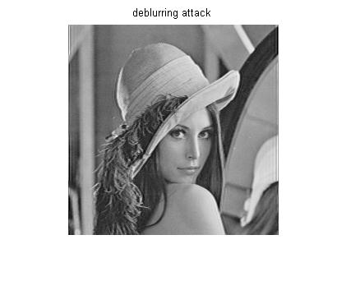

Fig 6.7: The above figure shows the deblurred watermarked image. The deblurring attack is done at step size value of step=4.

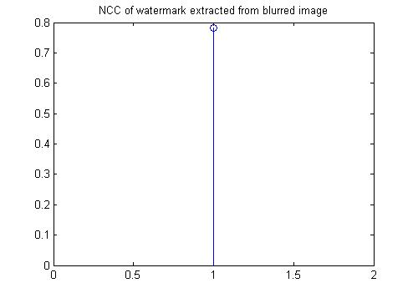

Fig 6.8: The above figure shows the graph of Normalized Cross Correlation in case of blurring attack (extracted from first level.The more the value nearer to 1 the more robust is the watermark. The value is NCC=.7828 at step size of step=15.

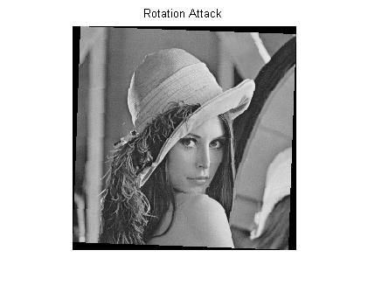
Fig 6.9: The above figure shows the rotated watermarked image by 2 degree in counter clockwise direction .The rotating attack is done at step size of 15
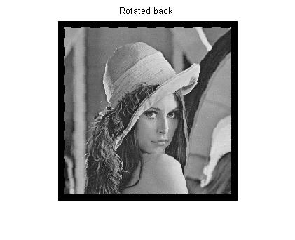

Fig 6.10: The above figure shows the rotated back watermarked image. The rotating attack is done at step size of 15

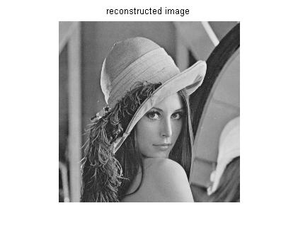
Fig 6.11 watermarked image at step size of 15

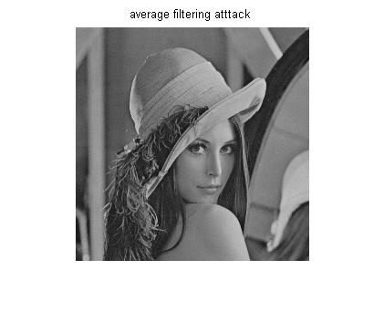
Fig 6.12 average filtered watermarked image at step size 15

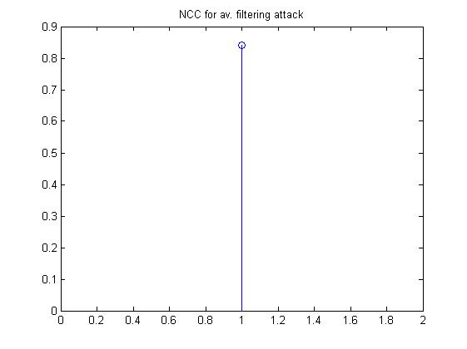

Fig 6.13 The above figure shows the graph of Normalized Cross Correlation in case of av. filtering attack (extracted from first level.The more the value nearer to 1 the more robust is the watermark. The value is NCC=.8418 at step size of step=15.

Fig 6.14 watermarked image at step size 15

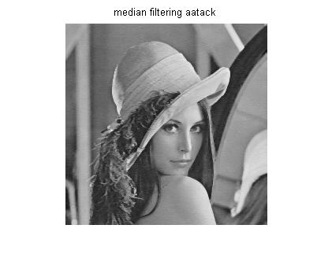
Fig 6.15 median filtered watermarked image at step size 15

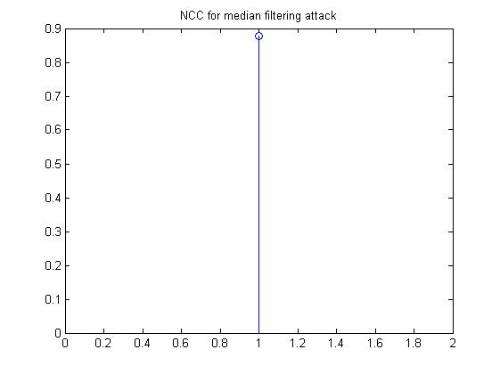
Fig 6.16: The above figure shows the graph of Normalized Cross Correlation in case of median filtering attack (extracted from first level. The more the value nearer to 1 the more robust is the watermark. The value is NCC=.8786 at step size of step=15.

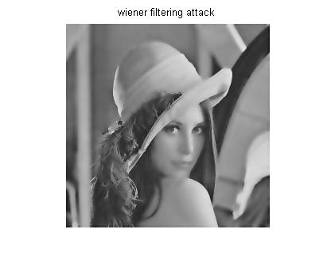
Fig 6.17: wiener attacked watermarked image at step size 15
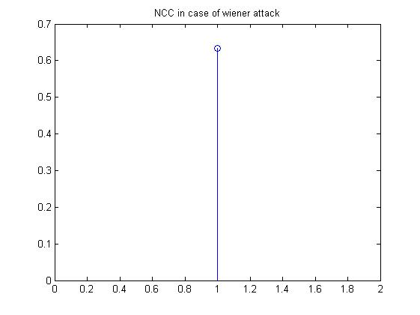
Fig 6.18: The above figure shows the graph of Normalized Cross Correlation in case of wiener filtering attack (extracted from first level. The more the value nearer to 1 the more robust is the watermark. The value is NCC=.6337 at step size of step=15.

[6.1] EFFECT OF INCREASING SCALING FACTOR ON CORRELATION COEFFICIENT CALCULATION FROM DIFFERENT ATTACKS

Step size  Step | Correlation  Coeff.(P1)  In Blurring attack | Correlation  Coeff (P2) in scaling  Attack | Correlation  Coeff (P3) in rotating  Attack | Corr.Coeff (P4)in avg.  Filtering  attack | Correlation  Coeff (P5) in median  Filt.attack | Corr. Coeff(P6)  In wiener  attack
4 | .6050 | .17708 | .6582 | .6028 | .7186 | .6598
15 | .7828 | .29206 | .6784 | .8418 | .8786 | .6337
30 | .8583 | .43938 | .6820 | .9249 | .9101 | .6503
60 | .9152 | .59436 | .6935 | .9857 | .9109 | .6542

Table1. Relation between the increasing value of scaling factor and correlation coefficient
The table shows that as the value of step size is increased the correlation between the original watermark and the extracted watermark from different attacked images increases. In my project I have fixed the value of step size =15. Higher value of step size increases the energy of the watermark. At the step size value above 30 the watermarked picture quality becomes poor and it can be easily determined by anyone that picture has some degraded perceptual quality. I have increased the scaling factor from 4 to 60 at variable interval.

[6.2] EFFECT OF INCREASING VALUE OF ATTACK STRENGTH ON CORRELATION COEFFICIENT AT FIXED VALUE OF SCALING FACTOR:
We have analyzed the effect of increasing scaling factor on the correlation. Here i am giving the value of correlation coefficient at different value of attack strength and fixed value of scaling factor.
[6.2 a] IN BLURRING ATTACK CASE:
In this case I have changed the value of length of filter which creates the PSF. By changing the value of length, the input watermarked images have different effect by passing it through filter. For doing filtering this attack requires a special filter design. So we design special filter in MATLAB with fspecial command.

Length ,theta | Step size | Correlation P1
(3,1) | 15 | .7828
(4,1) | 15 | .6821
(5,1) | 15 | .6577

Table2. Shows that at different value of attack strength the correlation value is decreasing.
In the table the scaling factor is same throughout. So we conclude that high value of attack strength makes watermarking less robust in the case of blurring attack.
[6.2 b] IN SCALING ATTACK CASE:
In this case I have scaled the watermarked image for .5, .25, .125 size of original image. In each case I have calculated the value of correlation coefficient P1 between the original watermark and the watermark extracted from the scaled image.

Scaling factor of image | Step size | Correlation  P2
.5 | 15 | .29206
.125 | 15 | .17041
.25 | 15 | .17381

Table3. Shows that at different value of attack strength the correlation value is decreasing.
In the above table the correlation value is decreasing. It shows that for higher value of scaling of image the similarity decreases between the original and extracted watermark.
[6.2 c] IN ROTATING ATTACK CASE:
In rotating attack case I rotated the image for different value of angle in counter clockwise direction and for each value I have calculated the correlation between the original and extracted watermark from the rotated image.
Angle theta | Scaling factor | Correlation P3
-1 | .3 | .7385
-2 | .3 | .6784
-3 | .3 | .6554

Table4. Shows that at different value of attack strength the correlation value is decreasing.

In this case when we are increasing the value of angle theta in counter clockwise direction and taking the correlation between the extracted and original watermark, the value of correlation P3 is decreasing. So this attack is not feasible for higher attack strength.
[6.2 d] IN AVERAGE FILTERING CASE:
In average filtering we average filter the watermark image by a multidimensional filter. As I have increased the strength of filter the correlation value is determined and shown below in the table.

Filter F_h | Scaling factor | Correlation P4
(1,1)/1.17 | .3 | .8418
(2,2)/5 | .3 | .6457
(3,3)/9 | .3 | .6355

Table5. Shows that at different value of attack strength the correlation value is increasing.
F_h is a multidimensional filter which filters the input image passed through it. The output pixels are average filtered in neighbor hood of the filter coefficient. The correlation value found is decreasing as we are increasing the value of attack strength. So we conclude that the scheme can’t be robust for higher attack strength.
[6.2 e] IN MEDIAN FILTERING CASE:
In median filtering we median filter the watermark image by a two dimensional filter. As I have increased the strength of filter the correlation value is determined and shown below in the table.

Filter of size  M by N | Scaling factor | Correlation P5
(1,3) | .3 | .8786
(2,3) | .3 | .6407
(4,3) | .3 | .6556

Table6. Shows that at different value of attack strength the correlation value is increasing.
M by N is a two dimensional filter which filter the input image passed through it. The output pixel are median filtered in neighbourhood of M by N of the input image value. The correlation value found is increasing as we are increasing the value of attack strength. So we conclude that the scheme can be robust for higher attack strength.

[6.2 f] IN WIENER FILTERING CASE:
In wiener filter we do the adaptive low pass filtering of the watermarked image. The wiener filter attack removes the noise added to the image. In case we do not include noise the Gaussian noise is added. In this case I have changed the filter dimension and extracted the watermark for each case. The correlation value is given in the next table.

Wiener filter of size M by N | Scaling factor | Correlation P6
(3,3) | .3 | .6293
(5,5) | .3 | .6329
(6,6) | .3 | .6337

Table7. Shows that at different value of attack strength the correlation value is increasing.
M by N is a two dimensional wiener filter which adaptively low pass filter the input image passed through it. The correlation value found is increasing as we are increasing the value of attack strength. So we conclude that the scheme can be robust for higher attack strength.
[6.3] COMPERISON RESULT BETWEEN PAYLODE, BIT RATE & PSNR :
The experiment was performed on standard Lena image. Different payloads are used capacity vs. distortion comparisons among our met. Payload size is varied by embedding multiple watermarks in image. Bit rate (bits hidden per pixel) and PSNR values are recorded for each payload and presented in the table.
Payload size (bits) | 8192 | 16384 | 32768 | 65536
Bit rate (bits per pixel) | 0.0532 | 0.1107 | 0.2116 | 0.4167
PSNR (dB) | 36.34 | 33.81 | 29.57 | 26.93

Table 8. Show the comparison result between payload, bit rate and psnr.

CONCLUSION:
In my project work I have implemented an extended difference algorithm for reversible watermarking. It is an extended algorithm of Tian’s reversible watermarking used difference expansion. In case Tian’s algorithm if a pair of pixel is expandable then only we embedded a watermarked bit , otherwise we are not embedding any bit into this pair of pixel. For this reason the payload capacity of this algorithm is decreased and if we want a high capacity payload image then this algorithm not work on that image. This problem is totally avoided in this paper by extending the expandable pixel pair. In this way the algorithm provided a very embedding capacity and keeps the distortion low. Experimental result also show that the performance of the proposed algorithm is much higher compared to Tian’s algorithm. Another advantage of histogram shifting is that it can be applied to any difference expansion based reversible watermarking.
An image authentication scheme based on reversible watermarking using invariant sum values of pixel pairs is presented in this paper. For each pixel pair, if a certain value is added to one pixel while the same value is subtracted from the other pixel, then the sum of these two pixels will remain unchanged. In this case, one watermark bit can be embedded into each pixel pair. Our method can achieve embedding rates of close to a bit per pixel by adopting small thresholds in multiple embedding.

FUTURE WORK:

I have implemented an extended difference expansion algorithm using histogram shifting. This algorithm increased the payload capacity and keeping the distortion low. As the main focus of reversible watermarking is protect sensitive data from un authorised access, there be a lot of scope to improve the algorithm. So one can easily used lots of encryption technique on the image before it embedded into the original image. This steps increase the hiding capacity of the watermark from un wanted access and also improve the algorithm. In the extraction process we used the reverse encryption technique to get the original image. So here one thing is very important is that the encryption technique also reversible, otherwise we lost some important data which is not desirable in this algorithm.

BIBLIOGRAPHY:

[1]- Digital Watermarking and Steganography, Second Edition Ingemar J. Cox, Matthew L. Miller, Jeffrey A. Bloom, Jessica Fridrich, and Ton Kalker
[2]- C. Podilchuk and W. Zeng, “Image-adaptive watermarking using visual models,” IEEE J. Select. Areas Commun., vol. 16, pp. 525-539, May 1998.
[3]- R.B. Wolfgang, C.I. Podilchuk, and E.J. Delp, “Perceptual watermarks for digital images,” Proc. IEEE, no. 7, pp. 1108-1126, July 1999.
[4]- F. Petitcolas, R. Anderson, and M. Kuhn,“Attacks on copyright marking systems,” in Information Hiding (D. Aucsmith, ed.), vol. 1525 of Lecture Notes in Computer Science, (Berlin), pp. 218–238, Springer- Verlag, 1998.
[5]- J. R. Hern´andez, F. P´erez-Gonz´alez, and J. M. Rodr´ıguez, “Coding and synchronization: A boost and a bottleneck for the development of image watermarking,” in Proc. of the COST #254 workshop on Intelligent Communications, (L’Aquila, Italia), pp. 77–82, SSGRR, June 1998.
[6]- A. Herrigel, J. O’Ruanaidh, H. Petersen, S. Pererira, and T. Pun, “Secure copyright protection techniques for digital images,” in Information Hiding (D. Aucsmith, ed.), vol. 1525 of Lecture Notes in Computer Science, (Berlin), pp. 169–190, Springer- Verlag, 1998.
[7]- Digital Watermarking.pdf Michael Stumpfl Dept. of Electronics and Computer Science University of Southampton e-mail: ms601@soton.ac.uk
[8]- C. Podilchuk and W. Zeng, “Image-adaptive watermarking using visual models,” IEEE J. Select. Areas Commun., vol. 16, pp. 525-539, May 1998.
[9]- R.B. Wolfgang, C.I. Podilchuk, and E.J. Delp, “Perceptual watermarks for digital images,” Proc. IEEE, no. 7, pp. 1108-1126, July 1999.
[10]- I.J. Cox, J. Kilian, T. Leighton, and T. Shamoon, “Secure spread spectrum watermarking for multimedia,” NEC Research Institute, Princeton, NJ, Technical Report 95 10, 1995.
[11]- I. Cox, J. Kilian, T. Leighton, and T. Shamoon, “Secure spread spectrum watermarking for multimedia,” IEEE Trans. Image Processing, vol. 6, pp. 1673-1687, Dec. 1997.
[12]- M.D. Swanson, B. Zhu, and A.H. Tewfik, “Transparent robust image watermarking,” in IEEE Proc. Int. Conf. Image Processing, Lausanne, Switzerland, 1996, pp. 211-214.
[13]- R.G. Schyndel, A. Tirkel, and C. Osborne, “A digital watermark,” in Proc.IEEE Int. Conf. Image Processing (ICIP), 1994, pp. 86-90.
[14]- G. Caronni, “Assuring ownership rights for digital images,” in Proc. Reliable IT Systems, VIS ‘95,1995, pp. 251-263.
[15]- W. Bender, D. Gruhl, and N. Morimoto, “Techniques for data hiding,” IBM Syst. J., vol. 35, nos. 3-4, pp. 313-336, 1996.
[16]- K. Tanaka, Y. Nakamura, and K. Matsui, “Embedding secret information into a dithered muti-level image,” in IEEE Proc. Military Communications Conf.’90, 1990, pp. 216-220.
[17]- I. Pitas, “A method for signature casting on digital images,” in IEEE Proc. Int. Conf. Image Processing, Lausanne, Switzerland, Sept. 1996, vol. 3, pp. 215-218.
[18]- R.B. Wolfgang and E.J. Delp, “A watermark for digital images,” in IEEE Proc. Int. Conf. Image Processing, Lausanne, Switzerland, Sept. 1996, vol. 3, pp. 219-222.
[19]- S. Walton, “Information authentication for a slippery new age,” Dr. Dobbs J., vol. 20, no. 4, pp. 18-26, Apr. 1995.
[20]- M. Kutter, F. Jordan, and F. Bossen, “Digital watermarking of color images using amplitude modulation,” J. Electron. Imaging, vol. 7, no. 2, pp. 326-332, Apr. 1998.
[21]- A.B. Watson, G.Y. Yang, J.A. Solomon, and J. Villasenor, “Visibility of wavelet quantization noise,” IEEE Trans. Image Processing, vol. 6, pp. 1164-1175, Aug. 1997.
[22]- A.B. Watson, G.Y. Yang, J.A. Solomon, and J. Villasenor, “Visibility of wavelet quantization noise,” IEEE Trans. Image Processing, vol. 6, pp. 1164-1175, Aug. 1997.
Finish of journal
[23]-W.sweldens The lifting scheme: A custom-design of bi-orthogonal wavelets. Applied Computational and Harmonic Analysis, 3(2):186-200, 1996.
[24]- I. Daubechies, W. Sweldens , Factoring wavelet transforms into lifting steps J.Fourier Analysis and Applications 4(3), 247-269,1998
[25]- A.R. calderbank, I .Daubechies,W.Sweldens and B.L.Yeo. Wavelet Transforms That Map Integers to Integers. Applied computational and Harmonic Analysis, 5(3), 332-369,1998
[26]- Security, Steganography, and Watermarking of Multimedia Contents VII, SPIE Vol. 5681,San Jose, CA, Jan. 2005. Unitary Embedding for Data Hiding with the SVD Clifford Bergman and Jennifer Davidson
[27]- G. Golub and C. F. Van Loan, Matrix Computations, Johns Hopkins University Press, Baltimore, MD, 1983.
[28]- Robust DCT-SVD Domain Image Watermarking for Copyright Protection: embedding data in all frequencies Alexander Sverdlov, Scott Dexter, Ahmet M. Eskicioglu
[29]- R. Liu and T. Tan, “A SVD-Based Watermarking Scheme for Protecting Rightful Ownership,” IEEE Transactions on Multimedia, 4(1), March 2002, pp.121-128.
[30]- D. Kahaner, C. Moler and S. Nash, Numerical Methods and Software (New Jersey: Prentice-Hall, Inc, 1989).
[31]- Ching-Yu Yang*, Wei-Ying Hwang, and Ya-Fen Cheng ‘IWT-based Watermarking By Adaptive Bit-labeling Scheme’ International Conference on Intelligent Information Hiding and Multimedia Signal Processing.
[32]- Liu Xin1,2, Lv Xiaoqi, Wang Ying. “A Semi-fragile Digital Watermarking Algorithm Based on Integer Wavelet Matrix Norm Quantization For Medical Images” IEEE journal on image processing.
[33]- Zhong Wang, Xiong-fei Ye, Nian Xiao, ‘Robust Watermarking Based on Norm Quantization Singular Value Decomposition and Zernike Moments’ 2008 IEEE Pacific-Asia Workshop on Computational Intelligence and Industrial Application .
[34] J.M. Barton, Method and apparatus for embedding authentication information within data, U.S. Patent 5646997, 1997.

[35] C.W. Honsinger, P.W. Jones, M. Rabbani, J.C. Stoffel, Lossless recovery of an original image containing embedded data, U.S. Patent 6278791, 2001.

[36] B. Macq, Lossless multiresolution transform for image authenticating watermark, in: Proceedings of the EUSIPCO, Tampere, Finland,September 2000, pp. 533–536.

[37] C. De Vleeschouwer, J.F. Delaigle, B. Macq, Circular interpretation of bijective transformations in lossless watermarking for media asset management, IEEE Trans. Multimedia 5 (Mar.) (2003) 97–105.

[38] J. Fridrich, M. Goljan, R. Du, Lossless data embedding – new paradigm in digital watermarking, EURASIP J. Appl. Signal Process.2002 (2) (2002) 185–196.

[39] J. Fridrich, M. Goljan, R. Du, Lossless data embedding for all image formats, in: Proceedings of the SPIE Photonics West, Electronic Imaging, Security and Watermarking of Multimedia Contents, vol.4675, San Jose, CA, January 2002, pp. 572–583.

[40] M.U. Celik, G. Sharma, A.M. Tekalp, E. Saber, Reversible data hiding, in: Proceedings of the IEEE International Conference Image Processing, vol. II, September, 2002, pp. 157–160.

[41] J. Tian, Reversible data embedding using a difference expansion,IEEE Trans. Circ. Syst. Video Technol. 13 (8) (2003)890–896.

[42] A.M. Alattar, Reversible watermark using the difference expansion of a generalized integer transform, IEEE Trans. Image Process. 13 (8)(2004) 1147–1156.

[43] M. Voigt, B. Yang, C. Busch, Reversible watermarking of 2D-vector data, in: Proceedings of the 2004 Multimedia and Security Workshop on Multimedia and Security, Magdeburg, Germany, 2004, pp. 160–165.

[44] X.-M. Niu, C.-Y. Shao, X.-T. Wang, A survey of digital vector map watermarking, Int. J. Innovative Comput. Inform. Control 2 (6)(2006) 1301–1316.

