COMPANY PROFILE

Introduction to ST-Ericsson



ST-Ericsson is 50/50 joint venture uniting the wireless semiconductor division of STMicroelectronics (ST-NXP Wireless) and the mobile platform division of Ericsson (Ericsson Mobile Platforms) two of the world’s leading wireless semiconductor and platform companies, both with strong industry heritage.

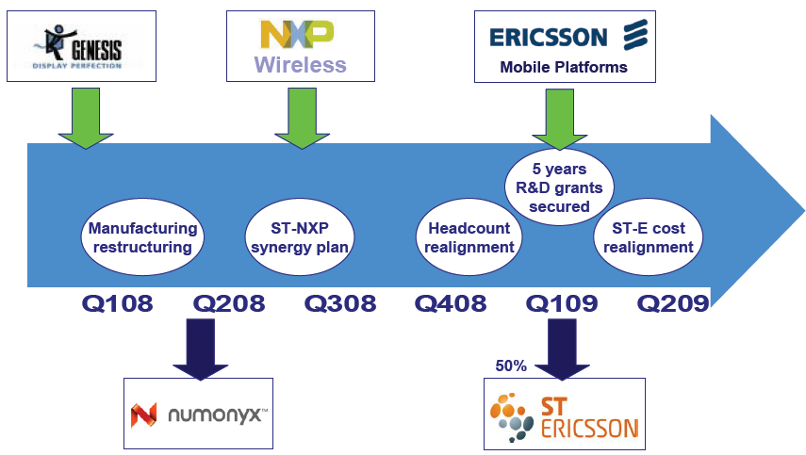

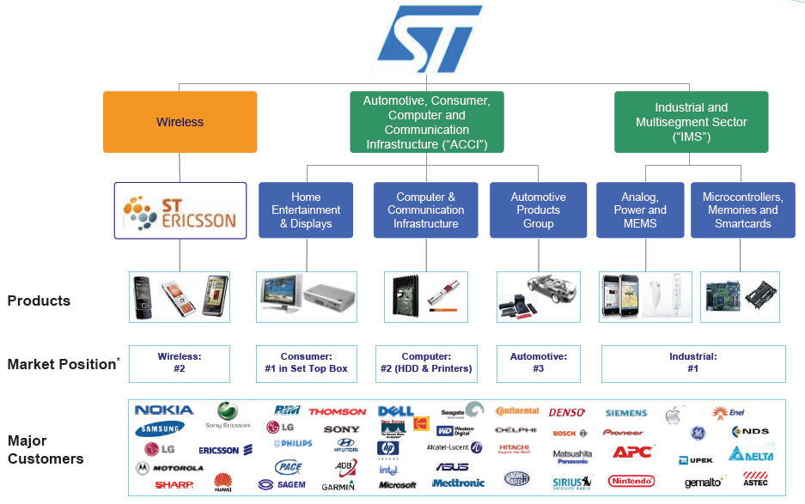

ST-Ericsson – A World leader in wireless platforms and Semiconductors

Pre-merger, the businesses individually generated combined pro-forma revenues of about US$3.6bn in 2008, placing ST-Ericsson among the top players in wireless semiconductors.
Incorporated in Switzerland and headquartered in Geneva, the Company employs approximately 8,000 people worldwide, more than 85 percent of whom are in R&D.
ST-Ericsson is a fabless company, with wafer processing performed by an appropriate combination of the front-end facilities of STMicroelectronics, as well as by external foundries.
ST-Ericsson has full access to world-class assembly and test manufacturing facilities located at Calamba (Philippines) and Muar (Malaysia), operated by STMicroelectronics.
ST-Ericsson operations are spread around the world, with main centers in China, Finland, France, Germany, India, Japan, Korea, Netherlands, Norway, Singapore, Sweden, Türkiye (Turkey), the UK, the USA.

Technology and innovation leader

ST-Ericsson is innovation-focused, with the vast majority of its employees working in research and development. The company is backed by the strongest Intellectual Property Rights (IPR) portfolio in the wireless industry through its parent companies – Ericsson and STMicroelectronics.

Reliable and trusted partner

Collaboration is in the DNA of ST-Ericsson. The company has long-standing relationships with global mobile phone manufacturers, spanning more than 15 years. As an experienced partner, ST-Ericsson provides reliable support at every stage of product development. More than 4 billion phones have been built using ST-Ericsson’s products and technologies, and more than 1 billion phones have been built on the company’s complete platform solutions.

Complete solution provider
In a business where scale matters, the complete product portfolio across the broad range of wireless technologies delivers significant synergies for customers. ST-Ericsson is unique in its ability to deliver state-of-the-art platforms, integrating mobile multimedia and connectivity for GSM, EDGE, WCDMA, HSPA, as well as TD-SCDMA and LTE.
Platform Portfolio
In ST-Ericsson’s complete platform portfolio we will find 2G, EDGE, 3G, HSPA, HSPA+, TD-SCDMA, and LTE technologies. With their long experience and proven track record company ensure robust and future-proof solutions.
- SmartPhones
Building the best device which customer can put in their pocket. STEricsson’s Smartphone platforms are the starting point for advanced open software platform solutions.

Greater choice for the Smartphone market

Smartphones powered by ST-Ericsson solutions can address the varied needs of the market thanks to a complete portfolio of dedicated platforms. From a best-in-class smartphone experience to devices enabling internet for the masses, ST-Ericsson’s platforms offer leading technologies to device manufacturers.

All-in-one platforms from a single supplier

ST-Ericsson’s platforms integrate all the capabilities needed for a complete smartphone solution. With integrated application processor, multimedia and graphics subsystems, broadband modems and Open OS software, customers are able to reduce their development cost and time-to-market.

- Feature Phones
Devices the customers want to use everyday.
Feature phone platforms combining state-of-the-art multimedia capabilities with great connectivity in a small form factor. ST-Ericsson feature phone platforms enable superior multimedia experiences: high resolution video and cameras, 3D audio, stunning user interfaces and rich gaming experiences, as well as content creation, sharing and distribution. Our proven solutions are optimized to handle power-hungry multimedia applications, resulting in extended battery life.

Company’s solutions and support: Customers Success

Our solutions, our end-to-end approach to testing and qualification and our dedicated support teams give you all the tools you need to give your project the best possible chance of success.

Entry Phones
Opening new market areas is demanding. STEricsson’s entry platforms allow us to build highly competitive solutions from GSM phones to entry-level 3G devices. STEricsson’s highly-integrated, cost-optimized solutions allow us to build mobile devices from ultra-low cost GSM phones to entry-level 3G phones. They offer the highest integration in a single chip with best-in-class power consumption for cost-driven solutions.

Connected Devices
STEricsson’s connected devices platforms provide the best combined up-link and down-link for a true mobile broadband experience. Wireless modems in laptops and other devices give users Internet access at speeds in many cases surpassing those of fixed broadband. This opens up completely new opportunities for operators and manufacturers, as well as content and technology providers everywhere.

Product Portfolio
The exceptional products that make up their platforms can also make excellent additions and enhancements to our existing platforms and solutions.
Whether we need additional connectivity such as WLAN, a multimedia enhancement such as TV-out or a USB headset, additional power management features or enhanced RF performance, the company can offer a full range of suitable components.
Audio and Video Peripherals

STEricsson is a worldwide leader in high performance audio solutions and audio accessory solutions, providing a wide portfolio of digital, analog and mixed-signal integrated circuits.

Board of directors
Carl-Henric Svanberg, Chairman of the Board
Carlo Bozotti, Vice Chairman of the Board
Chapter 1
INTRODUCTION

  - Introduction

1.1.1 Embedded Software Development
An embedded system is a computer system designed to perform one or a few dedicated functions often with real-time computing constraints. It is embedded as part of a complete device often including hardware and mechanical parts. By contrast, a general-purpose computer, such as a PC, is designed to be flexible and to meet a wide range of end-user needs. Embedded systems control many devices in common use today.
Embedded systems are controlled by one or more main processing cores that are typically either microcontrollers or digital signal processors (DSP). The key characteristic, however, is being dedicated to handle a particular task, which may require very powerful processors. For example, air traffic control systems may usefully be viewed as embedded, even though they involve mainframe computers and dedicated regional and national networks between airports and radar sites.
Physically, embedded systems range from portable devices such as digital watches and MP3 players, to large stationary installations like traffic lights, factory controllers, or the systems controlling nuclear power plants. Complexity varies from low, with a single microcontroller chip, to very high with multiple units, peripherals and networks mounted inside a large chassis or enclosure.
1.1.2 Characteristics
- Embedded systems are designed to do some specific task, rather than be a general-purpose computer for multiple tasks.
- Embedded systems are not always standalone devices. Many embedded systems consist of small, computerized parts within a larger device that serves a more general purpose. For example, the Gibson Robot Guitar features an embedded system for tuning the strings, but the overall purpose of the Robot Guitar is, of course, to play music. Similarly, an embedded system in an automobile provides a specific function as a subsystem of the car itself.
- The program instructions written for embedded systems are referred to as firmware, and are stored in read-only memory or Flash memory chips. They run with limited computer hardware resources: little memory, small or non-existent keyboard and/or screen.
1.1.3 Applications

- Electronics Applications & Consumer Devices: Smartphone, web-enabled navigation systems, radios etc.
- Industrial automation and process control software
- Military and aerospace embedded software app: For ex. Automated Flight Information Reporting System
- Medical Electronics Technology

1.2 Organization of Dissertation

This report will begin with a quick introduction on company profile of ST-Ericsson. It will show various divisions of STMicroelectronics, its market position and customers.
Chapter 1 gives the introduction about the embedded software development; its few characteristics and applications.
Chapter 2 is concerned about the transaction level modeling with systemC. It explains about transaction and its application in embedded software development and architecture exploration. The last part of the Chapter 2 gives an overview of system C language.
Chapter 3 describes about SOC virtual platform and its benefits in embedded software development.
Chapter 4 gives overview on symbian OS.
Chapter 5 shows the running layout of this project with describing each and every Mat Lab generated figures and corresponding watermark detector response. It describes how to insert and regain watermark using DCT technique in both Color and Gray watermarking. Lastly it shows that watermarked image attacked by various types & corresponding watermark detector response.
Chapter 6 show some EIP use cases.
Chapter 7 describes the complete design of communication application.
Chapter 8 describes the complete design of command interpreter.
Chapter 9 describes the test environment for both applications.
Chapter 10 this chapter shows EIP tests and results.
Chapter 11 this chapter describes how EIP framework is integrated in symbian image and last part show the changes made for booting up the image on SVP.
Chapter 12 discusses about the conclusion and future directions in this project.
Chapter 13 shows the references which is used for making this report.

Chapter 2
TRANSACTION LEVEL MODELLING WITH SYSTEM C

System architects working on SoC design have traditionally been hampered by the lack of a cohesive methodology for architecture evaluation and co-verification of hardware and software. These activities are crucial and must be addressed at an early stage to prevent costly redesign effort later in the design cycle which can adversely affect time-to-market. SystemC 2.0 facilitates the development of Transaction Level Models (TLMs) which are models of the hardware system components at a high level of abstraction. System architects can quickly develop these models and be ready with an executable specification of the hardware blocks as soon as the initial functional specifications of the system are decided. The high speed of simulation of these TLMs allows early development and verification of hardware dependent application software Timing details can be incorporated into these models to allow performance estimation and architecture exploration. The modular nature of SystemC also promotes reuse of developed components from one system to another. This chapter elaborates on the concepts mentioned above and introduces an example SoC TLM platform.

Transaction-level modeling (TLM) is modeling at high level of abstraction. In order to handle the increasing complexity in the design of system-on-chips (SoCs), the design abstraction has been raised to the system level to increase productivity. System level design enables making design decisions at higher levels of abstraction and reusing design components.
It is a high-level approach to model digital systems, where details of communication among computation components are separated from the details of the implementation of computation components. Communication is modeled as channels and transaction requests take place by calling interface functions of these channel models. Unnecessary details of communication and computation are hidden in the TLM and may be worked out later. This approach makes it easier for the system-level designer to experiment, for example, with different bus architectures (all supporting a common abstract interface) without having to recode models that interact with any of the buses, provided these models interact with the bus though the common interface.
It enables speeding up simulation time, exploring and validating implementation alternatives at the higher level of abstraction.
Objectives of TLM
- Enable hardware-dependent software development before physical prototypes and boards are available i.e. hardware and software co-development
- Architectural analysis
- Verification
In simple terms, TLM platforms are efficient software solutions to simulate all required SoC hardware behaviors. Such hardware platforms enable software developers to execute and debug the final embedded code easily on their own workstation without tedious specific adaptations, expensive tools or complex external hardware setup.

  - Introduction

A system-on-a-chip comprises of many components such as processors, timers, interrupts controller, busses, and memories and embedded software. It is a complete system, which would have been assembled on a board a few years back, but can now be fit, entirely in a single circuit because of advances in semiconductor technology. The traditional RTL to layout design and verification flow proves inadequate for these multimillion gate systems which have the added complexity of embedded software running on them to cope with. At STMicroelectronics, we are moving towards extending this flow by concentrating our design and verification efforts before the RTL to layout flow comes into the picture. We call this the System-to-RTL flow. Systems can be modeled at various levels of abstraction. In this chapter, the micro architecture level of abstraction refers to a cycle accurate models that include complete pin and signal descriptions that verify cycle and system behavior at a very low level. The architecture level of abstraction is less detailed but these models are still implementation dependent. It is useful for software developers who can use the instruction set of the processor that is made available at this abstraction to run and debug their code. Finally there is the functional level of abstraction, which captures the functional behavior of the system, without much concern for implementation details. These models are generally architecture independent. Our extended flow for system-on-a-chip introduces the concept of Transaction Level Modeling. These models are not as detailed, no rare they concerned with the micro-architecture like the RTL models. Rather, they correspond to the architecture level of abstraction. This is a natural extension of the high-level design process since SoC designs are actually conceived at the transaction level. System architects do not start out thinking about relationships between pins and address busses. Rather they start out by mapping out data flow details - the type of data that flows and where it is stored.

2.2 What is Transaction?

In the SoC world, the term transaction has several meanings. In our context, the term refers to the exchange of a data or an event between two components of a modeled and simulated system. Here we are not interested in the protocol that realizes this exchange, as we are not verifying the micro-architecture. A data transaction can be a single word, a series of words or a complex data structure that is transferred over a bus between system components. For example, a DMA master can request to read data from a memory. To do so, it issues a read transaction specifying the address in the memory to read data from. Another case could be a write transaction issued by the embedded software when it wants to write to the registers of the DMA controller. An event transaction models synchronization aspects that ensure correct operation of the SoC model. Interrupts between components can be considered to be an example of an event transaction

2.3 TLMs for Embedded Software Development

One of the major areas of interest for Transaction Level Modeling is embedded software (eSW). Since most SoCs contain at least one programmable processor, software is an essential part of a SoC. TLM models ease the development of eSW by enabling high-speed simulation of quickly developed models early in the SoC development lifecycle. The speeds required for this purpose vary around 1/1000th to 1/100th of real simulation time of the final product. This means a simulation speed of at least 100k bus transactions per second, which is possible with TLM models but not with the detailed RTL models which tend to be naturally much slower. These TLM models can be built as soon as the architectural specification is available, and even before the time consuming RTL code development commences. This means that eSW development, which is a very lengthy activity, takes place in parallel with the RTL development and not after it. Tasks closely related to the hardware implementation such as low level software development will still have to wait for the RTL model to be completed, but there is still a considerable saving of time which can cut off several valuable months from the development cycle. For instance, the MPEG4 IVT team in STMicroelectronics used TLM models for eSW development 6 months before the top-level netlist was made available.

2.4 TLMs For Architecture Exploration

Untimed TLM models, which include the correct ordering of events with no notions of physical time or duration, provide the first level of analysis which is useful for eSW developers. System architects are more interested in timed TLM models, which they can utilize for architecture exploration. One can argue that cycle accurate models in RTL provide a more precise basis for analysis. But this is only partially true. These cycle accurate models require many times the effort that goes into the development of TLM models. The detailed models are also much more difficult to change than TLM models when, for example, HW/SW tradeoffs are being explored. Using TLM models for the purpose of architecture exploration is still being studied. Precision issues essential to issue modeling guidelines for developers of high level TLM models targeted at architecture exploration need to be further understood before being accepted by system architects. In an experiment done by the System Architecture group (CR&D) STMicroelectronics , a complex dual processor SoC platform at the TLM and RTL levels was compared and it was found that the TLM model had less than a 15% error margin for most figures (such as interrupt latencies and bus utilization) against transactions observed in RTL SoC simulation. This is an encouraging result that is already being used as the basis for new and additional comparisons using other SoC models. The aim is to gain the confidence of RTL architects and designers by showing that decisions made at the timed TLM level are also valid at the cycle accurate reference RTL platform level.

2.5 SOC Lifecycle and Consistency Issues

According to the approach outlined above, the SoC lifecycle will require at least three models - one for each of the three levels of abstraction. Since the functionality of the SoC is independent of the architecture, its functional model can be started at an early stage of product specification s, once the SoC architecture specification is made available, work on RTL code development and the SoC TLM model starts. The TLM model is built quickly with a much shorter development time than the detailed RTL model. This means that eSW development and architectural exploration can begin almost as soon as the first architecture specification is released. While the software and architecture teams are working on the SoC TLM model, the RTL development takes place culminating in a SoC RTL platform. At this stage, hardware implementation dependent tasks like low level software development and validation can begin. These tasks are conducted concurrently with the synthesis and back end implementation using the standard ASIC design flow. By the time the first hardware emulator board is available, the eSW has been developed and validated thoroughly so that chances of first time silicon success are high. One problem that would have to be addressed in this flow is that of maintaining consistency between the three views of the same system - functional, architectural and micro-architectural. This issue can be addressed by reusing the same system test vectors across all views, therefore ensuring conformance to expected functionality.

2.6 SystemC 2.0

We have used SystemC 2.0 for our Transaction Level Modeling effort. SystemC is a C++ library aimed specifically at system level modeling. It has all the benefits that C++ possesses - it is an object oriented design language that makes full use of data encapsulation and generic programming concepts. SystemC 2.0 defines primary channels for communicating transactions but leaves it to the user to define higher-level SystemC channels suited to their design needs.

Chapter 3
SOC VIRTUAL PLATFORM

3.1 Introduction

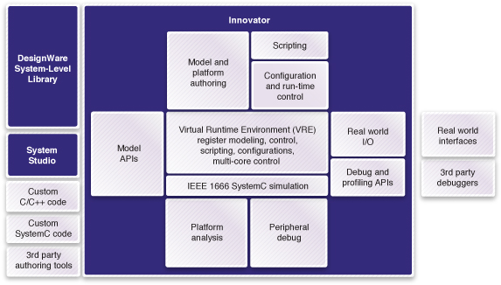
Fig : 3.1
Virtual platforms are fully-functional, transaction-level software representations of a hardware design, including single- or multicore SoCs, peripheral devices, I/O, board components and user interfaces. Virtual platforms run on a general-purpose PC or workstation and are detailed enough to execute unmodified production code, including drivers, the OS and applications at close-to-real-time speed.
Virtual platforms provide software engineers with high-speed, pre-silicon software execution environments that allow the development of SoC-related software before hardware is available. These models are available up to 9 to 12 months prior to the hardware they simulate. Virtual platforms allow concurrent development of hardware and software, and significantly shorten the hardware/software integration-key advantages for system suppliers and developers to accelerate their products to market.
OSCI’s SystemC TLM-2.0 APIs have recently become the interoperable infrastructure for virtual platforms. Innovator comes with full IEEE 1666 SystemC support and is capable of importing and executing arbitrary SystemC models including TLM-2.0 compliant models.

Synopsys Innovator is a SystemC-based integrated development environment (IDE) for virtual platform developers to efficiently integrate, analyze and verify transaction-level models. In addition to re-use of existing IEEE 1666 SystemC models with arbitrary interfaces, Innovator enables the authoring of Open SystemC Initiative’s (OSCI) SystemC TLM-2.0 compatible models.

Once a virtual platform is assembled and verified with Innovator, it can be delivered to programmers as a standalone, run-time executable, seamlessly fitting into software developers’ work flows. Innovator provides open interfaces for software debuggers and software development tool chains. In combination with the Synopsys DesignWare® System-Level Library of standards-based transaction-level models (TLMs), Synopsys Innovator significantly increases the productivity for creating, assembling and deploying virtual platforms. Innovator supports SystemC loosely timed (LT) modeling for pre-silicon software development and SystemC approximately timed (AT) modeling for architecture analysis as well as links to RTL verification.

Synopsys provides a complete solution of models, tools and services for developing and running virtual platforms. The key components are:

- DesignWare System-Level Library: A collection of transaction-level models (TLMs) written in SystemC (IEEE 1666) used as the building blocks for virtual platforms
- Innovator: A powerful, fully integrated tool for developing, running and debugging virtual platforms
- Services: A comprehensive set of consulting and design services for helping customers build and use virtual platforms.

MARKET SEGMENT(S)
- Embedded
- Home
- Mobile
- Emerging Applications
TARGET PLATFORM(S)
- Linux
- Other OS
- Symbian
- Windows Embedded CE
ARM PROCESSOR(S)
- ARM7TDMI
- ARM920T
- ARM926EJ-S
- ARM946E-S
- ARM1136JF-S
- ARM1176JZ(F)-S
- Cortex-A8
- XScale
SYSTEM IP
- AMBA
- Level 2 Cache Controller
- Primecell Peripherals
EMBEDDED SOFTWARE
- TrustZone™ Technology
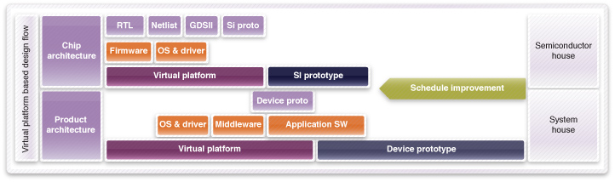
The Early Route To Pre-Silicon Software Development
Fig : 3.2

Virtual platforms are software models of complete systems that provide software engineers with high-speed, pre-silicon development environments months before hardware is available. Virtual platforms enable concurrent development of SoC hardware and software, significantly shortening embedded system suppliers’ hardware/software integration time and accelerating their products to market. Because they are based on software models, virtual platforms offer unmatched effectiveness for developing and debugging multi-core designs. Synopsys provides a complete solution of models, tools and services for developing and running virtual platforms.

3.2 Key Benefits of SVP

Virtual platform technology enables the creation of software models that can fully represent the functionality of an embedded system. They combine high-speed processor instruction-set simulators and abstract, transaction-level models (TLM) of the hardware building blocks to create a high-performance software development environment. This promotes continuous, pre-silicon hardware/software integration, instead of waiting to bring hardware and software together near the end of the silicon development.
Virtual platforms improve software development productivity by allowing unlimited observability and controllability of the target hardware, and through predictable and repeatable execution of debug scenarios. Virtual platforms allow developers to boot operating systems, create applications and multimedia codecs and develop low-level drivers.
Virtual platforms enable concurrent development of SoC hardware and software, significantly shortening embedded system suppliers’ hardware/software integration time and accelerating their products to market.
It eradicates the need of having a board for every developer to develop software. A developer can even debug the code using MODEL DEBUGGER which has everything that one needs for debugging like breakpoints, step-up etc. You can run your test cases. You can log the result of test cases for future references. SVP is even connected to the RATIONAL CLEAR CASE, a version controlled management system used in STEricsson, making it even more beneficial to use. The benefit of having connected to Clear Case is that you need not to worry about copying file to your log in because now you can have them from Clear Case only. This saves the whole time of copying files to your log in. Moreover, you can even open the file which is a private file. You just need to create a view in LINUX and then edit the configuration spec accordingly. Now you can see the same view through Windows and modify the private file. After saving the changes, you can see that modified file in LINUX.
3.3 Before Virtual Platform
What if we have nothing like Virtual Platform? I have already explained the usefulness of Virtual Platforms. They help us in to be ready with the software much before we get the actual hardware on which we need to develop our software. Before the concept of Virtual platforms came, we used to first develop the hardware and then we used to develop the software and after that the integration part of the software/hardware comes.
So that means, we need to wait for the hardware first to complete and then we develop the software on that hardware. After developing both, we integrate them. Thus, taking a lot of time of developers and integrators. Moreover, to develop software every developer needs a hardware which accounts for many boards which is not a good thing economically.

Chapter 4
SYMBIAN OS OVERVIEW

Symbian is an operating system (OS) designed for mobile devices and smart phones, with associated libraries, user interface, frameworks and reference implementations of common tools, originally developed by Symbian Ltd. Symbian OS runs exclusively on ARM processors and has evolved from Psion's EPOC which was developed as a rudimentary operating system for early electronic organizers. The Psion EPOC OS was referred to EPOC16 beginning in the late 1990's to help distinguish it from the newer 32bit Operating system EPOC32, which eventually became Symbian OS.
Symbian OS was created with three systems design principles:
- the integrity and security of user data is paramount,
- user time must not be wasted, and
- all resources are scarce.
4.1 Structure
The Symbian System Model contains the following layers, from top to bottom:
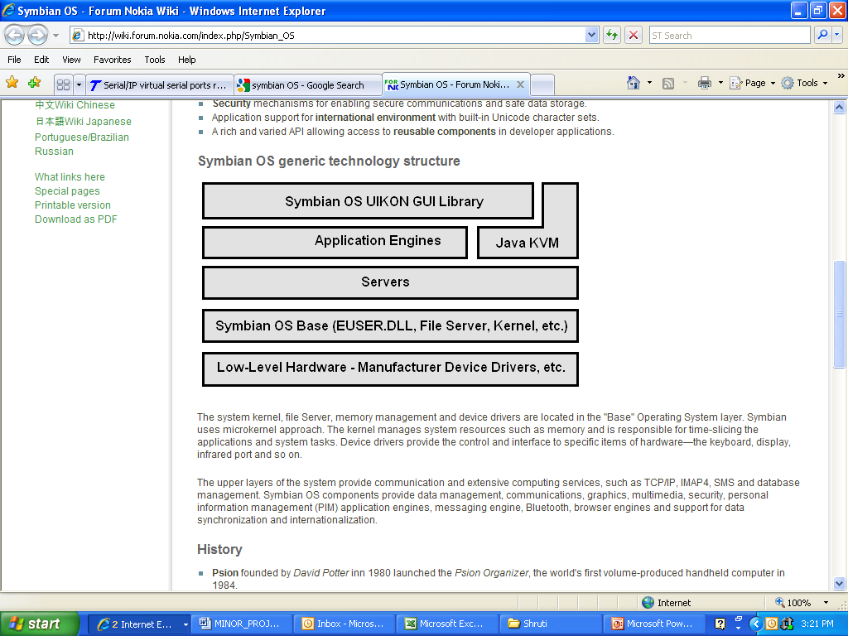
Fig : 4.1
- UI Framework Layer
- Application Services Layer
  - Java ME
- OS Services Layer
  - generic OS services
  - communications services
  - multimedia and graphics services
  - connectivity services
- Base Services Layer
- Kernel Services & Hardware Interface Layer
Symbian has a microkernel architecture, which means that the minimum necessary is within the kernel to maximize robustness, availability and responsiveness. It contains a scheduler, memory management and device drivers, but other services like networking, telephony and file system support are placed in the OS Services Layer or the Base Services Layer. The inclusion of device drivers means the kernel is not a true microkernel. The EKA2 real-time kernel, which has been termed a nanokernel, contains only the most basic primitives and requires an extended kernel to implement any other abstractions.
There is also a large volume of user interface (UI) Code. Only the base classes and substructure were contained in Symbian OS, while most of the actual user interfaces were maintained by third parties. The three major UIs - S60, UIQ and MOAP - were contributed to Symbian in 2009.
4.2 Why Use ARM With Symbian?
ARM has been at the heart of Symbian since 1994, building a close partnership resulting in all Symbian OS Smartphone being built with ARM technology. As an ARM partner, Symbian is featured in the ARM Connected Community.
- ARM and Symbian collaborate to provide Symbian OS with early access to new ARM platforms including ARM1176, ARM Cortex-A8 and ARM11 MPCore.
- Symbian OS is created using RealView® technology
- Performance – Symbian OS is designed to make minimal demands on batteries and to have low memory.

- Multitasking – telephony and universal messaging are fundamental components. All applications are designed to work seamlessly in parallel.
4.3 Key Design Features
- Standards – the use of technologies based on agreed-upon standards is a basic principle of Symbian OS, ensuring that applications are robust, portable, and interoperable
- Object-oriented software architecture.
- Memory management optimized for embedded software environment.
- Runtime memory requirements are minimized – very small executable sizes and ROM-based code that executes in place.
- Security mechanisms for enabling secure communications and safe data storage.
- Application support for international environment with built-in Unicode character sets.
A rich and varied API allowing access to reusable components in developer applications.

Chapter 5
PRILIMINARIES & PROPOSED APPROACH FOR EARLY INTEGRATION PLATFORM

  - Problem Statement
On SVP, Integration testing is not possible where IPs have physical interfaces. Thus, EIP is proposed which uses both SVP and Board together to fulfill the requirement.

5.2 Architecture
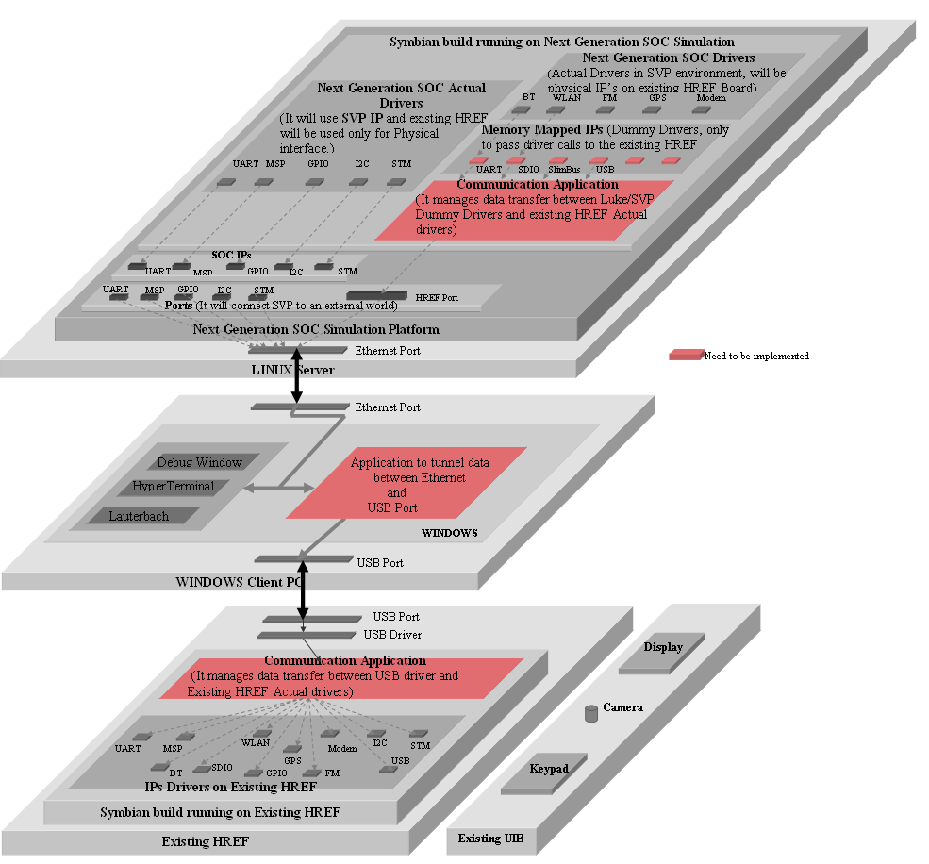

Fig : 5.1

  - Preliminary Design
5.3.1 Static Organization
EIP is an integrated platform of Next Generation Virtual SOC and existing HRef Board used for integration Testing. The Symbian BSP will run on both (SVP and HRef) the platforms. A client PC will act as a background communication channel between SVP and HRef Board. All communication is first between SVP and Client PC through Ethernet protocol and then using USB from PC to HRef and vice-versa.
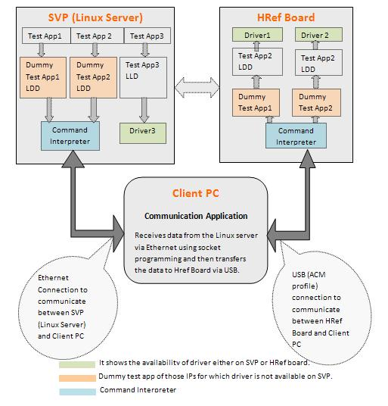
Fig. 5.2: Block Diagram to Information Flow in Integrated Platform

5.3.2 Command Interpreter
This application is OS specific (in current environment Symbian) will run on SVP and as well as on HRef board.
The APIs received from the dummy layer specific to each driver will send command to the common layer where packet is formed having information like command, number of arguments, argument list, data and sends to the UART0 of the SVP. Also, receives packet from the USB port at HRef and decode the packet to get the command and then sends to the lower layer to process the command.
The more detail of this application is available in the design document of command Interpreter.

5.3.3 Communication Application
This application will on Client PC and independent of OS running on SVP or on HRef Board. The application will receives the packet from SVP (via Ethernet) using sockets and sends them to the USB port of PC using USB ACM profile.

5.4 Dynamic Organization

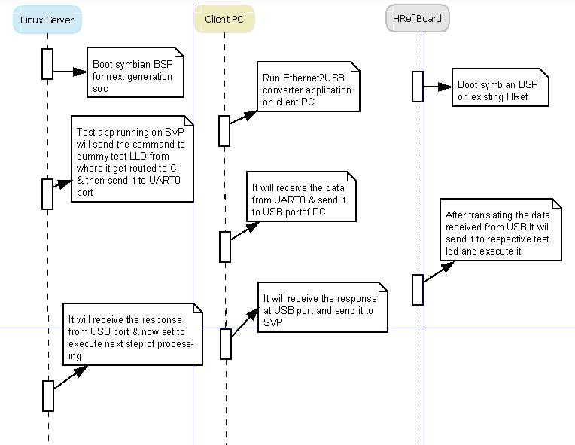
Fig : 5.3

5.4 Prerequisite
- Symbian BSP for Next Generation SVP and for Existing HRef should be available.
- The Symbian BSP for SVP should have to UART driver and UART port is available in SVP.
- The Symbian BSP of HRef should have a support of USB ACM profile.

5.5 Design Constraints
- Intermediate Client PC is required for communication as no Ethernet port is available on HRef boards.
- Only single UART interface is available on HRef board which is used as user interface for Symbian BSP. Hence, NO UART interface is available and the communication from Client PC to HRef using RS-232 is ruled out.
- SVP only exposing virtual ports of UART (USB and Ethernet IP not available in SVP). Hence all the communication from SVP is routed through UART port only.
- For some use cases UART’s low bandwidth may create problem and these use cases would be inapplicable in these cases unless an alternative higher bandwidth port is available on SVP.

5.6 Future Enhancement
- Process Synchronization mechanism Need to develop for better performance. For example if, two commands (API) are mutually exclusive then the second one can run while first one is waiting for response.
- Queue management is required to manage multiple commands.
- Handshaking to ensure the reliable communication of commands.

5.7 Use Case
- An MMC test application can be taken as a use case for the Integrated Architecture validation.
- This MMC test application will copy a file (.jpeg or .mp3) from RAM memory of SVP to the real MMC card on HRef board with different buffer size. We use the latest BSP running on next-generation SVP where we include the file (.jpeg or .mp3) on RAM of SVP.
- Now the file available on RAM of SVP can be transferred to uart0 port of
SVP with a test application running on it.
- On client PC, ETHERNET-to-UART application will be running.
- USB ACM profile on board will be used to connect HRef Board to Client PC. By this USB profile, USB will be recognized as a Virtual UART port on our client PC.
- Our Ethernet-to-UART application directly will send the file to the Virtual UART of our client pc and hence to the board with highest baud rate available.
- On Board data received by USB ACM profile will be collected as a file and stored and forwarded to the MMC card.

Chapter-6
EIP USECASES

This chapter describes the usage of EIP for soc development and user guide for setting up the environment. This chapter also describes the various scenarios where we can use EIP. It also tells that how a user can install and use EIP framework.

6.1 Usage of EIP
EIP is an integrated platform of Next Generation Virtual SOC and existing HRef Board used for integration testing before the actual boards come. Following are the situations where EIP can be used:

HRef

Next Generation Virtual SOC
Displaying video on PC
Video Driver + IP
Application
SDMMC Driver
UART0 Driver
UART0 Driver
SLIMBus Driver
SLIMBus Driver
SDMMC Driver + IP
SDMMC Driver
+ IP
UART 0 IP
UART 0 IP
SLIMBus IP
SLIMBus IP
SDMMC IP
SDMMC IP

SDMMC Card
SDMMC Card
BT IP
BT IP
Next Generation Virtual SOC
SOC
Existing HRef
Existing HRef
USB ACM profile
EIP API
EIP API
CI_h
UART0
UART1
EIP API
CI_s
EIP Components
BT+UART Driver

UART 0 IP

Fig: 6.1

The above diagram representing the following scenarios:

Scenario1: IPs available on SVP and executing there only.
Application sending request to Video driver and IP at SVP, complete execution at SVP and finally displaying the image on PC.

Scenario2: IPs available on SVP
Driver will run in SVP environment and HRef will be used as physical interface of the IP to real world. No change is required in application or driver.
Example: SDMMC, UART, MSP, etc ..
Application sends request to SDMMC driver at SVP which in turn to SDMMC IP at SVP. Then SDMMC IP accesses the data at SD Card at HRef. The communication channel is
  - SDMMC IP sends request to EIP component known as SVP Command Interpreter and via SDMMC IP port at SVP route the request to HRef.
  - At HRef the request has been received by HRef Command Interpreter via USB ACM profile and sends the request to SDMMC Driver which finally accesses the data from SD Card.

Scenario3: IPs available on HRef but not on SVP
In this case driver will run at HRef and SVP will control it by sending request. The SVP will send the request to HRef and will wait for the status and data from HRef. The application at SVP needs to be modified to remotely access the IP at HRef. E.g. Writing on MMC card at HRef, which can be done in 3 ways:

  - Send the command from the SVP, which get executed at HRef and send back the status.
at SVP: Send the command to write on MMC card.
at HRef: The file is present on RAM and gets copied to MMC Card.

  - Transfer data from SVP to HRef, and after receiving the data command get executed at HRef and send the status back to HRef.
at SVP: Send the file to copy.
at HRef: Receive the file to copy and then copy the file to MMC Card.

  - Transfer data and command from the SVP and HRef will execute the application as per the command from SVP and send the status back to SVP.
at SVP: Send the file to copy and then the command to execute to copy the file on MMC Card.
at HRef: Receive the file and then the command and execute that command which copy the file to MMC Card.
In this case, SVP needs the data from other drivers or application running on HRef. HRef will be used for providing OS services only. SVP will send a request for data to HRef and wait for it. HRef will send the data back to SVP and then further processing will be done by driver running on SVP. For this purpose some changes are required in the application at SVP.
Example: Display video on SVP when .jpg is present on MMC card at HRef. The video will request to read file using remote APIs.
At SVP: The API in the application is
EIP_Read (filename, start pointer, buffer, size)
{
Transfer information from SVP: filename, start pointer, size and EIP_Read;
Wait for data from HRef;
Fill the buffer;
Return;
}

EIP_Read at SVP will send the request for reading an image file from MMC card at HRef
At HRef: EIP_Read
{
OpenFile (“filename”);
Read file (start pointer, temp_buffer, size);
Send the buffer to SVP;
FileClose();
}
EIP_Read at HRef will read the contents from the file and sends the buffer to SVP. On SVP, video driver will be used to run the received file from HRef.

Scenario4: IPs which are on HRef board but not on SOC
The information between drivers is exchanged. The driver at SVP send request to the driver at HRef for data. In this case, communication between SVP and HRef will be take place for raw data. An IO mapped driver like BT running on SVP will transfer a data request to UART driver on SVP which will send the data to the UART1 port at SVP. Command Interpreter on HRef will capture the data from UART1 port at SVP using USB ACM profile and send to the UART1 driver at HRef which in turn send to the BT IP on HRef.
The BT driver at SVP sends request to UART0 driver at HRef.
- It communicates with the HRef using EIP components, sends request to EIP API layer which in turn sends the request to SVP command Interpreter and sends to UART1 IP at SVP which transfers the data and command to HRef.
- The request received by HRef command Interpreter via USBACM profile which further send to EIP API layer and then access the service of UART0 driver at HRef.
The information between drivers is exchanged. The driver at SVP send request to the driver at HRef for data.
BT will send the request to transfer or receive data. In turn the UART0 at HRef will transmit and receive the data.
This scenario is possible for IO mapped device.

6.2 How EIP will work?
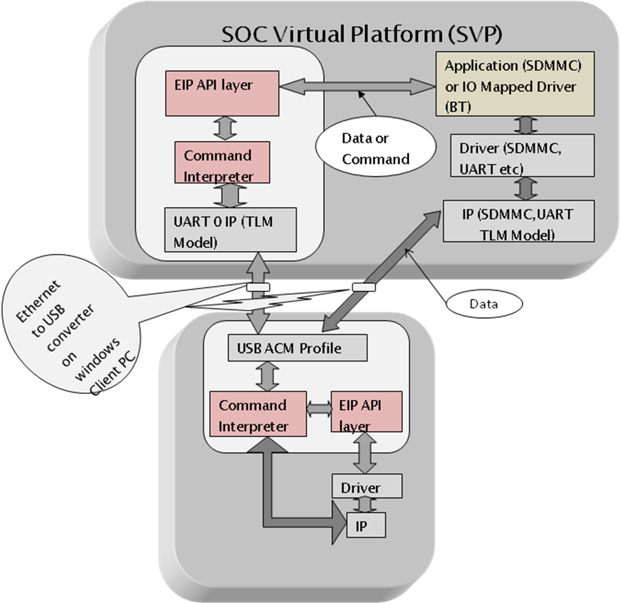
Fig : 6.2

6.3 EIP Setup
For EIP setup 3 main platforms are required:
6.3.1 SVP
For installing SVP framework the following steps are to be done:
- Linux Access Permission: To access Linux PC from windows environment, VNC is used. The steps are as follows:
- Get your short login accounts for Linux environment. You will get login ID for linux access from administrator.
- Logon to Linux server using putty, write "xserver1" in putty
%source /sw/cshrc/solaris/cshrc_common
%which vncserver
It should give path as: /sw/freeware/pkgs/evnc/4.3/vncserver
- Check for the vncserver path before starting new vncserver
- Start the vncserver as following:
a) For PC/desktop users:
% vncserver -geometry 1268x1000 -AlwaysShared -IdleTimeout 0
b) For Laptop users:
% vncserver -geometry 1024x708 -AlwaysShared -IdleTimeout 0
This will start a vncserver and return a unique session id in the form
<server_name>:<port>. Take a note of this id.
- Launch VNC viewer
Go to start -> All Programs -> vnc -> vnc viewer -> run vnc viewer
- Enter your serevr name and port id obtained from the step 4.
Go to start -> All Programs -> vnc -> vnc viewer -> run vnc viewer
Click ok and enter your username and password. Now you can use linux GUI framework.

- Now install latest SVP by running SVP executive file. For example currently we are using SVP_8500_V1_3.3.0.67.2_1_2-RedHatEnterpriseAS_4-x86_64-gcc_4.1.1
You can also install it using terminal. Open the terminal and install SVP package using
<<<<Package Name>>> and enter....
- Also install ST_MMDSP_Tools_4_1_0 either by running its bin file or by using terminal.
For detailed information you can refer SVP Manual.
6.3.2 HRef
Boot HRef with the EIP components integrated SSP image.
6.3.3 Communication Channel
Communication channel is used to connect SVP and HRef board via socket application for which “Ethernet2USB converter” is provided in the EIP framework need to run on Windows Client PC.

How to Use EIP framework?

To validate EIP you have to run three applications simultaneously.
- One application will run on SVP which execute run EIP components such as command interpreter and EIP API layer on SVP.
- Similarly one application will run on HRef which will execute EIP components such as command interpreter and EIP API layer on HRef.
- Communication Application on Client PC to connect SVP and HRef via Socket.
6.4 Appendix:
A. Only the services where context need not to be saved can be provided by the HRef. Whereas in the services where context at HRef need to be saved is not provided by EIP.
B. Requirement from SVP:
- A soft port to transfer/receive data from SVP to HRef which makes the communication fast.
- Ports of different IPs at SVP to transfer and receive data.

Chapter 7
ETHERNET TO USB CONVERTER

This chapter describes an application to transfer the data from the distant Linux server (on which SVP is running) to the USB port of Window based user side client PC. This application is used to establish a part of the Early Integration platform for SOC simulation. Mainly this will provide a communication medium link to transfer data/API between SVP (SOC Virtual Platform) and Hardware board.
7.1 Functionalities
It includes mainly three functionalities:

- Winsock application: Transfer of the data from Linux server to the windows client PC using windows socket2 programming
- Serial communication application: Forwarding that data to COM port and further to USB port using USB ACM profile as per programming in serial communication in win32
- USB ACM: This profile checks that we can use Href’s USB DUT as a serial device and transfer data successfully through it.
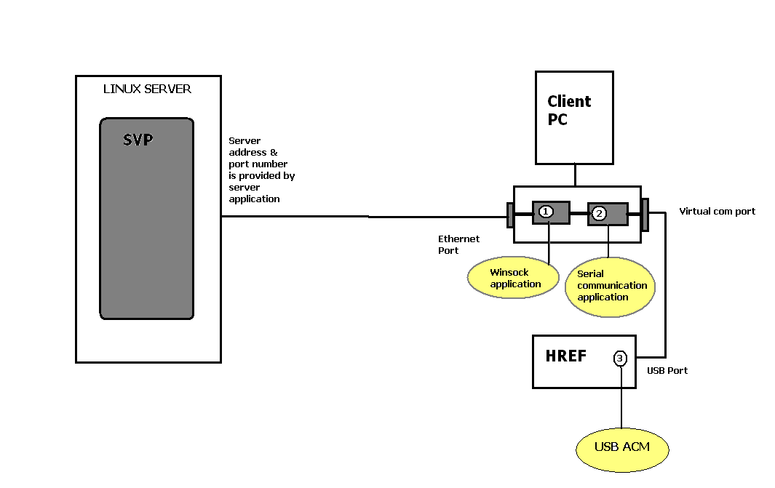 Fig : 7.1

7.2 Detailed Design
Both Winsock application and Serial Communication Client side application is developed on Visual Studio Professional Edition 2005. Before we compile and run the our program we must have to include the ws2_32.lib library because the default installation of the Visual Studio / .Net does not add the library to the project by default.
Both Server and Client communicate each other using sockets. Winsock programming is done for developing this application. Here, we don’t require the server side application as SVP itself could do that. So only a client application must be running on client side windows PC. Although both server and client application is explained below.

7.2.1 Winsock application:
There are two distinct types of socket network applications: Server and client. In simple words, servers provide services for clients and other servers whereas clients request services from servers. Servers and clients have different behaviors; therefore, the process of creating them is different. What follows is the general model for creating a streaming TCP/IP server and client. The steps in creating (and difference between) server and client sockets are listed below.

Server side programs:
Steps:
- Initialize WSA – WSAStartup().
- Create a socket – socket().
- Bind the socket – bind().
- Listen on the socket – listen().
- Accept a connection – accept(), connect().
- Send and receive data – recv(), send(), recvfrom(), sendto().
- Disconnect – closesocket().

Client side programs:
Steps:
- Initialize WSA – WSAStartup().
- Create a socket – socket().
- Connect to the server – connect().
- Send and receive data – recv(), send(), recvfrom(), sendto().
- Disconnect – closesocket().

Below steps are used to send/receive data from com port.

7.2.2 Serial communication application:

7.2.2.1 Initial/Open serial port communication.
The first step in opening a serial port is initiation or setting a serial port's configuration. The purpose of this is to create the serial port agent. All throughout the application we are going to use a file handle as serial port agent.
- Creating a port handle
- Restoring a configuration (DCB)
- Modifying a configuration
- Storing a configuration
- Setting a Time-Out communication

7.2.2.2 Receive/Send data

Sending data

Receiving data

Close a serial port

- Creating a port handle
The serial port's handle is a handle that can be used to access the object of serial port. The function that is used to create the serial port handle is the CreateFile function. The following code shows the function that is used to create a handle:
handlePort_ = CreateFile(portName, // Specify port device: default "COM1"
GENERIC_READ | GENERIC_WRITE, // Specify mode that open device.
0, // the devide isn't shared.
NULL, // the object gets a default security.
OPEN_EXISTING, // Specify which action to take on file.
0, // default.
NULL); // default.

Restoring a configuration
The restoration of serial port configuration is getting current configuration at control device. The configuration of serial port includes parameters that are used for setting a serial communications device.
The GetCommState function is used to get the current device-control and then fills to a device-control block (a DBC structure) with the current control settings for a specified communications device. The following code shows the function that is used to get the current control device:
// Get current configuration of serial communication port.
if (GetCommState(handlePort_,&config_) == 0)
{
AfxMessageBox("Get configuration port has problem.");
return FALSE;
}

Modifying a configuration
When you already have serial port configuration in the DBC format, you have to modify parameters a bit. Following code shows the parameters modified:
// Assign user parameter.
config_.BaudRate = dcb.BaudRate; // Specify buad rate of communicaiton.
config_.StopBits = dcb.StopBits; // Specify stopbit of communication.
config_.Parity = dcb.Parity; // Specify parity of communication.
config_.ByteSize = dcb.ByteSize; // Specify byte of size of communication.
- DWORD BaudRate:
Current baud rate (default = 9600)
- BYTE StopBits:
0,1,2 = 1, 1.5, 2 (default = 0)
- BYTE Parity:
0-4= no, odd, even, mark, space (default = 0)
- BYTE ByteSize:
Number of bits/byte, 4-8 (default = 8)

Storing a configuration
The next step is the storage of new configuration that is modified already into device control. Call SetCommState API function to store the configuration. The SetCommState function configures a communications device according to the specifications in a device-control block (a DBC structure). The function reinitializes all hardware and control settings, but it does not empty output or input queues. Following code shows storage of a new configuration:
if (SetCommState(handlePort_,&config_) == 0)
{
AfxMessageBox("Set configuration port has problem.");
return FALSE;
}

Setting a Time-Out communication
The final step in serial port opening is setting communication Time-out by using the COMMTIMEOUTS data-structure and calling SetCommTimeouts function. The code below shows setting time-out of communication:
// instance an object of COMMTIMEOUTS.
COMMTIMEOUTS comTimeOut;
// Specify time-out between charactor for receiving.
comTimeOut.ReadIntervalTimeout = 3;
// Specify value that is multiplied
// by the requested number of bytes to be read.
comTimeOut.ReadTotalTimeoutMultiplier = 3;
// Specify value is added to the product of the
// ReadTotalTimeoutMultiplier member
comTimeOut.ReadTotalTimeoutConstant = 2;
// Specify value that is multiplied
// by the requested number of bytes to be sent.
comTimeOut.WriteTotalTimeoutMultiplier = 3;
// Specify value is added to the product of the
// WriteTotalTimeoutMultiplier member
comTimeOut.WriteTotalTimeoutConstant = 2;
// set the time-out parameter into device control.
SetCommTimeouts(handlePort_,&comTimeOut);

ReadIntervalTimeout
Specifies the maximum time, in milliseconds, allowed to elapse between the arrival of two characters on the communications line. During a ReadFile operation, the time period begins when the first character is received. If the interval between the arrival of any two characters exceeds this amount, the ReadFile operation is completed and any buffered data is returned. A value of zero indicates that interval time-outs are not used.
A value of MAXDWORD, combined with zero values for both the ReadTotalTimeoutConstant and ReadTotalTimeoutMultiplier members, specifies that the read operation is to return immediately with the characters that have already been received, even if no characters have been received.

ReadTotalTimeoutMultiplier
Specifies the multiplier, in milliseconds, used to calculate the total time-out period for read operations. For each read operation, this value is multiplied by the requested number of bytes to be read.

ReadTotalTimeoutConstant
Specifies the constant, in milliseconds, used to calculate the total time-out period for read operations. For each read operation, this value is added to the product of the ReadTotalTimeoutMultiplier member and the requested number of bytes.
A value of zero for both the ReadTotalTimeoutMultiplier and ReadTotalTimeoutConstant members indicates that total time-outs are not used for read operations.

WriteTotalTimeoutMultiplier
Specifies the multiplier, in milliseconds, used to calculate the total time-out period for write operations. For each write operation, this value is multiplied by the number of bytes to be written.

WriteTotalTimeoutConstant
Specifies the constant, in milliseconds, used to calculate the total time-out period for write operations. For each write operation, this value is added to the product of the WriteTotalTimeoutMultiplier member and the number of bytes to be written.
A value of zero for both the WriteTotalTimeoutMultiplier and WriteTotalTimeoutConstant members indicates that total time-outs are not used for write operations.
Note: After the user has set the time-out of communication without any error, the serial port has opened already.

Sending data
Most of data transmission of serial port is done as writing a file. Programmer can apply file operation functions for sending data to serial port. The WriteFile function is a function used to send data in serial port communication.
if (WriteFile(handlePort_, // handle to file to write to
outputData, // pointer to data to write to file
sizeBuffer, // number of bytes to write
&length,NULL) == 0) // pointer to number of bytes written
{
AfxMessageBox("Reading of serial communication has problem.");
return FALSE;
}
Note: If the function succeeds, the return value is nonzero.

Receiving data
Most of data reception of serial communication is done as reading a file. Programmer can apply file operation functions for receiving data from serial port. The ReadFile function is the function that handles reading data in serial port communication.
if (ReadFile(handlePort_, // handle of file to read
inputData, // handle of file to read
sizeBuffer, // number of bytes to read
&length, // pointer to number of bytes read
NULL) == 0) // pointer to structure for data
{
AfxMessageBox("Reading of serial communication has problem.");
return FALSE;
}
Note: If the function succeeds, the return value is nonzero.

Closing a serial port
The serial port closing calls the CloseHandle API function to close handle of device control.
if(CloseHandle(handlePort_) == 0) // Call this function to close port.
{
AfxMessageBox("Port Closeing isn't successed.");
return FALSE;
}
Note: If the function succeeds, the return value is nonzero.
7.3 Integration
In the final application code both applications can be integrated. WINSOCK application will be used to capture the UART0 data from distant SVP Ethernet port to a buffer, this buffer will be passed to the serial communication application instantly. For proper operation time out settings, error code and connection settings must be managed properly.

Pseudo code for the application

The pseudo code mentioned below provides both way communication between server’s socket and com port of the client PC using both WINSOCK and serial communication application:

- Add bin file and include file as mentioned above
- Give the port and server address we want to connect to
- Define COM port datatypes
- Check socket support
- Initialize sockets and set parameters
- Connect to the server
- Open COM port
- Set timeout settings in milliseconds
- Set Port parameters
- Now lets do the client related stuff
- SVP to HREF
  - Receive server data in to a buffer
  - Pass this buffer to com port using file write application.
- Href to SVP
  - Recive data from com port using read file operation
  - Pass this buffer to the socket
- MutiThreading must be used for synchronizing the both events accordingly
- Close com port and socket
7.4 Threading:

7.4.1 Introduction to Multithread Programs
A thread is basically a path of execution through a program. It is also the smallest unit of execution that Win32 schedules. A thread consists of a stack, the state of the CPU registers, and an entry in the execution list of the system scheduler. Each thread shares all the process's resources.
A process consists of one or more threads and the code, data, and other resources of a program in memory. Typical program resources are open files, semaphores, and dynamically allocated memory. A program executes when the system scheduler gives one of its threads execution control. The scheduler determines which threads should run and when they should run. Threads of lower priority might have to wait while higher priority threads complete their tasks. On multiprocessor machines, the scheduler can move individual threads to different processors to balance the CPU load.
Each thread in a process operates independently. Unless you make them visible to each other, the threads execute individually and are unaware of the other threads in a process. Threads sharing common resources, however, must coordinate their work by using semaphores or another method of interprocess communication

7.4.2 Sharing Common Resources Between Threads
Each thread has its own stack and its own copy of the CPU registers. Other resources, such as files, static data, and heap memory, are shared by all threads in the process. Threads using these common resources must be synchronized. Win32 provides several ways to synchronize resources, including semaphores, critical sections, events and mutexes.
When multiple threads are accessing static data, your program must provide for possible resource conflicts. Consider a program where one thread updates a static data structure containing x,y coordinates for items to be displayed by another thread. If the update thread alters the x coordinate and is preempted before it can change the y coordinate, the display thread might be scheduled before the y coordinate is updated. The item would be displayed at the wrong location. You can avoid this problem by using semaphores to control access to the structure.
A mutex (short for mutual exclusion) is a way of communicating among threads or processes that are executing asynchronously of one another. This communication is usually used to coordinate the activities of multiple threads or processes, typically by controlling access to a shared resource by locking and unlocking the resource. To solve this x,y coordinate update problem, the update thread sets a mutex indicating that the data structure is in use before performing the update. It would clear the mutex after both coordinates had been processed. The display thread must wait for the mutex to be clear before updating the display. This process of waiting for a mutex is often called blocking on a mutex because the process is blocked and cannot continue until the mutex clears.

7.4.3 Threading Procedure:
There are some scenarios when data should be passed both ways so setting up the communication application in single direction (Either SVP to Href or Href to SVP) is not a good approach. Thus, Multithreading feature is must. Application has two threads writeSVPThread and readSVPThread. When data is coming from SVP, readSVPThread runs and when data is coming from HRef writeSVP Thread runs.

Structure:

// Initialize the threads

DWORD WINAPI readSVPThread(LPVOID lpParam);
DWORD WINAPI writeSVPThread(LPVOID lpParam );

// Create Threads

dwThread[0] = CreateThread(NULL,0,readSVPThread,data,0,&readThread_id);
dwThread[1] = CreateThread(NULL,0,writeSVPThread,data,0,&writeThread_id);
//waitformultipleobject
WaitForMultipleObjects(2,dwThread,true,INFINITE);

// Terminate threads

TerminateThread(dwThread[0],1);
TerminateThread(dwThread[0],1);

// Thread

DWORD WINAPI readSVPThread(LPVOID lpParam)
{
while(true)
{
// Code for reading data from SVP to HRef
}
}

DWORD WINAPI writeSVPThread(LPVOID lpParam)
{
while(true)
{
// Code for writing data from HRef to SVP
}
}

7.5 Prerequisite
- The Symbian BSP for SVP should have to UART driver and UART port is available in SVP.
- USB ACM profile must be available and working properly
7.6 Design Constraints
Interaction of this client application and SVP results initially to send some enormous 5 character data which must be eliminated or take cared always.

Chapter-8
COMMAND INTERPRETER

8.1 Purpose
The Command Interpreter provides a means to forward the requests of proxy application from SVP to the proxy application on HRef board and vice versa. The purpose of CI is to encode or decode the packet on SVP and HRef both and pass it to the next layer. This packet contains the information of API call received from the proxy application.

8.2 Overview
This application is OS specific (in current environment Symbian) will run on SVP as well as on HRef board. It will behave as an intermediate between SVP and HRef board to pass the calls.
The command interpreter will behave as an encoder/decoder on SVP and HRef both. At the time when the command interpreter will act as encoder on SVP, it will act as a decoder on HRef board and vice versa. Hence the Command Interpreter can be defined into two categories.
- Command Interpreter running on SVP (CI-1)
- Command Interpreter running on HRef (CI-2)
Command Interpreter on HRef (CI-2) will use the USB ACM profile to transfer the data on virtual UART port (USB)

USB ACM Profile

This profile connects a standard PC serial application to the USB application running on the target board. This profile checks if the USB device can be detected by the host PC as a virtual serial device.

- Purpose
- This profile checks that we can use our USB DUT as a serial device and transfer data successfully through it.
- Since USB DUT appears as a virtual serial port on client PC, This virtual serial port can be used in our serial communication application code and data can be transferred from SVP to Href and vice versa using USB ACM

CASE-1: When the commands are to be sent from SVP to HRef board
Proxy Application
(It receives the commands from the user level API request to command interpreter.)

(It sends the request to specific driver.)
Command Interpreter (CI-1: Encoder)
(It encodes the APIs’ received from proxy application and bind into a packet.)
Command Interpreter (CI-2: Decoder)
(It decodes the APIs’ received from SVP and transfer it to the proxy application.)

Running on SVP side
Proxy Application
(It gets the call and processes it further.)
Running on HREF Board
Fig. 8.1: Data Flow from SVP to HRef boards

CASE-2: When the commands are to be sent from HRef board to SVP

Proxy Application
(It receives the commands from the user level API request to command interpreter.)

(It sends the request to specific driver.)
Command Interpreter (CI-2: Encoder)
(It encodes the APIs’ received from proxy application into a packet and sent it to a virtual com port.

Command Interpreter (CI-1: Decoder)
(It decodes the APIs’ received from UART port of SVP and transfer it to the proxy application.)

Running on HRef Board
Proxy Application
(It gets the call and processes it further.)

Running on SVP
Fig. 8.2: Data Flow from HRef board to SVP

Design
The working of command interpreter depends on the direction of commands flowing between SVP and HRef board.

8.3 Preliminary Design

Case-1: When the commands are to be sent from SVP to HRef board.

Command Interpreter running on SVP (CI-1)
For sending a command from SVP it will works as Encoder. It will perform this action in the following manner.
- The command interpreter will receive API calls from the proxy application layer.
- It will generate a packet containing information such as instruction type, no of arguments, argument list, data etc.
- After binding the command interpreter will sent the packet to the UART0 port of SVP.
Once this packet comes to the UART0 port on SVP it will be sent to USB port of HRef board by using ACM profile of USB.
The proxy application on SVP will wait for further processing until it gets an acknowledgement back from HRef board. As CI handle all the user level APIs only so driver level exception handling will take care by the proxy application on SVP as well as HRef board.

Command Interpreter running on HRef board (CI-2)
At the time of receiving it will work as Decoder on HRef board. It will perform this action in the following manner.
- The command interpreter will receive a packet from USB port of HRef board.
- It will decode a packet to get the original API calls as sent by the proxy application layer on SVP.
- After getting original API it will sent the API to the proxy application layer on HRef board to process it.

Case-2: When the commands are to be sent from HRef board to SVP
In EIP, we are integrating SVP and HRef board to perform complete validation. It requires proper communication between SVP and HRef at application level also. This can be achieved by sending acknowledgement from HRef to SVP.
Also, any command can be initiated on HRef board itself and will send to SVP for processing it.

Command Interpreter running on HREF board (CI-2)
For sending a command from HRef board it will works as Encoder. It will perform this action in the following manner.
- The command interpreter will receive API calls from the proxy application layer on board.
- It will generate a packet containing information such as instruction type, no of arguments, argument list, data etc.
- After binding the command interpreter will sent the packet to the virtual UART port (USB port) of HRef board.
Once this packet comes to the virtual UART port on HRef board it will be sent to UART port of SVP by using ACM profile of USB.

Command Interpreter running on SVP (CI-1)
At the time of receiving it will work as Decoder on SVP. It will perform this action in the following manner.
- The command interpreter will receive a packet from UART port of SVP.
- It will decode a packet to get the original API calls as sent by the proxy application layer on HRef board.
- After getting original API it will sent the API to the proxy application layer on SVP to process it.
  - Detailed Design

Packet Details

Instruction_Type(1 byte) | API_ID(1 byte) | Packet_Size(2 bytes) | No_of_arguments(1 byte) | Arg_list(2 bytes) | Reserved Area(1 byte) | Status (1 byte)

Packet#2: API Packet

Instruction_Type specifies whether the call is for data or command.
API ID specifies the function called by the corresponding driver.
Packet_Size defines the size of the packet.
No_of_arguments is a variable which defines the no of arguments in a specific API.
Arg_list retrieves the parameters from an API and stores in Arg_list.
Reserved Area is reserved for future use.
Status defines the status of test execution.
Packet#2: Data Packet
Size (1 byte) | Data (2 bytes)

Structure
We will use “union” data structure to manage data and API calls together. However the members that compose a union all share the same storage area within the memory where as each member within a structure is assigned its own unique storage area.
Class packet
{
Uchar API_ID; // API_ID tells the API called by the corresponding driver.
Uint Packet_Size; // defines the packet size
Union command
{
Struct APIpacket;
Struct DATApacket;
} cmdobj;
Uchar Status; //tells the status of completion
Uchar Reserved; // reserved for future purpose
};

struct APIpacket
{
Uint No_of_arguments; // No of arguments in an API
Struct Arg_list *arg_list; // fetches all the arguments in an API
} APIpacket;

struct DATApacket
{
int size;
Uchar *data;

};

Enum UART_API //defines the user level APIs of UART driver
{
};

Enum SDMMC_API //defines the user level APIs of SDMMC driver
{
};

struct list
{
Uchar info [10];
list *next;
list *prev;
}

- Arg_list-> parameters of an API is read by comma (,) separator and will be store in a list and picked one by one from this list during execution.
- Count will give the No_of_arguments.
- In case of pointer, a memory is created by the application on receiving end and the data will be copied into buffer.
  - Design Constraints

- For longer data (size more than specified size in packet) a request for another data frame should be handled.

Chapter 9
TEST ENVIRONMENT FOR COMMAND INTERPRETER AND ETHERNET TO USB CONVERTER

9.1 Test Environment for Command Interpreter

Test Execution
The command Interpreter (CI) will run on SVP as well as on board for encoding and decoding the commands. On SVP, CI (Encoder) will receive a command from the upper layer and encode it into a packet. The generated packet will be forwarded to UART0 on SVP. At receiving end, CI (Decoder) will receive the packet from USB port and decode the packet to get the original API. The original API will be forwarded to the lower layer application to process it.

SVP
(Sender)
HRef Board
(Receiver)
Data Transmission through socket
Application1
(Encoder)
It will encode the APIs’ calls into a packet and sends it on UART0.
Application2
(Decoder)
It will receive the packet and decode it to get the original information.
UART0 Port

USB Port

Fig : 9.1

9.2 Test Environment for Ethernet2USB Converter

1. Test Execution (Data Transfer from SVP to Href)
- Symbian BSP would be running on SVP, windows socket application is configured using server address and port address which are provided by SVP on the command prompt earlier.
- At SVP a test application is running which send a text string to the UART0 and this serial data is send to the Ethernet port and later our application will capture that data and will pass to programmed com port.
- Using NULL modem transfer data to nearby Test PC where hyper terminal application is configured with the same connection settings, set in the serial communication application code previously.
- On hyper terminal of the test PC the string or traces are seen which are sent by SVP.
- For validation of EIP, this test PC can be replaced by Href, using USB ACM.
  - In this case our serial communication application will use virtual com port provided by USB ACM profile of HREF board.
  - To receive the SVP test string USB ACM code must be modified accordingly to see the capture data for confirmation.
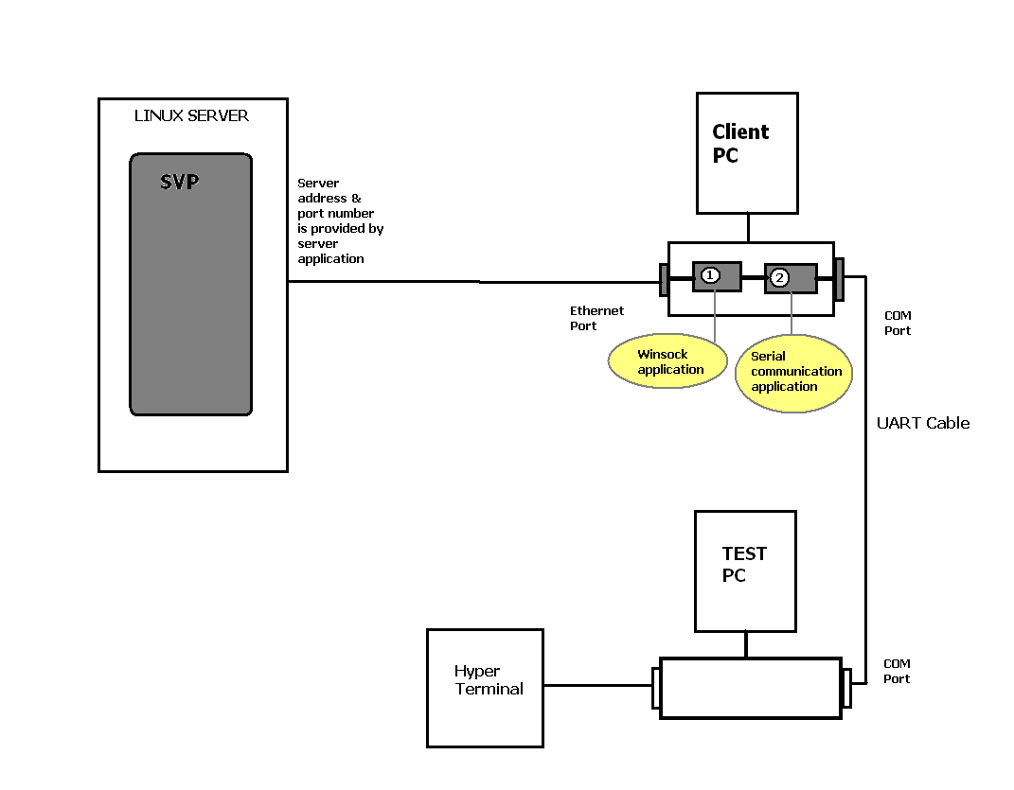
Fig : 9.2

2. Test Execution (Data Transfer from Href to SVP)
- Symbian BSP would be running on SVP and a test application would configure UART0 in receiving mode.
- On Hyper terminal of a test PC a test string will be sent to com port of the client PC. This test string will be captured and passed to SVP’s UART0 Socket by our communication application.
- At SVP side’s UART0, test string will be received which was sent by Hyper terminal of test PC
- For Validation of EIP, this Test PC can be replaced by Href, using USB ACM
  - In this case serial communication application will use virtual com port provided by USB ACM profile of HREF board.
  - A Test string will be sent by HREF board which will be passed to virtual com port and further to UART0 socket of SVP
9.3 Test Results
Both Tests are successful if we get the data from SVP to the configured hyper terminal and vice versa on the TEST PC

1. Start all the three applications

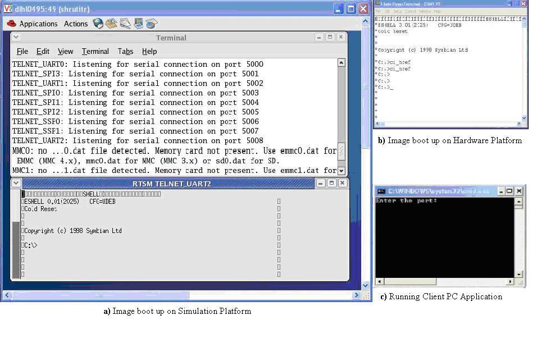

Fig : 9.3

9.3.1 FILE READ

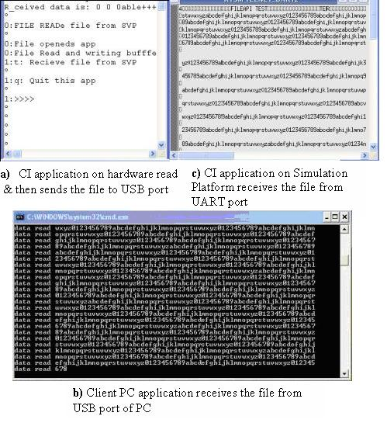
Fig : 9.4

9.3.2 FILE WRITE

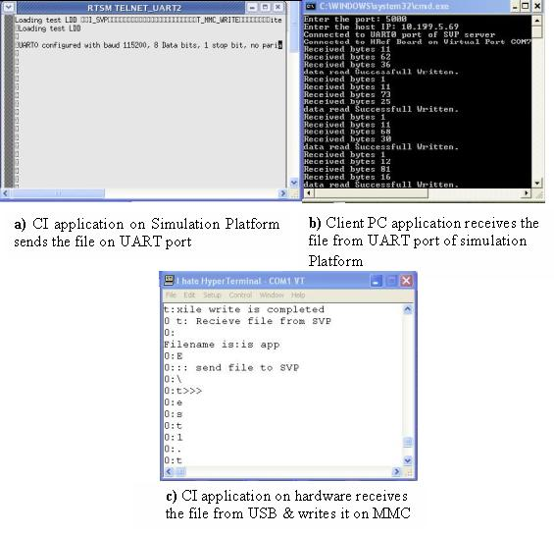

Fig : 9.5

Chapter 10
EIP TESTS & RESULTS: COMPONENT TEST SPECIFICATION

Introduction

This test plan describes testing procedures designed to verify the EIP platform. It concentrates on the user’s view of this system, and should probe for any weaknesses that might not have been covered during EIP implementation.

The testing prescribed is functional testing. In functional testing, the system is treated like a black box. Input is supplied and the output of the system is observed. The test plan identifies the functional capabilities specified in the requirements and specifications and prescribes a set of input values that exercise those functions. These inputs must include boundary values and error conditions as well as the main processing stream.

Tests should cover multiple operational scenarios, not merely the nominal case. The test plan must include tests designed to ensure that interfaces among subsystems are thoroughly demonstrated, as well as tests that challenge the robustness of the system by examining its performance under load and its response to user or data errors.

Environmental prerequisites
This test plan targets the SVP of HRefV1 and HRef V1 board.
The SSP BSP release for SVP and HRef V1

Fig : 10.1

Tests
Class t_valid_EIP_01: Software Unit Testing

Tests summary

Tests description
Test t_EIP_01_01: Validation of EIP Setup
- Test purpose
This test case tests the following functionalities
- USB ACM profile working fine at HRef
- UART0 working fine at SVP
- Method
The USB cable attached between the HRef and Windows Client PC and run the CI at both the ends on HRef and as well as on SVP. Now transfer some data from SVP to HRef then send back the same data from HRef to SVP. The data received at SVP should be same as send by SVP.
- Test input
Input parameter | Data Type | Description | Remark
Text to send over the channel | String | Sending back the data to SVP as received by HRef. | Testing the Communication Channel.
- Expected result
The same data should be received.

Class t_valid_EIP_02: Validation of Communication channel of EIP
Test t_EIP_02_01: Validation of Communication channel of EIP
- Test purpose
This test case tests the following functionality.
Transfer of data from SVP to Client PC
Transfer of data from Client PC to Href
Copying of data to MMC card at Href.
- Method
Transfer files of different sizes from SVP to MMC card at HRef and compare them that received is complete and error free.
- Test input
Input parameter | Data Type | Description | Range of values
File to transfer | File format | Communication channel between SVP and HRef. | The uncorrupted file should be received.
- Expected result
The file will get transfer completely without any error.

Test t_EIP_02_02: Validation of Communication channel of EIP
- Test purpose
This test case tests the following functionality.
Transfer of data from HRef to Client PC
Transfer of data from Client PC to SVP
Copying of file from MMC card to SVP.
- Method
Transfer file of different sizes from MMC Card at Href to SVP and compare the file received is correct..
- Test input
Input parameter | Data Type | Description | Remark
File to transfer | File format | Communication channel between SVP and HRef. | The uncorrupted file should be received.
- Expected result
The file will get transfer completely without any error.

Class t_valid_EIP_03: Validation of Command Interpreter of EIP
Test t_EIP_03_01: Validation of Command Interpreter of EIP
- Test purpose
File APIs provided by EIP to read from or write to a file at HRef board. This test case tests the following functionality.
Transfer of APIs from SVP to Href.
Execute API at Href
Send status and result back from HRef to SVP.
- Method
This test case tests APIs provided by EIP function with all possible values of argument and checks whether the returned value matches with the expected value.
- Test input
Input parameter | Data Type | Description | Remark
File to read or write | EIP APIs | The Files APIs at SVP get executed remotely on HRef. | Data while reading file and status while writing a file.
- Expected result
The file will get transfer completely without any error.

Test t_EIP_03_02: Validation of Command Interpreter of EIP
- Test purpose
File APIs provided by EIP to read a JPG file at HRef board and get displayed on SVP. This test case tests the following functionality.
User level API transfer from SVP to Href i.e. using HRef’s user level services by SVP.
- Method
This test case tests APIs provided by EIP function with all possible values of argument and checks whether the returned value matches with the expected value.
- Test input
Input parameter | Data Type | Description | Remark
JPG File at HRef. | EIP APIs | The image get displayed on SVP | Error image to get displayed
- Expected result
The image gets displayed without any distortion.

Class t_valid_EIP_03: Handling of multi-tasking by EIP
Test t_EIP_03_01: Multiple requests from SVP to HRef.
- Test purpose
To tests the multiple request from two different processes at SVP to HRef.
- Method
There is one request of file read from process 1 and another of file read from process 2. They should get executed at HRef in the order they requested by SVP. Also, the results of both the request did not get affected.
- Test input
Input parameter | Data Type | Description | Remark
File to read from process1 and process2 | EIP APIs | The Files APIs at SVP get executed in the order they requested by SVP. | The result of both the request did not get affected.
- Expected result
The results received by two processes should be correct.

Test Application:
Read a file from SVP RAM and write it to the MMC card on HRef using APIs provided by EIP. Now read the same file from MMC card at Href using EIP APIs and compare with the file in RAM.

Chapter 11
List of changes on SVP and HRef for EIP Validation

In EIP framework, three applications are used to transfer the data/command from SVP to HRef.
- Command Interpreter on SVP
- Command Interpreter on HRef
- Client PC Application
11.1 Command Interpreter on SVP:
CI on SVP provides a means to forward the requests of proxy application from SVP to the CI on HRef board and vice versa. The directory structure for CI on SVP is shown as below.
PATH:
(<View name>\MMTC_MMSTB9.2_src\devkit\montblanc\src\soc\core\proxyapp)
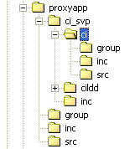

Contents:

Folder name: ci_svp
Path: (<ViewName>\MMTC_MMSTB9.2_src\devkit\montblanc\src\soc\core\proxyapp\ci_svp)

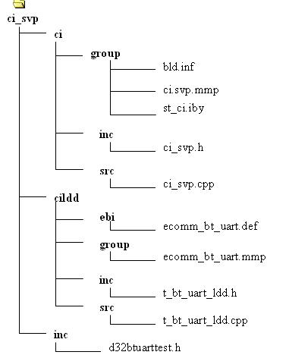

Folder name: proxyapp
Path: (<View name>\MMTC_MMSTB9.2_src\devkit\montblanc\src\soc\core\proxyapp)
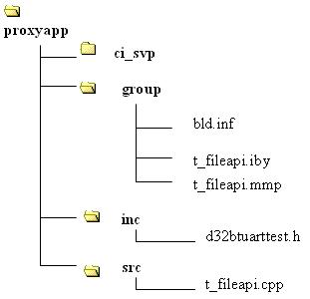

1) proxyapp

TARGETTYPE: .lib
LIB NAME: t_fileapi.lib

2) ci_svp

TARGETTYPE: .lib
LIB NAME ci_svp.lib

11.2 Command Interpreter on HRef:
CI on HRef provides a means to take the requests of proxy application from SVP and after translation forward it to the corresponding testldd. After processing the command an acknowledgement is sent back to the proxy application of SVP. The directory structure for CI on SVP is shown as below.

PATH:
(<View name>\MMTC_MMSTB9.2_src\devkit\montblanc\src\soc\core\ci_href)

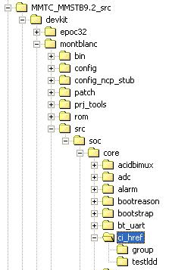

Contents:
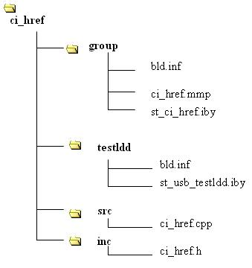

ci_href

TARGETTYPE: .exe
LIB NAME ci_svp.exe

11.3 Scenario : File Write from SVP to HRef

Objective: To write a file from SVP environment to MMC on HRef board.
Step 1: In case of writing a file from SVP to MMC of HRef board, a user will send a request of RFileWrite with a buffer containing data to be written on MMC.

API Implemented: RFileWrite (startpos, buffer, length)
Targettype: .lib
File Name: t_fileapi.cpp
Path:
<View name>\MMTC_MMSTB9.2_src\devkit\montblanc\src\soc\core\proxyapp\src\
Description: RFileWrite API makes a packet and transfer it on UART0 port.

Step 2: Client PC application takes the data from UART0 via ethernet and sends it to USB port of Client PC.
Step 3: CI on HRef takes the data from the USB port of Client PC. It reads the packet, processes it and sends an acknowledgement to the Client PC using USB.

API Implemented: RFileWrite (startpos, buffer, length)
Targettype: .exe
File Name: ci_href.cpp
Path:
<View name>\MMTC_MMSTB9.2_src\devkit\montblanc\src\soc\core\ci_href\src\
Description: RFileWrite API receives a packet from USB and process it accordingly.

Step 4: Client PC application receives the response at USB port and then transfer through Ethernet to UART0 port of SVP.
Step 5: The CI on SVP then receives the response back and now set to execute next step of the above test application.

11.4 EIP VALIDATION:

For EIP validation the following changes are required:

- Required Changes on SVP:
  - Include ci_svp and t_fileapi library into the test application (for ex. Test.exe) which calls the API (for ex: RFileRead, RFileWrite etc) of Command Interpreter.
File Changed: test.mmp
Libraries included: t_fileapi.lib, ci_svp.lib
Header Files included:
ci_svp.h
Path: \MMTC_MMSTB9.2_src\devkit\montblanc\src\soc\core\/proxyapp/ci_svp/ci/inc/

d32btuarttest.h
Path:
\MMTC_MMSTB9.2_src\devkit\montblanc\src\soc\core\proxyapp/ci_svp/inc/
t_fileapi.h
Path: \MMTC_MMSTB9.2_src\devkit\montblanc\src\soc\core\proxyapp/inc

File Changed: For ex. test.cpp
Header Files included: “ci_svp.h”, “t_fileapi.h”

  - Use bt_uart driver of wk19 BSP. Exclude power component form BT UART as power module is not available on SVP.

Files Changed:
    - Bt_uart_manager.mmp
Path:
\MMTC_MMSTB9.2_src\devkit\montblanc\src\soc\core\bt_uart\8500\
Comment “library VariantTarget (power, lib)”
    - Bt_uart_manager.cpp
Path:
\MMTC_MMSTB9.2_src\devkit\montblanc\src\soc\core\bt_uart\src\
Changed File link:

- Required Changes on HRef:
(<View name>\MMTC_MMSTB9.2_src\devkit\montblanc\src\soc\core\ci_href)

- Include Command Interpreter application (ci_href.exe) in the image of existing hardware.

File Changed: st_core.iby
File Name: ci_href.exe
TARGETTYPE EXE

3. Client PC Application for connecting SVP and HRef

11.5 For booting the image of SVP the following changes are required:

- Required Changes for SVP on NOI_WMM_BRIDGE_BASE_W1005_V5.1.3
    - Standard Changes:
      - Include iic.dll (I2C) while exclude i2c_psl.dll from st_i2c_kext.iby file
(Path:\montblanc\src\soc\core\i2c\kext\group\st_i2c_kext.iby)
Reason:
Since GPIO uses I2C, so I2C must be included in the core image. But since PSLPRM is not supported on SVP, so we are excluding i2c_psl.dll from the st_i2c_kext.iby file.

    - New Changes:
      - Bootstrap: Config.inc (Path:\montblanc\src\soc\core\bootsrap\hrefv1\config.inc) Reason:
NonFlashBoard will be used for SVP so GBLL FLASHED_BOARD flag should be commented.

      - ASSP/Variant: Variant_init_8500v1.cpp
(Path:\montblanc\srs\soc\core\variant\8500\variant_init_8500v1.cpp)
Reason:
In MsTimerTick() function some unnecessary delay Kern::NanoWait(130*1000) was found which was creating problem on SVP only while it was passed on board. Since SVP is quite sensitive on timings and delays, this kind of timing issues are must be taken care of.
Execution method of any test case at boot time:
      - Include following command line at the end of epoc32/rom/include/st_core.iby file.
data = \epoc32\data\z\autoexec.bat autoexec.bat
2. Copy autoexec.bat file at path \epoc32\data\z\autoexec.bat
3. Change test case name in the autoexec.bat file if required.
4. Put command lines in the .bat file in a following way:
z:
cd sys
cd bin
<test_case_name>

Chapter 12
CONCLUSIONS AND FUTURE DIRECTIONS

System architects and embedded software developers are accepting transaction level modeling into their design flow because it addresses their need for early architecture exploration and eSW development. SystemC 2.0 lends itself to TLM modeling and is thus increasingly becoming the language to propagate the TLM paradigm. However work still needs to be done to formalize the methodology for architecture exploration and for adopting a common set of modeling guidelines to promote interoperability.

It is forecasted that in the next few years, most of the content of SoCs will be pre-designed. This will occur along with a move to platforms in which many elements of an architecture are predetermined. The modular approach used by SystemC will allow libraries of system components to be developed and reused for different platforms, thus reducing time-to-market without compromising on SoC quality.

SoC virtual platform is one of the best example of this TLM models. These days lots research is going on these models. Synopsys’s Coware is also a TLM based environment. If once this embedded software development is completely ported on SVP type virtual hardware model there would be a revolution as all this semiconductor companies would not take much time to deliver their new revolutionary products.

Using EIP writing on the physical devices is possible, by interacting board and SVP with each other. This would provide a complete driver development and integrated test validation system rapidly.

SVP has wide range of future enhancement scope in it which includes the following functionalities-
  - Till now, some of the ips/components have been added. It is needed to add rest of many more components so that it can be used for complete STn8500 early embedded software development.
  - It should behave in the same way as hardware board does as in this case it will be easy to port all hardware board test environment to SVP easily and it would not take much extra learning effort for the developer too.
  - There must be some quick and innovative feedback system should be placed so that bug in SVP could be removed as soon as possible.

EIP also has some wide range of future enhancement scope which includes the following functionalities-
1. All integration test cases should be included in to EIP framework.
2. Speed should be increased using another communication profile otherwise integration testing of some test cases where high data rates are required would not be possible.

Wish, it would succeed soon in near future in upcoming days.

As an intern, it was really my one of best industrial experience working in this embedded domain. I got the opportunity to learn lots of new things. As I come to see the embedded software development more closely ever.

Chapter 13
BIBLIOGRAPHY

[1]A. Clouard, G. Mastrorocco, F. Carbognani, A. Perrin, F, Ghenassia. “Towards Bridging the Precision Gap between SoC Transactional and Cycle Accurate Levels”,
DATE 2002

[2] A. Ferrari and A. Sangiovanni - Vincentelli, System Design. “Traditional Concepts and New Paradigms”. Proceedings of the 1999 Int. Conf. On Comp. Des, Oct 1999, Austin

[3] “Functional Specification for SystemC 2.0”, Version 2.0-P, 0ct 2001

[4] Frank Vahid, Tony Givargis. “Embedded System Design: A Unified Hardware
/Software Introduction”. John Wiley & Sons, Inc

[5] Transaction level modeling of SoC with SystemC 2.0, Sudeep Pasricha
Design Flow and Reuse/CR&D, STMicroelectronics Ltd, Plot No. 2 & 3, Sector 16A
Noida – 201301 (U.P) India

[6] Clear case & T32 help documents

