LEVEL & TEMPERATURE CONTROLLER
USING MICROCONTROLLER

A dissertation submitted in Partial fulfillment of the Requirement for the degree of

MASTER OF ENGINEERING
(CONTROL AND INSTRUMENTATION)

By
BOBEN JOSEPH
(Roll No. 10702)

Under the guidance of
Prof. PRAMOD KUMAR
Department of Electrical Engineering



Delhi College of Engineering, Bawana Road,
Delhi-42
(University of Delhi)
Year 2008

CERTIFICATE

This is to certify that the major project entitled “LEVEL & TEMPERATURE CONTROLLER USING MICROCONTROLLER” is a bonafide work done by BOBEN JOSEPH (Roll No. 10702) towards partial fulfillment of the requirement for the award of MASTER OF ENGINEERING degree in CONTROL AND INSTRUMENTATION from Delhi College of Engineering.

Delhi
Dated:
Supervisor
Prof. PRAMOD KUMAR
Department of Electrical Engg.

ACKNOWLEDGEMENT

It is a matter of great pleasure for me to express my profound gratitude to Prof. PRAMOD KUMAR for his able guidance, constant encouragement, constructive criticism and helpful discussion through out the course of this work. I would like to acknowledge the co-operation extended to me by Mr. Verma & Mr. Rakesh (Director, Manger of Vinytics Peripherals Pvt. Ltd, Delhi). Also, I would like to give special thanks to Dr. (Mrs.) AMITA DEV (Principal) and Mr. SUNEET TEWARI (Incharge), AMBEDKAR POLYTECHNIC, Delhi for their support and kind co-operation during this project. At last but not the least, I would like to thank all those who have directly or indirectly helped me in the successful completion of this project.

Date:
BOBEN JOSEPH
ME (C&I)
Roll No. 10702

CONTENTS

CHAPTER I: INTRODUCTION

1.1 BASIC THEROY
1.2 Proportional Control
1.3 Integral control
1.4 Derivative Control
1.5 ON/OFF CONTROL OR TWO-POSITON CONTROL
1.6 COMBINATIONS OF CONTROL ACTIONS

CHAPTER II: LITERATURE REVIEW

2.1 THE MICROCONTROLER
2.2 MICROCONTROLLERS VERSUS MICROPROCESSORS
2.2 MICROCONTROLLERS VERSUS MICROPROCESSORS
2.4 Choosing a microcontroller
2.5 VARIOUS 8051 MICROCONTROLLERS
2.6 APPLICATION AND SELECTIONS OF LEVEL SENSORS
2.7APPLICATIONS & SELECTIONS OF TEMPERATURE SENSORS

CHAPTER III: BRIEF DESCRIPTION OF 89C51 HARDWARE

3.1 THE MICROCONTROLER
3.2 AT89C51 FROM ATMEL CORPORATION
3.3 PIN DESCRIPTION OF 89C51
  - Program counter value upon reset
3.5 Registers and Flags of 89C51
3.7 MEMORY SPACE ALLOCATION

CHAPTER IV: HARDWARE DETAIL OF ANALOG TO DIGITAL CONVERTOR

4.1 ADC0803/ ADC0804
4.2 Understanding A/D Error Specs
4.3 Detailed Description
4.4 Interfacing 8051

CHAPTER V: HARDWARE DETAILS OF LEVEL & TEMPERATURE CONTROLLER USING MICROCNTROLLER

5.1 hardware Component
5.2 LM 35 Precision Temperature Sensor
5.3 LEVEL PROBE
5.4 OPTOCOUPLER (MCT-2E)
5.5 Power supply unit
5.6 LIQUID CRYSTAL DISPLAY
5.7 RELAY

CHAPTER VI: SOFTWARE DETAILS

6.1 INTRODUCTION
6.2 PROGRAM

CHAPTER VII: CONCLUSION & FUTURE SCOPE

7.1 Conclusion
7.2 Future Scope

REFERENCES
APPENDIX-A
APPENDIX-B
APPENDIX-C
APPENDIX-D

CHAPTER I
INTRODUCTION

1.1 BASIC THEROY
The block diagram of conventional feedback control system is illustrated in figure 1.1. The signals entering the summing point are the input signal x and Hy. Exiting the summing point is the signal “x-Hy”.
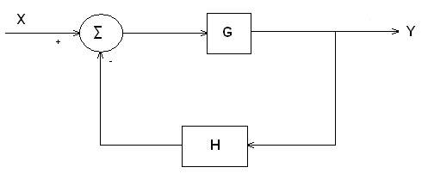
figure 1.1
This is multiplied by the transfer G to obtain the output of the system:
Y= G(x-Hy)
Y + GHy = Gx
Y(1+ GH) = Gx
Writing this as ratio of y to x:
y/x = G/(1 + GH)
The G-bock is the forward transfer function. In a typical process control application the forward transfer function consists of two main components, as illustrated in figure 1.2. The first is the controller unit, whose transfer function is symbolized by C(s). The second component is the transfer function of the process itself, symbolized by P(s). It is desired to control the output of P(s) by using the appropriate control action C(s).
By comparing figures 1.1 and 1.2, the following expression can be derived.
G(s) = C(s)P(s)
The conventional feedback control system compares the system output y with the input x. Since the y signal may be a different type than the input signal (e.g., y is displacement while x is voltage), it may be necessary to use a transducer, represented by H(s), to convert the output signal into a form that is compatible with the input. The summing block in Figure 1.2 represents the comparison between x and y.
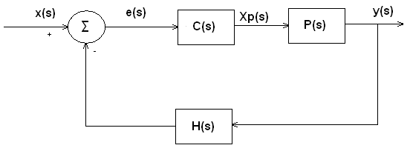
Figure 1.2

Any difference between the two is used as the input to the controller. Thus the actuating signal for C(s) in the block diagram is the difference e(s) = x(s) – H(s)y(s). The particular way in which C(s) manipulates this signal is referred to as the control action. The output of the controller is xp(s), which becomes the input to the process P(s). The controller unit must be designed so that its control action is to correct any deviations from the desired level of the output. The selection of the best control action C(s) depends on the nature of P(s) and H(s).

There are four basic control actions, which are commonly used either alone or in some combination. These are:
- Proportional control
- Integral control
- Derivative control
- On/off control
We discuss the four basic types in this section and then examine how to select the appropriate control action in the following sections.

1.2 Proportional Control
In proportional control, the controller output xp is proportional to the input e. This is expressed in equation form as
Xp = Ke
Where K is the constant of proportionality. For purpose of control system analysis, this can be expressed as a transfer function:
Xp(s)/e(s) = K
The value K is often called the gain of the proportional controller.
The relationship between the error signal e and the output signal xp is shown is figure 1.3. Both signals are shown as a function of time. The nature of this control action is that as long as the error persists, the controller will continue to produce a corrective signal.
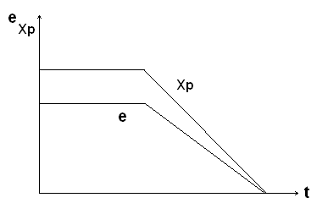
figure 1.3

1.3 Integral control
An alternative form of control action is integral control. In this case, the output of the controller is proportional to the time integral of the actuating signal e. This can be written mathematically as
Xp =K∫e dt
Where K is the gain of the integral controller. Rewriting this in transfer function notation, the integral control action becomes
Xp(s)/e(s) = K/s
The relationship between e and xp is illustrated in figure 1.4. lif the error signal is positive, the correction signal xp will occur at an increasing rate. The rate of increase will be proportional to the level of the error signal. If the error signal is zero, the signal xp will be constant. In order for the correction signal xp to decrease, a negative error e must be present. This results in the tendency for integral control action to overshoot the desired value of the output, which in turn produces an oscillatory response on the part of the process output.
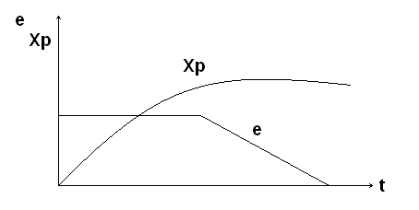
figure 1.4
1.4 Derivative Control
In derivative control, the value of xp is proportional of the rate of change of e. This can be expressed as follows:
Xp = Kde/DT
Where K is the gain of the derivative controller. The corresponding transfer function function for the derivative controller is
Xp(s)/e(s) = Ks
The relationship between xp and e, both plotted overtime, is shown in figure VMC 1.3(c). When the error signal e is steady, the derivative control produces an output signal xp = o. When e is increasing or decreasing, the controller provides for a signal that is proportional to the rate of decrease. Hence, when e is increasing at a steady rate, xp is a constant positive value. When e is decreasing at a constant rate, xp is a negative value.
The disadvantage of derivative control, as illustrated in figure 1.5, is that an error can exist without any corrective action being taken. In the first time interval of Figure 1.5, e is a constant positive value. However, it is not until that error signal begins to change that we see the derivative control by itself. Instead, it is generally used in parallel with one of the two previous control actions.
The advantage of derivative control is that it tends to anticipate the occurrence of a deviation from the desired output level. As soon as the e signal deviates from a steady state level, the derivative control action begins to make a correction.
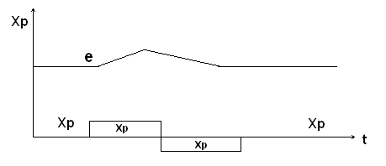
Figure 1.5

1.5 ON/OFF CONTROL OR TWO-POSITON CONTROL
In many control systems, it is satisfactory for the controller to operate at either of two levels rather than over a continuous range as in the three preceding control actions. Typically, the two levels are on or off. More generally, this type of control action is referred to as two-position control. The reason is that the two levels may be other than on and off. For instance, the controller may operate at either of two constant speeds, or forward/reverse, and so on.

Perhaps the most familiar application of on/off control is in the operation of home heating systems. The controller unit is the thermostat. The occupant of the home sets the thermostat at the desired temperature level. If the actual room temperature finally reaches the thermostat setting, the furnace is turned off. As the room cools down, the thermostat finally turns the furnace back on. The home heating system cycles back and forth between the on and off positions.
The on/off control action is illustrated in figure 1.6. When the erroe exceeds the control setting, the controller sets the value of xp to9 the off value . When e is below the control setting, xp is set to the on position. Recall that e represents the difference between the input x and the feedback signal from y. Accordingly, the control setting will usually be set at a value of zero.
The disadvantage with two-position conteol is that the controller response cannot be matched to the magnitude of the error signal. The control action is either too much or none at all. Depending on the sensitivity of the system, the controller may potentially cycle back and forth between the two positions at a frequency that is too high. To compensate for this problem, the controller is often provided with two limits. The lower limit may within a range of values rather than at one given level . The advantage of the two-position controller is its low const and simplicity. In many control situations, this type of control action is quite adqate.

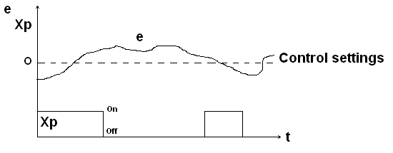
Figure 1.6

1.6 COMBINATIONS OF CONTROL ACTIONS
Combinations of the proportional, integral, and derivative actions are frequently used to achieve the desired control over the process. The resulting transfer functions include the following:
- Proportional plus Integral: xp(s)/e(s) = K₁ + K₂/s
- Proportional plus derivative : xp(s)/e(s) = K₁ + K₃s
- Proportional plus Integral and derivative : xp(s)/e(s) = K₁ + K₂/s + K₃s

CHAPTER II
LITERATURE REVIEW
2.1 THE MICROCONTROLER

In our day to day life the role of micro-controllers has been immense. They are used in a variety of applications ranging from home appliances, FAX machines, Video games, Camera, Exercise equipment, Cellular phones musical Instruments to Computers, engine control, aeronautics, security systems and the list goes on.

2.2 MICROCONTROLLERS VERSUS MICROPROCESSORS

What is the difference between a microprocessor and microcontroller? The microprocessors (such as 8086,80286,68000 etc.) contain no RAM, no ROM and no I/O ports on the chip itself. For this reason they are referred as general- purpose microprocessors. A system designer using general- purpose microprocessor must add external RAM, ROM, I/O ports and timers to make them functional. Although the addition of external RAM, ROM, and I/O ports make the system bulkier and much more expensive, they have the advantage of versatility such that the designer can decide on the amount of RAM, ROM and I/o ports needed to fit the task at hand. This is the not the case with microcontrollers. A microcontroller has a CPU (a microprocessor) in addition to the fixed amount of RAM, ROM, I/O ports, and timer are all embedded together on the chip: therefore, the designer cannot add any external memory, I/O, or timer to it. The fixed amount of on chip RAM, ROM, and number of I/O ports in microcontrollers make them ideal for many applications in which cost and space are critical. In many applications, for example a TV remote control, there is no need for the computing power of a 486 or even a 8086 microprocessor. In many applications, the space it takes, the power it consumes, and the price per unit are much more critical considerations than the computing power. These applications most often require some I/O operations to read signals and turn on and off certain bits. It is interesting to know that some microcontrollers manufactures have gone as far as integrating an ADC and other peripherals into the microcontrollers.

EXTERNAL
INTERRUPTS
ON-CHIP ROM for program code
ON-CHIP RAM

ETC.

TIMER 0

TIMER 1
INTERRUPT CONTROL

CPU

BUS CONTROL
SERIAL PORT

4 I/O PORTS

OSC

TXD RXD

Fig. 2.1 Microcontroller Block Diagram

2.3 MICROCONTROLLERS FOR EMBEDDED SYSTEMS
In the literature discussing microprocessors, we often see a term embedded system. Microprocessors and microcontrollers are widely used in embedded system products. An embedded product uses a microprocessor (or microcontroller) to do one task and one task only. A printer is an example of embedded system since the processor inside it performs one task only: namely, get data and print it. Contrasting this with a IBM PC which can be used for a number of applications such as word processor, print server, network server, video game player, or internet terminal. Software for a variety of applications can be loaded and run. Of course the reason a PC can perform myriad tasks is that it has RAM memory and an operating system that loads the application software into RAM and lets the CPU run it. In an embedded system, there is only one application software that is burned into ROM. An PC contains or is connected to various embedded products such as the keyboard, printer, modem, disk controller, sound card, CD-ROM driver, mouse and so on. Each one of these peripherals has a microcontroller inside it that performs only one task. For example, inside every mouse there is a microcontroller to perform the task of finding the mouse position and sending it to the PC.
Although microcontrollers are the preferred choice for many embedded systems, there are times that a microcontroller is inadequate for the task. For this reason, in many years the manufacturers for general-purpose microprocessors have targeted their microprocessor for the high end of the embedded market.

2.4 Choosing a microcontroller
There are four major 8-biy microcontrollers. They are: Freescale’s 6811, Intel’s 8051, Zilog’s Z8, and PIC 16X from Microchip Technology. Each of these microcontrollers has a unique instruction set and register set; therefore they are not compatible with each other. Programs written or one will not run on the others. There are also 16-bit and 32-bit microcontrollers made by various chip makers. With all these different microcontrollers, what criteria do designers consider in choosing one? Three criteria in choosing microcontrollers are as follows (1) meeting the computing needs of the task at hand efficiently and cost effectively, (2) availability of software development tools such as compilers, assemblers, and debuggers, and (3) wide availability and reliable sources of the microcontroller.

Criteria for choosing Microcontroller
- The first and foremost criterion in choosing a microcontroller is that it must meet the task at hand efficiently and const effectively. In analyzing the needs of a microcontroller – based project, we must first see whether an 8-bit, 16-bit, or 32-bit microcontroller can best handle the computing needs of the task most effectively. Among other considerations in this category are:
- Speed. What is the highest speed that the microcontroller supports?
- Packaging. Does it come in a 40 – pin DIP (dual inline package) or a QFP (quad flat package), or some other packaging format? This is important in terms of space, assembling, and prototyping the end product.
- Power consumption. This is especially critical for battery – powered products.
- The amount of RAM and ROM on chip.
- The number of I/O pins and the timer on the chip.
- How easy it is to upgrade to higher-performance or lower power –consumption versions.
- Cost per unit. This is important in terms of the final cost of the product which a microcontroller is used. For example, there are microcontrollers that cost 50 cents per unit when purchased 100,000 units at a time.

- The second criterion in choosing a microcontroller is how easy it is to develop products around it. Key considerations include the availability of an assembler, debugger, a code efficient C language compiler, emulator, technical support, and both in house and outside expertise. In many cases, third –party vendor (that is, is supplier other than the chip manufacturer) support for the chip is as good as if not better than, support from the chip manufacturer.
- The third criterion in choosing a microcontroller is its ready availability in needed quantities both now and in the future. For some designers this is even more important than the first two criteria. Currently, of the leading 8-biy microcontrollers, the 8051 family has the largest number of diversified suppliers. By supplier is meant a producer besides the originator of the microcontroller. In the case of the 8051, which was originated by Intel, several companies also currently produce the 8051. These companies include: Intel, Atmel, Philips/Signetics, AMD, Infineon(formerly Siemens), Matra, and Dallas Semiconductor.

Table 2.1 Some of the Companies Producing a member of the 8051 Family
Company | Website
Intel | www.intel.com/design/mcs51
Atmel | www.atmel.com
Philips/Signetics | www.semiconductors.philips.com
Infineon | www.infineon.com
Dallas Semi/Maxim | www.maxim-ic.com

2.5 VARIOUS 8051 MICROCONTROLLERS
Although the 8051 is the most popular member of the 8051 family, you will not see “8051” in the part number. This is because the 8051 is available in different memory types, such as UV – EPROM, flash, and NV-RAM, all of which have different part numbers. The UV – EPROM version of the 8051 is the 8751. The flash ROM version is marketed by many companies including Atmel Corp. and Dallas Semiconductor. The Atmel Flash 8051 is called AT89C51, while Dallas Semiconductor calls theirs DS89C4*0 (DS89C420/430/440). The NV-RAM version of the 8051 made by Dallas Semiconductor is called DS5000. There is also an OTP (one-time programmable) version of the 8051 made by various manufacturers.

2.5.1 8751 MICROCONTROLLER
This 8751 chip has only 4K bytes of on-chip UV – EPROM. Using this chip for development requires access to a PROM burner, as well as a UV-EPROM inside the 8751 chip before you can program it again. Because the on-chip ROM for the 8751 is UV-EPROM, it takes led many manufacturers to introduce flash and NV-RAM version of the 8051. There are also various speed versions of the 8751 available from different companies.

2.5.2 AT89C51 from Atmel Corporation
The Atmel Corp. has a wide selection of 8051 chips, as shown in table. For example, the AT89C51 is a popular and inexpensive chip used in many small projects. It has 4K bytes of flash ROM. Notice the AT89C51-12PC, where “C” before the 51 stands for CMOS, which has low power consumption, “12” indicates 12MHz, “P” is for plastic DIP package, “C” is for commercial.

Table 2.2 Versions of 8051 from Atmel (All ROM Flash)

Part Number | ROM | RAM | I/O pins | Timer | Interrupt | Vcc | Packaging
AT89C51 | 4K | 128 | 32 | 2 | 6 | 5V | 40
AT89LV51 | 4K | 128 | 32 | 2 | 6 | 3V | 40
AT89C1051 | 1K | 64 | 15 | 1 | 3 | 3V | 20
AT89C2051 | 2K | 128 | 15 | 2 | 6 | 3V | 20
AT89C52 | 8K | 128 | 32 | 3 | 8 | 5V | 40
AT89LV52 | 8K | 128 | 32 | 3 | 8 | 3V | 40

Table 2.3 Various Speeds of 8051 from Atmel
Part Number | Speed | Pins | Packaging | Use
AT89C51-12PC | 12 MHz | 40 | DIP plastic | Commercial
AT89C51-16PC | 16 MHz | 40 | DIP plastic | Commercial
AT89C51-20PC | 20 MHz | 40 | DIP plastic | Commercial

2.6 APPLICATION AND SELECTIONS OF LEVEL SENSORS

Applications
Level measurement applications can be broadly grouped by services as follows: atmospheric vessels, pressurized vessels, and accounting grade. Accounting grade measurements are made in both atmospheric and pressurized vessels.

Selection
The service is divided into liquids and solids applications and is subdivided for switches, local indicators, local controllers, and transmitters. Further divisions are made to cover the nature of the material to be measured, such as foam, clean, or hard-to-handle. With the service defined the reader can scan down the column to find a letter indication (E-excellent, G-good, F-fair, P-poor) of the suitability of the various designs. The grading is based on such factors as inaccuracy, reliability and ease of maintenance but do not take is rated good or excellent for a particular service may not be an economical selection (see Table 2.4).

2.7APPLICATIONS & SELECTIONS OF TEMPERATURE SENSORS

Selection of Temperature Sensor
Temperature sensors should be selected to meet the requirements of specific application. Table 2.5 should serve to assist the reader in this task. If the application engineer determines the required temperature level, the nature of the information required (point or average temperature) and the nature of the process environment, this table can be used to determine the suitability of various sensors to that application. The most difficult temperature measurement applications are those where high temperature are to be detected within a hostile environment, such as that which exists within a fluid-bed coal gasified.

Factors Affecting Temperature Measurements
All temperature measurements fall into two basic categories including measurements of fluid temperature (liquid, gas, vapor, and slurries) and measurement of temperature on or within solid bodies. The discussion immediately following has been limited to sensing devices employed by attaching to or immersing in the substance of interest.

ORIENTATION TABLE FOR LEVEL DETECTOR (Table 2.4)
SERVICE  INSTRUMENT TYPE | LIQUIDS | SOLIDS  Switches Transmitters
SERVICE  INSTRUMENT TYPE | Switches Local Self-Contained Transmitters  Indicators Local Controller | SOLIDS  Switches Transmitters
SERVICE  INSTRUMENT TYPE | Clean Foam Accounting Standard Clean Hard Clean Hard-  Fluid - to- to-  Handle Handle | SOLIDS  Switches Transmitters
Antenna Level Sensors  Bubblers  Capacitance Probes  Conductivity Probes | G -- -- -- -- -- P P  P-F -- P-F P-F P-F P-F P-F P-F  G P-F P-F F -- -- F P-F  F P -- -- -- -- -- -- | G P  -- --  F P-F  P-F --
Diaphragm Level Detectors  Differential Pressure Level Detectors  Displacer Level Detectors  Float Level Devices  Impedance Probes | F -- P F F F P-F P  G -- F G G F G F  E -- F G E P-F E P-F  G -- F F -- -- P-F P  G P-F P-F F -- -- G G | G --  -- --  -- --  -- --  E F
Level Gauges  Optical Level Switches  Radiation Level Sensors  Resistance Tapes  Rotating Paddle Switches | -- -- F G -- -- -- --  G -- -- -- -- -- -- --  G -- G -- -- -- G E  -- -- P F -- -- P P  -- -- -- -- -- -- -- -- | -- --  -- --  E G  -- F  G --
Slip Tubes  Tape Level Devices  Thermal Level Sensors  Time Domain Reflectometry  Ultrasonic Level Detectors  Vibrating Reed or Tuning Fork Switches | -- -- P-F P-F -- -- -- --  G -- E G -- -- G P-F  G -- -- -- -- -- -- --  -- -- -- -- -- -- -- --  G P-F F G -- -- F G  G F -- -- -- -- -- -- | -- --  -- F-G  -- --  -- --  G F  G --
E – Excellent G – Good F – Fair P – Poor

TEMPERATURE SENSOR SELECTION TABLE (Table 2.5)

Measured Temperature | Under 500 ̊C |  |  |  | Above 500 ̊C
Reading¹ | Point |  | Average |  | Point |  | Average
Hostile environment² | No | Yes | No | Yes | No | Yes | No | Yes
Interference³ | No Yes | No Yes | No Yes | No Yes | No Yes | No Yes | No Yes | No Yes
Sensor⁴  Color indicators | G(L) G(L) | G(L) G(L) |  |  | G(L) G(L) | G(L) G(L)
Bimetallic units | G F | G(P) F(P)
Filled elements | G F | G(P) F(P) | G(L) F | F(P) F(P)
Resistance bulbs | E F | E(P) F(P) | E F | E(P) F(P) | E F | G(P) F(P) | G(L) F | G(P,L) F(P,L)
Thermistor | E(L) F | G(P) F(P) | E(L) F | G(P) F(P)
Thermocouple | G F | G(P) F(P) | F(L) F(L) | F(L) F(L) | E F | E(P) F(P) | F(L) F(L) | F(L,P) F(L,P)
Quartz crystals | E(L) F
Radiation pyrometer |  |  |  |  | E(L) G(L) | E(L) G(L) | E(A,L) G(A,L) | E(A,L) G(A,L)
Infrared pyrometers | E(L) E(L) | E(L) G(L) |  |  | E(L) E(L) | E(L) E(L)
Spectroscopic
(Fraunhofer sensor)
Thermopile |  |  | G(A) F(A) |  |  |  | G(A) F(A)
Acoustic time domain  Reflectometry (TDR) |  |  | D D | D D |  |  | D D | D D

Code letters: D-in development
L-limited
F-fair
G-good
E-excellent
P- Protective well reduces speed of response
A-Detects the average temperature of an area

EXAMPLES: G(D)- this combination of the code letters refers to a device which is a good selection for the particular service, but is not yet commercially available.

NOTES: 1.This device either detects a point or average temperature of some section of the process or the refractory.
2. The term ‘hostile environment’ here is used to mean process such as fluid beds, where the sensor is likely to experience the mechanical impact of the high velocity solid particles.
3. “Interference” refers to need to overcome temperature interference due to hot refractories or to temperature differences between the carrier gas and solid particles in it.
4. For the considerations of measurement error, span, cost stability, response time, linearity, materials of construction, etc., refer to the text.

Temperature Range
Specification of temperature range can identify the type of sensing device which must be used. This is apparent from Table 2.5. For example, if the temperature range for a measurement is 1,000 to 3,000degreeF (538 to 1650degree Celcius), the choice of temperature sensors is narrowed to several types of commercially available thermocouples. If the temperature range is from 0 to 200degreeF (-18 to 93degreeC), the choice include several types of thermocouples, liquid filled bulbs such as mercury thermometers, resistance thermometers, thermistors and bimetallic thermometers.

Accuracy
Accuracy requirements impose an additional restriction on the choice of sensing device. In considering accuracy two factors must be reviewed. First is the inherent accuracy of the measuring device. This generally represents the highest accuracy that can be achieved with the device under ideal conditions. The second consideration, which in general is a greater limitation than the inaccuracy of actual measurement due to environment effects, method of installation and use.

Environmental Influences
In considering the validity of a measurement, it should be remembered that temperature sensing devices respond only to the temperature which they experience. It may be considerably different from the temperature one is attempting to measure if the sensor is of improper size or configuration, or is installed in a manner such that it interferes with the temperature that would exist if the sensor was not present, or if the sensor is not adequately coupled thermally to the media whose temperature is being measured.

CHAPTER III
BRIEF DESCRIPTION OF 89C51 HARDWARE

3.1 INTRODUCTION TO 8051
In 1981, Intel Corporation introduced an 8-bit microcontroller called the 8051. This microcontroller had 128 bytes of RAM, 4K bytes of on-chip ROM, two timers, one serial port, and four ports (8-bit) all on a single chip. The 8051 is an 8-bit processor, meaning the CPU can work on only 8- bit pieces to be processed by the CPU. The 8051 has a total of four I/O ports, each 8- bit wide. Although 8051 can have a maximum of 64K bytes of on-chip ROM, many manufacturers put only 4K bytes on the chip.
The 8051 became widely popular after Intel allowed other manufacturers to make any flavor of the 8051 they please with the condition that they remain code compatible with the 8051. This has led to many versions of the 8051 with different speeds and amount of on-chip ROM marketed by more than half a dozen manufacturers. It is important to know that although there are different flavors of the 8051, they are all compatible with the original 8051 as far as the instructions are concerned. This means that if you write your program for one, it will run on any one of them regardless of the manufacturer. The major 8051 manufacturers are Intel, Atmel, Dallas Semiconductors, Philips Corporation, Infineon.

3.2 AT89C51 FROM ATMEL CORPORATION
This popular 8051 chip has on-chip ROM in the form of flash memory. This is ideal for fast development since flash memory can be erased in seconds compared to twenty minutes or more needed for the earlier versions of the 8051. To use the AT89C51 to develop a microcontroller-based system requires a ROM burner that supports flash memory: However, a ROM eraser is not needed. Notice that in flash memory you must erase the entire contents of ROM in order to program it again. The PROM burner does this erasing of flash itself and this is why a separate burner is not needed. To eliminate the need for a PROM burner Atmel is working on a version of the AT89C51 that can be programmed by the serial COM port of the PC.

Features of AT89C51
- 4K on-chip ROM
- 128 bytes internal RAM (8-bit)
- 32 I/O pins
- Two 16-bit timers
- Six Interrupts
- Serial programming facility
- 40 pin Dual-in-line Package
3.3 PIN DESCRIPTION OF 89C51

Although 8051 family members (e.g., 8751, 89C51, 89C52, DS89C4×0) come in different packages, such as DIP (dual in-line package), QFP (quad flat package), and LLC (leadless chip carrier), they all have 40 pins that are dedicated to various functions such as I/O, RD, WR, address, data, and interrupts. 8031 is a ROM-less 8051, where the external ROM contains the program.
Figure 3.1 show the pins for the 8031/8051/52. Examining Figure 3.1, note that of the 40 pins, a total of 32 pins are set aside for the four ports P0,P1, P2, and P3, where each port takes 8 pins. The rest of the pins are designated as Vcc, GND, XTAL1, XTAL2, RST, and EA, PSEN, and ALE. Of these pins, six (Vcc, GND, XTAL1, XTAL2, RST, and EA) are used by all members of the 8051 and 8031 families. In other words, they must be connected in order for the system to work, regardless of whether the microcontroller is of the 8051 or 8031 family. The other two pins, PSEN and ALE, are used mainly in 8031-based systems. First describe the functions of each pin. Ports are discussed separately.

Vcc:
Pin 40 provides supply voltage to the chip. The voltage source is +5V.

GND:
Pin 20 is the ground.

XTAL1 AND XTAL2:
The 8051/8031 has an on-chip oscillator but requires and external clock to run it. Most often a quartz crystal oscillator is connected to inputs XTAL1 (pin 19) and XTAL2 (pin 18). The quartz crystal oscillator connected to XTAL1 and XTAL2 also needs two capacitors of 30 pF value. One side of each capacitor is connected to the ground as shown in Figure 3-2(a).
To use a frequency source other than a crystal oscillator, such as a TTL oscillator, it will be connected to XTAL1; XTAL2 is left unconnected, as shown in fig.3-2(b).

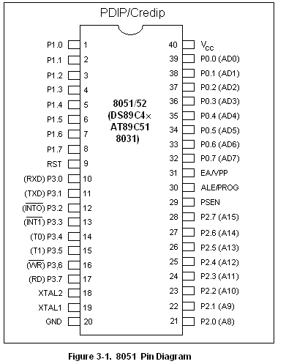
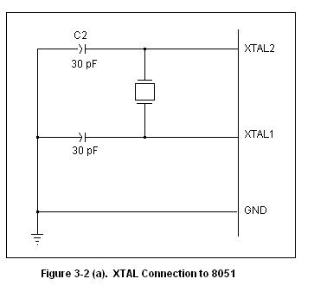

RST:
Pin 9 is the RESET pin. It is an input and is active high (normally low).Upon applying a high pulse to this pin, the microcontroller will reset and terminate all activities. This is often referred to as a power-on reset. Activating a power-on reset will cause all values in the registers to be lost. It will reset program counter to all 0s.

Figures 3.3 (a) and (b) show two ways of connecting the RST pin to power-on reset circuitry. Figure 3-3 (b) uses a momentary switch for reset circuitry.

In order for the RESET input to be effective, it must have a minimum of two machine cycles. In other words, the high pulse must be high for minimum of two machine cycles before it is allowed to low.

EA:
The 8051 family members such as the 8751/52, 89C51/52, or DS89C4x0, all come with on-chip ROM to store programs. In such cases, the EA pin is connected to V_{cc.} For family members such as 8031and 8032 in which there is no on-chip ROM, code is stored in an external ROM and is fetched by the 8031/32. Therefore for the 8031 the EA pin must be connected to GND to indicate that the code stored externally. EA, which stands for “external access,” is pin number 31in the DIP packages. It is input pin and must be connected to V_{cc.} or GND. In other words it cannot be left unconnected.

PSEN:
This in an output pin. PSEN stands for “program store enable.” In an 8031 based system in which external ROM hold the program code, this pin is connected to the OE pin of the ROM.

ALE:
ALE (address latch enable) is an output pin and is active high. When connecting an 8031 to an external memory, port 0 provides both address and data. In other words 8031 multiplexes the address and data through port 0 to save pins. The ALE pin is used for demutiplexing the address and data by connecting to the G-pin of the 74LS373 chip.

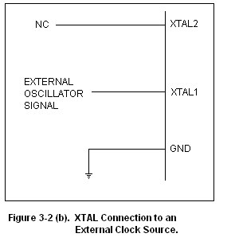

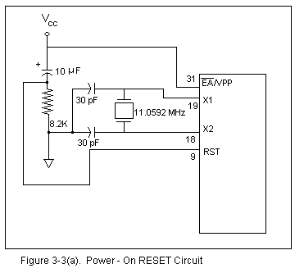

Ports 0, 1, 2 and 3:
As shown in fig. 3-1, the four ports P0, P1, P2 and P3 each uses 8 pins, making them 8-bits ports. All the ports upon the RESET configured as input, since P0 - P3 have value FFH on them. As shown in fig. 3-1, port 0 is also designed as AD0 – AD7, allowing it to be used for both address and data. An 8051/31 multiplexes address and data through port 0 to save pins. ALE indicates if P0 has address or data. When ALE = 0, it provides data D0 – D7, but when ALE = 1 it has address A0 – A7. Therefore, ALE is used for demultiplexing address and data with the help of a 74LS373 latch. In the 8051-based systems where there is no external memory connection, the pin of P0 must be connected externally to a 10K-ohm pull-up resistor. This is due to the fact that P0 is an open drain, unlike P1, P2, and P3. Open drain is a term used for MOS chips in the same way that open collector is used for TTL chips. In many systems using the 8751, 89C51, or DS89C4x0 chips, we normally connect P0 to pull-up resistors. See Figure 3-4. With external pull-up resistors connected to P0, it can be used as a simple I/O port, just like P1 and P2. In contrast to port 0, ports P1, P2, and P3 do not need any pull up resistors since they already have pull-up resistors internally. Upon reset, ports P1, P2, and P3 are configured as input ports.

P1 AND P2:
In 8051-based system with external memory connection, port 2 must be used along with P0 to provide the 16-bit address for the external memory. As shown in Figure 3-1, port 2 is also designated as A8-A15, indicating its dual function. Since an 8031/51is capable of accessing 64K bytes of external memory, it needs a path for the 16 bits of the address. While P0 provides the lower 8 bits via A0-A7, it is the job of P2 to provide bits A8-A15 of the address. In other words, when the 8031/51 is connected to external memory, P2 is used for the upper 8 bits of the 16-bits address, and it cannot be used for I/O.

PORT 3:
Port 3 occupies a total of 8 pins, pins 10 through 17. It can be used as input or output. P3 does not need any pull-up resistors, the same as P1 and P2 did not. Although port 3 is configured as an input port upon reset, this is not the way it is most commonly used. Port 3 has the additional function of
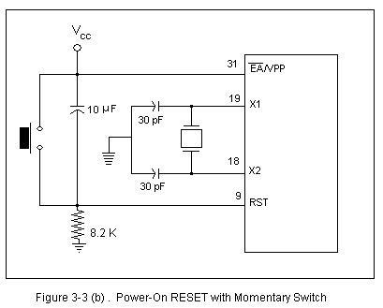

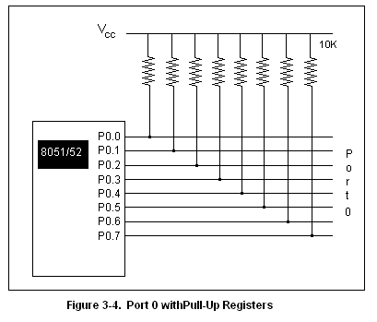

Providing some extremely important signals such as interrupts. Table 3-1 provides these alternate functions of P3. This information applies to both 8051 and 8031 chips.
P3.0 and P3.1 are used for the RxD and TxD serial communications signals.
Bits P3.2 and P3.3 are set aside for external interrupts. Bits P3.4 and P3.5 are used for Timers 0 and 1. Finally, P3.6 and P3.7 are used to provide the WR and RD signals of external memory connections. In systems based on the 8051, pins 3.6 and 3.7 are used for I/O while the rest of the pins in port 3 are normally used in the alternate function role.

Table 3.1: Port 3 Alternate Functions

P3 Bit | Function | Pin
P3.0 | RxD | 10
P3.1 | TxD | 11
P3.2 | INT0 | 12
P3.3 | INT1 | 13
P3.4 | T0 | 14
P3.5 | T1 | 15
P3.6 | WR | 16
P3.7 | RD | 17

3.4 Program counter value upon reset:
Activating a power-on reset will cause all values in the registers to be lost. Table 3-2 provides a partial list of 8051/31 registers and their values after power-on reset. From Table 3-2 we note that the value of the PC (program counter) is 0 upon reset, forcing the CPU to fetch the first opcode from ROM memory location 0000. This means that we must place the first byte of opcode in ROM location 0 because that is where the CPU expects to find the first instruction.

Table 3-2: RESET Value of some 8051 Registers
Register | Reset Value (hex)
PC | 0000
DPTR | 0000
ACC | 00
PSW | 00
SP | 07
B | 00
P0-P3 | FF

  - Registers and Flags of 89C51

Registers
In the CPU, registers are used to store information temporarily. That information could be a byte of data to be processed, or an address pointing to the data to be fetched. In the 8051 there us only one data type: 8 bits. With an 8- bit data type, any data larger than 8 bits has to be broken into 8-bit chunks before it is processed.

A

B
R0
R1
R2
R3
R4
R5
R6
R7

DPH DPL

DPTR

Program Counter
PC

Fig.3.5(b) Some 8051 16-bit registers

Fig. 3.5(a) Some 8051 8-bit registers

The most commonly used registers of the 8051 are A (accumulator), B, R0, R1, R2, R3, R4, R5, R6, R7, DPTR (data pointer) and PC (program counter). All the above registers are 8-bit registers except DPTR and the program counter. The accumulator A is used for all arithmetic and logic instructions.

Program Counter and Data Pointer
The program counter is a 16- bit register and it points to the address of the next instruction to be executed. As the CPU fetches op-code from the program ROM, the program counter is incremented to point to the next instruction. Since the PC is 16 bit wide, it can access program addresses 0000 to FFFFH, a total of 64K bytes of code. However, not all the members of the 8051 have the entire 64K bytes of on-chip ROM installed.
The DPTR register is made up of two 8-bit registers, DPH and DPL, which are used to furnish memory addresses for internal and external data access. The DPTR is under the control of program instructions and can be specified by its name, DPTR. DPTR does not have a single internal address; DPH and DPL are assigned an address each.

Flag bits and the PSW Register
Like any other microprocessor, the 8051 have a flag register to indicate arithmetic conditions carry bit. The flag register in the 8051 is called the program status word (PSW) register.
The program status word (PSW) register is an 8-bit register. It is also referred as the flag register. Although the PSW register is 8-bit wide, only 6 bits of it are used by the microcontroller. The two unused bits are user definable flags. Four of the flags are conditional flags, meaning they indicate some conditions that resulted after an instruction was executed. These four are CY (carry), AC (auxiliary carry), P (parity), and OV (overflow). The bits of the PSW register are shown below:

CY AC F0 RS1 RS0 OV -- P

CY PSW.7 Carry flag
AC PSW.6 Auxiliary carry flag
-- PSW.5 Available to the user for general purpose
RS1 PSW.6 Register bank selector bit 1
RS0 PSW.3 Register bank selector bit 0
OV PSW.2 Overflow flag
F0 PSW.1 User definable bit
P PSW.0 Parity flag

CY, the carry flag
This flag is set whenever there is a carry out from the d7 bit. This flag bit is affected after an 8-bit addition or subtraction. It can also be set to 1 or 0 directly by an instruction such as “SETB C” and “CLR C” where “SETB C” stands for set bit carry and “CLR C” for clear carry.
AC, the auxiliary carry flag
If there is carry from D3 to D4 during an ADD or SUB operation, this bit is set: otherwise cleared. This flag is used by instructions that perform BCD arithmetic.
P, the parity flag
The parity flag reflects the number of 1s in the accumulator register only. If the register A contains an odd number of 1s, then P=1. Therefore, P=0 if A has an even number of 1s.
OV, the overflow flag
This flag is set whenever the result of a signed number operation is too large, causing the high order bit to overflow into the sign bit. In general the carry flags are used to detect errors in unsigned arithmetic operations.

  - MEMORY SPACE ALLOCATION

Internal ROM
The 89C51 has 4K bytes of on-chip ROM. This 4K bytes ROM memory has memory addresses of 0000 to 0FFFh. Program addresses higher than 0FFFh, which exceed the internal ROM capacity, will cause the microcontroller to automatically fetch code bytes from external memory. Code bytes can also be fetched exclusively from an external memory, addresses 0000h to FFFFh, by connecting the external access pin to ground. The program counter doesn’t care where the code is: the circuit designer decides whether the code is found totally in internal ROM, totally in external ROM or in a combination of internal and external ROM.

Internal RAM
The 1289 bytes of RAM inside the 8051 are assigned addresses 00 to 7Fh. These 128 bytes can be divided into three different groups as follows:
- A total of 32 bytes from locations 00 to 1Fh are set aside for register banks and the stack.
- A total of 16 bytes from locations 20h to 2Fh are set aside for bit addressable read/write memory and instructions.
- A total of 80 bytes from locations 30h to 7Fh are used for read and write storage, or what is normally called a scratch pad. These 80 locations of RAM are widely used for the purpose of storing data and parameters by 8051 programmers.
Countdown timers can be constructed using discrete digital ICs deluding up/down counters and /or 555 timers. If you wish to incorporate various facilities like setting the count, start, stop, reset and display facilities, these circuits would require too many ICs.
Here is a simple design based on 40- atmel AT89C51 microcontroller that performs count- down operation for up to LCD displays showing the actual time left. During the activity period, a relay is latched and a flashing led indicates countdown timing’s progress.
Four tactile, push-to-on switches are used to start /stop and to set the initial value for countdown operation. The timing value can also be changed while the counting is still in progress. Auto-repeat key logic also works, i.e., if you hold up or down key continuously, the timing as shown on L displays changes at a faster rate. The program code in hex is only 800 bytes long, while AT89C2051 microcontroller can take up to 2kb of code. This program can be ‘burnt’ into the chip using any universal programmer suitable for Atmel AT 89C2051 chip.
CHAPTER IV

HARDWARE DETAIL OF ANALOG TO DIGITAL CONVERTOR

4.1 ADC0803/ ADC0804

8-Bit, Microprocessor-Compatible, A/D Converters:
The ADC080X families are CMOS 8-Bit, successive-approximation A/D converters which use a modified potentiometric ladder and are designed to operate with the 8080A control bus via three-state outputs. These converters
appear to the processor as memory locations or I/O ports, and hence no interfacing logic is required. The differential analog voltage input has good common- mode-rejection and permits offsetting the analog zero-input-voltage value. In addition, the voltage reference input can be adjusted to allow encoding any smaller analog voltage span to the full 8 bits of resolution.

Features

• 80C48 and 80C80/85 Bus Compatible - No Interfacing
Logic Required
• Conversion Time . . . . . . . . . . . . . . . . . . . . . . . . . . 100ms
• Easy Interface to Most Microprocessors
• Will Operate in a “Stand Alone” Mode
• Differential Analog Voltage Inputs
• Works with Bandgap Voltage References
• TTL Compatible Inputs and Outputs
• On-Chip Clock Generator
• Analog Voltage Input Range………………(Single + 5V Supply) 0V to 5V
• No Zero-Adjust Required
• 80C48 and 80C80/85 Bus Compatible - No Interfacing Logic Required
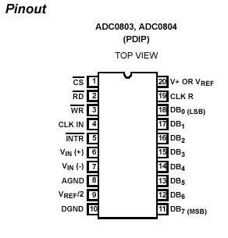

Figure 4.1

4.2 Understanding A/D Error Specs
It has a perfect A/D transfer characteristic (staircase wave-form) the horizontal scale is analog input voltage and the particular points labeled are in steps of 1LSB (19.53mV with 2.5V tied to the V REF /2 pin). The digital output codes which correspond to these inputs are shown as D-1, D, and D+1. For the perfect A/D, not only will center-value (A - 1, A, A + 1, . . .) analog inputs produce the correct output digital codes, but also each riser (the transitions between adjacent output codes) will be located 1 / 2 LSB
away from each center-value. As shown, the risers are ideal and have no width. Correct digital output codes will be provided for a range of analog input voltages which extend 1 / 2 LSB from the ideal center-values. Each tread (the range of analog input voltage which provides the same digital output code) is therefore 1 LSB wide. The error curve of Figure 11B shows the worst case transfer function for the ADC080X. Here the specification guarantees that if we apply an analog input equal to the LSB analog voltage center-value, the A/D will produce the correct digital code.

4.3 Detailed Description
The functional diagram of the ADC080X series of A/D converters operates on the successive approximation principle. Analog switches are closed sequentially by successive-approximation logic until the analog differential input voltage [V lN(+) - V lN(-) ] matches a voltage derived from a tapped resistor string across the reference voltage. The most significant bit is tested first and after 8 comparisons (64 clock cycles), an 8- bit binary code (1111 1111 = full scale) is transferred to an output latch.

The normal operation proceeds as follows. On the high-to-low transition of the WR input, the internal SAR latches and the shift-register stages are reset, and the INTR output will be set high. As long as the CS input and WR input remain low, the A/D will remain in a reset state. Conversion will start from 1 to 8 clock periods after at least one of these inputs makes a low-to- high transition. After the requisite number of clock pulses to complete the conversion, the INTR pin will make a high-to-low transition. This can be used to interrupt a processor, or otherwise signal the availability of a new conversion. A RD operation (with CS low) will clear the INTR line high again. The device may be operated in the free-running mode by connecting INTR to the WR input with CS = 0. To ensure start-up under all possible conditions, an external WR pulse is required during the first power-up cycle. A conversion-in-process can be interrupted by issuing a second start command.

Digital Operation
The converter is started by having CS and WR simultaneously low. This sets the start flip-flop (F/F) and the resulting “1” level resets the 8-bit shift register, resets the Interrupt (INTR) F/F and inputs a “1” to the D flip-flop, DFF1, which is at the input end of the 8-bit shift register. Internal clock signals then transfer this “1” to the Q output of DFF1. The AND gate, G1, combines this “1” output with a clock signal to provide a reset signal to the start F/F. If the set signal is no longer present (either WR or CS is a “1”), the start F/F is reset and the 8-bit shift register then can have the “1” clocked in, which starts the conversion process. If the set signal were to still be present, this reset pulse would have no effect (both outputs of the start F/F would be at a “1” level) and the 8-bit shift register would continue to be held in the reset mode. This allows for asynchronous or wide CS and WR signals.
After the “1” is clocked through the 8-bit shift register (which completes the SAR operation) it appears as the input to DFF2. As soon as this “1” is output from the shift register, the AND gate, G2, causes the new digital word to transfer to the Three-State output latches. When DFF2 is subsequently
clocked, the Q output makes a high-to-low transition which causes the INTR F/F to set. An inverting buffer then supplies the INTR output signal.
When data is to be read, the combination of both CS and RD being low will cause the INTR F/F to be reset and the three-state output latches will be enabled to provide the 8-bit digital outputs.

Digital Control Inputs
The digital control inputs (CS, RD, and WR) meet standard TTL logic voltage levels. These signals are essentially equivalent to the standard A/D Start and Output Enable control signals, and are active low to allow an easy interface to microprocessor control busses. For non-microprocessor based applications, the CS input (pin 1) can be grounded and the standard A/D Start function obtained by an active low pulse at the WR input (pin 3). The Output Enable function is achieved by an active low pulse at the RD input (pin 2).

Analog Operation
The analog comparisons are performed by a capacitive charge summing circuit. Three capacitors (with precise ratioed values) share a common node with the input to an auto-zeroed comparator. The input capacitor is switched between V lN(+) and V lN(-) , while two ratioed reference capacitors are switched between taps on the reference voltage divider string. The net charge corresponds to the weighted difference between the input and the current total value set by the successive approximation register. A correction is made to offset the comparison by 1 / 2.

Analog Input Current
The internal switching action causes displacement currents to flow at the analog inputs. The voltage on the on-chip capacitance to ground is switched through the analog differential input voltage, resulting in proportional currents entering the V IN(+) input and leaving the V IN(-) input. These current transients occur at the leading edge of the internal clocks. They rapidly decay and do not inherently cause errors as the on-chip comparator is strobe at the end of the clock period.

Reference Voltage Span Adjust
For maximum application flexibility, these A/Ds have been designed to accommodate a 5V, 2.5V or an adjusted voltage reference. This has been achieved in the design of the IC as shown in Figure 4.2. Notice that the reference voltage for the IC is either 1 / 2 of the voltage which is applied to the V+ supply pin, or is equal to the voltage which is externally forced at the V REF / 2 pin. This allows for a pseudo-ratio metric voltage reference using, for the V+ supply, a 5V reference voltage. Alternatively, a voltage less than 2.5V can be applied to the V REF /2 input. The internal gain to the V REF /2 inputs is 2 to allow this factor of 2 reductions in the reference voltage such an adjusted reference voltage can accommodate a reduced span or dynamic voltage range of the analog input voltage. If the analog input voltage were to range from 0.5V to 3.5V, instead of 0V to 5V, the span would be 3V. With 0.5V applied to the V lN(-) pin to absorb the offset, the reference voltage can be made equal to 1 / 2 of the 3V span or 1.5V. The A/D now will encode the V lN(+) signal from 0.5V to 3.5V with the 0.5V input corresponding to zero and the 3.5V input corresponding to full scale. The full 8 bits of resolution are therefore applied over this reduced analog input voltage range. The requisite connections are shown in Figure 4.3. For expanded scale inputs, the circuits of Figures 4.4 and 4.5 can be used.
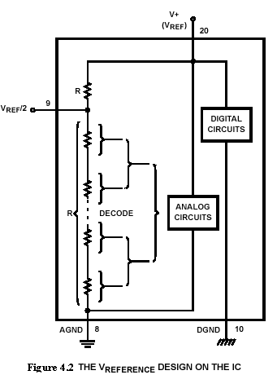

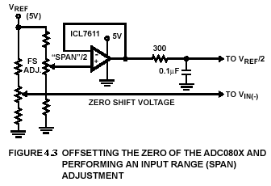
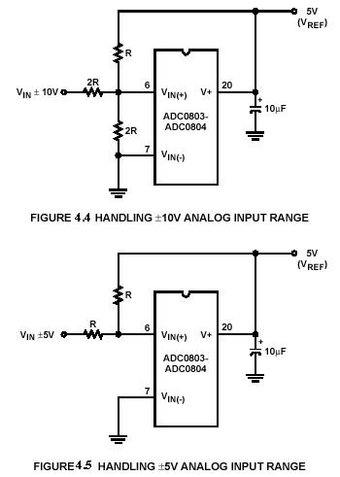
Clocking Option
The clock for the A/D can be derived from an external source such as the CPU clock or an external RC network can be added to provide self-clocking. The CLK IN (pin 4) makes use of a Schmitt trigger as shown in Figure 4.6.

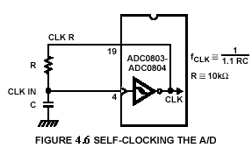
Heavy capacitive or DC loading of the CLK R pin should be avoided as this will disturb normal converter operation. Loads less than 50pF, such as driving up to 7 A/D converter clock inputs from a single CLK R pin of 1 converter, are allowed. For larger clock line loading, a CMOS or low power
TTL buffer or PNP input logic should be used to minimize the loading on the CLK R pin (do not use a standard TTL buffer).

Restart During a Conversion
If the A/D is restarted (CS and WR go low and return high) during a conversion, the converter is reset and a new conversion is started. The output data latch is not updated if the conversion in progress is not completed. The data from the previous conversion remain in this latch.
Continuous Conversions
In this application, the CS input is grounded and the WR input is tied to the INTR output. This WR and INTR node should be momentarily forced to logic low following a power-up cycle to insure circuit operation. See Figure 4.7 for details.
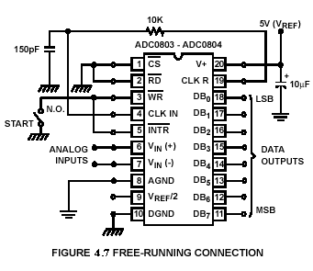

4.4 Interfacing 8051
The easiest way to do analog to digital conversion is to use an IC such as the ADC0804 that does the work for you. The analog voltage is applied to pin 6 and the result is available at pins 11 through 18. We will connect pin 1 and 2 (Chip Select and Read) to ground so that the chip is always enabled. (If you wanted to use more than one ADC you could use this pin to control which chip is currently enabled).
Connect pin 7 (Vin - ) to ground. The ADC0804 includes an internal oscillator which requires an external capacitor and resistor to operate. Connect the 150 pF capacitor from pin 4 (CLOCK IN) to ground and the 10k ohm resistor from pin 4 to pin 19 (CLOCK R).
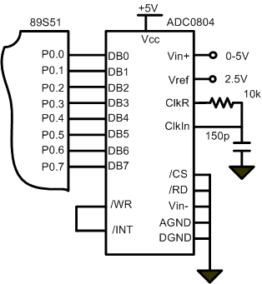
Figure 4.8 Typical connection of free running mode
CHAPTER-V

HARDWARE DETAILS OF LEVEL & TEMPERATURE CONTROLLER USING MICROCNTROLLER

5.1 Hardware Components
The equipment consists of the following Hardware components
- Micro-controller AT89C51
- A/D Converter 0803/0804
- LM 35 Precision Temperature Sensor
- Level Sensor (Resistance Method)
- Optocoupler MCT-2E
- LCD Display GDM2004D
- Regulated Power supply (+5V)
- Relay

5.2 LM 35 Precision Temperature Sensor

General Description
The LM35 series are precision integrated-circuit temperature sensors, whose output voltage is linearly proportional to the Celsius (Centigrade) temperature. The LM35 thus has an advantage over linear temperature sensors calibrated in ° Kelvin, as the user is not required to subtract a large constant voltage from its output to obtain convenient Centigrade scaling. The LM35 does not require any external calibration or trimming to provide typical accuracies of ±¼°C at room temperature and ±¾°C over a full -55 to +150°C temperature range. Low cost is assured by trimming and calibration at the wafer level. The LM35's low output impedance, linear output, and precise inherent calibration make interfacing to readout or control circuitry especially easy. It can be used with single power supplies, or with plus and minus supplies. As it draws only 60 µA from its supply, it has very low self-heating, less than 0.1°C in still air. The LM35 is rated to operate over a -55° to +150°C temperature range, while the LM35C is rated for a -40° to +110°C range (-10° with improved accuracy). The LM35 series is available packaged in hermetic TO-46 transistor packages, while the LM35C, LM35CA, and LM35D are also available in the plastic TO-92 transistor package. The LM35D is also available in an 8-lead surface mount small outline package and a plastic TO-220 package.
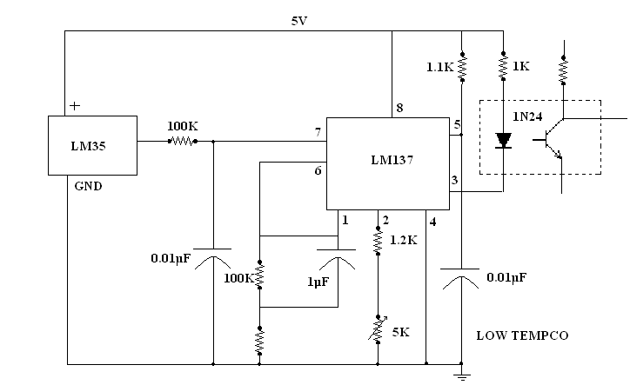
Figure 5.1
Features
• | Calibrated directly in ° Celsius (Centigrade)
• | Linear + 10.0 mV/°C scale factor
• | 0.5°C accuracy guarantee able (at +25°C)
• | Rated for full -55° to +150°C range
• | Suitable for remote applications
• | Low cost due to wafer-level trimming
• | Operates from 4 to 30 volts
• | Less than 60 µA current drain
• | Low self-heating, 0.08°C in still air
• | Nonlinearity only ±¼°C typical
• | Low impedance output, 0.1 Ohm for 1 mA load
Table 5.1
LM35 TEMPERATURE SENSOR SERIES SELECTION
GUIDE
PART | TEMPERATURE RANGE | ACCURACY | OUTPUT SCALE
LM35A | -55 C to +150 C | +1.5 C | 10mV/C
LM35 | -55 C to +150 C | +1.5 C | 10mV/C
LM35CA | -40 C to +110 C | +1.0 C | 10mV/C
LM35C | -40 C to +110 C | +1.5 C | 10mV/C
LM35D | 0 C to +100 C | +2.0 C | 10mV/C

5.3 LEVEL PROBE
The probes consist of five conductors mounted at different levels. As the level increases each transistor becomes conductive step by step. Accordingly the +5v supply gets connected to the concerned pin of the microcontroller port which assumes it as a high level. If a transistor is not conducting due to lack of water level, the respective bit of microcontroller is assumed as low level.

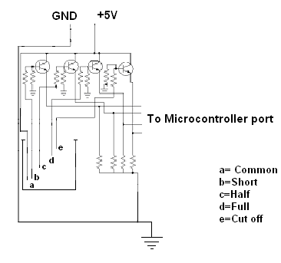
Figure 5.2
Advantages:
- Where there is a need for a fairly continuous record of the level, more and more contact rods can be added, with separate signal outputs for each contact rod. The signal can be used for indication and also for initiating some control action to actuate valves or pumps as well as warning lights and alarms depending upon the level.
- The system uses low voltage to eliminate danger to operators and to prevent arcing at the contact point.

Disadvantages:
- In order to have a step less indicating of the liquid level, an extremely large number of contacts rods are needed.
- The contact rods are corroded by corrosive liquids. In addition, the electric charges promote corrosion.

5.4 OPTOCOUPLER (MCT-2E)

The MCT2XXX series opt isolators consist of a gallium arsenate infrared emitting diode driving a silicon phototransistor in a 6-pin dual in-line package. There is no electrical connection between the two, just a beam of light. The light emitter is nearly always an LED. The light sensitive device may be a photodiode, phototransistor, or more esoteric devices such as thyristors, triacs etc. To carry a signal across the isolation barrier, optocouplers are operated in linear mode.

Pin Description of MCT2E
Fig shows the six-pin IC package for an optocoupler and the electronic diagram of its pin outline. The IC package may also be called an IC or a chip. It is important to note that each type of optocoupler may use different pin assignments.
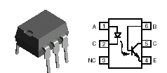

Pin no. | Function
1 | Anode
2 | Cathode
3 | NC
4 | Emitter
5 | Collector
6 | Base
MCT-2E Pins
Figure 5.3

Detectors and Emitters
For carrying a linear signal across isolation barrier there are two types of optocouplers. Both types use an infrared light emitting diode (LED) to generate and send a light signal across an isolation barrier. The difference is in the detection method. Some optocouplers use a phototransistor detector while others use a photodiode detector which drives the base of a transistor.

The phototransistor detector uses the transistors collector base junction to detect the light signal. This necessitates that the base area be relatively large compared to a standard transistor. The result is a large collector to base capacitance which slows the collector rise time and limits the effective frequency response of the device. In addition the amplified photocurrent flows in the collector base junction and modulates the response of the transistor to the photons. This cause the transistor to behave in a non-linear manner. Typical phototransistor gains range from 100 to 1000.
The photodiode/transistor detector combination on the other hand uses a diode to detect the photons and convert them to a current to drive the transistor base. The transistor no longer has a large base area. The response of this pair is not affected by amplified photocurrent and the photodiode capacitance does not impair speed.

Optocoupler Operation
Optocouplers are good devices for conveying analog information across a power supply isolation barrier, they operate over a wide temperature range and are often safety agency approved they do, however, have many unique operating considerations.
Optocouplers are current input and current output devices. The input LED is excited by changes in drive current and maintains a relatively constant forward voltage. The output is a current which is proportional to the input current. The output current can easily be converted to a voltage through a pull-up or load resistor.

Applications
- AC mains detection
- Reed relay driving
- Switch mode power supply feedback
- Telephone ring detection
- Logic ground isolation
- Logic coupling with high frequency noise rejection.
5.5 Power supply unit

Need of power supply
Perhaps all of you are aware that a power supply is a primary requirement for the test bench of a home experimenter’s mini lab. A battery eliminator can eliminate or replace the batteries of solid-state electronic equipment and 220V A.C. mains instead of the batteries or dry cells thus can operate the equipment. Nowadays, the sued of commercial battery eliminator or power supply unit have become increasingly popular as power source for household appliances like transceiver, record player, clock etc.
Summary of power supply circuit features:-
- Brief description of operation: gives out well regulated +5V output, output current capability of 500mA.
- Circuit protection: Built –in overheating protection shuts down output when regulator IC gets too hot.
- Circuit complexity: simple and easy to build.
- Circuit performance: Stable +5V output voltage, reliable Operation.
- Availability of components: Easy to get, uses only common basic components.
- Design testing: Based on datasheet example circuit, I have used this circuit successfully as part of other electronics projects.
- Applications: part of electronics devices, small laboratory power supply.
- Power supply voltage: unregulated 8-18V-power supply.
- Power supply current: needed output current 500 mA.
- Components cost: Few rupees for the electronic components plus the cost of input transformer.

Pin Diagram of 7805 Regulator IC
Pin 1: Unregulated voltage input
Pin 2: Ground
Pin3: Regulated voltage output

Component list

- 7805 regulator IC
2. 12- 0-12 transformer
3. 1000uf and 100uf. Capacitor, at least 25V voltage rating.
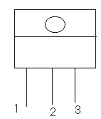

Figure 5.4

DESCRITION OF POWER SUPPLY

This circuit is a small + 5 volts power supply. This is useful when experimenting with digital electronics. Small inexpensive battery with variable output voltage are available, but usually their voltage regulation is very poor, which makes them not very usable for digital circuit experimenter unless a better regulation can be achieved in some way. The following circuit is the answer to the problem.
This circuit can give +5V output at about 500mA current. The circuit has overload and terminal protection.
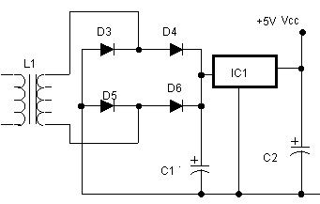
Figure 5.5
The above circuit utilizes the voltage regulator IC 7805 for the constant power supply. The capacitors must have enough high voltage rating to safely handle the input voltage feed to circuit. The circuit is very easy to build for example into a piece of Zero board.
For the proper working of this local control section except the mobile phone or local telephone set it needs a permanent back up which gives a 8V back up continuously. This is achieved by using a 8V regulated power supply from a voltage regulated IC 7805. This 5V source is connected to all ICs and relays.

5.6 LIQUID CRYSTAL DISPLAY
It can display 4 lines of 20 characters each. It has green backlight which can be switched off if required by de-soldering the contact J5. Turning off the power increases the battery life.
After finishing the connections, the cable can be attached to the printer port on the back of your computer, and powered via a Molex connector from the inside of your computer case. When the computer is powered up, the LCD screen should - if working correctly - display a number of solid blocks.
The details of a LCD, its characteristics and features are given in the appendix C.

TABLE 5.2: LCD pin description
Pin | Symbol | I/O | Description
1 | VSS | - | Ground
2 | VCC | - | +5V power supply
3 | VEE | - | Power supply to control contrast
4 | RS | I | RS=0 to select command register, RS=1 to select data register.
5 | R/W | I | R/W=0 for write, R/W=1 for read
6 | E | I/O | Enable
7 | PB0 | I/O | The 8 bit data bus
8 | PB1 | I/O | The 8 bit data bus
9 | DB2 | I/O | The 8 bit data bus
10 | DB3 | I/O | The 8 bit data bus
11 | DB4 | I/O | The 8 bit data bus
12 | DB5 | I/O | The 8 bit data bus
13 | DB6 | I/O | The 8 bit data bus
14 | DB7 | I/O | The 8 bit data bus

5.7 RELAY
Relay is a common, application of electromagnetism. It uses an electromagnet made from an iron rod wound with hundreds of fine copper wire. When electricity is applied to the wire, the rod become magnetic. A movable contact arm above the rod is then pulled toward; a small spring pulls the contract arm away from the rod until it closes, a second switch contact. By means of relay, a current circuit can be broken or closed in one circuit as a result of a current in another circuit. Relays can have several poles and contacts. The types of contacts could be normally open and normally closed. One closure of the relay can turn on the same normally open contacts; can turn off the other normally closed contacts
A relay is a switch worked by an electromagnet. It is useful if we want a small current in one circuit to control another circuit containing a device such as a lamp or electric motor which requires a large current, or if we wish several different switch contacts to be operated simultaneously.
The structure of relay and its symbol are shown in figure. When the controlling current flows through the coil, the soft iron core is magnetized and attracts the L-shaped soft iron armature. This rocks on its pivot and opens, closes or changes over, the electrical contacts in the circuit being controlled.
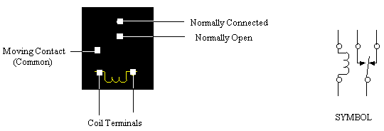

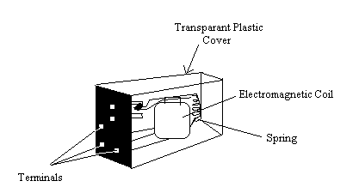

Figure 5.6

Completer Circuit Diagram

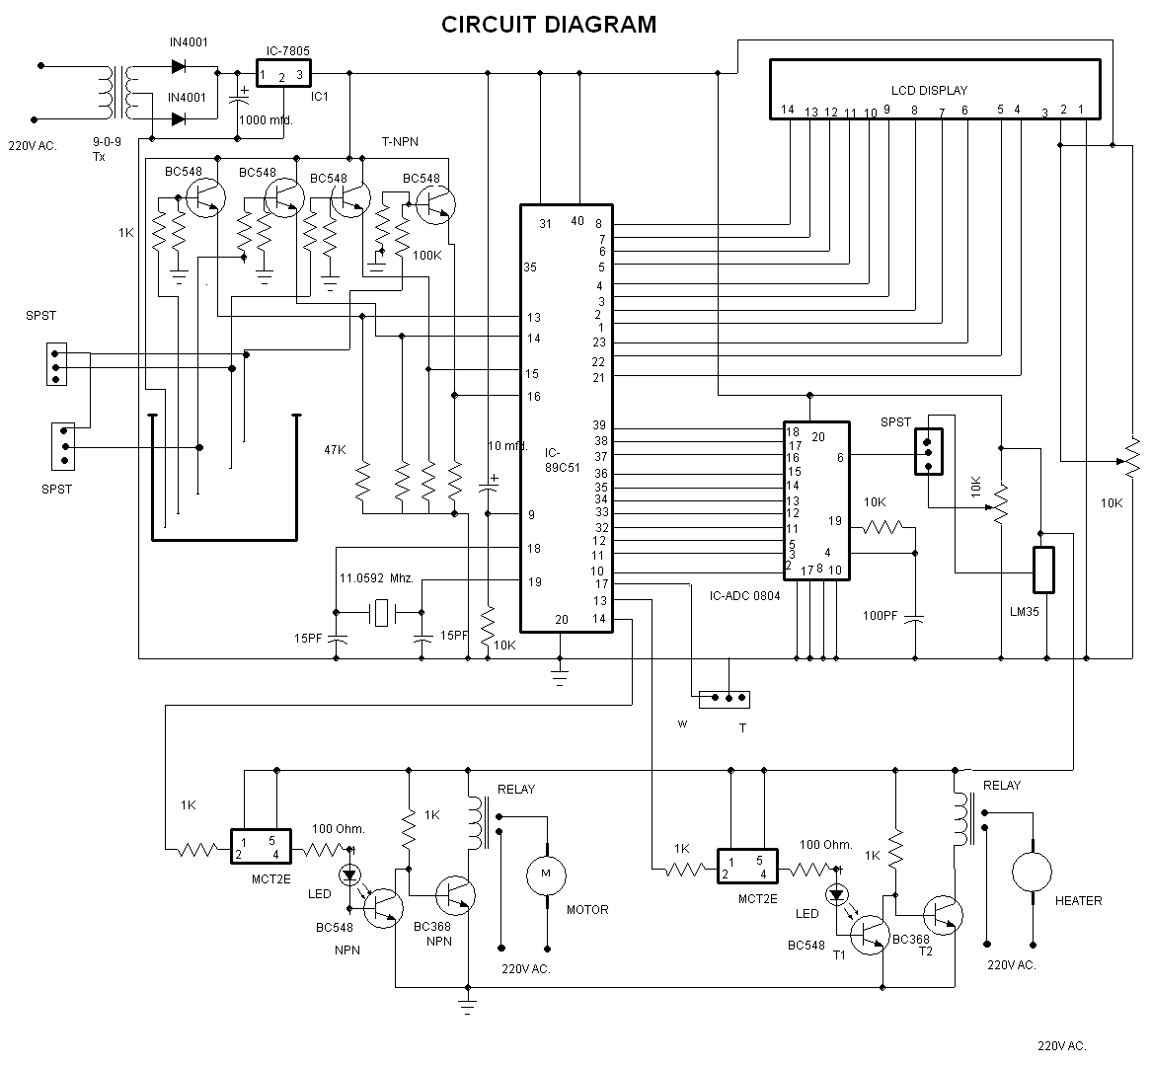

CHAPTER – VI

SOFTWARE DETAILS

6.1 INTRODUCTION
The software part of the LEVEL & TEMPERATURE CONTROLLER is written for execution on 8051 micro-controller. The flow Chart of the software is given below
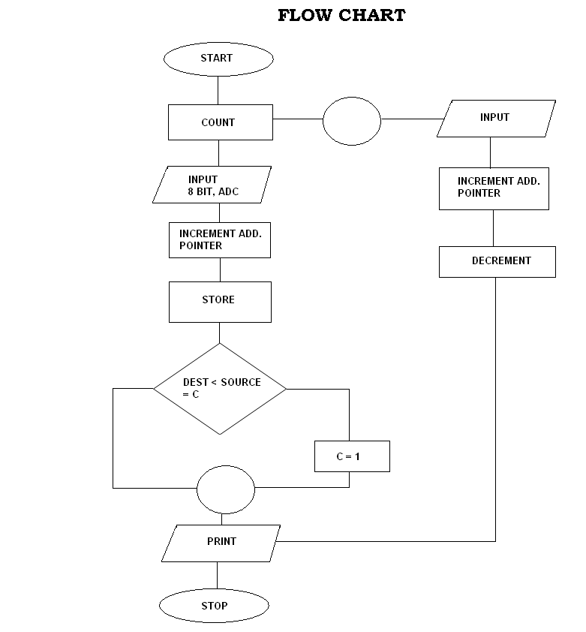

Figure 6.1

6.2 PROGRAM

org 0000

setb p3.6
;setb p3.3
;clr c
Q: JNB P3.6,heater
ajmp waterlevel
; here is heater prog

heater:
ram_addr equ 40h
asci_rsult equ 50h
count equ 3
acall SETUP
mov p0,#0ffh
setb p3.2
back:
clr p3.1
setb p3.1
here: jb p3.2,here
clr p3.0
mov a,p0
mov r6,p0
jnb P3.3,bu
clr p3.5
jb P3.3,$
setb p3.5
mov r5,p0
bu:
acall conversion
acall data_display
setb p3.0
acall DELAY
mov A,R5
clr c
subb a,r6
;acall DELAY
jc next
setb p3.5
sjmp back
next:
clr p3.5
sjmp back

conversion:
acall bin_dec_convrt
acall dec_asci_convrt
SETUP:MOV A,#38H
ACALL COMNWRT
ACALL DELAY
MOV A,#0EH
ACALL COMNWRT
ACALL DELAY
MOV A,#01
ACALL COMNWRT
ACALL DELAY
MOV A,#06H
ACALL COMNWRT
ACALL DELAY
MOV A,#80H
ACALL COMNWRT
ACALL DELAY
ret
COMNWRT:
MOV P1,A
CLR P2.0
CLR P2.1
SETB P2.2
ACALL DELAY
CLR P2.2
RET
DATAWRT:
MOV P1,A
SETB P2.0
CLR P2.1
SETB P2.2
ACALL DELAY
CLR P2.2
RET

data_display:
MOV A,52H
ACALL DATAWRT
ACALL DELAY
MOV A,51H
ACALL DATAWRT
ACALL DELAY
MOV A,50H
ACALL DATAWRT
ACALL DELAY
MOV A,#' '
ACALL DATAWRT
ACALL DELAY
MOV A,#'C'
ACALL DATAWRT
ACALL DELAY
RET

bin_dec_convrt:
mov r0,#ram_addr
mov a,p0
mov b,#10
div ab
mov @r0,b
inc r0
mov b,#10
div ab
mov @r0,b
inc r0
mov @r0,a
ret

dec_asci_convrt:
mov r0,#ram_addr
mov r1,#asci_rsult
mov r2,#3
b1: mov a,@r0
orl a,#30h
mov @r1,a
INC R0
inc r1
djnz r2,b1
ret

DELAY: MOV R3,#150
HERE2: MOV R4,#150
HER: DJNZ R4,HER
DJNZ R3,HERE2
RET
; now water lavel
waterlevel:
setb p2.4
setb p2.5
setb p2.6
setb p2.7
setb p3.4
;MOV P3,#0FFH
;MOV P2,#0FFH

MOV R0,#04H
MOV R1,#04H
MOV R5,#05H
MOV A,#38H
ACALL COMNWR
ACALL DELAY1
MOV A,#0EH
ACALL COMNWR
ACALL DELAY1
MOV A,#01
ACALL COMNWR
ACALL DELAY1
MOV A,#06H
ACALL COMNWR
ACALL DELAY1
MOV A,#80H
ACALL COMNWR
ACALL DELAY1
MAIN:
MOV R0,#04H
MOV R1,#04H
MOV R5,#05H
GG:JNB P2.6,GG

;
A1:JNB P2.5,A1
mov A,#01H
ACALL COMNWR
ACALL DELAY1
MOV DPTR,#LOOK2
BA1: CLR A
MOVC A,@A+DPTR
ACALL DATAWR
ACALL DELAY1
INC DPTR
DJNZ R5,BA1
;
A2:JNB P2.4,A2
mov A,#01H
ACALL COMNWR
ACALL DELAY1
MOV DPTR,#LOOK1
BAC1: CLR A
MOVC A,@A+DPTR
ACALL DATAWR
ACALL DELAY1
INC DPTR
DJNZ R1,BAC1
;
A3:JNB P2.3,A3
CLR P3.4
mov A,#01H
ACALL COMNWR
ACALL DELAY1
MOV DPTR,#LOOK
BACK1: CLR A
MOVC A,@A+DPTR
ACALL DATAWR
ACALL DELAY1
INC DPTR
DJNZ R0,BACK1

;
MOV R0,#04H
MOV R1,#04H
MOV R5,#05H

F2:JB P2.4,F2
mov A,#01H
ACALL COMNWR
ACALL DELAY1
MOV DPTR,#LOOK1
BAC: CLR A
MOVC A,@A+DPTR
ACALL DATAWR
ACALL DELAY1
INC DPTR
DJNZ R1,BAC
F3:JB P2.5,F3
mov A,#01H
ACALL COMNWR
ACALL DELAY1
MOV DPTR,#LOOK2
BA: CLR A
MOVC A,@A+DPTR
ACALL DATAWR
ACALL DELAY1
INC DPTR
DJNZ R5,BA
F5: JB P2.6,F5
SETB P3.4

ACALL MAIN

COMNWR:
MOV P1,A
CLR P2.0
CLR P2.1
SETB P2.2
ACALL DELAY1
CLR P2.2
RET
DATAWR:
MOV P1,A
SETB P2.0
CLR P2.1
SETB P2.2
ACALL DELAY1
CLR P2.2
RET
water:
setb p3.4

DELAY1: MOV R3,#150
HERE21: MOV R4,#150
HERE1: DJNZ R4,HERE1
DJNZ R3,HERE21
RET

LOOK: DB "FULL"
LOOK1: DB "HALF"
LOOK2: DB "SHORT"

END

CHAPTER – VII

CONCLUSION & FUTURE SCOPE

7.1 Conclusion
A typical level and temperature control loop has been implemented in this project using 89C51 microcontroller and 0804 ADC chip. The temperature sensor used is LM35, and resistance base level probe is used for level signal pick-up. The mode selection switch (SPST) is used to select the control loop of level or temperature. Multiple control loops can be built in this system using ADCs like 0809 wherein we can use 8-channels of analog inputs.

7.2 Future Scope
Sampling and ADC can be kept in interrupt mode. Calculation of proportional signal (Y_{p}), integral signal (Y_{i}) and derivative signal (Y_{p}) can be done in separate subroutines. Further cumulative control signal Y=Y_{p}+Y_{i}+Y_{d} can be calculated using another subroutines, to implement PID and algorithm. Also, keyboard can be interfaced to set the desired value of the controlled variable. Also, suitable function keys can be assigned to select/ adjust the parameters namely K_{d}, K_{i}, K_{p} at the desired value.

REFERENCES

- “The 8051 Micro-Controller and Embedded Systems” by Mazidi, Gillispie & Mckinlay, Pearson Education

- “8051 Micro-Controller” by J.Ayala

- “Course in Electrical & Electronic measurements & Instrumentation”,A.K Sawhney

- “Introduction to Microcontroller & their application”, T.R.Padmanabhan

- User’s Manual of VMC – PID of Vinytics Peripherals Pvt. Ltd.

- www.amrita.edu/downloads/micro.ppt

- google.com

- Intel “MCS51 microcontroller family user’s manual”

- Padmanabhan, T.R., “Industrial Instrumentation Principles & Design”.

- “Instrument Engineer’s Handbook”, M.Considine

- “Instrument Engineer’s Handbook” , Bela G.Liptak, kriszta Venczel

Appendix-a

Mnemonic |  |  |  | Description
Arithmetic Operation  ADD A, Rn  ADD A, direct  ADD A, @Ri  ADD A, #data  ADDC A, Rn  ADDC A, direct  ADDC A, @Ri  ADDC A, #data  SUBB A, Rn  SUBB A, direct  SUBB A, @Ri  SUBB A, #data  INC A  INC Rn  INC direct  INC @Ri  DEC A  DEC Rn  DEC direct  DEC @Ri  INC DPTR  MUL AB  DIV AB  DA A |  |  |  | Add register to accumulator  Add direct byte to accumulator  Add indirect RAM to accumulator  Add immediate data to accumulator  Add register to Accumulator with carry  Add direct byte to accumulator with carry  Add indirect RAM to ACC with carry  Add immediate data to Acc with carry  Subtract Register from Acc with borrow  Subtract direct byte from Acc with borrow  Subtract indirect RAM from Acc with borrow  Subtract immediate data to Acc with borrow  Increment Accumulator  Increment register  Increment direct byte  Increment direct RAM  Decrement Accumulator  Decrement register  Decrement direct byte  Decrement indirect RAM  Increment Data Pointer  Multiply A & B  Divide A by B  Decimal Adjust Accumulator
LOGICAL OPERATIONS
ANL | A,Rn | AND Register to accumulaor
ANL | A, direct | AND direct byte to accumulator
ANL | A, @Ri | AND indirect RAM to accumulator
ANL | A, #data | AND immediate data to accumulator
ANL | direct, A | AND Accumulator to direct byte
ANL | direct, #data | AND immediate data to direct byte
ORL | A, Rn | OR register to accumulator
ORL | A, direct | OR direct byte to accumulator
ORL | A, @Ri | OR indirect RAM to accumulator
ORL | A, #data | OR immediate data to accumulator
ORL | direct, a | OR Accumulator to direct byte
ORL | direct, #data | OR immediate data to direct byte
XRL | A, Rn | Exclusive-OR register to Accumulator
XRL | A, direct | Exclusive-OR byte to Accumulator
XRL | A, @Ri | Exclusive-OR indirect RAM to accumulator
XRL | A, data | Exclsive-OR immediate data to accumulator
XRL | direct, A | Exclusive-OR accumulator to direct byte
XRL | direct, #data | Exclusive-OR immediate data to direct byte
CLR | A | Clear Accumulator
CPL | A | Complement Accumulator
RL | A | Rotate Accumulator left
RLC | A | Rotate Accumulator left through the carry
RR | A | Rotate Accumulator Right
RRC | A | Rotate Accumulator right through the carry
SWAP | A | Swap nibbles within the Accumulator
DATA TRANSFER
MOV | A,Rn | Move register to accumulator
MOV | A, direct | Move direct byte to accumulator
MOV | A, @Ri | Move indirect RAM to accumulator
MOV | A, #data | Move immediate data to accumulator
MOV | Rn, A | Move accumulator to register
MOV | Rn, direct | Move direct byte to register
MOV | Rn, #data | Move immediate data to register
MOV | direct, A | Move accumulator to direct byte
MOV | direct, Rn | Move register to direct byte
MOV | direct, direct | Move direct byte to direct
MOV | direct, @Ri | Move indirect RAM to direct byte
MOV | direct, #data | Move immediate data to direct byte
MOV | @Ri, A | Move accumulator to indirect RAM
MOV | @Ri, direct | Move direct byte to indirect RAM
MOV | @Ri, #data | Move immediate data to indirect RAM
MOV | DPTR, #data16 | Load data pointer with a 16bit constant
MOVC | A, @A+DPTR | Move code byte relative to DPTR to accumulator
MOVC | A, A+PC | Move code byte relative to PC to accumulator
MOVX | A, @Ri | Move external RAM (8bit addr) to accumulator
MOVX | A, @DPTR | Move exteranl RAM (16bit addr) to accumulator
MOVX | @Ri,A | Move accumulator to external RAM(8bit addr)
MOVX | @DPTR, A | Move accumulator to external RAM(16bit addr)
PUSH | direct | Push direct byte on to stack
POP | direct | Pop direct byte from stack
XCH | A, Rn | Exchange register with accumulator
XCH | A, direct | Exchange direct byte with accumulator
XCH | A, @Ri | Exchange indirect RAM with accumulator
XCHD | A, @Ri | Exchange low order digit indirect RAM with accumulator
BOOLEAN VARIABLE MANIPULATION

CLR | C | Clear Carry
CLR | bit | Clear direct bit
SETB | C | Set Carry
SETB | bit | Set direct bit
CPL | C | Complement Carry
CPL | bit | Complement direct bit
ANL | C, bit | AND direct bit to Carry
ANL | C, /bit | AND complement of direct bit to Carry
ORL | C. bit | OR direct bit to Carry
ORL | C, /bit | OR complement of direct bit to Carry
MOV | C, bit | Move direct bit to Carry
MOV | bit, C | Move Carry to direct bit
JC | rel | Jump if Carry is set
JNC | rel | Jump if Carry is not set
JB | bit, rel | Jump if direct bit is set
JNB | bit, rel | Jump if direct bit is not set
JBC | bit, rel | Jump if direct bit is set & clear bit
PROGRAM BRANCHING

ACALL | addr11 | Absolute subroutine call
LCALL | addr16 | Long subroutine call
RET |  | Return from subroutine
RET1 |  | Return from interrupt
AJMP | addr11 | Absolute jump
LJMP | addr16 | Long jump
SJMP | rel | short jump(relative addr)
JMP | @A+DPTR | Jump indirect relative to DPTR
JZ | rel | Jump if accumulator is zero
JNZ | rel | Jump if accumulator is not zero
CJNE | A, direct,rel | Compare direct byte to accumulator and jump if not equal
CJNE | A, #data, rel | Compare immediate to accumulator and jump if not equal
CJNE | Rn, #data, rel | Compare immediate to register and jump if not equal
CJNE | @Ri, #data, rel | compare immediate to indirect and jump if not equal
DJNZ | Rn, rel | Decrement register and jump if Not Zero
DJNZ | direct, rel | Decrement direct byte and jump if Not Zero
NOP |  | No Operation

APPENDIX-B

Instruction Opcodes in Hexadecimal Order

HEX  CODE | Number of  Bytes | Mnemonics | Operands
00 | 1 | NOP
01 | 2 | AJMP | Code addr
02 | 3 | LJMP | Code addr
03 | 1 | RR | A
04 | 1 | INC | A
05 | 2 | INC | Data addr
06 | 1 | INC | @ R0
07 | 1 | INC | @ R1
08 | 1 | INC | R0
09 | 1 | INC | R1
0A | 1 | INC | R2
0B | 1 | INC | R3
0C | 1 | INC | R4
0D | 1 | INC | R5
0E | 1 | INC | R6
0F | 1 | INC | R7
10 | 3 | JBC | Bit addr, code addr
11 | 2 | ACALL | Code addr
12 | 3 | LCALL | Code addr
13 | 1 | RRC | A
14 | 1 | DEC | A
15 | 2 | DEC | Data addr
16 | 1 | DEC | @R0
17 | 1 | DEC | @R1
18 | 1 | DEC | R0
19 | 1 | DEC | R1
1A | 1 | DEC | R2
1B | 1 | DEC | R3
1C | 1 | DEC | R4
1D | 1 | DEC | R5
1E | 1 | DEC | R6
1F | 1 | DEC | R7
20 | 3 | JB | Bit addr, code addr
21 | 2 | AJMP | Code addr
22 | 1 | RET
23 | 1 | RL | A
24 | 2 | ADD | A,# data
25 | 2 | ADD | A, data addr
26 | 1 | ADD | A,@R0
27 | 1 | ADD | A,@R1
28 | 1 | ADD | A,R0
29 | 1 | ADD | A,R1
2A | 1 | ADD | A,R2
2B | 1 | ADD | A,R3
2C | 1 | ADD | A,R4
2D | 1 | ADD | A,R5
2E | 1 | ADD | A,R6
2F | 1 | ADD | A,R7
30 | 3 | JNB | Bit addr, Bit addr, code addr
31 | 2 | ACALL | code addr
32 | 1 | RETI
33 | 1 | RLC | A
34 | 2 | ADDC | A,# data
35 | 2 | ADDC | A, data addr
36 | 1 | ADDC | A,@R0
37 | 1 | ADDC | A,@R1
38 | 1 | ADDC | A,R0
39 | 1 | ADDC | A,R1
3A | 1 | ADDC | A,R2
3B | 1 | ADDC | A,R3
3C | 1 | ADDC | A,R4
3D | 1 | ADDC | A,R5
3E | 1 | ADDC | A,R6
3F | 1 | ADDC | A,R7
40 | 2 | JC | code addr
41 | 2 | AJMP | code addr
42 | 2 | ORL | data addr, A
43 | 3 | ORL | data addr, #data
44 | 2 | ORL | A,# data
45 | 2 | ORL | A,data addr
46 | 1 | ORL | A,@R0
47 | 1 | ORL | A,@R1
48 | 1 | ORL | A,R0
49 | 1 | ORL | A,R1
4A | 1 | ORL | A,R2
4B | 1 | ORL | A,R3
4C | 1 | ORL | A,R4
4D | 1 | ORL | A,R5
4E | 1 | ORL | A,R6
4F | 1 | ORL | A,R7
50 | 2 | ACALL | code addr
51 | 2 | ANL | code addr
52 | 2 | ANL | data addr, A
53 | 2 | ANL | data addr, #data
54 | 2 | ANL | A,# data
55 | 2 | ANL | A,data addr
56 | 1 | ANL | A,@R0
57 | 1 | ANL | A,@R1
58 | 1 | ANL | A,R0
59 | 1 | ANL | A,R1
5A | 1 | ANL | A,R2
5B | 1 | ANL | A,R3
5C | 1 | ANL | A,R4
5D | 1 | ANL | A,R5
5E | 1 | ANL | A,R6
5F | 1 | ANL | A,R7
60 | 2 | JZ | code addr
61 | 2 | AJMP | code addr
62 | 2 | XRL | data addr, A
63 | 3 | XRL | data addr, #data
64 | 2 | XRL | A,# data
65 | 2 | XRL | A, data addr
66 | 1 | XRL | A,@R0
67 | 1 | XRL | A,@R1
68 | 1 | XRL | A,R0
69 | 1 | XRL | A,R1
6A | 1 | XRL | A,R2
6B | 1 | XRL | A,R3
6C | 1 | XRL | A,R4
6D | 1 | XRL | A,R5
6E | 1 | XRL | A,R6
6F | 1 | XRL | A,R7
70 | 2 | JNZ | code addr
71 | 2 | ACALL | code addr
72 | 2 | ORL | C, bit addr
73 | 1 | JMP | @A+DPTR
74 | 2 | MOV | A, #data
75 | 3 | MOV | Data addr,# data
76 | 2 | MOV | @R0, # data
77 | 2 | MOV | @R1, # data
78 | 2 | MOV | R0, # data
79 | 2 | MOV | R1, # data
7A | 2 | MOV | R2, # data
7B | 2 | MOV | R3, # data
7C | 2 | MOV | R4, # data
7D | 2 | MOV | R5, # data
7E | 2 | MOV | R6, # data
7F | 2 | MOV | R7, # data
80 | 2 | SJMP | code addr
81 | 2 | AJMP | code addr
82 | 2 | ANL | C, bit addr
83 | 1 | MOVC | A, @A + PC
84 | 1 | DIV | AB
85 | 3 | MOV | data addr, data addr
86 | 2 | MOV | data addr, @R0
87 | 2 | MOV | data addr, @R1
88 | 2 | MOV | data addr, R0
89 | 2 | MOV | data addr, R1
8A | 2 | MOV | data addr, R2
8B | 2 | MOV | data addr, R3
8C | 2 | MOV | data addr, R4
8D | 2 | MOV | data addr, R5
8E | 2 | MOV | data addr, R6
8F | 2 | MOV | data addr, R7
90 | 3 | MOV | DPTR, #data
91 | 2 | ACALL | Code addr
92 | 2 | MOV | Bit addr
93 | 1 | MOVC | A, @A + DPTR
94 | 2 | SUBB | A, #data
95 | 2 | SUBB | A, data addr
96 | 1 | SUBB | A,@R0
97 | 1 | SUBB | A,@R1
98 | 1 | SUBB | A,R0
99 | 1 | SUBB | A,R1
9A | 1 | SUBB | A,R2
9B | 1 | SUBB | A,R3
9C | 1 | SUBB | A,R4
9D | 1 | SUBB | A,R5
9E | 1 | SUBB | A,R6
9F | 1 | SUBB | A,R7
A0 | 2 | ORL | C,/ bit addr
A1 | 2 | AJMP | Code addr
A2 | 2 | MOV | C, bit addr
A3 | 1 | INC | DPTR
A4 | 1 | MUL | AB
A5 |  | Reserved
A6 | 2 | MOV | @R0, data addr
A7 | 2 | MOV | @R1, data addr
A8 | 2 | MOV | R0, data addr
A9 | 2 | MOV | R1, data addr
AA | 2 | MOV | R2, data addr
AB | 2 | MOV | R3, data addr
AC | 2 | MOV | R4, data addr
AD | 2 | MOV | R5, data addr
AE | 2 | MOV | R6, data addr
AF | 2 | MOV | R7, data addr
B0 | 2 | ANL | C, / bit addr
B1 | 2 | ACALL | Code addr
B2 | 2 | CPL | Bit addr
B3 | 1 | CPL | C
B4 | 3 | CJNE | A, # data, code addr
B5 | 3 | CJNE | A, data addr, code addr
B6 | 3 | CJNE | @R0,# data, ,code addr
B7 | 3 | CJNE | @R1, #data, code addr
B8 | 3 | CJNE | R0, #data, code addr
B9 | 3 | CJNE | R1, #data, code addr
BA | 3 | CJNE | R2, #data, code addr
BB | 3 | CJNE | R3, #data, code addr
BC | 3 | CJNE | R4, #data, code addr
BD | 3 | CJNE | R5, #data, code addr
BE | 3 | CJNE | R6, #data, code addr
BF | 3 | CJNE | R7, #data, code addr
C0 | 2 | PUSH | Data addr
C1 | 2 | AJMP | Code addr
C2 | 2 | CLR | Bit addr
C3 | 1 | CLR | C
C4 | 1 | SWAP | A
C5 | 2 | XCH | A, data addr
C6 | 1 | XCH | A,@R0
C7 | 1 | XCH | A, @R1
C8 | 1 | XCH | A,R0
C9 | 1 | XCH | A,R1
CA | 1 | XCH | A,R2
CB | 1 | XCH | A,R3
CC | 1 | XCH | A,R4
CD | 1 | XCH | A,R5
CE | 1 | XCH | A,R6
CF | 1 | XCH | A,R7
D0 | 2 | POP | Data addr
D1 | 2 | ACALL | Code addr
D2 | 2 | SETB | Bit addr
D3 | 1 | SETB | C
D4 | 1 | DA | A
D5 | 3 | DJNZ | Data addr, code addr
D6 | 1 | XCHD | A, @R0
D7 | 1 | XCHD | A, @ R1
D8 | 2 | DJNZ | R0, code addr
D9 | 2 | DJNZ | R1, code addr
DA | 2 | DJNZ | R2, code addr
DB | 2 | DJNZ | R3, code addr
DC | 2 | DJNZ | R4, code addr
DD | 2 | DJNZ | R5, code addr
DE | 2 | DJNZ | R6, code addr
DF | 2 | DJNZ | R7, code addr
E0 | 1 | MOVX | A,@DPTR
E1 | 2 | AJMP | Code addr
E2 | 1 | MOVX | A, @R0
E3 | 1 | MOVX | A, @R1
E4 | 1 | CLR | A
E5 | 2 | MOV | A, data addr
E6 | 1 | MOV | A,@R0
E7 | 1 | MOV | A, @R1
E8 | 1 | MOV | A,R0
E9 | 1 | MOV | A,R1
EA | 1 | MOV | A,R2
EB | 1 | MOV | A,R3
EC | 1 | MOV | A,R4
ED | 1 | MOV | A,R5
EE | 1 | MOV | A,R6
EF | 1 | MOV | A,R7
F0 | 1 | MOVX | @DPTR, A
F1 | 2 | ACALL | Code addr
F2 | 1 | MOVX | @ R0, A
F3 | 1 | MOVX | @ R1, A
F4 | 1 | CPL | A
F5 | 2 | MOV | Data addr, A
F6 | 1 | MOV | @R0, A
F7 | 1 | MOV | @R1, A
F8 | 1 | MOV | R0, A
F9 | 1 | MOV | R1, A
FA | 1 | MOV | R2, A
FB | 1 | MOV | R3, A
FC | 1 | MOV | R4, A
FD | 1 | MOV | R5, A
FE | 1 | MOV | R6, A
FF | 1 | MOV | R7,A

APPENDIX – C

Technical aspects of the LCD

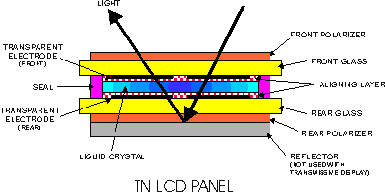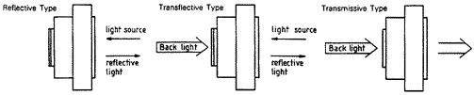
Liquid Crystal Display Technology
A Liquid Crystal Display (LCD) is a passive display device. Since they do not emit light, they use ambient light or some type of backlighting. LCD’s operate by manipulating this light to display images.
Types of LCD’s
Reflective LCD's have a full reflector attached to the rear polarizer and cannot be backlit. They are often used in battery-powered application and provide the best contrast in high ambient light conditions.

Transflective LCD's have a partially reflecting film attached to the rear polarizer and can either reflect ambient light or transmit EL, LED, fluorescent or incandescent backlights. They provide the most versatile viewing mode with only a slight reduction in contrast.

Transmissive LCD's do not have any reflective properties and must be used with a backlight. Depending on the backlight brightness, they can be used in well-lit indoor environments as well as dark conditions, however, this mode is not recommended for daylight usage. Transmissive LCD’s offer a different appearance for typical LCD's, bringing a light emitting look to the product.

different appearance for typical LCD's, bringing a light emitting look to the product.
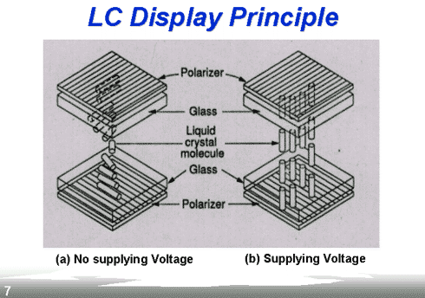
Powering the LCD
Backlight Details
- Light Emitting Diodes (LED) - LED’s offer a long-life and simple drive scheme. The typical operating life of an LED backlight is between 50k and 100k hours. Since the LED’s operate from a 5VDC voltage, no extra external circuitry is needed. A wide variety of colors is available with yellow/green being the most popular. Recently white LED’s have dropped in price and are gaining popularity very quickly.
- Electroluminescent (EL) - EL backlights have the advantage of providing a uniform light. Their power consumption is considerably lower than an LED backlight. EL backlights require ~100VAC @ 400Hz to operate. This voltage is supplied by an external inverter that converts a 5 or 12 VDC input into an AC output. EL life is measured by the time it takes for the lamp to degrade to half of its 50k hours.
- original brightness. Normally this range is 3k to 5k hours.
- Cold Cathode Fluorescent Lamp (CCFL) - CCFL backlights produce a very bright white light. CCFL backlights require an AC voltage to operate, 800VAC @ 30kHz. The operational life of CCFL backlights can be great.

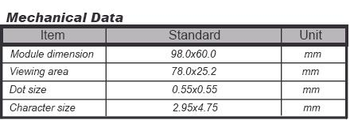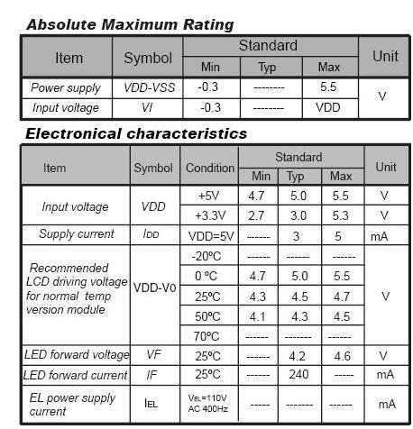

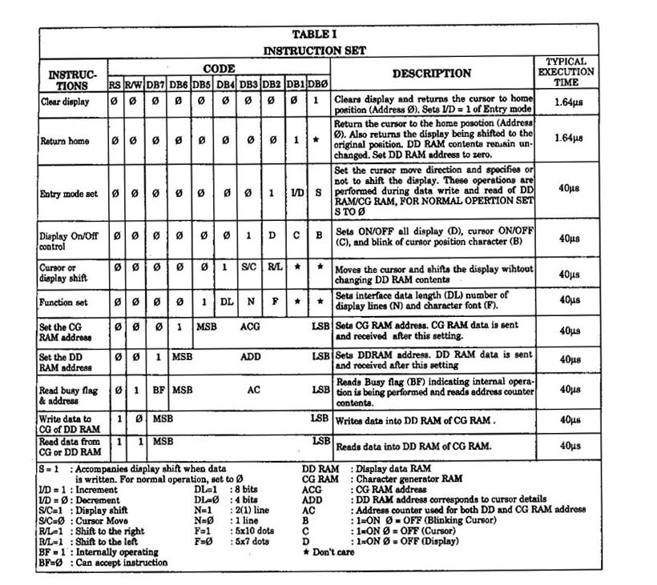

Example of busy flag testing using an 8-bit interface. 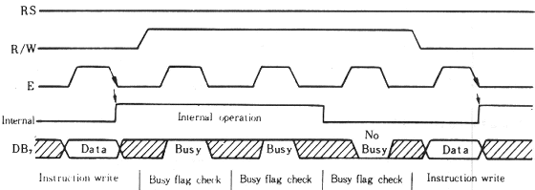

Example of data transfer using a 4-bit interface. 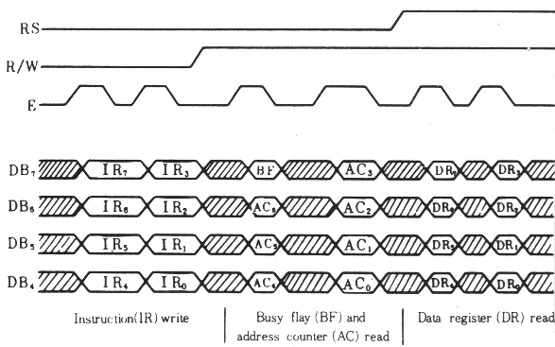

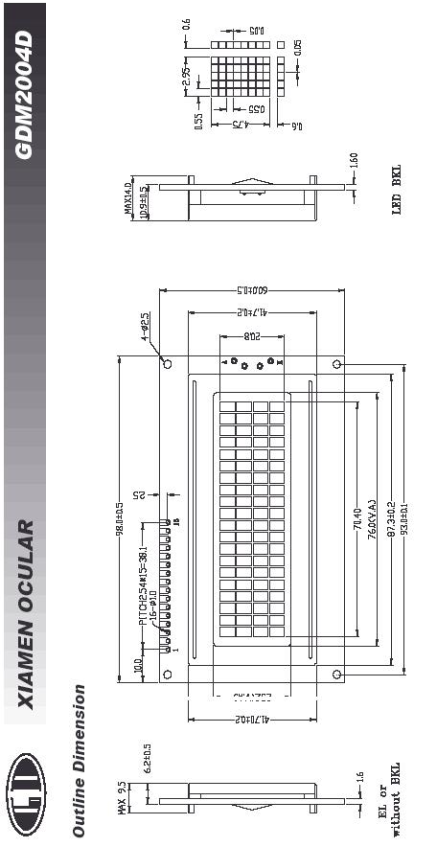

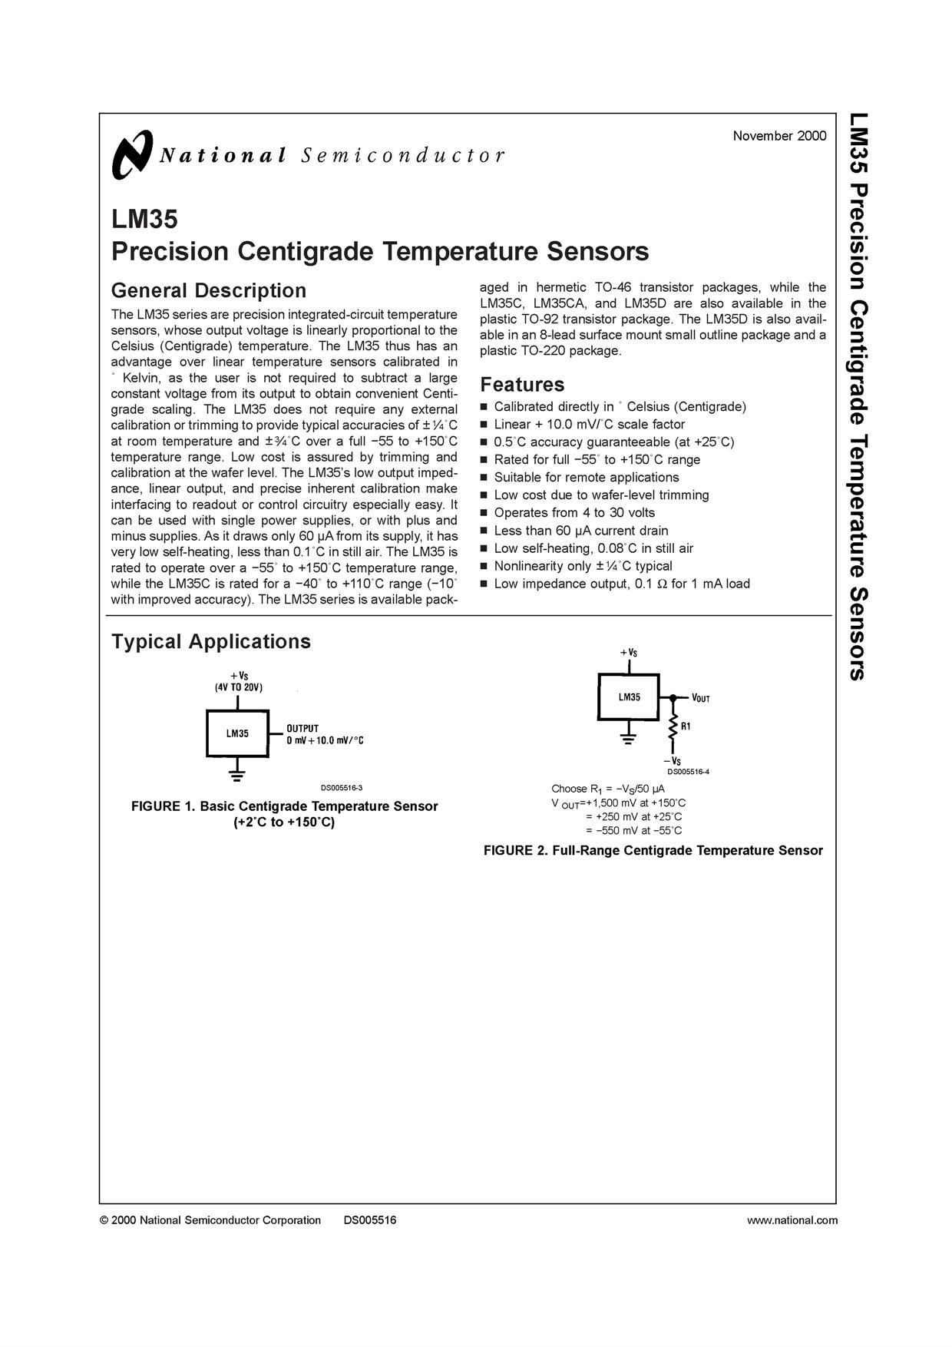
APPENDIX – D
