INVESTIGATIONS ON CONDUCTING POLYANILINE NANOFIBERS

A MAJOR PROJECT REPORT SUBMITTED IN PARTIAL FULFILMENT OF THE REQUIREMENT FOR THE AWARD OF THE DEGREE OF

MASTER OF ENGINEERING

IN

POLYMER TECHNOLOGY

BY

MOHD.FAIZY KHAN

COLLEGE ROLL NO.08/POLY/07
UNIVERSITY ROLL NO.12354



UNDER THE GUIDANCE OF
Dr. D. KUMAR
DEPARTMENT OF APPLIED CHEMISTRY AND POLYMER TECHNOLOGY
DELHI COLLEGE OF ENGINEERING, UNIVERSITY OF DELHI MAINBAWANA ROAD,DELHI 110042

Department of Applied Chemistry & Polymer Technology
Delhi College of Engineering
(Govt. of National Capital Territory of Delhi)
Main Bawana Road, Delhi -110042

Certificate

This is to certify that the major project work that is being presented in this dissertation entitled “Investigations on conducting polyaniline nanofibers” is a work of Mohd. Faizy Khan (Roll No.12354), a student of Delhi College of Engineering, Delhi University, Delhi. This work was completed and carried out under my supervision and forms a part of the Master of Engineering (Polymer Technology) course and curriculum. He has completed his work assiduously with utmost sincerity and diligence.

Prof. G. L. Verma Dr. D. Kumar
Head Asstt. Professor
Department of Applied Chemistry Department of applied Chemistry Delhi College of Engineering Delhi College of Engineering

Acknowledgement

I would like to avail this opportunity to humbly thank and appreciate the contribution and support, which various individuals have provided for the successful completion of this dissertation. My heartfelt thanks to my mentor and guide Dr. D. Kumar, Asstt. Professor, Department of Applied Chemistry & Polymer Technology, Delhi College of Engineering, who provided me an opportunity to work under his able guidance. His valuable guidance and motivation has helped me to complete my project successfully.
I also express my grateful thanks to Professor G. L. Verma, Head, Department of Applied Chemistry & Polymer Technology, Delhi College of Engineering, and all the faculty members of the department for their valuable suggestions and help, wherever needed.
I wish to express my deep sense of gratitude to Mr. Irfan Ahmad Mir, Mrs. Tarushee Ahuja and Ms. Sudha PhD. scholars, Department of Applied Chemistry & Polymer Technology Delhi college of Engineering for their enthusiastic support throughout the study .Their keen interest and suggestions were the source of inspiration for the successful completion of the project.
I am highly indebted to Professor A. P. Gupta Asstt. Professor and his research scholar Mr. Gopal, for their valuable suggestions and support during the course of my work. I am also grateful to Mr. Sharma, lab assistant, Department of Fiber Technology, IIT DELHI for his kind cooperation and suggestions when it was most required.
I am highly indebted to Dr. Mushaid Hussain and his research scholar Mr. Javed, Department of Nanotechnology, Jamia Milia Islamia, for their valuable suggestions and cooperation during my dissertation.
Thanks is too small a word to acknowledge the contribution of my friends, Bharat ,Govind, Pravat , Javed, Hakim, Ankur, Chandrajeet, Akhtar and Jagat in my dissertation.

Mohd. Faizy Khan
College Roll No. 08/poly/07
University Roll No.12354
M.E. (Polymer Technology)
Department of Applied Chemistry & Polymer Technology
Delhi College of Engineering
University of Delhi
Delhi -110042

LIST OF CONTENTS PAGE

ABSTRACT 5
CHAPTER I CONDUCTING POLYMERS 6
1.1 INTRODUCTION 7
1.2 Conducting polymers 8
1.2.1 Conducting polymer composites 8
1.2.2 Organometallic polymeric conductors 8
1.2.3 Polymeric charge transfer complexes 9
1.2.4 Inherently conducting polymers 9
1.2.5 Developments in the field of conducting polymers 12

CHAPTER II CHIRALITY IN CONDUCTING POLYMERS 15
2.1 CHIRALITY 16
2.2 Chiral dopants for conducting polymers 17
2.3 Polynailine 19
2.4 Synthesis of polyaniline 20
2.5 Doping of polymers 21
2.6 Dopants 22
2.6.1 Types of doping agents 23
2.7 Different types of doping 23
2.8 Charge appearing on the polymer chains upon doping 24
2.9 Effect of doping on conductivity 26
2.10 Electrical properties of conducting polymers 29
2.11 Applications 29
2.1 2 Aim/Objective 30

CHAPTER III EXPERIMENTAL WORK 32
3.1 OPTICALLY ACTIVE POLYANILINE 33
3.2 Chemicals used 33
3.3 Synthesis of polyaniline nanofibres 33

CHAPTER IV CHARACTERIZATION 36
4.1 CHARACTERIZATION 37
4.1.1 UV-Visible spectroscopy 37
4.1.2 Fourier Transform Infrared spectrometry 39
4.1.3 Scanning electron microscope 39
4.1.4 Electrical investigations 40
4.1.5 Circular dichroism 40

CHAPTER V RESULTS & DISCUSSION 42
5.1 UV-Visible spectroscopy 42
5.2 Fourier Transform Infrared spectrometry 46
5.3 Circular dichroism spectroscopy 47
5.4 Scanning electron microscope 48
5.5 Electrical investigations 51
CHAPTER IV CONCLUSION 54
Conclusion 55
References 56

ABSTRACT

The synthesis of (+) tartaric acid doped polyaniline has been done by oxidative chemical polymerization method. FTIR, UV-visible and scanning electron microscopy techniques have been used to characterize the polymeric samples prepared in the present work. It has been seen that the optical activity of the chiral polyaniline arise from preferential adsorption of a one-handed helical screw by developing polyaniline chains, depending upon the hand of the chiral {(+) tartaric acid} dopant anion. The chiral induction is believed to be initiated by specific electrostatic and hydrogen bonding interaction between radical cation -N^{.+} and amine –NH⁻ sites of polyaniline chains with tartarate anion and carbonyl group, respectively. The electrical conductivity of the sample was measured using two probe multimeter (DM - 453) which ranges in semiconductors region.

CHAPTER I

CONDUCTING POLYMERS

1.1 INTRODUCTION
Conducting polymers have emerged as an important class of electronic materials because of their potential applications in solid state batteries, electrochromic displays, and microelectronic devices, etc. These intrinsically conducting polymers can be blended into traditional polymers to form electrically conductive blends. The electrical conductivities of the intrinsically conducting polymer systems now range from those typical of insulators (<10⁻¹⁰ S/cm) to those typical of semiconductors such as silicon (~10⁻⁵ S/cm) to greater than 10⁴ S/cm (nearly that of a good metal such as copper, 5×10⁵ S/cm). Conducting polymers were first discovered in 1976. In the mid 1970s, the first polymer capable of conducting electricity, polyacetylene, was reportedly prepared by accident by Shirakawa [1]. The subsequent discovery by Alan Heeger and Alan MacDiarmid showed that the polymer would undergo an increase in conductivity of 12 orders of magnitude by oxidative doping quickly reverberated around the polymer and electrochemistry [2].
An intensive search for other conducting polymers soon followed. In 1976, Alan MacDiarmid, Hideki Shirakawa, and Alan Heeger, along with a group of young students found that conductivity of polyacetylene increased by up to 6 orders of magnitude when reacted with iodine (10⁻⁴ to 10² S/cm); this phenomenon, known as doping, is as a result of charge carriers. In addition, it was discovered that varying the level of doping yielded polymers exhibiting wide range of electrical properties, from insulator, or semi-conductor, to metal [3].
Although polyacetylene is not stable in air, the fact that it could be become conductive upon doping led to further experimentation with other known conjugated polymers. Since 1976, a number of conducting polymers, namely polypyrrole, polythiophene, and polyaniline, have become the focus of much study. The importance of conducting polymers is exemplified by the awarding of the 2000 Nobel Prize in Chemistry jointly to MacDiarmid, Shirakawa, and Heeger, for the discovery and development of conducting polymers [4].
The discovery of conductive polymers has opened up many new possibilities for devices which combine unique optical, electrical, and mechanical properties. Existing knowledge relating to conducting polymers reveals the diversity of materials that can be used in microelectronics. Examples of the conducting polymers are poly(p-phenylene), polyaniline, poly(p-phenylenevinylene) etc. These polymers can be fabricated to have a high degree of flexibility. The devices using them include light-emitting diodes (LEDs) and lasers for which the color of the light emitted can be chemically tuned.
1.2 Conducting polymers
Conducting polymers can be classified in different types on the basis of conduction mechanism that renders electrical conductivity to polymers [5].
• Conducting polymer composites
• Organometallic polymeric conductors
• Polymeric charge transfer complexes
• Inherently conducting polymers

1.2.1 Conducting Polymer Composites
Conducting polymer composites are mixture or blends of conductive particles and polymers. Various conductors have been used in different forms together with large number of conducting and engineering plastics. Various conductive fillers have been tried such as carbon blacks, graphite flakes, fibers, metal powders etc. The electrical conductivity of the material is decided by the volume fraction of the filler. A transition from insulating to non-insulating behavior is generally observed when volume fraction of conductive filler in the mixture reaches a threshold of about 25%. The various polymers, which have been used as main matrix, are typically PP, Nylon, and PVC etc.
1.2.2 Organometallic Polymeric Conductors
This type of conducting materials is obtained by adding organometallic groups to polymer molecules. In this type of materials the d-orbital of metal may overlap orbitals of the organic structure and thereby increases the electron delocalization. The d-orbital may also bridge adjacent layers in crystalline polymers to give conducting property to it e.g., polyphthalocyanines (Fig.1.1).
Fig. 1.1 Structure of polyphthalocyanines

Metallophthalocyanines and their polymers fall in this class of polymeric material. These polymers have extensively conjugated structures. The bridge transition metal complexes form one of the stable systems exhibiting intrinsic electrical conductivities, without external oxidative doping. Polyferrocenylene is also an example of this type of polymer. These materials possess strong potential for future applications such as molecular wires, antistatic foils and in fibers etc.
1.2.3 Polymeric Charge Transfer Complexes
Polymeric charge transfer complexes (CTC) are formed when acceptor like molecules are added to the insulating polymers. There are many charge transfer complexes, e.g., CTC of tetrathaifulvalene (TTF) with bromine; chlorine etc. is a good conductor. The reason for high conductivity in polymeric charge transfer complexes and radical ion salts are still somewhat obscure. It is likely that in polymeric materials, the donor-acceptor interaction promotes orbital overlap, which contributes to alter molecular arrangements and enhanced electron delocalization.
1.2.4 Inherently Conducting Polymers
Research in the field of inherently conducting polymer started nearly three decades ago when Shirakawa and his group found drastic increase in the electrical conductivity of polyacetylene films when exposed to iodine vapor [6]. The highest crystalline variety of the polyacetylene showed electrical conductivity of the order of 10⁻⁵ S/cm and was in all possibility the trans-form of polyacetylene. Leading on from this breakthrough, many small conjugated molecules were found to polymerize, producing conjugated polymers, which were either insulating or semiconducting in the oxidized or doped state. The electronic properties of conjugated polymers are due to the presence of electrons. The conjugated polymers are studied as the intrinsically conductive polymers. The conductivity in such polymers arises due to a special type of metallic bonding in which valence electrons are completely delocalized and move almost freely through the crystal lattice. It is therefore necessary for the polymer backbone is necessary for a polymer to behave as an electrical conductor. This delocalization of electrons may occur through the interaction of n-bonded electrons in a highly conjugated chain or by a similar interaction of n-electrons with non-bonded electrons of electron rich hetero-atoms (e.g., S, N, etc.) in the backbone. For this reason, the molecular structure of the backbone should be planar. There should be no torsion at the bonds, which would decrease the delocalization of the electron system. Some of the examples of inherently conjugated polymers are shown in Figure 1.2

Fig. 1.2 Inherently conducting polymers

The electrical and optical properties of these kinds of materials depend on the electronic structure and on the chemical nature of the repeated units. The electronic conductivity is proportional to both density and the drift mobility of the charged carriers. The carrier drift mobility is defined as the ratio of the drift velocity to the electric field and reflects the ease with which carriers are propagated. To enhance the electrical conductivity of polymers, an increase in the carrier mobility and the density of the charge carriers is required.
Among conducting polymers, polyaniline is of high interest due to its outstanding properties. It is one of the so-called doped polymers in which conductivity results from a process of partial oxidation or reduction. Polyaniline compounds can be designed to achieve the required conductivity for a given application. The resultant blends can be as conductive as silicon and germanium or as insulating as glass. Another advantage is that the compound can be simply mixed with conventional polymers and it is easy to fabricate polyaniline products into specific shapes. The conductivity of polyaniline makes it an ideal shield against static electricity discharges and thus polyaniline compounds have been used in the packaging of electronics products [7]. Polyaniline compounds are being tested for use as protection against electromagnetic radiation. Further, scientists hope that one day printed circuit boards, electrochromic windows in houses and cars, and conductive fabrics will contain polyaniline compounds. It is well known that polyaniline compounds provide protection against corrosion. Polyaniline has become a focal point of interest because of its environmental stability, controllable electrical conductivity, and interesting redox properties associated with the chain nitrogen [8]. The electrical properties of the aniline polymers can be substantially improved through secondary doping. Their excellent processability, together with the presence of a number of intrinsic redox states, has substantially enhanced the potential applications of aniline polymers for use in practical devices. Polyaniline is a member of the semi-flexible rod polymer family. The synthesis and characterization of electroactive polymers have become two of the most important areas of research in polymers as well as in materials science over the past three decades.
Polyaniline mainly occurs in four different forms (Fig.1.3) like leucoemeraldine (fully reduced) pernigraniline (fully oxidized) nigraniline (75% oxidized) and emeraldine (50% oxidized).

Fig. 1.3 Redox states of polyaniline

There is particular interest in employing the protonated polyaniline or the emeraldine salt, their derivatives, or polyaniline-metal composites as sensing materials. The preference for a conductive polymer over a conventional metal as a sensing material mainly because conductive polymer is light and less expensive in processing, it can be operated at lower applied voltages and temperatures, and it interacts more favorably with organic compounds. The great potential of polyaniline is, however, masked by its serious disadvantages such as insolubility, infusibility and hence poor process ability. Attempts have been made to improve its solubility, of which the most widely adopted strategy is to dope polynailine with organic acids such as sulphonic acid [9].

1.2.5 Developments in the field of conducting polymers
Street et al. [10] in his work compared all reported conducting polymers with that of classical materials. They discussed the mechanism of doping together with the final state of the dopant and polymer. They also highlighted some of the problems related with the inhomogeneous distribution of dopants. Solaneck et al. [11] have studied that polyacrylonitrile (PAN) can be electropolymerised and adopts a linear conformation. The new feather in the cap of conducting polymers was the invention of polyaniline by Wu-Song Huang et al. [12] who gave new theory of non-oxidative doping of this material. Extensive work has been carried out on this polymer. According to them, the emeraldine salt form of polyaniline, conducting in the metallic regime, could be synthesized electrochemically as a film exhibiting a well defined fibrillar morphology closely resembling that of polyacetylene. Probable chemical changes which occurred and the compounds which were formed when
chemically synthesized polyaniline was electrochemically oxidized and reduced between –0.2 and 1.0 V in aqueous HCl solutions at pH values ranging from –2.12 to 4. These were shown to be consistent with chemical and conductivity studies of emeraldine base and emeraldine salt forms of polyaniline. It was proposed that the emeraldine salt form of polyaniline has a symmetrical conjugated structure having extensive charge delocalization resulting from a new type of doping of an organic polymer–salt formation rather than oxidation which occurs in the p-doping of all other conducting polymer systems [13].
According to Heeger et al. [14] principal goal of the field of conducting polymers was to strive for advances in materials quality that would enable the exploration of the intrinsic electrical properties. In this context, they summarize the requirements for achieving high performance conducting polymers with electrical conductivities greater than that of copper. They investigated that to avoid localization onto one-dimensional polymer chains, interchain charge transfer was required.
Clark et al. [15] carried out that advances in the synthesis of organic conducting polymer systems had increased the electrical conductivity of these systems by several orders of magnitude in the last decade. Several practical applications were envisioned for such systems, but a thorough understanding of the conduction mechanisms and identification of the charge carriers was lacking, making design and implementation for bulk synthesis difficult. They clarified the electrical properties of these systems, the resistivity and magnetoresistivity of various polymers doped near the metal-insulator transition, such as polyaniline protonated by camphor sulfonic acid (PANI-CSA) and polypyrrole doped with PF₆ (PPy-PF₆), was studied down to 25 mK in magnetic fields up to 16 T.
Michael et al. [16] described a method for generating a variety of chemically diverse broadly responsive low-power vapor sensors. The chemical polymerization of pyrrole in the presence of plasticizers has yielded conducting organic polymer films whose resistivities were sensitive to the identity and concentration of various vapors in air. An array of such sensing elements produced a chemically reversible diagnostic pattern of electrical resistance changes upon exposure to different odorants. They investigated that, this type of polymer-based array was chemically flexible, simple to fabricate, and utilized a 16 W power DC resistance readout signal transduction path to convert chemical data into electrical signals.
Schoch et al. [17] found out that there had been considerable progress in both processing the conducting polymer materials as well as developing certain applications for them. They discussed the advances in materials synthesis and processing, the characteristics of these materials, and the applications receiving the most attention at that time. They also compared the conductivity of several conductive polymers with other materials which has been presented in Fig 1.4.
Fig. 1.4 Electrical conductivity of selected solids

CHAPTER II

CHIRALITY AND POLYANILINE

2.1 CHIRALITY

Molecules that cannot be super imposable on their mirror images are said to be chiral and the mirror images are termed as enantiomers. Enatiomeric compounds exhibit identical physical properties such as melting point, boiling point, and solubility in achiral medium. Their interactions with achiral substances are also identical; however, they can be distinguished from one another by their interaction with polarized light. An enantiomer of a chiral molecule will rotate plane polarized light in one direction while other hand compound rotate it in other direction this phenomena is termed as optical activity and was first observed by Louis Pasture, in case of circular polarized light, enantiomers absorb left or right handed circularly polarized to different extent. This differential absorption is measured in a technique known as circular dichroism spectroscopy light [18].
There are mainly four main types of chirality in molecules; these are central chirality planar, axial chirality and helical chirality. In the study of conducting polymers the most important form of chirality is of central chirality and helical chirality. Central chirality arises when a tetrahedral molecule has four different atoms attached to it (e.g., amino acid such as alanine). A helical molecule can give either a left or right hand twist giving rise to helical chirality. This type of chirality is found in DNA, proteins and in synthetic polymers, such as conducting polymers [19].
The induction of chirality in conducting polymers may occur via several routes, such as the presence of a chiral subsituent the monomer repeats units, a chiral dopant, or acid–base interactions with chiral molecules.
The first optically active polymer prepared by the polymerization of pyrrole monomers bearing substituents were by Lesenbaumer et al., Salmon and Bidan [20] in 1985 and since that time, the synthesis of optically active conducting polymers in this manner has been extensively studied for both polypyrrole and polythiophene. Initial studies suggested that presence of chiral substitutes on the pyrrole or thiophene monomers included a one handed helical structure on to the polymer chain. However more recent studies by Miejer et al [21] suggested that for chiral polythiophene the observed optical activity arises from the formation of supramolecular chiral aggregates rather than one handed helix. This approach to the preparation of optically active conducting polymers has to date not been used for polyaniline.

2.2 Chiral dopants for conducting polymers
The induction of chirality in polypyrrole via the incorporation of optically active dopant anions has not been studied to the same extent for chiral polypyrrole monomers. Kato et al., Zhou et al., and Aboutanos et al., [22] has examined the doping of polypyrrole with (+) and (-) tartaric acid and (–) mandelic acid. The polypyrrole materials so formed were found to be weakly optically active and had poor mechanical properties. A different approach was applied by Piao et al [23] to form chiral polyacetylenes where the addition of axially chiral molecules and metal dopants for nematic liquid crystals formed a chiral solvent the polymerization of acetylene within this solvent resulted in formation of one handed helical form of polyacetylene.
The majority of success stories where chiral dopant anions have been used as chiral inducers in conducting polymers involves polyaniline since the first report of optically active polyaniline doped with enantiomerically pure 10-camphorsulpfonic acid by Majidi et al [24]. There has been a great deal of interest in these materials and many new chiral dopants have been used. Optically active polyaniline containing chiral dopant have been prepared by the doping of preformed emeraldine base via electropolymerization of aniline monomers in the presence of chiral dopants or by chemical polymerization in the presence of chiral dopant the optically activity of these polyanilne is believed to arise via induction of a one handed helix in the polymer chains it is though that the dopant interact with the chain via electrostatic interaction and H-bonding there by forcing the polymer chain to preferentially adopt a one handed helical structure.
Chirality is widely expressed in organic materials, perhaps most notably in biological molecules such as DNA and proteins, owing to the homochirality of their components (D-sugars and L-amino acids). Chiral materials have shown potential applications in materials science, chemical and biological sensors, catalysis, pharmaceutics, and enantioselective separation. Chirality can be expressed at different levels, from chiral small molecules to helical conformation of macromolecules, and even to helical nanostructures and supramolecular structures. Weak inter- and intra-molecular interactions, including hydrogen bonding, solvophobic interaction, p–p interactions, and chiral templates, play an important role in forming helical architectures.
Conducting polymers are interesting materials because of their multiple applications in electrically and optically active materials and devices. A helical conformation of conducting polymers such as helical polyaniline (PANI) can be obtained by ionic interaction with a chiral dopant, and shows induced circular dichroism (ICD) in circular dichroism (CD) spectra. However, nanostructured optically active conducting polymers have been produced by template and “template-free” methods. In the template-free method, nanotubes or sub-micrometer tubes have been realized by using micelles as a “soft template” while nanofibers have been obtained as a result of the intrinsic nanofibrillar morphology of PANI by preventing their overgrowth [25]. However, the synthesis of enantiomerically pure helical nanostructures of conducting polymers still remains a scientific challenge.
In recent years, much interest has been focused on the synthesis of chiral conjugated polymers in view of their potential applications involving circularly polarized electroluminesence, and as chiral electrodes for asymmetric synthesis. In addition, research on the control of the chiral architecture of synthetic macromolecules has received considerable attention because of its possible application in many fields. Chiral polyaniline has recently been enantioselectively prepared by an in situ polymerization of achiral aniline in the presence of low molecular (+) or (-) camphorsulfonic acid (CSA⁻H⁺ or HCSA) as the chiral dopant or post doping PANI emeraldine base with these chiral acids, in which the macromolecular asymmetry presumably arises from electrostatic bonding of the CSA⁻ ion with PANI HN^{.+} centers and H-bonding of CSA⁻ carbonyl groups to –HN⁻ sites. Chiral conducting PANI has exhibited potential use in some areas, such as electrochemical asymmetric synthesis, chiral chromatography, and membrane separation technology. However, the inherent intractability of PANI limited its potential commercial application. On consideration of the application of chiral PANI, it was a significant goal of recent studies to achieve a processable even water-dispersible chiral PANI. Synthesis of ring-substituted chiral polyaniline derivatives has been reported by Wallace and coworkers [26] to improve the processability. However, Kane-Maguire et al. [27] have reported that molecules like HCSA were easily removed by solution phase dedoping. Without the chiral dopant’s maintenance of the chiral conformation, PANIs emeraldine base lost all of its optical activity when it was dissolved in organic solvents. Besides, when a chiral PANI-CSA in film was heated and HCSA was eliminated, optical activity was also lost due to thermal randomization in the PANI chiral conformation. McCarthy et al. [28] have found that the presence of polyelectrolyte strand in the complex helped to stabilize the chiral conformation of PANI due to the interpolymeric complexation. Nevertheless, in all of the above cases, the induction of the chirality into PANI was dependent on the incorporation of CSA⁻ on its chain.

2.3 Polyaniline
Polyaniline exists in different protonation and oxidation forms as shown in Fig. 2.1.

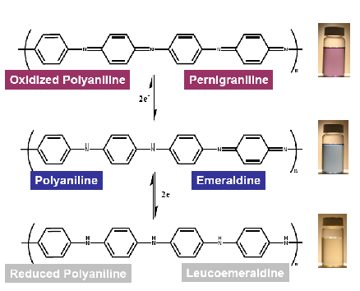
Fig. 2.1 Different states of polyaniline

The most important form of polyaniline, green protonated emeraldine is produced by the oxidative polymerization of aniline in aqueous acids. Its electrical conductivity is due to the presence of cation radicals in its structure (Fig. 2.2). The positive charge on aniline units is balanced by negatively charged counter-ions, typically chloride or sulfate anions (Fig. 2.3).

Fig.2.2: Protonated emeraldine.

The efficient polymerization of aniline is achieved only in an acidic medium, where aniline exists as an anilinium cation, ammonium peroxydisulfate is used as an oxidant. To minimize the presence of residual aniline and to obtain the best yield of PANI, the stoichiometric peroxydisulfate/aniline ratio should be 1.25 [29]. The oxidation of aniline hydrochloride with ammonium peroxydisulfate to yield polyaniline (emeraldine) hydrochloride is presented in the figure given as below.

Fig. 2.3 Synthesis of polyaniline (emeraldine) hydrochloride

2.4 Synthesis of polyaniline

Mainly polyaniline is being synthesized by using two methods namely chemical and electrochemical synthesis.

- Chemical synthesis
Synthesis of polyaniline by chemical oxidative route involves the use of either hydrochloric or other mineral acid like sulfuric acid in the presence of ammonium peroxodisulfate as the oxidizing agent in the aqueous medium. The principal function of the oxidant is to withdraw a proton from an aniline molecule, without forming a strong co-ordination bond either with the substrate/intermediate or with the final product. However smaller quantity of oxidant is used to avoid oxidative degradation of the polymer formed. In the review article by Gospodinova et al. [30], they had reported that the propagation of polymer chains proceeds by a redox process between the growing chain (as an oxidant) and aniline (as a reducer) with addition of monomer to the chain end. The high concentration of a strong oxidant, (NH₄)₂S₂O₈, at the initial stage of the polymerization enables the fast oxidation of oligomers and polyaniline, as well as their existence in the oxidized form.
Fig. 2.4 Synthesis of PANI

- Electrochemical synthesis
In this case electropolymerization is carried out in a one compartment cell with three electrodes using potentiostat like BAS CV-27 potentiostat. The PANI films are deposited over ITO coated glass (sputter coated with Pt) working electrodes. Pt-mesh and Ag/AgCl can be used as auxiliary and reference electrodes.

2.5 Doping of polymers

Conducting polymers generally exhibit poor electrical conductivity (σ ≤ 10⁻¹² S/cm) in the virgin state and behave as insulators. These virgin polymers need to be treated with a suitable oxidizing or reducing agents to remarkably enhance their conductivities to the metallic region. This phenomenon has been termed as “doping”. Doping can be simply regarded as the insertion or ejection of electrons. Doping process results in dramatic changes in the electronic, electrical, magnetic, optical, and structural properties of the polymer. Doping of polymeric semiconductors is different from that in inorganic or conventional semiconductors. Inorganic semiconductors have three dimensional crystal lattice and on incorporation of specific dopant, n-type, or p-type in ppm level, the lattice becomes only highly distorted. The dopant is distributed along specific crystal orientations in specific sites on a repetitive basis. Whereas, doping of conducting polymer involves random dispersion or aggregation of dopants in molar concentrations in the disordered structure of entangled chains and fibrils. The dopant concentration may be as high as 50%. Also incorporation of the dopant molecules in the quasi one dimensional polymer systems considerably disturbs the chain order leading to reorganization of the polymer. Doping process is reversible, and it produces the original polymer with little or no degradation of the polymer backbone. Both doping and dedoping processes, involving dopant counter ions which stabilize the doped state, may be carried out chemically or electrochemically. Doping of inorganic semiconductors generates either holes in the valence band or electrons in the conduction band. On the other hand, doping of polymer leads to the formation of conjugation defects, viz., solitons, polarons or bipolarons in the polymer chain. The ultimate conductivity in polymeric semiconductors depends on many factors, viz. nature, and concentration of dopants, homogeneity of doping, carrier mobility, crystallinity and morphology of polymers. By controllably adjusting the doping level, conductivity anywhere between that of the non-doped (insulating or semiconducting) and that of the fully doped (highly conducting) form of the polymer can be easily obtained. The various oxidation states of PANI obtained by different doping is given in the. Generally in conducting polymers p- type doping is conducted with an electron acceptor, such as p and n-type doping is conducted with donor species, such as Li. In the doped state, the backbone of a conducting polymer consists of a delocalized system. In the undoped state, the polymer may have a conjugated backbone such as in trans- (CH)_{x} which is retained in a modified form after doping, or it may have a non conjugated backbone, as in polyaniline (leucoemeraldine base form), which becomes truly conjugated only after p-doping, or a nonconjugated structure as in the emeraldine base form of polyaniline which becomes conjugated only after protonic acid doping.

2.6 Dopants
Dopants are either strong oxidizing or reducing agents. On doping, either positive or negative charge carriers are created in polymers.
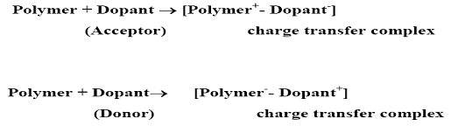
Fig. 2.5 Dopants effect on polymer
2.6.1 Types of doping agents
Dopants may be classified as:
A) Neutral dopants: I₂, Br₂, AsF₂, Na, K, H₂SO₄, FeCl₃ etc.
B) Ionic dopants: LiClO₄, FeClO₄, CF₃SO₃Na, BuNClO₄ etc.
C) Organic dopants: CF₃COOH, CF₃SO₃Na, p-CH₃C₆H₄SO₃H
D) Polymeric dopants: PVS, PPS
Neutral dopants are converted into negative or positive ions with or without chemical modifications during the process of doping. Ionic dopants are either oxidized or reduced by an electron transfer with the polymer and the counter ion remains with the polymer to make the system neutral. Organic dopants are anionic dopants, generally incorporated into polymers from aqueous electrolytes during anodic deposition of the polymer.

2.7 Different types of doping
The expression doping is ambiguous and refers to an uptake into pure material of some other material. This uptake may be diffusion of dopants in to the fibers, a chemical reaction with internal or surface chains or simple adsorption on the surface. Doping is accomplished by chemical methods of direct exposure of the conjugated polymer to a charge transfer agent in the gas or solution phase, or by electrochemical oxidation or reduction. The dopant concentration can be determined by chemical or spectroscopic analysis, or simple weight uptake. Doping of polymers may be done by the following methods [31].

A) Redox doping
Redox doping is the most common method of doping. This is also known as oxidative doping and accomplished by removing pi- electrons from the conjugated pi-electrons. All conducting polymers e.g., PPy, PT, PANI etc. undergo p- and/ or n-redox doping by chemical and/ or electrochemical processes during which the number of electrons associated with the polymer backbone changes. p-doping is accompanied by partial oxidation of the backbone of the polymer. It was first discovered by treating trans- (CH)_{x} with an oxidizing agents such as iodine. p-doping can also be done by electrochemical anodic oxidation by immersing a trans-(CH)_{x} film in a solution of LiClO₄ and attaching it to the positive terminal of a DC power source, the negative terminal being attached to an electrode also immersed in the solution. n-doping, i.e., partial reduction of the backbone system of an organic polymer, was also discovered using trans-(CH)_{x} by treating it with a reducing agents such as sodium naphthalide.

B) Photo-doping
When trans (CH)_{x} is exposed to radiation of energy greater than its band gap, electrons are promoted across the gap and polymer undergoes “photo-doping”.

C) Charge injection doping
Charge injection doping is most conveniently carried out using a metal/insulator/semiconductor (MIS) configuration involving a metal and a conducting polymer separated by a thin layer of a high dielectric strength insulator. Application of an appropriate potential across the structure can give rise to a surface charge layer. The resulting charges in the polymer, for example, (CH)_{x} or poly (3-hexylthiophene) are present without any associated dopant ion.

D) Non redox doping
Although oxidative doping is available to polyaniline, a more common method of producing doped polyaniline is known as acid- doping (or proton doping). This type of doping differs from redox doping is that the number of electrons associated with the polymer backbone does not change during the doping process. As with the oxidative Doping process, doped polyaniline may be produced in one step. The presence of the acid (HA) results in the protonation of nitrogen atoms. Once protonated, the polymer chain is now positively charged, and has associated counter- anions. The degree of protonation depends on the oxidation state of the polymer and the pH of the acid solution. The energy levels are rearranged during doping. The emeraldine base form of PANI was the first example of the doping of an organic polymer to a highly conductive regime by nonredox type doping.
Neutral (or undoped) polyaniline exhibits conductivity on the order of 10⁻¹⁰ S/cm; as with oxidative doping, protonic, or acid, doping can result in a significant increase in conductivity (up to 10 S/cm or 11 orders of magnitude).

2.8 Charge appearing on the polymer chains upon doping
In a polymer, just as in a crystal, the interaction of a polymer unit cell with all its neighbors leads to the formation of electronic bands. The highest occupied electronic levels constitute the valence band (VB) and the lowest unoccupied levels, the conduction band (CB).the width of the forbidden band, or band gap (E_{g}), between the VB and CB determines the intrinsic electrical properties of the material. In organic molecule, it is usually the case that equilibrium geometry in the ionized state is different from the ground state. On ionization of an organic molecule the geometry of the molecule is first distorted in the ground state in such a way that the molecule adopts the equilibrium geometry of the ionized state. This costs distortion energy E_{dis}. Then the reduction in the ionization energy i.e., E_{IP-V} - E_{IP-d} upon distortion is larger than the energy E_{dis} required to make that distortion [Fig.2.6]

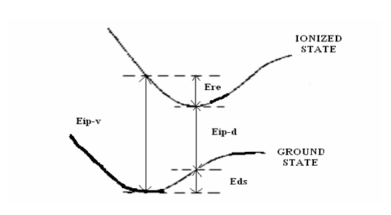

Fig. 2.6 Molecular ionization process in conducting polymers

However in an organic polymer chain, it can be energetically favorable to localize the charge that appears on the chain and to have, around the charge, a local distortion (relaxation) of the lattice. This process causes the presence of a localized electronic state in the band gap (Fig.2.7) considering the case of oxidation that is the removal of an electron from the chain. This causes the formation of radical ion on the polymer chain and around that charge or cation localization occurs. This radical cation which is formed is having more energy then that of the energy of the valance band. This radical cation associated with the lattice distortion is known as polaron and the presence of localized electronic state in the gap referred to as polaron state. It is having half (1/2) spin.
Fig. 2.7 Conduction states

A bipolaron is defined as a pair of like charges associated with a strong local distortion it is spinless.The bipolaron charge carrier is of relatively high energy, and thus is short- lived. Redistribution of charge and spin yields a polaron as the more stable charge carrier. A radical, cation, or anion defect on a polyacetylene backbone divides the polymer into sections which are mirror image to each other. The defect can move in either direction without affecting the energy of the backbone. The movement of the defect can be describes as a solitary wave or soliton. The radical defect is referred to as soliton, the anion and cation defects are charged solitons.The neutral soliton is having spin whereas the anion and cation defects are spinless.

2.9 Effect of doping on conductivity

The doping process involves transfer of the charge to or from the bonding system of the conjugated polymer, leaving the system essentially intact and hence the structural identity of an individual chain preserved. However, vibrational, electronic, and other properties of the polymer are strongly altered upon doping as well as its supramolecular structure. The most spectacular result of the doping is the increase of the polymer conductivity over several orders of magnitude. In some cases conjugated polymers reach the conductivity of metals with a negative temperature coefficient which is characteristic of metallic behavior. Doping with acceptor or donor molecules causes a partial oxidation (p-doping) or reduction (n-doping) of the polymer molecule [32]. As a result positively or negatively charged quasi-particles are created presumably polarons in the first step of doping. When doping proceeds reactions among polarons take place leading to energetically more favorable quasi-particles, i.e., a pair of charged solitons (bipolarons) in materials with a degenerate ground state. Thus due to the changes in the environment of the chains disorders are created from doping. At low dopant concentration, the dopant molecules occupy random positions between the chains. This affects the electronic properties by their coulomb potential and by hybridization with the polymer p-orbitals. As polarons produced has long lifetime, they are treated as quasi-particles. Polarons have low mobility, which results in obtaining moderate conductivity at low doping concentration. As the doping level is increased, the concentration of polarons goes up and they become crowded together, close enough to form bipolaron. At this point in the doping process, conductivity undergoes a marked increase. Once the radical components of the polarons have combined to form bonds, the remaining charges achieve high mobility along the chain. Example showing formation of polarons –bipolarons in PANI chain is given in figure 2.8.
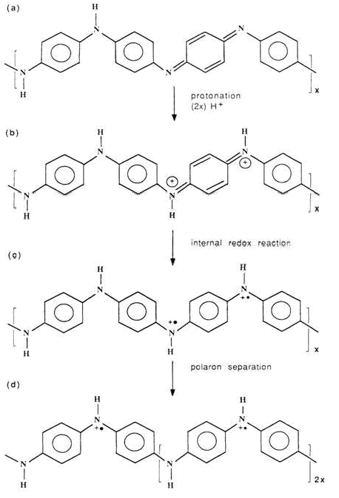
Fig. 2.8 Geometrical structure of polyemeraldine a) before protonation and (b)—(d) after protonation (b) formation of bipolarons (c) of poloron (d) the poloron separate, which results in a poloron lattice

2.10 Electrical properties of conducting polymers

It is only the doping which makes most of the conjugated polymers conducting from their insulating state to semiconducting or conducting. Although the charged species are incorporated by doping, the electrical conductivity is not ionic but electronic. Electronic conductivity of conducting polymers depends upon numerous factors. Significant among these are:
A) Nature or chemical reactivity of the dopant
B) Process of doping
C) Doping level
D) Method and condition of polymer synthesis
E) Processing of the polymer
Chemical reactivity of the dopant is of prime importance to obtain a conducting polymer. Not all dopants are equally capable of oxidizing a polymer chain. Iodine is a dopant for increasing the electrical conductivity of polyacetylene by 13 orders of magnitude but is too weak to oxidize PPy or PANI. Similarly HCl is used to conduct PANI. The electrical conductivity of polyaniline hydrochloride observed is 4.4 ± 1.7 S/cm.
Doping conditions also play an important role. Electrical conductivity usually increases with the doping level due to increase in charge carriers concentration. Rapid increase in mobility of the charge carriers may be responsible for this high rate of increase in conductivity. Development of quantitative model for conduction is hampered by the fact that there are at least three elements contributing to the carrier mobility:
_ Single chain or intramolecular transport
_ Interchain transport
_ Interparticle contact
Electrical conductivity is very much dependent on the method of polymer synthesis, purification of the polymer, physical treatment of the polymer etc. besides nature of the dopants and the process of doping.

2.11 Applications
The extended p-systems of conjugated polymer are highly susceptible to chemical or electrochemical oxidation or reduction. These alter the electrical and optical properties of the polymer, and by controlling this oxidation and reduction, it is possible to precisely control these properties. Since these reactions are often reversible, it is possible to systematically control the electrical and optical properties with a great deal of precision. It is even possible to switch from a conducting state to an insulating state. There are two main groups of applications for these polymers. The first group utilizes their conductivity as its main property. The second group utilizes this electroactivity. (Table 1.1)

Table 1.1 Applications of conducting polymers

Much research will be needed before many of the above applications will become a reality. The stability and processibility both need to be substantially improved if they are to be used in the market place. The cost of such polymers must also be substantially lowered. However, one must consider that, although conventional polymers were synthesized and studied in laboratories around the world, they did not become widespread until years of research and development had been done. In a way, conducting polymers are at the same stage of development as their insulating brothers were some 50 years ago. Regardless of the practical application that is eventually developed for them, they will certainly challenge researchers in the years to come with new and unexpected phenomena. Only time will tell whether the impact of these novel polymers will be as large as their insulating relatives.

2.12 Aim/Objective
Main aim of this major project is to prepare the conducting polyaniline nanofibres doped with (+)-(-) tartaric acid utilizing interfacial polymerization technique modified by the use of separating funnel and to observe the effect of contact time between the reactants through an interface.
Present investigation deals with the synthesis of conducting polymers, their characterization, and activity towards oxidation, their conductivity, and also the identification of products. The conducting polymer chosen was polyaniline. Its synthesis, purification, and modification were done by chemical method.

CHAPTER III

EXPERIMENTAL WORK

3.1 OPTICALLY ACTIVE POLYANILINE

The preparation of optically active polyaniline has been reported through electro-polymerization as well as chemical polymerization in presence of chiral acid (HA) such as (+) or (-) - camphor sulphonic acid (CSA), dodecylbenzene sulphonic acid (DBSA) and (+) or (-) - tartaric acid etc. used as doping agents. All polymers obtained were dark green powder.
3.2 Chemicals used

All chemicals used in the present study along with the sources are given in Table 3.1.These chemicals were used as received for synthesis purpose except aniline.
Table 3.1 Chemicals used for synthesis
CHEMICALS | ACRONYM | SOURCE
ANILINE | ANI | C.D. H LABORATORY
AMMONIUM PEROXODISULPHATE | APS | MERCK
DICHLORO METHANE | METHYLENE DICHLORIDE | SPECTROCHEM PVT. LTD.
HYDROCHLORIC ACID | HCL | QUALIGENS INDIA
METHYL-2-PYRROLIDINONE | NMP | SPECTROCHEM PVT LTD
M-CRESOL | M-CRESOL | SRL
(+)TARTARIC ACID | (+)TARTARIC ACID | SPECTROCHEM PVT. LTD.
(-)TARTARIC ACID | (-)TARTARIC ACID | SPECTROCHEM PVT. LTD.

3.3 Synthesis of emeraldine polyaniline nanofibres

Chemical synthesis of emeraldine polyaniline nanofibres involves the oxidation of the monomer viz., aniline with oxidizing agents such as APS in acidic medium [(+) - (-) tataric acid solution]. Distilled water and dichloromethane were used for the polymerization reaction purpose. Detailed procedure for the synthesis is given as below.
1) Aniline was distilled under reduced pressure before polymerization.
2) 0.3 mM aniline was dissolved in 20 ml of dichloromethane (CH₂Cl₂) to prepare aniline solution in CH₂Cl_{2.}
3) 0.18 g APS was dissolved in 20 ml of 5 M (+) tataric acid to form APS solution in 5 M (+) tataric acid.
4) Aniline solution prepared in step 2 was poured in the separating funnel.
5) APS solution was poured over the aniline solution through pipette till an aqueous layer of APS solution (15 ml) was formed over aniline.
6) The excess amount of aniline solution (5ml) was taken out this was done to remove the unreacted aniline below the interface.
7) The reactants were allowed to be in contact through an interface for different time intervals for e.g., 50, 80, and 120 seconds respectively. After these time intervals, the reactants were taken out in a beaker containing 100 ml of 5 M (+) tataric acid kept in ice bath. This was done to break the contact time between the reactants because when the reactants were initially in contact through an interface were poured out in 5 M (+) tataric acid redistribution of the reactants molecule takes place which inhibits the overgrowth of polyaniline.
8) (+) tataric acid solution containing the reactants was kept untouched for some time.
9) Two layers in contact with each other through an interface appeared in the beaker containing (+) tartaric acid. Upper layer was APS solution while lower one was of aniline solution.
10) After 10 minutes bluish green particles appeared at the interface of the reactants in the beaker which were hydrophilic in nature and moved from the interface to the aqueous layer of APS solution.
11) After 20 minutes the whole interface was covered with bluish green particles which moved to the APS solution after being formed at the interface.
12) After 2 Hours the whole beaker was filled with green precipitate and changes occurring in the beaker gets stopped which was an indication of the completion of the reaction.
13) The product was then filtered, and then washed with distilled water and methyl alcohol till the filtrate becomes colorless.
14) The product was finally dried at room temperature and then characterized by using different techniques.
A similar procedure was followed to prepare emeraldine polyaniline doped with (-) tataric acid.

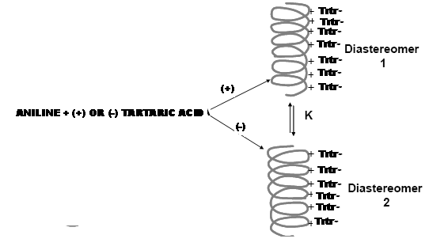
Fig. 3.1 Diagramatic representation of doping of polyaniline with (+) - (-) tartaric acid

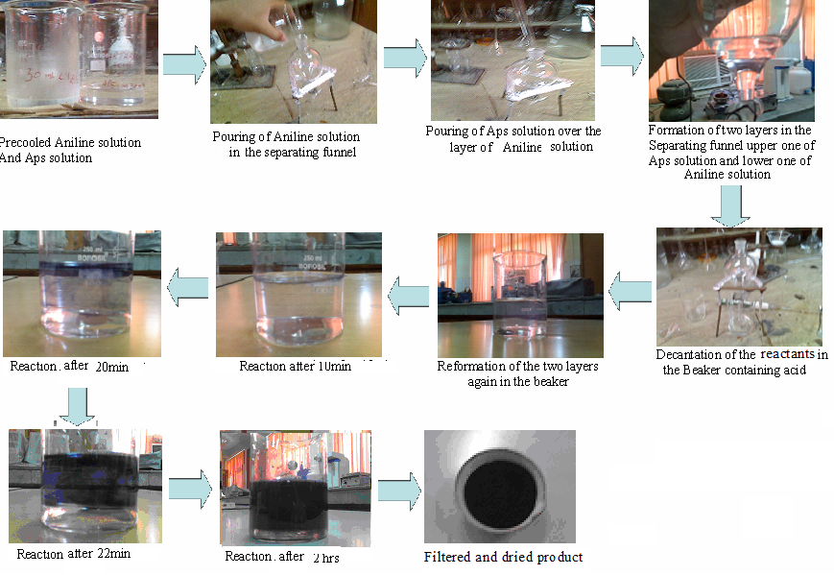
3.2 Step-wise representation of whole procedure

CHAPTER IV

44

CHARACTERIZATION

4.1 CHARACTERIZATION
The characterization of the sample was carried out by using different techniques like UV-visible spectroscopy, Fourier transform infrared spectrometry, circular dichroism (CD) spectroscopy, scanning electron microscope (SEM) and two-probe conductivity technique etc.

4.1.1 UV-Visible Spectroscopy
A diagram of the components of a typical spectrometer is shown in the figure 4.1. The functioning of this instrument is relatively straightforward. A beam of light from a visible and/or UV light source (colored red) is separated into its component wavelengths by a prism or diffraction grating. Each monochromatic (single wavelength) beam in turn is split into two equal intensity beams by a half-mirrored device. One beam, the sample beam (colored magenta), passes through a small transparent container (cuvette) containing a solution of the compound being studied in a transparent solvent. The other beam, the reference (colored blue), passes through an identical cuvette containing only the solvent. The intensities of these light beams are then measured by electronic detectors and compared. The intensity of the reference beam, which should have suffered little or no light absorption, is defined as I₀. The intensity of the sample beam is defined as I. Over a short period of time, the spectrometer automatically scans all the component wavelengths in the manner described. The ultraviolet (UV) region scanned is normally from 200 to 400 nm, and the visible portion is from 400 to 800 nm.
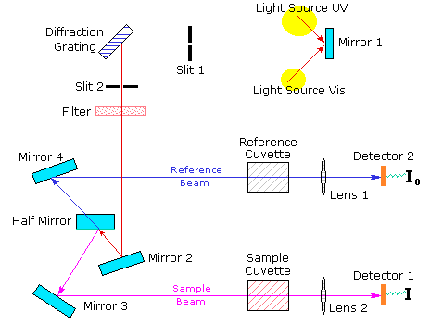
Figure 4.1 Ray diagram of working of UV-vis spectrophotometer
If the sample compound does not absorb light of a given wavelength, I = I₀. However, if the sample compound absorbs light then I is less than I₀, and this difference may be plotted on a graph versus wavelength, as shown on the right. Absorption may be presented as transmittance (T = I/I₀) or absorbance (A= log I₀/I). If no absorption has occurred, T = 1.0 and A= 0. Most spectrometers display absorbance on the vertical axis, and the commonly observed range is from 0 (100% transmittance) to 2 (1% transmittance). The wavelength of maximum absorbance is a characteristic value, designated as λ_{max}
Different compounds may have very different absorption maxima and absorbance. Intensely absorbing compounds must be examined in dilute solution, so that significant light energy is received by the detector, and this requires the use of completely transparent (non-absorbing) solvents. The most commonly used solvents are water, ethanol, hexane, and cyclohexane. Solvents having double or triple bonds, or heavy atoms (e.g. S, Br & I) are generally avoided. Because the absorbance of a sample will be proportional to its molar concentration in the sample cuvette, a corrected absorption value known as the molar absorptivity is used when comparing the spectra of different compounds. This is defined as:
Molar Absorptivity,ε = A/ c l
(Where A= absorbance, c = sample concentration in moles/liter & l = length of light path through the cuvette in cm.)
4.1.2 Fourier Transform Infrared Spectrometry

FT-IR stands for Fourier Transform Infra Red, the preferred method of infrared spectroscopy. In infrared spectroscopy, IR radiation is passed through a sample. Some of the infrared radiation is absorbed by the sample and some of it is passed through (transmitted). The resulting spectrum represents the molecular absorption and transmission, creating a molecular fingerprint of the sample. Like a fingerprint no two unique molecular structures produce the same infrared spectrum. This makes infrared spectroscopy useful for several types of analysis. A ray diagram of FTIR spectrophotometer is shown in figure 4.2.
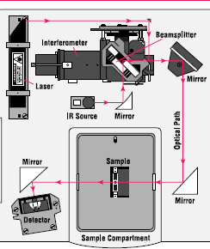
Figure 4.2 Ray diagram of FTIR spectrophotometer

4.1.3 Scanning electron microscope (SEM)
An electron microscope is a type of microscope that uses a particle beam of electrons to illuminate a specimen and create a highly-magnified image. Electron microscopes have much greater resolving power than light microscopes that use electromagnetic radiation and can obtain much higher magnifications of up to 2 million times, while the best light microscopes are limited to magnifications of 2000 times. Both electron and light microscopes have resolution limitations, imposed by the wavelength of the radiation they use. The greater resolution and magnification of the electron microscope is because the wavelength of an electron, its de Broglie wavelength, is much smaller than that of a photon of visible light.
The electron microscope uses electrostatic and electromagnetic lenses in forming the image by controlling the electron beam to focus it at a specific plane relative to the specimen in a manner similar to how a light microscope uses glass lenses to focus light on or through a specimen to form an image. A ray diagram of scanning electron microscope is shown as below.
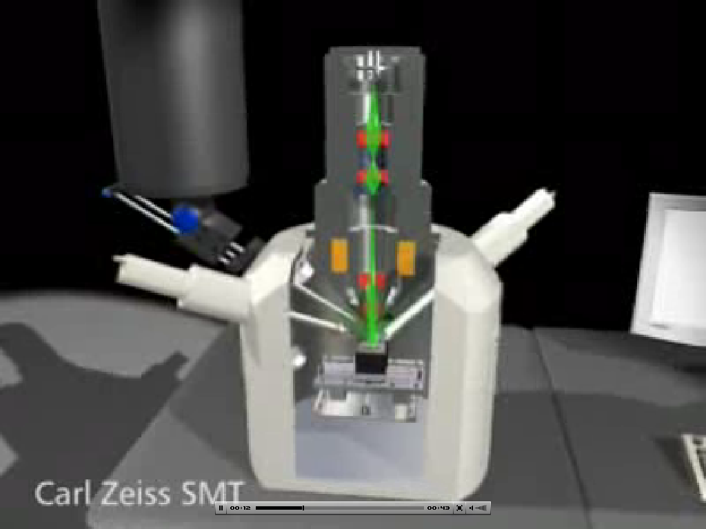
Figure 3.2 Ray diagram of scanning electron microscope

4.1.4 Electrical investigation
It is one of the most important characteristic of a conducting polymer especially to explore their use in electrical and electronic devices. We have attempted to measure the electrical conductivity of the products through two probe technique by forming its pellets and connecting it with ITO coated probes. This gives the current which can flow across its thickness through which we can calculate its conductivity/resistivity.
4.1.5 Circular dichroism
If circularly polarized light is imposed on the enantiomers of a compound then these enantiomers of a compound absorb left or right handed circularly polarized to different extent. This differential absorption is measured in a technique known as circular dichroism spectroscopy light. Therefore, we have made some measurements on our samples using this technique also.

CHAPTER V
RESULTS
&
DISCUSSION

5.1 UV-Visible Spectroscopy
Ultra violet spectra of the polymeric samples were recorded on the double beam UV-vis spectrophotometer (Model No. UV5704SS) as shown in the diagram below.
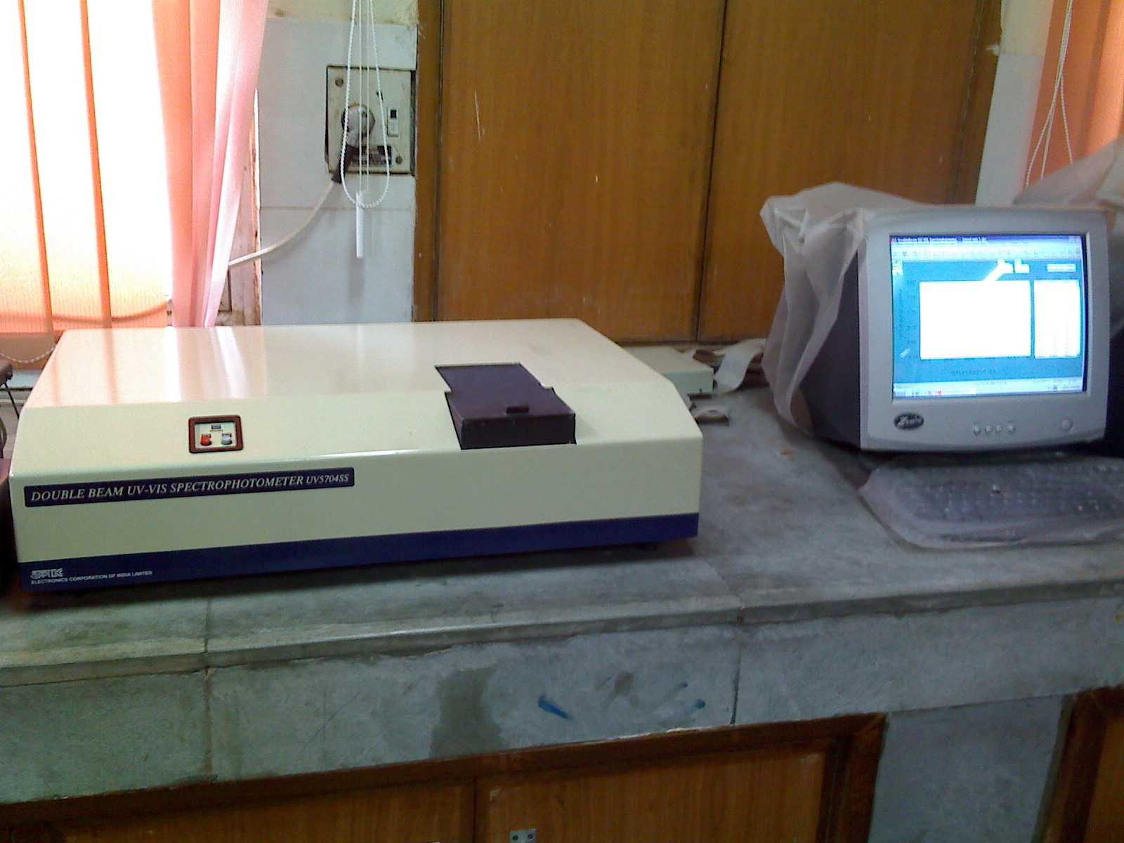

Figure 5.1 UV-vis spectrophotometer-UV5704SS

The absorption spectra of emeraldine polyaniline doped with (+)-tartaric acid shown in figure 5.2 was recorded in m-cresol solvent which shows a strong peak at about 290 nm along with shoulders at 370 and 420 nm and a broad peak was observed at 810 nm.
The peak at 290 nm reveals the formation of nano-structure in the compound as this peak is not oftenly present in case of granular polyaniline. The shoulder at 370 nm is due to Π→Π* transition of benzenoid ring of PANI while the shoulder at 420 nm corresponds to the protonation of PANI. Peak with a long tail at 810 nm is assigned as the polaron band indicates that the nanotubes are in doped state of PANI.

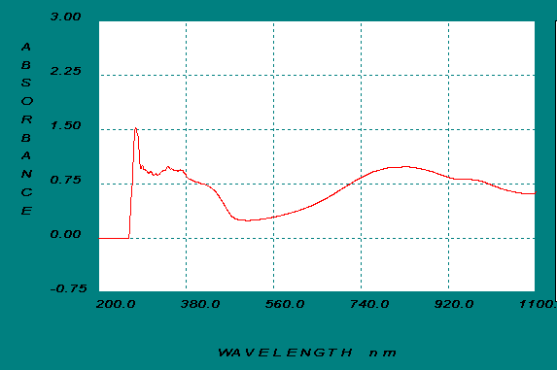
Fig. 5.2 UV-vis spectra of polyaniline doped with (+)-tartaric acid in m-cresol

UV-Visible absorption spectra of the sample shown in figure 5.3 were also recorded in NMP which shows an interesting data. In this case, the sample gets dedoped and showed a strong peak at 320 nm while a broad peak at 640 nm.
The peak at 320 nm arises due to the Π→Π* transition of benzenoid rings and at 640 nm due to the absorption of quinonoid rings. Besides these two bands a new band at 275 nm also appeared in this spectra which was absent in the spectra of granular PANI and indicates the presence of nanofibres in our sample [33].

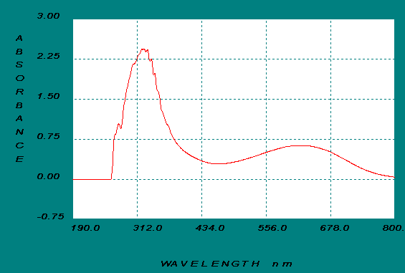
Fig. 5.3 UV-vis spectra of polyaniline doped with (+)-tartaric acid in NMP

5.2 Fourier Transform Infrared Spectrometry

FTIR spectra of the sample were recorded on Thermo NICOLET 380 FTIR as shown below.
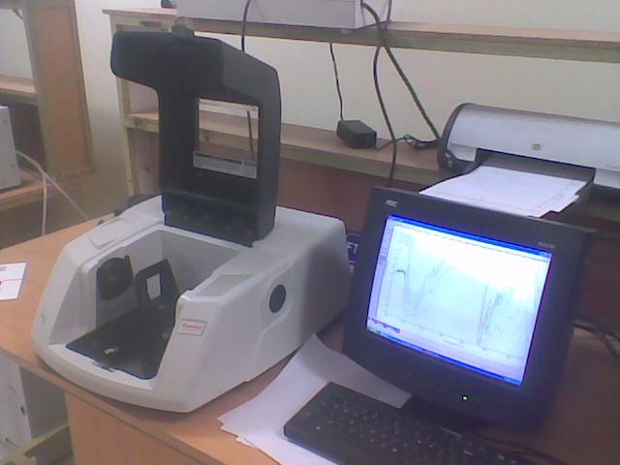
Fig. 5.4 Thermo NICOLET 380 FTIR Spectrophotometer Pellet pressers

Figure 5.5 shows the IR spectra of PANI doped with (+) tartaric acid recorded on Thermo Nicolet 380 FTIR. The spectra of the (+) tartaric acid doped PANI show the various characteristic absorption peaks at, 3436, 2924, 1557, 1471, 1279, 1116 and 810 cm⁻¹. The peak at 3436 cm⁻¹ corresponds to –NH₂ stretching while peak observed at 2924 cm⁻¹ is attributed to C–H stretching which reveals that there is hydrocarbon character due to the doping with dicarboxilic acid and C–N stretching is observed at 1279 cm⁻¹. The peaks at about 1116 cm^{–1} is due to the C–C stretching peak and is found of highest intensity which may be due to the doping with (+) tartaric acid. The bands at 1557 and 1471 cm^{–1}are attributed due to the C=N and C=C stretching modes of vibration for the quinonoid and benzenoid units, respectively. The peak due to para-coupling in case of polyaniline appears in the range of 804 to 819 cm⁻¹ which is clearly seen in the above spectra at around 806 cm⁻¹.

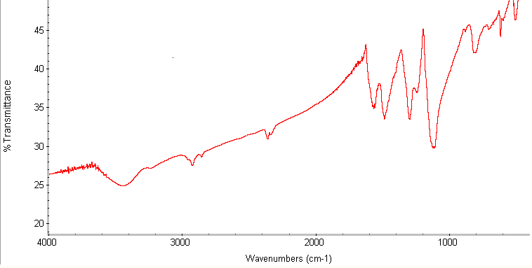

Fig.5.5 FTIR spectra of polyaniline doped with (+)-tartaric acid

5.3 Circular dichroism (CD) spectroscopy
The CD spectra observed for polyaniline are usually bisignate, having positive and negative components. Bisignate CD bands arise from exciton coupling between chromophores located near one another in space, resulting in a splitting of the electronic excited state for the molecule and hence the observed positive and negative cotton effect for CD band. In conducting emeraldine salt, exciton coupling may arise via intrachain coupling between polaron chromophores on the same polymer chain or through interchain coupling between such chromophores on adjacent polymer chain. Chiral polyaniline in other oxidation states (fully reduced leucoemeraldine and fully oxidized pernigraniline) have also been reported in their CD spectra. The CD spectra of the sample in NMP shown below were recorded on CHIRASCAN by applied photo physics. As observed in the spectra, there is a strong peak at 305 nm and at around 350 nm. There is also a clear and distinct peak between 700 to 800 nm which is due to the polaron band and reveals the doping of polyaniline by tartaric acid. The spectra shown in figure 5.6 is an example of bisignate, spectra having positive and negative components. This is a clear indication for the formation of nanofibres in helical form.

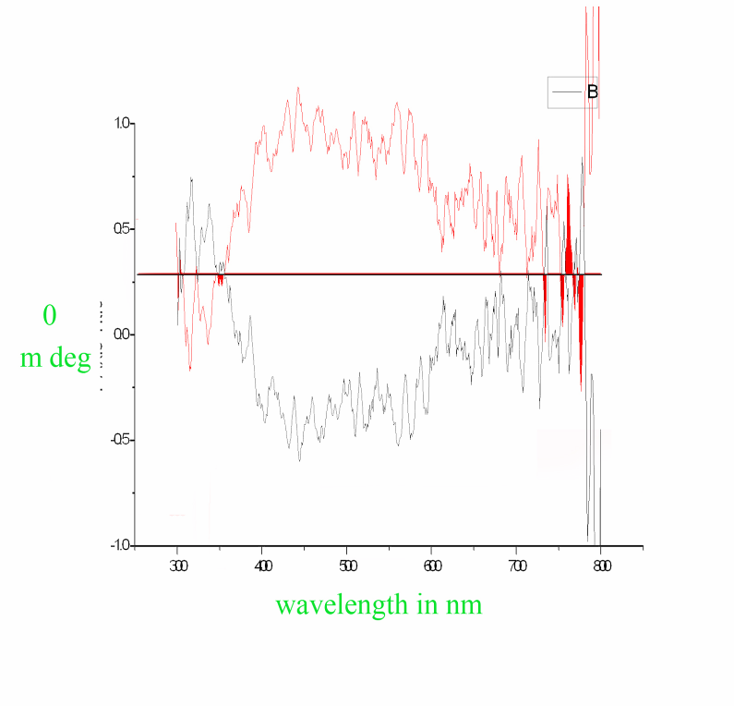
Fig. 5.6 CD spectra of (+) and (-) tartaric acid doped polyaniline

5.4 Scanning electron microscope (SEM)
The scanning electron microscope used to obtain the images of the sample was EVO-50 as shown below.

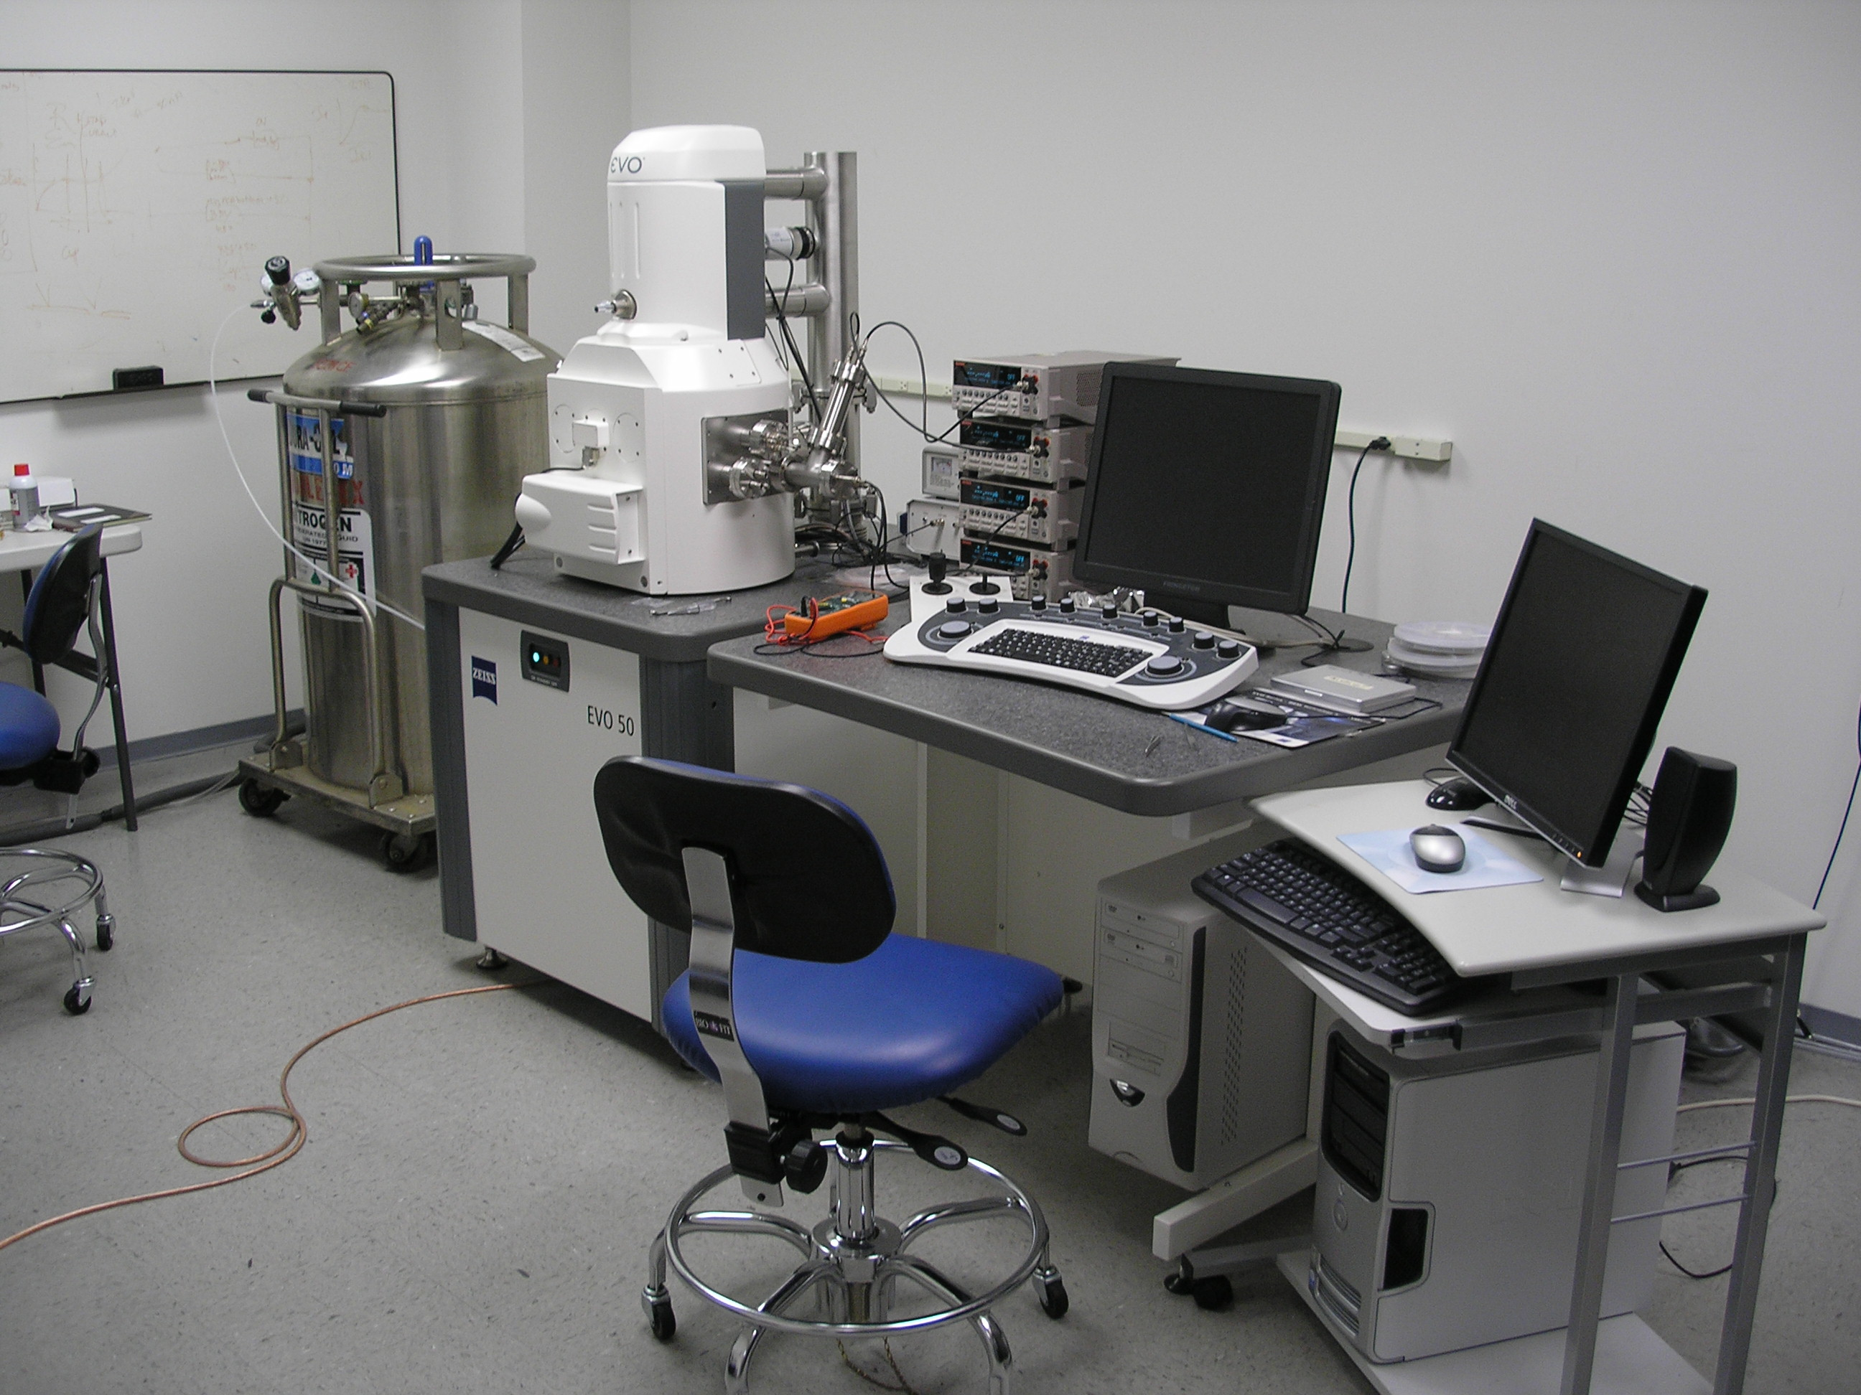
Fig. 5.7 Scanning electron microscope set up
Fig. 5.8 to 5.10 show the SEM micrographs of polyaniline nanofibers with different contact time intervals, i.e., 50, 80 and 120 sec. It is clearly seen from the images that maximum percentage of nanofibres are obtained in case where the contact time was 50 sec which is least in all the three cases. Thus, it is evident that with an increase in contact time, the agglomeration of product takes place hence fibre content decreases.

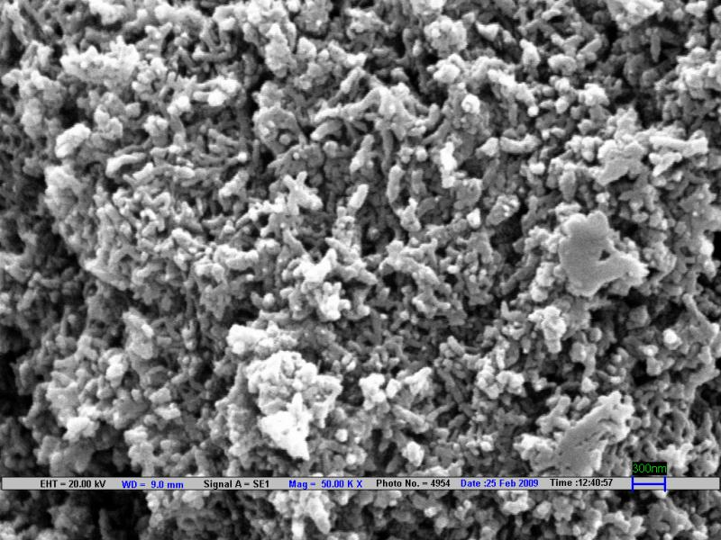

Fig. 5.8 SEM micrograph of polyaniline doped with (+)-tartaric acid contact time 50 sec

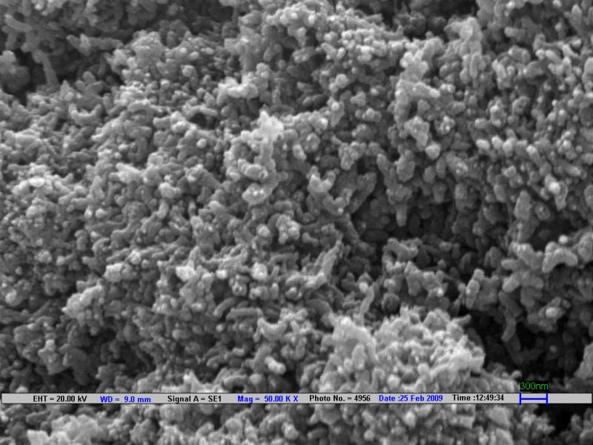

Fig. 5.9 SEM micrograph of polyaniline doped with (+)-tartaric acid contact time 80 sec

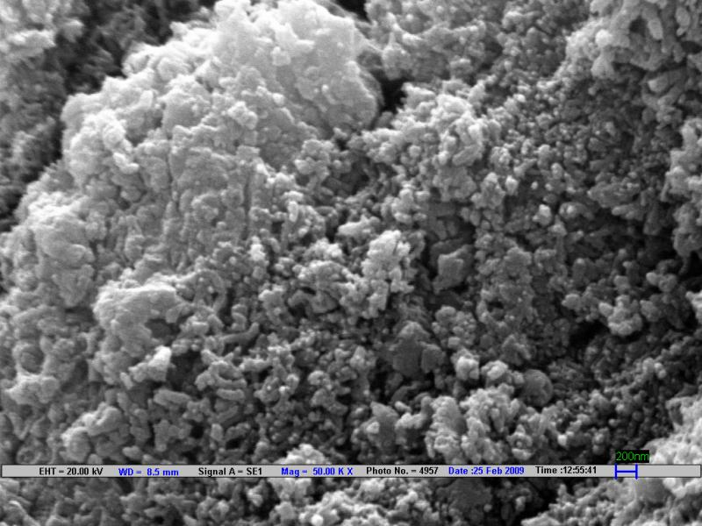

Fig. 5.9 SEM micrograph of polyaniline doped with (+)-tartaric acid contact time 120 sec
5.5 Electrical Investigations

It is one of the most important characteristic of a conducting polymer especially to explore their use in electrical devices. We have attempted to measure resistivity, conductivity, capacitance, and dielectric constant of PANI under different conditions.

Resistivity and conductivity measurements
The conductivity measurements were carried out by a two-probe technique recorded by a multimeter (Keithley model 2001). The thin pellets of the samples were prepared and sandwiched between the two ITO coated glass plates. The conductivity of the ITO coated glasses was measured by using the multimeter (DM-453). The connections for measuring electrical parameters were made with ITO substrates using indium solder.

The specific resistivity has been evaluated as
ρ = RA/L (1)

Or conductivity, σ = 1 / ρ (2)

Where ρ is its resistivity, A is the cross sectional area of the sample and L is its thickness.

Details of pellets specification for the conductivity measurement using two probe method are given as below.

Thickness (L) 1mm = 0.1 cm
Diameter (D) 10mm = 1 cm
Radius D/2 = 0.5 cm
Area of pellet Πr² = 0.7850 cm²
Voltage applied across the pellet = 10 V

Putting the above values in equation (2) we get the conductivity of the pellets at different conditions which is given in the table below

Sample | Current at different temperature |  |  | V | Conductivity( S/cm) at different temperature
Sample | Room temp.  308.16k | 338.16K | 353.16K | V | Room temperature  308.16K | 338.16K | 353.16K
In case of  120 sec | 0.012 A | 0.015 A | 0.021 A | 10 | 1.52 x10⁻⁴ | 1.9 x10⁻⁴ | 2.6 x10⁻⁴
In case of  80 sec | 0.014A | 0.013A | 0.017A | 10 | 1.7 x10⁻⁴ | 1.6 x10⁻⁴ | 2.1 x10⁻⁴
In case of  50 sec | 0.021A | 0.023A | 0.026 µA | 10 | 2.6 x10⁻⁴ | 2.9 x10⁻⁴ | 3.3 x10⁻⁴

Thus form the above table it is manifested that maximum conductivity is achieved in case when the contact time between the reactants was 50 sec which is due to higher percentage of nanofibres in the product which is evedent from the SEM results
The increase in conductivity with temperature was obvious for semiconducting polymer which might be due to thermal activation process. The electrical conductivity in the doped PANI powders might be associated with excitation of the mobile p-electrons from the valence band containing highest occupied molecular orbital (HOMO) to the conduction band containing lowest unoccupied molecular orbital (LUMO) and the charge hopping between the polymer chains. The conduction mechanism in PANI as observed in case of tartaric acid doped PANI can be explained on the concept of polaron and bipolaron formation. Low level of oxidation of the polymer gives polaron and higher level of oxidation gives bipolaron. Both polarons and bipolarons are mobile and could move along the polymer chain by the rearrangement of double and single bonds in the conjugated system. Conduction by polarons and bipolarons was supposed to be the dominant factors which determine the mechanism of charge transport in polymer with non-degenerate ground states. The magnitude of the conductivity was determined by the number of charge carriers available for conduction and the rate at which they move i.e. mobility. In conducting polymers which could be considered as semiconductor the charge carrier concentration increased with increasing temperature. Since the charge carrier concentration was much more temperature dependent than the mobility, therefore it was the dominant factor and conductivity increased with increase in temperature. Hence, it may be summarized that the conduction is associated with thermal excitation of charge carriers from the impurity levels.

CHAPTER VI

CONCLUSION

6.1 Conclusion
The present work was an attempt to understand the effect of contact time between the reactants during oxidative polymerization of polyaniline on the morphology of polyanilne. thus by the images of (+)- tartaric acid doped PANI obtained through SEM manifested that with decrease in contact time the agglomeration of nanofibres to granular polyaniline could be checked by decrease in contact time between the reactant. APS was used as initiater to provide free radicals which generates free radical to intiate the polymerization of aniline into polyaniline. Thus it is observed through CD spectroscopy that chiral dopants like (+) tartaric acid generates helical structures. Due to the formation of helix the delocalization of pi-electrons increases which resulted in the development of conductivity in the polymer and the polymer behaves like a semiconductor. This is confirmed by the two probes technique that by increase in temperature conductivity also increases which is an indication of semiconductor.

REFERENCES
1) H. Shirakawa, E. J. Louis, A. G .MacDiarmid, C. K. Chiang, A. J.Heeger, Chem. Commun.578 (1977).
2) A. J. Heeger, Angew, Chem. Int. Ed 40 (I976) 2591.
3) G. L. Yuan, N. Kuramoto, Synth. Met. 2002
4) MacDiarmid, A.G., Epstein, A.J. Faraday Discussions, 88(2001), 317-332.
5) Handbook of organic conductive materials and polymers(Ed : H. S. Nalwa) wiley New york 1997
6) H. Shirakawa, E. J. Louis, A. G .MacDiarmid, C. K. Chiang, A. J.Heeger, Chem. Commun.578 (1977).
7) Handbook of conducting polymers (Eds: T. A. skotheim ,R. L.Elsenbaumer, J.F. Reynolds) 2nd edition Marcel Dekker, New York 1998
8) Jiaxing Huang Synthesis and application of conducting polymer polyaniline nanofibres pure Appl. Chem., vol. 78, No1 pp. 15-27, 2006
9) Stejskal J, Riede A, Hlavata D, Prokes J, Helmstedt M and Holler P, Synth Met 96:55 (1998).
10) G.B.Streetand T.C. Clarke, IBM J.Res.Develop., 25 (1981), 1.
11) W.R.Solaneck, J.L. Dreads, C.R. Wu and J.J.Ritsko, Chem Phys.Lett.127 (1986), 8.
12) W.S. Haung, B.D. Humphery and A.G. Mac Diarmid, J.Chem.Soc. Faraday Trans I, 82 (1986) 2385.
13) Elena N Konyushenko,1 Jaroslav Stejskal, Ivana S ede nkova , Miroslava Trchova ,Irina
Sapurina, Miroslav Cieslar and Jan Prokes Polym Int 55:31–39 (2006) DOI: 10.1002/pi.1899
14) Heeger, A.J., Angew Chem.Int. Ed. Engl., 40 (2001), 2591- 2611.
15) J. C. Clark, G. G. Ihas, M. Reghu, C. O. Yoon, A. J. Heeger and Y. Cao, Journal of Low Temperature Physics (Historical Archive, 101 (1995), 605 – 610.
16) S. F. Michael and Nathan, S. L., Proc. Natl. Acad. Sci. USA, 92 (1995) 2652-2656.
17) K. F. Schoch, Jr. Westinghouse Science and Technology Center IEEE Electrical Insulation Magazine.
18) Handbook of Conducting Polymers, ed. By Skotheim
19) Silverstein RM, Bassler GC and Morrill TC, Spectrometric Identification of Organic
Compounds,5th edn. J Wiley, New York (1991).
20) Fu Y and Lesenbaumer RL, Chem Mater 6:671 (1994).
21) Meeger et al Synth Met 96:55 101 (1995),
22) Keto et al Journal of Applied Electrochemistry, 27 (1997), 309-316.

23) K. Akagi, G. Piao, S. Kaneko, K. Sakamaki, H. Shirakawa, M.Kyotani, Science 1998,
282, 1683.
24) Mir Reza Majidi, Leon A. P. Kane-Maguire and Gordon G. Wallace Australia Journal
Chemistry
25) Cheng C, Jiang J, Tang R and Xi F, Synth Met 1998 (2004).
26) G. G. Wallace L. A. P. Kane-Maguire, I. D. Norris, Synth. Met. 1999, 101, 817.
27) L. A. P. Kane-Maguire, J. M. Davey, C. O. Too, S. F. Ralph, G. G. Wallace,
Macromolecules 2000, 300
28) P. A. McCarthy, J. Huang, S. C.Yang, H. L.Wang, Langmuir 2002, 18, 159.
29) Wang X, Liu N, Yan X, Zhang W and Wei Y, Chem Lett 34:42 (2005).
30) N. Gospodinova, and L.Terlemezyan, Prog. Polym. Sci., 21 (1998) 443.
31) Mazur M, Tagowska M, Palys B and Jackowska K, Electrochem Commun 5:403 (2003).
32) Trchov M, Stejskal J and Proke J, Synth Met 101:840 (1999).
33) W. G. Li, H. L. Wang, J. Am. Chem. Soc. 2004, 126, 2278. b) Y. S. Yang, M. X. Wan, J.
Mater. Chem 2002, 12, 897.

LIST OF ACRONYMS

APS AMMONIUN PEOXO DISULPHATE
ATP ADINOSINE TRIPHOSPHATE
CB CONDUCTION BAND
DC DIRECT CURRENT
DMSO DIMETHYL SULPHOXIDE
E_{dis} _{DISTORTION ENERGY}
E_{IP} _{IONIZATION ENERGY}
ESD ELECTRO STATIC DISCHARGE
HCl HYDRO CHLORIC ACID
HOMO HEIGHEST OCCUPIED MECULAR ORBITAL
IR INFRARED
LUMO LOWEST UNOCCUPIED MECULAR ORBITAL
MO MECULAR ORBITAL
NMP N, N’- DIMETHYL PYROLLIDONE
PANI POLYANILINE
ppm PARTS PER MILLION
PPS POLY PROPYLENE STYRENE
PPy POLYPYRROLE
PTh POLY THIOPHENE
PVC POLY VINYL CHLORIDE
SEM SCANNING ELECTRON MICROSCOPE
UV ULTRA VIOLET
λ_{max} MAXIMUM WAVELENGTH

LIST OF SYMBOLS

C MAR CONCENTRATION

D INTERPLANAR DISTANCE

Ω OHM

K KELVIN

nm NANOMETER

R RESISTANCE

μ MOBILITY

ρ RESISTIVITY

σ CONDUCTINITY

t TIME

ºC TEMPERATURE

