INVESTIGATION ON WEAK BEAM STRONG COLUMN CONCEPT IN PERFORMANCE OF R.C. FRAMED BUILDING UNDER SEISMIC CONDITIONS
A Major Project
Submitted In Partial Fulfilment of Requirements
For The Award of the Degree of
MASTER OF ENGINEERING
IN
CIVIL ENGINEERING
(WITH SPECIALIZATION IN STRUCTURAL ENGINEERING)
Submitted by
ANURAG AGRAWAL
University Roll No.12361

Under the Supervision of
SHRI ALOK VERMA

DEPARTMENT OF CIVIL ENGINEERING
DELHI COLLEGE OF ENGINEERING
UNIVERSITY OF DELHI
DELHI-110042
2009

Department of Civil & Environmental Engineering

Delhi College of Engineering, Delhi-110042


CERTIFICATE

This is to certify that the project entitled “INVESTIGATION ON WEAK BEAM STRONG COLUMN CONCEPT IN PERFORMANCE OF R.C. FRAMED BUILDING UNDER SEISMIC CONDITIONS” being submitted by me, is a bonafide record of my own work carried by me under the guidance of Mr. Alok Verma in partial fulfillment of requirements for the award of the degree of Master of Engineering (Structural Engineering) in Civil Engineering, Delhi University, Delhi.
The matter embodied in this project has not been submitted for the award of any other degree.

ANURAG AGRAWAL
Roll No: 12361
M.E. (Structural Engineering)
CERTIFICATE
This is to certify that the above statement made by the candidate is correct to the best of my knowledge.

Alok Verma
Lecturer
Department of Civil Engineering
Delhi College of Engineering,
Delhi- 110042.

Acknowledgement

It is a matter of great pleasure to express my deep sense of gratitude and indebtness to Shri. Alok Verma, Lecturer for his valuable guidance without which completion of this project would not have been possible.

I also express my sincere gratitude to the faculty of Civil Engineering Department, Computer Centre & Library, Delhi college of Engineering. I also acknowledge my indebtedness to many sources, including those specially mentioned in the references, at the end of the text for using their literature for the preparation of this report.

Last but not the least; I am thankful to my parents and friends for their help and encouragement.

ANURAG AGRAWAL
Roll No.12361

ABSTRACT

The reduction of earthquake risk will require improved understanding of structural earthquake behavior, advancement of the methods used to simulating structural response, and the development of new seismic design procedures.

In multi-storey reinforced concrete buildings the seismic inertia forces generated at its floor levels are transferred through the various structural elements to the ground. The failure of a column can affect the stability of the whole building, but the failure of a beam causes localized effect. Lack of ductility in columns, beams, and connections has been blamed for the most serious damage to the major structures that occurred during recent earthquakes. That is why moment resistant ductile frames of reinforced concrete are designed for strength and ductility. Strength relates to the maximum capacity of the structural member to resist the earthquake load and ductility relates to the maximum deformation beyond the yield stress without loss of strength. To prevent the failure during strong earthquake the column member is designed stronger than the beam member. It is called as strong column and weak beam concept. This study is based on strong column and weak beam concept.

In the present work, the performances of RC framed buildings of different columns and beam capacities subjected to Seismic loading were studied to determine the favourable combination of column and beam section. In this study a real building and an idealized building model were analysed with varying column and beam’s stiffness. Percentage changes in base shear value, time period and story drift as a result of change in relative stiffness were found out through STAAD 2005 structural engineering software. Performance of real building and an idealized building in seismic conditions have been compared.
.
LIST OF CONTENTS

- CERTIFICATE
- ACKNOWELDGEMENT
- ABSTRACT
- LIST OF CHARTS
- LIST OF TABLE
- ABREVIATION
  - INTRODUCTION
  - GENRAL
  - EARTHQUAKE
  - OBJECTIVE
- LITERATURE REVIEW
  - CODAL SPECIFICTION
  - CONCEPT OF STRONG COLUMN WEAK BEAM
- PLAN OF STUDY
- RESULTS & DISCUSSION
- CONCLUSIONS
- FURTHER SCOPE OF STUDY
REFFRENCES

LIST OF CHARTS

- %Variation in time period for mode 1 in x direction for idealized modal.
- %Variation in time period for mode 1 in x direction for real modal.
- % Variation in time period in mode 2 in x direction for idealized modal.
- % Variation in time period in mode 2 in x direction for real modal.
- % Variation in time period in mode 3 in x direction for idealized modal.
- % Variation in time period in mode 3 in x direction for real modal.
- % Variation in time period in mode 4 in x direction for idealized modal.
- % Variation in time period in mode 4 in x direction for real modal.
- % Variation in time period in mode 5 in x direction for idealized modal.
- % Variation in time period in mode 5 in x direction for real modal.
- % Variation in time period in mode 6 in x direction for idealized modal.
- % Variation in time period in mode 6 in x direction for real modal.
- % Variation in time period in mode 7 in x direction for idealized modal.
- % Variation in time period in mode 7 in x direction for real modal.
- % Variation in time period in mode 8 in x direction for idealized modal.
- % Variation in time period in mode 8 in x direction for real modal.
- % Variation in CQC base shear in x direction for idealized modal.
- % Variation in CQC base shear in x direction for real modal.
- % Variation in SRSS base shear in x direction for idealized modal.
- % Variation in SRSS base shear in x direction for real modal.
- % Variation in 10PCT base shear in x direction for idealized modal.
- % Variation in 10PCT base shear in x direction for real modal.
- % Variation in ABS base shear in x direction for idealized modal.
- % Variation in ABS base shear in x direction for real modal.
- % Variation in story drift for 10th story in x- direction for idealized modal.
- % Variation in story drift for 10th story in x- direction for real modal.

LIST OF TABLES

- Chronology of Earthquake in India and its surrounding regions.
- % Variation in Modal time periods in x direction for idealised modal.
- % Variation in Modal time periods in x direction for idealised modal.
- % Variation in Base shears value in x direction for idealised modal.
- % Variation in story drifts in x direction for idealized modal.
- % Variation in Modal time periods in x direction for real modal.
- % Variation in Modal time periods in x direction for real modal.
- % Variation in Base shears value in x direction for real modal.
- % Variation in story drifts in x direction for real modal.

Abbreviations

CQC Complete Quadratic Combination

SRSS Square root of sum of square

ABS Absolute sum

1. INTRODUTION

  - GENERAL

Earthquakes pose an important challenge for the art and science of structural engineering. Traditionally, India has been vulnerable to various natural hazards, especially earthquakes, which are considered to be among the most destructive with the potential of inflicting huge losses to life and property.

Past earthquakes have inflicted great losses to this region. Therefore, it is essential to make studies to anticipate the performance of structures in different conditions so that potential losses expected from the disasters are reduced.

One of the major concerns during an earthquake is the inadequacy of strength of column and beam member in RCC frame buildings. They should follow the concept of ‘strong column weak beam’. Time period, Base shear and story drift are the parameters generally used to identify behaviour of buildings and estimate adequate section for column and beam members.

  - EARTHQUAKE
Earthquake is the shaking of the Earth’s surface caused by rapid movement of the Earth’s rocky outer layer. Earthquakes occur when energy stored within the earth, usually in the form of strain in rocks, suddenly releases. This energy is transmitted to the surface of the Earth by earthquake waves. The point within the earth where earthquake waves originate is called the focus. Vibrations from the focus spread in all directions. The vibration first reaches the ground surface at a point immediately above the focus, which is called the “epicentre”. The destruction an earthquake causes depends on its magnitude and duration, or the amount of shaking that occurs. Earthquakes vary from small, imperceptible shaking to large shocks felt over thousands of kilometres. Earthquakes can deform the ground, make buildings and other structures collapse, and create tsunamis.

1.2.1 TYPES OF EARTHQUAKES
There are many different types of earthquakes: tectonic, volcanic, and explosion. The type of earthquake depends on the region where it occurs and the geological make-up of that region. The most common are tectonic earthquakes. These occur when rocks in the earth's crust break due to geological forces created by movement of tectonic plates. Another type, volcanic occurs in conjunction with volcanic activity. Collapse earthquakes are small earthquakes in underground caverns and mines, and explosion earthquakes result from the explosion of nuclear and chemical devices.
1.2.2 CAUSES OF EARTHQUAKE
Earthquakes occur when a build-up of pressure or strain between sections of rocks within the earth's crust is suddenly released, causing minor or severe vibrations on the surface of the land. The point at which layers of rock shift and reposition in relation to one another, is called the focus. This is the effective centre of the earthquake.
This energy can be generated by a sudden dislocation of segments of the crust or plate, by a volcanic eruption, or even by manmade explosions. The earth is divided into three main layers - a hard outer crust, a soft middle layer and a centre core. The outer crust is broken into massive, irregular pieces called "plates". The majority of earthquakes in recent years fall under the category of plate tectonics. When two plates interact at their boundaries they put forces on each other. These forces of reaction cause physical and chemical changes at their boundaries. Plates move side to side, up and down, and also interact head on. Earthquakes also occur in these areas where new plates are being created and old plates are being sub ducted into the Earth's interior. Earthquakes which are due to the interaction of plates are called interplate earthquakes. But what about intraplate earthquakes, which occur across one plate? Less common than earthquakes that occur at plate boundaries, these earthquakes are due to local systems of forces, such as lack of strength or changes in temperature below the Earth's crust. Most often they are due to movement on pre-existing faults.

1.2.3 STATUS OF EARTHQUAKE IN INDIA

India is a country located in south Asia. India is surrounded by the regions of high seismicity, which include the Himalayan Arc and Shillong Plateau in the north, the Burmese Arc, Arakan Yoma anticlinorium in the east and complex Naga-Disang-Jaflong thrust zones in the northeast. It is also the site of the Dauki Fault system along with numerous subsurface active faults and a flexure zone called Hinge Zone. These weak regions are believed to provide the necessary zones for movements within the basin area. (www.usgs.gov)
In the seismic zoning map of India (figure 1), the country is divided into four generalised zones: zone-II, zone-III, zone-IV and zone-V. A study carried based on the building data in the vulnerability atlas of India 1997 shows that only in the seismic zone V of India covering an area of 12% of the total land area of the country, there are 11.1 million vulnerable housing units as per census of India 1991. If one accounts for similar vulnerable buildings in seismic zone IV also, the number will at least be 5o million. (ref. 1)

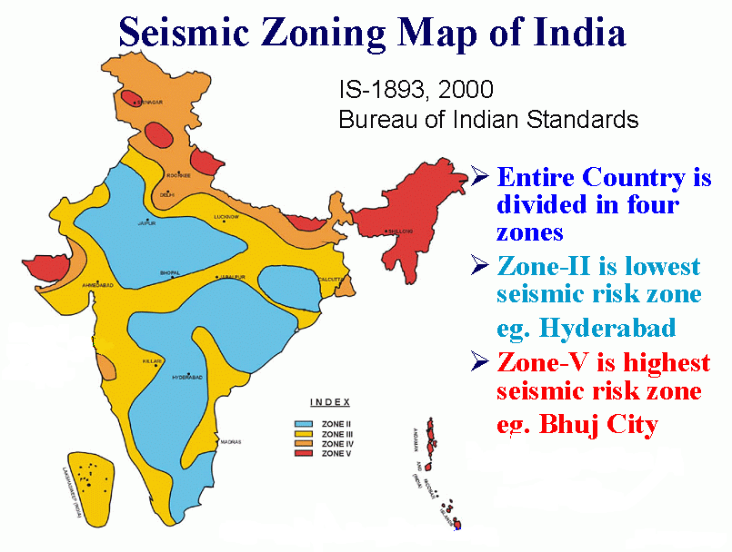
Figure 1 (ref- 2)

1.2.4 HISTORYOF EARTHQUAKES IN INDIA

Accurate historical information on earthquakes is very important in evaluating the seismicity of India. Information on earthquakes in and around India is available for the last 190 years. Table 1 gives a brief list of the historic earthquakes recorded in and around India.

Chronology of Earthquake in India and its surrounding region
(www.usgs.gov, www.nicee.org, www.imd.ernet.in )
Table 1
Place | Year | Magnitude | Experiences
KUTCH | 1819-06-16 | 8 | 2000 approx. died
CACHER | 1869-06-21 | 7.8 | No record.
SHILLONG | 1897-06-12 | 8.7 | 1500 approx. died
KANGRA (H.P.) | 1905-04-04 | 8 | > 20,000 died
SIBSAGAR | 1906-08-31 | 7 | Property damage
SRIMANGAL | 1918-07-8 | 7.6 | 4500 sq km are suffered damage
SOUTH WEST ASSAM | 1923-09-09 | 7.1 | Property damage
JABALPUR | 1927-06-02 | 6.5 | No record
ASSAM | 1931-01-27 | 7.6 | Property damage
BIHAR-NEPALBORDER | 1934-01-15 | 8.3 | > 10,633 died
INDORE | 1938-03-14 | 6.3 | No record
ANDAMAN ISLANDS | 1941-06-26 | 8.1 | No record
NORTH EAST ASSAM | 1943-10-23 | 7.2 | Destruction to property
UPPER ASSAM | 1949-07-29 | 7.6 | Sever damage
ARUNACHAL PRADESH-CHINA BORDER | 1950-08-15 | 8.5 | 1526 died
ANJAR, GUJARAT | 1956-07-21 | 7 | 113 died
KOYNA, MAHARASHTRA | 1967-12-10 | 6.5 | 177 died
NORTH BIHAR | 1988 | 6.5 | 1000 approx died
INDO- MYANMAR BOARDER | 1988-08-6 | 7.5 | No causality
UTTARKASHI | 1991-10-20 | 6.6 | >20,000 died
KILLARI(LATHUR) | 1993-09-09 | 6.3 | >10000 died
JABALPUR | 1997-05-21 | 6 | >55 died
CHAMBOLI | 1999-03-29 | 6.8 | >150 died
BHUJ | 2001-01-01 | 7.6 | 20,023 died
NORTH ANDMAN | 2002-09-14 | 6.5 | Damage to property
NICOBAR ISLAND INDIAN REGION | 2005-07-24 | 7.2 | No record
KASHMIR (POK) | 2005 Oct 8 | 7.6 | 1329 in India, 47,700 in Pakistan died
SUMATRA ISLAND | 2005-12-26 | 9.1 | 2,27,898 died
SIKKIM | 2006-02-14 | 5.3 | Destruction to buildings

  - OBJECTIVE OF STUDY

Following are the objectives of this study.

- Investigation of strong column weak beam concept.

- Investigation of variation in other parameters just like model time period, base shear and story drifts due change in strength of structural members.

- Comparisons of effects due to changes made in idealized & real buildings.

2. LITERATURE REVIEW

Good details and construction quality are of secondary value if a building has an odd shape that was not properly considered in the design. Although a building with an irregular configuration may be designed to meet all code requirements, irregular buildings generally do not perform as well as regular buildings in an earthquake. Typical building configuration deficiencies include an irregular geometry, a weakness in a given story, a concentration of mass, or a discontinuity in the lateral force resisting system. Vertical irregularities are defined in terms of strength, stiffness, geometry and mass. Horizontal irregularities involve the horizontal distribution of lateral forces to the resisting frames or shear walls.

  - SEIESMIC VULNERABILITY FACTOR

    - IRREGULAR CONFIGURATION

Configuration of buildings is related to dimensions, building form, geometric proportions and the location of structural components. The configuration of a building will influence its seismic performance, particularly regarding the distribution of the seismic loads. Based on past earthquake experiences, it can be stated that symmetrical buildings with simple configurations are more resistant to earthquake shaking

- PLAN IRREGULARITY ( ref 2)

- TORSION IRREGULARITY
Whenever there is significant torsion in a building, the concern is for additional seismic demands and lateral drifts imposed on the vertical elements by rotation of the diaphragm. Buildings can be designed to meet code forces including torsion, but buildings with severe torsion are less likely to perform well in earthquakes. It is best to provide a balanced system at the start rather than design torsion into the system. Torsion irregularity to be considered to exist when the maximum story drift, computed with design eccentricity, at one end of the structures transfers to an axis is more than 1.2 times the average of the story drifts at the two ends of the structures. (ref 2)

- RE-ENTRANT CORNERS

Diaphragms with plan irregularities such as extending wings, plan insets, or E-, T-, X-, L-, or C-shaped configurations have re-entrant corners where large tensile and compressive forces can develop. The diaphragm may not have sufficient strength at these re-entrant corners to resist these tensile forces and local damage may occur. This occurs when both projection at re-entrained corner are greater than 15 to 20 %.(ref 2)

- DIAPHRAGM DISCONTINUITY

Diaphragm discontinuity is occurs on that structure in which Diaphragms with abrupt discontinuities or variations in stiffness, including those having cut-out or open areas greater than 50 percent of the gross enclosed diaphragm area, or changes in effective diaphragm stiffness of more than 50 percent from one story to the next. (ref 2)

- OUT-OF-PLANE OFFSETS

Large openings at shear walls significantly limit the ability of the diaphragm to transfer lateral forces to the wall. This can have a compounding effect if the opening is near one end of the wall and divides the diaphragm into small segments with limited stiffness that are ineffective in transferring shear to the wall. Large openings may also limit the ability of the diaphragm to provide out-of-plane support for the wall

- VERTICAL IRREGULARITY

Vertical irregularities are defined in terms of strength, stiffness, geometry, and mass. These factors are evaluated separately but are related and may occur simultaneously. Horizontal irregularities involve the horizontal distribution of lateral forces to the resisting frames or shear walls.

WEAK STORY

The story strength is the total strength of all the lateral force-resisting elements in a given story for the direction under consideration. It is the shear capacity of columns or shear walls. If the columns are flexural controlled, the shear strength is the shear corresponding to the flexural strength. Weak stories are usually found where vertical discontinuities exist, or where member size or reinforcement has been reduced. It is necessary to calculate the story strengths and compare them. The result of a weak story is a concentration of inelastic activity that may result in the partial or total collapse of the story.

SOFT STORY

This condition commonly occurs in hospital buildings with particularly tall first stories. Such cases are not necessarily soft stories because the tall columns may have been designed with appropriate stiffness, but they are likely to be soft stories if they have been designed without consideration for inter-story drift. Soft stories are usually revealed by an abrupt change in inter-story drift. Although a comparison of the stiffness in adjacent stories is the direct approach, a simple first step might be to plot and compare the inter-story drifts if analysis results happen to be available.
The difference between "soft" and "weak" stories is the difference between stiffness and strength. A column may be limber but strong or stiff but weak. A change in column size can affect strength and stiffness and both need to be considered.

- STIFFNESS IRREGULARITY –SOFT STORY

A soft story is one in which the lateral stiffness is less than 70 percent of that in the story above or less than 80 percent of the average lateral stiffness of the three stories above.(ref-2)

- MASS IRREGULARITY

Mass irregularities can be detected by comparison of the story weights. The effective mass consists of the dead load of the structure on each level plus the actual weight of partitions and permanent equipment on each floor. The validity of this approximation is dependent upon the vertical distribution of mass and stiffness in the building. Mass irregularity shall be considered to exist where the seismic weight of any story is more than 200 percent of that of its adjacent stories. The irregularity need not be considered in case of roofs. (ref 2)

- VERTICAL GEOMETRIC IRREGULARITY

Vertical irregularity is usually detected by visual observation. The most common example is a discontinuous column or masonry shear wall. The element is not continuous to the foundation but stops at an upper level. The shear at this level is transferred through the diaphragm to other resisting elements below. This issue is a local strength and ductility problem below the discontinuous element, not a global story strength or stiffness irregularity. The concern is that the wall or frame may have more shear capacity than considered in the design. Vertical geometric irregularity shall be considered to exist where the horizontal dimension of the lateral force resisting system in any story is more than 150 percent of that in its adjacent story.

- DISCONTINUITY IN CAPACITY-WEAK STORY

A weak story is one in which the story lateral strength is less than 80 percent of that in the story above (ref-2). The story lateral strength is the total strength of all seismic force resisting elements sharing the story shear in the considered direction.

2.1.2 STRONG COLUMN WEAK BEAM

When columns are not strong enough to force hinging in the beams, column hinging can lead to story mechanisms and a concentration of inelastic activity at a single level. Excessive story drifts may result in instability of the frame due to P-D effects. Good post-elastic behaviour consists of yielding distributed throughout the frame. A story mechanism will limit forces in the levels above, preventing the upper levels from yielding. The alternative procedure checks for the formation of a story mechanism. The story strength is the sum of the shear capacities of all the columns as limited by the controlling action. If the columns are shear critical, a shear mechanism forms at the shear capacity of the columns. If the columns are controlled by flexure, a flexural mechanism forms at a shear corresponding to the flexural capacity. (ref-3)

2.1.3 LOAD PATH

The general load path of a building is as follows: seismic forces originating throughout the building are delivered through structural connections to horizontal diaphragms; the diaphragms distribute these forces to vertical lateral-force-resisting elements such as shear walls and frames; the vertical elements transfer the forces into the foundation; and the foundation transfers the forces into the supporting soil.
There must be a complete lateral-force-resisting system that forms a continuous load path between the foundation, all diaphragm levels, and all portions of the building for proper seismic performance. If there is a discontinuity in the load path, the building is unable to resist seismic forces regardless of the strength of the existing elements. Mitigation with elements or connections needed to complete the load path is necessary to achieve the selected performance level.
Examples would include a masonry shear wall that does not extend to the foundation, or a column in an upper story that does not continue to the foundation.

2.1.4 ADJACENT BUILDINGS AND POUNDINGS

If buildings are built without sufficient gaps between them and the interaction has not been considered, the buildings may impact with each other, or pound, during an earthquake. Building pounding can alter the dynamic response of both buildings and impart additional inertial loads on both structures. Buildings of the same height with matching floors will exhibit similar dynamic behaviour. If the buildings pound, floors will impact with other floors, which means that damage due to pounding usually will be limited to non-structural components. However, when the floors of adjacent buildings are at different elevations, floors will impact with the columns of the adjacent building and that can cause structural damage. Since neither building is designed for these conditions, there is a potential for extensive damage and possible collapse.

Geometric irregularities are usually detected through an examination of the story-to-story variation in the dimensions of the lateral-force-resisting system. A building with upper stories set back from a broader base structure is a common example. Another example is a story in a high-rise that is set back for architectural reasons. It should be noted that the irregularity of concern is in the dimensions of the lateral-force-resisting system and not the dimensions of the envelope of the building, and, as such, it may not be obvious.

Figure 2
Torsions irregularity (ref 3)

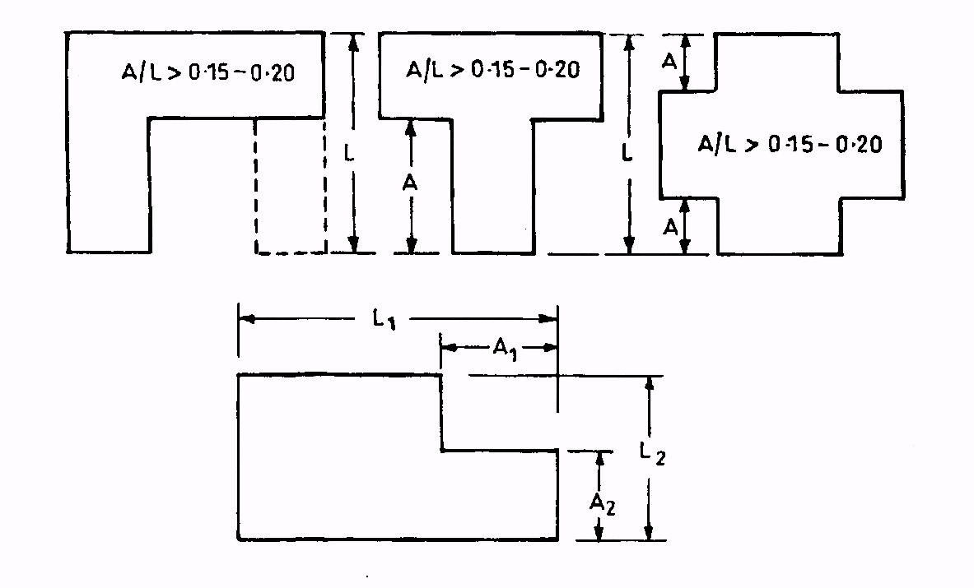

Figure 3
Re-entrant Corner (ref 2)

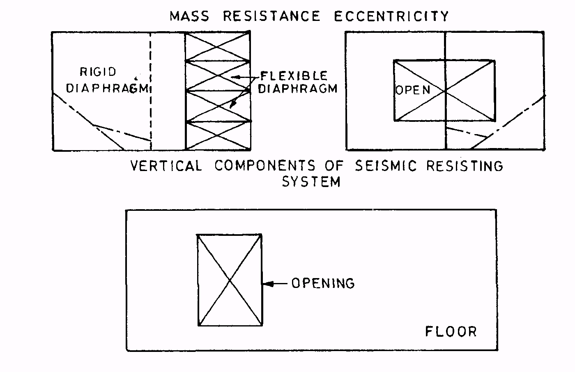
Figure 4
Diaphragm discontinuity (ref-2)

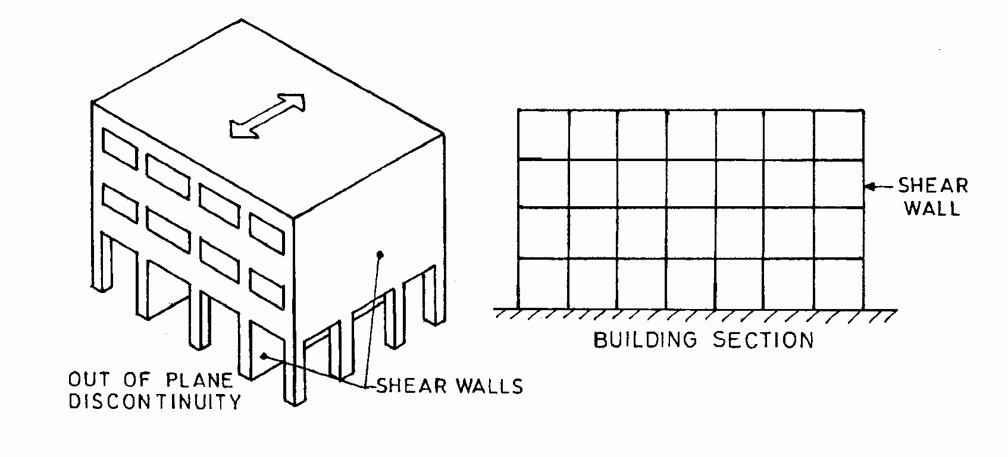

Figure 5
Out of Plane Discontinuity (ref 2)
Figure 6 (ref 3)
Soft story due to excessive floor height in the ground story

Figure 7
Soft story due to lack of brick infill (ref 3)

Figure 8
Mass Irregularity (ref- 3)
Figure 9
Vertical irregularity in buildings (ref-3)
Figure 10 Figure 11
Shear walls in cantilever (ref-3) Excessive setback (ref-3)

Figure 12
Load path (ref 3)
Figure 13
Different floor height buildings suffer more in pounding (ref 3)

Figure 14
Pounding due to small gap between two buildings (ref 3)

Figure 15
Sufficient gap between two buildings prevents pounding (ref-3)

  - CONCEPT OF STRONG COLUMN AND WEAK BEAM

Moment resistant ductile frame of reinforced concrete structure is designed for strength and ductility. Strength related to the maximum capacity of the structural member to resist the earthquake load, ductility related to the maximum deformation beyond the yield stress without loss of strength. To prevent the failure during strong earthquake the column member is designed stronger than the beam member it is called as strong column and weak beam concept.

2.2.1 BEHAVIOR OF STRONG COLUMN & WEAK BEAM

For a strong earthquake a reinforced concrete structure should be designed so that it can provide the energy dissipation to the possible extent. The only method can be used to follows the requirement above is strong column and weak beam design method.
The following are the major aspect of the strong column and weak beam concept, as follows:
- The overall structure is designed so it can develop inelastic structural behaviour.
- Columns are designed stronger than beams. It means, during strong earthquake column member remain elastic so it can provide stability and strength of the stories above.
- The sum of the moment of resistance of the columns shall be at least 1.1 times the sum of the moment of resistance of the beams at each frame joint.(ref 4)
- The development of plastic hinge forms at the end of beam, so the energy dissipation occurs in the plastic hinge.
- To ensure the perfect energy dissipation at plastic hinge, plastic hinge region requires special reinforcement detailing (confinement) to improve ductility, energy absorption capacity and perform inelasticity.

2.2.2 PLASTIC HINGE FORMATION

In the strong column and weak beam concept the beam is permitted to yields but the column remains elastic. The behaviour of reinforced concrete beam is more ductile than the reinforced concrete column, so it is safer to design the location of plastic hinge forms at the end of beam rather at the column.
The figure below shows the desirable and undesirable formation of plastic hinge at the end of reinforced concrete beam, as follows:

Figure 16
DESIRABLE FORMATION OF PLASTIC HINGE (www.seaoc.org/bluebook)

Figure 17
UNDESIRABLE FORMATION OF PLASTIC HINGE (www.seaoc.org/bluebook)

2.2.3 DUCTILITY

In general meaning ductility is the ability of the structural member to deform beyond its yield stress several times without significant losses of its strength. As already known concrete material is a brittle material so during the strong earthquake this material may fail suddenly. To provide the ductility of the plastic hinge region which at the end of beam special reinforcement detailing is required so during the earthquake the plastic hinge can deform beyond its yield stress without failure.

The main structural elements and their connection shall be designed to have a ductile failure. This will enable the structure to absorb energy during earthquakes to avoid sudden collapse of the structure. Providing reinforcing steel in masonry at critical sections, as provided in this standard will not only increase strength and stability but also ductility. The detail for achieving ductility in reinforced concrete structures is given in IS 13920: 1993.but IS 13920 – 1993 does not incorporate explicitly the specifications for strong-column weak-beam concepts, which are essential for structural survivability (ref 5). The codes of practice do not include specifications for the design of beam-column joints; guidelines are available in literature, however (Rao, 1995).

Because strength of column and beam depends on stiffness (flexural stiffness (EI/L) and axial stiffness (EA/L)) that is why in this research work, many cases with variation in section of column and beam of RC framed building are analysing. A quantitative comparison method is used to develop earthquake vulnerability scenario of a multi-storyed buildings.

3. PLAN OF STUDY

- A project study was undertaken with a view to determine the extent of possible variation in the seismic performance of real & idealized RC- framed building having different degree of structural stiffness.

- Firstly a real building model and building model of idealized building is made with help of software STAAD, which are shown in figure 18 and 19.

- Stiffness of columns of buildings is varied up to 20 % of section and real building and idealized building models are analysed.

- Then stiffness of beams of buildings is varied up to 20 % of section and once again the buildings are analysed.

- Then effect of this change in stiffness on performance of RC framed building under seismic loading is determined by observation of change in Time period, model time period, Base shear and story drift of RC framed buildings.

- On the basis of data which comes by this quantitative analysis, some conclusions and recommendations are made.

The result in the form of Charts and tables with the different case of buildings analysed in STAAD-2005 are given here after.

BUILDING MODEL

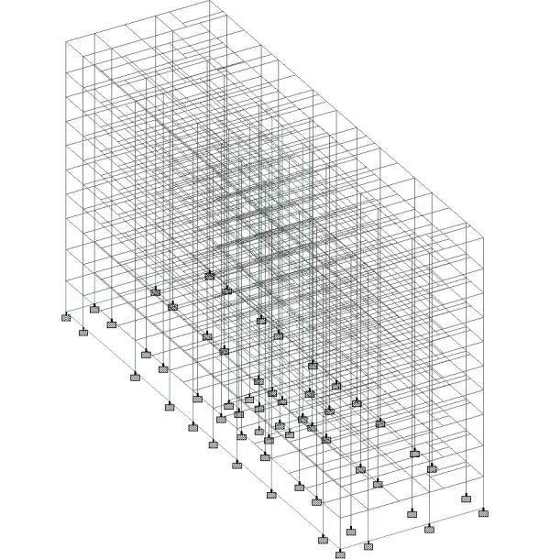
Figure 18
IDEALIZED BUILDING

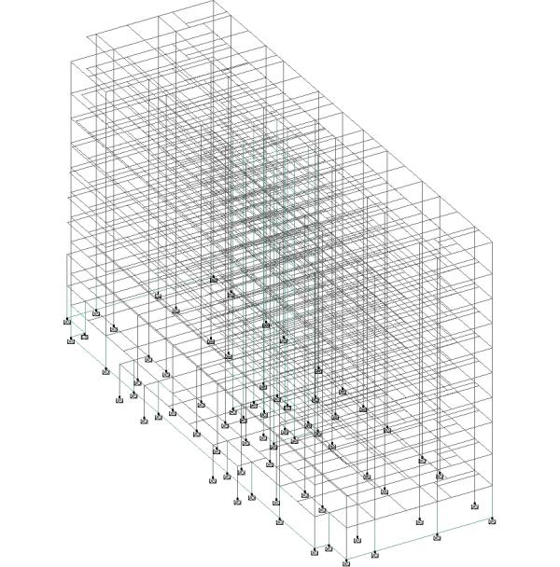

Figure 19
REAL BUILDING

Now to make a comparative study we have followed various cases as an input to our software

Two building model are considered
- Idealized building model
Cases are TiBj. In idealized building model reference case is T1B1 in which no change in column section and no change in beam section are taken.
- Real building model
Cases are DiBj. In Real building model reference case is D1B1 in which no change in column section and no change in beam section are taken.

The meaning of the nomenclature may be understood as follows,
If j = 0.8 it means section of beam reduced by 20%
If j = 0.9 it means section of beam reduced by 10%
If j = 1.1 it means section of beam increased by 10%
If j = 1.2 it means section of beam increased by 20%
If j = 1 it means no change in beam section
If i = 0.8 it means section of column reduced by 20%
If i = 0.9 it means section of column reduced by 10%
If i = 1.1 it means section of column increased by 10%
If i = 1.2 it means section of column increased by 20%
If i = 1 it means no change in column section

- RESULT AND DISCUSSION

% Variation in Modal time periods
For idealized
Table 2
CASE | MODE1 | MODE2 | MODE 3 | MODE4
T0.8B0.8 | 11.68 | 13.87 | 6.98 | 11.30
T0.8B0.9 | 7.82 | 10.23 | 4.50 | 7.73
T0.8B1 | 4.54 | 7.12 | 2.34 | 4.68
T0.8B1.1 | 1.70 | 4.44 | 0.44 | 2.04
T0.8B1.2 | -0.77 | 2.08 | -1.24 | -0.28
T0.9B0.8 | 9.25 | 10.03 | 5.82 | 8.79
T0.9B0.9 | 4.95 | 5.24 | 2.54 | 4.86
T0.9B1 | 2.04 | 3.09 | 1.07 | 2.13
T0.9B1.1 | -0.83 | 0.33 | -0.87 | -0.54
T0.9B1.2 | -3.34 | -2.10 | -2.60 | -2.88
T1B0.8 | 7.26 | 7.08 | 4.84 | 6.67
T1B0.9 | 3.34 | 3.26 | 2.25 | 3.08
T1B1 | 0.00 | 0.00 | 0.00 | 0.00
T1B1.1 | -2.89 | -2.83 | -1.98 | -2.68
T1B1.2 | -5.42 | -5.31 | -3.75 | -5.04
T1.1B0.8 | 5.59 | 4.71 | 4.00 | 4.83
T1.1B0.9 | 1.66 | 0.85 | 1.37 | 1.26
T1.1B1 | -1.70 | -2.45 | -0.92 | -1.82
T1.1B1.1 | -4.60 | -5.32 | -2.93 | -4.50
T1.1B1.2 | -7.15 | -7.85 | -4.73 | -6.87
T1.2B0.8 | 4.14 | 2.73 | 3.27 | 3.21
T1.2B0.9 | 0.21 | -1.15 | 0.60 | -0.35
T1.2B1 | -3.15 | -4.47 | -1.71 | -3.42
T1.2B1.1 | -6.06 | -7.36 | -3.76 | -6.10
T1.2B1.2 | -8.62 | -9.91 | -5.58 | -8.46

Table 3
CASE | MODE 5 | MODE 6 | MODE 7 | MODE 8
T0.8B0.8 | 12.85 | 5.56 | 11.28 | 11.77
T0.8B0.9 | 9.72 | 3.44 | 7.91 | 9.11
T0.8B1 | 7.02 | 1.61 | 5.03 | 6.81
T0.8B1.1 | 4.66 | 0.01 | 2.53 | 4.80
T0.8B1.2 | 2.57 | -1.40 | 0.33 | 3.01
T0.9B0.8 | 9.14 | 4.78 | 8.45 | 8.22
T0.9B0.9 | 5.22 | 1.65 | 4.61 | 4.48
T0.9B1 | 3.11 | 0.75 | 2.24 | 3.13
T0.9B1.1 | 0.66 | -0.89 | -0.25 | 1.05
T0.9B1.2 | -1.50 | -2.34 | -2.45 | -0.80
T1B0.8 | 6.15 | 4.10 | 5.99 | 5.15
T1B0.9 | 2.86 | 1.90 | 2.69 | 2.40
T1B1 | 0.00 | 0.00 | 0.00 | 0.00
T1B1.1 | -2.50 | -1.67 | -2.63 | -2.12
T1B1.2 | -4.72 | -3.15 | -4.82 | -4.01
T1.1B0.8 | 3.65 | 3.50 | 3.81 | 2.39
T1.1B0.9 | 0.32 | 1.27 | 0.56 | -0.35
T1.1B1 | -2.56 | -0.66 | -2.24 | -2.75
T1.1B1.1 | -5.10 | -2.36 | -4.70 | -4.88
T1.1B1.2 | -7.35 | -3.86 | -6.87 | -6.78
T1.2B0.8 | 1.45 | 2.96 | 1.82 | -0.20
T1.2B0.9 | -1.87 | 0.70 | -1.36 | -2.90
T1.2B1 | -4.75 | -1.25 | -4.13 | -5.26
T1.2B1.1 | -7.30 | -2.97 | -6.55 | -7.37
T1.2B1.2 | -9.56 | -4.50 | -8.70 | -9.26

% Variation in Base shear value
Table 4
CASE | % SRSS | % 10PCT | % ABS | %CQC
T0.8B0.8 | -5.21 | -5.03 | -3.69 | -4.97
T0.8B0.9 | -3.35 | -3.26 | -2.64 | -3.25
T0.8B1 | -1.73 | -1.68 | -1.74 | -1.68
T0.8B1.1 | -0.21 | -0.23 | -1.03 | -0.24
T0.8B1.2 | 1.13 | 1.14 | -0.29 | 1.12
T0.9B0.8 | -4.30 | -4.30 | -2.84 | -4.24
T0.9B0.9 | -2.19 | -2.19 | -2.37 | -2.23
T0.9B1 | -0.81 | -0.75 | -0.41 | -0.75
T0.9B1.1 | 0.78 | 0.85 | 0.37 | 0.78
T0.9B1.2 | 2.26 | 2.25 | 0.61 | 2.19
T1B0.8 | -4.15 | -4.37 | -17.07 | -4.73
T1B0.9 | -1.77 | -1.73 | -1.04 | -1.73
T1B1 | 0.00 | 0.00 | 0.00 | 0.00
T1B1.1 | 1.67 | 1.69 | 0.92 | 1.64
T1B1.2 | 3.19 | 3.20 | 1.71 | 3.13
T1.1B0.8 | -3.14 | -3.13 | -1.99 | -3.09
T1.1B0.9 | -1.19 | -1.15 | -0.78 | -1.13
T1.1B1 | 0.73 | 0.69 | 0.26 | 0.68
T1.1B1.1 | 2.44 | 2.42 | 1.19 | 2.36
T1.1B1.2 | 4.08 | 4.01 | 2.13 | 3.96
T1.2B0.8 | -2.65 | -2.66 | -1.81 | -2.64
T1.2B0.9 | -0.59 | -0.60 | -0.57 | -0.60
T1.2B1 | 1.26 | 1.29 | 0.54 | 1.28
T1.2B1.1 | 3.11 | 3.05 | 1.50 | 3.02
T1.2B1.2 | 4.82 | 4.74 | 2.40 | 4.68

% Variation in story drifts in x direction for idealized model
Table 5
CASE | 10th STORY | 9th STORY | 8th STORY | 7th STORY | 6th STORY | 5th STORY | 4th STORY | 3rd STORY | 2nd STORY | 1st STORY
T0.8B0.8 | 12.84 | 11.89 | 10.54 | 9.14 | 6.33 | 8.28 | 5.63 | 5.49 | 4.71 | 2.94
T0.8B0.9 | 9.94 | 8.82 | 7.69 | 6.65 | 4.25 | 6.31 | 3.49 | 4.24 | 3.27 | 2.31
T0.8B1 | 7.51 | 6.19 | 5.23 | 4.47 | 2.43 | 4.61 | 1.62 | 2.52 | 3.10 | 1.74
T0.8B1.1 | 5.47 | 3.91 | 3.09 | 2.61 | 0.84 | 3.13 | 0.00 | 1.13 | 2.83 | 1.20
T0.8B1.2 | 3.75 | 1.90 | 1.26 | 0.96 | -0.57 | 1.85 | -1.40 | -0.09 | 2.62 | 0.73
T0.9B0.8 | 9.04 | 8.73 | 7.89 | 6.89 | 4.44 | 6.79 | 4.93 | 4.16 | 3.17 | 2.03
T0.9B0.9 | 5.96 | 5.60 | 4.72 | 4.15 | 2.56 | 5.26 | 1.79 | -0.44 | -0.05 | -1.90
T0.9B1 | 3.39 | 2.82 | 2.40 | 2.04 | 0.34 | 2.90 | 0.71 | 1.30 | 1.30 | 0.82
T0.9B1.1 | 1.22 | 0.46 | 0.18 | 0.07 | -2.19 | 2.20 | -0.99 | 0.04 | 0.72 | 0.32
T0.9B1.2 | -0.64 | -1.59 | -1.77 | -1.63 | -2.81 | -0.06 | -2.48 | -0.98 | 0.14 | -0.19
T1B0.8 | 5.95 | 6.09 | 5.67 | 5.06 | 2.91 | 5.57 | 4.45 | 3.11 | 1.54 | 1.08
T1B0.9 | 2.71 | 2.82 | 2.62 | 2.33 | 0.58 | 3.39 | 2.04 | 1.38 | 0.82 | 0.60
T1B1 | 0.00 | 0.00 | 0.00 | 0.00 | 0.00 | 0.00 | 0.00 | 0.00 | 0.00 | 0.00
T1B1.1 | -2.28 | -2.40 | -2.28 | -2.01 | -3.13 | -0.16 | -1.75 | -1.17 | -0.69 | -0.51
T1B1.2 | -4.25 | -4.53 | -4.28 | -3.82 | -4.71 | -1.71 | -3.27 | -2.24 | -1.28 | -1.04
T1.1B0.8 | 3.39 | 3.84 | 3.79 | 3.47 | 1.54 | 4.60 | 3.98 | 1.87 | 0.63 | 0.47
T1.1B0.9 | 0.01 | 0.51 | 0.68 | 0.67 | -15.01 | 17.11 | 1.55 | 0.31 | -0.38 | -0.16
T1.1B1 | -2.81 | -2.36 | -2.02 | -1.72 | -2.86 | 0.34 | -0.55 | -1.07 | -1.23 | -0.73
T1.1B1.1 | -5.21 | -4.84 | -4.35 | -3.80 | -4.66 | -1.40 | -2.41 | -2.27 | -1.92 | -1.30
T1.1B1.2 | -10.23 | -7.01 | -6.39 | -5.64 | -6.26 | -2.93 | -4.01 | -3.33 | -2.54 | -1.77
T1.2B0.8 | 1.22 | 1.90 | 2.15 | 2.06 | 0.44 | 3.77 | 3.63 | 0.78 | -0.29 | -0.22
T1.2B0.9 | -2.28 | -1.48 | -1.02 | -0.76 | -1.98 | 1.42 | 1.14 | -0.77 | -1.32 | -0.85
T1.2B1 | -5.21 | -4.40 | -3.75 | -3.19 | -4.09 | -0.62 | -1.01 | -2.10 | -2.21 | -1.42
T1.2B1.1 | -7.69 | -6.96 | -6.29 | -5.20 | -5.97 | -2.44 | -2.93 | -3.29 | -3.01 | -1.99
T1.2B1.2 | -9.82 | -9.16 | -8.22 | -7.23 | -7.61 | -4.02 | -4.58 | -4.32 | -3.67 | -2.47

% Variation in Modal time periods
For real building
Table 6
CASE | MODE 1 | MODE 2 | MODE 3 | MODE 4
D1B0.8 | 7.55 | 7.07 | 4.44 | 6.81
D1B0.9 | 3.48 | 3.26 | 2.07 | 3.16
D1B1 | 0.00 | 0.00 | 0.00 | 0.00
D1B1.1 | -3.01 | -2.84 | -1.83 | -2.76
D1B1.2 | -5.65 | -5.34 | -3.47 | -5.19
D0.8B0.8 | 11.41 | 13.33 | 6.69 | 11.00
D0.8B0.9 | 7.38 | 9.68 | 4.43 | 7.33
D0.8B1 | 3.94 | 6.55 | 2.46 | 4.17
D0.8B1.1 | 0.98 | 3.83 | 0.71 | 1.43
D0.8B1.2 | -1.62 | 1.44 | -0.84 | -0.99
D0.9B0.8 | 11.27 | 14.24 | 13.40 | 11.18
D0.9B0.9 | 7.06 | 10.22 | 10.66 | 7.33
D0.9B1 | 1.79 | 2.86 | 1.13 | 1.92
D0.9B1.1 | 0.38 | 3.81 | 6.19 | 1.14
D0.9B1.2 | -3.83 | -2.38 | -2.26 | -3.27
D1.1B0.8 | 6.04 | 4.84 | 3.55 | 5.10
D1.1B0.9 | 1.97 | 1.00 | 1.14 | 1.47
D1.1B1 | -1.51 | -2.30 | -0.97 | -1.67
D1.1B1.1 | -4.53 | -5.17 | -2.84 | -4.42
D1.1B1.2 | -7.18 | -7.71 | -4.50 | -6.85
D1.2B0.8 | 4.71 | 2.96 | 2.77 | 3.56
D1.2B0.9 | 0.65 | -0.90 | 0.33 | -0.04
D1.2B1 | -2.83 | -4.21 | -1.81 | -3.16
D1.2B1.1 | -5.85 | -7.10 | -3.71 | -5.89
D1.2B1.2 | -7.21 | -6.81 | 0.80 | -6.70

Table 7
CASE | MODE 5 | MODE 6 | MODE 7 | MODE 8
D1B0.8 | 6.02 | 3.73 | 6.09 | 4.93
D1B0.9 | 2.80 | 1.72 | 2.83 | 2.30
D1B1 | 0.00 | 0.00 | 0.00 | 0.00
D1B1.1 | -2.47 | -1.52 | -2.48 | -2.04
D1B1.2 | -4.67 | -2.87 | -4.68 | -3.87
D0.8B0.8 | 12.08 | 5.06 | 11.22 | 10.90
D0.8B0.9 | 9.00 | 3.13 | 7.84 | 8.34
D0.8B1 | 6.33 | 1.47 | 4.93 | 6.12
D0.8B1.1 | 3.98 | 0.02 | 2.39 | 4.16
D0.8B1.2 | 1.90 | -1.27 | 0.15 | 2.41
D0.9B0.8 | 15.05 | 14.61 | 10.84 | 15.90
D0.9B0.9 | 11.49 | 12.36 | 7.43 | 12.93
D0.9B1 | 2.83 | 0.69 | 2.30 | 2.85
D0.9B1.1 | 5.71 | 8.69 | 1.90 | 8.04
D0.9B1.2 | -1.74 | -2.12 | -2.44 | -0.96
D1.1B0.8 | 3.69 | 3.18 | 3.91 | 2.33
D1.1B0.9 | 0.45 | 1.15 | 0.72 | -0.27
D1.1B1 | -2.38 | -0.61 | -2.06 | -2.56
D1.1B1.1 | -4.87 | -2.15 | -4.50 | -4.60
D1.1B1.2 | -7.09 | -3.53 | -6.67 | -6.44
D1.2B0.8 | 1.61 | 2.68 | 1.90 | -0.15
D1.2B0.9 | -1.62 | 0.62 | -1.21 | -2.69
D1.2B1 | -4.45 | -1.15 | -3.93 | -4.95
D1.2B1.1 | -6.94 | -2.72 | -6.33 | -6.96
D1.2B1.2 | -5.16 | 4.61 | -6.73 | -3.34

% Variation in Base shear value
Table 8
CASE | % SRSS | % 10PCT | ABS | CQC
D1B0.8 | -2.70 | -2.12 | -1.73 | -1.51
D1B0.9 | -1.02 | -0.61 | -0.81 | 0.11
D1B1 | 0.00 | 0.00 | 0.00 | 0.00
D1B1.1 | 2.09 | 2.39 | 0.74 | 3.00
D1B1.2 | 3.44 | 3.67 | 1.40 | 4.28
D0.8B0.8 | -3.78 | -3.45 | -2.76 | -2.68
D0.8B0.9 | -2.26 | -1.97 | -1.95 | -1.22
D0.8B1 | -0.84 | -0.61 | -1.26 | 0.10
D0.8B1.1 | 0.36 | 0.67 | -0.57 | 1.34
D0.8B1.2 | 1.60 | 1.93 | 0.02 | 2.47
D0.9B0.8 | -8.19 | -7.90 | -6.23 | -7.24
D0.9B0.9 | -6.55 | -6.26 | -5.37 | -5.70
D0.9B1 | 0.00 | 0.22 | -0.54 | 0.91
D0.9B1.1 | -3.77 | -3.54 | -3.91 | -2.95
D0.9B1.2 | 2.62 | 2.79 | 0.68 | 3.44
D1.1B0.8 | -1.96 | -1.59 | -1.47 | -1.02
D1.1B0.9 | -0.24 | 0.10 | -0.51 | 0.67
D1.1B1 | 1.39 | 1.63 | 0.35 | 2.23
D1.1B1.1 | 2.84 | 3.15 | 1.13 | 3.69
D1.1B1.2 | 4.30 | 4.42 | 1.85 | 5.06
D1.2B0.8 | -1.44 | -1.22 | -1.28 | -0.58
D1.2B0.9 | 0.32 | 0.65 | -0.19 | 1.17
D1.2B1 | 1.97 | 2.27 | 0.75 | 2.80
D1.2B1.1 | 3.51 | 3.77 | 1.54 | 4.30
D1.2B1.2 | -0.08 | 0.11 | -1.80 | 0.59

% Variation in story drift
Table 9
CASE | 10th story | 9th story | 8th STORY | 7th STORY | 6th STORY | 5th STORY | 4th STORY | 3rd STORY | 2nd STORY | 1st STORY
D1B0.8 | 5.95 | 6.61 | 6.34 | 5.56 | 4.59 | 4.01 | 4.39 | 3.71 | 2.06 | 1.74
D1B0.9 | 2.80 | 3.12 | -0.81 | 6.37 | 2.17 | 1.96 | 2.07 | 1.75 | 0.83 | 0.93
D1B1 | 0.00 | 0.00 | 0.00 | 0.00 | 0.00 | 0.00 | 0.00 | 0.00 | 0.00 | 0.00
D1B1.1 | -2.58 | -2.79 | -2.65 | -2.38 | -2.01 | -1.70 | -1.87 | -1.60 | -0.69 | -0.38
D1B1.2 | -4.97 | -5.38 | -4.96 | -4.68 | -3.86 | -3.30 | -3.62 | -3.07 | -1.27 | -1.06
D0.8B0.8 | 13.33 | 12.89 | 11.67 | 10.12 | 8.60 | 7.14 | 5.53 | 6.53 | 5.64 | 3.64
D0.8B0.9 | 10.53 | 9.56 | 8.49 | 7.32 | 6.37 | 5.31 | 3.44 | 4.63 | 4.42 | 2.92
D0.8B1 | 7.98 | 6.56 | 5.60 | 4.80 | 4.30 | 3.58 | 1.57 | 2.95 | 3.40 | 2.16
D0.8B1.1 | 5.60 | 3.87 | 3.01 | 2.52 | 2.44 | 2.01 | -0.11 | 1.45 | 2.52 | 1.52
D0.8B1.2 | 3.42 | 1.37 | 0.66 | 0.43 | 0.69 | 0.58 | -1.68 | 0.11 | 1.78 | 0.85
D0.9B0.8 | 1.33 | 9.18 | 9.80 | 10.12 | 10.55 | 11.72 | 14.00 | 16.43 | 14.64 | 17.69
D0.9B0.9 | -2.37 | 5.19 | 6.05 | 6.79 | 7.77 | 9.26 | 11.29 | 13.95 | 13.62 | 16.34
D0.9B1 | 3.62 | 3.02 | 2.59 | 2.19 | 1.94 | 1.62 | 0.66 | 1.47 | 1.46 | 1.18
D0.9B1.1 | -8.61 | -1.53 | -0.30 | 1.14 | 2.97 | -1.55 | 6.64 | 9.86 | 11.95 | 13.92
D0.9B1.2 | -1.15 | -2.29 | -2.44 | -2.25 | -1.78 | -1.55 | -2.73 | -1.45 | -0.05 | -0.13
D1.1B0.8 | 3.21 | 4.15 | 4.22 | 3.81 | 3.03 | 2.89 | 4.01 | 2.31 | 0.86 | 0.93
D1.1B0.9 | -0.04 | 0.59 | 0.87 | 0.81 | 0.56 | 0.69 | 1.61 | 0.30 | -0.16 | 0.17
D1.1B1 | -3.05 | -2.55 | -2.14 | -1.88 | -1.69 | -1.29 | -0.55 | -1.47 | -1.04 | -0.55
D1.1B1.1 | -5.75 | -5.41 | -4.84 | -4.30 | -3.72 | -3.09 | -2.49 | -3.07 | -1.71 | -1.23
D1.1B1.2 | -8.16 | -7.98 | -7.30 | -6.47 | -5.58 | -4.72 | -4.26 | -4.48 | -2.34 | -1.82
D1.2B0.8 | 0.86 | 2.03 | 2.40 | 2.25 | 1.73 | 1.94 | 3.73 | 0.92 | 0.02 | 0.17
D1.2B0.9 | -2.52 | -1.56 | -1.00 | -0.79 | -0.81 | -0.32 | 1.23 | -1.07 | -1.02 | -0.59
D1.2B1 | -5.56 | -4.77 | -4.01 | -3.50 | -3.07 | -2.37 | -0.97 | -2.80 | -1.85 | -1.40
D1.2B1.1 | -8.36 | -7.65 | -6.77 | -5.94 | -5.18 | -4.25 | -3.00 | -4.37 | -2.66 | -1.95
D1.2B1.2 | -9.20 | -10.29 | -9.86 | -7.26 | -4.51 | -1.25 | 2.62 | 3.28 | 7.49 | 9.94

Model time period variation in x direction
Idealized model
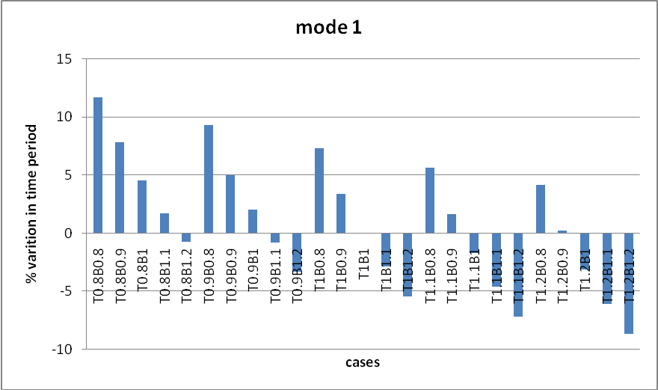
Chart 1
Real model
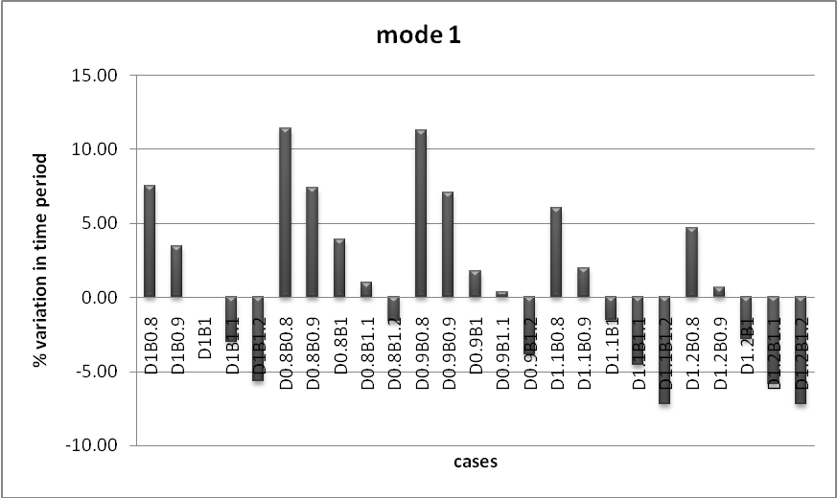
Chart 2

Idealized model
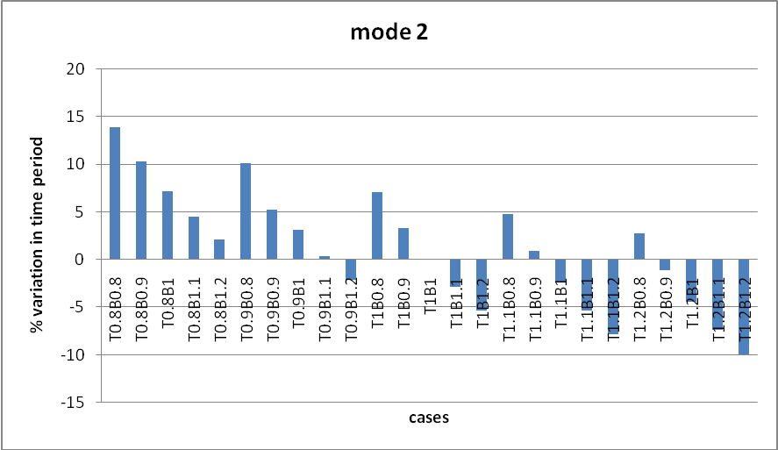
Chart 3
Real model
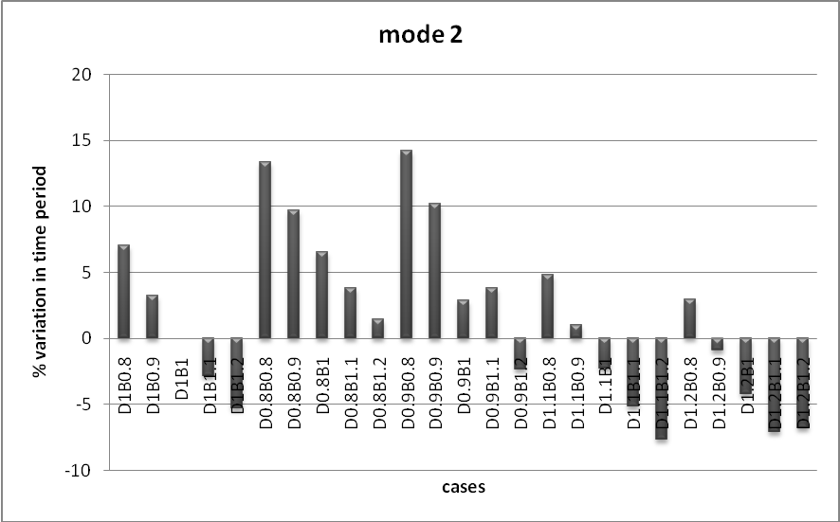
Chart 4

Idealized model
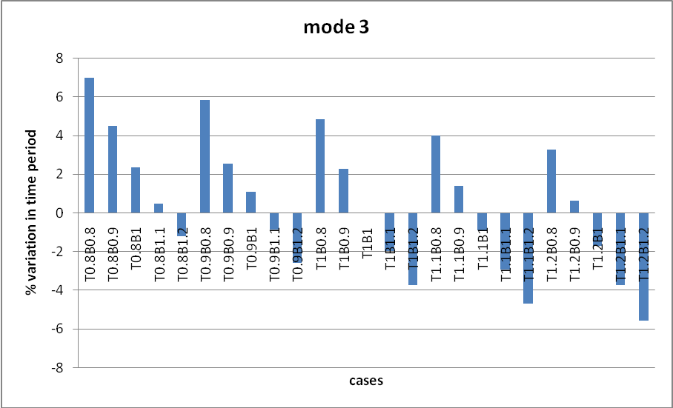
Chart 5
Real model
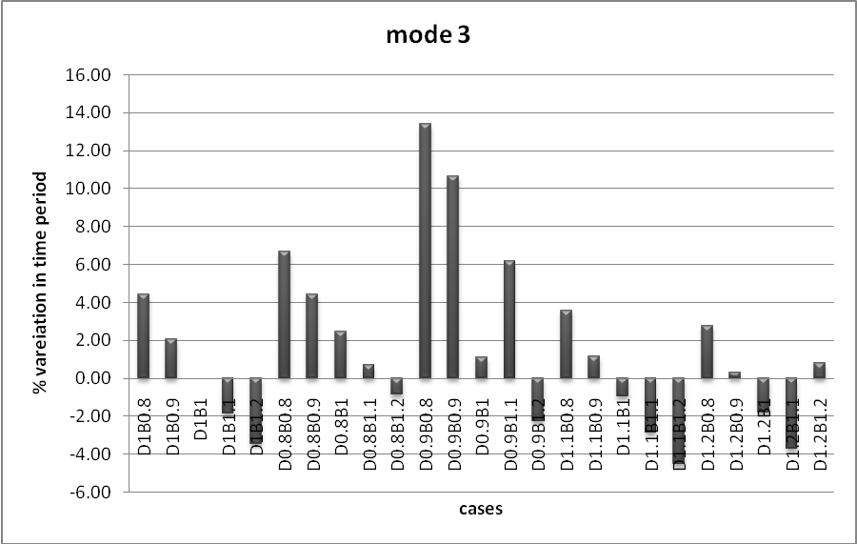
Chart 6

Idealized model
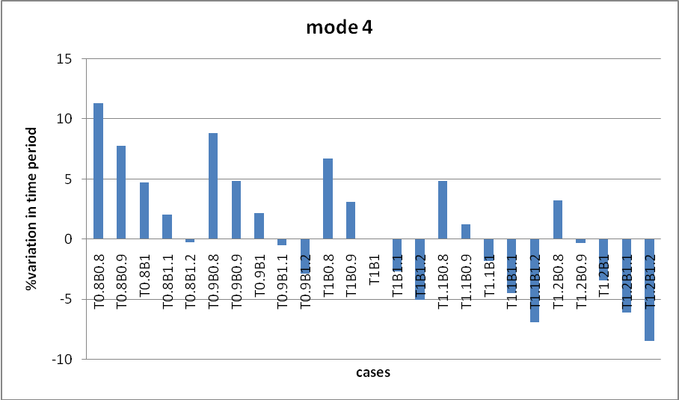
Chart 7
Real model
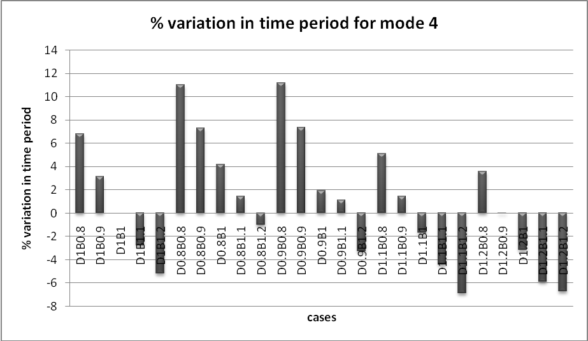
Chart 8

Idealized model
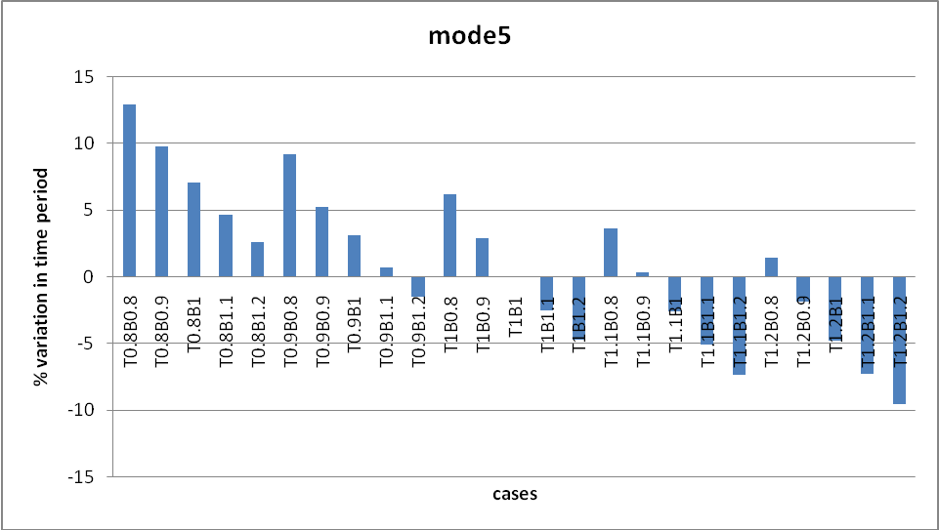
Chart 9
Real model
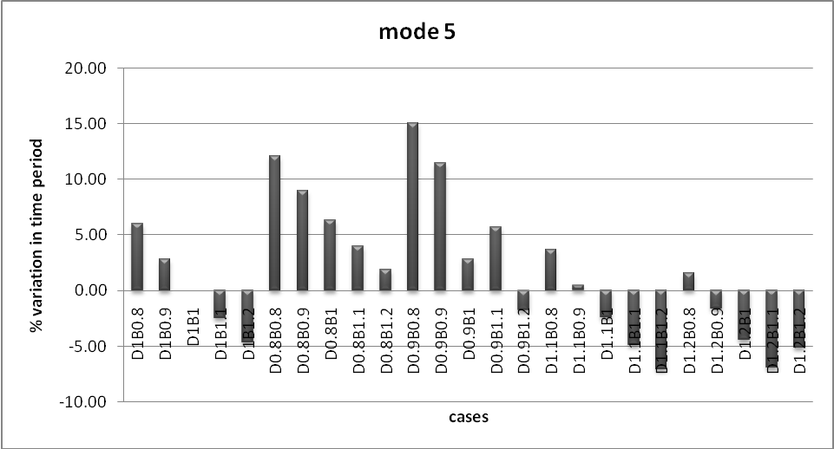
Chart 10

Idealized model
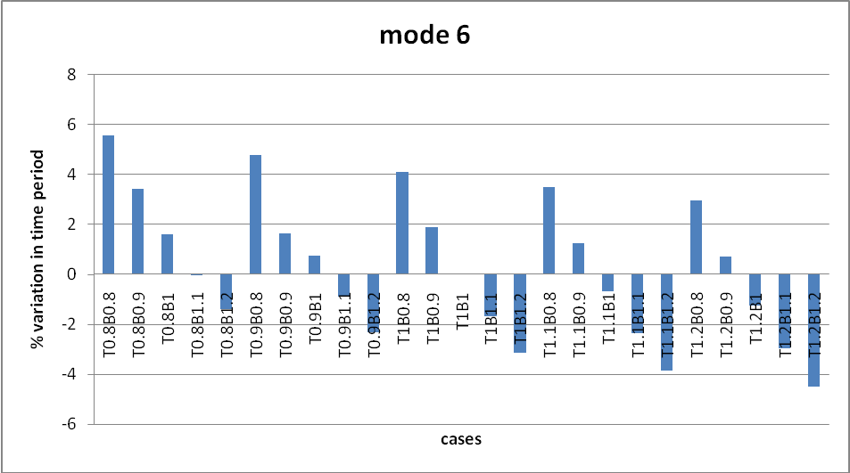
Chart 11
Real model
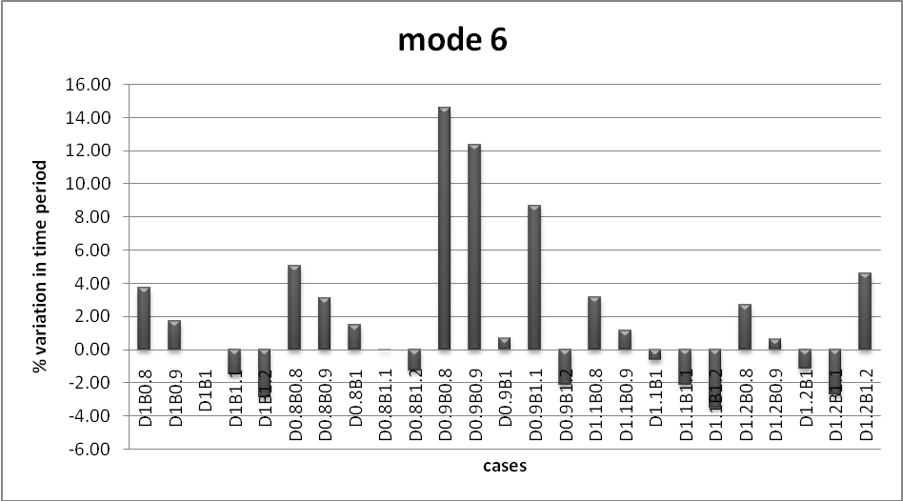
Chart 12

Idealized model
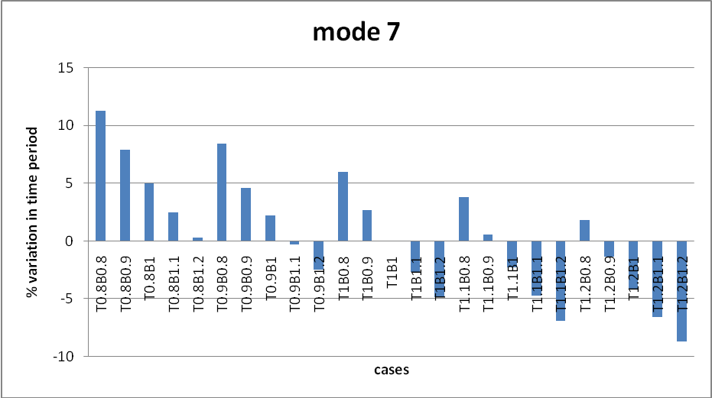
Chart 13
Real model
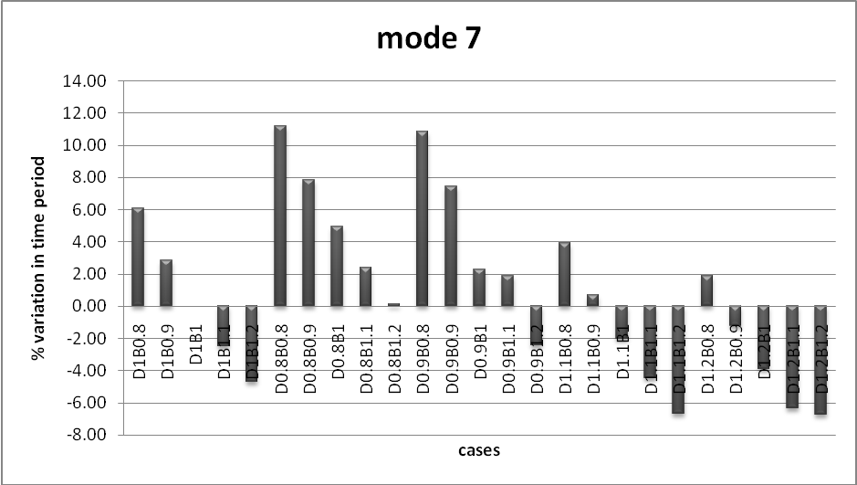
Chart 14

Idealized model
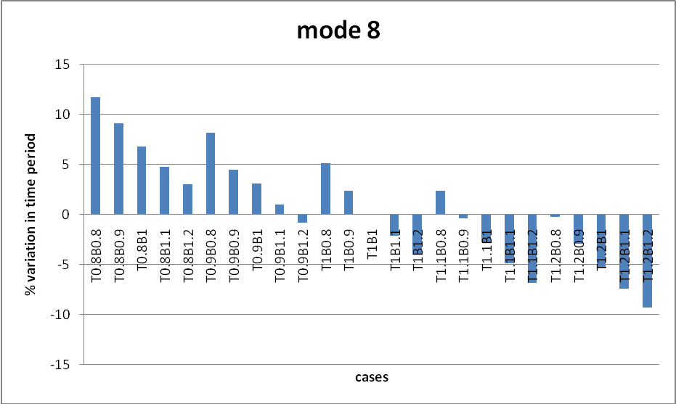
Chart 15

Real model
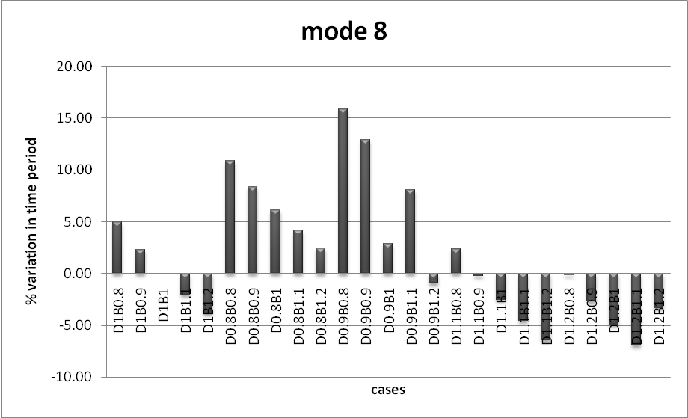
Chart 16

% Variation in CQC base shear in x direction
Idealized model
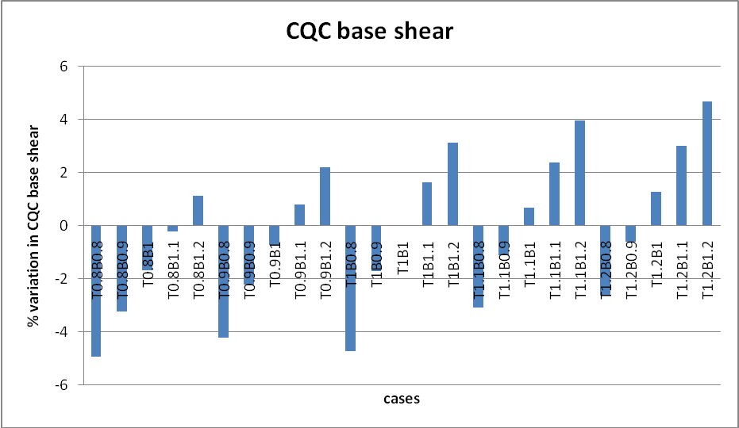
Chart 17
Real model 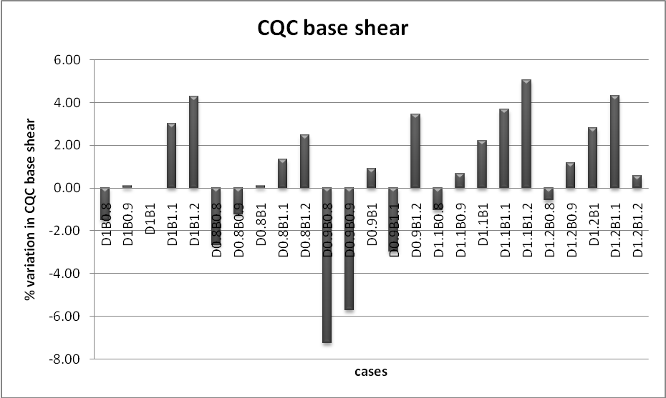
Chart 18

Idealized model
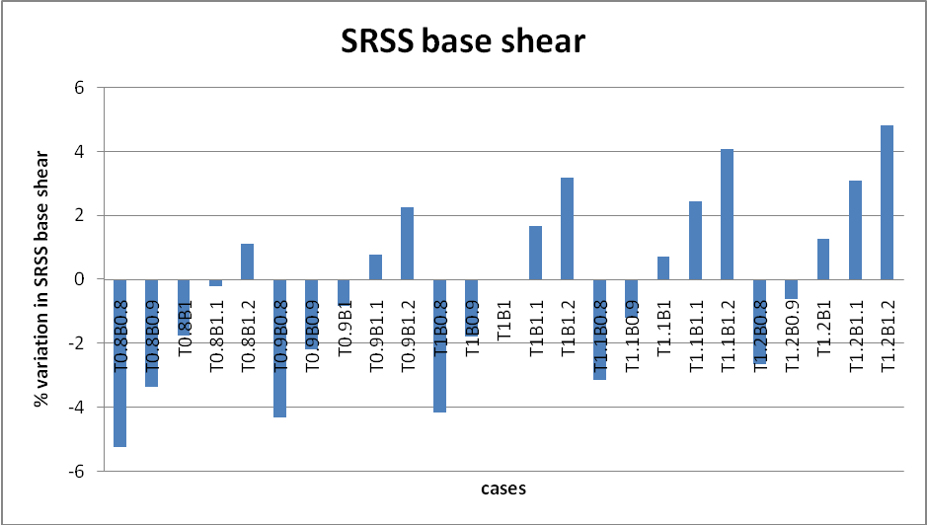
Chart 19
Real model
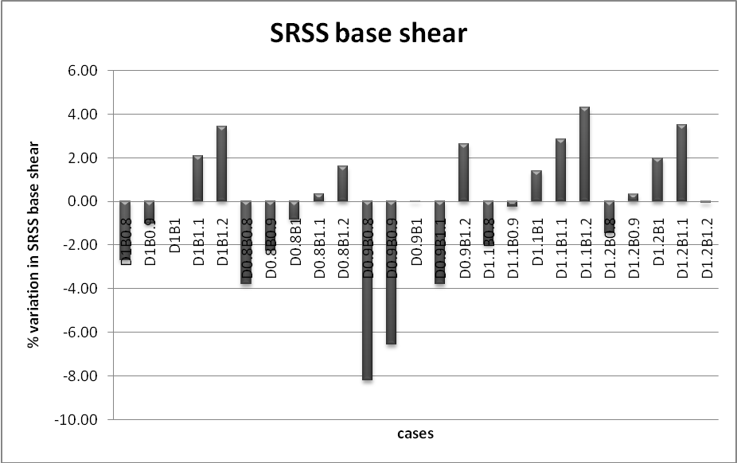
Chart 20

Idealized model
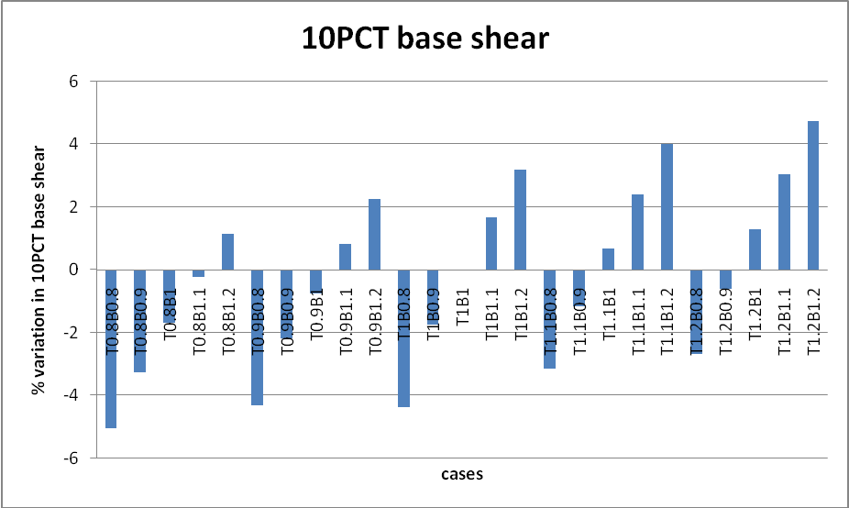
Chart 21
Real model
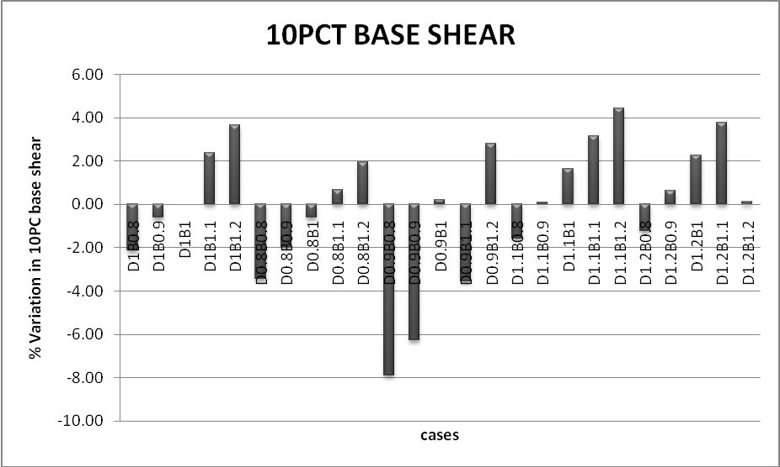
Chart 22

Idealized model
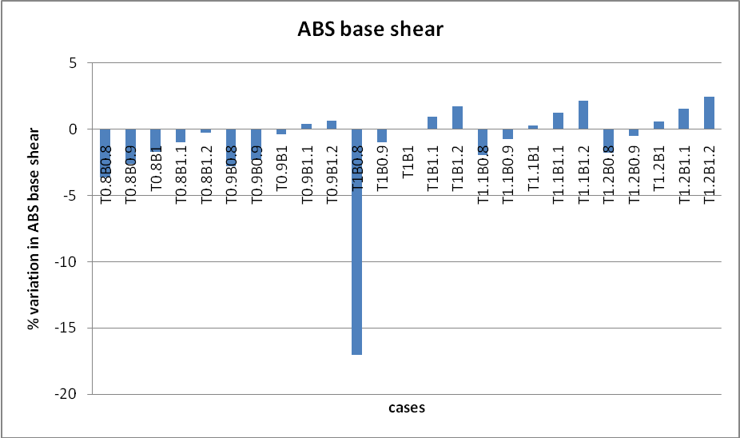
Chart 23
Real model
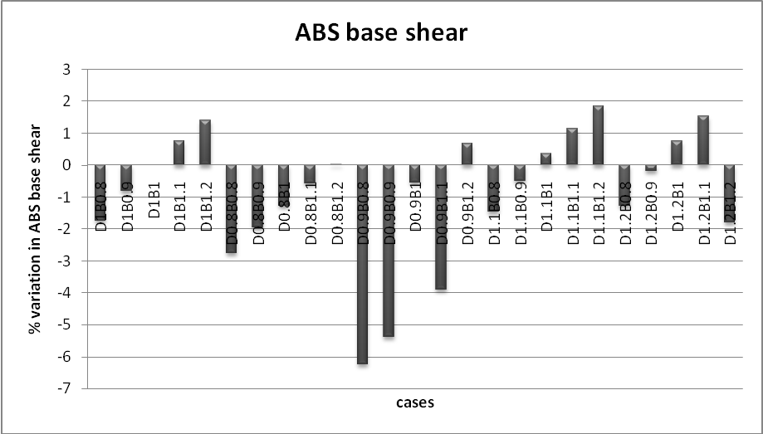
Chart 24

Variation in story drifts variation in 10th story in x- direction
Idealized model
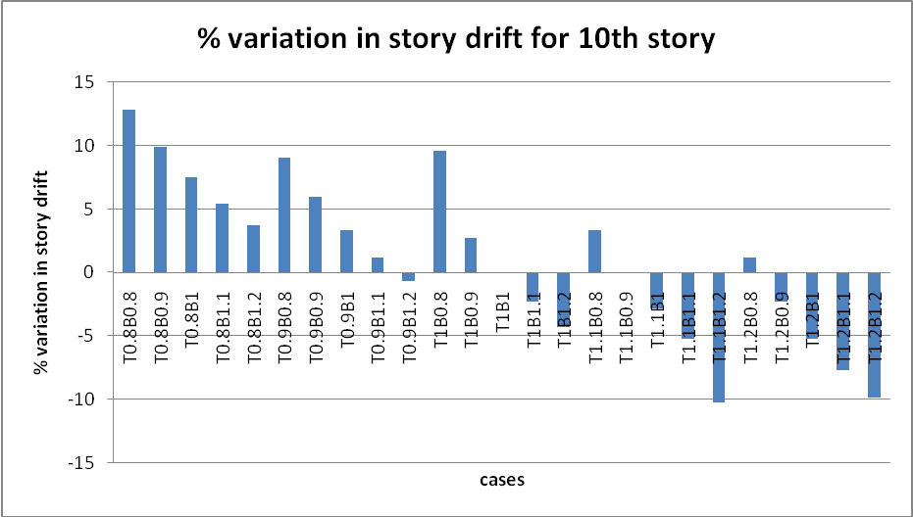
Chart 25
Real model
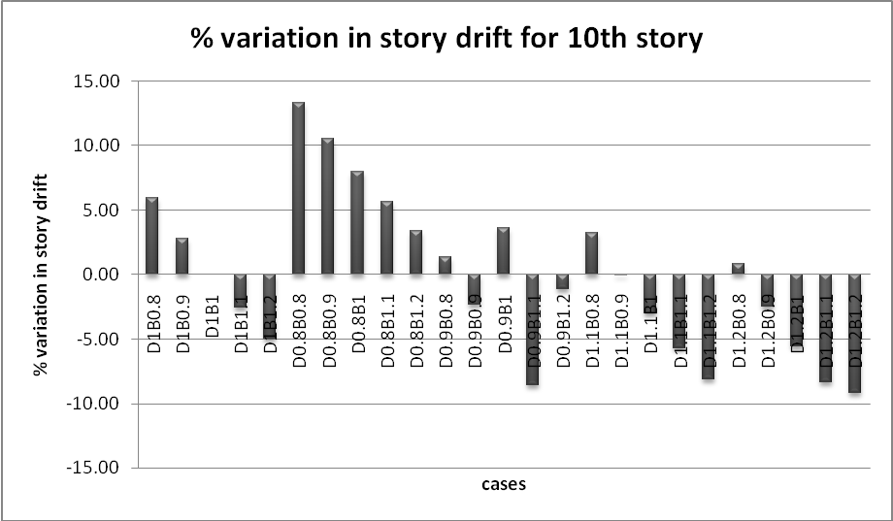
Chart 26

DISCUSSION
Story drift

      - From the table we can see that percentage variation in story drift for that structure which are having strong column weak beam shows less variations while those structures, in which stiffness of beam is greater than that of columns, show a larger variation.
      - Story drift variation for real and idealised building with respect to reference building shows very much similar variation but some cases show different type of variation. In both the cases maximum value of increase in story drift obtained when stiffness of column and beam is decreased by 20%. It means if stiffness of structural member is decrees then story drift is increases.
      - Story drifts decreases by a maximum extent when stiffness of column is increased by 10% and stiffness of beam increased by 20%. But the base shear values may also be important to be considered as the structure shall behave as a rigid structure in such a case. No change in story drift is obtained when stiffness of column is increased by 10% and stiffness of beam is decreased by 10% in both the cases of real and idealized buildings
Data Table

Building type | Maximum percentage increase | Maximum percentage decrease | Minimum percentage increase | Minimum percentage decreased
Idealized | 12.84  (T0.8B0.8) | 10.23 (T1.1B1.2) | 0.01 (T1.1B0.8) | 0.64 (T0.9B1.2)
Real | 13.33  ( D0.8B0.8) | 8.16  (D1.1B1.2) | 0.86 (D1.2B0.8) | 0.04 (D1.1B0.9)

Time period

- Modal time period variation for real and idealised building with respect to reference building shows wide variation but modal time period for different mode shows less variation.
- Maximum value of increase in time period for various mode for idealized model obtained when stiffness of column and beam are decreased by 20 %.
- Maximum value of increase in time period for various modes for real model obtained when stiffness of column is decreases by 10 %and beam are decreased by 20% respectively.
- Maximum value of decreased time period for idealized model is obtained when column & beam stiffness are increased by 20%, It shows that if we increase the stiffness of structural members (column and beam) then time period is decreases.
- When stiffness of column is increased by 20 % and stiffness of beam is decreased by 20% then minimum change in modal time period is obtained for idealized building
Data table

Building type | Maximum percentage increase | Maximum percentage decrease | Minimum percentage increase | Minimum percentage decreased
Idealized | 13.87 (T0.8B0.8, mode 2) | 9.91 (T1.2B1.2, mode 2) | 0.21 (T1.2B0.0.9, mode 1) | 0.20(T1.2B0.8,mode 8)
Real | 15.96 ( D0.9B0.8, mode 8) | 7.71 (D1.1B1.2, mode 2) | 0.02 (D0.8B1.1, mode7) | 0.04 (D1.2B0.9, mode4)

Base shear

- Maximum percentage increase in SRSS, 10PCT, ABS and CQC base shear is obtained when stiffness of column and beam increased by 20%.

- Minimum percentage variation is shown by ABS base shear.

- Minimum percentage variation in base shear values for the idealized building is obtained when stiffness of column is increased by 10 %.

- Maximum percentage increase in SRSS, 10PCT, ABS and CQC is obtained with higher degree of variation in real and idealize building.

- For real building model maximum percentage variation in increase of base shear is obtained when stiffness of column is increased by 10% and stiffness of beam is increased by 20 %.

- Minimum change in variation in base shear of building is achieved when obtain the stiffness of column is increased by 20 % and beam’s stiffness is decreased by 10%.

- Base shear values just like SRSS, 10PCT, ABS and CQC shows less variation.
Datatable.
building type | Idealized | Real
Maximum percentage increase | 4.82 (T1.2B1.2, SRSS) | 5.06(D1.1B1.2,CQC )
Maximum percentage decrease | 17.07 (T1B0.8,ABS) | 7.9 (D0.9B0.8, 10PCT)
minimum percentage increase | 0.26 (T1.1B1, ABS) | 0 (D0.9B1 SRSS)
minimum percentage decrease | 0.21(T0.8B1.1,SRSS) | 0 (D0.9B1 SRSS)

5. CONCLUSIONS

- Story drift for that structure which are having strong column weak beam shows less variations. Those structures in which stiffness of beam is greater than that of columns show a larger variation in story drift.

- Story drift for real and idealized buildings are very much similar for many cases but for some cases it shows different variations.

- Due to change in stiffness, time period of building for different structures shows wide variation with respect to reference buildings.

- Due to change in stiffness of structural members, story drifts of buildings have been found to vary and percentage increase in story drift increases with reduction in stiffness of columns and beams.

- Due to change in stiffness of structural component of buildings, SRSS, 10PCT, ABS, CQC, base shears for different structures shows wide variation and SRSS and CQC base shear gives maximum percentage variation in different structures under consideration. Due to change in stiffness of structural component ABS base shear shows lesser variation for both real and idealized building.

- Similar studies on different such structures may help in quantifying changes in different parameters. These may be helpful in taking quick decisions during the design of such structures

- FURTHER SCOPE OF STUDY

The following Asspects may form further scope of study.

- Affect of changes in relative stiffness of beams & column in high rise buildings

- Affect of changes in relative stiffness of beams & column in irregular buildings.

- Effect of Soil structure interaction in both the above cases.

- Possible retrofitting solution’s in problem cases.

STAAD INPUT FILE

STAAD SPACE
START JOB INFORMATION
ENGINEER DATE 12-Feb-09
END JOB INFORMATION
INPUT WIDTH 79
UNIT METER KN
JOINT COORDINATES
1 0 0 0; 2 4.07 0 0; 3 12.86 0 0; 4 20.675 0 0; 6 4.07 0 4.3; 7 12.86 0 4.3;
8 20.675 0 4.3; 9 -2 0 4.3; 10 4.07 0 12.9; 11 12.86 0 12.9; 12 20.675 0 12.9;
13 -2 0 12.9; 14 4.07 0 17.2; 15 12.86 0 17.2; 16 20.675 0 17.2; 17 0 0 17.2;
18 4.07 0 25.8; 19 12.86 0 25.8; 20 20.675 0 25.8; 21 0 0 25.8;
22 4.07 0 31.72; 23 12.86 0 31.72; 24 20.675 0 31.72; 25 0 0 31.72;
51 -4 0 25.8; 54 -4 0 19.8; 55 6.6 0 31.72; 56 6.6 0 29.22; 57 9.56 0 31.72;
58 9.56 0 29.22; 59 12.86 0 29.22; 60 0 -4.5 0; 61 4.07 -4.5 0;
62 12.86 -4.5 0; 63 20.675 -4.5 0; 64 4.07 -4.5 4.3; 65 12.86 -4.5 4.3;
66 20.675 -4.5 4.3; 67 -2 -4.5 4.3; 68 4.07 -4.5 12.9; 69 12.86 -4.5 12.9;
70 20.675 -4.5 12.9; 71 -2 -4.5 12.9; 72 4.07 -4.5 17.2; 73 12.86 -4.5 17.2;
74 20.675 -4.5 17.2; 75 0 -4.5 17.2; 76 4.07 -4.5 25.8; 77 12.86 -4.5 25.8;
78 20.675 -4.5 25.8; 79 0 -4.5 25.8; 80 4.07 -4.5 31.72; 81 12.86 -4.5 31.72;
82 20.675 -4.5 31.72; 83 0 -4.5 31.72; 84 -4 -4.5 25.8; 85 -4 -4.5 19.8;
86 6.6 -4.5 31.72; 87 6.6 -4.5 29.22; 88 9.56 -4.5 31.72; 89 9.56 -4.5 29.22;
90 12.86 -4.5 29.22; 91 8.465 0 0; 92 8.465 0 4.3; 93 8.465 0 12.9;
94 8.465 0 17.2; 95 8.465 0 25.8; 96 16.7675 0 4.3; 97 16.7675 0 12.9;
98 16.7675 0 17.2; 99 16.7675 0 25.8; 100 16.7675 0 31.72; 101 -2 0 25.8;
102 6.6 0 25.8; 103 9.56 0 25.8; 104 -2 0 19.8; 105 0 0 19.8;
106 20.675 0 21.5; 107 16.7675 0 21.5; 108 12.86 0 21.5; 109 8.465 0 21.5;
110 4.07 0 21.5; 111 0 0 21.5; 112 20.675 0 8.6; 113 16.7675 0 8.6;
114 12.86 0 8.6; 115 8.465 0 8.6; 116 4.07 0 8.6; 118 -2 0 8.6;
119 5.11962e-008 0 12.9; 120 5.11962e-008 0 4.3; 121 14.86 0 0;
122 14.86 0 4.3; 123 16.7675 0 29.22; 124 20.675 0 29.22; 125 4.07 0 29.22;
126 0 0 29.22; 127 14.86 0 3.3; 128 20.675 0 3.3; 129 5.11962e-008 -4.5 4.3;
130 -2 -4.5 25.8; 131 -2 -4.5 19.8; 132 0 0 34.22; 133 0 0 68.44;
134 4.07 0 68.44; 135 12.86 0 68.44; 136 20.675 0 68.44; 137 4.07 0 64.14;
138 12.86 0 64.14; 139 20.675 0 64.14; 140 -2 0 64.14; 141 4.07 0 55.54;
142 12.86 0 55.54; 143 20.675 0 55.54; 144 -2 0 55.54; 145 4.07 0 51.24;
146 12.86 0 51.24; 147 20.675 0 51.24; 148 0 0 51.24; 149 4.07 0 42.64;
150 12.86 0 42.64; 151 20.675 0 42.64; 152 0 0 42.64; 153 4.07 0 36.72;
154 12.86 0 36.72; 155 20.675 0 36.72; 156 0 0 36.72; 157 -4 0 42.64;
158 -4 0 48.64; 159 6.6 0 36.72; 160 6.6 0 39.22; 161 9.56 0 36.72;
162 9.56 0 39.22; 163 12.86 0 39.22; 164 0 -4.5 68.44; 165 4.07 -4.5 68.44;
166 12.86 -4.5 68.44; 167 20.675 -4.5 68.44; 168 4.07 -4.5 64.14;
169 12.86 -4.5 64.14; 170 20.675 -4.5 64.14; 171 -2 -4.5 64.14;
172 4.07 -4.5 55.54; 173 12.86 -4.5 55.54; 174 20.675 -4.5 55.54;
175 -2 -4.5 55.54; 176 4.07 -4.5 51.24; 177 12.86 -4.5 51.24;
178 20.675 -4.5 51.24; 179 0 -4.5 51.24; 180 4.07 -4.5 42.64;
181 12.86 -4.5 42.64; 182 20.675 -4.5 42.64; 183 0 -4.5 42.64;
184 4.07 -4.5 36.72; 185 20.675 -4.5 36.72; 186 0 -4.5 36.72;
187 -4 -4.5 42.64; 188 -4 -4.5 48.64; 189 8.465 0 68.44; 190 8.465 0 64.14;
191 8.465 0 55.54; 192 8.465 0 51.24; 193 8.465 0 42.64; 194 16.7675 0 64.14;
195 16.7675 0 55.54; 196 16.7675 0 51.24; 197 16.7675 0 42.64;
198 16.7675 0 36.72; 199 -2 0 42.64; 200 6.6 0 42.64; 201 9.56 0 42.64;
202 -2 0 48.64; 203 0 0 48.64; 204 20.675 0 46.94; 205 16.7675 0 46.94;
206 12.86 0 46.94; 207 8.465 0 46.94; 208 4.07 0 46.94; 209 0 0 46.94;
210 20.675 0 59.84; 211 16.7675 0 59.84; 212 12.86 0 59.84; 213 8.465 0 59.84;
214 4.07 0 59.84; 215 -2 0 59.84; 216 5.11962e-008 0 55.54;
217 5.11962e-008 0 64.14; 218 14.86 0 68.44; 219 14.86 0 64.14;
220 16.7675 0 39.22; 221 20.675 0 39.22; 222 4.07 0 39.22; 223 0 0 39.22;
224 14.86 0 65.14; 225 20.675 0 65.14; 226 12.86 -4.5 36.72;
227 6.6 -4.5 36.72; 228 6.6 -4.5 39.22; 229 9.56 -4.5 36.72;
230 9.56 -4.5 39.22; 231 12.86 -4.5 39.22; 232 5.11962e-008 -4.5 64.14;
233 -2 -4.5 42.64; 234 -2 -4.5 48.64; 235 4.07 0 34.22; 236 6.6 0 34.22;
237 9.56 0 34.22; 238 12.86 0 34.22; 239 16.7675 0 34.22; 240 -2 0 36.72;
241 -4 0 36.72; 242 -2 0 31.72; 243 -4 0 31.72; 244 -2 0 34.22; 245 -2 0 29.22;
246 0 4.5 0; 247 4.07 4.5 0; 248 8.465 4.5 0; 249 12.86 4.5 0; 250 14.86 4.5 0;
251 -2 4.5 4.3; 252 5.11962e-008 4.5 4.3; 253 4.07 4.5 4.3; 254 8.465 4.5 4.3;
255 12.86 4.5 4.3; 256 14.86 4.5 4.3; 257 -2 4.5 12.9;
258 5.11962e-008 4.5 12.9; 259 4.07 4.5 12.9; 260 8.465 4.5 12.9;
261 12.86 4.5 12.9; 262 16.7675 4.5 12.9; 263 0 4.5 17.2; 264 4.07 4.5 17.2;
265 8.465 4.5 17.2; 266 12.86 4.5 17.2; 267 16.7675 4.5 17.2; 270 0 4.5 25.8;
271 4.07 4.5 25.8; 272 6.6 4.5 25.8; 273 12.86 4.5 25.8; 274 16.7675 4.5 25.8;
275 0 4.5 31.72; 276 4.07 4.5 31.72; 277 6.6 4.5 31.72; 278 9.56 4.5 31.72;
279 12.86 4.5 31.72; 280 16.7675 4.5 31.72; 281 6.6 4.5 29.22;
282 9.56 4.5 29.22; 283 12.86 4.5 29.22; 284 0 4.5 19.8; 285 0 4.5 29.22;
286 4.07 4.5 8.6; 287 4.07 4.5 21.5; 288 4.07 4.5 29.22; 289 12.86 4.5 8.6;
290 12.86 4.5 21.5; 291 20.675 4.5 0; 292 20.675 4.5 3.3; 293 20.675 4.5 4.3;
294 20.675 4.5 8.6; 295 20.675 4.5 12.9; 296 20.675 4.5 17.2;
297 20.675 4.5 21.5; 298 20.675 4.5 25.8; 299 20.675 4.5 29.22; 300 -2 4.5 8.6;
302 8.465 4.5 8.6; 303 8.465 4.5 25.8; 304 9.56 4.5 25.8; 305 8.465 4.5 21.5;
306 16.7675 4.5 4.3; 307 16.7675 4.5 8.6; 308 16.7675 4.5 21.5;
309 20.675 4.5 31.72; 310 16.7675 4.5 29.22; 312 0 4.5 21.5; 313 14.86 4.5 3.3;
314 0 4.5 68.44; 315 4.07 4.5 68.44; 316 8.465 4.5 68.44; 317 12.86 4.5 68.44;
318 14.86 4.5 68.44; 319 -2 4.5 64.14; 320 5.11962e-008 4.5 64.14;
321 4.07 4.5 64.14; 322 8.465 4.5 64.14; 323 12.86 4.5 64.14;
324 14.86 4.5 64.14; 325 -2 4.5 55.54; 326 5.11962e-008 4.5 55.54;
327 4.07 4.5 55.54; 328 8.465 4.5 55.54; 329 12.86 4.5 55.54;
330 16.7675 4.5 55.54; 331 0 4.5 51.24; 332 4.07 4.5 51.24;
333 8.465 4.5 51.24; 334 12.86 4.5 51.24; 335 16.7675 4.5 51.24;
338 0 4.5 42.64; 339 4.07 4.5 42.64; 340 6.6 4.5 42.64; 341 12.86 4.5 42.64;
342 16.7675 4.5 42.64; 343 0 4.5 36.72; 344 4.07 4.5 36.72; 345 6.6 4.5 36.72;
346 9.56 4.5 36.72; 347 12.86 4.5 36.72; 348 16.7675 4.5 36.72;
349 6.6 4.5 39.22; 350 9.56 4.5 39.22; 351 12.86 4.5 39.22; 352 0 4.5 48.64;
353 0 4.5 39.22; 354 4.07 4.5 59.84; 355 4.07 4.5 46.94; 356 4.07 4.5 39.22;
357 12.86 4.5 59.84; 358 12.86 4.5 46.94; 359 20.675 4.5 68.44;
360 20.675 4.5 65.14; 361 20.675 4.5 64.14; 362 20.675 4.5 59.84;
363 20.675 4.5 55.54; 364 20.675 4.5 51.24; 365 20.675 4.5 46.94;
366 20.675 4.5 42.64; 367 20.675 4.5 39.22; 368 -2 4.5 59.84;
370 8.465 4.5 59.84; 371 8.465 4.5 42.64; 372 9.56 4.5 42.64;
373 8.465 4.5 46.94; 374 16.7675 4.5 64.14; 375 16.7675 4.5 59.84;
376 16.7675 4.5 46.94; 377 20.675 4.5 36.72; 378 16.7675 4.5 39.22;
380 0 4.5 46.94; 381 14.86 4.5 65.14; 382 0 4.5 34.22; 383 4.07 4.5 34.22;
384 12.86 4.5 34.22; 385 6.6 4.5 34.22; 386 9.56 4.5 34.22;
387 16.7675 4.5 34.22; 389 4.07 9 0; 390 8.465 9 0; 391 12.86 9 0;
392 14.86 9 0; 393 -2 9 4.3; 394 5.11962e-008 9 4.3; 395 4.07 9 4.3;
396 8.465 9 4.3; 397 12.86 9 4.3; 398 14.86 9 4.3; 399 -2 9 12.9;
400 5.11962e-008 9 12.9; 401 4.07 9 12.9; 402 8.465 9 12.9; 403 12.86 9 12.9;
404 16.7675 9 12.9; 405 0 9 17.2; 406 4.07 9 17.2; 407 8.465 9 17.2;
408 12.86 9 17.2; 409 16.7675 9 17.2; 410 0 9 25.8; 411 4.07 9 25.8;
412 6.6 9 25.8; 413 12.86 9 25.8; 414 16.7675 9 25.8; 415 0 9 31.72;
416 4.07 9 31.72; 417 6.6 9 31.72; 418 9.56 9 31.72; 419 12.86 9 31.72;
420 16.7675 9 31.72; 421 6.6 9 29.22; 422 9.56 9 29.22; 423 12.86 9 29.22;
424 0 9 19.8; 425 0 9 29.22; 426 4.07 9 8.6; 427 4.07 9 21.5; 428 4.07 9 29.22;
429 12.86 9 8.6; 430 12.86 9 21.5; 431 20.675 9 0; 432 20.675 9 3.3;
433 20.675 9 4.3; 434 20.675 9 8.6; 435 20.675 9 12.9; 436 20.675 9 17.2;
437 20.675 9 21.5; 438 20.675 9 25.8; 439 20.675 9 29.22; 440 -2 9 8.6;
441 8.465 9 8.6; 442 8.465 9 25.8; 443 9.56 9 25.8; 444 8.465 9 21.5;
445 16.7675 9 4.3; 446 16.7675 9 8.6; 447 16.7675 9 21.5; 448 20.675 9 31.72;
449 16.7675 9 29.22; 450 0 9 21.5; 451 14.86 9 3.3; 453 4.07 9 68.44;
454 8.465 9 68.44; 455 12.86 9 68.44; 456 14.86 9 68.44; 457 -2 9 64.14;
458 5.11962e-008 9 64.14; 459 4.07 9 64.14; 460 8.465 9 64.14;
461 12.86 9 64.14; 462 14.86 9 64.14; 463 -2 9 55.54; 464 5.11962e-008 9 55.54;
465 4.07 9 55.54; 466 8.465 9 55.54; 467 12.86 9 55.54; 468 16.7675 9 55.54;
469 0 9 51.24; 470 4.07 9 51.24; 471 8.465 9 51.24; 472 12.86 9 51.24;
473 16.7675 9 51.24; 474 0 9 42.64; 475 4.07 9 42.64; 476 6.6 9 42.64;
477 12.86 9 42.64; 478 16.7675 9 42.64; 479 0 9 36.72; 480 4.07 9 36.72;
481 6.6 9 36.72; 482 9.56 9 36.72; 483 12.86 9 36.72; 484 16.7675 9 36.72;
485 6.6 9 39.22; 486 9.56 9 39.22; 487 12.86 9 39.22; 488 0 9 48.64;
489 0 9 39.22; 490 4.07 9 59.84; 491 4.07 9 46.94; 492 4.07 9 39.22;
493 12.86 9 59.84; 494 12.86 9 46.94; 495 20.675 9 68.44; 496 20.675 9 65.14;
497 20.675 9 64.14; 498 20.675 9 59.84; 499 20.675 9 55.54; 500 20.675 9 51.24;
501 20.675 9 46.94; 502 20.675 9 42.64; 503 20.675 9 39.22; 504 -2 9 59.84;
505 8.465 9 59.84; 506 8.465 9 42.64; 507 9.56 9 42.64; 508 8.465 9 46.94;
509 16.7675 9 64.14; 510 16.7675 9 59.84; 511 16.7675 9 46.94;
512 20.675 9 36.72; 513 16.7675 9 39.22; 514 0 9 46.94; 515 14.86 9 65.14;
516 0 9 34.22; 517 4.07 9 34.22; 518 12.86 9 34.22; 519 6.6 9 34.22;
520 9.56 9 34.22; 521 16.7675 9 34.22; 523 4.07 12.5 0; 524 8.465 12.5 0;
525 12.86 12.5 0; 526 14.86 12.5 0; 527 -2 12.5 4.3; 529 4.07 12.5 4.3;
530 8.465 12.5 4.3; 531 12.86 12.5 4.3; 532 14.86 12.5 4.3; 533 -2 12.5 12.9;
535 4.07 12.5 12.9; 536 8.465 12.5 12.9; 537 12.86 12.5 12.9;
538 16.7675 12.5 12.9; 540 4.07 12.5 17.2; 541 8.465 12.5 17.2;
542 12.86 12.5 17.2; 543 16.7675 12.5 17.2; 545 4.07 12.5 25.8;
546 6.6 12.5 25.8; 547 12.86 12.5 25.8; 548 16.7675 12.5 25.8;
550 4.07 12.5 31.72; 551 6.6 12.5 31.72; 552 9.56 12.5 31.72;
553 12.86 12.5 31.72; 554 16.7675 12.5 31.72; 555 6.6 12.5 29.22;
556 9.56 12.5 29.22; 557 12.86 12.5 29.22; 558 0.057 12.5 19.8;
560 4.07 12.5 8.6; 561 4.07 12.5 21.5; 562 4.07 12.5 29.22; 563 12.86 12.5 8.6;
564 12.86 12.5 21.5; 565 20.675 12.5 0; 566 20.675 12.5 3.3;
567 20.675 12.5 4.3; 568 20.675 12.5 8.6; 569 20.675 12.5 12.9;
570 20.675 12.5 17.2; 571 20.675 12.5 21.5; 572 20.675 12.5 25.8;
573 20.675 12.5 29.22; 574 -2 12.5 8.6; 575 8.465 12.5 8.6;
576 8.465 12.5 25.8; 577 9.56 12.5 25.8; 578 8.465 12.5 21.5;
579 16.7675 12.5 4.3; 580 16.7675 12.5 8.6; 581 16.7675 12.5 21.5;
582 20.675 12.5 31.72; 583 16.7675 12.5 29.22; 585 14.86 12.5 3.3;
587 4.07 12.5 68.44; 588 8.465 12.5 68.44; 589 12.86 12.5 68.44;
590 14.86 12.5 68.44; 591 -2 12.5 64.14; 593 4.07 12.5 64.14;
594 8.465 12.5 64.14; 595 12.86 12.5 64.14; 596 14.86 12.5 64.14;
597 -2 12.5 55.54; 599 4.07 12.5 55.54; 600 8.465 12.5 55.54;
601 12.86 12.5 55.54; 602 16.7675 12.5 55.54; 604 4.07 12.5 51.24;
605 8.465 12.5 51.24; 606 12.86 12.5 51.24; 607 16.7675 12.5 51.24;
609 4.07 12.5 42.64; 610 6.6 12.5 42.64; 611 12.86 12.5 42.64;
612 16.7675 12.5 42.64; 614 4.07 12.5 36.72; 615 6.6 12.5 36.72;
616 9.56 12.5 36.72; 617 12.86 12.5 36.72; 618 16.7675 12.5 36.72;
619 6.6 12.5 39.22; 620 9.56 12.5 39.22; 621 12.86 12.5 39.22;
622 0.057 12.5 48.64; 624 4.07 12.5 59.84; 625 4.07 12.5 46.94;
626 4.07 12.5 39.22; 627 12.86 12.5 59.84; 628 12.86 12.5 46.94;
629 20.675 12.5 68.44; 630 20.675 12.5 65.14; 631 20.675 12.5 64.14;
632 20.675 12.5 59.84; 633 20.675 12.5 55.54; 634 20.675 12.5 51.24;
635 20.675 12.5 46.94; 636 20.675 12.5 42.64; 637 20.675 12.5 39.22;
638 -2 12.5 59.84; 639 8.465 12.5 59.84; 640 8.465 12.5 42.64;
641 9.56 12.5 42.64; 642 8.465 12.5 46.94; 643 16.7675 12.5 64.14;
644 16.7675 12.5 59.84; 645 16.7675 12.5 46.94; 646 20.675 12.5 36.72;
647 16.7675 12.5 39.22; 649 14.86 12.5 65.14; 651 4.07 12.5 34.22;
652 12.86 12.5 34.22; 653 6.6 12.5 34.22; 654 9.56 12.5 34.22;
655 16.7675 12.5 34.22; 657 4.07 16 0; 658 8.465 16 0; 659 12.86 16 0;
660 14.86 16 0; 661 -2 16 4.3; 662 5.11962e-008 16 4.3; 663 4.07 16 4.3;
664 8.465 16 4.3; 665 12.86 16 4.3; 666 14.86 16 4.3; 667 -2 16 12.9;
668 5.11962e-008 16 12.9; 669 4.07 16 12.9; 670 8.465 16 12.9;
671 12.86 16 12.9; 672 16.7675 16 12.9; 674 4.07 16 17.2; 675 8.465 16 17.2;
676 12.86 16 17.2; 677 16.7675 16 17.2; 679 4.07 16 25.8; 680 6.6 16 25.8;
681 12.86 16 25.8; 682 16.7675 16 25.8; 684 4.07 16 31.72; 685 6.6 16 31.72;
686 9.56 16 31.72; 687 12.86 16 31.72; 688 16.7675 16 31.72; 689 6.6 16 29.22;
690 9.56 16 29.22; 691 12.86 16 29.22; 692 0.291 16 19.8; 694 4.07 16 8.6;
695 4.07 16 21.5; 696 4.07 16 29.22; 697 12.86 16 8.6; 698 12.86 16 21.5;
699 20.675 16 0; 700 20.675 16 3.3; 701 20.675 16 4.3; 702 20.675 16 8.6;
703 20.675 16 12.9; 704 20.675 16 17.2; 705 20.675 16 21.5; 706 20.675 16 25.8;
707 20.675 16 29.22; 708 -2 16 8.6; 709 8.465 16 8.6; 710 8.465 16 25.8;
711 9.56 16 25.8; 712 8.465 16 21.5; 713 16.7675 16 4.3; 714 16.7675 16 8.6;
715 16.7675 16 21.5; 716 20.675 16 31.72; 717 16.7675 16 29.22;
719 14.86 16 3.3; 721 4.07 16 68.44; 722 8.465 16 68.44; 723 12.86 16 68.44;
724 14.86 16 68.44; 725 -2 16 64.14; 726 5.11962e-008 16 64.14;
727 4.07 16 64.14; 728 8.465 16 64.14; 729 12.86 16 64.14; 730 14.86 16 64.14;
731 -2 16 55.54; 732 5.11962e-008 16 55.54; 733 4.07 16 55.54;
734 8.465 16 55.54; 735 12.86 16 55.54; 736 16.7675 16 55.54;
738 4.07 16 51.24; 739 8.465 16 51.24; 740 12.86 16 51.24;
741 16.7675 16 51.24; 743 4.07 16 42.64; 744 6.6 16 42.64; 745 12.86 16 42.64;
746 16.7675 16 42.64; 748 4.07 16 36.72; 749 6.6 16 36.72; 750 9.56 16 36.72;
751 12.86 16 36.72; 752 16.7675 16 36.72; 753 6.6 16 39.22; 754 9.56 16 39.22;
755 12.86 16 39.22; 756 0.291 16 48.64; 758 4.07 16 59.84; 759 4.07 16 46.94;
760 4.07 16 39.22; 761 12.86 16 59.84; 762 12.86 16 46.94; 763 20.675 16 68.44;
764 20.675 16 65.14; 765 20.675 16 64.14; 766 20.675 16 59.84;
767 20.675 16 55.54; 768 20.675 16 51.24; 769 20.675 16 46.94;
770 20.675 16 42.64; 771 20.675 16 39.22; 772 -2 16 59.84; 773 8.465 16 59.84;
774 8.465 16 42.64; 775 9.56 16 42.64; 776 8.465 16 46.94;
777 16.7675 16 64.14; 778 16.7675 16 59.84; 779 16.7675 16 46.94;
780 20.675 16 36.72; 781 16.7675 16 39.22; 783 14.86 16 65.14;
785 4.07 16 34.22; 786 12.86 16 34.22; 787 6.6 16 34.22; 788 9.56 16 34.22;
789 16.7675 16 34.22; 791 4.07 19.5 0; 792 8.465 19.5 0; 793 12.86 19.5 0;
794 14.86 19.5 0; 795 -2 19.5 4.3; 796 5.11962e-008 19.5 4.3;
797 4.07 19.5 4.3; 798 8.465 19.5 4.3; 799 12.86 19.5 4.3; 800 14.86 19.5 4.3;
801 -2 19.5 12.9; 802 5.11962e-008 19.5 12.9; 803 4.07 19.5 12.9;
804 8.465 19.5 12.9; 805 12.86 19.5 12.9; 806 16.7675 19.5 12.9;
808 4.07 19.5 17.2; 809 8.465 19.5 17.2; 810 12.86 19.5 17.2;
811 16.7675 19.5 17.2; 813 4.07 19.5 25.8; 814 6.6 19.5 25.8;
815 12.86 19.5 25.8; 816 16.7675 19.5 25.8; 818 4.07 19.5 31.72;
819 6.6 19.5 31.72; 820 9.56 19.5 31.72; 821 12.86 19.5 31.72;
822 16.7675 19.5 31.72; 823 6.6 19.5 29.22; 824 9.56 19.5 29.22;
825 12.86 19.5 29.22; 826 0.695 19.5 19.8; 828 4.07 19.5 8.6;
829 4.07 19.5 21.5; 830 4.07 19.5 29.22; 831 12.86 19.5 8.6;
832 12.86 19.5 21.5; 833 20.675 19.5 0; 834 20.675 19.5 3.3;
835 20.675 19.5 4.3; 836 20.675 19.5 8.6; 837 20.675 19.5 12.9;
838 20.675 19.5 17.2; 839 20.675 19.5 21.5; 840 20.675 19.5 25.8;
841 20.675 19.5 29.22; 842 -2 19.5 8.6; 843 8.465 19.5 8.6;
844 8.465 19.5 25.8; 845 9.56 19.5 25.8; 846 8.465 19.5 21.5;
847 16.7675 19.5 4.3; 848 16.7675 19.5 8.6; 849 16.7675 19.5 21.5;
850 20.675 19.5 31.72; 851 16.7675 19.5 29.22; 853 14.86 19.5 3.3;
855 4.07 19.5 68.44; 856 8.465 19.5 68.44; 857 12.86 19.5 68.44;
858 14.86 19.5 68.44; 859 -2 19.5 64.14; 860 5.11962e-008 19.5 64.14;
861 4.07 19.5 64.14; 862 8.465 19.5 64.14; 863 12.86 19.5 64.14;
864 14.86 19.5 64.14; 865 -2 19.5 55.54; 866 5.11962e-008 19.5 55.54;
867 4.07 19.5 55.54; 868 8.465 19.5 55.54; 869 12.86 19.5 55.54;
870 16.7675 19.5 55.54; 872 4.07 19.5 51.24; 873 8.465 19.5 51.24;
874 12.86 19.5 51.24; 875 16.7675 19.5 51.24; 877 4.07 19.5 42.64;
878 6.6 19.5 42.64; 879 12.86 19.5 42.64; 880 16.7675 19.5 42.64;
882 4.07 19.5 36.72; 883 6.6 19.5 36.72; 884 9.56 19.5 36.72;
885 12.86 19.5 36.72; 886 16.7675 19.5 36.72; 887 6.6 19.5 39.22;
888 9.56 19.5 39.22; 889 12.86 19.5 39.22; 890 0.695 19.5 48.64;
892 4.07 19.5 59.84; 893 4.07 19.5 46.94; 894 4.07 19.5 39.22;
895 12.86 19.5 59.84; 896 12.86 19.5 46.94; 897 20.675 19.5 68.44;
898 20.675 19.5 65.14; 899 20.675 19.5 64.14; 900 20.675 19.5 59.84;
901 20.675 19.5 55.54; 902 20.675 19.5 51.24; 903 20.675 19.5 46.94;
904 20.675 19.5 42.64; 905 20.675 19.5 39.22; 906 -2 19.5 59.84;
907 8.465 19.5 59.84; 908 8.465 19.5 42.64; 909 9.56 19.5 42.64;
910 8.465 19.5 46.94; 911 16.7675 19.5 64.14; 912 16.7675 19.5 59.84;
913 16.7675 19.5 46.94; 914 20.675 19.5 36.72; 915 16.7675 19.5 39.22;
917 14.86 19.5 65.14; 919 4.07 19.5 34.22; 920 12.86 19.5 34.22;
921 6.6 19.5 34.22; 922 9.56 19.5 34.22; 923 16.7675 19.5 34.22; 925 4.07 23 0;
926 8.465 23 0; 927 12.86 23 0; 928 14.86 23 0; 929 -2 23 4.3;
930 5.11962e-008 23 4.3; 931 4.07 23 4.3; 932 8.465 23 4.3; 933 12.86 23 4.3;
934 14.86 23 4.3; 935 -2 23 12.9; 936 5.11962e-008 23 12.9; 937 4.07 23 12.9;
938 8.465 23 12.9; 939 12.86 23 12.9; 940 16.7675 23 12.9; 942 4.07 23 17.2;
943 8.465 23 17.2; 944 12.86 23 17.2; 945 16.7675 23 17.2; 947 4.07 23 25.8;
948 6.6 23 25.8; 949 12.86 23 25.8; 950 16.7675 23 25.8; 952 4.07 23 31.72;
953 6.6 23 31.72; 954 9.56 23 31.72; 955 12.86 23 31.72; 956 16.7675 23 31.72;
957 6.6 23 29.22; 958 9.56 23 29.22; 959 12.86 23 29.22; 960 1.269 23 19.8;
962 4.07 23 8.6; 963 4.07 23 21.5; 964 4.07 23 29.22; 965 12.86 23 8.6;
966 12.86 23 21.5; 967 20.675 23 0; 968 20.675 23 3.3; 969 20.675 23 4.3;
970 20.675 23 8.6; 971 20.675 23 12.9; 972 20.675 23 17.2; 973 20.675 23 21.5;
974 20.675 23 25.8; 975 20.675 23 29.22; 976 -2 23 8.6; 977 8.465 23 8.6;
978 8.465 23 25.8; 979 9.56 23 25.8; 980 8.465 23 21.5; 981 16.7675 23 4.3;
982 16.7675 23 8.6; 983 16.7675 23 21.5; 984 20.675 23 31.72;
985 16.7675 23 29.22; 987 14.86 23 3.3; 989 4.07 23 68.44; 990 8.465 23 68.44;
991 12.86 23 68.44; 992 14.86 23 68.44; 993 -2 23 64.14;
994 5.11962e-008 23 64.14; 995 4.07 23 64.14; 996 8.465 23 64.14;
997 12.86 23 64.14; 998 14.86 23 64.14; 999 -2 23 55.54;
1000 5.11962e-008 23 55.54; 1001 4.07 23 55.54; 1002 8.465 23 55.54;
1003 12.86 23 55.54; 1004 16.7675 23 55.54; 1006 4.07 23 51.24;
1007 8.465 23 51.24; 1008 12.86 23 51.24; 1009 16.7675 23 51.24;
1011 4.07 23 42.64; 1012 6.6 23 42.64; 1013 12.86 23 42.64;
1014 16.7675 23 42.64; 1016 4.07 23 36.72; 1017 6.6 23 36.72;
1018 9.56 23 36.72; 1019 12.86 23 36.72; 1020 16.7675 23 36.72;
1021 6.6 23 39.22; 1022 9.56 23 39.22; 1023 12.86 23 39.22;
1024 1.269 23 48.64; 1026 4.07 23 59.84; 1027 4.07 23 46.94;
1028 4.07 23 39.22; 1029 12.86 23 59.84; 1030 12.86 23 46.94;
1031 20.675 23 68.44; 1032 20.675 23 65.14; 1033 20.675 23 64.14;
1034 20.675 23 59.84; 1035 20.675 23 55.54; 1036 20.675 23 51.24;
1037 20.675 23 46.94; 1038 20.675 23 42.64; 1039 20.675 23 39.22;
1040 -2 23 59.84; 1041 8.465 23 59.84; 1042 8.465 23 42.64; 1043 9.56 23 42.64;
1044 8.465 23 46.94; 1045 16.7675 23 64.14; 1046 16.7675 23 59.84;
1047 16.7675 23 46.94; 1048 20.675 23 36.72; 1049 16.7675 23 39.22;
1051 14.86 23 65.14; 1053 4.07 23 34.22; 1054 12.86 23 34.22;
1055 6.6 23 34.22; 1056 9.56 23 34.22; 1057 16.7675 23 34.22; 1059 4.07 26.5 0;
1060 8.465 26.5 0; 1061 12.86 26.5 0; 1062 14.86 26.5 0; 1063 -2 26.5 4.3;
1064 5.11962e-008 26.5 4.3; 1065 4.07 26.5 4.3; 1066 8.465 26.5 4.3;
1067 12.86 26.5 4.3; 1068 14.86 26.5 4.3; 1069 -2 26.5 12.9;
1070 5.11962e-008 26.5 12.9; 1071 4.07 26.5 12.9; 1072 8.465 26.5 12.9;
1073 12.86 26.5 12.9; 1074 16.7675 26.5 12.9; 1076 4.07 26.5 17.2;
1077 8.465 26.5 17.2; 1078 12.86 26.5 17.2; 1079 16.7675 26.5 17.2;
1081 4.07 26.5 25.8; 1082 6.6 26.5 25.8; 1083 12.86 26.5 25.8;
1084 16.7675 26.5 25.8; 1086 4.07 26.5 31.72; 1087 6.6 26.5 31.72;
1088 9.56 26.5 31.72; 1089 12.86 26.5 31.72; 1090 16.7675 26.5 31.72;
1091 6.6 26.5 29.22; 1092 9.56 26.5 29.22; 1093 12.86 26.5 29.22;
1094 2.019 26.5 19.8; 1096 4.07 26.5 8.6; 1097 4.07 26.5 21.5;
1098 4.07 26.5 29.22; 1099 12.86 26.5 8.6; 1100 12.86 26.5 21.5;
1101 20.675 26.5 0; 1102 20.675 26.5 3.3; 1103 20.675 26.5 4.3;
1104 20.675 26.5 8.6; 1105 20.675 26.5 12.9; 1106 20.675 26.5 17.2;
1107 20.675 26.5 21.5; 1108 20.675 26.5 25.8; 1109 20.675 26.5 29.22;
1110 -2 26.5 8.6; 1111 8.465 26.5 8.6; 1112 8.465 26.5 25.8;
1113 9.56 26.5 25.8; 1114 8.465 26.5 21.5; 1115 16.7675 26.5 4.3;
1116 16.7675 26.5 8.6; 1117 16.7675 26.5 21.5; 1118 20.675 26.5 31.72;
1119 16.7675 26.5 29.22; 1121 14.86 26.5 3.3; 1123 4.07 26.5 68.44;
1124 8.465 26.5 68.44; 1125 12.86 26.5 68.44; 1126 14.86 26.5 68.44;
1127 -2 26.5 64.14; 1128 5.11962e-008 26.5 64.14; 1129 4.07 26.5 64.14;
1130 8.465 26.5 64.14; 1131 12.86 26.5 64.14; 1132 14.86 26.5 64.14;
1133 -2 26.5 55.54; 1134 5.11962e-008 26.5 55.54; 1135 4.07 26.5 55.54;
1136 8.465 26.5 55.54; 1137 12.86 26.5 55.54; 1138 16.7675 26.5 55.54;
1140 4.07 26.5 51.24; 1141 8.465 26.5 51.24; 1142 12.86 26.5 51.24;
1143 16.7675 26.5 51.24; 1145 4.07 26.5 42.64; 1146 6.6 26.5 42.64;
1147 12.86 26.5 42.64; 1148 16.7675 26.5 42.64; 1150 4.07 26.5 36.72;
1151 6.6 26.5 36.72; 1152 9.56 26.5 36.72; 1153 12.86 26.5 36.72;
1154 16.7675 26.5 36.72; 1155 6.6 26.5 39.22; 1156 9.56 26.5 39.22;
1157 12.86 26.5 39.22; 1158 2.019 26.5 48.64; 1160 4.07 26.5 59.84;
1161 4.07 26.5 46.94; 1162 4.07 26.5 39.22; 1163 12.86 26.5 59.84;
1164 12.86 26.5 46.94; 1165 20.675 26.5 68.44; 1166 20.675 26.5 65.14;
1167 20.675 26.5 64.14; 1168 20.675 26.5 59.84; 1169 20.675 26.5 55.54;
1170 20.675 26.5 51.24; 1171 20.675 26.5 46.94; 1172 20.675 26.5 42.64;
1173 20.675 26.5 39.22; 1174 -2 26.5 59.84; 1175 8.465 26.5 59.84;
1176 8.465 26.5 42.64; 1177 9.56 26.5 42.64; 1178 8.465 26.5 46.94;
1179 16.7675 26.5 64.14; 1180 16.7675 26.5 59.84; 1181 16.7675 26.5 46.94;
1182 20.675 26.5 36.72; 1183 16.7675 26.5 39.22; 1185 14.86 26.5 65.14;
1187 4.07 26.5 34.22; 1188 12.86 26.5 34.22; 1189 6.6 26.5 34.22;
1190 9.56 26.5 34.22; 1191 16.7675 26.5 34.22; 1193 4.07 34.5 0;
1194 8.465 34.5 0; 1195 12.86 34.5 0; 1196 14.86 34.5 0; 1197 -2 34.5 4.3;
1198 5.11962e-008 34.5 4.3; 1199 4.07 34.5 4.3; 1200 8.465 34.5 4.3;
1201 12.86 34.5 4.3; 1202 14.86 34.5 4.3; 1203 -2 34.5 12.9;
1204 5.11962e-008 34.5 12.9; 1205 4.07 34.5 12.9; 1206 8.465 34.5 12.9;
1207 12.86 34.5 12.9; 1208 16.7675 34.5 12.9; 1210 4.07 34.5 17.2;
1211 8.465 34.5 17.2; 1212 12.86 34.5 17.2; 1213 16.7675 34.5 17.2;
1215 4.07 34.5 25.8; 1216 6.6 34.5 25.8; 1217 12.86 34.5 25.8;
1218 16.7675 34.5 25.8; 1220 4.07 34.5 31.72; 1224 16.7675 34.5 31.72;
1228 2.744 34.5 19.8; 1230 4.07 34.5 8.6; 1231 4.07 34.5 21.5;
1232 4.07 34.5 29.22; 1233 12.86 34.5 8.6; 1234 12.86 34.5 21.5;
1235 20.675 34.5 0; 1236 20.675 34.5 3.3; 1237 20.675 34.5 4.3;
1238 20.675 34.5 8.6; 1239 20.675 34.5 12.9; 1240 20.675 34.5 17.2;
1241 20.675 34.5 21.5; 1242 20.675 34.5 25.8; 1243 20.675 34.5 29.22;
1244 -2 34.5 8.6; 1245 8.465 34.5 8.6; 1246 8.465 34.5 25.8;
1247 9.56 34.5 25.8; 1248 8.465 34.5 21.5; 1249 16.7675 34.5 4.3;
1250 16.7675 34.5 8.6; 1251 16.7675 34.5 21.5; 1252 20.675 34.5 31.72;
1253 16.7675 34.5 29.22; 1255 14.86 34.5 3.3; 1257 4.07 34.5 68.44;
1258 8.465 34.5 68.44; 1259 12.86 34.5 68.44; 1260 14.86 34.5 68.44;
1261 -2 34.5 64.14; 1262 5.11962e-008 34.5 64.14; 1263 4.07 34.5 64.14;
1264 8.465 34.5 64.14; 1265 12.86 34.5 64.14; 1266 14.86 34.5 64.14;
1267 -2 34.5 55.54; 1268 5.11962e-008 34.5 55.54; 1269 4.07 34.5 55.54;
1270 8.465 34.5 55.54; 1271 12.86 34.5 55.54; 1272 16.7675 34.5 55.54;
1274 4.07 34.5 51.24; 1275 8.465 34.5 51.24; 1276 12.86 34.5 51.24;
1277 16.7675 34.5 51.24; 1279 4.07 34.5 42.64; 1280 6.6 34.5 42.64;
1281 12.86 34.5 42.64; 1282 16.7675 34.5 42.64; 1284 4.07 34.5 36.72;
1288 16.7675 34.5 36.72; 1292 2.744 34.5 48.64; 1294 4.07 34.5 59.84;
1295 4.07 34.5 46.94; 1296 4.07 34.5 39.22; 1297 12.86 34.5 59.84;
1298 12.86 34.5 46.94; 1299 20.675 34.5 68.44; 1300 20.675 34.5 65.14;
1301 20.675 34.5 64.14; 1302 20.675 34.5 59.84; 1303 20.675 34.5 55.54;
1304 20.675 34.5 51.24; 1305 20.675 34.5 46.94; 1306 20.675 34.5 42.64;
1307 20.675 34.5 39.22; 1308 -2 34.5 59.84; 1309 8.465 34.5 59.84;
1310 8.465 34.5 42.64; 1311 9.56 34.5 42.64; 1312 8.465 34.5 46.94;
1313 16.7675 34.5 64.14; 1314 16.7675 34.5 59.84; 1315 16.7675 34.5 46.94;
1316 20.675 34.5 36.72; 1317 16.7675 34.5 39.22; 1319 14.86 34.5 65.14;
1321 4.07 34.5 34.22; 1322 12.86 34.5 34.22; 1323 6.6 34.5 34.22;
1324 9.56 34.5 34.22; 1325 16.7675 34.5 34.22; 1326 5.11962e-008 0 8.6;
1327 5.11962e-008 0 59.84; 1328 5.11962e-008 4.5 8.6;
1329 5.11962e-008 4.5 59.84; 1330 5.11962e-008 9 8.6;
1331 5.11962e-008 9 59.84; 1334 5.11962e-008 16 8.6;
1335 5.11962e-008 16 59.84; 1336 5.11962e-008 19.5 8.6;
1337 5.11962e-008 19.5 59.84; 1338 5.11962e-008 23 8.6;
1339 5.11962e-008 23 59.84; 1340 5.11962e-008 26.5 8.6;
1341 5.11962e-008 26.5 59.84; 1342 5.11962e-008 34.5 8.6;
1343 5.11962e-008 34.5 59.84; 1344 16.7675 0 15.55; 1345 12.86 0 15.55;
1346 20.675 0 15.55; 1347 12.86 0 27.22; 1348 16.7675 0 27.22;
1349 20.675 0 27.22; 1350 12.86 0 41.22; 1351 16.7675 0 41.22;
1352 20.675 0 41.22; 1353 -2 0 17.2; 1355 4.07 30 0; 1356 8.465 30 0;
1357 12.86 30 0; 1358 14.86 30 0; 1359 -2 30 4.3; 1360 5.11962e-008 30 4.3;
1361 4.07 30 4.3; 1362 8.465 30 4.3; 1363 12.86 30 4.3; 1364 14.86 30 4.3;
1365 -2 30 12.9; 1366 5.11962e-008 30 12.9; 1367 4.07 30 12.9;
1368 8.465 30 12.9; 1369 12.86 30 12.9; 1370 16.7675 30 12.9;
1372 4.07 30 17.2; 1373 8.465 30 17.2; 1374 12.86 30 17.2;
1375 16.7675 30 17.2; 1377 4.07 30 25.8; 1378 6.6 30 25.8; 1379 12.86 30 25.8;
1380 16.7675 30 25.8; 1382 4.07 30 31.72; 1383 6.6 30 31.72;
1384 9.56 30 31.72; 1385 12.86 30 31.72; 1386 16.7675 30 31.72;
1387 6.6 30 29.22; 1388 9.56 30 29.22; 1389 12.86 30 29.22; 1390 2.744 30 19.8;
1392 4.07 30 8.6; 1393 4.07 30 21.5; 1394 4.07 30 29.22; 1395 12.86 30 8.6;
1396 12.86 30 21.5; 1397 20.675 30 0; 1398 20.675 30 3.3; 1399 20.675 30 4.3;
1400 20.675 30 8.6; 1401 20.675 30 12.9; 1402 20.675 30 17.2;
1403 20.675 30 21.5; 1404 20.675 30 25.8; 1405 20.675 30 29.22; 1406 -2 30 8.6;
1407 8.465 30 8.6; 1408 8.465 30 25.8; 1409 9.56 30 25.8; 1410 8.465 30 21.5;
1411 16.7675 30 4.3; 1412 16.7675 30 8.6; 1413 16.7675 30 21.5;
1414 20.675 30 31.72; 1415 16.7675 30 29.22; 1417 5.11962e-008 30 8.6;
1418 14.86 30 3.3; 1420 4.07 30 68.44; 1421 8.465 30 68.44;
1422 12.86 30 68.44; 1423 14.86 30 68.44; 1424 -2 30 64.14;
1425 5.11962e-008 30 64.14; 1426 4.07 30 64.14; 1427 8.465 30 64.14;
1428 12.86 30 64.14; 1429 14.86 30 64.14; 1430 -2 30 55.54;
1431 5.11962e-008 30 55.54; 1432 4.07 30 55.54; 1433 8.465 30 55.54;
1434 12.86 30 55.54; 1435 16.7675 30 55.54; 1437 4.07 30 51.24;
1438 8.465 30 51.24; 1439 12.86 30 51.24; 1440 16.7675 30 51.24;
1442 4.07 30 42.64; 1443 6.6 30 42.64; 1444 12.86 30 42.64;
1445 16.7675 30 42.64; 1447 4.07 30 36.72; 1448 6.6 30 36.72;
1449 9.56 30 36.72; 1450 12.86 30 36.72; 1451 16.7675 30 36.72;
1452 6.6 30 39.22; 1453 9.56 30 39.22; 1454 12.86 30 39.22;
1455 2.744 30 48.64; 1457 4.07 30 59.84; 1458 4.07 30 46.94;
1459 4.07 30 39.22; 1460 12.86 30 59.84; 1461 12.86 30 46.94;
1462 20.675 30 68.44; 1463 20.675 30 65.14; 1464 20.675 30 64.14;
1465 20.675 30 59.84; 1466 20.675 30 55.54; 1467 20.675 30 51.24;
1468 20.675 30 46.94; 1469 20.675 30 42.64; 1470 20.675 30 39.22;
1471 -2 30 59.84; 1472 8.465 30 59.84; 1473 8.465 30 42.64; 1474 9.56 30 42.64;
1475 8.465 30 46.94; 1476 16.7675 30 64.14; 1477 16.7675 30 59.84;
1478 16.7675 30 46.94; 1479 20.675 30 36.72; 1480 16.7675 30 39.22;
1482 5.11962e-008 30 59.84; 1483 14.86 30 65.14; 1485 4.07 30 34.22;
1486 12.86 30 34.22; 1487 6.6 30 34.22; 1488 9.56 30 34.22;
1489 16.7675 30 34.22; 1492 9.56 34.5 36.72; 1493 12.86 34.5 36.72;
1497 9.56 34.5 31.72; 1498 12.86 34.5 31.72; 1504 12.86 34.5 39.22;
1507 6.6 34.5 31.72; 1510 6.6 34.5 29.22; 1511 9.56 34.5 29.22;
1516 6.6 34.5 39.22; 1517 9.56 34.5 39.22; 1522 6.6 34.5 36.72;
1531 12.86 34.5 29.22; 1532 0.0570001 12.5 12.9; 1533 0.057 12.5 17.2;
1534 0.057 12.5 25.8; 1535 0.057 12.5 31.72; 1536 0.057 12.5 29.22;
1537 0.057 12.5 21.5; 1538 0.0570001 12.5 55.54; 1539 0.057 12.5 51.24;
1540 0.057 12.5 42.64; 1541 0.057 12.5 36.72; 1542 0.057 12.5 39.22;
1543 0.057 12.5 46.94; 1544 0.057 12.5 34.22; 1545 0.291 16 12.9;
1546 0.291 16 17.2; 1547 0.291 16 25.8; 1548 0.291 16 31.72;
1549 0.291 16 29.22; 1550 0.291 16 21.5; 1551 0.291 16 55.54;
1552 0.291 16 51.24; 1553 0.291 16 42.64; 1554 0.291 16 36.72;
1555 0.291 16 39.22; 1556 0.291 16 46.94; 1557 0.291 16 34.22;
1558 0.695 19.5 12.9; 1559 0.695 19.5 17.2; 1560 0.695 19.5 25.8;
1561 0.695 19.5 31.72; 1562 0.695 19.5 29.22; 1563 0.695 19.5 21.5;
1564 0.695 19.5 55.54; 1565 0.695 19.5 51.24; 1566 0.695 19.5 42.64;
1567 0.695 19.5 36.72; 1568 0.695 19.5 39.22; 1569 0.695 19.5 46.94;
1570 0.695 19.5 34.22; 1571 1.269 23 12.9; 1572 1.269 23 17.2;
1573 1.269 23 25.8; 1574 1.269 23 31.72; 1575 1.269 23 29.22;
1576 1.269 23 21.5; 1577 1.269 23 55.54; 1578 1.269 23 51.24;
1579 1.269 23 42.64; 1580 1.269 23 36.72; 1581 1.269 23 39.22;
1582 1.269 23 46.94; 1583 1.269 23 34.22; 1584 2.019 26.5 12.9;
1585 2.019 26.5 17.2; 1586 2.019 26.5 25.8; 1587 2.019 26.5 31.72;
1588 2.019 26.5 29.22; 1589 2.019 26.5 21.5; 1590 2.019 26.5 55.54;
1591 2.019 26.5 51.24; 1592 2.019 26.5 42.64; 1593 2.019 26.5 36.72;
1594 2.019 26.5 39.22; 1595 2.019 26.5 46.94; 1596 2.019 26.5 34.22;
1597 2.744 30 12.9; 1598 2.744 30 17.2; 1599 2.744 30 25.8;
1600 2.744 30 31.72; 1601 2.744 30 29.22; 1602 2.744 30 21.5;
1603 2.744 30 55.54; 1604 2.744 30 51.24; 1605 2.744 30 42.64;
1606 2.744 30 36.72; 1607 2.744 30 39.22; 1608 2.744 30 46.94;
1609 2.744 30 34.22; 1610 1.074 30 17.2; 1611 1.074 30 19.8;
1612 1.074 30 25.8; 1613 1.074 30 29.22; 1614 1.074 30 21.5;
1615 1.074 30 12.9; 1616 1.074 30 31.72; 1617 1.074 30 51.24;
1618 1.074 30 48.64; 1619 1.074 30 42.64; 1620 1.074 30 39.22;
1621 1.074 30 46.94; 1622 1.074 30 55.54; 1623 1.074 30 36.72;
1624 1.074 30 34.22; 1625 2.744 34.5 12.9; 1626 2.744 34.5 17.2;
1627 2.744 34.5 25.8; 1628 2.744 34.5 31.72; 1629 2.744 34.5 29.22;
1630 2.744 34.5 21.5; 1631 2.744 34.5 55.54; 1632 2.744 34.5 51.24;
1633 2.744 34.5 42.64; 1634 2.744 34.5 36.72; 1635 2.744 34.5 39.22;
1636 2.744 34.5 46.94; 1637 2.744 34.5 34.22; 1638 1.07 34.5 17.2;
1639 1.07 34.5 19.8; 1640 1.07 34.5 25.8; 1641 1.07 34.5 29.22;
1642 1.07 34.5 21.5; 1643 1.07 34.5 12.9; 1644 1.07 34.5 31.72;
1645 1.07 34.5 51.24; 1646 1.07 34.5 48.64; 1647 1.07 34.5 42.64;
1648 1.07 34.5 39.22; 1649 1.07 34.5 46.94; 1650 1.07 34.5 55.54;
1651 1.07 34.5 36.72; 1652 1.07 34.5 34.22; 1653 16.7675 4.5 15.55;
1654 12.86 4.5 15.55; 1655 20.675 4.5 15.55; 1656 12.86 4.5 27.22;
1657 16.7675 4.5 27.22; 1658 20.675 4.5 27.22; 1659 12.86 4.5 41.22;
1660 16.7675 4.5 41.22; 1661 20.675 4.5 41.22; 1662 16.7675 9 15.55;
1663 12.86 9 15.55; 1664 20.675 9 15.55; 1665 12.86 9 27.22;
1666 16.7675 9 27.22; 1667 20.675 9 27.22; 1668 12.86 9 41.22;
1669 16.7675 9 41.22; 1670 20.675 9 41.22; 1671 16.7675 12.5 15.55;
1672 12.86 12.5 15.55; 1673 20.675 12.5 15.55; 1674 12.86 12.5 27.22;
1675 16.7675 12.5 27.22; 1676 20.675 12.5 27.22; 1677 12.86 12.5 41.22;
1678 16.7675 12.5 41.22; 1679 20.675 12.5 41.22; 1680 16.7675 16 15.55;
1681 12.86 16 15.55; 1682 20.675 16 15.55; 1683 12.86 16 27.22;
1684 16.7675 16 27.22; 1685 20.675 16 27.22; 1686 12.86 16 41.22;
1687 16.7675 16 41.22; 1688 20.675 16 41.22; 1689 16.7675 19.5 15.55;
1690 12.86 19.5 15.55; 1691 20.675 19.5 15.55; 1692 12.86 19.5 27.22;
1693 16.7675 19.5 27.22; 1694 20.675 19.5 27.22; 1695 12.86 19.5 41.22;
1696 16.7675 19.5 41.22; 1697 20.675 19.5 41.22; 1698 16.7675 23 15.55;
1699 12.86 23 15.55; 1700 20.675 23 15.55; 1701 12.86 23 27.22;
1702 16.7675 23 27.22; 1703 20.675 23 27.22; 1704 12.86 23 41.22;
1705 16.7675 23 41.22; 1706 20.675 23 41.22; 1707 16.7675 26.5 15.55;
1708 12.86 26.5 15.55; 1709 20.675 26.5 15.55; 1710 12.86 26.5 27.22;
1711 16.7675 26.5 27.22; 1712 20.675 26.5 27.22; 1713 12.86 26.5 41.22;
1714 16.7675 26.5 41.22; 1715 20.675 26.5 41.22; 1716 16.7675 30 15.55;
1717 12.86 30 15.55; 1718 20.675 30 15.55; 1719 12.86 30 27.22;
1720 16.7675 30 27.22; 1721 20.675 30 27.22; 1722 12.86 30 41.22;
1723 16.7675 30 41.22; 1724 20.675 30 41.22; 1725 16.7675 34.5 15.55;
1726 12.86 34.5 15.55; 1727 20.675 34.5 15.55; 1728 12.86 34.5 27.22;
1729 16.7675 34.5 27.22; 1730 20.675 34.5 27.22; 1731 12.86 34.5 41.22;
1732 16.7675 34.5 41.22; 1733 20.675 34.5 41.22; 1734 2.744 30 8.6;
1735 2.744 30 4.3; 1736 2.744 30 0; 1737 2.744 30 59.84; 1738 2.744 30 64.14;
1739 2.744 30 68.44; 1740 2.744 34.5 8.6; 1741 2.744 34.5 4.3;
1742 2.744 34.5 0; 1743 1.07 34.5 59.84; 1744 1.07 34.5 64.14;
1746 2.744 34.5 59.84; 1747 2.744 34.5 64.14; 1748 2.744 34.5 68.44;
1749 2.019 26.5 8.6; 1750 2.019 26.5 4.3; 1751 2.019 26.5 0;
1752 2.019 26.5 59.84; 1753 2.019 26.5 64.14; 1754 2.019 26.5 68.44;
1755 1.269 23 8.6; 1756 1.269 23 4.3; 1757 1.269 23 0; 1758 1.269 23 59.84;
1759 1.269 23 64.14; 1760 1.269 23 68.44; 1761 0.695 19.5 8.6;
1762 0.695 19.5 4.3; 1763 0.695 19.5 0; 1764 0.695 19.5 59.84;
1765 0.695 19.5 64.14; 1766 0.695 19.5 68.44; 1767 0.291 16 8.6;
1768 0.291 16 4.3; 1769 0.291 16 0; 1770 0.291 16 59.84; 1771 0.291 16 64.14;
1772 0.291 16 68.44; 1773 0.057 12.5 8.6; 1774 0.057 12.5 4.3;
1775 0.057 12.5 0; 1776 0.057 12.5 59.84; 1777 0.057 9 64.14;
1778 0.057 12.5 64.14; 1779 0.057 12.5 68.44; 1780 5.11962e-008 9 0;
1781 5.11962e-008 9 68.44; 1782 0.057 9 68.44; 1783 16.7675 -4.5 31.72;
1784 16.7675 -4.5 36.72;
MEMBER INCIDENCES
1 60 1; 2 61 2; 3 62 3; 4 63 4; 5 64 6; 6 65 7; 7 66 8; 8 67 9; 9 68 10;
10 69 11; 11 70 12; 12 71 13; 13 72 14; 14 73 15; 15 74 16; 16 75 17; 17 76 18;
18 77 19; 19 78 20; 20 79 21; 21 80 22; 23 82 24; 24 83 25; 25 84 51; 26 85 54;
32 1 2; 33 2 91; 34 3 121; 35 9 120; 36 6 92; 37 7 122; 38 13 119; 39 10 93;
40 11 97; 41 17 14; 42 14 94; 43 15 98; 44 51 101; 45 21 18; 46 18 102;
47 19 99; 48 25 22; 49 22 55; 50 55 57; 51 57 23; 52 23 100; 53 56 58;
54 58 59; 56 17 105; 57 21 126; 58 2 6; 59 6 116; 60 10 14; 61 14 110;
62 18 125; 63 3 7; 64 7 114; 65 11 1345; 66 15 108; 67 19 1347; 68 59 23;
69 4 128; 70 8 112; 71 12 1346; 72 16 106; 73 20 1349; 74 9 118; 75 54 51;
76 56 55; 77 58 57; 78 91 3; 79 92 7; 80 91 92; 81 93 11; 82 92 115; 83 94 15;
84 93 94; 85 95 103; 86 94 109; 87 96 8; 88 97 12; 89 96 113; 90 98 16;
91 97 1344; 92 99 20; 93 98 107; 94 100 24; 95 99 1348; 96 101 21; 97 13 1353;
98 102 95; 99 56 102; 100 103 19; 101 58 103; 102 104 101; 103 54 104;
104 105 111; 105 104 105; 106 106 20; 107 107 99; 108 106 107; 109 108 19;
110 107 108; 111 109 95; 112 108 109; 113 110 18; 114 109 110; 115 111 21;
116 110 111; 117 112 12; 118 113 97; 119 112 113; 120 114 11; 121 113 114;
122 115 93; 123 114 115; 124 116 10; 125 115 116; 128 118 13; 130 119 10;
131 17 119; 132 120 6; 133 1 120; 134 116 1326; 135 121 4; 136 122 96;
137 121 127; 138 123 100; 139 59 123; 140 124 24; 141 123 124; 142 125 22;
143 56 125; 144 126 25; 145 125 126; 146 127 122; 147 128 8; 148 127 128;
162 164 133; 163 165 134; 164 166 135; 165 167 136; 166 168 137; 167 169 138;
168 170 139; 169 171 140; 170 172 141; 171 173 142; 172 174 143; 173 175 144;
174 176 145; 175 177 146; 176 178 147; 177 179 148; 178 180 149; 179 181 150;
180 182 151; 181 183 152; 182 184 153; 183 185 155; 184 186 156; 185 187 157;
186 188 158; 187 133 134; 188 134 189; 189 135 218; 190 140 217; 191 137 190;
192 138 219; 193 144 216; 194 141 191; 195 142 195; 196 148 145; 197 145 192;
198 146 196; 199 157 199; 200 152 149; 201 149 200; 202 150 197; 203 156 153;
204 153 159; 205 159 161; 206 161 154; 207 154 198; 208 160 162; 209 162 163;
210 148 203; 211 152 223; 212 134 137; 213 137 214; 214 141 145; 215 145 208;
216 149 222; 217 135 138; 218 138 212; 219 142 146; 220 146 206; 221 150 1350;
222 163 154; 223 136 225; 224 139 210; 225 143 147; 226 147 204; 227 151 1352;
228 140 215; 229 158 157; 230 160 159; 231 162 161; 232 189 135; 233 190 138;
234 189 190; 235 191 142; 236 190 213; 237 192 146; 238 191 192; 239 193 201;
240 192 207; 241 194 139; 242 195 143; 243 194 211; 244 196 147; 245 195 196;
246 197 151; 247 196 205; 248 198 155; 249 197 1351; 250 199 152; 251 144 202;
252 200 193; 253 160 200; 254 201 150; 255 162 201; 256 202 199; 257 158 202;
258 203 209; 259 202 203; 260 204 151; 261 205 197; 262 204 205; 263 206 150;
264 205 206; 265 207 193; 266 206 207; 267 208 149; 268 207 208; 269 209 152;
270 208 209; 271 210 143; 272 211 195; 273 210 211; 274 212 142; 275 211 212;
276 213 191; 277 212 213; 278 214 141; 279 213 214; 280 215 144; 281 216 141;
282 148 216; 283 217 137; 284 133 217; 285 214 1327; 286 218 136; 287 219 194;
288 218 224; 289 220 198; 290 163 220; 291 221 155; 292 220 221; 293 222 153;
294 160 222; 295 223 156; 296 222 223; 297 224 219; 298 225 139; 299 224 225;
313 25 132; 314 132 156; 315 22 235; 316 23 238; 317 24 155; 318 55 236;
319 57 237; 320 100 239; 321 235 153; 323 236 159; 325 237 161; 327 238 154;
329 239 198; 331 157 241; 332 101 245; 333 240 199; 334 156 240; 335 241 243;
336 240 241; 337 242 244; 338 25 242; 339 243 51; 340 242 243; 341 244 240;
343 245 242; 344 126 245; 346 246 247; 347 247 248; 348 249 250; 349 251 252;
350 253 254; 351 255 256; 352 257 258; 353 259 260; 354 261 262; 355 263 264;
356 264 265; 357 266 267; 359 270 271; 360 271 272; 361 273 274; 362 275 276;
363 276 277; 364 277 278; 365 278 279; 366 279 280; 367 281 282; 368 282 283;
369 263 284; 370 270 285; 371 247 253; 372 253 286; 373 259 264; 374 264 287;
375 271 288; 376 249 255; 377 255 289; 378 261 1654; 379 266 290; 380 273 1656;
381 283 279; 382 291 292; 383 293 294; 384 295 1655; 385 296 297; 386 298 1658;
387 251 300; 389 281 277; 390 282 278; 391 248 249; 392 254 255; 393 248 254;
394 260 261; 395 254 302; 396 265 266; 397 260 265; 398 303 304; 399 265 305;
400 306 293; 401 262 295; 402 306 307; 403 267 296; 404 262 1653; 405 274 298;
406 267 308; 407 280 309; 408 274 1657; 411 272 303; 412 281 272; 413 304 273;
414 282 304; 417 284 312; 419 297 298; 420 308 274; 421 297 308; 422 290 273;
423 308 290; 424 305 303; 425 290 305; 426 287 271; 427 305 287; 428 312 270;
429 287 312; 430 294 295; 431 307 262; 432 294 307; 433 289 261; 434 307 289;
435 302 260; 436 289 302; 437 286 259; 438 302 286; 439 300 257; 440 258 259;
441 263 258; 442 252 253; 443 246 252; 444 286 1328; 445 250 291; 446 256 306;
447 250 313; 448 310 280; 449 283 310; 450 299 309; 451 310 299; 452 288 276;
453 281 288; 454 285 275; 455 288 285; 456 313 256; 457 292 293; 458 313 292;
459 314 315; 460 315 316; 461 317 318; 462 319 320; 463 321 322; 464 323 324;
465 325 326; 466 327 328; 467 329 330; 468 331 332; 469 332 333; 470 334 335;
472 338 339; 473 339 340; 474 341 342; 475 343 344; 476 344 345; 477 345 346;
478 346 347; 479 347 348; 480 349 350; 481 350 351; 482 331 352; 483 338 353;
484 315 321; 485 321 354; 486 327 332; 487 332 355; 488 339 356; 489 317 323;
490 323 357; 491 329 334; 492 334 358; 493 341 1659; 494 351 347; 495 359 360;
496 361 362; 497 363 364; 498 364 365; 499 366 1661; 500 319 368; 502 349 345;
503 350 346; 504 316 317; 505 322 323; 506 316 322; 507 328 329; 508 322 370;
509 333 334; 510 328 333; 511 371 372; 512 333 373; 513 374 361; 514 330 363;
515 374 375; 516 335 364; 517 330 335; 518 342 366; 519 335 376; 520 348 377;
521 342 1660; 524 340 371; 525 349 340; 526 372 341; 527 350 372; 530 352 380;
532 365 366; 533 376 342; 534 365 376; 535 358 341; 536 376 358; 537 373 371;
538 358 373; 539 355 339; 540 373 355; 541 380 338; 542 355 380; 543 362 363;
544 375 330; 545 362 375; 546 357 329; 547 375 357; 548 370 328; 549 357 370;
550 354 327; 551 370 354; 552 368 325; 553 326 327; 554 331 326; 555 320 321;
556 314 320; 557 354 1329; 558 318 359; 559 324 374; 560 318 381; 561 378 348;
562 351 378; 563 367 377; 564 378 367; 565 356 344; 566 349 356; 567 353 343;
568 356 353; 569 381 324; 570 360 361; 571 381 360; 572 275 382; 573 382 343;
574 276 383; 575 279 384; 576 309 377; 577 277 385; 578 278 386; 579 280 387;
580 383 344; 581 382 383; 582 385 345; 583 383 385; 584 386 346; 585 385 386;
586 384 347; 587 386 384; 588 387 348; 589 384 387; 591 389 390; 592 391 392;
593 393 394; 594 395 396; 595 397 398; 596 399 400; 597 401 402; 598 403 404;
599 405 406; 600 406 407; 601 408 409; 602 410 411; 603 411 412; 604 413 414;
605 415 416; 606 416 417; 607 417 418; 608 418 419; 609 419 420; 610 421 422;
611 422 423; 612 405 424; 613 410 425; 614 389 395; 615 395 426; 616 401 406;
617 406 427; 618 411 428; 619 391 397; 620 397 429; 621 403 1663; 622 408 430;
623 413 1665; 624 423 419; 625 431 432; 626 433 434; 627 435 1664; 628 436 437;
629 438 1667; 630 393 440; 631 421 417; 632 422 418; 633 390 391; 634 396 397;
635 390 396; 636 402 403; 637 396 441; 638 407 408; 639 402 407; 640 442 443;
641 407 444; 642 445 433; 643 404 435; 644 445 446; 645 409 436; 646 404 1662;
647 414 438; 648 409 447; 649 420 448; 650 414 1666; 651 412 442; 652 421 412;
653 443 413; 654 422 443; 655 424 450; 656 437 438; 657 447 414; 658 437 447;
659 430 413; 660 447 430; 661 444 442; 662 430 444; 663 427 411; 664 444 427;
665 450 410; 666 427 450; 667 434 435; 668 446 404; 669 434 446; 670 429 403;
671 446 429; 672 441 402; 673 429 441; 674 426 401; 675 441 426; 676 440 399;
677 400 401; 678 405 400; 679 394 395; 681 426 1330; 682 392 431; 683 398 445;
684 392 451; 685 449 420; 686 423 449; 687 439 448; 688 449 439; 689 428 416;
690 421 428; 691 425 415; 692 428 425; 693 451 398; 694 432 433; 695 451 432;
697 453 454; 698 455 456; 699 457 458; 700 459 460; 701 461 462; 702 463 464;
703 465 466; 704 467 468; 705 469 470; 706 470 471; 707 472 473; 708 474 475;
709 475 476; 710 477 478; 711 479 480; 712 480 481; 713 481 482; 714 482 483;
715 483 484; 716 485 486; 717 486 487; 718 469 488; 719 474 489; 720 453 459;
721 459 490; 722 465 470; 723 470 491; 724 475 492; 725 455 461; 726 461 493;
727 467 472; 728 472 494; 729 477 1668; 730 487 483; 731 495 496; 732 497 498;
733 499 500; 734 500 501; 735 502 1670; 736 457 504; 737 485 481; 738 486 482;
739 454 455; 740 460 461; 741 454 460; 742 466 467; 743 460 505; 744 471 472;
745 466 471; 746 506 507; 747 471 508; 748 509 497; 749 468 499; 750 509 510;
751 473 500; 752 468 473; 753 478 502; 754 473 511; 755 484 512; 756 478 1669;
757 476 506; 758 485 476; 759 507 477; 760 486 507; 761 488 514; 762 501 502;
763 511 478; 764 501 511; 765 494 477; 766 511 494; 767 508 506; 768 494 508;
769 491 475; 770 508 491; 771 514 474; 772 491 514; 773 498 499; 774 510 468;
775 498 510; 776 493 467; 777 510 493; 778 505 466; 779 493 505; 780 490 465;
781 505 490; 782 504 463; 783 464 465; 784 469 464; 785 458 1777; 787 490 1331;
788 456 495; 789 462 509; 790 456 515; 791 513 484; 792 487 513; 793 503 512;
794 513 503; 795 492 480; 796 485 492; 797 489 479; 798 492 489; 799 515 462;
800 496 497; 801 515 496; 802 415 516; 803 516 479; 804 416 517; 805 419 518;
806 448 512; 807 417 519; 808 418 520; 809 420 521; 810 517 480; 811 516 517;
812 519 481; 813 517 519; 814 520 482; 815 519 520; 816 518 483; 817 520 518;
818 521 484; 819 518 521; 821 523 524; 822 525 526; 824 529 530; 825 531 532;
827 535 536; 828 537 538; 830 540 541; 831 542 543; 833 545 546; 834 547 548;
836 550 551; 837 551 552; 838 552 553; 839 553 554; 840 555 556; 841 556 557;
842 1533 558; 843 1534 1536; 844 523 529; 845 529 560; 846 535 540;
847 540 561; 848 545 562; 849 525 531; 850 531 563; 851 537 1672; 852 542 564;
853 547 1674; 854 557 553; 855 565 566; 856 567 568; 857 569 1673; 858 570 571;
859 572 1676; 860 527 574; 861 555 551; 862 556 552; 863 524 525; 864 530 531;
865 524 530; 866 536 537; 867 530 575; 868 541 542; 869 536 541; 870 576 577;
871 541 578; 872 579 567; 873 538 569; 874 579 580; 875 543 570; 876 538 1671;
877 548 572; 878 543 581; 879 554 582; 880 548 1675; 881 546 576; 882 555 546;
883 577 547; 884 556 577; 885 558 1537; 886 571 572; 887 581 548; 888 571 581;
889 564 547; 890 581 564; 891 578 576; 892 564 578; 893 561 545; 894 578 561;
895 1537 1534; 896 561 1537; 897 568 569; 898 580 538; 899 568 580;
900 563 537; 901 580 563; 902 575 536; 903 563 575; 904 560 535; 905 575 560;
906 574 533; 908 1533 1532; 912 526 565; 913 532 579; 914 526 585; 915 583 554;
916 557 583; 917 573 582; 918 583 573; 919 562 550; 920 555 562; 921 1536 1535;
922 562 1536; 923 585 532; 924 566 567; 925 585 566; 927 587 588; 928 589 590;
930 593 594; 931 595 596; 933 599 600; 934 601 602; 936 604 605; 937 606 607;
939 609 610; 940 611 612; 942 614 615; 943 615 616; 944 616 617; 945 617 618;
946 619 620; 947 620 621; 948 1539 622; 949 1540 1542; 950 587 593;
951 593 624; 952 599 604; 953 604 625; 954 609 626; 955 589 595; 956 595 627;
957 601 606; 958 606 628; 959 611 1677; 960 621 617; 961 629 630; 962 631 632;
963 633 634; 964 634 635; 965 636 1679; 966 591 638; 967 619 615; 968 620 616;
969 588 589; 970 594 595; 971 588 594; 972 600 601; 973 594 639; 974 605 606;
975 600 605; 976 640 641; 977 605 642; 978 643 631; 979 602 633; 980 643 644;
981 607 634; 982 602 607; 983 612 636; 984 607 645; 985 618 646; 986 612 1678;
987 610 640; 988 619 610; 989 641 611; 990 620 641; 991 622 1543; 992 635 636;
993 645 612; 994 635 645; 995 628 611; 996 645 628; 997 642 640; 998 628 642;
999 625 609; 1000 642 625; 1001 1543 1540; 1002 625 1543; 1003 632 633;
1004 644 602; 1005 632 644; 1006 627 601; 1007 644 627; 1008 639 600;
1009 627 639; 1010 624 599; 1011 639 624; 1012 638 597; 1014 1539 1538;
1018 590 629; 1019 596 643; 1020 590 649; 1021 647 618; 1022 621 647;
1023 637 646; 1024 647 637; 1025 626 614; 1026 619 626; 1027 1542 1541;
1028 626 1542; 1029 649 596; 1030 630 631; 1031 649 630; 1032 1535 1544;
1033 1544 1541; 1034 550 651; 1035 553 652; 1036 582 646; 1037 551 653;
1038 552 654; 1039 554 655; 1040 651 614; 1042 653 615; 1043 651 653;
1044 654 616; 1045 653 654; 1046 652 617; 1047 654 652; 1048 655 618;
1049 652 655; 1051 657 658; 1052 659 660; 1053 661 662; 1054 663 664;
1055 665 666; 1056 667 668; 1057 669 670; 1058 671 672; 1060 674 675;
1061 676 677; 1063 679 680; 1064 681 682; 1066 684 685; 1067 685 686;
1068 686 687; 1069 687 688; 1070 689 690; 1071 690 691; 1072 1546 692;
1073 1547 1549; 1074 657 663; 1075 663 694; 1076 669 674; 1077 674 695;
1078 679 696; 1079 659 665; 1080 665 697; 1081 671 1681; 1082 676 698;
1083 681 1683; 1084 691 687; 1085 699 700; 1086 701 702; 1087 703 1682;
1088 704 705; 1089 706 1685; 1090 661 708; 1091 689 685; 1092 690 686;
1093 658 659; 1094 664 665; 1095 658 664; 1096 670 671; 1097 664 709;
1098 675 676; 1099 670 675; 1100 710 711; 1101 675 712; 1102 713 701;
1103 672 703; 1104 713 714; 1105 677 704; 1106 672 1680; 1107 682 706;
1108 677 715; 1109 688 716; 1110 682 1684; 1111 680 710; 1112 689 680;
1113 711 681; 1114 690 711; 1115 692 1550; 1116 705 706; 1117 715 682;
1118 705 715; 1119 698 681; 1120 715 698; 1121 712 710; 1122 698 712;
1123 695 679; 1124 712 695; 1125 1550 1547; 1126 695 1550; 1127 702 703;
1128 714 672; 1129 702 714; 1130 697 671; 1131 714 697; 1132 709 670;
1133 697 709; 1134 694 669; 1135 709 694; 1136 708 667; 1137 668 1545;
1138 1546 1545; 1139 662 1768; 1141 694 1767; 1142 660 699; 1143 666 713;
1144 660 719; 1145 717 688; 1146 691 717; 1147 707 716; 1148 717 707;
1149 696 684; 1150 689 696; 1151 1549 1548; 1152 696 1549; 1153 719 666;
1154 700 701; 1155 719 700; 1157 721 722; 1158 723 724; 1159 725 726;
1160 727 728; 1161 729 730; 1162 731 732; 1163 733 734; 1164 735 736;
1166 738 739; 1167 740 741; 1169 743 744; 1170 745 746; 1172 748 749;
1173 749 750; 1174 750 751; 1175 751 752; 1176 753 754; 1177 754 755;
1178 1552 756; 1179 1553 1555; 1180 721 727; 1181 727 758; 1182 733 738;
1183 738 759; 1184 743 760; 1185 723 729; 1186 729 761; 1187 735 740;
1188 740 762; 1189 745 1686; 1190 755 751; 1191 763 764; 1192 765 766;
1193 767 768; 1194 768 769; 1195 770 1688; 1196 725 772; 1197 753 749;
1198 754 750; 1199 722 723; 1200 728 729; 1201 722 728; 1202 734 735;
1203 728 773; 1204 739 740; 1205 734 739; 1206 774 775; 1207 739 776;
1208 777 765; 1209 736 767; 1210 777 778; 1211 741 768; 1212 736 741;
1213 746 770; 1214 741 779; 1215 752 780; 1216 746 1687; 1217 744 774;
1218 753 744; 1219 775 745; 1220 754 775; 1221 756 1556; 1222 769 770;
1223 779 746; 1224 769 779; 1225 762 745; 1226 779 762; 1227 776 774;
1228 762 776; 1229 759 743; 1230 776 759; 1231 1556 1553; 1232 759 1556;
1233 766 767; 1234 778 736; 1235 766 778; 1236 761 735; 1237 778 761;
1238 773 734; 1239 761 773; 1240 758 733; 1241 773 758; 1242 772 731;
1243 732 1551; 1244 1552 1551; 1245 726 1771; 1247 758 1770; 1248 724 763;
1249 730 777; 1250 724 783; 1251 781 752; 1252 755 781; 1253 771 780;
1254 781 771; 1255 760 748; 1256 753 760; 1257 1555 1554; 1258 760 1555;
1259 783 730; 1260 764 765; 1261 783 764; 1262 1548 1557; 1263 1557 1554;
1264 684 785; 1265 687 786; 1266 716 780; 1267 685 787; 1268 686 788;
1269 688 789; 1270 785 748; 1272 787 749; 1273 785 787; 1274 788 750;
1275 787 788; 1276 786 751; 1277 788 786; 1278 789 752; 1279 786 789;
1281 791 792; 1282 793 794; 1283 795 796; 1284 797 798; 1285 799 800;
1286 801 802; 1287 803 804; 1288 805 806; 1290 808 809; 1291 810 811;
1293 813 814; 1294 815 816; 1296 818 819; 1297 819 820; 1298 820 821;
1299 821 822; 1300 823 824; 1301 824 825; 1302 1559 826; 1303 1560 1562;
1304 791 797; 1305 797 828; 1306 803 808; 1307 808 829; 1308 813 830;
1309 793 799; 1310 799 831; 1311 805 1690; 1312 810 832; 1313 815 1692;
1314 825 821; 1315 833 834; 1316 835 836; 1317 837 1691; 1318 838 839;
1319 840 1694; 1320 795 842; 1321 823 819; 1322 824 820; 1323 792 793;
1324 798 799; 1325 792 798; 1326 804 805; 1327 798 843; 1328 809 810;
1329 804 809; 1330 844 845; 1331 809 846; 1332 847 835; 1333 806 837;
1334 847 848; 1335 811 838; 1336 806 1689; 1337 816 840; 1338 811 849;
1339 822 850; 1340 816 1693; 1341 814 844; 1342 823 814; 1343 845 815;
1344 824 845; 1345 826 1563; 1346 839 840; 1347 849 816; 1348 839 849;
1349 832 815; 1350 849 832; 1351 846 844; 1352 832 846; 1353 829 813;
1354 846 829; 1355 1563 1560; 1356 829 1563; 1357 836 837; 1358 848 806;
1359 836 848; 1360 831 805; 1361 848 831; 1362 843 804; 1363 831 843;
1364 828 803; 1365 843 828; 1366 842 801; 1367 802 1558; 1368 1559 1558;
1369 796 1762; 1371 828 1761; 1372 794 833; 1373 800 847; 1374 794 853;
1375 851 822; 1376 825 851; 1377 841 850; 1378 851 841; 1379 830 818;
1380 823 830; 1381 1562 1561; 1382 830 1562; 1383 853 800; 1384 834 835;
1385 853 834; 1387 855 856; 1388 857 858; 1389 859 860; 1390 861 862;
1391 863 864; 1392 865 866; 1393 867 868; 1394 869 870; 1396 872 873;
1397 874 875; 1399 877 878; 1400 879 880; 1402 882 883; 1403 883 884;
1404 884 885; 1405 885 886; 1406 887 888; 1407 888 889; 1408 1565 890;
1409 1566 1568; 1410 855 861; 1411 861 892; 1412 867 872; 1413 872 893;
1414 877 894; 1415 857 863; 1416 863 895; 1417 869 874; 1418 874 896;
1419 879 1695; 1420 889 885; 1421 897 898; 1422 899 900; 1423 901 902;
1424 902 903; 1425 904 1697; 1426 859 906; 1427 887 883; 1428 888 884;
1429 856 857; 1430 862 863; 1431 856 862; 1432 868 869; 1433 862 907;
1434 873 874; 1435 868 873; 1436 908 909; 1437 873 910; 1438 911 899;
1439 870 901; 1440 911 912; 1441 875 902; 1442 870 875; 1443 880 904;
1444 875 913; 1445 886 914; 1446 880 1696; 1447 878 908; 1448 887 878;
1449 909 879; 1450 888 909; 1451 890 1569; 1452 903 904; 1453 913 880;
1454 903 913; 1455 896 879; 1456 913 896; 1457 910 908; 1458 896 910;
1459 893 877; 1460 910 893; 1461 1569 1566; 1462 893 1569; 1463 900 901;
1464 912 870; 1465 900 912; 1466 895 869; 1467 912 895; 1468 907 868;
1469 895 907; 1470 892 867; 1471 907 892; 1472 906 865; 1473 866 1564;
1474 1565 1564; 1475 860 1765; 1477 892 1764; 1478 858 897; 1479 864 911;
1480 858 917; 1481 915 886; 1482 889 915; 1483 905 914; 1484 915 905;
1485 894 882; 1486 887 894; 1487 1568 1567; 1488 894 1568; 1489 917 864;
1490 898 899; 1491 917 898; 1492 1561 1570; 1493 1570 1567; 1494 818 919;
1495 821 920; 1496 850 914; 1497 819 921; 1498 820 922; 1499 822 923;
1500 919 882; 1502 921 883; 1503 919 921; 1504 922 884; 1505 921 922;
1506 920 885; 1507 922 920; 1508 923 886; 1509 920 923; 1511 925 926;
1512 927 928; 1513 929 930; 1514 931 932; 1515 933 934; 1516 935 936;
1517 937 938; 1518 939 940; 1520 942 943; 1521 944 945; 1523 947 948;
1524 949 950; 1526 952 953; 1527 953 954; 1528 954 955; 1529 955 956;
1530 957 958; 1531 958 959; 1532 1572 960; 1533 1573 1575; 1534 925 931;
1535 931 962; 1536 937 942; 1537 942 963; 1538 947 964; 1539 927 933;
1540 933 965; 1541 939 1699; 1542 944 966; 1543 949 1701; 1544 959 955;
1545 967 968; 1546 969 970; 1547 971 1700; 1548 972 973; 1549 974 1703;
1550 929 976; 1551 957 953; 1552 958 954; 1553 926 927; 1554 932 933;
1555 926 932; 1556 938 939; 1557 932 977; 1558 943 944; 1559 938 943;
1560 978 979; 1561 943 980; 1562 981 969; 1563 940 971; 1564 981 982;
1565 945 972; 1566 940 1698; 1567 950 974; 1568 945 983; 1569 956 984;
1570 950 1702; 1571 948 978; 1572 957 948; 1573 979 949; 1574 958 979;
1575 960 1576; 1576 973 974; 1577 983 950; 1578 973 983; 1579 966 949;
1580 983 966; 1581 980 978; 1582 966 980; 1583 963 947; 1584 980 963;
1585 1576 1573; 1586 963 1576; 1587 970 971; 1588 982 940; 1589 970 982;
1590 965 939; 1591 982 965; 1592 977 938; 1593 965 977; 1594 962 937;
1595 977 962; 1596 976 935; 1597 936 1571; 1598 1572 1571; 1599 930 1756;
1601 962 1755; 1602 928 967; 1603 934 981; 1604 928 987; 1605 985 956;
1606 959 985; 1607 975 984; 1608 985 975; 1609 964 952; 1610 957 964;
1611 1575 1574; 1612 964 1575; 1613 987 934; 1614 968 969; 1615 987 968;
1617 989 990; 1618 991 992; 1619 993 994; 1620 995 996; 1621 997 998;
1622 999 1000; 1623 1001 1002; 1624 1003 1004; 1626 1006 1007; 1627 1008 1009;
1629 1011 1012; 1630 1013 1014; 1632 1016 1017; 1633 1017 1018; 1634 1018 1019;
1635 1019 1020; 1636 1021 1022; 1637 1022 1023; 1638 1578 1024; 1639 1579 1581;
1640 989 995; 1641 995 1026; 1642 1001 1006; 1643 1006 1027; 1644 1011 1028;
1645 991 997; 1646 997 1029; 1647 1003 1008; 1648 1008 1030; 1649 1013 1704;
1650 1023 1019; 1651 1031 1032; 1652 1033 1034; 1653 1035 1036; 1654 1036 1037;
1655 1038 1706; 1656 993 1040; 1657 1021 1017; 1658 1022 1018; 1659 990 991;
1660 996 997; 1661 990 996; 1662 1002 1003; 1663 996 1041; 1664 1007 1008;
1665 1002 1007; 1666 1042 1043; 1667 1007 1044; 1668 1045 1033; 1669 1004 1035;
1670 1045 1046; 1671 1009 1036; 1672 1004 1009; 1673 1014 1038; 1674 1009 1047;
1675 1020 1048; 1676 1014 1705; 1677 1012 1042; 1678 1021 1012; 1679 1043 1013;
1680 1022 1043; 1681 1024 1582; 1682 1037 1038; 1683 1047 1014; 1684 1037 1047;
1685 1030 1013; 1686 1047 1030; 1687 1044 1042; 1688 1030 1044; 1689 1027 1011;
1690 1044 1027; 1691 1582 1579; 1692 1027 1582; 1693 1034 1035; 1694 1046 1004;
1695 1034 1046; 1696 1029 1003; 1697 1046 1029; 1698 1041 1002; 1699 1029 1041;
1700 1026 1001; 1701 1041 1026; 1702 1040 999; 1703 1000 1577; 1704 1578 1577;
1705 994 1759; 1707 1026 1758; 1708 992 1031; 1709 998 1045; 1710 992 1051;
1711 1049 1020; 1712 1023 1049; 1713 1039 1048; 1714 1049 1039; 1715 1028 1016;
1716 1021 1028; 1717 1581 1580; 1718 1028 1581; 1719 1051 998; 1720 1032 1033;
1721 1051 1032; 1722 1574 1583; 1723 1583 1580; 1724 952 1053; 1725 955 1054;
1726 984 1048; 1727 953 1055; 1728 954 1056; 1729 956 1057; 1730 1053 1016;
1732 1055 1017; 1733 1053 1055; 1734 1056 1018; 1735 1055 1056; 1736 1054 1019;
1737 1056 1054; 1738 1057 1020; 1739 1054 1057; 1741 1059 1060; 1742 1061 1062;
1743 1063 1064; 1744 1065 1066; 1745 1067 1068; 1746 1069 1070; 1747 1071 1072;
1748 1073 1074; 1750 1076 1077; 1751 1078 1079; 1753 1081 1082; 1754 1083 1084;
1756 1086 1087; 1757 1087 1088; 1758 1088 1089; 1759 1089 1090; 1760 1091 1092;
1761 1092 1093; 1762 1585 1094; 1763 1586 1588; 1764 1059 1065; 1765 1065 1096;
1766 1071 1076; 1767 1076 1097; 1768 1081 1098; 1769 1061 1067; 1770 1067 1099;
1771 1073 1708; 1772 1078 1100; 1773 1083 1710; 1774 1093 1089; 1775 1101 1102;
1776 1103 1104; 1777 1105 1709; 1778 1106 1107; 1779 1108 1712; 1780 1063 1110;
1781 1091 1087; 1782 1092 1088; 1783 1060 1061; 1784 1066 1067; 1785 1060 1066;
1786 1072 1073; 1787 1066 1111; 1788 1077 1078; 1789 1072 1077; 1790 1112 1113;
1791 1077 1114; 1792 1115 1103; 1793 1074 1105; 1794 1115 1116; 1795 1079 1106;
1796 1074 1707; 1797 1084 1108; 1798 1079 1117; 1799 1090 1118; 1800 1084 1711;
1801 1082 1112; 1802 1091 1082; 1803 1113 1083; 1804 1092 1113; 1805 1094 1589;
1806 1107 1108; 1807 1117 1084; 1808 1107 1117; 1809 1100 1083; 1810 1117 1100;
1811 1114 1112; 1812 1100 1114; 1813 1097 1081; 1814 1114 1097; 1815 1589 1586;
1816 1097 1589; 1817 1104 1105; 1818 1116 1074; 1819 1104 1116; 1820 1099 1073;
1821 1116 1099; 1822 1111 1072; 1823 1099 1111; 1824 1096 1071; 1825 1111 1096;
1826 1110 1069; 1827 1070 1584; 1828 1585 1584; 1829 1064 1750; 1831 1096 1749;
1832 1062 1101; 1833 1068 1115; 1834 1062 1121; 1835 1119 1090; 1836 1093 1119;
1837 1109 1118; 1838 1119 1109; 1839 1098 1086; 1840 1091 1098; 1841 1588 1587;
1842 1098 1588; 1843 1121 1068; 1844 1102 1103; 1845 1121 1102; 1847 1123 1124;
1848 1125 1126; 1849 1127 1128; 1850 1129 1130; 1851 1131 1132; 1852 1133 1134;
1853 1135 1136; 1854 1137 1138; 1856 1140 1141; 1857 1142 1143; 1859 1145 1146;
1860 1147 1148; 1862 1150 1151; 1863 1151 1152; 1864 1152 1153; 1865 1153 1154;
1866 1155 1156; 1867 1156 1157; 1868 1591 1158; 1869 1592 1594; 1870 1123 1129;
1871 1129 1160; 1872 1135 1140; 1873 1140 1161; 1874 1145 1162; 1875 1125 1131;
1876 1131 1163; 1877 1137 1142; 1878 1142 1164; 1879 1147 1713; 1880 1157 1153;
1881 1165 1166; 1882 1167 1168; 1883 1169 1170; 1884 1170 1171; 1885 1172 1715;
1886 1127 1174; 1887 1155 1151; 1888 1156 1152; 1889 1124 1125; 1890 1130 1131;
1891 1124 1130; 1892 1136 1137; 1893 1130 1175; 1894 1141 1142; 1895 1136 1141;
1896 1176 1177; 1897 1141 1178; 1898 1179 1167; 1899 1138 1169; 1900 1179 1180;
1901 1143 1170; 1902 1138 1143; 1903 1148 1172; 1904 1143 1181; 1905 1154 1182;
1906 1148 1714; 1907 1146 1176; 1908 1155 1146; 1909 1177 1147; 1910 1156 1177;
1911 1158 1595; 1912 1171 1172; 1913 1181 1148; 1914 1171 1181; 1915 1164 1147;
1916 1181 1164; 1917 1178 1176; 1918 1164 1178; 1919 1161 1145; 1920 1178 1161;
1921 1595 1592; 1922 1161 1595; 1923 1168 1169; 1924 1180 1138; 1925 1168 1180;
1926 1163 1137; 1927 1180 1163; 1928 1175 1136; 1929 1163 1175; 1930 1160 1135;
1931 1175 1160; 1932 1174 1133; 1933 1134 1590; 1934 1591 1590; 1935 1128 1753;
1937 1160 1752; 1938 1126 1165; 1939 1132 1179; 1940 1126 1185; 1941 1183 1154;
1942 1157 1183; 1943 1173 1182; 1944 1183 1173; 1945 1162 1150; 1946 1155 1162;
1947 1594 1593; 1948 1162 1594; 1949 1185 1132; 1950 1166 1167; 1951 1185 1166;
1952 1587 1596; 1953 1596 1593; 1954 1086 1187; 1955 1089 1188; 1956 1118 1182;
1957 1087 1189; 1958 1088 1190; 1959 1090 1191; 1960 1187 1150; 1962 1189 1151;
1963 1187 1189; 1964 1190 1152; 1965 1189 1190; 1966 1188 1153; 1967 1190 1188;
1968 1191 1154; 1969 1188 1191; 1971 1193 1194; 1972 1195 1196; 1973 1197 1198;
1974 1199 1200; 1975 1201 1202; 1976 1203 1204; 1977 1205 1206; 1978 1207 1208;
1980 1210 1211; 1981 1212 1213; 1983 1215 1216; 1984 1217 1218; 1986 1220 1507;
1987 1507 1497; 1988 1497 1498; 1989 1498 1224; 1990 1510 1511; 1991 1511 1531;
1992 1626 1228; 1993 1627 1629; 1994 1193 1199; 1995 1199 1230; 1996 1205 1210;
1997 1210 1231; 1998 1215 1232; 1999 1195 1201; 2000 1201 1233; 2001 1207 1726;
2002 1212 1234; 2003 1217 1728; 2004 1531 1498; 2005 1235 1236; 2006 1237 1238;
2007 1239 1727; 2008 1240 1241; 2009 1242 1730; 2010 1197 1244; 2011 1510 1507;
2012 1511 1497; 2013 1194 1195; 2014 1200 1201; 2015 1194 1200; 2016 1206 1207;
2017 1200 1245; 2018 1211 1212; 2019 1206 1211; 2020 1246 1247; 2021 1211 1248;
2022 1249 1237; 2023 1208 1239; 2024 1249 1250; 2025 1213 1240; 2026 1208 1725;
2027 1218 1242; 2028 1213 1251; 2029 1224 1252; 2030 1218 1729; 2031 1216 1246;
2032 1510 1216; 2033 1247 1217; 2034 1511 1247; 2035 1228 1630; 2036 1241 1242;
2037 1251 1218; 2038 1241 1251; 2039 1234 1217; 2040 1251 1234; 2041 1248 1246;
2042 1234 1248; 2043 1231 1215; 2044 1248 1231; 2045 1630 1627; 2046 1231 1630;
2047 1238 1239; 2048 1250 1208; 2049 1238 1250; 2050 1233 1207; 2051 1250 1233;
2052 1245 1206; 2053 1233 1245; 2054 1230 1205; 2055 1245 1230; 2056 1244 1203;
2057 1204 1643; 2058 1626 1625; 2059 1198 1741; 2061 1230 1740; 2062 1196 1235;
2063 1202 1249; 2064 1196 1255; 2065 1253 1224; 2066 1531 1253; 2067 1243 1252;
2068 1253 1243; 2069 1232 1220; 2070 1510 1232; 2071 1629 1628; 2072 1232 1629;
2073 1255 1202; 2074 1236 1237; 2075 1255 1236; 2077 1257 1258; 2078 1259 1260;
2079 1261 1262; 2080 1263 1264; 2081 1265 1266; 2082 1267 1268; 2083 1269 1270;
2084 1271 1272; 2086 1274 1275; 2087 1276 1277; 2089 1279 1280; 2090 1281 1282;
2092 1284 1522; 2093 1522 1492; 2094 1492 1493; 2095 1493 1288; 2096 1516 1517;
2097 1517 1504; 2098 1632 1292; 2099 1633 1635; 2100 1257 1263; 2101 1263 1294;
2102 1269 1274; 2103 1274 1295; 2104 1279 1296; 2105 1259 1265; 2106 1265 1297;
2107 1271 1276; 2108 1276 1298; 2109 1281 1731; 2110 1504 1493; 2111 1299 1300;
2112 1301 1302; 2113 1303 1304; 2114 1304 1305; 2115 1306 1733; 2116 1261 1308;
2117 1516 1522; 2118 1517 1492; 2119 1258 1259; 2120 1264 1265; 2121 1258 1264;
2122 1270 1271; 2123 1264 1309; 2124 1275 1276; 2125 1270 1275; 2126 1310 1311;
2127 1275 1312; 2128 1313 1301; 2129 1272 1303; 2130 1313 1314; 2131 1277 1304;
2132 1272 1277; 2133 1282 1306; 2134 1277 1315; 2135 1288 1316; 2136 1282 1732;
2137 1280 1310; 2138 1516 1280; 2139 1311 1281; 2140 1517 1311; 2141 1292 1636;
2142 1305 1306; 2143 1315 1282; 2144 1305 1315; 2145 1298 1281; 2146 1315 1298;
2147 1312 1310; 2148 1298 1312; 2149 1295 1279; 2150 1312 1295; 2151 1636 1633;
2152 1295 1636; 2153 1302 1303; 2154 1314 1272; 2155 1302 1314; 2156 1297 1271;
2157 1314 1297; 2158 1309 1270; 2159 1297 1309; 2160 1294 1269; 2161 1309 1294;
2162 1308 1267; 2163 1268 1650; 2164 1632 1631; 2165 1262 1744; 2167 1294 1746;
2168 1260 1299; 2169 1266 1313; 2170 1260 1319; 2171 1317 1288; 2172 1504 1317;
2173 1307 1316; 2174 1317 1307; 2175 1296 1284; 2176 1516 1296; 2177 1635 1634;
2178 1296 1635; 2179 1319 1266; 2180 1300 1301; 2181 1319 1300; 2182 1628 1637;
2183 1637 1634; 2184 1220 1321; 2185 1498 1322; 2186 1252 1316; 2187 1507 1323;
2188 1497 1324; 2189 1224 1325; 2190 1321 1284; 2192 1323 1522; 2193 1321 1323;
2194 1324 1492; 2195 1323 1324; 2196 1322 1493; 2197 1324 1322; 2198 1325 1288;
2199 1322 1325; 2200 1 246; 2208 2 247; 2209 247 389; 2210 389 523;
2211 523 657; 2212 657 791; 2213 791 925; 2214 925 1059; 2215 1059 1355;
2216 3 249; 2217 249 391; 2218 391 525; 2219 525 659; 2220 659 793;
2221 793 927; 2222 927 1061; 2223 1061 1357; 2224 4 291; 2225 291 431;
2226 431 565; 2227 565 699; 2228 699 833; 2229 833 967; 2230 967 1101;
2231 1101 1397; 2232 6 253; 2233 253 395; 2234 395 529; 2235 529 663;
2236 663 797; 2237 797 931; 2238 931 1065; 2239 1065 1361; 2240 7 255;
2241 255 397; 2242 397 531; 2243 531 665; 2244 665 799; 2245 799 933;
2246 933 1067; 2247 1067 1363; 2248 8 293; 2249 293 433; 2250 433 567;
2251 567 701; 2252 701 835; 2253 835 969; 2254 969 1103; 2255 1103 1399;
2256 9 251; 2257 251 393; 2258 393 527; 2259 527 661; 2260 661 795;
2261 795 929; 2262 929 1063; 2263 1063 1359; 2264 10 259; 2265 259 401;
2266 401 535; 2267 535 669; 2268 669 803; 2269 803 937; 2270 937 1071;
2271 1071 1367; 2272 11 261; 2273 261 403; 2274 403 537; 2275 537 671;
2276 671 805; 2277 805 939; 2278 939 1073; 2279 1073 1369; 2280 12 295;
2281 295 435; 2282 435 569; 2283 569 703; 2284 703 837; 2285 837 971;
2286 971 1105; 2287 1105 1401; 2288 13 257; 2289 257 399; 2290 399 533;
2291 533 667; 2292 667 801; 2293 801 935; 2294 935 1069; 2295 1069 1365;
2296 14 264; 2297 264 406; 2298 406 540; 2299 540 674; 2300 674 808;
2301 808 942; 2302 942 1076; 2303 1076 1372; 2304 15 266; 2305 266 408;
2306 408 542; 2307 542 676; 2308 676 810; 2309 810 944; 2310 944 1078;
2311 1078 1374; 2312 16 296; 2313 296 436; 2314 436 570; 2315 570 704;
2316 704 838; 2317 838 972; 2318 972 1106; 2319 1106 1402; 2320 17 263;
2328 18 271; 2329 271 411; 2330 411 545; 2331 545 679; 2332 679 813;
2333 813 947; 2334 947 1081; 2335 1081 1377; 2336 19 273; 2337 273 413;
2338 413 547; 2339 547 681; 2340 681 815; 2341 815 949; 2342 949 1083;
2343 1083 1379; 2344 20 298; 2345 298 438; 2346 438 572; 2347 572 706;
2348 706 840; 2349 840 974; 2350 974 1108; 2351 1108 1404; 2352 21 270;
2360 22 276; 2361 276 416; 2362 416 550; 2363 550 684; 2364 684 818;
2365 818 952; 2366 952 1086; 2367 1086 1382; 2368 24 309; 2369 309 448;
2370 448 582; 2371 582 716; 2372 716 850; 2373 850 984; 2374 984 1118;
2375 1118 1414; 2376 25 275; 2384 153 344; 2385 344 480; 2386 480 614;
2387 614 748; 2388 748 882; 2389 882 1016; 2390 1016 1150; 2391 1150 1447;
2392 155 377; 2393 377 512; 2394 512 646; 2395 646 780; 2396 780 914;
2397 914 1048; 2398 1048 1182; 2399 1182 1479; 2400 156 343; 2408 149 339;
2409 339 475; 2410 475 609; 2411 609 743; 2412 743 877; 2413 877 1011;
2414 1011 1145; 2415 1145 1442; 2416 150 341; 2417 341 477; 2418 477 611;
2419 611 745; 2420 745 879; 2421 879 1013; 2422 1013 1147; 2423 1147 1444;
2424 151 366; 2425 366 502; 2426 502 636; 2427 636 770; 2428 770 904;
2429 904 1038; 2430 1038 1172; 2431 1172 1469; 2432 152 338; 2440 145 332;
2441 332 470; 2442 470 604; 2443 604 738; 2444 738 872; 2445 872 1006;
2446 1006 1140; 2447 1140 1437; 2448 146 334; 2449 334 472; 2450 472 606;
2451 606 740; 2452 740 874; 2453 874 1008; 2454 1008 1142; 2455 1142 1439;
2456 147 364; 2457 364 500; 2458 500 634; 2459 634 768; 2460 768 902;
2461 902 1036; 2462 1036 1170; 2463 1170 1467; 2464 148 331; 2472 141 327;
2473 327 465; 2474 465 599; 2475 599 733; 2476 733 867; 2477 867 1001;
2478 1001 1135; 2479 1135 1432; 2480 142 329; 2481 329 467; 2482 467 601;
2483 601 735; 2484 735 869; 2485 869 1003; 2486 1003 1137; 2487 1137 1434;
2488 143 363; 2489 363 499; 2490 499 633; 2491 633 767; 2492 767 901;
2493 901 1035; 2494 1035 1169; 2495 1169 1466; 2496 144 325; 2497 325 463;
2498 463 597; 2499 597 731; 2500 731 865; 2501 865 999; 2502 999 1133;
2503 1133 1430; 2504 137 321; 2505 321 459; 2506 459 593; 2507 593 727;
2508 727 861; 2509 861 995; 2510 995 1129; 2511 1129 1426; 2512 138 323;
2513 323 461; 2514 461 595; 2515 595 729; 2516 729 863; 2517 863 997;
2518 997 1131; 2519 1131 1428; 2520 139 361; 2521 361 497; 2522 497 631;
2523 631 765; 2524 765 899; 2525 899 1033; 2526 1033 1167; 2527 1167 1464;
2528 140 319; 2529 319 457; 2530 457 591; 2531 591 725; 2532 725 859;
2533 859 993; 2534 993 1127; 2535 1127 1424; 2536 133 314; 2544 134 315;
2545 315 453; 2546 453 587; 2547 587 721; 2548 721 855; 2549 855 989;
2550 989 1123; 2551 1123 1420; 2552 135 317; 2553 317 455; 2554 455 589;
2555 589 723; 2556 723 857; 2557 857 991; 2558 991 1125; 2559 1125 1422;
2560 136 359; 2561 359 495; 2562 495 629; 2563 629 763; 2564 763 897;
2565 897 1031; 2566 1031 1165; 2567 1165 1462; 2648 1326 118; 2651 1327 215;
2654 1328 300; 2657 1329 368; 2660 1330 440; 2663 1331 504; 2672 1334 708;
2675 1335 772; 2678 1336 842; 2681 1337 906; 2684 1338 976; 2687 1339 1040;
2690 1340 1110; 2693 1341 1174; 2696 1342 1244; 2699 1343 1308; 2700 120 1326;
2701 1326 119; 2702 216 1327; 2703 1327 217; 2704 252 1328; 2705 1328 258;
2706 326 1329; 2707 1329 320; 2708 394 1330; 2709 1330 400; 2710 464 1331;
2711 1331 458; 2736 1344 98; 2737 1345 15; 2738 1344 1345; 2739 1346 16;
2740 1344 1346; 2741 1347 59; 2742 1348 123; 2743 1347 1348; 2744 1349 124;
2745 1348 1349; 2746 1350 163; 2747 1351 220; 2748 1350 1351; 2749 1352 221;
2750 1351 1352; 2751 1353 104; 2752 17 1353; 2756 1355 1356; 2758 1357 1358;
2760 1359 1360; 2762 1361 1362; 2764 1363 1364; 2766 1365 1366; 2768 1367 1368;
2770 1369 1370; 2773 1372 1373; 2775 1374 1375; 2778 1377 1378; 2780 1379 1380;
2783 1382 1383; 2784 1383 1384; 2785 1384 1385; 2786 1385 1386; 2787 1387 1388;
2788 1388 1389; 2789 1598 1390; 2790 1599 1601; 2791 1355 1361; 2792 1361 1392;
2793 1367 1372; 2794 1372 1393; 2795 1377 1394; 2796 1357 1363; 2797 1363 1395;
2798 1369 1717; 2799 1374 1396; 2800 1379 1719; 2801 1389 1385; 2803 1397 1398;
2805 1399 1400; 2808 1401 1718; 2809 1402 1403; 2811 1404 1721; 2812 1359 1406;
2813 1387 1383; 2814 1388 1384; 2815 1356 1357; 2816 1362 1363; 2817 1356 1362;
2818 1368 1369; 2819 1362 1407; 2820 1373 1374; 2821 1368 1373; 2822 1408 1409;
2823 1373 1410; 2824 1411 1399; 2825 1370 1401; 2826 1411 1412; 2827 1375 1402;
2828 1370 1716; 2829 1380 1404; 2830 1375 1413; 2832 1386 1414; 2833 1380 1720;
2834 1378 1408; 2835 1387 1378; 2836 1409 1379; 2837 1388 1409; 2838 1390 1602;
2839 1403 1404; 2840 1413 1380; 2841 1403 1413; 2842 1396 1379; 2843 1413 1396;
2844 1410 1408; 2845 1396 1410; 2846 1393 1377; 2847 1410 1393; 2848 1602 1599;
2849 1393 1602; 2850 1400 1401; 2851 1412 1370; 2852 1400 1412; 2853 1395 1369;
2854 1412 1395; 2855 1407 1368; 2856 1395 1407; 2857 1392 1367; 2858 1407 1392;
2859 1406 1365; 2860 1366 1615; 2861 1598 1597; 2862 1360 1735; 2864 1392 1734;
2865 1358 1397; 2866 1364 1411; 2867 1358 1418; 2868 1415 1386; 2869 1389 1415;
2870 1405 1414; 2871 1415 1405; 2872 1394 1382; 2873 1387 1394; 2874 1601 1600;
2875 1394 1601; 2876 1418 1364; 2877 1398 1399; 2878 1418 1398; 2882 1420 1421;
2884 1422 1423; 2886 1424 1425; 2888 1426 1427; 2890 1428 1429; 2892 1430 1431;
2894 1432 1433; 2896 1434 1435; 2899 1437 1438; 2901 1439 1440; 2904 1442 1443;
2906 1444 1445; 2909 1447 1448; 2910 1448 1449; 2911 1449 1450; 2912 1450 1451;
2913 1452 1453; 2914 1453 1454; 2915 1604 1455; 2916 1605 1607; 2917 1420 1426;
2918 1426 1457; 2919 1432 1437; 2920 1437 1458; 2921 1442 1459; 2922 1422 1428;
2923 1428 1460; 2924 1434 1439; 2925 1439 1461; 2926 1444 1722; 2927 1454 1450;
2929 1462 1463; 2931 1464 1465; 2934 1466 1467; 2935 1467 1468; 2937 1469 1724;
2938 1424 1471; 2939 1452 1448; 2940 1453 1449; 2941 1421 1422; 2942 1427 1428;
2943 1421 1427; 2944 1433 1434; 2945 1427 1472; 2946 1438 1439; 2947 1433 1438;
2948 1473 1474; 2949 1438 1475; 2950 1476 1464; 2951 1435 1466; 2952 1476 1477;
2953 1440 1467; 2954 1435 1440; 2955 1445 1469; 2956 1440 1478; 2958 1451 1479;
2959 1445 1723; 2960 1443 1473; 2961 1452 1443; 2962 1474 1444; 2963 1453 1474;
2964 1455 1608; 2965 1468 1469; 2966 1478 1445; 2967 1468 1478; 2968 1461 1444;
2969 1478 1461; 2970 1475 1473; 2971 1461 1475; 2972 1458 1442; 2973 1475 1458;
2974 1608 1605; 2975 1458 1608; 2976 1465 1466; 2977 1477 1435; 2978 1465 1477;
2979 1460 1434; 2980 1477 1460; 2981 1472 1433; 2982 1460 1472; 2983 1457 1432;
2984 1472 1457; 2985 1471 1430; 2986 1431 1622; 2987 1604 1603; 2988 1425 1738;
2990 1457 1737; 2991 1423 1462; 2992 1429 1476; 2993 1423 1483; 2994 1480 1451;
2995 1454 1480; 2996 1470 1479; 2997 1480 1470; 2998 1459 1447; 2999 1452 1459;
3000 1607 1606; 3001 1459 1607; 3002 1483 1429; 3003 1463 1464; 3004 1483 1463;
3005 1600 1609; 3006 1609 1606; 3007 1382 1485; 3008 1385 1486; 3009 1414 1479;
3010 1383 1487; 3011 1384 1488; 3012 1386 1489; 3013 1485 1447; 3015 1487 1448;
3016 1485 1487; 3017 1488 1449; 3018 1487 1488; 3019 1486 1450; 3020 1488 1486;
3021 1489 1451; 3022 1486 1489; 3023 1417 1406; 3024 1482 1471; 3050 1355 1193;
3051 1357 1195; 3052 1359 1197; 3053 1361 1199; 3054 1363 1201; 3055 1365 1203;
3056 1367 1205; 3057 1369 1207; 3058 1372 1210; 3059 1374 1212; 3060 1377 1215;
3061 1379 1217; 3062 1382 1220; 3063 1397 1235; 3064 1399 1237; 3065 1401 1239;
3066 1402 1240; 3067 1404 1242; 3068 1414 1252; 3070 1420 1257; 3071 1422 1259;
3072 1424 1261; 3073 1426 1263; 3074 1428 1265; 3075 1430 1267; 3076 1432 1269;
3077 1434 1271; 3078 1437 1274; 3079 1439 1276; 3080 1442 1279; 3081 1444 1281;
3082 1447 1284; 3083 1462 1299; 3084 1464 1301; 3085 1466 1303; 3086 1467 1304;
3087 1469 1306; 3088 1479 1316; 3089 1532 535; 3090 1533 540; 3091 1534 545;
3092 1535 550; 3095 1538 599; 3096 1539 604; 3097 1540 609; 3098 1541 614;
3101 1544 651; 3102 1545 669; 3103 1546 674; 3104 1547 679; 3105 1548 684;
3108 1551 733; 3109 1552 738; 3110 1553 743; 3111 1554 748; 3114 1557 785;
3115 1558 803; 3116 1559 808; 3117 1560 813; 3118 1561 818; 3121 1564 867;
3122 1565 872; 3123 1566 877; 3124 1567 882; 3127 1570 919; 3128 1571 937;
3129 1572 942; 3130 1573 947; 3131 1574 952; 3134 1577 1001; 3135 1578 1006;
3136 1579 1011; 3137 1580 1016; 3140 1583 1053; 3141 1584 1071; 3142 1585 1076;
3143 1586 1081; 3144 1587 1086; 3147 1590 1135; 3148 1591 1140; 3149 1592 1145;
3150 1593 1150; 3153 1596 1187; 3154 1597 1367; 3155 1598 1372; 3156 1599 1377;
3157 1600 1382; 3158 1601 1613; 3159 1602 1614; 3160 1603 1432; 3161 1604 1437;
3162 1605 1442; 3163 1606 1447; 3164 1607 1620; 3165 1608 1621; 3166 1609 1485;
3167 1610 1598; 3168 1610 1611; 3169 1612 1599; 3171 1612 1613; 3173 1611 1614;
3174 1614 1612; 3175 1615 1597; 3176 1610 1615; 3177 1616 1600; 3178 1613 1616;
3179 1617 1604; 3180 1617 1618; 3181 1619 1605; 3183 1619 1620; 3185 1618 1621;
3186 1621 1619; 3187 1622 1603; 3188 1617 1622; 3189 1623 1606; 3190 1620 1623;
3191 1624 1609; 3192 1616 1624; 3193 1624 1623; 3194 1625 1205; 3195 1626 1210;
3196 1627 1215; 3197 1628 1220; 3198 1629 1641; 3199 1630 1642; 3200 1631 1269;
3201 1632 1274; 3202 1633 1279; 3203 1634 1284; 3204 1635 1648; 3205 1636 1649;
3206 1637 1321; 3207 1638 1626; 3208 1638 1639; 3209 1640 1627; 3211 1640 1641;
3213 1639 1642; 3214 1642 1640; 3215 1643 1625; 3216 1638 1643; 3217 1644 1628;
3218 1641 1644; 3219 1645 1632; 3220 1645 1646; 3221 1647 1633; 3223 1647 1648;
3225 1646 1649; 3226 1649 1647; 3227 1650 1631; 3228 1645 1650; 3229 1651 1634;
3230 1648 1651; 3231 1652 1637; 3232 1644 1652; 3233 1652 1651; 3234 1653 267;
3235 1654 266; 3236 1653 1654; 3237 1655 296; 3238 1653 1655; 3239 1656 283;
3240 1657 310; 3241 1656 1657; 3242 1658 299; 3243 1657 1658; 3244 1659 351;
3245 1660 378; 3246 1659 1660; 3247 1661 367; 3248 1660 1661; 3249 1662 409;
3250 1663 408; 3251 1662 1663; 3252 1664 436; 3253 1662 1664; 3254 1665 423;
3255 1666 449; 3256 1665 1666; 3257 1667 439; 3258 1666 1667; 3259 1668 487;
3260 1669 513; 3261 1668 1669; 3262 1670 503; 3263 1669 1670; 3264 1671 543;
3265 1672 542; 3266 1671 1672; 3267 1673 570; 3268 1671 1673; 3269 1674 557;
3270 1675 583; 3271 1674 1675; 3272 1676 573; 3273 1675 1676; 3274 1677 621;
3275 1678 647; 3276 1677 1678; 3277 1679 637; 3278 1678 1679; 3279 1680 677;
3280 1681 676; 3281 1680 1681; 3282 1682 704; 3283 1680 1682; 3284 1683 691;
3285 1684 717; 3286 1683 1684; 3287 1685 707; 3288 1684 1685; 3289 1686 755;
3290 1687 781; 3291 1686 1687; 3292 1688 771; 3293 1687 1688; 3294 1689 811;
3295 1690 810; 3296 1689 1690; 3297 1691 838; 3298 1689 1691; 3299 1692 825;
3300 1693 851; 3301 1692 1693; 3302 1694 841; 3303 1693 1694; 3304 1695 889;
3305 1696 915; 3306 1695 1696; 3307 1697 905; 3308 1696 1697; 3309 1698 945;
3310 1699 944; 3311 1698 1699; 3312 1700 972; 3313 1698 1700; 3314 1701 959;
3315 1702 985; 3316 1701 1702; 3317 1703 975; 3318 1702 1703; 3319 1704 1023;
3320 1705 1049; 3321 1704 1705; 3322 1706 1039; 3323 1705 1706; 3324 1707 1079;
3325 1708 1078; 3326 1707 1708; 3327 1709 1106; 3328 1707 1709; 3329 1710 1093;
3330 1711 1119; 3331 1710 1711; 3332 1712 1109; 3333 1711 1712; 3334 1713 1157;
3335 1714 1183; 3336 1713 1714; 3337 1715 1173; 3338 1714 1715; 3339 1716 1375;
3340 1717 1374; 3341 1716 1717; 3342 1718 1402; 3343 1716 1718; 3344 1719 1389;
3345 1720 1415; 3346 1719 1720; 3347 1721 1405; 3348 1720 1721; 3349 1722 1454;
3350 1723 1480; 3351 1722 1723; 3352 1724 1470; 3353 1723 1724; 3354 1725 1213;
3355 1726 1212; 3356 1725 1726; 3357 1727 1240; 3358 1725 1727; 3359 1728 1531;
3360 1729 1253; 3361 1728 1729; 3362 1730 1243; 3363 1729 1730; 3364 1731 1504;
3365 1732 1317; 3366 1731 1732; 3367 1733 1307; 3368 1732 1733; 3369 1734 1417;
3370 1597 1734; 3371 1735 1361; 3372 1734 1735; 3373 1736 1355; 3374 1735 1736;
3375 1737 1482; 3376 1603 1737; 3377 1738 1426; 3378 1737 1738; 3379 1739 1420;
3380 1738 1739; 3381 1740 1342; 3382 1625 1740; 3383 1741 1199; 3384 1740 1741;
3385 1742 1193; 3386 1741 1742; 3387 1743 1343; 3389 1744 1747; 3392 1746 1743;
3393 1631 1746; 3394 1747 1263; 3395 1746 1747; 3396 1748 1257; 3397 1747 1748;
3398 1749 1340; 3399 1584 1749; 3400 1750 1065; 3401 1749 1750; 3402 1751 1059;
3403 1750 1751; 3404 1752 1341; 3405 1590 1752; 3406 1753 1129; 3407 1752 1753;
3408 1754 1123; 3409 1753 1754; 3410 1755 1338; 3411 1571 1755; 3412 1756 931;
3413 1755 1756; 3414 1757 925; 3415 1756 1757; 3416 1758 1339; 3417 1577 1758;
3418 1759 995; 3419 1758 1759; 3420 1760 989; 3421 1759 1760; 3422 1761 1336;
3423 1558 1761; 3424 1762 797; 3425 1761 1762; 3426 1763 791; 3427 1762 1763;
3428 1764 1337; 3429 1564 1764; 3430 1765 861; 3431 1764 1765; 3432 1766 855;
3433 1765 1766; 3434 1767 1334; 3435 1545 1767; 3436 1768 663; 3437 1767 1768;
3438 1769 657; 3439 1768 1769; 3440 1770 1335; 3441 1551 1770; 3442 1771 727;
3443 1770 1771; 3444 1772 721; 3445 1771 1772; 3446 533 1532; 3447 574 1773;
3449 527 1774; 3450 1773 560; 3451 1532 1773; 3452 1774 529; 3453 1773 1774;
3454 1775 1774; 3457 638 1776; 3459 1776 624; 3460 1538 1776; 3466 1775 523;
3467 597 1538; 3468 591 1778; 3469 1778 593; 3470 1776 1778; 3471 1778 1779;
3472 1779 587; 3473 1780 394; 3474 1780 389; 3475 1777 459; 3476 458 1781;
3477 1777 1782; 3478 1782 453; 3479 1783 100; 3480 100 280; 3481 280 420;
3482 420 554; 3483 554 688; 3484 688 822; 3485 822 956; 3486 956 1090;
3487 1090 1386; 3488 1386 1224; 3489 1784 198; 3490 198 348; 3491 348 484;
3492 484 618; 3493 618 752; 3494 752 886; 3495 886 1020; 3496 1020 1154;
3497 1154 1451; 3498 1451 1288;
ELEMENT INCIDENCES SHELL
149 87 56 58 89; 150 89 58 59 90; 151 87 56 55 86; 152 88 57 58 89;
153 81 23 59 90; 154 60 1 2 61; 155 61 2 3 62; 156 60 1 120 129;
157 67 9 120 129; 158 67 9 13 71; 159 71 13 104 131; 160 131 104 101 130;
161 62 3 4 63; 300 228 160 162 230; 301 230 162 163 231; 302 228 160 159 227;
303 229 161 162 230; 304 226 154 163 231; 305 164 133 134 165;
306 165 134 135 166; 307 164 133 217 232; 308 171 140 217 232;
309 171 140 144 175; 310 175 144 202 234; 311 234 202 199 233;
312 166 135 136 167; 345 130 101 199 233; 2568 56 281 282 58;
2569 58 282 283 59; 2570 281 421 422 282; 2571 282 422 423 283;
2572 421 555 556 422; 2573 422 556 557 423; 2574 555 689 690 556;
2575 556 690 691 557; 2576 689 823 824 690; 2577 690 824 825 691;
2578 823 957 958 824; 2579 824 958 959 825; 2580 957 1091 1092 958;
2581 958 1092 1093 959; 2584 160 349 345 159; 2585 349 485 481 345;
2586 485 619 615 481; 2587 619 753 749 615; 2588 753 887 883 749;
2589 887 1021 1017 883; 2590 1021 1155 1151 1017; 2592 55 277 281 56;
2593 277 417 421 281; 2594 417 551 555 421; 2595 551 685 689 555;
2596 685 819 823 689; 2597 819 953 957 823; 2598 953 1087 1091 957;
2600 162 350 346 161; 2601 350 486 482 346; 2602 486 620 616 482;
2603 620 754 750 616; 2604 754 888 884 750; 2605 888 1022 1018 884;
2606 1022 1156 1152 1018; 2608 57 278 282 58; 2609 278 418 422 282;
2610 418 552 556 422; 2611 552 686 690 556; 2612 686 820 824 690;
2613 820 954 958 824; 2614 954 1088 1092 958; 2616 163 351 347 154;
2617 351 487 483 347; 2618 487 621 617 483; 2619 621 755 751 617;
2620 755 889 885 751; 2621 889 1023 1019 885; 2622 1023 1157 1153 1019;
2624 23 279 283 59; 2625 279 419 423 283; 2626 419 553 557 423;
2627 553 687 691 557; 2628 687 821 825 691; 2629 821 955 959 825;
2630 955 1089 1093 959; 2632 160 349 350 162; 2633 349 485 486 350;
2634 485 619 620 486; 2635 619 753 754 620; 2636 753 887 888 754;
2637 887 1021 1022 888; 2638 1021 1155 1156 1022; 2640 162 350 351 163;
2641 350 486 487 351; 2642 486 620 621 487; 2643 620 754 755 621;
2644 754 888 889 755; 2645 888 1022 1023 889; 2646 1022 1156 1157 1023;
3029 1091 1387 1388 1092; 3030 1092 1388 1389 1093; 3031 1387 1510 1511 1388;
3032 1388 1511 1531 1389; 3033 1155 1452 1453 1156; 3034 1156 1453 1454 1157;
3035 1452 1516 1517 1453; 3036 1453 1517 1504 1454; 3037 1155 1452 1448 1151;
3038 1452 1516 1522 1448; 3039 1087 1383 1387 1091; 3040 1383 1507 1510 1387;
3041 1156 1453 1449 1152; 3042 1453 1517 1492 1449; 3043 1088 1384 1388 1092;
3044 1384 1497 1511 1388; 3045 1093 1389 1385 1089; 3046 1389 1531 1498 1385;
3047 1153 1450 1454 1157; 3048 1450 1493 1504 1454;
ELEMENT PROPERTY
149 TO 161 300 TO 312 345 2568 TO 2581 2584 TO 2590 2592 TO 2598 2600 TO 2606 -
2608 TO 2614 2616 TO 2622 2624 TO 2630 2632 TO 2638 2640 TO 2646 -
3029 TO 3048 THICKNESS 0.23
DEFINE MATERIAL START
ISOTROPIC CONCRETE
E 2.17185e+007
POISSON 0.17
DENSITY 23.5616
ALPHA 1e-005
DAMP 0.05
END DEFINE MATERIAL
MEMBER PROPERTY AMERICAN
2 TO 15 17 18 21 163 TO 176 178 179 182 2208 TO 2319 2328 TO 2343 -
2360 TO 2367 2384 TO 2391 2408 TO 2423 2440 TO 2463 2472 TO 2535 -
2544 TO 2567 3050 TO 3066 3070 TO 3086 PRIS YD 0.65 ZD 0.65
32 TO 52 56 TO 75 78 79 81 83 85 87 88 90 92 94 96 TO 98 100 102 TO 106 109 -
113 115 117 120 124 128 130 TO 133 135 136 140 142 144 147 187 TO 207 210 -
211 TO 229 232 233 235 237 239 241 242 244 246 248 250 TO 252 254 256 TO 260 -
263 267 269 271 274 278 280 TO 284 286 287 291 293 295 298 313 TO 321 323 -
325 327 329 331 TO 341 343 346 TO 357 359 TO 366 369 TO 387 391 392 394 396 -
398 400 401 403 405 407 411 413 417 419 422 426 428 430 433 437 439 TO 443 -
445 446 450 452 454 457 459 TO 470 472 TO 479 482 TO 500 504 505 507 509 -
511 513 514 516 518 520 524 526 530 532 535 539 541 543 546 550 552 TO 556 -
558 559 563 565 567 570 572 TO 580 582 584 586 588 591 TO 609 612 TO 630 -
633 634 636 638 640 642 643 645 647 649 651 653 655 656 659 663 665 667 670 -
674 676 TO 679 682 683 687 689 691 694 697 TO 715 718 TO 736 739 740 742 -
744 746 748 749 751 753 755 757 759 761 762 765 769 771 773 776 780 -
782 TO 785 788 789 793 795 797 800 802 TO 810 812 814 816 818 821 822 824 -
825 827 828 830 831 833 834 836 TO 839 842 TO 860 863 864 866 868 870 872 -
873 875 877 879 881 883 885 886 889 -
893 PRIS IX 0.0001 IY 100 YD 0.6 ZD 0.4
895 897 900 PRIS IX 0.0001 IY 100 YD 0.6 ZD 0.4
904 906 908 912 913 917 3089 TO 3092 3235 3237 3239 3242 3244 3247 3250 3252 -
3254 3257 3259 3262 3265 3267 3269 -
3272 PRIS IX 0.0001 IY 100 YD 0.6 ZD 0.4
2751 PRIS IX 0.0001 IY 100 YD 0.6 ZD 0.4
2746 2749 PRIS IX 0.0001 IY 100 YD 0.6 ZD 0.4
2741 2744 PRIS IX 0.0001 IY 100 YD 0.6 ZD 0.4
2737 2739 PRIS IX 0.0001 IY 100 YD 0.6 ZD 0.4
2700 TO 2711 PRIS IX 0.0001 IY 100 YD 0.6 ZD 0.4
919 921 924 927 928 930 931 933 934 936 937 939 940 942 TO 945 948 TO 966 -
969 970 972 974 976 978 979 981 983 985 987 989 991 992 995 999 1001 1003 -
1006 1010 1012 1014 1018 1019 1023 1025 1027 1030 1032 TO 1040 1042 1044 -
1046 1048 1051 TO 1058 1060 1061 1063 1064 1066 TO 1069 1072 TO 1090 1093 -
1094 1096 1098 1100 1102 1103 1105 1107 1109 1111 1113 1115 1116 1119 1123 -
1125 1127 1130 1134 1136 TO 1138 1142 1143 1147 1149 1151 1154 1157 TO 1164 -
1166 1167 1169 1170 1172 TO 1175 1178 TO 1196 1199 1200 1202 1204 1206 1208 -
1209 1211 1213 1215 1217 1219 1221 1222 1225 1229 1231 1233 1236 1240 1242 -
1243 TO 1245 1248 1249 1253 1255 1257 1260 1262 TO 1270 1272 1274 1276 1278 -
1281 TO 1288 1290 1291 1293 1294 1296 TO 1299 1302 TO 1320 1323 1324 1326 -
1328 1330 1332 1333 1335 1337 1339 1341 1343 1345 1346 1349 1353 1355 1357 -
1360 1364 1366 TO 1369 1372 1373 1377 1379 1381 1384 1387 TO 1394 1396 1397 -
1399 1400 1402 TO 1405 1408 TO 1426 1429 1430 1432 1434 1436 1438 1439 1441 -
1443 1445 1447 1449 1451 1452 1455 1459 1461 1463 1466 1470 1472 TO 1475 -
1478 1479 1483 1485 1487 1490 1492 TO 1500 1502 1504 1506 1508 1511 TO 1518 -
1520 1521 1523 1524 1526 TO 1529 1532 TO 1550 1553 1554 1556 1558 1560 1562 -
1563 1565 1567 1569 1571 1573 1575 1576 1579 1583 1585 1587 1590 1594 1596 -
1597 TO 1599 1602 1603 1607 1609 1611 1614 1617 -
3411 PRIS IX 0.0001 IY 100 YD 0.6 ZD 0.4
3413 3415 3417 3419 3421 PRIS IX 0.0001 IY 100 YD 0.6 ZD 0.4
1618 TO 1624 1626 3412 3414 3420 3424 3426 3430 3432 3436 3438 3442 -
3444 PRIS IX 0.0001 IY 100 YD 0.6 ZD 0.4
1627 1629 1630 1632 TO 1635 1638 TO 1656 1659 1660 1662 1664 1666 1668 1669 -
1671 1673 1675 1677 1679 1681 1682 1685 1689 1691 1693 1696 1700 -
1702 TO 1705 1708 1709 1713 1715 1717 1720 1722 TO 1730 1732 1734 1736 1738 -
1741 TO 1748 1750 1751 1753 1754 1756 TO 1759 1762 3095 TO 3098 3102 TO 3105 -
3108 TO 3111 3115 TO 3118 3121 TO 3124 3128 TO 3131 3134 TO 3137 -
3142 TO 3144 3274 3277 3280 3282 3284 3287 3289 3292 3295 3297 3299 3302 -
3304 3307 3310 3312 3314 3317 3319 3322 3402 -
3418 PRIS IX 0.0001 IY 100 YD 0.6 ZD 0.4
2756 2758 2760 2762 2764 2766 2768 2770 2773 2775 2778 2780 2783 TO 2786 2789 -
3155 TO 3157 3167 TO 3169 3177 3373 PRIS IX 0.0001 IY 100 YD 0.6 ZD 0.4
1139 1763 TO 1780 1783 1784 1786 1788 1790 1792 1793 1795 1797 1799 1801 1803 -
1805 1806 1809 1813 1815 1817 1820 1824 1826 TO 1829 1832 1833 1837 1839 -
1841 1844 1847 TO 1854 1856 1857 1859 1860 1862 TO 1865 1868 TO 1886 1889 -
1890 1892 1894 1896 1898 1899 1901 1903 1905 1907 1909 1911 1912 1915 1919 -
1921 1923 1926 1930 1932 TO 1935 1938 1939 1943 1945 1947 1950 1952 TO 1960 -
1962 1964 1966 1968 1971 TO 1978 1980 1981 1983 1984 1986 TO 1989 -
1992 TO 2010 2013 2014 2016 2018 2020 2022 2023 2025 2027 2029 2031 2033 -
2035 2036 2039 2043 2045 2047 2050 2054 2056 TO 2059 2062 2063 2067 2069 -
2071 2074 2077 TO 2084 2086 2087 2089 2090 2092 TO 2095 2098 TO 2116 2119 -
2120 2122 2124 2126 2128 2129 2131 2133 2135 2137 2139 2141 2142 2145 2149 -
2151 2153 2156 2160 2162 TO 2165 2168 2169 2173 2175 2177 2180 2182 TO 2190 -
2192 2194 2196 2198 2790 TO 2801 2803 2805 2808 2809 2811 2812 2815 2816 -
2818 2820 2822 2824 2825 2827 2829 2832 2834 2836 2838 2839 2842 2846 2848 -
2850 2853 2857 2859 TO 2862 2865 2866 2870 2872 2874 2877 2882 2884 2886 -
2888 2890 2892 2894 2896 2899 2901 2904 2906 2909 TO 2912 2915 TO 2927 2929 -
2931 2934 2935 2937 2938 2941 2942 2944 2946 2948 2950 2951 2953 2955 2958 -
2960 2962 2964 2965 2968 2972 2974 2976 2979 2983 2985 TO 2988 2991 2992 -
2996 2998 3000 3003 3005 TO 3013 3015 3017 3019 3021 3141 3147 3370 TO 3372 -
3374 3376 TO 3380 PRIS IX 0.0001 IY 100 YD 0.6 ZD 0.4
3382 TO 3386 3389 3393 TO 3397 3399 3401 3403 3405 3407 3409 3423 3425 3427 -
3429 3431 3433 TO 3435 3437 3439 3441 3443 3445 TO 3447 3449 TO 3454 3457 -
3459 3460 3466 TO 3478 PRIS IX 0.0001 IY 100 YD 0.6 ZD 0.4
3400 3406 3408 PRIS IX 0.0001 IY 100 YD 0.6 ZD 0.4
3148 TO 3150 3154 3160 TO 3163 3171 3173 TO 3176 3178 TO 3181 3183 -
3185 TO 3190 3192 TO 3197 3200 TO 3203 3207 TO 3209 3211 3213 TO 3221 3223 -
3225 TO 3230 3232 3233 3325 3327 3329 3332 3334 3337 3340 3342 3344 3347 -
3349 3352 3355 3357 3359 3362 3364 -
3367 PRIS IX 0.0001 IY 100 YD 0.6 ZD 0.4
53 54 76 77 80 82 84 86 89 91 93 95 99 101 107 108 110 TO 112 114 116 118 -
119 121 TO 123 125 134 137 TO 139 141 143 145 146 148 208 209 230 231 234 -
236 238 240 243 245 247 249 253 255 261 262 264 TO 266 268 270 272 273 275 -
276 TO 277 279 285 288 TO 290 292 294 296 297 299 344 367 368 389 390 393 -
395 397 399 402 404 406 408 412 414 420 421 423 TO 425 427 429 431 432 434 -
435 TO 436 438 444 447 TO 449 451 453 455 456 458 480 481 502 503 506 508 -
510 512 515 517 519 521 525 527 533 534 536 TO 538 540 542 544 545 -
547 TO 549 551 557 560 TO 562 564 566 568 569 571 581 583 585 587 589 610 -
611 631 632 635 637 639 641 644 646 648 650 652 654 657 658 660 TO 662 664 -
666 668 669 671 TO 673 675 681 684 TO 686 688 690 692 693 695 716 717 737 -
738 741 743 745 747 750 752 754 756 758 760 763 764 766 TO 768 770 772 774 -
775 777 TO 779 781 787 790 TO 792 794 796 798 799 801 811 813 815 817 819 -
840 841 861 862 865 867 869 871 874 876 878 880 882 884 887 888 890 TO 892 -
894 896 898 899 901 TO 903 905 914 TO 916 918 920 922 923 925 946 947 967 -
968 971 973 975 977 980 982 984 2736 2742 2747 3234 3240 -
3245 PRIS IX 0.0001 IY 100 YD 0.45 ZD 0.3
3249 3255 3260 3264 3270 PRIS IX 0.0001 IY 100 YD 0.45 ZD 0.3
2648 2651 2654 2657 2660 2663 PRIS IX 0.0001 IY 100 YD 0.45 ZD 0.3
986 988 990 993 994 996 TO 998 1000 1002 1004 1005 1007 TO 1009 1011 1020 -
1021 TO 1022 1024 1026 1028 1029 1031 1043 1045 1047 1049 1070 1071 1091 1092 -
1095 1097 1099 1101 1104 1106 1108 1110 1112 1114 1117 1118 1120 TO 1122 -
1124 1126 1128 1129 1131 TO 1133 1135 1141 1144 TO 1146 1148 1150 1152 1153 -
1155 1176 1177 1197 1198 1201 1203 1205 1207 1210 1212 1214 1216 1218 1220 -
1223 1224 1226 TO 1228 1230 1232 1234 1235 1237 TO 1239 1241 1247 -
1250 TO 1252 1254 1256 1258 1259 1261 1273 1275 1277 1279 1300 1301 1321 -
1322 1325 1327 1329 1331 1334 1336 1338 1340 1342 1344 1347 1348 -
1350 TO 1352 1354 1356 1358 1359 1361 TO 1363 1365 1371 1374 TO 1376 1378 -
1380 1382 1383 1385 1406 1407 1427 1428 1431 1433 1435 1437 1440 1442 1444 -
1446 1448 1450 1453 1454 1456 TO 1458 1460 1462 1464 1465 1467 TO 1469 1471 -
1477 1480 TO 1482 1484 1486 1488 1489 1491 1503 1505 1507 1509 1530 1531 -
1551 1552 1555 1557 1559 1561 1564 1566 1568 1570 1572 1574 1577 1578 1580 -
1581 TO 1582 1584 1586 1588 1589 1591 TO 1593 1595 1601 1604 TO 1606 1608 -
1610 1612 1613 1615 1636 1637 1657 1658 1661 1663 1665 1667 1670 1672 1674 -
1676 1678 1680 1683 1684 1686 TO 1688 1690 1692 1694 1695 1697 TO 1699 1701 -
1707 1710 TO 1712 1714 1716 1718 1719 1721 1733 1735 1737 1739 1760 1761 -
1781 1782 1785 1787 1789 1791 1794 1796 1798 1800 1802 1804 1807 1808 1810 -
1811 TO 1812 3101 3114 3127 3140 3410 PRIS IX 0.0001 IY 100 YD 0.45 ZD 0.3
3416 3422 3428 3440 PRIS IX 0.0001 IY 100 YD 0.45 ZD 0.3
3275 3279 3285 3290 3294 3300 3305 3309 3315 3320 3324 -
3330 PRIS IX 0.0001 IY 100 YD 0.45 ZD 0.3
2787 2788 2813 2814 2817 2819 2821 2823 2826 2828 2830 2833 2835 2837 2840 -
2841 2843 TO 2845 3339 3345 PRIS IX 0.0001 IY 100 YD 0.45 ZD 0.3
2672 2675 2678 2681 2684 2687 2738 2740 2743 2745 2748 2750 2752 3236 3238 -
3241 3243 3246 3248 3251 3253 3256 3258 3261 3263 3266 3268 3271 3273 3276 -
3278 3281 3283 3286 3288 3291 3293 3296 3298 3301 3303 3306 3308 3311 3313 -
3316 3318 3321 3323 3326 3328 3331 3333 3336 3338 3341 3343 3346 3348 3351 -
3353 3356 3358 3361 3363 3366 3368 PRIS IX 0.0001 IY 100 YD 0.45 ZD 0.3
1814 1816 1818 1819 1821 TO 1823 1825 1831 1834 TO 1836 1838 1840 1842 1843 -
1845 1866 1867 1887 1888 1891 1893 1895 1897 1900 1902 1904 1906 1908 1910 -
1913 1914 1916 TO 1918 1920 1922 1924 1925 1927 TO 1929 1931 1937 -
1940 TO 1942 1944 1946 1948 1949 1951 1963 1965 1967 1969 1990 1991 2011 -
2012 2015 2017 2019 2021 2024 2026 2028 2030 2032 2034 2037 2038 -
2040 TO 2042 2044 2046 2048 2049 2051 TO 2053 2055 2061 2064 TO 2066 2068 -
2070 2072 2073 2075 2096 2097 2117 2118 2121 2123 2125 2127 2130 2132 2134 -
2136 2138 2140 2143 2144 2146 TO 2148 2150 2152 2154 2155 2157 TO 2159 2161 -
2167 2170 TO 2172 2174 2176 2178 2179 2181 2193 2195 2197 2199 2690 2693 -
2696 2699 2847 2849 2851 2852 2854 TO 2856 2858 2864 2867 TO 2869 2871 2873 -
2875 2876 2878 2913 2914 2939 2940 2943 2945 2947 2949 2952 2954 2956 2959 -
2961 2963 2966 2967 2969 TO 2971 2973 2975 2977 2978 2980 TO 2982 2984 2990 -
2993 TO 2995 2997 2999 3001 3002 3004 3016 3018 3020 3022 TO 3024 3153 3158 -
3159 3164 TO 3166 3191 3198 3199 3204 TO 3206 3231 3335 3350 3354 3360 3365 -
3369 3375 3381 3387 3392 3398 3404 PRIS IX 0.0001 IY 100 YD 0.45 ZD 0.3
MEMBER PROPERTY AMERICAN
1 16 20 24 TO 26 162 177 181 184 TO 186 2200 2320 2352 2376 2400 2432 2464 -
2536 PRIS YD 0.45 ZD 0.45
UNIT MMS NEWTON
MEMBER PROPERTY AMERICAN
19 23 180 183 2344 TO 2351 2368 TO 2375 2392 TO 2399 2424 TO 2431 3067 3068 -
3087 3088 PRIS YD 400 ZD 1000
3479 TO 3498 PRIS YD 750 ZD 300
UNIT METER KN
CONSTANTS
MATERIAL CONCRETE ALL
SUPPORTS
60 TO 90 164 TO 188 226 TO 231 FIXED
129 232 FIXED
130 131 233 234 FIXED
1783 FIXED
1784 FIXED
CUT OFF MODE SHAPE 40
LOAD 1 EQX
JOINT LOAD
1 FX 172.62 FZ 172.62
2 FX 312.248 FZ 312.248
3 FX 378.275 FZ 378.275
4 FX 220.954 FZ 220.954
6 FX 459.074 FZ 459.074
7 FX 623.31 FZ 623.31
8 FX 457.979 FZ 457.979
9 FX 219.512 FZ 219.512
10 FX 455.903 FZ 455.903
11 FX 553.106 FZ 553.106
12 FX 418.437 FZ 418.437
13 FX 425.546 FZ 425.546
14 FX 607.709 FZ 607.709
15 FX 822.516 FZ 822.516
16 FX 527.03 FZ 527.03
17 FX 225.361 FZ 225.361
18 FX 599.468 FZ 599.468
19 FX 891.582 FZ 891.582
20 FX 706.579 FZ 706.579
21 FX 281.292 FZ 281.292
22 FX 113.389 FZ 113.389
23 FX 569.356 FZ 569.356
24 FX 552.657 FZ 552.657
25 FX 464.596 FZ 464.596
51 FX 167.222 FZ 167.222
54 FX 0.589 FZ 0.589
55 FX 161.769 FZ 161.769
56 FX 153.816 FZ 153.816
57 FX 36.312 FZ 36.312
58 FX 264.825 FZ 264.825
59 FX 334.327 FZ 334.327
60 FX 82.529 FZ 82.529
61 FX 148.349 FZ 148.349
62 FX 243.727 FZ 243.727
63 FX 142.09 FZ 142.09
64 FX 22.398 FZ 22.398
65 FX 22.398 FZ 22.398
66 FX 22.398 FZ 22.398
67 FX 135.253 FZ 135.253
68 FX 22.398 FZ 22.398
69 FX 22.398 FZ 22.398
70 FX 22.398 FZ 22.398
71 FX 186.3 FZ 186.3
72 FX 22.398 FZ 22.398
73 FX 22.398 FZ 22.398
74 FX 22.398 FZ 22.398
75 FX 10.735 FZ 10.735
76 FX 22.398 FZ 22.398
77 FX 22.398 FZ 22.398
78 FX 22.398 FZ 22.398
79 FX 10.735 FZ 10.735
80 FX 22.398 FZ 22.398
81 FX 17.263 FZ 17.263
82 FX 22.398 FZ 22.398
83 FX 10.735 FZ 10.735
84 FX 10.735 FZ 10.735
85 FX 10.735 FZ 10.735
86 FX 21.481 FZ 21.481
87 FX 49.459 FZ 49.459
88 FX 30.466 FZ 30.466
89 FX 24.407 FZ 24.407
90 FX 2.359 FZ 2.359
101 FX 358.674 FZ 358.674
104 FX 347.011 FZ 347.011
120 FX 292.074 FZ 292.074
129 FX 1.875 FZ 1.875
130 FX 184.955 FZ 184.955
131 FX 99.851 FZ 99.851
133 FX 172.476 FZ 172.476
134 FX 312.939 FZ 312.939
135 FX 379.326 FZ 379.326
136 FX 222.158 FZ 222.158
137 FX 457.977 FZ 457.977
138 FX 625.025 FZ 625.025
139 FX 458.362 FZ 458.362
140 FX 219.255 FZ 219.255
141 FX 473.367 FZ 473.367
142 FX 540.004 FZ 540.004
143 FX 394.004 FZ 394.004
144 FX 427.467 FZ 427.467
145 FX 441.39 FZ 441.39
146 FX 540.65 FZ 540.65
147 FX 391.087 FZ 391.087
148 FX 140.382 FZ 140.382
149 FX 448.16 FZ 448.16
150 FX 762.485 FZ 762.485
151 FX 642.055 FZ 642.055
152 FX 205.147 FZ 205.147
153 FX 129.904 FZ 129.904
154 FX 570.778 FZ 570.778
155 FX 561.535 FZ 561.535
156 FX 440.383 FZ 440.383
157 FX 169.867 FZ 169.867
158 FX 3.296 FZ 3.296
159 FX 163.06 FZ 163.06
160 FX 152.151 FZ 152.151
161 FX 34.555 FZ 34.555
162 FX 264.398 FZ 264.398
163 FX 363.845 FZ 363.845
164 FX 82.704 FZ 82.704
165 FX 147.816 FZ 147.816
166 FX 242.525 FZ 242.525
167 FX 141.891 FZ 141.891
168 FX 22.398 FZ 22.398
169 FX 22.398 FZ 22.398
170 FX 22.398 FZ 22.398
171 FX 135.207 FZ 135.207
172 FX 22.398 FZ 22.398
173 FX 22.398 FZ 22.398
174 FX 22.398 FZ 22.398
175 FX 184.823 FZ 184.823
176 FX 22.398 FZ 22.398
177 FX 22.398 FZ 22.398
178 FX 22.398 FZ 22.398
179 FX 10.735 FZ 10.735
180 FX 22.398 FZ 22.398
181 FX 22.398 FZ 22.398
182 FX 22.398 FZ 22.398
183 FX 10.735 FZ 10.735
184 FX 22.398 FZ 22.398
185 FX 22.398 FZ 22.398
186 FX 10.735 FZ 10.735
187 FX 10.735 FZ 10.735
188 FX 10.735 FZ 10.735
199 FX 367.745 FZ 367.745
202 FX 363.604 FZ 363.604
217 FX 293.132 FZ 293.132
226 FX 14.978 FZ 14.978
227 FX 21.151 FZ 21.151
228 FX 49.717 FZ 49.717
229 FX 30.089 FZ 30.089
230 FX 24.783 FZ 24.783
231 FX 7.496 FZ 7.496
232 FX 1.299 FZ 1.299
233 FX 177.071 FZ 177.071
234 FX 93.638 FZ 93.638
246 FX 101.772 FZ 101.772
247 FX 297.182 FZ 297.182
249 FX 405.843 FZ 405.843
251 FX 362.963 FZ 362.963
253 FX 520.338 FZ 520.338
255 FX 618.541 FZ 618.541
257 FX 339.362 FZ 339.362
259 FX 487.566 FZ 487.566
261 FX 537.395 FZ 537.395
263 FX 243.448 FZ 243.448
264 FX 439.834 FZ 439.834
266 FX 575.04 FZ 575.04
270 FX 277.269 FZ 277.269
271 FX 449.875 FZ 449.875
273 FX 807.308 FZ 807.308
275 FX 193.752 FZ 193.752
276 FX 240.868 FZ 240.868
277 FX 160.108 FZ 160.108
278 FX 36.889 FZ 36.889
279 FX 589.251 FZ 589.251
281 FX 155.066 FZ 155.066
282 FX 259.068 FZ 259.068
283 FX 328.537 FZ 328.537
291 FX 212.779 FZ 212.779
293 FX 334.86 FZ 334.86
295 FX 268.264 FZ 268.264
296 FX 410.753 FZ 410.753
298 FX 702.374 FZ 702.374
309 FX 554.898 FZ 554.898
314 FX 100.408 FZ 100.408
315 FX 297.982 FZ 297.982
317 FX 406.278 FZ 406.278
319 FX 363.378 FZ 363.378
321 FX 520.06 FZ 520.06
323 FX 619.198 FZ 619.198
325 FX 339.504 FZ 339.504
327 FX 485.3 FZ 485.3
329 FX 531.883 FZ 531.883
331 FX 243.87 FZ 243.87
332 FX 440.676 FZ 440.676
334 FX 568.187 FZ 568.187
338 FX 277.152 FZ 277.152
339 FX 451.124 FZ 451.124
341 FX 811.512 FZ 811.512
343 FX 194.385 FZ 194.385
344 FX 240.039 FZ 240.039
345 FX 159.976 FZ 159.976
346 FX 37.095 FZ 37.095
347 FX 590.167 FZ 590.167
349 FX 153.683 FZ 153.683
350 FX 258.844 FZ 258.844
351 FX 323.101 FZ 323.101
359 FX 244.333 FZ 244.333
361 FX 458.178 FZ 458.178
363 FX 386.931 FZ 386.931
364 FX 433.531 FZ 433.531
366 FX 702.84 FZ 702.84
377 FX 554.322 FZ 554.322
389 FX 321.617 FZ 321.617
391 FX 346.551 FZ 346.551
393 FX 330.493 FZ 330.493
395 FX 504.949 FZ 504.949
397 FX 600.318 FZ 600.318
399 FX 368.413 FZ 368.413
401 FX 493.627 FZ 493.627
403 FX 535.53 FZ 535.53
406 FX 578.653 FZ 578.653
408 FX 545.283 FZ 545.283
411 FX 718.065 FZ 718.065
413 FX 728.901 FZ 728.901
416 FX 564.859 FZ 564.859
417 FX 26.7 FZ 26.7
418 FX 76.902 FZ 76.902
419 FX 506.202 FZ 506.202
421 FX 52.154 FZ 52.154
422 FX 221.21 FZ 221.21
423 FX 305.171 FZ 305.171
431 FX 210.4 FZ 210.4
433 FX 407.397 FZ 407.397
435 FX 360.377 FZ 360.377
436 FX 398.236 FZ 398.236
438 FX 632.603 FZ 632.603
448 FX 486.575 FZ 486.575
453 FX 353.325 FZ 353.325
455 FX 344.258 FZ 344.258
457 FX 370.435 FZ 370.435
459 FX 520.132 FZ 520.132
461 FX 600.514 FZ 600.514
463 FX 364.337 FZ 364.337
465 FX 491.725 FZ 491.725
467 FX 531.883 FZ 531.883
470 FX 579.273 FZ 579.273
472 FX 535.513 FZ 535.513
475 FX 718.028 FZ 718.028
477 FX 729.371 FZ 729.371
480 FX 565.1 FZ 565.1
481 FX 26.661 FZ 26.661
482 FX 76.867 FZ 76.867
483 FX 506.152 FZ 506.152
485 FX 52.374 FZ 52.374
486 FX 221.313 FZ 221.313
487 FX 305.21 FZ 305.21
495 FX 211.631 FZ 211.631
497 FX 406.675 FZ 406.675
499 FX 355.024 FZ 355.024
500 FX 390.058 FZ 390.058
502 FX 633.298 FZ 633.298
512 FX 486.513 FZ 486.513
523 FX 313.355 FZ 313.355
525 FX 344.707 FZ 344.707
527 FX 327.924 FZ 327.924
529 FX 507.291 FZ 507.291
531 FX 591.267 FZ 591.267
533 FX 362.95 FZ 362.95
535 FX 497.446 FZ 497.446
537 FX 528.361 FZ 528.361
540 FX 568.682 FZ 568.682
542 FX 543.085 FZ 543.085
545 FX 702.579 FZ 702.579
547 FX 724.79 FZ 724.79
550 FX 531.776 FZ 531.776
551 FX 48.232 FZ 48.232
552 FX 68.618 FZ 68.618
553 FX 502.629 FZ 502.629
555 FX 56.191 FZ 56.191
556 FX 213.14 FZ 213.14
557 FX 302.215 FZ 302.215
565 FX 207.164 FZ 207.164
567 FX 401.119 FZ 401.119
569 FX 354.774 FZ 354.774
570 FX 394.641 FZ 394.641
572 FX 627.275 FZ 627.275
582 FX 482.397 FZ 482.397
587 FX 313.104 FZ 313.104
589 FX 345.156 FZ 345.156
591 FX 327.894 FZ 327.894
593 FX 506.871 FZ 506.871
595 FX 591.953 FZ 591.953
597 FX 363.012 FZ 363.012
599 FX 497.513 FZ 497.513
601 FX 524.074 FZ 524.074
604 FX 568.773 FZ 568.773
606 FX 533.825 FZ 533.825
609 FX 702.548 FZ 702.548
611 FX 725.795 FZ 725.795
614 FX 531.723 FZ 531.723
615 FX 48.223 FZ 48.223
616 FX 68.642 FZ 68.642
617 FX 502.571 FZ 502.571
619 FX 56.135 FZ 56.135
620 FX 213.048 FZ 213.048
621 FX 301.639 FZ 301.639
629 FX 206.888 FZ 206.888
631 FX 401.68 FZ 401.68
633 FX 350.774 FZ 350.774
634 FX 385.188 FZ 385.188
636 FX 627.898 FZ 627.898
646 FX 482.295 FZ 482.295
657 FX 310.722 FZ 310.722
659 FX 343.876 FZ 343.876
661 FX 317.836 FZ 317.836
663 FX 505.672 FZ 505.672
665 FX 593.433 FZ 593.433
667 FX 344.364 FZ 344.364
669 FX 495.24 FZ 495.24
671 FX 529.71 FZ 529.71
674 FX 567.422 FZ 567.422
676 FX 542.677 FZ 542.677
679 FX 688.439 FZ 688.439
681 FX 725.234 FZ 725.234
684 FX 507.793 FZ 507.793
685 FX 55.992 FZ 55.992
686 FX 67.685 FZ 67.685
687 FX 501.964 FZ 501.964
689 FX 65.418 FZ 65.418
690 FX 212.413 FZ 212.413
691 FX 300.347 FZ 300.347
699 FX 206.879 FZ 206.879
701 FX 401.22 FZ 401.22
703 FX 355.254 FZ 355.254
704 FX 394.154 FZ 394.154
706 FX 627.104 FZ 627.104
716 FX 482.481 FZ 482.481
721 FX 310.852 FZ 310.852
723 FX 343.733 FZ 343.733
725 FX 314.891 FZ 314.891
727 FX 504.307 FZ 504.307
729 FX 594.033 FZ 594.033
731 FX 344.038 FZ 344.038
733 FX 494.839 FZ 494.839
735 FX 525.757 FZ 525.757
738 FX 567.218 FZ 567.218
740 FX 534.033 FZ 534.033
743 FX 688.375 FZ 688.375
745 FX 726.538 FZ 726.538
748 FX 507.843 FZ 507.843
749 FX 55.969 FZ 55.969
750 FX 67.769 FZ 67.769
751 FX 501.893 FZ 501.893
753 FX 65.334 FZ 65.334
754 FX 212.016 FZ 212.016
755 FX 298.946 FZ 298.946
763 FX 206.908 FZ 206.908
765 FX 401.543 FZ 401.543
767 FX 350.479 FZ 350.479
768 FX 385.096 FZ 385.096
770 FX 627.901 FZ 627.901
780 FX 482.161 FZ 482.161
791 FX 301.245 FZ 301.245
793 FX 344.464 FZ 344.464
795 FX 306.299 FZ 306.299
797 FX 515.271 FZ 515.271
799 FX 592.533 FZ 592.533
801 FX 320.852 FZ 320.852
803 FX 501.506 FZ 501.506
805 FX 556.471 FZ 556.471
808 FX 555.811 FZ 555.811
810 FX 609.756 FZ 609.756
813 FX 659.237 FZ 659.237
815 FX 743.37 FZ 743.37
818 FX 461.735 FZ 461.735
819 FX 74.381 FZ 74.381
820 FX 65.656 FZ 65.656
821 FX 500.67 FZ 500.67
823 FX 81.759 FZ 81.759
824 FX 211.855 FZ 211.855
825 FX 292.314 FZ 292.314
833 FX 206.948 FZ 206.948
835 FX 400.714 FZ 400.714
837 FX 427.624 FZ 427.624
838 FX 495.051 FZ 495.051
840 FX 643.781 FZ 643.781
850 FX 479.799 FZ 479.799
855 FX 301.227 FZ 301.227
857 FX 344.446 FZ 344.446
859 FX 306.33 FZ 306.33
861 FX 515.243 FZ 515.243
863 FX 593.49 FZ 593.49
865 FX 320.684 FZ 320.684
867 FX 502.005 FZ 502.005
869 FX 524.969 FZ 524.969
872 FX 559.183 FZ 559.183
874 FX 536.561 FZ 536.561
877 FX 660.289 FZ 660.289
879 FX 728.593 FZ 728.593
882 FX 461.552 FZ 461.552
883 FX 74.498 FZ 74.498
884 FX 64.94 FZ 64.94
885 FX 502.073 FZ 502.073
887 FX 81.913 FZ 81.913
888 FX 212.877 FZ 212.877
889 FX 298.09 FZ 298.09
897 FX 206.895 FZ 206.895
899 FX 401.573 FZ 401.573
901 FX 350.609 FZ 350.609
902 FX 384.819 FZ 384.819
904 FX 627.66 FZ 627.66
914 FX 482.597 FZ 482.597
925 FX 285.54 FZ 285.54
927 FX 345.153 FZ 345.153
929 FX 291.652 FZ 291.652
931 FX 529.629 FZ 529.629
933 FX 592.25 FZ 592.25
935 FX 294.786 FZ 294.786
937 FX 509.444 FZ 509.444
939 FX 527.686 FZ 527.686
942 FX 545.078 FZ 545.078
944 FX 548.436 FZ 548.436
947 FX 620.42 FZ 620.42
949 FX 730.034 FZ 730.034
952 FX 405.41 FZ 405.41
953 FX 93.556 FZ 93.556
954 FX 61.962 FZ 61.962
955 FX 501.622 FZ 501.622
957 FX 100.369 FZ 100.369
958 FX 213.764 FZ 213.764
959 FX 298.667 FZ 298.667
967 FX 206.768 FZ 206.768
969 FX 401.343 FZ 401.343
971 FX 355.509 FZ 355.509
972 FX 393.669 FZ 393.669
974 FX 626.469 FZ 626.469
984 FX 482.658 FZ 482.658
989 FX 285.561 FZ 285.561
991 FX 345.115 FZ 345.115
993 FX 291.662 FZ 291.662
995 FX 529.529 FZ 529.529
997 FX 592.826 FZ 592.826
999 FX 294.843 FZ 294.843
1001 FX 509.267 FZ 509.267
1003 FX 523.698 FZ 523.698
1006 FX 544.741 FZ 544.741
1008 FX 539.825 FZ 539.825
1011 FX 620.33 FZ 620.33
1013 FX 731.353 FZ 731.353
1016 FX 405.443 FZ 405.443
1017 FX 93.54 FZ 93.54
1018 FX 62.053 FZ 62.053
1019 FX 501.544 FZ 501.544
1021 FX 100.279 FZ 100.279
1022 FX 213.368 FZ 213.368
1023 FX 297.302 FZ 297.302
1031 FX 206.748 FZ 206.748
1033 FX 401.699 FZ 401.699
1035 FX 350.77 FZ 350.77
1036 FX 384.574 FZ 384.574
1038 FX 627.264 FZ 627.264
1048 FX 482.335 FZ 482.335
1059 FX 261.833 FZ 261.833
1061 FX 345.793 FZ 345.793
1063 FX 274.411 FZ 274.411
1065 FX 548.033 FZ 548.033
1067 FX 592.199 FZ 592.199
1069 FX 271.401 FZ 271.401
1071 FX 515.665 FZ 515.665
1073 FX 528.455 FZ 528.455
1076 FX 516.754 FZ 516.754
1078 FX 554.369 FZ 554.369
1081 FX 563.838 FZ 563.838
1083 FX 733.677 FZ 733.677
1086 FX 333.535 FZ 333.535
1087 FX 122.298 FZ 122.298
1088 FX 55.679 FZ 55.679
1089 FX 500.449 FZ 500.449
1091 FX 125.204 FZ 125.204
1092 FX 215.609 FZ 215.609
1093 FX 299.773 FZ 299.773
1101 FX 207.484 FZ 207.484
1103 FX 400.901 FZ 400.901
1105 FX 355.033 FZ 355.033
1106 FX 392.879 FZ 392.879
1108 FX 626.696 FZ 626.696
1118 FX 448.378 FZ 448.378
1123 FX 261.844 FZ 261.844
1125 FX 345.762 FZ 345.762
1127 FX 274.421 FZ 274.421
1129 FX 547.949 FZ 547.949
1131 FX 592.763 FZ 592.763
1133 FX 271.391 FZ 271.391
1135 FX 515.713 FZ 515.713
1137 FX 524.221 FZ 524.221
1140 FX 516.851 FZ 516.851
1142 FX 545.01 FZ 545.01
1145 FX 563.783 FZ 563.783
1147 FX 734.563 FZ 734.563
1150 FX 333.526 FZ 333.526
1151 FX 122.299 FZ 122.299
1152 FX 55.71 FZ 55.71
1153 FX 500.376 FZ 500.376
1155 FX 125.205 FZ 125.205
1156 FX 215.563 FZ 215.563
1157 FX 299.53 FZ 299.53
1165 FX 207.456 FZ 207.456
1167 FX 401.28 FZ 401.28
1169 FX 350.848 FZ 350.848
1170 FX 383.624 FZ 383.624
1172 FX 627.328 FZ 627.328
1182 FX 448.288 FZ 448.288
1193 FX 146.132 FZ 146.132
1195 FX 272.43 FZ 272.43
1197 FX 178.323 FZ 178.323
1199 FX 530.967 FZ 530.967
1201 FX 600.435 FZ 600.435
1203 FX 193.868 FZ 193.868
1205 FX 510.429 FZ 510.429
1207 FX 526.909 FZ 526.909
1210 FX 568.036 FZ 568.036
1212 FX 514.854 FZ 514.854
1215 FX 790.769 FZ 790.769
1217 FX 618.112 FZ 618.112
1220 FX 544.711 FZ 544.711
1235 FX 187.074 FZ 187.074
1237 FX 345.454 FZ 345.454
1239 FX 289.144 FZ 289.144
1240 FX 282.737 FZ 282.737
1242 FX 332.497 FZ 332.497
1252 FX 308.074 FZ 308.074
1257 FX 146.145 FZ 146.145
1259 FX 272.342 FZ 272.342
1261 FX 178.328 FZ 178.328
1263 FX 530.899 FZ 530.899
1265 FX 601.048 FZ 601.048
1267 FX 193.851 FZ 193.851
1269 FX 510.522 FZ 510.522
1271 FX 522.48 FZ 522.48
1274 FX 568.158 FZ 568.158
1276 FX 505.531 FZ 505.531
1279 FX 790.705 FZ 790.705
1281 FX 619.2 FZ 619.2
1284 FX 544.722 FZ 544.722
1299 FX 187.008 FZ 187.008
1301 FX 345.896 FZ 345.896
1303 FX 284.797 FZ 284.797
1304 FX 273.62 FZ 273.62
1306 FX 333.234 FZ 333.234
1316 FX 307.906 FZ 307.906
1355 FX 265.662 FZ 265.662
1357 FX 361.071 FZ 361.071
1359 FX 219.458 FZ 219.458
1361 FX 638.837 FZ 638.837
1363 FX 554.243 FZ 554.243
1365 FX 233.359 FZ 233.359
1367 FX 621.656 FZ 621.656
1369 FX 522.434 FZ 522.434
1372 FX 660.88 FZ 660.88
1374 FX 596.691 FZ 596.691
1377 FX 766.154 FZ 766.154
1379 FX 854.109 FZ 854.109
1382 FX 500.976 FZ 500.976
1383 FX 90.861 FZ 90.861
1384 FX 60.671 FZ 60.671
1385 FX 548.245 FZ 548.245
1387 FX 104.458 FZ 104.458
1388 FX 236.652 FZ 236.652
1389 FX 313.075 FZ 313.075
1397 FX 224.415 FZ 224.415
1399 FX 396.786 FZ 396.786
1401 FX 388.301 FZ 388.301
1402 FX 440.091 FZ 440.091
1404 FX 677.717 FZ 677.717
1414 FX 529.258 FZ 529.258
1420 FX 265.677 FZ 265.677
1422 FX 361.042 FZ 361.042
1424 FX 219.468 FZ 219.468
1426 FX 638.748 FZ 638.748
1428 FX 554.805 FZ 554.805
1430 FX 233.367 FZ 233.367
1432 FX 621.662 FZ 621.662
1434 FX 518.278 FZ 518.278
1437 FX 660.886 FZ 660.886
1439 FX 587.493 FZ 587.493
1442 FX 766.096 FZ 766.096
1444 FX 855.054 FZ 855.054
1447 FX 500.983 FZ 500.983
1448 FX 90.856 FZ 90.856
1449 FX 60.706 FZ 60.706
1450 FX 548.159 FZ 548.159
1452 FX 104.465 FZ 104.465
1453 FX 236.622 FZ 236.622
1454 FX 312.829 FZ 312.829
1462 FX 224.394 FZ 224.394
1464 FX 397.151 FZ 397.151
1466 FX 384.005 FZ 384.005
1467 FX 430.841 FZ 430.841
1469 FX 678.366 FZ 678.366
1479 FX 529.125 FZ 529.125
1492 FX 127.315 FZ 127.315
1493 FX 422.791 FZ 422.791
1497 FX 127.272 FZ 127.272
1498 FX 422.828 FZ 422.828
1504 FX 161.101 FZ 161.101
1507 FX 63.095 FZ 63.095
1510 FX 123.903 FZ 123.903
1511 FX 194.459 FZ 194.459
1516 FX 123.913 FZ 123.913
1517 FX 194.444 FZ 194.444
1522 FX 63.088 FZ 63.088
1531 FX 161.499 FZ 161.499

**********************************
***ZONE(III)=0.16; R=5; I=1;
***HT=38 M; (Z/2 x I/R)=(0.16/2)X(1/5)=0.016; T=0.075X38^0.75=1.147; Sa/g=(1.36/1.147)=1.184;
***Ah= 0.016*1.184= 0.0189; W=113200t; VB= 0.0189*113200 =2140 t;
***FROM Dynamic Analysis (CQC) VBx=853ton;
********SCale X=2140/853=2.50
**********************************************************************
SPECTRUM CQC X 0.024 ACC SCALE 1.636 DAMP 0.05
0.05 17.168; 0.1 24.525; 0.15 24.525; 0.2 24.525; 0.25 24.525; 0.3 24.525;
0.35 24.525; 0.4 24.525; 0.45 24.525; 0.5 24.525; 0.55 24.525; 0.6 22.236;
0.65 20.526; 0.7 19.059; 0.75 17.789; 0.8 16.677; 0.85 15.696; 0.9 14.824;
0.95 14.044; 1 13.342; 1.05 12.706; 1.1 12.129; 1.15 11.601; 1.2 11.118;
1.25 10.673; 1.3 10.263; 1.35 9.883; 1.4 9.53; 1.45 9.201; 1.5 8.894;
1.55 8.607; 1.6 8.339; 1.65 8.086; 1.7 7.848; 1.75 7.624; 1.8 7.412;
1.85 7.212; 1.9 7.022; 1.95 6.842; 2 6.671; 2.05 6.508; 2.1 6.353; 2.15 6.205;
2.2 6.064; 2.25 5.93; 2.3 5.801; 2.35 5.677; 2.4 5.559; 2.45 5.446; 2.5 5.337;
2.55 5.232; 2.6 5.131; 2.65 5.035; 2.7 4.941; 2.75 4.851; 2.8 4.765;
2.85 4.681; 2.9 4.601; 2.95 4.523; 3 4.447; 3.05 4.374; 3.1 4.304; 3.15 4.235;
3.2 4.169; 3.25 4.105; 3.3 4.043; 3.35 3.983; 3.4 3.924; 3.45 3.867;
3.5 3.812; 3.55 3.758; 3.6 3.706; 3.65 3.655; 3.7 3.606; 3.75 3.558;
3.8 3.511; 3.85 3.465; 3.9 3.421; 3.95 3.378; 4 3.335; 4.05 3.294; 4.1 3.254;
4.15 3.215; 4.2 3.177; 4.25 3.139; 4.3 3.103;
LOAD 2 EQZ
*************************************************
***ZONE(III)=0.16; R=5; I=1;
***HT=38 M; (Z/2 x I/R)=(0.16/2)X(1/5)=0.016; T=0.075X38^0.75=1.147; Sa/g=(1.36/1.147)=1.184;
***Ah= 0.016*1.184= 0.0189; W=113200t; VB= 0.0189*113200 =2140 t;
***FROM Dynamic Analysis (CQC) VBz=910t;
********SCale X=2140/910=
*****SCALE FACTOR 1*1.78= 1.78=2.35
*******************************************************************
SPECTRUM CQC Z 0.024 ACC SCALE 1.929 DAMP 0.05
0.05 17.168; 0.1 24.525; 0.15 24.525; 0.2 24.525; 0.25 24.525; 0.3 24.525;
0.35 24.525; 0.4 24.525; 0.45 24.525; 0.5 24.525; 0.55 24.525; 0.6 22.236;
0.65 20.526; 0.7 19.059; 0.75 17.789; 0.8 16.677; 0.85 15.696; 0.9 14.824;
0.95 14.044; 1 13.342; 1.05 12.706; 1.1 12.129; 1.15 11.601; 1.2 11.118;
1.25 10.673; 1.3 10.263; 1.35 9.883; 1.4 9.53; 1.45 9.201; 1.5 8.894;
1.55 8.607; 1.6 8.339; 1.65 8.086; 1.7 7.848; 1.75 7.624; 1.8 7.412;
1.85 7.212; 1.9 7.022; 1.95 6.842; 2 6.671; 2.05 6.508; 2.1 6.353; 2.15 6.205;
2.2 6.064; 2.25 5.93; 2.3 5.801; 2.35 5.677; 2.4 5.559; 2.45 5.446; 2.5 5.337;
2.55 5.232; 2.6 5.131; 2.65 5.035; 2.7 4.941; 2.75 4.851; 2.8 4.765;
2.85 4.681; 2.9 4.601; 2.95 4.523; 3 4.447; 3.05 4.374; 3.1 4.304; 3.15 4.235;
3.2 4.169; 3.25 4.105; 3.3 4.043; 3.35 3.983; 3.4 3.924; 3.45 3.867;
3.5 3.812; 3.55 3.758; 3.6 3.706; 3.65 3.655; 3.7 3.606; 3.75 3.558;
3.8 3.511; 3.85 3.465; 3.9 3.421; 3.95 3.378; 4 3.335; 4.05 3.294; 4.1 3.254;
4.15 3.215; 4.2 3.177; 4.25 3.139; 4.3 3.103;
LOAD 3 LOADTYPE Dead
SELFWEIGHT Y -1
FLOOR LOAD
*125mm thk slab
*0.125*25=3.125kn/m2
*1.5kn/m2 floor finish
*total load =3.125+1.5=4.625kn/m2
YRANGE 0 34.5 FLOAD -4.625
*extra load for 450 mm sunk
*0.45*25=11.25kn/m2
YRANGE 0 30 FLOAD -11.25 XRANGE 12.86 20.675 ZRANGE 27.22 31.72
YRANGE 0 30 FLOAD -11.25 XRANGE 12.86 20.675 ZRANGE 36.72 41.22
*JOINT LOAD
*1215 1220 1252 1279 1284 1316 FY -50
*LOAD 4 WALL LOAD
MEMBER LOAD
591 TO 593 596 604 609 612 613 623 625 TO 630 633 647 649 653 TO 658 665 667 -
676 678 682 684 687 691 694 695 697 TO 699 702 710 715 718 719 729 -
731 TO 736 739 753 755 759 TO 764 771 773 782 784 788 790 793 797 -
800 TO 803 805 806 816 821 822 834 839 842 843 853 855 TO 860 863 877 879 -
883 TO 888 895 897 906 908 912 914 917 921 924 925 927 928 940 945 948 949 -
959 961 TO 966 969 983 985 989 TO 994 1001 1003 1014 1027 1032 1033 1036 -
3446 3449 3454 3466 TO 3468 3471 TO 3474 3476 TO 3478 UNI GY -13.4
624 730 3252 3254 3257 3259 3262 3267 3269 3272 3274 3277 UNI GY -13.4
854 960 1012 1018 1020 1023 1030 1031 1035 1046 1051 TO 1053 1056 1064 1069 -
1072 1073 1083 1085 TO 1090 1093 1107 1109 1113 TO 1118 1125 1127 -
1136 TO 1139 1142 1144 1147 1151 1154 1155 1157 TO 1159 1162 1170 1175 1178 -
1179 1189 1191 TO 1196 1199 1213 1215 1219 TO 1224 1231 1233 1242 TO 1244 -
1248 1250 1253 1257 1260 TO 1263 1265 1266 1276 1281 TO 1283 1286 1294 1299 -
1302 1303 1313 TO 1320 1323 1333 1336 TO 1339 1343 TO 1348 1355 1357 1366 -
1367 TO 1369 1372 1374 1377 1381 1384 1385 1387 TO 1389 1392 1400 1405 1408 -
1409 1419 TO 1426 1429 1443 1445 1449 TO 1454 1461 1463 1472 TO 1475 1478 -
1480 1483 1487 1490 TO 1493 1495 1496 1506 1511 TO 1513 1516 1524 1529 1532 -
1533 1543 TO 1550 1553 1567 1569 1573 TO 1578 1585 1587 1596 TO 1599 1602 -
1604 1607 1611 1614 1615 1617 TO 1619 1622 1630 1635 1638 1639 1649 TO 1656 -
1659 1673 1675 1679 TO 1684 1691 1693 1702 TO 1705 1708 1710 1713 1717 1720 -
1721 TO 1723 1725 1726 1736 1741 TO 1743 1746 1754 1759 1762 1763 -
1773 TO 1780 1783 1797 1799 1803 TO 1808 1815 1817 1826 TO 1829 1832 1834 -
1837 1841 1844 1845 1847 TO 1849 1852 1860 1865 1868 1869 1879 TO 1886 1889 -
1903 1905 1909 TO 1914 1921 1923 1933 TO 1935 1947 1952 1953 3294 3402 3403 -
3408 3409 3414 3415 3420 3421 3426 3427 3432 3433 3438 3439 3444 -
3445 UNI GY -13.4
1084 1190 3282 3284 3287 3289 3292 3297 3299 3302 3304 3307 3312 3314 3317 -
3319 3322 3327 3329 3332 3334 3337 UNI GY -13.4
1932 1938 1940 1943 1950 1951 1955 1966 1983 1993 2003 TO 2005 2020 2029 2031 -
2033 2062 2064 2071 2075 2089 2099 2109 TO 2111 2126 2135 2137 2139 2168 -
2170 2177 2181 TO 2183 2185 2189 2196 2198 3196 3202 3359 -
3364 UNI GY -13.4
1971 TO 1973 1976 1992 2006 TO 2010 2013 2035 2036 2045 2047 2056 TO 2059 -
2067 2074 2077 TO 2079 2082 2098 2112 TO 2116 2119 2141 2142 2151 2153 2162 -
2163 TO 2165 2173 2180 2186 2760 2766 2812 2859 2860 2862 2886 2892 2938 2985 -
2986 2988 3168 3171 3173 3174 3176 3178 3180 3183 3185 3186 3188 3190 3192 -
3193 3208 3211 3213 3214 3216 3218 3220 3223 3225 3226 3228 3230 3232 3233 -
3357 3362 3367 3385 3386 3389 3396 3397 UNI GY -5
32 TO 35 41 45 47 52 61 66 TO 74 78 92 TO 94 96 97 100 TO 102 106 TO 108 112 -
113 TO 114 117 128 133 135 137 140 147 148 187 TO 190 202 207 221 TO 228 232 -
246 248 251 254 TO 256 260 271 280 284 286 288 291 298 299 316 317 320 327 -
329 332 333 337 341 343 346 TO 349 352 361 366 369 370 380 381 385 TO 387 -
391 405 407 413 414 417 419 TO 421 428 439 441 443 445 447 450 454 -
458 TO 462 465 474 479 482 483 493 TO 500 504 518 520 526 527 530 -
532 TO 534 541 543 552 554 556 558 560 563 567 570 TO 573 575 576 579 586 -
588 2736 TO 2741 2744 2746 2749 2751 2752 2756 2758 2780 2786 2789 2790 2800 -
2801 2803 2805 2808 2809 2811 2815 2829 2832 2836 TO 2839 2841 TO 2843 2848 -
2850 2861 2865 2870 2874 2877 2882 2884 2906 2912 2915 2916 2926 2927 2929 -
2931 2934 2935 2937 2941 2955 2958 2962 TO 2965 2967 TO 2969 2974 2976 2987 -
2991 2996 3000 3003 3005 3006 3008 3009 3019 3239 3242 3244 3247 3342 3344 -
3347 3349 3352 3370 3372 TO 3374 3376 3378 TO 3380 UNI GY -18
LOAD 4 LL
FLOOR LOAD
YRANGE 0 34.5 FLOAD -4
*extra load for AHU
YRANGE 0 30 FLOAD -7 XRANGE 16.767 20.675 ZRANGE 21.5 27.22
YRANGE 0 30 FLOAD -7 XRANGE 16.767 20.675 ZRANGE 41.22 46.94
*extra load for ups room at 5th floor
YRANGE 19.5 19.5 FLOAD -7 XRANGE 16.767 20.675 ZRANGE 12.9 21.5
*M/c room extra load on terrace
YRANGE 34.5 34.5 FLOAD -7 XRANGE 2.744 12.86 ZRANGE 25.8 42.64
*LOAD COMB 5 JOINT LOAD
*3 1.0 4 0.5
LOAD COMB 6 FOUNDN DESIGN
3 1.0 4 0.6
LOAD COMB 7 (1.5DL+1.5EQX)
3 1.5 1 1.5
LOAD COMB 8 (1.5DL-1.5EQX)
3 1.5 1 -1.5
LOAD COMB 9 (1.5DL+1.5EQZ)
3 1.5 2 1.5
LOAD COMB 10 (1.5DL-1.5EQZ)
3 1.5 2 -1.5
LOAD COMB 11 (0.9DL+1.5EQX)
3 0.9 1 1.5
LOAD COMB 12 (0.9DL-1.5EQX)
3 0.9 1 -1.5
LOAD COMB 13 (0.9DL+1.5EQZ)
3 0.9 2 1.5
LOAD COMB 14 (0.9DL-1.5EQZ)
3 0.9 2 -1.5
LOAD COMB 15 (1.2DL+0.6LL+1.2EQX)
3 1.2 4 0.6 1 1.2
LOAD COMB 16 (1.2DL+0.6LL-1.2EQX)
3 1.2 4 0.6 1 -1.2
LOAD COMB 17 (1.2DL+0.6LL+1.2EQZ)
3 1.2 4 0.6 2 1.2
LOAD COMB 18 (1.2DL+0.6LL-1.2EQZ)
3 1.2 4 0.6 2 -1.2
LOAD COMB 19 1.5(DL+LL)
3 1.5 4 1.5
LOAD COMB 20 1.5(DL+90%LL)
3 1.5 4 1.35
LOAD COMB 21 1.5(DL+80%LL)
3 1.5 4 1.2
LOAD COMB 22 1.5(DL+70%LL)
3 1.5 4 1.05
LOAD COMB 23 1.5(DL+60%LL)
3 1.5 4 0.9
PERFORM ANALYSIS
FINISH

References

- Prof. Arya A. S. Earthquake hazard damage, proceeding of workshop on retrofitting of structure, Oct 2003 IIT Roorkee.
- IS: 1893-2002, Criteria for earthquake resistant design of structures
- Guidelines for Seismic Vulnerability Assessment of Hospitals, Nepal EPR publicarion Nepal_-_EPR_Publications_Annex-4 (2000).
- Dr. Sudhir K. Jain Dr. C. V. R. Murty, ‘Proposed Draft Provisions and Commentary on Ductile Detailing of RC Structures Subjected to Seismic Forces’.
- A.R. Chandrasekaran ⁺ and D. S. Prakash Rao, ‘Aseismic Design of Multi-storied RCC Buildings (2002).
Websites
- www.usgs.gov
- www.imd.ernet.in
- www.nicee.org
- www.seaoc.org
- www.tpub.com

