ACKNOWLEDGEMENT

I am very grateful and thankful to all people who extended their support to successful completion of my project.
I express my gratitude to our esteemed guide Dr. M.Kulkarni H.O.D of computer center & Asstt. Professor in Deptt. Of Electronics and Communication Engg. D.C.E. Delhi, who Indebted to me for valuable support, encouragement and suggestion .Without there guidance the success of this project would have been impossible.
I would be failing in my duties, if I did not thank Prof. Asok Bhattacharyya, Head of the Deptt. of Electronics and Communication Engineering, D.C.E. Delhi, for inspiring me to strive to achieve the best.
I also take this opportunity to thank the management and the Lab assistants of DCE for permitting me and providing me the necessary facilities to carry out my project.

Vinod shokeen
University Roll No. : 8740
Class Roll. No. 22/E&C/04

CERTIFICATE

This is to certify that Mr. VINOD SHOKEEN, University Roll No. : 8740 and Class Roll No. 22/E&C/04, have successfully carried out the project work titled “IMPLEMENTATION OF SPEECH CODING USING VOICE EXCITED LINEAR PREDICTIVE VOCODER” as a partial requirement for the award of Degree of Master Of Engineering, in Electronics & Communications Department, by Delhi University, New Delhi and is a record of bonafide work carried out and completed under my supervision and guidance during the academic session 2004-2006. The project report has been approved as it satisfied the academic requirements in respect of thesis work prescribed for the Master of Engineering Degree.

Dr.M.Kulkarni
H.O.D. (computer center)
(Project Guide) Delhi College of Engg.
Delhi-110042

ABSTRACT

The focus of the project entitled “IMPLEMENTATION OF SPEECH CODING USING VOICE EXCITED LINEAR PREDICTIVE VOCODER” is to ultimately to reduce the bit rate to 16 kbits/sec. so that speech quality is less synthetic and much easier to understand.
The main idea behind the voice-excitation is to avoid the imprecise detection of the pitch and the use of an impulse train while synthesizing the speech. One should rather try to come up with a better estimate of the excitation signal. Thus the input speech signal in each frame is filtered with the estimated transfer function of LPC analyzer. This filtered signal is called the residual. If this signal is transmitted to the receiver, one can achieve a very good quality. The tradeoff, however, is paid by a higher bit rate, although there is no longer a need to transfer the pitch frequency and the voiced / unvoiced information. We therefore looked for a solution to reduce the bit rate to 16 kbits/sec.
A voice excited LPC vocoder, sends LP parameters, Excitation Component and gain to the receiver. Considering all these factors in a voice excited LPC vocoder, the voice-excited LPC reconstructed file sounds more spoken and less whispered. The speech quality is less synthetic, almost reaching the communication quality and the words are much easier to understand. Overall the speech constructed over a voice excited LPC vocoder sounds much better, but still sounds muffled.

contents

Table 1
Chapters |  |  |  | Pages
1 | Elements of Digital System |  |  | 7
2 | Source Coding |  |  | 9
 | 2.1 | Sampling |  | 9
 | 2.2 | A Logarithmic Measure of Information |  | 9
 | 2.3 | Pulse Code Modulation |  | 10
 | 2.4 | Optimum Quantization |  | 11
3 | Voice Techniques |  |  | 14
4 | Model Based Source Coding |  |  | 17
5 | LPC Compression Technique |  |  | 20
 | 5.1 | LPC Modeling |  | 20
 | 5.2 | LPC Analysis |  | 23
 | 5.3 | 2400 bps LPC Vocoder |  | 26
6 | Voice Excited Linear Predictive Vocoder |  |  | 29
 | 6.1 | Introduction |  | 29
 | 6.2 | Description of Coder |  | 30
 |  | 6.2.1 | Encoder | 32
 |  | 6.2.2 | Decoder | 32
 | 6.3 | Functional Description of Encoder |  | 33
 |  | 6.3.1 | Pre Processing | 33
 |  | 6.3.2 | LP Analysis and Quantization | 36
 |  | 6.3.3 | Windowing | 36
 |  | 6.3.4 | Autocorrelation and Levinson-Durbin Algorithm | 36
 |  | 6.3.5 | LP to LSP conversion | 37
 |  | 6.3.6 | Quantization of Line spectrum pairs | 38
 |  | 6.3.7 | LSP to LP conversion | 38
 |  | 6.3.8 | Generation of Residual\Innovation signal | 39
 |  | 6.3.9 | DCT of residual signal | 40
 |  | 6.3.10 | Sample rate conversion | 40
 |  | 6.3.11 | Gain computation and Quantization | 41
 | 6.4 | Functional Description of Decoder |  | 41
 |  | 6.4.1 | Decoding of LP filter coefficients | 42
 |  | 6.4.2 | Reconstruction of Excitation\ Innovation signal | 42
 |  | 6.4.3 | Sample rate conversion | 43
 |  | 6.4.4 | Reconstruction of speech signal | 43
 |  | 6.4.5 | Post processing | 43
7 | MATLAB implementation of Voice-Excited LPC Model |  |  | 45
8 | Performance Analysis |  |  | 52
 | 8.1 | Gain Parameter |  | 55
 | 8.2 | LSP Parameters |  | 56
 | 8.3 | DCT Coefficients Parameters |  | 56
 | 8.4 | Overall delay of the System |  | 64
 | 8.5 | SNR Comparision of LPC-10 and VELP |  | 65
 | 8.6 | Bit rate Performance |  | 65
9 | Conclusion |  |  | 67

Chapter 1
Elements of Digital system

The subject of digital communication involves the transmission of information in digital form from a source that generates the information to one or more destinations. Figure 1 illustrates the functional block diagram and the basic elements of a digital communication system [2].

Information source and input transducer
Source Encoder
Channel Encoder
Digital Modulator

Channel

Output Transducer
Source Decoder
Channel Decoder
Digital Demodulator
Output
Signal

Figure 1

In a digital communication system, the messages produced by the source are converted into sequence of binary digits. We seek an efficient representation of the source output that results in little or no redundancy. The process of efficiently converting the output of either analog or digital source into a sequence of binary digits is called source coding or data compression.

The sequence of binary digits from the source encoder is passed on to the channel encoder. The purpose of the channel encoder is to introduce, in a controlled manner, some redundancy in the binary information sequence that can be used at the receiver to overcome the effects of noise and interference encountered in the transmission of the signal through the channel.

The binary sequence at the output of the channel encoder is passed onto the digital modulator, which serves as the interface to the communication channel.

The communication channel is the physical medium that is used to send the signal from the transmitter to the receiver. At the receiving end of the digital communication system, the digital demodulator processes the channel corrupted transmitted waveform and reduces the waveforms to a sequence of numbers that represent estimates of the transmitted data symbols. This sequence of symbols is transmitted to the channel decoder, which attempts to reconstruct the original information sequence from the knowledge of the code used by the channel encoder and the redundancy contained in the receive data.

As the final step, when an analog output is desired, the source decoder accepts the output sequence from the channel decoder and attempts to reconstruct the original from the source.

Chapter 2
Source Encoding

Communication systems are designed to transmit the information generated by a source to some destination. Information source may take a variety of forms. Whether a source is analog or discrete, a digital communication system is designed to transmit information in digital form. Consequently, the output of the source must be converted to a format that can be transmitted digitally. The conversion of source output to a digital form is generally performed by a source encoder, whose output may be assumed to be a sequence of binary digits.

2.1 Sampling

Two distinct operations are required to convert an analog information waveform into a digital signal. First the time axis must be discretized (Sampling); then the resulting list of numbers must be reformatted so that each number is drawn from a discrete alphabet (Quantization).

The sampling theorem, states that, if the fourier transform of a time function is zero for f>fm and the values of the time function are known for t = nTs, then the time function is exactly known for all values of t provided that the samples are close enough together. The restriction is that Ts< 1/2fm.

2.2 A Logarithmic Measure of the Information

The concept of information is related to predictability. That is, the more likely a particular message, the less information is is given by transmitting that message.

The definition of information content should be such that it monotonically decreases with increasing probability and goes to zero for a probability of unity. The information content of a message, x, can be defined as I_{x},

I_{x} = log (1/P_{x}) = -log P_{x}

Where P_{x} is the probability of occurrence of message x. Thus for P_{x}=1, I_{x}=0.

When all the possible messages are equally likely, the information content of any single message is the same as that of any other message. In case where the probabilities are not equal, the information content depends upon which particular message is transmitted.

Entropy is defined as the average information per message. To calculate the entropy, we take the various information contents associated with the messages and weight each by the fraction of time we can expect that particular message to occur. This fraction is the probability of one message. Thus, given n messages, x1 through xn, the entropy is defined as
n
n

H = ∑ P_{xi} I_{xi} = ∑ P_{xi} log(1/P_{xi})
I=1
I=1

2.3 Pulse Code Modulation

Pulse Code modulation is a technique for rounding off the amplitudes of samples of a waveform. This is the second form of the two operations required to change an analog signal into digital signal. The rounding off procedure is known as quantization, and the round-off error is known as quantization noise. the more quantization round-off levels used, the closer the staircase function resembles the desired signal.

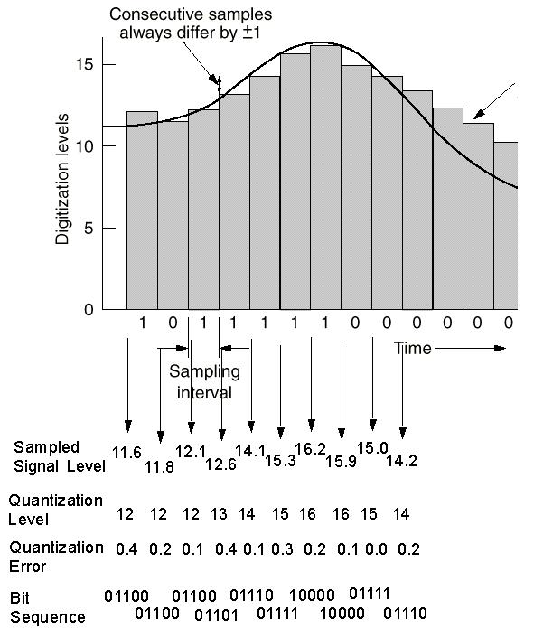

Figure 2.1

2.4 Optimum Quantization

Quantization of the amplitudes of the sampled signal results in data compression but it also introduces some distortion of the waveform or a loss of signal fidelity. The minimization of this distortion is the optimization of quantization.

2.4.1 Scalar Quantization
In source encoding, the quantizer can be optimized if we know the probability density function of the signal amplitude at the input to the quantizer. For a sequence {x_{n}} at the input to the quantizer has a pdf p(x) and let L=2R be the desired number of levels. We wish to design the optimum scalar quantizer that minimizes some function of the quantization error q = χ – x, where χ is the quantized value of x. If ƒ(χ – x) denotes the desired function of the error. Then the distortion resulting from quantization of the signal amplitude is
∞
D = ∫ ƒ (χ – x)p(x)dx
-∞

In general, an optimum quantizer is one that minimizes D by optimally selecting the output levels and the corresponding input range of each output level.

2.4.2 Vector Quantization
In scalar quantization we consider the quantization of the output signal from a continuous-amplitude source when the quantization is performed on a sample-by-sample basis. When we consider the joint quantization of a block of signal samples or a block of signal parameters. This type of quantization is called block or vector quantization.
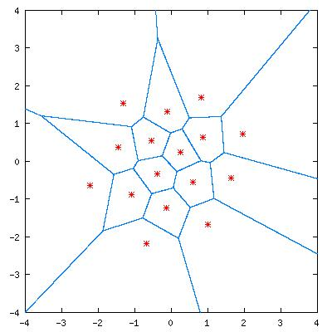 Figure 2.2
The vector quantization problem may be formulated as follows: We have an n-dimensional vector X = [x₁, x₂, … , x_{n}] with real valued, continous amplitude components { x_{k} , 1 ≤ k ≤ N } that are described by joint pdfs p(x₁, x₂, …, x_{n}). The vector X is quantized into another n-dimensional vector χ with components {χ_{k} , 1≤k≤N}. we express the quantization as Q(.), so that,

χ = Q(X)

Basically, vector quantization of blocks of data may be viewed as a pattern recognition problem involving the classification of blocks of data into discrete number of categories or cells in a way that optimizes some fidelity criterion. The quantization of two dimensional vectors X=[x₁ x₂]. The two-dimensional space is partitioned into cells as shown in the figure.3 , where we have arbitrarily selected cells {C_{k}}. All input vectors that fall in cell C_{k} are quantized into the vector χ_{k}, which is shown as the center of the hexagon.
In general, quantization of the n-dimensional vector X into an n-dimensional vector χ introduces a quantization error or a distortion d(X, χ). The average distortion over a set of input vectors X is
L
D = ∑ P(X Є C_{k})E[d(X, χ) | X Є C_{k}]
k=1

Where P(X Є C_{k}) is the probability that the vector X falls in the cell C_{k} and p(X) is the joint pdf of n random variables. As in the case of scalar quantization, we can minimize D by selecting the cells {C_{k}, 1 ≤ k ≤L} for a given pdf p(X).

Vector Quantization is not limited to quantizing a block of signal samples of a source waveform. It can also be applied to quantizing a set of parameters extracted from the data. For example, in linear predictive coding (LPC), the parameters extracted from the signal are the prediction coefficients, which are the coefficients in the all pole filter model for the source that generates the observed data.

Chapter 3
Voice Techniques

Typical speech waveforms possess frequencies from several tens of hertz to high of the order of ten kilo hertz. Infact, high quality sound reproduction systems often cover the band from 20 Hz to about 40kHz. Athough the ear does not respond to frequencies above perhaps 15kHz ( i.e. the upper limit decreases at one stage), the higher frequencies do contribute to an overall sensory appreciation of sound.

In evaluating digitization techniques for speech, we need a measure of success. The signal-to-quantization-noise ratio, a measure that we discussed earlier, is related to the mean square quantization error. However in speech transmission, subjective measures often take precedence over these mathematical measures.

Voice digitization techniques fall into two distinct classes. The first treats the voice as an analog signal and attempts to code this to reproduce the time signal at the receiver. This is called waveform digitization. The second treats parameters of the speech signals, and the goal is to preserve the actual word information. Analysis of such systems involves breaking speech up into its basic components and waveform segments.

PCM can be used for speech waveform. This uses 8000 samples per second with seven bit quantization of each sample value. Other common systems for speech waveform encoding are DPCM, ADPCM, DM and ADM. The criteria for choosing a system includes signal-to-noise ratio and the complexity of the system. ADPCM has been shown to yield the highest SNR for a given bit rate.

Linear Predictive Coding is one technique for sending essential speech information using fewer bits per second. A typical system might only require only 2.4kbps to send a voice waveform, as compared to 56kbps using PCM.

u(t)
A/D Converter
Autocorrelation
Equation Solving
s_{n}

Filter parameters
Pitch Extraction
MUX
To Channel

Analyzer

Pitch Impulse Generator
White Noise Generator

DEMUX and Processor
From
Channel
Predictor Filter
Post Det. Filter

Filter Parameters š_{n} ǔ(t)
(LPF)
Synthesizer
Figure 3.1

The analyzer is used to reduce the speech waveform to a minimum set of data. The waveform id first digitized using A/D. the statistics of the waveform are calculated using autocorrelation analysis, and the essential frequency content is extracted using a pitch extractor. The pitch information, together with the parameters of the linear prediction filter are sent to the receiver or synthesizer.

The synthesizer separates the pitch information and the filter parameters and simulates the proper filter to control the pitch generator. White noise forms the basis of reconstructing the intelligible speech signal.

Improvement in speech intelligibility is possible by using more sophisticated encoding schemes. The Adaptive Predictive Coding (APC) scheme is a differential scheme which transmits the difference between the predicted and actual voice waveform samples.

Speech information can be transmitted using bit rates below 1kHz by employing vocoders.

We can summarize the various techniques by comparing bit rate to send a single channel of voice information.

LPC Vocoder

ADM

ADPCM

PCM

Synthetic Quality / Communications Quality / Toll Quality
0 8 16 24 32 40 48 56 64
Bitrate in kbps
Figure 3.2

Quality is difficult to measure, and depends upon SNR and various subjective criteria.

Chapter 4
Model Based Source Coding

In contrast to the waveform encoding methods, model based source coding represents a completely different approach. In this, the source is modeled as a linear system that, when excited by an appropriate input signal, results in the observed source output. Instead of transmitting the samples of the source waveform to the receiver, the parameters of the linear system are transmitted along with an appropriate excitation signal. If the number of parameters is sufficiently small, the model based methods provide a large compression of the data.

The most widely used model-based coding method is called linear prediction coding. In this the sampled sequence denoted by x_{n,} n = 0,1, … , N-1, is assumed to have been generated by an all-pole (discrete time) filter having the transfer function

G
H(z) =
p
1 – ∑ a_{k} z ^{-k}
K=1

Appropriate excitation functions are an impulse, a sequence of impulses or a sequence of white noise with unit variance. In any case, suppose that the input sequence is denoted by v_{n}, n = 0,1,2,3,… Then the output sequence of the all pole model satisfies the difference equation
p
x_{n} = ∑ a_{k} x_{n-k} + G v_{n} , n=0,1,2,3,…
K=1

In General, the observed source output x_{n}, n=0,1,2,3,…,N-1, dose not satisfy the difference equation, but only its model does. If the input is a white-noise sequence or an impulse, we may form an estimate(or prediction) of x_{n} by the weighted linear combination.

p
χ_{n} = Σ a_{k} x_{n-k}, n > 0
K=1

the difference between x_{n} and χ_{n}, namely,

e_{n} = x_{n} – χ_{n}
p
= x_{n} - Σ a_{k} x_{n-k}
K=1

represents the error between the observed value x_{n} and the estimated (predicted) value x_{n}. The filter coefficients {a_{k}} can be selected to minimize the mean square value of the error.

Suppose that the input {v_{n}} is a white noise sequence. Then, the filter output x_{n} is a random sequence and so is the difference e_{n} = x_{n} - χ_{n}. The ensemble average of the squared error is

ξ_{p} = E ( e_{n}² )
p
= E [ ( x_{n} - Σ a_{k} x_{n-k} ) ]
k=1
p
p
p
= φ(0) – 2 Σ a_{k} Φ(k) + Σ Σ a_{k} a_{m} Φ(k-m)
m=1
k=1
k=1

where φ(m) is the autocorrelation function of the sequence xn, n=0,1,…,N-1. But ξ_{p} is identical to the MSE. Consequently, minimization of ξ_{p} yields the set of normal equations given previously. To completely specify the filter H(z), we must also determine the filter gain G.
p
E[(Gv_{n})²] = G² E( v_{n}² ) = E [ ( x_{n} - Σ a_{k} x_{n-k} ) ] = ξ_{p}
k=1
where ξ_{p} is the residual MSE obtained by substituting the optimum prediction coefficients. With this substitution, the expression for ξ_{p} and hence G2 simplifies to
p
ξp = G² = φ(0) - Σ a_{k} Φ(k)
k=1

In practice, we do not usually know priori the true autocorrelation function of the source output. Hence, in place of φ(n), we substitute an estimate Φ(n), which is obtained from the set of samples x_{n}, n=0,1,2,…,N-1, emitted by the source.

The Levinson-Durbin algorithm may be used to solve for the predictor coefficients {a_{k}} recursively, beginning with a first order predictor and iterating the order of the predictor up to order p. The recursive equations for {a_{k}} may be expressed as

i - 1
Φ(i) - Σ a_{i-1k} Φ(i – k)
K=1
a_{ii} =
ζ _{i-1}

a_{ik} = a_{i - 1k} – a_{ii} a_{i - 1i – k}

ζ _{i} = ( 1 – a_{ii} ) ζ _{i-1}

a₁₁ = Φ(1) Φ(0) ζ ₀ = Φ(0)

Chapter 5
Various speech compression techniques
(Model Based)
Digital speech signals are sampled at a rate of 8000 samples/sec. Typically, each sample is represented by 8 bits (using mu-law). This corresponds to an uncompressed rate of 64 kbps (kbits/sec). With current compression techniques (all of which are lossy), it is possible to reduce the rate to 8 kbps with almost no perceptible loss in quality. Further compression is possible at a cost of lower quality. All of the current low-rate speech coders are based on the principle of linear predictive coding (LPC) which is presented in the following sections.

5.1 LPC Modeling
A. Physical Model:
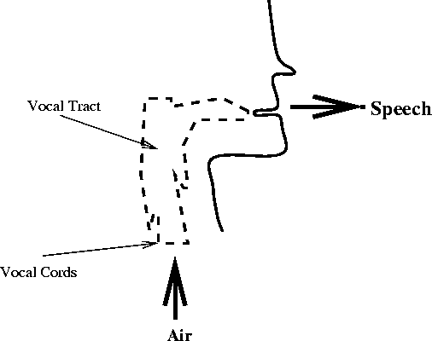
Figure 5.1
When you speak:
- Air is pushed from your lung through your vocal tract and out of your mouth comes speech.
- For certain voiced sound, your vocal cords vibrate (open and close). The rate at which the vocal cords vibrate determines the pitch of your voice. Women and young children tend to have high pitch (fast vibration) while adult males tend to have low pitch (slow vibration).
- For certain fricatives and plosive (or unvoiced) sound, your vocal cords do not vibrate but remain constantly opened.
- The shape of your vocal tract determines the sound that you make.
- As you speak, your vocal tract changes its shape producing different sound.
- The shape of the vocal tract changes relatively slowly (on the scale of 10 msec to 100 msec).
- The amount of air coming from your lung determines the loudness of your voice.
B. Mathematical Model:
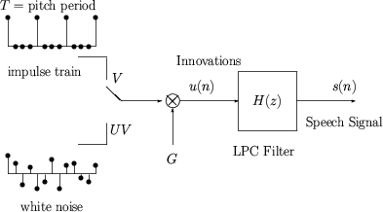
Figure 5.2

- The above model is often called the LPC Model.
- The model says that the digital speech signal is the output of a digital filter (called the LPC filter) whose input is either a train of impulses or a white noise sequence.
- The relationship between the physical and the mathematical models:
Vocal Tract |  | (LPC Filter)
Air |  | (Innovations)
Vocal Cord Vibration |  | (voiced)
Vocal Cord Vibration Period |  | (pitch period)
Fricatives and Plosives |  | (unvoiced)
Air Volume |  | (gain)
- The LPC filter is given by:
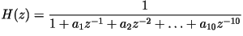
which is equivalent to saying that the input-output relationship of the filter is given by the linear difference equation:
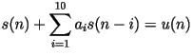
- The LPC model can be represented in vector form as:
- changes every 20 msec or so. At a sampling rate of 8000 samples/sec, 20 msec is equivalent to 160 samples.
- The digital speech signal is divided into frames of size 20 msec. There are 50 frames/second.
- The model says that
is equivalent to
Thus the 160 values of is compactly represented by the 13 values of .
- There's almost no perceptual difference in if:
  - For Voiced Sounds (V): the impulse train is shifted (insensitive to phase change).
  - For Unvoiced Sounds (UV):} a different white noise sequence is used.

- LPC Synthesis: Given , generate (this is done using standard filtering techniques).
- LPC Analysis: Given , find the best

5.2 LPC Analysis
- Consider one frame of speech signal:
- The signal is related to the innovation through the linear difference equation:
- The ten LPC parameters are chosen to minimize the energy of the innovation:
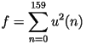
- Using standard calculus, we take the derivative of with respect to and set it to zero:
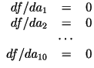
- We now have 10 linear equations with 10 unknowns:
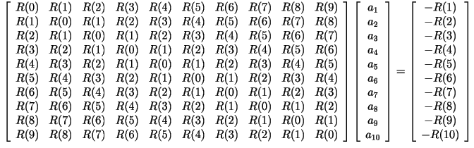

where
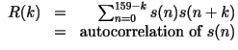
The above matrix equation could be solved using:
  - The Gaussian elimination method.
  - Any matrix inversion method (MATLAB).
  - The Levinson-Durbin recursion (described below).
- Levinson-Durbin Recursion:
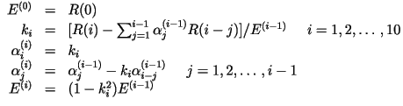
Solve the above for , and then set
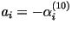
- To get the other three parameters:, we solve for the innovation:
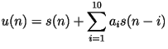
Then calculate the autocorrelation of :
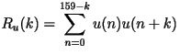
- Then make a decision based on the autocorrelation: 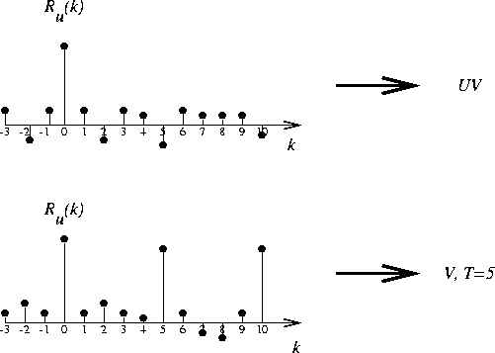
5.3 2400bps LPC Vocoder
- The following is a block diagram of a 2.4 kbps LPC Vocoder:
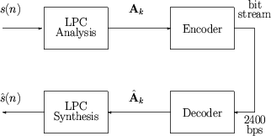
- The LPC coefficients are represented as line spectrum pair (LSP) parameters.
- LSP are mathematically equivalent (one-to-one) to LPC.
- LSP are more amenable to quantization.
- LSP are calculated as follows:
- Factoring the above equations, we get:
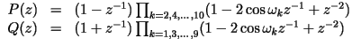
are called the LSP parameters.
- LSP are ordered and bounded:
- LSP are more correlated from one frame to the next than LPC.
- The frame size is 20 msec. There are 50 frames/sec. 2400 bps is equivalent to 48 bits/frame. These bits are allocated as follows:
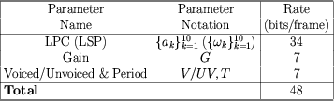
- The 34 bits for the LSP are allocated as follows:
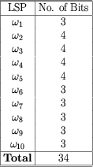
- The gain, , is encoded using a 7-bit non-uniform scalar quantizer (a 1-dimensional vector quantizer).
- For voiced speech, values of ranges from 20 to 146. are jointly encoded as follows:
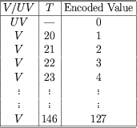

Chapter 6
Voice Excited Linear Predictive Vocoder
6.1 Introduction
As described earlier, LPC 10 (Plain LPC) converts a 64kbps speech signal into a 2.4 – 4.2 kbps speech signal. Basic parameters sent to the receiver are the LP coefficients, gain, pitch period and unvoiced/voiced excitation. LP coefficients are generated using Autocorrelation technique and the set of equations are solved using Levinson Durbin Algorithm. Gain is computed for the signal and the pitch period and the voiced/unvoiced source excitation information is also computed by taking autocorrelation of the input speech signal frames.
If the signal is unvoiced then the excitation is taken as white noise and if the signal is voiced then the pitch period of the signal is calculated for each frame and at the receiver , this pitch period is used to construct the pulse with a this pitch period. This pulse is used as the excitation signal for the reconstruction of the speech signal.
Gain and the excitation signal are very integral components of the LPC vocoder as the characteristics of these parameters greatly influences the quality of reconstruction. The speech quality of a LPC 10 vocoder output is synthetic and has negative SNR . the output of the LPC vocoder is nearly intelligible.
Thus according to the above description the weakest part in the LPC 10 vocoder methodology is the voice excitation. According to the reference [7], one solution to improve the quality of sound is the use of voice excited LPC vocoder. Main difference between LPC 10 and VELP ( Voice Excited LPC) is the excitation detector.
The main idea behind the voice-excitation is to avoid the imprecise detection of the pitch and the use of an impulse train while synthesizing the speech. One should rather try to come up with a better estimate of the excitation signal. Thus the input speech signal in each frame is filtered with the estimated transfer function of LPC analyzer. This filtered signal is called the residual. If this signal is transmitted to the receiver, one can achieve a very good quality. The tradeoff, however, is paid by a higher bit rate, although there is no longer a need to transfer the pitch frequency and the voiced / unvoiced information. We therefore looked for a solution to reduce the bit rate to 16 kbits/sec
A voice excited LPC vocoder, sends LP parameters, Excitation Component and gain to the receiver. Considering all these factors in a voice excited LPC vocoder, the voice-excited LPC reconstructed file sounds more spoken and less whispered. The speech quality is less synthetic, almost reaching the communication quality and the words are much easier to understand. Overall the speech constructed over a voice excited LPC vocoder sounds much better, but still sounds muffled.

6.2 Description of coder

Many current speech coders use a source-filter model in which the signal is decomposed on a frame wise basis into an excitation component and a filter component. The filter component is then parameterized and coded by a separate encoder.
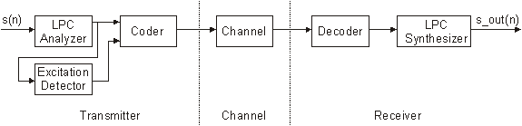
Fig. 6.1: Block diagram of a voice-excited LPC vocoder.
The coder operates on speech frames of 20ms corresponding to 160 samples at a sampling rate of 8000 samples per seconds. For every 20ms frame, the speech signal is analyzed to extract the parameters of the voice excited linear prediction model (linear prediction filter coefficients, Discrete Cosine Transform Coefficients of residual signal and gain). These parameters are encoded and transmitted. At the decoder, these parameters are used to retrieve the excitation and synthesis filter parameters.

In this section an explanation of the LPC speech coding technique will be given. The specific modifications and additions done to improve this algorithm will also be covered. However, before jumping into the detailed methodology of our solution, it will be helpful to give a brief overview of speech production. Speech is produced when velum is lowered to make it acoustically coupled with the vocal tract. Nasal sounds of speech are produced this way [7]. Speech signals consist of several sequences of sounds. Each sound can be thought of as a unique information. There are voiced and unvoiced types of speech sounds. The fundamental difference between these two types of speech sounds comes from the way they are produced. The vibrations of the vocal cords produce voiced sounds. The rate at which the vocal cords vibrate dictates the pitch of the sound. On the other hand, unvoiced sounds do not rely on the vibration of the vocal cords. The unvoiced sounds are created by the constriction of the vocal tract. The vocal cords remain open and the constrictions of the vocal tract force air out to produce the unvoiced sounds [7].
LPC technique will be utilized in order to analyze and synthesize speech signals. This method is used to successfully estimate basic speech parameters like pitch, formants and spectra. A block diagram of an LPC vocoder can be seen in Fig.3-1. The principle behind the use of LPC is to minimize the sum of the squared differences between the original speech signal and the estimated speech signal over a finite duration. This could be used to give a unique set of predictor coefficients [7]. These predictor coefficients are normally estimated every frame, which is normally 20 ms long. The predictor coefficients are represented by ak. Another important parameter is the gain (G). The transfer function of the time-varying digital filter is given by:
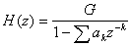
The summation is computed starting at k=1 up to p, which will be 10 for the LPC-10 algorithm, and 18 for the improved algorithm that is utilized. This means that only the first 18 coefficients are transmitted to the LPC synthesizer. The two most commonly used methods to compute the coefficients are, but not limited to, the covariance method and the auto-correlation formulation. For our implementation, we will be using the auto-correlation formulation. The reason is that this method is superior to the covariance method in the sense that the roots of the polynomial in the denominator of the above equation is always guaranteed to be inside the unit circle, hence guaranteeing the stability of the system H (z) [7]. Levinson - Durbin recursion will be utilized to compute the required parameters for the auto-correlation method

6.2.1 Encoder

The encoding principle is shown in Figure 6.2. The input signal is high-pass filtered and scaled in the pre-processing block. The pre-processed signal serves as the input signal for all subsequent analysis. LP analysis is done once per 20 ms frame to compute the LP filter coefficients. These coefficients are converted to Line Spectrum Pairs (LSP) and quantized using optimum quantization technique.
Input speech
LPC Analyzer
Excitation synthesizer
Gain Analyzer
Excitation parameter

LP parameters
Gain Parameter

Figure 6.2: Block Diagram of VELP encoder

The residual signal is generated by using Moving Average Digital Filter [3] in which actual input speech signal is fed as excitation component and the LP filter coefficients as the filter component to simulate the filter and hence the residual/innovation signal is synthesized.
For good reconstruction of excitation, Discrete Cosine Transform of residual signal is employed which concentrates most of the energy of the signal in first few coefficients. Finally the coefficients are quantized.
Gain is calculated according to the ratio of the rms value of the input power to the rms value of the output power for each frame. It is quantized by uniform 7 bit scalar quantizer.

6.2.2 Decoder
The decoder principle is shown in figure. First, the parameters are extracted from the received bitstream for a 20ms speech frame. The parameters are the LSP coefficients, the gain and the DCT coefficients of the innovation signal. The LSP coefficients are interpolated and converted to LP filter coefficients for each frame.
Excitation Reconstructor
LP Synthesis Filter
Output reconstructed speech signal

Gain Calculation

Figure 6.3: Block diagram for VELp decoder

- The excitation is reconstructed by taking inverse discrete cosine transform of the DCT coefficients.
- The speech is reconstructed by filtering the excitation through the LP synthesis filter ( Autoregressive model [3] ).
- The reconstructed speech signal is passed through a post-detection filter which includes the high pass filtering and scaling operation.

6.3 Functional Description of the Encoder
The different functions of the encoder are described.
6.3.1 Pre-processing
The input to the speech encoder is assumed to be a 16 bit PCM signal. Two pre-processing functions are applied before the ncoding process:
1) signal scaling; and
2) high-pass filtering.
The scaling consists of dividing the input by a factor 2 to reduce the possibility of overflows in the fixed-point implementation. The high-pass filter serves as a precaution against undesired low-frequency components. A second order pole/zero filter with a cut-off frequency of 140 Hz is used. Both the scaling and high-pass filtering are combined by dividing the coefficients at the numerator of this filter by 2. The resulting filter is given by:

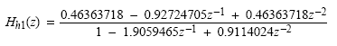
Pre-emphasis Filter
From the speech production model it is known that the speech undergoes a spectral tilt of -6dB/oct. To counteract this fact a pre-emphasis filter of the following form is used:
The frequency response of a typical pre-emphasis filter is shown in Fig. 3-3 as well as its inverse filter. This is involved during the synthesis / reconstruction of the speech signal and is as follows:
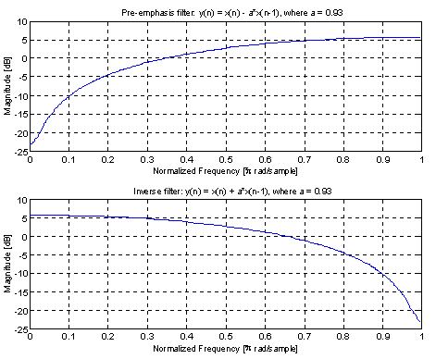
Fig. 3-3: Frequency response of the pre-emphasis filter and its inverse filter
The main goal of the pre-emphasis filter is to boost the higher frequencies in order to flatten the spectrum. To give an idea of the improvement made by this filter the reader is referred to the plotted frequency spectrum in Fig. 3-4 of the vowel /i/ in the word nine. It can be seen how the spectrum is flattened. This improvement leads to a better result for the calculation of the coefficients using LPC. There are higher peaks visible for higher frequencies in the LPC-spectrum as can be seen in Fig. 3-5. Clearly, the coefficients corresponding to higher frequencies can be better estimated.
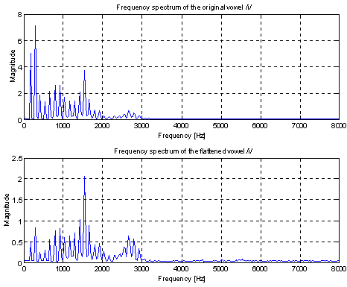
Fig. 3-4: Frequency spectrum of the vowel /i/ in the word nine.
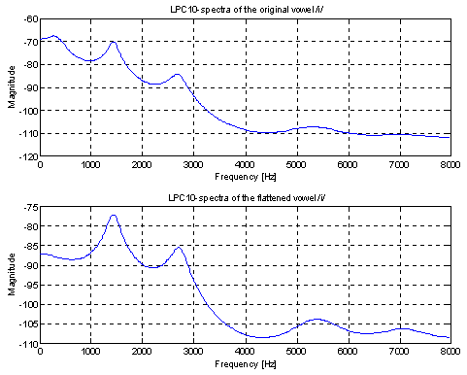
Fig. 3-5: Spectrum of the LPC model for the vowel /i/ in the word nine.

6.3.2 Linear prediction analysis and quantization
The short-term analysis and synthesis filters are based on 10th order Linear Prediction (LP) filters. The LP synthesis filter is defined as:
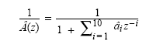
where âi, i = 1,...,10, are the (quantized) Linear Prediction (LP) coefficients. Linear prediction analysis is performed once per speech frame using the autocorrelation method with a 20 ms asymmetric window. Every 160 samples (20 ms), the autocorrelation coefficients of windowed speech are computed and converted to the LP coefficients using the Levinson algorithm. Then the LP coefficients are transformed to the LSP domain for quantization and interpolation purposes. The interpolated quantized and unquantized filters are converted back to the LP filter coefficients (to construct the synthesis filter for each frame).

6.3.3 Windowing
The LP analysis window consists of a Kaiser window of size of 160 samples or 20 ms.
The impulse response of Kaiser window is given by:
$$h(n)=\frac{Io\left[α\sqrt{{\left(\frac{M−1}{2}\right)}^{2}−{\left(n−\frac{M−1}{2}\right)}^{2}}\right]}{Io\left[α\left(\frac{M−1}{2}\right)\right]}$$

6.3.4 Autocorrelation and Levinson Durbin Algorithm
It is known from the literature [1] that the ensemble average of the squared error can be minimized to yield a set of equations where the consequent maximization of the autocorrelation functions of the sequence yield the appropriate filter coefficients for the proper reconstruction of speech signal.
Levinson Durbin algorithm [1], [3] and [4] is used to solve for the predictor coefficients recursively, beginning with a first order predictor and iterating the order of the predictor up to ten.

6.3.5 LP to LSP conversion
The LP filter coefficients ai, i = 0,...10 are converted to Line Spectral Pair (LSP) coefficients for quantization and interpolation purposes. For a 10th order LP filter, the LSP coefficients are defined as the roots of the sum and difference polynomials:
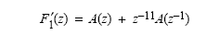
and
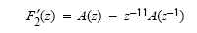
respectively. The polynomial F₁‘(z) is symmetric, and F₂‘(z) is antisymmetric. It can be proven that all roots of these polynomials are on the unit circle and they alternate each other. F₁′(z) has a root z = −1 (ω = π) and F₂′(z) has a root z = 1 (w = 0). These two roots are eliminated by defining the new polynomials:

and
Each polynomial has five conjugate roots on the unit circle and they can be written as:
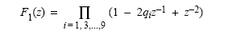
and
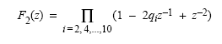
where q_{i} = cos(ω_{i}). The coefficients ωi are the Line Spectral Frequencies (LSF) and they satisfy the ordering property 0 < ω_{i} < ω₂ < ... < ω₁₀ < π. The coefficients q_{i} are referred to as the LSP coefficients in the cosine domain. Since both polynomials F₁(z) and F₂(z) are symmetric only the first five coefficients of each polynomial need to be computed. The coefficients of these polynomials are found by the recursive relations:
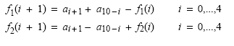
where f₁(0) = f₂(0) = 1.0.

6.3.6 Quantization of Line spectrum pairs
Since the LSP parameters are uniformly distributed over the entire range of (-1,1), a uniform scalar quantizer is used to quantize LSP parameters and encode into bitstream which is then transmitted to the Channel

6.3.7 LSP to LP Conversion

Once the LSP coefficients are quantized and interpolated, they are converted back to the LP coefficients a_{i}. This conversion is done as follows. The coefficients of F₁(z) and F₂(z) are found by expanding above equations knowing the quantized and interpolated LSP coefficients. The coefficients f₁(i), i = 1,...,5, are computed from q_{i} using the recursive relation:

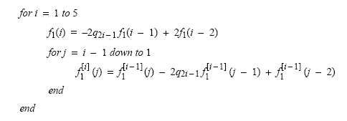
with initial values f₁(0) = 1 and f₁(−1) = 0. The coefficients f₂(i) are computed similarly by replacing q_{2i−1} by q_{2i}. Once the coefficients f₁(i) and f₂(i) are found, F₁(z) and F₂(z) are multiplied by 1 + z⁻¹ and 1 − z⁻¹, respectively, to obtain F₁ ′(z) and F₂ ′(z); that is:
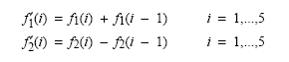
Finally the LP coefficients are computed from f ′₁(i) and f’ ₂(i) by:
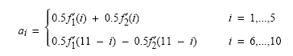
This is directly derived from the relation A(z) = (F₁′(z) + F₂′(z))/2, and because F₁′(z) and F₂′(z) are symmetric and anti-symmetric polynomials, respectively.

6.3.8 Generation of Residual/Innovation Signal
The residual signal is generated by a MA (Moving Average) Filter [3] in which original speech signal is fed as the input excitation component and the filter component is the LP filter coefficients obtained after the conversion of LSP parameters to LP coefficients.
The MA filter synthesized is given by

$\begin{aligned}\underline{u(z)} \\ x(z)\end{aligned}$= 1 + $\sum_{k=1}^{\text{10}}{a_{k}z^{−k}}$

or in difference equation form

$u[n]=\sum_{k=0}^{\text{10}}{a_{k}x[n−k]}$ ; $a_{0}=1$

Hence the excitation component or the innovation signal u[n] is generated using filter coefficients and signal x[n] for each frame.

6.3.9 DCT of Residual Signal
The N×N cosine transform matrix C = { C(k,n) }, also called Discrete Cosine Transform, is defined as

$$c(k,n)=\left\{\begin{matrix}1/\sqrt{N} & ;k=0,0≤n≤N−1 \\ \sqrt{\frac{2}{N}} & \text{cos}\frac{(2n+1)kπ}{2N};1≤k≤N−1,0≤n≤N−1\end{matrix}\right.$$

The DCT of a sequence {u[n], 0≤n≤N-1 } is defined as

$$u[k]=α(k)\sum_{n=0}^{N−1}{u[n]\text{cos}\left[\frac{π(2n+1)k}{2N}\right]}\begin{matrix} & ;0≤k≤N−1\end{matrix}$$

where

$$α(0)≃\begin{matrix}\frac{1}{\sqrt{N}} & ,α(k)≃\sqrt{\frac{2}{N}} & ;1≤k≤N−1\end{matrix}$$

the discrete cosine transform has excellent energy compaction for highly correlated data i.e. it concentrates the maximum amount of energy of the innovation signal into its first few coefficients. This property of cosine transform together with the fact that it is a fast transform has made it useful for the highly correlated first order Markov sequences.

6.3.10 Signal rate conversion [3]
Each frame consists of 160 samples i.e., for one frame of innovation signal will have 160 samples. But DCT requires number of samples in the powers of 2. Hence 160 samples have to be interpolated and decimated to number which can be described in the form 2^{N} . Thus taking N=8 give 256 samples which can be formed by interpolating by a factor of 8 and then decimating by a factor of 5 which converts 160 samples into 256 samples.
DCT of the 256 samples frame is calculated and the first few samples which contain the maximum concentration of energy are taken and then quantized using an uniform scalar quantizer.

6.3.11 Gain Computation and Quantization
Due to Lossy nature of VELP compression there is a loss of power in the reconstructed speech signal. The amplitude of the reconstructed signal is much lower than the original signal because of the loss of power in the Transmission of innovation signal through DCT coefficients. To overcome this loss, we need to employ some method to regain the lost power. It can be done in two ways
- Statistical analysis of the power lost in the signal
- Computation of gain by taking the ratio of the rms voltage of the input to the output signal
Since statistical analysis in based on hit and trial method of comparing the input and output signal power and then finding the gain. Hence it cannot be generalized for different signals.
Second method of gain computation involves the computation of rms voltage of the original input speech signal for each frame. This rms value is quantized using non uniform A-law compander [2]. This quantized rms value is transmitted to the receiver.
At the receiver the RMS voltage of the reconstructed speech signal is computed for each frame. The gain is computed at the receiver end by taking the ratio of the incoming rms voltage of original speech signal to the RMS voltage value of the reconstructed speech signal for each frame. The gain calculated is applied on the reconstructed speech signal on a frame-wise basis.

6.4 Functional Description of Decoder
The principle of decoder is shown in figure. First the parameters decoded ( LP coefficients, DCT coefficients and the gain). The transmitted parameters (for optimizd performance) are listed

Parameters | No. of bits
LSP parameters | 8 bits each
Gain | 7 bits each
DCT coefficients | 6 bits each

These decoded parameters are used to compute the reconcstructed speech signal. This signal is enhanced by post processing operations ( high pass filtering and upscaling)

6.4.1 Decoding of LP filter coefficients
The quantized LSP parameters obtained from the received bitstream for a frame are converted back to LP filter coefficients by interpolating the LSP coefficients. These LP filter coefficients are used for synthesizing the reconstructed speech signal.

6.4.2 Reconstruction of the excitation/innovation signal
The excitation input for the filter can be obtained from the Inverse Discrete Cosine Transform of the DCT coefficients obtained.
In order to get the IDCT of the DCT coefficients, we need to increase the number of coefficients to 256. This is done by padding zeros at the end of the coefficients to make the number of coefficients some power of 2 ( i.e. 256 in our case).
The inverse discrete transformation is given by

$$u(n)=\sum_{k=0}^{N−1}{\begin{matrix}α(k)v(k)\text{cos}\left[\frac{π(2n+1)k}{2N}\right], & 0≤n≤N−1\end{matrix}}$$

Then the IDCT of these coefficients results in 256 samples frame which is similar to the actual innovation signal because of the high concentration of energy in the DCT coefficients transmitted.

6.4.3 Sample rate conversion [3]
The 256 samples frame has to be converted back to a 160 samples frame. This is achieved by interpolating the signal by a factor of 5 and then decimating by a factor of 8. Thus the signal obtained consists of frames having 160 samples.
This is the excitation input in the speech signal reconstruction filter.

6.4.4 Reconstruction of speech signal
Autoregressive (AR) digital filter model [3] is used to reconstruct the speech signal. The LP coefficients computed from the interpolation of the LSP parameters are used as the filter coefficients for the AR model for each frame. An AR model is an all pole Digital filter model.
The innovation signal reconstructed from the inverse DCT of the DCT coefficients transmitted is used as the excitation component for the AR model for each frame. The output of the AR model is the reconstructed speech signal on a frame-wise basis.
The reconstructed speech signal has very low power. So in order to increase the power of the signal, gain has to be provided to the signal. And the signal has to be processed in order to high-pass filter the signal and upscale it by a factor of 2.

6.4.5 Post Processing
Post processing involves high pass filtering and up-scaling of the signal. A high pass filter with a cut off frequency of 100Hz is applied to the reconstructed speech. The filter is given by

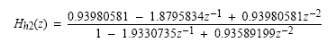
The filtered signal is multiplied by a factor of 2 to restore the input signal level.

Features
- 28-/56-bit, 25 MHz digital audio processor  - Stereo ADC: 95 dB dynamic range and -90 dB THD+N  - 4-channel DAC: 96 dB dynamic range and -90 dB THD+N  - Complete stand-alone operation: Self-boot from serial EEPROM, 4-channel auxiliary control ADC, GPIOs for digital controls and outputs  - Fully programmable with SigmaStudio™ graphical tool  - 28-bit × 28-bit multiplier with 56-bit accumulator for full double precision calculations | - Clock Oscillator for generating master clock from crystal  - PLL for generating master clock from 64 × fs, 256 × fs, 384 × fs, or 512 × fs clocks  - Flexible serial data I/O ports with I2S compatible, left-justified, right-justified, and TDM modes  - Sampling Rates up to 192 kHz supported  - On-chip voltage regulator for compatibility with 3.3 V systems  - 48-lead LQFP plastic package

Specification:-
Instruction/Cycle | 512
DNR (dB) | 96dB
THD+N @ 1 kHz (-dB) | 90dB
Digital I/O Channels | 8/8
Analog I/O Channels (ADCs/DACs) | 2/4
Product Description | SigmaDSP 28/56-Bit Audio Processor with 2 ADC/4 DAC

Chapter 7

MATLAB implementation of
Voice excited LPC Model

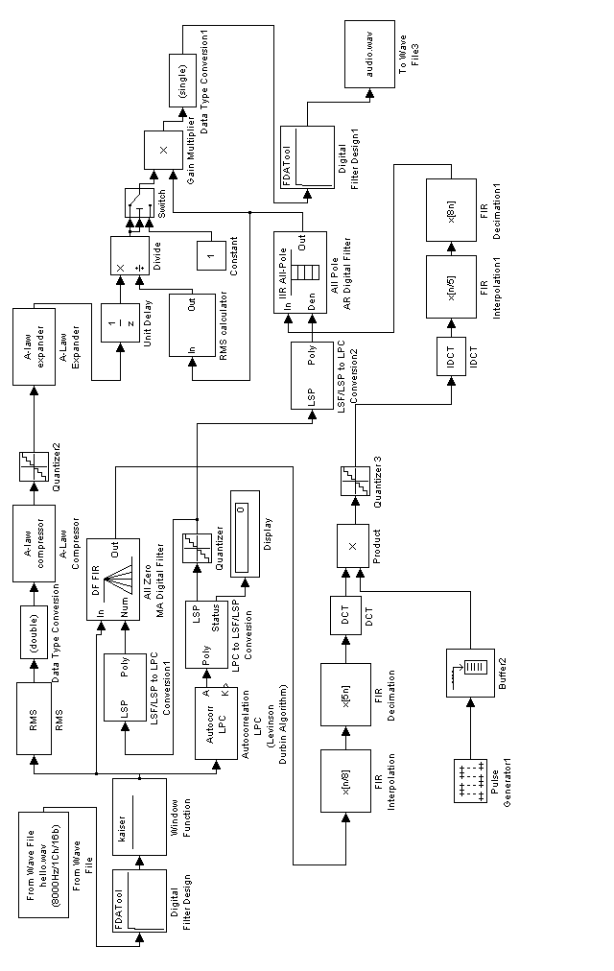
VOICE EXCITED LPC DECODER (SYNTHESIZER)
VOICE EXCITED LPC ENCODER (ANALYZER)
Figure 7.1: Full Block diagram of Voice Excited LPC Vocoder
Figure 7.1 shows the MATLAB-Simulink generated Voice excited LPC vocoder.
Various components of Encoder are:
Input wave file | The input speech signal is fed into this component for processing
FDA tool | This tool synthesizes the preprocessing component of the encoder
Kaiser window | Window implemented for 20 ms frame
Autocorrelation LPC | This component finds the autocorrelation of each frame and solves the set of equations using Levinson Durbin Algorithm to find out the LP parameters
LP to LSP conversion | This components converts the LP parameters to LSP parameters
Quantizer | Its is uniform scalar quantizer
LSP to LP conversion | This component converts the LSP parameters back to LP parameters
MA Digital Filter | This is the digital filter used to generate the innovation signal from the input speech signal and the LP parameters.
RMS | This component calculates the RMS value of the voltage of each frame
Double type Conversion | It is used for type conversion (Needed for MATLAb simulation)
A-Law Compressor | This components is needed to perform the non uniform quantization of the RMS values
FIR interpolator | This component is responsible for the sample rate interpolation.
FIR Decimator | This component is responsible for the saple rate decimation
DCT | This component performs the Discrete Cosine Transform on the innovation signal.
Pulse Generator | This component generates the pulse sequence in order to extract the first few coefficients of DCT.
Buffer | It is there to convert stream data into frames
Product | This component multiplies to signals element-wise

Various Components of Decoder are:
LSP to LP conversion | This components decodes the received LSP parameters into LP parameters.
IDCT | This component performs the inverse discrete cosine transform on the received DCT coefficients and reconstructs the innovation signal.
FIR interpolation | This components interpolates the sample rate
FIR Decimation | This component decimates the sample rate
All Pole AR Digital Filter | This component reconstructs the speech signal by synthesizing the filter using the excitation component and the filter components
A-Law Expander | This component is used to expand the received RMS values over the whole dynamic range.
Unit Delay | This component is there to negotiate the system delay, in order to produce the correct results.
RMS calculator | This component calculates the RMS values of the reconstructed speech for each frame.
Divider | This component calculates the ratio of the RMS value of the original signal to the RMS value of the reconstructed signal for each frame and thus produces the Gain
Switch | This is needed to overcome the error caused due to the delay in the system.
Multiplier | This component multiplies the gain to reconstructed speech.
Single data type conversion | To convert the data type
FDA tool | This component performs the post-processing of the speech signal
Wave file | This component generates the wave file of the speech signal.

Original and Reconstructed speech signals

1. hello.wav = “Hello, how are you” (Male Voice)

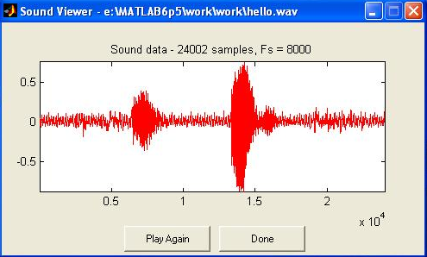

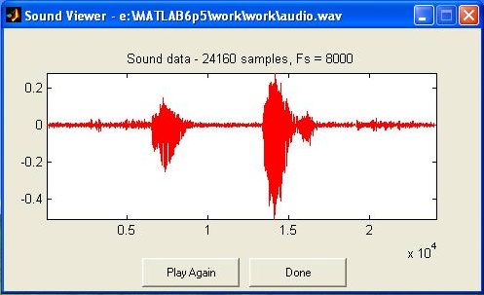

2. pra.wav = “Matlab is a fantastic tool for DSP” (Male Voice)

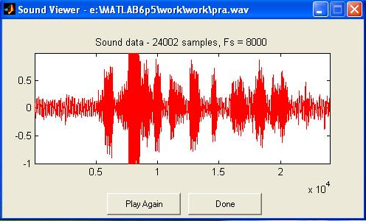

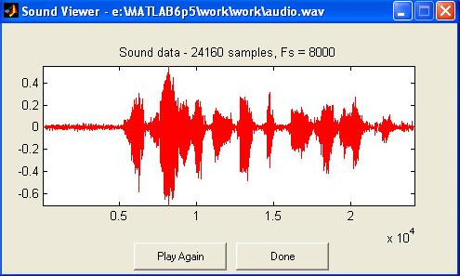

3. gau.wav = “ My name is Garima Khare” (Female Voice)

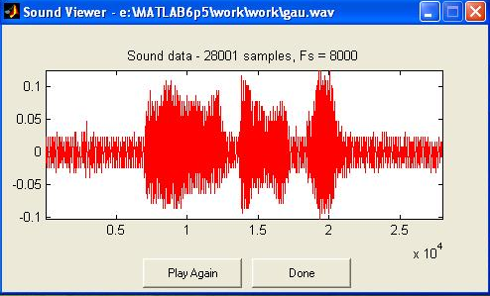

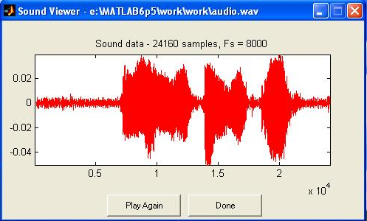

Chapter 8
Performance Analysis
8.0 Performance Analysis
8.1 Bit Rates
In the sequel the necessary bit rates of the two solutions are computed. The bit rate for a plain LPC vocoder is shown in Table 4-1 and the bit rate for a voice-excited LPC vocoder with DCT is printed in Table 4-2. The following parameters were fixed for the calculation:
· Speech signal bandwidth B = 8 kHz
· Sampling rate Fs = 16000 Hz (or samples/sec.)
· Window length (frame): 20 ms
which results in 320 samples per frame by the given sampling rate Fs
· Overlapping: 10 ms (overlapping is needed for perfect reconstruction)
hence: the actual window length is 30ms or consists of 480 samples
· There are 50 frames per second
· Number of predictor coefficients of the LPC model = 18 (see calculation in ….)
void | Number of bits per frame
Predictor coefficients | 18 * 8 = 144
Gain | 5
Pitch period | 6
Voiced/unvoiced switch | 1
Total | 156
Overall bit rate | 50 * 156 = 7800 bits / second
Table 4-1: Bit rate for plain LPC vocoder

void | Number of bits per frame
Predictor coefficients | 18 * 8 = 144
Gain | 5
DCT coefficients | 40 * 4 = 160
Total | 309
Overall bit rate | 50 * 309 = 15450 bits / second
Table 4-2: Bit rate for voice-excited LPC vocoder with DCT
8.2 Overall Delay of the System
The overall delay of the systems tells one how long it takes from the input of the first sample of speech into the system until the first sample of the synthesized speech is available at the output of the system. This is clearly an important number, since one would like to process the data in real-time. If, for example, an LPC vocoder is used in a communication system, e.g. a cellular phone, one does not accept a large delay of the transmitted speech signal. Humans are able to perceive delays of speech within a several hundred of milliseconds during a talk at the telephone. For our project the limit was set to a maximum allowed value of 100 ms.
For both of our proposed solutions the overall delay is 30 ms, since the window length is 20ms and the overlapping is 10ms. In other words, the systems needs to have at least 30 ms of input data before the first calculation can be done. Of course, the calculation time needs to be added to this delay. It is not possible to come up with this number, since we employed Matlab for our simulations. The calculation time therefore depends on the speed of the used computer. We therefore just provide the reader a way to calculate this number on its own for a particular microprocessor system, for which the processor speed is known. This simply requires the knowledge of the computational complexity of the system, which is provided in section 4.2.3 of this report.
8.3 Computational Complexity
Again, the same parameters, as stated in section 4.2.1, are fixed for the calculations. All numbers show the multiplications or additions required per frame. This number needs to be multiplied by the number of frames of a given speech signal.
· Calculation of the LPC coefficients. The Levinson-Durbin recursion requires O(p2) floating point operations per second (FLOPS). In our case p = 18, hence this step requires 324 FLOPS per frame.
· The pre-emphasis filter needs 480 additions and 480 multiplications, which is equal to 960 operations.
· The cross-correlation consists of 480 additions and 480 multiplications, which is equal to 960 operations.
· The reconstruction of the LPC needs about 480*18 additions and 480*18 multiplications, which is equal to 17280 operations.
· The inverse filter requires again 480 additions and 480 multiplications, which is equal to 960 operations
Hence, the total number of operations for the plain LPC vocoder is 20484 operations per frame. The sentences in section 4.2.4 typically contain of about 150 frames at 50 frames/second. Thus, the computational complexity for the plain LPC vocoder is about 1 MFLOPS (Mega-Flops).
For the voice-excited vocoder the calculation of the cross-correlation is not needed but the discrete cosine transform and its inverse is needed instead. However, in the Matlab-code used, the cross-correlation is still computed as it was the case for the plain LPC vocoder. Therefore, the complexity is slightly increased.
· The DCT (if the fast algorithm is applied) requires 480 multiplications equaling 480 operations
· The inverse-DCT requires the same number of operations, namely 480 operations
The total number of FLOPS for the voice-excited LPC vocoder is therefore 21444 operations per frame. If we consider the same parameters as before, the computational complexity is roughly 1.07 MFLOPS. The improved sound quality makes up for the higher number of FLOPS.
4.2.4 Objective Performance Evaluation
We measured the segmental signal to noise ratio (SEGSNR) of the original speech file compared to the coded and reconstructed speech file using the provided Matlab-function "segsnr". The obtained results are as follows:
1) A Male speaker saying: "Kick the ball straight and follow through."
2) A Female speaker saying: "It's easy to tell the depth of a well."
3) A Male speaker saying: "A pot of tea helps to pass the evening."
4) A Female speaker saying: "Glue the sheet to the dark blue background."
Vocoder type | SNR 1 | SNR 2 | SNR 3 | SNR 4
Plain LPC | -24.92 dB | -24.85 dB | -24.87 dB | -23.94 dB
Voice-excited LPC | 0.5426 dB | 0.7553 dB | 0.5934 dB | 0.2319 dB
Note that the calculation of the SNR requires the signals to be normalized before the ratio can be calculated.

Performance of the Voice Excited LPC Vocoder is influenced by 3 parameters
- Gain parameter: Number of bits to quantize the RMS value of the voltage level of the original speech signal for each frame.
- DCT coefficients parameters: There are two parameters which decide this parameter.
  - Number of DCT coefficients being transmitted.
  - Number of bits used to quantize the DCT coefficients.
- LSP parameters: Number of bits used to quantize the LSP parameters.

Depending on these parameters and their different combinations we obtain different signal to noise ratios. Plotting these values on a graph gives the optimized values of these parameters which gives the optimum performance of the VELP vocoder.

8.5 Gain Parameter
Effect of varying the number of bits used to quantize the RMS voltage (gain parameter) of the original signal is not very significant. The speech quality does not show any noticeable change in it. Hence a 7 bit quantization of the gain parameter is taken as constant value for all the subsequent analysis.
Minimum number of quantization bits that we can employ for gain parameter are 5 bits. But using a 7 bit quantizer makes a difference of two bits in overall bits for one frame. Thus the effect is very insignificant thus a 7 bit quantizer can be used.

Other parameters that are kept fixed for calculations:
Signal bandwidth = 4kHz
Sampling Rate = 8000 Hz (samples per second)
Window Length = 20 ms
Number of predictor coefficients = 10
The subsequent calculations are done three speech signal files.
- pra.wav – “Matlab is an fantastic tool for DSP” (Male Voice)
- hello.wav – “Hello how are you” (Male Voice)
- gau.wav – “My name is Garima Khare” (Female Voice)

The quantization step is defined as

$$Δ=(a_{\text{max}}−a_{\text{min}})/{2^{N}}$$

where a_{max} and a_{min} are maximum and minimum levels of voltage and N is the number of bits.
8.6 LSP parameters
The quantization levels for LSP parameters are constant for every speech signal used because the value has been normalized between the range of -1,1. Hence the range of values always remain constant and consequently the quantization levels are also constant for respective values of N for every input speech signal.

$a_{\text{max}}−a_{\text{min}}$= 2.0
N | Δ
8 | 0.0078125
7 | 0.015625
6 | 0.03125
5 | 0.0625

8.7 DCT coefficients parameters

DCT coefficients depend on two internal parameters as described above.

For pra.wav

$a_{\text{max}}−a_{\text{min}}$= 0.1155
N | Δ | Comment
8 | 0.000451171875 | Good
7 | 0.00090234375 | Good
6 | 0.0018046875 | Optimum
5 | 0.003609375 | Pathetic

The calculated values of SNRs and bitrates are given in the table

Calculation of bitrate involves following calculations
LSP parameters | 10 × (No. of LSP bits, L) = 10L
Gain | 7 bits
DCT Coefficients | (No. of DCT coeff., C) × (No. of bits, D) = CD

Hence total number of bits for each frame are = 10L + 7 + CD
Since there are 50 frames per second
Thus the bitrate is = 50 × (10L + 7 + CD)

Number of DCT coefficients (C)= 40
LSP ( L ) | DCT (D) | SNR (dB) | Total bits/frame | Bit Rate(kbps)
6 | 6 | 0.6525 | 307 | 15.35
7 | 6 | 0.2942 | 317 | 15.85
8 | 6 | 0.2646 | 327 | 16.35

Number of DCT coefficients (C)= 40
LSP ( L ) | DCT (D) | SNR (dB) | Total bits/frame | Bit Rate(kbps)
6 | 7 | 0.4734 | 347 | 17.35
7 | 7 | 0.3446 | 357 | 17.85
8 | 7 | 0.254 | 367 | 18.35

Number of DCT coefficients (C)= 50
LSP ( L ) | DCT (D) | SNR (dB) | Total bits/frame | Bit Rate(kbps)
6 | 6 | 0.6577 | 367 | 18.35
7 | 6 | 0.295 | 377 | 18.85
8 | 6 | 0.2659 | 387 | 19.35

Number of DCT coefficients (C)= 50
LSP ( L ) | DCT (D) | SNR (dB) | Total bits/frame | Bit Rate(kbps)
6 | 7 | 0.479 | 417 | 20.85
7 | 7 | 0.3461 | 427 | 21.35
8 | 7 | 0.2551 | 437 | 21.85

For hello.wav

$a_{\text{max}}−a_{\text{min}}$= 0.19722
N | Δ | Comment
8 | 0.000770390625 | Good
7 | 0.00154078125 | Good
6 | 0.0030815625 | Optimum
5 | 0.006163125 | Pathetic

The calculated values of SNRs and bitrates are given in the table

Calculation of bitrate involves following calculations
LSP parameters | 10 × (No. of LSP bits, L) = 10L
Gain | 7 bits
DCT Coefficients | (No. of DCT coeff., C) × (No. of bits, D) = CD

Hence total number of bits for each frame are = 10L + 7 + CD

Since there are 50 frames per second
Thus the bitrate is = 50 × (10L + 7 + CD)

Number of DCT coefficients (C)= 40
LSP ( L ) | DCT (D) | SNR (dB) | Total bits/frame | Bit Rate(kbps)
6 | 6 | 0.41 | 307 | 15.35
7 | 6 | 0.3264 | 317 | 15.85
8 | 6 | 0.2536 | 327 | 16.35

Number of DCT coefficients (C)= 40
LSP ( L ) | DCT (D) | SNR (dB) | Total bits/frame | Bit Rate(kbps)
6 | 7 | 0.4453 | 347 | 17.35
7 | 7 | 0.4156 | 357 | 17.85
8 | 7 | 0.2424 | 367 | 18.35

Number of DCT coefficients (C)= 50
LSP ( L ) | DCT (D) | SNR (dB) | Total bits/frame | Bit Rate(kbps)
6 | 6 | 0.3981 | 367 | 18.35
7 | 6 | 0.3281 | 377 | 18.85
8 | 6 | 0.2571 | 387 | 19.35

Number of DCT coefficients (C)= 50
LSP ( L ) | DCT (D) | SNR (dB) | Total bits/frame | Bit Rate(kbps)
6 | 7 | 0.467 | 417 | 20.85
7 | 7 | 0.4182 | 427 | 21.35
8 | 7 | 0.2459 | 437 | 21.85

For gau.wav

$a_{\text{max}}−a_{\text{min}}$= 8.013 × 10⁻³

N | Δ | Comment
8 | 0.00003130078125 | Good
7 | 0.0000626015625 | Good
6 | 0.000125203125 | Optimum
5 | 0.00025040625 | Pathetic

The calculated values of SNRs and bitrates are given in the table

Calculation of bitrate involves following calculations
LSP parameters | 10 × (No. of LSP bits, L) = 10L
Gain | 7 bits
DCT Coefficients | (No. of DCT coeff., C) × (No. of bits, D) = CD

Hence total number of bits for each frame are = 10L + 7 + CD

Since there are 50 frames per second
Thus the bitrate is = 50 × (10L + 7 + CD)
Number of DCT coefficients (C)= 40

LSP ( L ) | DCT (D) | SNR (dB) | Total bits/frame | Bit Rate(kbps)
6 | 6 | 0.5718 | 307 | 15.35
7 | 6 | 0.231 | 317 | 15.85
8 | 6 | 0.2206 | 327 | 16.35

Number of DCT coefficients (C)= 40
LSP ( L ) | DCT (D) | SNR (dB) | Total bits/frame | Bit Rate(kbps)
6 | 7 | 0.3226 | 347 | 17.35
7 | 7 | 0.229 | 357 | 17.85
8 | 7 | 0.2182 | 367 | 18.35

Number of DCT coefficients (C)= 50
LSP ( L ) | DCT (D) | SNR (dB) | Total bits/frame | Bit Rate(kbps)
6 | 6 | 0.5469 | 367 | 18.35
7 | 6 | 0.2355 | 377 | 18.85
8 | 6 | 0.2234 | 387 | 19.35

Number of DCT coefficients (C)= 50
LSP ( L ) | DCT (D) | SNR (dB) | Total bits/frame | Bit Rate(kbps)
6 | 7 | 0.3045 | 417 | 20.85
7 | 7 | 0.2327 | 427 | 21.35
8 | 7 | 0.2209 | 437 | 21.85

From the above graphs we observe that, unlike channel coding, where system performs better at higher values of SNRs, in Source coding the system performance becomes better at lower values of SNRs. Thus it is a very favourable situation the system performs much better at lower SNRs.

For hello.wav

We fix the quantization bits for LSP parameters to 8 bits with 17 LP parameters
30 DCT coefficients with number of quantization bits to 4 bits
We get SNR as low as 0.2219 dB
No of frame bits are,
17 LP parameters with 8 bits each
7 bits of gain parameter
30 DCT coefficients with 4 bits each
This sums to 17×8+7+30×4 = 263 bits per frame
Bit Rate of the signal becomes 263×50=13150 bps

8.4 Overall Delay of the system

The overall delay of the systems tells one how long it takes from the input of the first sample of speech into the system until the first sample of the synthesized speech is available at the output of the system. This is clearly an important number, since one would like to process the data in real-time.
The overall delay in the project is 20 ms, since the window length is 20 ms. In other words, the system needs to have at least 20 ms of data before the first calculation can be made. The calculation time also adds to this delay but due to the nature of processing in MATLAB, it is not possible to calculate the calculation delay or the processing delay. Thus the delay of the system depends on the frame size ( window size ) used in the system. Since the system is meant for audio processing, and voice communication cannot allow noticeable latency hence the frame size has to be small. Thus the delay of the system does not go to a large value.

8.5 SNR comparison of LPC 10 and VELP

LPC 10 has a very noisy output with a negative SNR (ranging in -22dB) [7]. Thus noise is much more prominent than the actual signal. The voice excited LPC output sounds far better and its SNR, although barely, is in positive side which is even proved in our results in performance analysis of the project.

8.6 Bit Rate Performance
The achieved bit rate in both method (LPC 10 and VELP) are quite low, both under the required 16kbps. However, the voice-excited LPC coding requires a bandwidth twice as large as the plain LPC coding. This huge increase ends up with a better sound, but still not perfect. The computational complexity is nonetheless roughly the same.
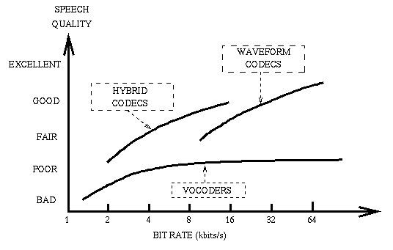
Fig. 8.1 Speech quality vs. Bit rate trade-offs for different speech coding techniques
In the plain LPC vocoder, one tries to estimate the pitch and then excite the synthesizer with the estimated parameters. This results in a poor, almost unintelligible sentence. The lack of accuracy in determining the pitch and the exact mathematical excitation results in a huge degradation in the quality. Shifting to the voice excited LPC technique, the pitch and the binary choice in the method of excitation is dropped (7 bits per frame) but all the errors have to be sent.
The increase in the bit rate results then from a change in the excitation method. While impulse train was used as a source to the transfer function, the actual error made when computing the a_{k}'s, is now encoded and sent. Taking the discrete cosine transform (DCT) and keeping only the 40 first coefficients (each quantized over 4 bits) allows a pretty good reconstruction. The maximum energies are located in the first few coefficients.
However, we could notice that increasing the bit-rate of a vocoder is not the best idea since the improvement in the quality is not linear as can be seen in Fig. 8.2: Speech quality vs. Bit rate trade-offs for different speech coding techniques, as provided in [7].

Chapter 9
Conclusion
The results achieved from the voice excited LPC are intelligible. On the other hand, the plain LPC results are much poorer and barely intelligible. This first implementation gives an idea on how a vocoder works, but the result is far below what can be achieved using other techniques. Nonetheless the voice-excited LPC used gives understandable results and is not optimized. The tradeoffs between quality on one side and bandwidth and complexity on the other side clearly appear here. If we want a better quality, the complexity of the system should be increased or a larger bandwidth has to be used. Due to the better SNR results of Voice excited LPC it can be used over Plain LPC although it needs almost double bandwidth.
Methods involved to generate the excitation parameters and the gain have been proposed depending on their simplicity. DCT computation to transmit the excitation signal energy in first few coefficients give a better reconstruction of innovation signal at the receiver as compared to the primitive method of pitch estimation used in plain LPC. Gain computation done in terms of the RMS value of the voltage levels for each frame reduces the complexity involved as compared to plain LPC, where gain was calculated in terms of mean square error [1].
Methods for reconstruction of excitation and gain parameter computation results in better performance by the voice excited LPC vocoder described in the project in comparison to the plain LPC.
As already known, code excited LPC [6] provides a better performance at lower bitrate at the cost of complexity, which involves the generation of code-book and perceptual weighing filter [6]. Where as, Voice excited LPC being a very simple system can provide similar performance at the comparable bitrates.
The performance of this voice excited LPC vocoder can be improved by proper quantization of the parameters transmitted. Major improvement can be made by proper selection of number of DCT coefficients to be transmitted and their optimal quantization. Use of a code-book in this system will lead to much better performance with much lower bitrates, although it is at the cost of increase in complexity.

References

- http://www.data-compression.com/speech.html
- http://www.bell-labs.com/
- http://cslu.cse.ogi.edu/HLTsurvey/ch10node4.html
- M. H. Johnson and A. Alwan, "Speech Coding: Fundamentals and Applications", to appear as a chapter in the Encyclopedia of Telecommunications, Wiley, December 2002.
- http://www.ti.com/corp/docs/company/history/pmos.shtml
- http://www-mobile.ecs.soton.ac.uk/
- L. R. Rabiner and R. W. Schafer, "Digital Processing of Speech Signals", Prentice- Hall, Englewood Cliffs, NJ, 1978.
- B. S. Atal, M. R. Schroeder, and V. Stover, "Voice-Excited Predictive Coding Systetm for Low Bit-Rate Transmission of Speech", Proc. ICC, pp.30-37 to 30-40, 1975
- C. J. Weinstein, "A Linear Predictive Vocoder with Voice Excitation", Proc. Eascon, September 1975
- Auditory toolbox: http://rvl4.ecn.purdue.edu/~malcolm/interval/1998-010/
- COLEA: Software Tool for Speech Analysis: http://www.utdallas.edu/~loizou/speech/colea.htm
- Orsak, G.C. et al. "Collaborative SP education using the Internet and MATLAB" IEEE SIGNAL PROCESSING MAGAZINE Nov. 1995. vol.12, no.6, pp.23-32.
- J. Hagenauer, P. Hoeher, “ A viterbi algorithm with soft-decision outputs and its applications,” GLOBECOM 1989, IEEE, vol 3, pp. 1680-1686, November 1989
- P. Robertson, E. Villebrun, P. Hoeher, “A comparison of optimal and sub-optimal MAP decoding algorithms operating in the log domain,” ICC ’95, IEEE, vol. 2, pp. 1009- 1013
- J.A. Erfanian, S.Pasupathy, G. Gulak, “Reduced complexity symbol detectors with parallel structures for ISI channels,” IEEE Transactions on Communications, vol. 42, pp.1661-1671, April 1994
- D.J. Young and N.C. Beaulieu, “The generation of correlated Rayleigh random variates by inverse discrete Fourier transform,” IEEE Transactions on Communications, vol. 48, no. 7, July 2000
- J. I. Smith, “A computer generated multipath fading simulation for mobile radio,” IEEE Trans. Veh. Technol., vol. VT-24, pp. 39–40, August 1975.
- W. Jakes, Microwave mobile communications, New York, Wiley, 1974

- Patzold M., Szczepanski A., Youssef N., “Methods for Modeling of specified and measured Multipath power-delay profiles,” IEEE Transactions on vehicular technology, vol. 51, no. 5, September 2002
- Wang Cheng-Xiang, Patzold M., “Methods of generating multiple uncorrelated rayleigh fading processes,” Vehiculatr Technology Conference, vol. 1, pp. 510-514, April
- 2003.
- Lei-Lei Lock, Xiangming Kong, Barton R.J., “Simulation of time-varying, frequency-selective multipath fading channels for spread spectrum waveforms,” 33rd Asilomar Conference on signals, systems, and computers, vol. 2, pp. 1675-1679, October 1999
- J. Andrea Goldsmith, Soon-Ghee Chua, “Variable-rate variable-power MQAM for fading channels,” IEEE Transactions on communications, vol. 45, no. 10, October 1997 [59] Xiaoming She, Shidong Zhou, Xibin Xu, Yan Yao, “Power and bit allocation for adaptive turbo coded modulation in OFDM systems,” Global Telecomunications Conference 2003, vol. 2, pp. 903-907, December 2003
- P.S. Chow, J.M. Cioffi, J.A.C. Bingham, “A practical discrete multitone transceiver loading algorithm for data transmission over spectrally shaped channels,” IEEE Transactions on Communications, vol. 43, no. 2/3/4, pp. 773-775, February/March/April 1975.
- federal standard 1015 was published in 1984.
- federal standard 1016 was published in 1991.
- Source code for both LPC10e and CELP is available at ftp://ftp.super.org/pub/speech/.
- See the comp.speech FAQ for more pointers to articles on the algorithms and federal standards.
- Digital Processing of Speech Signals.L. R. Rabiner and R. W. Schafer.
Prentice-Hall (Signal Processing Series), 1978.

- "The Government Standard Linear Predictive Coding Algorithm: LPC-10"
Thomas E. Tremain.
Speech Technology Magazine, April 1982, p. 40-49.
- "The Proposed Federal Standard 1016 4800 bps Voice Coder: CELP"
Joseph P. Campbell Jr., Thomas E. Tremain and Vanoy C. Welch.
Speech Technology Magazine, April/May 1990, p. 58-64.

