A

Major Project Report

On

“IMPLEMENTATION OF SUPERVISORY CONTROL AND DATA ACQUISITION SYSTEM FOR AC SERVOMOTOR USING PLC”

Submitted In Partial Fulfillment of Requirements

For The Award of the Degree of

MASTER OF ENGINEERING

(CONTROL & INSTRUMENTATION)

By

Saima Wani

Roll No: 8457

Under the Supervision of

PROF. MADHUSUDAN SINGH



Department of Electrical Engineering

Delhi College of Engineering

Delhi-110042

2010

CERTIFICATE

This is to certify that the work presented in this project entitled “Implementation of Supervisory Control and Data Acquisition System for AC Servomotor using PLC”, submitted in partial fulfillment of the requirement for the award of the degree of Master of Engineering in Control & Instrumentation by Saima Wani (09/C&I/08) to the Electrical Engineering Department, Delhi College of Engineering is a record of the student’s own work carried out under my supervision and guidance.

This work has not been submitted for the award of any other degree or diploma.

(Dr. MADHUSUDAN SINGH.)

Professor

Electrical Engineering Department

Delhi College of Engineering

Delhi-110042

ACKNOWLEDGMENT

I am thankful to the Almighty Allah because without His countless blessings this work would not have been possible.

I would like to express my deepest gratitude to Prof. Madhusudan Singh, my project supervisor for his constant motivation, invaluable guidance and encouragement during the entire duration of this project. It is my privilege and honour to have worked under his supervision.

I would also like to thank Dr. Parmod Kumar, Professor Electrical Engineering Department, for his support and encouragement.

I am sincerely thankful to GE-FANUC support team for the support and cooperation extended during completion of this project.

Last but not least, I am thankful to my parents, my siblings and my friends for their moral support throughout.

SAIMA WANI

College Roll No.09/C&I/08

University Roll No: 8457

M.E (C&I)

CONTENTS

Page no.

CERTIFICATE ii

ACKNOWLEDGEMENT iii

LIST OF FIGURES vii

LIST OF TABLES x

ABSTRACT xi

Chapter - I INTRODUCTION 1 - 8
  - General 1
  - An overview of three-phase AC Servomotor 1
1.2.1 Control schemes for three-phase AC Servomotor 3
    - Supervisory Control and Data Acquisition in AC Servomotor 4
    - Servomotor automation using PLC 6
  - Scope of present work 7
  - Conclusion 8

Chapter - II LITERATURE REVIEW 9 - 19
2.1 General 9
2.2 Literature survey 9
    - Role of PLC in Control of Electrical machines 9
2.2.2 Applications of PLC resulting in automation 11
2.2.3 AC Servomotor position control 14
2.2.4 AC Servomotor speed control 17
2.2.5 AC Servomotor control using SCADA 18
2.3 Conclusion 19

Chapter-III HARDWARE REQUIREMENT FOR CONTROL AND MONITORING OF AC SERVOMOTOR 20 - 48
3.1 General 20
3.2 Three-phase voltage source inverter fed AC Servo drive 21
    - Pulse Width Modulation control 23
    - Rectifier and DC link 23
    - Three-phase Voltage Source Inverter VSI 24
    - Insulated Gate Bipolar Transistor (IGBT) 25
    - Pulse Width Modulation technique 26
  - Position control mode 27

3.4 Speed control mode 28
3.5 Torque control mode 28

3.6 Programmable Logic Controller (PLC) 29

3.6.1 Basic parts of PLC 30

3.7 PLC Programming language 34

3.7.1 Ladder Logic 35

3.7.2 Types of instructions 36
3.8 Communication and Networking of PLC 38
3.8.1 Human Machine Interface (HMI) 38
    - Supervisory Control and Data Acquisition system(SCADA) 39
3.9 Three-phase AC Servomotor 40
3.9.1 Constructional features of AC Servomotor 42
3.9.2 Model equations of Servomotor 43
3.9.3 Working of AC Servomotor 45
    - Characteristics of AC Servomotor 47
  - Conclusion 48

CHAPTER IV SOFTWARE DEVELOPMENT FOR CONTROL AND MONITORING OF AC SERVOMOTOR 49 - 67
4.1 General 49
4.2 Development of Ladder Logic for three-phase Servo drive 49
4.2.1 Algorithm for Servo drive control (control modes) 50
4.2.2 Switching between various Control modes 51
      - Position control mode 51
      - Speed control mode 53
      - Torque control mode 54
  - Description of PLC programming software (Proficy machine edition 5.9) 55
  - Data monitoring in AC Servo drive (Versamotion servo configuration tool) 59
  - Implementation of Supervisory Control and Data Acquisition through Proficy cimplicity 7.5 HMI/SCADA software 63
  - Conclusion 67
CHAPTER V COMMUNICATION AND PROTOCOLS USED IN AUTOMATION OF SERVO DRIVE SYSTEM 68 - 75
5.1 General 68
5.2 Layout of Communication System used 68
5.2.1 Serial communication (RS-232) 69
    - Modbus-RTU 70
    - Profibus 70
    - Ethernet 73
  - Conclusion 75

CHAPTER VI EXPERIMENTAL RESULTS AND DISCUSSIONS 76 - 102
6.1 General 76
6.2 Experimental setup for control of three-phase AC Servomotor 76
6.3 Development of control scheme for AC Servomotor 77
6.3.1 Position control mode of three-phase servo drive 79
6.3.2 Speed control mode of three-phase servo drive 83
6.3.3 Torque control mode of three-phase servo drive 85
6.4 Some case study on control of processes using SCADA 87
6.4.1 Designing SCADA system for bottle filling plant 87
6.4.2 Designing SCADA system for automatic loading/ unloading in godowns 88
6.5 Performance study and power quality issues in servo drive 89
    - Performance of servo drive under no load condition 89
6.5.2 Performance of motor under variable torque (load) 92
6.5.3 Performance of servo drive under variable speed constant load condition 98
6.6 Conclusion 102

CHAPTER VII CONCLUSION AND FUTURE SCOPE OF WORK 103 - 104
  - Conclusion 103
  - Future scope of work 103

REFRENCES 105 - 107

LIST OF FIGURES
Fig. 3.1 Block Diagram of various hardware devices used for control of AC servomotor 20
Fig. 3.2 Internal architecture of a commercially used PWM based servo-drive 22
Fig. 3.3 PWM scheme for servo drive 23
Fig. 3.4 Three-phase Inverter Bridge 25
Fig. 3.5 Shows hysteresis band current PWM control of a three-phase motor 26
Fig. 3.6 PWM Voltage and Current waveforms 27
Fig. 3.7 PWM voltage and current waveforms 27
Fig. 3.8 Block diagram of PLC 30
Fig. 3.9 Block diagram showing major CPU components 30
Fig. 3.10 Illustration of a scan loop 31
Fig. 3.11 I/O interface 32
Fig. 3.12 Personal computer used as programming device 32
Fig. 3.13 PLC ladder logic program 36
Fig. 3.14 Communication of HMI with various devices 39
Fig. 3.15 Typical Three-phase AC servomotor 43
Fig. 3.16 AC Servomotor with Permanent Magnet Field and Three-Phase Stator 45
Fig. 3.17 Current vector for three-phase AC servomotor 46
Fig. 3.18 Typical speed- torque curve 47
Fig. 4.1 Block diagram of position control mode 52
Fig. 4.2 Start up screen of PLC software 56
Fig. 4.3 Project screen of PLC software 56
Fig. 4.4 Configuration of hardware to project window 57
Fig.4.5 Software window of PLC program in Offline mode 58
Fig.4.6 Software window of PLC program in Run mode 58
Fig. 4.7 Servomotor parameter monitoring on Data scope 59
Fig. 4.8 Parameter Configuration Window 60
Fig. 4.9 Digital IO / Jog control dialog box window 61
Fig. 4.10 Status monitor window 62
Fig. 4.11 Start up window of Cimplicity software 64
Fig. 4.12 Cimplicity project wizard window 65
Fig. 4.13 Software window for drawing test screens 66
Fig. 4.14 CimEdit screen for automatic loading and unloading process system 67
Fig. 5.1 Communication System Architecture 68
Fig. 5.2 Application of PROFIBUS at all levels of automation. 72
Fig. 5.3 Profibus OSI model 72
Fig. 5.4 Ethernet and OSI Model 74
Fig. 6.1 Block diagram of experimental setup 77
Fig. 6.2 Flow chart for implementation of main control scheme 78
Fig. 6.3 Flowchart to implement position control mode 80
Fig. 6.4 PLC ladder logic program 81
Fig. 6.5 HMI screen for selection between PLC testing and option to start program 82
Fig. 6.6 HMI screen developed for PLC testing 83
Fig. 6.7 HMI screen developed for control of servomotor 83
Fig.6.8 Desired and actual speed graph 85
Fig.6.9 SCADA screen showing animated bottle filling application 87
Fig. 6.10 Bottle filling using SCADA 88
Fig.6.11 SCADA screen showing animated conveyor operation 89
Fig. 6.12 Input voltage and current of servomotor under no-load conditions at 3000rpm 90
Fig. 6.13 Harmonic spectrum of line current at 3000rpm 91
Fig. 6.14 Speed variation during starting of three-phase ac servomotor 91
Fig. 6.15 Input voltage and current of servomotor under no-load conditions at 1500rpm 91
Fig. 6.16 Harmonic spectrum of line current at 1500rpm 92
Fig. 6.17 Speed variation during starting of ac servomotor at no load and 1500rpm speed 92
Fig. 6.18 Input voltage and line current of servomotor at 25% load conditions at 3000rpm 93
Fig. 6.19 Harmonic spectrum of line current at 25% load and 3000rpm speed 94
Fig. 6.20 Speed variation during starting of ac servomotor at 25% load and 3000rpm 94
Fig. 6.21 Input voltage and current of servomotor at 50% load conditions at 3000rpm 94
Fig. 6.22 Harmonic spectrum of line current at 50% load and 3000rpm speed 95
Fig 6.23 Input voltage and current of servomotor under 25% load conditions at 1500rpm 96
Fig. 6.24 Harmonic spectrum of line current at 25% load and 1500rpm speed 96
Fig. 6.25 Speed variation during starting of servomotor at 25% load and 1500rpm speed 96
Fig 6.26 Input voltage and current of servomotor under 50% load conditions at 1500rpm 97
Fig. 6.27 Harmonic spectrum of line current at 50% load and 1500rpm speed 97
Fig. 6.28 Speed variation during starting of servomotor at 50% load and 1500rpm speed 97
Fig. 6.29 Input voltage and line current of servomotor at 25% load and 500rpm 98
Fig. 6.30 Harmonic spectrum of line current at 25% load and 500rpm speed 98
Fig 6.31 Performance of servomotor under 25% load and 1000rpm 99
Fig. 6.32 Harmonic spectrum of supply current at 25% load and 1000rpm speed 99
Fig 6.33 Performance of servomotor under 25% load and 2000rpm 99
Fig. 6.34 Harmonic spectrum of supply current at 25% load and 2000rpm speed 100
Fig 6.35 Performance of servomotor under 25% load and 2500rpm 100
Fig. 6.36 Harmonic spectrum of supply current at 25% load and 2500rpm speed 100
Fig. 6.37 variation of speed and torque with variable load 101
Fig. 6.37 variation of speed and main circuit voltage with variable load 101

LIST OF TABLES

Table 3.1 Hardware descriptions of 90-30 GE Fanuc make PLC 33

Table 3.2 PLC power module specifications 33

Table 3.3 PLC CPU specifications 33

Table 3.4 PLC input module specifications 33

Table 3.5 PLC output module specifications 34

Table 3.6 PLC Network interface module specifications 34

Table3.7 AC servomotor specification 41

Table 4.1 Position control of servomotor 52

Table 4.2 Speed control of servomotor 54

Table 4.3 Torque Control of Servomotor 54

Table 4.4: System requirement for GE-Fanuc’s Proficy HMI/ SCADA Cimplicity 7.5 software 63

ABSTRACT
This dissertation describes a Programmable Logic Controller (PLC) based semi-automation scheme for control of three-phase AC servomotor and monitoring of its parameters. A control method for Servomotor has been designed and tested for a position precision application under varying load conditions (varying torque). The control of servomotor in three basic modes i.e. position, speed and torque modes is achieved through PLC programming, Supervisory Control and Data Acquisition (SCADA) and Human Machine Interface (HMI) control. Monitoring of servomotor parameters is realized by configuring the application software for servo-drive. The real time data related to servo amplifier (drive) and servomotor such as output of position encoder, torque developed by servomotor, power input to motor, etc. are accessed for supervisory control of servo-drive.
The easy accessibility and availability of drive data coupled with the software to manipulate, analyze and process the information becomes a powerful tool for accessing precision applications involving servomotor control. An integrated control method comprising of servomotor, servo amplifier, Supervisory Control and Data Acquisition System (SCADA) along with Human Machine Interface (HMI) makes position control more versatile. Some virtual process operations such as automated bottle filling system, automatic sorting and loading of containers in transport vehicle using real-time inputs from PLC has been also designed and tested using SCADA. Performance of AC servomotor has been analysed in real-time and effect of servo drive on power quality has been recorded.

CHAPTER I
INTRODUCTION

  - GENERAL

In this fast developing electronic era, automation has become an integral part of process industries. Automation of electric machines helps in precision control of industrial processes with higher productivity and product quality. Programmable Logic Controllers (PLCs) over a short period of time have shown remarkable presence in process automation industries. Besides PLC advent of Supervisory Control and Data Acquisition (SCADA), an intelligent system which helps in continuous monitoring, supervising and controlling process plants, has lead to new heights in the field of automation for ac machines and processes.
The invention of the electric motor more than a century ago has proved to be one of the main driving elements in industrial revolution. Its widespread use for all kinds of mechanical motion has made life simple and has ultimately aided the advancement of masses. The advent of the inverter (AC drives) has facilitated speed and torque control of AC motors at higher frequency and power, which in turn has propelled the use of electric motor to new realms. Advances in power semiconductors along with digital controls have enabled apprehension of motor drives especially servo-drives that are robust and can control position and speed to a high degree of precision.

  - AN OVERVIEW OF THREE-PHASE AC SERVOMOTOR

Electric motors can be classified by their functions as servomotors, gear-motors, and so forth, and by their electrical configurations as DC (direct current) and AC (alternating current) motors. DC motors are preferred dominantly in variable speed applications. Increasing use of AC motors can be seen prior to improvements in solid state components.
Servomotor is a motor used for position or speed control in closed-loop control systems. The requirement from a servomotor is to turn over a wide range of speeds and also to precisely perform position and speed instructions given to it. Depending on the structure of position control systems DC and AC servomotors are considered for numerous applications. Two types of AC servomotors are available i.e. squirrel cage asynchronous and permanent magnet synchronous motors. Use of AC drives for AC motors has resulted in easy speed control, energy savings and enhanced system efficiency. The present day industry categorizes AC motor drives into two distinct categories namely: induction motor drives and servo-drives (permanent magnet AC motor drives). The basic difference between the two types of drives is performance and cost.
When the requirement of a control process is low power and variable speed, AC servomotors are the ones preferred in such control processes. They certainly introduce a brushless structure and therefore, offer no maintenance. Applications of AC servomotors can be seen widely in conveying technology, printing, wood processing, textile industry, plastics industry, food and packaging industry, packaging and filling plants, and machine tools. Recently, AC servo system (AC servomotor, servo-drive and controllers) is extensively applied to robot actuator, machining centre, computer numerical control machine and precise industrial robot control. AC servo systems are, therefore, in tough competition with DC servo systems for motion control. Because of their favourable electrical and mechanical properties, good dynamics and high efficiency, AC servomotors have covered most servo-applications in robotics, machine tools and positioning devices.
The research in the field of AC servo system purely focuses on the speed, position and torque control of the motor. AC servo systems are preferably recommended when maintenance free and variable speed intelligent applications are needed. AC servomotor PWM based driver system has become a key sub-system of semiconductor assembly and packaging equipment. Servomotors are also used in radio controlled airplanes, radio controlled cars, puppets and of course, robots. These motors are becoming very popular in many industrial applications including elevators and pumps. The residential markets will soon be using motor drives for pumps, well water, HVAC, etc. All these applications are ideally suited for servomotors. Many of these applications do not need precise control of position or do not require servo type performance but the main purpose of using these motors in residential and other unsophisticated applications is primarily to reduce size and achieve higher efficiency.
AC servo systems have achieved remarkable improvements in control performance over a past decade. Speed response which is a barometer of the servo’s basic characteristics has improved by a factor of 4 and the encoder resolution has improved by a factor of 16. As a result shorter tact time and high position control are possible. Due to its outstanding performances such as high resolution, lower torque ripple and wide operation range, AC servomotor is an ideal choice in the position precision applications. Another important advantage of AC servomotor is that if a heavy load is placed on the motor, the driver will increase the current to the motor coil as it attempts to rotate the motor and as such, there is no out-of-step condition as occurs in most stepper motors.
Besides this, high-speed operation is possible through servomotors (3000 to 5000 rpm maximum). Noise and vibrations of servomotors are little compared to stepper and induction motors of same ratings. Servomotor has ability to operate at very low speeds for long periods of time without getting overheated. It also has the ability to operate at zero speed and retain sufficient torque to hold load in an instructed position. These motors have better speed versus torque characteristics, long operating life, higher dynamics response and an overall higher efficiency.
However, since the design of servo drive is very complicated, it is not possible to fabricate our own driving circuit. Therefore, servomotor and servo-drive are sold as a set.

1.2.1 CONTROL SCHEMES FOR THREE-PHASE AC SERVOMOTOR

The word “Servo” is derived from Greek word “Servus” meaning servant. The entire system along with servomotor and servo drive is called servo system because it responds faithfully or precisely to positioning commands. It is a system that controls various mechanisms in compliance with the variation of position or target speed value i.e., designated value or command value. The servo system works using feedback loops in which the response value is fed back so that the difference between response and command values is close to zero.
The experimental setup used in this project work consists of a three-phase 1kW, AC servomotor, with a fitted encoder and amplifier. The servomotor is not fed directly, rather it is fed through a PWM based Versamotion servo drive, which provides high frequency control voltage to motor stator windings. A 2500 ppr (10,000 Quadrature counts/ revolution) incremental encoder is used for feedback. This is equivalent to a resolution of 0.036 degrees at the motor shaft. Servomotor has a mechanical loading arrangement. The servomotor parameters can be changed and different modes of operation of AC servomotor can be selected using AC servo drive. Various control modes of servomotor include:
- Position control mode: The position control modes i.e., external position control or internal position control mode are usually used for applications requiring precision positioning, such as rotary drilling machine, metal profile cutting machine, valve control in petro chemical industry, etc. This control mode is bifurcated into two types of controls. In the first type, command can be given to motor to repeat On/Off sequence for continuous process and a maximum of 600 sequences (General) can be achieved in single minute with the accuracy of 0.0001 mm. In the second type, motor can be programmed for forward / reverse sequence and timing of timers used in PLC ladder logic diagram can also be adjusted accordingly to do the same task with 0.0001 mm tolerance.

- Speed control mode: The speed control mode is usually used for applications that require precision speed control such as robot manipulator, computer numeric control milling machine (CNC), etc. In this mode servomotor can be made to run from zero to full speed, i.e. variable speed with very high torque i.e., nearly 20 times more than ordinary AC motors and unlike AC motors, it consumes 27% less electricity at no load and 5 to 7% at full load current.

- Torque control mode: The torque control mode is usually used for applications that require accurate control of torque such as military applications involving faster torque control, etc. In this control mode high torque can be achieved, which is more than positive rated torque that is obtained in control modes described above (i.e., position control mode and speed control mode).

    - SUPERVISORY CONTROL AND DATA ACQUISITION IN AC SERVOMOTOR

SCADA is acronym used for Supervisory Control and Data Acquisition, is an intelligent system providing the facility of continuously monitoring, supervising and controlling the process plants. It is a system for gathering and analysing real time data of a plant or equipment in industries such as electric power distribution industry, water and waste control industry and other control process industries. The main components of SCADA system include:
- Master Terminal Unit: The MTU is located at operators central control facility and it enables two way data communication and control of remote field devices (AC servomotor in this project). Therefore, in order to supervise, control and analyse the performance of field devices a digital computer is to be used which is called Master Computer Station or Master Terminal Unit.

- Remote Terminal Unit: It is a field interface device which collects information from the field devices that are to be monitored. The RTU are basically nodes of the distributed SCADA system that are located at a remote site and are meant to gather data from field devices like pumps, motors, valves, sensors, etc. They are rugged and able to work unattended for a long duration. Since these RTUs have to operate for a long duration unattended, the basic requirement is minimum power consumption and considerable self diagnostic capability. There are two modes in which remote terminal units work i.e., under command from master computer and stand alone mode.

- Communication Media: Communication media is an important component of the SCADA system. The communication media transmits the information from RTU to central computer or in the reverse direction. Generally, data highway i.e., Ethernet is used for enabling communication links between server computer and master computer.

- SCADA / HMI software: For efficient process monitoring and control, effective communication is necessary between process operator and the process to be automated. The man-machine dialogue between process operator and the process to be automated is carried out through Human Machine Interface. The employment of an easy-to-use SCADA software package (Proficy HMI/SCADA-Cimplicity 7.5) on PC provides a reliable representation of the real system at work. An HMI allows the operator to view virtually all system alerts, warnings etc., and also to analyse, archive or present data trends.
SCADA through its virtues, therefore, enables a site operator to monitor and control processes from remote locations. SCADA has become the backbone for control and monitoring of process plants. PLC based control systems allow efficient and flexible use of a Supervisory Control and Data Acquisition (SCADA) system. Non-PLC based systems require site visit to assess operation status, troubleshoot or gather data. With PLCs and SCADA, information can be accessed directly from PC and at any place in case of web-based SCADA.

    - SERVOMOTOR AUTOMATION USING PLC

Programmable Logic Controller (PLC) is a programmable sequential device that controls machines and processes. It uses a programmable memory to store instructions and execute specific functions that include ON/OFF control, timing, counting, sequencing, arithmetic and data handling. The inputs are connected to the input module of the PLC and the outputs are connected to the output module of the PLC. In an automated system, a PLC controller is usually the central part of a process control system. In this project, control of AC servomotor and monitoring of its parameters as well as evaluation of performance in AC servomotor under different condition is carried out using PLC based controller. Based on the algorithm a logic program is developed and downloaded to PLC. Once the program is downloaded and PLC is in RUN mode the system works automatically on user defined instruction. A GE-Fanuc make PLC series 90-30 type has been used in the project work to monitor and control three-phase AC servomotor.
One of the important features is that PLC can be used as a standalone system as well as in a network. PLC can be easily interfaced with field devices and supports almost all types of communication systems present in present day control industry. The flexibility to use PLC in any type of system makes it a very useful device on industrial platforms. PLC provides a base platform to all the devices, communication modules and real time control and monitoring software’s. System designed is highly reliable and flexible and it can be easily configured to any application just by merely changing the PLC program involved.
By and large PLC based systems are cost effective and comparatively require less downtime compared to previous controls, are less manual labor intensive, can be networked together and enables “real-time” monitoring, troubleshooting, and adjustments to set points. Present day PLCs are extensively used to control manufacturing and treatment processes.

  - SCOPE OF PRESENT WORK

- An experimental setup comprising of a three-phase servomotor, servo drive, position encoder, PLC, HMI and SCADA system is designed and implemented for performance studies, monitoring and control of servo system for different process applications. The control of servomotor has been achieved through different methodologies as illustrated below:
i) Direct Control: In this method, direct control of servo drive through PLC is implemented. The developed ladder logic is downloaded into PLC processor and control of motor is achieved by simply activating the particular logical input involved, which ultimately results in instigation of application developed.
ii) HMI Control: This method is meant for manual control of field devices through a control panel, having touch screen facilities, generally facilitated with push buttons having the same address as that of logical inputs involved in PLC ladder logic developed. HMI allows control systems to be much more interactive than before. The basic purpose of HMI is to allow easy graphical interface with control processes. HMI allows an operator to use simple displays for determining machine parameters and for supervising control processes. HMI operating windows are designed for demonstrating the operation of AC servo drive, usually at operators end. A number of HMI screens have been developed and tested using simple push buttons to start and stop servomotor. The HMI programs are replicas of PLC programs with of course change of syntax.
iii) SCADA Control: This method is mainly devised for remote control of AC servomotor with the aid of some logic developed. It is facilitated with software capabilities for monitoring of servomotor parameters in different control modes. GE-Fanuc’s Cimplicity 7.5 software proves to be excellent software for development of animation windows for easy control of the system. User defined controls like (start, stop, speed set) have been developed on the software window to control the servo system remotely

- Control systems developed using PLC possess larger amount of flexibility in operation and control of field devices, since field devices can be connected to input, output and networking modules of PLC as required. Diagnosis of the status of entire experimental setup can be done by LED indicators present on control panel of the PLC. The input as well as output status such as over load warning, status of AC servomotor, etc. can be continuously monitored and diagnosed for the said purpose.

- SCADA helps in real time control and monitoring of field devices. Proficy SCADA/HMI Cimplicity 7.5 software provides provision for development of graphical animation, data trends and graphs. Several studies on applications of SCADA like bottle filling and conveyor operation have been developed and tested using Proficy SCADA/HMI Cimplicity 7.5 software.

- PWM based servo drive present in the system provides operation and protection to servomotor against over-loading and activates alarms and warning signals under unfavourable conditions. The control of servomotor through servo drive in three basic control modes i.e., position mode, speed mode and torque mode is implemented and performance parameters of drive are obtained.

- Ethernet connectivity of PLC to various devices of system i.e., HMI, PC, etc., provides provision for networking i.e. it gives ability to the system to be connected to different networks at a time. Ethernet provides high speed connectivity to PLC and enable it to be controlled by multiple-users. Control of servomotor through another computer other than the one on which SCADA screens are developed has also been achieved. An Ethernet communication between servo drive, PLC and SCADA system is developed and configured for operation, control and monitoring of servomotor for different applications.

  - CONCLUSION

This chapter describes various control schemes that have been used in control of AC servomotor. Use of PLC and SCADA in automation of control processes, their importance and advantages have been described in brief. This chapter presents brief outline on operation, monitoring, control, design and communication network developed for different applications of three-phase servo system.

CHAPTER II

LITERATURE REVIEW

  - GENERAL

A brief description of work carried on industrial automation being achieved through PLC has been described in this chapter. A properly designed PLC based system proves to be more beneficial in terms of saving money and time and providing qualitative and reliable control. The PLC based control schemes used in controlling several field devices have also been discussed. Besides, use of Supervisory Control and Data Acquisition (SCADA) for remotely controlling various processes has also been covered. A SCADA system as such saves man power and time by eliminating the need for service personnel to visit each site for inspection, data logging or for monitoring system parameters in Real-time. Limited numbers of studies are found in the literature about AC servomotor motion control, since AC servomotor technology is respectively new. AC servomotors applied in some research articles are overviewed herein.

  - LITERATURE SURVEY

2.2.1 ROLE OF PLC IN CONTROL OF ELECTRICAL MACHINES

Maria G. Ioannides et al. [1] describes a PLC based monitoring and control scheme for induction motor. A control program has been developed, in accordance of which PLC continuously monitors the inputs and activates the outputs accordingly. A speed sensor is employed for speed feedback, a current sensor for load current feedback and an additional current sensor is attached to stator circuits. The programming method used is ladder diagram method. This paper therefore suggests that PLC can be used in automation industries involving control of induction motor. The speed control of motor achieved through PLC gives system high accuracy in speed regulation at constant speed-variable load operation. The efficiency of the induction motor system fed by an inverter is increased appreciably by using PLC. At high speeds and loads, the efficiency of PLC-controlled system is increased up to 10–12%. Therefore, in brief this paper proves PLC as a versatile and efficient control tool in industrial electric drives applications.

A.M. Graham et al. [2] describes implementation of the fuzzy method for speed control of a motor/generator set using PLC. The speed control using fuzzy logic has been accomplished by using a general purpose modular PLC. The angular speed control of separately excited DC motor using fuzzy logic is achieved by varying the armature voltage supply, while maintaining constant field current. The PLC in this case utilizes high speed counter input module and optical encoder to track speed of the motor. This paper suggests that general purpose PLCs can be utilized in the control of power plants and industrial plants. It precisely presents a method for increasing the utilization level of existing general-purpose PLCs.

A.S.Zein El Din et al. [3] illustrates an industrial PLC used for controlling five-axis rotor position, direction and speed, thereby decrementing circuit components and cost and at the same time enhancing reliability. Ladder diagram has been used to control robot through PLC. The robustness of the PLC controller has been achieved by rotating the motor in both clockwise as well as counter-clockwise directions. Consequently, the PLC controller proves to be a simple tool for controlling robot by extremely simple algorithm.

Wang Huiqiang et al. [4] illustrates the use of PLC in the control of belt grinder. Improvement in the automation level of the belt grinding has been achieved. A three-phase motor and a stepper motor have been used to accomplish the task. The paper elaborates the belt grinding machine which enhances grinding efficiency enormously. The touch screen facility makes system control extremely simple. The performance of system is found to be stable and reliability is high.

Adel A. Ghandakly et al. [5] illustrates development of a control technique for incorporating an intelligent adaptive controller based on the self tuning regulator algorithm using parameter optimization for a field controlled dc motor. A technique for incorporating the proposed controller within an existing PLC framework has also been presented. The PLC used is an Allen Bradley (AB) PLC5 system. The PLC programming language used is Ladder Logic. The adaptive control mode has been successfully incorporated in the overall PLC program.

REN Sheng-le et al. [6] introduces a closed-loop tension control system with PLC, provided with function modules serving as its control kernel. The control system possesses AC servomotor as its final control element and the radius-following device to accomplish the real-time radius compensation. The mechanism of the tension control system has been analyzed and numerical model of the system has been established. The compensation technique used for radius of the scroll has also been analyzed. Results discussed show that the system is well qualified with high control precision and high reaction speed.

A.R.Al-Ali et al. [7] proposes a power factor controller for a 3-phase induction motor, utilizing Programmable Logic Controller. This paper focuses on the implementation of a model for a PLC based power factor controller to improve the power factor of a 3-phase induction motor. Voltage to frequency ratio has been maintained constant to obtain maximum toque. The power factor controller hardware comprises of S7-PLC, a 3-phase squirrel cage induction motor coupled with a dc shunt generator and an electronic conditioning circuit. Features like interlocking, i.e., disabling the controller until it detects currents, voltage, frequency and power factor angles, switch failure detection, monitoring voltage to frequency ratio constant during correcting the power factor, independent control of reactive currents in each phase and maximum compensation even when switch failure occurs, have all been incorporated in the software program. The control strategy developed may be adopted for power factor and protection control. Such controller will not introduce any harmonics in the system. This might pose a serious challenge to the fixed capacitor thyristor controller reactor type of compensator. The proposed system could be cost effective.

I. Colak et al. [8] illustrates a protection scheme to protect induction motors against possible failures thereby increasing reliability, efficiency and performance of the system. The proposed approach is a sensor-based technique, therefore, currents, voltages, speed and temperature values of the induction motor were measured with sensors and whenever any fault is detected during operation of the motor, PLC controlled on-line operation system activates immediately. The motor protection achieved is much reliable than classical techniques and can be applied even to larger motors. The protection system developed shows good performance in detecting the faults and in clearing them.

    - APPLICATIONS OF PLC RESULTING IN AUTOMATION

Xiaoling Yang et al. [9] describes development of 2 nine-storey elevator control system for a residential building. The control system that has been developed adopts PLC as controller and achieves minimum waiting time to run 2 elevators in parallel mode. The paper presents the ladder diagram as key aspect for running the system. In this paper, improvement of an old elevator control system has been achieved by using PLC and group control of 2 elevators has been realised. Due to the non-parallel running before the reform, the average waiting time and maximum waiting time of down-peak and up-peak are very longer than the reformed. Overall, the control system has been able to establish enhanced reliability and better performance of the elevators.

Robert A. Hanna et al. [10] presents development and design of Programmable Logic Controller (PLC) programs for optimising operation of a refinery electrical distribution system. The power distribution of the refinery face problems of severe voltage dips or short duration power interruptions due to which on-line starters de-energize and motors stop resulting in plant upset. In order to minimize the impact of momentary power disturbances, it is highly required that motors used for critical services be restarted automatically and sequentially. The use of PLC in the system makes it automatic, hence solving major problems.

Tanabodee Duangsoithong et al. [11] presents development of PLC-based turbine control system for small hydroelectric power plants (Kaplan turbine type). The proposed system represents a pilot project for modernization of power plant control systems. The system is implemented for Mae-Ngat hydropower plant so as to test its performance. The system consists of two main parts: Governor Control and Operation Control. The Governor Control part is composed of speed, power and position control modes, which are designed and implemented. In the Operation Control part, all control sequences with Human Machine Interface (HMI) for configuration modification, parameter settings and indications are developed. The operation of the PLC-based turbine control system has been verified and confirmed by simulation and severe tests. The results of test indicate that the proposed turbine control system can work properly. The usefulness of the implemented turbine control system is that the operator can work comfortably and control the turbine. Moreover, accuracy of the control is increased.

Gabor A. Biacs et al. [12] describes a solution for PLC control of rotating ironing press for textiles. The application of the PLC device ensures a simple solution for sequence control of rotating ironing press. By using this method a considerable flexibility of program execution has been achieved. Besides, great conformity of input and change of parameters has been achieved due to built-in display and keyboard. Overall significant results have been achieved in the field of machine performance and regarding precision of positioning of the press.

Masao Ogawa et al. [13] presents a PC (Personal Computer)-PLC (Programmable Logic Controller) combination control system called PC+PLC based control system for automation of process plant of beer brewery process. The developed production control system proves to be cost effective and flexible. The major role of PLC in the entire system is to integrate the PLC system to the PID control loop function as well as development of control and monitoring system for tank selection. These and many other associated features provide the plant with very high speed of manufacturing and helps in production of quality products.

Zhao Futao et al. [14] presents use of PLC control system in main feed-water process of Qinshan Nuclear Power Plant. TI545 type PLC has been applied to Qinshan Nuclear Power Plant main feed-water system. Results obtained from implementation of this scheme indicate that the PLC control system improves the performance of both steam generators water levels regulation and disturbance rejection. Steam generators levels are kept well within alarm limitation under 75% plant power trip test. Moreover, as plant power escalates from 10% to 105% steam generators levels have been controlled automatically without any manual intervention. The control system proves to be economically beneficial and is applicable to the control of steam generators and boilers of other power plants.

Akram Hossain et al. [15] presents development of a software based dynamic computer model for monitoring, controlling, tuning, and predictive maintenance for an industrial process. The dynamic model has been interfaced with a real-time industrial process control setup through a programmable logic controller (PLC) system. An integrated model is flexible and powerful for modern manufacturing applications. Integrated model provides high level definition and simulation capability to the real time processes which makes it useful to detect any error before the actual implementation. Recording and displaying of process variable can be done during runtime as well as during reporting time, without interrupting the control of the process. It also helps in prediction of deterioration of certain equipment, thereby minimizing the chances of unscheduled maintenance.

Andrew Davis P. Eng et al. [16] describes up gradation of Inuvik Power Station by replacing the outdated SCADA system with Programmable Logic Controller (PLC)/ SCADA, which incorporates automatic features of modern diesel generating stations. The paper thus focuses on the PLC/ SCADA upgrade at Inuvik, explaining reasons for development of the project, its technical details and moreover, features of the existing and developed system. The system incorporates a PLC on every genset. These PLCs provide local, "stand-alone" control for each genset. The station PLC is responsible for supervisory control of the entire power plant. This PLC provides automatic station control with communication to the local PLC’s and main control room interface for the operators via HMI (Human Machine Interface) system. The basic design of the PLC system allows addition and integration of other systems under a common PLC control system. The control technique applied to new system provides a cost effective and powerful solution. It ultimately results in cost savings, improved maintenance, load and generation optimization and easy integration of existing system with other systems.

2.2.3 AC SERVOMOTOR POSITION CONTROL

L. Canan Dulger et al. [17] presents a study on trajectory tracking problem for an AC synchronous servomotor. A permanent magnet synchronous AC servomotor with a fitted resolver is used. Resolver is a sort of rotary transformer producing an output signal, which is a function of the rotor position. This paper discusses dynamic behaviour and practical implementation of AC synchronous servomotor. An experimental arrangement is built up and different motion profiles are implemented to examine the positioning performance of the system for potential industrial applications. The tracking performance of an AC servomotor system is demonstrated with the help of PID controller and an overall good tracking performance is obtained in experimental results. AC servo systems are certainly recommended when maintenance free and variable speed intelligent applications are needed.

Akira Shimada et al. [18] describes development of a position sensorless control technique for AC servomotor position control systems. In this paper AC servomotor position sensorless control system has been developed by applying the vector control method. Using vector control, the controller needs the data of the magnetic pole position on the rotor of the AC servomotor. It, therefore, uses rotary encoders installed on AC servomotors in order to detect the angles of the magnetic poles. By using the AC servomotor position sensorless control technique, the controller should estimate both the magnetic pole position and mechanical position. The simulation results appear to indicate good performance.

Yoshitaka Morimoto et al. [19] describes development of a new positioning system to realize both fine motion and coarse motion independently and/or simultaneously to reduce the positioning time under the limitation of guaranteeing the positioning accuracy. The conventional reducer unit driven by AC servomotor is utilized to cope with the problem of accuracy of position. The fine-coarse motion of the developed mechanism is realized by only mechanical parts consisting of two servomotors and a harmonic drive speed reducer aligned in an axis. The coarse motion and the fine motion are realized independently to use a harmonic drive speed reducer and two servomotors. The hybrid motion is realized by controlling two servomotors simultaneously. The basic performances of angular positioning are evaluated by the feedback positioning system. The maximum angular error of 0.001 degree and 0.06 degree is observed in the fine motion and coarse motion respectively.

Heui-Wook Kim et al. [20] proposes an accurate position control using new estimator (Kalman filter) which estimates the instantaneous speed and position with a low precision shaft encoder. The overall performance of position control system strongly depends on the accuracy of the position information and the performance of the speed controller in low speed range. In this paper, the position and speed of the motor are obtained from Kalman filter which is an optimal full order estimator. The encoder used has a resolution of 2000 ppr (pulse per revolution). This estimator has good performance even in very low speed range including standstill. The simulation and experimental results presented show that the proposed system has good performance and they confirm the validity of the proposed estimation and control technique.

Dongmei Yu et al. [21] presents a new position tracking control strategy that meets the position tracking performance and the closed loop robustness to external disturbances and model parameter variations without parameter identification. Based on fuzzy logic, the parameters of the feedback controller are adjusted on-line to improve robustness. In this paper, a two-degree-of-freedom internal model control method based on fuzzy logic, which adjust the parameters of feedback controller on-line for the PMLSM position servo system is proposed. It can be seen from the comparison of the simulated curves that the position tracking performance and robustness to external disturbances based on fuzzy logic is obviously superior to traditional PID control.

Joon Hyuk Kang et al. [22] proposes a robust position control scheme for AC servomotors. A disturbance torque suppresser is adopted to eliminate the effects of the disturbance torque independently of the main control loop and variation in moment of inertia, thus the proposed controller has improved robustness. Position errors due to the disturbances are drastically reduced. Superior position tracking performance of the proposed controller over the conventional Proportional Integral and feed forward controller has been demonstrated through simulation and experimental results. The robustness of the proposed position controller has been demonstrated and is now being used for the motion control of robots and CNCs.

Akihiko Yoneya et al. [23] illustrates development of a new type observer for a motion control system and applied to the self-sensing control of an AC servomotor by estimating the rotor position with the observer. The rotor position is estimated with a kind of observer whose two versions are described: one needs a dividing operation but the other does not. The later one, suitable to a DSP application having low sensitivity to the noises, is the proposed one. The proposed observer does not need any dividing operation by using the structure similar to quasi-sliding mode observer. An experimental example is presented to show the effectiveness of the proposed self-sensing control algorithm.

Kariyappa B. S. et al. [24] describes a new method of controlling position of AC servomotor using Field Programmable Gate Array (FPGA). FPGA controller is used to generate direction and the number of pulses required to rotate motor for a given angle. Pulses are sent as a square wave, and the number of pulses determines the angle of rotation and frequency of square wave determines the speed of rotation. The proposed control scheme has been realized using FPGA and tested using Alternating Current (AC) servomotor. Experimental results show that the position of the AC servomotor can be controlled effectively and motor finally reaches the required position in one of the directions (clockwise or anticlockwise) that takes less possible time. The result also shows that the motor rotates with the minimum of 0 % error to maximum of 8%. The maximum error reduction to 1% for a motor that takes 3600 pulses to rotate 360 degrees is considered.

2.2.4 AC SERVOMOTOR SPEED CONTROL

Kariyappa B. S. et al. [25] presents a Xilinx Field Programmable Gate Array (FPGA) based speed control of AC servomotor using sinusoidal PWM technique. Xilinx FPGA is a programmable logic device that generates 50 Hz sine wave as well as high frequency carrier wave. The carrier signal is compared with the reference sine wave to generate SPWM signals. The sinusoidal pulse width controls the speed of motor. The hardware is tested by running AC servomotor SM115 model at different speeds. FPGA controller also compares the entered speed and the motor speed from feedback, based on the difference, the width of SPWM is varied by varying sine wave. The result provides a controllable speed with satisfactory dynamic and static performances. The result also indicates higher efficiency in achieving the set speed.

Uk-Youl Huht et al. [26] illustrates a sliding mode controller used for speed control of AC servomotor. Sliding mode controller can be characterized by high accuracy, fast response and robustness. An integral compensator has been added to reduce steady state error and to provide continuous torque reference. The acceleration which is necessary to get the sliding plane is estimated by an observer from actual speed and an integral compensator. Sliding surface is included in control input to enhance the robustness, insensitivity to sudden change of load and improvement in transient response without increasing sliding mode controller gain. The proposed controller is implemented by DSP (digital signal processor). The effectiveness of the proposed control scheme for speed controller is confirmed through the real-time experimental results. It is also verified that speed response has less chattering to the load variation.

Pyoung-Ho Kim et al. [27] describes speed control of AC servomotor using novel control incorporating neural network. Neural network is developed for self tuning PID based on AC servomotor speed control. Excellent control performance has been obtained. This technique can produce smooth output and optimal value time constant will also be considered in the X-Y Cartesian type robot actuator and CNC.

Geum-Bae Cho et al. [28] proposes a new control technique based on a neural network for control of AC servomotors. The PID control is widely used in servo systems as it has simple structure, guarantees safety and reliability. However, it faces certain problems in a complex system, resulting in imperfect action in the presence of uncertain parameters. In order to solve these problems, a new hybrid control algorithm of the PID controller is proposed, which could drive the AC servomotor system using neural network PID controller perfectly. It is concluded that the PID control using neural network is superior. Since the PID controller using neural network has learning ability of nonlinear function without mathematical modelling and is robust to changeable parameters, it can identify complex systems such as nonlinear systems by learning. It is observed that if the neural network followed by conventional reverse learning method is applied to the proposed algorithm, the speed control characteristics achieved are excellent.

2.2.5 AC SERVOMOTOR CONTROL USING SCADA

D. Swoboda et al. [29] describes implementation of the control and supervision of a Large Ion Collider Experiment (ALICE) Zero Degree Calorimeters (ZDC) positioning systems. The movement of the calorimeter modules and the protection switches are remote controlled by the positioning system. The vertical movement to approach or retract each of the ZDC with respect to the recombination beam pipes is controlled by one dedicated PLC which acts on a servo controller for each of the four calorimeter modules. The process control functions are shared between PLC and the servo controllers. The PLC monitors the position of the calorimeters and controls the movement of the servo-motors which is hard limited by a number of the interlock switches. In order to change the position of a calorimeter the supervisory system needs to send first the new set point value to the PLC and then the go command. This causes an activation of the corresponding servo-drive until PLC receives a new command which supersedes the previous command. The successful commissioning of the system has been performed in two stages.

Aung Naing Myint et al. [30] illustrates implementation of control unit using SCADA system for filling system and development of its modelling design. The main purpose of this paper is to implement the hardware components for the filling process and to interface between master station and control unit for controlling the data. Microcontroller and control circuits have been used for the operation of filling process and decision sequences of data. Easy, simple and accurate manufacturing systems have been supported by this system.

2.3 CONCLUSION

An extensive literature review of role of PLCs in control of electrical machines as well as on position and speed control of AC servomotor has been presented. Implementation of applications relating both PLC and SCADA has also been covered in brief in this chapter. Limited literature is available on SCADA and PLC control of AC servomotor.

CHAPTER III

HARDWARE REQUIREMENT FOR CONTROL AND MONITORING OF AC SERVOMOTOR

  - GENERAL

A detailed description of the hardware devices used for monitoring and control of AC servomotor has been discussed in this chapter. Programmable logic controller (PLC) is the main device being used in the experimental setup, which helps in communication and interfacing with field devices like AC servo drive, Variable frequency drive (VFD), etc., as well as in the control of these field devices. Human Machine Interface (HMI), through a touch pad screen, is being employed for manual control of field devices and various drives while SCADA terminal is used for remotely controlling and monitoring various field devices and drives. Versamotion servo-drive is the final control element of the system by which various parameters of AC servomotor can be changed in both online as well as offline mode. Fig. 3.1 shows various hardware devices used for control and monitoring of Servomotor.
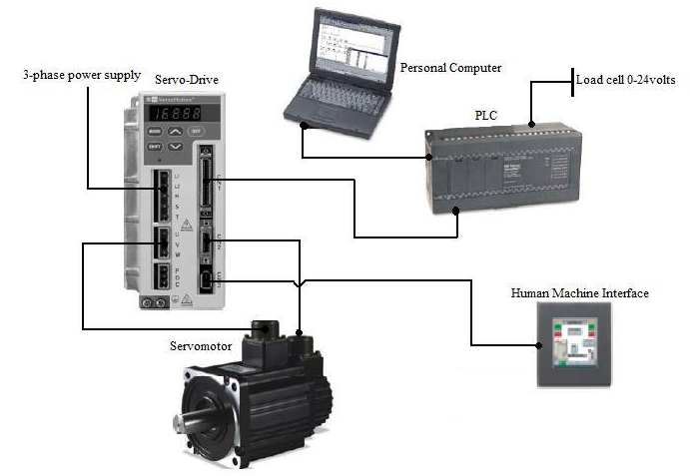

Fig. 3.1 Block Diagram of various hardware devices used for control of AC servomotor
3.2 THREE-PHASE VOLTAGE SOURCE INVERTER FED AC SERVO DRIVE

The servomotor parameters are changed and different modes of operation i.e., position, speed and torque control modes are selected using AC servo drive. The word “Servo” is derived from Greek word “Servus” meaning servant. The entire system along with servomotor and servo drive is called servo system because it responds faithfully or precisely to positioning commands. It is a system that controls various mechanisms in compliance with the variation of position or target speed value i.e., designated value or command value. The servo system works using feedback loops in which the response value is fed back so that the difference between the response and command values is close to zero.
The servo system used in this setup employs a PWM based Versa motion servo-drive. It is the final control element of the system by which various parameters of AC servomotor can be changed in both online as well as offline mode. For online control Versamotion servo configuration tool, present in Proficy Machine Edition 5.9 (PLC software), is provided and through this option motor parameters like average load, feedback pulse count, motor rotation speed, etc can be easily monitored in real time. In offline mode, parameters can be directly changed from servo-drive. The drive is equipped with serial communication (RS-232) and a display screen to set and read the parameters of the drive. The drive has 8 digital inputs and 5 digital outputs. The function of each I/O point can be configured by the user. There are 45 input options and 11 output options. These digital input/ output options are used in combinations of eight and five respectively, depending on the type of application to be developed and it also depends on control mode in which motor is to be run. CN1 port in servo-drive is for communication with PLC, CN2 for encoder interface and CN3 for serial communication.The internal architecture of a commercially used PWM based servo drive is shown below in Fig. 3.2
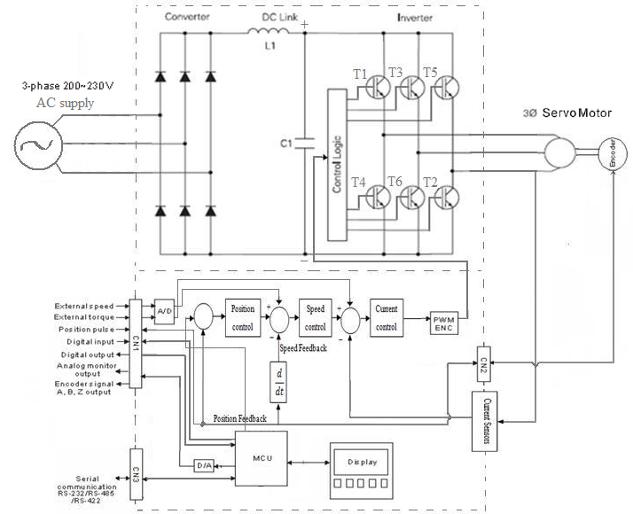

Fig. 3.2 Internal architecture of a commercially used PWM based servo-drive

Fig. 3.2 shows a three-phase AC servomotor fed through a voltage source inverter (VSI) fed servo-drive. The rectifier circuit converts it into DC voltage which is then fed to three-phase inverter through a DC link (choke coil) and capacitor. The DC link capacitor removes ripples in the converted voltage and regenerative resistor is meant for dissipation of regenerative energy produced during braking. The drive has a protection circuit which protects motor against undue overloading, faults, etc. The closed loop control circuits for control of position, speed and current (torque) are also present within the drive. Suitable pulses (position mode), a suitable current (torque mode) or an adjustable voltage (speed mode) as required for controlling motor operation is provided by PWM control of VSI. The pulses to the gate circuitry of IGBTs are controlled by gating circuits and in turn AC servomotor operation is controlled. The drive has a display screen to view and change various parameters as required.
A typical inverter receives 415 V, 50 Hz, three-phase AC input power and in turn provides PWM voltage and current for a given position, torque or speed required by the motor. The three common inverter types are: variable voltage inverter (VVI), current source inverter (CSI), and pulse width modulation (PWM). Almost all AC drives convert AC to DC, and then through various switching techniques invert the DC into a variable voltage or variable frequency output. The control technique used in this drive is pulse width modulation (PWM) technique.

    - PULSE WIDTH MODULATION CONTROL

Pulse width modulation (PWM) drives provide a more sinusoidal current output to control frequency and voltage which is in turn being supplied to servomotor. PWM drives are more efficient and typically provide higher levels of performance. Fig. 3.3 shows a typical PWM based drive. A typical PWM drive consists of a rectifier, DC link, control logic and an inverter.
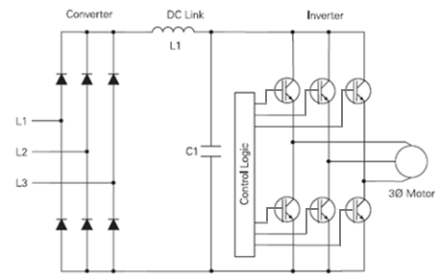

Fig. 3.3 PWM scheme for servo drive

3.2.2 RECTIFIER AND DC LINK

The converter section consists of a diode bridge rectifier which converts the three-phase AC power supply to a DC voltage. L1, the choke coil and C1, the smoothening capacitor, are used to filter ripples present in the converted DC voltage. The dc bus capacitor has a large value, which serves two purposes. One purpose is to act as a large filter so that a smooth dc bus voltage is available to the inverter. The second purpose is to help absorb energy produced during regeneration or braking of the motor and load. But this drive has an internal regenerative resistor to help absorb regenerative energy produced during braking of AC servomotor.
While the diode rectifier can supply power during motoring or driving, it cannot return power to the AC supply during braking. The regenerated energy is absorbed by the dc bus capacitor until it charges to a maximum allowable voltage and then the regenerative circuit “dumps” excess energy in the regenerative resistor where it is eliminated in the form of heat. Most AC servo-drives include a small built-in regenerative resistor while having the provision for adding an external resistor with a much larger wattage.The rectified DC value is approximately 1.35 times the line-to-line value of supply voltage. The rectified DC value is approximately 560V, DC for a 415 V, three-phase AC supply.

3.2.3 THREE PHASE VOLTAGE SOURCE INVERTER (VSI)

The output voltage and frequency applied to motor are controlled by VSI with PWM control. The inverter section consists of six switching devices connected in a proper sequence as shown in the Fig.3.4. Switching devices commonly used for this purpose include bipolar transistors, MOSFETs and IGBTs. In the VSI, present within servo-drive, IGBTs are used as switching devices. A voltage source power inverter is used to convert DC to required AC voltage and frequency. The power inverter has six switches that are controlled in such a way so as to generate an AC output from the DC input. The control logic generated by microcontroller unit controls the gate circuitry of these six switches.
The phase voltage is determined by the duty cycle of the PWM signals. At a time, maximum of three switches will be ON, either one upper and two lower switches, or two upper and one lower switch. When switches are ON, current begins to flow into the motor stator windings. Since motor stator windings are highly inductive in nature, they hold electric energy in the form of current. This current needs to be dissipated while switches are OFF. Diodes connected across the switches give a path for the current to dissipate when the switches are OFF. These diodes are also called freewheeling diodes.
Upper and lower switches of the same limb should not be switched ON at the same time; otherwise it will give a dead short circuit to DC supply. A dead time is, therefore, given between switching OFF the upper switch and switching ON the lower switch and vice versa in order to ensure that both switches are not conductive when they change states from ON to OFF, or vice versa.
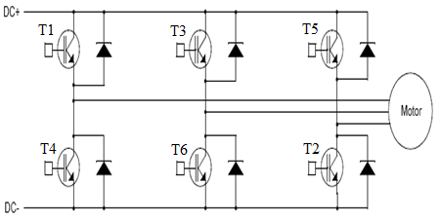

Fig. 3.4 Three-phase Inverter Bridge

3.2.4 INSULATED GATE BIPOLAR TRANSISTOR (IGBT)

IGBTs provide a high switching speed necessary for operating PWM inverter. IGBTs are capable of switching ON and OFF several thousand times per second. An IGBT can turn ON in less than 400 nanoseconds and it can turn OFF in approximately 500 nanoseconds. A typical IGBT consists of a gate, collector and an emitter.
When a positive voltage (typically +15 VDC) is applied to the gate, IGBT turns ON. This is similar to closing of a switch. Current flows between the collector and emitter. The device is turned OFF as soon as the positive voltage is removed from the gate. During the OFF state IGBT gate voltage is normally held at a small negative voltage (-15 VDC) to prevent the device from turning ON.

3.2.5 PULSE WIDTH MODULATION TECHNIQUE

An IGBT or any other type of switching device can be switched ON by connecting motor to the positive DC voltage and soon current starts flowing from converter into the motor. Fig. 3.5 shows hysteresis band current PWM control of three-phase motor.
Initially IGBT is switched ON for a short period of time, allowing only a small amount of current to build up in the motor and then it is switched OFF. Latter, IGBT is switched ON and left ON for progressively longer periods of time; allowing current to build up to higher levels until current in the motor reaches a peak value. IGBT is then again switched ON for progressively shorter periods of time, which results in decreased current build up in the motor. The negative half of the sine wave is generated by switching an IGBT connected to the negative terminal of the converted DC voltage and then switching it ON and OFF similarly as done in the previous case i.e., in case of IGBT connected to positive terminal.
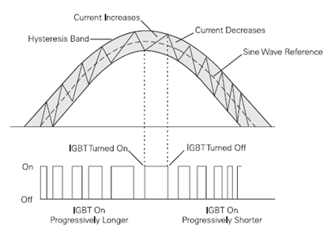

Fig. 3.5 Shows hysteresis band current PWM control of a three-phase motor

There is a reduction in torque pulsations and low speed motor cogging, since more sinusoidal current output is produced by the PWM technique. Also by using a six-step output, motor losses become noticeable. The voltage and frequency is controlled electronically by control circuit present within the AC drive. The fixed DC voltage is modulated or clipped with this method to provide a variable voltage and frequency. At low output frequencies, a low output voltage is required and switching devices are turned ON for shorter periods of time consequently voltage and current build up in the motor is low. At high output frequencies, a high voltage is required and switching devices are turned ON for longer periods of time, allowing voltage and current to build up to higher levels inside the motor. Fig. 3.6 shows PWM voltage and current waveforms.

Fig. 3.6 PWM Voltage and Current waveforms

The PWM voltage and current waveforms as recorded at the terminal of three-phase VSI are shown in Fig. 3.7.

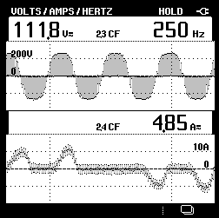

Fig. 3.7 PWM voltage and current waveforms

3.3 POSITION CONTROL MODE

A Servo drive can be configured to operate in position control mode by following the settings described below:
- SON: This control signal has DI parameter value as 01 and it serves the function of servo on.
- CTRG: This control signal has DI parameter value as 08 and it serves the function of command triggering and is available in position mode only.
- POS0: This control signal has DI parameter value as 11 and it serves the function of position command selection for defined position selections from 1-8.
- POS1: This control signal has DI parameter value as 12 and it serves the function of position command selection for defined position selections from 1-8.
- POS2: This control signal has DI parameter value as 13 and it serves the function of position command selection for defined position selections from 1-8.
- ARST: This control signal has DI parameter value as 02 and it serves the function of resetting the whole program settings.
- EMGS: This control signal has DI parameter value as 21 and it serves the function of stopping the motor in case of emergency.

3.4 SPEED CONTROL MODE

A Servo drive can be configured to operate in speed control mode by following the settings described below:

- SON: This control signal has DI parameter value as 01 and it serves the function of servo on.
- TRQLM: This control signal has DI parameter value as 09 and it serves the function of enabling torque limit.
- SPD0: This control signal has DI parameter value as 14 and it serves the function of speed command selection for defined speed selections from 1-4.
- SPD1: This control signal has DI parameter value as 15 and it serves the function of speed command selection for defined speed selections from 1-4.
- ARST: This control signal has DI parameter value as 02 and it serves the function of resetting the whole program settings.
- EMGS: This control signal has DI parameter value as 21 and it serves the function of stopping the motor in case of emergency.

  - TORQUE CONTROL MODE

A Servo drive can be configured to operate in torque control mode by following the settings described below:

- SON: This control signal has DI parameter value as 01 and it serves the function of servo on.
- SPDLM: This control signal has DI parameter value as 10 and it serves the function of enabling speed limit.
- TCM0: This control signal has DI parameter value as 16 and it serves the function of torque command selection for defined torque selections from 1-4.
- SPD1: This control signal has DI parameter value as 17 and it serves the function of torque command selection for defined torque selections from 1-4.
- ARST: This control signal has DI parameter value as 02 and it serves the function of resetting the whole program settings.
- EMGS: This control signal has DI parameter value as 21 and it serves the function of stopping the motor in case of emergency.

3.6 PROGRAMMABLE LOGIC CONTROLLER (PLC)

A programmable logic controller (PLC) is a sequential control device like digital computer which accepts and senses inputs from switches and sensors, stores user-oriented instructions using programmable memory, evaluates these in accordance with a stored program, executes specific functions that include ON/OFF control, timing, counting, sequencing, etc. and generates outputs to control machines and processes involved. In actual operation, the memory unit sequentially scans and senses inputs (sensors, limit switches, push buttons, etc.) in cyclic fashion to determine which outputs (contacts, motor starters, solenoids, pilot lights, converters, etc.) are to be turned ON or OFF. The PLC output module runs and controls field devices as per the specified ladder logic program (user-logic). The program is downloaded into the PLC from a personal computer through RS-232 serial communication (as well as through Ethernet for high speed control). The PLC used in this project is GE Fanuc Series 90-30 type, having modular structure with provision of its expansion.
PLCs are used for automation of electromechanical processes, such as control of machinery on factory assembly lines, amusement rides, or lighting fixtures. PLCs are also used for many industrial purposes, such as packaging, filling etc. Unlike general-purpose computers, PLC is designed for multiple input and output arrangements, extended temperature ranges, immunity to electrical noise, and resistance to vibrations and impacts.

3.6.1 BASIC PARTS OF PLC

PLC is a micro-controller, which has two basic parts as shown in Fig. 3.8 below:
- Central Processing Unit (CPU).
- Input / Output interface system (I/O).
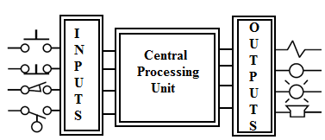

Fig. 3.8 Block diagram of PLC

The CPU governs all PLC activities. The I/O interfaces provide connection between CPU, information providers (inputs) and controllable devices (outputs).The following three components, shown in Fig. 3.9, form the CPU:
- Processor.
- Memory system.
- System power supply.
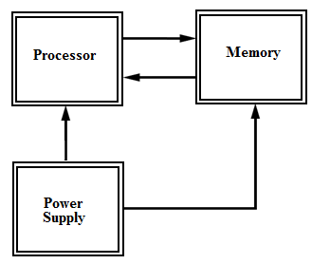

Fig. 3.9 Block diagram showing major CPU components

The operation of a programmable controller is relatively simple. During its operation, the CPU completes three processes:
- It reads, or accepts, the input data from the field devices via the input interfaces.
- It executes the control program stored in the memory system, and
- It writes, or updates, the output devices via the output interfaces.
This process of sequentially reading or sensing the inputs, evaluating the program in memory and updating the outputs is known as scanning. Fig. 3.10 illustrates graphical representation of a scan.
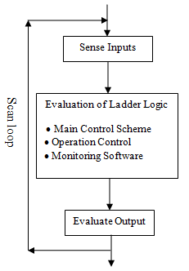

Fig. 3.10 Illustration of a scan loop

The I/O system forms the interface by which field devices are connected to the controller. The (I/O) system is physically connected to the field devices that are encountered in the machine or that are used in the control of a process. These field devices may be discrete or analog I/O devices, such as limit switches, pressure transducers, push buttons, motor starters, solenoids, etc. The main purpose of the interface is to condition the various signals received from or sent to external field devices. Incoming signals from sensors like push buttons, limit switches, analog sensors, selector switches, etc. are wired to terminals on the input interfaces. Devices that are to be controlled, like motor starters, solenoids, valves, pilot lights, etc., are connected to the terminals of the output interfaces. The system power supply provides all the voltages required for the proper operation of the various central processing unit sections.
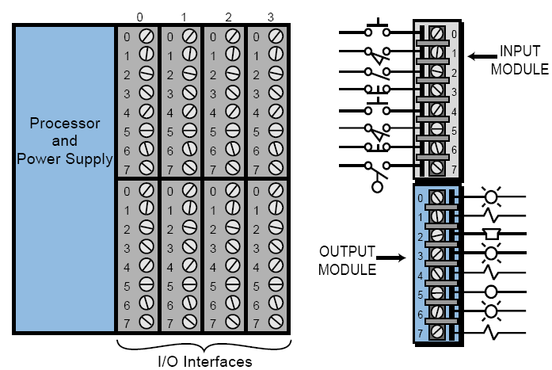

Fig. 3.11 I/O interface

Although not generally considered a part of the controller, the programming device, usually a personal computer is required to enter the control program into memory of PLC. The programming device must be connected to the controller when entering or monitoring the control program. Fig. 3.12 shows connection of PC to PLC.
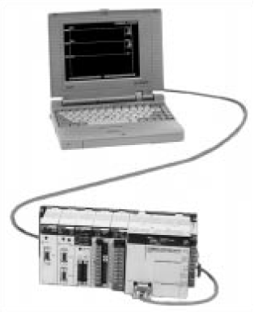

Fig. 3.12 Personal computer used as programming device

In this system, PLC controls servo-drive through 16-digital inputs and 32-digital outputs. The Versamotion servo configuration tool software, provided by Proficy machine Edition 5.9, can continuously monitor Versamotion servo drive, which is the final control element of this experimental control system. The PLC system in itself consists of several modules, shown below in Table 3.1, with the provision of expansion.

Table 3.1 Hardware descriptions of 90-30 GE Fanuc make PLC

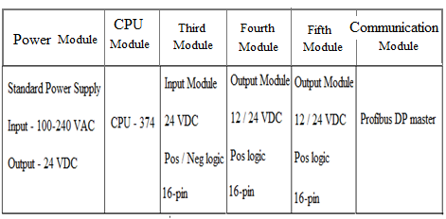

The specifications of various PLC modules as per sequence in which they are fixed in the PLC control panel are described in the tables shown below:

Table 3.2 PLC power module specifications
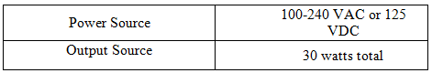

Table 3.3 PLC CPU specifications
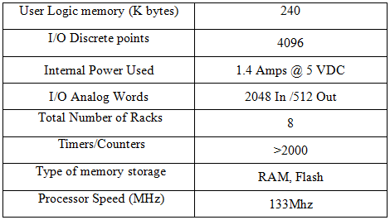

Table 3.4 PLC input module specifications
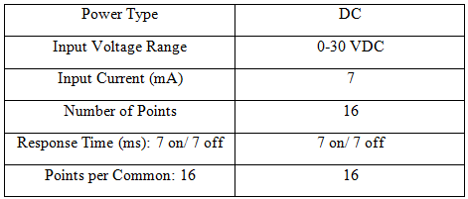
Table 3.5 PLC output module specifications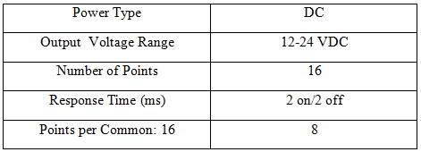

Table 3.6 PLC Network interface module specifications
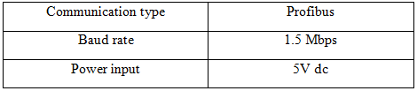

The most important advantage that makes PLC a versatile device is that it can be easily configured with any device such as servo-drive, variable frequency drives, HMI and SCADA. With this additional feature PLC can be accessed in any local network as well as in web based control systems. Communication and networking modules are enhancements for the present day PLC’s, and make PLC reliable for a wide range of applications through which programmer or supervisor can access PLC from any place in a described network.
In addition to the above mentioned advantages, PLC also possesses certain advantages such as ease of programming and maintenance. It can be used in diagnosing the process faults by LED indicators on its modules. It can be quickly installed and is adaptable to changes, as is required in a particular application, giving it high flexibility. PLC has given automation new heights.

3.7 PLC PROGRAMMING LANGUAGE

A Program is a user-developed series of instructions or commands. A programming language provides rules for combining these instructions. Early PLCs, up to the mid-1980s, were programmed using programming panels or special purpose programming terminals, which often had dedicated function keys representing various logical elements of PLC programs. Programs were stored on cassette tape cartridges. Facilities for printing and documentation were very minimal due to lack of memory capacity. Recently, PLC programs are typically written in a special application on a personal computer, and then downloaded by a direct connection cable or over a network to the PLC. The oldest PLCs used non-volatile magnetic core memory but now the program is stored either in battery-backed-up RAM or some other non-volatile flash memory present in PLC processor.
Earlier PLCs were programmed only in “ladder logic”, which strongly resembles a schematic diagram of relay logic. Modern PLCs can be programmed in a variety of ways, from ladder logic to more traditional programming languages such as BASIC and C. Another method is state logic, a very high level programming language designed to program PLCs based on state transition diagrams. Recently, international standard IEC 61131-3 has defined five programming languages for programmable control systems which include FBD (Function block diagram), LD (Ladder diagram), ST (Structured text, similar to the Pascal programming language), IL (Instruction list, similar to assembly language) and SFC (Sequential function chart). These techniques emphasize logical organization of operations.
In this project, PLC programs are written in Proficy Machine Edition 5.9, GE Fanuc and are communicated to PLC through RS-232 serial communication (or through Ethernet). This software integrates all the modules of PLC as well as the devices connected to its networking module (Profibus-DP master) which include HMI panel, AC servo-drive and ethernet connector for LAN network or for multi-user SCADA system.

3.7.1 LADDER LOGIC

Ladder logic is the programming language used in this project. Ladder logic programs are represented by graphical diagrams which represent the interconnection of the virtual devices needed to control field devices (servomotor in this case) as desired and is based on the electrical circuit diagrams of relay-based logic hardware, also known as ladder diagram. The name is based on the observation that programs in this language resemble ladders, with two vertical rails and a series of horizontal rungs between them. The logic in a ladder diagram typically flows from left to right. Each rung typically consists of a combination of input instructions. These instructions lead to a single output instruction. Each input or output instruction is assigned an address indicating the location in the PLC memory where the state of that instruction is stored. Fig. 3.13 shows a view of ladder logic program in which start button, relay coil and output Q1 are represented by normally open switches and emergency stop by a normally closed switch. As soon as the start switch is ON, relay is activated, which activates latched relay coil and an on-delay timer simultaneously. After 100 seconds, Q1 is ON which makes the motor to run. By switching ON emergency stop switch, motor can be stopped at any moment as required.

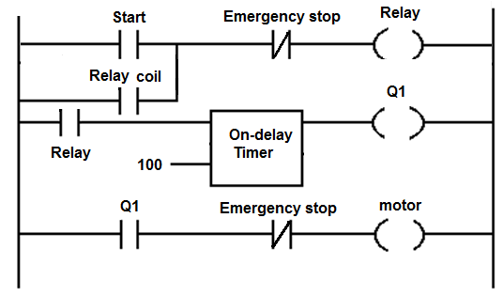
Fig. 3.13 PLC ladder logic program

3.7.2 TYPES OF INSTRUCTIONS

Ladder logic programming allows PLC to perform different types of tasks, including Boolean logic, timing, counting, arithmetic and special functions. In addition to these instructions, most PLCs support many extended instructions to perform more complicated tasks.
- Boolean logic: Boolean logic is actually what PLCs and relay based systems perform. The actual operations in Boolean logic include AND, OR and NOT operations. The AND operation simply means that all inputs must be ON for output to be ON; which is analogous to relay contacts being connected in series. The OR operation means that the output is ON if at least one of the inputs is ON; which is analogous to relay contacts being connected in parallels. The NOT operation means that the output is OFF if and only if the input is ON and vice-versa; which is analogous to a normally closed relay contact. PLCs perform Boolean logic using basic relay instructions. Common input instructions used include normally open contact and normally closed contact.
- Timing instructions: The basic timing instructions include ON-delay and OFF-delay instructions. With ON-delay timers, output associated with the timing instruction is turned ON some specified time after the input is ON, but it turns OFF immediately when the input is turned OFF. With OFF-delay timers, output is turned ON immediately when the input is turned ON. However, it remains ON for a specified period of time after the input has been turned OFF, and then turns OFF. Timing instructions are usually connected like relay coil instructions in the ladder diagram, so any combination of input conditions can be programmed to trigger them. When a timing instruction is created in the PLC program, memory space is reserved for timer running value and the preset value i.e., the value at which the timer will trip.
- Counting instruction: The basic counting instructions provide for up-counter and down-counter functions. The up-counter instruction simply increases the value of a counter by 1 each time an upward (OFF to ON) transition is detected in the input. A down-counter instruction does the opposite i.e., decreasing the count value by 1 on each upward transition of the input. When the value of the count reaches or exceeds a preset number, output is turned ON. The reset instruction resets the value of the count to 0 or to a predetermined reset value. As in case of timing instructions, counting instructions are also usually connected like relay coil instructions in the ladder diagram.
- Arithmetic instructions: Almost all PLCs have simple ladder diagram instructions to add, subtract, multiply, and divide two numbers. A ladder rung for an instruction used to perform an arithmetic operation typically has three parts. First are the input conditions that must be true in order for the computation to take place. Second are the locations of the two numbers to be operated upon; these locations resemble examine instructions, which tell the program where to find the numbers in memory. The third and final part is the output location; it is usually entered as an address assigned to the actual arithmetic instruction (+, -, x, or /), which resembles a relay coil instruction. Each time the input conditions are met, the two numbers are retrieved from the input locations, indicated arithmetic operation is performed and result is put into the output location.
Another group of arithmetic instructions are compare instructions, which determine if one number is less than, equal to or greater than another number. They are programmed in the same way as arithmetic operations.
The Proficy Machine Edition 5.9 Software provides a wide variety of options and instructions including the above mentioned instructions. This software provides significant flexibility and versatility in terms of instruction options available.
3.8 COMMUNICATION AND NETWORKING OF PLC

Communication and networking as already mentioned are added features to the modern PLCs. As a matter of fact PLC is the main device used, which helps in communication and interfacing with other devices as well as in control of field devices like AC Servo-drive. The PLC output module runs and controls motor as per the specified ladder logic program (user-logic). The program is downloaded into the PLC from a personal computer through RS-232 serial communication preferably (or sometimes even through Ethernet for high speed communication).

These features i.e., communication and networking add to flexibility of PLC making control of devices connected to PLC much easier and at the same time increase the possibility to control these devices remotely through HMI and SCADA. Human Machine Interface (HMI), through a touch pad screen, is being employed for manual control of field devices and various drives like servo-drive while SCADA terminal is used for remotely controlling these devices.

3.8.1 HUMAN MACHINE INTERFACE (HMI)

HMI allows control systems to be much more interactive than before. The basic purpose of an HMI is to allow easy graphical interface with a process. HMI allows an operator to use simple displays for determination of machine parameters and for supervising control processes. The most common use includes continuous monitoring, display as well as diagnosis of machine faults and machine status, for further action by the operator as required. It allows the operator to start and stop cycles and to monitor, control and supervise operation of machine at every instance of time. It also helps the operator to detect abnormal situations and undertake corrective action before the situation becomes uncontrollable. A human machine interface allows information to flow in both the directions, that is
HMI is designed mostly for harsh industrial environments. It has rugged and compact architecture. It provides reliable ergonomic control by keyboard or touch screen and has highly contrasted screens for excellent legibility.
HMI support various communication protocols such as Ethernet, Profibus-DP and Modbus RTU. Fig. 3.14 shows the communication facilities of the HMI based system. It can be easily configured with hardware devices such as PLC, AC drives, personal computers, Ethernet hub, and web server. In the block diagram below HMI communicates with personal computer and PLC through data highway i.e., Ethernet. It communicates with servo-drive and other AC drives through Profibus/Modbus communication buses. Profibus-DP is an open bus standard and is used for communication with field devices or those involved in process control.
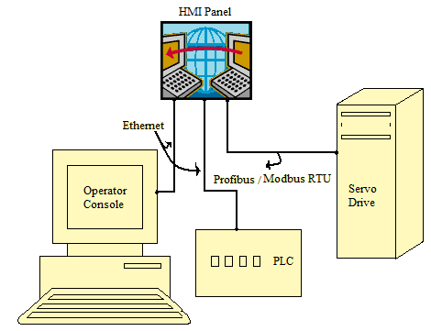

Fig. 3.14 Communication of HMI with various devices

    - SUPERVISORY CONTROL AND DATA ACQUISITION (SCADA) SYSTEM

PLC-based control systems allow efficient and flexible use of a SCADA system. SCADA system is being used these days in industries to establish automation and to control easily and simply. It is a computer controlled system and has software design applications. A typical SCADA control system consists of one or more remote terminal units (RTU or PLCs) connected to a variety of sensors and actuators, relaying information to concerned control system. A properly designed SCADA system reduces labor costs by minimizing site visits for inspection, data collection/logging and making adjustments. Control systems developed using SCADA are therefore cost effective and can easily be configured and programmed.
PLC/SCADA system allows real-time monitoring from PC system, troubleshooting and increased equipment life by providing better preventive maintenance. Automatic report generation is also an advanced feature associated with SCADA systems.
In this project AC servomotor has been controlled through SCADA software namely Proficy HMI/SCADA Cimplicity 7.5. This software proves to be excellent software for development of animation windows for easy control of the system remotely and it also provides provision for development of SCADA scheme for the system involved.
SCADA as such provides supervision in form of latest graphical animations both virtual and real time as well as data trends of all other processes on the window of personal computer or the screen of HMI. User defined controls like (start, stop, speed set) can also be developed on the software window in order to control the system remotely. Using SCADA software makes monitoring of numerous control processes dynamic and easy. SCADA along with the supervision provides data cataloguing or data acquisition of all the system parameter possible in form of graphics and tables.

3.9 THREE-PHASE AC SERVOMOTOR

Servomotors are electromechanical devices used to convert electrical signals i.e., control voltage applied to them is converted into an angular displacement of the shaft. A servomotor can either operate in a continuous duty or step duty (jog mode) depending on construction and requirements.

The servomotor controller directs operation of the servomotor by sending velocity command signals to the amplifier, which drives the servomotor. An integral feedback device (resolver) or devices (encoder and tachometer) are either incorporated within the servomotor or are remotely mounted, often on the load itself. These provide servomotor position and speed feedbacks, which are then compared by the controller to its programmed motion profile and used to alter its velocity signal. Servomotors feature a motion profile, which is a set of instructions programmed into the controller that defines the servomotor operation in terms of time, position, and speed. The ability of the servomotor to adjust to differences between the motion profile and feedback signals depends greatly upon the type of controls and servomotors used

Three basic types of servomotors are used in modern Servo systems: AC Servomotors, based on induction motor designs, DC servomotors, based on dc motor designs and AC brushless servomotors, based on synchronous motor designs.
The experimental system consists of a three-phase 1kW AC servomotor, based on synchronous motor design, with a fitted encoder, and amplifier. A three-phase main switch feeds servomotor through a PWM based Versamotion servo drive, which provides high frequency control-signals to motor stator windings. By using frequencies of 400Hz or higher, the system can be made less susceptible to low-frequency noise. Due to this feature, ac devices are extensively used in aircraft and missile control system in which the noise and disturbance often create problems. A 2500 ppr (10,000 Quadrature counts/ revolution) incremental encoder is used for feedback. This is equivalent to a resolution of 0.036 degrees at the motor shaft. Servomotor has a variable load belt and pulley attached to it.

Motor parameters like voltage, current, frequency, feedback pulse count, torque, etc can be monitored in real time by using Versamotion servo configuration tool software.
The Motor specification data is given in Table 3.7 shown below.

Table3.7 AC servomotor specification
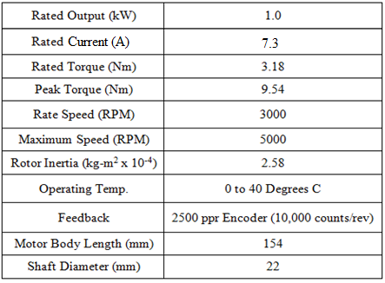
3.9.1 CONSTRUCTIONAL FEATURES OF AC SERVOMOTOR

Electronically there is no difference between the synchronous AC servomotor and asynchronous standard motor but mechanically there is a difference. The permanent magnet AC servomotor has a very straight-forward and rugged construction. The stator of AC servomotor consists of stacked steel laminations with winding placed in the slots that are axially cut along the inner periphery. The stator has three symmetrical windings, which are internally connected in a wye configuration. The construction of the AC servomotor is thermally more effective because almost all of the losses are in the stator where they can be more easily routed to the outside ambient. The rotor contains the permanent magnets, which can be mounted in different ways depending on a specific technology. The rotor of the servomotor is very long with a small radius. This enables high dynamics of the motor with good precision and high torque.
The permanent magnet material ranges from low cost ceramic (ferrite) to the more expensive rare-earth materials such as samarium cobalt or neodymium iron boron (“neo”). Most, recent AC servomotor designs use “neo” as a good compromise between magnetic properties, availability and cost. The rotor also includes a rotary position sensor. The multi-purpose position sensor is used for commutation (or generation of the sinusoidal current commands), velocity feedback, and position feedback.
The rotor construction is usually squirrel cage or drag cup type. The squirrel cage rotor is made of laminations. The rotor bars are placed on the slots and short circuited at both ends by end rings. The diameter of the rotor is kept small in order to reduce inertia and to obtain good accelerating characteristics.
The drag cup construction is employed for very low inertia applications. In this type of construction, the rotor will be in the form of hollow cylinder made of aluminium. The aluminium cylinder itself acts as short circuited rotor conductors. Electrically both the types of rotors are identical. The synchronous AC servomotor has better precision and a greater shaft torque than the asynchronous standard motor which struggles in achieving control. Fig. 3.15 shows permanent magnet three-phase AC synchronous servomotor.
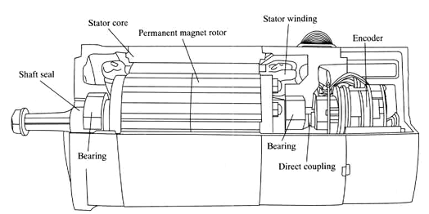

Fig. 3.15 Typical Three-phase AC servomotor

3.9.2 MODEL EQUATIONS OF SERVOMOTOR

The model of servo system consists of a servomotor coupled to a gearbox and an inertial load rigidly fixed to output shaft. Friction is taken as negligible throughout the analysis. The relations for stator and rotor windings and dynamic torque analysis for the permanent magnet AC servomotor can be described by the following nonlinear differential equations. Voltage equations for stator winding can be expressed in terms of its phases as described below:
v_{sa} = R_{sa}i_{sa} + L_{sa}i_{sa} + v_{a (bemf)} (3.1)
v_{sb} = R_{sb}i_{sb} + L_{sb}i_{sb} + v_{b (bemf)} (3.2)
v_{sc} = R_{sc}i_{sc} + L_{sc}i_{sc} + v_{c (bemf)} (3.3)
Similarly, voltage equations for rotor winding can be expressed in terms of its phases as described below:
v_{SA} = R_{SA}i_{SA} + L_{SA}i_{SA} + v_{A(bemf)} (3.4)
v_{SB} = R_{SB}i_{SB} + L_{SB}i_{SB} + v_{B(bemf)} (3.5)
v_{SC} = R_{SC}i_{SC} + L_{SC}i_{SC} + v_{C(bemf)} (3.6)
Where, a, b and c represent the three phases of stator winding and A, B and C represent the three phases of rotor winding respectively.
v_{sa}, v_{sb} and v_{sc} represent voltages in the three phases a, b and c of stator winding and v_{SA,} v_{SB} and v_{SC} represent voltages in the three phases A, B and C of rotor winding respectively.
Also, R_{Sa}, R_{Sb} and R_{Sc}; and L_{sa}, L_{sb} and L_{sc} represent values of resistances and inductances of the three phases a, b and c of stator winding and R_{SA,} R_{SB} and R_{SC}; and L_{SA}, L_{SB}, and L_{SC} represent values of resistances and inductances of the three phases A, B and C of rotor winding respectively.
In addition to the above symbols we have, v_{a(bemf)}, v_{b(bemf)} and v_{c(bemf)} represent the respective back emfs in the three phases a, b and c of stator winding and v_{A(bemf)}, v_{B(bemf)} and v_{C(bemf)} represent the respective back emfs in the three phases A, B and C of rotor winding.
Now for phase “a” of stator winding phase voltage,
v_{sa} = v_{sa} e^{jwt} (3.7)
Where, w = rotating frequency of the electrical field.
Also, i_{sa} = i_{sa} e^{j (wt + δ)} (3.8)
Therefore, by substituting values in equation 1 we have,
v_{sa} e^{jwt} = R_{sa}i_{sa} e^{j (wt + δ)} + L_{sa}i_{sa} e^{j (wt + δ)} + v_{a (bemf)} e^{jwt} (3.9)
v_{sa} e^{jwt} = R_{sa}i_{sa} e^{j (wt + δ)} + jwL_{sa}i_{sa} e^{j (wt + δ)} + v_{a (bemf)} e^{jwt} (3.10)
v_{sa} = R_{sa}i_{sa} e^{jδ} + jw L_{sa} i_{sa} e^{jδ} + v_{a (bemf)} (3.11)
e^{jδ} = cos(δ) + jsin(δ) (3.12)
Therefore,
v_{sa} = R_{sa}i_{sa} cos (δ) - w L_{sa} i_{sa} sin (δ) + v_{a (bemf)} + j (w L_{sa} i_{sa} cos (δ) + R_{sa}i_{sa} sin (δ)) (3.13)
The phase angle α represents the phase shift between the motor phase voltage and the motor BEMF and can be derived from 3.13 to yield the following two equations.
α =
α = R_{sa}i_{sa} cos (δ) - w L_{sa} i_{sa} sin (δ) / wL_{sa} i_{sa} cos (δ) + R_{sa}i_{sa} sin (δ) (3.14)
These equations constitute the general solution for the phase angle of AC servomotors. The phase shift is the result of the motors inductance. The torque expression is given by:
T_{M} = K_{T} i_{sa} cos (δ) (3.15)
where, T_{M} represents motor torque and K_{T} represents motor torque constant.
The above expressions show that the torque angle must be zero to get maximum torque at any speed. In that case, the phase shift between the motor phase voltage and BEMF is presented by
α = w L_{sa} i_{sa}/ (R_{sa}i_{sa} + v_{a (bemf)}) (3.16)
Similar, type of analysis can be done for other phases of stator winding and similarly for phases of rotor winding.

3.9.3 WORKING OF AC SERVOMOTOR

Consider the magnetic field of ac servomotor. Fig. 3.16 shows a simple representation of an AC Servomotor with a permanent magnet rotor and three-phase stator where the windings are spaced by 120 degrees. The magnetic field vector established by the permanent magnets is labelled B. Unlike the dc servomotor where the permanent magnets are stationary, the magnets of the ac servomotor move as they are mounted on the rotor. The challenge of the field-oriented control strategy is to generate the three-phase stator currents in such a way as to keep the composite current vector perpendicular to the magnetic field vector at all times.
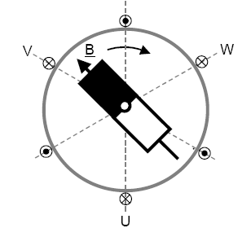
Fig. 3.16 AC Servomotor with Permanent Magnet Field and Three-Phase Stator

The composite current vector generation is of utmost importance in an AC Servomotor. The generation of composite current vector is described by Fig. 3.17. The three-phase stator currents are represented as three sine waves that are displaced in space by 120 degrees with axes labelled as U, V, and W. As an example, the composite current vector is developed for angles of 60 and 90 degrees. It can be noticed that for every angle the composite current vector has a magnitude equal to 1.5I_{T} where I_{T} is the amplitude of the phase currents and 1.5I_{T} has an angular position equal to the angle δ.

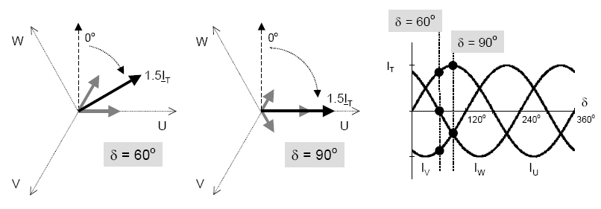
Fig. 3.17 Current vector for three-phase AC servomotor
A fixed amplitude magnetic field vector is created by the permanent magnet that rotates synchronously with the rotor of the motor. The composite current vector rotates at the angular frequency of the phase currents and has amplitude that is proportional to the peak value of the sinusoidal phase currents. In order to explain control of torque of AC Servomotor, consider the angle of the motor rotor be δ and let δ be the angular frequency of the sinusoidal phase currents. Then at δ=0⁰, the current vector is perpendicular to the magnetic field vector. In practice, this is accomplished by physically orienting the rotor position sensor, usually an encoder or a resolver, so that the composite current vector is perpendicular to the magnetic field vector. Actually, the motor back EMF (B_{EMF}) signal is easier to measure and is uniquely related to the magnetic field vector so the position feedback device is oriented to the B_{EMF} signals during the manufacturing process. Therefore, no matter what motion the rotor might make, the current vector will always be perpendicular to the magnetic field vector.
Therefore, we conclude that permanent magnets on the rotor create a field vector that rotates synchronously with the rotor of the motor. Composite current vector is located perpendicular to the field vector at all times by locking the angular frequency of the three phase stator currents to the properly defined rotor angle. Torque is then directly proportional to the amplitude of the three-phase sinusoidal currents T_{M} = K_{T} I_{T}. The torque produced, hence leads to rotation of rotor.

3.9.4 CHARACTERISTICS OF AC SERVOMOTOR

The key characteristic of a servomotor is the ability to provide precise torque control. Ideally, the output torque of a servo system should be highly responsive and independent of motor position and speed across the system’s entire operating speed range. Although it is impractical for torque and speed to be completely independent, most servomotors are close enough to this ideal that simple models for servo systems can be based on that assumption. This is especially true when the purpose of the model is to predict stability. More accurate models of servomotors show torque declining as speed increases. This reduction comes from numerous effects, including increased losses from windage friction and bearing friction.
Fig. 3.18 shows speed-torque curve for AC servomotor used in this setup. The motor can operate continuously at any combination of speed and torque within the prescribed continuous operating zone. The limit of the continuous operating zone is determined with the motor’s ambient temperature at 20°C and its drive current as a pure sine wave. Actual operation is limited by the current of the servo drive unit. The continuous operating zone must be derated for ambient temperature above 20°C.
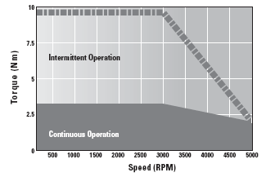
Fig. 3.18 Typical speed- torque curve

In most servo systems, the limit to torque responsiveness is the responsiveness of the current loop. Current loops, like all control loops, are bandwidth limited by stability requirements. The bandwidth of current loops varies from about 300 Hz to 2500 Hz in servo systems. Brushless motors are therefore more complex and are often documented as part of a system.

3.10 CONCLUSION

The chapter presents a detailed description of the hardware devices used in control of AC servomotor. AC servo drive, the final control element, and PLC, the main control unit, have been extensively described in this chapter. A mathematical model of a three-phase AC servomotor is also developed for analytical studies. PLC programming language gives a feel of application development which is the ultimate goal of the experimental setup.

CHAPTER IV

SOFTWARE DEVELOPMENT FOR CONTROL AND MONITORING OF AC SERVOMOTOR

4.1 GENERAL

A detailed description of the software packages used for monitoring and control of AC servomotor has been discussed in this chapter. The AC servomotor control is achieved through PLC, Proficy machine Edition 5.9 and monitoring of its parameters is done using utility tool called Versa motion servo configuration tool. The supervisory control and development of virtual applications is achieved through Proficy HMI/SCADA CIMPLICITY 7.5 software package. The PLC programming with SCADA system enables an automated control and monitoring of AC servomotor.

4.2 DEVELOPMENT OF LADDER LOGIC FOR THREE-PHASE SERVO-DRIVE

PLC programming is based on logical instruction rather than numerical computational algorithms. Most of the programming instructions work on simple “ON” and “OFF” mechanism. The programming method employed in this project is ladder logic diagram method. The PLC system provides a design environment in the form of software tools running on a host computer terminal which allows ladder diagrams to be developed, verified, tested, and diagnosed. The ladder diagram is converted into binary instruction codes so that they can be stored in Random Access Memory (RAM) or Erasable Programmable Read Only Memory (EPROM). Each successive instruction is decoded and executed by the CPU. The function of the CPU is to control the operation of memory and I/O devices and to process data according to the programming instructions. Each input and output connection point on a PLC has an address used to identify the I/O bit and to provide an access to these points in the program. The method for accessing these inputs, outputs, and memory is based on the fact that the PLC memory is organized into three regions namely Image Memory (I), Output Image Memory (Q), and Internal Memory (M). Any memory location is referenced directly using %I, %Q, and %M. The PLC program uses a cyclic scan in the main program loop through which periodic checks are made to the input variables. The ladder logic is executed rung-by-rung. Scanning the program and solving the logic of the various ladder rungs determines output. The updated output is stored in fixed memory locations i.e., Output Image Memory “Q”. The output values held in memory are then used to set and reset the physical outputs of the PLC.
A host computer (PC), connected via an RS232 serial port (or via Ethernet for high speed communication) to the target PLC, is used for compiling ladder logic programs through various software application tools. The developmental process for compiling the program which is to be run on the PLC consists of: using an editor to draw the source ladder program, converting the source program to binary object code which will run on the microprocessor of concerned PLC and downloading the object code from the PC to the PLC system via the serial communication port. In this experimental system PLC programming is done by Proficy Machine Edition 5.9 which is a GE Fanuc product. This software integrates all modules and devices connected to the PLC system. This software also integrates PC to the networking module of PLC i.e., HMI.

4.2.1 ALGORITHM FOR SERVO DRIVE CONTROL (CONTROL MODES)

The VersaMotion servo can be programmed to provide six single and five dual modes of operation, which are described below:

Mode | Code | Description
External Position Control | Pt | External position control for the servomotor is achieved via an external pulse command.
Internal Position Control | Pr | Internal position control for servomotor is achieved by eight commands stored in the servo controller and executed by digital inputs.
Speed Control | S | Speed control for servomotor is provided from an external analog -10 to +10 VDC command.
Internal Speed Control | Sz | Internal speed control for servomotor is provided only by parameters set within the controller. Digital Inputs control the internal speed parameters. (A maximum of three speeds can be stored internally).
Torque Control | T | Torque control for the servomotor is provided from an external analog -10 to +10 VDC command.
Internal Torque Control | Tz | Internal torque control for the servomotor is provided only by parameters set within the controller. Digital Inputs control the internal torque parameters. (A maximum of three torque levels can be stored internally).
Dual Modes
External Position-Speed | Pt-S | Either Pt or S control mode can be selected via Digital Inputs.
External Position-Torque | Pt-T | Either Pt or T control mode can be selected via Digital Inputs.
Internal  Position-Speed | Pr-S | Either Pr or S control mode can be selected via Digital Inputs.
Internal  Position-Torque | Pr-T | Either Pr or T control mode can be selected via Digital Inputs.
Speed - Torque | S-T | Either S or T control mode can be selected via Digital Inputs.

4.2.2 SWITCHING BETWEEN VARIOUS CONTROL MODES

Changing the control modes require the following steps to be followed:
a) Switch the servo drive to servo-off status. Turning SON signal to OFF completes this action.
b) Next set parameter P1-01 to required control mode and desired output direction value.
c) After this setting is complete, remove power from servo drive, and then power it up again after 3-5 seconds.
Three main control modes described below have been used for control of AC servomotor using servo-drive and PLC programming language (Proficy Machine Edition 5.9 software).

4.2.2.1 POSITION CONTROL MODE

The position control modes i.e., external position control (Pt) or internal position control (Pr) mode are usually used for applications requiring precision positioning, such as indexing table, valve opening in petro-chemical industries etc. In order to provide convenient position control using servo drive, eight internal preset parameters are present. There are two methods for setting internal parameters. The first method is to set different position commands into eight internal parameters before operation and then use digital inputs POS0-POS2 to perform positioning control. The other method is to use serial communication to change values of eight internal parameters.
The command sources for internal position control mode are eight built-in parameters P1-15 to P1-30. Parameter P1-33 is used to select whether these commands represent absolute or incremental position control. Digital I/O signals (POS0 to POS2 and CTRG) are used to select one of the eight position commands and then trigger the execution of that command as shown in the table below:

Table 4.1 Position control of servomotor
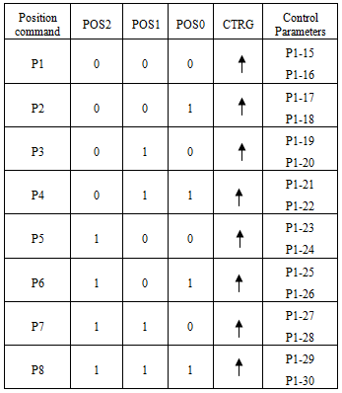

In this table value “0” of POS0-POS2 indicates that the contact is in OFF state (Normally open) and “1” indicates that contact is in ON state (Normally closed). CTRG in the given table represents the input used to trigger the move selected using the POS0, POS1 and POS2 inputs. The move is triggered on the rising edge of this digital input. The parameters P1-15, P1-17, P1-19, P1-21, P1-23, P1-25, P1-27 and P1-29 are for setting the number of rotations required in a particular application. The remaining even parameters in the table are for setting number of pulses as required in any application. The position control mode can be briefly described by the block diagram shown in Fig. 4.1.
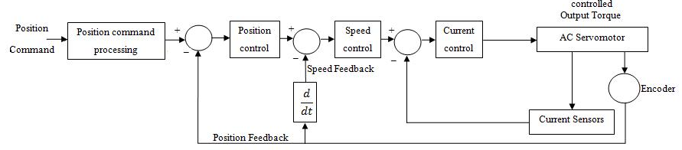

Fig. 4.1 Block diagram of position control mode
In Fig. 4.1 position loop, which is the outer most loop, is used to allow the rotation angle of the motor reach the desired position (rotation angle) that was externally designated. The speed feedback is offshoot of position feedback and helps to run the servomotor in speed control mode. The position loop feeds back the position data (rotation angle) of the encoder or resolver.
The speed control involves speed command signal as analog input for motor operation. The speed loop is used to run the servomotor at the speed designated by the external analog speed command or the speed command that is output from the position loop. The current command is output from the speed loop to current loop.
The torque control involves current command signal as analog input for motor operation. The current loop provides the motor with the current designated by the current command set by speed controller. The current loop feeds back the motor line current and compares it with the required current. The difference of the two current signals is processed through current controller.

4.2.2.2 SPEED CONTROL MODE

The speed control mode (S or Sz) is usually used on applications that require precision speed control. The Versamotion servo drive supports two command sources in speed control mode. One is external analog speed command and the other is stored internal parameters. The external analog signal is from an external voltage input, where the applied voltage is proportional to the speed of the servomotor. There are two methods of using the internal parameters. The first method is to set different speed commands using the three speed control parameters before operation and then using SPD0 and SPD1 digital inputs to select the desired speed. The other method is to use the serial communications to change the value of the speed parameter. The speed control command sources can be:
i) External analog signal or speed command.
ii) Internal parameters: P1-09 to P1-11

Table 4.2 Speed control of servomotor
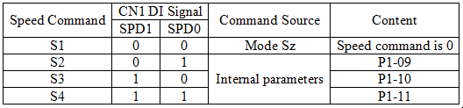

In Table 4.2 value of SPD0-SPD1 “0” indicates OFF state of contacts involved (normally open) and a value of “1” indicates ON state of the same contacts (normally closed).
When both SPD0 and SPD1 equal 0 (OFF) and the control mode is Sz, the speed command is 0. Therefore, Sz mode can be used to prevent the zero speed drift problem of an analog voltage command. When at least one of SPD0 and SPD1 is 1 (ON), the internal parameters (P1-09 to P1-11) are used for the speed command. The command is valid (enabled) only after either SPD0 or SPD1 is changed.

      - TORQUE CONTROL MODE

The torque control involves current command signal as analog input for motor operation. The torque control mode is usually used on applications that require accurate control of torque. Versamotion servo drives support two kinds of command sources in torque control mode: external analog signal or internal torque parameters. Torque command sources include:
i) External analog signal or torque command.
ii) Internal parameters: P1-12 to P1-14.
The command source selection is determined by the Digital Inputs (DI) on connector CN1.
Table 4.3 Torque Control of Servomotor
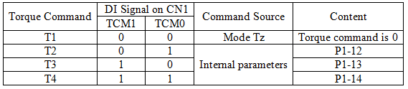
In Table 4.3 value of TCM0-TCM1 “0” indicates OFF state of contacts involved (Normally Open) and a value of “1” indicates ON state of the same contacts (Normally Closed). When TCM0 and TCM1 are both 0 (OFF) and the control mode of operation is Tz, and the torque command is 0. When at least value of either TCM0 or TCM1 is 1(ON), the torque command uses internal parameters (P12-P14). The new command selection is valid (enabled) only after either TCM0 or TCM1 is changed.
The torque command that is described above not only can be taken as torque command in torque control mode but also can be the torque limit input in position mode and speed control mode.

  - DESCRIPTION OF PLC PROGRAMMING SOFTWARE (PROFICY MACHINE EDITION 5.9)

Proficy Machine Edition 5.9 provides software utilities for PLC programming. It gives an easy access to various virtual devices like ON-Delay timer, OFF-delay timer, UP-Counter, DOWN-Counter; normally open Switch, Relay coil, etc. The programs developed can be validated before downloading it to PLC controller. The software provides a fully-integrated environment in which every tool and editor works efficiently with each other. Proficy Machine Edition in short offers a complete solution for the development of automation applications under one roof. Procedure for development of PLC program in Proficy Machine Edition 5.9 is described below:

a) Open the Proficy Machine Edition 5.9 icon by simply double clicking on its shortcut. A window appears in front of us as shown below in Fig 4.2. To create a new project, right click on “My Computer” in the left side of window and select option “New”.

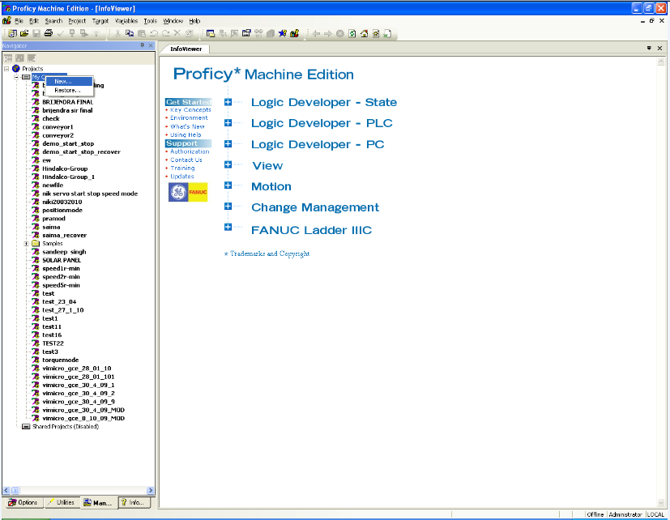
Fig. 4.2 Start up screen of PLC software

b) Give an appropriate name to the project say “NEW PROJECT” on the dialog box that appears in front and select project template as GE Fanuc Series 90-30 type PLC. Click OK to proceed further. The software by itself configures settings for series 90-30 type PLC and apparently other screen overlays itself on the previous window screen. The Fig.4.3 below shows the captured view of NEW PROJECT widow.

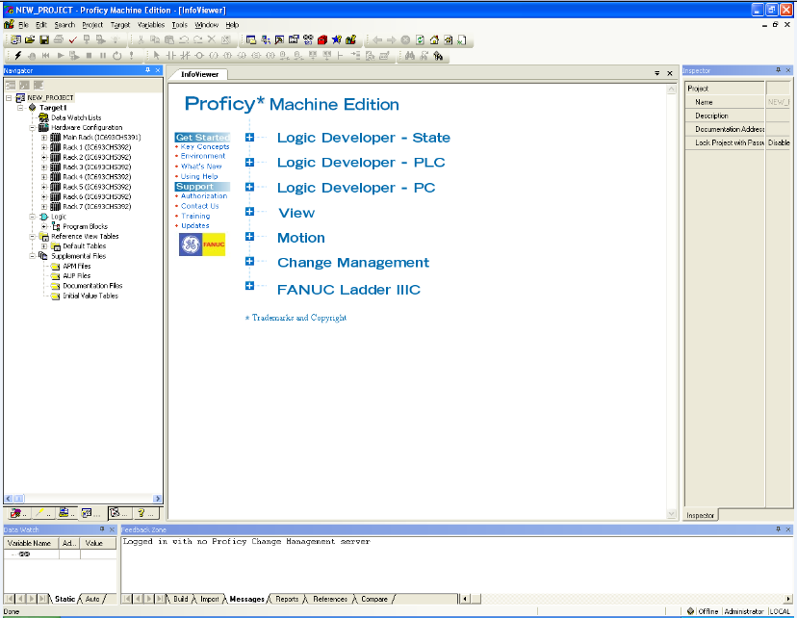
Fig. 4.3 Project screen of PLC software
c) In the “NEW PROJECT” window, right click on the NEW PROJECT. Select “Add target” and then in the GE Fanuc Controller option, select “Series 90-30 PLC”. Next change the hardware configuration to the one installed in the setup. For the present setup add Power supply module (IC693PWR330), CPU type (IC693CPU374), Digital Input module (IC693MDL645), Digital Output module (IC693MDL740) and Bus controller module (IC693PBM200). Since the experimental setup involves two output modules, therefore, select two slots for output while adding hardware configuration to the project. The procedure for addition of Digital input module is shown in Fig. 4.4.

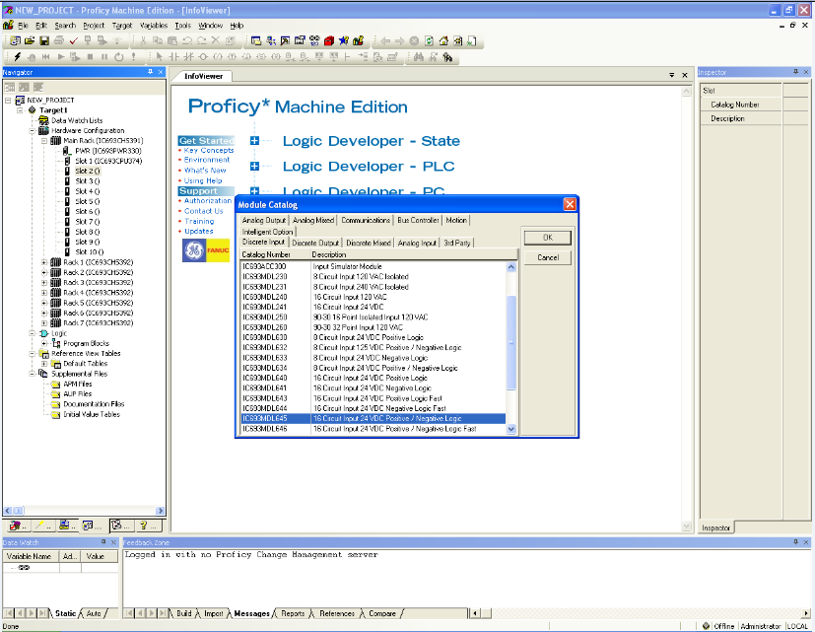
Fig. 4.4 Configuration of hardware to project window

d) Create a new ladder diagram by selecting “MAIN” in program blocks present in logic folder given on left side of the programming window as shown in Fig.4.5. The figure basically represents programming window in offline mode with two vertical rails having provision for addition of rungs so as to develop ladder logic program on it which is the ultimate goal of Proficy Machine Edition software. The Fig. 4.5 shows a simple PLC program incorporating various virtual devices that include normally open and normally closed switches, timers and relay coils.
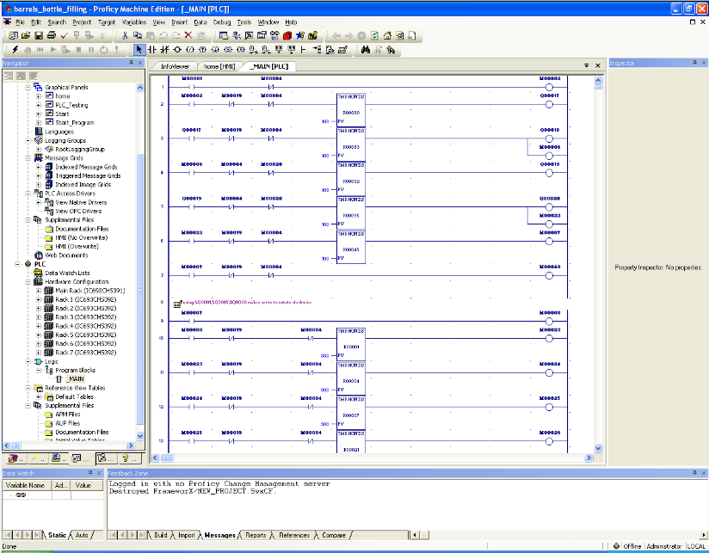
Fig.4.5 Software window of PLC program in Offline mode
e) Save the program and right click on target PLC select “Go online”, if PLC is connected properly through serial communication or through Ethernet it will show “connected”. If it shows “unable to go online” check connections and modules selected. When PLC is online, go to the “Programmer Mode”, and select “Download and Run Program”, Machine Edition software will by itself check the program and for a correct program, PLC goes into Run mode indicated by a green LED on PLC board. Fig.4.6 shows PLC in run mode.
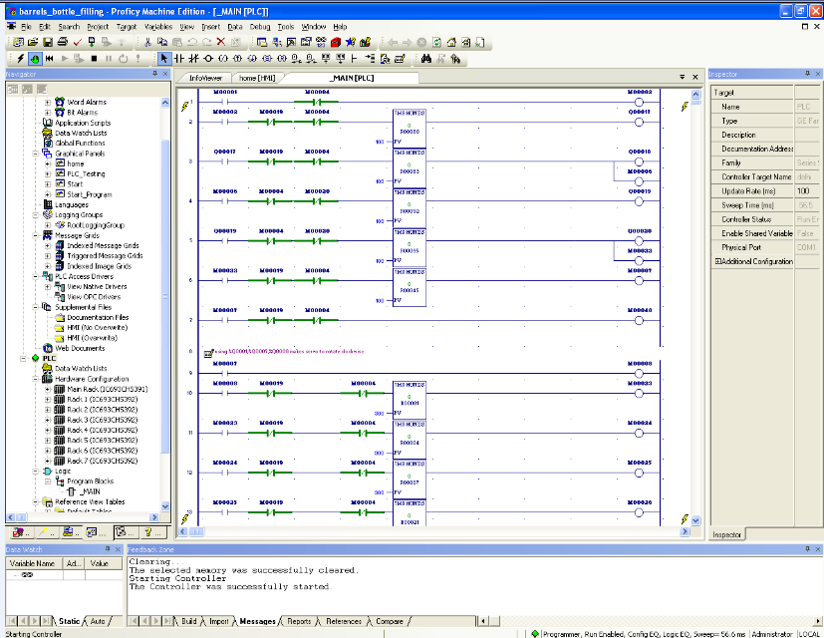
Fig.4.6 Software window of PLC program in Run mode
4.4 DATA MONITORING IN AC SERVO DRIVE (VERSAMOTION SERVO CONFIGURATION TOOL)

There is an additional utility tool provided with Proficy Machine Edition software called Versamotion servo configuration tool which can be used for:
a) Monitoring various parameters of servomotor online i.e. when servomotor is running.
b) Changing various parameters of servo drive through serial communication.
c) Determining performance of servomotor online i.e., when servomotor is in running mode.
In order to access this tool, go to utilities option and from there select the option of Versa motion Servo Configuration tool. Now for establishing a connection with Servo drive, in the settings window select on-line option, choose Baud rate and protocol type as 2:19200 and 6:8,N,2 (RTU) respectively. This utility provides provision for:
a) Online monitoring of Servomotor through a data scope: The data scope present in the utility tool helps in graphical display of internal signals, similar to a digital oscilloscope. The data scope has three independent channels. The data on scope window can be printed or saved as a file. The data scope has in addition to this zoom and trigger functions as well as a movable trace cursor is present on it for clear vision. Fig. 4.7 below shows data scope and servo-drive parameters i.e. motor feedback pulse number, motor rotation speed and ratio of load inertia to motor inertia are being monitored, their values and graphical representation.
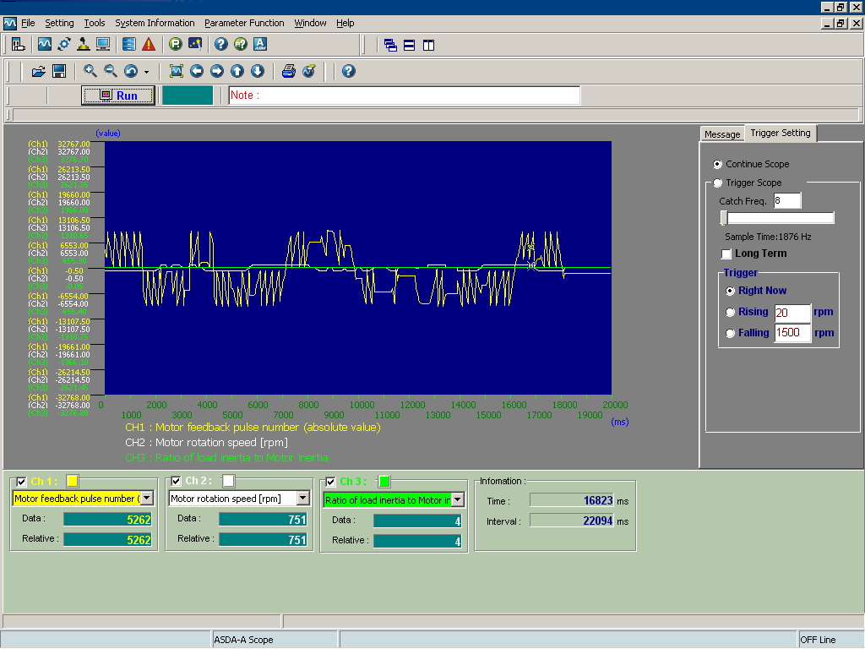
Fig. 4.7 Servomotor parameter monitoring on Data scope
b) Parameter Editor: Parameter configuration is another advantage linked with Versamotion servo configuration tool. This option provides facility to user to read back all of the parameters of the servo drive to PC as well as allows user to write all the parameters, set in PC into the servo drive. It also allows the user to display, change and compare the setting value of some certain parameters.
Parameters can be viewed/ set by the software or by using the drive keypad. Most parameters will use default values and can be printed or saved to a file for archiving and reuse. Changing values of certain servo-drive parameters needs power reboot to be given to servo-drive, while certain parameters cannot at all be altered and retain default factory setting values.
For instance, if the requirement is to change the speed of the motor to 600rpm while it is running at any specified speed say 3000rpm simply enter the required value and press enter, the new value will be by itself implemented and motor will now be running at newly selected speed.
Similarly, values of various parameters such as change of control mode, changing direction of rotation, number of pulse feedback, etc. can be changed directly from PC through the aid of VersaMotion Servo Configuration Tool and performance of motor can be recorded accordingly. Fig. 4.8 explains parameter configuration achieved through software.
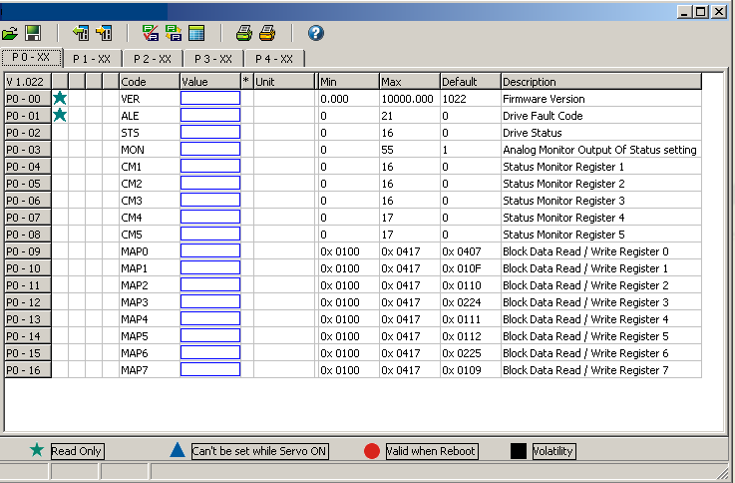
Fig. 4.8 Parameter Configuration Window
c) Control and verification of the digital I/O signals option allows the control and verification of the digital I/O signals in the servo drive. Click on Digital IO / Jog control icon directly on the tool bar to execute this option and enter into the dialog box shown in Fig. 4.9. Both the digital inputs (DIs) and digital outputs (DOs) are shown, including their individual settings and contact type. If the DI/DO signal is a contact A, the name of the DI/DO signals will display in black text and green background. If the DI/DO signal is a contact B, the name of the DI/DO signals will display in white text and brown background and the text "(B)" will also be added at the end of the name of the DI/DO signals to indicate that it is a contact B.
The central part of this dialog box shows the On/Off status of the DI/DO signals. The buttons on the right side are used to enable the DI and DO control via Versamotion software. The user may use these buttons to control the DI/DO signals while the Versamotion software is connected. To activate the DI signals manually: Check the box next to "On/Off" button in the DI area first and then press the "On/Off" button to enable the communication control function. Pressing the "On/Off" button once again can change the status of the DI signals directly. Similar procedure is followed for DO signals.
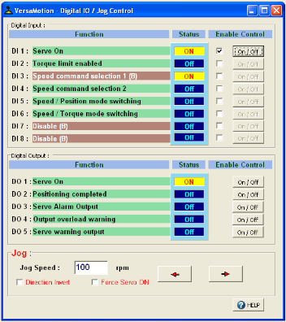
Fig. 4.9 Digital IO / Jog control dialog box window
d) Status Monitor helps the user to monitor the servo status. The motor rotation speed, motor feedback pulse and rotation number, and input command value, etc. will be displayed in this status monitor dialog box.
Click on status monitor icon directly on the tool bar to execute this option, the following dialog box shown in Fig. 4.10 opens in front. In the dialog box, left side displays the monitored items, i.e. the setting value of parameter P0-02. The right side displays the value of the monitored item.
e) Model Information is used to provide the communication port information and model information of the servo drive and the specifications of the servomotor for user's reference.
f) Alarm Information can display the related alarm information via HMI screen whenever an alarm occurs in the servo drive.
g) Control Mode Wizard guides the user to set the servo parameters easily.
h) Troubleshooting, real-time monitoring, machine start-up are additional features associated with Versamotion servo configuration tool.

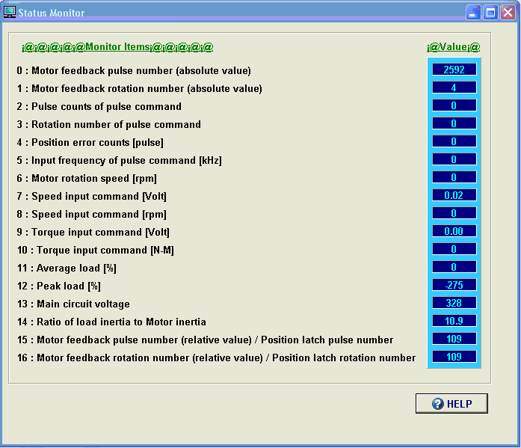
Fig. 4.10 Status monitor window
4.5 IMPLEMENTATION OF SUPERVISORY CONTROL AND DATA ACQUISITION THROUGH PROFICY CIMPLICITY 7.5 HMI/SCADA SOFTWARE

Monitoring and control of the various output devices connected to PLC such as servomotor, induction motor, etc. is possible through SCADA (Supervisory Control and Data Acquisition) system. SCADA can be defined as a system that gets data about a system under supervision in order to control that system. A SCADA system has two elements
a) The system or machine to be monitored and controlled. It can be a power plant, a PLC system, a network, a system of traffic lights, or anything else.
b) A network of intelligent devices that interfaces with the first system through sensors and control outputs. This gives SCADA system ability to measure and control specific elements of the former system.
SCADA provide supervision in form of graphical animation and data trends of all the processes on the window of personal computer or screen of HMI. User defined controls like start, stop, speed control, etc. can also be developed on the software window to control the system remotely. Using SCADA makes monitoring of processes very easy. SCADA along with auxiliary software systems provide data logging or data acquisition of all the device parameters in form of graphs trends, excel sheet, tables etc.
GE-Fanuc’s Proficy HMI/ SCADA Cimplicity 7.5 software is used for remote monitoring and control of the system. A minimum recommended hardware and operating system requirements for running this software are given in Table 4.4.

Table 4.4: System requirement for GE-Fanuc’s Proficy HMI/ SCADA Cimplicity 7.5 software
Operating system | Windows XP with Service Pack 2
Computer type
Minimum computer type | Pentium 4-based 1 GHz
For optimum performance | Pentium 4-based 3 GHz
Minimum recommended RAM | 1 GB
Minimum recommended free hard disk | 800 MB
Installation requirement | CD-ROM drive
Monitor | Better color graphics monitor and a 100% IBM-compatible, 24-bit graphics card capable of 800x600 resolution.
CIMPLICITY software is scalable from a Human Machine Interface to a fully networked Supervisory Control and Data Acquisition (SCADA) system. The networking capabilities are inherent at all levels and the software virtually eliminates redundant configuration within a network.
CIMPLICITY is based on a client-server architecture consisting of servers and viewers. Servers are responsible for the collection and distribution of data. Viewers connect into servers and have full access to the collected data for viewing and control actions. Servers and viewers can be easily networked together to seamlessly share data without the need to replicate point database from node to node. For example, points are configured once and only once on a server. Screens can be developed and stored in a single location on the network and accessed by any other CIMPLICITY display on the network. This gives system flexibility in communication and gives it dynamism by adding feature of any where control to its features.
a) To create a new file on the Cimplicity workbench window, go to file option and select New Project as shown in Fig. 4.11.

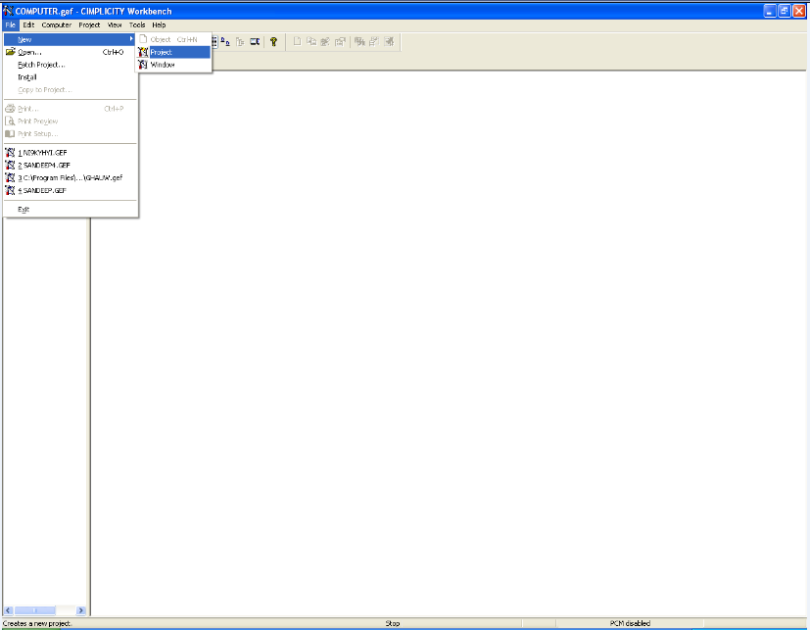
Fig. 4.11 Start up window of Cimplicity software
b) Dialog box overlays on the above window. In the dialog box, select protocol type as “S90 TRIPLEX”, and select option type as “Database Logger: points”. Name the project as say “NEW PROJECT” and finally click on create.
c) Another dialog box appears in front. In that enable project broadcast and give an appropriate IP address. A Cimplicity Project wizard window appears in front as shown in Fig. 4.12. In this window configure PLC type, ports used, etc. Project wizard by itself guides user to configure the device connected to the personal computer, as PLC is connected to PC in this case. The wizard also configures various communication ports and controller type of the connected device. It also helps in input addressing, output addressing and memory addressing by creating new points corresponding to these addresses. After finishing all this click exit to escape from project wizard window. It will automatically configure available information and create points corresponding to addresses used in PLC program.

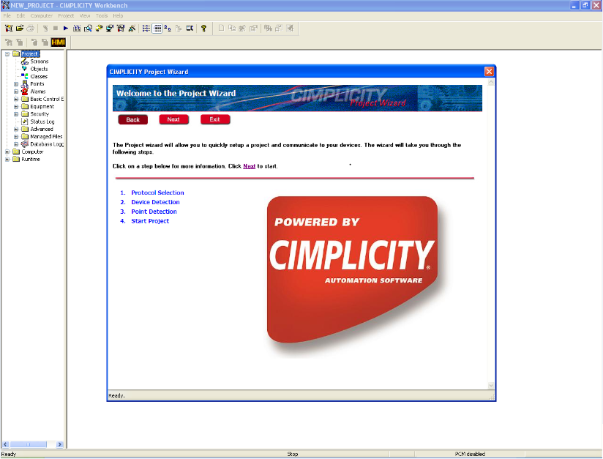
Fig. 4.12 Cimplicity project wizard window
d) Click on screen icon of Cimplicity workbench screen and start the project, this will make SCADA to communicate with PLC. Create a graphical interactive window as required by using object explorer. Lastly, click on test screen icon to run the project.

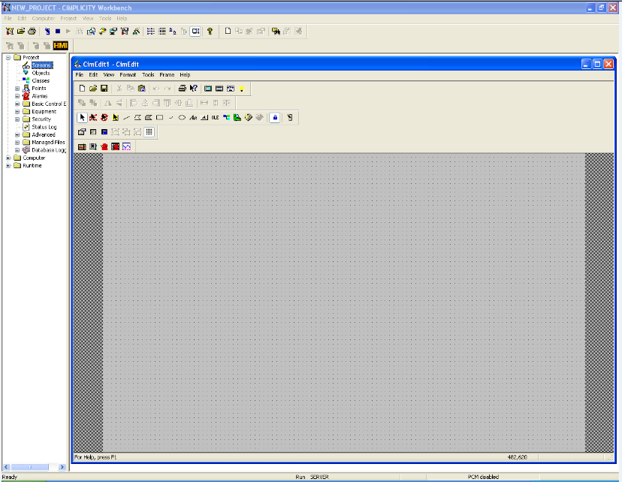
Fig. 4.13 Software window for drawing test screens

CimEdit provides a set of tools that can graphically represent any control process. Windows users will quickly notice the toolbars located around the screen. The toolbars provide the drawing tools such as the capability to draw line, polyline, polygon, rectangle and ellipse, arcs, text and button objects. Trending, quality charts, and alarm viewer are examples of CIMPLICITY ActiveX objects. With this combination of graphic tools, drawing graphic screens that accurately depict a production process is very simple. Once the objects are placed on the screen, another toolbar provides a powerful set of alignment tools. Objects can be aligned automatically with a configurable grid, or aligned as groups using the object alignment tools, which include the ability to space objects evenly as well as align them in relation to each other. Objects can also be rotated, flipped, grouped, or ungrouped. Any object can then be animated using the object property sheet that pops up when we double-click on an object or click on the property sheet icon on the forms toolbar. This property sheet allows user to choose from a wide variety of animation and control functions. These animation properties include: rotation, fill, movement, colour, and text annunciation, geometry, scaling, events, etc. The Fig. 4.14 shows an animated window created by user in CimEdit. In this Fig. a SCADA screen is developed to present an automatic loading and unloading process system.

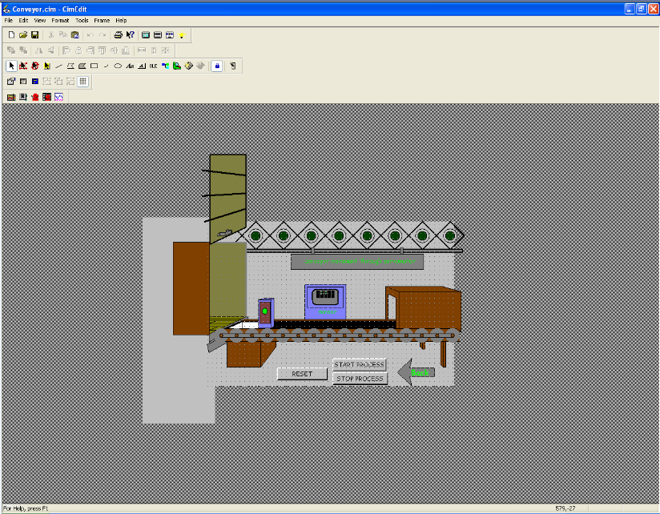
Fig. 4.14 CimEdit screen for automatic loading and unloading process system

  - CONCLUSION

The chapter provides a detailed description of software utilities used for control and monitoring of AC servomotor. It mainly focuses on Proficy Machine Edition 5.9 (PLC) employed for control of AC servomotor and Proficy HMI/ SCADA Cimplicity 7.5 for monitoring and remotely controlling AC servomotor.

CHAPTER V

COMMUNICATION AND PROTOCOLS USED IN AUTOMATION OF SERVO DRIVE SYSTEM

5.1 GENERAL

This chapter presents a detailed description of different communication modes and protocols used in Servo control system. Communication of PLC with external devices has shown great advancements in the recent past. This provides high degree of flexibility in controlling and monitoring PLC based systems. In order to understand PLC communication and networking both physical layouts and logical perspectives need to be described.

5.2 LAYOUT OF COMMUNICATION SYSTEM USED

Communication layout for monitoring and control of servo drive is shown in Fig. 5.1. It shows that servo drive communicates with HMI through data highway i.e. Ethernet. Ethernet is a family of frame-based computer networking technologies are widely used for local area networks (LANs). Processor of computer communicates to servo drive through MODBUS-RTU, an open serial (RS-232 or RS-485) protocol, widely accepted due to its ease of use and reliability. RTU is the “Eye”, “Ear” and “Hands” of a SCADA System. The RTU acquires all the field data from different field devices, processes it and transmits the relevant data to the processor. At the same time, it distributes the logical signals received from PLC to these field devices.
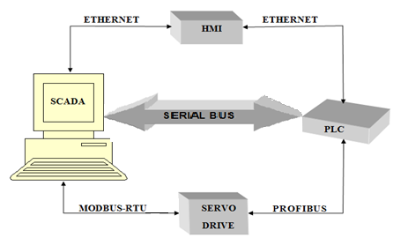
Fig. 5.1 Communication System Architecture
A serial communication Bus (RS-232 i.e., Recommended Standard 232) exists between PLC and PC. A Profibus DP master communication module present on PLC is meant for its communication with field devices including Servo-Drive. As device connectivity is selective; there is a need for choosing best protocols and communication channels.

5.2.1 SERIAL COMMUNICATION (RS-232)

Serial communication, as the name implies, occurs in serial form through simple, twisted-pair cables. Serial data transmission is used for most peripheral communication devices, since these devices are slow in nature and require long cable connections. Serial communication allows peripheral equipment, such as terminals, modems, operator interface panels etc. to receive ASCII information.
Two of the most popular standards for serial communication are the RS-232 and the 20mA current loop. Other PLC standards are the RS-422 and RS-485, which improve performance and give greater flexibility in data communication interfaces.
RS-232 (i.e. Recommended Standard 232) is a standard for serial binary data signals connecting between a DTE, Data Terminal Equipment and a DCE, Data Circuit-Terminating Equipment. It is commonly used in computers for serial communication ports. In RS-232, user data is sent as a time-series of bits. Both synchronous and asynchronous transmissions are supported by this standard. In addition to the data circuits, the standard defines a number of control circuits used to manage the connection between DTE and DCE.
The data communication links used with peripheral equipment can be unidirectional or bidirectional. If a peripheral is strictly either an input or an output device, then data transmission occurs in only one direction. In this case, a unidirectional serial signal line is all that is required to complete the link. Devices that serve as both input and output devices (e.g. video terminals) require bidirectional links. There are two ways to achieve this bidirectional communication. First, a single data line can be used as a shared communication line. The data can be sent in either direction, but only in one direction at a time. This operation is known as half duplex. If simultaneous bidirectional communication is required, two lines can connect the PLC to the peripheral. One line would be assigned permanently as an input, while the other would be a permanent output. This mode is known as full duplex.
Both data and control circuits are unidirectional in operation. Since circuits for transmitting and receiving data are separate, the interface can operate in a full duplex manner, supporting concurrent data flow in both directions.

5.2.2 MODBUS-RTU

Modbus-RTU is an open, serial (RS-232 or RS-485) protocol derived from the client or server architecture. It is a widely accepted protocol since it is easy to use and is more reliable. Modbus-RTU is widely used within Building Management Systems (BMS) and Industrial Automation Systems (IAS). The RTU acquires all the field data from different field devices like servo drive, processes it and transmits the relevant data to the processor. At the same time, it distributes the logical signals received from PLC to the field devices. The wide acceptance to MODBUS-RTU is because it is easy to use. MODBUS-RTU messages are simple 16-bit CRC (Cyclic-Redundant Checksum). The simplicity of these messages is to ensure reliability. MODBUS is considered an application layer messaging protocol, providing client or server communication between devices connected together through buses or networks. On the OSI model, MODBUS is at level 7 position. MODBUS is intended to be a request/reply protocol and delivers services specified by function codes. The function codes of MODBUS are elements of MODBUS’ request/reply PDUs (Protocol Data Units).
The Modbus communication interface is built around messages. The format of these Modbus messages is independent of the type of physical interface used. RS-232 has same messages as those used by Modbus or TCP over Ethernet. This gives Modbus interface definition a longer lifetime. The same protocol can be used regardless of the connection type. Because of this, Modbus gives the possibility to easily upgrade the hardware structure of an industrial network, without the need for large changes in the software. A device can also communicate with several Modbus nodes at once, even if they are connected with different interface types, without the need to use a different protocol for every connection.

5.2.3 PROFIBUS

PROFIBUS (PROcess Field BUS) is a well-proven, widely accepted open Field-Bus standard. Field-Bus is in simple words digital communication system for field devices. PROFIBUS was introduced in 1989 as German standard DIN 19245, later adopted as International Standard EN 50170. The PROFIBUS standard is now incorporated into IEC 61158, the international Field-Bus standard.
Devices on the system connect to a central line. Once connected, these devices can communicate information in an efficient manner and can also go beyond automation messages. The communication is two-way so that devices can receive information from controlling stations and also can send information to controlling stations. The data can be simple i.e., digital on/off signals or can be complex i.e., from/to sophisticated instruments such as on-line process analysers or actuators such as variable-speed drives etc.
The PROFIBUS family consists of three compatible version offering very high integrity and a capability appropriate to the need.
a) PROFIBUS DP - Decentralised Periphery: It involves low cost, has high speed, and provides simple field level communications. About 90% of current PROFIBUS applications are DP.
b) PROFIBUS FMS - Field-bus Message Specification: It involves high-end, provides application level communications and are used at cell or controller level. It provides object oriented transmission of structured data, loading and control of programs, alarm services etc.
c) PROFIBUS PA - Process Automation: It has been developed specifically for the process industry. It involves very cost effective two-wire connection carrying both power and data and is particularly cost effective for hazardous environments (intrinsically safe protection).
All three systems can operate together; DP and FMS share the same electrical transmission system (RS485), PA uses a different electrical transmission system (IEC 1158-2) but shares the same protocol as DP and FMS.
PROFIBUS DP extensions and the integration of PROFIBUS with Ethernet technology (PROFINET) mean that FMS is less important than in the past. FMS is no longer supported by PROFIBUS International. However, there are still FMS installations successfully operating.
PROFIBUS is used across a wide range of industries: Factory automation, Robotics and numerically controlled machine tools, Continuous web and film production, Food production, Chemical and petro-chemical plant, Building automation, Automated warehousing and material handling, etc. Fig 5.2 explains use of PROFIBUS at the levels of automation. It shows wide use of PROFIBUS in all types of automation applications.
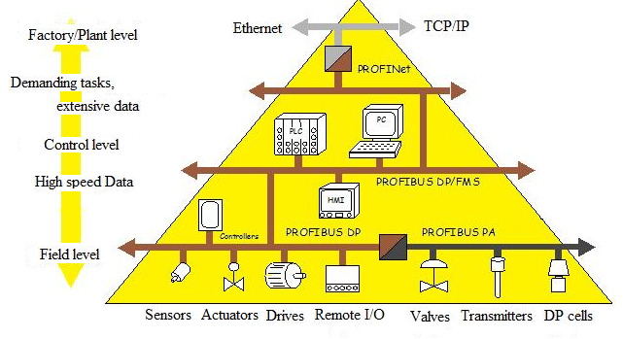
Fig. 5.2 Application of PROFIBUS at all levels of automation.

PROFIBUS devices can also participate in self-diagnosis and connection diagnosis. At the most basic level, PROFIBUS benefits from superior design of its OSI layers and basic topology. Fig. 5.3 shows a Profibus OSI model.
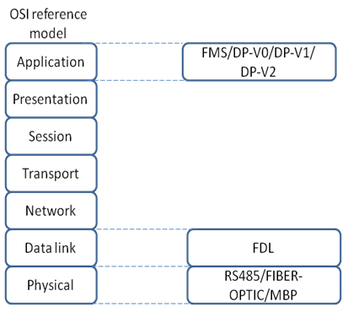
Fig. 5.3 Profibus OSI model

PROFIBUS networks make use of three separate layers of the OSI Network model. First, PROFIBUS describes the application layer. There are multiple versions of PROFIBUS that handle different types of messaging at the application layer. Some of the types of messaging PROFIBUS supports include cyclic and acyclic data exchange, diagnosis, alarm-handling, etc.
PROFIBUS does not define layers from three to six. It does, however, define the data link and physical layers, layers one and two. The data link layer is completed through a Field-bus Data Link (FDL). The FDL system combines two common schemes, master-slave methodology and token passing. In a master-slave network, masters usually controllers send requests to slaves i.e., sensors and actuators. The slaves respond accordingly. PROFIBUS also includes token passing, a system in which a “token” signal is passed between nodes. Only the node with the token can communicate. The token passing concept is like the speaking couch; only the person with the couch is allowed to talk. Finally, PROFIBUS defines a physical layer, though it leaves room for flexibility. PROFIBUS systems can have three types of media. The first is a standard twisted-pair wiring system and here this is defined by RS485. Two more advanced systems are also available. PROFIBUS systems can now operate using fiber-optic transmission. A safety-enhanced system called Manchester Bus Power (MBP) is also available in situations where environment is prone to chemical explosion.
PROFIBUS-DP, Decentralized Periphery, is much simpler and faster protocol. This type of PROFIBUS is more universal. PROFIBUS DP is used these days in majority of PROFIBUS application profiles. PROFIBUS DP has in itself three separate versions. Each version from DP-V0, DP-V1 and DP-V2 provides newer and more complicated features. PROFI-drive was created for motion control applications. Software added to the PROFIBUS DP specification allows the network to achieve precise control of servomotors and other equipments.

5.2.4 ETHERNET

Ethernet is a family of frame-based computer networking technologies for local area networks (LANs). The name comes from the physical concept of ether. It defines a number of wiring and signaling standards for the Physical Layer of the OSI networking model, through means of network access at the Media Access Control (MAC) /Data Link Layer with a common addressing format. Ethernet is standardized as per IEEE standard IEEE 802.3. The combination of the twisted pair versions of Ethernet for connecting end systems to the network along with the fiber optic versions for site backbones is the most widespread wired LAN technology now a days.
Most manufacturers who offer Ethernet compatibility to implement supervisory functions over equipment controlling plant floor functions use a TCP/IP protocol for layers 3 and 4 of the OSI model. The Transmission Control Protocol/Internet Protocol (TCP/IP) was initially developed for Arpanet, a computer network created in the early 1970s in the United States. The U.S. Department of Defence established this protocol to communicate information in a reliable manner from one computer to another over the Arpanet network. Nowadays, the TCP/IP protocol is utilized in the Internet data network.
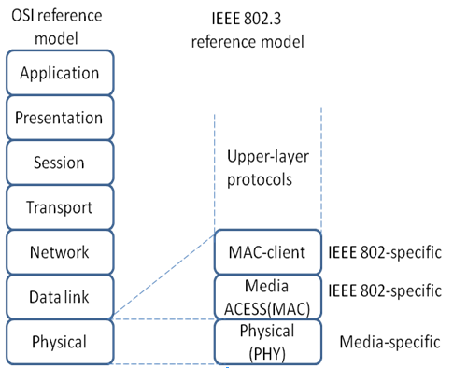

Fig. 5.4 Ethernet and OSI Model

Ethernet supports the physical and data link layers, with TCP/IP as its protocol. Ethernet uses Carrier Sense Multiple Access/Collision Detection (CSMA/CD) to support the data link layer. The CSMA/CD checks the media for other devices before transmitting, thus managing and reducing the number of data collisions. The Ethernet uses Transmission Control Protocol/Internet Protocol (TCP/IP) to provide for layers of the OSI model. The four layers of the TCP/IP can loosely fit the seven layers of the OSI. The Network layer corresponds to the Internet layer of the TCP/IP model. Internet Protocol helps this layer for moving data to various devices on the network. The Transport layer corresponds to the Host-to-Host layer of the TCP/IP model. Almost all devices on a TCP/IP network are considered hosts and this layer communicates data peer-to-peer (or host-to-host). The Session, Presentation and Application layers of the OSI model correspond to the Process/Application layer of the TCP/IP model and all these layers provide user with network services.

  - CONCLUSION

This chapter describes the communication and networking system used for the PLC based control and monitoring of AC Servomotor. The system can be controlled remotely and in any LAN system. These are basically added features to PLC and they add to versatility of PLC. Communication basically forms the back bone of control processes because if correct communication protocol is not selected then the said process becomes a failure.

CHAPTER VI
EXPERIMENTAL RESULTS AND DISCUSSIONS

6.1 GENERAL

This chapter presents a detailed discussion on control methods being developed and tested for the control of three-phase ac servomotor. The control strategy has been developed to control servomotor in three basic control modes (position, speed and torque modes). The performance of motor under variable load torque and variable speed of the servo drive has been tested and effect on power quality due to three-phase servo drive has also been analysed through harmonic spectrum of supply current. Different parameters such as voltage, current, power and frequency have been observed and recorded through power quality analyzer and their effects are evaluated in real-time. Also torque and speed variations have been recorded using SCADA system and Versamotion configuration utility and speed-torque characteristics of three-phase servomotor have been determined.

6.2 EXPERIMENTAL SETUP FOR CONTROL OF THREE-PHASE AC SERVOMOTOR

The experimental setup consisting of three-phase ac servomotor, PLC, HMI, SCADA and mechanical loading arrangement is implemented and tested for variable load and variable speed conditions. Fig.6 1 shows a block diagram of the experimental setup used.
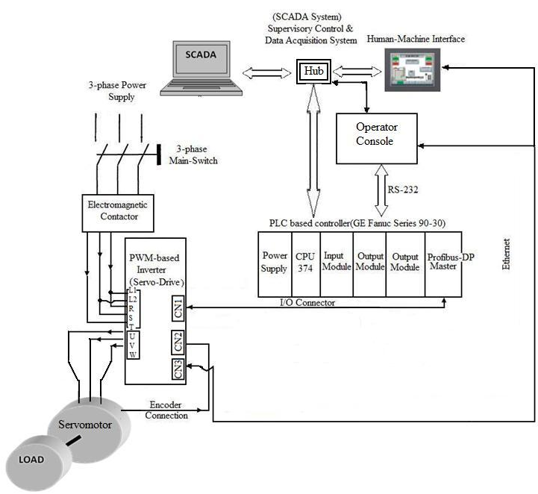
Fig. 6.1 Block diagram of experimental setup

6.3 DEVELOPMENT OF CONTROL SCHEME FOR AC SERVOMOTOR

The control scheme is divided into two parts: Main control and HMI/ SCADA control. Main control program is developed on PLC programming space using Proficy Machine Edition 5.9 (GE Fanuc). The HMI/ SCADA control (operation control) is developed on a personal computer with the aid of Proficy Machine Edition 5.9 and the Proficy Complicity 7.5 software (GE Fanuc). The flow chart shown in Fig.6.2 describes main control algorithm.
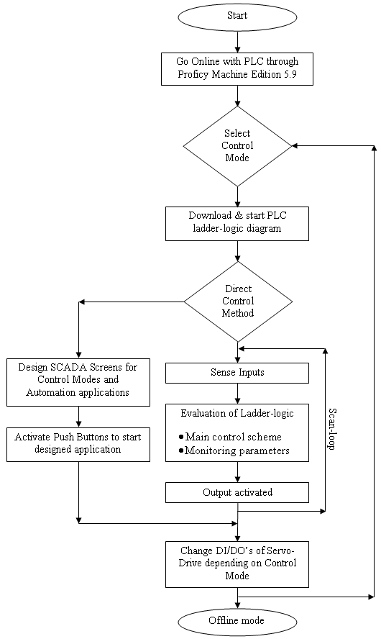
Fig. 6.2 Flow chart for implementation of main control scheme

Main control includes control in all the control modes i.e. Position, Speed and Torque modes. In this control method PLC programs, application specific, are written in PLC logic developer software tool and are communicated to PLC through RS-232 serial communication (or even through Ethernet for high speed communication). This software integrates all the modules of PLC as well as the devices connected to its networking module (Profibus-DP master) which include HMI panel, AC Servo-Drive and Ethernet connector for LAN network or for multi-user SCADA system.
HMI/ SCADA control method involves control of motor in all the modes with the help of SCADA program developed in Proficy Complicity 7.5 software involving Ethernet communication.

6.3.1 POSITION CONTROL MODE OF THREE-PHASE SERVO DRIVE

The procedure for position control begins with downloading PLC ladder logic program (application specific) into the PLC processor memory. After download is complete serial communication cords are exchanged and one which serially connects servomotor to local PC being used is plugged-in. The digital inputs and outputs are set using values which are mode and application specific. Various parameters configured are discussed below. The parameter P1-01 in the Servo drive is set to a value of 108 to ensure that internal position mode of drive is selected and the motor rotates in clockwise direction for forward mode. The format of control option is as follows.
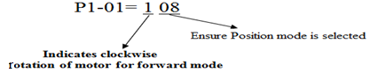
The parameter P1-09 is then set to desired speed and timings of timers, virtual devices being used in PLC programming, are adjusted accordingly. The timings between the various pauses can also be adjusted as desired for application in use. For a longer pause a higher valve is set for timer and vice versa for a short pause. Next set the digital inputs DI1 to DI7 using parameters P2-10 to P2-17. These values change while switching from one mode to another. The values set for various parameters in position mode are given below:
P2-10 = 101, ensures to switch Servo ON, when desired in a particular application.
P2-11 = 108, when the drive is in Position control mode CTRG needs to be activated, in order to trigger the move of motor, in absence of CTRG motor motion is disabled. The drive will command the motor to move to stored position that corresponds to POS 0, POS 1 and POS 2 position settings.
P2-12 = 111, in order to select POS 0.
P2-13 = 112, in order to select POS 1.
P2-14 = 013, in order to select POS 2.
By setting POS 0, POS 1 and POS 2 to 110 selects position P4 among the seven defined positions.
P2-15 = 118, for selecting position/speed mode, which constitutes dual mode.
P2-16 = 014, in order to deactivate source of speed command.
P2-17 = 0, deactivates digital input (DI7).
Also parameters P1-15 to P1-30 representing rotation number and pulse count for positions from P1 to P8 should be altered as desired.
Various steps involved in executing position mode have been illustrated in the flowchart shown in Fig. 6.3.
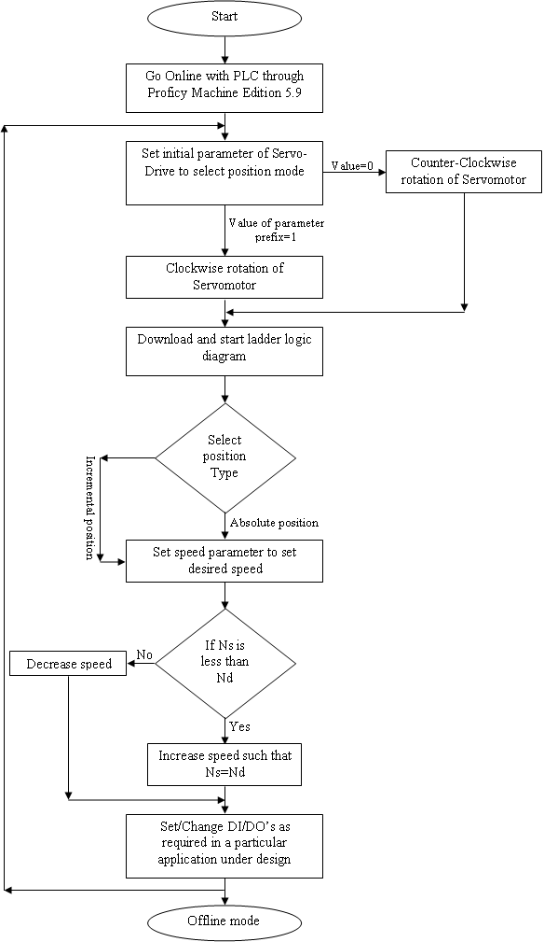
Fig. 6.3 Flowchart to implement position control mode
A position precision application has been designed and tested by direct control method as well as through HMI/SCADA control. The ladder logic developed is meant to rotate the motor by specified angles. For instance, if it is desired to rotate motor by θ_{m} degrees at a speed of N_{d} Rpm, the timers used in the PLC ladder logic need to be adjusted to value obtained after proper calculations.
i.e., θ_{m} = N_{d} * t (5.1)
where, θ_{m} is angle specified for motor rotation, N_{d} is desired speed and t is time calibrations for timer.
The ladder logic developed is shown in Fig. 6.4.
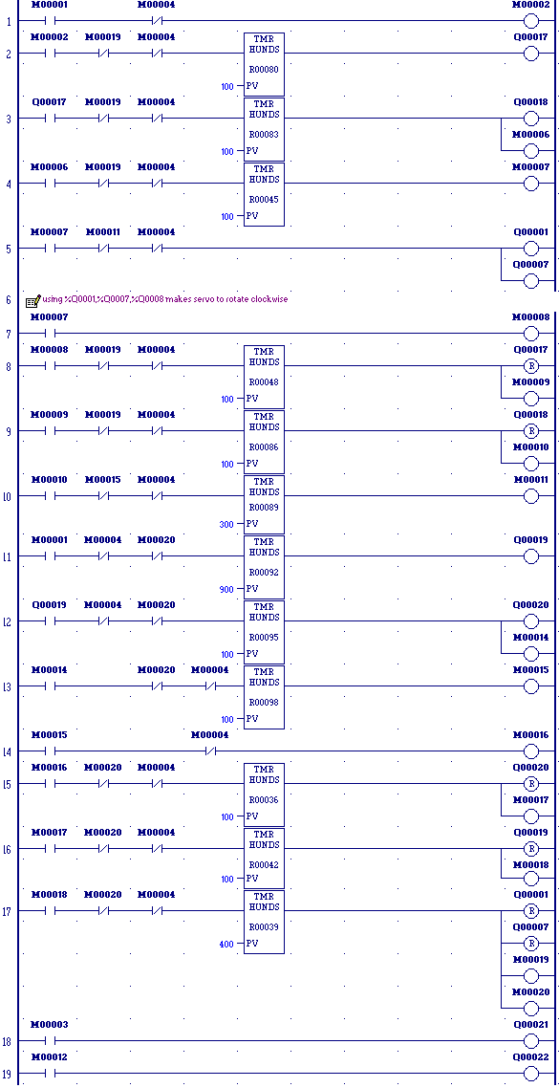
Fig. 6.4 PLC ladder logic program
In this program outputs Q00017, Q00018, Q00019 and Q00020 are used to test the PLC performance initially before loading the actual application program part. Since the program developed needs position precision hence use of PLC digital output Q00001 and Q00007 to run motor is must. Each of the timers used has its own significance in the logic developed. When the memory element M00001 is turned ON, the program logic starts and motor rotates through specified angles without halting, unless user by itself activates memory element M00004.
The input and output addresses used in ladder logic are also used in HMI programming window to develop HMI screens, which can be used by operator for implementing the same logic as developed in PLC ladder diagram at remote places away from field devices. Various HMI screens developed are displayed in figures below. Fig 6.5 shows the screen for selection between PLC testing and option to start program, which has been developed to rotate motor through certain defined angles. Simple push buttons are used to implement these commands, these buttons simply activate the input or output elements involved. Fig. 6.6 shows HMI screen developed for PLC diagnosis before actual program is downloaded into PLC. Fig. 6.7 shows HMI screen having option to start servomotor in accordance with the developed program.
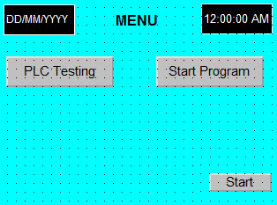

Fig. 6.5 HMI screen developed for selection between PLC testing and option to start program
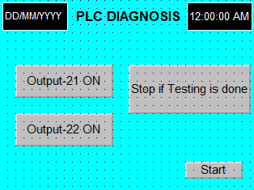

Fig. 6.6 HMI screen developed for PLC testing

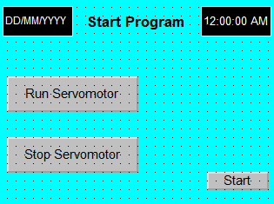

Fig. 6.7 HMI screen developed for control of servomotor.

6.3.2 SPEED CONTROL MODE OF THREE-PHASE SERVO DRIVE

The procedure for ensuring motor operation in speed control mode is similar to that of position control mode, except for some digital inputs and outputs along with PLC digital outputs which are control mode specific. The parameter P1-01 in the servo drive is set to a value of 108 to ensure that dual mode of drive involving speed control mode is selected and the motor rotates in clockwise direction for forward mode. The parameter P1-09 is set to desired speed. Next set the digital inputs DI1 to DI7 using parameters P2-10 to P2-17. These values change while switching from one mode to another. The values set for various parameters in speed mode are given below:
P2-10 = 101, ensures to switch Servo ON, when desired in a particular application.
P2-11 = 110, in order to set speed limit command in active mode.
P2-12 = 014, to select speed selection SPD 0.
P2-13 = 115, to select speed selection SPD 1.
P2-14 = 118, in order to select dual speed/position mode.
P2-15 = 119, in order to select dual speed/torque mode.
P2-16 = 0, deactivates digital input DI6.
P2-17 = 0, deactivates digital input DI7.
After defining the above configuration, the PLC ladder logic is downloaded and run. The monitoring of actual speed of servomotor is achieved through Versamotion utility option available in PLC programming software i.e. Proficy machine edition 5.9. In PLC logic developer software window, Versamotion utility is opened and options of speed input command i.e., desired speed and motor rotation speed i.e., speed with which motor is actually rotating are selected for two channels of the data scope. It is observed from the graphs obtained through scope that motor rotates with high precision at the specified speed. For instance, if desired speed is 1500Rpm, after a delay of approximately 300ms, motor actual speed of rotation reaches 1500Rpm as shown in Fig. 6.8. It can be observed from the figure that speed is maintained throughout at defined speed input command value without any fluctuations. Even at a low speed of 1Rpm same precision in rotational speed is observed for speed control mode of servomotor
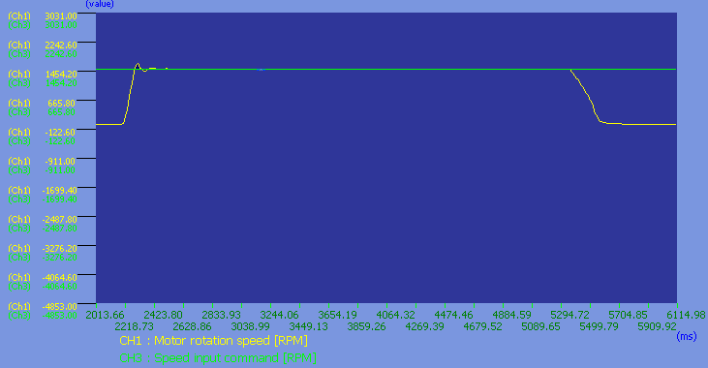

Fig.6.8 Desired and actual speed graph

Also set digital outputs using parameters P2-18 to P2-22. The values set for various parameters in speed mode are given below:
P2-18=102, to ensure activation of servo on (SON), when control power is applied to the servo drive.
P2-19=106, to ensure activation of torque limit (TQL), when the drive has detected that the motor has reached set torque limits.
P2-20=107, to ensure activation of alarm (ALRM), when the drive has detected a fault condition.
P2-21=110, to ensure activation of output overload (OLW), when the servo drive detects that the motor has reached the output overload level set.
P2-22=111, to ensure activation of warning output (WARN), when the drive detects an emergency stop, serial communication error or an Undervoltage fault condition.

6.3.3 TORQUE CONTROL MODE OF THREE-PHASE SERVO DRIVE

In torque control mode, load is changed externally and variations in servomotor stator currents are observed. Even at low speed and high torque, cogging has a minimum value. For torque mode parameter P1-01 in the servo drive is set to a value of 110 to ensure torque mode is selected and the motor rotates in clockwise direction for forward mode. The control format is given by:
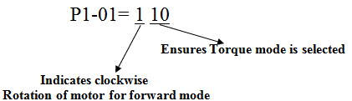
Set the parameter P1-09 to desired speed. Next set the digital inputs DI1 to DI7 using parameters P2-10 to P2-17. These values change while switching from one mode to another. The values set for various parameters in speed mode are given below:
P2-10 = 101, ensures to switch Servo ON, when desired in a particular application.
P2-11 = 108, to activate CTRG.
P2-12 = 016, to select torque selection TCM 0.
P2-13 = 117, to select torque selection TCM 1.
P2-14 = 118, for selecting dual speed/position mode.
P2-15 = 119, for selecting dual speed/torque mode.
P2-16 = 109, in order to set the torque limit command in active mode.
P2-17 = 014, deactivates source of speed command.
Also set digital outputs using parameters P2-18 to P2-22. The values set for various parameters in torque mode are given below:
P2-18=102, to ensure activation of servo on (SON), when control power is applied to the servo drive.
P2-19=106, to ensure activation of torque limit (TQL), when the drive has detected that the motor has reached set torque limits.
P2-20=107, to ensure activation of alarm (ALRM), when the drive has detected a fault condition.
P2-21=110, to ensure activation of output overload (OLW), when the servo drive detects that the motor has reached the output overload level set.
P2-22=111, to ensure activation of warning output (WARN), when the drive detects an emergency stop, serial communication error, or an Undervoltage fault condition.

6.4 SOME CASE STUDY ON CONTROL OF PROCESSES USING SCADA

6.4.1 DESIGNING SCADA SYSTEM FOR BOTTLE FILLING PLANT
Design and implementation of SCADA based virtually animated control units to control the filling system and to control movement of objects on a conveyor has been demonstrated using real time control inputs from AC servo drive.
The design of bottle filling plant implements the filling operation of some liquid like pure drinking water using SCADA and PLC control. The Real-time inputs and outputs have been used to control the designed process. The design, therefore, uses ac servomotor, programmable logic controller (PLC) and SCADA. The SCADA screen developed for bottle filling process is shown in Fig 6.9. A brief description of the process is given in flow chart displayed in Fig.6.10. In this process it is considered that movement of conveyor belt is achieved through a three-phase servomotor.
In the designed screen as soon as “start process” button is pushed ON, servomotor starts to rotate and conveyor starts to move. Conveyor movement is felt by bottle moving over the conveyor belt and when the bottle reaches just below the pump, motor stops and pump starts. After bottle filling is complete, motor starts and pump stops. Finally, when the filled bottle reaches the package box, another bottle pops out and same procedure is followed. Real-time inputs have been used for conveyor movement with the help of motor rotation and filling of bottle with the help of pump.

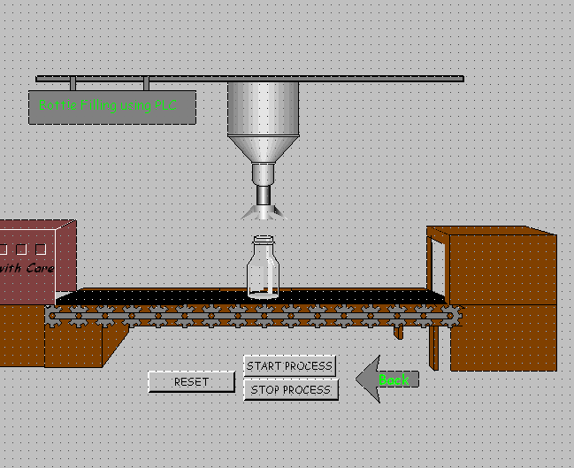
Fig.6.9 SCADA screen showing animated bottle filling application
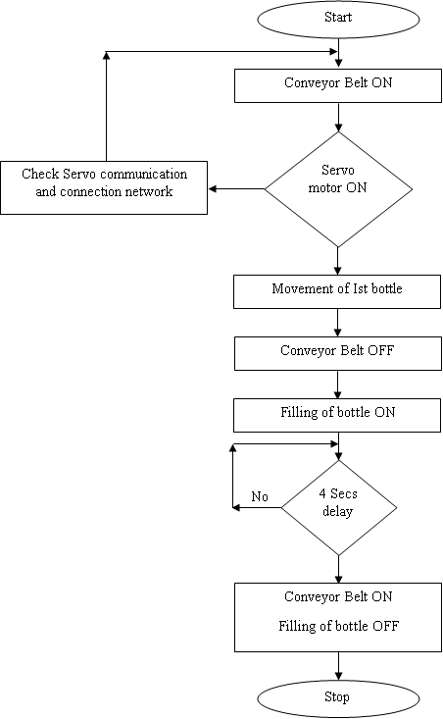

Fig. 6.10 Bottle filling using SCADA

6.4.2 DESIGNING SCADA SYSTEM FOR AUTOMATIC LOADING/ UNLOADING IN GODOWNS

Another application developed using SCADA screens, PLC and servomotor is that of automatic loading of packed items in a load carrier using conveyor operation. Screen developed is displayed in Fig. 6.11. In this design example as well the conveyor movement gets real-time input from servomotor and barrels start to move because of conveyor movement. There is a sensor present near the conveyor belt which senses presence of faulted barrel movement and indicator turns red because of its presence. Further, the control system discards the faulted barrel and prevents it from loading into the load carrier.
When the start process button is pushed ON, conveyor movement starts. The conveyor gets real-time input from PLC, which is indicated by starting of servomotor. The barrels are continuously loaded on the conveyor and from conveyor into the load carrier except for some faulted barrels which are discarded and hence prevented from loading with other barrels. As soon as the load carrier is fully loaded, it moves and another load carrier takes its place, and same process is repeated again.

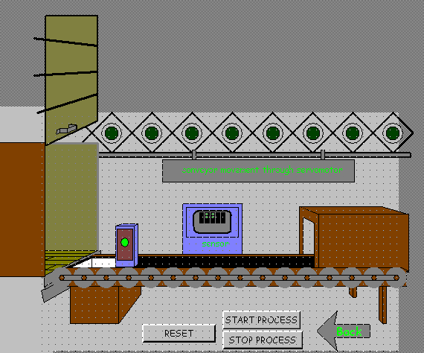
Fig.6.11 SCADA screen showing animated conveyor operation

6.5 PERFORMANCE STUDY AND POWER QUALITY ISSUES IN SERVO DRIVE

    - PERFORMANCE OF SERVO DRIVE UNDER NO LOAD CONDITION

Fig.6.12 shows the real time performance of the PWM based servo drive under no load condition. As soon as power supply is given to motor, the rotor reaches to set synchronous speed (3000 rpm) in about 300ms (shown in Fig. 6.14), which shows fast time response of AC servomotor as compared to AC motors of same ratings. The inrush current recorded at no load is about 30A, and it settles down to 18A at steady state. During this period magnitude of the voltage (rms) is maintained at a constant value of 109 volts (phase voltage). The power drawn during steady-state performance of motor is about 0.32 KW. Harmonic spectrum of line current going into the drive under no load condition and at rated speed is displayed in Fig.6.13 THD (total harmonic distortion) displayed is 75.3% of the fundamental component for the current magnitude (rms) of 5A. Harmonic spectrum at 50% of rated speed (1500 rpm) under no load condition has been shown in Fig.6.16. THD is 76.9% of the fundamental component for rms current of 4.87A. Comparing the two reading of harmonics it is observed that at lower current value, harmonics in line current increase which means that at low speed, performance and hence accuracy of control in servo drive is affected due to higher magnitude current harmonics. The speed response under no load and at half of rated speed is shown in Fig. 6.17. It is observed that the time response at low speeds is fast. Motor reaches to set speed in about 250ms at half of rated speed compared to 300ms at rated speed of 3000rpm.

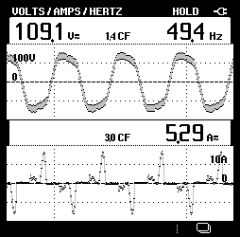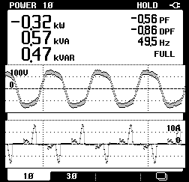

Fig. 6.12 Input voltage and line current of servomotor under no-load conditions at 3000rpm

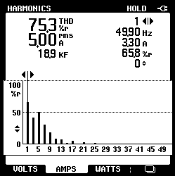
Fig. 6.13 Harmonic spectrum of line current at 3000rpm

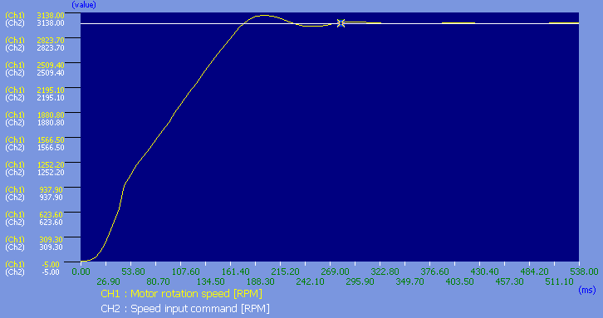
Fig. 6.14 Speed variation during starting of three-phase ac servomotor

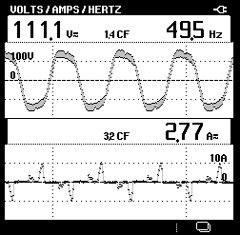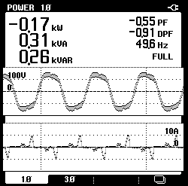
Fig. 6.15 Input voltage and line current of servomotor under no-load conditions at 1500rpm
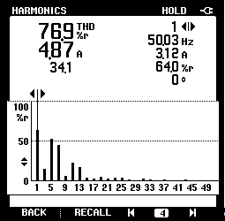
Fig. 6.16 Harmonic spectrum of line current at 1500rpm

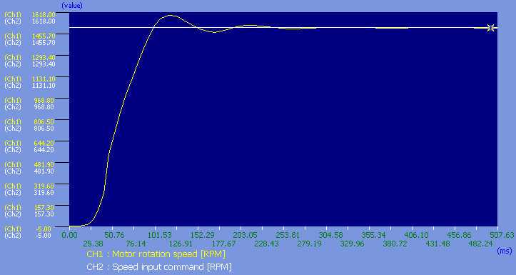
Fig. 6.17 Speed variation during starting of ac servomotor at no load and 1500rpm speed

6.5.2 PERFORMANCE OF MOTOR UNDER VARIABLE TORQUE (LOAD)

Fig.6.18 shows real time performance of servo drive with 25% load condition at rated speed (3000rpm). Fig.6.21 shows real time performance of servo drive with 50% load condition and rated speed (3000rpm). Continuous variation of load from 6% to almost 70% of full load torque is applied on servomotor which accounts for load torque from 0.19Nm to 2.23Nm. On applying load torque of more than 70% servo drive shows an over load warning and servomotor trips and reconnects several times until load applied is a bit released. Speed of the motor is constant throughout, i.e. as the load torque increases there is no change in the speed of the motor and it maintains speed at 3000rpm. The current drawn increases continuously as the torque is increased i.e. from no load value of 5.29A it increases to 17.71A at 25% load torque and to 25.25A at 50% load. During this transition the magnitude of voltage varies in between 105.4 volts to 195.8 volts. The power drawn under no load condition is 0.32 kW and increases to 1.29kW as load torque increases to 0.79Nm. Harmonic spectrum of the line current at 25% load condition and rated speed is shown in Fig.6.19. THD (total harmonic distortion) is 61.7% of the fundamental component with current reading (rms) of 17.81A. Harmonic waveform of the current at 50% load and rated speed is displayed in Fig.6.22. THD reading at 50% load and rated speed is 55% of the fundamental with line current (rms) of 25.51A. Comparison of harmonic waveforms at different loads reveals that at higher load torque value of harmonics in line current decreases, this shows that servo drive performance is better as the load torque increases. Fig.6.20 shows speed variation observed at 25% of load torque and speed of 3000rpm. Motor reaches to 1500rpm in about 800ms at 25% load. A switching operation is observed when motor is started at 25% load and rated speed. However, motor is unable to start at 50% load and rated speed.

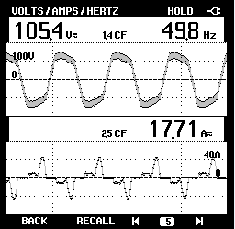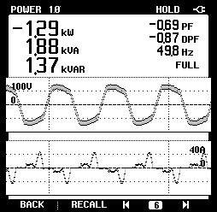

Fig. 6.18 Input voltage and line current of servomotor at 25% load conditions at 3000rpm
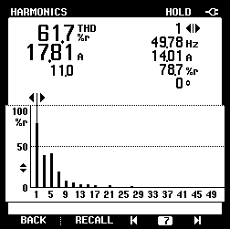
Fig. 6.19 Harmonic spectrum of line current at 25% load and 3000rpm speed

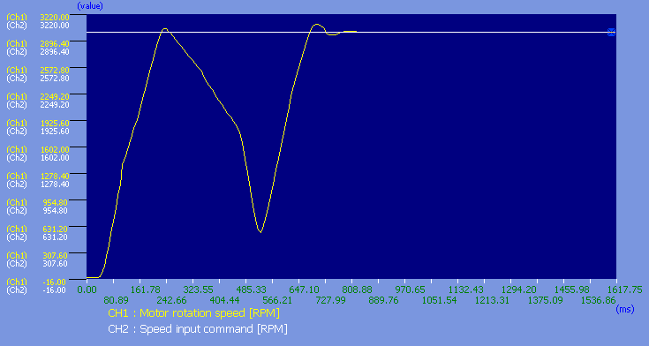
Fig. 6.20 Speed variation during starting of ac servomotor at 25% load and 3000rpm speed

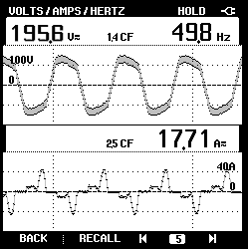
Fig. 6.21 Input voltage and line current of servomotor at 50% load conditions at 3000rpm
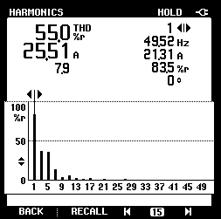
Fig. 6.22 Harmonic spectrum of line current at 50% load and 3000rpm speed

Fig.6.23 shows the performance of servo drive with 25% load at 1500 rpm (half of rated speed). Fig.6.26 shows the performance of servo drive with 50% load at 1500 rpm. The load is varied continuously from 6% to 70% of full load torque. The motor performance is almost similar to that observed at rated speed except for the fact that motor can operate at 70% load torque for longer time compared to its operation at a speed of 3000Rpm. The current reading increases continuously as the torque is increased i.e. from no load value of 2.77A it increases to 10.96A at 25% load torque and to 18.13A at 50% load. The power drawn under no load condition is 0.17 kW and increases to 1.34kW as load torque increases to 0.79Nm Harmonic spectrum of the line current at 25% load condition and half of rated speed is shown in Fig.6.24. THD (total harmonic distortion) is 71.7% of the fundamental component with current (rms) of 10.03A. Harmonic spectrum of the line current at 50% load and half of rated speed is shown in Fig.6.27. THD reading at 50% load is 61.8% of the fundamental with current (rms) of 18.18A. Comparison of harmonic waveforms at different load torque values reveals that at higher load torque, value of harmonics in line current decreases, but at lower speed the value of harmonics is more. This shows that servo drive performance is better as the load torque increases and also as speed increases. Fig.6.25 shows speed variation observed at 25% of load torque and speed of 1500rpm. Fig.6.28 shows speed variation observed at 50% of load torque and speed of 1500rpm. It is observed that the time response at increased load is fast. Motor reaches to set speed in about 250ms at 25% load compared to 170ms at 50% load and half of rated speed.
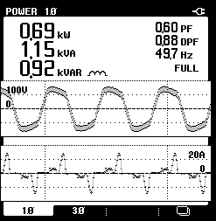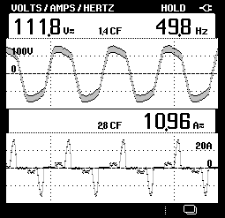
Fig 6.23 Input voltage and line current of servomotor under 25% load conditions at 1500rpm

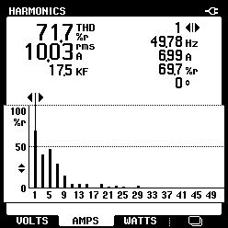
Fig. 6.24 Harmonic spectrum of line current at 25% load and 1500rpm speed

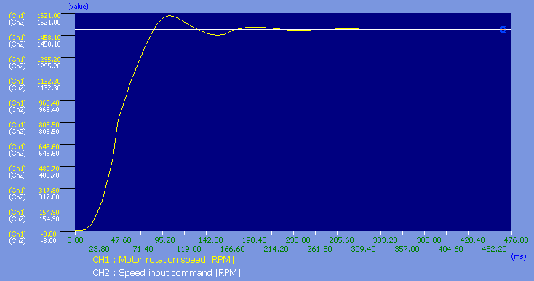
Fig. 6.25 Speed variation during starting of servomotor at 25% load and 1500rpm speed
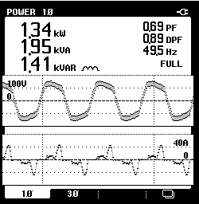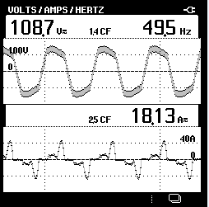
Fig 6.26 Input voltage and line current of servomotor under 50% load conditions at 1500rpm

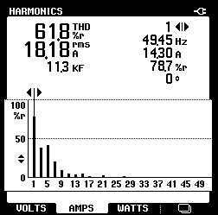
Fig. 6.27 Harmonic spectrum of line current at 50% load and 1500rpm speed
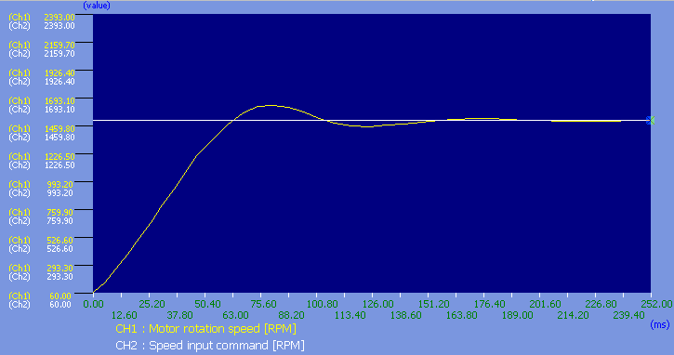
Fig. 6.28 Speed variation during starting of servomotor at 50% load and 1500rpm speed
6.5.3 PERFORMANCE OF SERVO DRIVE UNDER VARIABLE SPEED CONSTANT LOAD CONDITION

The Real-time performance of the PWM based servo drive under variable speed constant load condition (25% of load torque) is discussed herein. For a speed of 500rpm power consumption is 0.36kW at a current (rms) of 5.55A. As we go on increasing speed from 500rpm to 3000rpm (rated speed) the power consumption goes on increasing from a value of 0.36kW to 1.29kW with increase in current from 5.55A to 17.71A. Therefore, it is clear that with increasing speed, current also goes on increasing and performance of motor gets better as harmonic distortions in supply current go on decreasing. Input voltage and line current at 25% of load torque and 500rpm speed is shown in Fig. 6.29. Harmonic spectrum at 25% of load torque and 500rpm speed is displayed in Fig. 6.30.

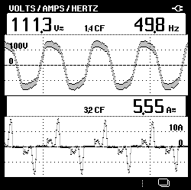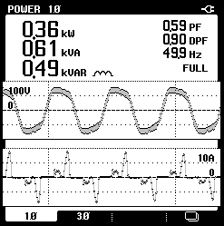
Fig. 6.29 Input voltage and line current of servomotor at 25% load and 500rpm

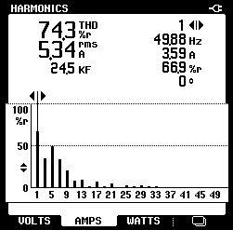
Fig. 6.30 Harmonic spectrum of line current at 25% load and 500rpm speed
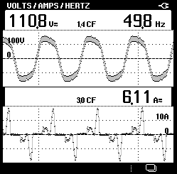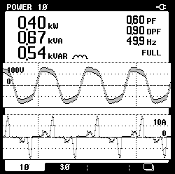
Fig 6.31 Performance of servomotor under 25% load and 1000rpm

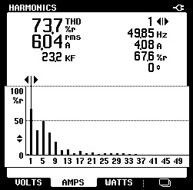
Fig. 6.32 Harmonic spectrum of supply current at 25% load and 1000rpm speed

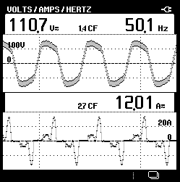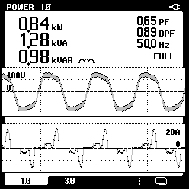
Fig 6.33 Performance of servomotor under 25% load and 2000rpm
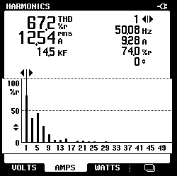
Fig. 6.34 Harmonic spectrum of supply current at 25% load and 2000rpm speed
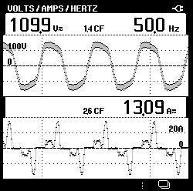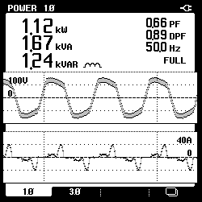
Fig 6.35 Performance of servomotor under 25% load and 2500rpm

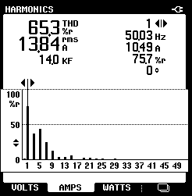
Fig. 6.36 Harmonic spectrum of supply current at 25% load and 2500rpm speed
6.5.4 SPEED TORQUE CHARACTERISTICS

Fig.6.37 shows speed and torque variation as load is continuously increased from 6% to 70% and above. As soon as motor operation begins, it reaches synchronous speed in about 0.3secs. The speed of motor is then constant throughout. When the increased load reaches to about 71%, switching operation is observed i.e. motor tries to reach set speed but before it responds to set value, speed again decreases resulting in switching and preventing motor from turning ON. Fig.6.38 shows variation of main circuit voltage with increasing load.
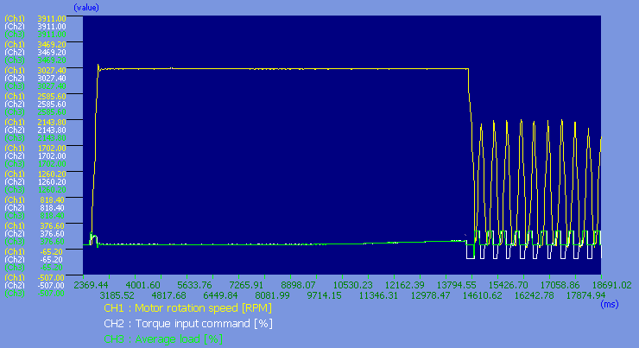
Fig. 6.37 variation of speed and torque with variable load

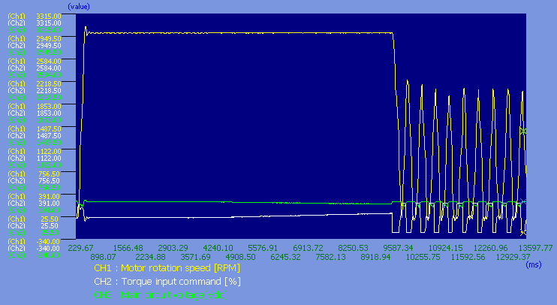
Fig. 6.38 variation of speed and main circuit voltage with variable load
  - CONCLUSION

The control of AC servomotor through PLC, SCADA/HMI has been successfully implemented and tested for specific applications. Various application programs have been developed in PLC programming language and SCADA and these applications have been tested in Real-time. The analysis related to performance of servo drive reveals better performance of motor with increasing speed and at an increased load torque.

CHAPTER VII
CONCLUSION AND FUTURE SCOPE OF WORK

  - MAIN CONCLUSION

In this dissertation a control scheme for a three-phase AC servomotor has been developed using PLC, SCADA and HMI. The designed scheme has been successfully implemented and tested for control of AC servomotor in three basic modes i.e. position, speed and torque modes using PLC programming and SCADA/HMI control. Several communication modes and protocols have been used to achieve efficient control of servomotor. Ethernet communication between PLC, PC and SCADA provides communication at a high speed value, while Profibus communication mode is used to make PLC communicate with field devices. These communications make control of servomotor easy from any place in the given network. Some virtual process operation programs such as those for automated bottle filling system, automatic sorting and loading of containers in transport vehicle have been developed using PLC programming language and SCADA. These applications have been tested using real-time inputs from PLC. It is observed that these virtual schemes synchronise with their real control processes. Performance of servo drive and its effects on power quality are recorded in different varying conditions i.e.
a) Performance of servo drive under no load condition
b) Performance of motor under variable torque (load)
c) Performance of servo drive under variable speed constant load condition
The control system designed is based on the most advanced PLC technology which gives high amount of flexibility and efficiency. Effective Speed control especially in low speed is another efficient feature of the system.

  - FUTURE SCOPE OF WORK

a) The control scheme that has been developed can be simulated in MATLAB to verify the results obtained.
b) Practical implementation of the developed SCADA screens can be attained, since each application developed runs using real-time inputs from PLC.
c) The control scheme developed can be tested for various other parameters of the servo-drive to make the developed method more flexible.

REFRENCES
- Maria G. Ioannides, Senior Member, IEEE, “Design and Implementation of PLC-Based Monitoring Control System for Induction Motor”, IEEE transaction in energy conversion, vol.19, no.3, 2004.
- A.M. Graham and M. Etezadi-Amoli, “Design, Implementation and Simulation of PLC Based Speed Controller Using Fuzzy Logic”, Proceedings of IEEE Power Engineering Society Summer Meeting, vol. 4, 2000, pp. 2475–2480
- A.S.Zein El Din, “High Performance PLC Controlled Stepper Motor in Robot Manipulator”, in Proceedings of IEEE International Symposium on Industrial Electronics, vol.2, 1996, pp. 974–978.
- Wang Huiqiang, Cui Jianjun, Zheng Ying and Hu Minying, “The Research And Design Of The Belt Grinder Which Based On PLC”, IEEE International Asia Conference on Informatics in Control, Automation and Robotics 2009
- Adel A. Ghandakly, Mark. E. Shields, and Mohammed E. Brihoum, “Design of an adaptive controller for a DC motor within an existing PLC framework,” in Proceedings of Conf. Rec. 31st IEEE Industry Applications Society Annual Meeting, vol. 3, 1996, pp. 1567–1574
- REN Sheng-le, LU Hua, WANG Yong-zhang and FU Hong-ya, “Development of PLC-based Tension Control System”, Chinese Journal of Aeronautics 20(2007) 266-271
- A. R. Al-Ali, M. M. Negm, and M. Kassas, “A PLC based power factor controller for a 3-phase induction motor,” in Proceedings Conf. Rec. IEEE Industry Applications, vol. 2, 2000, pp. 1065–1072
- I. Colak, R. Bayindir, A Bektas, I. Sefa and G. Bal, “Protection of Induction Motor Using PLC”, proceedings on Power engineering IEEE, April 12-14, 2007, Setubal, Portugal
- Xiaoling Yang, Qunxiong Zhu and Hong Xu, “Design and Practice of an Elevator Control System Based on PLC”, 2008 Workshop on Power Electronics and Intelligent Transportation System, August 2-3
- Robert A. Hanna, Peter Bulmer and Rasul Kohis Ani, “Minimizing Refinery Upset During Power Interruptions Using PLC Control.” Petroleum and Chemical Industry Conference, 1992, Record of Conference Papers, Industry Applications Society 39th Annual Volume , Issue , 28-30 Sep 1992 Page,185 - 195
- Tanabodee Duangsoithong and Chanapan Kongnam, “Renovation of Turbine Control System Using PLC-Based for Small Hydroelectric Power Generation”, Technical Report, 2007 (in Thai).
- Gabor A. Biacs and Milan S. Adzic, “PLC Control for a Rotating Ironing Press”, proceedings of IEEE 2008
- Masao Ogawa and Yutaka Henmi, “Recent Developments on PC+PLC based Control Systems for Beer Brewery Process Automation Applications”, SICE-ICASE International Joint Conference 2006 Oct. 18-21, in Bexco, Busan and Korea.
- Zhao Futao, Du Wei, Xu Yiheng and Hu Zhiren, “Programmable Logic Controller Applied in Steam Generators Water Levels,” in Proceedings of IEEE/IAS 31st Annual Meeting Conference. Rec. , vol. 3, 1996, pp .1551–1556.
- A. Hossain and S. M. Suyut, “Monitoring and controlling of a real time industrial process using dynamic model control technology,” in Proceedings of IEEE Ind. Application Soc. Workshop on Dynamic Modelling Control Applications for Industry, 1997, pp. 20–25
- D. P. Eng, “Diesel generation control system modernization,” in Proc IEEE Con. Elect. Computer Eng. Conf. Rec., vol. 1, 1998, pp. 125–128.
- L. Canan Dulger and Ali Kirecci, “Motion Control and Implementation for an AC Servomotor System,” Modelling and Simulation in Engineering, Volume 2007, Article ID 50586, 6 pages
- Akira Shimada, Yu Kishiwada and Michiyo Arimura, “AC Servo Motor Position Sensorless Control using Mechanical Springs”, proceedings of IEEE 2006
- Yoshitaka Morimoto, “Evaluation of positioning performance of a fine-coarse mechanism by AC servomotors”, SICE Annual Conference 2008 August 20-22, 2008, The University Electro-Communications, Japan, pp378-383.
- Heui-Wook Kim, Jong-Woo Choi, Seung-Ki SUI, “Accurate Position Control for AC Servo Motor using Novel Speed Estimator”, proceedings of IEEE 1995, IECON 21st International Conference.
- Dongmei Yu, Qingding Guo and Qing Hu, “Position Control of Linear Servo System Using Intelligent Feedback Controller”, Proceedings of the Sixth International Conference on Intelligent Systems Design and Applications (ISDA'06), IEEE.
- Joon Hyuk Kang, Chung Hyuk Yim and Dong I1 Kim, “Robust Position Control of AC Servo Motors”, Industrial Electronics, Control, and Instrumentation, 1995., Proceedings of the 1995 IEEE IECON 21st International Conference on Volume 1.
- Akihiko Yoneya, Kiyotaka Yoshimaru and Yoshitaka Togari, “Self-Sensing Control of AC-Servo Motor with DSP Oriented Observer”. 6th International Workshop on Advanced Motion Control, proceedings of IEEE 2000
- Kariyappa B. S., Hariprasad S. A. and R. Nagaraj, “Position Control of an AC Servo Motor Using VHDL & FPGA”, World Academy of Science, Engineering and Technology, Vol. 49, Jan 2009.
- Kariyappa B. S and Dr. M. Uttara Kumari, “FPGA Based Speed Control of AC Servomotor Using Sinusoidal PWM”, IJCSNS International Journal of Computer Science and Network Security, VOL.8 No.10, October 2008.
- Uk-Youl Huh and Je-Hie Lee, “A Modified Sliding Mode Speed Control Scheme for AC Servo Motor”, proceedings of IEEE 1995, IECON-95, Vol. 2, pp 730-735.
- Geum-Bae Cho and Pyoung-Ho Kim, “A Precise Control of AC Servo Motor Using Neural Network PID Controller”, Current science, Vol. 89, No. 1, 10 July 2005
- Pyoung-Ho kim, Sa-Hyun Sin, Hyung-Lae Baek and Geum-Bae Cho, “Speed Control Of AC Servomotor Using Neural Networks” Proceedings of the 1995 IEEE IECON 21st International Conference.
- D. Swoboda and T. Gallmeister, “Implementation of the Control and supervision of ALICE ZDC positioning Systems”, ALICE-DOC-2004-003 v.1
- Aung Naing Myint, Hla Soe, Theingi, and Win Khaing Moe, “Implementation of Control Unit using SCADA System for Filling System”, World Academy of Science, Engineering and Technology vol. 46, 2008.
- VersaMotion Servo Motors and Amplifiers User’s Manual, GFK-2480 December 2007 by“GE Fanuc”.

