“Implementation of Process Accelerator for Productivity Management and Enhancement in SMEs”

A Dissertation submitted in partial fulfilment of the requirement for the award of minor project of

Master of Engineering
In
Computer Technology and Application

By Under the guidance of
Priti Kumari Goyal Mr. Vinod Kumar
College Roll No. - 09/CTA/07 Asstt. Professor
University Roll No. – 12206 Delhi College Of Engineering, Delhi

Department
Department of Computer Engineering
Delhi College of Engineering
University of Delhi
2008-2009
CERTIFICATE

DELHI COLLEGE OF ENGINEERING
(Govt. of National Capital Territory of Delhi)
BAWANA ROAD, DELHI – 110042

Date: ___________

This is to certify that dissertation entitled “IMPLEMENTATION OF PROCESS ACCELERATOR FOR PRODUCTIVITY MANAGEMENT AND ENHANCEMENT IN SMEs” has been completed by Priti Kumari Goyal in partial fulfilment of the requirement of Master of Engineering in Computer Technology & Application.

This is a record of his work carried out by him under my supervision and support during the academic session 2008 -2009. This is a beneficial work in the field of software development & automation for project management & productivity enhancement of small & medium size software organizations. This is very critical element for survival & growth of any SMEs.

(Mr. Vinod Kumar)
Asst. Professor & Project Guide
(Dept. of Computer Engineering)
Delhi College of Engineering
BAWANA ROAD, DELHI - 110042
ACKNOWLEDGEMENT

“At times our own light goes out and is rekindled by a spark from another person. Each of us has a cause to think with deep gratitude of those who have lighted the flame within us."
–Albert Schweitzer

It is distinct pleasure to express my deep sense of gratitude and indebtedness to my learned supervisors Mr. Vinod Kumar, Department of Computer Engineering, Delhi College of Engineering, for their invaluable guidance, encouragement and patient reviews. His continuous inspiration only has made me complete this dissertation. He kept on boosting me time to time for putting an extra ounce of effort to realize this work.
I would also like to take this opportunity to present my sincere regards & thanks to Mr. Pankaj Goyal, manager Senior Technical Consultant, CresTech S/W System Pvt. Ltd. for their guidance, coaching, support and encouragement.
Finally, I would like to thank my classmates for their unconditional support and motivation during this work.

(PRITI KUMARI GOYAL)
Master of Engineering
(Computer Technology & Application)
Dept. of Computer Engineering
DELHI COLLEGE OF ENGINEERING
BAWANA ROAD, DELHI - 110042
ABSTRACT

Since the beginning of industrial revolution and setting up of manufacturing industries, resource productivity management has always been the main concern of the enterprises. Productivity management approaches have been developed and mastered in order to optimally utilize the resources under given dynamic constraints within an organization. Productivity management gains all the more importance in the time of economic downturn and slowdown when companies look to get more from less.

There have been multiple theories and papers published on productivity management. Total productivity management (TPM) formulated and propagated by Dr David. J. Sumanth also talks about improving the competitiveness of products and services in quality, price, cost and customer responsiveness, thereby increasing the profitability, market share, and return on investment in human, material, capital, and technology resources.

One of the major problems afflicting the TPM approaches is the scale. While these productivity management approaches have been practiced and modified innumerable times by large enterprises, small and medium enterprises (SMEs) often find it difficult to commit to a structured approach of productivity management. Some of the reasons for this are pressures on Margins, absence of a dedicated quality control department within organization and often Ad-hoc nature of operations. Also while there have been established principals and methodologies on improving productivity in manufacturing field, there have been little research done in the field of software.

Aim is to study some of the common factors impeding the productivity management in small and medium enterprise, identify the common problems and propose and implement a solution (called Process Accelerator) to resolve the problem through effective knowledge management and clear cut work breakdown structure. Results achieved out of the implementation of Process Accelerator in phase 1 within Crestech were really encouraging with managers reporting a productivity increase of nearly 15%

While this study has been done and solution implemented in one of the enterprises (Crestech Software Systems), I am confident that the same process with some slight modification can also be implemented across large organizations.

TABLE OF CONTENTS

CERTIFICATE 2
ACKNOWLEDGEMENT 3
ABSTRACT 4
List of Figures 7
List of Tables 7
- INTRODUCTION............................................................................8
1.1 General Concepts 8
1.2 Motivation 9
1.3 Related work 10
1.4 Proposed work 12
1.5 Thesis Statement & Outline 13
- PRODUCTIVITY MANAGEMENT............................................14
2.1 Conventional Approach 14
2.2 Shortfalls in Conventional Approach 31
- BUSINESS INTELLIGENCE.......................................................35
3.1 Balance Scorecard 39
3.2 Reports and Dashboards 43
- OUR APPROACH IN FINDING SOLUTION 46
4.1 Problem Gathering 46
4.2 Result 47
4.3 Proposed Solution 49
5. PROCESS ACCELERATOR DEFINITION...............................51
6. PROCESS ACCELERATOR IMPLEMENTATION.................53
  - Scenarios 55
  - Use Cases 57
  - Database Structure 65
  - Screenshots 70
  - Reporting 76
7. CONCLUSION...................................................................................80

REFERENCES 83
LIST OF FIGURES

Figure 3.1: Business intelligence...............................................................37
Figure 3.2: Balance scorecard....................................................................41
Figure 3.3: Dashboard reports....................................................................45
Figure 6.1: Admin Activities form for user details....................................70
Figure 6.2: Admin Activities form for creating user account....................71
Figure 6.3: Admin Activities form for entity details….............................71
Figure 6.4: Admin Activities form for role details....................................72
Figure 6.5: Admin Activities form for role privilege details.....................72
Figure 6.6: Manager Activities form (home page)....................................73
Figure 6.7: Manager Activities form for SLA details................................73
Figure 6.8: Manager Activities form for account details...........................74
Figure 6.9: Manager Activities form for process accelerator details.........74
Figure 6.10: Manager Activities form for product service details.............75
Figure 6.11: Reporting Layer.....................................................................79

LIST OF TABLES

Table 2.1: Two approaches to 20% increase in productivity....................18
Table 2.2: Roadmap to high productivity..................................................19
Table 2.3: Quality-delivery grid................................................................20
Table 6.1: Use cases for iteration1 (tester and manager)...........................57
Table 6.2: Use cases for iteration2 (manager)...........................................60
Table 6.3: Use cases for iteration3 (admin)...............................................63
Table 6.4: Typical database table..............................................................65

Chapter 1

INTRODUCTION

1.1 GENERAL CONCEPT:
A general definition of productivity is the relationship between output generated by the production or service system and input provided to generate this output. Thus productivity is defined as the efficient use of resources – information, human, capital, land etc. in the production of various goods and services

Higher productivity means accomplishing more with the same amount of resources or achieving higher output in terms of volume and quality for the same input. This is usually stated as

Output/Input = Productivity

Productivity can also be defined as relationship between results and time it takes to accomplish them. Time is often a good parameter since it is a universal parameter and beyond human control. The less time taken to produce the desired result, the more productive is the system. Though productivity means different things to different people, the basic concept is always the relationship between quantity and quality of services produced and quantity/quality of resource consumed to produce them.

There are many productivity factors the firm can manage. How well does the firm utilize new knowledge; is it working at an economy-of-scale level; are the employees highly motivated and loyal or is there resource unrest and high worker turnover; is the resource (human and capital) allocation maximizing established goals; and finally, what is the overall quality of the company's management? And, if management sees productivity as a problem, is there a commitment to establish a company-wide Productivity Improvement Program?

The Role of knowledge Management in productivity management cannot be stated more. In modern knowledge driven economies, firms are increasingly aware that individual and collective knowledge of team is a major factor of improving performance. The larger the firms and the stronger their connection with technology intensive industries, the more are they likely to set up knowledge management (KM) policies, such as promoting a culture of information and knowledge sharing , motivating employees and executives to remain with the firm, forging alliances and partnerships for knowledge acquisition, implementing written knowledge management rules.
Taking this to the Software Industry, effective Software Project management has been considered as an effective sidearm to Software Productivity management. Software project management is a sub-discipline of project management in which software projects are planned, monitored and controlled.

1.2 MOTIVTION:
In organization, where multiple projects are happening concurrently & there are multiple stake holders, there is a need to have a transparent system, which will not only streamline project development process, project tracking process, project delivery process and project quality tracking process. This is becoming more and more important considering skill set with in company varies from basic level to advance level.
It’s also important to ensure that managers are able to monitor and track delivery against metrics like schedule adherence, quality, SLA with customer etc

R&D team within Crestech is working on building a New Age Services Portfolio management solution. This product (called in interim as Process Accelerator) is aimed towards SME segment and helps companies manage their project portfolio in a more reliable and repeatable manner. This product is first of its kind solution that helps companies leverage upon the power of integrated project management solution with the process framework of corporate best practices

“Process Accelerator” is a process framework for Project Management in a software organization. This is developed with the objective to keep all the stakeholders customers, project management, senior management etc. on the same page on the project development.

Business Intelligence(BI) is one of the most critical components of this solution. The conventional approach to data mining and BI might not be suited for the real time on the fly reporting needs of modern day manager who needs to be equipped with intelligent data analysis to take critical business decisions.

We need a better approach where instead of gathering data from different systems and collating at one database and then drawing reports out of it, the data is picked at runtime from these systems and reports are generated on the fly. This can also be implemented as SAS model

1.3 RELATED WORK

There have been multiple theories and papers published on productivity management. Total productivity management (TPM) formulated and propagated by Dr David. J. Sumanth also talks about improving the competitiveness of products and services in quality, price, cost and customer responsiveness, thereby increasing the profitability, market share, and return on investment in human, material, capital, and technology resources.

One of the major problems afflicting the TPM approaches is the scale. While these productivity management approaches have been practiced and modified innumerable times by large enterprises, small and medium enterprises (SMEs) often find it difficult to commit to a structured approach of productivity management. Some of the reasons for this are pressures on Margins, absence of a dedicated quality control department within organization and often Ad-hoc nature of operations. Also while there have been established principals and methodologies on improving productivity in manufacturing field, there have been little research done in the field of software.

The balanced scorecard is a strategic planning and management system that is used extensively in business and industry, government, and nonprofit organizations worldwide to align business activities to the vision and strategy of the organization, improve internal and external communications, and monitor organization performance against strategic goals. It was originated by Drs. Robert Kaplan (Harvard Business School) and David Norton as a performance measurement framework that added strategic non-financial performance measures to traditional financial metrics to give managers and executives a more 'balanced' view of organizational performance. While the phrase balanced scorecard was coined in the early 1990s, the roots of the this type of approach are deep, and include the pioneering work of General Electric on performance measurement reporting in the 1950’s and the work of French process engineers (who created the Tableau de Bord – literally, a "dashboard" of performance measures) in the early part of the 20th century.

This new approach to strategic management was first detailed in a series of articles and books by Drs. Kaplan and Norton. Recognizing some of the weaknesses and vagueness of previous management approaches, the balanced scorecard approach provides a clear prescription as to what companies should measure in order to 'balance' the financial perspective.

1.4 PROPOSED WORK

In the proposed work, I studied some of the common factors impeding the productivity management in small and medium enterprise, identified the common problems and propose and implemented it in a software (called Process Accelerator). This software is proposed to resolve the problem through effective knowledge management and clear cut work breakdown structure. I did implementation & got some early results. Results achieved out of the implementation of “Process Accelerator” in phase 1 within Crestech were really encouraging with managers reporting a productivity increase of nearly 15%.

Following are the goals listed out to develop the Process Accelerator.

1. Provide feature to define process framework for different type of services
- Support variability in process framework for same service across customers in separate verticals
2. Support security role to ensure strict control on information
3. Provide reports and visualizations
- Provide homepage and dashboard to help user identify key tasks or metrics. Keep information in this pages actionable
4. Support scale and performance
- Multiple user access up-to 100 users with concurrency of 25 users
5. Provide external portals accessible to key customer users and internal users allowing them to view status of their projects and perform other functions
6. Support content management
- Ability to upload documents used during service delivery
- Ability to define guidelines
- Ability to link external web pages as reference

1.5 THESIS STATEMENT AND OUTLINE

This thesis is organized as follows:

Chapter 2 describes the conventional approach of Productivity Management with some business example. This chapter also describes the shortfalls in conventional approach.

Chapter 3 describes “Business Intelligence”, which provides support and development of procedures for making business decisions and Balance Scorecard. Business intelligence today covers the elements of information technology, accounting management, business analysis and marketing. The balanced scorecard is a strategic planning and management system that is used extensively in business and industry

Chapter 4 describes our approach in finding solution for productivity management & enhancement in SME, which includes Questionnaire Approach, Result and Solution.

Chapter5 describes the details of "Process Accelerator Definition".

Chapter 6 describes the implementation details & results, which includes Scenarios, Use Cases, Database Structure, Screen Shots and Reporting.

And finally Conclusion and Future work are mentioned in Chapter 7.

Chapter 2

PRODUCTIVITY MANAGEMENT

In today's result oriented world, we all want to become more productive. Increased productivity is often seen as the way to achieve increased success, increased income, and ultimately increased satisfaction and happiness. Essentially, a productive person is someone who yields many positive results. Similarly, a productive day is one when a lot of work is accomplished. It is easy to see the connection between productivity and time. Writing an article or a report in a couple of hours is a productive thing to do, whereas a less productive person might spend a week or two on the same task.

2.1 Conventional Approach:
When costs rise, the knee-jerk reaction of many companies is to assault their customers with higher prices and/or their employees with lower wages or layoffs. Customers strike back by buying less or from somewhere else, and employees by working less or starting unrest. As a result, costs further increase, profits further decline. The problem is compounded and the vicious cycle begins. Not a few companies have self-destruct with such easy and thoughtless approach to contain costs.
It is the fundamental job of managers to absorb costs by increasing productivity, not by sacrificing the company's most important stakeholders: customers and employees. World class companies have shown that any increase in almost all costs - man, material, machine, money (4M's) - can be diffused and dampened by productivity gains. What sets them apart from mediocre companies is that most of thinking and working time of their managers and executives are spent on continuously raising productivity throughout the organization. This non-stop company-wide effort continue to observe & check the increasing cost. Productivity gains serve as an invisible buffer ready to absorb costs increases if and when they come from any direction.
World Class and Conventional productivity:
The universal definition of productivity is OUTPUT/INPUT; the higher this ratio, the better. It is a measurement of how efficiently you convert inputs or resources into useful outputs, products, or results. Another way of looking at it is RESULTS/RESOURCES. Mathematically, you can increase the ratio by raising output, decreasing input, or both. But in terms of operating decisions, what we really change are
1) The amount of input and
2) The process that converts input to output.
Output is not actually manipulated; it is just a result of and the target for our decisions in 1) and 2). In practice, productivity is raised by improving the process rather than by adjusting the input quantity. Only after the process is improved, input requirements eventually reduced or output increased. Productivity is finding ways of doing things smarter and better. It is not as simple as adjusting input quantity or achieving economies of scale by operating at high volumes to increase input yields.
Two schools of thought on how to improve productivity have emerged:
Conventional:
"Getting the most output from the available input"
OR
MAXIMUM PRODUCTIVITY = MAXIMUM OUTPUT/AVAILABLE INPUT
World Class:
"Getting the required output with minimum input"
OR
MAXIMUM PRODUCTIVITY = REQUIRED OUTPUT/MINIMUM INPUT

OUTPUT IS USER-DEFINED
Before we examine the difference, let us see what we really mean by "output", the more important variable in our productivity ratio. As the term deceivingly connotes, it is something that is "put" "out" by any process - man or machine. It could be cars assembled, documents filed, hamburgers cooked, holes drilled, words typed per minute, etc. Not surprisingly, "output" is part of the engineering mind-set; output/input is the engineer's definition of machine "efficiency" until it was borrowed by business and renamed "productivity". As far as the engineer is concerned, anything that comes out of his machine is an output.
The problem starts when the concept is transplanted into the business setting, more precisely, the market place - where not all outputs are useful or have value. How is this so? In business, an output has value if it is a saleable or usable product, finished or in-process. All products are outputs, but not all outputs are products. Something does not become useful just because it comes out of a process. An output acquires value if and only if it is taken in - used or bought - as an input by another process - another worker, machine, or customer, whatever the case may be. We have to increase productivity in the context of coming out with outputs or products which a particular user desires. In short, it is making the right thing the right way. The next process, an internal customer or external customer, will accept an output of a preceding process as an input if it is of the right quality, quantity and arrives at the right time.

Productivity Is Not About Production
The danger with the conventional approach of maximizing output to raise productivity is that it tends to disregard the right quality and quantity which the user - the next process - will accept. The tendency is to overproduce, overstock and sacrifice quality for the sake of quantity. Even during times of lean demand due to product seasonality, tough competition, or product obsolescence, the factory is made to run at high gear, full capacity, in the name of "productivity." The problem worsens as productivity in this context is tied up to workers' compensation or to managers' bonus schemes. In effect, you are actually paying and motivating your employees to produce piles of inventory, wastes, defects, and increase carrying costs - productivity in reverse gear.
While conventional productivity is production-oriented, the world class approach is market-oriented. It starts with the requirements of the customer - output quantity and quality- and then works back to improve all processes and minimize all inputs. Since the productivity program started with the user or customer in mind, all outputs are guaranteed to be usable. Nothing is wasted in output or input. The world class productivity philosophy is consistent with the just-in-time or JIT manufacturing system which requires any process to produce only the quantity withdrawn or used by the next process.
It may appear that in a buyer's market, world class productivity, like JIT, would be more effective than the traditional approach. If all goods produced can be sold, wouldn't maximizing output be better than restricting output. Naturally, in such a situation, maximizing output is the best decision, but world class productivity is still the better option. In a seller's market, the "required output" in the world class productivity ratio becomes the "maximum output" because that is what is required by the market. It is however better than the conventional approach, because the latter just maximizes output with the available input, but a world class company would maximize output and minimize input at the same time in a seller's market, thus achieving much higher productivity and profitability. During high demand, a typical company would be excited and contented with high sales at the same cost, but a world class company will be one step ahead with high sales and lower cost.

APPARENT AND REAL PRODUCTIVITY:
Suppose 10 workers can assemble 100 radios per hour. If your can increase their efficiency through training, methods improvement, or kaizen by 20%, what will be the new set-up? The typical approach would be to let the 10 workers produce 120 radios. Since nobody is sure to buy the extra 20 radios, they would just stay as unplanned inventory - idle and costly. If the 20 radios are treated as useless output, then there was no change in real productivity. The more pragmatic world class approach is to let 8 workers produce the same 100 radios - without disturbing the market.

Table 2.1: two approaches to 20% increase in productivity
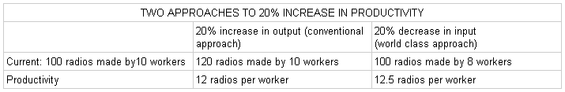
Customers will not increase their demand and budgets just because you increased your output and productivity - they could not care less. You cannot force them to buy and absorb your extra output just because you became smarter and more efficient. What happens to the two extra workers? They do not have to be laid off; they can be reassigned to some other jobs or lines and you could recruit less people next time. Their fate should not affect the implementation of productivity plans. Productivity will not increase if there is no decrease in labor inputs; if the same number of people just works faster, then there is no change in labor costs.
From the table above, we would notice that even in a seller's market, (all production are sold) ,conventional productivity would yield a productivity ratio of 120/10 or 12 radios/worker while the world class ratio is higher at 100/8 or 12.5. Decreasing input always yields higher productivity than increasing output by the same percentage. In fact, to raise the productivity ratio through kaizen, an input can be reduced continuously until it becomes zero and unnecessary.

Idle Output vs Idle Input:
Another difference between traditional and world class productivity is that the former tends to favor idle output while the latter, idle input. World class companies believe that it is always cheaper, wiser, safer, and more flexible to carry idle inputs - idle men, machines, raw material inventory - than to carry idle outputs in the form of finished goods inventory. The latter, which is high-value added outputs, would entail high carrying costs, not to mention the other hidden costs like risk of obsolescence. It is not unusual for world class companies to shut down entire lines and factories during times of lean demand; they have discovered that it is cheaper to pay workers salaries to do nothing than pay them to make radios that will not be sold.

WASTE ELIMINATION:
Productivity is increased by elimination of all waste - defined as anything unnecessary - input or output - that entails costs or investment. The first to tackle is unnecessary output, the next is unnecessary inputs. The following input-output grid shows the map to true productivity.
Table 2.2: Roadmap to High Productivity
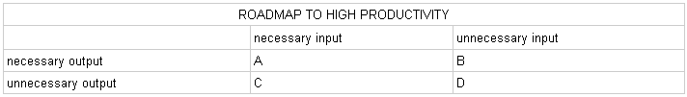
There are only two steps:
Step 1: Stop making unnecessary outputs - thus ridding of C and D. C means something valuable is used to produce waste. D means wastes to produce more wastes. Never produce something not needed by the next process, the internal customer, or the buyer, the external customer.
Step 2: Improve the process, and then eliminate all unnecessary inputs used in making necessary outputs - thus ridding of B. Only A should remain in the final stage in which there is no waste in either input or output.
We should never start with eliminating unnecessary inputs.

Finding the Right Output
How do we determine necessary outputs? Outputs include all products and services to satisfy an external or internal customer. "Necessary" means the right products and services at the right time as specified by the external or internal customer. The following quality-delivery grid shows the guide to determining necessary outputs.
Table 2.3: Quality-Delivery Grid
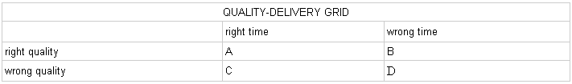
The right quality means the desired product with the desired specifications of the user or customer. The right time means neither early nor late - just in time for immediate usage by the customer. The right time also means the right quantity or amount - no more, no less - as required by the customer. For practical purposes, products delivered on time with the wrong quantity, insufficient or excess, are considered delivered at the wrong time. There are only two steps in determining the right output:
Step 1: Eliminate all products and services unwanted by the external or internal customer because of wrong quality- thus ridding of C and D.
Step 2: Avoid the early or late delivery of the right products and services - thus eliminating B. Only A should remain as the necessary output.
We should never start solving delivery problems; we may end up delivering the wrong products at the right time - another waste of time.

Resource Abundance Not an Excuse
Abundance of resource and inputs is often used as an excuse to waste them and run operations unproductively and inefficiently. Unproductive companies proliferate in economies endowed with cheap labor and abundant natural resources. World class companies make full and efficient use resources, regardless of their cost and availability, and regardless of the location of their operations. With cheap inputs, they earn much more profits than unproductive companies using the same resources.
World class productivity lowers total cost by focusing on the minimizing the usage of inputs, not by lowering the acquisition or purchase price of inputs. For instance, it does not justify low and exploitative wages. Japanese firms which have high productivity pay very high wages, but have low total labor costs. "Productivity Ode" summarizes this principle:

High wages with low productivity is charity
Low wages with high productivity is exploitation
Low wages with low productivity is suicide
High wages with high productivity is progress

Productivity Links Capital to Sales
Productivity is the black box that converts capital to sales and profits. It is the missing link that has been neglected and overlooked by those who think that business is all a matter of raising and increasing capital to buy more or better inputs, and expect sales and profits to naturally happen. These companies always discover that they are always starved for capital while profitability continuously decline. Infusing capital into wasteful
operations are like feeding fire with fire or throwing good money after bad. Of course, productivity cannot be bought by capital; there is no short-cut. It is a result of hard-work, change of corporate culture, management outlook, and if necessary, the change of the entire management.
The crux of world class productivity is to reduce resources (inputs) without sacrificing results (outputs) by improving and streamlining the conversion process. World class productivity will soften, if not neutralize, the effects of any increase in inputs costs in the 4M's through reduction in input quantity required, thus preserving profitability. Companies which continuously improve productivity are virtually immune from cost increases and inflation. They can maintain competitive prices while unproductive companies have no choice but to price themselves out of the market.

Challenges for Software Productivity Measurement

In order to understand the variables that affect software productivity, people interested in measuring it must be able to answer the following five questions: (a) Why measure software productivity? (b) Who (or what) should measure and collect software productivity data? (c) What should be measured? (d) How to measure software productivity? (e) How to improve software productivity? The purpose of asking these questions is to appreciate the complexity of the answers as well as to see that different answers lead to different software production measurement strategies. Unfortunately, as we have begun to see in the preceding section, the answers made in practice can lead to undesirable compromises in the analytical methods employed, or in the reliability of the results claimed.

Why measure software productivity?

In simplest terms, the idea is to identify (and measure) how to reduce software development costs, improve software quality, and improve the rate at which software is developed. In practical terms, this includes alternatives such as:
- increase the volume of work successfully accomplished by current staff effort,
- accomplish the same volume of work with a smaller staff,
- develop products of greater complexity or market value with the same staff workload,
- avoid hiring additional staff to increase workload,
- rationalize higher levels of capital-to-staff investment,
- reduce error densities in delivered products, and decreasing the amount of time and effort needed to rectify software errors,
- streamline or downsize software production operations,
- identify possible product defects earlier in development,
- identify resource utilization patterns to discover production bottlenecks and underutilized resources,
- identify high-output or responsive personnel to receive rewards, and
- identify low-output personnel for additional training or reassignment.
Clearly, there are many reasons for measuring software productivity. However, once again it may not be desirable to try to accomplish most or all of these objectives through a single productivity measurement program. For example, different people involved in a large software project may value certain of these alternatives more than others. Similarly, each alternative implies certain kinds of data be collected. This diversity may lead to conflicts over why and how to measure software productivity which, in turn, may lead to a situation where the measured results are inaccurate, misleading, or regarded with suspicion. Thus, a productivity measurement program must be carefully design to avoid creating conflicts, mistrust, or other conditions for mismeasurement within the software projects to be studied. Involving the software developers and project managers in the design of the measurement instrument, data collection, and feedback program can help minimize the potential organizational problems as well as gain their support.

Who should measure software productivity data?

The choice of who (or what) should collect and report software production data is determined in part by the reasons for measuring productivity noted above. The choices include:
- Programmer self report,
- Project or team manager,
- Outside analysts or observers,
- Automated performance monitors.
Programmer or manager self-reported data are the least costly to collect, although they may be of limited accuracy. However, if productivity measures are to be used for personnel evaluation, then one should not expect high reliability or validity in self-reported data. Similarly, if productivity measures are employed as the basis of allocating resources or rewards, then the data reporters will have an incentive to improve their reported production values. This is a form of the Hawthorne Effect, whereby people seek to accommodate their (software production) behavior to generate data values they think the data evaluators want to see.
Instead, we want to engender a software production measurement capability that can feed back useful information to project managers and developers in a form that enhances their knowledge and experience over time. Outside observers can often collect such information, but at a higher cost than self report.
Overall, if data quality or accuracy is not at issue, self-reported production data is sufficient. If causal behavior or organizational circumstances do not need to be taken in account, then automated performance monitors can be used. Similarly, if the desire is to show measured improvement in software productivity, whether or not production improves, self-reported or automated data collection procedures will suffice.
On the other hand, if the intent of the productivity measurement program is to ascertain what affects software production, and what alternative work arrangements might further improve productivity, then reliable and accurate data must be collected. Such data might best be collected by analysts or observers who have no vested interest in particular measured outcomes, nor who will collect data to be used for personnel evaluation. In turn, the collected data should be analyzed and results fed back to project developers and managers in a form they can act upon. Again, this might be best facilitated through the involvement of representative developers and managers in the design of the data collection effort.

What should be measured?

The choices over what to measure are many and complex. However, it is clear that focusing on program product attributes such as lines or code, source statements, or function points will not lead to significant insights on the contributing or confounding effects of software production process or production setting characteristics of software productivity, nor vice versa. The studies in earlier sections clearly indicate that different LSS product, process, and production setting characteristics individually and collectively affect software productivity. However, based on this survey, there are some inconsistencies in determining which characteristics affect what increase or decrease in software productivity. As such, an integrated productivity measurement or improvement strategy must account for characteristics of the products, processes, and settings to delineate the potential interrelationships. This is necessary since we cannot predict beforehand which constituent variables will reveal the greatest significance or variance in different projects or computing environments. Similarly, we should expect that software product, process, and setting characteristics will need to be measured using a combination of nominal, ordinal, interval and ratio measures. As such, consider in turn, the following constituents of software products, production processes, and production settings.

How to measure software productivity?

Measuring software productivity presupposes an ability to construct a measurement program comparable to those employed in experimental designs for behavioral studies. This is necessary to insure that the measures employed are reliable, valid, accurate, and repeatable.
In an informal sense, productivity is getting more bangs for the buck or doing the right things right. But these definitions do not help much when actual measurement is required. For that, a more mathematical approach is needed.
Productivity is a ratio, a comparison of what is produced and what is used to produce it. It compares outputs with inputs, that is, it divides outputs by inputs. Output is a physical entity - a car, a light bulb, a typed page, or a processed pay voucher. For measurement, an output must be countable over time, a direct result of identifiable activities, and homogeneous (don't mix apples and oranges). Inputs can be classified into four types: labor, materials, capital and energy.
Each input can be used as the basis of a partial measure of productivity, depending upon circumstances. Labor productivity, for example, is measured by dividing output by hours worked, number of employees, or labor cost. Capital productivity is arrived at by dividing output by money invested or machine hours used. Materials productivity is output divided by units of materials used, units of scrap, or money spent. And energy productivity is output divided by units of energy consumed (like BTU's), or money spent.
Labor productivity (output = hours worked) is used by the government as the measure of the Nation's productivity. Many large, diversified companies, however, now use all four inputs to determine what is called Total Factor Productivity. In a purely office environment, since labor is the key input, some organizations use what is called the Administrative Productivity Index (API). It divides work output such as typing, loans serviced, clients interviewed or invoices processed by total hours worked to produce the administrative output. So the API essentially is a labor productivity measure.
Outputs and inputs can be measured in physical units or values or both. For example, an input unit for labor is hours and for value is dollars. A unit of output is the physical count of something and its value is its base selling price. If value (the dollar) is used as the basis of measurement, inflation must be accounted for to maintain a true value over time in constant dollars. Thus, all input and output values usually are tied to the Producer Price Index of each input and output (this compensates for the impact of inflation) to maintain valid input-output and value relationships in constant dollars over time. In other words, if revenues from product an increased 20% over last year, but its price increased by 8% to account for inflation, the real increase in dollar output was 12%. Yearly comparisons must be done using constant dollars. If the company mixes dollars and units, it still must deflate the dollars to maintain a valid relationship between physical quantities and value.
Another complicating aspect of measuring productivity is that not all inputs are equal and not all outputs are the same. Some production processes are more labor intensive than others; some use a variety of different labor skill (value) levels. Output products also change in quality and composition over time. So the process of weighing inputs and outputs to account for their relative values must be done before a truly accurate productivity measure is possible.
The point to remember is, whether employing a partial or total productivity measurement, whether for service or industrial application, or whether the business is large or small, all inputs and outputs must reflect constant values and true mixtures. To do this, all factors must be deflated and weighed.
One final technical consideration, productivity measurements should be indexed to facilitate comparison. Index each input and output measure to a base year and assign each measure the number 100. This makes it easier to calculate percentage changes over time.
Measuring productivity is time consuming and demanding: inputs and outputs must be defined, appropriate formulas developed, worksheets for keeping count printed, data collected, and calculations made. But the result will be more than just some numbers. Productivity measurement will provide a tool to assess the efficiency and effectiveness of the company, to forecast investment requirements, and to estimate the impact of cost increases or technological advances. The results do justify the effort required.

How to improve software productivity?

In addressing this question, Boehm [10] identifies a number of strategies for improving software productivity: get the best from people, make development steps more efficient, eliminate development steps, eliminate rework, build simpler products, and reuse components. These strategies draw attention to the development activities or processes that add value to an emerging software system. However, Boehm does not indicate how these productivity improvement opportunities are or should be measured to ascertain their effectiveness, nor can he or anyone else state how much improvement each strategy or a combined strategy might realize.

There are many productivity factors the firm can manage. How well does the firm utilize new knowledge; is it working at an economy-of-scale level; are the employees highly motivated and loyal or is there labour unrest and high worker turnover; are the resource (human and capital) allocation maximizing established goals.

Establishing A Productivity Improvement Program
Recent studies indicate that the quality of management is the key to increasing business productivity. It is up to the managers to identify productivity problems and develop an appropriate program to solve these problems. In the past several years, many of the Nation's most successful, larger corporations have started Productivity improvement Programs (PIP). With profits slipping, their managements realized that improving productivity was the key to improving income; that only through an efficient and effective utilization of resources could they remain competitive and profitable.
The following Productivity Improvement Program outlines the key elements of programs successfully used by many companies including such giants as Honeywell, Westinghouse, GM and Ford.
Key elements of a Productivity Improvement Program (PIP):
1. Obtain Upper Management Support. Without top management support, experience shows a PIP likely will fail. The Chief Executive Officer should issue a clear, comprehensive policy statement. The statement should be communicated to everyone in the company. Top management also must be willing to allocate adequate resources to permit success.
2. Create New Organizational Components. A Steering Committee to oversee the PIP and Productivity Managers to implement it are essential. The Committee should be staffed by top departmental executives with the responsibilities of goal setting, guidance, advice, and general control. The Productivity Managers are responsible for the day-to-day activities of measurement and analysis. The responsibilities of all organizational components must be clear and well established.
3. Plan Systematically. Success doesn't just happen. Goals and objectives should be set, problems targeted and rank ordered, reporting and monitoring requirements developed, and feedback channels established.
4. Open Communications. Increasing productivity means changing the way things are done. Desired changes must be communicated. Communication should flow up and down the business organization. Through publications, meetings, and films, employees must be told what is going on and how they will benefit.
5. Involve Employees. This is a very broad element encompassing the quality of work life, worker motivation, training, worker attitudes, job enrichment, quality circles, incentive systems and much more. Studies show a characteristic of successful, growing businesses is that they develop a "corporate culture" where employees strongly identify with and are an important part of company life. This sense of belonging is not easy to engender. Through basic fairness, employee involvement, and equitable incentives, the corporate culture and productivity both can grow.
6. Measure and Analyze. This is the technical key to success for a PIP. Productivity must be defined, formulas and worksheets developed, sources of data identified, benchmark studies performed, and personnel assigned. Measuring productivity can be a highly complex task. The goal, however, is to keep it as simple as possible without distorting and depreciating the data. Measurement is so critical to success, a more detailed analysis is helpful.

Industry Examples
So much for theory and mechanics. In practice, how have various businesses and industries actually gone about improving productivity? In the banking industry, for example, there has been revolution in productivity in the past decade. Through the use of computers, magnetic ink character recognition equipment, and mechanizing various repetitive operations, there has been a 50 percent reduction in labor requirements for check handling between.
Studies on the cosmetics industry show that through improved technology and by utilizing larger plants, it maintained a solid 4% annual manufacturing productivity increase. Economies-of scale seem to have been the key factor here since plants with 500 or more employees were 37% more productive than the smaller ones. Studies on administrative productivity programs indicate that improved productivity comes from standardizing administrative procedures, streamlining operations, and increasing computer applications. These examples illustrate the importance to productivity of both advanced technology and proper management.
Different businesses use different measures of productivity. Airlines traditionally have used passengers boarded per employee and revenue ton miles per employee as partial productivity measures.

2.2 SHORTFALLS IN CONVENTIONAL APPROACH

Business is a dynamic competitive contest and in the realities of today’s business environment require companies to be fast, focused and adaptable in order to thrive.
Business processes that hinder these organizational capabilities, that make it more difficult for companies to reach to their optimized levels of performance, are unnecessary, if not harmful. Business leaders need to abandon cumbersome processes and, working with others in the business, improvise different, more productive ways to get the job done.
Business is a dynamic competition, similar in many ways to the game of basketball. In such contests, the plan changes as the game unfolds; strategies evolve; new tactics must be developed to compensate for what doesn’t work. The actions of competitors, the performance of team mates, and chance affect the dynamics of the game and thus, the requirements for success. The business team that quickly appreciates developments, improvises, and makes adjustments while still maintaining a focused approach is most likely to achieve peak performance in the competition.

Traditional productivity and performance management systems are insufficient:

There are several reasons why they’re insufficient.
They are costly and time consuming. Only some top level employees have knowledge regarding the project or product. So, whenever they quit then there are two ways to maintain the productivity. One is to hire the person having that knowledge by paying high wage and the other is to train the other employee which will take a lot of time.

They are too slow. To be truly educational, feedback has to occur at the speed of business circumstances. It is most powerful when it follows directly on the heels of performance. When feedback is fresh it can be more deeply discussed, considered, and incorporated in a timely fashion. Feedback coming once or twice a year---weeks or months after it is critical to performance in a particular situation---is worthless for developing complex skills, including interpersonal skills.
They are too remote. Too often the voices of customers, team-mates and co-workers are filtered and delivered through the manager. The manager has to speak for others and share events that s/he only knows about second hand. Managers can’t effectively explain or clarify issues and situations with which they aren’t familiar. Placing the manager between team-mates often reduces the ability of team-mates to talk directly to each other. It can also strain the relationship between the worker and the manager.
They are too vague. Useful feedback is specific, focused, actionable, and relevant to a particular situation or set of circumstances. This requires a level of explicitness that is seldom reached with current performance management systems, which rely on annual or bi-annual performance reviews. The events of six or nine months ago are colored by memory lapses and misunderstandings. It is even more difficult to clearly recreate the contexts in which those events unfolded. Evaluated dimensions are often broad behavioural categories such as “responsible,” “reliable” and “industrious.” Such terms open the door for heated debates about their exact meanings in specific situations. Holding these conversations is like mucking through a swamp of ambiguity. Most line managers dread them, as do most employees. Once an effective tool in a time when business circumstances unfolded much more slowly than they now do, individual performance reviews as most companies practice them have devolved into nearly useless ritual.
They are too emotionally laden. The mind is best prepared to grasp new information, think effectively and learn when it is clear and focused. Understanding, thinking and learning are more complicated when a person is anxious, self-conscious, angry or defensive. Under such circumstances, the individual’s goal is to protect the ego, not to become more vulnerable. Tying long-term performance feedback into a process that also affects salaries, promotional opportunities, and ultimately, one’s job security creates a situation in which the manager and the worker are emotionally at odds and the conversation is more about managing HR processes than about improving worker performance on a day-to-day basis.
They are too focused on each individual alone. This is the single, most damning aspect of traditionally practiced performance management systems. Optimizing your own performance without regard to your impact on others, or the synergies required for effective teamwork, is insufficient today. A successful company isn’t a collection of individuals performing independently; it is a networked, interdependent system that operates as an organic whole. Feedback has to relate to individuals, but within the context of the whole interdependent system. Systems that don’t aid in developing shared understandings about effective team performance are simply inadequate to meet the challenges found on the playing fields of today’s business competitions.

They are linear. .If we increase employee training about products, then they will become more knowledgeable about the full range of products they can sell; if employees are more knowledgeable about products, then their sales
effectiveness will improve. If their sales effectiveness improves, then the average margins of the products they sell will increase” In reality, sales effectiveness depends only upon the employee’s knowledge about the product.

Chapter 3

BUSINESS INTELLIGENCE

Business intelligence today covers the elements of information technology, accounting management, business analysis and marketing. It enables collection, analysis, distribution and acting based on the business information and for the purpose of easier solving of management problems and making of best business decisions. So, business intelligence system originally intended for the decision makers even though in today’s modern conditions of new economies decisions are made by majority of the managers in the company.

Business intelligence is obtainment and usage of knowledge based on facts for purpose of improvement of strategic and tactical business advantage on the market. Business intelligence represents basic technological structure which enables business subjects total management of information and ensuring better market position. Basic mission of business intelligence is the support and development of procedures of making business decisions. Making of business intelligence dictates establishment of coherent approach in management of information and development of unique attitude depending on their role and importance in the organization, company or institution.
Business intelligence (Fig 3.1) includes:

- Techniques collection of data (Extracting Transformation Loading - ETL);
- Storage of data (Data Warehouse – DW);
- Data synthesis and data analysis (On Line Analytical Processing - OLAP);
- Presentation of data to end user.

One of basic conditions of construction of system of business intelligence is achievement of satisfactory data quality. Process of collection and processing of
information for system of business intelligence needs is ETL (Extraction, Transformation and Loading) procedure. ETL is software that enables businesses to consolidate their disparate data while moving it from place to place, and it doesn't really matter that that data is in different forms or formats. The data can come from any source. ETL is powerful enough to handle such data disparities.From the view of business intelligence it can be said that from the three steps ETL procedure (extraction, transformation and loading) it is the step of transformation that is most critical and time consuming. In the transformation step amongst other data quality is increased.

Business intelligence system leans on technology of data storage, multi-dimensional data bases and OLAP. For data storage in most cases constructed is a dimensional model whilst for the transaction system built is the data model based on the objects and their relations. Dimensional data storage model provides better possibility of data visualization, which is considering the purpose of storage a large advantage. It is the possibility of easy visualization of data, which are in their nature abstract, which is the key to understanding dimensional data model.

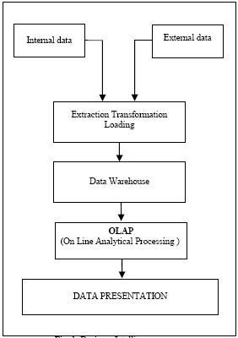

Figure 3.1: Business Intelligence

Data warehouse is theme orientated, integrated, long term and unchangeable data storage with main purpose of support of process of decision making with own analytical possibilities. Theme orientation of data means that they are organized around the subject and give information of exactly specified subjects within the scope of the company (for example within the scope of sale, supply…) instead of current operations of the company. Integration means that the data is collected in a data base from different sources and is always saved in the same format. Time invariability means that all the data in the data storage is related and is identified by a specific time period, which means it is of historical character. In the operation data bases kept is only current, latest data. Unchangeable content means that the data in storage is stable and once it is saved in the storage, by rule, it cannot be changed. This enables management or anyone using this data storage to be sure that they will get the same regardless of time or frequency of questions asked. In other words it could be said that data storage is a specialized data base based on the information from the operative data base, containing data for a longer time period, and it’s intention is firstly for needs of analysis and support in decision making of middle and high management.

Executives and managers are becoming increasingly reliant on business intelligence (BI) applications to provide them with the information they need to drive day-to-day business operations in all business areas. Many companies, in fact, can no longer operate effectively without this information, and a business intelligence system and its underlying data warehouse now need to be comparable to operational systems in their availability, scalability and manageability.

This is particularly true in the front office, where business intelligence is needed to better understand the customer and improve the effectiveness of marketing, sales and customer service in all channels. Making intelligence available to all front office staff and applications is paramount to consistent customer treatment and improving customer relationships. Integrating it into campaign management, for example, results in targeted multi-channel marketing campaigns. Integrating customer intelligence into customer facing operational business processes makes a company a customer-intelligent business in day-to-day operations.
Increased demand for BI means pressure is mounting for faster deployment of business intelligence in nearly all business areas, including marketing, sales, customer service, corporate finance, human resource, procurement and supply chain business functions. As a result, companies are considering packaged analytic applications to speed up implementation and delivery of intelligence.

Technologies and products for deploying business intelligence (BI) applications to users have improved dramatically over the past few years. In the past, business intelligence applications were perhaps nice to have but they now have become so essential to strategic and tactical business decision making that organizations cannot operate their businesses effectively without them. The demand to deliver business intelligence to drive day-to-day operations has never been greater as companies seek business intelligence in functions enterprise wide. However, despite the investment that many companies have made in data warehousing and business intelligence, few can claim that they can monitor performance in all business areas and provide full customer intelligence to all front office operations in all channels to market. Even fewer can claim that they have business intelligence that is integrated into daily operational business processes for use by the mass user base. The demand for actionable intelligence is still increasing as greater numbers of users require ‘just-in-time’ information to improve business performance. Thus the backlog of BI projects in the pipeline for development is growing, which poses significant challenges for IT staff. On the one hand, IT staffs are increasingly required to spend time justifying BI spending, while on the other, they face business pressure to speed up the delivery and integration of intelligence to help achieve key business objectives.

Executives use scorecards to help manage business performance. Scorecards are defined using special software and include mission statements, themes, strategic objectives and key performance indicators (KPIs). KPIs are associated with specific objectives in the scorecard to monitor business performance. Scorecard software needs to sit on top of enterprise analytics to achieve this. Dashboards present particular KPIs in an easily understandable way, e.g. speed dials. New dashboards, scorecards, themes and objectives need to form part of any new modular intelligence component added to the enterprise analytics solution to extend the overall offering.

3.1 BALANCE SCORECARD

The balanced scorecard is a strategic planning and management system that is used extensively in business and industry, government, and nonprofit organizations worldwide to align business activities to the vision and strategy of the organization, improve internal and external communications, and monitor organization performance against strategic goals. It was originated by Drs. Robert Kaplan (Harvard Business School) and David Norton as a performance measurement framework that added strategic non-financial performance measures to traditional financial metrics to give managers and executives a more 'balanced' view of organizational performance. While the phrase balanced scorecard was coined in the early 1990s, the roots of the this type of approach are deep, and include the pioneering work of General Electric on performance measurement reporting in the 1950’s and the work of French process engineers (who created the Tableau de Bord – literally, a "dashboard" of performance measures) in the early part of the 20th century.

The balanced scorecard has evolved from its early use as a simple performance measurement framework to a full strategic planning and management system. The “new” balanced scorecard transforms an organization’s strategic plan from an attractive but passive document into the "marching orders" for the organization on a daily basis. It provides a framework that not only provides performance measurements, but helps planners identify what should be done and measured. It enables executives to truly execute their strategies.
This new approach to strategic management was first detailed in a series of articles and books by Drs. Kaplan and Norton. Recognizing some of the weaknesses and vagueness of previous management approaches, the balanced scorecard approach provides a clear prescription as to what companies should measure in order to 'balance' the financial perspective. The balanced scorecard is a management system (not only a measurement system) that enables organizations to clarify their vision and strategy and translate them into action. It provides feedback around both the internal business processes and external outcomes in order to continuously improve strategic performance and results. When fully deployed, the balanced scorecard transforms strategic planning from an academic exercise into the nerve center of an enterprise.

Kaplan and Norton describe the innovation of the balanced scorecard as follows:
"The balanced scorecard retains traditional financial measures. But financial measures tell the story of past events, an adequate story for industrial age companies for which investments in long-term capabilities and customer relationships were not critical for success. These financial measures are inadequate, however, for guiding and evaluating the journey that information age companies must make to create future value through investment in customers, suppliers, employees, processes, technology, and innovation."

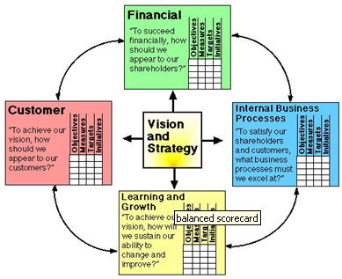

Figure 3.2: Balance Scorecard

Perspectives
The balanced scorecard suggests that we view the organization from four perspectives, and to develop metrics, collect data and analyze it relative to each of these perspectives:

The Learning & Growth Perspective
This perspective includes employee training and corporate cultural attitudes related to both individual and corporate self-improvement. In a knowledge-worker organization, people -- the only repository of knowledge -- are the main resource. In the current climate of rapid technological change, it is becoming necessary for knowledge workers to be in a continuous learning mode. Metrics can be put into place to guide managers in focusing training funds where they can help the most. In any case, learning and growth constitute the essential foundation for success of any knowledge-worker organization.
Kaplan and Norton emphasize that 'learning' is more than 'training'; it also includes things like mentors and tutors within the organization, as well as that ease of communication among workers that allows them to readily get help on a problem when it is needed. It also includes technological tools; what the Baldrige criteria call "high performance work systems."
The Business Process Perspective
This perspective refers to internal business processes. Metrics based on this perspective allow the managers to know how well their business is running, and whether its products and services conform to customer requirements (the mission). These metrics have to be carefully designed by those who know these processes most intimately; with our unique missions these are not something that can be developed by outside consultants.

The Customer Perspective
Recent management philosophy has shown an increasing realization of the importance of customer focus and customer satisfaction in any business. These are leading indicators: if customers are not satisfied, they will eventually find other suppliers that will meet their needs. Poor performance from this perspective is thus a leading indicator of future decline, even though the current financial picture may look good.
In developing metrics for satisfaction, customers should be analyzed in terms of kinds of customers and the kinds of processes for which we are providing a product or service to those customer groups.

The Financial Perspective
Kaplan and Norton do not disregard the traditional need for financial data. Timely and accurate funding data will always be a priority, and managers will do whatever necessary to provide it. In fact, often there is more than enough handling and processing of financial data. With the implementation of a corporate database, it is hoped that more of the processing can be centralized and automated. But the point is that the current emphasis on financials leads to the "unbalanced" situation with regard to other perspectives. There is perhaps a need to include additional financial-related data, such as risk assessment and cost-benefit data, in this category.

3.2 REPORTS AND DASHBOARDS
Reports are probably the most common application of business intelligence. A report can be described as a document that contains data used for reading or viewing. It can be as simple as a data table or as complex as a subtotaled view with interactive drilling, similar to Excel's Subtotal functionality.
The key attribute of a report is that it doesn't lead a reader to a predefined conclusion. Although a report can include analysis, aggregations, and even charts, reports often allow for the end user to apply his own judgment and analysis to the data.

A dashboard is a visual interface that provides at-a-glance views into key measures relevant to a particular objective or business process. Dashboards have three main attributes:
- Dashboards are typically graphical in nature, providing visualizations that help focus attention on key trends, comparisons, and exceptions.
- Dashboards often display only data that are relevant to the goal of the dashboard.
- Because dashboards are designed with a specific purpose or goal, they inherently contain predefined conclusions that relieve the end user from performing his own analysis.
Project reports and dashboards are accessed via automated or customizable views.
These views provide fully updated progress reports in real time and cover items such as project critical deliverables, timelines, budgets, resource loads, deadlines and critical path overviews across all your live and active projects.
As a result, we can:
- Remain updated on every project anytime, anywhere
- View personalized dashboards containing news, changes and updates as well as overall project performance, progress, scheduling status, delay predictions and project, resource or delivery conflicts
- Run multiple reports in parallel in order to view conflicts, intersections, overlap or deadlines across multiple projects
- Run predefined reports or create new customized reports based on your individual needs
- Export all reports to Excel

Financial Executives today are inundated with information. There never seems to be enough time to monitor and analyze the company’s core activities and their performance. This study looks at how dashboard reports can help alleviate this situation. Dashboards (sometimes labeled Business Activity Monitoring software) belong to a quickly growing software category popularly labeled Business Performance Management software or BPM for short. This type of reporting provides a quick, easy and analytical way of reviewing and understanding data that is important to the organization.
Dashboard reports come in many flavors. What our dashboard should look like, what type of data it should contain and who the key audience should be, are all very important questions we need to answer before starting a new dashboard project.
Figure 3.3: Dashboard Reports

Business intelligence (BI) is the process of aggregating, storing, analyzing, and reporting on business data in order to support informed business decisions.

Chapter 4

OUR APPROACH IN FINDING SOLUTION

4.1 PROBLEM GATHERING

To analyze the productivity management & enhancement in small and medium enterprises, following approach is taken.

I did a survey in “CresTech Software System Pvt. Ltd. “ to collect the data for analysis. For survey I took the questionnaire approach. In this, a questionnaire was given to 5 Senior Project Managers, 5 Project Managers, 10 Engineers, asking them the questions on various aspects of the project management & the process followed.

Questionnaire

Note: This survey is designed for research purposes only, and I expected honest responses. So we gave the assurance to participants upfront that their identity will not be disclosed. Participants were asked to answer the question on the scale of “1” to “5”

Scale (1=poor, 2=Average, 3=good, 4=very good, 5=Excellent)
- How do you rate your present project’s success on scale of 1 to 5?
- How do you rate importance of soft skills in success of project on scale of 1 to 5?
- How do you rate your project manager’s knowledge of processes as important factor in success of project on scale of 1 to 5?
- How do you rate your project team’s knowledge of tools as important factor in success of project on scale of 1 to 5?
- How do you rate your project team’s knowledge of techniques as important factor in success of project on scale of 1 to 5?
- How do you rate your project team’s communication skill as important factor in success of project on scale of 1 to 5?
- How do you rate your project manager’s team building skill as important factor in success of project on scale of 1 to 5?
- How do you rate your project team’s flexibility & creativity as important factor in success of project on scale of 1 to 5?
- How do you rate your project manager’s leadership skill as important factor in success of project on scale of 1 to 5?
- How do you rate your project team’s stress management skill as important factor in success of project on scale of 1 to 5?
- How do you rate your project team’s time management skill as important factor in success of project on scale of 1 to 5?
- How do you rate your project manager’s change management skill as important factor in success of project on scale of 1 to 5?
- How do you rate your project teams’ trustworthiness as important factor in success of project on scale of 1 to 5?
- How do you rate your project manager’s conflict management skill as important factor in success of project on scale of 1 to 5?

4.2 RESULT OF THE QUESTIONNAIRE

Following is the summary of the responses; I got from Senior Project Managers, Project Managers and Engineer:

- 90% of them rated project team’s time management skill as important factor in the success of the project. According them it is a big challenge to deliver the product on time which is also a big obstacle in success of project.
- 80% of them rated project team’s “knowledge of techniques” as important factor in the success of the project. Sometimes project team doesn’t have much knowledge about the techniques. This is the big obstacle in the success of project.
- 70% of them rated project team’s awareness on the “step by step procedure” as important factor in the success of the project. Sometimes they don’t know what to come next? This is also a big problem in success of project.
- 70% of them rated project team’s communication skill as important factor in the success of the project. Due to poor communication in the team, everybody might not be having sufficient information to be able to successful in the project. So, this is a key in success of project.
- 70% of them told the problem regarding the team’s trustworthiness. There is possibility of leak of information. So, this is also a big obstacle in success of project.
- 60% of them told the problem regarding the team’s stress management which is a big obstacle in success of project.

On the basis of above feedback, I concluded that there is no consistency in delivery of same service across different customers by same person or different person, which is leading to lots of supervisory overheads
a) Lack of consistency leads to lack of predictability. In number of customer engagements, there are surprises on meeting the timelines & dependencies towards the last phase of the project, leading to firefighting.
b) Lack of consistency makes reporting across projects challenging

Without any process framework it is difficult to set right customer expectation and this creates un-necessary challenges in customer engagement.

4.3 PROPOSED SOLUTION

In industries, there are running many projects in parallel and many of the projects have around 70% processes same. In Cres Tech which is a testing company, has projects in “Performance Testing”, “Security Testing”, “Functional Testing” and in other testing.
The projects which have same processes, we can make templates for them.
The criterion for making templates is:
-Technology
-Domain
-Project Architecture

Now following description describes the flow, which should be followed in the proposed solution.

Whenever a new project comes then that project can be associated with the appropriate template suited for that project. Now users (Tester/Developer) can be linked with this project by assigning the tasks of the project on the basis of their skills already available in the database. This makes sure that any user is assigned the task suited to his skills. There may be different templates for different projects.

Now when a user login to the system he can see his task assigned to him by the manager. Time line is also provided with the task so the user can complete that task to that timeline. If user completes the task before the time line, system displays his productivity and how his efficiency.

Overall, the system is divided into three categories:
-System Admin
-Project Manager
-User (Tester/Developer)
System Admin creates & manages the system. He is responsible to create the project template, maintaining & updating the system as required.

Project Manager manages the project and is responsible for assigning the tasks to users as per their skills & requirement of the project. He also assigns time line.

User can open this system and can only view his task. He can see his timelines as well. User can submit his results on the assigned tasks in the system & optionally can also attach the detailed report for manager’s reference.

Now this integrated system has three independent systems. System admin has exclusive rights CRUD (Create, Read, Update, and Delete) to access the database of all three systems i.e. “System Admin”, “Manager” & “Users”.

Managers have the Read/Update rights for “Manager: & “User” system.

User can only Read/Update “User” System.

Reporting:

Reporting is the important part of business management. A report can be described as a document that contains the required project data for measuring and managing the project’s progress. This is based on the templates created by System Admin & data entered by users & manager.

For this we will use a “Modified Balance Scorecard” by which we can track and manage the past, present and potential performance of any organization.

Without process accelerator Crestech has increased dependency on few persons for ensuring smooth supervision of service delivery which was the biggest obstacle in scaling operations. With process accelerator, now we have transparent system, where all the data related to the project is lying in one database. Anybody can pull in the desired data, whenever required.
Chapter 5

PROCESS ACCELERATOR DEFINITION

5.1 OVERVIEW
As Crestech is growing there is a need to streamline service delivery process and make it more predictable. This is becoming more and more important considering skill set with in company varies from basic level to advance level. It’s also important to ensure that managers are able to monitor and track delivery against metrics like schedule adherence, quality, SLA with customer etc. This chapter describes goals and solution overview of this product. This document is meant to ensure that all stakeholders are on same page regarding purpose of Process Accelerator.

5.2 PROBLEM

5.2.1 Justification
1. There is no consistency in delivery of same service across different customers by same person or different person, which is leading to lots of supervisory overheads
- Lack of consistency leads to lack of predictability. In number of customer engagements there are surprises leading to firefighting.
- Lack of consistency makes reporting across opportunities challenging
2. Without any process framework its difficult to set right customer expectation and this creates un-necessary challenges in customer engagement
3. Without process accelerator Crestech has increased dependency on few persons for ensuring smooth supervision of service delivery which is the biggest obstacle in scaling operations.

5.2.2 Goals
Following are the goals listed out to develop the Process Accelerator.

1. Provide feature to define process framework for different type of services
- Support variability in process framework for same service across customers in separate verticals
2. Support security role to ensure strict control on information
3. Provide reports and visualizations
- Provide homepage and dashboard to help user identify key tasks or metrics. Keep information in this pages actionable
4. Support scale and performance
- Multiple user access up-to 100 users with concurrency of 25 users
5. Provide external portals accessible to key customer users and internal users allowing them to view status of their projects and perform other functions
6. Support content management
- Ability to upload documents used during service delivery
- Ability to define guidelines
- Ability to link external web pages as reference

5.2.3 Non Goals
- 1. Automation of service delivery

Chapter 6

PROCET ACCELERATOR IMPLEMENTATION

“Process Accelerator” is a process framework for Project and Productivity Management in a software organization. This is developed with the objective to keep all the stakeholders customers, project management, senior management etc. on the same page on the project development.

Process Accelerator has multiple users (managers, developers, etc.) based on their role defined in this system. So, role of user is very important. The user having role “A” can only see screen “A” and user having role “B” can only see screen “B” and so on. Users are provided with different
- Menu Items
- Privileges
- Actions
This is again dependent on their role.
Process Accelerator includes 3 iterations:
-Iteration 1
-Iteration 2
-Iteration 3

Iteration 1 is tester role
Iteration 1 Key Scenario:
- User (tester) logs in
- System displays opportunities assigned to him along with the tasks
- Selects a Service Task
- System displays task details with links to “How-To” contents
- User updates task details with link to status report
Iteration 2 includes manager role.
Iteration 2 Key Scenario:
- User (Admin/Manager) logs in
- Defines a Process accelerator
- Assigns a Process Accelerator to an Account Service
- System generates tasks based on Process Accelerator assigned
- Manager assign a tester as owner of a Account Service task generated by system
- Tester logs in view all tasks assigned to him with articfacts and how-to documents
Iteration 3 includes admin role.
Iteration 3 Key Scenario:
- User (Admin) logs in
- Admin can create/update/delete User (Tester/Manager)
- Admin can create/update/delete Role
- Admin can create/update/delete Entity
- Admin can create/update/delete Role Privilege

When a User (System Admin/Manager/Tester) logs into the system, Process Accelerator will open the screen with the appropriate role.

About Role Management

To deal with the roles and tasks, we need to design two tables.

Role privilege table:

RoleID | EntityID | Create | Read | Update | Delete

Here RoleID act as primary key and EntityID act as a foreign key. Create, read, update, delete and read [CRUD] will have Boolean values specifying whether a particular role is having privilege for particular operation or not.
About assigning of owner to a process accelerator tasks

For this it require searching of relevant user for a particular task. Search for the user can be done on the basis of requirements of the task and user skill set.

To implement this we need to define a rule engine to map [required expertise level, difficulty level, and ambiguity level] of an account service task to [experience level, competency level] of a user.

Accordingly the set of users resulted will be shown to the owner list of that task (not all users).

As of now, we need to show all relevant users for a particular task with status available or not. [Availability Status will be based on two criteria: Start/End Time, Account Information]

6.1 SCENARIOS

This section describes the different scenarios that might be required, while working on different projects in a typical SME. Here are some scenarios taken from CresTech.

1) Pankaj (Delivery Head) defines process frameworks for different services for different verticals in the product. He is able to write it at home and then import it in the application portal. Once imported process framework needs to be activated. Once activated users are able to associate process framework with opportunities.

2) Vebhav (Test manager) is assigned to Max New York opportunity for delivering performance testing related service. Vebhav associates process framework for performance testing in Insurance companies with this service opportunity. System generates all tasks as per process framework for service opportunity. Vebhav also associates a SLA with service opportunity.

3) Vebhav (Test manager) opens each task generated by associated process framework and using the skill/competency indicated by process framework and people finder assigns task to appropriate available tester. Vebhav also ensures that tasks delivery is aligned with SLA agreed with customer.

4) Sachin (tester) receives a mail informing him that a task is assigned to him. He logs-into portal. In his home page, system shows him tasks assigned to him. He opens the task. System shows knowledge and guideline required for performing task. After executing task, Sachin updates tasks to indicate completion after associating artifacts used/generated during this task execution.

5) Pankaj view dashboard to view whether across service opportunities tasks are executed as per the SLA or not.

6) Pallavi (Process Consultant) log into portal and uploads knowledgebase articles related with one of the process framework.

7) Rajit Mehta (COO) wishes to view status of testing executed by Crestech for one of their key applications. He logs-into the application portals. And views list of all projects currently executed by Crestech for his company. He selects an application and system shows him latest status against agreed SLA. Optionally he selects mail notification for meeting SLA milestones.

6.2 USE CASES

A use case is a description of a system’s behavior as it responds to a request that originates from outside of that system. In other words, a use case describes "who" can do "what" with the system in question.

Use cases describe the interaction between a primary actor (the initiator of the interaction) and the system itself, represented as a sequence of simple steps. Actors are something or someone which exists outside the system under study, and that take part in a sequence of activities in a dialogue with the system to achieve some goal. Actors may be end users, other systems, or hardware devices. Each use case is a complete series of events, described from the point of view of the actor.

I have designed some Use Cases for iteration 1, iteration 2 and iteration 3. So they would be helpful to achieve goals.

Table 6.1: Use cases for iteration1 (Tester & Manager)

S.N | Description | Precondition | Actor | Action | System Response | Post condition
1. | Tester wants to login the system | having valid account in the system | Tester | 1. enter the user ID 2. enter the password 3. clickon OK button | load the page and generate the menu option items based on user's role and privileges | load the page on the tester's screen
2. | Tester wants to view task assigned to him/her | 1. have a valid account 2. login the system | Tester | 1. login the system 2. click on the view task in the menu option items | task appears on the screen | tester can view that task
3. | Tester wants to submit the task | 1. have task assigned to him 2. have task completed | Tester | clickon the submit button | task is submitted to his manager | his manager can view the status of that task
4. | Tester wants to attach the report with his task | 1. have task assigned to him 2. have task completed | Tester | 1. complete the task 2. make the report 3. attach the report with the task 4. click on the submit button
5. | Tester wishes to check his/her status | 1. have a valid account 2. login the system 3. click on the view status | Tester | 1. login the system 2. click on the view status in the menu option items | status of that tester is appeared on the screen | tester can view his status
6. | Manager wants to login the system | having valid account in the system | Manager | 1. enter the user ID 2. enter the password 3. click on OK button | load the page and generate the menu option items based on user's role and privileges | load the page on the manager's screen
7. | manager wants to view the task list | 1. have a valid account 2. login the system | Manager | 1. login the system 2. click on the view task in the menu option items | task list appears on the screen | manager can view that task list
8. | Manager wants to assign the task to testers | 1. having a task list 2. having availability of testers | Manager | 1. check the expertise level, difficulty level, ambiguity level of tasks 2. check experience level and competency level of testers 3. on the basis of level of task,it is assigned | task is assigned to the tester | Tester can view that task on his screen
9. | Manager wants to check the status of the task | 1. have a valid account 2. login the system 3. click on the view status | Manager | 1. login the system 2. click on the view status in the menu option items | status of the task is appeared on the screen | Manager can view the status of task

Table 6.2: Use cases for iteration2 (Manager)

S.N. | Description | Precondition | Actor | Action | System Response | Post condition
1. | Manager wants to view account service form | have a valid account | Manager | 1. login the system 2. double click on the account name in the grid | account service form is appeared | Manager can view the form
2. | Manager wants to edit SLA | 1. have a valid account | Manager | 1. login the system 2. click on the SLA 3.clickon the edit SLA  4. select the SLA name  5. click on the edit button  6. edit the details 7. click on the submit button | editing is done | database is updated
3. | Manager wants to assign SLA | 1. have a valid account 2. have a account name and product service name | Manager | 1. login the system 2. double click on account name 3.fill account and product service name 4 click on hyperlink assign SLA  5. fill SLA name and description  6. click on assign button | SLA is assigned in the account service form | SLA is assigned and manager can view it
4. | Manger wants to create SLA | 1. have a valid account 2. have a new SLA | Manager | 1. login the system 2. click on the SLA 3. click on the create new SLA  4. fill the details in the SLA form  5. click on submit button | A new SLA is created | A new SLA is created in the system
5. | Manager wants to create process accelerator | 1. have a valid account 2. have a new process accelerator | Manager | 1. login the system 2. click on the process accelerator 3. click on create new process accelerator 4. fill the details 5. click on submit button | A new process accelerator is created | A new process accelerator is created in the system
6. | Manager wants to edit process accelerator | have a valid account | Manager | 1. login the system 2. click on the process accelerator 3. click on edit process accelerator 4. select the process accelerator name | editing is done | database is updated
7. | Manager wants to assign process accelerator | 1. have a valid account 2. have a account and product service name 3. SLA should be assigned | Manager | 1. login the system 2. double click on account name  3. fill account, product name and SLA 4. click on hyperlink assign process accelerator 5. fill the process accelerator name | process Accelerator is assigned in the account service form | process accelerator is assigned and manager can view it and account service task will be automatically generated

Table 6.3: Use case for iteration3 (admin)

S.N. | Description | Pre  condition | Actor | Action | System Response | Post condition
1 | Admin wants to create new user | login the  system | Admin | 1. clickon create user button  2. fill the entries like name, password, secret question  3. click on save button | new user is created | database is updated with this new user
2 | Admin wants to update existing user | login the system | Admin | 1. click on the user name which has to be updated 2. update the entries 3. click on update button | existing user is updated | database is updated with new entries of that existing user
3 | Admin wants to create role | login the system | Admin | 1. click on the create role button  2. fill the entries (role name and description)  3. click on save button | new role is created | database is updated with new role
4 | Admin wants to update role | login the system | Admin | 1. click on the role name  2. update the entries  3. click on the update button | the role is updated | database is updated with new entries of the existing role
5 | Admin wants to create entity | login the system | Admin | 1. click on the create entity button  2. fill the entries (entity name and description)  3. clickon save button | new entity is created | database is updated with new entity
6 | Admin wants to update the existing entity | login the system | Admin | 1. click on the entity name  2. update the entries  3. click on the update button | the entity is updated | database is updated with new entries of that existing entity
7 | Admin wants to create new role privilege | login the system | Admin | 1. click on the create new role privilege button  2. fill the entries like role, entity, access mode  3. click on the save button | new role privilege is created | database is updated with new role privilege
8 | Admin wants to update the existing role privilege | login the system | Admin | 1. click on the role privilege name  2. update the entries  3. click on the update button | the role privilege is updated | database is updated with new entries of existing role privilege
9 | Admin wants to delete a user record | login the system | Admin | 1. click on the user name which has to be deleted 2. click on delete button | the user record is deleted | database is updated by deleting that user record

6.3 DATABASE STRUCTURE

In process accelerator project, SQL Server Express 2005 database is used.
It store data in the form of tables e.g. SLA(Service Level Agreement), Account, Account Service, Process Accelerator, User, Content, KBArticles (knowledge Base Articles), Role, Entity etc. These database tables have primary key and foreign key. These tables are interrelated to each other by foreign key. Data can be retrieved from the database by giving query to SQL server.

This integrated database is created and updated by different type of users based on their roles. Different sections of integrated database have privileged R/W accesses which is dependent on the roles of the users.

Following table shows the example of database tables.

Table 6.4: Typical database table

Database  Table | Table Column Names | Key | Data Type | NULL /  NOT NULL
SLA | SLAID | Primary Key | int | NOT NULL
SLA | Title |  | VarChar(500) | NOT NULL
SLA | Description |  | VarChar(2500) | NULL
SLA | From |  | Date (yyyy-mm-dd) | NULL
SLA | To |  | Date (yyyy-mm-dd) | NULL
SLA | AccountID | Foreign Key (Account Table) | int | NOT NULL
SLA | Billable |  | Boolean | NULL
SLA | SalesPerson |  | VarChar(200) | NOT NULL
SLA | ContentID | Foreign Key (Content Table) | int | NULL
SLA | AccountContactID | Foreign Key (Account Contacts Table) | int | NULL
SLATerms | SLATermID | Primary Key | int | NOT NULL
SLATerms | SLAID | Foreign Key (SLA Table) | int | NOT NULL
SLATerms | Type |  | VarChar(1000) | NOT NULL
SLATerms | Committed_Completion_Date |  | Date (yyyy-mm-dd) | NOT NULL
SLATerms | Planned_Completion_Date |  | Date (yyyy-mm-dd) | NOT NULL
SLATerms | Artifact_Required |  | Boolean | NOT NULL
SLATerms | AccountContactID_Worker | Foreign Key (Role Table) | int | NOT NULL
SLATerms | AccountContactID_Supervisor | Foreign Key (Role Table) | int | NOT NULL
SLATerms | AccountContactID_Approver | Foreign Key (Role Table) | int | NOT NULL
Account  Service | AccountServiceID | Primary Key | int | NOT NULL
Account  Service | AccountID | Foreign Key (Account Table) | int | NOT NULL
Account  Service | SLAID | Foreign Key (SLA Table) | int | NULL
Account  Service | ServiceID | Foreign Key (Product_services Table) | int | NOT NULL
Account  Service | Billable |  | Boolean | NOT NULL
Account  Service | ProcessAcceleratorID | Foreign Key (Process  Accelerator Table) | int | NOT NULL
Account  Service | Start Date |  | Date (yyyy-mm-dd) | NULL
Account  Service | SalesPerson |  | VarChar(200) | NOT NULL
Account  Service  Tasks | AccountServiceTaskID | Primary Key | int | NOT NULL
Account  Service  Tasks | AccountServiceID | Foreign Key (AccountService Table) | int | NOT NULL
Account  Service  Tasks | ProcessAcceleratorTasksID | Foreign Key (Process  Acceleratortasks Table) | int | NOT NULL
Account  Service  Tasks | Owner | Foreign Key (User Table) | int | NOT NULL
Account  Service  Tasks | Status |  | VarChar(50) | NULL
Account  Service  Tasks | Deliverable_ContentID | Foreign Key (Content Table) | int | NOT NULL
Account  Service  Tasks | Start_Date |  | Date (yyyy-mm-dd) | NULL
Account  Service  Tasks | Finish_Date |  | Date (yyyy-mm-dd) | NULL
Account  Service  Tasks | SLATermID | Foreign Key (SLATerms Table) | int | NOT NULL
Account  Service  Tasks | Description |  | VarChar(2000) | NOT NULL
Account | AccountID | Primary Key | int | NOT NULL
Account | Name |  | VarChar(200) | NOT NULL
Account | Billable Address |  | VarChar(2000) | NOT NULL
Account | Ship_Address |  | VarChar(2000) | NOT NULL
Account | Primary ContactID | Foreign Key (AccountContacts Table) | int | NOT NULL
Account  Contacts | ContactID | Primary Key | int | NOT NULL
Account  Contacts | AccountID | Foreign Key (Account Table) | int | NOT NULL
Account  Contacts | First Name |  | VarChar(100) | NOT NULL
Account  Contacts | Last Name |  | VarChar(100) | NOT NULL
Account  Contacts | Designation |  | VarChar(100) | NOT NULL
Account  Contacts | Role | Foreign Key (Role Table) | int | NOT NULL
Account  Contacts | Contact Details |  | VarChar(500)
User | UserID | Primary Key | int | NOT NULL
User | UserName |  | VarChar(100) | NOT NULL
User | Password |  | VarChar(100) | NOT NULL
User | Secret Question |  | VarChar(200) | NOT NULL
User | Secret Answer |  | VarChar(200) | NOT NULL
User | RoleID | Foreign Key (Role Table) | int | NOT NULL
Role | RoleID | Primary Key | int | NOT NULL
Role | RoleName |  | VarChar(100) | NOT NULL
Role | Privilege_Description |  | VarChar(1000) | NULL
KB Articles | KBArticleID | Primary Key | int | NOT NULL
KB Articles | Subject |  | VarChar(500) | NOT NULL
KB Articles | ServiceID | Foreign Key (Product_services Table) | int | NULL
KB Articles | Data |  | BLOB | NOT NULL
Content | ContentID | Primary Key | int | NOT NULL
Content | keywords |  | VarChar(1000) | NULL
Content | Name |  | VarChar(1000) | NOT NULL
Content | Subject |  | VarChar(500) | NOT NULL
Content | Data |  | BLOB | NULL
Links | LinkID | Primary Key | int | NOT NULL
Links | URL |  | VarChar(500) | NOT NULL
Links | keywords |  | VarChar(1000) | NULL
Product_  services | ServiceID | Primary Key | int | NOT NULL
Product_  services | Name |  | VarChar(500) | NOT NULL
Product_  services | Description |  | VarChar(2500) | NULL
Process  Accelerat-or | ProcessAcceleratorID | Primary Key | int | NOT NULL
Process  Accelerat-or | Name |  | varchar(200) | NOT NULL
Process  Accelerat-or | Description |  | varchar(2500) | NULL
Process  Accelerat-or | ServiceID | Foreign Key (Product_services Table) | int | NULL
Process  Accelerat-or Tasks | ProcessAcceleratorTasksID | Primary Key | int | NOT NULL
Process  Accelerat-or Tasks | ProcessAcceleratorID | Foreign Key (ProcessAccelerator Table) | int | NOT NULL
Process  Accelerat-or Tasks | Name |  | varchar(200) | NOT NULL
Process  Accelerat-or Tasks | Duration |  | datetime | NULL
Process  Accelerat-or Tasks | ContentID | Foreign Key (Content Table) | int | NULL
Process  Accelerat-or Tasks | LinkID | Foreign Key (Links Table) | varchar(600) | NULL
Process  Accelerat-or Tasks | RequiredExpertiseLevel |  | varchar(50) | NOT NULL
Process  Accelerat-or Tasks | AmbiguityLevel |  | varchar(50) | NOT NULL
Process  Accelerat-or Tasks | DifficultyLevel |  | varchar(50) | NOT NULL
Process  Accelerat-or Tasks | TechnologyRequired |  | varchar(100) | NOT NULL
Process  Accelerat-or Tasks | Predecessor | Foreign Key (ProcessAcceleratortasks  Table) | int | NULL
Process  Accelerat-or Tasks | Successor | Foreign Key (ProcessAcceleratortasks  Table) | int | NULL
skill | skillID | Primary Key | int | NOT NULL
skill | Skill_Name |  | varchar(200) | NOT NULL
skill | type |  | varchar(1000) | NOT NULL
User skill | user_skillID | Primary Key | int | NOT NULL
User skill | userID | Foreign Key (user Table) | int | NOT NULL
User skill | skill ID | Foreign Key (skill Table) | int | NOT NULL
User skill | Experience |  | int
User skill | Competency Level |  | varchar(1000)
Role privilege | Role_PrivID | Primary Key | int | NOT NULL
Role privilege | RoleID | Foreign Key (Role Table) | int | NOT NULL
Role privilege | EntityID | Foreign Key (Entity Table) | int | NOT NULL
Role privilege | Create |  | Boolean | NOT NULL
Role privilege | Read |  | Boolean | NOT NULL
Role privilege | Update |  | Boolean | NOT NULL
 | Delete |  | Boolean
Entity | EntityID | Primary Key | int | NOT NULL
Entity | Name |  | varchar(1000) | NOT NULL

6.4 SCREEN SHOTS

In this section, I have captured various screen snapshots, describing manager & admin activities, while working in the process accelerator system.

Figure 6.1: Admin Activities form for User details

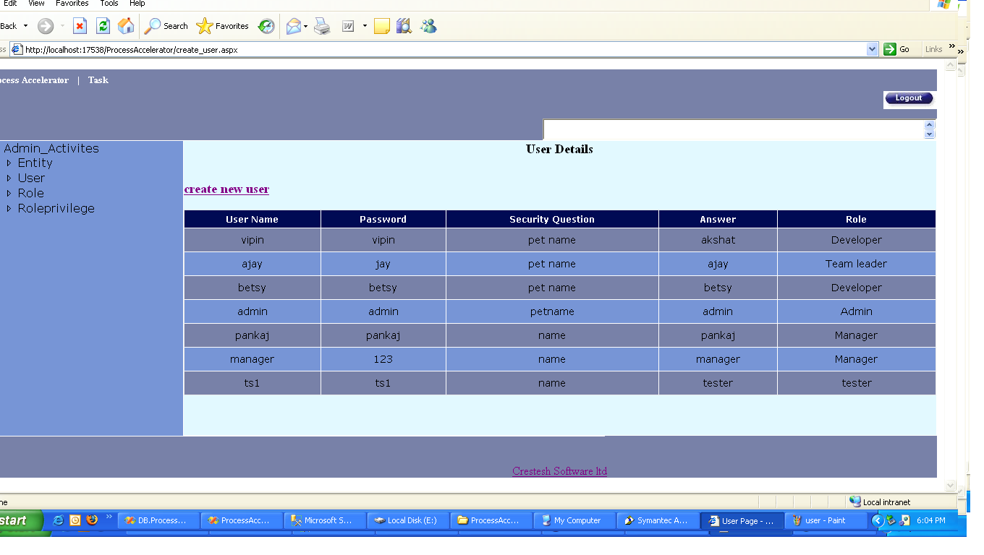

Figure 6.2: Admin Activities form for creating User account

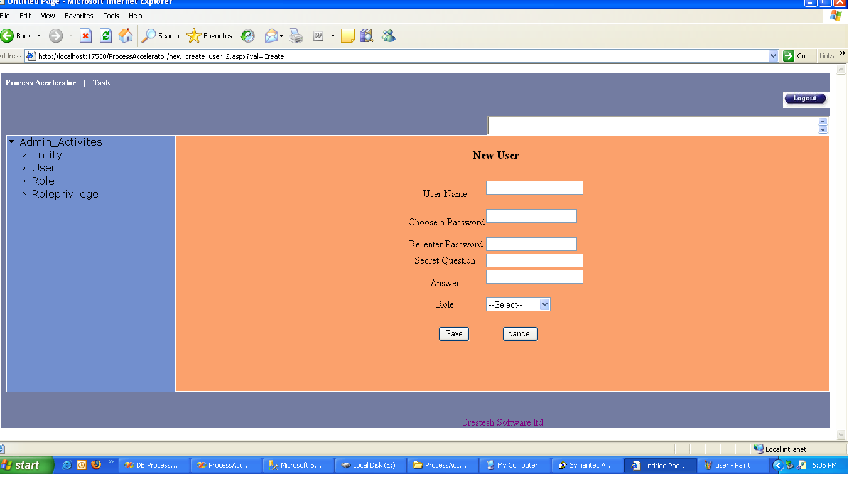

Figure 6.3: Admin Activities form for Entity details

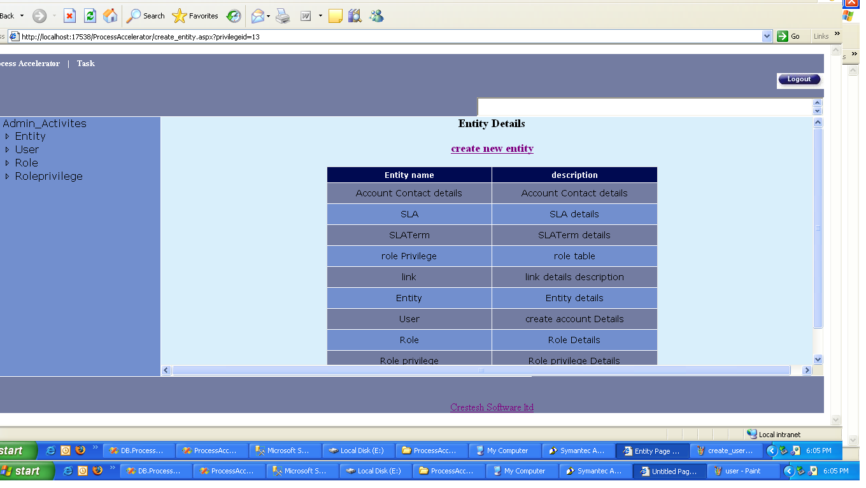

Figure 6.4: Admin Activities form for Role details

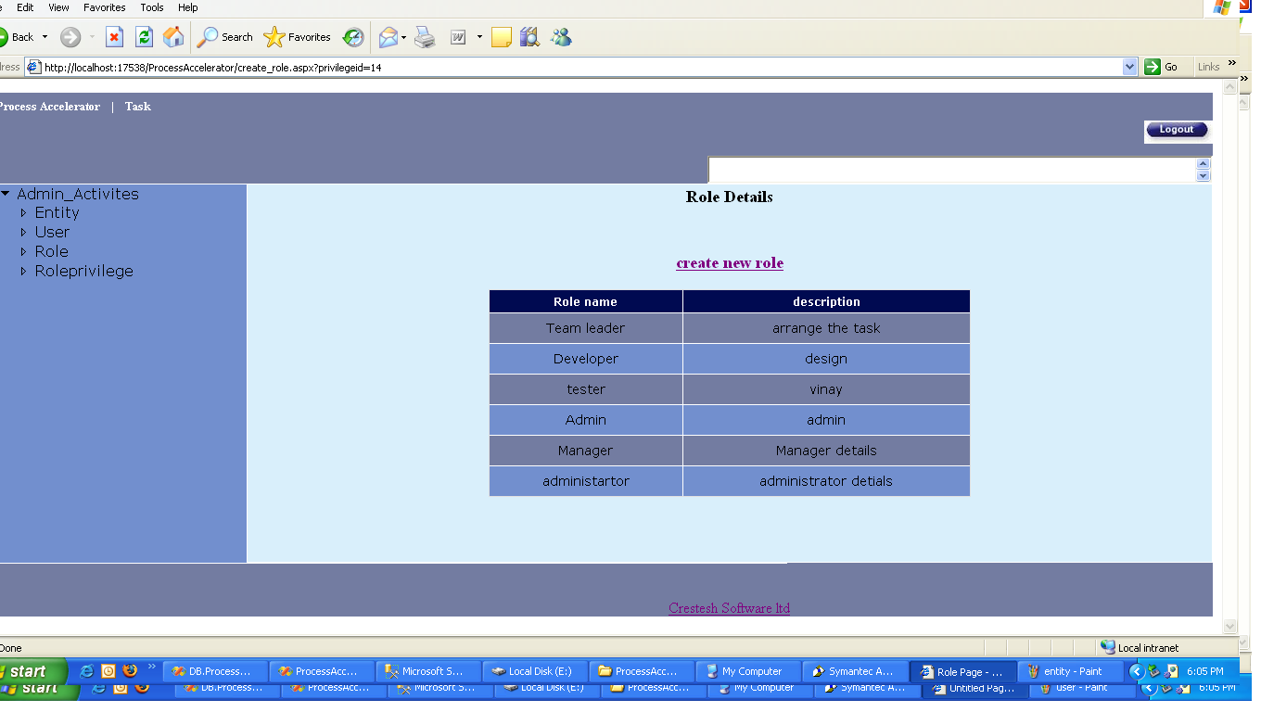

Figure 6.5: Admin Activities form for Role Privilege details

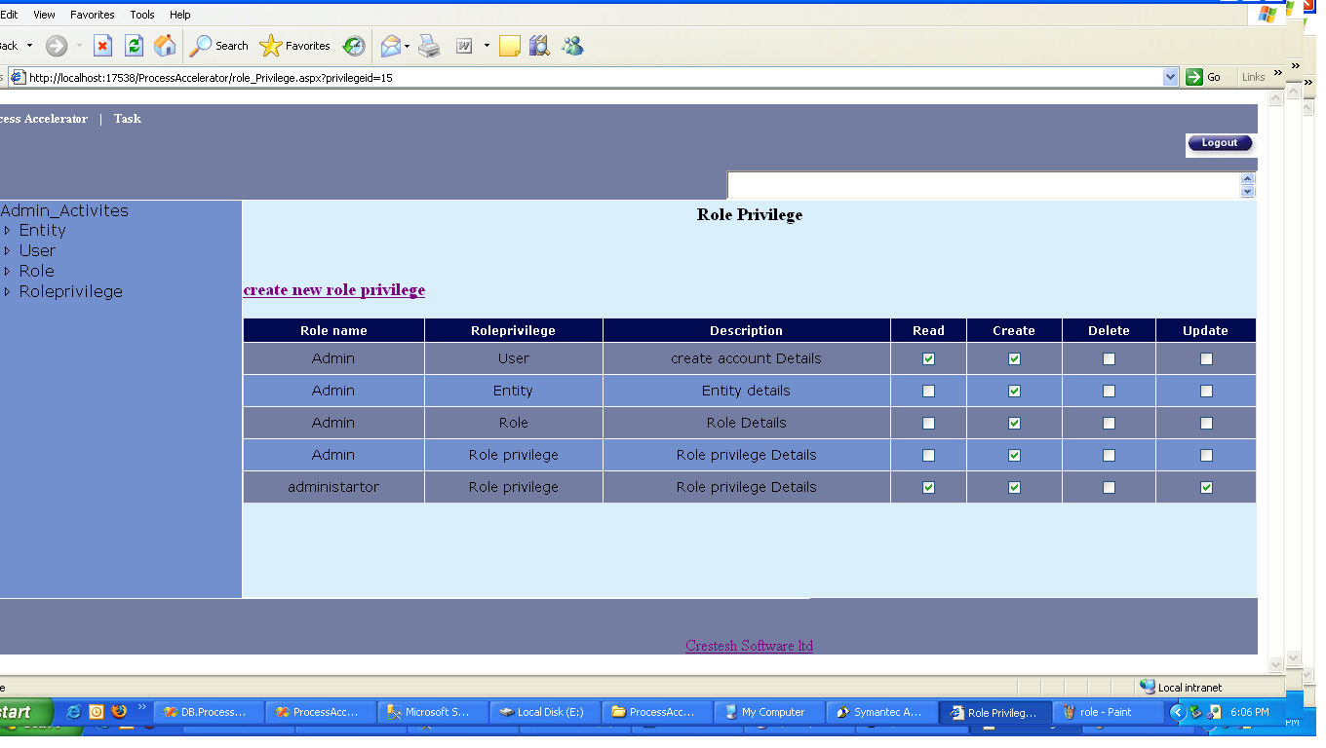

Figure 6.6: Manager Activities form (Home Page)

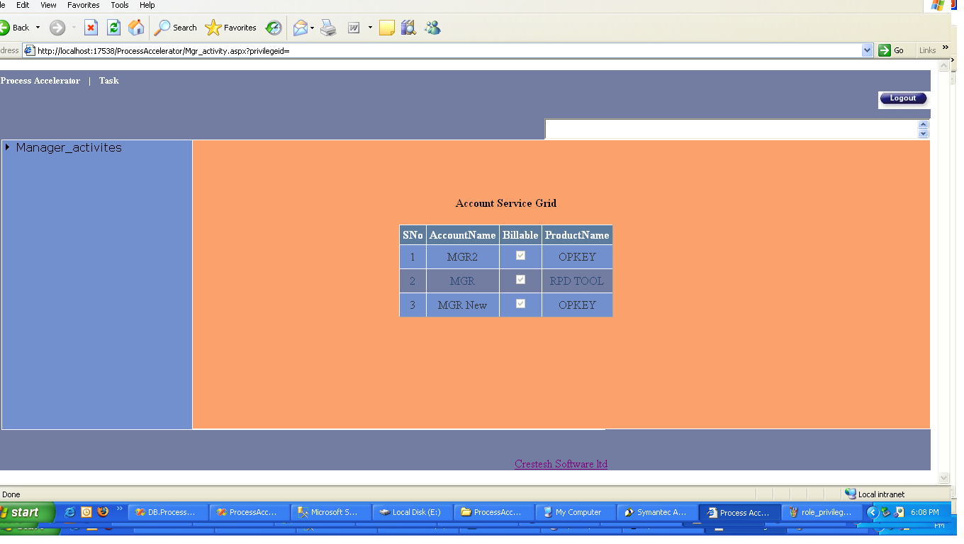

Figure 6.7: Manager Activities form for SLA details

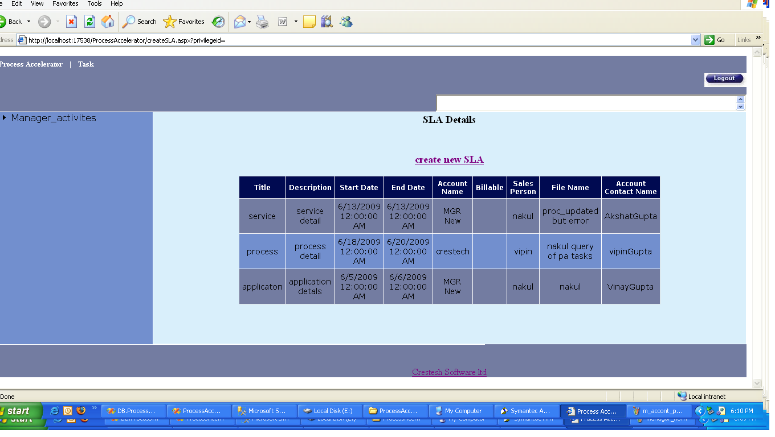
Figure 6.8: Manager Activities form for Account details

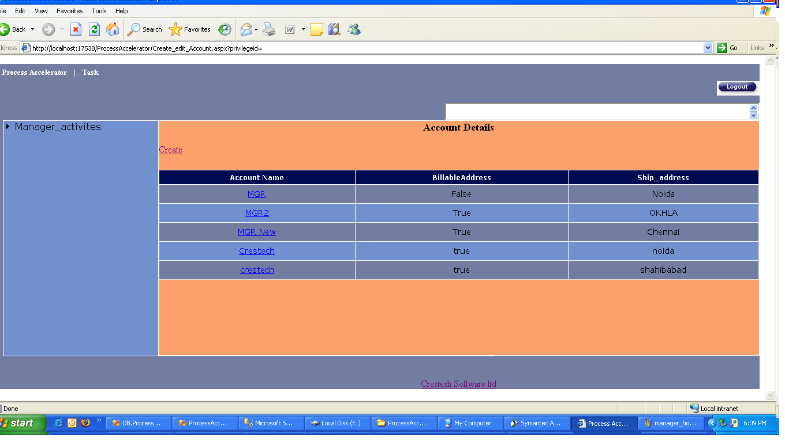

Figure 6.9: Manager Activities form for different projects

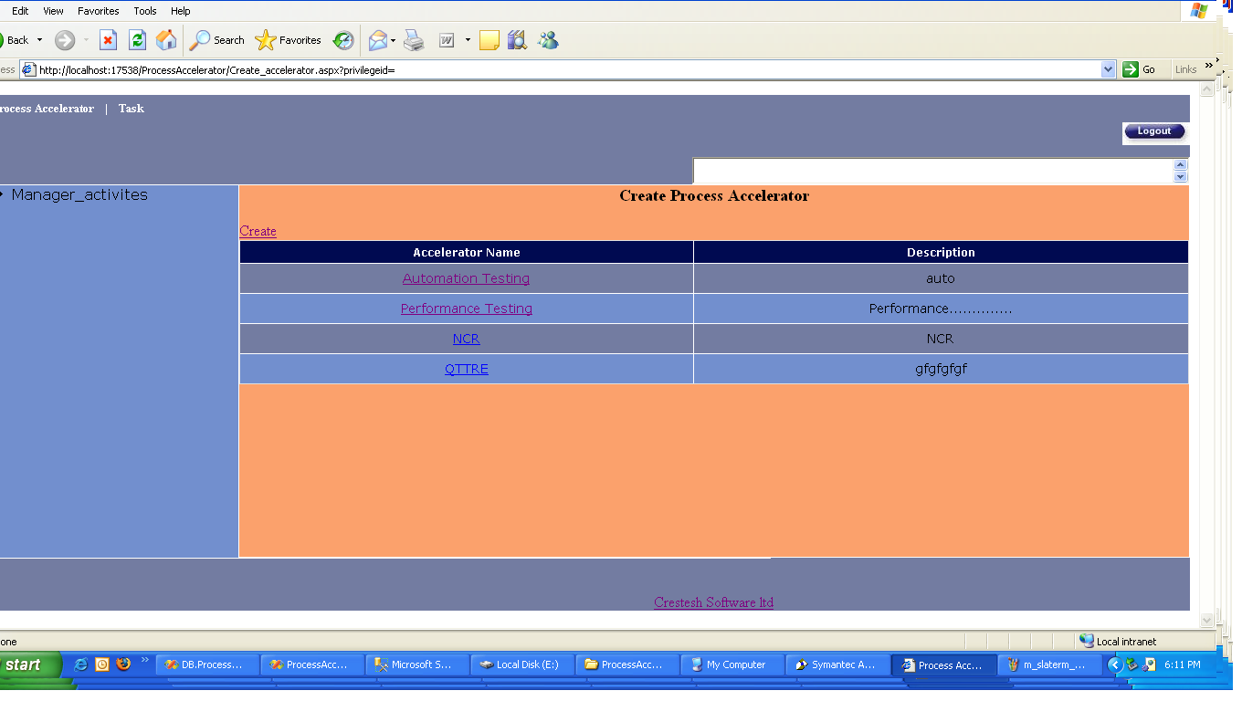
Figure 6.10: Manager Activities form for Product Service details

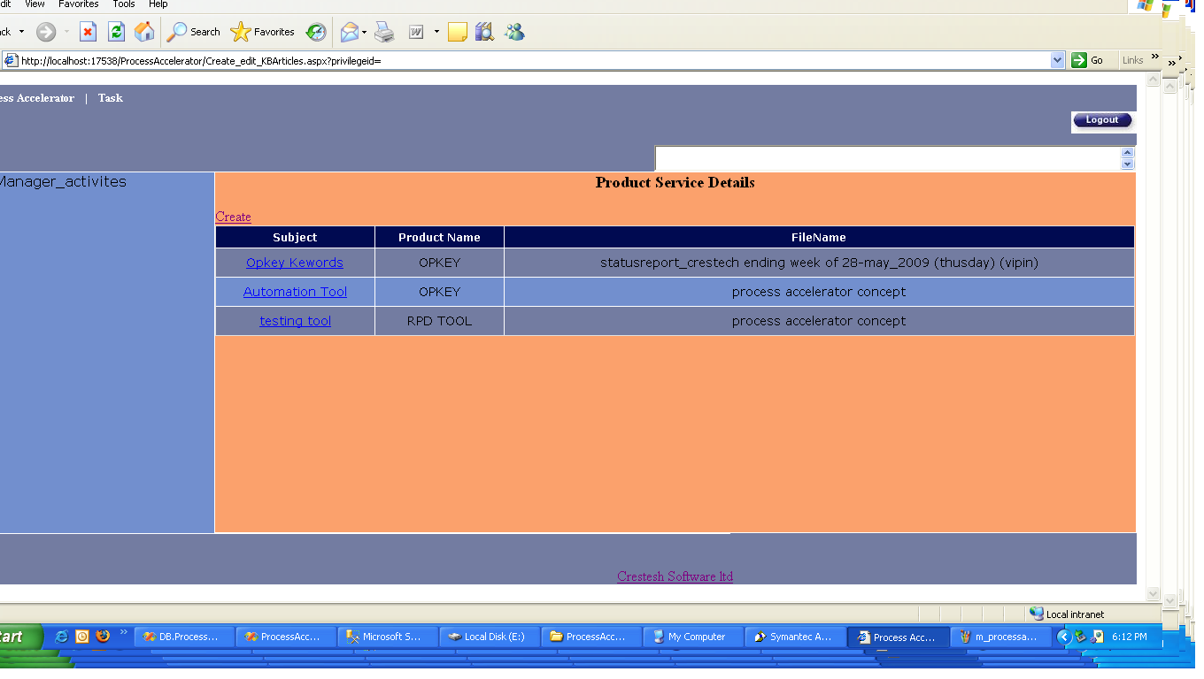

These all are screen shots regarding to Admin and Manager’s activities.

6.4 REPORTING

Reporting is going to be one of the main productivity enhancer of the “Process Accelerator”. Intuitive and customizable reporting solution and dashboards are going to give managers and project leads a 360 views of the project.
The following five report categories are planned to equip the management with the information they require to take decisions and put the project back on corrective path, in case there are delays due to any reasons
- Project Status report
- Resource Productivity Report
- Task assignment report
- Task Completion report
- Skill Mapping Report

Project Status Report
Project status Report is the most critical of the reports. This Report and associated dashboards are meant to provide a look into the current project status. There would be metrics like
- Task Delays (Project Level)
- Resources Sufficiency
- Delivery Timeline Dashboard
- Risk dashboard and mitigation Checklist
- Issue Ageing Dashboard

Resource Productivity Report
This report is aimed at the managers and top management and provides a real time insight into resource productivity and related issues

Task assignment Report
This report is for the managers/leads and provides the top level snapshot of the task assigned to different resources. This also acts as a load balancer dashboard and indicates if there is unfair concentration of tasks on a particular resource

Task completion Report
This report is for the project lead and provides a consolidated view of task completed by team members for a specific project

Flow Chart for Reporting
Note:
This flowchart corresponds to the Hybrid designed algorithm for faster Search based Business Intelligence
Here attributes refer to the database entities like Tasks, Timelines, resources etc.

Start
Check the Type of attribute required in Report (task, time etc…)
Rebuild the corresponding data-Cube in data Layer
Has the attribute been used in any other report in last 24 hours?
Was attribute last updated less than 24 hours before?
Fetch the Latest Attributes from Data Layer
Rebuild the corresponding data-Cube in data Layer
Update the Last used index in corresponding table
Pass the attribute value to the business logic layer and display reports
Stop
Yes
No
Yes
No

Block Diagram (Reporting Layer)
Resource Cube
Time Cube
Task Cube
Skill Cube
Dashboards
Reports
Central Project Database

Figure 6.11: Reporting Layer

Chapter 7

CONCLUSION

In organization, where multiple projects are happening concurrently & there are multiple stake holders, there is a need to have a transparent system, which will not only streamline project development process, project tracking process, project delivery process and project quality tracking process. This is becoming more and more important considering skill set with in company varies from basic level to advance level.

Business Intelligence(BI) is one of the most critical components of this solution. The conventional approach to data mining and BI might not be suited for the real time on the fly reporting needs of modern day manager who needs to be equipped with intelligent data analysis to take critical business decisions.

We need a better approach where instead of gathering data from different systems and collating at one database and then drawing reports out of it, the data is picked at runtime from these systems and reports generated on the fly. This can also be implemented as SAS model.

Reporting is the important part of business management. For this I have used a “Modified Balance Scorecard” by which we can track and manage the past, present and potential performance of any organization.

Process accelerator needs definition of Project Templates for various category of the projects. The criterion for making templates is:
-Technology
-Domain
-Project Architecture
Overall, the Process Accelerator system is divided into three categories (Iteration):
-System Admin (Iteration3)
-Project Manager (Iteration2)
-User (Tester/Developer) (Iteration1)

System Admin creates & manages the system. He is responsible to create the project template, maintaining & updating the system as required.
Project Manager manages the project and is responsible for assigning the tasks to users as per their skills & requirement of the project. He also assigns time line.
User can open this system and can only view his task. He can see his timelines as well. User can submit his results on the assigned tasks in the system & optionally can also attach the detailed report for manager’s reference.

Following is my contribution to this big project.

1) I did a survey in “CresTech Software System Pvt. Ltd.” to collect the data for analysis. For survey I took the questionnaire approach. In this, a questionnaire was given to 5 Senior Project Managers, 5 Project Managers, 10 Engineers, asking them the questions on various aspects of the project management & the process followed.
2) I helped in conceptualizing the vision document of Process Accelerator based on feedback received from questionnaire.
3) I created use cases based on the surveys.
4) I was the part of .team that prepared database design including database table.
5) I created the modified algorithm based on “Balanced Scorecard” technique for reporting system in Process Accelerator.
6) I implemented iteration3 for Process Accelerator.

Future Work:-
1) To complete all the remaining iterations of Process Accelerator work.
2) Exhaustive testing of this system for various organizations & real time projects.
3) Extend this work for the suitability of large scale organizations.
4) To integrate Process Accelerator with other Industry Standard Project Management software.

REFERENCES

[1] Hassan Qudrat-Ullah, Walden University: “Beyond the Balanced Scorecard: Towards the Dynamic Balanced Scorecard”, hassanqu@gmail.com, IEEE, UKSim 2009: 11th International Conference on Computer Modelling and Simulation.

[2] Chen Qing-lan and MO Chang-wei: “Project management mechanism: mediates the influence of business strategy on corporate performance” Xiamen University of Technology, china, blue777@163.com, IEEE, 2008.

[3] Dragoljub Krneta, Dragica Radosav ,Biljana Radulovic LANACO computers & communications, Banja Luka, Bosnia and Herzegovina: “Realization Business Intelligence in Commerce using Microsoft Business Intelligence”, IEEE, 2008.

[4] Zhou Qihai, Huang Tao and Wang Tao: “Analysis of Business Intelligence and Its Derivative -- Financial Intelligence”, International Symposium on Electronic Commerce and Security, IEEE, 2008.

[5] Nicholas Bloom, Raffaella Sadun and John Van Reenen: “Do Private Equity-Owned Firms Have Better Management Practices?” 21 December 2008

[6] Lida Xu, Li Zeng, Zhongzhi Shi, Qing He, Maoguang Wang: “Research on Business Intelligence in Enterprise Computing Environment”, IEEE, 2007.

[7] Nick Bloom, Stephen Dorgan, John Dowdy, Christos Genakos, Raffaella Sadun and John Van Reenen: “Management Practices and Productivity”, E.S.R.C. 2006

[8] Daniel D. Elash, Ph.D.: “Traditional Performance Management Is Insufficient” Monday, 14th November 2005.

[9] Rene T. Domingo: “True Productivity: The Key to Profitability” rtd@aim.edu, Business Management Article, 2003.

[10] Prof. N.P. Agarwal & Sonia Agarwal: “Value Balanced Score Card —A Tool of Performance Appraisal”, October 2003.

[11] Steven Mair: “A Balanced Scorecard for a Small Software Group”, IEEE, November/December 2002.

[12] J. A. Hastey, P.E. and Ervin Williams, Ph.D.: “Improving Productivity ...
Management by Objectives” IEEE, 1997.

[13] Walt Scacchi, Information and Operations Management Department
School of Business Administration University of Southern California: “Understanding Software Productivity” Volume 4, pp. 37-70, (1995), December 1994.

[14] Warren B. Brown and David Gobeli, “Warren B. Brown and David Gobeli” IEEE Transactions on Engineering Management, VOL. 39, NO. 4, November 1992.

[15] William K. Hoehn, Ph.D., Raytheon Systems Company, Tucson, Arizona: “Managing Organizational Performance:Linking the Balanced Scorecard to a Process Improvement Technique”

[16] Visual Basic .NET Programming by Steven Holzner (Black Book).

