“IMPLEMENTATION OF DYNAMIC SMART DECISION MODEL FOR VERTICAL HANDOFF”
A Major Project
submitted in partial fulfillment of the
requirement of the degree of
MASTER of engineering
IN
Electronics & communication engineering
by
NIDHI SAHNI
Roll No. 20/E&C/2005
under the guidance of
mr. Rajesh Rohilla

DEpartment of
electronics & communication engineering
delhi college of engineering
(university of delhi), Delhi
certificate

This is to certify that NIDHI SAHNI carried out this thesis work under my supervision. The project entitled “Implementation of Dynamic Smart Decision Model for Vertical Handoff”, which is being submitted in fulfillment of requirements for award of the degree of Master of Engineering in Electronics and Communication in the Department of Electronics and Communication, Delhi College of Engineering, University of Delhi is a record of bonafide work done by her under my supervision and guidance.

It is also certified that the dissertation has not been submitted elsewhere for any other degree to the best of my knowledge and belief.

(Prof. ASOK BHATTACHARYYA) (RAJESH ROHILLA)
H.O.D. Project Guide,
ECE Dept. Asst. Prof., ECE Dept
Delhi College of Engineering Delhi College of Engineering
Delhi -110042 Delhi - 110042

Acknowledgment

The satisfaction and Euphoria that accompanies the successful completion of any task would be incomplete without a mention of the people who made it possible, whose constant guidance and encouragement crown all the efforts with success.

I am grateful to Mr, RAJESH ROHILLA (Asst Professor.,ECE Dept. DCE) for providing me opportunity to undertake this project and for being my project guide for taking keen interest in my work and for his constant monitoring and invaluable guidance and support through out the course of my project. I profusely thank him for having patience to clear my doubts and channelize my efforts. His cheerful disposition made my work all the more enjoyable.

I am also grateful to Prof ASOK BHATTACHARYYA (HOD., ECE Dept. DCE) and other faculty members who helped me directly or indirectly for the completion of this dissertation.

Last, but not least I wish to express out sincere gratitude to one and everyone who have contributed their suggestions and encouragement in successful completion of this project work.

NIDHI SAHNI
College Roll No.
University Roll No.
Delhi College of Engineering
University of Delhi, Delhi
Table of contents
ABSTRACT 7
Chapter1 8
INTRODUCTION 8
1. Introduction 11
Chapter 2 16
WIRELESS NETWORKS – 1G, 2G, 3G & 4G 16
CONCEPTS AND STAGES OF EVOLUTION 16
2. History and Evolution of Mobile Services 17
2.1. Features of 4G Networks 22
2.2. Possible Architectures for 4G Networks 23
2.2.1. Multimode Devices 25
2.2.2. Overlay Network 25
2.2.3. Common Access Protocol 26
2.3. Mobility Management Issues in 4G Networks 26
2.4. Challenges in 4G Networks 28
2.4.1. Mobile Station 29
2.4.2. System 30
2.4.3. Services 30
Chapter 3 32
HAND-OFF IN NETWORKS 32
3. Hand-off in Networks 33
3.1. Handoff Criteria 35
3.2. Handoff Strategies 36
3.3. Handoff Methods 36
3.4. Handoff Scenarios 38
3.5. Horizontal Handoff 39
3.6. Vertical Handoff 39
3.7. Support for Vertical Handoffs 39
Chapter 4 43
DYNAMIC DECISION MODEL (Vertical HANDOFF) FOR HETROGENOUS NETWORKS 43
Chapter 4 44
4. INTRODUCTION 44
4.1. BACKGROUND 45
4.2. ALGORITHM 51
Chapter 5 57
SIMULATION 57
Chapter 5 58
5. Implementation Details 58
5.1. Code Structure and Description 64
5.1.1. Inputs: 64
5.1.2. Outputs 67
5.1.3. System Requirements: 69
5.2. Results: 69
5.2.1. Static Decision Example – Scenario 72
5.2.2. Dynamic Decision Example – Scenario 74
5.3. Assumptions: 74
Chapter 6 76
CONCLUSION 76
Chapter 6 77
6. CONCLUSION 77
Appendix 79
Appendix A – Code 80
Handoff Manager and Executor 80
Smart Decision 84
Appendix B 86
Sample Run1 (Dynamic Decision) 86
Sample Run 3 (Static Score Decision) 88
Chapter 7 89
REFERENCES 89
7. REFERENCES : 90

Table of Figures
Table 2.0 Short History of Mobile Telephone Technologies 17
Table 2.1 Wireless Network and Service Evolution 18
Figure 2.2 4G Visions 20
Figure 2.3 Possible Architectures for 4G Networks 24
Figure 2.4 Network Technologies 26
Figure 3.0 Simple PLMN [23] 33
Figure 3.1 Signal Quality Behaviors [23] 35
Figure 3.2 Handoff Methods [23] 37
Figure 3.3 Basic Handoff Scenarios [23] 38
Figure 3.4 WLAN-CDMA Cellular Interconnection Architecture based on IP[24] 41
Figure 3.5 Mobile Host Protocol STACK [24] 42
Figure 4.0 Horizontal and Vertical Handoff. 46
Figure 4.1Universal Seamless Handoff Architecture 49
FIGURE 4.2 DYNAMIC DECISION MODEL ALGORITHM 53
Figure 5.0 Handoff Manager and Executor 59
Figure 5.1 User Preferences 59
Figure 5.2 Network Discovery 60
Figure 5.3 System Monitor 61
Figure 5.4 Region Preferences 62
Figure 5.5 Network Analyses and Dynamic Decision Model 63
Figure 5.6 Graphical Comparisons of Selected Network Parameters and User Preferences. 64
Figure 5.7 Network Parameters 66
Figure 5.8 Dynamic Decision Output 67
Figure 5.9 Dynamic Decision Output Vs User Preferences. 68

ABSTRACT
International Mobile Telecommunications-Advanced (IMT Advanced); better known as 4G is the next level of evolution in the field of wireless communications. 4G Wireless networks enable users to access information anywhere, anytime, with a seamless connection to a wide range of information and services, and receiving a large volume of information, data, pictures, video and thus increasing the demand for High Bandwidth and Signal Strength. Wireless heterogeneous networks like CDMA, WLAN, GPRS are the mediums or technologies that users use to get information. The mobility among various networks is achieved through Vertical Handoff. Vertical handoffs refer to the automatic failover from one technology to another in order to maintain communication. The heterogeneous co-existence of access technologies with largely different characteristics creates a decision problem of determining the “best” available network at “best” time for handoff.

In this major project thesis, we implemented the proposed Dynamic and Smart Decision model to decide the “best” network interface and “best” time moment to handoff. A Dynamic score function is utilized in the model to make the dynamic smart decision based on various factors, such as the properties of available network interfaces, the system information, the user preferences and the Received Signal Strength. The results of the simulation show the behavior of the handoff with respect to Signal Strength Variation.

The proposed model implementation not only demonstrates the individual user needs but also improve the whole system performance i.e. Quality of Service by reducing the unnecessary handoffs and maintains mobility.

Chapter1

INTRODUCTION

Abréviations and Acronyms

Abbreviations and Acronyms used in this project.

S. No. | Terminology /  Acronyms | Description
 | AP | Access Point
 | BS | Base Station
 | CDMA | Code Division Multiple Access
 | CMR | Call to Mobility Ratio
 | DD | Dynamic Decision
 | EDGE | Enhanced Data rates for Global Evolution
 | FDMA | Frequency Division Multiple Access
 | GPRS | Global Packet Radio Service
 | GSM | Global System for Mobile
 | HA | Handoff Server
 | HHO | Horizontal Handoff
 | HME | Handoff Manager and Executor.
 | HO | Handoff
 | IP | Internet Protocol
 | LA | Location Area
 | LAN | Local Area Network
 | LCMR | Local Call to Mobility Ratio
 | LRU | Least Recently Used
 | MA | Mobile Agent
 | MD | Mobile Download
 | MH | Mobile Host
 | MH | Mobile Hosts
 | MSL | Media Selection Layer
 | MT | Mobile Terminal
 | MU | Mobile Upward
 | NA | Network Analysis
 | ND | Network Discovery
 | PAN | Personal Area Networking
 | PDA | Personal Digital Assistant
 | PDC | Personal Digital Cellular
 | PSTN | Public Switched Telephone Network
 | QoS | Quality of Service
 | RAN | Radio Access Networking
 | RF | Radio Frequency
 | RSS | Received Signal Strength.
 | SA | Subnet Agent
 | SDOs | Standards Development Organizations
 | SDR | Software Defined Radio
 | SM | System Monitor
 | SMS | Short Message Service
 | SS7 | Signaling System 7
 | TDMA | Time Division Multiple Access
 | UMTS | Universal Mobile Telecommunications System
 | USHA | Universal Seamless Handoff Architecture
 | VHO | Vertical Handoff
 | WCDMA | Wideband Code Division Multiple Access

Chapter 1

Introduction

“The wireless telegraph is not difficult to understand. The ordinary telegraph is like a long cat. You pull the tail in New York, and it meows in Los Angeles. The wireless is the same, only without the cat.”-Albert Einstein.

Today’s wireless users expect great things from tomorrow’s wireless networks.

These expectations have been fueled by hype about what the next generations of wireless networks will offer. The rapid increase of wireless subscribers increases the quality of services anytime, anywhere, and by any-media becoming indispensable. Integration of various networks such as CDMA2000 and wireless LAN into IP-based networks is required in these kinds of services, which further requires a seamless vertical handoff to 4th generation wireless networks.

As mobile computing increases in prevalence and popularity, it is becoming increasingly important to have a vertical handoff solution which can perform a vertical handoff seamlessly and smartly.

Background:
In the past decade, the telecommunications industry has witnessed an ever accelerated growth of the usage of the mobile communications. As a result, the mobile communications technology has evolved from the so-called second-generation (2G) technologies, GSM in Europe, IS-95(CDMA) and IS-136 (TDMA) in USA, to the third generation (3G) technologies. Along with the standards development for providing voice service to mobile users, a group of standards to deliver data to the mobile users have evolved from both SDO’s (Standards development organizations) and industry. Systems and applications, such as Short Message Service (SMS) for sending and receiving short text messages for mobile phone users, have been built and continue to be developed.

The genius of the cellular system is the division of a city into small cells. This allows extensive frequency reuse across a city, so that millions of people can use cell phones simultaneously. In a typical analog cell-phone system in the United States, the cell-phone carrier receives about 800 frequencies to use across the city. The carrier divides the entire city into cells. Each cell is typically sized at about 10 square miles (26 square kilometers). Cells are normally thought of as hexagons on a larger hexagonal grid, as shown in Figure1.1:

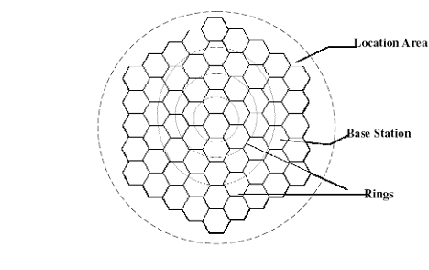

Figure 1.1 The Cell Topology

Each cell has a base station that consists of a tower and a small building containing the radio equipment that is used to communicate with Mobile Terminals over pre-assigned radio frequencies. Cell phones have low-power transmitters in them. Many cell phones have two signal strengths: 0.6 watts and 3 watts [1]. The base station also transmits at low power.

Low-power transmitters have two advantages:
• The transmissions of a base station and the phones within its cell do not make it very far outside that cell. Therefore, in Figure1.1, both of the cells in alternate rings and non-adjacent cells can reuse the same frequency. The same frequencies can be reused extensively across the city.
• The power consumption of a cell phone, which is normally battery-operated, is relatively low. Low power corresponds to small batteries, and this is what has made handheld cellular phones possible.

The cellular approach requires a large number of base stations in a city of any size. A typical large city can have hundreds of towers. But because so many people are using cell phones, costs remain low per user. Each carrier in each city also runs one central office called the Mobile Telephone Switching Office (MTSO). This office handles the entire phone connections to the normal land-based phone system, and controls all of the base stations in the region. Groups of several cells are connected to a Mobile Switching Center (MSC) through which the calls are then routed to the telephone networks. The area serviced by a MSC is called a Registration Area (RA) or Location Area (LA). A group of RA’s composes a Service Area (SA). Each SA is serviced by a Home Location Register (HLR). A wireless network may include several SA’s and thus several HLR’s.

All cell phones have special codes associated with them. These codes are used to identify the phone, the phone's owner and the service provider. Electronic Serial Number (ESN) (a unique 32-bit number programmed into the phone when it is manufactured), Mobile Identification Number (MIN) (a 10-digit number derived from the owners phone's number), and a System Identification Code (SID) (a unique 5-digit number that is assigned to each carrier by the FCC-Federal Communications Commission (A U.S. government agency charged with the task of regulating all forms of interstate and international communication)) are a few of the standard cell phone codes employed. While the ESN is considered a permanent part of the phone, both the MIN and SID codes are programmed into the phone when one purchases a service plan and has the phone activated.

2G systems such as GSM, IS-95, and CDMA One were designed to carry speech and low bit rate data. 3G systems were designed to provide higher data rate services. During the evolution from 2G to 3G, a range of wireless systems, including GPRS, Bluetooth, WLAN and Hyper LAN have been developed. All these systems were designed independently, targeting different service types, data rates, and users. As these systems all have their own merits and shortcomings, there is no single system that is good enough to replace all the other technologies.

In cellular networks such as GSM, a call is seamlessly handed over from one cell to another using hard handover without the loss of voice data. This is managed by networks based handover control mechanisms that detect when a user is in a handover zone between cells and redirect the voice data at the appropriate moment to the mobile node via the cell that the MN has just entered. In 4G networks a handover between different networks is required. A handover between different networks is referred to as a vertical handover. Although commercial mobile telephone networks existed as early as the 1940’s, many consider the analog networks of the late 1970’s to be the first generation (1G) wireless networks.

The details of 1G, 2G, 3G and 4 G and their stages of evolution and the concepts involved are discussed in the Literature review of the Chapter 2. Features of 4G networks, possible architectures for 4G and various mobility management issues are discussed. 4G Networks are all IP based heterogeneous networks that allow users to use any system at anytime and anywhere. Users carrying any integrated terminal can use a wide range of applications provided by multiple wireless networks.4G systems not only provides telecom services, but also a data-rate service when good system reliability is provided. 4G networks face number of challenges in providing service anywhere and anytime which are discussed in Chapter 2.

An event when a mobile station moves from one wireless cell to another is called Handoff. Handoff Criteria, Handoff Strategies, Handoff Methods, Handoff Scenarios and different types of handoffs are discussed in Chapter 3.
Chapter 4 discusses the Vertical handoff procedure and algorithm between various networks in different regions. Universal Seamless Handoff Architecture is also discussed in this chapter.
Chapter 5 discusses the implementation details, system requirements and results.
Chapter 6 discusses the conclusion from the study and implementation.
Appendix A and Appendix B contains the source code of main algorithm and test results of simulation respectively.
Chapter 7 lists the references used in the thesis.

Chapter 2

WIRELESS NETWORKS – 1G, 2G, 3G & 4G

CONCEPTS AND STAGES OF EVOLUTION

Chapter 2

History and Evolution of Mobile Services

The History and evolution of mobile services from the 1G (first generation) to fourth generation are discussed in this section. Table1 presents a short history of mobile telephone technologies.
Technology | IG | 2G | 2.5G | 3G | 4G
Design Began | 1970 | 1980 | 1985 | 1990 | 2000
Implementation | 1984 | 1991 | 1999 | 2002 | 2010
Service | Analog  Voice,  Synchronous  data to 9.6  kbps | Digital  Voice,  short  messages | Higher  capacity,  pocketsize data | Higher  capacity,  broadband  data upto 2  Mbps | Higher  capacity,  completely  IP-oriented,  multimedia,  data to  hundreds of  megabits
Standards | AMPS,  TACS,  NMT, etc | TDMA,  CDMA,  GSM,  PDC | GPRS, EDGE,  1xRTT | WCDMA,  CDMA2000 | Single  standard
Data Bandwidth | 1.9 kbps | 14.4 kbps | 384 kbps | 2 Mbps | 200 Mbps
Multiplexing | FDMA | TDMA, CDMA | TDMA,CDMA | CDMA | CDMA?
Core Network | PSTN | PSTN | PSTN,Packet Network | Packet Network | Internet

Table 2.0 Short History of Mobile Telephone Technologies

First Generation | Second  Generation | Third Generation | Fourth Generation
- Mobile Telephone Service: car phone | - Digital Voice +  - And Messaging  - -Data  - Mobile Phone  - Fixed Wireless  - Loop | - Integrated  - High Quality  - Audio, Video and  - Data.  - Narrow band and Broadband Multimedia Services + IN/IP  - integration | - Dynamic  - information  - access  - Telepresence  - (virtual  - meetings,  - education, and  - training )  - Wearable  - devices
- Analog Cellular  - Technology  - Macro cellular  - Systems | - Digital Cellular  - Technology + IN  - emergence  - Microcellular and  - Pico cellular:  - Capacity, quality  - Enhanced  - Cordless  - Technology | - Broader  - Bandwidth  - CDMA Radio  - Transmission  - Information  - Compression  - Higher Frequency  - Spectrum  - Utilization  - IN + Network  - Management  - integration ‰ IP  - technology | - Unified IP and seamless combination of  - Broadband hot spots  - WLAN/LAN/  - PAN  - 2G/3G + 802.11  - Knowledge-  - Based  - Network  - Operations

Table 2.1 Wireless Network and Service Evolution

The history and evolution of mobile service from the 1G (first generation) to fourth generation process began with the designs in the 1970s that have become known as 1G. Refer to table 2.2 for an overview of the evolution of mobile service. The earliest systems were implemented based on analog technology and the basic cellular structure of mobile communication. These early systems solved many fundamental problems. The 2G systems designed in the 1980s were still used mainly for voice applications but were based on digital technology, including digital signal processing techniques. These 2G systems provided circuit-switched data communication services at a low speed.

During 1990s, two organizations worked to define next, or 3G, mobile system, which would eliminate previous incompatibilities and become a truly global system. The 3G system would have higher quality voice channels, as well as broadband data capabilities, up to 2Mbps. An interim step is being taken between 2G and 3G, the 2.5G. It is basically an enhancement of the two major 2G technologies to provide increased capacity on the 2G RF (Radio Frequency) channel and to introduce higher throughput for data service up to 384 kbps. A very important aspect of 2.5G is that the data channels are optimized for packet data, which introduces access to the internet from mobile devices, whether telephone, PDA (Personal digital assistant), or laptop. However, the demand for higher access speed multimedia communication in today’s society, which greatly depends on computer communication in digital format, seems unlimited.

Traditional phone networks (2G cellular networks) such as GSM, used mainly for voice transmission, are essentially circuit-switched. 2.5G networks, such as GPRS, are an extension of 2G networks, in that they use circuit switching for voice and packet switching for data transmission. Circuit switched technology requires that the user be billed by airtime rather than the amount of data transmitted since that bandwidth is reserved for the user. Packet switched technology utilizes bandwidth much more efficiently, allowing each user’s packets to compete for available bandwidth, and billing users for the amount of data transmitted. Thus a move towards using packet-switched, and therefore IP networks, is natural.

3G networks were proposed to eliminate many problems faced by 2G and 2.5 G networks, like low speeds and incompatible technologies (TDMA/CDMA) in different countries. Expectations for 3G included increased bandwidth: 128Kbps in a car and 2 Mbps in fixed applications. In theory, 3G would work over North American as well as European and Asian wireless air interfaces. In reality, the outlook for 3G is neither clear nor certain. Part of the problem is that network providers in Europe and North America currently maintain separate standards’ bodies. The standards’ bodies mirror differences in air interface technologies. In addition there are financial questions as well that cast a doubt over 3G’s desirability. There is a concern that in many countries, 3G will never be deployed. This concern is grounded, in part, in the growing attraction of 4G wireless technologies.

A 4G or 4th generation network, a new generation of wireless is intended to complement and replace the 3G systems. Accessing information anywhere, anytime, with a seamless connection to a wide range of information and services, and receiving a large volume of information, data, pictures, video, and so on as shown is Figure 2.2 are the keys of the 4G infrastructures.

Figure 2.2 4G Visions

The future 4G infrastructure [3] will consist of a set of various networks using IP as a common protocol so that users are in control because they will be able to choose every application and environment. A 4G or 4th generation network is the name given to an IP based mobile system that provides access through a collection of radio interfaces. A 4G network promises seamless roaming/handover and best connected service, combining multiple radio access interfaces (such as WLAN, Bluetooth, GPRS) into a single network that subscribers may use [12]. With this feature, users will have access to different services, increased coverage, the convenience of a single device, one bill with reduced total access cost, and more reliable wireless access even with the failure or loss of one or more networks.

4G was simply an initiative by R & D labs to move beyond the limitations, and address the problems of 3G which was having trouble meeting its promised performance and throughput. In the most general level, 4G architecture includes three basic areas of connectivity: Personal Area Networking (such as Bluetooth), local high-speed access points on the network including wireless LAN technologies, and cellular connectivity.

4G calls for a wide range of mobile devices that support global roaming. Each device will be able to interact with Internet-based information that will be modified on the fly for the network being used by the device at that moment. The roots of 4G lie in the idea of pervasive computing [20]. The glue for all this is likely to be software defined radio (SDR) [13]. SDR enables devices such as cell phones, PDAs, PCs and a whole range of other devices to scan the airwaves for the best possible method of connectivity, at the best price. In an SDR environment, functions that are formerly carried out solely in hardware – such as the generation of the transmitted radio signal and the tuning of the received radio signal – are performed by software [7]. Thus, the radio is programmable and able to transmit and receive over a wide range of frequencies while emulating virtually any desired transmission format. As the number of wireless subscribers rapidly increases guaranteeing the quality of services anytime, anywhere, and by any-media becomes indispensable. These services require various networks to be integrated into IP-based networks, which further require a seamless vertical handoff to 4th generation wireless networks. And as one of the next generation mobile communications, the 4th generation mobile communications provides various services, such as high-speed data services and IP-based access to Radio Access Network, etc. Various interface techniques such as WLAN, Bluetooth, UTMS, and CDMA2000 are integrated into the IP-based networks as an overlay structure. In this structure, the optimum services are provided to mobile hosts. Mobile hosts in this structure can be connected to the network through various access points. Moreover, a seamless handoff should also be supported between different air interface techniques during inter network movement.

Features of 4G Networks

High Speed - 4G systems should offer a peak speed of more than 100Mbits per second in stationary mode with an average of 20Mbits per second when traveling.
High Network Capacity – Should be at least 10 times that of 3G systems. This will quicken the download time of a 10-Mbyte file to one second on 4G, from 200 seconds on 3G, enabling high-definition video to stream to phones and create a virtual reality experience on high-resolution handset screens.
Fast/Seamless handover across multiple networks – 4G wireless networks should support global roaming across multiple wireless and mobile networks.
Next-generation multimedia support – The underlying network for 4G must be able to support fast speed volume data transmission at a lower cost than today.

The goal of 4G [4] is to replace the current proliferation of core mobile networks with a single worldwide core network standard, based on IP for control, video, packet data, and voice. This will provide uniform video, voice, and data services to the mobile host, based entirely in IP. The objective is to offer seamless multimedia services to users accessing an all IP based infrastructure through heterogeneous access technologies. IP is assumed to act as an adhesive for providing global connectivity and mobility among networks. An all IP-based 4G wireless network has inherent advantages over its predecessors. It is compatible with, and independent of the underlying radio access technology [4].

An IP wireless network replaces the old Signaling System 7 (SS7) [6] telecommunications protocol, which is considered massively redundant. This is because SS7 signal transmission consumes a larger part of network bandwidth even when there is no signaling traffic for the simple reason that it uses a call setup mechanism to reserve bandwidth, rather time/frequency slots in the radio waves. IP networks, on the other hand, are connectionless and use the slots only when they have data to send. Hence there is optimum usage of the available bandwidth. Today, wireless communications are heavily biased toward voice, even though studies indicate that growth in wireless data traffic is rising exponentially relative to demand for voice traffic. Because an all IP core layer is easily scalable, it is ideally suited to meet this challenge. The goal was a merged data/voice/multimedia network.

Possible Architectures for 4G Networks

Accessing different mobile and wireless networks is one of the most challenging problems to be faced in the deployment of 4G technology [22]. Figure 2.3 shows three possible architectures:
- Using a multimode device
- An overlay network
- A common access protocol

Figure 2.3 Possible Architectures for 4G Networks

Multimode Devices

To access services on different wireless networks, one single physical terminal with multiple interfaces is used. Existing advanced mobile phone system on code division multiple access dual function cell phone, dual function satellite cell phone and global system for mobile telecommunications are examples of Multimode Device architecture. Call completion can be improved and coverage area is expanded effectively using this architecture.
When there is network, link or switch failure, reliable wireless coverage should be provided. The handoff between networks can be initiated by user, device or network. There is no requirement of wireless network modification or employment of inter working devices as the device itself incorporates most of the additional complexity. A database can be deployed by each network which stores the information to keep track of user location, device capabilities, network conditions and user preferences.

Overlay Network

There are several universal access points in overlay network with which a user can access. A wireless network is selected by each universal access points based on availability, quality of service specifications and user defined choices [8]. Protocol and frequency translation, content adaptation is performed by universal access point on behalf of users. As the user moves from one universal access point to another, rather than the user or the device, Hand-offs are performed by overlay networks. User, network, device information, capabilities and preferences are stored by the universal access point. Single billing and subscription is supported as universal access points keep track of the various resources a caller uses.

Common Access Protocol

Supporting one or two standard access protocols by wireless networks allows this protocol to become viable. Using wireless asynchronous mode requires networking between different networks as one possible solution. Transmission of ATM cells with additional headers or wireless ATM cells requiring changes in the wireless networks must be allowed by every wireless network to implement wireless ATM. One protocol might be used by one or more types of satellite based networks while another protocol is used by one or more terrestrial wireless networks.

Mobility Management Issues in 4G Networks

A critical aspect of 4G is Mobility [2]. The three main issues regarding mobility management [16] in 4G networks are as follows:
- The optimal choice of access technology or how to be best connected is the first issue dealt with in the mobility of 4G. Considering how the terminal and an overlay network choose the radio access technology is necessary when a user is given connectivity from more than one technology at any one time.

Application Layer
TCP/UDP
IP
GPRS | WLAN | BLUETOOTH | WCDMA

Figure 2.4 Network Technologies

There are several network technologies available today, which can be viewed as complementary. For high data rate indoor coverage, WLAN is best suited. GPRS or UMTS are best suited for nation wide coverage and can be regarded as wide area networks, providing a higher degree of mobility. An optimal choice of radio access technology among all those available should be made by the user of the mobile terminal or the network. The network to be connected and when to perform a handover between different networks are determined by a handover algorithm. Ideally, the handover algorithm would assure that the best overall wireless link is chosen. The type of application being run by the user at the time of handover should be taken into consideration during the network selection strategy. This ensures stability as well as optimal bandwidth for interactive and background services.

2) The second issue regards the design of a mobility enabled IP networking architecture, which contains the functionality to deal with mobility between access technologies. This includes fast, seamless vertical (between heterogeneous technologies) handovers (IP micromobility), quality of service (QoS), security and accounting. Real-time applications in the future will require fast/seamless handovers for smooth operation. Mobility in IPv6 [15] is not optimized to take advantage of specific mechanisms that may be deployed in different administrative domains. Instead, IPv6 provides mobility in a manner that resembles only simple portability. To enhance mobility in IPv6, ‘micro-mobility’ protocols, Cellular IP and Hierarchical Mobile IPv6 [5] have been developed for seamless handovers i.e.; handover that result minimal handover delay, minimal packet loss, and minimal loss of communication state.

3) The adaptation of multimedia transmission across 4G networks is the third and the last issue. As multimedia is the main service feature of 4G networks, and changing radio access networks may in particular result in drastic changes in the network changes. Thus the framework for multimedia transmission must be adaptive. In cellular networks such as UMTS, users compete for scarce and expensive bandwidth. Variable bit rate services provide a way to ensure service provisioning at lower costs. In addition the radio environment has dynamics that renders it difficult to provide a guaranteed network service. This required that the services are adaptive and robust against varying radio conditions. High variations in the network Quality of Service [18] leads to significant variations of the multimedia quality.
The result could sometimes be unacceptable to the users. Avoiding this requires choosing an adaptive encoding framework for multimedia transmission. The network should signal QoS variations to allow the application to be aware in real time of the network conditions. User interactions will help to ensure personalized adaptation of the multimedia presentation.

Wireless Mobile Networks has Mobility Management as an integral function. Mobility Management influences the type and quality of Wireless Network service offerings. Each generation of Wireless Mobile Network has different mechanisms for Mobility Management. Network support of subscriber mobility requires registration, authentication, paging, roaming, radio resource management and excess channel capacity. Mobility Management focuses on the network’s ability to allocate radio access network resources.

Challenges in 4G Networks

4G Networks are all IP based heterogeneous networks that allow users to use any system at anytime and anywhere. Users carrying any integrated terminal can use a wide range of applications provided by multiple wireless networks. 4G systems provide not only telecommunications services, but also a data-rate service when good system reliability is provided. At the same time, a low per-bit transmission cost is maintained. Users can use multiple services from any provider at the same time. Imagine a 4G mobile user who is looking for information on movies shown in nearby cinemas. The mobile may simultaneously connect to different wireless systems. These wireless systems may include Global Positioning System (GPS) (for tracking users current location), a wireless LAN (for receiving previews of the movies in nearby cinemas), and a code-division multiple access (for making a telephone call to one of the cinemas). In this example, the user is actually using multiple wireless services that differ in quality of service (QoS) levels [18], security policies, device settings, charging methods, and applications. There are number of challenges faced by 4G networks in integrating all the services.

An overview of challenges in Integrating Heterogeneous Systems
The challenges mentioned in the above table are grouped into three different aspects:
- Mobile Station
- System
- Service

Mobile Station

To use large variety of services and wireless networks in 4G systems, multimode user terminals are essential as they can adapt to different wireless networks by recon Figuring them. The need to use multiple terminals is eliminated. Adapting software radio approach is the most promising way of implementing multimode user terminals [14]. The analog part of the receiver consists of an antenna, a band pass filter, and a low noise amplifier. The received analog signal is digitized by the analog/digital converter immediately after the analog processing. The processing in the next stage is then performed by a reprogrammable baseband digital signal processor. The digital signal processor will process the digitized signal in accordance with the wireless environment.
Unfortunately, the current software radio technology is not completely feasible for all the different wireless networks due to the following technological problems. It is impossible to have one antenna and one low noise amplifier to serve the wide range of frequency bands. Using multiple analog parts to work in different frequency bands is the only solution. The design complexity and physical size of a terminal are increased. And existing analog/digital converters are not fast enough.

System

For 4G infrastructure to provide wireless services at any time and anywhere, terminal mobility is a must. Terminal mobility allows mobile clients to roam across geographic boundaries of wireless networks. The two main issues in terminal mobility are location management and handoff management. The system tracks and locates a mobile terminal for possible connection. Location management involves handling all the information about the roaming terminals, such as original and current located cells, authentication information, and QoS capabilities. Handoff Management maintains ongoing communication when the terminal roams. Mobile IPv6 is a standardized IP-based mobility protocol for IPv6 wireless systems. Each terminal has an IPv6 home address. Whenever the terminal moves outside the local network, the home address becomes invalid, and the terminal obtains a new IPv6 address called care-of address in the visited network. A binding between the terminal’s home address and care-of address is updated to its home agent in order to support continuous communications. This kind of handoff process causes an increase in system load, high handover latency, and packet losses. It is hard to decide the correct handoff time because measuring handoffs among different wireless systems is very complicated. The uncertain handoff completion time adds to the complexity in designing good handoff mechanisms.

Services

More comprehensive billing and accounting systems are needed, with the increase of service varieties in 4G systems. Customers may subscribe to many services from a number of service providers at the same time rather than only one operator. Dealing with multiple service providers might be inconvenient for customers. Operators need to design new business architecture, accounting processes, and accounting data maintenance. It is challenging to formulate one single billing method that covers all the billing schemes involved. 4G networks support multimedia communications, which consists of different media components with possibly different charging units. This adds difficulty to the task of designing a good charging scheme for all customers. The media components may have different QoS requirements. To decide a good tariff for all possible components is very complicated. To build a structural billing system for 4G, several frameworks have been studied.

Chapter 3

HAND-OFF IN NETWORKS
Chapter 3

Hand-off in Networks

The services provided by the public switched telephone networks (PSTN) [23] are leveraged by wireless mobile telephone network of public land mobile networks (PLMN). PSTNs are backbones to PLMNs. Infrastructure for wireless access, mobility management and external network gateways are provided by the network elements of PLMNs. A simple PLMN [23] consists of the following components:
- Base stations
- Mobile switching service Centers (MSC)
- Home Location Register (HLR)
- Visitor Location Registers (VLR)
- Authentication Centre (AUC)
- Equipment Identification Register (EIR).

Figure 3.0 Simple PLMN [23]

Radio interface for mobile subscribers are used to provide network access by the base stations. Managing base stations, consulting PLMN database to establish subscriber access rights, routing mobile traffic is managed by MSC. MSC also serves as a gateway to external networks. Subscriber profiles, location encryption codes and equipment data are stored in PLMN databases. HLR, VLR, AVC and EIR are PLMN databases.

All telephone networks require fundamental services like Call establishment and connection maintenance. Call initiation signaling, connection path establishment, alerting called party, call acceptance and preservation of connection until end of session signaling is detected consists of the PSTN call process for two authorized fixed location subscribers. The PSTN uses the fixed location of the subscriber to simplify network functions. Authentication, call establishment and call preservation are simplified by fixed subscriber location. Subscriber mobility significantly complicates network operations, although a PLMN call process performs the same functions of a PSTN.

PLMN’s must implement mobility management technologies to provide PSTN services. These technologies enable PLMN’s to establish and maintain calls to authorized mobile subscriber. Mobility Management uses the HLR, VLR’s, MSC’s and Base Stations. Call quality, reliability and availability are strongly influenced by Mobility Management technologies. Mobility Management is the ability of a PLMN to orchestrate calls for its subscribers and radio management maintains the call regardless of the mobility of the subscribers. PLMN’s must track and dynamically route calls to its subscribers in a transparent fashion. The main functions of mobility management are locating, authenticating and tracking mobile subscribers. PLMNs use a registration process to report a mobile station’s right to access network services. Roaming allows authorized mobile subscribers to use networks other than their home PLMN. Signal quality assessments, base station selection and switching constitute Radio Resource Management (RRM).

Handoff Criteria

Increasing distance from the base station attenuates the radio signal as a subscriber travels away from its base station.

Figure 3.1 Signal Quality Behaviors [23]

Prior to loss of communication, reliable detection of this condition is crucial. When deteriorating signal strength is detected the PLMN responds by seeking an alternative base station with higher signal strength. The PLMN moves the call to the new base station and releases the previous base station after selecting and reserving a new base station channel.

Received signal strength is described by Received Signal Strength Indicator (RSSI) and handoff process relies on this signal strength. As the characteristics of base station and mobile handset receivers are well known, it is possible to predict performance ranges based on received signal levels. The crucial factor for PLMN’s radio resource management is accurate and reliable signal quality assessments between the mobile station and its serving base station. Real time measurements effect PLMN’s rapid execution of handoffs. Another key parameter for radio resource management is the reference point of signal strength measurements. The PLMN can use measurements made at the base station, handset or both as a reference for resource switching decisions.

Handoff Strategies
An event when a mobile station moves from one wireless cell to another is called hand-off. Handoff can be of two types: horizontal (intra-system) and vertical (inter-system) cases. Handoff within the same wireless access network technology is considered as Horizontal handoff, and handoff among heterogeneous wireless access network technologies is considered vertical handoff. The terminology of horizontal and vertical reflects the wireless access network technology instead of the administrative domain in comparison to macro- and micro mobility. There are different subclasses such as follows:

- Vertical macro mobility refers to mobility among different administrative domains using different wireless technologies
- Horizontal macro mobility refers to mobility among different administrative domains using the same wireless technology
- Vertical micro mobility refers to mobility within the same administrative domain using different wireless technologies
- Horizontal micro mobility refers to mobility within the same administrative domain using the same wireless technology.

Handoff Methods

Handoffs have several methods and they are technology dependent. The two main handoff methods are:
- Hard Handoff: It has a brief disruption of service as it has to break before a making a switching action. Hard Handoffs are used by Time Division Multiple Access (TDMA) and Frequency Division Multiple Access (FDMA) systems.
- Soft Handoff: It has no disruption of service action as it makes a switching action before the break. Multiple network resources are used by soft handoffs. Soft handoffs are used by CDMA system.

Figure 3.2 shows two different handoffs.

Figure 3.2 Handoff Methods [23]

Handoff Scenarios

As mobiles traverse cell or sector boundaries, majority of handoffs support calls. The following are scenarios where Handoff processes are required:
- Intra-MSC - Involve crossing cell boundaries within a MSC’s service area
- Inter-MSC - Involves crossing cell boundaries between MSCs
- Roaming - Involves crossing cell boundaries between different network operators
- Intra-cell – Involves crossing sector boundaries within a cell
- Switching channels to circumvent persistent interference

Figure 3.3 Basic Handoff Scenarios [23]

Horizontal Handoff

A Horizontal handoff is a handoff between two network access points that use the same network technology and interface. For example, when a mobile device moves in and out of various 802.11b network domains, the handoff activities would be considered as a horizontal handoff, since connection is disrupted solely by device mobility.

Vertical Handoff

A Vertical handoff is a handoff between two network access points, which are using different connection technologies. For example, when mobile device moves out an 802.11b network into a GPRS network, the handoff would be considered a vertical handoff.

Support for Vertical Handoffs

The current IPv6 [17] specification does not support vertical handoffs. Since IP is the common protocol, everything below it is abstracted from the application. For the application, it is always connected as handoffs occur. To provide this support in IPv6 a daemon can be run at the network layer which takes care of switching between different radio accesses technologies. The mobile device might be having separate interface cards for each of the networks or may use a single multimode card which works in different modes at different times. The protocol stacks of each of the different radio access technology are stored in the mobile device. The daemon in the network layer will then choose which radio access network (RAN) to use on the basis of network speed, quality of service, cost of usage and other similar criteria. The selection policies are customizable and changes between different RANs are automatic and transparent to the user and depend on coverage and network load conditions. After selecting the RAN, the daemon then initializes the appropriate protocol stack before starting to use that interface. This way the IP datagrams being passed down get encapsulated in the correct format of the radio access technology in use. This model allows the device to utilize any interface as long as the hardware is present by just installing the necessary stack protocols.

A seamless handoff should also be supported between different air interface techniques during inter-network movement. This type of handoff is called a vertical handoff, because the mobile is moving to another network (heterogeneous network) which has a different air interface technique. Various wireless LAN services are being introduced in hotspot areas such as campuses, hotels and offices. IEEE802.11 WLAN services having high bandwidth are used to cover limited hotspot areas. If the mobile host (MH) goes out of the hotspot coverage, the call will be dropped. In the 4th generation, a WLAN cell is overlaid within a CDMA2000 cell that is constructed into an ALL-IP based network. A seamless handoff is supplied through the vertical handoff process even if the MH goes out of the WLAN coverage area. The minimized cell size in 4th generation networks results in frequent handoffs.

Recently proposed network architecture and procedure for the vertical handoff [24] adopts the mobility management concept through the Mobile Agent (MA) and Subnet Agent (SA) functions to minimize the delay during vertical handoff. The first goal of seamless handoff is low handoff latency, power saving, and low bandwidth overhead [8]. WLAN and CDMA 2000 networks have different frequency, maximum data speed and cost characteristics. The time for the handoff procedure to begin in the handoff region is decided by the handoff delay time and throughput according to traffic characteristics. The real-time traffic preferentially takes into account the handoff delay, and the non-real time traffic takes the throughput into account.

Methods for interconnecting CDMA2000 networks with heterogeneous air interfaces and WLAN use emulators, virtual access points, or mobile IP. Mobile IP [9] method is operated peer-to-peer relationship that shows better performance than the previous two methods that operate in master/slave relationship. An IP-based architecture using mobile IP is shown in Figure 3.4

Figure 3.4 WLAN-CDMA Cellular Interconnection Architecture based on IP[24]

In the WLAN-CDMA Cellular Interconnection architecture [24], handoff occurs in the following cases:
- Mobile Download
- Mobile Upward
- Mobile Through
Mobile Download
When the mobile host serviced in the WLAN region moves to another area and is synchronized to the CDMA network Mobile Download occurs.
Mobile Upward
When the Mobile Host enters into a WLAN from the cellular network outside the WLAN, mobile upward occurs.
Mobile Through
When one of the two networks in the media selection layer is selected, Mobile Through occurs.

Figure 3.5 Mobile Host Protocol STACK [24]

The mobile host saves power by operating only one interface card when operating in the handoff transition region before it goes into the handoff transition region. The mobile host after moving into the transition region then activates the interface card for the neighbors.

Chapter 4

DYNAMIC DECISION MODEL (Vertical HANDOFF) FOR HETROGENOUS NETWORKS

Chapter 4

Introduction

With the development of 4G mobile communication systems, more and more mobile hosts nowadays are equipped with multiple network interfaces which are capable of connecting to the internet. As a result, an interesting problem surfaced on how to decide the “best” network to use at a “best” time moment.

The decision to decide best network may be based on static factors such as the bandwidth of each network (capacity), usage charges of each network, power consumption of each network interface and battery level of mobile device. However, Dynamic factors must be considered in handoff decisions for effective network usage. For example, information on current network conditions such as received signal strength (RSS) can help in improving whole system performance; current user conditions, such as a mobile host’s moving speed can eliminate certain networks that do not support mobility, from consideration.

This project proposes to implement the dynamic decision model to make the right vertical handoff decisions by determining the “best” network at “best” time among available networks based on, dynamic factors such as “Received Signal Strength (RSS)” of network and “velocity” of mobile station as well as static factors. Thus this model not only meets the individual needs but also improve the whole system performance by reducing the unnecessary handoffs.

As per the present knowledge, there exist very few works dealing with Vertical Handoff (VHO) beyond simple extensions to the common techniques for Horizontal Handoff (HHO). Three main approaches for VHO algorithms are recorded in the literature. The first approach is based on the traditional strategies of using the RSS that may be combined with other parameters such as network loading. The second approach uses artificial intelligence techniques combining several parameters such as network conditions and Mobile Terminal’s (MT) mobility in the handoff decision. However, these artificial intelligence based algorithms are complex and may be difficult to implement in practical systems. The third approach combines several metrics such as access cost, power consumption, and bandwidth in a cost function estimated for the available access networks, which is then used in the MT handoff decision.

Wang et al. introduce the policy enabled handoff in [5], which was followed by several papers on similar approaches. Policy enabled handoff systems separates the decision making (i.e. which is the “best” network and when to handoff) from the handoff mechanism. These systems allows users to express policies on what is the “best” wireless system at any moment and make tradeoffs among network characteristics and dynamics such as cost, performance and power consumption. A generic vertical handoff decision function [6] proposed considering the different factors and metric qualities that give an indication of whether or not a handoff is needed. The decision function enables devices to assign weights to different network factors such as monetary cost, quality of service, power requirements, personal preferences etc. A decision strategy [7] considers the performance of the whole system while taking VHO decisions by meeting individual needs. This decision strategy selects the best network based on the highest received signal strength (RSS) and lowest Variation of received signal strength (VRSS).thus it ensures the high system performance by reducing the unnecessary handoffs. A time adaptive VHO decision scheme [8] make right VHO decisions timely through adjusting interface activating intervals based on the user’s movement and the actual network performance. All the schemes presented till now either used only static parameters or used only one dynamic parameter (RSS or velocity) with the static ones to improve the system performance but not both. So this Project proposed a dynamic decision model which used both RSS and velocity as dynamic factors to improve the system performance.

BACKGROUND

The Heterogeneous networks are expected to become a main focus in the development toward the next generation wireless networks. In the heterogeneous or converged network [13], both intra-technology handoff and inter-technology handoff take place as illustrated in Fig. 1. Intra-technology handoff is the traditional Horizontal Handoff (HHO) process in which the mobile terminal hands-off between two Access Points (AP) or two Base Stations (BS) using the same access technology. On the other hand, inter-technology handoff, or Vertical Handoff (VHO), occurs when the MT roams between different accesses technologies.

Figure 4.0 Horizontal and Vertical Handoff.

The main distinction between VHO and HHO is symmetry. While HHO is a symmetric process, VHO is an asymmetric process in which the MT moves between two different networks with different characteristics. This introduces the concept of a Preferred Network, which is the network that provides better performance at lower cost, even if several other networks are available and in good condition for the user.

There are two main scenarios in VHO: moving out of the preferred network (MO) and moving into the preferred network (MI). In the converged model, it is highly desirable to associate the MT with the preferred network, as long as the preferred network satisfies the user preferences. This can improve both, the resource utilization of access networks as well as the user perceived quality of service (QoS). Furthermore, this handoff should be seamless with minimum user intervention, while dynamically adapting to the wireless channel state, network layer characteristics, and application requirements.
In general, the vertical handoff process can be divided into three main steps [10], namely
- System Discovery,
- Handoff Decision, and
- Handoff Execution.
During the system discovery phase, mobile terminals equipped with multiple interfaces have to determine which networks can be used and the services available in each network. The networks may also advertise the supported data rates for different services. During the handoff decision phase, the mobile device determines which network it should connect to. The decision may depend on various parameters including the available bandwidth, access cost, transmit power, current battery status of the mobile device, and the user's preferences. During the handoff execution phase, connections need to be re-routed from the existing network to the new network in a seamless manner. This phase also includes the authentication and authorization, and the transfer of user's context information. A seamless handoff is defined as a handoff scheme that maintains the connectivity of all applications on the mobile device when the handoff occurs. Seamless handoffs aim to provide continuous end-to-end data service in the face of any link outages or handoff events. Various seamless handoff techniques [2] have been proposed. These proposals can be classified into two categories: network layer approaches and upper layer approaches.
Seamless handoff solutions, whether network layer or upper layer approaches, are often complex to implement and operate. For the network layer solutions, deployment means upgrading every existing router without mobile IP capabilities. For the upper layer solutions, a new session layer or transport protocol requires an update to all existing applications and servers not supporting it. In both the above cases, the high cost imposed by these solutions hinders their chances of deployment. Consequently, even though these handoff solutions have managed to minimize both latency and packet loss, they are often deemed impractical by the majority of service providers and are still rarely deployed in reality.
A Universal Seamless Handoff Architecture (USHA) was proposed in [2] to deal with both horizontal and vertical handoff scenarios with minimal changes in infrastructure which requires deployment of handoff servers only on the Internet. USHA is an upper layer solution; however, instead of introducing a new session layer or a new transport protocol, it achieves seamless handoff by following the middleware design philosophy [5], integrating the middleware with existing Internet services and applications.
USHA is based on the fundamental assumption that handoff, either vertical or horizontal, only occurs on overlaid networks with multiple Internet access methods (i.e. soft handoff), which translates to zero waiting time in bringing up the target network interface when the handoff event occurs. If coverage from different access methods fails to overlap (i.e. hard handoff), it is possible for USHA to lose connectivity to the upper layer applications.

Figure 4.1Universal Seamless Handoff Architecture

In above figure, a handoff server (HS) and several mobile hosts (MHs) are shown. USHA is implemented using IP tunneling techniques (IP encapsulation), with the handoff server functioning as one end of the tunnel and the mobile host as the other. An IP tunnel is maintained between every MH and the HS such that all application layer communications are “bound” to the tunnel interface instead of any actual physical interfaces. All data packets communicated through this IP tunnel are encapsulated and transmitted using the connectionless UDP protocol.

The IP tunnel above utilizes two pairs of virtual/fixed IP addresses, one on HS and one on MH. The fixed IP addresses are necessary for an MH to establish a physical connection to the HS. When the handoff event occurs and the physical connection from MH to HS changes, the MH is responsible for automatically switching the underlying physical connection of the virtual tunnel to the new interface, as well as notifying the HS of its change in physical connection. Upon handoff notification, the HS immediately updates its IP tunnel settings so that any subsequent data packets will be delivered to MH’s new physical link. Since all data packets are encapsulated and transmitted using UDP, there is no need to reset the tunnel after the handoff. Therefore, end-to-end application sessions (e.g. TCP) that are bound to the IP tunnel are kept intact. This provides handoff transparency to upper layer applications.

On the other hand, though USHA provides a simple and practical seamless handoff solution, it still has difficulty in performing handoff smartly, i.e. the handoff cannot be triggered automatically so far. It turns out that a manual handoff solution is still far from becoming practical, since an appreciable solution should keep mobility transparent to the mobile users, i.e. the seamless handoff solution should be “smart” enough so that it is able to perform a handoff properly at the proper moment.

In multi-network environments, Criteria of a vertical handoff is one of the chief challenges for seamless mobility as there does not exist a single factor than can provide a clear idea of when to handoff. Some of the most important decision factors are:
- Usage Cost: The cost of using a network to the user is a major issue. The network providers may well provide a variety of billing plans and options that will probably influence the customer’s choice of network and thus handoff decision.
- Power Requirements: Wireless devices operate on limited battery power. When the level decreases, handing off (or remaining connected) to a network with low power consumption can provide elongated usage time.
- Offered Bandwidth: Higher offered bandwidth ensures lower call dropping and call blocking probabilities, hence higher throughput.
- Velocity: Because of the overlaid architecture of heterogeneous networks, handing off to an embedded network, having small cell area, when traveling at high speeds is discouraged since a handoff back to the original network would occur very shortly afterwards.
- Signal Strength: The signal strength has a great role in the HHO decisions due to its comparability between the current attachment point RSS and that of the candidate attachment points. But In VHO, the RSSs are incomparable due to VHO’s asymmetrical nature. However, they can be used to determine the availability as well as the condition of different networks. If more than one candidate networks are available, the MT should associate itself with the one having the strongest RSS as it does in HHO.

In the proposed Dynamic Decision Model, above mentioned
Criteria’s are taken into consideration with special emphasis on velocity, RSS and user preferences in order to improve the system performance by reducing the unnecessary handoffs.

ALGORITHM

This section presents the proposed Dynamic decision model which support flexible configuration in executing vertical handoffs. Fig. 2 depicts the proposed dynamic decision model. A Handoff Management Center (HMC), monitors the various inputs collected from the network interfaces and their base stations (BS), analyze this information and took handoff decisions. It also provides the connection between the network interface and the upper layer applications. HMC is composed of five components: Network Analysis (NA), Network Discovery (ND), Dynamic decision (DD), system monitor(SM) and Handoff manager & executor (HME).

NA is responsible for monitoring the status of each network interface (i.e. offered bandwidth, user charges, power consumption of network interface) and analyzing based on the calculated score function. SM monitors and reports system information (i.e. current remaining battery and user preferences) to NA module. ND module discovers all the available networks at fixed time intervals. It monitors the velocity of MS and the Received Signal strength (RSS) of the base station (BS), select the candidate networks and assigns them priorities. Finally, the DD module takes the decision, for selecting “Best” network to handoff, based on the inputs from NA and ND modules.
The algorithm for dynamic decision is described in Fig. 3. The Priority Phase is used to remove all the unwanted and is negligible networks from the prospective candidate networks. The Normal Phase is used to accommodate user-specific preferences regarding the usage of network interfaces. The user preferences are expressed in terms of weight factors. Finally, the Decision Phase is used to select the “Best” network and executing the handoff to the selected network.
- System Monitor: This module monitor the current battery level of the mobile station and record the user preferences for various networks based on the current battery level, offered bandwidth, usage charges and power consumption by their interface card. These preferences, expressed in terms of weight factors, are passed on to the Network Analysis module to calculate the score function.
- Network Analysis (NA): The network is analyses based on a static score S. The S can be defined as a function of the following parameters: the offered bandwidth (Bn), power consumption of using the network access device (Pn) and the usage charge of the network (Cn)-
  - Sn =f (Bn, Pn, Cn) ………….. (1)
Here, Sn is the static score for network n.

Dynamic Decision Process
- Priority Phase: (User Preferences)
- Collect user preferences in terms of Cost, Bandwidth and Power
Weight age.
- Priority Phase :(NETWORK DISCOVERY)
- Add all available interfaces into candidate list.
- Scan all the networks and record their Received Signal Strength(RSS)
- Record the velocity of the mobile station(MS)
- Remove the networks which do not satisfy the required RSS and velocity criteria.
- Calculate and assign the priorities to all the candidate networks based on percentage difference between RSS and its threshold value.
- Continue with Normal Phase.

B) Normal Phase: (NETWORK ANALYSIS)
- Collect current system status from SM component and
- Use the score function to obtain the static score ‘S’ of every wireless interface in the candidate list.
- Handoff all current transmissions to the interface with the highest score if different from current device.
- Continue with Decision Phase

C) Decision Phase: (NETWORK SELECTION AND EXECUTION)
- Calculate a dynamic score “DScore” by multiplying the priority of each candidate network with it’s static score “S”.
- Select the network with the highest value of “DScore”
- Handoff all current information to the “Selected network” if different from current network

FIGURE 4.2 DYNAMIC DECISION MODEL ALGORITHM

We can imagine that such a score function is the sum of some normalized form of each parameter. Normalization is needed to ensure that the sum of the values in different units is meaningful. In general, suppose that there are k factors to consider in calculating the score, the final score of the interface i will be a sum of k weighted functions.
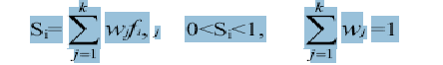
In the equation, wj stands for the weight of factor j and fi, j represents the normalized score of interface i for factor j.
For our model –
Where wb is weight factor for Offered Bandwidth, wp is weight factor for Power Consumption by network interface and wc is weight factor for Usage Cost of network. fb,i , fp,i and fc,I represents the normalized score of interface i for Offered Bandwidth, Power Consumption and Usage Cost respectively
which are defined as :
f_{b,I} = 1/ e^{αi} (4)
f_{p,I} = 1/e^{I} (5)
f_{c,I} = 1/e ^{γi} (6)

The coefficients αi, βi, γi can be obtained via a lookup table or well-tuned functions as below:
γ_{i} = Network Cost / User specified Maximum cost (7)
α_{i} = User specified Min Bandwidth/Network Bandwidth (8)
_{i} = Network Power / User Specified Maximum Power (9)

Eq. 5 & 6, used the inversed exponential equation for fp,I and fc,i to bound the result to between zero and one (i.e. these functions are normalized) and properly model users preferences. For fb,i a new term M is introduced as the denominator to normalize the function, where M is defined as the maximum link capacity among all available interfaces. Note that, the properties of bandwidth and usage cost/power consumption are opposite (i.e. the more bandwidth the better, whereas lower cost/power consumption is preferred).

- Network Discovery (ND) The object of this module is to identify all the Candidate Networks from all the available networks and assign them Priority.
Candidate Network Selection:
A candidate network is the network whose received signal strength is higher than its threshold value and its velocity threshold is greater than the velocity of mobile station.
Let N= {n1,n2,n3………nk} is the set of available network interfaces.
VT={vt1,vt2,vt3,…….vtk} is the set of threshold values of velocities for a mobile station for the respective networks.
RSST={rsst1,rsst2,rsst3,…………rsstk} is the set of threshold values of received signal strengths of respective networks.
RssDiff={RssDiff1,RssDiff2,…….RssDiffk} is the set of values of difference between the received signal strength and its threshold value.
CN = { } is the set of all eligible candidate networks into which the handoff can take place.
P={0,1/k,2/k,..j/k,…,1} is the set of priority values for jth network, where j=1..k
The network base station (BS) and mobile station(MS) is observed for the RSS and Velocity respectively at the specified time intervals and the decisions are taken as below to select the candidate networks :

Let the MS is currently in network ni Then
If RSSi < rssti then
For all nj where j ≠ I
If (RSSj > rsstj and vi < vtj ) then
{CN} = {CN} U {nj}
RssDiffj=RSSj-rsstj
Priority Assignment:
The priority is based on RssDiff where higher the RssDiff means higher the priority. It is so because higher RssDiff indicate that the MS is more nearer to the BS of that network and hence the MS can stay for more time in the cell of the respective network before asking for another handoff. Thus it

makes possible to reduce the unnecessary handoffs and improve the overall performance of the system. The priory p is assigned to all the networks as below-

Let there are n candidate networks out of k available networks then

For j=1 to k Do
If j is not a candidate network Then
Pj =0
Else if j is the only candidate network Then
Pj =1
Else if network is at ith position in an ascending order sorted set of RssDiff Then
pj=i/k;

Using above rule based the Network Discovery module select the eligible networks from the all available networks and assign the priority.

Dynamic Decision (DD)
This module is responsible to take final decision of selecting a particular candidate networks from a set of candidate networks decided earlier by network discovery (ND) module. A dynamic score “DScore” is calculated for each network i as below-
DScorei = Si * pi (4)
Where Si is the score calculated by the NA module and pi is the priority decided by the ND module for the ith network.

A candidate networks which has highest corresponding value of “DScore” is selected as the “best” network to handoff.

Chapter 5

SIMULATION

Chapter 5

Implementation Details

In this chapter we describe how the Dynamic Decision Model for Vertical Handoff Algorithm is implemented and how the simulation is carried out. It is important that we test the performance of the algorithm by simulating it over a wide range of simulation parameters. This is true not only for the Vertical Handoff Algorithm but as a matter of fact, for any algorithm.

Simulation firstly, helps us determine whether the algorithm is performing correctly as required by the standards and the user. Before the algorithm is implemented in real time systems, its performance has to be carefully studied so that, the system in which the algorithm is implemented performs according to the users expectations.
Secondly, this simulation also helps us determine the right values of the parameters that need to be set so that the algorithm attains a satisfactory performance level. If the parameters are not appropriately set then it may happen that the algorithm might be switching too often between the two networks without any real necessity for doing it and thus, causing a sub-optimal performance of the system/device; or it might also happen that the algorithm does not switch the device connection between networks even though the device might perform better in the other network.

Thus, it is very important that we test the algorithm using simulation in order to determine its effectiveness when used in real world devices and to find the right parameters of the algorithm so that its performance is optimized.

We start off this chapter by describing the code and the inputs required and how the code operates. In the next section we present some results and analyze the plots so obtained. Finally, we present the conclusions drawn from our simulation study.

Below is the snapshot of Vertical Handoff Manager and Executor which is implemented in Java 1.5.
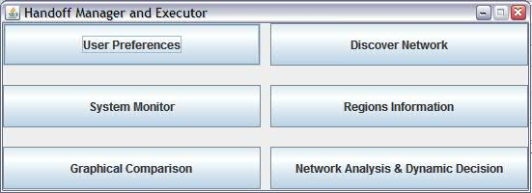

Figure 5.0 Handoff Manager and Executor

There are six major modules/components in Dynamic Decision Model project which are mentioned below.

- User Preferences: This is a static field where user gives his preferences in the form of weight age for Cost, Bandwidth and Power. The total of all these should be equal to 1.

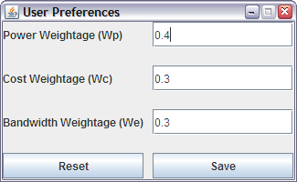
Figure 5.1 User Preferences

- Discover Network: This component lists all the available networks like CDMA, GSM etc and user can set values or parameters for these networks like usage cost, bandwidth etc. The object of this module is to identify all the Candidate networks from the available networks and assign priority to them.

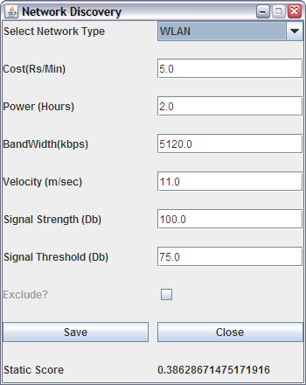
Figure 5.2 Network Discovery

- System Monitor: This component/module monitors the current battery level of the mobile station and record the user preferences for various networks based on the current battery level, offered bandwidth, usage charges and power consumption by their interface card. These preferences are passed on to the Network Analysis module to calculate the score function.
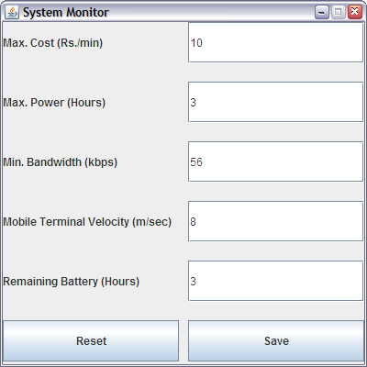
Figure 5.3 System Monitor

- Regions Information: A mobile terminal with multiple interfaces can move in cell boundaries of any network during simulation. The mobile terminal can be in any of the regions from A, B, C and D at a moment of time. Currently, our simulation is executed on 4 regions which can easily be extended. Each region at a given point of time, lists all the networks available. In current simulation we have provided opportunity to user to select what all networks are available in a given region. User can also input the sequence of regions where he intends to travel. In real world scenario, while in roaming Mobile Terminal will monitor the networks as well as system for various parameters but handoff decision function is executed at specified time intervals, value of which is provided at the start of simulation.

Parameters comparison for cost, bandwidth, velocity, battery status can be done visually for each region using graphs provision for each region.

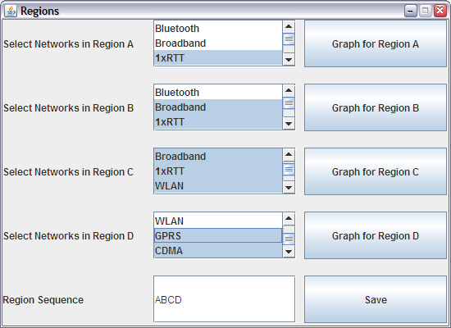
Figure 5.4 Region Preferences

- Network Analysis & Dynamic Decision: This component/module will compute which network is best at a given point of time based on the user preferences and priority which is based on RSS. This module computes the static and dynamic score for each network based on static parameters like user preferences, system information and RSS and velocity. Static Score for each network is also displayed in Discover Network screen for easy reference and testing purpose. We can modify the inputs to change values of parameters to see variation in static score.
To capture variations in RSS, project has assigned priority based on the difference between RSS and Signal Strength Threshold for each network.

Static Score = Weight Factor * Normalized Score of Interface I for factor j
Dynamic Score = Static Score * Priority
.

Higher the Dynamic Score, better the chances for handoff to that network if already not current.

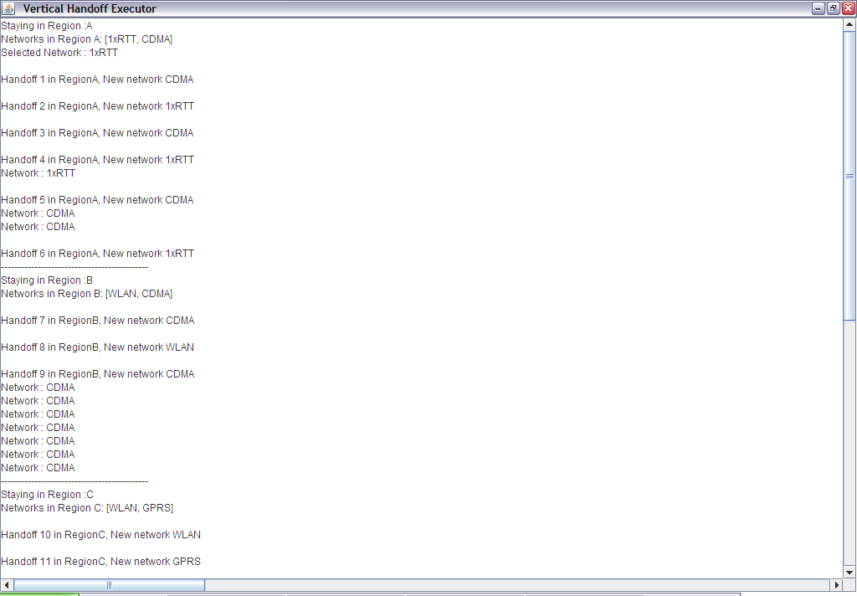
Figure 5.5 Network Analyses and Dynamic Decision Model

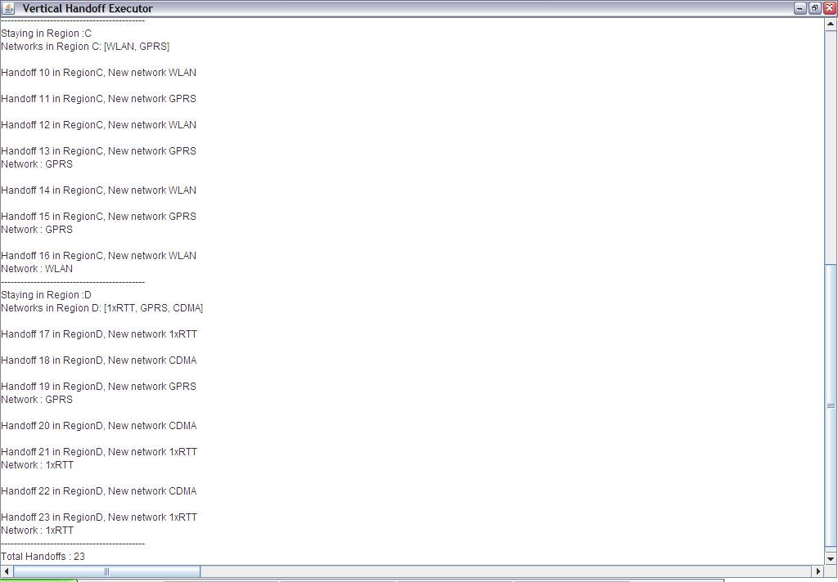

- Graphical Comparison: This module/component is to display the graphical comparison for each parameter ie cost, bandwidth, velocity, battery, signal strength etc with respect to user preferences. It also explains the reason for selection for a particular network over the other while doing Vertical Handoff.

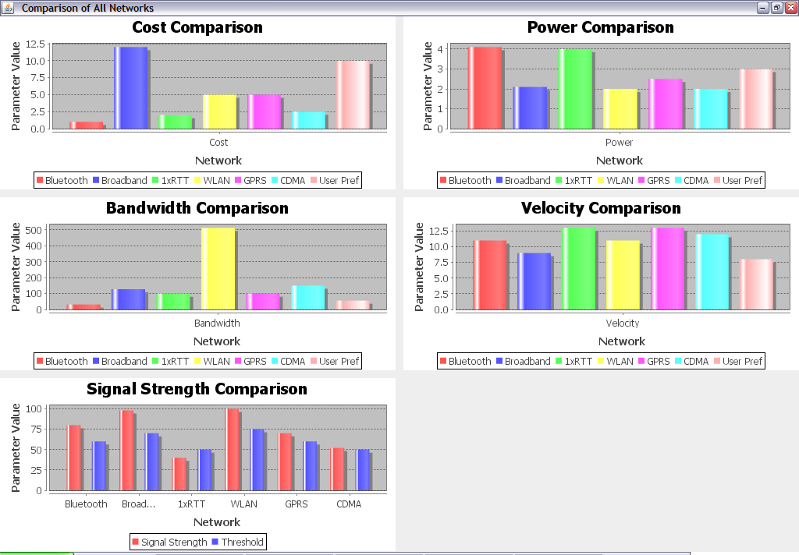
Figure 5.6 Graphical Comparisons of Selected Network Parameters and User Preferences.

Code Structure and Description

The code structure shown in above section figures is self explanatory, but for the sake of clarity it is elaborated in this section. Refer Appendix A for Code.

Inputs:

The code requires a set of input values for the parameters which are described below.

- Cost, Bandwidth and Battery Weightage: User needs to provide weightage with respect to Cost, Bandwidth and Power which will be used to calculate static score. Weighatge for each should be in the range of 0 to 1 and sum of all three should not exceed 1. Refer Diagram in previous section.

- Network Parameters: User can select any network from the system and set their initial parameters to study the variations in simulation for various test scenarios. It also provides option of exclusion of any network from the overall system. In practical environment these network parameters are as per service provider and user will be able to select any plan from group of plans provided by Service provider. Below screen shows parameters set for Bluetooth network. This module also displays the static score for the network which is handy for testing different scenarios.

Any signal having strength less than this threshold value is considered weak and any signal having strength greater than the threshold value is considered as strong. We can also choose to set the user in any of the networks at the start of the simulation. Obviously in real world whether the user is working in a network is determined by the position of the user or the position of his device to be more precise. Also simulation is carried on for a specific period of time, there are 10 iterations taken for each network to simulate Signal strength with respect to time ie with 100 ms of wait.

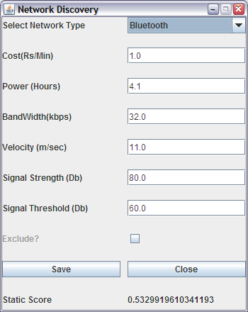
Figure 5.7 Network Parameters

- Regions: Code requires input in the form of networks present in a given region. More the networks present, more is the probability of vertical handoff close to user preferences. In practical world, various networks information will be read by MT with multiple interfaces. User can also input the sequence of regions to study handoff probabilities if no of regions increases or decreases. Refer diagram in above section.

- System Monitor: It provides the boundary conditions with respect to user preferences ie Max Cost expected, Minimum Bandwidth desired, Maximum Power, Mobile Terminal Velocity. Refer diagram in above section.

Outputs

Dynamic Decision Model does network analysis based on algorithm mentioned in previous chapter and provide under mentioned outputs.
Below screen describes which network is best in a region as per user preferences and received signal strength. It also mentions the total hand-offs required if MT moves in the region sequence as mentioned.
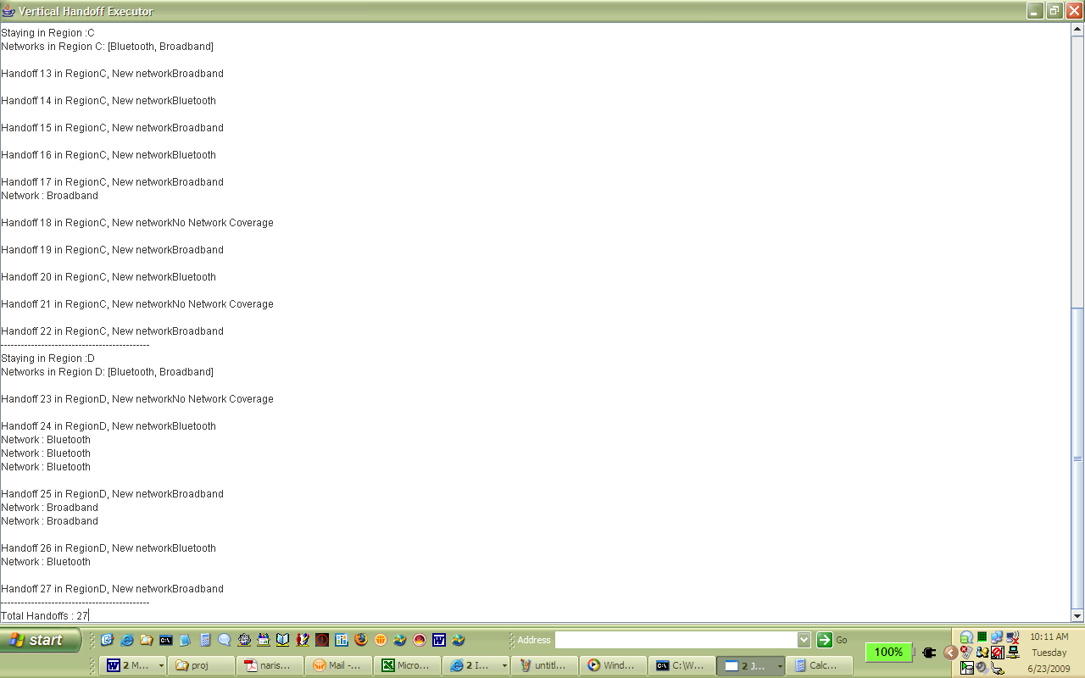
Figure 5.8 Dynamic Decision Output
Below graphical comparison presentation screenshot details all the networks which are short listed based on cost, bandwidth, power etc with respect to user preferences. These graphs helps to study the reasons for handoff required and which network is best in any given region.
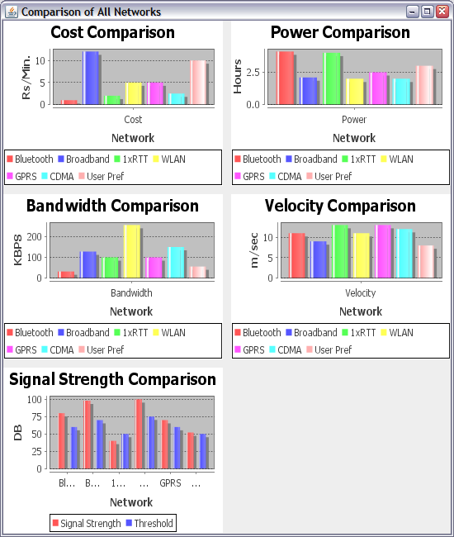

Figure 5.9 Dynamic Decision Output Vs User Preferences.

System Requirements:

- Windows XP or UNIX machine with atleast 512 Mb RAM and Intel X86 processor.
- Java 1.5.X Runtime Environment or higher.

Results:

We have tested the performance of the algorithm over a varied range of simulation parameters. Results of the Simulation are described below along with graphs. This section also explains the functioning and results of the whole algorithm with the help of example. Refer Appendix B for results and sample run.

- Handoffs are being decided based on D-Score which is measure of weightage into cost, bandwidth and power functions, multiply by priority based on signal strength difference between threshold and current value.
- Handoffs are being done whenever there is higher Dynamic Score for any network even though the current network signal strength is higher than the threshold. The graph below at points 18 and 20 shows that network GPRS is selected over WLAN even when WLAN was having higher signal strength.
- Handoffs are being triggered whenever there is fall in signal strength of current network and increase in Signal Strength of other available networks.
In above diagram GPRS signal strength decreases after 15th handoff hence it handoffs to WLAN whose signal strength increases.
- All networks which are available in new region will be considered for handoff whenever Mobile Terminal will leave the current region.
- No of Handoffs are based on frequency to measure signal strength. We are measuring signal strength every 100MS, hence no of handoffs in our simulation are high. But in real time scenario, this will lead to increased utilization of resources hence, not recommended. Our simulation can be scaled to real time scenario to get accurate results.
- No of Handoff’s are decreased by almost half if current network is allowed to continue until it reaches below or equal to threshold signal strength value than to switch network on every high D score for other network.
- In above diagram the total numbers of handoffs are reduced to 10 from 22 as shown in previous diagram. Reason for the same is non consideration of signal strength until it drops to threshold value, which leads to usage of same network again and again as shown by yellow, blue scatter points. This reflects overall low QOS to the user. For detailed report please refer to sheet in appendix.
- No of Handoffs are always more for Dynamic Decision Model than Static Model because it evaluates the priority of Received Signal Strength continuously based on frequency set by Base Station, hence provides more flexibility with the Quality of Service to be provided to end user. Refer above diagram.

- End user is always working on best available user preferences and received signal strength, thereby decreasing the probability for call disconnect or lower bandwidth or higher cost.
- Static Model compels the user to work on same network until signal strength of the current network drops below the threshold value or new network with higher static score becomes available in the same region or cell. With static approach, there are high chances of call disconnect if Received Signal Strength falls below the threshold value. Refer diagram on last page.
- Dynamic Model will still allow the handoffs even if user provided weightage for cost, bandwidth and power and System monitor parameters are same across all available networks whereas Static Model will not allow any handoffs due to same Static score for all networks. In this condition Static Model fails to provide quality of service to user if better quality is available on another network.

Static Decision Example – Scenario

- A mobile user currently using 1xRTT on his mobile device enters a café.

- HCC immediately discovers a usable 802.11b (WLAN) access point inside the café and conducts the following comparisons:
  - Expense/Cost:
    - 1xRTT: 2 Rs/min
    - 802.11b: 5 Rs/min
  - Link Capacity:
    - 1xRTT: 100 Kbps
    - 802.11b: 5 Mbps
  - Power Consumption (battery time):
    - 1xRTT: 4 hours
    - 802.11b: 2 hours

- User preference for Cost is less than equal to 5Rs/minute.
- The WLAN signal strength is stronger and faster than 1xRTT network
- The mobile user prefers to spend more time in the café and feels that cost and connection speed are equally important to her, thus
  - w_{p}=0.4, w_{e} = 0.3, w_{c} = 0.3

- Coefficient obtained from her preference previously were:
  - α_{i} = xi / 20 , x_{i} : Rs/min
    - α_{i} = 0.1 for (1xRTT)
    - α_{i} = 0.25 for (802.11b)

  - β_{i} = Min(yi, M)/M , M = 5 Mbps
    - β_{i} = 100 / (1024 * 5) = .02 for (1xRTT)
    - β_{i} = 5 /5 =1 for (802.11b)

  - γ_{i} = 2 / zi , z_{i} : hours
    - γ_{i} = 2 / 4 = 0.5 for (1xRTT)
    - γ_{i} = 2 / 2 = 1 for (802.11b)

- Scores calculated using the score function are:
  - S1xRTT = 1/e^{0.1} * 0.3 + 1/e^{0.5} * 0.4 + e^{.02}/e⁵ == 0.27+ 0.24 + 0.0068 = .5161
  - S802.11b = 1/e^{.25} * 0.3 + 1/e * 0.4 + e/e⁵ == .233 + .147+
.0183 = .3862

- Since S1xRTT > S802.11b , HCC decides to continue using the 1xRTT interface.

Vales as calculated by Simulation Program
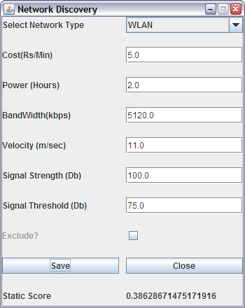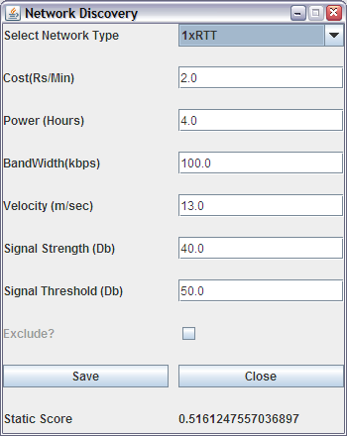

Dynamic Decision Example – Scenario

Taking the same scenario as specified in static decision example, let us assume that signal strength of both networks at a given point of time is as follows

  - Received Signal Strength:
    - 1xRTT: 55 Db
    - 802.11b: 100 Db
  - Signal Strength Threshold:
    - 1xRTT: 50Db
    - 802.11b: 75Db
  - Received Signal Strength % Diff.
    - 1xRTT: (55-50)/50 *100 = 10%
    - 802.11b: (100-75)/75 * 100 = 33%
Since RSS% Diff. of 802.11b > 1xRTT
    - Priority of 1xRTT = ½
    - Priority if 802.11b = 1
  - Dynamic score
DScore of 1xRTT = ½ * 0.5161 = 0.2508
DScore of 802.11b = 1 * 0.386 = 0.386
- Since D1xRTT < D802.11b, HCC decides to shift to faster 802.11b interface.

This Vertical Handoff demonstrates improve in the Quality of Service provided to user.

Assumptions:

- User Preference weightage for cost, bandwidth and power is same across all the regions.
- Signal Strength which is input to the Dynamic Decision Manager and Executor is varying based on Random Signal Strength Generator. In real world, such large variation may not happen.
- Normalization is done for cost, bandwidth and power so that static score is between 0 to 1 range.
- Cost, Bandwidth and Power Functions have been used from IEEE papers which are assumed to work in all situations.
- All the networks which are part of any region must have network sharing agreement with your current service provider or they provide flexibility for handoff to end user itself.
- Mobile devices or terminals are having multiple interfaces and capable of understanding the relevant protocols used for each type of network.
- Quality of Service to end customer is the highest priority in the whole design and implementation.

Chapter 6

CONCLUSION

Chapter 6

Conclusion

This project thesis proposes, develop and simulate the Dynamic SMART Decision Model, for performing the vertical handoffs to the “Best” interface at the “given” time moment, successfully and efficiently.

The Dynamic Decision Model for VHO adopts a three phase approach comprising Priority phase, Normal phase and Decision phase. The Priority Phase, discover all available networks, filter out ineligible networks based on RSS & velocity and then assign the priorities to all eligible candidate networks using the percentage difference between RSS and its threshold value RSST where Higher the difference, higher the priority. The Normal phase record the system information and user preferences for offered bandwidth, power consumption, and network usage in terms of respective weight factors wb, wp,& wc where higher the preference, higher the value of weight factor. It then calculates a cost function for each candidate network. Finally, the Decision phase calculates a Score function, by multiplying the priority from priority phase and cost function from normal phase, for each candidate network.
It then select a network having the highest value of score function as “Best” network to handoff and transfer all the current transmissions to selected network if different from the current network.

This Dynamic Decision Model is simple and applicable with any handoff Implementation techniques. However, this model is more suitable to perform “Soft Vertical Handoffs” using application layer approaches like USHA.

The algorithm, as shown by the simulation results, does provide quality of service to the users as it results in frequent handoffs between the various networks in different regions when we decrease the time interval to capture signal strength and take the decision to handoff to any other network even with minute D score variation. This is the most important advantage of the Dynamic Decision model as compared to Static model which does not perform any handoff if user preferences and System Monitor Value are identical for all networks. This algorithm can further be extended to include User Preferences to change dynamically but its main usage would only be if all service providers want to provide total and complete flexibility to choose parameters by user at run time because that will provide risk of loosing users to their competitors if later is providing the best network and within customer preferences. Right now, there is trade-off between best available network and user preferences as Dynamic Decision Model switched to best network even though its cost is slightly higher than user preferences. In the whole design and implementation, Quality of Service to end customer is the major aim.

Appendix

Appendix A – Code

Handoff Manager and Executor
package com.handoff;

import java.awt.Font;
import java.awt.GridLayout;
import java.io.File;
import java.io.FileReader;
import java.util.ArrayList;
import java.util.Collections;
import java.util.HashMap;
import java.util.Iterator;
import java.util.List;
import java.util.Map;
import java.util.Properties;
import java.util.Vector;

import javax.swing.JButton;
import javax.swing.JComboBox;
import javax.swing.JFrame;
import javax.swing.JLabel;
import javax.swing.JOptionPane;
import javax.swing.JPanel;
import javax.swing.JScrollPane;
import javax.swing.JSeparator;
import javax.swing.JTextArea;
import javax.swing.JTextField;

import org.exolab.castor.mapping.Mapping;
import org.exolab.castor.xml.Unmarshaller;

public class HandoffMgrExecutor extends JFrame {

private javax.swing.JPanel jContentPane = new JPanel(new GridLayout(1,1,10,20));
private JLabel label = new JLabel();
private JTextArea area = new JTextArea();
StringBuffer buffer = new StringBuffer();
StringBuffer temp = new StringBuffer();

//User Preferences
private Map userPref = GUIStatics.getUserPref();

/**
* This is the default constructor
*/
public HandoffMgrExecutor() {
super();
initialize();
}
/**
* This method initializes this
*
* @return void
*/
private void initialize() {
this.setSize(700,450);
this.setTitle("Vertical Handoff Executor(Initializing...)");
this.setContentPane(getJContentPane());
this.setTitle("Vertical Handoff Executor");
setDefaultCloseOperation(HIDE_ON_CLOSE);
}
/**
* This method initializes jContentPane
*
* @return javax.swing.JPanel
*/
private javax.swing.JPanel getJContentPane() {
int hoCount = 0; // Hand off count
setVisible(true);
Map regMap = GUIStatics.getRegionListMap(); // Get Regions information
Iterator regItr = regMap.keySet().iterator();
Map netMap = GUIStatics.getNetworkInterfaceMap();
ArrayList devList = new ArrayList();
// Region Sequence in which user is roaming
String regSeq = (String)GUIStatics.getUserPref().get("regseq");
String a = null;
String b = null;
String newNet = null;
String oldNet = null;

// Roam over each region
for(int i=0;i<regSeq.length();i++){
a=b;
b= String.valueOf(regSeq.charAt(i));
devList.clear();
ArrayList list = ((Region)regMap.get(b)).getNetwork();
for (Iterator iterator = list.iterator(); iterator.hasNext();) {
String object = (String) iterator.next();
devList.add(netMap.get(object));
} // get networks in a regions
buffer.append(("Staying in Region :" + b + "\n"));
buffer.append("Networks in Region " + b + ": " + devList + "\n");
// check for signal strength in each region 10 times
for(int j =0;j<10;j++){
newNet = decideNetwork(b,devList); // decide best network in region

if(oldNet==null)
{
buffer.append("Selected Network : " + newNet + "\n");
oldNet= newNet;
}
else {
if(oldNet!=null && oldNet.equals(newNet)){
// No hand off
buffer.append("Network : " + newNet + "\n");
}
else if(newNet.equals("No Network Coverage")){
buffer.append("No Network Coverage\n");
oldNet = null;
}
else{
hoCount ++;
buffer.append("\nHandoff " + hoCount + " in Region" + b + ", New network " +
newNet + "\n");
oldNet = newNet;
}
}
Thread thread = Thread.currentThread();
try {
thread.sleep(100); // wait for 100 ms before second signal strength checking
} catch (Exception e) {
e.printStackTrace();
}
}
buffer.append("--------------------------------------------\n");
}
buffer.append("Total Handoffs : " + hoCount);
JScrollPane scrollPane1 = new JScrollPane( area);
scrollPane1.getViewport().setView(area);
jContentPane.add(scrollPane1);
buffer.append("\n" + rss.toString());
area.setText(buffer.toString());

return jContentPane;
}

private Map rss = new HashMap(); // received signal strength result
private void addToList(String name, float value){
List list =(List) rss.get(name);
if(list==null){
rss.put(name, new ArrayList());
list =(List) rss.get(name);
}
list.add(value);
}

private String decideNetwork(String b,List nw){
float mtVel = Float.parseFloat((String)GUIStatics.getUserPref().get("v"));
List candidateList = new ArrayList(); // create candidate list for networks
for (Iterator iter = nw.iterator(); iter.hasNext();) {
NetworkInterfaceDevice element = (NetworkInterfaceDevice) iter.next();
RandomNumGen gen = new RandomNumGen(); // Random signal strength generator
element.setSignalStrength(gen.getRandNum(element.getThreshold()));
addToList(element.getName(), element.getSignalStrength());
// remoce networks based on signal strength and velocity criteria
if(element.getSignalStrength()>=element.getThreshold() && element.getVelocity() >= mtVel){
candidateList.add(element);
}
}
if(candidateList.size()==0){ // no network coverage in region
addToList("Selected", 0);
return "No Network Coverage";
}

String maxName=null;
double maxScore = -23456d;
float maxSig =0;
Collections.sort(candidateList, new NetworkIfComparator()); // Sort based on signal strength % diff.
int ind = 0;
Properties properties = System.getProperties();
String isStatic = properties.getProperty("STATIC");

for (Iterator iter = candidateList.iterator(); iter.hasNext();) {
ind++;
NetworkInterfaceDevice element = (NetworkInterfaceDevice) iter.next();
SmartDecision decision = new SmartDecision(element.getCost(),element.getPower(),
element.getBandWidth(),userPref);
double score = 0;
if(isStatic!=null && isStatic.equals("true")){
score = decision.getScore(); // generate static score
}
else
{
score = decision.getScore()* 1/ind; // generate dynamic score
}
if(score > maxScore){ // decide max score
maxScore=score;
maxName = element.getName();
maxSig = element.getSignalStrength();
}
}
addToList("Selected", maxSig);
return maxName;

}

}

Smart Decision

package com.handoff;

import java.util.HashMap;
import java.util.Map;

public class SmartDecision {

private float cost;
private float power;
private float band;
private float x;
private float y;
private float z;
private long m;

private Map map = new HashMap();
/**
*
*/
public SmartDecision(float cost, float power, float band, Map pref) {
this.cost=cost;
this.power= power;
this.band=band;
this.map = pref;
x = Float.parseFloat((String)map.get("x"));
y = Float.parseFloat((String)map.get("y"));
z = Float.parseFloat((String)map.get("z"));
m = 5;
}

public float calculateScore(){
return 0;
}
public float getAlpha(float x){
return cost/20;
}
public float getBeta(float y){
return Math.min(band/1024, m)/m;
}
public float getGamma(float z){
return 2/power;
}

public double getExpenseCoff(){
return 1 / Math.exp(getAlpha(x));
}

public double getBandwidthCoff(){
return Math.exp(getBeta(y))/Math.exp(m);
}

public double getPowerCoff(){
return 1/Math.exp(getGamma(z));
}

public double getScore(){
double score = 0;
float wp,we,wc;
wp = Float.parseFloat((String)map.get("wp"));
we = Float.parseFloat((String)map.get("we"));
wc = Float.parseFloat((String)map.get("wc"));
score = wp * getPowerCoff() + wc * getExpenseCoff() + we * getBandwidthCoff();

return score;
}

}

Appendix B

Sample Run1 (Dynamic Decision)
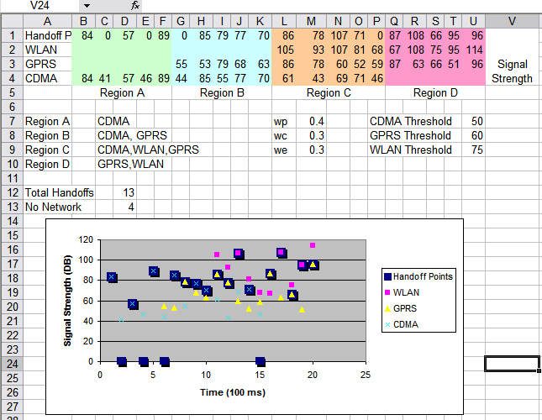
Sample Run 2 (Dynamic Decision)
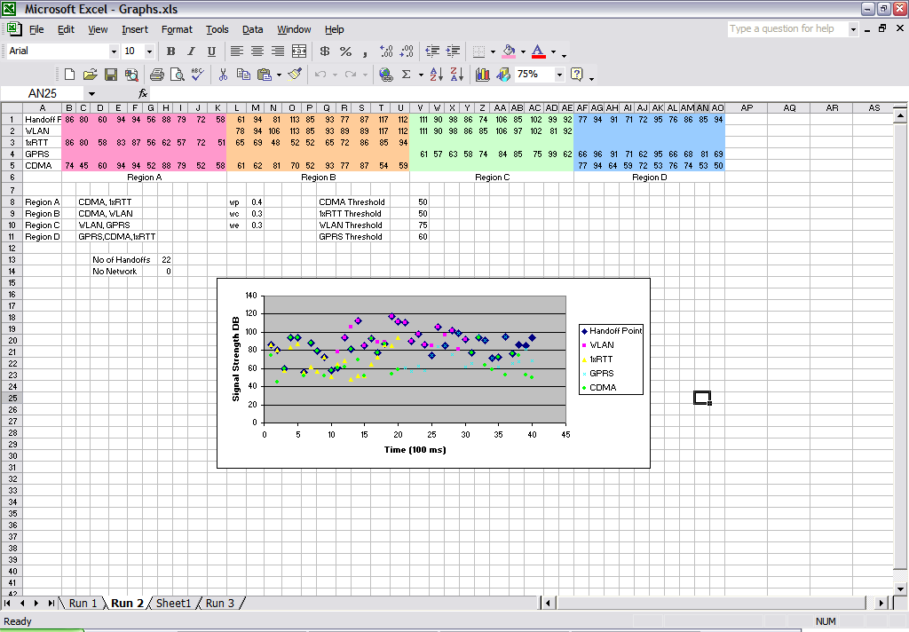

Sample Run 3 (Static Score Decision)
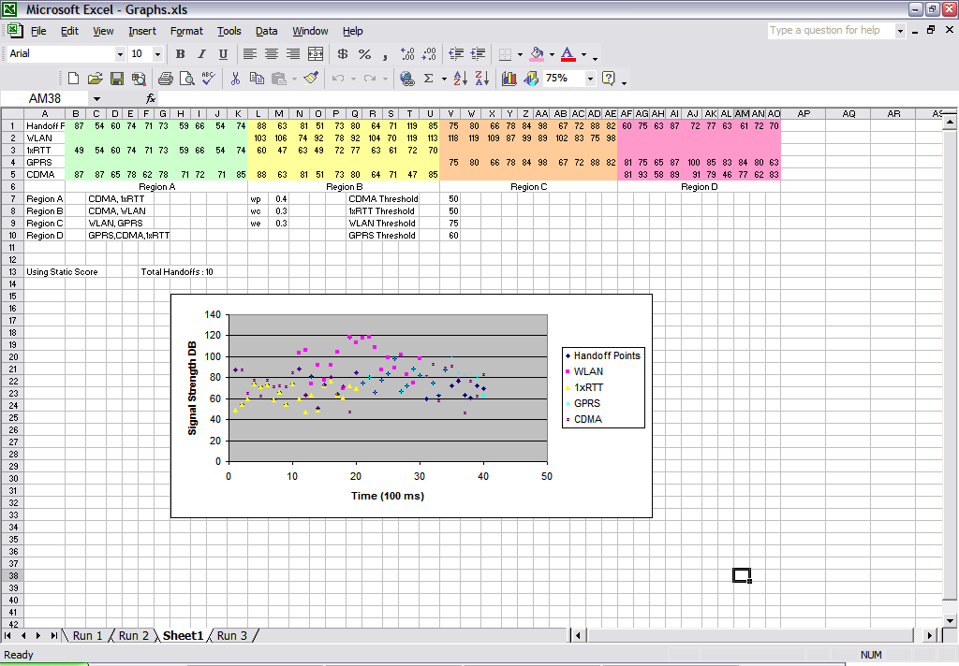

Chapter 7

REFERENCES

Chapter 7

REFERENCES :

- “A Smart Decision Model for Vertical Handoff “ Ling-Jyh Chen*, Tony Sun*, Benny Chen*, Venkatesh Rajendran†, Mario Gerla* Department of Computer Science, University of California at Los Angeles, Los Angeles, CA 90095, USA
- M. Angermann and J. Kammann, “Cost Metrics For Decision Problem In Wireless Ad Hoc Networking,” IEEE CAS Workshop on Wireless Communications and Networking, 2002.
- H.J. Wang, R. H. Katz, and J. Giese, “Policy-Enabled Handoffs across Heterogeneous Wireless Networks,” Proc. of ACM WMCSA, 1999.
- A Dynamic Decision Model for Vertical Handoffs across Heterogeneous Wireless Networks ‘ Pramod Goyal, and S. K. Saxena’.
- “Vertical Handoffs in Wireless Overlay Networks,” ACM MONET, 1998.
By Mark Stemm, and Randy H. Katz.
- A Decision Scheme for Vertical Handoff in Overlay Wireless Networks” 4th International Conference on Innovations in Information Technology, 2007. Innovations '07. 18-20Nov.2007 by Tawil, R.; Salazar, O.; Pujolle,G.; Demerjian,J .
- A Cross-Layer Vertical Handover Decision Model for Heterogeneous Wireless Networks” 4th International Conference on Innovations in Information Technology, 2007.Innovations'07. 18-20 Nov. 2007 Page(s):441-445. Ahmad, S.Z.; Akbar, M.S.; Qadir, M.A
- A Novel Decision Strategy of Vertical Handoff in Overlay Wireless Networks” Fifth IEEE International Symposium on Network Computing and Applications, 2006 by Shen,W.;Zeng,Q.-A
- “Signal Threshold Adaptation for Vertica handoff in heterogeneous wireless networks”, Mobile Network Application (2006), Springer science by Ahmed H.zahran, Ben Liang, Aladdin Saleh.
- Frederic Paint, Paal Engelstad, Erik Vanem, Thomas Haslestad, Anne Mari Nordvik, Kjell Myksvoll, Stein Svaet, “Mobility aspects in 4G Networks- White Paper”
- B. G. Evans and K. Baughan, "Visions of 4G,"Electronics and Communication Engineering Journal, Dec. 2002.
- R. Berezdivin, R. Breinig, and R. Topp, "Next-Generation Wireless Communications Concepts and Technologies," IEEE Communications Magazine

