Abstract

The project “Identity based secure Routing for Mobile Ad hoc Networks” aims at securing the routing process used in AODV (Ad-Hoc On Distance Vector Routing) using the Identity Based Cryptography. Routing in networks, in particular Wireless networks has always been susceptible to various kinds of attacks like Black Hole attack, Worm Hole Attack, Packet Leashes, etc. New protocols or extensions to existing protocols have been proposed for counter-fighting these attacks, e.g. SAODV (Secure AODV), TESLA (Timed efficient stream loss-tolerant authentication) , SEAD (Secure efficient Distance vector routing) , but these systems are either two expensive and incur huge overhead.

Secure AODV (SAODV) which is an extension of AODV provides security by the use of RSA based Crypto-System. But the problem is that it incurs a huge overhead over the system for maintaining the certificates and revocation lists, making it less suitable for wireless scenario where the bandwidth is limited.

In this project Identity Based Signature scheme has been used for generating the signatures which are then used to secure the routing. The ID based Cryptography is a public key cryptography scheme with the difference that in this system we can use any string like e-mail id
or IP address as our public key. No certificates are involved in this system thus reducing the bandwidth overhead.

The securing process used here is similar to the one adopted by SAODV, that is each node signs

the routing packet it generates and the signature is then verified by each intermediate node who receives this message. If the verification fails at a node that packet is not transmitted further and immediately dropped.

I have used the ID based Signature Scheme for signing the routing messages. The signature scheme required four different kinds of arithmetic namely BigInteger, Binary Field Arithmetic, Elliptical Curve Arithmetic, Extension Field Arithmetic. The Pairing Algorithm has been implemented in C++, to attain maximum efficiency. This Signature generation scheme was then integrated into the existing implementation of AODV in NS2. Timing results for the Signature generation and verification and graphical results for simulations for the simulation on
NS2 have been shown.

ix

Chapter 1

Introduction

Wireless networks, whether cellular networks or wireless local area networks (LANs), have rapidly become an indispensable part of our life. Evidence of this is the widespread usage of such networks in several areas such as office, home, universities, hot-spots such as airports and hotels etc. However the security concerns in wireless networking remains a serious impediment to widespread adoption. The underlying radio communication medium for wireless networks is a big vulnerability that can be exploited to launch several attacks against wireless networks. One such point of attack in the wireless networks is Routing.

Routing is an important function in any network, be it wired or wireless. The protocols designed for routing in these two types of networks, however, have completely different characteristics. Routing protocols for wired networks typically do not need to handle mobility
of nodes within the system. These protocols also do not have to be designed so as to minimize the communication overhead, since wired networks typically have high bandwidths. Very importantly, the routing protocols in wire line networks can be assumed to execute on trusted entities, namely the routers.

These characteristics change completely when considering ad hoc wireless networks. Mobility is a basic feature in such networks. Resource constraints like limited bandwidth and computing power of the devices also aggravates the problem of designing routing protocols for such networks which do not require high bandwidths. Ad hoc networks also do not have trusted entities such as routers, since every node in the network is expected to participate in the routing function. Therefore, routing protocols need to be specifically designed for wireless ad hoc networks.

.Ad-hoc routing protocols, including AODV (Ad-Hoc Distance Vector Routing), DSR (Dynamic Source Routing), OLSR(Optimized Link State Routing), etc are designed for performance, not security, and thus all of them are subjected to some kind of attacks. These attacks include, packet dropping, modification of packets (modifying sequence numbers, hop count, etc), impersonation, replaying of old routing information etc. These attacks can
partition a network or may introduce excessive load into the network by causing

retransmission and inefficient routing. Thus a secure routing scheme deals with this problem

by providing authentication, integrity and non repudiation.

In this project I have tried to integrate the concept of Identity Based Signature Generation Schemes instead of traditional signature schemes to AODV so as to secure the routing process without incurring much overhead on the system. This signature scheme will allow us
to use Email-ID and IP address as our pubic key, thus eliminating the need of any certificates which will save the network bandwidth. Also ID based signature schemes are based on Pairing based cryptography which allows us to use smaller key size maintaining a similar level of security as provided by other schemes.

1.1 Security goals

Following are the security goals that we wish to achieve in any cryptographic system.

• Confidentiality: Keeping data secret from all but those authorized to see it - Messages sent by A to B should not be readable by E.

• Data integrity: Ensuring that data has not been altered by unauthorized means, B

should be able to detect when data sent by A has been modified by E.

• Data origin authentication: corroborating the source of data—B should be able to verify that data purportedly sent by A indeed originated with A.

• Non-repudiation: Preventing an entity from denying previous commitments or actions—when B receives a message purportedly from A, not only is B convinced that
the message originated with A, but B can convince a neutral third party of this; thus A

cannot deny having sent the message to B.

1.2 Approach

The main aim is to develop an ID based Signature generation scheme and further integrate it in AODV in order to provide it security at low bandwidth costs since ID based Signature Scheme result in signatures of small sizes.

C++ has been chosen as the language of implementation as it is computationally faster. The implementation consists of an ID based signature scheme along with the pairing operation whose output is required by the ID based signature scheme. The algorithm of pairing and
signature scheme together required four different kinds of arithmetic which need their libraries to be developed. Optimizations have been included wherever possible to speed up
the computation of pairing which is considered to be an expensive process. The signature can only be applied to the immutable fields whereas for the security of the mutable fields any of
the existing solutions like Hash Chains can be used. For the purpose of integrating the signature scheme, NS2 (Network Simulator 2) AODV implementation was chosen and few changes were made to it so that it meets our needs. Few changes were made in the packet headers as well to carry the necessary information required for cryptographic purpose.

Each packet that is send across the network is signed by the sender and each intermediate node verifies the signature and only then further processing takes place otherwise the packet
id dropped. This is how the system provides security in routing process.

1.3 Limitations of Existing Secure Routing Protocols

Currently, some solutions propose to use cryptographic methods to secure the ad-hoc routing protocols. Those methods include, HMAC (Hashed Message Authentication Code)-based schemes, such as SRP (Secure Routing Protocol), Digital-signature-based scheme, such as SAODV (Secure AODV) and ARAN (for DSR), and hash-chain-based or TESLA-based scheme, such as SEAD and Ariadne.

The HMAC-based schemes provide only peer-to-peer message authentication, not broadcast message authentication, so they are not suitable for broadcasting-based routing messages. Digital-signature-based schemes (like SAODV) can achieve broadcast message authentication, but all these schemes need the certificate, which incurs a large amount overhead in communication, computation and storage. TESLA based schemes use the time synchronization, but it may not be practicable for general applications. The above limitations
can be summarized as:-

Schemes | Cryptographic Primitives | Broadcast Authentication
SRP | HMAC | No
SAODV, ARAN | Digital Signature with  Certificates | Yes, but have certificate burden
SEAD, Ariadne | Hash Chain | Yes,time synchronization required

Table 1.1: Limitations of Existing Secure Protocols
Chapter 2

Wireless Ad-Hoc Network

2.1 Introduction
Wireless ad-hoc network has some unique properties which distinguish it from other conventional networks. These properties make such network popular but on the other hand opens door for many attacks. So the chapter focuses on features of wireless ad-hoc network along with their vulnerabilities and attacks they experience.

2.2 What is Wireless Ad-Hoc Network?

Ad-Hoc (or "spontaneous") network is a local area network or other small network, especially one with wireless or temporary plug-in connections, in which some of the network devices are part of the network only for the duration of a communications session or, in the case of mobile or portable devices, while in some close proximity to the rest of the network. The term has been applied to future office or home networks in which new devices can be quickly added, using, for example, the Bluetooth technology in which devices communicate with the computer and perhaps other devices using wireless transmission.

Each user has a unique network address that is immediately recognized as part of the network. The technology would also include remote users and hybrid wireless/wire connections.

Figure 2.1 An Ad-Hoc Network
2.3 Applications Of Ad-Hoc Network

• Ad-hoc networks are suited where an infrastructure is unavailable or to deploy one
is not cost effective.

• Work has been going on to introduce the fundamental concepts of game theory. The cooperation of the users is necessary to the operation of ad-hoc networks; therefore, game theory provides a good basis to analyze the networks.

• Another application example of a mobile ad-hoc network is Bluetooth, which is designed to support a personal area network by eliminating the need of wires between
various devices, such as printers and personal digital assistant.

2.4 Features of Ad-Hoc Networks

Numbers of features are identified from different source, which are illustrated below:-

Distributed nature: Wireless Ad-Hoc network is distributed in its operation and functionalities, like routing, host configuration and security.

Dynamic network topology: Nodes in the network are mobile by nature. They can join or leave the network at any time. So, wireless ad-hoc networks adheres dynamic topology . Since, the topology arbitrarily changes and changes of the surrounding environment, the routing protocols must adapt to the dynamic topology. Traditional wired routing protocols like OSPF (Open Shortest Path First) do not support for frequent network topology changes. So the current routing protocols for ad-hoc environment are specifically designed to handle node mobility as well as changing topologies.

No fixed infrastructure: There is no fixed infrastructure for wireless ad-hoc network i.e. no Access Point, router etc. Nodes communicate each other in peer to peer fashion. So, the functionality of an ad hoc network highly depends on the forwarding behavior of the participating nodes.

Multi-hop routing: In the absence of any routing infrastructure, the nodes forming the ad hoc networks themselves need to act as routers. Two nodes are allowed to communicate directly if they are close enough. So if the source and destination of a message is out of the radio range, they use multi-hop routing to deliver their packets to distant destinations. In single-hop scenario in ad-hoc networks nodes do not act as routers, so communication is possible only between nodes within each other’s Radio Frequency (RF) range.

Same Medium: Mobile nodes within their radio range usually share the same physical media; they transmit and acquire signals at the same frequency band, and follow the same hopping sequence. In wireless ad-hoc network, devices are connected through wireless interface. The stability, capacity and reliability of wireless link are always poorer than wired links. Additionally nodes suffer limited hardware resources like limited battery, less powerful CPUs and small memory capacity which might lead complicated routing for such network.

2.5 Threats and Vulnerability Analysis

The features discussed above helps to deploy a network and share information easily but on the other hand they open door for many attacks. What makes the ad-hoc network vulnerable is the subject of this section. Like wired network wireless ad-hoc network also faces threats like eavesdropping, spoofing, and denial of service. Wireless ad-hoc networks are vulnerable to various kinds of security threats and attacks due to lack of a centralized infrastructure. For the same reason assignment of well defined roles like trusted third parties and key management is impossible.

2.5.1 Vulnerability through wireless link

Wireless link is itself vulnerable by nature. Any node in the network can get access to the wireless link easily. So attacks like eavesdropping, spoofing (of MAC address), denial of service, masquerading and impersonation are possible.

2.5.2 Vulnerability due to lack of centralized authority

Decision-making in wireless ad-hoc network is usually decentralized and most of the algorithms for this purpose rely on cooperative participation of all nodes. The lack of centralized authority helps the attackers to make use of this vulnerability for new types of attacks designed to break the cooperative algorithm.

2.5.3 Vulnerability due to dynamic topology

Because of dynamic topology and volatile physical environment wireless ad-hoc networks do not have any physical boundary, so centralized firewall can not be employed like wired network to provide access control. For the same reason mobility and membership of nodes within the network is very random and rapid. Hence, it is hard to differentiate between intrusions and legitimate operations or conditions in wireless ad-hoc network. Figure 2.2 shows how the topology varies in time.

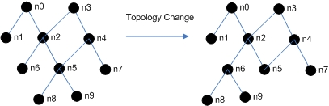

Figure 2.2 Dynamic Topology

2.5.4 Vulnerability due to self-directed nodes

As mobile nodes are autonomous units that are capable of roaming independently, physical protection is not adequate, so nodes can be captured, compromised, and hijacked easily. Tracking down a particular mobile node in a large scale ad-hoc network cannot be done easily. Moreover, attack by a compromised node is difficult to trace. In wireless ad-hoc network IP address configured automatically, a malicious node can pretend to use the IP address of a legitimate node. This blocks the legitimate node from joining the network. Figure 2.3 shows failure or malicious behavior of any node disconnects or degrades the performance of the network.

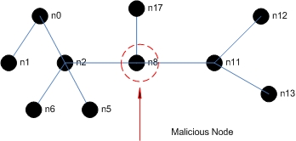

Figure 2.3 A malicious node can degrade network performance

2.5.5 Vulnerability due to ad-hoc routing

Most of the routing protocols designed for wireless ad-hoc network are cooperative in nature which tends to make it vulnerable. In wired network extra protection can be located in gateway or router but in ad-hoc network there is no such option. So an attacker who hijacks or compromises the node could breakdown the entire wireless network by broadcasting (flooding) false routing information.

2.5.6 Vulnerability due to low battery power

In wireless ad-hoc network, nodes usually use battery power for their operation. An attacker can force a node to forward packets and thus makes battery power used up and initiate a denial-of service (DoS) attack. This kind of attack is known as Sleep Deprivation Torture.

2.6 Attacks

In previous section vulnerabilities of wireless ad-hoc network are analyzed. In this section some of the significant attacks often experienced by ad-hoc network due to those vulnerabilities will be discussed. One attack technique can be initiated to accomplish another attack. For example: Rushing attack is used to accomplish DoS attack.
2.6.1 Denial of Service (DoS) Attack

One of most significant attack experienced by the wireless ad-hoc network is DoS attack. Denial of Service is the degradation or prevention of legitimate use of network resources. For such cases a node in the network is prohibited from sending and receiving messages or packets. Different techniques and other types of attacks are used to accomplish DoS attack. For example a simple denial-of-service attack can be launched in DSR (Dynamic Source Routing) by altering the source routes in packet headers.

2.6.2 Wormhole Attack

In wormhole attack a path or tunnel is created between two nodes within the network which can be used to transmit messages secretly. A wormhole attack is implemented with few resources and is difficult to detect. To lunch a wormhole attack, an attacker establishes a direct link between two nodes via a wire line or a long range wireless transmission. This communication link does not exist in regular communication channel. By using wormhole attack, attacker can redirect and observe large amount of traffic as well as can trigger a route oscillation in the network which may lead DoS attack.

2.6.3 Sybil Attack

Each physical node in a wireless ad-hoc network is also known as entity. These entities maintain identity within the network. If an entity attempts to forge multiple identities (presents multiple identities for a single entity) to perform some attacks, then it performs a Sybil Attack. This attack weakens the security, data integrity and resource utilization of the system.

2.6.4 Selfishness of node

As wireless ad-hoc network is based on multi hop routing technology, each node has to forward its packets to other nodes. So, selfish behavior of any node can provide significant gain over saving battery life and more bandwidth for its own traffic.

2.6.5 Network Partition Attack

Wireless ad-hoc network can be partitioned by an attacker so that nodes cannot communicate with each other even though link or path exists among them.

2.6.6 Rushing Attack

The rushing attack act as an effective DoS attack against several on-demand ad-hoc network routing protocols (DSR , AODV ) are unable to discover routes when subject to this attack. The attack is also successful against protocols like Ariadne , ARAN etc that are designed to be secure. A node needing a route to a destination floods the network with ROUTE_REQUEST packets in an attempt to find a route to the destination. Sometime attacker blocks legitimate messages by distributing false control messages.

2.6.7 Other routing attacks

Besides Rushing attack there are other attacks that can be targeted at the ad-hoc routing protocol in which the malicious node actively interrupts the functioning of the cooperative routing mechanisms. In routing disruption attack a malicious node intentionally drops control packets, misroutes data, or disseminates incorrect information about its neighbors. Another attack “Routing table poisoning” is the modification, deletion or contains false information in the routing table. The “Routing loop attack” concentrates on the creation of the loop in the routing path. Most of the cases these type of attacks experienced by both AODV and DSR protocols. A table of attacks in wireless ad-hoc is depicted from above discussion. It specifically shows actual intention of these attacks as well as causes (vulnerability) of their occurrence.

Attacks | Initiator | Intention | Cause  (Vulnerability) | Impact
Sleep Deprivation  Torture | Malicious Node | Denial of Service  (DoS) | Low Battery Power | The cannot perform  further operation
Network Partition  Attack | Outside  Attacker | Denial of Service  (DoS) | Lack of centralized  authority | Nodes cannot communicate each  other though path exit  between them
Rushing Attack | Malicious Node | Eavesdropping | Ad-hoc routing | Observe traffic to get  the information about  source to destination  path
Wormhole | Outside  Attacker | Denial of Service  (DoS) | Lack of centralized  authority | Transmit information  between two nodes  secretly. Trigger route  oscillation
Sybil attack | Malicious Node | Masquerade | Autonomous  behavior of node | Forge multiple  identities to hamper  on data integrity and  illegal access of  information

Table 2.1 Attacks in wireless ad-hoc network

Chapter 3

Ad-hoc On Demand Distance Vector Routing(AODV)

3.1 Introduction

The Ad hoc On Demand Distance Vector (AODV) routing algorithm is a reactive routing protocol designed for ad hoc mobile networks. AODV is a method of routing messages between mobile devices. To transmit data over an ad-hoc network, the AODV protocol enables dynamic, self-starting, multi-hop routing between mobile devices. It allows these mobile computers, or nodes, to pass messages through their neighbors to nodes with which they cannot directly communicate.

AODV is able to provide unicast, multicast, and broadcast communication ability. This capability of having all three communication forms in a single protocol offers numerous advantages. When searching by using the multicast route discovery it increases the unicast routing knowledge and vice versa. In mobile environments any reduction in control overheads has a significant advantage. Additionally, having all three communication forms in a single protocol simplifies the implementation process of the protocol.

Route tables are used in AODV to store applicable routing information. AODV utilizes both a route table for unicast routes and a multicast route table for multicast routes. The unicast route table includes information about the destination, the next-hop IP address and its sequence number. For each destination a node maintains a list of precursor nodes, which route through it in order to reach the destination . This list is maintained for the purpose of route maintenance in case of a link breakage. Additionally, a lifetime is associated with each route table entry which is updated whenever the route is successfully used. When an entry’s lifetime attribute expires because it was not frequently used it is removed form the routing table and if there is a need for this route again it is reacquired through a route discovery process. AODV is able to maintain both unicast and multicast routes even for nodes with mobility. Also it provides a quick detection mechanism of invalid routes through the use of route errors (RERR) messages. The protocol is able to respond to topological changes that affect the active routes in a quick and timely manner. Finally, because it does not use source routing it does not introduce additional overhead since it requires only the next-hop routing information.

3.2 Route Discovery
When a node desires to communicate with some destination node, it checks if the route to this destination is available and valid in its routing table. In the case that the route is available and valid the communication is feasible right away, but if the route is either unavailable or it has expired a route discovery process has to be initiated. In order to initiate a route discovery process the source node has to send a RREQ packet. The fields of the route request packet are illustrated in figure 3.1. After creating the RREQ packet the node sets a timer and waits for a route reply (RREP) message .

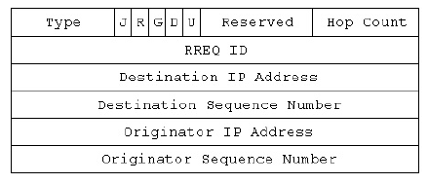
Figure 3.1: The format of Route Request packet.

An intermediate node upon the reception of a RREQ packet checks whether it has seen it before by examining the originator’s IP address and the RREQ broadcast ID pair. Each node maintains a list of the originator IP and RREQ broadcast ID pair for each route request that it receives. This information remains in this list for a finite period of time and it is used to avoid flooding attacks or anomalous node behavior. If the intermediate node has already seen this RREQ it silently discards the packet. If it has not seen this RREQ within this finite period of time it starts processing it. The first step is to set up the reverse route in its routing table. The reverse route contains the originator IP address, the sequence number, the hops required to reach the source node and the neighbor from which it has received the packet. This process is essential since it is used to forward back the RREP. Figure 3.2 indicates the propagation process of a RREQ along with the formation of the relevant reverse routes.

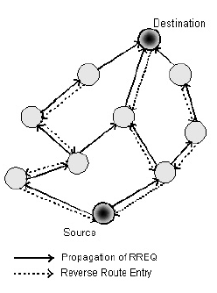

Figure 3.2: Propagation of an AODV RREQ and establishment of the reverse routes

In order for an intermediate node to reply to a RREQ it has to have an unexpired entry for the destination in its routing table. Additionally, the sequence number associated with that destination must be greater or equal to the one indicated in the RREQ packet. If the entry satisfies these two conditions then it unicasts a RREP back to the source of the RREQ by incrementing the hop count by one. The structure of the RREP and the fields it contains are presented in figure 3.3

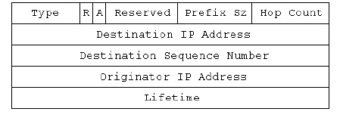

Figure 3.3: Format of a Route Reply (RREP) packet.

If none of the intermediate nodes is able to reply, the RREQ eventually reaches the destination node. When the destination node sends the RREP it places its current sequence number in the packet, initializes the hop count to zero and places the length of time this route is valid in the RREP’s Lifetime field . If this is the first time the source node communicates with this node the sequence number will not be available and therefore it will not be included in the packet. When an intermediate node receives the RREP it uses the reverse route established for the RREQ to forward the packet to each destination, but before doing so it increments the hop count by one. Figure 3.4 indicates the path of a RREP from the destination to the source node.

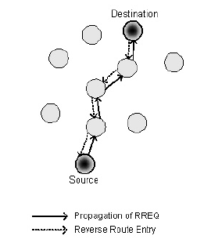
Figure 3.4: Propagation of a RREP message from the destination to the source node.

It is possible that the destination node will receive more than one RREP from its neighbors. In this case it uses the first RREP that it receives and upon the reception of another reply it checks if the later packet contains a greater destination sequence number or if it has a smaller hop count, meaning that it provides a fresher or sorter route. In this case it updates the route entry with the new values; otherwise the reply packet is discarded.

3.3 Route Maintenance

Once the route between the source and the destination nodes is established it is maintained for the source node as long as it remains active. If the source node moves during an active session, it can simply reinitiate a route discovery process and establish a new route to the destination and continue communication. However, if either the destination or an intermediate node moves a RERR packet is sent to the source affected nodes. The RERR packet header fields are illustrated in figure 3.5

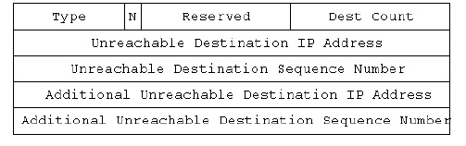

Figure 3.5: The format of the Route Error (RERR) message.

The RERR message is initiated by the node upstream of the link failure which is closer to the source. If the node upstream of the break has listed more that one nodes as a precursor node for the destination, it broadcasts the REER to these neighbors. When the neighbor nodes receive the RERR packet they mark the route to the destination as invalid by setting the distance to this destination node to infinity, and if they have any precursor list of their own they propagate this message forward to their precursor nodes. When the RERR reaches the source node it can reinitiate a route discovery if the route is still needed.

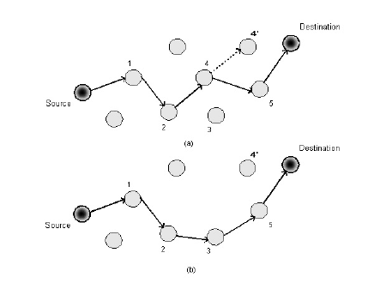

Figure 3.6: Route maintenance.

In figure 3.6 the route maintenance procedure is illustrated. In figure 3.6(a) the route from source to destination contains the nodes 1, 2, 4, and 5. When node 4 decides to move to position 4` breaks the connectivity in node 2. Node 3 being the closest upstream neighbor to the link loss sends a RERR to node 1. Node 1 upon reception of the REER packet marks the route as invalid and then forwards the RERR to the source node that reinitiates a route discovery process since it still requires communication with the destination node. The new route that was created is presented in figure 3.6(b) where node 4 was replaced by node 3. RERRs are also sent when a node receives data packets for a destination that is not listed in its routing table . In this way the node without the route that is receiving the data packets can inform its upstream neighbor that it should stop
sending them, thus they are not constantly discarded.
Chapter 4

Encryption Schemes And Types Of Key Management

4.1 Introduction
Encryption is the process of converting ordinary information called the plaintext into unintelligible text called the cipher text. To convert plaintext to cipher text we require a cipher which is a pair of algorithms which create the encryption and the reversing decryption. The detailed operation of a cipher is controlled both by the algorithm and in each session by a key which is a piece of information or a parameter that determines the functional output of a cryptographic algorithm. Key management can be done in a variety of ways as possible solutions to the security problem and each way of key management has it own drawbacks and advantages

4.2 Symmetric Encryption

In a symmetric encryption mechanism, both the communicating links share the same key. The keys, in practice, represent a shared secret between two or more parties that can be used to maintain a private information link It can accommodate a few users only as each pair of nodes would require different keys.

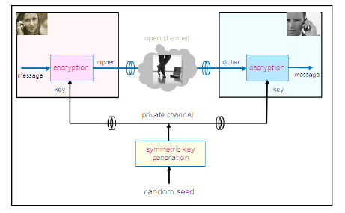

Figure 4.1: Symmetric Encryption
4.3 Asymmetric Encryption

The key used to encrypt a message is not the same as the key used to decrypt it. Each user has
a pair of cryptographic keys — a public key and a private key. The private key is kept secret, while the public key may be widely distributed. Messages are encrypted with the recipient's public key and can only be decrypted with the corresponding private key. The keys are related mathematically, but the private key cannot be feasibly derived from the public key.
It is further of two types:

    - PKI (Public Key Infrastructure) Encryption
Here the sender encrypts the data using the public key which is then transmitted over an open channel. The receiver then decrypts it using the private key. A trusted third party authority manages the pair of private and the public key.

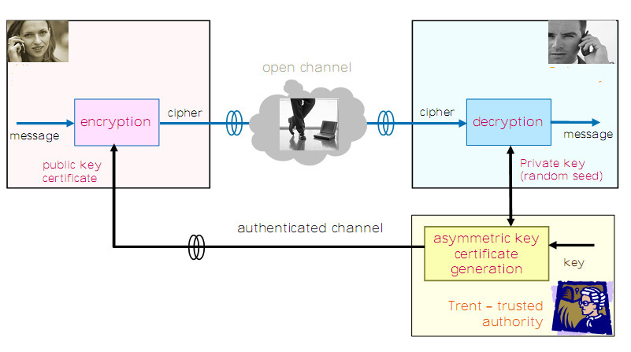

Figure 4.2: PKI Encryption
The binding between a public key and its 'owner' must be correct, lest the algorithm function perfectly and yet be entirely insecure in practice. A public key will be known to a large and,
in practice, unknown set of users. All events requiring revocation or replacement of a public key can take a long time to take full effect with all those users who possess that key. For this reason, systems which must react to events in real time (e.g. safety-critical systems or national security systems) should not use public-key encryption without taking great care.

4.3.2 Identity-Based Encryption

Public key is generated based on the identity of the node (e.g., email or ip address), and the private key is generated by a trusted third party called a private key generator (PKG). This
cryptography method is called ID-Based Cryptography (IBC).

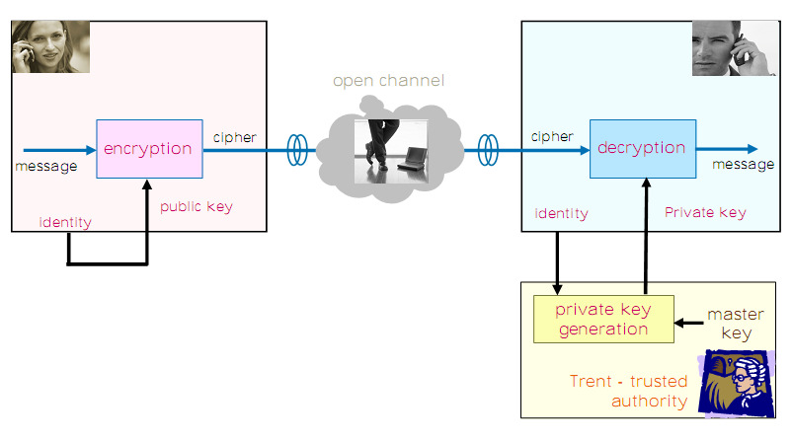

Figure 4.3 : Identity Based Encryption

4.4. Comparison of ID based Crypto-System to PKI

The protocols for encryption, decryption, signing, and signature verification have similar functionality in both systems. The main difference, however, is key management. We compare ID-based cryptography to the traditional PKI setting, considering the following practical aspects: key distribution, authenticity of system parameters, key escrow, key revocation.

4.4.1 Key distribution

The great simplification of key distribution was the main reason to introduce identity-based cryptography. Namely, all public keys can be derived from the identity of the users. So obtaining someone’s public key, for encryption or signature verification, becomes a simple and transparent procedure. This is in contrast to PKI, where one has to look up the corresponding certificate and verify the CA’s (Certificate Authority ) signature and check the expiration date of the certificate. Moreover, one has to check the validity of the certificate, which can be done by either using an up-to-date CRL( Certificate Revocation List) or performing an online check at a Validation Authority.

4.4.2 Authenticity of system parameters

An attacker in an ID–Based System can generate his own master key and the system parameters. He can then decrypt any message of any user using those forged parameters. Thus it is of great importance that the PKG somehow guarantees the authenticity of the correct system parameters.

A similar problem can exist in the PKI based system where the attacker can make users believe that some public key of his choice is the public key of the CA, then he can create certificates containing forged public keys for which he owns the secret key.

4.4.3 Key escrow

Identity-based cryptosystems have inherent key escrow. Namely, since the PKG owns the master key, he can generate any private key at any moment. For signatures schemes, however, it is often highly undesirable to have key escrow, as it prevents non-repudiation.

This is not much of a problem in PKI systems because users generate the key pairs themselves thus there is no way that keys can be retrieved and there is no key escrow. This is
in contrast to an ID-based setting where the PKG always has the ability to regenerate keys. The only solution to key escrow problem is threshold PKG and CA.
4.4.4 Key Revocation

When a certificate is revoked in a PKI-based scheme, other users are notified by means of a public Certificate Revocation List or CRL.

However, in ID based setup since a user’s public key is derived from his identity, he cannot simply obtain a new key pair after revocation as in a PKI-based scheme. Since it is very inconvenient or simply impossible to change the identity every time, a new key pair is needed. A partial solution to this problem could be to derive the public key not solely from
the identity, but to concatenate the identity with some other general information like the current date.

Chapter 5

Identity Based Cryptography and Signatures

5.1 Introduction
The concept of identity-based cryptosystems was introduced in 1984 by Shamir. In these systems the public key is generated based on the identity of the node (e.g., email or IP Address), and the private key is generated by a trusted third party called a private key generator (PKG). This cryptography method is called ID-Based Cryptography (IBC).

To Operate, the PKG first publishes a master public key, and retains the corresponding master private key also referred to as the master key. Given the master public key, any party can compute a public key corresponding to the identity ID by combining the master public key with the Identity value. To obtain a corresponding private key, the party authorized to use the identity ID contacts the PKG, which uses the master private key to generate the private key for Identity ID.

As a result, parties may encrypt messages or verify signatures with no prior distribution of keys between individual participants. This is extremely useful in cases where pre-distribution
of authenticated keys is inconvenient or infeasible due to technical restraints. However, to decrypt or sign messages, the authorized user must obtain the appropriate private key from
the PKG. A caveat of this approach is that the PKG must be highly trusted, as it is capable of generating any user's private key and may therefore decrypt (or sign) messages without authorization. Because any user's private key can be generated through the use of the third party's secret, this system has inherent key escrow.

The main advantages of IBC are the simple key management process and reduced memory storage cost compared to traditional public key methods. Nodes must maintain only the PKG parameters, not the public key of all other nodes. In IBC every node is able to discover the public key of another node without exchanging any data.

5.2 Identity Based Signatures

As a mirror image of the above identity-based encryption, one can consider an Identity- Based Signature (IBS) scheme. In this scheme, the signer first obtains a signing (private) key associated with her identifier information from the PKG. She then signs a message using
the signing key. The verifier now uses the signer’s identifier information to verify the signature. Therefore there is no need for any certificates.

5.2.1 Advantages

• One of the major advantages of any IBS scheme is that if there are only a finite number of users, after all users have been issued with keys the third party's secret can
be destroyed. This can take place because this system assumes that, once issued; keys

are always valid.
• As public keys are derived from identifiers, IBS eliminates the need for a public key distribution infrastructure. The authenticity of the public keys is guaranteed implicitly
as long as the transport of the private keys to the corresponding user is kept secure Therefore all the three basic requirements of any secure system are taken care of i.e., Authenticity, Integrity, and Confidentiality.

• Apart from these aspects, IBS offers features emanating from the possibility to encode additional information into the identifier. For instance, a sender might specify an expiration date for a message. He appends this timestamp to the actual recipient's identity. When the receiver contacts the PKG to retrieve the private key for this public key, the PKG can evaluate the identifier and decline the extraction if the expiration data has passed. Generally, embedding data in the ID corresponds to opening an additional channel between sender and PKG with authenticity guaranteed through the dependency of the private key on the identifier

5.2.2 Disadvantages

• IBC suffers form the key escrow. Sine PKG has access to the private key of all the users, it can decrypt or encrypt on behalf of any user. This problem does not exist with the current PKI system wherein private keys are usually generated on the user's computer.

• A secure channel between a user and the PKG is required for transmitting the private key on joining the system. Here, a SSL-like connection is a common solution for a large-scale system.

• Once the key of a node is compromised, the revocation can be a difficult problem, as changing the Identity of the node is not trivial.

Chapter 6

Mathematical Concepts For Signature Generation And Verification Process

For understanding the Signature Generation and verification process the following mathematical concepts would be required.

6.1 Groups
Let G be a non-empty set and ◦ a binary operation on G. We say (G, ◦) is a group, if the
following three properties hold:
- ’◦’ is associative, i.e. ∀a, b, c ∈ G, a ◦ (b ◦ c) = (a ◦ b) ◦ c.
b) G has an identity (or unity) e ∈ G, such that ∀a ∈ G, a◦ e = e◦ a = a.
c) For each g ∈ G there is an inverse element g−1 ∈ G such that g◦g−1 = e.

We say the group is commutative or abelian if for all a, b ∈ G, a ◦ b = b ◦ a. A group is called finite if it contains finitely many elements. The number of elements in a finite group is called order and is denoted by |G|.

6.2 Fields

Fields are abstractions of familiar number systems (such as the rational numbers Q, the real numbers R, and the complex numbers C) and their essential properties. They consist of a set
F together with two operations, addition (denoted by +) and multiplication (denoted by ·), that satisfy the usual arithmetic properties:

a. (F, +) is an abelian group with (additive) identity denoted by 0.

b. (F \ {0}, ·) is an abelian group with (multiplicative) identity denoted by 1.

c. The distributive law holds: (a + b) ·c = a ·c +b ·c for all a,b,c ∈ F.

If the set F is finite, then the field is said to be finite. The order of a finite field is the number

of elements in the field. There exists a finite field F of order q if and only if q is a prime power, i.e., q = pm where p is a prime number called the characteristic of F, and m is a positive integer. If m = 1, then F is called a prime field. If m ≥ 2, then F is called an extension field. For any prime power q, there is essentially only one finite field of order q.
Fields can be represented as Primary fields or Binary fields.

Figure 6.1: Correspondence between Groups and Fields

6.2.1 Prime Fields
Let p be a prime number. The integers modulo p , consisting of the integers
{0, 1,2,...,p - 1} with addition and multiplication performed modulo p , is a finite field of order p called a prime field. We shall denote this field by Fp. Also p is called the modulus
of Fp.

6.2.2 Binary fields

Finite fields of order 2m are called binary fields or characteristic-two finite fields. Here m

denotes the length of the field.

There are two ways of representing binary fields

1. Polynomial Basis Representation.

Here, the elements of F2m are the binary polynomials i.e., polynomials whose coefficients are in the field F2 = {0, 1}) of degree at most m - 1:
F2m ={am−1z m−1+am−2z m−2 +···+a2z2 +a1z+a0 : ai ∈{0,1}}.

2. Normal Basis Representation

Optimal normal basis (ONB) representations are classified as either Type I or Type II. The value of m determines which type shall be used.

• When d+1 is prime and 2 is a primitive element of Fd+1. Then the nontrivial
(d+1)th roots of unity form an optimal normal basis of F2d , called a Type I ONB.

• When 2d +1 is prime and either 2 is primitive in F2d+1 or 2d +1 ≡ 3(mod4) and
the order of 2 in F2d+1 is d, then it is type II ONB.

An irreducible binary polynomial f (z) of degree m is chosen. Irreducibility of f (z) means that f (z) cannot be factored as a product of binary polynomials each of degree less than m. Addition of field elements is the usual addition of polynomials, with coefficient arithmetic performed modulo 2. Multiplication of field elements is performed modulo the reduction polynomial f (z). For any binary polynomial a (z), a (z) mod f (z) shall denote the unique remainder polynomial r(z) of degree less than m obtained upon long division of a(z) by f (z); this operation is called reduction modulo f (z).

6.3 Extension Fields

Let Fp be a finite field, with a prime p .The field Fm with an integer m > 1 is called an extension field of the subfield Fp. We represent the elements of the extension field, as F[x]/(f), where f is an irreducible monic polynomial over Fp with degree m. We call f the field polynomial. Elements A ∈ Fpm are then represented by polynomials as follows

A = aam−1xm−1+ · · · + a1x1 + a0x0

with ai ∈ Fp, i = m− 1, · · · , 0. Arithmetic operations in the extension field are operations on

the polynomials modulo the field polynomial.
6.4 Elliptic Curves Groups

Elliptic curves are a class of curves, denoted by E, whose complexity has been found apt for the use in cryptography. An elliptic curve E over a field K is defined by an equation.

E : y2+a1xy+ a3 y = x3 +a2x2 +a4x +a5 , where a1, a2, a3, a4, a5 ∈ K

Generally elliptic curves are defined over a finite field K.

Let q be a prime power, and q = pm. If m = 1 then Fp denote the finite field of integers modulo
p, else Fqm denoted the field of integers modulo Irreducible polynomial. The set of all the points on E is defined over a finite field denoted by E (Fpm) forms an elliptical curve group which is suitable for cryptography.

Figure 6.2: Examples of Elliptic Curve

6.4.1 Representations of Points on Curves

There are different sets of coordinates we can use to represent a point on an elliptic curve. The two most common coordinate sets are affine and projective coordinates. Affine representations have the form (x, y) and projective representations are (X: Y: Z). To convert between these two representations, we set x = X/Z and y = Y /Z. Each representation has its
advantages and disadvantages in terms of the computations involved.
6.4.2 Elliptic Curves Group Law

The set of points of an elliptic curve over a finite field F together with the point 0 at infinity

as an identity element form an abelian group with the point addition. It is this group that is used in the construction of elliptic curve cryptographic systems.

Point Addition

Let E be an elliptic curve defined over the field K. There is a chord-and-tangent rule for adding two points in E(K) to give a third point in E (K ). The addition is explained geometrically.

Figure 6.3 : Point Addition : P + Q = R

Let P = (x1, y1) and Q = (x2, y2) be two distinct points on an elliptic curve E. Then the sum R, of P and Q, is defined as follows. First draw a line l1 through the points P and Q. This line will intersect the curve E at exactly one more point R0 = P * Q. Draw a line l2 parallel to the y axis through R0. The line l2 will intersect the curve at exactly one more point R = P + Q, the result of the addition.

Point Doubling

The double R, of P, is defined as follows. First draw the tangent line to the elliptic curve
at P. This line intersects the elliptic curve at a second point. Then R is the reflection of this point about the x-axis.

Figure 6.4 : Point Doubling P + P = R

6.4.3 Order of a curve

Let E be an elliptic curve defined over Fq. The number of points in E(Fq), called the order of

the elliptic curve, is denoted by #E(Fq). The trace of Frobenius or simply trace of a curve is the value t satisfying #E(Fq) = q + 1 − t.

6.4.4 m-torsion Points on a Curve

We denote for m ∈ Z, P ∈ E

• [m] P = P + · · · + P , m terms, for m > 0

• [0] P = 0

• [m] P = [−m] (−P) for m < 0

The m-torsion subgroup of E (m ∈ Z, E is an elliptic curve), denoted by E [m], is the

set of points of order m in E :

E [m]:= P ∈ E [m] P = 0. P ∈ E [m] is called an m-torsion point.

6.5 Types of Elliptic Curves

There are two types of elliptic curves that are of importance:
1. Super Singular Curves

The elliptic curve E/Fq is said to be supersingular if the characteristic p of Fq divides t. Supersingular curves have small k and support a distortion map, Φ(Q) which evaluates as a point on E(Fqk), if Q is on E(∈Fq). So choose P and Q on E(Fq), then ê(P,Q) =e(P, Φ(Q))

2. Non Super Singular curves

The elliptic curve E/Fq is said to be supersingular if the characteristic p of Fq does not divide t. They do not support a distorsion map and therefore are only suitable
for asymmetric identity based encryption.

Chapter 7

Concept Of Pairing To Compute The Signature

7.1 Introduction

They were originally created to break crypto systems and are the rationale behind the signature scheme. A pairing in this context is a function that takes as input two points on an elliptic curve and outputs an element of some multiplicative group. The ID Based Signature scheme employs the output of pairing to compute the signature. Thus Pairing algorithms are a key to implementing the Signature schemes. Also Pairings are hard to construct. There are many Pairing algorithms such a Weil Pairing, Tate pairing, eta, etc.

Diagrammatically,

Figure 7.1: Concept of Pairing

7.2. Types of pairing and their properties

7.2.1 Asymmetric Pairings

If we restrict the first and second coordinate of the Tate pairing to G1 and G2. Then, an exponentiation is required to get a unique outcome in G3. Then for k > 1 we have

<·, ·> (qk−1)/m: G1 × G2 → G3, with

<P, Q> (qk−1)/m = 1

In cryptography, these pairings are said to be asymmetric, as G1 ≠ G2.

7.2.2 Symmetric Pairings

If we can restrict both parameters of the modified Tate pairing to G1 and perform an exponentiation to get a unique outcome. Then for the bilinearity of the pairing, we have for
k > 1:

< ·, ·> (qk−1)/m : G1 × G1 → G3, with <P,Q> (qk−1)/m = 1 ⇔ P = 0 ∨ Q = 0.

These pairings are called symmetric, because both input parameters come from the same cyclic group G1

7.2.3 Properties of Pairing

Bilinear pairing is non-degenerate, bilinear map e: G1 × G1 → G2 with the following properties:

1. Bilinear: e (aQ1, bQ2) = e (bQ1, aQ2) = e (P, Q) ab where Q1, Q2 ∈ G1 and a, b ∈ Zq*.

2. Non-degenerate: e (P, P) ≠ 1and therefore it is a generator of G2.

3. Computable: There is an efficient algorithm to compute e (Q1, Q2) for all Q1 Q2 ∈ G1.

G1 will be the group of points on an elliptic curve and G2 will be a multiplicative extension of a finite field.

7.3 Distortion Maps

Need for distortion maps

Pairing requires the property of bilinearity but because of the bilinearity, the pairing of two linearly dependent points yields the l. Hence, we need two linearly independent points. Hence
we use distortion map on supersingular curves, which is a useful tool for finding such a pair

of independent points.

Definition

Let m be an integer co prime to q, E/Fq an elliptic curve and P ∈ E (Fq)[m]. A distortion map with respect to P is an endomorphism φ ∈ End (E) that maps the point P to a point φ(P) that is linearly independent from P.

An endomorphism always maps the point at infinity 0 to itself, so there exists no distortion map with respect to 0. Moreover, the image of an m-torsion point under an endomorphism is again an m-torsion point. Hence, the distortion map φ with respect to P ∈ E(Fq)[m], if existing, maps to an m-torsion point φ(P) ∈ E[m].

In particular, they allow for the construction of modified pairings (or symmetric pairings) which take both parameters from the same group G1, simply by using (P, φ(Q)) where both P and Q are in the same group G1.

Figure 7.2: All the subgroups for a given group. Q is mapped to Q’ by distorsion map

7.4 Embedding Degrees

The definitions of the Tate pairings over an elliptic curve E(Fq) imply extensions of the field

Fq. In the case of the Tate pairing, the domain requires two independent r-torsion points. For

the Tate pairing, r is required to be co-prime to q, and the domain and co-domain require an extension of degree k, such that k is the smallest integer satisfying l |(qk − 1), where l is the order of the curve We call this value of k the Tate embedding degree, and denote it kt.

From the cryptographic point of view, the larger the embedding degree of a curve, more cryptographically secure it will be, but this will also increase the computation overhead, hence this is a trade off.

7.5 Tate Pairing

Let E be a supersingular elliptic curve defined over a finite field Fq and consider the l - torsion points subgroup, with l prime and l | #F(Fq) ; let k be the embedding degree of the curve, then Tate Pairing can be deifned as-

Given two points P,Q ∈ E(Fq)[ l ] ), the Tate pairing is defined as a rational function fP over
the points of the curve and such that it maps curve points to the l -th roots of the unity subgroup µ l ⊂ Fqk* .

<.,.> : E(Fq)[l ]×E(Fq)[l ]→µ l ;

<P,Q> = f(P(φ(Q))(qk−1)/ l

In order to have a non-trivial value <P,Q> ≠ 1 it is necessary to pair two linearly independent points. For this purpose, in the definition of the pairing it was used a distortion map φ(·).The distortion map grants that points P, φ(Q) are linearly independent so that they do not map to 1 when used to evaluate the pairing function.

7.5.1 Miller’s algorithm

A method to compute the pairing function is given by Miller’s algorithm, which uses a double-and-add strategy with some extra computation due to the construction and evaluation
of the rational function given by the straight line gU,V : 1y + 2x + 3 = 0 with i ∈ Fq, i = 1,2,3

passing through the elliptic curve points U and V. It satisfies the following properties

• Well-defined:
• <OE,Q >= 1 ∀ Q ∈ E(Fq)[ l ]; <P,OE> = 1 ∀ P ∈ E(Fq)[ l ].

• Non-degeneracy:

∀P ∈ E(Fq)[l ]\{OE}, ∃Q ∈ E(Fq)[ l ] s.t. < P,Q > ≠ 1.

• Bilinearity:

∀ P,Q,R ∈ E(Fq)[l ], <P + R,Q> = <P,Q> · <R,Q> and <P,Q+R> = <P,Q> · <P,R>.

Let P and Q be points on an elliptic curves E. Let l1 be a line through P and Q (if P = Q then

l1 is taken to be a tangent on the curve at P). Then l 1 intersects the cubic curve E at one further point say R1. Now let l 2 be a line between R1 and OE (which is the vertical line when
R1 ≠ OE). Then l2 intersects E at a third point say R2 which is defined as the sum of P and Q. The lines l1 and l2 are the functions on the curve.
As per the algorithm gV,V represents the l1 and g2V as the line l2 and the corresponding values can be evaluated for the algorithms by substituting the values if x and y.

Millers Algorithm to compute the Tate pairing

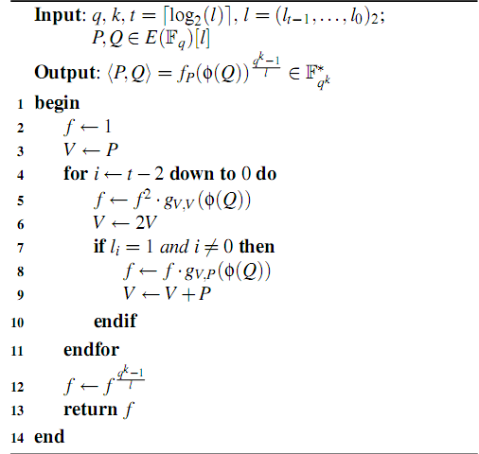

7.6 Signature Scheme

It is a set of algorithm that define the public parameters that would be send over to the nodes

by the PKG and the set of mathematical calculations that define the use of pairing and other mathematical computations and lead to the generation of signature and also the mathematical calculations that describe the computations required to check if the signature is verified or not.

7.6.1 Basic Algorithms involved in an ID based Signature Scheme

Identity-based signature schemes are normally specified by four algorithms [3].

1. Setup: Takes security parameters as input and returns a master public/private key pair for the system. The master private key is only known by the PKG.

2. Extract: The signer authenticates herself to the PKG and obtains a private key associated with her identity.

3. Signature Generation: Using her private key signer creates a signature σ on her message M.

4. Signature Verification: Having obtained the signature σ and the message M from the sender, the verifier checks whether σ is a genuine signature on M using original signer’s identity and the PKG’s public key pkPKG. If it is, he returns “Accept”. Otherwise, he returns “Reject”.

Figure 7.3: Identity Based Signature
Various ID based signature schemes like Hess and BLMQ schemes have been proposed but only a scheme that is fast can be chosen. Also numbers of pairings required by the scheme should be as less as possible.

The above mentioned algorithms call for specific kind of arithmetic which is being explained

in the next section.

Chapter 8

Design and Implementation Details

The entire development process can be divided into 3 phases:

I. Implementing the Pairing

II. Implementing the BLMQ Signature Scheme

III. Integrating the Above scheme into AODV

8.1 Implementing the Pairing

The process of implementing the Signature Scheme is dependent on the Pairing and can be divided into the following steps:

Before implementing the system a selection needs to be made to select the right set of parameters and algorithms that are to be used in the pairing and signature scheme, this can be explained in the following way.

1. Selecting a finite field and a representation for the field elements.

2. Selecting an elliptic curve, and a representation for elliptic curve points.

3. Selecting a Pairing Algorithm.

8.1.1 Finite Field Selection

As explained in the previous sections [6.2] there are different kinds of finite fields. But for this implementation Binary Field has been chosen. The choice is based on the observation that it is more suitable for implementation on the computer architecture as the elements of the fields are either 0, or 1 which correspond the bit 0 and 1 for the computer. For cryptographic
purposes the m should be a prime greater that 160.
Binary Field Representation

The base field F2m has been constructed using the polynomial basis representation. Here,
the elements of F2m are the binary polynomials (polynomials whose coefficients are in the field F2 = {0, 1}) of degree at most m – 1.

F2m ={am−1z m−1+am−2z m−2 +···+a2z2 +a1z+a0 : ai ∈{0,1}}.

An irreducible polynomial f(z) of degree m is chosen.

8.1.2 Elliptic Curve Selection

Selecting the right curve is the most important criteria for building an efficient and secure ID based Crypto System. It may be possible that the arithmetic on the curve be computationally highly efficient but it may not be strong enough for cryptographic purposes. Even the vice versa can be true.

Thus a selection needs to be made of a curve that is secure enough and the arithmetic on which is computationally efficient.

As Ad-Hoc networks are being dealt here, in which power efficiency is a major concern, a Supersingular curve has been chosen because they have apt embedding degree required for cryptographic purposes and also support computationally efficient arithmetic.

Highly efficient Pairing algorithms exist for these curves thus making cryptography based on them realizable in the real world scenario. Although these curves are considered a little weak cryptographically but the right kind of field selection can considerably solve this problem.

The elliptical curve chosen for the implementation is given by the general equation:- Eb: y2 + y = x3 + ax + b where a, b ∈ {0,1}
Taking a = 1, and b = 1

Eb: y2 + y = x3 + x + 1

Supersingular curves have an advantage that distortion maps exist for them.
Though other supersingular curves exist, but since this curve has an embedding degree of 4, which is maximum in its class, it is more secure as compared to other supersingular curves.

Elliptic Curve over the Binary Field:

The curve has been defined over the Binary field.

Each point on the curve will be represented in terms of a pair of values from the field. That is

a point is given as (x, y) where x, y ∈ F2m .

For the given selection of the curve Eb and the field F2m, the order of the curve is given as:-

#Eb(F2m) = 2m + 1 + (−1) b ; m ≡ 1,7 (mod 8)

#Eb(F2m) = 2m + 1− (−1) b ; m ≡ 3,5 (mod 8)

For cryptographic purpose the order of the curve, represented by l is required to have

following properties:

i. It should be a prime.

ii. It should divide qk -1, where q = 2m.

iii. It should be at least 160 bits in length.

Representation of Elliptic curve points

As explained in the previous section [6.4.1] elliptic curve points can be represented as Projective or Affine Coordinate system. Affine Coordinate (Affine V2) system has been chosen since results have shown that Projective coordinates yields better results only when
the Inversion in the field is too expensive as compared to field multiplication.

8.1.3 Selecting the Pairing Algorithm

Pairing is the heart of the ID based cryptosystem and computationally an expensive process. The efficiency of the cryptosystem highly depends on the efficiency of the pairing algorithm used. Tate Paring has been chosen which is considered to be twice as fast as the Weil Pairing.
The basic algorithm for computing Tate pairing is the Millers algorithm.
But the basic Millers algorithm has under went several modifications depending on the nature

of the selected curve. These modified algorithms are thus more efficient and are more suitable for cryptographic purposes.

The following Pairing algorithm has been chosen, which was proposed by [303.ps]. It has been optimized for the Supersingular curves and makes use of the distortion map.

, where Distortion Map

For the selected curve Eb, the distortion map is given as

Map | Parameters
 | with s, t ∈ F24m

The algorithm for pairing is given as:-

Algorithm for computing f P (φ (Q))
Input: P = (α, β), Q = (x, y) , α, β, x, y ∈ F2m

Output: C = f P (φ (Q))

1. C = 1

2. for (i = 1 to m ; i + +)

3. α ← α2

4. β ← β ²
5. z ← α + x
6. w ← z + αx + β + y + b
7. C ← C.(w + zt + (z +1)t² ) /* Extension Field F₂^{4m} */
8. x ←
9. y ←
end for
The result obtained after applying the pairing algorithm is not unique; therefore a final

Exponentiation is done for obtaining a unique result for cryptographic purposes.

C = ,

where q = 2m , and = order of the curve

Arithmetic Required

From the Pairing Algorithm described above we can analyze that following kinds of arithmetic need to be implemented

i. Field Arithmetic, Binary field as chosen ii. Extension Field Arithmetic
iii. Elliptic Curve Arithmetic

8.2 Selecting a Signature Scheme

As the final step for building the cryptosystem, a Signature generation algorithm is required. Since an Id based system is being built, a scheme that allows us to use any form of identity like E-mail id, IP address is chosen as the public key.

Many such algorithms exist, but a selection needs to be of a scheme which provides efficient key generation, signature generation and verification.

8.2.1 BLMQ Signature Scheme

The BLMQ [Baretto et al. 2005] Signature generation scheme has been chosen as this scheme offers the following advantages:-

a) Requires no pairing in signature generation.

b) Single pairing is required in signature verification.

c) Operates using normal Cryptographic Hash Functions instead of using specialized
PointToMap (Hash Functions that outputs a point on the curve) as required by some other schemes.
As every crypto-system has some Hard Problem associated with it, which can not be solved

in polynomial time. The hard problem associated with BLMQ scheme is Bilinear Difie- Hellman (BDH) assumption

For a, b, c , given (aP_{i}, bP_{j}, cP_{k}), for some values of i, j, k {1, 2}, computing ^{abc} is hard
*

As explained earlier that an ID Based Signature generation scheme consist of four main steps.

I. Setup

II. Private Key Extraction III. Signature Generation IV. Signature Verification
With respect to the above steps, the BLMQ Scheme can be explained as:-

1. SETUP

1. Select a security parameter k. For the implementation k ≈ m, the field length.

2. Select a k bit prime number l , and bilinear map groups (G1,G2,GT ) of order

supporting an efficiently computable, non-degenerate pairing e : G1 × G2 → GT

In this case G₁ = G₂ = E(F₂^{m}), that is the Elliptical Curve Group defined over binary field, and G_{T} = , that is the multiplicative group of the extension field. The order of the groups G₁ is then given by the equation () described earlier.

Pairing e: G1 × G2 → GT,

In this case changes to e: G1 × G1 → GT, (symmetrical pairing) and is computed using the

Pairing Algorithm described above followed by a final Exponentiation described earlier.

3. Select Generators ( torsion points )P ∈ G1, Q ∈ G2,

P and Q here are any points on the elliptic curve, since the order of the curve
has been chosen and it is known that there are , torsion points on a curve therefore in our case any point selected on the curve will be its generator.
4. Hash functions h0 : GT × {0 1}*→ /, , h1 : {0 1}*→ /,

4. Hash functions h₀ : G_{T} × {0 1}*→ , h₁ : {0 1}*→

denotes the multiplicative groups of the prime number .

The Hash functions H0 and H1 can be implemented using the normal cryptographic Hash

functions like SHA, thus avoiding any use of point to map Hash Functions.

5. A master key s→
,

associated.
is chosen, with which the public key Ppub = sP ∈ G1 is

This part of the algorithm make use of Elliptic Curve Arithmetic for calculating the

system public key Ppub. It is explained in section [9.2].

6. The generator g = e(P, Q) ∈ GT

g ∈ GT (element of extension field) is the result of applying the pairing algorithm on the selected points P and Q.

7. Thus the public Parameters are :

k, l , G1,G2,GT , P, Q, g, Ppub, e, h0, h1

But since the Elliptical Groups and the Hash Functions are already there with each of the participating nodes, the parameters that actually need to be transmitted are:-

k, P, Q, g, Ppub,, l .

2. PRIVATE-KEY EXTRACTION

This part of algorithm deals with the allocation of Private key to a node, once the node submits its identity. Following steps are taken:

1. The Private Key Generator, PKG takes as input entity A’s identifier IDA ∈ {0, 1}* and extracts A’s identity-based private key

QA ← (h1 (IDA) + s) −1 Q ∈ G2.

This process requires the support for BigIntegers, a class that can deal with numbers of
arbitrary large size and Elliptic Curve Arithmetic for calculating the Private Key QA, which is actually a point on the Curve.

This communication takes place using a secure channel and with the help of secure key distribution system, so that only the correct node gets the private key and no node can impersonate some other node. No secure channel has been established it is assumed that one already exist in the network.

2. A node can verify the consistency of his key by checking

e(h1(IDA)P + Ppub QA) = g.

The above method of key establishment is called Sakai Kasahara key style [Sakai

and Kasahara 2003].

3. SIGNING
The process of signing a message m ∈ {0, 1}* under the private key QA, consist of the following steps.

1. The signer picks u ←
,

group of l .

2. It computes r ←.
, that is it selects a random number from the multiplicative

This step requires us to perform exponentiation in the extension field GT.

3. h ← h0(r, m)

4. S ← (u − h)QA
It involves Elliptic curve arithmetic as QA is a point on the curve. The signed message is the triple

(m, h, S) ∈ {0, 1} * ×
× G2.

Therefore it can be seen that signature is a composition of two main things besides the

message

i. ‘h’, which is a number that belongs to
,

, and thus it is approximately a k bit

number, since k is large ( >= 160 for good security), a special BigInteger library is required for handling calculations involving it.

ii. S, it is a point on the elliptic curve and hence requires support for curve arithmetic.

Thus it can also be seen that no pairing is involved in the signing process, which makes the signature generation an efficient process.

4. VERIFY

This part of the algorithm deals with the verification of the signature (m, h, S), given the public key of the signer IDA. The algorithm performs the following steps.

1. r ← e(h1(IDA)P + Ppub, S) gh

2. v ← h0(r, m)

The verifier accepts the signed message iff v = h.

Arithmetic Required

As it can be analyzed from the above Signature Scheme that the following Arithmetic needs

to be implemented:-

1. Elliptical Curve arithmetic

2. Extension Field Arithmetic

3. Big Integer Arithmetic

4. Hash Functions

8.3 Integrating the Signature scheme in AODV

The above described signature generation scheme was integrated into the existing AODV code in the NS2 with the purpose of securing the routing messages, this called for some changes to be made to the existing NS2 AODV implementation.

The basic aim is that each node should sign the routing packet it generates using Signature scheme implemented. The IP address of the node has been chosen as its Public Key and the message to be signed here is the Routing Packet. Each intermediate node then first verifies
the packet it receives and only then any further processing takes place.

The Routing packets mainly consist of two kinds of field
1. Non-Mutable : Which remains same throughout the journey of the packet

2. Mutable: Fields whose value can be altered by the intermediate nodes, like Hop

Count.

Each node signs only the Non-Mutable fields with its private key, and then forwards the packet after integrating the signature and its public key in it.

In this project only Non-Mutable fields have been dealt with. Existing solutions like Hash

Chains can be used for dealing with Mutable fields.

8.3.1 Changes made to AODV

The embedding of the signature required the following changes in the existing NS2

implementation of AODV.

1. In the existing implementation of the AODV, the RREP message was modified while forwarding the reply, which prohibited the signing of the message. Some changes were made to the routing process so that there was no need to modify the RREP while forwarding the reply.

2. Route Reply by an intermediate node on behalf of the destination node has been disabled, since the intermediate nodes cannot sign on behalf of the destination node.

3. Packet format was extended to include two more fields,

i. ID: Public key of the node, who signed the message

ii. Signature: It is obtained by applying the Signature Scheme on the

Routing Packet (not including the Hop count field).

As it has already been discussed that signature is a combination of a (h, S). Thus in the packet also the Signature is represented as a combination of 2 fields.

i. BigInt number , h

ii. A Point on the Elliptic Curve, S.
RREQ / RREP

ID (Public key of node)

Signature = {RREQ/RREP - HopCount}K-1a

Figure 8.1: Extended Packet Format of AODV

Both of these fields were converted into a character array format for embedding them into a packet.

The routines for Handling the packets were changed in the following way:-

8.3.2 Initializing the routing Process

Key Distribution

All the nodes first obtain their copy of Public Parameters, from the PKG. No special key distribution scheme have been used, the PKG is represented in the library as PKG.{h, cc}. It returns a structure named Public Parameter to the node that requested the parameters; this structure contains all the required public parameters.

The Node then submits their Identity (Public Key) to the PKG to obtain the Private Key. This process should be made via a secure channel so that the key is delivered to the correct owner.
The establishment of the secure channel has not been considered in this Project.

Public Parameters

Node
ID – Public Key

Private - Key
PKG

Figure 8.2 Key Distribution

8.3.3 Securing the Routing Process

In this project emphasis has been made on securing the RREP and RREQ messages. Other routing messages like RRER and HELLO messages can be secured in a similar way.

1. Sending RREQ/RREP

i. Before sending the RREQ/RREP packet (which is filled with the required info), the sender signs the packet with its private key. Hop count field (which is a mutable field) is set to zero before signing and then restored again.

ii. The signing node then inserts its Public Key (ID) and the Signature generated into the Packet.

iii. Finally the packet is transmitted.

Creating a Routing Packet

Signing the Packet with Private Key

Embeding the Signature and ID in the Packet

Transmiting the Packet

Figure 8.3: Process of creating and Sending Routing Packet.

2. Receiving RREQ/RREP

i. Any intermediate node receiving the RREQ first verifies the signature of the sending node in the packet.
ii. If the signature is verified only then any further processing takes place on the packet (like setting up reverse path or sending RREP), else the packet is dropped.

Extracting the Public Key (ID) and signature from the
routing message

Verifying the signature

Packet is processed iff signature is verified, otherwise
the packet is dropped

Figure 8.4: Receiving and verifying the Routing Packet
3. Securing Other Routing messages, RRER and HELLO

RERR messages are used in AODV to indicate a link failure(s). The node tells the other nodes that the following path is no more reachable from the node.

The authenticity can be maintained by making the node generating the RERR sign that packet, but only signing can not prevent a node from lying. That is a node can generate a false RERR message to reduce the load through it. The signature would still get verified but
the malicious behavior of the node would not get detected.

Thus to actually prevent this malicious behavior system should be extended so that ranking

(reputation) is assigned to each node.

The HELLO messages can be secured in a similar way.

Chapter 9

Library Developed

Based On the requirements analyzed in the previous section(s) the following library has been developed.

Elliptic Curve Arithmetic
SIGNATURE
(BLMQ)
PAIRING
(Modified Millers)
PointF2M
(Point Representation)

F2M4
(Extension Field) ))Field)

F2M
(Binary Field)
BigInt
(BigInt Arithmetic)
HASH FUNCTIONS
Figure 18:

DF2M

Figure 9.1 Library Diagram

9.1. Binary Field Arithmetic - Field2M.{h, cc}

This piece of code represents a Class named F2M, which represent a binary field and defines

the associated arithmetic. It uses an array of computer word to store the polynomial. A single word of size W bits can accommodate the binary field polynomial of degree W-1.

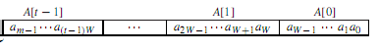

It provides support for the Binary Field Operations like:-
- Addition : Simple XOR ing
- Multiplication : Shift and Add Algorithms
- Squaring : Fast Squaring using pre-computed tables
- Division : Shift and Subtract Algorithms
- Reduction : Fast polynomial specific reduction
- Inversion : Binary Inversion Algorithm
- Exponentiation : Binary Exponentiation Algorithm
- Left And Right Shift

DF2M.{h, cc}

This class is just a helper class DF2M for the class F2M.

9.2 Elliptical Curve Arithmetic – PointF2M.{h, cc}

This file contains a class named PointF2M .It is used for performing various operations on

the point on the elliptical curve. This class PointF2M represents a point on the Elliptical

Curve Eb. That is, it represents a coordinate (x, y) on the curve where x, y ∈ F2m.

The mathematical formulae for point addition and doubling are curve dependent. The Group

Law for the chosen curve is:

9.2.1 Group law for supersingular E/F2m: y2 +cy = x3 +ax +b

• Identity. P +∞ = ∞+ P = P for all P ∈ E (F2m).

• Negatives. If P = (x, y) ∈ E (F2m), then (x, y) + (x, y + c) = ∞. The point (x, y +c) is denoted by −P and is called the negative of P; -P is also a point on the curve .Also,
−∞=∞.

• Point Addition. Let P = (x1, y1) ∈ E (F2m) and Q = (x2, y2) ∈ E (F2m), where, P ±Q.

Then P + Q = (x3, y3), where

x₃ =( + x₁ + x₂ and y₃ = ( (x₁ + x₃) + y₁ + c

• Point Doubling. Let P = (x1, y1) ∈ E(F2m), where P ≠ −P. Then 2P = (x3, y3),

x₃ = and y₃ =

• Point Multiplication. Point multiplication is the process of adding a point to itself.

kP = P + P + P + P + …..k times

Repeated Add and Double Algorithm have been used to perform Point Multiplication.

9.2.2 Finding a Random Point On The Curve

The Trace of a polynomial F₂^{m} c_{i} ∈{0, 1}, represented as a vector c =

(cm-1, … c1, c0) is given as

Tr(c) = Tr() = )

Half Trace of c for odd m is given by

H(c) =

And H(c) is the solutions of the equation y2 + y = c, (in this case c = x3 + x + 1) when Tr(c) =0.

Trace Tables and Half Trace tables have been used for speeding up the computation. The process can be summarized as the following algorithm.

Algorithm For Finding A Point On the Curve Eb.

Output : Point (x,y) on the Curve Eb

1. Select a random x ∈ F2m

2. Compute c = , that is for the RHS of the curve

3. Find Trace of c ,Tr(c)

4. If Tr(c) = 0, then goto step 5 else goto step 1

5. Compute Half Trace, y = H(c)

6. Return Point(x,y)

Therefore the basic algorithms by class PointF2M are :-

• Point Addition

• Point Doubling

• Point Multiplication

• Finding A Random Point On the Curve

9.3 Extension Field Arithmetic – Field2M4.{h, cc}

This file contains a class named F2M4.

Since for the chosen curve the embedding degree is 4, thus there is a need to perform some calculation in the extension field F24m where F2m as the base binary field.

This class represents the elements of the extension field as an array of elements of the F2m.
All the calculation for the extension field is performed in terms of the base field, F2m. with the help of an irreducible polynomial, which in our case is x4 + x + 1, efforts have been made to reduce the number of base field calculations as the extension field arithmetic is
computationally highly expensive.

Basic Operations provided by this class are:-

• Addition

• Squaring
- Multiplication : Requires 9 multiplication in base field
- Exponentiation : Binary Exponentiation Algorithm

9.4 BigInt Arithmetic: BigInt. {h, cc}

This code represents a class BigInt which performs BigInteger Arithmetic. Each digit in the

BigInt is represented in the base and in the signed magnitude representation. Therefore the basic algorithms by class BigInt are:-
• Addition

• Subtraction

• Left and Right Shifting

9.5 Other Files

Util.{h, cc}

Provides support for some common operations on a polynomial like :-

• Getting Degree of Polynomial

• Setting/Clearing a particular Coefficient

• Displaying the Polynomial

Hash Algorithms – Hash.cpp

This code utilizes the SHA160 Algorithm along with the BigInt and F2M4 class to implement the Hash functions H0 and H1 as required by the BLMQ Signature Scheme.

Pairing.cc

This part of the library implements the pairing algorithm using the above mentioned classes. The Pairing Algorithm as explained above has been implemented in this part of the code.
This algorithm takes as an input two point on the elliptic curve and returns an element from

the extenstion field. This is the most expensive algorithm is the entire library developed.
PKG.cc

This class represents the Private Key Generator (PKG), as required by the Signature Generation Scheme. It runs the Setup algorithm and establishes the Public Parameters required by the nodes and the Master Secret Key required by the PKG. Main task performed
by this code are.

1.Distributing the Public Parameters

At the time of initializing the routing agent in the AODV each node uses this class to obtain the set of Public Parameters. All the public parameters are integrated in form of a structure is defined in PublicParam.h. The PKG then returns an instance of this structure with all the public parameters initialized to the required node.

2. Distributing the Private Key

The nodes submit their ID or Public Key to the PKG, which then uses its Master Secret key to generate the private key for the corresponding Public Key.

SignVer.cc

The above class uses the Pairing Algorithm and the Hash Functions to Generate and Verify

the Signature. It also provides the algorithm for Key Verification. Thus it implements the final two steps , that is Signature and Verification of the Signature.

1. Key Verification

This algorithm verifies that whether correct Private key that has been delivered is correct or not.

2. Signature Generation

This algorithm takes as input the Private key of the node along with the message to be signed. The Signature is then returned in the form of a Structure defined in the Signature.h, which is then returned to the node.

3. Signature Verification

This algorithm takes as input the Public Key of the signing node along with the message that was signed and the structure representing the Signature. The algorithm
then returns “true” indicating successful verification else false is returned.
Chapter 10

Results And Evaluation

For the finite field F2m with m = 163 the following results were obtained:

Timing Results

Operation | Time (ms)
Pairing | 25
Signature Generation | 7
Signature Verification | 30

58
Following graphical results were obtained by performing the simulation of AODV integrated with ID-Based Signature Scheme using NS2.

The simulation environment consisted of 20 nodes moving over an area of 670 X 670.

- Throughput of Sending packets
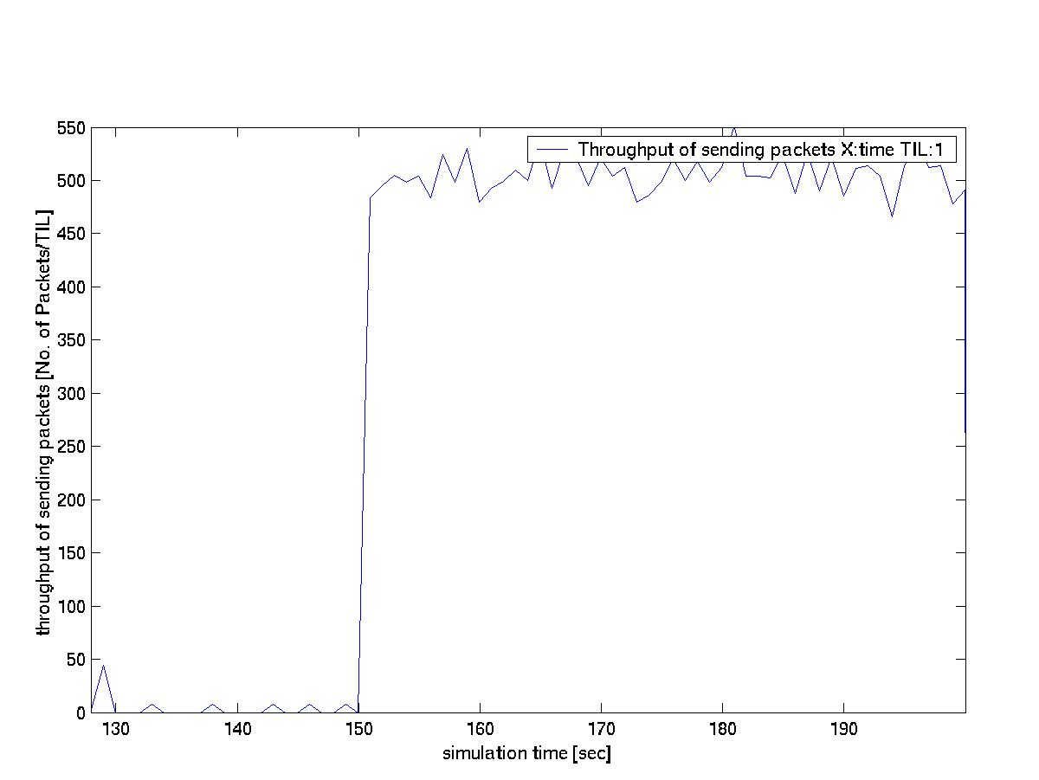

AODV + ID Based Signature

AODV

59

- Throughput of receiving packet
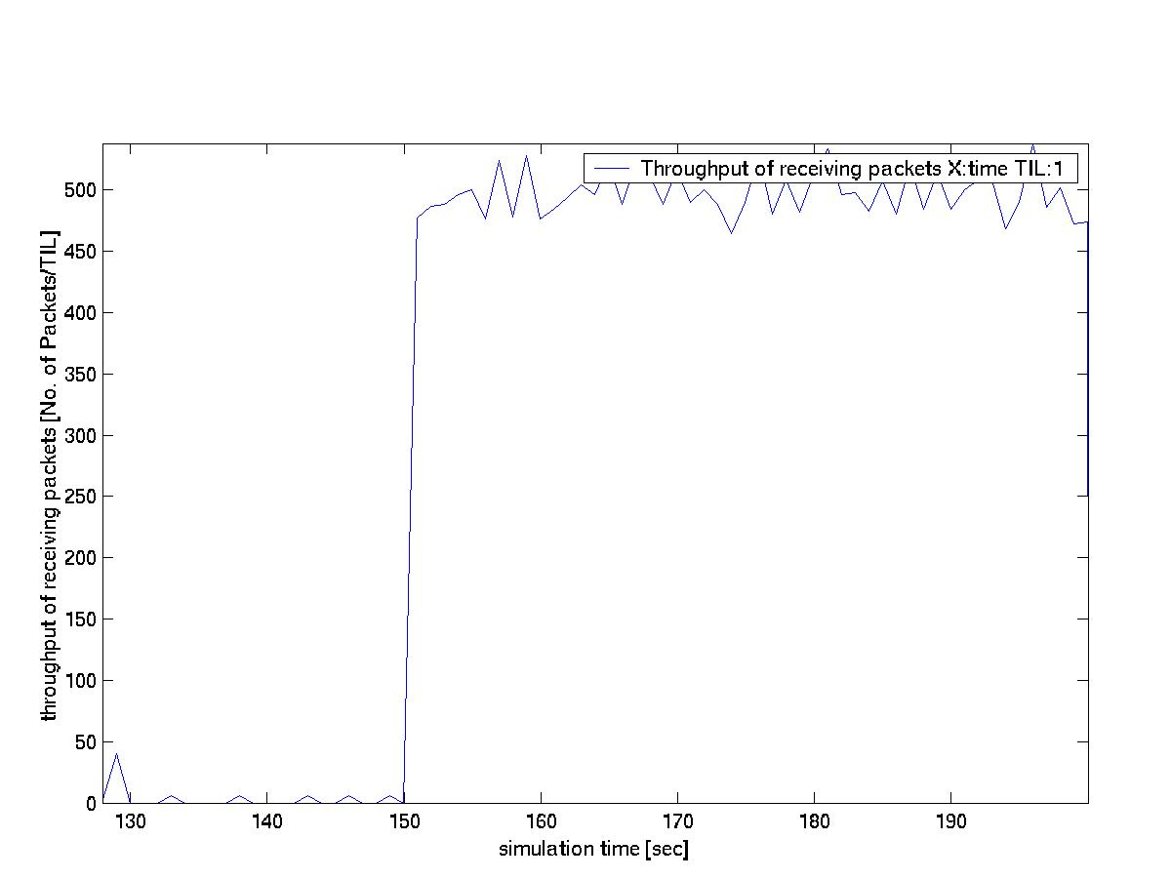

AODV + ID Based Signature

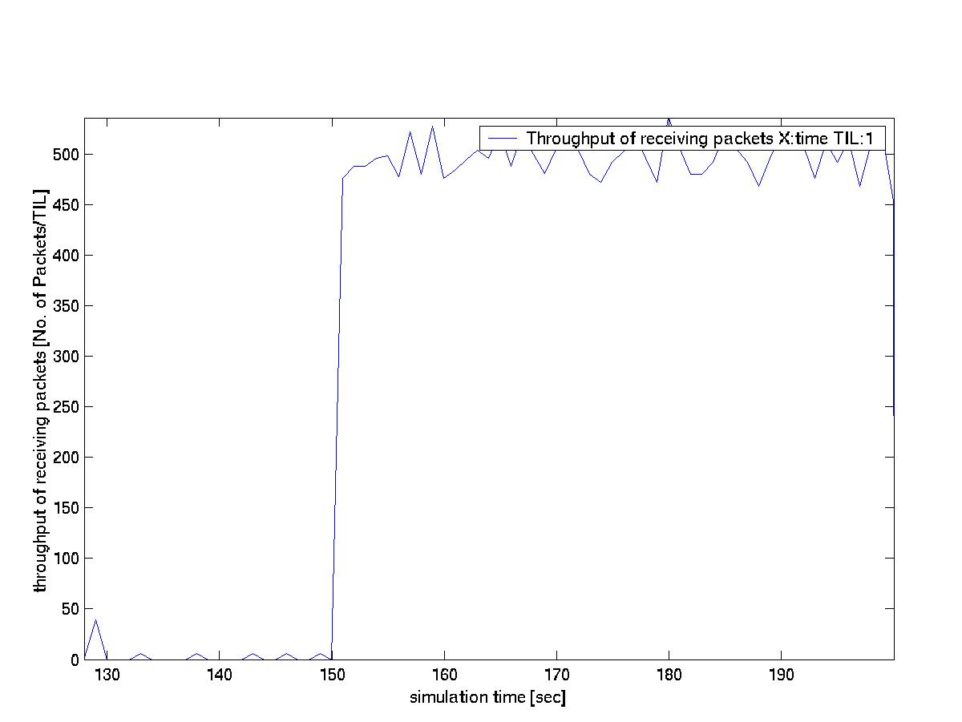
AODV

60

- Sum of number of all Packets Dropped
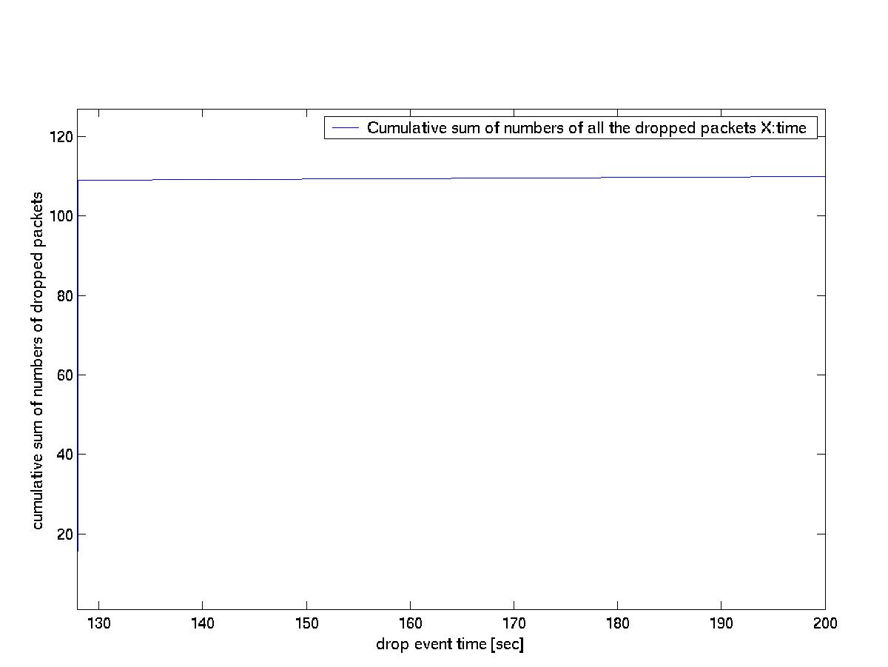
AODV + ID Based Signature

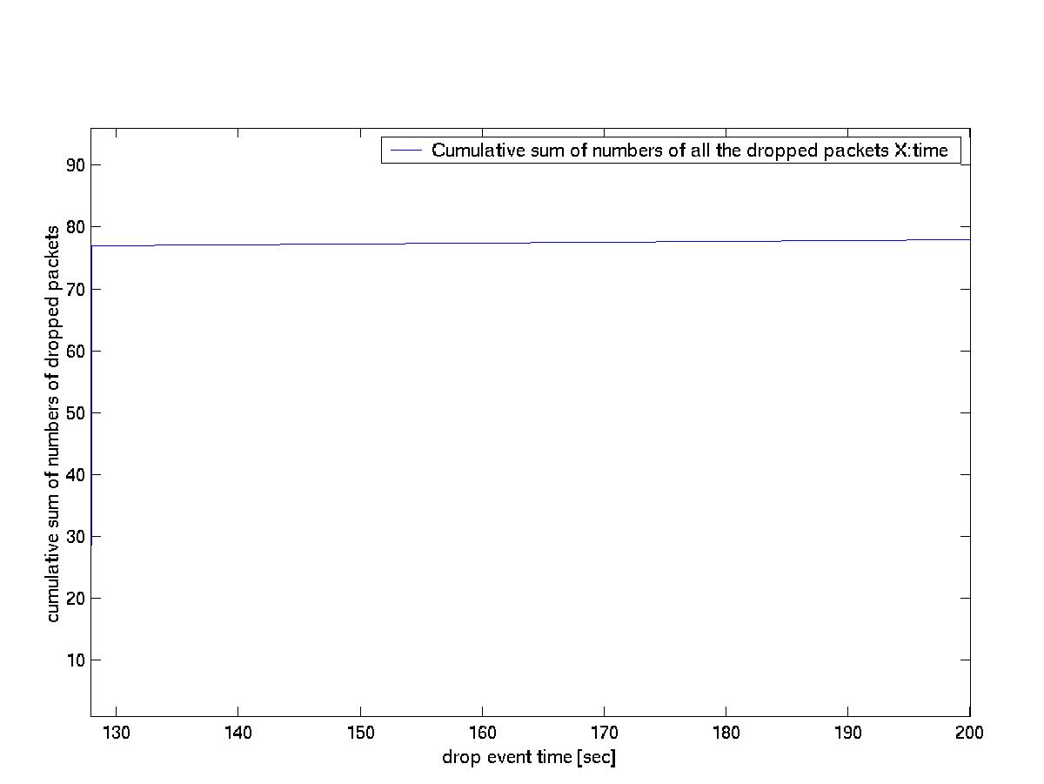
AODV

61

Chapter 11

Conclusions And Future Work

The ID based Signature scheme has been successfully implemented and the same has been integrated into the AODV. The timing results for the pairing algorithms and the key generations and verification has been shown.

The graphical results for the throughput of the system with signature scheme integrated in

AODV have also been shown.

Although the throughput of the system has decreased for normal circumstance but the system has gained the capability to defend itself in the event of any node being malicious.

The most important algorithm involved in the signature scheme is the pairing; the efficiency

of the pairing algorithm should further be improved to reduce the time required in signature generation and verification.
• Use of dedicated hardware for performing the arithmetic can improve the overall throughput of the system.
• Use of Threshold Cryptography can avoid the key escrow problem associated with ID

based system.

• Mixed coordinate system can improve the elliptical curve arithmetic.

• Presently I have secured only the Non-mutable fields, and for complete security and efficient method for securing mutable field in the routing packets should also be
employed.

62

REFERENCES

1. Luke Klein-Berndt Wireless Communications Technologies Group National Institute

of Standards and Technology, “A Quick Guide to AODV Routing”.

2. A. Shamir, “Identity-Based Cryptosystems and Signature Schemes,” CRYPTO’ 84, LNCS, 1985, pp. 53–57.

3. Joonsang Baek, Jan Newmarch, Reihaneh Safavi-Naini, and Willy Susilo, School of Information Technology and Computer Science, University of Wollongong, “A Survey of Identity-Based Cryptography”.

4. Darrel Hankerson , Alfred Menezes, Scott Vanstone , “Guide to Elliptic Curve

Cryptography”

5. G. Berton, L. Breveglieri, P. Fragneto1, G. Pelosi and L. Sportiello ST Microelectronics1, Politecnico di Milano “Software Implementation of Tate Pairing over GF(2m)”.

6. Yih-Chun Hu University of California, Berkeley; Adrian Perrig Carnegie Mellon

University “A Survey of Secure Wireless Ad Hoc Routing”.

7. C. Perkins, E. B. Royer and S. Das, “Ad-hoc On-Demand Distance Vector (AODV) Routing,” RFC 3561, Jul. 2003.

8. Liqun Chen Hewlett-Packard Laboratories , “Identity-based Cryptography “, ’06.

9. Mike Scott Dublin City University , “Efficient Implementation of Cryptographic pairings”.

10. Soonhak Kwon Department of Mathematics, Sungkyunkwan University, Korea,” Efficient Tate Pairing Computation for Supersingular Elliptic Curves over Binary Fields “.

11. P. S. L. M. Barreto, H. Y. Kim, B. Lynn and M. Scott, “Efficient Algorithms for

Pairing-Based Cryptosystems,” Proc. Advances in Cryptology -- Crypto'02, pp.354-

368, 2002.

63
12. Wenbo Mao, Principal Engineer HP Labs., Bristol “Divisors, Bilinear Pairings and

Pairing Enabled Cryptographic Applications”.

13. Paulo S. L. M. Barreto1 , Alexandre Machado Deusajute “Toward Effcient

Certificateless Signcryption from (and without) Bilinear Pairings”.

14. Wei Ren, Yoohwan Kim1, Ju-Yeon Jo2, Mei Yang3 and Yingtao Jiang.” IdSRF: ID- based Secure Routing Framework for Wireless Ad-Hoc Networks”.

64

