A
Major Report
On

FUZZY FILTER DESIGN FOR NOISE REMOVAL IN COLOR IMAGE USING WAVELET

Submitted in Partial fulfillment of the requirement
For the award of the degree of

MASTER OF ENGINEERING
(Electronics and Communication)

Submitted by
Anil Singh Parihar
(University Roll No. 10271)

Under the Guidance of
Mr. O. P. VERMA
(Asst. Prof.)
Head of the Department
Department of Information Technology



DEPARTMENT OF ELECTRONICS & COMMUNICATION ENGINEERING
DELHI COLLEGE OF ENGINEERING
BAWANA ROAD, DELHI -110042
(UNIVERSITY OF DELHI)

2006-2008

CERTIFICATE
This is to certify that the MAJOR REPORT titled as “FUZZY FILTER DESIGN FOR NOISE REMOVAL IN COLOR IMAGE USING WAVELET” is being submitted by ANIL SINGH PARIHAR Class Roll No. 01/E&C/06, University Roll No. 10271, in partial fulfillment for the award of “Master of Engineering Degree in Electronics & Communication” in Delhi College of Engineering, (Delhi University), Delhi; is the original work carried out by him under my guidance and supervision. The matter contained in this report has not been submitted elsewhere for award of any other degree.

Mr. O.P. VERMA
( H.O.D. Dept. of Information Technology Engineering)
Project Guide
Dept. of Electronics and Communication
Delhi College of Engineering, Delhi

ACKNOWLEDGEMENT

Firstly, I would like to express my hearty gratitude and thanks to my project guide Mr. O.P. VERMA H.O.D. of Deptt. of Information Technology; D.C.E. Delhi, for continuous inspiration, encouragement and guidance in every stage of preparation of this major project report.

I am also extremely thankful to Assistant Prof. P.R. Chaddha, Head of the Deptt. of Electronics and Communication Engineering, D.C.E. Delhi, for the support provided by him during the entire duration of degree course and especially in this thesis.
I am also thankful to all teaching and non-teaching staff at DCE, and my fellows, who have helped me directly or indirectly in completion of this thesis report.

ANIL SINGH PARIHAR
M.E.(Electronics & Communication)
Roll. No. 01/EC/06
Uni. Roll. No. 10271

ABSTRACT

The focus of this project is removal of various types of noise present in color images. We have used two type of concepts namely fuzzy filtering and filters based on wavelet. Fuzzy filter system combines the outputs of several filters at any one time. It is observed that different objective function associated with a filter yields differing capability in the filtering. Hence the objective functions were divided into 2 types: multiplicative type and summation type. we present several filter combinations and show that the each filter combination, which consists of filters from both types, is effective in reducing Gaussian type and impulse noises. The outputs of filters are combined depending upon the value of pixel compatibility, which is computed from the gray-level differences between the central pixel and its neighbors.
Wavelet based filter utilizes a new differentiable thresholding function for image denoising in the wavelet domain. Next, function is used in a new subband-adaptive thresholding neural network to improve the efficiency of the method. In these learning methods, both the threshold and the thresholding function effects are considered simultaneously. These methods are used to suppress two types of important noises, Gaussian and speckle, from natural images to Ultrasound and SAR pictures. The simulation results show that the proposed. This makes it an efficient method in image denoising applications.

CONTENTS

Chapter 1

INTORDUCTION

1.1 Importance of wavelet based fuzzy filters
1.2. Motivation and Organization

Chapter 2

DENOISING USING WAVELET

2.1 Introduction to Wavelets
2.2 The Continuous Wavelet Transforms
2.3 The Discrete Wavelet Transforms
2.4 DWT and Filter Banks
2.4.1 Multi-resolution Analysis using Filter Banks
2.4.2 Condition for perfect Reconstruction
2.4.3 Classification of Wavelets
2.5 Wavelet Families
2.6 Denoising using Wavelets
2.6.1 Denoising of Gaussian and Speckle noise

Chapter 3

FUZZY FILTER SYSTEM

3.1 Introduction to Fuzzy Logic
3.2. Clustering
3.2.1 Fuzzy C-means Clustering
3.3. Fuzzy Filter System
3.4. Modified Fuzzy Filter System
3.5 Results

Chapter 4

DENOISING OF COLOR IMAGE USING WAVELETS

4.1 Gaussian Noise
4.2 Speckle Noise
4.3 Nonlinear Thresholding function
4.4 Thresholding function with three shape tuning factors
4.5 Adaptive noise reducing using TNN
4.5.1 Adaptive Learning Algorithm
4.5.2 Unsupervised Learning
4.6 Results

Chapter 5

DENOISING OF COLOR IMAGE USING FUZZY FILTERS

5.1 Introduction
5.2 Adaptive Filter System
5.2.1 Compatibility Measure
5.2.2 Filter System
5.3 Results

Chapter 6

RESULTS AND COMPARISON

6.1 Comparison among different combination of Fuzzy filter system
6.2 Comparison among different combination of Modified Fuzzy filter system
6.3 Results of Wavelet based filter

Chapter 7

CONCLUSION

REFERENCES

Chapter 1

Introduction

1.1 Importance of wavelet based fuzzy filter

One of important task of image and signal processing is to effectively reduce noise from a digital color image while keeping its features intact (e.g., edges, color component distances, etc.). Three main types of noise exist: impulse noise, additive noise, and multiplicative noise. Impulse noise is usually characterized by some portion of image pixels that are corrupted, leaving the remaining pixels unchanged. Examples of impulse noise are fixed-valued impulse noise and randomly valued impulse noise. We talk about additive noise when a value from a certain distribution is added to each image pixel, for example, a Gaussian distribution. Multiplicative noise is generally more difficult to remove from images than additive noise because the intensity of the noise varies with the signal intensity (e.g., speckle noise).
Fuzzy set theory and fuzzy logic [1] offer us powerful tools to represent and process human knowledge represented as fuzzy if-then rules. Fuzzy image processing [2] has three main stages: 1) image fuzzification, 2) modification of membership values, and 3) image defuzzification. The fuzzification and defuzzification steps are due to the fact that we do not yet possess fuzzy hardware. Therefore, the coding of image data (fuzzification) and decoding of the results (defuzzification) are steps that make it possible to process images with fuzzy techniques. The main power of fuzzy image processing lies in the second step (modification of membership values). After the image data is transformed from input plane to the membership plane (fuzzification), appropriate fuzzy techniques modify the membership values. This can be a fuzzy clustering, a fuzzy rule-based approach, a fuzzy integration approach, etc. Several fuzzy filters for noise reduction have already been developed, e.g., the iterative fuzzy control based filters from [3], [4], the GOA filter [5], [6], and so on. Most of these state-ofthe-art methods are mainly developed for the reduction of fattailed noise like impulse noise. These fuzzy filters are able to outperform rank-order techniques (such as the median based filters). Nevertheless, most of the current fuzzy techniques do not produce convincing results for additive noise, which is illustrated in [7] and [8]. Another shortcoming of the current methods is that most of these filters are especially developed for grayscale images. It is, of course, possible to extend these filters to color images by applying them on each color component separately, independent of the other components. However, this introduces many artifacts, especially on edge or texture elements. Therefore, this paper presents a new and simple fuzzy technique for filtering color images corrupted with narrow-tailed and medium narrow-tailed noise (e.g., Gaussian noise) without introducing these artifacts.
In literature, we can also find a huge amount of wavelet based methods [9] to achieve a good noise reduction (for the additive noise type), while preserving the significant image details. Typical wavelet based denoising methods consist of three steps: 1) compute the discrete wavelet transform (DWT)
or a nondecimated wavelet transform, 2) remove noise from the wavelet coefficients, and 3) reconstruct the enhanced image by using the inverse wavelet transformation. Due to the linearity of the wavelet transform, additive noise in the image domain remains additive in the transform domain, as well. If Ws,d(i, j) and Ys,d(i ,j) denote the noisy and the noise-free wavelet coefficients at position (i, j) of scale s and orientation d , respectively, then we can model the additive noise in the transform domain as

Ws,d(i,j) = Ys,d(i ,j) + Ns,d(i ,j) (1)

where Ns,d(i ,j ) is the corresponding noise component.
The second step in the wavelet denoising procedure usually consists of shrinking the wavelet coefficients: the coefficients that contain primarily noise should be reduced to negligible values, while the ones containing a significant noise-free component should be reduced less. A common shrinkage approach is the application of simple thresholding nonlinearities to the empirical wavelet coefficients [10]–[12]: If the coefficient’s magnitude is below the threshold, it is reduced to zero; otherwise, it is kept or modified. Shrinkage estimators can also result from a Bayesian approach, in which a prior distribution of the noise-free data (e.g., Laplacian [13], generalized Gaussian [14]–[16], Gaussian scale mixture [17], [18]) is integrated in the denoising scheme. The simplest Bayesian methods assume statistically independent data and rely on marginal statistics only [14], [15], [19], [20]. However, algorithms that exploit the different kinds of dependencies between the wavelet coefficients can result in better denoising performance, compared with the ones derived using an independence assumption. The wavelet coefficients are statistically dependent mainly due to two properties of the wavelet transform of natural images: 1) large coefficients will propagate across the scales (interscale dependencies), and 2) if a coefficient
is large/small, some of the neighboring coefficients are also likely to be large/small (intrascale dependencies).
In other words, the energy of the noise is spread among all the coefficients in the wavelet domain. Due to the fact that the wavelet transform of a noisy signal is a linear combination of the wavelet transform of the noise and the original signal, the noise power can be suppressed significantly with a suitable threshold while the main signal features can be preserved. In the noise reduction method in the wavelet domain that is called wavelet shrinkage, the wavelet coefficients of a noisy image are divided into important and non-important coefficients and each of these groups are modified by certain rules. The functionality of the shrinkage process is due to the threshold value and the thresholding rule. Hard and soft thresholding functions Image Denoising in the Wavelet Domain Using a New Adaptive Thresholding Function that are the basic ones introduced by Donoho and Johnstone [27] together with garrote [34] and semisoft thresholding functions [33] that are more powerful, are used in noise suppression applications. In these methods the nonimportant coefficients are set to zero. In hard thresholding, the important coefficients remain unchanged. In soft thresholding, the important coefficients are reduced by the absolute threshold value.

1.2 Motivation and organization

In this project we aim to develop combination of filters, which can remove various type of noise (such as Gaussian, salt and pepper and speckle noise). Filters are based on fuzzy logic and wavelet transform.
We take up the removal of the different combination of noise like impulse and Gaussian noises in color images. Other combination will be Gaussian and Speckle noise. There will be three filters corresponding to RGB components of a color pixel.
We have taken leaf from choi and Krishnapuram [21] ] who have proposed three fuzzy filter systems for dealing with Gaussian and impulse noises. A particular system is selected based on the compatibility function at the pixel of interest. This compatibility function is clustered into low, medium and high membership functions and these are multiplied with the three filter outputs of [21] to get the combined output for dealing with any noise in Hanmandlu et al. [22]. Using the concepts of both [21] and [22], three sigma and Pi filters are developed in [23]. However, all these filters are not efficient in removing the mixed noise.
Generally, linear averaging filters have the ability to remove Gaussian noise but ineffective to impulse noise. Edges and image details get blurred due to linear filtering. Conversely, edge-preserving filters will retain the edges and line structures but tend to amplify noise. Different methods have been proposed in literature to address this issue. The most effective methods are nonlinear and adaptive in nature [24-25]. Depending on the noise type, we are required to apply the optimum choice of filters to obtain the best output for a particular pixel.
There are several methods which use fuzzy selection filters for smoothing. The adaptive filter proposed by taguchi and Meguro [26] for the removal of mixed noise combines the output of five classical operators depending on three local features. The operators are midpoint filter, median filter, mean filter, identity filter, and small window median filter.
In the part of wavelet filter, we try to remove Gaussian and Speckle noise. A nonlinear thresholding function is proposed for image denoising in the wavelet domain. This function has some advantages over classical methods and produces better results in speckle and Gaussian noise reduction. To improve the capability of the function, three shape tuning factors have been added which lead to a comprehensive thresholding function that can be adjusted to any desired thresholding function. This function is used in an adaptive manner in a method that inspired form Zhang’s Thresholding Neural Network (TNN) [29]. A new method of adaptive learning is also proposed for TNN based image denoising. In this method, the shape tuning parameters of the thresholding function are tuned through an LMS-based learning algorithm similar to the threshold value. Using this method, the effect of two important factors (threshold value and proper thresholding function) is considered in denoising simultaneously.
The report is organized as follows. In chapter two we have introduce concept of wavelet and noise removal through wavelet. Chapter three discuss about fuzzy filters and chapter four and chapter five about denoising of color image using wavelet and fuzzy filter respectively. Chapter six gives results and comparison and finally conclusions are given in chapter seven.

Chapter 2
Denoising using wavelets

2.1 Introduction to wavelets

The transform of a signal is just another form of representing the signal. It does not change the information content present in the signal. The Wavelet Transform provides a time-frequency representation of the signal. It was developed to overcome the short coming of the Short Time Fourier Transform (STFT), which can also be used to analyze non-stationary signals. While STFT gives a constant resolution at all frequencies, the Wavelet Transform uses multi-resolution technique by which different frequencies are analyzed with different resolutions.
A wave is an oscillating function of time or space and is periodic. In contrast, wavelets are localized waves. They have their energy concentrated in time or space and are suited to analysis of transient signals. While Fourier Transform and STFT use waves to analyze signals, the Wavelet Transform uses wavelets of finite energy.

(a) (b)

Figure 2.1 Demonstration of (a) a Wave and (b) a Wavelet.

The wavelet analysis is done similar to the STFT analysis. The signal to be analyzed is multiplied with a wavelet function just as it is multiplied with a window function in STFT, and then the transform is computed for each segment generated. However, unlike STFT, in Wavelet Transform, the width of the wavelet function changes with each spectral component. The Wavelet Transform, at high frequencies, gives good time resolution and poor frequency resolution, while at low frequencies; the Wavelet Transform gives good frequency resolution and poor time resolution.
That is wavelet analysis gives both frequency and time information about signal unlike Fourier transform which gives only frequency information.

Frequency:2 Hz to 20 Hz Frequency:20 Hz to 2 Hz
Different in Time Domain
Time
Magnitude
Magnitude
Frequency (Hz)
Time
Magnitude
Magnitude
Frequency (Hz)
Same in Frequency Domain

Figure above shown is very good example. Example shows two signals one varies from 2 Hz to 20 Hz in frequency with respect to time and other from 20 Hz to 2 Hz. If we take Fourier transform of these two we will get same frequency information for both signals. That is from Fourier transform only we can not distinct these two signals. On the other hand wavelet completely describes these signals.
One major advantage afforded by wavelets is the ability to perform local analysis -- that is, to analyze a localized area of a larger signal. Consider a sinusoidal signal with a small discontinuity -- one so tiny as to be barely visible. Such a signal easily could be generated in the real world, perhaps by a power fluctuation or a noisy switch.

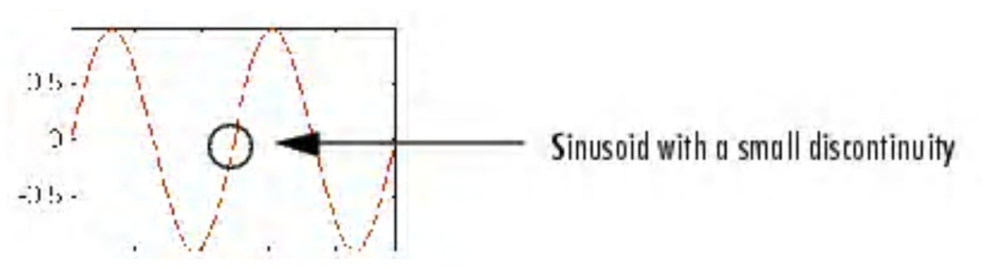

Fig. 2.2

A plot of the Fourier coefficients of this signal shows nothing particularly interesting: a flat spectrum with two peaks representing a single frequency. However, a plot of wavelet coefficients clearly shows the exact location in time of the discontinuity.

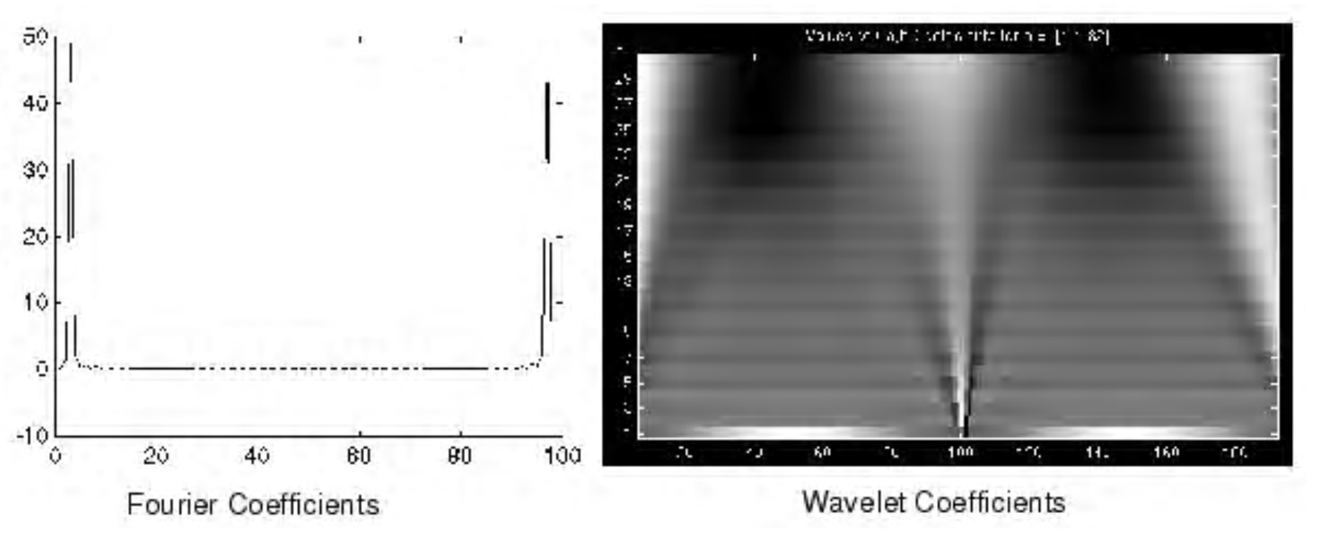
Fig. 2.3
Wavelet analysis is capable of revealing aspects of data that other signal analysis techniques miss, aspects like trends, breakdown points, discontinuities in higher derivatives, and self-similarity. Furthermore, because it affords a different view of data than those presented by traditional techniques, wavelet analysis can often compress or de-noise a signal without appreciable degradation. Indeed, in their brief history within the signal processing field, wavelets have already proven themselves to be an indispensable addition to the analyst's collection of tools and continue to enjoy a burgeoning popularity today.

2.2 The Continuous Wavelet Transform

The Continuous Wavelet Transform (CWT) is provided by equation 2.1, where x(t) is the signal to be analyzed. Ψ(t) is the mother wavelet or the basis function. All the wavelet functions used in the transformation are derived from the mother wavelet through translation (shifting) and scaling (dilation or compression).

2.1

The mother wavelet used to generate all the basis functions is designed based on some desired characteristics associated with that function. The translation parameter τ relates to the location of the wavelet function as it is shifted through the signal. Thus, it corresponds to the time information in the Wavelet Transform. The scale parameter s is defined as |1/frequency| and corresponds to frequency information. Scaling either dilates (expands) or compresses a signal. Large scales (low frequencies) dilate the signal and provide detailed information hidden in the signal, while small scales (high frequencies) compress the signal and provide global information about the signal. Notice that the Wavelet Transform merely performs the convolution operation of the signal and the basis function. The above analysis becomes very useful as in most practical applications, high frequencies (low scales) do not last for a long duration, but instead, appear as short bursts, while low frequencies (high scales) usually last for entire duration of the signal. The Wavelet Series is obtained by discretizing CWT. This aids in computation of CWT using computers and is obtained by sampling the time-scale plane. The sampling rate can be changed accordingly with scale change without violating the Nyquist criterion. Nyquist criterion states that, the minimum sampling rate that allows reconstruction of the original signal is 2ω radians, where ω is the highest frequency in the signal. Therefore, as the scale goes higher (lower frequencies), the sampling rate can be decreased thus reducing the number of computations. Any signal processing performed on a computer using real-world data must be performed on a discrete signal -- that is, on a signal that has been measured at discrete time. So what exactly is "continuous" about it? What's "continuous" about the CWT, and what distinguishes it from the discrete wavelet transform, is the set of scales and positions at which it operates. Unlike the discrete wavelet transform, the CWT can operate at every scale, from that of the original signal up to some maximum scale that you determine by trading off your need for detailed analysis with available computational horsepower. The CWT is also continuous in terms of shifting: during computation, the analyzing wavelet is shifted smoothly over the full domain of the analyzed function.

2.3 The Discrete Wavelet Transform

The Wavelet Series is just a sampled version of CWT and its computation may consume significant amount of time and resources, depending on the resolution required. The Discrete Wavelet Transform (DWT), which is based on sub-band coding is found to yield a fast computation of Wavelet Transform. It is easy to implement and reduces the computation time and resources required.
The foundations of DWT go back to 1976 when techniques to decompose discrete time signals were devised. Similar work was done in speech signal coding which was named as sub-band coding. In 1983, a technique similar to sub-band coding was developed which was named pyramidal coding. Later many improvements were made to these coding schemes which resulted in efficient multi-resolution analysis schemes.
In CWT, the signals are analyzed using a set of basis functions which relate to each other by simple scaling and translation. In the case of DWT, a time-scale representation of the digital signal is obtained using digital filtering techniques. The signal to be analyzed is passed through filters with different cutoff frequencies at different scales.

2.4 DWT and Filter Banks
2.4.1 Multi-Resolution Analysis using Filter Banks

Filters are one of the most widely used signal processing functions. Wavelets can be realized by iteration of filters with rescaling. The resolution of the signal, which is a measure of the amount of detail information in the signal, is determined by the filtering operations, and the scale is determined by upsampling and downsampling (sub sampling) operations [5].
The DWT is computed by successive lowpass and highpass filtering of the discrete time-domain signal. This is called the Mallat algorithm or Mallat-tree decomposition. Its significance is in the manner it connects the continuous-time mutiresolution to discrete-time filters. In the figure, the signal is denoted by the sequence x[n], where n is an integer. The low pass filter is denoted by G₀ while the high pass filter is denoted by H₀. At each level, the high pass filter produces detail information; d[n], while the low pass filter associated with scaling function produces coarse approximations, a[n].
At each decomposition level, the half band filters produce signals spanning only half the frequency band. This doubles the frequency resolution as the uncertainty in frequency is reduced by half. In accordance with Nyquist’s rule if the original signal has
a highest frequency of ω, which requires a sampling frequency of 2ω radians, then it now has a highest frequency of ω/2 radians. It can now be sampled at a frequency of ω radians thus discarding half the samples with no loss of information. This decimation by 2 halves the time resolution as the entire signal is now represented by only half the number of samples. Thus, while the half band low pass filtering removes half of the frequencies and thus halves the resolution, the decimation by 2 doubles the scale.
With this approach, the time resolution becomes arbitrarily good at high frequencies, while the frequency resolution becomes arbitrarily good at low frequencies. The filtering and decimation process is continued until the desired level is reached. The maximum number of levels depends on the length of the signal. The DWT of the original signal is then obtained by concatenating all the coefficients, a[n] and d[n], starting from the last level of decomposition.

Basically, the reconstruction is the reverse process of decomposition. The approximation and detail coefficients at every level are upsampled by two, passed through the low pass and high pass synthesis filters and then added. This process is continued through the same number of levels as in the decomposition process to obtain the original signal. The Mallat algorithm works equally well if the analysis filters, G₀ and H₀, are exchanged with the synthesis filters, G₁ ₁.

2.4.2 Conditions for Perfect Reconstruction

In most Wavelet Transform applications, it is required that the original signal be synthesized from the wavelet coefficients. To achieve perfect reconstruction the analysis and synthesis filters have to satisfy certain conditions. Let G₀(z) and G₁(z) be the low pass analysis and synthesis filters, respectively and H₀(z) and H₁(z) the high pass analysis and synthesis filters respectively. Then the filters have to satisfy the following two conditions:

G₀ (-z) G₁ (z) + H₀ (-z). H₁ (z) = 0 2.2
G₀ (z) G₁ (z) + H₀ (z). H₁ (z) = 2z^{-d} 2.3

The first condition implies that the reconstruction is aliasing-free and the second condition implies that the amplitude distortion has amplitude of one. It can be observed that the perfect reconstruction condition does not change if we switch the analysis and synthesis filters.
There are a number of filters which satisfy these conditions. But not all of them give accurate Wavelet Transforms, especially when the filter coefficients are quantized. The accuracy of the Wavelet Transform can be determined after reconstruction by calculating the Signal to Noise Ratio (SNR) of the signal. Some applications like pattern recognition do not need reconstruction, and in such applications, the above conditions need not apply.

2.4.3 Classification of wavelets

We can classify wavelets into two classes: (a) orthogonal and (b) biorthogonal. Based on the application, either of them can be used.
(a)Features of orthogonal wavelet filter banks
The coefficients of orthogonal filters are real numbers. The filters are of the same length and are not symmetric. The low pass filter, G₀ and the high pass filter, H₀ are related to each other by
H₀ (z) = z ^{-N} G₀ (-z⁻¹) 2.4

The two filters are alternated flip of each other. The alternating flip automatically gives double-shift orthogonality between the lowpass and highpass filters [1], i.e., the scalar product of the filters, for a shift by two is zero. i.e., ΣG[k] H[k-2l] = 0, where k,lЄZ [4]. Filters that satisfy equation 2.4 are known as Conjugate Mirror Filters (CMF). Perfect reconstruction is possible with alternating flip.

Also, for perfect reconstruction, the synthesis filters are identical to the analysis filters except for a time reversal. Orthogonal filters offer a high number of vanishing moments. This property is useful in many signal and image processing applications. They have regular structure which leads to easy implementation and scalable architecture

.
(b)Features of biorthogonal wavelet filter banks

In the case of the biorthogonal wavelet filters, the low pass and the high pass filters do not have the same length. The low pass filter is always symmetric, while the high pass filter could be either symmetric or anti-symmetric. The coefficients of the filters are either real numbers or integers.
For perfect reconstruction, biorthogonal filter bank has all odd length or all even length filters. The two analysis filters can be symmetric with odd length or one symmetric and the other antisymmetric with even length. Also, the two sets of analysis and synthesis filters must be dual. The linear phase biorthogonal filters are the most popular filters for data compression applications.

2.5 Wavelet Families
There are a number of basis functions that can be used as the mother wavelet for Wavelet Transformation. Since the mother wavelet produces all wavelet functions used in the transformation through translation and scaling, it determines the characteristics of the resulting Wavelet Transform. Therefore, the details of the particular application should be taken into account and the appropriate mother wavelet should be chosen in order to use the Wavelet Transform effectively.

(a) (b)
(e)(f)
(g)

Figure 2.4 Wavelet families (a) Haar (b) Daubechies4 (c) Coiflet1 (d) Symlet2 (e) Meyer (f) Morlet (g) Mexican Hat.
Figure 2.4 illustrates some of the commonly used wavelet functions. Haar wavelet is one of the oldest and simplest wavelet. Therefore, any discussion of wavelets starts with the Haar wavelet. Daubechies wavelets are the most popular wavelets. They represent the foundations of wavelet signal processing and are used in numerous applications. These are also called Maxflat wavelets as their frequency responses have maximum flatness at frequencies 0 and π. This is a very desirable property in some applications. The Haar, Daubechies, Symlets and Coiflets are compactly supported orthogonal wavelets. These wavelets along with Meyer wavelets are capable of perfect reconstruction. The Meyer, Morlet and Mexican Hat wavelets are symmetric in shape. The wavelets are chosen based on their shape and their ability to analyze the signal in a particular application.

2.6 Denoising using wavelets

The energy of the noise is spread among all the coefficients in the wavelet domain. Due to the fact that the wavelet transform of a noisy signal is a linear combination of the wavelet transform of the noise and the original signal, the noise power can be suppressed significantly with a suitable threshold while the main signal features can be preserved. In the noise reduction method in the wavelet domain that is called wavelet shrinkage, the wavelet coefficients of a noisy image are divided into important and non-important coefficients and each of these groups are modified by certain rules. The functionality of the shrinkage process is due to the threshold value and the thresholding rule. Hard and soft thresholding functions that are the basic ones introduced by Donoho and Johnstone, and semisoft thresholding functions by bruce that are more powerful, are used in noise suppression applications. In these methods the nonimportant coefficients are set to zero. In hard thresholding, the important coefficients remain unchanged. In soft thresholding, the important coefficients are reduced by the absolute threshold value.
Besides the thresholding function, selection of the optimum threshold value also plays an important role in suitable denoising process. In our work we have used thresholding function described in chapter 4 (Equation 4.6). In this function we have used three tuning parameters m, k and thr. These parameters are calculated to minimize MSE in each subband using SURE CRITERIA (Equation 4.12 ).
For optimization of parameters we have used thresholding neural network (TNN). Details of all these are described in chapter 4.
2.6.1 Denoising of Gaussian noise and Speckle noise
(a) Algorithm
1. Take DWT of noisy image.
2. Detail coefficients are thresholded using some initial values of parameters k, m and thr.
3. Calculated coefficients g(x) are calculated according to equation 4.9.
4. Calculate using equation 4.12.
5. Minimize to obtain optimum value of parameters using TNN.
6. Take IDWT to reconstruct denoised image.

For speckle noise we need two additional steps (1) Take log of image before DWT and (2) exponential after IDWT.

(b) Results
Gaussian noise with variance 0.005
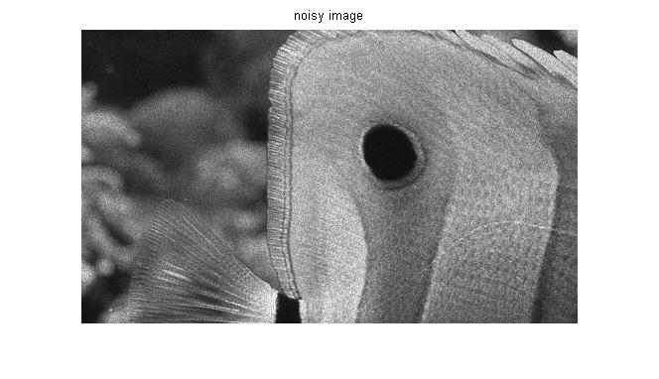
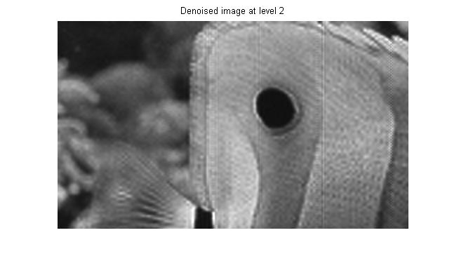
(b) Gaussian noise with variance 0.05
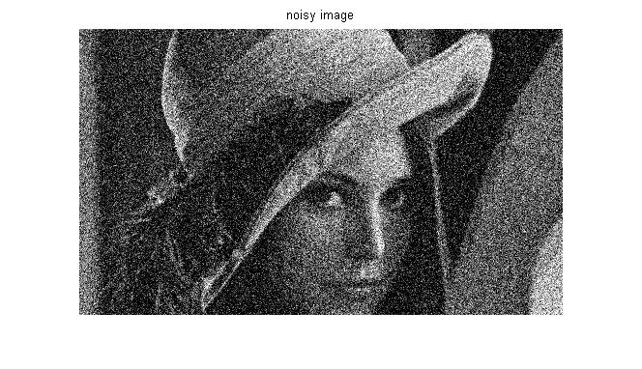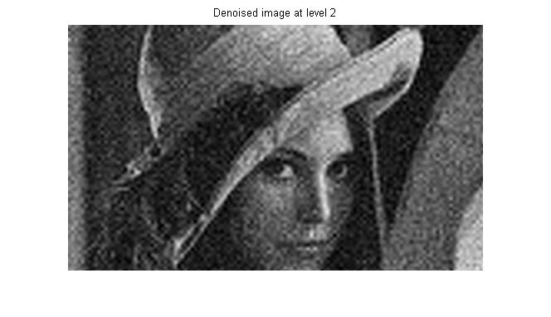

(c) Speckle noise
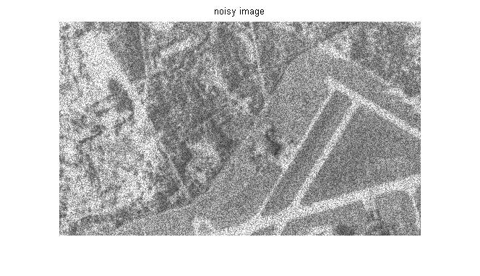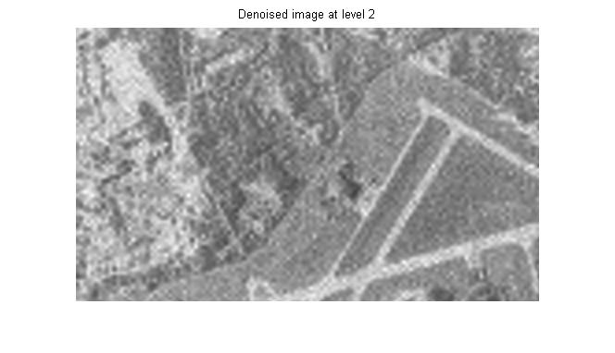

From above pictures and MSE calculation shows that noise removal is better in case of Gaussian noise though speckle noise is also reduced significantly.

Chapter: 3

Fuzzy Filter System

  - Introduction to fuzzy logic

Fuzzy Logic:

Fuzzy logic deals with fuzzy sets. A fuzzy set or subset is a generalization of an ordinary or crisp set. A fuzzy subset can be seen as a predicate whose truth values are drawn from the unit interval , I =[0,1] rather than the set {0,1} as in the case of an ordinary set. Thus the fuzzy subset has as its underlying logic a multivalued logic. The fuzzy set allows for the description of concepts in which the boundary between a property and not having a property is not sharp.
For example a set of heights forms a fuzzy set and its subsets include heights that can be categorized as tall, medium and short, here the property is height. All the temperatures in a year can be clustered into three groups (or fuzzy subsets) that belong to hot, moderate and cold. Here the property is temperature. In both these examples, the highest value of the property is taken as unity and the rest lie with in the interval [0, 1].

Membership function:

Let x be the universe of discourse (the domain of a property). A subset of A of X is associated with a membership function.

: x→ [0, 1]

Where (x) for each x indicates the degree to which x is a member of the set A. I t is also called the degree of association of x in A.
Depending on the variation of x in the set A, one can choose a particular shape for the membership function. Some of the shapes are described in the following.

  - Clustering

Clustering can be considered the most important unsupervised learning problem; so, as every other problem of this kind, it deals with finding a structure in a collection of unlabeled data. A loose definition of clustering could be “the process of organizing objects into groups whose members are similar in some way”.
A cluster is therefore a collection of objects which are “similar” between them and are “dissimilar” to the objects belonging to other clusters.
We can show this with a simple graphical example:
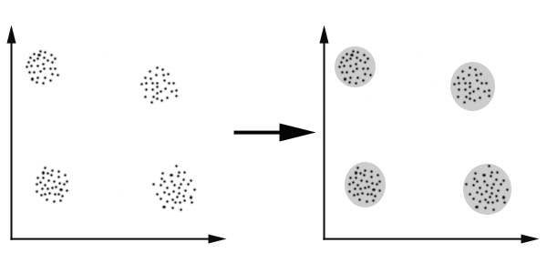

    - Fuzzy C-Means Clustering

The Algorithm
Fuzzy c-means (FCM) is a method of clustering which allows one piece of data to belong to two or more clusters. This method is frequently used in pattern recognition. It is based on minimization of the following objective function:
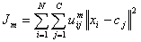 ,
where m is any real number greater than 1, u_{ij} is the degree of membership of x_{i} in the cluster j, x_{i} is the ith of d-dimensional measured data, c_{j} is the d-dimension center of the cluster, and ||*|| is any norm expressing the similarity between any measured data and the center. Fuzzy partitioning is carried out through an iterative optimization of the objective function shown above, with the update of membership u_{ij} and the cluster centers c_{j} by:
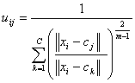 , 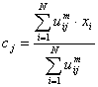
This iteration will stop when , where is a termination criterion between 0 and 1, whereas k are the iteration steps. This procedure converges to a local minimum or a saddle point of J_{m}.
The algorithm is composed of the following steps:
- Initialize U=[u_{ij}] matrix, U⁽⁰⁾
- At k-step: calculate the centers vectors C^{(k)}=[c_{j}] with U^{(k)}
- Update U^{(k)} , U^{(k+1)}
- If || U^{(k+1)} - U^{(k)}||< then STOP; otherwise return to step 2.
Remarks
As already told, data are bound to each cluster by means of a Membership Function, which represents the fuzzy behaviour of this algorithm. To do that, we simply have to build an appropriate matrix named U whose factors are numbers between 0 and 1, and represent the degree of membership between data and centers of clusters.
For a better understanding, we may consider this simple mono-dimensional example. Given a certain data set, suppose to represent it as distributed on an axis. The figure below shows this:
Looking at the picture, we may identify two clusters in proximity of the two data concentrations. We will refer to them using ‘A’ and ‘B’. In the first approach shown in this tutorial - the k-means algorithm - we associated each datum to a specific centroid; therefore, this membership function looked like this:
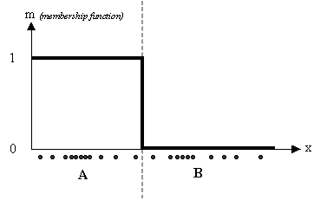
In the FCM approach, instead, the same given datum does not belong exclusively to a well defined cluster, but it can be placed in a middle way. In this case, the membership function follows a smoother line to indicate that every datum may belong to several clusters with different values of the membership coefficient.
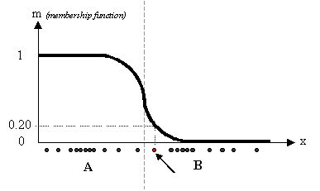
In the figure above, the datum shown as a red marked spot belongs more to the B cluster rather than the A cluster. The value 0.2 of ‘m’ indicates the degree of membership to A for such datum. Now, instead of using a graphical representation, we introduce a matrix U whose factors are the ones taken from the membership functions:
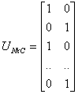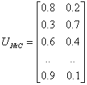
(a) (b)
The number of rows and columns depends on how many data and clusters we are considering. More exactly we have C = 2 columns (C = 2 clusters) and N rows, where C is the total number of clusters and N is the total number of data. The generic element is so indicated: u_{ij}.
In the examples above we have considered the k-means (a) and FCM (b) cases. We can notice that in the first case (a) the coefficients are always unitary. It is so to indicate the fact that each datum can belong only to one cluster. Other properties are shown below:
- 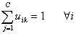
- 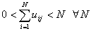
Here, we consider the simple case of a mono-dimensional application of the FCM. Twenty data and three clusters are used to initialize the algorithm and to compute the U matrix. Figures below show the membership value for each datum and for each cluster. The color of the data is that of the nearest cluster according to the membership function.
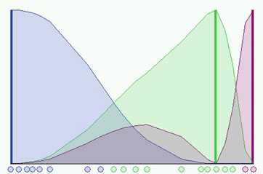
In the simulation shown in the figure above we have used a fuzzyness coefficient m = 2 and we have also imposed to terminate the algorithm when . The picture shows the initial condition where the fuzzy distribution depends on the particular position of the clusters. No step is performed yet so that clusters are not identified very well. Now we can run the algorithm until the stop condition is verified. The figure below shows the final condition reached at the 8th step with m=2 and =0.3:
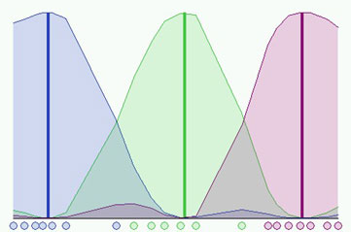
Is it possible to do better? Certainly, we could use an higher accuracy but we would have also to pay for a bigger computational effort. In the next figure we can see a better result having used the same initial conditions and =0.01, but we needed 37 steps!
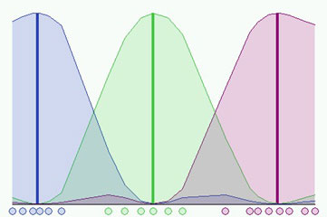
It is also important to notice that different initializations cause different evolutions of the algorithm. In fact it could converge to the same result but probably with a different number of iteration steps.

  - Fuzzy filter system

An adaptive fuzzy filter system combines the outputs of several filters at any time. It is observed that different objective function associated with a filter yields differing capability in filtering. Hence the objective functions are divided into two groups, multiplicative type and summation type.

We present several filter combinations and show that the each filter combination, which consists of filters from both type, is effective in reducing Gaussian and impulse noises. The outputs of filters are combined depending upon the value of the compatibility, which is computed from the gray-level difference between central pixel and its neighbors.

X

Compatibility of each pixel is calculated using fuzzy C-mean clustering. Pixels are clustered in three groups small, medium and large. The three clusters represent impulse noise, non-impulse (Gaussian) noise and edge pixels respectively.
Details of compatibility and filters are presented in chapter 5. Filters are defined as given below

Filter D

Filter A

Filter C

Filter B

3.4 Modified filter system
Above filter system is later modified by replacing by k in filters A, D and C, which is defined as below

Where L is maximum gray label.

3.5 Results
(a) Gaussian noise with variance = 0.005 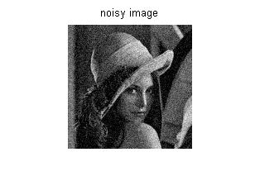 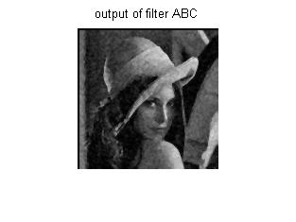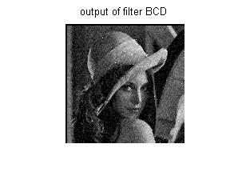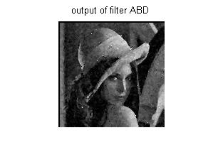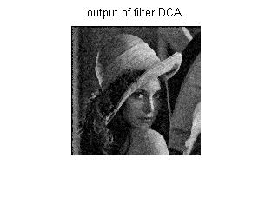

By visual perception and mean square values output of combination ABC is coming out to be best.

(b) salt and pepper with noise density 0.05.
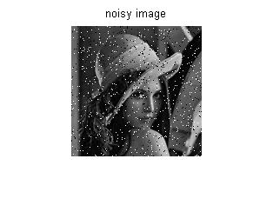
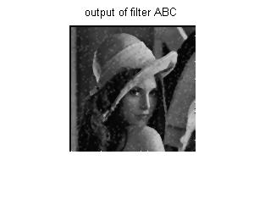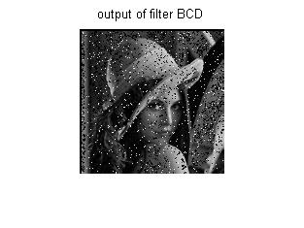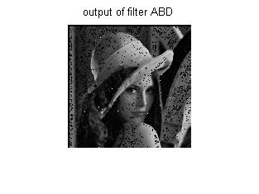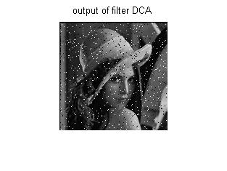
Again out put of filter combination ABC is best . Filter D is good for impulse noise.

Chapter 4
Denoising Of Color Images Using Wavelets

Here, the basics of noise reduction in the wavelet domain are presented for both types of Gaussian and speckle noises.

4.1 Gaussian Noise

Let us consider the data vector X = [X₀,X₁,…………X_{n-1]} which is corrupted by additive Gaussian noise,

X_{i}= V_{i} + N_{i} i= 0,1,2,……..n-1 (4.1)

in which Vi is the ith wavelet coefficient of noise-free signal and Ni is the element of iid1 Gaussian noise, Therefore, x_{i} is the noisy observation. The main purpose of denoising is to minimize the mean square error (MSE) risk. In other words, the difference between original noise-free signal and reconstructed one must be acceptably little.

If is the vector of coefficients of noise-free signal in the wavelet domain and Vˆ= [Vˆ0 ,Vˆ1 ,..., Vˆn-1 ] is the output of thresholding function in this domain, the MSE risk is calculated in (4.2).

Noise reduction in the wavelet domain can be summarized as follows. First, the noisy image is decomposed in the wavelet domain. Then by selecting a proper threshold value detail coefficients are modified based on a thresholding function. Finally, by applying inverse wavelet transform on modified coefficients, the reconstructed image is obtained.

In Visu Shrink method, the universal threshold is calculated based on noise statistics and calculated as:

(4.3)

where σ is noise standard deviation and if it is not known, a robust median estimator is used from the finest scale wavelet coefficients [27].

(4.4)

In Fig.4.1 classic thresholding functions are shown. In this figure, the typical threshold value for hard, soft, and garrote thresholding function are set to 5. For semisoft (firm) function they are set to 5 and 15.

(a) (b)

(c) (d)

Fig.4.1. The classic thresholding functions,
(a) Hard (b) Soft (c) semisoft (d) garrote thresholding function

In spite of the fact that improved thresholding functions such as garrote and semisoft are a compromise between soft and hard functions and have advantages over both of them, their fixed structure, their dependency on the threshold value, and sometimes lack of higher order differentiability, decrease their functionality and flexibility. Therefore, in some papers several classes of thresholding functions have been proposed with several shape tuning parameters. For example, Zhang functions in Fig.4.2 are extensions to soft thresholding function [28-29] .

(a) (b)

Fig.4.2. Zhang thresholding functions with different values of shape tuning factor.
(a) [28], (b) [29].

4.2 Speckle Noise

Due to multiplicative nature of speckle noise, at first, it must be converted to an additive one by applying the logarithm operator. Then, the thresholding step is applied similar to the Gaussian one. Finally, the exponential operator gives the final reconstructed image. Fig.4.3 shows the block diagram of speckle denoising in the wavelet domain.

Image with Speckle Reconstructed
Noise Image
↓ ↑
Log. Operator
Exp. Operator

↓ ↑
Discrete
Wavelet
Transform
Inverse
Discrete
Wavelet
Transform
Thresholding
→ →

Fig.4.3.Speckle noise reduction in the wavelet domain block diagram.

4.3 Nonlinear Thresholding Function

The thresholding function is presented in equation (4.5). The main difference between this function and other thresholding functions is in the non-important coefficients. Classic functions set the coefficients below the threshold value to zero, but in our proposed method these coefficients are tuned by a polynomial function. This tuning leads to increase capability of the function since we can attenuate the coefficients that are below the threshold value and near to it less than the far coefficients. Moreover, for important coefficients, the function is garrote-like, hence it leads to a more powerful function.

(4.5)

This function is shown in Fig.4.4 in comparison with hard and soft thresholding functions.

Fig.4.4. thresholding function with Hard and Soft thresholding functions.

4.4 Thresholding function with three shape tuning factors

To increase the flexibility and capability of the function in (4.5), three shape tuning factors are added to it as follows.

(4.6)

Where parameters n and m determine the shape of the function for coefficients that are less and bigger than absolute threshold value, respectively. The parameter k determines the asymptote of the function. In other words, for k=1, the function tends to hard thresholding function and when k→ 0 it tends to soft thresholding. Therefore, by tuning the parameter k, the thresholding function can be somewhere between hard and soft functions. Fig. 4.7 and 4.8 show the function for several values of the tuning parameters.

Fig.4.7.The class of thresholding functions for k=1 and several values of m and n in the range [1, 10].

Fig.4.8. The proposed class of thresholding functions for n=m=2 and k € (0, 1], note that for k →0 the function tends to soft thresholding function.

Due to the fact that the necessary condition for implementing an adaptive learning gradient based algorithms is the differentiability of the thresholding function in the next sub-section this property is investigated through applying the differentiability property on the proposed function.

4.5 Adaptive noise reduction using Thresholding Neural Network

Zhang proposed the thresholding neural network (TNN) idea based on neural networks concept and wavelet coefficients thresholding [29]. In this new type of neural networks, the activation function is replaced with the wavelet thresholding function. Moreover, the learning process focuses on learning the threshold value of the thresholding function instead of learning the weights of the classic networks. In other words, in this neural network the weights of the network are fixed to one whereas their activation factor has a variable structure and can be learnt. In the Zhang’s method for image denoising, the 1-D coefficients data stream which contains the space-scale information of 2-D image in the wavelet domain enters the thresholding functions in each channel [30]. After the learning process, the optimum value of the threshold is obtained for each channel. At the end, the inverse wavelet transform yields the final denoised image. Zhang uses a differentiable thresholding function that is presented by (6). In this paper, a new type of thresholding neural networks is proposed for image denoising in the wavelet domain. The proposed TNN is subband-adaptive instead of space-scale adaptive noise reduction. On the other hand, the utilized thresholding function in this new-TNN is a nonlinear function. This function was introduced in the previous section. The new-TNN structure can increase the speed and efficiency of the learning phase.

4.5.1 Adaptive Learning Algorithms

One of the most practical methods in neural networks learning is Least Mean squares (LMS) algorithm that is an iterative learning algorithm [31]. Using LMS algorithm, in each step the threshold value is adjusted along with gradient descent of the mean square error (MSE) risk. The threshold value in step j for subband p is calculated as follows.

(4.7)

Where is calculated in (5).

(4.8)

And is learning rate and J is MSE risk. In the next section different types of LMS learning in the TNN are investigated.

4.5.2 Unsupervised learning

In some practical image denoising problems the original image or another noisy version of the image is not available. In such cases the estimation of MSE can be used in the absence of these images in an unsupervised manner. One of the most practical estimations of MSE is SURE. In this section, we investigate SURE criteria for the proposed thresholding function.

First we suppose that the noise variance is normalized (without loss of generality) and define g(x) as follows.

(4.9)

Where is the thresholding function and is a function from to .

We have:

(4.10)

Therefore, when the thr is calculated to minimize E{|| g(x)||^₂ }, the J(thr) is minimized as a result. On the other hand, Stein showed that if g(x)is weakly differentiable is resulted [32].

(4.11)

where .Unbiased estimates of (24) results in SURE criteria as follows [28].

(4.12)

Fig.4.9 shows MSE and SURE risks in different subbands of “Boat” image for different threshold values. As can be seen, the SURE risk is a vertical shift of MSE risk and we can minimize it instead of MSE in threshold finding process.

Fig.4.9. Comparison of SURE and MSE in denoising “Boat” image with Gaussian noise σ=10 using proposed thresholding function with 4 level wavelet decomposition. (Dashed line shows MSE risk and solid line shows SURE criteria, moreover horizontal axis shows threshold value and vertical one is risk value.)

Therefore, we can use SURE risk instead of MSE risk in (4.12) to estimate the optimum threshold, as follows.

(4.13)

As (26) shows, we need g(x) and its derivatives and to calculate the threshold values. These functions are shown in Fig. 4.10.

Fig.4.10.The g(x) and its derivatives for m=2 and k=1.

4.6 results

For denoising of color image we three separate filters for each component R, G and B. Algorithm is same as for gray image.

- Gaussian noise with variance 0.01
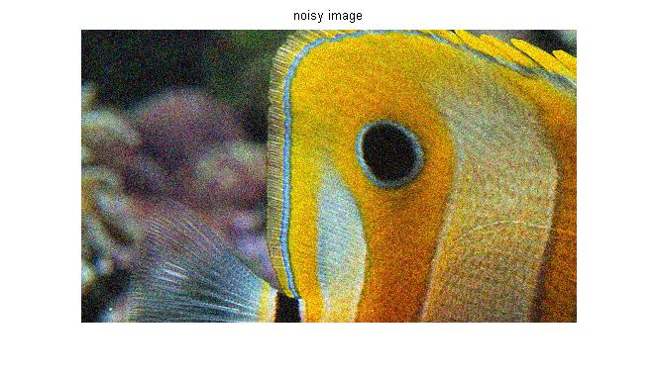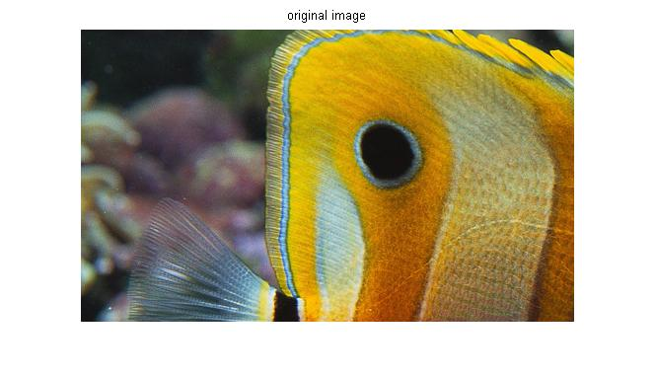
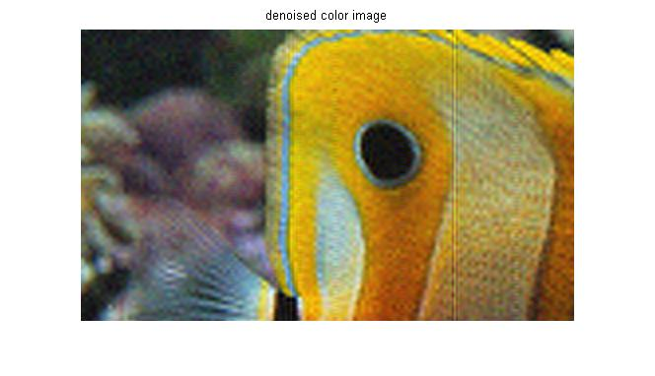
- Speckle noise with variance 0.01

Original Image
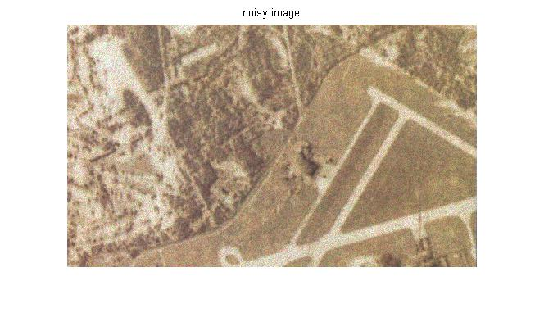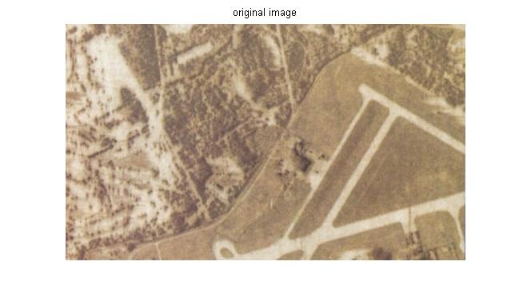
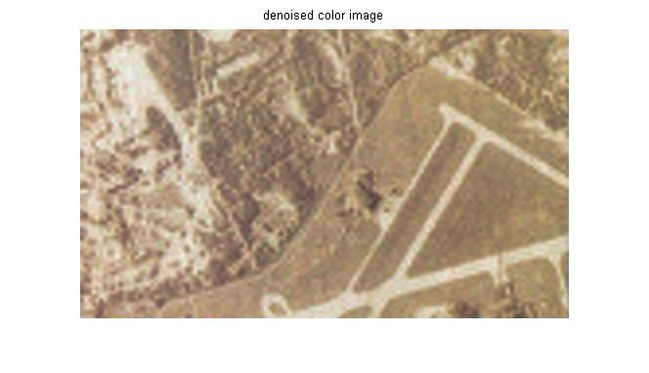

Chapter: 5

Denoising of Color Images Using Fuzzy Filters

5.1 Introduction

Image enhancement is an important step in many image processing applications. The type of image enhancement algorithm to be used depends on the objective to be achieved by the enhancement process as well as the particular application. The problem of image enhancement can be stated as that of filtering out impulse noise, smoothing out non-impulse noise, and enhancing edges or certain other salient structures in the input image. Noise smoothing and edge enhancement are inherently conflicting processes, since smoothing a region might destroy an edge and sharpening edges might lead to unnecessary noise. A plethora of techniques for this problem have been proposed in the literature [1], [2]. Noise filtering can be viewed as replacing the gray-level value of every pixel in the image with a new value depending on the local context. Ideally, the filtering algorithm should vary from pixel to pixel based on the local context. For example, if the local region is relatively smooth, then the new value of the pixel may be a type of average of the local values. On the other hand, if the local region contains edge or impulse-noise pixels, a different type of filtering should be used. However, it is extremely hard, if not impossible, to set the conditions under which a certain filter should be selected, since the local conditions can be evaluated only vaguely in some portions of an image. Therefore, a filtering system needs to be capable of performing reasoning with vague and uncertain information. In this project, we propose to incorporate robust adaptive filtering into a fuzzy rule-based system [3] that smoothes noise while preserving edges and image details. We derive four different filters for these purposes using the weighted (or fuzzy) least squares (LS) method, which is a robust estimator [4]. Each filter is applied when certain conditions are satisfied. That is, each filter and its conditions constitute a production rule. However, due to the uncertainty and incompleteness of information contained in an image, there might be several conflicting production rules whose preconditions are satisfied by the local image. There are many sophisticated control strategies to solve this problem in traditional systems [5]–[7]. However, fuzzy rule-based systems solve this problem trivially and efficiently by combining the consequents of the rules [3]. In other words, in a fuzzy rule-based system, we make “soft” decisions based on each condition, aggregate the
decisions made, and finally make a decision based on the aggregation. This approach is consistent with the principle of least commitment proposed by Marr [8]. To summarize, we propose an approach in which the selection criteria for the filters constitute the antecedent clauses of the fuzzy rules, and the corresponding filters constitute the consequent clauses of the fuzzy rules. Since the rules are fuzzy, at each pixel, each of the antecedent clauses may be satisfied, albeit to a different degree. Thus, all filters are applied, and the overall result of the enhancement is computed as the weighted combination of the results of the individual enhancement filters. The weight associated with the result of a particular filter is proportional to the degree to which the selection criteria for that filter are satisfied in the given situation. This gives us a smoother result compared to a method that makes hard decisions at each pixel and applies only one particular filter.

5.2 Adaptive fuzzy filter system

5.2.1. Compatibility Measure

One way to estimate the noise is by using the fuzzy measure of neighbourhood compatibility, which is explained below.

The filter system operates on a window. For simplicity, let us consider this window to be size of 3x3. Let us consider a digitized image having L gray levels. Let be the pixel’s gray-level at location shown in Fig.1.

X

Fig. 1
Let be the set of N=8 neighboring pixels (j = 1 to 8). Let represent the degree of compatibility of a neighboring pixel with respect to .Thus, the membership function can be a decreasing function of the gray level difference scaled by a parameter. The fuzzy membership function is defined by:

(1)

in which ß is the scale parameter. The parameter ß can be determined on the basis of the variations in pixel intensities in a given spatial window. Since ß is an estimate of scale, it should reflect the variance (dispersion) of the gray-level differences between the center pixel and its neighboring pixels. We can simply take the mean of in the neighborhood as ß, described by the function:

Where (2)

In order to find out whether a particular central pixel is an noise pixel, we have to consider the compatibilities of all the neighboring pixels with respect to the center pixel . To evaluate this property, we can simply take the mean of , as described by the function:

(3)

The are clustered into three clusters (small, large and medium), using Fuzzy C-means clustering. The three clusters each represent impulse noise, non-impulse (Gaussian) noise and edge pixels respectively. Every pixel has membership to each of the three clusters, which indicate the extent of the noise or image at that pixel. The class memberships of a pixel determine the weights of each filter at that pixel. The sum of the membership values of a certain pixel in all the three clusters is always 1. The final pixel value is the weighted average of the output of each filter at that pixel.

5.2.2 Filter system

Four filters are used ,which are defined as

Filter D

Filter A

Filter C

Filter B

These filters are also modified as described in chapter 3.

Filter A: The weight approaches zero as approaches infinity. Therefore, filter A does not consider neighboring pixels with very large distances, e.g. impulse noise pixels. Suppose that a center pixel lies on an object boundary. The values will be smaller than for pixels on one side of the edge and will be larger than on the other side. The neighbors from the other side, therefore, will have negative weights. Hence, after applying Filter A, the updated will be further away from the pixels with negative weights. Thus, the negative weight has a sharpening effect, and consequently this adaptive filter will have smoothing and sharpening properties.

Filters B and C: If a pixel has a large associated with it, then pixel is less reliable because its neighboring pixels are significantly different from it. Suppose we have a noise pixel. Then, we should not consider the degree to which its neighbors represent the noise pixel. A more important criterion in this case is the reliability o f its neighbors. Therefore, we can conclude that Filter B is suitable for removing impulse noise. If we want to consider both the similarity and reliability of its neighbors and not blindly maximize every membership value, we can use Filter C which assigns a small weight to a very similar neighbor if it has a large, and vice versa. Therefore, we can apply Filter C to smooth a region while preserving edges.

Filter D: The form is quite similar to that of Filter A except for the factor of instead of . This has the effect of scaling the positive or negative weight described earlier in Filter A. A neighboring pixel with bigger difference in intensity from the center pixel will have a smaller weight, irrespective of whether it is positive or negative. The weight would be larger when the intensity difference between the center pixel and is small, meaning it has the property of preserving relatively uniform areas. Where the differences are larger, the contribution of is less. Therefore, we present the filter systems derived fro m a combination filters from both categories and show that these filter systems yields pleasing results. These are able to smooth salt & pepper and Gaussian noise while preserving edges.

5.3 Results

For denoising of color image we three separate filters for R, G and B components.

- Gaussian noise with variance 0.01

Original image

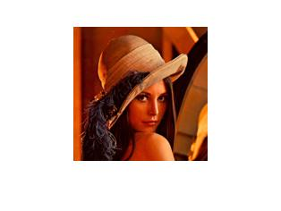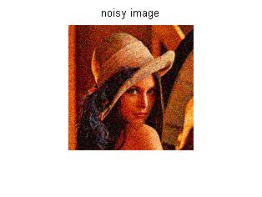
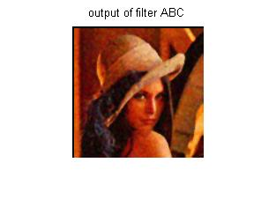
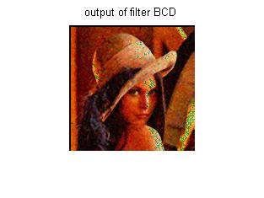
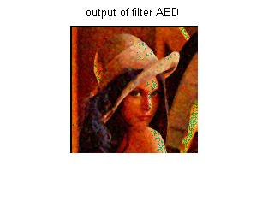
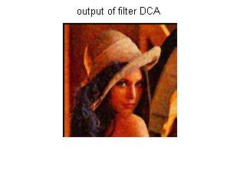
By visual perception and mean square error calculation out put of combination ABC is best.

- Salt and pepper noise with noise density 0.05

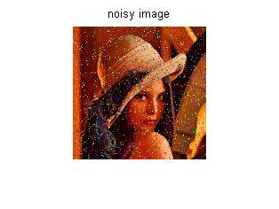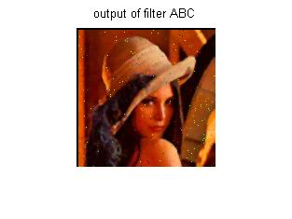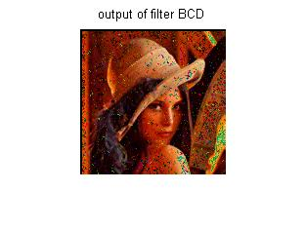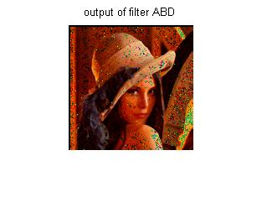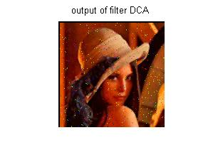

Here too ABC is better as filter D is not good.

- mixed noise(Gaussian+ Salt and Pepper)

Original Image

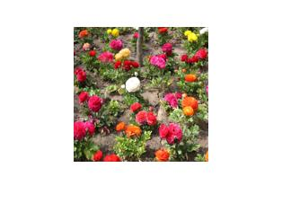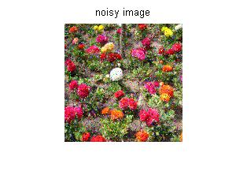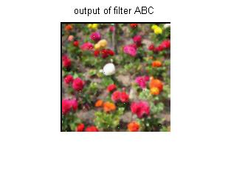
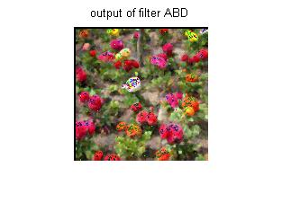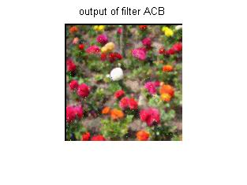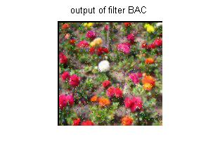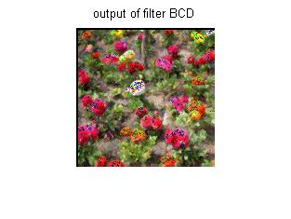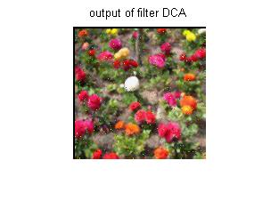

For mixed noise too ABC is best.

Chapter 6

Results and comparison

We are able to remove various types of noises like Gaussian, Speckle and Salt and Pepper noise. For this purpose we have use fuzzy filter system and wavelet based filter. Both type of filters have their advantages and disadvantages. For the comparison purpose we have calculated Mean Square Error (MSE) as

Where org is original image and img may be noisy or denoised image. M and N are size of image.
Also we have taken Gaussian noise for comparison because it is removed by all filters.

  - comparison among different combination of fuzzy filter system

with Gaussian noise of variance 0.005

Noisy image | ABC | BCD | ABD | DCA
0.0046 | 0.0016 | 0.0039 | 0.0040 | 0.0030

Figure shown below shows that output of filter combination ABC is much better results than other combinations. This is also indicated by MSE values.
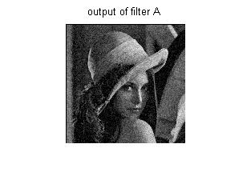

  - comparison among Modified Fuzzy Filters

with Gaussian noise of variance 0.005

Noisy image | ABC | BCD | ABD | DCA
0.0046 | 0.0014 | 0.0018 | 0.0019 | 0.0017

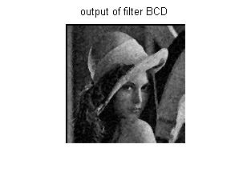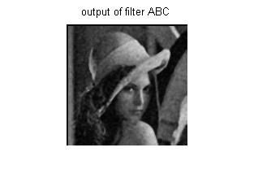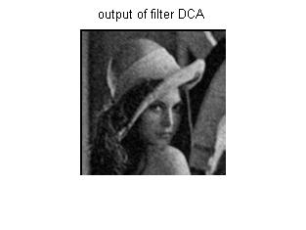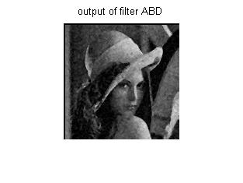

By observation of above figures and MSE values it comes out that nearly all the filters are good with combination ABC have little better results.

  - Results of wavelet based filter

with Gaussian noise of variance 0.005

Noisy image | Denoised image
0.0046 | 0.0015

MSE of denoised image is coming out be comparable to ABC filter but looking at
Figures shown below reviles that some artifacts are introduced in denoised image. Thought less blurring is present in denoised image.
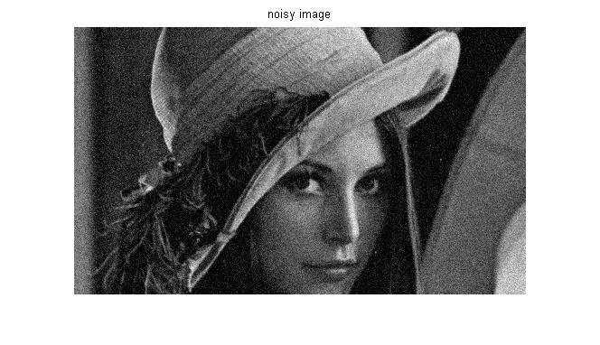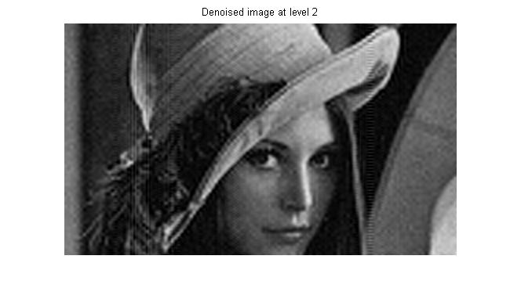

Chapter 7

Conclusion

We have generated different filter systems from a combination of filters that satisfy certain objective functions for removing salt and pepper and Gaussian noise while retaining edges. A compatibility measure is calculated at each pixel, which represents the noise content in it. Later we have also modified this fuzzy filter system which is giving better results for various combinations.
Wavelet based filter is able to remove additive Gaussian noise as well as multiplicative Speckle noise. Method is efficient in suppressing both noises. Another important consideration is that method is utilized in universal threshold and subband adaptive cases.
This method only consider the primary properties of wavelet transform. Utilizing secondary wavelet properties such as parent child relation in network learning can be another topic for future work.

References

[1] E. E. Kerre, Fuzzy Sets and Approximate Reasoning. Xian, China:Xian Jiaotong Univ. Press, 1998.
[2] H. R. Tizhoosh, Fuzzy-Bildverarbeitung: Einfhrung in Theorie undPraxis. Heidelberg, Germany: Springer-Verlag, 1997.
[3] F. Farbiz, M. B. Menhaj, and S. A. Motamedi, “Edge preserving imagefiltering based on fuzzy logic,” in Proc. 6th EUFIT Conf., 1998, pp.1417–1421.
[4] F. Farbiz and M. B. Menhaj, “A fuzzy logic control based approchfor image filtering,” in Fuzzy Tech. Image Process., E. E. Kerre andM. Nachtegael, Eds., 1st ed. Heidelberg, Germany: Physica Verlag, 2000, vol. 52, pp. 194–221.
[5] D. Van De Ville, M. Nachtegael, D. Van der Weken, W. Philips, I. Lemahieu, and E. E. Kerre, “A new fuzzy filter for Gaussian noise reduction,” in Proc. SPIE Vis. Commun. Image Process., 2001, pp. 1–9.
[6] D. Van De Ville, M. Nachtegael, D. Van der Weken, E. E. Kerre, and W. Philips, “Noise reduction by fuzzy image filtering,” IEEE Trans. Fuzzy Syst., vol. 11, no. 8, pp. 429–436, Aug. 2003.
[7] M. Nachtegael, S. Schulte, D. Van der Weken, V. De Witte, and E. E. Kerre, “Fuzzy filters for noise reduction: The case of Gaussian noise,” in Proc. IEEE Int. Conf. Fuzzy Systems, 2005, pp. 201–206.
[8] S. Schulte, B. Huysmans, A. Piˇzurica, E. E. Kerre, and W. Philips, “A new fuzzy-based wavelet shrinkage image denoising technique,” Lecture Notes Comput. Sci., vol. 4179, pp. 12–23, 2006.
[9] H. L. Resnikoff and R. O.Wells,Wavelet Analysis: The Scalable Structure of Information. New York: Springer-Verlag, 1998.
[10] D. Donoho, “Denoising by soft-thresholding,” IEEE Trans. Inf. Theory, vol. 41, no. 3, pp. 613–627, May 1995.
[11] D. Donoho and I. Johnstone, “Adapting to unknown smoothness via wavelet shrinkage,” J. Amer. Statist. Assoc., vol. 90, pp. 1200–1224, 1995.
[12] S. Chang, B. Yu, and M. Vetterli, “Adaptive wavelet thresholding for image denoising and compression,” IEEE Trans. Image Process., vol. 9, no. 9, pp. 1532–1546, Sep. 2000.
[13] M. Hansen and B. Yu, “Wavelet thresholding via mdl for natural images,” IEEE Trans. Inf. Theory, vol. 46, no. 5, pp. 1778–1788, Aug. 2000.
[14] E. Simoncelli and E. Adelson, “Noise removal via Bayesian wavelet coring,” in Proc. IEEE Int. Conf. Image Processing, 1996, pp. 379–382.
[15] P. Moulin and J. Liu, “Analysis of multiresolution image denoising schemes using generalized Gaussian and complexity priors,” IEEE Trans. Inf. Theory, vol. 45, no. 3, pp. 909–919, Apr. 1999.
[16] A. Piˇzurica, W. Philips, I. Lemahieu, and M. Acheroy, “A joint interand intrascale statistical model for Bayesian wavelet based image denoising,” IEEE Trans. Image Process., vol. 11, no. 5, pp. 545–557, May 2002.
[17] J. Portilla, V. Strela, M. Wainwright, and E. Simoncelli, “Image denoising using Gaussian scale mixtures in the wavelet domain,” IEEE Trans. Image Process., vol. 12, no. 11, pp. 1338–1351, Nov. 2003.
[18] J. Portilla and E. Simoncelli, “Image restoration using Gaussian scale mixtures in the wavelet domain,” in Proc. IEEE Int. Conf. Image Processing, 2003, pp. 965–968.
[19] B. Vidakovic, “Nonlinearwavelet shrinkage with bayes rules and bayes factors,” J. Amer. Statist. Assoc., vol. 93, pp. 173–179, 1998.
[20] H. Chipman, E. Kolaczyk, and R. McCulloch, “Adaptive Bayesian wavelet shrinkage,” J. Amer. Statist. Assoc., vol. 92, pp. 1413–1421,
[21] Choi, Y.S., and Krishnapuram, R., “A robust approach to image enhancement based on fuzzy logic”,IEEE Trans. ImageProcessing 6(6), 808-825, 1997
[22] M. Hanmandlu, D. Jha, B. Vittal and Vivek Gera, “Image smoothing using fuzzy clustering”, Proceedings of MMU International Symposium on Information and Communication Technologies (M2USIC’ 2001), 16-17 October 2001, Kaula Lumpur, Malaysia, pp. 4.1(1)-4.1(5).

[23] H.S.Kam, M. Hanmandlu, and W.H. Tan, “An adaptive fuzzy filter system for smoothing noisy images”, Conference on Convergent Technologies for Asia-Pacific Region Volume 4, 15-17 Oct. 2003, Vol.4, pp 1614 - 1617

[24] Pitas, I. and Venetsanopoulos, A. N.,Nonlinear digital filters: Principles and Applications, Kluwer, 1990.
[25] Mitra, S. K. and Sicuranza, G. (Eds.),Nonlinear Image Processing,Academic Press, 2000.
[26] A. Taguchi and M. Meguro, “Adaptive L-filters based on fuzzy rules”, in Proc. 1995 IEEE Int. Symp. Circuits Systems,ISCAS ’95, Seattle, WA, Apr. 15, pp. 961-964.
[27] Donoho D. L. and Johnstone I. M. 1994, “Ideal spatial adaptation by wavelet shrinkage,” Biometrika, vol. 81, no.3, pp. 425–455.
[28] Zhang X-P and Desai M.D. 1998, “Adaptive denoising based on SURE risk,” IEEE Signal Processing Letters,Vol. 5, No.10, PP. 265-267.
[29] Zhang X.-P. 2001, “Thresholding Neural Network for Adaptive Noise reduction,” IEEE Transactions on Neural Networks, vol.12, no. 3, pp.567-584.
[30] Zhang X.-P. 2001, “Space-Scale adaptive noise reduction in images based on thresholding neural networks,” in Proc. IEEE International Conference on Acoustics, Speech, and Signal Processing, pp. 1889-1892.
[31] Haykin S., 1999, Neural Network: A Comprehensive Foundation, Prentice-Hall, NJ, 2nd ed.
[32] Stein C., 1981, “Estimation of the mean of a multivariate normal distribution,” Ann. Stat., vol. 9, pp. 1135–1151.
[33] Gao, H.-Y., and Bruce, A. G. 1997, “WaveShrink with Firm Shrinkage,” Statistica Sinica, 7, 855–874.
[34] Gao H. 1998, “Wavelet shrinkage denoising using the nonnegative garrote,” J. Comput. Graph. Stat., vol. 7, pp.
469–488.

