FUZZY EDGE AND CORNER DETECTION BY USING ADAPTIVE THRESHOLDING

A DISSERTATION SUBMITTED IN PARTIAL FULFILLMENT OF THE REQUIREMENTS FOR THE AWARD OF THE DEGREE OF

MASTER OF ENGINEERING
IN
ELECTRONICS AND COMMUNICATION

SUBMITTED BY

PANKAJ GANGWAR

(ROLL NO. 10278)

UNDER THE ESTEEMED GUIDANCE OF
Mr.O.P.VERMA
(ASSISTANT PROFESSOR, HOD I.T.)



DEPARTMENT OF ELECTRONICS AND COMMUNICATION
ENGINEERING
DELHI COLLEGE OF ENGINEERING
UNIVERSITY OF DELHI
(2007-2008)

CERTIFICATE


This is to certify that the project entitled FUZZY EDGE AND CORNER DETECTION BY USING ADAPTIVE THRESHOLDING submitted by Mr. Pankaj Gangwar , student of Master of Engineering (Electronics and Communication) from Delhi college of Engineering, Delhi work carried out by him under supervision of Mr O.P.Verma, Assistant professor, H.O.D. I.T., Delhi college of Engineering, Delhi during the session 2007-2008. His work has been found excellent for the partial fulfilment of the requirement for the degree of M.E. to the best of our knowledge and belief, this work has not been submitted to any other University or Institution for the award of any degree or diploma.

Mr.O.P.VERMA
Assistant Professor
H.O.D. Information Technology Delhi College of Engineering, Delhi

ACKNOWLEDGEMENT

It is my great pleasure to express my profound gratitude to my project supervisor, Mrs. O.P.VERMA, Assistant Professor, H.O.D. I.T., Delhi college of Engineering, Delhi during the session 2007-2008, for there guidance, constant inspiration, cooperation and invaluable suggestions for carrying out this work. They gladly accepted all the pains in going through my work. The discussions held with them were very enlightening and always motivated me to work with greater zeal and enthusiasm.
I humbly extend my words of gratitude to other faculty members, laboratory staff and administration of this department for providing us the valuable help and time whenever it was require. I also want to say thanks to all my laboratory mates for their support in all my endeavours. I will be indebted to my parents for helping me realise my goals.
And, finally thanks to all those who inspired me directly or indirectly.

DATE: PANKAJ GANGWAR

ADSTRACT
In this thesis the work is performed on edge and corner detection of an image. We are using SUSAN principle to extract the edges and corners of an image. From SUSAN principle we take USAN area. Gray level has been replaced by the USAN area. From USAN area we calculate fuzzifier and membership function. Here we are using piecewise membership function. Applying proper adoptive thresholding to it and get the edges and corner of an image. The result is depend upon the value of two parameters, (1) threshold’s of comparison equation for calculation of USAN area, (2)mean of adoptive thresholding. By varying these two values we are getting different results. When we receive proper result then that result will compare with Canny’s edge detector and SUSAN’s edge and corner detector.
Results show that this edge detector is immensely suitable for applications such as palm print and fingerprint identification or any type of images, as it does not distort the shape and is able to retain the important edges unlike the Canny edge detector.

CONTENTS

CHAPTER 1: INTRODUCTION
1.1 Introduction
1.2 Biometric Systems
1.3 Human Detection and Tracking For Video Surveillance
1.4 Localized Edge Detection in Sensor Fields

CHAPTER 2: SUSAN PRINCIPLE, FUZZIFICATION , TYPE-1 AND TYPE-2 MEMBERSHIP FUNCTION

2.1 SUASAN
2.1.1 SUSAN Principle for Feature Detection
2.2 Fuzzification
2.2.1 Fuzzy Logic
2.2.2 Membership Function
2.2.3 Fuzzy image representation
2.2.4 Histogram-based fuzzy membership function
2.3 Type-1 and Type-2 Membership Function

CHAPTER 3: ADAPTIVE THRESHOLDING
3.1 Introduction

  - Different methods of Adaptive Thresholding

  - Adaptive Thresholding which include the Mean of the Local intensity distribution

3.4 Proposed Algorithm
3.5 Flowchart of Algorithm

CHAPTER 4: RESULT AND DISCUSSION
4.1 Edge Detection Result
4.2 Experimental Results For Edges
4.3 Experimental Results For Corners
CHAPTER 5: COMPARISION OF RESULTS
5.1 Edge Comparison
5.2 Corner Comparison
5.3 Discussion
CHAPTER 6: CONCLUSION
6.1 Conclusion
REFERENCES

Chapter 1

Introduction

1.1 Introduction

Figure detection, such as edge and corner detection plays an important role in many computer vision application such as image segmentation, object recognition, tracking etc. A large numbers of feature detectors is based on the differential structure images [1,2,3,4] . However , many edge detection operators are not designed to detect edge and corner junction ,and thus fails to provide edge connectivity in these areas[3].Corners are considered to be the most important feature [5] because they are often more abundant in real images than straight edges . Corner detectors are generally developed to detect only corner points [6,7,8] , but
some have the ability to perform both as a corner detector and an edge detector [1,2,3,5,9] .
Most of the edge and corner detector methods extract edges first and then find corners points [2,5,9].It has been noticed that accuracy of corner is depend upon how accurately we detect edge which may lead to find the ambiguous structure to corner points[10]. Alternative methods can work directly on the image to extract edges and corner[2,3,7].
Marovec[7]developed a corner detector that shifted a small square window in vertical , horizontal and diagonal direction . By measuring the intensity variation as the window is shifted and corner is detected. Harris and Stephens[3] expands the Marovec operator[7] , removing the limitation of discrete window shifts to develop a combined corner and edge detector.
Smith and Brandy’s[2] SUSAN edge and corner detector is based on brightness comparisons over neighbourhoods. By using different geometric threshold values the SUSAN detector can distinguish both corner and edge pixels. Shen and Wang[10] have expended a local edge detection so that corners may also be detected. Edges are found in a local window and where two straight edges pass through local window a corner is deemed to be present. Etou et al [11] use a modified slit rotational edge detector to detect corners. Pei and Ding [12] developed a corner detector that can also be used to detect edges and other regions of interest by tangent and vertical axes and case table.
Current work by Dermot Kerr, Sonya Coleman, Bryan Scotney[13], Finite-element based methods have been used to develop gradient operator for edge and corner detection that have angular accuracy over standard technique . Wavelet are applied in corner detection in [14, 15, 16 ,17]. In [14], multiscale transform information is used to judge corner points .The input image is decomposed using a B-spline wavelet at several scales. The sum of the frequency components from the decomposed low-high, high-low, high-high, sub bands threshold to get edge map. The corner is detected if the high-high component is larger than a threshold and belonging to the edge map. In[15] , Fransson clams that high-high sub bands are full of noise in practical applications. He uses the low-high and high-low sub bands to detect corners. In [16], fast multilevel fuzzy Detection of blurred images, in which it which it enhance the image contrast by means of the fast multilevel fuzzy enhancement algorithm and then the edges are extracted from the enhanced images by the two stage edge detection operation that identifies the edge candidates based on the local characteristics of the image and then determines the true edge pixels using the edge detection operator based on extremum of gradient values.
In this paper , we are calculating the USAN area[2] of a gray image by placing circular mask by applying comparison equation[2] .USAN area is later transform to histogram where x-axis is USAN area and Y-axis is total number of pixels .Apply histogram membership function and the resultant value is then adaptedly thresholded and after that we get edge and corner of an image . Here using of a single global threshold gives poor result because images contain variations at different levels. To avoid this we use locally driven adaptive thresholding [22].
We can use this feature extraction technique in many application such as biometric system , object tracking , etc

1.2 Biometric Systems
A biometric system is essentially a pattern recognition system that operates by acquiring biometric data from an individual, extracting a feature set from the acquired data, and comparing this feature set against the template set in the database. Depending on the application context, a biometric system may operate either in verification mode or identification mode. We are using identification in which the recorded biometric feature is compared to all biometric data stored in the system. If there is a match, the identification is successful, and the corresponding user name or user ID may be processed subsequently.
A biometric system is designed using the following four main modules:
- Sensor module, which captures the biometric data of an individual. An example is a palmprint sensor that images the wrinkles, principal lines and ridges of a user’s palm.

- Feature extraction module, in which the acquired biometric data is processed to extract a set of salient or discriminatory features. For example, the position and orientation of minutiae points (local ridge and valley singularities) in a palmprint image are extracted in the feature extraction module of a palmprint-based biometric system.

- Matcher module, in which the features extracted during recognition are compared against the stored templates to generate matching scores. The matcher module also encapsulates a decision making module, in which a user’s claimed identity is confirmed (verification) or a user’s identity is established (identification) based on the matching score.

- System database module, which is used by the biometric system to store the biometric templates of the enrolled users. The enrolment module is responsible for enrolling individuals into the biometric system database.
Sensor

Application
Device
Pre - processing
Feature Extraction

Template Generator
Matcher

Stored Templates
Test

Test

Enrollment

Fig. 1.1 Biometric Systems
1.3 Human Detection And Tracking For Video Surveillance

An object oriented video surveillance system that monitors activity in a site. The process is performed in two steps: first, detection of human faces as a guess for objects of interest is done and tracking of these entities through a video stream. The guidelines here are not to perform a very accurate detection and tracking, based on the contours for example, but to provide a global image processing system on a simple Personal Computer taking advantage from co-operation of detection and tracking. So the scheme we propose here provides a simple. fast solution that tracks few specific points of interest on the object boundary and possibly engage a motion based detection in order to recover the object of interest in the scene or to detect new object of interest as well. This tracker also enables learning motion activities, detecting unusual activities. and supplying statistical information about motion in a scene.
1.4 Localized Edge Detection in Sensor Fields

A wireless sensor network for detecting large-scale phenomena (such as a contaminant flow or a seismic disturbance) may be called upon to provide a description of the boundary of the
phenomenon (either a contour or some bounding box). In such cases, it may be necessary for each node to locally determine whether it lies at (or near) the edge of the phenomenon. In
this paper, we show that such localized edge detection techniques are non-trivial to design in an arbitrarily deployed sensor network. We define the notion of an edge and develop performance metrics for evaluating localized edge detection algorithms. We propose three different approaches for localized edge detection and present one example scheme for each.
In all our approaches, each sensor gathers information from its local neighborhood and determines whether or not it is an edge sensor. We evaluate the performance of each of the example schemes and compare them with respect to the developed metrics.
The organization of the paper is as follows. Chapter1 History of biometric system. Chapter2, Introduction of work. Chapter3, The SUSAN principal for feature detection. Chapter4 presents the fuzzification and type-2 membership function. In Chapter5, introduces Adaptive Thresholding. In Chapter6, Binary image enhancement. In Chapter7, Praposed algorithm and flowchart. In Chapter8, Result and discussion. In Chapter9, Conclusion.

1.5 Organization of the dissertation

The dissertation work is organized as follows:

In Chapter 2, SUSAN principle, Fuzzification , Type-1 and Type-2 membership function

In Chapter 3, Adaptive Thresholding for edge and corner detection

In Chapter 4, Comparison of results
In Chapter 5 , Conclusions of the dissertation work and suggestions for the future work are provided

Chapter 2

SUSAN principle, Fuzzification , Type-1 and Type-2 membership function

2.1 SUSAN
The SUSAN principle: An image processed to give as output inverted USAN area has edges and two dimensional features strongly enhanced, with the two dimensional features more strongly enhanced than edges .

2.1.1 The SUSAN Principle for Feature Detection
The SUSAN principle is now introduced, from which the research described in this paper is derived. Consider Fig. 2.11, showing a dark rectangle on a white background. A circular mask (having a centre pixel which shall be known as the “nucleus”) is shown at five image positions. If the brightness of each pixel within a mask is compared with the brightness of that mask’s nucleus then an area of the mask can be defined which has the same (or similar) brightness as the nucleus. This area of the mask shall be known as the “USAN”, an acronym standing for “Univalue Segment Assimilating Nucleus”. In Fig.2.2 each mask from Fig. 2.1 is depicted with its USAN shown in white. This concept of each image point having associated with it a local area of similar brightness is the basis for the SUSAN principle. The local area or USAN contains much information about the structure of the image. It is effectively region finding on a small scale. From the size, centroid and second moments of the USAN two
dimensional features and edges can be detected. This approach to feature detection has many differences to the well known methods, the most obvious being that no image derivatives are used and that no noise reduction is needed. The area of an USAN conveys the most important
information about the structure of the image in the region around any point in question. As can be seen from Figs. 2.1 and 2.2, the USAN area is at a maximum when the nucleus lies in a flat region of the image surface, it falls to half of this maximum very near a straight edge,
and falls even further when inside a corner. It is this property of the USAN’s area which is used as the main determinant of the presence of edges and two dimensional features. Consider now Fig. 2.3, where a small part of a test image has been processed to give USAN
area as output Fig. 2.2. Each point in the input image is used as the nucleus of a small circular mask, and the associated USAN is found. The area of the USAN is used in the three dimensional plot shown. The USAN area falls as an edge is approached (reaching a minimum at the exact position of the edge), and near corners it falls further, giving local minima in USAN area at the exact positions of image corners. Figure 4.1 shows a small part of a real noisy image, and the resulting output from USAN area processing. (The variation in brightness within the “flat regions” is of the order of 15—out of 256—greyscale levels.) Again there is edge and corner enhancement, with the noise having no visible effect on the final plot. Consideration of the above arguments and observation of the examples and results shown in Figs. 2.1, 2.2, 2. 3 and 2.4 lead directly to formulation of the SUSAN principle: An image processed to give as output inverted USAN area has edges and two dimensional features strongly enhanced, with the two dimensional features more strongly enhanced than edges.

Figure 2.1. Four circular masks at different places on a simple image.
Figure2.2. Masks with similarity colouring; USANs are shown as the white parts of the masks.
Figure 2.3. A three dimensional plot of USAN area given a small part of a test image

Figure2. 4. A three dimensional plot of USAN area given a small art of a real noisy image, showing edge and corner enhancement.
Figure 2.5. a) The original similarity function (y axis, no units) versus pixel brightness
difference b) The more stable function now used. c) The boundary detector B

This gives rise to the acronym SUSAN (Smallest Univalue Segment Assimilating Nucleus). Mathematical analyses of the principle are given after the algorithms have been described in detail. The fact that SUSAN edge and corner enhancement uses no image derivatives explains why the performance in the presence of noise is good. The integrating effects of the principle, together with its non-linear response, give strong noise rejection. This can be understood simply if an input signal with identically independently distributed Gaussian noise is considered. As long as the noise is small enough for the USAN function (see Fig. 2.5) to contain each “similar” value, the noise is ignored. The integration of individual values in the calculation of areas further reduces the effect of noise. Another strength of the SUSAN edge detector is that the use of controlling parameters is much simpler and less arbitrary (and therefore easier to automate) than with most other edge detection algorithms. The SUSAN noise reduction algorithm is related to the SUSAN principle in that the USAN is used to
choose the best local smoothing neighbourhood.

The edge detection algorithm described here follows the usual method of taking an image and, using a predetermined window centred on each pixel in the image, applying a locally acting set of rules to give an edge response. This response is then processed to give as the output a set of edges. The SUSAN edge finder has been implemented using circular masks (sometimes known as windows or kernels) to give isotropic responses. Digital approximations to circles have been used, either with constant weighting within them or with Gaussian weighting—this is discussed further later. The usual radius is 3.4 pixels (giving a mask of 37 pixels), and the smallest mask considered is the traditional three by three mask. The 37 pixel circular mask is used in all feature detection experiments unless otherwise stated. The mask is placed at each point in the image and, for each point, the brightness of each pixel within the mask is compared with that of the nucleus (the centre point). Originally a simple equation determined this comparison—see Fig. 2.5(a);

(2.1)

where r0 is the position of the nucleus in the two dimensional image, r is the position of any other point within the mask, I (r) is the brightness of any pixel, t is the brightness difference threshold and c is the output of the comparison. This comparison is done for each pixel within the mask, and a running total, n, of the outputs (c) is made;

(2.2)

This total n is just the number of pixels in the USAN, i.e., it gives the USAN’s area. As described earlier this total is eventually minimized. The parameter t determines the minimum contrast of features which will be detected and also the maximum amount of noise which will be ignored. I(r0) is the initial edge response. This is clearly a simple formulation of the SUSAN principle, i.e., the smaller the USAN area, the larger the edge response. When non-maximum suppression has been performed the edge enhancement is complete. In the case of a curved edge, this will correspond to the boundary of the region which is convex at the step
edge. Thus valid edges should not be rejected. If the edge is not an ideal step edge but has a smoother profile then n will have even lower minima so that there is even less danger of edges being wrongly rejected. The algorithm as described gives quite good results, but a much more stable and sensible equation to use for c in place of Eq. (2.1) is

C(r,r_{o})=e^{-(I(r)-I(ro))/t)^6} (2.3)
This equation is plotted in Fig. 2.5(b). The form of Eq. (2.3) was chosen to give a “smoother” version of Eq. (2.1). This allows a pixel’s brightness to vary slightly without having too large an effect on c, even if it is near the threshold position. The exact form for Eq. (2.3), i.e., the use of the sixth power, can be shown to be the theoretical optimum; see later for analytic comparison of shapes varying from one extreme (Gaussian) to the other (square function, as originally used). This form gives a balance between good stability about the threshold and the function originally required (namely to count pixels that have similar brightness to the nucleus as “in” the univalue surface and to count pixels with dissimilar brightness as “out” of the surface).

2.2 Fuzzification
2.2.1 Fuzzy Logic:
Fuzzy logic deals with fuzzy sets. A fuzzy set or subset is a generalization of an ordinary or crisp set. A fuzzy subset can be seen as a predicate whose truth values are drawn from the unit interval , I =[0,1] rather than the set {0,1} as in the case of an ordinary set. Thus the fuzzy subset has as its underlying logic a multivalued logic. The fuzzy set allows for the description of concepts in which the boundary between a property and not having a property is not sharp.
2.2.2Membership function:-
Let x be the universe of discourse (the domain of a property). A subset of A of X is associated with a membership function.
: x→ [0, 1]
Where (x) for each x indicates the degree to which x is a member of the set A. I t is also called the degree of association of x in A.
Depending on the variation of x in the set A, one can choose a particular shape for the membership function. We used Gaussian membership function so it is :
A Gaussian MF is specified by two parameters {c, }
Gaussian (x; c, ) =

2.2.3 Fuzzy image representation:
In the representation of a USAN area domain image in the fuzzy domain, a gray tone image X of dimension M x N, and L levels, can be considered as an array of fuzzy singleton sets.

X = {(μ_{mn}, x_{mn}); m=1,…,M; n=1,…,N;} (2.2.3.1)

where each pixel is characterized by the intensity value x_{mn} and its grade of possessing some membership μ_{mn}(0 ≤ μ_{mn} ≤1), relative to some brightness level in the range [0, L-1].

2.2.4 Histogram-based fuzzy membership function

Fuzzy property can be expressed in terms of continuous function called as membership function. Here, we use a modified Gaussian membership function , being a simpler transformation function that contains only one fuzzifier f_{h}, and is given as

μ_{(m,n)}= e-((max_usan-usan(m,n))2)/(2* fh 2) (2.2.4.1)

where μ_{(m,n)} is a Gaussian function, and max_usan and usan(m,n) are the maximum and (m,n)th USAN area .

A fuzzy histogram is used to obtain the frequency of occurrence of membership functions of USAN area in the fuzzy image. Thus,

$X=\left\{μ(x),p(x)\right\}=\left\{μ | | {\text{mn}}/{x_{\text{mn}}}\right\};m=1,\text{.}\text{.}\text{.},M;n=1,2,\text{.}\text{.}\text{.},N$ (2.2.4.2)

where μ(x) is the membership of pixel with intensity value of x, and p(x) is the number of occurrences of the USAN area value x, in image X. The distribution of p(x) is normalized

such that
$\sum_{x=0}^{L−1}{p(x)=1}\text{.}$ (2.2.4.3)

Here, we propose a histogram-based membership function to represent pixels of the spatial domain in the fuzzy domain by histogram fuzzification function as

$μ(k)=e^{[−(x_{\text{max}}−k{)^{2}}/2f_{h^{2}}]}$ (2.2.4.4)

The fuzzifier parameter, f_{h} can be determined as

$f_{h^{2}}=\frac{\sum_{k=0}^{L−1}{(x_{\text{max}}−k)^{4}p(k)}}{2\sum_{k=0}^{L−1}{(x_{\text{max}}−k)^{2}p(k)}}$ (2.2.4.5)

where k is a certain value in the range [0, L-1], and p(k) stands for the frequency of occurrence of k in histogram X and x_{max} is maximum USAN area.
In the fuzzy plane, image is low perception (dark), or high perception (bright) values. This leaves pixels near μ = 0.2 having the highest ambiguity and do not belong to either perception class.

2.3 Type-1 and Type-2 Membership Function
Fuzzy logic systems (FLSs) usually employ type-1 fuzzy sets and represent uncertainty by numbers in the range [0,1] which are referred to as degrees of membership. Type-2 fuzzy sets are an extension of type-1 fuzzy sets with an additional dimension that represent the uncertainty about the degrees of membership. Type-2 fuzzy sets are useful in circumstances
where it is difficult to determine the exact membership function (mf) for a fuzzy set. Type-1 mfs are precise in the sense that once they have been chosen all the uncertainty disappears.
However, type-2 mfs are fuzzy themselves. The simplest type-2 sets are interval type-2 sets whose elements’ degree of membership are intervals with secondary membership degree of 1.0. FLSs consist of four main interconnected components: rules, fuzzifier, inference engine, and output processor. Fuzzy sets are associated with the linguistic terms in the rules, shown in italics above, and with the inputs to and the output of the FLS. Type-1 FLSs use type-1 fuzzy sets and an FLS which uses at least one type-2 fuzzy set is called a type-2 FLS. A general type-2 FLS is too complicated, inferencing and output processing are prohibitive [25]. A simplification approach is to use interval type-2 fuzzy sets. The concept of type-2 fuzzy sets was introduced by Zadeh [24].
Type-1 FLSs, like classical expert systems, are deterministic in the sense that for the same inputs the outputs are always the same. However, human experts exhibit a nondeterministic behaviour in decision making. Variation may occur among the decisions of a panel of human experts as well as in the decisions of an individual expert for the same inputs. The terms that are used in an FLS have different meanings for different experts and experts may arrive to different conclusions in their inferencing depending on environmental conditions or over time. Understanding the dynamics of the variation in human decision making could allow the creation of ‘truly intelligent’ systems that cannot be differentiated from their human counterparts. Moreover, in application areas where having an expert constantly available are not possible; such systems can produce a span of decisions that may be arrived at by a panel of experts. This paper presents the results of the research that studies the relation between the variation in decision making of an FLS and the shape of the type-2 mfs that are used in the FLS.

Here we are using piecewise type 2 membership function

μ(k)= (2.3.1)

where a is the subtracting factor to fuzzifier . As we know that starting values of histogram having most of the edges so we are keeping high value of membership function to extract more number of edges from the image. For high values of membership function there is no need to include subtracting factor.

Chapter 3
Adaptive Thresholding
3.1 Introduction:
The Adaptive Threshold module is used in uneven lighting conditions when you need to segment a lighter foreground object from its background. In many lighting situations shadows or dimming of light cause thresholding problems as traditional thresholding considers the entire image brightness. Adaptive Thresholding will perform binary thresholding (i.e. it creates a black and white image) by analyzing each pixel with respect to its local neighborhood. This localization allows each pixel to be considered in a more adaptive environment. During the thresholding process, individual pixels in an image are marked as “object” pixels if their value is greater than some threshold value (assuming an object to be brighter than the background) and as “background” pixels otherwise. This convention is known as threshold above. Variants include threshold below, which is opposite of threshold above; threshold inside, where a pixel is labeled "object" if its value is between two thresholds; and threshold outside, which is the opposite of threshold inside (Shapiro, et al 2001:83). Typically, an object pixel is given a value of “1” while a background pixel is given a value of “0.” Finally, a binary image is created by coloring each pixel white or black, depending on a pixel's label.
Thresholding is called adaptive thresholding when a different threshold is used for different regions in the image. This may also be known as local or dynamic thresholding (Shapiro, et al 2001:89).

3.2 DIFFERENT METHODS OF ADAPTIVE THRESHOLDING:
The key parameter in the thresholding process is the choice of the threshold value (or values, as mentioned earlier). Several different methods for choosing a threshold exist; users can manually choose a threshold value, or a thresholding algorithm can compute a value automatically, which is known as automatic thresholding (Shapiro, et al 2001:83). A simple method would be to choose the mean or median value, the rationale being that if the object pixels are brighter than the background, they should also be brighter than the average. In a noiseless image with uniform background and object values, the mean or median will work well as the threshold, however, this will generally not be the case. A more sophisticated approach might be to create a histogram of the image pixel intensities and use the valley point as the threshold. The histogram approach assumes that there is some average value for the background and object pixels, but that the actual pixel values have some variation around these average values. However, this may be computationally expensive, and image histograms may not have clearly defined valley points, often making the selection of an accurate threshold difficult. One method that is relatively simple, does not require much specific knowledge of the image, and is robust against image noise, is the following iterative method:
- An initial threshold (T) is chosen, this can be done randomly or according to any other method desired.
- The image is segmented into object and background pixels as described above, creating two sets:
  - G₁ = {f(m,n):f(m,n)>T} (object pixels)
  - G₂ = {f(m,n):f(m,n)T} (background pixels) (note, f(m,n) is the value of the pixel located in the m^{th} column, n^{th} row)
- The average of each set is computed.
  - m₁ = average value of G₁
  - m₂ = average value of G₂
- A new threshold is created that is the average of m₁ and m₂
  - T’ = (m₁ + m₂)/2
- Go back to step two, now using the new threshold computed in step four, keep repeating until the new threshold matches the one before it (i.e. until convergence has been reached).
Sezgin and Sankur (2004) categorize thresholding methods into the following six groups based on the information the algorithm manipulates (Sezgin et al, 2004):
- "histogram shape-based methods, where, for example, the peaks, valleys and curvatures of the smoothed histogram are analyzed
- clustering-based methods, where the gray-level samples are clustered in two parts as background and foreground (object), or alternately are modeled as a mixture of two Gaussians
- Entropy -based methods result in algorithms that use the entropy of the foreground and background regions, the cross-entropy between the original and binarized image, etc.
- Object attribute-based methods search a measure of similarity between the gray-level and the binarized images, such as fuzzy shape similarity, edge coincidence, etc.
- [...] spatial methods [that] use higher-order probability distribution and/or correlation between pixels
- Local methods adapt the threshold value on each pixel to the local image characteristics."

Thresholding techniques are often used to segment images consisting of dark objects against bright backgrounds, or vice versa. They are usually performed either globally or adaptively. Whereas the conventional thresholding operator uses a global threshold for all pixels, adaptive thresholding changes the threshold dynamically over the image. In many applications, such as OCR, or DNA processing, proper thresholding is important to locate characters or DNA dot arrays. When the background is uneven or in non-uniform illumination conditions, a fixed (or global) grey-level threshold will not segment the image correctly [18]. In these cases, the foreground is many small components located in the much larger background. On the assumption that segmented objects were validated by the gradients
along their boundaries, we propose an adaptive thresholding algorithm based on variational background. Other than the method [ 18 ] which tries to find the thresholding surface from gradient magnitude, we first want to find the background surface and then set a surface parallel to it to be the thresholding surface. This consideration will achieve a thresholding surface more concordant to the original image background. Thus, the algorithm is composed of three steps: background region locating, background surface finding, and global thresholding.
There are some adaptive thresholding techniques, adaptive thresholding using variational[17] theory. The method requires only one parameter to be selected and the adaptive threshold surface can be found automatically from the original image. The main advantage of our method is that the object boundary points selection which involves many parameter decisions and interpolation by solving a Laplace equation are integrated by solving a Poisson equation, in which only one coefficient ∝ has to be set. a discrete-cosine transform (DCT)-based adaptive thresholding [19]algorithm , that adopts a DCT-based thresholding algorithm to effectively transform the image features into an accurate binary representation of target image block and search region for binary block matching motion search. An adaptive thresholding technique based on gray level co-occurrence matrix (GLCM)[20] is presented to handle images with fuzzy boundaries. As GLCM contains information on the distribution of gray level transition frequency and edge information, it is very useful for the computation of threshold value. Here the algorithm is designed to have flexibility on the edge definition so that it can handle the object’s fuzzy boundaries. By manipulating information in the GLCM, a statistical feature is derived to act as the threshold value for the image segmentation process.
Otsu's method [21]is used to automatically perform histogram shape-based image thresholding or, the reduction of a gray level image to a binary image. The algorithm assumes that the image to be thresholded contains two classes of pixels (e.g. foreground and background) then calculates the optimum threshold separating those two classes so that their combined spread (within-class variance) is minimal. The extension of the original method to multi-level thresholding is referred to as the Multi Otsu method . It is important in picture processing to select an adequate threshold of gray level for extracting objects from their background. A variety of techniques have been proposed in this regard. In an ideal case, the histogram has a deep and sharp valley between two peaks representing objects and background, respectively, so that the threshold can be chosen at the bottom of this valley .
However, for most real pictures, it is often difficult to detect the valley bottom precisely, especially in such cases as when the valley is flat and broad, imbued with noise, or when the two peaks are extremely unequal in height, often producing no traceable valley. There have been some techniques proposed in order to overcome these difficulties. They are, for example, the valley sharpening technique, which restricts the histogram to the pixels with
large absolute values of derivative (Laplacian or gradient), and the difference histogram method , which selects the threshold at the gray level with the maximal amount of difference. These utilize information concerning neighbouring pixels (or edges) in the original picture to modify the histogram so as to make it useful for thresholding. Another class of methods deals directly with the gray-level histogram by parametric techniques. For example, the histogram is approximated in the least square sense by a sum of Gaussian distributions, and statistical decision procedures are applied. However, such a method requires considerably tedious and sometimes unstable calculations. Moreover, in many cases, the Gaussian distributions turn out to be a meager approximation of the real modes.

A method to select a threshold automatically from a gray level histogram has been derived from the viewpoint of discriminant analysis. This directly deals with the problem of evaluating the goodness of thresholds. An optimal threshold (or set of thresholds) is selected by the discriminant criterion; namely, by maximizing the discriminant measure q (or the measure of separability of the resultant classes in gray levels). The proposed method is characterized by its nonparametric and unsupervised nature of threshold selection and has the following desirable advantages.

1) The procedure is very simple; only the zeroth and the first order cumulative moments of the gray-level histogram are utilized.

2) A straightforward extension to multithresholding problems is feasible by virtue of the criterion on which the method is based.

3) An optimal threshold (or set of thresholds) is selected automatically and stably, not based on the differentiation (i.e.. a local property such as valley), but on the integration (i.e., a global property) of the histogram.

4) Further important aspects can also be analyzed (e.g., estimation of class mean levels, evaluation of class separability, etc.).

5) The method is quite general: it covers a wide scope of unsupervised decision procedure.

The range of its applications is not restricted only to the thresholding of the gray-level picture, such as specifically described in the foregoing, but it may also cover other cases of unsupervised classification in which a histogram of some characteristic (or feature)
discriminative for classifying the objects is available.

After receiving the values of histogram by applying membership function we have to scale it by 255. We know that values of membership function lies between 0 to 1 and for the application of adaptive thresholding on histogram values of it be lie from 0 to 255. So , we scaled it by 255 and after thresholding we get values between 0 and 1, mean to say we get binary images .

3.3 Adaptive thresholding include the mean of the local intensity distribution
Adaptive thresholding[17] typically takes a grayscale or colour image as input and, in the simplest implementation, outputs a binary image representing the segmentation. For each pixel in the image, a threshold has to be calculated. If the pixel value is below the threshold it is set to the background value, otherwise it assumes the foreground value.
There are two main approaches to finding the threshold: (i) the Chow and Kaneko approach and (ii) local thresholding. The assumption behind both methods is that smaller image regions are more likely to have approximately uniform illumination, thus being more suitable for thresholding. Chow and Kaneko divide an image into an array of overlapping sub images and then find the optimum threshold for each sub image by investigating its histogram. The threshold for each single pixel is found by interpolating the results of the sub images. The drawback of this method is that it is computational expensive and, therefore, is not appropriate for real-time applications.
An alternative approach to finding the local threshold is to statistically examine the intensity values of the local neighbourhood of each pixel. The statistic which is most appropriate depends largely on the input image. Simple and fast functions include the mean of the local intensity distribution,
the median value,
or the mean of the minimum and maximum values,
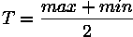
The size of the neighbourhood has to be large enough to cover sufficient foreground and background pixels, otherwise a poor threshold is chosen. On the other hand, choosing regions which are too large can violate the assumption of approximately uniform illumination. This method is less computationally intensive than the Chow and Kaneko approach and produces good results for some applications.
Like global thresholding, adaptive thresholding is used to separate desirable foreground image objects from the background based on the difference in pixel intensities of each region. Global thresholding uses a fixed threshold for all pixels in the image and therefore works only if the intensity histogram of the input image contains neatly separated peaks corresponding to the desired subject(s) and background(s). Hence, it cannot deal with images containing, for example, a strong illumination gradient.
Local adaptive thresholding, on the other hand, selects an individual threshold for each pixel based on the range of intensity values in its local neighbourhood. This allows for thresholding of an image whose global intensity histogram doesn't contain distinctive peaks.
The method succeeds in the area surrounding the text because there are enough foreground and background pixels in the local neighbourhood of each pixel; i.e. the mean value lies between the intensity values of foreground and background and, therefore, separates easily. On the margin, however, the mean of the local area is not suitable as a threshold, because the range of intensity values within a local neighbourhood is very small and their mean is close to the value of the centre pixel.

3.4 Proposed algorithm
The steps of the fuzzy-based edge detection algorithm are as follows:
1. Place a circular mask around the pixel of image (the nucleus).
2. Using Eq. (4a) calculate the number of pixels within the circular mask which have
similar brightness to the nucleus. (These pixels deﬁne the USAN.)
3. Using Eq. (4.4 ) calculate the fuzzifier. Also calculate values using Gaussian
Membership function Eq(4.3).
4. Apply theadaptive threshold and get the strong edge

3.5 Flowchart of Algorithm
START
STOP
Load The Image and Decide appropriate value of t
Apply circular mask on image using comparison Equation
Calculate Fuzzifier and Type-2 Gaussian Membership Function
Apply Adaptive Thresholding
Apply Binary image enhancement by using some morphological operator
Print the Enhanced image edges and corners

Chapter 4
Discussion Of Result
4.1 Edge detection result:
The fuzzy edge detector algorithm is implemented on the database consisting of palm print specimen. Prior to the application of this algorithm, no pre-processing was done on these images. The algorithm is applied on number of images and compares the result to the Canny’s Edge Detector.
As the algorithm has two phases – Pre Adaptive thresholding and post adaptive thresholding, we present the results of implementation on these images separately. Here, one of the palm images is used for visual analysis.
4.1 Experimental Results For Edges
In this algorithm we are not enhancing or contrasting the image. We are doing operation directly on image . The algorithm performance will depend upon some parameters which we are using in this algorithm. The USAN area will lies between 1 to 37 and it depends upon the threshold ‘t’ . The value of t is pre-set and by experimentation, If we are using some simple image then we prefer low value of ‘t’ 10<t<20 but if we are using real life image and having some noise in it then we prefer high value of ‘t ‘ 20<t<50 .
The mean value of adaptive thresholding also affects the algorithm performance by default it is using 0.04 but if we increase it then additional noise will remove and some edges also removed. If we decrease the mean value then some more desired information will be received. So, it depends image to image that which value we should apply.
The original and enhanced image of palm and lena images are shown in fig. 8. As can be seen, the algorithm appears to be more suitable for the detection of edges .

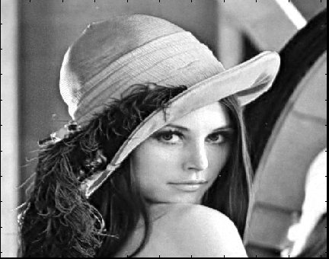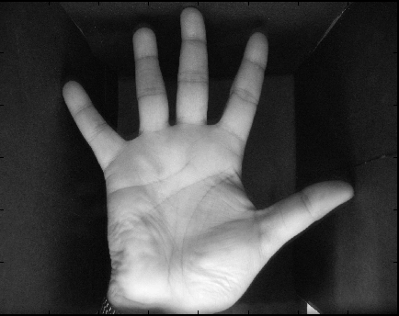
Fig 4.1.1(a) Original lena image Fig4.1.2(b) Original palm print image

After calculating the fuzzifier we need to calculate the histogram based fuzzy membership function and here we are using t=25.

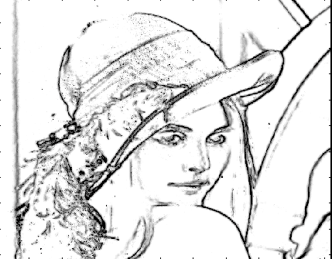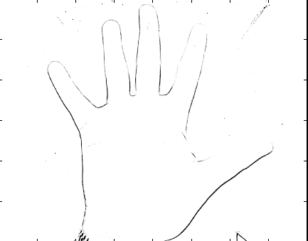
Fig4.1.2(a)(b) Image after Membership function

Adaptive thresholding will deal with the image(Fig4.2) locally and with mean value 0.04.

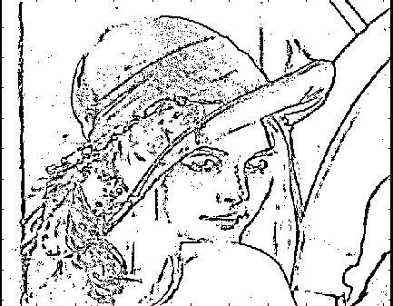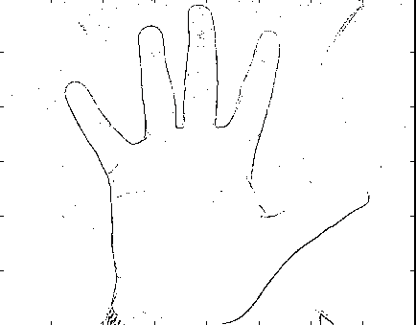
Fig4.1.3(a)(b) Image after Adaptive Thresholding

Here this is the final result, In lena (Fig8.1.3(a)) image short and weak edges are clear such as eyes lips and hair. We observe that the expression of face is clear and background of image is also quite noticeable. The edges at the hat are also sound.
In palm print (Fig4.1.3(b)) image , we can notice the desirable result . Here, we want the outer edges of the palm. We don’t want background edges and edges present on palm print. We are getting desirable result. Background edges are somewhat omitted and desired edges are sound and good.

Here are the results where we are changing the threshold‘t’ but keeping mean value constant which is 0.04.

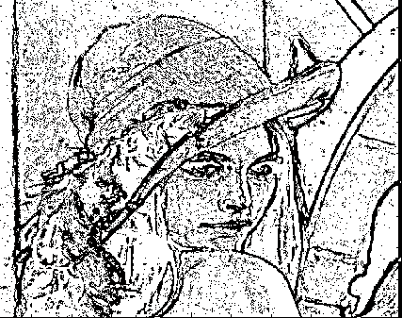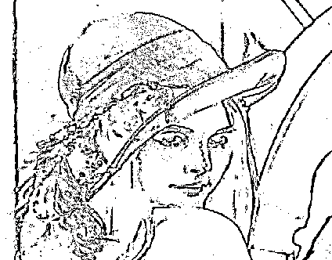
Fig4.1.4 Mean 0.04 (a)t=10(b)t=25
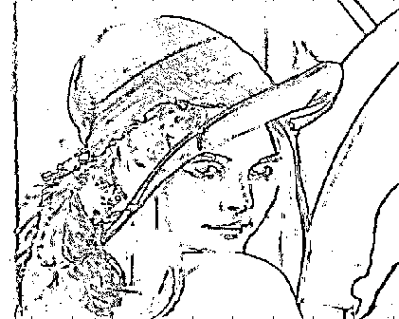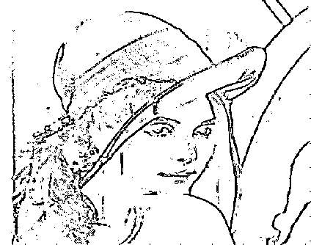
Fig4.1.4 Mean 0.04 (c) t=10(d)t=25

While keeping mean value of adaptive threshold fixed and changing the value of threshold we receive different result. We are keeping mean value constant to 0.04 and changing the value of threshold‘t’. When t=10 then there is the weak edges are clear but those edges which are short not clear like eyes, lips, hairs etc . Two or more edges which are close to each other at t=10 value, algorithm is not able to separate them. Some unwanted part of image is also present. When t=25 then, there is presence of weak and strong edges. Small edges like eyes, lips are clear. Some background edges are also missing here. At t=30, 40 lots of edges are missing. Eyes, lips and hairs edges are also missing.

Here are the results where we are changing the mean but keeping threshold value’t’ constant which is 25.

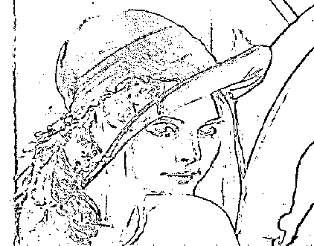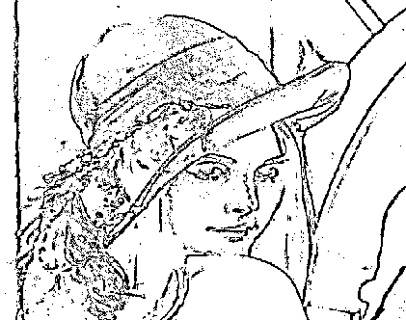
Fig.4.1.5 t=25 , (a)Mean=0.1(b)Mean=0.01
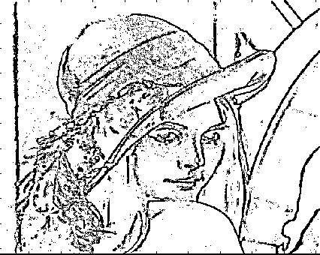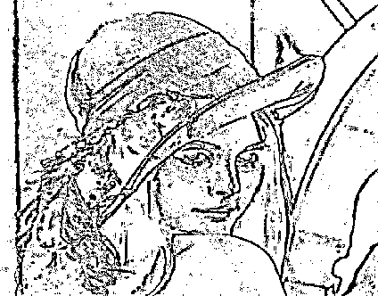
Fig.4.1.5 t=25 , (c)Mean= 0.005 ,(d)Mean= 0.0001

While keeping mean threshold‘t’ fixed and changing the mean value of adaptive thresholding receive different result. We are keeping threshold ‘t’ value constant to 25 and changing the value of mean. When mean=0.1 the edges are clear, small edges like lips, hairs etc are clear but background edges are not clear. At mean=0.01, 0.05, 0.001 we are receiving extra edges but also noise is getting prominent. At nose there is change in shadow so it is giving false edge.

Here are the results where we are changing the threshold‘t’ but keeping mean value constant which is 0.04.
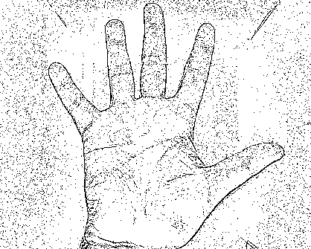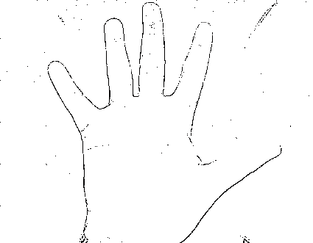
Fig4.1.6 Mean 0.04 , (a)t=10,(b)t=25
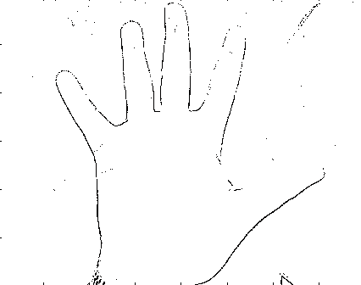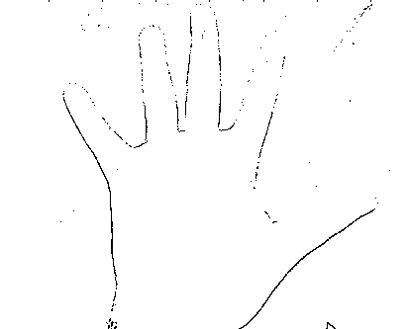
Fig4.1.6 Mean 0.04 ,(c) t=30,(d) t=40

While keeping mean value of adaptive threshold fixed and changing the value of threshold we receive different result. We are keeping mean value constant to 0.04 and changing the value of threshold‘t’. When t=10 then there is the weak edges are clear but missing edges at palm and background images are present after detection. There is also interference of noise in it. When t=25 noise has been removed. Background edges and edges on palm are also removed. When t=30, 40 then edges of palm is missing, we observe that 2nd finger’s edges are not clear or deleted. As we increases the threshold value noise will be removed but in addition some important information also lost.

Here are the results where we are changing the mean but keeping threshold value ’t’ constant which is 25.

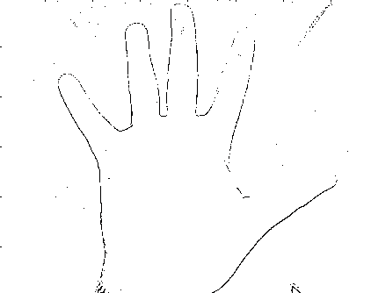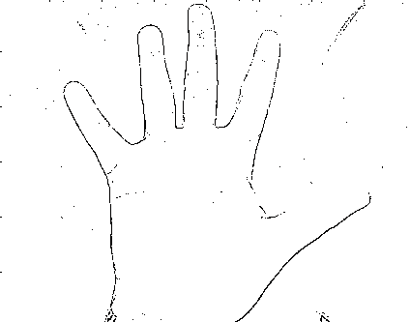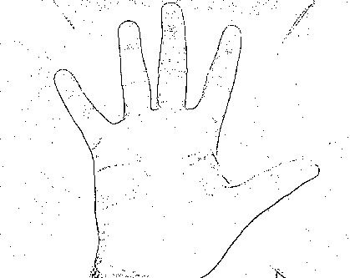
Fig.4.1.7 t=25 ,(a) Mean=0.1 ,(b)Mean=0.01 ,(c)Mean=0.04

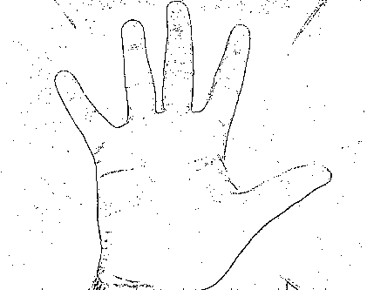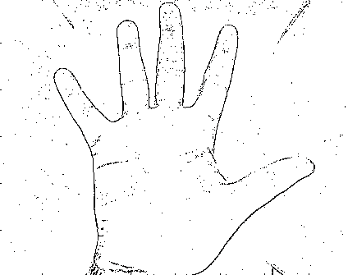
Fig.4.1.7 t=25 , (d)Mean=0.001 , (e)Mean=0.0001

While keeping mean threshold‘t’ fixed and changing the mean value of adaptive thresholding receive different result. We are keeping threshold ‘t’ value constant to 25 and changing the value of mean. When meam is 0.1 then we see that we are not getting proper edges or say, information is missing though we are getting desired background. When mean is 0.01 or 0.04 we observe that the edges are getting better and better. When mean 0.001 and 0.0001 as we are getting edges we are also getting noise also.

Now we apply our algorithm for different images
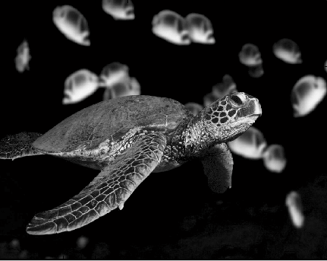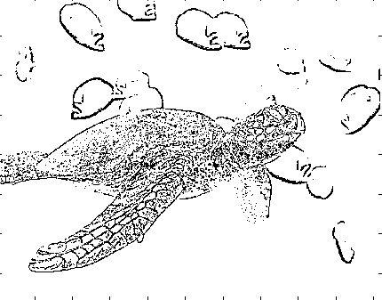
Fig4.1.9 (a)Working Image(b)After applying algorithm t=25, mean=0.04

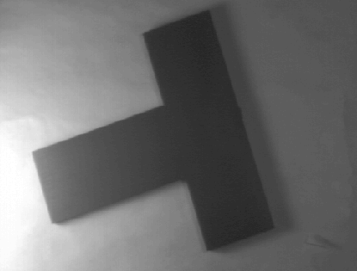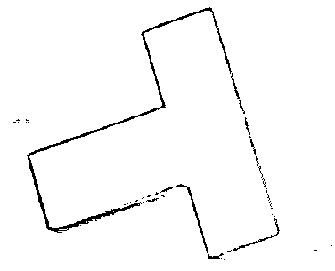
Fig4.1.10 (a)Working Image(b)After applying algorithm t=10, mean=0.04
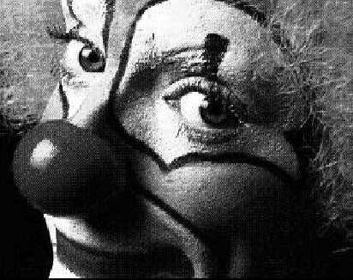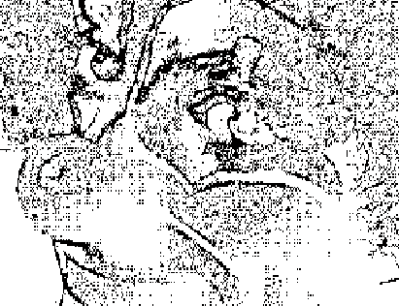
Fig4.1.11 (a)Working Image(b)After applying algorithm t=25, mean=0.04

4.2 Experimental Results For Corners
In this algorithm we are not enhancing or contrasting the image. We are doing operation directly on image . The algorithm performance will depend upon some parameters which we are using in this algorithm. The USAN area will lies between 1 to 37 and it depends upon the threshold ‘t’ . The value of t is pre-set and by experimentation, If we are using some simple image then we prefer low value of ‘t’ 10<t<20 but if we are using real life image and having some noise in it then we prefer high value of ‘t ‘ 20<t<50 .
The mean value of adaptive thresholding will detect the corners of the image. By performing number of experiments it shows that the value of mean should lie between 0.5 to 1.The value of‘t’ be fixed to any appropriate value i.e. 40. There is no need to edit the image after adaptive thresholding .So , this algorithm directly show corners after adaptive thresholding.
Only one morphological operation I performed that is dilation. Due to this operation, some unconnected corners of the image get connected, so tracing the corners becomes more efficient and they are more clear .
Here are some simple figure on which we apply this algorithm.

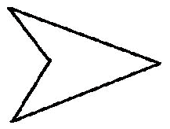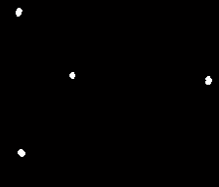

Fig4.2.1(a)working Image (b)Corner of working Image t=40,Mean=0.57

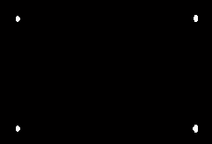
Fig4.2.2(a)working Image (b)Corner of working Image t=40,Mean=0.5

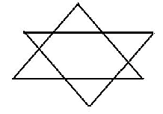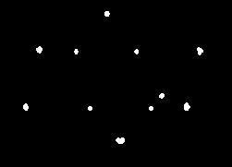
Fig4.2.3(a)working Image (b)Corner of working Image t=40,Mean=0.4

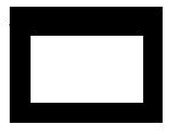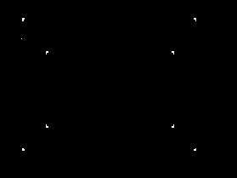

Fig4.2.4(a)working Image (b)Corner of working Image t=40,Mean=0.6

Chapter 5
Comparison of Result
Here we can compare our result with other edge detector like Canny[1] and SUSAN[2] edge detector.

Canny Edge Detector:
The Canny operator was designed to be an optimal edge detector. It takes as input a gray scale image, and produces as output an image showing the positions of tracked intensity discontinuities. The Canny operator works in a multi-stage process. First of all the image is smoothed by INCLUDEPICTURE "mhtml:file://C:\\Users\\pankaj\\Desktop\\pankaj material\\canny edge detector\\Feature Detectors - Canny Edge Detector.mht!http://homepages.inf.ed.ac.uk/rbf/HIPR2/mote.gif" \* MERGEFORMATINET Gaussian convolution. Then a simple 2-D first derivative operator (somewhat like the Roberts Cross) is applied to the smoothed image to highlight regions of the image with high first spatial derivatives. Edges give rise to ridges in the gradient magnitude image. The algorithm then tracks along the top of these ridges and sets to zero all pixels that are not actually on the ridge top so as to give a thin line in the output, a process known as INCLUDEPICTURE "mhtml:file://C:\\Users\\pankaj\\Desktop\\pankaj material\\canny edge detector\\Feature Detectors - Canny Edge Detector.mht!http://homepages.inf.ed.ac.uk/rbf/HIPR2/mote.gif" \* MERGEFORMATINET non-maximal suppression. The tracking process exhibits hysteresis controlled by two thresholds: T1 and T2, with T1 > T2. Tracking can only begin at a point on a ridge higher than T1. Tracking then continues in both directions out from that point until the height of the ridge falls below T2. This hysteresis helps to ensure that noisy edges are not broken up into multiple edge fragments.

SUSAN Edge and Corner Detector:
A new approach to low level image processing; in particular, edge and corner detection and structure preserving noise reduction. Non-linear filtering is used to define which parts of the image are closely related to each individual pixel; each pixel has associated with it a local image region which is of similar brightness to that pixel. The new feature detectors are based on the minimization of this local image region, and the noise reduction method uses this region as the smoothing neighbourhood. The resulting methods are accurate, noise resistant and fast.

5.1Edge Comparison:
Lets now first of all take lena image and apply Canny and SUSAN Edge detector and compare it with our algorithm result.
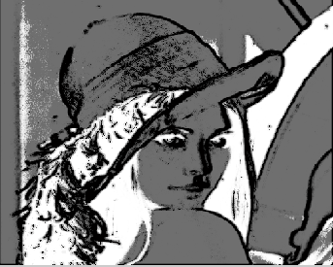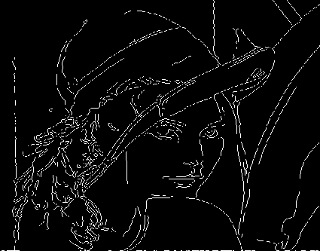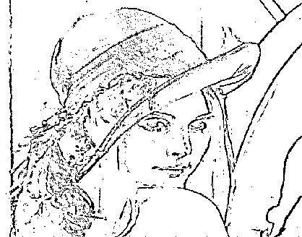
Fig5.1Edge obtained by (a)SUSAN=27(b)Canny 0.02(c)Our result mean=0.04,t=25
Here, we compare all three edge detector. In Fig5.1 (a) SUSAN edge detector we observe that edges are not sharp and if two edges are close to each other then SUSAN is not able to distinguish it. At nose part there is presence of shadow and it is giving edge there. In Fig5.1(b) Canny is giving good result but at above lips it is showing some distortion and some part of background is also missing. In this we are not receiving proper expression of lena image. Fig5.1 (c)In this algorithm we are getting some extra edges which Canny is not able to extract . Here we are getting proper expression of image. It is giving better result than SUSAN also because where SUSAN is not able to recognise two close edges, this algorithm easily find that. Also edges is sharper than SUSAN one.
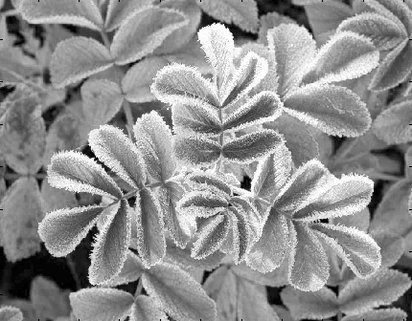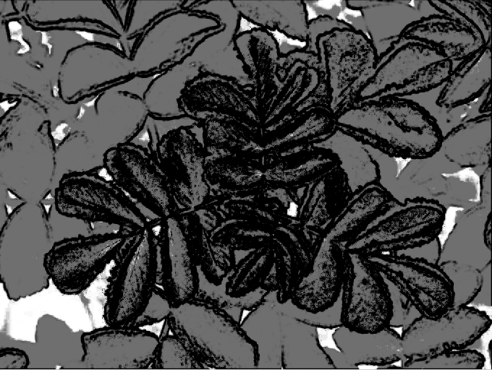
Fig5.2 (a)Original image, Edge obtained by (b)SUSAN=27
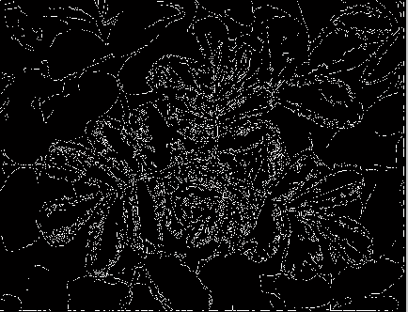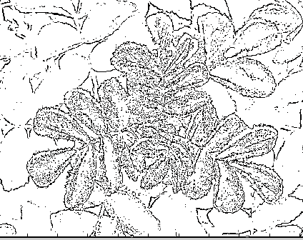
Fig5.2 (c)Canny 0.02(d)Our result mean=0.04,t=25
Here again we are taking some image. Fig5.2 (a) is the original image. Fig5.2 (b)SUSAN gives the edges. Here edges are not proper. Fig5.2 (c) we are getting better result than SUSAN but we cannot recognise properly the edges .Edges are not properly organised. Fig5.2(d) result is better than SUSAN’s and Canny’s one .Here we can easily locate the edges . There is less interference of noise.

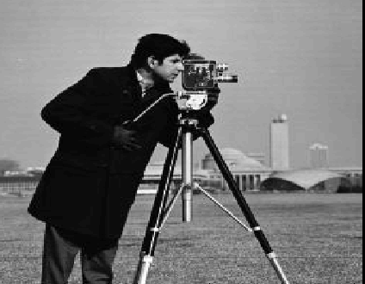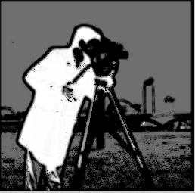
Fig5.3 (a)Original image, Edge obtained by (b)SUSAN=27
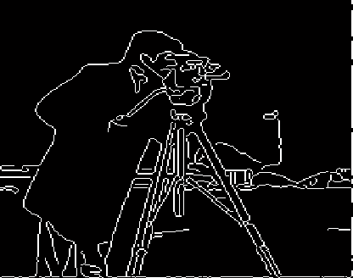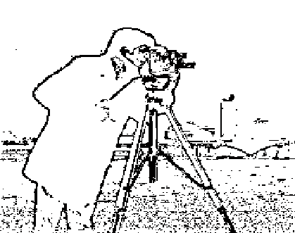
Fig5.3 (c)Canny 0.02(d)Our result mean=0.04,t=25
Here again we are taking some image. Fig5.3 (a) is the original image. Fig5.2 (b)SUSAN gives the edges. Here edges are not proper. Camera and face mix together and give nothing. Fig5.3 (c) we are getting better result than SUSAN but we cannot recognise face expression of image. Fig5.3 (d) result is better than SUSAN’s and Canny’s one .Here we can easily locate the edges. We also recognise the face expression of cameraman.

5.2 Corner Comparison:
Here we are taking simple images for edge detection. We are compare with SUSAN corner detector.
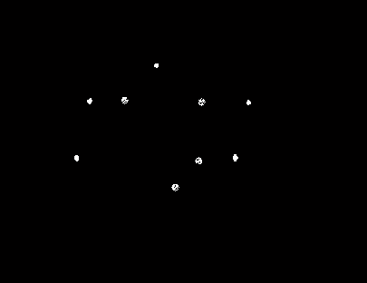
Fig5.4(a)Original Image (b)SUSAN edge detector
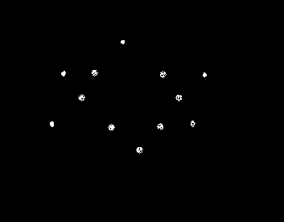
Fig5.4 (c) Corner result
Fig5.4 (a) is the original image. Here are total 12 corners in the image Fig5.4 (b) SUSAN gives the corners. The number of corners are 9 and 3 corners are missing. Fig5.4 (c) give total 12 edges . So in this image this algorithm is showing better result than SUSAN one. Corner localization is also good and we are also not getting false corner in both the images.

5.3 DISCUSSION:
Though the performance of the proposed fuzzy edge detector excels as a shape and detail detector, it is fraught with some drawbacks. It loses few details during thresholding. Also, the weak edges are not eliminated but for some applications, these may be required. This detector has another distinctive feature, i.e. it retains the texture of the original image. This feature can be utilized for the identification of fingerprints, where the ridges may have different intensities. As far as the parameters of edge detection operator are concerned, we have to choose correctly so we get appropriate result. As the success of the edge and corner detection depends on these parameters, we are experimenting on several images to come up with a useful selection guideline.

Chapter 6
Conclusion
6. Conclusions:
The fuzzy edge detector presented in this paper uses global (histogram of USAN area) information. The local information is fuzzified using a modified Gaussian membership function. Using the adaptive thresholding obtain the final edge and corner image.
Results show that this edge detector is immensely suitable for applications such as palm print and fingerprint identification or any type of images, as it does not distort the shape and is able to retain the important edges unlike the Canny edge detector. Choice of some of the parameters, t, and mean is crucial for the success of this algorithm.

References:
[1]. J.F. Canny, “A computational approach to edge detection”, IEEE Trans. on Pattern Analysis and Machine Intelligence, 8(6), 1986, 679-698.
[2]. S.M. Smith, and J.M. Brady, “SUSAN – A new approach to low level image processing”, International Journal of Computer Vision, 23(1), 1997.
[3] C.Harris and M. Stephens, “A Combined Corner and Edge Detector,” Proc.Fourth Alvey Vision Conf., vol. 15, pp. 147-151, 1988.
[4].T.Lindeberg, “Feature Detection with Automatic Scale Selection,” Int’l J. Computer Vision, vol. 30, no. 2, pp. 77-116, 1998.
[5]. Tissainayagam, P., Suter, D., “Assessing the performance of corner detectors for point feature tracking applications” Image and Vision Computing,Elsevier, Vol. 22, pp. 663-679, 2004.
[6].Kitchen, L., Rosenfeld, A., “Gray level corner detection” Pattern Recognition Letters, pp.85-102, 1982.detection” Pattern Recognition Letters, pp.85-102, 1982.
[7] Moravec, H.P., “Towards Automatic Visual Obstacle Avoidance” Proc,5th Int. Joint Conf. Artificial Intelligence, Cambridge, MA, USA, p584, 1977.
[8] Noble, J.A., “Finding Corners” Image and VisionComputing, Elsevier, Vol. 6, No. 2, May 1988.
[9] Asada, H., Brady, M., “The Curvature Primal Sketch”,IEEE Trans Pattern Analysis and Machine Intelligence,Vol. 8, pp. 2-14, 1986.
[10] Shen, F., Wang, H., “A Local Edge Detector Used for Finding Corners” Proc 3rd Int. Conf. Inf, Comm. And Signal Processing, Singapore, Dec. 2001.
[11] Etou, Y.; Sugiyama, T.; Abe, K.; Abe, T., "Corner detection using slit rotational edge-feature detector," Proc IEEE ICIP, vol.2, pp. 797- 800, 2002
[12] Pei, S.C.; Ding, J.J, "New corner detection algorithm by tangent and vertical axes and case table,", Proc. IEEE ICIP, vol.1, pp. I- 365-8, 11-14 Sept. 2005
[13] Dermot Kerr, Sonya Coleman, Bryan Scotney “Near-Circular Corner and Edge Detection Operators”, International Machine Vision and Image Processing Conference.
[14]A. K. Chan, C. K. Chui, J. Zha, and Q. Liu, “Corner detection using spline-wavelets,” in Proc. SPIE Curves Surfaces Comp. Vis. Graph. II,Boston, MA, 1991, vol. 6610, pp. 211–322.
[15] P. Fransson, “Using wavelet to detect corner points in images,” Master’s thesis, Dept. Mathematics, Lund Inst. Technol., Lund,Sweden, 1992.
[16] Jinbo Wu, Zhouping Yin, and Youlun Xiong, “The Fast Multilevel Fuzzy Edge
Detection of Blurry Images”, IEEE SIGNAL PROCESSING LETTERS, VOL. 14, NO. 5, MAY 2007
[17] Francis H. Y. Chan, F. K. Lam, and Hui Zhu,” Adaptive Thresholding by Variational Method” IEEE TRANSACTIONS ON IMAGE PROCESSING, VOL. 7, NO. 3, MARCH 1998
[18] CHAN, F.H.Y., LAM, F.K., and ZHU, HUI: ‘Adaptive thresholding by variational method’, IEEE Trans. Image Process., 1998, 7, (3), pp. 468473

[19] Chung-Bin Wu, Chin-Yuan Yao, Bin-Da Liu, Senior Member, IEEE, and Jar-Ferr Yang, Senior Member, IEEE” DCT-Based Adaptive Thresholding Algorithm for Binary Motion Estimation, IEEE TRANSACTIONS ON CIRCUITS AND SYSTEMS FOR VIDEO TECHNOLOGY, VOL. 15, NO. 5, MAY 2005

[20] S.A.R. Abu Bakar, M. M. Mokji ADAPTIVE THRESHOLDING BASED ON CO-OCCURRENCE MATRIX EDGE INFORMATION” , Asia International Conference on Modelling & Simulation (AMS'07)0-7695-2845-7/07 © 2007 IEEE

[21] N. Otsu (1979). "A threshold selection method from gray-level histograms". IEEE Trans. Sys., Man., Cyber. 9: 62–66.
[22] http://homepages.inf.ed.ac.uk/rbf/HIPR2/adpthrsh.htm
[23].Rafel C. Gonzale and Richard E.Woods ,”Digital Image Processing”.

