FUZZY CONTROLLER BASED VOLTAGE REGULATION OF A THREE - PHASE ALTERNATOR

A MAJOR PROJECT
SUBMITTED IN PARTIAL FULFILLMENT OF REQUIREMENTS
FOR THE AWARD OF THE DEGREE OF
MASTER OF ENGINEERING
(CONTROL & INSTRUMENTATION)

Submitted by
Qateef Nahvi
University Roll No. 10217

Under supervision of

Prof. Madhusudan Singh
Electrical Engineering Department



Delhi College of Engineering
University of Delhi
Delhi-110007
2008

CERTIFICATE

This is to certify that Major project titled “FUZZY CONTROLLER BASED VOLTAGE REGULATION OF A THREE - PHASE ALTERNATOR” submitted by Qateef Nahvi in partial fulfillment of requirements for award of the degree of Master of Engineering (Control & Instrumentation) of the Electrical Engineering Department, Delhi college of Engineering, Delhi – 110042 is a bonafide record of work that she has carried out under my guidance and supervision.

Dr. Madhusudhan Singh
Professor
Electrical Engineering Department
Delhi College of Engineering
Delhi-110042

ACKNOWLEDGEMENT

I would like to extend my sincere gratitude to my supervisor, Prof. Madhusudhan Singh for his assistance and invaluable guidance in carrying out the project work and preparation of this dissertation. Its only because of his continuous efforts in making us work that this project has been completed.
I would like to thank Prof. Parmod Kumar, Head of Department, Electrical Engineering for the help and support he provided not only during this project but during the entire period of my study here.
I am thankful to my friends Versha and Deepali for their useful discussions and the cooperation extended during my project work.

Qateef Nahvi
M.E. (C& I )
University Roll No. 10217

FUZZY CONTROLLER BASED VOLTAGE REGULATION OF A
THREE PHASE ALTERNATOR

CONTENTS

ABSTRACT
CHAPTER I INTRODUCTION
1.0 General.
1.1 Load Characteristics of Synchronous Generator
1.1.1 Generator Voltage Regulation
1.1.2 Generator Excitation Requirement for Constant terminal Voltage
1.2 Field Excitation Methods of Synchronous Generator
1.2.1 Brushless Excitation
1.2.2 Series Excitation
1.3 Objective of Present Work
1.4 Conclusion
CHAPTER II LITERATURE SURVEY
2.0 General
2.1 Literature Survey
2.1.1 Excitation Control of Synchronous Generator
2.1.2 Fuzzy Logic Controller for Voltage Regulation of Synchronous
Generator
2.1.3 Fuzzy Logic Controller for Power System
2.1.4 Fuzzy Controller for Power Electronics
2.2 Scope of the Present Work
CHAPTER III FUZZY LOGIC CONTROLLER
3.0 General
3.1 Fuzzy Logic-A Historical Review
3.2 Fuzzy sets and Fuzzy logic
3.3 How Fuzzy logic is different from conventional control methods
3.4 Why to use Fuzzy logic
3.5 Linguistic variables
3.6 Fuzzy logic control
3.7 Fuzzy control system
3.7.1 Fuzzifier
3.7.2 Knowledge base
3.7.3 Rule base
3.7.4 Inferencing
3.7.5 Deffuzifier
3.7.6Membership function
3.8 Matlab Fuzzy logic toolbox
3.8.1 FIS editor
3.8.2 Membership function editor
3.8.3 Rule editor 3.8.5 Rule viewer
3.8.6 Surface viewer
3.9 Difficulties in Fuzzy system design
3.10 Conclusion
CHAPTER IV MATHEMATICAL MODELING AND MATLAB SIMULATION OF VOLTAGE CONTROLLER FOR THREE PHASE ALTERNATOR

4.0 General
4.1System description
4.2 Mathematical Modeling of System for Voltage control of Synchronous Generator
4.2.1 Mathematical model of Synchronous generator
4.2.2 Mathematical model of Hydraulic turbine
4.2.3 Mathematical model of load
4.2.4 Mathematical model of Voltage Controller
I PI controller
II Sliding mode controller
III Fuzzy logic controller
4.3 MATLAB/Simulink
4.3.1 MATLAB Model of Synchronous Generator
4.3.2 MATLAB Model of Hydraulic turbine
4.3.3 MATLAB Model of Fuzzy logic controller
4.4 Conclusion
CHAPTER V RESULTS AND DISCUSSION
5.0 General
5.1 Simulation results
5.1.1 Performance of the Alternator with fixed excitation
5.1.2 Performance with PI Controller for excitation control
5.1.3 Performance with Sliding mode Controller for excitation control
5.1.4 Performance with Fuzzy logic Controller for excitation control
5.2 Performance with Various Controllers
5.3 Conclusion
CHAPTER VI CONCLUSION AND FUTURE SCOPE OF WORK
6.0 Conclusion
6.1 Future scope of work

REFERENCES
APPENDIX

ABSTRACT

In this project, the design and simulation of a fuzzy logic based voltage controller for regulating the output voltage of a synchronous generator is carried out. The simulation study is carried out on a 187MVA, 13.8kV alternator. An automated fuzzy logic based control strategy is presented for controlling the armature voltage of the synchronous generator by varying its field voltage. The controller makes an intelligent decision on the amount of field voltage that should be applied to the generator in order to keep the output voltage at its rated value. The control algorithm is implemented in MATLAB. The performance of the fuzzy logic controller is compared with a conventional PI controller and also a sliding mode controller (SMC). It is observed that fuzzy logic controller gives better performance than either of the two controllers.
Fuzzy logic controller is rapidly becoming a viable alternative for classical controllers. The reason for this is that the fuzzy controller can closely imitate human control processes. Fuzzy logic technology enables the use of engineering experience and experimental results in designing an embedded system. In many applications, this circumvents the use of rigorous mathematical modeling to derive a control solution.
Another advantage of using a fuzzy logic control strategy is that it allows a model-free estimation of the system. Thus the designer does not need to state how the outputs depend mathematically upon the inputs. A fuzzy controller can be developed by encoding the structured knowledge of the system. This allows faster and accurate dynamic response of the system.

CHAPTER I
INTRODUCTION

- GENERAL

Synchronous generators are used extensively for a wide range of electricity generation applications. A range of power generation probably greater than for any other class of rotating electrical machines. On the lower end are the smaller machines for clock, timing and control application in the milliwatt range, at the higher end are giant alternators used in electric power generation i.e. 50-150 MW range.
Synchronous generators are responsible for the bulk of electrical power generated in the world today. They are mainly used in power stations and are predominantly driven either by steam or hydraulic turbines. More than 90% of electric energy used in the world is generated by alternators. The very large amount of energy generated by these generators has made companies very conscious about their efficiency. If efficiency of a 1000MW generating station improves by only 1%, it represents extra revenues of several hundred dollars per day.
Synchronous generators are usually connected to an infinite bus where the terminals voltage is held at a constant value by the momentum of all the generators also connected to it. Another common application of synchronous generators is their use in stand alone or isolated power generation systems. The voltage regulation (that is the voltage rise at the terminals when a given load is thrown off, the excitation and speed remaining constant), is of a critical importance in such type of generators.
The voltage regulation system in a stand alone synchronous generator is called an automatic voltage regulator (AVR). It is a device that automatically adjusts the output voltage of the generator in order to maintain it at a relatively constant value. This is achieved by comparing the output voltage with a reference voltage and from the difference (error), it makes the necessary adjustments in the field current to bring the output voltage closer to the required value. Older AVR’s used in early days belong to a class of electromechanical devices. They are generally slow acting and possess zones of insensitivity called dead bands. There is a wide variety of electromechanical AVR’s ranging from vibrating contact regulators to carbon pile regulators. However, they are now being replaced with continuously acting electronic regulators.
In this project, a fuzzy logic based AVR for a synchronous generator is presented. The use of fuzzy logic is gaining widespread popularity in control engineering. Use of fuzzy logic controllers is specially useful in systems that are complex or that are nonlinear and are difficult or impossible to model mathematically.
The aim of this project is to develop an improved control system for hydraulic turbine driven stand alone synchronous generator set. Its primary objective is to design and build a working prototype that incorporates a new control strategy and the latest engineering innovations. The objectives include ensuring that the prototype system :
- Can be used effectively as a starting point for further studies into a new generation of controllers for stand alone synchronous generator sets.
- Incorporates a certain amount of artificial intelligence such that it is flexible and not specific to a particular type of engine-generator set
- Is designed using a systematic process which enables rapid prototyping of future improvements
- Takes advantage of modern digital electronic technology
1.1 LOAD CHARACTERISTICS OF SYNCHRONOUS GENERATOR
The equivalent circuit of the synchronous generator is shown in Fig.1
Fig. 1 Equivalent Circuit of Synchronous Generator.

Assuming that the synchronous generator is being driven at constant speed and with constant excitation. On open circuit, the terminal voltage V is the same as the open circuit e.m.f E_{t.} Suppose a unity power factor load be connected to the machine. The flow of load current produces a voltage drop IZ_{s} and the terminal voltage V is reduced. Fig. 1.1 shows the phasor diagram for different types of load. The terminal voltage is obtained from the phasor diagram

(a) Unity power factor loads (b) Lagging load

(c) Leading load

Fig. 1.1 Phasor Diagram of Synchronous Generator at constant excitation.

Where
Et- Excitation voltage( AC)
V-Terminal voltage
X_{s}-Synchronous reactance
Z_{s}-Synchronous impedance
R-Armature resistance

$E_{t}=V+{\text{IZ}}_{s}$ or $V=E_{t}−{\text{IZ}}_{s}$ (1.1)
Since the resistance in normal machines is small compared with the synchronous reactance, the voltage is given approximately by
$V=E_{t}−{\text{IX}}_{s}$ (1.2)
For cos ф =0, the lagging phasor is shown in Fig. 1.1(b). A leading load of zero power factor will have the voltage
$V=E_{t}+{\text{IX}}_{s}$ (1.3)

Intermediate load power factors produce voltage /current characteristics as shown in Fig. 1.2. The voltage drop with load (i.e. the regulation) is clearly dependent upon the power factor of the load.
The short circuit current I_{sc} at which the load terminal voltage falls to zero may be about 150 percent (1.5 per unit) of normal current in large modern machines.

Fig. 1.2 Generator load characteristics

1.1.1 GENERATOR VOLTAGE REGULATION

The voltage regulation of a synchronous generator is the voltage rise at the terminals when a given load is thrown off, the excitation and speed remaining constant. The voltage rise is clearly the numerical difference between E_{t} and V, where V is the terminal voltage for a given load and Et is the open circuit voltage for the same field excitation. Expressed as a fraction, the regulation is
= $\frac{E_{t}−V}{V}$ per unit (1.4)
Comparing the voltages on full load (1.0 per unit normal current) in Fig.1.2, it will be seen that it much depends on the power factor of the load. For unity and lagging power factors there is always a voltage drop with increase of load, but for a certain leading power factor the full load regulation is zero, i.e. the terminal voltage is the same for both full and no load conditions. At lower leading power factors the voltage rises with increase of load, and the regulation is negative. From Fig. 1.2 the regulation for the load current I at power factor cos ф is obtained from the equation
$E_{t}^{2}={\left(V\text{cos}φ+\text{IR}\right)}^{2}+{\left(V\text{sin}φ+{\text{IX}}_{s}\right)}^{2}$ (1.5)

1.1.2 GENERATOR EXCITATION REQUIREMENTS FOR CONSTANT TERMINAL VOLTAGE

Fig. 1.3 shows that excitation requirement for maintaining constant terminal voltage at different power factor load. The excitation e.m.f is proportional to the excitation when the synchronous reactance is constant. All unity and lagging power factor loads will require an increase of excitation with increase of load current. Low leading power factor loads on the other hand, will require the excitation to be reduced on account of the direct magnetizing effect of the zero power factor component. Fig. 1.3 shows typical e.m.f./current curves for a constant output voltage (they may be derived also from the general load diagram). The ordinates of Fig.1.3 are marked in percentage of no load field excitation, to which the e.m.f. E_{t} exactly corresponds when saturation is neglected.

Fig. 1.3 Generator excitation for constant voltage

1.2 FIELD EXCITATION METHODS OF SYNCHRONOUS GENERATOR

The field windings of conventional polyphase synchronous machines are energized, or excited from a d.c source. Other types of synchronous machines are excited by permanent magnets. Also, certain synchronous machines have no external excitation and are called singly excited synchronous machines.
The source of energy for synchronous machine field windings may be any conventional dc power supply, including batteries, solar converters, dc generators, and electronic power supplies. Regardless of the source, there is always some measure of control of the energy source’s voltage and/or current, which provides one of the most valuable features of synchronous machines. Excitation control provides a simple, and generally relatively easy, means of controlling synchronous machine’s characteristics such as terminal voltage, power factor, short circuit current, transient response and torque.
In large synchronous machines, the excitation source is often mounted on the same shaft as the synchronous machine itself. The exciter machine may be a d.c or a.c machine with appropriate control; if ac the exciter is generally a conventional synchronous machine of the same configuration as the main machine. If the field of the main machine is on the rotor, which is the most common configuration, the excitation is supplied by means of a brush-slip ring system. Excitation control can be provided by controlling the dc field of the exciter or by controlling the exciter armature voltage, or by both methods. Except for battery energy sources, the typical excitation source may contain considerable ripple, which is generally undesirable since it greatly increases the harmonic content of the generated voltage; thus an integral part of most excitation systems is a filter to reduce the ripple of the excitation output to an acceptable value. Since excitation ripple is of relatively low frequency, the cost of the filter may be significant portion of the total excitation cost

    - BRUSHLESS EXCITATION

Except in large central station steam generating plants, the use of slip rings to connect the exciter output to the synchronous machine field circuit may be undesirable. Slip rings present problems except where the environment is well controlled and where frequent inspection is performed, as in large central station plants. Therefore, in smaller sizes, synchronous machines are frequently constructed in a brushless configuration known as rotating-rectifier machines, especially when operation in harsh environments is required.
The rotating-rectifier configuration uses an exciter mounted on the same shaft as the main synchronous machine and is often combined structurally into a common housing with the main machine. The exciter has the reverse configuration of the conventional synchronous machine, with the field on the stator and the armature on the rotor. The output of the voltage generated in the exciter armature is rectified and applied directly to the main field circuit, eliminating the need for slip rings, since the exciter armature , rectifier and main field are all mounted on the same rotating shaft; hence the term rotating rectifier . Excitation control is achieved by controlling the stationary field of the exciter.

    - SERIES EXCITATION
Series excitation refers to providing excitation derived from an element in series with the main machine’s armature (or load) connections. Physically, it can be a current transformer, resistive current shunt, Hall device, or an actual series winding as used in dc machines. The first three of these schemes generally apply the output of the current sensing device to the exciter control. Likewise, in the latter of the above schemes, the series winding is generally on the exciter rather than on the main field pole. This type of excitation is appropriate for isolated synchronous alternators that are used in motor starting applications where high inrush current is required. Series excitation is seldom used in large central station alternators.

1.3 OBJECTIVE OF PRESENT WORK

Fuzzy controllers are increasingly being accepted by scientists and engineers as a viable alternative for classical controllers. The processes involved in fuzzy controllers closely imitate human control processes. Human responses to stimuli are not governed by transfer functions and neither are those from fuzzy controllers. In the present work, a fuzzy logic controller is designed and simulated for voltage control of synchronous generator An automated fuzzy logic based control strategy is presented for controlling the armature voltage of a synchronous generator by varying the field voltage. The FLC will take into account the voltage difference between the immediate output voltage and rated voltage of generator. It will also take into account the rate of change of voltage error. The controller will make an intelligent decision on the amount of field voltage that should be applied to the generator in order to keep the output voltage at its rated value.
1.4 CONCLUSION
The field voltage of the synchronous generator need to be changed whenever there is a change in load in order to maintain the ouput voltage of the generator constant. For unity and lagging power factor loads, there is always voltage drop with increase in load, hence the excitation needs to be increased . However in leading power factor loads the excitation needs to be decreased since the voltage increases with increase in load.
CHAPTER II
LITERATURE SURVEY
2.0 GENERAL
Over the last few years, the use of fuzzy set theory or fuzzy logic, in control systems has been gaining widespread popularity. A large number of articles and numerous books have been devoted to the study on design and implementation of fuzzy logic controllers. Voltage regulation of synchronous generators is also of critical importance since they are responsible for the bulk of electrical power that we use today. Numerous papers have been written which present different control strategies to regulate the output voltage of the synchronous generator under varying load conditions. An extensive literature survey on the voltage control strategy of generation was carried out.

2.1 LITERATURE SURVEY

2.1.1 EXCITATION CONTROL OF SYNCHRONOUS GENERATOR

A paper on “Design and implementation of a personal computer based automatic voltage regulator for a synchronous generator” [1] describes a straightforward designing method for a digital voltage regulator for a synchronous generator. The design is carried out directly in the z-domain using root locus method. Simple software routines are written in assembly language thereby making it suitable for on line computer control. Digital simulation studies are also carried out to test and compare the design and its dynamic results. The design is implemented on a laboratory size 5 KVA generator with a personal computer acting as a digital controller and voltage regulation of the generator is studied.
A synchronous generator or an alternator is equipped with an automatic voltage regulator (AVR), which is responsible for keeping the generator output voltage constant under normal operating conditions at various load levels. With the advancement in the design of fast acting AVRs as well as increasing complexity of large interconnected power systems, oscillations may continue for an extended period and even instability may occur following some system disturbances. The control algorithms to overcome these problems are generally implemented using analog components.
The availability of inexpensive microprocessors and microcontrollers has prompted a great deal of attention towards digital excitation control. These microprocessor control systems have a great deal of flexibility and have the ability to implement sophisticated control algorithms efficiently and economically. Most of the recent investigations of the digital AVRs have been focusing on sophisticated control algorithms such as those of self tuned and adaptive regulators. Some improvements of the system performance have been reported using self tuned regulators over that of traditional AVRs. However, in view of their large computational requirements and complexity of their software, the degree of improvement obtained need to be examined carefully for optimum solution.
To avoid these difficulties, this paper presents an effective and straightforward digital design which can easily be implemented. The generator is represented by a first order approximation and the controller design is done directly in the z domain using root locus method. The final difference equation is implemented using an on line personal computer. The back up protection as well as monitoring of voltages and currents of the generator is done by the same personal computer with a slight modification of the software and hardware. The complete system including the digital control algorithm has been simulated using a software package. The final design is then implemented and tested on a 5 KVA, 220 V synchronous machine in the laboratory
The results show that a compensated digital AVR maintains the terminal voltage values much better under various loading conditions compared to either the proportional controller or the open loop controller.

“An adaptive synchronous generator stabilizer design by generalized multi variable pole shifting (GPMS) technique” [2] presents a robust adaptive power system stabilizer algorithm using a Generalized multivariable pole shifting (GPMS) technique. The algorithm handles systems with equal or unequal numbers of input and outputs, therefore both the shaft speed as well as the generator power are used to derive the stabilizing control. The technique also provides a simple scheme of on line self searching pole shifting factor to meet the excitation control limits. The application of the proposed stabilizer to a simulated generator excitation control under a wide range of operating and disturbance conditions demonstrates that the new control strategy is superior to conventional power system stabilizer(PSS) and the widely accepted Minimum Variance Self Tuning Controller(MVSTC)
The high complexity and nonlinearity of power systems, together with their almost continuously time varying nature, have created a great deal of challenge to power system control engineers for decades. A particular issue encountered at the generating plant level is to maintain unit stability under various operating conditions. The essential control for qualified synchronous generator controllers includes three aspects: effective and fast response, adaptive feature, and feasibility and implementation.
This paper proposes a GPMS adaptive power system stabilizer scheme. The method is capable of handling MIMO systems with arbitrary numbers of inputs and outputs. The pole shifting factor is self-adjusted on-line such that the control constraints will not be violated. The algorithm is applied to a single machine infinite bus system excitation control. Both shaft speed and accelerating power are employed as control inputs. The latter one is added because of its proven effect in improving control response. A set of multi fault simulation studies are presented to compare the system performance obtained by conventional power system stabilizer. Minimum Variance controller and the proposed Generalized Multivariable Pole shifting controller respectively. In all the cases, the proposed controller demonstrates consistent superiority and most importantly consistent reliability and robustness.
Results of multi fault simulation studies under a wide range operating conditions demonstrate robustness, improved performance and most importantly, consistent reliability of the proposed scheme over the conventional power system stabilizer and Minimum Variance Self tuning controller. The studies presented also reveal the inherent instability of Minimum Variance Self tuning control when the system identified model becomes non minimum phase.

The paper on “Design and implementation of a PC based Automatic voltage regulator and fuzzy logic power system stabilizer” [3] describes the design and implementation of automatic voltage regulator (AVR) and fuzzy logic power system stabilizer(FLPSS) for single machine infinite bus power system. The AVR was designed using z-domain analytical design method. The proposed FLPSS employs two non linear fuzzy membership functions to improve its performance. The design and digital simulation studies are carried out using MATRIX_{x} – a large control system design and simulation software package. The design is implemented in a power system laboratory with a computer acting as a real time controller.
Both simulation and implementation results show that the proposed PC based AVR and FLPSS are very effective. The proposed FLPSS provided better dynamic performance under disturbance conditions than the conventional PSS. The design of FLPSS does not require mathematical model representation of synchronous machine and power plant and is quicker and easier to implement than the self tuning PSS which requires real time model identification. Both simulation and implementation results show that the digital a AVR maintain terminal voltage values under various loading conditions and FLPSS increases the system damping dramatically.

2.1.2 FUZZY LOGIC CONTROLLER FOR VOLTAGE REGULATION OF SYNCHRONOUS GENERATOR

A tutorial by Steven D. Kaehler “Fuzzy logic- an introduction” [4] gives some basic information about how fuzzy logic works and how it originated .The concept of fuzzy logic was conceived by Lotfi Zadeh, a professor at the university of California and presented not as a control methodology but as a way of processing data by allowing partial set membership rather than the crisp set membership or non membership. This approach to set theory was not applied to control systems until the 70s due to insufficient small-computer capability prior to that time. Real world problems can be extremely complex and complex systems are inherently fuzzy. The main advantage of FLCs is their ability to incorporate experience, intuition and heuristics into the system instead of relying on mathematical models. This makes them more effective in applications where existing models are ill defined and not reliable enough. FLs approach to control problems mimics how a person would make decisions, only much faster. FL incorporates simple rule based IF X AND Y THEN Z approach to solving a control problem rather than attempting to model a system mathematically. The FL model is empirically-based relying on an operators experience rather than their technical understanding of the problem.
FL was conceived as a better method for sorting and handling data but has proven to be an excellent choice for many control system applications since it mimics human control logic.. It can be built into anything from small hand-held products to large computerized process control systems. It uses an imprecise but very descriptive language to deal with input data more like a human operator. It is very robust and forgiving of operator and data input and often works when first implemented with little or no tuning.
There is a unique membership function associated with each input parameter. The membership functions associate a weighting factor with values of each input and the effective rules. The weighting factors determine the degree of influence or the degree of membership (DOM) each active rule has. The inputs are combined logically using the AND operator to produce output response values for all expected inputs. The logical product of each rule is inferred to arrive at a combined magnitude for each output membership function. This can be done by max-min, max-dot, averaging, RSS or other methods. Once inferred, the magnitudes are mapped into their respective output membership functions. The final result is taken as the crisp output. Tuning the system amounts to “tweaking” the rules and membership function definition parameters to achieve acceptable system response.
Fuzzy logic provides a completely different, unorthodox way to approach a control problem. This method focuses on what the system should do rather than trying to understand how it works. One can concentrate on solving the problem rather than trying to model the system mathematically. This almost invariably leads to quicker, cheaper solutions. Once understood , this technology is not difficult to apply and the results are usually quite surprising and pleasing.

A paper titled “Design and implementation of fuzzy based automatic voltage regulation for a synchronous generator”[5] involves the design and application of fuzzy control to the problem of automatic voltage regulation of a synchronous generator. The paper discusses how fuzzy controllers are increasingly being accepted by engineers and scientists as a viable alternative for classical controllers. The processes involved in fuzzy controllers closely imitate human control processes. Human responses to stimuli are not governed by transfer functions and neither are those from fuzzy controllers.
A synchronous machine is equipped with an automatic voltage regulator which is responsible for keeping the output voltage constant under normal operating conditions at various load levels. The control algorithms are usually implemented using analog components.
In recent years, fuzzy theory has emerged as a powerful tool in various control system applications. Researchers are starting to use fuzzy control in various power system application areas. The application of fuzzy logic seems to be very useful whenever a well defined control objective cannot be specified or the system to be controlled is a very complex one. Under traditional laws of logic something either belongs to a set or does not belong to the set, thereby leaving no room for ambiguities. However, ambiguities are the norm, rather than the exception in the real world. Contrary to traditional logic, where boundaries are rigid, fuzzy logic not only tolerates but is based on the looseness of boundaries.
The paper presents a method of realizing a fuzzy logic controller for an AVR system using a personal computer. The fuzzy logic algorithm is based on simple linguistic rules and was implemented for a 5kVA synchronous machine.
The method uses error and rate of change of voltage to maintain a constant output voltage. Software routines are written in C language. The fuzzy system is successfully designed and implemented to control the generator voltage. The main benefit of designing and implementing a fuzzy controller is the ease of design and flexibility. The implementation algorithm without any transfer function simplifies model development and testing by eliminating the need for determination of coefficients. The resulting system was both computationally efficient and had minimal overshoot.

Another article titled “Fuzzy logic based voltage control for a synchronous generator”[6] proposes a novel method using the fuzzy technique and gain tuning for constant voltage control of the synchronous generator. The gain tuning technique of the control scheme is designed to be applicable to various load conditions. The fuzzy controller applies the method of gain tuning to quickly converge the terminal voltage of the generator to the set value. The controller has a wider range of operating conditions and smaller settling time compared with that of conventional controllers using fixed gain.
The method was demonstrated using a 50KVA synchronous generator. Simulation results show that the approach is computationally efficient and has good control performances. Furthermore, because of the use of fuzzy technique, no transfer function development is required for the implementation of the method. Thus the proposed controller has the advantages of ease of design and flexibility.
The proposed controller, implemented by two lookup tables, for coarse control and fine control speeds up the response and eliminates the steady state error. Furthermore, by performing the technique of gain tuning, the proposed controller quickly converges the terminal voltage to the set value while attaining minimal settling time.
To demonstrate the effectiveness of this scheme, control performances of this technique are compared with that of the conventional controllers using fixed gain. It is found that the proposed controller can remarkably improve the dynamic performances of the AVR for the synchronous generator.

Another paper which describes the voltage control of synchronous generator is “Design and implementation of a fuzzy logic based voltage controller for voltage regulation of a synchronous generator” [7]. In this paper the design and implementation of a fuzzy logic based controller is described for regulating the output voltage of the synchronous generator. An automated fuzzy logic based control strategy is presented for controlling the armature voltage of a synchronous generator by varying the field current in real time. The fuzzy logic controller takes into account the voltage difference between the immediate output voltage and the rated voltage of the generator. It also takes into account the rate of change of voltage error. The controller makes an intelligent decision on the amount of field current that should be applied to the generator in order to keep the output voltage at its rated value. The control algorithm is implemented on a digital signal processor.
A three phase, 5 KVA alternators running at rated speed and rated armature voltage experiences a varying 3-phase load. As the armature voltage fluctuates with the changing load, the excitation current into the field of the generator is altered to bring the armature voltage back to its rated value. The line to line voltage of the alternator is fed into a step down and isolation stage which produces a signal that is suitable for the DSP. This signal is first converted from analog to digital using an onboard 12-bit signed A/D converter. The DSP compares the immediate armature voltage to its rated armature voltage to find the voltage error that exists. It then finds the rate of change of voltage by comparing the previous voltage value to the immediate armature voltage. These two inputs are evaluated using a fuzzy logic based control algorithm and an output signal is produced. The digital output signal is fed into a D/A converter giving an analog signal which is proportional to the field current. This is fed into an isolation amplifier and then a power amplifier that produces the necessary field current in order to regulate the armature voltage. Despite the highly nonlinear nature of the system, the transient and steady state performance with the fuzzy controller are quite satisfactory.

The book “ Neural and Fuzzy logic control of drives and power systems”[8] describes the fuzzy logic control of a synchronous generator set. The generator is a permanent magnet synchronous generator with diesel engine as the prime mover. Two control units are presented: a fuzzy logic controller (FLC) for the engine and a PWM controller for the output inverter. The fuzzy controller is designed using VHDL and comprehensively tested with the power system. The main achievements of the system are that the output voltage and frequency is independent of the rotational speed of the generator thus allowing the optimum speed patio of the diesel engine. Fuel economy is also achieved by the use of fuzzy logic controller, The PWM control system maintains the output voltage at the desired magnitude and frequency against changes in Vdc which arise in the change in speed and/or load.

“Fuzzy logic control of synchronous generator under the condition of transient three phase short circuit” [9] focuses on the implementation of fuzzy logic excitation control of a synchronous generator. A simple fuzzy logic control scheme for voltage control and generator stabilization is tested on real laboratory model that includes digital system for excitation control and synchronous system connected to an AC system through a transformer and two parallel transmission lines. The experiments are performed for transient three phase short circuit on one transmission line. The behaviour of the excitation system with fuzzy logic is compared with excitation system based on PI controller and conventional power system stabilizer.
The basic function of the power system stabilizer is to provide damping to the system oscillations of concern. These oscillations are typically in frequency range 0.1 to 0.3 Hz and insufficient damping of these oscillations may limit the ability to transmit power. Generator active power is used as input signal of power system stabilizer. In this paper a fuzzy logic based synchronous generator control is used. For tuning the fuzzy logic stabilizing controller there is no need for exact knowledge of power system mathematical model. The fuzzy control parameter settings are independent due to nonlinear changes in generator and transmission lines operating conditions.
Compared to the PI voltage controller and conventional power system stabilizer, experiments results show improved performance of fuzzy logic controller for voltage control and stability of a synchronous generator in static as well as in dynamic operating conditions.

2.1.3 FUZZY LOGIC CONTROLLER FOR POWER SYSTEMS

There are many applications of fuzzy logic in the area of power system and machines. An article by Yong-hua song and Allan T. Johns[10] titled “Application of fuzzy logic in power system” is one such article. The paper is in three parts. The first part discusses why fuzzy logic should be used in power system.
Analytical approaches have been used over the years for many power system operation, planning and control problems. However there are many uncertainties in various power system problems because power systems are large, complex geographically widely distributed and influenced by unexpected events. These facts make it difficult to deal with many power system problems through strict mathematical formulations alone. Although a large number of Artificial techniques have been employed in the power systems, fuzzy logic is a powerful tool in meeting challenging problems in power systems. This is so because fuzzy logic is the only technique which can handle imprecise, vague or fuzzy information. Many types of uncertainties or imprecision can exist in power systems e.g. changing power system operating conditions such as changes in load or generation and changes in the topology of the power system. Various power system configurations such as untransposed, transposed lines, shunt compensation, series compensation and the introduction of new techniques such as flexible A.C transmission system. There can also be different fault/disturbance conditions. Inaccuracies can also be caused by voltage and current transducers or noise introduced through electromagnetic interference. Imprecise information can also be caused by human beings involved in planning, management, operation and control of power systems.
There are many fuzzy concepts in power systems associated with uncertainty e.g. power system stability is a very important issue in power system operation. A power system is either stable or unstable. However if the system is stable, we need to describe its degree of relative stability, using terms such as lightly damped, highly damped, over damped e.t.c .If the system is unstable ,we may have to refer to small disturbance instability, dynamic instability, transient or voltage instability. Thus the concept of stability is quite fuzzy.
The second part in this series of three articles [11] discusses the comparison, integration with expert system, neural networks and genetic algorithms. The goal of artificial intelligence is to produce intelligent machines which simulate or emulate human beings intelligence. Expert systems, fuzzy systems, artificial neural networks and genetic algorithms all attempt to meet this object. Despite having similar objectives, the four techniques are profoundly different in both structure and performance. The difference lies essentially in the way that knowledge is represented in the system and how it is obtained.
The third and the last article of the series [12] discuss the general issues in applying fuzzy logic in power systems and present some example applications.
There are many applications of fuzzy logic in the area of control (Power system stabilizer, machine control, load frequency control, FACTS control), optimization (planning, generation, scheduling, reliability, pricing, maintenance scheduling, distribution system optimization), operation (contingency analysis, VAR/voltage control, stability assessment, load forecasting, state estimation, power flow), protection and diagnosis.
There are many benefits of fuzzy logic over conventional methods such as it is based on natural language and is conceptually easy to understand, its tolerant of imprecise data and handle ambiguity. Fuzzy logic can be built on top of experience of experts or can be implemented with other techniques. It can also resolve conflicting objectives. It is also flexible and is relatively easy to implement.
The paper describes an FLC for power system stability control. The continuing interconnection of bulk power systems has led to an increasingly complex power system that has been pressed to operate ever closer to its unit. A major concern for power engineers is to maintain adequate control at all time. In recent years, the utilization of additional/supplementary control measures for improving transient and dynamic stability has received much attention. In particular, power system stabilizer ( PSS ) design techniques continue to take advantage of control theories and the development in hardware technology. Fuzzy PSS does not require exact mathematical models which are normally difficult to obtain for large powers systems and are also simple and easy to implement. The principle design parameters for a fuzzy PSS are fuzzification strategies, rule base, inference engine and de-fuzzification strategies. The target is to improve, the damping of the synchronous machine. Generator speed deviation and active power deviation are usually chosen as controller inputs. Membership function of triangular shape has been selected. To have a smooth control surface, an overlap between adjacent labels is provided. The knowledge required to generate fuzzy rules can be derived from an offline simulation, an expert operator and design engineer. The power system model consisting of a synchronous machine connected to a constant voltage bus through a double circuit transmission line is used in simulation studies. The control signal generated by the proposed FLPSS is injected as stabilizing signal to the AVR summing point. The FLPSS results are compared with a conventional PSS.
The system without a stabilizer is highly oscillatory. Although the CPSS is effective in damping the oscillations, the load angle settles to its new value very quickly and smoothly with FLPSS.
Fuzzy logic can also be used in problems which involve an optimization process. The target is to minimize the costs for constraints and operation of the system. An example is the fuzzy based optimal reactive power control. The general purpose of optimal reactive power dispatch is to improve the voltage profile and minimize the system losses. Fuzzy modeling is also applied to constraints. Its seen that the solutions obtained by fuzzy based approach has lesser power losses compared to non fuzzy formulations.
Another paper which focuses on the application of fuzzy logic in power system is “The design of a robust power system stabilizer using fuzzy logic for a multi-machine power system”[13]. The paper presents a deign procedure for a fuzzy logic based power system stabilizer (FPSS) and investigates the robustness of the FPSS for a multi-machine power system. Speed deviation of the synchronous generator and its derivative are chosen as the input signals to the FPSS.
Power systems are in general nonlinear and the operating conditions can vary over a wide range. In recent years, small signal stability of power systems has received much attention. The main reasons for this are the increasing size of generating units, the loading of the transmission lines and the use of high speed excitation systems nearer to their limit.
Conventional power system stabilizers (CPSS) are used to damp out small oscillations and they are designed based on a model which is linearized around a particular operating point. The configuration of the power system changes with time. The parameters of the power system stabilizer (PSS) must be retuned as frequently as possible so that it can provide a better dynamic performance over wide range of operating conditions. However its difficult to realize a self tuning PSS. Fuzzy logic controller is used to overcome this problem. Its main advantages are less computation time and robustness. Fuzzy logic techniques have been found to be a better substitute for conventional control techniques which are based on highly complex mathematical models.
The simulation results show that FPSS is robust to take different disturbances and also has wider stable region. It is seen from these results that the FPSS can damp both local and interarea modes of oscillations effectively.

Another article which focuses on the same topic is“ Application of fuzzy logic stabilizers in a multi machine power system environment”[14] which describes the application of fuzzy logic based power system stabilizer(FLPSS) in a multi machine environment. A five machine power system representing two generation areas is used. The proposed FLPSS uses machine speed deviation and accelerating power as inputs
The objective of this paper is to show the effectiveness of the FLPSS in damping multimodal oscillations and this has been illustrated on a multi machine system that exhibits such a phenomenon. The results show that the FLPSS can damp both modes of oscillations effectively. The results also show that the FLPSS can work cooperatively with CPSS.

2.1.4 FUZZY CONTROLLER FOR POWER ELECTRONICS

Fuzzy logic has also found application in the control of various machine drives. “A fuzzy logic based controller for an indirect vector controlled three-phase induction motor”.[15] The analysis design and simulation of the fuzzy logic based controller for an IVCIM drive are carried on based on a fuzzy set theory. The FLC algorithm has been simulated on simulink toolbox in Matlab.
The vector control or field oriented control (FOC) theory is the base of a special control for induction motor drives. With this theory, induction motors can be controlled like a separately excited DC motor. This method enables the control of field and torque independently (decoupling) by manipulating the corresponding field oriented quantities.
The proposed FLC has been successfully simulated on a simulink model with the help of fuzzy logic toolbox. The performance of the FLC is compared with a conventional PI controller. It is found that the proposed FLC is insensitive to load variation and sudden changes in speed command

“Design and implementation of sliding mode fuzzy controllers for a buck converter”[16] presents a sliding mode fuzzy controller which combines the advantages of both fuzzy and sliding mode controllers. Both fuzzy and sliding mode controllers have been utilized to regulate the output voltage of a buck converter in response to the changes in the load and input voltage. Although both control techniques possess desirable characteristics, they have disadvantages which prevent them from being applied extensively. The performance of the sliding mode fuzzy controller is evaluated through a comparison with an ordinary fuzzy controller and a linear PID controller.
Sliding mode control is a powerful method that can produce a very robust closed loop system under plant uncertainties and external disturbances because the sliding mode can be designed entirely independent of these effects. However several disadvantages exist for sliding mode control. Chattering always occurs in steady state and appears as an oscillation that may excite high frequency dynamics in the system. Fuzzy control has also been applied to control the DC-DC converters. Fuzzy controllers are well suited to non linear time variant systems and do not need an exact mathematical model for the system being controlled. They are usually designed based on expert knowledge of the converters, and extensive tuning is required based on trial and error method. This can be quite time consuming.
The sliding mode fuzzy controller combines the advantages of both fuzzy and sliding mode controllers and has its unique advantages that facilitate its design and implementation. The rule base and the scaling factors are derived from a switching function instead of from expert knowledge of the plant when designing an ordinary fuzzy controller. In this controller, chattering was eliminated and also the amount of time needed for tuning was significantly reduced.

A paper titled“ Comparative study of proportional, integral, sliding mode and fuzzy logic controllers for power converters”[17] presents a comparative evaluation of the proportional-integral, sliding mode and fuzzy logic controllers for applications to power converters. The mismatch between the characteristics leading to varying performance is outlined. This paper also demonstrates certain similarities of both FLC and SLMC. Sensitivity of these controllers to supply voltage disturbances and load disturbances is studied.
Power converters are inherently non linear. The causes of nonlinearity in power converters include a variable structure within a single switching period, saturating inductances, voltage clamping e.t.c. With the advent of resonant converters, power converters are getting complicated, resulting in complex mathematical models. The FLC seems to be a viable controller for power electronic applications.
The study of fuzzy logic control, PI control and SLMC control suggests that FLC performs satisfactorily in regulating the output voltage during external disturbances. The transient overshoot in FLC is negligible compared to PI response. The control law employed in SLMC inherently has steady state error due to PD type of feedback. PI shows under damped response during disturbances due to off tuned gain constants. FLC seems to be a viable controller for applications in power electronic systems.

2.2 SCOPE OF PRESENT WORK

In this project, mathematical models of Synchronous generator, Hydraulic turbine and fuzzy controller for the voltage regulation system is described. An integrated system comprising of Synchronous generator, Hydraulic turbine and a controller which regulates the voltage of the generator is developed in MATLAB. Three controllers i.e. conventional PI, Sliding mode controller(SMC) and fuzzy logic controller are used in the voltage regulation system. Simulation of performance is carried out in different loading conditions.

CHAPTER III
FUZZY LOGIC AND FUZZY CONTROLLERS
3.0 GENERAL

Over the past few years, the use of fuzzy set theory, or fuzzy logic, in control systems has been gaining widespread popularity. Fuzzy logic is a part of artificial intelligence (AI) which is an important branch of computer science. Recently AI techniques are making a serious impact in electrical engineering, particularly in the area of power electronics and motor drives. AI is basically computer emulation of human thinking called computational intelligence. The human brain is the most complex machine on earth. However, our understanding of the brain and its behaviour has been extremely inadequate. The goal of the AI is to mimic human intelligence so that the computer can think like a human being. However complex the human thought process, there is no denying the fact that computers have adequate intelligence to help solve problems that are difficult to solve by traditional methods.
AI techniques are principally classified into four areas

- FUZZY LOGIC
- EXPERT SYSTEM
- ARTIFICIAL NEURAL NETWORK
- GENETIC ALGORITHM

Despite having similar objectives, the four techniques are profoundly different in both structure and performance. The difference essentially lies in the way that knowledge is represented in the system and how it is obtained.
The comparisons of the various intelligent systems are summarized in the table given in Table. 3.1

Properties | Fuzzy systems | Expert systems | Neural networks | Genetic algorithms
Mathematical model | Moderately good | Moderately bad | Bad | Bad
Learning ability | Bad | Bad | Good | Moderately bad
Knowledge representation | Good | Good | Bad | Bad
Expert knowledge | Good | Good | Bad | Bad
Knowledge acquisition | Bad | Bad | Good | Moderately good
Nonlinearity | Moderately good | Bad | Good | Good
Fault tolerance | Good | Bad | Good | Good
Uncertainty tolerance | Good | Bad | Good | Moderately good
Real time operation | Good | Bad | Moderately good | Bad
Explanation | Good | Good | Bad | Bad

Table 3.1 Comparisons of various intelligent systems

Control that is based on AI techniques is often defined as intelligent control. Traditional control is based on the mathematical models of the plant. For example, the control parameters of PI or PID control for linear system can be determined by Nyquist or Bode analysis. Intelligent control, on the other hand may not need any mathematical model. Many processes, such as nuclear reactor control, combustion in a boiler, chemical fermentation, etc, do not have mathematical models, or models may be ill defined. Even a well defined plant such as dynamic model of an induction motor may have parameter variation. Intelligent control is a good candidate for such plants.
Today fuzzy logic based control systems or simply fuzzy logic controllers (FLCs), can be found in increasing number of products, from washing machines to speed boats, from air conditioning units to hand-held auto focus cameras.
The concept of fuzzy logic (FL) was conceived by Lotfi Zadeh, a professor at the university of California, Berkley. He presented it not as a control methodology, but as a way of processing data by allowing partial set membership rather than crisp set membership or non membership. This approach to set theory was not applied to control systems until the 70’s due to insufficient small computer capability prior to that time. If feedback controllers could be programmed to accept noisy, imprecise input, they would be much more effective and perhaps easier to implement. Unfortunately, US manufacturers have not been so quick to embrace this technology while the Europeans and Japanese have been aggressively building real products around it.
The success of fuzzy logic controllers is mainly due to their ability to cope with knowledge presented in linguistic form instead of representation in the conventional mathematical framework. Control engineers have traditionally relied on mathematical models for their designs. However, the more complex a system, the less effective the mathematical model. This is the fundamental concept that provided the motivation for fuzzy logic .
Zadeh summarized that:

As the complexity of a system increases, our ability to make precise and yet significant statements about its behavior diminishes until a threshold is reached beyond which precision and significance become almost mutually exclusive characteristics

Real world problems can be extremely complex and complex systems are inherently fuzzy. The main advantage of fuzzy logic controllers is their ability to incorporate experience, intuition and heuristics into the system instead of relying on mathematical models. This makes them more effective in applications where the existing models are ill defined and not reliable enough.

3.1 FUZZY LOGIC- A HISTORICAL REVIEW

The term ‘fuzzy’ in fuzzy logic was first coined in 1965 by Professor Lotfi Zadeh. He used the term to describe multi valued sets in his seminal paper ‘ fuzzy sets’. The work in his paper is derived from multi valued logic, a concept which emerged in 1920s to deal
with Heisenberg’s uncertainty principle in quantum mechanics. Multivalued logic was further developed by distinguished logicians such as Jan Lukasiewicz, Bertrand Russell and Max Black. At that time multi valence was usually described by the term ‘vagueness’, when Zadeh developed his theory, he introduced the term ‘Fuzzy’.
Zadeh applied multivalued logic to set theory and created what he called fuzzy sets-sets whose elements belong to it in different degrees. According to the fuzzy principle, ’everything is a matter of degree’. While conventional logic is bivalent (TRUE or FALSE,1 or 0) fuzzy logic is multivalence (from 0 to 1). It is a shift from conventional mathematics and number crunching to philosophy and language. At the beginning fuzzy logic remained very much a theoretical concept with little practical applications. The work Zadeh was involved in consisted mainly of computer simulations of mathematical ideas. In 1970s; Professor Edrahim Mamdani built the first fuzzy system, a steam controller, and later the first fuzzy traffic lights. This led to extensive development of fuzzy control applications and products that we see today.

3.2 FUZZY SETS AND FUZZY LOGIC

Classical set theory was founded by a German mathematician Georg Cantor. In the theory, a Universe of discourse ‘U’ is defined as a collection of objects all having the same characteristics. A classical set is then a collection of a number of those elements. The member elements of a classical set belong to the set 100 percent. Other elements, in the universe of discourse, which are non member elements of the set, are not related to the set at all. A definite boundary can be drawn for the set, as depicted in Fig. 3.1

cUaaaaaaaa b
Ucaaaab
a
(a) (b)
Fig. 3.1 (a) Classical/Crisp set Boundary; (b) Fuzzy set boundary

A classical set can be denoted by A = {x$∈U/P(x)$where the elements of A have the property P, and U is the universe of discourse. The characteristic function μ_{A}(x):U$→\left\{0,1\right\}$is defined as a ‘0’ if x is not an element of A and ‘1’ if x is an element of A. There is ambiguity about membership. For example, consider the set ‘ADULT’, which contains elements classified by the variable AGE. It can be said that an element with AGE = 5 would not be a member of the set whereas an element with AGE = 45 would be. The question which arises is, where can a sharp and discrete line be drawn in order to
separate members from non members? At age =18?By doing so ,it means that elements with AGE=17.9 are not members of the set ADULT but those with AGE=18.1 are. This system is obviously not realistic to model the definition of an adult human. Simple problems such as this one embody the notion behind Zadeh’s Principle of Incompatibility.
In Fuzzy set theory, the concept of characteristic function is extended into a more generalized form, known as membership function : μ_{A}(x):U$→\left\{0,1\right\}$.While a characteristic function exists in two element set of {0,1},a membership function can take up any value between the unit interval [0,1](the curly brackets are used to represent discrete membership while square brackets are used to represent continuous membership).The set which is defined by this extended membership function is called fuzzy set. In contrast, a classical set which is defined by the two-element characteristic function is called a crisp set. Fuzzy set theory essentially extends the concept of sets to encompass vagueness. Membership to a set is no longer a matter of ‘true’ or ‘false’, ‘1’,or ‘0’,but a matter of degree. The degree of membership becomes important. The boundary of a fuzzy set is shown in Fig. While point ‘a’ is a member of the fuzzy set and point ‘c’ is not a member, the membership of point ‘b’ is ambiguous as it falls on the boundary. The concept of membership function is used to define the extent to which a point on the boundary belongs to the set.
Returning to the earlier example, an element with AGE=18.1 may now be assigned with a membership degree to the set ADULT of say, 1.0.An element of AGE=17.9 may then have a membership of 0.8 instead of 0.Such a gradual change in the degree of membership provides a better representation of the real world. However, the exact shape of the membership function is very subjective and depends on the designer and the context of the application.
Fig.3.2 explains the concept of membership functions (MF) with multi valued logic as used by FL by means of a simple example of the definition of a tall person. We can define a person as tall if his height is 6ft or above, and not tall if his height is below 6ft. Such a definition follows the Boolean logic shown in the upper curve. The curve is defined as MF and the vertical axis is defined as the degree of membership or membership value (μ). The MF of the curve varies abruptly at 6ft. However such a definition of tall person is unfair. A more practical definition is shown in the lower curve, where the degree of membership gradually varies between 0 and 1. For example, if the person is of 4ft or less, we can define him as not tall (μ=0 ). If the height is 4.5ft with μ =0.3, the person can be defined as really not very tall at all. For the height of 5.5ft (μ=0.95), he can be defined as almost definitely a tall person, whereas for 6ft and above (μ=1.0 ), he is a tall person. The continuously varying MF in the lower figure where the μ varies between 0 and 1(multivalued) is appropriate in FL. In this case, height is a fuzzy set or linguistic expression tall, and different values of height constitute the universe of discourse.

Fig. 3.2 Concept of membership function between “tall” and “not tall” persons

While set operations such as complement, union and intersection are straight forward definitions in classical set theory, their interpretations is more complicated in fuzzy set theory due to graded attribute of membership functions. Zadeh proposed the following fuzzy set operation definitions as an extension to the classical operations:

Complement $\begin{aligned}∀x∈X:μ_{A^{'}}(x)=1−μ_{A}(x) \\ \end{aligned}$ (3.1)
Union $∀x∈X:μ_{A∪B}(x)=\text{max}[μ_{A}(x),μ_{B}(y)]$ (3.2)

Intersection $∀x∈X:μ_{A∩B}(x)=\text{min}[μ_{A}(x),μ_{B}(y)]$ (3.3)

These definitions form the basis of fuzzy logic theory. The logical operations of fuzzy sets and crisp sets are similar in nature as shown in Fig.(3.3). The operations are shown assuming that fuzzy MFs have a triangular shape. The relationship between an element in the universe of discourse and the fuzzy set is defined by its membership function. The exact nature of relation depends on the shape or the type of membership used.

Fig. 3.3 Logical operations on crisp set and fuzzy set

3.3 HOW FUZZY LOGIC IS DIFFERENT FROM CONVENTIONAL CONTROL METHODS

Fuzzy Logic incorporates a simple, rule-based IF X AND Y THEN Z approach to solving control problems rather than attempting to model the system mathematically. The FL model is empirically based, relying on an operator’s experience rather their technical understanding of the system. For example rather than dealing with temperature control in terms such as “SP=500F”, “T<1000F”, terms like “IF (process is too cool) AND (process is getting colder) THEN (add heat to the process)” or “IF (process is too hot) AND (process is heating rapidly) THEN “ (cool the process quickly)” are used. These terms are imprecise and yet very descriptive of what must actually happen. FL’s approach to control problems mimics how a person would make decisions, only much faster. It is robust and forgiving of operator and data input and often works when first implemented with little or no tuning.

3.4 WHY TO USE FUZZY LOGIC

FL offers several unique features that make it a particularly good choice for many control problems.
- It is inherently robust since it does not require precise, noise-free inputs and can be programmed to fail safely if a feedback sensor quits or is destroyed. The output control is a smooth function despite a wide range of input variations.
- Since FL controller processes user-defined rules governing the target control system, it can be modified and tweaked easily to improve or drastically alter system performance. New sensors can easily be incorporated into the system simply by generating appropriate governing rules.
- FL is not restricted to a few feedback inputs and one or two control outputs, nor is it necessary to measure or compute rate of change parameters in order for it to be implemented. Any sensor data that provides some indication of a system’s actions and reactions is sufficient. This allows the sensors to be inexpensive and imprecise thus keeping the overall system cost and complexity low.
- FL can control nonlinear systems that would be difficult or impossible to model mathematically. This opens doors for many control systems that would normally be deemed unfeasible for automation.

3.5 LINGUISTIC VARIABLES

The concept of linguistic variable, a term which is used to describe the inputs and outputs of FLC, is the foundation of fuzzy logic control systems. A conventional variable is numerical and precise. It is not capable of supporting the vagueness in fuzzy set theory. By definition, a linguistic variable is made up of words, sentences or artificial language which is less precise than numbers. It provides the means of approximate characterization of complex or ill defined phenomena. For example ‘AGE’ is a linguistic variable whose values maybe fuzzy sets, ‘YOUNG’ and ‘OLD’.A more common example in fuzzy control would be the linguistic variable ‘ERROR’, which may have linguistic values such as ‘POSITIVE’, ‘ZERO’ and ‘NEGATIVE’.

3.6 FUZZY LOGIC CONTROL

Generally the foundation of control theory are associated with mathematical control theory, developed intensively after world war second. But the basic principles of feedback control, in the form of experience, intuition, and practical skills, have been known and applied for centuries.
The elementary basic block diagram of a feedback control system is presented in the
Fig. 3.4

Fig. 3.4 Block Diagram of a basic feedback control system

The object (plant, process, vehicle, etc.) to be controlled is called the system and is denoted as S. The purpose of feedback controller is to guarantee a desired response of the output y. The purpose of keeping the output y close to the set point (reference input) w, despite the presence of disturbances, fluctuations of the system parameters, and noise measurements, is called regulation. The law governing the corrective action of the controller is called control algorithm. The output of the controller, C, is the control action u. The general form of the control law is:
u(k)=f(e(k),e(k-1),…,e(k-v),u(k-1),u(k-2),…,u(k-v))……. (3.4)
providing a control action that describes the relationship between the input and output of the controller. In the above equation, e = w-y, represents the error between the desired set point w and the output of the object, parameter v defines the order of the controller C; and f is in general a nonlinear function. Different control algorithms – Proportional (P), derivative(D),integral(I),Proportional+integral(PI)
Propotional+integral+derivative(PID),and so forth, can be derived from control law for different values of parameter v and for different functions f. To distinguish control law from the control laws used in fuzzy logic control, we shall call this conventional control law.
A common feature of the conventional control is that the control algorithm is analytically described by equations-algebraic, difference, differential and so on. In general, the synthesis of such control algorithms requires a formalized analytical description of the controlled system by a mathematical model. The concept of analyticity is one of the main paradigms of conventional control theory.
The seminal work by Lotfi Zadeh on fuzzy algorithms introduced the idea of formulating the control algorithm by logical rules based on the implementation of human understanding and human thinking.
The main paradigm of fuzzy control is that the control algorithm is a knowledge-based algorithm, described by the methods of fuzzy logic. The fuzzy logic control system is a kind of expert knowledge based system that contains the control algorithm in a simple rule base. The knowledge encoded in the rule base is derived from human experience and intuition, and from theoretical and practical understanding of the dynamics of the controlled object. What makes the fuzzy control special and conceptually different from conventional control is the lack of an analytical description.

3.7 FUZZY CONTROL SYSTEM

Fig. 3.5 shows the block diagram of a typical fuzzy logic controller(FLC)and the system plant. There are five principal elements to a fuzzy logic controller:

- Fuzzification Module (Fuzzifier)
- Knowledge Base.
- Rule Base.
- Inference Engine.
- Defuzzification Module (Defuzzifier).

Fig. 3.5 Block diagram of a typical fuzzy logic controller

Automatic changes in the design parameters of any of the five elements creates an adaptive fuzzy controller. Fuzzy control systems with fixed parameters are non-adaptive. Other non-fuzzy elements which are also part of the control system include the sensors, the analog-digital converters, the digital-analog converters and the normalization circuits. There are usually two types of normalization circuits: one maps the physical values of the control inputs onto a normalized universe of discourse and the other maps the normalized value of the control output variables back onto its physical domain.

3.7.1 FUZZIFIER

The fuzzification module converts the crisp values of the control inputs into fuzzy values, so that they are compatible with the fuzzy set representation in the rule base. The choice of fuzzification strategy is dependent on the inference engine, i.e. whether it is composition based or individual rule-firing-based.

3.7.2 KNOWLEDGE BASE
The knowledge base consists of a database of the plant. It provides all the necessary definitions for the fuzzification process such as membership functions, fuzzy set representation of the input-output variables and the mapping functions between the physical and fuzzy domain.

3.7.3 RULE BASE

The rule base is essentially the control strategy of the system. It is usually obtained from expert knowledge or heuristics and expressed as set of IF-THEN rules. The rules are based on the fuzzy inference concept and they antecedents and consequents are associated with linguistic variables. For example:

IF error (e) is positive big (PB) THEN output (u) is negative big (NB)

Rule antecedent Rule consequent

Error (e) and output (u) are linguistic variables while Positive Big (PB) and Negative Big (NB) are the linguistic values. The rules are interpreted using a fuzzy implication technique. In fuzzy control theory, this is normally Mamdani’s implication technique.

3.7.4 INFERENCING

As inputs are received by the system, the rule base is evaluated. The antecedent blocks test the inputs and produce conclusions. The conclusion blocks of some of the rules are satisfied while others are not. The conclusions are combined to form logical sums. These conclusions feed into the inference process where each response output function’s firing strength is determined. Several inference methods exist:
- The MAX-MIN method tests the magnitude of each rule and selects the highest one. This method does not combine the effects of all applicable rules but does produce a continuous output function and is easy to implement.
- The MAX DOT or MAX PRODUCT method scales each member function to fit under its respective peak and takes the horizontal coordinate of the fuzzy centroid of the composite area under the function(s) as output. This method combines the influence of all active rules and produces a smooth, continuous output.
- The AVERAGING method is another approach that works but fails to give increased weighting to more rule votes per output member function. Each function is clipped at the average and fuzzy centroid of composite area is computed.
- The ROOT-SUM-SQUARE (RSS) method combines the effects of all applicable rules, scales the functions at their respective magnitudes. This method is more complicated mathematically than other methods but gives the best weighted influence to all firing rules.

3.7.5 DEFUZZIFIER

In most cases, the fuzzy output value S, has very little practical use as most applications require non fuzzy(Crisp) control actions. Therefore, it is necessary to produce a crisp value to represent the possibility distribution of the output. The mathematical procedure of converting fuzzy values into crisp values is known as Defuzzification. A number of defuzzification methods have been suggested. The different methods produce similar but not always the same results for a given input condition. The choice of defuzzification methods usually depends on the application and the available processing power.
- Centroid deffuzification
Returns the centre of area under the curve. If we assume the area as a plate of equal density, then centroid is the point along the x axis about which this shape would balance.
- Bisector
This is the vertical line that divides the region into two subregions of equal area. It is sometimes but not always coincident with centroid line.
- Middle, smallest and largest of maximum
MOM SOM and LOM stand for middle small and largest of maximum respectively. These three methods key off the maximum value assumed by the aggregate membership function. If the aggregate function has a unique maximum, then MON SOM and LOM take on the same value.

3.7.6 MEMBERSHIP FUNCTIONS

The membership function is the graphical representation of the magnitude of participation of each input. It associates a weighting with each of the input that are processed, define functional overlap between the inputs, and ultimately determines the output response,. The rules use the input membership values as weighting factors to determine their influence on fuzzy output sets of the final output conclusion. Once the functions are inferred, scaled, and combined, they are defuzzified into a crisp output which drives the system. There are different membership functions associated with each input and output response.
SHAPE- triangular is common but bell, trapezoidal, haversine and exponential have been used. More complex functions are possible but require greater computing to implement.
HEIGHT-or magnitude is usually normalized to one.
WIDTH-base of the function.
CENTER-center of the membership function shape .
OVERLAP-typically about 50% of width but can be less.
The degree of membership (DOM) is determined by plugging the selected input parameter into the horizontal axis and projecting vertically to the upper boundary of the membership function(s)

Fig. 3.6 Types of membership functions: (a) Γ- function; (b) S-function; (c) L-function;
(d) Λ-function;(e) Gaussian function; (f) Π-function

The choice of shape depends on the individual application. In fuzzy control applications, Gaussian or bell-shaped functions and S-functions are not normally used. Functions such as Γ- function, L-function and Λ-function are far more common.
$Γ:\overset{}{U}→\left[0,1\right]$
0 $\overset{}{x}<α$
$Γ\left(x;α,β\right)=$ $\frac{\left(x−α\right)}{\left(x−β\right)}$ $α≤x≤β$ (3.5)
1 $x>β$

$$L:\overset{}{U}→\left[0,1\right]$$
1 $\overset{}{x}<α$
$L\left(x;α,β\right)=$ $\frac{\left(x−β\right)}{\left(α−β\right)}$ $α≤x≤β$ (3.6)
0 $x>β$

$$Λ:\overset{}{U}→\left[0,1\right]$$
0 $\overset{}{x}<α$
$Λ\left(x;α,β\right)=$ $\frac{\left(x−α\right)}{\left(β−α\right)}$ $α≤x≤β$
$\frac{\left(x−γ\right)}{β−γ}$ $β≤x≤γ$ (3.7)
0 $x>γ$

3.8 MATLAB FUZZY LOGIC TOOLBOX

Among the number of software tools available on the market, the MATLAB-based fuzzy logic Toolbox is very user friendly, powerful, and popularly used software. The toolbox can be used easily with a graphical user interface (GUI) rather than with a command line functions. There are five primary GUI toolbox for building, editing, a and observing fuzzy systems. These are FIS editor, Membership function editor, Rule editor, Rule viewer, and surface viewer. These functional elements are linked dynamically and help to build and edit the fuzzy systems rapidly. Once the fuzzy system has been designed, its performance can be tested by embedding it in simulink model of the system and tuning the system iteratively to achieve desired performance of the system.

3.8.1 FIS EDITOR

The FIS editor of the toolbox gives general information about the fuzzy system and its features are pictorially displayed in the Fig. 3.7. At the top left, the names of the defined input fuzzy variables are indicated, and at the right, the output variables are shown. The MFs shown in the boxes are simple icons and do not indicate the actual MFs used. Below this figure, the system name and inference method (Mamdani or Sugeno) are indicated. At the lower left, various steps of the inference process that are user-selectable are shown. At the lower right, the name of the input or output variable, its associated MF type, and its range are displayed.
In this project a fuzzy PD controller is used. Two input variables i.e. voltage error and the rate of change of voltage error are used. The output variable is the field voltage. Bisector method is used for defuzzification as it gave the best results during trial and error. The inference method is of type Mamdani.

Fig. 3.7 FIS editor of the toolbox

3.8.2 MEMBERSHIP FUNCTION EDITOR

The membership function (MF) editor, as shown in the Fig.3.8, generates, displays and permits editing of all MFs of the input and output variables. At the upper left, the variables whose MFs can be set are shown. Each setting includes a selection of the MF type and the number of MFs of each variable. At the lower right, the controls permit the name, type, and parameters of each MF to be changed once the MF has been selected.
In this project, the membership functions used for the two input variables as well as for the output variable are triangular in shape. The range for the voltage error is chosen as [-15 15], for the rate of change of voltage error its chosen as [-23 23] and the field voltage varies between [ 0 2] pu. This universe of discourse is divided into seven linguistic variables as NL,NM,NS,ZE,PS,PM,PL.

Fig.3.8 Membership function editor of the toolbox

3.8.3 RULE EDITOR

The Rule editor, as shown in Fig. 3.9, permits rules to be constructed one by one by selecting and clicking appropriate boxes, once the rule base is designed on paper and the input and output variables are described in the FIS editor. The logical connectives of rules, AND, OR, and NOT are then selected. Choosing “none” for a variable will exclude that variable from a given rule. The rules can be changed, deleted or added by clicking the appropriate button.
The fuzzy controller used in this project has 49 rules. These rules describe how to modify the control variable for observed values of state variables. Experience and a certain amount of common sense are used to derive these rules, e.g. if the voltage is negative large(NL) and the rate of change of voltage is also negative large, then the output variable(i.e. field voltage) should be positive large(PL). The complete rule base will be discussed in the next chapter.
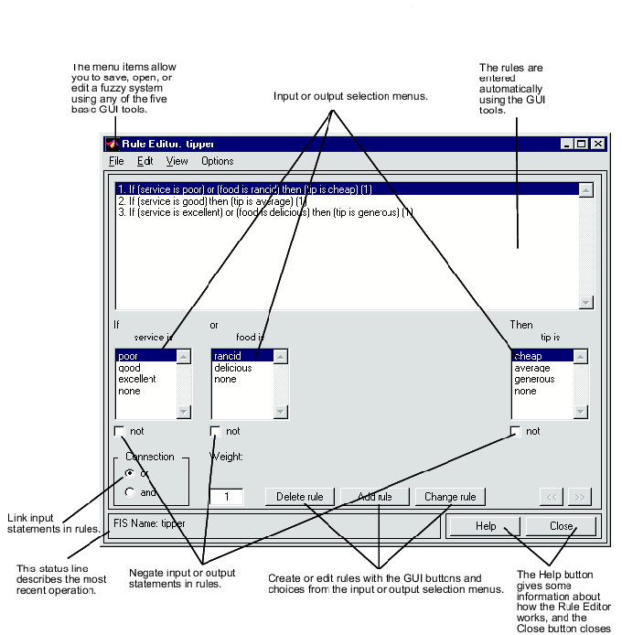
Fig. 3.9 Rule editor of the toolbox

3.8.4 RULE VIEWER

After building the fuzzy system with FIS editor, MF editor, and the rule Editor, the Rule Viewer permits the operation and contribution of individual rules to the output to be checked. In Fig. 3.10, each rule is a row of plots , and each column is a variable.

Fig. 3.10 Rule viewer of the toolbox

3.8.5 SURFACE VIEWER

The surface Viewer, as shown in Fig. 3.11, permits us to view the mapping relations between the input and output variables after building the fuzzy system. The three dimensional plot gives a clear picture of contributions of inputs to the output.

Fig. 3.11 Control surface viewer of the toolbox

3.9 DIFFICULTIES IN FUZZY SYSTEM DESIGN

Although the results of fuzzy systems are excellent, the controller does not have any systematic design approach. It is difficult to know precisely how to select the distribution of fuzzy sets for each variable, the shape and slope of MFs, their degree of asymmetry if needed, and the overlap. Similar problems exist for the design of the rule table. The whole design approach is approximate and depends on the designer’s or operator’s experience with the behaviour of the plant. Therefore, fuzzy systems design may sometimes be tedious and time consuming. With such a design approach, performance prediction is difficult. If there is no model of the system, performance of the fuzzy system is to be iterated based on experimental results. Some of the difficulties in the fuzzy system design are :
- THERE IS NO SYSTEMATIC DESIGN APPROACH
- NO DEFINITE CRITERIA FOR SELECTION OF:
FUZZY SETS OF VARIABLES
SHAPE AND SLOPE OF MFs
DEGREE OF OVERLAP OF MFs
RULE TABLE
- TUNING OF RULE TABLE FOR OPTIMUM RESPONSE MAY BE TIME CONSUMING IF ITERATION IS BASED ON EXPERIMENTAL RESULTS
- SYSTEM ANALSIS AND PERFORMANCE PREDICTION ARE DIFFICULT
- USE ITERATION BY SOFTWARE PROGRAM ON SIMULATED SYSTEM IF MATHEMATICAL PLANT MODEL IS AVAILABLE
- COMPUTATION RESULTS ARE ALWAYS APPROXIMATE
(SOFT COMPUTATION)

3.10 CONCLUSION

In this chapter, a brief description of fuzzy logic and fuzzy controllers was presented. The implementation of fuzzy PD control in MATLAB fuzzy logic toolbox was also discussed in detail.

CHAPTER IV
MATHEMATICAL MODELLING AND MATLAB SIMULATION OF VOLTAGE CONTROLLER FOR THREE PHASE ALTERNATOR
4.0 GENERAL

A newly developed control system should be simulated on a computer prior to breadboard or prototype development, particularly if it is complex.
A simulation study can provide the steady state, transient and fault performance of the system and can also help to design the system and its protection. The software emulation and virtual performance tests give the developer a lot of confidence in the product development. The FFT analysis of waveforms can aid in line power quality studies and design. Simulation results are highly educational. If a simulated system behaves abnormally, there is no fear of any damage.
In last few decades, number of simulation packages are made available by various manufacturers such as:

- MATLAB/SIMULINK
- PSPICE
- PSIM
- EMTP
- ACSL
- MATRIX_{x}
- SIMNON
- SABER
- C

Most of these programs are available for personal computers. Historically, analog, digital and hybrid computers have been widely used for simulation. However, digital simulation are widely popular now. Some of the programs listed above are good for circuit simulation, and others are good for system simulation. For example, MATLAB simulink is more convenient for system simulation, whereas PSPICE is more convenient for circuit simulation. Recently, simulink’s capability has been advanced by addition of simpower systems. PSIM provides the advantage of circuit simulation hybriding with system simulation. EMTP (Electro-Magnetic Transients Program) is circuit oriented and has traditionally used in power systems that incorporate power electronics. Simnon is equation oriented, where each element is described by a state space equation and then interconnected by a connection routine. ACSL (recently named ACSL sim) and MATRIX_{x} are also equation based programs. SABER provides large and powerful sophisticated simulation of analog and digital systems that may include electric, power electronic, hydraulic, mechanical, etc, systems. The traditional C or even FORTRAN language has been widely used in simulation of power electronic systems. One advantage of C simulation is that the controller codes can be used in DSP for real time control. One general rule in simulation programs is that the more users friendly it is, the slower it is. Of course, with the current dramatic increase in computer speeds, this is not much of a problem.
4.1 SYSTEM DESCRIPTION
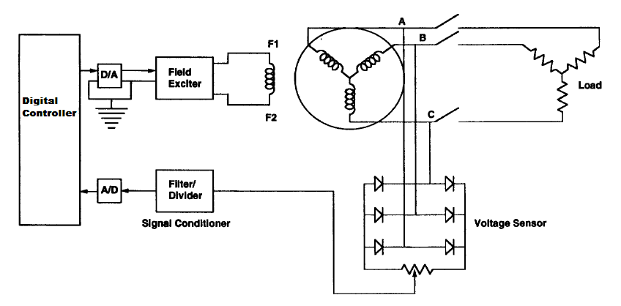
Fig. 4.1 General schematic of the set up

The general schematic of the system is shown in Fig. 4.1. It consists of a synchronous generator, the output voltage of which is rectified. This rectified voltage is then fed to the controller which compares the actual output with a reference voltage and based on the error, i.e., the voltage difference between the reference and the actual voltage and the rate of change of error, the controller takes an intelligent decision on the amount of field voltage to be applied to the generator so that the output voltage remains constant under varying load conditions.

4.2 MATHEMATICAL MODELING OF SYSTEM FOR VOLTAGE CONTROL OF ALTERNATOR

4.2.1 MATHEMATICAL MODEL OF ALTERNATOR
The d-q equivalent circuit of the synchronous generator is shown in Fig.4.2. The model is represented in the rotor reference frame (qd frame). All rotor parameters and electrical quantities are viewed from stator. They are identified by primed variables. The subscripts used are defined
- d, q: d and q axis quantity
- R, s: Rotor and stator quantity
- l, m: Leakage and magnetizing inductance
- f, k: Field and damper winding quantity
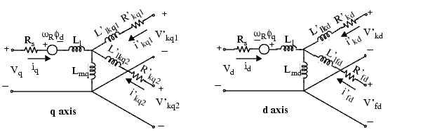
Fig. 4.2 Electrical model of the synchronous generator
With the following equations
$V_{d}=R_{s}i_{d}+\frac{d}{\text{dt}}φ_{d}−ω_{R}φ_{q}$ (4.1)
$V_{q}=R_{s}i_{q}+\frac{d}{\text{dt}}φ_{q}−ω_{R}φ_{d}$ (4.2)
$V_{\text{fd}}^{'}=R_{\text{fd}}^{'}i_{\text{fd}}^{'}+\frac{d}{\text{dt}}φ_{\text{fd}}^{'}$ (4.3)
$V_{\text{kd}}^{'}=R_{\text{kd}}^{'}i_{\text{kd}}^{'}+\frac{d}{\text{dt}}φ_{\text{kd}}^{'}$ (4.4)
$V_{\text{kq}1}^{'}=R_{\text{kq}1}^{'}i_{\text{kq}1}^{'}+\frac{d}{\text{dt}}φ_{\text{kq}1}^{'}$ (4.5)
$V_{\text{kq}2}^{'}=R_{\text{kq}2}^{'}i_{\text{kq}2}^{'}+\frac{d}{\text{dt}}φ_{\text{kq}2}^{'}$ (4.6)
$φ_{d}=L_{d}i_{d}+L_{\text{md}}\left(i_{\text{fd}}^{'}+i_{\text{kd}}^{'}\right)$ (4.7)
$φ_{q}=L_{q}i_{q}+L_{\text{mq}}i_{\text{kq}}^{'}$ (4.8)
$φ_{\text{fd}}^{'}=L_{\text{fd}}^{'}i_{\text{fd}}^{'}+L_{\text{md}}\left(i_{\text{fd}}+i_{\text{kd}}^{'}\right)$ (4.9)
$φ_{\text{kd}}^{'}=L_{\text{kd}}^{'}i_{\text{kd}}^{'}+L_{\text{md}}\left(i_{d}+i_{\text{fd}}^{'}\right)$ (4.10)
$φ_{\text{kq}1}^{'}=L_{\text{kq}1}^{'}i_{\text{kq}1}^{'}+L_{\text{mq}}i_{q}$ (4.11)
$φ_{\text{kq}2}^{'}=L_{\text{kq}2}^{'}i_{\text{kq}2}^{'}+L_{\text{mq}}i_{q}$ (4.12)

4.2.2 MATHEMATICAL MODEL OF HYDRAULIC TURBINE

The block diagram as shown in Fig. 4.3 represents the dynamic characteristics of a simple hydraulic turbine, with a penstock, unrestricted head and tail race, and with either a very large or no surge tank.
The penstock is modeled by assuming an incompressible fluid and an incompressible fluid and a rigid conduit of length L and cross section A. Penstock head losses are proportional to flow squared and f_{p} is the head loss coefficient usually ignored.

Fig. 4.3 Non linear Model of Hydraulic turbine.
From the laws of momentum, the rate of flow of conduit is
$\frac{d\overline{q}}{\text{dt}}=\left(\overline{h_{o}}−\overline{h}−\overline{h_{1}}\right)g$ A/m (4.13)
q¯ turbine flow rate m³/sec
A penstock area m²
L penstock length m
g acceleration due to gravity m/sec²
h_{o}¯ static head of water column m
h¯ head at turbine admission m
h₁¯ head loss due to friction in the conduit m
Expressed in per unit, this relation is
$\frac{\text{dq}}{\text{dt}}=\frac{1−h−h_{1}}{T_{w}}$ (4.14)
where h and h₁ are the head at the turbine and head loss respectively in per unit with h_{base} defined as the static head of the water column above the turbine.
$T_{W}=\frac{L}{A}\frac{q_{\text{base}}}{h_{\text{base}}g}$ sec (4.15)
q_{base} is defined as the turbine flow rate with the gates fully open
The per unit flow rate through the turbine is
$q=G\sqrt{h}$ (4.16)

In an ideal turbine, mechanical power is equal to flow times the head with appropriate conversion factors
The fact that the turbine is not 100% efficient is taken into account by subtracting the no load flow from the actual flow giving the difference as the effective flow, which, multiplied by head produces mechanical power. There is also speed deviation damping effect which is a function of gate opening.
Per unit turbine power on generator MVA base is expressed as
$P_{n}=A_{t}h\left(q−q_{\text{nl}}\right)−\text{DG}ΔW$ (4.17)
Where
q_{nl} per unit no load flow accounting for turbine fixed power losses
A_{t} proportionality factor and is assumed constant
$A_{t}=\frac{\text{Turbine}\text{.}\text{.}\text{.}\text{MW}\text{.}\text{rating}}{\left(\text{Gen}\text{.}\text{.}\text{MVA}\text{.}\text{rating}\right)h_{r}\left(q_{r}−q_{\text{nl}}\right)}$ (4.18)

4.2.3 MATHEMATICAL MODEL OF LOAD

The load used in this project is purely resistive in nature. The expressions for voltage and power are given as
Voltage across the load
$V_{l}=I_{l}R_{l}$ (4.19)
Power dissipated in the load
$P_{l}={V_{l}^{2}}/{R_{l}}$ (4.20)
4.2.4 MATHEMATICAL MODEL OF VOLTAGE CONTROLLER

I PI CONTROLLER

This is a control mode that results from a combination of the proportional mode and the integral mode. The main advantage of this composite control mode is that the integral mode eliminates the offset problem of proportional controllers. The mode can be used in systems with frequent or large load changes. The analytic expression for this control process is:
$p=K_{p}e+K_{I}\int_{0}^{t}{e}\text{dt}$ (4.21)

Where
K_{p} proportional gain
K_{I} integral gain
p controller output
e error

II SLIDING MODE CONTROLLER

Two major and complementary approaches to dealing with model uncertainty are robust control and adaptive control. A simple approach to robust control is the sliding control methodology. It is based on the remark that it is much easier to control 1st order systems
( i.e. systems described by first order differential equations) be they nonlinear or uncertain than it is to control a general nth order system. Sliding control has been applied successfully to robot manipulators, underwater vehicles, automotive transmissions and engines, high performance electric motors and power systems.
Consider the single input dynamic system
$x=f\left(x\right)+b\left(x\right)u$ (4.22)
Where the scalar x is the output of interest, the scalar u is the control input, and x is the state vector. The function f(x) and the control gain b(x) are not exactly known. The control problem is to get the state x to track a specific time varying sate x_{d} in the presence of model imperfection on f(x) and b(x).
Let x₁ be the tracking error such that
$x_{1}=x−x_{d}$ (4.23)
Let a time varying surface S(t) be defined by the scalar equation
$s\left(x;t\right)={\left(\frac{d}{\text{dt}}+λ\right)}^{n−1}x_{1}$ (4.24)
where λ is a strictly positive constant. When n=2, eq. 4.24 becomes
$s={\overset{˙}{x}}_{1}+{λx}_{1}$ (4.25)
This equation is used to design the controller used in this project. The value of λ is chosen to be 4000 and x₁ is the error between the actual output voltage of the generator and the reference value.

III FUZZY LOGIC CONTROLLER

The fuzzy logic controller implemented in this project is PD in nature. The fuzzy PD controller describes with the aid of fuzzy if then rules, the relationship between the control value u(k) on one hand and the error e(k) and its change $Δe\left(k\right)=e\left(k\right)−e\left(k−1\right)$ on the other hand as
$u\left(k\right)=F\left(e\left(k\right),Δe\left(k\right)\right)$ (4.26)
the rules of this FLC have as inputs(antecedents), the error e and its change $Δe$ and as output the control u.
the mapping in eq. 4.26 implemented in the FLC is similar to the known PD controller .
$u\left(k\right)=K_{p}e\left(k\right)+K_{D}Δe\left(k\right)$ (4.27)
Hence the fuzzy control algorithm realizing the control law is called PD like FLC.

4.3 MATLAB/SIMULINK

Simulink is a toolbox in MATLAB. A toolbox is defined as a subprogram in the MATLAB environment for solving specialized problems. Simulink is a simulation program with graphical use interface (GUI). Signal processing helps analysis of time and frequency domain signals. Control system helps modeling, analysis and design of control systems. System identification helps generation of mathematical system and parameters. Fuzzy logic, neural network and genetic algorithm toolboxes help in the design of intelligent control and estimation of the system. Programs in different toolboxes can be interconnected to build and study a composite system. For example, in neural network designed with the neural network toolbox can be embedded in a simulink based drive simulation program, and system performance can then be studied.
- SIMULINK FEATURES
- POWERFUL MATHEMATICAL MODEL BASED SYSTEM
- SIMULATION PROGRAM IN MATLAB ENVIRONMENT
- GRAPHICAL USER INTERFACE(GUI)
- SIMULATION OF NON LINEAR DYNAMIC SYSTEMS
LINEAR/NONLINEAR
CONTINOUS/DISCRETE TIME
MULTIRATE
HIERARCHICAL MODEL
- LIBRARY OF GRAPHICAL BUILDING BLOCKS
- USER INTERFACE FROM MATLAB , FORTRAN, OR C CODE
- CAN GENERATE C CODE FROM MODELS FOR REAL TIME CONTROL
- SIMULATION CAN BE LINKED WITH OTHER TOOLBOXES
- SIMULATION RESULTS CAN BE USED FOR MATLAB PROCESSING
- EXTENSIVE GRAPHICS CAPABILITY

Simulink is basically a digital simulation program for non linear dynamic systems that operate in the MATLAB environment, where MATLAB is used as its computational engine. The system can be continuous, discrete time or a multi rate with different sample times. Complex models can be represented by adding a hierarchy of subsystems. The systems mathematical model is to be developed first either in the time domain in terms of state space, integral and algebraic equations, or with Laplace transfer functions prior to simulation study. The graphical user interface permits fast simulation setups. Simulink has a graphical block library of sources, sinks, continuous, discontinuous , discrete , lookup tables, math operations, signal attributes, signal routing etc. The blocks can be drag into the model window and interconnected. The parameters of clock can be defined in the dialog box. An integration method is selected before running the simulation. Often, a fixed but conservatively selected time step shortens the simulation time. The running of simulation is interactive; i.e., the parameters can be changed on the fly to observe the effect of the change. The simulation results can be observed on scope or stored in work space or files. The system designed can be optimized by means of iterative simulation studies. Once the simulation is iterated for successful design, the real time workshop program can translate the controller software into C code, which can be compiled and used in DSP for real time control. In addition, simulink can generate VHDL (very high speed hardware description language) software for FPGA implementation of control system. This is one of the great advantages of simulink simulation. The simulation waves can be used, for example, to plot a harmonic spectrum by using a MATLAB based Fourier analysis program.
In the last few years, simulink has become the most widely used software package in academia and industry for modeling and simulating dynamic systems.
Simulink encourages one to try things out. One can easily build models from scratch, or take an existing model and add to it. Simulations are interactive, so one can change parameters on the fly and immediately see what happens. There is an instant access to all the analysis tools in MATLAB so on can take the results and analyze and visualize them.
With simulink, one can move beyond idealized linear model to explore more realistic non-linear models, factoring in friction, air resistance, gear slippage, hard stops, and the other things that describe real world phenomena.

4.3.1 MATLAB MODEL OF ALTERNATOR(SYNCHRONOUS MACHINE)

A MATLAB simulink model of Synchronous machine is shown in Fig. 4.3.
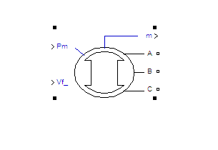
Fig. 4.3 Synchronous machine model
The synchronous machine operates in generator or motor modes. The operating mode is dictated by the sign of the mechanical power (positive for generator mode and negative for motor mode).
INPUTS AND OUTPUTS
The first Simulink input is the mechanical power (Pm) at the machine's shaft. In generating mode, this input can be a positive constant or function or the output of a prime mover block In motoring mode, this input is usually a negative constant or function.
The second Simulink input of the MATLAB block is the field voltage (Vf). The notation
m The Simulink output of the block is a vector containing 22 signals. One can demultiplex these signals by using the Bus Selector block provided in the Simulink library.
1 Stator current is_a
2 Stator current is_b
3 Stator current is_c
4 Stator current is_q
5 Stator current is_d
6 Field current ifd
7 Damper winding current ikq1
8 Damper winding current ikq2
9 Damper winding current ikd
10 Mutual flux phimq
11 Mutual flux phimd
12 Stator voltage vq
13 Stator voltage vd
14 Rotor angle deviation
15 Rotor speed wm
16 Electrical power Pe
17 Rotor speed deviation
18 Rotor mechanical angle
19 Electromagnetic torque Te
20 Load angle delta
21 Output active power Peo
22 Output reactive power Qeo

4.3.2 MATLAB MODEL OF HYDRAULIC TURBINE

The MATLAB model of the hydraulic turbine is shown in Fig. 4.4
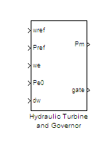
Fig. 4.4 Hydraulic turbine model
The Hydraulic Turbine and Governor block implements a nonlinear hydraulic turbine model, a PID governor system, and a servomotor as shown in Fig. 4.5.

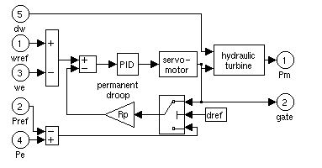
Fig. 4.5 Hydraulic turbine and Governor block.

The hydraulic turbine is modeled by the following nonlinear system.

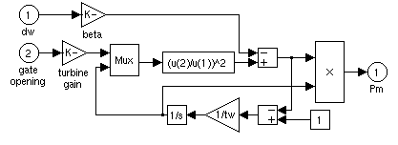
Fig. 4.6 Model of Hydraulic turbine.

The gate servomotor is modeled by a second-order system.

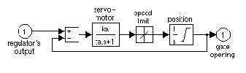
Fig. 4.7 Model of Gate Servomotor.

Inputs and Outputs

wref
Reference speed, in p.u.
Pref
Reference mechanical power in p.u. This input can be left unconnected if you want to use the gate position as input to the feedback loop instead of the power deviation.
we
Machine actual speed, in p.u.
Pe0
Machine actual electrical power in p.u. This input can be left unconnected if you want to use the gate position as input to the feedback loop instead of the power deviation.
dw
Speed deviation, in p.u.
Pm
Mechanical power Pm for the Synchronous Machine block, in p.u.
gate
Gate opening, in p.u.

4.3.3 MATLAB MODEL OF FUZZY LOGIC CONTROLLER:

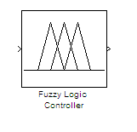
Fig. 4.5 Fuzzy logic controller model

The model of the fuzzy logic controller is shown in Fig. 4.5. The FLC takes two inputs, i.e., the error and the rate of change of error. Based on these inputs, The FLC takes an intelligent decision on the amount of field voltage to be applied which is taken as the output and applied directly to the field winding of generator
The two fuzzy state variables are:
(i)Voltage error: which is the difference between the predetermined set voltage and the actual voltage. This error can be either positive or negative. The error is positive if the actual voltage is higher than the set voltage and negative if the actual voltage is less than the set voltage.
(ii) del_voltage: it is the rate of change of voltage . It is positive if the voltage is rising and negative if the voltage is falling. The one fuzzy control variable is field voltage. Intuitively, the fuzzy control variable field voltage will be positive if the actual voltage drops below the set voltage and negative if the actual voltage rises above the set voltage.
In general, the universe of discourse for all the three variables is he real line ‘R’. However, in practice, each universe of discourse is limited to a comparatively smaller region. For del_voltage, the universe is [+23volt/sec,-23volt/sec] centered about zero , for the voltage error
[-15 volts, 15 volts], for the field voltage [0p.u,2p.u]
Each Universe of discourse can be quantitized into seven overlapping fuzzy set values. The fuzzy variables can be divided into three broad divisions namely positive, zero ,or negative. These divisions can be further quantitized into small, medium, or large. These quantitization yield the following divisions,

NL: Negative large
NM: Negative medium
NS: Negative small
ZE: Zero
PS: positive small
PL: positive large

The exact shape of the fuzzy sets defined above is not of major concern. Although this is not a rule, in practice, the quantitizing fuzzy sets are usually symmetric triangles or trapezoids centered about representative values. This is not a rule though. The essence of fuzzy systems is the overlap between sets.
Voltage control rules are triples such as (NM, ZE, PM) where, NM and ZE correspond to the sets for error and del_voltage respectively, while PM corresponds to the set for field voltage. These rules describe how to modify the control variable for observed values of state variables. The voltage control is a 7 by 7 matrix with linguistic fuzzy sets entries. The columns of the matrix are indexed by the seven fuzzy sets that quantitize the error universe of discourse .On the other hand, the rows are indexed by the seven fuzzy sets that quantitize the ‘del-voltage’ universe of discourse.
Each matrix entry can equal one of the seven field voltage fuzzy set values. Also, for every pair of ‘error’ and ‘del_voltage’ values, there is exactly one ‘field voltage’value. Common sense and a certain amount of experience is used in obtaining the entries for a matrix. For example, if the voltage does not change, the del_voltage=ZE. Now, if ‘error’ is a positive value, then the value of ‘field voltage’ must be negative .Therefore the fourth row corresponding to ‘del_voltage=ZE’ should be equal the ordinal inverse of ‘error’ as shown in the Table. 4.1 . The membership functions of input and output variables are shown in Fig. 4.6

Table. 4.1 Rule base for fuzzy controller

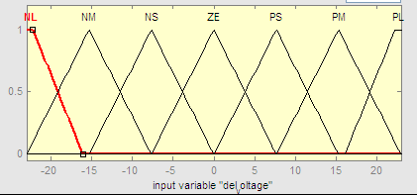

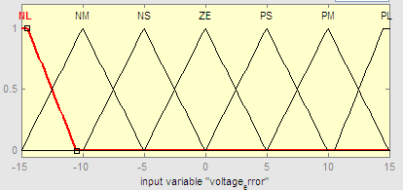

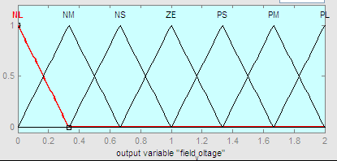

Fig. 4.6 Membership functions(a) del_voltage (b) Voltage error(c) field voltage

The complete MATLAB model of the Synchronous generator with Hydraulic turbine as prime mover is shown in Fig. 4.7. The generator is initially started with 50MW load and after t=1.5s the breaker closes, thus loading the machine further by 50MW. As a result of this, the output voltage of the generator falls. This voltage is rectified, scaled down and compared to a reference value. The error so produced is passed through a derivative block which gives the rate of change of error. This error and the rate of change of error are taken as inputs to the Fuzzy logic controller. The controller takes a decision on the amount of field voltage to be applied depending on the inputs. The output voltage as seen from Fig. 4.8 is thus regulated.

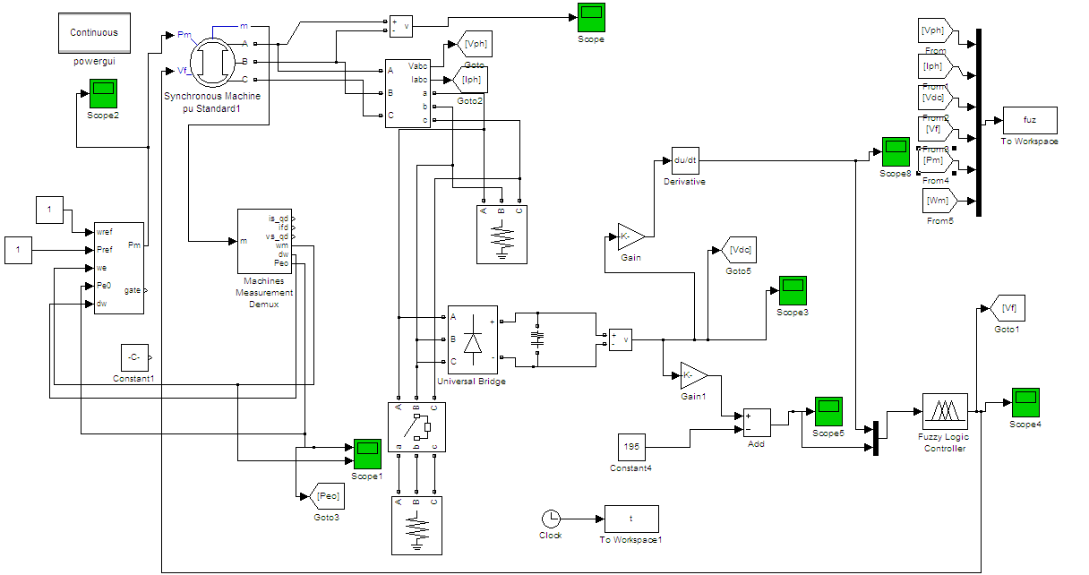
Fig. 4.7 Complete MATLAB model of a Synchronous generator Connected to a
Hydraulic turbine

Fig. 4.8 Output rectified voltage of the Synchronous Generator

4.4 CONCLUSION
In this chapter, mathematical models of Synchronous generator, Hydraulic turbine and different voltage controller i.e. PI, SMC and Fuzzy PD were developed. The simulation model of the Synchronous generator with Fuzzy logic controller as the voltage regulator
was developed in MATLAB for the performance analysis of Synchronous generator under varying load conditions.

CHAPTER V
RESULTS AND DISCUSSION
5.0 GENERAL

The performance of the synchronous generator is studied with and without controller through simulation in MATLAB. The output voltage of the alternator is observed in open loop conditions with constant field voltage; closed loop voltage regulation of the alternator with PI , sliding mode and fuzzy logic controllers are then studied and analyzed in detail.

5.1 SIMULATION RESULTS

5.1.1 PERFORMANCE OF THE ALTERNATOR WITH FIXED EXCITATION

The effect of load variations on the output voltage of the synchronous generator is shown in Fig. 5.2. It is observed that the output voltage of the synchronous generator varies appreciably when a load of 50MW, unity p.f is switched at generator terminals at t=1.5s. Fig. 5.1 shows a MATLAB model of synchronous generator with hydraulic turbine as the prime mover. The generator rating is 187MVA, 13.8KV, 60Hz. The machine is initially started with a resistive load of 50MW and after 1.5s the breaker closes thus loading the machine further by 50MW. The system performance was simulated for 10s .The output voltage of the synchronous machine is rectified through a bridge rectifier. The effect of loading on this dc voltage is shown in Fig. 5.2. The variation of generator terminal voltage (V_{g}), generator line current(i_{L}), prime mover power(Pm), Load power(Peo) and field excitation(Ifd) is also shown in Fig. 5.3. With switching of load (50 kW) at t=1.5s, the voltage of the generator drops significantly, clearly indicating poor voltage regulation with fixed excitation.

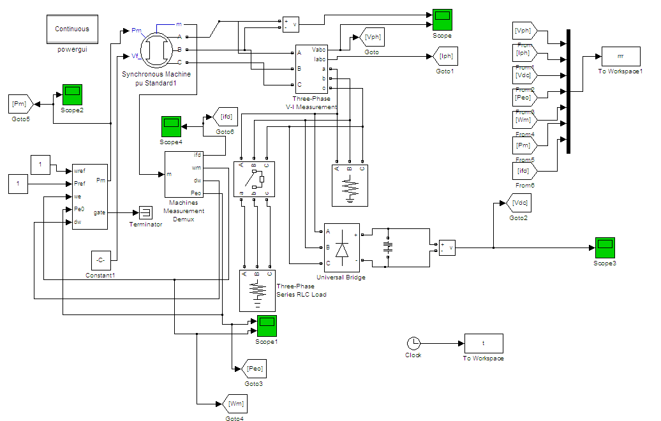

Fig. 5.1 MATLAB model of Synchronous generator with fixed excitation and switching of load of 50 MW at t=1.5s.

Fig.5.2 Rectified terminal voltage of synchronous generator

Fig.5.3 Performance of alternator with fixed excitation.

The alternator is started with an initial load of 100MW. At t=1.5sec, the load is further increased upto 150MW and at t=4.5s, the load is thrown off by 50MW
Fig. 5.4 and Fig. 5. 5 show the variation of different parameters

Fig.5.4 Rectified terminal voltage of synchronous generator

Fig.5.5 Performance of alternator with fixed excitation.
5.1.2 PERFORMANCE WITH PI CONTROLLER FOR EXCITATION CONTROL

Fig. 5.6 shows the MATLAB model of an alternator with a PI controller for its excitation control.
The performance of the alternator is studied when a PI controller for excitation control is used which regulates the field voltage of the synchronous generator under various loading conditions. The generator is initially started with a load of 50MW and after t=1.5sec, an additional load of 50MW is put on the generator terminals. The output voltage of the synchronous generator is rectified through a bridge rectifier. This dc voltage is then stepped down and is compared with a reference value (195V). The error (change in voltage between the reference and the actual output voltage) and the integral of the error is calculated and the field voltage varies according to these two inputs. The various waveforms are shown in Fig.5.7 and Fig. 5.8

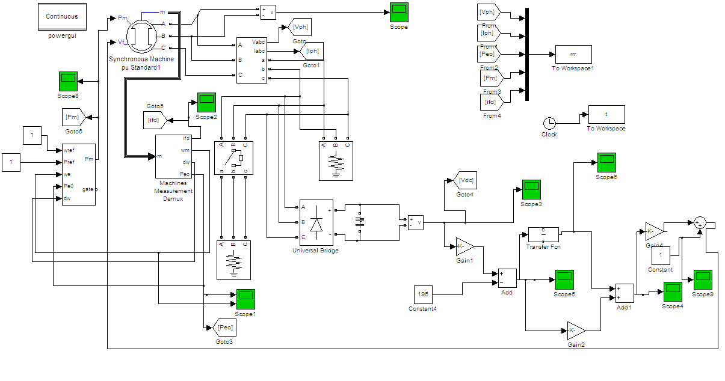

Fig. 5.6 Matlab Model Of Synchronous Generator with PI controller and switching of load of 50MW at t=1.5sec.
Fig.5.7 Rectified terminal voltage of synchronous generator

Fig. 5.8 Performance of alternator with PI excitation controller
The alternator is started with an initial load of 100MW. At t=1.5sec, the load is further increased upto 100MW and at t=4.5s, 50 MW load is thrown off.
Fig. 5.9 and Fig. 5.10 show the variation of different parameters.
Fig. 5.9 Rectified terminal voltage of synchronous generator
Fig. 5.10 Performance of alternator with PI excitation controller

5.1.3 PERFORMANCE WITH SLIDING MODE CONTROLLER FOR EXCITATION CONTROL

The PI controller for excitation control with varying load is now replaced by a sliding mode controller. The model of the synchronous generator with sliding mode controller as the voltage regulator is shown in Fig. 5.11. The various waveforms are shown in Fig 5.12 and Fig 5.13 when the alternator is suddenly loaded by 50MW at t=1.5s

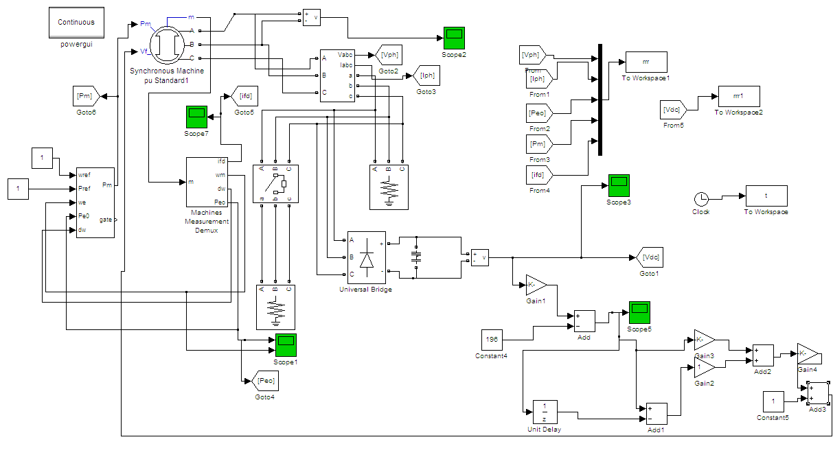

Fig. 5.11 MATLAB Model Of Synchronous Generator with SMC controller and switching of load of 50MW at t=1.5sec.

Fig. 5.12 Rectified terminal voltage of synchronous generator

Fig. 5.13 Performance of the Alternator with SMC controller.

The alternator is started with an initial load of 100MW. At t=1.5sec, the load is further increased upto 150MW and at t=4.5s, 50MW load is thrown off .
Fig. 5.14 and Fig. 5. 15 show the variation of different parameters

Fig. 5.14 Rectified terminal voltage of synchronous generator

Fig. 5.15 Performance of the alternator with SMC controller
5.1.4 PERFORMANCE WITH FUZZY LOGIC CONTROLLER FOR EXCITATION CONTROL
The output voltage is now regulated by the fuzzy logic controller. The rule base and the membership functions have been already described in the previous chapter. Fuzzy logic controller takes two inputs: the change in voltage and the rate of change of voltage and the output is the field voltage which varies according to the change in the two inputs.
The output voltage of the generator is rectified and compared with a reference which gives the error. The error is then passed through a derivative block which gives the rate of change of error. These two inputs go to the fuzzy logic controller which then takes an intelligent decision on the amount of field voltage to be applied based on these two inputs. Fig. 5.16 shows the synchronous generator connected to the FLC. Fig. 5.17 and Fig. 5.18 shows the various waveforms when a load of 50MW is suddenly put on the generator terminals at t=1.5s.

Fig. 5.16 MATLAB Model Of Synchronous Generator with SMC controller and switching of load of 50MW at t=1.5sec.
Fig. 5.17 Rectified terminal voltage of synchronous generator

Fig. 5.18 Performance of the alternator with FLC controller

The alternator is started with an initial load of 100MW. At t=1.5sec, the load is further increased upto 150MW and at t=4.5s, 50MW load is thrown off .
Fig. 5.19 and Fig. 5. 20 show the variation of different parameters.
Fig. 5.19 Rectified terminal voltage of synchronous generator

Fig. 5.20 Performance of the alternator with FLC controller

5.2 PERFORMANCE WITH VARIOUS CONTROLLERS

A comparative study on the performance of synchronous generator 187MVA, 13.8kV, 20 pole, 60Hz with P, PI, SMC, and Fuzzy controller is summarized in Table. 5.1

Sr. No. | Rating of Alternator | Performance parameters with fixed excitation |  | Performance parameters with PI Controller |  | Performance parameters with SMC Controller |  | Performance parameters with Fuzzy controller
 | 187MVA  13.8kV  Pole 20  60Hz | Voltage regulation (% VR) | Steady state error(V) | Voltage regulation (% VR) | Steady state error(V) | Voltage regulation (% VR) | Steady state error(V) | Voltage regulation (% VR) | Steady state error(V)
1 | 187MVA  13.8kV  Pole 20  60Hz | 11.282 | 2200 | 4.10 | 800 | 2.564 | 500 | 1.02 | 200
2 | 187MVA  13.8kV  Pole 20  60Hz | 11.34 | 200 | 4.12 | 100 | 2.835 | 100 | 1.8 | 50

Table 5.1 A comparison of voltage regulation characteristics of alternator with different excitation controllers

5.3 CONCLUSION

In this chapter the results of the various simulations are shown which are carried out in MATLAB SIMULINK. The performance of the synchronous generator with various excitation controllers is presented. The voltage regulation of the synchronous generator with PI, SMC, and FLC controller is described in detail. It has been observed that the fuzzy logic controller performs the best in regulating the voltage of the alternator followed by the sliding mode controller.

CHAPTER VI
CONCLUSION AND FUTURE SCOPE OF WORK

6.0 CONCLUSION

In this project, mathematical modeling and MATLAB simulation for voltage regulation through excitation control of synchronous generator is described in details. Different types of excitation controllers such as PI, SMC, and FLC have been used and simulation performance of the synchronous generator is obtained and analyzed in detail. A fuzzy logic controller when used to regulate the output voltage of a synchronous generator under various loading conditions offers superior performances.

6.1 FUTURE SCOPE OF WORK

This project describes the voltage regulation of the Synchronous generator under different loading conditions. With the increase in load, the speed of the prime mover also decreases. A control strategy based on fuzzy logic can be adopted to bring the speed back to its reference value.
The simulation results obtained from this project can be used to implement the fuzzy logic controller for voltage regulation in real time.

REFERENCES

- AHMS Ula., Abul R Hasan, “Design and Implementation of a Personal Controller Based Automatic Voltage Regulator for a Synchronous Generator ”,IEEE Transactions on Energy Conversion,Vol. 7, No1,March 1992, pp 125-131
- Adel A. Ghandakly.,Jiang J.Dai, “An adaptive synchronous generator stabilizer design by generalized multi variable pole shifting (GPMS) technique”,Transactions on power systems, Vol.7,No3,Aug 1992,pp 1239-1244
- Juan Shi.,L.H. Herron.,A.Kalam,”Design and implementation of a PC based automatic voltage regulator and fuzzy logic power system stabilizer”,IEE 2nd international conference on advances in power system control,operation and management”,Dec 1993, pp 293-298
- Steven D. Kaehler “Fuzzy logic- an introduction”
- Hasan, Abul R., Martis, Thomas S., Sadrul,A.H.M, “Design and Implementation of a Fuzzy Controller Based Automatic Voltage Regulator for a Synchronous Generator”, IEEE Transactions on ElectricalMachinery,Vol.9,No.6, Sep. 1994,pp 550-557
- Ching-Tzong., Hong-Rong Hwung., Guor-Rurng Lii, “Fuzzy logic based voltage control for a synchronous generator”, Electric Power System Research,1997,225-231
- Brock J. LaMeres.,” Design and implementation of a fuzzy logic based voltage regulation of a synchronous generator”,Montana state university.
- M.N.Cristea., A. Dinu.,J.G. Khor., M. McCormick, Neural and fuzzy logic control of drives and power systems.
- Damir Sumina., Tomislav Idzotic., Igor Erceg, “Fuzzy Logic control of synchronous under the condition of transient three phase short circuit”, IEEE transactions on electrical machinery, 2006
- Yong-Hua ., Allan T. Johns, “ Applications of fuzzy logic in power systems-Part 1”, Power engineering journal, October 1997
- Yong-Hua ., Allan T. Johns, “ Applications of fuzzy logic in power systems-Part 2”, Power engineering journal, August 1998
- Yong-Hua ., Allan T. Johns, “ Applications of fuzzy logic in power systems-Part 3”, Power engineering journal, April 1999
- P. Lakshmi., M. Abdullah Khan, “ Design of a robust power system stabilizer using fuzzy logic for a multi machine power sytem”, Electric Power System Research,1998.
- K.A. El-Metwally., O.P. Malik, “ Application of Fuzzy Logic Stabilizers in a Multi machine Power System Environment”, IEE Proc-generation, transmission, distribution, Vol 143, No 3, May 1996.
- Norman Mariun., Samsul Bahari Mohd Noor., Jastronita Jasni.,Omar S.Bennanes, “ A Fuzzy Logic based Controller for an indirect vector controlled three-phase alternator”,IEEE transactions on electrical machinery,2004
- Liping Gua., J.Y.Hang., R.M.Nelms, “ Design and implementation of sliding mode fuzzy controllers for Buck Converter”
- V.S.C Raviraj., P.C.Sen., “ Comparative study of proportional-integral,Sliding Mode, and Fuzzy Logic Controllers for Power converters”.IEEE transactions on industry applications,Vol 33,No 2,March 1997.
- Sergey Drakunov., Vadin Utkin, “ Sliding mode observers”, IEEE Proceedings of the 34th conference of decision and control. Dec 1995
- M.G.Say, The performance and Design of Alternating Current Machines.
- Ronald R.Yager., Dimitar P. Filev, Essentials of Fuzzy modelling and control.
- Bimal Bose., Power electronics and Motor drives.
- Mohammad Jamshidi.,Andre Titli., Lotfi Zadeh, Applications of fuzzy logic.
- I.J Nagrath.,D.P Kothari, Electric Machines.
- S.A.Nasar, Handbook of Electric Machines
- htpp://www.mathswork.com

APPENDIX

SYNCHRONOUS MACHINE RATING
Nominal Power- Pn = 187e6 VA
Line-Line Voltage- Vn(Vrms) = 13800
Frequency- fn = 60Hz
Reactances(pu)
Xd = 1.305 Xq = 0.474
Xd^{́ =} 0.296 Xq́́́ = 0.243
Xd^{́́́́́ =} o.252
Stator resistance- Rs(pu) =.003
Coefficient of inertia H(s) = 3.7
Friction F(pu) = 0
Pole pairs 20

HYDRAULIC TU RBINE AND GOVERNER
Servo motor where
Ka = 10/3
Ta = .07
Hydraulic turbine
Beta = 0
Tw = 1.67

