A MAJOR THESIS
AN EXPERIMENTAL STUDY OF EFFECT OF WELDING PARAMETERS ON WELD HARDNESS IN MIG WELDING OF SS 304 TAGUHI & RESPONSE SURFACE METHODOLOGY TECHNIQUES OF D.O.E.

BY

KAPIL YADAV

Roll No. 06/PROD/05
Uni.Roll No 2405

UNDER THE GUIDANCE OF
Dr. C.K. DATTA

SUBMITTED IN PARTIAL FULFILLMENT OF THE REQUIREMENT FOR THE AWARD OF THE DEGREE OF

MASTER OF ENGINEERING

TO



DEPATMENT OF MECHANICAL ENGINEERING
DELHI COLLEGE OF ENGINEERING
YEAR 2005-07
CERTIFICATE

I, kapil yadav, hereby certify that the work which is being presented in the thesis entitled “AN EXPERIMENTAL STUDY OF THE EFFECT OF PARAMETER ON WELD HARDNESS IN MIG WELDING OF SS 304 BY USING TAGUCHI & RESPONSE SURFACE METHODOLOGY TECHNIQUES OF D.O.E.” in the partial fulfillment of requirement for the award of Degree of MASTER OF ENGINEERING submitted in the Department of Mechanical Engineering at DELHI COLLEGE OF ENGINEERING under DELHI UNIVERSITY, DELHI, is an authentic record of my own work carried out during a period from July 2006 to July 2007, under the supervision of PROF. C.K. DATTA (Mechanical Engg. Department). The matter presented in this thesis has not been submitted in any other University/ Institute for the award of any degree.

(KAPIL YADAV)
Roll No. 06/prod/05
University Roll No. 2405

This is to certify that the above statement made by the candidate is correct to best of my knowledge.
(PROF. C.K.DATTA)
Guide
Acknowledgement
It is a matter of great pleasure for me to present my dissertation report on “AN EXPERIMENTAL STUDY OF THE EFFECT OF PARAMETER ON WELD HARDNESS IN MIG WELDING OF SS 304 BY USING TAGUCHI & RESPONSE SURFACE METHODOLOGY TECHNIQUES OF D.O.E”. First and foremost, I am profoundly grateful to my guide PROF C.K.DATTA, Mechanical Engineering Department for his expert guidance and continuous encouragement during all stages of thesis. His help in the form of valuable information and research papers at proper time has brought life in this thesis. I feel lucky to get an opportunity to work with him. Not only understanding the subject, but also interpreting the results drawn thereon from the graphs was very thought provoking. I am thankful to the kindness and generosity shown by him towards me, as it helped me in completing the project before actually starting it.
I wish to express my gratitude to SH V JEGANATHAN, Mechanical Engineering Department workshops.
I would also like to thank Mr. DESHRAJ (welding shop In Charge), Mr. PRADEEP (metallurgical lab In Charge) for their cooperation. Without their support it would have been almost impossible to complete my thesis work in time.
I would also like to extend my sincere thanks to all staff members of the Mechanical Engineering Department for the moral support and encouragement they had given to me during completion of this thesis.
Last, but not the least, I would like to thank my family members and my classmates for their help, encouragement and prayers through all these months. I dedicate my work to them.

Abstract
This study aimed at the investigation of the effect of preheating, shielding gas flow rate and heat input on the hardness of weldment. In this study, 304 stainless steel was bonded by MIG welding with Argon as a shielding gas and hardness properties of the welded samples at different points from the weld centre line was investigated. For that purpose welding was done with different level of preheat, shielding gas flow rate and heat input. Welding samples were characterized by means of hardness test on optical Brinell hardness tester. Hardness test revealed that for all welding parameters hardness in HAZ and weld metal was higher than parent metal.
With application of design of experiment (DOE) mathematical relationship between the welding process input parameters and output variable like hardness of welded joint in order to determine the welding input parameters that lead to desired weld hardness. Preheat, shielding gas flow rate, and heat input are selected as input parameter and hardness as output parameter. By application of response surface methodology and Tanguchi method of DOE, relationship between these parameters and Hardness was developed.
The experiment result show that the heat input has greatest effect. Gas flow rate has second largest effect on hardness and preheat has very little effect on hardness of weldment.

Keywords: MIG; SS 304; Preheat; Gas flow rate; Heat input; Hardness.

CONTENTS
Page No.

Certificate i
Acknowledgement ii
Abstract iii
List of figures vii
List of Tables ix

Introduction 1
Literature review 3

Chapter 1: GAS METAL ARC WELDING (GMAW) OF AISI 304
1.1 Introduction 8
1.2. Typical GMAW Process Control Settings 10
1.3. Holding and Positioning Welding Gun 13
1.4. Conditions That Affect Weld Bead Shape 14 1.5. Gun Movement during Welding 15
1.6. Poor Weld Bead Characteristics 15
1.7. Good Weld Bead Characteristics 16
1.8. Common GMAW Shielding Gases 16
1.9. Modes of GMAW transfer 17
1.10 GMAW welding trouble shooting 21
1.11 Welding of stainless steel 24

Chapter 2: PARAMETER DESIGN OPTIMIZATION OF CNC TURNING USING
DOE
  - Concept of DOE 33
  - Brainstorming 36
    - Objectives of Study and Evaluation Criteria 37
    - Design Factors 37
    - Noise Factors 37
    - Factor Levels 37
    - Interaction between Factors 37
    - Scopes of Studies 37
    - Additional Items 38
  - Types of Optimization Problems 38
    - Static Problems 38
    - Dynamic Problems 39
  - Batch Process Optimization 40
    - Smaller the Better 40
    - Larger the Better 41
    - Nominal the Best 41
  - Steps in Taguchi Methodology 41
  - Response Surface Methodology 43
  - Summary 48

Chapter 3: EXPERIMENTAL WORK
3.1Welding machine: 49
3.2 Material information: 50
3.2.1 Chemical Composition 50
3.2.2 Mechanical properties 51
3.3 Welding parameters 51
3.4 Experimental array 53
3.5 Hardness measurement: 54
3.6 Observed values 60

Chapter 4: RESULTS AND DISCUSSIONS
  - Introduction 62
  - Analysis of Data for hardness by Taguchi method: 62
  - Regression Analysis (by Taguchi method) 64
  - Analysis of Data for Surface Roughness by RSM 65
  - Regression Analysis (by RSM): 68

Chapter 5: CONCLUSION AND FUTURE SCOPE
  - Conclusion 69
  - Scope for Future Work 70
  - References 71

List of figures

Figure No Figure title Page No

1.1 GMAW Process 8
1.2 Typical GMAW Semiautomatic Setup 10
1.3 Parameter selection 12
1.4 Holding and Positioning Welding Gun 13
1.5 Conditions That Affect Weld Bead Shape 14
1.6 Gun movement 15
1.7 Poor Weld Bead Characteristics 15
1.8 Good Weld Bead Characteristics 16
1.9 Short circuit transfer and Short Circuit Cycle 18
1.10 Globular Transfers 19
1.11 Spray Arc Transfer 20
1.12 Schaeffler diagram 31
1.12 De Long Diagram 32
2.1 P-Diagram for Static Problem 38
2.2 P-Diagram for Dynamic Problems 39
3.1 Locations of points of hardness measurement 54
3.2-3.28 Hardness profiles for 1 to 27 run 55-59
4.1 Main Effect Plot for S/N Ratio (hardness) 63
4.2 Main Effect Plot for Mean (hardness) 64
4.3 Interaction chart for S/N 64
4.4 Interaction chart for means 64
4.5 Contour plot of hardness for preheat Vs gas flow rate 66
4.6 Surface plot of hardness for preheat Vs gas flow rate 66
4.7 Contour plot of hardness for preheat Vs heat input 68
4.8 Surface plot of hardness for preheat Vs heat input 68
4.9 Contour plot of hardness for gas flow rate Vs heat input. 68
4.10 Surface plot of Ra for feed Vs depth of cut 68

List of Tables

Table No. Table Description Page No.

1.1 shielding gas selection 17
1.2 Excessive Spatter 21
1.3 Porosity 21
1.4 Incomplete Fusion 22
1.5 Excessive Penetration 22
1.6 lack of penetration 23
1.7 Burn Through 23
1.8 Waviness of Bead 23
1.9 Distortion 24
1.10 Edge preparation choices varying with thickness 27
1.11 Welding consumable types used for austenitic stainless steel 28
3.1 Technical specification of welding machine 49
3.2 Chemical Composition of AISI 304 50
3.3 Mechanical properties of AISI 304 51
3.4 Level of parameters 52
3.6 S/N ratio and mean value of hardness 53
4.1 S/N Ratio and Mean for hardness 62
4.2 Analysis of hardness by RSM method 65

ABSTRACT
This study aimed at the investigation of the effect of preheating, shielding gas flow rate and heat input on the hardness of weldment. In this study, 304 stainless steel was bonded by MIG welding with Argon as a shielding gas and hardness properties of the welded samples at different points from the weld centre line was investigated. For that purpose welding was done with different level of preheat, shielding gas flow rate and heat input. Welding samples were characterized by means of hardness test on optical Brinell hardness tester. Hardness test revealed that for all welding parameters hardness in HAZ and weld metal was higher than parent metal.
With application of design of experiment (DOE) mathematical relationship between the welding process input parameters and output variable like hardness of welded joint is developed in order to determine the welding input parameters that lead to desired weld hardness. Preheat, shielding gas flow rate, and heat input are selected as input parameter and hardness as output parameter. By application of response surface methodology and Tanguchi method of DOE, relationship between these parameters and Hardness was developed.
The experiment result show that the heat input has greatest effect. Gas flow rate has second largest effect on hardness and preheat has very little effect on hardness of weldment.

Keywords: MIG; SS 304; Preheat; Gas flow rate; Heat input

INTRODUCTION
The GMAW welding process is easily found in any industry whose products require metal joining in a large scale. It establishes an electric arc between a continuous filler metal electrode and the weld pool, with shielding from an externally supplied gas, which may be an inert gas, an active gas or a mixture. The heat of the arc melts the surface of the base metal and the end of the electrode. The electrode molten metal is transferred through the arc to the work where it becomes the deposited weld metal (weld bead).
The quality of the welded material can be evaluated by many characteristics, such as bead geometric parameters (penetration, width and height), hardness, residual stresses and deposition efficiency (ratio of weight of metal deposited to the weight of electrode consumed). These characteristics are controlled by a number of welding parameters, and, therefore, to attain good quality, is important to set up the proper welding process parameters. Out of these properties hardness is important property because hardness determines the impact strength, toughness and crack susceptibility of welded joint.
Unfortunately, an underlying mechanism connecting welding parameters and quality characteristics is usually not known. Traditionally, it has been necessary to determine the weld input parameters for every new welded product to obtain a welded joint with the required specifications. To do so, requires a time-consuming trial and error development effort, with weld input parameters chosen by the skill of the engineer or machine operator. Then welds are examined to determine whether they meet the specification or not. Finally the weld parameters can be chosen to produce a welded joint that closely meets the joint requirements. Also, what is not achieved or often considered is an optimized welding parameters combination, since welds can often be produced with very different parameters. In other words, there is often a more ideal welding parameters combination, which can be used if it can only determined.
In order to overcome this problem, various optimization methods can be applied to define the desired output variables through developing mathematical models to specify the relationship between the input parameters and output variables. In the last two decades, design of experiment (DoE) techniques has been used to carry out such optimization.
The Taguchi method is a systematic application of design and analysis of experiments for the purpose of designing and improving product quality. In recent years, the Taguchi method has become a powerful tool for improving productivity during research and development so that high quality products can be produced quickly and at low cost.
One of the most widely used methods to solve this problem is the response surface methodology (RSM), in which the experimenter tries to approximate the unknown mechanism with an appropriate empirical model, being the function that represents it called a response surface model Identifying and fitting from experimental data a good response surface model requires some knowledge of statistical experimental design fundamentals, regression modeling techniques and elementary optimization methods

LITERATURE REVIEW
Many researchers and academicians of international repute have probed into the topic of study of effect of welding parameters whose name and work abstract has been given below:
- Y.C. Lin and K.H. lee in 2005 studied the effect of preheating on hardness in type 304 stainless steel weldment. The study revealed that hardness value was less in preheating than conventional welding.
- BehcetGulenc, KayaDeveli, Nizamettin Kahraman and Ahmet Durgutlu in 2005, have studied the effect of hydrogen in argon as a shielding gas in MIG welding of austenitic stainless steel. Hardness values were studied on parameters like shielding gas composition and welding current.
- A Griffiths, W.Nimmo, B roebuck, G.Hinds and A turnbull in 2004 studied the hardness profile in welding of 13 Cr stainless steel welds .It was found that the hardness was maximum at 4 to 6 mm far from the weld centre.
- V. BalSubramanian and B. Guha in November 1998, adopted a modified method to analyze Fatigue life prediction of shielded metal arc welded joints containing LOP defects by a mathematical model. Mathematical model is developed to predict the fatigue life of Shielded Metal Arc Welded (SMAW) cruciform joints containing Lack of Penetration (LOP) defect. High strength, quenched and tempered steel (ASTM 517 ‘F’ Grade) is used as the base material throughout the investigation. Four factors, five levels were used to optimize the required number of experiments. The model is developed by Response Surface Method (RSM). Analysis of Variance (ANOVA) technique is applied to check the validity of the model.
- Davi Sampaio Correia, Cristiene Vasconcelos Goncalves, Sebastiao Simoes da Cunha and JValtair Antonio Ferraresi in 2003, made a Comparison between genetic algorithms and response surface methodology in GMAW welding optimization. The situation was to choose the best values of three control variables (reference voltage, wire feed rate and welding speed) based on four quality responses (deposition efficiency, bead width, depth of penetration and reinforcement), inside a previous delimited experimental region.
- S.C. Juang and Y.S. Tarng in 2000, worked on the selection of process parameters for obtaining optimal weld pool geometry in the tungsten inert gas (TIG) welding of stainless steel is presented. To consider the front height, front width, back height and back width of the weld pool characteristics together in the selection of process parameters, the modified Taguchi method is adopted to analyze the effect of each welding process parameter on the weld pool geometry, and then to determine the process parameters with the optimal weld pool
- Manonmani investigated the effect of the laser welding parameters on the bead geometry of 2.5 mm thick AISI 304 stainless steel. In this study the relationship between the process parameters (beam power, welding speed and beam incidence angle) and the weld-bead parameters (penetration, bead width and area of penetration) has been developed using RSM.

- Juang and Tarng adopted a modified Taguchi method to analyze the effect of each welding process parameter (arc gap, flow rate, welding current and speed) on the weld pool geometry (front and back height, front and back width) and then to determine the TIG welding process parameters combination associated with the optimal weld pool geometry. It was experimentally reported that, the four smaller-the-better quality characteristics, ‘four responses’ of the weld pool in the TIG welding of S304 stainless steel of 1.5 mm in thickness are greatly improved by using this approach.
- Hyoung-Keun Lee, Hyon-Soo Han, Kwang-Jae Son and Soon-Bog Hong in 2005 optimized the Nd: YAG laser welding parameters for sealing Small titanium tube ends. The effects of the laser welding parameters on the melted length were analyzed and optimized by the Taguchi and regression analysis method. The laser pulse width and focal position among the welding parameters had the greatest effects on the S/N ratio of the melted length.
- A.G. Olabi, G. Casalino, K.Y. Benyounis, M.S.J. Hashmi in 2006 optimized the CO2 laser welding by ANN and Taguchi algorithms. In this paper Taguchi approach to the design of the experiment. They were applied to find out the optimum levels of the welding speed, the laser power and the focal position for CO2 keyhole laser welding of medium carbon steel butt weld
- Y.S. Tarng, S.C. Juang and C.H. Chang used of Taguchi methods to determine submerged arc welding process parameters in hardfacing. In this paper, the use of grey-based Taguchi methods for the optimization of the submerged arc welding (SAW) process parameters in hardfacing with considerations of multiple weld qualities is reported. In this new approach, the relational analysis is adopted to solve the SAW process with multiple weld qualities. Optimal process parameters are determined by using the parameter design proposed by the Taguchi method.
- Lung Kwang Pan, Che Chung Wang, Ying Ching Hsiao and Kye Chyn Ho in 2004 optimized the Nd: YAG laser welding on to magnesium. The use of an Nd: YAG laser for thin plate magnesium alloy butt welding was optimized using the Taguchi analytical methodology. The welding parameters governing the laser beam in thin plate butt welding were evaluated by measuring of the ultimate tension stress.
- B. Hu and T.M. Richardson in 2005 studied the Micro structure and mechanical properties of AA7075 (T6) hybrid laser/GMA welds. The weldability of AA7075 using a hybrid laser/gas metal arc (GMA) welding process was examined. After welding process optimization, the influence of filler wire composition, natural ageing, artificial ageing and a short duration solution heat treatment was investigated to enhance weld microstructural and mechanical properties.

Summary
In this chapter different research papers published in the journals of international repute were studied and the end results of different experiments carried out by the researchers around the world are written in this chapter. After the review of these papers it was decided to optimize welding parameters using Taguchi and response surface methodology (RSM) techniques of design of experiment. The welding parameters will be preheat, shielding gas flow rate and heat input and there will be three levels for each parameter. The orthogonal array is to be used

CHAPTER 1
GAS METAL ARC WELDING (GMAW) OF AISI 304 __ _____________________________________________

1.1 Introduction
Gas Metal Arc Welding (GMAW) is a welding process which joins metals by heating the metals to their melting point with an electric arc. The arc is between a continuous, consumable electrode wire and the metal being welded. The arc is shielded from contaminants in the atmosphere by a shielding gas.

Figure 1.1 GMAW Process

GMAW can be done in three different ways:
Semiautomatic Welding - equipment controls only the electrode wire feeding. Movement of welding gun is controlled by hand. This may be called hand-held welding.
Machine Welding - uses a gun that is connected to a manipulator of some kind (not hand-held). An operator has to constantly set and adjust controls that move the manipulator.
Automatic Welding - uses equipment which welds without the constant adjusting of controls by a welder or operator. On some equipment, automatic sensing devices control the correct gun alignment in a weld joint.
Basic equipment for a typical GMAW semiautomatic setup: Welding Power Source - provides welding power.
Wire Feeders (Constant Speed And Voltage-Sensing) - controls supply of wire to welding gun.
Constant Speed Feeder - Used only with a constant voltage (CV) power source. This type of feeder has a control cable that will connect to the power source. The control cable supplies power to the feeder and allows the capability of remote voltage control with certain power source/feeder combinations. The wire feed speed (WFS) is set on the feeder and will always be constant for a given preset value.
Voltage-Sensing Feeder - Can be used with either a constant voltage (CV) or constant current (CC) - direct current (DC) power source. This type of feeder is powered off of the arc voltage and does not have a control cord. When set to (CV), the feeder is similar to a constant speed feeder. When set to (CC), the wire feed speed depends on the voltage present. The feeder changes the wire feed speed as the voltage changes. A voltage sensing feeder does not have the capability of remote voltage control.
Supply of Electrode Wire.
Welding Gun - delivers electrode wire and shielding gas to the weld puddle. Shielding Gas Cylinder - provides a supply of shielding gas to the arc.

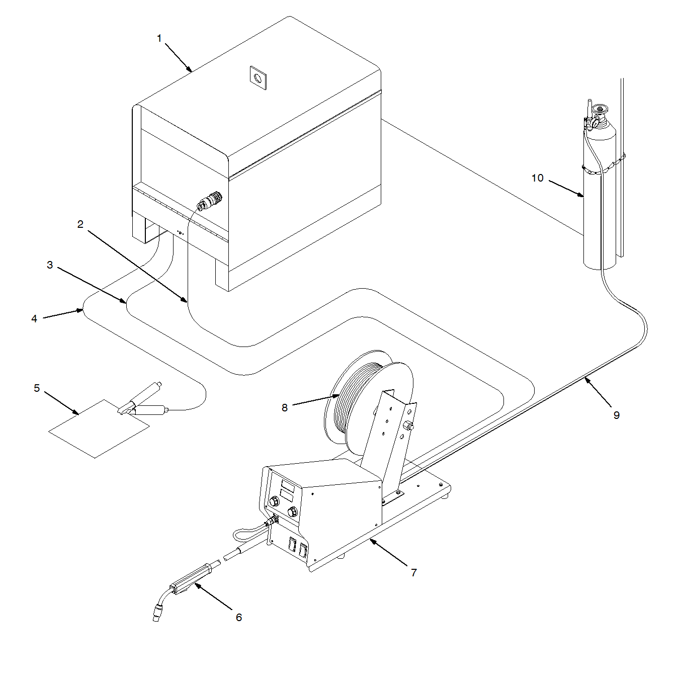
Figure1.2 Typical GMAW Semiautomatic Setup With Constant Speed Feeder

1 Constant Voltage (CV) Welding Power Source 2 Contactor Control/Power Cord 3 Weld Cable To Feeder 4 Ground Cable To Workpiece 5 Workpiece 6 Welding Gun 7 Constant Speed Wire Feeder 8 Electrode Wire 9 Gas Hose 10 Shielding Gas Cylinder

1.2. Typical GMAW Process Control Settings
These settings are guidelines only. Material and wire type, joint design, fit up, position, shielding gas, etc. affect settings. Test welds to be sure they comply with specifications.

1. Amperage (A)
Convert Material Thickness to Amperage (A)
(.001 in = 1 ampere)
.125 = 125 A
Material thickness determines weld parameters.
2. Select Wire Size
Wire Size | Amperage Range
.030 in  .035 in  .045 in | 40 − 145 A  50 − 180 A  75 − 250 A

3 Select Wire Speed (Amperage)
Wire size | Wire speed
.030 in  .035 in  .045 in | 250 ipm  200 ipm  125 ipm

4 Select Voltage
Low Voltage: wire stubs into work
High Voltage: arc is unstable (spatter)
Set voltage midway between high/low voltages.
Voltage controls height and width of weld bead.

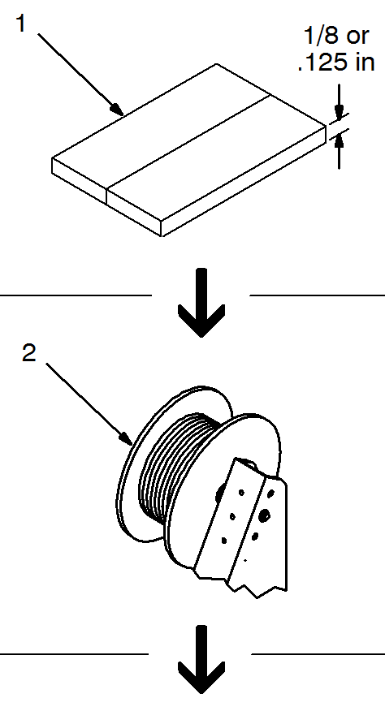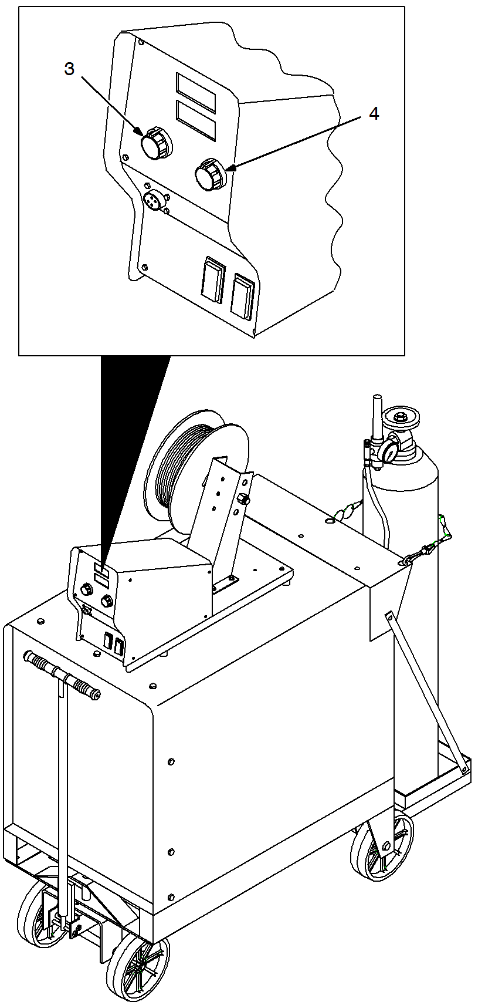
Figure 1.3 parameter selection depends on plate thickness and wire thickness

1.3. Holding and Positioning Welding Gun
Welding wire is energized when gun trigger is pressed. Before lowering helmet and pressing trigger, be sure wire is no more than 1/2 in (13 mm) past end of nozzle, and tip of wire is positioned correctly on seam.
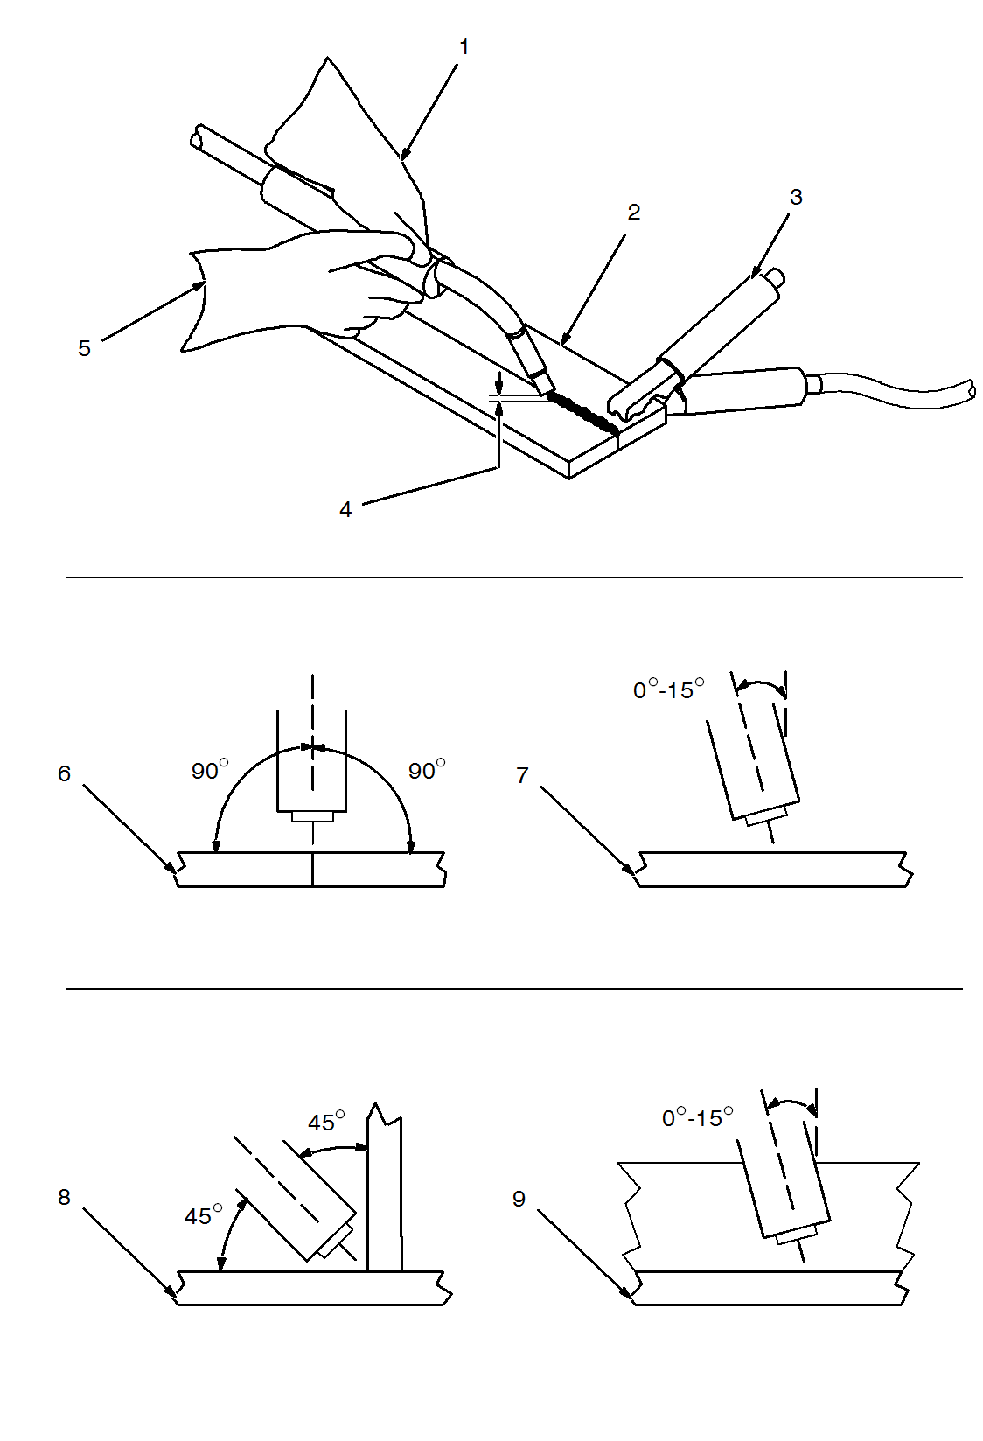
Figure 1.4 Holding and Positioning Welding Gun
1 Hold Gun and Control Gun Trigger 2 Workpiece 3 Work Clamp 4 Electrode Extension (Stick out)1/4 To 1/2 in (6 To 13 mm) 5 Cradle Gun And Rest Hand On Workpiece Groove Welds 6 End View Of Work Angle 7 Side View Of Gun Angle Fillet Welds 8 End View Of Work Angle 9 Side View Of Gun Angle
1.4. Conditions That Affect Weld Bead Shape

Weld bead shape depends on gun angle, direction of travel, electrode extension (stick out), travel speed, thickness of base metal, wire feed speed (weld current), and voltage.
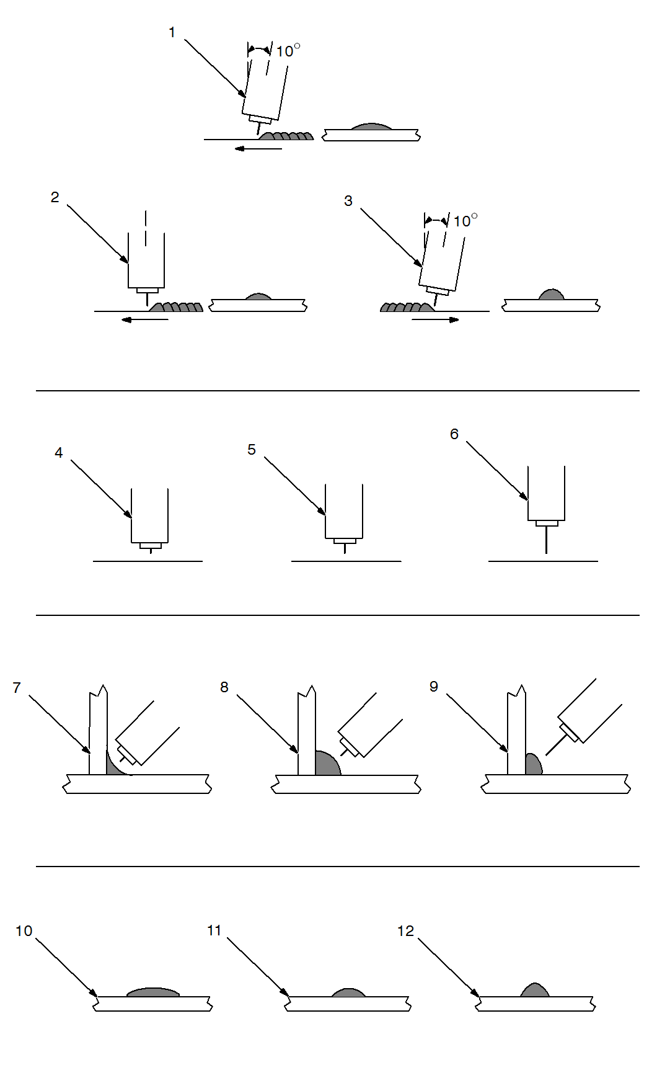
Figure 1.5 Conditions That Affect Weld Bead Shape
Gun Angles and Weld Bead Profiles: 1Push 2 Perpendicular 3 Drags Electrode Extensions (Stick out):4 Short 5 Normal 6 Long Fillet Weld Electrode Extension (Stick out): 7 Short 8 Normal 9 Long
Gun Travel Speed: 10 Slow 11 Normal 12 Fast

1.5. Gun Movement during Welding
Normally, a single stringer bead is satisfactory for most narrow groove weld joints. However, for wide groove weld joints or bridging across gaps, a weave bead or multiple stringer beads works better.
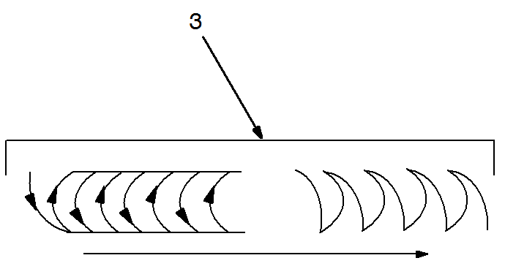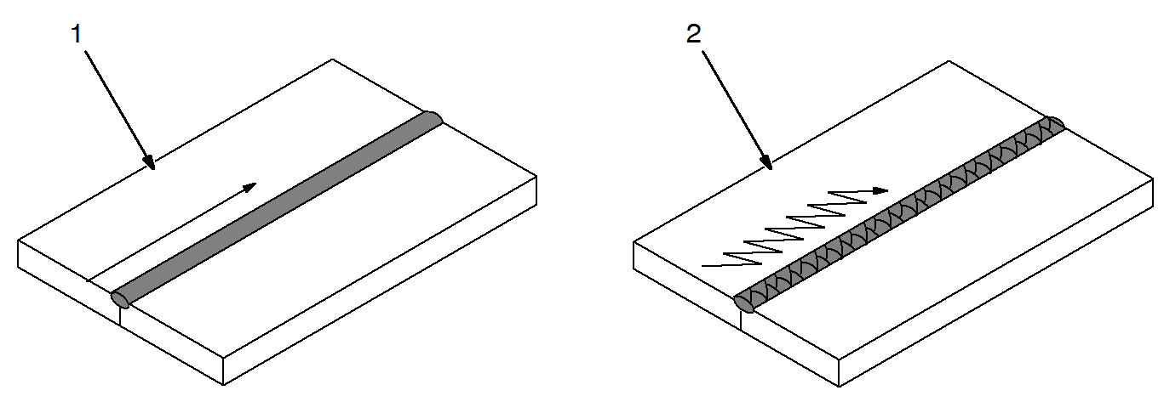
Figure 1.6 gun movement
1 Stringer Bead − Steady Movement along Seam 2 Weave Bead − Side to Side Movement along Seam 3 Weave Patterns Use weave patterns to cover a wide area in one pass of the electrode.
1.6. Poor Weld Bead Characteristics
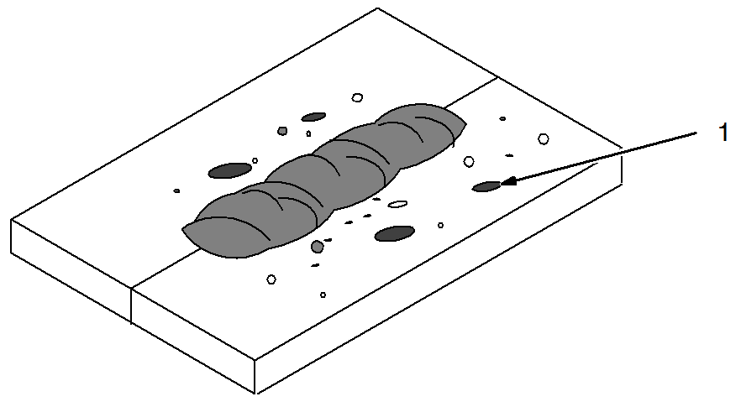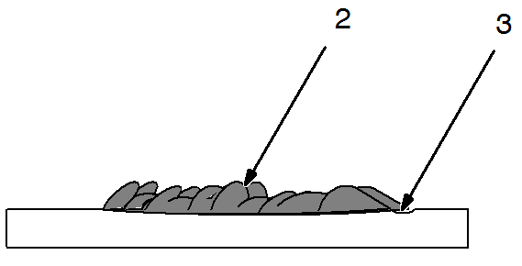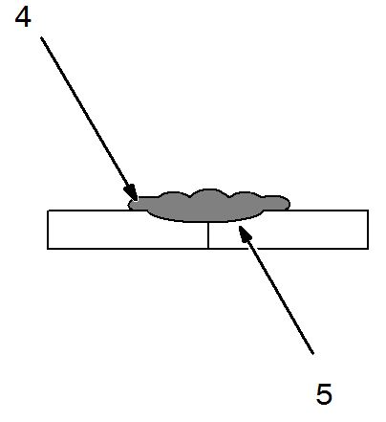
Figure 1.7 Poor Weld Bead Characteristics
1 Large Spatter Deposits 2 Rough, Uneven Bead 3 Slight Crater during Welding 4 Bad Overlap 5 Poor Penetration

1.7. Good Weld Bead Characteristics
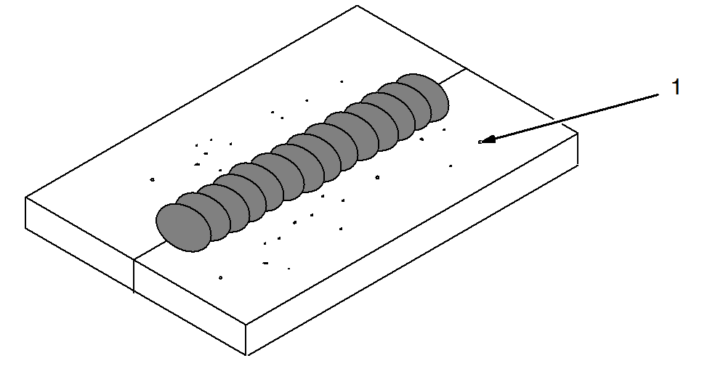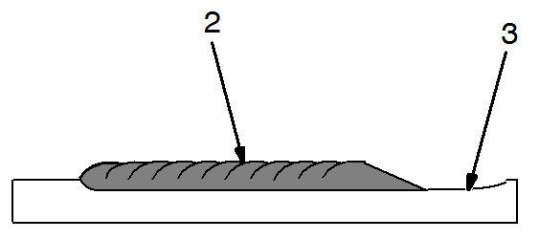
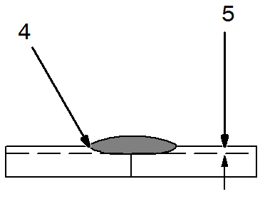
Figure 1.8 Good Weld Bead Characteristics
1 Fine Spatter 2 Uniform Bead 3 Moderate Crater During Welding Weld a new bead or layer for each 1/8 in (3.2 mm) thickness in metals being welded. 4 No Overlap 5 Good Penetration into Base Metal

1.8. Common GMAW Shielding Gases
This is a general chart for common gases and where they are used. Many different combinations (mixtures) of shielding gases have been developed over the years.

Table1.1 shielding gas selection
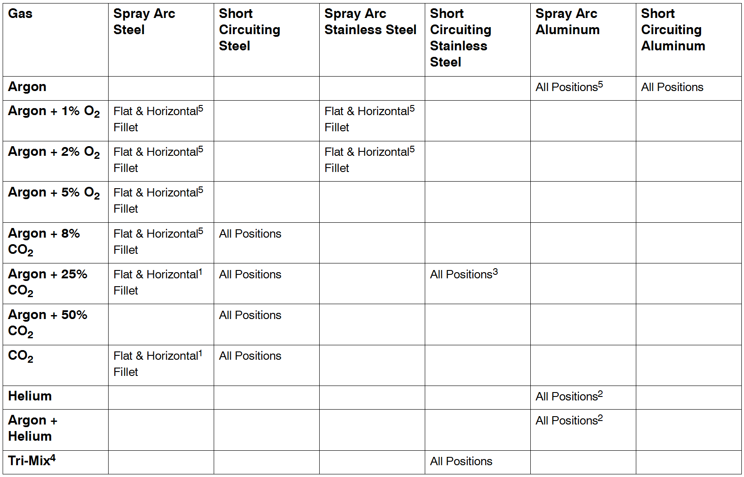

1 Globular Transfer 2 Heavy Thicknesses 3 Single Pass Welding Only 4 90% HE + 7-1/2% AR + 2-1/2% CO2 5 Also for GMAW-P, All Positions

1.9. Modes of GMAW transfer
GMAW transfer mode is determined by variables such as shielding gas type, arc voltage, arc current, diameter of electrode and wire feed speed.
1.9.1. Short Circuit Transfer
Short circuit transfer refers to the welding wire actually “short circuiting” (touching) the base metal between 90 - 200 times per second. With short circuit transfer, wire feed speeds, voltages, and deposition rates are usually lower than with other types of metal transfer such as spray transfer. This makes short circuit transfer very versatile allowing the welder to weld on thin or thick metals in any position.
Limitations of short circuit transfer:
A relatively low deposition rate
Lack of fusion on thicker metals
More spatter
Short circuit transfer usually has a crackling (bacon frying) sound when a good condition exists
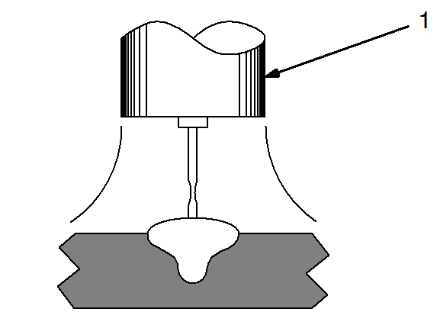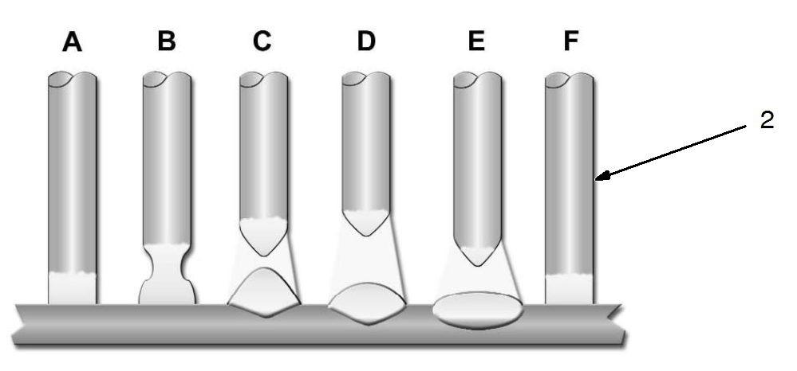
Figure 1.9 Short circuit transfer and Short Circuit Cycle

Short Circuit Cycle
A - Electrode is short circuited to base metal. No arc and current is flowing through electrode Wire and base metal.
B - Resistance increases in electrode wire causing it to heat, melt and “neck down”.
C - Electrode wire separates from weld puddle, creating an arc. Small portion of electrode wire is deposited which forms a weld puddle.
D - Arc length and load voltage are at maximum. Heat of arc is flattening the puddle and increasing the diameter tip of electrode.
E - Wire feed speed overcomes heat of arc and wire approaches base metal again.
F - Arc is off and the short circuit cycle starts again.

1.9.2 Globular Transfer
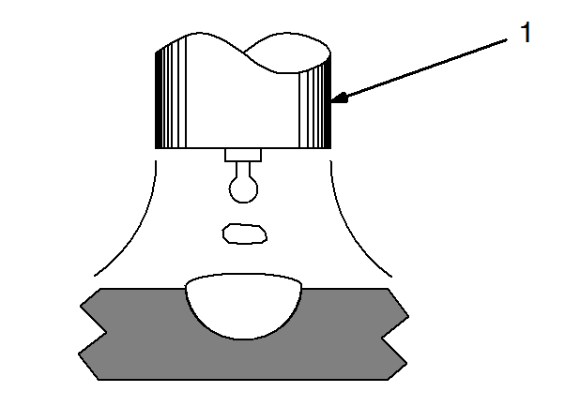
Figure 1.10 Globular Transfers
1 Globular Transfer
Globular transfer refers to the state of transfer between short-circuiting and spray arc transfer. Large globs of wire are expelled off the end of the electrode wire and enter the weld puddle.
Globular transfer can result when welding parameters such as voltage, amperage and wire feed speed are somewhat higher than the settings for short circuit transfer.
Limitations of globular transfer:
Presence of spatter
Less desirable weld appearance than spray arc transfer
Welding is limited to flat positions and horizontally fillet welds
Welding is limited to metal 1/8 inch (3 mm) or thicker

1.9.3 Spray Arc Transfer
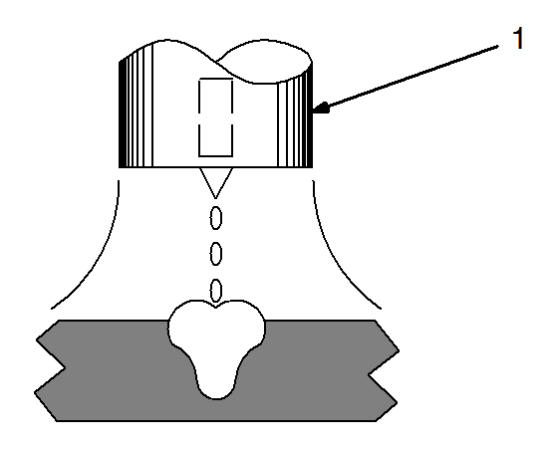
Figure 1.11 Spray Arc Transfer
1 Spray Arc Transfer
Spray arc transfer “sprays” a stream of tiny molten droplets across the arc, from the electrode wire to the base metal.
Spray arc transfer uses relatively high voltage, wire feed speed and amperage values, compared to short circuit transfer.
To achieve a true spray transfer, an argon-rich shielding gas must be used.
When proper parameters are used, the spray arc transfer produces a characteristic humming or buzzing sound.
Advantages of spray arc transfer:
High deposition
Good fusion and penetration
Good bead appearance
Capability of using larger diameter wires
Presence of very little spatter
Limitations of spray arc transfer:
Used only on material 1/8 inch (3 mm) and thicker (hand held)
Limited to flat and horizontal fillet weld position

Section 1.10 GMAW welding trouble shooting
1.10.1 Excessive Spatter
Table 1.2 Excessive Spatter
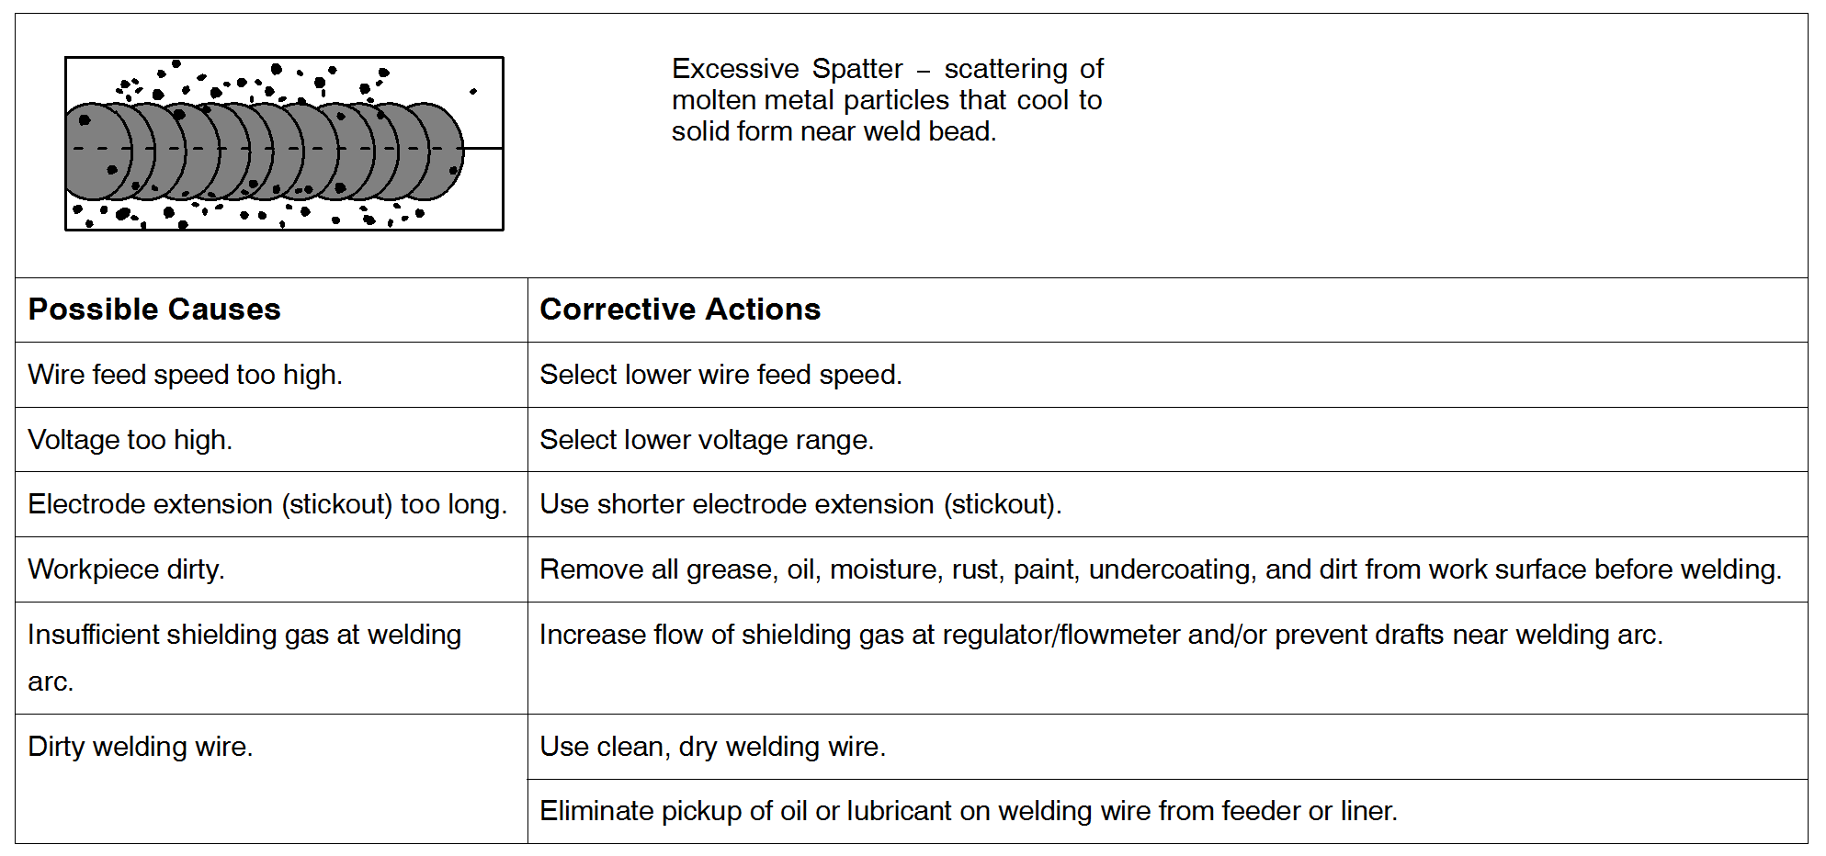
1.10.2 Porosity
Table1.3 Porosity
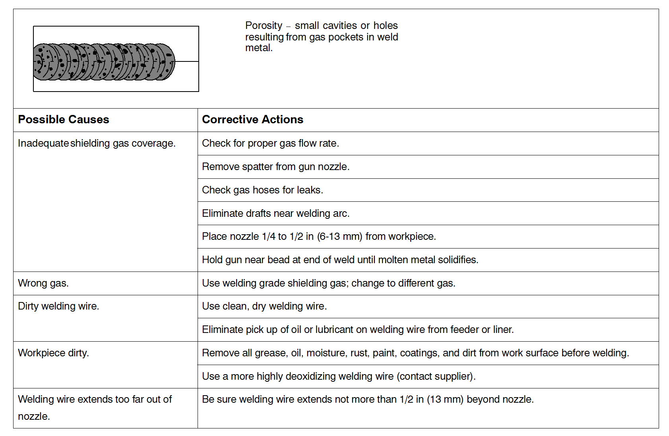

1.10.3 Incomplete Fusion
Table 1.4 Incomplete Fusion
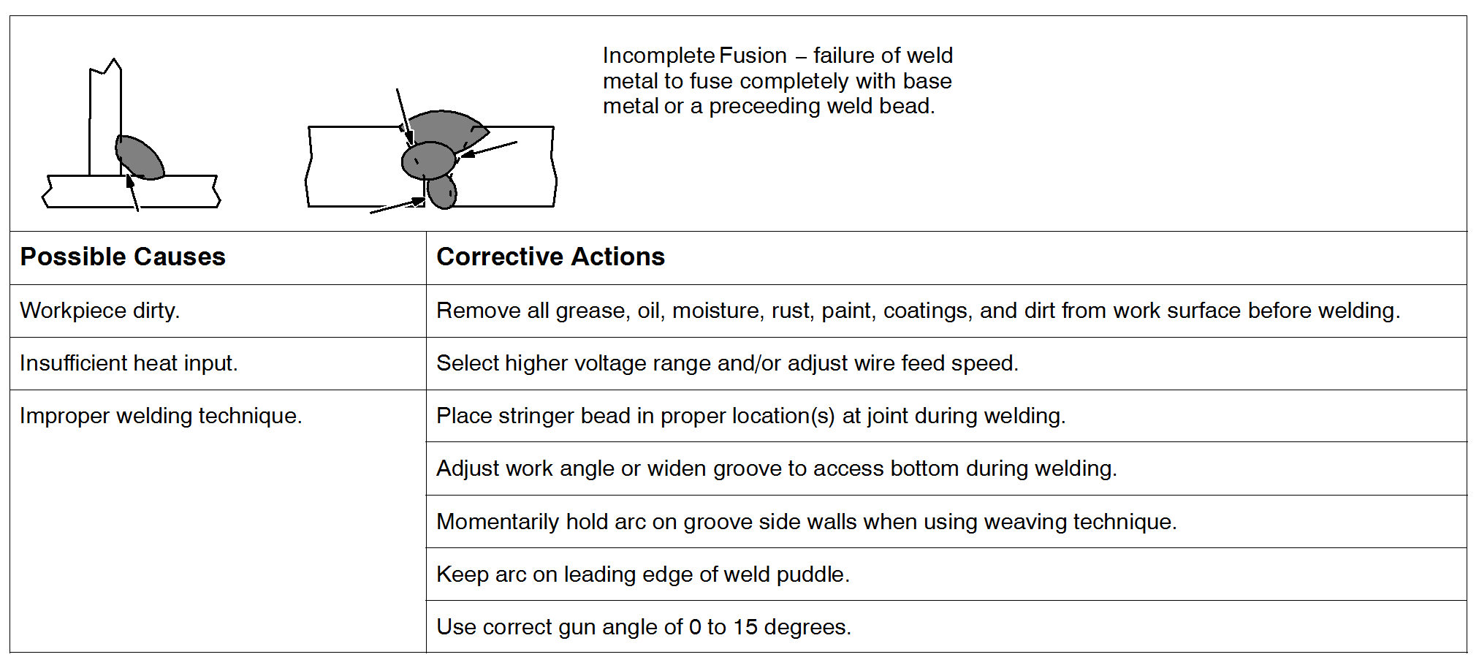

1.10.4 Excessive Penetration
Table 1.5 Excessive Penetration
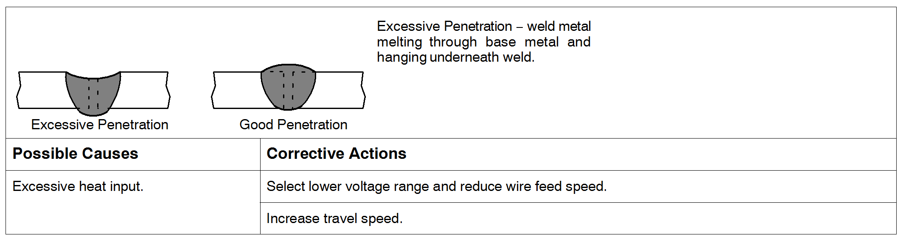

1.10.5. Lack of Penetration
Table1.6 lack of penetration
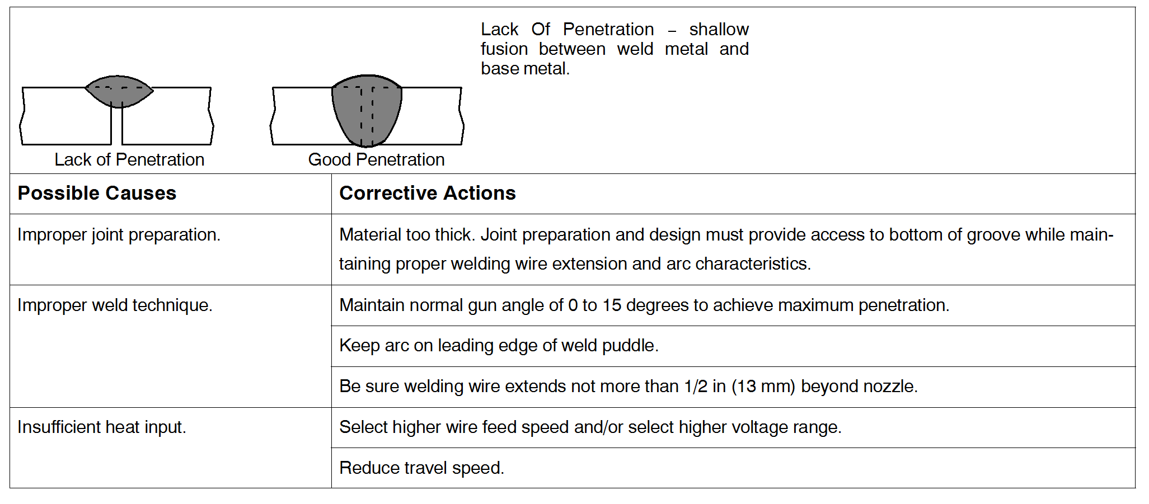
1.10.6 Burn Through
Table 1.7 Burn Through
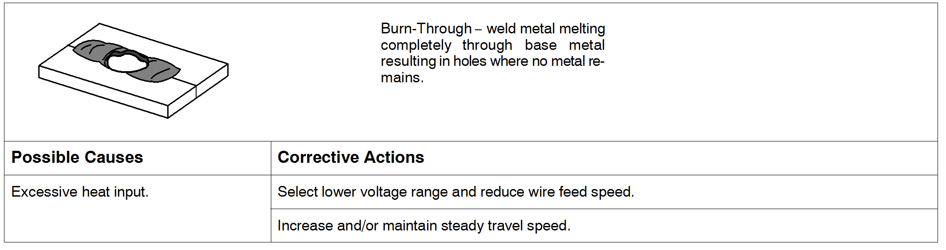
1.10.7 Waviness of Bead
Table 1.8 Waviness of Bead
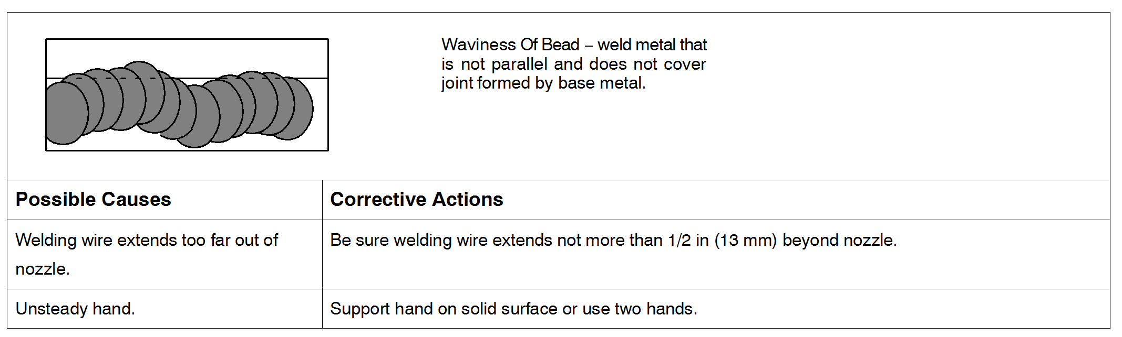

4-8. Distortion
Table1.9 Distortion
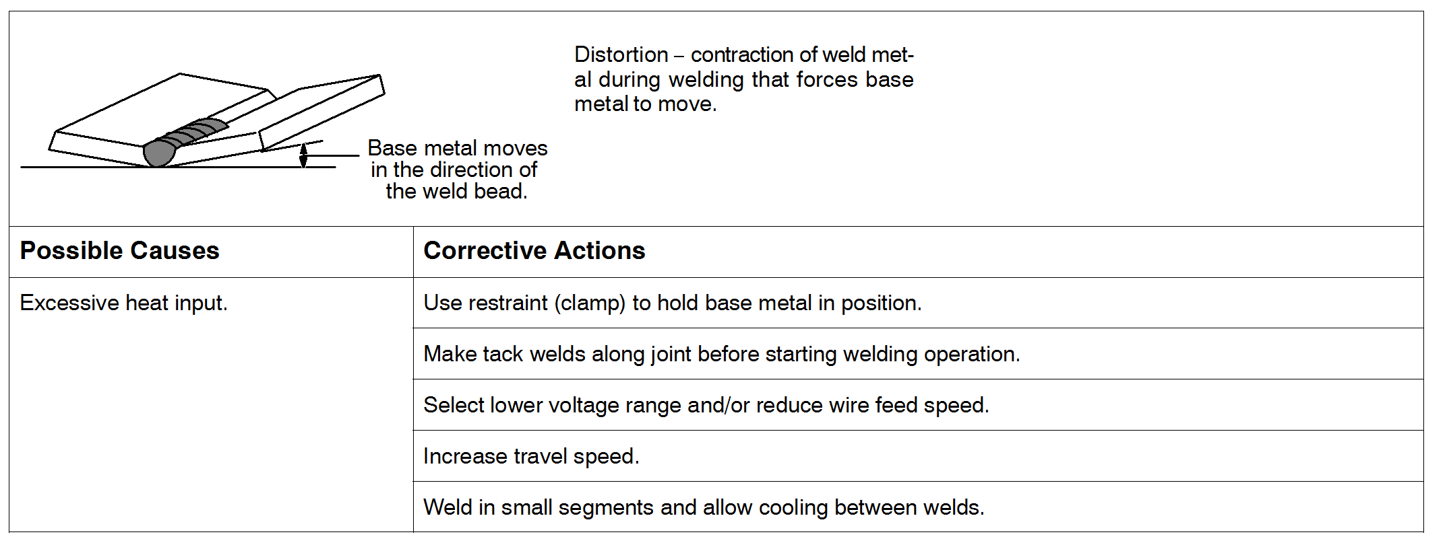

1.11 Welding of stainless steel
1.11.1 Introduction.
Stainless steels are an important grade of structural material used worldwide for a multitude of applications based on their corrosion resistance, heat resistance, aesthetic appeal, low temperature properties, high strength and or ease of cleaning and sterilizing.
The main types of weldable stainless steels available include:
Austenitic Stainless Steels (AISI 200 and 300 series) which are easy to weld and by tar the most popular type - accounting for over 70% of the stainless steel sold around the world.
Ferritic stainless steels (AISI 400 series) which are weldable particularly in thin sections and commonly used for elevated temperature applications.
Martensitic Stainless Steels (AlSI 400 series) which are difficult to weld and commonly used for wear resistant applications.
VA Duplex stainless steels which are weldable with precautions and used for corrosion resistant applications as an alternative to 300 series austenitic stainless steels.
1.11.2 Welding technique
The technique of welding stainless steels does not differ greatly from that of the welding of mild steel, but as the material being handled is very expensive, and exacting conditions of service are usually involved, extra precautions and attention to detail at all stages of fabrication is desirable. In principle, all stainless steel for high-class work should be welded with a short arc.
Any techniques which aim at increasing the penetration speed of travel or the use of wide weaving techniques are to be discouraged. Usually the lowest convenient current should be used. Weaving should be not wider than twice the diameter of the electrode for base material and electrodes of like composition, and even less for plate of dissimilar composition.
The edges of the preparation should be free from scale. Clamps and jigs are advisable when welding sheets thinner than 3 mm (18 in) while cooling blocks are helpful with sheets 1.6mm to 2.5 mm (116 in to 332 in) thick. Tack welds, particularly on thin sheets, should be placed much closer together than is the usual practice for mild steel. This procedure is necessary as the thermal conductivity of these alloy steels is less and the coefficient of expansion is considerably greater than that of mild steel.

1.11.3 Notes on technique:
1. Ensure that the surface of the material in the weld area is clean and free from foreign matter.
2. Use the edge preparation shown in Table 1 over the page.
3. Tack at regular intervals, at about half the pitch used for mild steel.
2. Maintain a short arc during welding, to avoid loss of alloying materials during transfer across the arc.
5. Use stringer passes rather than wide weaves.
6. To minimize distortion, employ back step or block sequences when welding
7. Thoroughly remove slag from welds between passes.
8. When welding double V or U joints, balance the welding on each side, to minimize distortion.
9. Never use emery wheels or buffs for grinding or polishing stainless if they have previously been used for mild steel.
10. Do not use excessive welding current Because of the high electrical resistance and low thermal conductivity the currents used with stainless steel electrodes are somewhat lower than those used for mild steel.

Table 1.10 Edge preparation choices varying with thickness
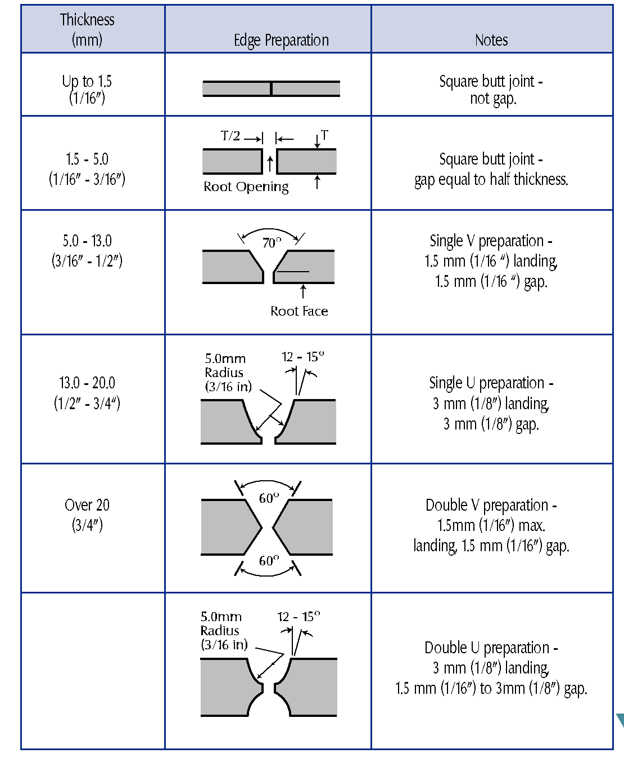
Austenitic stainless steels are easily welded 4th all standard arc welding processes, using matching or near matching welding consumables. Because of their high thermal expansion and low thermal conductivity compared to carbon steel they will distort more during and after welding. This can be minimized by more frequent tacking prior to welding, balanced and back step welding methods and the use of lower welding current and heat input parameters. Low carbon austenitic stainless steels are commonly used because they are less susceptible to sensitization (or carbide precipitation) during welding or high temperature service which can result in intergranular corrosion in a caustic environment. Matching low carbon welding consumables (designated 4th and “L’) are also commonly used to desensitize the weld deposit in the same way as the parent metal, and eliminate the risk of intergranular corrosion of the welded joint.
The common welding consumable types used for welding the many austenitic stainless steel grades are shown in the following table.
Table 1.11 common welding consumable types used for austenitic stainless steel
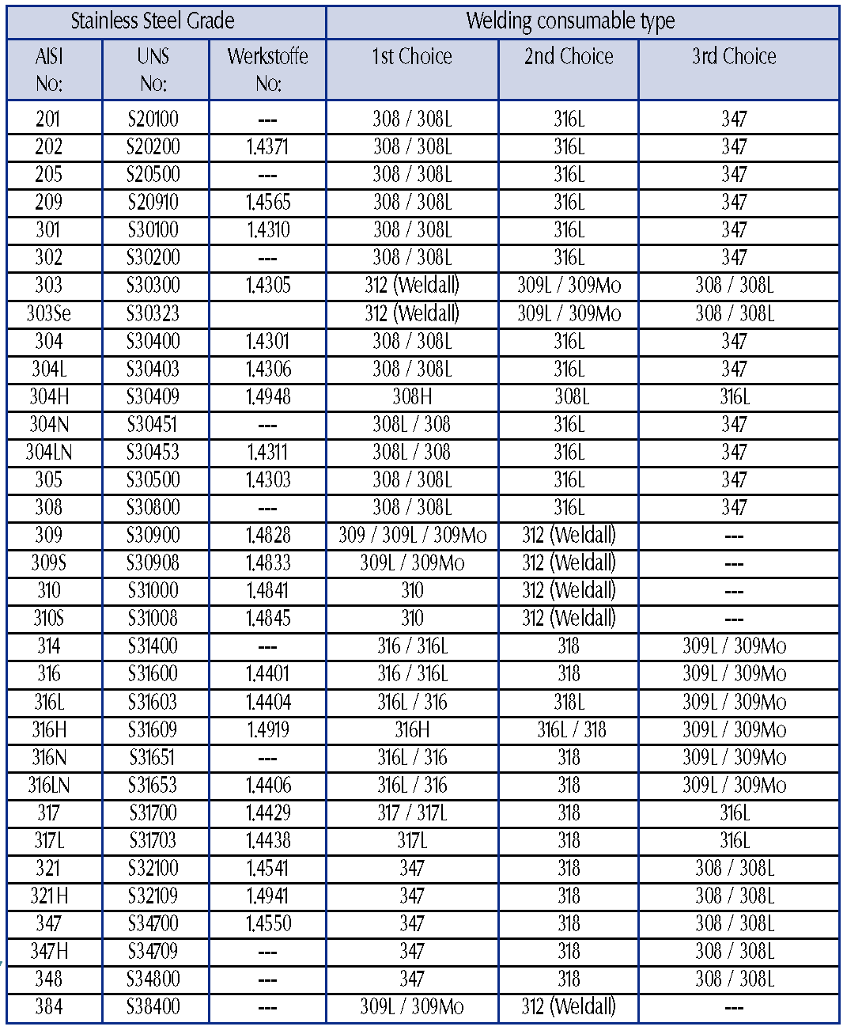
1.11.4 Heat Input
Generally heat input should be limited to between 0.6-2.6 KJ/mm. When a welding process with less than 0.6ki mm heat input is used (as in automatic GMAW), preheating up to 150 C medium may be required to reduce the cooling rate and increase austenite in the weld and the HAZ.
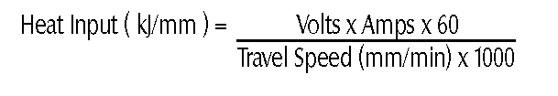

Interpass Temperature Control:
Interpass temperature should be limited to between 75-150 C.
1.11.5 Preheat:
On thicknesses below 6mm no preheat is required. For heavier sections or for welds under high restraint preheat may be used to minimize the risk of weld cracking. When a welding process with less than 0.6ki mm heat input is used, preheating to between 50-200C is helpful in reducing the cooling rate and increasing austenite in the weld and the HAZ. It the air temperature is below 15 C preheat of 50 C should be used.
1.11.6 Schaeffler and De Long Diagrams:
The alloying elements used in stainless steel base metals and welding consumables have a significant influence on the resultant microstructure. Anton Schaeffler was the first person to carry out a detailed study of the relationship between the composition and microstructure of stainless steel weld metals. The results of this research are summarized in the Schaeffler diagram shown in Diagram 1.12 which predicts the microstructure of freely cooled All Weld Metal (AWM) stainless steel deposits as a function of Chromium and Nickel Equivalents.
Chromium and Nickel Equivalents for the Schaeffler diagram are calculated as follows:
Chromium Equivalent = %Cr + %Mo + 1.5 x %Si + 0.5 x %Nb
Nickel Equivalent = %Ni + 30 x %C + 0.5 x %Mn
The Chromium and Nickel equivalent have been calculated the Schaeffler diagram can be used to estimate the microstructural phases present It should be noted that the Schaeffler diagram is not applicable to the Heat affected Zone (HAZ) of the welded joint nor is it usable for weld deposits which have been heat treated after welding
1.11.6 The De Long Diagram: The De Long Diagram shown in Diagram 1.13 is a later development of the central part of the Schaeffler diagram. The De Long diagram works in a similar way to the Schaeffler diagram, however it incorporates nitrogen in the calculation of the Nickel Equivalent which is particularly important for the gas shielded welding processes such as Gas Metal Arc and Gas Tungsten Arc Welding where gas shielding can significantly influence nitrogen pickup in the weld deposit The De Long diagram also classifies ferrite content as a Ferrite Number (FN) rather than as a percentage.
Once the Chromium and Nickel Equivalents are calculated they can be plotted on the Schaeffler or De Long diagrams to determine the microstructural phases present in the weld deposit the crack free, austenite - ferrite microstructure of 309Mn-17 manual arc electrode is shown as Point D in Diagram 1.13, calculated from typical AWM chemical analysis. In predicting the microstructural phases present in the weld deposit the Schaeffler diagram is also a guide to potential joint problems such as hot cracking, sigma phase embrittlement, martensitic cracking and brittle grain coarsening. See the shaded regions on the Schaeffler diagram for details.
The Schaeffler diagram is commonly used to predict weld deposit microstructures for the joining of dissimilar metals, given the chemical analyses of both base metals and the welding consumable
AWM deposit for example, the resultant weld deposit microstructure from joining mild steel to 316 austenitic stainless steel using 309Mo-17 is shown in Diagram 1.12.

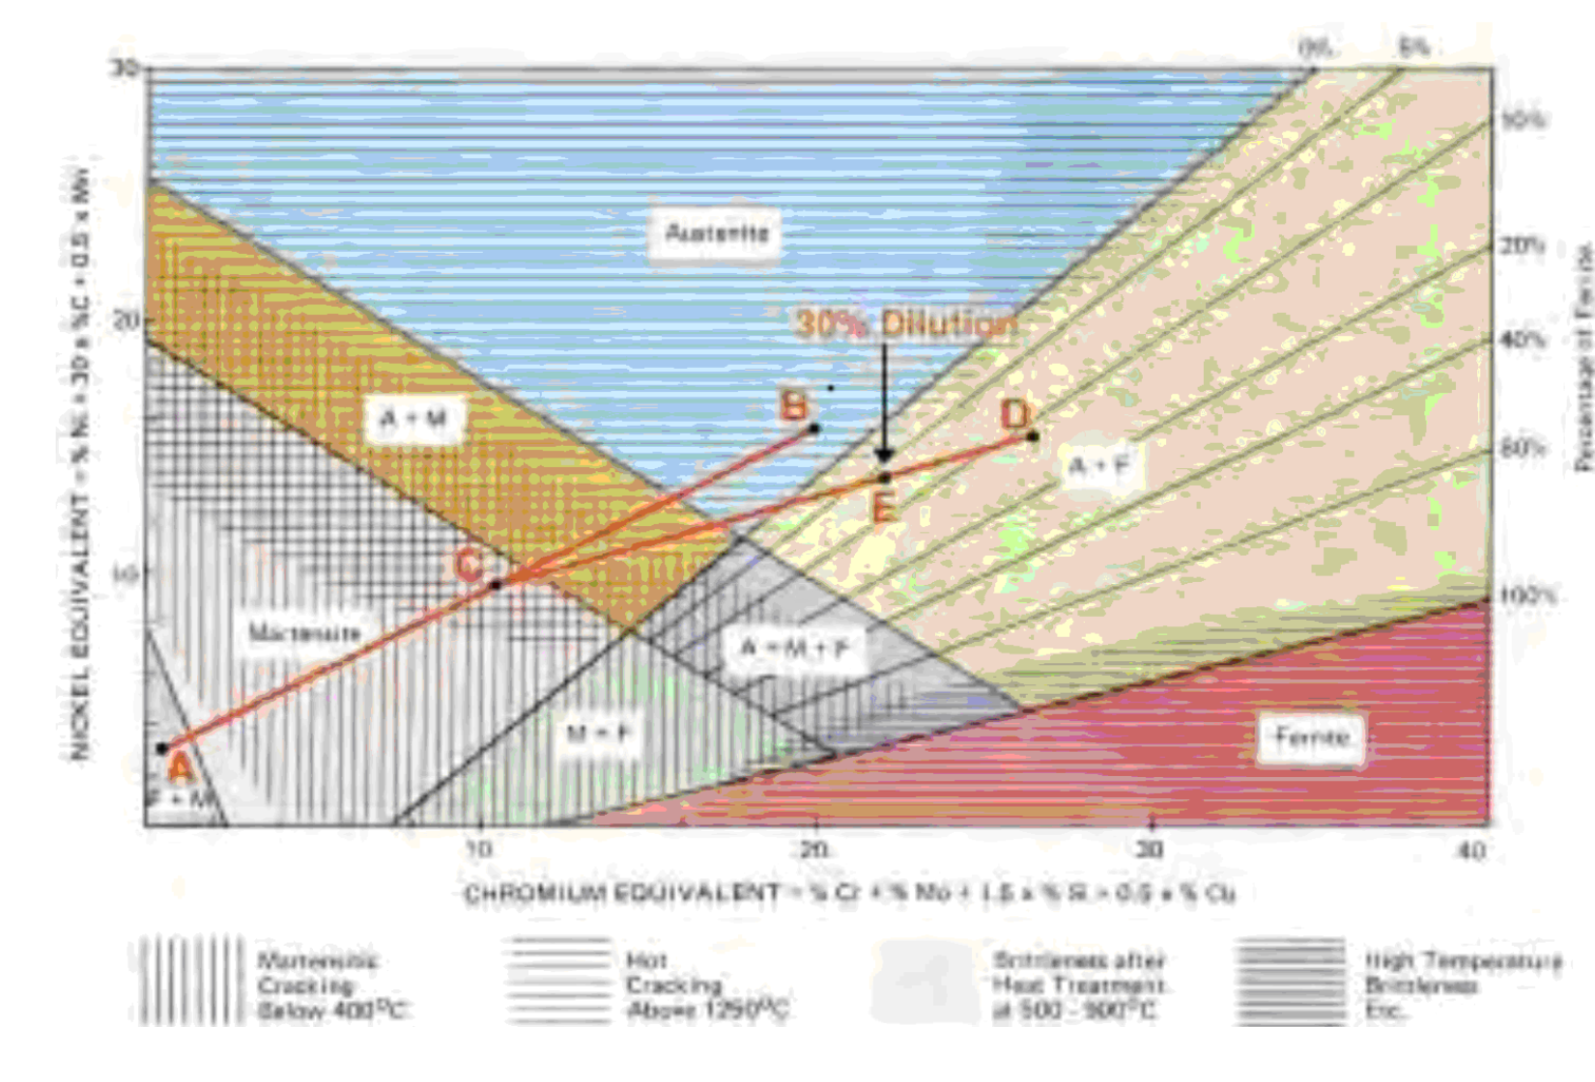
Figure 1.12 Schaeffler diagram
By explanation:
Point A on the Schaeffler diagram = microstructure of mild steel base metal.
Point B on the Schaeffler diagram = microstructure of 316 stainless steel base metal.
Point C on the Schaeffler diagram = weld deposit microstructure for joining mild steel to316 stainless steel without a filer metal.
Point Don Schaeffler diagram = microstructure of AWM deposit with 309Mo-17
Point Eon Schaeffler diagram = microstructure of weld deposit assuming 30% dilution using the manual metal arc welding process.
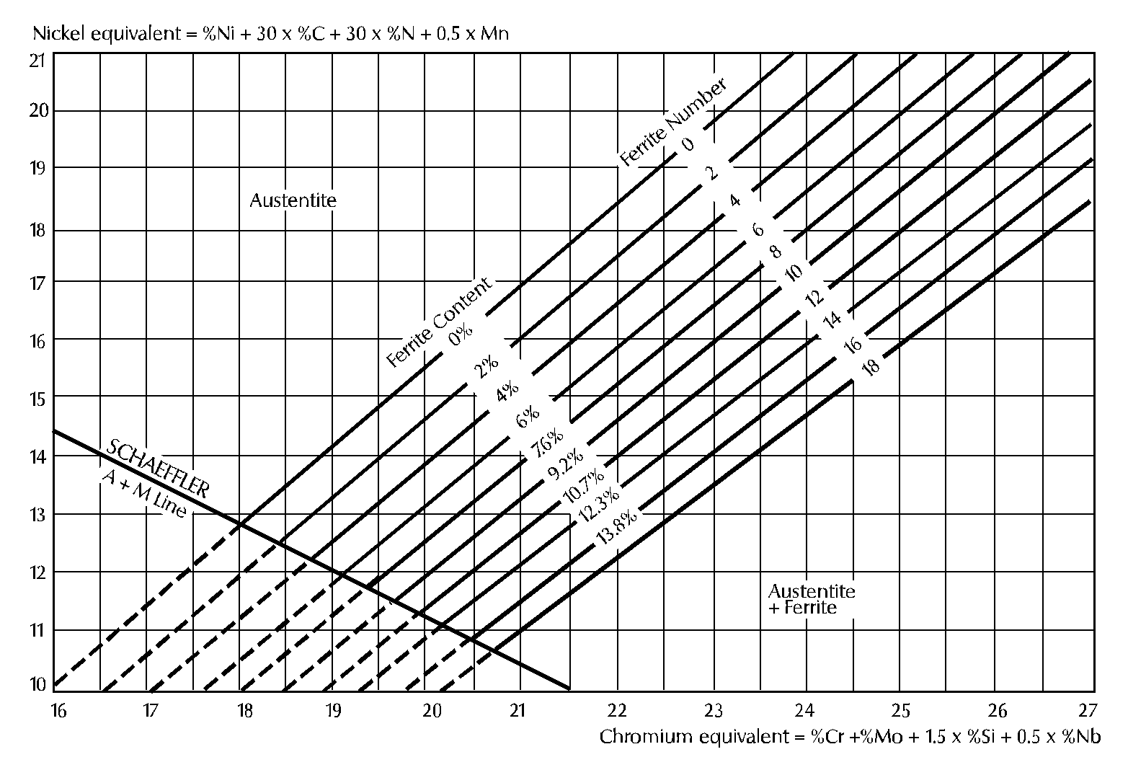
Figure 1.13 De Long Diagram

1.12 Summary
In this chapter important aspects of GMAW process and SS welding are studied. This study is extremely important in deciding parameters of GMAW process. This chapter is also very important in deciding heat input and preheat parameters. This section is designed to provide technical overview for welding the major types of stainless steels available today.

CHAPTER 2
DESIGN OF EXPERIMENT: AN INTRODUCTION

2.1 Concept of DOE
Design of Experiment (DOE) is a structured, organized method that is used to determine the relationship between the different factors (Xs) affecting a process and the output of that process (Y). Sir Ronald A. Fisher, the renowned mathematician and geneticist first developed this method in the 1920s and 1930.
Design of experiment (DOE) is to understand the impact of specific changes to the inputs of the process, and then to maximize, minimize or normalize the outcome by manipulating the input.
DOE is a scientific approach which allows the researchers to gain knowledge in order to better understand a process and to determine how the impacts (attribute effect the output response).
It is usually used when it is unclear what impact a specific set of inputs may have either individually or collectively on process or product. A designed experiment id the simultaneous evaluation of two or more factors (parameters) for their ability to affect the resultant average or variability of a particular product or process characteristic. To accomplish this in an effective and statically proper fashion, the level of factors are varied in a strategic manner, the results of particular test combination are observed, and the complete set of results is analyzed to determine the influential factors and preferred levels, and whether increase or decrease of those levels will potentially lead to further improvement. It is important to note that this is an iterative process; the first round through the DOE process will many times lead to subsequent rounds of experimentation. The beginning round, often referred to as screenings experiment, is used to find the few important influential factors out of the many possible factors involved with the process or product design. The experiment is typically a small experiment with many factors at two levels. Later rounds of experiments typically involve few factors at more than two levels to determine conditions of further improvement.
- DOE is the most cost effective and efficient method for identifying the key input factors and in understanding the relationship between input factors and response.
- DOE investigate a number of input factors with relatively small number of tests.
- DOE helps to identify important/ critical attributes of a process improvement effort, as they can be characteristics to be examined and the desired effect.
The DOE process is divided is divided into three main phases, which encompasses all experimental approaches. These three phases are (1) the planning phase (2) the conducting phase (3) the analyzing phase.
The planning phase is when factors and levels are selected and, therefore the most important stage of experimentation. Also the correct selection factors and levels is non statistical in nature and more dependent upon product or process expertise.
The second most important phase is the conducting phase, when the test results are actually collected. If experiments are well planned and conducted, the analysis is actually much easier and more likely to yield positive information about factors and levels.
The analysis phase is when the positive or negative information concerning the selected factors and levels is generated based on the previous two phases. This phase is statistical in nature.
The major steps to complete an effective designed experiment are listed in the following 12 steps. The planning phase includes steps 1 through 9, the conducting step 10, and the analysis phase include steps 11 and 12.
- State the problem(s) or areas(s) of concern.
- State the objective(s) of the experiment.
- State the quality characteristic(s) and measurement system(s).
- Select the factors that may influence the selected quality characteristics.
- Identify control and noise factors.
- Select levels of factor.
- Select the appropriate orthogonal array (OA) or Ors.
- Select interactions that may influence the selected quality characteristics or go back to step 4(iterative steps).
- Assign factors to OA(s) and locate interactions.
- Conduct tests described by trials in OAs.
- Analyze and interpret results of the experimental trials.
- Conduct confirmation experiment.

2.2 Brainstorming
When physical experiments are used, it is sometimes impossible or very expensive to carry out an experiment according to the set-up. Thus it becomes necessary to first study and discuss about the process and process parameters. A good knowledge about the work to be done, process and optimization technique may be very helpful to get expected results. Important steps that are to be considered are as follows:
- Objectives of Study and Evaluation Criteria
- Factors
- Noise Factors
- Factor Levels
- Interaction between Factors
- Scopes of Studies
- Additional Items
2.2.1 Objectives of Study and Evaluation Criteria
- What are the criteria of evaluation?
- How are each of these criteria measured?
- How are these criteria combined into a single number?
- What is the common characteristic of these criteria?
- What is the relative influence these criteria exhibit?
2.2.2. Design Factors
- What are the factors that influence the performance criteria?
- Which factors are more important than others?
2.2.3 Noise Factors
- Which factors can't be controlled in real life?
- Is the performance dependent on the application environment?
2.2.4 Factor Levels
- What are the ranges of values the factors can assume within
practical limits?
- How many levels of each factor should be used for the study?
- What is the tradeoff for a higher level?
2.2.5 Interaction between Factors
- Which factors are most likely to interact?
- How many interactions can be studied?
2.2.6 Scopes of Studies
- How many experiments can we run?
- When do we need the results?
- How much does each experiment cost?
2.2.7 Additional Items
- What do we do with factors that are not included in the study?
- In what order do we run these experiments?
- Who will do these experiments?
2.3 Types of Optimization Problems
2.3.1 Static Problems
Generally, a process to be optimized has several control factors, which directly decide the target or desired value of the output. The optimization then involves determining the best control factor levels so that the output is at the target value. Such a problem is called as a "STATIC PROBLEM".
This is best explained using a P-Diagram, which is shown below ("P" stands for Process or Product). Noise is shown to be present in the process but should have no effect on the output. The primary aim of the Taguchi experiments is to minimize variations in output even though noise is present in the process. The process is then said to have become robust.
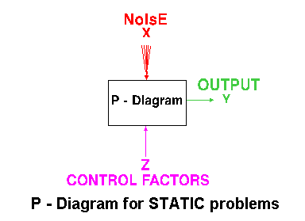
Figure 2.1 P-Diagrams for Static Problems

2.3.2 Dynamic Problems
If the product to be optimized has a signal input that directly decides the output, the optimization involves determining the best control factor levels so that the "input signal / output" ratio is closest to the desired relationship. Such a problem is called as a "DYNAMIC PROBLEM". The difference between dynamic and static problem is that in dynamic problems we study the effects on output due to noise also which are not considered in static problems. This is best explained by a P-Diagram, which is shown below. Again, the primary aim of the Taguchi experiments - to minimize variations in output even though noise is present in the process- is achieved by getting improved linearity in the input/output relationship.
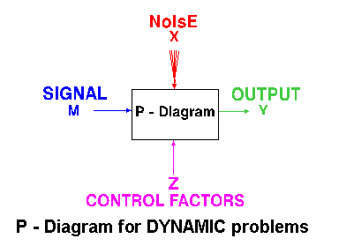
Figure 2.2 P-Diagrams for Dynamic

2.4 Batch Process Optimization
There are 3 Signal-to-Noise ratios of common interest for the purpose of optimization;
2.4.1 Smaller-The-Better
n = -10 Log₁₀ [mean of sum of squares of measured data]
This is usually the chosen S/N ratio for all undesirable characteristics like "defects, surface roughness" etc. for which the ideal value is zero. Also, when an ideal value is finite and its maximum or minimum value is defined (like maximum purity is 100% or minimum time for making a telephone connection is 1 sec) then the difference between measured data and ideal value is expected to be as small as possible. The generic form of S/N ratio then becomes,
n = -10 Log₁₀ [mean of sum of squares of {measured - ideal}]
2.4.2 Larger-The-Better
n = -10 Log₁₀ [mean of sum squares of reciprocal of measured data]
This case has been converted to SMALLER-THE-BETTER by taking the reciprocals of measured data and then taking the S/N ratio as in the smaller-the-better case.
2.4.3 Nominal-The-Best
n = 10 Log₁₀ (Square of mean / variance)
This case arises when a specified value is MOST desired, meaning that neither a smaller nor a larger value is desirable.
2.5 Steps in Taguchi Methodology
Taguchi method is a scientifically disciplined mechanism for evaluating and implementing improvements in products, processes, materials, equipment, and facilities. These improvements are aimed at improving the desired characteristics and reducing the number of defects by studying the key variables controlling the process and optimizing the procedures or design to yield the best results.
The method is applicable over a wide range of engineering [3, 18, 20, 31, 35] fields that include processes that manufacture raw materials, sub systems, products for professional and consumer markets. In fact, the method can be applied to any process be it engineering fabrication, computer-aided-design, banking and service sectors etc. Taguchi method is useful for 'tuning' a given process for 'best' results.
Taguchi proposed a standard 8-step procedure for applying his method for optimizing any process. These are:
Step1: formulation of the problem – the success of any experiment is dependent
on a full understanding of the nature of the problem. It is important to establish just what the experiment is aiming to solve.
Step2: Determine the objective:-Identify the output characteristics (responses) to be studied and eventually optimized and determine the method of measurement. To establish measurement reliability, a separate experiment may be required
Step 3: Identification of control factors, noise factors and signal factors (if any). Control factors are those which can be controlled under normal production conditions. Noise factors are those which are either too difficult or too expensive to control under normal production conditions. Signal factors are those which affect the mean performance of the process. Taguchi believes that it is generally preferable to consider as many factors (rather than many interactions) as it is economically feasible for the initial screening.
Step 4: selection of factor levels, possible interactions and the degrees of freedom associated with each factor and the interaction effects. Assign the controllable factors and their interactions to the columns of the inner array, and the noise factors to the columns f the outer array.
Step 5: Conduct the experiment: Perform the experimental trials and collect the experimental data.
Step 6: Analyze the data: Evaluate the performance measures (TPM and NPM) for each trial run of the inner array and analyze them using the appropriate statistical analysis technique
Step 7: Interpret the results: Identify the variability control factors (VCF) and target control factors (TCF) and select their optimal levels. For the VCF’s the optimal levels are those, which maximize the NPM (minimize variability in the response), and for the TCF’s they are those, which bring the mean response nearest to the target value.
Step 8: Run a confirmatory Experiment: It is necessary to confirm, by some follow up experimental trials. A successful confirmation can alleviate concerns about the possibilities of a wrong choice for factor levels and experimental design.
If predicted results are not confirmed, or otherwise unsatisfactory, additional experiments may be required and a repetition of step no. 3 to 8 may be necessary.
2.6 Response surface methodology (RSM)
Experimentation and making inferences are the twin features of general scientific methodology. Statistics as a scientific discipline is mainly designed to achieve these objectives. Planning of experiments is particularly very useful in deriving clear and accurate conclusions from the experimental observations, on the basis of which inferences can be made in the best possible manner. The methodology for making inferences has three main aspects. First, it establishes methods for drawing inferences from observations when these are not exact but subject to variation, because inferences are not exact but probabilistic in nature. Second, it specifies methods for collection of data appropriately, so that assumptions for the application of appropriate statistical methods to them are satisfied. Lastly, techniques for proper interpretation of results are devised.
The advantages of design of experiments as reported by Adler et al (1975) and Johnston
(1964) are as follows.
(1) Numbers of trials are reduced.
(2) Optimum values of parameters can be determined.
(3) Assessment of experimental error can be made.
(4) Qualitative estimation of parameters can be made.
(5) Inference regarding the effect of parameters on the characteristics of the process can be made.
Cochran & Cox (1962) quoted Box and Wilson as having proposed response surface methodology for the optimization of experiments. In many experimental situations, it is possible to represent independent factors in quantitative form. Then these factors can be thought of as having a functional relationship or response:
Y = φ(X1,X2, . . . ,Xk) ± e_{r} ,
between the response Y and X1,X2, . . . Xk of k quantitative factors. The function φ is called response surface or response function. The residual er measures the experimental error. For a given set of independent variables, a characteristic surface responds. When the mathematical form of φ is not known, it can be approximated satisfactorily within the experimental region by a polynomial. The higher the degree of the polynomial the better is the correlation, though at the same time the costs of experimentation become higher.
The methodology may be applied for developing the mathematical models in the form
of multiple regression equations correlating the dependent parameters such as cutting force, power consumption, surface roughness, tool life etc. with three independent parameters, viz. cutting speed, feed rate and depth of cut, in a turning process. In applying the response surface methodology, the dependent parameter is viewed as a surface to which a mathematical model is fitted. For the development of regression equations related to various quality characteristics of turned parts, the second-order response surface may be assumed as:

Y = b₀ +b₁x₁+b₂x₂+b₃x₃+b₄x₁²+b₅x₂²+b₆x₃²+b₇x₁x₂+b₈x₁x₃+b₉x₂x₃+e ...1

This assumed surface Y contains linear, squared and cross-product terms of variables Xi ’s. In order to estimate the regression coefficients a number of experimental design techniques are available. Box & Hunter (1957) have proposed that the scheme based on central composite design fits the second-order response surfaces very accurately. Lambert & Taraman (1973) developed an adequate mathematical model for the cutting force acting on a carbide tool while machining SAE 1018 cold-rolled steel in a turning operation and then utilized the model in the selection of the levels of the machining variables of cutting speed, feed rate, and depth of cut, such that the rate of metal-removal could be at the highest possible value without violating some given force restriction. By using response surface methodology the three independent variables (cutting speed, feed rate and depth of cut) could be investigated simultaneously to study their effects on the cutting force, resulting in considerable saving in time and money over traditional methods of analysis.
Taraman (1974) investigated multi-machining output multi-independent variable turning research by response surface methodology. The purpose of this research was to develop a methodology that would allow determination of the cutting conditions (cutting speed, feed rate and depth of cut) such that the specified criterion for each of several machining-dependent parameters (surface finish, tool force and tool life) could be achieved simultaneously. To accomplish this, first mathematical models were developed representing the relationship between the dependent and independent variables of the process. A central composite design was used to develop the models in order to minimize the amount of experimentation. The models were represented by response surfaces and contours of these surfaces were obtained at different levels of each of the independent variables in planes of the other independent variables. By superimposing the contours, a proper combination of the cutting speed, feed rate and depth of cut can be selected to satisfy some specified criteria. Disposable inserts of tungsten carbide were used to turn SAE1018 cold-rolled steel.
Hassan & Suliman (1990) presented mathematical models for the prediction of surface roughness, tool vibration, power consumption and cutting time, when turning medium carbon steel using tungsten carbide tools under dry conditions. The functional relationships of these variables and the machining-independent variables (cutting speed, feed rate and depth of cut) were established by a second-order polynomial multi-regression analysis. The surface roughness model developed was used as an objective function to establish the optimum cutting conditions while the tool vibration level, power consumption and cutting time were considered the functional constraints.
El Baradie (1993) presented a study of the development of a surface roughness model for turning grey cast iron (154 BHN) using tipped carbide tools under dry conditions and for a constant depth of cut (d = 1.00mm). The mathematical model utilizing the response surface methodology was developed in terms of cutting speed, feed rate and nose radius of the cutting tool. These variables were investigated using design of experiments and utilization of the response surface methodology. The turning operation was performed on a 10 h.p. lathe. The work pieces were cast in the form of cylindrical bars 200mm in diameter and approximately 500mm in length. The cutting tests were carried out using a tungsten carbide insert (grade K10). Surface roughness measurements were made using a Taylor–Hobson Surtronic surface roughness measuring instrument. A first-order model covering the cutting speed range of 110–350 m/min and a second-order model covering the cutting speed range of 80–495 m/min are presented in this study. Contours of the surface roughness outputs were obtained in planes containing two of the independent variables. These contours were further developed to select the proper combination of the cutting speed and feed rate to increase the metal removal rate without sacrificing the quality of the surface roughness produced. Table 1 summarizes the traditional and latest optimization techniques discussed in §§ 2 and 3 for the optimization of process variables in metal machining.

2.7 Summary
In this chapter problem and its optimization technique are studied thoroughly. Different parameters of optimization technique, which play decisive role in finding the optimum results, were also examined. Optimization technique to be used was also compared with other optimization techniques. Advantages and limitations were also studied in this chapter.

CHAPTER 3
EXPERIMENTAL WORK
_______________________________________________________

3.1 Welding machine:
Welding machine has following specification:
Table 3.1 technical specification of welding machine
Characteristics control | Constant potential thyristorised phase control
Input supply voltage 3 phase, 50Hz | 415 V +/- 10%
Maximum input current | 32 Amps R.M.S.
Recommended switch fuse | 32 Amps
Rated power: 60% duty cycle  100% duty cycle | 23.0 KVA  19.5 KVA
Welding current: 60% duty cycle  100% duty cycle | 400 Amps D.C.  310 Amps D.C.
Open circuit voltage (max) | 55V D.C. max
Output welding current range | 50A-400A D.C.
Cooling | Forced air
Dimensions L*W*H | 790*585*810 MM
Weight | 145 Kgs.

3.2 Material information:
3.2.1 Chemical Composition:
Table 3.2 Chemical Composition of AISI 304
C | Mn | P | S | Si | Cr | Ni
0.03 | 2.0 | 0.045 | 0.030 | 1.0 | 18.0 to 20.0 | 8.0 to10.50

3.2.2 Mechanical properties:
Table 3.3 Mechanical properties of AISI 304
Tensile Strength, MPa | 590
Proof strength, (Offset 0.2 %), MPa | 310
Elongation (Percent in 50mm) | 60
Hardness (Brinell) | 201
Endurance (fatigue) limit,MPa | 240

3.3 Welding parameters
Voltage: 22V
Wire feed rate: 2 Inch/sec
Electrode stick out: 7mm
Inert gas: Argon
Consumable wire: SS 304L
Root gap: 1.5mm
Joint type: square butt joint
Welding speed: 133.92 mm/sec
Polarity: DCEP
Wire thickness: 1.2 mm
Weld length: 10 mm
Plate thickness: 6 mm

Heat input (Welding current); Gas flow rate and Amount of Preheat are changing as they are the part of study. Heat input depends on welding current and calculated according to formula given below:

3 levels of each were decided as a part of study, they are:

Table 3.4 Level of parameters
Process parameters | Levels
Process parameters | 1 | 2 | 3
preheat (ºC) | 50 | 125 | 200
Gas flow rate (L /min) | 14 | 18 | 22
Heat input (KJ/mm) | 1.18 | 1.38 | 1.57

3.4 Experimental array
Experiments are performed according to L27 orthogonal array of taguchi design. Hence welding is done on 27 pieces with 27 combinations of parameters; i.e. preheat, Gas flow rate and Heat input as given in table.

Table 3.5 Experimental array
Run order  (welded piece) | Preheat  (ºC) | Gas flow rate  (L/hr.) | Heat input  (kj/mm)
1 | 50 | 14 | 1.182
2 | 50 | 14 | 1.380
3 | 50 | 14 | 1.570
4 | 50 | 18 | 1.182
5 | 50 | 18 | 1.380
6 | 50 | 18 | 1.570
7 | 50 | 22 | 1.182
8 | 50 | 22 | 1.380
9 | 50 | 22 | 1.570
10 | 125 | 14 | 1.182
11 | 125 | 14 | 1.380
12 | 125 | 14 | 1.570
13 | 125 | 18 | 1.182
14 | 125 | 18 | 1.380
15 | 125 | 18 | 1.570
16 | 125 | 22 | 1.182
17 | 125 | 22 | 1.380
18 | 125 | 22 | 1.570
19 | 200 | 14 | 1.182
20 | 200 | 14 | 1.380
21 | 200 | 14 | 1.570
22 | 200 | 18 | 1.182
23 | 200 | 18 | 1.380
24 | 200 | 18 | 1.570
25 | 200 | 22 | 1.182
26 | 200 | 22 | 1.380
27 | 200 | 22 | 1.570

3.5 Hardness measurement:
Hardness was measured by optical BHN hardness tester across the weld bead on these 27 pieces according to figure.

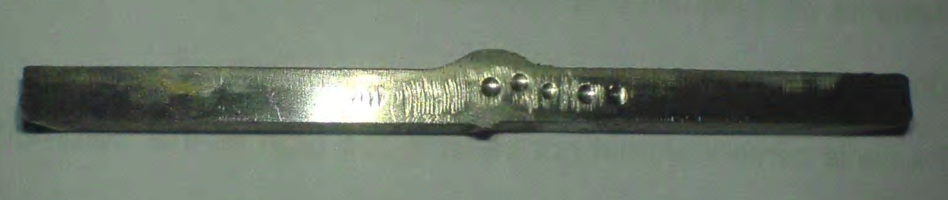

Figure 3.1 locations of points of hardness measurement

The hardness values along the cross section are observed for each welded piece. These observation are depicted in graph 3.2 to graph 3.28

Figure 3.2 hardness profile 1st run Figure 3.3 hardness profile 2nd run

Figure 3.4 hardness profile 3rd run Figure 3.5 hardness profile 4th run
Figure 3.6 hardness profile 5th run Figure 3.7 hardness profile 6th run

Figure 3.8 hardness profile 7th run Figure 3.9 hardness profile 8th run

Figure 3.10 hardness profile 9th run Figure 3.11 hardness profile 10th run
Figure 3.12 hardness profile 11th run Figure 3.13 hardness profile12th run

Figure 3.14 hardness profile 13th run Figure 3.15 hardness profile 14th run

Figure 3.16 hardness profile 15th run Figure 3.17 hardness profile 16th run
Figure 3.18 hardness profile 17th run Figure 3.19 hardness profile 18th run

Figure 3.20 hardness profile 19th run Figure 3.21 hardness profile 20th run

Figure 3.22 hardness profile 21st run Figure 3.23 hardness profile 22nd run
Figure 3.24 hardness profile 23rd run Figure 3.25 hardness profile 24th run

Figure 3.26 hardness profile 25th run Figure 3.27 hardness profile 26th run

Figure 3.28 hardness profile 27th run
Out of these 5 values, highest value of hardness is chosen as critical value. It is observed that for most of the pieces highest value of hardness is observed at 8 mm distance from the weld centre except for sample 4 for which highest value observed at 4 mm distance from the weld centre.
Value of hardness at point 16 mm away from the weld fusion line is hardness of parent metal average value of which is 198 BHN.

3.6 Observed values
Final observed values are shown in table. S/N ratio is also calculated and shown in table 3.6

Table 3.6 S/N ratio and mean value of hardness
Run order  (welded piece) | Preheat  (ºC) | Gas flow rate (L/hr.) | Heat input (kj/mm) | Hardness  (BHN) | S/N ratio | Hardness mean
1 | 50 | 14 | 1.182 | 224 | -47.0050 | 224
2 | 50 | 14 | 1.380 | 229 | -47.1967 | 229
3 | 50 | 14 | 1.570 | 239 | -47.5680 | 239
4 | 50 | 18 | 1.182 | 215 | -46.6488 | 215
5 | 50 | 18 | 1.380 | 217 | -46.7292 | 217
6 | 50 | 18 | 1.570 | 224 | -47.0050 | 224
7 | 50 | 22 | 1.182 | 222 | -46.9271 | 222
8 | 50 | 22 | 1.380 | 226 | -47.0822 | 226
9 | 50 | 22 | 1.570 | 231 | -47.2722 | 231
10 | 125 | 14 | 1.182 | 224 | -47.0050 | 224
11 | 125 | 14 | 1.380 | 229 | -47.1967 | 229
12 | 125 | 14 | 1.570 | 236 | -47.4582 | 236
13 | 125 | 18 | 1.182 | 213 | -46.5676 | 213
14 | 125 | 18 | 1.380 | 217 | -46.7292 | 217
15 | 125 | 18 | 1.570 | 222 | -46.9271 | 222
16 | 125 | 22 | 1.182 | 217 | -46.7292 | 217
17 | 125 | 22 | 1.380 | 219 | -46.8089 | 219
18 | 125 | 22 | 1.570 | 226 | -47.0822 | 226
19 | 200 | 14 | 1.182 | 219 | -46.8089 | 219
20 | 200 | 14 | 1.380 | 224 | -47.0050 | 224
21 | 200 | 14 | 1.570 | 229 | -47.1967 | 229
22 | 200 | 18 | 1.182 | 211 | -46.4856 | 211
23 | 200 | 18 | 1.380 | 213 | -46.5676 | 213
24 | 200 | 18 | 1.570 | 217 | -46.7292 | 217
25 | 200 | 22 | 1.182 | 219 | -46.8089 | 219
26 | 200 | 22 | 1.380 | 222 | -46.9271 | 222
27 | 200 | 22 | 1.570 | 226 | -47.0822 | 226

CHAPTER 4
RESULTS AND DISCUSSIONS
_______________________________________________________

4.1 Introduction
MINITAB 13software has been used for the analysis of the experimental work. The MINITAB software studies the experimental data and then provides the results. In this work, the software is used to give the mean and signal to noise ratio for the hardness. The effect of different process parameters on hardness is calculated and plotted as the process parameters changes from one level to another. The average value of S/N ratios has been calculated to find out the effects of different parameters and as well as their levels.
4.2 Analysis of Data for hardness by Taguchi method:

Table 4.1 S/N Ratio and Mean for hardness
Run order  (welded piece) | Preheat  (ºC) | Gas flow rate (L/hr.) | Heat input (kj/mm) | Hardness  (BHN) | S/N ratio | Hardness mean
1 | 50 | 14 | 1.182 | 224 | -47.0050 | 224
2 | 50 | 14 | 1.380 | 229 | -47.1967 | 229
3 | 50 | 14 | 1.570 | 239 | -47.5680 | 239
4 | 50 | 18 | 1.182 | 215 | -46.6488 | 215
5 | 50 | 18 | 1.380 | 217 | -46.7292 | 217
6 | 50 | 18 | 1.570 | 224 | -47.0050 | 224
7 | 50 | 22 | 1.182 | 222 | -46.9271 | 222
8 | 50 | 22 | 1.380 | 226 | -47.0822 | 226
9 | 50 | 22 | 1.570 | 231 | -47.2722 | 231
10 | 125 | 14 | 1.182 | 224 | -47.0050 | 224
11 | 125 | 14 | 1.380 | 229 | -47.1967 | 229
12 | 125 | 14 | 1.570 | 236 | -47.4582 | 236
13 | 125 | 18 | 1.182 | 213 | -46.5676 | 213
14 | 125 | 18 | 1.380 | 217 | -46.7292 | 217
15 | 125 | 18 | 1.570 | 222 | -46.9271 | 222
16 | 125 | 22 | 1.182 | 217 | -46.7292 | 217
17 | 125 | 22 | 1.380 | 219 | -46.8089 | 219
18 | 125 | 22 | 1.570 | 226 | -47.0822 | 226
19 | 200 | 14 | 1.182 | 219 | -46.8089 | 219
20 | 200 | 14 | 1.380 | 224 | -47.0050 | 224
21 | 200 | 14 | 1.570 | 229 | -47.1967 | 229
22 | 200 | 18 | 1.182 | 211 | -46.4856 | 211
23 | 200 | 18 | 1.380 | 213 | -46.5676 | 213
24 | 200 | 18 | 1.570 | 217 | -46.7292 | 217
25 | 200 | 22 | 1.182 | 219 | -46.8089 | 219
26 | 200 | 22 | 1.380 | 222 | -46.9271 | 222
27 | 200 | 22 | 1.570 | 226 | -47.0822 | 226

Figure 4.1 Main Effect Plot for S/N Ratio (hardness)
Figure 4.2 Main Effect Plot for Mean (hardness)
Figure 4.3 Interaction chart for S/N between preheat, gas flow rate and heat input
Figure 4.4 Interaction chart for means between preheat, flow rate and heat input

4.3 Regression Analysis (by Taguchi method): Variation of hardness with preheat, gas flow rate and heat input, the regression equation is
HARDNESS = 205 - 0.0348 preheat (C) - 0.625 gas flow rate (L/min)
+ 24.4 heat input (KJ/mm) [MINITAB]

4.4 Analysis of Data for hardness by RSM:
Table 4.2 Analysis of hardness by RSM method
Std Order | Run Order | Blocks | A | B | C | Hardness
1 | 1 | 1 | 50 | 18 | 1.57 | 224
2 | 2 | 1 | 50 | 18 | 1.18 | 215
10 | 3 | 1 | 125 | 18 | 1.375 | 217
13 | 4 | 1 | 125 | 22 | 1.180 | 217
5 | 5 | 1 | 125 | 18 | 1.375 | 217
9 | 6 | 1 | 200 | 18 | 1.570 | 217
12 | 7 | 1 | 200 | 22 | 1.375 | 222
14 | 8 | 1 | 125 | 14 | 1.180 | 224
7 | 9 | 1 | 125 | 18 | 1.375 | 217
8 | 10 | 1 | 200 | 14 | 1.375 | 224
15 | 11 | 1 | 200 | 18 | 1.180 | 211
6 | 12 | 1 | 50 | 14 | 1.375 | 229
4 | 13 | 1 | 125 | 22 | 1.570 | 226
3 | 14 | 1 | 50 | 22 | 1.375 | 226
11 | 15 | 1 | 125 | 14 | 1.570 | 226

Fig 4.5 Contour plot of hardness for preheat Vs gas flow rate

Fig 4.6 surface plot of hardness for preheat Vs gas flow rate

As shown in Fig 4.5 and 4.6 that at constant heat input the hardness first decreases and then increases with increase in gas flow rate. Hardness decreases with preheat. But there is sharp change due to gas flow rate then the feed.

Fig 4.7 Contour plot of hardness for preheat Vs heat input

Fig 4.8 Surface plot of hardness for preheat Vs heat input
As shown in Fig 4.7 and 4.8 that at constant flow rate the hardness increases with increase in heat input. Hardness decreases with preheat. But there is sharp change due to heat input then the preheat.
Fig 4.9 Contour plot of hardness for gas flow rate Vs heat input.

Fig 4.10 Surface plot of Ra for feed Vs depth of cut

As shown in Fig 4.9 and 4.10 that at constant preheat the hardness first decreases and then increases with increase in gas flow rate. The hardness increases with increase in heat input.

4.5 Regression Analysis (by RSM):

The regression equation is
Hardness = 206 - 0.0333 preheat(c) - 0.687 gas flow rate (L/min)
+ 23.1 heat input (KJ/mm)

CHAPTER 5

CONCLUSION AND FUTURE SCOPE

5.1 Conclusion
In this study the GMAW process was optimized in the ranges of the investigated parameters using the L27 Taguchi approach and RSM methodology. The optimization of the performance characteristics can be greatly simplified through this approach. It is shown that the performance characteristics of the GMAW process such as hardness can be improved by using the method proposed by this study. The modified Taguchi method is adopted to solve the optimal weld hardness with smaller-the-better quality characteristics. Experimental results have shown that the heat input has greatest effect on hardness. The present study can be concluded in the following steps:
- Taguchi and RSM design of experiment techniques can be very efficiently used in the optimization of welding parameters in GMAW process.
- Formulation of equation is done with the help of which surface roughness can be predicted as
By Taguchi approach:
HARDNESS = 205 - 0.0348 preheat (C) - 0.625 gas flow rate (L/min)
+ 24.4 heat input (KJ/mm)
By response surface methodology:
Hardness = 206 - 0.0333 preheat(c) - 0.687 gas flow rate (L/min)
+ 23.1 heat input (KJ/mm)
- Hardness relation with parameters predicted by Taguchi and RSM are almost same.
- Contour and surface plots obtained through this study can be used as standard for selecting parameters for target surface finish.

5.2 Scope for future work
The welding parameters are selected in this study are preheat, gas flow rate and heat input. Study can be done on more parameter like for different gas type and mixtures, root preparation, welding speed etc. In this study hardness was selected as output parameter. In addition to hardness weld bead geometry, cavity size of gas porosity, welding fume generation rate and particle size (which is critical in case of SS welding) can also be selected as part of study.
It is also one of the important things to analyze why hardness first decreases and then increases with gas flow rate.

References
- Lin Y.C. and Lee K.H., 1997, Effect of preheating on the residual stress in type 304 stainless steel weldment, 63,707-801.
- El-Batahgy Abdel-Monem, 1997, Effect of laser welding parameters on fusion zone shape and solidification structure of austenitic stainless steels, Materials Letters, 32,155-163.
- Gűlenc Behcet, Develi Kaya, Kahraman Nizamettin, Durgutlu Ahmet, 2005, Experimental study of the effect of hydrogen in argon as a shielding gas in MIG welding of austenitic stainless steel, International Journal of Hydrogen Energy ,30, 1475-1481.
- Zambona A., Ferro P., Bonollo, 2006, Micro structural, compositional and residual stress evaluation of CO₂ laser welded superaustenitic AISI 904L stainless steel, Materials Science and Engineering,A 424,117-127.
- Mutupandi V., Bala Srinivasan Bala, Seshadri S.k., Sundresan S., 2003, Effect of weld metal chemistry and heat input on the structure and properties of duplex stainless steel welds, Material Science and Engineering,A358, 9-16.
- Lin Y.C. and Lee K.H., 1997, Effect of preheating on the residual stress in type 304 stainless steel weldment, 63,707-801.
- Griffiths A., Nimmo W., Roebuck B., Hinds G., Turnbull* A., 2004, A novel approach to characterizing the mechanical properties of supermartensitic 13 Cr stainless steel welds, Materials Science and Engineering,A384 83-91.
- Dasgupta Ashish, Mazumder Jyoti, Effect of processing parameters on Zero-Zap lasers welds made on multi-coated steel84, 502-512.
- Kacar*amazan, Kokemli Kőray, 2005, Effect of controlled atmosphere on the mig-mag arc weldment properties, Materials and Designs, 26,508-516
- Tarng Y.S., Juang S.C., Chang C.H., 2002, the use of grey-based Taguchi methods to determine submerged are welding process parameters in hardfacing,
- Juang S.C., Tarng Y.S, 2002, Process parameter selection for optimizing the weld pool geometry in the tungsten inert gas welding of stainless steel, vol 122, pp33-37
- Ross, P.J., 1988, Taguchi Techniques for Quality Engineering, McGraw Hill, New York.
- Lung Kwang Pan, Che Chung Wang, Ying Ching Hsiao, Kye Chyn Ho,2004, “Optimization of Nd:YAG laser welding onto magnesium alloy via Taguchi analysis,vol 37,pp 33-42
- Yang WH, Tarng YS. 1998, Optimization of the weld bead geometry in gas tungsten arc welding by the Taguchi method, Int J Adv Manuf Technol; 14,549-554.
- Tarng Y.S., Juang S.C., Chang C.H., 2002, The use of grey-based Taguchi methods to determine submerged arc welding process parameters in hardfacing, Journal of Materials Processing Technology,128,I-6
- Tarng Y.S., Yang W.H., 1998, Optimization of the weld bead geometry in gas tungsten arc welding by the Taguchi method, Tnt. J. Adv. Manuf. Technol. 14, 549-554.
- Davi Sampaio Correia, Cristiene Vasconcelos Gonçalves, Sebastiao Simoes da Cunha, Jr., 2005, Comparison between genetic algorithms and response surface methodology in GMAW welding optimization, Journal of Materials Processing Technology 160, 70-76.
- Gunaraj, Murugan, 2002, Prediction of heat-affected zone characteristics in submerged arc welding of structural steel pipes. Weld J. AWS: 94-s 8-s.
- Manonmani K, Murugan N, Buvanasekaran G. Effect of process parameters on the weld bead geometry of laser beam welded stainless steel sheets. Mt J Joining Mater 2005:l7(4):l03 9.
- Gunaraj, Murugan. Prediction and control of weld bead geometry and shape relationships in submerged arc welding of pipes. J Mater Process Technol 2005;l68:478 87.
- Koleva E. Electro beam weld parameters and thermal efficiency improxement. Vacuum J 2005;77:4l3 21.
- Benyounis KY, Olabi AG, Hashmi MSJ. Effect of laser welding parameters on the heat input and weld-bead profile. J Mater Process Tech 2005;l64 165:978 85.
- Benyounis KY. Olabi AG, Hashmi MSJ. Optimizing the laser-welded butt joint of medium carbon steel using RSM. J Mater Process Technol 2005;l64—l65:986 9.
- Koleva E. Vuchkov I. Model-based approach for quality improvement of electro beam welding applications in mass production. J Vacuum 2005;77:423 8.
- Kannan T, Murugan N. Effect of flux cored arc welding process parameters on duplex stainless steel clad quality. J Mater Process Technol 2006;l76:230 9.
- Andersen K, Cook G. Karsai 0, Ramaswamy K. Artificial neural network applied to arc &elding process modelling and control. IEEE Trans md Appl l990;26(5):824—30.
- Cook 0, Barnett RJ. Andersen K. Strauss AM. Weld modelling and control using artificial neural networks. IEEE Trans md AppI l995;3l(6):l484 91.
- Vitek JM. Iskander YS, Oblow EM. et al. Neural network modeling of pulsed-laser weld pool shapes in aluminum alloy welds. p. 442 8.
- Juang SC, Tarng YS, Lii HR. A comparison between the back- propagation and counter-propagation networks in the modelling of the TIG welding process. J Mater Process Technol 1998:75:54 62.
- Noordin M.Y., Venkatesh V.C., Sharif S., Eltng S., Abdullah A. 2004 “Application of response surface methodology in describing the performance of coated carbide tools when turning AISI 1045 steel”. Journal of material Processing Technology, vol 145, pp 46-58.
- Olabi A.G., Casalino G.,.Benyounis K.Y, Rotondo A. 2006 “Minimization of the residual stress in the heat affected zone by means of numerical methods”. Materials & Design, vol 28, pp 2295-2302.
- Otto K. N, Antonsson E. K. 1991 “Extensions to the Taguchi Method of Product Design”. Journal of Engineering and Applied Sciences.
- Ozel T. and Yigit.k.2005“Prediction of Surface Roughness and Tool Wear in Finish Dry Hard Turning Using Back Propagation Neural Networks”. International Journal of Machine Tools and Manufacture, vol 45, pp 467-479.
- Palanikumar K., Karunamoorthy L. and Karthikeyan R. 2005“Assessment of factors influencing surface roughness on the machining of glass fiber-reinforced polymer composites” Journal of Materials and Design.
- Reddy S.V. Bhaskara, Shunmugama M.S. and Narendran T.T. 1998“Optimal sub-division of the depth of cut to achieve minimum production cost in multi-pass turning using a genetic algorithm approach”. Journal of Materials Processing Technology, vol 79, pp. 101–108.
- Ribeiro M.V., Moreira M.R.V. and Ferreira J.R. 2003 “Optimization of titanium alloy (6Al–4V) machining” Journal of Materials Processing Technology, vol 143–144, pp. 458–463.

