PERFORMANCE AND EMISSIONS STUDY OF BIODIESEL DERIVED FROM NON EDIBLE OILS ON C. I. ENGINES
A Major thesis submitted
In partial fulfillment of the requirements for the award of the degree of
Master of Engineering
In
Thermal Engineering
By
BAL KRISHAN ARYA
Roll. No. 04/THR/08
(University Roll. No. 8552)
Session 2008-10
Under the Guidance of
Mr. AMIT PAL & Prof. S. MAJI

Department of Mechanical Engineering
Faculty of Technology, University of Delhi
Delhi-110 007, INDIA

STUDENT’S DECLARATION

I hereby certify that the work which is being presented in the major project entitled “PERFORMANCE AND EMISSIONS STUDY OF BIODIESEL DERIVED FROM NON EDIBLE OILS ON C. I. ENGINES” in partial fulfilment of the requirements for the award of the degree of Master of Engineering in Thermal Engineering, submitted to the Department of Mechanical Engineering, is an authentic record of my own work carried under the supervision of Prof. S. Maji, Professor and Mr. Amit Pal Sr. Lecturer of Mechanical Engineering Department, Faculty of Technology, University of Delhi, Delhi.

I have not submitted the matter embodied in this major project as whole or in part, for the award of any other degree.

BAL KRISHAN ARYA
ME (Thermal)
Univ. Roll No.-8552

CERTIFICATE

Date: ___________
This is to certify that the dissertation entitled “PERFORMANCE AND EMISSIONS STUDY OF BIODIESEL DERIVED FROM NON EDIBLE OILS ON C. I. ENGINES” submitted by Mr. Bal Krishan Arya (04/THR/08), (University Roll. No.8552) in partial fulfillment for the award of the Degree of Master of Engineering in Thermal Engineering of University of Delhi, is an authentic record of student’s own work carried out by him under our guidance and supervision.
This is also certified that this dissertation has not been submitted to any other Institute/University for the award of any degree or diploma.

Prof. Amit Pal Prof. Dr. S. Maji
Sr. Lecturer Professor

Department of Mechanical Engineering
University of Delhi, Delhi

ACKNOWLEDGEMENT

It is distinct pleasure to express my deep sense of gratitude and indebtedness to my learned supervisor Dr. S. Maji, Professor and Mr. Amit Pal, Sr. Lecturer in the Department of Mechanical Engineering, Faculty of Technology, University of Delhi,
Delhi, for his invaluable guidance, encouragement and patient review. His continuous inspiration only has made me complete this major project.
I am thankful to Dr. S.S. Kachhwaha, Asst. Professor and Dr. B. D. Pathak, HOD of Mechanical Engineering Department, Faculty of Technology, University of Delhi, Delhi for their approval for the equipment and infrastructure required for completion of this project.

I would like to thank Sh. Lalit Kumar & Sh. Vijay Kumar of I. C. Engine laboratory for extending their kind support and sharing their valuable time for the completion of the major project.
I am thankful to my all teachers, classmates and friends for their unconditional support and motivation during this project. It is a great opportunity for me to extend my heartiest felt gratitude to everybody who helped me throughout the course of this minor project in anyway.

BALKRISHAN ARYA
ME (Thermal)
Univ. Roll. No. 8552

ABSTRACT

The increasing industrialization and motorization of the world has led to a steep rise for the demand of petroleum products. Petroleum based fuels are obtained from limited reserves. These finite reserves are highly concentrated in certain regions of the world. Therefore, those countries not having these resources are facing a foreign exchange crisis, mainly due to the import of crude oil. Hence, it is necessary to look for alternative fuels, which can be produced from materials available within the country. In this project biodiesel performance testing is done in C.I. engine. For this project biodiesel has been prepared from WCO oil and Thumba oil by mechanical stirring method and comparison also has been made with diesel. The performances of this biodiesels have been tested by the performance parameters like torque, brake power, brake thermal efficiency and brake specific fuel consumption, brake specific energy consumption, exhaust gas temperature, air fuel ratio and emission characteristics like smoke opacity. Performance testing has been performed on 4-stroke, single cylinder, water cooled kirloskar C.I. engine and 4-cylinder Tata indica C. I. engine which is attached by eddy current dynamometer for loading purpose. Performance parameters has been obtained from the computer (software is “Engine soft”) which is incorporate with the engine panel box. Smoke opacity checked by the A.V.L smoke meter.The results obtained are in favour of biodiesel over diesel oil. More torque obtained at starting speed. Brake thermal efficiency has slightly increased with biodiesel. Specific fuel consumption is higher for biodiesel than diesel. Smoke Opacity is reduced for higher blends of biodiesel.

 |  | CONTENTS  ACKNOWLEDGEMENT |  |  |  |  |  |  |  |  | I
 |  | ABSTRACT |  |  |  |  |  |  |  |  | II
 |  | LIST OF FIGURES |  |  |  |  |  |  |  |  | III-XI
 |  | LIST OF TABLES |  |  |  |  |  |  |  |  | XII-XIV
 |  | LIST OF ABBREVIATIONS |  |  |  |  |  |  |  |  | XV
CHAPTER 1 |  |  |  |  |  |  |  |  |  |  | 1-17
1.1 |  |  |  |  | INTRODUCTION |  |  |  |  |  | 1-3
 |  |  |  |  | 1.1.1 |  |  |  |  | Energy Crisis | 1
 |  |  |  |  | 1.1.2 |  |  |  |  | Energy Scenario: Indian Context | 1
 |  |  |  |  | 1.1.3 |  |  |  |  | Alternative Fuel Imputes | 3
1.2 |  |  |  | BIODIESEL |  |  |  |  |  |  | 4-17
 |  |  |  | 1.2.1 |  |  |  |  | General |  | 4
 |  |  |  | 1.2.2 |  |  |  |  | Advantages of Biodiesel |  | 5
 |  |  |  | 1.2.3 |  |  |  |  | Indian Scenario in Biodiesel |  | 6-8
 |  |  |  | 1.2.4 |  |  |  |  | Resources of Biodiesel |  | 8-11
 |  |  |  | 1.2.5 |  |  |  |  | Properties of biodiesel |  | 11-14
 |  |  |  | 1.2.6 |  |  |  |  |  | Storage, Handling and Distribution | 14-15
 |  |  |  | 1.2.7 |  |  |  |  | Additives for Oxidative Stability of Biodiesel |  | 15-16
 |  |  |  | 1.2.8 |  |  |  |  | Material Compatibility |  | 16
1.3 |  |  |  | Motivation for present work |  |  |  |  |  |  | 16-17
1.4 |  |  |  | Objective of present research work |  |  |  |  |  |  | 17
1.5 |  |  |  | Organization of the Report |  |  |  |  |  |  | 17
CHAPTER 2 |  |  |  |  |  |  |  |  |  |  | 18-38
LITERATURE REVIEW
2.1 |  | Performance and Emission Studies of WCO |  |  |  |  |  |  |  |  | 18-21
2.2 |  | Performance & emissions studies of other non edible oil |  |  |  |  |  |  |  |  | 22-36
2.3 |  | Conclusion of Literature Review |  |  |  |  |  |  |  |  | 37-38
CHAPTER 3 |  |  |  |  |  |  |  |  |  |  | 39-44
BIODIESEL PRODUCTION
3.1 | Mechanical stirring method |  |  |  |  |  |  |  |  |  | 39
 | 3.1.1 |  |  |  |  |  |  | Experimental setup |  |  | 39
 | 3.1.2 |  |  |  |  |  |  | Regents and materials used in experiment |  |  | 40
 | 3.1.3 |  |  |  |  |  |  | Experimental procedure |  |  | 40-41
3.2 | Experiment results |  |  |  |  |  |  |  |  |  | 41-44
CHAPTER 4 |  |  |  |  |  |  |  |  |  |  | 45-106
PERFORMANCE AND EMISSION STUDY
4.1 |  |  | Experimental setup of single cylinder kirloskar Engine |  |  |  |  |  |  |  | 45-49
4.2 |  |  | Engine Test Setup of four cylinder Tata Indica Engine |  |  |  |  |  |  |  | 49-52
4.3 |  | Preparation of biodiesel blends for single cylinder engine |  |  |  |  |  |  |  |  | 52
4.4 |  | Performance Evaluation |  |  |  |  |  |  |  |  | 53-54
4.5 |  | Observations of single cylinder kirloskar engine |  |  |  |  |  |  |  |  | 55-65
 |  | 4.5.1 |  |  |  | Pure diesel |  |  |  |  | 55
 |  | 4.5.2 |  |  |  | Biodiesel blends from Waste cooking oil |  |  |  |  | 55-60
 |  | 4.5.2 |  |  |  | Biodiesel blends from Thumba oil |  |  |  |  | 61-65
4.6 |  | Preparation of Biodiesel blends for 4-cylinder Tata Indica engine |  |  |  |  |  |  |  |  | 66
4.7 |  | Observations of 4-cylinders Tata Indica Engine |  |  |  |  |  |  |  |  | 66-72
 |  | 4.7.1 |  |  |  |  | Pure diesel and various blends of WCO biodiesel |  |  |  | 66-69
 |  | 4.7.2 |  |  |  |  | Biodiesel blends from thumba oil |  |  |  | 69-72
4.8 |  | Results and discussion of single cylinder Kirloskar engine |  |  |  |  |  |  |  |  | 72-91
4.9 |  | Results and discussion of 4-cylinder Tata indica engine |  |  |  |  |  |  |  |  | 92-106
CHAPTER 5 |  |  |  |  |  |  |  |  |  |  | 107
CONCLUSION AND FUTURE SCOPE |  |  |  |  |  |  |  |  |  |  | 107
5.1 | Conclusions |  |  |  |  |  |  |  |  |  | 107
5.2 | Scope for future work |  |  |  |  |  |  |  |  |  | 107
 | REFERENCES |  |  |  |  |  |  |  |  |  | 108-112

 |  | CONTENTS  ACKNOWLEDGEMENT |  |  |  |  |  |  |  |  | I
 |  | ABSTRACT |  |  |  |  |  |  |  |  | II
 |  | LIST OF FIGURES |  |  |  |  |  |  |  |  | III-XI
 |  | LIST OF TABLES |  |  |  |  |  |  |  |  | XII-XIV
 |  | LIST OF ABBREVIATIONS |  |  |  |  |  |  |  |  | XV
CHAPTER 1 |  |  |  |  |  |  |  |  |  |  | 1-17
1.1 |  |  |  |  | INTRODUCTION |  |  |  |  |  | 1-3
 |  |  |  |  | 1.1.1 |  |  |  |  | Energy Crisis | 1
 |  |  |  |  | 1.1.2 |  |  |  |  | Energy Scenario: Indian Context | 1
 |  |  |  |  | 1.1.3 |  |  |  |  | Alternative Fuel Imputes | 3
1.2 |  |  |  | BIODIESEL |  |  |  |  |  |  | 4-17
 |  |  |  | 1.2.1 |  |  |  |  | General |  | 4
 |  |  |  | 1.2.2 |  |  |  |  | Advantages of Biodiesel |  | 5
 |  |  |  | 1.2.3 |  |  |  |  | Indian Scenario in Biodiesel |  | 6-8
 |  |  |  | 1.2.4 |  |  |  |  | Resources of Biodiesel |  | 8-11
 |  |  |  | 1.2.5 |  |  |  |  | Properties of biodiesel |  | 11-14
 |  |  |  | 1.2.6 |  |  |  |  |  | Storage, Handling and Distribution | 14-15
 |  |  |  | 1.2.7 |  |  |  |  | Additives for Oxidative Stability of Biodiesel |  | 15-16
 |  |  |  | 1.2.8 |  |  |  |  | Material Compatibility |  | 16
1.3 |  |  |  | Motivation for present work |  |  |  |  |  |  | 16-17
1.4 |  |  |  | Objective of present research work |  |  |  |  |  |  | 17
1.5 |  |  |  | Organization of the Report |  |  |  |  |  |  | 17
CHAPTER 2 |  |  |  |  |  |  |  |  |  |  | 18-38
LITERATURE REVIEW
2.1 |  | Performance and Emission Studies of WCO |  |  |  |  |  |  |  |  | 18-21
2.2 |  | Performance & emissions studies of other non edible oil |  |  |  |  |  |  |  |  | 22-36
2.3 |  | Conclusion of Literature Review |  |  |  |  |  |  |  |  | 37-38
CHAPTER 3 |  |  |  |  |  |  |  |  |  |  | 39-44
BIODIESEL PRODUCTION
3.1 | Mechanical stirring method |  |  |  |  |  |  |  |  |  | 39
 | 3.1.1 |  |  |  |  |  |  | Experimental setup |  |  | 39
 | 3.1.2 |  |  |  |  |  |  | Regents and materials used in experiment |  |  | 40
 | 3.1.3 |  |  |  |  |  |  | Experimental procedure |  |  | 40-41
3.2 | Experiment results |  |  |  |  |  |  |  |  |  | 41-44
CHAPTER 4 |  |  |  |  |  |  |  |  |  |  | 45-106
PERFORMANCE AND EMISSION STUDY
4.1 |  |  | Experimental setup of single cylinder kirloskar Engine |  |  |  |  |  |  |  | 45-49
4.2 |  |  | Engine Test Setup of four cylinder Tata Indica Engine |  |  |  |  |  |  |  | 49-52
4.3 |  | Preparation of biodiesel blends for single cylinder engine |  |  |  |  |  |  |  |  | 52
4.4 |  | Performance Evaluation |  |  |  |  |  |  |  |  | 53-54
4.5 |  | Observations of single cylinder kirloskar engine |  |  |  |  |  |  |  |  | 55-65
 |  | 4.5.1 |  |  |  | Pure diesel |  |  |  |  | 55
 |  | 4.5.2 |  |  |  | Biodiesel blends from Waste cooking oil |  |  |  |  | 55-60
 |  | 4.5.2 |  |  |  | Biodiesel blends from Thumba oil |  |  |  |  | 61-65
4.6 |  | Preparation of Biodiesel blends for 4-cylinder Tata Indica engine |  |  |  |  |  |  |  |  | 66
4.7 |  | Observations of 4-cylinders Tata Indica Engine |  |  |  |  |  |  |  |  | 66-72
 |  | 4.7.1 |  |  |  |  | Pure diesel and various blends of WCO biodiesel |  |  |  | 66-69
 |  | 4.7.2 |  |  |  |  | Biodiesel blends from thumba oil |  |  |  | 69-72
4.8 |  | Results and discussion of single cylinder Kirloskar engine |  |  |  |  |  |  |  |  | 72-91
4.9 |  | Results and discussion of 4-cylinder Tata indica engine |  |  |  |  |  |  |  |  | 92-106
CHAPTER 5 |  |  |  |  |  |  |  |  |  |  | 107
CONCLUSION AND FUTURE SCOPE |  |  |  |  |  |  |  |  |  |  | 107
5.1 | Conclusions |  |  |  |  |  |  |  |  |  | 107
5.2 | Scope for future work |  |  |  |  |  |  |  |  |  | 107
 | REFERENCES |  |  |  |  |  |  |  |  |  | 108-112
LIST OF FIGURE
Figure 1.1 | Karanja tree
Figure 1.2 | Jatropha tree.
Figure 3.1 | Photograph of Mechanical stirrer
Figure 3.2 | Photograph of washing process of biodiesel
Figure 3.3 | Graphical representation of Time & Yield % for molar ratio 6:1 and different catalyst percentage
Figure 3.4 | Graphical representation of Time & Yield % for molar ratio 4.5:1 and different catalyst percentage
Figure 4.1 | Schematic layout of single cylinder Engine Setup
Fig 4.2 | Actual Engine test setup of single cylinder
Figure 4.3 | A.V.L smoker meter
Figure 4.4 | Schematic Diagram of the 4-Cylinder Tata Indica Engine
Figure 4.5 | Experimental setup of 4-Cylinder Tata Indica Engine
Fig 4.6(a) | BTE Vs Brake power of WCOB 20,TB 20
Fig 4.6(b) | % change in Smoke opacity with biodiesel blends of 20% compared to diesel fuel as baseline
Fig 4.6(c) | BTE Vs Brake power of WCOB 40,TB 40
Fig 4.6(d) | % change in BTE with biodiesel blends of 40% compared to diesel fuel as baseline
Fig 4.6 (e) | BTE v/s Brake power of WCOB60,TB60
Fig 4.6(f) | %Change in BTE with biodiesel blends of 60% compared to diesel fuel as baseline
Fig4.6(g) | BTE V/s Brake power of WCOB 80,TB 80
Fig 4.6(h) | %change in BTE with biodiesel blends of 80% compared to diesel fuel as baseline
Fig 4.6(i) | BTE v/s Brake power of WCOB 100,TB 100
Fig 4.6(j) | %change in BTE with biodiesel blends of 100% compared to diesel fuel as baseline
Fig 4.6(k) | BTE v/s Brake power of various blends of WCO
Fig 4.6(l) | %change in BTE with biodiesel blends of WCO compared to diesel fuel as baseline
Fig 7(a) | BSFC v/s Brake power of WCOB 20,TB 20
Fig 4.7(b) | %change in BSFC with biodiesel blends of 20% compared to diesel fuel as baseline
Fig 4.7(c) | BSFC v/s Brake power of WCOB 40,TB 40
Fig 4.7(d) | %change in BSFC with biodiesel blends of 40% compared to diesel fuel as baseline
Fig 4.7(e) | BSFC v/s Brake power of WCOB 60,TB 60
Fig 4.7(f) | %change in BSFC with biodiesel blends of 60% compared to diesel fuel as baseline
Fig 4.7(g) | BSFC v/s Brake power of WCOB 80,TB 80
Fig 4.7(h) | %change in BSFC with biodiesel blends of 80% compared to diesel fuel as baseline
Fig 4.7(i) | BSFC v/s Brake power of WCOB 100,TB 100
Fig 4.7(j) | %change in BSFC with biodiesel blends of 100% compared to diesel fuel as baseline
Fig 4.7(k) | BSFC v/s Brake power of various WCO biodiesel
Fig 4.7(l) | %change in BSFC with biodiesel blends of WCO compared to diesel fuel as baseline
Fig 4.8(a) | BSEC v/s Brake power of WCOB 20,TB 20
Fig 4.8(b) | %change in BSEC with biodiesel blends of 20% compared to diesel fuel as baseline
Fig 4.8(c) | BSEC v/s Brake power of WCOB 40,TB 40
Fig 4.8(d) | %change in BSEC with biodiesel blends of 40% compared to diesel fuel as baseline
Fig 4.8(e) | BSEC v/s Brake power of WCOB 60,TB 60
Fig4.8(f) | %change in BSEC with biodiesel blends of 60% compared to diesel fuel as baseline
Fig4.8(g) | BSEC v/s Brake power of WCOB 80,TB 80
Fig 4.8(h) | %change in BSEC with biodiesel blends of 80% compared to diesel fuel as baseline
Fig 4.8(i) | BSEC v/s Brake power of WCOB 100,TB 100
Fig 4.8(j) | %change in BSEC with biodiesel blends of 100% compared to diesel fuel as baseline
Fig 4.8(k) | BSEC v/s Brake power of various WCOB
Fig 4.8(l) | %change in BSEC with biodiesel blends of WCO compared to diesel fuel as baseline
Fig 4.9(a) | Exhaust temp. v/s Brake power of WCOB 20,TB 20
Fig 4.9(b) | %change in EXT with biodiesel blends of 20% compared to diesel fuel as baseline
Fig 4.9 (c) | Exhaust temp. v/s Brake power of WCOB 40,TB 40
Fig 4.9(d) | %change in EXT with biodiesel blends of 40% compared to diesel fuel as baseline
Fig 4.9(e) | Exhaust temp. v/s Brake power of WCOB 60,TB 60
Fig 4.9(f) | %change in EXT with biodiesel blends of 60% compared to diesel fuel as baseline
Fig 4.9(g) | Exhaust temp. v/s Brake power of WCOB 80,TB 80
Fig 4.9(h) | %Change in EXT with biodiesel blends of 80% compared to diesel fuel as baseline
Fig 4.9(i) | Exhaust temp. v/s Brake power of WCOB 100,TB 100
Fig 4.9(j) | %change in EXT with biodiesel blends of 100% compared to diesel fuel as baseline
Fig 4.9(k) | Exhaust temp. v/s Brake power of various WCOB
Fig 4.9(l) | %change in EXT with biodiesel blends of WCOcompared to diesel fuel as baseline
Fig4.10(a) | Air/fuel ratio v/s Brake power of WCOB 20,TB 20
Fig 4.10(b) | %change in A/F ratio with biodiesel blends of 20% compared to diesel fuel as baseline
Fig 4.10(c) | Air/fuel ratio v/s Brake power of WCOB 40,TB 40
Fig 4.10(d) | %change in A/F ratio with biodiesel blends of 40% compared to diesel fuel as baseline
Fig 4.10(e) | Air/fuel ratio v/s Brake power of WCOB 60,TB 60
Fig 4.10(f) | %Change in A/F ratio with biodiesel blends of 60% compared to diesel fuel as baseline
Fig 4.10(g) | Air/fuel ratio v/s Brake power of WCOB820,TB 80
Fig 4.10(h) | %change in A/F ratio with biodiesel blends of 80% compared to diesel fuel as baseline
Fig 4.10(i) | Air/fuel ratio v/s Brake power of WCOB 100,TB 100
Fig 4.10(j) | %change in A/F ratio with biodiesel blends of 100% compared to diesel fuel as baseline
Fig 4.10(k) | Air/fuel ratio v/s Brake power of various WCOB
Fig 4.10(l) | %change in A/F ratio with biodiesel blends of WCO compared to diesel fuel as baseline
Fig 4.11(a) | Smoke opacity v/s Brake power of WCOB 20,TB 20
Fig4.11(b) | %change in Smoke opacity with biodiesel blends of 20% compared to diesel fuel as baseline
Fig 4 .11(c) | Smoke opacity v/s Brake power of WCOB 40,TB 40
Fig 4.11(d ) | %change in Smoke opacity with biodiesel blends of 40% compared to diesel fuel as baseline
Fig4.11(e) | Smoke opacity v/s Brake power of WCOB60,TB 60
Fig 4.11(f) | %change in Smoke opacity with biodiesel blends of 60% compared to diesel fuel as baseline
Fig 4.11(g) | Smoke opacity v/s Brake power of WCOB 80,TB 80
Fig 4.11(h) | %change in Smoke opacity with biodiesel blends of 80% compared to diesel fuel as baseline
Fig 4.11(i) | Smoke opacity v/s Brake power of WCOB 100,TB 100
Fig 4.11(j) | %change in Smoke opacity with biodiesel blends of 100% compared to diesel fuel as baseline
Fig 4.11(k) | Smoke opacity v/s Brake power of various WCOB
Fig 4.11(l) | %change in Smoke opacity with biodiesel blends of WCO compared to diesel fuel as baseline
Fig4.12(a) | Comparison of torque v/s speed for WCOB10, TB10
Fig4.12(b) | %change in torque with biodiesel blends of 10% compared to diesel fuel as baseline
Fig4.12(c) | Comparison of torque vs speed for WCOB 20, TB20
Fig4.12(d) | %change in torque with biodiesel blends of 20% compared to diesel fuel as baseline
Fig: 4.12(e) | Comparison of torque vs speed for WCOB30, TB30
Fig 4.12(f) | % change in torque with biodiesel blends of 30% compared to diesel fuel as baseline
Fig 4.12(g) | Comparison of torque vs speed for various blends of WCO
Fig 4.12(h) | %change in torque with biodiesel blends of WCO compared to diesel fuel as baseline
Fig 4.13(a) | Comparison of Brake power v/s speed for WCOB10,TB10
Fig4.13(b) | %change in brake power with biodiesel blends of 10% compared to diesel fuel as baseline
Fig 4.13(c) | Comparison of Brake power v/s speed for WCOB20,TB20
Fig 4.13(d) | %change in brake power with biodiesel blends of 20% compared to diesel fuel as baseline
Fig 4.13(e) | Comparison of Brake power v/s speed for WCOB30,TB30
Fig 4.13(f) | %change in brake power with biodiesel blends of 30% compared to diesel fuel as baseline
Fig 4.13(g) | Comparison of Brake power v/s speed for WCOB10,WCOB20, WCOB30
Fig 4.13(h) | %change in brake power with biodiesel blends of WCO compared to diesel fuel as baseline
Fig 4.14(a) | Comparison of Brake thermal efficiency v/s speed for WCOB10,TB10
Fig 4.14(b) | %change in BTE with biodiesel blends of 10% compared to diesel fuel as baseline
Fig 4.14(c) | Comparison of Brake thermal efficiency v/s speed for WCOB20,TB20
Fig 4.14(d) | %change in BTE with biodiesel blends of 20% compared to diesel fuel as baseline
Fig 4.14(e) | Comparison of Brake thermal efficiency vs speed for WCOB30,TB30
Fig 4.14(f) | %change in BTE with biodiesel blends of 30% compared to diesel fuel as baseline
Fig 4.14(g) | Comparison of Brake thermal efficiency v/s speed for WCOB10,WCOB20,WCOB30
Fig 4.14(h) | %change in BTE with biodiesel blends of WCO compared to diesel fuel as baseline
Fig 4.15(a) | Comparison of BSFC vs speed for WCOB10,TB10
Fig 4.15(b) | %Change in BSFC with biodiesel blends of 10% compared to diesel fuel as baseline
Fig 4.15(c) | Comparison of BSFC vs speed for WCOB20,TB20
Fig 4.15(d) | %change in BSFC with biodiesel blends of 20% compared to diesel fuel as baseline
Fig 4.15(e) | Comparison of BSFC vs speed for WCOB30,TB30
Fig 4.15(f) | %change in BSFC with biodiesel blends of 30% compared to diesel fuel as baseline
Fig 415(g) | Comparison of BSFC vs speed for WCOB10,WCOB20,WCOB30
Fig 4.15(h) | %change in BSFC with biodiesel blends of WCO compared to diesel fuel as baseline
Fig 4.16(a) | Comparison of BSEC vs speed for WCOB10,TB10
Fig 4.16(b) | %Change in BSEC with biodiesel blends of 10% compared to diesel fuel as baseline
Fig 4.16(c) | Comparison of BSEC v/s speed for WCOB20,TB20
Fig 4.16(d) | %change in BSEC with biodiesel blends of 20% compared to diesel fuel as baseline
Fig 4.16(e) | Comparison of BSEC vs speed for WCOB30,TB30
Fig 4.16(f) | %change in BSEC with biodiesel blends of 30% compared to diesel fuel as baseline
Fig 4.16(g) | Comparison of BSEC vs speed for WCOB10, WCOB20,WCOB30
Fig 4.16(h) | %change in BSEC with biodiesel blends of WCO compared to diesel fuel as baseline
Fig 4.17(a) | Comparison of Opacity vs speed for WCOB10,TB10
Fig 4.17(b) | %change in smoke opacity with biodiesel blends of 10% compared to diesel fuel as baseline
Fig 4.17(c) | Comparison of Opacity vs speed for WCOB20,TB20
Fig 4.17(d) | %change in smoke opacity with biodiesel blends of 20% compared to diesel fuel as baseline
Fig 4.17(e) | Comparison of Opacity vs speed for WCOB30,TB30
Fig 4.17 (f) | %change in smoke opacity with biodiesel blends of 30% compared to diesel fuel as baseline
Fig 4.17(g) | Comparison of smoke opacity v/s speed WCOB10, WCOB20, WCOB30
Fig 4.17(h) | %change in smoke opacity with biodiesel blends of WCO compared to diesel fuel as baseline

LIST OF TABLES
Table 1.1 | Demand of energy for the consumption in India
Table 1.2 | Demand for diesel and biodiesel requirement
Table 1.3 | Global productions of the major vegetable oils
Table 1.4 | Top 10 countries in terms of biodiesel potential
Table 1.5 | Summary of proposed BIS (Bureau of Indian Standards) standards for biodiesel
Table 3.1 | Oil, alcohol and catalyst during the experimentation
Table 3.2 | Time and yield (%) of waste cooking oil for different molar ratio and catalyst percentage
Table 4.1 | Description of different blends of biodiesel
Table 4.2 | Performance parameters for pure diesel versus BP(kW)
Table 4.3 | Performance parameters for WCOB20 versus BP (kW)
Table 4.4 | % change of Performance parameters for WCOB20 in reference to diesel
Table 4.5 | Performance parameters for WCOB40 versus BP (kW)
Table 4.6 | % change of Performance parameters for WCOB40 in reference to diesel
Table 4.7 | Performance parameters for WCOB60 versus BP (kW)
Table 4.8 | % change of Performance parameters for WCOB60 in reference to diesel
Table 4.9 | Performance parameters for WCOB80 versus BP(kW)
Table4.10 | % change of Performance parameters for WCOB80 in reference to diesel
Table 4.11 | Performance parameters for WCOB100 versus BP(kW)
Table 4.12 | % change of Performance parameters for WCOB100 in reference to diesel
Table 4.13 | Exhaust gas Temperature of diesel and WCO
Table 4.14 | Air/Fuel ratio of diesel and WCO
Table 4.15 | % Change in Exhaust gas Temperature and A/F ratio of WCO in reference
Table 4.16 | Performance parameters for TB20 versus BP(kW)
Table 4.17 | % change of Performance parameters for TB 20 in reference to diesel
Table 4.18 | Performance parameters for TB40 versus BP(kW)
Table 4.19 | % change of Performance parameters for TB 40 in reference to diesel
Table 4.20 | Performance parameters for TB60 versus BP(kW)
Table 4.21 | % change of Performance parameters for TB60 in reference to diesel
Table 4.22 | Performance parameters for TB80 versus BP(kW)
Table 4.23 | % change of Performance parameters for TB80 in reference to diesel
Table 4.24 | Performance parameters for TB100 versus BP(kW)
Table 4.25 | % change of Performance parameters for TB100 in reference to diesel
Table 4.26 | Exhaust gas Temperature of Thumba Biodiesel
Table 4.27 | Air /fuel ratio of Thumba Biodiesel
Table 4.28 | % change in Exhaust gas Temperature and A/F ratio of Thumba in reference to
Table 4.29 | Description of different blends of biodiesel
Table 4.30 | Performance parameters for pure diesel versus speed
Table 4.31 | Performance parameters for WCOB10 versus speed
Table 4.32 | % change of Performance parameters for WCOB10 in reference to diesel
Table 4.33 | Performance parameters for WCOB20 versus speed
Table 4.34 | % change of Performance parameters for WCOB20 in reference to diesel
Table 4.35 | Performance parameters for WCOB30 versus speed
Table 4.36 | % change of Performance parameters for WCOB30 in reference to diesel
Table 4.37 | Performance parameters for TB10 versus speed
Table 4.38 | % change of Performance parameters for TB10 in reference to diesel
Table 4.39 | Performance parameters for TB20 versus speed
Table 4.40 | % change of Performance parameters for TB20 in reference to diesel
Table 4.41 | Performance parameters for TB30 versus speed
Table 4.42 | % change of Performance parameters for TB30 in reference to diesel

LIST OF ABBREVIATIONS

BTE | Brake thermal efficiency
BSFC | Brake specific fuel consumption
BSEC | Brake specific energy consumption
BP | Brake power
EXT | Exhaust temperature
TB | Thumba biodiesel
WCO | Waste cooking oil
FP | Frictional power
IP | Indicated power
IThE | Indicated thermal efficiency
MechE | Mechanical efficiency
A/F | Air fuel ratio
BMEP Brake mean effective pressure
PPM Parts Per Million
EGR Exhaust Gas Recirculation

CHAPTER 1

INTRODUCTION
  - Introduction
Energy is one of the most significant inputs for growth of all sectors including agricultural, industrial services and transport sectors. Energy has been at the centre stage of national & global economic development since several decades. The demand for energy, around the world is increasing exponentially, specifically the demand for petroleum-based energy. Petroleum derived fuels, actually, exceeds the demand of any other fuels or energy resources. The world consumption for petroleum and other liquid fuel will grow from 85 million barrels/day in 2006 to 107 million barrels/day in 2030. Under these growth assumptions, approximately half of the world’s total resources would be exhausted by 2030. Also, as per many studies, the world oil production would peak sometime between 2007 and 2030 [1]. Therefore, the future energy availability is a serious global concern. Another, major global concern is environmental degradation or climate change such as global warming. Global warming is related with the greenhouse gases which are mostly emitted from the combustion of petroleum fuels. In order to control the emissions of greenhouse gases, Kyoto Protocol targets to reduce the greenhouse gas emission by a collective average of 5% below 1990 level of respective countries. The Intergovernmental Panel on Climate Change (IPCC) concludes in the Climate Change 2007 that, because of global warming effect the global surface temperatures are likely to increase by 1.1°C to 6.4°C between 1990 and 2100 [1].
1.1.1 Energy Crisis
There is a realization throughout the world that the petroleum resources which are non-renewable, are limited and are being consumed at an alarming rate. The growing demand for energy and gradual extinction of fossil fuels has lead to an energy crisis. Most of the power in industries and transportation is derived from oil and coal. Special mention is needed for automobiles where almost all of the fuels for combustion engine today are derived from petroleum, a non renewable source of energy, which is nearing its end at an unprecedented pace. The grave name of the energy problem was sharply brought into focus by the oil crisis of 1973. Since then, several price hikes have taken place, upsetting economy of most of the nation. The globe today uses about 147 trillion kWh of energy which is expected to rise in the coming future [2]. The expected rise in the world consumption of energy up to 2030. A major chunk of this rise will be due to the developing countries, which are bound to grow by leaps and bounds.
1.1.2 Energy Scenario: Indian Context
India had experienced robust growth for the past few years, and after an impressive 9.6 per cent gross domestic product (GDP) growth in 2006-07 the Indian economy is headed towards 8.7 per cent growth in the current fiscal. The energy needs of India are also rising to cope up the growth rate Of the 156.1 million tonnes of crude oil that India consumed in 2007-08, it produced only 34.12 million tonnes [3]. Indian economy is mainly agriculture based and modern agriculture system is heavily dependent upon internal combustion engines for running farm machinery, irrigation pump sets, and other equipments. Indian growth is mainly based on energy, produced by “oil-burning” in IC engines. It is very difficult to find clear blue sky in Indian metropolis. Petroleum fuels are major contributor to ecological imbalance in India. As Indian economy is heavily based upon IC engines, it is not possible in any case to discard them and some other, easily available renewable fuels in India. These renewable fuels must be sought to lease new life to existing engines in order to curb the twin problems of fuel scarcity and air pollution. Various national emission standards have been set by the Government of India through which the fleets are facing greater pressures to switch to cleaner alternative fuels. The alternative fuels are desirable from the fact that they are the only fuels used with recent engine developments, which can meet the stringent EURO-IV emission norms, which are expected to be enforced in India from 2010. India being richer in flora and fauna can look forward to use fuels from bio origin as the suitable alternatives. The prominent bio fuels from Indian perspective are ethanol and biodiesel. India, the world's
second most populous nation, has seen its population exploding from 300 million in 1947 to around 1.2 billion today. This rapidly growing population has placed a strain not only on India's infrastructure, but also on its environment. According to the World Health Organization, New Delhi is one of the top ten most polluted cities in the world. Two primary sources of air pollution in India are vehicular emissions and untreated industrial smoke. The number of vehicles has registered a sharp increase more so, during the last decade. In Delhi alone, the vehicle number has crossed about 4.6 million. Today, the vehicular pollution contributes roughly 64 % of total air pollution in Delhi, followed closely by Mumbai at 52% and somewhat controlled figure of 30% for Kolkata. About 50% of the total petroleum products consumed in the country go into the transport sector mainly in the form of high-speed diesel and gasoline [4]. India's per capita energy use and carbon emissions, while lower than the world average, result in a substantial percentage of world energy use and carbon emissions, due to the country's large population and heavy reliance on fossil fuels. Increased use of renewable energy is one means of reducing carbon emissions.
1.1.3 Alternative Fuel Imputes
There are some very important parameters which should be considered before adaptation of an alternative fuel in an existing engine. These include:
- No or minimum modification required in design of engine,
- Use of same storage and transportation infrastructure,
- Biodegradable and non-toxic assuring safe handling and transportation,
- Capability of being produced locally and low investment cost.
The economic benefits of the fuels like vegetable oils, compressed natural gas, ethanol, and methanol etc. compared to the traditional petroleum resources are marginal but the environmental benefits are enormous, thus public policies need to be revised to encourage the development of these resources for which:
- Land for production need to be explored.
- An efficient extraction of oil from oil seeds and trans esterification plant would be required.
- Distribution and storage facilities constructed.
- Monitoring of major users for detection of problems
- Large scale use are needed before the technology can be recommended for general use
- The magnitude of our energy needs provides an inexhaustible market of our total agriculture production capacity at the highest possible level farm back to work providing for our food needs and also growing crops and livestock for energy.
- Energy is the only crop that we could never grow in surplus. [5]

1.2 BIODIESEL
1.2.1 General
The idea of using vegetable oil as a substitute for diesel fuel was demonstrated by the inventor of the diesel engine, Rudolph Diesel, around the year 1900, when vegetable oil was proposed as fuel for engines. The oil use as diesel fuel was limited due to its high viscosity (near 10 times of the gas oil). In order to adapt the fuel to the existing engines the properties of vegetable oil had to be modified.Various products derived from vegetable oils have been proposed as an alternative fuel for diesel engines [6].
ASTM International defines Biodiesel as the “mono alkyl esters of long chain fatty acids derived from renewable liquid feedstock’s, such as vegetable oils and animal fats, for use in compression ignition engines.” In the 1980s and 1990s significant R&D was conducted to evaluate a variety of biodiesel blending stocks, develop emissions data, assess engine/vehicle performance, and develop cost-effective manufacturing processes. The main commodity sources of biodiesel in India are non edible oils obtained from plant species such as Jatropha, Pongamia pinnata, karanja etc. [7]. Biodiesel can be blended at any level with petroleum diesel to create a biodiesel blend or can be used in its pure form. Just like petroleum diesel, biodiesel operates in compression ignition engine; which essentially require very little or no engine modifications because biodiesel has properties similar to petroleum diesel fuels. It can be stored just like petroleum diesel fuel and hence does not require separate infrastructure. The use of biodiesel in conventional diesel engines results in substantial reduction of un-burnt hydrocarbons (HC), carbon monoxide (CO) and particulate matters [27]. But uses of biodiesel slightly increase nitrogen oxide (NO_{X}) which can be reduced by incorporating EGR system. Biodiesel is considered as a clean fuel since it has almost no sulphur, no aromatics and has about 10% built in oxygen, which helps it to burn fully. Its higher cetane number improves the ignition quality even when blended in the petroleum diesel. Due to the fact that vegetable oils are produced from plants, their burning leads to a complete recyclable CO₂ (green house gas).
There are also some drawbacks in the bio diesel fuel as compared to petroleum fuels which includes high cost of biodiesel which is around 1.5 times to that of petroleum diesel, unavailability at large scale, and requirement of large area of land.
Now a day’s various techniques have been developed for producing biodiesel. Some of them are mechanical stirring, ultrasonic cavitation, hydrodynamic cavitation and supercritical methanol.
1.2.2 Advantages of the Biodiesel over Petroleum based Diesel Fuel
- Biodiesel is a good lubricant about 66% better than petro diesel
- Biodiesel produce less smoke and particulates maters as it is free of sulphur and aromatics.
- Biodiesel have higher cetane number having good anti knocking property.
- Produce lower carbon monoxide and hydrocarbon emissions.
- Bio-diesel is renewable, biodegradable and non-toxic.
In comparison with petroleum-based diesel fuel, biodiesel is characterized by:
• Lower heating value (by about 10-12%)
• Higher cetane value (typically 45-60)
• About 11% oxygen content(petroleum-based diesel contains no oxygen)
• No aromatics contents (and no PAHs)
• No sulphur or extremely low sulphur content
• Better lubricity
• Higher viscosity
• Higher freezing temperature (higher cloud point and pour point)
• Higher flash point
• No toxicity or low toxicity
• Biodegradability
• Different corrosive properties
Some of the above properties, such as the high cetane value or good lubricity, are obvious advantages of biodiesel while others, including the lower heating value, high freezing point (and inferior flow properties at low temperature), or corrosion properties are its drawbacks. Biodiesel changes the character and can increase the intensity of the odour of diesel exhaust [8].

1.2.3 Indian scenario in biodiesel
The country's energy demand is expected to grow at an annual rate of 6.8 per cent over the next couple of decades. Most of the energy requirements are currently satisfied by fossil fuels – coal, petroleum based products and natural gas. Past and projected increased demand is shown in Table 1.1. Domestic production of crude oil can only fulfil 25-30 per cent of national consumption rest we are importing from other countries. In these circumstances bio fuels are going to play an important role in meeting India’s growing energy needs. Bio fuels offer an attractive alternative to fossil fuels, but a consistent scientific framework is needed to ensure policies that maximize the positive and minimize the negative aspects of bio fuels.
Table 1.1 Demand of energy for the consumption in India

Source | Units | 1994-95 | 2001-02 | 2006-07 | 2011-12
Electricity | Billion units | 289.36 | 480.08 | 712.67 | 1067.88
Coal | Million tonnes | 76.67 | 109.01 | 134.99 | 173.47
Natural gas | Million cubic meters | 9880 | 15730 | 18291 | 20853
Oil products | Million tonnes | 63.55 | 99.89 | 139.95 | 196.47
Source: Planning commission report, 2003
The government of India has formulated an ambitious National Biodiesel Mission to meet 20 per cent of the country’s diesel requirements by 2016-2017. Requirement of biofuel for blending under different scenario are given in Table 1.2. A commercialization period during 2007-2012 will continue Jatropha cultivation and install more transesterification plants which will position India to meet 20 per cent of its diesel needs through biodiesel.
Table 1.2 Demand for diesel and biodiesel requirement

year | Diesel demand Mt | Biodiesel blending requirement (in metric ton)
year | Diesel demand Mt | @5% | @10% | @20%
2006-07 | 52.32 | 2.62 | 5.23 | 10.46
2011-12 | 66.91 | 3.35 | 6.69 | 13.38
2016-17 | 83.58 | 4.18 | 8.36 | 16.72
Source: Planning commission report, 2003
The main problem in getting the biodiesel program rolling has been the difficulty in initiating the large-scale cultivation of Jatropha because farmers do not consider Jatropha cultivation rewarding enough. Therefore government needs to sponsor confidence-building measures such as establishing a minimum support price for Jatropha oilseeds and assuring farmers of timely payments.The plantations under this mission will be established by NGOs, public and private sectors. The Ministry of Forests and Environment (MoEF) and the National Oilseed and Vegetable Oil Development (NOVOD) Board will serve as responsible agencies for the cultivation in the forest and non-forest areas, respectively by providing the necessary information and financial assistance.
In India, there are about 100 varieties of oil seeds but only 10-12 varieties have been tapped so far, amongst which Jatropha and Pongamia are the key wild plant species identified as the potential feedstock for biodiesel production. Their cultivability in wasteland and relatively adverse climatic conditions are the key attribute for their promotion as a feedstock material. According to the Economic Survey of Government of India, out of the total cultivated land area, about 175 million hectares of land is classified as waste and degraded land. It is perceived at various levels of government that encouraging sustainable cultivation of Pongamia and Jatropha trees on these lands can meet part of the country’s energy requirements. With this background, the Planning Commission of India, along with the Ministries of Petroleum, Rural Development, Poverty Alleviation and Environment, has conceptualized a national mission that recommends a major multi-dimensional program to commercialize the biodiesel industry in India. One prime objective is the progressive replacement of petro-diesel by blending in 5%, 10%, and, eventually, 20% of biodiesel.
There are many key challenges and market barriers for biodiesel promotion in India. Information regarding the agro economic practices are limited, which often discourages the risk-averse small and marginal farmers from growing non-edible oil seeds. Still there is uncertainty about the potential yields and reliability of seeds. Further cultivation of such crops having relatively longer gestation period such as Jatropha (3 years) & Pongamia (5 Years). At present the country is relying on imported technology, which is extremely expensive and is also proven for edible oil as feedstock. There are risks associated with the technology for its costs and compatibility. Though indigenous technologies are available at low costs and in smaller plant sizes with lower levels of performance regarding conversion of oil to diesel. Finance of biodiesel projects are a major constraint but few venture capital firms and banking institutions are coming forward to finance biodiesel-manufacturing plants. The production costs of bio-diesel are currently higher than conventional fuels, so it will be very difficult to gain market share without Government intervention in terms of favourable duty and taxation levels. At present wide and uncertain price band ranging from Rs 17-45 per litre of biodiesel discourage the seller & distributor to set up separate distribution channels.
1.2.4 Resources of Biodiesel
Many developed countries have active biodiesel programs. Currently biodiesel is produced mainly from field crop oil like rapeseed, sunflower, karanja, jatropha etc. shown in fig. in Europe and soybean in US. Malaysia utilizes palm oil for biodiesel production while in Nicaragua it is jatropha oil.

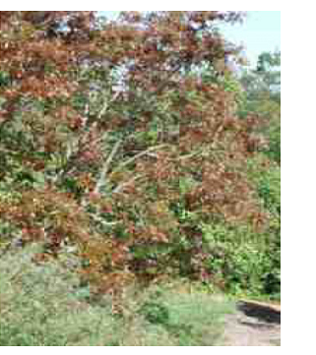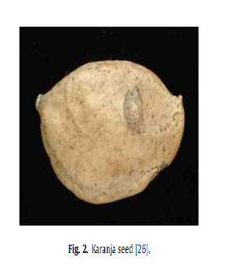
Figure 1.1: Karanja tree

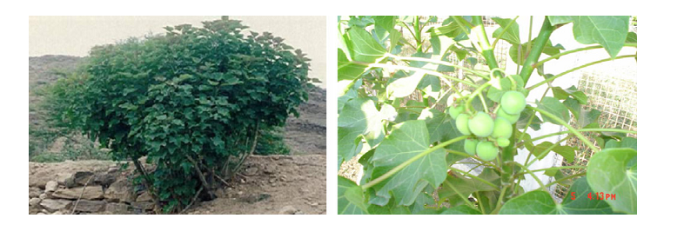Figure 1.2: Jatropha tree.
The productions of vegetable oil globally and in India are given in Table 1.3. There are many countries which have large amount of bio-diesel potential. And if this potential is used for the production of biodiesel than the crisis of petroleum based diesel and fossil fuel can be solved. The global warming problem can also be solved because biodiesel is bio- fuel and it has no harmful emission in diesel engine. In Table 1.4 top 10 countries biodiesel potential (Liter) an there production cost ($/Liter) is given.
Table 1.3 Global productions of the major vegetable oils [9]
Oil | Production  (million tons) | Oil | Production  (million tons) | Oil | Production  (million tons)
Soybean | 27.8 | Palm kernel | 2.9 | Sesame | 0.26
Rapeseed | 13.7 | Olive | 2.7 | Castor | 0.25
Cottonseed | 4.0 | Corn | 2.0 | Niger | 0.03
Sunflower | 8.2 | Castor | 0.5 | Coconut | 0.55
Peanut | 5.1 | Groundnut | 1.40 | Rice Bran | 0.55
Coconut | 3.5 | Soya | 0.82 | Linseeds | 0.1
Linseeds | 0.6 | Mustard | 1.55 | Cottonseed | 0.44
Palm | 23.4 | Sunflower | 0.3
Total | 86.3 | Total | 12.17 | Total | 2.18

Table 1.4: Top 10 countries in terms of biodiesel potential [10]

Rank | country | Volume potential (Liter) | Production cost ($/L)
1  2  3  4  5  6  7  8  9  10 | Malaysia  Indonesia  Argentina  USA  Brazil  Netherlands  Germany  Philippines  Belgium  Spain | 14540,000,000  7595,000,000  5255,000,000  3212,000,000  2567,000,000  2496  2024  1234  1213  1073 | $ 0.53  $ 0.49  $ 0.62  $ 0.70  $ 0.62  $ 0.75  $ 0.79  $ 0.53  $ 0.78  $ 1.71
1.2.5 PROPERTIES OF BIODIESEL
Density/ Specific gravity
Density is the mass per unit volume. The measurement was made at room temperature. The density was measured with the help of a U-Tube Oscillating True Density meter. Biodiesel is slightly heavier than conventional diesel fuel (specific gravity 0.88g/cm³ compared to 0.84g/cm³ for diesel fuel). This allows use of splash blending by adding biodiesel on top of diesel fuel for making biodiesel blends.
Viscosity
When a fluid is subjected to external forces, it resists flow due to internal friction. Viscosity is a measure of internal friction. The viscosity of the fuel affects atomization and fuel delivery rates. It is an important property because if it is too low and too high then atomization and mixing of air and fuel in combustion chamber gets affected. In addition to lubrication of fuel injection system components, fuel viscosity controls the characteristics of the injection from the diesel injector (droplet size, spray characteristics etc.). The viscosity of methyl esters can go to very high levels and hence, it is important to control it within an acceptable level to avoid negative impact on fuel injection system performance. Therefore, the viscosity specifications proposed are same as that of the diesel fuel.

Cetane Number
Biodiesels has higher cetane number than conventional diesel fuel. This result in higher combustion efficiency and smoother combustion. Biodiesel have more than 51 cetane number.
Flash and Fire point.
Flash point is the minimum temperature at which the oil vapor, which when mixed with air forms an ignitable mixture and gives a momentary flash on application of a small pilot flame. The flash point of biodiesel is higher than the petroleum based diesel fuel. The flash point of biodiesel is around 160⁰C. Fire point is an extension of flash point in a way that it reflects the condition at which vapor burns continuously for at least for 5 seconds. Fire point is generally higher than the flash point by 5-8º C.
Cloud and Pour Point.
Cloud and Pour points are important for determining the feasibility of using the fuel in engine at lower ambient temperatures. Fuels with high pour points give flow problems at lower temperature, therefore it cannot be recommended for use in engine at low temperatures. Pour point for fuel oils, lubricating oils and diesel fuels is used as criteria in cold surroundings. The cloud and pour point of the fuel were measured as per the specification given of ASTM D2500 and ASTM D97 respectively .Biodiesel generally has higher cloud point than diesel fuels.The pour point is the lowest temperature at which the liquid will flow in a specific way when cooled under controlled conditions. The cessation of flow results from an increase in viscosity or from the crystallization of wax from the oil. Fuel oils of wax bearing crude oils have much higher pour point then those derived from crude oils of low wax content. A low pour point is a desired property of oil in respect of handling in cold atmosphere.
Cold filter plugging point (CFPP)
At low operating temperature fuel may thicken and not flow properly affecting the performance of fuel lines, fuel pump and injectors. Cold filter plugging point of biodiesel reflects its cold weather performance. It defines the fuels limit of filterability. Biodiesel thicken at low temperatures so need cold flow improver additives to have acceptable CFPP.
Aromatics
Biodiesel does not contain any aromatics so aromatic limit not specified.

Stability
Biodiesel age more quickly than fossil diesel fuel due to the chemical structure of fatty acids and methyl esters present in biodiesel. Typically there are up to 14 types of fatty acid methyl esters in the biodiesel. The individual proportion of presence of these esters in the fuel affects the final properties of biodiesel..There are three types of stability criteria namely Oxidation stability, Storage stability and Thermal stability.
Iodine number
Iodine number refers to the amount of iodine required to convert unsaturated oil into saturated oil. It refers to the amount of unsaturated fatty acid in the fuel. One value of iodine number can be obtained by using several grades of unsaturated acids. Therefore an additional parameter, linolenic acid (C18: 3) content is specified and limited to 15% in Austrian Standard ON C 1191.
Acid number/ Neutralization number
Acid number reflects the presence of free fatty acids or acid used in manufacture of biodiesel. It also reflects the degradation of biodiesel due to thermal effect. The resultant high acid number can cause damage to injector and also result in deposit in fuel system and affect life of pumps and filters.
Properties of waste cooking oil methyl ester.
Property WCOME
density 885 kg/m³
kinematic viscosity 4.73 cSt
flash point 142⁰C
calorific value 37000 kj/kg
acid value 0.08 KOH/g
Some of the important properties of biodiesel proposed by BIS (Bureau of Indian standards) are given in Table 1.5.

Table 1.5 Summary of proposed BIS (Bureau of Indian Standards) standards for biodiesel [7]
Standard property | Unit | Proposed BIS specification
Density @ 15ºC | g/cm³ | 0.87 – 0.90
Viscosity @ 40ºC | mm²/s | 3.5 - 5.0
Flash point | ºC | >=100
Sulphur, max. | %mass | 0.035
CCR,100%distilation residual max.. | %mass | 0.05
Sulphated ash, max | %mass | 0.02
Water.max | mg/kg | 500
Total contamination, max. | mg/kg | 20
Cetane no |  | >=51
Acid no | mg KOH/g | <=0.8
Methanol | %mass | <=0.02
Ester content | %mass | >=96.5
Triglyceride | %mass | <=0.2
Triglyceride | %mass | <=0.2
Free glycerol | %mass | <=0.02
Total glycerol | %mass | <=0.25
Iodine no |  | <=115
Phosphorus | Ppm | <=10
Alkaline matter(Na,K) |  | <=10
Distillation, T 95% | ºC | <=360

1.2.6 Storage, Handling and Distribution
Biodiesel is significantly safer than diesel. The storage and handling procedures for petroleum diesel can also be used for biodiesel. The fuel is best stored in a dark, dry and clean environment, in storage tanks, preferably steel, aluminium, Teflon, fluorinated polyethylene or polypropylene. Materials which should be avoided include lead, copper, brass, tin and zinc. Biodiesel has a flash point higher than diesel. Many diesel fuel suppliers recommend storing diesel for no more than three to six months unless using a stabilizing additive. The current industry recommendation is that biodiesel or biodiesel blends also be used within six months. A longer safe life is possible and storage enhancing additives can provide additional benefits. Acid numbers in biodiesel and biodiesel blends will become elevated if the fuel ages, or if it was not properly manufactured. Raised acid numbers have been associated with fuel system deposits and reduce the life of fuel pumps and filters. Pure biodiesel and biodiesel blends should be stored at temperatures higher than the pour point of the fuel. Biodiesel blends will not separate in the presence of water however it is recommended that good ‘housekeeping’ be maintained. This is in respect to tank and fuel maintenance, to ensure water in storage systems is monitored and minimised [5].
1.2.7 Additives for oxidative stability of biodiesel
Oxidative stability is a major industry issue for diesel and biodiesel fuels. Some biodiesels are more stable than others and some unstable biodiesel contain stability additives that perform very well. The tendency of a fuel to be unstable can be predicted by the Iodine number (ASTM D 1510) but the test method may not pick up the presence of stability additives. Iodine number actually measures the presence of C=C bonds that are prone to oxidation. The general rule of thumb is that instability increases by a factor of 1 for every C=C bond on the fatty acid chain; thus, 18:3 are three times more reactive than C18:0. Stability can be predicted from knowledge of the feedstock only if you know the proportion of C18:2 and C18:3 fatty acids present in the fuel and know whether or not the fuel has been treated for stability. High fractions of those two types of fatty acids can adversely affect fuel stability if additives are not used. Poor stability can lead to increasingly high acid numbers, increasing viscosity, and the formation of gums and sediments that can clog filters. Comparing the fuel’s acid number and viscosity over time can provide some idea about whether or not the fuel is oxidizing, but you need to take a sample at the beginning when the fuel is fresh and then sample on a regular basis after that.
Long-term storage in the presence of diesel fuel, diesel additives, water, sediments, heat, and air has not been adequately documented in the field. Biodiesel and blends of biodiesel and diesel fuel should not be stored for longer than 6 months in either storage tanks or vehicles until better field data is available. If it becomes necessary to store biodiesel longer than 6 months, or the storage conditions are poor, use antioxidants. The common antioxidants that work with biodiesel are TBHQ (t-butyl hydroquinone), Tenox 21, and tocopherol (Vitamin E). Most of these are sold by food additive firms. Powdered antioxidants are difficult to mix into biodiesel. A trick used is to heat a small amount of biodiesel (1 gal or so) up to 37.7 C or until all the powdered antioxidant is dissolved. Then mixed the treated biodiesel into the bulk biodiesel fuel [6].
1.2.8 Material compatibility
Brass, bronze, copper, lead, tin, and zinc will oxidize diesel and biodiesel fuels and create sediments. Lead solders and zinc linings should be avoided, as should copper pipes, brass regulators, and copper fittings. The fuel or the fittings will tend to change colour and sediments may form, resulting in plugged fuel filters. Affected equipment should be replaced with stainless steel or aluminium. Acceptable storage tank materials include aluminium, steel, fluorinated polyethylene, fluorinated polypropylene, and Teflon. The effect of B20 on vulnerable materials is diluted compared to higher blends. Some slow oxidation can occur, although it may take longer to materialize. Biodiesel can also affect some seals, gaskets, and adhesives, particularly those made before 1993 made from natural or nitrile rubber. It is primarily for these reasons that vehicle and storage equipment are modified. Most engines made after 1994 have been constructed with gaskets and seals that are generally biodiesel resistant. Earlier engine models or rebuilds may use older gasket and seal materials and present a risk of swelling, leaking, or failure. Fuel pumps may contain rubber valves that may fail. The typical approach is to create a maintenance schedule that checks for potential failures. Users can also contact engine manufacturers for more information [6].
1.3 Motivation for present work
The decrease of world petroleum reserves and high energy demand in the power industries and transport sector has necessitated the need for an alternative source of energy. Due to harmful emission and green house gas from fossil fuel, environment is continuously degrading .Therefore there is an also need of alternative fuel which improve the environmental condition. Biodiesel obtained from vegetable oil can be alternative source of energy because its property is similar to petroleum derived diesel oil and produces favourable effects on the environment, such as a decrease in acid rain and greenhouse effect. Due to these factors, the use of biodiesel is considered an advantage to that of fossil fuels. Government of India has also setup national biodiesel mission to meet the aim of 20% blend of biodiesel with diesel by 2011-2012.
This work hoped a positive way towards security of energy in future. The aim of this project to search for optimum condition for biodiesel production and effective method of biodiesel production, then cheque performance in C.I. Engine.
1.4 Objective of the present research work
1). Production of WCO (waste cooking oil) and thumba biodiesel through mechanical stirring .
2). Performance and emission testing of WCO and thumba biodiesel on single cylinder Kirloskar engine.
3). Performance and emission testingof WCO and thumba biodiesel on 4-cylinder tata indica C. I. Engine
1.5 Organization of the report
First chapter is introduction which deals with the energy demand over world and need of renewable energy to secure the future demand of energy. This chapter comprises of various subheadings like general which is about biodiesel and its advantage over fossil fuel, Indian energy scenario which show the position of India on consumption of energy and contribution towards renewable energy source, resources of biodiesel which show existence of energy crops over the world, storage, handling and distribution of biodiesel and last one is biodiesel properties according to BIS standards. Second chapter is literature review in which literatures available on biodiesel performance and emission testing are summarized. Third chapter describe the biodiesel production techniques. Fourth chapter describe the experimental setup of a single cylinder Kirloskar engine and 4-cylinders Tata indica engine and result and discussion of performance studies of biodiesel derived from and waste cooking oil, thumba oil. Performance parameters are torque, brake power, brake thermal efficiency, specific fuel consumption, specific energy consumption and smoke opacity. Chapter fifth conclusion and future scope and refrences.

CHAPTER 2
LITRATURE REVIEW
2.1 Performance & Emissions studies of WCO (waste cooking oil)
A artiﬁcial neural network (ANN) modelling of a diesel engine using waste cooking biodiesel fuel to predict the brake power, torque, speciﬁc fuel consumption and exhaust emissions of the engine was studied by Ghobadian et al. [11]. To acquire data for training and testing the proposed ANN, a two cylinders, four-stroke diesel engine was fuelled with waste vegetable cooking biodiesel and diesel fuel blends and operated at different engine speeds. The properties of biodiesel produced from waste vegetable oil was measured based on ASTM standards. The experimental results revealed that blends of waste vegetable oil methyl ester with diesel fuel provide better engine performance and improved emission characteristics. It can be concluded that R values are very close to one for torque, SFC, CO and HC, while the MSE error was 0.0004. Analysis of the experimental data by the ANN revealed that there is a good correlation between the predicted data resulted from the ANN and measured ones.
The exhaust emissions of a diesel direct injection Perkins engine fueled with waste olive oil methyl ester were studied by Arnal et al. [23] at several steady-state operating conditions. Emissions were characterized with neat biodiesel from used olive oil and conventional Diesel fuel. Results revealed that the use of biodiesel resulted in lower emissions of CO (up to 58.9%), CO₂ (up to 8.6%, excepting a case which presented a 7.4% increase), NO (up to 37.5%), and SO₂ (up to 57.7%), with increase in emissions of NO2 (up to 81%, excepting a case which presented a slight reduction). Biodiesel also presented a slight increase in brake speciﬁc fuel consumption (lower than 8.5%) that may be tolerated due to the exhaust emission beneﬁts. Combustion efﬁciency remained constant using either biodiesel or diesel fuel. Engine performance of used olive oil methyl ester was similar to diesel fuel and no changes in operation were noticed. The proposed alternative for diesel fuel could signiﬁcantly decrease the enormous amount of waste frying oil, furthermore becoming less dependent on fossil oil imports and decreasing environmental pollution.
Gonzalez Gomez et al. [24] were evaluated the exhaust emission and performance characteristics in a Toyota van, powered by a 2l indirect injection (IDI) naturally aspirated diesel engine, operating on vegetable based waste cooking oil methyl ester (WCOME). Exhaust emission results showed that lower levels of CO, CO₂, smoke (approximately 64%, 7.5% and 48% respectively) and SO₂ can be attained with WCOME. On the other hand, NOx emissions were higher (approximately 20%)for WCOME. Engine performance was satisfactory for WCOME. The power developed by WCOME was higher (approximately 9%) than that for mineral diesel fuel at low speeds although it was lower at higher speeds. It seems that WCOME had better performance characteristics than mineral diesel fuel at low speeds. Polymerization of the lubricating oil did not occur. The viscosity was still in grade at the end of the trial. The wear metals were higher when the trial finished. WCOME is a good option as alternative fuel due to the similarities with mineral diesel fuel and its improvement in exhaust emission levels. However, it is certain that further research into the reduction of NO emissions is needed.
The performance and exhaust emissions of a single cylinder diesel engine have been evaluated by Pugazhvadivu and Jeychandran [25] using diesel, waste frying oil (without preheating) and waste frying oil preheated to two different inlet temperatures (75 and 135⁰C). The high viscosity of the waste frying oil was reduced by preheating. For diesel, WFO (waste frying oil) (75 ⁰C) and WFO (135 ⁰C) the minimum BSEC was occurred at the rated power output whereas for WFO (without preheating) alone the minimum BSEC was occurred at 85% of the rated power output. The minimum BSEC using WFO (without preheating) was 28% higher than that of diesel. An improvement of 17 and 1.9% in BSEC was achieved using WFO (75 ⁰C) and WFO (135 ⁰C), respectively, compared to the minimum BSEC obtained using WFO (without preheating). It can also be seen that the minimum BSEC attained using WFO (135 ⁰C) was closer to that of diesel. This result indicates that the engine performance is approaching that of conventional diesel by preheating WFO to 135 ⁰C. The maximum brake thermal efficiency using WFO (without preheating) was 21.6 % as against 30% for diesel. A maximum thermal efficiency of 25.26 and 25.79% were attained using WFO (75 ⁰C) and WFO (135 ⁰C), respectively as against the thermal efficiency of 21.6 % using WFO (without preheating). The results indicate that a significant improvement in thermal efficiency could be realized by preheating WFO to 135 ⁰C. It is seen that the maximum NOx emission was 44% lower for WFO (without preheating) compared to diesel. The maximum NOx emission was increased by 23 and 25% using WFO (75 ⁰C) and WFO (135 ⁰C), respectively compared to WFO ( without preheating). The NOx emissions were 26 and 28% lower, respectively, using WFO (75 ⁰C) and WFO (135 ⁰C) compared with that of diesel. The maximum CO emission was 0.22 and 0.77% with diesel and WFO (without preheating), respectively. The maximum CO emission was 0.58 and 0.48%, respectively, with WFO (75 ⁰C) and WFO (135 ⁰C), respectively. The smoke emission was reduced by 10 and 24%, respectively, using WFO (75 ⁰C) and WFO (135 ⁰C) compared to WFO (without preheating). The maximum reduction in smoke emission was observed using WFO (135 ⁰C). it is concluded that WFO could be used as a diesel fuel substitute by reducing its viscosity to that of diesel by preheating it to a temperature of 135 ⁰C.
An experimental investigation has been carried out by Biona &Licauco [28] to analyze the performance of a compression ignition engine fuelled with pre-heated waste cooking oil and its corresponding effects on the economics when used in public utility jeepneys relative to mineral diesel. Oil pre-heating in the experiments to reduce the oil’s viscosity is provided by a heat exchanger utilizing waste heat from the engine’s cooling system. The performance parameters evaluated were brake speciﬁc fuel consumption (BSFC) and smoke opacity. The average BSFC is higher by 19 % while its effect on public utility jeepneys’ fuel mileage is much lower at 8.5 % reduction. With the lower cost of waste cooking oil, its use could cut down public utility jeepney fuel expenses by 28.5% on the average. It was also found to reduce smoke opacity by 54 %. Pre-heated waste cooking oil has a good potential for use in public utility jeepneys in Metro Manila.
The study was performed by Rao & Rajagopal [45] on a single cylinder, 4.4 kW direct-injection air-cooled stationary C.I. Engine coupled with swinging field electrical dynamometer is used for the experimental study. BTE of UCME (used cooking methyl ester) is lower than that of diesel by 2.5%. The BTE of blends of UCME lie between those of diesel and UCME at all loads. . Since the engine is operated under constant injection advance and UCME has a smaller ignition delay. UCME has lower calorific value than that of diesel. Hence the specific fuel consumption is slightly higher than that of diesel for UCME and its blends. The emission of CO is reduced by 15% for 20% UCME and by 50% for UCME when compared to diesel at rated load condition. CO is predominantly formed due to the lack of oxygen. Since UCME is an oxygenated fuel, it leads to better combustion of fuel resulting in the decrease in CO emission. Reduction in CO emissions is a strong advantage in favor of UCME. UBHC emissions are reduced over the entire range of loads for UCME – diesel blends. It decreases with increase in % of UCME in the blend. Since the UCME is an oxygenated fuel, it promotes combustion and results in reduction in UBHC emissions. A vast reduction in smoke intensity is observed with increase in percentage of UCME in the blend especially at high loads. UCME and its blends as fuel in diesel engines significantly reduce smoke.
The study was performed by Nanthagopal & Subharao [44] on four-stroke water-cooled DI (direct injection) diesel engine, 5kW rated power at 1500 rpm and coupled with electrical dynamometer with waste oil-diesel mixture in emulsion with water. This efficiency is lower when pure diesel is used. Also, it is found that BTE is more when WCO (waste cooking oil)-diesel blend is used. As water content is increased, efficiency is found decreasing. This is due to poor mixture formation as a result of high viscosity and stability WCO blend have higher thermal efficiency than diesel and with water content, highest thermal efficiency is 31.2% for WCO and diesel blend. There is a marginal increment of about 2.78% in brake thermal efficiency for 20% water content when compared to diesel. It shows that BSFC is less when pure diesel is used and is more when 30% of water is added. This could be explained by the lower heating value of the emulsified fuel. The CO concentration is reduced as the water concentration is increased. But, if water is added above 20%, the CO concentration shoots up. This is due to the increase in the viscosity that affects the combustion. It is found that particulate emission for emulsified fuel is higher when compared with pure diesel. Particulate matter for diesel is 4.8 g/h and for 20% water content is 6.3 g/h. So, there is an increment of about 23.8% at full load. From the experiments conducted it is found that 20% water content gives optimum results. As seen from the conclusions, there is a significant reduction in NOx, while the smoke and particulate emissions are high. Therefore by properly control ling the emissions of smoke and particular late, this fuel can be viewed as an effective alternate to the raw vegetable oil as a fuel in diesel engines.

2.2 Performance & emissions studies of other non edible oil
In this chapter literature of performance and study of biodiesel derived from various vegetable in diesel engine has been reviewed. In this literatures performance and emission of biodiesel is compared with diesel at various blend of biodiesel.
The combustion and emissions of engines using diesel fuel and bio-diesel B10,B20,B100) fuel have been investigated by Yuan et al. [12]. The results illustrate that the combustion happens in advance and the ignition delay period is shortened. The results also show that the specific fuel consumption of bio-diesel increases by about 12%.The emissions, such as CO, HC, and particulate matter decrease 41.4%, 38.8%, 38.7 respectively whereas NOx increases 5.6%.
Engine performance and emission characteristics were studied and compared with pure diesel fuel by Yamin et al. [13] . The 4-stroke, 4-cylinder, direct injection, water-cooled compression ignition engine is used. The results showed that there was a loss in the fuel calorific value of about 13.43 % for waste oil biodiesel and 7.24% for unused oil biodiesel, the density of the fuel was found to increase by about 4.75% with respect to pure reference fuel. The experimental results of this study showed that the brake power of bio-diesel is slightly higher, BSFC is higher and lower thermal efficiency is lower than the normal diesel.
The Combustion, performance and emission is tested by Sukumar et al. [14] on single cylinder, four-stroke, air-cooled diesel engine developing 4.4 kW at 1,500 rpm and LOME(linseed oil methyl ester) , SFOME(sunflower oil methyl ester), JOME(jathropha oil methyl ester), MOME(mahua oil methyl ester), COME(coconut oil metyl ester), Diesel is used. A biodiesel fuel with 93% unsaturated fatty ester composition (LOME) has higher density of 0.89 kg/m³ but less viscosity of 3.8 cSt compared to biodiesel with 10% un- saturated ester (COME) of 0.86 kg/m³ and 4.8 cSt. High saturated (90%) biodiesel fuel like COME has higher cetane number and heating value of 59 MJ/kg and 41 MJ/kg respectively. The thermal efficiency increases with load. As load increases the specific energy consumption gradually reduces. This is due to the fact that at lower loads mixture is leaner compared to full load; hence, combustion is poor, resulting in higher energy consumption. It can also be observed that the specific energy consumption at all loads is higher in the case of biodiesel than diesel fuel except LOME and JOME. LOME shows higher CO emission compared to other biodiesel but lesser than diesel. NOx emission is higher in LOME as compared to other biodiesel.
Combustion analysis by Nwafor et al. [15] on both diesel fuel and vegetable oil fuels, with the standard and advanced injection timing.The Petter model single cylinder, air-cooled, high speed, indirect injection, four-stroke diesel engine used. The test results showed that plant oil fuels exhibited longer ignition delay with lower burning rates. The test results also showed that each alternative fuel aquires injection advance appropriate to its delay period. The delay period was signiﬁcant increase in brake thermal efficiency when running on rapeseed oil fuel with standard injection timing. Mechanical efficiency was observed to be reduced with advanced timing. The engine ran smoothly with advance of 3.5⁰ as compared to the standard timing. The signiﬁcant reduction in CO and CO₂ emissions with advanced timing for the speeds tested. At 3000 rpm rape standard & rape advance have 3% higher than B0, AT 2400 rpm rape standard & rape advance have 4% higher than diesel. Rape standard have lowest at 2400 rpm, Rape adva standard have lowest at 2400 rpm, have higher than B0 at 3000 rpm. or diesel fuel HC will increase first and than decrease. For rape oil standard HC will constant for short period initially than it decreases and then increases at very slow rate.
Combustion and exhaust emissions with neat diesel fuel and diesel–biodiesel blends NOME (Neem oil methyl ester) have been investigated Nabi Nurun et al. [16] on a single cylinder water-cooled, natural aspirated, direct injection diesel engine. The reductions in CO and smoke emissions and the increase in NOx emission with diesel-NOME blends. The ester of this oil can be used as environment-friendly alternative fuel for diesel engine and thus food versus fuel conﬂict will not arise. Upto 1000 rpm BTE increases gradually with increase in speed and after that it decreases with increase in BMEP, CO remain almost constant, but it is less than diesel by almost 25 ppm. With increase in BMEP NOx increases first than remain constant for some period and then again increases. But NOx is greater than neat diesel about 5%.
The investigations were carried out by Banapurmath et al. [17] on a single cylinder, four stroke, direct-injection, CI engine operated with methyl esters of Honge oil, Jatropha oil and sesame oil. Comparative measures of brake thermal efﬁciency, smoke opacity, HC, CO, NO_{x}, ignition delay, combustion duration and heat release rates were done Engine performance in terms of higher brake thermal efﬁciency and lower emissions (HC, CO, NO_{x}) with sesame oil methyl ester operation was observed and compared to methyl esters of Honge and Jatropha oil operation. All the esters show an increased ignition delay and combustion duration as compared to neat diesel. The maximum brake thermal efficiency was recorded with SOME(sunflower methyl ester) and is 30.4% at 80% power output compared to 31.25% for diesel. However, the brake thermal efficiency values for HOME, SOME and JOME were 29.51%, 30.4% and 29%, respectively, at 80% load. CO remain constant upto 3 kW brake power and then its value increase suddenly after 4.5 kW brake power. JOME have highest value 40% and lowest for diesel is 19.5% at full load. Among the biodiesels, tested HC emission values were 67, 60 and 65 ppm for JOME, SOME and HOME, respectively, compared to 40.5 ppm with diesel operation at 80% load.
Sharma et al. [18] investigated various aspects of engine performance using neem biodiesel diesel blend (B20) as fuel on single cylinder vertical four stroke high speed Kirloskar CI engine at different injection pressure. Data thus obtained were analysed and compared with those of pure diesel. Significant reduction in emissions was observed. It was observed that BTE at higher loads was slightly low about 3% as compared to that with pure diesel at full load .It can be seen that this difference tends to increase with the increase of injection pressure. (IP range is from 1.37 to 1.67 kN/cm²). BSFC is slightly higher as compared with pure diesel and tends to increase with the increase of injection pressure throughout the entire the load range .NOME (Neem oil methyl ester) have 1.MJ/kWh than diesel at 3kW and 1.67kN/cm². CO emission at all injection pressures with both neem-diesel blend and pure diesel tends to initially decrease with increase in load and further increases sharply near full load. Diesel have 110ppm &NOME have 100ppm at 1.47 kN/cm² at full load. HC emission was significantly reduced with neem-diesel blend as compared to that of pure diesel. HC reduction is mainly due to complete combustion of neem-diesel blend within the combustion period. NOME have 103 ppm & diesel have 130 ppm at 3.7kN/cm².
Neat vegetable oil poses some problems when subjected to prolong use in CI engines has been carried out by Rodjanakid and Chinda [19] . The problems are attributed to its high viscosity and low volatility. These problems can be minimized by the process of transesterification. Biodiesel from refined palm oil steering is a promising alternative for using in diesel engines. It is easier for delivering and storage than diesel oil, because of its higher flash point. The biodiesel from refined palm oil steering has the lowest operating temperature at 15 °C or it may clog at a pipe. The 10% blended biodiesel from refined palm oil steering can be used in high-speed diesel engine since the viscosity and pour point are in the standard limit for high-speed diesel. However, the use of biodiesel generates more smoke and has a lower brake power than diesel oil. Biodiesel from refined palm oil steering can be used as alternative diesel fuel for small CI engine without any modifications.
Biodiesel fuel derived from rice bran oil was tested by Kyunghyun and Youngtaig [20] as an alternative fuel on a water-cooled, 4-cylinder, 4-stroke, commercial ID (Iindirect injection) agricultural diesel engine with no modifications. The experiments were conducted at engine speeds of 1200, 1500, 2000, and 2500 rpm, and at engine loads of 0, 25, 50, 75, 90, and 100%. A Bosch smoke meter (HBN-1500) and an exhaust gas analyzer (Green line MK) that used an electrochemical cell detector were installed in the exhaust pipe (300 mm from the exhaust manifold) to measure exhaust emissions. The torque and power slightly increased when 20 % biodiesel fuel was used, as compared
to neat diesel fuel. The BSEC decreased with the biodiesel content of the diesel fuel. As the biodiesel content of the diesel fuel increased, the smoke emissions decreased up to 46%. The biodiesel fuel was very effective for reducing the smoke emissions at high engine speeds and full loads. The CO and CO₂ emissions decreased as the biodiesel content of the diesel fuel increased. NOx emissions were not very sensitive to the biodiesel content of the diesel fuel; the emissions were similar to those measured using neat diesel fuel. Based on these results, we conclude that biodiesel fuel can be utilized effectively as a renewable and low-pollution alternative fuel for agricultural indirect injection diesel engines. Furthermore, biodiesel fuel can significantly reduce smoke emission without increasing NOx emission.
The properties, performance, emissions and combustion characteristics of biodiesel ( soybean crude oil) and diesel were investigated by Geng et al. [21] on a single cylinder, naturally aspirated, four-stroke, water cooled, direct injection, high speed diesel engine. The speciﬁc gravity of the biodiesel is approximately 6.1% higher than that of diesel. The LHV(lower heating value) of the biodiesel is approximately 10.2% lower than that of diesel. The ﬂash point is higher than that of diesel The higher fuel consumption reﬂects its lower heating value. Both fuels give nearly identical BSEC. The emission of carbon monoxide, hydrocarbon, nitrogen oxides and smoke are averagely decreased by 27, 27, 5, 52% respectively under speed characteristic at full load. The study tacitly suggests that biodiesel from soybean crude oil can be used as a substitute for diesel in diesel engine.
The Soyabean, Palm ,Sunﬂower, Linseed B20, B40, B50, B75, B100 were tested by Agarwal [22] on 4-stroke DI diesel engine. A 20% blend of biodiesel with mineral diesel improved the cetane number of diesel. The caloriﬁc value of biodiesel was found to be slightly lower than mineral diesel. The 20% biodiesel blend was found to be the optimum concentration for biodiesel blend, which improved the peak thermal efﬁciency of the engine by 2.5%, reduced the exhaust emissions and the brake speciﬁc energy consumption substantially. Smoke emissions reduced appreciably as a result of biodiesel. The carbon deposits on piston top and injector coking substantially reduced in biodiesel-fuelled system The wear of various vital parts reduced up to 30% because of additional lubricity properties of biodiesel.
Performance of castor non-edible vegetable oil and its blend with diesel have been investigated by Naga Prasad et al. [26] on a single cylinder, 4 stroke, naturally aspirated, direct injection, water cooled, eddy current dynamometer Kirloskar Diesel Engine at 1500 rpm for variable loads. Dilution of castor oil reduces the viscosity considerably close to viscosity of diesel at 30⁰C and does not require any heating prior to injection into combustion chamber. Blends containing 50%, 25%, and 0% diesel require preheating up to 70, 80 and 95⁰C respectively. The performance and emission characteristics of 25% blend of castor is better than that of all other blends and it is well comparable with diesel. However at rated load, the neat castor oil emissions viz. CO, UHC, smoke are 56.41%, 20.27%,31.32% respectively higher and NOx are 44% lower compared to those of diesel. This is due to incomplete combustion of the fuel and delay in the ignition process. BTE, BSFC of castor oil are 33.45% lower and 54.76% higher compared to those of diesel. This is due to higher viscosity and lower calorific value of the fuel.
An experimental investigation has been carried out to analyze the performance and emission characteristics of a compression ignition engine fuelled with Karanja oil and its blends (10%, 20%, 50% and 75%) with mineral diesel by Agarwal &Rajamonoharan [27]. The effect of temperature on the viscosity of Karanja oil has also been investigated. Thermal efﬁciency of the engine with preheated oil blends is nearly 30% and for lower blends (unheated) such as K10, K20 and K50, it was 24–27%. The brake speciﬁc fuel consumption and brake speciﬁc energy consumption of the engine with preheated lower blends showed an improved trend. The unheated oil blends up to K50 also showed an improved trend compared to mineral diesel. The smoke density from exhaust gas of preheated lower blends as well as unheated lower blends was almost similar to that of diesel fuel. The HC emissions from unheated and preheated lower blends (K10 and K20) are lower than that of mineral diesel. The emission of NO from all blends with and without preheating are lower than mineral diesel at all load conditions. This is a signiﬁcant advantage over mineral diesel while using vegetable oil and their blends. Hence it can be concluded that the Karanja oil blends with diesel up to 50% (v/v) without preheating as well as with preheating would replace diesel for running the CI engine for lower emissions and improved performance.
Experiments were conducted by Aggarwal and Agarwal [29] using various blends of Jatropha oil with mineral diesel to study the eﬀect of reduced blend viscosity on emissions and performance of diesel engine. A single cylinder, four stroke, constant speed, water cooled, direct injection diesel engine typically used in agricultural sector was used for the experiments. Thermal efficiency was found to increase with increasing fuel injection pressure from 180 bars to 200. However, increase in fuel injection pressure from 200 bars to 240 bars showed decrease in thermal efficiency. Maximum thermal efficiency (31.75%) was found at fuel injection pressure of 200 bar. at 72% of rated load. Thermal efficiency of preheated Jatropha oil was found slightly lower than diesel. However, thermal efficiency for preheated Jatropha oil was higher than unheated Jatropha oil. BSFC decreases as the fuel injection pressure increases from 180 bars to 200 bars. Further increase in fuel injection pressure results in increased BSFC. BSFC decreases as the load increases. But, at higher loads, BSFC increases. Lowest BSFC (0.3 kg/kWh) was found at 200 bars. At t lower loads, CO emissions were nearly similar for these fuels but at higher loads, CO emissions were higher for Jatropha oil compared to that of diesel emissions are lower at partial load, but tend to increase at higher loads for all fuels. This is due to lack of oxygen resulting from engine operation at higher equivalence ratio. Diesel fuel operation produced lower HC emissions compared to Jatropha oil.
Results are presented by Forson et al. [30] on a single-cylinder direct-injection engine operating on diesel fuel, jatropha oil, and blends of diesel and jatropha oil in proportions of 97.4%/2.6%; 80%/20%; and 50%/50% by volume. The results covered a range of operating loads on the engine. The test further showed increases in brake thermal eﬃciency, brake power and reduction of speciﬁc fuel consumption for jatropha oil and its blends with diesel generally, but the most signiﬁcant conclusion from the study is that the 97.4% diesel/2.6% jatropha fuel blend produced maximum values of the brake power and brake thermal eﬃciency as well as minimum values of the speciﬁc fuel consumption. The test showed that jatropha oil could be conveniently used as a diesel substitute in a diesel engine.
A 5.2 kW diesel engine with alternator was used to test Jatropha curces biodiesel and its blends and compared with conventional commercial diesel fuel by Ramesh & Sampathrajan [31]. In the case of jatropha biodiesel alone, the fuel consumption was about 14 per cent higher than that of diesel. The calorific value of the jatropha biodiesel was about 12 per cent lower than that of diesel fuel. The per cent increase in fuel consumption of biodiesel blends (B20 to B80) ranged from 2 to 13 per cent than diesel fuel due to increase in calorific value of these fuels. The brake thermal efficiency with biodiesel and its blends was found to be slightly higher than that of diesel fuel at tested load conditions. It varied from 28.6 to 33.0 per cent for diesel fuel alone. There was no difference between the biodiesel and its blended fuels on efficiencies. The brake thermal efficiencies of engine, operating with biodiesel mode were 28.8, 30.6 and 33.1 per cent at 2, 2.5 and 3.5 kW load conditions respectively. The highest exhaust gas temperature was observed as 463ºC for biodiesel among three load conditions. The raise in exhaust gas temperature of 3.5 kW load followed similar trend for blended fuels. The diesel fuel mode exhaust gas temperature was observed as 375ºC. The CO₂ increased with increase in load conditions for diesel and for biodiesel blended fuels. The jatropha biodiesel followed the same trend of CO2 emission, which was higher than in case of diesel. The CO reduction by biodiesel was 16, 14 and 14 per cent at 2, 2.5 and 3.5 kW load conditions. With diesel fuel mode the lowest CO was recorded as 520 ppm at 2 kW load and as load increased to 3.5 kW, CO also increased to 898 ppm. The NOx emission increased for biodiesel by 15, 18 and 19 per cent higher than diesel fuel at 2, 2.5 and 3.5 kW load conditions. The percentage increase in NOx concentration for blended biodiesel fuels were observed as 6.6 to 19 per cent when compared with diesel fuel.
The performance, emission and combustion characteristics of a single cylinder, constant speed, direct injection diesel engine using orange oil as an alternate fuel were studied and the results are compared with the standard diesel fuel operation by Purshothaman& Nagarajan [32]. The brake thermal efficiency is higher by about 2.4% for orange oil than the diesel fuel at full load because of better evaporation and mixture preparation of the orange oil resulting in rapid heat release ratesIt can be seen that the improvement in brake thermal efficiency is more significant at higher brake outputs. It is seen that the brake specific energy consumption (BSEC) is lower for orange oil because of better combustion of orange oil which has compensated for the additional energy. It is noticed that CO varies from 2.7 gm/kW- h at low load to 0.87 gm/kW h at full load for diesel fuel and for orange oil it varies from 2.2 g/kW h at low load to0.59 g/kW h at full load. It is seen that the HC emissions for diesel fuel is 0.21 g/kW h at low load and 0.06 g/kW h at full load and for orange oil it is 0.09 g/kW h at low load and 0.02 g/kW h at full load. For orange oil, the HC emissions are lower than that of diesel fuel this may be due to complete combustion. It is observed that there is an increase in NOx emissions due to the presence of oxygen in the orange oil thus enhancing the combustion resulting in higher combustion temperature. Another probable reason for the increase in NOx may be due to higher cylinder pressure, which in turn causes higher peak combustion temperature. The NOx emission for orange oil is 16.7 gm/kWh and for diesel it is 14.9 g/kWh at full load. Smoke level at the maximum power output is 0.8 Bosch Smoke Unit (BSU) with orange oil whereas for diesel it is 0.85 BSU. This may be due to more complete combustion and the presence of oxygen in the orange oil. And also at lower load the smoke is 0.05 BSU for orange oil and for diesel it is 0.3 BSU.
The performance and emission charrectestics are find out by Lapuerta et al. [33] on single cylinder and used non edible oil. The loss of torque and power ranged between 5% and 10%, and particularly at full load, the loss of power was closer to 5% at low speed and to 10% at high speed. Obtained about 2.5% increases in BSFC from their tests with 20% blends and about 14% from those with pure biodiesel. A minor number of studies report small improvements in efficiency with biodiesel, or even synergic blending effects, which could be caused by reductions in friction loss associated with higher lubricity. They observed that an average, soybean-oil biodiesel provided a 15% increase in NOx emissions as compared to those with diesel fuel, rapeseed provided a 12% increase, while biodiesel made from animal fats led to only a 3%increase. PM maximum reductions (around 40%) were reached in the case of indirect injection engine and reductions of up to 70% can be found with pure biodiesel and up to 45% with 20% biodiesel blends. They tested 10%, 20%, 30%, 50% and 100% biodiesel from soybean oil in a heavy-duty engine. THC reductions with 10%, 20% and 100% biodiesel were 28%, 32% and 75%, respectively, there for relatively larger reductions were reached with lower biodiesel contents. CO mean reductions were 45% when biodiesel was compared to conventional diesel and 35% when it was compared to a clean diesel (high-cetane number, low density).
The investigation by Hebbal et al. [34] on Deccan hemp, a non-edible vegetable oil in a diesel engine for its suitability as an alternate fuel. The performance and emission characteristics of blends are evaluated at variable loads of 0.37, 0.92, 1.48, 2.03, 2.58, 3.13 and 3.68 kW at a constant rated speed of 1500 rpm and results are compared with diesel. Brake thermal efficiency of 50% blend is very close to diesel for entire range of operation. Maximum brake thermal efficiency of 50% blend is 26.714% against 26.673% of diesel oil, which is lower by 0.041%. We can say that brake thermal efficiency of 50% blend is well comparable with diesel. Brake thermal efficiency of other blends follows in the order of 25%, 75% blend and neat deccan hemp oil. The maximum brake thermal efficiency of 25% blend and neat deccan hemp oil are 26.281% and 25.063% against 26.67% of diesel. BSFC of 50% blend closely matches with diesel followed by 25% blend. Minimum BSFC of 50% blend and 25% are 0.334 and 0.333 kg/kW h against 0.321 kg/kW h of diesel oil. BSFC of neat deccan hemp oil is 0.05 kg/kW h higher than that of diesel. CO emission of all blends is higher than that of diesel. Among the blends, 50% blend has a lower CO emission followed by 25% blend. CO emission of 50% and 25% blends at maximum load is 1.2% and 1.306% volume against 0.700% volume of diesel. CO emission of neat deccan hemp oil is higher than all other blends for entire operating range and maximum of 1.7% volume occurs at rated load. Unburnt HC emissions of all blends except 75% blend are lower than that of diesel for low and part load operation. However at maximum load unburnt HC is more for 50% blend and neat deccan hemp oil. Maximum unburnt HC of neat Deccan hemp oil is 230 ppm compared with 180 ppm of diesel. Smoke emission of 50% blend is lower compared with other blends followed by 25% blend. However smoke emission of 50% blend is higher than that of diesel. Smoke emission at maximum load for 50% and 25% blends are 6.1 and 6.45 Bosch units against, 4.020 Bosch units of diesel. For neat deccan hemp oil smoke emission is on higher side for entire range of operation and maximum emission of 7.1 Bosch units occurs at maximum load.
This work investigated by Akhter et al. [35], the production of biodiesel from non-edible CSO(Cotton seed oil) and performance study of diesel engine with diesel fuel and biodiesel mixtures on a single cylinder, water-cooled, NA(natural aspirated), 4-stroke, DI(direct injection) diesel engine Compared to the neat diesel fuel, 10% biodiesel mixtures reduced PM, smoke emissions by 24% and 14%, respectively. Biodiesel mixtures (30%) reduced CO emissions by 24%, while 10% increase in the NOx emission was experienced with the same blend. Thermal efﬁciency with biodiesel mixtures was slightly lower than that of neat diesel fuel due to lower heating value of the mixtures. However, volatility, higher viscosity, higher density may be additional reasons for efﬁciency reduction with biodiesel mixtures.
The performance & emission was tested by Labeckas & Slavinskas [36] on a four stroke, four cylinder, water cooled, direct injection, naturally aspirated Diesel engine D-243 (59 Kw) with rapeseed oil methyl ester . The torque of the engine was measured with a three phase asynchronous 110 kW electrical AC dynamometer. The brake thermal efficiency increases with load up to bmep 0.68 MPa, reaching the top efficiency values of 0.375, 0.380 and 0.378 for diesel fuel and the B5 and B10 blends, respectively. Thermal efficiencies increase smoothly with load, they tend to converge to the one obtained under diesel operation on neat RME with lower top efficiency values averaged at 0.355. the brake specific fuel consumption of 234.5 g/ kW h was obtained for the diesel fuel and 256.4 g/kW h for the RME (rape seed methyl ester). In spite of the different calorific values, the fuel blends B5 and B35 maintain, at equivalent loads, about the same bsfc as that of diesel fuel, whereas the B10 and B20 blends suggest the bsfc is lower by 3.2% and 1.7%, respectively. At a higher speed of 1800 rpm the bsfc of the fully loaded engine for the B20 blend is the same as that for Diesel fuel, 230.4 g/kW h, whereas B35 and RME suggest the bsfc is higher by 8.5% and 18.7%, respectively. the engine runs under full load at the rated speed 2200rpm, where only blends B5 and B10 maintain their bsfc lower by 1.5% relative to diesel fuel (228 g/kW h). The higher RME concentration in blends B20 and B35, as well as the use of neat RME, suggest the bsfc is higher by 8.8%, 14.0% and 23.2%, respectively. the CO emission of the B10and higher blends, including neat RME, are reduced up to two times, ranging between 300 and 600 ppm with more rapid increase only for heavy loads. When the engine load reaches a certain bmep (0.72 MPa), the CO emissions start to increase more rapidly. At fully opened throttle, the biggest CO emission of 1150 ppm was measured for Diesel fuel, and the lowest of 557 ppm was obtained for blend B10. The CO emissions for blends B5, B20, B35 and neat biodiesel were 633, 695, 580 and 811 ppm, respectively. The emission of unburned hydrocarbons HC for all fuels and speeds is negligibly small,5–21 ppm, increasing slightly with load and proportion of fuel injected. The emission of nitric monoxide NO increases gradually with load, reaching the maximum values of 1924–2066 ppm for RME and 1823–1925 ppm for Diesel fuel at high loads. In the maximum torque regime of 1800 min -1 the NO emissions for all the biofuel blends average from 3.5% to 15.3% higher than those of Diesel fuel, whereas at the rated speed of 2200 min-1, only the B5 and B10 blends suggest NO emissions lower by 22.5% to 7.2% and 11.2% to 7.6%, respectively, at adequate loads. The maximum NOx emissions increase with revolutions up to 2000 min rpm, reaching the top value of 1983 ppm for Diesel fuel and 2132 ppm for the B35 blend.
Suresh et al. [37] investigated on on single cylinder four-stroke, water-cooled and constant-speed (1500 rpm)compression ignition Kirlosker engine, rated power is 3.68 kW. The engine is equipped with a DC swinging field generator and a salt-water rheostat in order to apply the required load. For the blends B20 and B40, the BSFC is lower than and equal to that of diesel, respectively. the BSFC increases at all loads and the percentage increase is higher at low loads. It is interesting to note that the engine emits more CO for diesel as compared to PPME (Pongamia pinnata methyl ester) blends under all loading conditions. It is seen that the CO concentration is totally absent for the blends of B40 and B60 for all loading conditions and as the PPME concentration in theblend increases above 60%, the presence of CO is observed. It is seen that the HC emission decreases with increase in load for diesel and it is almost nil for all PPME blends except for B20 where some traces are seen at no load and full load. The NOx emission for all the fuels tested followed an increasing trend with respect to load. The reason could be the higher average gas temperature residence time at higher load conditions. The maximum and minimum amount of NOx produced were 230 and 48 ppm corresponding to B20 and B60. The CO₂ emission increased with increase in load for all blends. The lower percentage of PPME blends emits less amount of CO₂ in comparison with diesel. Blends B40 and B60 emit very low emissions.
Sehmus Altun et al. [38] performed experiments on one cylinder, four-stroke, air-cooled, direct injection diesel engine, it was loaded with a Cussion brand electrical dynamometer and used sesame oil. Specific fuel consumption (SFC) varies depending on the engine power. For both fuels used in the tests, specific fuel consumption has high value at low speed, with increasing speed it decreases, and then it reaches high values engine power has high values in the range of 2400 and 3000 rpm. It is clear that CO emissions decreases with engine speed and the blend produces significantly lower CO emissions than that of diesel fuel. CO emissions are high at low engine speeds. NOx emissions from the mixture of sesame oil and diesel fuel are lower than that of diesel fuel. The reduction of NOx emissions is possibly due to the smaller calorific value of the blend.
This work was investigated by Pramanik [39] on single cylinder open combustion chamber Kirloskar Oil C.I. Engine, rated output 3.68 kW at 1500 rpm with Hydraulic dynamometer using jatropha curcas oil. Thermal efficiencies were obtained at BkW of 3.078 and then tends to decrease with further increase in BkW. There was a considerable increase in efficiencies with the blends compared to the efficiency of jatropha oil alone, but the brake thermal efficiencies of the blends and the jatropha curcas oil were lower than that with diesel fuel throughout the entire range. The maximum values of thermal efficiencies with 60:30 and 70:30 J/D were observed as 21.45% and 20.53%, respectively. Among the blends tested, in the case of 30:70 J/D, the thermal efficiency and maximum power output were close to the diesel values followed by the 40:60 J/D blend maximum brake thermal efficiencies of 26.09% and 24.36% were observed with these blends. A reasonably good thermal efficiency of 22.44% was also observed with the 50:50 J/D blend. The maximum thermal efficiency of 27.11% was achieved with diesel, whereas only 18.52% thermal efficiency was observed using jatropha curcas oil. It was observed that the specific fuel consumptions of the oil as well as the blends were decreased with increasing load from 0.77 to 3.078 and tended to increase with further increase in BkW. The SFC values were found to be 0.338 and 0.365 at 3.078 BkW; the corresponding value for diesel is 0.316. The specific fuel consumption of 0.693 was observed using 50:50 J/D blend as fuel which is comparable to the SFC obtained with diesel oil under the same load.
The study was performed by Ghai et al. [40] on 4-stroke, single cylinder, DI (direct injection) diesel engine [model DAF-8], manufactured by Kirloskar Oil Engines Ltd. Rated brake power: 5.9/8 (kW/BHP at 1500 rpm with sunflower methyl ester. At part loads, diesel fuel thermal efficiency (BTE) is superior however at peak loads (near full load condition), BTE of SFME (sunflower methyl ester ) blends B25 and B30 is better by 1.5% to 4% points. At small and peak loads, there is a gain of 2% and 0.75% respectively. However, at medium loads, there is a loss of about 3 to 4%. The reason is that at medium loads due to higher C.V. and normal rates of heat release (ROHR), power generated by generated by diesel is better whereas at peak loads, BD fuels (B25 and B30) exhibit better combustion characteristics and perform better. The results are in compliance with findings of other research studies. With biodiesel blends, there is less of wall quenching and bulk quenching and hence less hydrocarbon emissions . NOx formation is higher in SFME blended fuels due to higher temperatures during combustion in diffusion burning phase and better access to oxygen. Biodiesel blends contain 2.6-3.1 (wt) % oxygen, have more density and more amount of fuel (mf) is injected.
The study was performed by Agarwal et al. [41] on single cylinder, four stroke, water cooled, Kirloskar diesel engine, 4kW rated power at 1500 rpm, (The engine was coupled to an electrical generator using linseed oil blends showed almost similar thermal efficiency at lower loads. Fifty percent linseed oil blend is found more efficient than other blends with maximum thermal efficiency about 33%. It can be observed that all mahua oil blends have almost similar thermal efficiency. Rice bran oil blends show almost similar thermal efficiency for all other oil blends. Twenty per cent biodiesel blend showed maximum thermal efficiency B30 & B50 have 33%. However, thermal efficiency decreased with further addition of biodiesel to mineral diesel. BSEC is also almost similar for all blends. similar trends. Smoke density increased with proportion of mahua oil in diesel. Smoke density first decreases with addition of rice bran oil in diesel and then increases with further addition of rice bran oil in diesel.
The study was performed on single cylinder 4-stroke water cooled diesel engine by Muammer et al. [42]. Maximum rated power 5.5 kW at 1700 rpm and engine is coupled with electrical generator. The minimum SFC value with traditional diesel was 272.4 g/kWh at 2500 rpm and with biodiesel and biodiesel with glycerin it was 307.8 g/kWh and 314.6 g/kWh at 2250 and 2000 rpm, respectively. The SFC value of Diesel was 11.5% lower than that of biodiesel with glycerin and 13.4% lower than that of biodiesel.
The study was performed by Kumar siva et al. [43] investigated on A single cylinder 4-stroke water cooled diesel engine developing 5.2 kW at 1500 rpm. An eddy current dynamometer was used for loading the engine. It is observed that with the increase in engine speed up to 850 rpm, the BTE increases. This was due to the fact that with the increase in engine speed, the output power of the engine increases the engine BTE. The BTE decreases when the engine running above 850 rpm. Diesel have about 1% higher BTE than cotton seed B10. BSFC decreases with increases engine torque in case of biodiesel mixture the BSFC value determine the higher value than neat diesel fuel.B30 have the higher value than other fuel. For bio-diesel mixtures CO emission was lower than that of diesel fuel, because biodiesel mixture contains some extra oxygen in their molecule that resulted in complete combustion of the fuel and supplied the necessary oxygen to convert CO to CO₂. Compared to neat diesel fuel, 30% bio-diesel mixtures reduced CO emissions by 24%. NO emission increases with increases engine speed NOx level was higher for biodiesel mixtures than conventional diesel fuel at the same engine torque. This additional oxygen was responsible for extra NOx emission. Approximately 10% increase in NOx emission was realized with 30% biodiesel mixtures. It was found that particulate emission with 20% biodiesel mixture was lower than that of neat diesel fuel because neat biodiesel contains 10-12% extra oxygen, which resulted in better combustion, lowers PM emission. With 20% biodiesel mixtures, PM emission was reduced by 24% compared with neat diesel fuel. For 10% biodiesel mixtures, smoke emission was less, compared to neat diesel fuel. The maximum reduction of smoke emission with 10% biodiesel mixtures was observed by 14%.
The study on four cylinder, indirect injection, naturally aspirated diesel engine, Diesel-Ethanol- Biodiesel were examined by Hulwan & Joshi [46]. The BSFC increased for the blends at all the loads compared to diesel fuel. The increase is about 7% at minimum load and 18% at the higher loads for the blend D. The main reason behind this is decrease of the calorific value for the blends, requiring the injection of additional fuel to produce the same power. It is also increasing for the blends compared to diesel fuel at all the loads. The improvement is seen from 11.77% to 13.11% at lower load and 21.72% to 23.37% at higher load. The BTE increase for the blends is due to the rise in the peak pressure resulting from a better combustion process, which tends to increase the conversion of heat into work. At the higher loads the reduction is more than 35% for the blends. The mixture of fuel and air becomes richer at higher loads causing the incomplete combustion and higher amount of smoke emission. The overall smoke emission of the engine is more at higher loads, as it is a reconditioned IDI engine and working at a lower volumetric efficiency. The No emissions are higher for blends C, and B and moderate for the blends A and D compared to diesel fuels. The increase in NO emissions is ranging from 6% to 34 %. The NO emissions are decreasing with load as the fuel quantity increases with the load. The carbon monoxide emissions are increasing with the loads for all the blends as the fuel quantity increases, leading to the incomplete combustion. At low loads, CO emissions of the blends were not much different from that of conventional diesel. However, at higher load, CO emissions of the blends decreased by 25%, for blend C, compared with those of conventional diesel. This may be due to additional oxygen available in the blends. The Lower HC emission means that the engine has higher combustion efficiency, resulting in higher energy output and a cleaner combustion chamber.

2.3 Conclusion of literature review
1). Various experimental studies on biodiesel includes approach of vegetable oil such as SFOME, JOME, COME, LOME, rapeseed oil, Neem biodiesel, alcohols and biodiesel, trans esterified waste olive oil, neat orange oil, Biodiesel with Glycerin, waste oil-diesel mixture in emulsion with water, waste cooking oil methyl ester etc. Most authors were used single cylinder engine rated power 4 kW, some authors are used multi cylinder engine having rated power 15 kW to 40 kW. Most authors find similar thermal efficiency to diesel fuel when using biodiesel or even with blends. The increase in fuel consumption is not caused by any loss in efficiency but rather by the reduced heating value of biodiesel. A minor number of studies report small improvements in efficiency with biodiesel, (about 1-2%) or even synergic blending effects, which could be caused by reductions in friction loss associated with higher lubricity.
2). With respect to consumption of diesel fuel, a large majority of authors found increases in biodiesel fuel consumption in proportion to the biodiesel content in the blends and to the loss of heating value (around 14% in mass basis for most pure biodiesel fuels) . In
those cases where different trends were found, some deficiencies either in biodiesel quality or in measurement accuracy can be supposed. The SFC increases upto 14%.
3). CO are usually found to significantly decrease with biodiesel. A more complete combustion caused by the increased oxygen content in the flame coming from the biodiesel molecules has been pointed out as the main reason. The higher the cetane number, the lower the probability of fuel-rich zones formation, usually related to CO emissions. The range of reduction of co emission from biodiesel is 20-50% than diesel.
4). HC are usually found to significantly decrease with biodiesel. A more complete combustion caused by the increased oxygen content in the flame coming from the biodiesel molecules has been pointed out as the main reason. The higher cetane number of biodiesel reduces the combustion delay, and such a reduction has been related to decreases in HC emissions. The range of reduction of CO emission of biodiesel 20 to 40% than diesel.
5). Among all the reasons given to explain the increase in NOx emissions, only the advance of injection start when compared to diesel fuel appears to be a solid argument, especially in the case of a pump-line-nozzle injection system, where apart from being advanced as a function of the accelerator position, the injection is affected by the pressure transmission speed through the injection line. The increased cetane number of biodiesel, which leads to an advanced combustion by shortening the ignition delay and the higher oxygen availability in the combustion chamber when using biodiesel, which could promote the NO formation reactions. The range of increases of NO_{X} emission of biodiesel 5-10% than diesel.
6). Smoke are usually found to significantly decrease with biodiesel. The biodiesel fuel was very effective for reducing the smoke emissions at high engine speeds and full loads. The smoke emissions were also sensitive to the oxygen content of the fuel. The reduction of smoke opacity emission of biodiesel 38 % than diesel.

CHAPTER 3
BIODIESEL PRODUCTION
This chapter contains the details of biodiesel production methodology. In the present work biodiesel is produced from conventional magnetic stirring.
3.1 Mechanical Stirring
In this process mixing of oil and alcohol is done by a magnetic stirrer. A magnetic capsule is dipped in the immiscible liquid (oil and alcohol are not miscible with each other), as the capsule starts rotating a whirl is formed which disturb the phase boundary between two immiscible liquid and resulted in emulsification of mixture.
3.1.1 Experimental set-up
The transesterification reactions were carried out with a magnetic mechanical stirrer. Photograph of mechanical stirrer is shown in Figure 3.1. Temperature is measured with the help of a thermometer and kept between the 45-60 °C range.
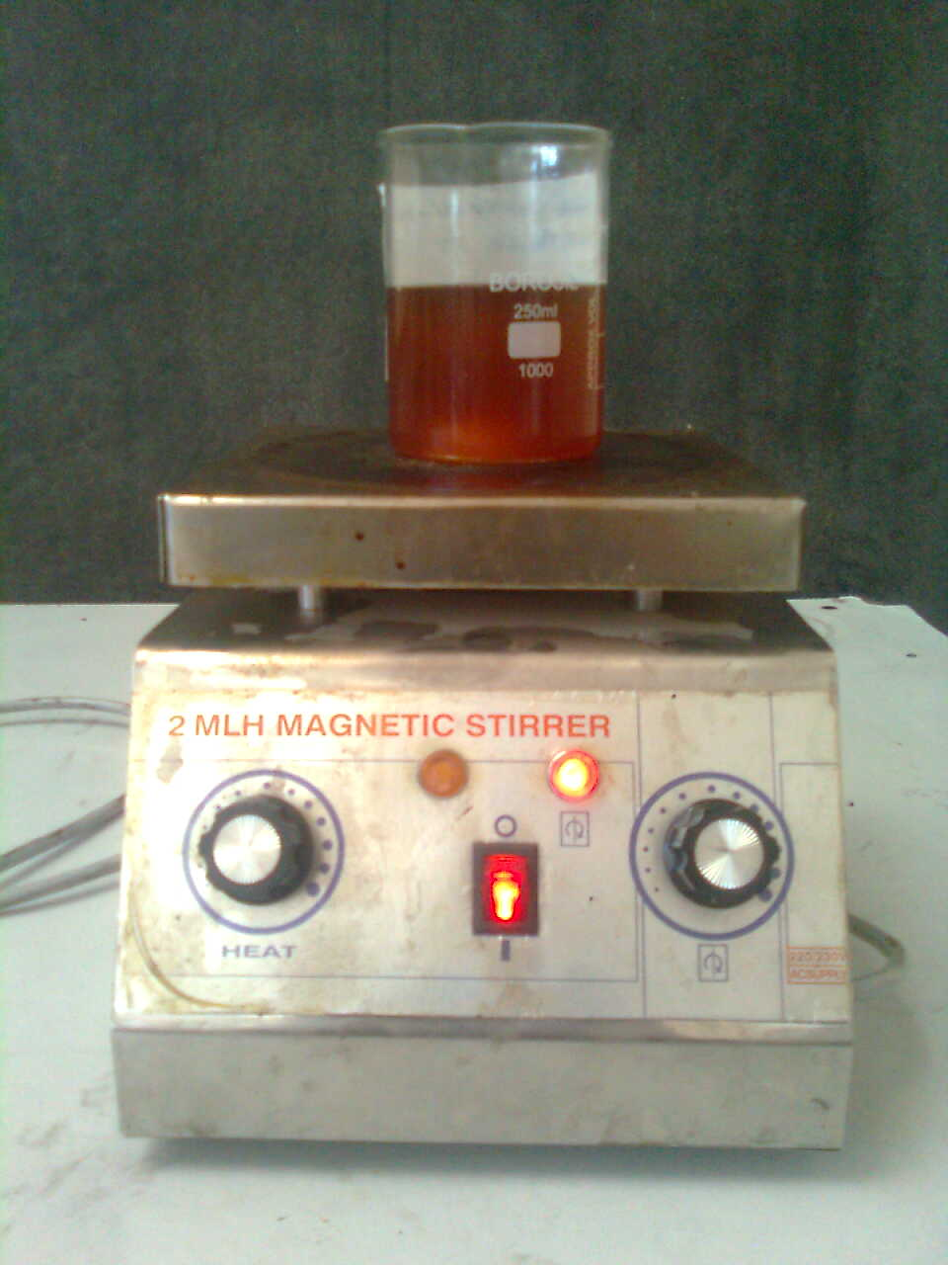
Figure 3.1: Photograph of Mechanical stirrer

3.1.2 Reagents and materials used for experiment
- Waste cooking oil (100g/sample) for preparing experimental biodiesel sample.
- Methyl alcohol (CH₃OH) (99% pure) for removing the free fatty acid from the oil.
- Base catalyst (KOH ) (85% pure) for accelerating the reaction mixture.
3.1.2 Experimental Procedure

This experiment has been performed to evaluate performance of mechanical stirring method of biodiesel production in terms of yield (%) and time.

Experiment has been performed with the following steps:
- Waste cooking oil (100g) is taken in a 250 ml beaker and filtered it to remove impurities. The raw oil is heated up to 110⁰C in order to remove water content of oil to avoid soap formation. This oil is allowed to cool up to 45⁰C temperature for the reaction to take place.
- Now methyl alcohol (CH3OH) is taken with a molar ratio of (1:4.5 & 1:6) and Catalyst (KOH) is taken as (0.5%, 0.75% and 1% by weight of oil).The mixer of methyl alcohol and KOH stirred until KOH dissolve in methyl alcohol.
- This mixture is mixed with waste cooking oil. The methanol is immiscible with the oil.
- A magnetic capsule is dipped in the mixture of oil, methanol and catalyst and rotated with the help of magnetic stirrer.
- During the reaction the temperature of mixture is kept between 45-60⁰C.
- When reaction is completed the beaker is kept for the separation. Fatty acid has higher specific weight therefore it will settle at bottom. Separation of methyl ester and glycerol will take 2 to 3 hr duration.
- After complete separation bio-diesel (methyl Ester) is visible in the upper layer and glycerol at the bottom.
- Bio-diesel is separated from beaker for purification process. The catalyst present in the methyl ester is impurity.
- Excess methanol present in biodiesel has been removed by vaporization process.

- To remove the catalyst, water at around 40⁰C is mixed with the methyl ester and left for settling down. Water due to its higher specific gravity collected at bottom, This is shown in Figure 3.2.
- Excess water is removed by heating the biodiesel.

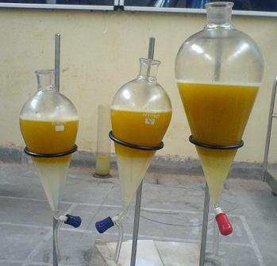
Figure 3.2: Photograph of washing process of biodiesel
3.2 Experimental Results
The experiments are performed with alcohol to oil molar ratio as 6:1 and 4.5:1. The amount of oil, alcohol and catalyst taken is shown in Table 3.1.
Table 3.1 Oil, alcohol and catalyst during the experimentation
Molar ratio  (alcohol/oil) | Quantity of non-edible oil (g) | Quantity of methanol (g) | Catalyst (KOH)
Molar ratio  (alcohol/oil) | Quantity of non-edible oil (g) | Quantity of methanol (g) | 0.5% | 0.75% | 1.0%
6:1 | 100 g | 22 g | 0.5 g | 0.75 g | 1.0 g
4.5:1 | 100 g | 16.56 g | 0.5 g | 0.75 g | 1.0 g
For calculation of molar ratio following data are used
Molecular weight of triglycerides from waste cooking oil = 870
Molecular weight of methanol = 32
Hence, 1 gm mole of waste cooking oil = 870 gm
and 1 gm mole of methanol = 32 gm
Catalyst (KOH) = 0.5%, 0.75% and 1% by weight of oil
Amount of methanol for 100 g of vegetable oil
- For 1:6 molar ratio = (32 / 870) ×100 × 6 = 22 g
- 1:4.5 molar ratio = (32 / 870) ×100 × 4.5 = 16.56 g

Sample Calculation for yield
Quantity of WCO taken = 100 gm
Quantity of alcohol = 22 gm (For molar ratio 6:1)
Quantity of KOH = 1 gm (For 1% KOH)
Quantity of biodiesel produced = 94.03 gm (say)
Yield % = (Quantity of biodiesel produced/Quantity of oil taken)*100
= (94.03/100)*100
= 94.03%
Time and yield produced for waste cooking oil
Main aim of this experiment is to calculate time, catalyst percentage and molar ratio (alcohol/oil) for biodiesel production with maximum yield. The results obtained from magnetic stirring experiment are shown below in tabular form.

Experimental Data for Magnetic Stirring Method
Time and yield of methyl ester for waste cooking oil and catalyst (%) of oil is shown in the table 3.2
Table 3.2 Time and yield (%) of waste cooking oil for different molar ratio and catalyst percentage
Percentage of catalyst | Molar ratio 6:1 |  | Molar ratio 4.5:1
Percentage of catalyst | Time (in min.) | Yield % | Time (in min.) | Yield %
0.5 | 45 | 94.15 | 45 | 80.21
 | 60 | 95.60 | 60 | 88.61
 | 75 | 97.12 | 75 | 90.13
 | 90 | 97.01 | 90 | 90.00
0.75 | 45 | 95.55 | 45 | 90.41
 | 60 | 96.67 | 60 | 94.67
 | 75 | 98.22 | 75 | 96.42
 | 90 | 98.32 | 90 | 96.35
1.0 | 45 | 85.96 | 45 | 88.52
 | 60 | 87.06 | 60 | 92.05
 | 75 | 93.00 | 75 | 94.24
 | 90 | 92.80 | 90 | 93.85

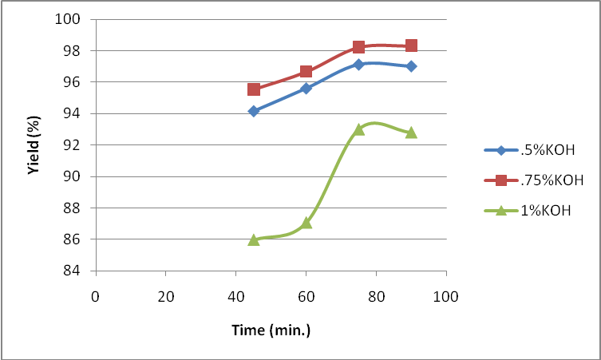
Figure 3.3: Graphical representation of Time & Yield % for molar ratio 6:1 and different catalyst percentage.
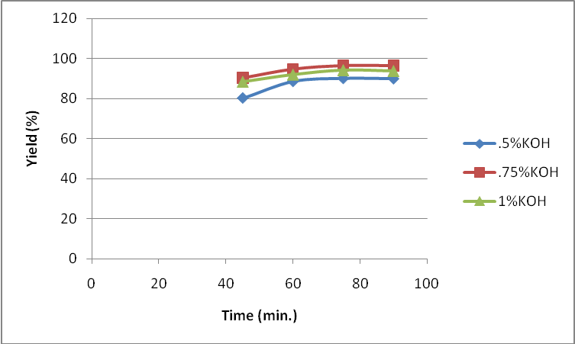
Figure 3.4: Graphical representation of Time & Yield % for molar ratio 4.5:1 and different catalyst percentage.
From figure 3.3 shows the variation of yield versus time of molar ratio 6:1at different % of KOH. The yield increases when time is increases. After 70 min. the yield is almost constant with time, at the molar ratio 6:1 and 0.75% KOH have the highest value of yield about 98% and 1% KOH have the lowest value of yield 92%. Figure 3.4 shows variation of yield with time of molar ratio 4.5:1 at different % of KOH. At all % of KOH the yield have similar trends with time.

CHAPTER 4
PERFORMANCE AND EMISSION STUDIES
4.1 Experimental Setup of single cylinder kirloskar Engine
The setup consists of single cylinder, four strokes, Diesel engine connected to eddy current type dynamometer for loading is used with necessary instruments for combustion pressure and crank-angle measurements. These signals are interfaced to computer through engine indicator for P-θ & P-V diagrams. Sensors are used interfacing airflow, fuel flow, temperatures and load measurement. The setup has stand-alone panel box consisting of air box, two fuel tanks for duel fuel test, manometer, fuel measuring unit, transmitters for air and fuel flow measurements, process indicator and engine indicator. Rotameters are provided for cooling water and calorimeter water flow measurement. The setup enables varying the compression ratio for measurement of engine performance parameters like brake power, indicated power, frictional power, BMEP, IMEP, brake thermal efficiency, indicated thermal efficiency, Mechanical efficiency, volumetric efficiency, specific fuel consumption, A/F ratio and heat balance. Lab view based Engine performance Analysis software package “Engine soft LV” is used for on line performance evaluation. A computerized diesel injection pressure sensor is used for the measurement of combustion chamber pressure. Normally, the diesel engine produce excessive knocking that can damage the engine, besides that it produces gases like carbon monoxide, nitrogen oxides, unburnt hydrocarbon, smoke, soot and other forms of black carbon as well as particulate matter, such as lead. All the gases are harmful to the environment and human kind; they can cause greenhouse effect, acid rain and air pollution and thus harm the environment. Due to these effects, human beings may suffer from various diseases, such as lung cancer, breathing difficulties, poisoning and skin cancer etc. The test engine used was a single cylinder, water cooled, direct injection, normally aspirated, four stroke diesel engine 87.5 mm bore, 110 mm stroke and compression ratio (17.5), the detailed The gaseous fuels employed were fumigated into the intake air at a point in the engine manifold just outside the cylinder. The engine was coupled directly to an electric dynamometer, which permitted the engine to operate under partial motoring conditions representing negative brake output. Four different commercial and other prepared diesel fuels were used, having different cetane numbers.
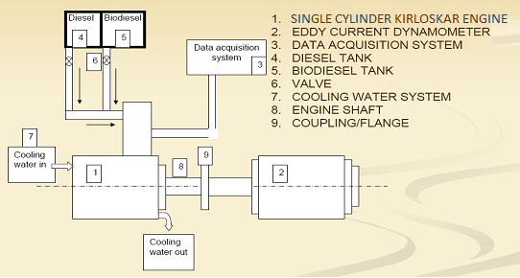
Figure: 4.1 Schematic Layout of Single Cylinder Engine Setup
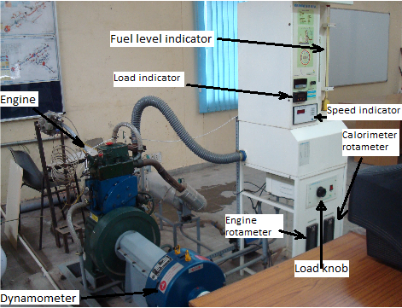
Fig: 4.2 actual Engine test setup
Specifications
Component | Specifications
Product | VCR Engine test setup 1 cylinder, 4 stroke, Diesel  (Computerized)
Product code | 234
Engine | Make Kirloskar, Type 1 cylinder, 4 stroke Diesel, water cooled, power 3.5 kW at 1500 rpm, stroke 110 mm, bore 87.5 mm. 661 cc, CR 17.5, Modified to VCR  engine CR range 12 to 18
Dynamometer | Type eddy current, water cooled, with loading unit
Propeller shaft | With universal joints
Air box | M S fabricated with orifice meter and manometer
Fuel tank | Capacity 15 lit with glass fuel metering column
Calorimeter | Type Pipe in pipe
Piezo sensor | Range 5000 PSI, with low noise cable
Crank angle sensor | Resolution 1 Deg, Speed 5500 RPM with TDC pulse.
Data acquisition device | NI USB-6210, 16-bit, 250kS/s.
Piezo powering unit | Make-Cuadra, Model AX-409.
Digital milivoltmeter | Range 0-200mV, panel mounted
Temperature sensor | Type RTD, PT100 and Thermocouple, Type K
Temperature transmitter | Type two wire, Input RTD PT100, Range 0–100 ⁰C, Output 4–20 mA and Type two wire, Input Thermocouple, Range 0–1200 ⁰C, Output 4–20 mA
Load indicator | Digital, Range 0-50 Kg, Supply 230VAC
Load sensor | Load cell, type strain gauge, range 0-50 Kg
Fuel flow transmitter | DP transmitter, Range 0-500 mm WC
Air flow transmitter | Pressure transmitter, Range (-) 250 mm WC
Software | “Enginesoft” Engine performance analysis software
Rotameter | Engine cooling 40-400 LPH; Calorimeter 25-250 LPH
Pump | Type Monoblock
Overall dimensions | W 2000 x D 2500 x H 1500 mm
Optional | Computerized Diesel injection pressure measurement
Shipping details | Gross volume 1.33m3, Gross weight 619kg, Net weight 543kg
Electric supply | Provide 230 +/- 10 VAC, 50 Hz, single phase electric supply with proper earthing. (Neutral – Earth voltage less than 5 VAC) 5A, three pin socket with switch (2  Nos.)
Water supply | Continuous, clean and soft water Supply @ 1000 LPH, at 10 m. head. Provide tap with 1” BSP size  connection
Computer | IBM compatible with standard configuration (with free PCI slot on motherboard)
Space | 3300Lx3200Wx1700H in mm
Drain | Provide suitable drain arrangement  (Drain pipe 65 NB/2.5” size)
Exhaust | Provide suitable exhaust arrangement  (Exhaust pipe 32 NB/1.25” size)
Fuel, oil | Diesel@10 lit.  Oil @ 3.5 lit. (20W40)
This smoke meter works on the light extinction principle. A continuously taken exhaust sample is passed through a tube of about 46 cm length which has a light source at one end and photocell or solar cell at the other end. The amount of light passed through this smoke column is used as an indication of smoke level. The smoke density is defined as the ratio of electric output from the photocell or solar cell when sample is passed through this smoke column to the electric output when clean air is passed through it. The fraction of the light transmitted through the smoke (T) and the length of the light path (L) are related y the Beer-Lambert law.
T = e ^{–KL}
K = n A θ
Where K is the optional absorption coefficient of the obscuring matter per unit length, n the number of soot particles per unit volume; A the average projected area of each particles; and θ the specific absorbance per particle.

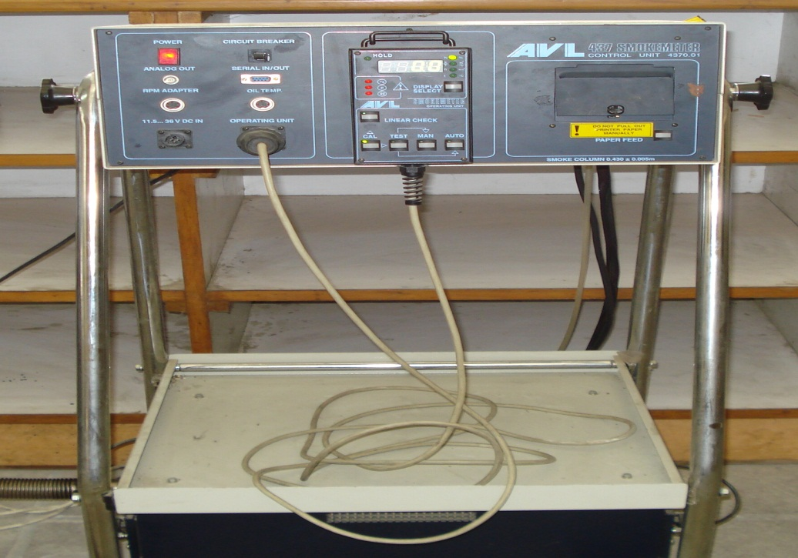
Figure: 4.3 A.V.L smoker meter

4.2 Engine Test Setup Of four cylinders Tata Indica engine
The setup consists of a four cylinder, four stroke, diesel engine connected to eddy current type dynamometer for loading. It is provided with necessary instruments for combustion pressure and crank-angle measurements. These signals are interfaced to computer through engine indicator for Pθ−PV diagrams. Provision is also made for interfacing airflow, fuel flow, temperatures and load measurement. The set up has stand-alone panel box consisting of air box, fuel tank, manometer, fuel measuring unit, transmitters for air and fuel flow measurements, process indicator and engine indicator. Rotameters are provided for cooling water and calorimeter water flow measurement. Photograph of engine setup, schematic diagram of engine and photograph of smoke meter is shown in Figure 4.4 and 4.5 The setup enables study of engine performance for brake power, indicated power, frictional power, BMEP, IMEP, brake thermal efficiency, indicated thermal efficiency, Mechanical efficiency, volumetric efficiency, specific fuel consumption, A/F ratio and heat balance. Windows based Engine Performance Analysis software package “Engine soft” is provided for on line performance evaluation.The main aim of this experiment is to investigate the effects on performance of blending of biodiesel with diesel fuel in Tata Indica engine.
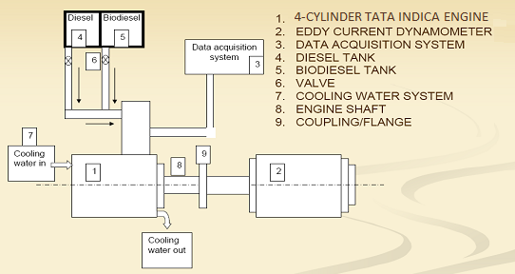
Figure 4.4 : Schematic Diagram of the 4-Cylinder Tata Indica Engine
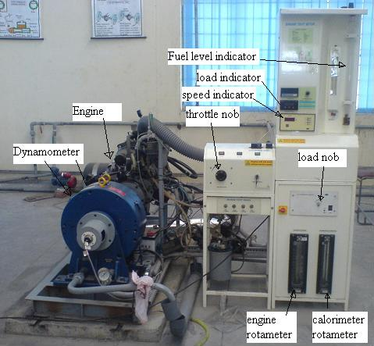
Figure: 4.5 Experimental setup of 4-Cylinder Tata Indica Engine
Specifications
Product Engine test setup 4 cylinder, 4 stroke, Diesel
(Computerized)
Engine Make Telco, Model Tata Indica, Type 4
Cylinder, 4 Stroke, Diesel water cooled, Power
39kW at 5000 rpm, Torque 85 Nm at 2500 rpm,
stroke 79.5mm, bore 75mm, 1405 cc, C. R. 22
Dynamometer Type eddy current, water cooled, with loading
unit
Air box M S fabricated with orifice meter and
manometer
Fuel tank Capacity 15 lit with glass fuel metering column
Calorimeter Type Pipe in pipe
Piezo sensor Range 5000 PSI, with low noise cable
Crank angle sensor Resolution 1 Deg, Speed 550 RPM
Engine indicator Input Piezo sensor, crank angle sensor, No of channels 2, Communication RS232
Digital milivoltmeter Range 0-200mV, panel mounted
Temperature sensor Type RTD, PT100 and Thermocouple, Type K
Temperature transmitter Input RTD PT100, Range 0–100 ⁰C, Output 4–
20 mA and Type two wire, Input thermocouple,
Range 0–1200 ⁰C, Output 4–20 mA
Load indicator Digital, Range 0-50 Kg, Supply 230VAC
Load sensor Load cell, type strain gauge, range 0-50 Kg
Fuel flow transmitter DP transmitter, Range 0-500 mm WC
Air flow transmitter Pressure transmitter, Range (-) 250 mm WC
Rota meter Engine cooling 100-1000 LPH;
Calorimeter 25-250 LPH
Data acquisition card Resolution12 bit, 8/16 input, mounting PCI slot
Software “Enginesoft” performance analysis software
Overall dimensions W 2000 x D 2750 x H 1750 mm
Smoke meter Make AVL, for opacity measurement
4.3 Preparation of biodiesel blends for single cylinder engine

Three different blends B-20 (20 % biodiesel + 80 % diesel v/v), B-40 (40 % biodiesel + 60 % diesel v/v), B-60 (60 % biodiesel + 40 % diesel v/v), B80(80% biodiesel +20% diesel v/v) , B100 (100% biodiesel + o% diesel v/v) were prepared. The total quantity of each blend is One liter. These blends were prepared for WCO biodiesel.
Calorific value of petroleum diesel = 43000 kJ/kg.
Calorific value of biodiesel (WCOME) = 37000 kJ/kg.
Density of petroleum diesel = 821 kg/m³.
Density of biodiesel = 885 kg/m³ [tested in laboratory].
The biodiesel blends calorific value and densities have been calculated by volume fraction and are shown in table 4.1
Type of blend | Amount diesel (ml) | Amount of biodiesel(ml) | Resultant calorific value (kj/kg) | Resultant density (kg/m³)
Diesel | 1000 | 0 | 43000 | 821
B-20 | 800 | 200 | 41726.313 | 833.8
B-40 | 700 | 300 | 40491.14 | 846.6
B-60 | 600 | 400 | 39292.76 | 859.4
B-80 | 400 | 600 | 38129.55 | 872.2
B-100 | 0 | 1000 | 37000 | 885

4.4 Performance Evaluations
A single cylinder Diesel engine was used for the experimental analysis. Fuel was supplied to the engine from an outside tank. All runs started with a 5-min warm-up period prior to data collection. The gap of 3 to 4 minutes was provided between the two consecutive runs. The data measured during the tests included engine speed, brake power, torque, and fuel consumption, BSFC, heat balance. During the test engine load was varied from 0 to 12 kg by adjusting the load knob provided on the control panel of the test rig while maintaining a constant engine speed of about 1500 rpm. The tests were performed with pure diesel fuel and biodiesel blends (B-20, B-340,B-60, B-80,B100). Biodiesel blends of WCOME (waste cooking oil methyl ester) and thumba oil were used.
Formulation used for calculation of various parameters are described below
Torque (kg m) = Load × Arm length
Brake power (kW) = (2 × π × Speed × Torque × 9.81) / (60 × 1000)
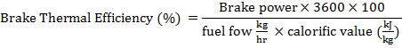
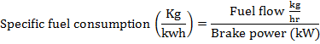

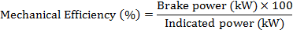
Heat balance (kJ/h):
Heat supplied by fuel (kJ/h) = fuel flow (kg/h) × Calorific value (kJ/kg)
Heat equivalent to useful work (kJ/h) = Break power (kW) × 3600

Heat carried in jacket cooling water = F₃ × C _{p}w × (T₂ – T₁)

Heat in Exhaust (calculate C _{p}ex value):
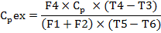
Where,
C _{p}ex Specific heat of exhaust gas (kJ/kg ⁰C).
C _{p}w Specific heat of water (kJ/kg ⁰C).
F₁ Fuel consumption (kg/hr).
F₂ Air consumption (kg/hr).
F₃ Engine water flow rate (kg/hr).
F₄ Calorimeter water flow rate (kg/hr).
T_{amb} ambient temperature (⁰C).
T₁ Engine water inlet temperature (⁰C).
T₂ Engine water outlet temperature (⁰C).
T₃ Calorimeter water inlet temperature (⁰C).
T₄ Calorimeter water outlet temperature (⁰C).
T₅ Exhaust gas to calorimeter inlet temp (⁰C).
T₆ Exhaust gas from calorimeter outlet temp (⁰C)
Heat in Exhaust (kJ / h) = (F₁ + F₂) × C _{p}ex × (T₃ - T_{amb})
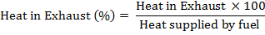
Heat to Radiation and unaccounted (%)= Heat Supplied By Fuel (%) - { (Heat In Jacket Cooling Water (%)+ Heat To Exhaust (%) + Heat Equivalent To Useful Work (%)}

4.5 Observation of single cylinder kirloskar engine

4.5.1 Pure diesel
Engine performance parameters obtained from performance testing in single cylinder CI engine against different loads for pure diesel are given below in Table 4.2
Table 4.2 Performance parameters for pure diesel versus BP(kW)

SPEED (rpm) | TORQUE kgm | BP kW | FP kW | IP kW | BThE % | IThE % | MechE % | BSFC kg/kWhr | BSEC MJ/kW-hr | Opacity (%)
1566 | 0.00 | 0 | 1.92 | 1.92 | 0.10 | 42.35 | 0.23 | 5.10 | 219.3 | 8.2
1567 | 3.21 | 0.5 | 2.06 | 2.58 | 10.31 | 50.59 | 20.38 | 0.81 | 34.83 | 13.5
1558 | 6.25 | 1 | 1.84 | 2.86 | 15.84 | 44.38 | 35.69 | 0.53 | 22.79 | 19.2
1537 | 9.54 | 1.5 | 1.81 | 3.35 | 20.03 | 43.70 | 45.83 | 0.42 | 18.06 | 26.2
1530 | 12.38 | 2 | 1.68 | 3.66 | 23.44 | 43.25 | 54.21 | 0.36 | 15.48 | 31.1
1520 | 15.78 | 2.5 | 1.54 | 4.05 | 28.42 | 45.79 | 62.07 | 0.29 | 12.47 | 39.5
1509 | 18.71 | 3 | 1.44 | 4.40 | 27.84 | 41.46 | 67.14 | 0.30 | 12.9 | 54.6
1499 | 22.11 | 3.5 | 1.33 | 4.80 | 29.56 | 40.89 | 72.29 | 0.28 | 12.04 | 74.5

4.5.2 Biodiesel blends from Waste cooking oil
Experiment has been performed by taking WCO (waste cooking oil) blends with diesel in proportion of 20%, 40%,60%,80%, and 100% respectively as a diesel engine fuel and following parameters has been obtained. The performance and emission parameter of WCO (B20,B40,B60,B80,B100) is given below table 4.3, 4.5, 4.7 ,4.9, 4.11, and the percentage change are given below in table 4.4, 4.6, 4.8, 4.10, 4.12 respectively.
Table 4.3 Performance parameters for WCOB20 versus BP (kW)

SPEED (rpm) | TORQUE kgm | BP kW | FP kW | IP kw | BThE % | IThE % | MechE % | BSFC kg/kWhr | BSEC MJ/kW-hr | Opacity(%)
1569 | .01 | 0 | 2.04 | 2.04 | 0.03 | 45.88 | 0.07 | 5.18 | 216.1 | 8.1
1561 | 3.09 | 0.5 | 1.88 | 2.39 | 10.14 | 47.91 | 21.16 | 0.85 | 35.46 | 11.4
1551 | 6.44 | 1 | 1.73 | 2.78 | 16.33 | 43.33 | 37.69 | 0.53 | 22.11 | 15.3
1544 | 9.14 | 1.5 | 1.56 | 3.03 | 20.69 | 42.47 | 48.72 | 0.42 | 17.52 | 20.24
1528 | 12.54 | 2 | 1.53 | 3.54 | 23.84 | 42.06 | 56.68 | 0.36 | 15.02 | 25.98
1516 | 15.96 | 2.5 | 1.47 | 4.00 | 26.53 | 41.89 | 63.34 | 0.33 | 13.76 | 36.89
1507 | 19.60 | 3 | 1.35 | 4.44 | 28.92 | 41.54 | 69.62 | 0.30 | 12.51 | 41.29
1497 | 22.30 | 3.5 | 1.36 | 4.85 | 29.98 | 41.63 | 72.04 | 0.29 | 12.10 | 55.34

Table 4.4 % change of Performance parameters for WCOB20 in reference to diesel

TORQUE kgm | BP kW | FP kW | IP kW | BThE % | IThE % | MechE % | BSFC kg/kWhr | BSEC MJ/kW-hr | Opacity (%)
0 | Idling | 6.25 | 6.25 | -4 | 8.33 | -69.56 | 1.56 | -1.45 | -1.21
-3.73 | 0.5 | -8.73 | -7.36 | -1.64 | -5.29 | 3.82 | 4.93 | 1.80 | -15.5
3.04 | 1 | -5.97 | -2.79 | 3.09 | -2.36 | 5.60 | 0 | -2.98 | -20.31
-4.19 | 1.5 | -13.81 | -9.55 | 3.29 | -2.81 | 6.30 | 0 | -2.99 | -22.7
1.29 | 2 | -8.92 | -3.27 | 1.70 | -2.75 | 4.55 | 0 | -2.97 | -16.46
1.14 | 2.5 | -4.5 | -1.23 | -6.65 | -8.51 | 2.04 | 13.79 | 10.34 | -6.60
4.75 | 3 | -6.25 | 0.90 | 3.8 | 0.19 | 3.69 | 0 | -3.02 | -24.37
0.85 | 3.5 | 2.25 | 1.04 | 1.42 | 1.80 | -0.34 | 3.57 | 0.49 | -25.71

Table 4.5 Performance parameters for WCOB40 versus BP (kW)

SPEED (rpm) | TORQUE kgm | BP kW | FP kW | IP kW | BThE % | IThE % | MechE % | BSFC kg/kWhr | BSEC MJ/kW-hr | Opacity(%)
1574 | 0.01 | 0 | 1.77 | 1.77 | 0.00 | 45.81 | 0.13 | 4.53 | 183.42 | 8.1
1560 | 3.16 | 0.5 | 1.80 | 2.31 | 9.41 | 42.19 | 22.31 | .94 | 38.06 | 12.21
1546 | 6.28 | 1 | 1.71 | 2.73 | 15.46 | 41.53 | 37.22 | 0.58 | 23.48 | 13.79
1534 | 9.32 | 1.5 | 1.61 | 3.11 | 20.32 | 42.24 | 48.11 | 0.44 | 17.81 | 22.7
1520 | 12.56 | 2 | 1.53 | 3.53 | 23.58 | 41.62 | 56.66 | 0.38 | 15.38 | 27.76
1515 | 15.65 | 2.5 | 1.42 | 3.90 | 26.36 | 41.46 | 63.58 | 0.34 | 13.76 | 35.31
1504 | 19.45 | 3 | 1.36 | 4.42 | 28.67 | 41.36 | 69.31 | 0.31 | 12.55 | 43.51
1491 | 22.24 | 3.5 | 1.31 | 4.78 | 29.89 | 41.14 | 72.67 | 0.30 | 12.14 | 57.1

Table4.6 % change of Performance parameters for WCOB40 in reference to diesel

TORQUE kgm | BP kW | FP kW | IP kW | BThE % | IThE % | MechE % | BSFC kg/kWhr | BSEC MJ/kW-hr | Opacity(%)
0 | Idling | -7.81 | -7.85 | 0 | 8.17 | -43.4 | -11.1 | -16.36 | -1.21
-1.55 | 0.5 | -12.62 | -10.46 | -8.72 | -16.60 | 9.47 | 16.04 | 9.27 | -9.55
0.48 | 1 | -7.06 | -4.54 | -2.39 | -6.42 | 4.28 | 9.43 | 3.027 | -28.1
-2.30 | 1.5 | -11.04 | -7.16 | 1.44 | -3.34 | 4.97 | 4.76 | -1.38 | -13.35
1.45 | 2 | -8.92 | -3.55 | 0.59 | -3.76 | 4.51 | 5.55 | -0.64 | -10.73
-0.82 | 2.5 | -7.79 | -3.70 | -7.24 | -9.45 | 2.43 | 17.24 | 10.34 | -10.60
3.95 | 3 | -5.55 | 0.45 | 2.98 | -0.24 | 3.23 | 3.33 | -2.71 | -20.31
0.58 | 3.5 | -1.50 | -0.41 | 1.11 | 0.61 | 0.52 | 7.14 | 0.83 | -23.35

Table 4.7 Performance parameters for WCOB60 versus BP (kW)

SPEED (rpm) | TORQUkgm | BP kW | FP kW | IP kw | BThE % | IThE % | MechE % | BSFC kg/kW-hr | BSEC MJ/kW-hr | Opacity  (%)
1566 | 0.01 | 0 | 2.08 | 2.08 | 0.05 | 46.03 | 0.11 | 4.05 | 159.13 | 8.2
1556 | 3.39 | 0.5 | 1.86 | 2.41 | 10.00 | 43.73 | 22.88 | 0.92 | 36.14 | 11.3
1548 | 6.27 | 1 | 1.62 | 2.64 | 16.08 | 41.68 | 38.57 | 0.57 | 22.39 | 14.1
1534 | 9.33 | 1`.5 | 1.57 | 3.07 | 20.35 | 41.63 | 48.88 | 0.45 | 19.25 | 20.11
1522 | 12.57 | 2 | 1.52 | 3.53 | 23.85 | 41.98 | 56.83 | 0.38 | 14.93 | 26.58
1513 | 15.62 | 2.5 | 1.44 | 3.92 | 26.52 | 41.99 | 63.16 | 0.35 | 13.75 | 33.27
150 4 | 19.06 | 3 | 1.35 | 4.36 | 28.28 | 41.03 | 68.92 | 0.32 | 12.57 | 39.26
1493 | 22.33 | 3.5 | 1.36 | 4.86 | 29.97 | 41.69 | 71.90 | 0.30 | 11.78 | 45.7

Table 4.8 % change of Performance parameters for WCOB60 in reference to diesel
TORQUE kgm | BP kW | FP kW | IP kW | BThE % | IThE % | MechE % | BSFC kg/kWhr | BSEC MJ/kW-hr | Opacity  (%)
0 | Idling | 8.33 | 8.33 | -2 | 8.68 | -52.17 | -20.58 | -27.4 | 0
5.60 | 0.5 | -9.70 | -6.58 | -3.00 | -13.56 | 12.26 | 13.58 | 3.76 | -16.29
0.32 | 1 | -11.95 | -7.69 | 1.51 | -6.08 | 8.06 | 7.54 | -1.75 | -26.56
-2.20 | 1.5 | -13.25 | -8.35 | 1.59 | -4.73 | 6.65 | 7.14 | 6.58 | -23.24
1.53 | 2 | -9.52 | -3.55 | 1.74 | -2.93 | 4.83 | 5.55 | -3.55 | -14.53
-1.01 | 2.5 | -6.49 | -3.20 | -6.68 | -8.29 | 1.75 | 20.68 | 10.26 | -15.77
1.87 | 3 | -6.25 | -0.90 | 1.58 | -1.03 | 2.65 | 6.66 | -2.55 | -28.09
0.99 | 3.5 | 2.25 | 1.25 | 1.38 | 1.95 | -0.53 | 7.14 | -2.15 | -38.65

Table 4.9 Performance parameters for WCOB80 versus BP(kW)

SPEED (rpm) | TORQUE Nm | BP kW | FP kW | IP kW | BThE % | IThE % | MechE % | BSFC kg/kWhr | BSEC MJ/kW-hr | Opacity(%)
1571 | 0.01 | 0 | 1.87 | 1.88 | 0.03 | 43.07 | 0.06 | 4.69 | 178.82 | 9.16
1563 | 3.10 | 0.5 | 1.73 | 2.24 | 9.43 | 41.65 | 22.64 | 1.00 | 38.13 | 12.13
1550 | 6.27 | 1 | 1.67 | 2.69 | 16.02 | 42.32 | 37.85 | 0.59 | 22.49 | 15.14
1538 | 9.50 | 1.5 | 1.58 | 3.11 | 20.76 | 42.21 | 49.19 | 0.45 | 17.15 | 18.19
1522 | 12.56 | 2 | 1.54 | 3.55 | 23.86 | 42.27 | 56.45 | 0.40 | 15.25 | 28.1
1514 | 16.35 | 2.5 | 1.40 | 3.99 | 27.06 | 41.71 | 64.88 | 0.35 | 13.34 | 37.18
1504 | 19.08 | 3 | 1.40 | 4.40 | 28.52 | 41.78 | 68.26 | 0.33 | 12.58 | 41.66
1492 | 22.50 | 3.5 | 1.30 | 4.82 | 29.87 | 40.93 | 72.97 | 0.32 | 12.20 | 54.67

Table4.10 % change of Performance parameters for WCOB80 in reference to diesel

TORQUE kgm | BP kW | FP kW | IP kW | BThE % | IThE % | MechE % | BSFC kg/kWhr | BSEC MJ/kW-hr | Opacity(%)
0 | Idling | -2.60 | -2.08 | -5 | 1.70 | -73.91 | -8.03 | -18.45 | 11.70
-3.42 | 0.5 | -16.01 | -13.17 | -8.53 | -17.67 | 11.08 | 23.45 | 9.47 | -10.14
0.32 | 1 | -9.23 | -5.94 | 1.13 | -4.64 | 6.05 | 11.32 | -1.31 | -21.14
-0.41 | 1.5 | -12.70 | -7.16 | 3.64 | -3.40 | 7.33 | 7.14 | -5.03 | -30.57
1.45 | 2 | -8.33 | -3.00 | 1.79 | -2.26 | 4.13 | 11.11 | -1.48 | -9.64
3.61 | 2.5 | -9.09 | -1.48 | -4.78 | -8.91 | 4.52 | 20.68 | 6.97 | -5.87
1.97 | 3 | -2.77 | 0 | 2.44 | 0.77 | 1.66 | 10 | -2.48 | -23.69
1.76 | 3.5 | -2.25 | 0.41 | 1.04 | 0.09 | 0.94 | 14.28 | 1.32 | -26.61

Table 4.11 Performance parameters for WCOB100 versus BP(kW)
SPEED (rpm) | TORQUE kgm | BP kW | FP kW | IP kW | BThE % | IThE % | MechE % | BSFC kg/kWhr | BSEC MJ/kW-hr | Opacity(%)
1580 | 0.01 | 0 | 1.99 | 1.99 | 0.05 | 44.69 | 0.11 | 5.23 | 193.51 | 9.28
1561 | 3.23 | 0.5 | 1.75 | 2.28 | 9.75 | 42.11 | 23.16 | 1.00 | 37 | 11.87
1549 | 6.26 | 1 | 1.64 | 2.66 | 16.03 | 41.95 | 38.21 | 0.61 | 22.57 | 13.19
1535 | 9.32 | 1.5 | 1.53 | 3.03 | 20.57 | 41.60 | 49.44 | 0.47 | 17.39 | 21.18
1523 | 13.08 | 2 | 1.45 | 3.54 | 24.67 | 41.82 | 58.99 | 0.39 | 14.43 | 28.21
1519 | 15.81 | 2.5 | 1.43 | 3.94 | 26.86 | 42.12 | 63.76 | 0.336 | 12.43 | 34.17
1509 | 19.18 | 3 | 1.32 | 4.36 | 28.77 | 41.34 | 69.58 | 0.34 | 12.58 | 44.1
1497 | 22.47 | 3.5 | 1.26 | 4.79 | 30.18 | 41.01 | 73.58 | 0.32 | 11.84 | 66.2

Table 4.12 % change of Performance parameters for WCOB100 in reference to diesel
TORQUE kgm | BP kW | FP kW | IP kW | BThE % | IThE % | MechE % | BSFC kg/kWhr | BSEC MJ/kW-hr | Opacity(%)
0 | Idling | 3.64 | 3.64 | -5 | 5.52 | -52.17 | 2.54 | -11.7 | 13.17
0.62 | 0.5 | -15.04 | -11.62 | -5.43 | -16.76 | 13.64 | 23.45 | 6.23 | -12.07
0.16 | 1 | -10.86 | -6.99 | 1.19 | -5.47 | 7.06 | 15.09 | -0.96 | -31.30
-2.30 | 1.5 | -15.46 | -9.55 | 2.69 | -4.80 | 7.87 | 11.90 | -3.70 | -19.16
5.65 | 2 | -13.69 | -3.27 | 5.24 | -3.30 | 8.81 | 8.33 | -6.78 | -9.29
0.19 | 2.5 | -7.14 | -2.7 | -5.48 | -8.01 | 2.72 | 15.86 | -0.32 | -13.49
2.51 | 3 | -8.33 | -0.90 | 3.34 | -0.28 | 3.63 | 13.33 | -2.48 | -19.23
1.62 | 3.5 | -5.26 | -0.20 | 2.09 | 0.29 | 1.7 | 14.28 | -1.66 | -11.14

Table 4.13 Exhaust gas Temperature of Diesel and WCO
BP (kw) | Diesel | WCOB 20 | WCOB 40 | WCOB 60 | WCOB 80 | WCOB 100
BP (kw) | EXT | EXT | EXT | EXT | EXT | EXT
0 | 158.12 | 163.11 | 172.91 | 164.43 | 171.28 | 169.43
0.5 | 184.49 | 180.84 | 184.27 | 183.32 | 181.07 | 179.67
1 | 203.24 | 201.27 | 204.36 | 200.43 | 200.91 | 199.80
1.5 | 231.85 | 217.91 | 225.89 | 225.91 | 224.76 | 222.92
2 | 252.70 | 250.42 | 253.68 | 254.47 | 251.33 | 250.97
2.5 | 281.10 | 278.11 | 279.73 | 277.34 | 280.88 | 274.27
3 | 306.63 | 308.48 | 312.32 | 304.10 | 308.42 | 302.39
3.5 | 339.43 | 336.64 | 339.73 | 338.79 | 342.44 | 333.80

Table 4.14 Air/Fuel ratio of Diesel and WCO
BP (kw) | Diesel | WCOB 20 | WCOB 40 | WCOB 60 | WCOB 80 | WCOB 100
BP (kw) | A/F ratio | A/F ratio | A/F ratio | A/F ratio | A/F ratio | A/F ratio
0 | A/F | A/F | 76.47 | 70.46 | 71.64 | 69.79
0.5 | 73.72 | 75.67 | 58.87 | 56.79 | 57.61 | 55.35
1 | 68.32 | 66.25 | 51.45 | 49.51 | 50.14 | 47.95
1.5 | 55.33 | 53.26 | 42.24 | 42 | 40.63 | 39.34
2 | 46.78 | 46.44 | 36.16 | 38.02 | 34.53 | 33.42
2.5 | 40.68 | 38.47 | 32.61 | 33.03 | 30.85 | 30.53
3 | 39.51 | 34.11 | 30.02 | 29.07 | 26.81 | 26.71
3.5 | 30.43 | 28.23 | 25.54 | 25.41 | 25.05 | 24.21

Table 4.15 % Change in Exhaust gas Temperature and A/F ratio of WCO in reference to diesel
TB20 |  | TB40 |  | TB60 |  | TB80 |  | TB100
EXT | A/F | EXT | A/F | EXT | A/F | EXT | A/F | EXT | A/F
3.15 | 2.64 | 9.3 | 3.73 | 3.99 | -4.42 | 8.32 | -2.82 | 7.15 | -5.33
-1.97 | -3.02 | -0.11 | -13.83 | -0.63 | -16.87 | -1.85 | -15.67 | -2.61 | -18.98
-0.96 | -3.74 | 0.55 | -7.01 | -1.38 | -10.51 | -1.14 | -9.38 | -1.69 | -13.33
-6.01 | -0.72 | -2.57 | -9.70 | -2.56 | -10.2 | -3.05 | -13.14 | -3.85 | -15.90
-0.90 | -5.43 | 0.38 | -11.11 | 0.70 | -6.53 | -0.54 | -15.1 | -0.68 | -17.84
-1.06 | -13.6 | -0.48 | -17.46 | -1.33 | -16.40 | -0.07 | -21.91 | -2.42 | -22.72
0.60 | -7.22 | 1.85 | -1.34 | -0.82 | -4.46 | 0.58 | -11.89 | -1.38 | -12.22
-0.82 | -3.76 | 0.08 | -10.1 | -0.18 | -10.6 | 0.88 | -11.91 | -1.65 | -14.8

4.5.3 Biodiesel blends from thumba oil
Experiment has been performed by taking thumba biodiesel (TB) blends with diesel in proportion of 20%, 40%,60%,80% and 100% respectively as a diesel engine fuel and following parameters has been obtained . The performance and emission parameter of thumba (B20,B40,B60,B80,B100) is given below tables 4.16, 4.18, 4.20 ,4.22, 4.24 and percentage change are given in tables 4.17, 4.19, 4.21, 4.23, 4.25 respectively.
Table 4.16 Performance parameters for TB20 versus B.P.(kW)

SPEED (rpm) | TORQUE kgm | BP kW | FP kW | IP kW | BThE % | IThE % | MechE % | BSFC kg/kWhr | BSEC MJ/kW-hr | Opacity(%)
1575 | 0.02 | 0 | 2.67 | 2.66 | 0.07 | 52.32 | 0.13 | 5.98 | 251.56 | 9
1563 | 3.03 | 0.5 | 2.56 | 3.05 | 8.16 | 50.32 | 16.23 | 1.05 | 44.17 | 12.9
1548 | 6.26 | 1 | 2.50 | 3.52 | 14.25 | 49.38 | 28.85 | 0.60 | 25.42 | 16.7
1539 | 9.32 | 1.5 | 2.39 | 3.89 | 19.25 | 49.85 | 38.60 | 0.44 | 18.50 | 21.9
1523 | 12.55 | 2 | 2.33 | 4.33 | 22.24 | 48.16 | 46.19 | 0.38 | 15.98 | 27.6
1512 | 15.79 | 2.5 | 2.24 | 4.74 | 24.82 | 47.07 | 52.73 | 0.34 | 14.30 | 37.7
1504 | 19.04 | 3 | 2.08 | 5.08 | 26.44 | 44.84 | 59.01 | 0.32 | 13.46 | 42.3
1495 | 22.13 | 3.5 | 1.74 | 5.21 | 28.14 | 42.31 | 66.51 | 0.30 | 12.62 | 56.6

Table 4.17 % change of Performance parameters for TB 20 in reference to diesel

TORQUE kgm | BP kW | FP kW | IP kW | BThE % | IThE % | MechE % | BSFC kg/kWhr | BSEC MJ/kW-hr | Opacity(%)
100 | Idling | 39.06 | 38.54 | -6 | 23.54 | -43.47 | 17.25 | 14.71 | 9.75
-5.60 | 0.5 | 24.27 | 18.21 | -20.85 | -0.53 | -20.36 | 29.62 | 26.81 | -4.44
0.16 | 1 | 35.86 | 23.07 | -10.03 | 11.26 | -19.1 | 13.20 | 11.54 | -13.02
-2.30 | 1.5 | 32.04 | 16.11 | -3.89 | 14.07 | -15.77 | 4.76 | 2.43 | -16.41
1.37 | 2 | 38.69 | 18.30 | -5.11 | 11.3 | -14.79 | 5.55 | 3.22 | -11.2
0.06 | 2.5 | 45.45 | 17.03 | -12.66 | 2.79 | -15.04 | 17.24 | 14.67 | -4.55
1.76 | 3 | 44.44 | 15.45 | -5.028 | 8.15 | -12.12 | 6.66 | 4.34 | -22.52
0.09 | 3.5 | 30.82 | 8.54 | -4.80 | 3.47 | -7.99 | 7.14 | 4.81 | -24.0

Table 4.18 Performance parameters for TB40 versus BP(kW)

TORQUE Nm | BP kW | FP kW | IP kW | BThE % | IThE % | MechE % | BSFC kg/kWhr | BSEC MJ/kW-hr | Opacity(%)
0.02 | 0 | 2.39 | 2.39 | 0.06 | 51.63 | 0.11 | 5.76 | 237.07 | 9.5
3.04 | 0.5 | 2.24 | 2.74 | 8.84 | 48.62 | 18.18 | 0.99 | 40.74 | 13.9
6.08 | 1 | 2.09 | 3.08 | 15.19 | 47.37 | 32.06 | 0.58 | 23.78 | 15.7
9.31 | 1.5 | 2.03 | 3.53 | 20.44 | 48.11 | 42.49 | 0.43 | 17.69 | 23.9
12.39 | 2 | 2.00 | 3.97 | 22.83 | 45.93 | 49.71 | 0.38 | 15.64 | 28.6
15.81 | 2.5 | 1.83 | 4.34 | 25.66 | 44.39 | 57.80 | 0.34 | 13.99 | 36.7
18.90 | 3 | 1.65 | 4.62 | 27.22 | 42.27 | 64.39 | 0.32 | 13.17 | 44.3
22.17 | 3.5 | 1.48 | 4.94 | 28.59 | 40.87 | 69.96 | 0.31 | 12.76 | 56.71

Table 4.19 % change of Performance parameters for TB 40 in reference to diesel

TORQUE kgm | BP kW | FP kW | IP kW | BThE % | IThE % | MechE % | BSFC kg/kWhr | BSEC MJ/kW-hr | Opacity(%)
0 | Idling | 24.47 | 24.47 | -4 | 21.91 | -52.17 | 12.94 | 8.10 | 15.85
-5.29 | 0.5 | 8.73 | 6.20 | -14.2 | -3.89 | -10.79 | 22.22 | 16.9 | 2.96
-2.72 | 1 | 13.58 | 7.69 | -4.10 | 6.73 | -10.17 | 9.43 | 4.34 | -18.2
-2.41 | 1.5 | 12.15 | 5.37 | 2.04 | 10.09 | -7.28 | 2.38 | -2.04 | -8.77
0.08 | 2 | 19.04 | 8.46 | -2.60 | 6.196 | -8.30 | 5.55 | 1.03 | -8.03
0.19 | 2.5 | 18.83 | 7.16 | -9.71 | -3.05 | -6.87 | 17.24 | 12.18 | -7.0
1.0 | 3 | 14.58 | 5 | -2.22 | 1.95 | -4.09 | 6.66 | 2.09 | -18.8
0.27 | 3.5 | 11.27 | 2.91 | -3.28 | -0.04 | -3.22 | 10.71 | 5.98 | -23.87

Table 4.20 Performance parameters for TB60 versus BP(kW)

SPEED (rpm) | TORQUE Nm | BP kW | FP kW | IP kW | BThE % | IThE % | MechE % | BSFC kg/kWhr | BSEC MJ/kW-hr | Opacity  (%)
1576 | 0.01 | 0 | 2.00 | 2.01 | 0.03 | 44.23 | 0.07 | 5.87 | 236.37 | 8.9
1557 | 3.04 | 0.5 | 1.86 | 2.36 | 9.12 | 43.45 | 21.00 | 0.98 | 39.46 | 12.5
1547 | 6.25 | 1 | 1.78 | 2.79 | 15.72 | 43.42 | 36.21 | 0.57 | 22.95 | 15.7
1534 | 8.33 | 1.5 | 1.71 | 3.20 | 19.95 | 42.66 | 46.76 | 0.45 | 18.12 | 20.9
1522 | 12.38 | 2 | 1.61 | 3.58 | 23.12 | 42.00 | 55.04 | 0.39 | 15.70 | 27.2
1513 | 15.69 | 2.5 | 1.57 | 4.06 | 25.74 | 41.98 | 61.31 | 0.35 | 14.09 | 34.9
1505 | 19.17 | 3 | 1.48 | 4.50 | 27.69 | 41.24 | 67.15 | 0.32 | 12.88 | 40.9
1488 | 22.69 | 3.5 | 1.41 | 4.94 | 29.12 | 40.72 | 71.52 | 0.31 | 12.48 | 45.6

Table 4.21 % change of Performance parameters for TB60 in reference to diesel

TORQUE kgm | BP kW | FP kW | IP kW | BThE % | IThE % | MechE % | BSFC kg/kWhr | BSEC MJ/kW-hr | Opacity(%)
-50 | Idling | 4.16 | 4.68 | -3 | 4.43 | -69.56 | 15.09 | 7.78 | 8.53
-5.29 | 0.5 | -9.70 | -8.52 | -11.5 | -14.1 | 3.04 | 20.98 | 13.29 | -7.40
0 | 1 | -3.26 | -2.44 | -0.75 | -2.16 | 1.45 | 7.54 | 0.70 | -18.22
-12.68 | 1.5 | -5.52 | -4.47 | -0.39 | -2.37 | 2.02 | 7.14 | 0.33 | -20.2
0 | 2 | -4.16 | -2.18 | -1.36 | -2.89 | 1.53 | 8.33 | 1.42 | -12.54
-0.57 | 2.5 | 1.94 | 0.24 | -9.42 | -8.32 | -1.22 | 20.6 | 12.9 | -11.64
2.45 | 3 | 2.77 | 2.27 | -0.53 | -0.53 | 0.014 | 6.66 | -0.15 | -25.0
2.62 | 3.5 | 6.01 | 2.91 | -1.48 | -0.41 | -1.06 | 10.71 | 3.65 | -38.7

Table 4.22 Performance parameters for TB80 versus BP(kW)

SPEED (rpm) | TORQUE Nm | BP kW | FP kW | IP kW | BThE % | IThE % | MechE % | BSFC kg/kWhr | BSEC MJ/kW-hr | Opacity(%)
1563 | 0.01 | 0 | 1.95 | 1.95 | 0.04 | 44.06 | 0.10 | 6.10 | 240.33 | 9.8
1555 | 2.88 | 0.5 | 1.86 | 2.33 | 8.73 | 43.39 | 20.11 | 1.05 | 41.36 | 13.6
1544 | 6.23 | 1 | 1.82 | 2.83 | 15.64 | 43.90 | 35.62 | 0.58 | 22.85 | 16.5
1531 | 9.15 | 1.5 | 1.72 | 3.18 | 19.76 | 42.86 | 46.11 | 0.46 | 18.12 | 20.3
1521 | 12.93 | 2 | 1.64 | 3.70 | 23.66 | 42.50 | 55.68 | 0.39 | 15.36 | 29.4
1516 | 15.81 | 2.5 | 1.58 | 4.09 | 25.97 | 42.26 | 61.44 | 0.35 | 13.78 | 38.7
1507 | 19.07 | 3 | 1.48 | 4.49 | 27.74 | 41.36 | 67.08 | 0.33 | 13.00 | 43.3
1491 | 22.32 | 3.5 | 1.49 | 4.98 | 29.01 | 41.43 | 70.02 | 0.31 | 12.22 | 55.2

Table 4.23 % change of Performance parameters for TB80 in reference to diesel

TORQUE kgm | BP kW | FP kW | IP kW | BThE % | IThE % | MechE % | BSFC kg/kWhr | BSEC MJ/kW-hr | Opacity(%)
-50 | Idling | 1.56 | 1.56 | -5 | 4.03 | -56.52 | 19.60 | 9.58 | 19.51
-10.28 | 0.5 | -9.70 | -9.68 | -15.32 | -14.23 | -1.32 | 29.62 | 18.74 | 0.74
-0.32 | 1 | -1.08 | -1.04 | -1.26 | -1.08 | -0.19 | 9.43 | 0.26 | -14.0
-4.08 | 1.5 | -4.97 | -5.07 | -1.34 | -1.92 | 0.61 | 9.52 | 0.33 | -22.5
4.44 | 2 | -2.38 | 1.09 | 0.93 | -1.73 | 2.71 | 8.33 | -0.77 | -5.46
0.19 | 2.5 | 2.59 | 0.98 | -8.62 | -7.70 | -1.01 | 20.68 | 10.50 | -2.02
1.92 | 3 | 2.77 | 2.04 | -0.35 | -0.24 | -0.08 | 10 | 0.77 | -20.6
0.94 | 3.5 | 12.03 | 3.75 | -1.48 | 1.32 | -3.14 | 10.71 | 1.49 | -25.9

Table 4.24 Performance parameters for TB100 versus BP(kW)

SPEED (rpm) | TORQUkgm | BP kW | FP kW | IP kW | BThE % | IThE % | MechE % | BSFC kg/kWhr | BSEC MJ/kW-hr | Opacity(%)
1567 | 0.01 | 0 | 2.01 | 2.01 | 0.05 | 45.17 | 0.11 | 5.76 | 222.04 | 10.5
1555 | 3.24 | 0.5 | 1.84 | 2.37 | 9.57 | 42.49 | 22.29 | 0.98 | 37.77 | 1.2
1547 | 5.97 | 1 | 1.72 | 2.69 | 15.32 | 42.63 | 35.95 | 0.61 | 23.51 | 14.7
1528 | 9.52 | 1.5 | 1.69 | 3.22 | 20.11 | 42.47 | 47.35 | 0.46 | 17.73 | 22.7
1524 | 12.58 | 2 | 1.66 | 3.67 | 23.34 | 42.69 | 54.67 | 0.40 | 15.42 | 29.6
1514 | 15.63 | 2.5 | 1.62 | 4.09 | 25.56 | 42.23 | 60.52 | 0.37 | 14.26 | 35.8
1506 | 19.24 | 3 | 1.56 | 4.59 | 27.84 | 42.13 | 66.07 | 0.34 | 13.10 | 45.5
1488 | 22.34 | 3.5 | 1.50 | 4.98 | 28.92 | 41.34 | 69.95 | 0.32 | 12.33 | 66.6

Table 4.25 % change of Performance parameters for TB100 in reference to diesel

TORQUE kgm | BP kW | FP kW | IP kW | BThE % | IThE % | MechE % | BSFC kg/kWhr | BSEC MJ/kW-hr | Opacity  (%)
-50 | Idling | 4.6 | 4.68 | -4 | 6.65 | -52.17 | 12.94 | 1.24 | 28.04
0.93 | 0.5 | -10.6 | -8.13 | -7.17 | -16.05 | 9.37 | 20.98 | 8.44 | -91.11
-4.48 | 1 | -6.52 | -5.94 | -3.28 | -3.94 | 0.72 | 15.09 | 3.15 | -23.43
-0.20 | 1.5 | -6.62 | -3.88 | 0.39 | -2.81 | 3.31 | 9.52 | -1.82 | -13.35
1.61 | 2 | -1.19 | 0.27 | -0.42 | -1.2 | 0.84 | 11.11 | -0.38 | -4.82
-0.95 | 2.5 | 5.19 | 0.98 | -10.06 | -7.77 | -2.49 | 27.58 | 14.35 | -9.36
2.83 | 3 | 8.33 | 4.31 | 0 | 1.61 | -1.59 | 13.33 | 1.55 | -16.66
1.04 | 3.5 | 12.78 | 3.75 | -2.16 | 1.10 | -3.23 | 14.2 | 2.40 | -10.6

Table 4.26 Exhaust gas Temperature of Thumba Biodiesel
BP (kw) |  | TB 20 | TB 40 | TB 60 | TB 80 | TB 100
BP (kw) | EXT | EXT | EXT | EXT | EXT | EXT
0 | 158.1 | 162.23 | 157.98 | 162.93 | 164.03 | 155.06
0.5 | 184.4 | 183.23 | 180.02 | 176.53 | 175.76 | 172.68
1 | 203.2 | 209.94 | 203.13 | 198.41 | 198.85 | 192.08
1.5 | 231.8 | 231.96 | 228.94 | 223.96 | 222.55 | 222.56
2 | 252.7 | 259.06 | 254.89 | 250.24 | 254.12 | 249.33
2.5 | 281.1 | 288.48 | 283.43 | 278.03 | 278.02 | 277.02
3 | 306.6 | 321.51 | 314.08 | 310.22 | 306.01 | 309.79
3.5 | 339.4 | 351.03 | 344.94 | 340.00 | 336.18 | 338.48

Table 4.27 Air /fuel ratio of Thumba Biodiesel
BP (kw) | Diesel | TB 20 | TB 40 | TB 60 | TB 80 | TB 100
BP (kw) | A/F ratio | A/F ratio | A/F ratio | A/F ratio | A/F ratio | A/F ratio
0 | 73.72 | 68.02 | 74.28 | 72.97 | 72.82 | 70.71
0.5 | 68.32 | 54.28 | 61.72 | 76.53 | 58.04 | 54.36
1 | 55.33 | 47.36 | 49.13 | 62.51 | 49.64 | 48.05
1.5 | 46.78 | 44.84 | 45.95 | 50.17 | 41.58 | 40.16
2 | 40.68 | 36.75 | 36.21 | 41.98 | 35.79 | 36.13
2.5 | 39.51 | 31.52 | 33.40 | 36.79 | 32.07 | 30.87
3 | 30.43 | 27.24 | 30.19 | 31.26 | 28.43 | 27.06
3.5 | 28.44 | 25.16 | 25.51 | 27.37 | 25.29 | 23.19

Table 4.28 % change in Exhaust gas Temperature and A/F ratio of Thumba in reference to
TB20 |  | TB40 |  | TB60 |  | TB80 |  | TB100
EXT | A/F | EXT | A/F | EXT | A/F | EXT | A/F | EXT | A/F
2.59 | -7.73 | -0.08 | 0.75 | 3.041 | -1.01 | 3.73 | -1.2 | -1.93 | -4.08
-0.68 | -20.55 | -2.42 | -9.66 | -4.31 | 12.01 | -4.73 | -15.0 | -6.40 | -20.43
3.29 | -14.40 | -0.05 | -11.20 | -2.3 | 12.97 | -2.16 | -10.28 | -5.49 | -13.15
0.047 | -4.14 | -1.25 | -1.77 | -3.40 | 7.24 | -4.01 | -11.11 | -4.00 | -14.15
2.51 | -9.66 | 0.86 | -10.98 | -0.97 | 3.19 | 0.56 | -12.02 | -1.33 | -11.18
2.62 | -20.22 | 0.82 | -15.46 | -1.09 | -6.88 | -1.0 | -18.83 | -1.45 | -21.86
4.85 | -10.48 | 2.42 | -0.78 | 1.17 | 2.72 | -0.20 | -6.57 | 1.030 | -11.07
3.47 | -11.5 | 1.62 | -10.30 | 0.16 | -3.76 | -0.95 | -11.07 | -0.27 | -18.45

4.6 Preparation of Biodiesel blends for 4-cylinder Tata Indica Engine
On this engine experiments are performed with different blends of biodiesel (pure diesel, B-10, B-20, and B-30). These blends are prepared in quantity of 2 liter each by mixing required quantity of biodiesel in petroleum diesel. There description is shown in Table 4.29
Calorific value of petroleum diesel = 43000 kJ/kg.
Calorific value of biodiesel = 37000 kJ/kg.
Density of petroleum diesel = 821 kg/m³.
Density of biodiesel = 885 kg/m³
Table 4.29 Description of different blends of biodiesel
Type of  blend | Amount of  diesel (ml) | Amount of  Biodiesel(ml) | Resultant calorific  value (kJ/kg) | Resultant  density (kg/m³)
Diesel | 2000 | 0 | 42000 | 821
B-10 | 1800 | 200 | 42358.23 | 827.4
B-20 | 1600 | 400 | 41726.313 | 833.8
B-30 | 1400 | 600 | 41104.022 | 840.2

4.7 Observations of 4-cylinder Tata Indica Engine
4.7.1 Pure diesel
The performance and emission parameter of pure diesel are given in Table 4.30, WCO (B10,B20,B30) is given below table 4.30, 4.31, 4.33 ,4.35, and the percentage change are shown in table 5.32, 4.34, 4.36 respectively.
Table 4.30 Performance parameters for pure diesel versus speed

SPEED (rpm) | TORQUE kgm | BP kW | FP kW | IP kW | BThE % | IThE % | MechE % | BSFC kg/kWhr | BSEC MJ/kW-hr | Opacity(%)
4997 | 6.28 | 31.99 | 19.27 | 51.26 | 20.16 | 33.01 | 62.40 | .443 | 19.04 | 58.2
4507 | 6.36 | 29.45 | 23.25 | 52.7 | 23.16 | 41.44 | 55.88 | 0.367 | 15.78 | 57.7
3921 | 76.97 | 28.07 | 19.06 | 47.13 | 28.37 | 47.63 | 59.57 | 0.3 | 12.9 | 56.4
3505 | .1 | 25.55 | 14.8 | 40.35 | 25.48 | 40.24 | 63.33 | 0.334 | 14.36 | 54.7
2919 | 7.06 | 21.19 | 10.55 | 31.74 | 25.15 | 37.67 | 66.75 | 0.338 | 14.53 | 49.3
2536 | 5.11 | 13.31 | 8.22 | 21.53 | 22.25 | 26.29 | 61.83 | 0.38 | 16.34 | 41.2
1987 | 4.63 | 9.45 | 7.31 | 16.76 | 25.49 | 45.2 | 56.39 | .333 | 14.31 | 22
1507 | 2.87 | 4.47 | 4.91 | 9.38 | 20.17 | 42.29 | 47.65 | .435 | 18.70 | 7.4

Table 4.31 Performance parameters for WCOB10 versus speed

SPEED (rpm) | TORQUE kgm | BP kW | FP kW | IP kW | BThE % | IThE % | MechE % | BSFC kg/kWhr | BSEC MJ/kW-hr | Opacity(%)
 | 6.41 | 31.15 | 25.06 | 56.21 | 20.32 | 54.72 | 55.42 | 0.426 | 18.04 | 53.98
  4995
4431 | 6.22 | 26 | 21.09 | 47.09 | 21.05 | 38.13 | 55.22 | 0.404 | 17.11 | 54.75
4090 | 7.39 | 28.63 | 17.98 | 46.62 | 24.1 | 39.88 | 61.43 | 0.33 | 13.97 | 52.69
3457 | 7.31 | 24.73 | 13.32 | 38.05 | 26.51 | 56.18 | 64.99 | .36 | 15.24 | 54
3202 | 7.45 | 19.37 | 15.37 | 26.73 | 24.32 | 46.47 | 42.52 | 0.372 | 15.75 | 45.92
2498 | 7.72 | 11.96 | 10.93 | 20.68 | 22.85 | 48.44 | 47.17 | 0.376 | 15.92 | 35.74
2031 | 5.63 | 10.42 | 9.7 | 19.43 | 22.79 | 47.43 | 53.62 | .39 | 16.51 | 18.93
1568 | 3.58 | 2.96 | 5.11 | 8.08 | 12.03 | 32.78 | 36.7 | .42 | 17.79 | 8.92

Table 4.32 % change of Performance parameters for WCOB10 in reference to diesel

SPEED (rpm) | TORQUE kgm | BP kW | FP kW | IP kW | BThE % | IThE % | MechE % | BSFC kg/kWhr | BSEC MJ/kW-hr | Opacity(%)
4997 | -3.34 | -2.62 | -21.6 | 9.65 | 0.79 | 65.76 | -11.18 | -35.44 | -5.25 | -7.25
4507 | -10.2 | -11.71 | -28.38 | -10.64 | -9.11 | -7.98 | -1.18 | 10.08 | 8.42 | -5.11
3921 | -2.29 | 1.99 | -35.94 | -1.082 | -15.05 | -16.2 | 3.12 | 10 | 8.29 | -6.57
3505 | -1.97 | -3.20 | -47.86 | -5.70 | 4.04 | 39.61 | 2.62 | 7.78 | 6.12 | -1.27
2919 | -8.49 | -46.3 | -27.46 | -15.78 | -3.30 | 23.36 | -36.29 | 10.05 | 8.39 | -6.85
2536 | 33.07 | -26.67 | -17.88 | -3.94 | 2.69 | 84.25 | -23.71 | -1.05 | -2.57 | -13.25
1987 | 6.04 | 10.26 | 2.64 | 15.93 | -10.59 | 4.93 | -4.91 | 17.11 | 15.37 | -13.95
1507 | -35.8 | -33.78 | 14.31 | -13.85 | -40.3 | -22.48 | -22.98 | -3.44 | -4.86 | 20.54
Table 4.33 Performance parameters for WCOB20 versus speed

SPEED (rpm) | TORQUE kgm | BP kW | FP kW | IP  KW | BThE % | IThE % | MechE % | BSFC kg/kWhr | BSEC MJ/kW-hr | Opacity  (%)
5085 | 5.91 | 29.21 | 22.18 | 51.39 | 19.10 | 46.1 | 56.63 | .443 | 18.48 | 53.91
4511 | 6.19 | 28.67 | 23.52 | 52.19 | 27.37 | 49.83 | 54.93 | 0.315 | 13.14 | 54.32
4014 | 6.5 | 26.81 | 18.06 | 44.87 | 23.41 | 39.18 | 59.74 | 0.369 | 15.39 | 53.7
3501 | 6.93 | 24.93 | 15.8 | 40.73 | 25.7 | 42 | 61.2 | 0.336 | 14.01 | 52.1
3063 | 7.15 | 22.49 | 14.14 | 36.63 | 29.12 | 47.42 | 61.41 | 0.296 | 12.35 | 44.9
2482 | 6.92 | 17.64 | 9.24 | 26.88 | 25.78 | 39.28 | 65.63 | 0.335 | 13.97 | 34.1
2058 | 5.01 | 10.6 | 9.26 | 19.86 | 25.23 | 47.25 | 53.38 | 0.342 | 14.27 | 16.8
1536 | 2.57 | 5.89 | 6.32 | 12.21 | 16.57 | 55.67 | 29.34 | .492 | 20.52 | 9.79

Table 4.34 % change of Performance parameters for WCOB20 in reference to diesel

SPEED (rpm) | TORQUE kgm | BP kW | FP kW | IP kW | BThE % | IThE % | MechE % | BSFC kg/kWhr | BSEC MJ/kW-hr | Opacity(%)
5085 | -5.89 | -8.69 | 15.10 | 0.25 | -5.25 | 39.6 | -9.24 | 0 | -2.94 | -7.37
4511 | -2.67 | -2.64 | 1.16 | -0.96 | 18.17 | 20.24 | -1.70 | -14.1 | -16.37 | -5.85
4014 | -6.74 | -4.48 | -5.24 | -4.79 | -17.4 | -17.74 | 0.28 | 23 | 19.30 | -4.78
3501 | -2.39 | -2.42 | 6.75 | 0.94 | 0.86 | 4.37 | -3.36 | 0.59 | -2.43 | -4.75
3063 | 1.27 | 6.13 | 34.02 | 15.40 | 15.78 | 25.88 | -8 | -12.4 | -15.00 | -8.29
2482 | 35.42 | 32.5 | 12.40 | 24.84 | 15.86 | 49.4 | 6.14 | -11.84 | -14.50 | -17.2
2058 | 8.20 | 12.16 | 26.67 | 18.49 | -1.02 | 4.53 | -5.33 | 2.70 | -0.27 | -23.63
1536 | -10.4 | 31.76 | 28.71 | 30.17 | -17.8 | 31.63 | -38.4 | 13.10 | 9.73 | 32.29

Table 4.35 Performance parameters for WCOB30 versus speed

SPEED (rpm) | TORQUE kgm | BP kW | FP kW | IP kW | BThE % | IThE % | MechE % | BSFC kg/kWhr | BSEC MJ/kW-hr | Opacity(%)
5040 | 6.12 | 30.25 | 25.69 | 55.84 | 19.87 | 36.24 | 52.97 | .44 | 18.081 | 55.2
4392 | 6.15 | 27.77 | 22.49 | 50.26 | 20.8 | 37.64 | 55.25 | 0.421 | 17.26 | 53.7
4107 | 6.5 | 27.43 | 18.72 | 46.15 | 23.33 | 39.25 | 59.43 | 0.375 | 15.41 | 54.2
3497 | 6.75 | 24.25 | 15.1 | 39.36 | 23.94 | 38.85 | 61.62 | 0.366 | 15.04 | 51.9
3026 | 7.11 | 22.1 | 12.8 | 34.9 | 28.61 | 45.18 | 63.33 | 0.306 | 12.57 | 44.8
2483 | 6.92 | 17.66 | 11.06 | 28.72 | 24.44 | 39.74 | 61.5 | 0.358 | 14.71 | 36.1
2071 | 4.94 | 10.52 | 8.86 | 19.38 | 28.03 | 51.66 | 54.27 | 0.312 | 12.82 | 17.2
1605 | 2.51 | 4.13 | 9.55 | 13.68 | 17.16 | 56.79 | 30.21 | 0.51 | 20.96 | 8.6

Table 4.36 % change of Performance parameters for WCOB30 in reference to diesel

SPEED (rpm) | TORQUE kgm | BP kW | FP kW | IP kW | BThE % | IThE % | MechE % | BSFC kg/kWhr | BSEC MJ/kW-hr | Opacity(%)
5000 | -2.54 | -5.43 | 33.31 | 8.93 | -1.43 | 10.60 | -15.11 | -0.67 | -5.036 | -5.15
4050 | -3.30 | -5.70 | -3.26 | -4.62 | -10.1 | -9.16 | -1.12 | 14.71 | 9.37 | -6.93
4000 | -6.74 | -2.28 | -1.78 | -2.07 | -17.76 | -17.5 | -0.23 | 25 | 19.45 | -3.90
3500 | -4.92 | -5.08 | 2.02 | -2.45 | -6.04 | -3.45 | -2.70 | 9.58 | 4.73 | -5.11
3000 | 0.70 | 4.29 | 21.32 | 9.95 | 13.75 | 19.93 | -5.12 | -9.46 | -13.48 | -9.12
2500 | 35.42 | 32.68 | 34.54 | 33.39 | 9.84 | 51.16 | -0.53 | -5.78 | -9.97 | -12.3
2000 | 6.69 | 11.32 | 21.20 | 15.63 | 9.96 | 14.29 | -3.75 | -6.30 | -10.41 | -21.8
1500 | -12.54 | -7.60 | 94.50 | 45.84 | -14.92 | 34.28 | -36.6 | 17.24 | 12.08 | 16.21

4.7.2 Thumba biodiesel
The performance and emission parameter of thumba (B10,B20,B30) is given below table 4.37, 4.39, 4.41 , and the percentage change are shown in tables 4.38, 4.40, 4.42 respectively.
Table 4.37 Performance parameters for TB10 versus speed

SPEED (rpm) | TORQUE kgm | BP kW | FP kW | IP kW | BThE % | IThE % | MechE % | BSFC kg/kWhr | BSEC MJ/kW-hr | Opacity  (%)
5091 | 6.07 | 30.61 | 21.8 | 54.41 | 19.34 | 47.24 | 59.99 | 0.447 | 18.93 | 55.1
4419 | 5.71 | 30.38 | 17.37 | 47.75 | 20.79 | 38.47 | 63.12 | 0.42 | 17.79 | 53.1
4032 | 6.81 | 31.19 | 15.98 | 47.17 | 22.89 | 39.86 | 66.62 | 0.411 | 17.40 | 51.3
3453 | 6.96 | 27.31 | 12.33 | 39.64 | 24.87 | 40.89 | 69.42 | 0.389 | 16.47 | 53.8
3135 | 6.46 | 22.33 | 10.67 | 33.01 | 22.37 | 46.67 | 67.64 | 0.393 | 16.64 | 44.6
2227 | 6.8 | 17.81 | 7.63 | 27.44 | 20.24 | 47.49 | 72.19 | 0.378 | 16.01 | 38.1
2010 | 4.91 | 12.56 | 6.21 | 18.77 | 20.98 | 42.78 | 66.91 | 0.38 | 16.09 | 18.1
1548 | 1.84 | 5.11 | 5.89 | 11 | 17.3 | 36.49 | 46.45 | 0.4 | 16.94 | 9.05

Table 4.38 % change of Performance parameters for TB10 in reference to diesel

SPEED (rpm) | TORQUE kgm | BP kW | FP kW | IP kW | BThE % | IThE % | MechE % | BSFC kg/kWhr | BSEC MJ/kW-hr | Opacity  (%)
5000 | 2.07 | -4.31 | 13.12 | 6.14 | -4.06 | 43.10 | -3.86 | 0.90 | -0.57 | -5.32
4500 | -2.20 | 3.15 | -25.29 | -9.39 | -10.23 | -7.16 | 12.95 | 14.44 | 12.73 | -7.97
4000 | 6.02 | 11.11 | -16.15 | 0.08 | -19.31 | -16.31 | 11.83 | 37 | 34.88 | -9.04
3500 | 2.95 | 6.88 | -16.6 | -1.75 | -2.39 | 1.61 | 9.61 | 16.46 | 14.69 | -1.64
3000 | 5.52 | 5.37 | 1.13 | 4.00 | -11.05 | 23.89 | 1.33 | 16.27 | 14.52 | -9.53
2500 | 31.50 | 33.80 | -7.17 | 27.45 | -9.03 | 80.63 | 16.75 | -0.52 | -2.01 | -7.52
2000 | 21.59 | 32.91 | -15.04 | 11.99 | -17.6 | -5.35 | 18.65 | 14.11 | 12.43 | -17.72
1500 | 24.73 | 14.31 | 19.95 | 17.27 | -14.22 | -13.71 | -2.51 | -8.04 | -9.41 | 22.2

Table 4.39 Performance parameters for TB20 versus speed

SPEED (rpm) | TORQUE kgm | BP kW | FP kW | IP kW | BThE % | IThE % | MechE % | BSFC kg/kWhr | BSEC MJ/kW-hr | Opacity  (%)
5045 | 6.17 | 30.33 | 23.25 | 53.58 | 18.86 | 65.11 | 56.6 | 0.412 | 17.19 | 56.8
4478 | 6.24 | 25.55 | 20.78 | 41.33 | 26.49 | 49.24 | 61.81 | 0.413 | 17.26 | 52.3
4043 | 6.65 | 28.41 | 14.31 | 46.33 | 24.99 | 35.07 | 61.32 | 0.408 | 17.02 | 50.9
3573 | 6.63 | 25.91 | 12.26 | 38.17 | 25.07 | 37.96 | 67.81 | 0.396 | 16.52 | 53.2
3013 | 6.66 | 19.65 | 6.98 | 26.63 | 27.18 | 34.42 | 74.68 | 0.379 | 15.81 | 45.9
2501 | 5.53 | 14.31 | 7.16 | 21.47 | 22.53 | 39.4 | 66.65 | 0.383 | 15.98 | 36.3
2016 | 4.04 | 9.61 | 5.93 | 11.54 | 21.34 | 38.9 | 48.61 | 0.398 | 16.60 | 17.9
1507 | 3.63 | 4.87 | 5.20 | 10.72 | 20.21 | 39.65 | 45.16 | .41 | 17.10 | 10.2

Table 4.40 % change of Performance parameters for TB20 in reference to diesel

SPEED (rpm) | TORQUE kgm | BP kW | FP kW | IP kW | BThE % | IThE % | MechE % | BSFC kg/kWhr | BSEC MJ/kW-hr | Opacity(%)
5000 | -1.75 | -5.18 | 20.65 | 4.52 | -6.44 | 97.24 | -9.29 | -6.99 | -9.71 | -2.40
4500 | -1.88 | -13.2 | -10.62 | -21.5 | 14.37 | 18.82 | 10.61 | 12.53 | 9.37 | -9.35
4000 | -4.5 | 1.21 | -24.92 | -1.69 | -11.91 | -26.36 | 2.93 | 36 | 31.93 | -9.75
3500 | -6.61 | 1.40 | -17.16 | -5.40 | -1.60 | -5.66 | 7.07 | 18.56 | 15.04 | -2.74
3000 | -5.66 | -7.26 | -33.83 | -16.09 | 8.07 | -8.62 | 11.88 | 12.13 | 8.80 | -6.89
2500 | 8.21 | 7.5 | -12.89 | -0.27 | 1.25 | 49.86 | 7.79 | 0.78 | -2.20 | -11.89
2000 | -12.7 | 1.69 | -18.87 | -31.14 | -16.28 | -13.9 | -13.79 | 19.51 | 16.00 | -18.63
1500 | 26.4 | 8.94 | 5.90 | 14.28 | 0.19 | -6.24 | -5.22 | -5.74 | -8.55 | 37.8

Table 4.41 Performance parameters for TB30 versus speed

SPEED (rpm) | TORQUE kgm | BP kW | FP kW | IP kW | BThE % | IThE % | MechE % | BSFC kg/kWhr | BSEC MJ/kW-hr | Opacity(%)
5015 | 6.1 | 30.23 | 26.23 | 56.46 | 20.2 | 38.4 | 53.54 | 0.45 | 18.49 | 57.6
4457 | 6.07 | 28.2 | 21.19 | 49.49 | 21.27 | 38.35 | 56.98 | 0.445 | 18.29 | 50.1
3982 | 6.31 | 27.63 | 18.9 | 46.53 | 24.75 | 37.97 | 59.38 | 0.395 | 16.23 | 49.4
3465 | 6.35 | 25.47 | 15.53 | 41 | 25.04 | 37.01 | 62.21 | 0.386 | 15.86 | 48.5
3009 | 6.69 | 22.51 | 12.67 | 35.18 | 27.38 | 43.67 | 63.98 | 0.326 | 13.39 | 44.1
2507 | 6.75 | 16.23 | 10.12 | 26.36 | 26.97 | 41.16 | 61.97 | 0.368 | 15.12 | 35.2
2054 | 4.72 | 9.97 | 7.25 | 17.22 | 27.61 | 43.12 | 57.89 | 0.39 | 16.03 | 17.5
1516 | 2.22 | 4.45 | 4.46 | 8.91 | 18.39 | 44.74 | 49.94 | 0.496 | 20.38 | 8.8

Table 4.42 % change of Performance parameters for TB30 in reference to diesel

SPEED (rpm) | TORQUE kgm | BP kW | FP kW | IP kW | BThE % | IThE % | MechE % | BSFC kg/kWhr | BSEC MJ/kW-hr | Opacity(%)
5000 | -2.86 | -5.50 | 36.11 | 10.14 | -1.43 | 16.32 | -14.1 | 1.58 | -2.88 | -1.03
4500 | -4.55 | -4.24 | -8.86 | -6.09 | -10.19 | -7.45 | 1.96 | 21.25 | 15.90 | -13.17
4000 | -9.46 | -1.56 | -0.83 | -1.27 | -17.7 | -20.28 | -0.31 | 31.66 | 25.81 | -12.41
3500 | -10.5 | -0.31 | 4.93 | 1.61 | -6.04 | -8.02 | -1.76 | 15.56 | 10.44 | -11.33
3000 | -5.2 | 6.22 | 20.09 | 10.83 | 13.75 | 15.92 | -4.14 | -3.55 | -7.84 | -10.54
2500 | 32.09 | 21.9 | 23.11 | 22.43 | 9.84 | 56.56 | 0.22 | -3.15 | -7.46 | -14.56
2000 | 1.94 | 5.50 | -0.82 | 2.74 | 9.96 | -4.60 | 2.66 | 17.11 | 12.01 | -20.4
1500 | -22.64 | -0.44 | -9.16 | -5.01 | -14.92 | 5.79 | 4.80 | 14.02 | 8.98 | 18.9
4.8 Result and discussion of single cylinder Kirloskar engine
Variation of brake thermal efficiency w.r.t brake power
Figure 4.6 shows the variation of BTE v/s brake power and % variation of BTE for thumba and WCO blends of B20, B40, B60, B80 and B100 respectively compared with diesel. For all blends BTE increases with increases power output. The maximum percentage daviation of BTE for all blends of WCO and thumba is ± 8% for figure 4.6(l) and ± 13% respectively. this narrow range of variation for wide range of brake power output shows that WCO and thumba can be similar alternative of diesel petrolium. the biodiesel produced from WCO and thumba have good combustion quality due to presence of oxygen and higher lubricity than diesel.
Variation of brake specific fuel consumption w.r.t. brake power
BBSFC v/s brake power are shown in figures 4.7. The specific fuel consumption of various biodiesel blends have the same trends except idling. The specific fuel consumption is higher for all blends of biodiesel as compared to diesel, due to lower heating value of the fuels and higher mass flow rate of fuel to meet the engine loads. the increasing of bBSFC for WCO is less than 20% for 0.5 to 3.5 kWpower output range. % increases in bBSFC for thumba blends is slightly higher than WCO. BBSFC remain constant for wide range of brake power (1-3.5 kW).
Variation of brake specific energy consumption w.r.t. brake power
Figures shown in 4.8 represents the variation of the brake specific energy consumption with brake power and % variation bsec of WCO and thumba biodiesel blends of (B20, B40, B60, B80, B100) respectively and compared with diesel. Brake specific energy consumption (BSEC) is an ideal parameter for comparing engine performance of fuels having different calorific values. At idling the specific fuel energy consumption decreases for all blends of biodiesel. The specific energy consumption increases due to decreases thermal efficiency. The trends are similar to bBSFC excluding the idling range the variation for bsec ± 10 %. and ± 18% for WCO and thumba oil respectively.
Variation of exhaust gas temperature w.r.t. brake power
Figures shown in 4.11 represents the variation of the exahaust gas temperature with brake power and % change of different blends of WCO and thumba biodiesel compared with diesel. At all loads, diesel was found to have the highest temperature. The exhaust gas temperature increased with increase in load and amount of blended biodiesel in the fuel. The exhaust gas temperature reflects on the status of combustion inside the combustion chamber. The reason for raise in the exhaust gas temperature may be due to ignition delay and increased quantity of fuel injected. The exhaust gas temperature can be reduced by adjusting the injection timing/injection pressure in to the diesel engine. The exhaust gas temperature for all blends increasing linearly (160 to 340⁰C) with increase in brake power excluding idling, the maximum % variation in exhaust temperature is ± 6% range.
Variation of A/F ratio w.r.t brake power
Figure shown in 4.10 shows the variation of air fuel ratio versus brake power and % variation for WCO and Thumba blends respectively. Air fuel ratio decreases with increases in brake power required of rich mixture at higher brake outputs. the maximum variation in the value of air fuel ratio is -20% for all blends of WCO and thumba.
Variation of smoke opacity w.r.t. brake power
Shown in figures 4.11reperesents the variation of the smoke opacity with brake power for different blends of WCO and thumba biodiesel blends compared with diesel. Smoke opacity is usually found to significantly decrease with biodiesel as compared to diesel. The smoke emissions were also sensitive to the oxygen content of the fuel and good combustion characteristics. Because of the heterogeneous nature of diesel combustion, fuel-air ratios, which affect smoke formation, tend to vary within the cylinder of a diesel engine. Smoke formation occurs primarily in the fuel-rich zone of the cylinder, at high temperatures and pressures. If the applied fuel is partially oxygenated, locally over-rich regions can be reduced and primary smoke formation can be limited. Percentage variations are shown in figure 4.11. The % variation of smoke opacity have -36% at wide range of loads

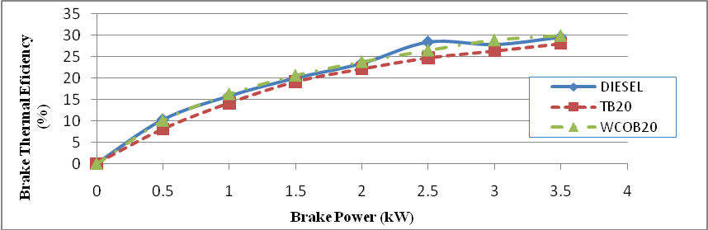
Fig:4.6(a) BTE V/s Brake power of WCOB 20,TB 20
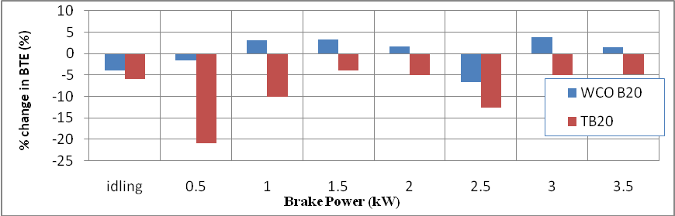
Fig: 4.6(b) %Change in BTE with biodiesel blends of 20% compared to diesel fuel as baseline
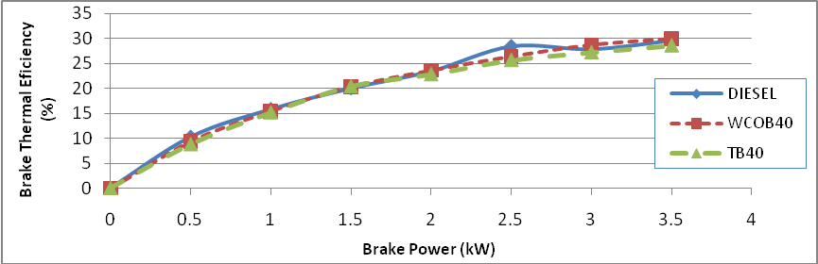
Fig:4.6(c) BTE v/s Brake power of WCOB 40,TB 40
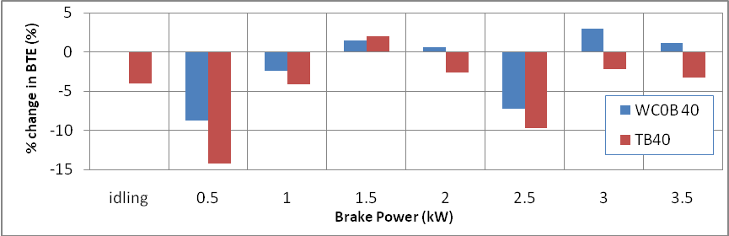
Fig: 4.6(d) %Change in BTE with biodiesel blends of 40% compared to diesel fuel as baseline

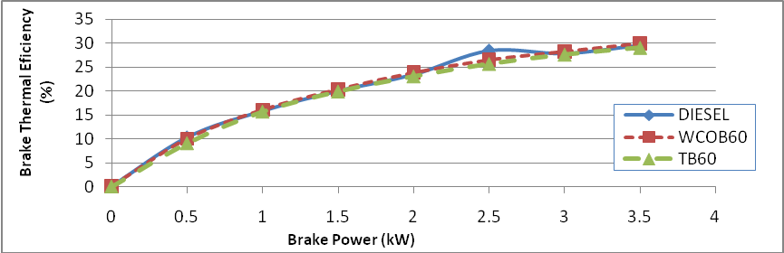
Fig: 4.6 (e) BTE v/s Brake power of WCOB60,TB60
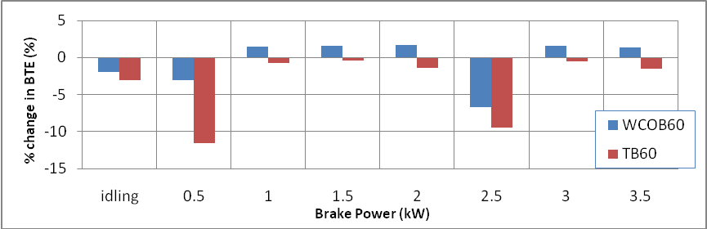
Fig: 4.6(f) %Change in BTE with biodiesel blends of 60% compared to diesel fuel as baseline
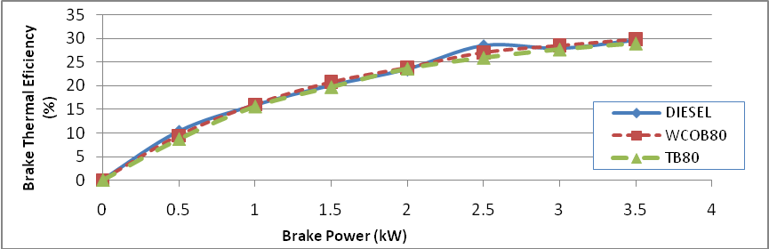
Fig:4.6(g) BTE V/s Brake power of WCOB 80,TB 80
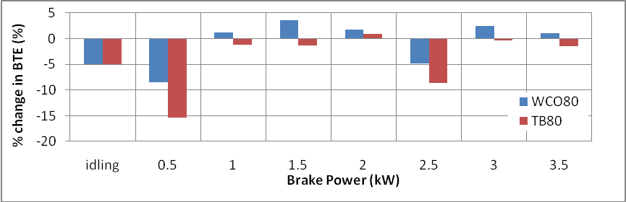
Fig: 4.6(h) %Change in BTE with biodiesel blends of 80% compared to diesel fuel as baseline

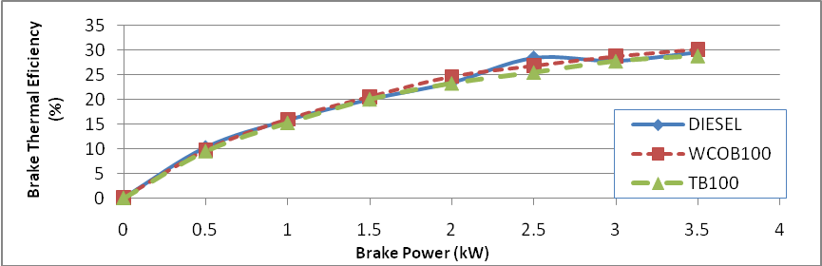
Fig: 4.6(i) BTE v/s Brake power of WCOB 100,TB 100
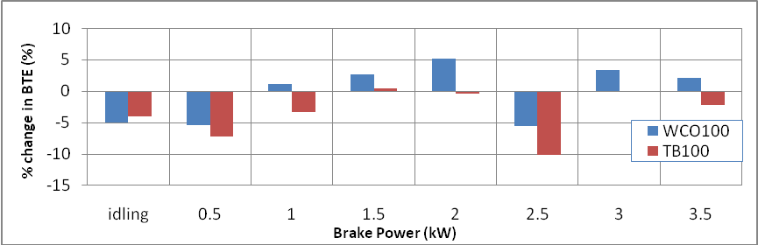
Fig: 4.6(j) %Change in BTE with biodiesel blends of 100% compared to diesel fuel as baseline
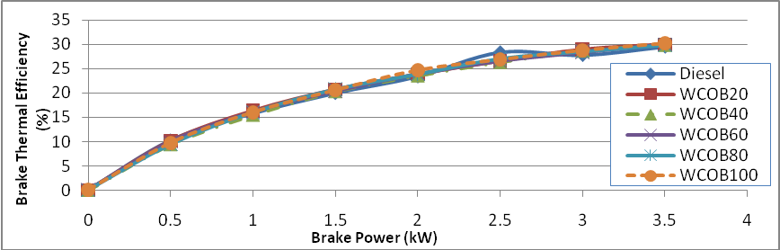
Fig: 4.6(k) BTE v/s Brake power of various blends of WCO
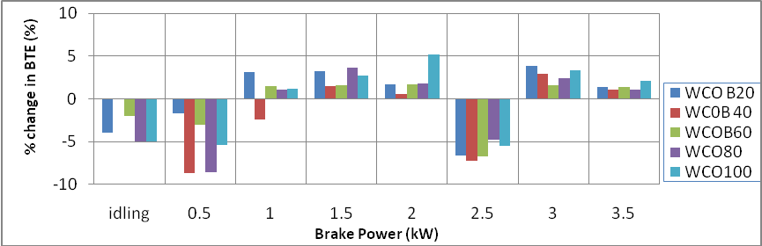
Fig:4.6(l) %Change in BTE with biodiesel blends of WCO compared to diesel fuel as baseline
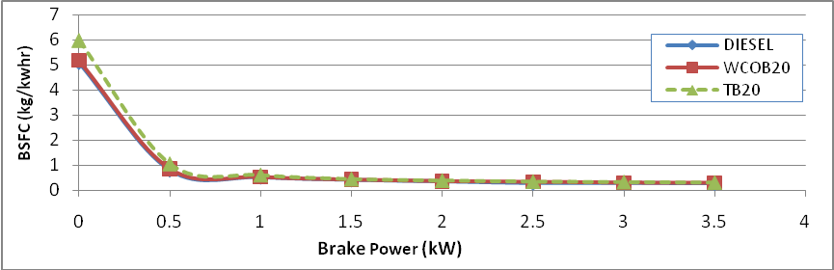
Fig:4.7(a) BBSFC v/s Brake power of WCOB 20,TB 20
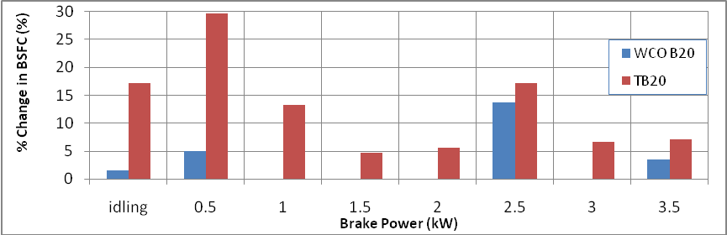
Fig: 4.7(b) %Change in BBSFC with biodiesel blends of 20% compared to diesel fuel as baseline
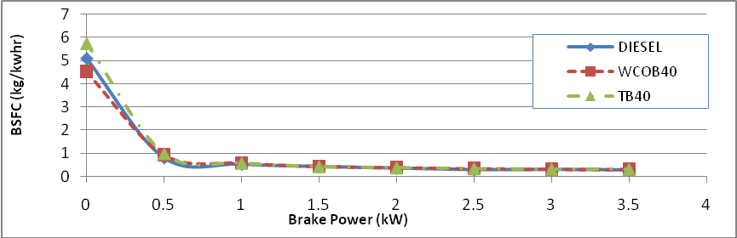
Fig: 4.7(c) BBSFC v/s Brake power of WCOB 20,TB 20
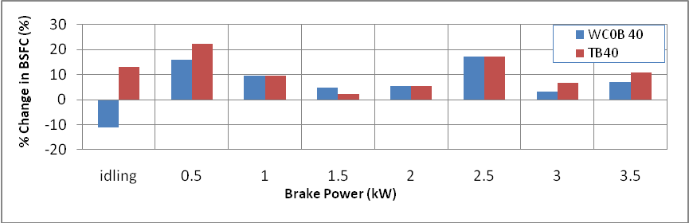
Fig: 4.7(d) %Change in BBSFC with biodiesel blends of 40% compared to diesel fuel as baseline

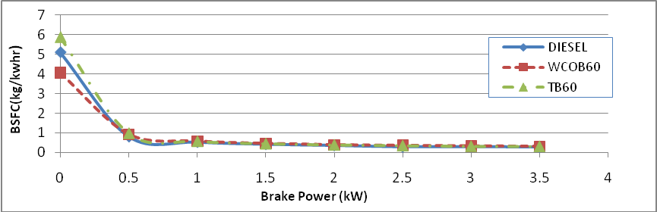
Fig: 4.7(e) BBSFC v/s Brake power of WCOB 60,TB 60
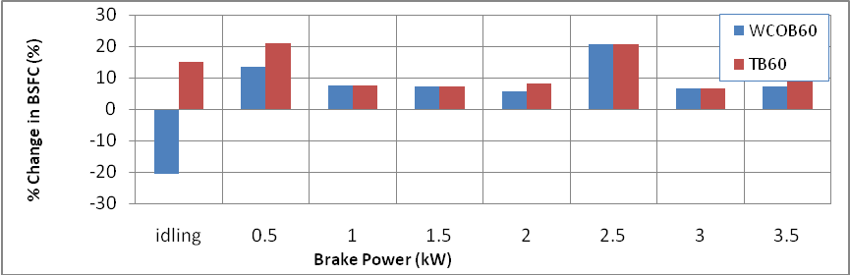
Fig: 4.7(f) %Change in BBSFC with biodiesel blends of 60% compared to diesel fuel as baseline
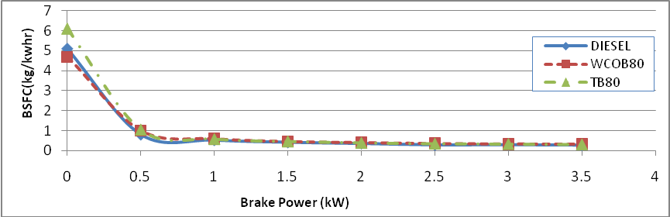
Fig: 4.7(g) BBSFC v/s Brake power of WCOB 80,TB 80
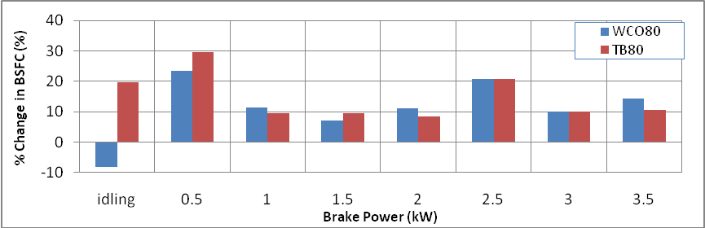
Fig: 4.7(h) %Change in BBSFC with biodiesel blends of 80% compared to diesel fuel as baseline

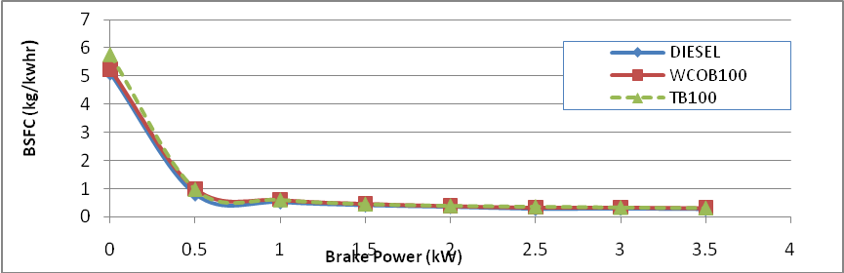
Fig: 4.7(i) BBSFC v/s Brake power of WCOB 100,TB 100
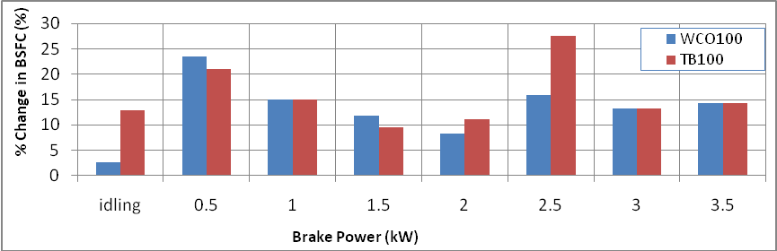
Fig: 4.7(j) %Change in BBSFC with biodiesel blends of 100% compared to diesel fuel as baseline
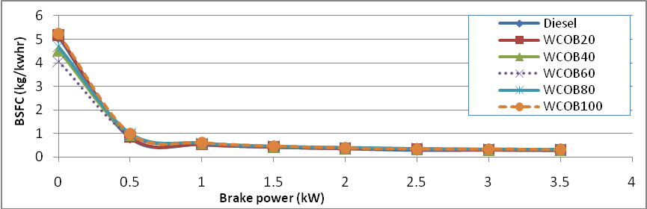
Fig: 4.7(k) BBSFC v/s Brake power of various WCO biodiesel
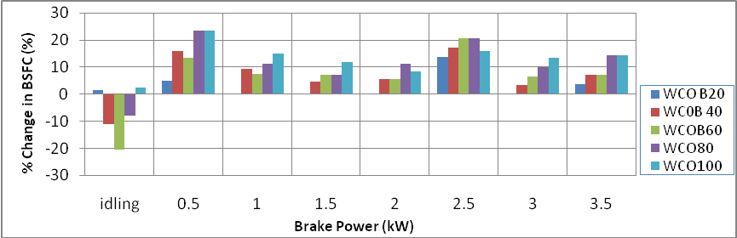
Fig: 4.7(l) %Change in BBSFC with biodiesel blends of WCO compared to diesel fuel as baseline

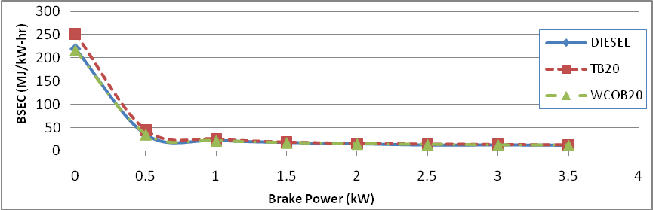
Fig: 4.8(a) BSEC v/s Brake power of WCOB 20,TB 20
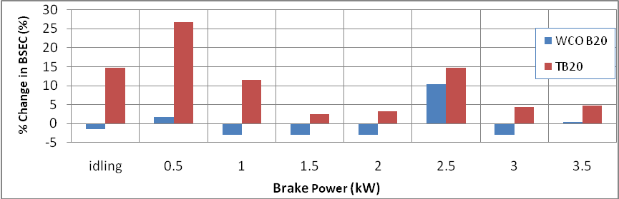
Fig: 4.8(b) %Change in BSEC with biodiesel blends of 20% compared to diesel fuel as baseline
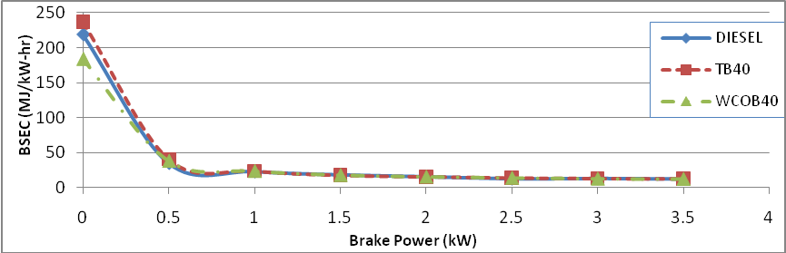
Fig: 4.8(c) BSEC v/s Brake power of WCOB 40,TB 40
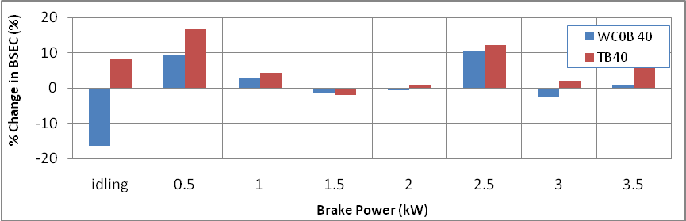
Fig: 4.8(d) %Change in BSEC with biodiesel blends of 40% compared to diesel fuel as baseline

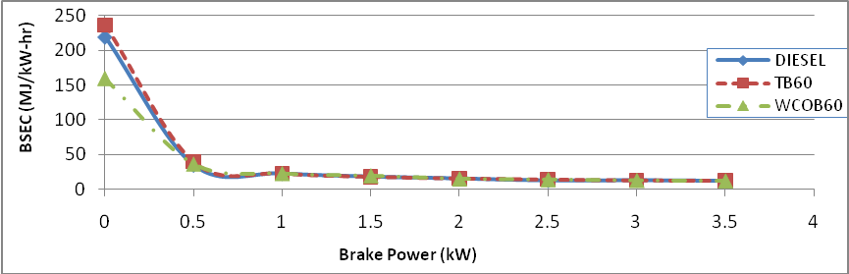
Fig: 4.8(e) BSEC v/s Brake power of WCOB 60,TB 60
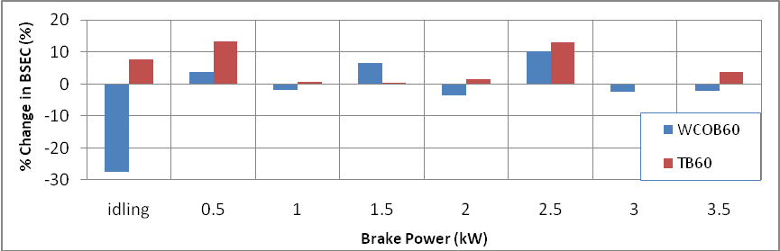
Fig:4.8(f) %Change in BSEC with biodiesel blends of 60% compared to diesel fuel as baseline
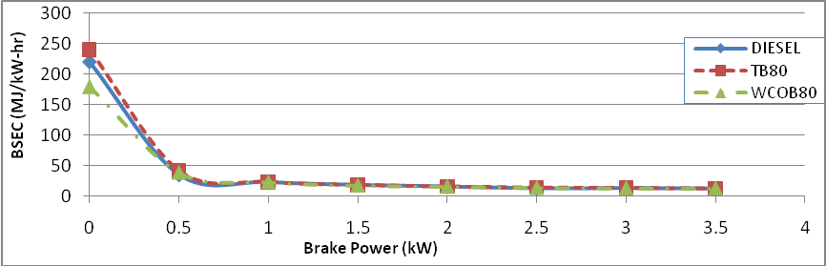
Fig: 4.8(g) BSEC v/s Brake power of WCOB 80,TB 80
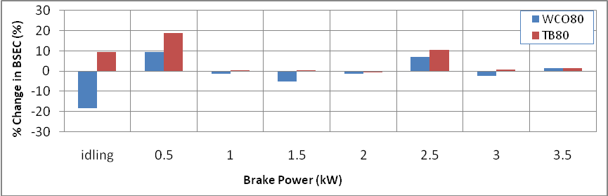
Fig: 4.8(h) %Change in BSEC with biodiesel blends of 80% compared to diesel fuel as baseline

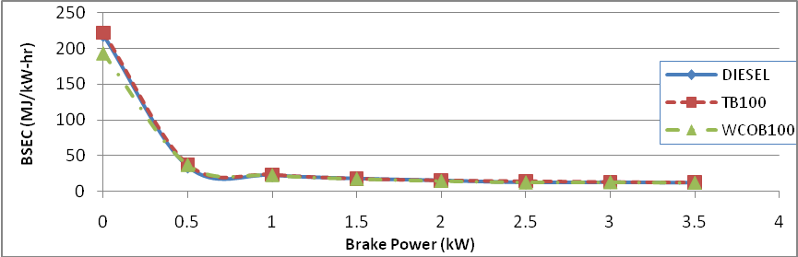
Fig: 4.8(i) BSEC v/s Brake power of WCOB 100,TB 100
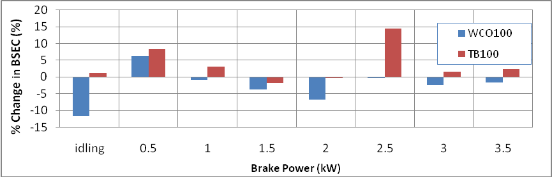
Fig: 4.8(j) %Change in BSEC with biodiesel blends of 100% compared to diesel fuel as baseline
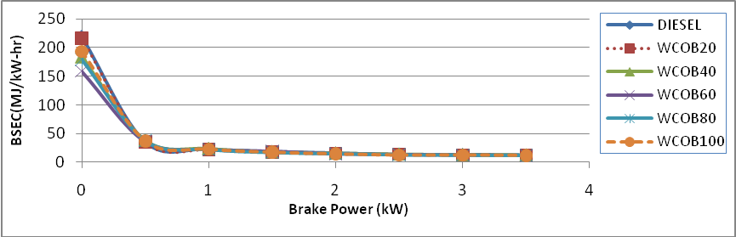
Fig: 4.8(k) BSEC v/s Brake power of various WCOB
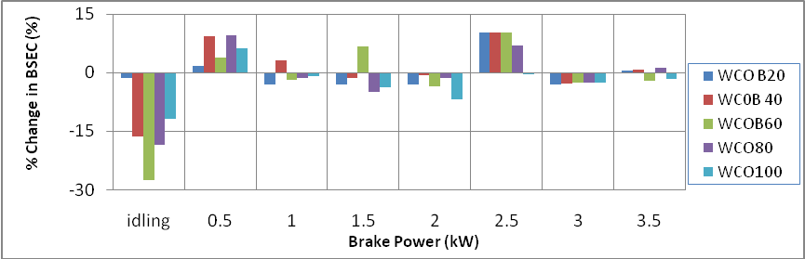
Fig: 4.8(l) %Change in BSEC with biodiesel blends of WCO compared to diesel fuel as baseline

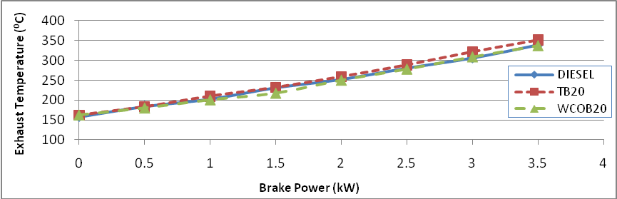
Fig: 4.9(a) Exhaust temp. v/s Brake power of WCOB 20,TB 20
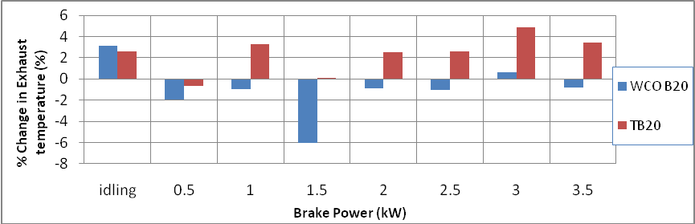
Fig: 4.9(b) %Change in EXT with biodiesel blends of 20% compared to diesel fuel as baseline
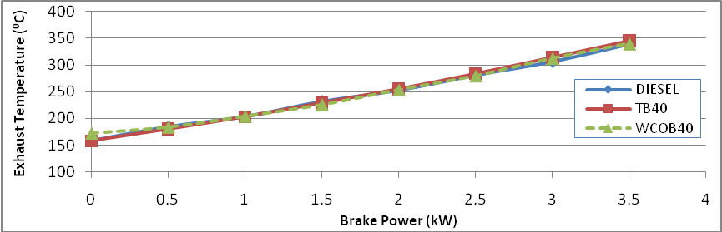
Fig: 4.9 (c) Exhaust temp. v/s Brake power of WCOB 40,TB 40
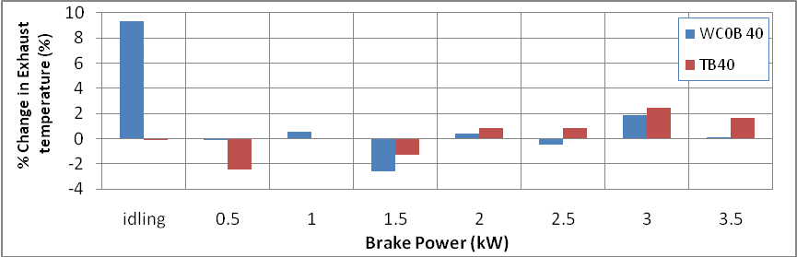
Fig: 4.9(d) %Change in EXT with biodiesel blends of 40% compared to diesel fuel as baseline
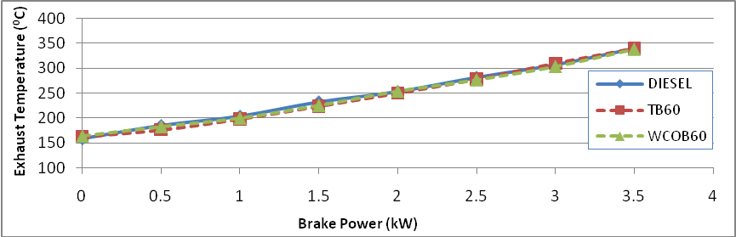
Fig: 4.9(e) Exhaust temp. v/s Brake power of WCOB 60,TB 60
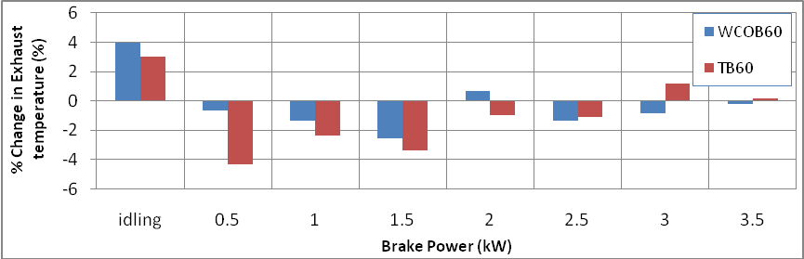
Fig: 4.9(f) %Change in EXT with biodiesel blends of 60% compared to diesel fuel as baseline
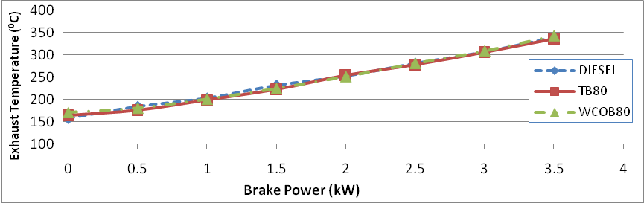
Fig: 4.9(g) Exhaust temp. v/s Brake power of WCOB 80,TB 80
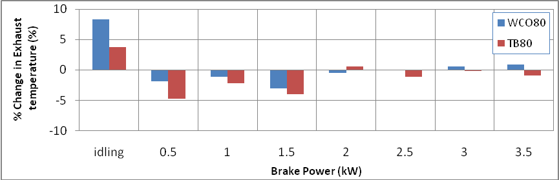
Fig: 4.9(h) %Change in EXT with biodiesel blends of 80% compared to diesel fuel as baseline
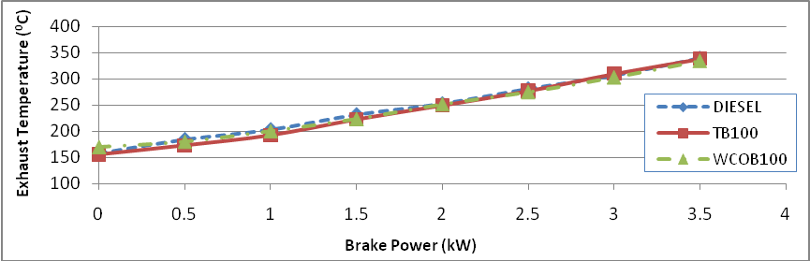
Fig: 4.9(i) Exhaust temp. v/s Brake power of WCOB 100,TB 100
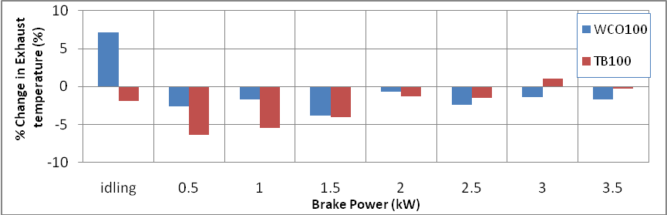
Fig: 4.9(j) %Change in EXT with biodiesel blends of 100% compared to diesel fuel as baseline
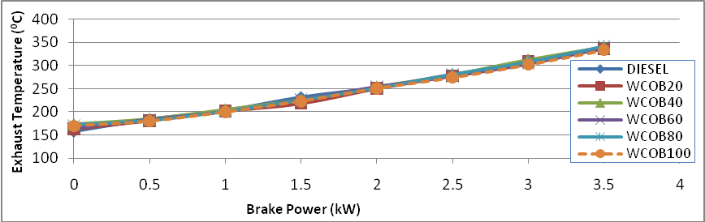
Fig: 4.9(k) Exhaust temp. v/s Brake power of various WCOB
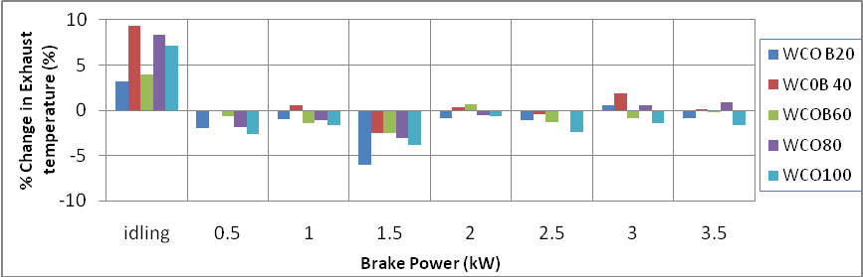
Fig: 4.9(l) %Change in EXT with biodiesel blends of WCO% compared to diesel fuel as baseline
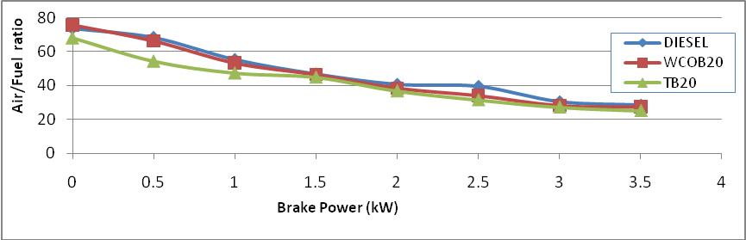
Fig:4.10(a) Air/fuel ratio v/s Brake power of WCOB 20,TB 20
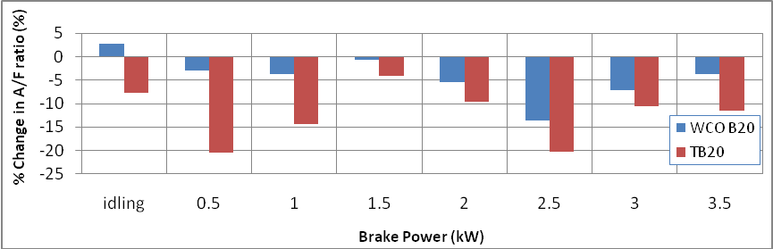
Fig: 4.10(b) %Change in A/F ratio with biodiesel blends of 20% compared to diesel fuel as baseline
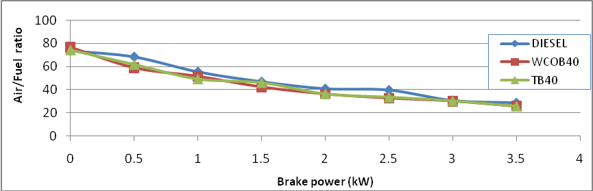
Fig: 4.10(c) Air/fuel ratio v/s Brake power of WCOB 40,TB 40
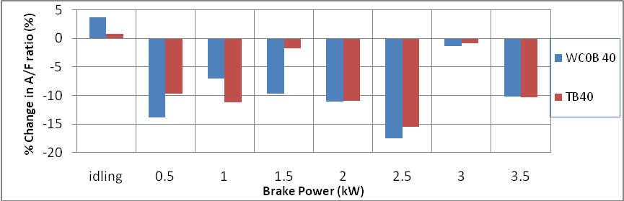
Fig: 4.10(d) %Change in A/F ratio with biodiesel blends of 40% compared to diesel fuel as baseline

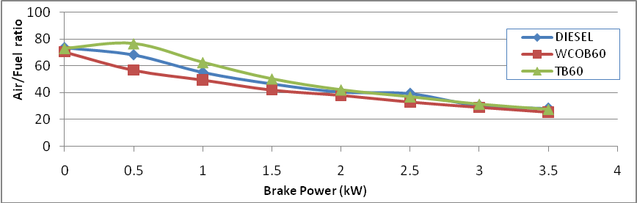
Fig: 4.10(e) Air/fuel ratio v/s Brake power of WCOB 60,TB 60
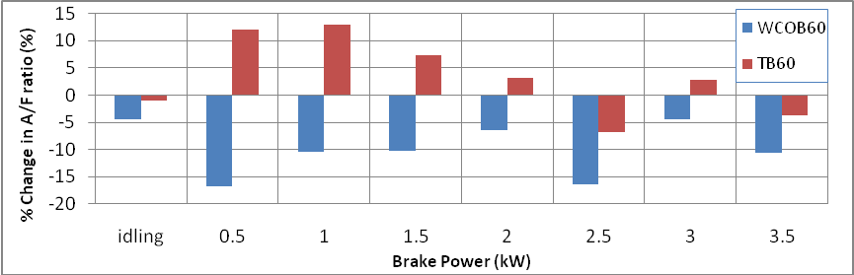
Fig: 4.10(f) %Change in A/F ratio with biodiesel blends of 60% compared to diesel fuel as baseline
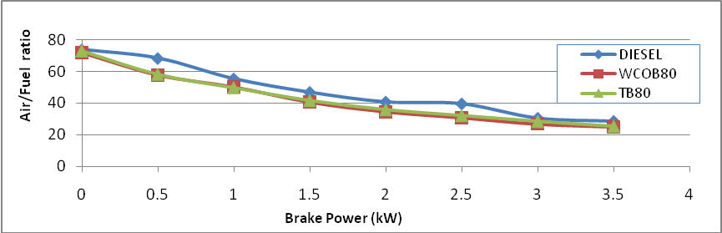
Fig: 4.10(g) Air/fuel ratio v/s Brake power of WCOB820,TB 80
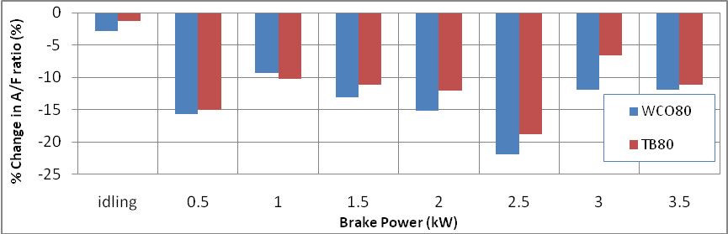
Fig: 4.10(h) %Change in A/F ratio with biodiesel blends of 80% compared to diesel fuel as baseline
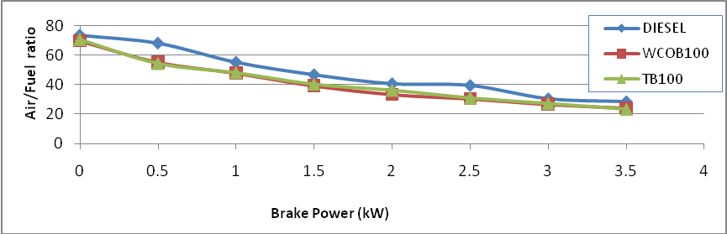
Fig: 4.10(i) Air/fuel ratio v/s Brake power of WCOB 100,TB 100
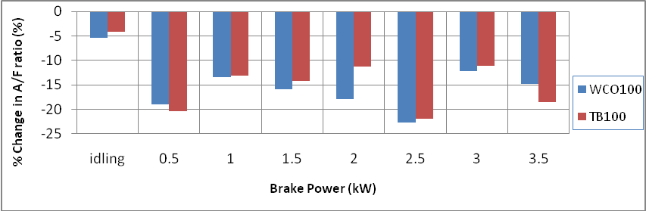
Fig: 4.10(j) %Change in A/F ratio with biodiesel blends of 100% compared to diesel fuel as baseline
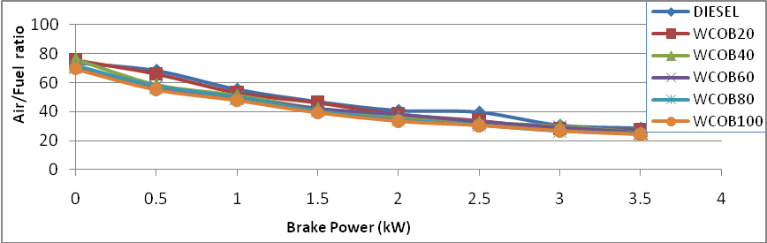
Fig: 4.10(k) Air/fuel ratio v/s Brake power of various WCOB
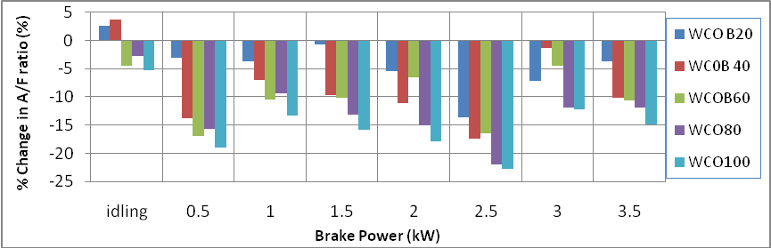
Fig: 4.10(l) %Change in A/F ratio with biodiesel blends of WCO compared to diesel fuel as baseline

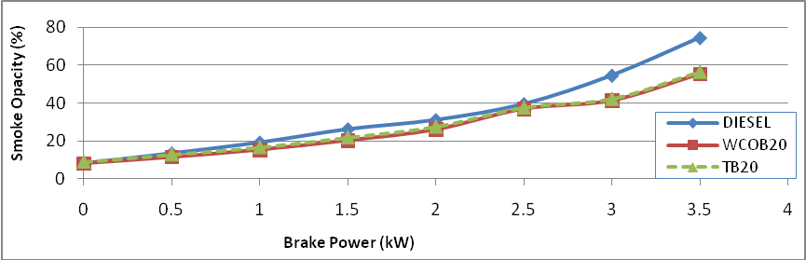
Fig: 4.11(a) Smoke opacity v/s Brake power of WCOB 20,TB 20
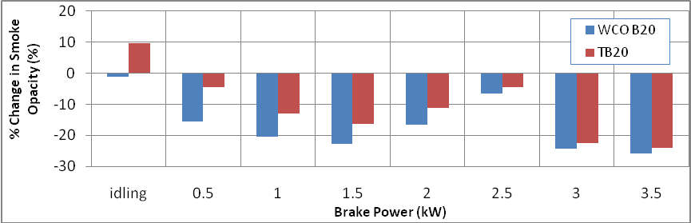
Fig:4.11(b) %Change in Smoke opacity with biodiesel blends of 20% compared to diesel fuel as baseline
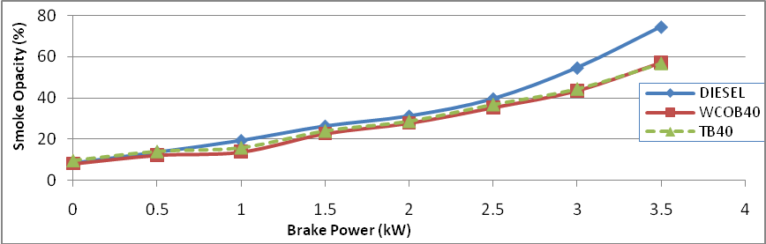
Fig: .11(c) Smoke opacity v/s Brake power of WCOB 40,TB 40
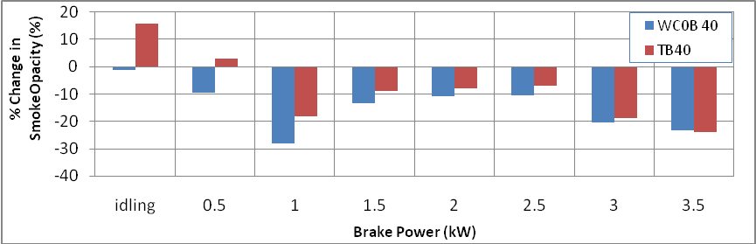
Fig: 4.11(d ) %Change in Smoke opacity with biodiesel blends of 40% compared to diesel fuel as baseline
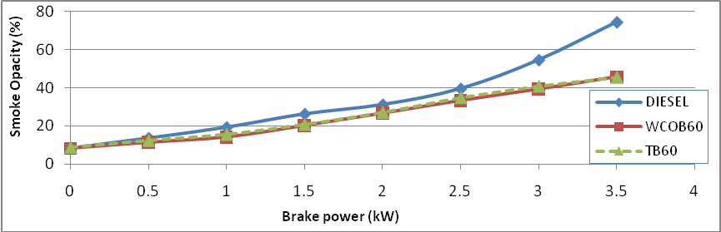
Fig:4.11(e) Smoke opacity v/s Brake power of WCOB60,TB 60
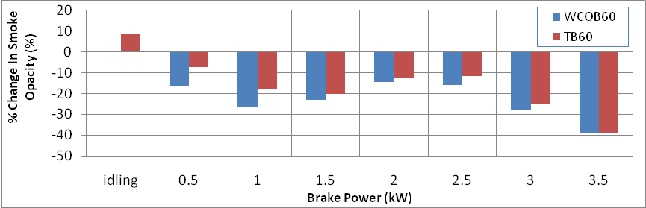
Fig: 4.11(f) %Change in Smoke opacity with biodiesel blends of 60% compared to diesel fuel as baseline
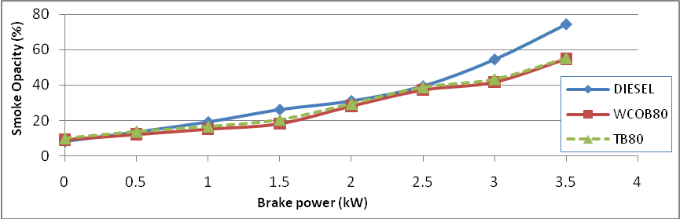
Fig: 4.11(g) Smoke opacity v/s Brake power of WCOB 80,TB 80
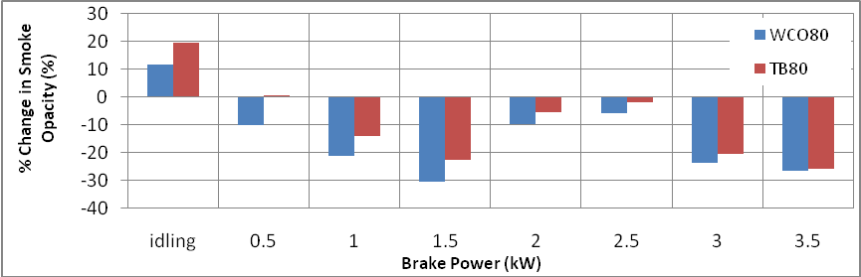
Fig: 4.11(h) %Change in Smoke opacity with biodiesel blends of 80% compared to diesel fuel as baseline
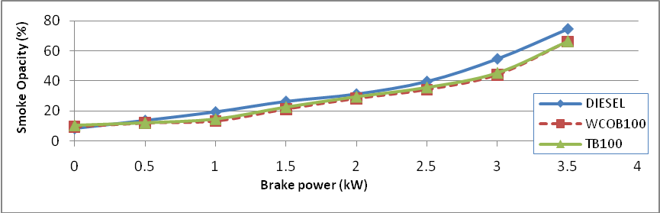
Fig: 4.11(i) Smoke opacity v/s Brake power of WCOB 100,TB 100
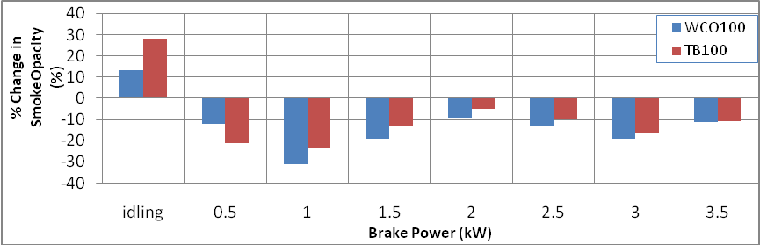
Fig: 4.11(j) %Change in smoke opacity with biodiesel blends of 100% compared to diesel fuel as baseline
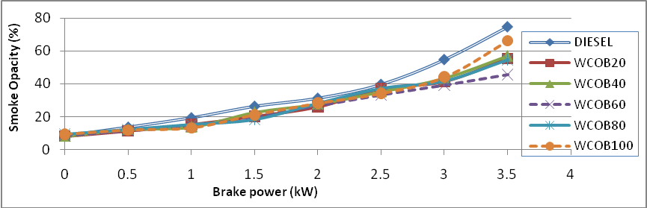
Fig: 4.11(k) Smoke opacity v/s Brake power of various WCOB
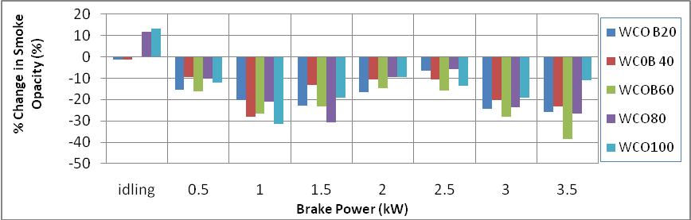
Fig: 4.11(l) %Change in smoke opacity with biodiesel blends of WCO compared to diesel fuel as baseline

4.9 Result and discussion of 4-cylinder Tata indica engine.
Variation of torque w.r.t speed
The figure 4.12 represent the variation of torque v/s speed and % change for both blends biodiesel of WCO and thumba (B10, B20, B30) respectively. In case of both biodiesel blends and pure diesel, initially the torque rises sharply with increase in engine speed up to 2500 rpm. Between speed 2500 to 4000 rpm the variation or torque with speed remain almost constant. Further increase in speed causes decrease in torque. The pattern is almost same for all blends. The maximum torque achieved in case of thumba biodiesel blend (WCO-20) is 7.5 kg-m at 2500 rpm. The percentage change of brake power of biodiesels with speed considering diesel oil at baseline is ±30%.
Variation of Brake power w.r.t speed
The figure 4.13 represent the variation of brake power with speed and % change for both blends of biodiesel (B10, B20, B30). The Brake Power increases proportionally to engine speed in the range of 2000 to 4000 rpm. In this speed range variation of brake power is between 6-31 kW. For more than 4000 rpm there is fluctuating variation in brake power among the biodiesel blends. The maximum brake power achieved for thumba biodiesel blend (WCO-30) is 31 kW at 5000 rpm. The variation of brake power is almost negligible for all types of blends and pure diesel for upto 4000 engine rpm. The percentage change of brake power of biodiesels with speed considering diesel oil at baseline is shown in figure. At initial speed brake power obtained is more in case of biodiesel for all percentage of blends. Maximum percentage increase in brake power has obtained for biodiesel WCOB30 blend and at 2500 rpm which is 32.5% more. Thumba and WCO biodiesel shows similar pattern. At the speed range of 2500 to 4000 brake power of biodiesel is almost constant with diesel oil for all blends. At 2000 rpm biodiesel shows slightly more power than diesel oil. Percentage variation are ±24% for different speed.
Variation of Brake thermal .eff. w.r.t speed
Figure 4.14 shows comparison of Brake thermal efficiency vs. speed and % deviation for different biodiesel blends of thumba and WCO in comparison to diesel respectively. The maximum value of brake thermal efficiency for all blends & pure diesel is at 2000 rpm. For all blends of both oil variation of brake thermal efficiency is higher as compared to pure diesel for wide range of engine speed. The maximum thermal efficiency is achieved by using WCO-30 blend is around 28.9 % at 2000 rpm which is 5 % higher as compared to pure diesel. The brake thermal efficiency is almost constant between rpm range of 2000 to 4000, and it decreases sharply with further increase in rpm and with increase in percentage of biodiesel blending the brake thermal efficiency increase for wide range of engine rpm. Both WCO and thumba oil exhibit comparatively higher efficiency for all speed range than pure diesel with all blends. Biodiesel blend of 30% shows much higher efficiency than diesel fuel. Percentage variation are shown in figure 4.14 ± 40% at different range of speed.
Variation of BBSFC w.r.t speed
The variations of brake specific fuel consumption vs. speed and % deviation are shown in Figure 4.15 for biodiesel blends WCO and thumba . For all cases the bBSFC initially increases sharply with increase in rpm upto 2000 and afterward between the rpm 2000-4000 bBSFC remains approximately constant. For more than 4000 rpm range bBSFC increases sharply with speed. The bBSFC for all blends and pure diesel is least at 2000 rpm. The bBSFC for WCO-30 oil is lowest between the rpm range of 2000 to 4500. In this speed range the bBSFC varies between 0.32 kg/kWh to 0.42kg/kWh. In case of all thumba and WCO biodiesel blends bBSFC values are significantly higher as compared to pure diesel for a wide range of engine speed. Percentage variation are shown in figure 4.15 are ±21% at different speed.
Variation of BSEC w.r.t speed
The variations of brake specific fuel consumption vs. speed and % deviation are shown in Figure 4.16 for biodiesel blends and pure diesel. Thumba biodiesel have the higher value bsec than wco and diesel for all speed range. The bsec have highest value at 2000 rpm. This energy consumption is the energy input required to develop unit power. This small variation may be due to the combined effect of lower heating value and high density of biodiesel. Percentage variation are shown in figure 4.16 are ±25 % at different speed.

Variation of Smoke opacity w.r.t speed
To understand the pollution aspect of biodiesel the variation of opacity vs. speed and % change are shown in Figure 4.17 for biodiesel blends in comparison to pure diesel. The opacity value for pure diesel is slightly higher as compared to all type of blends for wide range of engine rpm. There is no significant change in opacity value for above 4000 rpm engine speed. The trend regarding variation of opacity with respect to speed is almost similar for all type of blends and further the variation of opacity value of different blend at a particular rpm is almost negligible. The biodiesel blends shows lower smoke opacity than diesel. Percentage variation are shown in figure 4.17 is -20 % except 1500 rpm.

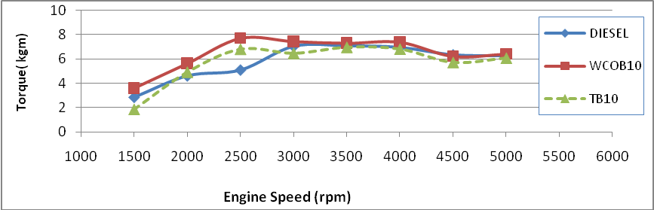
Fig:4.12(a) Comparison of torque v/s speed for WCOB10, TB10
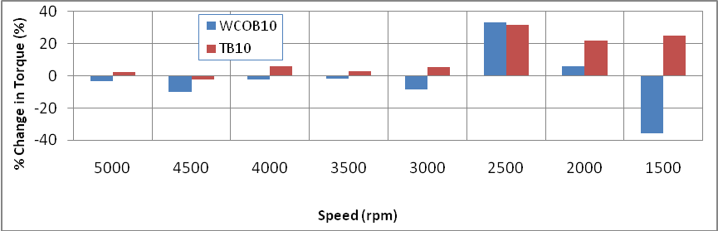
Fig:4.12(b) % Change in torque with the biodiesels blend of 10% compared to diesel fuel as baseline
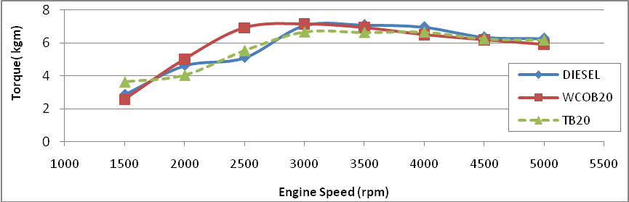
Fig:4.12(c) Comparison of torque vs speed for WCOB 20, TB20
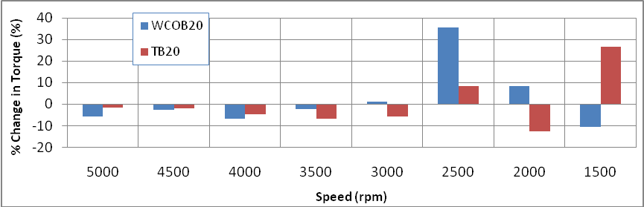
Fig:4.12(d) % Change in torque with the biodiesels blend of 20% compared to diesel fuel as baseline
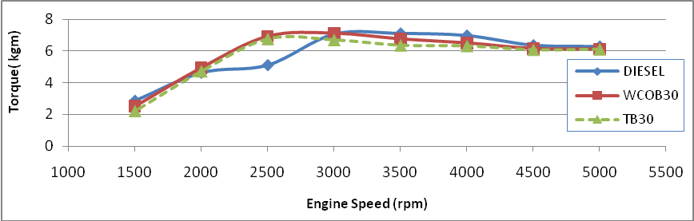
Fig: 4.12(e) Comparison of torque vs speed for WCOB30, TB30
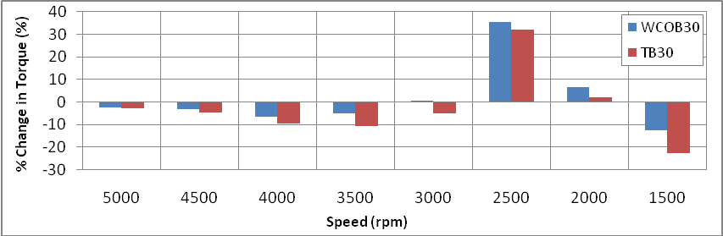
Fig :4.12(f) % Change in torque with the biodiesels blend of 30% compared to diesel fuel as baseline
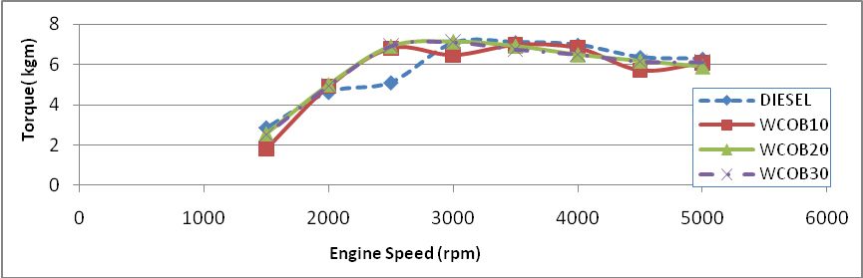
Fig: 4.12(g)Comparison of torque vs speed for various blends of WCO
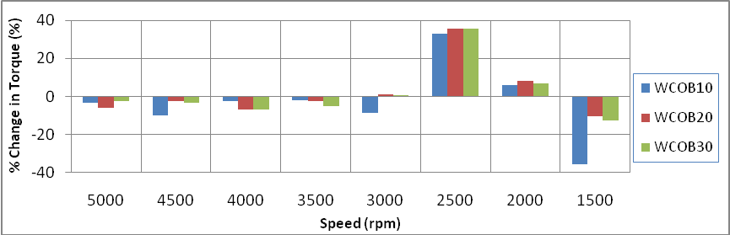
Fig: 4.12(h) % Change in torque with the biodiesels blend of WCO compared to diesel fuel as baseline
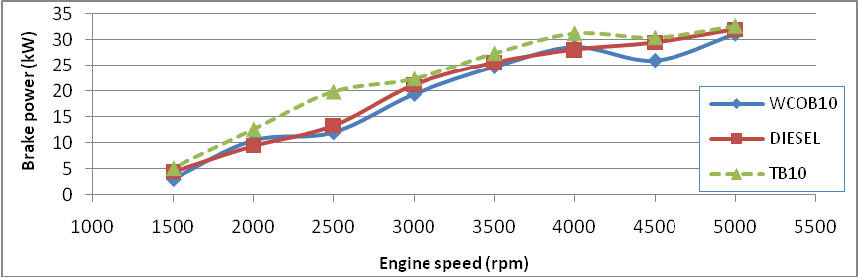
Fig: 4.13(a) Comparison of Brake power v/s speed for WCOB10,TB10
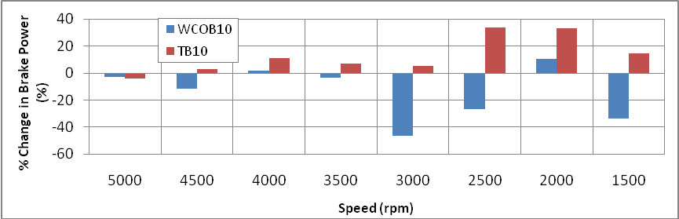
Fig :4.13(b) % Change in brake powert with the biodiesels blend of 10% compared to diesel fuel as baseline
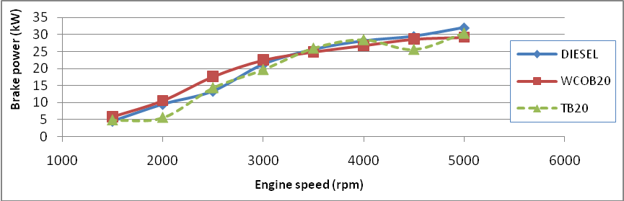
Fig:4.13(c) Comparison of Brake power v/s speed for WCOB20,TB20
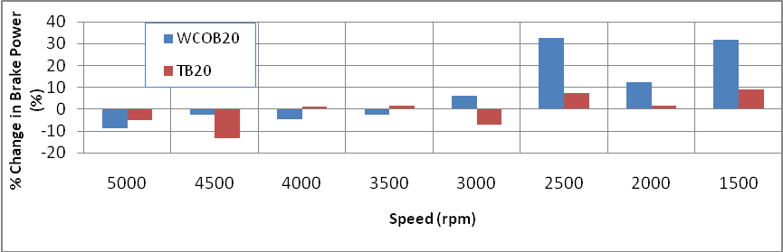
Fig : 4.13(d) % Change in brake powert with the biodiesels blend of 20% compared to diesel fuel as baseline
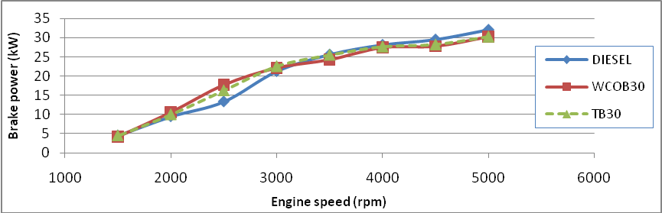
Fig :4.13(e) Comparison of Brake power v/s speed for WCOB30,TB30
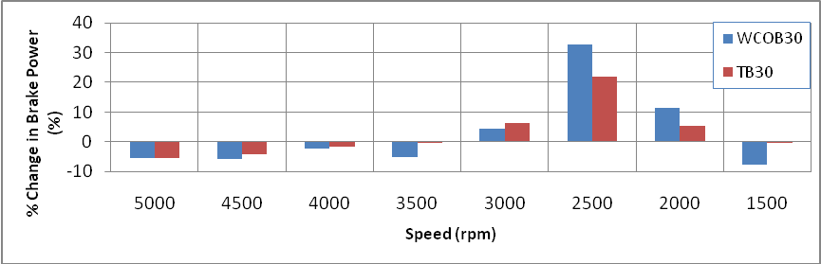
Fig :4.13(f) % Change in brake powert with the biodiesels blend of 30% compared to diesel fuel as baseline
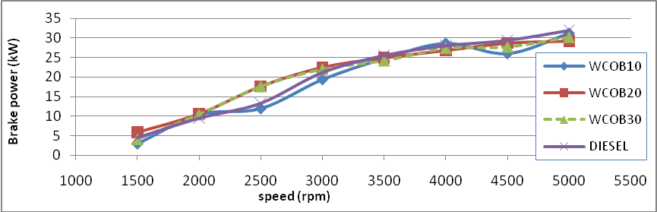
Fig :4.13(g) Comparison of Brake power v/s speed for WCOB10,WCOB20, WCOB30
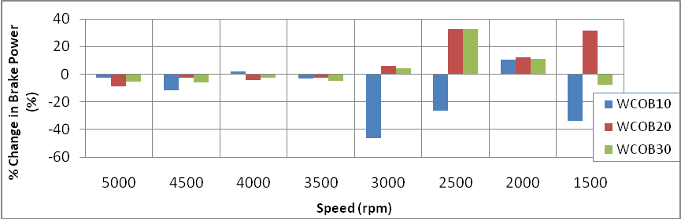
Fig :4.13(h) % Change in brake powert with the biodiesels blend of WCO compared to diesel fuel as baseline
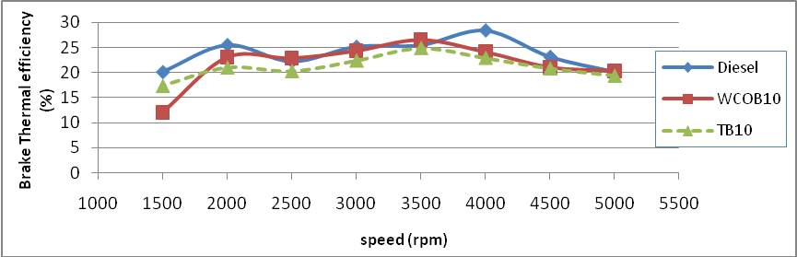
Fig :4.14(a) Comparison of Brake thermal efficiency v/s speed for WCOB10,TB10
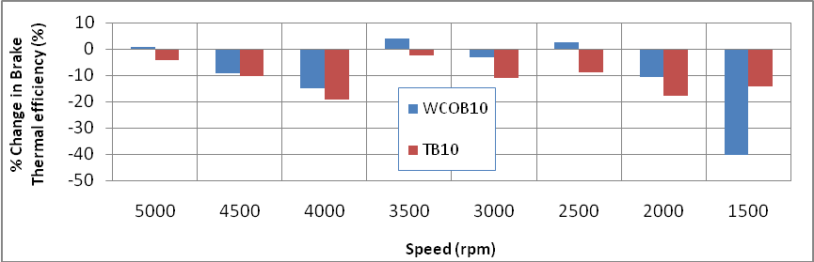
Fig : 4.14(b) % Change in BTE with the biodiesels blend of 10% compared to diesel fuel as baseline
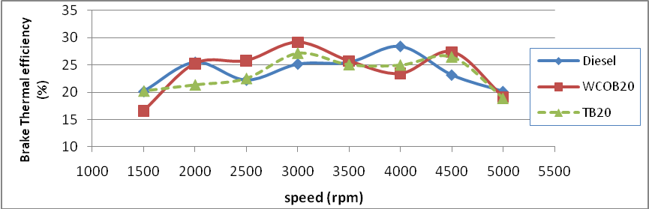
Fig : 4.14(c)Comparison of Brake thermal efficiency v/s speed for WCOB20,TB20
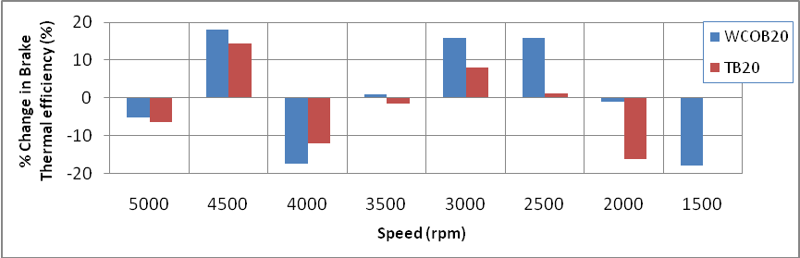
Fig :4.14(d) % Change in BTE with the biodiesels blend of 20% compared to diesel fuel as baseline
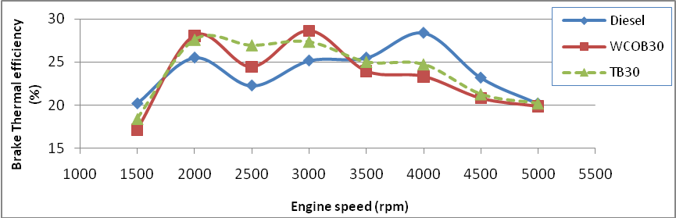
Fig :4.14(e)Comparison of Brake thermal efficiency vs speed for WCOB30,TB30
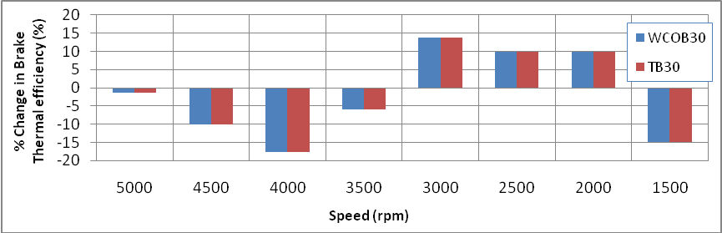
Fig :4.14(f) % Change in BTE with the biodiesels blend of 30% compared to diesel fuel as baseline
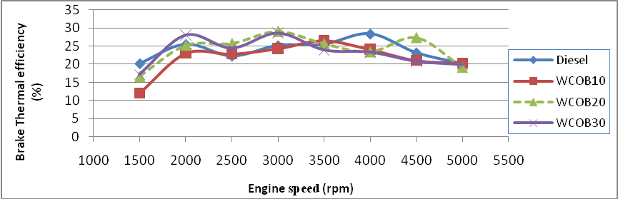
Fig :4.14(g)Comparison of Brake thermal efficiency v/s speed for WCOB10,WCOB20,WCOB30
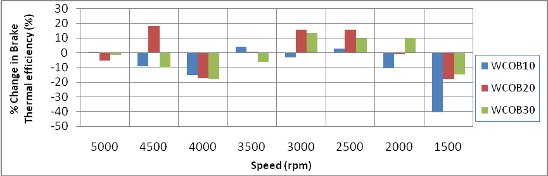
Fig : 4.14(h% Change in BTE with the biodiesels blend of WCO compared to diesel fuel as baseline
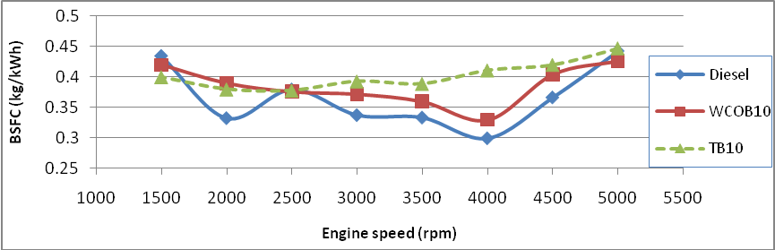
Fig :4.15(a) Comparison of BBSFC vs speed for WCOB10,TB10
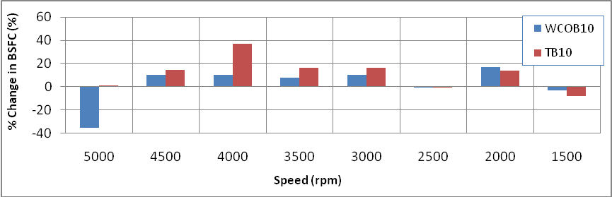
Fig :4.15(b) % Change in BBSFC with the biodiesels blend of 10% compared to diesel fuel as baseline
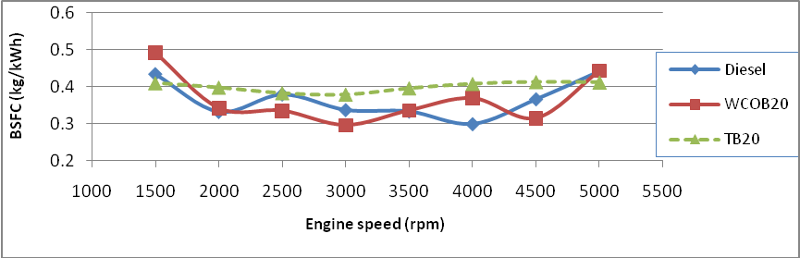
Fig :4.15(c)Comparison of BBSFC vs speed for WCOB20,TB20
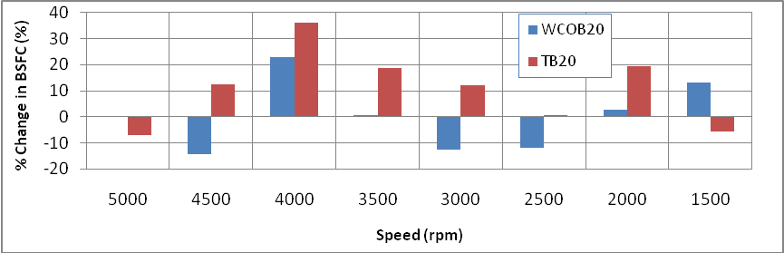
Fig :4.15(d) % Change in BBSFCwith the biodiesels blend of 20% compared to diesel fuel as baseline
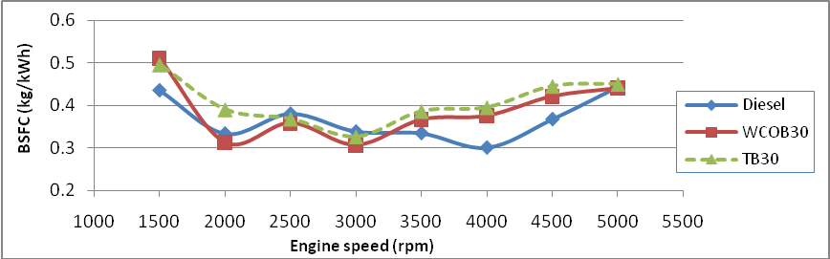
Fig :4.15(e) Comparison of BBSFC vs speed for WCOB30,TB30
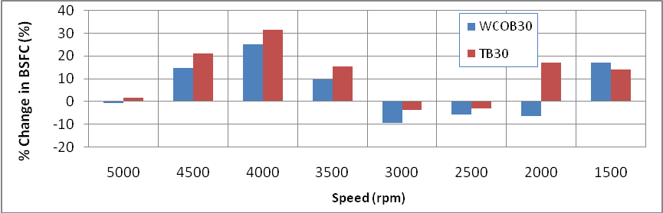
Fig :4.15(f) % Change in BBSFCwith the biodiesels blend of 30% compared to diesel fuel as baseline
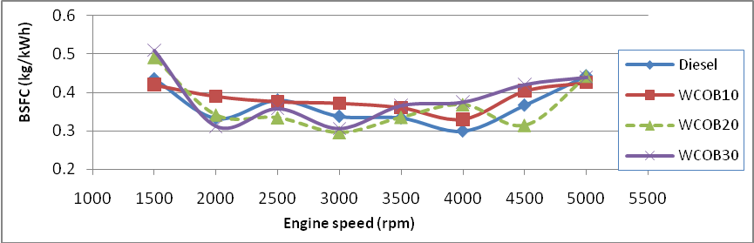
Fig :4.15(g) Comparison of BBSFC vs speed for WCOB10,WCOB20,WCOB30
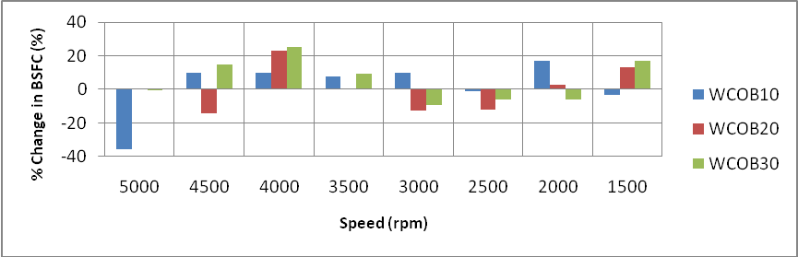
Fig :4.15(h) % Change in BBSFC with the biodiesels blend of WCO compared to diesel fuel as baseline
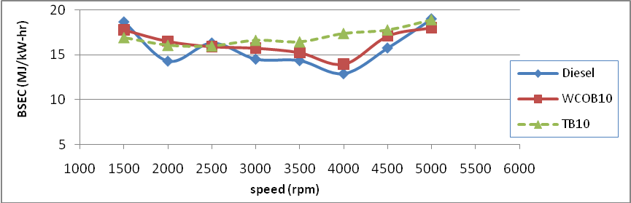
Fig :4.16(a) Comparison of BSEC vs speed for WCOB10,TB10
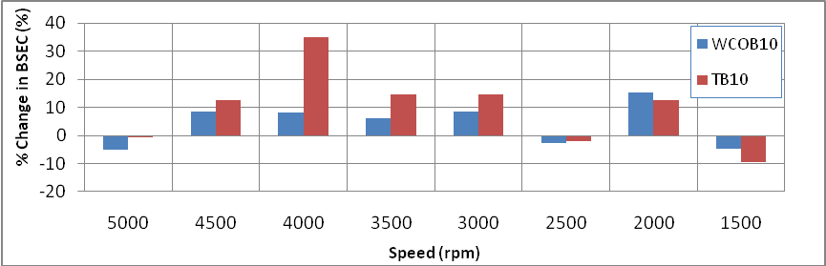
Fig :4.16(b) % Change in BSEC with the biodiesels blend of 10% compared to diesel fuel as baseline
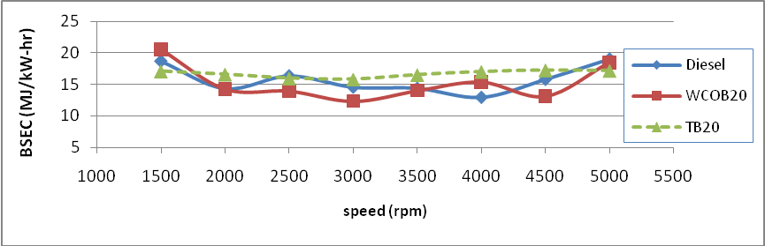
Fig :4.16(c) Comparison of BSEC v/s speed for WCOB20,TB20
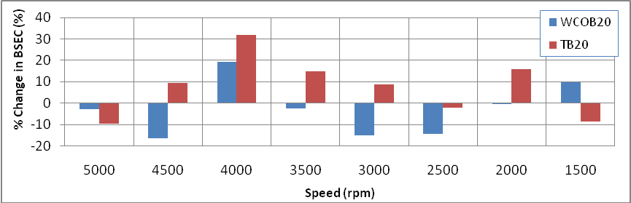
Fig : 4.16(d) % Change in BSEC with the biodiesels blend of 20% compared to diesel fuel as baseline

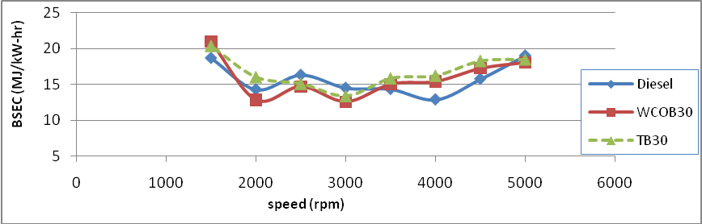
Fig :4.16(e) Comparison of BSEC vs speed for WCOB30,TB30
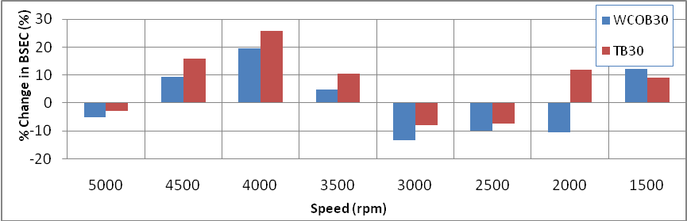
Fig :4.16(f) % Change in BSEC with the biodiesels blend of 30% compared to diesel fuel as baseline
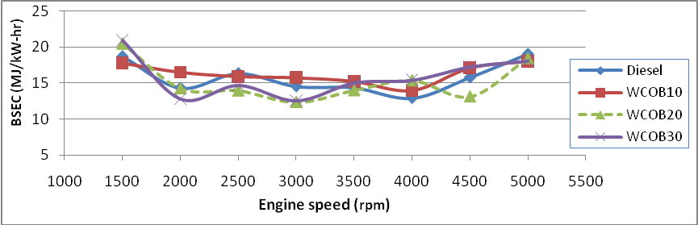
Fig :4.16(g) Comparison of BSEC vs speed for WCOB10, WCOB20,WCOB30
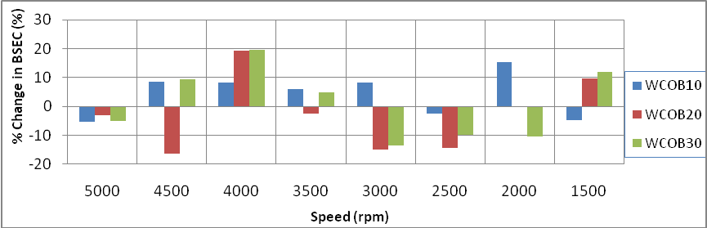
Fig :4.16(h) % Change in BSEC with the biodiesels blend of WCO compared to diesel fuel as baseline

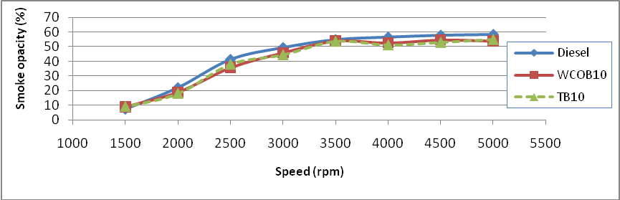
Fig :4.17(a)Comparison of Opacity vs speed for WCOB10,TB10
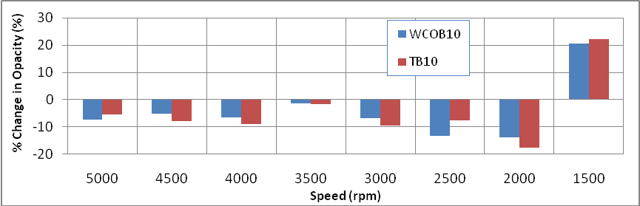
Fig : 4.17(b) % Change in smoke opacity with the biodiesels blend of 10% compared to diesel fuel as baseline
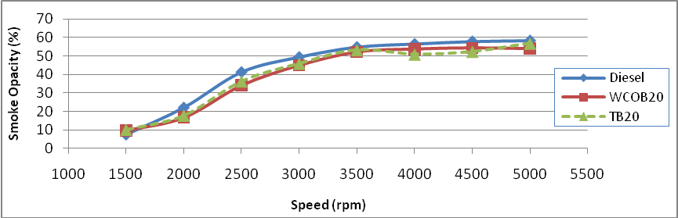
Fig :4.17(c) Comparison of Opacity vs speed for WCOB20,TB20
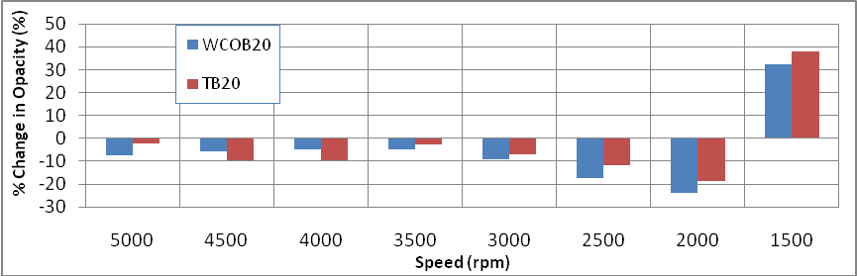
Fig : 4.17(d) % Change in smoke opacity with the biodiesels blend of 20% compared to diesel fuel as baseline
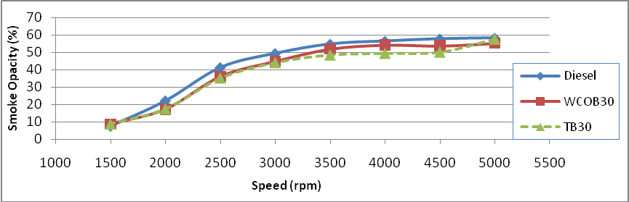
Fig :4.17(e) Comparison of Opacity vs speed for WCOB30,TB30
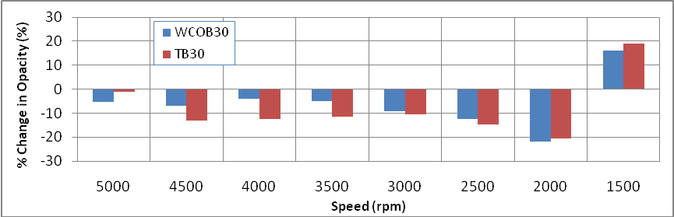
Fig : 4.17 (f) % Change in smoke opacity with the biodiesels blend of 30% compared to diesel fuel as baseline
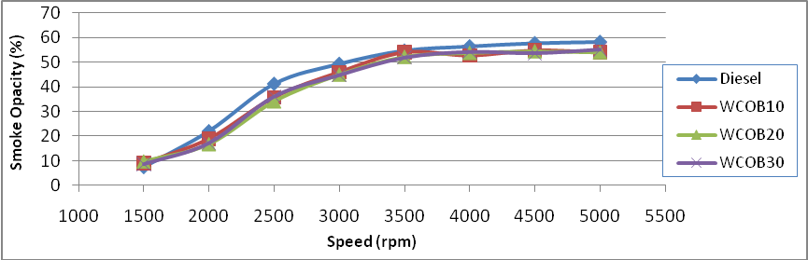
Fig :4.17(g) Comparison of Opacity vs speed for WCOB10,WCOB20,WCOB30
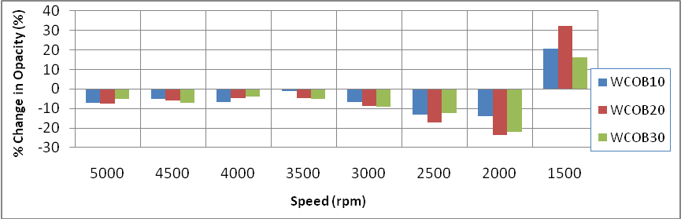
Fig :4.17(h) % Change in smoke opacity with the biodiesels blend of WCO compared to diesel fuel as baseline

CHAPTER 5

CONCLUSION AND FUTURE SCOPE
5.1 Conclusion
From the engine performance testing and biodiesel production the following conclusion was made
- The biodiesel produced suitably through mechanical stirring at .75% catalyst and 4.5:1 molar ratio.
- The performance parameters for both biodiesel thumba and WCO (waste cooking oil) have almost similar results than the conventional diesel oil. The performance parameter like brake thermal efficiency, brake specific fuel consumption, brake specific energy consumption, torque have similar result at wide range of power output.
- The emission characteristics like smoke opacity give better result than conventional diesel.
- From the overall performance analysis, thumba and waste cooking oil can be recommended as good alternative fuel for C. I. engine.
5.2 Scope for future work
The future study can also required for biodiesel production and performance testing.
1. Experimental observations can be taken at different compression ratio on VCR engine.
2. For higher blends of biodiesel upto B30 can be tested on Tata indica engine at wide range of speed.
3. The study of various additives for biodiesel blends can be required.
4. other production techniques can also examined for biodiesel production .

REFERENCES
- Intergovernmental Panel. “IPCC Fourth Assessment Report on Climate Change,2009, www.ipcc.ch”, as on 12 may 2009.
- Energy Information administration. “International Energy Outlook.” Office of Integrated Analysis and Forecasting, www.eia.doe.gov/oiaf/ieo/pdf/0484,pdf”, U.S. Department of Energy, (2009).
- Ministry of Petroleum and Natural gas, “Govt of India www.petroleum.nic.in./ petstat.pdf” April 20, 2009.
- Central Pollution Control Board, “www.cpcb.nic.in” as on April 15, 2009.
- Peterson C. L, Casada M.E, Safley L. M., Broder J. D.“Potential Production of Agriculture Produced Fuels”. Applied Engineering in Agriculture, Vol-11,767-772, (1995).
- Fukuda H, Kondo A and Noda H. “Biodiesel fuel production by trans esterification of oils”. Bioeng J Biosci, 92(5), 405–16(2001).
- Demirbas Ayhan, “Progress and recent trends in biodiesel fuels”. Energy Conversion and Management, 14–34, 16(Oct 2008).
- Choudhury S. and Bose P. K. “Jatropha derived Biodiesel and its suitability as C I engine fuel.”, SAE international, vol 28 – 0040 (2008).
- Ji Jianbing, Wang Jianli, Li Yongchao, Yu Yunliang and Xu Zhichao. “Preparation of biodiesel with the help of ultrasonic and hydrodynamic cavitation”, Ultrasonic, 411-414, 44( 2006).
- Warabi Yuichiro, Kusdiana Dadan and Shiro Saka. “Reactivity of triglycerides and fatty acids of rapeseed oil in supercritical alcohols.” Bioresource Technology, 283–287,91 (2004).
- Ghobadian B.and Rahimi H., Nikbakht A.M. , Najaﬁ G. , Yusaf T.F.. “Diesel engine performance and exhaust emission analysis using waste cooking biodiesel fuel with an artiﬁcial neural network”. Renewable Energy, 976–982,34 (2009).
- Yinnan YUAN, Deqing MEI, Zhong WANG, Tian ZHANG. “Combustion and emissions of the diesel engine using bio-diesel fuel.” Front. Mech. Eng. China, 189–192,3 (2008).
- Jehad A. A. Yamin, Sakhnin Nina i, Sakhrieh Ahmad, Hamdan M. “Performance of CI engines using Biodiesel as fuel.” Amman‐Jordan, March 31st – April 2nd( 2009).
- Puhan Sukumar, Gopinath A., Nagarajan G. “Combustion, performance and emission characteristics of a DI CI engine using biodiesel with varied fatty acid composition.” Renewable Energy Technology, Vol. 1, No. 1, (2009).
- Nwafor O.M.I., Rice G., Ogbonn A.I. a. “Effect of advanced injection timing on the performance of rapeseed oil in diesel engines.” Renewable Energy Renewable Energy , 433–444, 21(2000).
- Nurun Nabi Md., Shamim Akhter Md., Mhia Md.Zaglul Shahadat. “Improvement of engine emissions with conventional diesel fuel and diesel–biodiesel blends.” Bioresource Technology, 372–378, 97 (2006).
- BanapurmathN.R. and Tewari P.G., Hosmath R.S. “Performance and emission characteristics of a DI compression ignition engine operated on Honge, Jatropha and sesame oil methyl esters.” Renewable Energy, 1982–1988, 33 (2008)
- Sharma D, Soni S L, Pathak S C,(Ms) Gupta R. “Performance and Emission Characteristics of Direct Injection Diesel Engine using Neem-Diesel Blends.” MNIT Jaipur Vol 86, (July 2005).
- Rodjanakid Kanok-on, Charoenphonphanich Chinda. “Performance of an Engine Using Biodiesel from Refined Palm Oil Stearin and Biodiesel from Crude Coconut Oil.” Sustainable Energy and Environment, (Dec 2004).
- Ryu Kyunghyun , Oh Youngtaig . “Combustion Characteristics of an Agricultural Diesel Engine using Biodiesel Fuel.” KSME International Journal, Vol. 18 No. , 709- 717, 4(2004).
- Qi D. H., Geng L. M., Chen H., Bian Y.ZH., Liu J., Ren X.CH. “Combustion and performance evaluation of a diesel engine fuelled with biodiesel produced from soybean crude oil.” Renewable Energy ,2706–2713,34 (2009).
- Agarwal Avinash Kumar. “Biofuels (alcohols and biodiesel) applications as fuels for internal combustion engines.” Progress in Energy and Combustion Science ,233–271, 33 (2007).
- Doradoa M.P., Ballesteros E., Arnal J. M. l, Gomez J. c, Lopez F. J. “Exhaust emissions from a Diesel engine fuelled with trans esteriﬁed waste olive oil.” Fuel, 1311–1315, 82 (2003).
- Gonzalez gomez M., howard-hildige R., J. leahy, Malone. “emission and performance characteristics of a 2 litre toyota diesel van operating on esterified waste cooking oil and mineral diesel fuel.” environmental monitoring and assessment , 13–20, 65 (2000).
- M. Pugazhvadivua, K. Jeyachandran. “Investigations on the performance and exhaust emissions of a diesel engine using preheated waste frying oil as fuel.” Renewable Energy, 2189–2202, 30 (2005).
- Ch . Naga Prasad S., Vijaya K., .Kumar B.S.P, Ramjee E., Hebbel O. D., Nivendgi M. C. “Performance and emission characteristics of a diesel engine with castor oil.” Indian Journal of Science and Technology, Vol.2, (Oct 2009).
- Agarwal Avinash , Rajamanoharan K. “Experimental investigations of performance and emissions of Karanja oil and its blends in a single cylinder agricultural diesel engine.” Applied Energy, 106–112, 86 (2009).
- Biona J. B. M., E. Licauco J. “Performance, smoke characteristics and economics of pre-heated used vegetable oil utilization in Philippine public utility jeepers.” Clean Tech. Environ Policy , 239–245,11 (2009).
- Agarwal Deepak, Agarwal Avinash. “Performance and emissions characteristics of Jatropha oil (preheated and blends) in a direct injection compression ignition engine.” Applied Thermal Engineering, 2314–2323, 27 (2007).
- Forson F.K., Oduro E.K., Hammond-Donkoh E. “Performance of jatropha oil blends in a diesel engine.” Renewable Energy, 1135–1145, 29 (2004).
- Ramesh D., Sampathrajan A. “Investigations on Performance and Emission Characteristics of Diesel Engine with Jatropha Biodiesel and Its Blends.” CIGR Ejournal, Vol.10( March 2008).
- Purushothaman K. and Nagarajan G. “Performance, emission and combustion characteristics of a compression ignition engine operating on neat orange oil”. Renewable Energy, 242–245.,30 ( 2009).
- Lapuerta Magin, Armas Octavio, Fernandez Jose Rodrıguez. ”Effect of biodiesel fuels on diesel engine emissions”. Progress in Energy and Combustion Science, 198–223, 34 (2008).
- Hebbal O.D, Reddy Vijayakumar, Rajagopal K. “Performance characteristics of a diesel engine with deccan hemp oil”. Fuel , 2187–2194, 85 (2006).
- Nurun Nabi Md., Rahman Md. Mustaﬁzur , Akhter Md.Shamim. “Biodiesel from cotton seed oil and its effect on engine performance and exhaust emissions.” Applied Thermal Engineering, 2265–2270, 29 (2009).
- Labeckas Gvidonas , Slavinskas Stasys. “The effect of rapeseed oil methyl ester on direct injection Diesel engine performance and exhaust emissions.” Energy Conversion and Management, 1954–1967, 47 (2006).
- Sureshkumar K., Velraj R., Ganesan R.. “Performance and exhaust emission characteristics of a CI engine fuelled with Pongamia pinnata methyl ester (PPME) and its blends with diesel.” Renewable Energy , 2294–2302, 33 (2008).
- Altun Sehmus, Bulut Husamettin, Oner Cengiz. “The comparison of engine performance and exhaust emission characteristics of sesame oil–diesel fuel mixture with diesel fuel in a direct injection diesel engine.”Renewable Energy, 1791–1795, 33 (2008).
- Pramanik K. “Properties and use of jatropha curcas oil and diesel fuel blends in compression ignition engine.” Renewable Energy , 239–248, 28 (2003).
- Ghai Sudhir, Das L. M. and Gajendra Babu M. K.. “ Emissions and performance study with sunflower methyl ester as diesel engine fuel.” ARPN Journal of Engineering and Applied Sciences,1819-6608, VOL. 3, NO. 5, OCTOBER 2008.
- Agarwal Deepak, Kumar Lokesh, Agarwal Avinash . “Performance evaluation of a vegetable oil fuelled compression ignition engine.” Renewable Energy, 1147–1156, 33 (2008).
- Ozkan Muammer, Ergenc Alp T., Deniz Orhan. “Experimental Performance Analysis of Biodiesel, Traditional Diesel and Biodiesel with Glycerine.” Turkish J. Eng. Env. Sci., 89- 94, 29 (2005).
- Kumar A. Siva, Maheswar D., Reddy K. Vijaya. “ Comparision of Diesel Engine Performance and Emissions from Neat and Transesterified Cotton Seed Oil.” JJMIE, 190 –197, Volume 3, Number 3, September 2009.
- Nanthagopal Kasianantham and Subbarao Rayapati. “Experimental investigation and performance evaluation of di diesel engine fueled by waste oil-diesel mixture in emulsion with water.” Thermal science, 83-89, 13 (2009).
- Rao G Lakshmi Narayana, Sampath S, Rajagopal K. “Experimental Studies on the Combustion and Emission Characteristics of a Diesel Engine Fuelled with Used Cooking Oil Methyl Esterand its Diesel Blends.” International Journal of Applied Science, Engineering and Technology,4 (2008).
- Hulwan D.B., Joshi S.V.. “Experimental investigations on utilization of diesel-ethanol-biodiesel blend in a multi cylinder indirect injection diesel engine.” 20th National and 9th International ISHMT-ASME Heat and Mass Transfer Conference, 978-981, (2010)

