PERFORMANCE ANALYSIS OF
CASCADE REFRIGERATION SYSTEM

A Major Thesis Submitted in
Partial fulfillment of the requirements for the award of the degree of

MASTER OF ENGINEERING
in
THERMAL ENGINEERING



Submitted by
PRAVEEN GARG
Roll No. 10234

Under the Guidance of

Prof. R. S. MISHRA Prof. A. ARORA

DEPARTMENT OF MECHANICAL ENGINEERING
DELHI COLLEGE OF ENGINEERING
UNIVERSITY OF DELHI
(Session 2006-08)
CANDIDATE’S DECLARATION
I hereby declare that the work which being present in the major thesis entitled “Performance Analysis of Cascade Refrigeration System” in the partial fulfillment for the award of degree of MASTER of ENGINEERING with specialization in “THERMAL ENGINEERING” submitted to Delhi College of Engineering, University of Delhi, is an authentic record of my own work carried out under the supervisions of Dr. R. S. MISHRA and Mr. A. ARORA, Department of Mechanical Engineering Delhi College of Engineering, University of Delhi. I have not submitted the matter in this dissertation for the award of any other Degree or Diploma or any other purpose what so ever.

PRAVEEN GARG
College Roll No. 06-THR-2006
University Roll No: 10234

*****************************************************
CERTIFICATE

This is to certify that the above statement made by PRAVEEN GARG is true to the best of my knowledge and belief.

(Mr. A. ARORA) (Dr. R. S. MISHRA)
Lecturer Professor
Department of Mechanical Engg. Department of Mechanical Engg.
Delhi College of Engineering, Delhi Delhi College of Engineering, Delhi
ACKNOWLEDGEMENT

“If brain is the nucleus of thoughts, teacher is the source of energy to run the operation of solving cross puzzles of doubts that often poise the mind of students.”
It is a great pleasure to have the opportunity to extent my heartiest felt gratitude to everybody who helped me throughout the project.
It is distinct pleasure to express my deep sense of gratitude and indebtedness to my learned supervisors Dr. R. S. MISHRA and Mr. A. ARORA. Department of Mechanical Engineering, Delhi College of Engineering, for their invaluable guidance, encouragement and patient review. Their continuous inspiration only has made me complete this dissertation. .
I would also like to take this opportunity to present my sincere regards to my teachers for their kind support and encouragement.
I am thankful to my friends and classmates for their unconditional support and motivation for this dissertation.

PRAVEEN GARG
College Roll No. 06-THR-2006
University Roll No: 10234
ABSTRACT

Ammonia/CO₂ mixture is presently considered to be the best for cascade refrigeration up to 216.58ºK. However to approach temperatures lower than 216.58ºK the mixture of CO₂ with other refrigerants are required. The aim of present work was to study the possibility of using carbon dioxide mixtures in those applications where temperatures below CO₂ triple point (216.58 K) are needed. The blends considered for analysis purpose are R744/R125, R744/R41, R744/R32, and R744/R23. The analysis of cascade refrigeration cycle has been carried out with the help of a computer program developed using Engineering Equation Solver (EES). The composition of CO₂ is varied from a mole fraction of 0.1 to 0.8 along with R23, R32, R41 and R125. The mixtures properties of the investigated blends (R744/R125, R744/R41, R744/R32, and R744/R23) were calculated by Ref Prop 7.0 and used in EES program. Ammonia is used as refrigerant in high-temperature-circuit.
Blend of CO₂ with R125 having a mole fraction ratio of 0.3/0.7 is the best among all the blends considered as it offers highest COP values. Up to mole fraction ratio 0.5/0.5, CO₂/R125 blend is better than other blends for same mole fraction ratio. At mole fraction ratio of 0.8/0.2, the blends R744/R125, R744/R41and R744/R32 have almost same values of COP and that of R744/ R32 blend is lowest. Hence R744 blends are an attractive option for the low-temperature circuit of cascade systems operating at temperatures approaching 200 K.
TABLE OF CONTENTS

 | Contents | Page
 | Candidate’s declaration  Certificate  Acknowledgement  Abstract  Table of Contents  List of figures  Nomenclature | i  i  ii  iii  iv  vi  xvii
1. | Introduction | 1
2. | Literature review  2.1 Conclusion and gaps  2.2 Problem formulation | 4  8  9
3. | Thermodynamic analysis | 10
 | - System Description  3.2 Thermodynamic analysis  3.2.1 Cascade refrigeration system with liquid vapour heat exchanger  3.3 Formulation of problem | 10  12  14  15
4. | Results and discussion  4.1 Mass flow rate in high temperature circuit  4.1.1 Effect of superheating and subcooling  4.1.2 Effect of approach  4.1.3 Effect of mole fraction of carbon dioxide  4.1.4 Effect of condenser temperature  4.1.5 Effect of liquid vapour heat exchanger  4.2 Total compressor work  4.2.1 Effect of superheating and subcooling  4.2.2 Effect of approach  4.2.3 Effect of mole fraction of carbon dioxide  4.2.4 Effect of condenser temperature  4.2.5 Effect of liquid vapour heat exchanger  4.3 Coefficient of performance  4.3.1 Effect of superheating and subcooling  4.3.2 Effect of approach  4.3.3 Effect of mole fraction of carbon dioxide  4.3.4 Effect of condenser temperature  4.3.5 Effect of liquid vapour heat exchanger  4.4 Volumetric cooling capacity  4.4.1 Effect of superheating and subcooling  4.4.2 Effect of approach  4.4.3 Effect of mole fraction of carbon dioxide  4.4.4 Effect of condenser temperature | 18  18  18  18  18  19  19  19  19  19  20  20  20  20  20  21  21  21  21  21  22  22  22  22
5. | Conclusions | 86
6. | Scope for future work | 87
7. | References | 91
 | Appendix A  Computer Program  Flow Diagram | 88  88  90

LIST OF FIGURES | Page no.
Fig.1 Two stage cascade refrigeration cycle  Fig.2 Ozone depletion process  Fig.3 Schematic representation of two stage cascade refrigeration cycle  Fig.4 P-h diagram of cascade refrigeration system  Fig.5 Schematic representation of cascade refrigeration cycle with liquid vapour heat exchanger.  Fig.6 Comparison of results with Nicola et al. results for R-125  Fig.7 Comparison of results with Nicola et al. results for R-41  Fig.8 Variation in mass flow rate in high temp circuit with intermediate temperature for cascade system operating with R744 blend at 0.0 mole fraction as low temperature working fluid with approach 0ºC.  Fig.9 Variation in mass flow rate in high temp circuit with intermediate temperature for cascade system operating with R744 blend at 0.1 mole fraction as low temperature working fluid with approach 0ºC.  Fig.10 Variation in mass flow rate in high temp circuit with intermediate temperature for cascade system operating with R744 blend at 0.3 mole fraction as low temperature working fluid with approach 0ºC.  Fig.11 Variation in mass flow rate in high temp circuit with intermediate temperature for cascade system operating with R744 blend at 0.5 mole fraction as low temperature working fluid with approach 0ºC.  Fig.12 Variation in mass flow rate in high temp circuit with intermediate temperature for cascade system operating with R744 blend at 0.8 mole fraction as low temperature working fluid with approach 0ºC.  Fig.13 Variation in mass flow rate in high temp circuit with intermediate temperature for cascade system operating with R744 blend at 0.0 mole fraction as low temperature working fluid with approach 5ºC.  Fig.14 Variation in mass flow rate in high temp circuit with intermediate temperature for cascade system operating with R744 blend at 0.1 mole fraction as low temperature working fluid with approach 5ºC.  Fig.15 Variation in mass flow rate in high temp circuit with intermediate temperature for cascade system operating with R744 blend at 0.3 mole fraction as low temperature working fluid with approach 5ºC.  Fig.16 Variation in mass flow rate in high temp circuit with intermediate temperature for cascade system operating with R744 blend at 0.5 mole fraction as low temperature working fluid with approach 5ºC.  Fig.17 Variation in mass flow rate in high temp circuit with intermediate temperature for cascade system operating with R744 blend at 0.8 mole fraction as low temperature working fluid with approach 5ºC.  Fig.18 Variation in mass flow rate in high temp circuit with intermediate temperature for cascade system operating with R744 blend at 0.1 mole fraction as low temperature working fluid for R-23 at different condenser temperature.  Fig.19 Variation in mass flow rate in high temp circuit with intermediate temperature for cascade system operating with R744 blend at 0.1 mole fraction as low temperature working fluid for R-32 at different condenser temperature.  Fig.20 Variation in mass flow rate in high temp circuit with intermediate temperature for cascade system operating with R744 blend at 0.1 mole fraction as low temperature working fluid for R-41 at different condenser temperature.  Fig.21 Variation in mass flow rate in high temp circuit with intermediate temperature for cascade system operating with R744 blend at 0.1 mole fraction as low temperature working fluid for R-125 at different condenser temperature.  Fig.22 Variation in mass flow rate in high temp circuit with intermediate temperature for cascade system operating with R744 blend at 0.0 mole fraction as low temperature working fluid with approach 0ºC.  Fig.23 Variation in mass flow rate in high temp circuit with intermediate temperature for cascade system operating with R744 blend at 0.1 mole fraction as low temperature working fluid with approach 0ºC.  Fig.24 Variation in mass flow rate in high temp circuit with intermediate temperature for cascade system operating with R744 blend at 0.3 mole fraction as low temperature working fluid with approach 0ºC.  Fig.25 Variation in mass flow rate in high temp circuit with intermediate temperature for cascade system operating with R744 blend at 0.5 mole fraction as low temperature working fluid with approach 0ºC.  Fig.26 Variation in mass flow rate in high temp circuit with intermediate temperature for cascade system operating with R744 blend at 0.8 mole fraction as low temperature working fluid with approach 0ºC.  Fig.27 Variation in mass flow rate in high temp circuit with intermediate temperature for cascade system operating with R744 blend at 0 mole fraction as low temperature working fluid with approach 5ºC.  Fig.28 Variation in mass flow rate in high temp circuit with intermediate temperature for cascade system operating with R744 blend at 0.1 mole fraction as low temperature working fluid with approach 5ºC.  Fig.29 Variation in mass flow rate in high temp circuit with intermediate temperature for cascade system operating with R744 blend at 0.3 mole fraction as low temperature working fluid with approach 5ºC.  Fig.30 Variation in mass flow rate in high temp circuit with intermediate temperature for cascade system operating with R744 blend at 0.5 mole fraction as low temperature working fluid with approach 5ºC.  Fig.31 Variation in mass flow rate in high temp circuit with intermediate temperature for cascade system operating with R744 blend at 0.8 mole fraction as low temperature working fluid with approach 5ºC.  Fig.32 Variation in mass flow rate in high temp circuit with intermediate temperature for cascade system operating with R744 blend at 0.1 mole fraction as low temperature working fluid for R-23 at different condenser temperature.  Fig.33 Variation in mass flow rate in high temp circuit with intermediate temperature for cascade system operating with R744 blend at 0.1 mole fraction as low temperature working fluid for R-32 at different condenser temperature.  Fig.34 Variation in mass flow rate in high temp circuit with intermediate temperature for cascade system operating with R744 blend at 0.1 mole fraction as low temperature working fluid for R-41 at different condenser temperature.  Fig.35 Variation in mass flow rate in high temp circuit with intermediate temperature for cascade system operating with R744 blend at 0.1 mole fraction as low temperature working fluid for R-125 at different condenser temperature.  Fig.36 Variation in mass flow rate in high temp circuit with CO₂ mole fraction for cascade system operating with R744 blends as low temperature working fluid.  Fig.37 Variation in mass flow rate in high temp circuit with intermediate temperature for cascade system operating with R744 blend at 0.1 mole fraction as low temperature working fluid for R-23 by taking LVHE effectiveness 1.  Fig.38 Variation in mass flow rate in high temp circuit with intermediate temperature for cascade system operating with R744 blend at 0.1 mole fraction as low temperature working fluid for R-125 by taking LVHE effectiveness 1.  Fig.39 Variation in total compressor work with intermediate temperature for cascade system operating with R744 blend at 0 mole fraction as low temperature working fluid with approach 0ºC.  Fig.40 Variation in total compressor work with intermediate temperature for cascade system operating with R744 blend at 0.1 mole fraction as low temperature working fluid with approach 0ºC.  Fig.41 Variation in total compressor work with intermediate temperature for cascade system operating with R744 blend at 0.3 mole fraction as low temperature working fluid with approach 0ºC.  Fig.42 Variation in total compressor work with intermediate temperature for cascade system operating with R744 blend at 0.5 mole fraction as low temperature working fluid with approach 0ºC.  Fig.43 Variation in total compressor work with intermediate temperature for cascade system operating with R744 blend at 0.8 mole fraction as low temperature working fluid with approach 0ºC.  Fig.44 Variation in total compressor work with intermediate temperature for cascade system operating with R744 blend at 0 mole fraction as low temperature working fluid with approach 5ºC.  Fig.45 Variation in total compressor work with intermediate temperature for cascade system operating with R744 blend at 0.1 mole fraction as low temperature working fluid with approach 5ºC.  Fig.46 Variation in total compressor work with intermediate temperature for cascade system operating with R744 blend at 0.3 mole fraction as low temperature working fluid with approach 5ºC.  Fig.47 Variation in total compressor work with intermediate temperature for cascade system operating with R744 blend at 0.5 mole fraction as low temperature working fluid with approach 5ºC.  Fig.48 Variation in total compressor work with intermediate temperature for cascade system operating with R744 blend at 0.8 mole fraction as low temperature working fluid with approach 5ºC.  Fig.49 Variation in total compressor work with intermediate temperature for cascade system operating with R744 blend at 0.1 mole fraction as low temperature working fluid for R-23 at different condenser temperature.  Fig.50 Variation in total compressor work with intermediate temperature for cascade system operating with R744 blend at 0.1 mole fraction as low temperature working fluid for R-32 at different condenser temperature.  Fig.51 Variation in total compressor work with intermediate temperature for cascade system operating with R744 blend at 0.1 mole fraction as low temperature working fluid for R-41 at different condenser temperature.  Fig.52 Variation in total compressor work with intermediate temperature for cascade system operating with R744 blend at 0.1 mole fraction as low temperature working fluid for R-125 at different condenser temperature.  Fig.53 Variation in total compressor work with intermediate temperature for cascade system operating with R744 blend at 0 mole fraction as low temperature working fluid with approach 0ºC.  Fig.54 Variation in total compressor work with intermediate temperature for cascade system operating with R744 blend at 0.1 mole fraction as low temperature working fluid with approach 0ºC.  Fig.55 Variation in total compressor work with intermediate temperature for cascade system operating with R744 blend at 0.3 mole fraction as low temperature working fluid with approach 0ºC.  Fig.56 Variation in total compressor work with intermediate temperature for cascade system operating with R744 blend at 0.5 mole fraction as low temperature working fluid with approach 0ºC.  Fig.57 Variation in total compressor work with intermediate temperature for cascade system operating with R744 blend at 0.8 mole fraction as low temperature working fluid with approach 0ºC.  Fig.58 Variation in total compressor work with intermediate temperature for cascade system operating with R744 blend at 0 mole fraction as low temperature working fluid with approach 5ºC.  Fig.59 Variation in total compressor work with intermediate temperature for cascade system operating with R744 blend at 0.1 mole fraction as low temperature working fluid with approach 5ºC.  Fig.60 Variation in total compressor work with intermediate temperature for cascade system operating with R744 blend at 0.3 mole fraction as low temperature working fluid with approach 5ºC.  Fig.61 Variation in total compressor work with intermediate temperature for cascade system operating with R744 blend at 0.5 mole fraction as low temperature working fluid with approach 5ºC.  Fig.62 Variation in total compressor work with intermediate temperature for cascade system operating with R744 blend at 0.8 mole fraction as low temperature working fluid with approach 5ºC.  Fig.63 Variation in total compressor work with intermediate temperature for cascade system operating with R744 blend at 0.1 mole fraction as low temperature working fluid for R-23 at different condenser temperature.  Fig.64 Variation in total compressor work with intermediate temperature for cascade system operating with R744 blend at 0.1 mole fraction as low temperature working fluid for R-32 at different condenser temperature.  Fig.65 Variation in total compressor work with intermediate temperature for cascade system operating with R744 blend at 0.1 mole fraction as low temperature working fluid for R-41 at different condenser temperature.  Fig.66 Variation in total compressor work with intermediate temperature for cascade system operating with R744 blend at 0.1 mole fraction as low temperature working fluid for R-125 at different condenser temperature.  Fig.67 Variation in total compressor work with CO₂ mole fraction for cascade system operating with R744 blends as low temperature working fluid.  Fig.68 Variation in total compressor work with intermediate temperature for cascade system operating with R744 blend at 0.1 mole fraction as low temperature working fluid for R-23 by taking LVHE effectiveness 1.  Fig.69 Variation in total compressor work with intermediate temperature for cascade system operating with R744 blend at 0.1 mole fraction as low temperature working fluid for R-125R-23 by taking LVHE effectiveness 1.  Fig.70 Variation in COP with intermediate temperature for cascade system operating with R744 blend at 0 mole fraction as low temperature working fluid with approach 0ºC.  Fig.71 Variation in COP with intermediate temperature for cascade system operating with R744 blend at 0.1 mole fraction as low temperature working fluid with approach 0ºC.  Fig.72 Variation in COP with intermediate temperature for cascade system operating with R744 blend at 0.3 mole fraction as low temperature working fluid with approach 0ºC.  Fig.73 Variation in COP with intermediate temperature for cascade system operating with R744 blend at 0.5 mole fraction as low temperature working fluid with approach 0ºC.  Fig.74 Variation in COP with intermediate temperature for cascade system operating with R744 blend at 0.8 mole fraction as low temperature working fluid with approach 0ºC.  Fig.75 Variation in COP with intermediate temperature for cascade system operating with R744 blend at 0 mole fraction as low temperature working fluid with approach 5ºC.  Fig.76 Variation in COP with intermediate temperature for cascade system operating with R744 blend at 0.1 mole fraction as low temperature working fluid with approach 5ºC.  Fig.77 Variation in COP with intermediate temperature for cascade system operating with R744 blend at 0.3 mole fraction as low temperature working fluid with approach 5ºC.  Fig.78 Variation in COP with intermediate temperature for cascade system operating with R744 blend at 0.5 mole fraction as low temperature working fluid with approach 5ºC.  Fig.79 Variation in COP with intermediate temperature for cascade system operating with R744 blend at 0.8 mole fraction as low temperature working fluid with approach 5ºC.  Fig.80 Variation in COP with intermediate temperature for cascade system operating with R744 blend at 0.1 mole fraction as low temperature working fluid for R-23 at different condenser temperature.  Fig.81 Variation in COP with intermediate temperature for cascade system operating with R744 blend at 0.1 mole fraction as low temperature working fluid for R-32 at different condenser temperature.  Fig.82 Variation in COP with intermediate temperature for cascade system operating with R744 blend at 0.1 mole fraction as low temperature working fluid for R-41 at different condenser temperature.  Fig.83 Variation in COP with intermediate temperature for cascade system operating with R744 blend at 0.1 mole fraction as low temperature working fluid for R-125 at different condenser temperature.  Fig.84 Variation in COP with intermediate temperature for cascade system operating with R744 blend at 0 mole fraction as low temperature working fluid with approach 0ºC.  Fig.85 Variation in COP with intermediate temperature for cascade system operating with R744 blend at 0.1 mole fraction as low temperature working fluid with approach 0ºC.  Fig.86 Variation in COP with intermediate temperature for cascade system operating with R744 blend at 0.3 mole fraction as low temperature working fluid with approach 0ºC.  Fig.87 Variation in COP with intermediate temperature for cascade system operating with R744 blend at 0.5 mole fraction as low temperature working fluid with approach 0ºC.  Fig.88 Variation in COP with intermediate temperature for cascade system operating with R744 blend at 0.8 mole fraction as low temperature working fluid with approach 0ºC.  Fig.89 Variation in COP with intermediate temperature for cascade system operating with R744 blend at 0 mole fraction as low temperature working fluid with approach 5ºC.  Fig.90 Variation in COP with intermediate temperature for cascade system operating with R744 blend at 0.1 mole fraction as low temperature working fluid with approach 5ºC.  Fig.91 Variation in COP with intermediate temperature for cascade system operating with R744 blend at 0.3 mole fraction as low temperature working fluid with approach 5ºC.  Fig.92 Variation in COP with intermediate temperature for cascade system operating with R744 blend at 0.5 mole fraction as low temperature working fluid with approach 5ºC.  Fig.93 Variation in COP with intermediate temperature for cascade system operating with R744 blend at 0.8 mole fraction as low temperature working fluid with approach 5ºC.  Fig.94 Variation in COP with intermediate temperature for cascade system operating with R744 blend at 0.1 mole fraction as low temperature working fluid for R-23 at different condenser temperature.  Fig.95 Variation in COP with intermediate temperature for cascade system operating with R744 blend at 0.1 mole fraction as low temperature working fluid for R-32 at different condenser temperature.  Fig.96 Variation in COP with intermediate temperature for cascade system operating with R744 blend at 0.1 mole fraction as low temperature working fluid for R-41 at different condenser temperature.  Fig.97 Variation in COP with intermediate temperature for cascade system operating with R744 blend at 0.1 mole fraction as low temperature working fluid for R-125 at different condenser temperature.  Fig.98 Variation in COP with CO₂ mole fraction for cascade system operating with R744 blends as low temperature working fluid.  Fig.99 Variation in COP with intermediate temperature for cascade system operating with R744 blend at 0.1 mole fraction as low temperature working fluid for R-23 by taking LVHE effectiveness 1.  Fig.100 Variation in COP with intermediate temperature for cascade system operating with R744 blend at 0.1 mole fraction as low temperature working fluid for R-125 by taking LVHE effectiveness 1.  Fig.101 Variation in volumetric cooling capacity with intermediate temperature for cascade system operating with R744 blend at 0.0 mole fraction as low temperature working fluid with approach 0ºC.  Fig.102 Variation in volumetric cooling capacity with intermediate temperature for cascade system operating with R744 blend at 0.1 mole fraction as low temperature working fluid with approach 0ºC.  Fig.103 Variation in volumetric cooling capacity with intermediate temperature for cascade system operating with R744 blend at 0.3 mole fraction as low temperature working fluid with approach 0ºC.  Fig.104 Variation in volumetric cooling capacity with intermediate temperature for cascade system operating with R744 blend at 0.5 mole fraction as low temperature working fluid with approach 0ºC.  Fig.105 Variation in volumetric cooling capacity with intermediate temperature for cascade system operating with R744 blend at 0.8 mole fraction as low temperature working fluid with approach 0ºC.  Fig.106 Variation in volumetric cooling capacity with intermediate temperature for cascade system operating with R744 blend at 0 mole fraction as low temperature working fluid with approach 5ºC.  Fig.107 Variation in volumetric cooling capacity with intermediate temperature for cascade system operating with R744 blend at 0.1 mole fraction as low temperature working fluid with approach 5ºC.  Fig.108 Variation in volumetric cooling capacity with intermediate temperature for cascade system operating with R744 blend at 0.3 mole fraction as low temperature working fluid with approach 5ºC.  Fig.109 Variation in volumetric cooling capacity with intermediate temperature for cascade system operating with R744 blend at 0.5 mole fraction as low temperature working fluid with approach 5ºC.  Fig.110 Variation in volumetric cooling capacity with intermediate temperature for cascade system operating with R744 blend at 0.8 mole fraction as low temperature working fluid with approach 5ºC.  Fig.111 Variation in volumetric cooling capacity with intermediate temperature for cascade system operating with R744 blend at 0.1 mole fraction as low temperature working fluid for R-23 at different condenser temperature.  Fig.112 Variation in volumetric cooling capacity with intermediate temperature for cascade system operating with R744 blend at 0.1 mole fraction as low temperature working fluid for R-32 at different condenser temperature.  Fig.113 Variation in volumetric cooling capacity with intermediate temperature for cascade system operating with R744 blend at 0.1 mole fraction as low temperature working fluid for R-41 at different condenser temperature.  Fig.114 Variation in volumetric cooling capacity with intermediate temperature for cascade system operating with R744 blend at 0.1 mole fraction as low temperature working fluid for R-125 at different condenser temperature.  Fig.115 Variation in volumetric cooling capacity with intermediate temperature for cascade system operating with R744 blend at 0 mole fraction as low temperature working fluid with approach 0ºC.  Fig.116 Variation in volumetric cooling capacity with intermediate temperature for cascade system operating with R744 blend at 0.1 mole fraction as low temperature working fluid with approach 0ºC.  Fig.117 Variation in volumetric cooling capacity with intermediate temperature for cascade system operating with R744 blend at 0.3 mole fraction as low temperature working fluid with approach 0ºC.  Fig.118 Variation in volumetric cooling capacity with intermediate temperature for cascade system operating with R744 blend at 0.5 mole fraction as low temperature working fluid with approach 0ºC.  Fig.119 Variation in volumetric cooling capacity with intermediate temperature for cascade system operating with R744 blend at 0.8 mole fraction as low temperature working fluid with approach 0ºC.  Fig.120 Variation in volumetric cooling capacity with intermediate temperature for cascade system operating with R744 blend at 0.0 mole fraction as low temperature working fluid with approach 5ºC.  Fig.121 Variation in volumetric cooling capacity with intermediate temperature for cascade system operating with R744 blend at 0.1 mole fraction as low temperature working fluid with approach 5ºC.  Fig.122 Variation in volumetric cooling capacity with intermediate temperature for cascade system operating with R744 blend at 0.3 mole fraction as low temperature working fluid with approach 5ºC.  Fig.123 Variation in volumetric cooling capacity with intermediate temperature for cascade system operating with R744 blend at 0.5 mole fraction as low temperature working fluid with approach 5ºC.  Fig.124 Variation in volumetric cooling capacity with intermediate temperature for cascade system operating with R744 blend at 0.8 mole fraction as low temperature working fluid with approach 5ºC.  Fig.125 Variation in volumetric cooling capacity with intermediate temperature for cascade system operating with R744 blend at 0.1 mole fraction as low temperature working fluid for R-23 at different condenser temperature.  Fig.126 Variation in volumetric cooling capacity with intermediate temperature for cascade system operating with R744 blend at 0.1 mole fraction as low temperature working fluid for R-32 at different condenser temperature.  Fig.127 Variation in volumetric cooling capacity with intermediate temperature for cascade system operating with R744 blend at 0.1 mole fraction as low temperature working fluid for R-41 at different condenser temperature.  Fig.128 Variation in volumetric cooling capacity with intermediate temperature for cascade system operating with R744 blend at 0.1 mole fraction as low temperature working fluid for R-125 at different condenser temperature.  Fig.129 Variation in volumetric cooling capacity with CO₂ mole fraction for cascade system operating with R744 blends as low temperature working fluid. | 2  3  10  11  15  16  16  23  23  24  24  25  25  26  26  27  27  28  28  29  29  30  30  31  31  32  32  33  33  34  34  35  35  36  36  37  37  38  39  39  40  40  41  41  42  42  43  43  44  44  45  45  46  46  47  47  48  48  49  49  50  50  51  51  52  52  53  53  54  55  55  56  56  57  57  58  58  59  59  60  60  61  61  62  62  63  63  64  64  65  65  66  66  67  67  68  68  69  69  70  71  71  72  72  73  73  74  74  75  75  76  76  77  77  78  78  79  79  80  80  81  81  82  82  83  83  84  84  85
NOMENCLATURE

COP Coefficient of performance (non dimensional)
h Specific enthalpy (kJ/kg)
HTC High temperature circuit
LTC Low temperature circuit
m Mass flow rate (kg/s)
P Pressure (kPa)
Q Heat exchange per unit mass (kw)
s Specific entropy (kJ/kg k)
T Temperature (ºC/ºK)
VCC Volumetric cooling capacity (kJ/m³)
V_{s} Specific volume at inlet to the compressor (m³/kg)
W Specific work (kJ/kg)

Subscript/superscript
C Condenser
comp1 Low temperature circuit Compressor
comp2 High temperature circuit Compressor
E Evaporator
in inlet
MC Cascade condenser
out outlet
r Refrigerant
s Isentropic

Greek symbol
η Efficiency
∑ Summation of
CHAPTER-1 INTRODUCTION

Refrigeration is defined as “the transfer of heat from a lower temperature region to a higher temperature one.” Refrigeration devices that produce refrigeration are heat pumps, refrigerators, automotive air-conditioners, and residential/commercial air-conditioners. All of these devices have one thing is common, to reduce the temperature of an enclosed environment.
Vapour compression cycle can be used in temperature range -10 to -30°C easily. And low-temperature refrigeration systems are typically required in the temperature range from –30°C to –100°C for applications in food, pharmaceutical, chemical, and other industries, e.g., blast freezing, cold storages, liquefaction of gases such as natural gas, etc. At such low temperatures, single-stage compression systems with reciprocating compressors are generally not feasible due to high pressure ratios. A high pressure ratio implies high discharge and oil temperatures and low volumetric efficiencies and, hence, low COP values. Screw and scroll compressors have relatively flat volumetric efficiency curves and have been reported to achieve temperatures as low as –40°C to –50°C in single-stage systems (Stegmann, 2000). Further, the use of a single refrigerant over such a wide range of temperature results in either extremely low pressures in the evaporator and large suction volumes or extremely high pressures in the condenser. To increase volumetric efficiency and refrigerating effect and to reduce power consumption, multistaging with intercooling is often employed (Bansal and Jain, 2006).
Cascade refrigeration cycle can be used to achieve low temperatures, where series of single-stage units are used that are thermally coupled through evaporator/condenser cascades, as shown in Figure 1 for a two-circuit cascade unit. Each circuit has a different refrigerant suitable for that temperature, the lower temperature units progressively using lower boiling point refrigerants. Generally, two-circuit and rarely three-circuit cascade systems are used. In general, if the desired temperature can easily be achieved in a single-stage machine, it will be more efficient than a cascade system due to irreversibility and losses associated with a large number of components.
A commonly used refrigerant pair in the past has been R12 and R13 for the high pressure and low-pressure stages respectively in cascade system. But these refrigerants contained chlorine which is ozone depleting. So eco-friendly refrigerants are most suitable for industrial applications related to food preservation, such as in supermarkets, cold storages, blast freezing, etc., where refrigeration to temperatures down to –80°C is required (Bansal and Jain 2006). The conventional two-stage ammonia systems that were mostly used to cater to these applications are coming under cloud due to stricter safety regulations, particularly for human access facilities such as supermarkets, and the need for higher energy efficiencies.
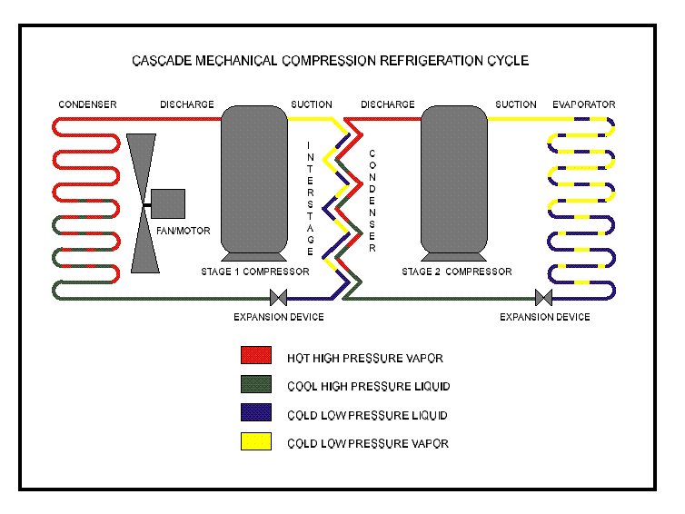
Fig.1 Two stage cascade refrigeration cycle
The continuous depletion of the ozone layer, which shields the earth’s surface from UV radiation, has resulted in a series of international treaties demanding a gradual phase out of halogenated fluids. The chlorofluorocarbons (CFCs) have been banned since 1996, and also the partially halogenated hydro chlorofluorocarbons (HCFCs) are bound to be prohibited in the near future. The HFCs (chlorofluorocarbons) are candidate for the definite substitution of both CFCs and HCFCs, as they do not contain chlorine.

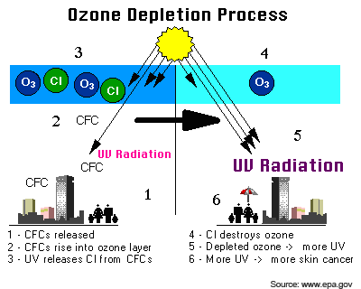
Fig.2 ozone depletion process
A further problem is the green house effect, stemming from the infrared radiation capture by some component of the atmosphere. Human activities have considerably increased the concentration of greenhouse gases (CFC, HCFCs, carbon dioxide, methane, nitrous oxide) that determine the earth’s surface and atmosphere warming that might adversely affect the natural ecosystem. Over the last hundred years, the mean temperature have increased by 0.3°C to 0.6°C, and doubling the amount of carbon dioxide in the atmosphere is likely to yield a further temperature increase from 1.5°C to 4.5°C in particular, it is well known that the green house effect resulting from an operating plant is not a secondary matter. Recent estimate indicate that the overall contribution, both direct and indirect, to the green house effect of HCFCs and CFCs exceeds 24% (Hougton, 1995). So, the choice of the working fluid in the vapour compression plant must depend on both the absence of chlorine atoms in the molecule (ozone depletion potential (ODP) equal to 0) and their low contribution to the green house effect (low global warming potential (GWP) and high energy efficiency). The phase out of fully halogenated CFCs and partially halogenated HCFCs in an irreversible process in the industrialized world, but the problem of their replacement has been partially solved.
In present days, we should look non ozone depleting refrigerant which do not cause global warming. With respect to global environmental protection, the use of natural refrigerant in cascade refrigeration system helps to satisfy the obligations of environmental treaties (Lee et al., 2006). Normally now a day’s no. of pair are used in cascade refrigeration cycle like R-717 and R-508b, R-717 and R-744 etc.
R-717 in high temperature circuit and R-744 in low temperature circuit is a very interesting application for the food industry, where evaporating temperatures between 30 and -40°C are needed but due to triple point of R-744 it cannot be uses beyond -56.57°C. In present work, usages of carbon dioxide blends with HFCs (R-23, R-32, R-41 and R-125) have been examined in low temperature circuit of cascade refrigeration cycle to achieve low temperatures up to 200ºK i.e. below triple point of R-744.

CHAPTER-2 LITERATURE REVIEW

In this chapter, it is intended to give a brief literature review of the work being carried out on cascade refrigeration system during last decade.
Getu and Bansal (2008) have analysed of carbon dioxide–ammonia (R744–R717) cascade refrigeration system to optimize the design and operating parameters of the system. A multi linear regression analysis was employed in terms of subcooling, superheating, evaporating, condensing, and cascade heat exchanger temperature difference in order to develop mathematical expressions for maximum COP, an optimum evaporating temperature of R717 and an optimum mass flow ratio of R717 to that of R744 in the cascade system
Wilson and Maier (2006) have analysed that cascade refrigeration systems is the initial installation cost being 10% higher than the traditional direct expansion systems. But this cost can be negated with less refrigerant charge requirements and the environmental advantage of the cascade system due to less direct emissions as compared to single-stage system.
Jain and Bansal (2006) reviewed two circuit cascade refrigeration systems. The high-temperature circuit uses high boiling point refrigerants such as R-22, R-134a, ammonia, propane, propylene etc. The low-temperature circuit uses low boiling refrigerants such as carbon dioxide, HFC-23, and R-508B etc. CO₂ differs from other common refrigerants in many aspects, and has some unique properties. CO₂ is most commonly applied in cascade or hybrid system designs in industrial refrigeration, because its pressure can be limited to such extent that commercially available components like compressors, controls and valves can be used. It has been found that ammonia is the best high-temperature refrigerant among propane, propylene, and R-404A considered in their study. It gives a theoretical optimum COP.
Lee et al. (2006) analyzed a carbon dioxide–ammonia (R744– R717) cascade system thermodynamically and determined the optimum condensing temperature of R744 in the low-temperature circuit. They have reported that the optimum condensing temperature of a cascade condenser increases by increasing evaporator and condenser temperature, whereas the maximum COP increases with only evaporator temperature, but decreases as condenser temperature decreases.
Russmann and Kruse (2006) have performed analysis of cascade refrigerating systems using N₂O as refrigerant for the low temperature cascade stage and various natural refrigerants like ammonia, propane, propene, carbon dioxide and nitrous oxide itself for the high temperature stage and the basis of the comparison was a conventional R23/R134a-cascade refrigerating system. This N₂O system has nearly equal COP as a conventional R23/R134a-cascade refrigerating system
Tagung (2005) has reported that CO₂ may be applied as a refrigerant in a number of different system types, including both subcritical and supercritical systems. The classic refrigeration cycle is subcritical, i.e. the entire range of temperatures and pressures are below the critical point and above the triple point. A single stage subcritical CO₂ system is simple, but it has some disadvantages, because of its limited temperature range and high pressure.
Sawalha (2005) have been observed the cascade systems with the same fluid in both circuits. By reducing amount of superheat in the discharge temperature of the high-temperature circuit that result in a reduced capacity of the high-temperature condenser and increased refrigeration effect. High-temperature circuit condenser, cascade condenser and evaporator losses can also be reduced if the sizes of the heat exchangers are properly optimized. Several types of cascade condensers such as plate, shell-and-plate or shell-and-tube heat exchangers can be employed for cascade systems to couple the low- and high-temperature circuits.
Bhattacharyya et al. (2005) have been presented the optimization analysis for a C₃H₈–CO₂ based cascade system for simultaneous refrigeration and heating applications. The COP of this cascaded system increases with rising refrigerated space temperature and decreases with rising heating outlet temperature.
Agnew and Ameli (2004) demonstrated optimising of a cascade refrigeration system with multi staging on the high temperature side and single staging on the low temperature side. The alternative ozone friendly pair R717 and R508b has been chosen as a replacement of R12 and R13 respectively. R717 is more commonly known as ammonia, a well tried and tested refrigerant and R508b is a relatively new formulation consisting of 46% of R23 with the remainder being R116. It has no ozone depleting potential and non-flammable. The chosen combination of R717 and R508b exhibited an improved performance over an original combination of R12 and R13.
Nicola et al. (2005) have presented a comparative analysis on the performance of a cascade refrigeration cycle operated with blends of carbon dioxide (R744) and HFCs (R23, R32, R41 and R125) as the low-temperature working fluid and R717 as the high temperature working fluid. They reported that R744 blends are an attractive option for the low-temperature circuit of cascade systems operating at temperatures approaching 200°K i.e. below CO₂ triple point 216.58°K. The mixtures (R744 blends) were modelled using the Carnahan–Starling–De Santis (CSD) Equation of state (EOS) taken as the thermal EOS from which the necessary vapour–liquid equilibrium and volumetric properties were derived to give the pressure–volume–temperature–composition (PVTx) parameters. The PVTx parameters were supplemented with the ideal gas heat capacity and described all the thermodynamic functions at each point in the cycle. The properties of the investigated blends (R744/R125, R744/R41, R744/R32, and R744/R23) were used to simulate the behaviour of a cascade cycle. They fixed evaporator temperature as 203°K, condenser temperature as 313°K and varying cascade condenser temperature as 213 to 283°K. They have taken 0°K approach and considered 5°K subcooling and 10°K superheating. They have not considered effect of varying the condenser temperature, effect of approach and cascade refrigeration system without superheating and subcooling. They performed each set of calculations for three compositions 0.1, 0.3 and 0.5 in mole fractions of R744 with HFCs (R23, R32, R41 and R125) and COP is presented as a function of cascade condenser temperature in the former and as a function of mixture composition in the latter. They reported that the COPs for all systems and compositions reach the maximum value at temperatures between 240 and 250°K. COP values are plotted in relation to mole fraction; they show a small negative departure from linearity.
Use of a liquid vapour heat exchanger in the low-temperature side was also investigated HFC/CO₂. They reported that the liquid vapour heat exchanger cannot be recommended for R717 and the use of a heat exchanger in low temperature circuit improves the COP values substantially for the R-125/CO₂ blend and marginally for others. It also shifts the optimum cascade temperature toward higher values. This implies higher operating pressures in the cascade condenser that do not seem to be very desirable unless the gains are substantial, as in the case of the R-125/CO₂ blend.
Klein et al. (2001) have used liquid vapour heat exchanger. Subcooling the liquid leaving the condenser with the vapour before it enters the compressor is known to be able to improve a cycle’s COP considerably. They have also reported that improvement only applies to refrigerants that have important exergy losses in the throttling process.
Missimer (1997) have analysed the auto refrigerating (or mixed refrigerant) cascades, to achieve temperatures to –180°C. Moderate sized (less than 14 kW power input) auto refrigerating cascade (ARC) systems have been successfully converted from the use of CFC components to completely CFC-free refrigerant mixtures with successful operation. New zeotropic mixtures have overall ODP levels below 0.02 with nearly identical Carnot efficiencies, as well as requiring no hardware or lubricant changes. Present efforts have reduced the ODP by a ratio of 20 to 30 times compared to pre conversion mixes. Additional efforts show promise of obtaining an ODP of less than 0.01 and eventually down to zero when more acceptable zero ODP substances become available. However, their use is limited to special applications only.
Ratts and Brown (2000) have reported that the optimum temperature distribution for a cascade system was determined by minimizing entropy generation at each stage of the system. The equations for entropy generation were developed in terms of a single independent variable, the intermediate temperature ratio, and in terms of specific heats. Through the inter-mediate temperature ratio and through equations for the specific heats, the optimum temperature distribution was found. The development in terms of a single independent variable also provided a way to characterize the distribution of the losses.
Pearson and Cable (2003) reported the use of a plate-and-shell type cascade condenser instead of shell-and-tube type cascade condenser that is bulky. Plate-and-shell type condenser is expensive but compact and minimizes the leakage of carbon dioxide into the ammonia system.

2.1 CONCLUSION AND GAPS
Cascade refrigeration systems are used to achieve low-temperatures. Using carbon dioxide in low temperature circuit and ammonia in high temperature circuit in cascade system is a very interesting application for refrigeration, where evaporating temperatures between -30 and -40 °C are needed. But where lower temperatures are needed, this is no longer a feasible solution, due to the triple-point temperature of carbon dioxide (216.58 K, -56.57 °C), which prevents its use in vapour compression cycles intended for use at lower temperatures. An obvious solution to overcome this drawback blends of carbon dioxide as mentioned by Nicola et al. (2005).
Most of the researchers used pure refrigerant except Nicola et al. (2005). They have done analysis of cascade system using carbon dioxide blend with HFCs. But they have not taken some parameters in their analysis such as approach (temperature difference between low temperature circuit condenser and high temperature circuit evaporator), effect of varying the condenser temperature on the performance parameters. They have considered the effect of superheating and subcooling in their model. Consideration of superheating and subcooling is natural but analysis of cascade system without superheating and subcooling is also necessary.
2.2 Problem formulation
In the present study, analysis of cascade refrigeration system has been carried out by taking R717 in low temperature circuit and R-744 mixture with HFCs (R23, R32, R41 and R125) to achieve low temperatures down to 200°K.
It is proposed to examine the effect of following parameters on the performance of cascade refrigeration system and evaluation of optimum cascade condenser temperature in the present work.
- Effect of approach
- Analysis with and without superheating and subcooling
- Effect of varying the condenser temperature
- Varying the mole fraction of R-744
- Effect of using LVHE in low temperature circuit

CHAPTER-3 THERMODYNAMIC ANALYSIS

In this chapter, it is intended to give thermodynamic analysis of the present work, which has been carried out on cascade refrigeration system.

3.1 SYSTEM DESCRIPTION

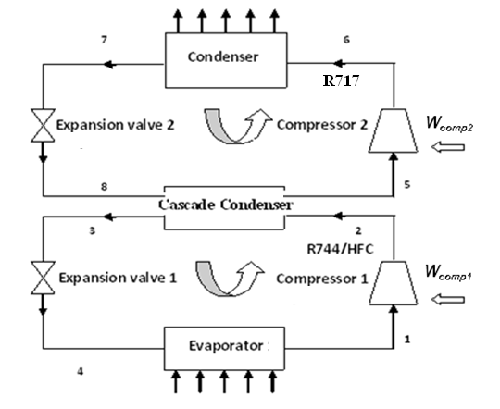
Fig.3 Schematic representation of two stage cascade refrigeration cycle
Fig.3 schematically represents a cascade refrigeration system. Fig.4 represents the corresponding pressure enthalpy diagrams. This refrigeration system comprises two separate refrigeration circuits- the high-temperature circuit (HTC) and the low-temperature circuit (LTC). Ammonia is the refrigerant in HTC, whereas carbon dioxide blend with HFCs (R-23, R-32, R-41 and R-125) are the refrigerants in LTC. The circuits are thermally connected to each other through a cascade-condenser, which acts as an evaporator for the HTC and a condenser for the LTC.

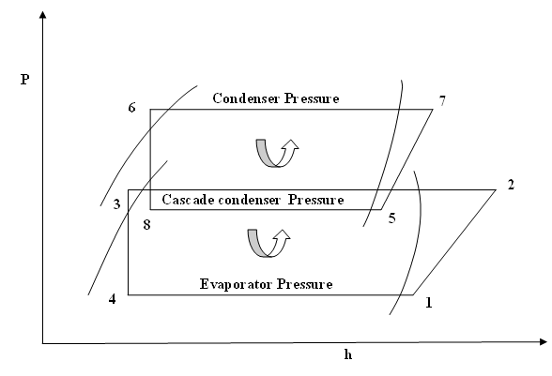
Fig.4 P-h diagram of cascade refrigeration system

The condenser in this cascade refrigeration system rejects a heat of Q_{C} from the condenser at condensing temperature of T_{C}, to its warm coolant or environment at temperature of T₀. The evaporator of this cascade system absorbs a refrigerated load Q_{E} from the cold refrigerated space at evaporating temperature T_{E}. The heat rejected by condenser of LTC equals the heat absorbed by the evaporator of the HTC. T_{MC} and T_{ME} represent the condensing and evaporating temperatures of the cascade condenser, respectively.
Approach represents the difference between the condensing temperature of LTC and the evaporating temperature of HTC. The evaporating temperature T_{E}, the condensing temperature T_{C}, and the temperature difference in the cascade-condenser are three important design parameters of a cascade refrigeration system.
3.2 THERMODYNAMIC ANALYSIS
In the present work, a parametric study with fixed mass flow rate in LTC, and various condensing temperature, evaporating temperature and approach in the cascade-condenser have been conducted to determine the optimum condensing temperature of the cascade-condenser.
The following assumptions are made to simplify the thermodynamic analysis, including energy analysis.
- All components are assumed to be a steady-state and steady-flow process. The changes in the potential and the kinetic energy of the components are negligible.
- The high and low-temperature circuit compressors are non-isentropic.
- The heat loss and pressure drops in the piping connecting the components are negligible.
- All throttling devices are isenthalpic.

Based on the assumptions mentioned above, the equations for mass and energy balance are written for each component. Each component in the cascade refrigeration system, shown in Fig.7 considered as a control volume.
Mass balance
(1)

Energy balance
(2)
Energy changes in each component of cascade refrigeration cycle are as follows:
Evaporator: evaporator is a heat exchanger which abstract heat from the cold room and this heat is called refrigeration effect, which is given by
(3)
Compressor: compressor is a work absorbing device in which, the isentropic work input to the compressor is expressed as
In compressor1:
(4)
Actual compressor work is specified by
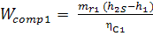
(5)

In compressor2
(6)
Actual compressor work is specified by
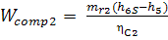
(7)

Condenser: condenser is a heat exchanger in which heat rejected by the condenser to the environment or warm coolant is given as
(8)

Expansion valve: expansion valve is a device in which expansion of refrigerant occurred and enthalpy remains constant.
In expansion valve 1:
(9)
In expansion valve 2:
(10)
Cascade condenser: it acts as an evaporator in the high-temperature stage and as a condenser in the low-temperature stage. Cascade condenser is a heat exchanger in which all the heat released by the low-temperature-circuit condenser is rejected to the high-temperature-circuit evaporator.
Energy balance in cascade condenser
(11)
Where m_{r1} = mass flow rate in low temperature circuit
m_{r2} = mass flow rate in low temperature circuit

Coefficient of performance
The performance parameter, COP of a cascade system is defined as the ratio of the refrigerating effect produced in the evaporator to the total work input to all compressors in the system. It can be express by following expression.

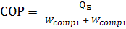 ₍₁₂₎

Volumetric cooling capacity
The volumetric cooling capacity is the cooling capacity per unit volume flow rate at the inlet to the compressor. It can be express by following expression
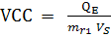 ₍₁₃₎
Where Vs = specific volume at inlet of the compressor

3.2.1 Cascade refrigeration system with liquid vapour heat exchanger
Energy balance in liquid vapour heat exchanger (assuming effectiveness as 1 for LVHE)
(14)

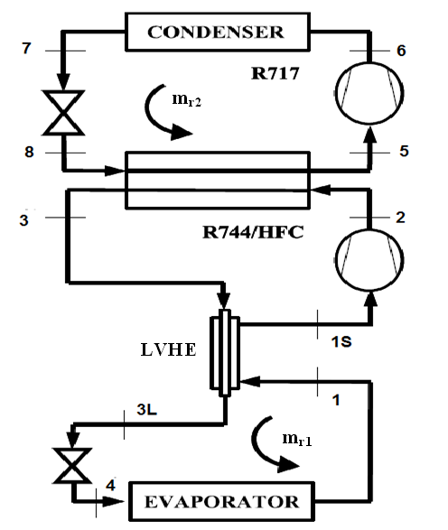

Fig.5 Schematic representation of cascade refrigeration cycle with liquid vapour heat exchanger.

3.3 Formulation of problem
Analysis of the cascade Refrigeration System shown in fig.3 and fig.5 has been carried out in this work.
The computer program has been developed in EES (Klein and Alvarado, 2005). The mixtures properties of the investigated blends (R744/R125, R744/R41, R744/R32, and R744/R23) were calculated by Ref Prop 7.0 (Huber et al. 2002) and used in EES program to calculate the performance parameters for a cascade refrigeration cycle.
For validation of program, results of the present work are compared with results of Nicola et al. (2005). Comparison of results for carbon dioxide (0.1 mole fraction) blend with R-125 and R-41 are shown in figure 6 and 7. The results from present work are 5% higher than that of Nicola et al. (2005).
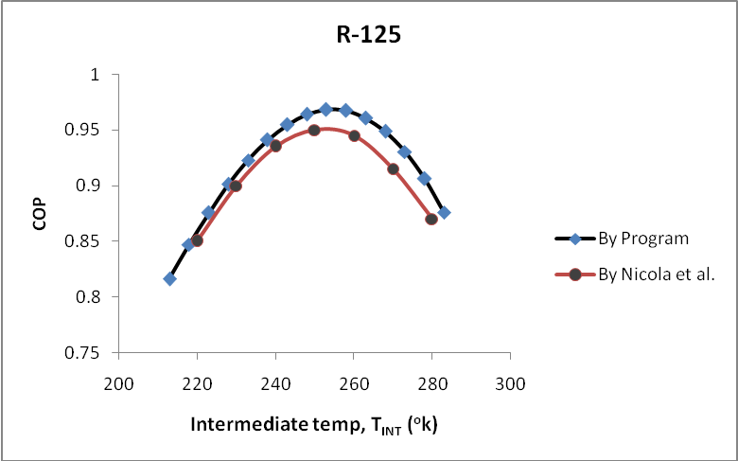
Fig.6 comparison of results with Nicola et al. results for R-125

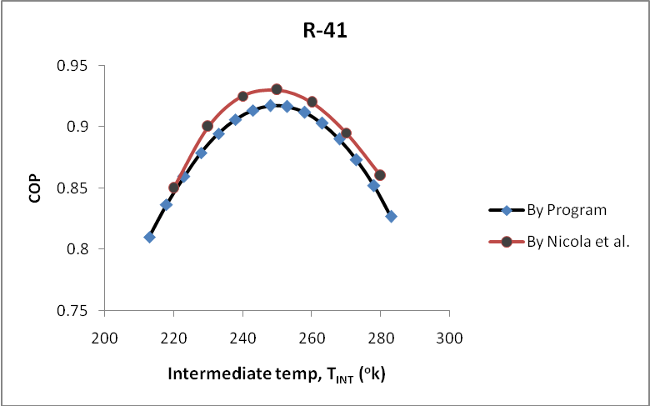
Fig.7 comparison of results with Nicola et al. results for R-41
The Input Parameters taken for computation of results are given below
Condenser Temperature T_{c} = 40 to 50°C in steps of 5ºC
Evaporator Temperature T_{E} = -70°C
Cascade condenser temperature T_{MC} = 10 to -60°C in steps of 5ºC
Approach A = 0, 5°C
Mass flow rate in low temperature circuit m_{r1} = 1 kg/sec
Compressor efficiency in low temperature circuit η_{c1}= 0.7
Compressor efficiency in high temperature circuit η_{c2}= 0.7
Refrigerant in high temperature circuit R-717
Refrigerant in low temperature circuit CO₂ blend with HFCs
HFCs used with carbon dioxide R-23, R-32, R-41 and R-125
Subcooling (in HTC and LTC) 0, 5°C
Superheating (in HTC and LTC) 0, 10°C
By carrying out the thermodynamic analysis of the system for the conditions stated above the values at various state points of the cascade refrigeration cycle have been obtained. The computer program for the thermodynamic analysis of the system developed in EES has been given in Appendix A along with its flow diagram for computation procedure.
In the present work, following parameters have been computed.
- Total compressor work.
- Coefficient of performance of the cascade refrigeration cycle.
- Volumetric cooling capacity of the compressor.
- Ratio of mass flow rate in HTC and LTC.

Based on above we have computed optimal cascade condenser temperature.
Chapter 4 RESULTS AND DISCUSSION

In the present results computed from the compute program have been discussed.
4.1 MASS FLOW RATE IN HIGH TEMPERATURE CIRCUIT
Figs 8 to 17 and Figs 22 to 31 show the variation of mass flow rate in high temp circuit for cascade refrigeration cycle with varying intermediate temperature for carbon dioxide blend with HFCs (R-23, R-32, R-41 and R-125) for different mole fraction. These figures show that the mass flow rate decreases with increase in intermediate temperature at a particular evaporator and condenser temperature for R-125 and R-23 due to decrease in load on cascade condenser. Mass flow rate increases with increase in intermediate temperature at a particular evaporator and condenser temperature for R-41 and R-32 due to increase of load on cascade condenser.
4.1.1 Effect of superheating (10°C) and subcooling (5°C)
Figs 22 to 31 show the effect of superheating of refrigerant inlet to compressor and subcooling of refrigerant outlet to condenser. By the comparison of figures with superheating and without superheating (Figs 8 to 17), mass flow rate increases around 3% by superheating and subcooling because load on cascade condenser increases due to combined effect of increase in compressor work and refrigerating effect.
4.1.2 Effect of approach
Approach is temperature difference between high temperature circuit evaporator and low temperature condenser. Figs 8 to 12 (with approach 0) and Figs 13 to 17 (with 5°C approach) show that by taking approach mass flow rate increases slightly by 0.9%.
4.1.3 Effect of mole fraction of carbon dioxide
Fig. 36 shows the variation of mole fraction of carbon dioxide in mixture with HFCs. Figure shows that by increasing mole fraction of carbon dioxide mass flow rate decreases for R-125 and R-23 and increases for R-41 and R-32.

4.1.4 Effect of condenser temperature
Figs 18 to 21 and Figs 32 to 35 present the effect of condenser temperature. By increasing condenser temperature 5ºC, increase in mass flow rate in high temperature circuit is around 2%.
4.1.5 Effect of liquid vapour heat exchanger
Figs 38 and 37 show that by using liquid vapour heat exchanger in low temperature circuit, mass flow rate in high temperature circuit increases by around 3%.
4.2 TOTAL COMPRESSOR WORK
Figs 39 to 48 and Figs 53 to 62 show the variation of total compressor work for cascade refrigeration cycle with varying intermediate temperature for carbon dioxide blend with HFCs (R-23, R-32, R-41 and R-125) for different mole fraction. These figures show that the total compressor work decreases with increase in intermediate temperature at a particular evaporator and condenser temperature. Total compressor work for R-41 mixture is highest among all mixtures followed by R-32, R-23 and R-125 respectively.
This happens because for a given condenser and evaporator temperature, as the intermediate temperature increases, the low temperature circuit compressor’s work done (W_{COMP1}) increases but the high temperature circuit compressor’s work done (W_{COMP2}) decreases, and the combined effect of these is to decrease work done.
4.2.1 Effect of superheating (10°C) and subcooling (5°C)
Figs 53 to 62 show the effect of superheating of refrigerant inlet to compressor and subcooling of refrigerant outlet to condenser. By the comparison of figures with superheating and without superheating (Figs 39 to 48), increase in that total compressor work is around 7% by superheating and subcooling.
4.2.2 Effect of approach
Approach is temperature difference between high temperature circuit evaporator and low temperature condenser. Figs 39 to 43 (with approach 0) and Figs 44 to 48 (with 5°C approach) show that by taking approach total compressor work increases because the low temperature circuit compressor’s work done (W_{COMP1}) decreases but the high temperature circuit compressor’s work done (W_{COMP2}) increases, and the combined effect of these is to increase the total compressor work by around 8%.
4.2.3 Effect of mole fraction of carbon dioxide
Fig. 67 shows the variation of mole fraction of carbon dioxide in mixture with HFCs. Figure shows that by increasing mole fraction of carbon dioxide total compressor work increases for R-125 and R-23 and decreases for R-41 and R-32.
4.2.4 Effect of condenser temperature
Figs 49 to 52 and Figs 63 to 66 present the effect of condenser temperature. By increasing condenser temperature 5°C, total compressor work is increased by 8%.
4.2.5 Effect of liquid vapour heat exchanger
Figs 68 and 69 show that by using liquid vapour heat exchanger in low temperature circuit, total compressor work increases by 3%.
4.3 COEFFICIENT OF PERFORMANCE
Figs 70 to 79 and Figs 84 to 93 show the variation of COP for cascade refrigeration cycle with varying intermediate temperature for carbon dioxide blend with HFCs (R-23, R-32, R-41 and R-125) for different mole fraction. These figures show that the COP increases with increase in intermediate temperature up to a temperature (optimum temperature) after this COP decreases with increase in intermediate temperature at a particular evaporator and condenser temperature. COP for R-125 mixture is highest among all mixtures followed by R-32, R-41 and R-23 respectively. Optimum temperature range for cascade refrigeration system is 240°K to 260°K.
This happens because for a given condenser and evaporator temperature, as the intermediate temperature increases, the refrigerating effect and the work done by the compressor both decreases, and combined effect of these is to increase COP up to optimum temperature but after optimum temperature COP decreases.
4.3.1 Effect of superheating (10°C) and subcooling (5°C)
Figs 84 to 93 show the effect of superheating of refrigerant inlet to compressor and subcooling of refrigerant outlet to condenser. By the comparison of figures with superheating and without superheating (Figs 70 to 79), COP increases by superheating and subcooling, this happens because by superheating work done increases and by subcooling refrigerating effect also increases, and combined effect of these is to increase COP. For R-125 mixture (with carbon dioxide) effect of superheating and subcooling on increase in COP is very high. At optimum temperature COP increased around 1% by superheating and subcooling.
4.3.2 Effect of approach
Approach is temperature difference between high temperature circuit evaporator and low temperature condenser. Figs 70 to 74 (with approach 0) and Figs 75 to 79 (with 5°C approach) show that by taking approach 5°C, COP decreases as around 8%, because of increase in compressor work. Optimum temperature is shifted 2% to higher side by taking approach.
4.3.3 Effect of mole fraction of carbon dioxide
Fig. 98 show the variation of mole fraction of carbon dioxide in mixture with HFCs. Figure show that by increasing mole fraction of carbon dioxide COP affect slightly. For R-23 and R-41, COP decreases with increase in mole fraction of carbon dioxide. For R-125, COP increases up to mole fraction 0.3 and after this decrease up to mole fraction 0.9. For R-32, COP decreases up to mole fraction 0.8 and after this COP increases.
4.3.4 Effect of condenser temperature
Figs 80 to 83 and Figs 94 to 97 present the effect of condenser temperature. By increasing condenser temperature 5°C, COP decrease by around 7%, because by increasing condenser temperature work done by compressor is increased. Optimum temperature is shifted around 1.5% to higher side by increasing condenser temperature.
4.3.5 Effect of liquid vapour heat exchanger
Figs 99 and 100 show that by using liquid vapour heat exchanger in low temperature circuit, COP decreases by 1%.
4.4 VOLUMETRIC COOLING CAPACITY
Figs 101 to 110 and Figs 115 to 124 show the variation of volumetric cooling capacity for cascade refrigeration cycle with varying intermediate temperature for carbon dioxide blend with HFCs (R-23, R-32, R-41 and R-125) for different mole fraction. These figures show that the volumetric cooling capacity decreases with increase in intermediate temperature at a particular evaporator and condenser temperature. Volumetric cooling capacity for R-23 mixture is highest among all mixtures followed by R-41, R-32 and R-125 respectively.
This happens because for a given condenser and evaporator temperature, as the intermediate temperature increases, the low temperature circuit compressor’s work done (W_{COMP1}) increases but the high temperature circuit compressor’s work done (W_{COMP2}) decreases, and combined effect of these is to decrease the total compressor work decreases and by decreasing total compressor work volumetric cooling capacity also decreases.
4.4.1 Effect of superheating 10°C and subcooling 5°C
Figs 115 to 124 show the effect of superheating of refrigerant inlet to compressor and subcooling of refrigerant outlet to condenser. By the comparison of figures with superheating and without superheating (Figs 101 to 110), volumetric cooling capacity is increased by superheating and subcooling.
4.4.2 Effect of approach
Approach is temperature difference between high temperature circuit evaporator and low temperature condenser. Figs 101 to 105 (with approach 0) and Figs 106 to 110 (with 5°C approach) show that by taking approach in cascade condenser volumetric cooling capacity does not affect.
4.4.3 Effect of mole fraction of carbon dioxide
Fig. 129 shows the variation of mole fraction of carbon dioxide in mixture with HFCs. Figure show that by increasing mole fraction of carbon dioxide volumetric cooling capacity increases.
4.4.4 Effect of condenser temperature
Figs 111 to 114 and Figs 125 to 128 present the effect of condenser temperature. By increasing condenser temperature volumetric cooling capacity does not change.
Variation in Mass Flow Rate in high temp circuit without superheating and subcooling for cascade system

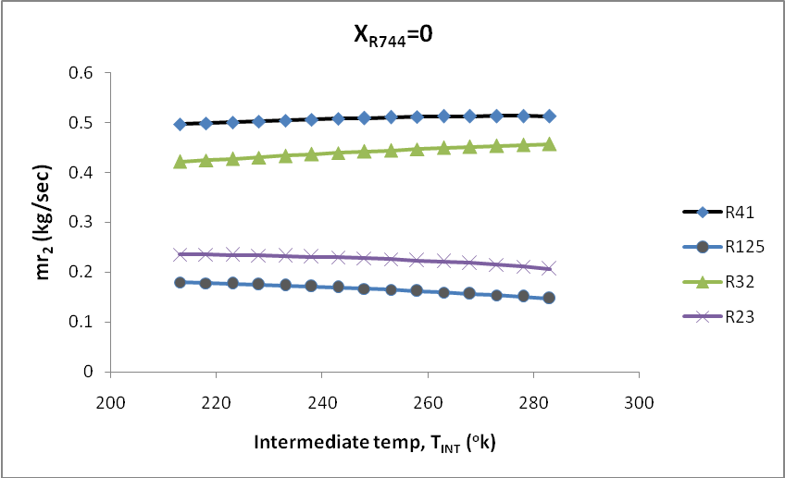
Fig.8 Variation in mass flow rate in high temp circuit with intermediate temperature for cascade system operating with R744 blend at 0.0 mole fraction as low temperature working fluid with approach 0ºC.

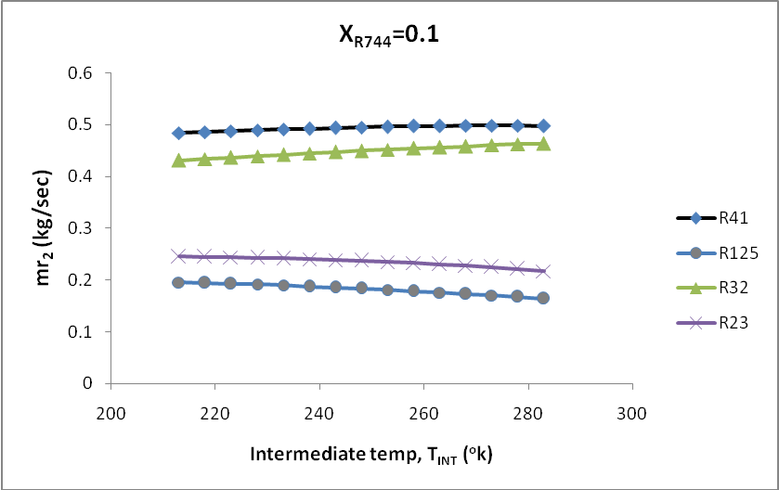
Fig.9 Variation in mass flow rate in high temp circuit with intermediate temperature for cascade system operating with R744 blend at 0.1 mole fraction as low temperature working fluid with approach 0ºC.
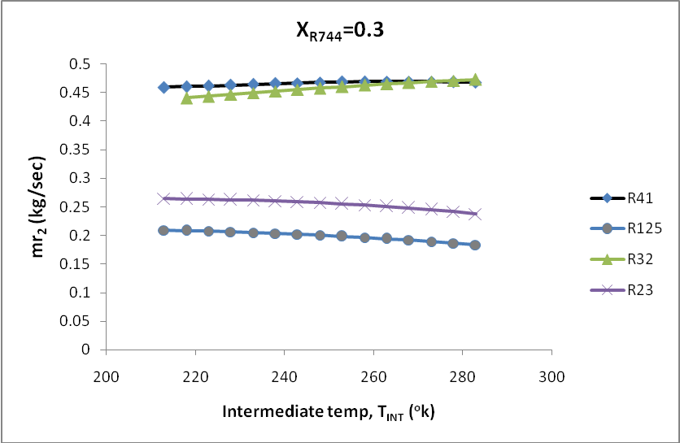

Fig.10 Variation in mass flow rate in high temp circuit with intermediate temperature for cascade system operating with R744 blend at 0.3 mole fraction as low temperature working fluid with approach 0ºC.

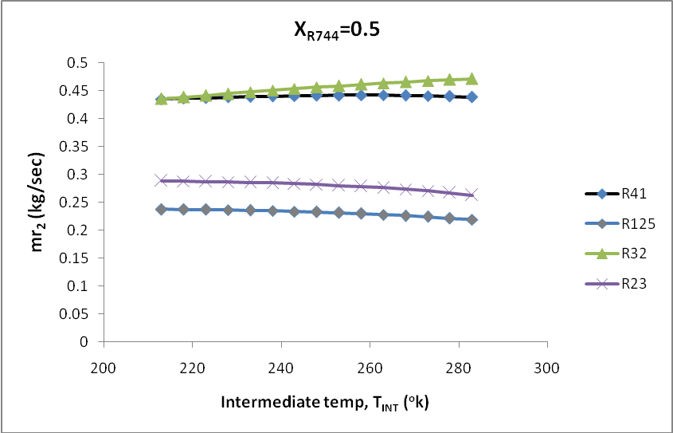

Fig.11 Variation in mass flow rate in high temp circuit with intermediate temperature for cascade system operating with R744 blend at 0.5 mole fraction as low temperature working fluid with approach 0ºC.
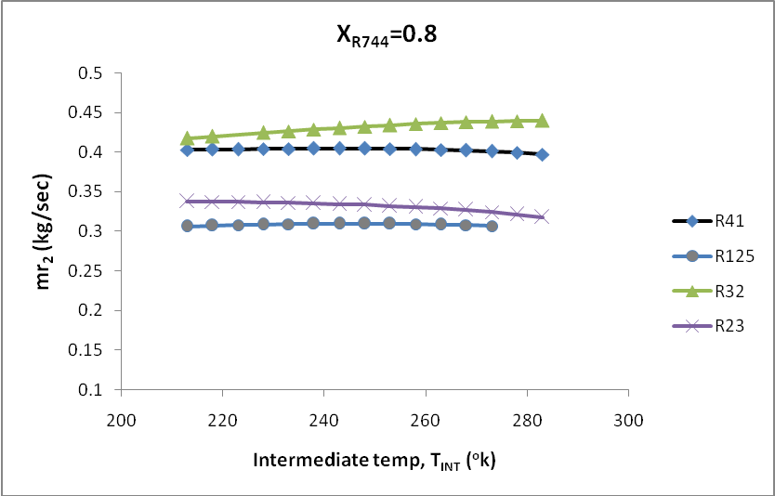

Fig.12 Variation in mass flow rate in high temp circuit with intermediate temperature for cascade system operating with R744 blend at 0.8 mole fraction as low temperature working fluid with approach 0ºC.

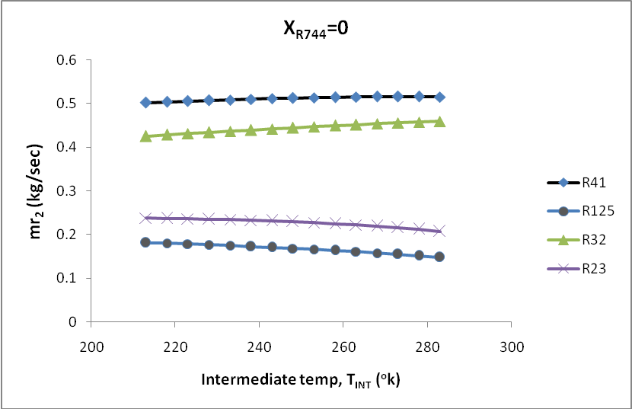

Fig.13 Variation in mass flow rate in high temp circuit with intermediate temperature for cascade system operating with R744 blend at 0.0 mole fraction as low temperature working fluid with approach 5ºC.
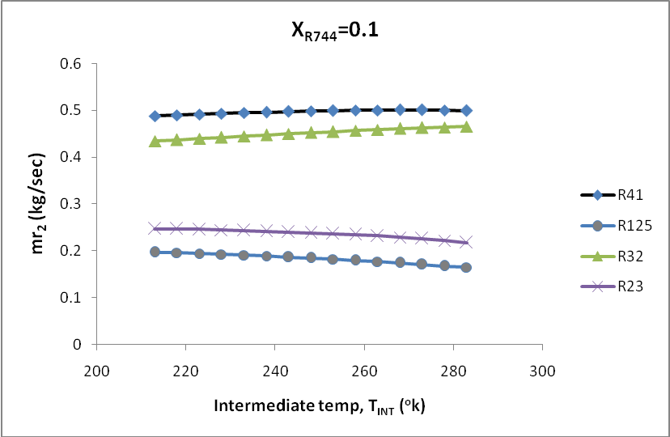

Fig.14 Variation in mass flow rate in high temp circuit with intermediate temperature for cascade system operating with R744 blend at 0.1 mole fraction as low temperature working fluid with approach 5ºC.

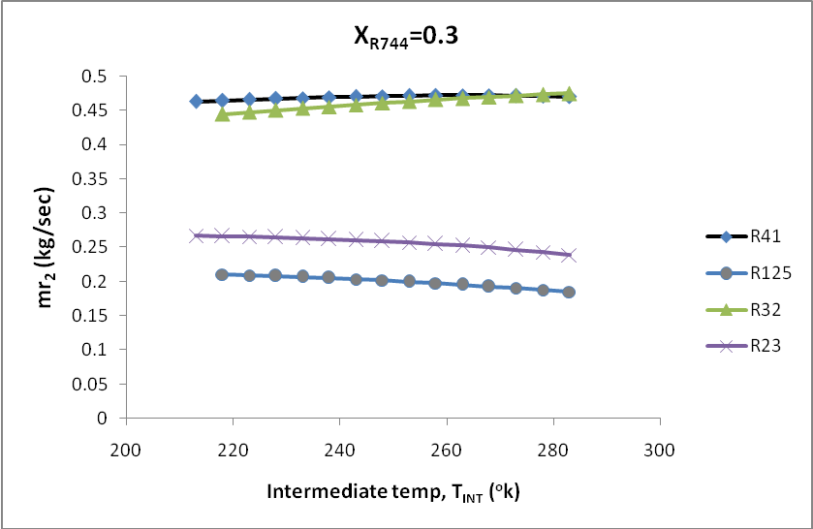

Fig.15 Variation in mass flow rate in high temp circuit with intermediate temperature for cascade system operating with R744 blend at 0.3 mole fraction as low temperature working fluid with approach 5ºC.
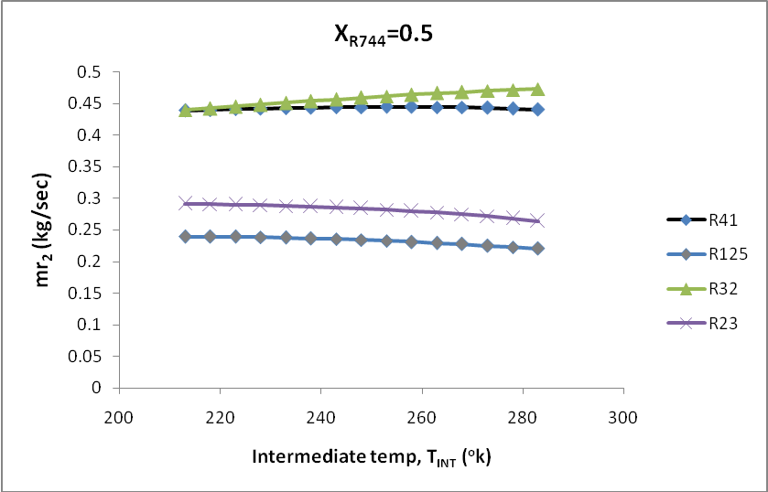

Fig.16 Variation in mass flow rate in high temp circuit with intermediate temperature for cascade system operating with R744 blend at 0.5 mole fraction as low temperature working fluid with approach 5ºC.

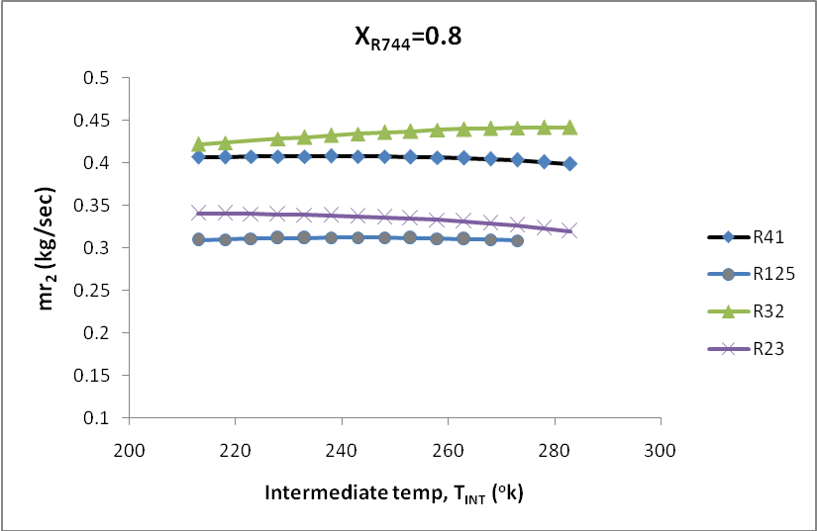

Fig.17 Variation in mass flow rate in high temp circuit with intermediate temperature for cascade system operating with R744 blend at 0.8 mole fraction as low temperature working fluid with approach 5ºC.
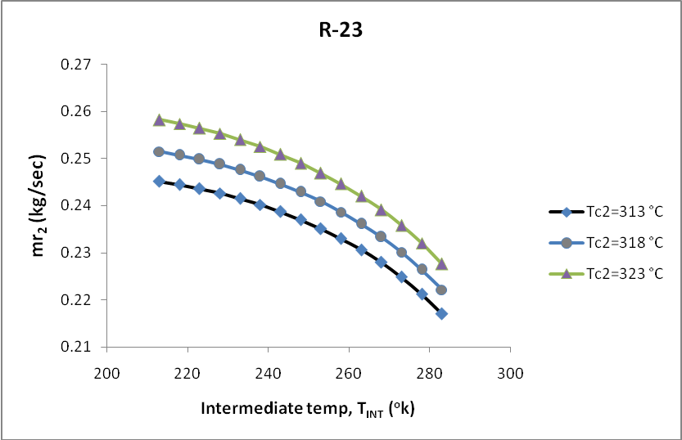

Fig.18 Variation in mass flow rate in high temp circuit with intermediate temperature for cascade system operating with R744 blend at 0.1 mole fraction as low temperature working fluid for R-23 at different condenser temperature.

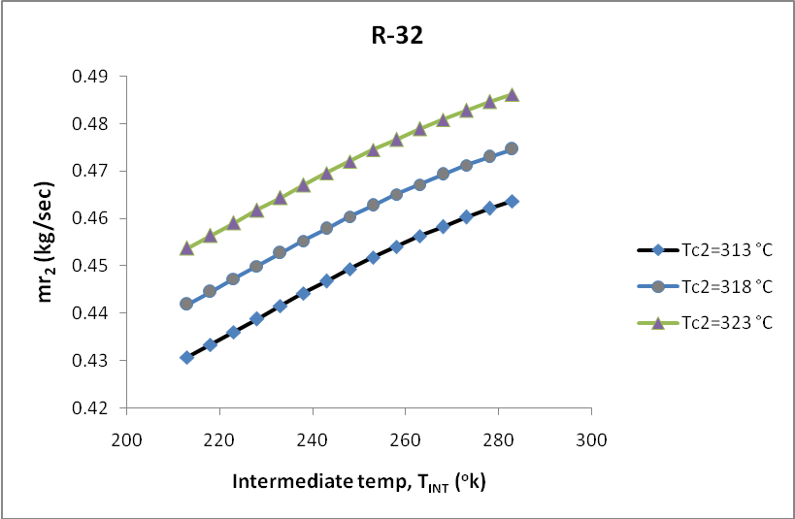

Fig.19 Variation in mass flow rate in high temp circuit with intermediate temperature for cascade system operating with R744 blend at 0.1 mole fraction as low temperature working fluid for R-32 at different condenser temperature.
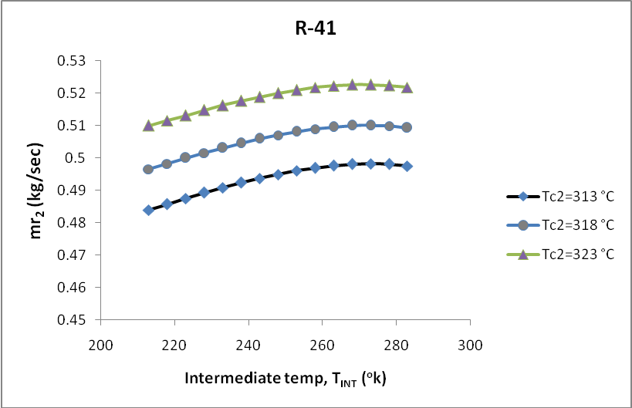

Fig.20 Variation in mass flow rate in high temp circuit with intermediate temperature for cascade system operating with R744 blend at 0.1 mole fraction as low temperature working fluid for R-41 at different condenser temperature.

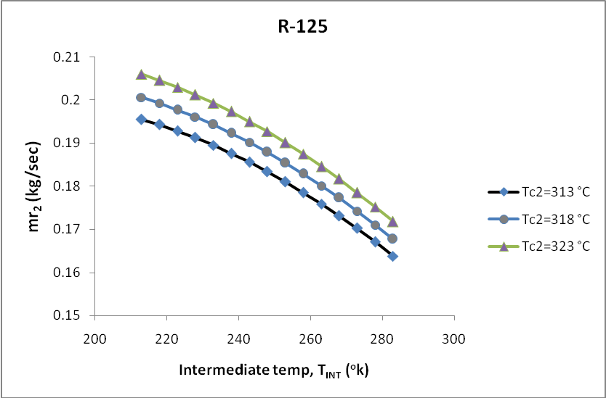

Fig.21 Variation in mass flow rate in high temp circuit with intermediate temperature for cascade system operating with R744 blend at 0.1 mole fraction as low temperature working fluid for R-125 at different condenser temperature.
Variation in Mass Flow Rate in high temp circuit with superheating 10ºC and subcooling 5ºC for cascade system

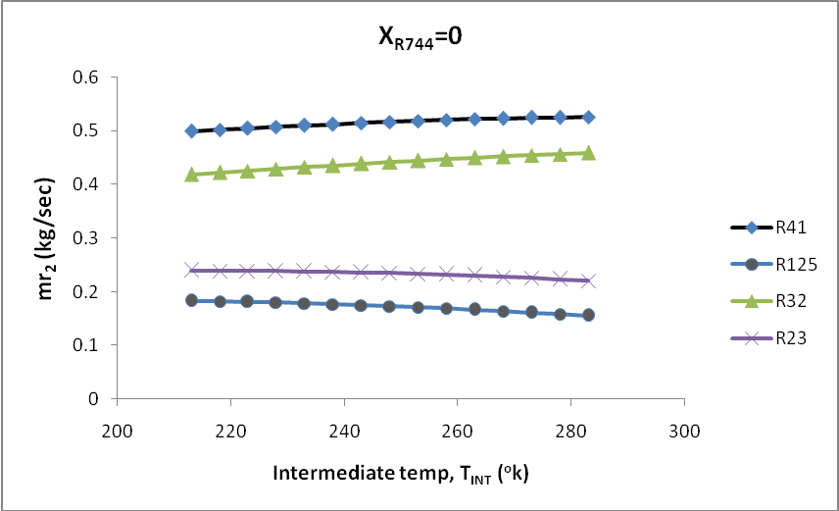

Fig.22 Variation in mass flow rate in high temp circuit with intermediate temperature for cascade system operating with R744 blend at 0.0 mole fraction as low temperature working fluid with approach 0ºC.

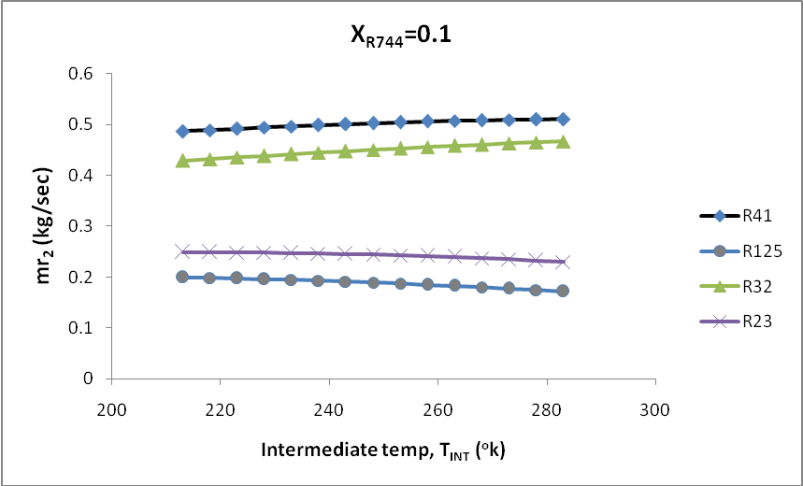
Fig.23 Variation in mass flow rate in high temp circuit with intermediate temperature for cascade system operating with R744 blend at 0.1 mole fraction as low temperature working fluid with approach 0ºC.
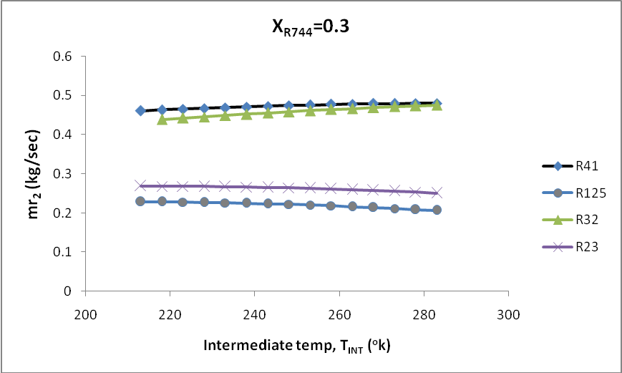

Fig.24 Variation in mass flow rate in high temp circuit with intermediate temperature for cascade system operating with R744 blend at 0.3 mole fraction as low temperature working fluid with approach 0ºC.

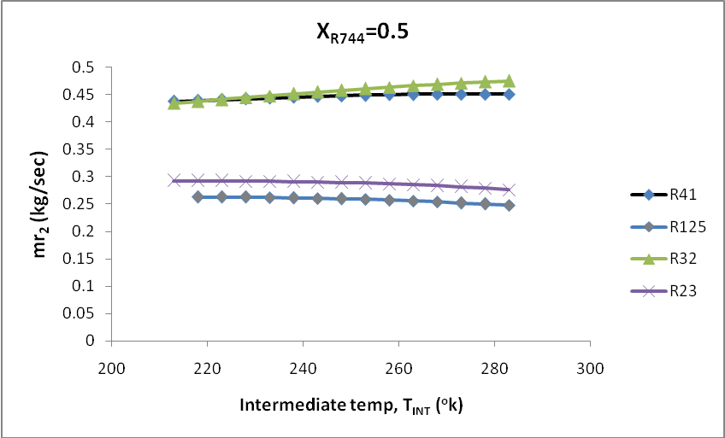

Fig.25 Variation in mass flow rate in high temp circuit with intermediate temperature for cascade system operating with R744 blend at 0.5 mole fraction as low temperature working fluid with approach 0ºC.
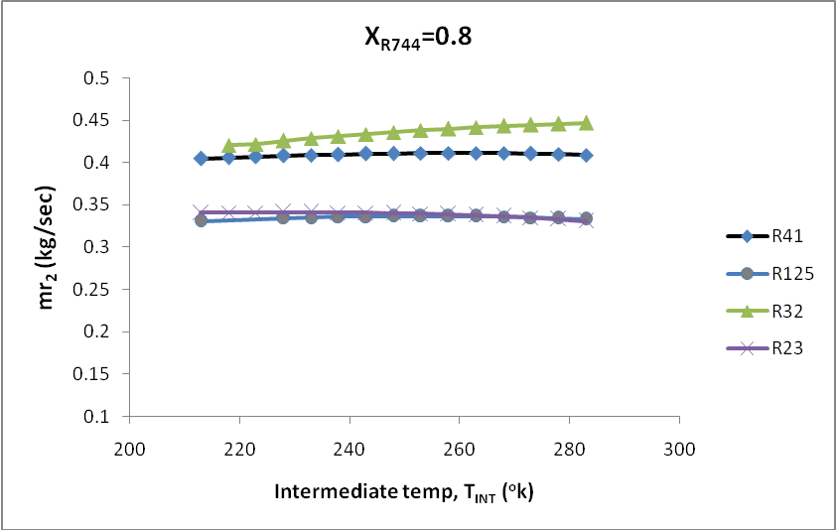

Fig.26 Variation in mass flow rate in high temp circuit with intermediate temperature for cascade system operating with R744 blend at 0.8 mole fraction as low temperature working fluid with approach 0ºC.

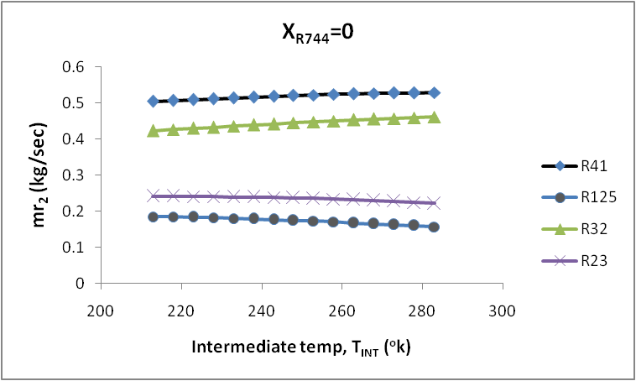

Fig.27 Variation in mass flow rate in high temp circuit with intermediate temperature for cascade system operating with R744 blend at 0 mole fraction as low temperature working fluid with approach 5ºC.
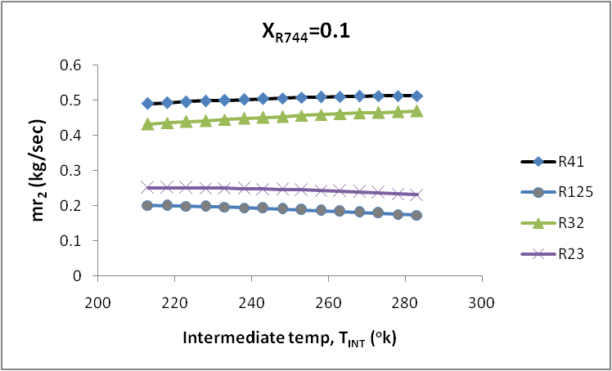

Fig.28 Variation in mass flow rate in high temp circuit with intermediate temperature for cascade system operating with R744 blend at 0.1 mole fraction as low temperature working fluid with approach 5ºC.

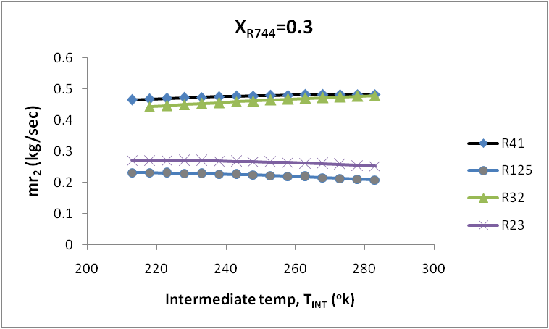

Fig.29 Variation in mass flow rate in high temp circuit with intermediate temperature for cascade system operating with R744 blend at 0.3 mole fraction as low temperature working fluid with approach 5ºC.
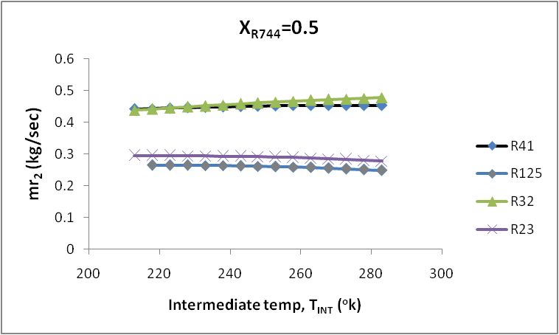

Fig.30 Variation in mass flow rate in high temp circuit with intermediate temperature for cascade system operating with R744 blend at 0.5 mole fraction as low temperature working fluid with approach 5ºC.

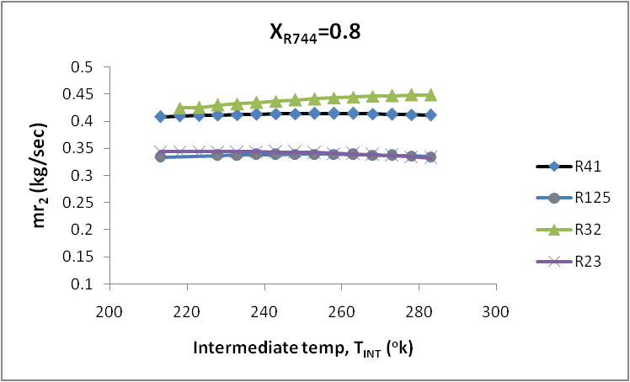

Fig.31 Variation in mass flow rate in high temp circuit with intermediate temperature for cascade system operating with R744 blend at 0.8 mole fraction as low temperature working fluid with approach 5ºC.
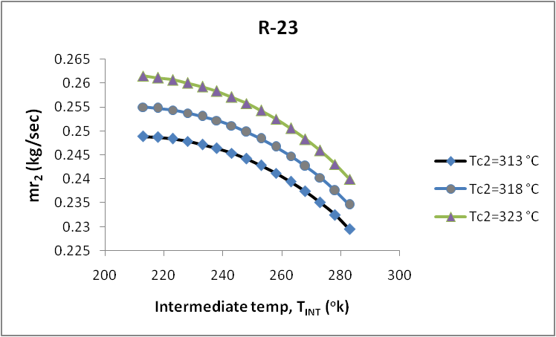

Fig.32 Variation in mass flow rate in high temp circuit with intermediate temperature for cascade system operating with R744 blend at 0.1 mole fraction as low temperature working fluid for R-23 at different condenser temperature.

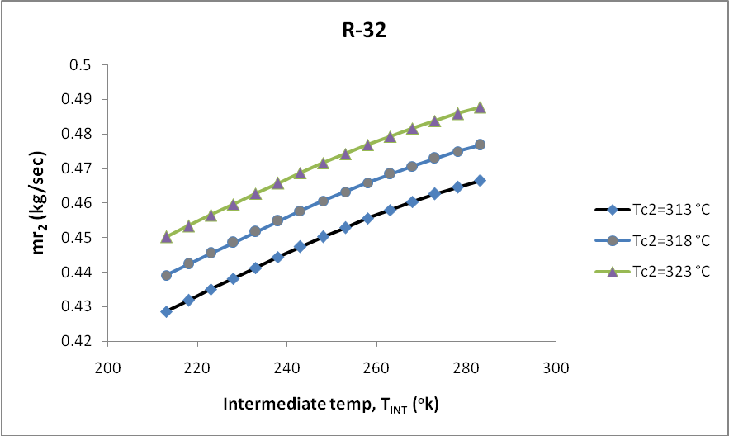

Fig.33 Variation in mass flow rate in high temp circuit with intermediate temperature for cascade system operating with R744 blend at 0.1 mole fraction as low temperature working fluid for R-32 at different condenser temperature.
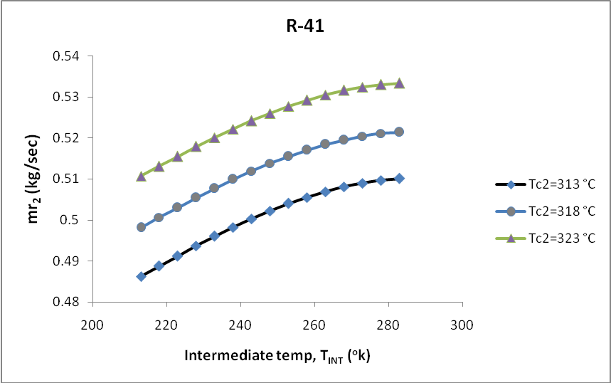

Fig.34 Variation in mass flow rate in high temp circuit with intermediate temperature for cascade system operating with R744 blend at 0.1 mole fraction as low temperature working fluid for R-41 at different condenser temperature.

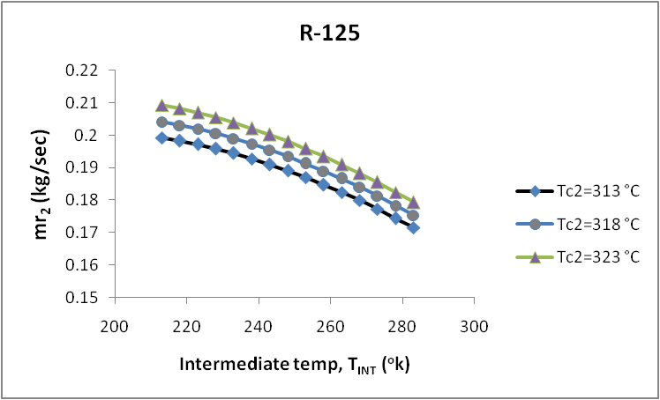

Fig.35 Variation in mass flow rate in high temp circuit with intermediate temperature for cascade system operating with R744 blend at 0.1 mole fraction as low temperature working fluid for R-125 at different condenser temperature.
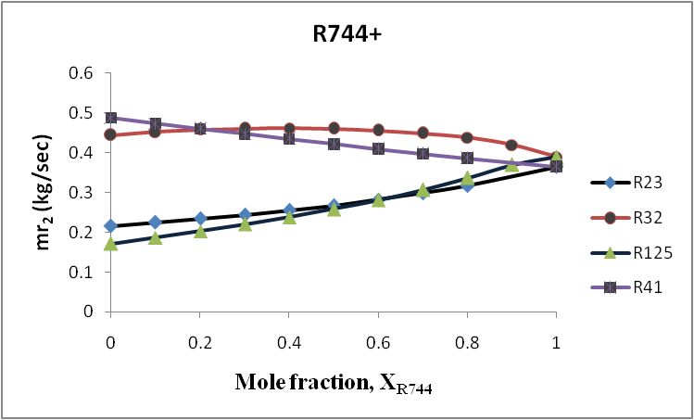

Fig.36 Variation in mass flow rate in high temp circuit with CO₂ mole fraction for cascade system operating with R744 blends as low temperature working fluid.

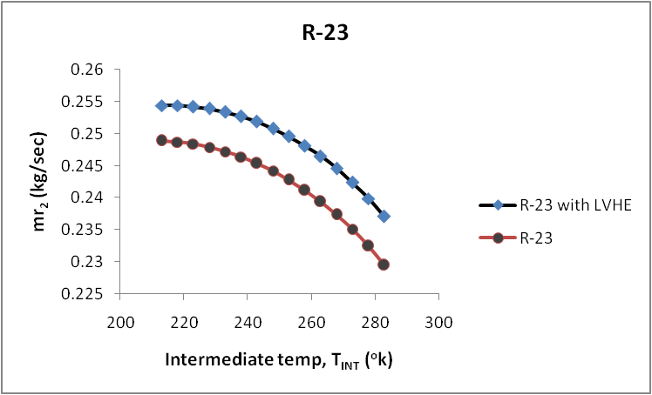

Fig.37 Variation in mass flow rate in high temp circuit with intermediate temperature for cascade system operating with R744 blend at 0.1 mole fraction as low temperature working fluid for R-23 by taking LVHE effectiveness 1.

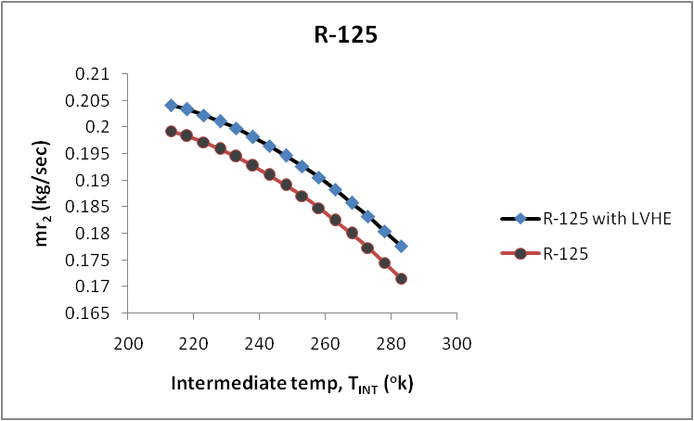

Fig.38 Variation in mass flow rate in high temp circuit with intermediate temperature for cascade system operating with R744 blend at 0.1 mole fraction as low temperature working fluid for R-125taking LVHE effectiveness 1.

Variation in total compressor work without superheating and subcooling for cascade system

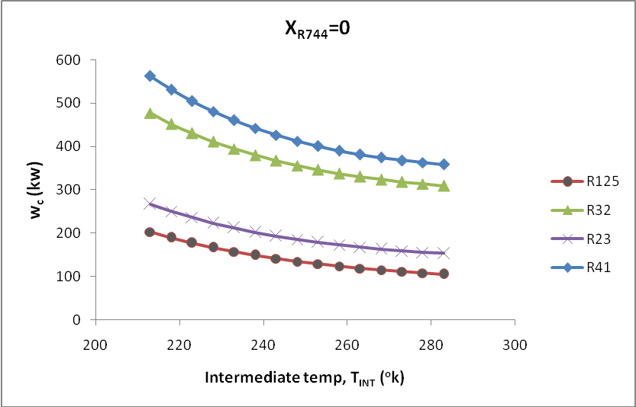

Fig.39 Variation in total compressor work with intermediate temperature for cascade system operating with R744 blend at 0 mole fraction as low temperature working fluid with approach 0ºC.

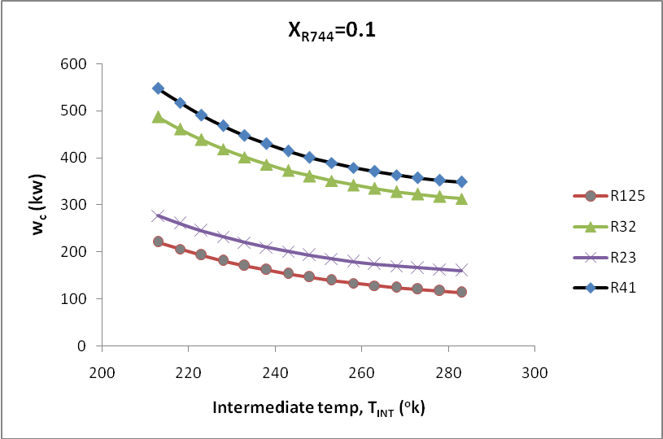
Fig.40 Variation in total compressor work with intermediate temperature for cascade system operating with R744 blend at 0.1 mole fraction as low temperature working fluid with approach 0ºC.
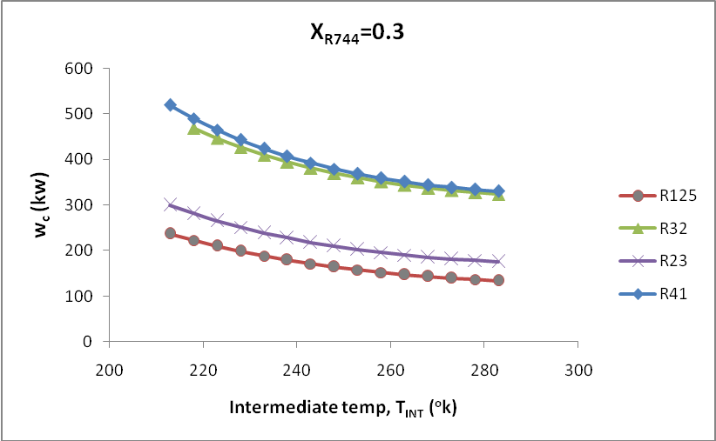

Fig.41 Variation in total compressor work with intermediate temperature for cascade system operating with R744 blend at 0.3 mole fraction as low temperature working fluid with approach 0ºC.

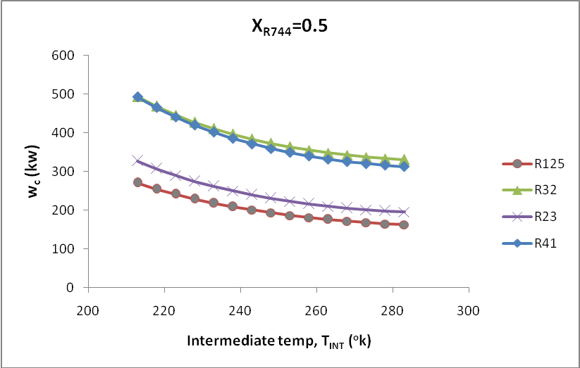

Fig.42 Variation in total compressor work with intermediate temperature for cascade system operating with R744 blend at 0.5 mole fraction as low temperature working fluid with approach 0ºC.

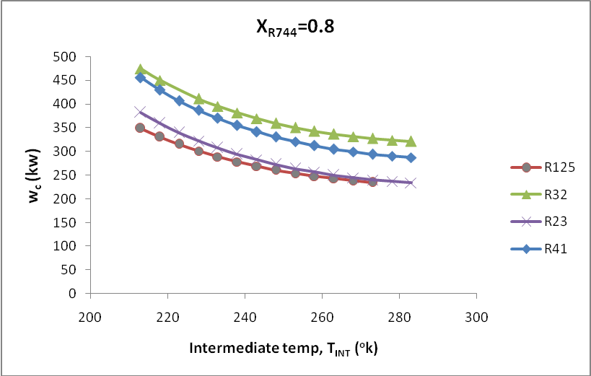

Fig.43 Variation in total compressor work with intermediate temperature for cascade system operating with R744 blend at 0.8 mole fraction as low temperature working fluid with approach 0ºC.

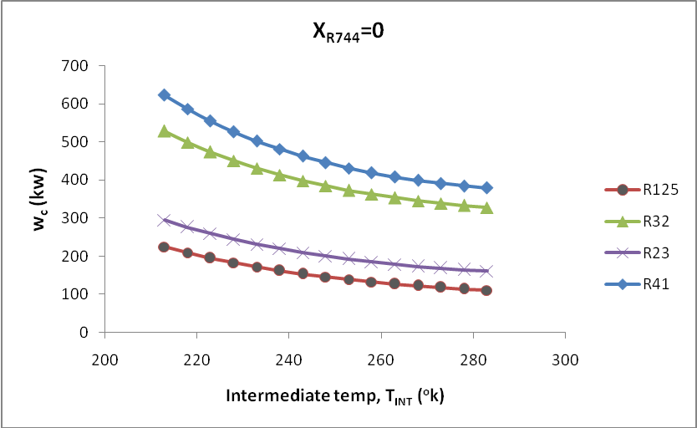

Fig.44 Variation in total compressor work with intermediate temperature for cascade system operating with R744 blend at 0 mole fraction as low temperature working fluid with approach 5ºC.
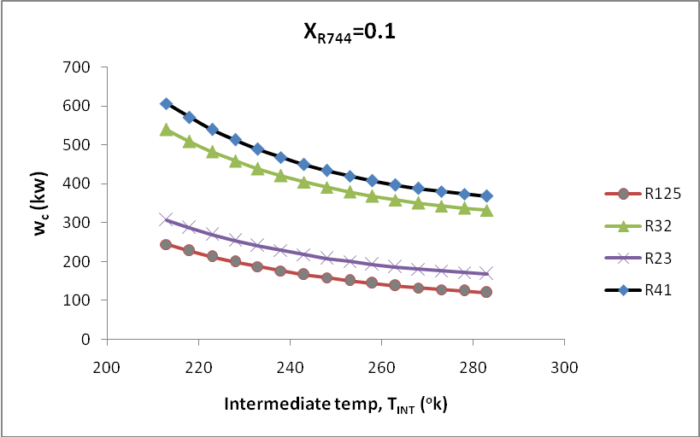

Fig.45 Variation in total compressor work with intermediate temperature for cascade system operating with R744 blend at 0.1 mole fraction as low temperature working fluid with approach 5ºC.

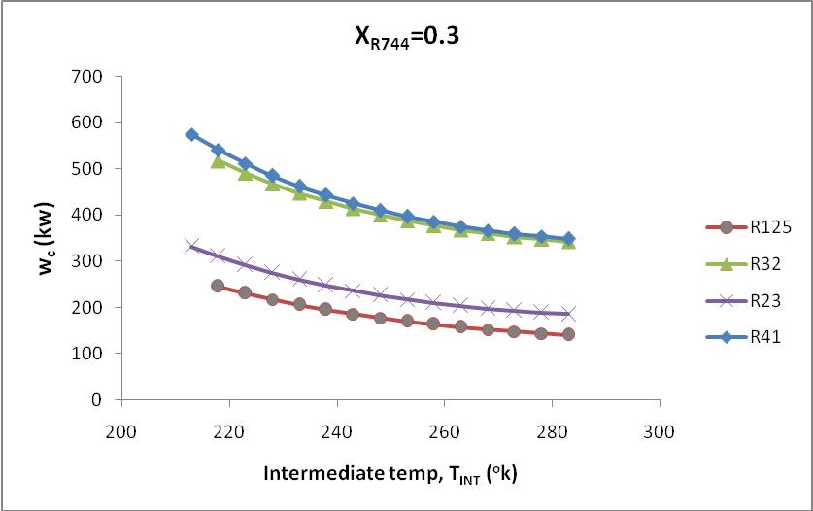

Fig.46 Variation in total compressor work with intermediate temperature for cascade system operating with R744 blend at 0.3 mole fraction as low temperature working fluid with approach 5ºC.
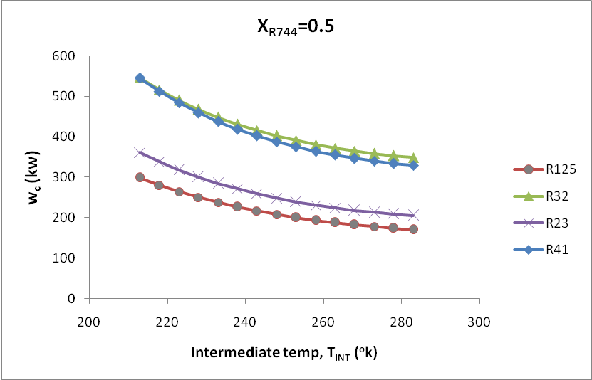

Fig.47 Variation in total compressor work with intermediate temperature for cascade system operating with R744 blend at 0.5 mole fraction as low temperature working fluid with approach 5ºC.

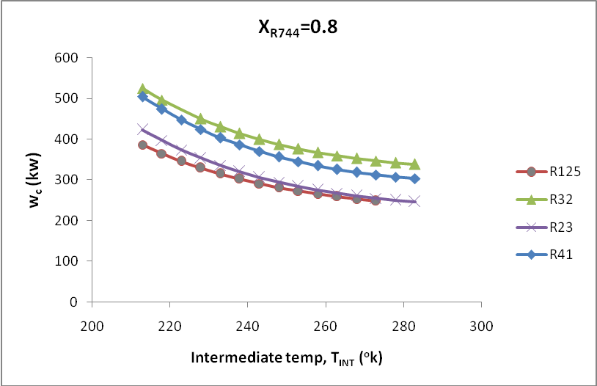

Fig.48 Variation in total compressor work with intermediate temperature for cascade system operating with R744 blend at 0.8 mole fraction as low temperature working fluid with approach 5ºC.

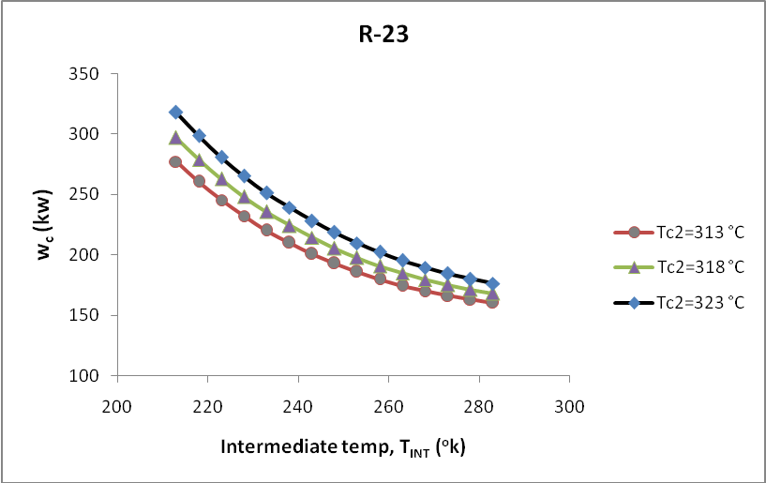

Fig.49 Variation in total compressor work with intermediate temperature for cascade system operating with R744 blend at 0.1 mole fraction as low temperature working fluid for R-23 at different condenser temperature.

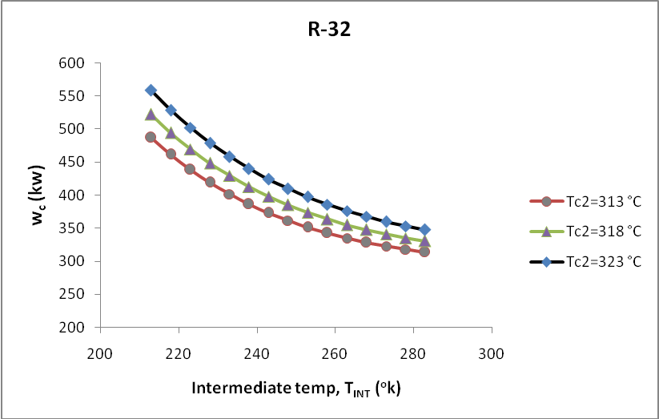

Fig.50 Variation in total compressor work with intermediate temperature for cascade system operating with R744 blend at 0.1 mole fraction as low temperature working fluid for R-32 at different condenser temperature.
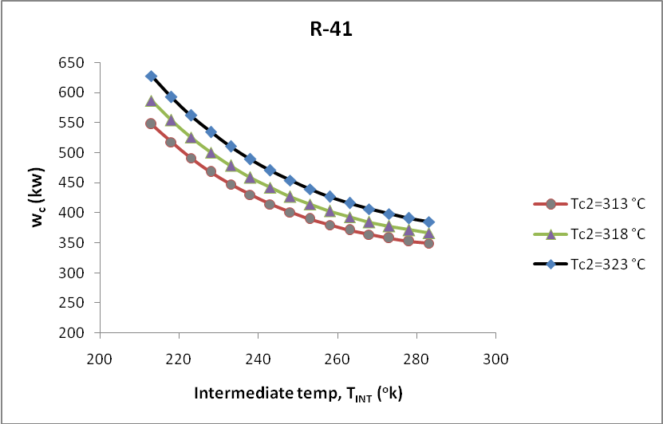

Fig.51 Variation in total compressor work with intermediate temperature for cascade system operating with R744 blend at 0.1 mole fraction as low temperature working fluid for R-41 at different condenser temperature.

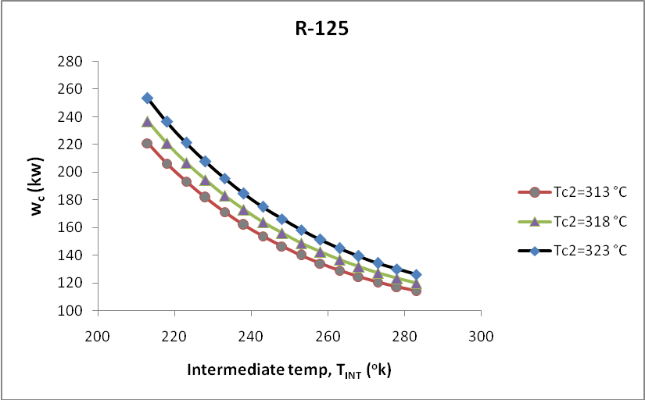

Fig.52 Variation in total compressor work with intermediate temperature for cascade system operating with R744 blend at 0.1 mole fraction as low temperature working fluid for R-125 at different condenser temperature.

Variation in total compressor work with superheating 10ºC and subcooling 5ºC for cascade system

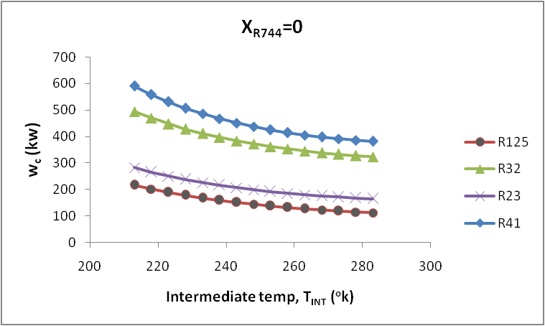

Fig.53 Variation in total compressor work with intermediate temperature for cascade system operating with R744 blend at 0 mole fraction as low temperature working fluid with approach 0ºC.

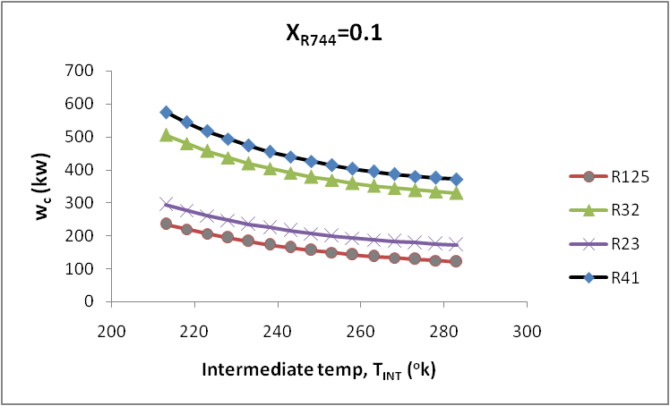
Fig.54 Variation in total compressor work with intermediate temperature for cascade system operating with R744 blend at 0.1 mole fraction as low temperature working fluid with approach 0ºC.
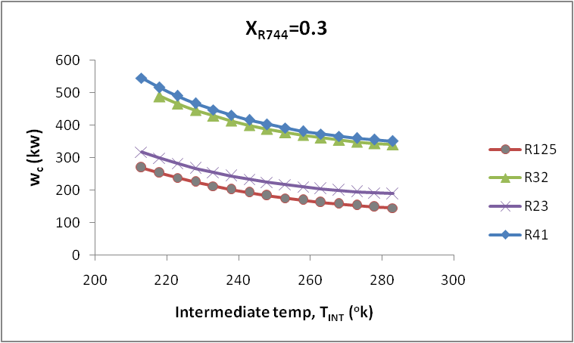

Fig.55 Variation in total compressor work with intermediate temperature for cascade system operating with R744 blend at 0.3 mole fraction as low temperature working fluid with approach 0ºC.

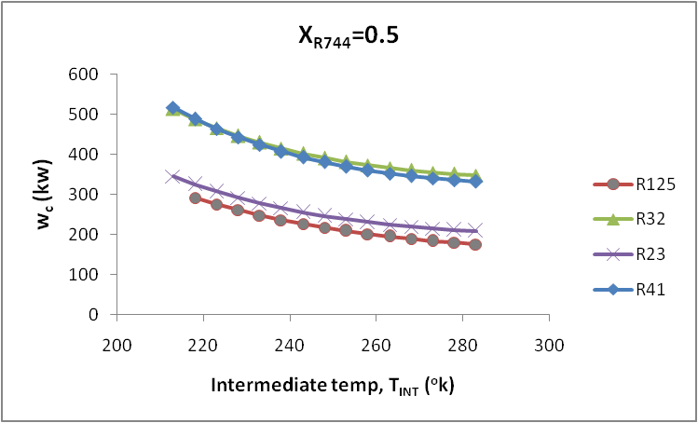

Fig.56 Variation in total compressor work with intermediate temperature for cascade system operating with R744 blend at 0.5 mole fraction as low temperature working fluid with approach 0ºC.
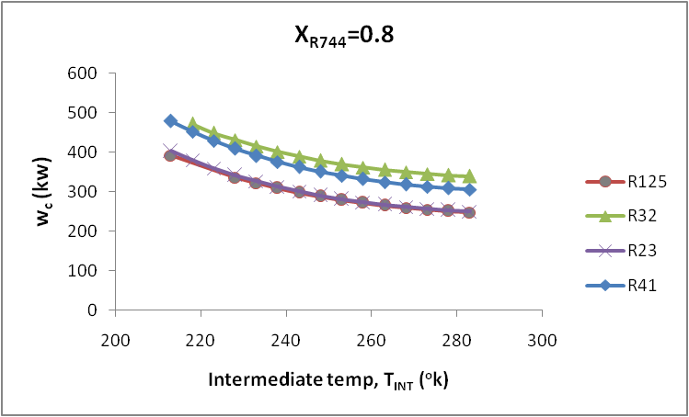

Fig.57 Variation in total compressor work with intermediate temperature for cascade system operating with R744 blend at 0.8 mole fraction as low temperature working fluid with approach 0ºC.

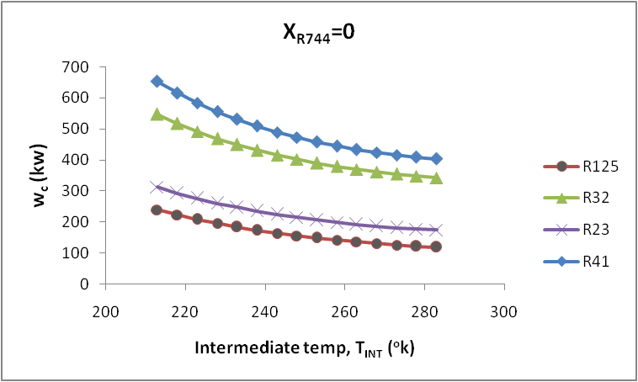

Fig.58 Variation in total compressor work with intermediate temperature for cascade system operating with R744 blend at 0 mole fraction as low temperature working fluid with approach 5ºC.

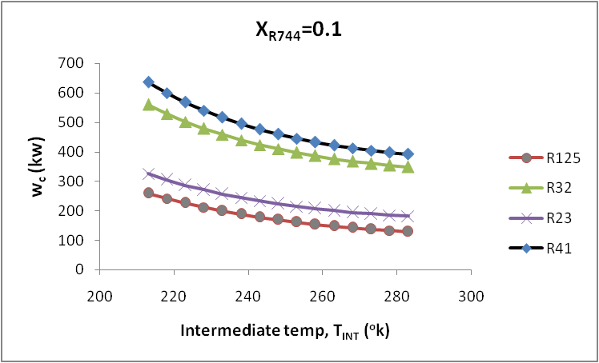

Fig.59 Variation in total compressor work with intermediate temperature for cascade system operating with R744 blend at 0.1 mole fraction as low temperature working fluid with approach 5ºC.

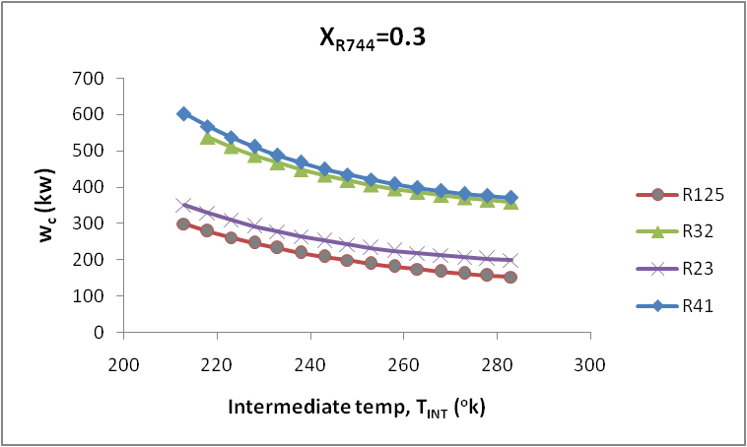

Fig.60 Variation in total compressor work with intermediate temperature for cascade system operating with R744 blend at 0.3 mole fraction as low temperature working fluid with approach 5ºC.

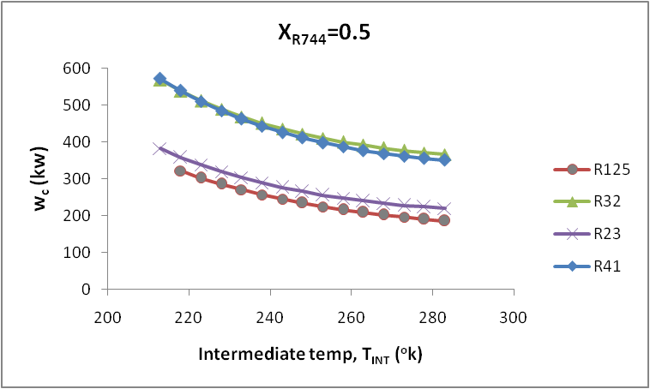

Fig.61 Variation in total compressor work with intermediate temperature for cascade system operating with R744 blend at 0.5 mole fraction as low temperature working fluid with approach 5ºC.

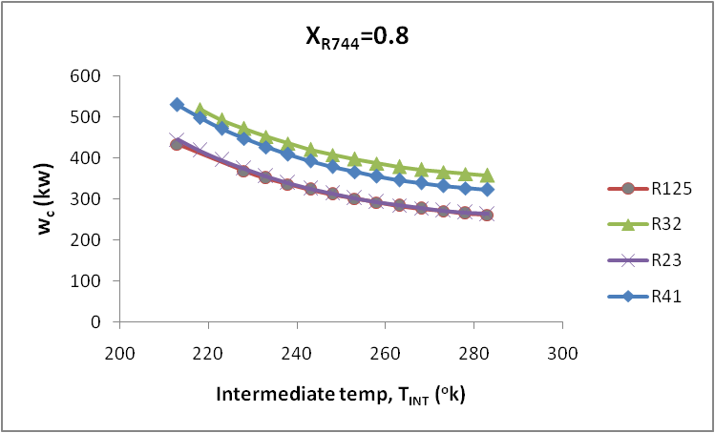

Fig.62 Variation in total compressor work with intermediate temperature for cascade system operating with R744 blend at 0.8 mole fraction as low temperature working fluid with approach 5ºC.

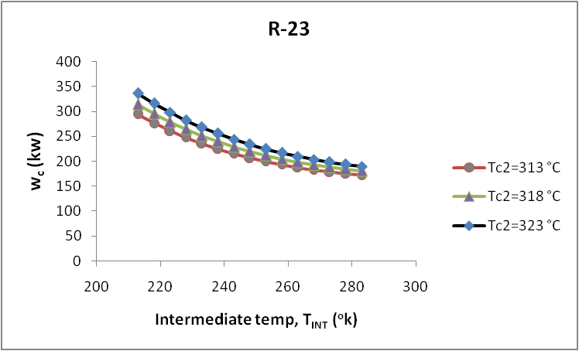

Fig.63 Variation in total compressor work with intermediate temperature for cascade system operating with R744 blend at 0.1 mole fraction as low temperature working fluid for R-23 at different condenser temperature.

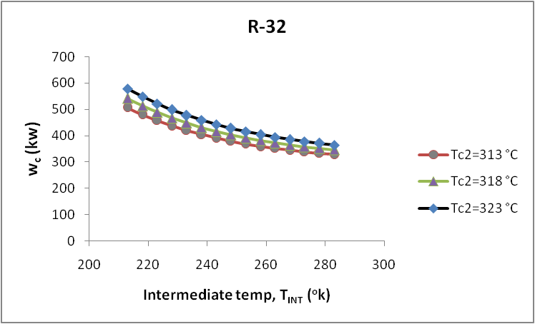

Fig.64 Variation in total compressor work with intermediate temperature for cascade system operating with R744 blend at 0.1 mole fraction as low temperature working fluid for R-32 at different condenser temperature.
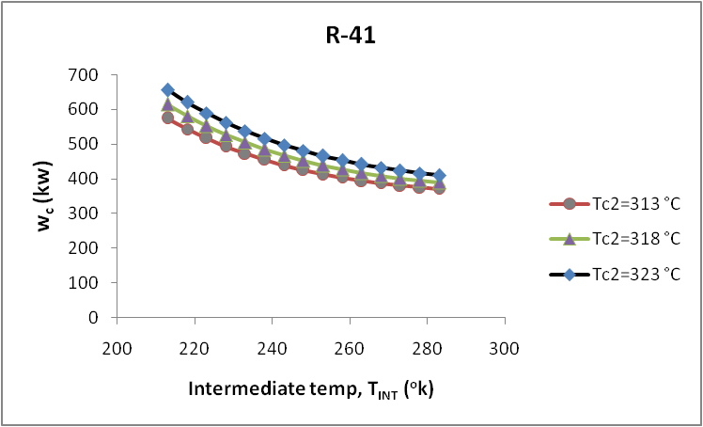

Fig.65 Variation in total compressor work with intermediate temperature for cascade system operating with R744 blend at 0.1 mole fraction as low temperature working fluid for R-41 at different condenser temperature.

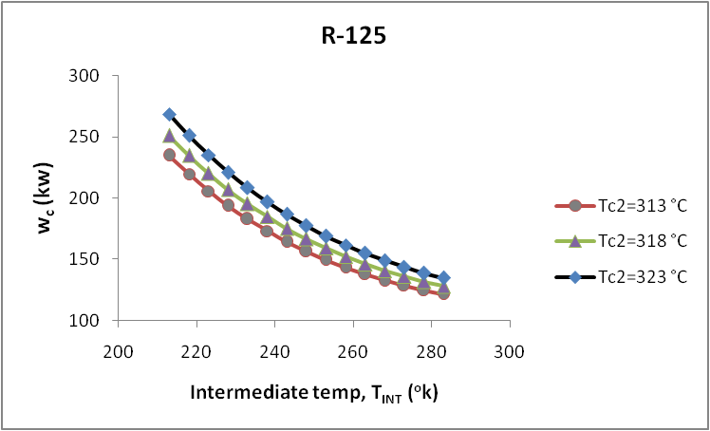

Fig.66 Variation in total compressor work with intermediate temperature for cascade system operating with R744 blend at 0.1 mole fraction as low temperature working fluid for R-125 at different condenser temperature.

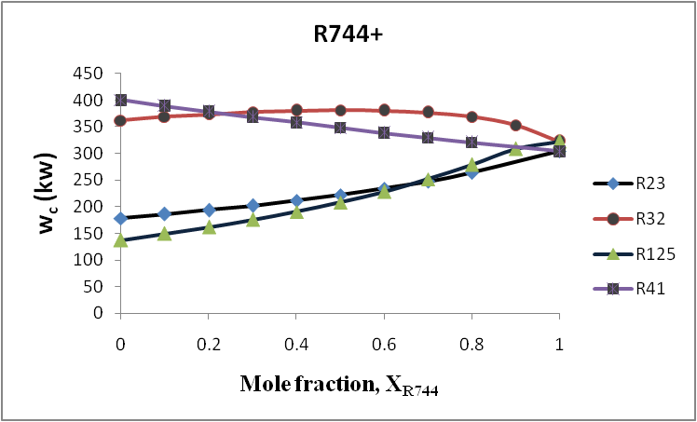

Fig.67 Variation in total compressor work with CO₂ mole fraction for cascade system operating with R744 blends as low temperature working fluid.

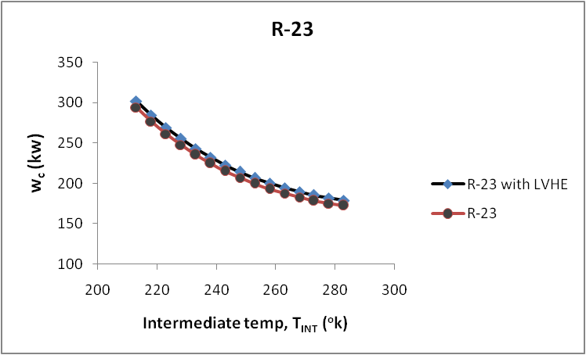

Fig.68 Variation in total compressor work with intermediate temperature for cascade system operating with R744 blend at 0.1 mole fraction as low temperature working fluid for R-23 taking LVHE effectiveness 1.

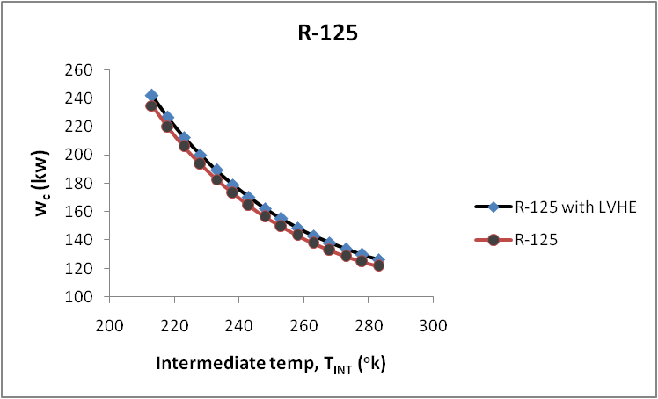

Fig.69 Variation in total compressor work with intermediate temperature for cascade system operating with R744 blend at 0.1 mole fraction as low temperature working fluid for R-125R-23 taking LVHE effectiveness 1.
Variation in Coefficient of Performance without superheating and subcooling for cascade system

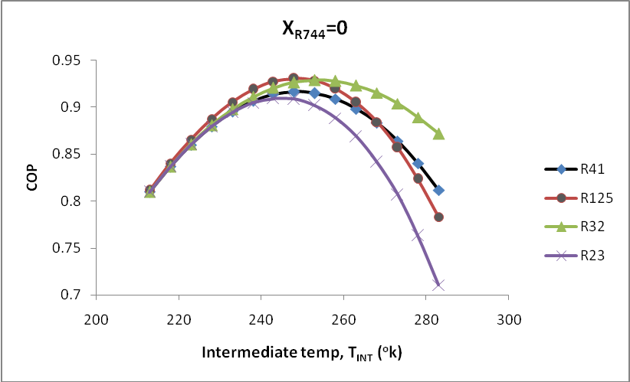
Fig.70 Variation in COP with intermediate temperature for cascade system operating with R744 blend at 0 mole fraction as low temperature working fluid with approach 0ºC.

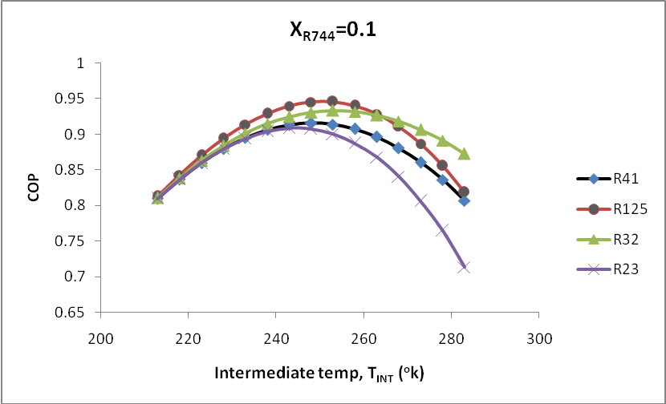
Fig.71 Variation in COP with intermediate temperature for cascade system operating with R744 blend at 0.1 mole fraction as low temperature working fluid with approach 0ºC.
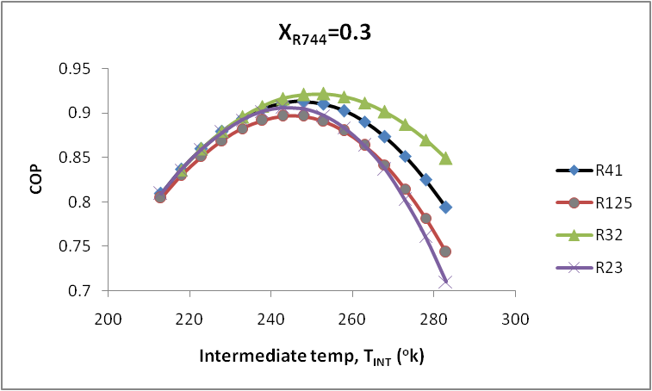
Fig.72 Variation in COP with intermediate temperature for cascade system operating with R744 blend at 0.3 mole fraction as low temperature working fluid with approach 0ºC.

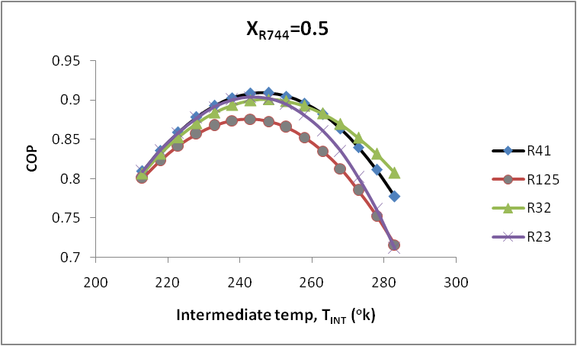
Fig.73 Variation in COP with intermediate temperature for cascade system operating with R744 blend at 0.5 mole fraction as low temperature working fluid with approach 0ºC.

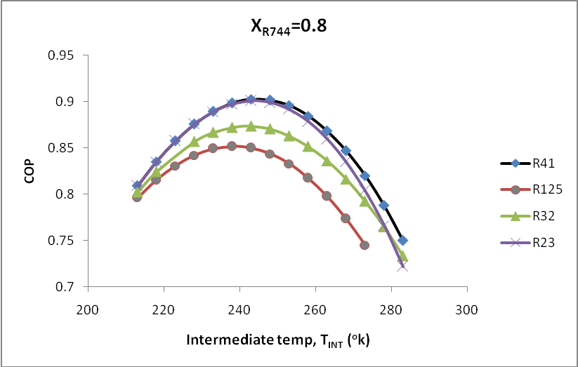
Fig.74 Variation in COP with intermediate temperature for cascade system operating with R744 blend at 0.8 mole fraction as low temperature working fluid with approach 0ºC.

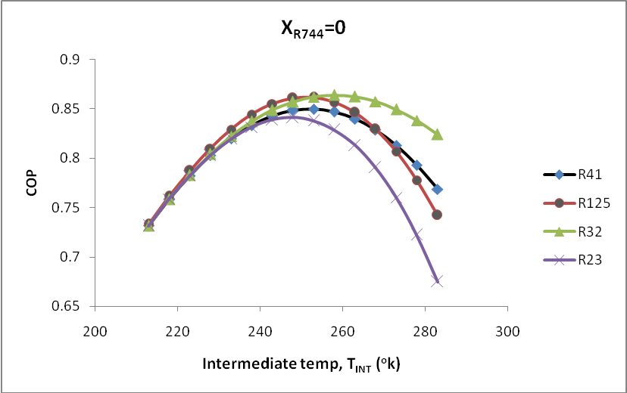
Fig.75 Variation in COP with intermediate temperature for cascade system operating with R744 blend at 0 mole fraction as low temperature working fluid with approach 5ºC.

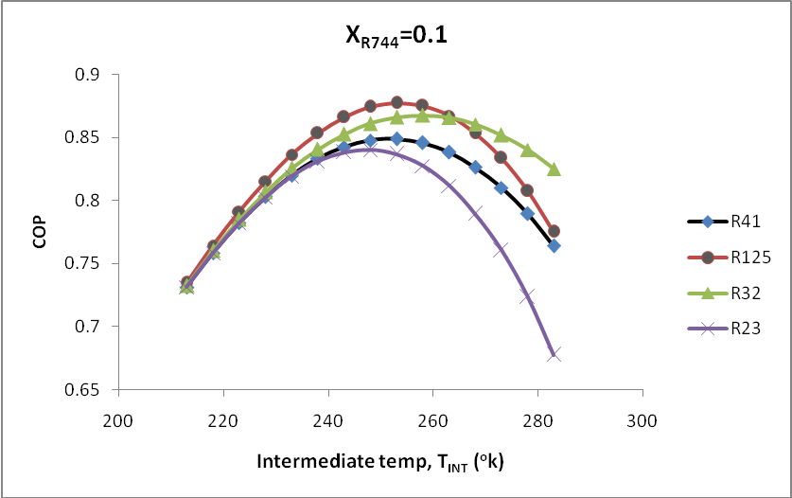
Fig.76 Variation in COP with intermediate temperature for cascade system operating with R744 blend at 0.1 mole fraction as low temperature working fluid with approach 5ºC.

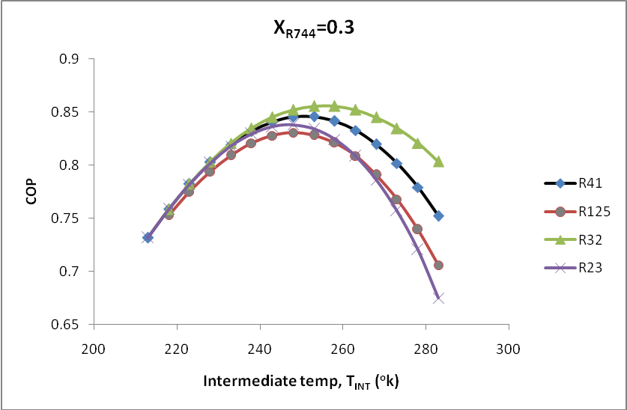
Fig.77 Variation in COP with intermediate temperature for cascade system operating with R744 blend at 0.3 mole fraction as low temperature working fluid with approach 5ºC.

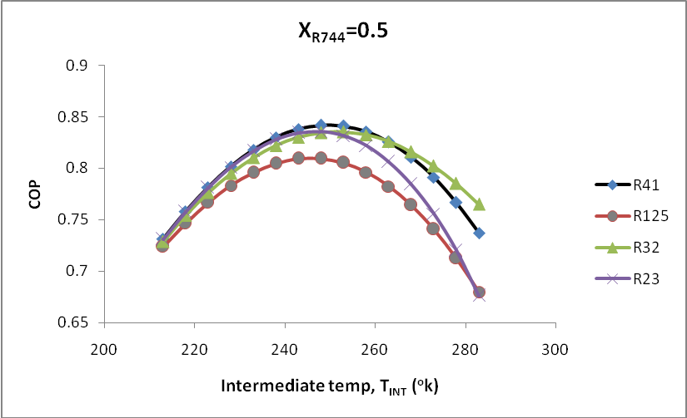
Fig.78 Variation in COP with intermediate temperature for cascade system operating with R744 blend at 0.5 mole fraction as low temperature working fluid with approach 5ºC.

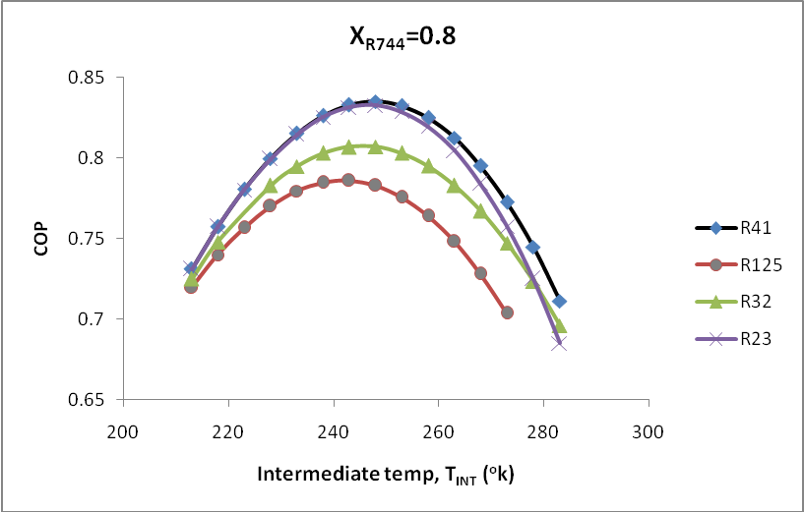
Fig.79 Variation in COP with intermediate temperature for cascade system operating with R744 blend at 0.8 mole fraction as low temperature working fluid with approach 5ºC.

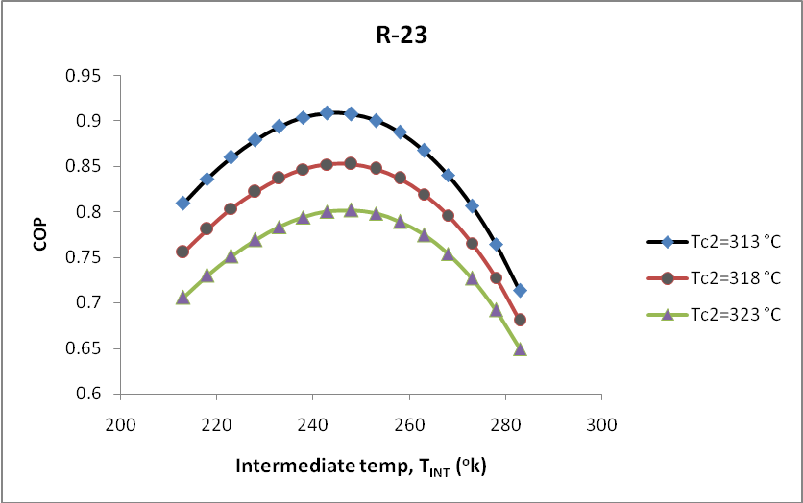
Fig.80 Variation in COP with intermediate temperature for cascade system operating with R744 blend at 0.1 mole fraction as low temperature working fluid for R-23 at different condenser temperature.

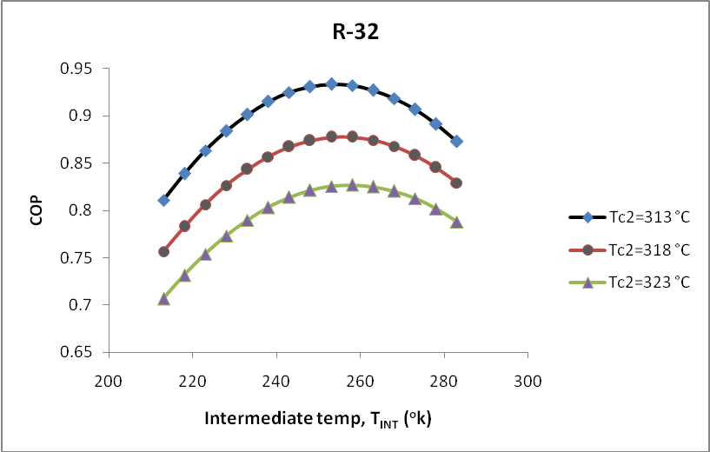
Fig.81 Variation in COP with intermediate temperature for cascade system operating with R744 blend at 0.1 mole fraction as low temperature working fluid for R-32 at different condenser temperature.

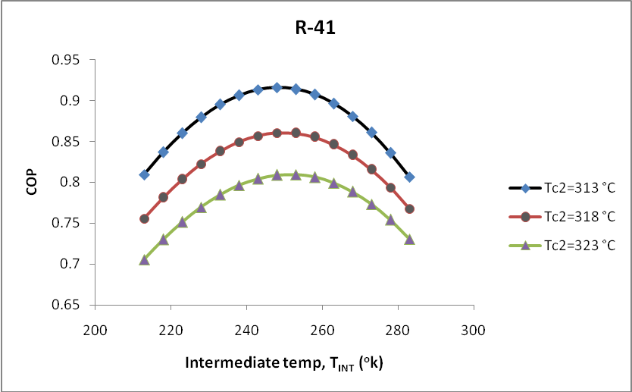
Fig.82 Variation in COP with intermediate temperature for cascade system operating with R744 blend at 0.1 mole fraction as low temperature working fluid for R-41 at different condenser temperature.

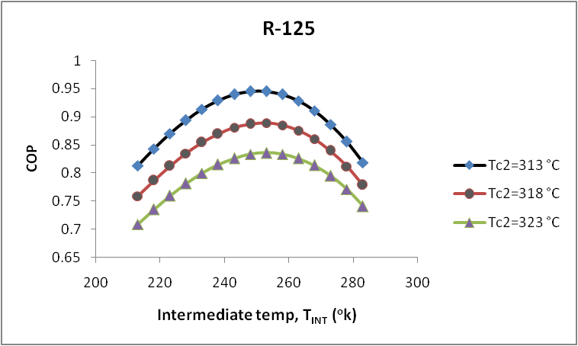
Fig.83 Variation in COP with intermediate temperature for cascade system operating with R744 blend at 0.1 mole fraction as low temperature working fluid for R-125 at different condenser temperature.
Variation in Coefficient of Performance with superheating 10ºC and subcooling 5ºC for cascade system

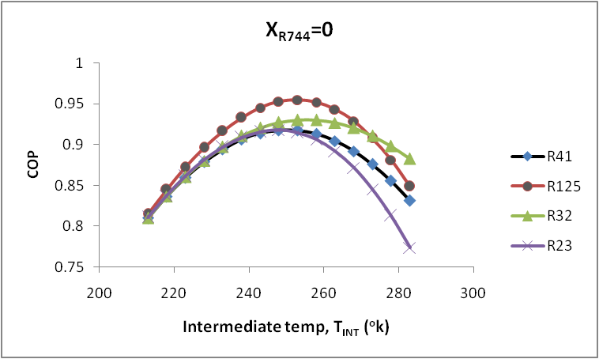

Fig.84 Variation in COP with intermediate temperature for cascade system operating with R744 blend at 0 mole fraction as low temperature working fluid with approach 0ºC.

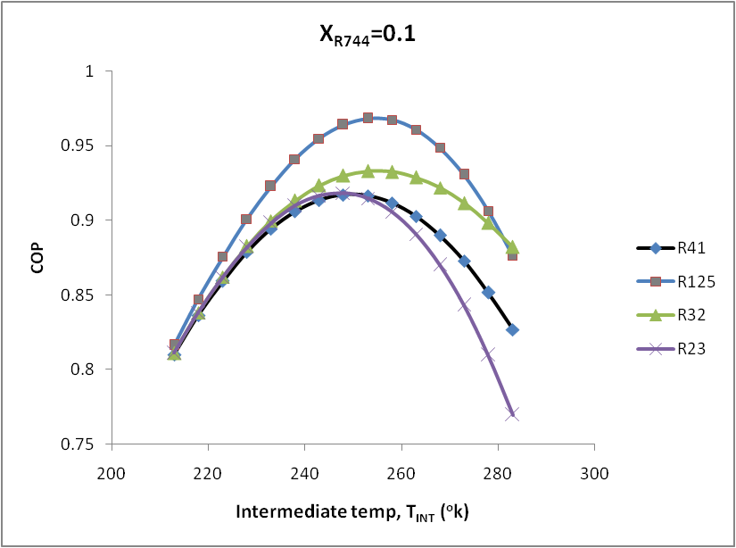

Fig.85 Variation in COP with intermediate temperature for cascade system operating with R744 blend at 0.1 mole fraction as low temperature working fluid with approach 0ºC.

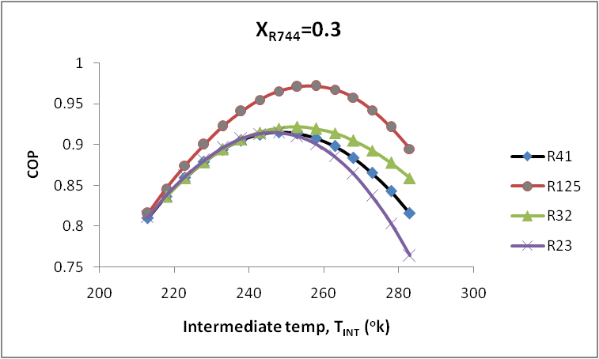

Fig.86 Variation in COP with intermediate temperature for cascade system operating with R744 blend at 0.3 mole fraction as low temperature working fluid with approach 0ºC.

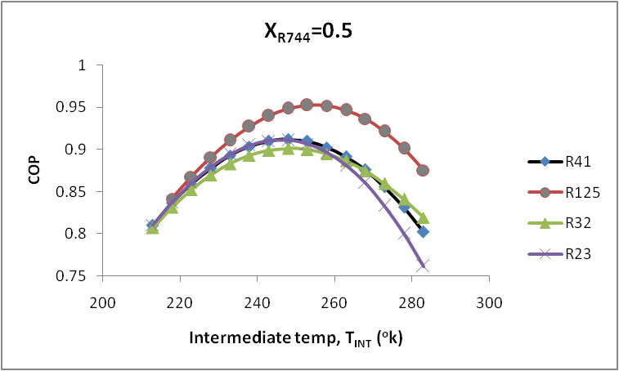

Fig.87 Variation in COP with intermediate temperature for cascade system operating with R744 blend at 0.5 mole fraction as low temperature working fluid with approach 0ºC.

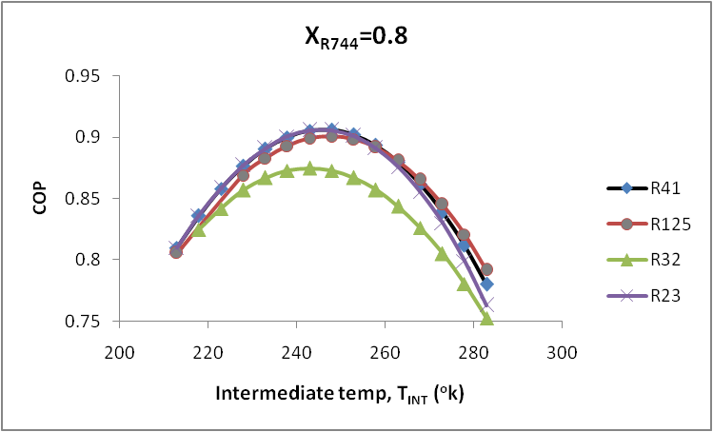

Fig.88 Variation in COP with intermediate temperature for cascade system operating with R744 blend at 0.8 mole fraction as low temperature working fluid with approach 0ºC.

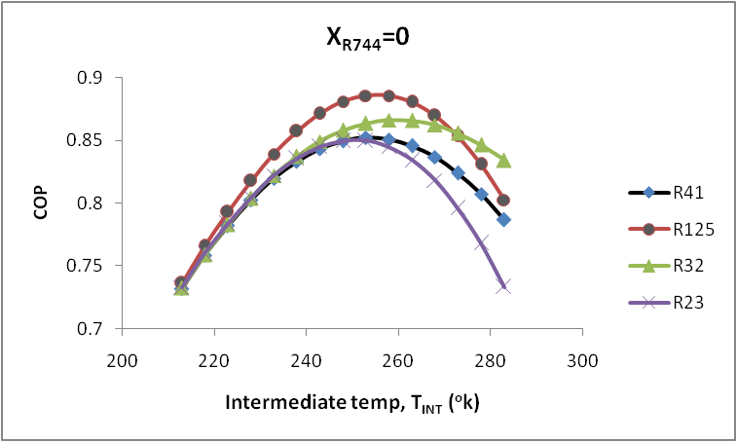

Fig.89 Variation in COP with intermediate temperature for cascade system operating with R744 blend at 0 mole fraction as low temperature working fluid with approach 5ºC.

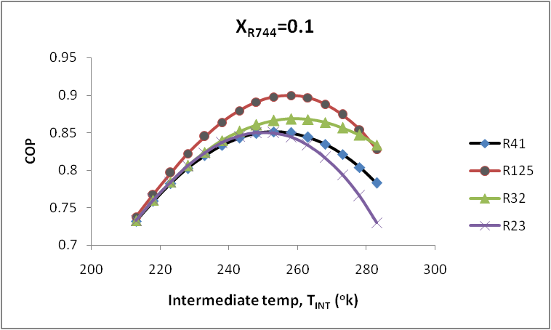

Fig.90 Variation in COP with intermediate temperature for cascade system operating with R744 blend at 0.1 mole fraction as low temperature working fluid with approach 5ºC.

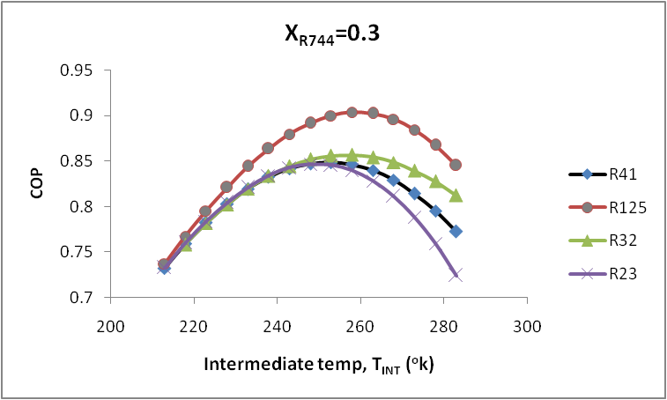

Fig.91 Variation in COP with intermediate temperature for cascade system operating with R744 blend at 0.3 mole fraction as low temperature working fluid with approach 5ºC.

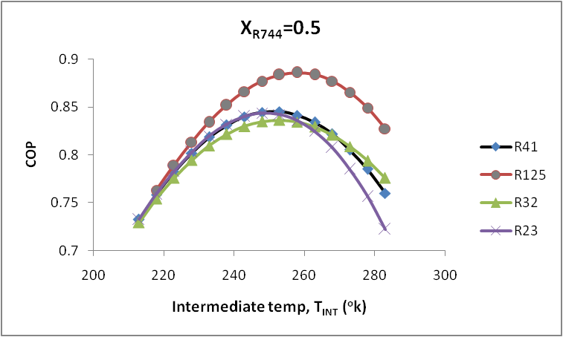

Fig.92 Variation in COP with intermediate temperature for cascade system operating with R744 blend at 0.5 mole fraction as low temperature working fluid with approach 5ºC.

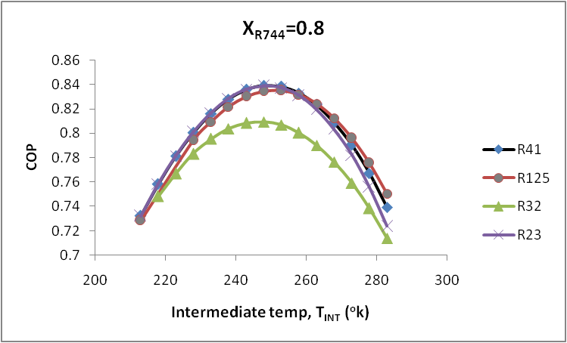

Fig.93 Variation in COP with intermediate temperature for cascade system operating with R744 blend at 0.8 mole fraction as low temperature working fluid with approach 5ºC.
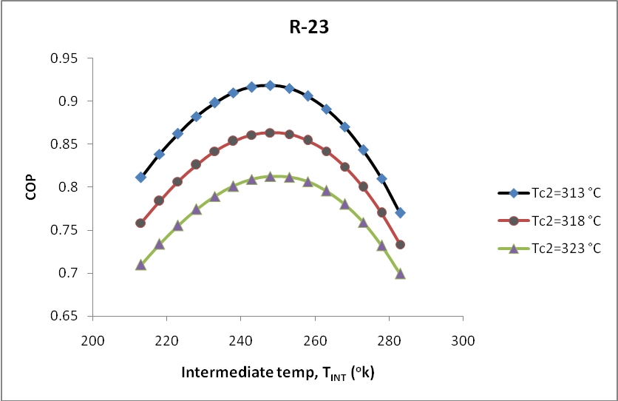
Fig.94 Variation in COP with intermediate temperature for cascade system operating with R744 blend at 0.1 mole fraction as low temperature working fluid for R-23 at different condenser temperature.

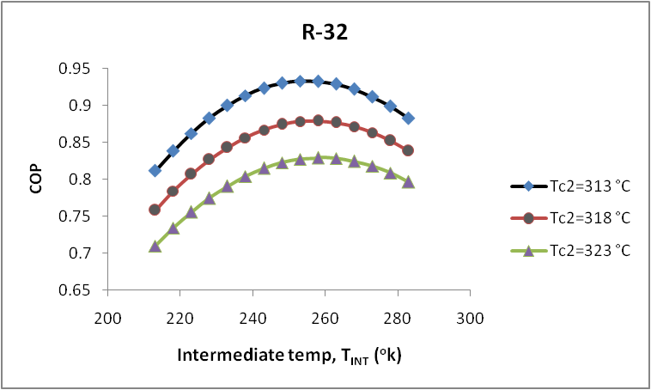

Fig.95 Variation in COP with intermediate temperature for cascade system operating with R744 blend at 0.1 mole fraction as low temperature working fluid for R-32 at different condenser temperature.

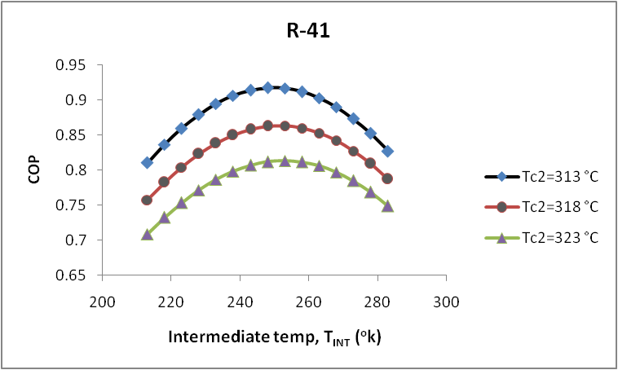

Fig.96 Variation in COP with intermediate temperature for cascade system operating with R744 blend at 0.1 mole fraction as low temperature working fluid for R-41 at different condenser temperature.

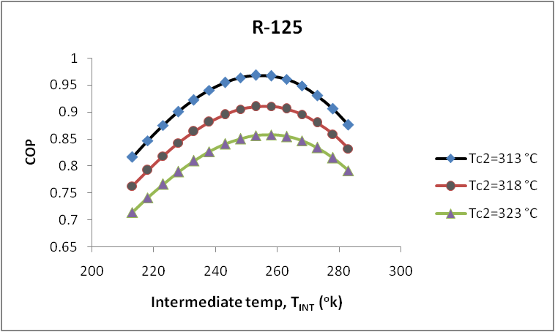

Fig.97 Variation in COP with intermediate temperature for cascade system operating with R744 blend at 0.1 mole fraction as low temperature working fluid for R-125 at different condenser temperature.

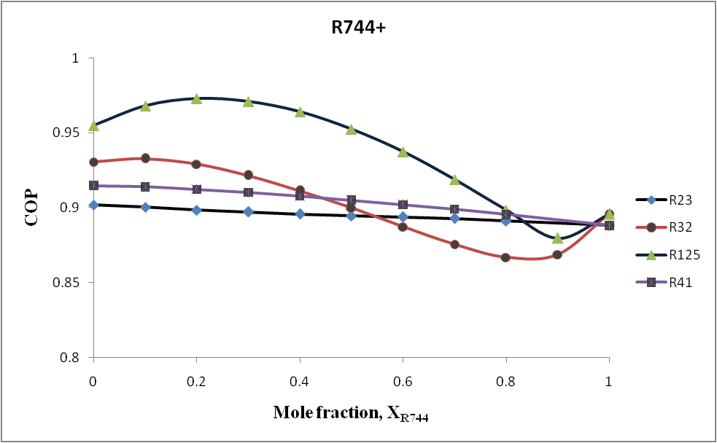

Fig.98 Variation in COP with CO₂ mole fraction for cascade system operating with R744 blends as low temperature working fluid.

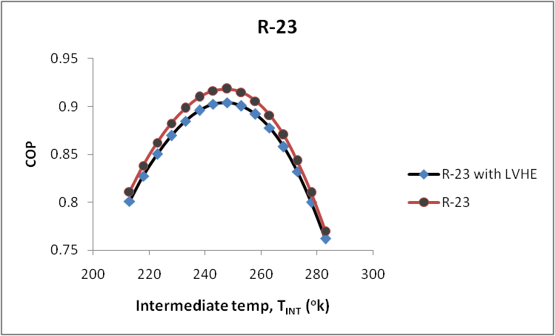

Fig.99 Variation in COP with intermediate temperature for cascade system operating with R744 blend at 0.1 mole fraction as low temperature working fluid for R-23 by taking LVHE effectiveness 1.

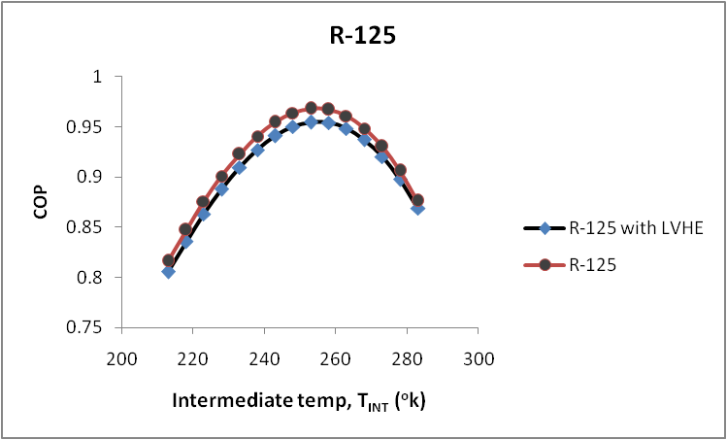

Fig.100 Variation in COP with intermediate temperature for cascade system operating with R744 blend at 0.1 mole fraction as low temperature working fluid for R-125by taking LVHE effectiveness 1.

Variation in Volumetric Cooling Capacity without superheating and subcooling for cascade system
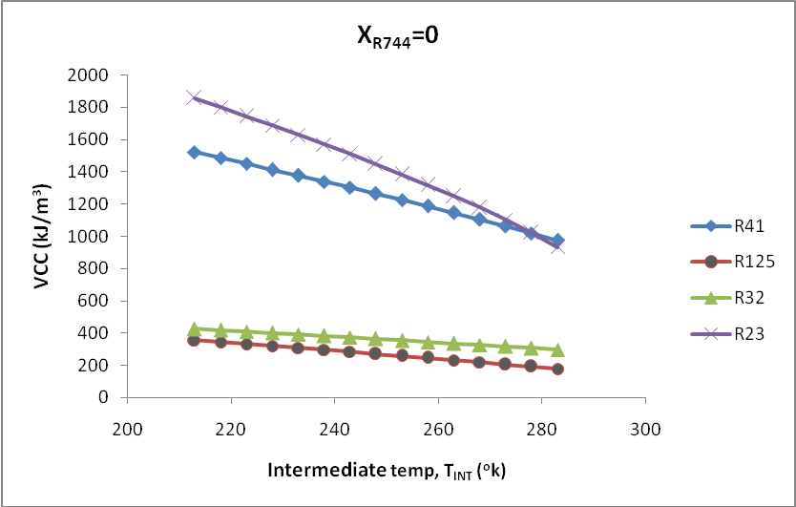
Fig.101 Variation in volumetric cooling capacity with intermediate temperature for cascade system operating with R744 blend at 0.0 mole fraction as low temperature working fluid with approach 0ºC.
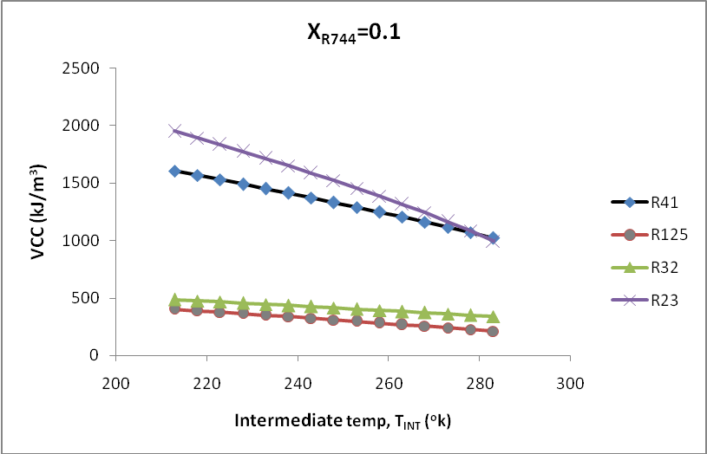
Fig.102 Variation in volumetric cooling capacity with intermediate temperature for cascade system operating with R744 blend at 0.1 mole fraction as low temperature working fluid with approach 0ºC.
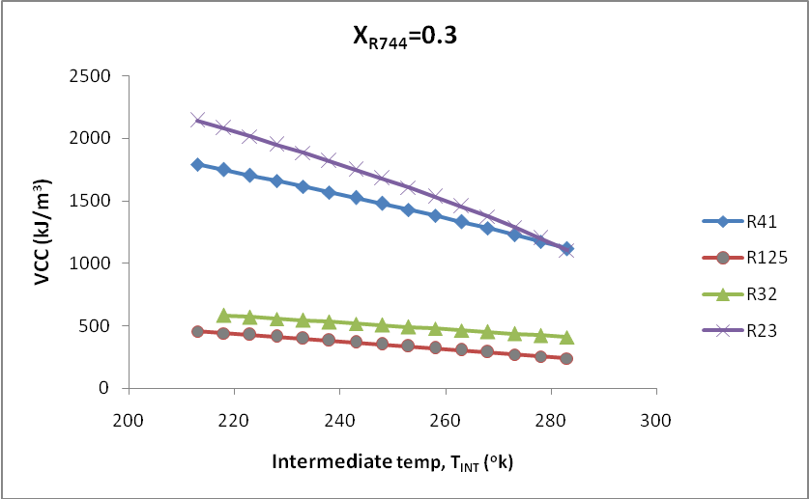
Fig.103 Variation in volumetric cooling capacity with intermediate temperature for cascade system operating with R744 blend at 0.3 mole fraction as low temperature working fluid with approach 0ºC.

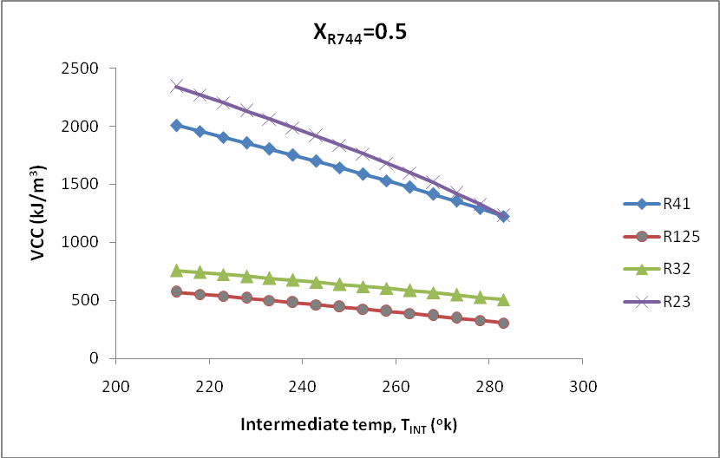
Fig.104 Variation in volumetric cooling capacity with intermediate temperature for cascade system operating with R744 blend at 0.5 mole fraction as low temperature working fluid with approach 0ºC.
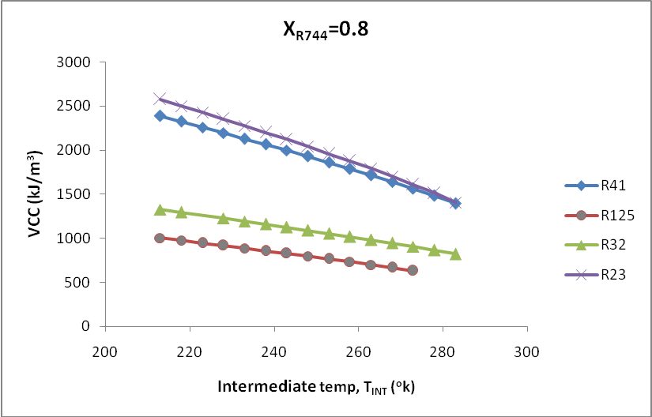
Fig.105 Variation in volumetric cooling capacity with intermediate temperature for cascade system operating with R744 blend at 0.8 mole fraction as low temperature working fluid with approach 0ºC.

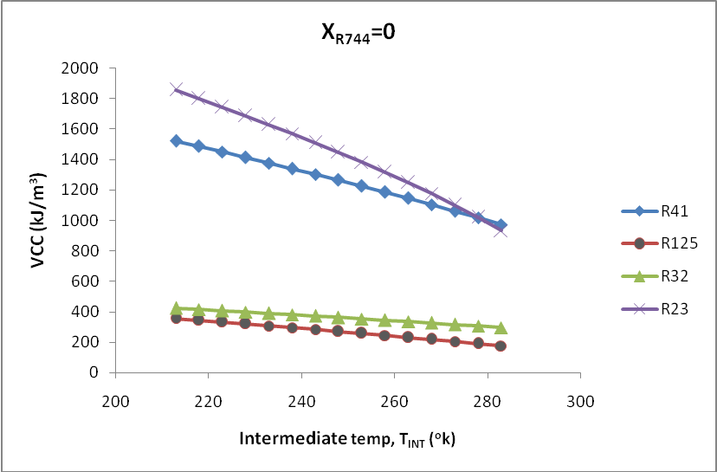
Fig.106 Variation in volumetric cooling capacity with intermediate temperature for cascade system operating with R744 blend at 0 mole fraction as low temperature working fluid with approach 5ºC.
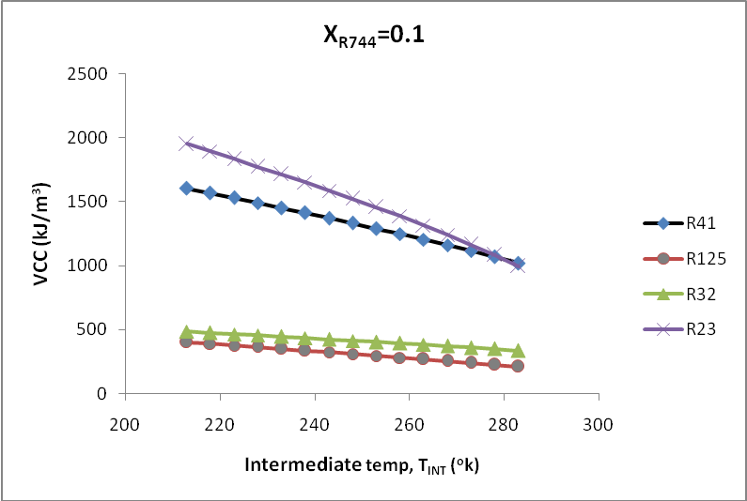
Fig.107 Variation in volumetric cooling capacity with intermediate temperature for cascade system operating with R744 blend at 0.1 mole fraction as low temperature working fluid with approach 5ºC.

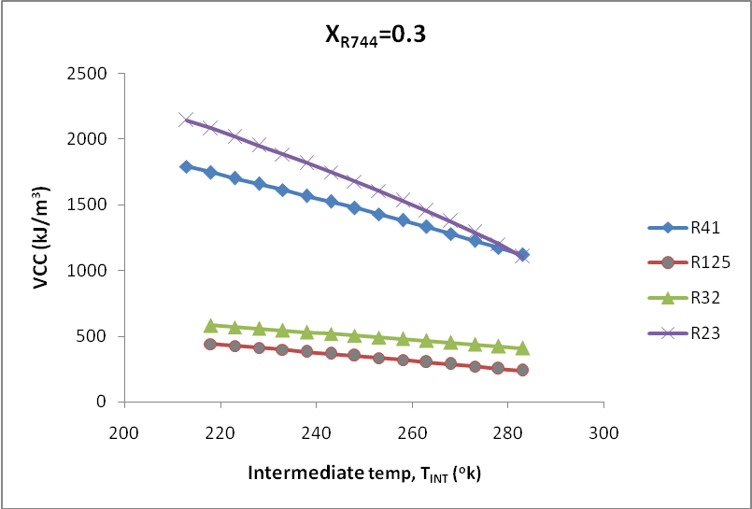
Fig.108 Variation in volumetric cooling capacity with intermediate temperature for cascade system operating with R744 blend at 0.3 mole fraction as low temperature working fluid with approach 5ºC.
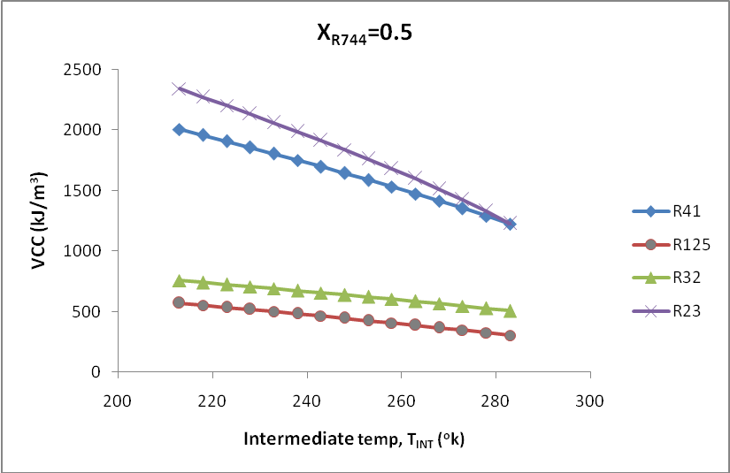
Fig.109 Variation in volumetric cooling capacity with intermediate temperature for cascade system operating with R744 blend at 0.5 mole fraction as low temperature working fluid with approach 5ºC.

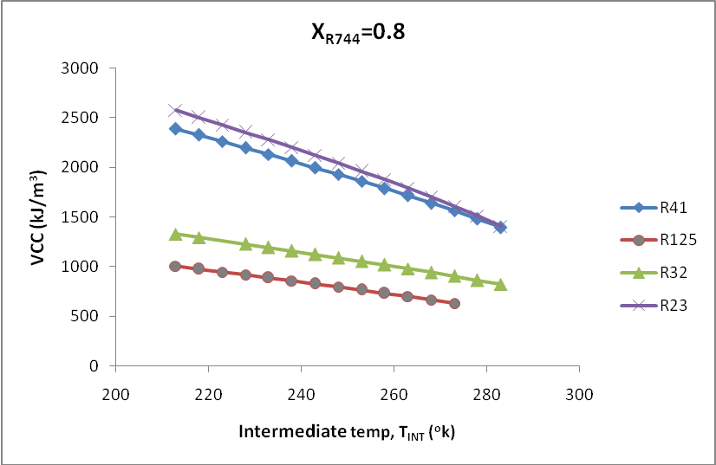
Fig.110 Variation in volumetric cooling capacity with intermediate temperature for cascade system operating with R744 blend at 0.8 mole fraction as low temperature working fluid with approach 5ºC.

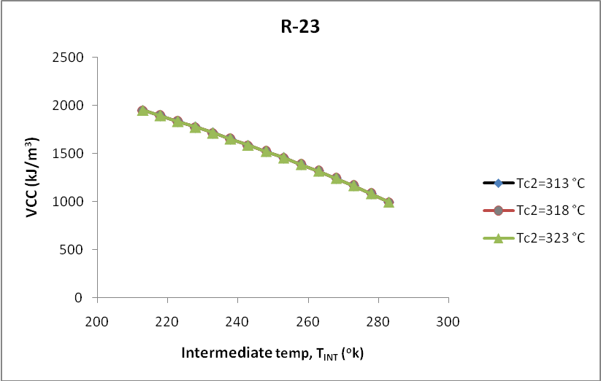
Fig.111 Variation in volumetric cooling capacity with intermediate temperature for cascade system operating with R744 blend at 0.1 mole fraction as low temperature working fluid for R-23 at different condenser temperature.

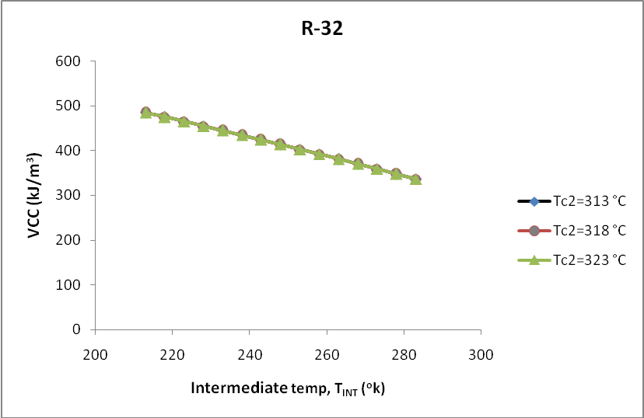
Fig.112 Variation in volumetric cooling capacity with intermediate temperature for cascade system operating with R744 blend at 0.1 mole fraction as low temperature working fluid for R-32 at different condenser temperature.
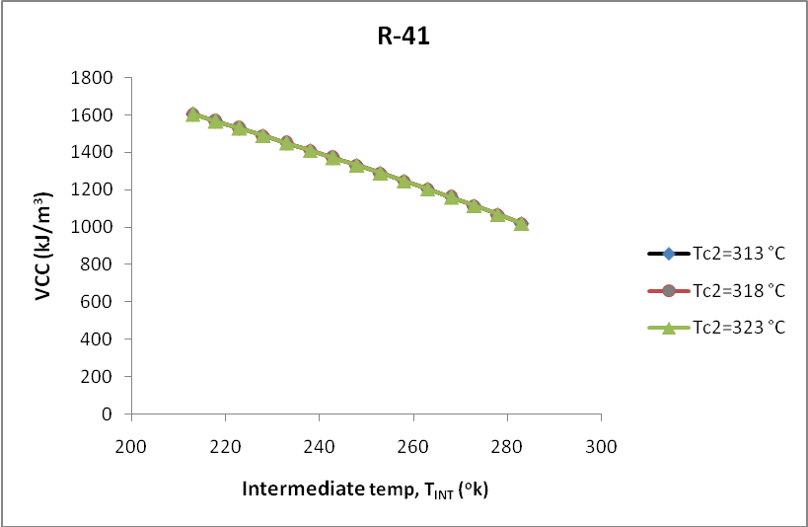
Fig.113 Variation in volumetric cooling capacity with intermediate temperature for cascade system operating with R744 blend at 0.1 mole fraction as low temperature working fluid for R-41 at different condenser temperature.

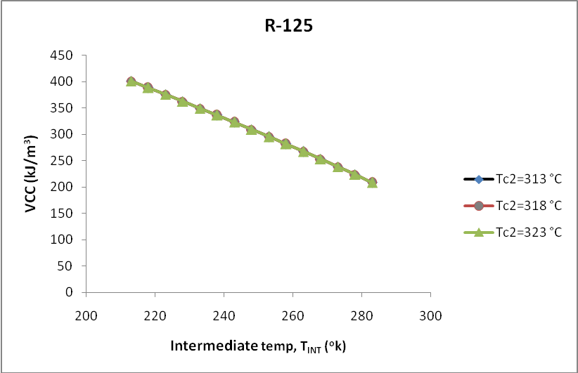
Fig.114 Variation in volumetric cooling capacity with intermediate temperature for cascade system operating with R744 blend at 0.1 mole fraction as low temperature working fluid for R-125 at different condenser temperature.
Variation in Volumetric Cooling Capacity with superheating 10ºC and subcooling 5ºC for cascade system

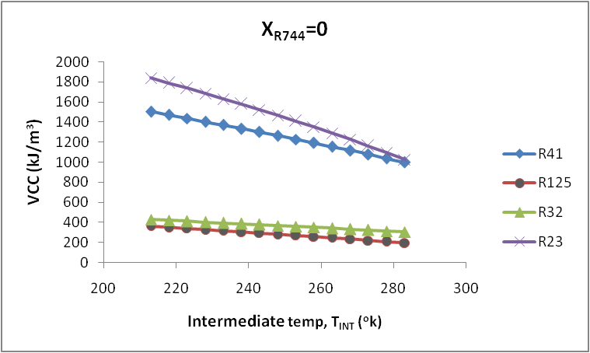

Fig.115 Variation in volumetric cooling capacity with intermediate temperature for cascade system operating with R744 blend at 0 mole fraction as low temperature working fluid with approach 0ºC.

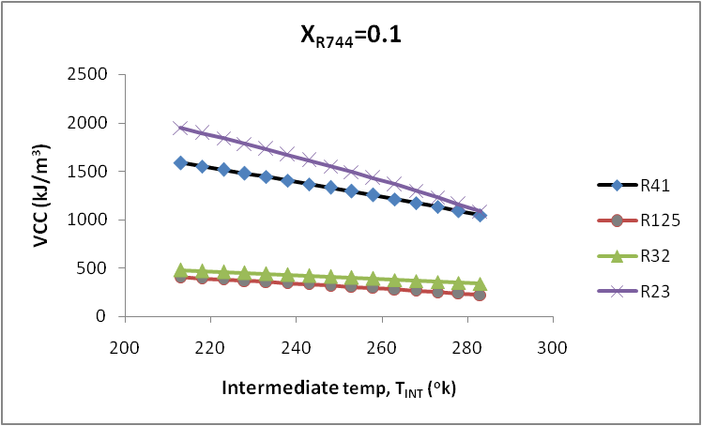

Fig.116 Variation in volumetric cooling capacity with intermediate temperature for cascade system operating with R744 blend at 0.1 mole fraction as low temperature working fluid with approach 0ºC.
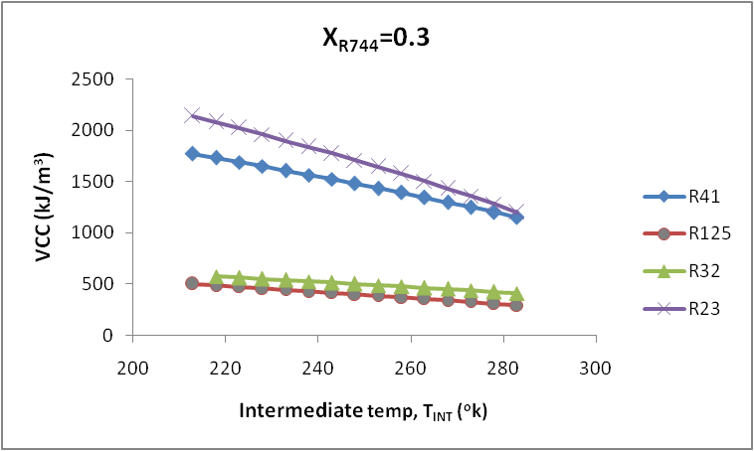

Fig.117 Variation in volumetric cooling capacity with intermediate temperature for cascade system operating with R744 blend at 0.3 mole fraction as low temperature working fluid with approach 0ºC.

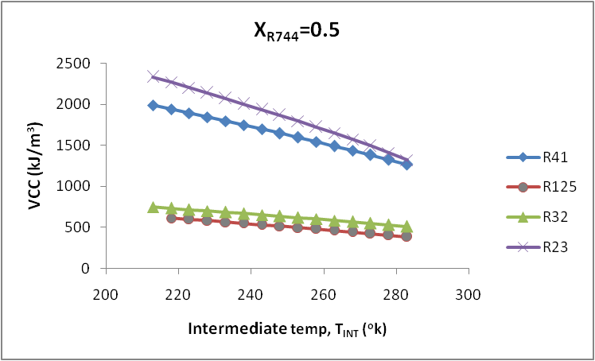

Fig.118 Variation in volumetric cooling capacity with intermediate temperature for cascade system operating with R744 blend at 0.5 mole fraction as low temperature working fluid with approach 0ºC.
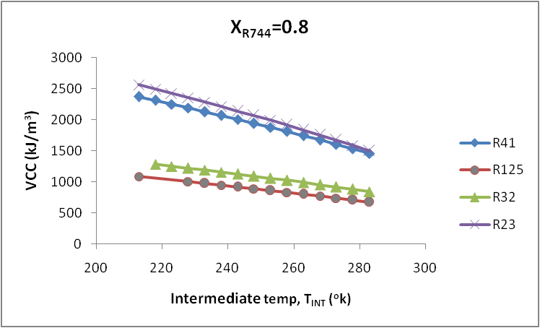

Fig.119 Variation in volumetric cooling capacity with intermediate temperature for cascade system operating with R744 blend at 0.8 mole fraction as low temperature working fluid with approach 0ºC.

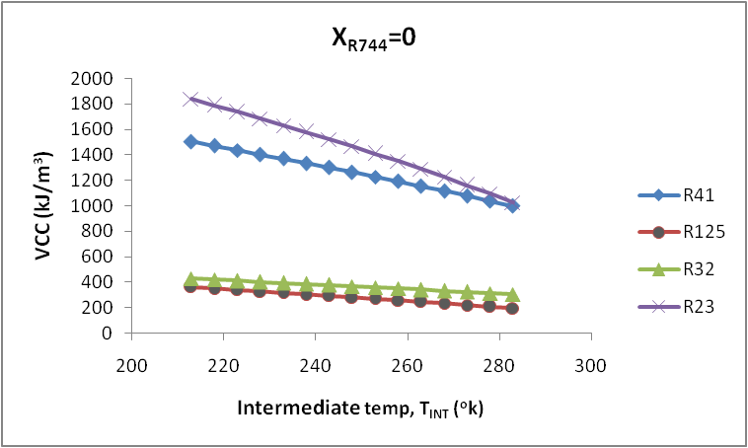

Fig.120 Variation in volumetric cooling capacity with intermediate temperature for cascade system operating with R744 blend at 0.0 mole fraction as low temperature working fluid with approach 5ºC.

Fig.121 Variation in volumetric cooling capacity with intermediate temperature for cascade system operating with R744 blend at 0.1 mole fraction as low temperature working fluid with approach 5ºC.

Fig.122 Variation in volumetric cooling capacity with intermediate temperature for cascade system operating with R744 blend at 0.3 mole fraction as low temperature working fluid with approach 5ºC.

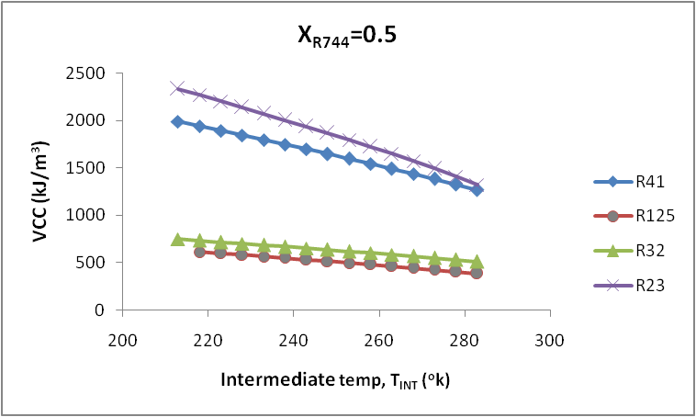

Fig.123 Variation in volumetric cooling capacity with intermediate temperature for cascade system operating with R744 blend at 0.5 mole fraction as low temperature working fluid with approach 5ºC.

Fig.124 Variation in volumetric cooling capacity with intermediate temperature for cascade system operating with R744 blend at 0.8 mole fraction as low temperature working fluid with approach 5ºC.
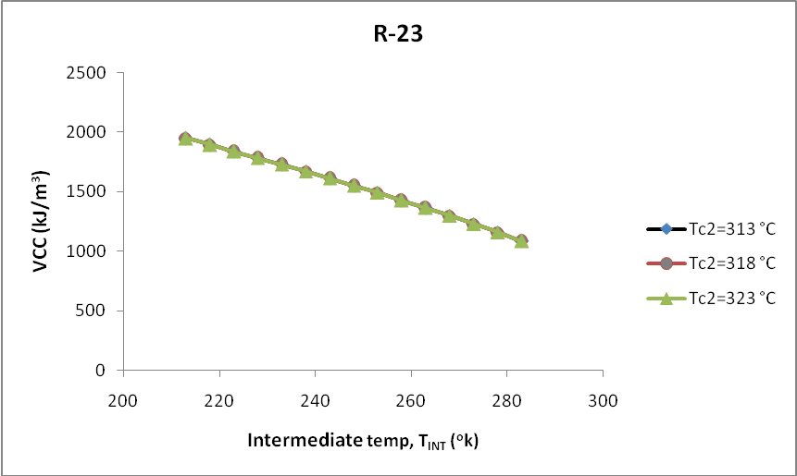
Fig.125 Variation in volumetric cooling capacity with intermediate temperature for cascade system operating with R744 blend at 0.1 mole fraction as low temperature working fluid for R-23 at different condenser temperature.

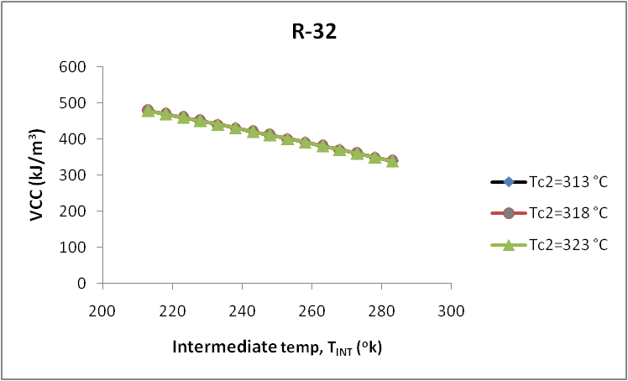

Fig.126 Variation in volumetric cooling capacity with intermediate temperature for cascade system operating with R744 blend at 0.1 mole fraction as low temperature working fluid for R-32 at different condenser temperature.

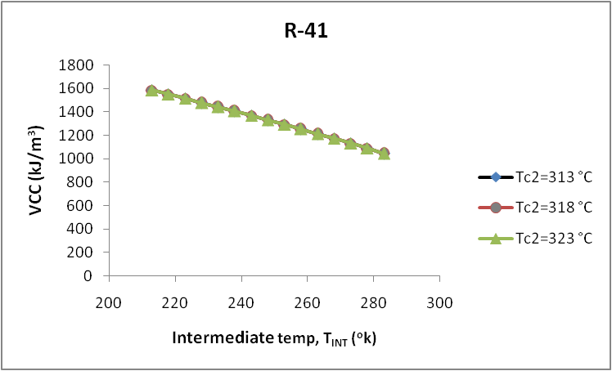

Fig.127 Variation in volumetric cooling capacity with intermediate temperature for cascade system operating with R744 blend at 0.1 mole fraction as low temperature working fluid for R-41 at different condenser temperature.

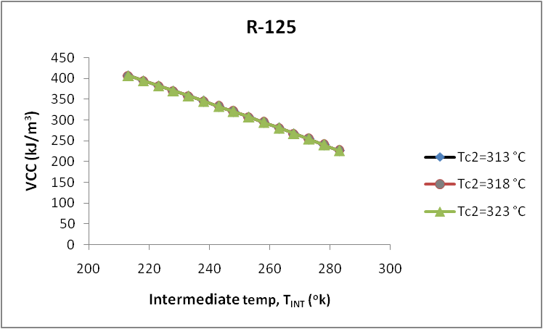

Fig.128 Variation in volumetric cooling capacity with intermediate temperature for cascade system operating with R744 blend at 0.1 mole fraction as low temperature working fluid for R-125 at different condenser temperature.

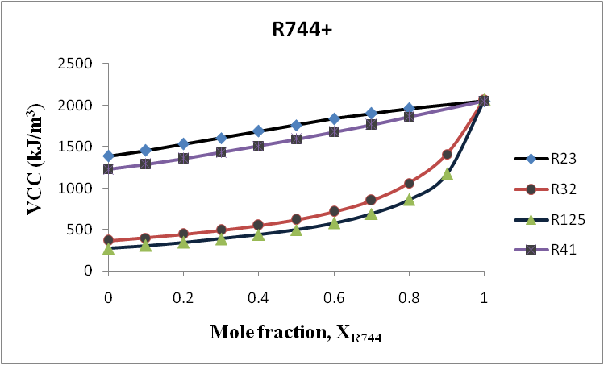

Fig.129 Variation in volumetric cooling capacity with CO₂ mole fraction for cascade system operating with R744 blends as low temperature working fluid.

Chapter 5 CONCLUSIONS
In the present study, thermodynamic analysis have been carried out for cascade refrigeration cycle using CO₂/HFC blends as the low-temperature fluid and ammonia as the high- temperature fluid with a view to extending the applicability of carbon dioxide in such systems below its triple point (216.58 K).
The results obtained permit the following remarks:
- Mass flow rate in high temperature circuit decreases with increase in intermediate temperature for R-125 and R-23.
- Mass flow rate in high temperature circuit increases slightly with increase in intermediate temperature for R-41 and R-32.
- The total compressor work decreases with increase in intermediate temperature.
- The total compressor work for R-41 mixture is highest among all mixtures followed by R-32, R-23 and R-125 respectively.
- COP increases with increase in intermediate temperature up to a temperature (optimum temperature) after this COP decreases with increase in intermediate temperature.
- COP for R-125 mixture is highest among all mixtures followed by R-32, R-41 and R-23 respectively.
- The volumetric cooling capacity decreases with increase in intermediate temperature.
- The volumetric cooling capacity for R-23 mixture is highest among all mixtures followed by R-41, R-32 and R-125 respectively.
- By using liquid vapour heat exchanger on the low-temperature circuit, COP decreases by 1%.
- Optimum temperature range for cascade refrigeration system is 245°K to 260°K without superheating and subcooling and 250°K to 265°K, with superheating and subcooling.

R744 blends can be considered an attractive option for the low-temperature-circuit in cascade refrigeration cycle operating at temperatures approaching 200 ºK due to its low cost, easy availability and favorable properties.

Chapter 6 SCOPE FOR FUTURE WORK

- Further investigating should be carried out for use of different hydrocarbons (HFCs) with carbon dioxide.
- Exergy analysis should be carried out for this cascade refrigeration system using carbon dioxide blend with HFCs in low temperature circuit.
- Exergo economic analysis should be carried out for this cascade refrigeration system using carbon dioxide blend with HFCs in low temperature circuit.

APPENDIX A
Computer program

t1=te1+10
h1=Enthalpy(r23,t=t1,p=pe1)
s1=Entropy(r23,T=T1,p=pe1)
v1=Volume(R23,T=t1,P=Pe1)
Pc1=P_sat(r23,T=tc1)
s2s=s1
h2s=Enthalpy(r23,s=s2s,p=pc1)
h2=h1+((h2s-h1)/nc1)
s2=Entropy(r23,P=Pc1,h=h2)
t3=tc1-5
h3=Enthalpy(r23,T=T3,p=pc1)
s3=Entropy(r23,T=T3,p=pc1)
h3=h4
Pe1=P_sat(r23,T=Te1)
s4=Entropy(r23,P=Pe1,h=h4)
wc1=mr1*(h2-h1)

t2=te2+10
h5=Enthalpy(r717,T=T2,p=pe2)
s5=Entropy(r717,T=T2,p=pe2)
Pc2=P_sat(r717,T=tc2)
s6s=s5
h6s=Enthalpy(r717,s=s6s,p=pc2)
h6=h5+((h6s-h5)/nc2)
s6=Entropy(r717,P=Pc2,h=h6)
t7=tc2-5
h7=Enthalpy(r717,T=T7,p=pc2)
s7=Entropy(r717,T=T7,p=pc2)
h7=h8
Pe2=P_sat(r717,T=Te2)
s8=Entropy(r717,P=Pe2,h=h8)
wc2=mr2*(h6-h5)
wc=wc1+wc2

Qe=mr1*(h1-h4)
mr1*(h2-h3)=mr2*(h5-h8)
cop=Qe/wc
vcc=Qe/(mr1*v1)
te2=tc1-approach
tc1=250
tc2=313
te1=203
mr1=1
nc1=0.7
nc2=0.7
approach=5

FLOW DIAGRAM
Start
Input Parameters T_{c1} , T_{c2} ,T_{E1,} , m_{r1} , η_{c1} , η_{c2} , approach

Calculate Pressures
Calculate Enthalpies
Calculate Specific vol. at compressor inlet

Calculate COP, VCC, W_{C}

Calculate specific entropies
Stop
Calculate refrigerating effect Q_{E}

Calculate Mass Flow rate in high temperature circuit m_{r2}

CHAPTER 7 REFERENCES

- Agnew, B., Ameli, S.M. (2004), “A finite time analysis of a cascade refrigeration system using alternative refrigerants”, Applied Thermal Engineering 24, pp. 2557–2565.
- Arora, C.P. (2002), “Refrigeration and Air Conditioning”, 2nd edition, Tata McGraw Hill, New Delhi.
- Bansal, P.K., Jain, S. (2006) “cascade systems: past, present, and future”, ASHRAE Journal in press.
- Bhattacharyya, S., Mukhopadhyay, S., Kumar, A., Khurana, R.K., Sarkar, J. (2005), “Optimization of a CO₂–C₃H₈ cascade system for refrigeration and heating”, International Journal of Refrigeration, 28, pp. 1284-1292.
- Domanski, P.A., Didion, D.A., Doyle, J.P. (1994), “Evaluation of suction-line/liquid-line heat exchange in the refrigeration cycle”, International Journal of Refrigeration, 17, pp. 487–493.
- Getu, H.M., Bansal, P.K. (2008), “Thermodynamic analysis of an R744–R717 cascade refrigeration system” International Journal of Refrigeration 31, pp. 45–54.
- Houghton, J. (1995), “Global warming the underlying science and the possible response”, International Journal Refrigeration 20, pp. 78-84. .
- Huber, M., Gallagher, J., McLinden, M., Morrison, G. (2002), “Thermodynamic Properties of Refrigerants and Refrigerant Mixtures Database (REFPROP) Version 7.0”, National Institute of Standards and Technology, Thermo physics Division.
- Klein, S.A., Alvarado, F. (2005), “Engineering Equation Solver, Version 7.441”, F Chart Software, Middleton, WI.
- Klein, S.A., Reindl, D.T, Brownell, K. (2000), “Refrigeration system performance using liquid–suction heat exchangers”, International Journal of Refrigeration, 23, pp. 588–596.
- Lee, T.S., Liu, C.H., Chen, T.W. (2006), “Thermodynamic analysis of optimal condensing temperature of cascade-condenser in CO₂/NH₃ cascade refrigeration systems”, International Journal of Refrigeration 29, pp. 1100-1108.
- Missimer, D.J. (1997), “Refrigerant conversion of auto-refrigerating cascade (ARC) systems”, International Journal of Refrigeration 20(3), pp. 201–207.
- Nicola, G.D., Giuliani, G., Polonara, F., and Stryjek, R. (2005), “Blends of carbon dioxide and HFCs as working fluids for the low temperature circuit in cascade refrigerating systems”, International Journal of Refrigeration, 28, pp. 130– 40.
- Pearson, A., Cable, P.J. (2003), “A distribution warehouse with CO₂ as refrigerant” Proceedings of the 21st International Congress of Refrigeration, Washington, DC, paper ICR0624.
- Ratts, E.B., Brown, J.S. (2000), “A generalized analysis for cascading single fluid vapor compression refrigeration cycles using an entropy generation minimization method”, International Journal of Refrigeration 23, pp. 353–365.
- Russmann, H., Kruse, H. (2006), ”The natural fluid nitrous oxide—an option as substitute for low temperature synthetic refrigerants”, International Journal of Refrigeration 29, pp. 799–806.
- Sawalha, S. (2005) “Using CO₂ in supermarket refrigeration”, ASHRAE Journal 47 (8), pp. 26–30.
- Sawalha, S. (2008) “Theoretical evaluation of trans-critical CO₂ systems in supermarket refrigeration. Part II: System modifications and comparisons of different solutions”, International Journal of Refrigeration, 31, pp. 525-534
- Stegmann, R. (2000), “Low temperature refrigeration”. ASHRAE Journal 42(1), pp. 42–50.
- Taylor, R. (2001), “Carbon dioxide-based refrigerant systems”, ASHRAE Journal, pp. 22–27.
- Wilson, I., Maier, D. (2006), “Carbon dioxide for use as a refrigerant”, The University of Auckland, pp. 305–311.

