THE PERFORMANCE ANALYSIS OF AN SI ENGINE WITH VARIOUS BLENDS OF ETHANOL - GASOLINE

A major thesis
Submitted in partial fulfillment
of the requirement for the award of the Degree of

MASTER OF ENGINEERING
in
THERMAL ENGINEERING



Submitted By:-
MOHAN KUMAR
Uni. Roll No...8567
Session 2005-2006

Guided by
DR. R.S MISHRA & Mr.Amit pal
Asst. Prof. Sr.lecturer

Department of Mechanical Engineering

Delhi College of Engineering,
University of Delhi
Delhi

CANDIDATE’S DECLARATION

I hereby declare that the work which is being presented in this project report entitled, “THE PERFORMANCE ANALYSIS OF AN SI ENGINE WITH VARIOUS BLENDS OF ETHANOL – GASOLINE” submitted as major project towards the fulfillment of the requirements for the award of the degree of Master of Engineering with specialization in Thermal Engineering, D.C.E. Delhi, is an authentic record of my own work carried out under the supervision of Sr. Lect. Mr. Amit Pal, Mechanical Engineering Department and DR.R S.Mishra, Asst. Prof. Mechanical Engg. Deptt. at Delhi College of Engineering, Delhi.
The matter embodied in this dissertation report has not been submitted by me for the
award of any other degree.

Mohan Kumar
16/THR/04
University Roll No …8567

CERTIFICATE
This is to certify that the above statement made by the candidate is correct to the best of
our knowledge.

Mr. Amit Pal Dr.R.S MISHRA
Sr.Lecturer Asst.Professor
Mechanical Engg. Deptt, Mechanical. Engg. Deptt
Delhi College of Engineering, Delhi College of Engineering
Delhi. Delhi.
ACKNOWLEDGEMENT

It is distinct pleasure to express my deep sense of gratitude and indebtedness to my learned guide Mr. Amit pal, Sr.Lecturer in the Department of Mechanical Engineering, Delhi College of Engineering, for his invaluable guidance, encouragement and patient review. His continuous inspiration only has made me complete this major dissertation.

I would also like to take this opportunity to present my sincere regards to my teacher DR. R.S MISHRA, Asst. Prof. in the Mechanical Engineering Department for his invaluable support and encouragement.
I would also like to thank Sh. Chintaram, Sh. Manmohan & Sh. Chhote Lal for extending their kind support and sharing their valuable time for the completion of the project.
It is a great pleasure to have the opportunity to extend my heartiest gratitude to everybody who helped me throughout the course of this major project report
I am thankful to my friends and classmates for their unconditional support and motivation during this major project report.

(Mohan Kumar)
ME (Thermal Engineering)
University Roll No. 8567

Abstract

As energy crunch loom large. Fossil fuel stocks are falling. Oil price have broken the $70 barrier par gallon. Many countries are switching to bio-fuels. The EU has decided to use 5.75% bio fuels like ethanol for motor-cars by 2010.China plans to use 10% bio- fuels by 2010.The US already produces about 10 million tones Ethanol. Interestingly, Henry Ford, the father of modern automobile was an ardent advocate of ethanol as a fuel for motor cars. He was a great believer in recycling. Presently we are using 5% ethanol blend with petrol which can be increased to 10%. Brazil is already using 10% ethanol blended with petrol in motor cars which can be increased to 100% ethanol dedicated vehicle. Research has shown that the use of high ethanol content fuels can result in up to a 66% reduction of hydrocarbon emissions. Hydrocarbons typically represent 80% of total vehicle emissions. Current vehicles are capable of using E10, a blend of 90% gasoline and 10% ethanol. The production and research on ethanol compatible vehicles has increased in recent years with a focus on six areas of importance: the engine, engine control system, cold starting strategy, emissions control, compatible materials, and safety. This major project report is concentrated on high energy content of different ethanol-Gasoline Blends E5, E10, E15, E20 and an effort to cover all the other important areas of concern.

TABLE OF CONTENTS

 | Pages
Declaration | I
Certificate | Ii
Acknowledgement | Iii
Abstract | Iv
CHAPTER 1 | 1-3
INTRODUCTION | 1
- Current Scenario Of Energy Consumption And Their Effect On The Environment | 3
CHAPTER 2 | 4-20
TYPES OF ALTERNATE FUEL | 4
2.1 Gasoline | 7
2.2 Methanol | 9
2.3 Liquid Petroleum Gas | 10
2.4 Compressed Natural Gas (CNG) | 11
2.5 Hydrogen | 13
2.6 Electricity | 15
2.7 Bio-Diesel | 17
CHAPTER 3 | 20
LITERATURE REVIEW | 20
3.1 Introduction | 20
3.2 Four-Stroke Cycle Spark–Ignition Engine | 21
3.2.1 Suction Stroke | 21
3.2.2 Compression Stroke | 21
3.2.3Power Stroke | 22
3.2.4 Exhaust Stroke | 22
3.3 The Otto Cycle | 22
3.4 Compression Ratios | 25
3.5 Indicated Thermal Efficiency (Ηth) | 25
3.6 Specific Fuel Consumption (Sfc) | 26
3.7 Gasoline | 27
3.8 Ethanol | 27
CHAPTER 4 CURRENT SCENARIO OF ETHANOL IN INDIA | 27
4.1 Availability Of Ethanol | 30
4.3 Ethanol Production | 30
4.4 Ethanol from Cellulose | 34
4.5 Fermentation | 35
4.6 Dry Milling: | 38
4.6.1 The Major Steps In The Dry Mill Process | 38
4.7 Wet Milling | 40
4.7.1 Inspection And Cleaning | 42
4.7.2 Steeping | 43
4.7.3 Germ Separation | 43
4.7.4 Fine Grinding And Screening | 44
4.7.5 Starch Separation | 44
4.7.6 Syrup Conversion | 46
4.8 Production Of Ethanol From Sugarcane | 48
4.9 Bio- Technology Based Production | 49
4.10 Production Of Ethanol With Enzymes | 50
4.11 Dramatic Cost Reductions | 52
4.12 Ethanol Distillation | 54
CHAPTER 5 Properties of ethanol | 56
5.1 Physical Properties | 58
5.1.1 Vapor Pressure: | 58
5.1.2 Calorific Value | 58
5.1.3 Octane Number | 58
5.1.4 Latent Heat Of Vaporization | 58
5.1.5 Viscosity And Lubricity | 58
CHAPTER 6 ETHANOL BLENDED WITH PETROL | 62
6.1 Ethanol Fuel Mixtures | 63
CHAPTER 7 MATERIALS COMPATIBILITY | 65
7.1 Causes And Solutions To Swelling And Embrittlement of Rubber Parts  7.2 Rubber Replacements  7.3 Galvanic Corrosion | 66  66  68
7.4 Sources Of Galvanic Corrosion | 68
7.5 Solutions To Galvanic Corrosion | 70
7.6 Conclusions To Materials Compatibility Issues | 70
CHAPTER 8 COLD START PROBLEMS AND TECHNOLOGIES | 72
8.1 Heat Storage Units | 72
8.2 Distillation System | 73
8.3 Fuel Pressure Increases | 75
8.4 Pox Reactor: | 75
8.5 Engine Control | 76
8.6 Fuel Injector. | 77
8.7 Spark Control | 78
CHAPTER 9 EMISSIONS AND EMISSION CONTROL ECHNOLOGIES | 79
- 9.1 Emissions Outcomes For Higher Ethanol Blends  - 9.2 EGR Valve  - 9.3 Three-Way Catalytic Convertor  - 9.4 Emission System Technologies  - 9.5 Electrically Heated Catalysts  - 9.6 Hydrocarbon Traps  - 9.7 Secondary Air Systems  - 9.8 Exhaust Gas Bagging  - 9.9 Ethanol Engines And Performance | 80  80  81  82  82  82  83  84  84
CHAPTER 10 EXPERIMENTAL SETUP | 85
Introduction | 85
10.1 Control Panel | 85
10.2 Engine Specifications :- | 86
10.3 Ancillary Components | 87
10.3.1Battery | 87
10.3.2 Ammeter | 88
10.3.3 Voltmeter | 88
10.3.4 Alternator | 89
10.3.5 Load Bank | 89
10.3.6 Rota-Meter | 89
CHAPTER 11 PERFORMANCE EVALUATION | 90
11.1 Gasoline:- | 90
11.1.1 Performance Curve For Gasoline | 90
11.2 PERFORMANCE CURVE FOR E-5 | 92
11.2.1 E-5:- (95% Gasoline +5% Ethanol) | 92
11.3 E-10:- (90% Gasoline + 10% Ethanol ) | 94
11.3.1 PERFORMANCE CURVE FOR E-10 | 94
11.4 E-15:- (85% Gasoline + 15% Ethanol ) | 96
11.4.1 PERFORMANCE CURVE FOR E-15 | 96
11.5 E-20 :- (80% Gasoline + 20% Ethanol ) | 98
11.5.1 PERFORMANCE CURVE FOR E-20 | 98
11.6 Comparison of different Blends: | 100
CHAPTER 12 STORAGE AND SAFETY | 101
12.1 DRAWBACKS OF ETHANOL | 103
CHAPTER 13 CONCLUSION AND SCOPE FOR FUTURE WORK | 104
13.1 CONCLUSION | 105
13.2 SCOPE FOR FUTURE WORK | 106
REFERENCES | 107

TABLE OF FIGURES

Figure 1.1 - Octane Increase vs. Liquid Volume % Ethanol | 2
Figure 3.1:- 4- Cylinder Internal Combustion Engine | 20
Figure3.2: - Otto Cycle | 23
Figure 4.1 :- Production of Ethanol | 35
Figure 4.2:- Production of ethanol | 37
Figure 4.3 :- Dry Milling | 38
Figure 4.4 :- Ethanol Wet milling process | 40
Figure 4.5:-Inspection And Cleaning Of Corns | 42
Figure 4.6:-Steeping | 42
Figure 4.7:-Germ Separation | 43
Figure 4.8:-Fine Grinding and Screening | 44
Figure 4.9:- Starch Separation | 44
Figure 4.10:- Syrup Conversion | 45
Figure 4.11:- Fermentation | 46
Figure 4.12:- Production of Ethanol from grain | 48
Figure 4.13:- Production of Ethanol from Cellulose | 50
Figure 4.14:-The ethanol plant at Manildra’s Bomaderry plant near Nowra. | 55
Figure 5.1:- ASTM Lubricity Test | 60
Figure 8.1:- Cold Start Fuel Injectors | 73
Figure 8.2:- Distillation System | 74
Figure 8.3:- POX Reactor | 76
Figure 9.1:- EHC, Light Off and Main Catalysts | 82
Figure 9.2:- HC Trap and EHC Used for 3.1 L V6 | 83
Figure10.1:- Briggs & Stratton Model 20 INTEK | 86
Figure 10.2:- The Alternator Used | 88
Figure10..3:- The Load Bank | 89
Figure 11.1:- Curve b/w Power Vs Load( petrol) | 90
Figure 11.2:- Curve b/w Efficiency Vs Load(petrol) | 91
Figure 11.3:- Curve b/w Bsfc Vs Load( petrol) | 91
Figure 11.4:- Curve b/w Power Vs Load(E-5) | 92
Figure 11.5:- Curve b/w Efficiency Vs Load(E-5)  Figure11.6:- Curve b/w Bsfc Vs Load(E-5) | 93  93
Figure 11.7:- Curve b/w Power Vs Load(E-10) | 94
Figure11.8:- Curve b/w Efficiency Vs Load(E-10) | 95
Figure 11.9:- Curve b/w Bsfc Vs Load(E-10) | 95
Figure11.10:- Curve b/w Power Vs Load(E-15) | 96
Figure11.11:- Curve b/w Efficiency Vs Load(E-15) | 97
Figure11.12:- Curve b/w Bsfc Vs Load(E-15) | 97
Figure11.13:- Curve b/w Power Vs Load(E-20) | 98
Figure11.14:- Curve b/w Efficiency Vs Load(E-20) | 99
Figure11.15:- Curve b/w Bsfc Vs Load(E-20) | 99
Figure11.16:-Comparison Curve b/w Power Vs Load | 100
Figure11.17:-Comparison Curve b/w Bsfc Vs Load | 100
Figure11.17:-Comparison Curve b/w Bsfc Vs Load  Figure 13.1 - Effect of RVP on Rich Flammability Limit Temperature | 101  103

LIST OF TABLES

TABLES | Pages
Table1:-Properties of gasoline , ethanol, methanol | 28
Table 2:-Typical exchanges associated with ethanol production based on molasses fermentation and distillation | 36
Table 5.1:- Comparison Between |Diesel, Ethanol, And Gasoline | 57
Table 5.2- Physical properties of ethanol | 57
Table 7.1 - Characteristics of E85 and Gasohol. | 64
Table 7.1 - Compatibility of Plastics with Ethanol | 67
Table 7.2 -Compatibility of Metals with Ethanol | 69
Table 7.3 - Necessary Materials for E85 Usage | 71
Table 12.1:- Variation in various parameters with the load for Pure Petrol Mode | 90
Table 11.2:- Variation in various parameters with the load forE-5 Ethanol-Petrol Mode | 92
Table 11.3:- Variation in various parameters with the load for E-10 Ethanol-Petrol Mode | 94
Table 11.4:- Variation in various parameters with the load for E-15 Ethanol-Petrol Blending | 96
Table 11.5:- Variation in various parameters with the load for E-20 Ethanol-Petrol Blending | 98

CHAPTER 1
INTRODUCTION
The global fuel crises in the 1970 have triggered awareness amongst many countries of their vulnerability to oil embargoes and shortages. Considerable attention was focused on the development of alternative fuel sources, with particular reference to the alcohols. A blend of 10% dry ethanol and unleaded gasoline (E10) was commercially introduced into the USA and is still marketed in the Midwest. More recently, the oxygenated and octane enhancing benefits of ethanol have been highlighted as a potential substitute for Methyl Tertiary Butyl Ether (MTBE), an oxygenated additive used to enhance octane and also reduce CO emissions. MTBE has been shown to be highly toxic even in small quantities when it contaminates groundwater. Flexible fuel vehicles introduced in the early 1990’s can be operated on up to 85% ethanol, straight unleaded gasoline or any mixture of the two fuels. The use of ethanol blended with gasoline was a subject of research in the 1970’s and it was shown that ethanol- gasoline blends were technically acceptable for existing gasoline engines. The relatively high cost of ethanol production at that time meant that the fuel could only be considered in cases of fuel shortages. Today the economics are much more favorable in the production of ethanol and it is able to compete fairly well with standard gasoline. Hence there has been renewed interest in the ethanol- gasoline blends with particular emphasis on emissions reductions. In the last two decades of the 20th century, major advances in engine technology have occurred, leading to greater fuel economy in vehicles. The reduction of emissions from engines has become a major factor in the development of new engines and manufacturers are trying to meet the requirements specified by Environmental Protection Agency (EPA). As a result the use of non-conventional fuels as a means of meeting these requirements has generated much attention. When considering an alternative fuel for use in gasoline engines, a number of issues are important. These issues include supply and distribution, integrity of the fuel being delivered to the engine, emissions and engine durability. An additional factor that makes ethanol attractive as a fuel extender or substitute is that it is a renewable resource.[2]
The dwindling fossil fuel sources and the increasing dependency of the USA on imported crude oil have led to a major interest in expanding the use of bio-energy. A national bio-based products and bio-energy initiative was formally proposed in 1999 and steps have been taken to identify areas of research presently underway and those that need to be expanded (Bio-energy, 2000). Research into the use of ethanol in gasoline engines fits well into this initiative. The objectives of this report are to review the studies that were completed on ethanol-petrol blends in the 1980’s when the emphasis was on providing a gasoline fuel extender or substitute, and to review research undertaken recently where emissions reductions and technical feasibility in the new generation of petrol engines have been the main focus.
Increasingly stringent pollution laws, awareness of global warming and continuously increasing oil prices are advancing the production of alternative fueled vehicles. Alternatives such as a natural gas and propane fulfill these requirements, but like imported oil, their supply is limited. A solution to this problem is to use fuels that are renewable and yet exhibit properties similar to gasoline. Alcohols exhibit properties similar to gasoline. Alcohols such as methanol and ethanol have been combined with gasoline to make blends that reduce emissions while increasing octane number. The increase in octane with the increase in volume percent ethanol.[3]
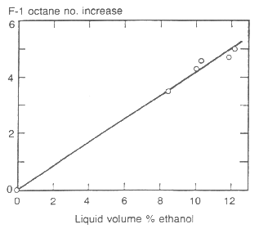
Figure 1.1 - Octane Increase vs. Liquid Volume % Ethanol
While methanol produces similar results as ethanol, it is not as favorable of a petroleum substitute since methanol is produced from coal, a natural resource. Ethanol is produced primarily from corn and sugar but can be produced from a variety of biomass materials including woody plants and agricultural and forestry residue. Ethanol’s production process from grain or sugar crop. [6]
1.1 Current Scenario of energy consumption and their Effect on the environment:-
- Proved non-renewable petroleum resources are estimated to last till 2049 and available natural gas resources till 2070.
- Half of the petroleum or 20% of the total energy is being consumed by 550 million automobiles.
- CO emission will increase by 65% over the current level till 2010
- Earth temperature has increased by 3.5 deg. Centigrade from 1630.
- Oil prices are touching a whopping 140 dollar par barrel.[4]
CHAPTER 2
TYPES OF ALTERNATE FUEL

TYPES OF ALTERNATE FUEL FOR SI ENGINE:-
Researches have been going on many types of alternate fuel which are beneficial for both the environment and engine, and they can be produced as per the demand. Following type of alternative fuels is available:-
- Alcohol
- Ethanol
- Methanol
3. CNG (Compressed Natural Gas)
4. LPG (Liquefied Propane Gas)
5. FUEL CELLS
6 BIO-DIESEL etc.
2.1 GASOLINE

Production
Early refineries used a simple distillation process to separate crude oil into its components according to their boiling points. The petrol produced by this method was only that naturally occurring in the crude oil.
As demand for motor spirit grew, engineers and chemists found that more severe heating of the higher boiling points hydrocarbons broke them down, or 'cracked' them, into smaller, lower boiling hydrocarbons more suitable for petrol production. From 1913, thermal cracking was used to increase petrol production.
Substances known as 'catalysts' were later found to do a better job of cracking hydrocarbons than heat alone, by speeding up the reaction and producing a greater yield of higher octane petrol.

Chemistry

Petrol is a derivative of petroleum. It is essentially a complex mixture of hydrocarbons that boils below 180⁰C. The hydrocarbon constituents are those that have 4 - 12 carbon atoms in their structure and fall into three general types:
• Paraffin, such as hexane (C₆H1₄), and octane (C₈H₁₈)
• Olefins, such as hexane (C₆H₁₂)
•Aromatics such as benzene (CH) and toluene
Petrol consists of a blend of more than 200 such hydrocarbons either occurring naturally in petroleum or manufactured from it. Petrol can vary considerably in composition, depending upon the source of the original crude oil, and the processes used in production. When there is enough oxygen, hydrocarbons can be burnt to form C0₂ and water vapor, releasing heat.
The equation for the complete combustion of hexane is:

For hexane: 2C₅H₁₄ + 190₂ = 12C0₂ + 14H₂0
For octane: 20₁₈ + 250₂ = 16C0₂ + 18H₂0

For hexane: 2C₆H₁₂ + 180₂ = 12CO_{Z} + 12H20
For benzene: 2C₅H₆ + 150₂ = 12C0₂ + 6H₂0
If insufficient oxygen is available, incomplete combustion occurs, forming carbon monoxide CO, nitrogen oxides and carbon, as well as carbon dioxide and water.

Environmental considerations:
Exhaust emissions from petrol-driven cars include, in addition to C0₂ and water vapor, hydrocarbons, nitrogen oxides and CO. These latter emissions may be effectively reduced by fitting a three-way catalytic converter that converts these three types of exhaust components into less reactive substances.
Volatile organic compounds are also emitted into the atmosphere through evaporation from fuel tanks, carburetors and refueling stations. These emissions can be reduced by using carbon canisters containing activated charcoal which absorbs these vapors. Evaporation can also be controlled during manufacturing and distribution with double tank roofs, improved tank seals and vapor recovery units.
An important element in the efficiency of petrol combustion is the octane number. This indicates the ability of the fuel to resist detonation, which is referred to as engine pinging or knocking. Such detonation is caused by the spontaneous igniting of the fuel and air in the engine cylinders before the spark is fired. Higher octane fuels are less susceptible to detonation and thus prevent engine knock and in turn maintain engine power.
Lead has traditionally been added to petrol as an effective and economic method of boosting octane quality. However, concerns have recently arisen about the possible health effects of lead in vehicle exhaust emissions. Concerns also about atmospheric 'smog' pollution have led to the desire to remove up to 90% of the smog precursors present in engine exhaust gases by the use of catalytic converters. This in turn requires that the petrol be lead free if the catalyst is to function properly. In Australia this resulted in a decision to change to cars which operate on unleaded petrol with a lower octane than previously used, so that changes to refinery configurations, to make up for the octane loss upon the removal of the lead, would not be too extensive.
This change is not without its disadvantages, since a lower octane fuel results in a less efficient engine, and an overall increase in carbon dioxide emissions. Some additional C0₂ emissions also arise from the changed refining processes. Thus, although the move to unleaded petrol may be successful on a local level from a smog point of view, it is likely to have an increased impact upon global air quality in terms of C0₂.

Economic considerations:

Most cars today run on petrol because it is a relatively cheap, convenient, safe and reliable fuel that yields good vehicle performance complete with a good vehicle range capability. It can also be stored and handled easily.

2.2 METHANOL

Methanol (CH₃0H), also known as wood alcohol, is an alcohol fuel and it can be used as an alternative fuel in flexible fuel vehicles that run on M85 (a blend of 85% methanol and 15% gasoline). However, it is not commonly used because automakers are no longer supplying methanol-powered vehicles.

Methanol can be used to make methyl tertiary-butyl ether (MTBE), an oxygenate which is blended with gasoline to enhance octane and create cleaner burning fuel. MTBE production and use has declined because it has been found to contaminate ground water. In the future, methanol could possibly be the fuel of choice for providing the hydrogen necessary to power fuel cell vehicles.

Chemical Properties
As engine fuels, ethanol and methanol have similar chemical and physical characteristics. Methanol is methane with one hydrogen molecule replaced by a hydroxyl radical (OH).

Production
Methanol (CH₃0H) is a clear liquid alcohol that can be produced from natural gas, coal, crude oil and biomass crops such as wood and wood residues as well as directly from catalytic synthesis:
C0+2H₂ =CH₃0H

At present, however, natural gas is by far the most economically and environmentally viable source.
Chemistry
Methanol is the simplest alcohol. It is a clear, colorless liquid.

Combustion of methanol:
2CH₃0H+ 30₂ =2C0₂ + 4H₂0
Currently, pure methanol can be used in purpose-designed engines such as some racing cars, since its very high octane rating allows for the use of very high compression engines producing significantly more power than an equivalent petrol engine.
Pure methanol can be mixed with petrol for use in flexible-fuelled vehicles (FFV) capable of measuring the methanol: petrol ratio being delivered to the engine. This is so that the engine management system can adjust the air: fuel ratio and timing to match the requirements of whatever mixture is being used.
The water solubility of methanol poses a problem. Methanol cannot be used in blends with petrol above 5% in normal cars, and then only with co-solvents, because of the fear of phase separation.

Environmental considerations
Methanol has the potential to reduce greenhouse gas emissions but would need to be produced from biomass to make a possible contribution. Methanol derived from natural gas using current technology offers at best only a small greenhouse gas emission benefit over petrol.
Although the emissions of CO, hydrocarbons and nitrogen oxides are lower in methanol-dedicated cars, the exhaust of these vehicles contains more formaldehyde, a known carcinogen. Methanol can also lead to greater unburnt fuel emissions of methanol and methane which, however, are usually more readily degraded than unburnt hydrocarbons. Methane is a major greenhouse gas. Under combustion, methanol produces neither soot particles nor sulphur oxides. It also yields less nitrogen oxides than any other fuel.

Economic considerations
Methanol is a high cost fuel compared with petrol, but relatively cheap compared with other options. Methanol is extremely toxic and therefore hazardous to handle. It is also corrosive requiring modification of a conventional vehicle's fuel system. It has only half the energy content of petrol, which results in greater fuel consumption per unit volume and shorter traveling range compensated to some extent by its suitability for use at a higher compression ratio and its ability to deliver more power. [9]

2.3 LIQUID PETROLEUM GAS (LPG)

Liquefied Petroleum Gas (LPG) is a petroleum derived, colorless Gas, typically comprised of mainly propane, butane, or a combination of these two constituents.
According to Clean Air Technologies Information Pool (2005), LPG fuel for vehicles is actually a mixture of various hydrocarbons which are gases at atmospheric pressure and temperature but which liquefy at higher pressure like less than 200 psi. LPG is produced as a by product of natural gas processing or crude oil refining. Approximately 30% of the LPG produced from oil refining and another 70% is generated from the natural gas processing.
United States Department of Energy’s Alternative Fuel Data Centre shows that LPG is most widely used alternative fuel in the world, with about 5.7 million vehicles running on it or using it.
Gasoline shows a little change over a normal temperature and pressure range. Propane, however, is a gas at ambient conditions. Its physical properties mainly depend on the temperature and pressure at which they are stored. There must be space left in a LPG storage tank. As the temperature rises, the volume of liquid increases significantly, especially Propane. Due to this Propane system has some kind of safety fill stop to prevent tank fills to no more than 80% to 85%. This provides room for liquid expansion if the temperature increases after the tank is filled. Due to low viscosity of propane and its storage under pressure, it may leak through small cracks, pumps, seals and gaskets more readily than gasoline.
Moreover pressure in the LPG cylinder must be higher than the surrounding in order to ensure steady supply at constant pressure. Thus, regulator is to release any extreme pressure build up. Latent heat of vaporization of LPG is consumed when transforming LPG from liquid to gas state. Therefore Exterior surface of the container is cold when the liquid boils as it obtains energy from the surrounding. Commercially three different grades of LPG are available, Table 1. Shows the various types of LPG available in market. Standard HD5 requires minimum propane content of 90 % and propylene content of less than 5 % (volume basis).

Production:
LPG is a by-product of two sources: natural gas processing and crude oil refining. When natural gas is produced, it contains methane and other light hydrocarbons that are separated in a gas processing plant. Because propane boils at -44⁰F and ethane boils at -127⁰F, separation from methane is accomplished by combining increasing pressure and decreasing temperature. The natural gas liquid components recovered during processing include ethane, propane and butane and other heavier hydrocarbons. Propane and butane along with other gases are also produced during crude refining as a by-product of the process that rearrange or break down the molecular structure to obtain more desirable petroleum compounds.
Chemistry:
LPG is a mixture of light hydrocarbons which are gaseous at normal temperatures and pressures, and which liquefy readily at moderate pressures or reduced temperature. It is odorless and so, for safety reasons, a pungent compound, mercaptan, is added to make any leaks easily detectable.
The main component gases of LPG are.
- Propane (C₃H₈)
- Propylene (C₃H₆)
- Butane (C₄H₁₀ )
Each gas undergoes a reaction during combustion:

Propane:
C₃H₈+ 50₂=3C02+4H20
Propylene: 2C₃H₆+ 90₂= 6C02+6H₂0
Butane: 2C₄H₁₀+ 130₂= 8C0₂+10H₂0

Environmental considerations:
Estimates are that exhaust and evaporative greenhouse emissions are approximately 15 per cent lower from LPG than from petrol vehicles. It does not need lead or other additives to boost its octane rating.
Comparisons of the levels of noxious gas emissions from LPG and petrol vehicles are inconclusive, with test results indicating both higher and lower levels that petrol vehicles. Some recent tests suggest that noxious emissions are worse from LPG vehicles.
LPG is a non-renewable resource.

Economic considerations:
LPG in the liquid form which is easily achieved is a very efficient way of carrying large amounts of gas. In general economic terms it is unattractive, requiring a subsidy, in the form of an excise exemption as an incentive to consumers who must cover the costs of conversion of the vehicle to operate on LPG. [7]

2.4 COMPRESSED NATURAL GAS (CNG)

Natural gas is a mixture of hydrocarbons-mainly methane (CH₄)-and is produced either from gas wells or in conjunction with crude oil production. Natural gas is consumed in the residential, commercial, industrial, and utility markets.
The interest in natural gas as an alternative fuel stems mainly from its clean burning qualities, its domestic resource base, and its commercial availability to end users. Because of the gaseous nature of this fuel, it must be stored onboard a vehicle in either a compressed gaseous state (CNG) or in a liquefied state (LNG).

Chemical Properties:
The main constituent of natural gas is methane, which is a relatively un-reactive hydrocarbon. Natural gas as delivered through the pipeline system also contains hydrocarbons such as ethane and propane; and other gases such as nitrogen, helium, carbon dioxide, hydrogen sulfide, and water vapor.

Production
Natural gas is comprised of a mixture of gases, mainly hydrocarbons, found in geological formations. Methane is the principal component, generally comprising from 87 per cent to 97 per cent by volume of the hydrocarbons depending on the source of the gas.

Chemistry
In addition to methane (CH₄), natural gas also contains small percentages of:
• Ethane (C₂H₆)
• Propane (C³H₈)
• Butane (C⁴H₁₀)
• Pentane (C⁵H¹²)
It can be compressed and used as an automotive fuel.
Its combustion is given by:
CH⁴+20² =C0₂+2H₂0
Environmental considerations
Because of its high octane number, CNG is an excellent fuel for spark ignition engines. Older cars are not difficult to convert from petrol to CNG. However, as engine management systems become more complicated, conversions are becoming more difficult or involve non-optimal engine operation. As a gas it can pose safety hazards during necessarily frequent refueling operations. Although when properly operated and maintained, leakage of CNG is minimal it should be noted that methane is an even more active greenhouse gas than CO₂.
Emissions from CNG-powered vehicles depend on the quality of the vehicle's conversion. In older cars without catalytic converters, non-methane hydrocarbon, CO and nitrogen oxides in exhausts from CNG-fuelled cars are much less than from petrol-driven vehicles. There is less difference between emissions from petrol and CNG in cars with catalytic converters in both instances emissions are greatly reduced. CO emissions are the same while nitrogen oxide emissions may be slightly higher from CNG. Overall there appears to be slightly less greenhouse gas emission from CNG vehicles compared to petrol vehicles. Use of CNG substantially reduces particulate emissions, particularly from the new, dedicated CNG engines now available for buses and trucks. These new engines reduce particulate emissions to very low levels and are expected to rapidly penetrate the city bus fleet sector because of their cleaner image. Many new CNG buses are in operation or on order for several Australian capital cities.

Economic considerations

The benefits of CNG are thus greatly reduced, because the compression ratio and engine efficiency of dual-fuelled cars cannot be increased to take advantage of CNG's high octane number. Storage of CNG is also a problem. Because of its low boiling point, natural gas must be stored in high pressure tanks. These are heavy, reducing payload and space in smaller vehicles. A CNG-fuelled car with a 75 liter tank is about 150kg. heavier than a petrol-driven car of the same size. This is not such a problem with large vehicles such as buses. Natural gas is lighter than air, and will dissipate into the atmosphere if leakage occurs. Like LPG, it is usually odorized to make it detectable. It is non-toxic and non-reactive.
The major problems with CNG are that it is uneconomic because the cost of converting cars is high and the short range between refueling is inconvenient. [8]

2.5 HYDROGEN
The simplest and lightest fuel is hydrogen gas (H₂). Hydrogen is in a gaseous state at atmospheric pressure and ambient temperatures. Hydrogen may contain low levels of carbon monoxide and carbon dioxide, depending on the source.
Hydrogen is being explored for use in combustion engines and fuel cell electric vehicles. On a volumetric basis, the energy density of hydrogen is very low under ambient conditions. This presents greater transportation and storage hurdles than for liquid fuels. Storage systems being developed include compressed hydrogen, liquid hydrogen, and physical or chemical bonding between hydrogen and a storage material (for example, metal hydrides).The ability to create hydrogen from a variety of resources and its clean-burning properties make it a desirable alternative fuel. Although there is no significant transportation distribution system currently for hydrogen transportation use, we can transport and deliver hydrogen for early market penetration using the established hydrogen infrastructure; for significant market penetration, the infrastructure will need further development.
Widespread use of hydrogen as an energy source could help address concerns about energy security, global climate change, and air quality. Fuel cells are an important enabling technology for the hydrogen future and have the potential to revolutionize the way we power our nation, offering cleaner, more efficient alternatives to the combustion of gasoline and other fossil fuels.
Hydrogen's main benefits are
• Stronger national energy security
• Reduced greenhouse gas emissions
• Improved air quality
• Increased energy efficiency

Production

There are two common feedstock for hydrogen production water and hydrocarbons such as methane.
1. Hydrogen is produced from water by hydrolysis, using electricity. The major positive aspect of hydrogen is that there is an almost limitless supply of it in water (if the supply of electricity is limitless), and that it is non-toxic.
2. Hydrogen is produced when hydrocarbons react with steam. While this is a very simple process, it relies upon the earth's finite reserves of hydrocarbons, making hydrogen, in this case, not a true non-fossil alternative. If, however, vegetable oils/plants are used as a source of hydrocarbons, hydrogen becomes a renewable, if expensive, alternative.
Chemistry
Hydrogen is the lightest element in the universe. Under normal conditions, it is a colorless, odorless and tasteless gas. The complete combustion of hydrogen is very clean, provided the peak temperature is limited:
2H₂ + 0₂ = 2H₂0
If it burns at high temperatures, nitrogen in the air is also heated, forming nitrogen oxides. However, the temperature can be controlled by introducing water to the hydrogen/air mixture while still obtaining good combustion. It is also possible to cool the combustion by using excess air since hydrogen will burn even in dilute mixtures.

Environmental considerations
Because hydrogen produced by electrolysis is an indirect user of electricity, which is most often derived from fossil fuel-powered stations, the complete production process may indirectly involve considerable C0₂ emissions. For the total environmental effect of hydrogen to be positive, the electricity used in its production should be generated from renewable sources such as solar, wind or hydro-power.

Economic considerations

Currently hydrogen is used as a fuel only in space rockets. However, some vehicle manufacturers are developing hydrogen powered engines which may be tested as prototypes in about three years' time. The main technical difficulty with hydrogen is storage. In compressed or liquid form, it needs a heavy and expensive tank. Another alternative is to utilize the ability of metal hydrides to absorb hydrogen, and to desorb it when it is needed. Liquefying it is costly in terms of energy use. Safety is a major concern, in use and distribution. Hydrogen is very flammable over a wide range of air: fuel ratios, and it burns rapidly with a high temperature, colorless flame.

2.6 ELECTRICITY
Electricity can be used as a transportation fuel to power battery electric and fuel cell vehicles. When used to power electric vehicles or EVs, electricity is stored in an energy storage device such as a battery. EV batteries have a limited storage capacity and their electricity must be replenished by plugging the vehicle into an electrical source. The electricity for recharging the batteries can come from the existing power grid or from distributed renewable sources such as solar or wind energy.
Fuel cell vehicles use electricity produced from an electrochemical reaction that takes place when hydrogen and oxygen are combined in the fuel cell "stack." The production of electricity using fuel cells takes place without combustion or pollution and leaves only two byproducts, heat and water. Electricity is unique among the alternative fuels in that mechanical power is derived directly from it, whereas the other alternative fuels release stored chemical energy through combustion to provide mechanical power. Motive power is produced from electricity by an electric motor. Electricity used to power vehicles is commonly provided by batteries, but fuel cells are also being explored. Batteries are energy storage devices, but unlike batteries, fuel cells convert chemical energy to electricity.

Production
Electricity is produced from power plants throughout the country, transmitted to substations through high voltage transmission systems, stepped down to lower voltages, and carried to homes and businesses through local distribution systems. This electricity is charged and stored in the onboard rechargeable batteries, which power the motor of the vehicles. Like battery powered vehicles fuel cell vehicles use on-board electric motor. But while drivers must periodically recharge battery powered vehicles with electricity generated elsewhere, fuel-cell vehicles make their own power from on board supply of hydrogen, or a hydrogen-rich fuel such as natural gas, methanol, ethanol or gasoline. This enables drivers to fill up at a service station, rather than recharge the car, making it a more practical solution for today's automobiles.
There are six basic types of fuel cells, solid oxide, phosphoric acid, alkaline, molten carbonate, direct methanol and Proton-Exchange Membrane (PEM).

The PEM fuel cell has several advantages for transportation use:
- High power density
- Relatively quick start up - Compact size
- Low operating temperature - Low noise levels.

Environmental Considerations
Electric vehicles (EVs) do not undergo any combustion process. Mechanical power is directly derived from electricity. There are no tailpipe emissions. Water is the only emission when hydrogen is used as the fuel in fuel cells. But the process of commercial hydrogen production to feed the fuel cell is associated with some C0₂ emissions. Emissions that can be attributed to EVs are generated in the electricity production process at the power plant.

Economical Considerations
EVs have lower "fuel" and maintenance costs than gasoline-powered vehicles. The cost of an equivalent amount of fuel for EVs costs less than the price of gasoline. Also, maintenance for EVs is less-EVs have fewer moving parts to service and replace, although the batteries must be replaced every three to six years.

2.6 BIO-DIESEL

Bio-diesel (fatty acid alkyl esters) is a cleaner burning diesel replacement fuel made from natural, renewable sources such as new and used vegetable oils and animal fats. Just like petroleum diesel, bio-diesel operates in compression ignition engines. Blends of up to 20% bio-diesel (mixed with petroleum diesel fuels) can be used in nearly all diesel equipment and are compatible with most storage and distribution equipment. These low-level blends (20% and less) generally do not require any engine modifications; however, users should consult their OEM and engine warranty statement. Bio-diesel can provide the same payload capacity and as diesel.
Higher blends, even pure bio-diesel (100% bio-diesel, or B100), may be able to be used in some engines (built since 1994) with little or no modification. However, engine manufacturers are concerned about the impact of B100 on engine durability. Additionally, B100 is generally not suitable for use in low temperature conditions. Transportation and storage of B100, however, require special management.

Production
Bio-diesel fuel can be made from new or used vegetable oils and animal fats, which are nontoxic, biodegradable, renewable resources. Fats and oils are chemically reacted with an alcohol (methanol is the usual choice) to produce chemical compounds known as fatty acid methyl esters. Bio-diesel is the name given to these esters when they're intended for use as fuel. Glycerol (used in pharmaceuticals and cosmetics, among other markets) is produced as a co-product.
Bio-diesel can be produced by a variety of esterification technologies. The oils and fats are filtered and preprocessed to remove water and contaminants. If free fatty acids are present, they can be removed or transformed into bio-diesel using special pretreatment technologies. The pretreated oils and fats are then mixed with an alcohol (usually methanol) and a catalyst (usually sodium hydroxide). The oil molecules (triglycerides) are broken apart and reformed into methyl-esters and glycerol, which are then separated from each other and purified. Approximately 55% of the bio-diesel industry can use any fat or oil feedstock, including recycled cooking grease. The other half of the industry is limited to vegetable oils, the least expensive of which is soy oil. The soy industry has been the driving force behind bio-diesel commercialization because of excess production capacity, product surpluses, and declining prices. Similar issues apply to the recycled grease and animal fats industry, even though these feed stocks are less expensive than soy oils.

Environmental considerations
Using bio-diesel in a conventional diesel engine substantially reduces emissions of unburned hydrocarbons, carbon monoxide, sulfates, polycyclic aromatic hydrocarbons, nitrated polycyclic aromatic hydrocarbons, and particulate matter. These reductions increase as the amount of bio-diesel blended into diesel fuel increases. The best emission reductions are seen with B100. Carbon dioxide is one of the main greenhouse gases contributing to global warming. Neat bio-diesel (100% bio-diesel) reduces carbon dioxide emissions by more than 75% over petroleum diesel. Using a blend of 20% bio-diesel reduces carbon dioxide emissions by 15%. Bio-diesel also produces fewer particulate matter, carbon monoxide, and sulfur dioxide emissions (all air pollutants under the Clean Air Act).

Economic considerations
Because little fossil energy is required to move bio-diesel, it is a substitute or extender for traditional petroleum diesel, and special pumps or high pressure equipment for fueling are not needed. In addition, it can be used in conventional diesel engines, so special vehicles or engines to run bio-diesel do not need to be purchased. However, users should always consult with the OEM and engine warranty statement before using bio-diesel.

CHAPTER 3

LITERATURE REVIEW

INTERNAL COMBUSTION ENGINE: AN OVERVIEW
3.1 Introduction
The internal combustion engine converts chemical energy into useful mechanical energy by burning fuel. Chemical energy is released when the fuel mixture is ignited by the spark in the combustion chamber. The gas produced in this reaction rapidly expands forcing the piston down the cylinder on the power. The basic components for a combustion cycle in a four stroke engine are combustion chamber (cylinder), piston, intake port and outlet or exhaust port.

3.2 Four-stroke cycle spark–ignition engine:

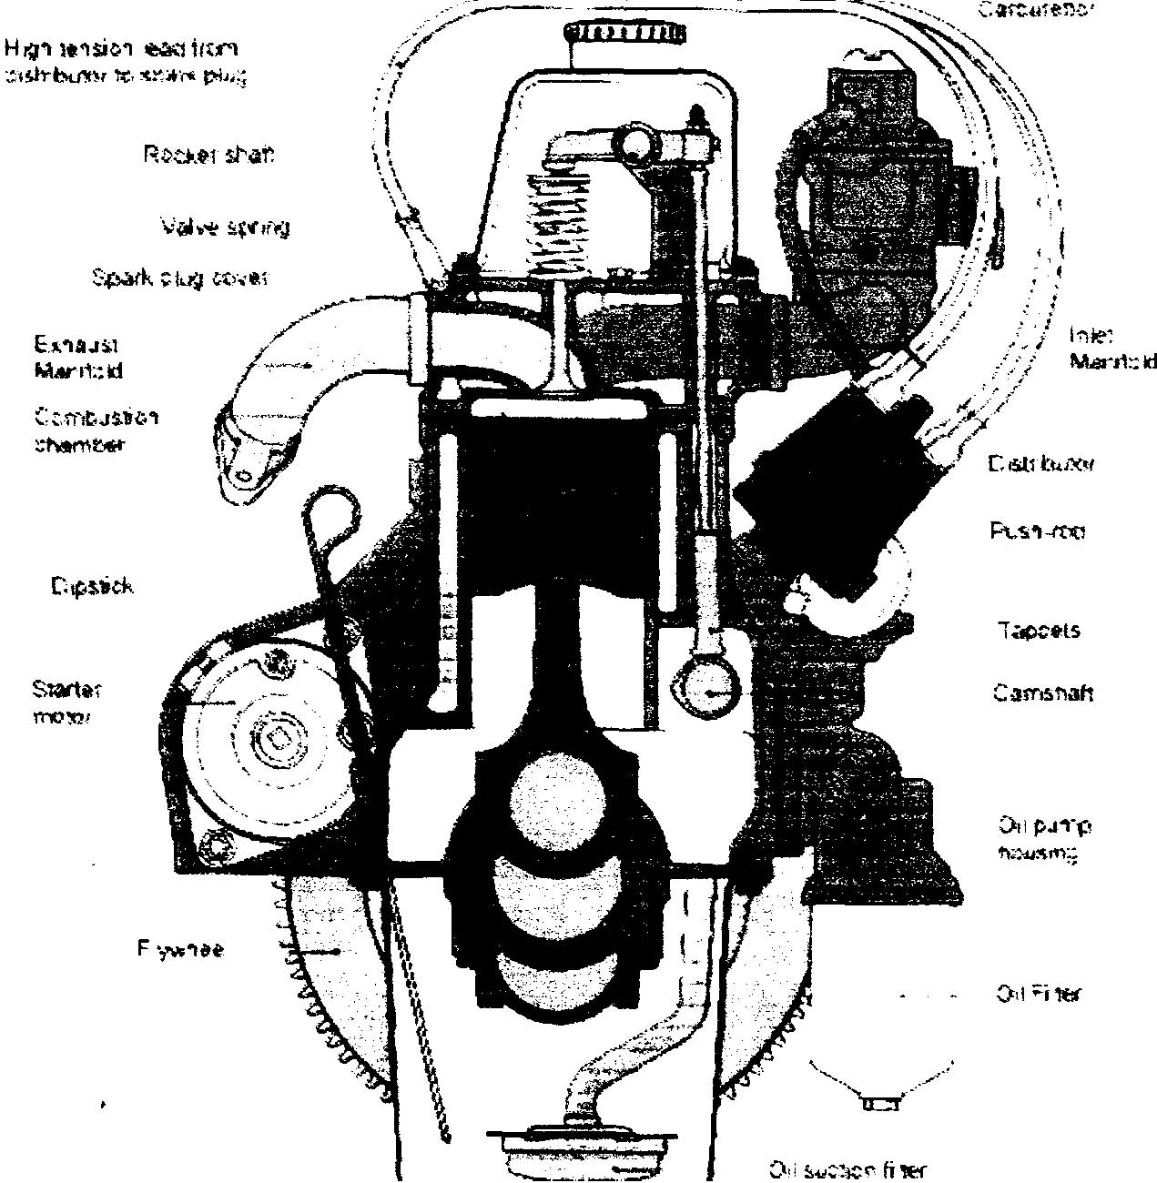

Figure 3.1:- 4- Cylinder Internal Combustion Engine

The pistons reciprocate inside the cylinder, exhaust and intake ports open and close during various stages of the cycle. The movement of the piston up or down the cylinder makes up one stroke of the four stroke cycle (Otto cycle). The linear motion is then converted to rotary motion by the crankshaft. The crankshaft is shaped to balance the pistons which are fired in a particular order to reduce the vibration (typically for a 4-cylinder engine, 1-2-4-3 or 1-3-4-2). The flywheel then helps smoothen out the linear movement of the pistons.

In four stroke cycle engine, the cycle of operation is completed in four-stroke of the piston or two revolution of the crankshaft. Each stroke consists of 180°, of crankshaft of rotation and hence consists of 720° of crankshaft rotation. The stroke in SI engine is:-

- Suction stroke
- Compression stroke
- Power stroke
- Exhaust stroke
3.2.1 Suction stroke:-
At the starting of suction stroke, piston is at top dead centre and about to move downwards the inlet valve is open at this time and exhaust valve is closed. Due to the suction created by the motion of the piston towards bottom dead centre, the charge consisting of fresh air mixed with the fuel is drawn into the cylinder, at the end of the suction stroke the inlet valve closes.
3.2.2 Compression stroke:-
The fresh charge taken into the cylinder during suction stroke is compressed by return stroke of the piston. During the stroke both inlet and exhaust valves remain closed. The air which occupied the whole cylinder is now compressed into clearance volume. Just before the end of compression stroke the mixture is ignited with the help of an electric spark plug located in combustion chamber wall. Burning takes place when the piston is almost at top dead centre. During the burning process the chemical energy of the fuel is converted into sensible energy, producing a temp.rise of about 2000° C and the pressure is also considerably increased.
3.2.3Power stroke:-
Due to high pressure the burnt gases force the piston towards bottom dead centre, both inlet and exhaust valves remain closed. Thus, power is obtained during this stroke. Both pressure and temp. decreases during the expansion.

3.2.3 Exhaust stroke:-

At the of the power stroke the exhaust valve opens, the inlet valve remaining closed, and the piston is moving bottom dead centre to top centre sweeps out the burnt gases from the cylinder. The exhaust valve closes at the end of the exhaust stroke and some ‘residual’ gases remain in the cylinder.

3.3 The Otto Cycle
Each movement of the cylinder up or down the cylinder is one stroke of the four stroke combustion cycle or Otto cycle. Most modern internal combustion engines use the four stroke cycle. The four stroke cycle consists of an induction stroke where air and fuel are taken into the cylinder as the piston moves downwards, a compression stroke where the air and fuel are compressed by the upstroke of the cylinder, the ignition or power stroke where the compressed mixture is ignited and the expansion forces the cylinder downwards, and an exhaust stroke where the waste gases are forced out of the cylinder. The intake and outlet ports open and close to allow air to be drawn into the cylinder and exhaust gases to be expelled. During the intake stroke the inlet valve opens at the top of the cylinder, as the piston moves down air and fuel are drawn into the cylinder. As the piston reaches its lowest position the inlet valve closes and the piston travels upwards compressing the air-fuel mixture. As the piston reaches its highest position at maximum compression a spark ignites the mixture causing a rapid expansion of gas raising the pressure in the cylinder and forcing the piston downwards. Once the cylinder has reached its lowest position the outlet port opens and as the piston rises up the cylinder the exhaust gases are forced out. The valves which open and close the port are sprung to make them naturally close. The valves are opened by a system of rotating cams and pushrods driven by a camshaft which in turn is timed and driven from the crankshaft. The valve timings vary between engines depending on the setup; generally there is some overlap to speed the flow of gases as shown below.

Named after Nikolaus Otto (1832-1891), the Otto cycle used as an ideal approximation for the spark-ignition engine. The Otto cycle consists of four idealized processes:

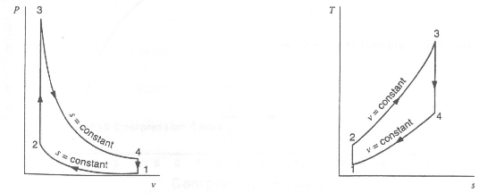
Figure3.2: - Otto Cycle
The Otto cycle creates the governing equations for thermal efficiency of a spark ignition engine. The Otto cycle is shown in Figure3.2 and the equations related to the Otto cycle follow:
1 to 2 adiabatic (no heat transfer) and reversible compression
2 to 3 heat addition, Q₂₃; at constant volume i.e. combustion is assumed to be so rapid that the piston does not move during the combustion event
3 to 4 adiabatic and reversible expansion
4 to 1 heat rejection, Qa1, at constant volume to complete the cycle

The Otto cycle's thermal efficiency η_{otto} is given by:
η_{otto} = W_{net} /Q23 (3.1)
From the 1st Law of thermodynamics for a complete cycle
ΔU=Q-W=0

W_{net} = Q_{net} = Q23 - Q41 (3.2)

Substituting (3.2) into (3.1) we have

η_{otto} = Q23 - Q41

Q23 = 1- Q41 /Q23 (3. 3)
Assuming air to be a perfect gas we have constant specific heat capacities; thus, for a fixed mass of air we have
Q23 = mCv (T3-T2)
Q41 = mCv (T4 –T1)
Thus
η_{otto} = 1 –(T4 - Tl)/ (T3 - T2) (3.4)

The heat addition and rejection processes are both isentropic, PV is a constant.
Thus:
T3 = T4 (V1/ V2) ^{y-1}
T2 = T1 (V1/V2)^{Y-1}
Where
Y is the ratio of gas specific heats
V1 /V2 is the compression ratio, r of the engine.
Substituting into equation (3.4) we have
η_{otto} = 1 - (1/r-1)

3.4 Compression Ratios
One of the biggest gains in performance with ethanol fuels in IC engines comes from increasing the compression ratio. In terms of energy, increased compression ratio increases the engine’s thermal efficiency.
Important parameter which affects the engine performance of the engine and its efficiency.
  - Indicated thermal efficiency (η_{th}) :-
Indicated thermal efficiency is the ratio of the energy in the indicated horse power to fuel energy.
η_{th}= Energy In Power / Energy Supplied by Fuel
η_{th} = ip / m_{f} Q_{lhv} ................( 3.5)
Where:
Q_{H} = input energy
Q_{L} = energy lost
C_{v} = specific heat of air at constant volume
T₁ = inlet air temperature
T₂ = temperature after compression
T₃ = temperature at end of power stroke
T₄ = exhaust temperature
k = ratio of specific heats of air Cp/Cv = 1.4
V₁ = V₂ = cylinder volume at BDC
V₂ = V₃ = cylinder volume at TDC
η_{th} = thermal efficiency
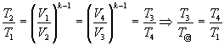 ............... (3.6)
As can be observed from Figure 3.2 the compression ratio r_{v} is:
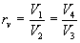 ............... (3.7)

The combinations of Equations 3.5,3.6 and 3.77 produce an expression (Equation 3.8) which describes the thermal efficiency of a spark ignition engine n_{th}:
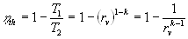............... (3.8)
3.6 Specific Fuel Consumption (SFC):-

The fuel consumption of engine are generally expressed in the terms of specific fuel consumption in grams per horsepower-hour or per KWhr.

Brakes specific fuel consumption and indicated specific fuel consumption are the specific fuel consumption on the basis of bhp (bp) and ihp (ip).

specific fuel consumption is an important characteristics when comparing the performance of two engines or comparing the performance of the same engine at loads.
Bsfc = (Fuel used in kg/h) / b.p in KW =m_{f} /b.p kg/kWh
Isfc = (Fuel used in kg/h) / i.p in KW =m_{f} / i.p kg / kWhr
3.7 Gasoline:-
Gasoline is the lightest liquid petroleum fraction. All material boiling up to 200°C is generally considered as gasoline .this is mixture of a number of hydrocarbons (more than 40). The composition depends upon the crude oil and refining process. Gasoline lies in specific gravity range 0.70 to 0.78. this covers most of fuels used for spark–ignition engines. Gasoline is the major product of the petroleum industry and forms most of the SI engine. it is a mixture of various hydrocarbons.[27]

3.8 Ethanol:-

General Information

- Systematic name: Ethanol
- Other names Ethyl alcohol
Grain alcohol
Hydroxyethane
- Molecular formula: C₂H₆O
- Molar mass: 46.07 g/mol
- Appearance: Colorless liquid
- Auto-ignition temperature: 363 C
- Flash point: 13 C[27]

Property | Gasoline | Methanol | Ethanol
1. Chemical formula | mC_{n}H_{2n} | CH₃OH | C₂H₅OH
2. Molecular weight | 112 | 32.0 | 46.0
3. Composition by weight - %  Carbon  Hydrogen  Oxygen | -  84.0  16.0  Nil | -  37.5  12.5  50.0 | -  52.0  13.0  35.0
4. Specific gravity at 15.5 °C | 0.7 to0.75 | 0.796 | 0.794
5. Boiling point or range °C | 30.0 | 65.0 | 78.0
6. latent heat of vapor^{n}. Kcal/kg | 70-100 | 264.0 | 204.0
7.Vapour pressure at 58°C | 0.8 | 0.32 | 0.21
8. Lower calorific value Kcal/kg | 10,500 | 4700.00 | 6400.0
9.Mixing heating value Kcal/kg air | 714 | 734.00 | 711.0
10. Stoichiometric air/fuel ratio | 14.17 | 6.4 | 9
11. Ignition limit | 6.0-22.0 | 2.15-12.8 | 3.57-17
12. Octane numbers  a) Research  b) Motor  Cetane No. | -  91 (Regular) 82 (Regular)  8.14 | -  114  94  3 | -  111  94  8
13. Self ignition temp. °C | 300-450 | 478 | 363

Table1:-Properties of Gasoline , Ethanol, Methanol.
CHAPTER 4
CURRENT SCENARIO OF ETHANOL IN INDIA
India is the second largest producer of sugarcane in world. India imports nearly 70% of its annual crude petroleum requirement, which is appox. 110 million tons. The prices are in the range of US$ 50-70 per barrel, and the expenditure on crude purchase is in the range of Rs.1600 billion per year, impacting in a big way, the country's foreign exchange reserves.( Oil Prices touched a record high of $70 per barrel ).
The Indian petroleum industry now looks very committed to the use of ethanol as fuel, as it is expected to benefit sugarcane farmers as well as the oil industry in the long run. Ethanol (FUEL ETHANOL) can also be produced from wheat, corn, beet, sweet sorghum etc. Ethanol is one of the best tools to fight vehicular pollution, contains 35% oxygen that helps complete combustion of fuel and thus reduces harmful tailpipe emissions. It also reduces particulate emissions that pose a health hazard.
In the first phase (2004) of the project, ethanol- blended petrol is being supplied through retail outlets in nine States and four Union Territories. These states are Andhra Pradesh, Goa, Gujarat, Haryana, Karnataka, Maharashtra, Punjab, Tamil Nadu and Uttar Pradesh. The four Union Territories include Chandigarh, Dadra and Nagar Haveli, Daman and Diu and Pondicherry. Petrol blended with 5 per cent ethanol would be supplied by petrol pumps all over the country under the second phase towards the end of the year. The content of ethanol blending would be increased to 10 per cent in the third phase of the programme scheduled for 2005.
Most industrial ethanol is denatured to prevent its use as a beverage. Denatured ethanol contains small amounts, 1 to 2 percent of several different unpleasant or poisonous substances. The removal of all these substances would involve a series of treatments more expensive than the federal excise tax on alcoholic beverages. These denaturants render ethanol unfit for some industrial uses. In such industries un-denatured ethanol is used under close federal supervision.[8]

4.1 Availability of Ethanol.
In the absence of a well-knit policy in the past for purchasing and blending ethanol, not many distilleries have been producing ethanol. Only three distilleries attached to sugar mills had war years’ experience, and were able to gear themselves up to supply ethanol immediately. Now, about 11 factories in Uttar Pradesh will be adding facilities to produce about 75 million liters of anhydrous alcohol by end-September; 7 units in Tamil Nadu (production capacity of 62.5 million liters of anhydrous alcohol); 8 units in Karnataka (anhydrous alcohol production capacity of 66.5 million liters); and 4 units in Andhra Pradesh (capacity of over 40 million liters). Similar steps have also be taken up by the cooperative sector units in Maharashtra, Punjab and UP.
As capacities are built up, the oil sector should also be able to generate that much demand for ethanol to guard against any idling capacity. The Petroleum Ministry may therefore like to look into this matter and ensure that the oil sector speeds up the creation of requisite facilities for blending ethanol with petrol. So far generation of demand for ethanol has been very low and it takes considerable time for IOC’s units to finalize purchase of ethanol against offers made by distilleries in response to their tenders.[10]
PRODUCTION OF ETHANOL
4.2 Introduction
India is the second largest producer in terms of sugarcane production; India and Brazil are almost equally placed. In Brazil, out of the total cane available for crushing, 45% goes for sugar production and 55% for the production of ethanol directly from sugarcane juice. This gives the sugar industry in Brazil an additional flexibility to adjust its sugar production keeping in view the sugar price in the international market as nearly 40% of the sugar output is exported.
The annual projected growth rate in the area under sugarcane at 1.5% per annum has doubled during the last five years. This is because it is considered to be an assured cash crop with good returns to the farmers vis-à-vis other competing crops.
India is currently passing through a glut situation with closing stocks at the end of the year of over 100 lakh tons since 1999-2000. Correspondingly, molasses production has also increased. The table below gives the production of molasses, alcohol utilization by the alcohol-based chemical industry, potable sector and the surplus at the end of each year. It is therefore evident that along with sugarcane production, phenomenal growth is also taking place in the production of molasses, the basic raw material for the production of ethanol from sugarcane. Of course, there are also other agro routes available to produce ethanol.[12]
According to MoPNG (MINISTRY OF PETROLEUM AND NATURAL GAS), 5% ethanol blends on an all-India basis would require 500 million liter of ethanol. The current availability of molasses and alcohol would be adequate to meet this requirement after fully meeting the requirement of the chemical industry and potable sectors. In the Indian Sugar Mill Association, this matter was recently examined and it was concluded that instead of taking up the scheme on a state-wise basis, it would be appropriate to take it up in metropolitan and other cities where environmental pollution is a major concern. The blending should be taken up to 10% and introduced selectively to make a better impact on the environment, as no changes in the engine or carburetor are required, and other countries are already carrying this out successfully.
There is considerable scope for further reduction in the cost of production of both sugarcane and sugar in India with liberalization of controls on the sugar industry. Consolidation of land holdings and corporate farming on the raw material side and expansion of capacity on the unit size are important developments and would lead to substantial improvements in productivity, thereby rendering India a cost-effective producer of sugar in the world.
The area under sugarcane is presently less than 2% of total cultivable area in the country and about 3% of the irrigated area. There is considerable scope for increasing the area under sugarcane considering the fact that it is more profitable compared to other crops. The Planning Commission has visualized a conservative increase in area under sugarcane by 6 lakh hectares during the 10th Plan period, but considering past trends, the area under cane is likely to exceed 5 million hectares.
During the 10th Plan period, the annual incremental growth in consumption has been estimated at 9 lakh tons per annum. For the first time the Indian Government has fixed a target of 15 lakh tons per annum for export for this period. However, the production target was fixed at 21.3 million tons keeping in view the large carry forward stocks at the beginning of the period and to correct the demand-supply distortions presently caused. These targets are achievable looking at the performance of the industry in the past with a production of 18.5 million tons achieved in 2000-01.
In conclusion, the sugar industry will not be lacking in meeting the requirement of ethanol. In a market economy, there would be a considerable shift from the gur and khandsari sectors which are inefficient producers with poor quality. In the current scenario of glut in sugar production, it may be advisable to divert such additional cane for the production of alcohol after meeting the sweetener requirement. The additional availability of alcohol on the assumption that the entire cane is utilized for the production of sweeteners will be about 200 million liters over and above that indicated in the table. Alternatively, if additional cane available is utilized for the production of alcohol to bring in a balance in the demand and supply of sugar, the alcohol production at the end of the 10th Plan would be around 1,485 million liters.
Such flexibility has become very relevant in the current scenario of economy liberalization and more particularly as a means to correct the aberrations in sugar production.
The task force on the sugar industry for the Tenth Five Year Plan has suggested the evolution of a national policy on alternative fuels, which would include the use of ethanol-blended gasoline.
Until such a policy is evolved, sugar factories and distilleries should be encouraged to produce ethanol from the surplus alcohol available with them, a report of the task force says. For this, it suggests providing loans from the Sugar Development Fund at 6 per cent per annum for up to 60 per cent of the project cost.
The ministry of petroleum and natural gas and the oil companies, in consultation with the department of food and public distribution, the All-India Distilleries Association and the apex bodies of the sugar industry, can set a reasonable price for ethanol produced by distilleries for the purpose of blending with gasoline.
There is a need to compare ethanol prices with other oxygenates-cum-octane boosters such as MTBE, and not with gasoline, the report states. As an oxygenate, ethanol contains oxygen, which naturally reduces its calorific value but improves the combustion efficiency and significantly reduces air pollution.
Considering the environment-friendly characteristics of ethanol-blended gasoline as an automobile fuel, the pricing of ethanol needs to be viewed not only in terms of a financial cost-benefit analysis, but also in terms of an economic cost-benefit analysis, the report adds.
In Brazil 20-24 per cent of ethanol is blended with gasoline. In the US, 10 per cent of ethanol, produced mainly from maize, is blended with gasoline.
There has been a steady increase in the production of alcohol in India, with the estimated production rising from 887.2 million litres in 1992-93 to nearly 1,654 million litres in 1999-2000. Surplus alcohol leads to depressed prices for both alcohol and molasses.
According to the task force, the projected alcohol production in the country will increase from 1869.7 million litres in 2002-03 to 2,300.4 million litres in 2006-07. Thus the surplus alcohol available in the country is expected to go up from 527.7 million litres in 2002-03 to 822.8 million litres in 2006-07.
Utilization of molasses for the production of ethanol in India will not only provide value-addition to the byproduct, it can also ensure better price stability and price realization of molasses for the sugar mills. This will improve the viability of the sugar mills, which will in turn benefit cane growers.
With gasoline demand expected to increase from 7.9 million tones in 2001-02 to 11.6 million tones in 2006-07, the requirement of ethanol at 5 per cent blending is expected to rise from 465 million liters to 682 million liters.[21]
4.3 ETHANOL PRODUCTION
The process of making alcohol has been around since virtually as long as man has been on this earth, though it has been immensely refined and upgraded in recent years leading to much improved efficiency. There are three main uses for ethanol (industrial, beverage and fuel) and the production processes vary slightly for each of them, but the main steps are the same.
Examples of industrial uses of ethanol would include ethanol used in perfumes, aftershaves and for cleaners. Beverage ethanol is used for drinking and must meet strict production standards because it will be used for human consumption.
4.4 ETHANOL FROM CELLULOSE

Cellulosic ethanol is fuel ethanol made from cellulosic biomass – plant matter composed primarily of inedible cellulose fibers that form the stems and branches of most plants. Crop residues (such as corn stalks, wheat straw and rice straw), wood waste, and even municipal solid waste are potential sources of cellulosic biomass. High-biomass dedicated energy crops, such as switchgrass, are also promising cellulose sources.
Cellulosic biomass is a highly undervalued and underutilized energy asset in India and around the world. Many forms of cellulosic biomass can contribute to energy solutions, including grain crops and switch grass, or crop residues like corn stalks, wheat straw, rice straw, grass clippings, and wood residues. These cellulose-containing natural waste products are widely abundant and can be sustain ably produced: indeed, cellulose has been estimated to make up half of all the organic carbon on the planet. [22]

4.5 FERMENTATION

Ethanol can be produced by fermentation of organic materials such as sugar, potatoes, rice, and molasses, or it can be produced from mineral oil. The fermentation of organic matter can produce liquor with 10-15% ethanol. The liquor is distilled to remove the water and other constituents and obtain a high-grade ethanol. The exchanges associated with alcohol fermentation and distillation varies from plant to plant depending on technology, equipment used as well as operational practices. The ethanol can be produced from various feedstocks such as sugarcane, grain sorghum, wheat, barley, or potatoes, corn. Brazil, the world's largest ethanol producer, makes the fuel from sugarcane.
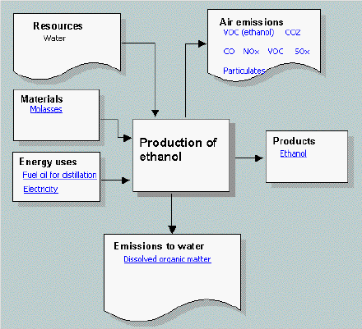
Figure 4.1:- Production of Ethanol

Table 2:-Typical exchanges associated with ethanol production based on molasses fermentation and distillation.
Alcohol Production
(in million liters)
Alcohol Year | Molasses Prod. | Production of  Alcohol | Industrial Use | Potable Use | Other Uses | Surplus Availability
1998-99 | 7.00 | 1411.8 | 534.4 | 5840 | 55.2 | 238.2
1999-00 | 8.02 | 1654.0 | 518.9 | 622.7 | 576 | 455.8
2000-01 | 8.33 | 1685.9 | 529.3 | 635.1 | 588 | 462.7
2001-02 | 8.77 | 1775.2 | 5398 | 647.8 | 59.9 | 527.7
2002-03 | 9.23 | 1869.7 | 550.5 | 660.7 | 61.0 | 597.5
2003-04 | 9.73 | 1969.2 | 578.0 | 693.7 | 70.0 | 627.5
2004-05 | 10.24 | 2074.5 | 606.9 | 728.3 | 73.5 | 665.8
2005-06 | 10.79 | 2187.0 | 619.0 | 746.5 | 77.2 | 742.3
2006-07 | 11.36 | 2300.4 | 31.4 | 765.2 | 81.0 | 822.8
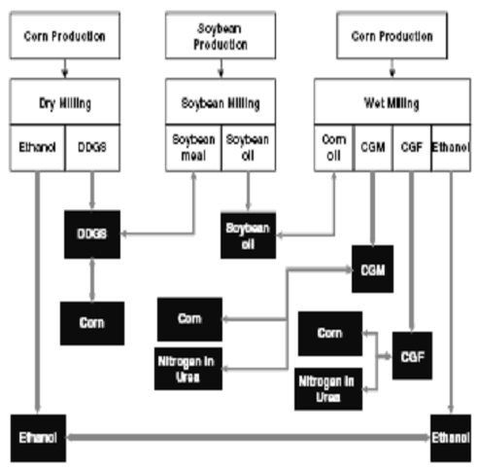
FIGURE 4.2:- Production of ethanol

Ethanol can also be made by following two processes:-
1. DRY MILL PROCESS
2. WET MILL PROCESS.

4.6 Dry Milling: Most of the ethanol in the world is made using the dry mill method. In the dry mill process, the starch portion of the corn is fermented into sugar the distilled into alcohol. 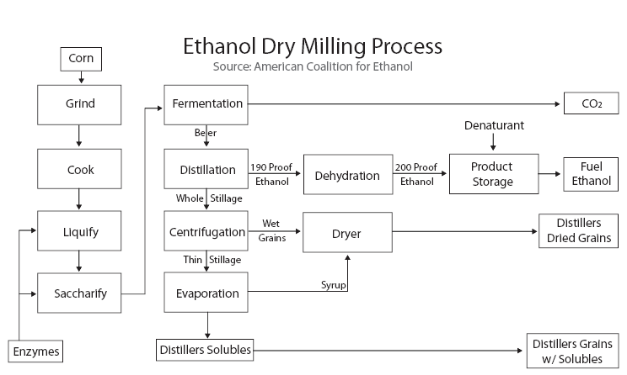
FIGURE 4.3:- Ethanol dry milling process
4.6.1 The major steps in the dry mill process are:
1. Milling. The feedstock passes through a hammer mill which grinds it into a fine powder called meal.
2. Liquefaction. The meal is mixed with water and alpha-amylase, then passed through cookers where the starch is liquefied. Heat is applied at this stage to enable liquefaction. Cookers with a high temperature stage (120-150 degrees Celsius) and a lower temperature holding period (95 degrees Celsius) are used. High temperatures reduce bacteria levels in the mash.
3. Saccharification. The mash from the cookers is cooled and the secondary enzyme (gluco-amylase) is added to convert the liquefied starch to fermentable sugars (dextrose).
4. Fermentation. Yeast is added to the mash to ferment the sugars to ethanol and carbon dioxide. Using a continuous process, the fermenting mash is allowed to flow through several fermenters until it is fully fermented and leaves the final tank. In a batch process, the mash stays in one fermenter for about 48 hours before the distillation process is started.
5. Distillation. The fermented mash, now called beer, contains about 10% alcohol plus all the non-fermentable solids from the corn and yeast cells. The mash is pumped to the continuous flow, multi-column distillation system where the alcohol is removed from the solids and the water. The alcohol leaves the top of the final column at about 96% strength, and the residue mash, called stillage, is transferred from the base of the column to the co-product processing area.
6. Dehydration. The alcohol from the top of the column passes through a dehydration system where the remaining water will be removed. Most ethanol plants use a molecular sieve to capture the last bit of water in the ethanol. The alcohol product at this stage is called anhydrous ethanol (pure, without water) and is approximately 200 proof.
7. Denaturing. Ethanol that will be used for fuel must be denatured, or made unfit for human consumption, with a small amount of gasoline (2-5%). This is done at the ethanol plant.
8. Co-Products. There are two main co-products created in the production of ethanol: distillers grain and carbon dioxide. Distillers grain, used wet or dry, is a highly nutritious livestock feed. Carbon dioxide is given off in great quantities during fermentation and many ethanol plants collect, compress, and sell it for use in other industries. [15]
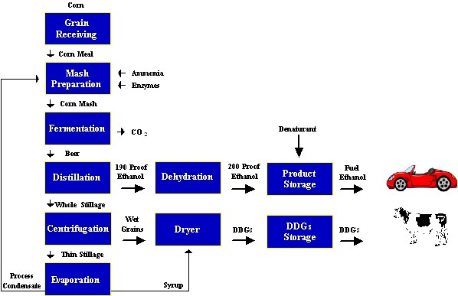
FIGURE 4.4:- Dry Milling
4.7 Wet Milling: This process uses both chemical and physical methods of separating the components of the corn. Extractable starch is the key measure of corn value, not just total starch. Waxy corn offers unique starch characteristics that are valued by food manufacturers and industrial users.

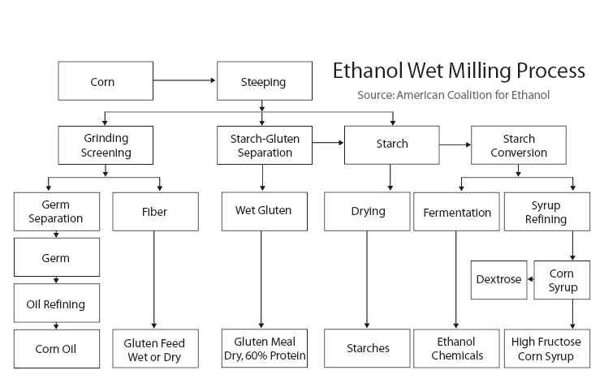
FIGURE 4.5:- Ethanol Wet milling process

4.7.1 INSPECTION AND CLEANING
Figure 4.5:-Inspection and Cleaning of corns
Refinery staff inspects arriving corn shipments and clean them twice to remove cob, dust, chaff and foreign materials before steeping, the first processing step, begins.
4.7.2 STEEPING
Figure 4.6:-Steeping
Each stainless steel steep tank holds about 3,000 bushels of corn for 30 to 40 hours of soaking in 50 degree water. During steeping, the kernels absorb water, increasing their moisture levels from 15 percent to 45 percent and more than doubling in size. The addition of 0.1 percent sulfur dioxide to the water prevents excessive bacterial growth in the warm environment. As the corn swells and softens, the mild acidity of the steep water begins to loosen the gluten bonds within the corn and release the starch. After steeping, the corn is coarsely ground to break the germ loose from other components. Steep water is condensed to capture nutrients in the water for use in animal feeds and for a nutrient for later fermentation processes. The ground corn, in a water slurry, flows to the germ separators.
4.7.3 GERM SEPARATION
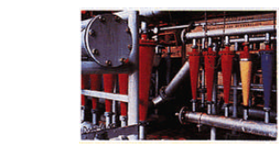
Figure 4.7:-Germ Separation
Cyclone separators spin the low density corn germ out of the slurry. The germs, containing about 85% of corn's oil, are pumped onto screens and washed repeatedly to remove any starch left in the mixture. A combination of mechanical and solvent processes extracts the oil from the germ. The oil is then refined and filtered into finished corn oil. The germ residue is saved as another useful component of animal feeds.

4.7.4 FINE GRINDING AND SCREENING
Figure 4.8:-Fine Grinding and Screening
The corn and water slurry leaves the germ separator for a second, more thorough, grinding in an impact or attrition-impact mill to release the starch and gluten from the fiber in the kernel. the suspension of starch, gluten and fiber flows over fixed concave screens (illustrated) which catch fiber but allow starch and gluten to pass through. The fiber is collected, slurried and screened again to reclaim any residual starch or protein, then piped to the feed house as a major ingredient of animal feeds. The starch-gluten suspension, called mill starch, is piped to the starch separators.

4.7.5 STARCH SEPARATION

Figure 4.9:- Starch Separation

Gluten has a low density compared to starch. By passing mill starch through a centrifuge, the gluten is readily spun out for use in animal feeds. The starch, with just one or two percent protein remaining, is diluted, washed 8 to 14 times, rediluted and washed again in hydro clones to remove the last trace of protein and produce high quality starch, typically more than 99.5 percent pure. Some of the starch is dried and marketed as unmodified corn starch, some is modified into specialty starches, but most is converted into corn syrups and dextrose.

4.7.6 SYRUP CONVERSION
Figure 4.10:- Syrup Conversion
Starch, suspended in water, is liquefied in the presence of acid and or enzymes which convert the starch to a low-dextrose solution. Treatment with another enzyme continues the conversion process. Throughout the process, refiners can halt acid or enzyme actions at key points to produce the right mixture of sugars like dextrose and maltose for syrups to meet different needs. In some syrups, the conversion of starch to sugars is halted at an early stage to produce low-to-medium sweetness syrups. In others, the conversion is allowed to proceed until the syrup is nearly all dextrose. The syrup is refined in filters, centrifuges and ion-exchange columns, and excess water is evaporated. Syrups are sold directly, crystallized into pure dextrose, or processed further to create high fructose corn syrup.

FERMENTATION
Figure 4.11:- Fermentation
Dextrose is one of the most fermentable of all of the sugars. Following conversion of starch to dextrose, many corn refiners pipe dextrose to fermentation facilities where the dextrose is converted to alcohol by traditional yeast fermentation or to amino acids and other bioproducts through either yeast or bacterial fermentation. After fermentation, the resulting broth is distilled to recover alcohol or concentrated through membrane separation to produce other bioproducts. Carbon dioxide from fermentation is recaptured for sale and nutrients remaining after fermentation are used as components of animal feed ingredients.

4.8 Production of ethanol from sugarcane:-

The process of production of ethanol from sugar and or grain is well known. Basically the starch in grain is converted to sugar by means by of enzymes and the sugar is than fermented with yeast to produce a dilute alcohol solution. Distillation is used to separate and purify the alcohol solution.

a). Ethanol can be manufactured from any feedstock containing carbohydrates such as corn, wheat, sugar-beat and other grains.
Production of ethanol from grains such as corn is shown. The grain is first ground and cooked with water to convert the starch to sugar with the enzyme amylase. The sugar is then fermented with. The sugar is then fermented with yeast to produce raw ethanol and a high protein material commonly known as distillers dried grain (DDG). The raw ethanol is distilled to remove impurities such as higher alcohols and to remove most of the water. Ethanol forms an azeotrope with 5% water, and the step in producing anhydrous ethanol is an extractive distillation with benzene. The DDG is dried and recovered for sale as a cattle feed . the optimum capacity of an ethanol fermentation plant is small because of the difficulties in controlling and storing raw materials and typically would be about 1.4 millions barrel per stream day

Ethanol from sugarcane. Production of ethanol from sugar-cane requires only simple , well established processes since the fermentable sugar is obtained directly from the sugarcane requires only simple , well established processes since the fermentable sugar is obtained directly from the sugarcane . the cane is first cut and ground and the cane juice is extracted by macerations .After clarification by filtration and concentration through evaporation, the juice is fermented with yeast raw ethanol. A series of distillation steps, including a final extractive distillation with benzene are used to obtain anhydrous ethanol.

Ethanol is produced by fermentation of carbohydrates by the Gay Lussac relation

C₆ H₁₂ O₆ 2 C₂ H₅ OH + 2CO

In this process 180 gm of carbohydrate are converted to liquid to fuel ethanol weighing only 92gm with almost no loss of energy. About 1.5 Kg of sugar yields liters of ethanol
Molasses contain a large percentage of sugar, 30% or higher and most of the nutrient content that was in cane such as nitrogen, potassium and phosphorous. The normal yield of ethanol is about 8.73 litres of alcohol per tones of cane processed in a sugar factory. Even taking yield to be as low as 4 litres per ton . the potential of ethanol production in India is about 475 million litres per year.[27]
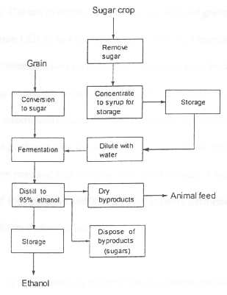
Figure 4.12 - Production of Ethanol from grain
Ethanol is produced by fermentation of carbohydrates by the Gay-Lussac relation: 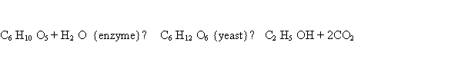
Where C₂H₅OH is ethanol. Environmentally as well as financially ethanol is an excellent choice for alternative fuels. The use of ethanol in the U.S. has reduced greenhouse emissions (emissions created from CO) 35 to 46% according to the U.S. Department of Energy. Our petrol consumption last year was eight million tones. We need only four lakh tones of ethanol to get a 5% blend. This is just 0.3% of our total sugarcane production. this blend can also be produced from just 5% of total jowar and maize production(21mmt) if fed directly to the distilleries.
Ethanol is produced from wheat or corn using the following process:
- Wheat or corn kernels are ground in a hammer mill to expose the starch.
- The ground grain is mixed with water, cooked briefly and enzymes are added to convert the starch to sugar using a chemical reaction called hydrolysis.
- Yeast is added to ferment the sugars to ethanol.
- The ethanol is separated from the mixture by distillation and the water is removed from the mixture using dehydration.
A new process is under development for making ethanol from the cellulose and semi cellulose components of cheaper biomass feed stocks such as wood and agricultural residues. The method is similar to the traditional process that uses the starch component of grain or corn. However, this method is more difficult because these types of feedstock require more complex pretreatment and hydrolysis steps that use acid or enzymes before the sugars can be fermented to ethanol.
Finally, for fuel and industrial purposes the ethanol is denatured with a small amount of a displeasing or noxious chemical to make it unfit for human consumption. In the U.S. the denaturant for fuel ethanol is gasoline.
4.9 Bio- technology Based Production:-
Recent advances, in the relatively new field of industrial biotechnology using techniques in genomics, proteomics, and bioinformatics – are making it possible to convert cellulosic biomass to fermentable sugars that can be used as feedstock for a new type of “carbohydrate crude oil.”

This technology breakthrough is creating a paradigm shift in the way we make transportation fuel because enzymes can economically convert plant matter to fermentable sugars.
Enzymes that break down cellulose are called celluloses and are found in nature in fungi as well as in microbes that are in the guts of termites. Biotech tools are necessary to identify or produce the most efficient celluloses on a scale useful for ethanol production.
Cellulosic ethanol can be the substitute for petroleum in many manufacturing processes such as plastics and could contribute in a major way to reducing World’s “addiction to oil,” while at the same time helping to address the climate change issue, by reducing our need to burn fossil fuels.

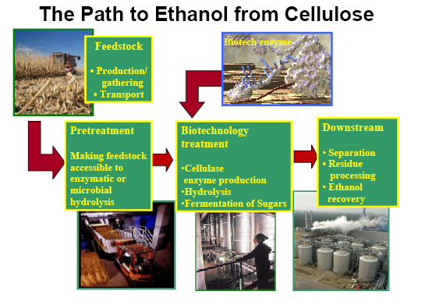
Figure 4.13:- Production of Ethanol from Cellulose
4.10 Production of ethanol with enzymes:-
Industrial biotechnology companies develop biocatalysts, such as enzymes, to be used in industrial manufacturing involving chemical synthesis. Enzymes are proteins that are present in all living organisms. Enzymes trigger or speed up chemical processes that would otherwise run very slowly, but they are not consumed in the process of changing other molecules. They are unique due to their catalytic activity and their ability to break down compounds such as cellulose. As catalysts, they can also put broken protein fragments back together. Over the past 35 years scientists have learned how to convert these biological systems and enzymes into very useful industrial tools that replace less efficient and possibly toxic chemical processes. Natural enzyme-based processes operate at lower temperatures; produce less toxic waste and fewer emissions than conventional chemical processes. They may also use less purified raw materials because they have precise chemical selectivity. Industrial biotech companies conduct genomic studies on microbes to capitalize on the wealth of genetic diversity in microbial populations. Researchers then use DNA probes to look for genes that express enzymes with specific biocatalyst capabilities. Once snared, enzymes can be identified and characterized for their ability to function in specific industrial processes and, if necessary, they can be improved with advanced biotechnology techniques. This is exactly what scientists have been doing to improve enzymes for ethanol production.

Once the needed enzyme is discovered and improved, it may be produced in commercial quantities using fermentation or systems similar to those that produce human therapeutic proteins or bulk yeast for the brewing industry. To improve the productivity of enzymes, scientists are using not only genomics, but also proteomics and bioinformatics to increase enzyme output rates. Biotechnology enables scientists to maximize the effectiveness and efficiency of enzymes and to custom tailor the specificity of enzymes, improve catalytic properties or broaden the conditions under which enzymes can function so that they are more compatible with existing industrial processes. Using enzymes in industrial processes has several benefits. Use of enzymes can reduce the amount of harsh chemicals in industrial processes that contaminate the environment. In addition to creating cleaner process outputs, enzymes help conserve energy and raw materials by reducing the amount of inputs in industrial processes. These enzymes are the key to ensuring that older industrial manufacturing processes evolve into cleaner, more sustainable industrial ones.

Biotech companies are producing improved enzymes for converting starch to ethanol production and have been perfecting enzymes for cellulosic ethanol production. Modern biorefineries will be constructed in Idaho, by Iogen, the Midwest, by Cargill, and overseas. These refineries will that take cellulosic biomass, convert the cellulose to sugars, and then fermented the sugar into ethanol.

4.11 Biotech Breakthroughs

4.11.1 Dramatic Cost Reductions
In 2001, the cost of cellulose enzymes to convert cellulose to sugars was the greatest technical barrier to cost-effective production of cellulosic ethanol. Enzyme producers Genencor International and Novozymes A/S partnered with the U.S. Department of Energy to increase enzyme activity and reduce the cost of production. Both have achieved dramatic results. Novozymes identified a range of new enzymes, and enhanced their activity to dramatically boost sugar yields, reducing the cost of enzymes for making ethanol from corn stover 30-fold from $5 per gallon in 2001 to a mere 10¢ to 18¢ in 2005. Genencor also achieved a 30-fold reduction in cost by developing a team of genetically enhanced enzymes that act in synergy to convert cellulose to sugar. DOE has determined that enzymatic processing is no longer an obstacle to commercialization.

Diversa Corporation has partnered with a consortium that includes DuPont, Deere & Co., the National Renewable Energy Laboratory and Michigan State University to develop a biorefinery that can produce ethanol and other products from the entire corn plant, integrating traditional grain-based ethanol production with cellulosic ethanol production from stalks and husks. In 2005, Diversa successfully developed a suite of enzymes that has enabled the consortium to begin developing a demonstration facility for this “Integrated Corn-Based Biorefinery” concept. DuPont will also utilize the enzymes to produce a bio-based plastic, “bio-PDO” at a facility in London, Tennessee. Dyadic International has developed an integrated technology platform (C1) which will enable researchers to identify, select and analyze novel enzymes best suited to convert biomass materials into bio-fuels. Dyadic has also developed enzymes for the textiles, pulp and paper, food and feed, and chemicals industries that greatly reduce waste while offering new and enhanced products to a variety of markets.

The First Commercial Production of cellulosic ethanol
In 2004, Iogen Corporation became the first company to begin commercial production of cellulosic ethanol. Using biotech enzymes that convert wheat straw to clean burning ethanol, Iogen’s pilot plant in Ottawa, Canada, has an annual capacity of 260,000 gallons. Ethanol from the plant is sold at a nearby Shell gas station. In January 2006, Iogen and Shell announced plans to explore cellulosic ethanol production in Germany, and Iogen is seeking government assistance to construct the first commercial-scale cellulosic bio-refinery in the US.

More Bio-refineries
In August, 2005, Abengoa Bio-energy began construction of the world’s first commercial scale cellulosic ethanol plant. Upon completion in 2006, the plant is expected to process 70 tonnes of agricultural residues, such as heat straw, each day, producing over 1 million gallons of cellulosic ethanol annually. Advances in cellulose enzymatic hydrolysis and fermentation were key to enabling Abengoa to take their technology to market.
Abengoa has also received a $10 million DOE grant to develop a next generation dry mill corn ethanol plant. This next-generation plant will be capable of producing ethanol from the entire corn kernel – both starch (the only portion currently utilized for ethanol) and the residual fiber (also known as dry distillers grains, or DDGs), which would require processing with cellulase enzymes. The application of cellulosic technology could dramatically increase the ethanol yield of the nation’s over 100 existing ethanol facilities.
In 2005, Cargill announced plans for two 110-million-gallon bio-ethanol plants that use traditional feed-stocks, in Nebraska and Minnesota, and began construction of a bio-diesel plant in Mainz, Germany. Cargill is exploring incorporating cellulosic feed-stocks into its existing refineries.
How it is that yeast can be so efficient?
Yeast grows rapidly in a glucose- or sucrose-rich medium, with a doubling time of about 60 minutes. High growth rates result in O2 depletion, and the neutral reaction products allow growth to be sustained anaerobic mode. There are strains of yeast able to tolerate as much as 20% ethanol, although strains producing 12-15% may actually grow better.
Ethanol is the end point of the only metabolic pathway that yeast can use for ATP production. ATP is produced at a low rate, 2 ATP per mole of glucose and per 2 moles of ethanol produced so that substrate is rapidly converted to product to provide the energy needs of cell growth.
Ethanol can escape into the medium rather than accumulating in the cell. This makes recovery of the product easier. Pure ethanol has to be recovered by distillation, which could represent the most expensive component of the production process. In tropical countries, solar distillation is possible taking ethanol production economically viable.

4.12 Ethanol Distillation
Distillation is the process of heating a solution to its boiling point, passing the vapors through a cooling device called a condenser, and collecting the liquid which condenses. Absolute Alcohol, C2H5OH, (i.e. 100% Ethanol) is pure anhydrous ethanol. Absolute alcohol has a boiling point of 78.3 ˚C. It is a clear colourless liquid with a pleasant smell. It is completely miscible with water and organic solvents and is very hydroscopic.
Absolute Alcohol is obtained from 95% Alcohol by using a ternary azeotrope (i.e. by distillation using a three component Azeotrope).
- A mixture of 7.5% Water, 18.5% Ethanol, and 74% Benzene (boiling point 80 degC), forms a ternary azeotrope, which has a minimum-boiling mixture.
- Benzene and Ethanol form a binary azeotrope (boiling point 68.2 degC).
- Thus, when a mixture of 95% ethanol and benzene is distilled, the above ternary azeotrope distills first, followed by the binary azeotrope, and the final fraction is absolute alcohol.

Distillation is the process of heating a solution to its boiling point, and passing the vapors through a cooling device called a condenser, and collecting the liquid which is condensed. Because the boiling point of alcohol is lower than that of water, almost all of the alcohol will boil off first, followed by the water. Thus if you start with 100 ml of solution, by the time almost 100 ml has distilled, you will have collected all of the alcohol and almost all of the water. If you then q. s. the resulting distillate to exactly 100 ml, you will restore it to its original volume and concentration. Because of the alcohol it contains, the distillate will have a specific gravity lower than that of distilled water. By the use of the table provided, the percentage of alcohol in a solution can be determined by knowing the specific gravity of the solution, assuming that no interfering substances co-distill with ethanol which would affect the specific gravity of the distillate. Interestingly, since the boiling point of ethanol is 78.5° C, well below the boiling point of water (100° C), the ethanol can be concentrated by the process of fractional distillation (collecting the distillate in aliquots rather than the whole solution). This is the source of liquors with higher alcohol contents.
A liquid must be brought just slightly above its boiling point before bubbling begins to start at its boiling point. As a bubble of vapor appears within the liquid, it may do one of two things: if it is below a minimum size, it will collapse because of the surface tension of the liquid, or if it is larger than the critical size, grow and rise to the surface of the liquid. If a liquid, which is free of solid impurities or dissolved gases, is heated slowly, a temperature much above the boiling point can be reached without any boiling actually taking place. This superheating occurs because extra energy is required before bubble formation is initiated. If a bubble should start to form in such a superheated solution, it might suddenly grow with almost explosive violence enough to shatter the container. This problem, called bumping, can be overcome by adding a boiling chip, a piece of porous material, to the liquid before it is heated to the boiling point. The pores act as built-in bubbles so that a liquid cannot superheat. As the distillation proceeds, the air in these pores is replaced by vapor of the distilling material, but this vapor cannot condense because the temperature of the liquid is just slightly above its boiling point. However whenever a distillation is stopped and then started again, a new boiling chip will be needed because the vapor in the pores will have condensed and filled the pores with liquids.

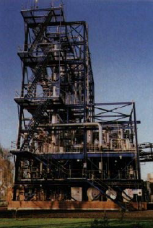

Figure 4.14:-The ethanol plant at Manildra’s Bomaderry plant near Nowra.

CHAPTER 5

Properties of ethanol

Ethanol (ethyl alcohol) is a clear, colorless liquid with a faint odour. It has a high latent heat of vaporization and contains oxygen, characteristics that are relevant to its environmental performance in combustion as a motor fuel, and in its storage and distribution.

There are a number of fuel properties that are essential to the proper operation of a petrol engine. Materials compatibility and corrosiveness are also important factors that need to be considered. Properties that affect safety should be foremost in any fuel evaluation. These include ash point and flammability. Finally fuel biodegradability has become a significant factor with respect to ground water contamination.

In dilute aqueous solution, ethanol has a somewhat sweet flavor, but in more concentrated solutions it has a burning taste. Ethanol (CH₃CH₂OH) is made up of a group of chemical compounds whose molecules contain a hydroxyl group, -OH, bonded to a carbon atom. Ethanol made from cellulosic biomass materials instead of traditional feedstock (starch crops) is called bio-ethanol [19]

5.1 Physical properties
Ethanol's hydroxyl group is able to participate in hydrogen bonding. At the molecular level, liquid ethanol consists of hydrogen-bonded pairs of ethanol molecules; this phenomenon renders ethanol more viscous and less volatile than less polar organic compounds of similar molecular weight. In the vapor phase, there is little hydrogen bonding; ethanol vapor consists of individual ethanol molecules.

Ethanol is a versatile solvent. It is miscible with water and with most organic liquids, including non polar liquids such as aliphatic hydrocarbons. Organic solids of low molecular weight are usually soluble in ethanol. Among ionic compounds, many mono valent salts are at least somewhat soluble in ethanol, with salts of large, polarizable ions being more soluble than salts of smaller ions. Most salts of polyvalent ions are practically insoluble in ethanol.
Several unusual phenomena are associated with mixtures of ethanol and water. Ethanol-water mixtures have less volume than their individual components: a mixture of equal volumes ethanol and water has only 96% of the volume of equal parts ethanol and water, unmixed. The addition of even a few percent ethanols to water sharply reduces the surface tension of water. This property partially explains the tears of wine phenomenon: when wine is swirled inside a glass, ethanol evaporates quickly from the thin film of wine on the wall of the glass. As its ethanol content decreases, its surface tension increases, and the thin film beads up and runs down the glass in channels rather than as a smooth sheet.
PHYSICAL PROPERTIES

Boiling point: 79 °C
Melting point: -117 ° C
Relative density (water = 1): 0.8
Solubility in water: miscible
Vapour pressure, kPa at 20°C: 5.8
Relative vapour density (air = 1): 1.6
Relative density of the vapour/air-mixture at 20 degree C (air = 1): 1.03
Flash point: 13 ° C
Auto-ignition temperature: 363 ° C
Explosive limits, vol% in air: 3.3-19
Table 5.1:- Comparison Between |Diesel, Ethanol, And Gasoline
Table5.2-Physical properties of ethanol

PHYSICAL PROPERTIES:-
5.1.1 Vapor Pressure:
The vapor pressure of Ethanol is a very important characteristic property of this fuel. It determines the cold start behavior of an engine. At low temperatures it is very difficult to create vapor. Alcohol has lower vapor pressure than gasoline. As a result, cold starting with E85 is very difficult as compared with conventional gasohol and gasoline engine. The E10 curve demonstrates that the higher level of gasoline (90%) in this blend produces a much higher vapor pressure at temperatures below 30°F, where cold starting is very difficult.
5.1.2 Calorific Value:
In addition to ethanol’s poor cold starting characteristics ethanol also has lower energy content than gasoline because of its chemical structure in which alcohol molecules contains fixed oxygen. E85 has 71.6% the energy of E10 as demonstrated in Table 2. This means it will require approximately 28.4% more E85 to produce the same heating value as gasohol. And in comparison to gasoline (43960/26800) =1.64 or approximately 64%more pure alcohol is required.
5.1.3 Octane Number:
Ethanol Blended Gasoline does offer a higher octane number, which allows for use in higher compression engines. This will increase thermal efficiency of engines and result in a slight decrease in fuel consumption.
5.1.4 Latent heat of vaporization:
In comparison with gasoline, ethanol has very high latent heat of vaporization. For pure ethanol it is 2.91 times that of gasoline in a stoichiometric mixture. It result in an air temperature reduction of approximately 4.5°C, thus increasing the volumetric efficiency and hence the power output.

5.1.5 Viscosity and lubricity:
Fuel viscosity and lubricity play significant roles in the lubrication of fuel injection systems, particularly those incorporating rotary distributor injection pumps that rely fully on the fuel for lubrication within the high pressure pumping mechanism. In the common rail accumulator fuel-injection system, the high-pressure pump that delivers fuel to the rail also relies on the fuel for lubrication. In in-line pumps and unit injectors, there is less reliance on the fuel for lubrication; however, there are still some metal interfaces that require lubrication by the fuel such as between plunger and barrel. Injector lubrication also is affected, particularly at the needle guide-nozzle body interface. Lower fuel viscosities lead to greater pump and injector leakage reducing maximum fuel delivery and ultimately power output. Hot restart problems also may be encountered as insufficient fuel may be injected at cranking speed when fuel leakage in the high-pressure pump is amplified because of the reduced viscosity of the hot fuel. The addition of ethanol to diesel lowers fuel viscosity and lubricity. Wrage and Goering (1980) investigated the variation of kinematics viscosity with percentage of ethanol present and generated the graph shown in Fig.3. They concluded that a blend of 18.5% dry ethanol (1.1 mm2/s viscosity) with No. 2 diesel (2.46 mm2/s viscosity) would equal the ASTM minimum viscosity of 2.0 mm2/s at 37.8 _C and would be well above the minimum for No. 1 diesel as shown in Fig. 1. Speidel and Ahmed (1999) reported a viscosity of 2.25 mm2/s for a blend containing 15% dry ethanol, 5% PEC additive and 80% diesel. It should be noted that the final blend viscosity is dependent on the viscosity of the diesel fuel. Blending ethanol with a diesel fuel that has a viscosity close to the minimum is likely to yield an overall viscosity lower than the ASTM minimum.[16]
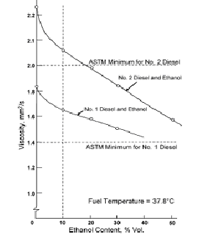
Figure 5.1 ASTM Lubricity Test

Two ASTM lubricity tests are commonly used to characterize the lubricity of fuels, the Scu.ng Load Ballon-Cylinder Lubricity Evaluator (SBOCLE), D6078-99 and the High Frequency Reciprocating Rig (HFRR), D6079-99. Relatively few lubricity tests have been carried out on ethanol–diesel blends. Speidel and Ahmed (1999) reported a SBOCLE test value of 5200 g for the blend containing 15% dry ethanol, 5% PEC additive and 80% diesel, as compared to the minimum of 3100 g specified for No. 2 diesel. Bio-based oils have been effective in increasing fuel lubricity and are commercially available. Hardenberg and Schaefer (1981) included 1% castor oil in a 95% ethanol fuel that was used successfully in affect of trucks and buses in Brazil. Minimum specifications for viscosity and lubricity of ethanol–diesel blends are required in order to ensure that fuel injection system durability is not compromised relative to diesel fuel usage and that engines are able to start reliably when hot.

Fuel viscosity also affects the atomization and spray characteristics in the combustion chamber. Lower viscosities typically result in smaller Sauter mean droplet diameters, thereby increasing the surface area of droplets and significantly influencing the evaporation characteristic time (Heywood, 1988; Desantes et al., 1998). The lack of reports of specific measurements to corroborate these trends with ethanol–diesel blends indicates a need to investigate their atomization and spray characteristics, as these parameters have a significant effect on the combustion process.
CHAPTER 6
ETHANOL BLENDED WITH PETROL
Ethanol (ethyl alcohol) is a clear, colorless liquid with a faint odour. It has a high latent heat of vaporization and contains oxygen, characteristics that are relevant to its environmental performance in combustion as a motor fuel, and in its storage and distribution.
Ethanol can be produced in two forms: hydrated and anhydrous.
Hydrated ethanol, usually produced by distillation from biomass fermentation, contains 95% ethanol with the balance being water. It is suitable for use as a straight spark ignition fuel in warm climates or for blending as a 15% emulsion in diesel.
A further process of hydration is required to produce anhydrous ethanol (100% ethanol) for blending with petrol. As ethanol is an excisable product, being the active ingredient of alcoholic drinks, it may only be produced by a licensed distillery. Most industrial ethanol is denatured (to prevent oral consumption), by the addition of small amounts (1 - 5 %) of unpleasant or poisonous substances. Ethanol can be used as an automotive fuel by itself and can be mixed with petrol to form an ethanol/petrol blend. The most common uses are:
a) 10% ethanol (known as E10);
b) 85% ethanol (known as E85);
This blend is used in some states of the US and requires particular vehicle technology known as ‘Flexible Fuel Technology” (FFT).
c) 20 - 24% ethanol (known as E22); This blend is used in Brazil, requires specific vehicle optimizations (re-calibration and component changes) for 22% ethanol .
d) 100% ethanol (E100); This is also used in Brazil and requires vehicle technology dedicated to the fuel. Ethanol is a known ‘octane enhancer’ and ‘oxygenate’. An octane enhancer is a component added to petrol to increase, in this case, the research octane number and to reduce engine knock. An oxygenate is a fuel octane component containing hydrogen, carbon and oxygen in its molecular structure. Oxygenates are often added to petrol to increase octane, to extend petrol supplies and to induce a lean shift (‘enleanment’) in the engine's operation.
Oxygenates chemically ‘enlean’ the fuel by providing it with additional oxygen, altering the air/fuel ratio10 and thereby improving combustion and reducing tailpipe emission of carbon monoxide (CO) for vehicles where no feed-back control of the air/fuel ratio exists .

6.1 Ethanol Fuel Mixtures
Generally, the higher the ethanol component of a gasohol blend, the lower its suitability for standard car engines. Pure ethanol reacts with or dissolves certain rubber and plastic materials and must not be used in unmodified engines. Additionally, pure ethanol has a much higher octane rating (116 AKI, 129 RON) than ordinary gasoline (86/87 AKI, 91/92 RON), requiring changes to the compression ratio or spark timing to obtain maximum benefit. To change a pure-gasoline-fueled car into a pure-ethanol-fueled car, larger carburetor jets (about 30-40% larger by area) are needed. (Methanol requires an even larger increase in area, to roughly 50% larger.) Ethanol engines also need a cold-starting system to ensure sufficient vaporization for temperatures below 13 °C (55 °F) to maximize combustion and minimize uncombusted non vaporized ethanol. On the other hand, if 10 to 30% ethanol is mixed with gasoline, no engine modification is typically needed. Many modern cars can run on these mixtures very reliably.
Beginning with the model year 1999, an increasing number of vehicles in the world are manufactured with engines which can run on any gasoline from 0% ethanol up to 85% ethanol without modification. Many light trucks (a class containing minivans, SUVs and pickup trucks) are designed to be dual fuel or flexible fuel vehicles, since they can automatically detect the type of fuel and change the engine's behavior, principally air-to-fuel ratio and ignition timing to compensate for the different octane levels of the fuel in the engine cylinders.[18]

Characteristic | E85 | Gasohol
Specific Gravity @60F | 0.78 | 0.73 - 0.76
Boiling Point (F) | ~173 | 77 – 410
Gross Heat of combustion (BTU/lb) | 13935 | 19468¹
Net Heating Value (mass) (BTU/lb) | 12,665 | 18,000
Net Heating Value (volume) (BTU/gal) | 82,150 | 112,900
Heat of Vaporization (BTU/lb) | 357 | 200
Vapor Pressure @ 100F (psi) | ~2.5 | 8 – 16
Octane Number  (RON)  (MON) | 109  91 | 92  87
Cetane Number | Below 15 | Not Applicable
Stoichiometric A/F | 9.7 | 14
Appearance | Pink, Colorless | Colorless to light amber

Table 6.1: - Characteristics of E85 and Gasohol.
CHAPTER 7
MATERIALS COMPATIBILITY WITH ENGINE AND ENGINE PARTS

The use of ethanol in gasoline engines in the early 1980s resulted in numerous materials compatibility studies, many of which are also applicable to the use of ethanol–diesel blends in diesel engines and particularly in the fuel injection system. The quality of the ethanol has a strong influence on its corrosive effects (Hardenberg and Schaefer, 1981). In addressing the problems of ethanol corrosion associated with gasoline blends, Brink et al. (1986) divided ethanol corrosion into three categories: general corrosion, dry corrosion and wet corrosion. General corrosion was caused by ionic impurities, mainly chloride ions and acetic acid. Dry corrosion was attributed to the ethanol molecule and its polarity. de la Harpe (1988) reviewed reports of dry corrosion of metals by ethanol and found that magnesium, lead and aluminum were susceptible to chemical attack by dry ethanol. Wet corrosion is caused by azeotropic water, which Oxidizes most metals (Brink et al.1986). Freshly formulated blends containing pH neutral dry ethanol would be expected to have relatively little corrosive effect. However, if a blend has been standing in a tank for sufficient time to allow the ethanol to absorb moisture from the atmosphere, it may tend to be more corrosive as it passes through the fuel injection system (de la Harpe, 1988). In addition, the fuel may stand in the fuel injection pump for a number of months, for example in a combine harvester engine, thus allowing the fuel time to corrode parts of the pump internally. Corrosion inhibitors have been incorporated in some additive packages used with ethanol–diesel blends (de la Harpe, 1988). Non-metallic components have also been affected by ethanol with particular reference to elasto-meric components such as seals and O-rings in the fuel injection system. These seals tend to swell and stamen. Resin-bonded or resin-sealed components also are susceptible to swelling and seals may be compromised (Bosch, 2001).[20]

One of the most important issues with using ethanol is to use materials unaffected by ethanol. Two basic materials problems exist with the use of alcohols such as:
1. Swelling and embrittlement of rubber fuel lines and oil-rings
2. Galvanic corrosion
7.1 Causes and Solutions to Swelling and Embrittlement to Rubber Components
Swelling of rubbers associated with fuel is simply due to the absorption of fuel into the rubber. Once absorbed into rubber, the oxygen in alcohol fuels will break the rubber’s carbon-carbon double bonds in the rubber and embrittle the rubber and cause swelling. The loss of bond strength creates a reduction in strength and results in failure. An additional problem with rubbers in fuel systems is the temporary attachment of hydrocarbons in the rubber to the hydrocarbons of the fuel. As a result, the hydrocarbons in the rubber may add to a fuel’s hydrocarbon content, creating increased emissions.
7.2 Rubber Replacements
Embrittlement, swelling, and component breakdown can all be solved by the use of compatible materials. The material resistance to ethyl alcohol is shown as a function of temperature. Vitons (DuPont’s trade name) are the most unaffected materials in the presence of ethanol. Vitons are highly fluorinated elastomers, thus the name fluoro-hydrocarbon elastomers. Viton B, Viton GFLT, Viton GF are all acceptable materials to be used in an ethanol vehicle.
Nylon components such as the fuel hoses that connect the main fuel supply to the main stainless steel fuel lines and the in-tank fuel pump reservoir are compatible with E85. Nylons demonstrate resistance to ethanol up to 80F. The strainer on the fuel pump is made of Saran, also a compatible material that exhibits no degradation.
Fuel pressure regulators that are generally used in gasoline run vehicle are not E85 compatible. The rubber diaphragm used in pressure regulator gets swelled with E85. Rubber used for the fuel fill tube in modern vehicles is generally not acceptable for use with E85. Viton materials must be used to replace the existing tube. The tube must also have a flame arrestor built into its design.
Fuel pumps for dedicated ethanol vehicles (E85) must also be replaced. Current production vehicles use in-tank electric fuel pumps that run continuously. The E85 compatible fuel pumps are modified by the use of silicone rubber around the power and ground wires leading into the electric motor. Silicone rubber is used to prevent the E85 from contacting the electrical connections that will result in a concentrated corrosion cell.
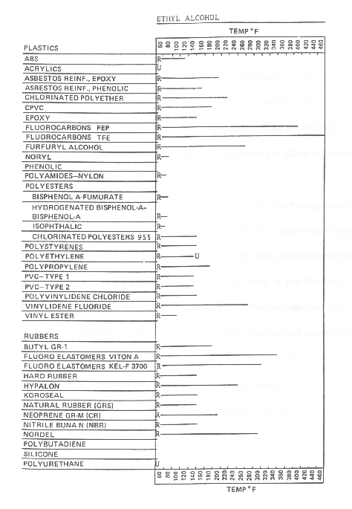
Table 7.1 - Compatibility of Plastics with Ethanol, R = Resistant ; U = Unsatisfactory
7.3 Galvanic Corrosion
In addition to the deterioration of rubbers and polymers caused by E85, the deterioration of metal components is also very important. Previously it was thought that methanol was more corrosive than ethanol. Tests by Norman Brinkman have shown E85 to be more corrosive than M85 due to higher levels of soluble corrosive contaminants. Corrosion contaminants such as sulfates are known to be initiators of galvanic corrosion.
7.4 Sources of Galvanic Corrosion
For the existence of galvanic corrosion there are three necessary components: an anode, cathode, and an electrical connection. In fuel systems, aluminum is generally the anodic or easily corroded material. The cathode or unaffected material can be brass, steel or any metal or graphite that is more resistant to corrosion than the anode. The connection of the two materials such as the stainless steel fuel lines to the aluminum fuel rails creates an electrical connection. Fuel such as E85 is also electrically conducting and serves as an electrolyte. Initially the sulfates and the ethanol will act as the electrically conducting medium (electrolyte) in the fuel. As the galvanic process continues metal will be removed thus increasing the conductivity of the fuel and thus increasing the corrosion rate. This is demonstrated by Faraday’s Law of Electrolysis shown in Equation 1.
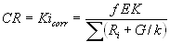 .................(1)
CR -Corrosion rate G -Geometrical factor
f -Faraday constant R_{i} -Interfacial impedances
K -Proportionality constant k -Electrical conductivity
E -Voltage between the anode and the cathode
i_{corr} -Electrical current flow through the solution-metal interface
For alcohol fuels the interfacial impedances are small relative to the G/k ratios. As a result, the interfacial impedance can be eliminated from Equation 1 to yield Equation 2.
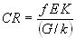 ........................(2)
In effect, the corrosion rate is limited by the conductivity of the fuel. When metal components corrode, their addition to the fuel system increase the corrosivity of the fuel. US Department of Energy suggests conductivity of not more than 5 µS/ .
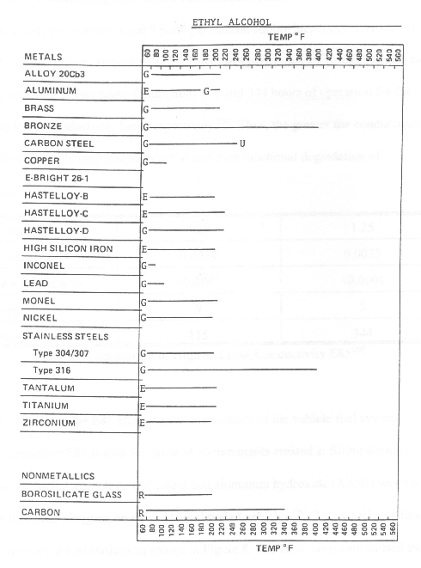
Table 7.2 -Compatibility of Metals with Ethanol
In addition to the E85 affecting the components of the vehicle fuel system, corrosion caused by E85 is also the cause of contaminants created at filling stations. A study conducted by Brinkman found that aluminum hydroxide (AlOH) is the source of fuel filter plugging on many alcohol fueled vehicles. The AlOH is found to be on the nozzles at fuel stations. Galvanic corrosion causes the formation of AlOH with the aluminum nozzle being the anode, the steel spring as the cathode and the E85 as the electrolyte. The aluminum nozzle also exhibits pitting corrosion from the E85.
7.5 Solutions to Galvanic Corrosion
To reduce the galvanic corrosion, dissimilar metals should not be used in contact. To control the galvanic corrosion anodized aluminum and stainless steel components should be used when using alcohols. Fuel lines, tanks, and fuel filters must be made of Stainless steel. Anodization process creates an aluminum oxide layer that prevents further deterioration by isolating the reactive aluminum surface. The fuel rails experienced no deterioration as a result. To protect the fuel rails an inert coating should be applied to the interior and exterior of the fuel rails. E85 properties also must be controlled to insure that sulfates are not originally present in the fuel.
7.6 Galvanic Corrosion
Conclusions to Materials Compatibility Issues:-
The components and the material must be replaced for dedicated E85 usage. When developing a vehicle for E85 the galvanic corrosion taking place within the fuel system must be considered. The longer the fuel is in an unprotected system the more advanced the corrosion will become.

Component | Material or action needed
Fuel Injectors | Replace with ethanol compatible
O-rings | Use Viton B, GF, GFLT
Fuel Pressure Regulator | Replace with ethanol compatible
Fuel Pump | Replace with ethanol compatible
Fuel Filter | Stainless Steel, Anodized aluminum
Fuel Fill Tube | Viton with flame arrestor
Sending Unit | Create pulse and hold circuit
Fuel lines | Stainless steel
Aluminum | Replace with stainless steel or anodize
Table 7.3 - Necessary Materials for E85 Usage
CHAPTER 8
COLD START PROBLEMS AND TECHNOLOGIES

Latent heat of vaporization and vapor pressure of the ethanol fuel are the two main factors responsible for the cold starting. As mentioned earlier latent heat of vaporization of the ethanol fuel is much more than the gasoline and vapor pressure is less than gasoline. During initial startup when the engine is cold the E85 will have less ability to vaporize due to above mentioned reasons. This unvaporized fuel droplets will remain on fuel injector and create a deposit. This Gum like dark-brown deposit can be removed from the nozzle by 100% pure Hexane. But the permanent solution is to solve the problem that causes deposit.
8.1 Heat Storage Units
Engine heat can also be used directly if the heat is stored and used during cold start. A Centaur Thermal Systems heat storage unit performs this task. The Centaur system is originally intended to store hot engine coolant after the engine is shut off and then routed to allow for the hot coolant to enter the engine block upon startup. The volume of coolant is adjustable by the size of the selected Centaur System. Both 5.0 L and 7.0 L units are available. The operation of the system requires that the engine come to full operating temperature which allows the thermostat to open. At this time coolant flows throughout the entire coolant system including the (in series) Centaur system. When the engine is turned off, the power signal is lost to the Centaur control unit which signals the outlet valve to shut. At the same time the Centaur pump fills the system completely full of hot coolant. The hot coolant stored in the Centaur system loses 9° F/hour which results in 108º F coolant after a 12 hour rest. Upon starting, the control system can be programmed to accept a key-on or tachometer signal. This signal is used to open both valves in the control unit and activate a pump the pushes the hot coolant into the engine while at the same time pulling the cold coolant out. The hot coolant in the engine block promotes improved atomization of the fuel droplets by preventing in-cylinder quenching that occurs when the droplets contact the cold cylinder walls.

8.2 Distillation Systems
The function of a distillation system is to separate the gasoline from ethanol and prevent the need of additional starting fuels. A schematic of the entire system is shown in Figure 8.1. The fuel enters the distillation column from the fuel tank. Hot engine coolant enters the distillation column and is circulated in coils to vaporize the gasoline. The higher vapor pressure of the gasoline causes the gasoline to vaporize more readily than ethanol and expand. As heat is increased in the distillation column the ethanol will also vaporize and result in a mixture of vapors leaving the column. As it expands, it enters a condenser that cools it back to liquid gasoline and ethanol which are held in a storage tank.

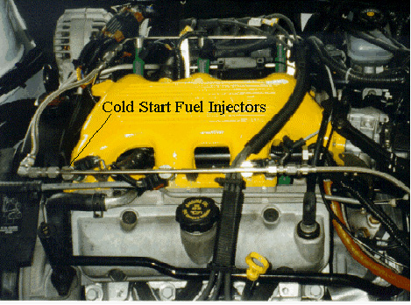
Figure 8.1 - Cold Start Fuel Injectors
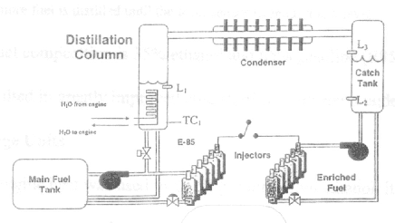
Figure 8.2 - Distillation System
For this system to control the fuel flow, a control module is created and programmed with the following logic:-
1. Fuel enters the re-boiler through a T fitting in the standard fuel line at ambient temperature.
2. The re-boiler is filled to level L₁ where the L₁ sensor detects the fuel level.
3. Approximately 194 – 221 degree F engine coolant passes through re-boiler and heats fuel in the column.
4. Thermocouple sensor (TC), detects the fuel temperature. The logic circuit then controls fuel input/output.
5. If the fuel temperature is less than 140 degree F, heating continues.
6. Distillate vapor passes through the condensing heat exchanger and is collected in the storage tank.
7. The storage tank is filled until level sensor L₃ detects fuel.
8. Once the storage tank level sensor L₃ detects fuel, the distillation re-boiler is purged.
9. Once the distillation column temperature is greater than 140° F, fuel is purged and returned to the fuel tank.
10. No more fuel is distilled until the level sensor L₂ reads a low level.
The final fuel composition is 35% ethanol and 65% gasoline (E85). The higher gasoline content resulted in greatly improved cold starting, with starts under 5 seconds.
8.3 Fuel Pressure Increases
In addition to heating the fuel droplets, an increase in fuel pressure is needed. Modern fuel injected automobiles operate at 38-43 psi. Increasing fuel pressure will promote increased fuel droplet atomization as it leaves the fuel injectors and thus improve cold starting. Conversion of a gasoline powered vehicle to ethanol will require the use of a fuel pressure regulator that is adjustable from 35 - 90 psi. Tradeoffs between fuel economy, performance and starting ability will have to be considered to determine the appropriate fuel pressure for each vehicle. Minimum and maximum values of 50 and 60 psi respectively are suggested when developing an ethanol powered vehicle. Vehicles originally intended for ethanol usage can be equipped with higher fuel pressure regulators by using springs with a higher spring rate. The material compatibility of these components must be considered before being used as discussed earlier.
8.4 POX REACTOR:
A system that requires less on-time is a partial oxidation reactor (POX reactor) as shown in Figure 8.3. The reactor functions by igniting the ethanol and air entering the reaction chamber and being ignited. The heated combustion products from the reactor then enter the air stream to the engine to aid in cold start. This system has been used to achieve smooth cold starts at 0°F in 10 seconds of engine cranking. Isherwood, Linna, and Loftus state that at colder temperatures the cranking time will depend on engine cranking speed which could be improved with the use of the 16 volt battery.

. 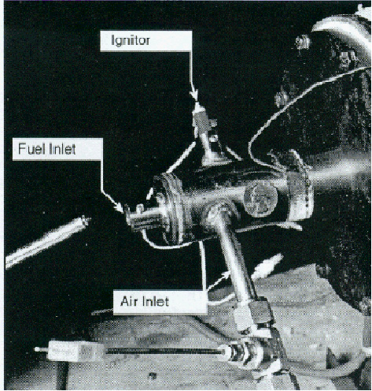
Figure 8.3 POX Reactor
8.5 ENGINE CONTROL
Control systems for cold start and engine operation are the most important aspects of an ethanol powered vehicle. Ethanol’s poor starting characteristics generally require drastic cold start enrichments to start the vehicle. The theory is very similar to the choke on a carburetor. When the engine is cold the choke closes to prevent unusable dense air from entering the cylinders during cranking, and the driver must pump the foot feed to add fuel to the engine for starting. As a result the cold air and fuel combust in roughly the correct ratio. In a fuel injected vehicle, the throttle body is closed, during cranking and additional fuel is added during cold start since the ECM senses the cold air. Proper cold start engine control is needed to allow for enrichments to the fuel injectors. With the aid of a useful cold start system, extensive enrichment is not needed and will decrease emissions during startup.

8.6 FUEL INJECTOR
Injector used in gasoline run vehicle is not compatible with E85 run vehicle. As mentioned earlier due to lower energy content fuel flow rate will have to be increased to get the same power output from the alcohol run vehicle as that of gasoline run vehicle.
An ethanol (E85) run vehicle requires 25% increase in fuel flow as compared to gasoline vehicle. This necessiate 12%increase in the diameter of fuel lines as shown by this equation:
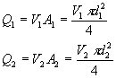
(Assume constant Pressure)
Q volume flow rate (in³/s)
V velocity of fuel (in/s)
A cross sectional area of fuel line (in²)
d diameter of fuel line (in)
For this calculation it is assumed that V will remain constant, and Q will only increase through an increase in fuel line size.
But flow from injector is limited by the current supplied to the solenoid that opens the plunger and by the hole sizes of the outlet orifices When current is supplied to the plunger a magnetic field is created that pulls the plunger away from the orifice plate allowing fuel flow outwards. Current supply is governed by the ECM and it is generally impossible to alter on a vehicle originally intended for gasoline usage. Thus for electronic as well as flow limited reasons the injectors must be replaced with ethanol-compatible fuel injectors. Injector replacement is also important from a materials aspect, in order to prevent deterioration of the inside of the injectors.
Along with the above, it must be able to provide enrichment during starting to aid in cold starting. Engine control module is modified to increase the pulse width by 30 to 40%. Based on testing, ethanol enrichment requires a 14ms pulse width on the injectors which is reduced back to 6.0ms after 5seconds of engine operation.
8.7 SPARK CONTROL
As with fuel injector design and control, fuel injector ignition timing is very important. Ethanol vehicles must be calibrated for optimal ignition timing. Gasohol (E10) powered vehicles advance ignition timing until knock is sensed by an accelerometer placed on the engine. Vehicles with lower compression ratios can utilize this technology for an ethanol conversion. Vehicles with higher compression ratios of 11.75:1 and 12.0:1 are likely to need the ECM modified to limit spark timing to 15degree advanced before top dead center (BTDC). This limit is created due to high compression that adds in-cylinder heat and aids in pre-ignition. The pre-ignition will result in knock and lead to damaged engine components.
CHAPTER 9
EMISSIONS AND EMISSION CONTROL TECHNOLOGIES

Engine control can be the source of engine failure and is also the limiting factor for emissions. Vehicle emissions are one of the primary reasons for using ethanol. Oxides of nitrogen (NO_{X}), carbon monoxide (CO), and hydrocarbons (HC) are the regulated vehicle emissions. NO_{X} are the by-product of high temperatures created from in-cylinder pressures. Thus as compression ratios increase, so do the cylinder pressures and temperatures and thus NO_{X} levels. NO_{X} is produced by the oxidation of nitrogen in the air and is a major contributor to photochemical smog. CO is produced by incomplete combustion of the HC in fuel. CO contributes to global warming and is toxic to humans. CO production is greatly decreased with ethanol usage. The reduction in CO emissions is due to the oxygen in the ethanol. Less O₂ from the air is required for combustion and thus less (oxygen combining) by-products are formed such as CO, resulting in a decrease in global warming.
Testing by Scheller in 1975 stated that gasohol (E10) emissions were generally lower than gasoline emissions. Scheller’s results showed a 32.4% drop in CO and relatively equal amounts of HC and NO_{x}. The substantial drop in CO suggests that gasohol will significantly decrease greenhouse emissions. As suggested, HC are a chain of bonded hydrogen and carbon molecules that create fuels. All fuels leave unburned HC during cold startup and 80% of all regulated emissions are created during cold starting. For gasohol and E85 the heats of vaporization are 200 and 357 BTU/lb respectively. The higher heat of vaporization results in a lower flame speed. As a result, a theoretical increase of 179% in the amount of E85 as compared to E10 is needed to start an engine intended for gasohol, which results in significant hydrocarbon levels at start up. An engine’s need for additional ethanol is created by ethanol’s high heat of vaporization. Ignition energy requirements are fulfilled by increasing the quantity of E85 until E85's heat of vaporization balances the energy needed for combustion at cold temperatures. The use of the aforementioned cold start strategies will significantly reduce the cold start emissions. However, traditional and specific ethanol emissions equipment is needed to reduce emissions.
9.1 Emissions outcomes for higher ethanol blends

The tests, performed at the US EPA's National Vehicle and Fuel Emissions Laboratories, looked at emissions resulting from nine ethanol blends from 10% to 40% ethanol. No modifications were made to the vehicles used in the study to adapt them to higher than normal fuel oxygen levels. The study indicates that, for the majority of the vehicles, total hydrocarbons and carbon monoxide emissions, as well as fuel economy, decreased, while NOx and acetaldehyde emissions increased as the ethanol content in the test fuel increased. Formaldehyde and vehicle exhaust CO2 were largely unaffected. Most of the emission responses to increasing ethanol concentrations were approximately linear as the ethanol content increased, the emission reduction or increase became larger. Hydrocarbon emissions decreased as higher percentages of ethanol were added to the fuel:
_ at 10% ethanol, HC emissions decreased by about 18%;
_ at 20%, HC emissions decreased by about 22%; and
_ at 40%, HC emissions decreased by 45%.
CO emissions were consistently lowered as higher levels of ethanol were added to the fuel:
_ at 10%, CO was reduced by about 18%;
_ at 25%, CO was reduced by over 30%; and
_ at 40%, CO was reduced by over 40%.
NOx emissions increased substantially with ethanol volume:
_ at 10%, the NOx emission increase was about 10%;
_ at 20%, the NOx emission increase was about 14%; and
_ at 40%, the NOx emission increase was about 20%.
CO2 emissions initially increased at ethanol volumes from 10% to 20%. At about 25%,
CO2 emissions decreased by about 2%. Formaldehyde emissions increased slightly with ethanol content, especially at volumes of greater than 30%. Acetaldehyde emissions increased significantly with the addition of ethanol. At 35% the increase was about 400%.
9.2 EGR Valve
Traditional emissions reductions strategies are exhaust gas recirculation (EGR) and 3-way catalytic converters. EGR is used primarily to reduce NO_{X} after the engine has come to operating temperature by allowing 5 - 10 % of the exhaust gas to re-enter the intake manifold and enter the cylinders. Residual EGR gases serve as a filler gas that does not combust and will thus result in less combustion products. In effect the total NO_{X} emissions may be cut in half with the use of EGR. The amount of EGR is controlled by the ECM and its limits must be determined experimentally as based on the acceptable decrease in performance produced by EGR lowering the lean burn limit. The lean burn limit is lowered due to the hot exhaust gases re-entering the cylinders, creating a tendency to pre-ignite stoichiometric air/fuel ratios. Once obtaining acceptable EGR performance and (out-of-the-engine) emissions, the remaining emissions must be treated by the catalytic converter.
9.3 Three-Way Catalytic Convertor
Three-way catalytic convertors work to reduce HC, CO, and NO_{X}. The chemical reactions for each are:
Oxidation of carbon monoxide (CO):
  - 2CO + O₂ → 2CO₂ - formation of CO₂
  - CO + H₂0→CO₂ + H₂ - formation of CO₂ and hydrogen
- Oxidation of hydrocarbons (HC):
  - C_{x}H_{y} + O₂→2CO₂ + H₂O - formation of CO₂ and water
- Reduction of nitrous oxides (NO_{x})
  - 2CO +2NO → N₂ + 2CO₂ - formation of nitrogen and CO₂
  - 2H₂ + 2NO → N₂ + 2H₂O - formation of nitrogen and water
For these processes to occur the convertor must be at least 572F. Standard emissions systems will require 2 minutes to achieve this temperature resulting in poor cold start emissions. Additionally, ethanol fueled vehicles require higher compression ratios to achieve acceptable performance. The increased compression ratios result in hotter exhaust gases that create increased levels of NO_{x}. The increased heat will improve convertor light-off time but will greatly affect overall NO_{x} levels.

9.4 Emission System Technologies
Many new emission technologies exist including: electrically heated catalytic convertors (EHC), hydrocarbon traps, secondary air, and exhaust bagging. Technologies likely to be accepted by industry will be discussed.
9.5 Electrically Heated Catalysts
EHC’s are operated by a control system that directs 200 amperes of direct current to an element in the catalyst as shown in Figure 10.1. The resistive heating element heats to red heat to begin light-off of the catalyst. This process takes approximately 20 seconds after the engine starts which results in approximately 20 seconds worth of raw emissions entering the atmosphere.
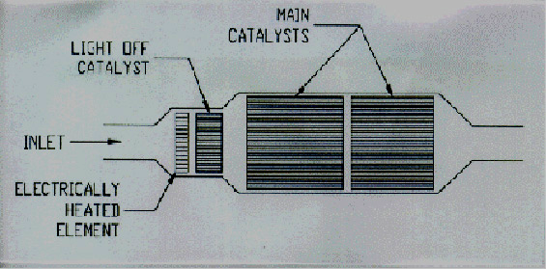
Figure9.1 - EHC, Light Off and Main Catalysts
9.6 Hydrocarbon Traps
Hydrocarbons produce 70 - 90% of total tailpipe emissions during cold start. Recalling that 80% of all emissions occur during cold start, it is thus very important to decrease hydrocarbons. HC traps consist of a substrate material covered with zeolite. During cold starts the zeolite has an affinity for HC and will absorb them until the trap reaches approximately 302°F near 20 seconds after a cold start. At this temperature, the HC are released into the catalytic convertor for oxidation. This suggests that the coupling of an HC trap with an EHC will produce very beneficial results. Such a system was constructed for the 3.1 liter V6 tested, however time was prohibitive in determining the effectiveness of all components. The entire system is displayed in Figure 9.2.

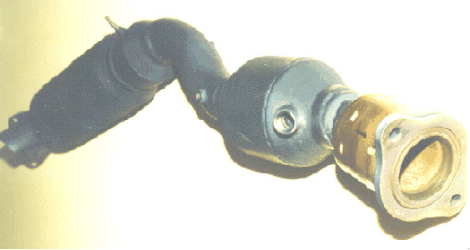
Figure 9.2 - HC Trap and EHC Used for 3.1 L V6
9.7 Secondary Air Systems
Air entering the exhaust system that was not combusted in the engine is called secondary air. A secondary air system is used to dilute exhaust gases by the oxidation of CO and HC which in turns promotes the reduction of NO_{X}. Secondary air systems are currently used on such vehicles as the GM Cadillac. Secondary air systems are driven by an air pump controlled by the ECM. The secondary air system is not activated until the catalytic convertor has reached its (light-off) temperature. For current vehicles this occurs approximately 2 minutes after cold start and thus a time input is used to activate the secondary air pump. Ethanol vehicles will benefit from secondary air by the reduction of NO_{X} that are created from their inherent high compression.
9.8 Exhaust Gas Bagging
To promote good cold start emissions, on-vehicle bags are used to store exhaust gases after they have passed through the catalytic converter. As the gases pass through the convertor they will heat the convertor to the light off temperature. After this temperature the emissions are then recirculated and catalyzed in the convertor. This system has usefulness but with a typical V6 engine at an idle using 80 cfm (cubic feet per minute) of air nearly 30 forty gallon garbage cans would be needed to store exhaust gas for the two minutes of standard convertor warm up time.
9.9 Ethanol Engines and Performance
Unlike emissions equipment, the development of (ethanol-based) engines can be very well predicted from previous work performed on ethanol. Performance and alcohol fuels first came together in the early 1900's in race cars. Enthusiasts were quick to discover the advantages of increased compression ratio with the high octane of alcohol fuels. It is unlikely that early enthusiasts were concerned with alcohol’s heating values that were lower than conventional gasoline of the times. Likely they were interested in using alcohol’s cooling effect that allows for an increased air charge density due to the lower specific heat of alcohols than gasoline and the associated horsepower with increased compression ratios. Today the interest in performance still exists but for the general public fuel economy is also an issue with the use of alcohols in personal vehicles. Ethanol’s 24% energy increase over methanol makes it the logical economy as well as performance choice of alcohol fuels.

CHAPTER 10

EXPERIMENTAL SETUP

Introduction

The main objective of the experiment is to investigate the effects of blending of ethanol with gasoline fuel in different ratio in a spark ignition engine. A Briggs and Stratton 305cc engine was employed as the test engine in the analysis.

Different blend of ethanol-gasoline being used are E-5, E-10, E-15, and E-20.
(Where numeral indicates the percentage of ethanol mixed in gasoline by volume.)

An electrical power load circuit was attached to the test engine to allow variation of the engine power using the bulb switches. Combinations of different values of engine loads were used in the experiment to evaluate the performance and pollutant emissions of the engine to compare between gasoline and ethanol fuels.

10.1 Control Panel:

A control panel consists of the following components: -

i. Direct current ammeter

ii. Electric bulbs which act as load bank

iii Flow meters

iv. Direct voltmeter

10.2 ENGINE SPECIFICATIONS:-



Figure10.1 Briggs & Stratton Model 20 INTEK

Description INTEK T"' IIC Model 202400 Model 205400

Displacement 18.6 cu. In. (305cc)

Bore 3.120 in. (79.25mm)

Stroke 243 8in(6167mm)

Compression Ratio 9.0:1
Horsepower 8.0 (5.96 Kw))/ 10.0 (7.46 Kw)
Torque 14.5 ft. lb. (19.66 Nm) @ 2800 RPM Emissions Certified
Valve Design Overhead Valve
Cylinder 30 degree slant
Bore Type Dura-Bore TM, Cast Iron Sleeve
Carburetor Side-Draft, (19.0 mm)
Ignition Magnetron®
Low-Mount (Panel) A/C Dual Element Air Filter (Oval
Air Cleaner Optional
Lubrication Dipper/Splash
Bearings DU Magneto DU PTO (Ball Bearing optional)
Controls 3 in 1, Manual/Fixed Speed
Fuel Tank (3.785 Liters) Polymer
Fuel rill In Tank 150 Micron (Additional In-Line 75 Micron fuel filter optional)
Muffler Lo-Tone Small (Super Lo-Tone optional)
Oil Capacity 26 Fl. Oz. (0.7 Liters)
Oil Fill (High Oil Fill Optional)
Oil Sensor (Low Oil Sensor, Rocker Stop switch Optional)

10.3 Ancillary Components

10.3.1 Battery
Battery is the power source which provides the motive force for the working of the pressure regulator. In the pressure regulator the pressure regulation is done by the movement of a piston for this battery act as source.
Specifications: 12 V, 35 A
10.3.2 Ammeter
The ammeter used is a Crompton Parkinson make of the following specifications
Range: 0 - 30 A a.c,
Least Count -1 A
10.3.3 Voltmeter

The voltmeter used is a Crompton Parkinson make of the following specifications
Range: 0 - 250 V
Least Count - 5V

10.3.4 Alternator

Alternator is an electrical device used to convert mechanical energy into electrical energy. It is coupled with the engine's flywheel and its output wires are connected to load panel. The alternator used for the experiment is a Kirloskar make.
Specifications: 220 V, 50 A, 60 Hz

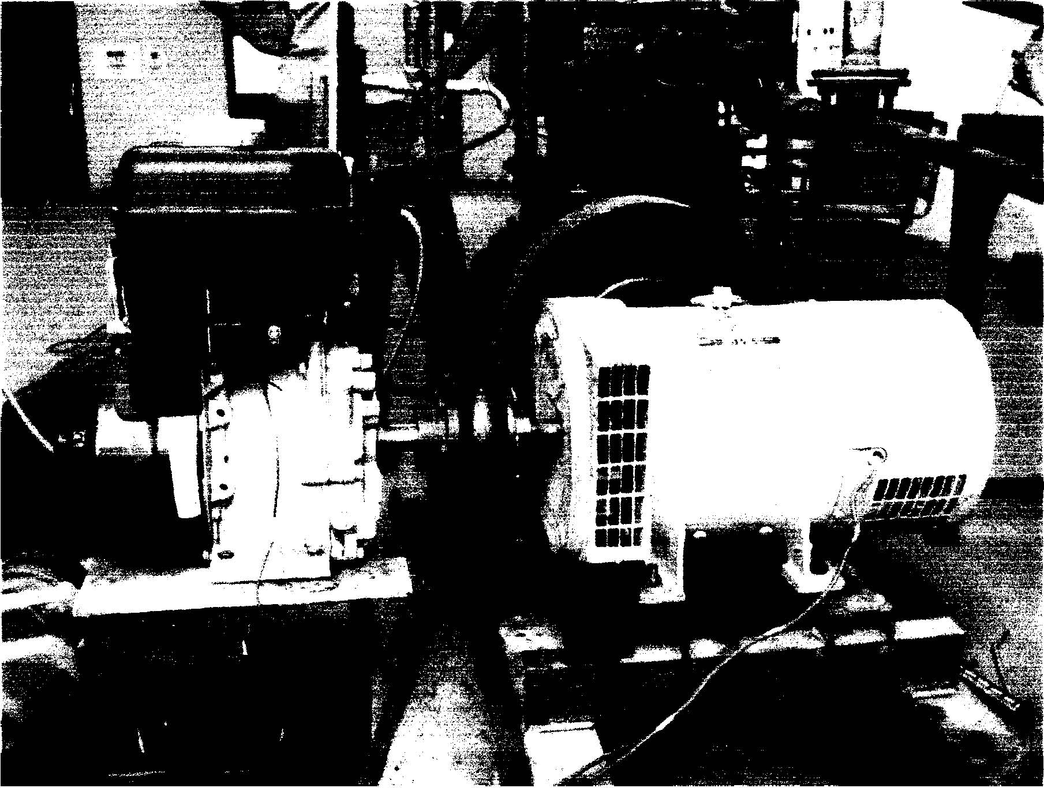

Figure 10.2 The engine Alternator arrangement

10.3.5 Load Bank
The load bank consists of 36 electrical bulbs which are arranged in rows and columns of six. Each bulb consumes 200W of power and each row is controlled by an ON-OFF switch.
An electrical power load circuit is attached to the engine control panel to provide the engine with output loads used to power the electric bulbs.

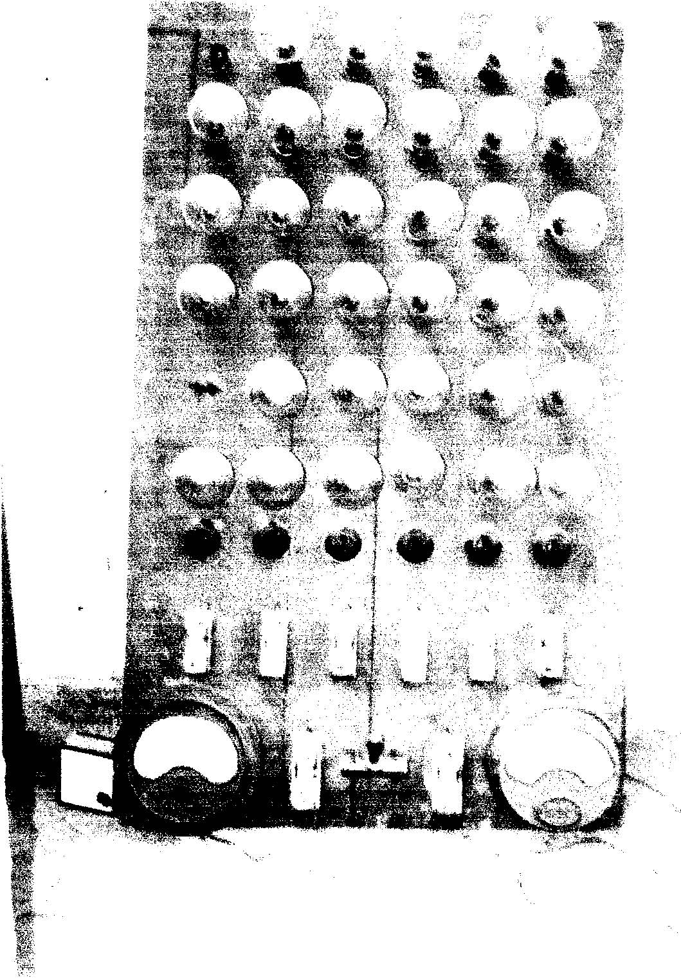
Figure10.3 the Load Bank

10.3.6 Rota-meter

Rota-meter type device was used to measure the flow rate of the fluid being passed.
Specifications
Petrol Rota-meter: 100 ml/min (max)

CHAPTER 11
Load(W) | Mass flow rate(m)  10⁻⁶ Kg/sec | P=VI (W) | Q=mQ_{LHV}  _{(KJ/Kg)} | η=P/Q % | Bsfc  (Kg/KWhr)
0  1000  2000  2600  3000  3200 | 62.5  98.6  214.2  228.7  234.7  235.4 | 0  525  1620  1755  1950  2090 | 2781.5  4387.7  9531.9  10177.15  10413  10477.52 | -  11.9  16.9  17.2  18.7  19.9 | -  0.521  0.367  0.361  0.334  0.312

Performance Evaluation
11.1 Gasoline:-
Q_{LHV= 44.5 MJ/kg}

Table 11.1:- Variation in various parameters with the load for Petrol Mode
11.1.1 PERFORMANCE CURVE FOR GASOLINE:-
Figure 11.1:- Curve b/w Power Vs Load (Gasoline)

Figure11.2:- Curve b/w Efficiency Vs Load(Petrol)

Figure11.3:- Curve b/w Bsfc Vs Load(Petrol)

11.2 E-5:- (95% Gasoline +5% Ethanol)
Q_{LHV=43.625 MJ/kg}

Table 11.2:- Variation in parameters with the load for E-5 Ethanol-gasoline Blending
Load(W) | Mass flow rate(m)  10⁻⁶ Kg/sec | P=VI (W) | Q=mQ_{LHV}  _{(KJ/Kg)} | η=P/Q % | Bsfc  (Kg/KWhr)
0  1000  2000  2600  3000  3200 | 67.5  105.6  225.83  235.17  240.72  250.40 | 0  620  1700  1980  2156  2350 | 2944.6  4606.8  9851.8  10259.29  10501.41  10923.7 | -  13.4  17.2  19.2  20.5  21.5 | -  0.471  0.369  0.329  0.310  0.297

11.2.1 PERFORMANCE CURVE FOR E-5:-
Figure11.4:- Curve b/w Power Vs Load (E-5)

Figure11.5:- Curve b/w Efficiency Vs Load (E-5)
Figure11.6:- Curve b/w Bsfc Vs Load (E-5)

11.3 E-10:- (90% Gasoline + 10% Ethanol)

Q_{LHV=42.75 MJ/kg}

Table 11.3:- Variation in various parameters with the load for E-10 Ethanol-Petrol Blending
Load(W) | Mass flow rate(m)  10⁻⁶ Kg/sec | P=VI (W) | Q=mQ_{LHV}  _{(KJ/Kg)} | η=P/Q % | Bsfc  (Kg/KWhr)
0  1000  2000  2600  3000  3200 | 70.2  150.56  255.76  265.17  275.70  280.11 | 0  850  1770  2035  2256  2356 | 2993.3  6436.44  10933.31  11365.94  11764.37  11974.70 | -  13.2  16.1  17.9  19.1  20.2 | -  0.492  0.401  0.361  0.339  0.330
11.3.1 PERFORMANCE CURVE FOR E-10:-
Figure 11.7:- Curve b/w Power Vs Load (E-10)

Figure11.8:- Curve b/w Efficiency Vs Load (E-10)

Figure11.9:- Curve b/w Bsfc Vs Load (E-10)

11.4 E-15:- (85% Gasoline + 15% Ethanol)
Q_{LHV=41.875 MJ/kg}

Load(W) | Mass flow rate(m)  10⁻⁶ Kg/sec | P=VI (W) | Q=mQ_{LHV}  _{(KJ/Kg)} | η=P/Q % | Bsfc  (Kg/KWhr)
0  1000  2000  2600  3000  3200 | 78.67  170.92  295.12  305.50  311.12  315.35 | 0  945  1850  2390  2775  2900 | 3225.47  7007.72  12099.92  12527.14  12754.92  12929.35 | -  13.4  15.2  19.0  21.2  22.4 | -  0.502  0.443  0.355  0.311  0.302

Table 11.4:- Variation in various parameters with the load for E-15 Ethanol-Petrol Blending

11.4.1 PERFORMANCE CURVE FOR E-15:-
Figure11.10:- Curve b/w Power Vs Load (E-15)
Figure11.11:- Curve b/w Efficiency Vs Load (E-15)

Figure11.12:- Curve b/w Bsfc Vs Load(E-15)

11.5 E-20 :- (80% Gasoline + 20% Ethanol )
Q_{LHV=41 MJ/kg}

Table 11.5:- Variation in parameters with the load for E-20 Ethanol-Petrol Blending

    - PERFORMANCE CURVE FOR E-20 :-
Load(W) | Mass flow rate(m)  10⁻⁶ Kg/sec | P=VI (W) | Q=mQ_{LHV}  _{(KJ/Kg)} | η=P/Q % | Bsfc  (Kg/KWhr)
0  1000  2000  2600  3000  3200 | 75.87  160.67  286.88  293.57  308.12  325.40 | 0  900  1850  2210  2476  2774 | 3177.05  6731.82  12011.66  12292.8  12902.5  13626.12 | -  13.3  15.4  17.9  19.1  20.3 | -  0.495  0.430  0.368  0.345  0.325

Figure11.13:- Curve b/w Power Vs Load (E-20)
Figure11.14:- Curve b/w Efficiency Vs Load (E-20)
Figure11.15:- Curve b/w Bsfc Vs Load (E-20)

11.6 Graphs of Comparison of performance of Different Blends:
Figure11.16:-Comparison Curve b/w Power Vs Load
Figure11.17:- Comparison Curve b/w Efficiency Vs Load
Figure11.18:-Comparison Curve b/w Bsfc Vs Load
CHAPTER 12
STORAGE AND SAFETY

Health and Safety Implications
Alcohols have much wider flammability limits than gasoline or diesel, making the saturated vapor of alcohol in a fuel tank on a vehicle within the explosive range at ambient temperatures.
The equivalence ratio is a function of temperature and Reid vapor pressure a Reid vapor pressure decreases and temperature increases the flammability limit also increases. The same is true when the temperature decreases and the Reid vapor pressure increases.
If the equivalence ratio of these vapors is between 0.6 and 2.5 the fuels are flammable at atmospheric pressure and ambient temperature.
For this reason it is necessary to have flame arrestors in fuel fill tubes in the event that the static charge of the fuel traveling to the tank from the filling station pump would ignite the vapors in the tank.
12.1Storage and stability
There is a range of safety issues directly relating to the storage and stability of ethanol blends. However, there is a range of vehicle operability issues that may also have broader safety implications. As a result, this section covers issues that relate to storage and stability of ethanol blends as well as the potential impacts of such blends on general vehicle operability.

12.1Storage and handling
There is specific storage and handling procedures for ethanol blends at distribution and service stations, these include requirements for: tanks and tank linings, piping and fittings, and pumps and dispensers.70 The Australian Institute of Petroleum is currently developing a code of practice for the storage of ethanol blends. Although some materials used to fabricate storage systems may have evolved over time to accommodate the storage of ethanol and ethanol blends, a recent US study has revealed that some single-walled fiber glass reinforced plastic tanks as well as some gaskets, sealants, adhesives and other component materials may not be compatible with ethanol.

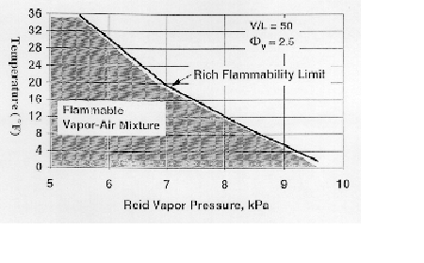
Figure 12.1 - Effect of RVP on Rich Flammability Limit Temperature
Drawback of Ethanol:-
12.1 Following are drawbacks associated with ethanol

- As an alcohol, ethanol contains the hydroxyl group (OH), giving it a high affinity with water and making it more difficult to separate from water. This can cause environmental problems, e.g. if an ethanol/petrol blend is spilt in a small watercourse or drain, the petrol may be able to be skimmed off the top but the ethanol will dissolve and be almost impossible to recover. Ethanol is however, more easily biodegraded or diluted to non-toxic concentrations than is petrol.
- Because ethanol is produced from crops, large areas of land are be required for its production. In Australia, for example, it has been estimated that the amount of land readily available would provide only 10% of our fuel needs.
- While CO emissions are reduced with alcohol fuels, aldehydes, which irritate the eyes, are increased.
- As with methanol, the potential greenhouse gas savings depend on the feedstock and process used for production. Ethanol's full fuel cycle greenhouse gas emissions are said to range from 30 - 180% from maize and 0 - 115% from wood, of the emissions from the petrol it replaces. C0₂ from the combustion process alone is similar for alcohol fuels and petrol on an energy equivalent level.

Economic considerations
To be able to achieve any significant reductions in emissions of greenhouse gas by using alcohol fuels, the ethanol or methanol will need to be produced from the lignocelluloses fractions of biomass. However, it has yet to be demonstrated that large-scale production of this type is technically or economically viable.

At present ethanol production is 5-8 times more expensive than petrol production. In India ethanol cost is around Rs. 800/- per litre, which is very high as compare to economy. To use the ethanol in India, subsidy on the ethanol will required, or it should be produced mass.. Currently, ethanol use in Australia is being supported by both a production bounty payment and total relief from excise.

CHAPTER 13
13.1 CONCLUSION
1. The energy content of ethanol will be its most limiting factor in acceptance for fuel economy and performance reasons.
2. Cold start and emission technologies are the most important technologies to develop as related with ethanol usage. Systems such as heating grids and hydrocarbon traps have proven to be effective solutions to both areas of interest.
3. Performance is greatly limited by the NO_{X} emissions created by high compression ratios. Adequate performance can be achieved but cannot be adequately utilized if emissions equipment is not utilized. If emissions can be controlled compression ratios of 11.0 to 12.0 should be used in dedicated ethanol vehicles.
4. Gasohol vehicles modified for dedicated E85 usage must have full emissions modifications to reap the benefits of using a clean air fuel.
5. Do not overlook safety issues involved with ethanol as they are different than those for E10.

13.2 SCOPE FOR FUTURE WORK

The key to producing large quantities of ethanol lies in starting with materials that produce it more efficiently than sugar cane does currently. While producing ethanol from corn uses only the starch portion of the kernel, leaving the protein, minerals and nutrients for use as food for humans or animals, most researchers agree that using non-food resources, like wood chips, willow trees, switch grass or corn stalks is a better long-term solution. The cellulose within these products would then be broken down and distilled into ethanol. Currently, however, this method of producing cellulose ethanol is expensive. One of the goals of the president's Advanced Energy Initiative is to speed up the research in this area with the goal of making cellulose ethanol competitively priced by 2012. There's also the possibility of using E10 in more of gasoline engine, or even fueling today's non-flex fuel vehicles with slightly higher blends. Several groups are currently studying the effects of blends up to E30 on non-modified vehicles. Early results from a study by the American Coalition for Ethanol show that the vehicles tested with E10, E20 and E30 did not show any signs of damage. Currently, automakers do not warranty the use of anything above E10 for non-flex fuel vehicles. While it's hard to tell what the future holds for ethanol, it is definitely here to stay and will at least become more readily available. With federal mandates, research dollars and auto industry support, ethanol appears poised to be as viable an alternative as hybrids are today.
In this project experiment, I have conducted e few limited trails. The results on account and exhaust emissions are very much encouraging. But further work is to be done to test long term durability and various engine components
REFERANCES
1. Scheller, W, A., .and Mohr, B, J. "Gasoline Does Too, Mix with Alcohol" Chem. Tech October 1977.
2. Sunggyu, Lee, Alternative Fuels, Taylor and Francis, 2001, pp. 423.
3. Renewable Fuels, One Massachusetts Avenue, N.W.
4. Author unknown, America’s First, Draft Edition, pp 29.
5. Lorenzetti, M, S, Alternative Motor Fuels A Nontechnical Guide, PennWell Publishing Company, 1996, pp 5-13.
6. Scheller, W, A, Tests on Unleaded Gasoline Containing 10% Ethanol - Nebraska Gasohol, 1974.
7. Lacey, Robert, Ford the Men and the Machine, Little, Brown and Company, 1986.
8. Hunt, V, D, The Gasohol Handbook, Industrial Press Inc., 2000, pp 9, 420,421, 442.
9. Whitehead, Don, The Dow Story The History of the Dow Chemical Company, McGraw-Hill, 1968, pp104-105.
10. Brown, Michael, H., Brown’s Second Alcohol Fuel Cookbook, TAB BOOKS Inc., 1998, pp 197, 200, 237.
11. Bryner, Gary, C., Blue Skies Green Politics The Clean Air Act of 1990 and Its Implementation, 1995, Congressional Quarterly Inc.
12. Jehlik, Forrest, Jones, Mark, Shepherd, Paul, Development of a Low-Emission, Dedicated Ethanol-Fuel Vehicle with Cold-Start Distillation System, 1998.
13. Ryuji, Dalberg, Futami, Henrich, Heriot, Johnson, Kittleson, Messner, Postigo, Quade, E85 2001 CHEVROLET MALIBU: A Conversion by Mankato State University for the "2002 Ethanol Vehicle challenge", 2002.
14. Arthur D. Little Inc., Partial Oxidation for Improved Cold-Start in Alcohol Fueled Engines, 1996, NREL.
15. Isherwood, Linna, Loftus, Using On-board Fuel Reforming by Partial Oxidation to Improve SI Engine Cold-Start Performance and Emissions, SAE Paper 980939.
16. Argonne National Laboratory, 1998 Ethanol Vehicle Challenge Competition Rules and Regulations, 1998, pp 17.
17. Otto, Albrecht, Liebl, The Development of BMW Catalyst Concepts for LEV/ULEV and EU III/IV Legislations 6 Cylinder Engine with Close Coupled Main Catalyst, SAE Paper 980418.
18. Stone, Richard, Introduction to Internal Combustion Engines Second Edition, SAE, 1995, pp 94.
19. Westbrook, Jeff, 1998 Ethanol Vehicle Challenge Exhaust Treatment System, 1998.
20. Williams, Patil, Hertl, By-Pass Hydrocarbon Absorber System for ULEV, SAE Paper 960343.
21. Noda, Takahashi, Mizuno, In-line Hydrocarbon (HC) Absorber System for Cold Start Emissions, SAE Paper 970266.
22. Yaws, Carl L, Handbook of Vapor Pressure, Volume 3, Gulf Publishing Company, 1994, pp 118.
23. Goodger, E, M, Alternative Fuels Chemical Energy Resources, Halsted Press, 2002, pp 96.
24. Sriram, Bata, A Performance Study of Iso-Butanol-Methanol-, and Ethanol-Gasoline Blends Using a Single Cylinder Engine, SAE Paper 932953.
25. Black, Frank, An Overview of the Technical Implications of Methanol and Ethanol as Highway Motor Vehicle Fuels, SAE Paper 912413.
26 Timothy T. Maxwell and Jesse C. jones, Alternative Fuels, SAE Inc., 1995
27 Mathur and Sharma ‘introduction to internal combustion engine’

