A NOVEL APPROACH FOR SECURITY AUTHENTICATION ARCHITECTURE BASED ON ELLIPTIC CURVE CRYPTOGRAPHY

THESIS SUBMITTED TO THE DELHI COLLEGE OF ENGINEERING
FOR THE DEGREE OF
MASTERS IN ENGINEERING

BY
FARZIL KIDWAI
College Roll No. 05/CTA/08
University Roll No. 8403



Department of Computer Engineering
Delhi College of Engineering
Bawana Road
Delhi
2008 - 2010

June 2010
CERTIFICATE

DELHI COLLEGE OF ENGINEERING
(Govt. of National Capital Territory of Delhi)
BAWANA ROAD, DELHI – 110042

Date:___________

This is to certify that dissertation entitled “A NOVEL APPROACH FOR SECURITY AUTHENTICATION ARCHITECTURE BASED ON ELLIPTIC CURVE CRYPTOGRAPHY” has been completed by Farzil Kidwai, University Roll No. 8403 in partial fulfillment of the requirement of major project of Master in Engineering in Computer Technology & Application.
This is a record of his work carried out by him under my supervision and support during the academic session of 2010. This is a beneficial work in field of Security Engineering for creating better and more secure authentication architectures.

(Dr. DAYA GUPTA)
HOD & PROJECT GUIDE
(Dept. of Computer Engineering)
DELHI COLLEGE OF ENGINEERING
BAWANA ROAD, DELHI - 110042

ACKNOWLEDGEMENT

It is my distinct pleasure to express my deep sense of gratitude and indebtedness to my learned supervisor Dr. Daya Gupta, HOD, Department of Computer Engineering, Delhi College of Engineering, for her invaluable guidance, encouragement and patient reviews. Her continuous inspiration only has made me complete this dissertation. She kept on boosting me time to time for putting an extra ounce of effort to realize this work. She provided the conceptions and theoretical background for this study as well as suggested the rational approach. She remained a pillar of help throughout the project.

No words are sufficient to express my heartfelt thanks to my respected parents Mrs. S. Kidwai and Professor M. Kidwai who are my inner strength and showed me the light to reach upto this stage. I owe a special gratitude to my sister who has been very supportive and has given me prism of positive outlook that enabled me to succeed in this endeavor.

I would also like to take this opportunity to present my sincere regards to my teachers Mrs. Kakali Chatterjee for her technical assistance and invaluable suggestions without which this project would not have been possible, and also to other staff members of Computer engineering Department providing me unconditional and anytime access to the resources and guidance.

Finally, I would like to thank my classmates for their unconditional support and motivation during this work.

Farzil Kidwai
Master in Engineering
(Computer Technology & Application)
Deptt. of Computer Engineering
Delhi College of Engineering
Bawana road, Delhi – 110042



Delhi College of Engineering |  |  | ABSTRACT OF THE MASTER’S THESIS
Author : | Farzil Kidwai
Name of the Thesis : | A NOVEL APPROACH FOR SECURITY AUTHENTICATION ARCHITECTURE BASED ON ELLIPTIC CURVE CRYPTOGRAPHY
Date : | 20 July,2010 | Number of Pages : |  | 104
Department : | Computer Engineering
Supervisor : | Dr. Daya Gupta , Head of Dept , Computer Engineering
Security strength of a system can be equated to the vulnerability or exploit obtained by an attacker in an attempt to breach it. The importance of security strength and risk continues to grow as individuals, business, and governments become increasingly reliant on software systems. The vulnerabilities are always there no matter how complex a system is or how many layers of security are present. This dissertation aims at designing a system for security authentication that can handle requests from multiple clients. This system proposes a mutual authentication protocol based on Elliptic Curve Digital Signature Algorithm and Elliptic Curve Diffie-Hellman key exchange intended for mutual authentication and key exchange respectively. The objective is to minimize the overheads on the Main server by providing a middle level system that can handle request from clients and reject obsolete or unwanted request at the same time. Process is fast on both client and Main server side. The proposed security architecture can be considered to increase the security strength and reduce security risk. For the same level of security, as RSA Cryptosystem, Elliptic Curve Cryptosystem can be implemented with much smaller parameters with significant performance advantages.

Keywords : Security Engineering , Security Architecture , Authentication , Authentication based on ECC ,Elliptic Curve Cryptography, Security Authentication Engineering , Authentication based on ECDH, Cryptosystems, Security Design, Elliptic Curve Cryptography(ECC), Elliptic Curve Deffie-Hellman (ECDH) key exchange, Elliptic Curve Digital Signature Algorithm(ECDSA)
Index of Contents
- Introduction  - Introduction  - Motivation of the work  - Problem Statement  - Scope  - Organization of report  - Introduction to E-commerce  - E-commerce and Security  - Existing Authentication mechanism for E-Commerce  - Two-tier architecture  - Three-tier architecture  - Related work of Cryptography  - Symmetric Key Cryptography  - Asymmetric Key Cryptography  - Elliptic Curve Arithmetic  - Thee Tier Security Architecture  - Proposed Architecture  - Design Architecture  - Implementation of the proposed architecture  - Code for implementation of the proposed architecture  - Advantages and Efficiency  - Analysis  - Specification  - Development Environment  - NetBeans  - Java Development Kit  - Database  - Implementation Results  - Implementation Results  - Application of the system  - Conclusion and Future Work  - Limitation of the system  - Future Scope  - Summary  - References | 1-8  1  4  5  6  7  9-32  9  24  24  31  33-60  38  43  51  61-78  61  63  67  72  76  77  78  79-85  79  81  83  86-96  87  95  97-99  98  98  99  100-104

List of Figures

Figure 1 : Secure business application logic model for e-Commerce Systems Security 17
Figure 2: n-Tier Architecture 18
Figure 3: Three Different Environments 22
Figure 4: Two Tier Architecture 26
Figure 5: Mutual dynamic symmetric authentication (using global keys) 28
Figure 6: Mutual dynamic symmetric authentication (using specific keys) 29
Figure 7: Unilateral dynamic asymmetric authentication (using card specific keys) 30
Figure 8: Three-Tier Architecture 32
Figure 9: Symmetric Key Cryptography 38
Figure 10: Public key Cryptography 45
Figure 11: Diffie Hellman Key Exchange 49
Figure 12: Equivalent key sizes for ECC and RSA 50
Figure 13: Elliptic Curve 52
Figure 14: Point Addition on elliptic curves over R 53
Figure 15: Three tier architecture for secure communication 62
Figure 16: Secure communication task flow 64
Figure 17: Block diagram of the authentication of the system 67
Figure 18: Timings for Elliptic Curve in real environment 77Screenshot 1. Main Login Screen 87
Screenshot 2. Authenticated login screen 87
Screenshot 3. Authentication Failed screen 88
Screenshot 4:Demo Console 88

INTRODUCTION

  - Introduction
E-Commerce is an integral part of our lives now. It has boomed in popularity for both retailers and consumers and this trend is not going to stop anytime soon. The cost-benefits for businesses in overhead and the convenience for shoppers are strong motivators to continue the growth of e-commerce. While there are many benefits of e-Commerce, it is important to remember that there are definitive security challenges that businesses face in e-commerce. But, these are probably not enough to deter merchants (and customers) from engaging in online transactions; still they need to be paid careful attention in order to minimize the risk. Furthermore, E-Commerce is not only limited to a fixed computer it has become wire-free. Wireless Networks are quickly becoming ubiquitous in our day to day life. With the increasing popularity of wireless technology security has been a major challenge for the IT industry.
In an age where cybercrime is steadily increasing, every business is at risk. Cyber criminals are interested in businesses of all shapes and sizes. Each one they can hack into provides a goldmine of information they can profit from which can range from customer personal data and credit card information to proprietary business information. And With the increasing popularity of wireless technology security has been a major challenge for the IT industry. ^{[66]}
Some of the technical challenges business must face are securing their networks, databases, providing encryption, firewalls, anti-virus software, and anti-intrusion security. These are all important measures a business needs to consider if they want to secure themselves and reduce risk of being infiltrated. Security provisions are present in the system, not for the sake of the system but to guard against the indentified security threats – Traffic analysis, Passive eaves dropping with known plaintext, man in the middle attack, unauthorized access, session high jacking, replay attack etc. that can also violate the integrity of the network traffic. Organization put up provisions for specific security features such as confidentiality, integrity, entity authentication and non repudiations, but very few businesses look at the possibility of a new and better secure architecture that can give them a new degree of freedom. Furthermore, there are devices which can be very constrained in terms of memory, computing power, and energy supply. To give proper security over the wireless mobile communication, Elliptic Curve Cryptography (ECC) comes in handy as many of these portable devices are restricted by some general computational constraints related to processor speed, bandwidth, memory etc.
Other challenges, which are more related to a company's managerial and organizational cultures are password habits, handling of data (including entering of data and opening/sending e-mail), segregation of duties and policies on database access for employees and removing employee access from those no longer employed. These can come up as a real challenge, especially if the organization is using a less secured network.
Today's cybercrime no longer consists of a person logging into networks or breaking into databases from the comfort of a basement; it has grown to become organized crime and is an international problem. Cybercriminals can be spread throughout the world all operating in a carefully synchronized manner in order to launch an attack. Be it wired network or a cell-phone, everything that is capable of communicating with the internet can be hacked.
Network and database security is a costly measure and a challenge, but one that is necessary for all businesses who engage in e-commerce. Even the most vigilant security conscious companies are still at risk, and the ones that do not put any effort or resources into securing their networks and databases increase their risk significantly.
Those that ignore security issues can liken it to leaving a car unlocked and the key in the ignition; if you do this, the possibility of the car being taken is highly increased. Companies that do not put forth effort in securing their data assets are essentially leaving the keys to their business in the door.
In a practical distributed environment many systems have a large number of remote devices communications with a central server. To reduce the unnecessary overhead on central servers, generally authenticating servers, a middle level server can be introduced and to secured the system a mutual authentication schema is developed which is based on Elliptic Curve Cryptography. Hence we propose a mutual authenticated key agreement protocol based on elliptic curve cryptographic techniques. The proposed protocol requires significantly less bandwidth than the different public key cryptosystems (such as RSA, EIGamal for encryption, and Diffie-Hellman for key exchanging protocols), and furthermore, it has lower computational burden and storage requirements on the user side. The use of elliptic curve cryptographic techniques provide greater security using fewer bits,^{[66]} resulting in a protocol which requires low computational overhead, and thus, making it suitable for wireless and mobile communication systems also, including smartcards and handheld devices.
The new protocol achieves many of the required security. It can resist dictionary attack and man-in-middle attack which is very often found in password based protocols. It is also resistant to known key and resilience to server attacks.

  - Motivation of the work
The thesis aims at designing a three level system for Authentication Security. Generally, simple client-server architecture exists for authentications and it follows a simple protocol where a request is sent to the server which checks this with a Database and acknowledges accordingly. This type of authentication is the simplest and can be easily compromised. The newer and more advanced Authentication protocols are also only a variation of this simple Client-Server Architecture but with improved Security Measures. The work described in this thesis is designed to abstract the client – server communication while authentication for improved security. A simple client –server communication can easily be compromised by using a simple brute-force attack on the server. The architecture described in this work is invulnerable against this attack because even if the hacker knows the address of the server it is only a middle level server and compromising it will give nothing since the actual authentication is generated by the final server. To ensure that a client doesn’t act as a middle level server to compromise the final server, further measures are provided by authenticating the middle server using Elliptic Curve Digital Signature Algorithm. The key Exchange at any point is achieved by using Elliptic Curve Diffie-Hellman Algorithm. Hence, we design the proposed architecture to enhance the security.

  - Problem Statement
The problem is to design a security authentication protocol where three systems are used for authentication. In this system, a middle server is also introduced to improve the level of security and also to abstract the data communication between Client and the Server. When multiple servers are communicating with a single root server, a lot of unnecessary traffic is generated. To reduce unwanted traffic by introducing a middle level server that performs filtering before the root server and to secured the system a mutual authentication schema is developed which is based on Elliptic Curve Cryptography .Mainly ECC is based on Elliptic Curve arithmetic (Discrete Logarithmic problem) and hence is not vulnerable to common attacks that are possible with RSA (Rivest Shamir Adleman). ECC also improves the performance of the system since it uses much smaller key sizes than the RSA algorithm and provides the same level of security. On the basis of the proposed three tier architecture of the system the design has been implemented in Java.

  - Scope
The work described in this thesis aims at reducing the unnecessary overhead on servers, generally authenticating servers, by introducing a middle level server. Along with this it also accomplishes the task of providing a more secure authenticating architecture. Hence the architecture can be employed at places where high security is the essential part of the organization and also where heterogeneous devices can be allowed to access the authentication system. The ideal place for employing this architecture would be an e-Commerce system. Moreover, since we are using Elliptic Curve Cryptography, we can also use low memory devices in our architecture.

  - Organization of Report
The first chapter introduces us to the thesis, as to why and what is being done. This is basically an Introduction of the report. We analyze the Motivation of the work and then we define the Problem statement and Scope for the work.
Second Chapter gives us an introduction to the E-Commerce. We give a brief overview of the e-Commerce and its security. Then we look at the Existing Authentication mechanisms of E-Commerce. The existing protocols can be broadly classified as two tier and three tier architectures.
The Third Chapter describes the Background to the different types of cryptography (Symmetric key cryptography and Asymmetric key cryptography) and then we provide a special focus on Elliptic key cryptography which is the main thing used to provide the security in our system.
Fourth chapter presents the Proposed Architecture for the system with middle level server. Then, its design and the actual implementation are discussed. The Advantages and Efficiency of the system is also discussed along with the analysis of the system. And in the end we discuss the specification of the designed System.
The Fifth chapter shows us the environment with which a demonstrative project was made. We have used NetBeans UI and Java SE. At the backend Databases are required to keep the track of users.
Sixth Chapter discusses the Implementation results of the system and the Application part which helps us to describe the actual use of the system.
Finally in Seventh and final chapter, we discuss the Limitations and Future scope of the system.

Conclusion
This chapter has discussed the overview of the entire thesis which helps us to analyze the thesis and to some extent describes what the work is all about. Further Chapters will describe the work in more detail and along with that will tell us about the positive and negative points about the work done.
INTRODUCTION TO E-COMMERCE

Introduction
This chapter describes the various backgrounds that were considered during the thinking process. Most of the background work described is well documented and is of good repute. This chapter can be treated as the basis of the thesis, as to why the work has been done and the necessity shall evolve automatically as we read further. This Chapter also introduces different types of cryptography. The main focus of the work is on E-commerce systems.

  - E-commerce and security
Electronic commerce basically refers to the online trading i.e. buying and selling goods online on the internet and other computer networks. The amount of trade on the internet has grown significantly with the increase in usage of the internet. This has also increased the bandwidth requirement in different continents of the world. The use of e-commerce has also made an impact on different industries. New innovations have evolved such as electronic funds transfer, internet marketing, Supply chain management, Automated data collection systems, electronic data interchange (EDI), inventory management systems, and online transaction processing. Most of the E-commerce systems today use the World Wide Web at some point in their transaction lifecycle.
Electronic commerce (EC) is a popular topic ^{[34]} in the mass media and in informatics circles as well. Perhaps its impact is most visible in the areas of financial services and retailing. Many EC initiatives have risen in a short period of time. Those initiatives include innovative smart cards to facilitate EC, remote payments and electronic checking ^{[31]}, online trading of stocks, bonds and related financial instruments, online banking, and online retailing (e-tailing). We are now becoming comfortable with the Internet, and we are beginning to appreciate its ability to provide a wealth of diverse information from around the globe; literally millions of sites are just a click away, opening up new opportunities for trade and information exchange. Internet use is no longer a novelty; it is becoming as much a part of our daily lives as television and telephony. We have witnessed a true revolution with the growth of the Internet and Internet use, but now we are experiencing a second Internet revolution and it is called electronic commerce. The tools and techniques to enable trading over the Internet are becoming mature, and EC is growing very rapidly. ^{[33]}
One can see evidence of EC everywhere on the World Wide Web (WWW). Many commercial web sites have catalogues and support online transactions, but EC is much more than these. It includes everything from sourcing to settlement and all the processes that underlie trading. The Internet’s WWW has become the primary driver of contemporary EC. Although the emphasis has moved from electronic data interchange (EDI) to the Internet, the focus is still on the technology required to exchange information rather than supporting inter- and intra-organizational business processes. EC is not just about facilitating individual business transactions, it also involves the management of the relationships that lead to and arise from transactions ^{[38]}. EC is the process of conducting business electronically among various entities in order to satisfy an organizational or individual objective. A key ingredient of EC, sometimes referred to as electronic trading, is the advertisement and procurement of goods and services over the Internet ^{[11]}. The success and volume of EC on the web has been widely reported. With success in establishing an environment in which EC can grow and flourish, every computer can become a window open to every business, large and small, around the globe. The electronic medium we call the Internet has the potential to reduce actual transaction time and processing time dramatically, while at the same time making information available globally. Internet-based EC has been embraced as a means of reducing operational cost and as a high potential means of generating revenue. The ubiquity of the web and the availability of browsers across different platforms provide a common base upon which EC applications can be built, especially in the enterprise ^{[12]}. This common platform has reduced the significance of issues pertaining to software distribution and software installation, thus encouraging the expansion of EC via Intranets, Extranets and the Internet. EC provides new channels for the global marketing of tangible goods and presents opportunities to create new businesses providing information and other knowledge-based intangible products. Although most EC is currently at the inter-corporate and inter-organizational level, services targeted at individual customers are evolving rapidly. The Internet is the most obvious example of this and is a major catalyst in the diffusion of EC, helping to foster a common environment for electronic transactions of all kinds ^{[13]}. EC encompasses all forms of interactive business transactions, which are facilitated by networks of computers. EC is expanding because of the greater number of businesses and individuals who are able to use these networks and the growing number of ways in which businesses can conduct transactions electronically with other organizations and directly with consumers. At present, business-to-business EC seems still to be of greater volume than business-to-consumer EC, but this may change in the future. These trends are important to the global economy and to the economy of individual countries because EC contributes to economic efficiency. EC contributes to economic efficiency in five important ways. They are as follows:
(a) shrinking distances and timescale,
(b) lowering distribution and transaction costs,
(c) speeding product development,
(d) providing more information to buyers and sellers and
(e) enlarging customer choice and supplier reach ^{[32]}.
As the market for e-commerce continues to heat up significantly, most stakeholders in the market are quick to declare that the system is secure. Encryption protocols such as SSL are promoted as proof of security by e-commerce vendors. Lost in the hype are the real security risks of e-commerce. Although encryption of data during transactions provides crucial confidentiality, integrity, and authentication, these attributes make up only a small portion of security that must be ensured for e-commerce security. Businesses engaging in e-commerce incur higher risk of attacks, higher risk of severe losses, and a higher loss-to-incident ratio than simply put up web pages. In fact, due to the complex nature of business, e-businesses are much more vulnerable than simple websites due to the greater complexity of the software necessary to support e-commerce transactions^{[41, 44]}. The software that executes on either end of the transaction-server-side or client-side software exposes real threats to the security, privacy and client trust of all e-commerce transactions. Two familiar adages play an important role in understanding how to secure e-commerce systems:
- a chain is only as strong as its weakest link; and
- in the presence of obstacles, the path of least resistance is always the path of choice ^{[43]}.

    - Designing for Security
As with all software development, good design and engineering practices are important for software quality. This point is particularly important for development of security-critical software such as e-commerce applications. Rather than thinking of security as an add-on feature to software systems, security should be designed into the system from the earliest stages of requirements gathering through development, testing, integration, and deployment. The goal of design for security is to break the penetrate-and-patch mindset that pervades commercial software security today, and replace it with a process for finding and removing security-related bugs prior to software release. Finding and fixing bugs in software after release costs orders of magnitude more than correcting them early during the software development lifecycle ^{[44]}. One unfortunate consequence of the huge pressure to reduce time to market for e-commerce services is that good software engineering practices are dropped (or more often never started).
As described in section ‘‘A key weak link: business application logic’’,^{[34]} the demand for e-commerce applications is driving the complexity of business application logic. Developing software such as a typical desktop application for one user at a time differs significantly from developing an e-commerce application that needs to handle tens of thousands of concurrent requests. Today’s e-commerce applications need to not only handle many simultaneous users, but also deal with malicious threats. As a result, developers must employ good software engineering practices to develop robust and secure business application logic. Several key activities mark good software engineering practices:
- Gathering and formally specifying requirements
- Developing normal and pathological usage scenarios
- Object-oriented analysis and design
- Adopting good coding practices
- Unit testing and integration
- Release engineering
- Third-party validation and verification

Requirements’ gathering has traditionally focused on users’ needs for the application under development. In gathering requirements for security critical applications, developers must equally focus on what the user should be allowed to do and should not be allowed to do.^{[34]} A plan for meeting functional requirements is typically captured in specifications for the application. However, specifications for e-commerce applications need to specify not only which functional behaviour is expected from the application, but also which behaviour is not desired. Therefore, to develop a specification of secure behaviour, the project team must develop a security policy for the e-commerce application (and its users). Developing specifications is often fraught with anxiety over formality. While formal notations can be useful for reducing ambiguity, if they are so daunting that they discourage the development of specifications, then they can have the opposite effect on software quality. Remember that the ultimate goal of software specification is to promote understanding of intended system behaviour, so any specification is better than none.^{[34]} A specification of undesired behaviour is not only useful for preventing security design flaws, but can also be used for security-oriented testing ^{[44]}.
Encryption protocols generally provide the strongest perceived security in all the components involved in e-commerce transaction ^{[41]}. However, in e-commerce as in other real-world systems, the security of the system is only as strong as its weakest component. On the whole, the security of server-side systems is much weaker than the security provided by secure data transaction protocols such as SSL, example of this claim refers to the above mentioned cases of security breach and the case study of Barclay Bank Web site targeted that is the case of Copy Cat Trick which is conducted through the server-side mis-configuration of software,^{[34]} cause of vulnerability/compromising server-side security is clearly proof of this claim.^{[34]} Considering these two adages together in the context of e-commerce security, privacy and client trust, it becomes clear that malicious perpetrators will rarely attempt to break encryption codes when they can much more easily break into a system, and enjoy a much higher return via this simpler approach ^{[43]}. This article addresses the topic of securing server-side software used in e-commerce applications. Today, most e-commerce server applications are implemented in n-tier architecture as shown in Figure 1. This architecture usually consists of a front-end web server, a business application layer, a backend database, ERP systems, and legacy software. In practice, many of the security issues in e-commerce sites are specific to the way in which these components are configured.^{[34]}
Figure 1 shows typical n-tier architecture for a component-based e-commerce application. The web browser client can display web pages in HTML, execute mobile code such as Java applets or web scripts, and capture business-specific semantics using XML. The web server provides web services in addition to other Internet services such as e-mail and File Transfer Protocol (FTP). The business application logic is coded in software components that can be custom-developed or purchased off the-shelf. The application servers provide the infrastructural services for particular component models such as EJB, CORBA, COM, and DCOM. They also provide an interface for the business application logic to back-end services such as database management, enterprise resource planning (ERP), and legacy software system services.

Figure 1 : Secure business application logic model for e-Commerce Systems Security^{[34]}

The technology behind e-Commerce is called n-tier technology since the application, has many levels of communication. An example is a system, which has a presentation tier, a process tier, a persistence tier as well as communication with outside third party vendors. A typical n-tier architecture model is shown in Figure 2.^{[16]}
In this model^{[16]}, sometimes also known as the three-tier model, clients remain focused on presenting information and receiving input from users. This is known as the presentation tier. Data, meanwhile, is hosted on one or more data servers in the data tier. Only that processing required to access data and maintains its integrity gets implemented on this tier. This includes SQL query engines and transaction managers for commercial software, as well as triggers and stored procedures written by database administrators. Unlike the client–server model, however, these triggers and procedures are limited in scope to managing the integrity of the data residing on this tier. Business rules are moved to the application logic tier sometimes referred to as the business services or middle tier. The components of business rules are usually in the middle tier.^{[16]}

Figure 2: n-Tier Architecture ^{[16]}
    - Features of n-tier architecture
An integrated information system using a distributed environment needs the following features (www.n-tier.com)^{[16]}:
Autonomous: A server is expected to be autonomous enough to protect its own critical resources and to take its own decision at critical moments.
Usability: The architecture should assist users in performing their jobs efficiently and effectively.
Adaptability: The architecture should have the ability to easily and cheaply redesign existing functions for new technology, should provide access to existing legacy information, and provide a variable transition period from the old technology to the new.
Distributability: The clients and components of the architecture should be able to efficiently execute across multiple hardware platforms of a network.
Inter-operability: The applications within the architecture should be able to work together in a consistent manner to perform tasks for the users of an information system.
Standardization: Components of the architecture should be based on software standards that are widely available or defined by an international standards organization.
Extensibility: The architecture should be easy to adapt to meet new and ever-changing requirements.
Internationalizability: The architecture should be able to display information in the languages and formats appropriate for all the countries and cultures in which the applications are used.
Manageability: The system managers should be able to economically configure, monitor, diagnose, maintain, and control the resources of the computing environment.
Portability: The software should be relatively easy to be moved from one platform to another.
Scalability: The architecture should be able to efficiently handle any size applications and grow with the business needs.
Security: The architecture should protect information and computer resources from unauthorized use. The security component should have the ability to provide network-wide authentication. Addition, this component should provide centralized authorization capabilities.
Reusability: The reuse of existing software components is key to effective use of valuable software engineering talent and the aggressive schedules imposed by audience expectations.
Reliability: The components of the architecture should be able to be depended on for mission-critical business operations. Quality design of object classes and frameworks with an eye to maximizing reuse can also increase the reliability of the resulting software system.

The design issues of n-tier technology: moving code or data?
The idea behind any n-tier architecture^{[18,16]} is that a program can call another program, or an application can call another application. In short, there are various pieces that work together, but they are built by different groups. Client-server is a two-tier architecture. Even though the client is built by somebody and the database is built by somebody else that works well because the database has a contract for saying how the client talks to the database––it is schema, ODBC and SQL. Here the client and the database server are tightly coupled.
For example, let us consider an Application X (a hospital) that wants to go and order some medicine. Some other one has written an Application Y (a pharmacy) that actually takes an order for medicine and processes it. Both in turn talk to an Application Z (an insurance) that does bill paying and settlement (Figure 3). In this network, there are a couple of processes going on that are not synchronous in real time. When a patient (X) orders a prescription, he does not want to actually have its bill debited until the prescription has been mailed out, and his insurance (Z) takes a day or two to settle the payment to Y.

Figure 3: Three Different Environments ^{[16]}
If it is a brokerage house, it can take even five days. To make them work, these applications are to be wired together in the form of n-tier way. Now how do they communicate each other? In the n-tier world, the original thinking was that we would have a world of distributed objects. The client would be interface definition language (IDLs) for describing the objects, and that would be the contract. The service contract may be an enquiry, quotation, purchase order, invoice between X and Y. In the same way, it may be credit, debit, and transfer of fund etc. between Y and Z. All the objects would talk to all the other objects by looking them up in an object request broker (ORB) or some sort of repository and then using the IDLs to figure out how to talk to them. It means that we are moving the code rather than the data. Let us now discuss the issues in moving the code instead of the data through various tiers.
In the world of distributed objects, objects are supposed to have encapsulation and communicating with an object is nothing but invoking a method of the object. Suppose Y is looking up a hospital record of a patient and Y wants to get his first name, last name, social security number, date of birth, and so on. Suppose Y invokes a get method to get the first name, invokes a get method to get the last name, invokes a get method to get the social security number and so on. Then what will happen? Y will have three or four hundred method calls that will make against that object remotely from one application to the other. This turns out to be highly expensive, and it has been a real problem even within the organization.
Running different applications built by different people that coordinate this way does not scale very well. In fact, the performance may not be impressive even when there are a very limited number of users in very high-speed networks under a known environment. But as soon as it is extended across big corporate networks, or across the Internet, that model completely breaks down.
To be precise, what that means is that we have to move data––not code. A lot of people had the idea that it would be enough to move code around to cause these things to happen––like objects––we move instructions around the Web.
Here is one more problem. What will happen when Application X is trying to move the object of purchase-order to Application Y and then execute it? Well, it may not be possible. Application X does not know Application Y, it does not know how to run the code of Application Y, it does not know what platform Y is, and the code of X is not running in the same context and the same framework. But at same time it is possible to move the purchase order as data, not as the object. It is a fundamental characteristic of a successful Web service that data is basically moved around, not code.
The new thinking is to move around data instead of code through the n-tier networks. The critical characteristics during the development of any n-tier architecture application are loosely coupled, coarse-grain communication, asynchronous and temporal.

  - Existing Authentication mechanism for E-Commerce
There are two types of authentication systems currently in use in the E-Commerce systems. One uses direct communication between client and server and second one uses a broker to make client – server communication. The second scheme offers more security, by first authenticating the client by the broker and then authenticating the broker by the server. Both of them use RSA type encryption decryption schemes for security. The Two architectures are discussed in detail in the following sub parts.

  - Two-tier architecture
The development of information and communication systems has made it critical to manage reliability of the infrastructure i.e. networks^{[25]}. The purpose of a network management system is to make sure that a network operates correctly, efficiently, and that it implements the policies of the organization that the network serves^{[26]}. Traditionally, networking device vendors have adopted different mechanisms to enable device management. As such proprietary protocols are incapable of managing a heterogeneous and complex network environment, two standards SNMP (Simple Network Management Protocol)^{[27]} and CMIP/CIMS (Common Management Information Protocol/ Common Management Information Services)^{[28,29]} for network management were respectively defined by IETF and ISO/OSI. Many Companies and research institutions have attempted to simplify the scenario by defining a single and consistent way for managing heterogeneous networks based on both CMIP and SNMP.
In recent years, WWW technology-based management solutions have become a strong trend in the data communications industry^{[31]}. Network management systems and network elements are being Web-enabled, making it possible to access them using Web technology. Flexibility, platform-independence, low cost and fast application development are among the most attractive characteristics of this implementation technique.
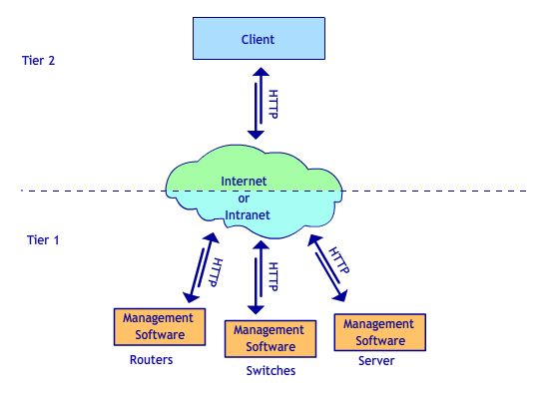
Figure 4: Two Tier Architecture

In the two-tier model (shown in Figure 4), the Network management software is integrated with the network device firmware. Users point their browser at a home page residing within the device. In a two-tier model the management software may not need to perform any translation. It evenly may not need the traditional network management protocol, such as SNMP or CMIP. It may convey all management information using the HTTP protocol alone. The Two tier architecture is two –tiered because of separation of the client from the Managed devices by the internet. The users need to access the Servers using an unsecure channel. The Client Server Authentication here is performed by first passing the information over the internet to the server and then retrieving it back. They may use secure channel also if the server supports it. In that case the HTTP channel is converted to HTTPS (S stands for Secure).
Two tier architectures are not only limited to e-Commerce System but are also existing for Smart-card authentication architecture. Encryption for a card and card reader is an important issue for smart card security, and the main problem with them is the distribution of secret key.
The smart card authentication schemes can be classified by ^{[64]}:
Algorithm:
- Symmetric: DES or triple-DES
- Asymmetric: RSA
Participants:
- Unilateral: establishes the authenticity of one of the two communications partners
- Mutual: establishes the authenticity of both of the communications partners
Process:
- Static: the same data is always used for the authentication
- Dynamic: each authentication is based on different data
Procedure:
    - Challenge-response (C/R): One partner asks a randomly generated question, and the other partner answers it using a certain algorithm.
    - Zero-knowledge based protocols.

    - Mutual dynamic symmetric authentication with integrity mechanism (using global keys)
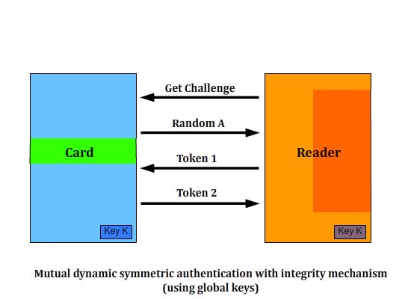
Figure 5: Mutual dynamic symmetric authentication with integrity mechanism (using global keys) ^{[64]}
This protocol is as follows: ^{[64]}
1) The card generates a random string Ra and sends it to the reader.
2) The reader generates a random string Rb and sends to the card the two values: RB||mK(RB||RA).
3) The card computes mK(RB|| RA) and verifies that it is identical to the value sent by the reader.
4) The card sends to the reader: RB||mK(RA|| RB).
5) The reader computes mK(RA|| RB) and verifies that it is identical to the value sent by the card. In this protocol, mK(X) denotes the MAC computed on the data string X using the key K.
    - Mutual dynamic symmetric authentication with integrity mechanism (using card specific keys)^{[64]}
In the procedure described above, all the cards and receivers are use the same secret key K. This can pose a serious security threat since all of the cards use the same secret key. A significant improvement on the authentication procedure described above can be achieved by using a different secret key. For this a serial number or ID number of each card is set during its production. A card-specific authentication key Kx is calculated (or derived) using a cryptological algorithm and a generated Master Key (Km).
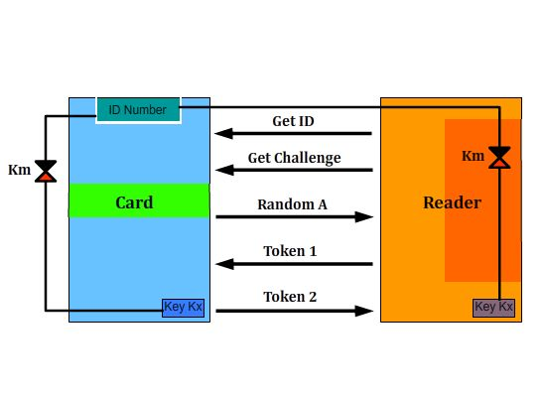
Figure 6: Mutual dynamic symmetric authentication with integrity mechanism (using card specific keys)
The mutual authentication ^{[64]} begins with the reader requesting the ID number of the card. In a special security module, the SAM (security authentication module), the card’s specific key is calculated using the master key KM. The SAM normally takes the form of a smart card with contacts incorporating a cryptoprocessor, which means that the stored master key can never be read. Certainly, this protocol can prevent the system from both replay attacks and active attacks. ^{[64]}

    - Unilateral dynamic symmetric authentication (using card specific keys)
The dynamic asymmetric authentication prevents re-use of any data intercepted from an earlier session and protects integrity of transmitted data, which adds protection against replay attacks and active attacks.
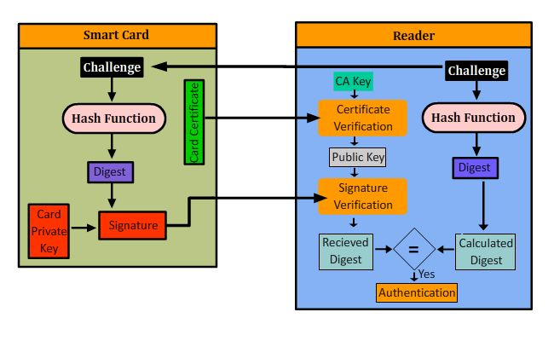
Figure 7: Unilateral dynamic asymmetric authentication (using card specific keys)
The Figure 7 given for the authentication architecture is pretty much self explanatory. The main focus here is that there is a mutual authentication being performed which improves the security strength of the system.

  - Three-tier architecture
In a three-tier model (shown in Figure 8), the management software runs as an application over the operating system and collects and disseminates the information gathered from network devices to the browser. When a user points his/her browser to the management software's home page, the management software relays aggregated management information from the network to the browser. In doing so, the management software may translate traditional management protocols (such as SNMP) to Web protocols (such as HTTP).^{[23]}
The Three tier architecture defined in the figure is based on the management devices point of view. It shows us how the hardware is logically structured in a three tier architecture when the devices are needed to be remotely configured. The Same architecture is applied when the client needs access in a three tier architecture.
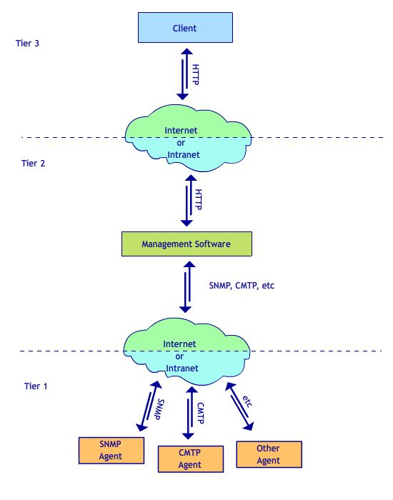
Figure 8: Three-Tier Architecture
When the managed devices are embedded with HTTPD, the three-tier model definitely offers greater capabilities. As the management software resides external to the device, the management software can leverage the capabilities provided by the host operating system such as increased memory, processing power and storage space. Additionally, a three-tier model provides a network-centric view to the browser. While in the two-tier model end-users simply need to point their browser at the home page contained within the device to manage it. Network device vendors can ship devices without any disk installed. However, the two-tier model requires users to open separate URLs to each network device, i.e., this model is device-centric.
RELATED WORK OF CRYPTOGRAPHY

Introduction
Cryptography means study and practice of data hiding. ^{[24]} It is the Science of securing data. It can be done in any form, place or time. A simple change of letters can produce an encrypted message. Before the modern era, cryptography was concerned solely with message confidentiality. The main objective was to render the message unreadable by interceptors or eavesdroppers without the secret knowledge. In recent decades, the field has expanded beyond confidentiality concerns to include techniques for message integrity, checking sender/receiver identity authentication, digital signatures, interactive proofs and secure computation, among others. While Cryptography relates to securing data, Cryptanalysis^{[24]} is the science of analyzing and breaking secure communication. Classical cryptanalysis involves an interesting combination of analytical reasoning, application of mathematical tools, pattern finding, patience, determination, and luck. Cryptanalysts are also called attackers.
One of the first recorded cryptographic algorithms is called the Caesar Shift. This simple cipher is a type of letter substitution taking the Standard English twenty-six character alphabet and shifting the characters by some number n less than 26. Encryption is then performed by adding n to the index of the current plain text character modulo 26 to get the cipher character’s index.
Example:
If n = 7, we shift the entire alphabet by 7 characters mod 26 to produce the key:
A B C D E F G H I J K L M N O P Q R S T U V W X Y Z
H I J K L M N O P Q R S T U V W X Y Z A B C D E F G
So, the plain text “INSECURE” would produce the ciphertext “PUZLJBYL”, and the ciphertext “ZLJBYL” would be decrypted to “SECURE”. The person receiving the message need only know what n and the original alphabet is to decrypt the message. This algorithm used is, by itself, trivial to break. Simple cryptanalysis by a person or computer can be accomplished quite quickly using the fact that certain short word patterns occur more commonly than others. If common words like; “THE”, “AND”, and “AS”, are present, then one would only need to map one or two letters to a key to be able to decrypt the entire message. During World War II, both the Americans and the Germans had developed impressive cryptographic rotor machines. The rotor machine, being the first mechanical encryption device intended to automate cryptography, was easily the most important device of World War II, and remained dominant until at least the nineteen fifties. A rotor machine is made up of a typewriter-style keypad and multiple rotors, with a complete desired alphabet imprinted around each rotor much like the old-fashioned typewriter balls. Each rotor is linked to the next, such that for each letter selection on a given rotor, a pseudo-random letter substitution is made of the alphabet onto the next rotor.
Example:
Each row represents a rotor in a four-rotor machine. So if “D” is selected from rotor 1, then the encryption sequence is D->K->F->J, after the 4th rotor is applied.
1: A B C D E F G H I J K L M N O P Q R S T U V W X Y Z
2: H I J K L M N O P Q R S T U V W X Y Z A B C D E F G
3: C D E F G H I J K L M N O P Q R S T U V W X Y Z A B
4: G H I J K L M N O P Q R S T U V W X Y Z A B C D E F
The true strength of the algorithm lies within the fact that, after each sequential letter substitution, the alignments of the rotors change to create a different substitution pattern.
Because all the rotors rotate at different rates, the period for an n-rotor machine is 26 n. Some early machines have a standard pattern by which the substitution permutation is performed and thus, once the machines were compromised, so were all past and future communications. The better of these machines accept a pass code or pass card that seeds the pseudo-random permutation sequence. The most effective rotor machine built was the German Enigma. The Enigma was a very complex machine with three rotors chosen from five, and a reflective rotor that meant each rotor would operate on each plaintext character twice. This machine was cracked by a team of Polish cryptographers and was continually studied by the British throughout the remainder of the war.
Government agencies are historically the major contributors to the field of cryptography. This is partially due to their seemingly open-ended budgets, and their legal ability to classify intellectual properties as secret. As a result, the private sector has not had, until recently, strong algorithms and applications at their immediate disposal. Around 1974, IBM Research proposed a public encryption algorithm at the request of the National Bureau of Standards (NBS, now the National Institute of Standards and Technology, NIST), which would soon become DES, the first public governmental Data Encryption Standard
For most of the history of cryptography, a key would be agreed upon using a secure, but non-cryptographic, method; for example, a face-to-face meeting or a trusted courier. This key, which must be kept absolutely secret, could then be used to exchange encrypted messages. There are a number of significant practical difficulties in this approach to distributing keys. Public-key cryptography was invented to address these drawbacks and so that users can communicate securely over a public channel without having to agree upon a shared key beforehand.
One-Time Pad^{[24]}
The One-Time Pad, sometimes referred to as the one-time tape, is the simplest algorithm to implement, but it is also the least practical. One-Time Pads rely solely on a truly random set of bits, the same length as the plaintext or longer, which is used as a key. An Exclusive OR operation is then performed on the plaintext and the one-time pad to produce the ciphertext. In order to recreate the plaintext from the ciphertext, simply XOR the ciphertext with the original pad. Since every plaintext message is equally possible, there is no way for the cryptanalyst to determine which plain text message is the correct one.
Example:
Encryption |  |  | Decryption
Plaintext: | 01100101 | Cipher text: | 11011000
One-time pad: | 10111101 | One-time pad: | 10111101
 | XOR |  | XOR
Ciphertext: | 11011000 | Plaintext: | 01100101

The security inherent in this algorithm lies within its protocol. Each one-time pad, as implied by its name, can be used no more than once. The sender and the receiver must both have a copy of the pad used to encrypt the message. If the same one-time pad is used on more then one message, then a somewhat complicated cryptanalysis can be done on both the ciphertexts to recreate the pad used to encrypt them. Originally, these pads were distributed as books. When a new message arrived, one would just turn to the next page to decrypt it. Data tapes and Compact Disks have made this algorithm somewhat more feasible, but there still remains the problem of how to distribute the new pads quickly, efficiently and securely.

  - Symmetric Key Cryptography

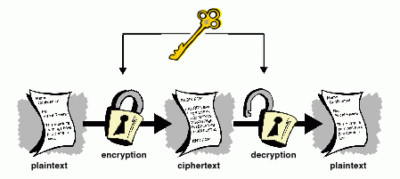
Figure 9: Symmetric Crypography
Figure 9: Symmetric Key Cryptography
This refers to the encryption method in which both the sender and receiver share the same key. Figure 9 shows a scheme that can be used to depict the Symmetric key cryptography. This is sometimes also called Secret key cryptography since the key used to encrypt and decrypt are the same, they must be passed on secretly between the sender and the receiver. This method is vulnerable because a password must be communicated via phone, fax, email, or in person and, if it is ever discovered, another communication must take place.
This scheme includes block ciphers and stream ciphers depending on the application. A block cipher takes as an input a block of plaintext and a key and outputs a block of cipher text of the same size. Since, messages can be longer than a single block some method of knitting together successive blocks is required. Data Encryption Standard (DES) and Advanced Encryption Standard (AES) are block cipher designs. Stream ciphers, in contrast to block cipher, create an arbitrarily long stream of key, which is combined with plaintext bit-by-bit or character-by-character. In stream cipher, the output stream is created based on a hidden internal state which changes as the cipher operates. RC4 is a widely used stream cipher.
Cryptographic hash functions are a third type of cryptographic algorithm. They take a message of any length as an input and output a short, fixed length hash which can be used as a digital signature. No two messages can produce same hash. MD4 was a long used hash function; MD5 is a strengthened variant of MD4. SHA is another example of the practically used hash. The U.S. National Security Agency developed the Secure Hash Algorithm series of MD5-like hash functions.
Message authentication codes (MACs) are similar to cryptographic hash functions, except that a secret key can be used to authenticate the hash value upon receipt.

    - Data Encryption Standard (DES)
The Data Encryption Standard (DES) is a block cipher (a form of shared secret encryption) that was selected by the National Bureau of Standards as an official Federal Information Processing Standard (FIPS) for the United States in 1976 and which has subsequently enjoyed widespread use internationally. It is based on a symmetric-key algorithm that uses a 56-bit key. The algorithm was initially controversial with classified design elements, a relatively short key length, and suspicions about a National Security Agency (NSA) backdoor. DES consequently came under intense academic scrutiny which motivated the modern understanding of block ciphers and their cryptanalysis.
DES is now considered to be insecure for many applications. This is chiefly due to the 56-bit key size being too small; in January, 1999, distributed.net and the Electronic Frontier Foundation collaborated to publicly break a DES key in 22 hours and 15 minutes (see chronology). There are also some analytical results which demonstrate theoretical weaknesses in the cipher, although they are infeasible to mount in practice. The algorithm is believed to be practically secure in the form of Triple DES, although there are theoretical attacks. In recent years, the cipher has been superseded by the Advanced Encryption Standard (AES). Furthermore, DES has been withdrawn as a standard by the National Institute of Standards and Technology (formerly the National Bureau of Standards). Despite the criticisms, DES was approved as a federal standard in November 1976, and published on 15 January 1977 as FIPS PUB 46, authorized for use on all unclassified data. It was subsequently reaffirmed as the standard in 1983, 1988 (revised as FIPS-46-1), 1993 (FIPS-46-2), and again in 1999 (FIPS-46-3), the latter prescribing "Triple DES" (see below). On 26 May 2002, DES was finally superseded by the Advanced Encryption Standard (AES), following a public competition. On 19 May 2005, FIPS 46-3 was officially withdrawn, but NIST has approved Triple DES through the year 2030 for sensitive government information. The algorithm is also specified in ANSI X3.92, NIST SP 800-67and ISO/IEC 18033-3 (as a component of TDEA). Another theoretical attack, linear cryptanalysis, was published in 1994, but it was a brute force attack in 1998 that demonstrated that DES could be attacked very practically, and highlighted the need for a replacement algorithm. These and other methods of cryptanalysis are discussed in more detail later in the article.
The introduction of DES is considered to have been a catalyst for the academic study of cryptography, particularly of methods to crack block ciphers. According to a NIST retrospective about DES, The DES can be said to have "jump started" the nonmilitary study and development of encryption algorithms. In the 1970s there were very few cryptographers, except for those in military or intelligence organizations, and little academic study of cryptography. There are now many active academic cryptologists, mathematics departments with strong programs in cryptography, and commercial information security companies and consultants. A generation of cryptanalysts has cut its teeth analyzing (that is trying to "crack") the DES algorithm. In the words of cryptographer Bruce Schneier,^{[14]} "DES did more to galvanize the field of cryptanalysis than anything else. Now there was an algorithm to study." An astonishing share of the open literature in cryptography in the 1970s and 1980s dealt with the DES, and the DES is the standard against which every symmetric key algorithm since has been compared.

    - Advanced Encryption Standard (AES)
After the thirty-plus years that DES has been in service, and after many successful attempts at cracking DES, the U.S-Government decided it was time to accept a new encryption standard to use for business and non-top secret documents. AES is a symmetric key algorithm like DES, and is intended to fully replace its predecessor. On January 2, 1997, the NIST announced the initiation of an effort to develop the AES, and made a formal call for algorithms on September 12, 1997. The AES search was public, where as the request for DES was only made to a few research facilities. Allowing cryptographers from all over the world to fully submit and evaluate the proposed algorithms is an incredible demonstration of the importance that peer review holds in cryptography. The winning algorithm, originally called Rijndael, was created by two cryptographers from Belgium, Dr. Joan Daemen and Dr. Vincent Rijmen.
The standard comprises three block ciphers, AES-128, AES-192 and AES-256, adopted from a larger collection originally published as Rijndael. Each of these ciphers has a 128-bit block size, with key sizes of 128, 192 and 256 bits, respectively. The AES ciphers have been analyzed extensively and are now used worldwide, as was the case with its predecessor, the Data Encryption Standard (DES).
AES was announced by National Institute of Standards and Technology (NIST) as U.S. FIPS PUB 197 (FIPS 197) on November 26, 2001 after a 5-year standardization process in which fifteen competing designs were presented and evaluated before Rijndael was selected as the most suitable (see Advanced Encryption Standard process for more details). It became effective as a Federal government standard on May 26, 2002 after approval by the Secretary of Commerce. It is available in many different encryption packages. AES is the first publicly accessible and open cipher approved by the NSA for top secret information.

  - Asymmetric Key Cryptography
    - History of public-key cryptography
An asymmetric-key cryptosystem ^{[47]} was published in 1976 by Whitfield Diffie and Martin Hellman, who, influenced by Ralph Merkle's work on public-key distribution, disclosed a method of public-key agreement. This method of key exchange, which uses exponentiation in a finite field, came to be known as Diffie–Hellman key exchange. This was the first published practical method for establishing a shared secret-key over an authenticated (but not private) communications channel without using a prior shared secret. Merkle's public-key-agreement technique became known as Merkle's Puzzles, and was invented in 1974 and published in 1978.
In 1997, it was publicly disclosed that asymmetric key algorithms were developed by James H. Ellis, Clifford Cocks, and Malcolm Williamson at the Government Communications Headquarters (GCHQ) in the UK in the early 1970s. The researchers independently developed Diffie–Hellman key exchange and a special case of RSA. The GCHQ cryptographers referred to the technique as "non-secret encryption".
A generalization of Cocks' scheme was independently invented in 1977 by Rivest, Shamir and Adleman, all then at MIT. The latter authors published their work in 1978, and the algorithm appropriately came to be known as RSA. RSA uses exponentiation modulo a product of two large primes to encrypt and decrypt, performing both public key encryption and public key digital signature, and its security is connected to the presumed difficulty of factoring large integers, a problem for which there is no known efficient (i.e., practicably fast) general technique.
Since the 1970s, a large number and variety of encryption, digital signature, key agreement, and other techniques have been developed in the field of public-key cryptography. The ElGamal cryptosystem (invented by Taher ElGamal) relies on the (similar, and related) difficulty of the discrete logarithm problem, as does the closely related DSA developed at the US National Security Agency (NSA) and published by NIST as a proposed standard. The introduction of elliptic curve cryptography by Neal Koblitz and Victor Miller independently and simultaneously in the mid-1980s has yielded new public-key algorithms based on the discrete logarithm problem. Although mathematically more complex, elliptic curves provide smaller key sizes and faster operations for equivalent estimated security.

    - Public-key cryptography
Symmetric-key cryptosystems use the same key for encryption and decryption of a message, though a message or group of messages may have a different key than others. A significant disadvantage of symmetric ciphers is the key management necessary to use them securely. Each distinct pair of communicating parties must, ideally, share a different key, and perhaps each ciphertext exchanged as well. The number of keys required increases as the square of the number of network members, which very quickly requires complex key management schemes to keep them all straight and secret. The difficulty of securely establishing a secret key between two communicating parties, when a secure channel does not already exist between them, also presents a chicken-and-egg problem which is a considerable practical obstacle for cryptography users in the real world.
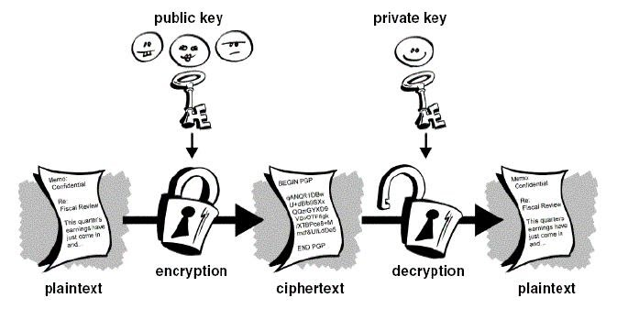
Figure 10: Public-key cryptography
Public-key cryptography is a cryptographic approach which involves the use of asymmetric key algorithms instead of or in addition to symmetric key algorithms. Unlike symmetric key algorithms, it does not require a secure initial exchange of one or more secret keys to both sender and receiver. The asymmetric key algorithms are used to create a mathematically related key pair: a secret private key and a published public key. Use of these keys allows protection of the authenticity of a message by creating a digital signature of a message using the private key, which can be verified using the public key. It also allows protection of the confidentiality and integrity of a message, by public key encryption, encrypting the message using the public key, which can only be decrypted using the private key.
Public key cryptography is a fundamental and widely used technology around the world. It is the approach which is employed by many cryptographic algorithms and cryptosystems. It underlies such Internet standards as Transport Layer Security (TLS) (successor to SSL), PGP, and GPG.
The primary benefit of public key cryptography is that it allows people who have no preexisting security arrangement to exchange messages securely. The need for sender and receiver to share secret keys via some secure channel is eliminated; all communications involve only public keys, and no private key is ever transmitted or shared. Some examples of public-key cryptosystems are Elgamal (named for its inventor, Taher Elgamal), RSA (named for its inventors, Ron Rivest, Adi Shamir, and Leonard Adleman), Diffie-Hellman (named, you guessed it, for its inventors), and DSA, the Digital Signature Algorithm (invented by David Kravitz). Because conventional cryptography was once the only available means for relaying secret information, the expense of secure channels and key distribution relegated its use only to those who could afford it, such as governments and large banks (or small children with secret decoder rings). Public key encryption is the technological revolution that provides strong cryptography to the adult masses.

    - Digital Signature
A major benefit of public key cryptography is that it provides a method for employing digital signatures. Digital signatures enable the recipient of information to verify the authenticity of the information’s origin, and also verify that the information is intact. Thus, public key digital signatures provide authentication and data integrity. A digital signature also provides non-repudiation, which means that it prevents the sender from claiming that he or she did not actually send the information. These features are every bit as fundamental to cryptography as privacy, if not more. A digital signature serves the same purpose as a handwritten signature. However, a handwritten signature is easy to counterfeit. A digital signature is superior to a handwritten signature in that it is nearly impossible to counterfeit, plus it attests to the contents of the information as well as to the identity of the signer. Some people tend to use signatures more than they use encryption. Digital signatures are used to verify authenticity of electronic documents and transfers. Using Public Key cryptography along with one-way hash functions, digital signatures present greater authenticity than a normal hand-signed document. A signature can be used in conjunction with encryption, or as a standalone method of verification. The signature algorithm is as follows: if John would like to sign a message and send it to Jane, he would first run a one-way hash function over the entire document to get the document’s hash. The next step is to encrypt the hash of the document using his private key. Encrypting only the hash allows for a small addition to the size of the document, and since public/private key algorithms are very expensive, limiting the amount of data to be encrypted is very important. The encrypted hash is then appended to the end of the message that Jane is to receive. Once received, Jane decrypts the hash with John’s public key and verifies that the hash is correct. This accomplishes two things. The first is that this assures, to Jane, that John was the true author since, if she is able to decrypt the hash, then it was truly John’s private key that signed it. The second is that since the original hash was encrypted, she can verify that no one has altered the document since it left John. If the message had been altered, then John’s hash and Jane’s hash would not match. The real power behind this scheme is the one-way hash function. There are many proven one-way hash function in use today, but the most common is the Secure Hash Algorithm (SHA).

    - Secure Hash Algorithm
The hash algorithm SHA was originally developed as a joint effort between NSA and NIST for use with the Digital Signature Standard.SHA takes any message of length < 264 bits as input and produces a 160-bit hash of the message. The basic steps of SHA include padding the message to be a multiple of 512-bits long by appending a one-bit and then as many zero-bits as are necessary, and then running each 512-bit block through four functions at twenty rounds each. These functions consist of four constants and bit operations such as OR, AND, XOR, and NOT.

    - Diffie Hellman Key agreement protocol
The scheme was first published by Whitfield Diffie and Martin Hellman in 1976, although it later emerged that it had been separately invented a few years earlier within GCHQ, the British signals intelligence agency, by Malcolm J. Williamson but was kept classified. In 2002, Hellman suggested the algorithm be called Diffie–Hellman–Merkle key exchange in recognition of Ralph Merkle's contribution to the invention of public-key cryptography [48].
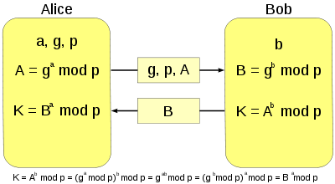
Figure 11: Diffie Hellman Key Exchange ^{[48]}
Although Diffie–Hellman key agreement itself is an anonymous (non-authenticated) key-agreement protocol, it provides the basis for a variety of authenticated protocols, and is used to provide perfect forward secrecy in Transport Layer Security's ephemeral modes (referred to as EDH or DHE depending on the cipher suite).

    - RSA (Rivest, Shamir, and Adleman)
RSA (Rivest, Shamir, and Adleman who first publicly descrived it) is an algorithm for asymmetric key. It is the first algorithm known suitable for both signing as well as encryption. RSA is widely used in e-Commerce protocols, and is believed to be secure given sufficiently long keys.
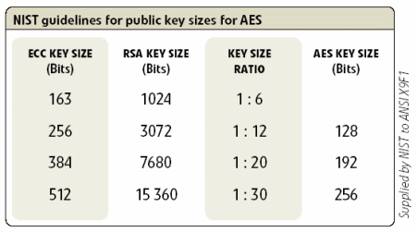
Figure 12: Equivalent key sizes for ECC and RSA
If we look at the NIST guidelines for public key sizes, we see that the key size is considerably decreased if we are to adopt 163 bit ECC instead of 1024 bit RSA, without losing the level or strength of the encryption. Although ECC is a bit slower than RSA but still it is the preferred method of authentication on Mobile Networks.

  - Elliptic Curve Arithmetic
While the 20-year history of public key cryptography has seen a diverse range of proposals for candidate hard problems, only two have stood the test of time. These problems are known as the discrete logarithm problem over a finite field and integer factorization ^{[53, 54].}
In 1985, Neal Koblitz and V.S. Miller ^{[58]} independently proposed using elliptic curves for public key cryptosystems. They did not invent a new cryptographic algorithm with elliptic curves over finite fields, but they implemented existing algorithms, like Diffe-Hellman, using elliptic curves.
Elliptic curves are rich mathematical structures which have shown themselves to be useful in a range of applications including primarily testing and integer factorization^{[60, 61]}. One potential use of elliptic curves is in the definition of public key cryptosystems that are close analogues of existing schemes. In this way, variants of existing schemes can be devised so that they rely their security on a different underlying hard problem.

    - Elliptic Curve
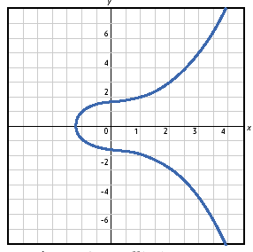
Figure 13: Elliptic Curve
An elliptic curve is defined by an equation in two variables, with coefficients. For elliptic curve cryptography, an operation over elliptic curves, called addition, is used. In general, cubic equations for elliptic curves take the form

Where a, b, c, d, and e are real numbers and x and y take on values in the real numbers.
Elliptic curve cryptography makes use of elliptic curves in which the variables and coefficients are all restricted to elements of a finite field. Two families of elliptic curves are used in cryptographic applications- prime curves defined over Z_{p} and binary curves constructed over GF(2^{n}).

It turns out that the form of cubic equation appropriate for cryptographic applications for elliptic curves is somewhat different for GF(2^{m}) than for Z_{p}.
The form is y² + xy = x³ + ax² + b where it is understood that the variables x and y and the coefficients a and b are elements of GF(2^{m}).
All calculations are performed modulo p, and 4a³ + 27b² ≠ 0, modulo p, for some odd prime p.

    - Group Law
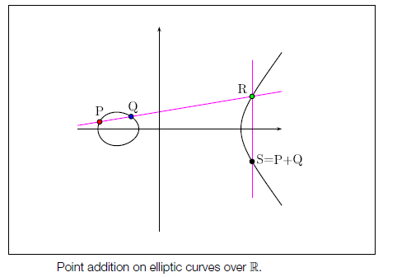
Figure 14: Point Addition on elliptic curves over R
An addition operation is defined over E/K using the chord-tangent method. It consists of considering the line through two points P and Q (or the tangent line, in case we want to double P). The intersection point of such a line with the elliptic curve is a rational point R. Then the addition point P +Q is obtained taking the symmetric point of R with respect to the x-axis. This operation, called elliptic addition, endows the set E(K) with an abelian group structure, where O is the identity element. Analytically, given a curve with equation, the coordinates of P + Q = (x3, y3), when P + Q 6= O, are obtained in terms of the coordinates of P = (x1, y1) and Q = (x2, y2) as follows x3 = _2 − x1 − x2, y3 = (x1 − x3)_ − y1, where _ = (y1−y2)/(x1−x2) if x1 6= x2, and _ = 3x21+a)/2y1 when x1 = x2 and y1 6= 0. The symmetric point of P = (x, y) is −P = (x,−y). Considering this group law, the scalar multiplication operation is defined as k · P = P + k · · · +P, for any P 2 E(K) and k a natural number. Such an operation, analogous to the exponentiation in multiplicative abelian groups, is important for the elliptic curve cryptography. There exist several algorithms to perform such an operation, although the most extended is the binary method, also called double-and add algorithm (an analogue of the square-and-multiply algorithm in multiplicative abelian groups). This method exploits the binary expression of k, and reduces an exponentiation to a chain of log2 (k) doublings and additions of points. For instance, 13 · P = `22(2 + 1) + 1´· P = 2 (2 (2 · P + P)) + P. From the point of view of computational complexity, the addition of two different points involves the computation of one inverse and three multiplications in the field, while doubling requires one inversion and 4 multiplications.

    - Elliptic Curves over finite fields
From a cryptographic perspective, elliptic curves over finite fields Fq, with q = pm and p prime, are interesting because they provide instances of finite groups where the discrete logarithm problem is hard. In practice, the most common fields are Fp or F2m, where p and m are large enough to grant the desired level of security. One should stress that the interest on these curves is connected to their number of points. The knowledge of the properties of such a cardinal, as well as the group structure, is crucial in the design of cryptographic applications, and it becomes an important requirement to be taken into account for the development of new schemes and techniques.
Let #E(Fq) denote the cardinal of the group of points. It is a well known fact that #E(Fq) can be written as #E(Fq) = q + 1 − t, with t the trace of the Frobenius endomorphism ' : E(Fq) ! E(Fq), which assigns to each point (x, y) the point (xq, yq). Hasse provided [36] a threshold for the value of the trace, and hence for the cardinal of the curve.
Theorem 1 (Hasse) The trace of the Frobenius endomorphism of a curve E/Fq satisfies |t| ≤ 2√q. Consequently, the cardinal of E(Fq) belongs to the interval [q + 1 − 2√q, q + 1 + 2√q].
As an example, we can consider the curve E : y² = x³ + 1013x + 2007 over the field Fp with p = 314159265359, which has cardinal
#E(Fp) = 31415893030968 = 2³ · 3 · 13089955457.
To obtain points P = (x, y) on the curve, one can take random values x in Fp, checking whether the Legendre symbol of x³ + 1013x + 2007 over p is 1. Hence, there exist two roots y, which correspond to the ordinates of two points with abscissa x, opposite one another. For instance, the points P = (63510465893, 141411081955) and −P = (63510465893, 172748183404) lie on the curve above and their order is 13089955457, since 13089955457 · P = O.The following result after J. W. Cassels, and completed by Schoof, describes the structure of the group of points of an elliptic curve over a finite field.

Theorem 2 (Cassels) The group E(Fq) is isomorphic either to the cyclic group Z_{m}, where m = #E(Fq), or to the group Z_{m1} × Z_{m2} , where m1 · m2 = m, m2|m1 and m2|(q − 1).
Moreover, as J. E. Cremona pointed out in a remark in the Number Theory distribution list, the value of m2 is completely determined by the value of m1, unless q is one of the integers
3, 5, 7, 11, 13, 17, 19, 23, 29, 31, 43, 61, 73, 181, 331,
547, 4, 9, 27, 81, 25, 49, 121, 841.
Hence, in the other cases the cardinal and structure of the group of points is completely determined by a point of order m1. On the other hand, E. Waterhouse showed that for any finite field Fp, there exist elliptic curves with cardinal equal to any of the integers in the Hasse interval, and one finds
elliptic curves with every possible group structure. This is one of the main advantages provided by elliptic curves: for a given finite field Fp there is a wide range of cryptographically interesting cardinals, which go through a large interval of length 4 √p.

    - Elliptic Curves over rings
Elliptic curves defined over rings Z_{n}, with n = p · q the product of two primes p, q, are also useful in the design of cryptosystems based on the intractability of the integer factorization problem. In fact, the chord and tangent addition law can be extended for points in a curve E over Zn. However, since there are elements in Zn which are not invertible, the addition law is not always well-defined when using analytical expressions like. One way to overcome this is to consider elliptic curves defined on the projective plane P²(Z_{n}). In this way, the points in the curve are given as triples |x, y, z| satisfying the equation y²z = x³ + axz² + bz³ in Z_{n}. Note that besides point at infinity [0, 1, 0] and the points [x, y, 1] in the affine plane, our curve also contains semi-infinite points [x, y, z] such that gcd(z, n) is either p or q. By the Chinese Remainder Theorem, it follows that the mapping E(Zn) ! E(Fp) × E(Fq), defined by the natural projections is a bijection, and this endows E(Zn) with a group structure compatible with the elliptic addition defined by the chord-tangent method. Moreover, considering mp = #E(Fp) and mq = #E(Fq) it follows that (1 + k · mp · mq) · P = P, 8P 2 E(Zn), 8k 2 Z. Similarly, the set of points E(Zn2 ) is given a group structure which takes care of the existence of more points at infinity, namely all those with coordinates Ok = [k · n, 1, 0], 0 _ k < n.

    - Elliptic Curves Cryptosystems
Koblitz and Miller suggested in 1985 to use elliptic curves over finite fields for the design of cryptosystems. Since then, several schemes have been proposed, and at the moment some of them are present in industrial standards, and some receive the same attention as the most widely used cryptosystems. The security of most of these schemes relies on the intractability of the discrete logarithm problem in the group of points of an elliptic curve. There also exist proposals concerning curves over the rings Z_{n} or Z_{n}² , n = p · q, which base their security on the complexity of the factorization problem. Some of these schemes extend the capabilities of RSA, and provide efficient mechanisms for semantically secure cryptography.

    - Elliptic Curves Parameters
ECC schemes operate on a sub-group of EC points on an elliptic curve. The group of points to be used can be specified by an EC parameter set, which can be defined as a 7-tuple, (a, b, q, G, n, h, Fr) Where, a and b define the elliptic curve, q identifies the underlying finite field, G is a base point which generates the chosen sub-group of points on the curve, n gives the number of points in the sub-group and h gives the total number of points on the curve. Fr can be used to give an indication of the representation to use for the underlying field elements. This is important for characteristic two extension fields, where a number of different basis for field element representation are possible.

    - Digital Signature using Elliptic Curves
The electronic communications era in a broad sense, and specially e-commerce, motivate the need for some mechanism for the sender to grant the claimed identity when a receiver obtains his message (non-repudiation mechanisms). Digital signatures emerge as an analogue to manual signatures in ordinary mail. In order to grant the length of the digital signature to be smaller than the message to sign, hash functions are used. These functions build in a reproducible way a fixed size fingerprint of the message and they are collision resistant. The digital signature depends then on the hashed message and the private key of the signer. As a result, any entity may check the veracity of a signature from the public key of the signer. The Digital Signature Algorithm (DSA in short) is a variant of the ElGamal signature, which is in its turn the basis of the Digital Signature Standard (DSS). The Elliptic Curve Digital Signature Algorithm (ECDSA) is the elliptic curve analogous to DSA. In fact, this algorithm has been included as a component of the set of cryptographic algorithms Suite B promulgated by the National Security Agency. The signature generation and verification procedures are as follows (N.B. one uses the same setup parameters as in ElGamal):
Algorithm (ECDSA digital signature generation)
INPUT: The parameters (p, a, b, P, n), the public key Q, the private key d and the plaintext m.
OUTPUT:The message m with the signature (r, s).
• Compute the Hash h = H(m) of the message.
• Choose a random integer k in [1, n − 1].
• Compute the point k · P = (x, y) on Ea,b(Fp).
• Compute r = x mod n (restart if r = 0).
• Compute s = k⁻¹(h + d · r) mod n (restart if s = 0).
• Return m and (r, s).
To verify the signature from the Hash of the message one needs to compute the inverse w of s modulo n. Then it is enough to use the public key to compute the point R = (w · h) · P + (w · r) · Q and check that the abscissas of the points R and k · P coincide, because k = w · h+w · d · r and Q = d · P.

Conclusion
This Chapter has presented a history and background on the work already done in the field. This presents fairly in detail what all is already done and presents a faint idea of what all could be done. The last part details about Elliptic curve and their use in security. My work is based on Elliptic Curve cryptography because of the strong points of Elliptic Curve.

THREE TIER SECURITY ARCHITECTURE

This chapter describes the main proposed architecture of the Thesis. The Architecture is one, that was mainly designed for authentication but it can be improved and further improvements can be done in the system depending upon the requirement. The Chapter starts with the description of the proposed Architecture, then, we discuss the model of the proposed architecture so as to give a detailed basis for our thesis. Then comes, the implementation of the proposed architecture, which describes how the proposed architecture can be practically implemented. Kindly note, the implementation is from a single developer’s point of view. Different developers may use different approaches to implement the given model. It all depends upon the developers comfort level with a particular set of tools/languages. After this, we analyze the Advantages of the proposed system and the Efficiency based on the observations derived from different work. Then we perform the Analysis of the system and finally we conclude with specification of the Proposed System.

  - Proposed Architecture
Our proposal is to reduce the amount of overhead on the Server performing the Authentication by reducing the number of valid requests. This is done by introducing a Middle Server which performs the first level of authentication. Figure 15 displays a model that depicts how the passing of information takes place according to our proposal.
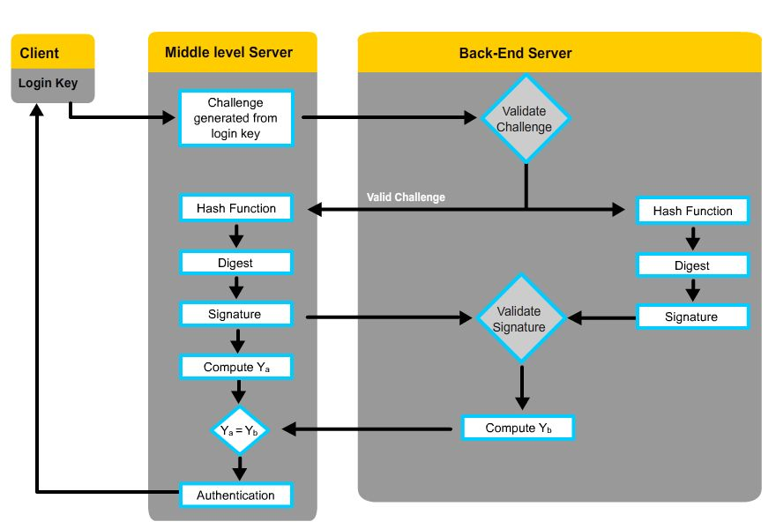
Figure 95: Three tier architecture for secure communication

The working of the architecture is devided into three phase - first phase is user login phase, then registration on middle server and final phase is authentication. In the first phase, the Client sends its login information to Middle Server and then Middle Server acts as a client and Authenticates itself for the rest of the phases. In the Second phase, Middle level server sends in the information to the Final level Server. First, Elliptic Curve Diffie-Hellman is used to exchange the keys, then Middle Level Server sends in the information with its signature to the final level server and the final level server checks this signature and information to validate first, the Middle level server and then the Client requesting authentication. In the third phase, the Client requesting authentication is sent an acknowledgement by the middle level server according to the message by the final level server. The Client has minimal processing requirements. This has been done so as to accept even the smallest processing capable clients.

  - Design Architecture
An Overview of the entire system task that is there in the System architecture is presented in Figure 16. The whole architecture is divided into three phases: the first step is user authentication; if it is successful, then service authentication is performed in the next step; a session key is established after the mutual authentication succeeds. The session key is used in the following service transaction over an insecure channel. The completed task flow is elaborated as follows.

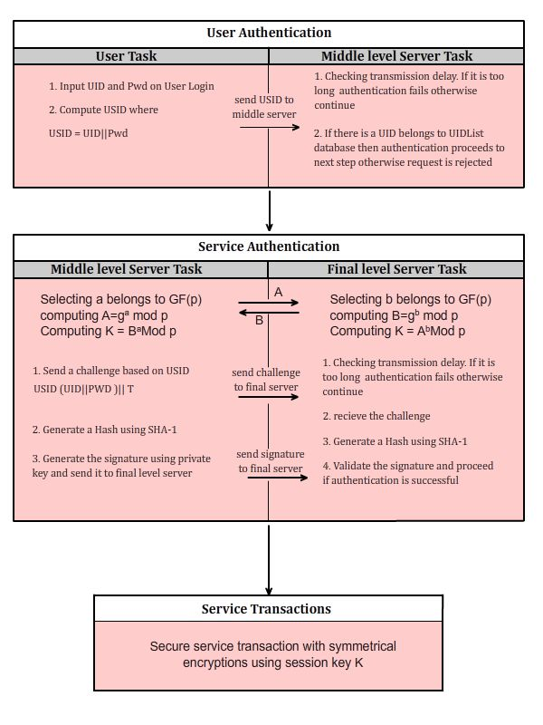
Figure 16: Secure communication task flow

    - User Authentication
To access a service, a user must first login with its credentials i.e. username and password. Based on the username (UID) and password, a USID is made. And then this USID is sent to milddle level server as an authentication request message.
On receiving the message from the user, the middle level provider performs following sequence of tasks.
- Checking the time interval between the timestamp on the message and the receiving time; if the interval is beyond a given reasonable transmission delay, the message may be tampered by some intruders during the transmission over an insecure network, and the authentication request will be rejected. Otherwise, continue to the next step;
- Checking if USID is in the USID list by exhaustively searching. If not found, the provider assumes the request comes from an invalid user, and rejects the request. Otherwise, continue to the Final Server authentication.

    - Service Authentication & Session Key generation
On successful authentication of the user, the Middle lever server continues with the following tasks:
- Selecting a random exponent a є GF(p) and Computing A = gª mod p
- Exchange this with Final level server
- Then Compute K = Bª mod p; This will be used as a session key.
- Then a challenge based on USID is sent to the final server which checks it against a database
- Generate a Hash using SHA-1 algorithm
- Generate a signature using the private key and send this to Final level server. This is a part of mutual authentication.
- On the Final Server side, we select b є GF(p) and Computing B = g^{b} mod p
- Send this B to middle level server.
- Then Compute K = A^{b} mod p; This will be used as a session key.
- Final server also checks for transmission delays. If it is too long the authentication will fail otherwise we continue with the mutual authentication.
- On receiving the challenge a Hash is generated using SHA-1 algorithm.
- Then the signature is validated using the key exchanged from middle level server.
- If the middle server is validated, The Client validation is performed against a database. On successful authentication of the client. We proceed to service transactions.

    - Service Transactions
After binding, a user can access all the services provided by the final level server. All the communications happen based on the session key generated in the algorithm. The client side processing is kept minimal, yet high security is maintained.

  - Implementation of the proposed architecture
In this section we present how the three layer security architecture can be implemented practically. We have used Elliptic Curve Diffie-Hellman Key Exchange (ECDH) for exchanging keys and Elliptic Curve Digital Signature Algorithm (ECDSA) for generation and verification of signature.

    - Authentication Process
The Authentication process between two servers is the most crucial part of our work. Figure 17 describes the Authentication process.
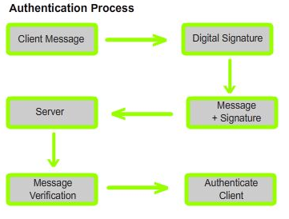
Figure 17: Block diagram of the authentication of the system
We are using Elliptic Curve Diffie-Hellman for Key Exchange and SHA1 for generating the Hash of the message required to generate the signature. First, a Message digest is created using the client’s Authentication request. The message digest is created using SHA1 hashing algorithm. Then After the ECDH Key Exchange takes place, we pass the Signature of Middle level server to the Final Server. After the Server has verified the Middle level Server, Clients Authentication request is handled. And finally, an acknowledgment or dis-acknowledgment is generated. To the Client, the whole process appears as if he is communicating to a single server. Figure 17 shows a block diagram depiction of the entire process.

    - Elliptic Curve Diffie-Hellman Key Exchange
The key exchange using elliptic curves can be done in the following manner. ^{[4]} Consider Eq(a,b) is elliptic curve with parameters a,b, and q, where q is a prime or an integer of the form 2^{m} and a base point G on elliptic curve whose order is large value n. A key exchange between users A and B can be accomplished as follows:
- A selects an integer n_{A} less than n. This is A’s private key. A then generates a public key P_{A} = n_{A}×G; the public key is a point in Eq(a,b).
- B similarly selects a private key n_{B} and computes a public key P_{B}.
- A generates the secret key K= n_{A}× P_{B}. B generates the secret key K= n_{B}× P_{A}.
- The two calculations in step 3 produce the same result because n_{A}×P_{B}=n_{A}×(n_{B} ×G)=n_{B}×(n_{A} × G)=n_{B}×P_{A}

    - ECDSA for Authentication
First, an elliptic curve E defined over GF(p) or GF(2^{k}) with large group of order n and a point P of large order is selected and made public to all users. Then, the following key generation primitive is used by each party to generate the individual public and private key pairs. Furthermore, for each transaction, the signature and verification primitives are used. We briefly outline the Elliptic Curve Digital Signature Algorithm (ECDSA) below:
ECDSA Key Generation
The user A follows these steps:
1. Select a random integer d є [2,n-2].
2. Compute Q = d ×P.
3. The public and private keys of the user A are (E; P; n;Q) and d, respectively.
ECDSA Signature Generation: User A signs the message m using these steps
1) Select a random integer k ε [2,n-2].
2) Compute k × P = (x₁,y₁) and r = x₁mod n.
3) Compute k⁻¹ mod n.
4) Computes s = k⁻¹(H(m) + dr) mod n. Here H is secure hash algorithm.
5) The signature for the message m is the pair of integers (r,s).
ECDSA Signature Verification:
User B verifies A’s signature (r,s) on the message m by applying the following steps-
1) Compute c = s⁻¹ mod n and H(m).
2) Compute u₁ = H(m)c mod n and u₂ = rc mod n.
3) Compute u₁× P + u₂ × Q = (x₀,y₀) and v = x₀mod n
4) Accept the signature if v = r.
Here we use an elliptic curve E defined over a finite field Fp. The elliptic curve parameters to be selected are:
1 -Two field elements a and b є Fp, which define the equation of the elliptic curve E over Fp (i.e., y² = x³ + ax + b in the case p ≥ 4, where 4a³ + 27b² ≠ 0 ).
2 -Two field elements x_{p} and y_{p} in F_{p}, which define a finite point P(x_{p,} y_{p}) of prime order in E(F_{p}) (P is not equal to O, where O denotes the point at infinity).
3 -The order n of the point P.
Before explaining how ECDSA runs, let us consider E be an elliptic curve defined over a finite field F_{p} and let P ε E(F_{p}) be a point of order n. Given Q where Q ε E(F_{q}), the elliptic curve discrete logarithm problem is to find the integer l, 0 ≤ l ≤ n − 1, such that Q = l.P. Here p, q are large prime numbers where p=2.q+1.
While Explaining the steps of ECDSA, Alice (user A) selects a random number d, where 2 ≤ d ≤ n − 2, as his secret key and computes the corresponding public key Q = d×P. Therefore the public key and the privatekey are (E; P; n;Q) and d. To generate a signature for a message m, Alice will select a random number k, where 2 ≤ k ≤ n − 2 computes k × P = (x₁,y₁) and r = x₁mod n. If r≠ 0, then computes s = k⁻¹(H(m) + dr) mod n. Here H is secure hash algorithm. To verify the signature Bob (user B) will first confirm that r and s є [2, n-2] and then computes c = s⁻¹modn and H(m), then computes u₁ = H(m)c mod n and u₂ = rc mod n. Also Bob computes u₁× P + u₂ × Q = (x₀,y₀) and v = x₀mod n. Finally Bob will accept the signature if v = r.
The main goal of this proposed protocol is to achieve mutual authentication and session key generation in order to establish a secure channel and at the same time reduce the number of false hits on the main server. The middle server does most of the work by checking each and every client request and forwards only if the request generates a valid challenge. This mutual authentication scheme applies the ECDSA to enhance the safety level and to simplify the computational and communications load.
The proposed protocol can work for service authentication between any low memory device like a PDA, Smart Card Reader, or even a mobile phone and the service provider.

  - Code for implementation of the proposed architecture
    - Code for Prime Number Generation
This code is for generating Prime numbers from a given String input. This was required in our project later. This implementation helps save time since we don’t have to use only big-integers for generating Primes.

import java.awt.*;

import java.math.*;

public class GeneratePrime {
TextField startfield, outfield;
Button startButton;

public BigInteger search(String input) {
BigInteger n = new BigInteger("0");
BigInteger one = new BigInteger("1");
BigInteger two = new BigInteger("2");
boolean ok = true;

try {
BigInteger temp = new BigInteger(input);
n = temp;
}
catch (NumberFormatException ex) {
System.err.print("Eroor in prime number ");
ok = false;
}

if (ok) {
if ((n.signum() <= 0) | (n.equals(one))) { // n < 2 => n := 2
n = two;
}

if ((n.getLowestSetBit() != 0) & (! n.equals(two))) {
n = n.add(one); // even -> odd (except for 2)
}

while (! n.isProbablePrime(7)) {
n = n.add(two);
// System.out.println(n);
}
}
return n;
}
}

    - Code for Login Screen
This code creates a string that’s a simple concatenation of Username and password and sends it to the server. The message received displays the message accordingly
String as;
as = jTextField1.getText() + '@' + gs.search(jPasswordField1.getText());
SendStringData(as);
jLabel3.setText("Waiting for Authentication");
// Read and display the response message sent by server application
String message = null;
message = AcceptStringData();
if(message.equalsIgnoreCase("ACK")) {
jLabel3.setText("Authenticated");
}
else jLabel3.setText("Authentication Failed!");

    - Code from Login Screen for Accepting Data from Server
This code creates a socket and then accepts the string from across the server. We have used a fixed port for simplicity.

public String AcceptStringData()
{
String msg = null ;
port = 7799; // PORT for RECIEVING DATA
try { server = new ServerSocket(port);
} catch (IOException e) {
e.printStackTrace();
}
System.out.println(" .. creating Socket ..");
try{ socket = server.accept();
} catch (IOException e) {
e.printStackTrace();
}
try {
ObjectInputStream ois = new ObjectInputStream(socket.getInputStream());
msg = (String) ois.readObject();
ois.close();
} catch (IOException e) {
e.printStackTrace();
} catch (ClassNotFoundException e) {
e.printStackTrace();
}
try {
socket.close();
server.close();
} catch (IOException e) {
e.printStackTrace();
} return msg; }

    - Code from Login Screen for Sending Data to Server
This code creates a socket and then sends the string to the server. We have used a fixed port for simplicity.
public void SendStringData(String msg)
{
port = 7798; //PORT for Sending data

try {
InetAddress host = InetAddress.getLocalHost();
socket = new Socket(host.getHostName(), port);
ObjectOutputStream oos2 = new ObjectOutputStream(socket.getOutputStream());
oos2.writeObject(msg);
oos2.close();

}catch (UnknownHostException e)
{
System.out.print("Unknown Host");
}
catch(IOException e) {
System.out.print("IO Exception");
}
try {
socket.close();
} catch (IOException e) {
e.printStackTrace();
}
}

    - Code for Elliptic Curve Diffie Hellman
This is a sample code for Elliptic Curve Diffie Hellman Scheme.

public static void ecdh() {
// Degree 163 Binary Field from fips186-2
ECDomainParameters e = ECDomainParameters.NIST_B_163();
int P[] = { 0, 1, 2 }; // Key Derivation Parameters

// User A generates a key
ECPrivKey skA = new ECPrivKey(e,BigInteger.valueOf(123));
ECPubKey pkA = new ECPubKey(skA);
System.out.println( "skA.s:" + skA.s.toString() + "\n" + "pkA.W:" + pkA.W.toString());
System.out.println("Size of skA: "+ skA.s.bitLength());

// User B generates a key
ECPrivKey skB = new ECPrivKey(e, BigInteger.valueOf(230));
ECPubKey pkB = new ECPubKey(skB);
System.out.println("skB:" + skB.toString() + "pkB:" + pkB.toString());

try { // try to catch any DER errors

// DER encoding, is a common standard method of
// representing public keys
DerIOBuffer derA = new DerIOBuffer(pkA); // User A
DerIOBuffer derB = new DerIOBuffer(pkB); // User B

// You might save the DER ecoded keys to files or send
// them over the network here.
System.out.println("DER Encoding of pkA: " + derA.toString());
System.out.println("DER Encoding of pkB: " + derB.toString());

// User A generates KA from his private key and user B's
// public key
ECPubKey pkB2 = derB.toECPubKey();
BigInteger KA = ECC.ECKAS_DH1(dp, skA.s, pkB2.W, P);
//System.out.println("pkB2:"+pkB2.toString());

// User B generates KB from his private key and
// user A's public key
ECPubKey pkA2 = derA.toECPubKey();
BigInteger KB = ECC.ECKAS_DH1(dp, skB.s, pkA2.W, P);
//System.out.println("pkA2:"+pkA2.toString());

// Verify that the keys match
// (typically, users A and B would use KA and KB to
// encrypt data with a symmetric cipher for
// transimission to each other here)
System.out.println("KA: " + KA.toString(16));
System.out.println("KB: " + KB.toString(16));

if (KA.compareTo(KB) == 0)
System.out.println("Keys match");
else
System.out.println("Error keys don't match");

} catch (Exception e) {
System.out.println(e.toString());
}

}

    - Code for ECDSA
This is a sample code for generating elliptic curve Digital Signature and then verifying it.

public static void ecdsa() {
// Degree 163 Binary Field from fips186-2
ECDomainParameters dp = ECDomainParameters.NIST_B_163();

//ECPrivKey sk = new ECPrivKey (dp, BigInteger.valueOf(123));
ECPrivKey sk = new ECPrivKey(dp);
ECPubKey pk = new ECPubKey(sk);
String M = "correct message";

try {
ECDSA sig1 = new ECDSA();

// ECDSA.initSignature(ECPubKey) throws NoSuchAlgorithmException
// if the SHA hash algorithm cannot be found.
sig1.initSignature(sk);
sig1.update(M.getBytes());
sig1.sign(); // generate the signature

// DER encoding, is a common standard method of
// representing digital signatures
DerIOBuffer der = new DerIOBuffer(sig1);

// You might save the DER ecoded signature to a file or
// send it over the network here.
System.out.println("DER Encoding of sig:" + der.toString());

// DerIOBuffer.toECSignature() throws Exception
// if the der encoded data is invalid.
ECDSA sig2 = der.toECSignature();

// ECDSA.initVerify(ECPubKey) throws NoSuchAlgorithmException
// if the SHA hash algorithm cannot be found.
sig2.initVerify(pk);
sig2.update(M.getBytes());

if (sig2.verify()) // try to verify the signature
System.out.println("valid signature");
else
System.out.println("invalid signature");

} catch (Exception e) {
System.out.println(e.toString());
}

}

  - Advantages & Efficiency
The Proposed architecture has an advantage over the broker type system that it uses ECC which is more efficient and less prone to attack than the RSA which is used by most 2-tier and 3-tier Architectures since ECC is based on Discrete Logarithmic problem. Because of this reason, our Architecture is not prone to timing attack. Also, Most Client-Server architectures give away the address of Server easily; hence there is a high possibility of server getting hit with a DDoS attack. Our architecture doesn’t give away the address of main Server hence it is protected by the DDoS attack directly. We have reduced the Overhead on the main server by introducing a middle lever server that can filter unwanted requests. Since, we use ECC the data overhead is considerably reduced, ECC uses lesser key sizes than the RSA.

  - Analysis
The Existing methods of authentication deploy RSA type encryption over the communication channel or for generating the digital signature. RSA has a huge space complexity and hence is not suitable for all devices. For example, one may think of authenticating its laptop within this type of architecture but not a simple mobile phone. Since the memory in a mobile phone is very restricted. Moreover, Mobile phone’s processor is not meant to perform such calculations. We have used Elliptic Curve Cryptography, hence it is more suitable for mobile devices and such.
Speed of Machine (in GHz) | Time for Curve Generation (in ms) | Time for Secret Key Generation (in ms) | Time for Public Key generation (in ms) | Time for Encryption of 899 bytes (in ms) | Time for Decryption of 899 bytes(in ms)
Intel Pentum M 1.2 GHz | 1232 | 100 | 521 | 3585 | 1282
Intel Atom N270 1.6 GHz | 375 | 110 | 140 | 2750 | 1782
Intel Core 2 Duo T 8100 2.1 GHz | 514 | 203 | 172 | 2715 | 1560
Intel Core 2 Quad 2.4 GHz | 391 | 47 | 62 | 1281 | 797
Intel Core 2 Duo E7200 2.53GHz | 141 | 31 | 47 | 750 | 453
Figure 18: Timings for Elliptic Curve in real environment
Figure 18 gives us an idea about the timings on different processors of Elliptic Curve cryptography when used on a real machine. They were all generated for a 160bit key length (both public and private).

  - Specification
A computer with network capabilities is required. This computer can be used to demonstrate the program alone, if it can handle two simultaneous servers and a client working at the same time. Additionally to demonstrate the full strength, two more computers will be required, that can work as servers with full network capabilities. Both Client and Servers were coded in Java so Java runtimes are required on the machine to run the program. No additional hardware requirement is there. The Program also uses Databases at the two server levels. They will be required to configure accordingly during the demonstration of the project.

Conclusion
This Chapter has discussed the work done in the thesis in detail. It shows the proposed architecture in detail and then the implementation of that proposed architecture. The Code presented in this discussion is not the original code used in my project but a similar code that is easier to understand. In the end we have also discussed the advantages of the implementation and the specification of the proposed architecture which gives us the fair idea about the machines required for the demonstration of the system. Implementation Results and the Application areas are discussed in the chapter following.

DEVELOPMENT ENVIRONMENT

Introduction
In this chapter the main focus is on the various technologies that were used while designing a practical working model for the demonstration of the concept. I am introducing only necessary details of the required technology in the project. More details of the same can be collected through reference links. Most of the technologies used in the project are freely available on the internet.

  - NetBeans
NetBeans ^{[1]} is both a platform framework for Java Desktop Applications, and an Integrated Development Environment (IDE). The platform ^{[2]} is a generic base for desktop applications. It provides services like window management, menus, settings and storage, an update manager, and file access. This also allows reusability of components. These are some standard services common to almost all large desktop applications. This Platform also allows tools for Rich Client Application Development. Platform also supports Modularity, Consistency and Reliability.
Modularity allows loading of modules dynamically without the need to download the entire application for an upgrade or a new release. Instead of writing a code over and over again, it can easily be assembled from already existing modules. Many of the useful open source modules written by the NetBeans community are ready to be embedded.
Consistency means that the applications based on NetBeans platform can be run on any machine. It allows using the platform and modules to be used as a base for multiple applications that share a common logic. NetBeans modules from other projects can also be integrated in your project. The IDE can also generate installers for different platforms.
Reliability of the NetBeans is based on the fact that it incorporates features like Quick Search, Toolbars, etc. into your own desktop applications and plugins. We can also use other APIs including Visual Library API for data visualization, NetBeans preference API for storing user settings, and the Lexer API for creating tokens from a textual input. We can even add metadata for lookup, Editor Actions, Service Providers and more.
The NetBeans IDE is an open-source integrated development environment ^{[3]}. It supports development of many of the languages. All Java application types (Java SE, Java EE, Java Micro Edition, Java Card and Java FX) are supported out of the box. It also supports Ant-based project system, maven support, refactorings, version control (subversion, CVS, Mervurial and Clearcase). All the functions are provided using modules, hence updating the IDE is very easy , by updating the required module only. IDE also supports development of new plugins for itself for adding additional functionality. Other languages supported by IDE are JavaScript, PHP, Python, Ruby, Groovy, C, C++, Scala, Clojure, Fortress, Erlang, Schliemann, Ada, Python. It also has tools like UML, XML, Hudson and Darkstar.

  - Java Development Kit
The Java Development Kit (JDK) is one of the Sun Microsystems products. It Aims at Java Developers. Java is the most widely used and preferred language for Object Oriented Programming because of the practical structure of the language and the platform independence. JDK is released under GNU General Public License hence it is freely available and most of the software developed on this are also part of GNU GPL.
The JDK has as its primary components a selection of programming tools, including: ^{[4]}
- java – the loader for Java applications. This tool is an interpreter and can interpret the class files generated by the javac compiler. Now a single launcher is used for both development and deployment. The old deployment launcher, jre, no longer comes with Sun JDK.
- javac – the compiler, which converts source code into Java bytecode
- jar – the archiver, which packages related class libraries into a single JAR file. This tool also helps manage JAR files.
- javadoc – the documentation generator, which automatically generates documentation from source code comments
- jdb – the debugger
- jps – the process status tool, which displays process information for current Java processes
- javap – the class file disassembler
- appletviewer – this tool can be used to run and debug Java applets without a web browser.
- javah – the C header and stub generator, used to write native methods
- javaws – the Java Web Start launcher for JNLP applications
- extcheck – a utility which can detect JAR-file conflicts.
- apt – the annotation-processing tool
- jhat – (experimental) Java heap analysis tool
- jstack – (experimental) utility which prints Java stack traces of Java threads
- jstat – (experimental) Java Virtual Machine statistics monitoring tool
- jstatd – (experimental) jstat daemon
- jinfo – (experimental) This utility gets configuration information from a running Java process or crash dump.
- jmap – (experimental) This utility outputs the memory map for Java and can print shared object memory maps or heap memory details of a given process or core dump.
- idlj – the IDL-to-Java compiler. This utility generates Java bindings from a given IDL file.
- policytool – the policy creation and management tool, which can determine policy for a Java runtime, specifying which permissions are available for code from various sources
- VisualVM – visual tool integrating several commandline JDK tools and lightweight performance and memory profiling capabilities
- wsimport – generates portable JAX-WS artifacts for invoking a web service.
- jrunscript – Java command-line script shell.
The JDK is also accompanied by a Java Runtime Environment. It includes a Java Virtual Machine and all of Class libraries present in the production environment and other libraries such as internationalization libraries and IDL libraries.
The JDK is a subset of Standard Development kit. Java has three major SDK. I have used Java Standard Edition or JAVA SE. Java SE is one of the widely used platforms for java application development.

  - Database
A database is an organized collection of data for one or more multiple uses^{[6]}. Database can be classified by its contents or the model or Architecture. I have used a textual database in my project. The type of database model was relational. Microsoft Access database, also known as Microsoft Office Access is a pseudo-relational database management^{[5]} system from Microsoft that combines the relational Microsoft Jet Database Engine with a graphical user interface and software-development tools. It is a part of Microsoft Office suite of application. Access stores data in its own format defined by the Access Jet Database Engine. It can also import and link with other data stored in other non-Microsoft databases. Access allows fast development of databases since it provides with a UI and a structured way to input data. This type of database is generally used in simple applications. It also allows integration of Macros to speed up the process. VB scripts can also be used to automatically generate data. Microsoft also offers a wide range of template database that can be downloaded from within the program. We have used JDBC connections for communicating with the database. JDBC is an API for Java that defines connectivity with the database. It supports creating and executing statements which can include update statements like SQL’s CREATE, INSERT, UPDATE and DELETE or query statements such as SELECT. Additionally, stored procedures may be invoked through a JDBC connection.

Conclusion
The softwares used for the development in this project are mostly free or widely available. They do not require any special hardware. A normal system with a minimal mouse, keyboard and a screen are enough to run these products. However, specifications of these softwares keep changing and hence the systems specifications can never be guaranteed to be fixed. Hence, generally a powerful computer is preferred with enough ram to support the development. The System used for the development of this system includes a standard mouse (Logitech MX-518), a Standard keyboard, and a standard Monitor.
CPU Specifications are as follows :-
CPU – Intel Quad Core Q6600 @ 2.4 GHz
Moterboard Chipset – Intel Eaglelake P45
System Memory – 4096 MB (DDR2 SDRAM)
VIDEO Adaptor – ATI Radeon HD 5770 Juniper (1 GB RAM)
Audio – Realtek ALC1200
Harddisk – 1.5 TB ( 2 x 250 GB + 1TB)
Operating System – Ubuntu + Windows XP x64

IMPLEMENTATION RESULTS
Introduction
This chapter gives us the implementation project’s results in form of screenshots and also the application areas of the project are discussed. The Screen-shots have brief description of them give right below them. This helps us to visualize the project better.
This also gives us a fair idea of how the system will work, if implemented on a larger scale. The results were calculated on a single machine which was capable of running the two servers and the client.

  - Implementation Results (Screen Shots)

Client
Screenshot 1 shows how the login screen looks like when it is initialized.
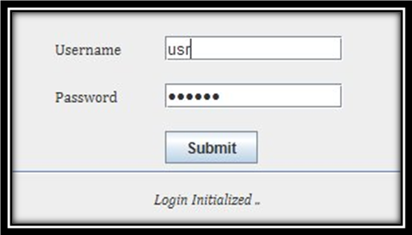
Screenshot 1. Main Login Screen

Client
Screenshot 2 demonstrate how the login screen looks like after it is authenticated
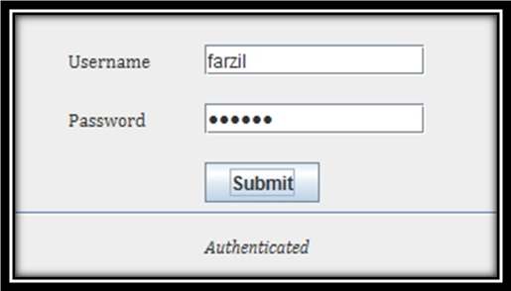
Screenshot 2. Authenticated login screen

Client
Screenshot 3 shows how the Authentication failed screen looks like
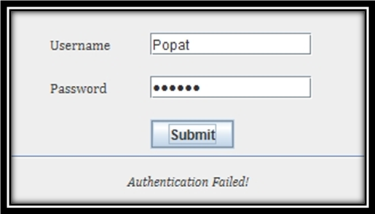
Screenshot 3. Authentication Failed screen
Server B
Screenshot 4 shows a demo server console. More functions and messages can be added according to the need. This helps us in debugging while system is being used in the real world environment
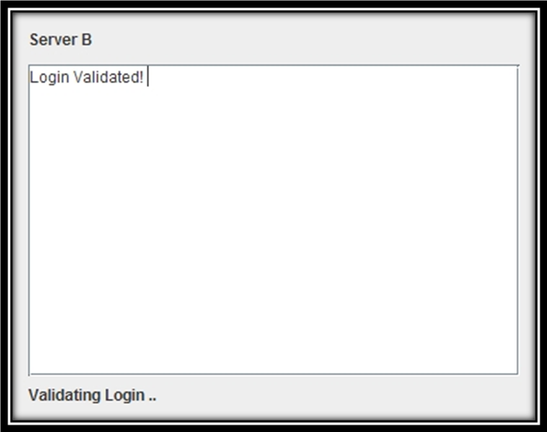
Screenshot 4: Demo Console
    - Messages on Server B
E:
x^163 + x^7 + x^6 + x^3 + 1
E:
a4:0x1
a6:0x20a601907b8c953ca1481eb10512f78744a3205fd
r: 5846006549323611672814742442876390689256843201587
G: x:3f0eba16286a2d57ea0991168d4994637e8343e36
y:d51fbc6c71a0094fa2cdd545b11c5c0c797324f1
k(#E/r): 2
These are the domain parameters on the Server B
skB.s:239
This is the Secret key on Server B
pkB.W:1334ec124bf2266d25d0609e00e9e16d920b69b6e,614094d346689a544c0534be4983b5120e54eb8b5
This is the Public Key on Server B generated from Secret key

Login Information is valid
After receiving login information from the Client, the Server starts exchanging information with Server B. First Diffie Hellman Algorithm is used to exchange Keys.
Public Key for B: 578fed89497be96cea9d6fe5dda781e21ba3c6454,6edbd4b0fc69c2079b3bd4d2f55fa3853d40bfa6c
This is the key generated on Server B
Public Key for A: 1334ec124bf2266d25d0609e00e9e16d920b69b6e,614094d346689a544c0534be4983b5120e54eb8b5
This is the key received from Server A
DER Encoding of pkA: 30,81,d5,30,81,a2,06,07,2a,86,48,ce,3d,02,01,30,81,96,02,01,01,30,1a,02,02,00,a3,06,09,2a,86,48,ce,3d,01,02,03,03,30,09,02,01,03,02,01,06,02,01,07,30,2e,04,15,00,00,00,00,00,00,00,00,00,00,00,00,00,00,00,00,00,00,00,00,01,04,15,02,0a,60,19,07,b8,c9,53,ca,14,81,eb,10,51,2f,78,74,4a,32,05,fd,04,2b,04,03,f0,eb,a1,62,86,a2,d5,7e,a0,99,11,68,d4,99,46,37,e8,34,3e,36,00,d5,1f,bc,6c,71,a0,09,4f,a2,cd,d5,45,b1,1c,5c,0c,79,73,24,f1,02,15,04,00,00,00,00,00,00,00,00,00,02,92,fe,77,e7,0c,12,a4,23,4c,33,02,01,02,03,2e,00,04,2b,04,05,78,fe,d8,94,97,be,96,ce,a9,d6,fe,5d,da,78,1e,21,ba,3c,64,54,06,ed,bd,4b,0f,c6,9c,20,79,b3,bd,4d,2f,55,fa,38,53,d4,0b,fa,6c,
DER Encoding of pkB: 30,81,d5,30,81,a2,06,07,2a,86,48,ce,3d,02,01,30,81,96,02,01,01,30,1a,02,02,00,a3,06,09,2a,86,48,ce,3d,01,02,03,03,30,09,02,01,03,02,01,06,02,01,07,30,2e,04,15,00,00,00,00,00,00,00,00,00,00,00,00,00,00,00,00,00,00,00,00,01,04,15,02,0a,60,19,07,b8,c9,53,ca,14,81,eb,10,51,2f,78,74,4a,32,05,fd,04,2b,04,03,f0,eb,a1,62,86,a2,d5,7e,a0,99,11,68,d4,99,46,37,e8,34,3e,36,00,d5,1f,bc,6c,71,a0,09,4f,a2,cd,d5,45,b1,1c,5c,0c,79,73,24,f1,02,15,04,00,00,00,00,00,00,00,00,00,02,92,fe,77,e7,0c,12,a4,23,4c,33,02,01,02,03,2e,00,04,2b,04,01,33,4e,c1,24,bf,22,66,d2,5d,06,09,e0,0e,9e,16,d9,20,b6,9b,6e,06,14,09,4d,34,66,89,a5,44,c0,53,4b,e4,98,3b,51,20,e5,4e,b8,b5,
The DER Encodings are used to generate the Secret key which is used to pass information between server A and Server B
========KB: 95640611935548466863713387610088210387
This variable helps us to check whether the key exchange was proper on both the sides or not. On Server A this is printed as KA

Client ACK from Server A
This helps us to send a message to Client in accordance to Acknowledgement or Dis-acknowledgement received from Server A

    - Messages on Server A

E:
x^163 + x^7 + x^6 + x^3 + 1
E:
a4:0x1
a6:0x20a601907b8c953ca1481eb10512f78744a3205fd
r: 5846006549323611672814742442876390689256843201587
G: x:3f0eba16286a2d57ea0991168d4994637e8343e36
y:d51fbc6c71a0094fa2cdd545b11c5c0c797324f1
k(#E/r): 2
This is the Domain parameters for Server A
skA.s:123
This is the private key of server A generated from the Domain paramenter
pkA.W:1334ec124bf2266d25d0609e00e9e16d920b69b6e,614094d346689a544c0534be4983b5120e54eb8b5
This is the public key of A generated from Server’s Private key
Public Key for B: 578fed89497be96cea9d6fe5dda781e21ba3c6454,6edbd4b0fc69c2079b3bd4d2f55fa3853d40bfa6c
This is the Public key of B Exchanged from Server B
Public Key for A: 1334ec124bf2266d25d0609e00e9e16d920b69b6e,614094d346689a544c0534be4983b5120e54eb8b5
This is the Public key of Server A
DER Encoding of pkA: 30,81,d5,30,81,a2,06,07,2a,86,48,ce,3d,02,01,30,81,96,02,01,01,30,1a,02,02,00,a3,06,09,2a,86,48,ce,3d,01,02,03,03,30,09,02,01,03,02,01,06,02,01,07,30,2e,04,15,00,00,00,00,00,00,00,00,00,00,00,00,00,00,00,00,00,00,00,00,01,04,15,02,0a,60,19,07,b8,c9,53,ca,14,81,eb,10,51,2f,78,74,4a,32,05,fd,04,2b,04,03,f0,eb,a1,62,86,a2,d5,7e,a0,99,11,68,d4,99,46,37,e8,34,3e,36,00,d5,1f,bc,6c,71,a0,09,4f,a2,cd,d5,45,b1,1c,5c,0c,79,73,24,f1,02,15,04,00,00,00,00,00,00,00,00,00,02,92,fe,77,e7,0c,12,a4,23,4c,33,02,01,02,03,2e,00,04,2b,04,01,33,4e,c1,24,bf,22,66,d2,5d,06,09,e0,0e,9e,16,d9,20,b6,9b,6e,06,14,09,4d,34,66,89,a5,44,c0,53,4b,e4,98,3b,51,20,e5,4e,b8,b5,
DER Encoding of pkB: 30,81,d5,30,81,a2,06,07,2a,86,48,ce,3d,02,01,30,81,96,02,01,01,30,1a,02,02,00,a3,06,09,2a,86,48,ce,3d,01,02,03,03,30,09,02,01,03,02,01,06,02,01,07,30,2e,04,15,00,00,00,00,00,00,00,00,00,00,00,00,00,00,00,00,00,00,00,00,01,04,15,02,0a,60,19,07,b8,c9,53,ca,14,81,eb,10,51,2f,78,74,4a,32,05,fd,04,2b,04,03,f0,eb,a1,62,86,a2,d5,7e,a0,99,11,68,d4,99,46,37,e8,34,3e,36,00,d5,1f,bc,6c,71,a0,09,4f,a2,cd,d5,45,b1,1c,5c,0c,79,73,24,f1,02,15,04,00,00,00,00,00,00,00,00,00,02,92,fe,77,e7,0c,12,a4,23,4c,33,02,01,02,03,2e,00,04,2b,04,05,78,fe,d8,94,97,be,96,ce,a9,d6,fe,5d,da,78,1e,21,ba,3c,64,54,06,ed,bd,4b,0f,c6,9c,20,79,b3,bd,4d,2f,55,fa,38,53,d4,0b,fa,6c,
DER encodings are used to generate a secret key that can be used to exchange information
========KA: 95640611935548466863713387610088210387
This is a variable that can be used to see if the key were exchanged properly or not
Signature part 1 Recieved: 3921307291268088561385381291608386517225883134884
Signature part 2 Recieved: 1681566992144050819539783399896823639721549710605
The signature from Server B is in Two parts. This shows the two parts separately
Message Recieved: farzil@123457
This is the message received from the Server B
Valid Signature!
Sending Acknowledgement
These are self explanatory messages. One is shown after verification of the signature and second shown when acknowledgement is sent.

  - Application of the System
Although this application was developed keeping in mind the security and architecture of an e-Commerce system it can be used across many other industries also since security is the prime focus of all the internet based applications across all the domains and verticals this application is applicable in all the sectors. Since the method developed in this thesis is fast and can allow multiple clients, it can be deployed in many fields.
Some example
- In banking sector, every transaction has authentication and security related facts like net banking through your client (smart card, mobile phone can be one of it).
- Travel and tourism is another industry where authentication of credential is very important. While paying through our credit card.
- In Medical Sector, doctors need to be authenticated before entering the premises and they need to be authorized whenever they are required to use some special drugs and tool.
- In Defence networks, although the security requirements are very high but there are times when a faster and stronger security is required. Then our Architecture could be deployed but with a simple variation where client will also be mutually authenticated with the middle server.

Conclusion
This chapter has shown the outputs for the implemented project. The Client has a minimal look because it was mainly made for low memory usage. The server’s console messages are also discussed in brief, which helps us to see the actually working of the server which is normally hidden. Since the project uses ECC, the key sizes are much smaller than the ones which we can expect in an RSA type implementation. The Chapter has in short, shown the complete internal working of the project which can be analyzed further if required.
CONCLUSION & FUTURE WORK

INTRODUCTION
This chapter shows us the Limitation of the proposed system and the Future development work that can be done to improve the loopholes currently present in our proposal. This chapter is a discussion which is limited to my thinking and analytical power. Different people have different approach to a particular problem. So some people may not agree to the ideas presented by me in this discussion. In the end, the Summary of the work done in our proposal is given.

  - Limitation of the System
Currently the only limitation this application has is that does not provide any security between the Client and first level server. This is because of the fact that many clients can be accessing the Middle level server and to reduce the overhead, I have not introduced a Client side security. This was mainly done to improve the time taken between Authentication request and Authentication reply. Since our Servers are already taking time to perform mutual authentication and then authenticate the client’s information.

  - Future Scope
The null processing on Client side helps us to use low memory devices as a client. Since the architecture is one mainly designed for e-commerce, we can now allow even mobile phones, smartcards, PDA, etc. to act as a client. The system currently doesn’t allow these low memory devices. Currently this is not included. Also, we may use multiple Middle level servers with a single final server. This helps brings down the cost. This type of architecture, where multiple middle level servers are communicating with a single final server, can help bring down the hardware cost in e-Commerce systems considerably. Since, we use ECC based mutual authentication on the Middle Level and Final server, we are improving the security while reducing the data overhead (due to smaller key sizes).

  - Summary
The work presented in this thesis is based on the Elliptic Curve Cryptography Algorithm developed by me in my Minor Project work. This algorithm was an optimized one for Java SE platform. Since, Elliptic Curve Cryptography is a complex cryptography algorithm hence many implementations of this do not exist. Thesis work done here is based on the fact that Elliptic Curve Cryptography reduces the space requirement of the Algorithms since we have reduced key sizes. The first chapter has explained the project problem in short. The second chapter has discussed cryptography and e-Commerce. The project is basically designed for E-Commerce Authentication. The Third Chapter has discussed the Development Environment in detail. We get to see the different platforms that were combined and put to use. The fourth chapter has the complete Implementation information about the proposed work. A Sample proposed work has also been implemented that helps us to analyze and give some results in the fifth chapter.

REFERENCES

- http://wiki.netbeans.org
- http://www.netbeans.org
- http://en.wikipedia.org/wiki/NetBeans
- http://en.wikipedia.org/wiki/Java_Development_Kit
- http://en.wikipedia.org/wiki/Microsoft_Access
- http://en.wikipedia.org/wiki/Database
- A. Gunasekarana, H.B. Marrib, R.E. McGaugheyc, M.D. Nebhwani,”E-commerce and its impact on operations management” Int. J. Production Economics 75 (2002) 185–197.
- N. Asokan, P.A. Janson, M. Steiner, M. Waidner, “The state of the art in electronic payment systems”, IEEE Computer 30 (9) (1997) 28–35.
- I. Morphett, “Foreword”, BT Technology Journal 17 (3) (1999) 17–23.
- W.M.P. VanderAalst, “Process-oriented architectures for electronic commerce and interorganizational workflow”, Information Systems 24 (8) (1999) 639–671.
- S. Wakid, J. Barkley, M. Skall, “Object retrieval and access management in electronic commerce”, IEEE Communication Magazine 37 (9) (1999) 74–77.
- R.L. Bartell, N.A. Blackwood, D. Eggenschwiler, M. Nguyen, C. Schnidrig, M.J. Yatchman, “The MediaXactt system – a framework for personalised electronic commerce services”, Bell Labs Technical Journal 4 (2) (1999) 153–173.
- “Electronic Commerce: Opportunities and Challenges for Government”, OECD Publication, Vienna, 1997.
- K. Levis, “Electronic commerce”, British Telecommunications Engineering 14 (4) (1996) 281–285.
- A. Brown, “eCommerce components for the internet”, The Business Forum Journal, 9297 Burton Way, Suite 1, Beverly Hills, California 90210, USA.
- P. D. Manuel, J. AlGhamdi, “A data-centric design for n-tier architecture”, Elsevier, Information Sciences 150 (2003) 195–206
- T. Chester, “High-performance Web sites: ADO versus MSXML”, Dr. Dobb’s Journal; San
Mateo 26 (10) (2001) 81–87.
- D. Cohen, “Construct your e-commerce business tier the easy way with XML, ASP, and scripting”, Microsoft Journal (February) (2000).
- S.H. Simon, “e-Commerce Solution for Business and IT Managers”, ISBN 0-07-137188-5, McGraw-Hill Publishing, 2001.
- M. Vizard, “IT infrastructures are woefully unprepared for the demands and stresses of ebusiness”, InfoWorld, Framingham 22 (2) (2000) 22–27.
- N. Gunton,”SOAP: Simplifying distributed development”, Dr. Dobb’s Journal, San Mateo 26 (9) (2001) 89–93.
- S. Lais, SOAP, “other protocols specify security for XML”, Computer world, Framingham 35(28) (2001) 37–40.
- J. Yang, J. Wu, Y. You, “A Web-based, event-driven management architecture”, 1999, Vol. 2, pg:1214 - 1221 vol.2, ISBN: 7-5635-0402-8
- http://en.wikipedia.org/wiki/Cryptography
- T. Ideguchi, S. Seno, et al, “An Implementation of a Hierarchical LAN Management System Based Upon Analysis of Network Management Operations”, IEICE Trans. Commun. Vol. E80-B, No. 6, June 1997, pp. 84 1-49.
- J. M. Anderson, M. Ilyas, S. Hsu, “Distributed Network Management in an Internet Environment”, GLOBECOM97, IEEE Global Telecom. Con$, New York, 1997, pp. 180-84.
- J. D. Case, M. Fedor, et al, “ A Simple Network Management Protocol (SNMP)”, RFCl157, Internet Network Working Group, Internet Engineering Task Force, May 1990.
- “Information Processing Systems-Open Systems Interconnection-Common Management Information Service Definition”, Geneva, Switzerland, 1990.
- http://www.helium.com/items/1617114-security-challenges-businesses-face-in-e-commerce
- L. Deri and B. Ban, “Static vs. Dynamic CMIP/SNMP Network Management Using CORBA”, Proc. IS & N ’97, Como, Italy, May 1997.
- P. Carlsund and M. Rolf, “An Element Manager based on Web Technology”, Ericsson Review, Vol: 75, Issue 1, 1998, pp 46-51.
- B. Bruins, “Some Experiences with Emerging Management Technologies”, The Simple Times, Vol.4, No.3, July 1996.
- M. Jander, “Welcome to the Revolution”, Data Communications, Nov. 1996, pp.39-53.
- F. Nabi, “Secure business application logic for e-commerce systems”, Computers & Security, Computers & Security (2005) 24, 208 -217
- V. Ahuja, “E-commerce on Internet” London, Academic Press Ltd, 1997.
- D. Chaffy, “Business information systems; technology”, development and management in the e-business; 2000. ISBN: 027365540X.
- Christiansen Tom, Torkington Nathan, “Perl cookbook: O’Reilly & Associates”, 1998, chapter 19: CGI programming.
- Ernst Young, “Internet shopping e an Ernst & Young special report”, 1998, Section 2
- Foresight, “E-commerce sets new rules”, Systems Relationships Marketing, on behalf of Datatec Ltd, 1998 November,1(3).
- Furche A, G. Wrightson, “Asystematic overview of electronic payment system”, Heidelberg, FDR: dpunkt, Verlag, Fur digtiale Technology Gmbh, 1996.
- G. Simson, S. Gene, “Web security and commerce: O’Reilly Publishing”, 1997.
- G. Shishir, “CGI programming on the World Wide Web”, O’Reilly & Associates; 1996.
- Anup K. Ghosh, “director of security research at software technologies”, Security and privacy in e-commerce. John Wiley & Sons; 2000.
- Anup K.Gosh, “E-commerce security: weak links, best defences”, John Wiley & Sons; 1998. ISBN: 0-471-19223-6.
- Hunt Craig, “TCP/IP for Unix administrators”, 2nd ed, O’Reilly, 1998. ISBN: 1-56592-322-7.
- K. Ravi, W. Patrick, “Frontiers of electronic commerce’, Addison-Wesley, 1996.
- http:// en.wikipedia.org /wiki/ Public-key_cryptography
- http:// wapedia.mobi/ en/ Diffie-Hellman
- M. Badra and P. Urien, “Introducing SmartCards to Remote Authenticate Passwords using Public Key Encryption”, IEEE 2004
- K. Lauter, “The Advantages of Elliptic Curve Cryptography for Wireless Security”, IEEE Wireless Communications Magazine,February 2004.
- V.GayosoMartinez, C.SanchevAvila, J.Garcia, L.Hernandez, “Elliptic Curve Cryptography: Java Implementation Issues”,2005 IEEE
- Mohammad Abdul Azim and Abbas Jamalipour, “An Efficient Elliptic Curve Cryptography based Authenticated Key Agreement Protocol for Wireless LAN Security”, 2005, IEEE.
- P.E. Abi-Char, A. M. Hamed, B. EL-Hassan, “A Secure Authenticated Key Agreement Protocol Based on Elliptic Curve Cryptography”, 2007 IEEE.
- M. Q. J. S. L. Law, A. Menezes and S. Vanstane. “An efficient protocol for authenticated key agreement”. In Designs, Codes and Cryptography, vol. 28.
- M. Q. J. S. L. Law, A. Menezes and S. Vanstane, “An efficient protocol for authenticated key agreement”, Technical report CORR98-05, Department of CO, University of Waterloo,1998.
- Sandra Kay Miller “Facing the challenge of wireless security” Technology news July 2001.
- IEEE P1363, “Standard specifications for public key cryptography”, Draft version 7, September 1998.
- V.Gayoso Martinez, C.Sanchev Avila, J.Garcia, L.Hernandez, “Elliptic Curve Cryptography:Java Implementation Issues”, 2005 IEEE
- W Stallings, “Cryptography and Network Security Principles and Practices.”
- I Biehl, B Meyer, V Muller, “Differential fault attacks on elliptic curve cryptosystems”, CRYPTO'2000: Proceedings of Crypto, pages 131-146. Springer, 2000.
- H.W. Lenstra, “Factoring integers with elliptic curves”, Annuals of Mathematics, 126: 649-673, 1987.
- A. Menezes, “Elliptic Curve Public Key Cryptosystems”, Kluwer Academic Publishers, 1993.
- M.J.B. Robshaw, Y L Yin, “Overview of Elliptic Curve Cryptosystems”, RSA Laboratories Technical Note ,Revised June 27, 1997
- L. Dang, W. Kou, and Y. Xiao, “An Improved Mutual Authentication Scheme for Smart Card Secure Messaging”, Proceedings of the IEEE International Conference on E-Commerce Technology for Dynamic E-Business (CEC-East’04), pages 261 – 264, ISBN: 0-7695-2206-8
- M. Hong, H. Guo1, B. Luo, “Security Design for Multi-Service Smart Card Systems”, Proceedings of the 2008 Second International Conference on Future Generation Communication and Networking - Volume 01, Pg 299-304, 2008, ISBN:978-0-7695-3431-2
- http://www.design-reuse.com/articles/7409/ecc-holds-key-to-next-gen-cryptography.html

