A

Project Report

On

MR Brain Image Segmentation using fuzzy Clustering Algorithm

MR IMAGE SEGMENTATION USING FUZZY CLUSTERING ALGORITHM
PROJECT REPORT
SUBMITTED
IN PARTIAL FULFILMENT OF THE REQUREMENTS
FOR THE AWARD OF THE DEGREE OF

MASTER OF ENGINEERING
IN
ELECTRONICS AND COMMUNICATION ENGINEERING
OF
Delhi University
BY
Niranjan Bhattacharyya
(University Roll No-8804)

DEPARTMENT OF ECE
DELHI TECHNOLOGICAL UNIVERSITY
(formerly Delhi College of Engineering)

CERTIFCATE
This is to certify that the project work entitled
MR IMAGE SEGMENTATION USING FUZZY CLUSTERING ALGORITHM

Is a bonafide work done by
Mr Niranjan Bhattacharyya

The students of M.E. in Electronics and Communication Engineering during the year 2009-2010 as a partial fulfillment of the requirement for the award of M.E. degree by the University of Delhi

(Project Guide) (Head, Dept of ECE)
Prof Asok Bhattacharyya Prof Rajiv Kapoor
ME,PhD,

ACKNOWLEDGEMENT

I am grateful to Department of Electronics and Communication Engineering, Delhi Technological University, Delhi, Which gave me the opportunity to have profound technical knowledge, enabling me to complete the project.

I express my sincere and heartfelt thanks to Prof Asok Bhattacharyya, Professor, Department of ECE, for his kind permission to undertake this project work and guiding me throughout the project.

We are extremely grateful to Prof Rajiv Kapoor, HOD of ECE, for her valuable suggestions and help in the endeavor which paved the way for the successful completion of this project

Last but not least, we express my thanks to all faculties, technical and non technical staff of the department of DTU for all the help and co-operation extended in bringing out this project successfully in time.

Niranjan Bhattacharyya

Chapter 1

INTRODUCTION
In image segmentation, one challenge is how to deal with the nonlinearity of real data distribution, which often makes segmentation methods need more human interactions and make unsatisfied segmentation results. Medical image segmentation plays an instrumental role in clinical diagnosis. An ideal medical image segmentation scheme should possess some preferred properties such as minimum user interaction, fast computation, and accurate and robust segmentation results.
Image segmentation is an image analysis process that aims at partitioning an image into several regions according to a homogeneity criterion. Image segmentation is a very complex task, which benefits from computer assistance, and yet no general algorithm exists. It has been a research field in computer science for more than 40 years now, and the early hope to find general algorithms that would achieve perfect segmentations independently from the type of input data has been replaced by the active development of a wide range of very specialized techniques. Most of the existing segmentation algorithms are highly specific to a certain type of data, and some research is pursued to develop generic frameworks integrating these techniques.
Segmentation can be a fully automatic process, but it achieves its best results with semi-automatic algorithms, i.e. algorithms that are guided by a human operator. This concept of semi-automatic process naturally involves an environment in which the human operator will interact with the algorithms and the data in order to produce optimal segmentations. The simplest example of the need of a human intervention during the task of segmentation results from the specificity of the existing algorithms: depending on the type of input data, the operator will have to carefully pick the best adapted algorithm, which most of the time cannot be done in an automatic way. The subjective point of view of the human is required.
Image segmentation has become an essential tool in the medical field
With the generalization of diagnosis using Magnetic Resonance Imaging (referred to as MRI), image segmentation is often required to allow doctors and surgeons to analyze the patients data, e.g. prior to surgery to determine the exact location of an organ or a tumor. MRI, also known as Nuclear Magnetic Resonance, is a method used mainly (but not only) in medical applications to visualize the insides of a patient in a harmless fashion. It relies on the relaxation properties of excited hydrogen nuclei in water after the body or part of the body to image has been placed in a powerful and uniform magnetic field. The obvious benefit of this technique is its harmless character, compared to other techniques such as CT scans and X-rays in which the patient is exposed to ionizing radiations. 3D and 4D (3D + time) MRI is increasingly used in diagnosis
and therapy.
The data acquired from MRI is generally presented as a volumetric image that can be viewed as a series of slices following one of the 3 axes: sagittal (following the X axis), coronal (following the Y axis) or axial (following the Z axis). The aim of the segmentation process is to locate with the highest accuracy possible the boundaries of a special part of the image (an organ, a tumor...), thus allowing the use of 3D information for planning of treatment, navigation or visualization. Once this task is achieved, simulation, pre-computations or training can be performed to prepare the real operation.
In this project we try to develop a segmentation algorithm for abnormal MRI images using Fuzzy C-means clustering technique and also to compare the results with the earlier techniques like Region growing method, K-means clustering algorithms. Abnormal brain images from four class,namely- metastases, meningioma, glioma and astrocytoma are being used in this work.
BACKGROUND
A mathematical definition of segmentation
The following is a very general definition of image segmentation. It uses a homogeneity predicate P ( ) that helps formalizing the notion of homogeneity in an image: a region R is homogeneous if and only if P(R) = True. Therefore, the homogeneity can be defined in infinity of different ways: on the grey levels, on the textures or even on non-obvious properties of the image
Definition 1 (segmentation): Let I be the set of pixels (the input image) and P( ) the homogeneity predicate defined on groups of connected pixels.
A segmentation S of I is a partitioning set of image regions {R1,R2, . . . ,Rn} such that

is a mathematical definition of a partition: the union of all the regions forms the whole image

and all the regions are distinct.

Signifies that the homogeneity predicate is valid on every region

signifies that the union of two adjacent regions cannot satisfy the homogeneity predicate, i.e. two adjacent regions must be distinct regarding the homogeneity predicate.

Signifies that the homogeneity predicate is valid on any sub-region of a region where it is verified.
A review on existing segmentation techniques
A wide range of very specialized segmentation techniques currently exist and since the research is very active in this field; the panel of available techniques and algorithms constantly evolves. Therefore, a complete study that would review all the state-of-the-art techniques is not relevant in the context of this document. Instead, this section tries to present a simple yet homogeneous and relevant classification of the existing techniques into a number of families. For each family the general functional philosophy is analyzed and a non-extensive list of algorithms is presented, with a short explanation of the specificities for each of them.
There are numerous types of classifications proposed in the specialized literature, each of which is relevant respectively to the point of view required by the study. Since this research project deals with medical image segmentation, where a large majority of the acquired data is grey-scaled, and all the techniques concerning color images will be left aside. The techniques are categorized into three main families:
• Pixel based techniques (also known as histogram thresholding);
• Edge based techniques;
• Region based techniques.
This classification is very commonly encountered in numerous papers as
- Histogram thresholding;
  - Edge based segmentation;
  - Tree/graph based approaches;
  - Region growing;
  - Clustering;
  - Probabilistic and Bayesian approaches;
  - Neural networks segmentation;
  - Other approaches.
- Histogram thresholding

The pixel-based family of techniques is probably the simplest one; it essentially consists in finding an acceptable threshold in the grey levels of the input image in order to separate the object(s) from the background. It is often referred to as histogram thresholding since the grey-levels histogram of an ideal image will clearly show two distinct peaks assimilable to Gaussians (which can be obtained by applying a filter to the image) representing the distribution of grey levels for one object and its background. This kind of histogram is sometimes referred to as bimodal.
The threshold value for an image can be computed by using several different methods, like the Gaussian filtering

- Edge-based segmentation
The edge-based family of techniques tries to detect edges in an image so that the boundaries of the objects can be inferred. The most simple method of this type is known as detect and link : the algorithm first tries to detect local discontinuities and then tries to build longer ones by connecting them, hopefully leading to closed boundaries which circumscribe the objects in the image. The main disadvantage of this technique lies in the fact that, depending on the quality of the input image, the algorithm is not guaranteed to produce closed edges. As a consequence, the image will not sharply split into regions. Some improvements for this method have been proposed in order to overcome this type of issue.
MR image segmentation based on edge detection has been proposed where a combination of Marr-Hildreth operator for edge detection and morphological operations for the refinement of the detected edges is used to segment 3D MR images. A boundary tracing method is proposed, where the operator clicks a pixel in a region to be outlined and the method then finds the boundary starting from that point. The method is, however, restricted to segmentation of large, well defined structures, but not to distinguish fine tissue types. Edge-based segmentation methods usually suffer from over or under-segmentation, induced by improper threshold selection. In addition, the edges found are usually not closed and complicated edge linking techniques are further required.

Active contour based segmentation:
Active contour deforms to fit the object’s shape by minimizing (among others) a gradient dependent attraction force while at the same time maintaining the smoothness of the contour shape. Thus, unlike edge detection, active contour methods are much more robust to noise as the requirements for contour smoothness and contour continuity act as a type of regularization. Another advantage of this approach is that prior knowledge about the object’s shape can be built into the contour parameterization process. However, active contour based algorithms usually require initialization of the contour close to the object boundary for it to converge successfully to the true boundary. More importantly, active contour methods have difficulty handling deeply convoluted boundary such as CSF, GM and WM boundaries due to their contour smoothness requirement. Hence, they are often not appropriate for the segmentation of brain tissues. Nevertheless, it has been applied successfully to the segmentation of intracranial boundary, brain outer surface , and Neuro-anatomic structures in MR brain images

- Region-based segmentation
The region-based family of techniques fundamentally aims at iteratively building regions in the image until a certain level of stability is reached. The region growing algorithms start from well chosen seeds (usually defined by the user). They then expand the seed regions by annexing their homogeneous neighbors. The process is iterated until all the pixels in the image have been classified. The region splitting algorithms use the entire image as a seed and split it into Regions until no more heterogeneity can be found. An algorithm that associates the advantages of both methods, called the Split, Merge and Group (SMG) algorithm, has been developed by Horowitz and Pavlidis
The shape of an object can be described in terms of its boundary or the region it occupies. Image region belonging to an object generally have homogeneous characteristics, e.g. similar in intensity or texture. Region-based segmentation techniques attempt to segment an image by identifying the various homogeneous regions that correspond to different objects in an image. Unlike clustering methods, region-based methods explicitly consider spatial interactions between neighboring voxels. In its simplest form, region growing methods usually start by locating some seeds representing distinct regions in the image. The seeds are then grown until they eventually cover the entire image. The region growing process is therefore governed by a rule that describe the growth mechanism and a rule that check the homogeneity of the regions at each growth step. Region growing technique has been applied to MRI segmentation.
A semi-automatic, interactive MRI segmentation algorithm was developed that employ simple region growing technique for lesion segmentation. In an automatic statistical region growing algorithm, based on a robust estimation of local region mean and variance, for every voxel on the image was proposed for MRI segmentation. The best region growing parameters are automatically found via the minimization of a cost functional. Furthermore, relaxation labeling, region splitting, and constrained region merging were used to improve the quality of the MRI segmentation. The determination of an appropriate region homogeneity criterion is an important factor in region growing segmentation methods. However, such homogeneity criterion may be difficult to obtain a priori. An adaptive region growing method is proposed where the homogeneity criterion is learned automatically from characteristics of the region to be segmented while searching for the region.
Other region-based segmentation techniques like,
- Split-and-merge based segmentation and
- Watershed based segmentation
have also been proposed for MRI segmentation.

- Split-and-merge based segmentation
In the split-and-merge technique, an image is first split into many small regions during the splitting stage according to a rule, and then the regions are merged if they are similar enough to produce the final segmentation.

2. Watershed-based segmentation
In the watershed-based segmentation, the gradient magnitude image is considered as a topographic relief where the brightness value of each voxel corresponds to a physical elevation. An immersion based approach is used to calculate the watersheds. The operation can be described by imagine that holes are pierced in each local minimum of the topographic relief. Then, the surface is slowly immersed in water, which causes a flooding of all the catchment basins, starting from the basin associated with the global minimum. As soon as two catchment basins begin to merge, a dam is built. The procedure results in a partitioning of the image in many catchment basins of which the borders define the watersheds. To reduce over-segmentation, the image is smoothed by 3D adaptive anisotropic diffusion prior to watershed operation. Semi-automatic merging of volume primitives returned by the watershed operation is then used to produce the final segmentation.

CHAPTER 2

SEGMENTATION ALGORITHMS

Region Growing:
Region growing is a technique for extracting an image region that is connected based on some predefined criteria. These criteria can be based on intensity information and/or edges in the image. In its simplest form, region growing requires a seed point that is manually selected by an operator and extracts all pixels connected to the initial seed based on some predefined criteria. For example, one possible criterion might be to grow the region until an edge in the image is met. Like thresholding, region growing is seldom used alone but usually within a set of image-processing operations, particularly for the delineation of small, simple structures such as tumors and lesions.
Region based method:
Growth of regions
The first region growing method was the seeded region growing method. This method takes a set of seeds as input along with the image. The seeds mark each of the objects to be segmented. The regions are iteratively grown by comparing all unallocated neighboring pixels to the regions. The difference between a pixel's intensity value and the region's mean, δ, is used as a measure of similarity. The pixel with the smallest difference measured this way is allocated to the respective region. This process continues until all pixels are allocated to a region. The growth of the regions is carried out from the seeds that were determined as input, where each one of them contains the following information:

- Position: These are x, y and z coordinates within the image. It is known that this point belongs to the region of interest.
- Intensity: The voxel intensity is important to determine the rank of intensities that will be included in the region (if the inclusion criterion makes use of this value).
Another input data of the algorithm is the three-dimensional image with a cubical matrix shape. The algorithm output will be a matrix with the same dimensions as the input image. This output matrix is initially filled out with zeroes in all the positions, and the seeds will be marked to let the region grow.
Fig: connected region growing
Growth Algorithm
An auxiliary FIFO (First In First Out) structure is used where the seeds are initially located, and where the Neighbors that belong to the region to be visited are queued up. In algorithm 1 it is possible to see the pseudo code of Voxel Grow algorithm in detail. The algorithm successively takes elements from the queue. Each one of these elements is one of the volume’s voxel that have already been accepted. For each one of them we must visit its neighbors, and decide if that neighbor belongs or not to the region according to the selection criterion. In order to compare neighbors, 6-connectedness is used.

One of the most remarkable aspects of this technique is that it always grows by neighbors, so it maintains connectivity between the elements that are included within the segmented region.
Growth Types
Three growth variations are provided to consider if a voxel belongs or not to the region of interest. The first one considers the variation of voxel intensity in relation to the seed intensity. The second one considers the local intensity variation in relation to the neighbor being visited. The last one considers the three-dimensional gradient of the image.
Seed Growth
In this case the seed intensity is taken always as reference. Each new voxel that is added to the region is included if the intensity difference that exists between it and the intensity of the seed maintains within a threshold determined previously. This threshold is compared directly with the intensity difference. This technique gives as result regions that contain voxels whose intensities are within a certain rank.

Neighbor Growth
Unlike the previous case, this variation considers that the voxel belongs to the region if the intensity difference with its neighbor remains underneath the threshold. In this technique, voxels that have great variations of intensity with their neighbors are excluded

Disadvantages of Region growing:
The primary disadvantage of region growing is that it requires manual interaction to obtain the seed point. Thus, for each region that needs to be extracted, a seed must be planted. Split and-merge is an algorithm related to region growing, but it does not require a seed point. Region growing can also be sensitive to noise, causing extracted regions to have holes or even become disconnected. Conversely, partial-volume effects can cause separate regions to become connected. To help alleviate these problems, a homotopic region-growing algorithm has been proposed that preserves the topology between an initial region and an extracted region. Fuzzy analogies to region growing have also been developed.
Fig: Region growing method with different initial seeds. Top-left: Original Image, Top-Right: the white matter, bottom–Left: a ventricle bottom right: The grey matter
Histogram-Based Methods
Histogram-based methods are very efficient when compared to other image segmentation methods because they typically require only one pass through the pixels. In this technique, a histogram is computed from all of the pixels in the image, and the peaks and valleys in the histogram are used to locate the clusters in the image. Color or intensity can be used as the measure. A refinement of this technique is to recursively apply the histogram-seeking method to clusters in the image in order to divide them into smaller clusters. This is repeated with smaller and smaller clusters until no more clusters are formed.
One disadvantage of the histogram-seeking method is that it may be difficult to identify significant peaks and valleys in the image. In this technique of image classification distance metric and integrated region matching are familiar.

CLUSTERING METHOD
Clustering can be considered the most important unsupervised learning problem because no information is provided about the "right answer" for any of the objects. It classifies a set of observations in the data and it finds a reasonable structure in the data set. Here priori information about classes is not required, i.e., neither the number of clusters nor the rules of assignment into clusters are known. They have to be discovered exclusively from the given data set without
any reference to a training set. Cluster analysis allows many choices about the nature of the algorithm for combining groups. There are two basic approach to clustering, which
we call supervised and unsupervised. In the case of unsupervised classification on clustering, we do not have labels. If we know the labels of our input data, the problem is considered supervised, or otherwise it is called unsupervised.
Clustering Definition: Clustering is a grouping of data with similar characteristics. To divide the data into several groups the similarity of objects are used, here the distance functions are being used to find the similarity of two objects in the data set.
Clustering algorithms essentially perform the same function as classifier methods without the use of training data. Thus, they are termed unsupervised methods. To compensate for the lack of training data, clustering methods iteratatively alternate between segmenting the image and characterizing the properties of each class. In a sense, clustering methods train themselves, using the available data. Three commonly used clustering algorithms are the K-means or ISODATA algorithm, the fuzzy c-means algorithm, and the expectation-maximization (EM) algorithm. The K-means clustering algorithm clusters data by iteratively computing a mean intensity for each class and segmenting the image by classifying each pixel in the class with the closest mean. Figure below shows the result of applying the K-means algorithm to a slice of an MR brain image in Figure below. The number of classes was assumed to be three, representing (from dark gray to white) cerebrospinal fluid, gray matter, and white matter. The fuzzy c-means algorithm generalizes the K-means algorithm, allowing for soft segmentations based on fuzzy set theory. The EM algorithm applies the same clustering principles with the underlying assumption that the data follow a Gaussian mixture model

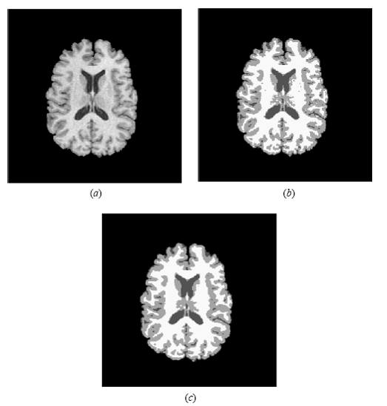
Fig : a) Original image b) segmentation using K-means algorithm c) segmentation using k means algorithm with markov fields
The posterior probabilities and computing maximum likelihood estimates of the means, covariance’s, and mixing coefficients of the mixture model. Although clustering algorithms do not require training data, they do require an initial segmentation (or, equivalently, initial parameters). The EM algorithm has demonstrated greater sensitivity to initialization than the K-means or fuzzy c-means algorithm. Like classifier methods, clustering algorithms do not directly incorporate spatial modeling and can therefore be sensitive to noise and intensity in homogeneities. This lack of spatial modeling, however, can provide significant advantages for fast computation. Work on improving the robustness of clustering algorithms to intensity in homogeneities in MR images has demonstrated excellent success. Robustness to noise can be incorporated by MRF modeling as described.
K-Means Algorithm
The K-means algorithm is an iterative technique that is used to partition an image into K clusters. The basic algorithm is:
- Pick K cluster centers, either randomly or based on some heuristic
- Assign each pixel in the image to the cluster that minimizes the variance between the pixel and the cluster center
- Re-compute the cluster centers by averaging all of the pixels in the cluster
- Repeat steps 2 and 3 until convergence is attained (e.g. no pixels change clusters)
In this case, variance is the squared or absolute difference between a pixel and a cluster center. The difference is typically based on pixel color, intensity, texture, and location, or a weighted combination of these factors. K can be selected manually, randomly, or by a heuristic.
This algorithm is guaranteed to converge, but it may not return the optimal solution. The quality of the solution depends on the initial set of clusters and the value of K. The detailed description of clustering methods for images is given in a source. The other approach to partition an image into K clusters is the statistical hierarchical agglomerative cauterization technique for identification of images regions by the color similarity. This method uses a binary mask and ranks the color components of the clusters’ central components. The basic algorithm is:
- Each pixel is the separate cluster
- The clusters with the same masks joins into new clusters
- New clusters are set up by the cluster integration with minimum distance. The stage may occur until the condition for clusters’ comparability is being obeyed. This is condition based on the binary mask of correlation and ranks.
Fuzzy C-Means:

The fuzzy c-means algorithm, like the k-means algorithm, the fuzzy c-means aims to minimize an objective function. The fuzzy c- mean algorithm is better than the k-mean algorithm, since in k-mean algorithm, feature vectors of the data’s set can be partitioned into hard clusters, and the feature vector can exactly be a member of one cluster only. Instead, the fuzzy c-mean relax the condition, and it allows the feature vector to have multiple membership grades to multiple clusters, Suppose the data set with known clusters and a data point which is close to both clusters but also equidistant to them. Fuzzy clustering gracefully copes with such dilemmas by assigning this data point equal but partial memberships to both clusters that is the point may belong to both clusters with some degree of membership grades varies from 0 to 1.
Example:
Suppose we have taken the data in table (1). We choose k = 2 (two clusters), where k is a number of clusters, and we use both crisp clustering method and fuzzy clustering method to make 2 clusters. Instead, in the fuzzy clustering, the object belongs to both clusters with different degrees of memberships.

Table 1 Example Data

EM Algorithm
Expectation Maximization (EM) is one of the most common algorithms used for density estimation of data points in an unsupervised setting. The algorithm relies on finding the maximum likelihood estimates of parameters when the data model depends on certain latent variables. In EM, alternating steps of Expectation (E) and Maximization (M) are performed iteratively till the results converge. The E step computes an expectation of the likelihood by
including the latent variables as if they were observed, and a maximization (M) step, which computes the maximum likelihood estimates of the parameters by maximizing the expected
likelihood found on the last E step. The parameters found on the M step are then used to begin another E step, and the process is repeated until convergence. Mathematically for a given training dataset {x(1),x(2),….x(m)} and model p(x, z) where z is the latent variable, We have

As can be seen from the above equation, The log likelihood is described in terms of x, z and θ. But since z, the latent variable is not known; We use approximations in its place. These approximations take the form of E & M steps mentioned above and formulated mathematically below.
E-step for each i
M-step for all z
Conceptually, The EM algorithm can be considered as a variant of the K Means algorithm
Where the membership of any given point to the clusters is not complete and can be fractional.

CHAPTER 3

PROPOSED METHDOLOGY
Two pixel-based segmentation methods are applied in our proposed method. One is histogram statistics and the other is K-means clustering. The histogram method defines single or multiple thresholds to classify an image pixel-by-pixel. A simple approach to determine the gray value threshold T is by analyzing the histogram for peak values and finding the lowest point, which is typically located between two consecutive peak values of the histogram. If a histogram is clearly bi-modal, the histogram statistics method can provide good results. By comparing the gray value of each pixel with the determined threshold T, a pixel can be classified into one or the two classes. An image f(x,y) can be segmented into two classes using a gray value threshold T so that
Where g(x,y) is the segmented image with two classes of binary values, “1” and “0”, and T is the threshold assigned to the lowest point, which is located between two peak values of the histogram. K-means is a widely used clustering algorithm to partition data into k clusters. Clustering is the process for grouping data points with similar feature vectors into a single cluster and for grouping data points with dissimilar feature vectors into different clusters. Let the feature vectors derived from l clustered data be X={x_{i}| i=1,2,…l}. The generalized algorithm initiates k cluster centroids C={c_{j}|j=1,2,…k} by randomly selecting k feature vectors from X. Later, the
feature vectors are grouped into k clusters using a selected distance measure such as Euclidean distance so that d=|x_{i}-c_{j}|
The next step is to re-compute the cluster centroids based on their group members and then regroup the feature vectors according to the new cluster centroids. The clustering procedure stops only when all cluster centroids tend to converge.
In the proposed method, we combine histogram statistics and K-means clustering to track the tumor objects in MR brain images. The flowchart of our method is shown as Fig.
Fig: Flow chart showing the proposed approach using K-means

Basically, feature space selection is a key issue in K-means clustering segmentation. The original MR brain image is rendered as a gray-level image that is insufficient to support fine features. To obtain more useful feature and enhance the visual density, the proposed method applies pseudo-color transformation, a mapping function that maps a gray-level pixel to a color-level pixel by a lookup table in a predefined color map. An RGB color map contains R, G, and B values for each item. Each gray value maps to an RGB item. The proposed method has adopted the standard
RGB color map, which gradually maps gray-level, values 0 to 255 into blue-to-green-to-red color. To retrieve important features to benefit the clustering process, the RGB color space is further converted to a CIELab color model (L*a*b*).The L*a*b* space consists of a luminosity layer L*, a chromaticity-layer a*, which indicates where color falls along the red-green axis, and a chromaticity-layer b*, which indicates where the color falls along the blue-yellow axis. The translating formula calculates the tri-stimulus coefficients first as
W=0.4303R+0.341G+0.1784B,
Y=0.2219R+0.7068G+0.0713B,
Z=0.0202R+0.1296G+0.9393B.
The CIELab color model is calculated as
L*=116(h(Y/Ys))-16,
a*=500(h(W/Ws))-h(Y/Ys),
b*=200(h(Y/Ys)-h(Z/Zs)),
h (q)=3sqrt(q) q>0.008856
7.787q+16/116 q<=0.008856,
where Ys Ws and Zs are the standard stimulus coefficients .
Both the a* and b* layers contain all required color information .there fore the proposed method then classifies the colors in the a*b* space using k means clustering .after the clustering process, the cluster containing an area of interest is selected as the primary segment .to eliminate the pixels which are not related to the interest in the selected cluster, histogram clustering is applied by luminosity feature l* to derive the final segment result.
In the proposed method we convert a gray level MR brain image into an RGB color image first and then convert the RGB color image into a CIELab color model. Therefore, colors in both the a* and b* spaces are feature vectors for K-means clustering .to demonstrate the detection performance of the proposed method, an MR brain image containing the pathological change area in the image served as a test image. The RGB color image converted from the gray-level image is shown in fig----. To prove that the feature vectors proposed by our method really can provide better segmentation performance, two different data sets were prepared; the gray feature vectors if the original MR brain image and the RGB features derived from the converted RGB color image .generally, an MR brain image consists of regions that represent the bone ,soft tissue, fat and background. In the gray and color test images suggest three primary clusters in the test image shown. When k=3 the image labeled by cluster index from the K-means process for different kinds of feature vectors. Using index labels, we can separate objects in the brain image by three colors: white, gray and black. The final segmentation results generated by histogram clustering are shown in k mean cluster image by combining the histogram cluster image we can see that not only a tumor is identified but also the white matter, cerebrospinal fluid, and the ventricles are. In other words, the segmentation result cannot exactly identify the position of the tumor shown in compared image.

However, the segmentation result generated by the proposed method can ignore most of the white matter locating the position of the tumor. Therefore the segmentation performance of the proposed features derived from the CIELab color model and the propped method is confirmed.

CHAPETR 4

Fuzzy C Means Clustering
Fuzzy C-Mean with MRI:
Fuzzy C means is a method of clustering which allows one pixel to belong to one or more clusters .The FCM algorithm attempts to partition a finite collection of pixels into a collection of “C” fuzzy clusters with respect to some given criteria. Depending on the data and the application different types of similarity measures may be used to identify classes. Some examples of values that can be used a similarity measures include distance, connectivity and intensity .In this work the images are segmented into four clusters namely white matter, grey matter, CSF and abnormal tumor region based on the feature values.
Fuzzy C-means Algorithm is based on minimization of the following objective function
u_{ij} is between 0 and 1; C_{i} is the centroids of cluster i
d_{ij} is the Euclidean distance between i^{th} centroids and j^{th} data point.
mЄ [1,∞] is a weighting function.
Fuzzy portioning of known data sample is carried out through an iterative optimization of the objective function
This iteration will stop when, where is a termination criterion between 0 and 1, whereas k are the iteration steps. This procedure converges to a local minimum or a saddle point of J_{m}.
The algorithm is composed of the following steps:
- Initialize U=[u_{ij}] matrix, U⁽⁰⁾
- At k-step: calculate the centers vectors C^{(k)}=[c_{j}] with U^{(k)}
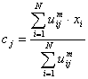
- Update U^{(k)} , U^{(k+1)}
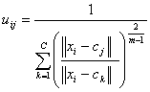
- If || U^{(k+1)} - U^{(k)}||< then STOP; otherwise return to step 2.

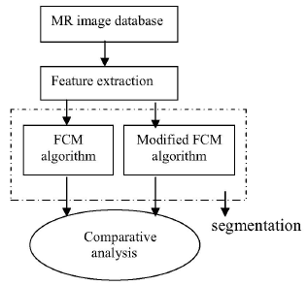
MODIFIED C Means Clustering
Clustering can also be thought of as a form of data compression, where a large number of samples are converted into a small number of representative or clusters. High dimensional feature space based image segmentation is time intensive than in one dimensional feature spaces. The modified FCM algorithm is based on the concept of data compression where the dimensionality of the input is highly reduced. The data compression includes two steps Quantization and aggregation.
The quantization of the feature space is performed by masking the lower ‘m’ bits of the feature value .The quantized output will result in the common intensity values for more than one feature vector. In the process aggregation ,feature vectors which share common intensity values are grouped together .a representative feature vector is chosen from each group and they are given as the input for the conventional FM algorithm. Once the clustering is complete ,the representative feature vector memberships values are distributed identically to all members of the quantization level .Since the modified FCM algorithm uses a reduced data set the convergence rate is highly improved when compared with the conventional FCM.A sample operation for the quantization and aggregation techniques with m =2 is given
In the above table, A,B,C features contrast, correlation and entropy respectively. For a 256 * 256 image, there are 65536 feature vectors. For simplicity, the operation is shown in the above table with four feature vectors each vector consists of three feature values. Initially the binary equivalent is found out and the bit mask 11111100 is used to quantize the data .The last column represents the quantized data where some feature vectors share common values which aid in data reduction. Table 2 illustrates the aggregation process
In the aggregation process, the feature vectors sharing the common values are grouped together and their mean value is calculated. These mean values form new feature vector which is a representative for the group .Similarly representative are take from each group which form a new data set y this reduced data set Y is used instead of the original o f the data set x in the conventional FCM algorithm one the clustering is complete ,the representative feature vector membership values are distributed identically to all members of quantization level. Since the dimensionality of the input data set is reduced the convergence is highly improved in the modified FCM algorithm.

Modified FCM Algorithm
The modified FCM algorithm uses the same steps of conventional FCM except for the change in the cluster updation and membership value updation criterions. The modified criterions are showed below
Practical Applications of Image segmentation
- Medical Applications
- Locate tumors and other pathologies
- Measure tissue volumes
- Computer guided surgery
- Diagnosis
- Treatment planning
- Study of anatomical structure
- Locate objects in satellite images (roads, forests, etc)
- Face Recognition
- Finger print Recognition , etc

RESULTS:-
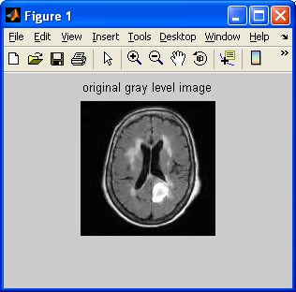
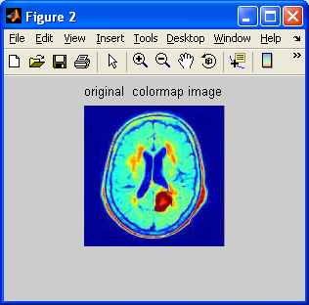
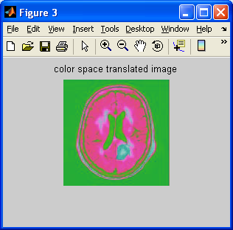
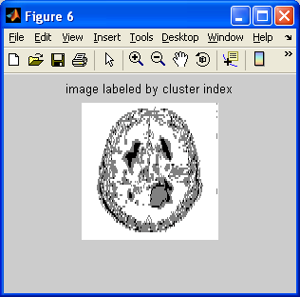
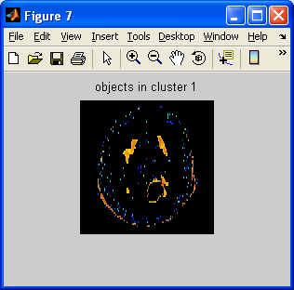
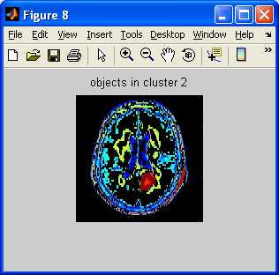
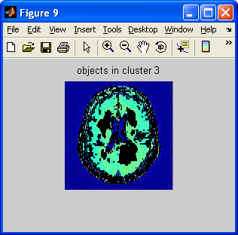
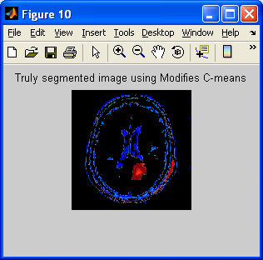
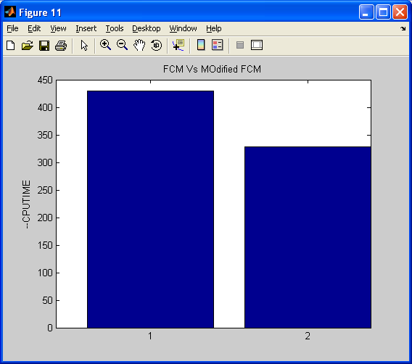

Conclusion:-
In this project three approaches for segmentation of brain tissue in MR images is presented. The results show that this method can successively segment a tumor provided the parameters are chosen properly. The visualization and detective valuations of the results of the segmentation show the success of the approaches. In this study, the tumor identification and the investigation are carried out for the potential use of MRI data for improving the tumor shape and 2D visualization of the surgical planning.
In this project, the problem of the Clustering based segmentation in MR images due to the brain image complexity has been addressed using seed point and region growing algorithm. Conventionally, for brain MR image segmentation, there are various structural and statistical approaches. Structural methods are based on the spatial properties of the image, such as edges and regions. Clustering algorithm like C –means and the modified C-means shows a considerable efficiency when compared with the earlier techniques.We found that the modified C means clustering took almost half of the processing time for CPU.this is a good improvement with respect to the computational complexity.

Future Scope:-
Future research in MRI segmentation should strive toward improving the accuracy, precision, and computation speed of the segmentation algorithms, while reducing the amount of manual interactions needed. This is particularly important as MR imaging is becoming a routine diagnostic procedure in clinical practice. It is also important that any practical segmentation algorithm should deal with 3D volume segmentation instead of 2D slice by slice segmentation, since MRI data is 3D in nature. Volume segmentation ensures continuity of the 3D boundaries of the segmented images whereas slice by slice segmentation does not guarantee continuation of the boundaries of the tissue regions between slices.
Future work will focus on the construction of more accurate brain atlas using a non rigid registration technique and on the investigation of the partial volume effect

APPENDIX
DIGITAL IMAGE PROCESSING
BACKGROUND:
Digital image processing is an area characterized by the need for extensive experimental work to establish the viability of proposed solutions to a given problem. An important characteristic underlying the design of image processing systems is the significant level of testing & experimentation that normally is required before arriving at an acceptable solution. This characteristic implies that the ability to formulate approaches &quickly prototype candidate solutions generally plays a major role in reducing the cost & time required to arrive at a viable system implementation.
What is DIP?
An image may be defined as a two-dimensional function f(x, y), where x & y are spatial coordinates, & the amplitude of f at any pair of coordinates (x, y) is called the intensity or gray level of the image at that point. When x, y & the amplitude values of f are all finite discrete quantities, we call the image a digital image. The field of DIP refers to processing digital image by means of digital computer. Digital image is composed of a finite number of elements, each of which has a particular location & value. The elements are called pixels.
Vision is the most advanced of our sensor, so it is not surprising that image play the single most important role in human perception. However, unlike humans, who are limited to the visual band of the EM spectrum imaging machines cover almost the entire EM spectrum, ranging from gamma to radio waves. They can operate also on images generated by sources that humans are not accustomed to associating with image.
There is no general agreement among authors regarding where image processing stops & other related areas such as image analysis& computer vision start. Sometimes a distinction is made by defining image processing as a discipline in which both the input & output at a process are images. This is limiting & somewhat artificial boundary. The area of image analysis (image understanding) is in between image processing & computer vision.
There are no clear-cut boundaries in the continuum from image processing at one end to complete vision at the other. However, one useful paradigm is to consider three types of computerized processes in this continuum: low-, mid-, & high-level processes. Low-level process involves primitive operations such as image processing to reduce noise, contrast enhancement & image sharpening. A low- level process is characterized by the fact that both its inputs & outputs are images. Mid-level process on images involves tasks such as segmentation, description of that object to reduce them to a form suitable for computer processing & classification of individual objects. A mid-level process is characterized by the fact that its inputs generally are images but its outputs are attributes extracted from those images. Finally higher- level processing involves “Making sense” of an ensemble of recognized objects, as in image analysis & at the far end of the continuum performing the cognitive functions normally associated with human vision.
Digital image processing, as already defined is used successfully in a broad range of areas of exceptional social & economic value.
What is an image?
An image is represented as a two dimensional function f(x, y) where x and y are spatial co-ordinates and the amplitude of ‘f’ at any pair of coordinates (x, y) is called the intensity of the image at that point.
Gray scale image:
A grayscale image is a function I (xylem) of the two spatial coordinates of the image plane.
I(x, y) is the intensity of the image at the point (x, y) on the image plane.
I (xylem) takes non-negative values assume the image is bounded by a rectangle [0, a] ×[0, b]I: [0, a] × [0, b] → [0, info)
Color image:
It can be represented by three functions, R (xylem) for red, G (xylem) for green and B (xylem) for blue.
An image may be continuous with respect to the x and y coordinates and also in amplitude. Converting such an image to digital form requires that the coordinates as well as the amplitude to be digitized. Digitizing the coordinate’s values is called sampling. Digitizing the amplitude values is called quantization.

Coordinate convention:
The result of sampling and quantization is a matrix of real numbers. We use two principal ways to represent digital images. Assume that an image f(x, y) is sampled so that the resulting image has M rows and N columns. We say that the image is of size M X N. The values of the coordinates (xylem) are discrete quantities. For notational clarity and convenience, we use integer values for these discrete coordinates. In many image processing books, the image origin is defined to be at (xylem)=(0,0).The next coordinate values along the first row of the image are (xylem)=(0,1).It is important to keep in mind that the notation (0,1) is used to signify the second sample along the first row. It does not mean that these are the actual values of physical coordinates when the image was sampled. Following figure shows the coordinate convention. Note that x ranges from 0 to M-1 and y from 0 to N-1 in integer increments.
The coordinate convention used in the toolbox to denote arrays is different from the preceding paragraph in two minor ways. First, instead of using (xylem) the toolbox uses the notation (race) to indicate rows and columns. Note, however, that the order of coordinates is the same as the order discussed in the previous paragraph, in the sense that the first element of a coordinate topples, (alb), refers to a row and the second to a column. The other difference is that the origin of the coordinate system is at (r, c) = (1, 1); thus, r ranges from 1 to M and c from 1 to N in integer increments. IPT documentation refers to the coordinates. Less frequently the toolbox also employs another coordinate convention called spatial coordinates which uses x to refer to columns and y to refers to rows. This is the opposite of our use of variables x and y.

Image as Matrices:
The preceding discussion leads to the following representation for a digitized image function:
f (0,0) f(0,1) ……….. f(0,N-1)
f(1,0) f(1,1) ………… f(1,N-1)
f(xylem)= . . .
. . .
f(M-1,0) f(M-1,1) ………… f(M-1,N-1)
The right side of this equation is a digital image by definition. Each element of this array is called an image element, picture element, pixel or pel. The terms image and pixel are used throughout the rest of our discussions to denote a digital image and its elements.
A digital image can be represented naturally as a MATLAB matrix:
f(1,1) f(1,2) ……. f(1,N)
f(2,1) f(2,2) …….. f(2,N) . . .
f = f(M,1) f(M,2) …….f(M,N)
Where f(1,1) = f(0,0) (note the use of a monoscope font to denote MATLAB quantities). Clearly the two representations are identical, except for the shift in origin. The notation f(p ,q) denotes the element located in row p and the column q. For example f(6,2) is the element in the sixth row and second column of the matrix f. Typically we use the letters M and N respectively to denote the number of rows and columns in a matrix. A 1xN matrix is called a row vector whereas an Mx1 matrix is called a column vector. A 1x1 matrix is a scalar.
Matrices in MATLAB are stored in variables with names such as A, a, RGB, real array and so on. Variables must begin with a letter and contain only letters, numerals and underscores. As noted in the previous paragraph, all MATLAB quantities are written using mono-scope characters. We use conventional Roman, italic notation such as f(x ,y), for mathematical expressions
Reading Images:
Images are read into the MATLAB environment using function imread whose syntax is
imread(‘filename’)
Format name Description recognized extension
TIFF Tagged Image File Format .tif, .ti
JPEG Joint Photograph Experts Group .jpg, .jpeg
GIF Graphics Interchange Format .gif
BMP Windows Bitmap .bmp
PNG Portable Network Graphics .png
XWD X Window Dump .xwd
Here filename is a spring containing the complete of the image file(including any applicable extension).For example the command line
>> f = imread (‘8. jpg’);
reads the JPEG (above table) image chestxray into image array f. Note the use of single quotes (‘) to delimit the string filename. The semicolon at the end of a command line is used by MATLAB for suppressing output. If a semicolon is not included. MATLAB displays the results of the operation(s) specified in that line. The prompt symbol(>>) designates the beginning of a command line, as it appears in the MATLAB command window.
When as in the preceding command line no path is included in filename, imread reads the file from the current directory and if that fails it tries to find the file in the MATLAB search path. The simplest way to read an image from a specified directory is to include a full or relative path to that directory in filename.
For example,
>> f = imread ( ‘D:\myimages\chestxray.jpg’);
reads the image from a folder called my images on the D: drive, whereas
>> f = imread(‘ . \ myimages\chestxray .jpg’);
reads the image from the my images subdirectory of the current of the current working directory. The current directory window on the MATLAB desktop toolbar displays MATLAB’s current working directory and provides a simple, manual way to change it. Above table lists some of the most of the popular image/graphics formats supported by imread and imwrite.
Data Classes:
Although we work with integers coordinates the values of pixels themselves are not restricted to be integers in MATLAB. Table above list various data classes supported by MATLAB and IPT are representing pixels values. The first eight entries in the table are refers to as numeric data classes. The ninth entry is the char class and, as shown, the last entry is referred to as logical data class.
All numeric computations in MATLAB are done in double quantities, so this is also a frequent data class encounter in image processing applications. Class unit 8 also is encountered frequently, especially when reading data from storages devices, as 8 bit images are most common representations found in practice. These two data classes, classes logical, and, to a lesser degree, class unit 16 constitute the primary data classes on which we focus. Many ipt functions however support all the data classes listed in table. Data class double requires 8 bytes to represent a number uint8 and int 8 require one byte each, uint16 and int16 requires 2bytes and unit 32.
Image Types:
The toolbox supports four types of images:
1 .Intensity images
2. Binary images
3. Indexed images
4. R G B images
Most monochrome image processing operations are carried out using binary or intensity images, so our initial focus is on these two image types. Indexed and RGB colour images.

Intensity Images:
An intensity image is a data matrix whose values have been scaled to represent intentions. When the elements of an intensity image are of class unit8, or class unit 16, they have integer values in the range [0,255] and [0, 65535], respectively. If the image is of class double, the values are floating _point numbers. Values of scaled, double intensity images are in the range [0, 1] by convention.

Binary Images:
Binary images have a very specific meaning in MATLAB.A binary image is a logical array 0s and1s.Thus, an array of 0s and 1s whose values are of data class, say unit8, is not considered as a binary image in MATLAB .A numeric array is converted to binary using function logical. Thus, if A is a numeric array consisting of 0s and 1s, we create an array B using the statement.
B=logical (A)
If A contains elements other than 0s and 1s.Use of the logical function converts all nonzero quantities to logical 1s and all entries with value 0 to logical 0s.
Using relational and logical operators also creates logical arrays.
To test if an array is logical we use the I logical function:
islogical(c)
If c is a logical array, this function returns a 1.Otherwise returns a 0. Logical array can be converted to numeric arrays using the data class conversion functions.
Indexed Images:
An indexed image has two components:
A data matrix integer, x.
A color map matrix, map.
Matrix map is an m*3 arrays of class double containing floating_ point values in the range [0, 1].The length m of the map are equal to the number of colors it defines. Each row of map specifies the red, green and blue components of a single color. An indexed images uses “direct mapping” of pixel intensity values color map values. The color of each pixel is determined by using the corresponding value the integer matrix x as a pointer in to map. If x is of class double ,then all of its components with values less than or equal to 1 point to the first row in map, all components with value 2 point to the second row and so on. If x is of class units or unit 16, then all components value 0 point to the first row in map, all components with value 1 point to the second and so on.
RGB Image:
An RGB color image is an M*N*3 array of color pixels where each color pixel is triplet corresponding to the red, green and blue components of an RGB image, at a specific spatial location. An RGB image may be viewed as “stack” of three gray scale images that when fed in to the red, green and blue inputs of a color monitor
Produce a color image on the screen. Convention the three images forming an RGB color image are referred to as the red, green and blue components images. The data class of the components images determines their range of values. If an RGB image is of class double the range of values is [0, 1].
Similarly the range of values is [0,255] or [0, 65535].For RGB images of class units or unit 16 respectively. The number of bits use to represents the pixel values of the component images determines the bit depth of an RGB image. For example, if each component image is an 8bit image, the corresponding RGB image is said to be 24 bits deep.
Generally, the number of bits in all component images is the same. In this case the number of possible color in an RGB image is (2^b) ^3, where b is a number of bits in each component image. For the 8bit case the number is 16,777,216 colors

REFERNCES:-
- Effective Fuzzy clustering algorithm for abnormal MR image segmentation by D.JUDE hemanth D.selvathi and J anitha 2009 International conference on image processing 2009

- Xia, Y., Bettinger, K., Shen, L., Reiss, A.: Automatic segmentation of the caudate nucleus from human brain MR images. IEEE Transactions on Medical Imaging 26(4) (2007) 509–517

- C. Chu and K. Takaya, “3-Dimensional rendering of MR images,” WESCANEX 93. Communications, Computers and Power in the Modern Environment Conference Proceedings, IEEE , pp. 165–170, 2003

- Clarke, L., Velthuizen, R., Camacho, M., Heine, J., Vaydianathan, M., Hall, L., Thatcher, R., Silbiger, M.: MRI segmentation: Methods and applications. Magnetic Resonance Imaging 13 (2002)

- . Cline, H., Lorensen, W., Kikinis, R. and Jolesz, F. (2001) Three- Dimensional Segmentation of MR Images of the Head Using Probability and Connectivity. J. Comp. Assis. Tomogr., 14, 1037–1045

- J. Liang, . McInerney, D. Terzopolos Interactive Medical Image Segmentation with United Snakes Medical Image Computing and Computer-Assisted Intervention - MICCAI’99, 116, 1999.

- Pham, D.L., Xu, C., Prince, J.L.: Current methods in medical image segmentation. Annual Review of Biomedical Engineering 2 (2000) 315{337

- Dugas-Phocion, G., Ballester, M.A.G., Malandain, G., Lebrun, C., Ayache, N.: Improved em-based tissue segmentation and partial volume effect quantification In multi-sequence brain mri. In: MICCAI. (2004)

- . Kapur, T., Grimson, W.E., Wells, W.M., Kikinis, R.: Segmentation of brain tissue from magnetic resonance images. Med Image Anal. 1 (1996)

- . Prastawa, M., Gilmore, J., Lin, W., Gerig, G.: Automatic segmentation of Neonatal brain mri. In: MICCAI. (2004)

- Leemput, K.V., Maes, F., Vandermeulen, D., Suetens, P.: Automated model- Based tissue classi¯cation of MR images of the brain. IEEE trans. on medical imaging 18 (1999) 897

- Zhang, Y., Brady, M., Smith, S.: Segmentation of brain MR images through a hidden markov random field model and the expectation-maximization algorithm. IEEE trans. on medical imaging 20 (2001) 45

- Digital Image Processing, by Rafael C. Gonzalez, Richard Eugene Woods

- Digital Image Processing, by Kenneth R. Castleman

- Digital Image Processing Using Matlab, by Rafael C. Gonzalez, Richard E. Woods, Steven L. Eddins

- Fundamentals of Digital Image Processing , by Anil K. Jain

- Digital Image Processing , by Bernd Jähne

- Digital Image Processing Algorithms and Applications , by Ioannis Pitas

