MODELLING OF SURFACE ROUGHNESS IN TURNING OF LEADED GUN METAL (BS 1400:LG2) USING REGRESSION, NEURAL NETWORK AND PARETO-ANOVA ANALYSIS

A Major Project thesis Submitted in partial fulfillment for the requirement for the award of the degree of

Masters of Engineering

In

Production and Industrial Engineering

Submitted By:
SUKHMEET SINGH
University Roll No. 2407

Under the guidance of
Sh. VIPIN
ASSTT. PROF.



DEPARTMENT OF MECHANICAL ENGINEERING
DELHI COLLEGE OF ENGINEERING
DELHI UNIVERSITY, DELHI-110042
July, 2007

Candidate’s declaration

I, SUKHMEET SINGH, hereby certify that the work which is being presented in this thesis entitled “MODELLING OF SURFACE ROUGHNESS IN TURNING OF LEADED GUN METAL (BS 1400:LG2) USING REGRESSION, NEURAL NETWORK AND PARETO-ANOVA ANALYSIS” in the partial fulfillment of requirement for the award of degree of Masters of Engineering submitted in the Department of Mechanical Engineering at Delhi College Of Engineering, is an authentic record of my own work carried out during a period from July 2006 to July 2007, under the supervision of Sh. VIPIN, Asstt. Prof. Department of Mechanical Engineering, Delhi College of Engineering, Delhi.
The matter presented in this thesis has not been submitted in any other University/ Institute for the award of M.E. Degree.

Signature of the Student
(SUKHMEET SINGH)

CERTIFICATE
This is to certify that the above statement made by the candidate is correct to best of my knowledge.

Signature of the Guide
(ASSTT. PROF. Sh. VIPIN)
ACKNOWLEDGEMENT

It is a matter of great pleasure for me to present my dissertation report on “MODELLING OF SURFACE ROUGHNESS IN TURNING OF LEADED GUN METAL (BS 1400:LG2) USING REGRESSION, NEURAL NETWORK AND PARETO-ANOVA ANALYSIS”. First and foremost, I am profoundly grateful to my guide Sh. VIPIN, Asst. PROF, Mechanical Engineering Department for his expert guidance and continuous encouragement during all stages of thesis. I feel lucky to get an opportunity to work with him. Not only understanding the subject, but also interpreting the results drawn thereon from the graphs was very thought provoking. I am thankful to the kindness and generosity shown by him towards me, as it helped me morally complete the project before actually starting it.
I would like to thank Sh. I Fransis (CNC In charge), Sh. Rahul Mool (Metrology Lab In charge) without their support it would be almost impossible to complete my thesis work in time.
Last, but not the least, I would like to thank my family members for their help, encouragement and prayers through all these months. I dedicate my work to them.
Date:
Place: SUKHMEET SINGH

CONTENTS

CANDIDATE’S DECLARATION i
ACKNOWLEDGEMENT ii
ABSTRACT v

Chapter 1: INTRODUCTION 9-14

1.1 Introduction 9

1.2 Types of Roughness 10
1.2.1 Ideal Roughness 10
1.2.2 Natural Roughness 10
1.3 Cutting Parameters 11 1.3.1 Cutting Speed 11
1.3.2 Feed 11
1.3.3 Depth of Cut 12
1.3.4 Effect of Cutting Parameters 12

Chapter 2: LITERATURE REVIEW 15-21

Chapter 3: NEURAL NETWORK, REGRESSION, PARETO ANOVA 22-60

  - Neural Network 22
    - Historical Background 22
    - Advantages of Neural Network 23
    - Human and Artificial Neurons 24
      - Firing Rules 25
    - Architecture of Neural Networks 27
      - Feed Forward Networks 27
      - Feedback Networks 28
      - Network Layers 29
      - Perceptrons 29
      - Learning Process 30
      - Transfer Function 32
    - Mathematics of ANN 33
    - Application of Neural Networks 36

  - Regression Analysis 38
    - Linear Regression 38
    - Non-Linear Regression 39
    - Analysis Technique 40
      - Least Square analysis 40
      - Model Assumptions 44
      - Model Validity 44
  - Design Of Experiments 48
    - Concept of DOE 48
    - Problem Identification 51
    - Taguchi’s Parameter Design Method 51
      - Objectives of Taguchi’s Method 51
      - Orthogonal Array 52
    - Brainstorming 53
    - Types of Optimization Problems 55
      - Static Problems 55
      - Dynamic Problems 55
    - Batch Process Optimization 56
      - Smaller the Better 56
      - Larger the Better 57
      - Nominal the Best 57
    - Steps in Taguchi Methodology 57
    - Advantages of Taguchi Design of Experiment 59
    - Limitations of Taguchi Design of Experiment 60

Chapter 4: EXPERIMENTAL SET UP 61-75

  - CNC Trainer Lathe 61
  - Surface Roughness Measuring Instrument 65
  - Work-piece material 70
  - Cutting tool material 71
  - Measurement of Surface Roughness 72
    - Direct Measurement Methods 72
    - Comparison Based Techniques 73
    - Non Contact methods 73
  - Factors and their levels 74

Chapter 5: ANALYSIS OF MACHINING DATA 76-112

5.1 Mathematical Models Formulation of Machining Data 76
    - Linear Model 76
    - Non-linear model 83
  - Neural network Modeling 89
    - Introduction 89
    - Scope 89
    - System overview 89
    - CODE file 90
    - Network for Linear Model 92
    - Network for Non-Linear Model 96
  - Pareto-ANOVA Analysis 99
    - Introduction 99
    - Analysis of Data for Surface Roughness by Taguchi 99
    - S/N Ratio Approach for Surface Roughness 100
    - PARETO ANOVA Analysis for Surface Roughness 108

5.4 Discussions 109

Chapter 5: RESULTS AND CONCLUSION 113-115

REFERENCES 116-118

APPENDIX 119-121

BIBLOGRAPHY 122-126

List of Tables

Table No Table Description Page
3.1 3- input neuron 26
3.2 Firing Rule 26
4.1 CNC lathe trainer specifications 63
4.2 Chemical Composition of Work Piece 71
4.3 Process Parameters and their Levels 74
4.4 Orthogonal Array of L₂₇ 75
5.1 Data Collection for Linear Model 80
5.2 Regression Analysis for Linear Model 81
5.3 Data Collection for Non- Linear Model 85
5.4 Regression Analysis for Non-Linear Model 86
5.5 Data Collection for Linear Model by ANN 95
5.6 Data Collection for Non-Linear Model by ANN 98
5.7 Response Table for Calculation for Cutting Speed (Roughness) 103
5.8 Response Table for Calculation for Depth of Cut (Roughness) 103
5.9 Response Table for Calculation for (Roughness) Feed Rate 104
5.10 Response Table for Interaction between Speed and feed Rate (A×B) 104
5.11 Response Table for Interaction between feed and depth of cut (B×C) 105
5.12 Response Table for Interaction between Speed and depth of cut (A×C) 105
5.13 Response Table Interaction of Speed and feed Rate (A×B) Repetition 106
5.14 Response Table of feed Rate and depth of cut (B×C) Repetition 106
5.15 Response Table Interaction of Speed and depth of cut (A×C) Repetitio 107
5.16 Response Table for Average S/N Ratio for Ra and Significant 107
Interaction
5.17 Total Effect of Factors at Different Levels for Surface Roughness 108
5.18. Pareto ANOVA Analysis for Percentage Contribution) 108

ABSTRACT

Turning is one of the most widely used metal cutting processes. The increasing importance of turning operations is gaining new dimensions in the present industrial age, in which the growing competition calls for all the efforts to be directed towards the economical manufacture of machined parts as well as surface finish is one of the most critical quality measure in mechanical products. In present work, a neural network is adopted to construct a prediction model for surface roughness. Once the process parameters (cutting speed, feed, and depth of cut) are given, the surface roughness can be predicted.

The work piece material is Leaded Gun Metal (BS 1400:LG2) which is processed by carbide-inserted tool. All the experiment work is conducted on CNC lathe. The experiments carried out by using an L-27 orthogonal array. Regression analysis is done considering Linear as well as Non-Linear model. A neural network model is generated in MATLAB to verify the accuracy of the regression analysis. Comparison of the two shows that neural network is more accurate than regression analysis. Then using Pareto-ANOVA technique it is found that feed is the most important factor of the three. Finally the contributions are summarized and future research directions are highlighted.

Keywords: Machining optimization, surface roughness, Neural Network, Regression Analysis, Taguchi Design of Experiment, Pareto-ANOVA.

Chapter 1
INTRODUCTION

1.1 Introduction
Todays manufacturing industries are very much concerned about the quality of their products. They are focused on producing high quality products in time at minimum cost. Surface finish is one of the crucial performance parameters that have to be controlled within suitable limits for a particular process. Therefore, prediction or monitoring of the surface roughness of machined components has been an important area of research. Surface roughness is harder to attain and track than physical dimensions are, because relatively many factors affect surface roughness. Some of these factors can be controlled and some cannot. Controllable process parameters include feed, cutting speed, tool geometry, and tool setup. Other factors, such as tool, work piece and machine vibration, tool wear and degradation, and work piece and tool material variability can not be controlled as easily.
Surface roughness also affects several functional attributes of parts, such as contact causing surface friction, wearing, light reflection, heat transmission, ability of distributing and holding a lubricant, coating or resisting fatigue. Therefore the desired finish surface is usually specified and the appropriate are selected to reach the required quality.
Several works have been reported in the broad field of tool condition monitoring. Researchers are trying to develop a robust and accurate model that can find a correlation between the cutting parameters and the surface roughness of the machined products.

1.2 Types of Roughness
The resultant roughness produced by a machining process can be thought of as the combination of two independent effects: Ideal roughness and Natural roughness.

1.2.1 Ideal Roughness
Ideal surface roughness is a function of only feed and geometry. It represents the best possible finish which can be obtained for a given tool shape and feed. It can be achieved only if the built-up-edge, chatter and inaccuracies in the machine tool movements are eliminated completely. For a sharp tool without nose radius, the maximum height of unevenness is given by:

R _{max} = f / (cot φ + cot β)
Ra = R_{max} / 4

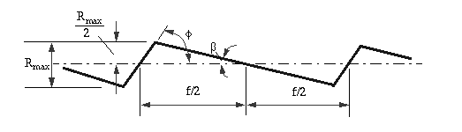
Fig. 1.1 Ideal roughness Geometry
f → Feed
Ф → Major cutting edge angle
Β → working minor cutting edge angle

1.2.2 Natural Roughness
In practice, it is not usually possible to achieve conditions such as those described above, and normally the natural surface roughness forms a large proportion of the actual roughness. One of the main factors contributing to natural roughness is the occurrence of a built-up edge. Thus, larger the built up edge, the rougher would be the surface produced, and factors tending to reduce chip-tool friction and to eliminate or reduce the built-up edge would give improved surface finish.

Surface roughness of machined surfaces
Surface roughness is caused by:
- The feed marked or ridges left by the cutting tool, and
- The fragments of built-up edge shed on the work surface in the process of chip formation. Surface finish can be improved by reducing the height of the feed ridges and the size of the built up edge.
1.3 Cutting Parameters
The important cutting parameters discussed here are cutting speed, feed and depth of cut.
1.3.1 Cutting Speed
All materials have an optimum Cutting Speed and it is defined as the speed at which a point on the surface of the work passes the cutting edge or point of the tool and is normally given in meters/min. To calculate the spindle Speed required,
N= 1000 V_{C} /Dπ
Where:
N = Spindle Speed (RPM), V_{C} = Cutting Speed of Metal (m/min), D = Diameter of W/p
1.3.2 Feed
The term `feed' is used to describe the distance the tool moves per revolution of the work piece and depends largely on the surface finish required. For roughing out a soft material a feed of up to 0.25 mm per revolution may be used. With tougher materials this should be reduced to a maximum of 0.10 mm/rev. Finishing requires a finer feed then what is recommended.
1.3.3 Depth of cut
It is the advancement of tool in the job in a direction perpendicular to the surface being machined. Depth of cut depends upon cutting speed, rigidity of machine tool and tool material etc. Depth of cut normally varies between 1 to 5mm for roughing operation and 0.2 to 1 mm for finishing operation.

1.3.4 Effect of cutting parameters
It is found in most of the cases surface roughness decreases with increase in cutting speed and decrease in feed and depth of cut.
Since these cutting parameters will decide about the type of chips which we expect at the time of machining of a single constant material thus we have to analyze them for no such built-up edge chips formation. At the optimum cutting speed at which the effect of built up edge is negligible, (high speed, ductile material) the profile of the cutting edge of the tool is reproduced on the work surface and this ideal surface roughness is mainly dependent on cutting feed. That means for a greater feed the average roughness value is more as compared to the lesser feed. Fig 1.2 shows the relation of feed and roughness while finishing turning aluminum alloys with a diamond tool.

Fig 1.2 Finish turning aluminum alloy with diamond tool
(Referred R.K. JAIN, Production Technology)

It would be noted that the size of chips cross-sectional area has a large effect on surface finish. Surface finish is poor for large cuts which is desirable from considerable of high tool life and power consumption. Large feed is more detrimental to surface finish than a large depth of cut.
The characteristics in fig.1.3 for finish turning of non-ferrous alloys between depth of cut 0.025 mm and 0.25 mm shows that the roughness is not very much affected at low depth of cut.
Fig 1.3 Finish turning non-ferrous alloys with feed of 0.01 mm/rev
(Referred R.K. JAIN, Production Technology)

For very high cutting speeds the chances of built up edge reduces thus surface roughness also expected to reduce, while when cutting speed is low built-up formation of chips would increase the surface roughness.

Chapter 2
LITERATURE REVIEW

A considerable number of studies have investigated the general effects of the speed, feed, and depth of cut, nose radius and others on the surface roughness. These studies have been briefly discussed for the variations observed experimentally.

- Yeo [1995] developed a methodology for an effective optimization of machining conditions of multi pass lathe operations and came to a conclusion that a single computer assisted optimization strategy that incorporates practical constraints can be used in industry.

- Kirby et al [1981] study in-process surface roughness prediction system, however, is an approach that can be used to indirectly determine the surface roughness of a work piece without the concern of components being negatively affected by the cutting process itself.
The surface roughness of the finish-turned work pieces was measured using a Federal Pocket Surf stylus profilometer, set up to measure Ra in μ-inch, with a travel length of 0.1 inch. The vibration data collection system was comprised of an accelerometer from which signals are amplified, converted to digital data, and processed using Windows-based software. The accelerometer sensor used was a PCB Piezotronics #356B08 triaxial accelerometer, which was mounted on the shank of the tool holder, directly below the cutting tool. The axes of the accelerometer were aligned with the axes of the lathe (X, Y, and Z), using the applicable surfaces on the tool turret as references.

- Rasch and Rolstadas [1971] worked on the series of finish turning tests, the surface roughness value has been observed under variation of parameters: material quality, tool quality, tool nose radius, feed, speed and cutting time. For one material and one tool quality the test results have been treated by a combined method for regression and multiple correlation analysis in order to establish that describes the surface roughness by the significant parameters.
With this equation as a basis, an automatic system for calculation of optimal cutting data has been developed. A mathematical model has been built enabling the use of mathematical programming techniques in solving the problem of optimal cutting data. Thus, the system gives as output optimal feed, speed and tool nose radius for given surface roughness, diameter and cutting length.

- Hassan and Suliman [1990] studied a two-stage method for obtaining machinability data for the steel turning process. In the first-stage, different mathematical model types are developed and compared for the turning process of medium carbon steel. The parameters of the models are established by curve fitting of experimental data which are collected from experiments conducted especially for this work. In the second stage, the model type(s) producing the best estimates of performance is/are used as aid in process optimization. Consequently, optimal machinability data is obtained for maximum removal of metal. This paper aims at developing modeling tools for turning medium carbon steels (225-275 BHN) with tungsten carbide tip (Sandvik Coromant SNMG 12 04 04-15).
Mathematical programming was applied to determine optimum cutting conditions by both deterministic and probabilistic models. Also, the optimal cutting conditions were approached by a manufacturing economics-based model consisting of cost elements required for a machining operation.
- Uros Zuperi and Francis Cus [2003] used neural networks to optimize cutting conditions and it was found that procedure is useful for the fast approx. determination of optimum cutting conditions

- Taraman et al [1974] developed a mathematical model for the surface roughness in a turning operation in terms of cutting speed, feed and depth of cut. Utilizing PL1 language and an IBM 360/50 computer, the model was used to generate contours of surface roughness in planes containing the cutting speed and feed at different levels of depth of cut. The surface roughness contours were to select the machining conditions at which an increase in the rate of metal removal was achieved without sacrifices in surface finish.
The surface roughness model was developed by utilizing Response Surface Methodology.

- Sundaram et al [1981] developed mathematical models to predict surface finish in fine turning of steels Part I. This paper outlines the experimental development of mathematical models for predicting the surface finish of AISI 4140 steel in fine turning operation using TiC coated tungsten carbide throw-away tools. A novel experimental design called the rotatable design was used for the experimental procedures. Variables included in the model are: cutting speed, feed, depth of cut, and time of cut of the tool. Statistical coding was used for the experimental variables. First order (log transformed) models were developed. For tools that exhibited lack of fit for the first-order models, a second-order model was developed. Multiple regression analysis was used in developing these prediction models.
- Malakutti and Raman [2000], developed an artificial neural network model to optimize machine setup. Here artificial neural network model was used by varying process parameters i.e. speed, feed and depth of cut to optimize cutting force, tool life, cutting temperature and surface finish.
- W.H.Yang, Y.S.Tarng [1997] made a model to optimize the cutting parameters in turning operation. In this study it has been shown that tool life and surface roughness can be improved significantly for turning operation. The confirmation experiments were conducted to verify the optimal cutting parameters and there was an improvement of 250% by conducting the experiments according to optimal parameters.
- Feng [2001] studied the impact of turning parameters on surface roughness. He studied the impact of Feed, Speed, and Depth of Cut, Nose radius of tool and work material on the surface roughness of work material. He found that the feed have most significant impact on the observed surface roughness and also observed that there were strong interactions among different turning parameters.
- Feng and Wang [2002], developed a model considering the following working parameters: work-piece hardness (material), feed, cutter nose radius, spindle speed and depth of cut. Two competing data mining techniques, nonlinear regression analysis and computational neural networks, are applied in developing the empirical models. The values of surface roughness predicted by these models are then compared with those from some of the representative models in the literature. Metal cutting experiments and tests of hypothesis demonstrate that the models developed in this research have a satisfactory goodness of fit. It has also presented a rigorous procedure for model validation and model comparison.

- Sahin and Motorcu [2004], found that feed rats, nose radius, work material and speed has significant impact on observed surface roughness but depth of cut has a little effect on the results. They also found that interactions play a significant role in the process.

- Jiao et al [2004], fuzzy adaptive networks in machining process modeling to predict surface roughness in turning operation and found that feed is most significant and also came to a conclusion that this approach is more powerful than the classical regression approach.

- Pal and Chakraborty [2005], developed a back propagation neural network model for the prediction of surface roughness in turning operation. A large number of experiments were performed on mild steel work-pieces using high speed steel as the cutting tool. Process parametric conditions including speed, feed, depth of cut, and the measured parameters such as feed and the cutting forces are used as inputs to the neural network model. Roughness of the machined surface corresponding to these conditions was the output of the neural network. The convergence of the mean square error both in training and testing came out very well.
- Cus and Zuperl [2003], proposed a neural network-based approach to complex optimization of cutting parameters. It describes the multi-objective technique of optimization of cutting conditions by means of the neural networks taking into consideration the technological, economic and organizational limitations. To reach higher precision of the predicted results, a neural optimization algorithm is developed and presented to ensure simple, fast and efficient optimization of all important turning parameters.
- Chien and Tsai [2003], used the back propagation neural network for predicting the tool wear and determining the optimum cutting condition in turning operations. They used the genetic algorithm in the optimizing model as well as Taguchi method to find the optimum parameter for both the models.
- Tugrul Ozel and Yigit Carpat [2003] used a neural network modeling approach to predict surface roughness and tool wear in turning operation. The factors considered were work piece properties ,tool material , tool geometry and cutting conditions in it a prediction system was developed which was capable of accurate surface roughness and tool wear prediction for the range it has been trainedLee and Chen [2003] have developed an online surface roughness recognition system using artificial neural network in turning operation. In their model, vibration signatures in the three directions have been used. The cutting tool with constant nose radius has been considered in their analysis.
- Palanikumar et al [2005] used the design of experiment concept for developing a procedure to assess and optimize the chosen factors to attain minimum surface roughness by incorporating response table and response graph, normal probability plot and ANOVA technique.
- Yang and Tarng [1998] made a model to optimize the cutting parameters in turning operation. In this study it has been shown that tool life and surface roughness can be improved significantly for turning operation. The confirmation experiments were conducted to verify the optimal cutting parameters and there was an improvement of 250% by conducting the experiments according to optimal parameters.

Chapter 3
NEURAL NETWORK, REGRESSION, PARETO ANOVA
3.1 Neural Network
An Artificial Neural Network (ANN) is an information processing paradigm that is inspired by the way biological nervous systems, such as the brain, process information. The key element of this paradigm is the novel structure of the information processing system. It is composed of a large number of highly interconnected processing elements (neurons) working in unison to solve specific problems. ANNs, like people, learn by example. An ANN is config.d for a specific application, such as identity selection, pattern recognition or data classification, through a learning process. Learning in biological systems involves adjustments to the synaptic connections that exist between the neurons. This is true of ANNs as well.

3.1.1 Historical background
Neural network simulations appear to be a recent development. However, this field was established before the advent of computers, and has survived at least one major setback and several eras. Many important advances have been boosted by the use of inexpensive computer emulations. Following an initial period of enthusiasm, the field survived a period of frustration and disrepute. These pioneers were able to develop convincing technology which surpassed the limitations identified by Minsky and Papert (1969). Minsky and Papert, published a book in which they summed up a general feeling of frustration (against neural networks) among researchers, and was thus accepted by most without further analysis. Currently, the neural network field enjoys a resurgence of interest and a corresponding increase in funding.
The first artificial neuron was produced in 1943 by the neurophysiologist Warren McCulloch and the logician Walter Pits. Then they were followed by Donald Hebb. The first practical application of artificial neural networks came in the late 1950s, with the invention of the perceptron network and associated learning rule by Frank Rosenblatt. Rosenblatt and his colleagues built a perceptron network and demonstrated its ability to perform pattern recognition. At about the same time, Bernard Widrow and Ted Hoff introduced a new learning algorithm and used it to train adaptive linear neural networks, which were similar in structure and capability to Rosenblatt perceptron. Then Teuvo Kohonen and James Anderson independently and separately developed new neural networks that could act as memories. Stephen Grossberg [was also very active during this period in the investigation of self-organizing networks.
Interest in neural networks had faltered during the late 1960s because of the lack of new ideas and powerful computers with which to experiment. During the 1980s both of these impediments were overcome, and research in neural networks increased dramatically. New personal computers and workstations, which rapidly grew in capability, became widely available.

Two new concepts were most responsible for the rebirth of neural networks. The first was the use of statistical mechanics to explain the operation of a certain class of recurrent network, which could be used as an associative memory. This was described in a seminal paper by physicist John Hopfield. The second key development of the 1980s was the back propagation algorithm for training multilayer perceptron networks, which was discovered independently by several different researchers. The most influential publication of the back propagation algorithm was by David Rumelhart and James McClelland.

3.1.2 Advantage of neural networks
Neural networks, with their remarkable ability to derive meaning from complicated or imprecise data, can be used to extract patterns and detect trends that are too complex to be noticed by either humans or other computer techniques. A trained neural network can be thought of as an "expert" in the category of information it has been given to analyze. This expert can then be used to provide projections given new situations of interest and answer "what if” questions.
Other advantages include:
- Adaptive learning: An ability to learn how to do tasks based on the data given for training or initial experience.
- Self-Organization: An ANN can create its own organization or representation of the information it receives during learning time.
- Real Time Operation: ANN computations may be carried out in parallel, and special hardware devices are being designed and manufactured which take advantage of this capability.
- Fault Tolerance via Redundant Information Coding: Partial destruction of a network leads to the corresponding degradation of performance. However, some network capabilities may be retained even with major network damage.

3.1.3 Human and Artificial Neurons
Much is still unknown about how the brain trains itself to process information, so theories abound. In the human brain, a typical neuron collects signals from others through a host of fine structures called dendrites. The neuron sends out spikes of electrical activity through a long, thin stand known as an axon, which splits into thousands of branches. At the end of each branch, a structure called a synapse converts the activity from the axon into electrical effects that inhibit or excite activity from the axon into electrical effects that inhibit or excite activity in the connected neurons. When a neuron receives excitatory input that is sufficiently large compared with its inhibitory input, it sends a spike of electrical activity down its axon. Learning occurs by changing the effectiveness of the synapses so that the influence of one neuron on another changes.
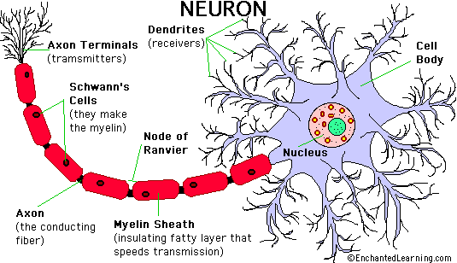
Fig 3.1 Human neuron
Artificial Neurons: - Neural networks are conducted by first trying to deduce the essential features of neurons and their interconnections. Then typically program a computer to simulate these features. However because our knowledge of neurons is incomplete and our computing power is limited, our models are necessarily gross idealizations of real networks of neurons. An artificial neuron is a device with many inputs and one output. The neuron has two modes of operation; the training mode and the using mode. In the training mode, the neuron can be trained to fire (or not), for particular input patterns.
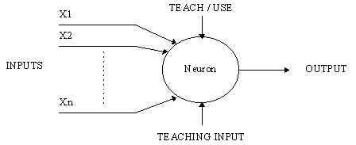
Fig 3.2 Simple neuron

In the using mode, when a taught input pattern is detected at the input, its associated output becomes the current output. If the input pattern does not belong in the taught list of input patterns, the firing rule is used to determine whether to fire or not.

3.1.3.1 Firing rules
The firing rule is an important concept in neural networks and accounts for their high flexibility. A firing rule determines how one calculates whether a neuron should fire for any input pattern. It relates to all the input patterns, not only the ones on which the node was trained.
A simple firing rule can be implemented by using Hamming distance technique. The rule goes as follows:
Take a collection of training patterns for a node, some of which cause it to fire (the 1-taught set of patterns) and others which prevent it from doing so (the 0-taught set). Then the patterns not in the collection cause the node to fire if, on comparison, they have more input elements in common with the 'nearest' pattern in the 1-taught set than with the 'nearest' pattern in the 0-taught set. If there is a tie, then the pattern remains in the undefined state.
For example, a 3-input neuron is taught to output 1 when the input (X1, X2 and X3) is 111 or 101 and to output 0 when the input is 000 or 001. Then, before applying the firing rule, the truth table is;
Table 3.1 3- Input neuron
X1: |  | 0 | 0 | 0 | 0 | 1 | 1 | 1 | 1
X2: |  | 0 | 0 | 1 | 1 | 0 | 0 | 1 | 1
X3: |  | 0 | 1 | 0 | 1 | 0 | 1 | 0 | 1
OUT: |  | 0 | 0 | 0/1 | 0/1 | 0/1 | 1 | 0/1 | 1
As an example of the way the firing rule is applied, take the pattern 010. It differs from 000 in 1 element, from 001 in 2 elements, from 101 in 3 elements and from 111 in 2 elements. Therefore, the 'nearest' pattern is 000 which belongs in the 0-taught set. Thus the firing rule requires that the neuron should not fire when the input is 001. On the other hand, 011 is equally distant from two taught patterns that have different outputs and thus the output stays undefined (0/1). By applying the firing in every column the following truth table is obtained;
Table 3.2 Firing Rule
X1: |  | 0 | 0 | 0 | 0 | 1 | 1 | 1 | 1
X2: |  | 0 | 0 | 1 | 1 | 0 | 0 | 1 | 1
X3: |  | 0 | 1 | 0 | 1 | 0 | 1 | 0 | 1
OUT: |  | 0 | 0 | 0 | 0/1 | 0/1 | 1 | 1 | 1

The difference between the two truth tables is called the generalization of the neuron. Therefore the firing rule gives the neuron a sense of similarity and enables it to respond 'sensibly' to patterns not seen during training.

3.1.3.2 A more complicated neuron
The previous neuron doesn't do anything that conventional computers don't do already. A more sophisticated neuron is the McCulloch and Pitts model (MCP). The difference from the previous model is that the inputs are ‘weighted’ the effect that each input has at decision making is dependent on the weight of the particular input. The weight of an input is a number which when multiplied with the input gives the weighted input. These weighted inputs are then added together and if they exceed a pre-set threshold value, the neuron fires. In any other case the neuron does not fire.
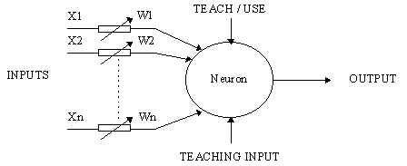
Fig 3.3 Complicated neuron
In mathematical terms, the neuron fires if and only if;
X1W1 + X2W2 + X3W3 + ... > T
The addition of input weights and of the threshold makes this neuron a very flexible and powerful one. The MCP neuron has the ability to adapt to a particular situation by changing its weights and/or threshold. Various algorithms exist that cause the neuron to 'adapt'; the most used ones are the Delta rule and the back error propagation. The former is used in feed-forward networks and the latter in feedback networks.

3.1.4 Architecture of neural networks

3.1.4.1 Feed-forward networks
Feed-forward Artificial Neural Networks (ANNs) allow signals to travel one way only; from input to output. There is no feedback (loops) i.e. the output of any layer does not affect that same layer. Feed-forward ANNs tend to be straight forward networks that associate inputs with outputs. They are extensively used in pattern recognition. This type of organization is also referred to as bottom-up or top-down.

3.1.4.2 Feedback networks
Feedback networks can have signals traveling in both directions by introducing loops in the network. Feedback networks are very powerful and can get extremely complicated. Feedback networks are dynamic; their 'state' is changing continuously until they reach an equilibrium point. They remain at the equilibrium point until the input changes and a new equilibrium needs to be found. Feedback architectures are also referred to as interactive or recurrent, although the latter term is often used to denote feedback connections in single-layer organizations.
Fig 3.4 Simple feed forward network

Fig 3.5 Complicated network

3.1.4.3 Network layers
The commonest type of artificial neural network consists of three groups, or layers, of units: a layer of "input" units is connected to a layer of "hidden" units, which is connected to a layer of "output" units.
- The activity of the input units represents the raw information that is fed into the network.
- The activity of each hidden unit is determined by the activities of the input units and the weights on the connections between the input and the hidden units.
- The behavior of the output units depends on the activity of the hidden units and the weights between the hidden and output units.

3.1.4.4 Perceptrons
The most influential work on neural nets in the 60's went under the heading of 'perceptrons' a term coined by Frank Rosenblatt. The perceptron turns out to be an MCP model (neuron with weighted inputs) with some additional, fixed, pre--processing. Perceptrons mimic the basic idea behind the mammalian visual system. They were mainly used in pattern recognition even though their capabilities extended a lot more.
Fig 3.6 Perceptron

3.1.4.5 Learning Process
The memorization of patterns and the subsequent response of the network can be categorized into two general paradigms:
- Associative mapping in which the network learns to produce a particular pattern on the set of input units whenever another particular pattern is applied on the set of input units. The associative mapping can generally be broken down into two mechanisms:
- Auto-association: an input pattern is associated with itself and the states of input and output units coincide. This is used to provide pattern completion, i.e. to produce a pattern whenever a portion of it or a distorted pattern is presented. In the second case, the network actually stores pairs of patterns building an association between two sets of patterns.
- Hetero-association: is related to two recall mechanisms:
  - Nearest-neighbor recall, where the output pattern produced corresponds to the input pattern stored, which is closest to the pattern presented, and Interpolative recall, where the output pattern is a similarity dependent interpolation of the patterns stored corresponding to the pattern presented. Yet another paradigm, which is a variant associative mapping, is classification, i.e. when there is a fixed set of categories into which the input patterns are to be classified.
- Regularity detection in which units learn to respond to particular properties of the input patterns. Whereas in associative mapping the network stores the relationships among patterns, in regularity detection the response of each unit has a particular 'meaning'. This type of learning mechanism is essential for feature discovery and knowledge representation.
Every neural network possesses knowledge which is contained in the values of the connections weights. Modifying the knowledge stored in the network as a function of experience implies a learning rule for changing the values of the weights.
Fig 3.7 Learning of network
Information is stored in the weight matrix W of a neural network. Learning is the determination of the weights. Following the way learning is performed, we can distinguish two major categories of neural networks:
- Fixed networks in which the weights cannot be changed, i.e. dW/dt=0. In such networks, the weights are fixed a priori according to the problem to solve.
  - Adaptive networks which are able to change their weights, i.e. dW/dt not= 0.
All learning methods used for adaptive neural networks can be classified into two major categories:
- Supervised learning which incorporates an external teacher, so that each output unit is told what its desired response to input signals ought to be. During the learning process global information may be required. Paradigms of supervised learning include error-correction learning, reinforcement learning and stochastic learning. An important issue concerning supervised learning is the problem of error convergence, i.e. the minimization of error between the desired and computed unit values. The aim is to determine a set of weights which minimizes the error. One well-known method, which is common to many learning paradigms, is the least mean square (LMS) convergence.
- Unsupervised learning uses no external teacher and is based upon only local information. It is also referred to as self-organization, in the sense that it self-organizes data presented to the network and detects their emergent collective properties. Paradigms of unsupervised learning are Hebbian learning and competitive learning. Human Neurons to Artificial Neuronesther aspect of learning concerns the distinction or not of a separate phase, during which the network is trained, and a subsequent operation phase. We say that a neural network learns off-line if the learning phase and the operation phase are distinct. A neural network learns on-line if it learns and operates at the same time. Usually, supervised learning is performed off-line, whereas unsupervised learning is performed on-line.

3.1.4.6 Transfer Function
The behavior of an ANN (Artificial Neural Network) depends on both the weights and the input-output function (transfer function) that is specified for the units. This function typically falls into one of three categories:
  - Linear (or ramp)
  - Threshold
  - Sigmoid
For linear units, the output activity is proportional to the total weighted output. For threshold units, the output are set at one of two levels, depending on whether the total input is greater than or less than some threshold value.
For sigmoid units, the output varies continuously but not linearly as the input changes. Sigmoid units bear a greater resemblance to real neurons than do linear or threshold units, but all three must be considered rough approximations.
To make a neural network that performs some specific task, we must choose how the units are connected to one another, and we must set the weights on the connections appropriately. The connections determine whether it is possible for one unit to influence another. The weights specify the strength of the influence.
We can teach a three-layer network to perform a particular task by using the following procedure:
- We present the network with training examples, which consist of a pattern of activities for the input units together with the desired pattern of activities for the output units.
- We determine how closely the actual output of the network matches the desired output.
- We change the weight of each connection so that the network produces a better approximation of the desired output.
3.1.5 Mathematics of ANN:
We want to train a multi-layer feed forward network by gradient descent to approximate an unknown function, based on some training data consisting of pairs (x,t). The vector x represents a pattern of input to the network, and the vector t the corresponding target (desired output).

Definitions:
- The error signal for unit j: |  | 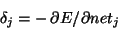
- The (negative) gradient for weight w_{ij}: |  | 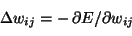
- The set of nodes anterior to unit i: |  | 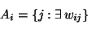
  - The set of nodes posterior to unit j:
Two factors by use of the chain rule:
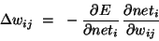
The first factor is the error of unit i. The second is
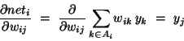
Putting the two together, we get
.
To compute this gradient, we thus need to know the activity and the error for all relevant nodes in the network.
Forward activation: The activity of the input units is determined by the network's external input x. For all other units, the activity is propagated forward:
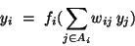
Note that before the activity of unit i can be calculated, the activity of all its anterior nodes (forming the set A_{i}) must be known. Since feed forward networks do not contain cycles, there is an ordering of nodes from input to output that respects this condition.
Calculating output error Assuming that we are using the sum-squared loss
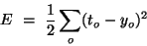
the error for output unit is simply.
Error back propagation For hidden units, we must propagate the error back from the output nodes (hence the name of the algorithm). Again using the chain rule, we can expand the error of a hidden unit in terms of its posterior nodes:
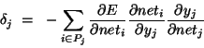
Of the three factors inside the sum, the first is just the error of node i. The second is
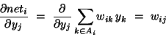
While the third is the derivative of node j's activation function:
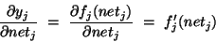
For hidden units h that use the tanh activation function, we can make use of the special identity
tanh(u)' = 1 - tanh(u)², giving us
Putting all the pieces together we get
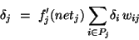
Note that in order to calculate the error for unit j, we must first know the error of all its posterior nodes (forming the set P_{j}). Again, as long as there are no cycles in the network, there is an ordering of nodes from the output back to the input that respects this condition. For example, we can simply use the reverse of the order in which activity was propagated forward.

3.1.6 Applications of neural networks
Neural networks have broad applicability to real world problems. In fact, they have already been successfully applied in many industries. Since neural networks are best at identifying patterns or trends in data, they are well suited for almost all problems including:
Aerospace In Aero space it is used in high performance aircraft autopilots, flight path simulations, aircraft control systems, autopilot enhancements, aircraft component simulations, aircraft component fault detectors, Automobile automatic guidance systems, warranty activity analyzers. In Banking neural network is used to Checks and other document readers, credit application evaluators. In Defense it is can be used as Weapon steering, target tracking, object discrimination, facial recognition, new kinds of sensors, sonar, radar and image signal processing including data compression, feature extraction and noise suppression, signal/image identification. Neural networking can be extensively used in Electronics for Code sequence prediction, integrated circuit chip layout, process control, chip failure analysis, machine vision, voice synthesis, nonlinear modeling. In Entertainment world it can be used as a tool for Animation, special effects, market forecasting etc. Its application are also in Financial for Real estate appraisal, loan advisor, mortgage screening, corporate bond rating, credit line use analysis, portfolio trading program, corporate financial analysis, currency price prediction. It can be used for Insurance Policy application evaluation, product optimization. In Manufacturing it is used for Manufacturing process control, product design and analysis, process and machine diagnosis, real-time particle identification, visual quality inspection systems, beer testing, welding quality analysis, paper quality prediction, computer chip quality analysis, analysis of grinding operations, chemical product design analysis, machine maintenance analysis, project bidding, planning and management, dynamic modeling of chemical process systems. Medical science can also take the benefit of neural networking in Breast cancer cell analysis, EEG and ECG analysis, prosthesis design, optimization of transplant times, hospital expense reduction, hospital quality improvement, and emergency room test advisement. It has a wide application in Robotics like Trajectory control, forklift robot, manipulator controllers, and vision systems etc. it is also used for Speech recognition, speech compression, vowel classification, text to speech synthesis, Market analysis, automatic bond rating, stock trading advisory systems. In Telecommunications it is applied in Image and data compression, automated information services, real-time translation of spoken language, customer payment processing systems. In Transportation neural networking can be used as Truck brake diagnosis systems, vehicle scheduling, routing systems.
3.2 REGRESSION ANALYSIS

Regression Analysis is a statistical forecasting model, that is concerned with describing and evaluating the relationship between a given variable (usually called the dependent variable) and one or more other variables (usually called the independent variables).
3.2.1 Linear Regression
In statistics, linear regression is a regression method that allows the relationship between the dependent variable Y and the p independent variables X and a random term ε. The model can be written as
Y = β₁ + β₂ X₂ +………. + β_{p}X_{p} + ε
where β₁ is the intercept ("constant" term), the β_{I} are the respective parameters of independent variables, and p is the number of parameters to be estimated in the linear regression.
This method is called "linear" because the relation of the response to the explanatory variables is assumed to be a linear function of the parameters. It is often erroneously thought that the reason the technique is called "linear regression" is that the graph of Y = β₀ + βX is a straight line or that Y is a linear function of the X variables. But if the model is (for example)
Y = α + βX + γX ²
The problem is still one of linear regression, that is, linear in x and x² respectively, even though the graph on x by itself is not a straight line.
There are many different approaches to solving the regression problem that is, determining suitable estimates for the parameters.
3.2.2 Nonlinear Regression
In statistics, nonlinear regression is the problem of inference for a model
y = f (x, θ) + ε
Based on multidimensional x,y data, where f is some nonlinear function with respect to unknown parameters θ. At a minimum, we may like to obtain the parameter values associated with the best fitting curve (usually, least squares).Also, statistical inference may be needed, such as confidence intervals for parameters, or a test of whether of not the fitted model agrees well with the data.
The scope of nonlinear regression is clarified by considering the case of polynomial regression, which actually is best not treated as a case of nonlinear regression. When f takes a form such as
f(x) = ax² + bx + c
Our function f is nonlinear as a function of x but it is linear as a function of unknown parameters a, b, and c. The latter is the sense of "linear" in the context of statistical regression modeling. The appropriate computational procedures for polynomial regression are procedures of (multiple) linear regression with two predictor variables x and x² say. However, on occasion it is suggested that nonlinear regression is needed for fitting polynomials. Practical consequences of the misunderstanding include that a nonlinear optimization procedure may be used when the solution is actually available in closed form. Also, capabilities for linear regression are likely to be more comprehensive in some software than capabilities related to nonlinear regression.
3.2.3 Analysis Technique
3.2.3.1 Least-squares analysis
Least-squares analysis was developed by Carl Friedrich Gauss in the 1820s. This method uses the following Gauss-Markov assumptions:
- The random errors ε_{i} have expected value 0.
- The random errors ε_{i} are uncorrelated (this is weaker than an assumption of probabilistic independence).
- The random errors ε_{i} are homoscedastic, i.e., they all have the same variance.
These assumptions imply that least-squares estimates of the parameters are optimal in a certain sense.
A linear regression with p parameters (including the regression intercept β₁) and n data points (sample size), with n >= (p + 1) allows construction of the following vectors and matrix with associated standard errors:
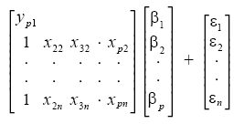
or, from vector-matrix notation above,
Y = Xβ + ε
Each data point can be given as , i = 1,2,3………..n. For n = p, standard errors of the parameter estimates could not be calculated. For n less than p, parameters could not be calculated.
The estimated values of the parameters can be given as
= (X^{T}X)⁻¹ X^{T}

Using the assumptions provided by the Gauss-Markov Theorem, it is possible to analyze the results and determine whether or not the model determined using least-squares is valid. The number of degrees of freedom is given by m − n.
The residuals, representing 'observed' minus 'calculated' quantities, are useful to analyze the regression. They are determined from
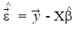
The standard deviation, for the model is determined from
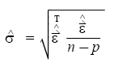
The variance in the errors can be described using the Chi-square distribution:
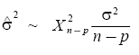
The 100(1 − α) % confidence interval for the parameter, β_{i}, is computed as follows:
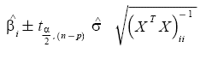
where t follows the Student's t-distribution with m − n degrees of freedom and (X^{T}X)_{ii} ⁻¹ denotes the value located in the i^{th} row and column of the matrix.
The 100(1 − α) % mean response confidence interval for a prediction (interpolation or extrapolation) for a value is given by:
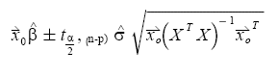
Where, 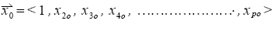
The 100(1 − α) % predicted response confidence intervals for the data are given by:
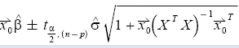
The regression sum of squares SSR is given by:
SSR = ∑ (_{i} - ) ²
where is an n by 1 unit vector.
The error sum of squares ESS is given by:
ESS = ∑ (y_{i} - _{i} ) ²
The total sum of squares TSS' is given by
TSS = ESS + SSR
Pearson's co-efficient of regression, R² is then given as:
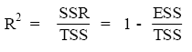
Assessing the least-squares model
Once the above values have been corrected, the model should be checked for 2 different things:
- Whether the assumptions of least-squares are fulfilled and
- Whether the model is valid
3.2.3.2 Model assumptions
The model assumptions are checked by calculating the residuals and plotting them. The residuals are calculated as follows:
The following plots can be constructed to test the validity of the assumptions:
- Plotting a normal probability plot of the residuals to test normality. The points should lie along a straight line.
- Plotting a time series plot of the residuals, that is, plotting the residuals as a function of time.
- Plotting the residuals as a function of the explanatory variables, X.
- Plotting the residuals against the fitted values, .
- Plotting the residuals against the previous residual.
In all, but the first case, there should not be any noticeable pattern to the data.
3.2.3.3 Model validity
The validity of the model can be checked using any of the following methods:
- Using the confidence interval for each of the parameters, β_{i}. If the confidence interval includes 0, then the parameter can be removed from the model. Ideally, a new regression analysis excluding that parameter would need to be performed and continued until there are no more parameters to remove.
- Calculate Pearson’s co-efficient of regression. The closer the value is to 1; the better the regression is. This co-efficient gives what fraction of the observed behavior can be explained by the given variables.
- Examining the observational and prediction confidence intervals. The smaller they are the better.
- Computing the F-statistic.
Confidence or prediction interval of a regression line
If you check the option box, Prism will calculate and graph either the 95% confidence interval or 95% prediction interval of the regression line. Two curves surrounding the best-fit line define the confidence interval.
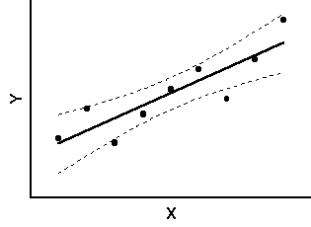
Fig. 3.8
The dashed lines that demarcate the confidence interval are curved. This does not mean that the confidence interval includes the possibility of curves as well as straight lines. Rather, the curved lines are the boundaries of all possible straight lines. The fig. below shows four possible linear regression lines (solid) that lie within the confidence interval (dashed).
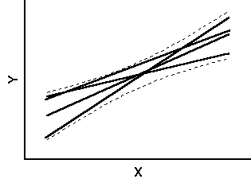
Fig. 3.9
Given the assumptions of linear regression, you can be 95% confident that the two curved confidence bands enclose the true best-fit linear regression line, leaving a 5% chance that the true line is outside those boundaries.
Many data points will be outside the 95% confidence interval boundary. The confidence interval is 95% sure to contain the best-fit regression line. This is not the same as saying it will contain 95% of the data points.
The 95% prediction interval is the area in which you expect 95% of all data points to fall. In contrast, the 95% confidence interval is the area that has a 95% chance of containing the true regression line. This graph shows both prediction and confidence intervals (the curves defining the prediction intervals are further from the regression line).
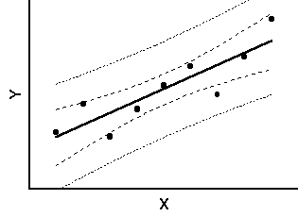
Fig. 3.10
The analysis of Experimental results obtained of surface roughness was analyzed. The data for speed, feed, depth of cut and surface roughness was recorded and analyzed in terms of obtaining best fit curve equations.
3.3 Parameter Design Optimization of CNC Turning Using DOE
This chapter is all about the steps and procedures used to optimize turning parameters using Taguchi’s design of experiment. In this chapter objectives of the study were set and according to the objectives of the study different factors were selected. After that experimental work was carried out on CNC turning machine according to L₂₇ orthogonal array. The values of response factor i.e. surface roughness are then recorded according to orthogonal array.

3.3.1 Concept of DOE

Design of Experiment (DOE) is a structured, organized method that is used to determine the relationship between the different factors (Xs) affecting a process and the output of that process (Y). Sir Ronald A. Fisher, the renowned mathematician and geneticist first developed this method in the 1920s and 1930.
Design of experiment (DOE) is to understand the impact of specific changes to the inputs of the process, and then to maximize, minimize or normalize the outcome by manipulating the input.
DOE is a scientific approach which allows the researchers to gain knowledge in order to better understand a process and to determine how the impacts (attribute effect the output response).
It is usually used when it is unclear what impact a specific set of inputs may have either individually or collectively on process or product. A designed experiment is the simultaneous evaluation of two or more factors (parameters) for their ability to affect the resultant average or variability of a particular product or process characteristic. To accomplish this in an effective and statically proper fashion, the level of factors are varied in a strategic manner, the results of particular test combination are observed, and the complete set of results is analyzed to determine the influential factors and preferred levels, and whether increase or decrease of those levels will potentially lead to further improvement. It is important to note that this is an iterative process; the first round through the DOE process will many times lead to subsequent rounds of experimentation. The beginning round, often referred to as screenings experiment, is used to find the few important influential factors out of the many possible factors involved with the process or product design. The experiment is typically a small experiment with many factors at two levels. Later rounds of experiments typically involve few factors at more than two levels to determine conditions of further improvement.
- DOE is the most cost effective and efficient method for identifying the key input factors and in understanding the relationship between input factors and response.
- DOE investigate a number of input factors with relatively small number of tests.
- DOE helps to identify important/ critical attributes of a process improvement effort, as they can be characteristics to be examined and the desired effect.
The DOE process is divided is divided into three main phases, which encompasses all experimental approaches. These three phases are:
  - The Planning Phase
  - The Conducting Phase
  - The analyzing phase.
The planning phase is when factors and levels are selected and, therefore the most important stage of experimentation. Also the correct selection factors and levels is non statistical in nature and more dependent upon product or process expertise.
The second most important phase is the conducting phase, when the test results are actually collected. If experiments are well planned and conducted, the analysis is actually much easier and more likely to yield positive information about factors and levels.
The analysis phase is when the positive or negative information concerning the selected factors and levels is generated based on the previous two phases. This phase is statistical in nature.
The major steps to complete an effective designed experiment are listed in the following 12 steps. The planning phase includes steps 1 through 9, the conducting step 10, and the analysis phase include steps 11 and 12.
- State the problem(s) or areas(s) of concern.
- State the objective(s) of the experiment.
- State the quality characteristic(s) and measurement system(s).
- Select the factors that may influence the selected quality characteristics.
- Identify control and noise factors.
- Select levels of factor.
- Select the appropriate orthogonal array (OA) or Ors.
- Select interactions that may influence the selected quality characteristics or go back to step 4(iterative steps).
- Assign factors to OA(s) and locate interactions.
- Conduct tests described by trials in OAs.
- Analyze and interpret results of the experimental trials.
- Conduct confirmation experiment.

3.3.2 Problem Identification
Set-up parameters play the most important role to get the desired results. The main objectives of this research are to carry out the experiments by selecting different variables and their levels, applying Taguchi design of experiment and then analyzing the results obtained. Quality characteristics considered is:
- Surface Roughness
The set-up parameters, which were used to get the expected results, are
- Spindle Speed
- Feed
- Depth of Cut
The experiments were conducted according to the Taguchi design of experiment i.e. the number of experiments were done as suggested by the Taguchi design of experiment according to number of factors, their levels and their interactions.

3.3.3 Taguchi's Parameter Design Method
3.3.3.1 Objective of Taguchi's Method
Taguchi's parameter design can be used to make a process robust against sources of variation and hence improve field performance. If we can design a process that has the robustness to noise factors that largely affects the variance of performance characteristics at a developing stage, it will very possible for the process to have robustness against other noise factors that could not be considered at the development stage. The aim of a parameter design experiment is, then, to identify settings of the design parameters that maximize the chosen performance measure and are insensitive to noise factors. (Feng. Chang-Xue (Jack)  2001)

3.3.3.2 Orthogonal Array
The goal of a Taguchi's experimental design is to identify optimal settings for all the design parameter, not to build the model fitting of process. Taguchi has achieved substantial payoffs just by conducting many main-effect-only-experiments and checking the results by confirmation experiments. If it can be proved that the system could be described well by even only main effects, the optimal condition determined by only main effect analysis can be very efficient and simple method for optimization. Orthogonal array has been used to minimize the number of test runs while keeping the pair-wise balancing property in Taguchi's method for that purpose. These basic principles serve as a screening filter, which allows the examination of the effects of many process variables, identifying those factors, which have a major effect on process characteristics using a single trial with a few reactions. For example, optimization experiment would normally require each variable to be tested independently. Thus, a trial run investigating the effects and interactions of four reaction variables each at three concentration levels, would require an experiment with 81 (i.e. 3⁴) separate reactions. Using an orthogonal array, however, an estimate of the effect of each variable can be carried out using only nine experiments. Providing that three level are used for each variable tested, the number of experiments required (E) is calculated from the equation E= 2k +1, where k is the number of factors to be tested. If the calculated number is not a multiple of three, then the required number of variables to be tested is the next multiple. Hence, as the number of components to be tested is increased, the reduction in the number of experiments required becomes more marked; e.g. to test 9 factors would require 3⁹ = 19683 experiments to analyze fully, whereas using Taguchi's methods this could be reduced to just 21(2 x 9 + 1 = 19), 19 is not a multiple of three and then next integer divisible by three is 21).

3.3.4 Brainstorming
When physical experiments are used, it is sometimes impossible or very expensive to carry out an experiment according to the set-up. Thus it becomes necessary to first study and discuss about the process and process parameters. A good knowledge about the work to be done, process and optimization technique may be very helpful to get expected results. Important steps that are to be considered are as follows:
- Objectives of Study and Evaluation Criteria
- What are the criteria of evaluation?
- How are each of these criteria measured?
- How are these criteria combined into a single number?
- What is the common characteristic of these criteria?
- What is the relative influence these criteria exhibit?
- Design Factors
- What are the factors that influence the performance criteria?
- Which factors are more important than others?
- Noise Factors
- Which factors can't be controlled in real life?
- Is the performance dependent on the application environment?
- Factor Levels
- What are the ranges of values the factors can assume within
practical limits?
- How many levels of each factor should be used for the study?
- What is the tradeoff for a higher level?
- Interaction between Factors
- Which factors are most likely to interact?
- How many interactions can be studied?
- Scopes of Studies
- How many experiments can we run?
- When do we need the results?
- How much does each experiment cost?
- Additional Items
- What do we do with factors that are not included in the study?
- In what order do we run these experiments?
- Who will do these experiments?

Use of Orthogonal Arrays (OAs) and Signal-to-Noise (S/N) Ratios
OAs is used to minimize the number of runs (or combinations) needed for the experiment. Many people are of the opinion that the application of OA is TM, but the application of OAs is only a part of TM. S/N ratios are used as a measure of the functionality of the system. S/N ratios capture the magnitude of real effects (signals) after making some adjustment to uncontrollable variation (noise).
Two-Step Optimization
After conducting the experiment, the factor–level combination for the optimal design is selected with the help of two step optimization. The first step is to minimize the variability (maximize S/N ratios). In the second step, the sensitivity (mean) is adjusted to the desired level since it is easier to adjust the mean after minimizing the variability.
3.3.5 Types of Optimization Problems
3.3.5.1 Static Problems
Generally, a process to be optimized has several control factors, which directly decide the target or desired value of the output. The optimization then involves determining the best control factor levels so that the output is at the target value. Such a problem is called as a "STATIC PROBLEM".
This is best explained using a P-Diagram, which is shown below ("P" stands for Process or Product). Noise is shown to be present in the process but should have no effect on the output. The primary aim of the Taguchi experiments is to minimize variations in output even though noise is present in the process. The process is then said to have become robust.
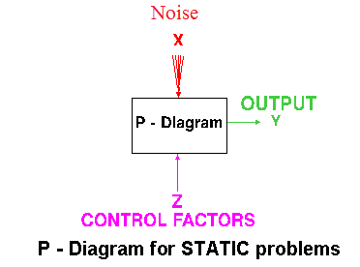
Fig. 3.11 P-Diagram for Static Problems

3.3.5.2 Dynamic Problems
If the product to be optimized has a signal input that directly decides the output, the optimization involves determining the best control factor levels so that the "input signal / output" ratio is closest to the desired relationship. Such a problem is called as a "DYNAMIC PROBLEM". The difference between dynamic and static problem is that in dynamic problems we study the effects on output due to noise also which are not considered in static problems. This is best explained by a P-Diagram, which is shown below. Again, the primary aim of the Taguchi experiments - to minimize variations in output even though noise is present in the process- is achieved by getting improved linearity in the input/output relationship.
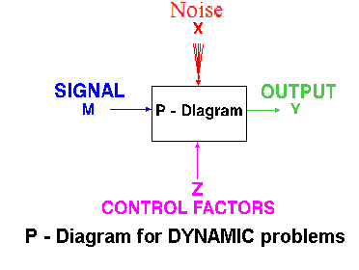
Fig. 3.12 P-Diagram for Dynamic Problems

3.3.6 Batch Process Optimization
There are 3 Signal-to-Noise ratios of common interest for the purpose of optimization;
3.3.6.1 Smaller-The-Better
n = -10 Log₁₀ [mean of sum of squares of measured data]
This is usually the chosen S/N ratio for all undesirable characteristics like "defects, surface roughness" etc. for which the ideal value is zero. Also, when an ideal value is finite and its maximum or minimum value is defined (like maximum purity is 100% or minimum time for making a telephone connection is 1 sec) then the difference between measured data and ideal value is expected to be as small as possible. The generic form of S/N ratio then becomes,
n = -10 Log₁₀ [mean of sum of squares of {measured - ideal}]
3.3.6.2 Larger-The-Better
n = -10 Log₁₀ [mean of sum squares of reciprocal of measured data]
This case has been converted to SMALLER-THE-BETTER by taking the reciprocals of measured data and then taking the S/N ratio as in the smaller-the-better case.
3.3.6.3 Nominal-The-Best
Square of mean
n = 10 Log₁₀ -----------------
variance
This case arises when a specified value is MOST desired, meaning that neither a smaller nor a larger value is desirable.
3.3.7 Steps in Taguchi Methodology
Taguchi method is a scientifically disciplined mechanism for evaluating and implementing improvements in products, processes, materials, equipment, and facilities. These improvements are aimed at improving the desired characteristics and simultaneously reducing the number of defects by studying the key variables controlling the process and optimizing the procedures or design to yield the best results.
The method is applicable over a wide range of engineering [35] fields that include processes that manufacture raw materials, sub systems, products for professional and consumer markets. In fact, the method can be applied to any process be it engineering fabrication, computer-aided-design, banking and service sectors etc. Taguchi method is useful for 'tuning' a given process for 'best' results.
Taguchi proposed a standard 8-step procedure for applying his method for optimizing any process. These are:

Step1: formulation of the problem – the success of any experiment is dependent
on a full understanding of the nature of the problem. It is important to establish just what the experiment is aiming to solve.
Step2: Determine the objective:-Identify the output characteristics (responses) to be studied and eventually optimized and determine the method of measurement. To establish measurement reliability, a separate experiment may be required
Step 3: Identification of control factors, noise factors and signal factors (if any). Control factors are those which can be controlled under normal production conditions. Noise factors are those which are either too difficult or too expensive to control under normal production conditions. Signal factors are those which affect the mean performance of the process. Taguchi believes that it is generally preferable to consider as many factors (rather than many interactions) as it is economically feasible for the initial screening.
Step 4: selection of factor levels, possible interactions and the degrees of freedom associated with each factor and the interaction effects. Assign the controllable factors and their interactions to the columns of the inner array, and the noise factors to the columns f the outer array.
Step 5: Conduct the experiment: Perform the experimental trials and collect the experimental data.
Step 6: Analyze the data: Evaluate the performance measures (TPM and NPM) for each trial run of the inner array and analyze them using the appropriate statistical analysis technique
Step 7: Interpret the results: Identify the variability control factors (VCF) and target control factors (TCF) and select their optimal levels. For the VCF’s the optimal levels are those, which maximize the NPM (minimize variability in the response), and for the TCF’s they are those, which bring the mean response nearest to the target value.
Step 8: Run a confirmatory Experiment: It is necessary to confirm, by some follow up experimental trials. A successful confirmation can alleviate concerns about the possibilities of a wrong choice for factor levels and experimental design.
If predicted results are not confirmed, or otherwise unsatisfactory, additional experiments may be required and a repetition of step no. 3 to 8 may be necessary.

3.3.8 Advantages of Taguchi Design of Experiment
- It changes the timing of the application of quality control from on line to offline, so that we can easily rely on inspection, can build quality into the product and the process and thus ‘do it right first time’.
- It changes the experiment procedure from varying one factor at a time to varying many factors at a time, through statistical experimental design techniques.
- It changes the objective of experiments and the definition of quality from ‘achieving conformance to specification’ to ‘achieving the target and minimizing the variability’.
- It changes the attitude for dealing with uncontrollable factors: remove the effect not the cause, by appropriately turning the controllable factors.

3.3.9 Limitations of Taguchi Design of Experiment
Sometimes it is claimed that, Dr. Taguchi, “has advocated some novel methods of statistical analysis and some approaches to the design of experiments that are unnecessarily complicated, inefficient, and sometimes ineffective”.
- Some of Taguchi’s experiment designs may lead to an incorrect answer when large two factor interactions appear.
- Taguchi method uses one array for control variables and one array for the noise variables and then a crossed array experiment is conducted, this makes the process difficult to understand.
- Several considerations favour the separate analysis of mean value and standard deviation instead of using Taguchi’s S/N ratio.
- There is only selected number of experiments to be done in Taguchi’s design of experiment that’s why it cannot be guaranteed that picking optimum level will provide optimum results.
- This process is limited to a certain number of designs.
- It will be useful only when it is implemented in early stages of design.

Chapter 4
EXPERIMENT SET UP

In this chapter, we would discuss the experimental set up, machine used its limitations, advantages, measuring instrument, tooling used on the machine.

4.1 CNC trainer lathe
The CNC Trainer Lathe consists of the machine unit with a three jaw independent chuck,
a computer numerically controlled tool slide, which cud move accordingly to two axis horizontal and vertical- X and Z axis. X axis represents the vertical movement which gives the depth of cut where as Z axis represents the location of the cutting tool. Thus after deciding the machining zero at a certain point the command is given in the form of a part program. The machine is also provided with a automatic lubrication motor for its slides.
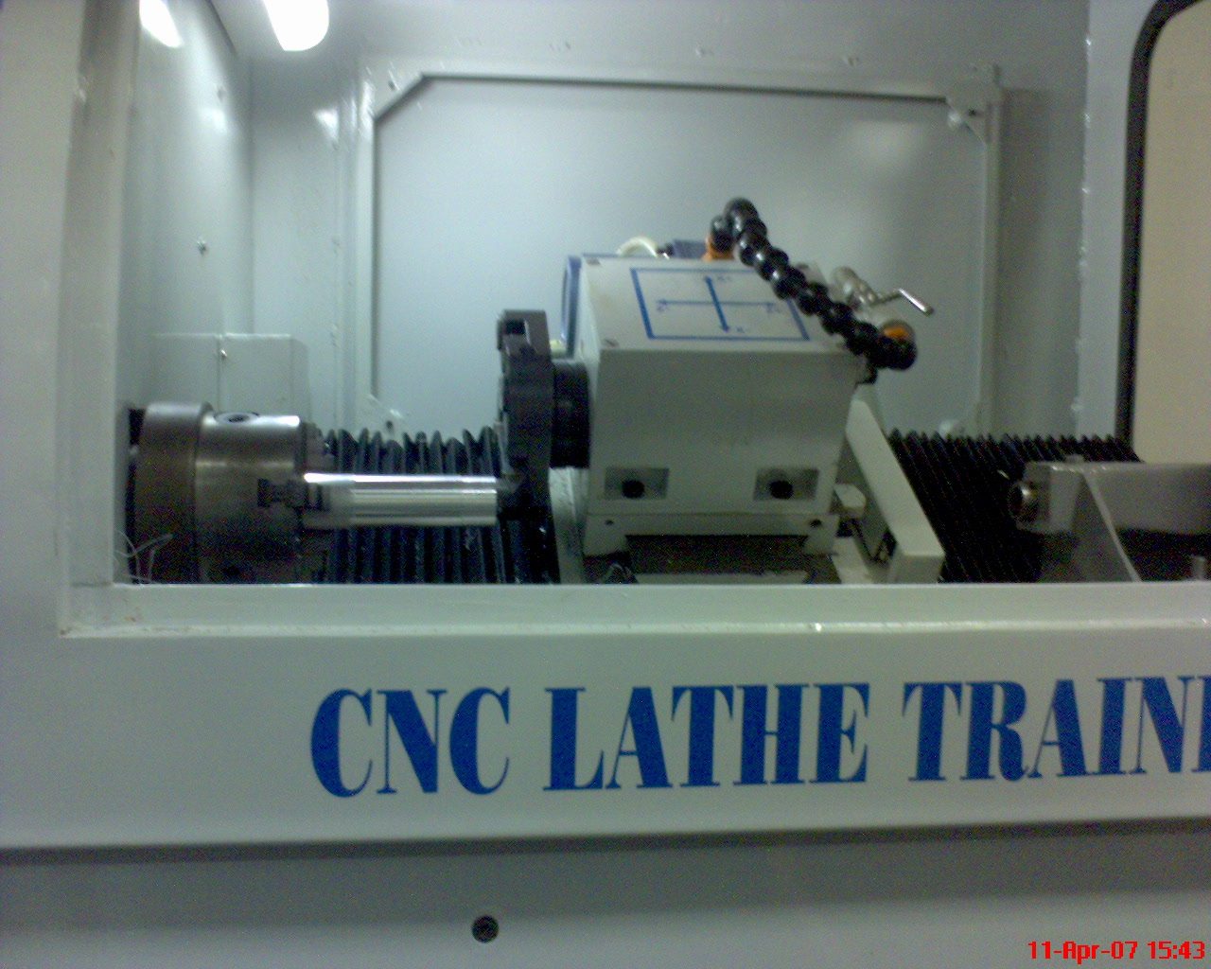

Fig.: 4.1 CNC TRAINER LATHE
System configuration
ENKAY make CNC lathe is the Computer Numerically Controlled Lathe Trainer. This machine has following configurations.
- Machine Controller consists of :
  - Pentium IV (866 MHz) with preinstalled Windows-98
  - 128 MB RAM
  - 40 GB HDD
  - SVGA Color Monitor
  - Keyboard & Mouse
  - I/O interface card. (Inside PC)
- Electronic Stabilizer :
  - Capacity – 3KVA
  - Regulation 1%
  - Voltage 230V
  - Current – 10 Amp.
  - Frequency – 50 Hz.
- Lubrication motor :
  - Voltage – 230V
  - Current – 1 Amp.
  - Operating Pressure : 6 – 15 Kg/Cm²
- X & Z Axes Stepper motor :
  - Capacity – 13 Kg-Cm for X Axis & 20 Kg-Cm for Z Axis.
  - Operating Voltage 36V DC
  - O/P Current– 4 Amp.
- Power supply :
  - Input 230V, 5 Amps.
  - Output 24V, 2 Amps.
  - 5V, 2 Amp, 15/0/ - 15V 500 mA
- SPECIFICATIONS OF I/0 CARD: (PCI 1751) :
  - I/O Controller – 8255-2
  - Slot for connection – PCI slot on the motherboard of the PC.
  - I/O Lines – 32 output & 16 inputs.
Table 4.1 CNC lathe trainer specifications
Model | SS-PT-100
Swing over bed | 250mm
Swing over cross slide | 100mm
Distance between centers | 400mm
Max. Longitudinal Travel | 350mm
Spindle inside diameter | MT3
Type of bearing for spindle | Angular contact bearings
Spindle Speed | 50 to 3500 rpm
Thrust (max.) | 120 kg
Cross Slide inclination | 0 deg.
Standard cutting tool size | 16*16mm
Spindle Motor | 2hp, PDNC
Threading | Straight
Automatic Lubrication points | Provided
Input System | Metric/inch
Control Axes | Simultaneous
Interpolation | Linear and circular
Minimum movement command X | 0.005
Minimum movement command Z | 0.005
Rapid Feed Rate X | 200 mm/min
Rapid Feed Rate X | 400 mm/min
X axis ballscrew | 16mm* 5mm PITCH
Z axis ballscrew | 25mm* 5mm PITCH
Feed override | 100%
Dwell (sec) | Programmable
Backlash compensation | Provided
Constant surface speed control | G96, G97
Canned Cycles | Available
In Built interface | Serial, Parallel
Manual reference point return | Provided
Emergency Stop | Provided
S function | Provided
Floor Space required | 1100* 700mm
Overall height of machine | 1450 mm
Net weight | 210 kg
4.2 Surface Roughness Measuring Instrument
The Surtronic 3+ is a portable, self-contained instrument for the measurement of surface texture and is suitable for use in both the workshop and laboratory. Parameters available for surface texture evaluation are: Ra, Rq, Rz (DIN), Ry and Sm.
The parameters evaluations and other functions of the instrument are microprocessor based. The measurement results are displaced on an LCD screen and can be output to an optional printer or another computer for further results.
The instrument is normally powered by an alkaline non-rechargeable battery. If preferred, a Ni-Cad rechargeable battery can be used.

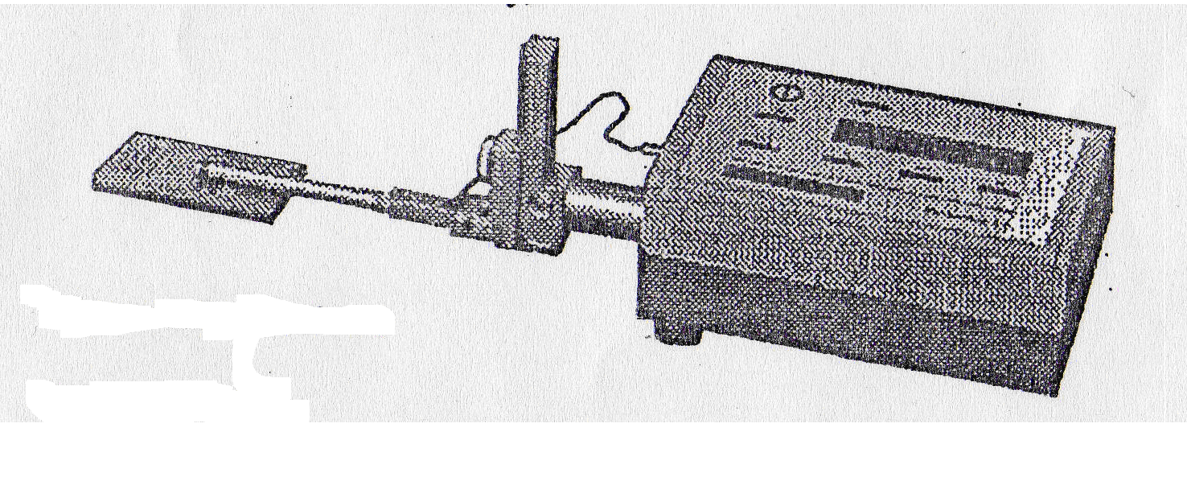
Fig.: 4.2 Surface roughness measurement apparatus
(Referred from Instrument Manual)

Display-Transverse Unit
The top panel of the display-traverse unit carries a membrane type control panel and a liquid crystal display. The unit houses the electronics for controlling the measurement sequence, computing the measurement data and outputting the results to the display, or to the RS232 port for use with a printer( when included) or to a computer for further analysis.

The unit also contains a drive motor which traverses the pickup across the surface to be measured. The measuring stroke always starts from the extreme outward positions. At the end of the measurement the pick up returns to this position ready for the next measurement. The traverse length is determined from selections of cut-off (Lc) or length (Ln).

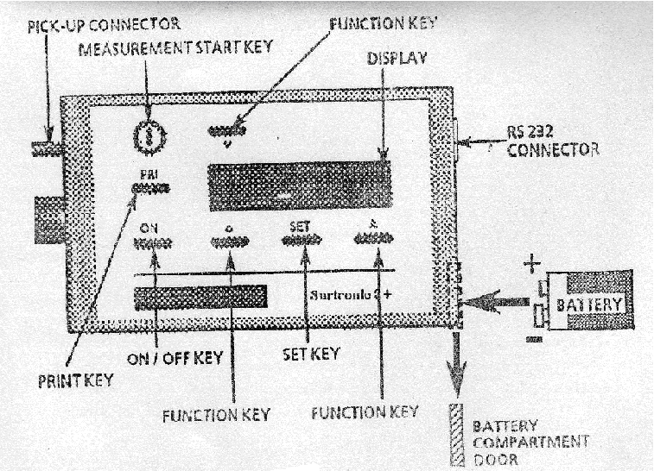

Fig.: 4.3 Display Transverse Unit (Referred from Instrument Manual)

Pick-Up Mounting Components
The pick-up is fastened to the drive shaft by the following means:

Mounting Bracket: This is clamped to the drive shaft by means of a knurled knob. Although normally used upright, it can be turned to angle the pick-up or to take it off the centre line. It can also be mounted sideways on the drive shaft, when the right-angle pick-up is in use.
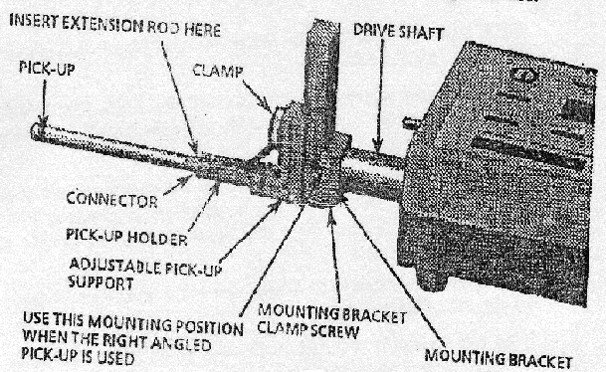

Fig.: 4.4 Mounting Bracket (Referred from Instrument Manual)
Adjustable Support: this can be clamped at any positions on the slide of the mounting bracket to provide pick-up height adjustment.

Pick-up Holder: This fits into the crutch of the pick-up support and is held in place by a spring plunger.
Connector: the connector of the pick-up lead is screwed into the end of pick-up and is then inserted into the end of the pick-up holder, with the lead coming out through the slot in the holder. It is advisable to connect the lead to the display-traverse unit first and then to the pick-up. When the extension rod is used, the short pick-up is not required and the end of the rod itself is inserted into the holder.

DIP switch settings: The instrument default settings, when powering up with a new battery, are set via DIP switches housed inside the display-traverse unit. The selections can be changed by menu/pushbuttons operations. The DIP switches are accessed by unscrewing the three feet from the base of the display-traverse unit, then removing the screws which were partly covered by the feet.

Pick-up
The pickup is a variable reluctance type transducer which is supported on the surface to be measured by a skid, a curved support projecting from the underside of the pickup in the vicinity of the stylus. As the pickup traverses across the surface, movements of the stylus relative to the skid are detected and are converted into a proportional electrical signal. The radius of curvature of the skid is much greater than the roughness spacing. This enables it to ride across the surface almost unaffected by the roughness, and provides a datum representing the general form of the surface. Even so, where the waviness is widely spaced it will be necessary to use the pickup with shoe, in conjunction with the 2.5mm (0.1 in) cut-off.
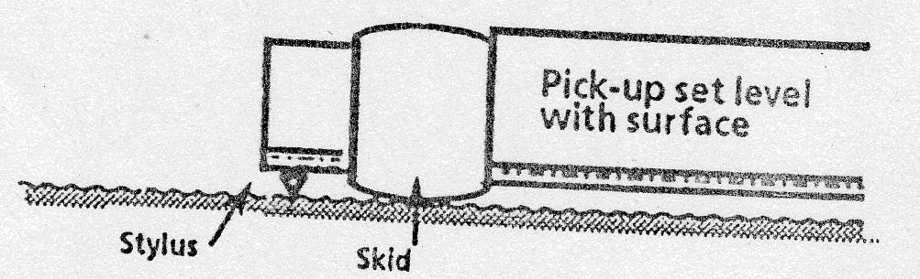

Fig.: 4.5 Pick-up (Referred from Instrument Manual)

Specifications

Battery: Alkaline: Minimum 600 Measurements of 4mm Measurements Lengths.
Ni-Cad: Minimum 200 Measurement of 4mm Length
Size: 6 LR 61 (USA/Japan), Fixed Battery
External Charger (Ni-Cad Only)
110/240V, 50/60 Hz
Traverse Unit: Traverse Speed: 1mm/Sec
Measurement: Metric/Inch Preset by DIP-Switch
Cut-Off Values: 0.25mm, 0.8mm, and 2.50mm
Traverse Length: 1, 3, 5, 10, Or 25.4 + 0.2mm At 0.8mm Cut-Off.
Display: LCD-Matrix. 2lines * 16 Characters
Keyboard: Membrane Switch Panel Tactile.
Filters: Digital Gauss Filters or 2CR Filter (ISO) Selectable By DIP-Switch.
Parameters: Ra, Rq, Rz (DIN), Ry and Sm.
Calculations Time: Less Than Reversal Time Or 2 Sec Which Ever Is The Longer.
4.3 Workpiece material
CNC Lathe Trainer made ENKAY was available for turning only Non-ferrous materials. The chuck holding the work piece diameter was only limited to 35 mm and the maximum work piece length was limited to about 150 mm length. Even the work pieces required are soft but ductile nature as the machine was not preferred to work on much harder work pieces.

Standardized material was selected to ensure consistency of the alloy, which is a Leaded Gun Metal Bronze used in industry thus, BS 1400:LG2 alloy (also known as SAE 40) made in the form of bars with the size of diameter 32 mm 120mm length so as to fit under the chuck. To more closely replicate typical finish turning processes and to avoid excessive vibrations due to work piece dimensional inaccuracies and defects, each work piece was rough-cut just prior to the measured finish cut.

After one rough cut on each work piece so as to smooth the surface, we divide each work piece into three zones with length starting from one face from where tool starts cutting. Thus simultaneously we could choose the machining zero required for generating cutting profile with reference to our work piece dimensions. These three zones of machining would represent three different values of feed at one depth of cut and at a single speed. These zones were from 0-25 mm, 25-50 mm and 50-75 mm from the machining zero side. Surtronic 3+ instrument available has a pickup with a skid which is used to travel automatically through a drive motor. Thus such travel would at least require a distance of at least 10 mm. Thus we require appropriate surface travel distance on turned gun metal work piece. These dimensions were taken so as to keep travel the stylus on the best surface as the cutting could improper at the starting or at the end. In this way the error in measurement could also be reduced and there are less chance of measuring the wrong side values.

4.4 Cutting Tool Material
The cutting tool which is provided with the CNC lathe Trainer was a 30 mm square tool
with 60 mm length having the same tool angles as for a normal turning tool.
The basic properties of HSS tools are superior hot hardness and wear resistance. These
can retain hardness at temperatures upto 600C but soften rapidly at higher temperatures.
Cutting Speeds are limited upto 0.75 to 1.8 m/sec.

The tool used was cemented carbide insert type. The geometry of tool is: Rake angle 6⁰ (+ve), 5⁰ (+ve) clearance angle, 60⁰ (+ve) major cutting edge angle, 60⁰ (+ve) included angle and 0⁰ cutting edge inclination angle. The work piece material was BS 1400:LG2 alloy with the chemical composition as under:

TABLE 4.2 (Chemical Composition of Work Piece)
Element | Weight %
Cu | 84-86
Sn | 4-6
Zn | 4-6
Pb | 4-6
Ni | 2% max
P | 0.05% max
Al | 0.005% max
Fe + As + Sb | 0.5% max
S | 0.08%
Si | 0.005%

LG2 is leaded gunmetal bronze, offering excellent machinability, excellent wear resistance at normal lubrication, high resistance to seizure and good corrosion resistance. This grade is also known as “Red Brass”. It has moderate strength, good corrosion resistance to sea water.
This alloy is used in pump bodies, bearings and gears with low loads and adequate lubrication.

4.5 Measurement of Surface Roughness
Inspection and assessment of surface roughness of machined work pieces can be carried out by means of different measurement techniques. These methods can be ranked into the following classes:
- Direct measurement methods
- Comparison based techniques
- Non contact methods

4.5.1 Direct Measurement Methods
Direct methods access surface finish by means of stylus type devices. Measurements are obtained using a stylus drawn along the surface to be measured. The stylus motion perpendicular to the surface is registered. This registered profile is then used to calculate the roughness parameters. The parameter Ra is used here.
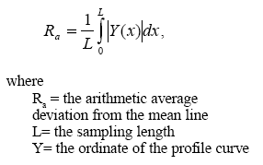
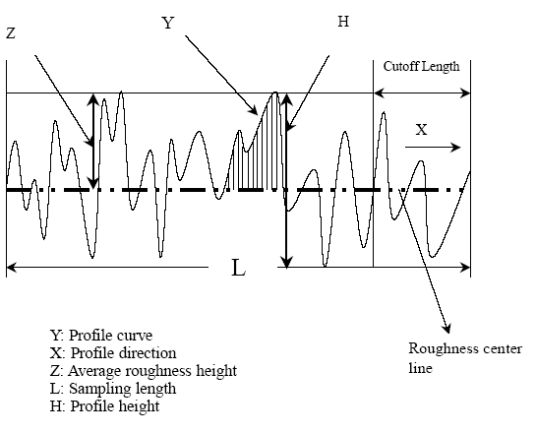
Fig. 4.6 (Measurement of Surface roughness by Stylus)

4.5.2 Comparison Based Techniques
Comparison techniques use specimens of surface roughness produced by the same process, material and machining parameters as the surface to be compared. Visual and tactile senses are used to compare a specimen with a surface of known surface finish. This method is useful for surface roughness Ra>1.6 micron.

4.5.3 Non Contact Methods

In it a rough surface is illuminated by a monochromatic plane wave with an angle of incidence with respect to the normal to the surface. The photo sensor of a camera placed in the focal plane of a Fourier lens is used for recording speckle patterns. Then the surface roughness can be defined and calculated
In these experiments direct measurement method has been used i.e. stylus type surface roughness meter was used to measure the surface roughness of the specimen. There were two main reasons behind selecting stylus type surface roughness; one is its easy availability and other is the ease with which it can be operated. The instrument used in these experiments is a product of precision devices.
4.6 Factors and their Levels
The factors and their levels have been selected on the basis of tool, work piece material, machine parameters and by studying different research papers and data hand books. Different cutting parameters and their level are shown in table:
Table 4.3 (Process Parameters and Their Levels)
Process parameters | Process designation | Levels
Process parameters | Process designation | -1 | 0 | 1
Speed (m/min) | A | 1000 | 1200 | 1400
Depth (mm) | B | 0.2 | 0.3 | 0.4
Feed (mm/min) | C | 25 | 50 | 75

Table 4.4 Orthogonal Array of L₂₇ (P.J.Ross)
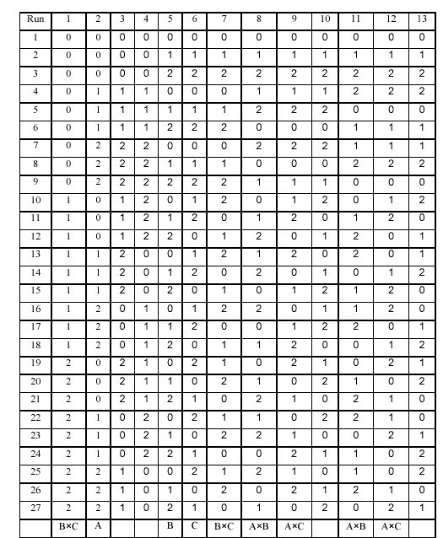
Chapter 5
ANALYSIS OF MACHINING DATA

Regression analysis is one of the most widely used techniques for analyzing multifactor data. Its broad appeal and usefulness result from the conceptually logical process of using an equation to express the relationship between a variable of interest (the response) and a set of related predictor variables. So regression analysis was used to develop the parametric equations. The following factors are used in the present analysis
Regression sum of squares:
${\text{SS}}_{R}=\sum_{i=1}^{n}{{\left({\hat{y}}_{i}−\bar{y}\right)}^{2}}$ (5.1)
Where $\bar{y}$= sum of dependent variable
${\hat{y}}_{i}$= fitted value of i^{th} dependent variable
Residual sum of squares:
${\text{SS}}_{\text{Res}}=\sum_{i=1}^{n}{{\left(y_{i}−{\hat{y}}_{i}\right)}^{2}}$ (5.2)
y_{i} = observed value of i^{th} dependent variable
Total sum of squares: It is the total variability in the observations of the data.
${\text{SS}}_{T}={\text{SS}}_{R}+{\text{SS}}_{\text{Res}}$ (5.3)
Predictor variables
$k={\text{SS}}_{R} / σ^{2}$ (5.4)
This has the same number of degree of freedom as number of regressor or predictor variables in the model.
σ² = variance
Regression mean squares
${\text{MS}}_{R}=\frac{{\text{SS}}_{R}}{k}$ (5.5)
Residual mean squares
${\text{MS}}_{\text{Res}}=\frac{{\text{SS}}_{\text{Res}}}{n−p}$ (5.6)
p = k +1 = parameter in the regression model
n = number of observations
Test of statistic
$F=\frac{{\text{MS}}_{R}}{{\text{MS}}_{\text{Res}}}$ (5.7)
Coefficient of determination
$R^{2}=\frac{{\text{SS}}_{R}}{{\text{SS}}_{T}}=1−\frac{{\text{SS}}_{\text{Res}}}{{\text{SS}}_{T}}$ (5.8)
Adjusted coefficient of determination
$\text{Adjusted} R^{2}=1−\frac{{{\text{SS}}_{\text{Res}}}/{\left(n−p\right)}}{{{\text{SS}}_{T}}/{\left(n−1\right)}}$ (5.9)
Standard error of regression: $\text{SE}=\sqrt{{\text{MS}}_{\text{Res}}}$ (5.10)

5.1 Mathematical Models Formulation of Machining Data
The purpose of developing the mathematical models relating the machining responses and their machining factors was to facilitate the optimization of the machining process. Using these mathematical models, the objective function and process constraints were formulated, and the optimization problem was then solved by using regression analysis.
The mathematical models commonly used are represented by:
$Y=φ\left(\text{V,f,d}\right)$ (5.11)
Where Y is the machining response,
$ϕ$ is the response function,
and V, f, d are machining variables.

5.1.1 Linear Regression
When expressed in the linear form, equation 5.11 becomes
Y = C + αV + βf + γd (5.12)
The surface roughness model was formulated as:
R_{a} = C + αV + βf + γd (5.13)
Using these mathematical models, the objective function and process constraints were formulated, and the optimization problem was then solved by using regression analysis as shown in Fig. 5.1

Surface
Roughness

Cutting speed

Feed

Depth of cut

Raw machinability data
Data set

Procedure

Output

Fig.: 5.1 Flow Chart for processing Linear Model in regression analysis [Yeo et al, 1989].

Table 5.1 Data Collection for Linear Model
S.No. | Diameter  (mm) | RPM | V | d | Feed |  | Ra | Predicted Ra | S/N
 | Diameter  (mm) | RPM | (m/min) | (mm) | (mm/min) | (mm/rev) | (µm)
1. | 29.8 | 1000 | 93.57 | 0.2 | 25 | 0.025 | 1.32 | 1.41 | -2.41
2. | 29.8 | 1000 | 93.57 | 0.2 | 50 | 0.05 | 2.46 | 2.66 | -7.82
3. | 29.8 | 1000 | 93.57 | 0.2 | 75 | 0.075 | 4.36 | 3.912 | -12.79
4. | 29.4 | 1000 | 92.32 | 0.3 | 25 | 0.025 | 1.42 | 1.41 | -3.04
5. | 29.4 | 1000 | 92.32 | 0.3 | 50 | 0.05 | 2.4 | 2.66 | -7.60
6. | 29.4 | 1000 | 92.32 | 0.3 | 75 | 0.075 | 3.82 | 3.91 | -11.64
7. | 28.8 | 1000 | 90.432 | 0.4 | 25 | 0.025 | 1.42 | 1.42 | -3.04
8. | 28.8 | 1000 | 90.432 | 0.4 | 50 | 0.05 | 2.32 | 2.67 | -7.30
9. | 28.8 | 1000 | 90.432 | 0.4 | 75 | 0.075 | 4.3 | 3.91 | -12.67
10. | 31.8 | 1200 | 119.82 | 0.2 | 25 | 0.020833 | 1.22 | 1.17 | -1.72
11. | 31.8 | 1200 | 119.82 | 0.2 | 50 | 0.041667 | 1.92 | 2.21 | -5.66
12. | 31.8 | 1200 | 119.82 | 0.2 | 75 | 0.0625 | 3.14 | 3.251 | -9.94
13. | 31.4 | 1200 | 118.31 | 0.3 | 25 | 0.020833 | 1.5 | 1.17 | -3.52
14. | 31.4 | 1200 | 118.31 | 0.3 | 50 | 0.041667 | 2.12 | 2.212 | -6.52
15. | 31.4 | 1200 | 118.31 | 0.3 | 75 | 0.0625 | 3.08 | 3.25 | -9.77
16. | 30.8 | 1200 | 116.05 | 0.4 | 25 | 0.020833 | 1.2 | 1.174 | -1.58
17. | 30.8 | 1200 | 116.05 | 0.4 | 50 | 0.041667 | 1.84 | 2.215 | -5.30
18. | 30.8 | 1200 | 116.05 | 0.4 | 75 | 0.0625 | 4.22 | 3.26 | -12.50
19. | 31.8 | 1400 | 139.80 | 0.2 | 25 | 0.017857 | 1.28 | 0.99 | -2.14
20. | 31.8 | 1400 | 139.80 | 0.2 | 50 | 0.035714 | 1.8 | 1.88 | -5.10
21. | 31.8 | 1400 | 139.80 | 0.2 | 75 | 0.053571 | 2.54 | 2.77 | -8.10
22. | 31.4 | 1400 | 138.03 | 0.3 | 25 | 0.017857 | 1.5 | 0.99 | -3.52
23. | 31.4 | 1400 | 138.03 | 0.3 | 50 | 0.035714 | 2.04 | 1.89 | -6.19
24. | 31.4 | 1400 | 138.03 | 0.3 | 75 | 0.053571 | 2.78 | 2.78 | -8.88
25. | 30.8 | 1400 | 135.34 | 0.4 | 25 | 0.017857 | 1.12 | 0.99 | -0.98
26. | 30.8 | 1400 | 135.34 | 0.4 | 50 | 0.035714 | 1.22 | 1.89 | -1.72
27. | 30.8 | 1400 | 135.34 | 0.4 | 75 | 0.053571 | 2.46 | 2.78 | -7.81
Table 5.2 Regression Analysis for Linear Model
n | 27
R² | 0.89
Adjusted R² | 0.88
SE | 0.3555
Term | Coefficient | SE | p | 95% CI of Coefficient
Intercept | 0.2933 | 0.6044 | 0.6321 | -0.9570 | to 1.5435
V - (m/min) | -0.0014 | 0.0039 | 0.7151 | -0.0094 | to 0.0066
d - (mm) | 0.0065 | 0.8410 | 0.9939 | -1.7334 | to 1.7463
f - (mm/rev) | 49.9772 | 3.9096 | <0.0001 | 41.8897 | to 58.0648
Source of variation | SSq | DF | MSq | F | p
Due to regression | 23.406 | 3 | 7.802 | 61.74 | <0.0001
About regression | 2.907 | 23 | 0.126
Total | 26.312 | 26

Fig.: 5.2 Regression Analysis showing Variation of Surface roughness parameter in linear model

Surface roughness equation for linear model
The data of analysis of variance of the roughness model for finish turning operation for aluminum are shown in table 5.2. The surface roughness model developed as:
R_{a} = 0.2933 - 0.0014V + 0.0065d + 49.9772f (5.14)
The R-square value of 0.92 indicated that 92% of the variability in the surface roughness was explained by the model with factors V, f and d. Based on the mathematical model, it can be concluded that the cutting speed is a dominant factor in the roughness model of finish turning in heavy machining operation.

5.1.2 Non-Linear Model
When expressed in the non- linear form, equation 5.11 becomes
$$Y=C V^{α} f^{β} d^{γ}$$
The surface roughness model was formulated as:
(5.15)
Logarithms taken on both sides of the equation 5.15
(5.16)

Equation 5.16 changed into the regression equation by changing the factors as:
Using these mathematical models, the objective function and process constraints were formulated, and the optimization problem was then solved by using regression analysis as shown in Fig. 5.3

Surface
Roughness

Cutting speed

Feed

Depth of cut

Raw machinability data
Logarithmic transformation
Data set
Procedure
Output
Fig. 5.3 Flow Chart for processing Non-Linear Model in regression analysis [Yeo et al, 1989].

Table 5.3 Data Collection for Non-Linear Model
S.No. | Diameter  (mm) | RPM | V | d | Feed |  | Ra | Predicted Ra
 | Diameter  (mm) | RPM | (m/min) | (mm) | (mm/min) | (mm/rev) | (µm) | Predicted Ra
1. | 29.8 | 1000 | 93.57 | 0.2 | 25 | 0.025 | 1.32 | 1.50
2. | 29.8 | 1000 | 93.57 | 0.2 | 50 | 0.05 | 2.46 | 2.63
3. | 29.8 | 1000 | 93.57 | 0.2 | 75 | 0.075 | 4.36 | 3.66
4. | 29.4 | 1000 | 92.32 | 0.3 | 25 | 0.025 | 1.42 | 1.47
5. | 29.4 | 1000 | 92.32 | 0.3 | 50 | 0.05 | 2.4 | 2.60
6. | 29.4 | 1000 | 92.32 | 0.3 | 75 | 0.075 | 3.82 | 3.60
7. | 28.8 | 1000 | 90.432 | 0.4 | 25 | 0.025 | 1.42 | 1.46
8. | 28.8 | 1000 | 90.432 | 0.4 | 50 | 0.05 | 2.32 | 2.57
9. | 28.8 | 1000 | 90.432 | 0.4 | 75 | 0.075 | 4.3 | 3.57
10. | 31.8 | 1200 | 119.82 | 0.2 | 25 | 0.020833 | 1.22 | 1.27
11. | 31.8 | 1200 | 119.82 | 0.2 | 50 | 0.041667 | 1.92 | 2.23
12. | 31.8 | 1200 | 119.82 | 0.2 | 75 | 0.0625 | 3.14 | 3.10
13. | 31.4 | 1200 | 118.31 | 0.3 | 25 | 0.020833 | 1.5 | 1.25
14. | 31.4 | 1200 | 118.31 | 0.3 | 50 | 0.041667 | 2.12 | 2.20
15. | 31.4 | 1200 | 118.31 | 0.3 | 75 | 0.0625 | 3.08 | 3.05
16. | 30.8 | 1200 | 116.05 | 0.4 | 25 | 0.020833 | 1.2 | 1.24
17. | 30.8 | 1200 | 116.05 | 0.4 | 50 | 0.041667 | 1.84 | 2.17
18. | 30.8 | 1200 | 116.05 | 0.4 | 75 | 0.0625 | 4.22 | 3.02
19. | 31.8 | 1400 | 139.80 | 0.2 | 25 | 0.017857 | 1.28 | 1.11
20. | 31.8 | 1400 | 139.80 | 0.2 | 50 | 0.035714 | 1.8 | 1.95
21. | 31.8 | 1400 | 139.80 | 0.2 | 75 | 0.053571 | 2.54 | 2.71
22. | 31.4 | 1400 | 138.03 | 0.3 | 25 | 0.017857 | 1.5 | 1.09
23. | 31.4 | 1400 | 138.03 | 0.3 | 50 | 0.035714 | 2.04 | 1.92
24. | 31.4 | 1400 | 138.03 | 0.3 | 75 | 0.053571 | 2.78 | 2.67
25. | 30.8 | 1400 | 135.34 | 0.4 | 25 | 0.017857 | 1.12 | 1.08
26. | 30.8 | 1400 | 135.34 | 0.4 | 50 | 0.035714 | 1.22 | 1.90
27. | 30.8 | 1400 | 135.34 | 0.4 | 75 | 0.053571 | 2.46 | 2.64
Table 5.4 Regression Analysis for Non-Linear Model
n | 27
R² | 0.85
Adjusted R² | 0.85
SE | 0.0728
Term | Coefficient | SE | P | 95% CI of Coefficient
Intercept | 1.5855 | 0.4009 | 0.0006 | 0.7562 | 2.4147
LogV - (µm) | -0.0689 | 0.2031 | 0.7375 | -0.4891 | 0.3513
Logd - (µm) | -0.0403 | 0.1138 | 0.7262 | -0.2757 | 0.1951
Logf - (µm) | 0.8124 | 0.0711 | <0.0001 | 0.6654 | 0.9594
Source of variation | SSq | DF | MSq | F | p
Due to regression | 0.769 | 3 | 0.256 | 48.43 | <0.0001
About regression | 0.122 | 23 | 0.005
Total | 0.891 | 26

Fig. 5.4 Regression Analysis showing Variation of Surface roughness parameter in non-linear model
Surface roughness equation
The data of analysis of variance of the roughness model for finish turning operation are shown in table 5.4 The surface roughness model developed as:
log R_{a} = 1.5855 – 0.0689 log V - 0.0403 log d + 0.8124 log f (5.17)
Equation formulated from the above model is:
R_{a} = 38.5035 d^{-0.0403} f^{.0.8124} V^{-0.0689} (5.18)
The R-square value of 0.99 indicated that 99% of the variability in the surface roughness was explained by the model with factors V, f and d. Based on the mathematical model, it can be concluded that the cutting speed is a dominant factor in the roughness model of finish turning in heavy machining operation.
5.2 Neural Network Modeling

5.2.1 Introduction: - Artificial neural networking (ANN) is a tool in MATLAB, which is used to get the output based upon the input. In this work, a feed-forward neural network model has been developed with the back propagation training algorithm. A large number of experiments have been performed on gun metal work-piece using HSS tool. Various conditions of process parameters such as speed, feed and depth of cut have been considered. Different network architectures have been studied for the training, and the best trained network architecture is used for predicting the surface roughness for the unseen data. The accuracy of the model implies that it has the capacity to predict surface roughness very well.

5.2.2 Scope: - The scope of the application is inside any manufacturing organization and in particular within department namely, planning purchase and dispatch. Although this code is custom build to meet the requirement of selection of roughness, but similar efforts can be extended to any other problem with multiple criterion decision making with some modification.

5.2.3 System overview: - The use of this software is very simple, user is required to write the input in excel file and call the input file in the network. It will produce the results in the terms of excel files and graphs. The hardware requirements of this application are:-

Processor- Intel P IV 2.2 GHz
Cache- 1MB
RAM – 256 MB
The software requirements are:-
Operating system- Windos98/ Me/ NT/ 2000/ XP
Communication interface- Excel
Development interface- MATLAB

5.2.4 CODE FILE:- The code is written in MATLAB and is as follows

function [net,ps,ts] = fitwithnet(p,t)
%FITWITHNET Creates and trains a neural network to fit input/target data.
%
% [NET,PS,TS] = FITWITHNET(P,T) takes:
% P - RxQ matrix of Q R-element input samples
% T - SxQ matrix of Q S-element associated target samples
% arranged as columns, and returns these results:
% NET - The trained neural network
% PS - Settings for preprocessing network inputs with MAPMINMAX.
% TS - Settings for postprocessing network outputs with MAPMINMAX.
%
% For example, to create an network with this function:
%
% load housing
% [net,ps,ts] = fitwithnet(p,t);
%
% To test the network on the original or new data:
%
% pn = mapminmax('apply',p,ps); % Preprocess inputs
% an = sim(net,pn); % Apply network
% a = mapminmax('reverse',an,ts); % Postprocess outputs
% e = t - a; % Compare targets and outputs
%
% To reproduce the results you obtained in NFTOOL:
%
% [net,ps,ts] = fitwithnet(unnamed',output');

% Random Seed for Reproducing NFTool results
rand('seed',9.31316785E8)
% Normalize Inputs and Targets
[normInput,ps] = mapminmax(p);
[normTarget,ts] = mapminmax(t);

% Create Network
numInputs = size(p,1);
numHiddenNeurons = 5; % Adjust as desired
numOutputs = size(t,1);
net = newff(minmax(normInput),[numHiddenNeurons,numOutputs]);

% Divide up Samples
testPercent = 0.20; % Adjust as desired
validatePercent = 0.20; % Adust as desired
[trainSamples,validateSamples,testSamples] = dividevec(normInput,normTarget,testPercent,validatePercent);

% Train Network
[net,tr] = train(net,trainSamples.P,trainSamples.T,[],[],validateSamples,testSamples);

% Simulate Network
[normTrainOutput,Pf,Af,E,trainPerf] = sim(net,trainSamples.P,[],[],trainSamples.T);
[normValidateOutput,Pf,Af,E,validatePerf] = sim(net,validateSamples.P,[],[],validateSamples.T);
[normTestOutput,Pf,Af,E,testPerf] = sim(net,testSamples.P,[],[],testSamples.T);

% Reverse Normalize Outputs
trainOutput = mapminmax('reverse',normTrainOutput,ts);
validateOutput = mapminmax('reverse',normValidateOutput,ts);
testOutput = mapminmax('reverse',normTestOutput,ts);

% Plot Regression
fig.
postreg({trainOutput,validateOutput,testOutput}, ...
{t(:,trainSamples.indices),t(:,validateSamples.indices),t(:,testSamples.indices)});

5.2.5 Networking for Linear Model

Network Learning: - On the basis of the code given, artificial neural network will develop a network and now it is required to make the network learn. So the data collected from machining will be feed in the network and learning of the network will be started for learning data is taken from more than fifteen readings.

TRAINING GRAPH:-Training graph of the data in table 5.5 is presented in fig. 5.5. This is generated with the help of Neural Networking. When a network get trained, it is required to define the percentage of train data, validation data, test data so that the network can itself validate and test its own training. This graph shows that how the training is progressing in each Epoch (regression) and consequently validation and test of network is in progress after 71 epochs training is complete as the nature of test data and validation data has become same.
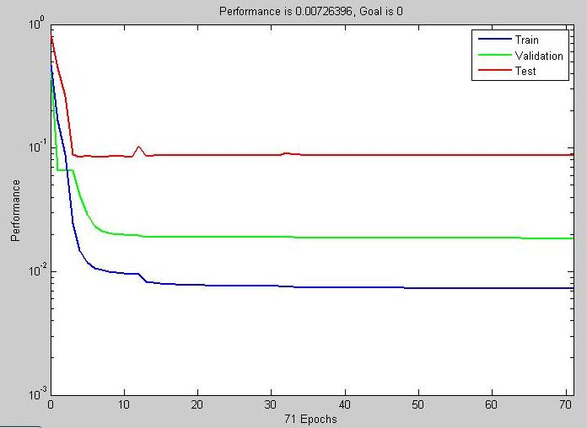
Fig 5.5 Training Graph
REGRESSION GRAPHS:-

Fig. 5.6 to fig. 5.8 shows the regression graphs of learning data, validation data and test data. In these graphs the dotted line shows A(output) = T (target) i.e. the ideal condition. While the dots show the actual output for particular sample and based on that a best fit line is drawn the best fit line should be as close as the dotted line.

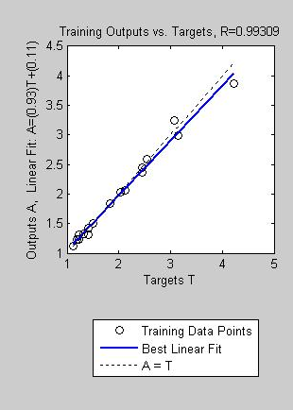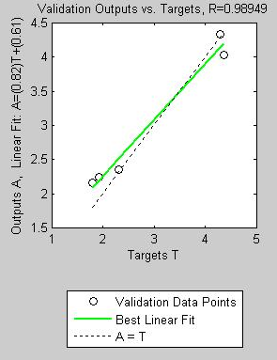

Fig 5.6 Regression Coefficient of Fig 5.7 Regression Coefficient of validation
of learning data data

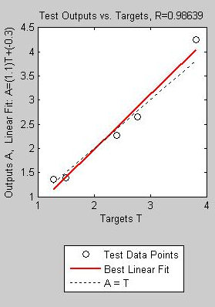

Fig 5.8 Regression coefficient of test data

Regression coefficients based on the data are 0.99309 for training set, 0.98949 for validation set and 0.98639 for test data set shows that the learning of the network is proper and now this application can be used
Table 5.5 Data Collection for Linear Model by ANN

S.No. | Diameter  (mm) | RPM | V | d | Feed |  | Ra | PredictedRa
 | Diameter  (mm) | RPM | (m/min) | (mm) | (mm/min) | (mm/rev) | (µm) | ANN | Reg.
1. | 29.8 | 1000 | 93.57 | 0.2 | 25 | 0.025 | 1.32 | 1.33 | 1.41
2. | 29.8 | 1000 | 93.57 | 0.2 | 50 | 0.05 | 2.46 | 2.36 | 2.66
3. | 29.8 | 1000 | 93.57 | 0.2 | 75 | 0.075 | 4.36 | 4.03 | 3.912
4. | 29.4 | 1000 | 92.32 | 0.3 | 25 | 0.025 | 1.42 | 1.314 | 1.41
5. | 29.4 | 1000 | 92.32 | 0.3 | 50 | 0.05 | 2.4 | 2.26 | 2.66
6. | 29.4 | 1000 | 92.32 | 0.3 | 75 | 0.075 | 3.82 | 4.24 | 3.91
7. | 28.8 | 1000 | 90.432 | 0.4 | 25 | 0.025 | 1.42 | 1.419 | 1.42
8. | 28.8 | 1000 | 90.432 | 0.4 | 50 | 0.05 | 2.32 | 2.35 | 2.67
9. | 28.8 | 1000 | 90.432 | 0.4 | 75 | 0.075 | 4.3 | 4.33 | 3.91
10. | 31.8 | 1200 | 119.82 | 0.2 | 25 | 0.020833 | 1.22 | 1.30 | 1.17
11. | 31.8 | 1200 | 119.82 | 0.2 | 50 | 0.041667 | 1.92 | 2.20 | 2.21
12. | 31.8 | 1200 | 119.82 | 0.2 | 75 | 0.0625 | 3.14 | 2.98 | 3.251
13. | 31.4 | 1200 | 118.31 | 0.3 | 25 | 0.020833 | 1.5 | 1.39 | 1.17
14. | 31.4 | 1200 | 118.31 | 0.3 | 50 | 0.041667 | 2.12 | 2.06 | 2.212
15. | 31.4 | 1200 | 118.31 | 0.3 | 75 | 0.0625 | 3.08 | 3.25 | 3.25
16. | 30.8 | 1200 | 116.05 | 0.4 | 25 | 0.020833 | 1.2 | 1.28 | 1.174
17. | 30.8 | 1200 | 116.05 | 0.4 | 50 | 0.041667 | 1.84 | 1.84 | 2.215
18. | 30.8 | 1200 | 116.05 | 0.4 | 75 | 0.0625 | 4.22 | 3.86 | 3.26
19. | 31.8 | 1400 | 139.80 | 0.2 | 25 | 0.017857 | 1.28 | 1.35 | 0.99
20. | 31.8 | 1400 | 139.80 | 0.2 | 50 | 0.035714 | 1.8 | 2.15 | 1.88
21. | 31.8 | 1400 | 139.80 | 0.2 | 75 | 0.053571 | 2.54 | 2.59 | 2.77
22. | 31.4 | 1400 | 138.03 | 0.3 | 25 | 0.017857 | 1.5 | 1.49 | 0.99
23. | 31.4 | 1400 | 138.03 | 0.3 | 50 | 0.035714 | 2.04 | 2.03 | 1.89
24. | 31.4 | 1400 | 138.03 | 0.3 | 75 | 0.053571 | 2.78 | 2.64 | 2.78
25. | 30.8 | 1400 | 135.34 | 0.4 | 25 | 0.017857 | 1.12 | 1.12 | 0.99
26. | 30.8 | 1400 | 135.34 | 0.4 | 50 | 0.035714 | 1.22 | 1.22 | 1.89
27. | 30.8 | 1400 | 135.34 | 0.4 | 75 | 0.053571 | 2.46 | 2.44 | 2.78
5.2.6 Networking for Non Linear model

TRAINING GRAPH:- Training graph of the data in table 5.6 is presented in fig. 5.9. This is generated with the help of Neural Networking. When a network get trained, it is required to define the percentage of train data, validation data, test data so that the network can itself validate and test its own training. This graph shows that how the training is progressing in each Epoch (regression) and consequently validation and test of network is in progress after 26 epochs training is complete as the nature of test data and validation data has become same.

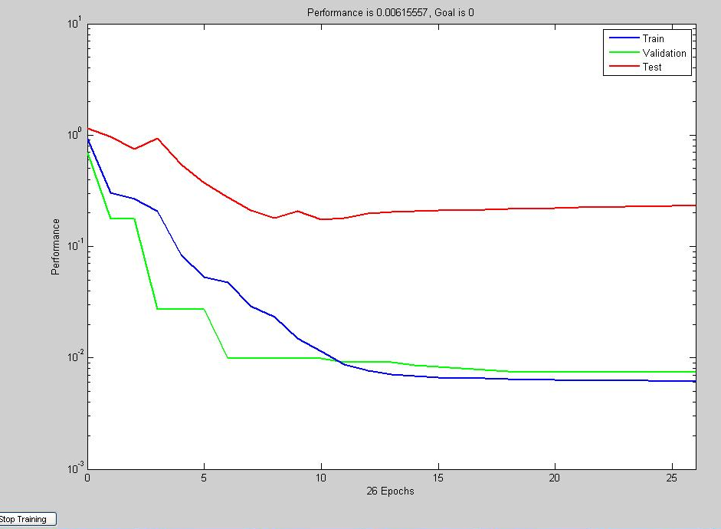

Fig 5.9 Training Graph

REGRESSION GRAPHS:-

Fig. 5.10 to fig. 5.12 shows the regression graphs of learning data, validation data and test data. In these graphs the dotted line shows A(output) = T (target) i.e. the ideal condition. While the dots show the actual output for particular sample and based on that a best fit line is drawn the best fit line should be as close as the dotted line.

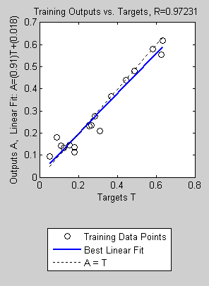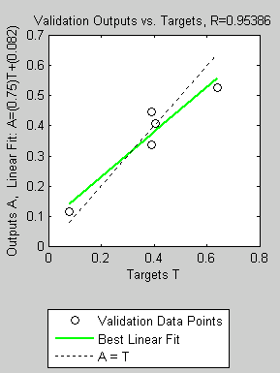
Fig 5.10 Regression Coefficient of Fig 5.11 Regression Coefficient of validation
of learning data data
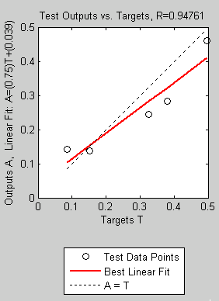

Fig 5.12 Regression coefficient of test data
Table 5.6 Data Collection for Non-Linear Model by ANN

S.No. | Diameter  (mm) | RPM | V | d | Feed |  | Ra | PredictedRa
 | Diameter  (mm) | RPM | (m/min) | (mm) | (mm/min) | (mm/rev) | (µm) | ANN | Reg.
1. | 29.8 | 1000 | 93.57 | 0.2 | 25 | 0.025 | 1.32 | 1.35 | 1.50
2. | 29.8 | 1000 | 93.57 | 0.2 | 50 | 0.05 | 2.46 | 2.27 | 2.63
3. | 29.8 | 1000 | 93.57 | 0.2 | 75 | 0.075 | 4.36 | 3.75 | 3.66
4. | 29.4 | 1000 | 92.32 | 0.3 | 25 | 0.025 | 1.42 | 1.37 | 1.47
5. | 29.4 | 1000 | 92.32 | 0.3 | 50 | 0.05 | 2.4 | 2.22 | 2.60
6. | 29.4 | 1000 | 92.32 | 0.3 | 75 | 0.075 | 3.82 | 3.81 | 3.60
7. | 28.8 | 1000 | 90.432 | 0.4 | 25 | 0.025 | 1.42 | 1.39 | 1.46
8. | 28.8 | 1000 | 90.432 | 0.4 | 50 | 0.05 | 2.32 | 2.31 | 2.57
9. | 28.8 | 1000 | 90.432 | 0.4 | 75 | 0.075 | 4.3 | 4.14 | 3.57
10. | 31.8 | 1200 | 119.82 | 0.2 | 25 | 0.020833 | 1.22 | 1.19 | 1.27
11. | 31.8 | 1200 | 119.82 | 0.2 | 50 | 0.041667 | 1.92 | 1.89 | 2.23
12. | 31.8 | 1200 | 119.82 | 0.2 | 75 | 0.0625 | 3.14 | 2.90 | 3.10
13. | 31.4 | 1200 | 118.31 | 0.3 | 25 | 0.020833 | 1.5 | 1.36 | 1.25
14. | 31.4 | 1200 | 118.31 | 0.3 | 50 | 0.041667 | 2.12 | 1.96 | 2.20
15. | 31.4 | 1200 | 118.31 | 0.3 | 75 | 0.0625 | 3.08 | 3.03 | 3.05
16. | 30.8 | 1200 | 116.05 | 0.4 | 25 | 0.020833 | 1.2 | 1.26 | 1.24
17. | 30.8 | 1200 | 116.05 | 0.4 | 50 | 0.041667 | 1.84 | 1.71 | 2.17
18. | 30.8 | 1200 | 116.05 | 0.4 | 75 | 0.0625 | 4.22 | 3.57 | 3.02
19. | 31.8 | 1400 | 139.80 | 0.2 | 25 | 0.017857 | 1.28 | 1.38 | 1.11
20. | 31.8 | 1400 | 139.80 | 0.2 | 50 | 0.035714 | 1.8 | 1.76 | 1.95
21. | 31.8 | 1400 | 139.80 | 0.2 | 75 | 0.053571 | 2.54 | 2.56 | 2.71
22. | 31.4 | 1400 | 138.03 | 0.3 | 25 | 0.017857 | 1.5 | 1.30 | 1.09
23. | 31.4 | 1400 | 138.03 | 0.3 | 50 | 0.035714 | 2.04 | 1.61 | 1.92
24. | 31.4 | 1400 | 138.03 | 0.3 | 75 | 0.053571 | 2.78 | 2.75 | 2.67
25. | 30.8 | 1400 | 135.34 | 0.4 | 25 | 0.017857 | 1.12 | 1.14 | 1.08
26. | 30.8 | 1400 | 135.34 | 0.4 | 50 | 0.035714 | 1.22 | 1.51 | 1.90
27. | 30.8 | 1400 | 135.34 | 0.4 | 75 | 0.053571 | 2.46 | 2.68 | 2.64
5.3 PARETO ANOVA analysis:
5.3.1 Introduction
Pareto ANOVA method is used to study the results obtained from experimental work. Pareto ANOVA is a simplified ANOVA method, which is based on Pareto principle. The major advantage of using the Pareto ANOVA technique is the no use of F test in this technique. These techniques identify the significant parameters and calculate the percentage effect of each parameter on different quality characteristics. The use of both Pareto ANOVA technique and S/N ratio approach makes it easy to analyze the results and hence make it fast to reach on the conclusion. Table 5.1 shows the experimental results for the surface roughness and corresponding S/N (signal to noise) ratio and as well as their means. These values of S/N ratio and means will then further be analyzed to detect the most responsible factor and the percentage contribution of each factor and their interactions on the variability of the results. The effects will be shown by both tables and as well as graphs and then it will be checked whether the results shown by the graphs and tables are same or not.
These efforts are helpful for the selection of optimal level of process parameters for surface roughness.
Table 5.1 shows the experimental results for the surface roughness. Corresponding s/n(signal to noise) ratio and as well as their means are also featured in the table.

5.3.2 Analysis of Data for Surface Roughness by Taguchi method:
Table 5.1 shows the experimental results for the surface roughness, corresponding s/n(signal to noise) ratio and as well as their means. Table 5.7 to 5.15 calculates the mean of different factors and their interactions at different levels. Table5.7, 5.8 and 5.9 are used to calculate the mean effect of cutting speed, feed rate and depth of cut at different levels. Rest of the tables i.e. Table 5.10 to 5.15 are used to calculate the mean effect of interactions between the factors at different levels on the surface roughness of the material. All the values from Table 5.7 to 5.15 will then be used in Table 5.16 and 5.17 to find the percentage contribution of individual factor and as well as their interactions on the surface roughness of the test specimen. The results obtained from Table 5.17 will then be used to cross-examine the results given by the software. The work done will be treated as correct if the results provided by software and the values given by Pareto ANOVA technique happen to be same.

5.3.3 S/N Ratio Approach for Surface Roughness
S/N ratio approach for smaller the better is used for the surface roughness. Fig. 5.1 and 5.2 shows the main effect of parameters on surface roughness and the fig.s show that the main effect on surface roughness is mainly due to feed rate. Table 5.3, 5.5 and 5.6 also show the effect of these three parameters on surface roughness. The effect of different parameters and their interactions can also easily be determined by table 5.12 in which the difference between the different levels can be used for the calculation of the effects due to different parameters, larger the difference, greater will be the effect due to the parameter. Table 5.12 also suggests that the parameters that have main effect on surface roughness is feed rate and interaction of cutting speed and depth of cut and the optimum combination to get the low value of surface roughness is speed 2400 rpm, feed 40 mm/min, and depth of cut 0.5 mm within the test range.
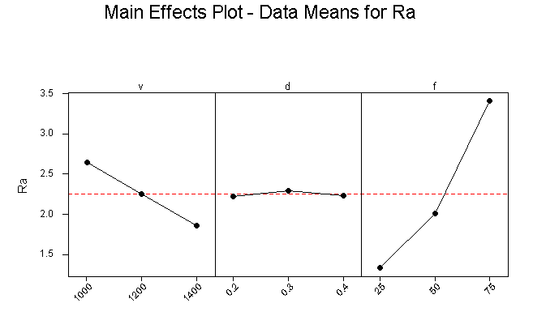
Fig. 5.13 Main Effects plot for Ra

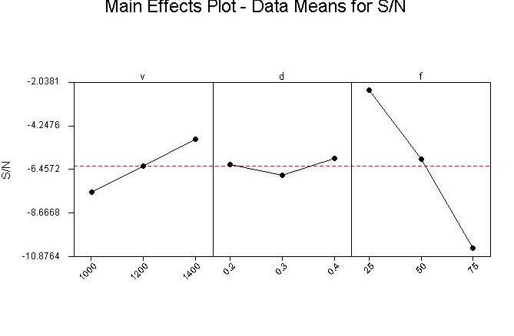
Fig.5.14 Main Effects plot for S/N
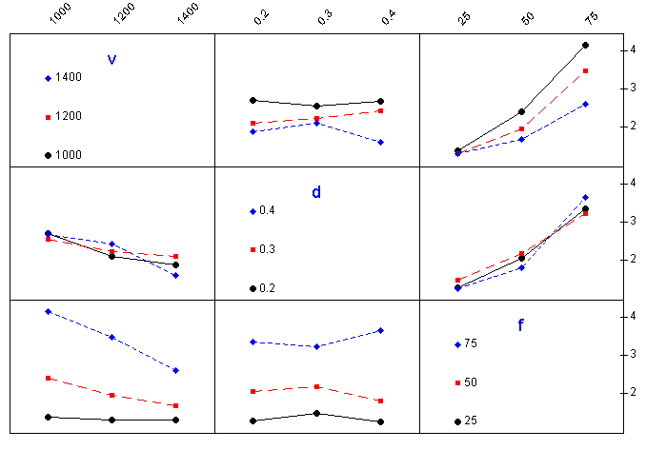
Fig. 5.15 Interaction Plot for Ra

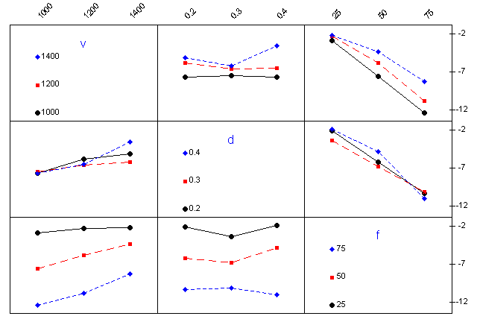
Fig. 5.16 Interaction Plot for S/N

Table 5.7 Response Table Calculation for Cutting Speed (Surface Roughness)
Cutting speed | S/N at level 0 | S/N at level 1 | S/N at level 2
1 | -2.41 | -1.72 | -2.14
2 | -7.82 | -5.66 | -5.1
3 | -12.79 | -9.94 | -8.1
4 | -3.04 | -3.52 | -3.52
5 | -7.60 | -6.52 | -6.19
6 | -11.64 | -9.77 | -8.88
7 | -3.04 | -1.58 | -0.98
8 | -7.3 | -5.3 | -1.72
9 | -12.67 | -12.30 | -7.81
Total | -68.31 | -56.31 | -44.44
Mean | -7.59 | -6.25667 | -4.93778

Table 5.8 Response Table Calculation for Depth of Cut (Surface Roughness)
Feed Rate | S/N at level 0 | S/N at level 1 | S/N at level 2
1 | -2.41 | -3.04 | -3.04
2 | -7.82 | -7.60 | -7.3
3 | -12.79 | -11.64 | -12.67
4 | -1.72 | -3.52 | -1.58
5 | -5.66 | -6.52 | -5.3
6 | -9.94 | -9.77 | -12.30
7 | -2.14 | -3.52 | -0.98
8 | -5.1 | -6.19 | -1.72
9 | -8.1 | -8.88 | -7.81
Total | -55.68 | -60.68 | -52.7
Mean | -6.18667 | -6.74222 | -5.85556
Table no. 5.9 Response Table Calculation for Feed Rate (Surface Roughness)
Depth of Cut | S/N at level 0 | S/N at level 1 | S/N at level 2
1 | -2.41 | -7.82 | -12.79
2 | -3.04 | -7.60 | -11.64
3 | -3.04 | -7.3 | -12.67
4 | -1.72 | -5.66 | -9.94
5 | -3.52 | -6.52 | -9.77
6 | -1.58 | -5.3 | -12.30
7 | -2.14 | -5.1 | -8.1
8 | -3.52 | -6.19 | -8.88
9 | -0.98 | -1.72 | -7.81
Total | -21.95 | -53.21 | -93.9
Mean | -2.43889 | -5.91222 | -10.4333

Table 5.10 Response Table for Interaction between Speed and depth of cut (A×B)
Depth of Cut | S/N at level 0 | S/N at level 1 | S/N at level 2
1 | -2.41 | -7.82 | -12.79
2 | -9.94 | -1.72 | -5.66
3 | -5.1 | -8.1 | -2.14
4 | -3.04 | -7.60 | -11.64
5 | -9.77 | -3.52 | -6.52
6 | -6.19 | -8.88 | -3.52
7 | -3.04 | -7.3 | -12.67
8 | -12.5 | -1.58 | -5.3
9 | -1.72 | -7.81 | -0.98
Total | -53.71 | -54.33 | -61.22
Mean | -5.96778 | -6.03667 | -6.80222
Table 5.11 Response Table for Interaction between feed and depth of cut (B×C)
Depth of Cut | S/N at level 0 | S/N at level 1 | S/N at level 2
1 | -2.41 | -7.82 | -12.79
2 | -1.72 | -5.66 | -9.94
3 | -2.14 | -5.1 | -8.1
4 | -7.6 | -11.64 | -3.04
5 | -6.52 | -9.77 | -3.52
6 | -6.19 | -8.88 | -3.52
7 | -12.67 | -3.04 | -7.3
8 | -12.5 | -1.58 | -5.3
9 | -7.81 | -0.98 | -1.72
Total | -59.56 | -54.47 | -55.23
Mean | -6.61778 | -6.05222 | -6.13667

Table 5.12 Response Table for Interaction between Speed and depth of cut (A×C)
Depth of Cut | S/N at level 0 | S/N at level 1 | S/N at level 2
1 | -2.41 | -7.82 | -12.79
2 | -9.94 | -1.72 | -5.66
3 | -5.1 | -8.1 | -2.14
4 | -11.64 | -3.04 | -7.6
5 | -6.52 | -9.77 | -3.52
6 | -3.52 | -6.19 | -8.88
7 | -7.3 | -12.67 | -3.04
8 | -1.58 | -5.3 | -12.5
9 | -7.81 | -0.98 | -1.72
Total | -55.82 | -55.59 | -57.85
Mean | -6.20222 | -6.17667 | -6.42778
Table 5.13 Response Table Interaction of Speed and Depth of cut (A×B) Repetition
Depth of Cut | S/N at level 0 | S/N at level 1 | S/N at level 2
1 | -2.41 | -7.82 | -12.79
2 | -5.66 | -9.94 | -1.72
3 | -8.1 | -2.14 | -5.1
4 | -3.04 | -7.6 | -11.64
5 | -6.52 | -9.77 | -3.52
6 | -8.88 | -3.52 | -6.19
7 | -3.04 | -7.30 | -12.67
8 | -5.3 | -12.50 | -1.58
9 | -7.81 | -0.98 | -1.72
Total | -50.76 | -61.57 | -56.93
Mean | -5.64 | -6.84111 | -6.32556

Table 5.14 Response Table of feed Rate and depth of cut (B×C) Repetition
Depth of Cut | S/N at level 0 | S/N at level 1 | S/N at level 2
1 | -2.41 | -1.72 | -2.14
2 | -7.82 | -5.66 | -5.1
3 | -12.79 | -9.94 | -8.1
4 | -3.04 | -3.52 | -3.52
5 | -7.60 | -6.52 | -6.19
6 | -11.64 | -9.77 | -8.88
7 | -3.04 | -1.58 | -0.98
8 | -7.3 | -5.3 | -1.72
9 | -12.67 | -12.30 | -7.81
Total | -68.31 | -56.31 | -44.44
Mean | -7.59 | -6.25667 | -4.93778

Table 5.15 Response Table Interaction of Speed and depth of cut (A×C) Repetition
Depth of Cut | S/N at level 0 | S/N at level 1 | S/N at level 2
1 | -2.41 | -7.82 | -12.79
2 | -5.66 | -9.94 | -1.72
3 | -8.1 | -2.14 | -5.1
4 | -11.64 | -3.04 | -7.60
5 | -3.52 | -6.52 | -9.77
6 | -6.19 | -8.88 | -3.52
7 | -7.30 | -12.67 | -3.04
8 | -12.50 | -1.58 | -5.3
9 | -0.98 | -1.72 | -7.81
Total | -58.3 | -54.31 | -56.65
Mean | -6.47778 | -6.03444 | -6.29444

Table 5.16 Response Table for Average S/N Ratio for Surface Roughness and Significant Interaction
Parameter Designation | Parameters | Average value of surface roughness |  |  | Main Effect
Parameter Designation | Parameters | Level 0 | Level 1 | Level 2 | Lmax-Lmin
A | Speed | -7.59 | -6.25667 | -4.93778 | 2.6522
B | Depth of Cut | -6.18667 | -6.74222 | -5.85556 | 0.887
C | Feed | -2.43889 | -5.91222 | -10.4333 | 7.9941
A×B | interaction | -5.96778 | -6.03667 | -6.80222 | 0.8344
B×C | interaction | -6.61778 | -6.05222 | -6.13667 | 0.5625
A×C | interaction | -6.20222 | -6.17667 | -6.42778 | 0.2256

Table 5.17 (Total Effect of Factors at Different Levels for Surface Roughness)
Sum at level | A | B | C | AB | BC | AC | AB | BC | AC
0 | -68.3 | -55.68 | -21.95 | -53.71 | -59.56 | -55.82 | -50.76 | -68.3 | -58.3
1 | -56.31 | -52.7 | -53.21 | -54.33 | -54.47 | -55.59 | -61.57 | -56.31 | -54.31
2 | -44.44 | -60.68 | -93.9 | -61.22 | -55.23 | -57.85 | -56.93 | -44.44 | -56.65

Table 5.18 (Pareto ANOVA Analysis for Percentage Contribution)

 | Parameters and Interactions
 | A | B | C | AB | BC | AC | AB | BC | AC
SSD | 853.95 | 97.56 | 7809.66 | 104.25 | 45.23 | 9.23 | 176.45 | 853.95 | 24.19
% con. | 8.56 | 0.98 | 78.29 | 1.04 | 0.453 | 0.092 | 1.77 | 8.56 | 0.242
Coml.. | 8.56 | 9.54 | 87.83 | 88.87 | 89.323 | 89.415 | 91.185 | 99.745 | 99.987

SSD – Sum of Square of Difference
% con. – Percentage Contribution
Coml. – Cumulative Contribution
5.3.4 Pareto ANOVA Analysis for Surface Roughness
The data obtained from the experimental results is also analyzed here by using PARETO ANOVA technique. Table 5.7 to table 5.18 has been used for the Pareto ANOVA analysis. Table 5.7 to table 5.9 are used to analyze the effect of individual parameters i.e. effect due to spindle speed, feed rate and depth of cut whereas table 5.10 to table 5.15 are to analyze the effects on surface roughness due to the interactions between speed, feed and depth of cut. The result obtained in table 5.18 shows that the feed rate and speed-depth of cut interaction have the most significant effect on the surface roughness.

5.4 Discussions
Surface roughness plays an important role in many areas and is a factor of great importance in the evaluation of machining accuracy. Although many factors affect the surface condition of a machined part, machining parameters such as cutting speed, feed rate and depth of cut have a significant influence on the surface roughness for a given machine tool and work piece set-up.

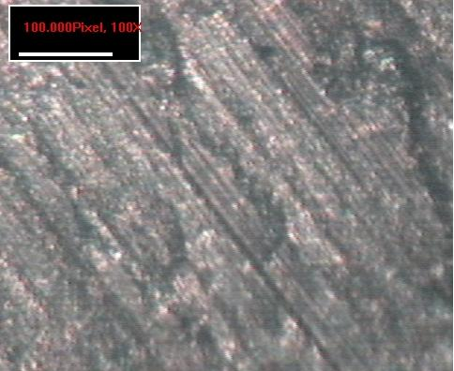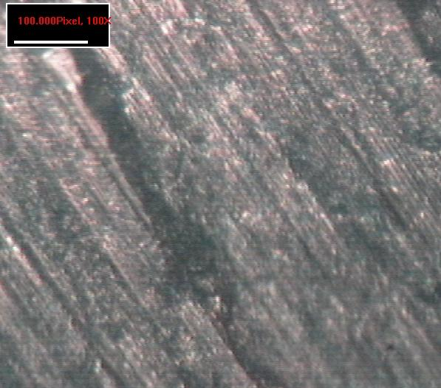
Fig. 5.17 Surface Texture at 1000 rpm, Fig.5.18 Surface Texture at 1000 rpm,
25 m/min 75 m/min

The increase in feed rate increased the heat generation and hence, tool wear, which resulted in the higher surface roughness. The increase in feed rate also increased the chatter and produced incomplete machining at a faster traverse, which led to higher surface roughness. The results shown prove that the roughness of the machined surface was highly influenced by the feed rate, since fig.5.20 is less homogeneous than the fig.5.19 at same speed.
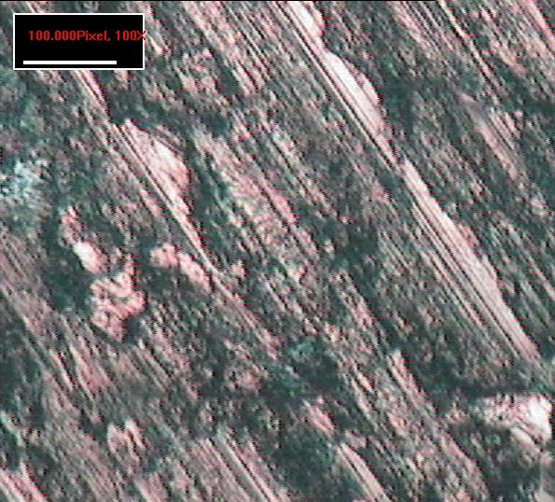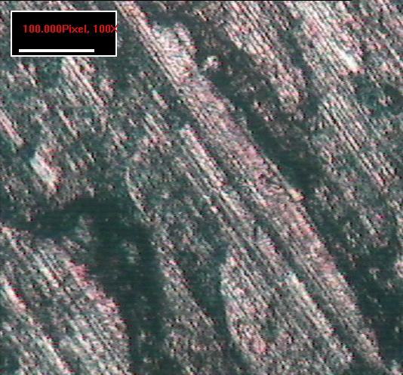
Fig. 5.19 Surface Texture at 1400 rpm, Fig. 5.20 Surface Texture at 1400 rpm,
25 m/min 75 m/min

The cutting speed plays an important role in deciding the surface roughness. At high cutting speeds, the surface roughness decreases. At low speeds, the BUE is formed and also the chip fracture readily producing the rough surface. As the speed increase, the BUE vanishes, chip fracture decreases, and hence the roughness decreases.
The increase in depth of cut, results in high normal pressure and seizure on the rake face and promotes the BUE formation. The increase in feed rate, increases the surface roughness linearly upto 0.5 mm/rev.
The results shown prove that the surface roughness of Gun metal is highly influenced by the feed rate, cutting speed. The depth of cut also plays a significant role on composite machining process in deciding the surface roughness.
The interaction between machining parameters also play a prominent role in machining of Gun metal. From the ANOVA analysis, it is found that feed rate is the most significant parameters than other parameters. Among the interactions, the interaction between cutting speed and feed rate is more significant factor than other interactions. Further more, the surface roughness reduces as the cutting speed increases. But the surface roughness increases with the increase of feed rate and depth of cut.
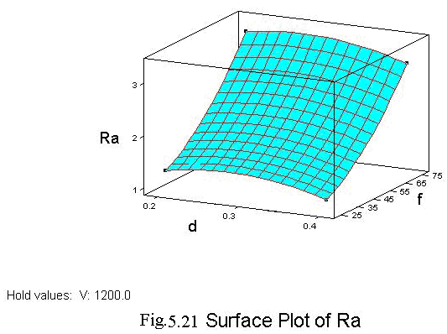
The above graph between Ra and d, f shows that as depth increases, roughness increases to a certain value and then decreases, while as feed increases, there is a sharp increase in surface roughness.
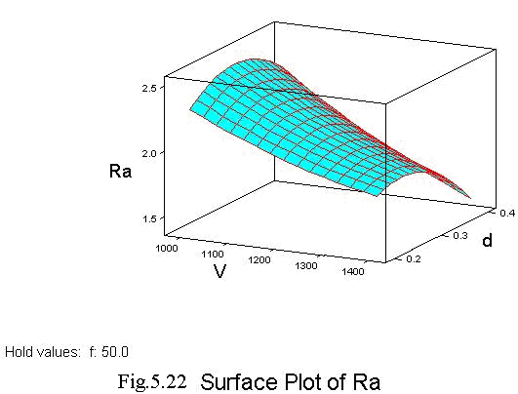
The above graph between Ra and V, d shows that as cutting speed increases, roughness decreases, while as depth increases, roughness increases and then decreases.
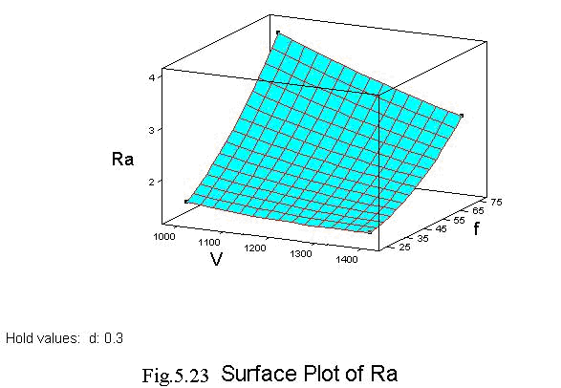
The above graph between Ra and V, f shows that as cutting speed increases, roughness decreases, while as feed increases , there is a sharp increase in surface roughness.
Chapter 6
RESULTS AND CONCLUSION

This work presented an experimentation approach to studying the impact of machining parameters on surface roughness. Strong interactions were observed among the machining turning parameters. Most significant interactions were found between work materials, feed and cutting speeds. A systematic approach was provided to design and analyze the experiments, which is able to reduce the cost and time of experiments and to utilize the data obtained to the maximum extend.
From the data collection we have observed that the increase in cutting speed tends to improve the finish, thus the average surface roughness value decreases. The increase in depth of cut influences the finish slightly, but greater depth of cut marks the finish poor. Feed rate is the most critical parameter when finish is the criterion. Finish gets poor as the feed increases, thus the average surface roughness value increases with increase in feed.
We have developed the regression models for both the linear as well as non-linear cases.
The present study can be concluded in the following steps:
- For linear regression equation relationship with the R-square value of 0.89 indicated that 89% of the variability in the surface roughness was explained by the model with factors V, f and d.

- For non-linear regression equation relationship with the R-square value of 0.85 indicated that 85% of the variability in the surface roughness was explained by the model with factors V, f and d. It is being observed that the non-linear model gives more accurate result than the linear model as when compared with the actual experimental results.
- A methodology for the prediction of surface roughness in turning using back propagation neural network has been developed. A good number of experiments have been conducted on gun metal work-piece using HSS as the cutting tool material. The optimum network architecture has been found out based on the mean square error and the convergence rate. The predicted surface roughness from the present neural network model is very close to the values measured experimentally, thus showing the efficacy of back propagation neural network for predicting surface roughness in turning. This technique is much better than Regression analysis when it comes to predicting the values.

- The third technique used is Pareto ANOVA analysis. It shows that the feed has the maximum effect on surface roughness.

Scope for future work
The machining variables are divided into three main categories. These are tool variables, work piece variables and set-up variables. Tool variables includes tool material, nose radius, tool wear, tool geometry, tool vibration, machine tool rigidity, and tool overhang etc. Work piece variables include work piece material, hardness, length and diameter etc. Set-up variables include cutting speed, feed rate, depth of cut etc. In the present work only set-up variables are considered. Tool variables and work piece variables can also be optimized by using Taguchi design of experiment There is also scope for considering more factors levels, interactions to optimize a selected set of parameters. A comparison between different optimization techniques can also be studied to check which optimization technique is better.
It is also one of the important things to analyze why surface roughness first increases and then decreases with design parameters.

REFERENCES

- Choudhury, S. K., Jain V. K. and Rama Rao, Ch. V. V., 1999, “On-line monitoring of tool wear in turning using a neural network” International Journal of Machine Tools and Manufacture, vol. 39, pp. 489-504

- Feng. Cang-Xue (Jack), 2001 “An Experimental Study of the Impact of Turning Parameters on Surface Roughness”. Proceedings of the 2001 Industrial Engineering Research Conference Copyright, Institute of Industrial Engineers, paper no. 2036.

- Feng, C. X. and Wang, X, 2002, “Development of empirical models for surface roughness prediction in finish turning”. International Journal of Advanced Manufacturing Technology, vol. 20, pp. 348-356.

- Jiao Y, Lei S., Pei Z.J. and Lee E.S., 2004“Fuzzy adaptive networks in machining process modeling: surface roughness prediction for turning operations”. International Journal of Machine Tools & Manufacture, vol. 44, pp. 1643–1651.

- Kirby, Zhang and Chen, 2004, “Determining the surface roughness of a work piece using a Federal Pocket Surf stylus profilometer”. Journal of Industrial Technology, vol-20 number-4 date Sept,2004.

- Lambert, B. K., 1983 “Determination of metal removal rate with surface finish restriction”. Carbide and Tool Journal, May- June: 16-19.

- Lambert, B. K., and Taraman, K., 1974 A surface roughness model for a turning operation. International Journal of Production Research, vol. 12, pp. 691-703.

- Lee S. S. and Chen J. C., 2003 “On-line surface roughness recognition system using artificial neural networks system in turning operations”. International Journal of Advance Manufacturing Technology, vol. 22, pp. 498–509.
- Malakooti B. and Raman V., 2000 “An interactive multi-objective artificial neural network approach for machine setup optimization”. Journal of Intelligent Manufacturing, vol. 11, pp. 41-50.
- Monostori L., 1993, “A step towards intelligent manufacturing: modelling and monitoring of manufacturing processes through artificial neural network”, Ann CIRP, vol. 42, pp. 485–493.

- Ozel, T. and Karpat, Y., 2004, “Predictive modeling of surface roughness and tool wear in hardturning using regression and neural networks” International Journal of Machine Tools & Manufacture, vol.45, pp. 467–479.

- Palanikumar K., Karunamoorthy L. and Karthikeyan R., 2005 “Assessment of factors influencing surface roughness on the machining of glass fiber-reinforced polymer composites” Journal of Materials and Design.

- Palanikumar K. and Karthikeyan R., 2007. “Assessment of factors influencing surface roughness on the machining of Al/SiC particulate composites” Journal of Materials and Design, vol. 28, pp. 1584-1591.

- Pal, S.K. and Chakraborty, D., 2005 “Surface roughness prediction in turning using artificial neural network”. Springer-Verlag London Limited.

- Rasch and Rolstadas, 1971, “Series of finish turning tests under variation of parameters: material quality, tool quality, tool nose radius, feed, speed and cutting time”. Journal of Materials Processing Technology vol-132, pp. 203-214.

- Sahin, Yusuf and Motorcu A.Riza., 2004“Surface Roughness Prediction Model in Machining of Carbon Steel by PVD Coated Cutting Tools”. American Journal of Applied Sciences, vol 1, pp. 12-17

- Sundaram. R. M., 1976, “A statistical analysis of surface finish in fine turning of steel, unpublished Doctoral Dissertation in Industrial Engineering”, Texas Tech
University Lubbock, TN.

- Sundaram, R. M. and Lambert, B. K., 1979, “Surface roughness variability of ANSI 4140 steel in fine turning using carbide tools”. International Journal of Production Research, vol.17, pp. 249-258.

- Sundaram, R. M. and Lambert, B. K., 1981, “Mathematical models to predict surface finish in fine turning of steel: Part I and Part II”. International Journal of Production Research, vol. 19, pp. 557-564

- Taraman, K. and Lambert, B. K., 1974, “A surface roughness model for a turning operation”, International Journal of Production Research, vol. 12, pp. 691-703.

- Wu, S.M. 1964. ‘Tool life testing by Response Surface Methodology-Part1”, Journal of Engineering for Industry. Transactions of ASME, pp. 111.

- Yang W.H., Tarng Y.S. 1998 “Design optimization of cutting parameters for turning operations based on the Taguchi method”. Journal of Materials Processing Technology, vol 84, pp. 122–129.
- Yeo, S.H., Rahman, M. and Wong, Y.S., 1989, “Towards enhancement of machinability data by multiple regression”. Journal of Mechanical Working Technology, vol. 19, pp. 85-99.

- Yeo, S.H., 1995, “A multipass optimization strategy for CNC lathe operations”. International Journal of Production Economics, vol 40, pp. 209-218.
- Zuperl Uros, Cus Franci 2003“Optimization of cutting conditions during cutting by using neural networks”. Robotics and Computer Integrated Manufacturing, vol 19, pp. 189–199.

APPENDIX

Programming of CNC Trainer Lathe

List of G Codes

CODE | FUNCTION
G00 | RAPID POSITIONING
G01 | LINEAR INTERPOLATION
G02 | CLOCKWISE CIRCULAR INTERPOLATION
G03 | CONTER CLOCKWISE CIRCULAR INTERPOLATION
G04 | DWELL IN SECONDS
G20 | INCH PROGRAMMING
G21 | METRIC PROGRAMMING
G28 | AUTO. RETURN TO REF. POINT
G32 | THREAD CUTTING CYCLE
G70 | FINISHING CYCLE
G71 | STOCK REMOVAL IN TURNING
G72 | STOCK REMOVAL IN FACING
G73 | PATTERN REPEATING CYCLE
G74 | PECK DRILLING CANNED CYCLE
G90 | DAIMETER CUTTING CYCLE
G94 | FACING CANNED CYCLE
G96 | CONSTANT SURAFCE SPEED ON

List of M Codes

CODE | FUNCTION
M00 | PROGRAM STOP
M01 | OPTIONAL PROGRAM STOP
M02 | PROGRAM END
M03 | SPINDLE START CLOCKWISE
M04 | SPINDLE START ANTICLOCKWISE
M05 | SPINDLE STOP
M07 | COOLANT NO. 1 ON
M08 | COOLANT NO.2 ON
M09 | COOLANT OFF
M13 | SPINDLE CLOCKWISE & COOLANT ON
M14 | SPINDLE ANTI-CLOCKWISE &  COOLANT ON
M30 | PROGRAM END & REWIND
M98 | START OF SUBROUTINE
M99 | END OF SUBROUTINE

PART PROGRAM CARRIED OUT ON CNC LATHE:

G21 G97 G98
G28 V0 W0
M06 T1
M03 S1400
N10 M03 S1400
N15 G00 X31 Z2
N20 G01 X29.4 Z2 F100
N25 G01 X29.4 Z-20 F25
N30 G01 X29.4 Z-40 F50
N35 G01 X29.4 Z-60 F75
N40 G01 X30
N45 Z2 F100
N50 M05
N55 M30

BIBLIOGRAPHY
1. Surface Roughness Terminology:
The quality of machined surface is characterized by the accuracy of its manufacture with respect to the dimensions specified by the designer. Every machining operation leaves characteristic evidence on the machined surface. This evidence in the form of finely spaced micro irregularities left by the cutting tool. Each type of cutting tool leaves its own individual pattern which therefore can be identified. This pattern is known as surface finish or surface roughness.
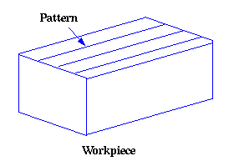

2. Roughness:
Roughness consists of surface irregularities which result from the various machining process. These irregularities combine to form surface texture.

3. Roughness Height:
It is the height of the irregularities with respect to a reference line. It is measured in millimeters or microns or micro inches. It is also known as the height of unevenness.

4. Roughness Width:
The roughness width is the distance parallel to the nominal surface between successive peaks or ridges which constitute the predominate pattern of the roughness. It is measured in millimeters.
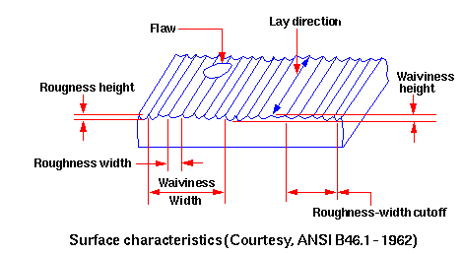

5. Roughness Width Cut Off:
Roughness width cut off is the greatest spacing of respective surface irregularities to be included in the measurement of the average roughness height. It should always be greater than the roughness width in order to obtain the total roughness height rating.
6. Lay:
Lay represents the direction of predominant surface pattern produced and it reflects the machining operation used to produce it.
7. Waviness:
This refers to the irregularities which are outside the roughness width cut off values. Waviness is the widely spaced component of the surface texture. This may be the result of work piece or tool deflection during machining, vibrations or tool run out.
8. Waviness Width:
Waviness height is the peak to valley distance of the surface profile, measured in millimeters.
9. Arithmetic Average (AA):
A close approximation of the arithmetic average roughness-height can be calculated from the profile chart of the surface. Averaging from a mean centerline may also be automatically performed by electronic instruments using appropriate circuitry through a meter or chart recorder. If X is the measured value from the profilometer, then the AA value can be calculated as shown below.
10. Root Mean Square (rms):
The rms value can be calculated as shown below. Its numerical value is about 11% higher than that of AA.
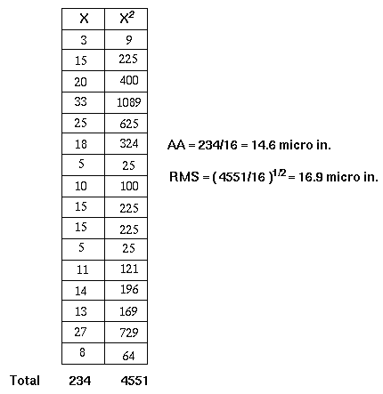
11. Cut-off value
The cut-off value controls the measurement length. For example, if an 0.8mm cut-off is selected and 7 sample lengths are measured, then the measurement length will be 7 x 0.8=5.6mm. In general for good statistical analysis, it is recommended that 5 sample lengths be used for assessment, although this is not always possible. If a 2CR filter is used, then 2 cut-offs will be discarded. This means the measurement length for a 2CR type filter will have to be 7 x 0.8 to allow for the 2 discarded cut-offs leaving a final 5 sample lengths for assessment. The Gaussian type filter is different and only discards one sample length.

12. Spacing Parameters
RSm is the mean spacing between profile peaks as they pass through the mean line (spacing is the distance between points that cross the mean line within a sample length in
an upward direction.
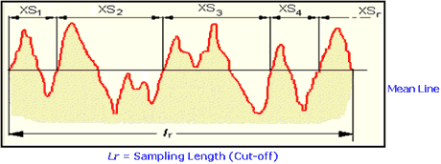
HSC - The high spot count is the number of complete profile peaks (within an assessment length) projecting above a horizontal reference line, in other words, parallel with the mean line. The reference line can be set at a selected distance above or below the mean line.
RPc - The peak count is the number of local peaks which project through a selectable band centered about the mean line. The count is determined only over the assessment length though the results are given in peaks per cm (or per inch). The peak count is obtained by using a multiplication factor. The parameter should, therefore, be measured over the greatest assessment length possible.
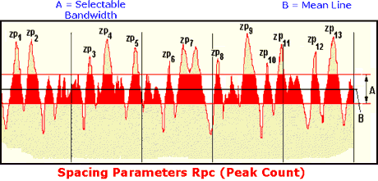

13. Stylus Tip Radius
The stylus tip radius is a key feature that is often overlooked. Assuming that a conisphere stylus is being used, the profile recorded by the instrument will in effect be the locus of the centre of a ball, whose radius is equal to that of the stylus tip, as it is rolled over the surface. This action broadens the peaks of the profile and narrows the valleys. For simplicity, if we consider the surface to be a sine wave, then this distortion is dependent both on the wavelength and the amplitude.

