Monitoring of Arsenic Removal from Contaminated Water: A Review

Ankur Garg ª, S. K. Singh ^{b}
- Undergraduate Student, Delhi College of Engineering, India

Research Fellow, Indian Institute of Technology Delhi, India
- Professor, Civil & Environmental Engineering, DCE, India

ABSTRACT
Excessive amounts of arsenic (As) in the groundwater in Bangladesh and neighboring states in India are a major public health problem. About 30% of the private wells in Bangladesh exhibit high concentrations of arsenic. Over half the country, 269 out of 464 administrative units, is affected. Similar problems exist in many other parts of the world, including the Unites States. This paper presents an assessment of the various conventional and novel treatment facilities available for arsenic contamination in the drinking water across the globe. The paper compares various available technologies and lists their comparative merits and demerits and lists specific situations to which they may be applied.

INTRODUCTION
Arsenic contamination of groundwater is a natural occurring high concentration of arsenic in deeper levels of groundwater, which became a high-profile problem in recent years due to the use of deep tubewells for water supply in the Ganges Delta, causing serious arsenic poisoning to large numbers of people. A 2007 study found that over 137 million people in more than 70 countries are probably affected by arsenic poisoning of drinking water. Arsenic contamination of ground water is found in many countries throughout the world, including the USA.

Approximately 20 incidents of groundwater arsenic contamination have been reported from all over the world. Of these, four major incidents were in Asia, including locations in Thailand, Taiwan, and Mainland China. South American countries like Argentina and Chile have also been affected. There are also many locations in the United States where the groundwater contains arsenic concentrations in excess of the Environmental Protection Agency standard of 10 parts per billion adopted in 2001.

Arsenic is a carcinogen which causes many cancers including skin, lung, and bladder as well as cardiovascular disease.

Some research concludes that even at the lower concentrations, there is still a risk of arsenic contamination leading to major causes of death. A study was conducted in a contiguous six-county study area of southeastern Michigan to investigate the relationship between moderate arsenic levels and twenty-three selected disease outcomes. Disease outcomes included several types of cancer, diseases of the circulatory and respiratory system, diabetes mellitus, and kidney and liver diseases. Elevated mortality rates were observed for all diseases of the circulatory system. The researchers acknowledged a need to replicate their findings.

A study preliminarily shows a relationship between arsenic exposure measured in urine and Type II diabetes. The results supported the hypothesis that low levels of exposure to inorganic arsenic in drinking water may play a role in diabetes prevalence.

Arsenic in drinking water may also compromise immune function “Scientists link influenza A (H1N1) susceptibility to common levels of arsenic exposure”.

ARSENIC CONTAMINATION IN BANGLADESH AND WEST BENGAL

The story of the arsenic contamination of the groundwater in Bangladesh is a tragic one. Many people have died from this contamination. Diarrheal diseases have long plagued the developing world as a major cause of death, especially in children. Prior to the 1970s, Bangladesh had one of the highest infant mortality rates in the world. Ineffective water purification and sewage systems as well as periodic monsoons and flooding exacerbated these problems. As a solution, UNICEF and the World Bank advocated the use of wells to tap into deeper groundwater for a quick and inexpensive solution. Millions of wells were constructed as a result. Because of this action, infant mortality and diarrheal illness were reduced by fifty percent. However, with over 8 million wells constructed, it has been found over the last two decades that approximately one in five of these wells is now contaminated with arsenic above the government's drinking water standard.

In the Ganges Delta, the affected wells are typically more than 20 m and less than 100 m deep. Groundwater closer to the surface typically has spent a shorter time in the ground, therefore likely absorbing a lower concentration of arsenic; water deeper than 100 m is exposed to much older sediments which have already been depleted of arsenic.

Dipankar Chakraborti from West Bengal brought the crisis to international attention in a research paper published in The Analyst in 1995 and reported on by David Bradley (The Guardian, January 5, 1995, "Drinking the water of death"). Beginning his investigation in West Bengal in 1988, he eventually published, in 2000, the results of a study conducted in Bangladesh, which involved the analysis of thousands of water samples as well as hair, nail and urine samples. They found 900 villages with arsenic above the government limit.

Chakraborti has criticized aid agencies, saying that they denied the problem during the 1990s while millions of tube wells were sunk. The aid agencies later hired foreign experts, who recommended treatment plants which were not appropriate to the conditions, were regularly breaking down, or were not removing the arsenic.

Chakraborti says that the arsenic situation in Bangladesh and West Bengal is due to negligence. He also adds that in West Bengal water is mostly supplied from rivers. Groundwater comes from deep tubewells, which are few in number in the state. Because of the low quantity of deep tubewells, the risk of arsenic patients in West Bengal is comparatively less.

According to the World Health Organisation, “In Bangladesh, West Bengal (India) and some other areas, most drinking-water used to be collected from open dug wells and ponds with little or no arsenic, but with contaminated water transmitting diseases such as diarrhoea, dysentery, typhoid, cholera and hepatitis. Programmes to provide ‘safe’ drinking-water over the past 30 years have helped to control these diseases, but in some areas they have had the unexpected side-effect of exposing the population to another health problem—arsenic.” The acceptable level as defined by WHO for maximum concentrations of arsenic in safe drinking water is 0.01 mg/L. The Bangladesh government's standard is at a slightly higher rate, at 0.05 mg/L being considered safe. WHO has defined the areas under threat: Seven of the nineteen districts of West Bengal have been reported to have ground water arsenic concentrations above 0.05 mg/L. The total population in these seven districts is over 34 million, with the number using arsenic-rich water is more than 1 million (above 0.05 mg/L). That number increases to 1.3 million when the concentration is above 0.01 mg/L. According to a British Geological Survey study in 1998 on shallow tube-wells in 61 of the 64 districts in Bangladesh, 46% of the samples were above 0.01 mg/L and 27% were above 0.050 mg/L. When combined with the estimated 1999 population, it was estimated that the number of people exposed to arsenic concentrations above 0.05 mg/L is 28-35 million and the number of those exposed to more than 0.01 mg/L is 46-57 million (BGS, 2000).

Throughout Bangladesh, as tube wells get tested for concentrations of arsenic, ones which are found to have arsenic concentrations over the amount considered safe are painted red to warn residents that the water is not safe to drink.

The solution, according to Chakraborti, is “By using surface water and instituting effective withdrawal regulation. West Bengal and Bangladesh are flooded with surface water. We should first regulate proper watershed management. Treat and use available surface water, rain-water and others. The way we're doing at present is not advisable."

ARSENIC CONTAMINATION IN UNITED STATES

There are many locations across the United States where the groundwater contains naturally high concentrations of arsenic. Cases of groundwater-caused acute arsenic toxicity, such as those found in Bangladesh, are unknown in the United States where the concern has focused on the role of arsenic as a carcinogen. The problem of high arsenic concentrations has been subject to greater scrutiny in recent years because of changing government standards for arsenic in drinking water.

Some locations in the United States, such as Fallon, Nevada, have long been known to have groundwater with relatively high arsenic concentrations (in excess of 0.08 mg/L). Even some surface waters, such as the Verde River in Arizona, sometimes exceed 0.01 mg/L arsenic, especially during low-flow periods when the river flow is dominated by groundwater discharge.

A drinking water standard of 0.05 mg/L (equal to 50 parts per billion, or ppb) arsenic was originally established in the United States by the Public Health Service in 1942. The Environmental Protection Agency (EPA) studied the pros and cons of lowering the arsenic Maximum Contaminant Level (MCL) for years in the late 1980s and 1990s. No action was taken until January 2001, when the Clinton administration in its final weeks promulgated a new standard of 0.01 mg/L (10 ppb) to take effect January 2006. The incoming Bush administration suspended the midnight regulation, but after some months of study, the new EPA administrator Christine Todd Whitman approved the new 10 ppb arsenic standard and its original effective date of January 2006.

Many public water supply systems across the United States obtained their water supply from groundwater that had met the old 50 ppb arsenic standard but exceeded the new 10 ppb MCL. These utilities searched for either an alternative supply or an inexpensive treatment method to remove the arsenic from their water. In Arizona, an estimated 35% of water-supply wells were put out of compliance by the new regulation; in California, the percentage was 38%.

The proper arsenic MCL continues to be debated. Some have argued that the 10 ppb federal standard is still too high, while others have argued that 10 ppb is needlessly strict. Individual states are able to establish lower arsenic limits; New Jersey has done so, setting a maximum of 0.005 mg/L for arsenic in drinking water.

AVAILABLE TREATMENT TECHNOLOGIES

ENHANCED COAGULATION

ENHANCED LIME SOFTENING

ION EXCHANGE

SORPTION TO ACTIVATED ALUMINA

MEMBRANE FILTRATION

COMPARISON OF TECHNOLOGIES

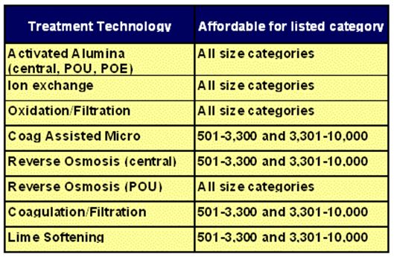

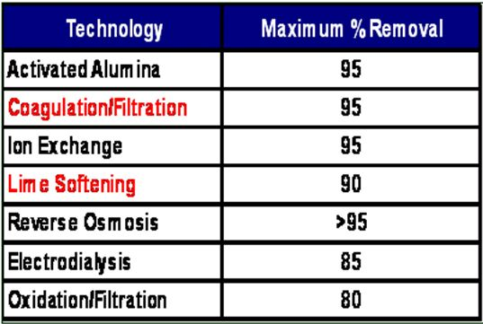

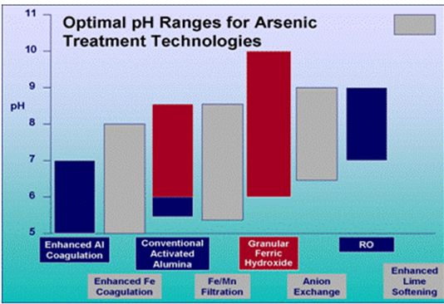

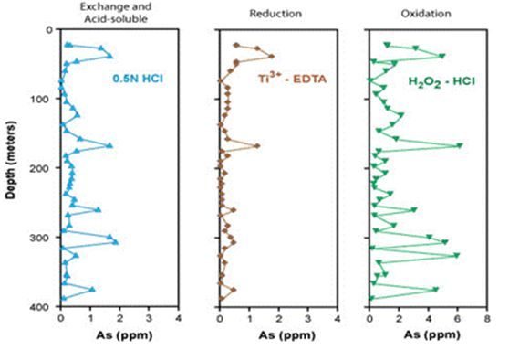

CONCLUSION

The choice of technology to be employed for arsenic treatment from contaminated water should be made with respect to geographical conditions, pH and available resources.
Coagulation filtration and Lime softening are found to be quite useful for As removals at lower costs. Minor changes can be made to improve available technologies considerably.

REFERENCES

- P Bhattacharya, G Jacks, B Sarkar. Arsenic in the Environment: A Global Perspective. Heavy Metals in the Environment. New York: Marcel Dekker, 2002, pp 147-215.
- DC Adriano. Trace Elements in the Terrestrial Environment. New York: Springer, 1986, 533pp.
- Arsenic Treatment Approaches. Arsenic Rule Training Sessions. USEPA, 2002.

